***“The use of Angelman syndrome model mice for finding metabolomic biomarkers to optimize transcranial direct stimulation as a therapeutic strategy.”***

***Background:***

***Angelman syndrome (AS)*** is a genetic neurodevelopmental disorder caused by a lack of expression of the maternal 15q11-q13 chromosome region containing the UBE3A gene. AS is characterized by a developmental delay, absence of speech, gait ataxia, epilepsy, and a unique behavioral phenotype1. AS patients require lifelong care and support, resulting in a significant socioeconomic burden on the healthcare system, their families, and caregivers. Currently, no AS-specific treatments exist, and the available therapies are symptomatic at best. AS shares many common features with multiple other autism spectrum disorders and thus can serve as a principal model for understanding and treating autism in general. The knockout of the UBE3A gene in mice recapitulates many features of AS (e.g., motor dysfunction, aberrant behavior, and cognitive deficits), making this model an efficient tool for investigating this disease 2–5. Using this model, we and others have shown that brain regions implicated in AS-related deficits correlate with aberrant cellular excitability 6–15, altered mitochondrial function16, and elevated oxidative stress17. In most but not all cases 7, recovery from aberrant oxidative stress17 or aberrant excitability6,9,11,13 correlates with the rescue of the behavioral deficits. Though the effects of the loss of UBE3A on neuronal physiology differ between brain regions such as the hippocampus, cortex, and cerebellum, the mechanisms responsible for behavioral deficits phenomenon remain poorly understood in mice and humans.

***Transcranial direct current stimulation (tDCS)*** is an evolving neurostimulation-based therapeutic modality used to treat multiple neurological and psychiatric indications such as major depression, stroke, and Parkinson’s disease 18–26. It entails the delivery of a weak direct current (DC) to the brain via the scalp 27–30. The advantages of tDCS include its non-invasive nature, portability, ease of use, low cost, and minimal side effects 31,32. However, despite the growing use of tDCS, its overall therapeutic efficacy remains unclear, and even those studies with encouraging results emphasize the need for further optimization 33–35. One of the most significant barriers to tDCS optimization is that its underlying mechanisms of action are not fully clear 34,36–42. The basic dogma for tDCS entails the generation of an electrical field that modulates the intrinsic and extrinsic properties of neurons43 while also affecting other brain cells, including astrocytes and glial cells44–48. Whether the effect of tDCS on non-neuronal cells is a direct consequence of the electrical current or an indirect effect due to the modulation of neuronal properties, remain unknown. Modeling studies and indirect measurements suggest that an electrical field parallel to the dendro-axonic axis generates incremental membrane polarization, which gradually reaches a maximum in the distal subcellular compartments 43,49–53.

Nonetheless, these models predicted that this terminal polarization effect is too small, even under optimal conditions to generate significant physiological effects 51,52. Using an *ex vivo* model of tDCS, where direct current stimulation (DCS) was applied to brain slices via submerged wires in the recording bath, we were able to collect direct measurements that confirmed this maximal polarization in the terminal compartments while also revealing the resultant polarization to be much larger than that predicted by prior models 52. We further demonstrated that models based on the cable theory considered only passive membrane properties, while the modulation of ion channel conductance amplifies associated terminal membrane polarization 54,55. These results provide a theoretical basis for explaining the non-linearity of tDCS dose-response relationships revealed in many prior studies 56–59. Despite all of the above, the cellular processes that govern the long-term effects of such treatment remain poorly understood.

***Angelman syndrome (AS) and Transcranial direct current stimulation (tDCS):*** tDCS can be delivered as an anodal or cathodal stimulation, and each type of stimulation induces differential effects. Based on our preliminary results, we hypothesized that anodal tDCS stimulation over the dorsal hippocampus of AS mice could modulate neuronal excitability, leading to normalizing AS hippocampal-dependent deficits. In an initial set of experiments that were designed to examine this hypothesis, electrodes were surgically fixed over the mice skull, above the dorsal hippocampi, and the mice were treated with sham (control) or tDCS before each training session (Fig 1A, B). Based on those experiments, we concluded that tDCS treatment rescued spatial memory deficits of AS mice (Fig 1C-E). However, the treatment did not affect motor functioning (Fig 1F), which is reasonable because this electrode position is unsuitable for motor effects. Furthermore, a small pilot study showed that tDCS enhanced object location memory (OLM) for the displaced object in both WT and AS mice littermates (Fig 2).

All of the above indicated that tDCS has the potential to evolve into a novel, non-invasive therapeutic approach for Angelman syndrome patients. ***However, before this therapeutic approach can be applied, we must understand how dose the*** ***tDCS stimuli affect the targeted parts of the brain, evaluate the effect of stimuli on overall behavior, and determine the impact of the treatment on the short and prolonged effects on neuronal metabolism, cellular homeostasis, and determine the duration of the treatment effect***.

The excitability of neurons is defined as the ability to generate a significant, rapid change of membrane voltage in response to a stimulus. Homeostatic regulation of neuronal excitability provides stability to the neural network, which is essential for maintaining normal brain functions. Any dysregulation in the homeostatic regulation of neuronal excitability could lead to neuropsychiatric disorders, such as epilepsy, depression, autism, and schizophrenia.

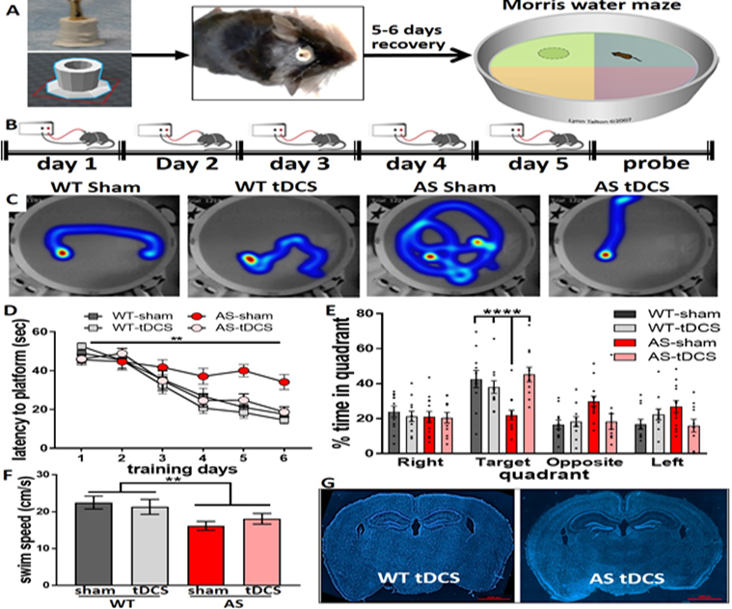**Figure 1:** tDCS alleviates spatial navigation memory deficits in AS mice. MWM testing revealed that 20 min of tDCS over the parietal cortex and dorsal hippocampus, ending 5 min before training, alleviated the spatial navigation memory deficits in AS mice. The center of anodal electrode was -1.5 mm posterior to the bregma, and the return electrode was positioned over the thorax using a Velcro corset. A. Experimental approach. B. Stimulation protocol during the MWM training period. C. Representative heat-maps of mice in the probe test. D. Latency to reach the platform [F(15,210)=2.6, p<0.01, RM-2way-ANOVA for interaction group*time]. E. Time in target quadrant in the probe test [F(3,42)=9.7, p<0.0001, ANOVA for target quadrant]. F. Swim speed is affected by genotype but not by tDCS [F(1,42)=8.9, p<0.01 and F(1,42)=0.06, p=0.82 for genotype and treatment, respectively; 2way-ANOVAs]. G. Histological analysis of brains after the end of experimental period did not reveale any tDCS-induced damage at the end of the experimental protocol. Data are means ± SEM as error bars. Dots represent individual mice. Numbers of mice: WT sham (11), WT tDCS (11), AS sham (13), AS tDCS (11). **p<0.01; ****p<0.0001

Previous studies performed by others60 and us16,61 showed that alteration in the expression level of UBE3A leads to mitochondrial abnormalities that can affect various glucose metabolic pathways, cellular homeostasis, calcium homeostasis, apoptosis, and accumulation of ROS. Furthermore, It has been previously shown that AS adult mice models, which display endophenotypes consistent with the human disorder, exhibit mitochondrial dysfunction and altered mitochondrial morphology in the hippocampus 60 62.

Neurons consume ~15% of the body’s resting energy to sustain action potential, neurotransmitter release, cytoskeletal dynamics, and gene expression. Despite the significant energy demands, neurons do not store energy but instantly and locally synthesize it in the form of ATP. Therefore, it is not surprising that metabolic insults, including acute ischemia, mitochondrial poisons, hypoglycemia, or even minor neuronal energy homeostasis disruptions, cause a rapid decline in nervous system function.

Interestingly, data which was generated in our lab show that direct current stimulation modulates neuronal excitability on the single-cell level as well as the circuit level and, at the same time, has the potential to alter the metabolic state of neurons and modify the expression of various metabolites which serve as signaling molecules and neurotransmitters63–65. These attributes of tDCS might serve as a therapeutic strategy for treating neurodevelopmental disorders similar to AS. And indeed, as we previously showed (Fig 1 and 2), tDCS treatment was able to rescue some of the behavioral aberrations associated with AS.

***We hypothesize that tDCS, like other types of neurostimulation, alters the metabolic state of the neurons and thus modulates neuronal excitability via modulation of the neuronal metabolic pathways and cellular homeostasis.*** Support for this hypothesis can be found in an experiment in which we treated WT rats with anodal tDCS for five consecutive days and analyzed the adenosine level in the rat cortex and hippocampus (Fig 3). We found that upon tDCS stimulation, adenosine level was up-regulated in the hippocampus, which was targeted by the tDCS stimuli and the prefrontal cortex.



**Figure 2: tDCS enhances object location memory in WT and AS mice.** tDCS electrode positioning was same as for MWM testing.Stimulation parameters; 150A for 20 min. **A.** OLM experimental scheme. **B.** tDCS increases test phase exploration index in WT and AS mice [F(1,14)=9.1, p<0.01 for treatment effect in 2 way-ANOVA]. No differences were observed between WT and AS. **C.** Equation for calculating exploration index %. N=5 mice/group for WT sham and AS sham. N=4 mice/group for WT tDCS and AS tDCS.

Adenosine serves as a neurotransmitter and neuromodulator in the central nervous system. It modulates neuronal plasticity, astrocytic activity, learning and memory, motor function, feeding, control of sleep, and aging. Adenosine is also an essential component of energy production that can be produced during the catabolism of adenosine triphosphate (ATP)66.

Moreover, it has been previously shown that anodal tDCS in the MPTP-induced PD mouse model decreases mitochondrial damage67 and reduces the oxidative stress level68. This finding is particularly interesting since we previously found elevated Reactive oxygen species (ROS) levels in the hippocampus of adult AS mice69. Moreover, Rae et al. reported that anodal tDCS treatment in human subjects exhibited an increased demand for adenosine triphosphate (ATP) and an increased pH, which affected creatine kinase steady-state equilibrium created by hydrolysis of PCr due to demand for ATP 70.

All of the above indicate that ***tDCS can affect the mitochondria and the capability of the mitochondria to produce cellular energy through the electron transport chain, affecting the overall mitochondrial dynamics.*** Additionally, tDCS has the potential to induce other metabolic effects that are not directly related to the mitochondria, such as changes in levels of neurotransmitter-related metabolites (such as adenosine (Fig 3)).



**Figure 3:** tDCS elvates the adenosine levels in the hippocampus and cortex of WT rats following tDCS treatment. Adenosine levels were measured by LS/MS in the rat cortex and hippocampus after 5 days of consecutive tDCS stimulation (150μA for 20 min). Data are means ± SEM * p < 0.05; n=3.

Angelman syndrome shares the same pathophysiological mechanisms as various autistic disorders like Rett Syndrome, Pitt-Hopkins, and other69. Additionally, some of the cellular properties associated with AS (like elevated levels of ROS and mitochondrial abortions) are also known to play a significant role in the pathophysiological of other neurodegeneration diseases like Alzheimer’s. Therefore, ***unveiling the effect tDCS treatment has on the cellular homeostasis of the central nervous system will benefit Angelman syndrome patients and potentially evolve to brode rang treatment for multiple types of neurodegeneration and neurodevelopmental***.

***Hypothesis or Objective:*** Angelman syndrome is a genetic condition that affects the nervous system and causes severe learning and behavioral disabilities, and is associated with aberrant cellular metabolism, calcium metabolism, and mitochondrial abnormalities. Our preliminary studies concluded that tDCS could improve the learning capabilities of both AS and WT mice (Fig. 1 and Fig.2), affect the level of metabolites and neurotransmitters, like adenosine (Fig. 3), and induces a shift in taurine 1H nuclear magnetic resonance (NMR) spectrum indicating a mitochondrial pH change (Fig. 4). However, while tDCS appears to have an overall beneficiary effect on learning capabilities, the cellular mechanisms by which tDCS exerts its efficacy, and the optimal stimulation parameters (e.g. intensity, duration) are still unknown. ***For this reason, this proposed study aims to*** ***study the short and long-term metabolic effects of tDCS in AS mice and the behavioral outcome of those treatments***.

***Specific Aims:***

1. To delineate the short and long-term effects of tDCS on behavioral phenotypes of wild-type and AS model mice.

2. To examine the short and long-term effects of tDCS on the metabolic profile of wild-type and AS model mice.

***The expected significance*** of the proposed study is three-fold: **1)** A better understanding of the cellular mechanisms underlying tDCS will enable the development of an efficient treatment regimen, thus optimizing its use for any application. **2)** Understanding tDCS-mediated metabolic mechanisms will facilitate the use of pharmacological agents that augment tDCS efficiency. 3**)** The test case of AS will support further studies for other neurodevelopmental disorders. Therefore, strategies that directly modify cellular functioning, brain region connectivity, or excitability, such as tDCS, may offer a more practical approach to treating AS and healthy individuals seeking to improve their learning capabilities.

***Strength of collaboration:*** This research project is a collaboration between two scientists who are experts in two distinct disciplines. Prof. Kaphzan is a neuroscientist and a psychiatrist who has a firm background in basic neuroscience, as well as vast clinical experience. As a practicing clinician, Prof. Kaphzan is committed to using his resources and knowledge to develop novel therapies to treat neurodevelopmental disorders. In particular, Prof. Kaphzan is a known expert in the neurobiology of neurodevelopmental disorders, with a particularly prominent reputation in the Angelman syndrome field. He is on the scientific advisory board for the international Angelman syndrome alliance. Prof. Goobes is a physical chemist and a leading expert in the biomolecular NMR spectroscopy and high-resolution molecular characterization of biomolecules, including metabolites using state-of-the-art liquid NMR spectroscopy. Combining these two forms of expertise will also enable the correlation of the metabolic effects of any intervention with the effects on brain functionality. Such collaborations are rare, and this work thus has the potential to yield discoveries that will revolutionize the current understanding of the etiology and treatment of autism spectrum disorders. This joint research effort has already yielded promising preliminary results (see **Fig. 4**).

***Visual Abstract:***

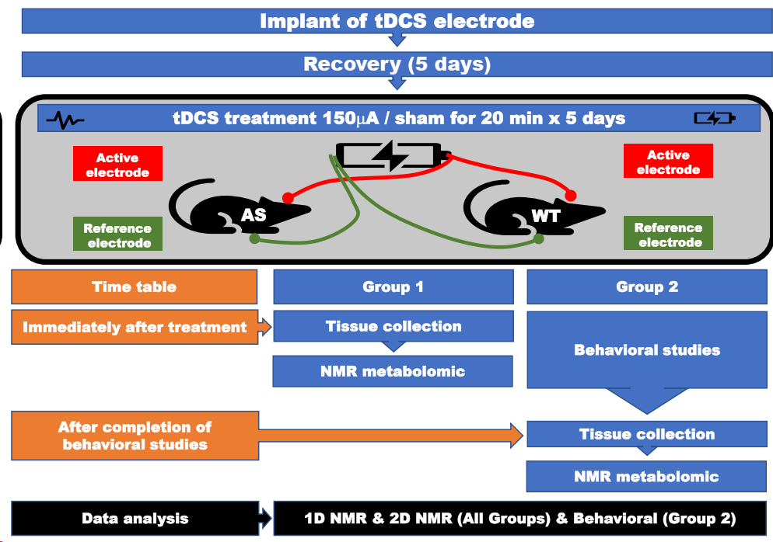

***Aim 1*: *To delineate the short and long-term effects of tDCS on behavioral phenotypes of wild-type and AS model mice.***

***Rationale:*** Many AS deficits correlate with aberrant excitability in corresponding brain regions, including the cerebellum, cortex, and hippocampus 6–14. In contrast to the results of one study7, we and others have shown a correlation between the recovery of neuronal excitability and rescue of AS behavioral deficits 6,9,11,13. One of these deficits is spatial memory impairment in AS mice were examined by Morris water maze (MWM) task 4,13,71–73. MWM task depends on the dorsal hippocampus 74–78 and the parietal cortex 79–82. Using a tDCS (Fig 1a), we demonstrated that applying tDCS above these regions successfully rescues AS deficit evident in the MWM (Fig 1). Furthermore, 20 min of tDCS just prior to habituation enhanced the hippocampal-dependent 83 novel object location memory (OLM) in both WT and AS mice (Fig 2). ***Therefore, we posit that modifying the excitability of distinct brain regions in AS mice using tDCS can alleviate cognitive/behavioral deficits.*** In this aim, we will apply tDCS over relevant brain regions of WT and AS littermates and test performance in corresponding behavioral tasks. We expect that applying tDCS over distinct brain regions will modify regional brain activity and surpass developmental deficits, thus rescuing certain AS deficits. We will examine the short and long-term effects of tDCS treatment on AS behavioral characteristics by repeating a specific set of behavioral paradigm examinations immediately after tDCS treatment and one-week post-tDCS treatment.

***Experimental design:*** We will surgically implant a custom-made hollow dome-shaped tDCS electrode (base internal diameter = 4 mm) filled with a sterile conductive gel in contact with a protruding copper wire (Fig. 1a). Mice will be anesthetized with isoflurane using a Somnosuite apparatus (Kent scientific). The mouse scalp will be cut to reveal the skull, and the electrode will be attached using a Metabond adhesive cement (Parkell). The scalp skin will be sutured above the baseplate of the electrode, and mice will receive postoperative antibiotics and analgesics for the following three days. After a 5-6 day postoperative recovery period, we will treat the mice with anodal tDCS or sham for five consecutive days. The sham procedure will include precisely the same elements of anodal stimulation except delivering an electrical current for only 20 seconds to generate the itchy sensation. The tDCS stimulation parameters will be the intensity of 150 μA (current density: 11.94 μA/mm2) for 20 min. Preliminary results show that mice tolerate these stimulation parameters without any observed pain, stress, or cellular damage to the brain tissue underneath the electrodes (Fig. 1g). The University of Haifa Institutional Committee approved all those experimental procedures for animal experiments according to the National Institutes of Health guidelines. Upon completion of the tDCS treatment, the mice will be divided into two groups. The brains of the first group (group 1) will be harvested immediately after the fifth stimulation and processed for NMR metabolomics (see aim 2). The second group (group 2) will be subjected to behavioral studies starting the following day of the last stimulation (aim 1), and immediately upon completion of behavioral studies, the brains will be harvested and processed for NMR metabolomics (see aim 2).

***Behavioral paradigms:*** Open field arena, marble burying, forced swim test, rotarod, and beam crossing motor tasks are behavioral paradigms that recapitulate AS pathological phenotypes. As such, they are frequently executed in our lab. These behavioral paradigms will be used to assess the motor and behavioral effects of tDCS, as described previously by us in detail 17,13,72. The brain regions involved in these behaviors have been shown to exhibit altered excitability in AS mice, which tDCS is expected to modulate. Hence, we speculate that tDCS will subsequently affect these pathological behavioral phenotypes. Behavioral tracking will be performed using the automatic tracking system EthoVision XT 12 software (Noldus).

***Alternative Approaches:*** If behavioral effects will not be apparent after tDCS administration, we will consider changing the stimulation parameters. We will increase the length of stimulation to more than 20 minutes (30-40 minutes), or we will increase the stimulation intensity to 200-250A. From our experience and based on the literature, stimulations up to 300 A are tolerable by mice given a current density <24μA/mm2. The high current levels are not our initial choice, as we aim to mimic the low levels administered in humans. We will also consider studying effects on other types of behavior, such as contextual fear conditioning, aggressive behavior, and hot plate72,84.

***Aim 2:*** ***To examine the short and long-term effects of tDCS on the metabolic profile of wild-type and AS model mice.***

***Rationale:*** In the early 1950s, it was demonstrated that the application of electric currents to brain cortical tissue could affect brain metabolism85. A later study demonstrated that tDCS is associated with an induced metabolic workload, with induction in ATP synthesis and increased brain pH 86. Recent studies demonstrated that when tDCS was applied to the MPTP-induced neurotoxic mouse model, this suppressed excessive mitophagy and balanced mitochondrial dynamics87. Mitochondria are organelles that play a vital role in maintaining cellular homeostasis. They are involved in numerous functions and signaling pathways, including energy metabolism, calcium homeostasis, and apoptosis. Rather than remaining static, mitochondria are dynamic organelles involved in adaptation to changes in the metabolic environment of cells. Altered mitochondrial function and oxidative stress are well-characterized pathophysiological mechanisms involved in neurodegenerative and autistic disorders, including Angelman syndrome17. ***In this aim, we will determine whether brain bioenergetics and metabolism are altered during tDCS treatment and clarify the nature and duration of those changes in the brain post-tDCS treatment.*** To this end, we will utilize high-throughput NMR metabolomics to assess the effect of tDCS on brain metabolism. This approach can measure the composition of metabolites, detect changes in the levels and state of metabolites (phosphorylation, neutralization, etc.), e.g., in energy-related metabolites, and reflect the dynamics of neurotransmitter activity88. This metabolomic approach will allow us to study the dynamics of different metabolites, which may play a crucial role in brain function and be affected by tDCS treatment. NMR spectroscopy is a powerful analytical technique used to study the structure and dynamics of molecules. NMR spectroscopy can also identify biomarkers for brain disorders, such as Alzheimer’s disease, Parkinson’s disease, and traumatic brain injury. For example, in Parkinson’s disease, NMR spectroscopy has been used to measure the levels of brain metabolites such as GABA, Glutamate, and Glutamine, which can be used as biomarkers to monitor the disease progression and to evaluate the effectiveness of treatment 89,90.

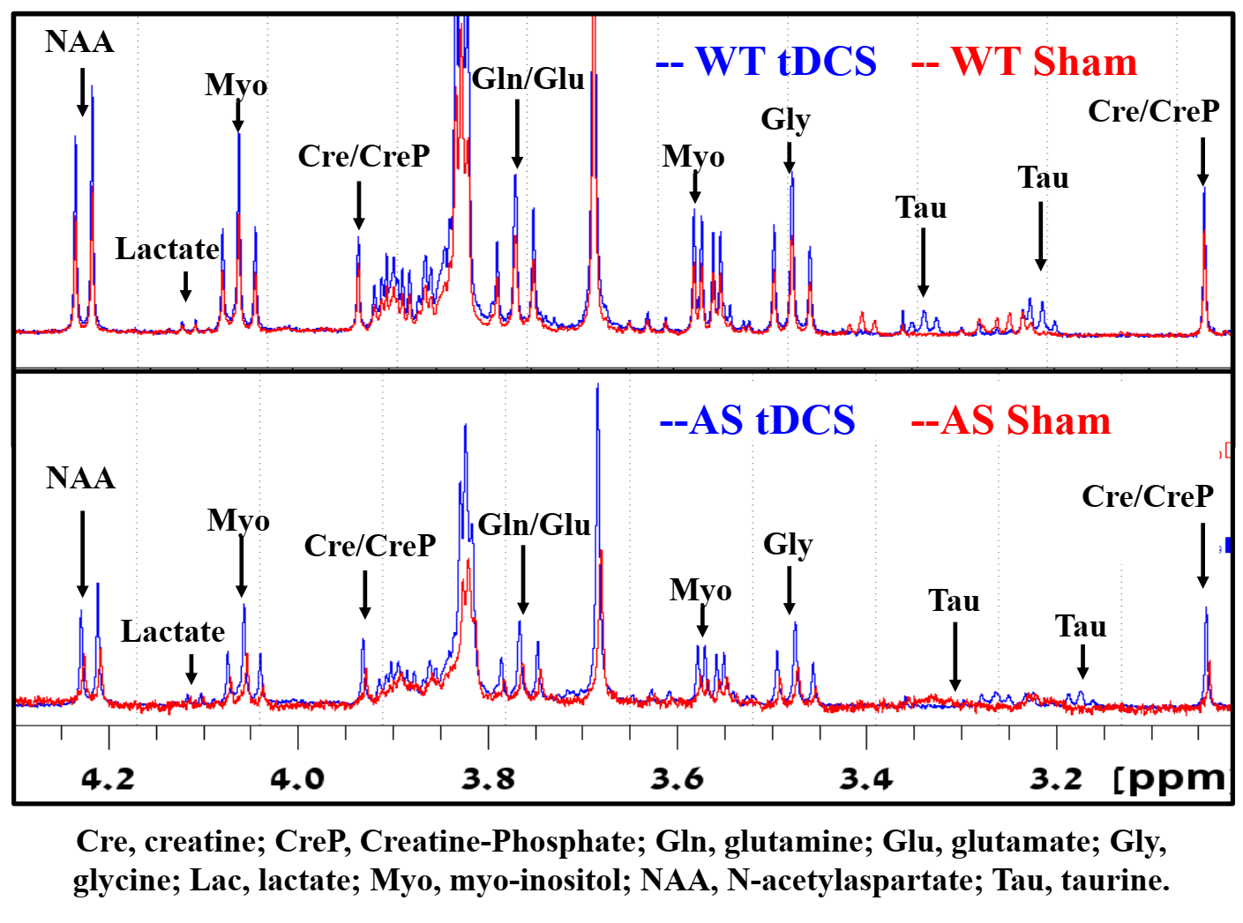

**Figure 4:** Preliminary results of 1H NMR spectra of dorsal hippocampal tissue from AS and WT mice subject to sham or tDCS treatment. Taurine line multiplets centered at 3.4 and 3.25 ppm in sham mice, shifting to a lower ppm with treatment indicating a rise in pH levels in the tissue. Excitatory metabolites experience intensity modulation after tDCS with a unique pattern in AS mice. Energy-related metabolites, lactate, NAA, creatine; and creatine-phosphate highlight the discrepancies in treatment effects between control and AS mice. N=2 mice per each group (WT-sham, WT-tDCS, AS sham, AS-tDCS.

Taurine is a metabolite that plays a pivotal role in mitochondrial pH buffering91,92. Taurine exhibits resolvable signals in the 1H NMR spectrum that shift in frequency in correlation to mitochondrial pH changes. The extent of the Taurine shift non-linearly correlates to the pH change 92. Spectral analysis of tDCS-treated mice vs. sham mice reveals shifts of taurine lines upfield for both AS and WT littermates, pointing to hippocampal pH increases accompanying anodal tDCS (Fig. 4). Interestingly, altered brain pH is correlated with various neurodevelopmental disorders such as schizophrenia, bipolar disorder, and autism spectrum disorders to the extent that it is also considered as an endophenotype93–95. Furthermore, it has been previously shown that the sensing of H+ ions by the acid-sensing ion channel (ASIC) is crucial for synaptic plasticity, learning, and memory96, all of which are in line with the overall behavioral improvements for the AS and WT mice upon treatment (Fig. 1 and 2). Based on all the above, we hypothesize that studying the spectral intensity and shift of different metabolites such as taurine may serve as a potential biomarker for tDCS treatment that will allow us to monitor, over time, the duration that tDCS treatment affects the brain’s function. Moreover, studying the metabolic response of the brain to tDCS treatment can enhance our understanding regarding the mechanism that mediated the beneficiary effect of tDCS not only in AS patients and healthy individuals but also in a variety of additional neurodevelopmental and neurogenerative disorders

***Experimental design:*** Upon completion of the tDCS treatment protocol (see aim 1), both the sham and treated mice brain tissue will be harvested either immediately after the treatment (group 1), and upon completion of the behavioral studies post-treatment (group 2). The effect of tDCS on glucose, glucose-derived metabolites (such as lactate and pyruvate), and different mitochondrial-related metabolite levels (such as Taurine, Fig 4) will be measured with 1H-NMR as previously described by Hongyu et al. 97 and Zheng et al. 98.

***NMR (Nuclear Magnetic Resonance) analysis:*** Both One-Dimensional (1D) NMR and Two-Dimensional (2D) NMR will be used to study the metabolic responses of the brain to tDCS treatment. **1D NMR** will provide information about the chemical shifts of different atoms on the array of metabolites, information that can be useful for identifying different chemical compounds and potential biomarkers. It is also, in principle, quantitative and allows monitoring variation in the concentration of individual metabolites between different states of the tissue (disease/healthy, treated/untreated). To obtain information about the spatial arrangement of atoms within a molecule, which can be important for understanding metabolic reactions, **2D NMR** is used, allowing for the correlation of chemical shifts of different atoms in a molecule, resolving metabolite lines that have certain common chemical shifts. 2D NMR thus provides information on the number of chemically distinct sites and the connectivity of atoms within a molecule. This approach will provide additional structural valuable information for understanding metabolic reactions and identifying biomarkers. It also expedites metabolic profiling by ~ ten-fold with its higher level of unambiguity. Biomarkers can be discovered by observing characteristic spectral patterns which reflect the state of the tissue (for example, treated *vs.* untreated). Identification of correlations between concentration changes of specific metabolites and the state of the tissue, which is accomplished by multivariate analysis, such as principal component analysis (PCA) and partial least-squares regression (PLS) is used to map the variation in activities of various cycles in the context of disease or treatment.

***1D NMR analysis:*** Spectral analysis of metabolites in brain tissue samples in NMR metabolomics will be done by identifying the discrete sets of signals associated with each metabolite. This is achieved owing to the excellent resolution of high-field NMR without the need to physically separate the mixture into its different components by chromatography and avoid the risk of metabolite breakdown and activity loss. The sets of metabolites recorded are identified, and their intensity and, thus, their concentration is collected for further analysis using statistical methods and separating sets of metabolites based on their appearance in metabolic pathways as described below.

***2D NMR analysis:*** 2D NMR facilitates tackling overlapping spectral lines by allowing the transfer of spin magnetization across a molecule based on spin−spin interactions. 2D NMR experiments utilizing scalar *J*-couplings for magnetization transfer are popular for small molecules are very useful, in particular, 1H−1H correlation spectroscopy (COSY), 1H−1H total correlation spectroscopy (TOCSY)99. TOCSY and COSY measurements allow the identification of individual 1H spin system that is within a molecule only and thus can be assigned to the particular of metabolites in the mixture. 2D NMR experiments that harness through-space spin couplings (via a cross-relaxation mechanism) for magnetization transfer are nuclear Overhauser effect spectroscopy (NOESY)100, which was implemented for metabolic analysis101,102 and rotating-frame nuclear Overhauser effect spectroscopy (ROESY)103. The method of choice is often 1H−1H TOCSY as it is ideally suited for computational analysis since each 1D slice of the compound along the chemical shift of a certain 1H atom represents the 1D spectrum of the metabolite analyzed.

***Alternative Approaches****:* If metabolic changes will not be apparent after the short- or long-term stimulation, we will change the stimulation properties as described in the alternative approaches of aim 1. The tackle sensitivity challenges, experiments will be run on higher magnetic fields, a 700 MHz spectrometer is at our facility on campus, and a 1 GHz spectrometer is available at the Weizmann Institute of Science for further sensitivity and resolution enhancement.

***Statistical Plan:*** We will generally examine two major groups according to the time point of tissue harvesting following the last tDCS stimulation for 1H NMR (See visual abstract). Each of the two groups will include two genotypes (WT and AS), and each will be subjected to either sham or tDCS treatment. Due to funding constraints, only males will be tested. Altogether, we will have 8 groups: 2 time-point (immediate & 5 days) X 2 genotypes (WT & AS) X 2 treatment protocols (sham & tDCS). After confirming that the results conform to a normal distribution, result comparisons between each genotype and treatment will be performed using two-way analyses of variance (2way-ANOVAs). Adjustment for multiple comparisons will be performed using Bonferroni post hoc correction method. For time-lapse comparisons of 1H-NMR results, we will employ 2-way ANOVA. Power analyses were used to establish the target sample sizes for this study. Given that, we will have a total of 8 groups. Considering a reasonable effect size of 0.3, an  of 0.05, and a  of 0.8, and given a 2x2 design that yields a numerator df of 1, the total sample size is ~90, necessitating ~12 mice per group. These values are true for behavioral and metabolic studies. Considering that each electrode implantation has a ~20% risk of falling off or postoperative complications, we will include ~120 mice (males only). Altogether 120 mice (males only) will be required over the 3-year study period.

**References:**

1. Maranga, C., Fernandes, T. G., Bekman, E. & da Rocha, S. T. Angelman syndrome: a journey through the brain. *FEBS J.* **287**, 2154–2175 (2020).

2. Jiang, Y. *et al.* Mutation of the Angelman Ubiquitin Ligase in Mice Causes Increased Cytoplasmic p53 and Deficits of Contextual Learning and Long-Term Potentiation. *Neuron* **21**, 799–811 (1998).

3. Miura, K. *et al.* Neurobehavioral and Electroencephalographic Abnormalities in Ube3aMaternal-Deficient Mice. *Neurobiol. Dis.* **9**, 149–159 (2002).

4. van Woerden, G. M. *et al.* Rescue of neurological deficits in a mouse model for Angelman syndrome by reduction of αCaMKII inhibitory phosphorylation. *Nat. Neurosci.* **10**, 280–282 (2007).

5. Sonzogni, M. *et al.* A behavioral test battery for mouse models of Angelman syndrome: A powerful tool for testing drugs and novel Ube3a mutants. *Mol. Autism* **9**, 1–19 (2018).

6. Sidorov, M. S. *et al.* Enhanced Operant Extinction and Prefrontal Excitability in a Mouse Model of Angelman Syndrome. *J. Neurosci.* **38**, 2671–2682 (2018).

7. Rotaru, D. C., van Woerden, G. M., Wallaard, I. & Elgersma, Y. Adult Ube3a Gene Reinstatement Restores the Electrophysiological Deficits of Prefrontal Cortex Layer 5 Neurons in a Mouse Model of Angelman Syndrome. *J. Neurosci.* **38**, 8011–8030 (2018).

8. Wallace, M. L., Burette, A. C., Weinberg, R. J. & Philpot, B. D. Maternal Loss of Ube3a Produces an Excitatory/Inhibitory Imbalance through Neuron Type-Specific Synaptic Defects. *Neuron* **74**, 793–800 (2012).

9. Gu, B. *et al.* Ube3a reinstatement mitigates epileptogenesis in Angelman syndrome model mice. *J. Clin. Invest.* **129**, 163–168 (2019).

10. Judson, M. C. *et al.* GABAergic Neuron-Specific Loss of Ube3a Causes Angelman Syndrome-Like EEG Abnormalities and Enhances Seizure Susceptibility. *Neuron* **90**, 56–69 (2016).

11. Kaphzan, H. *et al.* Reversal of Impaired Hippocampal Long-Term Potentiation and Contextual Fear Memory Deficits in Angelman Syndrome Model Mice by ErbB Inhibitors. *Biol. Psychiatry* **72**, 182–190 (2012).

12. Kaphzan, H., Buffington, S. A., Jung, J. I., Rasband, M. N. & Klann, E. Alterations in intrinsic membrane properties and the axon initial segment in a mouse model of Angelman syndrome. *J. Neurosci.* **31**, 17637–17648 (2011).

13. Kaphzan, H. *et al.* Genetic Reduction of the α1 Subunit of Na/K-ATPase Corrects Multiple Hippocampal Phenotypes in Angelman Syndrome. *Cell Rep.* **4**, 405–412 (2013).

14. Egawa, K. *et al.* Decreased Tonic Inhibition in Cerebellar Granule Cells Causes Motor Dysfunction in a Mouse Model of Angelman Syndrome. *Sci. Transl. Med.* **4**, 163ra157 (2012).

15. Wang, T., van Woerden, G. M., Elgersma, Y. & Borst, J. G. G. Enhanced Transmission at the Calyx of Held Synapse in a Mouse Model for Angelman Syndrome. *Front. Cell. Neurosci.* **11**, 1–19 (2018).

16. Panov, J., Simchi, L., Feuermann, Y. & Kaphzan, H. Bioinformatics analyses of the transcriptome reveal Ube3a-dependent effects on mitochondrial-related pathways. *Int. J. Mol. Sci.* **21**, 1–21 (2020).

17. Santini, E. *et al.* Mitochondrial superoxide contributes to hippocampal synaptic dysfunction and memory deficits in Angelman syndrome model mice. *J. Neurosci.* **35**, 16213–16220 (2015).

18. Bennabi, D. & Haffen, E. Transcranial Direct Current Stimulation (tDCS): A Promising Treatment for Major Depressive Disorder? *Brain Sci.* **8**, 81 (2018).

19. Palm, U. *et al.* Treatment of major depression with a two-step tDCS protocol add-on to SSRI: Results from a naturalistic study. *Brain Stimul.* **12**, 195–197 (2019).

20. Vaz, P. G. *et al.* Noninvasive brain stimulation combined with other therapies improves gait speed after stroke: a systematic review and meta-analysis. *Top. Stroke Rehabil.* **26**, 201–213 (2019).

21. Feil, J. & Zangen, A. Brain stimulation in the study and treatment of addiction. *Neurosci. Biobehav. Rev.* **34**, 559–574 (2010).

22. Duarte, D., Castelo-Branco, L. E. C., Uygur Kucukseymen, E. & Fregni, F. Developing an optimized strategy with transcranial direct current stimulation to enhance the endogenous pain control system in fibromyalgia. *Expert Rev. Med. Devices* **15**, 863–873 (2018).

23. Costa, B., Ferreira, I., Trevizol, A., Thibaut, A. & Fregni, F. Emerging targets and uses of neuromodulation for pain. *Expert Rev. Neurother.* **19**, 109–118 (2019).

24. Dagan, M. *et al.* Multitarget transcranial direct current stimulation for freezing of gait in Parkinson’s disease. *Mov. Disord.* **33**, 642–646 (2018).

25. Yang, F. *et al.* Effects and potential mechanisms of transcranial direct current stimulation (tDCS) on auditory hallucinations: A meta-analysis. *Psychiatry Res.* **273**, 343–349 (2019).

26. Kim, J. *et al.* A meta-analysis of transcranial direct current stimulation for schizophrenia: “Is more better?” *J. Psychiatr. Res.* **110**, 117–126 (2019).

27. Dmochowski, J. P., Datta, A., Bikson, M., Su, Y. & Parra, L. C. Optimized multi-electrode stimulation increases focality and intensity at target. *J. Neural Eng.* **8**, 046011 (2011).

28. Kessler, S. K. *et al.* Dosage Considerations for Transcranial Direct Current Stimulation in Children: A Computational Modeling Study. *PLoS One* **8**, e76112 (2013).

29. Truong, D. Q., Magerowski, G., Blackburn, G. L., Bikson, M. & Alonso-Alonso, M. Computational modeling of transcranial direct current stimulation (tDCS) in obesity: Impact of head fat and dose guidelines. *NeuroImage Clin.* **2**, 759–766 (2013).

30. Huang, Y. *et al.* Correction: Measurements and models of electric fields in the in vivo human brain during transcranial electric stimulation. *Elife* **7**, e35178 (2018).

31. Bikson, M. *et al.* Safety of Transcranial Direct Current Stimulation: Evidence Based Update 2016. *Brain Stimul.* **9**, 641–661 (2016).

32. Woods, A. J. *et al.* A technical guide to tDCS, and related non-invasive brain stimulation tools. *Clin. Neurophysiol.* **127**, 1031–1048 (2016).

33. Borrione, L., Moffa, A. H., Martin, D., Loo, C. K. & Brunoni, A. R. Transcranial Direct Current Stimulation in the Acute Depressive Episode. *J. ECT* **34**, 153–163 (2018).

34. Terranova, C. *et al.* Is There a Future for Non-invasive Brain Stimulation as a Therapeutic Tool? *Front. Neurol.* **9**, 1146 (2019).

35. Brunoni, A. R. *et al.* Noninvasive brain stimulation in psychiatric disorders: a primer. *Brazilian J. Psychiatry* **41**, 70–81 (2019).

36. Lefaucheur, J.-P. *et al.* Evidence-based guidelines on the therapeutic use of transcranial direct current stimulation (tDCS). *Clin. Neurophysiol.* **128**, 56–92 (2017).

37. Antal, A. *et al.* Low intensity transcranial electric stimulation: Safety, ethical, legal regulatory and application guidelines. *Clin. Neurophysiol.* **128**, 1774–1809 (2017).

38. Lafon, B., Rahman, A., Bikson, M. & Parra, L. C. Direct Current Stimulation Alters Neuronal Input/Output Function. *Brain Stimul.* **10**, 36–45 (2017).

39. Rahman, A., Lafon, B., Parra, L. C. & Bikson, M. Direct current stimulation boosts synaptic gain and cooperativity in vitro. *J. Physiol.* **595**, 3535–3547 (2017).

40. Yu, T.-H., Wu, Y.-J., Chien, M.-E. & Hsu, K.-S. Transcranial direct current stimulation induces hippocampal metaplasticity mediated by brain-derived neurotrophic factor. *Neuropharmacology* **144**, 358–367 (2019).

41. Stagg, C. J., Antal, A. & Nitsche, M. A. Physiology of Transcranial Direct Current Stimulation. *J. ECT* **34**, 144–152 (2018).

42. Sánchez-León, C. A. *et al.* Exploring new transcranial electrical stimulation strategies to modulate brain function in animal models. *Curr. Opin. Biomed. Eng.* **8**, 7–13 (2018).

43. Rahman, A. *et al.* Cellular effects of acute direct current stimulation: somatic and synaptic terminal effects. *J. Physiol.* **591**, 2563–2578 (2013).

44. Ruohonen, J. & Karhu, J. tDCS possibly stimulates glial cells. *Clin. Neurophysiol.* **123**, 2006–2009 (2012).

45. Monai, H. *et al.* Calcium imaging reveals glial involvement in transcranial direct current stimulation-induced plasticity in mouse brain. *Nat. Commun.* **7**, 11100 (2016).

46. Monai, H. & Hirase, H. Astrocytes as a target of transcranial direct current stimulation (tDCS) to treat depression. *Neurosci. Res.* **126**, 15–21 (2018).

47. Mishima, T. *et al.* Transcranial Direct Current Stimulation (tDCS) Induces Adrenergic Receptor-Dependent Microglial Morphological Changes in Mice. *eneuro* **6**, ENEURO.0204-19.2019 (2019).

48. Ma, Z. *et al.* Cortical Plasticity Induced by Anodal Transcranial Pulsed Current Stimulation Investigated by Combining Two-Photon Imaging and Electrophysiological Recording. *Front. Cell. Neurosci.* **13**, 400 (2019).

49. Radman, T., Datta, A., Ramos, R. L., Brumberg, J. C. & Bikson, M. One-dimensional representation of a neuron in a uniform electric field. in *2009 Annual International Conference of the IEEE Engineering in Medicine and Biology Society* vol. 2009 6481–6484 (IEEE, 2009).

50. Bikson, M., Rahman, A. & Datta, A. Computational Models of Transcranial Direct Current Stimulation. *Clin. EEG Neurosci.* **43**, 176–183 (2012).

51. Arlotti, M., Rahman, A., Minhas, P. & Bikson, M. Axon terminal polarization induced by weak uniform DC electric fields: A modeling study. in *2012 Annual International Conference of the IEEE Engineering in Medicine and Biology Society* vol. 2012 4575–4578 (IEEE, 2012).

52. Chakraborty, D., Truong, D. Q., Bikson, M. & Kaphzan, H. Neuromodulation of Axon Terminals. *Cereb. cortex* **28**, 2786–2794 (2018).

53. Bikson, M. *et al.* Effects of uniform extracellular DC electric fields on excitability in rat hippocampal slices in vitro. *J. Physiol.* **557**, 175–190 (2004).

54. Vasu, S. O. & Kaphzan, H. Calcium channels control tDCS-induced spontaneous vesicle release from axon terminals. *Brain Stimul.* **15**, 270–282 (2022).

55. Vasu, S. O. & Kaphzan, H. The role of axonal voltage-gated potassium channels in tDCS. *Brain Stimul.* **15**, 861–869 (2022).

56. Giordano, J. *et al.* Mechanisms and Effects of Transcranial Direct Current Stimulation. *Dose-Response* **15**, 155932581668546 (2017).

57. Batsikadze, G., Moliadze, V., Paulus, W., Kuo, M.-F. & Nitsche, M. A. Partially non-linear stimulation intensity-dependent effects of direct current stimulation on motor cortex excitability in humans. *J. Physiol.* **591**, 1987–2000 (2013).

58. Goldsworthy, M. R. & Hordacre, B. Dose dependency of transcranial direct current stimulation: implications for neuroplasticity induction in health and disease. *J. Physiol.* **595**, 3265–3266 (2017).

59. Esmaeilpour, Z. *et al.* Incomplete evidence that increasing current intensity of tDCS boosts outcomes. *Brain Stimul.* **11**, 310–321 (2018).

60. Su, H. *et al.* Mitochondrial dysfunction in CA1 hippocampal neurons of the UBE3A deficient mouse model for Angelman syndrome. *Neurosci. Lett.* **487**, 129–133 (2011).

61. Simchi, L., Panov, J., Morsy, O., Feuermann, Y. & Kaphzan, H. Novel Insights into the Role of UBE3A in Regulating Apoptosis and Proliferation. *J. Clin. Med.* **9**, 1573 (2020).

62. Rotaru, D. C., Mientjes, E. J. & Elgersma, Y. Angelman Syndrome: From Mouse Models to Therapy. *Neuroscience* **445**, 172–189 (2020).

63. Chakraborty, D., Truong, D. Q., Bikson, M. & Kaphzan, H. Neuromodulation of Axon Terminals. *Cereb. Cortex* **28**, 2786–2794 (2018).

64. Vasu, S. O. & Kaphzan, H. The role of sodium channels in direct current stimulation-axonal perspective. *Cell Rep.* **37**, (2021).

65. Vasu, S. O. & Kaphzan, H. Calcium channels control tDCS-induced spontaneous vesicle release from axon terminals. *Brain Stimul.* **15**, 270–282 (2022).

66. Garcia-Gil, M., Camici, M., Allegrini, S., Pesi, R. & Tozzi, M. G. Metabolic Aspects of Adenosine Functions in the Brain. *Front. Pharmacol.* **12**, (2021).

67. Lee, S. Bin, Youn, J., Jang, W. & Yang, H. O. Neuroprotective effect of anodal transcranial direct current stimulation on 1-methyl-4-phenyl-1,2,3,6-tetrahydropyridine (MPTP)-induced neurotoxicity in mice through modulating mitochondrial dynamics. *Neurochem. Int.* **129**, 104491 (2019).

68. Li, X. *et al.* Transcranial Direct Current Stimulation Ameliorates Behavioral Deficits and Reduces Oxidative Stress in 1-Methyl-4-Phenyl-1,2,3,6-Tetrahydropyridine-Induced Mouse Model of Parkinson’s Disease. *Neuromodulation Technol. Neural Interface* **18**, 442–447 (2015).

69. Santini, E. *et al.* Mitochondrial superoxide contributes to hippocampal synaptic dysfunction and memory deficits in Angelman syndrome model mice. *J. Neurosci.* **35**, 16213–16220 (2015).

70. Rae, C. D., Lee, V. H. C., Ordidge, R. J., Alonzo, A. & Loo, C. Anodal transcranial direct current stimulation increases brain intracellular pH and modulates bioenergetics. *Int. J. Neuropsychopharmacol.* **16**, 1695–1706 (2013).

71. Margolis, S. S., Sell, G. L., Zbinden, M. A. & Bird, L. M. Angelman Syndrome. *Neurotherapeutics* **12**, 641–650 (2015).

72. Koyavski, L. *et al.* Sex-Dependent Sensory Phenotypes and Related Transcriptomic Expression Profiles Are Differentially Affected by Angelman Syndrome. *Mol. Neurobiol.* **56**, 5998–6016 (2019).

73. Rayi, P. R., Koyavski, L., Chakraborty, D., Bagrov, A. & Kaphzan, H. α1-Na/K-ATPase inhibition rescues aberrant dendritic calcium dynamics and memory deficits in the hippocampus of an Angelman syndrome mouse model. *Prog. Neurobiol.* **182**, 101676 (2019).

74. Ulivi, A. F. *et al.* Longitudinal Two-Photon Imaging of Dorsal Hippocampal CA1 in Live Mice. *J. Vis. Exp.* (2019) doi:10.3791/59598.

75. Takahashi, S. The Hippocampal Ensemble Code for Spatial Navigation and Episodic Memory. in 49–70 (2018). doi:10.1007/978-3-319-94593-4_3.

76. Moser, M. B., Moser, E. I., Forrest, E., Andersen, P. & Morris, R. G. Spatial learning with a minislab in the dorsal hippocampus. *Proc. Natl. Acad. Sci.* **92**, 9697–9701 (1995).

77. Dong, H.-W., Swanson, L. W., Chen, L., Fanselow, M. S. & Toga, A. W. Genomic–anatomic evidence for distinct functional domains in hippocampal field CA1. *Proc. Natl. Acad. Sci.* **106**, 11794–11799 (2009).

78. Fanselow, M. S. & Dong, H.-W. Are the Dorsal and Ventral Hippocampus Functionally Distinct Structures? *Neuron* **65**, 7–19 (2010).

79. Saito, K. & Watanabe, S. Spatial memory activation of the parietal cortex measured with near-infrared spectroscopic imaging in the finger-maze of the Morris water maze analogue for humans. *Rev. Neurosci.* **17**, 227–38 (2006).

80. DiMattia, B. D. & Kesner, R. P. Spatial cognitive maps: differential role of parietal cortex and hippocampal formation. *Behav. Neurosci.* **102**, 471–80 (1988).

81. Krumin, M., Lee, J. J., Harris, K. D. & Carandini, M. Decision and navigation in mouse parietal cortex. *Elife* **7**, (2018).

82. Driscoll, L. N., Pettit, N. L., Minderer, M., Chettih, S. N. & Harvey, C. D. Dynamic Reorganization of Neuronal Activity Patterns in Parietal Cortex. *Cell* **170**, 986-999.e16 (2017).

83. Barker, G. R. I. & Warburton, E. C. When Is the Hippocampus Involved in Recognition Memory? *J. Neurosci.* **31**, 10721–10731 (2011).

84. Simchi, L. & Kaphzan, H. Aberrant aggressive behavior in a mouse model of Angelman syndrome. *Sci. Rep.* **11**, (2021).

85. McILWAIN, H. Glucose level, metabolism, and response to electrical impulses in cerebral tissues from man and laboratory animals. *Biochem. J.* **55**, 618–624 (1953).

86. Rae, C. D., Lee, V. H. C., Ordidge, R. J., Alonzo, A. & Loo, C. Anodal transcranial direct current stimulation increases brain intracellular pH and modulates bioenergetics. *Int. J. Neuropsychopharmacol.* **16**, 1695–1706 (2013).

87. Lee, S.-B., Youn, J., Jang, W. & Yang, H. O. Neuroprotective effect of anodal transcranial direct current stimulation on 1-methyl-4-phenyl-1,2,3,6-tetrahydropyridine (MPTP)-induced neurotoxicity in mice through modulating mitochondrial dynamics. *Neurochem. Int.* **129**, 104491 (2019).

88. Rodrigues, T. B., Valette, J. & Bouzier-Sore, A.-K. 13C NMR spectroscopy applications to brain energy metabolism. *Front. Neuroenergetics* **5**, (2013).

89. Havelund, J. F., Heegaard, N. H. H., Færgeman, N. J. K. & Gramsbergen, J. B. Biomarker Research in Parkinson’s Disease Using Metabolite Profiling. *Metabolites* **7**, (2017).

90. Virel, A., Dudka, I., Laterveer, R. & Bjerkén, S. af. 1H NMR profiling of the 6-OHDA parkinsonian rat brain reveals metabolic alterations and signs of recovery after N-acetylcysteine treatment. *Mol. Cell. Neurosci.* **98**, 131–139 (2019).

91. Hansen, S. H., Birkedal, H., Wibrand, F. & Grunnet, N. Taurine and regulation of mitochondrial metabolism. *Adv. Exp. Med. Biol.* **803**, 397–405 (2015).

92. Hansen, S. H., Andersen, M. L., Cornett, C., Gradinaru, R. & Grunnet, N. A role for taurine in mitochondrial function. *J. Biomed. Sci.* **17 Suppl 1**, S23 (2010).

93. Ullman, J. C. *et al.* A mouse model of autism implicates endosome pH in the regulation of presynaptic calcium entry. *Nat. Commun.* **9**, 330 (2018).

94. Hagihara, H., Shoji, H., Consortium, I. B. pH P. & Miyakawa, T. Systematic analysis of brain lactate and pH levels in 65 animal models related to neuropsychiatric conditions. *bioRxiv* 2021.02.02.428362 (2021) doi:10.1101/2021.02.02.428362.

95. Hagihara, H. *et al.* Decreased Brain pH as a Shared Endophenotype of Psychiatric Disorders. *Neuropsychopharmacology* **43**, 459–468 (2018).

96. Wemmie, J. A. *et al.* The Acid-Activated Ion Channel ASIC Contributes to Synaptic Plasticity, Learning, and Memory. *Neuron* **34**, 463–477 (2002).

97. Li, H. *et al.* 1H-Nuclear magnetic resonance-based metabolomic analysis of brain in mice with nicotine treatment. *BMC Neurosci.* **15**, 32 (2014).

98. Zheng, H. *et al.* NMR-based metabolomics reveals brain region-specific metabolic alterations in streptozotocin-induced diabetic rats with cognitive dysfunction. *Metab. Brain Dis.* **32**, 585–593 (2017).

99. Rance, M. *et al.* Improved spectral resolution in COSY 1H NMR spectra of proteins via double quantum filtering. *Biochem. Biophys. Res. Commun.* **117**, 479–485 (1983).

100. Jeener, J., Meier, B. H., Bachmann, P. & Ernst, R. R. Investigation of exchange processes by two‐dimensional NMR spectroscopy. *J. Chem. Phys.* **71**, 4546 (2008).

101. Simpson, A. J., Woods, G. & Mehrzad, O. Spectral editing of organic mixtures into pure components using NMR spectroscopy and ultraviscous solvents. *Anal. Chem.* **80**, 186–194 (2008).

102. Farooq, H., Soong, R., Courtier-Murias, D., Anklin, C. & Simpson, A. Tailoring 1H spin dynamics in small molecules via supercooled water: a promising approach for metabolite identification and validation. *Anal. Chem.* **84**, 6759–6766 (2012).

103. Bothner-By, A. A., Stephens, R. L., Lee, J. M., Warren, C. D. & Jeanloz, R. W. Structure Determination of a Tetrasaccharide: Transient Nuclear Overhauser Effects in the Rotating Frame. *J. Am. Chem. Soc.* **106**, 811–813 (1984).