**Powerless in the Digital Age?**

**A systematic review and meta-analysis of political efficacy and digital media use**

**ABSTRACT**

Many citizens feel powerless in the current globalized political context despite the potential of digital media to increase perceptions of being informed about politics and expand opportunities to interact with elected officials to try to influence government decisions. We analyze 193 studies to document the most popular ways to conceptualize, measure, and model political efficacy when also studying digital media. Furthermore, we conduct a meta-analysis of correlations. We find the positive estimates are larger, on average, when considering internal political efficacy and smaller, but still positive when considering external political efficacy. We also examine how the relationships differ by type of digital media use and for authoritarian (e.g., China) versus democratic systems. We propose a theoretical framework that considers reciprocal effects. While online information may contribute to feelings of being informed, feelings of being informed lead to online political participation. This paper concludes with recommendations for future research.

**Introduction**

Many citizens feel powerless in the current globalized political context. Citizens’ demands compete with ideologically driven political agendas, global trade agreements, and restrictions imposed by multi-level governance. In some cases, these multiple perspectives are at odds. In response, citizens might support populist movements that claim to give power to the people (Boulianne et al., 2020; Geurkink et al., 2020; Rico et al., 2020; Schultz et al., 2018).

Furthermore, political trust is in decline, particularly in the United States (Brady & Kent, 2022; Chamberlain, 2012) but also elsewhere (Edelman Trust Barometer, 2022; Uslaner, 2015). Many scholars connect the decline in trust to digital media use (Lorenz-Spreen et al., 2022; Uslaner, 2004; You & Wang, 2020). Political trust is related to feelings about the state’s responsiveness to citizens’ input on public policy. In a democratic system, governments should be responsive to citizens. As such, low levels of political trust and lack of perceived state responsiveness to citizens’ demands could undermine democratic legitimacy. In this paper, we examine citizens’ perceptions of political power. We focus on the concept of political efficacy – perceptions about one’s capacity to participate in politics (internal efficacy) and influence government as well as opinions about the responsiveness of government (external efficacy).

We examine the role of digital media in relation to political efficacy using a systematic analysis of 193 empirical studies in this field, drawing upon independent surveys conducted in 37 countries as well as pooled data from dozens of additional countries included large scale surveys (Chang, 2018; Lu & Luqiu, 2020; Macháčková & Tkaczyk, 2020; Wagner et al., 2017). We apply a broad definition of digital media as "information and entertainment products and services that use the internet" (Oxford Learners Dictionaries, 2023; also see Boulianne, 2020). First, we examine which dimensions of political efficacy (internal, external) have received the most attention, as well as which items have been used most often when studying digital media. We also consider which variable is modeled as the cause and which as the effect, because the modeling choices are indicative of the popularity of various theoretical claims. We reveal a disconnection between the assumed flow of causality (digital media use to political efficacy) in most scholarship and the complex causal flow tested in panel data. Scholarship should consider reciprocal effects depending on the measure of digital media use. In particular, informational uses of digital media may increase perceptions about being informed and these perceptions increases online forms of political participation.

Finally, we conduct a meta-analysis on a subset of 57 studies (with 75,642 respondents) that includes a correlation matrix connecting digital media use and political efficacy. We find the average weighted correlation is .15 (*k* = 223 effects) but that this positive correlation is larger when internal political efficacy is considered as opposed to external political efficacy. We interpret these findings as consuming online information increases citizens’ beliefs in their capacity to participate in politics; furthermore, this belief encourages citizens to engage in online forms of political participation. A similar positive relationship is found with respect to digital media and perceptions about the state’s responsiveness to citizens’ inputs; however, the correlations are smaller.

We also examine how the relationships differ by type of digital media use (information, expression/participation, other). We find similar estimates for information and expression/participation. We show that the relationship is positive in democratic and authoritarian systems, but that the magnitude of the relationship is strongest in the United States. We conclude with a list of suggestions for future research that would advance our understanding of the relationship between digital media and political efficacy.

**Literature Review**

Originally, political efficacy was defined as a single, global concept (Campbell et al., 1954). Morrell (2003, p. 589) summarizes the concept as “citizens’ perceptions of powerfulness (or powerlessness) in the political realm.” Over time, the study of political efficacy evolved into two dimensions: internal and external efficacy. Internal efficacy refers to an individual’s perceived ability to participate – do they feel informed, knowledgeable, well-qualified, and/or do they understand politics (Craig et al., 1990)? Internal efficacy is often measured using a four-item “scale” as the authors labelled it (Craig et al., 1990; Niemi et al., 1991). The items are:

“I consider myself well-qualified to participate in politics…I feel that I have a pretty good understanding of the important political issues facing our country…I feel that I could do as good a job in public office as most other people… I think that I am as well-informed about politics and government as most people.” (Craig et al., 1990, p. 308-309)

External efficacy refers to perceptions about the responsiveness of the political system and actors within that system. Early work focused on distinguishing this concept from political trust, but rather than offer a specific measurement recommendation, they suggested further research (Craig et al., 1990). Nonetheless, this early work included two items that continually appear in indexes of external efficacy: “People like me don't have any say about what the government does…I don't think public officials care much what people like me think” (Craig et al., 1990, p. 307).

The scholarship connecting digital media and political efficacy emerged amidst debates in political science about what constitutes internal and external political efficacy. For example, Morrell (2003) offers a short systematic review in which he concludes the biggest debate is the measure about citizens having “no say,” which he believes measures external efficacy, not internal efficacy (p. 593). These inconsistent measures matter. If the measurement is not consistent, we cannot compare findings across studies, nor can we decide which theoretical claims have the strongest empirical support. Another reason to review the items of political efficacy is that we can describe how this concept has evolved based on the measures applied in the field (see similar approach in Ruess et al., 2021). In particular, what new items have been developed to understand political efficacy in a digital context? Some items fall out of favor and new items are developed.

The rise in online opportunities to participate has created a debate about the perceived effectiveness of these online political activities. Some scholars are skeptical, dismissing online political participation as slacktivism or clicktivism, whereas others are more enthusiastic about its effectiveness (Boulianne & Theocharis, 2020; Halupka, 2022; Oser et al., 2022). This paper considers the attention paid to the distinction between internal and external efficacy, and also documents the use of other measures of political efficacy in the scholarship about digital media and politics.

**RQ1)** How has political efficacy been conceptualized and measured in the scholarship about digital media?

**Digital Media Uses and Political Efficacy**

Kenski and Stroud (2006) offer one of the first studies about the relationship between digital media and political efficacy; as noted in the Methods section, this study became one of the most widely cited studies related to political efficacy. They outline several theoretical claims about how digital media use and political efficacy are related. They cover the possibility of both positive and negative relationships and outline theoretical claims for both internal and external efficacy.

***External efficacy:***

Digital media increase opportunities for citizens and officials to interact, which may increase perceptions of responsiveness. Contacting officials is a common measure of political participation in a digital context (Ruess et al., 2021). Kenski and Stroud (2006, p. 175) write, “the Internet could enhance external political efficacy because it enables citizens to interact with public officials and to hold them accountable.” In the early days when their paper was published, citizens could use email to connect with public officials and hold them accountable. The Internet now offers a “new space that allows citizens and agencies of government to react to each other creating a perception of engagement” (Wagner et al., 2017, p. 278). The authors note that it is a *perception* of openness and transparency rather than an objective measure of reality (Wagner et al., 2017).

Civic technology groups developed mobile apps to facilitate this connection between citizens and government officials. For example, MySociety developed a series of apps to connect British citizens with their representatives. These interactions were expected to increase people’s perceptions that they could influence government and their confidence about understanding politics (Gibson et al., 2014). A lack of response to such messages might decrease political efficacy. Consider a scenario where a citizen contacts an official online but does not receive a response or receives a form letter as a response. In this case, this online interaction may negatively impact external efficacy in terms of the perceived responsiveness of the political system (Johnson & Kaye, 2003).

In more contemporary studies, social media facilitate the connection between citizens and public officials. On social media, politicians may be more visible and, thus, perceived as more accessible. Political leaders can be presented as more personable and approachable, making them seem more responsive. Social media are distinctive as communication tools because the exchange is publicly available for others to see. Of course, social media also offer more private exchanges, such as Facebook’s Messenger and Twitter’s Direct Message, but more attention is focused on the public displays of communication – for example their lack of civility (Theocharis et al., 2016). Chen et al. (2018) find that officials are overwhelmed by social media messages. In some cases, they largely ignore these messages or deprioritize them compared to more traditional forms of contact (Chen et al., 2018). Also, in China, government officials manipulate social media messages to officials, which may lead to increased political efficacy if citizens think the exchanges are authentic, but decreased efficacy if the citizens discover the exchanges are inauthentic (Pan & Chen, 2018). As such, the relationship between digital media use and external political efficacy could be positive or negative.

***Internal efficacy:***

In the early years, the Internet was characterized as an information technology, rather than a communication technology (Boulianne, 2020). These characterizations are critical to understanding how digital media might influence perceptions about being informed about politics, i.e., internal efficacy. Over the past 25 years, digital media have become an increasingly important medium for acquiring information.

The easy access to information may help citizens build their capacity to participate in politics. They may **perceive** themselves to be more informed about political issues and have more political knowledge about how the government works. In other words, informational uses of digital media have the potential to increase internal political efficacy. Kenski and Stroud (2006) write that “the Internet also gives individuals easy access to information about politics as many Web sites are designed with the objective of informing citizens about candidates, issues and politics in general” (p. 175). While they do not specify this process as connected to internal political efficacy, the argument points to citizens’ capacity to participate. It connects with measurement items focused on “being informed.” However, the perception of being knowledgeable is what is influenced by digital media.

Political knowledge is conceptually distinct from internal efficacy. Lee et al. (2022) use a multi-wave panel to study the effect of social media news use on subjective knowledge and objective knowledge. They find social media use is negatively related to objective knowledge, but positively related to subjective knowledge. A meta-analysis of 76 studies affirms that social media do not increase objective political knowledge (Amsalem & Zoizner, 2022). As illustrated in two meta-analysis studies in this field, political knowledge is more often measured as tests of factual (objective) knowledge (Amsalem & Zoizner, 2022; Lind & Boomgaarden, 2019). Lind and Boomgaarden (2019) note that the majority of literature relies on factual tests of knowledge rather than subjective knowledge. As noted, Lee et al. (2022) use a subjective measure, but that is a rare measurement approach in this field and introduces some conceptual blurriness. In short, while we point out the overlap in subjective knowledge and internal efficacy, in practice, political knowledge is its own distinct concept and is separate from political efficacy.

The theoretical claims about digital media use and internal and external efficacy point to positive relationships, yet scholars also document the conditions under which the relationship could be negative. In particular, the volume of information “may be overwhelming and thus lead to lower levels of personal confidence in one’s ability to understand the political world” (Kenski & Stroud, 2006, p. 176). As such, rather than state a hypothesis, we ask the question:

**RQ2)** What is the relationship between digital media uses (information, expression/participation or generic/other) and political efficacy (external, internal, combined, other)?

**Political efficacy as a predictor and outcome of digital media use**

At the time of Kenski and Stroud’s (2006) writing, the study of digital media and politics focused on information. This type of digital media use could increase political efficacy, especially measures about being informed. Today, digital media have connective and participatory affordances. Accordingly, the scholarship has evolved to explore how people can use digital media for political participation (Boulianne, 2020; Ruess et al., 2021). We might expect political efficacy to be a predictor of online political participation, just as it has been used to predict offline political participation (Oser et al., 2022). The rise of social media thus makes the study of efficacy and digital media more interesting, because social media are not merely information media that contribute to political efficacy; they are also participatory media, the use of which is driven by political efficacy.

For external efficacy, perceptions about the government’s openness or responsiveness might motivate people to participate in a variety of online political activities, such as signing petitions or engaging in political discussion, which are popular forms of online political participation (Ruess et al., 2021). Likewise, for internal efficacy, we might expect people who believe in their own ability to participate might be more likely to participate in online political activities. As such, we might see political efficacy as a predictor of digital media use. This theoretical argument is not an alternative to the other two processes described above. Instead, a reciprocal causal process is likely occurring, as proposed for political efficacy and offline forms of political participation (Finkel, 1987).

Social cognitive theory (SCT) supports the idea of a reciprocal relationship (Bandura, 1986). SCT proposes that environmental influences, personal dispositions, and behavior form a causal model of “triadic reciprocity.” Within this model, environmental influences shape personal dispositions (such as cognitions), which in turn affect behavior. At the same time, behavior also affects personal dispositions and, ultimately, the environment. However, these complex causal processes are difficult to untangle without multi-wave panel data (Boulianne, 2011). Conducting a review of this existing scholarship can help to identify and evaluate the evidence to support each causal modeling approach and its related theory.

**RQ3)** How is the relationship between digital media uses and political efficacy modeled in the literature?

**RQ4)** What do panel data suggest as the causal flow in the relationship between digital media uses and political efficacy?

**Methods**

This paper combines a systematic literature review (RQ1, RQ3) and a meta-analysis (RQ2, RQ4). The systematic review is intended to be a conceptual review of the concept of political efficacy, focusing on its link to digital media. The objectives of these reviews are to study: “How has phenomenon X been identified and defined? Which theories have been used to explain phenomenon X? Which theory provides the best fit to findings from empirical studies?” (Booth et al., 2016, p. 13). We are combining a conceptual review with a meta-analysis. Conceptual reviews and meta-analyses rely on similar search strategies (Booth et al., 2016). A meta-analysis is “the process of combining statistically quantitative studies that have measured the same effect using similar methods and a common outcome measure” (Booth et al., 2016, p. 309). The purpose of this meta-analysis is to empirically assess the relationship between political efficacy and digital media use considering different conceptualizations and causal flows.

**Study search**

We used three distinct strategies to identify studies for this project. The first strategy was to search Scopus, using “political efficacy,” “internal efficacy,” OR “external efficacy” in the title, abstract, and keywords. We completed this Scopus review multiple times (e.g., updated yearly from 2019 to 2022) and the last update was done on June 20, 2022 (*n* = 995). This search process spanned two years due to work disruptions caused by the COVID-19 pandemic. We limited the search to studies published between 1999 and 2021.

The second approach was to examine a canonical article in the field, which is a common practice (see, for example, Matthes et al., 2018, 2019). We used a Google Scholar search of “political efficacy” to find the most cited study that addressed both political efficacy and digital media, which was Kenski and Stroud (2006). We downloaded the corresponding list of citations using Publish or Perish multiple times (e.g., updated yearly from 2019 to 2022) and the last update was done on June 20, 2022 (*n* = 1,000 of the 1,032 citations listed due to API restrictions).

In total, we reviewed 1,995 records. Two coders worked independently to assess the relevance of these records; they agreed about relevance 70% of the time. For each record where there was disagreement, the first author reviewed the record to make the final determination about relevance. Studies were considered relevant if they included survey-based measures of political efficacy and digital media use. Digital media use could not be combined with other forms of media use. We excluded studies using experimental designs; we excluded studies that were not written in English, dissertations, and some (inaccessible) book chapters. In summary, we searched 1,995 Scopus and Google Scholar records to find 146 relevant studies.

The last approach was to build on an existing systematic review (Ruess et al., 2021), following advice from Siddaway et al. (2019). Ruess et al. (2021) identified 289 relevant studies from 22,096 records. The researchers shared their database of studies. In each of these 289 studies, we searched for “efficacy” in the Methods or Results section. This approach revealed 47 studies that were not identified through our citation- and keyword-based search approaches. We discovered political efficacy was not the focal point of these articles, which means these results are not subject to the same publication bias as other studies. In sum, we have 193 studies to analyze for the systematic review. Figure 1 outlines our study selection process using PRISMA (Page et al., 2021).

[insert Figure 1 here]

**Study profile**

Table 1 outlines the sample characteristics for the studies used in our analysis. Fifty-one studies are based on probability-based samples whereas 63 studies are based on youth or student samples. Sixty-three of the samples were based on the United States. Many studies are based on Asian countries: 23 studies from mainland China with another eight from Hong Kong, specifically, 11 from South Korea, and 9 from Taiwan. These countries are also popular as part of cross-national studies (see Chan et al., 2017). Eight studies are based on respondents from Germany. Other countries are also considered, but their presence is less frequent than the countries listed in Table 1. Twenty-three include more than one country, such as the 2017 Digital News Survey with 36 countries (Lu & Luqiu, 2020), the International Social Survey Programme 2014 with 34 countries (Chang, 2018), 2016 European Social Survey with 21 countries (Macháčková & Tkaczyk, 2020), the 2010 Latinobarómetro with 18 countries (Wagner et al., 2017), and other cross-national studies with 10 or fewer countries (e.g., Chan et al., 2017). Most of these cross-national samples are included in the category of “samples more than 1500” (*k* = 53), but some small samples, i.e., under 250 respondents (*k* = 20), are cross-national.

[insert Table 1 here]

The most popular journals for the publication of these studies are the *Journal of Information Technology & Politics* (9 studies), *Information, Communication & Society* (8 studies), *New Media & Society* (8 studies), *International Journal of Communication* (8 studies), *Journal of Broadcasting & Electronic Media* (7 studies), and *Social Science Computer Review* (7 studies).

The studies were published between 2002 and 2021. We found more than half of the studies were published since 2016, which is a period when social media are popular. A few studies collected survey data sometime between 2000 (despite the search critieria set to begin with 1999) and 2009 (*n* = 52), but most studies collected survey data between 2010 and 2020 (*n* = 159) with 2012 being most popular (*n* = 33).

**Coding work**

We coded efficacy items into broad classifications: internal or external efficacy, as well as a combined (internal and external) efficacy or other political efficacy, which includes collective efficacy (e.g., Halpern et al., 2017) and adaptions of traditional items to the online context (see Sasaki, 2016). We recognize a good deal of debate exists about which items align with internal efficacy and which align with external efficacy. Kenski and Stroud (2006) use “politics is complicated” and “people have no say,” noting some researchers treat these as both internal and external efficacy (also see Morrell, 2003), but treat “complicated” as internal and “no say” as external efficacy. We follow their direction on this point. Coders copied and pasted the description of the efficacy measurement approach into a spreadsheet, then they were asked to check off which items are used in the measurement. Returning to the example of Craig et al. (1990), the four items would have each been checked off as having been used. A coder at the first author’s university completed the first-round data entry, a coder at the second author’s university reviewed this approach, and finally, the first author reviewed all discrepancies, making a final determination.

**Effect sizes for the meta-analysis**

In terms of the meta-analysis, we use correlation matrices available in the published articles. Correlations are common measures of effect sizes in meta-analysis literature (Siddaway et al., 2019). Within political communication, many meta-analysis studies report on zero-order Pearson’s correlation coefficients (e.g., Amsalem & Nir, 2021; Lind & Boomgaarden, 2019; Matthes et al., 2018, 2019; Skoric et al., 2016), rarely converting these numbers into Fisher’s *z* (exception: Oser et al., 2022) or Cohen’s d (Amsalem & Zoizner, 2022).

Correlations have some limitations in that they do not suggest which variable is the cause and which the effect. Second, correlation matrices are rarely reported in published studies. For our 193 studies, 57 included a zero-order correlation matrix in the main body, supplementary files, or appendices. The size of this meta-analysis, i.e., 57 studies, is comparable to recent meta-analyses in the field of political communication: 68 studies (*k* = 84) in Lind & Boomgaarden (2019); 66 studies (*k* = 324) in Matthes et al. (2018); 48 studies (*k* = 114) in Matthes et al. (2019); and 48 studies (*k* = 184) in Oser et al. (2022).

Standard errors for the correlation coefficients were computed as (1/SQRT(n-3)). In our analysis of effect sizes, we divided the results based on measures of internal efficacy, external efficacy, and a combined (internal and external) efficacy or other political efficacy. In terms of digital media uses, we used a classification as follows: a) online information or news, including visiting news websites or campaign information on social media; b) political expression or participation in online political activities, such as signing petitions; and c) generic uses such as hours or frequency of use or other types of uses, such as entertainment. One study could have multiple measures of efficacy and digital media use and thus would appear more than once in our database, which is why we have 223 tests in only 57 studies. In these subset of studies, political expression or online political participation is the most common measure of digital media use.

**Results**

RQ1 is about the items in measures of efficacy that receive the most attention (Table 2). We originally had a list of 25 items. However, the results clearly demonstrate seven items are most common. In terms of internal efficacy, the most popular items are about believing politics is too complicated (57 studies), having a good understanding of political issues (54 studies), and believing oneself to be qualified to participate (51 studies). Theoretically, feeling informed about politics is important, but this measure was used less often (38 studies). In each case, this item was included as part of an index, following Craig et al. (1990) and Niemi et al. (1991). Since “feeling informed” is usually measured as part of a larger index, it is not possible to disentangle the effects of feeling informed and feeling capable/skilled. In addition, some studies included a measure about qualifications to hold public office (15 studies).

In terms of external efficacy, the most popular items are related to public officials caring (55 studies) and having a say in government (48 studies). As mentioned in the Methods section, coding “influence government” was difficult as some studies would define this measure as internal political efficacy and others as external political efficacy. We found 48 studies that used this measure. Seventeen studies considered views that voting matters or makes a difference. Only seven studies considered perceptions about the effectiveness of voting and other legal ways to influence government.

In addition, a handful of studies measure collective efficacy (e.g., Alberici & Milesi, 2016; Chan, 2017; Halpern et al., 2017; Jugert et al., 2013), i.e., “Organized groups of citizens can have enough impact on the political policies of this country” (Halpern et al., 2017, p. 335). Finally, a stream of research has adapted traditional items to the online environment (Demertzis et al., 2013; Nam, 2012; Sasaki, 2016). For example, Sasaki (2016, p. 204) asked people to agree or disagree with the statement: “By using the Internet, people like you can have more say in what the government does.” In addition, some internal efficacy items are adapted to the online environment, as is the case with the concepts of “social media political efficacy” (Macafee, 2018) or “political information efficacy” (Warner et al., 2012).

[insert Table 2 here]

To examine RQ2, we use the subset of studies that test the relationship between digital media and political efficacy. We consider studies that include a zero-order correlation matrix and use those estimates in our calculation of effect sizes (Figure 2). The average correlation (unweighted) is .15 based on the 223 coefficients available in the 57 studies (based on 75,642 respondents; each study’s sample is counted once). Once the correlations are weighted, the average correlation is .15 (SE = .009). The outliers in the distribution have limited impact on the average correlation because they are based on small sample surveys contributing little to the weighted average.

[insert Figure 2 here]

Next, we present forest plots that separate the estimates for internal efficacy (Figure 3, *k* = 48). The weighted average correlation is .19 with a standard error of .022 when focusing on internal efficacy. In contrast, when political efficacy is measured as external efficacy (Figure 4, *k* = 74), the weighted average correlation is .13 with a standard error of .014. The average correlation is lower when political efficacy is measured as external, compared to internal, efficacy.

[insert Figures 3 and 4 here]

When researchers use a combined measure that covers both internal and external efficacy items (Figure 5, *k* =38), the weighted average correlation is .12 with a standard error of .021. Finally, when a variety of other political efficacy measures are used (Figure 6, *k* = 63), the weighted average correlation is .17 with a standard error of .018.

[insert Figures 5 and 6 here]

We also consider if differences in the estimates are present based on the type of digital media use (information, expression/participation or generic/other). We find similar results for information (Figure 7) versus expression/online political participation (Figure 8), but a small average correlation when measuring generic or other uses (Figure 9). Online information (average correlation = .19, SE = .023, *k* = 45) and political expression/participation (average correlation = .17, SE = .014, *k* = 103) have larger relationships than generic or other measures of digital media use (average correlation = .10, SE = .013, *k* = 75).

[insert Figures 7, 8, 9 here]

Finally, RQ3 relates to the treatment of political efficacy (Table 3). Our sample size returns to the full 193 studies. Thirty-two studies treat both digital media use and political efficacy as co-predictors of some other variable. We could be underestimating the number, but these types of studies are the least informative to our research questions about the connection between digital media use and political efficacy and, thus, their omission is not detrimental to our findings. Within the total set of 193 studies, the relationship is more commonly modeled as digital media influencing political efficacy (*k* = 464), following the canon (Kenski & Stroud, 2006), than as political efficacy influencing digital media use (*k* = 346).

[insert Table 3 here]

In relation to Research Question 4, there are 12 multi-wave panel data studies in our set of studies, but these mostly assume, rather than test, different causal flows. The most definitive study about the direction of causal flow is Halpern et al. (2017). In 2013, they collected two-wave panel data in Chile. They consider whether political efficacy is a cause or an effect of using social media for political expression using a two-wave panel. They include three measures of political efficacy and two measures of social media for political expression: Facebook and Twitter. We include their 24 estimates of the relationships between various measures of political efficacy and different types of digital media use over two points in time. Figures 10a and 10b illustrate two key points. First, external efficacy and digital media have substantially lower correlations than internal or collective measures of efficacy; the larger sample of studies demonstrates this pattern (Figure 3 vs. Figure 4), but we see similar patterns when looking at panel data. Second, the correlations are larger in cross-sectional designs, but the panel results suggest the estimates are larger, on average (.08 vs. 03), when efficacy is treated as a predictor of digital media use. This finding is in sharp contrast to Table 3, which demonstrates most scholars model the relationship as efficacy being an outcome of digital media use. However, it is one study in a single country in 2013. Most importantly, they measure expression on social media and do not include informational uses, which may be differently related to measures of efficacy.

In terms of cross-national differences, there are three countries that have sufficient coverage to conduct a country-specific analysis about political efficacy (any type): China (7 studies with 28 estimates), South Korea (3 studies with 12 estimates), and the United States (16 studies with 51 estimates). The average correlation for China is smaller (average correlation = .09, SE = .025) than South Korea (average correlation = .17, SE = .034) and the United States (average correlation = .24, SE = .019). Unfortunately, there are two few estimates (especially for South Korea) to divide these results into internal and external efficacy.

**Discussion**

The study of political efficacy in a digital media context is on the rise. The increased interest in political efficacy relates to a broader crisis of democratic legitimacy, i.e., low levels of trust (Chamberlain, 2012; Edelman Trust Barometer, 2022; Uslaner, 2015), and the rise of populist movement claiming to give power back to citizens (Geurkink et al., 2020; Rico et al., 2020; Schultz et al., 2018). With this increase in scholarship, we seek to understand how this concept is measured and used to test theoretical claims about the relationship between efficacy and digital media use. Are traditional (internal and external) measures of political efficacy relevant for understanding politics in a digital age? In response to RQ1, we find traditional measures of political efficacy still hold scholars’ attention and that the average effect size between digital media use and traditional measures of political efficacy merit this continued attention. The average effect size is modest and positive. However, within this scholarship, there seems to be a blurring of the distinctiveness of internal and external efficacy (38 tests) and some additional conceptualizations of efficacy that do not fit the internal-external categorization (64 tests).

Turning to RQ2, we find a larger correlation between digital media use and internal political efficacy. Kenski and Stroud (2006) outline a theory about internal efficacy and digital media that focuses on online information as building capacity for participation. They note the volume of information might be overwhelming and lead to negative effects. However, this meta-analysis does not provide evidence to support this concern; few negative effects are evident (Figure 3).

RQ3 focuses on how the relationship between political efficacy and digital media use is modeled in the literature. Our analysis focuses on correlations, and most of the panel studies assume rather than test causal flow. While panel data (RQ4) suggest the causality flows from political efficacy to digital media use, most of the scholarship assumes the alternative causal flow. This scholarship is likely following the example set by Kenski and Stroud (2006). At the time of their writing, digital media uses were largely about information, which validates a theory about digital media building the capacity to participate. However, our meta-analysis findings suggest this assumption deserves serious scrutiny, particularly in light of online opportunities to participate in politics. Returning to SCT, we suggest that support exists for reciprocal causation but the strength of the causal flow depends on the measures used (e.g., Halpern et al., 2017). As noted, digital media as an informational tool strongly relates to perceptions about being qualified and informed to participate (internal efficacy). This internal efficacy might motivate posting to social media (Halpern et al., 2017). On the other hand, external efficacy has only small estimates in relation to posting political content on social media (Halpern et al., 2017). The rise of social media makes the study of efficacy and digital media more interesting, because social media are not merely information media that contribute to (internal) political efficacy; they are also participatory media, the use of which is driven by political efficacy. Indeed, we propose that while information may contribute to feelings of being informed, the causal flow is equally strong to suggest that feelings of being informed lead to online political participation.

Our study points to various opportunities for future research on political efficacy and digital media use. First, Kenski and Stroud (2006) outline a theory about external efficacy and digital media that focuses on the interaction between citizens and officials. Digital media could facilitate these contacts. However, existing research has not fully tested this idea. In particular, we do not see much attention paid to the efficacy of specific (online or offline) political activities. If we are discussing citizens having a say in politics, it would be useful to identify how they are communicating their input: Is it a social media post to an elected official, voting, signing a petition, or participating in a street protest? Do we expect that citizens perceive all forms of participation equally effective in yielding a response from the political system? In particular, political efficacy measures rarely distinguish perceptions about responsiveness of governments in the online environment and whether that might differ from the offline environment. We encourage additional research to explore the idea of online external efficacy: How do perceptions of responsiveness differ if contact is made online versus offline?

Second, the idea of system responsiveness relies on assumptions of a democratic system. What does system responsiveness look like in a non-democratic system (Pan & Chen, 2018) or in a globalized political system? Political efficacy in non-democratic systems merits a separate line of research. This line of research currently relies on American scholarship and may have a built-in bias towards individualism in conceptions of political efficacy. Studies about collective efficacy and digital media use are relatively rare. The correlation of political efficacy and digital media use may differ based on the type of political system. As mentioned, we compare the results for China, South Korea, and the United States; we find the relationship is positive across these three different contexts, but the magnitude of the relationship is smaller in China and largest in the United States.

Third, the measures of political efficacy are adopted from American studies, such as the American National Election Study (Morrell, 2003), but whether these measures can be easily transported, especially to non-democratic states, is not clear. Furthermore, the large-scale cross-national studies that have been conducted do not examine how the relationship between political efficacy and digital media differs by type of political system. For example, Lu and Luqiu (2020) consider how political efficacy and digital media penetration interact in their effects on news engagement. Chang (2018) considers political efficacy and digital media use as co-predictors in predicting political interest and satisfaction with government, controlling for government quality. Wagner et al. (2017) consider how digital information consumption affects the perceived efficacy of various activities in partly free vs. free countries in Latin America, finding slightly larger effects in more democratic countries. Their measure of political efficacy is distinctive from other scholarship, making it unclear if the differential effects would replicate the results found with other types of efficacy measures. In sum, our suggestions for further research include conducting multi-wave surveys and testing reciprocal causal flows, assessing collective and alternative concepts of efficacy, and conducting comparative work including countries with varying levels of democracy.

**References**

Alberici AI and Milesi P (2016) Online discussion, politicized identity, and collective action. *Group Processes & Intergroup Relations* 19(1): 43-59.

Amsalem E and Nir L (2021) Does interpersonal discussion increase political knowledge? A meta-analysis. *Communication Research* 48(5): 619-641.

Amsalem E and Zoizner A (2022) Do people learn about politics on social media? A meta-analysis of 76 studies. *Journal of Communication* 1–11.

Bandura A (1986) *Social foundations of thought and action.* Englewood Cliffs, NJ: Prentice-Hall.

Booth A, Sutton A and Papaioannou D (2016) *Systematic approaches to a successful literature review* (2nd edition ed.). Thousand Oaks: Sage.

Boulianne S (2011) Stimulating or reinforcing political interest: Using panel data to examine the use of news media and political interest. *Political Communication* 28(2): 147-162.

Boulianne S (2020) Twenty years of digital media effects on civic and political participation. *Communication Research* 47(7): 947-966.

Boulianne S, Koc-Michalska K and Bimber B (2020) Right-wing populism, social media and echo chambers in Western democracies. *New Media & Society* 22(4): 683-699.

Boulianne S and Theocharis Y (2020) Young people, digital media and engagement: A meta-analysis of research. *Social Science Computer Review 38*(2): 111-127.

Brady HE and Kent TB (2022) Fifty years of declining confidence & increasing polarization in trust in American institutions. *Daedalus* 151(4): 43-66.

Campbell A, Gurin G and Miller W (1954) *The voter decides*. Evanston, IL: Row, Peterson.

Chamberlain A (2012) A time-series analysis of external efficacy. *Public Opinion Quarterly* 76(1): 117-130.

Chan M (2017) Media use and the social identity model of collective action: Examining the roles of online alternative news and social media news. *Journalism & Mass Communication Quarterly* 94(3): 663-681.

Chan M, Chen HT and Lee FLF (2017) Examining the roles of mobile and social media in political participation: A cross-national analysis of three Asian societies using a communication mediation approach. *New Media and Society* 19(12): 2003-2021.

Chang WC (2018) Media use and satisfaction with democracy: Testing the role of political interest. *Social Indicators Research* 140(3): 999-1016.

Chen K, Lee N and Marble W (2018) *Do elected officials listen to constituents on social media? Survey evidence from local politicians in the United States.* Available at SSRN: https://ssrn.com/abstract=3251651

Craig SC, Niemi RG and Silver GE (1990) Political efficacy and trust: A report on the NES Pilot Study items. *Political Behavior* 12(3): 289-314.

Demertzis N, Milioni DL and Gialamas V (2013) Internet use and political efficacy: The case of Cyprus. *International Journal of Electronic Governance* 6(3): 187-208.

Edelman Trust Barometer (2022) *Edelman Trust Barometer: Global Report.* https://www.edelman.com/trust/2022-trust-barometer

Finkel SE (1987) The effects of participation on political efficacy and political support – evidence from a West German panel. *Journal of Politics* 49(2): 441-464.

Geurkink B, Zaslove A, Sluiter R, et al. (2020) Populist attitudes, political trust, and external political efficacy: Old wine and new bottles? *Political Studies* 68(1): 247-267.

Gibson R, Cantijoch M and Galandini S (2014) *The third sector and online citizen empowerment: The case of mySociety.* https://research.mysociety.org/publications/online-citizen-empowerment

Halpern D, Valenzuela S and Katz JE (2017) We face, I tweet: How different social media influence political participation through collective and internal efficacy. *Journal of Computer-Mediated Communication* 22(6): 320-336.

Halupka M (2022) Clicktivism, slacktivism and connective action. In: Ceron A (ed.) *Encyclopedia of Technology & Politics*. Edward Elgar Publishing, pp. 5-9.

Johnson TJ and Kaye BK (2003) A boost or bust for democracy? How the web influenced political attitudes and behaviors in the 1996 and 2000 presidential elections. *Harvard International Journal of Press/Politics* 8(3): 9-34.

Jugert P, Eckstein K, Noack P, Kuhn A and Benbow A (2013) Offline and online civic engagement among adolescents and young adults from three ethnic groups. *Journal of Youth and Adolescence* 42(1): 123-135.

Kenski K and Stroud NJ (2006) Connections between Internet use and political efficacy, knowledge, and participation. *Journal of Broadcasting & Electronic Media* 50(2): 173-192.

Lee S, Diehl T and Valenzuela S (2022) Rethinking the virtuous circle hypothesis on social media: Subjective versus objective knowledge and political participation. *Human Communication Research* 48(1): 57-87.

Lind F and Boomgaarden HG (2019) What we do and don't know: A meta-analysis of the knowledge gap hypothesis*. Annals of the International Communication Association* 43(32): 210-224.

Lorenz-Spreen P, Oswald L, Lewandowsky S et al. (2022) A systematic review of worldwide causal and correlational evidence on digital media and democracy. *Nature Human Behaviour*

Lu S and Luqiu LR (2020) Does political efficacy equally predict news engagement across countries? A multilevel analysis of the relationship among internal political efficacy, media environment and news engagement. *New Media and Society* 22(12): 2146-2165.

Macafee T (2018) The interplay between social media politics and offline political participation. *American Communication Journal* 20(1): 19-30.

Macháčková H and Tkaczyk M (2020) The effect of media and political beliefs and attitudes on trust in political institutions: a multilevel analysis on data from 21 European countries. *Communication Today* 11(2): 64-83.

Matthes J, Knoll J, Valenzuela S, et al. (2019) A meta-analysis of the effects of cross-cutting exposure on political participation. *Political Communication* 36(4): 523-542.

Matthes J, Knoll J and von Sikorski C (2018) The "spiral of silence" revisited: A meta-analysis on the relationship between perceptions of opinion support and political opinion expression. *Communication Research* 45(1): 1-31.

Morrell ME (2003) Survey and experimental evidence for a reliable and valid measure of internal political efficacy. *The Public Opinion Quarterly* 67(4): 589-602.

Nam T (2012) Dual effects of the internet on political activism: Reinforcing and mobilizing. *Government Information Quarterly* 29(1): S90-S97.

Niemi RG, Craig SC, Mattei F. (1991). Measuring internal political efficacy in the 1988 National Election Study. *American Political Science Review 85*(4): 1407-13.

Oser J, Grinson A, Boulianne S et al. (2022) How political efficacy relates to online and offline political participation: A multi-level meta-analysis. *Political Communication* 9(5): 607-633.

Oxford Learners Dictionaries (2023) *Digital media*. Available at: https://www.oxfordlearnersdictionaries.com/definition/english/digital-media

Page MJ, McKenzie JE, Bossuyt PM, et al. (2021) The PRISMA 2020 statement: an updated guideline for reporting systematic reviews. *BMJ* 372(71).

Pan J and Chen KP (2018) Concealing corruption: How Chinese officials distort upward reporting of online grievances. *American Political Science Review* 112(3): 602-620.

Rico G, Guinjoan M, and Anduiza E (2020) Empowered and enraged: Political efficacy, anger and support for populism in Europe. *European Journal of Political Research* 59(4): 797-816.

Ruess C, Hoffmann CP, Boulianne, S et al., (2021). Online political participation: The evolution of a concept. *Information Communication & Society*, 1-18.

Sasaki F (2016) Online political efficacy (OPE) as a reliable survey measure of political empowerment when using the Internet. *Policy and Internet* 8(2): 197-214.

Sasaki F (2017) Does Internet use provide a deeper sense of political empowerment to the less educated? *Information Communication & Society* 20(10): 1445-1463.

Schulz A, Müller P, Schemer C, et al. (2018) Measuring populist attitudes on three dimensions. *International Journal of Public Opinion Research* 30(2): 316-326.

Siddaway AP, Wood AM and Hedges LV (2019) How to do a systematic review: A best practice guide for conducting and reporting narrative reviews, meta-analyses, and meta-syntheses. *Annual Review of Psychology 70*: 747-770.

Skoric MM, Zhu Q, Goh D, et al., (2016). Social media and citizen engagement: A meta-analytic review. *New Media & Society* 18(9): 1817-1839.

Theocharis Y, Barbera P, Fazekas Z et al. (2016) A bad workman blames his tweets: The consequences of citizens' uncivil Twitter use when interacting with party candidates. *Journal of Communication* 66(6): 1007-1031.

Uslaner E (2004) Trust, civic engagement, and the Internet. *Political Communication* 21(2): 223-243.

Uslaner E (2015) Trust, political. In: Wright JD (ed.) *International encyclopedia of the social & behavioral sciences*. 2nd Edition. pp. 658-663

Wagner KM, Gray TJ and Gainous J (2017) Digital information consumption and external political efficacy in Latin America: Does institutional context matter? *Journal of Information Technology and Politics* 14(3): 277-291.

Warner BR, Turner McGowen S and Hawthorne J (2012) Limbaugh's social media nightmare: Facebook and Twitter as spaces for political action. *Journal of Radio & Audio Media* 19(2): 257-275.

You Y and Wang Z (2020) The internet, political trust, and regime types: A cross-national and multilevel analysis. *Japanese Journal of Political Science* 21(2): 68-89.

**Table 1.** Descriptive Statistics for Study Characteristics

|  |  |
| --- | --- |
|  | Number of studies |
| *Type of sample* |  |
| University students or other school-based samples; other youth sample | 63 |
| Random sample, such as random digit dialing surveys and area probability sampling for face-to-face interviews | 51 |
| Online panels matched to census characteristics | 65 |
| Other types of samples, including surveys of social media users, intercept street surveys, etc. | 28 |
| *Country* |  |
| United States | 63 |
| China (23) + Hong Kong (8) | 31 |
| South Korea | 11 |
| Taiwan | 9 |
| Germany | 8 |
| Multiple countries | 23 |
| Other countries (not listed above) | 70 |
| *Sample size* |  |
| Less than 250 respondents | 20 |
| 250 to 499 respondents | 62 |
| 500 to 749 respondents | 30 |
| 750 to 999 respondents | 38 |
| 1000 to 1249 respondents | 18 |
| 1250 to 1499 respondents | 9 |
| 1500 and more respondents | 53 |

*Sample could be more than one type, so numbers do not add up to 193. For example, three country samples with different sample sizes would be registered as different samples with different sample sizes.

**Table 2.** Most Popular Items in the Measurement of Efficacy

|  |  |
| --- | --- |
|  | Number of uses |
| *Internal efficacy* |  |
| Complicated: Sometimes politics and government seem so complicated that a person like me can’t really understand what’s going on | 57 |
| Understanding: I have a pretty good understanding of the issues | 54 |
| Qualified: I consider myself well qualified to participate in politics | 51 |
| Informed: I feel that I am better informed about politics than most people. | 38 |
| *External efficacy* |  |
| Care: I don’t think public officials care much what people like me think. | 55 |
| Say: People like me don’t have any say about what the government does. | 48 |
| Influence: How much can people like you affect what the government does/government decisions? | 48 |

**Table 3.** Model Specifications

|  |  |  |  |
| --- | --- | --- | --- |
|  | Independent Variable | Dependent Variable | Number of tests |
|  | Digital media and political efficacy | Other variables (offline participation, political knowledge, etc.) | 32 |
| *Political efficacy as an outcome*  *(k = 464)* | Digital media | Internal political efficacy | 135 |
| Digital media | External political efficacy | 122 |
| Digital media | Combination of internal and external efficacy | 59 |
| Digital media | *Other measure of political efficacy\** | 148 |
| *Political efficacy as a predictor (k = 346)* | Internal political efficacy | Digital media | 104 |
| External political efficacy | Digital media | 104 |
| Combination of internal and external efficacy | Digital media | 62 |
| *Other measure of political efficacy* | Digital media | 76 |

*Sasaki (2017) includes 96 partial correlations (tests) and suggests the relationship runs from digital media use to political efficacy. The number of studies does not add up because many studies include a test of both internal and external political efficacy, so they are counted multiple times in the above; some studies test reciprocal effects so would be counted in multiple spots; and many studies examine one traditional measure of political efficacy and an “other” measure, which would be counted in two spots. The causal flow is unclear in 16 tests.

**Figure 1.** PRISMA Diagram of Search Strategy



**Figure 2.** Frequency Distribution (Sampling Distribution) of Correlation Coefficients (*k* = 223)

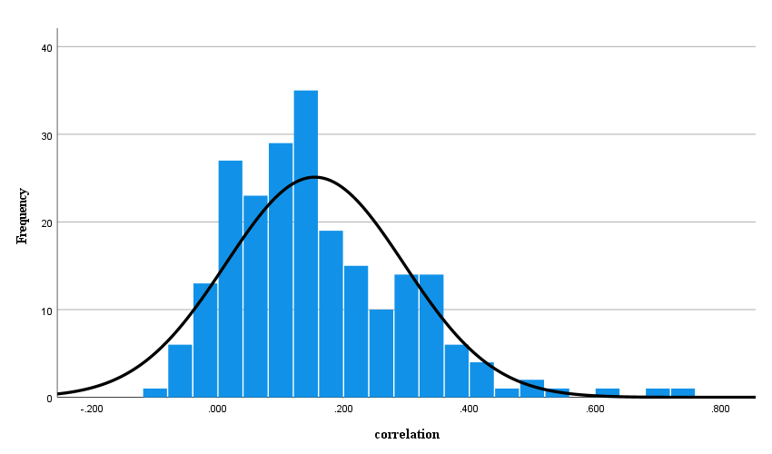

**Figure 3.** Forest Plot for Internal Political Efficacy and Digital Media Use (*k* = 48)

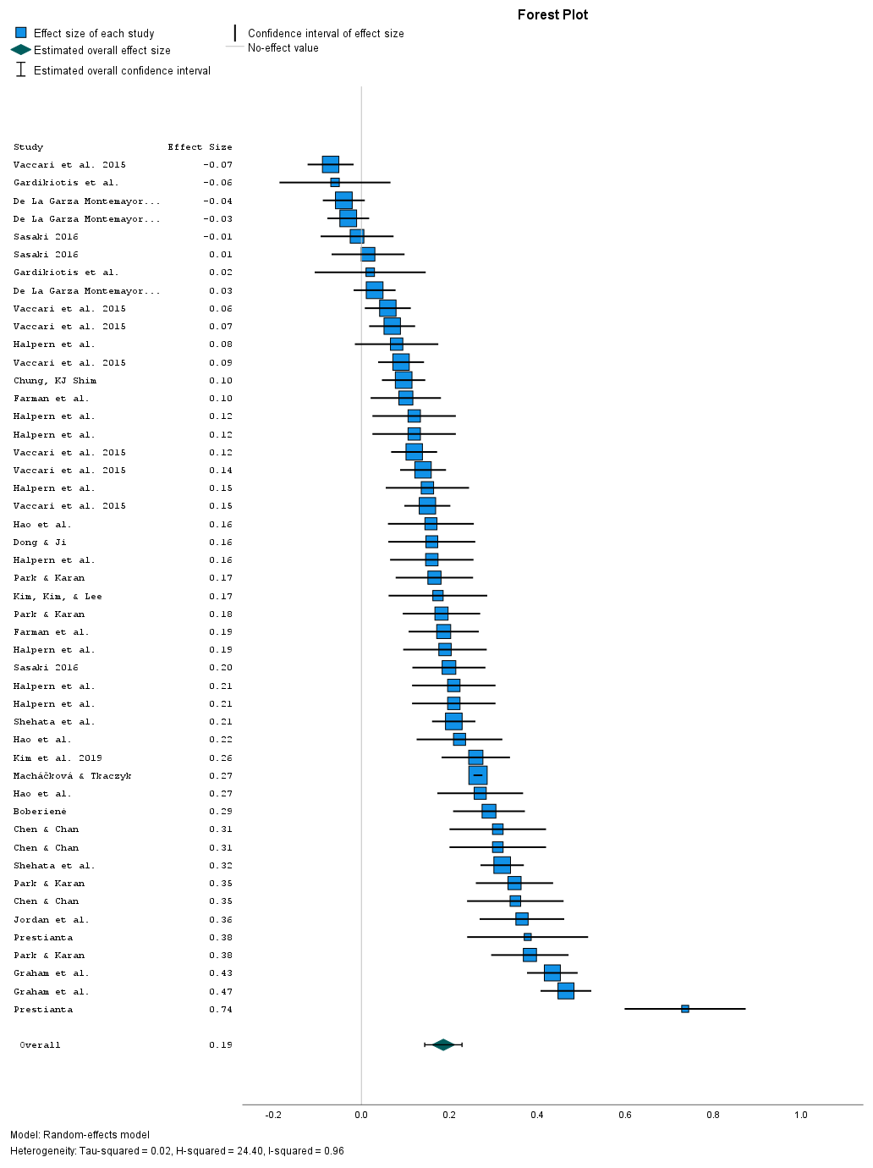

**Figure 4.** Forest Plot for External Political Efficacy and Digital Media Use (*k* = 74)

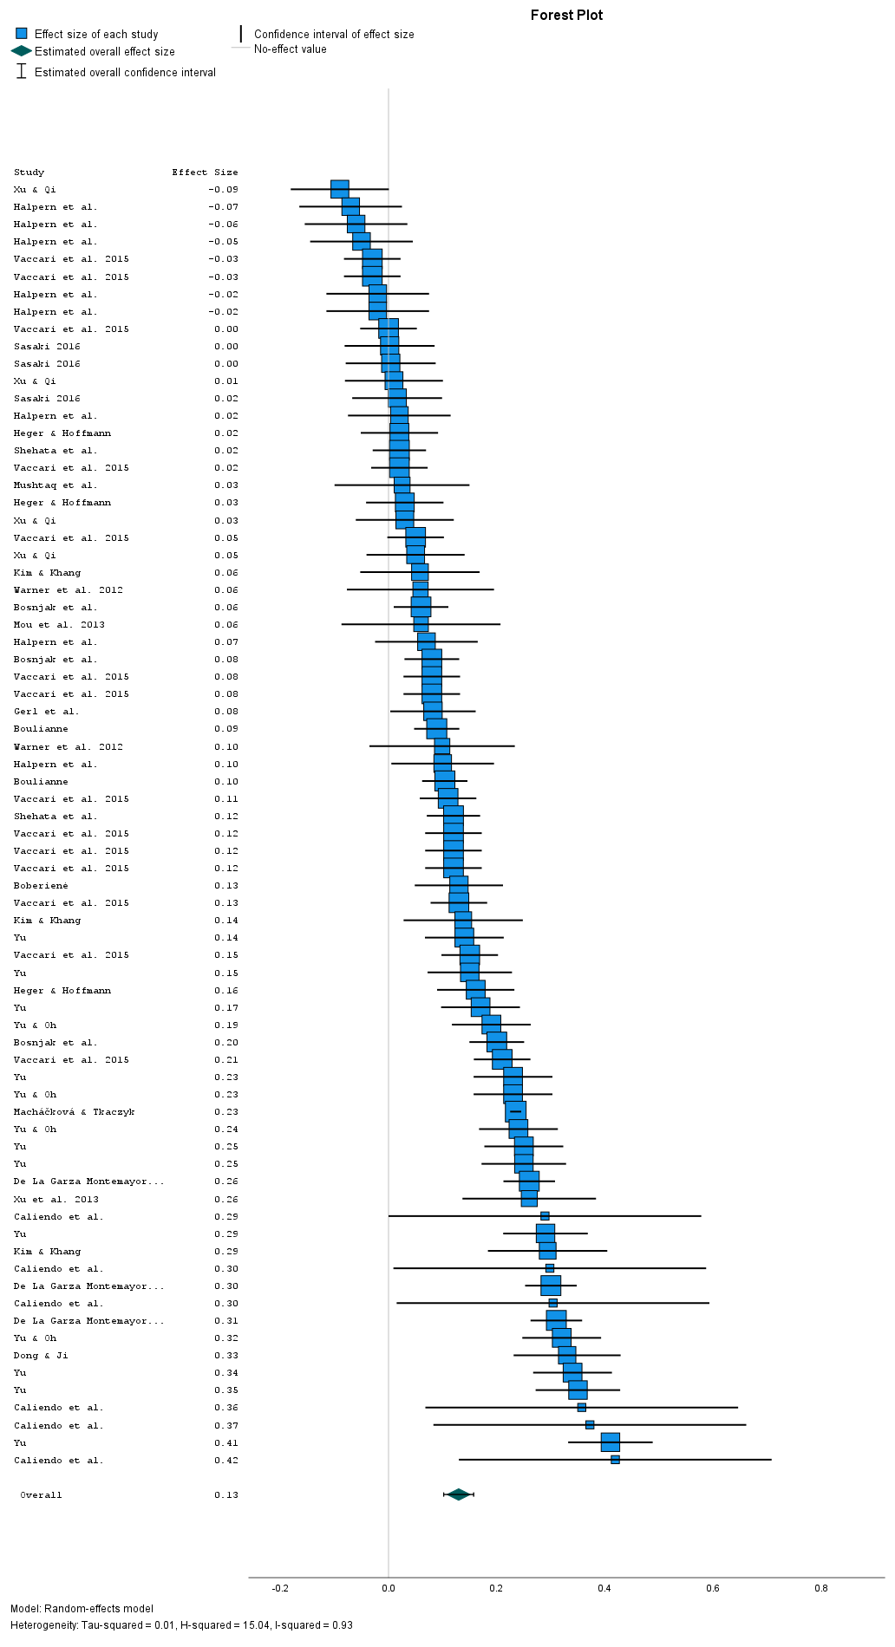

**Figure 5.** Forest Plot for Combined (internal and external) Political Efficacy and Digital Media Use (*k* = 38)

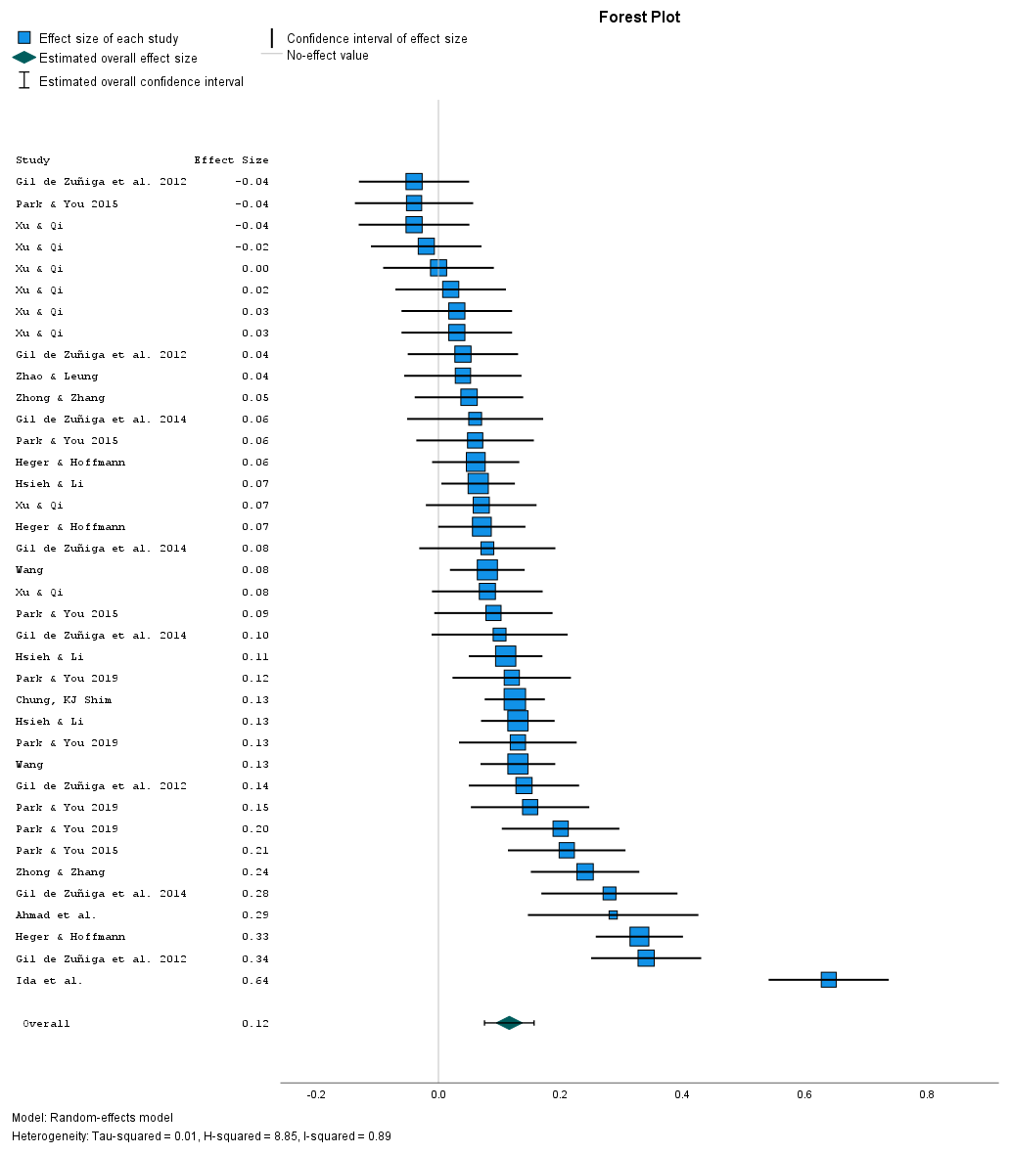

**Figure 6.** Forest Plot for Other Measures of Political Efficacy and Digital Media Use (*k* = 63)

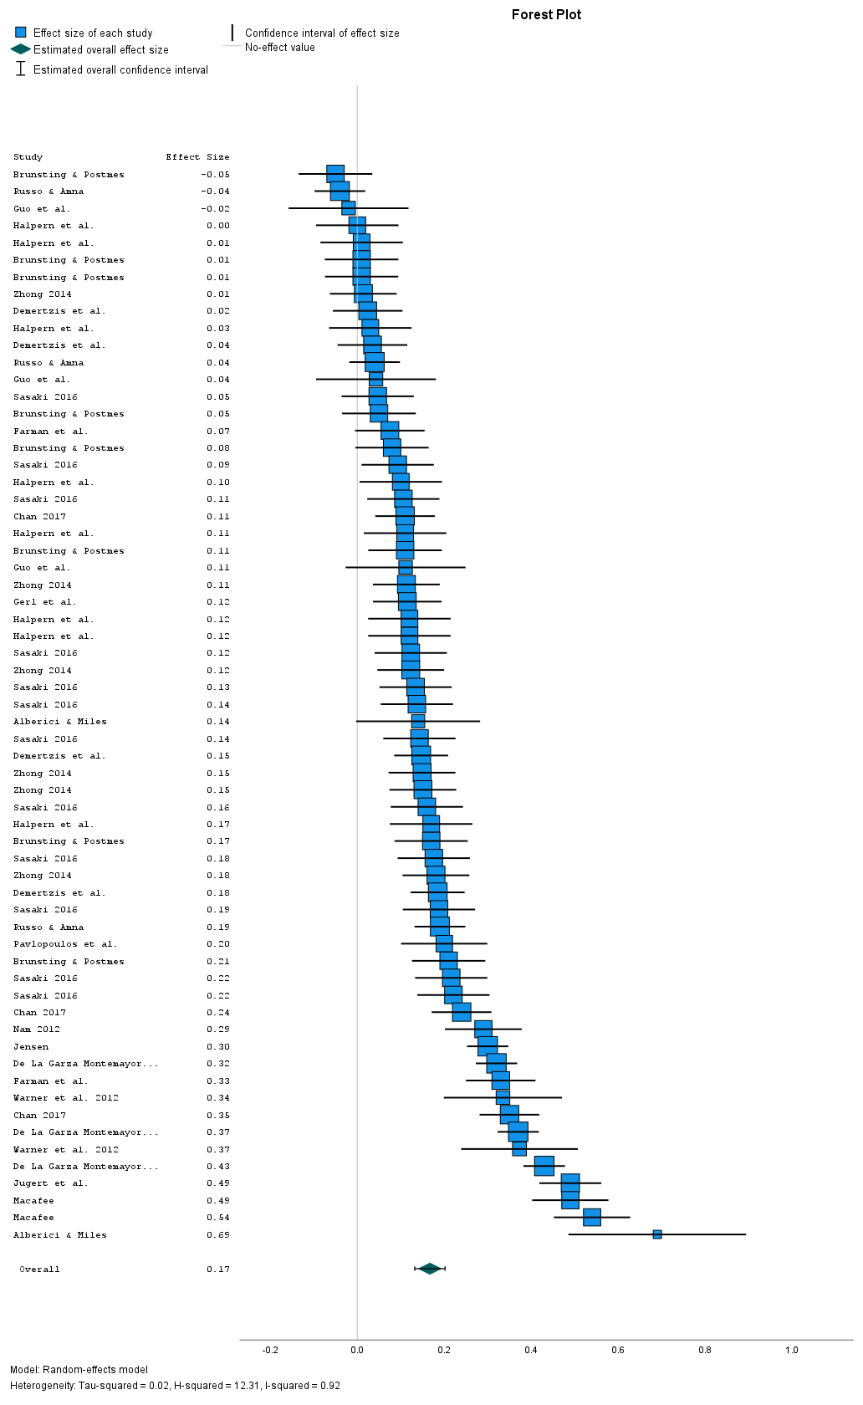

**Figure 7.** Forest Plot for Political Efficacy and Online Information (*k* = 45)

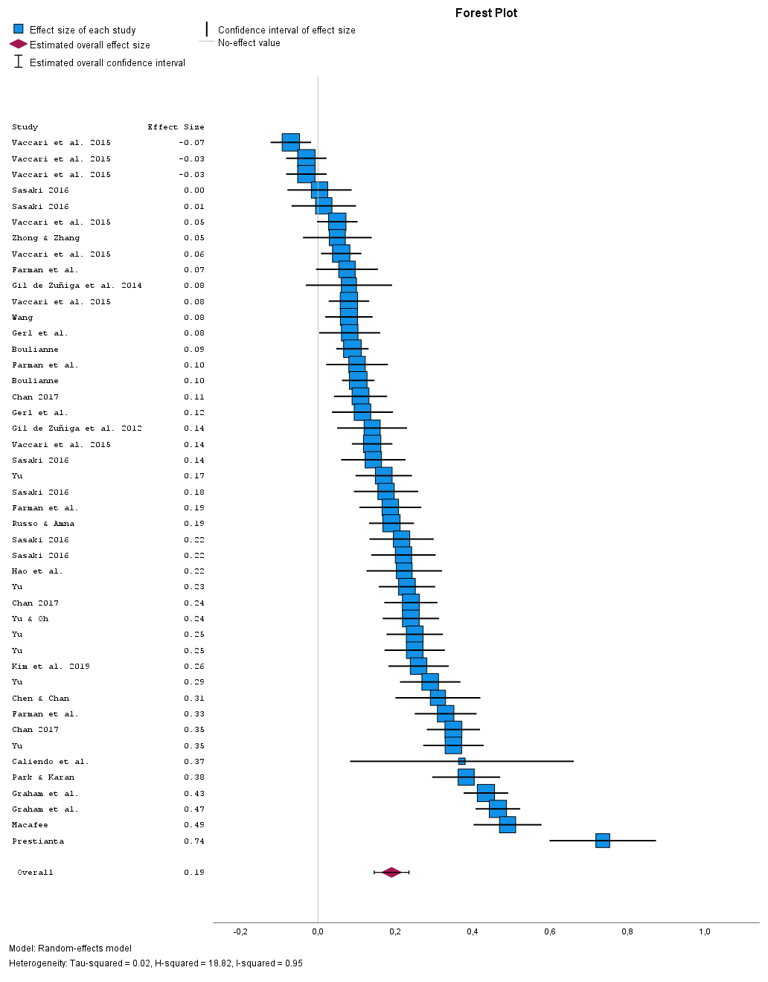

**Figure 8.** Forest Plot for Political Efficacy and Online Expression/Participation (*k* = 103)

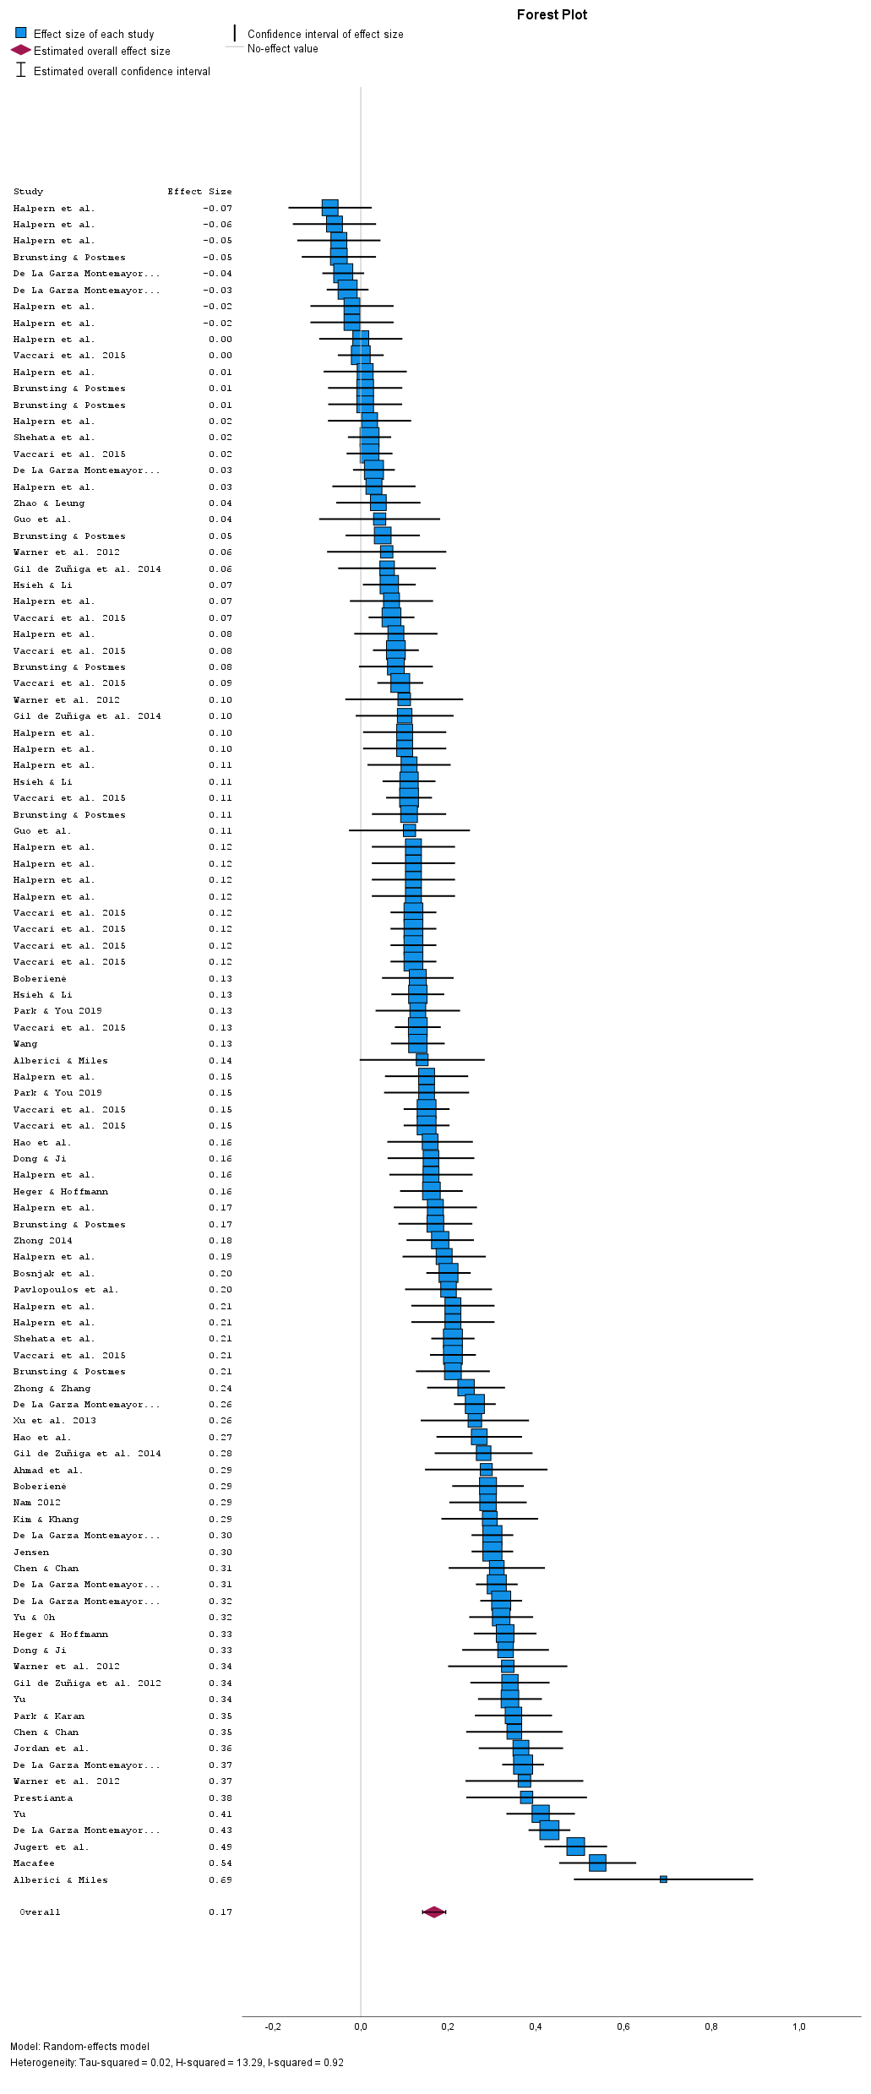

**Figure 9.** Forest Plot for Political Efficacy and Generic or Other Digital Media Uses (*k* = 75)

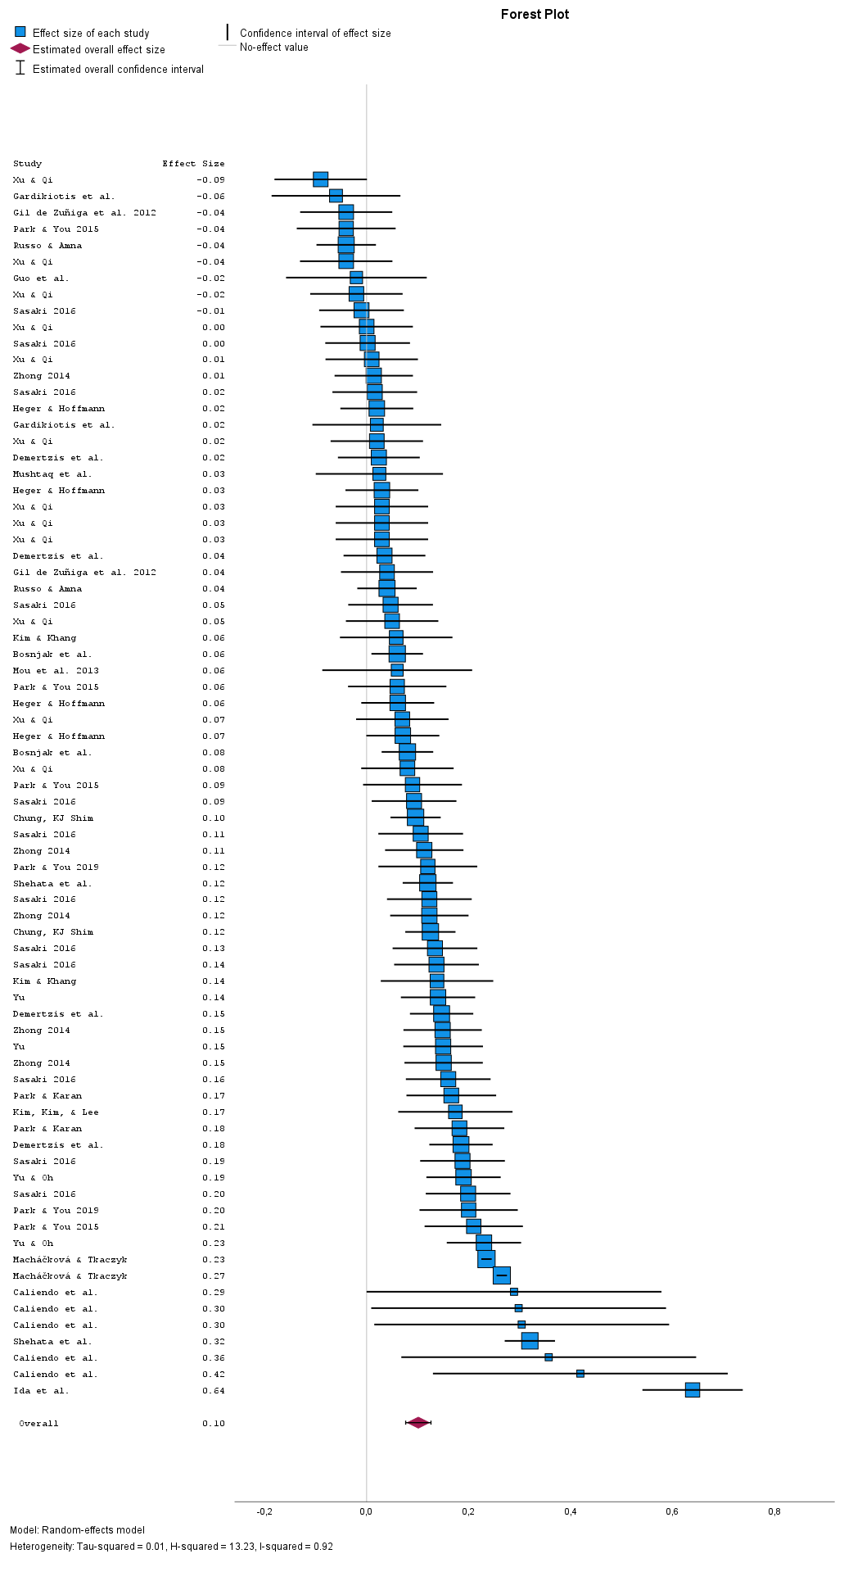

**Figure 10.** Example of Panel Study (Halpern et al., 2017) of Political Efficacy and Digital Media Use

|  |  |
| --- | --- |
| 10a) Type of efficacy | 10b) Design |
|  |  |

Notes:

a) Types of efficacy: IPE=internal political efficacy, EPE=external political efficacy, OPE=other type of political efficacy.

b) Design: IV=correlations when political efficacy is the independent variable and measured at wave 1, DV=correlations when political efficacy is the dependent variable and measured at wave 2, and cross=correlations based on the cross-sectional design.