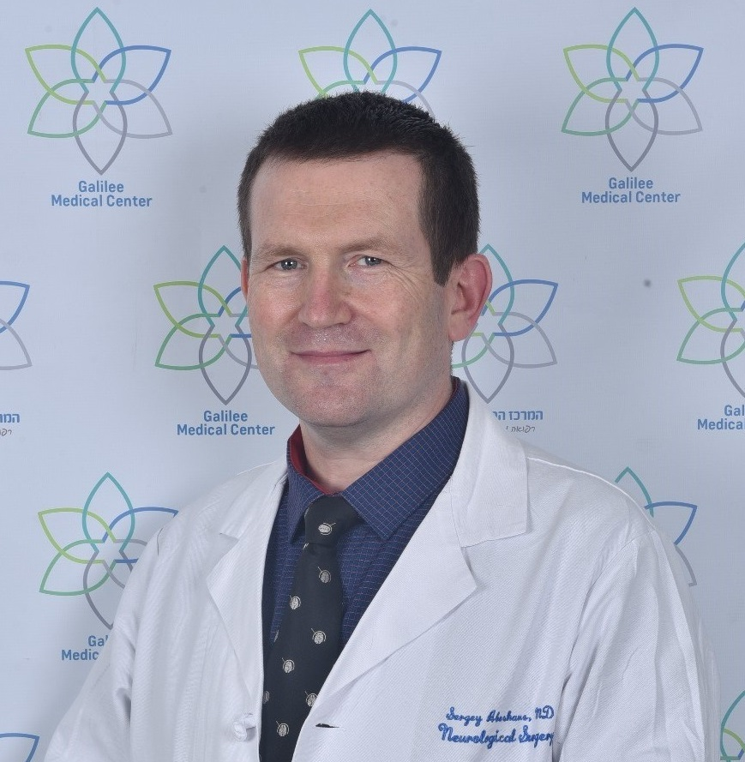**CURRICULUM VITAE**

**Name: SERGEY ABESHAUS**

**ID: 323228270**

**Date of Birth: November 21, 1973**

**Place of Birth: Saint Petersburg, Russia**

**Marital status: married +3**

**IDF: 7373040 Captain (reserve)**

**Current address: 37 HaZamir Street, Nahariya 2235219, ISRAEL**

**Contact info: cell phone +972-50-7887-817**

**Email: abeshaus@gmail.com**

1. **Academic History:**

|  |  |  |
| --- | --- | --- |
| 1990-1996 | **Medical School:** Pavlov State Medical University | Saint Petersburg, Russia |
| 1994-2000 | Laborant-Researcher, Behkterev Psychoneurological Institute, Saint Petersburg, Neurosurgery Department: Stereotactic Surgery for OCD and Tourett Syndrome. Mentor: Professor V.A. Shustin | Saint Petersburg, Russia |
| 1996-1999 | **Neurosurgical training:** Resident, Polenov Neurosurgical Research Institute, Saint Petersburg, Russia. Research: Surgery for Temporal Lobe Epilepsy in Children. Mentor: Professor V.P. Bersnev | Saint Petersburg, Russia |
| 1999-2000 | Scientific worker, Human Brain Institute, Department of Stereotactic Methods : Stereotactic Surgery for Movement Disorders and Drug Addiction. Mentor: Professor A.D. Anichkov | Saint Petersburg, Russia |
| 2000-2001 | Hebrew language preparation course for medical specialists: Ulpan Naamat | Haifa, Israel |
| 2001 | Israel Medical Licensing Examination Preparation Course, Rambam Health Care Campus | Haifa, Israel |
| 2002-2010 | **Neurosurgical training:** Resident, Rambam Health Care Campus (2007-2010 Chief Resident) Mentor: Professor M. Zaaroor | Haifa, Israel |
| 2011 -  2013 | **Pediatric Neurosurgery Fellowship**, Seattle Children’s Hospital. Program director:Professor J. Ojemann/Professor Richard G. Ellenbogen | Seattle, WA, USA |

1. **Appointments:**

|  |  |  |
| --- | --- | --- |
| 1999-2000 | Attending Neurosurgeon, Human Brain Institute, Department of Psychosurgery | Saint Petersburg, Russia |
| 2010-  2016 | Attending Neurosurgeon, Rambam Health Care Campus, Department of Neurosurgery, Pediatric Neurosurgery Unit | Haifa, Israel |
| 2016-  present time | Director of Pediatric Neurosurgery, Department of Neurosurgery, Galilee Medical Center | Nahariya, Israel |

1. **Professional Boards:**

|  |  |  |
| --- | --- | --- |
| September 1999 | Russian Neurosurgical Board Certification | Certificate A 0741986 |
| January, 2002 | Israel Medical Board Certification | Medical License 35079 |
| June  2007 | Israel Neurosurgical Board Certification Part A |  |
| February 2008 | European Examination in Neurosurgery Part I |  |
| November 2008 | Israel Neurosurgical Board Certification Part B |  |
| May 2010 | **Israel Neurosurgical Board Certification & Licensing** | Specialist in Neurosurgery,  License 29109 |
| October 17, 2010 | Educational Committee for Medical Graduates (ECFMG) | Certificate 0-757-466-8 |

1. **Academic Courses (last 15 years):**

|  |  |  |
| --- | --- | --- |
|  | **European Association of Neurosurgical Societies Training Course (2005-2008)** |  |
| August 2005 | **Vascular Neurosurgery** | Thessaloniki, Greece |
| August 2006 | **Brain Tumors and Hydrocephaly** | Bratislava, Slovakia |
| February 2007 | **Epilepsy, Pain, Neuromodulation and Head Injury** | Antalya, Turkey |
| February 2008 | **Spine and Peripheral Nerves** | Trondheim, Norway |
|  | **European Society for Pediatric Neurosurgery**  **Post-Graduate Course (2015-2017)** |  |
| May  2015 | **Hydrocephalus, Head trauma, Posterior fossa tumors** | Segovia, Spain |
| June  2016 | **Dysraphism, Spinal tumors, Craniovertebral junction, Vascular, Sellar and suprasellar tumors, Orbit and skull, idline tumors, Craniosynostosis** | Langvik, Finland |
| May  2017 | **Cerebral hemispheric tumors, Infection, Spasticity, Pineal region, Epilepsy** | Lowenstein, Germany |
|  |  |  |
|  |  |  |
|  |  |  |
| November 29, 2009  August 5-6 ,2011  August 11-13, 2011  July 9-11  2012  August 3-4  2012  November- December 2013 | Medtronic Intrathecal Baclofen Therapy Training  Anterior and Middle Fossa: Anatomy, Microsurgery and Endoscopy Course (UW ISIS Surgical Skills Lab)  Zimmer Spine Fellows/Chief Resident Training Program at the Medical Innovations and Training Institute  Opportunities for Hydrocephalus Research: Pathways to Better Outcomes  Approaches to the Middle Skull Base: Anatomy, Microsurgery and Endoscopy. An Overview of the Anterior, Middle and Posterior Skull Base and Anatomy of the Temporal Lobe (UW ISIS Surgical Skills Lab)  Good Clinical Practice and Management of Clinical Trails (Haifa University) | Israel  Seattle  WA, USA  Henderson  NV, USA  Seattle  WA, USA  Seattle  WA, USA  Israel |
| July 10-11  2015 | What is New in Pediatric Neurosurgery (WIN -1) course  At InternationaL Neuroscience Institute (Prof C. Di Rocco, Prof M. Samii) | Hannover, Germany |
| January 25-27 2016  May 21-22  2018  July-August  2019  February 2020 | IFNE-JSNE-GLEN Hands-on workshop on cerebral and ventricular neuroendoscopy.  Neonatal Cranial Ultrasound Course  Minimal invasive approaches in brain surgery fellowship including robotic neurosurgery and surgery in awake patient.  GCP course | Naples, Italy  Addenbrooke's Hospital,  University of Cambridge  UK  University of Washington, Seattle, USA  Israel |

1. **Awards**

|  |  |  |
| --- | --- | --- |
| 1994 | Young scientist contest grant (3D Stereotactic atlas of brain) |  |
| 2011 | Rambam Fellowship Award |  |

1. **Projects**
2. **ValveViz (shunt valve visualization protocol)**
3. **EasyTrocar with VIGOR LTD (safe trocar design for peritoneal shunt placement)**
4. **Publications :**

|  |  |
| --- | --- |
|  | Wright JN, Feyma TJ, Ishak GE, **Abeshaus S**, Metz JB, Brown ECB, Friedman SD, Browd SR, Feldman KW.Correction to: Subdural hemorrhage rebleeding in abused children: frequency, associations and clinical presentation. Pediatr Radiol. 2020 Jul;50(8):1161. doi: 10.1007/s00247-020-04687-0. |
|  | Wright JN, Feyma TJ, Ishak GE, **Abeshaus S**, Metz JB, Brown ECB, Friedman SD, Browd SR, Feldman KW. Subdural hemorrhage rebleeding in abused children: frequency, associations and clinical presentation. Pediatr Radiol. 2019 Dec;49(13):1762-1772. doi: 10.1007/s00247-019-04483-5. Epub 2019 Nov 19. |
|  | Katzir M, Attia M, Sviri GE, Zaaroor M, **Abeshaus S** Iatrogenic metastasis of a colloid cyst. Acta Neurochir (Wien). 2015 Dec;157(12):2201-3. doi: 10.1007/s00701-015-2554-x.Epub 2015 Aug 25. |
|  | Katzir M, **Abeshaus S**, Attia M, Zaaroor M Ogilvie's syndrome following ventriculoperitoneal shunt surgery for normal pressure hydrocephalus. Acta Neurochir (Wien). 2014 Apr;156(4):787-8. doi: 10.1007/s00701-014-2014-z. Epub 2014 Feb 9. |
|  | Lee A, Chen ML, **Abeshaus S**, Poliakov A, Ojemann JG. Posterior fossa tumors and their impact on sleep and ventilator control. A clinical perspective. Respir Physiol Neurobiol. 2013 Nov 1;189(2):261-71. doi: 10.1016/j.resp.2013.05.027. Epub 2013 May 28. |
|  | **Abeshaus** **S**, Friedman S, Poliachik S, Poliakov A, Shaw D, Ojemann JG, Ellenbogen RG. Diffusion tensor imaging changes with decompression of Chiari I malformation.  Neurosurgery. 2012 Aug;71(2):E578. (Oral Presentation CNS Meeting 2012) |
|  | Ojemann JG, Hersonskey TY, **Abeshaus** **S**, Geyer JR, Saneto RP, Novotny EJ, Kollros P, Leary S, Holmes MD. Epilepsy surgery after treatment of pediatric malignant brain tumors. Seizure. 2012 Oct;21(8):624-30. Epub 2012 Jul 24. |
|  | Soustiel JF, Sviri GE, Mahamid E, Shik V, **Abeshaus S**, Zaaroor M. Cerebral  blood flow and metabolism following decompressive craniectomy for control of increased intracranial pressure. Neurosurgery. 2010 Jul;67(1):65-72; discussion 72. |

1. **Oral Presentations, Invited Lectures**
2. Oral presentation, Diffusion tensor imaging changes with decompression of Chiari I malformation. CNS Meeting, October 2012, Chicago, USA
3. Invited Lecture, Current Updates in Pediatric Neurosurgery, Uzbekistan National Center of Neurosurgery, September 2017, Tashkent, Uzbekistan
4. Spontaneous resolution of Iatrogenic metastasis of a colloid cyst. A case report.  IFNE 8th World Congress of Neuroendoscopy, 1-3 November 2017, Cape Town, South Africa
5. Invited Lecture , Vagal Nerve Stimulation for Intractable Epilepsy, Guest Speaker, Congress of the Eurasian Association of Pediatric Neurosurgeons, December 2017, Minsk, Belarus
6. **Other Academic Activities**
7. **Neurosurgery Editorial Board, Neurosurgery Speaks Section**
8. **Bar Ilan University, Azrieli Faculty of Medicine, NTD Annual Lecture for medical students (2017- present)**
9. **Neurosurgery Board Exam Faculty Part A (2016-present)**
10. **Book chapters**

|  |
| --- |
| 1. **S. Abeshaus,** S. Browd, R. Ellenbogen   Ventricular Shunt Malfunction  Jamie S Ullman, P.B. Raksin Atlas of Emergency Neurosurgery (Thieme 2015)  2. Hai Sun, **Sergey Abeshaus**, Jeffrey G. Ojemann  The Surgical Treatment of Epilepsy: Overview  Alan R. Cohen Pediatric Neurosurgery: Tricks of Trade (Thieme 2015) |

1. **Medical societies**

|  |  |  |
| --- | --- | --- |
| Association of Neurosurgeons of Russia | 1996 |  |
| European Association of Neurosurgical Societies | 2005 |  |
| Israel Medical Association | 2002 |  |
| Israel Neurosurgical Society  American Association of Neurological Surgeons  International Society of Pediatric Neurosurgery | 2002  2011  2013 |  |

1. **Languages**

|  |  |  |
| --- | --- | --- |
| Speak | Russian, English, Hebrew |  |
| Read | Russian, English, Hebrew |  |
| Write | Russian, English, Hebrew  **Basic Arabic** |  |

1. **Other Activities**

|  |  |  |
| --- | --- | --- |
| Summer 1996 | International Camp Counselor Program | Camp Lee Mar, PA, USA |
| Summer 1997 | International Camp Counselor Program | Camp Lee Mar, PA, USA |
| Diving  Yachting | Master Diver  International Skipper | The Israeli Diving Federation  Ministry of Transport, Israel |