Gender-Neutral Language and Gender Disparities

Alma Cohen,[1]* Tzur Karelitz,[2]** Tamar Kricheli-Katz,[3]***

Sephi Pumpian,** and Tali Regev[4]****

This study examines empirically whether and how the use of gender-neutral language affects the performance of women and men in real high-stakes exams. We take advantage of a natural experiment in which the institute administering Israel’s standardized college admission tests amended the language of its questionnaires to make it more gender neutral. We find that replacing the form of addressing test takers to be more gender-neutral was associated by a significant increase in the performance of women in quantitative questions, which meaningfully reduced the gender gap between the performance of men and women in these questions. By contrast, the change did not affect the performance of women in verbal questions nor the performance of men in either quantitative or verbal questions. Our findings are consistent with the hypothesis that language evoking gender may introduce a "stereotype threat" that adversely affects women’s performance in tasks in which they are stereotypically perceived to underperform. Our findings have significant implications for the ongoing academic and policy discussions regarding the use and effects of gender-neutral language.

1. Introduction

This paper uses a natural experiment to investigate empirically whether and in what way the use of gender-neutral language affects behavior. We find that using gender-neutral language in standardized high-stakes tests improves the performance of women in certain tasks in which there is a gender gap in performance between men and women.

Languages vary in whether and how they encode gender. Even in languages that are more gender neutral, like English, some parts of speech deviate from gender-neutrality by signaling that the prototypical person is male (for example, prototypical police officers and fire fighters were refereed to as policemen and firemen and "he" had been used when referring to a generic person). In recent years, however, there is substantial support for and movement toward using a more gender-neutral language. Thus, for example, with respect to official communications and documents, the US House of Representatives adopted rules requiring the use of gender-neutral in House of Representatives communications; several US states including California and New York required the use of gender-neutral language in all official documents and forms; and the United Nations adopted guidelines for using such language in its official documents and communications. By contrast, after adopting such rules in 2015, the French government reversed them in 2022, taking the position the masculine is a neutral form that should be used in official documents for terms applicable to both women and men.

Education is a major area in which policies in favor of gender-neutral language have been adopted or considered (see, e.g., National Council of Teachers of English (2018)). For example, the Educational Testing Service, which administers the SAT (Scholastic Aptitude Test) that plays a key role in US college admissions, has considered mandating the use of gender-neutral language in questionnaires but decided not to do so (Educational Testing Service (2022)).

The policies discussed above are likely to be at least partially motivated by a belief that using gender-neutral language affects behavior and outcomes. Therefore, it is worthwhile to obtain evidence on whether, and in what settings and ways, making language gender-neutral has such effects.

We provide such empirical evidence. By using evidence from a natural experiment to address identification issues, we are able to identify a causal link between using a gender-neutral language and improving the performance of women in certain tasks in real-world standardized tests. Although there is significant empirical literature on the subject that uses a cross-sectional approach or a laboratory experimental approach, our study is, to the best of our knowledge, the first to provide natural-experiment evidence on the subject.

The natural experiment we use was carried out by the Israeli National Institute of Testing and Evaluation (NITE), which administers the Psychometric Entrance Test (PET). PET is an SAT-like standardized test that is used for admissions to Israeli universities. We show that the transition from addressing test takers in the singular masculine to addressing them in the plural masculine, which is a more gender-neutral form, positively affected the performance of women without adversely affecting the performance of men. Such use of a more gender-neutral language had a positive effect that is economically meaningful on the performance of women in quantitative questions. The policy-change increased women’s success by 1.5 percentage points in quantitative questions. . The size of this effect was about one-fifth of the original gender gap in the performance of men and women in quantitative questions. By contrast, the policy-change had no effect on the performance of women in verbal questions nor on the performance of men in quantitative questions and in verbal questions.

Our findings are consistent with the “stereotype threat” mechanism that has been documented in various settings. The large body of literature on stereotype threat has shown that when gender stereotypes are evoked (sometimes merely be making gender more salient), people behave according to them (Steele and Aronson (1995)), Spencer et al (1999), Bracha and Cohen (2018)). Because women are viewed as less good at math, making gender more salient in a setting in which math tasks need to be performed can lead to worse performance of women by increasing anxiety and cognitive load or decreasing effort and attention. Consistent with a stereotype threat channel, we find that women perform better on math questions (but not on verbal questions) when they are not addressed in a form that assumes that men are the ”prototypical test takers” and therefore activates gender stereotypes.

While our study is the first to provide real-world causal evidence from a natural experiment on the issue of gendered address, we rely on a growing body of literature on the effects of grammatical features of languages on people's behavior First, there is a large literature using cross-country studies that examine associations between linguistic features and grammatical structures and the behaviors of speakers (Ayres et al (2023), Chen (2013), Mavisakalyan et al (2018), Galor et al (2020), Robert et al (2015)). For example, studies using cross-country variation have identified correlations that gendered languages have with gender inequality in the labor force (e.g. Prewitt-Freilino et al. (2012), Gay et al. (2013), Shoham and Lee (2018)) or with educational gender gap (e.g. Davis and Reynolds (2018), Jakiela and Ozier (2018), Galor et al (2020)). As is widely understood, despite the richness and value of cross-country studies, there are limitations on the ability to infer causal conclusions from such cross-sectional studies due to problems such as omitted variables bias and simultaneity.

A second significant set of empirical studies has gone into the lab and pursued an experimental approach. These studies examined how the performance of lab participants was affected by the variation in linguistic features of the text given to them. For example, such studies examined the association between gendered language and sexist attitudes (e.g. Wasserman & Weseley (2009)), between gendered language and motivation (e.g. Vainapel et al. (2015)), and, closest to our setting, the association between gendered language and performance in math tasks (Kricheli-Katz and Regev (2021a,b), which finds results consistent with ours). Whereas experimental studies are not afflicted by some of the identification issues involved in cross-country studies, questions arise regarding the extent to which experimental findings can predict outcomes in real-world settings.[5]

Finally, and most broadly, our analysis is related to the large literature in linguistics and philosophy regarding the relationship between language and behavior (Ladd et al, (2018)). Whereas some universalist linguists view the different languages people use as sharing deep-seated structures (e.g., Chomsky (1957)), other linguists who hold the linguistic relativity view (Whorf (1956), Levinson (2012), Everett (2013)) argue that linguistic formats that tend to vary across languages shape our perception and behavior.

Before proceeding, we would like to note that, in the natural experiment we analyze, the change in language to a more gender-neutral addresses also made the questionaries more inclusive to non-binary identities, so that effects of inclusiveness and effects of neutrality cannot be disentangled. The remainder of the paper proceeds as follows. Section II provides the relevant linguistic and institutional background, as well as describes our natural experiment which enables testing for casual effects. Section III provides our empirical analysis, and Section IV concludes.

1. Institutional Background and the Natural Experiment
2. *Gender-Neutral and Non-Gender-Neutral Texts*

Gender-neutral language refers to a person in a format that does not reveal the person’s gender. In most languages,[6] standard uses of language have long had elements that were not gender-neutral. In some languages (Grammatical Gendered Languages), such as German, Romance languages, Arabic, and Hindu, every noun has a grammatical gender; in such languages for example, the term for a female student and a male student would not be the same. In other languages (Natural Gender Languages), such as English, Danish and Swedish, while personal nouns are mostly gender-neutral, personal pronouns are specific to the particular gender. Thus, in English, a test instruction such as “the student should open the bluebook” is gender-neutral, but a test instruction stating that “the student should open his bluebook” would indicate that the text has a male student in mind. In such a case, to make the instruction gender-neutral, it could be changed to “the student should open their bluebook” or “the student should open his or her bluebook.”

In the tests used in our natural experiment, the language of the test is Hebrew. Hebrew is similar to German in that it is a Grammatical Gendered Language in which nouns generally have a gender assigned to them and the gender of a noun affects the form of the verb used with it and the form of the pronoun used to refer to it. For our context, it is relevant that verbs are also associated with a gender, and thus when a man is asked, say, to write or to answer, the verb has a form that is different than when a woman is asked to write or to answer.[7]

For many years prior to the change examined in this paper, NITE used questionnaires that instructed test-takers using the masculine form of verbs, which signaled that the writers of the ­­text had men as the prototypical test-takers. When making the change, NITE switched to using the plural masculine form of the verb, which is understood to refer to both men and women.[8] We refer to such format for addressing a test-take as gender-neutral.

Hebrew has some modal verbs that are pronounced differently depending on the gender of the person being addressed by them but are spelled the same.[9] Because PET test-takers received PET instructions in written form, when such modal verbs were used, male and female could read them as addressed to them. Thus, for instructions that used such terms, the form of address was gender-neutral both before the switch to the plural form as well as after the switch. We refer to these modal verbs as *unisex*.

1. *The PET*

Many countries use standardized test for university admission, for example, the two tests used in the US are the SAT and the ACT. Israel similarly has such a test, which is referred to as PET and is administered by the Israeli NITE.

The PET serves as an important component of the admissions process for institutions of higher education in Israel. The test, which is similar in nature to the SAT test, is designed to measure cognitive abilities, mathematical reasoning, and verbal skills. The test is administered in many places around the country, four times a year. The substantial majority of test-takers take the Hebrew version (there are also versions in other languages), and our focus is on test-takers who took the Hebrew version.

The test consists of three sections: mathematical reasoning, verbal reasoning (including a writing assignment), and proficiency in English. In each test, there are two chapters for each one of the three sections. In addition, there are two pilot chapters that used for score calibration and quality assurance. Theses chapters are not scored as part of the official test. These pilot chapters are similar to the test chapters, but do not enter the grade, and are used for calibration purposes as well as for testing new questions for future use. These chapters are structured such that test-takers are not aware that these chapters are “pilot” chapters. Therefore, test-takers have to treat all chapters with the same degree of seriousness.

The quantitative chapter contains 20 questions that cover problems in various areas of mathematics such as geometry, algebra, percentages, averages, ratio questions, drawing conclusions from a diagram, etc. The mathematical knowledge required for the quantitative chapters is comparable to the lowest level of mathematics required for the high-school matriculation exam.

The verbal chapter contains about 25 questions that include analogies, logic and inference questions, and reading comprehension questions.

1. *The Natural Experiment*

In December of 2009, the Israeli NITE changed the PET form of address from the singular masculine to the plural masculine to create a more gender-neutral environment for all test-takers. We use this change as a natural experiment which allows us to compare test-takers’ performance in their real life setting, before and after the change. To account for potential confounders, we focus on a number of chapters given before and after the change, where the only difference between these chapter (before and after) in not in the questions themselves, but only in the form of address. By focusing on these chapters, we are able to compare test-takers’ performance before and after the change for the same exact questions.

The policy-change affected some questions while leaving other questions unaffected. Thus, by comparing changes in performance between questions that were affected to questions that were not affected before and after the policy-change, we are able to control for additional confounding effects that have occurred over time.

There are two types of questions that were affected by the policy-change. The first type includes questions that previously were addressed in the singular masculine form and after the policy-change were addressed in plural masculine (we refer to them as *gendered address* questions). The second type includes questions that before the change were addressed in the unisex form and after the change were addressed in the plural masculine (we refer to them as *unisex* questions).

Based on the literature mentioned above, we predict that the change from singular to plural-masculine form of address will improve women’s performance on quantitative questions. In particular, we would expect to see the improvement only for the *gendered address* questions. This is because unlike the plural masculine form and the *unisex* form, the singular masculine has the potential to activate the stereotype threat for women in tasks in which they are known to underperform, by making gender more salient and by excluding them.

We also do not expect to see an effect of the policy-change on women’s performance in verbal questions. This is because women are not known, or perceived, to be worse than men in these questions, and therefore their stereotype threat is not expected to be activated. We also do not expect to find an effect on men’s performance, not in the gendered address or the unisex questions regardless of the type of question, quantitative or verbal. The reason is that for male test takers there is no substantial difference between the singular- and the plural-masculine forms of address, as they both address them in the masculine gender.

1. Analysis

*A. Data and summary statistics*

We obtained data on all first-time test-takers who took the exam sometime between 2000 and2012 and answered one of the repeated chapters in the questionnaires of the NITE. We limit our analysis to first-time test-takers as they are more likely to ignore exam instructions because they have already taken the test and are familiar with it. Including them in our analysis may, therefore, understate the effect of the policy-change on test-takers that read the instructions.

We regard a chapter as a *Repeated Chapter* if there were no more than three questions that were replaced in the second time it was administered. In chapters where some questions were changed, we exclude these questions from our analysis. During our sample period (2000-2012) there were 8 quantitative repeated chapters (where in one of them there was only one question that was replaced), and 24 verbal repeated chapters (where in four of them only one question was replaced, and in 10 of them three questions were replaced).

We define a question to be *gendered address* if in the before period the form of address was in singular masculine. We define a question to be *unisex address* if in the before period the form of address was in its unisex form. Some questions are connected through common instructions, such as consecutive questions referring to the same graph. We drop these questions from our main analysis because we do not know if and to what extent test-takers might refer back to the instructions. We include these questions in our robustness analysis.

On average there are two gendered address questions in each of the 9 repeated quantitative chapters (12% of questions), and on average 3.11 gendered addressed questions in each of the 24 repeated verbal chapters (18% of questions). About 11% of quantitative questions and 10% of verbal questions are *unisex address*.

Our sample includes data from all 154,265 first-time test-takers who took one of the repeated chapters (quantitative or verbal) in their Hebrew version during our sample period (2000-2012). Of these, 45,082 took one of the repeated quantitative chapters and 109,183 took one of the repeated verbal chapters. About 2/3 of the test-takers in our sample took the test after the policy-change.

Table 1 provides summary statistics for the characteristics of the test-takers’ who were tested before and after the policy-change in the different chapters. The data contains information on 18,909 (26,173) test-takers who were took one of the quantitative (verbal) chapters before the policy-change and 26,173 (73,264) test-takers who took it after. More female took the test (55% which fits the official data), however, there are no significant differences in the gender gap in participation in the before and after the policy-change or by the type of chapter (quantitative or verbal). Relatedly, there are no significant differences in test-takers’ ages or income. Nonetheless, test takers who took the exams after the policy-change tended to have more educated parents, which can be explain by an increase in higher education over the years for the whole population, and by the share of immigrants with higher education (mainly coming from the USSR). For robustness purposes we replicate our analyses using only Israeli born test-takers.

Table 2 present the questions' success rate by gender, time (before and after), and type of question (quantitative and verbal) based on 2,524,334 question-by-test-takers’ observations. The average success rate in quantitative questions increases for women from 59.5% before the policy-change to 63.2% after, and for men from 68.7% to 70.7%. From the table we get that the gender gap in the period before and after the policy-change remained similar at around 8%.

The improvement in the verbal questions was milder (from 65.6% to 66.2% for women, and 67.8% to 68.6% for men), with a negligible gender gap.

*B. Empirical Strategy*

We study the relationship between gendered form of address and test-takers’ performance by running the following OLS regressions model:

$$y_{iqct}= β_{1}{Gendered}_{q}+β_{2}{Gendered}_{q}X{After}_{t}+ β_{3}{Gendered}_{q} X{ Female}_{i}+{β_{4}{Gendered}_{q} X {After}_{t}X Female}_{i}+ β_{4}X_{iq}+{γ_{c}+μ}_{q}+δ_{i}++ε_{iqt}$$

In this regression, $y_{iqct}$ is a binary indicator of whether person $i$ answered question $q$ correctly in chapter $c$, given the test was taken at time $t.$ $Gendered$ is a dummy variable which is equal to 1 if the question included a singular masculine address before the change and plural masculine address after the change and 0 otherwise, $After$ is a dummy variable equal to 1 if the repeated chapter was given in the period after the policy-change and 0 otherwise.

$Gendered X After$ is the interaction between the dummy specifying whether the question is gendered address and whether the repeated chapter was given in the period after the change of the policy. This interaction variable comes to capture changes that happened over time. $Gendered X Female$ is the interaction between the dummy specifying whether the questions is gendered address question and $Female$, which is a dummy variable equal to 1 if the test-taker is a female and 0 otherwise. This interaction variable captures whether the success rate for the specific question was different between men and female. $Gendered X After X Female$ is the triple interaction between whether the questions is gendered, in the period after the policy-change and whether the test-taker is a female. This triple interaction, which is our main variable of interest, captures whether the change in the form of address had an additional effect on female test-takers.

We also control for $Question No.$ (the question placement within the chapter) to control for fatigue and for $uestion No. X Female$, which is an interaction between the question placement and whether the tests-taker is female to allow for different fatigue between women and men. In the quantitative questions, we also control for whether the question was a question of graph, geometric or other (as the default).

In all models, we control for the chapter, and test-takers’ fixed effects. The chapter fixed effect captures differences among the various chapters, where test-takers fixed effect captures any difference between the different test-takers and enable us to conduct within test-taker analysis, which estimates relative improvement of the test-takers in questions that the form of address was gendered vs non-gendered.

*C. Main Specification Results*

Table 3 presents our main results. Column (1)-(3) presents the results of our main specification. As mentioned above we drop from our main analysis connected questions because we do not know if and to what extent test-takers refer back to the instructions of connected questions. Table 3 column (1) presents the results for the quantitative questions for all test-takers, both men and female. The coefficient of the interaction $Gendered X After$ is basically zero, suggesting that there were no changes in the performance of the gendered questions relative to the non- gendered questions between the before and after period. Column (1) also shows that the gendered questions were more difficult for female test-takers. The coefficient of the interaction $Gendered X Female$ is negative and equal to 1% and is statistically significant at the 5% level. The triple interaction $Gendered X After X Female$, which is our variable of interest, is positive and statistically significant at the 5% level suggesting that after the policy-change, women's success increased by 1.5 percentage points in quantitative questions with a gendered address relative to quantitative questions without a gendered address. This premium represents 2.4% relative to the 61.6% mean success rate of women in quantitative questions. To get a sense of the magnitude of this effect, recall (see Table 2) that the gender gap was about 8%, and thus the effect of the switch to gender0neutrality reduced the gender gap by about 20%.

Column (2) and (3) shows the results of the model when it is run separately for women and men, respectively. Column (2) shows that gendered questions were harder for women compared to non-gendered questions, however, there was an improvement in performance in these questions after the change in the policy, with an effect which is similar to what we obtained in column (1) with a significant level of 1%. As to men, column (3), we get that, men did better in these questions relative to non-gendered questions, but we see no effect of the change from singular masculine to plural masculine for men.

In column (4)-(6) we add to our main specification information about another type of questions, the $Unisex$ address questions and its interactions with $After$ and $Female$. As noted earlier, some forms of gendered-address are spelled the same way for the singular-male and singular-female but pronounce differently. We, therefore, hypothesis that since before the policy-change women could interpreted this form of address in the singular feminine form then the move to plural-masculine would have a smaller effect of no effect at all (as there would be no triggering to the gender of the test-taker in both forms).

Column (4) shows that the coefficient of $Unisex$ is negative and statistically significant at the 1% level, suggesting that these questions were harder compared to non-unisex questions, for both female and male test-takers. The interaction $Unisex X Female$ is positive and statistically significant at the 1% level, suggesting that women perform better in these questions relative to non-unisex questions. As for the triple interaction $Unisex X After X Female$ we get that it is small in magnitude and insignificant. It is interesting to note that although unisex questions are on average harder, the interaction between unisex and female is positive and statistically significant in a similar magnitude to what we obtain in column (1) for improvement for female test-takers in the gendered questions after the policy-change. This suggests that when addressed in the feminine form, women perform better, even when the questions are harder. And the fact that we do not see any different between the period before the change in the policy to after the change is consistent with the fact that female test-takers perceive the *unisex* form of address and the plural masculine form of address as gender-neutral. As before, Column (5) and (6) provides the results for the specification that includes the Unisex questions separately for female and male test-takers.

*D. Robustness Tests*

Table 4 provides the results of some robustness tests that we performed. Table 4 column (1) presents the results from adding to our main model a more demanding specification. In this specification instead of only controlling for chapter fixed effect we now control for $Chapter X Question No.$ fixed effect. The coefficient of our variable of interest (which is the triple interaction $Gendered X After X Female$) remains significant and similar in magnitude (1.3% and statistically significance at the 5% level).

In column (2) we exclude the $Unisex$ questions. Again, we get that the coefficient of our main variable of interest, the triple interaction, is similar in magnitude and statistically significant level, which means that our results are robust to the inclusion or exclusion of these questions.

Next, Column (3) and (4), test whether our results are robust to including the questions which were coded as “connected” to a question with a gendered address (which we excluded from our main specification). In Column (3) we add these questions and code them as non-gendered questions, and in Column (4), we add these questions but code them as gendered questions. In both case, we would expect the coefficient of our main variable of interest to be weaker. Indeed, we find that when the connected questions are added and regardless of how they are coded, the effect of the policy-change on women's performance is smaller in magnitude compared to our main specification. In both columns, the effect is negative and statistically significant at the 5% level, with an effect of 1.2% when the questions are coded as non-gendered and 0.9% when the question are coded as gendered.

To rule out the possibility that our results were obtained by chance, we conducted a placebo test. We randomly selected two questions from the quantitative section and defined them as $"Placebo Gendered Address"$ questions. We then ran our main specification (Table 3, Column(1)) using the $"Placebo Gendered Address"$ indicator instead of the $"Gendered Address"$ indicator. We repeated this procedure 1,000 times, obtaining 1000 coefficients for the triple interaction $"Placebo Gendered Address X After X Female"$. The distribution of these ,1000 coefficients is presented in Figure 1. The probability of obtaining a coefficient larger than 0.015 was found to be less than 10%.

Table 5 provides the results of these models when it applies to verbal questions. The findings indicate that the policy-change did not have a statistically significant effect on the success of either women or men in verbal questions.

1. Conclusion

Our study investigates the effect of using a more gender-neutral language on the performance of women and men in high-stakes standard exams. To this end we have taken advantage of a natural experiment that enabled us to identify whether gender-neutral language is causally linked to changes in performance.

We find that using gender-neutral language improved the performance of women in quantitative questions in the standardized test. The effect was not only statistically significant but also economically meaningful with a magnitude roughly equal to one-fifth of the gender disparity between men and women in answering such questions. Our findings suggest that using a non-neutral language exacerbates the gender gap between men and women by introducing a stereotype threat, and a switch to gender-neutral language can decrease this gender gap by weakening this stereotype threat.

Our results have significant implications. Among other things, they suggest that the organizations administering the SAT and ACT standardized college tests should reconsider their long-standing position of including non-neutral-language in their questionnaires, and at a minimum should conduct experiments such as the one carried out by the NITE and analyzed in this paper. Beyond standardized tests, our findings suggest that policies supporting gender-neutral-language, which have been increasingly used or debated, could well have practical effects on gender disparities in behavior and outcomes. Most broadly, our findings are consistent with and support the views, going back to classic theorists such as Whorf (1956) and Wittgenstein (1953) and subsequently developed by large literatures, regarding the inextricable links between the language structures and human behavior.

References

Ayres, Ian, Tamar Kricheli‐Katz, and Tali Regev (2023), "Do Languages Generate Future-Oriented Economic Behavior?." *Proceedings of the National Academy of Science.*

Bracha Anat, Alma Cohen and Lynn Conell-Price (2013), “The Heterogeneous Effect of Affirmative Action on Performance,” *Journal of Economics Behavior and Organization*, Vol. 158, pp. 172-218.

Carroll, Mary, Christiane Von Stutterheim, and Ralf Nüse.(2004). "The language and thought debate: a psycholinguistic approach." In Multidisciplinary Approaches to Language Production, ed. T Pechmann, C Habel, pp. 183–218. Berlin: Mouton de Gruyter.

Chen, Keith M. (2013), “The Effect of Language on Economic Behavior: Evidence from Savings Rates, Health Behaviors, and Retirement Assets.” *American Economic Review*, Vol 103, No. 2, pp. 690-731.

Chomsky, Noam (1957, *Syntactic Structures*.

Educational Testing Service (2022), ETS Guidelines for Fair Tests and Communications, <https://www.ets.org/content/dam/ets-org/pdfs/about/fair-tests-and-communications.pdf>.

Everett, Caleb. (2013) "Linguistic relativity." In Linguistic Relativity. De Gruyter Mouton.

Galor, Oded, Ömer Özak, and Assaf Sarid, (2020), "Linguistic traits and human capital formation." in *AEA Papers and Proceedings*, Vol. 110, pp. 309-13.

Gay, Victor, Estefania Santacreu-Vasut and Amir Shoham (2013), "The grammatical origins of gender roles," In: Working papers Berkeley Economic History Laboratory Paper Series.

Jakiela, Pamela and Owen Ozier (2018), "Gendered Language". Policy Research working paper; no. WPS 8464. Washington, D.C.: World Bank Group. <http://documents.worldbank.org/curated/en/405621528167411253/Gendered-language>

Kricheli-Katz, Tamar, and Tali Regev (2021a), "The effect of language on performance: do gendered languages fail women in maths?," *NPJ science of learning*, Vol. 6, no. 1, pp. 1-7.

Kricheli-Katz, Tamar, and Tali Regev (2021b), "Does the Hebrew Language fail women? Results from five experiments." *Israeli Sociology*, pp. 80-100.

Ladd, D. Robert, Seán G. Roberts, and Dan Dediu (2015), "Correlational studies in typological and historical linguistics," *Annu. Rev. Linguist.* Vol 1.1, pp. 221-241.‏

Levinson, Stephen C. (2012) Foreword. In Language, Thought, and Reality: Selected Writings of Benjamin Lee Whorf, ed. JB Carroll, SC Levinson, P Lee, pp. vii–xxiii. Cambridge, MA: MIT Press. 2nd ed.

Lewis Davis, and Megan Reynolds (2018), "Gendered language and the educational gender gap." *Economics Letters*, Vol. 168, pp. 46-48.

Mavisakalyan, Astghik, Yashar Tarverdi and Clas Weber (2018), "Talking in the present, caring for the future: Language and environment." *Journal of Comparative Economics*, Vol. 46(4), pp: 1370-1387.

National Council of Teachers of English (2018), *Statement on Gender and Language*.

Spencer, S. J., Steele, C. M. & Quinn, D. M. (1999), “Stereotype threat and women’s math performance,” *J. Exp. Soc. Psychol*, Vol. 35, pp. 4–28.

Prewitt-Freilino, Jennifer L., Andrew T. Caswell and Emmi K. Laakso (2012), "The gendering of language: A comparison of gender equality in countries with gendered, natural gender, and genderless languages." *Sex Roles*, Vol. 66, pp. 268 –281.

Shoham Amir, and Sang Mook Lee (2018), “The Causal Impact of Grammatical Gender Making on Gender Wage Inequality and County Income Inequality,” *Business and Society*, Vol. 56, No. 6, pp. 1216-1251

Steele, C. M. & Aronson, J. (1995), “Stereotype threat and the intellectual test performance of African Americans,” *J. Pers. Soc. Psychol*., Vol. 69, pp. 797 - XXX.

Whorf, Benjamin. Carroll, John B. (ed.) (1956), *Language, Thought, and Reality: Selected Writings of Benjamin Lee Whorf*, MIT Press.

Wittgenstein, Ludwig, (1953), *Philosophical Investigations*.

Figures

Figure 1: Placebo test results of randomly assigning a 'placebo gendered address'

Table 1 : Descriptive Statistics – per Test-Takers by Exam Chapter Type (Quantitative vs. Verbal), Before and After the Change

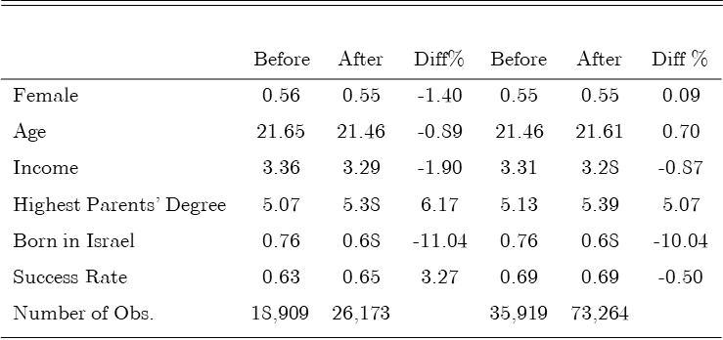

Table 2: Descriptive Statistics - Success Rate Type of Questions, Gender and Before and After the Change

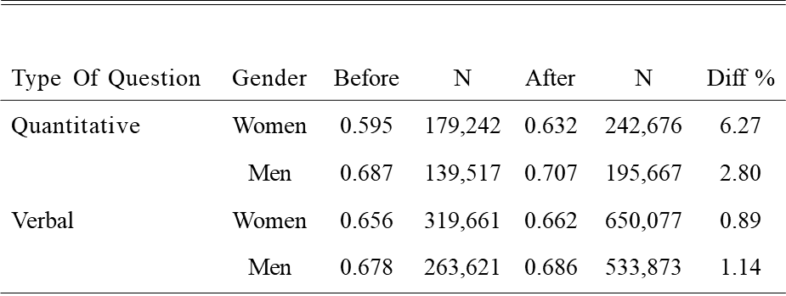

Table3: Question Success Rate and form of Address (quantitative questions)

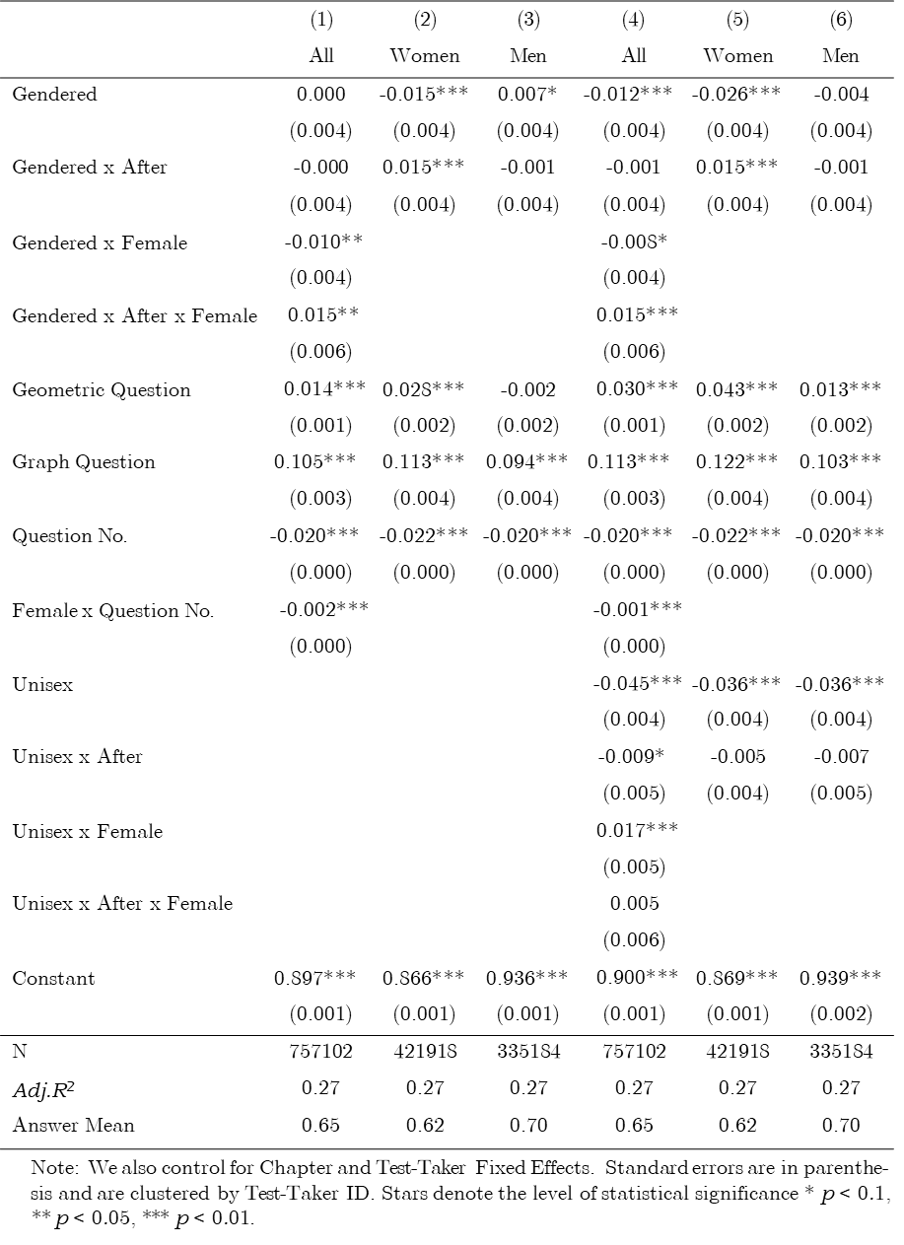

Table4: Robustness Tests

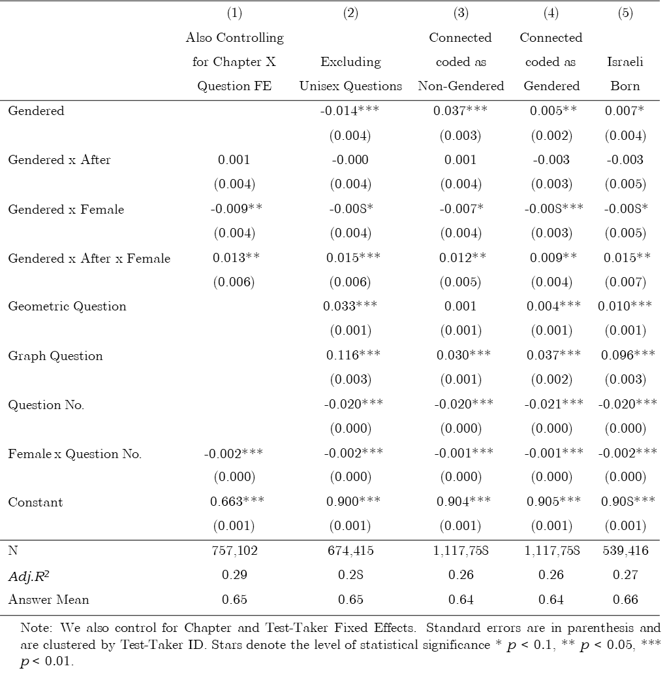

Table 5: Success Rate and form of Address (Verbal Questions)

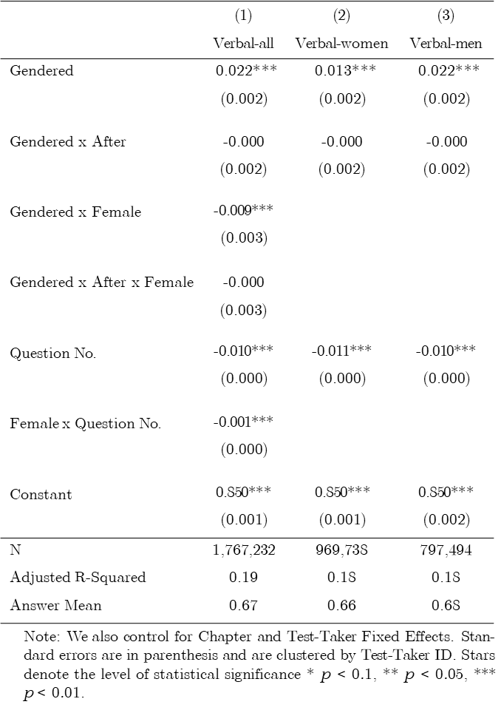

1. * Harvard Law School, Tel-Aviv University Berglas School of Economics, NBER, CEPR, and ECGI.
2. ** Israeli National Institute of Testing and Evaluations (NITE).
3. *** Tel Aviv University Buchman School of Law.
4. **** Reichman University Tiomkin School of Economics.
5. In particular, outcomes in an experiment might be influenced by participants’ recognition that they are taking part in in an experiment, and lab experiments usually cannot fully simulate real-world settings.
6. Exceptions include Estonian, Finnish and Hungarian that all have neither a grammatical gender nor gender-specific personal pronouns.
7. For example: *write* is spelled and pronounce K’tov for a man and Kitvi for a woman, and *answer* is spelled and pronounced Ane for a man , and Ani for a woman.
8. *Write* in plural masculine is spelled and pronounced Kitvu, and *answer* in the plural masculine is spelled and pronounced Anu.
9. For example, you must is spelled the same in Hebrew for both men and women but pronounced differently, Alecha for a man and Alayich for a woman.