The Human Eye

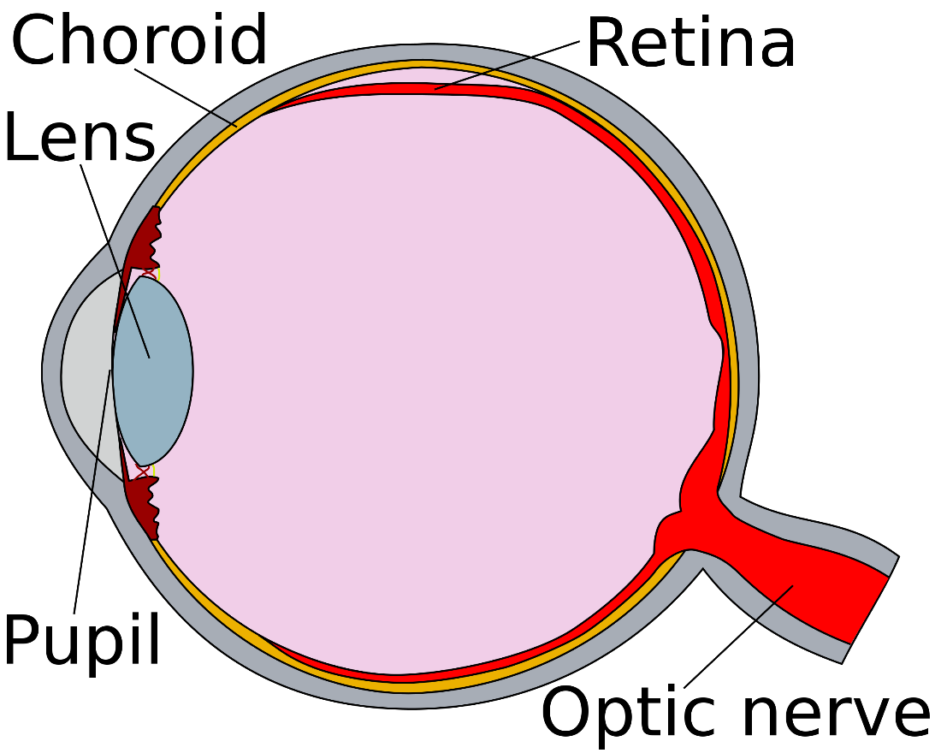
Cornea
Retina
Lens
Cornea
Pupil
Optic nerve

Pinhole Camera
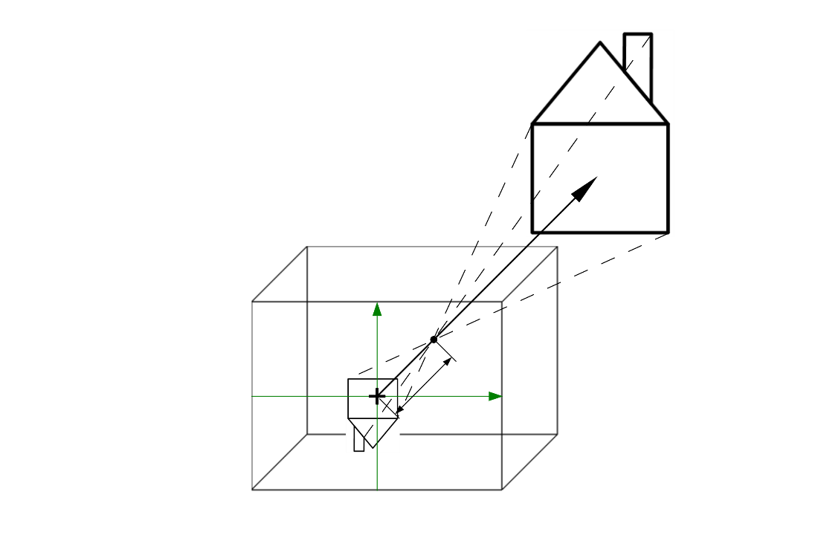
Camera Objective with Different Lenses
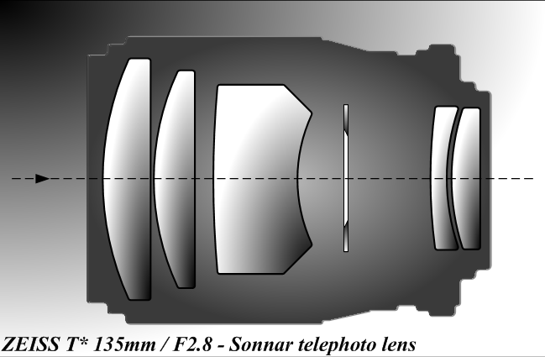

Camera Mechanisms and Image Influence
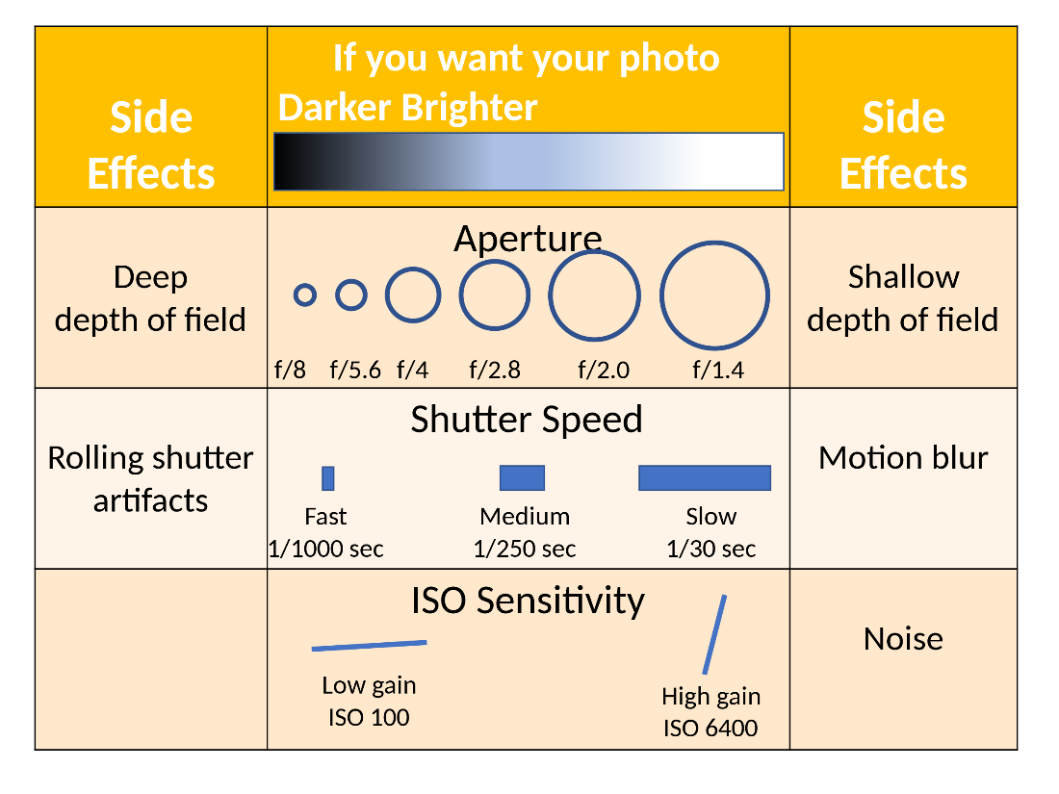
Side effects
Deep depth of field
If you want your photo
Darker
Brighter
Aperture
Shallow depth of field
Fast
Medium
Slow
ISO sensitivity
Motion blur
Low gain
High gain
Narrow Angle of View of a Camera
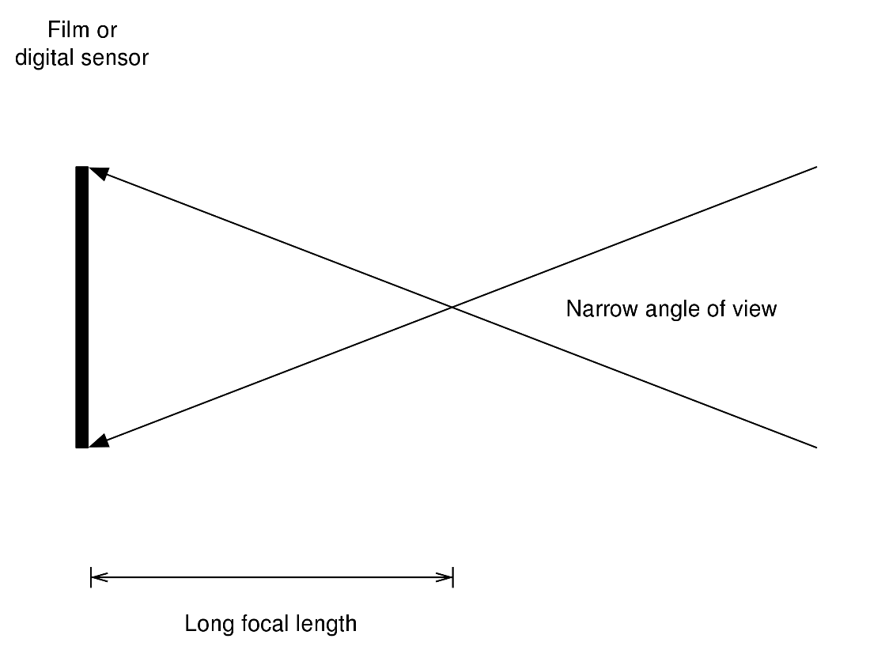
Film or digital sensor
Narrow angle of view
Long focal length

Wide Angle of View of a Camera
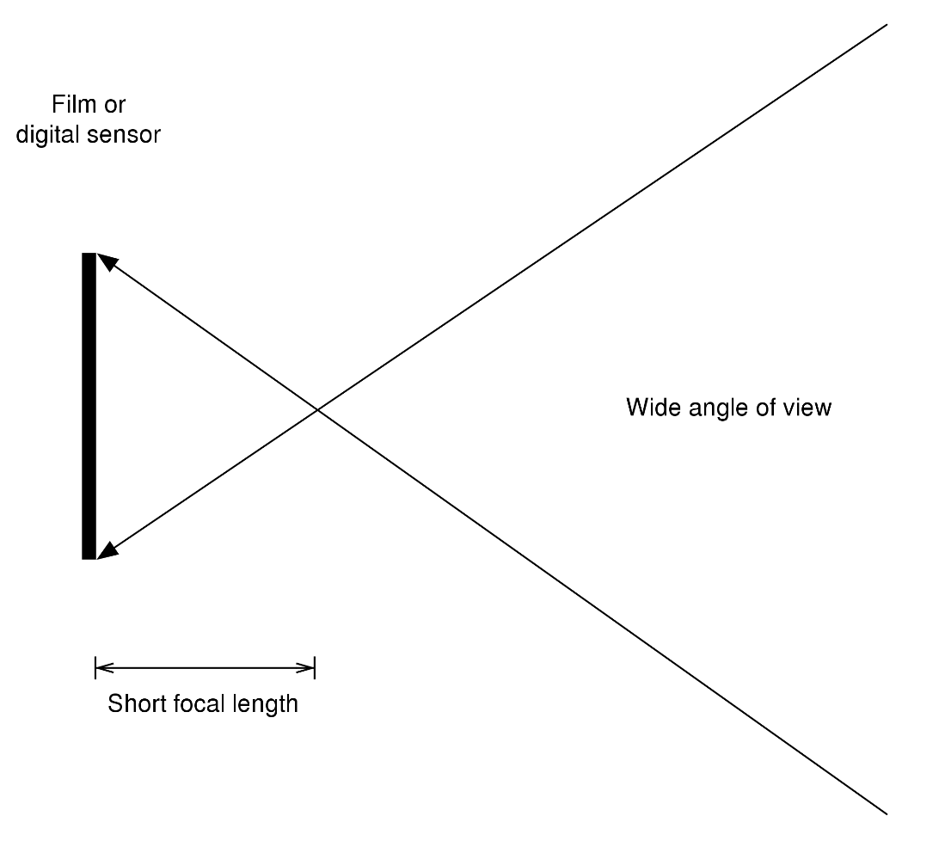
Film or digital sensor
Wide angle of view
Short focal length

Demosaicing of a Raw Image


Bayern Pattern and Corresponding Filter
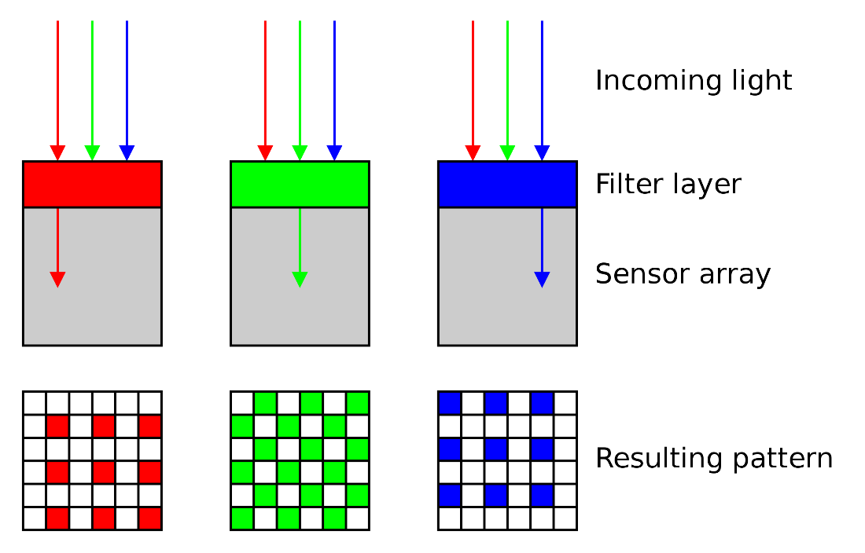
Incoming light
Filter layer
Senor array
Resulting pattern

Bayern Pattern and the Sensor


RGB Cube
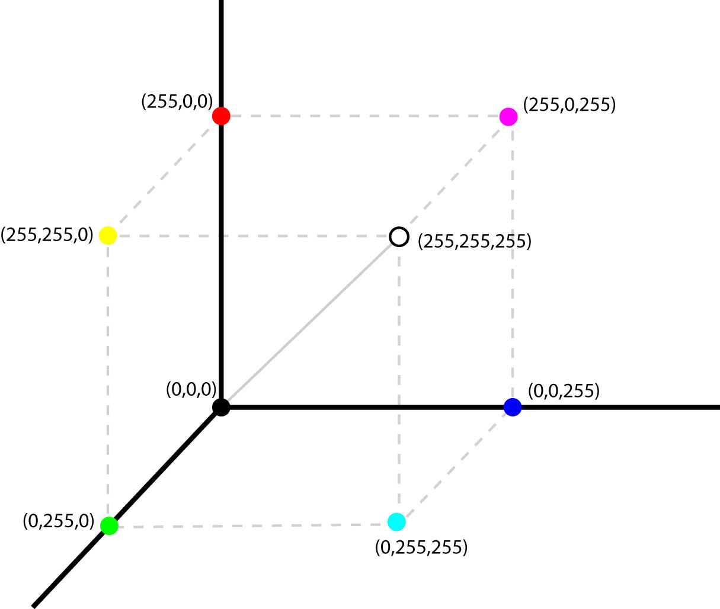

RGB Cube - Mixture of the Different Colors
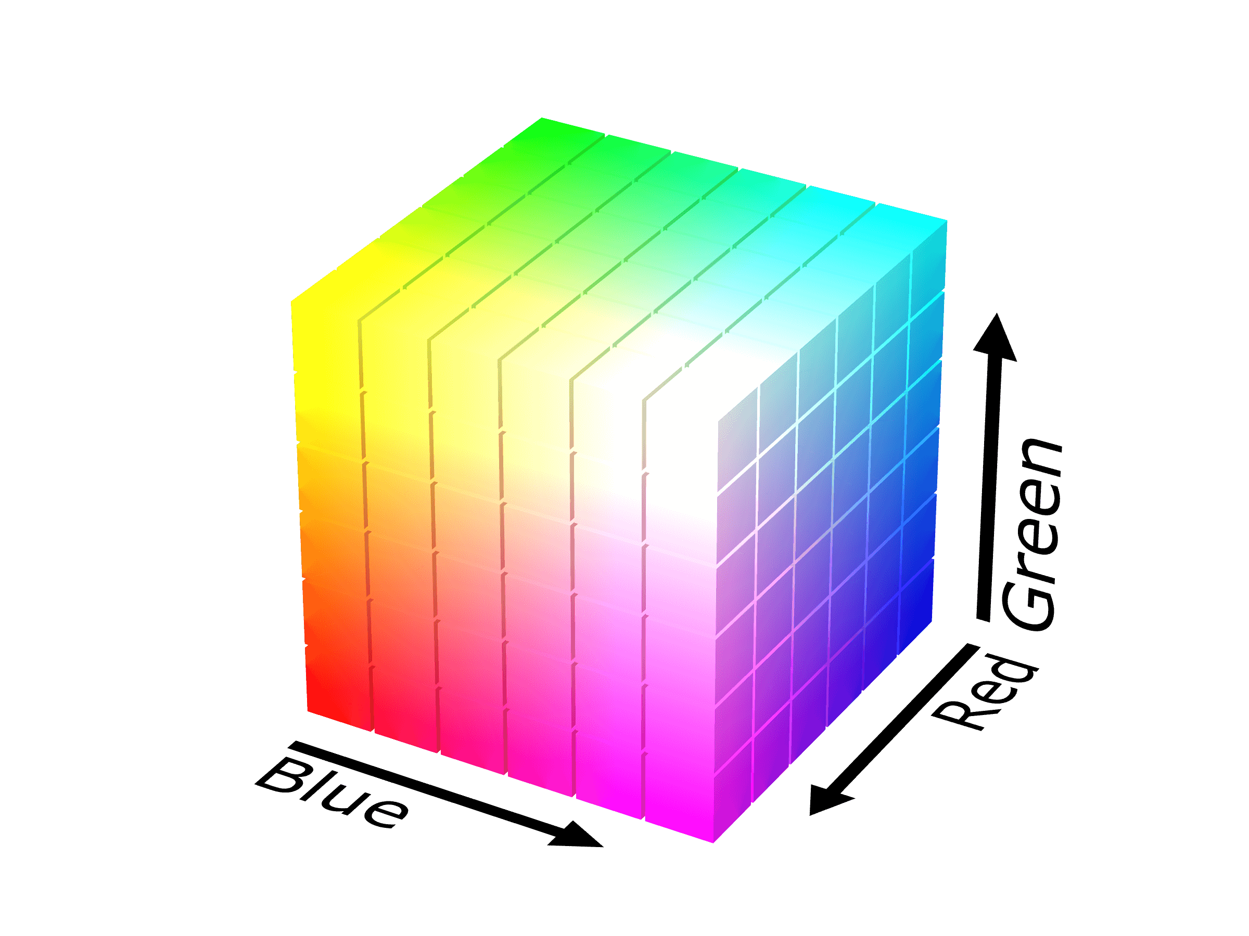
Red
Blue
Green

Samples of the MNIST Dataset
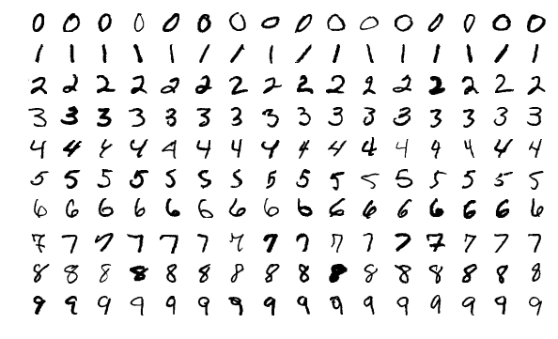

Example Array for the Circle of the Number Nine in Grayscale
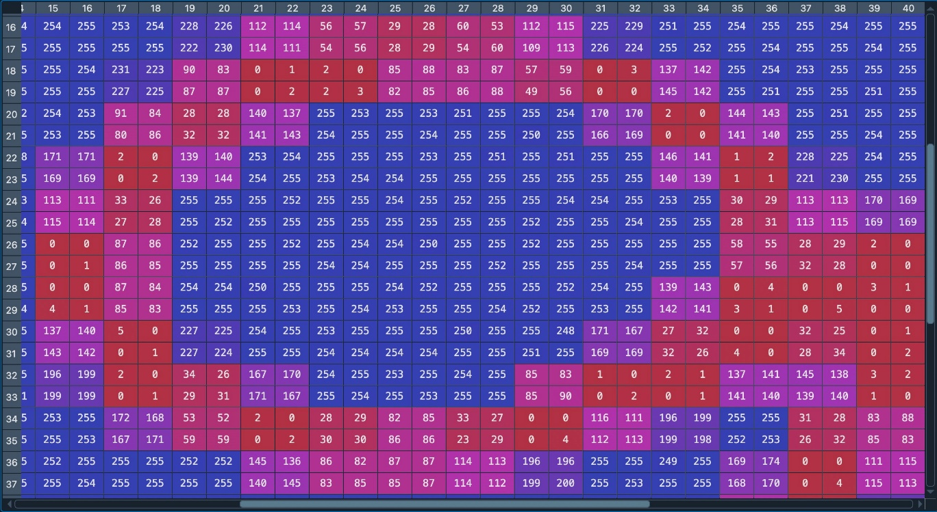

The Circle of the Number Nine in Grayscale
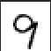
Salt and Pepper Noise
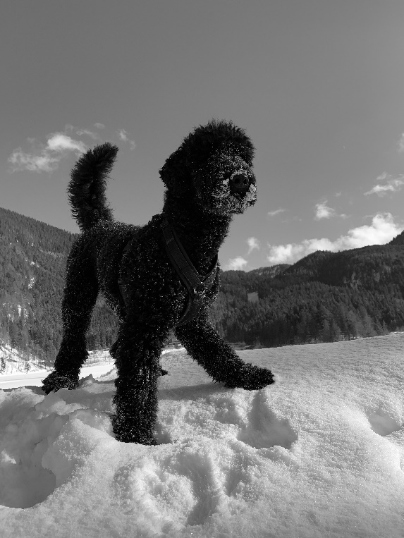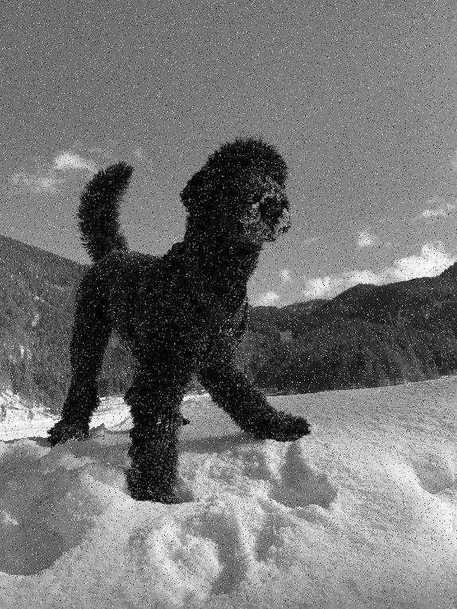
A Shift Invariant Linear System
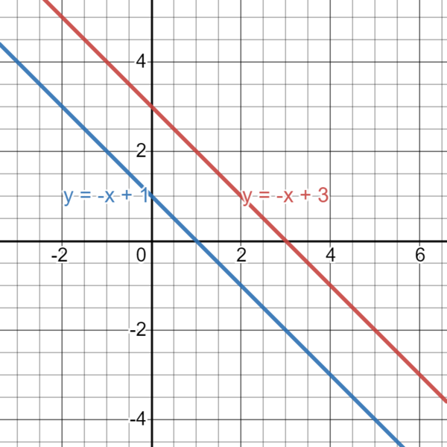

Illustration of a Convolution
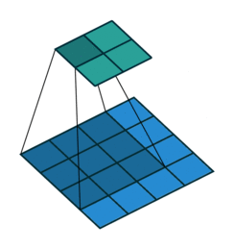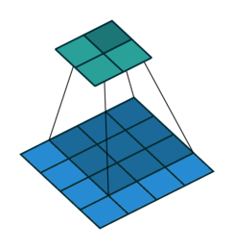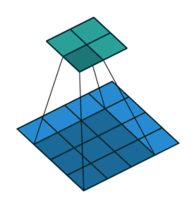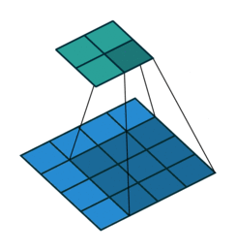

Convolution of Image Pixels

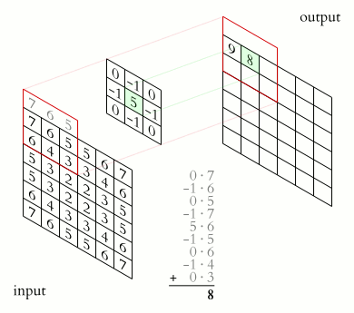

Input
Output

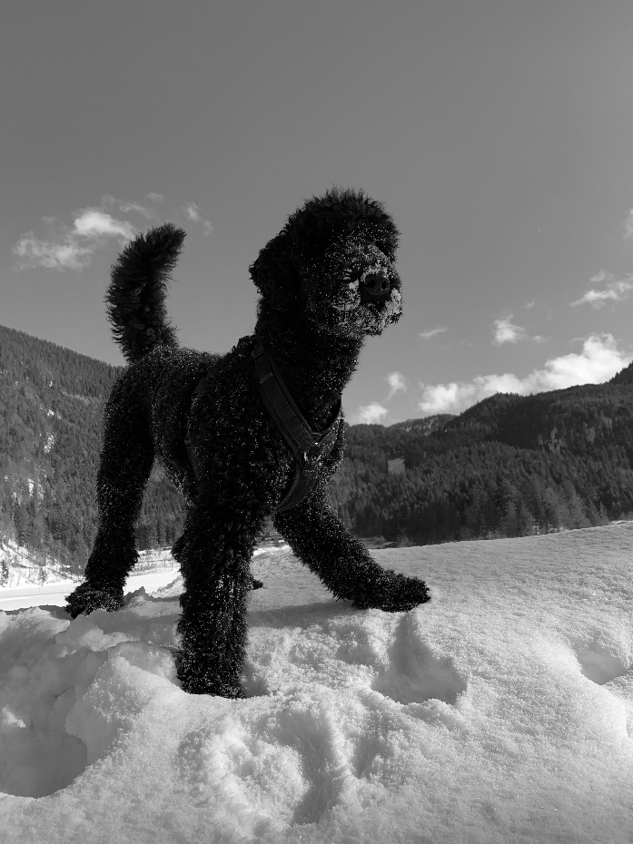
Applying a Convolution filter on Sirius the King

Illustration of Ground Truth
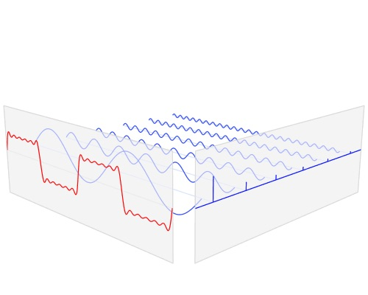

Illustration of Gaussian Distributions
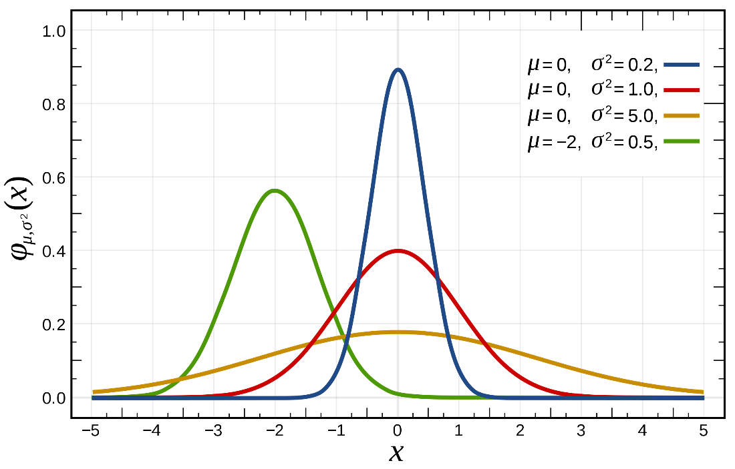
Illustration of the 2-Dimensional Gaussian Distribution
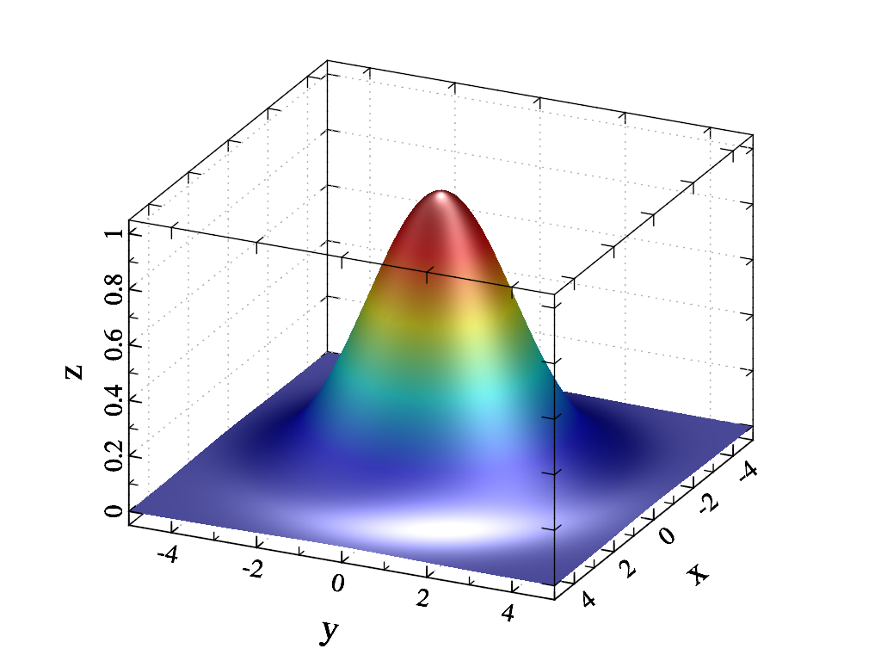

Application of Gauß Filter to Salt and Pepper Noise
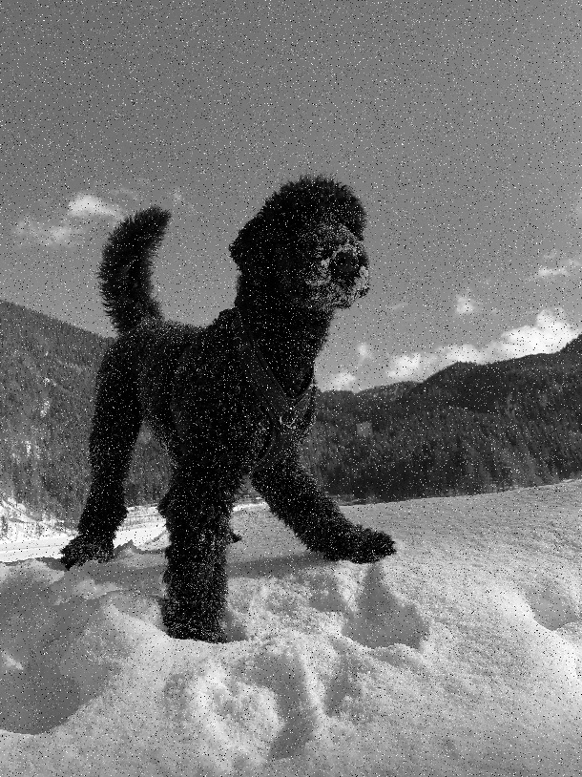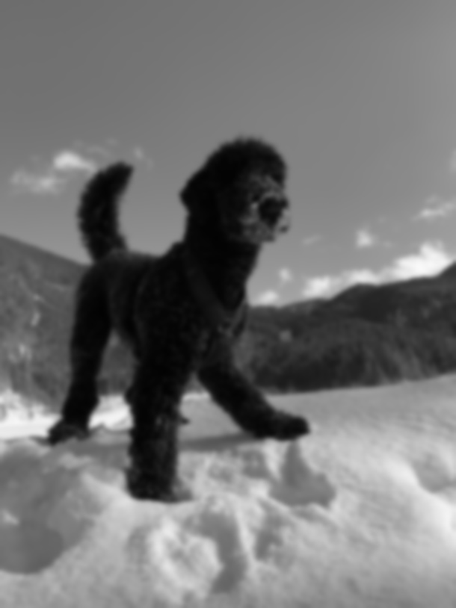

Mode of a Continuous Gaussian Distribution
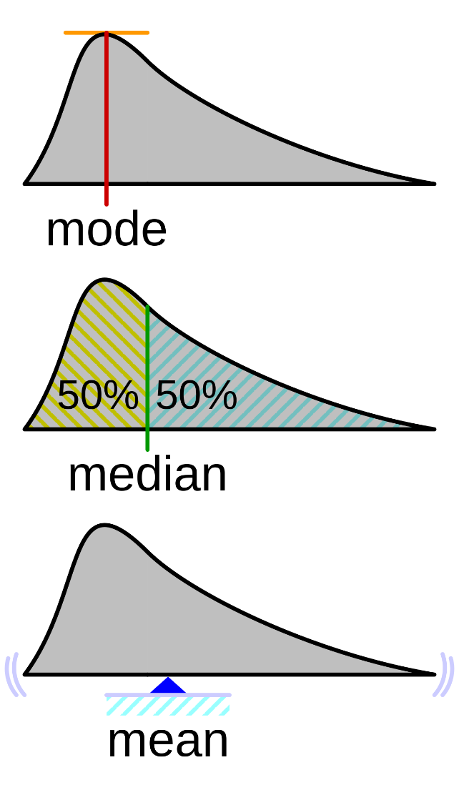
Mode

Application of Mode Filter to Salt and Pepper Noise
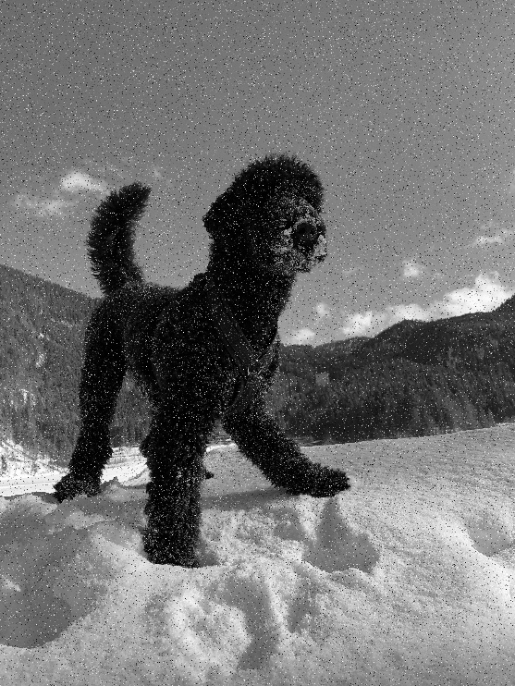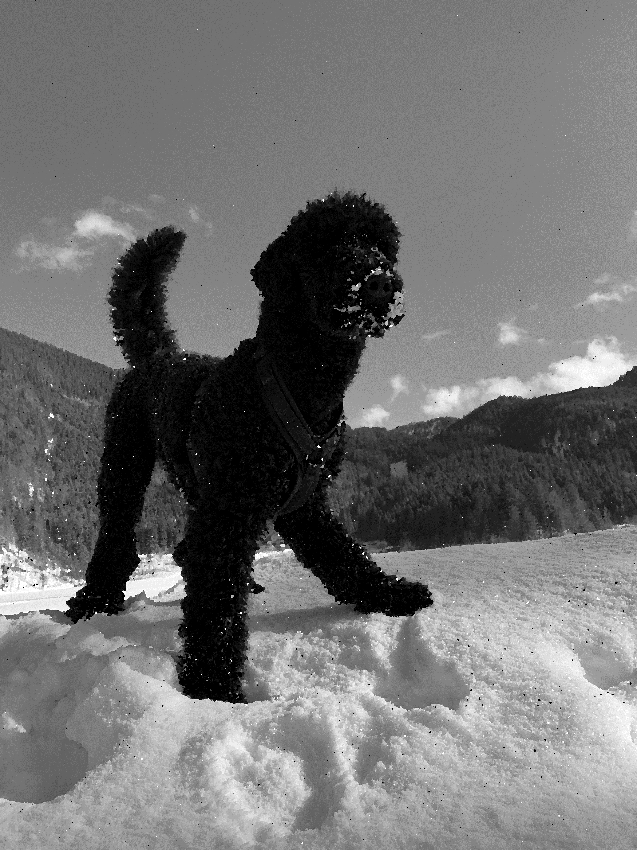
Illustration of a Median Filter Application with a 3x3 Size
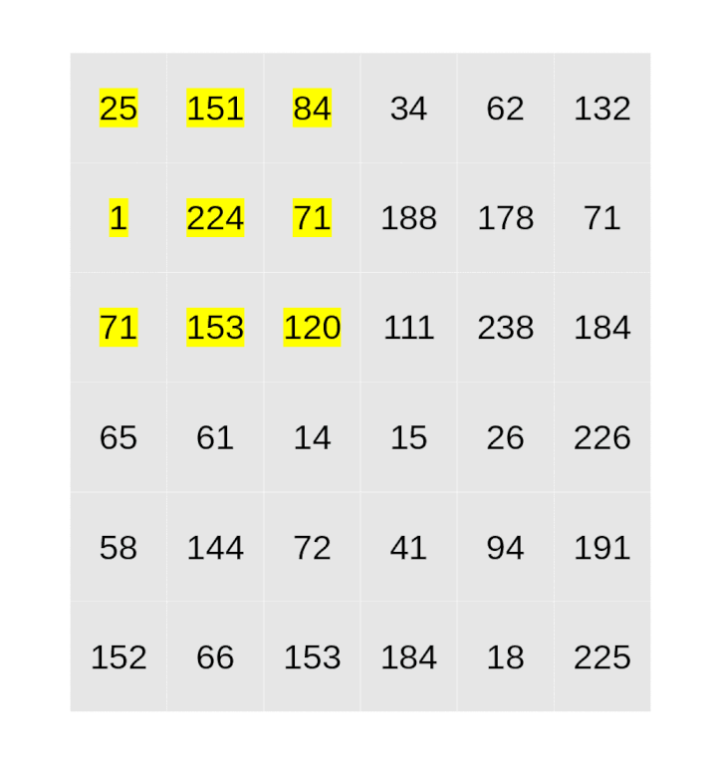
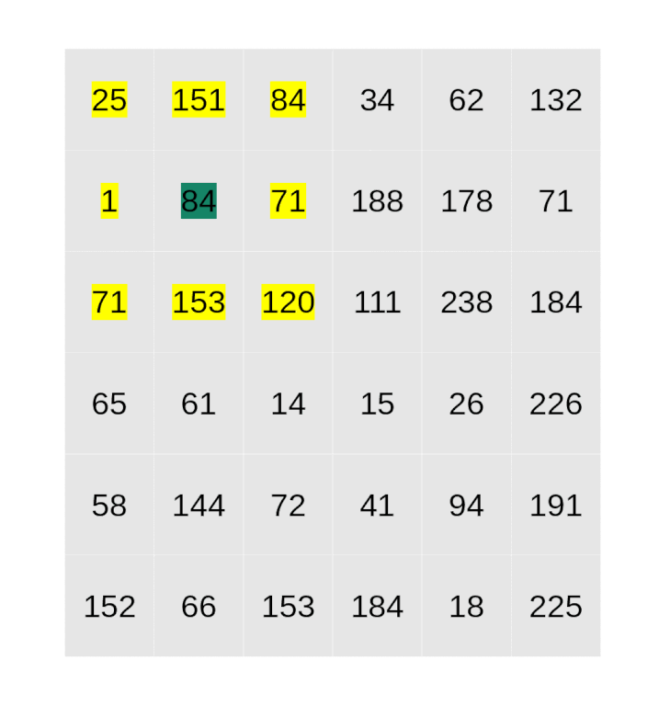

Application of Median Filter to Salt and Pepper Noise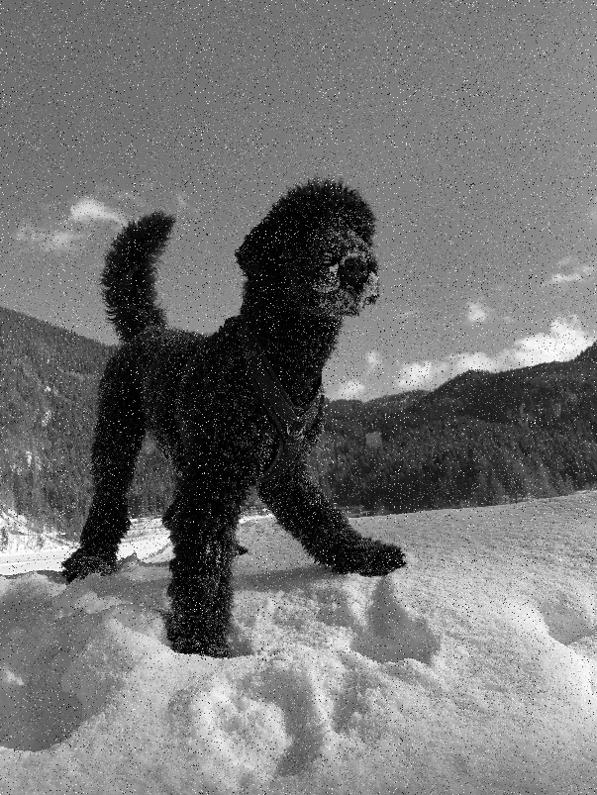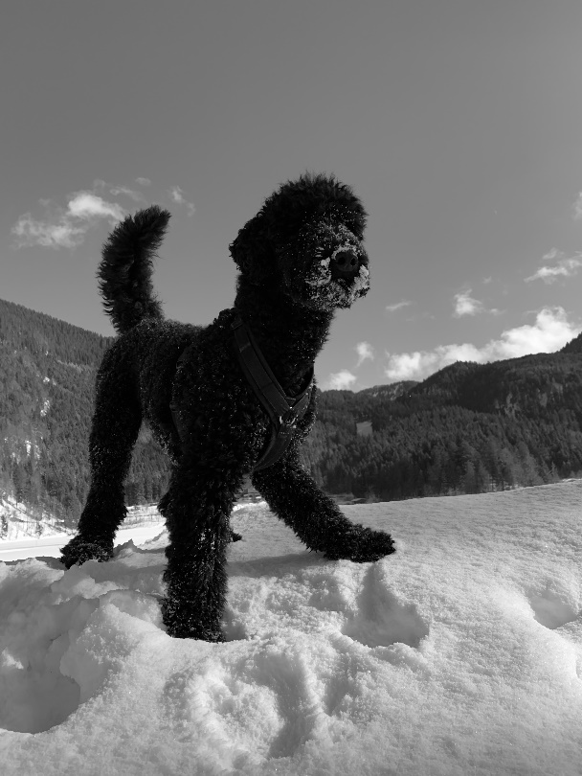
Application of Difference of Gaussian
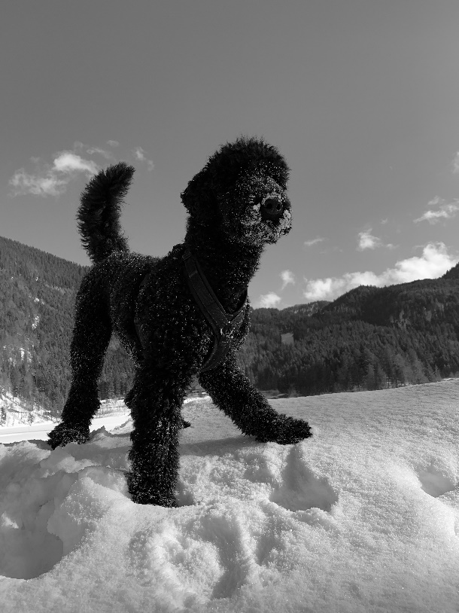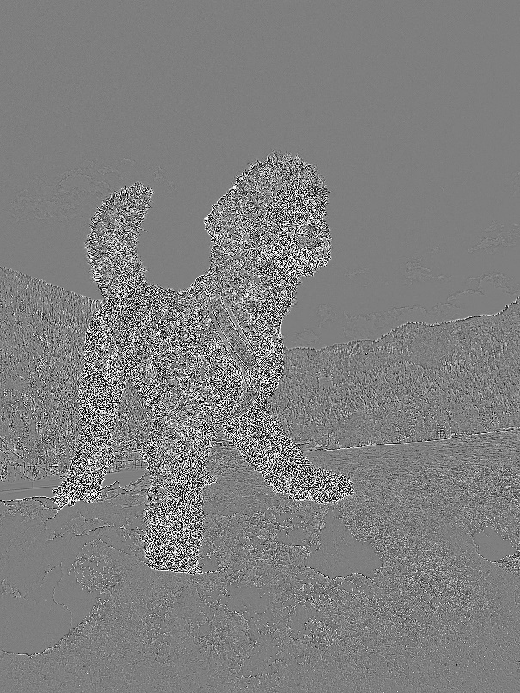

Characteristic Shape of Euclidean and Non-Euclidean Geometric Shapes
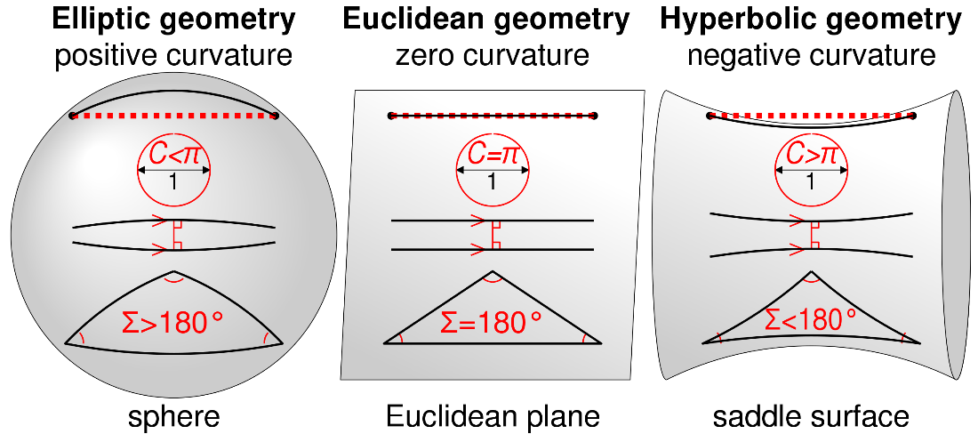
Elliptic geometry
Positive curvature
Sphere
Euclidean geometry
Zero curvature
Euclidean plane
Hyperbolic geometry
Negative curvature
Saddle surface

Illustration of Hough Transformation

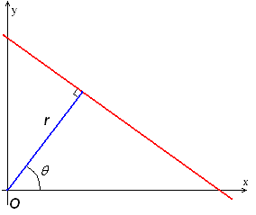

Example of Edge Detection for Medical Imaging
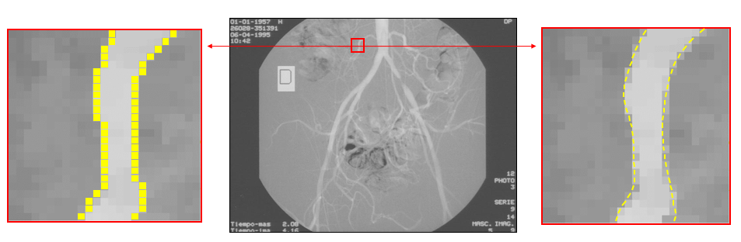
SUSAN Illustration
In this part of the mask, the pixels have different brightness to the nucleus.
In this part of the mask, the pixels have the same brightness as the nucleus.
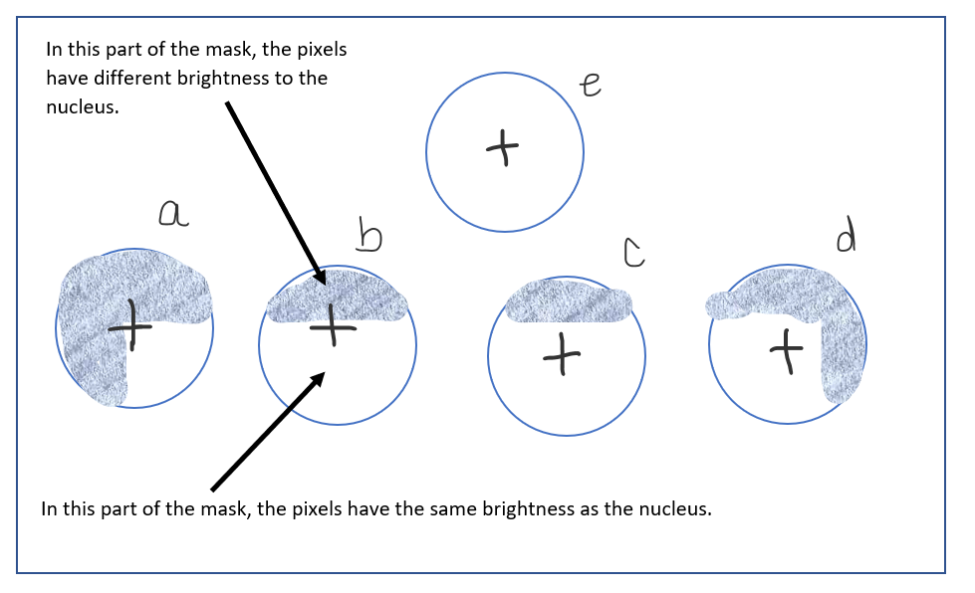

Typical Outcome of the SUSAN Corner Detection Algorithm
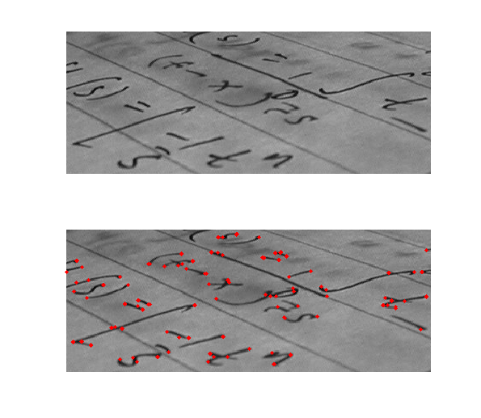
FAST Detector with the 16-Element Grid
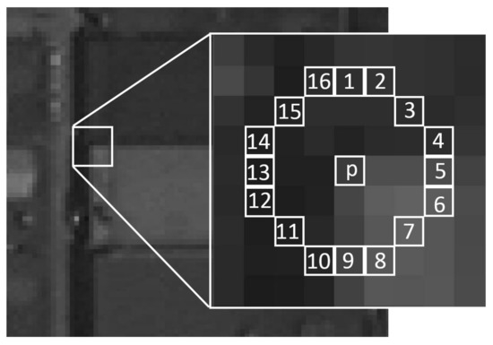

Example of FAST Algorithm

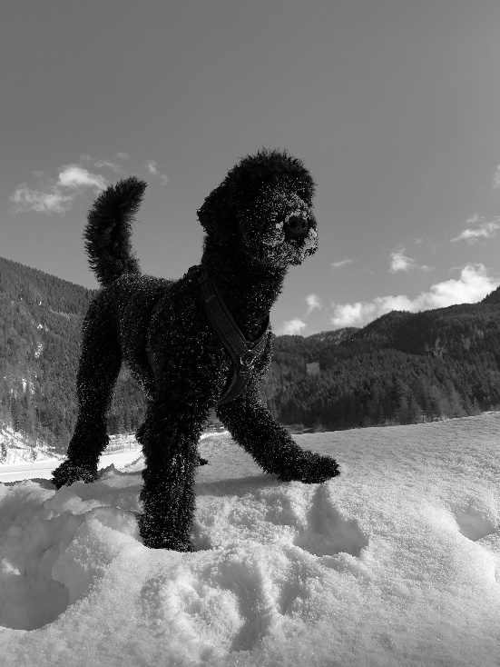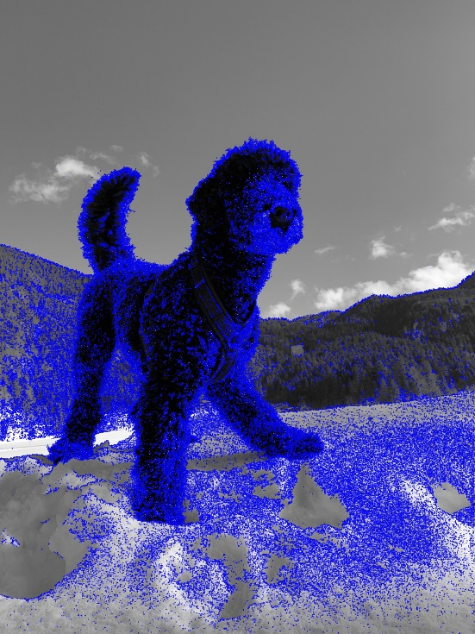

Example of Morphological Operations
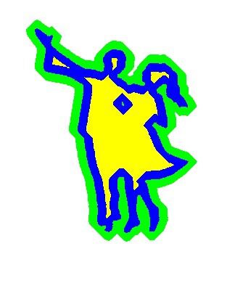

Example of a Neuron
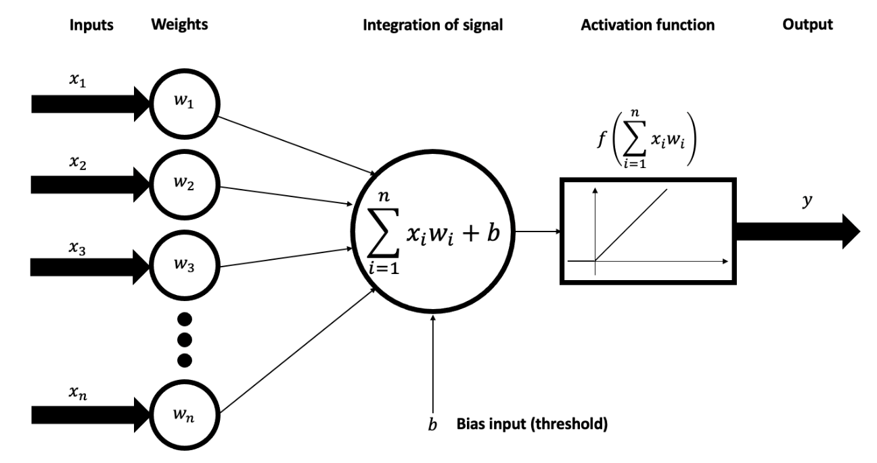
Inputs
Weights
Integration of signal
Activation function
Output
Bias input (threshold)

Activation Function RELU
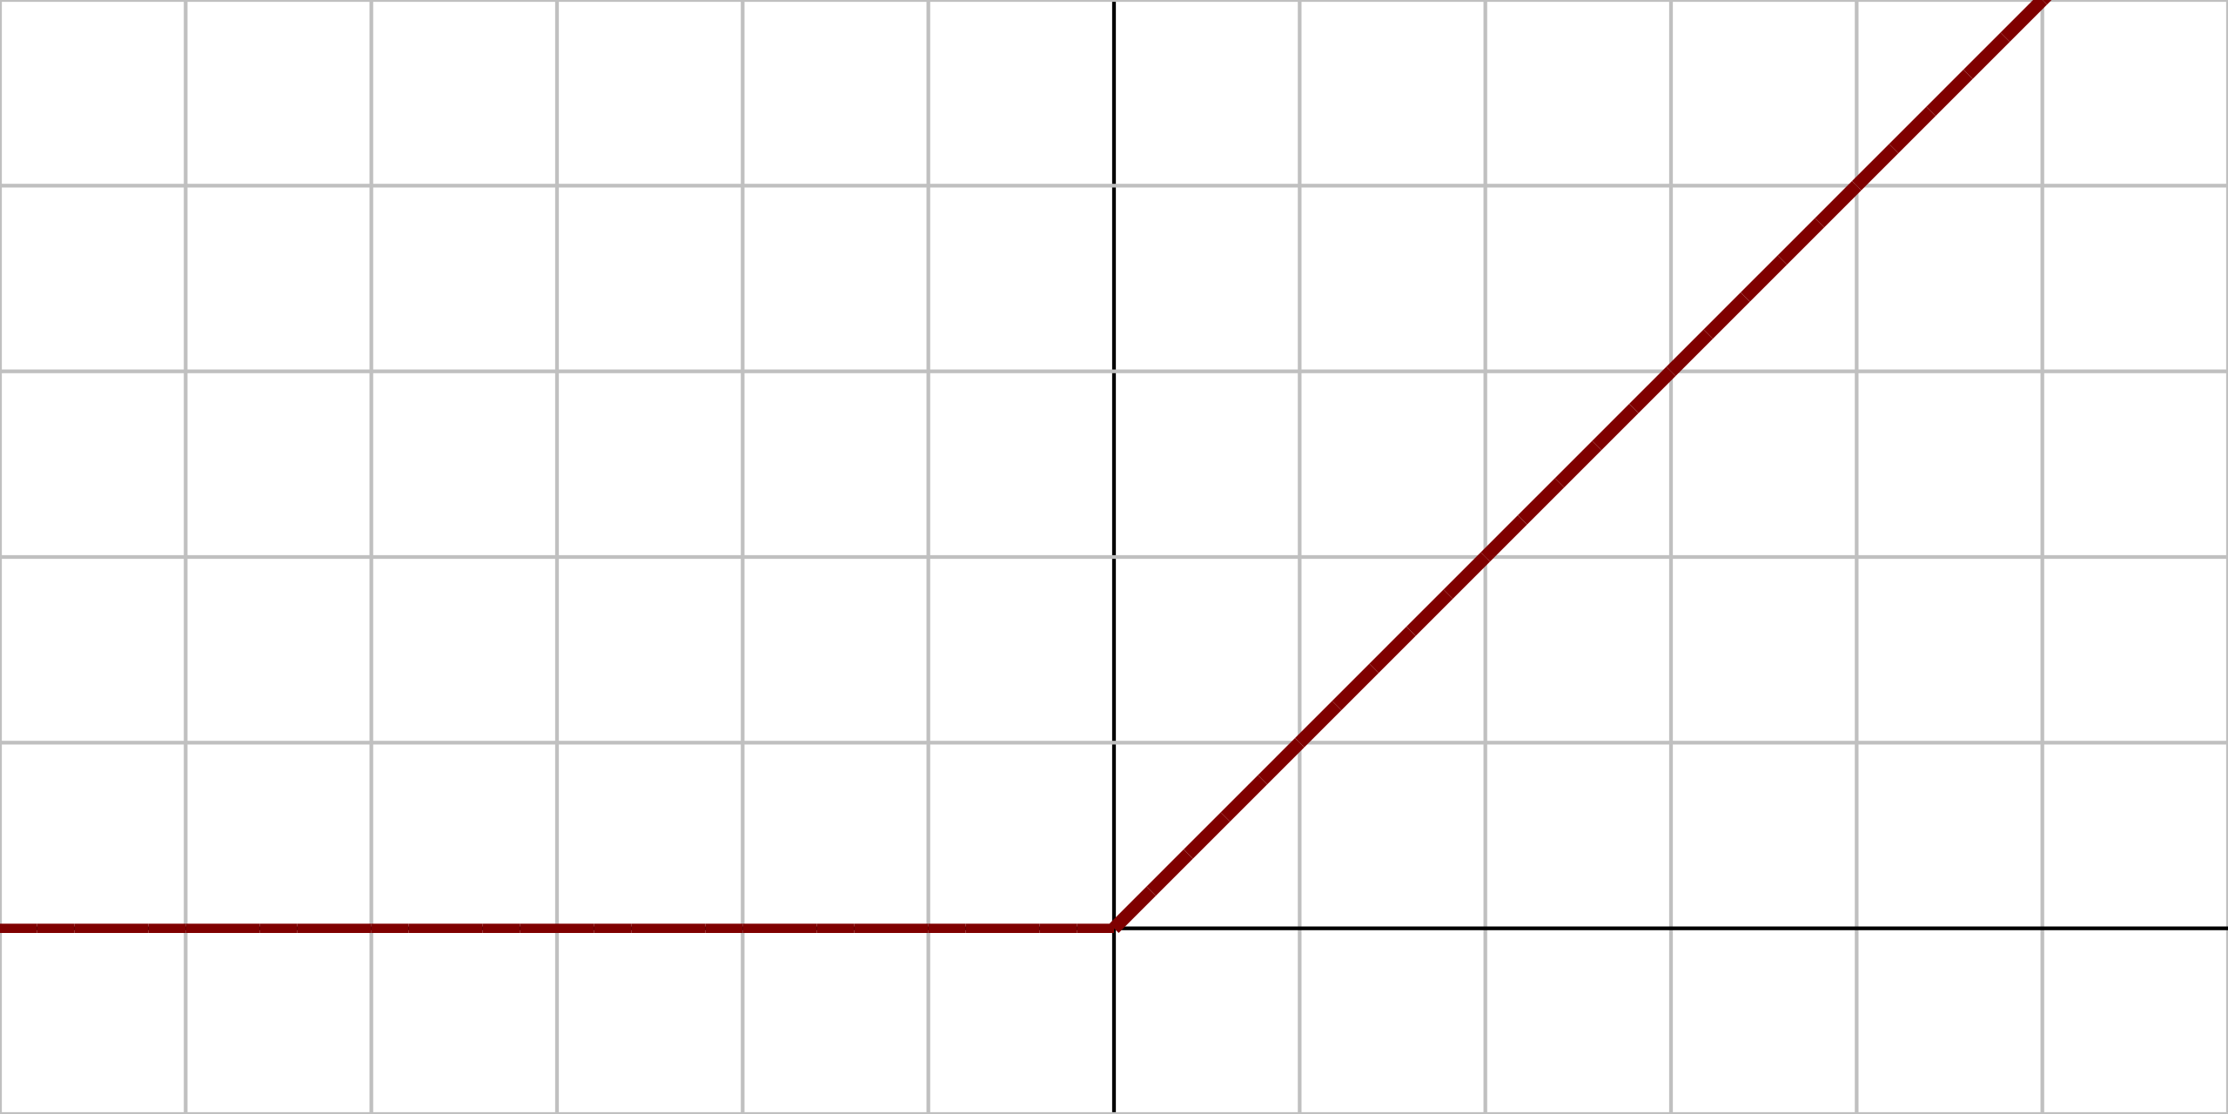

Activation Function Tanh
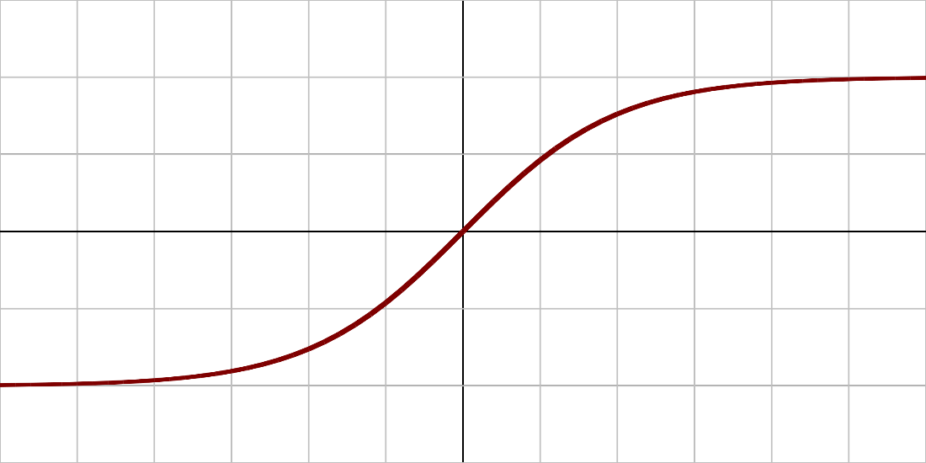

The Architecture of an ANN
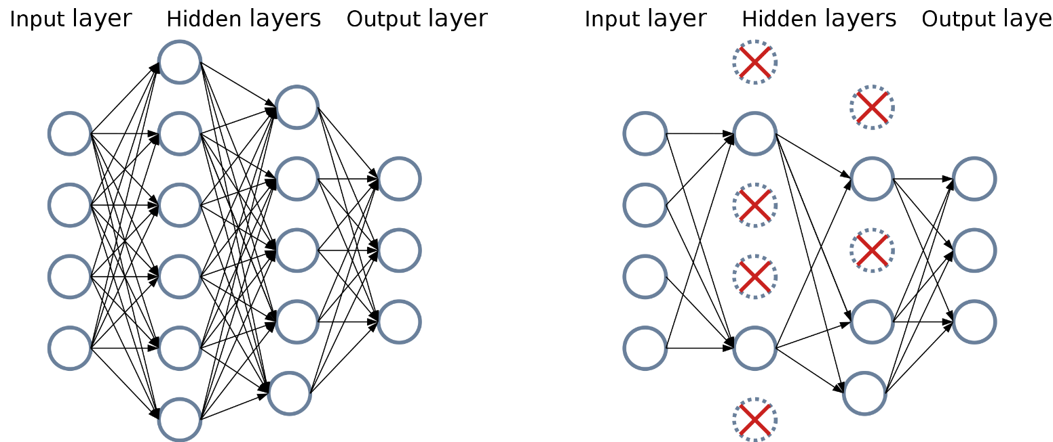
Input layer
Hidden layers
Output layer

Example of the Connection of the Different Layers in CNN
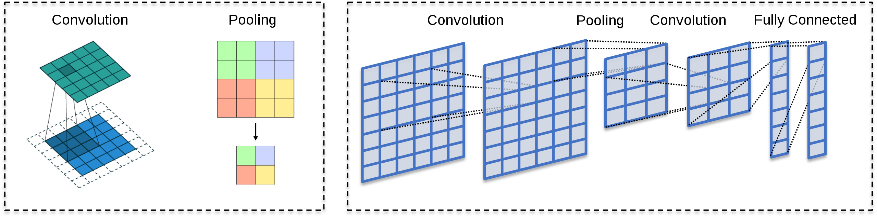
Convolution
Pooling
Fully connected

Example of a Convolution
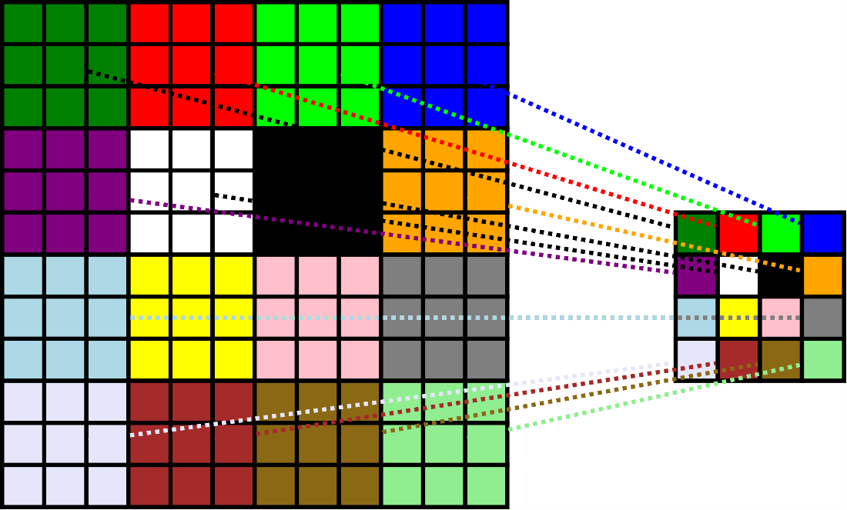

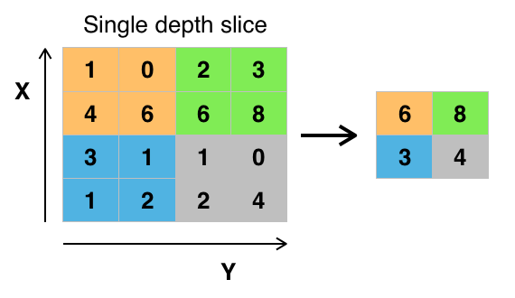
Example of Max-Pooling
Single depth slice

Illustration of How Dropout Works
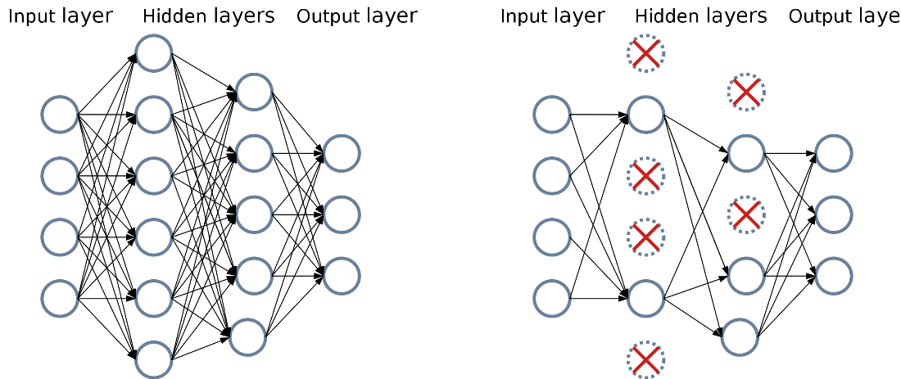
Input layer
Hidden layers
Output layer

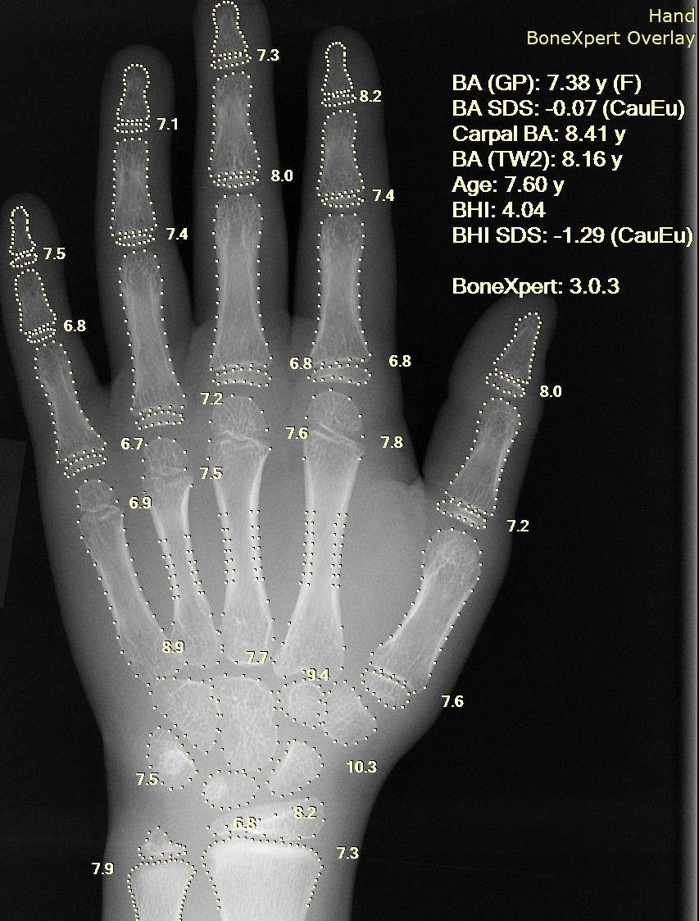
X-ray of a Hand with Automatic Calculation of Bone Age

Results Shown by the Image Searcher Through Example GOS
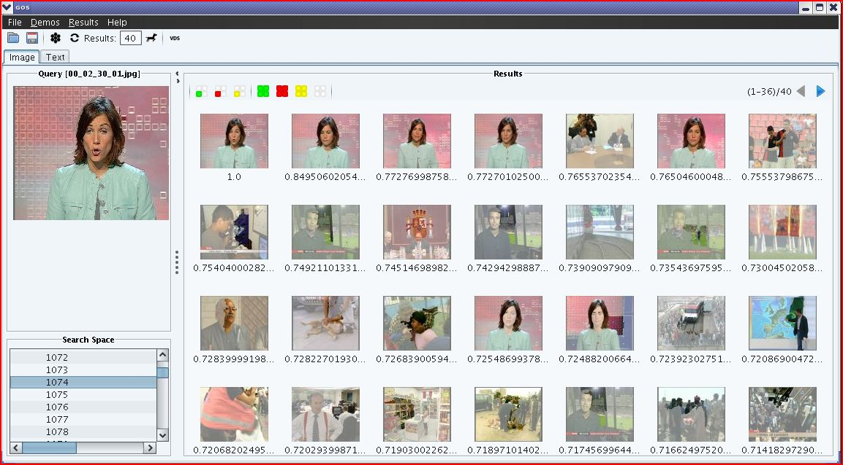

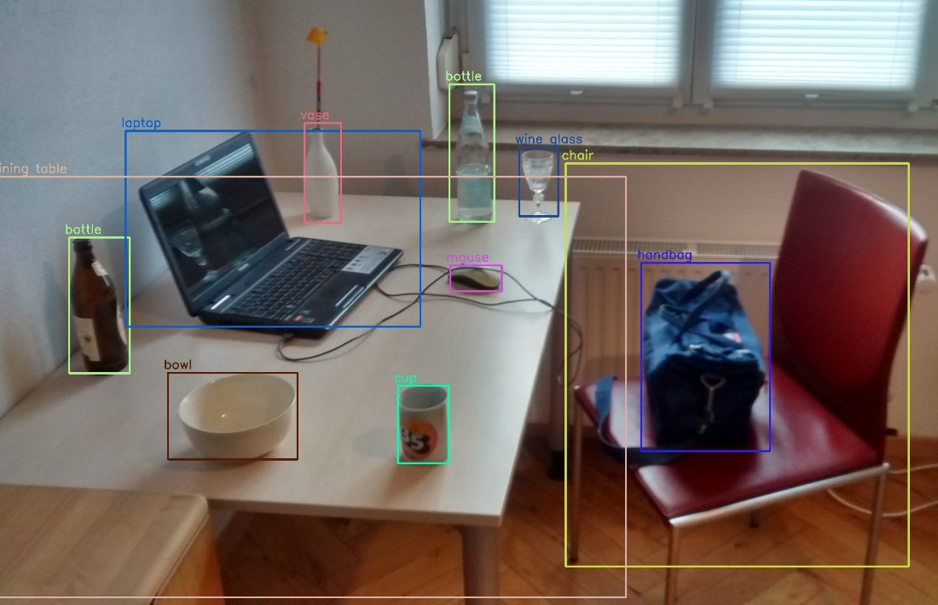
Objects Detected with OpenCV's Deep Neural Network Module

Example of an Image Segmentation – Original Image


Example of an Image Segmentation – Segmented Image
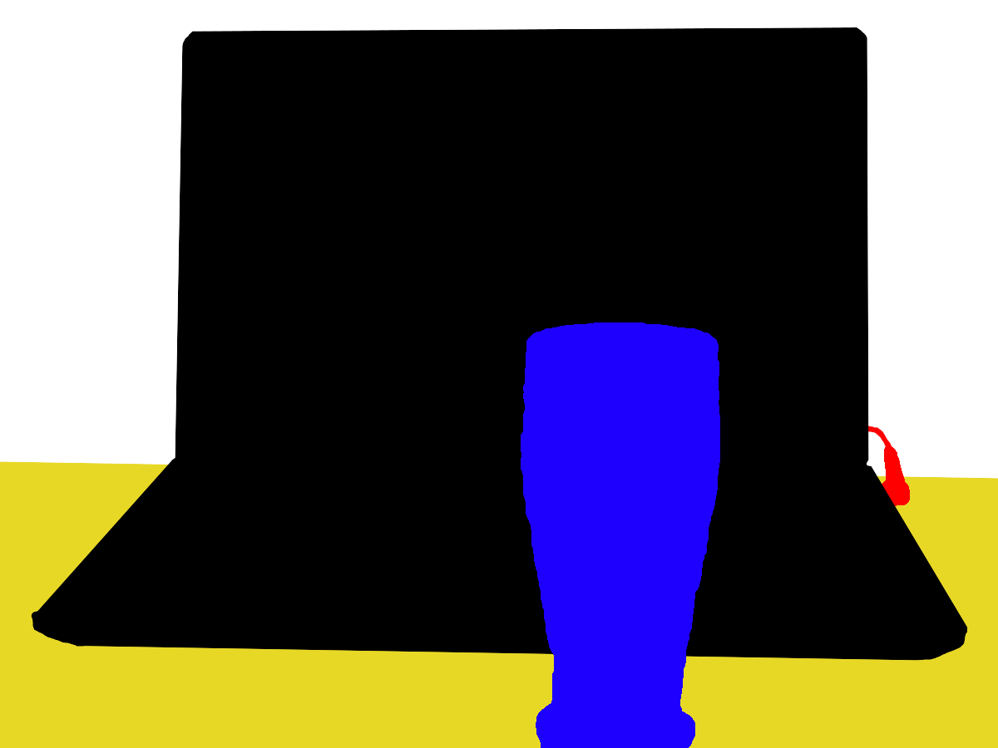

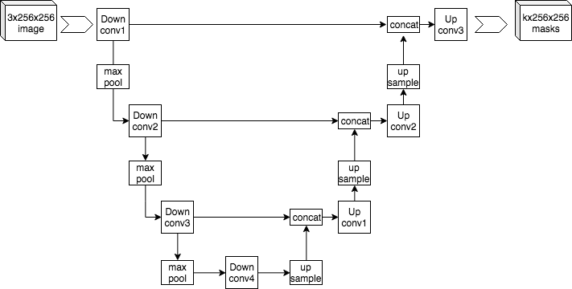
Example Architecture of U-Net
Image
Down conv
Up conv
Masks
Up sample
Max pool

Atrous Convolutional with Rate r=2
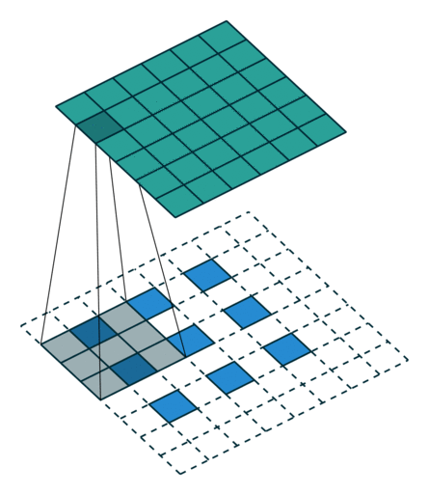

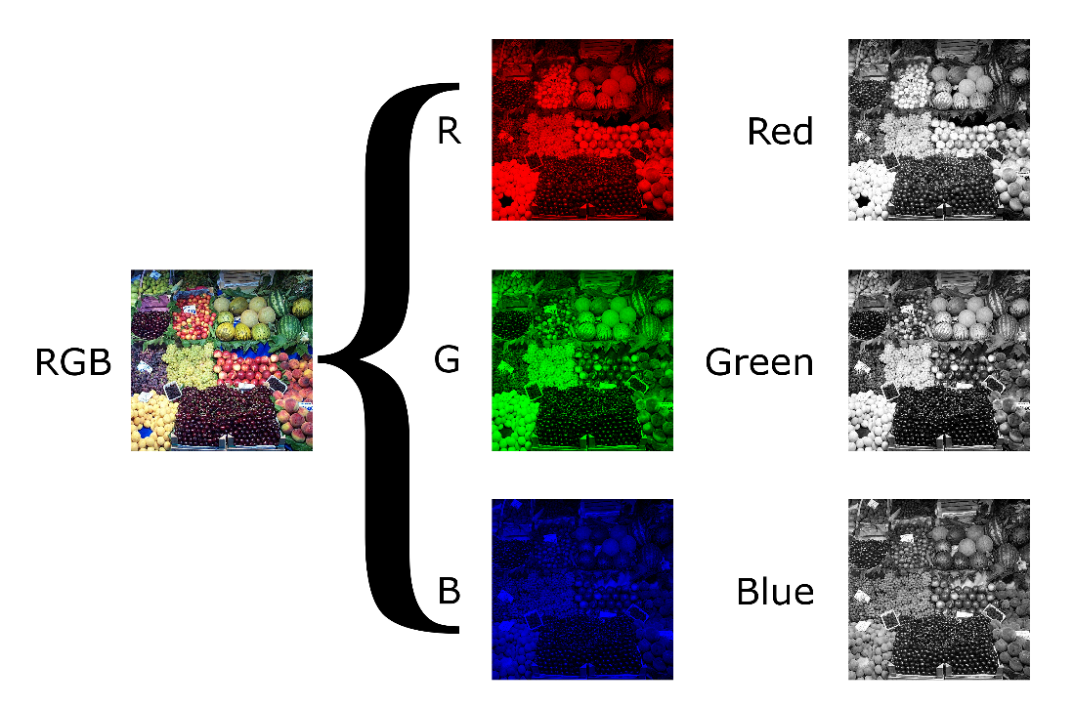
Example of How a Single Frame is Split into its RGB Channel
Red
Green
Blue

Example of Optical Flow
