IU

Introduction to Computer Vision
DLBAIICV01

Learning Objectives
Computer Vision refers to the process and techniques involved in using computers to extract information from a picture and video. The data is used to simply determine objects, to recommend specific actions, and even to achieve complex actions, like driving cars autonomously. Giving computers this ability allows them to expand their application area. Autonomous cars, quality verification in production, and face recognition are just a few examples that can be achieved with computer vision. Every day, more and more companies are discovering new ways to use computer vision and this field is becoming increasingly attractive. This course book will introduce you to the fundamental principles and techniques used in modern Computer Vision.
Introduction to Computer Vision will cover the important facts and key concepts surrounding image acquisition, both in humans, as well as technical systems. You will be able to describe the importance of filtering image processing and its practical applications. We’ll cover the role and function of lower-level features such as edges or salient points in vision processing. You also learn how deep learning methods are successfully applied in high-level vision tasks. Finally, this course book will cover the particularities of video processing and show you how to solve common problems related to the interpretation of video material.

Unit 1 – Vision Fundamentals

Study Goals

On completion of this unit, you will be able to …

… understand how the human visual system works.
… describe how a camera captures a scene and converts it into an image.
… represent a scene in a digital picture by numbers.

1. Vision Fundamentals

Case Study
You are learning about computer vision, and you want to train your computer to recognize the numbers of playing cards lying on your desk. For a human, this is a simple task, but for a computer, this seemingly simple task involves several aspects.
First, you will create the scene – playing cards on your desk – with numbers facing upwards. You recognize what you’re looking at right away, but a computer must be taught. Computers are super-fast at processing hundreds of millions of 0 and 1’s per second. You probably already know that images are represented by pixels, and each pixel has a numeric value. For example, a 12 MP camera has 12 million pixels in total.
Most smartphones can take colored images. Using your smartphone, take a picture of the cards on your desk. Next, upload the image to your computer, install python, install the OpenCV-python library, and read the image into a variable.
To help you understand the representation of the picture, take a close look at the variable. This results in a 3-dimensional array. Regardless of the colors on the cards, each dimension represents the colors red, blue, and green. And each dimension consists of two axes, x and y, which represent the location of the pixel. Each pixel thus has three numeric values, and those values define the exact color value of each pixel.

1.1 The Human Visual System
The visual system of humans consists of the components: cornea, lens, retina, optic nerves, and pupil, as shown in the following picture. The visual cortex is in the brain and processes the information obtained by the eye. (Rill et al, 2014).

The Human Eye

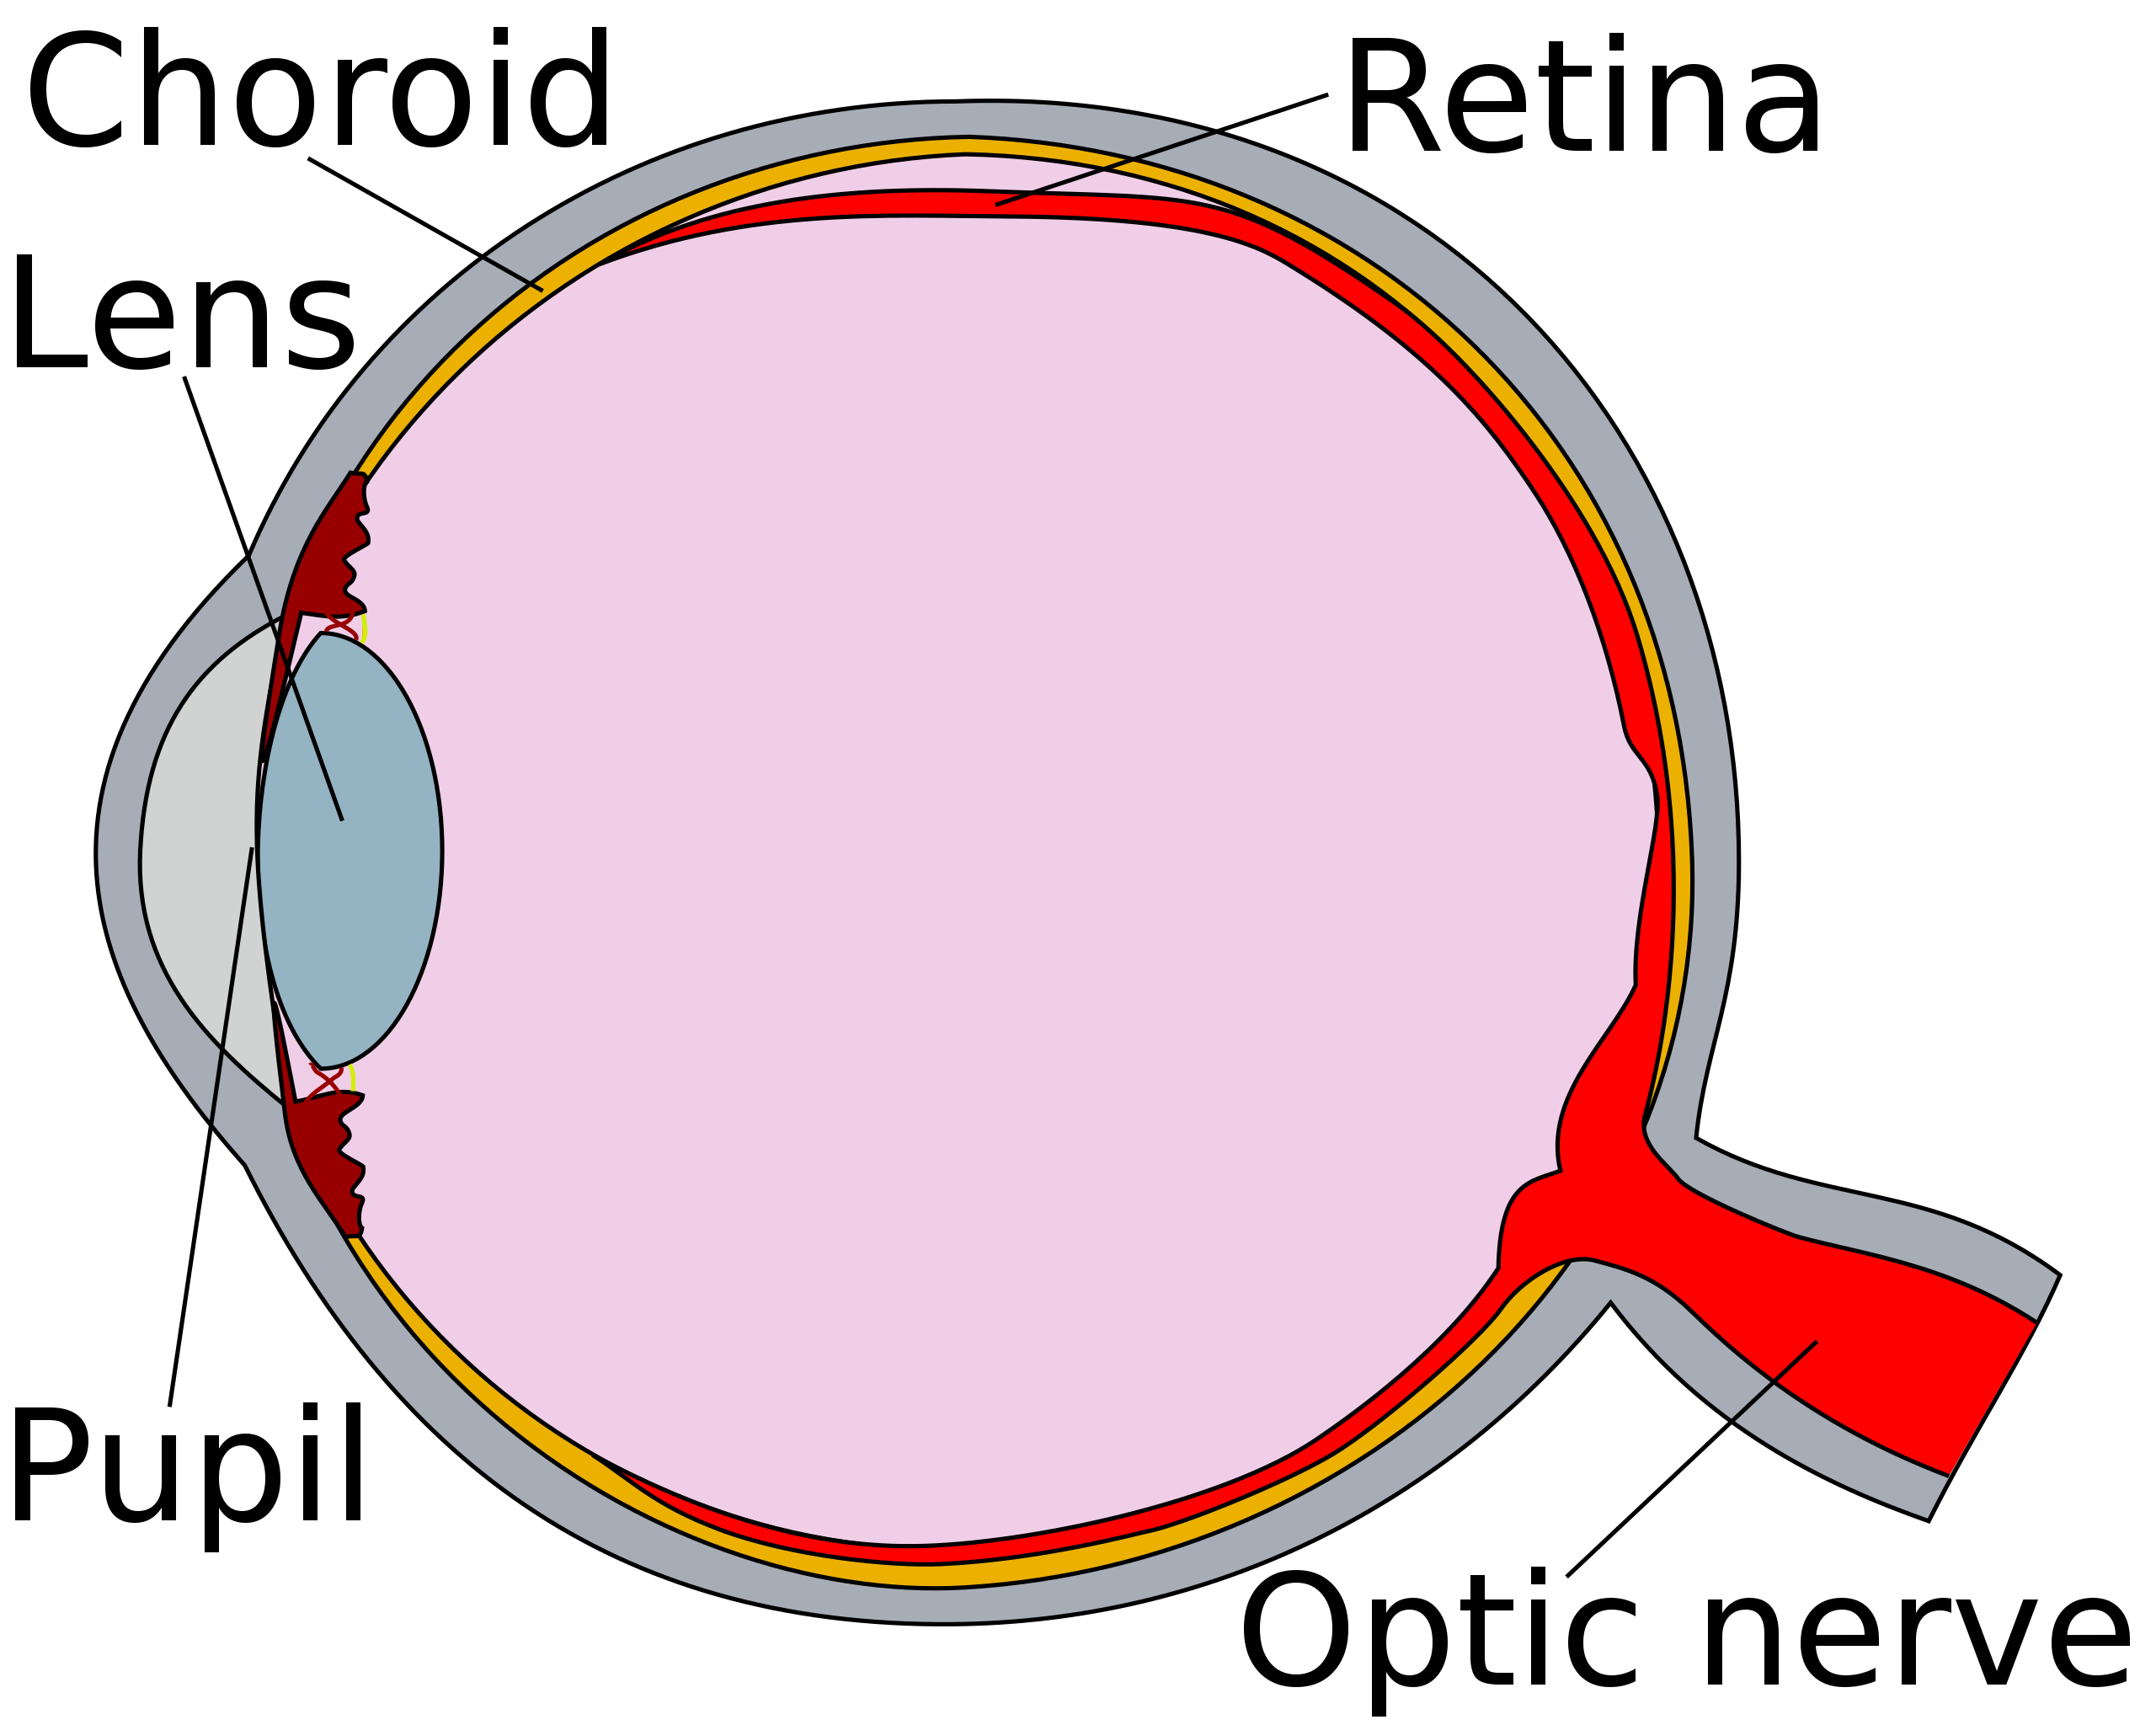
Cornea
Source: Based on Erin Silversmith (2019) CC BY-SA 3.0. https://commons.wikimedia.org/wiki/File:Human_eye_cross_section_detached_retina.svg

The first step in the optical system is creating an image on the retina. The structure and working of the component's cornea, lens, optic nerves, and pupil is complex and as described below:

Cornea
The hard white skin outside the eye is known as the sclera. The first transparent cover on the eye is known as the cornea, which is the extension of the sclera. This transparent cover is responsible for facilitating the continuous organization of collagen fiber layers that compose most of the thickness of the cornea. The outer part of the cornea, covered by a thin tear film, is maintained by the occasional closure of the eyelid that provides smooth refraction. The occurring differences in the tear film result in scattering and minor modifications in visual variability. The thickness of the cornea is about 0.5-0.6 mm.

Pupil
The pupil has two tasks within the human visual system. First, it limits the amount of light that reaches the retina and is responsible for altering the numerical apertures of the human eye imaging system. Greater pupil dilation does not necessarily provide the best image quality because of the aberrations and diffraction in the eye. The pupil size is not specific, but for the capturing of necessary spatial frequencies used by a human, the usual size of the pupil varies between the diameter of 2- and 8-mm. Acting as an aperture stop, the pupil lies between the lens and cornea, which means that changing the pupil’s size never affects the field of view.

Lens
The lens is positioned just behind the iris. See the figure above for an illustration. The optical power of the lens is measured in diopters. A diopter is a unit of the magnifying power of a lens. Diopters are proportional to one divided by the focal length. The focal length is the length between the lens and the fovea. A relaxed lens has the power of 20 diopters and with full accommodation, the lens has a power of 30 diopters. Accommodation refers to whether near or far away objects are focused and sharpened by the eye. The lens is placed next to the zonules near equators interlinked with the ciliary body. The contraction of ciliary muscles results in relaxing the tension on the zonules. Due to this, curvatures of the lens increase, accommodating the eye to focus on closer objects. With the relaxation of ciliary muscles, the tension on zonules also increases, thus flattening the lens and allowing the eye to focus on far things. The shape-changing ability of the lens reduces as the lens tends to harden with increasing age. Thus, combining lenticular and extra-lenticular factors, like an increase in lens size, aging of ciliary muscles, and last change in location for the insertion points of the zonules, can cause a condition called “presbyopia,” which is a loss of accommodation.
The lens comprises multiple layers of long lens fiber originating from the equator and are stretched towards the lens poles. The positioned crystalline layers in the lens have a continuous formation and growing procedure throughout life, with the increasing age factor. These developed suture patterns contribute to the rise of a crystalline lens with a gradient refractive index. In the case of simpler lenses, these gradient indexes of refraction determine with the help of spherical fish and mean optical lenses. But still, the exact gradient form of the human eye is unknown, while the index peaks in the center at 1.415 and drops off slowly first and then quickly near the surface to a value of about 1.37. (Atchison & Thibos, 2016). A gradual decrease has been observed in the ability of lenses to accommodate different object distances. In humans, the accommodation ability will diminish and be lost around the time the person reaches 60 years old.
Accomodation
The accommodation refers to the automatic adjustment, which allows the eye to seeing at different distances, is primarily achieved by changes in the convexity of the crystalline lens

Other Components
The opaque, fibrous, and protective outer layer of the eye is known as Sclera. It is responsible for continuous and direct connection with the cornea in front and the sheath covering the optic nerve from behind. The light-sensitive nervous tissues in the eye are known as the retina. They convert images from the eye’s optical system into electrical pulses and send them to the brain along the optic nerves for interpretation in the form of vision. It is a thin membranous lining consisting of a layer with two cells: cones and rods. In the case of a blind spot there are no cells as the nerves leave the eye at this point. The light-sensitive retinal receptor cells providing the day vision and color differentiation are known as cones. Rods are specialized retinal receptor cells that are light-sensitive and work at night vision and do not provide color. Rods are important for peripheral vision and to provide contrast.

Self-Check Questions

- Please mark the correct statement(s).
- The accommodation of the human visual system is inconstant over the years.
- The human eye can change focus between near and far away objects.
- Rods are necessary for obtaining color information.

1.2 Pinhole and Lens Cameras
The word camera derives from a Latin word called camera obscura. The translation for camera obscura is dark chamber. An ancient camera obscura is a dark room with an open hole. The light passes through the hole and the scene is projected on the other side on a flat surface. For the expression of modern photographic cameras, it has been analyzed that it evolved from camera obscura.

Pinhole Cameras
The explanation is based on Lord Rayleigh Sec. (1891). A box with a hole on one side is known as a pinhole camera that faces a well-lit scene. The scene is projected upside down by inverting from top to bottom and from right to left on the opposite side of the box. The change of the sides is caused by light always traveling in the form of a straight line. The light travels from the top of the scene to the bottom line of the projection and from the bottom of the scene to the top of the projection. Using the term “camera” sounds like one has a small device just for the cameras of the twenty-first century. Still, in the early centuries, most cameras were large. Spite, these were called cameras, but for capturing reproducible and permanent images, the technology was invented in the middle of the nineteenth century. The following illustration shows how pinhole cameras flip an image horizontally and vertically.
Pinhole Camera
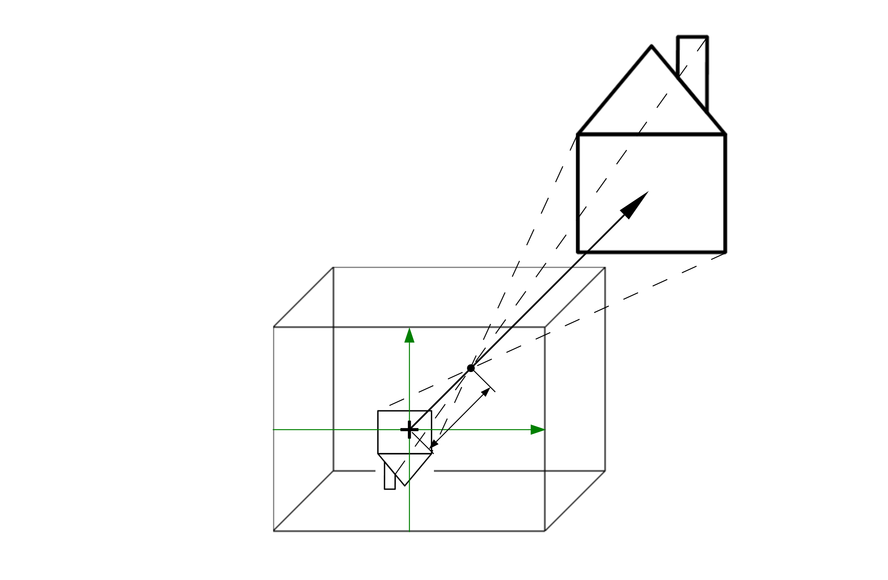
Source: Based on Olaf Peters, (2020). CC BY-SA 4.0
The main advantage of a pinhole camera is its simplicity. Since they do not have lenses, they are relatively inexpensive. Pinhole cameras do not require any lens to work and can cover many sizes. Whether small or discreet, pinhole cameras can be disguised into a wide range of other objects like headphones, glass frames, and even pens. This demanding advantage of their shape and size flexibility provides a variety of modern pinhole cameras with primary use in surveillance activities. Because of this covert feature, they are one of the perfect devices for recording videos, and images discreetly and closely. The main disadvantages of using pinhole cameras are that you cannot use them to study moving objects, and the obtained image is usually faint. It is not able to provide detailed information.
Pinhole Camera
This simple camera flips images on both the horizontal and vertical axis.

Lens Cameras
According to Szeliski (2022), cameras are optical instruments used for capturing scenes into images. In the basic levels, a sealed box called the camera body has a small hole called an aperture that allows the light to pass and capture the scene on light-sensitive surfaces. For the control of light falling on the light-sensitive surface, cameras have a variety of mechanisms. These cameras use a single lens or multiple lenses to focus the light of the object entering the camera. Regular lens cameras capture light from the visible spectrum, and specialized cameras can capture light from other portions of electromagnetic spectrums, for example, infrared. All cameras follow the same design: for light entering, positive/negative meniscus, or even biconvex and biconcave lenses are in an enclosed box that records the image on light-sensitive mediums called the sensor. The image below shows a combination of differently shaped lenses with light entering the camera from the left. On the right side of the image, the sensor is placed. The lenses are responsible for capturing light from objects and then focusing it on the sensor.
Camera Objective with Different Lenses
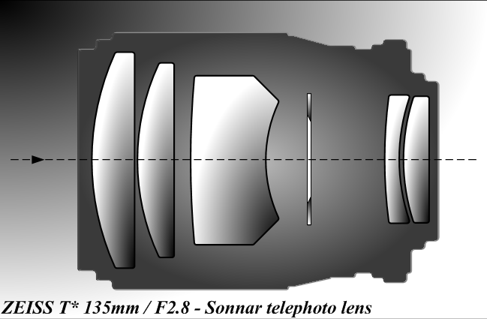
Source: Tamasflex, (2010). CC BY-SA 3.0.

The aperture controls the brightness. As a side effect the depth of field is influenced by the aperture stop. The aperture f/8 for example represents the focal length as f and the aperture diameter d=8. Thus, it is a combination of focal length and diameter. The focal length f is given by the distance from the principal plane to the image sensor. The shutter mechanism is responsible for controlling the length of time the light is entering the camera. Many cameras have a viewfinder feature that can show the recorded screens according to the adjusted combinations of shutter speed, aperture, and focus. The ISO sensitivity depicts how much light is needed to capture it on the sensor. Different settings for the camera's aperture, shutter speed, and ISO yield to different images and side effects. The illustration below shows some of the side effects as well as an overview of how the different camera mechanisms influence the image produced by the camera.

Camera Mechanisms and Image Influence
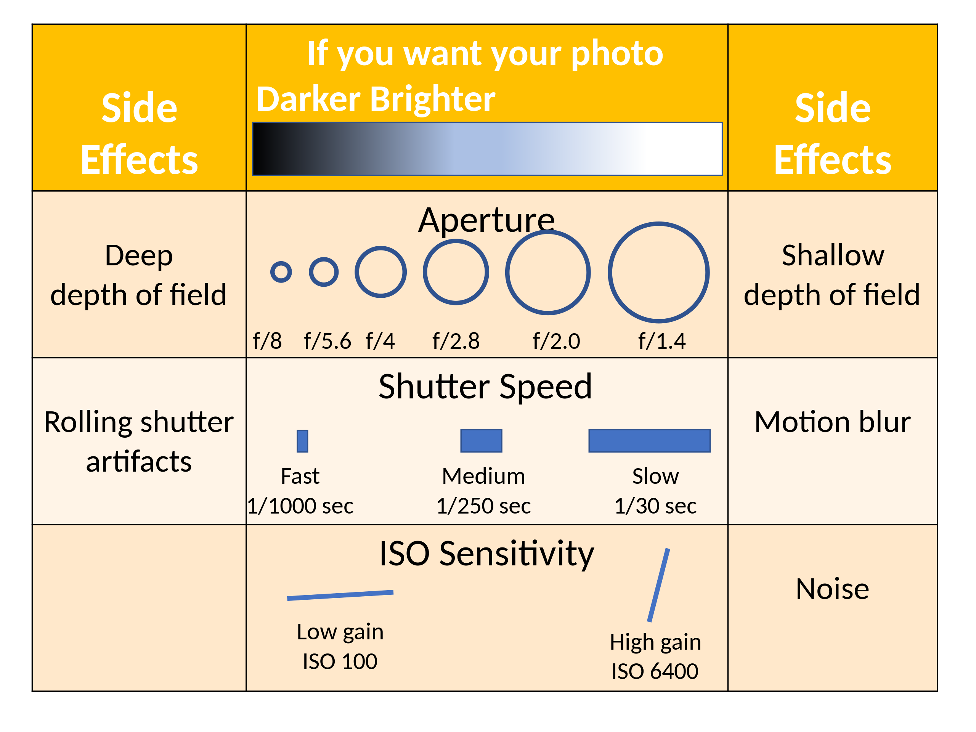
Source: JeanBizHertzberg (2022). CC BY-SA 4.0.
The photo quality depends on the design and manufacturing of the lens. In the 19th century, technological innovation modernized optical glass manufacturing and the creation of lenses. With this contribution to the modern manufacturing process, a wide range of optical instruments, like telescopes, and microscopes, are designed. Camera lenses are constructed in various focal lengths, like standard and medium telephoto and extremely wide angles. The reason behind the preference for extremely wide angles is their ability to capture big objects like mountains. The increased field of view for wide-angle cameras provides the ability to stand near a huge object and capture it. The choice of standard lenses is caused by having a wide aperture that enables them to capture documentary and street photography. The standard lenses have the same field of view as the human eye, which makes them considered for this purpose. Telephoto lenses are helpful in the case of wildlife and sports.
The following two graphics depict the difference between a narrow angle of view and a wide angle of view. The thick black stroke illustrates the image sensor in a camera and the point where the two thin black lines meet each other is the placement of the lens. The bottom part of each graphic depicts the focal length. The narrow angle of view has a long focal length, which makes it sensitive to shaking and motion blur in the captured images. The wide angle of view has a short focal length.
Narrow Angle of View of a Camera
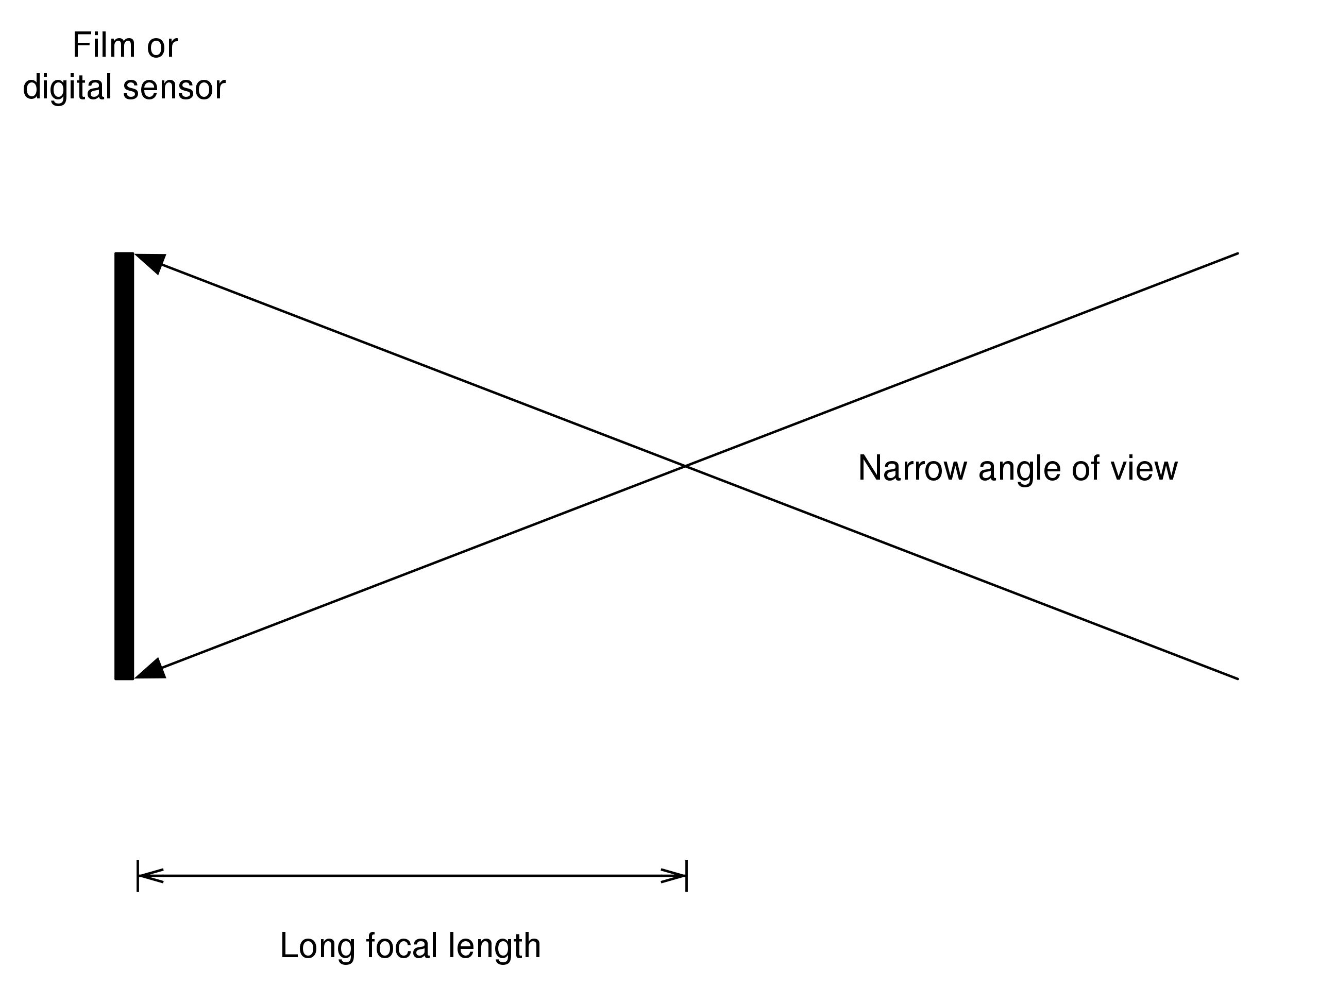
Source: Discoboy, (2011). CC0 1.0

Wide Angle of View of a Camera
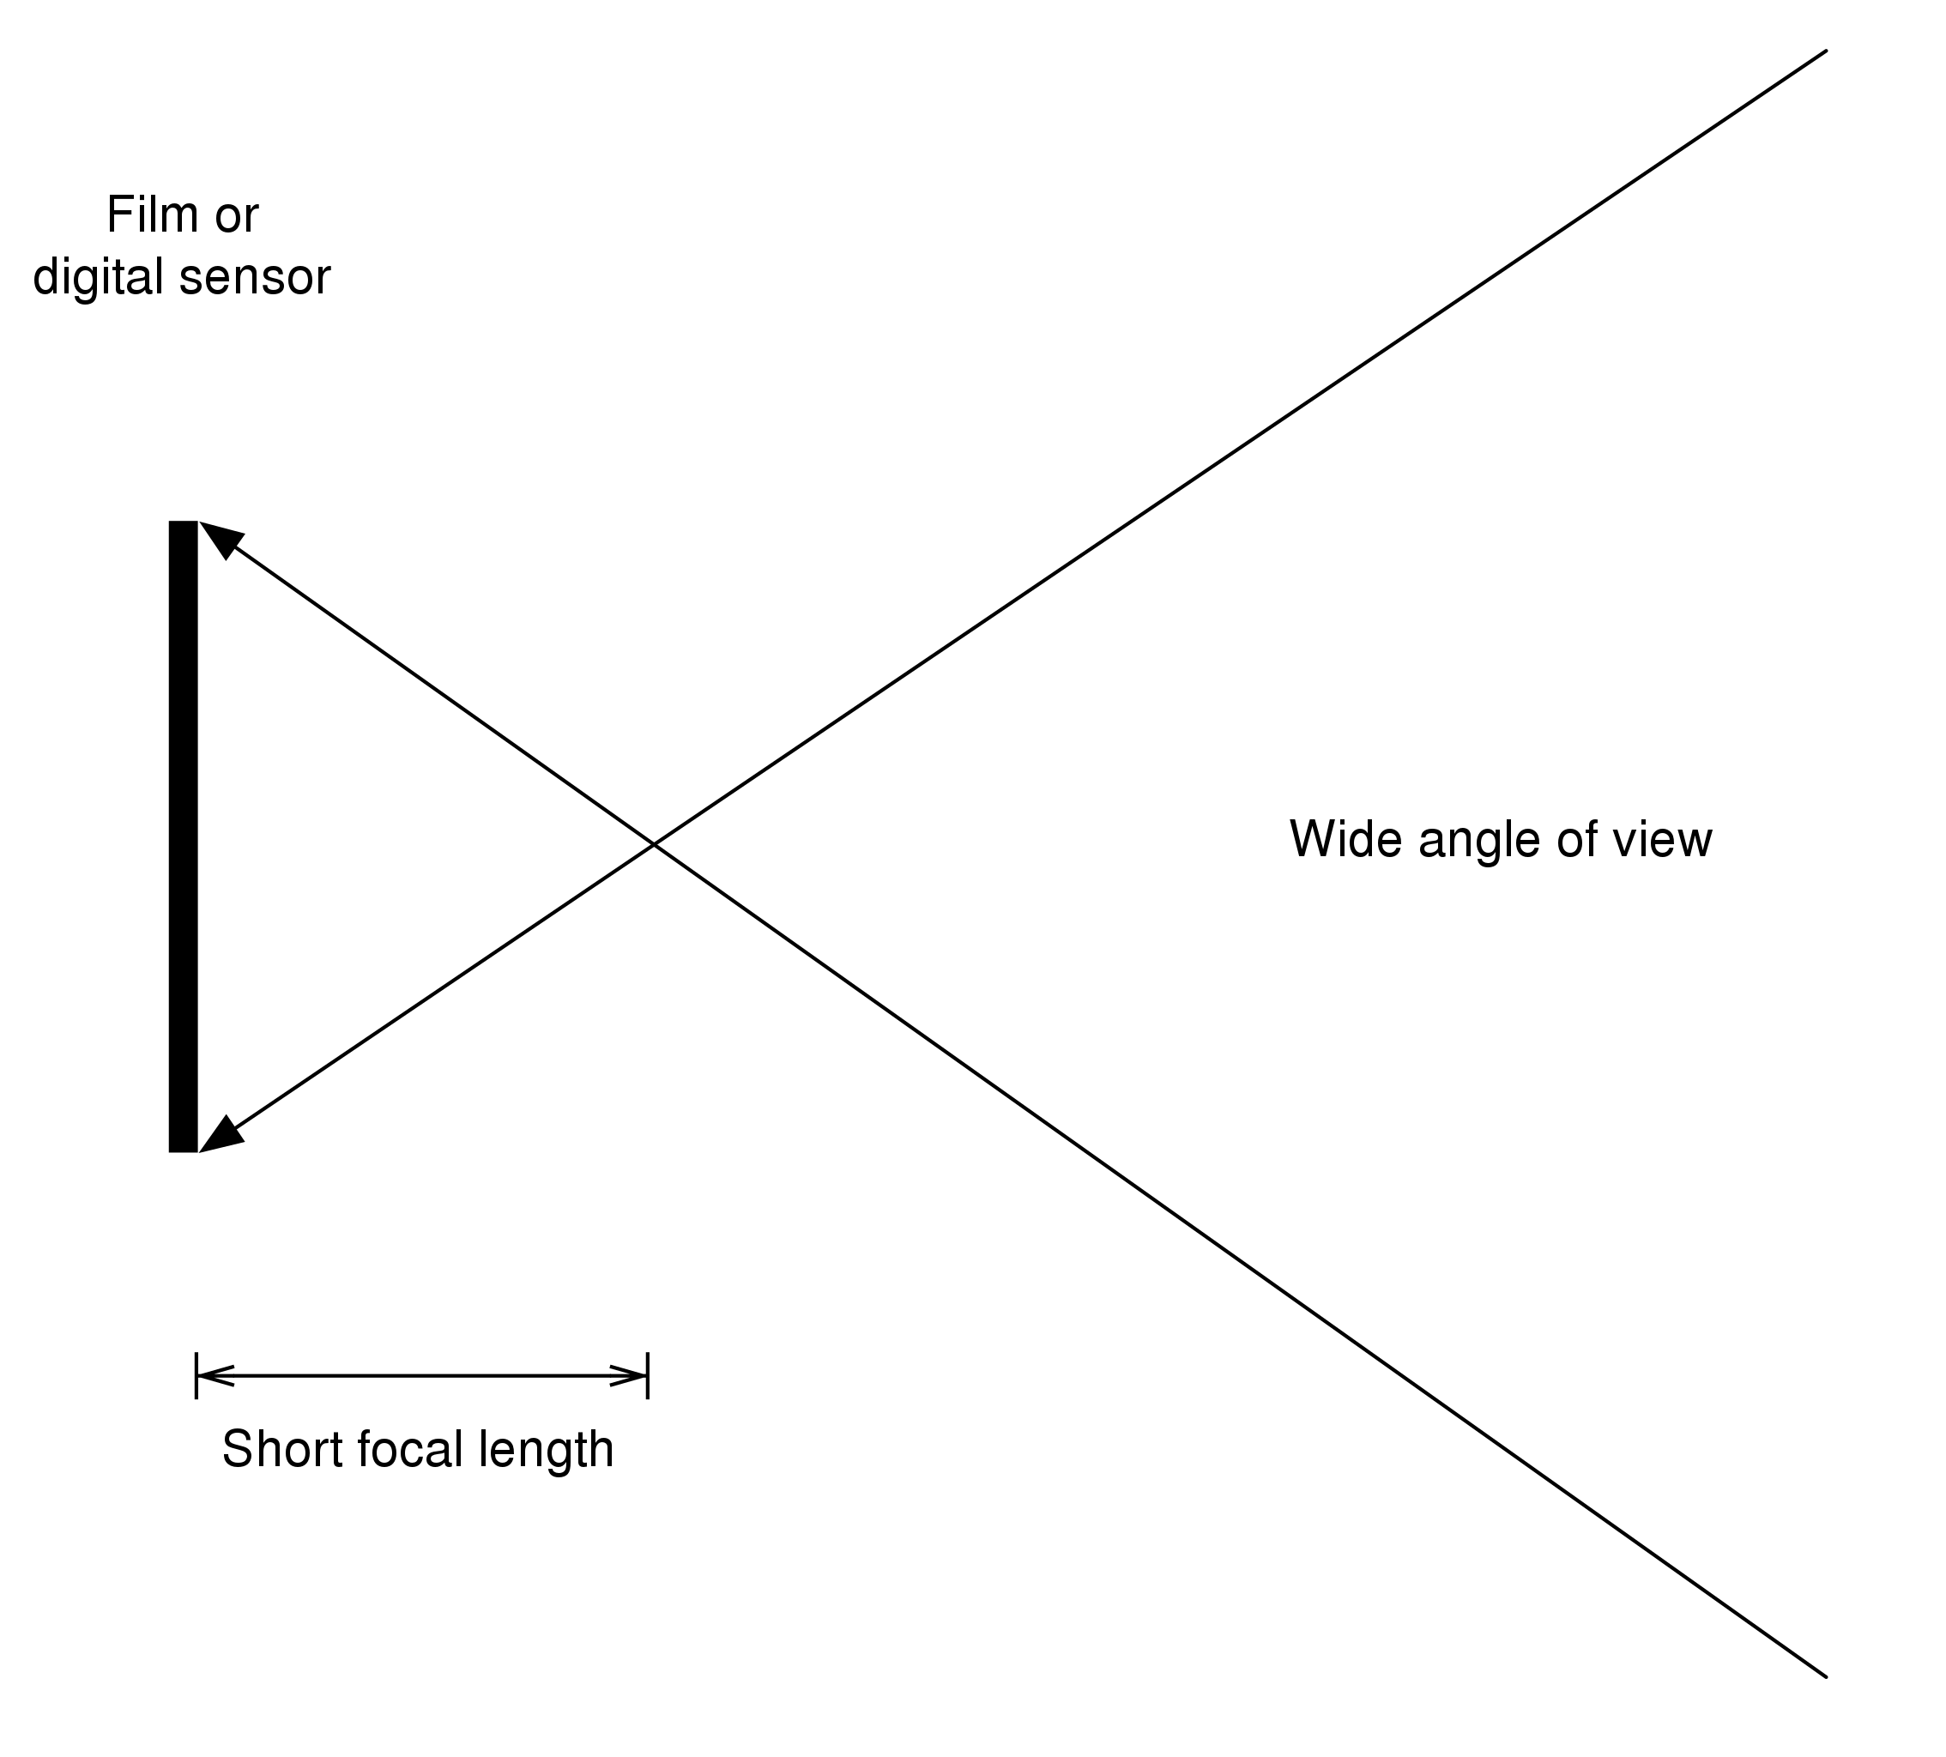
Source: Discoboy (2011). CC0 1.0.

Self-Check Questions
- Please mark the correct statement(s).
- A short focal length results in a wide angle of view.
- A long focal length results in a wide angle of view.
- A long focal length results in a narrow angle of view.

1.3 Image Sensors
Digital image sensors do the conversion of photons into electrical signals. The scene is then interpreted with numerical values and is processed by computational power. The two most famous image sensors nowadays for capturing videos and images are charge-coupled device (CCD) and complementary metal oxide on silicon (CMOS) This course book focuses on the CMOS sensor (Szeliski 2022).
Most digital cameras nowadays use a standard configuration. A photodetector for each pixel absorbs the light for the whole spectrum of colors. These colors are Red, Green, and Blue. At the top of the pixel array is a 2D Bayer arrangement of RGB color filters. The Bayer frame interpolation – demosaicing is then applied to interpolate the three colors into one. The image below shows an example. The left picture shows the image before the demosaicing, and the right picture shows the image after demosaicing.
Demosaicing
is applied to interpolate the three colors for each pixel.
Demosaicing of a Raw Image

Source: Based on: MikeRun (2019). CC BY-SA 4.0.
Along with this, there is a specific specialized filter arrangement that contains 1 quarter blue, 2 quarters green and 1 quarter red color filters. This arrangement was established by the inventor Bryce Bayer (1976) on the fact that human day vision is less sensitive to blue and red details than to green ones. Therefore, green details occur twice as often as blue or red ones. The respective arrangement is named after a 2x2 section of the filter i.e. BGGR (blue-green-green-red).
Bayern Pattern and Corresponding Filter
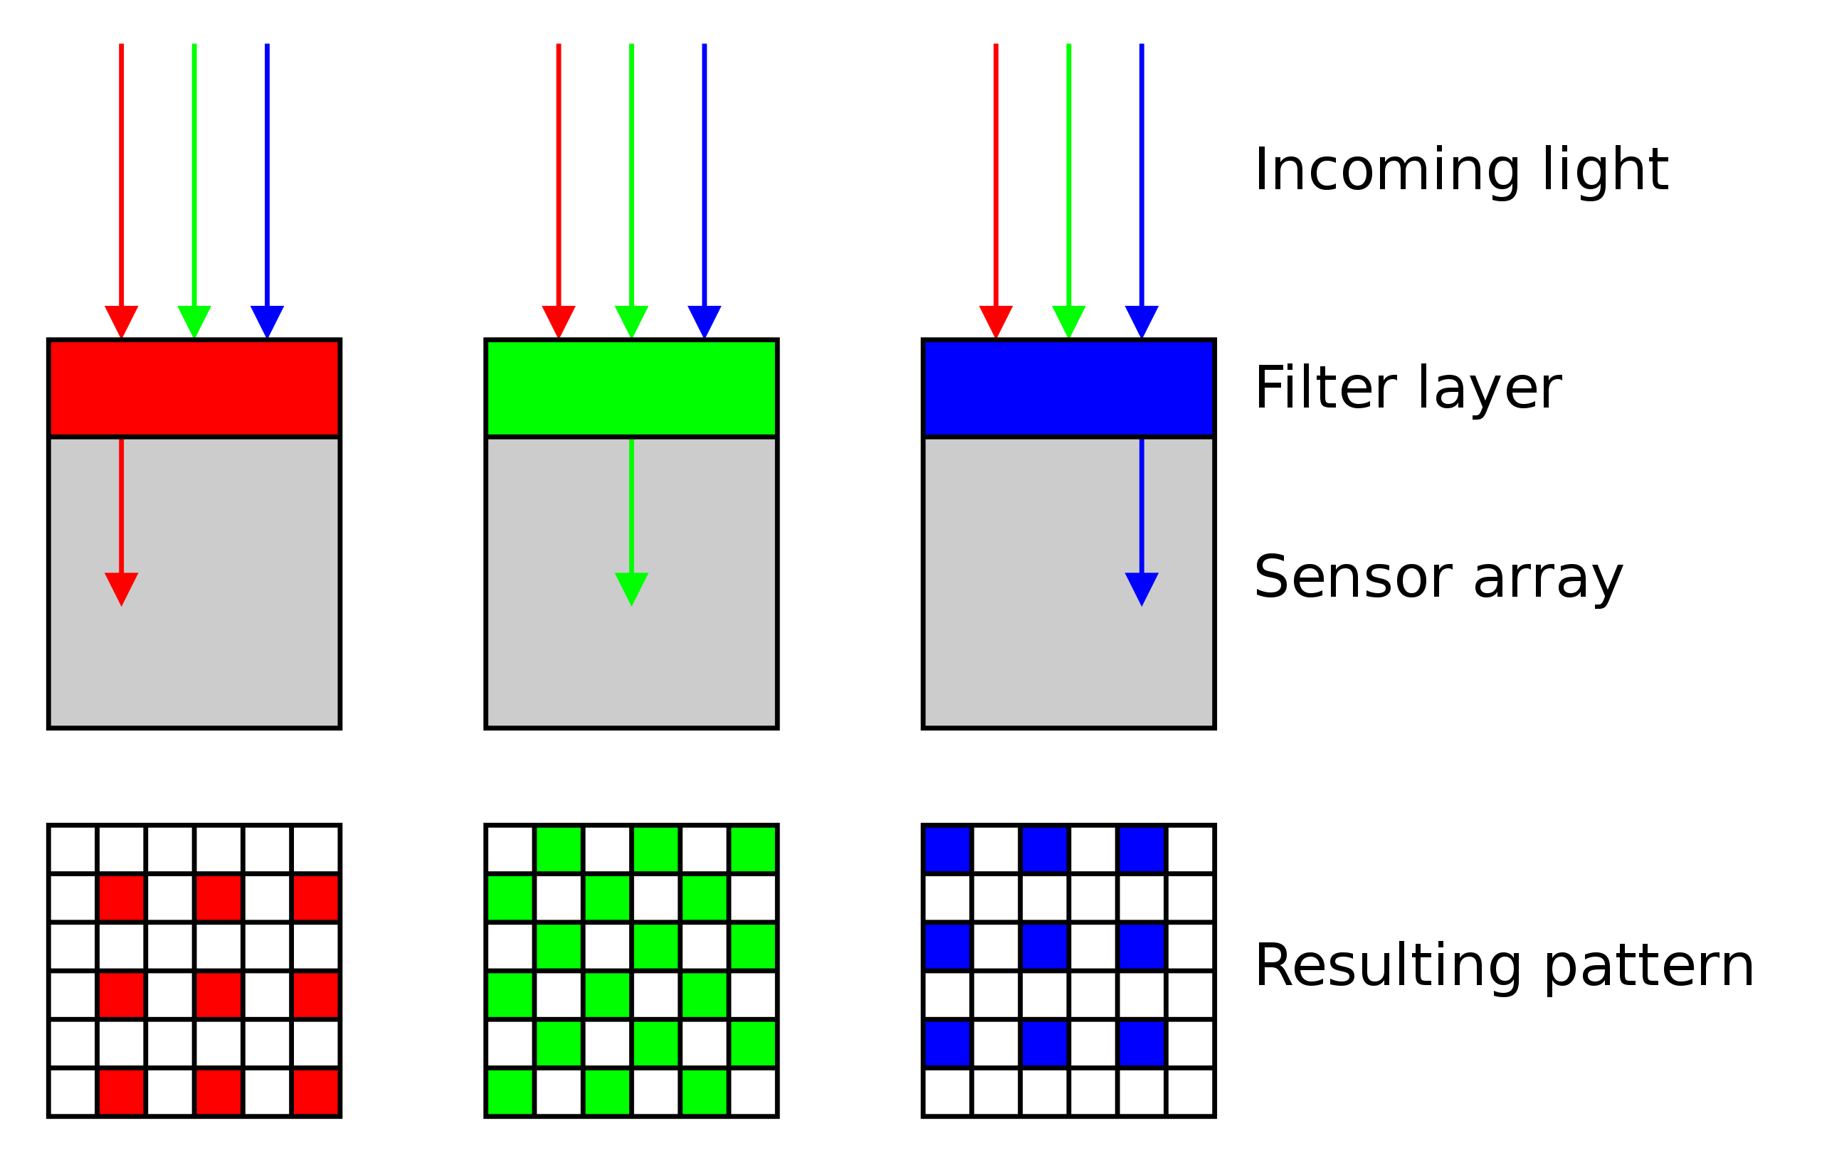
Source: Cburnett (2006). CC BY-SA 3.0.

Bayern Pattern and the Sensor
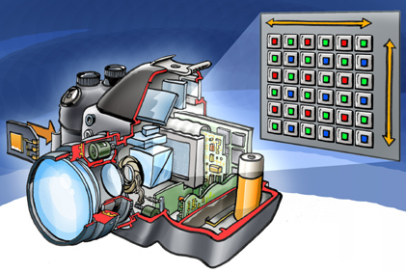
Source: Welleman (2008). CC BY 2.3.
As light strikes the photodiode in image sensors, the image gets converted into electronic signals and thus pushed at several internal devices: A capacitor, an amplifier, a serial shift register, and an ADC. ADC stands for Analog to Digital Converter. And there, the conversion from analog to digital takes place. These transformations result in the modifications of voltage signals to binary values, which can be further processed and stored.
Besides this, image sensors are of many types, a well-known example is the Complementary Metal Oxide Semiconductor (CMOS) image sensor. The main advantage of this sensor is that they allow the individual readings of each pixel. In praxis this happens line by line. Thus, these image sensors can perform at tiny sizes so that they would appear in smartphones, camcorders, and many other portable applications. Although many other image sensors have been created, most of them are variations of CMOS. Many innovations have been made in technology, like Back-Illuminated Sensors, which are based on CMOS. These sensors have enhanced the image sensors’ performance by increasing the amount of light they can capture. It is observed that, although many components play an essential role in the working of the imaging system, perhaps the most important ones are image sensors.
In a nutshell, the image sensor receives light and converts it into numerical values. Most computer vision libraries work with 3-dimensional arrays for colored images. Each dimension represents a color, namely red, green, and blue (RGB). Each pixel has 3 numerical values within the range of 0 to 255. The numerical value represents the intensity of the color.
The image below illustrates the combinations of different colors in RGB codes. The first image shows the cube with the colors and color code at its border. The second image shows the different sub-colors for RGB values not lying at the border.
RGB cube - example of a black pixel is (0,0,0) - example of a white pixel is (255,255,255).
RGB Cube
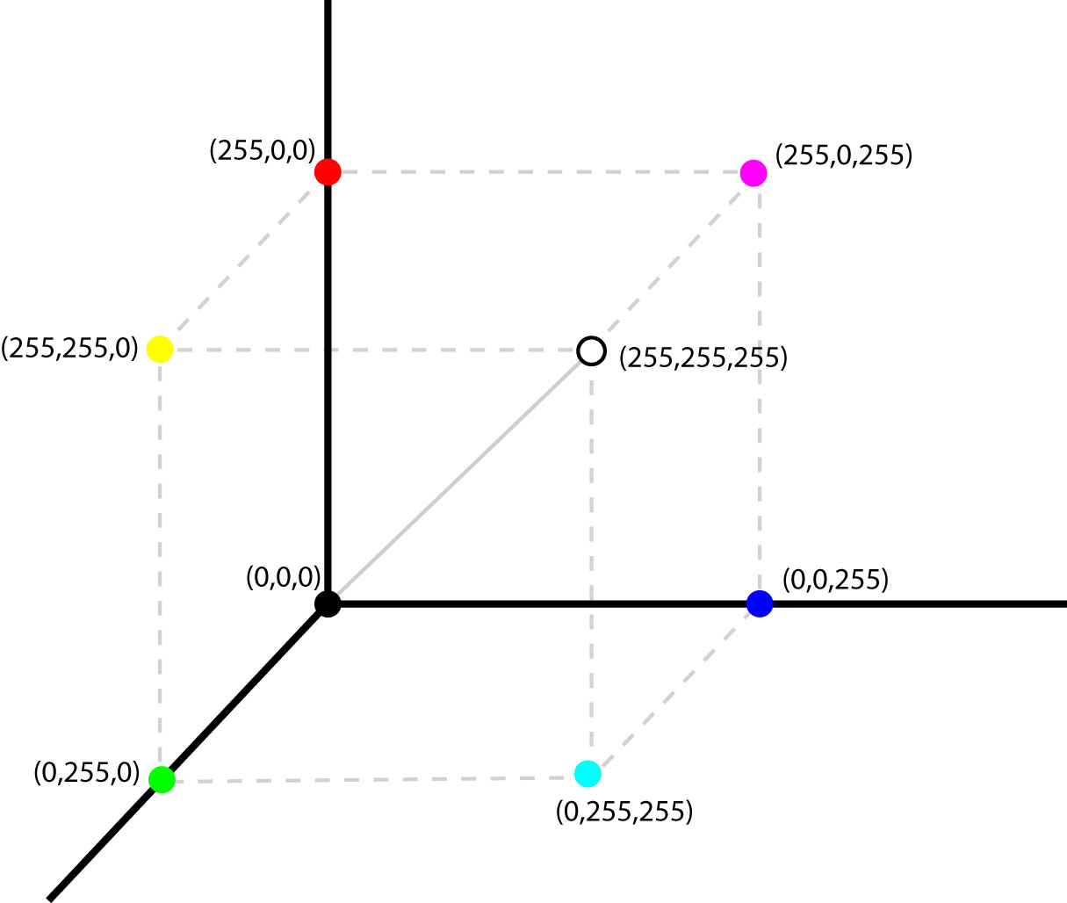
Source: Ntozis (2006). CC BY-SA 3.0.

RGB Cube - Mixture of the Different Colors
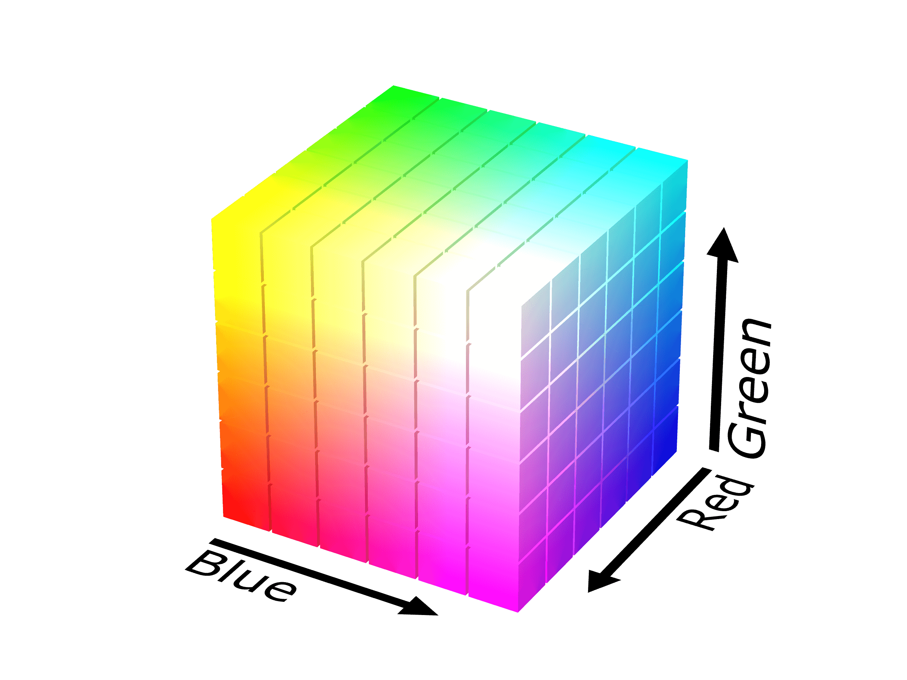
Source: SharkD (2008). CC BY-SA 4.0.
In contrast to colored images, grayscale images consist of a one-dimensional array. For simplicity, the following example is based on grayscale images. Let's have a closer look at the representation of an image in numerical values. Most famous task for computer vision is the MNIST dataset (Deng, 2012), which consists of hand-drawn numbers in grayscale. The image below shows some samples of this dataset.
Samples of the MNIST Dataset
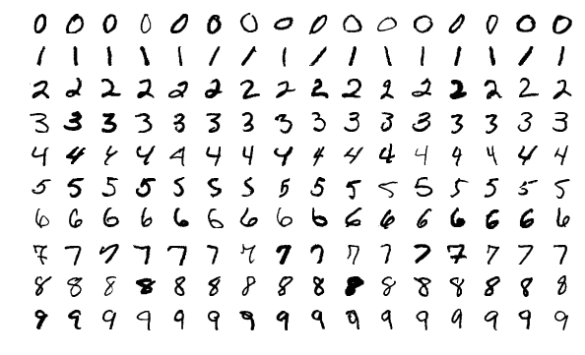
Source: Josef Steppan (2017). CC BY-SA 4.0.
Taking the grayscale number nine of the bottom right corner and focusing on the circle on the top part yields the following array. One can clearly see the white pixels have the value 255 and the black pixels have the value 0. As nearer the numerical value is to 0, the darker the Gray. As nearer the numerical value is to 255, the lighter the Gray. The first image shows the pixel values of the second image.
Example Array for the Circle of the Number Nine in Grayscale
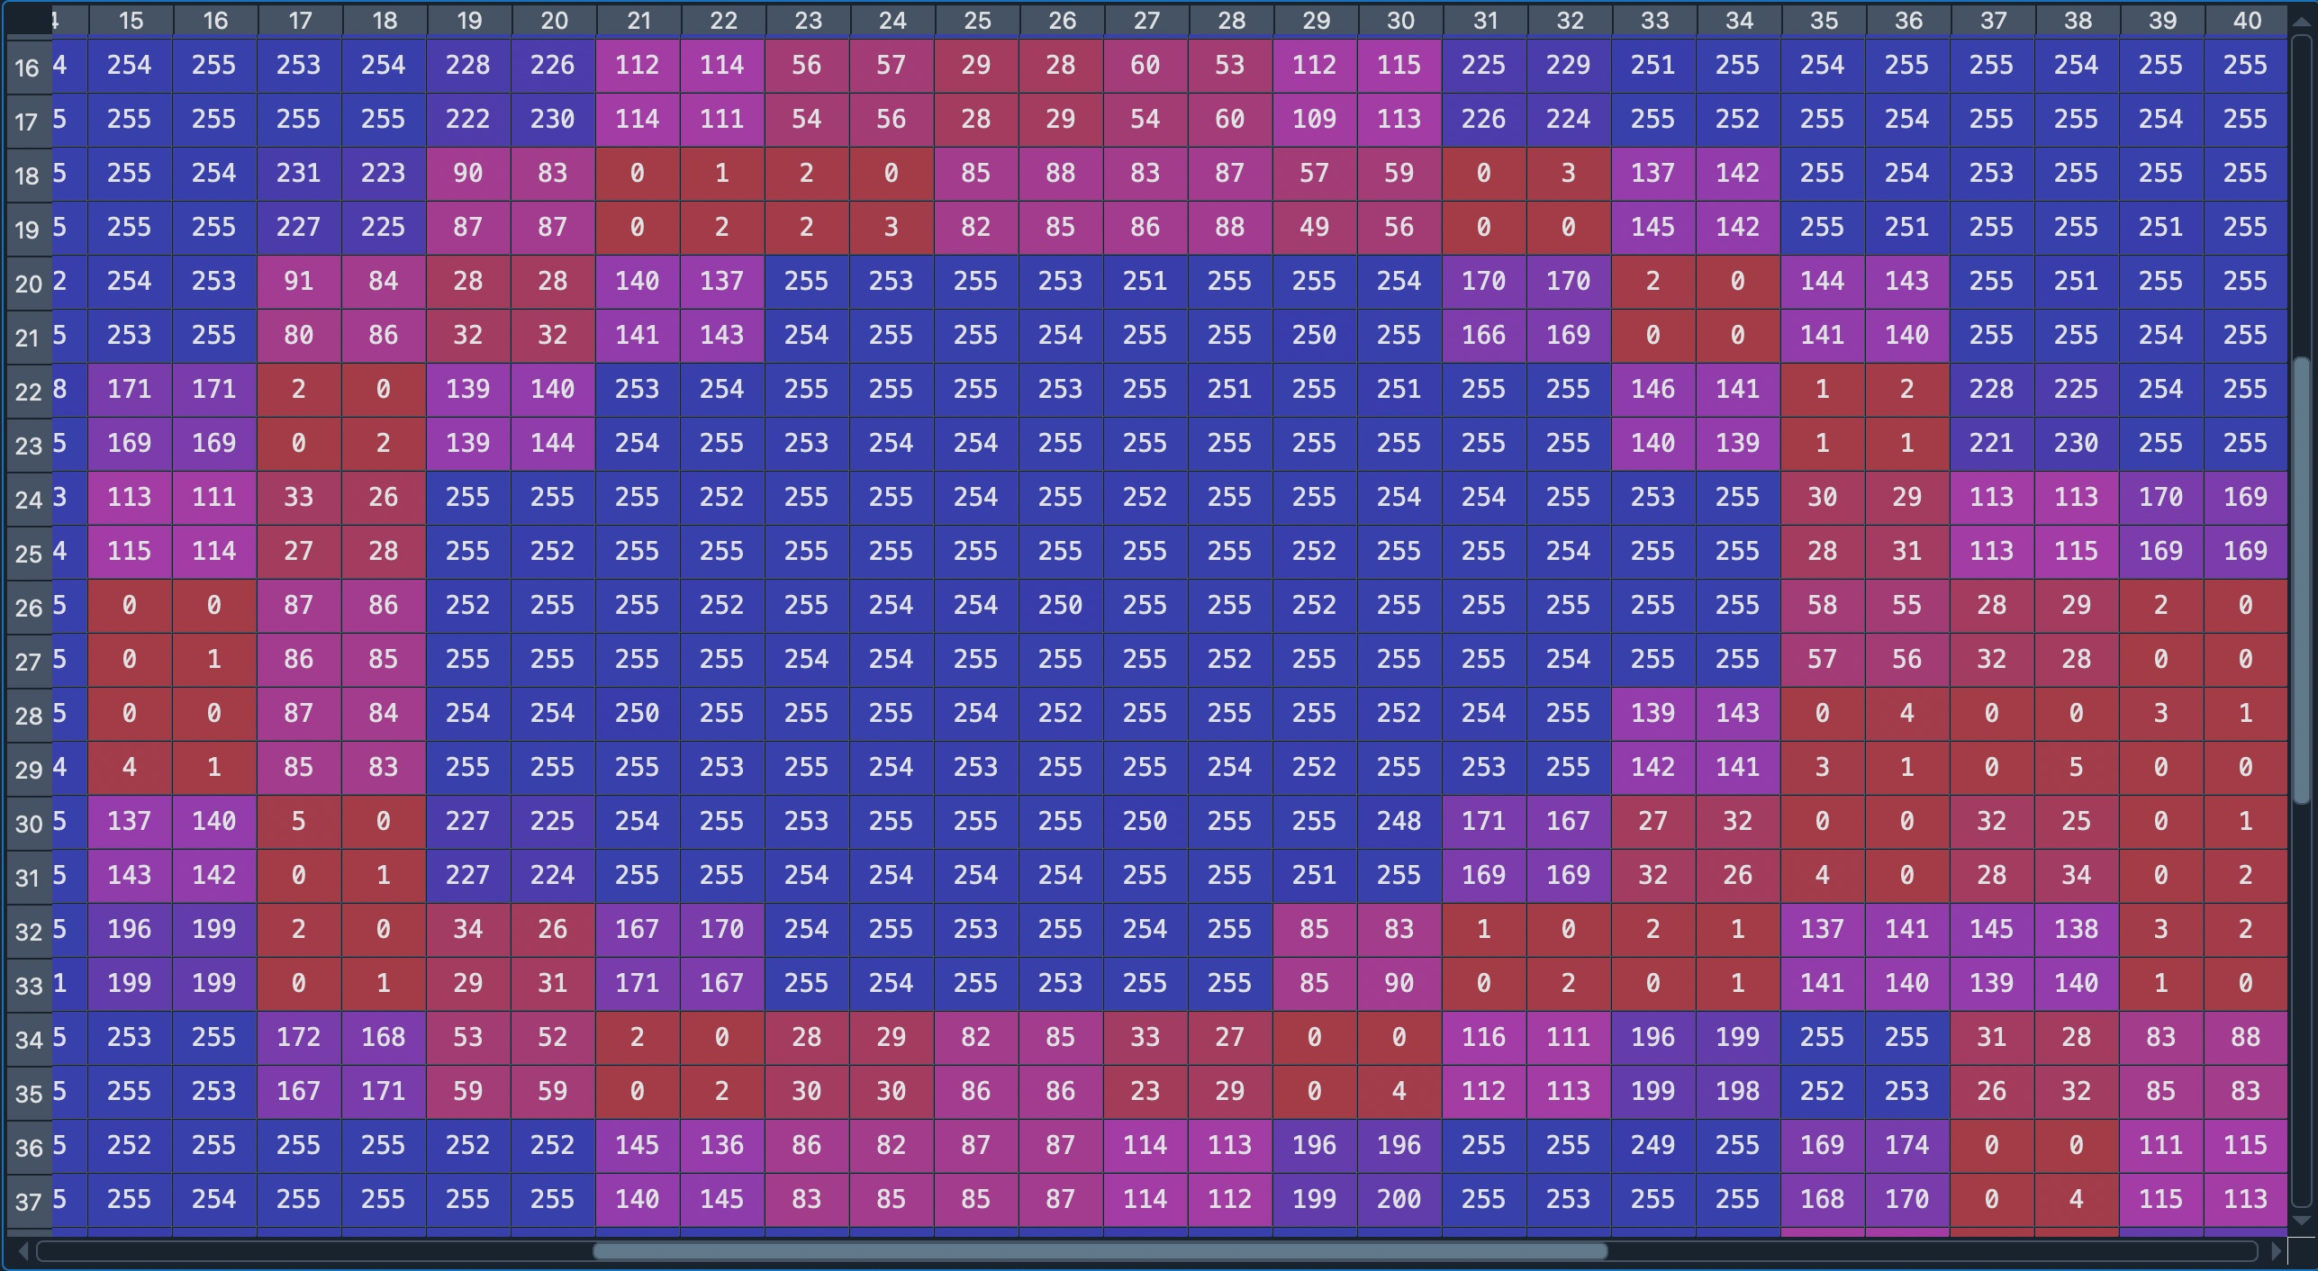
Source: Matthias Gruber, 2022.
The Circle of the Number Nine in Grayscale
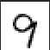

Source: Based on Source: Josef Steppan (2017). CC BY-SA 4.0.

Self-Check Questions
Describe the difference in representation between a colored and grayscale image.
A grayscale image is a one-dimensional array, and a colored image is a three-dimensional array.
Summary
Vision is the most fundamental and essential sense of a human being. Starting with the human visual system and later in history, engineering sensors can capture scenes permanently. Hundreds of years of research and development have driven us to the point where a computer can see, recognize objects and recommend actions based on that information. Transforming light into electrical impulses to shift them to numerical values is the base process for computer vision. Once a scene is captured into the array, it is no longer interpretable for the human eye. There lies the strength of computers - processing numerical values. In a nutshell computer vision consists of numerical operations, looking for similarities and differences.

Unit 2 - Image Filtering

Study Goals

On completion of this unit, you will be able to …

… explain why image filtering techniques are necessary for Computer Vision.
… understand a brief overview of different methods for image filtering.
… determine when to apply which filter.

2. Image Filtering

Case Study
You want to train your computer to predict the rank and suit of playing cards lying on your desk.
Using your smartphone, take a picture of some playing cards on your desk, upload the image to your computer, install python, install the OpenCV-python library, and read the image into a variable.
A computer can rank playing cards; but you need to process the images. For the recognition of the rank and suit of playing cards, the image's color and background are not necessary. Get some playing cards, place them on your desk, take a picture with your phone, and upload the photo to your computer. Download and install OpenCV-python and read the image into a variable. Process the color image into a black-and-white one. Apply different filters and investigate their effect. Choose the filter which lets the rank and suit be recognized. Be careful: Changing the angle of the camera, the lighting conditions in the room, etc., will lead to different results.

2.1 Linear Shift Invariant Systems, Convolutions, and the Point Spread Function
Almost all Computer Vision solutions start with processing the input, for example, filtering out noise. Image filtering improves image quality. Likewise, an amplifier reduces noise for audio data; we can adjust blurry images with filtering techniques. There are two types of image filtering techniques: linear and non-linear. Filtering obtained by convolution is called linear. Linear filters can be interpreted intuitively. Non-linear filters release their inputs as non-linear functions; thus, the results vary unintuitively. (Davies, 2018); and (Szeliski, 2022).
We want to process the image through techniques like image segmentation, edge detection, etc. But first, we need to remove the noise, unwanted shades, etc. For this, the median filter is the most effective non-linear filtering algorithm to find and eliminate salt and pepper noise. The salt and pepper noise are caused by sharp and sudden disturbances in the image signal. The resulting pixels are either black or white.
A median filter works by retaining the edge of the image and removing the noise, which is the main reason for its wide usage. It helps preserve the image details. In this algorithm, noise pixels are focused. After this, we apply the based median filter only to the pixels that are not noisy. We need to select the right filter for a specific purpose.
For example, if the input image has less noise while the amount of noise magnitude is high, we will apply the non-linear filters, but in the case of increased noise and low noise magnitude linear low-pass filter is sufficient. Linear filters are primarily used because of their simple and fast response. Compared to non-linear filters, linear filtering is done by applying the algorithms to the neighbor pixels. For identifying neighbor pixels, locations are identifiers relative to the input pixel. The algorithms used for linear filtering are Gaussian, Bilateral, Box blur, and Hann Window. (Davies, 2018); and (Szeliski, 2022).
Below is an example of an image containing salt and pepper noise. The left image is the original one and the right one contains salt and pepper noise.
Here are two images of Sirius the King. On the left, we see the original image. The image on the right shows salt and pepper noise.
Salt and Pepper Noise
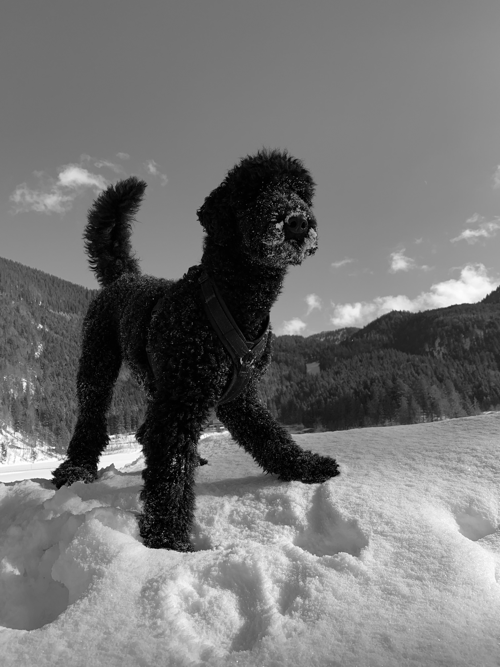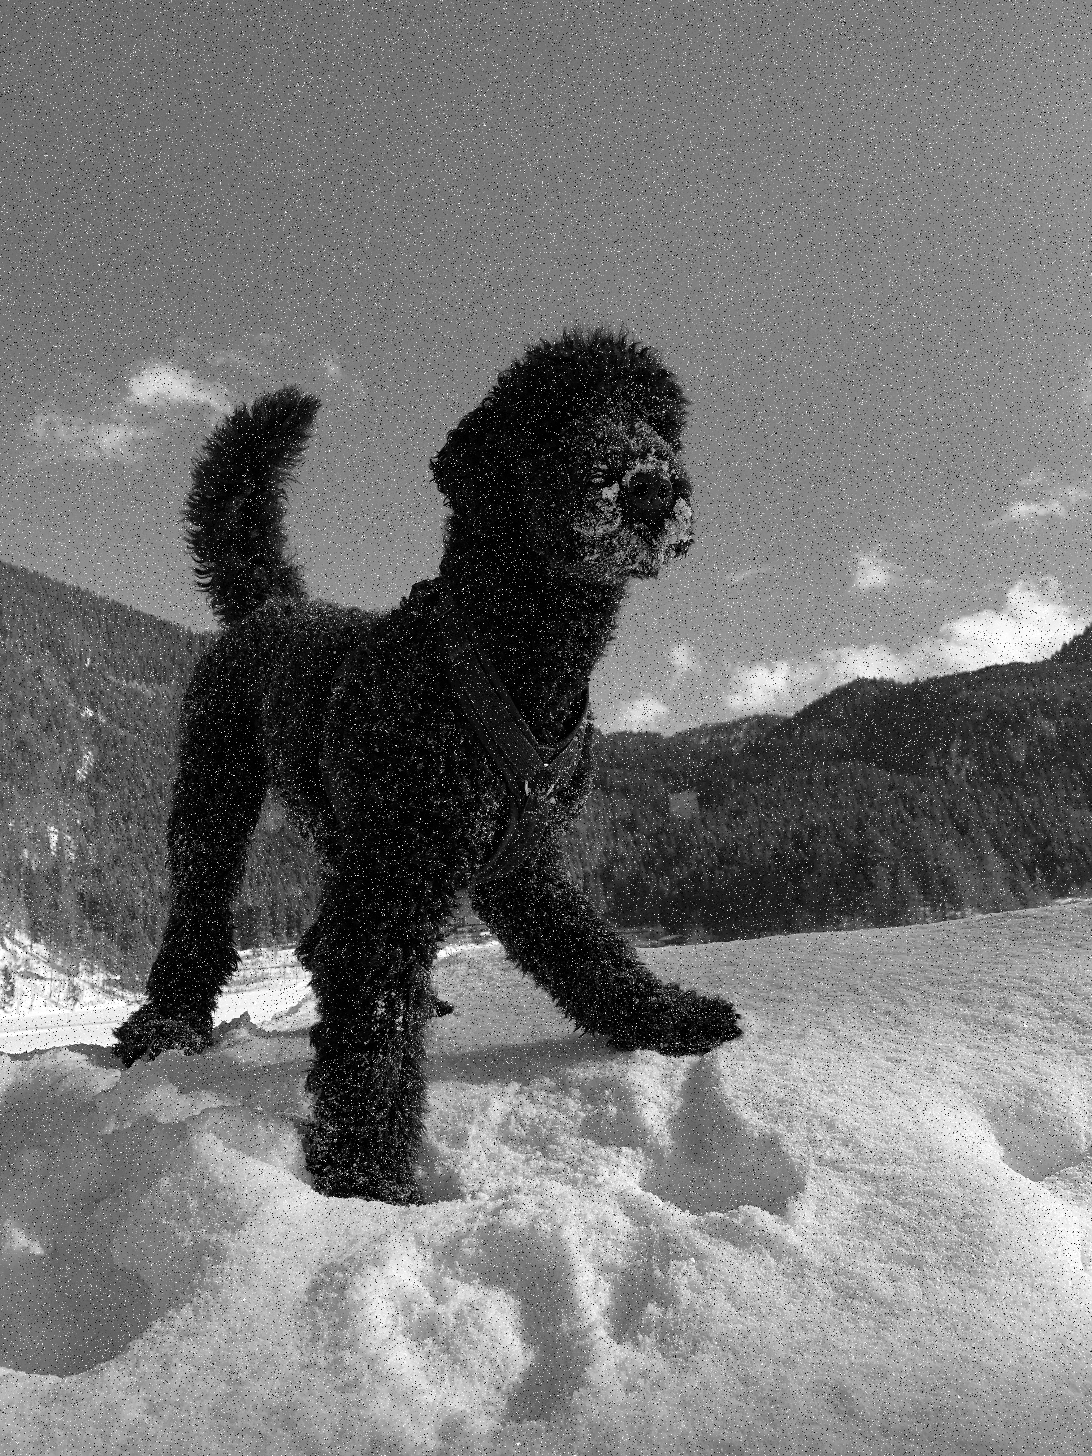
Source: Matthias Gruber (2022).

Linear Shift Invariant Systems
Linear shift-invariant systems are invariant systems according to the shifts in their independent variables. Linear systems take linear combinations of individual pixels as input and provide output as linear combinations of the input. Shift-invariance means that if we shift the input our result would be shifted by the same amount. Linearity and shift invariance are the two important properties for these kinds of systems.
This system's properties are independent and focus on matrix multiplication via an arbitrary matrix that is not only linear but also typically not a shift variant. Matrix multiplication will be explained in the next subsection.
Besides image processing, Linear shift or linear time-invariant systems have another significant application of electrical circuits. Shift invariant systems are essential as they are represented as linear combinations for shifted impulses. This happens in both the cases of discrete or continuous signals, and as a result, it gives the advantage of calculations using a superposition known as convolution.
Invariance
An invariance means that when the input is shifted by a scalar, the output is shifted by the same amount.
In the example below the shift is by two between the blue and the red line.
A Shift Invariant Linear System
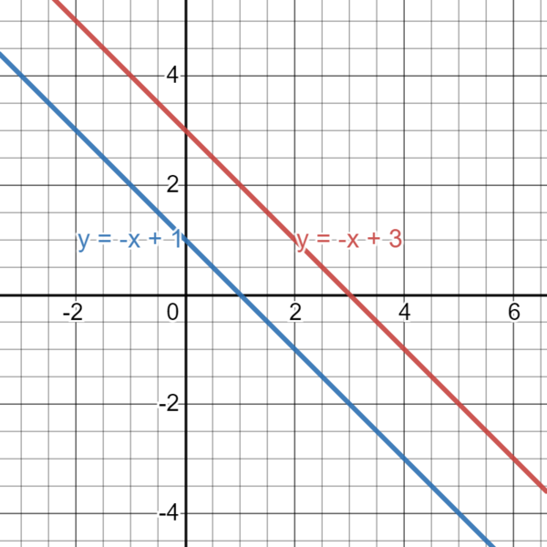
Source: Drigban (2022). Public Domain.

Convolution and Point Spread Function
Convolution refers to the idea of filtering an image. It usually can be seen as a filter that moves typically from the upper left corner to the downright corners. It takes multiple pixel values as input and outputs one. The following illustration shows a convolution of an image (Davies, 2018).
Illustration of a convolution. The 3x3 matrices represented as dark blue squares are aggregated and downsized to one. For a picture, these can be seen as 9-pixel values downsized to one.
Illustration of a Convolution
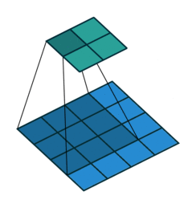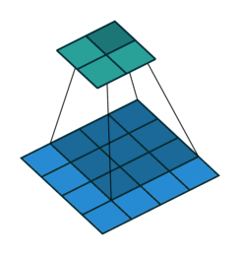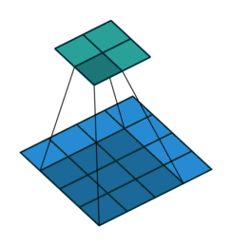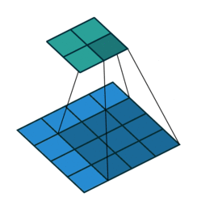
Source: Based on Vincent Dumoulin, Francesco Visin (2016).
A simple mathematical operation that can be fundamental to many commonly performed image processing operations is known as Convolution. It provides a way of multiplying two arrays of numbers. This is used in image processing to implement operations with linear combinations for output pixels by specific input pixel values. Convolution works by pushing the kernel over the image, starting in the upper left corner and moving to the edge of the lower right corner of the picture. In this way, the location of the entire kernel is a coordinate of an output pixel whose value is calculated by multiplying the pixel value in the main image with the kernel value for the cell. Images convolution is a general method used in almost all computer vision tasks. The main goal is to determine the sum values of a central pixel with the weighted values of all its neighbors together. Thus, these weights are applied for each input pixel and are determined by a term called convolution kernel Szeliski (2022).
The idea of convolution is to apply a Point Spread Function $g$to all pixels $f\left(x,y\right)$ of an image. The indices $\left(x,y\right)$ represent the location of each pixel within the image array.
Mathematically it is represented as
$$F\left(x,y\right)=f\left(x,y\right)*g$$
With $*$ as the convolution operator.
We can reformulate the equation to
$$F\left(x,y\right)=\sum_{ i}^{ }{\sum_{ j}^{ }{f\left(x+i,y+j\right)h\left(i,j\right)}}$$
A convolution iterates over each pixel of an image and outputs a new value for it based on the multiplications. See the below image for an illustration.
Convolution of Image Pixels

1 | 1 | 1
1 | 5 | 1
1 | 1 | 1

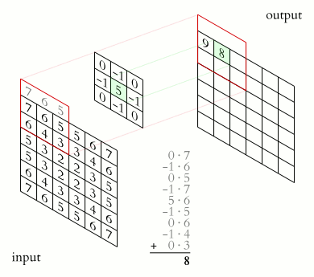

Source: Michael Plotke (2013). CC BY-SA 3.0.

Here we see Sirius the King, both in an original image and as a convolved image with the array given above. Applying the convolution filter from above results in the following picture.
Applying a Convolution filter on Sirius the King
Source: Matthias Gruber (2022).

Self-Check Questions
- Please complete the following sentence.
Filters are used to increase the performance of Computer Vision solutions by processing the input images, to enhance the detection of edges, objects, etc.

2.2 Fourier Transform and Spatial Frequency
Fourier transform is an important image processing tool that breaks an image into, for example, sine and cosine elements (Szeliski, 2022). The result of the conversion represents an image in the Fourier or frequency domain, while the input image is the same in the spatial domain. A spatial measure of the number of sinusoidal elements (as defined by the Fourier region) in a system that repeats itself. The idea of Fourier transformation in computer vision is to analyze the frequency characteristics of images. We are interested in analyzing what a filter does to specific images with different frequencies. The frequency can be low, as represented by the front blue line in the image below – or the frequency can be high, as represented by the back blue line in the image below. Medium frequencies are represented by the blue lines in between the high and low ones. The red line in the front is the ground truth $s\left(x\right)$ which gets pushed through a filter $h\left(x\right)$. The blue lines then indicate the output $o\left(x\right)$, which can be represented mathematically by
$o\left(x\right)=h\left(x\right)*s\left(x\right)$.
Illustration of ground truth in red pushed through a filter and the investigation of its frequencies in blue (Szeliski, 2022).
Illustration of Ground Truth
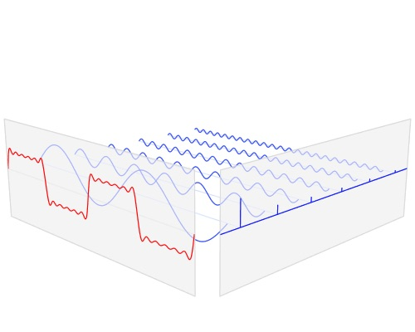
Source: Lucas V. Barbosa (2023). Public domain.

Self-Check Questions
Please complete the following sentence.
Fourier transform is used to investigate the effect of filters on images.

2.3 Common Image Filters

Gaussian Smoothing
A filter whose impulse response is a Gaussian function is known as Gaussian Smoothing. An approximation to the Gaussian function is also acceptable, although an accurate Gaussian response would have an infinite impulse response (Szeliski, 2022). Infinite impulse response means that the output of a filter never becomes zero, in fact at the borders of the gaussian distribution the values of G(x) become infinite small but never reach zero. This behavior can be seen in the following graphics. Gaussian smoothing is a convolutional 2D operator used to blur images. Thus, it is like the mean filter, but the difference is that it uses a different type of kernel that represents the output in the form of a Gaussian distribution.
The Gaussian distribution in 1-D has the form:$G\left(x\right)=\frac{1}{2πσ^{2}}e^{-\frac{x^{2}}{2σ^{2}}}$
1-D refers to having a one-dimensional input x. Whereas $σ^{2}$ presents the variance of the distribution. We can also assume that the distribution has a mean of zero as it is centered in the line where $x=0$. This distribution is represented in the following illustration.
Below is an illustration of Gaussian distributions with different means $μ$and variance $σ^{2}$.
Illustration of Gaussian Distributions
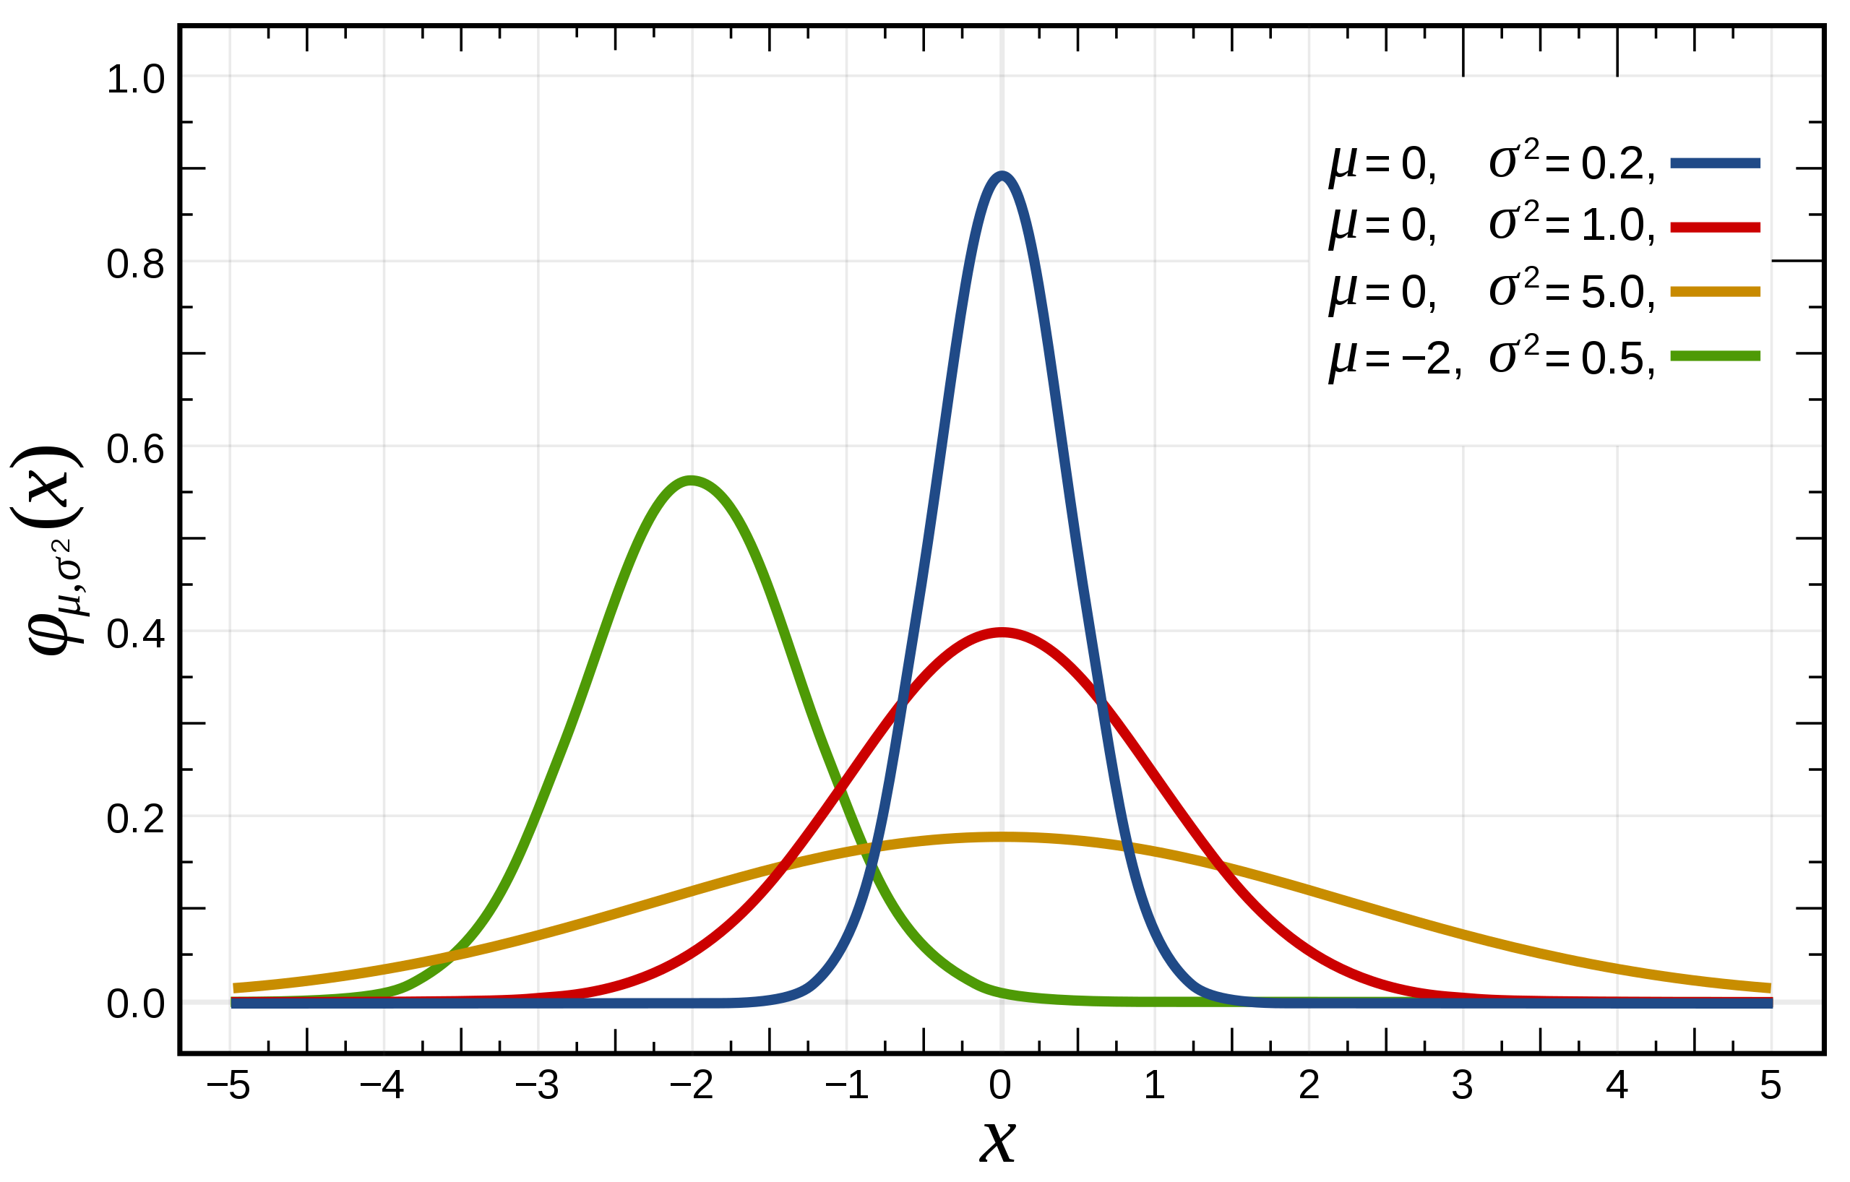
Source: Inductiveload (2008). Public Domain.
For a 2-dimensional case, a Gaussian is calculated by
￼￼$G\left(x,y\right)=\frac{1}{2πσ^{2}}e^{-\frac{x^{2}+y^{2}}{2σ^{2}}}$
This 2-D distribution is shown in the illustration below.
Illustration of the 2-Dimensional Gaussian Distribution
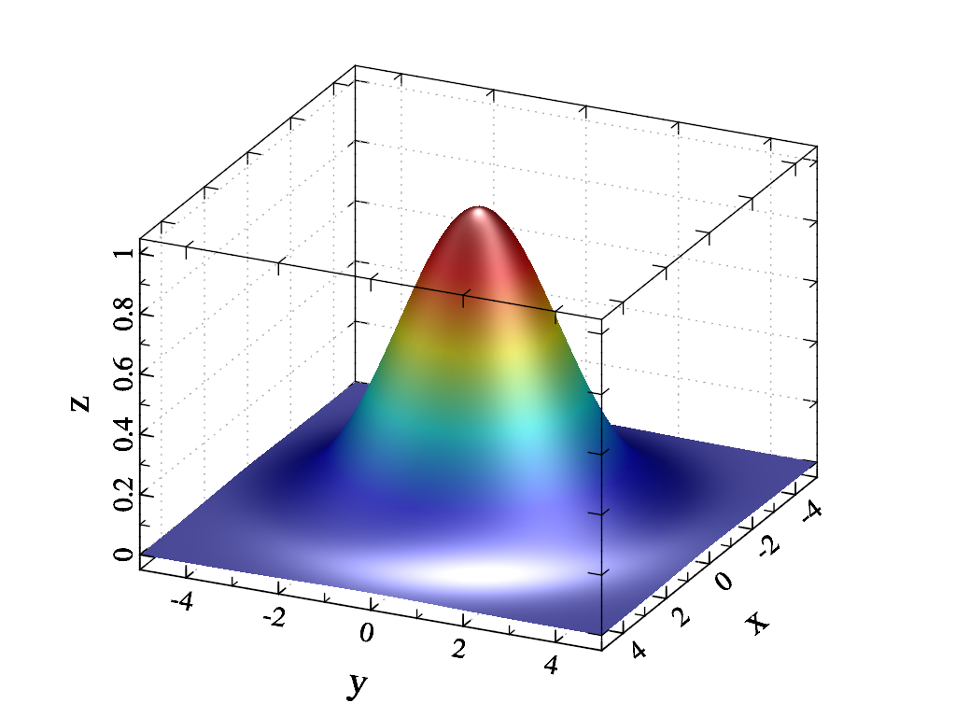

Source: Dracyon (2014). CC BY-SA 3.0)
Gaussian smoothing works on the idea of using 2D distribution as a point spreading function with the help of convolution. Thus, the image is stored as a collection of discrete pixels that we need for producing a discrete approximation for the Gaussian function. All this is done before performing the convolution. Theoretically, the value of Gaussian distribution is non-zero, which means it would require infinitely greater convolution kernels (Szeliski, 2022).
Application of Gauß Filter to Salt and Pepper Noise
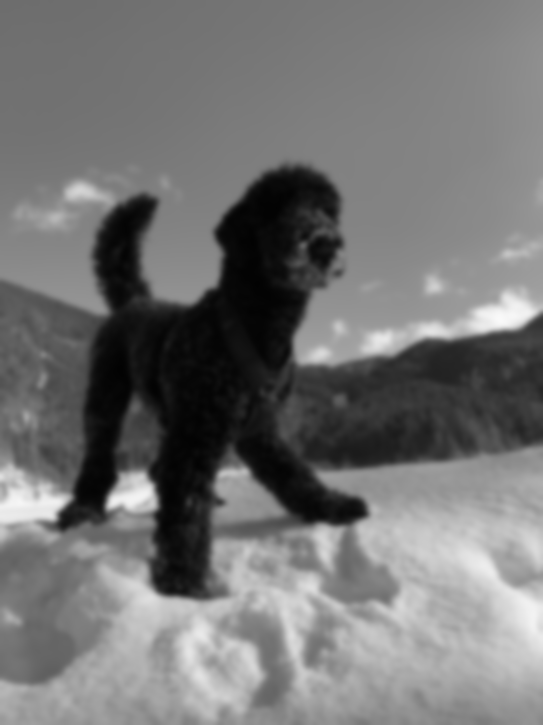
Source: Matthias Gruber (2022).

Mode Filter
An edge-preserving smoothing filter that takes the mode of the empirical density is known as a mode filter. (Davies, 2018). The mode filters have many applications in image processing, likewise image segmentation. For every input pixel, the original values are replaced with the mode of other pixels, considering a distance.
Mode
refers to the most frequent point of a distribution.
The mode of an input is calculated by the most frequent point. An example of calculating the mode of a discrete vector is given by
$mode\left(1,2,3,67,67,135,234,255\right)=67$. The value 67 appears two times within the vector and other values only one time. This results in a mode of 67 for the given vector.
The mode is the most frequent point of all the scalar values. One can always sort all values and then choose them. Another example would be
$$mode\left(1,2,3,67,135,135,234,255\right)=135$$
$$mode\left(1,2,3,67,135,234,255,255,255\right)=255$$

Mode of a Continuous Gaussian Distribution
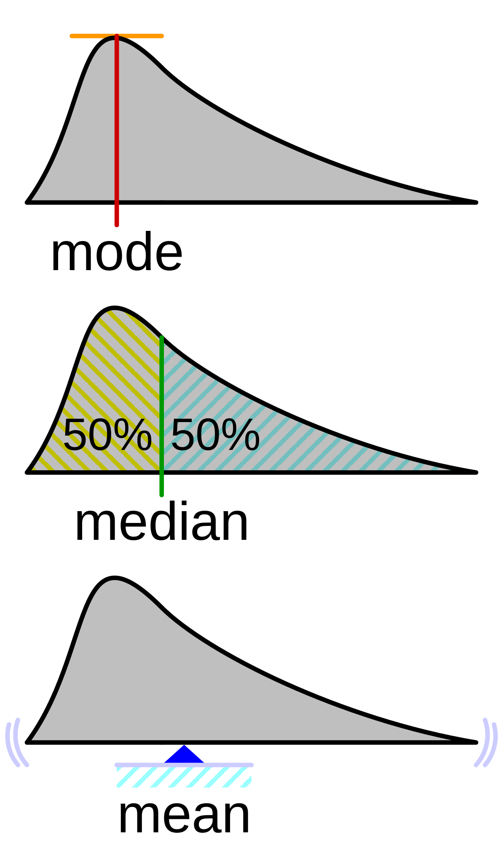
Source: Based on: Cmglee (2015). CC BY-SA 3.0.
Application of Mode Filter to Salt and Pepper Noise
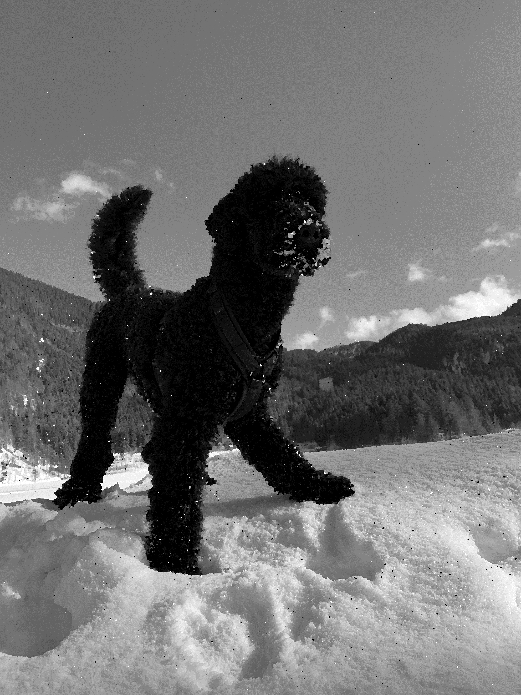
Source: Matthias Gruber (2022).

Rank Order and Median Filter
The rank-order filter is a nonlinear filter known for edge detection, noise reduction, and smoothing applications. This filter sorts the given input sequence and selects an output based on the rank (Davies, 2018). A rank order filter is an abstraction of dilation and grayscale erosion. One of the most efficient rank-order filters is the brick rank-order filter. The brick rank order filter evaluates each input image pixel as a rectangular set from the neighborhood. According to the determination of the rank order filter, the exact value of the neighborhood pixels is the one that is the r-the smallest in the set, and r would be any integer ranging between 1 and n. On the other hand, the provided rank value is a fraction value that ranges from 0.0 and 1.0. The median filter is a rank filter with a value of 0.5. The order filter classifies the entries according to their size based on the aggregation function. This introduces an odd-even merge sort algorithm used to validate the merging processes. The odd-sort merging algorithm converts two separate sequences and combines them into a 1-sort sequence. There are two combined elements, odd-merge and even-merge, and any entry with an odd client is an odd-merge entry. The results of each fusion group are compared with each other except for the first odd merger, the most significant component, and the final combined product, the minor part. The figure below shows a rank order filter with a window size value of nine (Davies, 2018).
Illustration of a Median Filter Application with a 3x3 Size
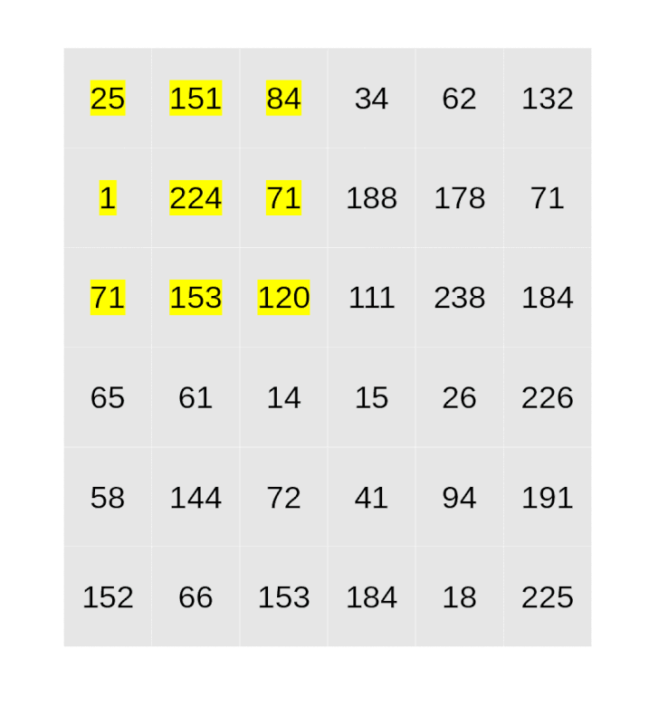
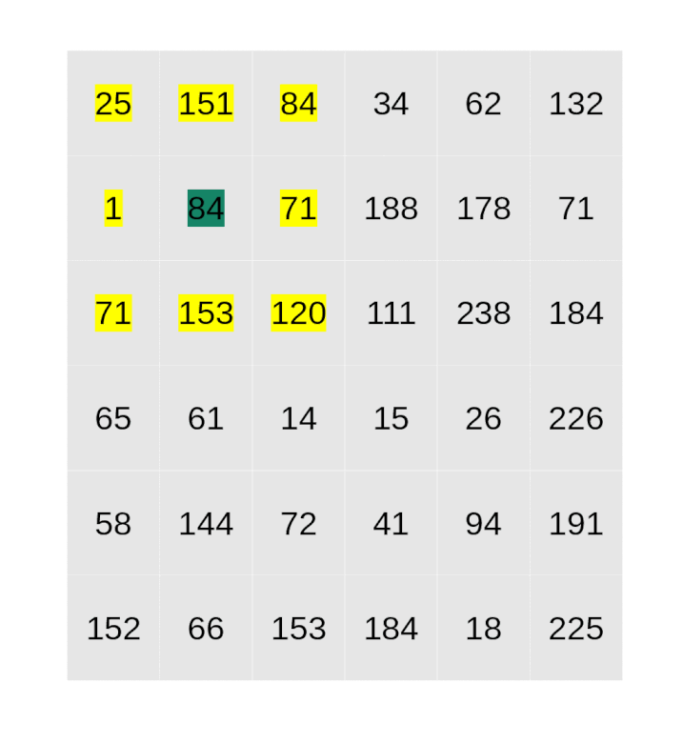
Source: Moein00 (2019). CC BY-SA 4.0.
The left image shows the application area of the median filter in yellow. The resulting computations follow:
$$med\left(25,151,84,1,224,71,71,153,120\right)=84$$
Hence, the pixel value of the green marked one is set to 84.
Computing the rank order filter for r=0.3 yields to an output for the green pixel of 71. The equation is

$$rank_{r=0.3}\left(25,151,84,1,224,71,71,153,120\right)=71$$
$$x=\left\{25,151,84,1,224,71,71,153,120\right\}$$
With $r=0.3$
Which yields to
$$y\left(x,r\right)=71$$
Because 71 is the 0.3 heaviest scalar. If one is sorting the input $x$, it yields to
$$x=\left\{1,25,71,71,84,120,151,153,202,224\right\}$$
As we have nine numbers in total, we simply take the scaler value at index ,
Yielding to 71.
Application of Median Filter to Salt and Pepper Noise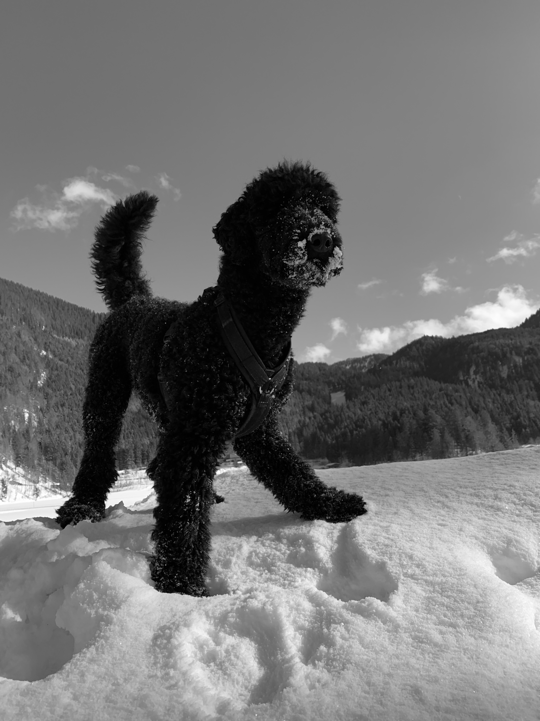
Source: Matthias Gruber (2022).

Self-Check Questions
- Please complete the following sentence.
Most filters use the neighbor's pixels to compute a new value for the input pixel.
Summary
Filter techniques are fundamental to enhancing image quality and detecting edges and information. It is essential to understand that Computer Vision algorithms have a fragile performance if the input changes by a high magnitude. The idea of filters is to pre-process the input to reduce noise and make the input constant. Applying filters to images is also called blurring. And blurring is used to overcome input shifts to enhance constant inputs.
Many different filter techniques exist, and their application depends on the situation. Choosing the right filter is often done by manual engineering, and it can be necessary to adapt these filters in case the conditions, for example, lighting changes.

Unit 3 – Low-Level Vision

Study Goals

On completion of this unit, you will be able to …

… understand low-level vision.
… define a feature within the context of computer vision.
… decide what concepts for feature detection are necessary for a specific task.

3. Low-Level Vision

Case Study
You want to train your computer to predict the rank and suit of playing cards lying on your desk.
Using your smartphone, take a picture of some playing cards on your desk, upload the image to your computer, install python, install the OpenCV-python library, and read the image into a variable.
Now you want to extract the rank and suit of your playing cards. You will need to crop the parts of the images which contain the cards. Since a typical playing card consists of four corners, you can use those as a reference. Furthermore, the size of the cards is usually standardized. However, you need to be careful because the camera angle will provide different scales. For example, a card located next to the camera will appear bigger in the image than a card which is far away from the camera. There are dozens of different frameworks which OpenCV functions can call. This process will require a lot of trial and error.
Try to assign the four corners to one single card if there are multiple cards on the table. Using the corners closest to each other is a good starting point. Once you have cropped the single cards, you must crop the rank and suit part of the card. This is easy, as these features always have the exact location. See the illustration below and try to crop only the top left corner of your image in the same way.
How to Crop a Corner of an Image

3.1 Blobs
A digital image consists of different information and objects that may provide valuable insights. Thus, such relevant features are extracted for further processing and information for high-level vision tasks. Blobs are defined as the group of pixels in the image with different attributes than the background, i.e., the surrounding pixels. It can be some large object or different color that is distinguishable from the background in the image.
The motivation behind detecting blobs is to provide additional information about the regions not provided by edge and corner detectors. It is used to identify regions of interest distinct from surrounding areas for further analysis. These zones could indicate the existence of items or parts of things in the visual domain, which could be used for object detection and tracking. In the case of histogram analysis, blob signifiers are used to detect the peak in terms of the segmentation task. The most popular algorithms for blob detection are Laplacian of Gaussian, the difference of gaussian, and determinant of the Hessian.
Blobs
within computer vision, a blob is defined as a feature which can be extracted out of an image.

Laplacian of Gaussian (LoG)
The most popular technique for blob detection is founded on LoG. Consider σ the standard deviation; thus, the gaussian function is given by the following equation.
$$G\left(x,y;σ\right) =\frac{1}{\sqrt{2π}σ^{2}}e^{-\frac{x^{2}+y^{2}}{2σ^{2}}}$$
$L\left(x,y;σ\right)$, Gaussian scale-space representation of image f (x, y) is given by
$$L\left(x,y;σ\right) =f\left(x,y\right)*G\left(x,y;σ\right)$$
were $*$ is convolutional operation.
Hence, the Laplacian operator ∇ is defined as
$$∇^{2}=\frac{δ^{2}f}{δx^{2}}+\frac{δ^{2}f}{δy^{2}}$$
The equation typically yields a positive response for dark blobs of equal size while negative for light blobs of comparable size. A LoG blob detector's response is greatly influenced by the relation between the blob structure's size and the scale of the kernel. (Kong et al., 2013).
It can be applied to an image's 𝐿(𝑥,𝑦;𝜎) or the LoG operator given in the following equation. It can be evaluated priorly and then convolved with the image to form the LoG scale-space representation.

$$∇^{2}G\left(x,y\right)=\frac{x^{2}+y^{2}-2σ^{2}}{πσ^{4}}e^{-\frac{x^{2}+y^{2}}{2σ^{2}}}$$
The combination of gaussian and Laplacian enhances the image by reducing noise. Also, Laplacian focuses on the pixels of drastic change in intensity that can be utilized to detect edges. If the scale of LoG is increased, the blob-like shapes meet at the local extrema. (Kong et al., 2013).

Difference of Gaussian (DoG)
The DoG method is well-known for detecting the blob features without changing the scale. The algorithm is designed to run the Gaussian convolutions in different images and subtract adjacent images from each other. Finally, the output image emphasizes the blob features. Moreover, all the pixels are searched at all scales to identify the local extrema, i.e., the pixels with the highest degree of change in intensities. Lastly, the unwanted features are filtered. (Xiong & Choi, 2013).
Analogous to LoG, initially, the smoothing is performed by convolution on the image by utilizing the Gaussian kernel of a certain width σ. Hereafter, another Gaussian kernel σ + ∆σ is used to perform the smoothing again on the original image. Hence, the DoG is the difference between the two smoothed images as given in the following equation.
$$DoG^{2}=\frac{σ}{Δσ}\left(L\left(x,y,σ+Δσ\right)-L\left(x,y,σ\right)\right)$$
The DoG is the bandpass filter that removes high-frequency noise and some low-frequency components representing homogeneous regions. Applying two kernels with the same kernel width$σ =σ+Δσ$results in $DoG^{2}=0$. By applying two kernels with different kernel width $σ ≠σ+Δσ$results in $DoG^{2}≠0$.
Applying the Difference of Gaussian to Sirius the King. The left image is the original and the right image shows the DoG applied to the original image.
Application of Difference of Gaussian
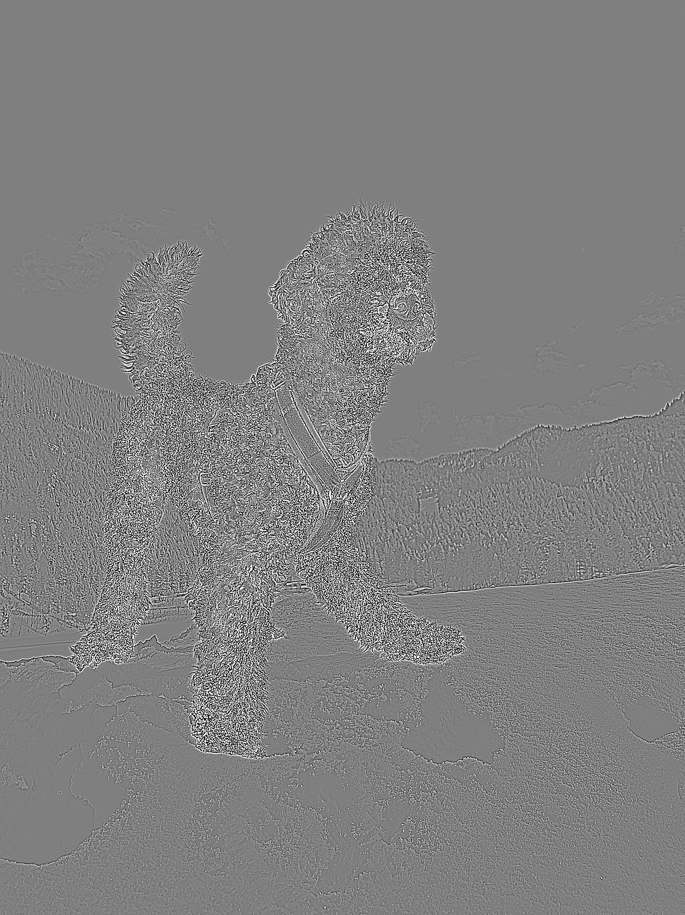
Source: Matthias Gruber (2022).

Determinant of the Hessian (DoH)
The explanation of DoH is based on (Xiong & Choi, 2013). The Hessian matrix is a square matrix of the function's second partial derivatives defined by an image's local curvature. DoH, like the LoG, uses scale-space to discover relevant spots for blob recognition, as shown in the following equation.
$$Δ_{norm}^{2}DoH\left(x,y,σ\right)=σ^{2} \left(L_{xx}L_{yy}-L_{xy}^{2}\right)$$
$L_{xx}, L_{yy}, and L_{xy}^{2}$Are the partial derivatives. If an equation has two unknown variables $x$and $y$, one can derivate the equation two times to $x$, yielding to $\frac{δ^{2}f}{δx^{2}}$, two times to $y$, yielding to $\frac{δ^{2}f}{δy^{2}}$, or one time to $x$and one time to $y$, yielding to $\frac{δ^{2}f}{δy}+\frac{δ^{2}f}{δx}$.
The interesting region is selected in the scale-space using the following function to find the maxima.
$$\left(x,y,σ\right)=\arg{\max{}} local_{\left(x,y,σ\right)}\left(Δ_{norm}^{2}DoH\right)$$
Operational differential geometric is utilized for describing the blob points $\left(x,y\right)$ and scales $σ$that provide covariant blob features concerning the rotations, rescaling, and translations. Under non-Euclidean affine transformations, blobs produced from scale-space extrema of the DoH demonstrate slightly superior scale selection features than the typical Laplacian operator. (Xiong & Choi, 2013).
Characteristic Shape of Euclidean and Non-Euclidean Geometric Shapes
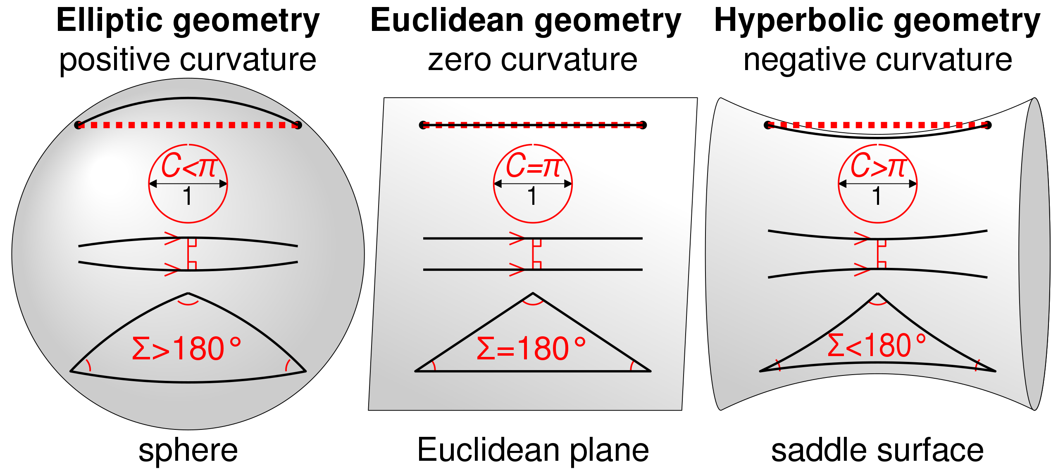
Source: Cmglee (2020). CC BY-SA 4.0).

Self-Check Questions
- Please list three key algorithms to detect blobs in images.
Determinant of the Hessian (DoH).
Laplacian of Gaussian (LoG).
Difference of Gaussian (DoG).

3.2 Edges and Lines
This section focuses on segmentation approaches that identify abrupt, local variations in intensity. We are particularly interested in the two image change types involving edges and lines. Edges are groupings of connected edge pixels, which are represented as the intensity of an image function that abruptly varies. A line can be considered an edge segment where the background intensity on each side of the line is either significantly higher or significantly lower than the line pixel's intensity. Derivatives can be used to identify any sudden or localized changes in intensity (Szeliski, 2022); (Davies, 2018).
A digital function's derivatives are specified in terms of differences. The first-order derivative approximation consists of the following requirements
- It should be zero in regions with consistent intensity.
- It must not be zero at the beginning of an intensity ramp or step.
- At the locations along an intensity ramp, it must not be zero.

The second order derivative approximation consists of the following requirements
- In areas of uniform intensity, it should be zero.
- At the start and finish of an intensity ramp or step ramp, it should not be zero.
- Across intensity ramps, it should be zero.

The equations are based on (Gonzalez, 2009). The first-order derivative of a function f(x) is denoted as
$$\frac{δf}{δx}=f^{'}\left(x\right)=f\left(x+1\right)-f\left(x\right)$$
The second order derivative of a function f(x) is denoted as
$$\frac{δ^{2}f}{δx^{2}}=f^{''}\left(x\right)=f\left(x+1\right)-f\left(x-1\right)-2f\left(x\right)$$
Second-order derivatives have better responsiveness to tiny details like thin lines, isolated spots, and noise, while first-order derivatives yield thicker lines. The sign of the second order derivative can be used to spot any change in an edge, whether from dark intensities to light intensities or vice versa (Szeliski, 2022); (Davies, 2018).

Line Detection
The most general line detection approaches include the Hough transform and methods based on convolution.

Hough Transform
The explanation of the Hough Transform is based on (Richard et al, 1972). Like the Fourier transform, the Hough transform transposes an image from one domain with spatial information to another with distinct representations of the relevant information. This method is utilized to find lines in an image picture and produce a parametric representation of those lines. If an image space has a line, it can be modeled using the following equation.
$$p=r \cos\left(θ\right) + c \sin\left(θ\right)$$
Where p represents the distance along a perpendicular line from the origin to the line, θ denotes the angle in degrees. It is measured in a clockwise direction from the source to the line. The procedure is illustrated in the graphic below which shows a Hough transform illustration of a line represented by its angle $θ$and the distance $r$.
Illustration of Hough Transformation

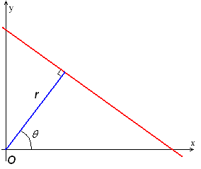
Source: Schha (talk) (2009). Public domain.

Convolution-based technique
In a convolution-based method, the utilized line detection operator contains a convolution mask tailored to find the line occurrences with a specific orientation and width. Applying the convolution mask to the entire image and then thresholding the output allows us to find lines moving in the direction we are interested in. These masks can identify vertical, horizontal, and oblique (-45 degrees and +45 degrees) lines.
Convolution Masks: Horizontal, Vertical, and Oblique
a) Horizontal mask
−1 | −1 | −1
2 | 2 | 2
−1 | −1 | −1

b) Vertical mask
−1 | 2 | −1
−1 | 2 | −1
−1 | 2 | −1
c) Oblique (+45 degrees)
−1 | −1 | 2
−1 | 2 | −1
2 | −1 | −1
d) Oblique (-45 degrees)
2 | −1 | −1
−1 | 2 | −1
−1 | −1 | 2

Source: Matthias Gruber (2022).
After applying the masks mentioned above, the points left have the most potent responses for one thick pixel line that matches most closely to the direction indicated by the mask.

Edge Detection
Edge Detection is a technique utilized to segment an image into discontinuous parts. An edge is referred to as a group of linked pixels that form the border between two regions. Real-world applications of edge detection in an image include face and fingerprint recognition, autonomous traffic management systems, finding an object in satellite photos, and medical imaging such as anatomical structure investigation. (Szeliski, 2022); (Davies, 2018)
Example of Edge Detection for Medical Imaging

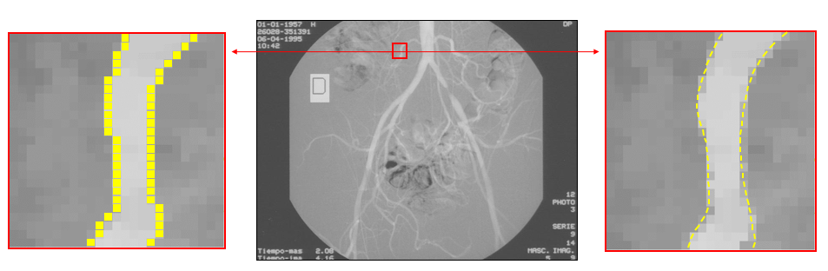
Source: Machanguillo1 (2018). CC BY-SA 4.0.
According to their intensity profiles, edges can be modeled as step, ramp, roof, and ridge edges. Step edges suddenly change an image's intensity from one value on one side of the discontinuity to the other. Ramp edges are the step edges where the intensity changes occur over a limited distance rather than instantly. In ridge edge, the image intensity suddenly changes value yet quickly returns to its initial value. Roof edges are ridge edges where the intensity changes over a fixed distance rather than instantly. The basic terminologies of the edge include:
- Edge Normal denotes a unit vector pointing in the direction of the highest intensity variation.
- Edge Direction represents a unit vector along an edge and is perpendicular to the edge normal.
- Edge magnitude denotes contrast in the local image along the normal.

The first derivative's local maxima or minima and the second derivative's zero-crossings can be used to identify points close to an edge.
There are four primary steps involved in edge detection.
- Smoothing is used to reduce noise while preserving actual edges.
- A sharpening filter is applied to improve the quality of the image's edges.
- Decide which edge pixels should be kept and which should be eliminated as noise.
- Discover the edge's precise location.

Operators that detect an edge in a digital image are classified into two categories.
- Gradient-based operators, such as the Prewitt, Sobel, and Robert operators, compute first-order derivations.
- Gaussian-based operators, such as Laplacian of Gaussian, and Canny edge detector, compute second-order derivations.
A brief introduction of the edge detection operators is mentioned below. The Sobel operator estimates the gradient approximation for detecting an edge in an image. The Sobel operator generates either the vector's normal or the matching gradient vector for each pixel of an image. Convolving two 3 x 3 masks with the input image yields the derivative approximations horizontally and vertically.
Sobel Operator for Edge Detection
$M_{X}=$
−1 | 0 | −1
-2 | 0 | -2
−1 | 0 | −1
$$M_{Y}=$$
−1 | -2 | −1
0 | 0 | 0
−1 | -2 | −1

Source: Matthias Gruber (2022).
It is easy to use, has quick computation, and is efficient in detecting smooth images. It has several challenges, such as the inability to preserve diagonal edges permanently, sensitivity to noise, and low accuracy.
The Prewitt operator also extracts an image's horizontal and vertical edges, much like the Sobel operator does. Applying masks or kernels proves to be among the most effective operators for determining the magnitude and orientation of an image. However, it also has some challenges, such as its coefficient's magnitude being fixed and cannot be tweaked. Also, points in a diagonal direction are not always retained.
Example of Prewitt Operator

$$M_{X}=$$
−1 | 0 | −1
-1 | 0 | -1
−1 | 0 | −1
$$M_{Y}=$$
−1 | -1 | −1
0 | 0 | 0
−1 | -1 | −1

Source: Matthias Gruber (2022).
Robert operator is a gradient-based operator. It calculates the sum of squares of differences amongst pixels in an image that are diagonally adjacent using discrete differentiation, and it utilizes 2 x 2 masks or kernels depicted below.
Example of Robert Operator
$$M_{X}=$$
−1 | 0
0 | -1
$$M_{Y}=$$
0 | 1
-1 | 0

Source: Matthias Gruber (2022).
Robert operator is relatively simple to detect edges and orientation, and diagonal direction points are retained. It also has limitations such as lower accuracy in detecting edges and high sensitivity to noise.
A gaussian-based operator called Laplacian of Gaussian (LoG) utilizes the Laplacian operator to determine an image's second derivative. It is highly beneficial when the change in the grey level appears abrupt. It operates using the zero-crossing technique, where a maximum level is determined when the second-order derivative crosses zero. Here, the Laplacian operator finds the sharp edges, while the Gaussian operator minimizes the noise. LoG has fixed properties in all directions and can efficiently detect edges and their varied orientations. It has some limitations, such as it is susceptible to noise, and it generates false edges. At curved edges, the localization problem can get highly severe.
The Canny Operator is a widely utilized gaussian-based edge detector that retrieves picture features without modifying or changing them. A canny operator utilizes three factors to identify edges that include a low error rate, edge points need to be located precisely, and only one single edge response should be permitted. This operator is less sensitive to noise and has effective localization. Additionally, it has several drawbacks like time-consuming computation, false zero crossing, and complex calculations.

Self-Check Questions
  - Please list three key algorithms to detect edges and lines in images.
Hough Transform
Sobel and Robert Operator.
Convolution-based techniques.

3.3 Corners and Points of Interest
An interesting point can consist of several regions like lines, curves, and edges. The interesting point which can be detected rapidly and is easy to calculate is known as a good interest point, thus considering it to be favorable to evaluate a feature. Hence, the interesting point is considered a qualifier or critical point that can be used to classify a feature.
A corner is a point at which two edges encounter. Alternatively, a corner is considered a point with two dominating and opposing edge orientations in its local surroundings. Corners are essential to detect as they describe the features' angular orientation. An interesting point can be a corner, an isolated point of maximum or minimum local intensity, a terminating line, or a position where there is a local maxima curve. Most of the methods used for interest point detection use a Gaussian filter and a gradient operator to decrease noise which is increased due to the use of the gradient operator. (Krig, 2014).

Moravec corner detection
The Moravec corner detection (Moravec, 1980) technique is a primitive corner detection approach that compares every pixel value in the image by its neighboring pixel of the overlapping region. The information is obtained from the correlation value of the two pixels about detecting a point or an edge. A corner is detected when the change in intensity is detected in all directions, while when no change is found in the edge direction, the edge is detected. However, if no change is observed in any direction, then flat terrain is detected. The Sum of the Squared Difference is calculated between the two overlapping regions to find the correlation difference. If its value is near 0, then the difference measures similarity. This method is computationally demanding. The equation for the sum of the squared difference is given below (Szeliski, 2020)
$$E_{SSD}\left(u\right)= \sum_{i}^{ }{w\left(x_{i}\right){\left[I_{1}\left(x_{i}+u\right)-I_{0}\left(x_{i}\right)\right]}^{2}}$$
With $w\left(x_{i}\right)$ weighting function, $u$as a displacement vector, and the index $i$iterating over all pixels.

Smaller Univalue Segment Assimilating Nucleus (SUSAN)
The SUSAN (Smith & Brady, 1997) utilizes a non-linear filtering approach to identify the components in the image that are highly related to the pixels. Every pixel is connected to the neighboring pixels having a similar brightness. Thus, the approach depends on segmenting the features by comparing similar brightness in the pixels to produce the features. These newly detected features minimize the small image patch and reduce noise to smooth the neighborhood. The developed methods are precise, noise-resistant, and quick.
SUSAN works by comparing neighbor pixels within a certain radius from the center nucleus pixel value, generating a set of pixels with similar brightness known as a USAN. Each USAN holds morphological data about the image, like center and size. It can be used to detect edges and corners. A low ratio of pixels in the circular zone compared to the centroid indicates the corner, while the higher ratio above 50% indicates the edge. Mathematically the response of the SUSAN operator is given by:
$$R\left(M\right)=g-n\left(M\right) if n\left(M\right) < g, else R\left(M\right)=0$$
With $g$being the geometric threshold. M is the region of the mask and n is the number of pixels within the region.
SUSAN Illustration
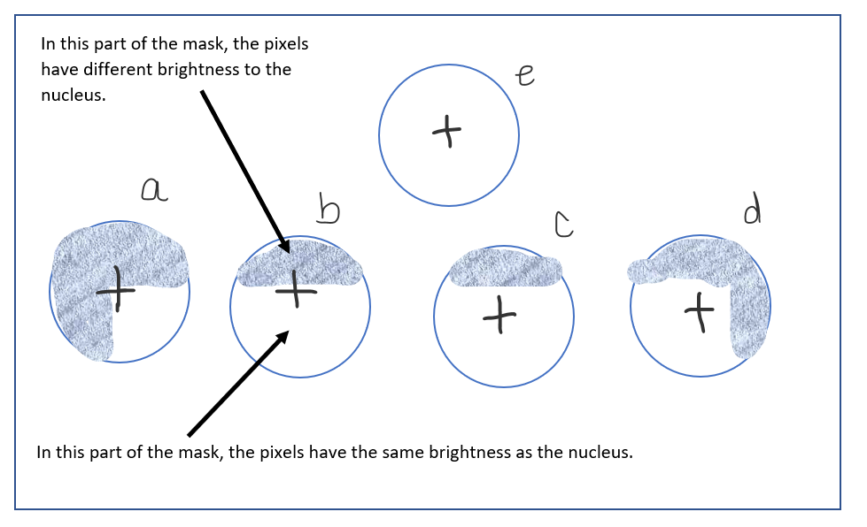
Source: Based on Fonte, Gautama and Wilfried. (2008).
Typical Outcome of the SUSAN Corner Detection Algorithm
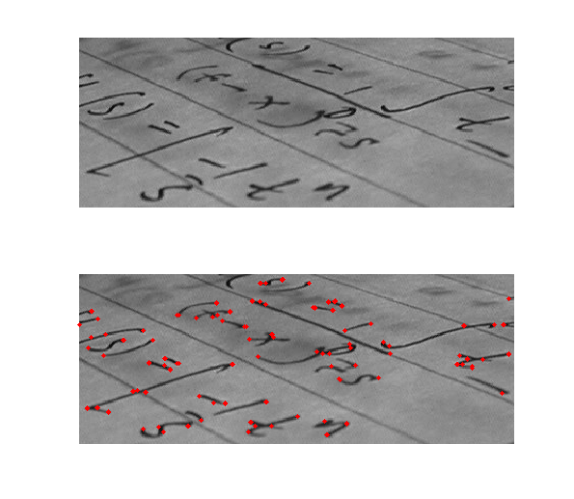
Source: Retardo (2006). Public domain.

Harris Methods, Harris-Stephens, Shi-Tomasi, and Hessian-Type Detectors
Harris or Harris-Stephen's corner detectors (Harris & Stephens, 1988); (Schmid & Mohr, 1997) surpass the Moravec approach by introducing a gaussian window instead of a rectangular one. A gaussian window can be seen as a window which is a layer over an area of pixels and weighs these pixels which the shape of the gaussian hump. The Harris technique uses a covariance matrix to find the direction in which the larger and smaller change is detected. The covariance matrix gives the variance of the pixels lying next to each other; thus, one can determine the directions in which there are same (low covariance) and different (high covariance) pixel values. The Eigenvalues are evaluated to a score factor to detect the edges, corners, and noise. The algorithm's structure is considered invariant to translation, rotation, and brightness change in some formulations, like the Harris-Laplace method employing scale space (Mikolajczyk & Schmid, 2002).
Mathematical computation works by taking an area of the image, shifting the input by a specific value within its position, and computing the weighted sum of squared differences:
$$S\left(x,y\right)=\sum_{ v}^{ }{\sum_{ u}^{ }{w\left(u,v\right){\left(I\left(x+v,y+u\right)-I\left(v,u\right)\right)}^{2}}}$$
With area $\left(u,v\right)$, the image $I$, and shifting $\left(x,y\right)$.
Eigenvalues
are a set of scalar values which corresponds to a linear system of equations (i.e., covariance matrix). They are sometimes also known as its characteristic values.
Many Harris family algorithms are computationally efficient in implementation. The algorithm uses the idea that the two edges join at the corner, thus having an ill-defined gradient. The gradient at the corner can be computed with two values concerning x and y, the underlying notion behind the Harris method.

Features-from-Accelerated-Segment Test (FAST)
Considering a bimodal segmentation target, the FAST techniques (Rosten & Drummond, 2006) are derived from SUSAN. On the other hand, FAST determines a corner by circularly connecting a series of 16 pixels. It is known for being quick to compute and producing very accurate results. The FAST algorithm detects the presence of a corner by evaluating a circular area around the potential center of the corner. If a continuous block of pixels is brighter than the addition of the center and the threshold or is darker than the center excluding a threshold, the test detects a corner. The generated description is saved as a continuous bit vector numbered 0 through 15. Similarly, storing the bit vector in a rotational invariant representation is easy because the pixel compares circular patterns. The figure below depicts the working of the FAST algorithm with the 16-element grid.
FAST Detector with the 16-Element Grid
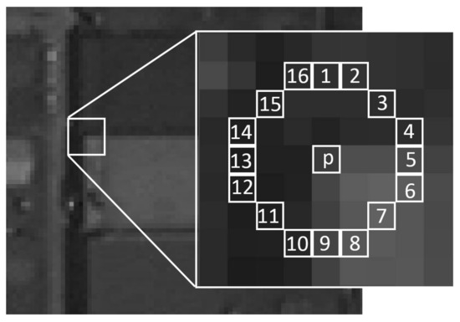
Source: Jingjin Huang et al. (2008). CC BY 4.0.
Mathematically the brightness of the center pixel $p$gets compared to the surrounding pixels 1 to 16 one by one.
If the surrounding pixel is brighter than the center pixel:
$$s\left(1,…,16\right)=d$$
If the surrounding pixel has similar brightness as the center pixel:
$$s\left(1,…,16\right)=s$$
If the surrounding pixel is darker than the center pixel:
$$s\left(1,…,16\right)=b$$
Now as each of the 16 pixels is assigned to one of the three values $d,s, or b$, we can divide them into three subgroups. If there is a corner, then at least three of the surrounding pixels must be assigned the value $d or b$.
Using the FAST algorithm and applying it to Sirius the King yields to the detection of the features represented in the right image. The left image shows the original one.
Example of FAST Algorithm

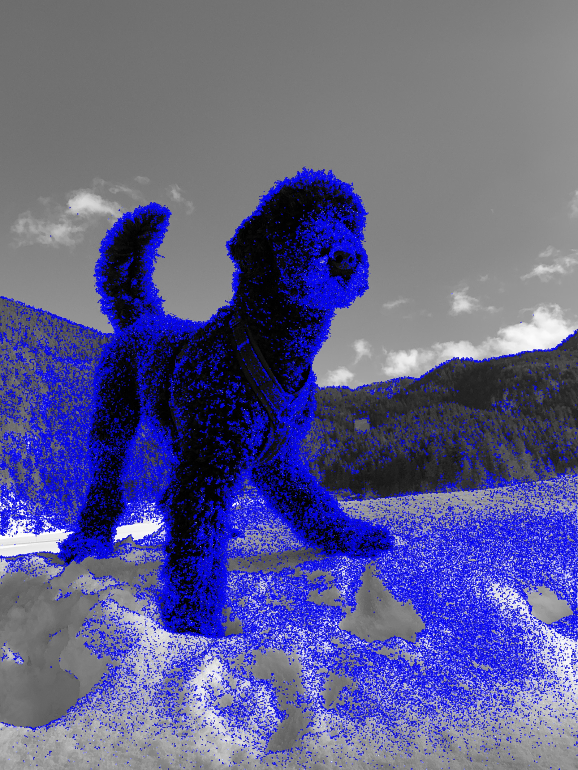
Source: Matthias Gruber (2022).

Morphological Interest Regions
The detection of interest points can be performed by combining multiple morphological operations, such as thresholding along with erosion and dilation. These operations perform enlargement, shrinking, and smoothing on the images. However, simple morphological procedures alone are insufficient; eroding left uncontrolled will diminish regions until they disappear. Thus, the intellect must be applied to the morphology pipeline to regulate the final region size and shape. Morphological procedures can be used on binary, grayscale, or color channel images to produce interesting regions. Applying some pre-processing to the images is essential before applying morphology, like histogram equalization and pixel remapping (Krig, 2014).
In this example of morphological operations, the shape of two people dancing in blue and its morphological dilation in green, and erosion in yellow.
Example of Morphological Operations
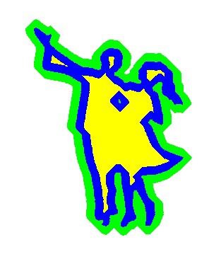
Source: Renato Keshet (2008). Public domain.

Self-Check Questions
- Please list three key features to detect in images.
Corners.
Lines.
Edges.
Summary
Low-level computer vision includes basic image processing techniques to extract the relevant features from the images. The various features that need to be extracted are, for example, but are not limited to boundaries, lines, blobs, points, and corners. Low-level vision provides image-to-image transformation as the input and output are images without understanding the features. The low-level vision task includes image enhancement, image restoration, and image compression.

Unit 4 – High-Level Vision

Study Goals

On completion of this unit, you will be able to …

… understand how Deep Learning Models are composed and predicting.
… describe the importance of CNN for computer vision.
… apply the basics of modern deep learning frameworks for object recognition.

4. High-Level Vision

Case Study
You want to train your computer to predict the rank and suit of playing cards lying on your desk.
Using your smartphone, take a picture of some playing cards on your desk. Upload the image to your computer, install python, install the OpenCV-python library, and read the image into a variable. Process the image of the card and crop out a single corner of the cards.
Now, you want to match the rank and suits for each single card. First, you must get references. Take images of all possible combinations of suits and ranks with your phone and upload them on your computer. Use the screenshot tool of your operating system to extract each possible combination of rank and suits. Make sure that the size (length and width) of the screenshots matches the extracted parts of your algorithm. The support vector machine (SVM) (OpenCV-Docs, 2022) is a nice machine learning tool which is fast to train and does not require GPU utilization.
To train an SVM classifier to identify your rank and suits, use the OpenCV implementation and your screenshots. Once it has finished, integrate it into your pipeline and match new images for their specific classes.

4.1 Deep Learning
Nowadays, mainly all the researchers focus on utilizing machine learning (ML) and deep learning (DL) for high-level vision tasks. ML is the branch of artificial intelligence (AI) that copies the behavior of the human brain. It learns, acts, and makes decisions on new data based on the learned data. For unstructured data like images and text, ML is performed using two steps: a) Extracting the relevant features using traditional image processing techniques, i.e., low-level vision tasks as described in previous chapter 3. b) Learning the ML model from the extracted features and predicting the new data. Moreover, the DL is the subset of ML that does not require manual feature extracted steps as in the case of ML. Hence, DL automatically extracts features from the images and performs high-level vision tasks.
Deep Learning (DL)
Is named for its numerous layers of interconnected neurons. The number of parameters of an ANN can be billions.
The foundation of DL is based on artificial neural networks (ANN) (Shanmugamani, 2018). ANN is founded based on the human brain's name, structure, and behavior and mimics the human brain in learning and making decisions. The basic mathematical model of ANN is given in this section.
Example of a Neuron
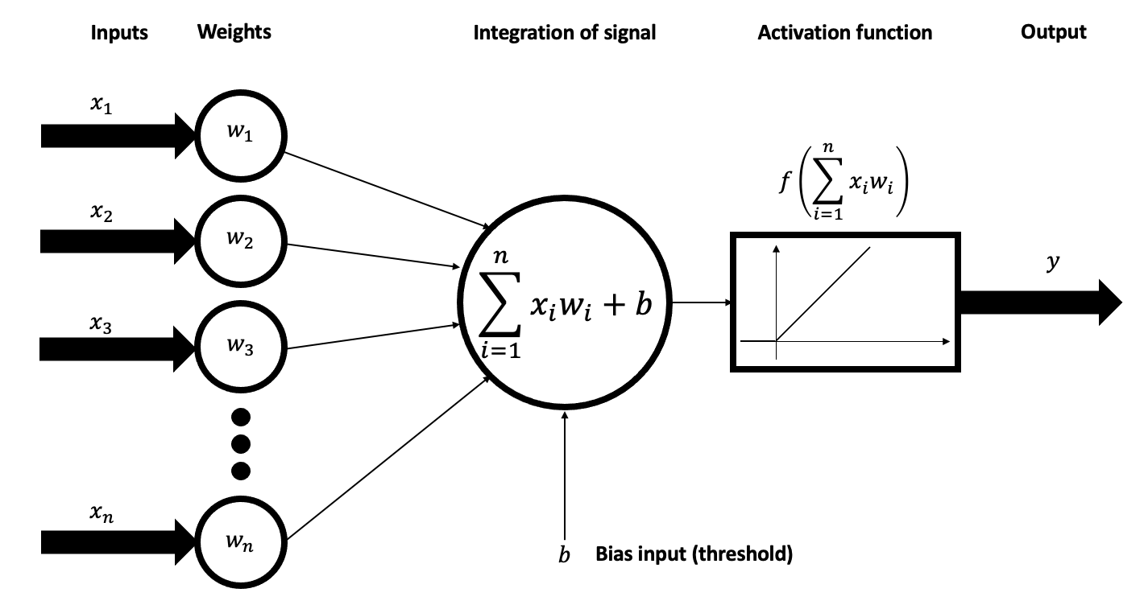
Source: BrunelloN (2021). CC BY-SA 4.0.

The above figure depicts the operative model of ANN and consists of inputs represented by $x_{1},x_{2},x_{3},…,x_{n}$; weights by $w_{1},w_{2},w_{3},…,w_{n}$; b is for bias, and $f\left(…\right)$ equals the activation function in the network.
Bias
a systematic scalar which determines the difference between the truth and the prediction.
The illustration assumes that the bias $b=0$. Activation functions can be linear as shown in the illustration above and non-linear. Non-linear examples will be stated later. The output is given by y. Henceforth, the output of the neural network is evaluated as given in the following equation. Inputs are also known as features, and the output is known as the target variable.
$$y=\sum_{i=1}^{n}{\left(x_{i}⋅w_{i}\right)}+b$$
The components of the ANN are:
- Weights are the hyperparameters that get updated and learned during the training of ANN. Hyperparameters are the parameters within machine learning models which influence the outcome of the model. The hyperparameters are adjusted during the learning process. They are randomly initialized, but as the training of the ANN proceeds, they get altered to build a more accurate network. Weights are the strengths of the connections between the nodes. Weights represent the effect of change in the input to the outcome of the network. Hence, the low value of weights does not affect the output, while the high value affects the output.

- Bias is utilized to adjust the error produced by the predicted output and the intended output. If the bias's value is high, it makes more assumptions regarding the nature of the output, while if the value is low, it makes fewer assumptions. A neuron is activated if the output value of its activation function is greater than zero. In the first image this is the case if the integration of the signal is grater zero. For values smaller than zero the activation function outputs zero and the neuron stays deactivated.
An activation function is also known as a transfer function. It is utilized in the ANN to transform the weighted sum of the input into an outcome from a node in the network layer. Although neural networks are linear, thus non-linearity in the ANN uses non-linear activation functions. The activation function is chosen concerning the model's requirements; therefore, its capacity and performance differ. It is applied to each layer of the network, and the same activation function is used across all layers. Possible activation functions are linear, Rectified Linear Unit (ReLU), Leaky ReLU, Sigmoid, and hyperbolic tangent (tanh). See the two illustrations below as an example for the two most common activation functions.
Activation Function RELU
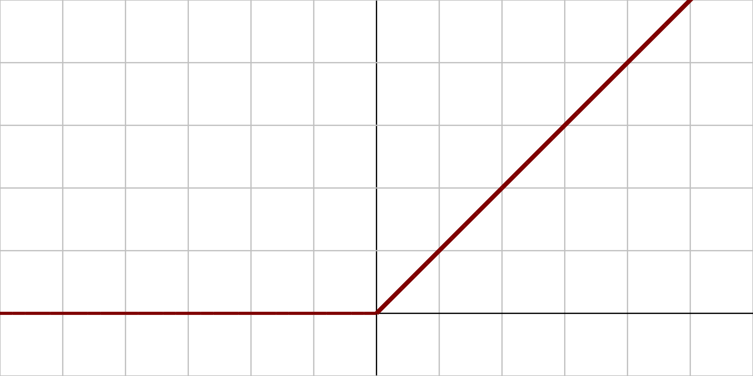
Source: Laughsinthestocks (2015). CC BY-SA 4.0.

Activation Function Tanh
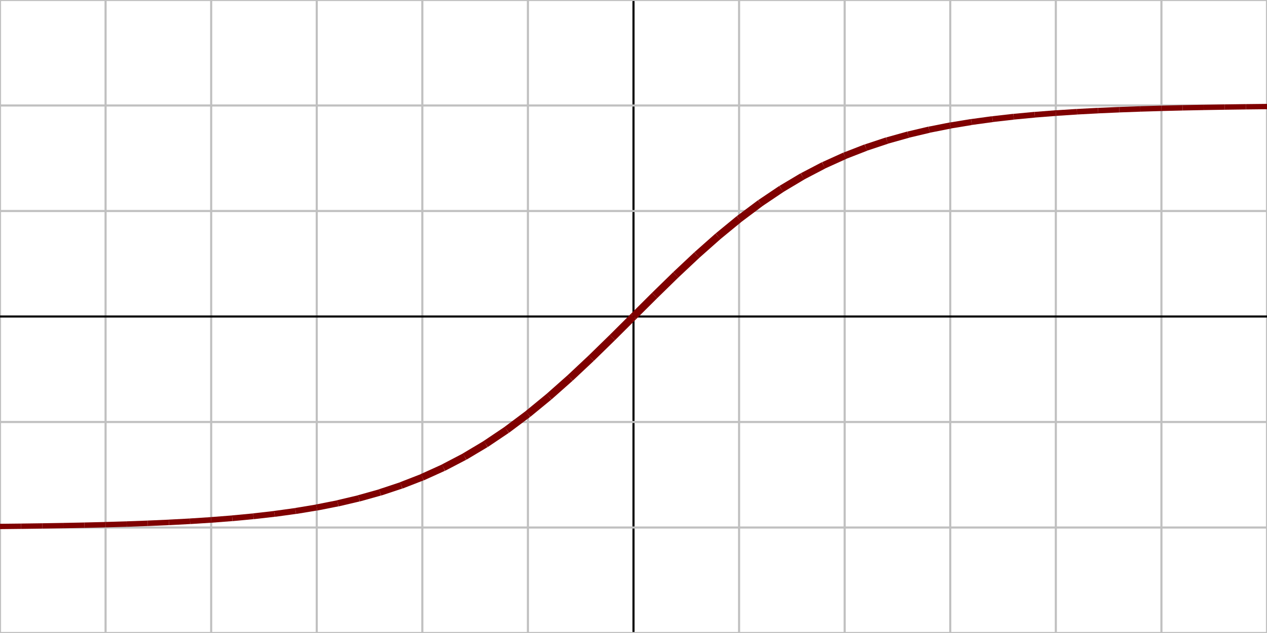
Source: Laughsinthestocks (2015). CC BY-SA 4.0.

The Architecture of an ANN
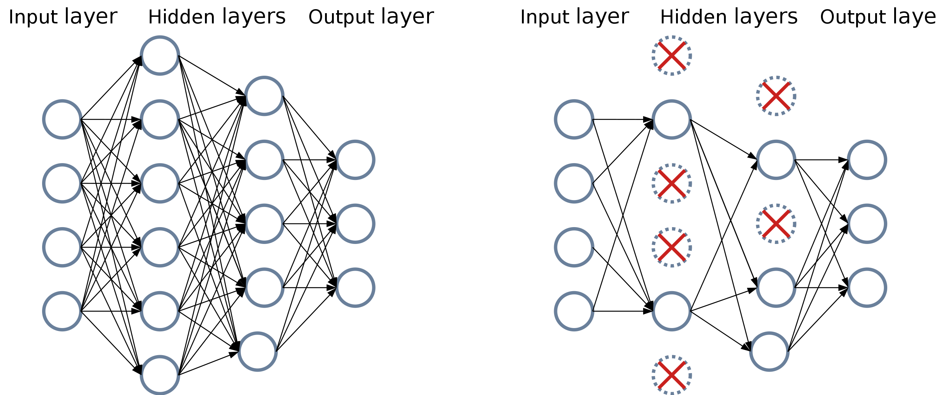
Source: Mads Dyrmann (2021). BY-SA 4.0.
There are three layers in an ANN: Input, output, and hidden layer.
The input layer is the first layer of the ANN. The features are provided as input to the first layer to find the information and relation between them. The number of nodes in the input layer equals the number of input variables in the data. For example, if there are 250 pixels, the input layer has 250 nodes.
The hidden layers follow the input layer. They are responsible for extracting more relevant hidden information from the input variables. The layers perform mathematical operations like scalar multiplication between the input values and the weights. It emphasizes the significance of the features in the input data as well. It provides input features that contribute more to learning with greater weight than other input features. For instance, in emotional analysis, negative words have a more significant influence on the choice than neutral ones.
As a result, the hidden layer will place a high value on negative words. As the hidden layers get more profound, more specific information is collected from the input features. Each hidden layer can be seen as further processing of low- and high-level features. As more hidden layers a models consist, the more information and features can be extracted.
The output layer provides the ultimate result; hence it is the last layer in the ANN. It comprises the same number of nodes as the different categories of classes available in the target variable for the classification operation. It receives inputs from the hidden layers, i.e., more suitable and accurate information, executes mathematical operations through its neurons or nodes, and then computes the result for each node in the output layer. The result will indicate if the input falls within the specified category.
The advanced version of the ANN is a convolutional neural network (CNN), the basic architecture for computer vision tasks. As ANNs are not useful to deal with image data as the number of neurons would be very large and the training and inference time will explode. The architecture of CNN is given in the following figure. It mainly consists of four different types of layers; convolutional layer, pooling layer, dropout layer, and fully connected layer. The illustration is just one application example, in reality, the numbers of convolution and pooling layers is a hyperparameter which needs to be optimized during the training process. There is not a single solution which generalizes to most of the use cases. However, for the explanation within this course book we use a simple architecture of two convolutions, one pooling, one convolution and two fully connected layers.
Example of the Connection of the Different Layers in CNN
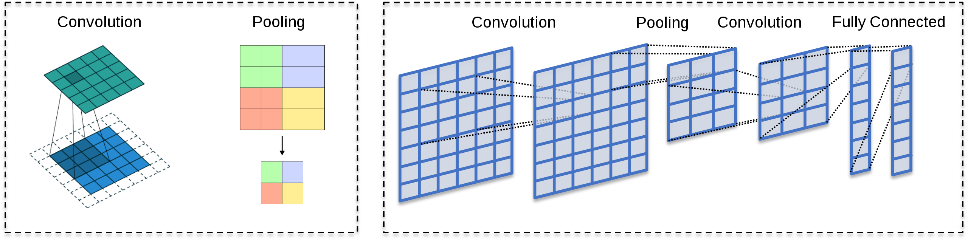
Source: Andreas Maier (2019). CC BY 4.0.
The first layer in the network performs a convolutional operation between the input image and the filter. Convolutional operation is the dot product between the filter and the part of the image under the filter, as depicted in the following figure. It extracts the low-level features of the image at the first convolutional operation. In contrast, as more convolutional layers are added to the network, more prominent features are extracted from the image. The output is the feature map that consists of the input image's information like lines, corners, edges, and points.
Example of a Convolution
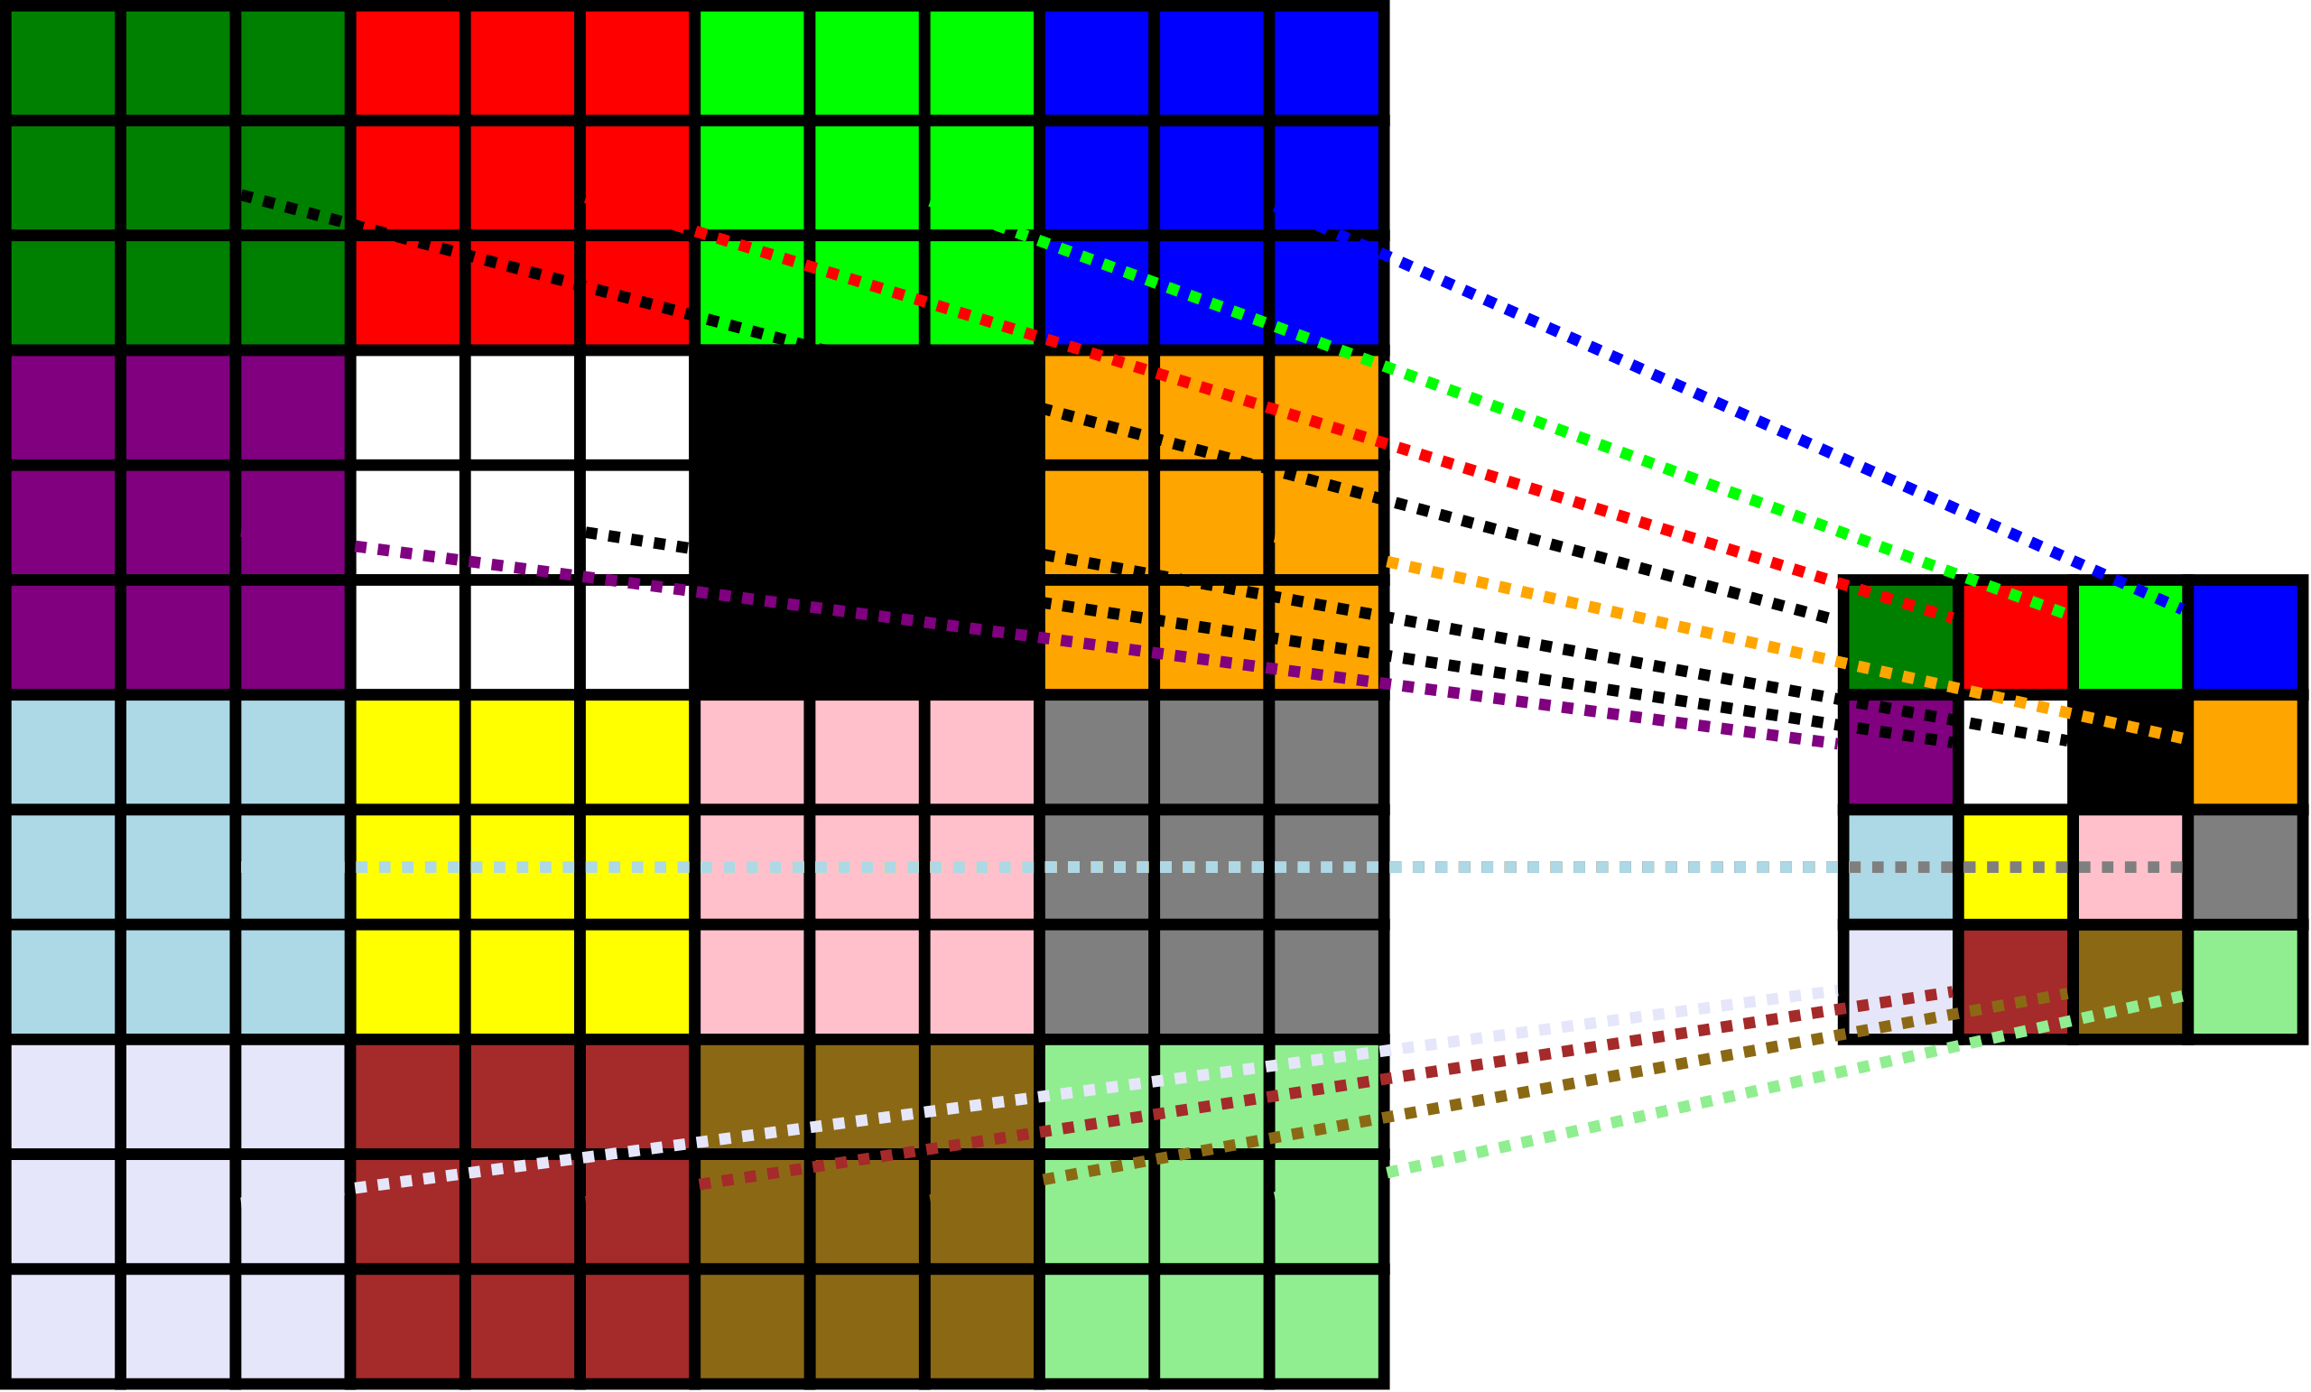
Source: Trougnouf (2019). CC BY 4.0.
Following the convolutional layer, the pooling layer is stacked. As demonstrated in the following figure, the pooling layer is used to lower the feature map’s size produced by the convolutional layer, hence decreasing computation time. As a result, it weakens the connections between the layers.
The different types of pooling operations are given below.
• Max Pooling- Chooses the most significant value.
• Min Pooling- Chooses the smallest value.
• Average Pooling- Performs an average of all the values.
• Sum pooling- Performs the summation of all the values.
Example of Max-Pooling
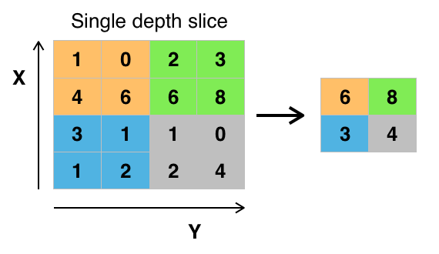
Source: Aphex34 (2015). CC BY-SA 4.0.

The max pooling approach chooses the highest value of the corresponding region of interest: $y=\max\left(1,0,4,6\right)=6$.
The min pooling approach chooses the minimum value of the corresponding region of interest: $y=\min\left(1,0,4,6\right)=0$.
The average pooling approach chooses the average value of the corresponding region of interest: $y=\frac{1}{4}\left(1+0+4+6\right)=2.25$.
The sum pooling approach chooses the sum of all values in the corresponding region of interest: $y=\left(1+0+4+6\right)=11$.

The fully connected layer is used to perform the final task of classifying or segmenting images. Every node in the former layer is linked to every node in the next layer. As a result, the matrix multiplication is computed in conjunction with the bias effect. These layers are used before the output layer, and the flattened input from the preceding layers is passed to the fully connected layer.
The dropout is applied to reduce the overfitting problem caused by fully connected layers as all the neurons in the previous layer are linked to all neurons in the following layer. Hence, the model will perform well on training data but poorly on test data, i.e., new data. During the training phase, the dropout layer removes a few neurons from the ANN, reducing the model's size. The dropout size must be specified; for example, if the dropout size is 0.1, then 10% of the neurons in the ANN are randomly eliminated.
Illustration of How Dropout Works
Source: Mads Dyrmann (2021). CC BY-SA 4.0.
The fundamental difference between ANN and CNN is that the ANN works similarly as it would be a model to the human brain. If something goes wrong, it rectifies the errors by propagating it backward, which modifies the weights and improves the network. ANN requires data points as the input to be provided to the input layer. CNN consists of various layers, especially the convolutional layer, and uses filters or kernels to process the image in parts. Each part of the image is divided into a rectangular region having a filter of, and the image is processed along with the filter until the complete image is covered. Even the corner pixels of the image need to be covered to extract the features. Also, CNN does not require data points to get a first solution because it automatically extracts features by the process mentioned above. One can simply put some convolution layers together and see what happens. For ANN, it will never yield good results if one implements the weights manually.
Despite the difference, there are many similarities between ANN and CNN as the background of the two approaches is nearly the same. Both work on the same principle of calculating the cost function to improve the network. Moreover, to introduce convergence, both the approaches are trained for several training cycles known as epochs to get the best accuracy and to find the best epoch from which the accuracy decreases and loss increases.

Self-Check Questions
- List four main pooling approaches.
Max Pooling.
Min Pooling.
Average Pooling.
Sum Pooling

4.2 Image Classification
Image classification is a procedure in computer vision to classify an image based on its visual information. The classification process's purpose is to allocate each pixel in a digital image to one of several classes. Image classification has been an essential topic in the field of computer vision since discriminating between different objects is a challenging process. Image classification is the process of categorizing images into one of several predetermined classes. As a result, image classification is defined as categorizing and identifying groups of pixels or vectors inside an image using specified rules. Image classification analyzes photos using deep learning models, with results that can even outperform human-level accuracy for some tasks. (Szeliski, 2022) and (Davies, 2018)
One of the most prominent uses of classification in computer vision is semantic image classification, in which we want to label an entire image (or a specified piece) with its most likely semantic category, such as horse, cat, or car. There are several applications of image processing, and some of the uses are briefly discussed below.

Facial Recognition
Facial recognition is classified into two types based on face representation. Appearance-based, which utilizes overall texture characteristics, and model-based, utilizing the contour and face texture, as well as 3D depth data. Facial recognition has the potential to replace boarding passes at airports. The technology recognizes passengers' faces and compares them to databases to verify their identity and flight information.

Logo Detection
Image classifiers can recognize visual brand mentions by scanning photos, also known as visual listening. Brands can also use visual listening to calculate the performance of difficult-to-quantify marketing activities, such as sponsoring sporting events. Companies can better assess their growth in brand awareness through a particular campaign by using visual listening.

Medical Imaging
Classification of Medical images is an essential technique in Computer-Aided Diagnosis systems. Medical image classification aims to categorize medical images to assist doctors in diagnosing diseases. The first step is to extract helpful image features, and in the second step, these features are utilized to develop models that classify the medical image dataset.
X-ray of a Hand with Automatic Calculation of Bone Age
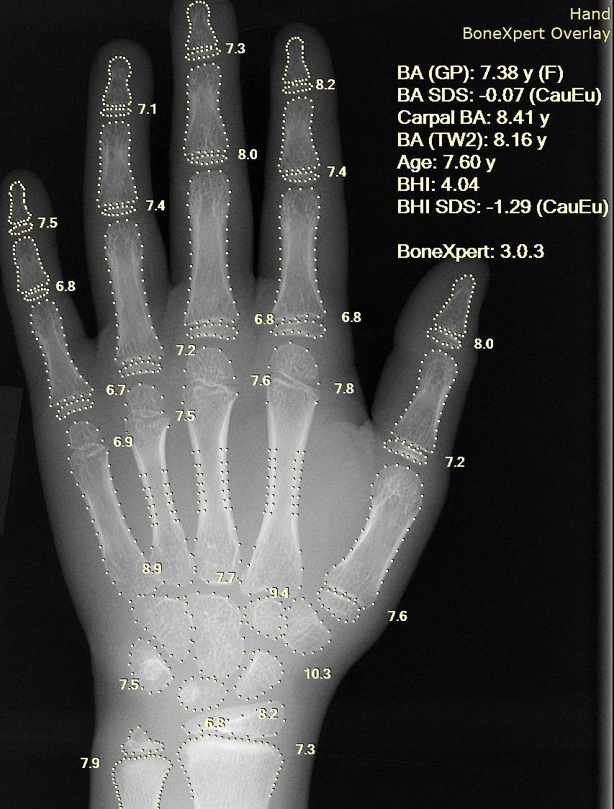
Source: Setzner1337 (2020). CC0 1.0.

Visual Search Engine
Similar images are returned in this application when a user inputs an image into the search engine. Consider having a photograph of your favorite actor. Feeding this image into a visual search engine yields additional images of your favorite actor - in various contexts and places.
Results Shown by the Image Searcher Through Example GOS
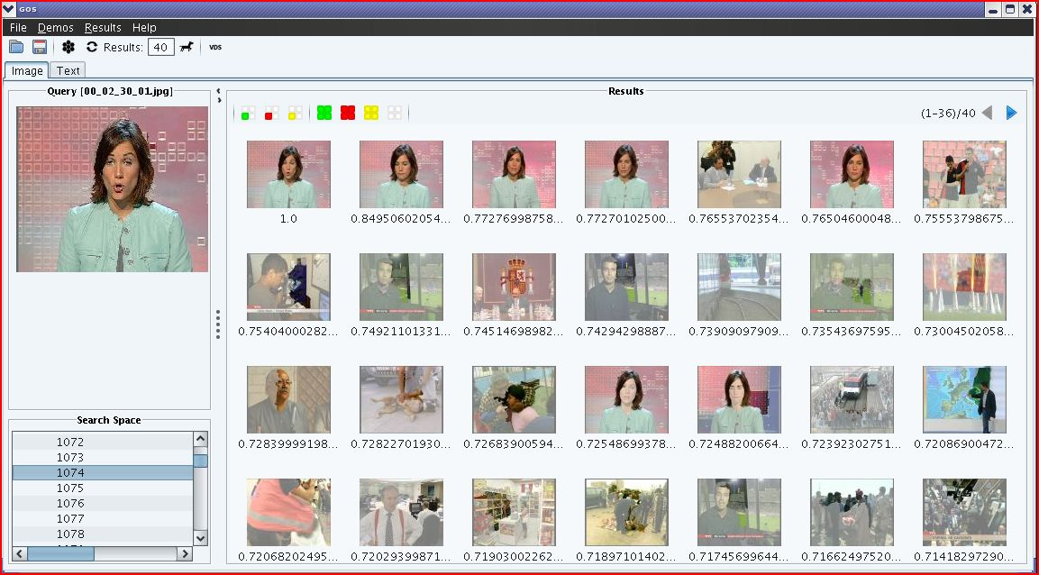
Source: Me (2010). CC BY-SA 4.0.

Object Identification
Object detection determines the presence and location of an object in images or videos. It categorizes individual elements and uses boundary boxes to show their location. To train such an algorithm, one has to take train images and label these manually.
Objects Detected with OpenCV's Deep Neural Network Module
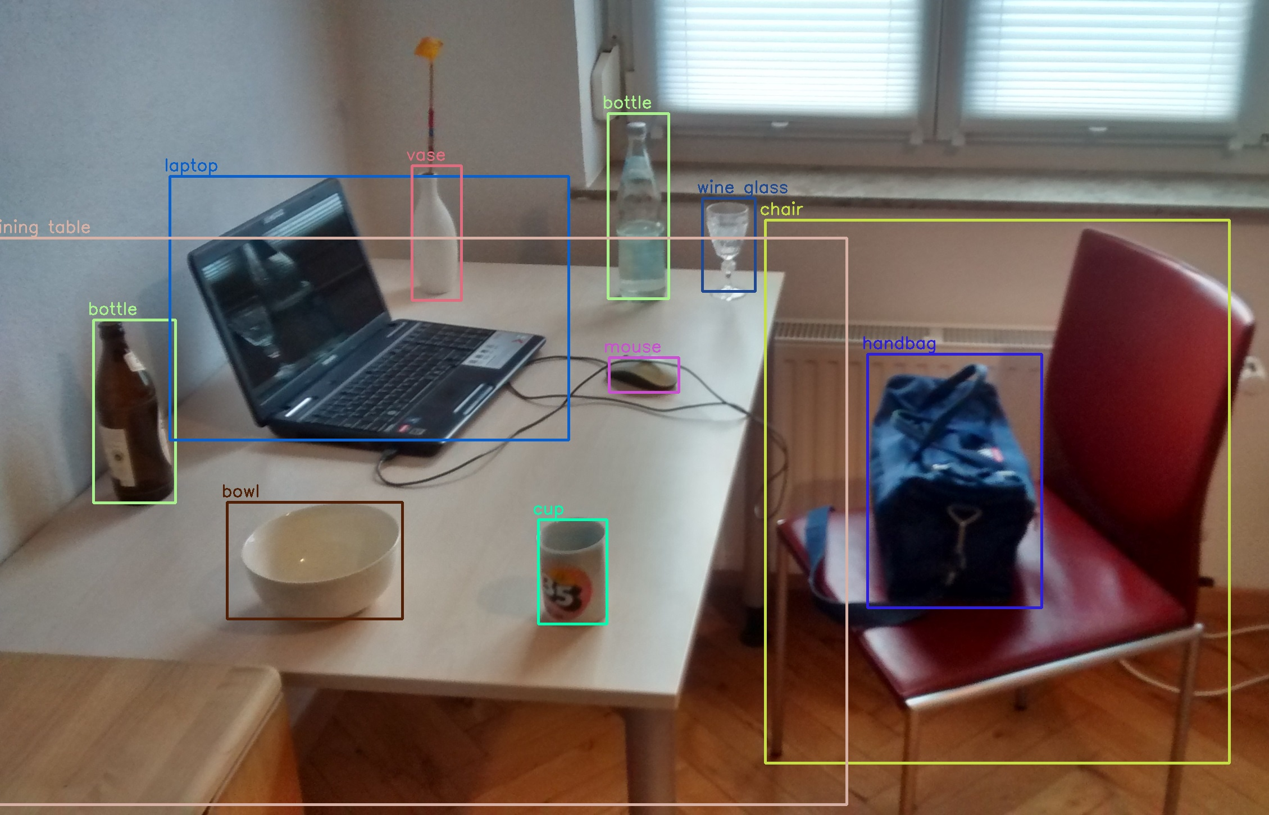
Source: MTheiler (2019). CC BY-SA 4.0.

Classification Techniques
Different classification approaches include supervised and unsupervised, hard and soft, parametric and nonparametric.

Supervised Techniques
It is the process of classifying pixels with an unknown identity using samples from training sets of known informative classes. A supervised machine learning approach needs labeled input and output data throughout the training stage of the machine learning lifecycle. The model can classify previously undiscovered datasets and forecast outcomes once it has established the relation between the input and output data. Supervised machine learning highlights the fact that this approach partially involves human supervision. Supervised machine learning algorithms may predict outcomes from new, unforeseen data by recognizing patterns between input and output data.

Unsupervised Techniques
As the name suggests, unsupervised machine learning adopts a hands-off method than supervised machine learning. In unsupervised classification, statistical data are presented without any labeled outputs. Unsupervised classification is when the results (groupings of pixels with similar properties) are based on software analysis of an image without the user giving sample classes. To classify the pixels, the computer employs methods to identify corresponding pixels. Unsupervised machine learning is well-suited to respond to answer queries regarding hidden correlations and trends within the data itself. Some unsupervised learning algorithms are anomaly detection, cluster analysis, neural networks, and learning latent variable models.

Parametric Classifier
A parametric classifier's performance is determined mainly by how well the data fit the pre-defined models and how precisely the model parameters were computed. For example, in the maximum likelihood classifier, the covariance matrix and mean vector are employed as parameters. This results in a classifier which takes the input $x$and the parameters $θ$and predicts the outcome $y$:
$$y=f\left(x,θ\right)$$
For the maximum likelihood classifier, the covariance matrix and mean vector are the parameters $θ$.

Nonparametric Classifier
There are no data assumptions in nonparametric classification. Additionally, nonparametric classifiers do not compute class separation using statistical parameters. For example, Artificial Neural Networks (ANN), Support Vector Machines (SVM), and decision tree classifiers like the Random Forest (RF) exemplify the nonparametric classifier. The SVM and decision tree classifiers are supervised machine learning techniques. For a deep explanation, the reader is referred to Davies (2012).

Hard Classifier
In this type of classifier, each pixel must display class membership for just one class. Hard classifiers target the classification decision boundary directly without creating a probability estimate.

Soft Classifier
Each pixel may belong to multiple or only a few classes in this type of classifier. Soft classifiers directly estimate the class conditional probabilities and then classify based on those estimates.

Self-Check Questions
- Provide four examples of real-world applications for Image Classification.
Facial Recognition.
Object Identification.
Logo Detection.
Medical Imaging.
4.3 Semantic Segmentation
Segmentation is the process of classifying each pixel of an image and assigning them labels. Thus, the group of pixels with the same label is segmented to form an object highlighted in the image. There are two types of segmentation, i.e., semantic and instance segmentation. Semantic segmentation provides a similar label if the pixels are similar, i.e., classifying each pixel that belongs to the label. For example, if there are two sheep in the image, then the same label will be provided for all the pixels of sheep in the image. However, each instance is classified and labeled in the case of instance segmentation. Hence, two labels are provided for two different sheep (Szeliski, 2022) and (Davies, 2018).
Example of an Image Segmentation – Original Image

Source: Martin Thoma (2016). CC0 1.0
Example of an Image Segmentation – Segmented Image
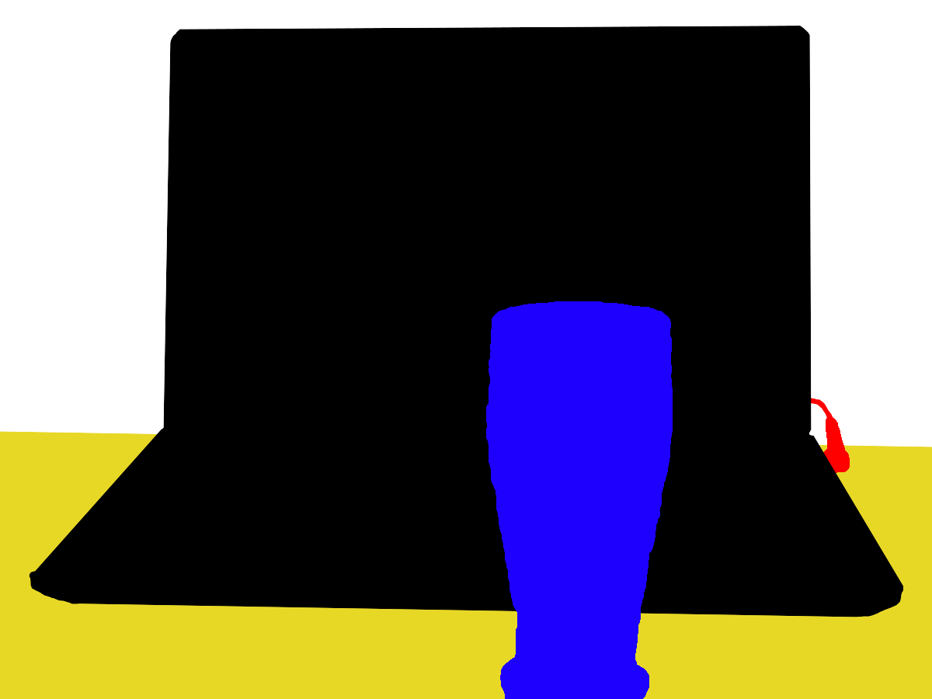

Source: Martin Thoma (2016). Public domain.

Self-Driving Cars
Semantic segmentation will segment the objects on the road in real-time to help the self-driving cars to understand which object is living and which one is a non-living object. It can also segment the hurdles on the road to have safe driving. Hence, by identifying the different objects, it can understand which object is more important than the other and make driving decisions based on it considering the safety of the humans inside and outside the car.

Medical Images
In medical applications, semantic segmentation plays a significant role in segmenting the tumor from the normal cells. It is a widely accepted technique by most researchers and proved promising. It assists the doctors in extracting information about the diseases and highlighting the position by segmenting it for deeper analysis. Various imaging techniques are used for analysis like X-ray, Computed tomography (CT)-scan, and Magnetic resonance imaging (MRI).

State of the Art Deep Learning Architectures for Semantic Segmentation
Researchers have developed various deep learning models for semantic segmentation. The most popular are UNET (Ronneberger et al., 2015) and DeepLab (Chen et al., 2016).

UNET
U-Net is a CNN architecture designed to segment biological images. When viewed, its architecture resembles the letter U, therefore the name is U-Net. Its architecture is divided into two parts: the contracting path on the left and the expansive way on the right. The purpose of the contracting path is to capture context, whereas the purpose of the expansive path is to aid in exact localization.
Example Architecture of U-Net
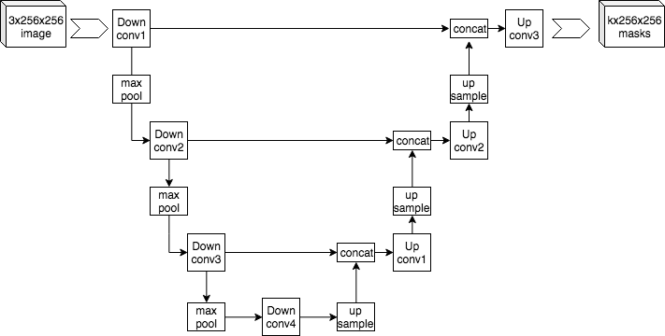
Source: Mehrdad Yazdani (2019). CC BY-SA 4.0.

DeepLab
DeepLab (Chen et al., 2017) is one of the state-of-the-art methods developed by google for semantic segmentation. The primary difference between UNET and DeepLab is that UNET uses regular convolutional operation while DeepLab uses an Atrous Convolution operation. Regular convolution extracts sparse features while atrous convolutional operation extracts dense features.
The various layers of convolutions and max pooling is used in deep CNN like UNET. This has the drawback of halving the feature map's spatial resolution at each stage. Sparse features are extracted by overlaying the final feature map over the original image. The convolutional filter downsamples the input image by a factor of two. The responses only correlate to one-fourth of the locations in the image, as shown by upsampling and superimposing the feature map on the image, known as sparse feature extraction. This operation is depicted in the figure below.
Dense feature extraction is made possible by the Atrous convolution, also referred to as dilated convolution, which addresses this issue. A novel parameter called rate (r) allows for solving this problem. Simply put, atrous convolution is like regular convolution, except that its kernel's weights are spread out over r locations instead of 1. This makes the kernel of dilated convolution layers sparse. Atrous convolutional with rate r=2 is depicted in the below figure.
Atrous Convolutional with Rate r=2
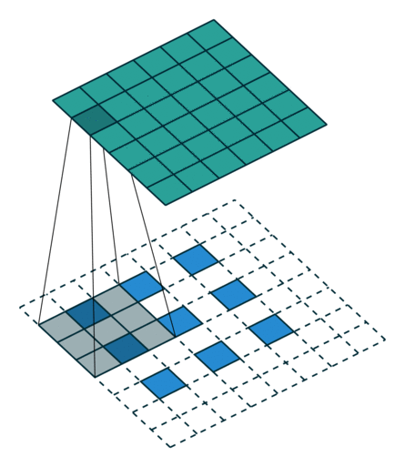
Source: Based on Vincent Dumoulin, Francesco Visin (2016).

The receptive fields, i.e., the size of the region of the input feature map from which each output component is derived. The convolutional layer can be freely controlled by varying the rate parameter. As a result, the convolutional filter can examine more significant portions of the input (receptive field) without sacrificing spatial resolution or growing the kernel size.

There are various versions of DeepLab

Version 1
DeepLab 1 up-samples the filters (atrous) in subsequent convolutional layers to generate feature maps computed at a higher sampling rate by removing the down-sampling operator from the final few max-pooling layers of DCNNs. Due to this, the features with higher resolution are extracted.

Version 2
Version 2 solves the issue of the presence of objects at different scales. This is resolved by combining the numerous atrous convolutions with different sample rates applied to the input feature map. The objects belonging to a similar class may appear in the image at different scales; this process will assist in considering these differences that can increase accuracy. This process is known as Atrous Space Pyramid Pooling.

Version 3
Version 3 resolves the issue of capturing the sharper object boundaries. This is achieved by implementing depth-wise separable convolutions along with an encoder-decoder network. A standard convolution is factored into a depth-wise convolution and a point-wise convolution (i.e., a 1 x 1 convolution) to achieve it. The depth-wise convolution independently performs a spatial convolution for each input channel, while the point-wise convolution combines the output of the depth-wise convolution.

Self-Check Questions
Please complete the following sentence.
Modern algorithms for image segmentation are DeepLab and U-NET.

4.4 Object Recognition
Object recognition is the segmentation and the labeling problem for the identified object models. If the system is provided with an image that contains one or more objects of interest (along with the background), along with a set of labels that correspond to a set of models that it is familiar with, the system should be able to correctly assign labels to regions or sets of regions within the image. The segmentation and object recognition problems are inextricably linked to one another. Segmentation cannot be performed unless at least some of the objects in the image are recognized, and object recognition cannot occur unless the image is first segmented.
All the computer vision tasks are linked with each other. When an image is classified, it is assigned a label based on a set of criteria, while when an object is localized, a box is drawn around it. Object detection is a more complex process that combines these two tasks. It involves drawing a bounding box around each object of interest in an image and labeling it with a class. These issues are grouped under the broad definition of “object recognition.” Hence object recognition is the superset of various computer vision tasks.

YOLO (You Only Look Once)
Regarding object recognition, the YOLO model is among the most well-known deep convolution neural network models because it achieves high performance with minimal effort required during training. YOLOv1 is the name given to the first iteration of the YOLO model, initially proposed in 2016. Following several revisions and updates, the most recent version, YOLOv5, was introduced by Glenn Jocher in 2020. Python's PyTorch library was used in the development of YOLOv5. Numerous variants of YOLOv5 exist, such as YOLOv5n (nano), YOLOv5s (small), YOLOv5m (medium), and YOLOv5l (large). All versions share the same architecture, with the smallest at the first and the largest at last. The model's performance may improve as its network size grows, but this will come at the expense of increased processing time. As a direct consequence, the larger models are used to solve complex problems requiring high accuracy. (Redmon et al., 2016)

R- CNN
The R-CNN (Region-based Convolutional Neural Network) is based on rectangular region proposals used to locate objects within an image (Girshick et al., 2014). The R-CNN detection algorithm has two steps. The first step determines a subset of image regions that may contain an object, and the object is classified in each region in the second step. R-CNN carries out the following tasks:
Object localization can be accomplished in various ways in any object detection procedure. One approach is using sliding filters of different sizes, referred to as an exhaustive search method. However, in addition to it, it works with color segmentation in the image. In other words, selective search is a technique for extracting individual objects from an image by assigning them different colors.
The regions are wrapped into 227 x 227 x 3 size images by the basic R-CNN. Warping is necessary to prevent spending time reshaping the image on CNN because the image size needs to be fixed per CNN's capacity. The ANN always requires to have the input in the same shape. That’s why wrapping is necessary. The fundamental R-CNN uses an SVM classifier to categorize various objects into their class.
Hence, R-CNN generates multiple image proposals from a single image, and the CNN is then used to generate a feature vector from those proposals. Finally, each feature vector is classified using SVMs for each object class.
Apart from R-CNN, there are two other region-based CNN models, Fast R-CNN (Girshick, 2015) and Faster R-CNN (Ren et al., 2015). Fast R-CNN is inspired by the SPPNet (Spatial Pyramid Pooling Network). CNN takes a long time to extract the feature from each region in basic R-CNN as 2000 regions must be calculated to complete the whole process. SPPNet transforms the entire image into the feature map simultaneously, rather than the 2000 individual regions. Despite this, Faster R-CNN owns the regional proposal network, allowing it to acquire the regional proposal and thus create sets of regions. Regional proposal network is the name given to the additional CNN that Faster R-CNN has. That is the distinction between the fast and faster R-CNNs.

Self-Check Questions
Please complete the following sentence.
R-CNN generates multiple image proposals from a single image, and CNN is then used to generate a feature vector from those proposals.
Summary
High-level vision focuses on interpreting the features extracted by utilizing low-level vision or basic image processing techniques. Interpretation is made concerning goals like detecting objects, classifying images, and recognizing objects. It is processing the image that evolves from investigating the primary image pixels to examining the structure of the external world that generated those images to extract useful information. The model used to identify objects or segment images mainly depends on the task.

Unit 5 – Video

Study Goals

On completion of this unit, you will be able to …

… understand why videos are related to images.
… know how to process a video within the context of computer vision.
… explain the basics of object tracking and action classification.

Case Study
You want to train your computer to predict the rank and suit of playing cards lying on your desk.
Using your smartphone, take a picture of some playing cards on your desk. Upload the image to your computer, install python, install the OpenCV-python library, and read the image into a variable. Process the image of the card and crop out a single corner of the cards. In order to match the rank and suit of each single card, you need references. Take images of all possible combinations of suits and ranks with your phone and upload them on your computer.
Now you want to transit from image data to video data. OpenCV offers inline functions to call a webcam and open the video stream live. Connect a webcam via USB to your computer and implement the video streaming. You can open a live view of the camera and even classify the cards in live. Start with a low FPS, maybe set it to 5 and slowly increase the FPS rate until your computer reaches its computational maximum.

5.1 Fundamentals of Video Data, Motion, and Optical Flow
Like images, video is visual information, but it consists of time information too. Videos are defined as temporal patterns that differs with time, and videos consist of still images that change with time. Hence, videos are also termed image sequences. The spatial intensity pattern of this time sequence of images is ordered as a function of time only into a 1D analog or digital video signal using a progressive or intertwined scanning convention. The time axis is one-dimensional.
Initially, the videos were analog, and recent technology has started using digital videos. Recent videos are stored and transmitted digitally, which has increased the research in video processing for tracking humans and objects, identifying the motion, and predicting the action based on it. Hence, many use cases are developed nowadays depending on the processing of videos using state-of-the-art techniques. The various use cases of video processing are utilized in multiple fields like security in military applications, surveillance and supervision in the military, robotic applications, tracking players and their motion in the games, medical imaging, broadcasting, movies, and many more.
Video data is represented in frames, and a frame consists of pixels, as in the case of images. Consequently, a video consists of the number of frames per second (FPS), and a frame consists of the number of pixels. The number of pixels in one frame is known as resolution. The standard definition (SD) has 720p, while high definition (HD) has 1080p. The p means that it is a progressive format which displays the odds and even lines on the monitor at the same time. In contrast, interlaced videos are tagged by 720i and 1080i for example. The interlaced means that the even and odd lines are displayed as separate fields.
Every pixel combines red, green, and blue colors, and the pixel's value represents the combination of these three colors.
Example of How a Single Frame is Split into its RGB Channel
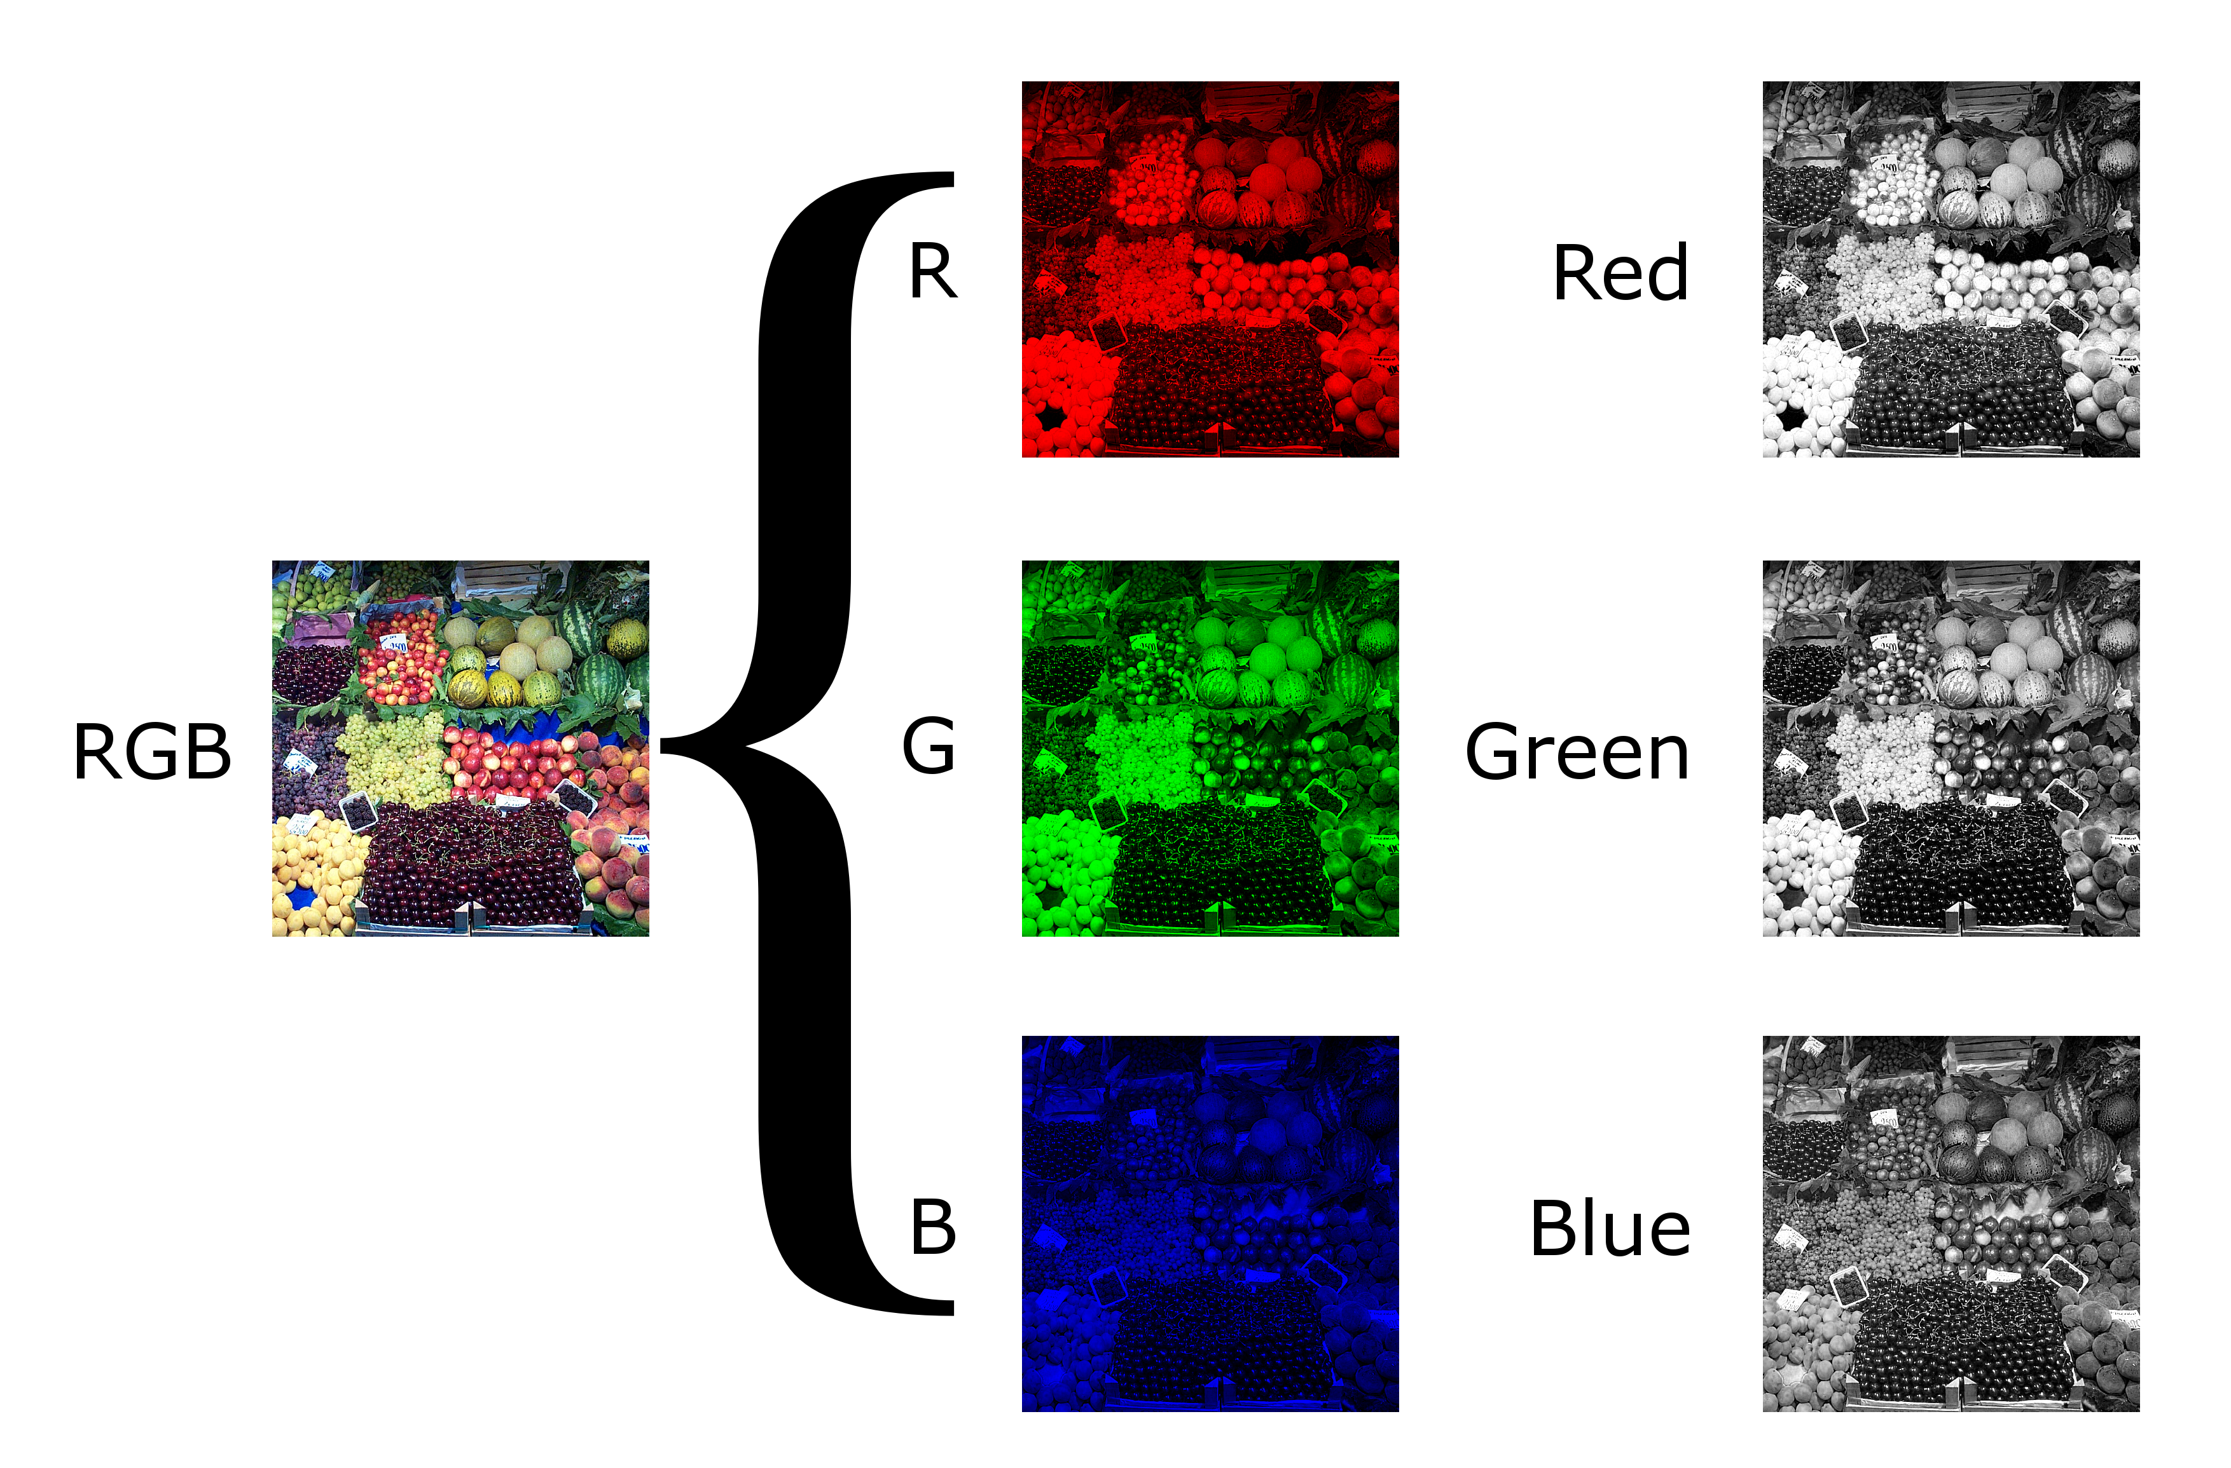
Source: Nevit Dilmen (2012). CC BY-SA 3.0.
If the 8 bits are required to store each color, the color depth is 8. Mostly, in HD videos, the color depth is 10 or 12. If the color depth is 10, the pixel value requires 10x3=30 bits to represent its value (Parker & Dhanani, 2012).
Generally, the resolution is represented as 1920 x 1080. This means that there are 1080 lines in a frame, and each line consists of 1920 pixels. Hence, as each pixel requires 30 bits to store information, there are 1080 lines and 1920 pixels in a line at a time. The information contained by a video frame is represented by 30 x 1080 x 1920 = 62,208,000 bits per frame, i.e., more than 60 million bits per frame.

Motion
Video is more informative than a still image because of the motion, which gives spatiotemporal relation with the objects. This is due to the capture of movements of the objects. As humans, we can recognize even the most hidden moving objects based solely on the registered motion they generate. There are two primary reasons why motion is essential for video processing and compression. To begin, motion conveys a great deal of information about the spatial and temporal relationships between the objects in an image. Such data can be used in traffic monitoring and security surveillance, for instance, to track the arrival and departure of vehicles or the motion of people or other objects on the scene. Second, when motion is tracked in an image, image properties like intensity and color maintain a high correlation with the direction of motion. For instance, a car's paint or shape remains the same in every video frame (Bovik, 2010).
Spatiotemporal
This term refers to things that has both spatial and temporal qualities.
It can be argued that motion detection is the most straightforward of the three motion-related tasks—namely, detection, estimation, and segmentation. To accomplish this, it must determine the image points or the regions of the image that have changed position between two distinct points in time (Szeliski, 2010). Thus, only videos shot with a stationary camera can benefit from using a motion detector. When camera motion is countered, image data from a moving camera can also benefit from the method.
Optical flow describes the apparent movement of various brightness patterns within an image. The motion of both the objects and the observer contributes to optic flow. As a result, optical flow can provide helpful information regarding the pattern, i.e., the spatial organization of the objects being observed and the rate at which this spatial pattern is shifting. Disruptions in the light flow can help segment an image into parts representing different objects. Such segmentation has been attempted using differences between consecutive image frames (Horn & Schunck, 1981).
In simpler terms, optical flow describes an object's apparent movement from one consecutive sequence frame to the next due to the relative motion of the object and the camera. The image below depicts an optical flow for a red circle with a dark background.
Example of Optical Flow
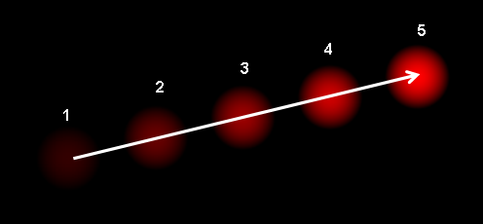
Source: Dhatfield. (2008). Public domain.

Self-Check Questions
Please complete the following sentence.
Optical flow describes the apparent movement of various brightness patterns within an image.

5.2 Object Tracking
Object tracking is estimating the position of the desired object in a scene based on historical data. Deep learning is used in object tracking, in which an algorithm follows the trajectory of a moving object. Moreover, it is the task of forecasting the positions of moving objects in a video, in addition to any other pertinent information about those objects. Object tracking typically begins with locating the objects to be tracked. The summary of the steps is given below:
- Object detection, i.e., the method of detecting and classifying objects using an algorithm that generates a box around them.
- Creating a unique identifier for each object (ID).
- Keeping track of the detected object moving through the frames while storing the data is essential to the tracking process.
Object tracking is different from object detection because it can estimate or predict where a target object will be in each frame of a video once the initial position of the target object has been found. In contrast, object detection refers to the action of selecting a specific target object from among those contained in a single video or image frame. For object detection to succeed, the input image must have a target. If something gets in the way of the target object, it won't be able to find it. An object tracker can be taught to follow an object's path even if it becomes obscured. There are two types of object tracking.

Image Tracking
Image tracking recognizes and follows images automatically. It is most used in augmented reality. For instance, the algorithm identifies two-dimensional planar images from a camera's input, which can be used to superimpose a three-dimensional graphic. After the 3D picture has been superimposed on top of the 2D image, the user can change the camera's direction without losing sight of the underlying surface. Various companies utilize such technologies to provide customers with a virtual representation of how their products will appear in their environments.

Video Tracking
Video tracking is the process of identifying and following a moving target within a video, known as “video tracking.” Video tracking aims to correlate or establish a connection between target objects as they appear in each video frame. This can be done by following the target object in each video frame. In other words, video tracking is looking at the video frames individually and putting together where the object was in the past and now by guessing and making a bounding box around it. The ability of video tracking to process video footage in real-time has made it useful in many fields, including traffic monitoring, autonomous vehicles, and security.
The steps in object tracking are
- Initializing the target: The first frame of the video incorporates the procedure of drawing a bounding box around the exciting object. The tracker then has to draw the bounding box and predict where the object will be in the remaining frames.
- Appearance modeling: It is concerned with simulating an object's visual appearance. When the object being tracked moves through different scenes, the lighting, angle, speed, etc., may change how the object looks, and this could cause the algorithm to get the wrong information or lose track of the object. It is necessary to carry out appearance modeling to ensure that modeling algorithms can capture the myriad of changes and distortions caused when the target object is moved. It is done by visual representations, i.e., focusing on developing robust features and representations that can describe the object visually. Also, statistical learning techniques are employed to construct mathematical approaches for object identification effectively.
- Estimating motion: The predictive ability of the model to accurately predict the object's future position is typically inferred when performing motion estimation.
- Positioning target: Motion estimation provides a rough estimate of the possible region where the object may most likely be found. Once the object's location is estimated, a visual model can pinpoint its precise coordinates.
- Object tracking can be classified into single object tracking and multi-object tracking, depending on the number of objects being tracked. Single object tracking refers to tracking an object of interest in one class and searching for the same object on each video frame. Conversely, multi-object tracking keeps track of each object of interest in the video. Starting with the number of objects in each frame, the tracking algorithm remembers their identities from one frame to the next until the point where they leave the frame.
The various applications of object tracking are given below.
1. Surveillance: Visual surveillance has a long history in computer vision, and one of its early primary applications was to obtain intelligence on military activities from high-flying aircraft or satellites (Davies, 2017). Despite this, following the introduction of ever more affordable video cameras, it eventually became widespread to observe traffic congestion. In more recent years, it has become almost universal to track commuters. In reality, its use has expanded far beyond this, with the ultimate goal being the identification of criminals or suspicious individuals like thieves. Along with safety and crime, surveillance can track other activities like monitoring crowds in cricket matches, identifying overcrowded places in case of stations and roads, controlling riots, etc.
2. Vehicle tracking: Vehicles can be tracked by using their license plates. From the license plate, it is easy to identify the vehicle's owner. Hence tracking the license plate in the videos will be helpful to impose a fine on the owner if the traffic rules are not followed or to automate parking houses. There are three main steps in identifying license plates: locating the plate and segmenting it, segmenting the individual characters, and recognizing them (Davies, 2017).
The various deep learning algorithms like CNN, Recurrent neural networks (RNN), Long short-term memory (LSTM) are widely utilized for object tracking.

Self-Check Questions
Please complete the following sentence.
Object tracking is estimating the position of the desired object in a scene based on historical data.

5.3 Action Recognition
Automatic video indexing has emerged as one of the most formidable obstacles in computer vision. Consequently, an increasing number of researchers are concentrating on automatically extracting high-level information from videos to describe the semantic content of the videos. Therefore, “event-based” and “action-based” classification methods are gradually replacing low-level-based ones in many applications. Both people and computer vision models must master the ability to recognize and differentiate between various motions to function correctly. The presence of human activity can be seen virtually everywhere, from personal surveillance systems to movies and television shows. As part of computer vision, action recognition is problematic because it needs information about the context. For example, the same motion can mean different things (e.g., starting a vehicle or locking the car). Large datasets of still images or moving videos are used to train artificial intelligence models for action recognition.
Action recognition
refers to the computer’s ability to recognize movement from a human being, a robot, or any other object.
Action classification is one of the parts of action recognition, which includes action classification and localization. The goal of action classification is to identify the activity depicted in an image or video and give it the appropriate label, like dancing, reading, etc. However, specific action and a video are required as inputs to perform action localization. The goal of action localization is to pinpoint the precise position and time in the video at which the action is being carried out.
The various applications of action recognition and classification are given below:
- Security: Action recognition and classification can be used with surveillance cameras to help locate and separate footage of individuals engaging in suspicious behavior, particularly in odd circumstances like late night hours or enclosed spaces. The system can then send notifications to the appropriate people for further investigation.
- Media: With the help of an action recognition system, it is possible to quickly and accurately identify relevant content among vast amounts of multimedia (photos, videos, etc.).
- Sports: Sports videos are fascinating because they have a lot of economic potential. Different works that address this issue can be broadly classified into two groups. The first one tends to label actions in sports with terms with a low semantic level, and it does so without using prior knowledge about the sport being studied. In contrast, the second one uses domain knowledge to extract elevated semantic features from sport-related actions.
- Healthcare: Supporting older adults with cognitive impairment who want to live independently at home rather than in a hospital is a problem. Creating “smart environments” aims to aid the elderly and those with risk factors who prefer to age in place without moving into an assisted living facility. For a home to qualify as an intelligent environment, it must be able to pick up on the occupant's routines and respond accordingly. It should be able to identify potential dangers as well. In addition, once such a system has been finished and is fully operational, it ought to be able to recognize irregularities or variations in the routine of the occupant, which may be an indication of a decline in the occupant's capabilities. To get reliable results, collecting as much data as possible about the environment is essential so that the system can always find and follow the supervised person and detect where their limbs are and what they're touching. In analyzing human activity, there are times when the minute details, such as the direction of the gaze or the hand gestures, can provide crucial information. Therefore, the person being monitored needs to be in a sophisticated setting that features technological amenities such as sensors, cameras with multiple views, and speakers.
According to Zhu et al. (2020), action recognition algorithms face various challenges.
- When it comes to datasets, it is not easy to define the label space for training action recognition models. This is because human actions are composite concepts, and their hierarchy is unclear.
- The process of annotating videos for action recognition is time-consuming, i.e., one must watch each frame of the video and be fraught with uncertainty, e.g., it's tough to precisely determine the start and end of the action.
- Certain well-known benchmark datasets, such as Kinetics and Carreira (2019), only make the video links available for users to download, not the videos themselves. This results in a situation in which different methods are judged using various sets of data. As a result, it is impossible to make reliable comparisons between different approaches and learn anything from them.
Algorithms like Improved Dense Trajectories (Wang et al., 2013), a popular approach that extracts trajectories and features from a compact set of interest points, encodes them in a fixed-sized video description and then trains a classifier like SVM on the resulting “bag of words” representation. In this method, each frame requires a considerable amount of preprocessing. However, by using DL approaches, there is no need for any preprocessing. The use of DL for action recognition started in 2014 with two research (Karpathy et al., 2014); (Simonyan & Zisserman, 2014) focusing on utilizing the CNN architecture for video classification and action recognition, respectively.
Deep learning algorithms like CNN, RNN, LSTM, etc., are utilized for action recognition. Nevertheless, spatiotemporal features like the function of optical flow as an input, the effects on real-time capabilities, the concision and applicability of the learned features, etc., are also aggregated using different deep architectures to enhance the predictability of the trained model.

Self-Check Questions
Please complete the following sentence.
The goal of action classification is to identify the activity depicted in an image or video and give it the appropriate label.
Summary
Video data is strongly connected to image data, as a Video is simply a collection of multiple images along a time axes. However, Video data enhances the application area of computer vision a lot. There are thousands of use cases which can be solved with video stream or recordings.

