**Figure 1**

*Probing the friends who take drugs × gender and sexual trauma × gender interactions.*

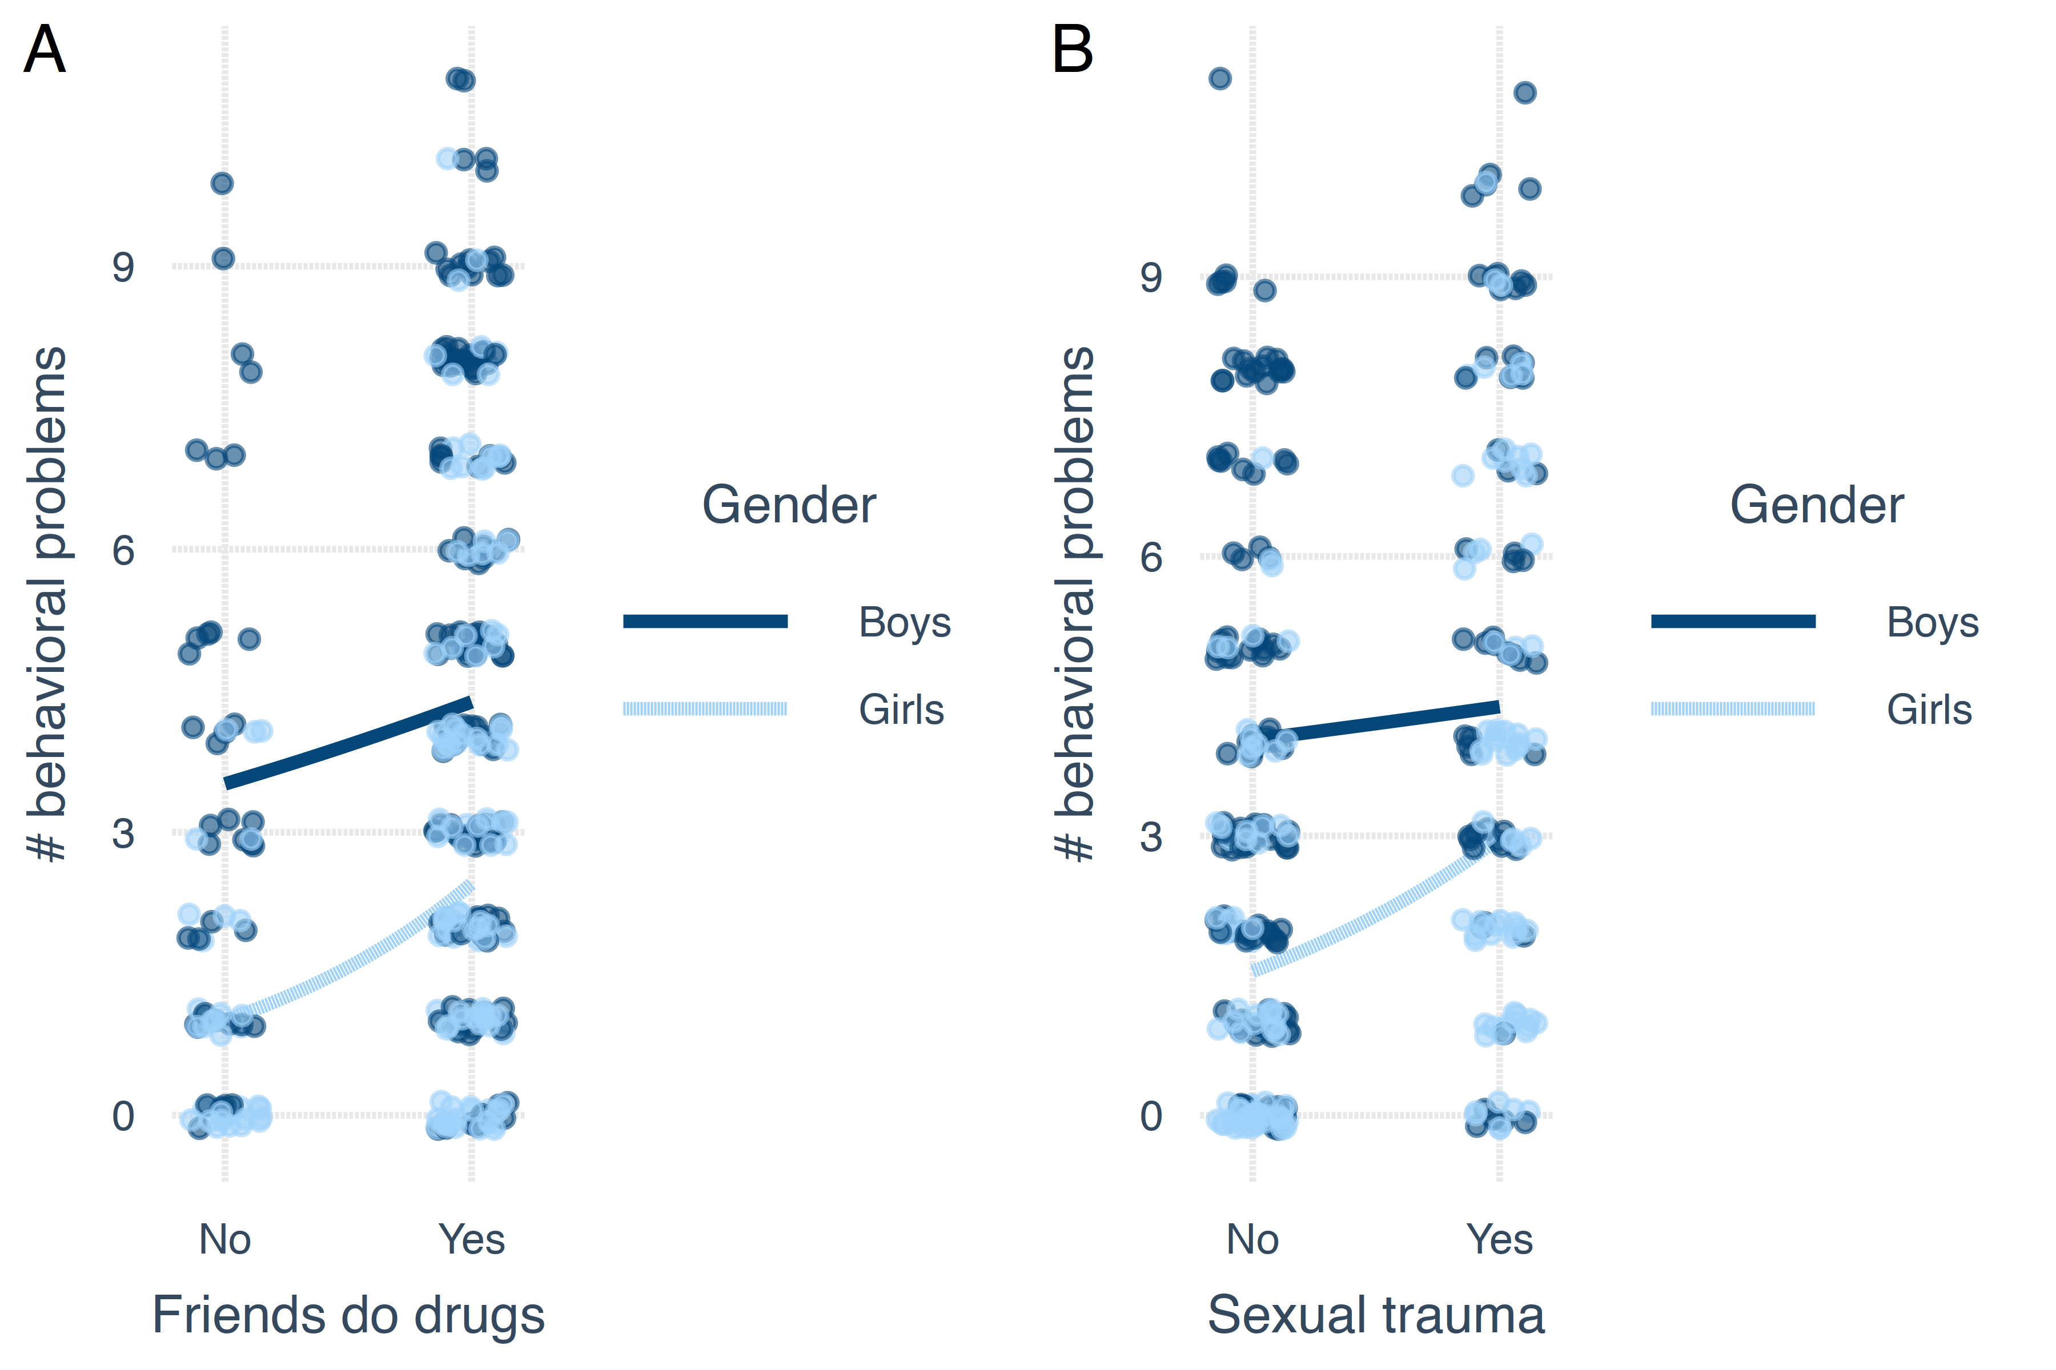

*Note.* For girls but not for boys, exposure to friends who do drugs and/or sexual trauma significantly increases the number of risk behaviors.