Contrasting Pictures of Intermarriage in Ruth and Nehemiah

By comparing the aggressive approach of Nehemiah towards the foreign wives of the Judahites with the positive role of Ruth as a Moabite woman who married into an Israelite family, we can attempt to uncover the core messages about Jewish identity that the two texts have in common.

Prof. Jacob L. Wright

Prof. Rabbi Tamara Cohn Eskenazi

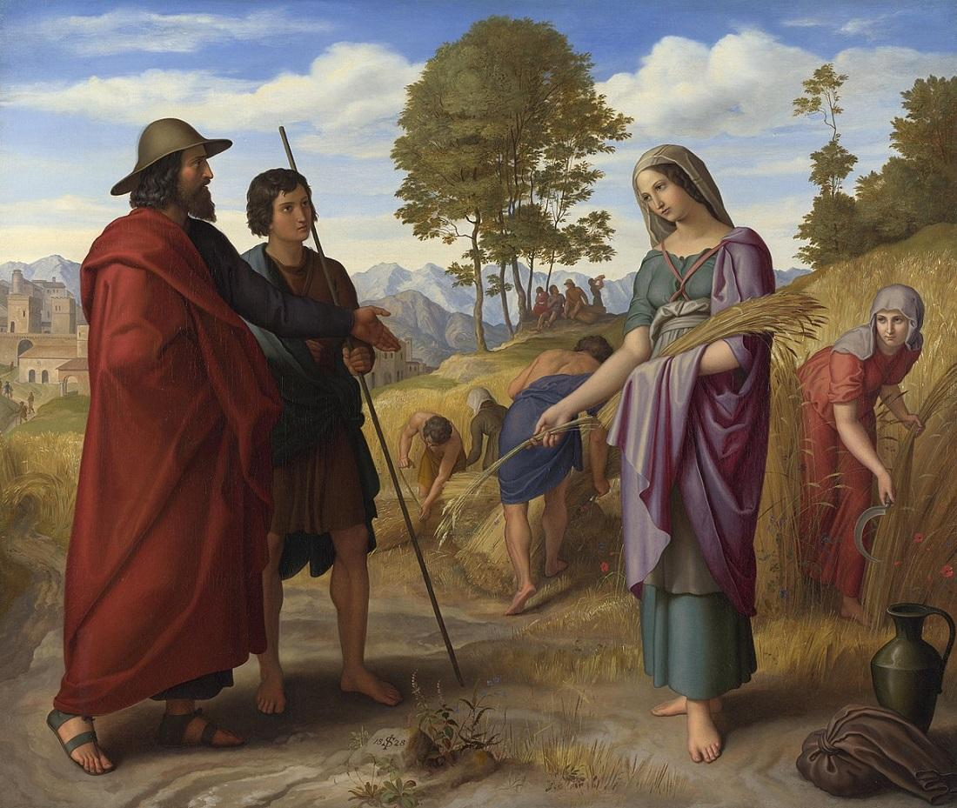

*Ruth in Boaz’s Field*, Julius Schnorr von Carolsfeld (1794–1872).

Shavuot as we have it in the Torah is a peculiar holiday. It’s not associated with an event in Israel’s history (similar to the way that Passover, for example, was eventually connected to the exodus). It seems to have competed with other harvest holidays (*hag ha-kaqqatzir*, *yom ha-bikkurim*). It doesn’t have a fixed date, marked by month and day.[1] Outside the Torah, it’s mentioned only one other time in the Bible (2 Chron 8:13), and it doesn’t even show up in Ezekiel’s festival calendar (45:18-46:7; exilic or early post-exilic period).[2]

Like all biblical festivals, Shavuot evolved over time. Whatever its origins may be, biblical authors made it one of the three pilgrimage festivals (*shalosh regalim*) during which all were expected to make their way to the Temple in Jerusalem.

Beginning in Hellenistic times groups celebrated it as an occasion of covenantal renewal (see Jubilees and the Dead Sea Scrolls).[3] The reason for celebration was now no longer solely the grain harvest but also Israel’s long history of redemption, culminating in the gift of the Torah at Sinai.

Ruth as the Shavuot Reading: A Story which Contradicts the Torah

The Sages left their mark on Shavuot by prescribing the reading of not only the Sinai account but also Ruth, a story that extolls the virtues of a Moabite woman and rewards her actions by making her nothing less than King David’s great-grandmother. The combination of these readings is incongruous, and probably intentionally so. The Torah, to which we renew our commitment on Shavuot, says about Moabites:

דברים כג:ד לֹא יָבֹא עַמּוֹנִי וּמוֹאָבִי בִּקְהַל יְ־הוָה גַּם דּוֹר עֲשִׂירִי לֹא יָבֹא לָהֶם בִּקְהַל יְ־הוָה עַד עוֹלָם.

Deut 23:4 No Ammonite or Moabite shall be admitted to the assembly of YHWH. Even to the tenth generation, none of their descendants shall be admitted to the assembly of YHWH.[4]

The text is straightforward: *No Ammonites or Moabites Allowed.* So why would the rabbis have wanted their communities to read an account that undermines an explicit dictum of the Torah on a festival dedicated to the revelation of the Torah?

Several explanations have been offered for the reading of Ruth on Shavuot, including that David was born and died on this holiday.[5] But we suggest that the most likely reason has to do with the distinctive rabbinic approach to legal discourse: For every seemingly unequivocal injunction, there is an alternative position and perspective (*davar acher*) to consider. The point is that nothing—even when it’s explicit as the Torah law cited above—is off limits to questioning.[6]

Moabite Males, not Females

The rabbis were uneasy with this tension and sought to reconcile it by claiming that the injunction applies only to Moabite *males*, so that marriage to a Moabite *woman* like Ruth was not prohibited. This interpretation was canonized in Mishna *Yebamot* (8:3):

עמוני ומואבי אסורים ואיסורן איסור עולם אבל נקבותיהם מותרות מיד

Ammonites and Moabites are forbidden [to marry an Israelite], and this prohibition is eternal (i.e., falls upon the descendants.) But their women are permitted immediately.

Yet biblical evidence reveals that already during the Persian period groups read the law as proscribing unions with Moabite women: The post-exilic book of Ezra-Nehemiah virtually quotes the law from Deuteronomy, concluding that Ammonite and Moabite women are ineligible for marriage to Judahite men.

* Nehemiah

נחמיה יג:א בַּיּ֣וֹם הַה֗וּא נִקְרָ֛א בְּסֵ֥פֶר מֹשֶׁ֖ה בְּאָזְנֵ֣י הָעָ֑ם וְנִמְצָא֙ כָּת֣וּב בּ֔וֹ אֲ֠שֶׁר לֹא־יָב֨וֹא עַמֹּנִ֧י וּמֹאָבִ֛י בִּקְהַ֥ל הָאֱלֹהִ֖ים עַד־עוֹלָֽם: יג:ב כִּ֣י לֹ֧א קִדְּמ֛וּ אֶת־בְּנֵ֥י יִשְׂרָאֵ֖ל בַּלֶּ֣חֶם וּבַמָּ֑יִם וַיִּשְׂכֹּ֨ר עָלָ֤יו אֶת־בִּלְעָם֙ לְקַֽלְל֔וֹ וַיַּהֲפֹ֧ךְ אֱלֹהֵ֛ינוּ הַקְּלָלָ֖ה לִבְרָכָֽה: יג:ג וַיְהִ֖י כְּשָׁמְעָ֣ם אֶת־הַתּוֹרָ֑ה וַיַּבְדִּ֥ילוּ כָל־עֵ֖רֶב מִיִּשְׂרָאֵֽל:

Neh 13:1 On that day they read from the book of Moses in the hearing of the people; and in it was found written that no Ammonite or Moabite should ever enter the assembly of God, 13:2 because they did not meet the Israelites with bread and water, but hired Balaam against them to curse them– yet our God turned the curse into a blessing. 13:3 When the people heard the law, they separated from Israel all those of foreign descent.

* Deuteronomy

דברים כג:ד לֹֽא־יָבֹ֧א עַמּוֹנִ֛י וּמוֹאָבִ֖י בִּקְהַ֣ל יְ־הֹוָ֑ה גַּ֚ם דּ֣וֹר עֲשִׂירִ֔י לֹא־יָבֹ֥א לָהֶ֛ם בִּקְהַ֥ל יְ־הֹוָ֖ה עַד־עוֹלָֽם: כג:ה עַל־דְּבַ֞ר אֲשֶׁ֨ר לֹא־קִדְּמ֤וּ אֶתְכֶם֙ בַּלֶּ֣חֶם וּבַמַּ֔יִם בַּדֶּ֖רֶךְ בְּצֵאתְכֶ֣ם מִמִּצְרָ֑יִם וַאֲשֶׁר֩ שָׂכַ֨ר עָלֶ֜יךָ אֶת־בִּלְעָ֣ם בֶּן־בְּע֗וֹר מִפְּת֛וֹר אֲרַ֥ם נַהֲרַ֖יִם לְקַֽלְלֶֽךָּ: כג:ו וְלֹֽא־אָבָ֞ה יְ־הֹוָ֤ה אֱלֹהֶ֙יךָ֙ לִשְׁמֹ֣עַ אֶל־בִּלְעָ֔ם וַיַּהֲפֹךְ֩ יְ־הֹוָ֨ה אֱלֹהֶ֧יךָ לְּךָ֛ אֶת־הַקְּלָלָ֖ה לִבְרָכָ֑ה כִּ֥י אֲהֵֽבְךָ֖ יְ־הֹוָ֥ה אֱלֹהֶֽיךָ: כג:ז לֹא־תִדְרֹ֥שׁ שְׁלֹמָ֖ם וְטֹבָתָ֑ם כָּל־יָמֶ֖יךָ לְעוֹלָֽם:

Deut 23:3 No Ammonite or Moabite shall be admitted to the assembly of YHWH. Even to the tenth generation, none of their descendants shall be admitted to the assembly of YHWH, 23:4 because they did not meet you with food and water on your journey out of Egypt, and because they hired against you Balaam son of Beor, from Pethor of Mesopotamia, to curse you. 23:5 (Yet YHWH your God refused to heed Balaam; YHWH your God turned the curse into a blessing for you, because YHWH your God loved you.) 23:6 You shall never promote their welfare or their prosperity as long as you live.

The people decide that those who had married them should send them away, together with their children (Ezra 9-10), and they vow to refrain from such unions in the future (Neh 13:23-29).

Aware of these texts, rabbinic sources tacitly acknowledge that their restriction of the law to Moabite *men* poses problems. They thus depict Boaz saying to Ruth:

שאילו בא אצלינו מתמול שלשם לא היינו מקבלין אותך שעדיין לא נתחדשה הלכה עמוני ולא עמונית מואבי ולא מואבית

[H]ad you come earlier (lit., yesterday or before) we would not have accepted you because the halacha had not yet been renewed to, “Ammonite men, not Ammonite women; Moabite men, not Moabite women.”[7]

So on one hand, we have a story that honors the deeds of a Moabite woman, and on the other hand, we have a historical narrative that depicts the post-exilic community using the law of Deuteronomy to chastise men who had married women from Moab (and elsewhere). The choice to include both of these witnesses in the biblical corpus was, once again, intentional. It should provoke us to think more deeply about the messages of these texts.

Ezra-Nehemiah versus Ruth

Biblical scholars today are wont to pit Ezra-Nehemiah against Ruth: the one as conservative, the other liberal. To them, the authors of Ezra-Nehemiah are xenophobic, the authors of Ruth open their arms to the Other.[8] The Bible contains two different political stances, and it’s up to us to choose the right one. Most Hebrew Bible introductory courses use this example to illustrate a point about the “dialogical” and “polyphonic” nature of biblical literature. It’s an ideal case because it relates to a central ethical problem: the integration of outsiders.

To be sure, the biblical writings, like their rabbinic successors, work pedagogically by provoking questions rather than offering a single, authorized perspective. But as two scholars who have worked extensively on Ezra-Nehemiah (with one of us having also completed a commentary on the book of Ruth[9]), we must challenge this approach to Ruth and Ezra-Nehemiah. Contrary to what is usually claimed, the two books do not offer mutually exclusive views on the treatment of Moabites and other non-Israelites.

Most strikingly, Ezra-Nehemiah never polemicizes against women, whether Moabite or of any other nationality. It’s the men who are culpable. The book also never actually depicts women (and their children) being sent away.[10] The authors are more interested in drawing attention to the problem and the communal process for rectifying it. Most importantly, the problem that the marriages poses is not one that the marriage to Ruth poses.

Ruth’s Transformation into an Israelite

Ruth resolves to become a full-fledged member of Naomi’s people. Her pledge in the opening chapter of the book expresses her determination to pursue this end:

רות א:טז אֶל־אֲשֶׁ֨ר תֵּלְכִ֜י אֵלֵ֗ךְ  
וּבַאֲשֶׁ֤ר תָּלִ֙ינִי֙ אָלִ֔ין  
עַמֵּ֣ךְ עַמִּ֔י  
וֵאלֹהַ֖יִךְ אֱלֹהָֽי:  
א:יז בַּאֲשֶׁ֤ר תָּמ֙וּתִי֙ אָמ֔וּת  
וְשָׁ֖ם אֶקָּבֵ֑ר  
כֹּה֩ יַעֲשֶׂ֨ה יְ־הֹוָ֥ה לִי֙  
וְכֹ֣ה יֹסִ֔יף  
כִּ֣י הַמָּ֔וֶת יַפְרִ֖יד בֵּינִ֥י וּבֵינֵֽךְ:

Ruth 1:16 Where you go, I will go;  
where you lodge, I will lodge;  
your people shall be my people,  
and your God my God.  
1:17 Where you die, I will die—  
there will I be buried.  
May YHWH do thus and so to me,  
and more as well,  
if even death parts me from you!”

The remarkably sophisticated narrative shows how the persevering protagonist undergoes a transformation from Ruth the Moabite” (in Ruth 4:10, for example) to simply “Ruth” (once the people approve the union; see Ruth 4:12-13). Through her union with Boaz, produces the line of King David.[11]

The Foreignness of the Women in Ezra-Nehemiah

The marriage unions at issue in Ezra-Nehemiah are very different.[12] What enrages Nehemiah is that the non-Judahite women are not undergoing transformations similar to Ruth’s. Nehemiah’s main concern is not the women *per se*, but their children, specifically that they are estranged from their culture:

נחמיה יג:כג גַּ֣ם׀ בַּיָּמִ֣ים הָהֵ֗ם רָאִ֤יתִי אֶת הַיְּהוּדִים֙ הֹשִׁ֗יבוּ נָשִׁים֙ (אשדודיות) אַשְׁדֳּדִיּ֔וֹת (עמוניות) עַמֳּנִיּ֖וֹת מוֹאֲבִיּֽוֹת: יג:כד וּבְנֵיהֶ֗ם חֲצִי֙ מְדַבֵּ֣ר אַשְׁדּוֹדִ֔ית וְאֵינָ֥ם מַכִּירִ֖ים לְדַבֵּ֣ר יְהוּדִ֑ית וְכִלְשׁ֖וֹן עַ֥ם וָעָֽם: יג:כה וָאָרִ֤יב עִמָּם֙ וָאֲקַֽלְלֵ֔ם וָאַכֶּ֥ה מֵהֶ֛ם אֲנָשִׁ֖ים וָֽאֶמְרְטֵ֑ם וָאַשְׁבִּיעֵ֣ם בֵּֽאלֹהִ֗ים אִם תִּתְּנ֤וּ בְנֹֽתֵיכֶם֙ לִבְנֵיהֶ֔ם וְאִם תִּשְׂאוּ֙ מִבְּנֹ֣תֵיהֶ֔ם לִבְנֵיכֶ֖ם וְלָכֶֽם: יג:כו הֲל֣וֹא עַל אֵ֣לֶּה חָטָֽא שְׁלֹמֹ֣ה מֶ֣לֶךְ יִשְׂרָאֵ֡ל וּבַגּוֹיִ֣ם הָרַבִּים֩ לֹֽא הָיָ֨ה מֶ֜לֶךְ כָּמֹ֗הוּ וְאָה֤וּב לֵֽאלֹהָיו֙ הָיָ֔ה וַיִּתְּנֵ֣הוּ אֱלֹהִ֔ים מֶ֖לֶךְ עַל כָּל יִשְׂרָאֵ֑ל גַּם אוֹת֣וֹ הֶחֱטִ֔יאוּ הַנָּשִׁ֖ים הַנָּכְרִיּֽוֹת: יג:כז וְלָכֶ֣ם הֲנִשְׁמַ֗ע לַעֲשֹׂת֙ אֵ֣ת כָּל הָרָעָ֤ה הַגְּדוֹלָה֙ הַזֹּ֔את לִמְעֹ֖ל בֵּֽאלֹהֵ֑ינוּ לְהֹשִׁ֖יב נָשִׁ֥ים נָכְרִיּֽוֹת:

Neh 13:23 In those days also I saw Jews who had married women of Ashdod, Ammon, and Moab; 13:24 and half of their children spoke the language of Ashdod, and they could not speak Judahite, but spoke the language of various peoples. 13:25 And I contended with them and cursed them and beat some of them and pulled out their hair; and I made them take an oath in the name of God, saying, “You shall not give your daughters to their sons, or take their daughters for your sons or for yourselves. 13:26 Did not King Solomon of Israel sin on account of such women? Among the many nations there was no king like him, and he was beloved by his God, and God made him king over all Israel; nevertheless, foreign women made even him to sin. 13:27 Shall we then listen to you and do all this great evil and act treacherously against our God by marrying foreign women?”

Nehemiah emphasizes that the offspring from these mixed unions “could not speak Judahite.”[13] (The term “Judahite” is probably more than just a *language*; it is arguably akin to what we would call *culture*, as in “the kids don’t even speak Jewish.”) If the women were integrated fully into Judahite society, this would not have been a problem.

Of Societies Rebuilding and Societies Thriving

The social conditions of Ruth are much different from those in Ezra-Nehemiah. Ezra-Nehemiah describes the constitution of Judah after destruction. The province is in the throes of re-consolidating from disparate, competing clans into a community with a common vision. Its inhabitants are in the process of figuring out what it means to be Judahite. The efforts of Judah’s men to establish their prestige by marrying women from illustrious foreign families undermined these consolidation efforts.

In Ruth, conversely, Judah is an already established society for which the marriage of someone who wishes to integrate herself fully into this society does not pose a problem. In order to underscore the very different social situations, the authors of Ruth, likely writing after Ezra-Nehemiah, at a time when Judah was more firmly established, set their story in an epoch of Israel’s early history (“during the days of the Judges” Ruth 1:1).

The authors of Ruth presuppose the achievements of Ezra and Nehemiah, and take their project a step forward. In the portrait of their protagonist, they present a model for including the Other in the newly reconsolidated community of Judah. Later the rabbis would, appropriately, point to Ruth as a paradigm for their new model of integrating outsiders (*giyyur* or “conversion”).[14]

A Diverse Yet Unified People

But in the end, it’s Ezra-Nehemiah that offers the enduring model for rebuilding identity. For at the center of its narrative is the account of how the people of Israel come together in Jerusalem and implore Ezra to read the Torah to the entire community (Nehemiah 8). In a way that anticipates the unifying role of the constitution for the heterogeneous population of America,[15] this text becomes the point of convergence for all the disparate groups in Judahite society to come together and affirm their mutual belonging.

From this perspective, by reading Ruth on Shavuot, we celebrate the first *Matan Torah*, the gift of the Torah, as the basis for belonging as a diverse, yet unified people. Those who integrate the rabbinic understanding of Ruth as a budding monotheist, committed to observance of Torah and *mitzvot*,[16] understand Shavuot as more than an ethnic, agriculturally oriented celebration, and highlight as well the centrality of Torah and *mitzvot* to their communal life.

[View Footnotes](https://www.thetorah.com/article/contrasting-pictures-of-intermarriage-in-ruth-and-nehemiah)

1. In fact, it occurs on the fifteenth of the month in book Jubilees, similar to so many other biblical holidays. See the discussion in Jacob Wright’s TABS article, [“Shabbat of the Full Moon.”](http://thetorah.com/shabbat-of-the-full-moon/) See also Michael Segal’s TABS essay, [“The Festival of Covenants,”](http://thetorah.com/the-festival-of-covenants/) for a discussion of Shavuot in Jubilees.
2. For more on this, see Evan Hoffman’s TABS essay, [“Ezekiel’s Failure to Mention Shavuot.”](http://thetorah.com/ezekiels-failure-to-mention-shavuot/)
3. See Norman Solomon’s TABS essay, [“Shavuot: How the Festival Grew,”](http://thetorah.com/shavuot-how-the-festival-of-harvest-grew/) as well as Michael Segal’s (op cit.).
4. Bible translations NRSV with minor adjustments.
5. David dying on Atzeret (=Shavuot) appears in j. *Chagigah* 2:3, and *Ruth Rabbah* 3:2.
6. In his *David, King of Israel, and Caleb in Biblical Memory*(New York: Cambridge Univ. Press, 2014), Wright shows how biblical author used war commemoration as a means of negotiating these issues of belonging, and how biblical narratives often provide readers with a basis for complicating simplistic application of the law. This idea is in line with current trends in Bavli studies with regard to about how the *stam* (unnamed editors) organized material, and specifically, the interplay between halacha and aggada. See, for example, Barry Scott Wimpfheimer, *Narrating the Law: A Poetics of Talmudic Legal Stories* (Divinations: Rereading Late Ancient Religion; Philadelphia: University of Pennsylvania Press, 2011).
7. See *Pesikta de Rav Kahana* “Nachamu” 16.1. Perhaps even more radical is the story in the Bavli about Amasa ben Yeter, who is purported to have threatened to stab anybody who did not accept that the court of Samuel the Prophet already decided that the law does not apply to Ammonite or Moabite women (b. *Yebamot* 77a). For more on this, see Tamara Cohn Eskanazi’s TABS essay, [“Megillat Ruth: When Kindness Conflicts with Torah.”](http://thetorah.com/megillat-ruth-when-kindness-conflicts-with-torah/)
8. For a nuanced example of this kind of comparison, focusing on the philosophical differences between the two works with regard to the nature of Israel, see Menachem Kellner’s TABS essay, [“Ralbag’s Surprising Take on Ruth’s Conversion.”](http://thetorah.com/ralbags-suprising-take-ruths-conversion/)
9. Tamara Cohn Eskenazi and Tikva Frymer-Kensky, *JPS Bible Commentary: Ruth* (Philadelphia: JPS), 2012.
10. See discussion in Yonina Dor, *Have the “Foreign Women” Really been Expelled? Separation and Exclusion in the Restoration Period* (Jerusalem: Magness, 2002) [Hebrew].
11. See, Neil Glover, “Your People, My People: An Exploration of Ethnicity in Ruth,” *JSOT* 33 (2009): 293-313. Glover helpfully identifies stages in the construction of religious identity. Ruth herself expresses her commitment to Naomi with threefold categories: “Wherever you go, I go, . . . your people – my people; your God- my God.” (Ruth 1:16). Her journey begins with a unilateral commitment by her. But to be effective, it requires responses from Naomi, the people, and God. As the book of Ruth unfolds, the responses gradually emerge: Naomi comes to treat her as a daughter whose welfare she seeks (Ruth 3:1). The community as a whole (“and all the people” in Ruth 4:11) welcomes her with a blessing (Ruth 4:11-12), and God’s approval is signaled when with a unique phrasing in the Bible “God gave her pregnancy and she bore a son” (4:13). Although she was called a Moabite still in 4:10, the Moabite label drops in 4:13.
12. In truth, the issues in Ezra and Nehemiah are themselves different from each other—Ezra is concerned with זרע הקדש (holy seed)—but this is not the place to parse that out.
13. Neh 13:24.
14. See Shaye J. D. Cohen, *The Beginnings of Jewishness: Boundaries, Varieties, Uncertainties* (Berkeley: University of California Press, 1999).
15. For another example of this kind of thinking in biblical texts, see Jacob Wright’s TABS essay, [“Redacting the Relationship to the Transjordanian Tribes: Kinship versus Commandment.”](http://thetorah.com/redacting-the-relationship-to-the-transjordanian-tribes/)
16. See Menachem Kellner, op cit.