# The top 100 most cited articles in Vitiligo: a bibliometric analysis

Zoé Attal*, Sapir Itzhaki Gabay MD,MHA*, Galia Peles MD, Amir Horev MD

Corresponding Author: Zoé Attal, Medical school for international Health at Ben Gurion University, Soroka University Medical Center, Beer Sheva, Israel

Phone: +9720533219577

Email: [zoegabri@post.bgu.ac.il](mailto:zoegabri@post.bgu.ac.il)

*These authors contributed equally to this work

Keywords: Vitiligo, dermatology, Bibliometric analysis, Autoimmune, psychology, repigmentation, epidemiology

Acknowledgements/Disclosures: no conflicts of interest.

Funding/Support: This study was not funded.  
Financial Disclosures: No financial disclosures.

Zoé Attal wrote the first draft and is the first author of the manuscript. No honorarium, grant, or other forms of payment was given to anyone to produce the manuscript.

Abstract

Introduction

Vitiligo is a skin disease targeting the melanocytes characterized by the development of areas of depigmented skin lesions. Several theories surround the etiology of vitiligo, including autoimmunity. Bibliometric analysis is used to identify high-quality research articles using criteria such as total citations, annual citations, and journal impact factors..

Methods

We extracted the 100 most cited articles on vitiligo using the Web of Science data base and analysed it on Microsoft excel 2019. Our search was limited to the keyword “vitiligo” being included in the title or abstract of the papers. The data extracted included title, author, corresponding author, institution affiliation, year of publication, journal of publications, total citations, and research area. We also calculated an annual citation rate to account for bias, as some publications are older than others.

Results

A total of 6,189 studies were retrieved. The top 100 cited articles were published between 1976 and 2017. The articles were sorted by country of origin, determining the United States of America (USA) as the highest publisher overall. After controlling for population, the Netherlands ranked first. The total citations of the top 100 articles ranged between 113 and 477 per individual article, with a sum of 19,528. The most published journal was “*Journal of Investigative Dermatology*” (n=16). Of the 100 most cited articles, 75 were original articles, with the research focuses being majorly pathogenesis (29%) and treatment (26%).

We separately retrieved the highest cited data from 2018-2022 and tabled the top 10. Five of the top 10 most cited articles since 2018 were original articles, and five were reviews

Conclusion

This bibliometric analysis provides insight into the current state of vitiligo literature by analysing published tendencies and their significance. In addition, we mapped the current research gaps

Introduction

Vitiligo is a skin disease targeting the melanocytes characterized by the development of areas of depigmented skin lesions. It typically develops between the ages of 10 and 30 years in 0.5% to 1% of the global population1.. It is more prevalent in relatives of patients with the diseaseThere is no ethnicity or gender described as more prone to developing the condition.

Several theories surround the pathogenesis of vitiligo. One suggests that it is an autoimmune disease in which autoreactive cytotoxic CD8+ T cells attack melanocytes and stimulate the secretion of IFNγ and chemokines from surrounding keratinocytes2. A strong stigma surrounds vitiligo, and navigating these changes can often cause depression, anxiety, or embarrassment 3. Thus, homogenizing skin color can provide psychological benefit.

The latest guideline4 published on 2021 provide an algorithm for vitiligo diagnosis and treatment, according to severity and onset of the disease. Treatments currently focus on blocking IFNy signalling by using JAK inhibitors. Unfortunately, with the discontinuation of use, relapse will occur. To prevent relapse, new treatments, such as Ruxolitinib, focus on targeting memory T cells, providing long-lasting benefits of therapy 5,6. Using sunscreen and clothing to protect affected areas is important to prevent severe sunburns 7.

A bibliometric analysis (BA) is defined as a scientific analysis of the existing literature on a chosen topic. It assesses the quality, quantity, and major ideas through the most cited articles. Additionally, it identifies aspects where improvements could benefit the topic.

Several fields in dermatology have been explored by BA, including atopic dermatitis 8, psoriasis9, nail psoriasis10, psoriatic arthritis11, melanoma12, hidradenitis suppurativa13 and rosacea14.The last BA on vitiligo was published five years ago and included all literature existing on vitiligo since 1975 15. However, we chose a different approach, by focusing solely on highly cited articles to extract the most significant data possible. We detailed the publications framing vitiligo practice by establishing crucial bibliometric characteristics in the top 100 cited vitiligo articles since 1972.

Materials and methods:

**Searching strategy**

We extracted the top 100 most cited articles on vitiligo from the Clarivate Web of Science (WoS) database on September 18th 2022. Our search was limited to the keyword “Vitiligo” being included in the title or abstract of the papers. Article type, country of origin, language or research area were not limited to include all the trends and novelties in the field between 1972 and 2022. Our BA did not require approval from an ethics committee, as the researcher did not analyze patient data or interact with patients in any way.

**Data extraction and bibliometric parameters**

Data from the 100 most cited articles on vitiligo was downloaded from the WoS and extracted to Microsoft Excel 2019. This included title, author, corresponding author, institution affiliation, year of publication, journal of publications, total citations (TC), and research area.

We calculated an annual citation (AC) rate (total citations divided by the age of publication) to counter the bias arising from publications being older than others. We included both total citations and annual rates in our table of the 100 most cited vitiligo articles

The manuscript type was described as an original article, review, rapid communication, or editorial material. The study design and research foci were identified by screening the abstract, available full texts, and keywords for each of the 100 articles. The research area was extracted directly from WoS and examined. Country and institution affiliation were identified based on the first author’s information for each article. Journal impact factor from 2021 was acquired from WoS database.

Results

A total of 6,189 studies were retrieved. The top 100 cited articles were listed in figure 1 and ranked by AC.

**Year of publication**

The top 100 cited articles were published between 1976 and 2017. Figure 2 shows the number of articles published in each 10-year interval. The increase in publications began after 1992, with prior intervals accountable for 15 articles, reaching its peak between 1993 and 2002 (n =37), followed by 34 articles in the next decade, and a significant decrease between 2013 and 2022 (n = 11).

**Citations**

The total citations (TC) of the top 100 articles ranged between 113 and 477 per individual article, with a sum of 19,528. The median of TC was 163 (133, 248). The top 10 most cited articles accounted for 19.68% (n= 3,843) of the total citations. Five of the top 10 ranked articles by highest AC remained in the top 10 when ranked according to TC. The AC ranged from 2.9 to 69.7 with a median of 8.5 (5.83, 15.14). The average AC has increase throughout the decades, however the increase has not been steady. Figure 3 shows the citation analysis for the average AC and TC in each 10-year interval from 1972 to 2017. From 1972 to 2017, the average AC increased parallel with the average TC until 2003. The last decade (2003-2017) has a TC sum of 2678 compared to 7217 in the previous 10 year interval.

**Countries, institutes, and corresponding authors**

The articles were sorted by country of origin, determining the United States of America (USA), The Netherlands, and England as the highest publishers, with n=35, n=13, and n=12 publications, respectively (Fig. 4). After controlling for populations, The Netherlands (n= $7.45×{10}^{0}$), Belgium (n= $2.59×{10}^{7}$), and England (n= $2.14×{10}^{7}$) were the highest three publishers and the USA (n= $1.06×{10}^{7}$), was low as 8th position. The countries of origin that published the most original articles are listed in figure 4 with their most affiliated publishing institute, corresponding author, and their respective number of published articles.

**Journal of publication**

The 100 articles were published in 28 different journals. The most published journal was “*Journal of Investigative Dermatology*” (n=16), followed by “*Pigment Cell Research*” (n=13), “*Archives of Dermatology*” (n=13), and “*Journal of the American Academy of Dermatology”* (n=10*)*. The top 4 journals contain 52% of the articles published (Fig.6). The impact factor, which highlights the exposure of the study worldwide (Fig. 7), outlines that 9 was the median impact factor. A total of 46 articles were published in journals with an impact factor of 9 and above.

**Article design, research focus, and research area**

Of the 100 most cited articles, 75 were original articles, 21 were reviews, two were rapid communications, one was editorial material and one was a note.

The 100 most cited articles were classified into different research focuses: pathogenesis (29%), treatment (26%), epidemiology (16%), immunopathology (10%), and others (19%). Additionally, they were divided by research areas: dermatology (71%), general& internal medicine (7%), oncology (5%), and others (17%) (Fig.8). The original articles were separated into different study design per decade. Out of them, 40% were case-control studies (n=30), 12% were clinical trials (n=9) and 12% were cohort studies (n=9) (Fig. 9). The original articles were then classified into research focuses per decades: treatment (28%), pathogenesis (28%), epidemiology (14.7%), immunopathology (10.7%), genetics (5.3%), treatment outcome (4%), basic science (4%), pathophysiology (2.7%), comprehensive review (1.3%) and diagnostics (1.3%) (Fig.10

**Recent articles**

Although the last article dates from 2017we extracted and sub-analysed the top articles since 2018 separately, as this data could indicate upcoming trends in vitiligo research. We tabled the top 10 highest cited articles since 2018 (Fig.11). Total citations ranged between 49 and 108, with a median of 64.5 (55.5, 92.25). The AC was between 16.3 and 46.5, with a median of 24 (18.5, 30.8). The median of ACs was significantly higher than the top 100 articles (24 compared to 8.5). However, the opposite was observed for TC. The TC of recent articles was much lower than for previous articles with a median of 64.5 compared to 163 (2.5x fold difference). Five of the top 10 most cited articles since 2018 were original articles, and five were reviews. The countries of origin include the USA (n=5), France (n=3), and China, PRC (n=2). The study designs included 50% of reviews (n=5), 40% of basic or applied science (n=4) and 10% of RCT (n=1).

The research focuses of the 10 articles were immunopathology (n=4), epidemiology (n=3), pathogenesis (n=2) and treatment (n=1).

**Discussion**

In this BA we identified trends in the data relating to vitiligo and the areas where research was lacking.

The largest number of articles published in a single decade was between 1993 and 2002, with 37 of published articles (Fig.2). This finding could be explained by three articles in our 100 list published in 1993. Specifically, the article “Vitiligo: where do we stand”16 (Ortonne,JP et al) that expressed the advances in vitiligo research, treatment, and epidemiology and could have encouraged subsequent publications. Another possible explanation for the popularity of the vitiligo topic at that time is the breadth of scientific advances and techniques that emerged in the 1990s and 2000s. For example, The Clustered Regularly Interspaced Short Palindromic Repeats (CRISPR), a gene editing system, was first characterized within that decade. Therapeutic targets of dermatologic conditions can be fulfilled by CRISPR, which is appealing to researchers 17.

Total citations divided by 10-year intervals mostly increased until 2002, stabilized until 2012, and have declined since. However, ACs divided by a 10-year interval have majorly increased since 1972 with a sharp ascension beginning in 2002 (Fig.3). These combined findings about ACs and TCs can be correlated to the number of publications emerging between 1993 and 2002 (37% of total vitiligo publications). It is possible that due to recent articles being more up-to-date, they tend to be more highly cited in recent years18. Additionally, in 2002, research output emphasized the oxidative stress link to vitiligo and elicited curiosity around the topic. For example, the CAT gene’s correlation to accumulated hydrogen peroxide (H2O2)19 and photo-oxidation of pterins producing H2O220.

Our research identified that most of the top cited articles per country of origin, after controlling for population, were from the Netherlands, Belgium and England. Interestingly, regardless of population, the Netherlands (2nd), and England (3rd) are still the topmost published countries (Fig.4). Research21,22 shows Europe having a slightly higher vitiligo prevalence than the USA (1.6% vs 1.4%), and overall higher than light-skin Asian countries such as Japan (0.5%)23.

Over half of the top cited articles were published in the Journal of Investigative Dermatology, followed by Pigment Cell Research, Archives of Dermatology and Journal of the American Academy of Dermatology (Fig 6.). This can be attributed to the high standard of these journals24.

Additionally, the median impact factor (IF) of nine is high and signifies that researchers are prone to choose high IF journals for citations 25. Journal selection is a complex decision, however, IF is almost systematically an important selection factor 25.

Our study revealed that the study design by decade remained relatively stable throughout the years except for case-control studies (Fig 9). Case-control studies peaked between 1993 and 2002 with 20 articles. A possible reason could be that case-control studies require less resources than CTs or RCTs. Additionally, during that same decade, treatment and pathogenesis research culminated. Case-control studies lend themselves well for a more general investigation of treatment or pathogenesis of vitiligo26 .

It is widely believed that case-control studies are less valuable than CT/RCTs They provide odds ratios while RCTs yield relative risk (a superior measure of association). The hierarchy of these two research designs is challenged as carefully constructed observational studies such as case-control yield similar results to RCTs. However, as bias is still more prevalent in observational studies, it would be beneficial to produce more RCTs on vitiligo in the future25.

Out of the top cited original articles, the main research focuses included treatment (28%) and pathogenesis (28%) (Fig.10). Of the treatment-related articles, 26.9% discuss treatment using UVB therapy 6. This historical treatment has the most data supporting it compared to other treatment options making it a trending research topic 6. Older vitiligo treatments target non-specific autoimmune suppression27,28, however, newer therapies focus on targeted approaches providing greater efficacy and safety, such as Janus Kinase inhibitors 29. Recently, the FDA approved Opzelura (Ruxolotinib) a revolutionary treatment for vitiligo 30. There has been a necessity to understand the pathogenesis/Immunopathology of the disease in order to develop better treatments31. This explains why since 1993 research in pathogenesis, immunopathology, and epidemiology has increased drastically. Interestingly, in the top 10 recent articles (2018-2020), this trend was also observed with immunopathology (40%) and epidemiology (30%) (Fig.11).

Vitiligo was found to be more progressive and extensive if beginning in childhood 32. Out of the top 100 cited articles, 7 articles discuss the pediatric population. Vitiligo can have different implications in adult vs pediatric populations. However, comparing the vitiligo prevalence in adults and children is a delicate affair as many criteria are at play. Repigmentation following treatment is largely more significant in the children 33. Eventually studies suggest that vitiligo is more common in adults, with less lesions than in children but with poorer repigmentation. This could explain why a larger proportion of research is conducted on adults, to determine more efficient treatment for that population.

Further research on the impact of childhood vitiligo, early detection, and treatment’s outcome on the patient's state at adulthood would yield a better understanding of the disease progression.

The study holds some limitations. Firstly, older articles are more likely to be cited, which causes a bias. We aimed to tackle that bias by analysing ACs as well. Additionally, highly cited authors tend to cite their previous work on the topic, thus increasing their TCs. This did not reflect article quality and significance but caused a bias in the TCs.

To conclude, the existing vitiligo BA published in 202015 focused on the correlation between Gross Domestic Product (GDP) per capita and publications per country. Their main finding was that developed countries published most of the vitiligo literature. Our BA confirms that statement while highlighting additional ramifications, such as the different research designs used, the impact of new investigative techniques on publication output, and research prevalence in pediatric populations. We determined highly researched areas, such as pathogenesis and treatment, and provided recommendations as to which areas would require more investigation.

Bibliography

1. Bergqvist C, Ezzedine K. Vitiligo: A Review. *Dermatology*. 2020;236(6):571-592. doi:10.1159/000506103

2. Njoo MD, Westerhof W. Vitiligo: Pathogenesis and Treatment. *American Journal of Clinical Dermatology*. 2001;2(3):167-181. doi:10.2165/00128071-200102030-00006

3. Pandve H. Vitiligo: Is it just a dermatological disorder? *Indian J Dermatol*. 2008;53(1):40. doi:10.4103/0019-5154.39745

4. Eleftheriadou V, Atkar R, Batchelor J, et al. British Association of Dermatologists guidelines for the management of people with vitiligo 2021*. *Br J Dermatol*. 2022;186(1):18-29. doi:10.1111/bjd.20596

5. Rosmarin D, Pandya AG, Lebwohl M, et al. Ruxolitinib cream for treatment of vitiligo: a randomised, controlled, phase 2 trial. *The Lancet*. 2020;396(10244):110-120. doi:10.1016/S0140-6736(20)30609-7

6. Westerhof W, Nieuweboer-Krobotova L. Treatment of vitiligo with UV-B radiation vs topical psoralen plus UV-A. *Arch Dermatol*. 1997;133(12):1525-1528.

7. Baykal Selçuk L, Katkat E, Aksu Arıca D, Yaylı S, Bahadır S. Sun-protection habits and knowledge of patients with vitiligo. *Acta Dermatovenerol Alp Pannonica Adriat*. 2020;29(1):7-10.

8. Kim D, Chae Y, Park HJ, Lee IS. A Bibliometric Analysis of Atopic Dermatitis Research over the Past Three Decades and Future Perspectives. *Healthcare*. 2021;9(12):1749. doi:10.3390/healthcare9121749

9. Daou L, El Hage S, Wakim E, Safi S, Salameh P. Psoriasis: A bibliometric analysis in the Arab World (2004–2019). *Australas J Dermatol*. 2021;62(1). doi:10.1111/ajd.13407

10. Gregoriou S, Tsiogka A, Rigopoulos D. Bibliometric Trends in Nail Psoriasis Research Publications. *Skin Appendage Disord*. 2022;8(2):122-128. doi:10.1159/000519191

11. Jamshidi AR, Gharibdoost F, Nadji A, et al. Presentation of psoriatic arthritis in the literature: a twenty-year bibliometric evaluation. *Rheumatol Int*. 2013;33(2):361-367. doi:10.1007/s00296-012-2428-y

12. Zhang H, Wang Y, Zheng Q, et al. Research Interest and Public Interest in Melanoma: A Bibliometric and Google Trends Analysis. *Front Oncol*. 2021;11:629687. doi:10.3389/fonc.2021.629687

13. Peles G, Horev A. A bibliometric analysis of hidradenitis suppurativa literature over the past 50 years. *Int J Dermatology*. 2023;62(4):534-546. doi:10.1111/ijd.16585

14. Wang Y, Zhang H, Fang R, Tang K, Sun Q. The top 100 most cited articles in rosacea: a bibliometric analysis. *J Eur Acad Dermatol Venereol*. 2020;34(10):2177-2182. doi:10.1111/jdv.16305

15. Şenel E. The depigmented literature: A holistic analysis of global vitiligo publications between 1975 and 2017. *Indian J Dermatol*. 2020;65(5):388. doi:10.4103/ijd.IJD_390_18

16. Ortonne JP, Bose SK. Vitiligo: Where Do We Stand? *Pigment Cell Res*. 1993;6(2):61-72. doi:10.1111/j.1600-0749.1993.tb00584.x

17. Baker C, Hayden MS. Gene editing in dermatology: Harnessing CRISPR for the treatment of cutaneous disease. *F1000Res*. 2020;9:281. doi:10.12688/f1000research.23185.2

18. Madison G, Sundell K. Numbers of publications and citations for researchers in fields pertinent to the social services: a comparison of peer-reviewed journal publications across six disciplines. *Scientometrics*. 2022;127(10):6029-6046. doi:10.1007/s11192-022-04495-3

19. Casp CB, She JX, Mccormack WT. Genetic Association of the *Catalase* Gene ( *CAT* ) with Vitiligo Susceptibility. *Pigment Cell Research*. 2002;15(1):62-66. doi:10.1034/j.1600-0749.2002.00057.x

20. Rokos H, Beazley WD, Schallreuter KU. Oxidative Stress in Vitiligo: Photo-oxidation of Pterins Produces H2O2 and Pterin-6-carboxylic Acid. *Biochemical and Biophysical Research Communications*. 2002;292(4):805-811. doi:10.1006/bbrc.2002.6727

21. Alkhateeb A, Fain PR, Thody A, Bennett DC, Spritz RA. Epidemiology of Vitiligo and Associated Autoimmune Diseases in Caucasian Probands and Their Families. *Pigment Cell Research*. 2003;16(3):208-214. doi:10.1034/j.1600-0749.2003.00032.x

22. Howitz J. Prevalence of Vitiligo: Epidemiological Survey on the Isle of Bornholm, Denmark. *Arch Dermatol*. 1977;113(1):47. doi:10.1001/archderm.1977.01640010049006

23. Bibeau K, Pandya AG, Ezzedine K, et al. Vitiligo prevalence and quality of life among adults in Europe, Japan and the USA. *Acad Dermatol Venereol*. 2022;36(10):1831-1844. doi:10.1111/jdv.18257

24. Bickers DR, Modlin RL. A Review of the Journal of Investigative Dermatology’s Most Cited Publications over the Past 25 Years and the Use of Developing Bibliometric Methodologies to Assess Journal Quality. *Journal of Investigative Dermatology*. 2012;132(3):1050-1060. doi:10.1038/jid.2011.391

25. Rowley J, Sbaffi L, Sugden M, Gilbert A. Factors influencing researchers’ journal selection decisions. *Journal of Information Science*. 2022;48(3):321-335. doi:10.1177/0165551520958591

26. Ridder HG. The theory contribution of case study research designs. *Bus Res*. 2017;10(2):281-305. doi:10.1007/s40685-017-0045-z

27. Norris DA, Kissinger RMark, Naughton GM, Bystryn JClaude. Evidence for Immunologic Mechanisms in Human Vitiligo: Patients’ Sera Induce Damage to Human Melanocytes In Vitro by Complement-Mediated Damage and Antibody-Dependent Cellular Cytotoxicity. *Journal of Investigative Dermatology*. 1988;90(6):783-789. doi:10.1111/1523-1747.ep12461505

28. Parrish JA. Photochemotherapy of Vitiligo: Use of Orally Administered Psoralens and a High-Intensity Long-Wave Ultraviolet Light System. *Arch Dermatol*. 1976;112(11):1531. doi:10.1001/archderm.1976.01630350007002

29. Craiglow BG, King BA. Tofacitinib Citrate for the Treatment of Vitiligo: A Pathogenesis-Directed Therapy. *JAMA Dermatol*. 2015;151(10):1110. doi:10.1001/jamadermatol.2015.1520

30. Sheikh A, Rafique W, Owais R, Malik F, Ali E. FDA approves Ruxolitinib (Opzelura) for Vitiligo Therapy: A breakthrough in the field of dermatology. *Annals of Medicine and Surgery*. 2022;81:104499. doi:10.1016/j.amsu.2022.104499

31. Rashighi M, Harris JE. Vitiligo Pathogenesis and Emerging Treatments. *Dermatologic Clinics*. 2017;35(2):257-265. doi:10.1016/j.det.2016.11.014

32. Mu EW, Cohen BE, Orlow SJ. Early-onset childhood vitiligo is associated with a more extensive and progressive course. *Journal of the American Academy of Dermatology*. 2015;73(3):467-470. doi:10.1016/j.jaad.2015.05.038

33. ANABA EL. Vitiligo: any differences in adult and childhood clinical characteristics. *The Nigerian Health Journal*. 2019;18(3):90-96.

**Figures**

Figure 1: Table if the 100 most cited articles in vitiligo literature between 1972 to September 8th 2022

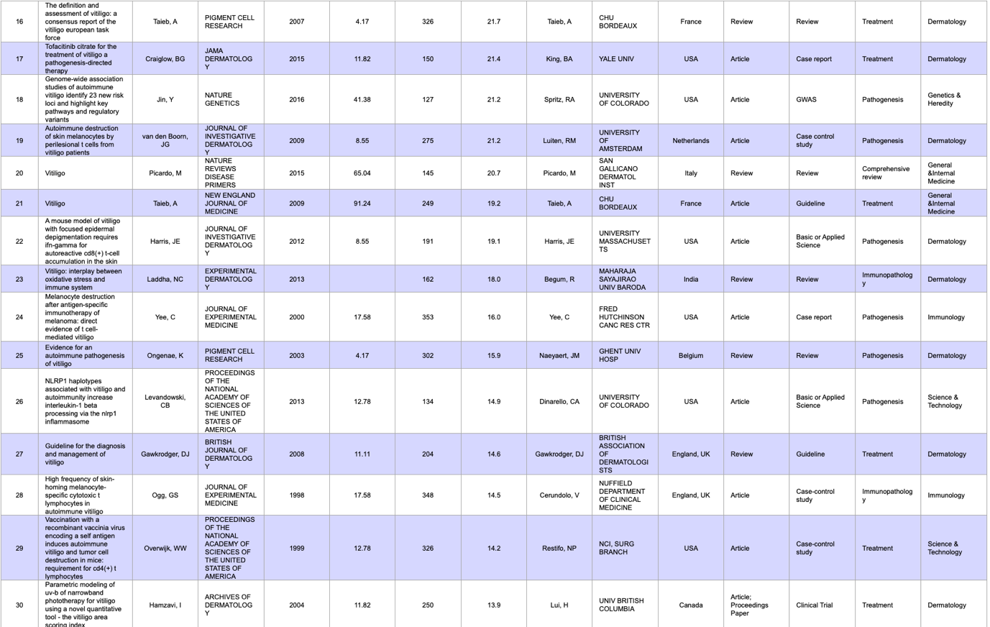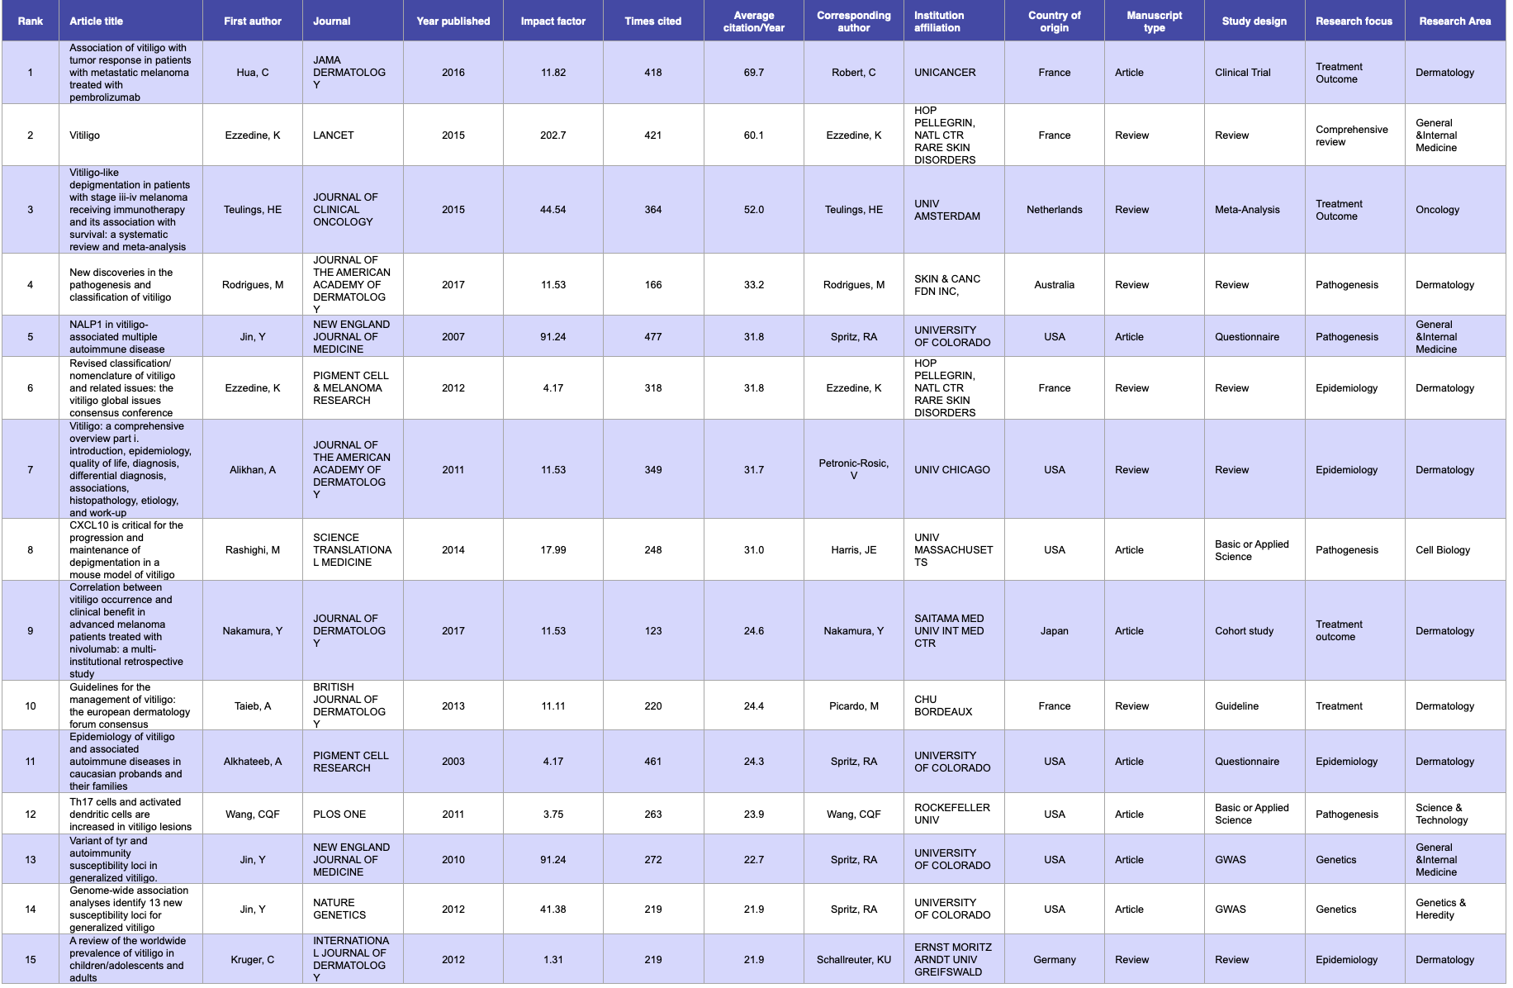 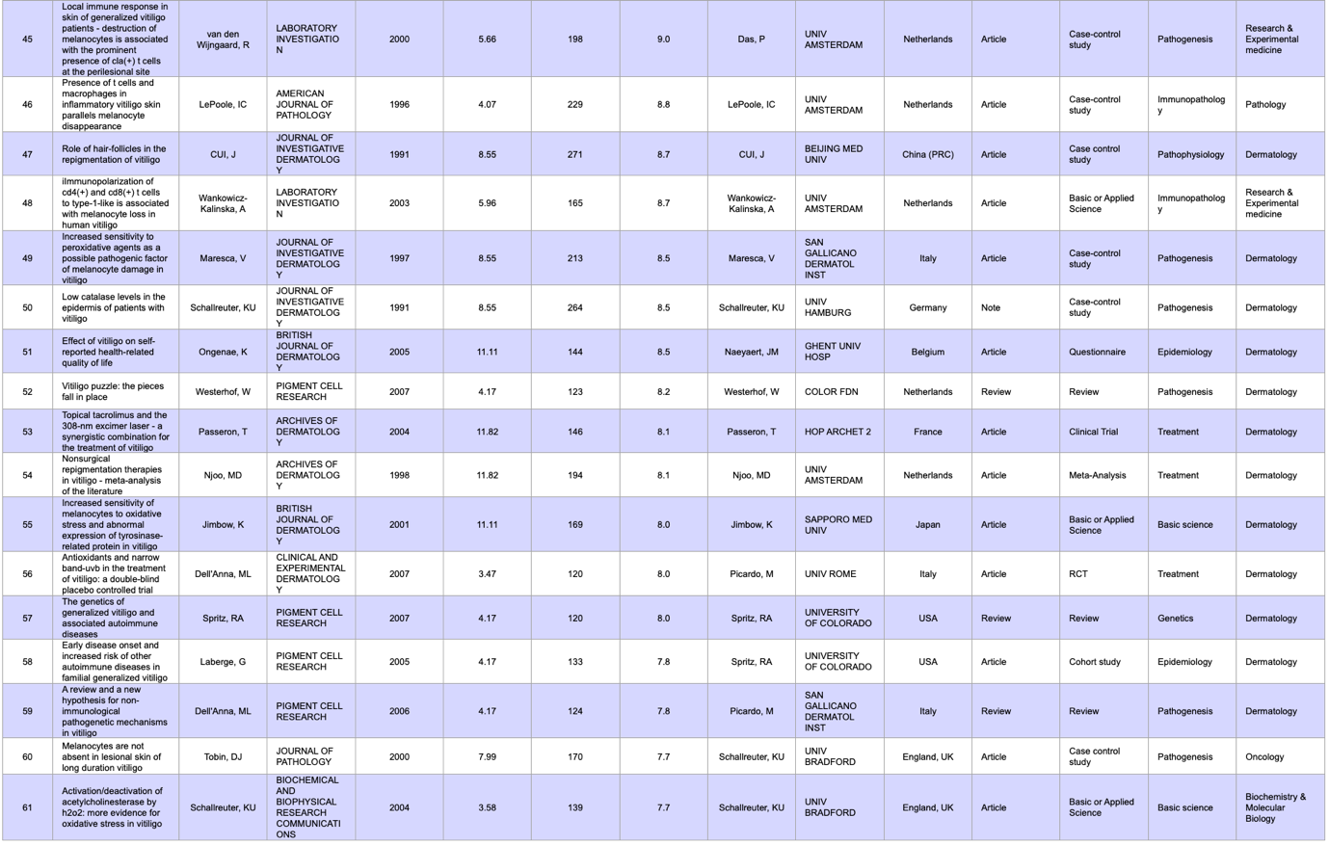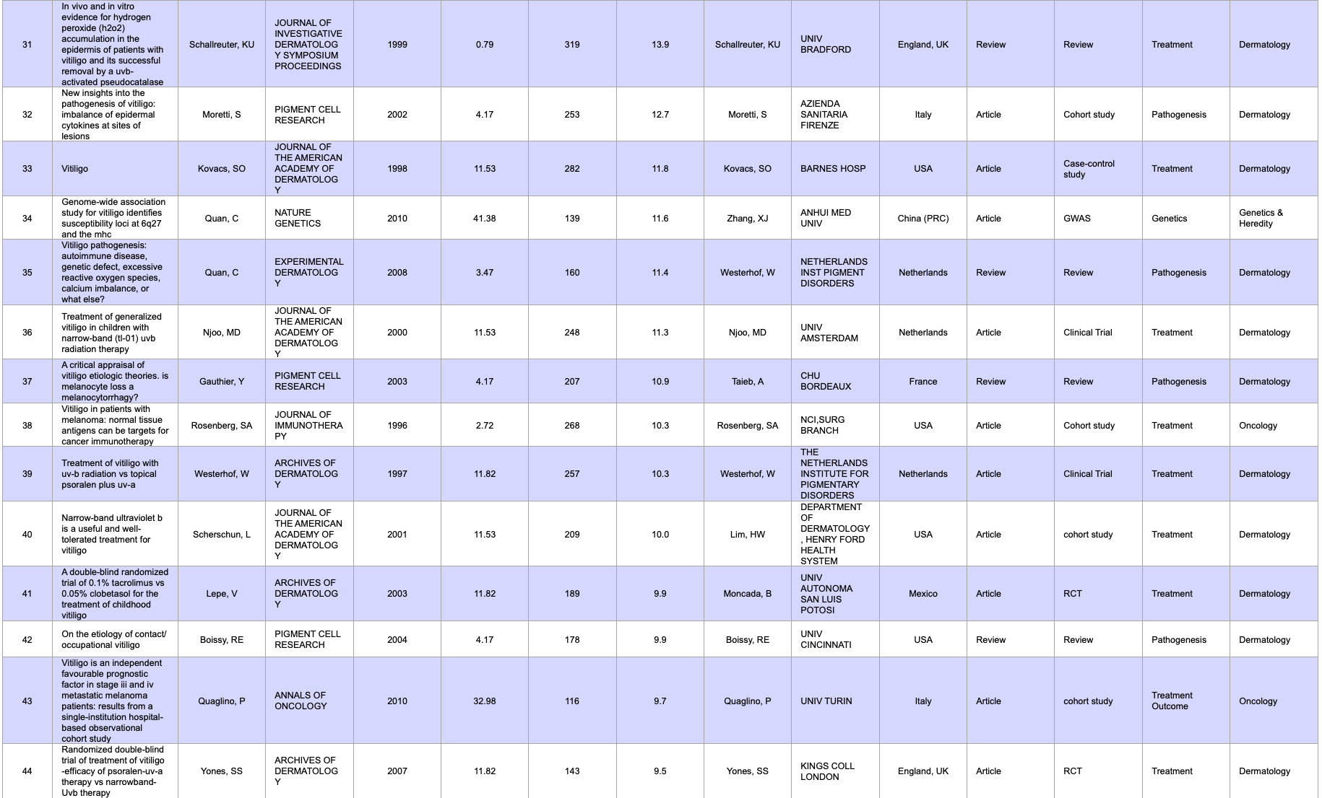

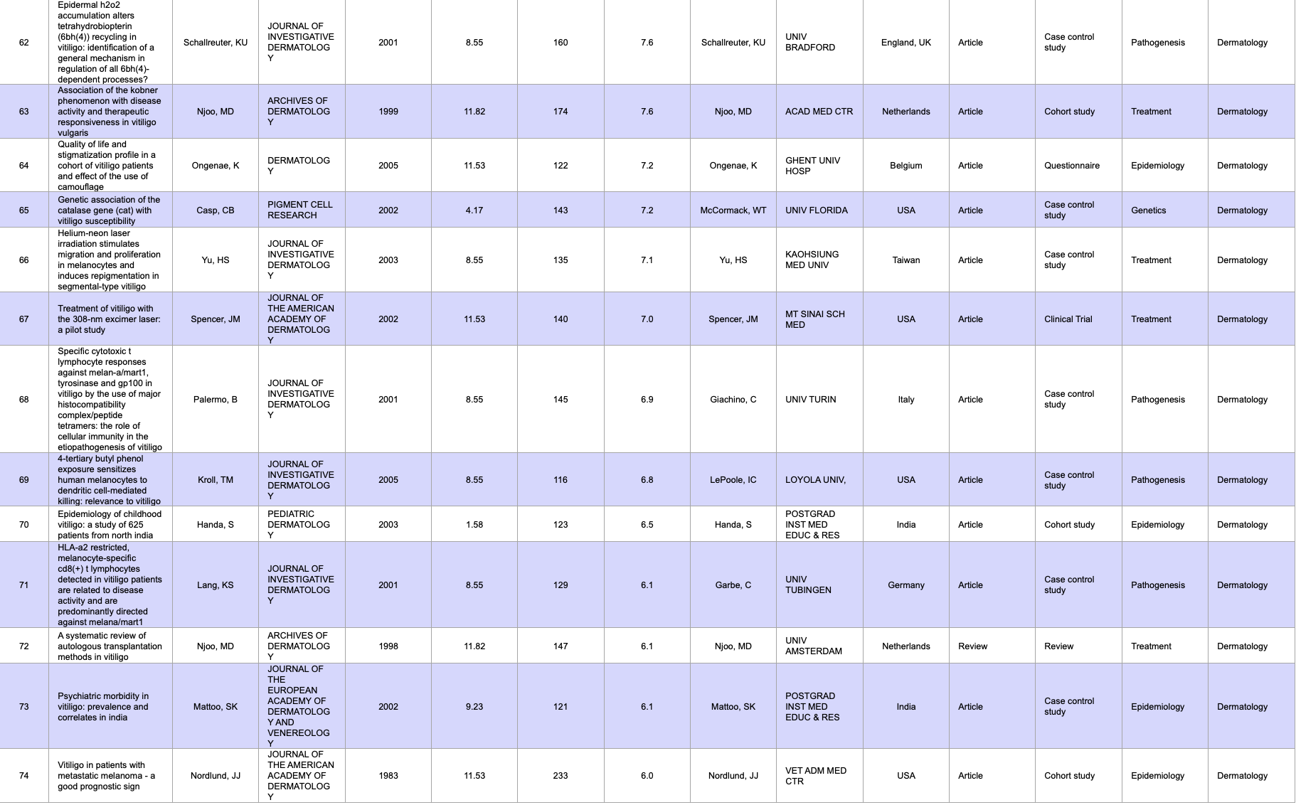 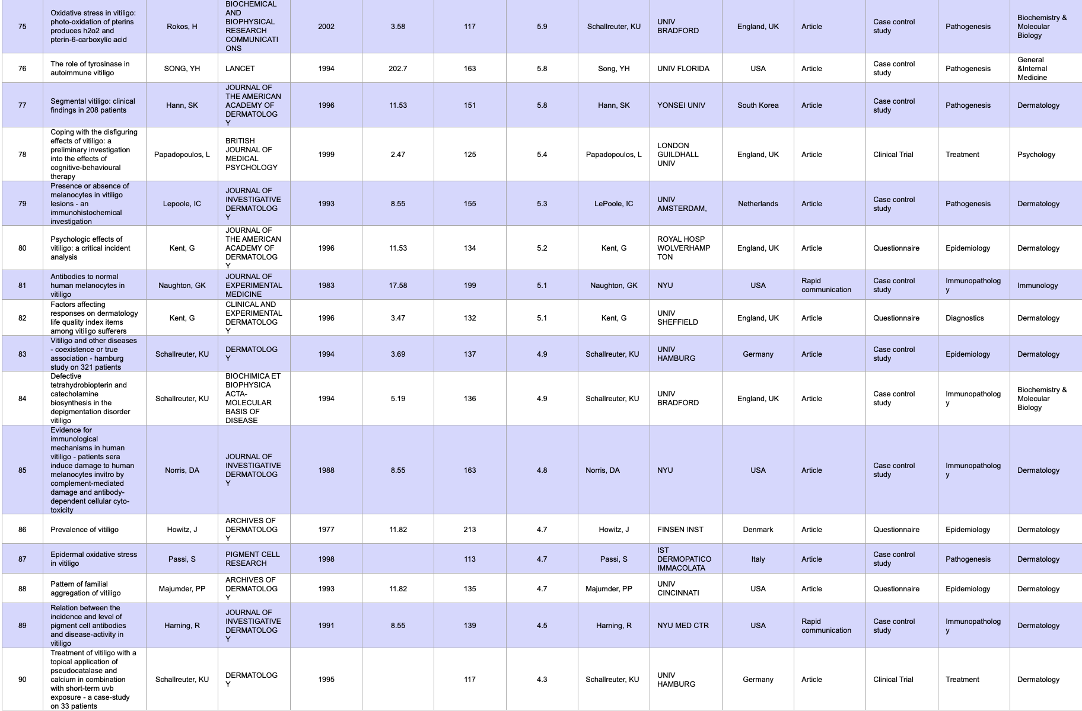 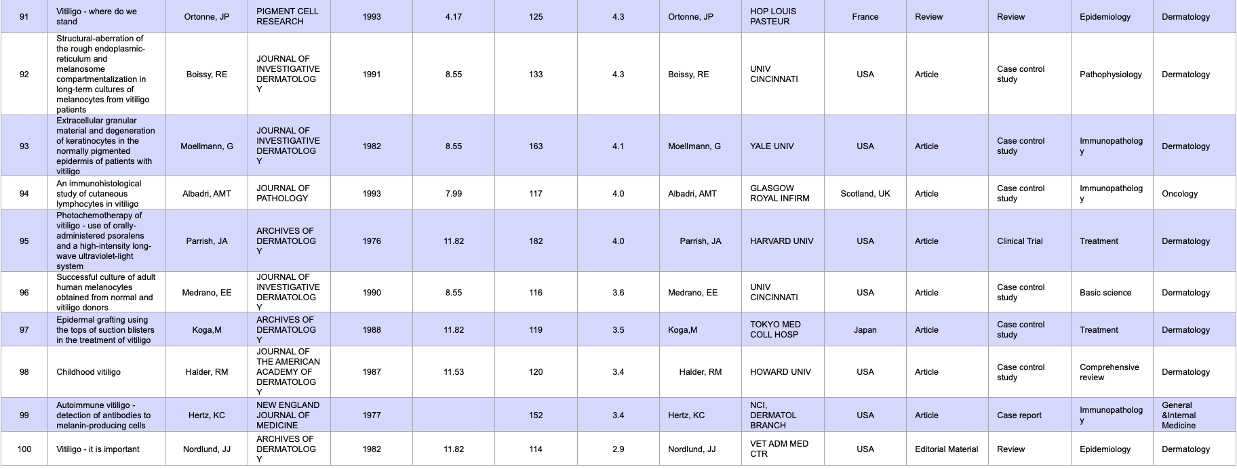

Figure 2: Publications per decade since 1972

Figure 3: Total citations and annual citations

Figure 4: Country of origin of the 100 most cited articles

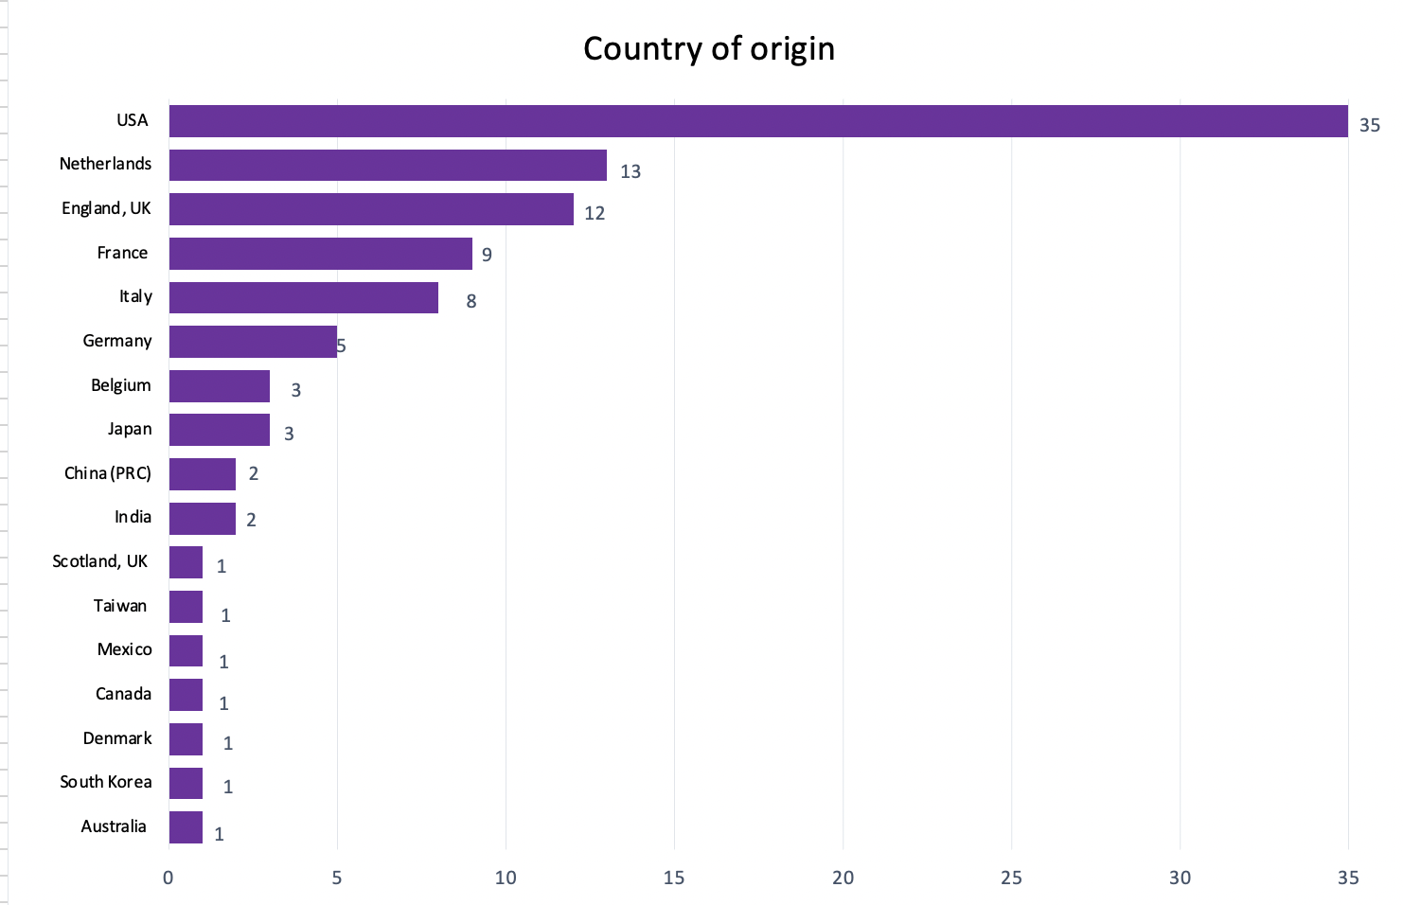

Figure 5: Most published authors with their affiliated institution and countries

Figure 6: Top journals of publication

Figure 7: Impact factor of Journal 2021

Figure 8: Research areas of the 100 most cited articles

Figure 9: Study design of original articles per decade

Figure 10: Research focus of original articles per decade

Figure 11: Top 10 articles since 2018.