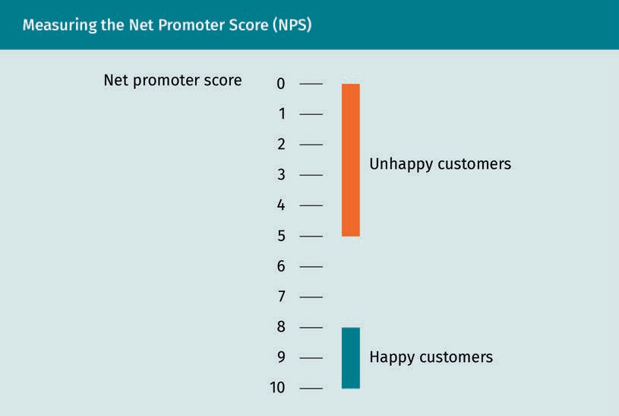
Measuring the NET Promoter Score (NPS)

Net promoter score
Unhappy costumers
Happy costumers

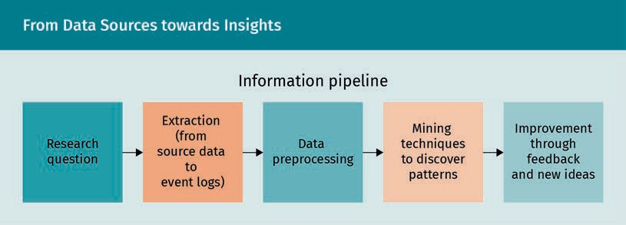
From Data Sources towards Insights

Information pipeline
Research questions
Extraction (from source data to event logs)
Data preprocessing
Mining techniques to discover patterns
Improvement through feedback and new ideas

Peri Net Example
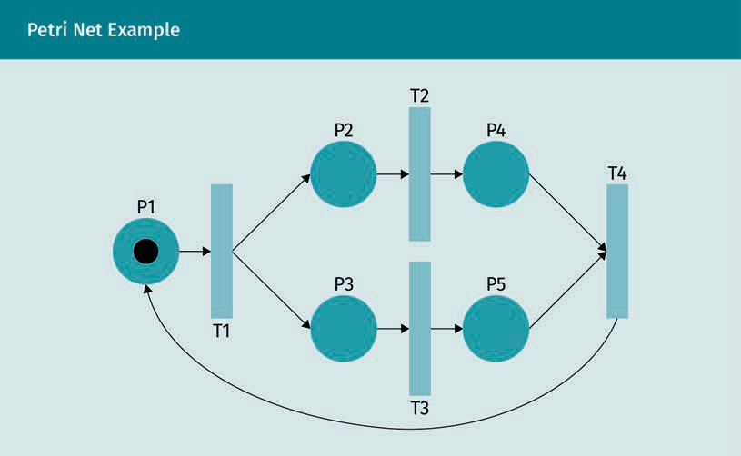

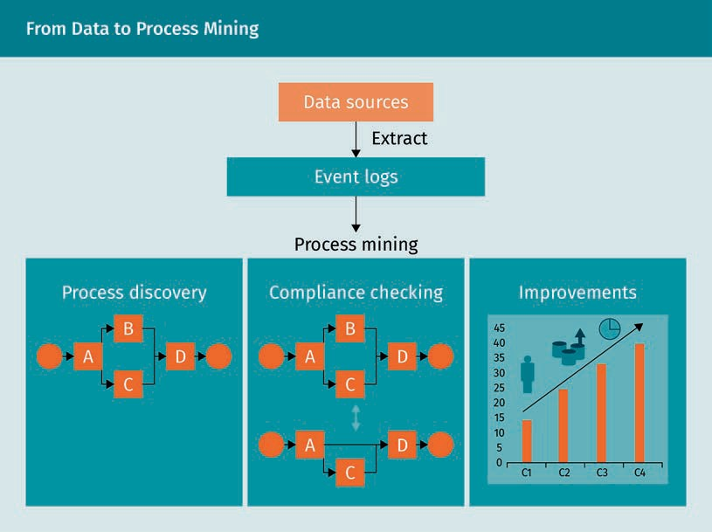
From Data to Process Mining

Data sources
Extract
Event logs
Process mining
Process discovery
Compliance checking
Improvements

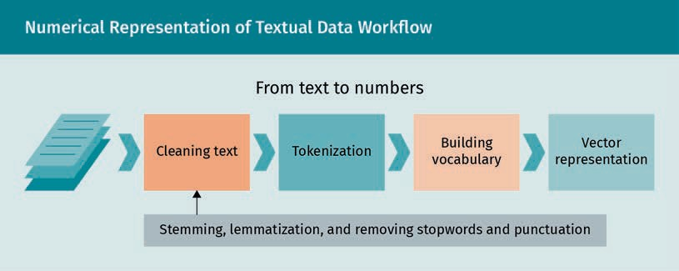
Numerical Representation of Textual Data Workflow

From text to numbers
Cleaning text
Tokenization
Building vocabulary
Vector representation
Stemming, lemmatization, and removing stopwords and punctuation

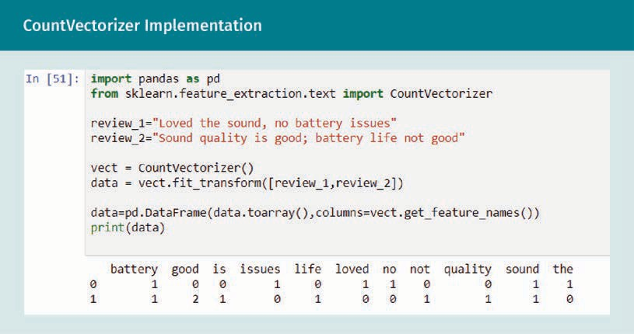
CountVectorizer Implementation

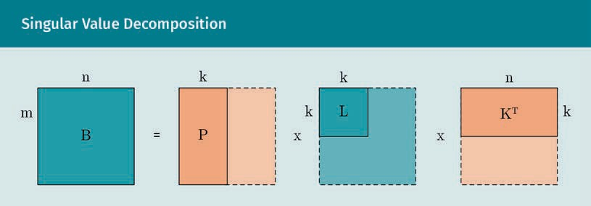
Singular Value Decompostion

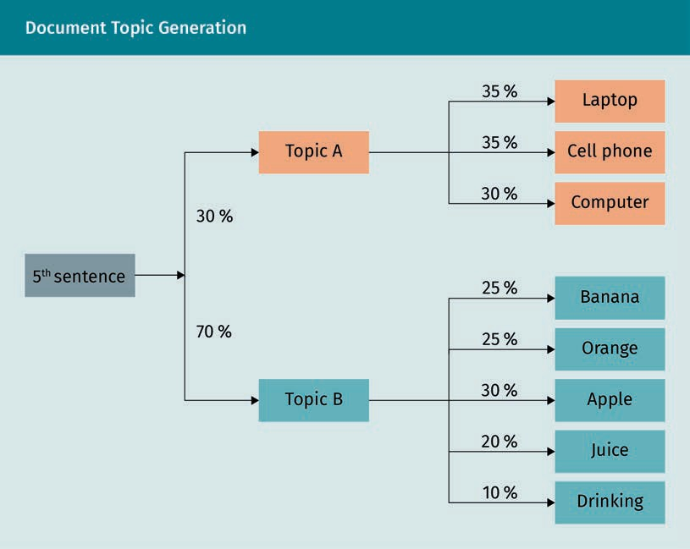
Document Topic Generation

5th sentence
Topic A
Topic B
Laptop
Cell phone
Computer
Banana
Orange
Apple
Juice
Drinking

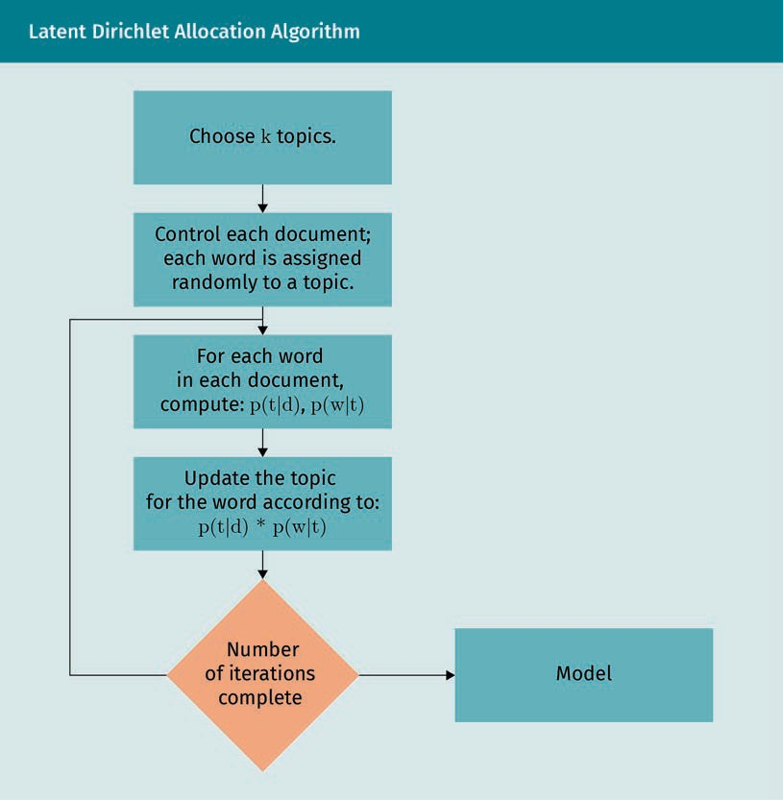
Latent Dirichlet Allocation Algorithm

Choose k topics
Control each document, each word is assigned randomly to a topic
For each word in each document, compute
Update the topic for the word according to
Number of iterations complete
Model

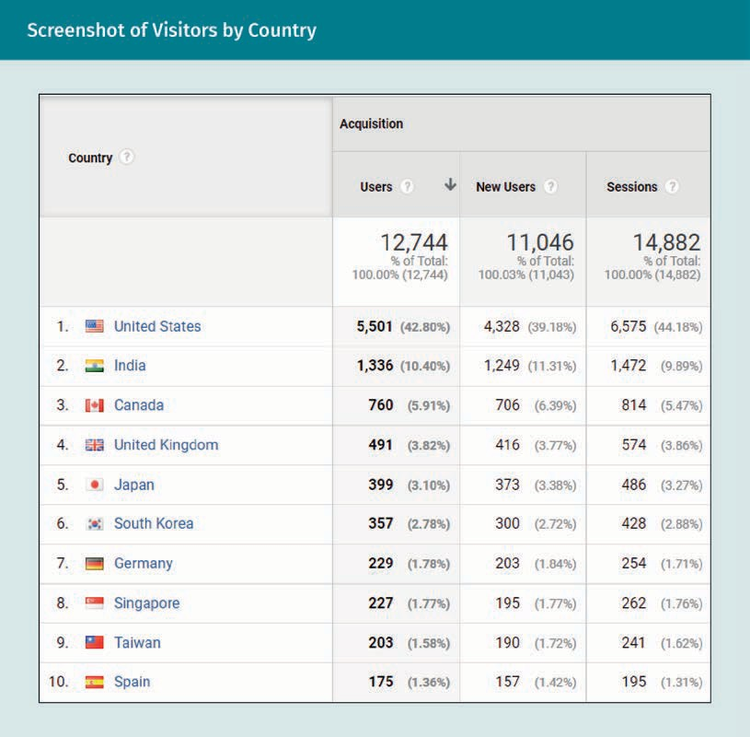
Screenshot of Visitors by Country

Country
Acquisition
Users
New
Sessions

Screenshot of Time Spent on Website
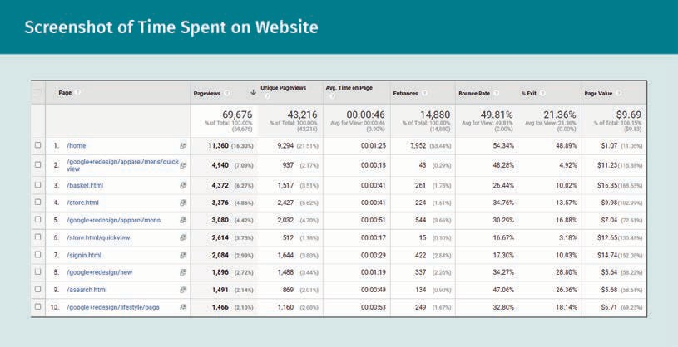

Screenshot of Bounce Rate Value
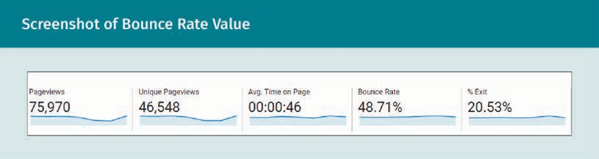

Pageviews
Unique
Avg. Time on Page
Bounce Rate
Exit

Screenshot of Engagement per Sessions

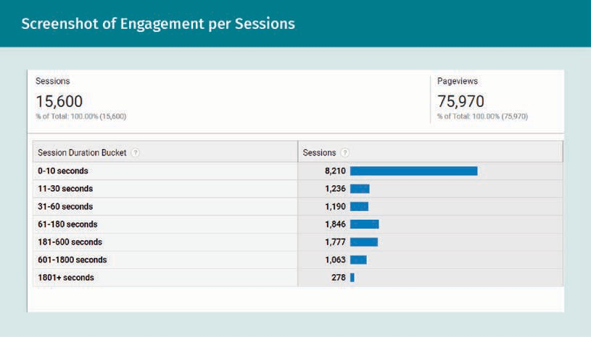

Sessions
Pageviews
Session Duration Bucket
seconds

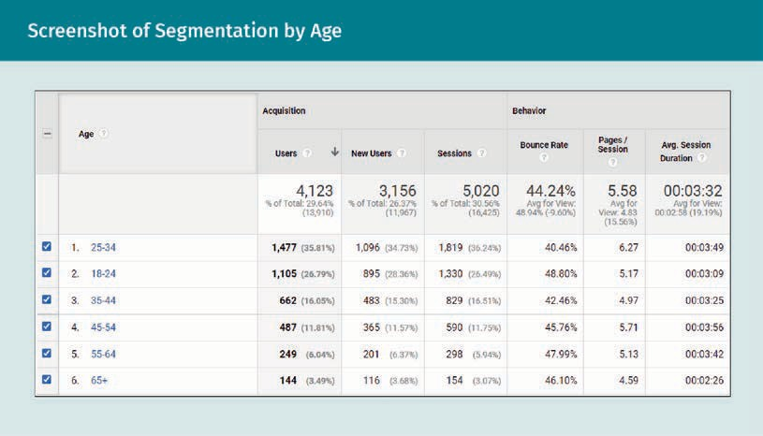
X

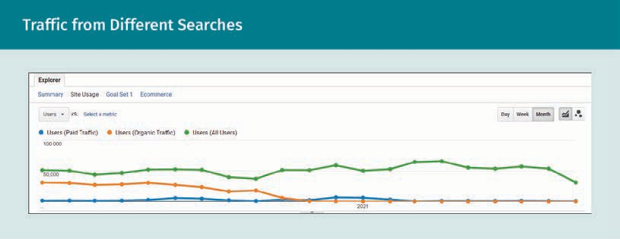
Traffic from Different Searches

Active Users of Social Media in 2021
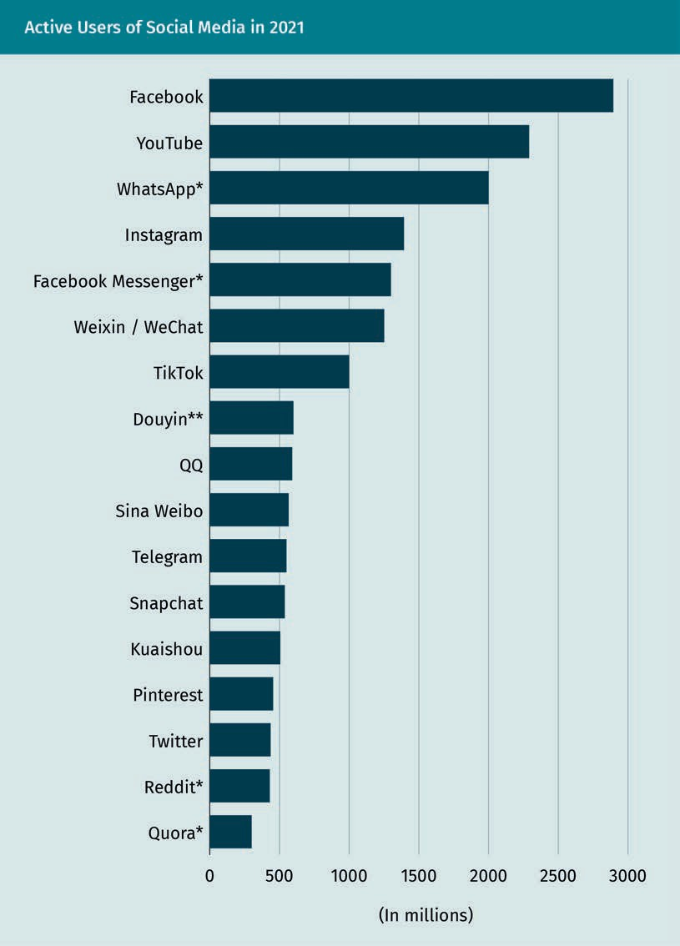

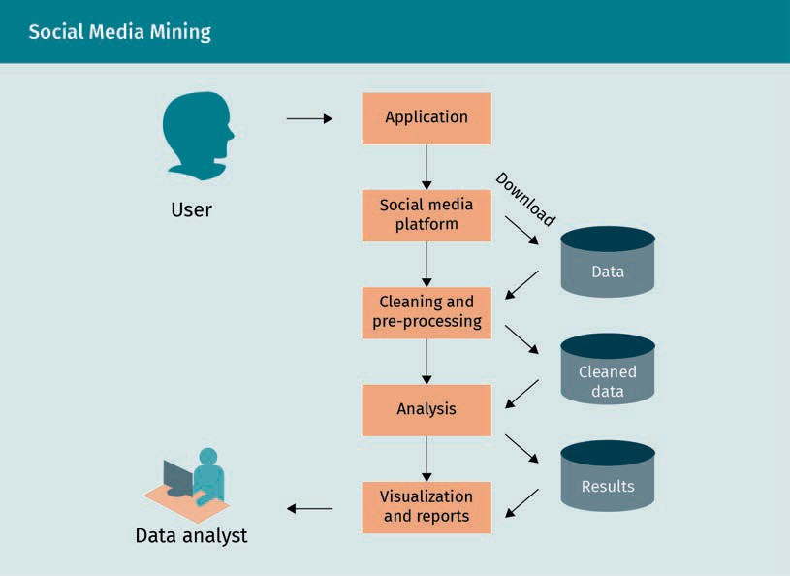
Social Media Mining

User
Application
Social media platform
Download
Data
Cleaning and pre-processing
Cleaned
Analysis
Results
Visualization and reports
Data analyst

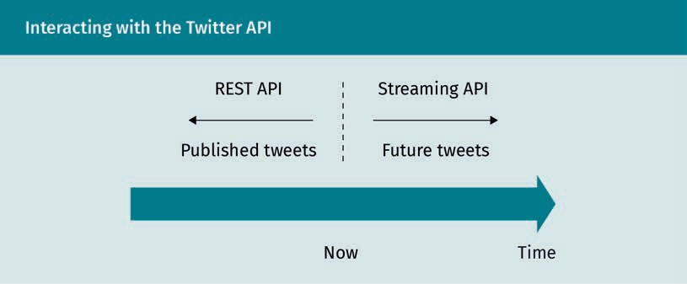
Interacting with the Twitter API

Rest API
Published tweets
Streaming API
Future
Now
Time

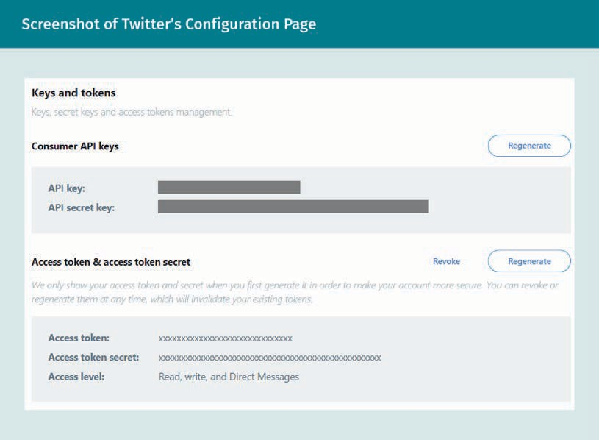
Screenshot of Twitter´s Configuration Page

Keys and tokens
Keys, secret and access tokens management
Regenerate
Consumer API keys
We only show your access token and secret when you first generate it in order to make your account more secure. You can revoke or regenerate them at any time, which will invalidate your existing tokens.
Access Level: Read, write, and Direct Messages

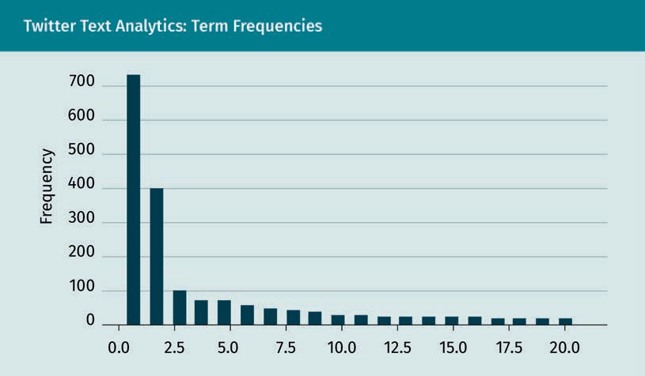
Twitter Text Analytics: Term Frequencies

Frequency

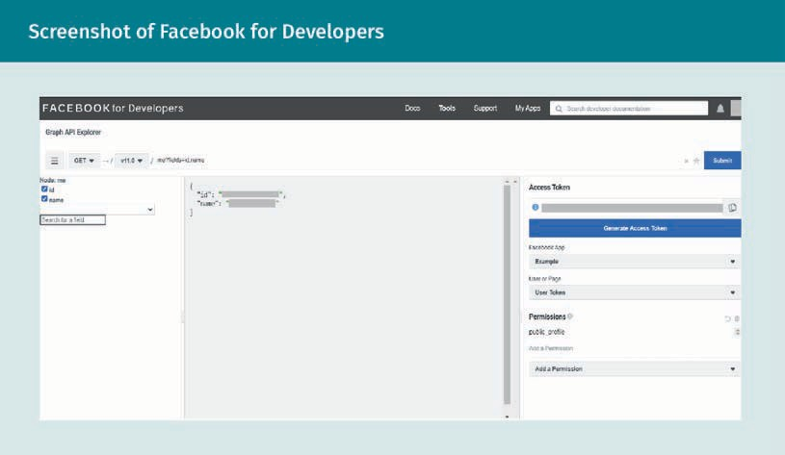
Screenshot of Facebook for Developers

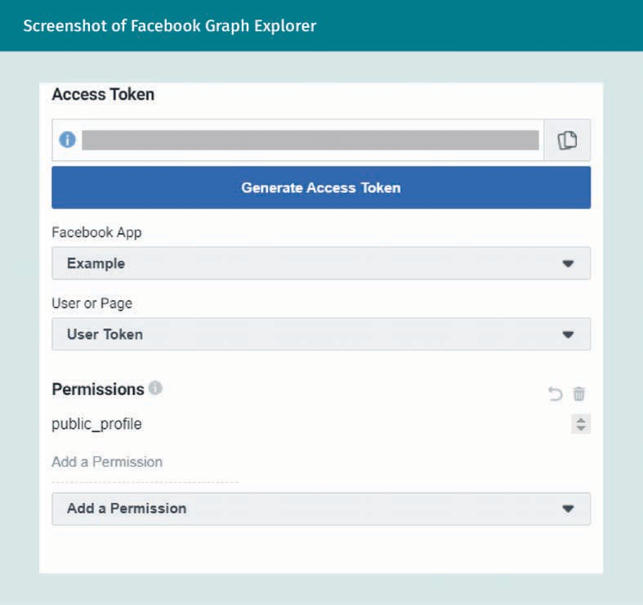
Screenshot of Facebool Graph Explorer

Access Token
Generate
Example
User or Page
Permissions
Public_profile
Add a

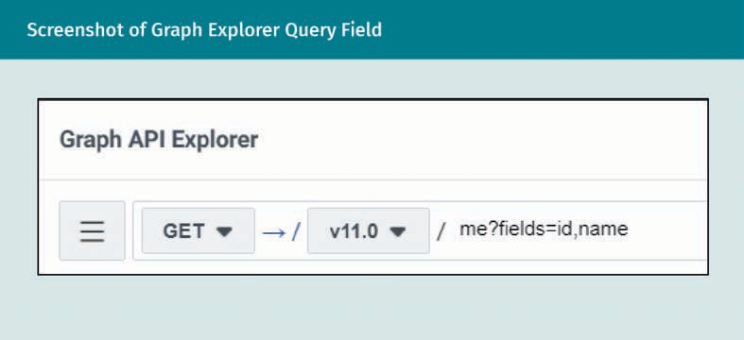
Screenshot of Graph Explorer Query Field

Graph API Explorer
Get
Me?fields=id,name

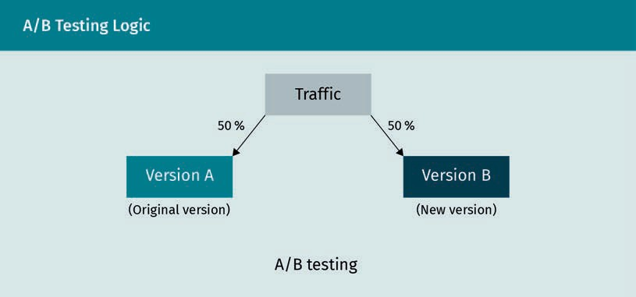
A/B Testing Logic

Traffic
Version A
Version B
A/B testing

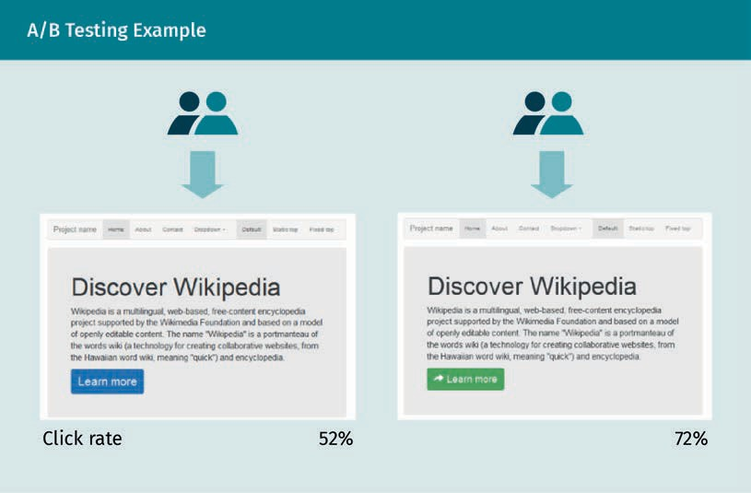
A/B Testing example

Discover Wikipedia
Learn more
Click rate

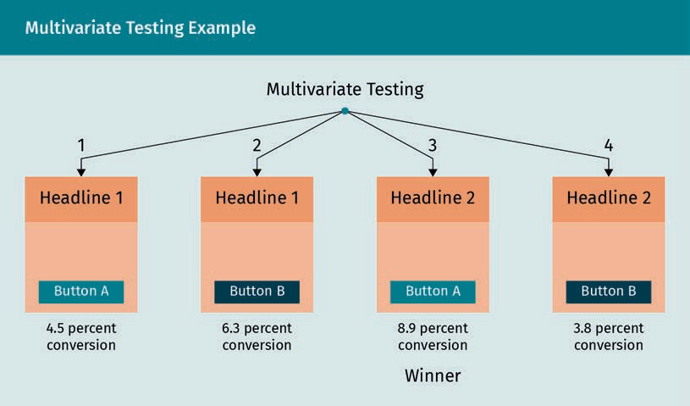
Multivariate Testing Example

Multivariate Testing
Headline
Button
Percent conversion
Winner

A/B Testing versus Multi-Armed Bandit Testing
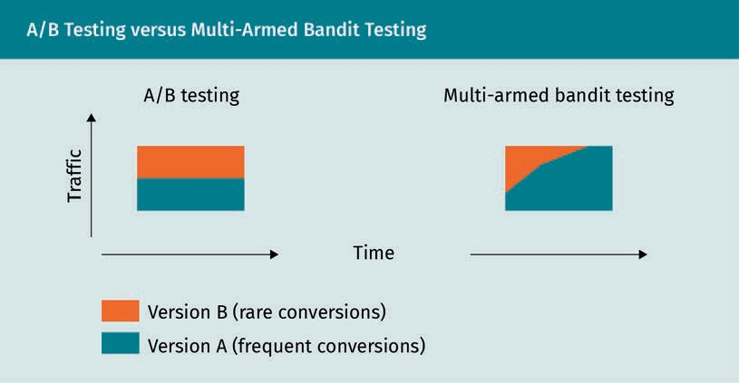
A/B testing
Multi-armed bandit testing
Traffic
Time
Version B (rare conversion)
Version A (frequent conversion)

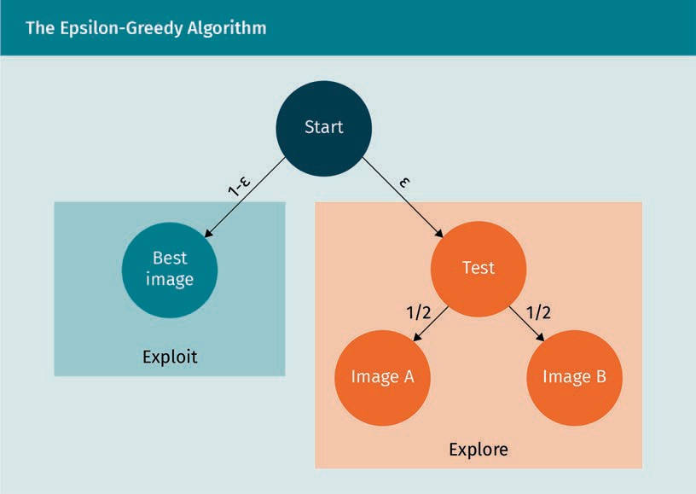
the Epsilon-Greedy Algorithm

Start
Best image
Exploit
Test
Image
Explore

