The Torah Is Not an Allegory

In a polemical response to Christian and Jewish allegorical interpretation of the Torah’s laws, Bekhor Shor writes that just as God speaks to Moses “clearly and without riddles” (Num 12:8), so too the Torah is clear and means what it says, and should not be interpreted allegorically.

[Prof. Rabbi Shaye J. D. Cohen](https://www.thetorah.com/author/shaye-j-d-cohen)

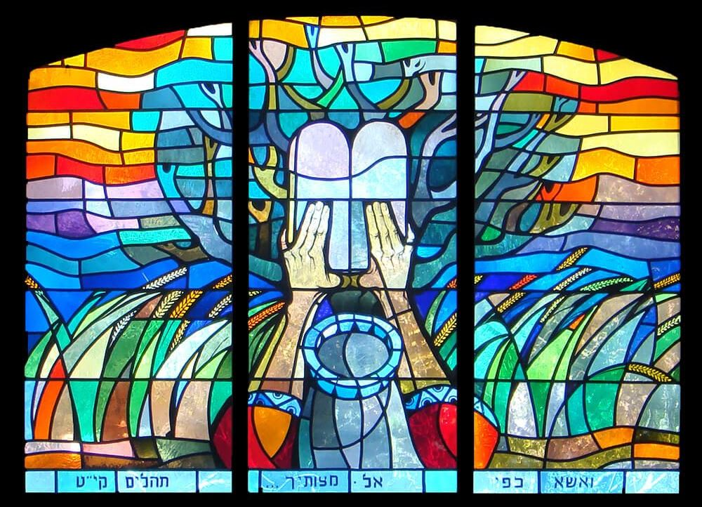

Stained-glass window inside The Great Synagogue of Jerusalem on King George Street

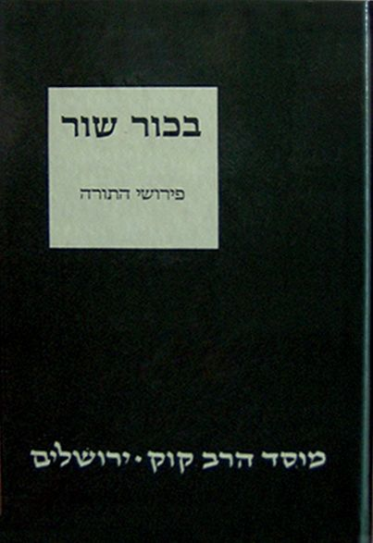

R.Joseph Bekhor Shor flourished in northern France in the mid or second half of the twelfth century. He is probably to be identified with R. Joseph of Orleans, a disciple of Rabbenu Tam (Jacob ben Meir, 1100-1171).[1] For a long time, he and his Torah commentary languished in relative obscurity, but perhaps his moment has finally arrived. In recent years two editions of his Torah commentary have appeared,[2] as well as a book-length monograph,[3] and many articles.[4]

This new interest is due in part to the growing recognition of his importance as a Torah commentator who stands between the radical *peshat*orientation of his older contemporary Rashbam (R. Samuel ben Meir, early twelfth century, brother of Rabbenu Tam), and the *aggadic* orientation of the Tosafist school of Torah commentators in twelfth-century northern France.[5] Bekhor Shor’s commentary is especially interesting when it is attacking “incorrect” biblical interpretation, such as Christian exegesis.

Moses Receives Clear Messages

One excellent example of this phenomenon is his reading of God’s rebuke of Miriam and Aaron in Numbers 12. In this story, Aaron and Miriam have just spoken out against their brother Moses. “Has not the Lord spoken to us too?” they complain. “What makes Moses so special?” God himself comes to Moses’ defense:

במדבר פרק יב:ווַיֹּאמֶר שִׁמְעוּ נָא דְבָרָי אִם יִהְיֶה נְבִיאֲכֶם יְ-הוָה בַּמַּרְאָה אֵלָיו אֶתְוַדָּע בַּחֲלוֹם אֲדַבֶּר בּוֹ. יב:ז לֹא כֵן עַבְדִּי מֹשֶׁה בְּכָל בֵּיתִי נֶאֱמָן הוּא. יב:ח פֶּה אֶל פֶּה אֲדַבֶּר בּוֹ וּמַרְאֶה וְלֹא בְחִידֹת וּתְמֻנַת יְ-הוָה יַבִּיט וּמַדּוּעַ לֹא יְרֵאתֶם לְדַבֵּר בְּעַבְדִּי בְמֹשֶׁה.

Numbers 12:6And he [God] said, “Hear my words: When there are prophets among you, I YHWH make myself known to them in visions; I speak to them in dreams. 12:7Not so with my servant Moses; he is entrusted with all my house.12:8With him I speak face to face—with clarity, not in riddles; and he beholds the form of YHWH. Why then were you not afraid to speak against my servant Moses?” (NJPS with adjustments)

Bekhor Shor uses these verses as an opportunity to dilate upon what makes Moses superior to all the other prophets: Moses is an intimate of God, to whom God speaks freely and to whom God reveals the entire truth of any given matter. Moses is an intimate of God, an agent whom God trusts entirely, and who understands the divine will completely. He begins by explaining that the reason Moses is trusted by all of Israel is:

כי אני מדבר עמו פה אל פה, במראה אני מראה לו הדבר ממש כמו שהוא ולא על ידי חידה ומשל, וכולם מבינים מה שהוא אומר בשמי.

Because I speak with him face to face – with clarity I (God) show Moses something as it actually is, not by means of a riddle or a parable, and everyone understands what he says in my name.[6]

Since Moses receives prophecies clearly, he can also communicate them clearly, making him an exceptionally successful prophet for the people who wish to know God’s word. The reasons Moses is given such clear messages is because he is particularly trustworthy:

והכל בא ממני, כי אני מגלה לו כל הסוד, כמו שאדם עושה [עם] שלוחו הנאמן לו, שמגלה לו כל סודו, ואומר [לו]: אמור לפלוני כך, כי כך וכך סוד ביני ובינו.

And everything comes from me, because I reveal to him the entire secret, just as a person does with a trustworthy agent to whom he reveals his entire secret. He says to the agent, “say such-and-such to so-and-so, because there is an understanding (secret) between him and me.”

ואם אין השליח נאמן לו, אומר לו: אמור לפלוני שיעשה אותו דבר שדברנו אני והוא, ואין השליח יודע איזו שליחות הוא עושה, ולפיכך כל באי עולם מחזיקין אותו בנאמן.

But if his agent is not trustworthy he says to him “say to so-and-so that he should do that thing of which we spoke,” and the agent does not understand the agency that he is accomplishing. Therefore, all the people of the world regard him (Moses) as trustworthy.[7]

Moses is the trusted agent from whom the master holds back nothing. Other prophets do not enjoy the same degree of trust, and thus they receive revelations (visions) from God whose meaning they do not fully comprehend. As a result of Moses’ special status “all the people in the world regard him as trustworthy.”[8]

Responding to Christian Allegory

Next, Bekhor Shor turns polemical and attacks the Christian allegorical interpretation of*mitzvot*, noting that they don’t realize Moses doesn’t speak in allegories, but delivers clear messages from God that mean exactly what they say:

ובכאן נשברו זרועם של אומות העולם שאומרים על מה שאמר משה רבינו אלגורי”א הם, כלומר: חידה ומשל, ואינו מה שהוא אומר, ומהפכין הנבואה לדבר אחר, ומוציאין הדבר ממשמעותו לגמרי.

And thus the arm of the nations of the world is broken, for they say that what Moses our teacher said is an*allegory*,[9] that is, a riddle and a parable, and does not mean what he actually says. And they change his prophecy into something else and they totally distort his meaning.

Although Bekhor Shor in other places polemicizes against Christian truth claims (e.g. the Trinity, the Eucharist, the temporary authority of the Torah), this is the only passage in which he attacks Christian allegorization of the laws.[10] It is worth noting here that many scholars believe that Bekhor Shor knew Latin, which was unusual for rabbis of his (or any) period, and that he had direct contract with Christian scholars.[11]

In Bekhor Shor’s understanding, the Christians think that Moses speaks in allegory and parable and that the Torah’s laws have no “actual” (ממש) meaning,[12] since the verses can be twisted to yield any meaning at all. Bekhor Shor is essentially turning an old polemic back against its source. Christian scholars argued that the Jews have misinterpreted scripture by reading it literally and missing its spiritual message; Bekhor Shor responds that, in fact, it is the Christians who are misreading.

Christians had long claimed, based on some passages in the New Testament, that the Jews read the Torah according to the letter, whereas God wants them to read it according to “the Spirit.” In the Christian readings, the legal sections of the Torah do not necessarily mean what they say, but communicate a deeper, hidden message. As Paul says in 2 Corinthians 3:6: “For the letter [of the law] kills, but the Spirit gives life (NRSV).”[13] Bekhor Shor’s basic argument is that Numbers 12 teaches us that Moses does not receive allegorical prophecies but literal ones, and thus, the laws mean what they say (ממש).

God’s Plan: Why Christians Do not Understand

Bekhor Shor further explains why it is that Christians read this way:

ועליהם אמר דוד “מגיד דבריו ליעקב, חקיו ומשפטיו לישראל, לא עשה כן לכל גוי ומשפטים בל ידעום” שאעפ”י שהעתיקו את התורה מלשון – הקודש ללשונם, לא נתן להם הקדוש ברוך הוא לב לדעת ועינים לראות ואזנים לשמוע, אלא מהפכין הדברים למה שאינם.

Concerning them David said (Psalms 147:19-20), “he speaks his words to Jacob, his laws and statutes to Israel; he has not done thus to any other nation, because he does not make known to them his statutes*.*” Even though they have translated the Torah from the holy tongue into their language, the Holy One, blessed be he, has not given them a heart for understanding, eyes for seeing, and ears for hearing, for instead they change the words to mean something that was never intended.

כי אין [הקדוש ברוך הוא] רוצה וחפץ בהם שידבקו בתורתו.

The Holy One, blessed be he, does not want or desire them to cleave to his Torah.

The reason that Christians do not understand the Torah, Bekhor Shor argues, is not as a result of lack of Hebrew knowledge or intellectual deficiency[14] but rather, it is a result of the divine will. Because Christians are not God’s people, God does not want them to understand his revelation.

Bekhor Shor notes how Christians are not part of Psalm 147’s category of “Jacob/Israel,” and thus the laws were not meant for their observance or understanding. Accordingly, the choice of Psalm 147 as a prooftext can be understood as a response to the Christian claim to be the “true Israel.”[15] Nevertheless, Bekhor Shor’s main point is that even though the Christians may have translated the Torah and they may read the Torah, they do not understand it, since their allegorical reading of Moses’ laws is mistaken.

Too Polemical?

Surely, however, if we could remove Bekhor Shor from his polemical context and allow him to speak freely, he would acknowledge that the question is complicated.[16] Are the legal portions of the Torah always and invariably to be interpreted literally? Are there not many examples in Rabbinic literature where laws are interpreted metaphorically? Rashi himself, in his commentary on various legal passages, says explicitly that given verses are meant as a *mashal.*[17]

One simple and clear example of the Sages reading a law metaphorically is their interpretation of Leviticus 19:14:

ויקרא יט:יד לֹא־תְקַלֵּ֣ל חֵרֵ֔שׁ וְלִפְנֵ֣י עִוֵּ֔ר לֹ֥א תִתֵּ֖ן מִכְשֹׁ֑ל…

Lev 19:14 You shall not insult the deaf or place a stumbling block before the blind…[18]

For reasons which they do not reveal, the Sages understand the first clause as literally referring to cursing (i.e., insulting) but the second clause metaphorically as causing someone to stumble in sin. In other words, the second prohibition has nothing to do with a physical “stumbling block” designed to trip someone’s feet; it is a metaphor for something which causes a person to “fall” and with which a person can sin.

In other words, a person who puts a stumbling block before the blind is one who enables someone else to do a sinful act. The classic example of this used the by Sages is one who gives wine to a nazirite, who made a vow against drinking wine. The wine in this example is the stumbling block. From the *Sifra* to the Talmud to Rashi and yes, even to Bekhor Shor, the second clause of the verse is understood this way.[19] Bekhor Shor never discusses how to distinguish between “legitimate” rabbinic metaphorical readings and the “illegitimate” Christian ones.

Illegitimate Jewish Interpretation

Finally, Bekhor Shor turns to his fellow Jews who appear to treat certain Torah laws as metaphor and ignore the “actual” (ממש) meaning of the Torah’s laws.

גם מבני עמינו שמעתי שמפקפקין על תפילין ומזוזות וכיסוי – הדם, שאומרים “והיה לאות על ידכה ולטוטפות בין עיניך, וכתבתם על מזוזות ביתך ובשעריך” שהוא כמו “שימני כחותם על לבך, כחותם על זרועך”, שתזכרני תמיד, ואינו חותם על זרועו ולבו ממש. וכן אילו אינם ממש תפילין ומזוזות,

Also I have heard that some people of our nation have doubted the commandments of *tefillin*(phylacteries), *mezuzot,*and the covering of the blood [of slaughtered fowl], for they say that “it shall be for a sign on your hand and for *totafot* between your eyes” (Exodus 13:16), and “you shall write them on the doorposts of your house and your gates” (Deuteronomy 6:8-9) has the same meaning as “place me like a seal on your heart, like a seal on your arm” (Song of Songs 8:6), that is, you should remember me always, and is not an actual seal on the arm or heart. And thus, in their opinion, these words do not refer to actual *tefillin* and *mezuzot.*

וכן “וכסהו בעפר”, כמו “וכסינו את דמו”, וכמו “ארץ אל תכסי דמי”. ואינו אומר כסוי הדם ממש,

And likewise, “and he shall cover it with earth” (Leviticus 17:13). They say this is like “And we shall cover his blood” (Genesis 37:26) and “earth, do not cover my blood” (Job 16:18), which does not mean actual covering of the blood*.*

אוי להם מעלבונה של תורה, כי אף הם עתידים ליתן את הדין.

Woe to them for insulting the Torah. The day will come when they will have to face divine judgment.

Bekhor Shor highlights three Torah verses whose legal content is mis-read as metaphor by some of his co-religionists: the verses commanding the wearing of *tefillin*(phylacteries), the related verses commanding the affixing of *mezuzot* to the doorposts of a home, and the verses commanding the covering with earth the blood of slaughtered fowl and wild animals (*kissuy ha-dam*).

Tefillin and Piety in the Middle Ages

Bekhor Shor’s polemic here may have multiple targets.

Rashbam – The allegorical interpretation of the tefillin passage is known from Rashbam’s commentary on Exodus 13:9:[20]

לאות על ידך – לפי עומק פשוטו יהיה לך לזכרון תמיד כאילו כתוב על ידך. כעין שימני כחותם על לבך

*“*A sign on your hand”*–*according to its fundamental plain meaning, it means that it shall be for a permanent memorial as if it were written on your hand. Similar to what is said in the verse “Place me as a seal on your heart” (Song of Songs 8:6)

In other words, says Rashbam, the verse does not require – it does not even suggest – the literal wearing of *tefillin.*The verse is metaphor; keep the words of God with you always, as if they were written on your hand and on your heart.[21]

Although it is likely that Bekhor Shor has Rashbam’s commentary in mind here, Rashbam may not have been the main target of his polemic. First, Rashbam does not apply this metaphorical reading to the *mezuzah*. Second, Rashbam certainly wore *tefillin* and put a*mezuzah* on his doorpost, and thus cannot fairly be described as someone who “doubts the commandments.”[22]

Karaite Exegesis – Karaite exegetes generally interpret both the *tefillin* and *mezuzah*passages metaphorically, and, in fact, Karaite Jews do not wear tefillin or put up *mezuzot*.[23]Thus, it is possible that Bekhor Shor has Karaites in mind here as well. Nevertheless, this still seems like an insufficient target for Bekhor Shor’s animus here. Karaites were hardly a significant competitor in twelfth century France. Also, Karaites do cover the blood after slaughtering an animal.[24]

Rabbinic Jews Didn’t Wear Tefillin or Put Up Mezuzot – Perhaps in addition to the theoretical allegorizing of Rashbam and the Karaite “practical allegorizers,” Bekhor Shor was aiming at local Jews who simply didn’t wear tefillin or put up *mezuzot*, not for philosophical reasons but because *tefillin*and *mezuzah*were not widely observed before this period. These *mitzvot* were observed by pietists but not by the (male) population at large.

Norms changed and expectations changed, however, and some members of the scholar class began to teach that these practices were to be norms of regular piety. At this point the old habit of ignoring *tefillin*and *mezuzah*was no longer tolerable; adult males were expected to don *tefillin*and Jewish habitations were expected to be marked by *mezuzot.*What was once perfectly acceptable behavior became deviance.[25]

If this is what was bothering him, then Bekhor Shor’s issue may not so much have been the neglect of *tefillin*and *mezuzah*born of philosophical speculation, but the failure in his community to adapt to new modes of piety. In fact, decades later, R. Moshe of Coucy (early 13th century) describes how he preached to Jewish communities about the importance of wearing tefillin (*Semag*, Positive Commandments 3):

כך דרשתי פרשה זו בגליות ישראל להוכיח שכל אחד ואחד חייב בתפילין ומזוזות.

Thus I preached about this biblical passage in the diaspora communities, to prove that each and every (man/person) is obligated in *tefillin* and *mezuzah*.

In short, Bekhor Shor seems to have had multiple targets, and he even seems to associate the Rashbam style allegories with the non-observance of these *mitzvot* within his community. Whether Rashbam’s interpretation actually aided “some of our people” in their resistance to the spread of new-found *tefillin*piety is not known.[26]

A Many-Sided Polemic

The commentary of Bekhor Shor on Numbers 12 is a window into several major issues confronting Ashkenazic Jewry in the twelfth century: Jewish vs. Christian truth claims, Jewish vs. Christian Bible interpretation, the power of allegory, and pietistic observances by the community at large.

[View Footnotes](https://www.thetorah.com/article/the-torah-is-not-an-allegory)

1. In the summer of 2017, I gave an early version of this essay as a talk twice. In each case a lively discussion ensued, and I would like to thank all those who took part. The first time was as a lecture at the Oranienburgerstrasse Synagogue in Berlin; the second was as a *dvar Torah*in memory of my friend Michael Hammer z”l at Congregation Sha’arei Tefillah in Newton MA. In anticipation of his tenth *yahrzeit*, I dedicate this piece to him. I would also like to acknowledge the assistance of many friends: Shani Berrin-Tzoref; Naftali Brawer; Daniel Lasker; Martin Lockshin.
2. Ed. Yehoshafat Nevo (Jerusalem: Mosad haRav Kook, 1994); ed. Malachi ha Cohen in the*Mikra’ot Gedolot haKeter*(Bar Ilan University Press). I transcribe the Torah commentary from the Bar Ilan data base (version 24).
3. Jonathan Jacobs, *Bekhor Shoro Hadar Lo*(Jerusalem: Magnes Press, 2017 [Hebrew]).
4. Modern discussion begins with Sarah Kamin, “The Polemic against Allegory in the Works of R. Joseph Bekhor Shor, *Beyn Yehudim le Notsrim be-Parshanut ha-Miqra (*Jerusalem: Magnes Press, second edition revised and corrected, 2009): 89-112. Other recent works include Jonathan Jacobs, “The ‘Anticipation Principle’ in the Biblical Commentary of R. Joseph Bekhor Shor,” *HUCA* 87 (2016): 251-277; Martin Lockshin, “Was R. Yoseph Bekhor Shor a *Pashtan,”*in *Iggud Mivhar Ma’amarim be-Mada’ei ha-Yahdut: Kerekh Aleph: Ha-Miqra ve-Olamo*(Jerusalem, 2008); Shaye J.D. Cohen, *Why Aren’t Jewish Women Circumcised? (*Berkeley: University of California Press, 2008) chapter eight; idem, “Does Rashi’s Torah Commentary Respond to Christianity? A Comparison of Rashi with Rashbam and Bekhor Shor,” in *The Significance of Yavneh and Other Essays in Jewish Hellenism*(Tübingen: Mohr-Siebeck 2010) 513-533.
5. Ya’aqov Gelis, ed., *Tosafot Ha-Shalem: Otsar Perushe ba’alei ha Tosafot* (Jerusalem: H. Wagshall, 1982).
6. All translations of Bekhor Shor and other commentators are my own unless otherwise noted.
7. Bekhor Shor brings a prooftext from Samuel:

וכן כתוב בשמואל “וידע כל ישראל… כי נאמן שמואל לנביא לה'”, כי נאמנו דבריו.

And thus it says in the book of Samuel (1 Samuel 3:20), *and all Israel knew that Samuel was a trustworthy prophet of the Lord,*because his words were proven to be true.

Because “nothing he predicted turned out false” (1 Sam 3:19), everyone trusted him.

1. This seems to mean that Moses is revered as prophet by everyone in the world, Jews, Christians, and Muslims alike. However, Bekhor Shor’s comment on the previous verse (Numbers 12:7) suggests that “all the people in the world” means “all the Jews in the world.”
2. Here Bekhor Shor transliterates the Greek/Latin term “allegoria.”
3. Kamin’s lists Bekhor Shor’s attacks on Christianity: Genesis 1:26, 3:22, 18:2, 19:1, 24:2, 49:10, Exodus 20:3, 31:18, 32:20, 32:25, Deuteronomy 6:4-5 and 13:4. See also Cohen, “Does Rashi’s Torah Commentary Respond to Christianity?” For the Jewish-Christian debate about the allegorical interpretation of the Torah see David Berger, *The Jewish Christian Debate in the High Middle Ages (*Jewish Publication Society 1979) 355-361.
4. See Jacobs, *Bekhor Shoro Hadar Lo*, 209, 227.
5. Note that Bekhor Shor uses the word *peshat*only twice (Genesis 1:26 and Deuteronomy 18:7); he uses the word *mamash*thirty-five times (not counting derived forms for either word).
6. See also John 6:63 about Shabbat, Romans 2:29 about circumcision. The *Epistle of Barnabas* (ca. 135 C.E.) is an early example of an attempt to explain the “true,” i.e., spiritual meaning of Torah laws such as kosher and Shabbat. Ironically, the allegorization of laws started in Jewish texts such as the Letter of Aristeas, or the works of Aristobolus and Philo. Editor’s note: For one example of such allegory in early Jewish and Christian sources, see Joshua Garroway, [“The Earliest Explanation for Kosher,”](https://thetorah.com/the-earliest-explanation-for-kosher/) *TheTorah.com* (2016).
7. Christians will explain that the Jews’ failure to understand the truth of Christianity is the result of intellectual deficiency; bereft of rational intellect Jews are more animal than human. See Jeremy Cohen, *Living Letters of the Law*(University of California, 1999) *259* (re Peter the Venerable’s view of the Jews).
8. Tanhuma *Vayera*on Genesis 18:17 and elsewhere.
9. Christians do not read all the laws of the Torah as allegories – some laws are binding on Christians too, like Lev 19:18, *Love your neighbor as yourself –*but in a polemical context, this point is probably too nuanced for Bekhor Shor to discuss.
10. Exodus 22:2; Deuteronomy 22:17
11. Cf. Deuteronomy 27:18
12. See the commentaries of Rashi (citing the Sifra) and Bekhor Shor on Leviticus 19:14. See too b. *Pesahim* 22b, *Bava Metzia* 75b, *Mo’ed Qatan* 5a and 17a. See the discussion in David Weiss Halivni, *Peshat and Derash* 11, 24, and 88.

וְהָיָה֩ לְךָ֨ לְא֜וֹת עַל־יָדְךָ֗ וּלְזִכָּרוֹן֙ בֵּ֣ין עֵינֶ֔יךָ

*It shall be a sign for you on your hand and a memorial between your eyes*

1. Ibn Ezra may also be bothered by Rashbam’s comment here, though he may also be aiming at Karaite exegesis, which would have been much more of a target for him (ibn Ezra) than for Bekhor Shor. Editor’s note: See discussion of Rashbam and ibn Ezra’s debate here in, Zev Farber, [“Can the Torah Contradict Halacha?”](https://thetorah.com/can-torah-contradict-halacha/) *TheTorah.com* (2014).
2. In Marty Lockshin’s notes on Rashbam (*ad loc*.), he suggests that whereas Bekhor Shor here is likely attacking Karaites, his comments on Deuteronomy 6:9 are probably aimed at Rashbam. See also discussion in Elazar Touitou, *Exegesis in Perpetual Motion* (Ramat Gan: Bar Ilan, 2005), 187 [Hebrew].
3. Editor’s note: For more on Karaite exegesis see Daniel Lasker, [“Biblical Exegesis as a Source of Jewish Pluralism: The Case of the Karaites,”](https://thetorah.com/biblical-exegesis-as-a-source-of-jewish-pluralism-the-case-of-the-karaites/) *TheTorah.com* (2017).
4. See e.g., Aaron ben Elijah (1328-1369), Gan Eden, “Laws of *Shechitah*” ch. 16; Elijah Bashyazi (ca. 1420-1490), *Aderet Eliyahu*, “Laws of *Shechitah*,” ch. 16. Bekhor Shor’s statements about the practice of covering the blood of slaughter, both here and in Leviticus 17, are a complicated problem which I hope to discuss on another occasion.
5. Ephraim Kanarfogel, “Rabbinic Attitudes toward Nonobservance in the Medieval Period,” *Jewish Tradition and the Nontraditional Jew*(Northvale: Jason Aaronson, 1992) 3-35 at 7-14; David Malkiel, *Reconstructing Ashkenaz*(Stanford University Press, 2009) 184-186. Elisheva Baumgarten, *Practicing Piety in Medieval Ashkenaz* (Philadelphia: University of Pennsylvania Press, 2014) 149-166.
6. Editor’s note: More than a century later, we find this exact criticism aimed at a sage named Levi ben Avraham by Rashba. See discussion in part 5 of, Gregg Stern, [“Allegorizers of the Torah and the Story of their Prosecution in Languedoc,”](https://thetorah.com/allegorizers-of-torah-and-the-story-of-their-prosecution-in-languedoc/) *TheTorah.com* (2015)