Dr. Atar Livneh

Ben-Gurion University

Dr. Atar Livneh is Assistant Professor in the Department of Bible, Archaeology, and Ancient Near Eastern Studies at Ben-Gurion University. She holds a Ph.D. and an M.A. in biblical studies from the University of Haifa. Her research focuses on *Jubilees* and Second Temple Literature.

Giving Miriam and the Matriarchs Their Proper Funerals

The Bible pays little attention to the death of its female characters, writing only cursory death notices, or sometimes none at all. Second Temple period authors retell the Torah’s stories to give more pride of place to the death scenes of its heroines.

[Dr. Atar Livneh](https://www.thetorah.com/author/atar-livneh)

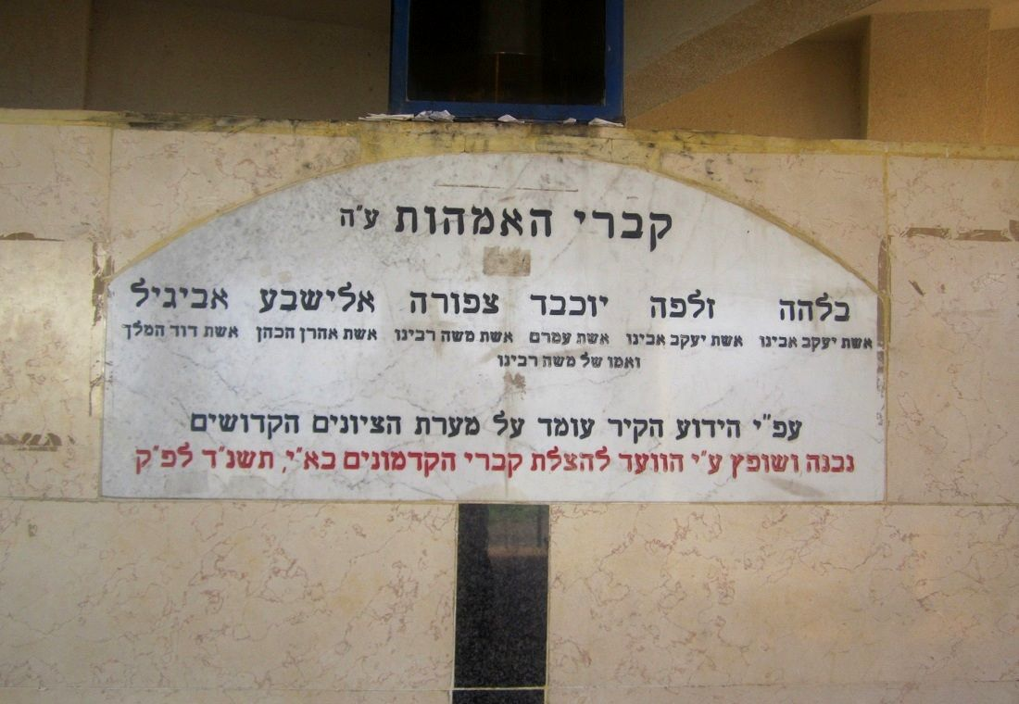

Matriarchs’ grave in Tiberias. by Almog CC

Comparing the Biblical Accounts of Miriam’s and Aaron’s Deaths

Numbers 20 reports Miriam’s death briefly and succinctly:

במדבר כ:א וַיָּבֹאוּ בְנֵי יִשְׂרָאֵל כָּל הָעֵדָה מִדְבַּר צִן בַּחֹדֶשׁ הָרִאשׁוֹן וַיֵּשֶׁב הָעָם בְּקָדֵשׁ וַתָּמָת שָׁם מִרְיָם וַתִּקָּבֵר שָׁם.

Num 20:1 The Israelites arrived in a body at the wilderness of Zin on the first new moon, and the people stayed at Kadesh. Miriam died there and was buried there.

This contrasts sharply with the description of Aaron’s death at the end of the same chapter:

במדבר כ:כג וַיֹּאמֶר יְ־הוָה אֶל מֹשֶׁה וְאֶל אַהֲרֹן בְּהֹר הָהָר עַל גְּבוּל אֶרֶץ אֱדוֹם לֵאמֹר. כ:כד יֵאָסֵף אַהֲרֹן אֶל עַמָּיו... כ:כה קַח אֶת אַהֲרֹן וְאֶת אֶלְעָזָר בְּנוֹ וְהַעַל אֹתָם הֹר הָהָר. כ:כו וְהַפְשֵׁט אֶת אַהֲרֹן אֶת בְּגָדָיו וְהִלְבַּשְׁתָּם אֶת אֶלְעָזָר בְּנוֹ וְאַהֲרֹן יֵאָסֵף וּמֵת שָׁם.

Num 20:23 At Mount Hor, on the boundary of the land of Edom, YHWH said to Moses and Aaron, 20:24 “Let Aaron be gathered to his kin... 20:25 Take Aaron and his son Eleazar and bring them up on Mount Hor. 20:26 Strip Aaron of his vestments and put them on his son Eleazar. There Aaron shall be gathered unto the dead.”

כ:כז וַיַּעַשׂ מֹשֶׁה כַּאֲשֶׁר צִוָּה יְ־הוָה וַיַּעֲלוּ אֶל הֹר הָהָר לְעֵינֵי כָּל הָעֵדָה. כ:כח וַיַּפְשֵׁט מֹשֶׁה אֶת אַהֲרֹן אֶת בְּגָדָיו וַיַּלְבֵּשׁ אֹתָם אֶת אֶלְעָזָר בְּנוֹ וַיָּמָת אַהֲרֹן שָׁם בְּרֹאשׁ הָהָר וַיֵּרֶד מֹשֶׁה וְאֶלְעָזָר מִן הָהָר. כ:כט וַיִּרְאוּ כָּל הָעֵדָה כִּי גָוַע אַהֲרֹן וַיִּבְכּוּ אֶת אַהֲרֹן שְׁלֹשִׁים יוֹם כֹּל בֵּית יִשְׂרָאֵל.

20:27 Moses did as YHWH had commanded. They ascended Mount Hor in the sight of the whole community. 20:28 Moses stripped Aaron of his vestments and put them on his son Eleazar, and Aaron died there on the summit of the mountain. When Moses and Eleazar came down from the mountain, 20:29 the whole community knew that Aaron had breathed his last. All the house of Israel bewailed Aaron thirty days.

God reveals both the time and place of Aaron’s death beforehand, instituting an elaborate ritual for the investiture of his successor. While “all the house of Israel bewailed Aaron thirty days,” no such mourning for Miriam is mentioned.

Josephus’ Retelling of Miriam’s Death

The divergence between the terse note of Miriam’s death and the elaborate depiction of Aaron’s death conforms to a literary convention elsewhere in the Bible. While the end to which heroes come is sometimes portrayed in detail, the demise of heroines, if indicated at all, typically consists of a short, gnomic formula (cf. the short statements regarding Sarah’s, Rebecca’s, and Leah’s burials [Gen 23:1-2; 49:29-31]).

Josephus, however, appears to be uncomfortable with this tradition of short burial notices for heroines. Writing his account of Jewish history at the end of the first century in Rome—largely a paraphrase of the biblical account as he had it—he takes pains to represent Miriam’s burial as befitting her high status:[1]

At that time, the end of life overtook his sister Mariamme, who had completed her fortieth year since she had left Egypt, on the new moon of the month of Xanthikos[2]according to the moon. They buried her lavishly at public expense on a certain mountain that they call Sin, and Moyses purified the people after they had mourned for thirty days in this manner. The high priest led forth and sacrificed a female calf … (Josephus,*Antiquities*4.78-79 [Feldman])

As Schalit and Feldman note, Josephus draws his information regarding Miriam’s death from both Greek and Jewish sources.[3] The lavish funeral at public expense he attributes to Miriam was an honor awarded to patriotic citizens and important political figures in Greek and Rome. Her mourning, on the other hand, seems to be inspired by the biblical portrayals of her brothers’ burial, including the Israelites lamenting both Aaron’s and Moses’ deaths for thirty days (see Num 20:29; Deut 34:8).

The claim that Miriam was mourned also helps Josephus resolve an exegetical problem—namely, why her death is juxtaposed with the ordinance of the red heifer in Numbers 19. Reversing the order of the two accounts, he is thus able to explain the latter on the grounds that it purified the Israelites after they had participated in Miriam’s death rites.[4]

Retellings of the Matriarchs’ Deaths

Second Temple writers treated the matriarchs’ deaths in a similar fashion. According to the biblical text:

בראשית כג:א וַיִּהְיוּ חַיֵּי שָׂרָה מֵאָה שָׁנָה וְעֶשְׂרִים שָׁנָה וְשֶׁבַע שָׁנִים שְׁנֵי חַיֵּי שָׂרָה. כג:ב וַתָּמָת שָׂרָה בְּקִרְיַת אַרְבַּע הִוא חֶבְרוֹן בְּאֶרֶץ כְּנָעַן וַיָּבֹא אַבְרָהָם לִסְפֹּד לְשָׂרָה וְלִבְכֹּתָהּ.

Gen 23:1 Sarah’s lifetime—the span of Sarah’s life—came to one hundred and twenty-seven years. 23:2 Sarah died in Kiriath-arba—now Hebron—in the land of Canaan; and Abraham proceeded to mourn for Sarah and to bewail her.

Josephus and Philo

Philo and Josephus both elaborate on this passage. Josephus extols Sarah in the same way as Miriam, stating that her funeral was paid for from the public coffers (*J.A*. 1.237). Philo — an Alexandrian from the first half of the first century c.e.— inserts an encomium to Sarah into his retelling of Genesis 23 (*Abr.*245-254), which reflects Graeco-Roman funeral orations[5] and familial values:

245 And at a subsequent period his wife dies, she who was most dear to his mind and most excellent in all respects, having given innumerable proofs of her affection towards her husband in leaving all her relations together with him; and in her unhesitating migration from her own country, and in her continued and uninterrupted wanderings in a foreign land, and in her endurance of want and scarcity, and in her accompanying him in his warlike expeditions. 246 For she was always with him at all times, and in all places, never being absent from any spot, or failing to share any of his fortune, being truly the partner of his life, and of all the circumstances of his life; judging it right equally to share all his good and evil fortune together with him… (*On Abraham 245-246*; [Yonge]).[6]

Philo lauds Sarah for the love she showed for her husband. Not usually noted in the Hebrew Bible, such affection is well known from Greek and Latin tomb inscriptions and literary sources. Thus, for example, Dionysius of Halicarnassus’ *Roman Antiquities* (late first-century b.c.e.) depicts Lucretia as a “woman, who … loved her husband as becomes a good wife” (*Rom. Ant*. 4.82.1 [Cary]).

Jubilees

*Jubilees*’ retelling of the matriarchs’ deaths, in contrast, draws primarily upon other biblical texts. Composed in the second century b.c.e. in the land of Israel, Jubilees elaborates the retrospective reference to Rebecca’s and Leah’s deaths in the biblical text:

בראשית מט:כט ...קִבְרוּ אֹתִי אֶל אֲבֹתָי אֶל הַמְּעָרָה אֲשֶׁר בִּשְׂדֵה עֶפְרוֹן הַחִתִּי.... כט:לא שָׁמָּה קָבְרוּ אֶת אַבְרָהָם וְאֵת שָׂרָה אִשְׁתּוֹ שָׁמָּה קָבְרוּ אֶת יִצְחָק וְאֵת רִבְקָה אִשְׁתּוֹ וְשָׁמָּה קָבַרְתִּי אֶת לֵאָה.

Gen 49:29 Bury me [Jacob] with my fathers in the cave which is in the field of Ephron the Hittite... 49:31 there Abraham and his wife Sarah were buried; there Isaac and his wife Rebekah were buried; and there I buried Leah.

Recounting Rebecca’s death in the context of her final days, its author adds that Jacob and Esau buried Rebecca (*Jub.* 35: 27) — a detail inspired by the account of Isaac’s burial in Gen 35:29.[7] *Jubilees*’ depiction of Rebecca summoning her sons at the end of her life (*Jub.* 35:1-26) similarly recalls Isaac’s calling of Esau to him before his death (Genesis 27). He also takes this occasion to portray Rebecca as delivering her last will and testament — an exclusively male act in the Bible:[8]

Then Rebecca sent and summoned Esau. When he had come to her, she said to him: ‘I have a request that I will make of you, my son; say that you will do it, my son’. He said: ‘I will do anything you tell me; I will not refuse your request’. She said to him: ‘I ask of you that on the day I die you bring me and bury me near your father’s mother Sarah; and that you and Jacob love one another, and that the one not aim at what is bad for his brother but only at loving one another. Then you will be prosperous, my sons, and be honored on the earth.’ ((*Jub.* 35:18-20 [Vanderkam])

*Jubilees*likewise accentuates Jacob and his sons’ mourning of Leah:

His wife Leah died during the fourth year of the second week of the forty-fifth jubilee. He buried her in the twofold cave near his mother Rebecca, on the left of his grandmother Sarah’s grave. All her sons and his sons came to mourn with him for his wife Leah and to comfort him regarding her because he was lamenting her. For he loved her very much from the time when her sister Rachel died because she was perfect and right in all her behavior and honored Jacob. In all the time that she lived with him he did not hear a harsh word from her mouth because she was gentle and possessed (the virtues of) peace, truthfulness, and honor. As he recalled all the things that she had done in her lifetime, he greatly lamented her because he loved her with all his heart and with all his person. (*Jub.* 36:21-24 [Vanderkam])

As in *Jubilees* in general, this reworking of Leah’s death (cf. Gen 49:31) stresses the harmonious relations within the patriarchal family: Jacob loved Leah and she honored her husband. The encomium to Leah here conforms to the ideal wife as presented in the books of Proverbs and Ben Sira.[9] Other details are drawn from the biblical accounts of the deaths of male protagonists. Jacob’s mourning for his wife—not mentioned in the Torah—thus parallels Abraham’s lamentation and weeping over Sarah (Gen 23:2), Jacob’s sons consoling of him deriving from the report of Jacob’s mourning for Joseph (Gen 37:35).

Post-biblical Praise

Despite being both a leader and a prophetess, the report of Miriam’s death conforms to the reports of the deaths of heroines in the Bible in its short, formulaic style. Post-biblical rewritings of this account—and of the matriarchs’ deaths—are frequently more elaborate, including details taken from biblical depictions of the demise of male protagonists. In some cases, the deceased woman is praised, in others she is given Graeco-Roman style public funerals. Hereby, Second Temple Jewish authors represent biblical heroines as significant and praiseworthy women whose death, burial, and mourning reflect the honor they deserve.[10]

[View Footnotes](https://www.thetorah.com/article/giving-miriam-and-the-matriarchs-their-proper-funerals)

1. The translation of the passage from Josephus, Antiquities of the Jews follows L. H. Feldman, *Judean Antiquities 1–4: Translation and Commentary.*Vol. 3 of *Flavius* *Josephus: Translation and Commentary* (ed. S. Mason; Leiden: Brill, 2000), 356. The spelling “Mariamme”, “Moyses” included therein are transliterations of the Greek forms of the names as they appear in *Antiquities*.
2. Xanthikos is Nisan; cf. Josephus, *Antiquities* 1.81
3. See A. Schalit, *Josephus, Antiquities of the Jews,*3. Vols. Jerusalem: Mosad Bialik, 1967, 2: p. ayin-tet, n. 50; Feldman, *Judean Antiquities 1–4: Translation and Commentary*, 356 n. 208.
4. Rearrangement of biblical passages is a common exegetical technique in second temple biblical exegesis, including Josephus.
5. For the Greco-Roman rhetorical background of *On Abraham*245-261 see S. Weisser, “Why does Philo Criticize the Stoic Ideal of Aphateia in *On Abraham* 257? Philo and Consolatory Literature,”*Classical Quarterly*62 (2012) 242–259, esp. 248–251.
6. Translation follows C. D. Yonge*, The Works of Philo: Complete and Unabridged* (London: Bohn, 1854-1890 [reprint: 1993]). It can be accessed online here: <http://www.earlyjewishwritings.com/philo.html>.
7. B. Halpern-Amaru, *The Empowerment of Women in the Book of Jubilees* (JSJSup 60; Leiden: Brill, 1999), 64.
8. Quotes from *Jubilees* follow J. C. VanderKam, *The Book of Jubilees* (CSCO 510–11; Scriptores Aethiopici 87–88; Leuven: Peeters, 1989).
9. B. C. Gregory, ‘The Death and Legacy of Leah in *Jubilees*’, *JSP*17 (2008): 99–120, esp. 108-9.
10. While Second Temple authors obviously lived in patriarchal society(ies), they elaborated on the roles/lives and death of biblical feminine figures. This phenomenon – which may be a consequence of a Greco-Roman influence – has not been thoroughly studied yet.