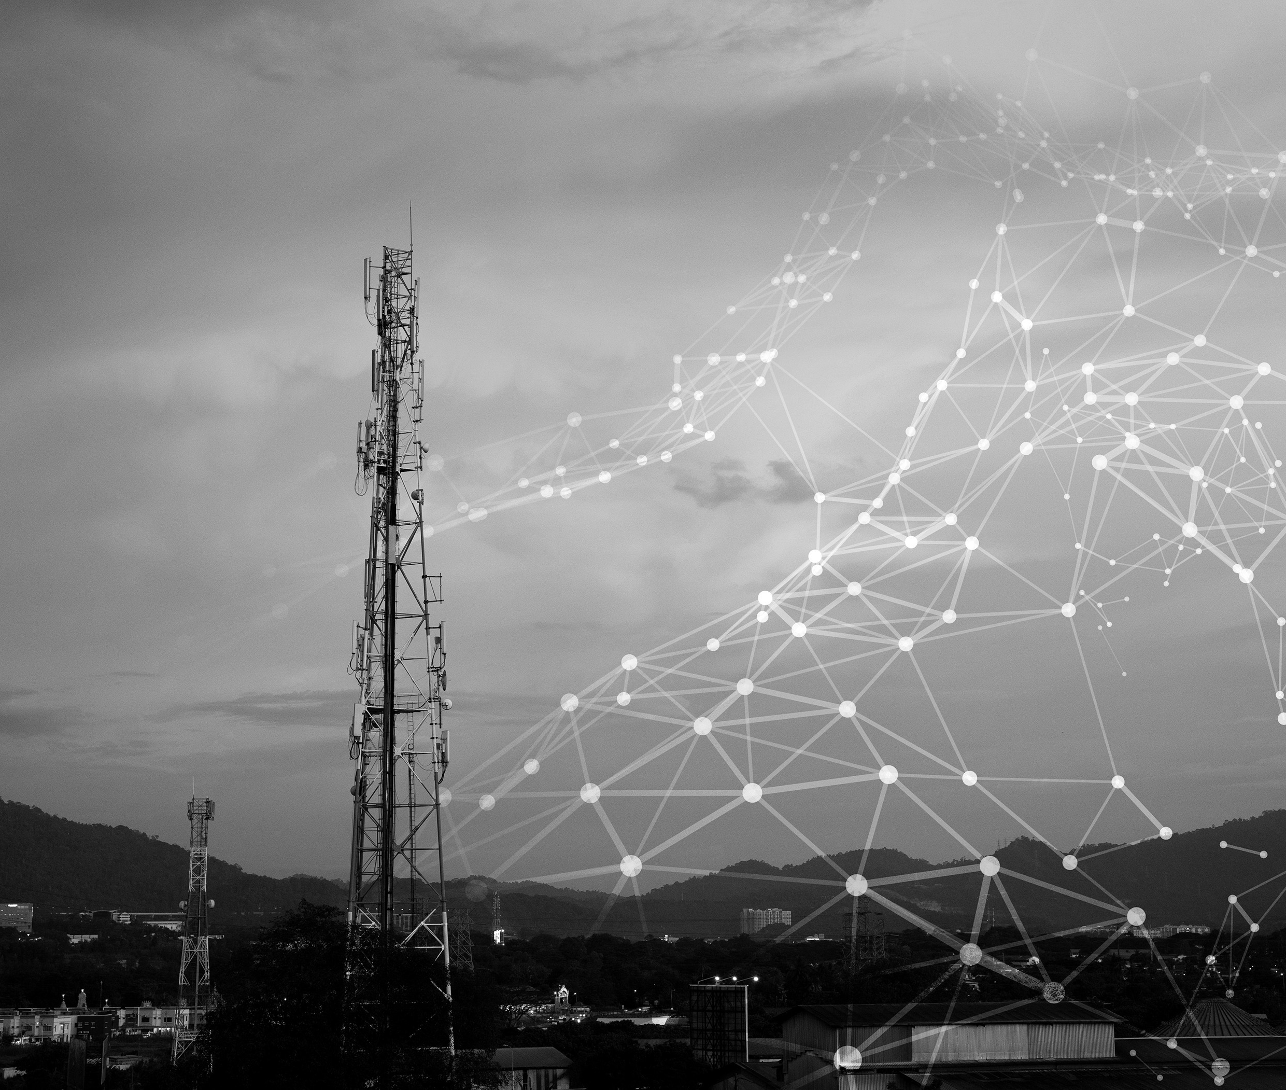

WIRELESS AND TELECOM

SECURITY
DLBCSEEMT01_E



LEARNING OBJECTIVES
The number of devices that can connect wirelessly to networks has already overtaken the number of desktop and laptop computers that connect to a local area network via a cable. In particular, phones and tablets dominate the market, and these connect to wireless tele- communication networks. But there are also many other forms of wireless communication that devices use. The idiosyncrasies of these wireless systems need to be understood to integrate them into a complete security concept. Wireless protocols often force users to put their trust in a system that they may not understand. This Wireless and Telecom Security course will shine a light on the subject.

We will explore the basics of wireless signals used in data transmission, including how to identify different types of wireless networking and understand their differences. We will go over telecommunications terminology and how it compares to IT terminology. This course book will show you how to analyze the architectures of the most important wireless tele- communication systems. We will outline the threat of attack vectors against handsets and devices as well as the core network. Lastly, we'll discuss other types of networking and how they are used.

12 PREVIEW-PDF, erzeugt: 2023-05-04T11:56:31.658+02:00

UNIT 1

WIRELESS PROTOCOLS OVERVIEW

STUDY GOALS

On completion of this unit, you will be able to ...

- understand differences between types of wireless networks based on their coverage area.
- outline different wireless standards of the Institute of Electrical and Electronics Engineers (IEEE) 802.11, regarding wireless fidelity (Wi-Fi) and its evolution.
- analyze wide area network protocols and their main characteristics (throughput, cover- age, and scalability).
- apply the main concepts of cryptography and analyze the security of Wi-Fi.

1. WIRELESS PROTOCOLS OVERVIEW

Introduction
If you are reading this book online on your PC or laptop, you are probably using a wireless connection to receive the information. If this is the case, you are using the Institute of Electrical and Electronics Engineers (IEEE) 802.11 standard, widely known as Wi-Fi, to connect to your router and further to the internet. Earlier today before you started to prepare for your class, you might have navigated into social networks from your phone, which was possibly connected to the internet wirelessly as well using a different wireless communication standard: cellular networks.

Wireless communication has become the main type of connectivity for many use cases and scenarios. It plays a crucial role in communication between people, devices, sensors, and actuators. Based on their coverage (how far two devices can communicate with each other), wireless networks can be categorized into three main groups

- Wireless personal area networks (WPAN) spanning up to several meters
- Wireless local area networks (WLAN) spanning several meters to 100s of meters
- Wide area networks (WAN) spanning several kilometers

While wireless personal area networks (WPAN) are used for communication between devi- ces that we carry with us (e.g., Bluetooth headsets, near-field communication (NFC) watches), wireless local and wide area networks are used for communication between machines and people (e.g., Wi-Fi for communication between computers, cellular phones for communication between people, and satellite networks for communication in remote areas). In the following subsections, we will introduce the main wireless protocols and their characteristics for each of the wireless network types.

Personal Area Network Protocols (Bluetooth, RFID, NFC, and more)
Wireless personal area networks are used for short distance communication. The main characteristics of such technologies are that they operate in Industrial Scientific and Medical (ISM) frequency bands, the cost is low (<2EUR/chip), the data rate is in terms of several 100s of kilobytes per second (KBps) up to several megabytes per second (MBps), and they should operate with low power for longer lifetime. Such technologies are utilized mainly for low data rate communication and over short distances, e.g., wireless speakers, wireless headsets, card payment communication, and even controlling light bulbs. Some of the technologies that will be discussed here include Bluetooth, IEEE 802.15.4, near-field communication (NFC), and RFID.

Bluetooth

Bluetooth radio technology was developed by Ericsson in 1994 as a short-range technology to replace wired communications for voice and data. Later, in 1998 the Bluetooth Special Interest Group (BT SIG)was established, comprising IBM, Nokia, Intel, and Ericsson to standardize open specifications for short-range wireless communication (Tanenbaum, 2021). The first version of BT was released in 1999, which used 79 channels of 1 MHz wide and channel hopping. In 2004, the new version of Bluetooth, BT 2.0, was released that offered higher data rates up to 3 Mbps, utilizing the Enhanced Data Rate (EDR) mechanism. Since then, the increase in throughput was the main driver in BT evolution, with the BT 3.0 release in 2009 and BT 4.0 release in 2010, known as Bluetooth low energy (BLE). BLE standardized the entirely new protocol stack up from the physical to the application layer, aiming the very low power usage where radio is powered by coin cells.

Bluetooth operates at a 2.4 GHz band between 2400 and 24835, with a channel spacing of 1 MHz. The first channel center frequency is at 2402 and the last one is at 2480. Bluetooth in total has 79 channels. BLE, as the latest Bluetooth version, uses the same frequencies but with a channel spacing of 2 MHz, which leads to 40 usable channels. Out of these 40 channels, three of them (37, 38, and 39) are used as primary advertisement channels while 37 other channels are used for connection-orientated communication as shown in the image below. The advertisement channels are selected in such a way that they do not get interfered with Wi-Fi communication, as they reside in between Wi-Fi channels.

Figure 1: BLE Channels and Their Frequencies
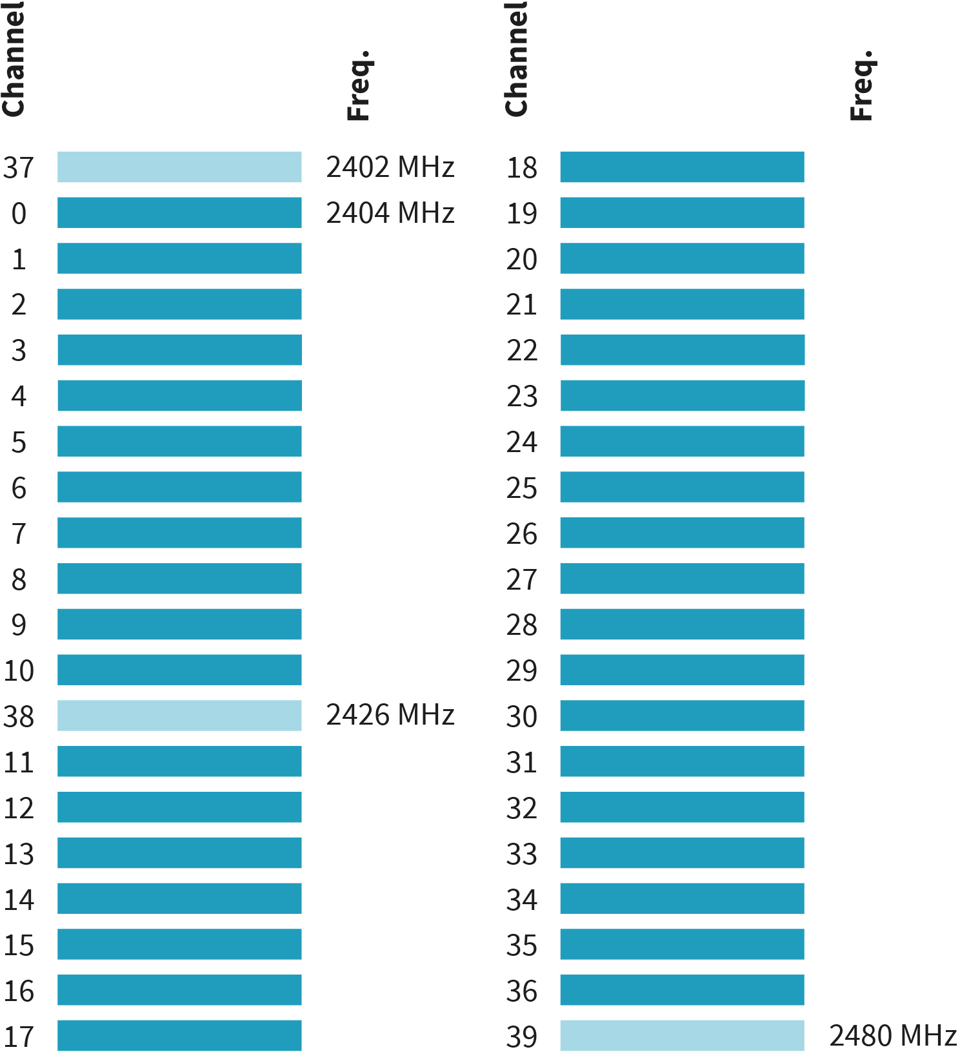

Source: Jetmir Haxhibeqiri (2023).
BLE uses two different modes of operation between devices: the advertising mode and connection-oriented mode as it is shown in image BLE Modes of Operation: The Advertising Mode and Connection-Oriented Mode. In advertising mode, one or more devices will broadcast information on three advertisement channels periodically at certain intervals. These devices are known to have the advertiser role. Other devices will scan the three advertisement channels, one at a time, at different intervals for a certain scanning window to pick up the advertisement information. These devices are known to have the scanner or observer role. The advertisement interval and the scanning interval do not have to be the same. Contrary to Bluetooth low energy (BLE), legacy Bluetooth supports only point-to- point network topologies, while BLE supports point-to-point, broadcast, and mesh topologies.

Figure 2: BLE Modes of Operation: The Advertising Mode and Connection-Oriented Mode
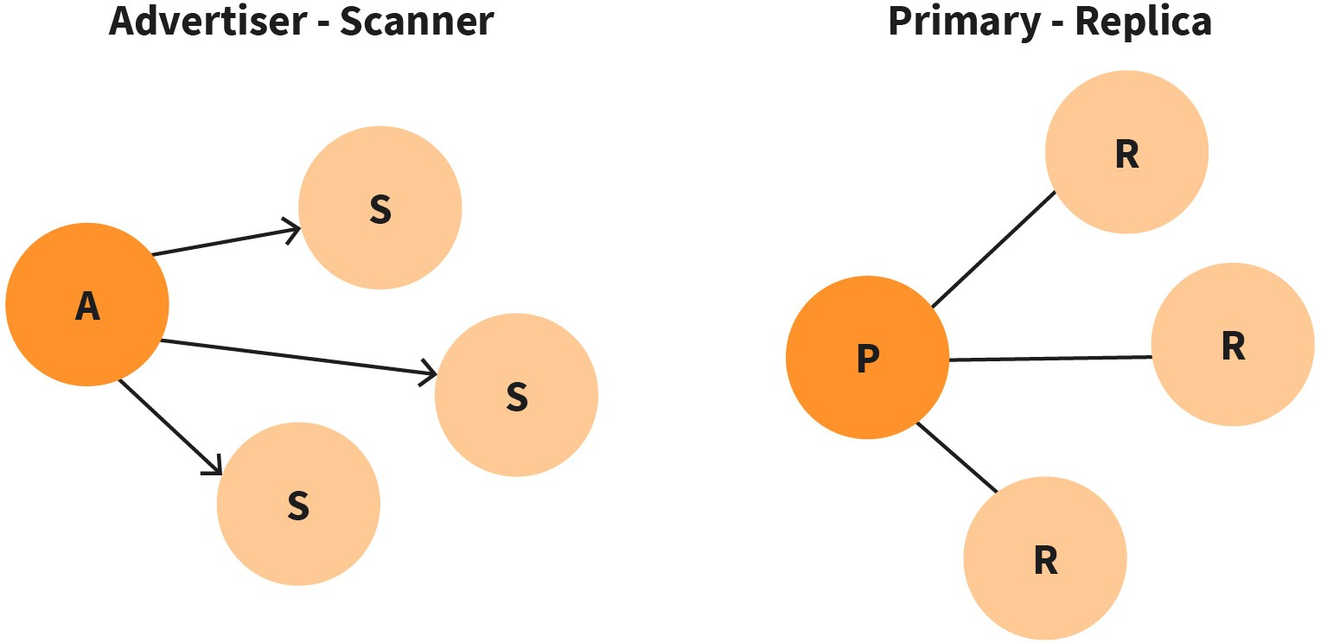

Source: Jetmir Haxhibeqiri (2023).
In the connection-oriented mode, one device is selected as a master (central device) and manages the connections of several peripheral devices. The central device manages and synchronizes the peripheral devices, and each connection uses a frequency hopping technique to ensure robustness. Different connections are organized at different times using the Time Division Multiple Access (TDMA) schemes.

IEEE 802.15.4

In many sensor networks used for control and monitoring, one of the main constraints when it comes to network deployment is the lifetime of the battery-enabled devices. The data rate used in such use cases is low, with a couple of packets sent in an hour. Other features that need to be addressed are the complexity of the end devices, the cost per end device, power consumption and self-healing, and mesh networking.

As an alternative to IEEE 802.11, IEEE 802.15.4 was established in 2003 to enable mesh sensor networks with lower complexity, low cost, and low power consumption. IEEE
802.15.4 defines only the physical and medium access control (MAC) layer standard for the realization of Wireless Sensor and Actuator Networks (WSAN). It is a foundation for several other network stacks that are defined above the IEEE 802.15.4 MAC layer, such as Zigbee, WirelessHRT, and ISA 100.11a. It specifies two different PHY layers: one operating at 2.4 GHz band using direct sequence spread spectrum (DSS) with an achievable data rate of 250 kbps, and one operating at 868/915 MHz band with much lower data rates, 40 kbps, and 20 kbps, respectively (Adams, 2006). At the 2.4 GHz band, 16 channels of 2 MHz wide with 5 MHz spacing are used for communication, the first 15 of them being worldwide available, as shown in Figure IEEE 802.15.4 Channel Usage.

Figure 3: IEEE 802.15.4 Channel Usage
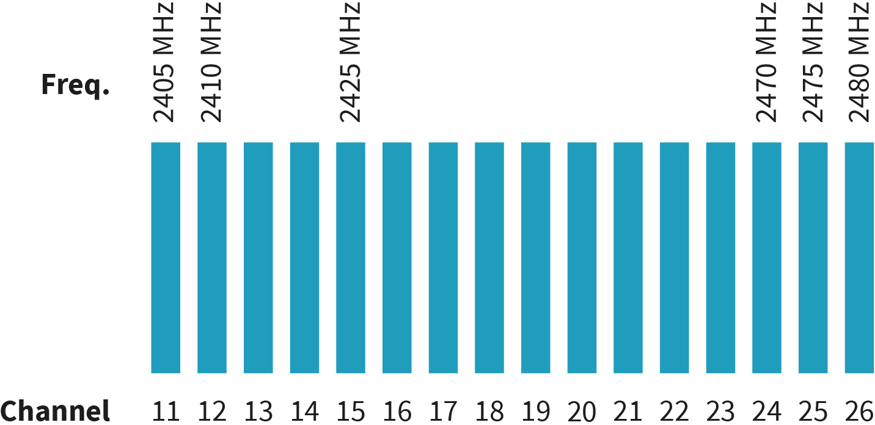

Source: Jetmir Haxhibeqiri (2023).
For accessing the transmission medium, two mechanisms are specified. The non-beaconed operation uses the Carrier Sense Multiple Access with Collision Avoidance (CSMA/CA) schemes. In the beacon-based medium access, the network coordinator will transmit bea- cons periodically where the communication superframe is determined. The communication superframe is further divided into the contention access period (where nodes use the CSMA/CA to access the medium) and the contention-free access period where certain Guaranteed Time Slots (GTS) are assigned to specific nodes. In terms of network topologies, peer-to-peer communication, and star communication topologies can be supported. In peer-to-peer communication is established in an ad-hoc matter between two communication devices, while in the star topology, a PAN coordinator will coordinate the channel access for other nodes transmitting beacons.

RFID and NFC Technology

Radio frequency ID (RFID) technology nowadays is utilized for access management, and tracking of goods, persons, animals, etc. It uses radio frequencies to identify tags even under non-line of sight (LOS) conditions. The concept of RFID is simple consisting of an RFID reader that will generate the RF pulse to poll the tags and an RFID tag that will respond with digital data encoding the tag ID.

RFID systems use different frequency bands that determine the communication distance they can reach, e.g., at 433 MHz the range is 1–100m, at ISM bands of 2.4 and 5 GHz the range can be 1–2m. Based on the types of tags and readers, the RFID systems can be classified into the following systems (Want, 2006):

- passive reader and active tag: Tag transmits while reader only receives.
- active reader and passive tag: Reader can interrogate the tag and receives the identification from the tag itself.
- active reader and active tag: Reader can interrogate the active tag by activating it using RF signals.

Similarly, to RFID technology, near-field communication (NFC) technology uses electro- magnetic waves to transmit data and to power the passive tags. The scanning range of NFC is much smaller than RFID, ranging up to 10 cm, and works only under Line of Sight (LOS) conditions (Thanpal, 2017). The data rates range from 106 kbps to 424 kbps.

Wireless Local Area Network Protocols (802.11a,b, g, ac, p and more)
Wireless local area networks (WLAN) protocols are usually used for communication between devices and machines in ranges from some meters up to several TENs of meters. The most prominent WLAN protocol is the IEEE 802.11 or Wireless Fidelity (Wi-Fi) that is standardized by the IEEE 802.11 WorkingGroupp on Wireless Local Area Networks. The Wi- Fi Alliance is a global non-profit industry association that groups hundreds of leading companies that offer products in seamless connectivity. It was established in 1999 by six companies: 3Com, Intersil, Nokia, Lucent, Aironet, and Symbol Technologies (Tanenbaum 2021). The Wi-Fi Alliance certification program was launched in March 2000 and helps in the interoperability and quality of products working with Wi-Fi. While Wi-Fi Alliance helps in the quality of products and standard compliance, the IEEE 802.11 Working Group standardizes the technology itself. As such Wi-Fi and IEEE 802.11 are usually interchangeable terms in use.

Wi-Fi standardization covers only the physical layer and data link layer (medium access control (MAC) layer) of the Open System Interconnection (OSI) layer. The first full version of the standard was published in 1997: IEEE 802.11-1997 (Wi-Fi legacy). Since then, several generations of standards have been published that cover different aspects of operation (channel band used, Quality of Service (QoS) support, multiple channel access used, etc.). The latest Wi-Fi standard by 2022 was IEEE 802.11be. The higher layers protocol (OSI model layers 3 to 7 – IP, TCP, and applications) are used as is in the Wi-Fi. From the application's perspective, there is no difference when running over Wi-Fi networks or other Ether- net-based networks.

IEEE 802.11 Network Topologies

Each Wi-Fi node can basically operate in two different network topologies: infrastructure mode and ad-hoc mode. In the infrastructure mode, communication happens between the end stations (STAs) and the access point (AP). Each AP creates a so-called Basic Service Set (BSS) which is a group of Wi-Fi devices that share the same service set identifier (SSID). The BSSID is determined by the AP of the BSS and is 48 bits long (usually it is selected from the MAC address of the AP). The AP acts as a bridge between the wireless network and the wired network as well as other BSSs. All the network functionalities in the infrastructure mode will rely on the AP. If the AP fails for any reason, then all communication will stop in the BSS. The wireless network is composed of multiple BSSs that are interconnected using a wired network that is called the Distribution System (DS). The set of all BSSs creates the Extended Service Set (ESS).

IEEE 802.11
is the most widely used WLAN technology stand- ardized by IEEE and certi- fied by the Wi-Fi Alliance.

In ad-hoc mode, STAs can communicate directly with each other without the need for an AP. This comes with an increase in the complexity of the STAs, as they must implement all the medium access mechanisms, to handle QoS and/or hidden node issues. The ad-hoc mode is preferred for its flexibility and as a replacement for the infrastructure mode.

IEEE 802.11 Physical Layer

The physical layer of the IEEE 802.11a/g standard is based on Orthogonal Frequency Division Multiplexing (OFDM). For each physical channel, it uses 52 subcarriers, with 12 virtual subcarriers used as guard spacing. Each subcarrier spacing is 312.5 kHz wide. This results in a total channel bandwidth of 20 MHz, out of which 16.6 MHz is actually used for trans- mission. The modulation techniques used are BPSK, QPSK, and QAM, resulting in data rates up to 54 Mbps. The a standard works on the 5 GHz band, while the g standard works on the 2.4 GHz band, the n standard works on both the 2.4 GHz and 5 GHz band, and while ac standard works only on the 5 GHz band. The latest ax standard works on the 2.4/5/6 GHz band. Depending on national regulations there are 14 channels at 2.4 GHz, starting at 2412 MHz center frequency for channel 1, until 2484 MHz for channel 14, as shown in the Wi-Fi channel distribution at 2.4 GHz image below. In Europe, only the first 13th channels are used. Out of these channels, only channels 1,6, and 11 are fully non-overlapping channels between each other. At the 5 GHz band there are 8 + 11 channels for use in Europe. Their center frequency can be determined by the formula 5000 + 5 * channel number. In Figure Wi-Fi Channel Distribution at 5 GHz and their numbering the channel distribution at 5GHz is shown.

Figure 4: Wi-Fi Channel Distribution at 2.4 Ghz
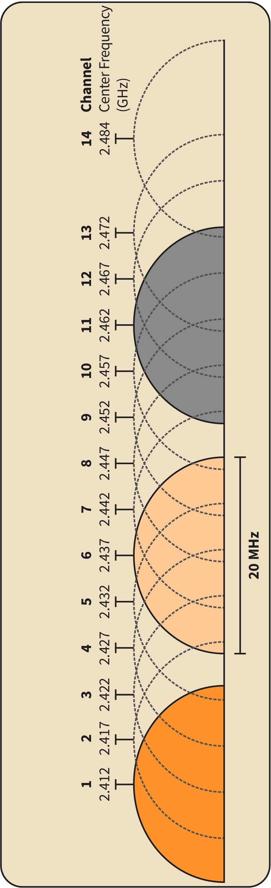

Source: Jetmir Haxhibeqiri (2023), based on Wikipedia (n.d.)

Figure 5: Wi-Fi Channel Distribution at 5 Ghz and Their Numbering
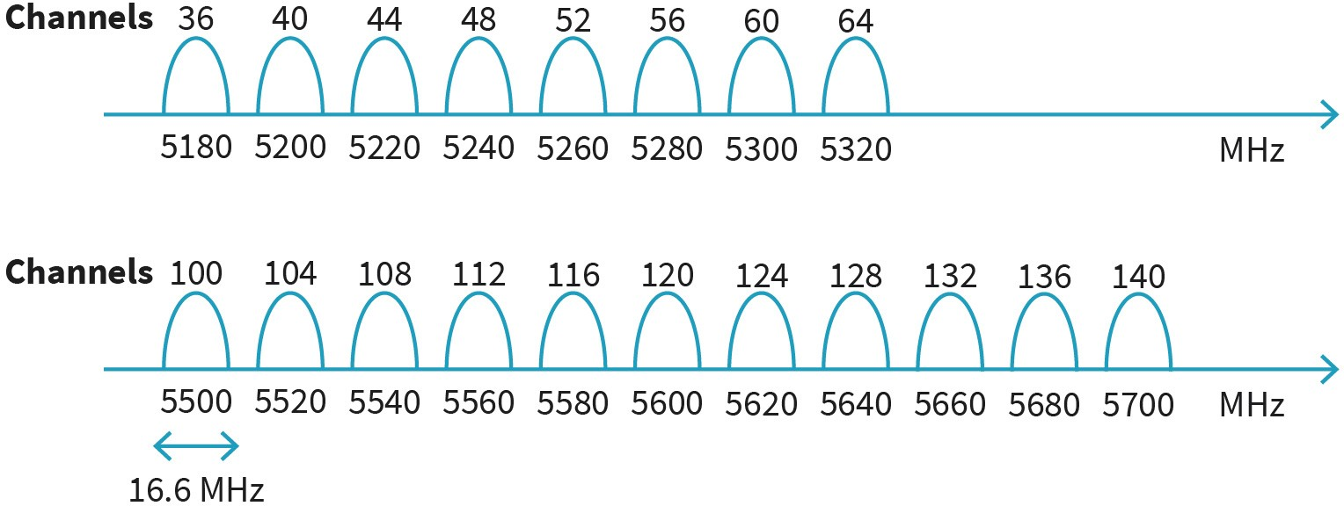

Source: Jetmir Haxhibeqiri (2023).

IEEE 802.11 Medium Access Control

The Medium Access Control (MAC) for Wi-Fi is based on carrier sense multiple access with collision avoidance (CSMA/CA) scheme. In this channel access scheme, each node will sense the channel using the Clear Channel Assessment (CCA) mechanism before each transmission and in case it is found idle it can transmit. Additionally, in the case of packet collision, the consecutive collision is avoided by the random backoff. If the medium is found to be idle for DCF Inter Frame Spacing for an amount of time, the transmission hap- pens immediately. In case the channel is found busy, the transmission is deferred until the channel remains idle for DIFS. In such a case a random backoff is performed after DIFS, to avoid any possible collisions with other nodes that were deferring their transmissions too. During the backoff, the node overhears the channel all the time. If it happens for the channel to become busy during the backoff time, the node will defer the backoff until the channel becomes IDLE again. The CSMA/CA approach is shown in the image below.

Figure 6: CSMA/CA Procedure in IEEE 802.11
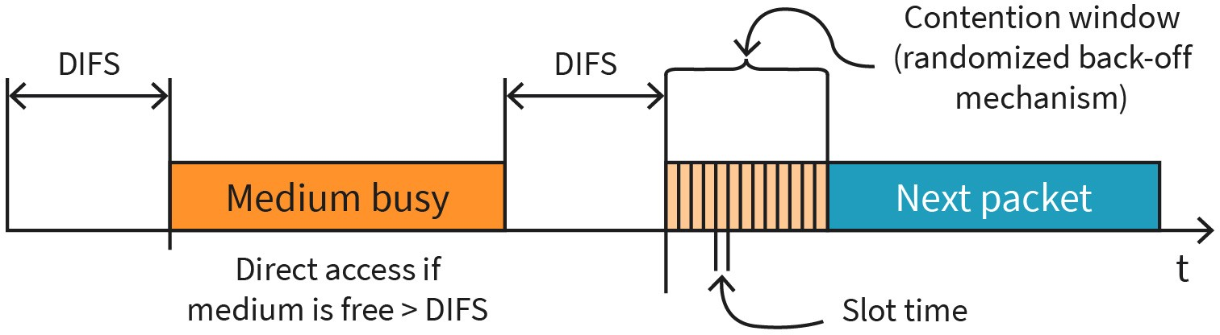

Source: Jetmir Haxhibeqiri (2023).
The backoff is randomized based on the selected contention window (CW) value and the slot time (ST). The CW is measured in a slot time unit. Wi-Fi MAC further specifies different inter-frame spaces for different medium access priorities, as follows (Coleman, 2021):

- short inter-frame spacing (SIFS): This is the shortest waiting time for medium access and is used for short control messages, such as acknowledgments.
- DCF inter-frame spacing (DIFS): This is the longest waiting time and is used for the trans- mission of data packets. DIFS is defined as SIFS plus two slots time.
- PCF inter-frame spacing (PIFS): This is a waiting time between DIFS and SIFS that is used for a time-bounded service; for example, when an AP polls other nodes it only waits for PIFS for medium access. PIFS is defined as SIFS plus one slot time.

The slot time and SIFS are determined based on the PHY layer used and for different Wi-Fi standards are as follows (Coleman, 2021):

- SIFS = 28 μs and 1 slot = 50 μs for FHSS (802.11)
- SIFS = 10 μs and 1 slot = 20 μs for DSSS/HR-DSSS (802.11/802.11b)
- SIFS = 16 μs and 1 slot = 9 μs for OFDM (802.11a) and HT@5GHz (802.11n)
- SIFS = 10 μs and 1 slot = 20 (or 9) μs for ERP (802.11g) and HT@2.4GHz (802.11n)

In order to avoid continuous packet collision between nodes, the CW will change every time a packet collides, as shown in CSMA/CA procedure in IEEE 802.11 image. CW starts with a minimal value (CW_min) and after every collided packet it doubles until it reaches the maximum allowed value (CW_max). Such a way of operating is called exponential backoff. The minimum and maximum CW depend on the PHY layer used and are as follows [CW_min, CW_max]: [15,1023] for IEEE 802.11, [31,1023] for IEEE 802.11b, [15,1023] for IEEE 802.11a/n, and [31,1023] for IEEE 802.11g.

In the managed mode of operation, the AP will transmit beacons for advertising its presence. Beacons are the only packets in the network that do not follow any backoff mechanism but are transmitted directly after the DIFS time. This is because beacons have higher priority than other packets in the network, thus they utilize the channel access first. Also, other packets that are a subsequence of the data packets; Wikipedia, those with layer two acknowledgment, do not follow the back-off mechanism but are transmitted immediately after the SIFS time after the end of the data packet.

Wide Area Network Protocols (Telecom Protocols, LoRa, Satellite Protocols, and More)
Wireless Wide Area Networks (W-WAN) are communications networks that span over long distances in terms of regions and countries. W-WAN can be categorized into three different main groups based on their offered data rate. The first group is composed of mobile broadband networks offered by the cellular networks (3G,4G,5G, XG), the second group is composed of low-power wide area networks, such as LoRa, Sigfox, Nb-IoT, etc., and the third group is the satellite networks.

Telecom Protocols

Protocols are defined as a set of rules that two parties need to follow in order to fulfill communication needs. Like in any other field of study, protocols are a standardized way of dealing with the heterogeneity of vendors and devices in the network. In communication engineering protocols are structured on different communication layers, each layer offering certain services to fulfill part of the communication needs. While services are added at each protocol layer, communication can be viewed in an end-to-end fashion as a set of services provided by different protocol layers on different network devices from the transmitter of the data until it is received at the destination.

In the communication network, the widely used protocol layering is the seven-layer structure defined by Open Systems Interconnection (OSI) model. Each protocol from each layer can be implemented as a software program or on the hardware, or on both. Going from up down the following protocol layers are defined by the OSI model (Kurose, 2013) and are shown in Protocol Layers Based on OSI Model. These layers are as follows:

    - The application layer is the highest layer and offers interaction between the user and the network. Usually, it includes the software that users use to interact with the net- works, e.g., HTTP (hypertext transfer protocol – web browsing), and File Transfer Proto- col (FTP).
    - The presentation layer offers means of data procession, such as data compression, data encryption, and data description.
    - The session layer is responsible for creating, controlling, and tearing down the communication session between devices in an end-to-end fashion.
    - The transport layer offers a means of transporting the messages (called segments) produced by higher layers to the other end of the network. The transport layer transports higher-layer packets from one process in one end node to another process in another end node. The most used transport protocols are UDP and TCP.
    - The network layer offers means of networking between all the devices in the network and transports the datagrams from one device to the other. The most used network protocols on today's Internet are IPv4 and IPv6.
    - The data link layer offers means for transporting the data between two “neighboring” nodes. The data link layer is divided into the medium access control (MAC) layer, which defines how nodes access the communication medium being it wired or wireless, and the logical link control (LLC) which provides encapsulation features for the network- layer packets.
    - The physical layer provides a means of data transfer over the communication channel (wired or wireless). Usually, this layer is fully implemented in hardware. Different physical layer protocols are used in today’s telecommunication networks ranging from twisted pair cables, Ethernet cables, optical fiber, or wireless links (Wi-Fi, satellite links, microwave links, etc.).

Figure 7: Protocol Layers Based On Osi Model
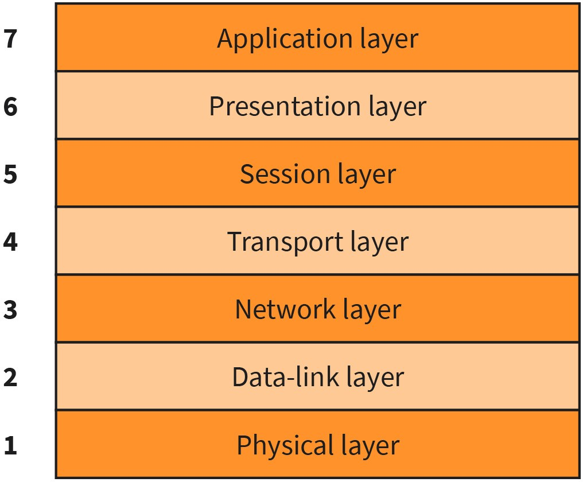

Source: Jetmir Haxhibeqiri (2023).

An analogy of the protocol services can be the post mail services. Once you want to send a message by post mail to someone the whole communication proceeds in sequential steps. First, you write the letter, which can be thought of as an application layer for the first inter- action between you as a writer and the letter. You can use whatever language or alphabet to write the letter as soon as the receiver can understand it, like the presentation layer of the OSI model. Then the letter is put in an envelope with the address of the sender and the receiver which can be thought of as a session layer. Next, you hand in this to the post office where the postage stamp is set, and this can be thought of as a transport layer as without a stamp the letter will not be delivered. Next, your letter is put in a bigger sack destined for the country where you mailed the letter, similar to the network layer. In the end, the post- man at the destination will hand in the packet to the receiver, which corresponds to the data link layer. In between the letter has been ‘traveling’ using an airplane, car, or bike giving the different physical transport used as in the physical layer of the OSI model.

In the current internet networks, the five-layer protocol stack is utilized. Different from the OSI model, the five-layer protocol stack removes the presentation and session layers, while keeping the other layer definition the same. The network devices implement a different number of protocol layers. The only network node that implements the full protocol stack is the end device, while e.g., routers implement the protocol stack up to the network layer, while switches implement the protocol stack up to the data link layer.

Lora-Based Networks

LoRa is a patented technology by Semtech (Seller, 2016) for long-range communication ranging up to several kilometers. LoRa physical layer is based on (Sforza, 2013), where modulation uses chirp spread spectrum (CSS) to achieve a long communication range. The usage of the CSS makes it possible to decode signals that are received even below – 130 dBm, providing they use the highest spreading factor (SF).

While LoRa specifies only the PHY layer, LoRaWAN Alliance specifies the MAC layer and topologies of LoRaWAN networks. LoRaWAN network is a star of stars network, where the network server (NS) is the center of the network, while LoRaWAN gateways provide the bridging of traffic from end nodes toward the NS as shown in the image below. Packets from single-end devices can be received by multiple network gateways and end up in the network server which will remove the duplicates. A network server can be connected to several Application Servers (APP Serv) serving different applications in the network. The communication from gateways toward the servers is IP based while the air interface uses LoRa communication.

Figure 8: Lorawan Network Topology
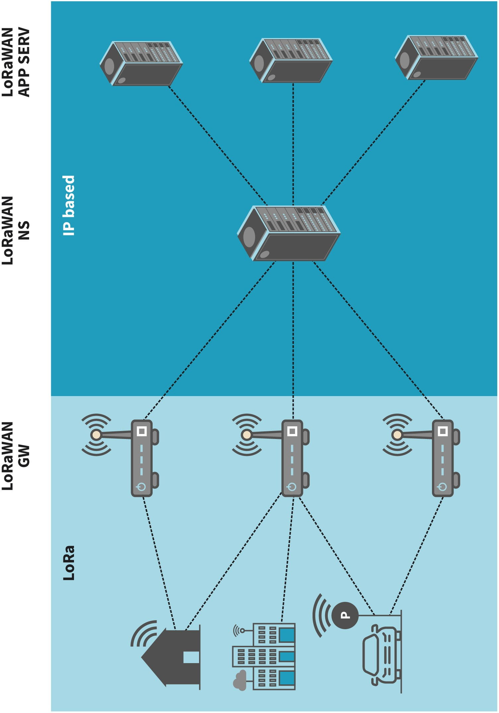

Source: Jetmir Haxhibeqiri (2018).
At the MAC layer, Aloha based channel access is used, which is the simplest channel access technique. Most of the time the end nodes are sleeping (in order to save energy), while once they are woken up, they will transmit immediately, thus decreasing the complexity of

the node implementation. On the other hand, the gateways are all the time listening for any packet to bridge in uplink toward the NS, or to transmit any waiting downlink packet for end nodes that are just woken up (Haxhibeqiri, 2018).

Compared to cellular networks the end nodes for LoRaWAN are far less complex and require lower energy for communication. The main use case of LoRaWAN networks is the large-scale non-critical monitoring networks in wide areas, e.g., farming monitoring.

Satellite Networks

Satellite communications dates to the early 50s of the previous century when the United States Navy's used the Moon as a passive reflector to reflect the signal back to Earth for sea-to-shore communication (Tanenbaum, 2021). This was one of the first satellite communication, however, it suffered from a weakened signal due to the absence of any amplifiers. In 1957, the first artificial satellite, Sputnik, was launched, which was equipped with a simple transceiver operating in the frequency of 20 to 40 MHz.

Satellite communications help to reach far distant areas that cannot be reached by terrestrial networks. The artificial satellites are equipped with transponders that receive the sig- nal from a point on Earth in a certain frequency, amplify it, and then transmit the signal in another frequency to another distant point on Earth. The different frequencies are used not to interfere between the incoming and outgoing signals. Further digital data process- ing can be done in the satellite to decrease noise amplification.

Based on the distance from Earth, satellites are grouped into three main groups: Geostationary Earth Orbit (GEO) satellites, Medium Earth Orbit (MEO) satellites, and Low Earth Orbit (LEO) satellites. Orbital distance from Earth determines the communication latency as well as the coverage zones of each satellite on the ground. While on terrestrial networks the communication latency is not impacted by the propagation delay (it is negligible due to short coverage distances), on satellite networks propagation delay makes up parts of the communication latency due to long communication distances.

The table below shows different satellite communication groups and their orbital distance. The higher the orbital distance, the lower the number of satellites per constellation to cover the whole Earth ground with the signal will be. Note that in the case of GEO satellites with 3 satellites only the area around the equator and up to latitudes of 81° both north and south can be covered. For covering the poles as well, we need other satellites with different orbits. On the contrary, the higher the orbital distance, the higher the communication latency will be, greatly impacted by the propagation delay.

Table 1: Satellite Networks Characteristics

Satellite | Orbital distance [km] | Latency [ms] | Number of satellites per global coverage
GEO | 35000 | 270 | 3
MEO | 2000–30000 | 35–85 | 10

Satellite | Orbital distance [km] | Latency [ms] | Number of satellites per global coverage
LEO | 200–2000 | 1–7 | 50
Source: Author based on Tanenbaum, A. S. (2021). Computer networks. Pearson Deutschland. p 178.

One of the most used satellite systems by the general public is the Global Position System (GPS), which is a MEO satellite system orbiting at ~20000 km. It has 32 satellites, out of which 27 are operational covering the whole surface of Earth. Signals from at least three satellites are needed to be received by the GPS end device, in order to determine the location. As such, with the GPS constellation each point on the Earth's ground is targeted to be covered by three different satellites, thus the number of satellites is 31. Another well- known satellite system is Starlink, which offers internet services over satellite. Starlink is an LEO satellite system due to low-latency communication requirements.

Key Exchange and Cryptography in Wireless Networking
Every network in general and wireless networks in particular have its security aspects that must be taken care of during the designing as well as operational phase. Wireless networking is even more prone to security issues due to the shared nature of the wireless medium. When two nodes communicate using wireless networking it must be ensured that the messages that they share are understandable for each of them, that messages are sent by authenticated nodes, messages are not altered during the transmission in the network, and that there is no communication drop. As such, secure communication must ensure the following properties (Kurose, 2013):

    - confidentiality of messages: Only the sender and receiver should be able to understand the content of the messages.
    - message integrity: The content of the messages is not altered in the network.
    - node authentication: Each node included in the communication should be able to con- firm the identity of the other node(s).
    - operational security: The network should be available throughout the operational time for the authenticated users.

In this section, we will focus only on confidentiality and authentication. We will analyze the elements of symmetric and asymmetric key cryptography, which are examples of confidentiality, and dive into the authentication procedures for Wi-Fi (WEP and WPA2).

Symmetric and Asymmetric Key Cryptography

Basic cryptography includes substituting some messages (part of messages) with another message (part of messages), by maintaining the one-to-one mapping. Cryptography has been known since ancient times, where critical messages were encrypted by replacing

Secure communication A secure communication should ensure confiden- tiality, integrity, authenti- cation, and operational security.

each letter with another letter shifted for a value, k. Such algorithm is known as Caesar encoding, attributed to Julius Caesar. Mapping one byte at a time or each character to another character is known as stream ciphering.

Another way of mapping is based on blocks of characters. For example, each message is divided into blocks of characters, and they are mapped to the same number of blocks of characters as is shown in the table below. The total number of mappings will be the per- mutation of all the inputs. In this case, it will 16!.

Table 2: 4-Bit Block Cipher

Input | Output | Input | Output | Input | Output | Input | Output
0000 | 0010 | 0100 | 0110 | 1000 | 1010 | 1100 | 1110
0001 | 0011 | 0101 | 0111 | 1001 | 1011 | 1101 | 1111
0010 | 0100 | 0110 | 1000 | 1010 | 1100 | 1110 | 0000
0011 | 0101 | 0111 | 1001 | 1011 | 1101 | 1111 | 0001
Source: Jetmir Haxhibeqiri (2023).

The drawback of the short block number is that it can be easily broken, while a long block number (k = 64 or k = 128) requires a huge amount of space to be stored. To make it even more random (and hard to be broken), the current cryptographic algorithms make use of functions on permutated smaller tables, as is the case with block ciphering process shown in the Block Ciphering Process image. Considering the previous example, each 16- bit block is broken into 4 chunks of 4-bit each for smaller table management. Then, all 4- bit outputs are assembled with permutated positions into a 16-bit block. The newly generated 16-bit block is fed back to the 16-bit input for another cycle. After n repetitions, the block is encoded. By doing multiple rounds each input bit will affect most of the output bits. Nowadays, the most used block ciphers are Data Encrypted Standard (DES), 3DES, and Advanced Encrypted Standard (AES) which are used in communication networks. Rather than tables, all these algorithms use functions to do mappings between plain text and ciphertext.

Figure 9: Block Ciphering Process
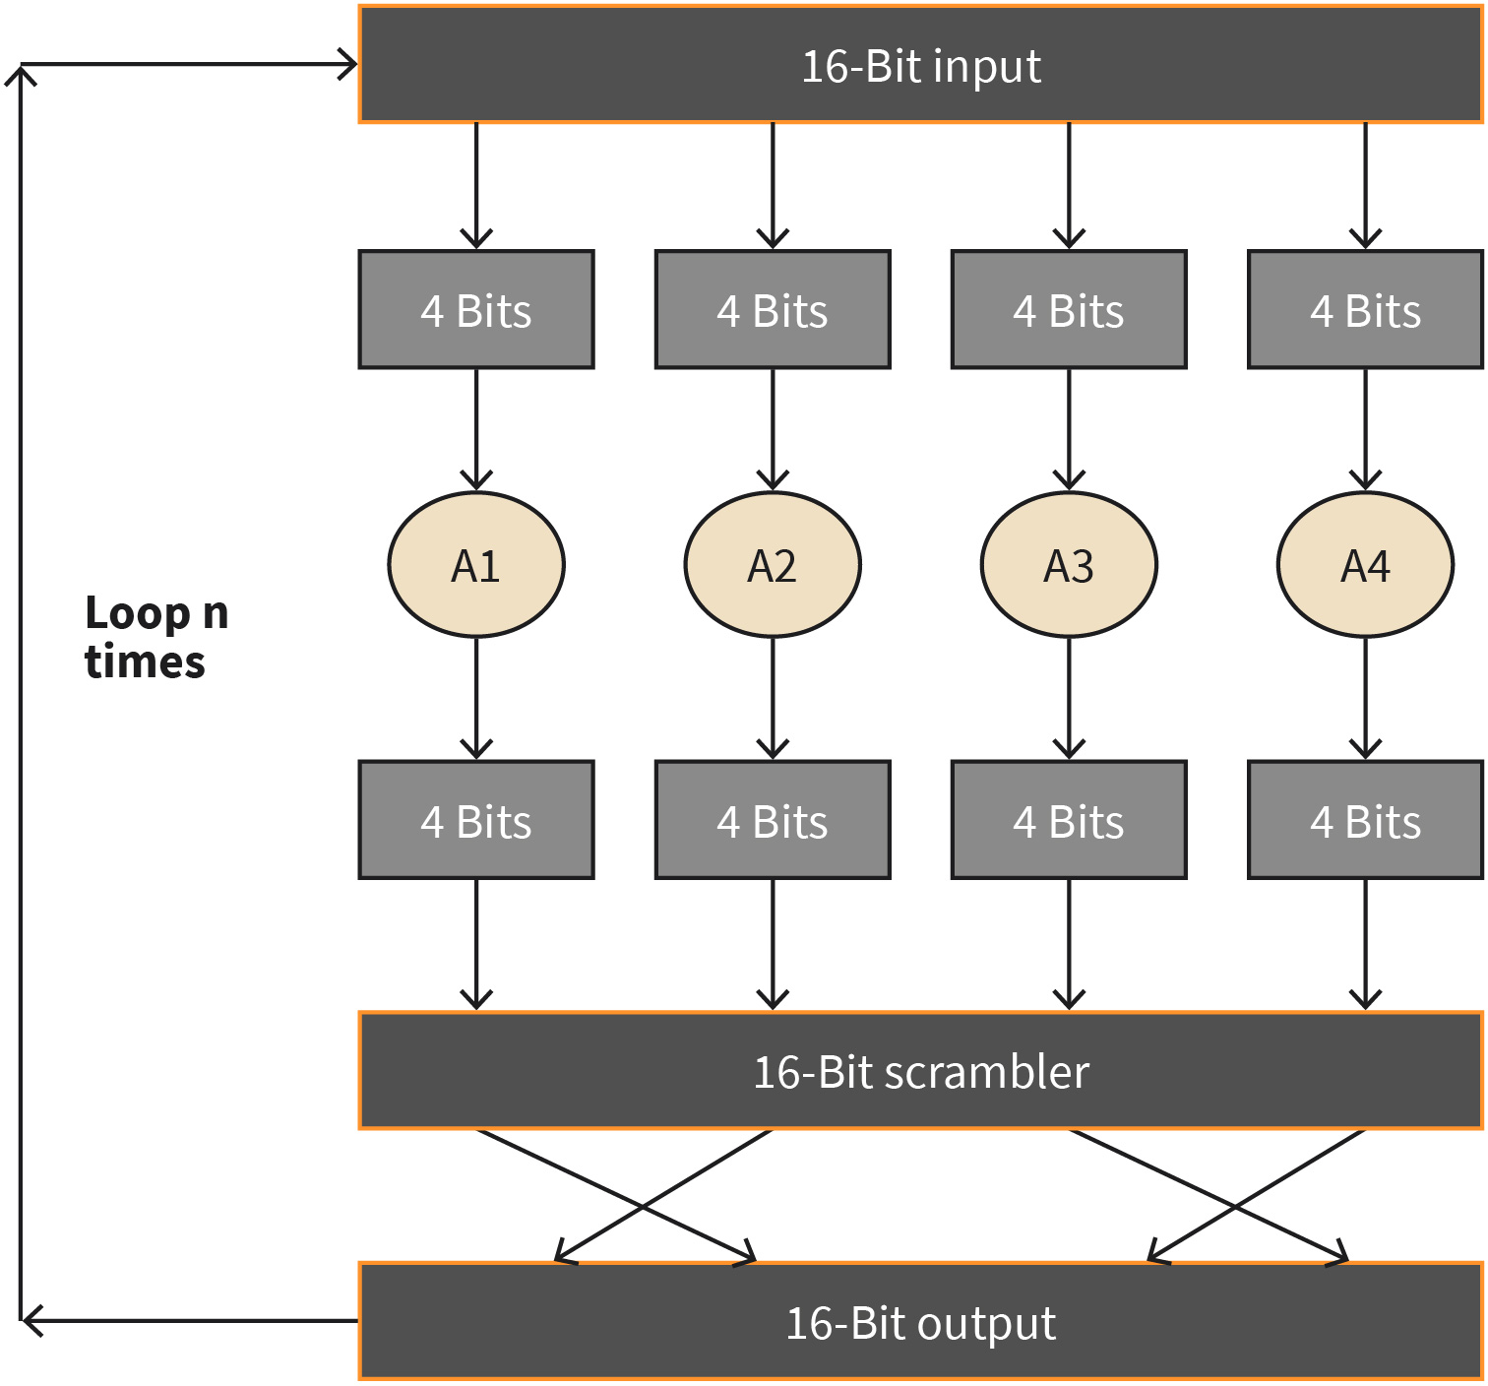

Source: Jetmir Haxhibeqiri (2023).
The main issue with one-to-one mapping is that words with the same message will result in the same ciphertext. Any intruder can do reverse engineering to find out the encryption key. To overcome this, cipher block chaining (CBC) will help. In this case, the sender will first generate a k-bit random string, called an initialization vector (IV), and send this to the receiver in plain text. We note this a c(0). Let m(1) be the first block of the plain text. Then the first block of the main text is encrypted c 1 = K m 1 ⊕ c 0 where K is the key and
⨁ is the XOR operation. The j block of the message is encrypted c j = K m j ⊕ c j − 1 , thus the same plaintext block will result in different ones depending on the previously transmitted block. Both K and IV should be known to both ends.

Differently from symmetric key cryptography, where the same key is used to encrypt and decrypt the data, in asymmetric key cryptography different keys are used. In symmetric key cryptography, both parties need to know the encryption key in order to perform the communication. In the case of asymmetric communication when a node is communicating to another node the so-called public key will be used to encrypt the message. The

receiving node will perform the decryption using the private key, which is known only to the receiver. As such, in asymmetric cryptography, there is no need for key exchange or key sharing between parties.

Wired Equivalent Privacy (WEP)

The Wired Equivalent Privacy (WEP) protocol was introduced to offer authentication and encryption for communication of wireless IEEE 802.11 networks. The protocol assumes that the secure key, K, is known by both communication parties in the network. The authentication algorithm goes as follows: the wireless station (STA) requests authentication with the AP, the AP responds with an authentication reply that contains a 128-byte nonce value, the STA encrypts the nonce value using the pre-shared symmetric key and sends it back to the AP, the AP then decrypts the encrypted nonce value and if it is the same with the one sent will authenticate the STA.

For data encryption the secret key is composed of a 40-bit symmetric key, K, that is appended by a 24-bit IV forming a 64-bit encryption key. The data is encrypted using the RC4 (Schneier, 2007) stream cipher, in which the 64-bit key value (K, IV) transforms in a stream of key values (k1, k2, k3, ...) that are used to encrypt the data. The encrypted is performed as an XOR operation of i^{th} byte of data with the i^{th} key, ki. The IV value changes from one frame to another and always is included as plain text with the packet.

The RC4 algorithm requires never to use the same 64-bit key for different encrypting. Considering that the 40-bit part of the 64-bit does not change, but only the 24-bit IV part changes over time, there are 2^24 different unique keys. This is a weakness of the algorithm as the probability of choosing the same key value increases at 99% only after a couple of seconds (Kurose, 2013).

Wi-Fi Protected Access II (WPA2)

Due to WEP security issues a new security protocol was introduced in Wi-Fi networks, Wi-Fi Protected Access (WPA). Wi-Fi Protected Access 2 (WPA2) is a successor of WPA that is standardized by IEEE as IEEE 802.11i released in 2004. In WA2, an authentication server is defined which may or may not run at same without the access point. WPA2 authentication follows these main phases (Stallings, 2017):

- The discovery phase is where access point using beacons will announce its presence and the supported authentication procedures by the network.
- The authentication phase is where each involved party will prove the identity to each other. In this phase, the AP is just a relay, while the end node and the authentication server will be engaged in the process. The Extensible Authentication Protocol (EAP) can be used to authenticate each other and to share the Master Key (MK) using public key encryption.
- Key management phase where the Pairwise Master Key (PMK) is derived from the MK.
- Encrypted communication phase where each data packet is encrypted using the Temporal Key (TK), which is generated from PMK and is used for link-layer encryption.

The latest authentication standard is WPA3, which was released in 2018. In order to improve further security, WPA3 utilizes the simultaneous authentication of equals (SAE) to exchange the pre-shared key in the beginning. Also, it uses 192-bit long keys for encryption and encrypts the management packets as well and not only the data packets. All new access points produced after 2020 should support WPA3.

SUMMARY
Wireless communication has paved the way for a better-connected world and since its introduction has ever targeted higher communication throughput. Wireless communication is found everywhere around you and you utilize it in everyday life. From connecting to the internet from your mobile phone to tracking your online pizza order, navigating in a new city utilizing digital maps, or when you visit a museum and have headsets connected wirelessly to the museum guide.

Depending on the requirements of a use case certain wireless technology can be more appropriate than others in terms of offered through- put, frequency band used, offered coverage, and scalability. In this unit, we discussed different wireless network protocols based on their cover- age distance. We showed that the wireless network protocols are grouped into three main groups based on their coverage.

The wireless personal area networks cover communication ranges up to several meters. The main characteristic of such communication is short- distance communication with low to moderate data rates. The main representatives of wireless personal area network technologies are Blue tooth (and its counterpart Bluetooth Low Energy), IEEE 802.15.4, RFID, and near-field communication.

Wireless local area networks are used to cover distances from several meters to 100s of meters offering high data rate communication up to 1Gbps (IEEE 802.11ax). Such networks are used for communication between machines and people. The main representative technology is IEEE 802.11, widely known as Wi-Fi. You have learned the differences between different generations of IEEE 802.11 in terms of offered throughput and frequency used. Wide area networks are the third group of wireless networks that cover ranges up to several kilometers. They offer high data rate communication (up to several 100s f Mbps in cellular networks) and low data rate and low power communication for massive monitoring use cases in wide area low power technologies.

Wireless communication is not secure due to the fact of the shared medium channel where anyone can intercept the communication or invert the transmitted messages. As such, this unit covered the basic

concepts of cryptography and how a message can be encrypted in the wireless link using block ciphering. In addition to this, the wired equiva- lent privacy (WEP) and WPA2 protocol were explained.

UNIT 2

WIRELESS BASICS

STUDY GOALS

On completion of this unit, you will be able to ...

- understand radio signal propagation and their characteristics.
- evaluate the received power at the destination node.
- analyze and compare different modulation schemes and data encodings.
- explain the trade-offs of each of them.

2. WIRELESS BASICS

Introduction
Electromagnetic radiation is used and found nearly everywhere. It is how the light travels from the sun to the earth, how a radiologist scans our body, how our microwave works, how our TV and radio signal is broadcast, and how we talk to each other via phones. For a communication engineer that will deal with wireless communication in the future, it is of utmost importance to understand the radio wave signals, their characteristics, and how they propagate in the medium. Different environments will have different challenges for radio propagation. Metallic industrial environments will introduce different effects on propagation such as reflection, diffraction, or scattering of radio waves. Understanding what these effects are and how to make use of them for better communication will be the target of this unit. Further, based on channel quality different modulation and data encoding schemes can be used to improve the channel communication throughput for the end users. Always there is a trade-off between the modulation and coding scheme used and the channel quality that we will explain in this chapter.

Frequencies
A radio frequency (RF) signal is generated as an alternative current by a transmitter and propagates through the communication medium being it a wire or wireless. In the case of the wireless transmitter, this signal is emitted by the antenna in the air. In an ideal vacuum environment, the RF signal will be emitted at the speed of light at 299 792 458 m/sec (~ 300 000 km/s). An RF signal radiates away from the antenna with a continuous pattern and is governedby the radio properties,such as amplitude, frequency, and phase.

Thinking of the RF signal like a sinusoidal wave that travels away from the antenna, the wavelength is defined as the distance between two successive peaks or valleys of the sinusoid. Frequency is the inverse proportion of the wavelength. The following formula describesthe relationship betweenthe wavelength,λ, frequency, f, and the speed of light, c:

λ = c
f

where the unit of λ is in meters, the unit of c is in m/s and the unit of f is in hertz [Hz].

Different wireless technologies operate at different frequency bands, e.g., the Institute of Electrical and Electronics Engineers (IEEE) 802.11 wireless fidelity (Wi-Fi)-based technologies operate at 2.4 GHz and 5 GHz frequency bands, cellular networks operate at 900 MHZ,
1.8 GHz, 1.9 GHz, 2.1 GHz (some of the bands), LoRa and SigFox at 860 MHz frequency bands. Different frequencies band are used for different reasons, e.g., the lower the frequency the higher the communication range, the lower the frequency the higher the pene-

tration in indoor environments. For example, for a cellular network operating in the 900 MHz band the coverage zone is much longer than for cellular networks operating in the 1700 MHz band.

The frequency defines the number of events happening over a time period. In the case of a radio frequency (RF) signal the frequency determines the cycles that the wave repeats over 1 second and it is measured in hertz (Hz). Another RF signal property is amplitude. It characterizes the signal strength, or signal power, and is defined by the maximum dis- placement of the signal wave from zero position. Phase is the last important RF signal property. It describes the relation between two radio signals sharing the same frequency. The phase defines the angle difference between the positions of the amplitude peaks of two different signals. If signals are in phase, it means that there is no difference between their peak amplitudes, and thus the receiver of the signal will see a superimposed amplitude.

Wave Propagation

In every communication system, we need a medium between two stations in order to enable communication. In cases when we have one transmitter and receiver, then we can use wire or the free space for transmitting the data between these two. If a wire is used, then the signal will be transmitted without any disturbance from outside factors. Based on this we can say that wired channels are predictable and stationary. On the other hand, the signal propagating in the wireless channel is impacted by different factors and different wave propagation mechanisms such as reflection, diffraction, scattering, attenuation, shadowing, and so on. Due to this all wireless channels are unpredictable and random. Crucial in the wave propagation in a wireless channel is the transmission path, if it is line-of-sight or it is obstructed by different objects like buildings, walls, mountains, etc. Usually, in a city and in an indoor environment there is no line-of-sight propagation due to the different obstacles and most of the systems try to get benefits from the reflected rays. Different propagation models are used in theory to predict the received power at the receiving side. They are grouped into two large groups: the large-scale propagation models which predict the mean signal strength for long distances between transmitter and receiver, and small-scale models which predict the fluctuations of the received signal in short distances. The simplest large-scale propagation model is the free space propagation model. It predicts the received signal strength where there exists the line-of-sight transmission path between the receiver and transmitter. The receiver's power decays with the square of the distance between the transmitter and receiver. It means that the received power decaysath a rate of 20 dB/decade with the distance. The Friis equation is used to give the relation between the transmitted power and received power (Rappaport, 2002):

Propagation model
This is used to predict the received power at the receiver side of a commu- nication channel.

Pr =
PtGtGrλ2

2 2

4π d

where Pt is the transmitted power, Gt and Gr are the gains of the transmitter and the receiver antenna, respectively, d is the distance between the transmitter and the receiver and λ is the wavelength in meters. The gain of the antenna depends on the antenna aper- ture and on the wavelength used. It is defined as:

G = 4πAe
λ2

The path loss gives the ratio of the effective transmitted power over the effective received power, or the difference between them in the dB scale. It is given by the equation:

PL dB = 10log · Pt = − 10log ·
Pr
GtGrλ2

2 2

4π d

The free space model (Friis equation) is valid just for the Fraunhofer region of an antenna. The electromagnetic wave changes with distance and in certain regions far away from the antenna the electromagnetic wave has different properties. The near-field is defined as a region where the electromagnetic wave has reactive properties while the far-field is defined as a region where the electromagnetic wave has non-reactive properties. So, in the far-field the magnetic field is due to the changes in the electric field and vice versa, while in the near-field the magnetic field is due to the currents in the source and the electric field is due to charges in the source. The electromagnetic wave in the far field is independent of the source it was generated from. The far field is determined in terms of Fraunhofer distance, which for an antenna larger than the wavelength of their radiation wave is defined as (Rappaport, 2002):

2D2
=
d
f λ

where D is the largest dimension of the antenna and λ is the wavelength. Two conditions that must be satisfied by Fraunhofer distance for determining the far field zone are (Rap- paport, 2002):

df ≫ D df ≫ λ

There exists a transition zone between far-field and near-field regions, where electromagnetic waves have both reactive and non-reactive properties. This region is in between the near-field distance:

1
D3
λ
2
R = 0.62

and the Fraunhofer distance df. Except for the line-of-sight propagation, there are different propagation mechanisms that enable electromagnetic waves to propagate in the environment when the line-of-sight path is not present. Reflection, diffraction, and scattering impact the propagation of electromagnetic waves between the transmitter and the receiver due to the many different obstacles on the way. In the following, we give a brief description of these mechanisms.

Reflection occurs when a propagating electromagnetic wave hits an object which has very large dimensions when compared to the wavelength of the propagating wave. Reflections occur from the earth's surface and from buildings. In the case of indoor environments reflection occurs from the walls (Rappaport, 2002).

Diffraction occurs when the electromagnetic wave hits the surface with sharp and irregular edges (Rappaport, 2002). Diffraction usually happens at the edge of big obstacles like buildings and walls. This allows the propagation of waves even behind obstacles. This phenomenon can be explained by Huygen’s principle, which says that all the points of the wavefront can be considered as points for new sources of wavelets, that can be combined to produce a new wavefront in the direction of propagation (Balanis, 2005).

Scattering is a kind of reflection when the electromagnetic wave hits non-smooth surfaces. In that case, the rough surface will reflect the electromagnetic wave in all directions in an irregular way. For scattering to happen, the irregularities of the surface should have dimensions like wavelength.

Modulations
In communication engineering, the modulation process is achieved by varying certain parameters of the carrier signal based on the inputs of the modulation signal. The carrier signal is a continuous electromagnetic wave, while the modulation signal can be a continuous signal or a discreet signal. Analogg modulation modulates a continuous signal to the carrier wave (like audio or video signals), while digital modulation modulates a discrete signal that is composed of 0s and 1s. Basic analog modulation techniques are: the amplitude modulation (AM), where the amplitude of the carrier is changed according to the modulation signal, the frequency modulation (FM), where the frequency of the carrier is changed according to the modulation signal and phase modulation (PM), where the phase of the carrier is varied based on the modulation signal. The last two are known as angle modulation techniques. Basic digitalmodulationsn are the amplitude shift keying (ASK), the frequency shift keying (FSK) and the phase shift keying (PSK). In the following sections we will discuss each of the digital modulation techniques. The transmitter block that per- forms the modulation process is called modulator, while the receiver block that performs the reverse process is called demodulator.

Digital Modulation Techniques

The basic digital modulation technique is amplitude shift keying (ASK). In this modulation technique, each of the two binary values (0 and 1) are represented with a different level of amplitude of the carrier signal. The binary values 0 and 1 represent one bit that is the smallest unit of data that can be transferred in the network. In the Digital Modulation Techniques image, an example of ASK is shown where one amplitude is 0 representing the binary 0, and the other high amplitude represents binary 1. Even though that ASK is simple to implement, it is susceptible to interference and multipath. Moreover, due to channel propagation characteristics (multi-path, noise, path loss, etc.), constant amplitude cannot be ensured, thus AKS is not used for wireless communication.

Modulation
Refers to the process of varying the carrier signal parameters based on the inputs of a modulation signal.

Most appropriate modulation technique for wireless communication is frequency shift keying (FSK), where shift in the frequency of the carrier signal represent each of the binary values (0 and 1). The simplest way to implement such a modulation technique is to switch the transmission of the carrier signal between two different oscillators with different frequencies. Then the demodulator will detect the frequency changes of the signal to detect the transmitted binary value. The FSK is more robust compared to ASK, as it is less susceptible to channel propagation characteristics. However, on the other hand it requires higher bandwidth to be transmitted compared to ASK. The figure Digital Modulation Techniques shows the FSK modulation.

Like FSK, phase shift keying (PSK) uses shifts of the angle of the carrier to modulate data. In this case it shifts the phase of the carrier signal for each modulated 0 or 1. The figure Digital Modulation Techniques shows the PSK modulation, where a phase shift of 180 degrees represents a change from 1 to 0 and a phase shift of –180 degrees represent a change from 0 to 1. Indeed, PSK that uses such phase shift is called binary PSK (BPSK). Compared to FSK, PSK is even more robust to wireless channel propagation characteristics, however, it comes with complexity of modulator and demodulator as both transmitter and receiver need to be synchronized in frequency as well as in phase.

Figure 10: Digital Modulation Techniques
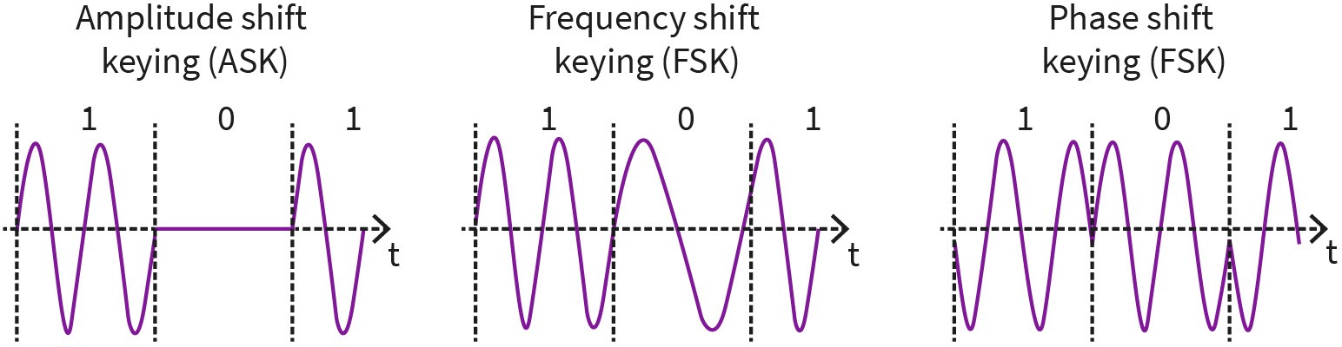

Source: Jetmir Haxhibeqiri (2023).
Here, we will introduce the necessary parameters to understand the modulation schemes better. The communication bandwidth is defined as the difference between the highest and lowest frequency used to transmit the data and it is measured in Hertz [Hz]. The more bits we transmit for the unit of time over a limited bandwidth the higher is the bandwidth efficiency. By transmitting only one bit for the variation of the carrier signal, the band- width efficiency is low. In order to improve it several bits are grouped into symbols, and then for each symbol one variation of carrier signal is done. The bit rate is measured in bits per second, while the symbol rate is measured in symbols (or baud) per second. Always the symbol rate is equal or smaller than the bit rate.

Advanced Shift Keying Modulation Techniques

In order to improve the bit rate of the modulation techniques, multiple levels of varying parameters are used. For example, in order to transmit 2 bits at once (4 different possible symbols) Quadrature PSK (QPSK) is used. Instead of using only two possible phase shifts (+-180 degrees), QPSK uses 4 different phase shifts (+-90 and +-180 degrees) being able to modulate two bits at once. The modulated signal and its constellation diagram are shown

below. The constellation diagram shows all the possible positions of a signal in quadrature (Q) and in-phase (I) plane. The QPSK modulation uses lower bandwidth for the same amount of data transmitted compared to BPSK. However, it is more complex in implementation and the transmitter, and the receiver needs to be synchronized using a reference signal. In QPSK transmitter will select chunks of data and modulate them as phase shift compared to the reference signal. In order to avoid the need for reference signal, differential-QPSK (DQPSK) is used, where the phase shift of current two bits is determined based on the position of the previous two bits. Other higher order PSK schemes use mode phase angle shifts to modulate data, achieving higher bit rates.

Figure 11: Modulated Signal Using QPSK And QPSK Constellation Diagram
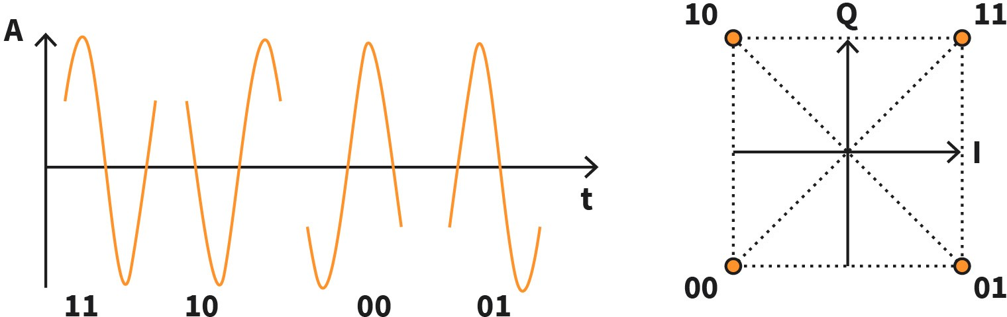

Source: Jetmir Haxhibeqiri (2023).
In order to use the assigned bandwidth more efficiently and increase the bit rate, PSK can be combined with ASK to achieve a higher number of varying parameters. In the next figure, 16- QAM Constellation Diagram, the 16-quadrature amplitude modulation is shown, where for each symbol 4 bits are transmitted. It uses 12 different angle shifts and 3 different amplitudes. The number of bits per symbol on the X-QPSK can be calculated at log₂ · X. In current wireless communications (e.g., IEEE 802.11ax) the higher order modulation schemes up to 1024-QAM are used to improve spectrum efficiency and data rate.

Figure 12: 16-QAM Constellation Diagram
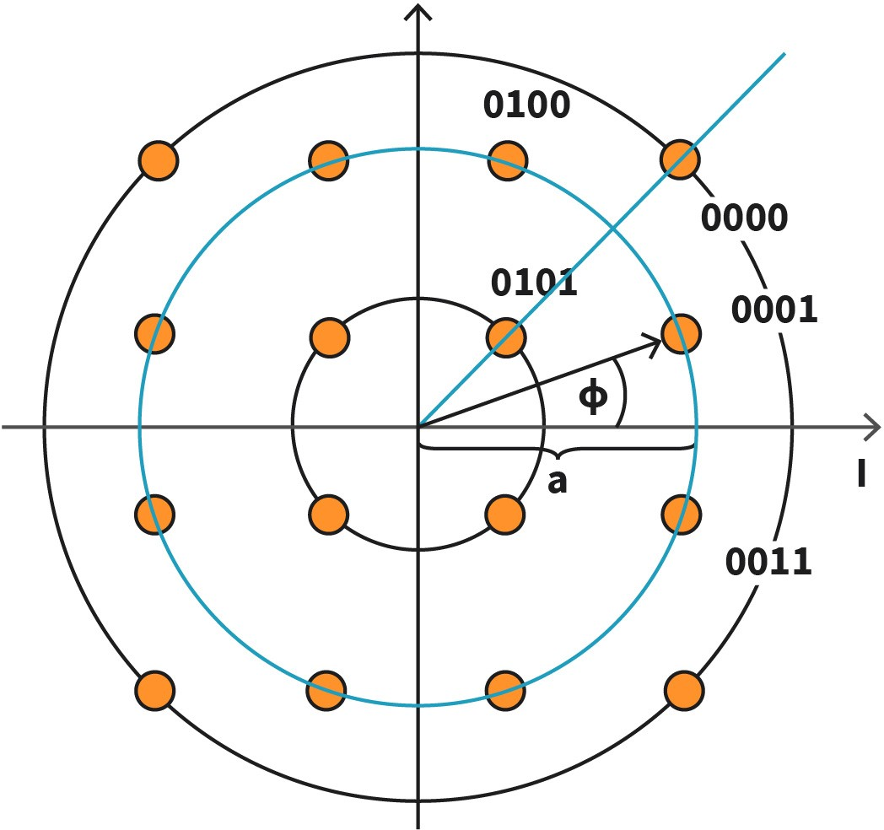

Source: Jetmir Haxhibeqiri (2023).

Multi-Carrier Modulation (MCM)

In multi-carrier modulation schemes the available channel is divided into sub-carriers that are orthogonal to each other. Such a modulation scheme is applied by the orthogonal frequency division multiplexing (OFDM) as shown in the figure OFDM Subcarriers. Each sub- carrier of the orthogonally frequency division multiple access (OFDMA) is orthogonal to each other, meaning that in the frequency domain each sub-carrier has a zero value on the other subcarrier’s main frequency. As such the inter-symbol interference (ISI) is overcome, compared to high single-carrier modulation when transmitting high bit rate streams. The high bit rate streams are separated into multiple lower bit rate streams each of them transmitting n symbols per second S/s. Then the total number of symbols transmitted per second is c*n, where c is the number of subcarriers used. Each subcarrier can use a certain modulation scheme. For example, if QPSK is used then for each symbol 2 bits are sent. The number of total bits sent by OFDM is proportional to number of subcarriers used, the modulation scheme used by the subcarriers and the symbol time. The IEEE 802.11ac uses 64 OFDM subcarriers (out of which 52 for data traffic), with an OFDM symbol time of 3.2 microseconds and guard time of 0.8/0.4 microseconds (Coleman, 2021). To calculate the total throughput provided by an OFDM, the following formula can be used:

Tℎ = c ⋅ bitscarrier
OFDMsymbtime

where c is the number of sub-carriers, bitscarrier is the number of bits per carrier and depends on the modulation scheme used for the sub-carriers, and OFDMsymbtime is the symbol time of an OFDM symbol.

Figure 13: OFDM Subcarriers
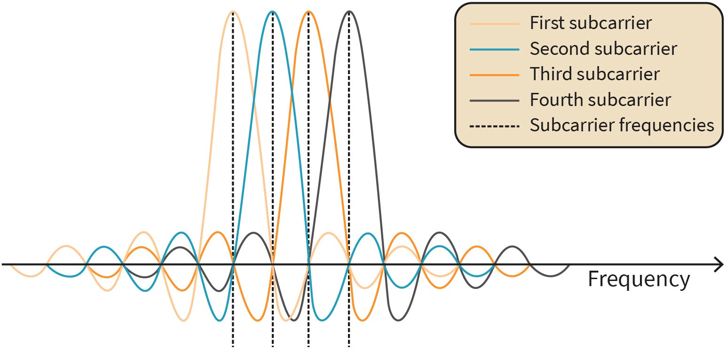

Source: Jetmir Haxhibeqiri (2023).
In addition to decreasing the ISI, OFDM is robust modulation scheme against the frequency selective fading. In such a case, the fading will happen only for certain sub-carriers, meaning that only certain bits of the symbol are interfered with. These errors can be reverted using error correction encoding. In case when too many subcarriers are interfered, the signal cannot be retrieved by the error correction codes, and a retransmission is needed.

Data Encodings
Data encoding covers the conversion of digital data (1s and 0s) to the signals that can be transmitted on the baseband already. The simplest way of encoding the data is to use one positive voltage level for expressing 1 and the negative voltage level to express 0. This scheme is called non-return to zero (NRZ) scheme and follows the bit stream that is trans- mitted. Such a stream is shown in the figure Different Data Encodings. In the case of NRZ, after a long consecutive run of 0s of 1s, it would be hard for the receiver to know the exact number of bits transmitted. Without level alternation during one bit time, the receiver can lose the synchronization with the transmitter, measuring the wrong level, thus detecting the wrong bit. As such NRZ, it is simple and good to start learning, but it is rather not used in communication.

Another data encoding is called Manchester encoding where the signal NRZ encoded data stream is XORed with a clock signal that runs twice the bit rate. In that case, for each trans- mitted bit a signal transition happens. For a 0 a low-to-high transition happens, while for a 1, a high-to-low transition occurs. As such, for the receiver, it will be easier to detect the exact number of continuous similar transmitted bits by just checking the number of signal transitions.

Similarly, the NRZ inverted (NRZI) encoding uses the signal transition to encode a 1 while no transition to encode a 0 bit (see the figure below). Still, in this case, there will be an issue with continuous transmission of 0.

In some cases, balanced signals, signals that have the same amount of negative and positive voltages over short periods of time, are convenient for transmissions in mediums where the DC component of the signal is highly attenuated. A way to produce a balanced coding of data is to use a +1 V for a 1 bit and –1 V for a 0 bit. To send a 1 bit, the signal is alternated between +1 V and –1 V, which will average out in a short amount of time to 0. This scheme is called bipolar encoding or Alternate Mark Inversion, as shown in the figure below (Tanenbaum, 2021).

Figure 14: Different Data Encodings
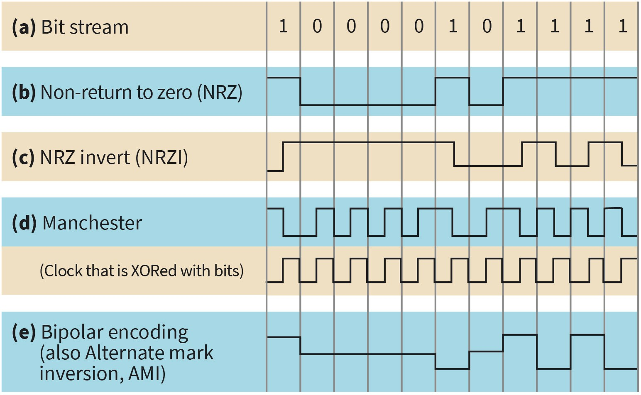

Source: Jetmir Haxhibeqiri (2023).

Trade-Offs
As a communication engineer, when designing wireless communication systems some tradeoffs should be known. Based on the quality of the wireless link, in terms of received signal strength (RSSI) and the signal to noise and interference ratio (SINR) or (SNR) one of the other modulation techniques can be more convenient. The RSSI is defined as the amount of power contained in the received signal, and it is expressed in decibel-milliwatt (dBm). The SNR and SINR are the comparison of the signal level over the background noise, and interference level, respectively. The higher the RSSI and SNIR, the cleaner the constellation diagram of the modulation technique, thus constellation points can be packed closer to each other, and higher modulation schemes can be used. The lower the SINR, the noisier the constellation diagram of the modulation technique will be, thus

increasing the distance space between the constellation diagram points will be a solution for the lower error. As such, lower-order modulation techniques are more robust in noisy and interfered environments. To know the point where each modulation order is beneficial and which is not, SNR levels and the achieved packet loss using certain modulation orders are measured. As such, rule-based algorithms are used to determine the temporal use of modulation order based on the measured SNR level. In IEEE 802.11 adaptive modulation and coding schemes are used based on the channel quality. If the channel quality goes down the modulation scheme order is decreased, meaning that a lower data rate is achieved. In the table Data Rate Versus SNR in IEEE 802.11, the relation between the SNR and the data rate achieved for different IEEE 802.11 standards is shown. As a rule of thumb, the further away from the access point, the lower the signal level and the lower the SNR, thus the data rate decreases. Also, the communication frequency used makes a difference. The higher the frequency the faster the signal decay over the distance, which is shown by the difference of the coverage in 2.4 GHz and 5 GHz in the table Data Rate Versus SNR in IEEE 802.11. A similar approach is present in any wireless communication network. E.g., in LoRa networks, the further the end node is from the gateway the higher the spreading factor, meaning the lower the data rate.

Table 3: Data Rate Versus SNR in IEEE 802.11

802.11 b/g  at 2.4 GHz | Data rate [Mbps] | 1 | 2 | 5.5 | 18 | 24 | 36 | 48 | 54
 | SNR [dB] | 4 | 6 | 8 | 10 | 12 | 16 | 20 | 21
802.11a at 5 GHz | Data rate [Mbps] | 6 | 9 | 12 | 18 | 24 | 36 | 48 | 54
 | SNR [dB] | 4 | 6 | 8 | 10 | 12 | 16 | 20 | 21
Source: Jetmir Haxhibeqiri (2023), based on Aruba Networks (n.d.).

Another trade-off is the relation of the channel bandwidth with the data rate. Usually, the wider the channel the higher the data rate can be, implying that in wider channel band- widths higher-order modulation schemes can be used. A rule of thumb is that when the channel bandwidth is increased by factor X, so can the modulation scheme order be increased by the same factor.

SUMMARY
Wireless communication utilizes radio frequencies to transmit modulated signals in the air. In this unit, we explained wave propagation and its characteristics. We showed how we can calculate the received power on the receiver side based on the frequency used and the transmit power of the transmitter. The main wave propagation characteristics, such as reflection, diffraction, and scattering explained how the signal is impacted in the air.

In order to modulate the data signal into a carrier signal certain parameters of the carrier signal are varied over time based on the input of the data signal. Such a process is called the modulation process. The main carrier signal parameters that are varied during the modulation process are amplitude, frequency, and phase. In this unit, we showed the main digital modulation techniques: amplitude shift keying (ASK), frequency shift keying (FSK), and phase shift keying (PSK). In other modulation techniques, multiple parameters can be varied at the same time, as is the case with QPSK, where amplitude and phase are varied at the same time. Data encodings techniques are techniques that convert digital data (0s and 1s) to signals that are ready to be transmitted by the transmitter. We have looked at the main data encodings used in communications: non-return to zero, Manchester encoding, non-return to zero inverted, and alternate mark inversion.

UNIT 3

TELECOM PROTOCOL CLASSES

STUDY GOALS

On completion of this unit, you will be able to ...

- differentiation between telecom and IT terminology.
- explain different telecom standards and standardization bodies.
- understand legacy digital protocols.
- analyze the long-term evolution (LTE) and 5G as the latest cellular network generation.

3. TELECOM PROTOCOL CLASSES

Introduction
When studying wireless and telecom security, students need to familiarize themselves with the terminology that is specific to each of the fields of study. While the telecom terminology is rooted in the public switched telephone network (PSTN) and later cellular net- works, the IT terminology is routed on the current Internet network. In addition to the diverse terminology used in both cases, the landscape of standardization bodies and standards in telecommunication is diverse and multilevel. There are national standardization bodies, international standardization bodies as well as standardization organizations that are groups of companies operating in certain fields of communication, such as 3GPP or the Institute of Electrical and Electronics Engineers (IEEE). As such, the ultimate goal in this unit is to make students able to understand and ‘navigate’ through different standards and standardization bodies.

Cellular technology is widely used in today's everyday life, with the latest 5th generation gradually being deployed and the newest 6th generation being still under standardization. We will focus on the fourth generation of cellular networks, long-term evolution (LTE), and on the 5th generation as well, 5G, and 5G New Radio (5G-NR).

Telecom Versus IT Terminology and Technologies
Nowadays, it is hard to draw a line between telecommunication and information technology itself. However, a rough separation between them is that telecommunication deals with the transmission of information from one distance point to another, while information technology deals with the creation, processing, storing, and exchanging of data information using computers (Chandler, 2011). In this sense, telecommunication as a concept is even older than any telecommunication technology itself, as it is all about information transmission.

For having a telecommunication system, the smallest subset of nodes needed are a transmitter, a receiver, and a transmission channel. As such, a telecommunication system is composed of all the transmitters, receivers, and other nodes that help in communication, such as routers, switches, and relays. Information transmission can be done via radio signals, wires, or fiber optic cables. Telecommunication technology includes telegraph, fixed voice communication networks public switched telephone networks (PSTN), radio and television broadcasting systems, and all mobile cellular networks.

Information technology is a synonym for computers and computer networks and includes computers, databases, servers, and data manipulation and retrieval systems. The most used technology of IT is the Internet which links all the computer networks and does not

give services directly to the users but gives services to computers and networks where services are located (Chandler, 2011). Another technology that is the core technology of IT is the World Wide Web (WWW), which is used to retrieve and interact with information residing in other networks.

This tight separation between telecommunication and IT is dimming out every day with telecommunication systems, such as mobile cellular networks becoming more data-oriented. While the telecommunication part can be regarded as the communication between the user equipment and the base stations in cellular networks, the communication in the core network can be regarded as the IT part. To enable communication in the core net- work of the cellular networks, many data are changed between different servers (e.g., for authentication purposes, for subscription rights purposes) that reside in the computer network communication. From the standardization point of view, while the telecommunication industry is highly centralized (3GPP is the main standardization body for cellular networks) IT is more diverse and can support different protocols that are standardized by the Internet Engineering Task Force (IETF) standardization body.

Based on the above-mentioned definition and differences, we will relate telecommunication networking to mobile cellular networks, as defined by International Telecommunications Unit (ITU-T) Recommendations M.1224-1 (ITU-T, 2012), while we will relate IT to computer and device communication using other networking technologies (e.g., Wi-Fi, sensor networks). In the next subsections, we will include the main terminology from both parts.

Telecom Terminology and Technologies

An extensive list of definitions of the most common terms used in telecommunication cellular networks, as defined in ITU-T Recommendations M.1224-1 (ITU-T, 2012) is given below:

- Massive machine type communication (mMTC): One of the 5g connectivity services offering wide machine type communication in the network.
- Radio access network (RAN): This enables radio communication between the user equipment and the core network.
- User equipment (UE): This is the end device that is connected wirelessly using RAN.
- “3GPP system: The telecommunication system standardized by the 3GPP consisting of a core network and a radio access network” (ITU-T, 2012. p 28).
- “3GPP core network: refers to the core network of any cellular network greater than 2nd generation.” (ITU-T, 2012. p 28).
- “Active communication: A UE is in active communication when it has a CS connection established. For PS active communication is defined by the existence of one or more activated PDP contexts. Either one or both of the mentioned active communications may occur in the UE.” (ITU-T, 2012. p 29).
- 5G core network functions (5GC NF): Functional building blocks of 5G network architecture that provide communication between the radio access network with other data networks.
- “Active set: Set of radio links simultaneously involved in a specific communication serv- ice between a UE and a UTRAN.” (ITU-T, 2012. p 29).

- “CAC (Connection admission control): A set of measures taken by the network to balance between the QoS requirements of new connections request and the current net- work utilization without affecting the grade of service of existing/already established connections.” (ITU-T, 2012. p 31).
- “Cell: Radio network object that can be uniquely identified by a user equipment from a (cell) identification that is broadcasted over a geographical area from one eNodeB or gNodeB. A cell is either FDD or TDD mode.” (ITU-T, 2012. p 32).
- “Control channel: A logical channel that carries system control information.” (ITU-T, 2012. p 33).
- The evolved terrestrial radio access network (E-UTRAN): The radio access network in LTE is composed of eNodeBs on the network side and the user equipment on the device side.
- eNodeB: A node in the radio access network of LTE networks that connects the LTE user equipment to the core network by implementing the orthogonal frequency division multiple access (OFDMA) in downlink and single carrier frequency division multiple access (SC-FDMA) in the uplink.
- evolved packet core (EPC): The core network of the LTE and provides packet-switched communication for the radio access network toward other data networks.
- gNodeB: A node in the radio access network of 5G networks that implements network functions compliant with the 5G new radio standard.
- Frequency division duplex (FDD), where users can transmit and receive at the same time slot using different frequencies.
- “Uu: The radio interface between UTRAN and the user equipment.” (ITU-T, 2012. p 59).
- Ultra-reliable and low-latency communications (URLLC): One of the 5G connectivity services offering low latency and high reliability “Soft handover is a category of hand- over procedures where the radio links are added and abandoned in such manner that the UE always keeps at least one radio link to the UTRAN.” (ITU-T, 2012. p 55).

IT Terminologies and Technologies

An extensive list of definitions of the most common terms used in IT, as defined in ITU-T Recommendations M.1224-1 (ITU-T, 2012) is given below:

- Access point (AP): A network node that provides wireless connection in IEEE 802.11 net- work.
- “Handover: the procedure where radio link between a STA and a new AP is established, and the previous radio link with the old AP is torn down.” (ITU-T, 2012. p 38).
- Channel bandwidth: This is the difference between the highest and lowest frequency used for communication. It is measured in Hz.
- Throughput: This is the achieved data rate in the link, measured in bits per second.
- MPDU – MAC protocol data unit, packet that has a MAC header from data link layer.
- MSDU – MAC service data unit, packet without a MAC header.
- OFDMA – orthogonally frequency-division multiple access is a channel access technique that is used for combining multiple transmission from different nodes in frequency resource units.
- EDCA – enhanced distributed channel access is used in IEEE 802.11 based networks to give different channel access priority for different data flows.

- “Dynamic frequency selection (DFS): The ability of a system to switch to different physical radio frequency (RF) channels based on channel measurement criteria to conform to regulatory requirements.” (ITU-T, 2012. p 21).
- “Broadband: Having instantaneous bandwidths greater than around 1 MHz and sup- porting data rates greater than about 1.5 Mb/s” (ITU-T, 2012. p 20).

Telecom Standards
Telecommunication systems might be comprised of devices produced by different companies. Moreover, they need to support end-user devices that are chosen by their clients. As such, to guarantee interoperability between different devices and vendors, the standardization process is an important part of the development of telecommunication systems. Several standardization bodies exist that deal with different communication technologies as well as communication networks. There are a number of standardization bodies that deal with standardization in the field of telecommunication and IT. In this subsection, we will focus on the following standardization bodies and their standards which are the main standardization bodies for cellular networks and internet protocols: The 3rd Generation Partnership Project (3GPP), IEEE 802.11, The Open Networking Foundation (ONF) for Soft- ware Defined Networking (SDN), The Internet Task Force (IETF), and ETSI ISG NFV.

The 3rd Generation Partnership Project (3GPP)

The 3GPP is a collaboration between different regional standardization bodies (ARIB, TTC, ETSI, TTA, ATIS, and CCSA), from Europe, Asia, and North America started in 1998 for producing technical reports and specifications for the 3rd generation of cellular networks [3GPP]. Since then, 2 more cellular network generations are already standardized, the Long Term Evolution (LTE) and 5th Generation (5G). The 3GPP is organized into three technical specification groups [3GPP]: the Radio Access Network (RAN) specification group, the Service and Systems Aspect (SSA) specification group, and the Core Network (CN) and Terminal specification group. Each specification group is divided into other working groups that deal with specific technical issues of the standardization process. The 3GPP works with “Releases,” a concept that is based on the definition by ITY Recommendation I.130. Each “release” offers a stable platform with the latest network and technology features that improve the previous release. The most interesting releases of 3GPP are:

    - release 15 to Release 18, which deals with the standardization of 5G
    - release 8 to Release 14, which deals with the standardization of LTE-Advanced

IEEE 802.11 and Wi-Fi Alliance

Another important standardization body is the IEEE. Its 802.11 working group for wireless local area network (WLAN) standards works on standardization of the technology named with the same name IEEE 802.11. The 802.11 working group is part of a bigger standardization set for local area networking (IEEE 802) that deals with local communication in general (being it wired or wireless). Nowadays, IEEE 802.11 has penetrated the market and is used in every PC, tablet, and mobile phone. The working group is further divided into dif-

The main standardi- zation bodies
are 3GPP, IEEE, ONF, IETF,
and ETSI.

ferent task groups (TGs) that deal with specific improvements and advancement of the IEEE 802.11 initial standard [IEEE802.11 WG]. The following are just some of the most important standardization task groups [IEEE802.11 WG]:

- TG ah specifies changes and amendments to IEEE 802.11 physical layer and MAC layer for operation in sub-GHz channels for extended communication range and low-power communication. IEEE 802.11ah is known by the market name “HaLow.”
- TG be specifies amendments and changes to IEEE 802.11 physical and MAC layer for Extremely High Throughput (EHT) communication. New features that are expected to be added compared to the previous IEEE 802.11 generation (ax standard) are: up to 16 spatial stream MIMO, multi-AP communication, time-sensitive networking features (time synchronization, stream reservation, time-aware shapers), etc.
- TG ay specifies amendments and changes to IEEE 802.11 physical and MAC layer for operation in the millimetric waves at 60 GHz band, offering extremely high data rates at physical links up to 7 Gbps. The ay standard is a follow-up to the previous standard in mm-wave communication, the IEEE 802.11 ad. Both standards benefit from the high bandwidth availability at the 60 GHz band offering high data rate communication.
- TG af standardized the changes for IEEE 802.11 to operate at TV white space at UHF and VHF frequency bands.

The Open Networking Foundation (ONF) for Software Defined Networking (SDN)

The Open Networking Foundation (ONF) (ONF, 2022) is a standardization body made up of network operators as well as other network stakeholders (device vendors and manufacturers) that standardizes software-defined networking (SDN) technologies. The SDN vision targets the separation of data plane functions from control plane functions (Lara, 2013) in network devices. OpenFlow is a communication protocol that offers such separation between the data forwarding plane and the control plane. By employing the OpenFlow protocol switches and routers from different vendors can be controlled by a single net- work controller that can manage directly the forwarding plane of the network devices, offering more flexible traffic management and routing.

In addition to OpenFlow, ONF has worked on other standards and technologies that are enablers of SDN. For managing and controlling Open RAN (O-RAN), ONF standardizes the SD-RAN that builds open-source components for mobile RAN space (ONF, 2022).

The SDN is not composed only of the controller architecture, but a key component is the ability of network programmability over time for reducing operational costs and improving and meeting the quality of service for users. In this direction, ONF has contributed to standardizing several protocols and technologies, such as P4 (Bosshart, 2014), open net- working operating system (ONOS) (Berde, 2014), and P4 Integrated Network Stack (PINS) (ONF, 2022). It must be stated that all the standardization and protocols from ONF are open-source and can be used by anyone.

The Internet Engineering Task Force (IETF)

The Internet Engineering Task Force (IETF) is a standardization body that deals with developing technical specifications of Internet technologies. The IETF work follows an open standardization process where practically any person can participate in it (IETF, 2022) and the work is done on a voluntary basis. IETF standardization structure is divided into the following seven main standardization areas:

- Application and real-time area (art) standardize the protocols and architectures for delay-sensitive applications as well as delay-tolerant applications. Such protocols standardized in the past include the well-known HTTP, HTTPS, FTP, and RTC-WEB.
- General area (gen) deals with updating and maintaining current standards as well as supporting activities during the standardization process of new standards.
- Internet area (int) deals with the standardization of protocols at the IP layer and their co-existence. The most well-known protocols include IPv4, IPv6, DHCP, and DNS. One of the current initiatives of deterministic networking (DetNet) is part of this focus area. DetNet deals with the standardization of deterministic communication at IP layer, by employing different features in order to improve reliability as well as latency.
- Operations and management area (ops) deal with technical standardization of the network management protocols and operation protocols. The most well-known standardized protocols include NETCONF, SNMP, INT, SMI, and YANG.
- The routing area (rtg) deals with the standardization of routing protocols for different network architectures and topologies, in order to maintain internet scalability. It does not focus only on distributed routing protocols but also on centralized routing proto- cols. The most well-known standardized protocols include OSPF, IS-IS, BGP, RSVP-TE, LDP, PIM, and RPL.
- The security area (sec) deals with the standardization of security protocols that target one of the network security features: authentication, integrity, confidentiality, and access control. Protocols, such as TLS and MLS are part of this standardization focus area.
- Transport area (tsv) deals with the standardization of protocols at the transport layer of the OSI model that supports end-to-end data transport from source to the destination over the Internet. The most well-known protocols from this area are TCP, UDP, MPTCP, and STCP.

All the IETF standards are open and are published as a request for comments (RFC) documents and can be implemented by any vendor or other organization.

ETSI ISG NFV

ETSI is the European Telecommunication Standards Institute that was founded in 1988 and deals with the standardization of information and telecommunication technologies (ICT). The ETSI standardization structure is divided into several committees, working groups, and projects. ETSI is one of the partners in 3GPP and it has contributed to the standardization of cellular communication networks.

One focus area of ETSI is network functions virtualization (NFV) and it has created a special group for that. The NFV concept considers the implementation of data plane functions on top of virtualized platforms consisting of different network nodes, such as switches, routers, and storage devices (Costa, 2013). ETSI NFV group has published over 100 documents on specifications for virtualization requirements, network architecture frameworks, NFV functional components as well as interfaces and protocols for communication between such components (ETSI NFV, 2022).

Legacy Digital Protocols
Over time different communication networks have converged to IP based networking, that is a unification at the network layer of the OSI stack. No matter the lower layer technologies being used at the data link and physical layer, the IP layer is the merge of all of them. This is seen with the current trends of running IP communication over sensor networks, such as the work of the 6lo working group of IETF on running IP over Bluetooth low energy (BLE) [RFC 7668], IP over near-field communication (NFC) (Hong, 2014), 6LowPAN (Schon, 2014), etc. Also, in the current cellular networks, all the data communication is IP-based communication.

However, there are other digital protocols that do not support IP communication and are categorized as legacy protocols. Examples of such protocols include the IPX, Systems Net- work Architecture (SNA), AppleTalk, and DECnet which are already decommissioned. In other specific use cases, such as industrial communication, specific protocol suites are standardized that may or may not be compatible with IP protocols, such as PROFINET, Modbus or EtherNet/IP.

PROFINET

Among multiple industrial communications standards like EutherCat, ProfiBUS, PROFINET is one of the most used in industry nowadays. It is a protocol based on Ethernet physical layer that is defined by IEC 61158 and IEC 61784 (PROFINET, 2018). In PROFINET networks devices can have different roles and according to their roles, PROFINET devices are divided into three groups: PROFINET controllers, PROFINET devices, and PROFINET supervisors. PROFINET devices can be input/output blocks, different instruments, or driver control blocks that need to communicate between them and with the PROFINET controller in real-time. Communication between PROFINET devices happens in cycles that can go down to 1 ms. Differently from the PROFINET devices, controllers manage and collect alarms and data received by the devices as well as can control and manage devices by updating the communication period. PROFINET controllers manage the PROFINET devices in real-time, while PROFINET supervisors just collect the data from the end devices but do not interact with them in real-time (PROFINET 2018).

Different communication channels are supported by PROFINET in order to maintain different types of applications, such as fail-safe applications, real-time applications, or control- loop applications. For other less critical communications, such as configuration and diagnostics a non-real-time communication channel is used. Supported communication

channels include non-real-time channels that implement the full OSI stack [PNUNI], while real-time and isochronous channels implement only the data link and physical layer. Moreover, in the isochronous channel, the physical layer is enhanced with new features compared to legacy Ethernet (PROFINET 2018). All three communications channels sup- ported by PROFINET and their OSI layer support are shown in the figure PROFINET Communication Channels. Three different device conformance classes (CC) are defined based on communication channels that the device supports (PN 2011). CC A devices support real-time communication channels, CC B devices support network diagnostic sharing, while CC C devices support bandwidth sharing and time synchronization (Haxhibeqiri, 2022). With new guidelines for PROFIENT integration with time-sensitive networking (TSN) (PNTSN 2021), a new conformance class for PROFINET devices, CC-D, is defined for PROFI- NET devices that run over TSN.

Differently from other communication networks (like Wi-Fi and cellular networks) where the order of security objectives is confidentiality, integrity, and availability, in an automation network the order is reversed. Availability is the most important security target, followed by integrity and confidentiality of the data being shared. For secure communication, PROFINET supports the digital signature of device description files that can be confirmed at any time by the central authority and the usage of management protocols with password access (such as SNMP with community string) (PROFINETSEC 2020).

Figure 15: PROFINET Communication Channels
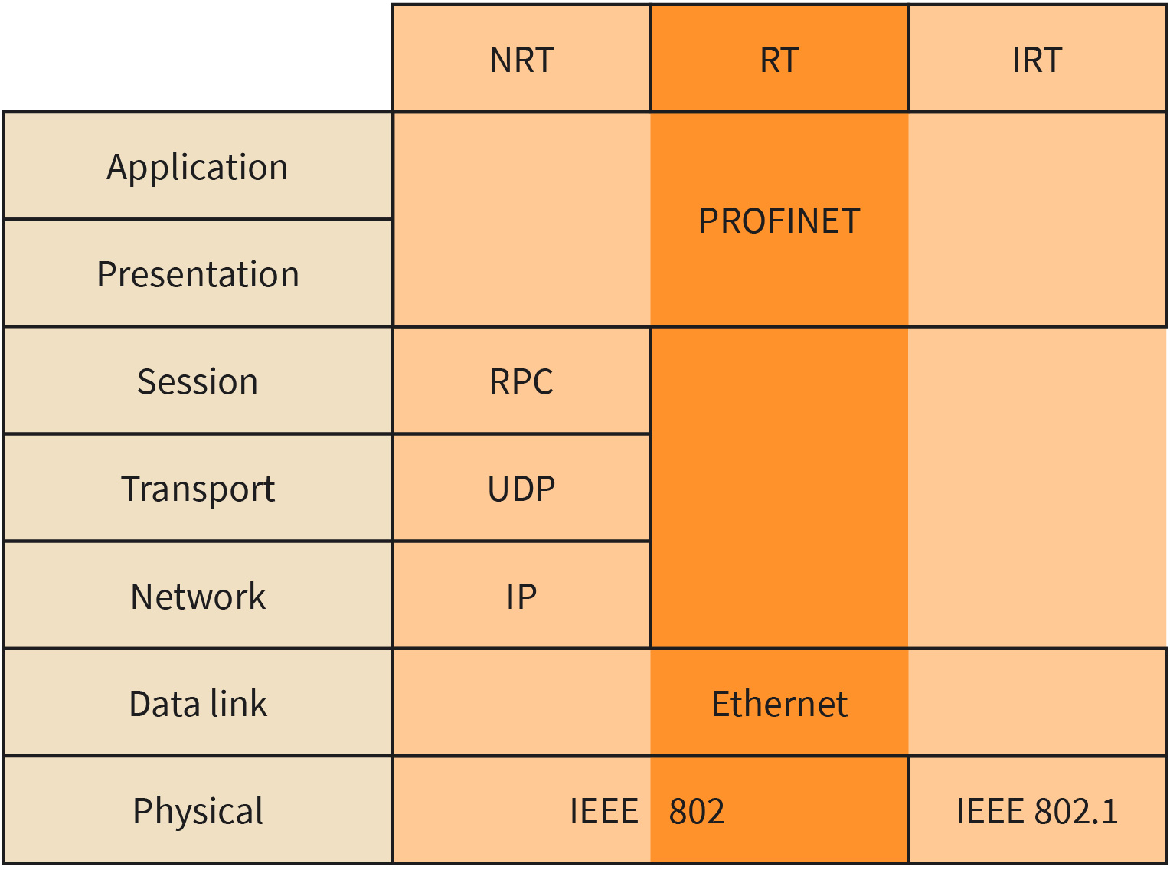

Source: Jetmir Haxhibeqiri (2023).

IPX

Internetwork Packet Exchange (IPX) is a network protocol that derives from the proprietary network systems of Xerox (Garfinkel, 2003). It is already decommissioned and all the network nodes that used to use IPX, currently supports the TCP/IP network stack. Differently from the IP header, the IPX header was shorter and is shown in the figure IPX Header Format. The IPX header is composed of 2 octets checksum, 2 octets packet length including the header length, 1 octet of hop count control, and 1 octet packet type. The source and destination addresses were 12 octets long. The address is formed of 4 octets network part, 6 octets of node part and 2 octets of the socket part. The network part addresses the network ID to which the IPX node belongs and can have a value from 0x1 to 0xFFFFFFFE. For the node part the MAC address of the node is used, while the socket part identifies the process or application to which the packet belongs. It is like the port number in TCP/IP suite. IPX did not include any security mechanisms in the protocol stack, to address any relevant security issues.

Figure 16: IPX Header Format
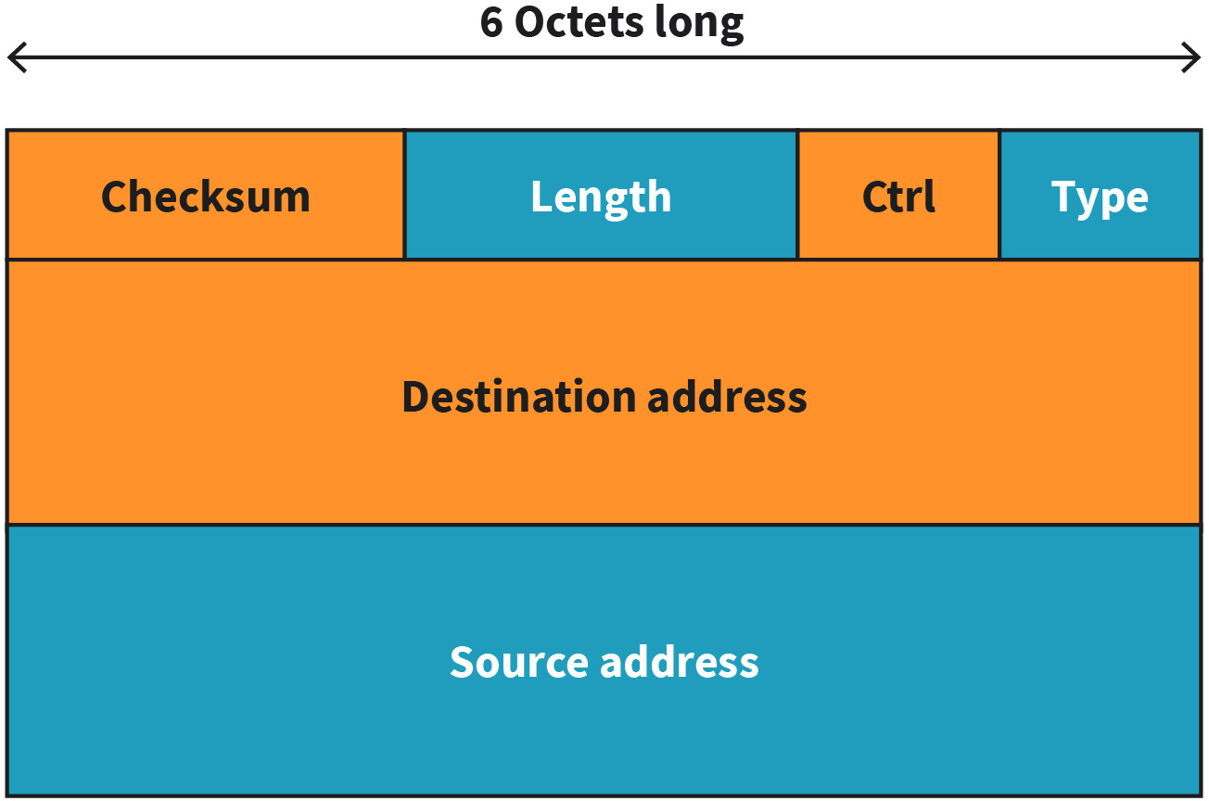

Source: Jetmir Haxhibeqiri (2023).

AppleTalk

Prior to the standardization of the protocol stack, there were proprietary network stacks suites that were in use by digital network equipment producers. One such proprietary net- work stack was AppleTalk which was used by Apple for the networking of their Macintosh computers. Even though AppleTalk used the OSI model layering for their protocol suite, their designed protocol did not work with any devices except Apple computers.

Figure 17: AppleTalk Stack
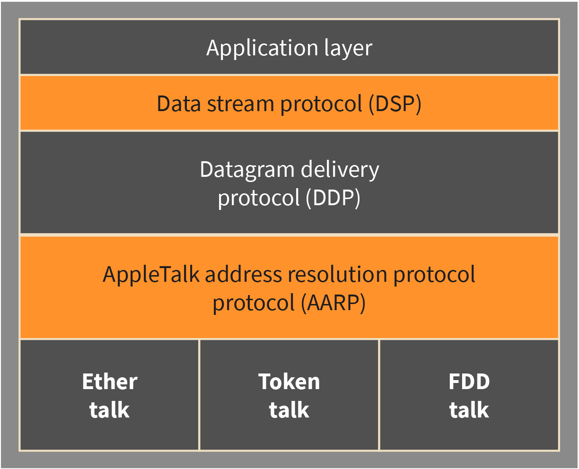

Source: Jetmir Haxhibeqiri (2023).
At the data link layer, AppleTalk used the AppleTalk Address Resolution Protocol (AARP), which has the same function as the address resolution protocol (ARP) TCP/IP and neighbor discovery protocol (NDP) in TCP/IPv6 network stack. The AARP was used to translate the MAC addresses to network addresses. Different from current Ethernet MAC addresses of 6 bytes, the AARP address was 4-bytes long consisting of 2-bytes for network ID, 1-byte for node ID and 1-byte for socket ID. The AARP operated like ARP and NDP. Once the node is connected to the network it sends an AARP packet to discover any router in the network that will give the network subnet information. If there was no response, the AARP selected a certain network subnet and broadcasted another AARP packet to inform the network for the selected subnet in order to remove any confusion in the network. If another node replied that that address is in use, the AARP will continue the same process again until it finds out the address that is not used in the network (Oppenheimer 2004).

At the network layer AppleTalk used Datagram Delivery Protocol (DDP), which ensured delivery of the datagrams end-to-end without any guarantees. As such, higher layers are needed to ensure the delivery guarantees of application layer data. To this end, at the transport layer, AppleTalk used data stream protocol (DSP) that was similar to TCP connection-oriented reliable transport protocol. In addition to the TCP connection-oriented mechanism, congestion and flow control mechanisms, DSP used attention messages that were a kind of short message that could be delivered as soon as possible by bypassing the data stream messages (Oppenheimer, 2004). As it is seen from the stack itself, minor attention was given to the network security functions, data were not encrypted, neither at the application layer nor at the network layer, although it is possible at internet protocol networks using the IPsec mechanism.

LTE
Cellular networks are one of the wide area networks technologies that are widely used nowadays. As a concept cellular network technologies are not new. They were used since the 50s of the 20th century, when the first push-to-talk system was deployed, to be used by cars (Tanenbaum 2021) . Such systems, in the beginning, were composed of a single cell with an antenna in a distinctive part of the city to achieve coverage and used only one communication channel. These systems are known as 1st generation cellular networks and provided only analog voice communication

Since then, other cellular network generation standards have been introduced. The 2nd cellular network generation known with the market name Global System for Mobile communication (GSM) started in the beginning of 80s of previous century as a European-wide standard. It was the first cellular network technology that provided digital voice communication using Time Division Multiplex (TDM) or Frequency Division Multiplex (FDM) channel access scheme.

Later, the 3rd cellular network generation provided digital voice and data communication based on Wideband Code Division Multiple Access (WCDMA) scheme. The 3rd generation was the first generation where users could surf on the internet from their phones, offered high quality of voice communication as well as multimedia communication like MMS. The 3rd generation is known with the market name Universal Mobile Telecommunication Systems (UMTS).

Long term evolution (LTE) was the 4th generation of cellular networks standardized by 3GPP and it is still in operation. The main technological advancement of the 4G over the previous 3G was that it offered end-to-end packet-switching communication even in the core network. This came as a natural advancement with other advancements in the other networks, such as Voice-over-IP, where the voice is transmitted over the network encapsulated in an IP packet.

LTE Network Architecture

Cellular network archi-
tecture The architecture of any cellular network is com- posed of the radio access network (RAN) and the core network (CN).
As with any other cellular network architecture, LTE network is composed of the radio access network (RAN) and the core network (CN). The RAN part offers wireless communication between the mobile devices, called user equipment's (UE) and the base stations, called eNodeB(s). The core network provides packet-switching and communication between different eNodeBs and between the RAN and other wired telephony networks. The core network in the 4G is called Evolved Packet Core (EPC), as differently from 3G where circuit switching is used for voice communication, in EPC all the voice and data are carried using IP packets. Thus, the whole 4G core network is an IP network. A 4G network composed of its RAN and EPC is shown in the figure Evolved Packet Core (EPC) Network and RAN of 4G. The main building blocks of the EPC are as follows (Tanenbaum, 2021):

- service gateway (S-GW): deals with forwarding functions of the data packets between the eNodeBs when user is moving from one to the other. It terminates the connection of the evolved terrestrial radio access network (E-UTRAN) and at any given time there is only one S-GW assigned to a UE.
- mobility management entity (MME): offers authentication service for the user device as well as selecting the SGW for the user once the user equipment (UE) joins the network. MME functions can be classified in two main categories: functions related to creation, maintenance and release of bearers between the UE and the EPC and functions related to connection establishment and secure connection between the UE and the network. Other MME functions include mobility management, inter-node signaling for handover management, selection of PGW and SGW, roaming and authentication (Ahmadi, 2013) MME is responsible for tracking the UE during the idle state and does the UE paging in case of the DL traffic availability. Upon reception of the paging message, UE moves to connection state and can be contacted in downlink.
- packet data network gateway (P-GW): offers communication between the UE and other packet data networks outside the EPC. When an UE joins the network it creates a dedicated connection with the P-GW using the so-called EPS bearers, that is a connection- oriented service between the UE and P-GW. If a UE has more than one connection to different packet data networks, then it will be connected to multiple P-GW. P-GW offers also connections for UEs using non-3GPP radio access. Other functions of the P-GW include IP address allocation, running DHCP(v6) services for the UE, gating control and rate control in UL/DL (Ahmadi, 2013).
- home dubscriber derver (HSS): provides subscription check services for the UEs. Once the UE joins the network, the MME checks if that UE has a valid subscription registered with HSS. HSS holds information such as: user identification, numbering and addressing, user security information, user authentication and authorization information. The HSS contains the master copy of the user profile that can be copied to the MME for faster processing and reduction of evolved terrestrial radio access network (E-UTRAN) overhead during bearer establishment and maintenance.

Figure 18: Evolved Packet Core (EPC) Network and RAN of 4G
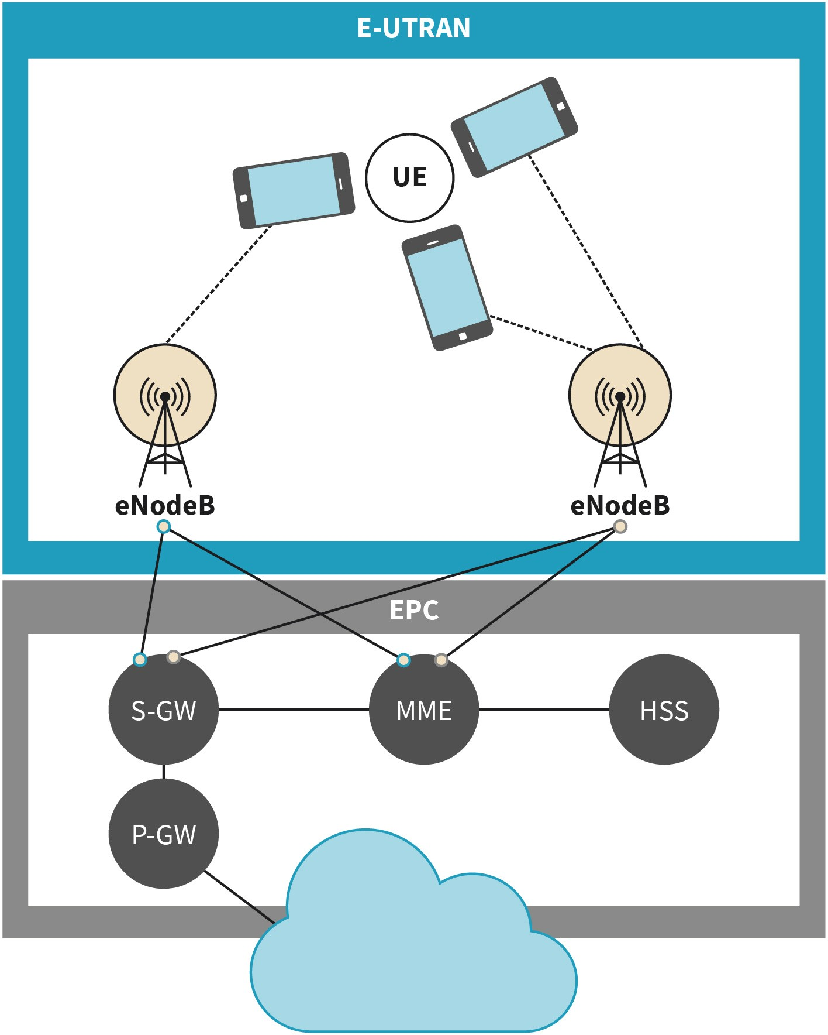

Source: Jetmir Haxhibeqiri (2023).

Differently from the EPC that is composed of different logical units, the radio access net- work is composed of a single unit eNodeB that provides radio access for user equipment (UEs). Each unit of the EPC as well as RAN is interconnected by a standardized interface that gives the network operator the possibility to install network elements from different vendors.

LTE Core Network Security

During the connection phase of a UE to the network, subscriber authentication takes place. The authentication service is provided by the MME and it is done using the UMTS Authentication and Key Agreement (AKA) procedure. AKA is a mechanism that performs

the key distribution in the network and is based in symmetric encryption. The authentication keys reside on the SIM card on the UE side, while on the network side on the MME. AKA gives the root key, out of which the hierarchy key is generated to be used for both signaling and data traffic (Ahmadi, 2013). As such the radio resource control (RRC) signaling integrity protection key is generated to be used for integrity check of signaling messages, the RRC signaling ciphering key to encode the signaling messages and the user-lane ciphering key to encode the data traffic. These keys are used between the UE and eNB. The non-access stratum (NAS) integrity protection key and ciphering is generation for integrity check/encryption of NAS signaling between UE and the E-UTRAN. This is shown in the figure LTE Core Network Security.

eNodeBs are not connected via wires to the core network. Due to distance microwave links are used. As such to improve security in the backhaul, IPsec protocol is used for protecting both signaling and data traffic in the backhaul links between the MME and eNodeB(s). To decrease the overhead the user traffic is just encrypted in the radio interface between UE and eNodeB, but no integrity check is performed.

Figure 19: LTE Core Network Security
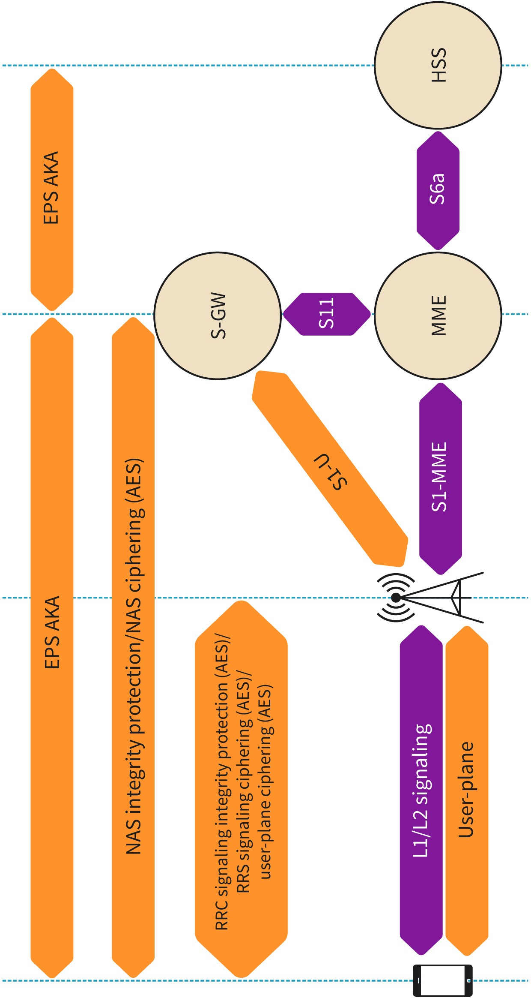

Source: Jetmir Haxhibeqiri (2023), based on Ahmadi, S. (2013).

The air interface between the UEs and the eNodeBs forms the Evolved Universal Terres- trial Radio Access (E-UTRA). E-UTRA uses orthogonally frequency division multiple access (OFDMA) and single carrier frequency division multiple access (SC-FDMA) to transmit to multiple clients in downlink (DL) from eNodeB and for multiplexing different transmissions from different UEs in uplink (UL), respectively. The OFDMA is a version of multi-user OFDM where different users are assigned a portion of the channel bandwidth, or a subset of sub-carriers where each of them is used to modulate the signal in parallel using one of the modulation techniques e.g., QAM. As such, in OFDMA a single user does not use the whole of the channel bandwidth but shares it with other users. Thus, the transmission bandwidth of a user is smaller than the actual channel bandwidth. The transmission bandwidth for a given user can be calculated by the following formula:

flow =

f − 0.18NRB − BW
2
C
guard; f
ℎigℎ =

f + 0.18NRB + BW
2
C
guardBW
trans =

fℎigℎ − flow

where the NRB is the respective start/end resource block, and the fC is the center frequency of the channel bandwidth. Note that 0.18 represents the resource block band- width in MHz.

In LTE there are specified several channel bandwidths set at 1.4, 3, 5, 10, 15, and 20 MHz. An OFDMA symbol is a set of subcarriers over a certain time, each of them using a certain modulation technique (e.g., QPSK). Multiple access scheme in LTE is organized into time intervals that have certain values. The smallest time interval is the OFDM symbol time that is 0.5/7 ms or 0.5/6 ms long, depending on if the normal or extended cyclic prefix (CP) is used, respectively. Then a time slot is composed of several OFDM symbols (7 or 6 depend- ing on the CP used) being 0.5 ms long in total. A sub-frame is composed of 2 time slots; thus it is 1 ms long. Then we have the definitions of a half-frame composed of 5 sub- frames, 5 ms long, and the definition of a frame that is 10 ms long.

In the frequency domain, the channel is divided into sub-carriers. The smallest organizational unit in the LTE radio link is the resource element (RE) that describes one sub-carrier and one OFDM symbol time. A resource block (RB) is the smallest unit that can be assigned to a user. An RB is 180 KHz wide in frequency.

LTE radio interface supports two duplex modes of operation, the frequency division duplex (FDD) and time division duplex (TDD) for combining uplink and downlink communication. For FDD mode the full-duplex communication is supported by separating the UL and DL transmissions in frequency and by transmitting them continuously. In the half- duplex FDD mode, the transmission of UL and DL happens at different frequencies, but they are not simultaneous, thus the UE cannot receive while it is transmitting. For the TDD mode, UL and DL communications are transmitted at different times at the same frequency.

LTE Channels

LTE channels can be grouped into three different types: logical channels, transport channels, and physical channels. Each of the subgroups is defined for each communication direction, being it downlink (DL) or uplink (UL). All the channel mappings are shown in the figure LTE channel mappings in DL and UL.

Figure 20: LTE Channel Mappings in DL and UL
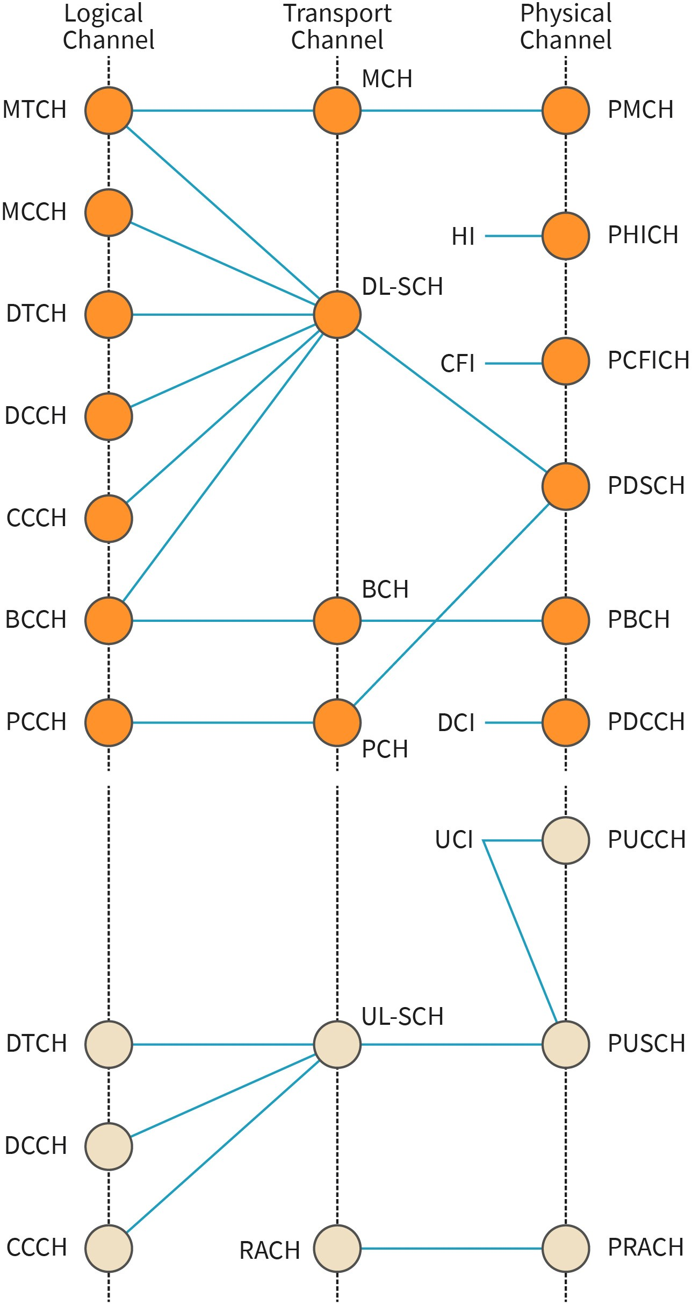

Source: Jetmir Haxhibeqiri (2023).

Logical channels are defined based on what information is being transmitted if it is related to the data plane or to the control plane. As such logical channels are subdivided into traffic channels and control channels. On the other hand, the transport channels are divided based on the way the packets are transported: being it unicast (dedicated), multicast, broadcast, or paging (discovery purposes).

From the network security point of view, the most interesting logical channels are the broadcast control channel (BCCH) and Multicast Control Channel (MCCH). These logical channels are used to transmit control data in DL to multiple end users. As such, different attacks exploit these channels to take control over the end device communication, such as the so-called rouge base station attack. By exploiting signaling traffic, unauthorized neat- work nodes can make the end nodes connect to them instead of the legitimate network.

Similarly, transport channels can be exploited to downgrade the network performance Random Access Channel (RACH) is used by the end nodes to initiate the network access and negotiate the data resources in UL. A malicious attack can jam the cell with several requests in RACH, achieving the downgraded service from the LTE cell.

Similarly, physical channels can be further classified as physical data channels and physical control channels, both in the uplink and downlink direction. Such classification is based on the type of message that is exchanged if it is a data message or a control and management message. The downlink physical channels are listed below (Ahmadi, 2013):

- physical broadcast channel (PBCH): transports system and cell information to the UE needed to access the communication network. It is a point-to-multipoint channel
- physical downlink shared channel (PDSCH): carries the paging information and user plane data
- physical multicast channel (PMCH): used to carry multicast data messages from the core network to UE
- physical downlink control channel (PDCCH): carries control information from the net- work to the UE or group of UEs in downlink
- physical hybrid arq indicator channel (PHAICH): reports the HARQ status and carries the HARQ ACK/NACK signals informing the UE which transport blocks are received correctly and what need to be retransmitted
- physical control format indicator channel (PCFI): transports information regarding the number of OFDMA symbols used to carry the PDCCH. It is always transmitted in the first symbol of the sub-frame.

The uplink physical channels are as follows:

- physical uplink shared channel (PUSCH): carries the transmissions of data plane messages from the UE to the network. Sometimes it can be used to carry control. messages in UL direction as well. It is seen as a counterpart of the PDSCH in the uplink.
- Physical random-access channel (PRACH): used by the UE to carry the random-access procedure to get and maintain the uplink synchronization with the network.
- physical uplink control channel (PUCCH): transmits control messages to the network related to scheduling requests, ACK/NACK for a data plane message received in down- link, and channel quality information parameters.

5G
With the increase in the market for mobile networks and new challenging use cases in industrial communication networks in 2012, ITU started a work program to define the successor of the IMT-Advanced, which was known by the name IMT-2020 (COX, 2020), addressing new use cases that were not possible using long-term evolution (LTE). This was followed by the 3GPP that started the definition and standardization of the new generation of cellular networks, the 5th generation (5G). Many use cases scenarios were defined where 5G can be beneficial in fulfilling the requirements, however, three main use case groups are:

- enhanced mobile broadband (eMBB)
- massive machine-type communication (MTC)
- ultra-reliable low latency communications (URLLC)

Enhanced Mobile Broadband (eMBB)

The enhanced Mobile Broadband (eMBB) addresses the same use cases as LTE, but in the 5G case, the key performance indicators (KPI) in terms of throughput and communication latency will be enhanced. In these use cases, the scenario family covers the wider-area coverage and hotspots where high-speed mobility, seamless coverage, and high user density are needed. In case of the high user density, the required user data rate is much higher than in the case of LTE (Shafi, 2017). The table below shows the technical key performance indicators for eMBB. It is seen that the minimal peak data rate can go up to 10s of Gbps, while radio communication latency is reduced to a couple of milliseconds. LTE can still support most of the use cases under non-congested network conditions (e.g., mobile video use cases require only several Mbps data rate), but it fails in supporting such requirements for highly dense scenarios (COX, 2020). As such, the biggest advantage of 5G compared to LTE is the offered node density, especially for use cases, such as communication in shopping malls, big concerts, or sports events (indoor or outdoor) (COX, 2020).

Table 4: Technical Key Performance Indicators for eMBB

Key Performance Indicator Values

Peak data rate | DL: 20 Gbps, UL: 10 Gbps
User experienced data rate | DL: 100 Mbps, UL: 50 Mbps (in dense urban scenar- ios)
Area traffic capacity | DL: 10 Mbps/m2
User Plane latency | 4 ms
Control Plane latency | 20 ms
Device density | 1M/km2
Mobility | Up to 500 km/h

Key Performance Indicator Values

Bandwidth | 100 MHz with possibility up to 1 GHz in higher fre- quency bands (>6 GHz)
Source: Jetmir Haxhibeqiri (2023),based on Shafi (2017).

Massive Machine-Type Communication (MTC)

The second group of use cases that are targeted by 5G are the Massive Machine-type Communications (MTC) which can be referred also as the Internet of Things (IoT). In such use cases communication needs to be provided for a high number of users in a relatively wide coverage area, each user producing a low data rate and delaying non-sensitive traffic. The users need to be low-cost and to be operational on battery power for a long time (in terms of years). Such use cases include sensor monitoring scenarios (monitoring of civil engineering structures, agronomy, and goods in a warehouse (COX, 2020), asset tracking (indoor or outdoor), or human body monitoring. In LTE MTC use case was covered by Nar- row Band IoT (NB-IoT) which is a new cellular radio technology that was standardized by Release 15 that targets the low-power operation of end users (GSM, 2019). Since the LTE NB-IoT can already fulfill most of the MTC requirements, it is not expected that 5G will have it as a core use case. This is related to the fact that the current forecast of device connections using cellular networks is only 10% of the market (Ericcsson, 2019) and that there is big competition from other LP-WAN technologies, such as LoraWAN and Sigfox.

URLLC

Ultra-reliable low-latency communication use cases cover a set of use cases and scenarios where both low latency and high reliability are required. This includes factory automation use cases or, so-called Industry 4.0, tactile internet, vehicular communication (vehicle-to- vehicle (V2V) and vehicle-to-everything (V2X), smart grids, and remote surgery (Shafi, 2017). Communication latency is defined as the time delay from the moment the packet is transmitted by the sender until the packet is received at the destination node, while reliability is defined as the percentage of packets received correctly over a period.

Compared to LTE which supports down to 10s of milliseconds communication latency under the condition of non-roaming UEs, 5G decreases this communication latency down to one digit millisecond latency. While 10s of millisecond communication latency is sufficient for VoIP and video over IP, it is not sufficient for the previously mentioned use cases (COX, 2020). The low latency is achieved by employing mini-slot-based transmission in the radio interface, meaning that a highly time-sensitive packet can preempt the other ongoing transmission to access the communication channel fast.

Next to communication latency, reliability is another aspect that 5G URLLC considers. The supported reliability according to Release 15 is 99.999% [REL 15]. The high reliability and low latency are achieved thanks to the employment of low-parity check codes (LPDC) at the physical layer that can be decoded in parallel and HARQ schemes that improve the reliability of the radio link.

5G differs in many ways from LTE and these differences provide the possibility for achieving certain goals. First, 5G targets diverse use cases (URLLC, MTC, eMBB) that require more flexibility in the radio interface. As such, 5G New Radio (5G NR) that provides more flexibility in subcarrier spacing (not only 15 KHz like in LTE but also 30, 60, 120, and 240 KHz), consequently in symbol time, makes it possible to support latencies down to 1 ms. With the employment of millimeter wave communication where more bandwidth can be available, 5G can support use cases, such as virtual reality and augmented reality with data rates up to several Gbps.

Another main difference between LTE and 5G is network core virtualization in 5G. All the 5G core network runs as network function virtualized in the cloud. Moreover, the data plane and control plane are fully separated, improving the network management and giv- ing the possibility for network slicing for dedicated applications. Service-based deploy- ment of 5G core network makes it possible to achieve stand-alone deployment in campus networks.

SUMMARY
In this unit, we analyzed the differences between telecommunication and IT terminology based on ITU-T Recommendations. Even though IT and telecom terminologies are usually interchangeably used, we described the differences between different terminologies. We defined the general concepts and terms that are important from a telecom back- ground, such as base stations, active communication, RAN, core net- work, FDD, and TDD contrasting them with the IT terminology and technologies including access point, OFDMA, EDCA, MSDU and MPDU.

Telecommunication systems are not owned and do not comprise devices from the same company. To this end, there is a high need for standardizations and interoperation protocols that can glue different devices from different products into the same system. As such, telecommunication standardization bodies play an important role in interoperability and inter-play between different technologies. In the second section of this unit, we zoomed in on several standardization bodies and how they work, focusing on 3GPP, IEEE 802.11, ONF, Internet Engineering Task Force (IETF), and ETSI. However, at the beginning of the development of IT and telecommunication technologies, legacy digital protocols were more common due to a lack of standardization bodies. In section 3 of this unit, we analyzed a few legacy digital protocols, some of them being discontinued over time, leaving room for standardized protocols.

Cellular technologies are by far the most widespread wireless technologies in the world, they have experienced several generations over time, with 5G currently being commercially deployed and the latest generations, such as 6G being standardized. In sections 4 and 5 of this unit, we analyzed and differentiated LTE (4th cellular technology generation) and

5G. We focused on the core network as well as a detailed description of the radio access network of LTE, while for 5G we understood its main use cases.

UNIT 4

TELECOM ARCHITECTURE

STUDY GOALS

On completion of this unit, you will be able to ...

- understand the overall telecom architecture of cellular networks.
- differentiation between the core network architecture and radio network part.
- explain software-defined networking and its application in cellular networks.
- describe the differences between the 5G campus network from the public 5G networks.
- analyze and evaluate the application layer security.

4. TELECOM ARCHITECTURE

Introduction
Telecom network architecture relates to the interplay of different blocks and their communication protocols. Two main network parts of a cellular network are the radio access net- work (RAN), offering wireless connectivity for the end users, and the core network (CN) which deals with the connectivity between different network cells as well as between the RAN and the other wired communication networks. CN provides core functionalities necessary for the management, control, and physical access of end-users using RAN. As such, to understand how cellular networks work, first we will analyze the overall architecture of the cellular network, and then we will dive into understanding the functions of the main RAN and CN components. Next, we will zoom into the core network as the heart of the cellular networks that offer both control and communication functions for the network. All this analysis will be done with a focus on the 5G network architecture.

In addition to ordinary network infrastructure, a new concept that has emerged in net- working is software-defined networking (SDN). The SDN targets the separation of data plane functions from control plane functions in the network devices, in order to offer higher flexibility to the network operators to share their networks for different specific users. In this unit, we will describe the main idea behind the SDN concept and its functional building blocks. In fact, the SDN is quite common in the current cellular networks (5G networks), mainly in the core network part, thus we will give separate attention to it.

For more specific use cases, such as industrial communications, 5G cellular networks can be deployed dedicated to a single user. Such networks are known as 5G campus networks or private 5G networks. We will analyze different types of deployments of the 5G campus networks. Finally, in the last section of the unit, we will give a look at the application layer security approaches for the end users.

Overall Architecture
Each telecom network architecture is divided into two main parts: the radio access net- work (RAN) and the core network (CN). The radio access network is composed of the user equipment and the base stations while the core network is composed of several components that enable the control, management and communication of the RAN with the wired network part as well as communication between different network cells.

Cellular Concept

The main challenge of the early telecom mobile systems was to achieve wide coverage of the base stations by providing high-power transmitters. On the other hand, this approach proved that frequency reuse was not possible, decreasing thus the network capacity. Later, the cellular concept was introduced, and all the telecom mobile networks adopted

the concept of dividing the geographical regions into smaller cells that were served with lower power transmitters. This allowed the possibility of frequency reuse and increased capacity as is seen in the figure Cell division of Geographical Areas and Mini-Cell Divisions of Macro-Cells. In case of increased capacity overloads, cells can be further divided into microcells that are served by a single transmitter.

Figure 21: Cell Division of Geographical Areas and Mini-Cell Divisions of Macro-Cells
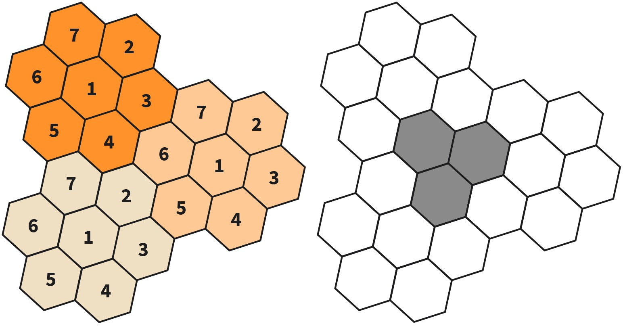

Source: Jetmir Haxhibeqiri (2023).
The capacity of the cellular network depends on the reuse factor of the channels in the cell. Assume that a network operator has N channels in total to be assigned, and they are divided into a disjoint cell of k channels per cell C then the total number of channels will be N = kC. If the operator repeats the cell organizations multiple times, M, then the total number of channels in the network will be CH = MN=MkC, which gives the capacity of the network in terms of channels used (Rappaport, 2002). Cellular organization of RAN is common for all generations of mobile networks. In the following subsection, we will focus on the 4G and 5G RAN as the latest generations of mobile systems that are already operative.

4G and 5G Radio Access Network (RAN)

Before digging more into the RG Radio Access Network (RAN), let us give a short overview of the Evolved UMTS Terrestrial Radio Access Network (E-UTRAN) which is the RAN of the 4th generation. E-UTRAN is composed of the base stations called evolved Node B (eNB) that include functions, such as TX/RX of the radio signal in the cell, digital signal process- ing, control and management of the UEs, and the data communication for the UEs (COX, 2020). The communication interface between the user equipment (UE) and the eNB is denoted as the Uu interface, while the eNB that serves the UE is called the serving cell. The communication between the eNB and the core network is done using the S1 interface, while the communication between different eNB is done using the X2 interface. Both inter- faces, S1 and X2 are used for data planes as well as control planes (COX, 2020). The sche-

matics of the RAN and its interconnections with evolved packet core (EPC) are shown in the long-term evolution (LTE) RAN image below. To improve the offered data rate to the UEs in RAN, two new concepts introduced in Release 15 [REL 15] are carrier aggregation and dual connectivity.

Figure 22: LTE RAN
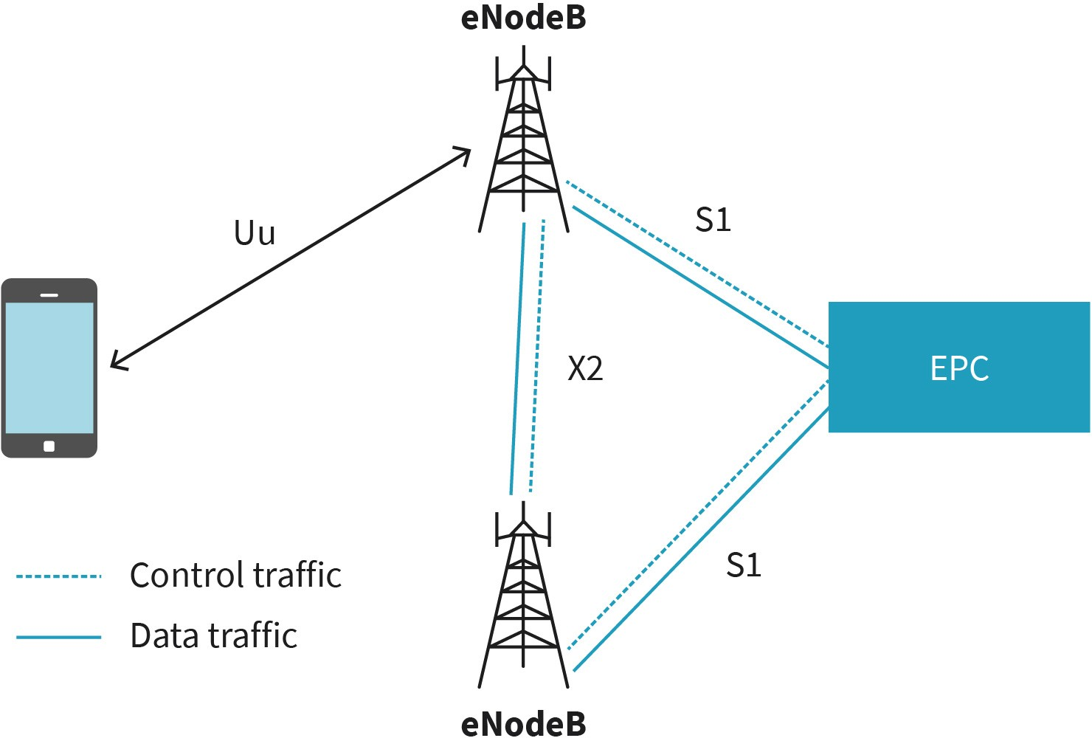

Source: Jetmir Haxhibeqiri (2023).
The carrier aggregation is activated when the UE communicates via multiple cells in order to increase the maximum data rate in UL and/or DL. The cell in this context is defined as an operational frequency controlled by an eNB. In the case of carrier aggregation, the differ- ent used cells are controlled by a single eNB. While the control and management of the UE happens via the primary cell, other secondary cells are used only for data plane communication. The UE can establish multiple secondary cells with the eNB, which operates at higher carrier frequencies to leave the lower ones to be used by the primary cell for better reach to the UE.

In addition to multiple-cell communication established with its master eNB, in the case of dual connectivity, UE communicates with the second eNB utilizing multiple cells in different frequencies as well. The main eNB that provides the primary cell (the cell through which the control and management of the UE are performed), is called the master eNB. The other eNB is called the secondary eNB. All the cells used by the master eNB are defined as the master cell group, while all the cells used by the secondary eNB are called the secondary cell group. Like carrier aggregation, the master cell group operates at lower frequencies compared with the secondary cell group in order to provide better coverage for the UE. The control of the UE from the cover network is done via the master eNB using the S1 interface while the S1 interface toward the secondary eNB is used only for the data

plane. The control of the secondary eNB is done from the master eNB utilizing the X2 inter- face. The figure Carrier Aggregation and Dual Connectivity Concepts in Rel 15 RAN shows the carrier aggregation concept and dual connectivity concept.

Figure 23: Carrier Aggregation and Dual Connectivity Concepts in Rel 15 RAN
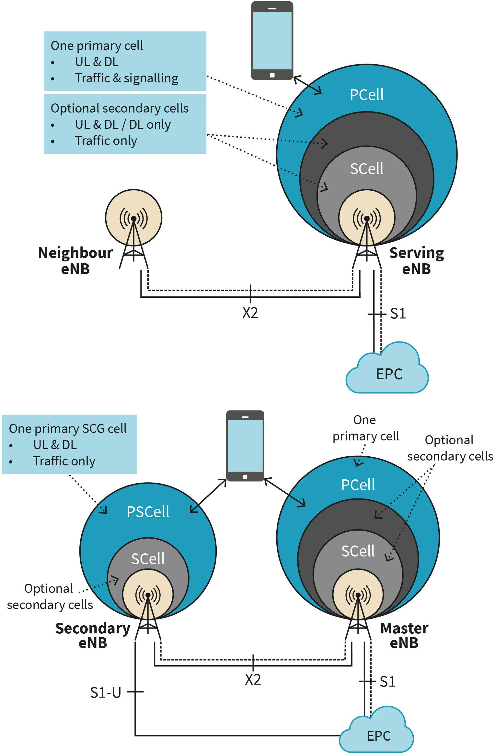

Source: Jetmir Haxhibeqiri (2023), based onCOX (2020).

In the 5th generation of cellular networks, the radio access network (RAN) is known by the name next-generation RAN (NG-RAN), while the base station is known by the name next- generation Node B (gNB). The gNB communicates with the UE using the air interface defined by the New Radio (NR) (NR, 2019). The gNB connects to the 5G core network via the NG reference interfaces, where N2 is the reference interface for the control traffic and N3 is the reference interface for the data plane. The interconnection between NG-RAN and the 5G core network is shown below.

Figure 24: NG-RAN
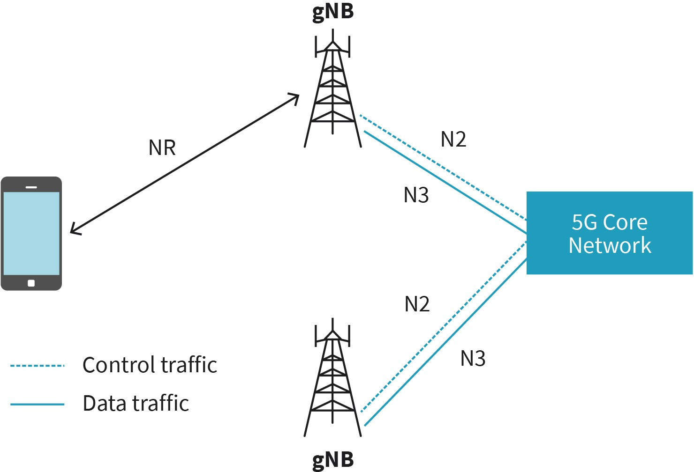

Source: Jetmir Haxhibeqiri (2023).
Unlike the 4G network where the eNB is a single network component, in 5G the gNB is composed of different functional blocks that can be installed all in a single location or they can be split into the network and communicate with each other using standardized interfaces. As such the data traffic functional blocks are decoupled from the control traffic functional blocks in the gNB. Decoupling of control from data processing functional blocks is one of the main 5G approaches compared to LTE, which is applied in the gNB as well. The gNB is composed of the following components (NR, 2019), as shown in the figure gNB Components and Building Blocks:

- The gNB distributed unit (gNB DU) manages the low-level functions of the gNB, such as digital signal processing and scheduling, and is installed at the local premises.
- The gNB central unit (gNB CU) controls the gNB during the operational time. The gNB CU can be used to control one or more gNBs DUs and can be installed on the edge.

  - The gNB CU control plane (gNB CU CP) unit communicates signaling messages to UE and to the core network. It also manages and controls the gNB CU user plane (gNB CU UP) unit.
  - The gNB CU UP communicates the data traffic between the core network and the UE.
- The remote radio head (RRH) implements the transmission and reception of radio sig- nals and is managed by a single gNB DU.

Figure 25: gNB Components and Building Blocks
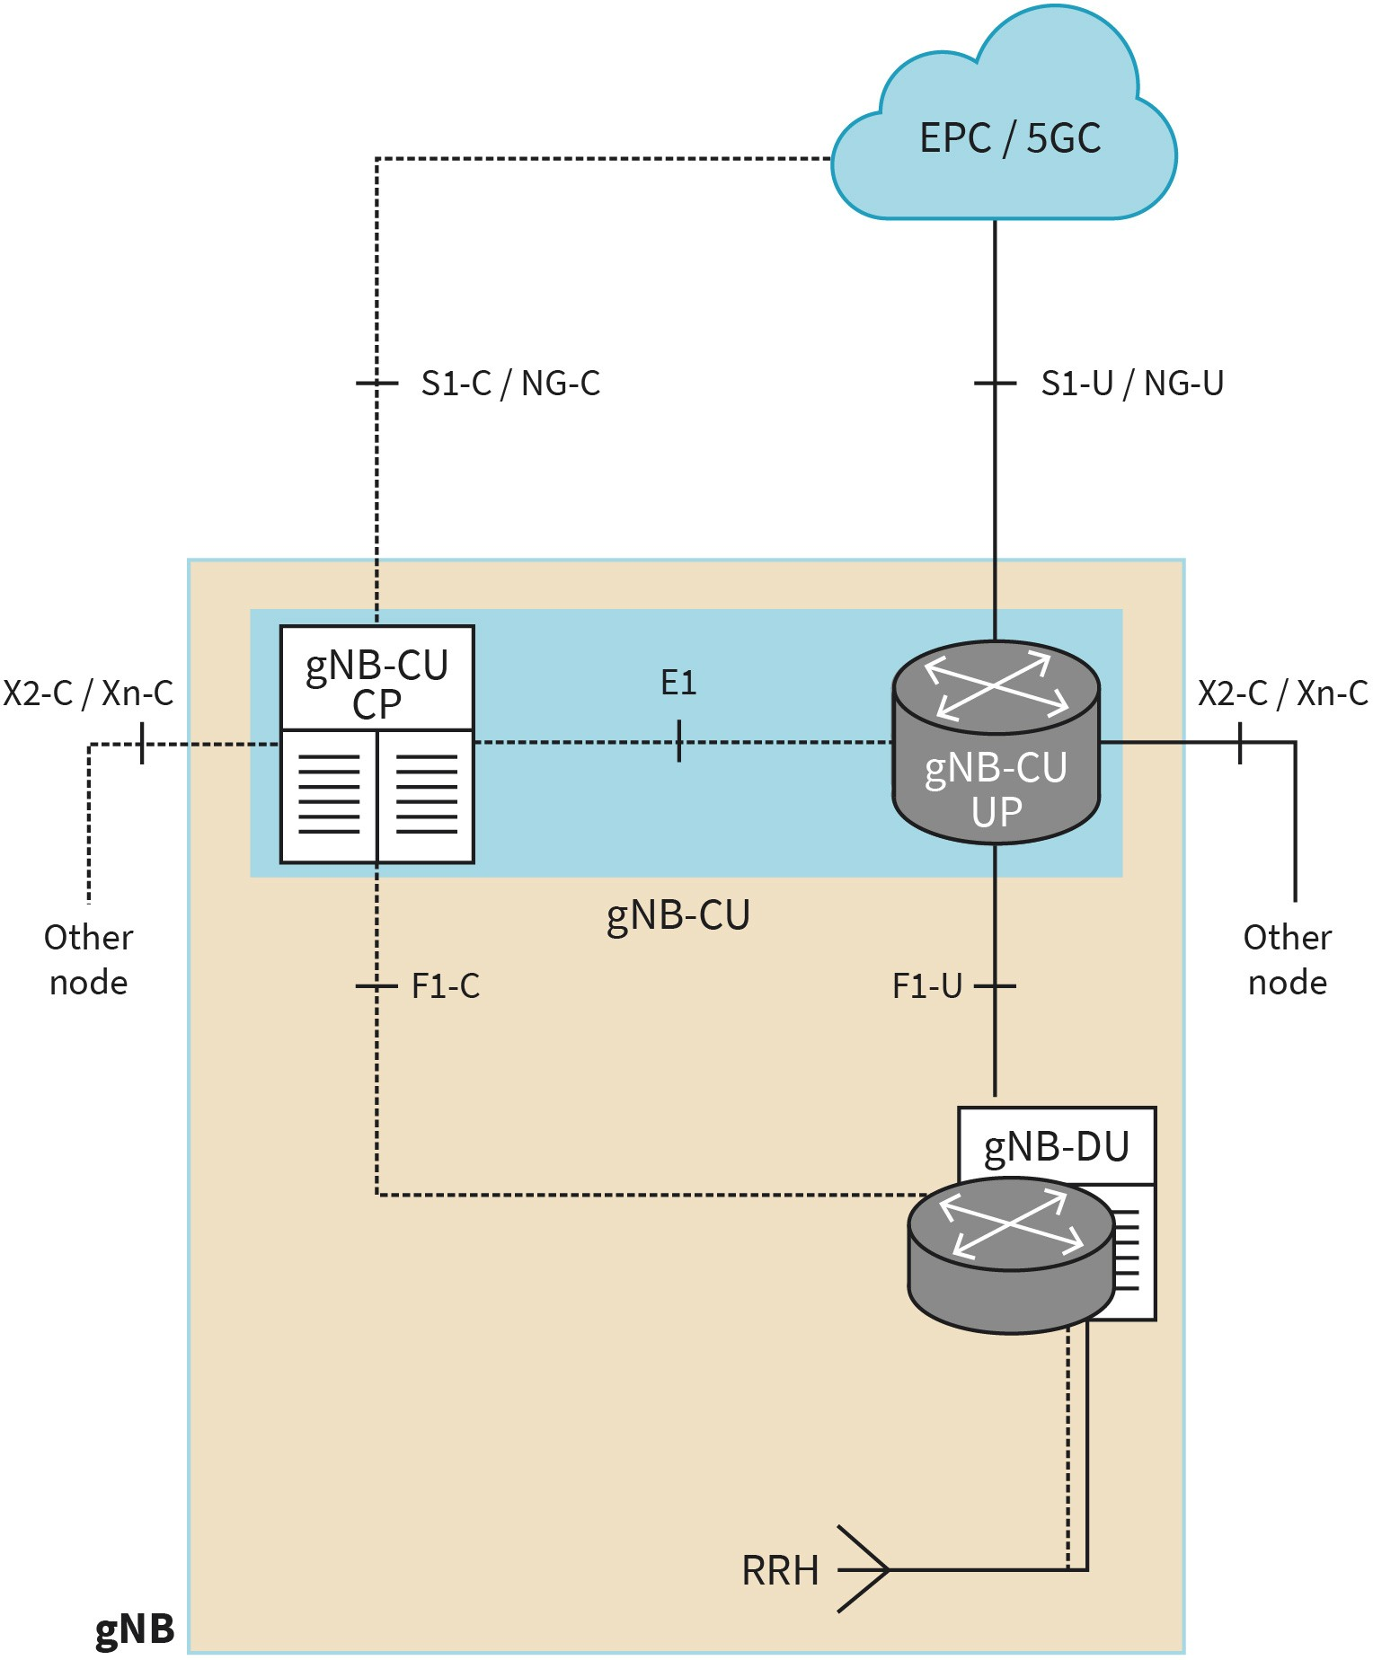

Source: Jetmir Haxhibeqiri (2023)based on COX (2020).

Core Architecture
To analyze the evolution of the core architecture from one cellular network generation to the other we will explain the core architecture of the LTE as well as 5G. The reader will have a view of both core architecture and will be able to compare and understand both. Moreover, understanding the LTE core architecture is crucial since it is still being used in the first deployments of the 5G networks nowadays.

LTE Core Architecture

The LTE core architecture is known by the name of evolved packet core (EPC) and the main building blocks of EPC are shown in the figure LTE Core Network Architecture. Each EPC can have multiple instances of each node in its network (COX, 2020). EPC provides connectivity for the user’s equipment and radio access network (RAN) toward other packet data networks as well as controls and manages RAN and UEs. The connectivity toward other packet data networks is offered by the packet data network gateway (PGW), which sup- ports user plane data delivery for incoming/outgoing traffic. From Release 14 onwards [REL 15C], the PGW is separated into two parts: the PGW-C for the control plane that car- ries the control signaling traffic and the PGW-U for the user plane that carries the data traffic (COX, 2020).

Figure 26: LTE Core Network Architecture
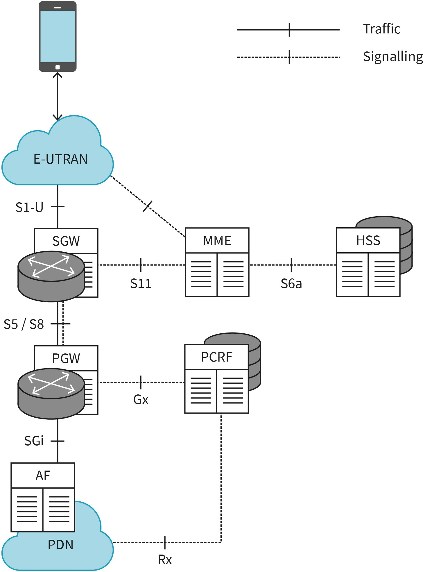

Source: Jetmir Haxhibeqiri (2023), based onCOX (2020).
Each user equipment is assigned a serving gateway (SGW) and a serving mobility management entity (MME) in the evolved packet data network. The SGW connects the RAN with the PGW in the data plane, while MME offers control and management services: mobility management signaling (controlling the communication of the UE with EPC) and session management signaling (controlling the UE communication with the PDN). The home sub- scriber server (HSS) maintains a database of the subscribed UEs with the core network and provides such information for other EPC elements via the control plane. Finally, the

policy and charging rules function (PCRF) maintains the network policies for each UE and provides such information to other elements of the EPC as well as to other PDN via, the so- called, application functions (AF), for setting up traffic streams via EPC. (COX, 2020).

5G Core Architecture

One of the main differences between the core network of 5G and LTE is the movement from dedicated nodes to virtualized services. The 5G core architecture is based on thee virtualization of services that can run on general-purpose hardware. As such, core network building elements shown in the next figure should be seen as part of services that 5G core should implement, but not as separate building blocks. They can all be running on the same or different hardware devices.

Figure 27: 5G Core Network Architecture Functions
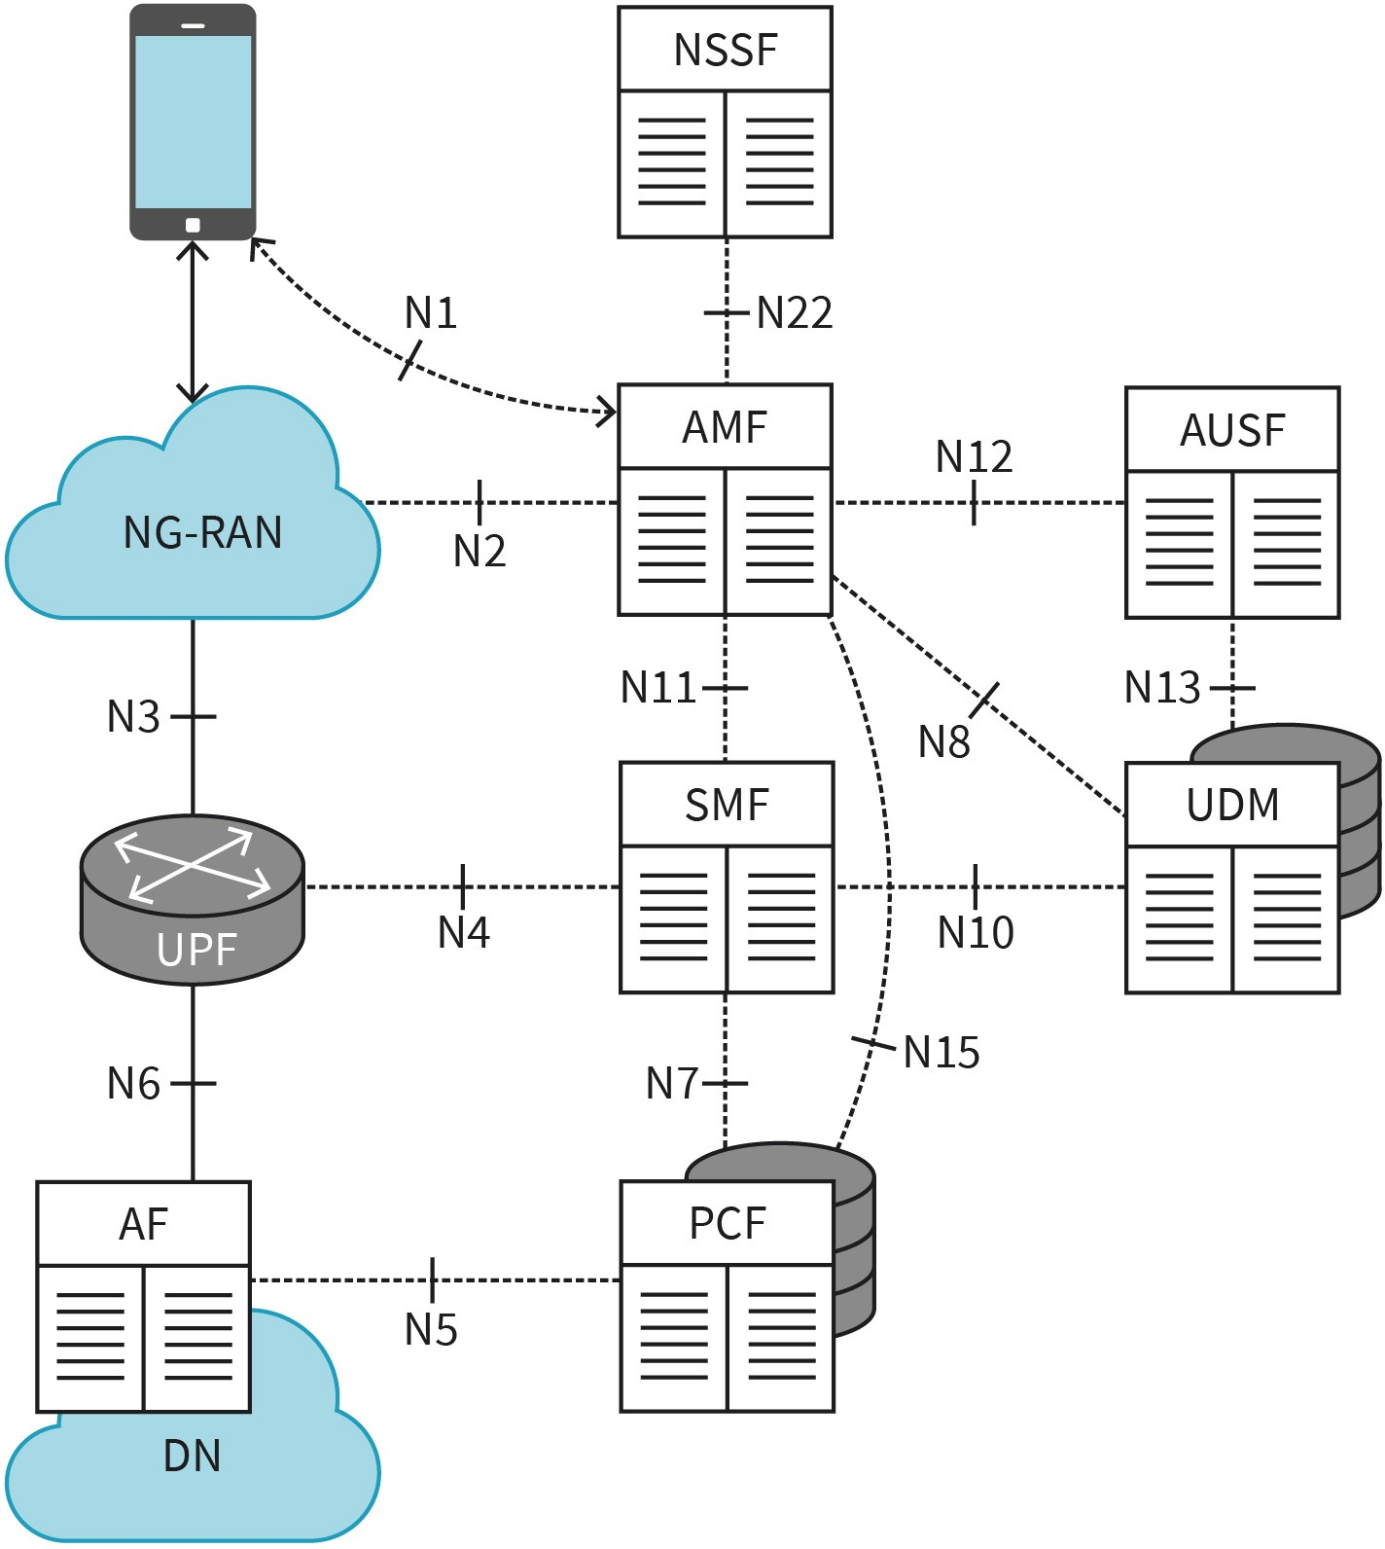

Source: Jetmir Haxhibeqiri (2023), based onCOX (2020).

5G Core Architecture The architecture of 5G core networks is based on virtualized functions com- pared to LTE which uses dedicated hardware nodes for its core net- work.

The data communication between the UE and the different data networks (DN) is enabled by the user plane functions (UPF). In the 5G core network, the control functions are separated by the data plane functions. UE is assigned a serving session management function (SMF) that controls the establishment of sessions between the UE and DN(s) via UPF. The access and mobility management functions (AMF) provide mobility management and control the interaction between the UE and the core network while relying on the signaling messages between the UE and the SMF. The unified data management (UDM) function provides the subscriber data to other functions in the core network, while the policy control functions (PCF) provide the network policy to SMF and AMF related to session setup. All the functions mentioned were part of the LTE core network as well.

New functions introduced to the 5G core network, compared to the LTE core network are the network slice session function (NSSF) and the authentication server function (AUSF) (COX, 2020). The NSSF offers management for network slices and defines to which net- work slice the UE will be subscribed, while the AUSF provides authentication functions for AMF during the security procedures.

5G Versus LTE Core Network

As was seen in the previous subsections, in terms of functional blocks 5G core network includes all the functions that the LTE core network provides. The main difference is that in 5G everything is virtualized in the cloud rather than running in dedicated nodes for each core network function.

The new concept introduced in 5G is the virtualized network functions (VNF) that relate to the software form of the core network functions that are deployed in virtual machines in the cloud. All of these VNFs are controlled, orchestrated, and managed by the network function virtualization (NFV) framework in 5G. This is not the case with the LTE core net- work where each function is running in a dedicated hardware node. Moreover, the data plane and control plane are fully separated in the 5G core network, offering opportunities for network slicing for dedicated applications. By comparison, the LTE core network does not provide slicing per se (Katsalis, 2017). Service-based deployment of 5G core network makes it possible to achieve stand-alone deployment in campus networks.

5G Network Deployment Scenarios

Due to technology readiness, regulator aspects, or organizational readiness to deploy 5G networks in different countries, different approaches are followed to provide 5G network services to the market. The two main approaches are non-stand-alone 5G deployment and stand-alone 5G network deployment.

The non-stand-alone 5G network deployment is the first step that mobile network opera- tors (MNO) are taking to provide 5G services. It relies on using LTE EPC to support the 5G network, where 5G new radio (NR) is coupled with the LTE core network. As such 5G net- work functions are not fully virtualized and run in dedicated nodes.

Differently from the first approach, the stand-alone approach goes with the deployment of 5G networks with dedicated core networks and coupling of 5G NR with cloud-native virtualized 5G network functions. While stand-alone deployment is more costly for MNOs, it gives higher flexibility supporting all three 5G network capabilities (eMBB, Ultra-reliable and low-latency communications (URLLC), and machine type communication (MTC). The non-stand-alone deployment is less costly for MNOs, but it will be rolled out faster and will provide only incremental 5G functions to LTE networks. Both standalone and non-stand- alone scenarios are shown in the figure below.

Figure 28: 5G Network Deployment Scenarios
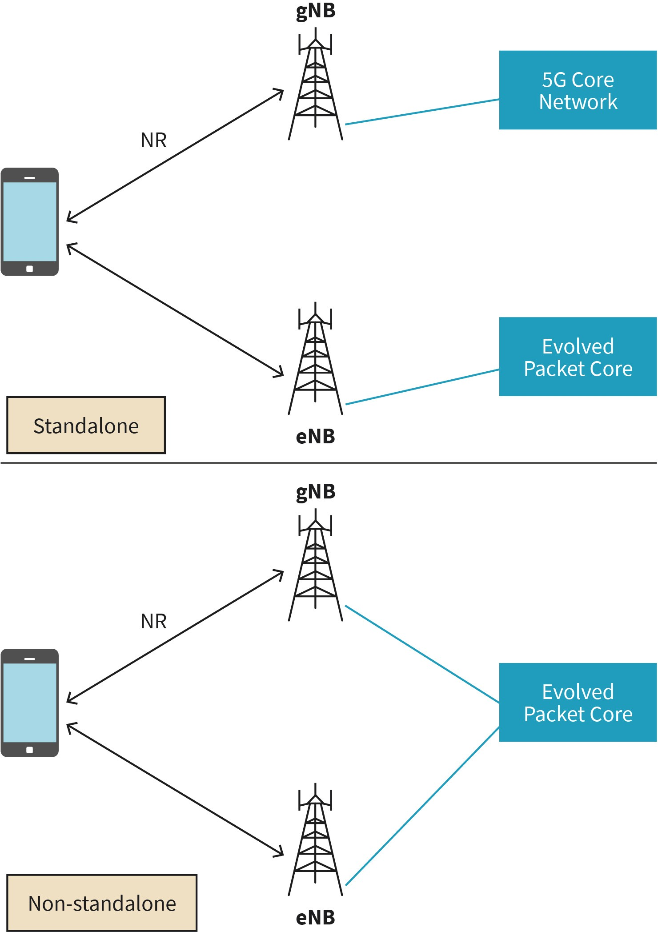

Source: Jetmir Haxhibeqiri (2023).

Software Defined Networking
Software-defined networking (SDN) targets the separation of the data plane and control plane in the network. Compared to traditional networking, SDN increases network programmability and automation, that in return improves network flexibility and agility. In SDN, networks are managed centrally, where automated security policies can be implemented, improving network security as well. Moreover, network operational costs will decrease by employing the SDN concept, as the network can easily be programmed based on required characteristics and quality of services needed, without the need for physical intervention. As such the SDN is composed of two main planes: the data plane, where the data packet forwarding action takes place, and the control plane, where the control of for- warding rules from a central controller takes place.

The main characteristics of SDN design can be grouped into the following (Kreutz, 2015):

    - Flow-based packet forwarding
    - Data-plane and control-plane separation
    - Central management of control functions
    - Network programmability

SDN Data Plane

In traditional networks, packet forwarding is done based on the layered communication stack, where each layer is responsible for part of the packet forwarding action. For example, the network layer will do routing based on routing tables; the data link layer will do packet switching based on neighboring tables; while there might exist firewall rules to drop certain packets, network address translator (NAT) or proxy features to enable communication between private networks and public ones (Kurose, 2013). In the case of the SDN data plane, the packet forwarding is done in a generalized way by matching different fields from different headers. The figure below shows the different values from the data link layer, network layer, and transport layer that are used to do the packet matching before the generalized forwarding actions. The most well-known SDN platform to implement a data plane is OpenFlow (OpenFlow, 2009), which uses 12 different fields from different layers for packet matching.

Figure 29: Packet Field Matching

Source: Jetmir Haxhibeqiri (2023).

In SDN, each packet-switching network device will contain so-called local flow tables that maintain the following 3 different fields:

- Header field values that the packet needs to be matched against
- Counters of the packets being matched to each flow rule until that moment
- The action that must be taken once the packet is matched with a rule

Actions that can be taken for a matched packet can be different: to forward the packet in one/all or multiple outgoing ports, to drop the packets (if no rule is matched), or to modify certain header(s)/header(s) field values before it is forwarded.

SDN Control Plane

The SDN control plane has two main components: the centralized controller and the net- work control applications residing in the network and the SDN control agents that reside in the network components (switches, routers, hosts). The SDN controller implements two interfaces to communicate and exchange information with the network and the agents of the SDN controller. The southbound interface supports communication between the SDN controller and the SDN agents in the network nodes. In the downlink, the SDN controller manages the flow rules and actions, while in uplink it receives the monitoring information and events from the network control applications. The northbound interface supports interaction between the SDN controller logic and the network-control applications to sup- port several actions such as routing, access control, and load balancing (Kurose, 2013).

To give an example of how the SDN controller behaves, let's have a look at the following network as specified in the figure SDN Controller Example. The network is composed of 5 switches that interconnect two hosts. Each SDN control application in each switch will maintain the link information and report this to the SDN controller. In the beginning, the packets are being forwarded via switch S1, S4, and S3 toward host 2. After some time the link between switch S1 and S4 breaks and each of the switches will report this to the SDN controller. The control steps will go as follows:

- Switches S1 and S4 report that the link is broken to the SDN controller.
- SDN controller will calculate the new route in the network.
- The new forwarding route will be via S1, S2, and S3 toward host 2.
- The SDN controller will instruct the SDN control applications on switches S1, S2, and S3 via its south-bound interface to install new link-state information to enable the for- warding of packets.
- Once the messages are received by the switches S1, S2 and S3 the neighboring tables are updated, and packet forwarding can take place.

Figure 30: SDN Controller Example
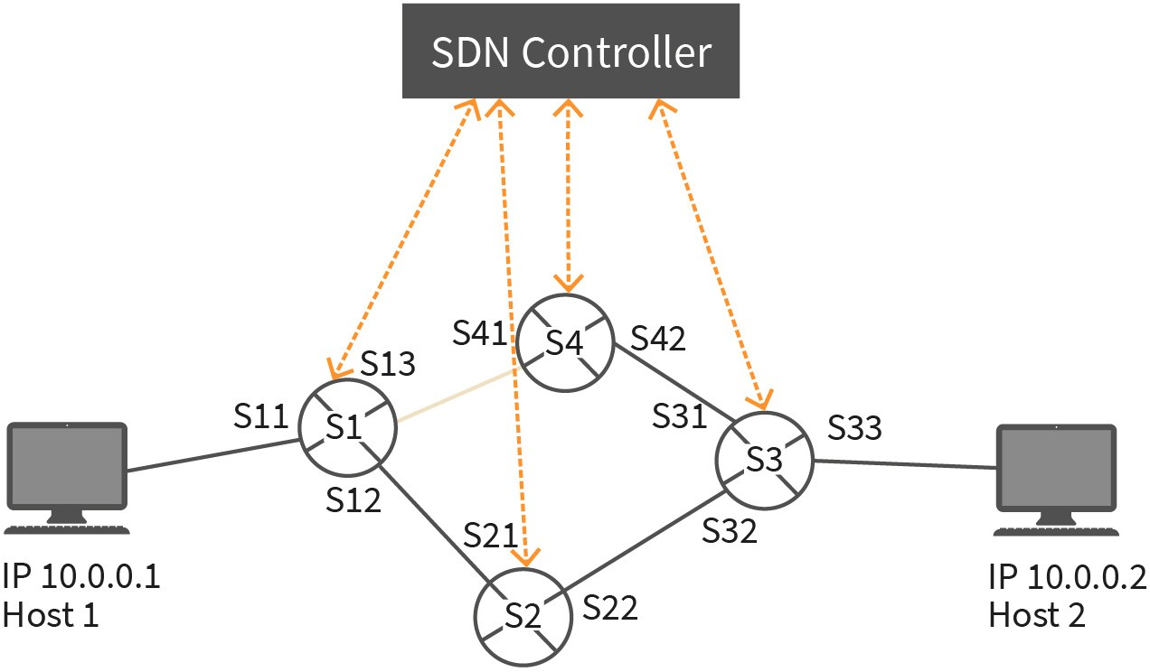

Source: Jetmir Haxhibeqiri (2023).

For the SDN controller to make appropriate and on-time decisions, network events and monitoring information need to be reported by the SDN agents to the SDN controller. A new monitoring approach has recently been applied in networks that use SDN, called in- band network telemetry (INT). INT is a monitoring framework where the monitoring hap- pens together with the data plane, by enriching the data packets with monitoring information on a per-hop, per-flow, and end-to-end basis (Isolani, 2022). Such monitoring information is included as IPv6 extensions or appended after the MAC header.

SDN is also important for mobile communication networks as it allows administrators to be more flexible and efficient when managing network resources. With an SDN network, administrators can use software to centrally manage the network, rather than controlling and managing each device individually. As such, this can lead to the following (Yang, 2015):

- increase network agility: Networks can rapidly be deployed and configured.
- improved network efficiency: SDN can help in network traffic optimization and reduced congestion.
- better quality of service (QoS): SDN can impose policies in the network ensuring traffic prioritization and QoS.
- reduced operational costs: Centralized and automated network management reduces the human costs for network management and physical intervention.

5G campus networks These are used as local 5G network for specific use cases and communi-
cation.

5G Campus Networks
A 5G campus network is defined as a local 5G network in private or public premises that is deployed (physically or virtually) to cover specific use cases and communication. Cam- pus networks are spatially limited, covering only specific sites, such as an industrial area, university campus or festival centers and can be temporal or developed to support com-

munication for big environments in a site. The 5G campus networks are deployed for industrial communication where the cellular network provided by mobile network opera- tor (MNO) cannot fulfill or support certain key performance indicators (KPIs) for such communication. 5G campus networks can operate as 5G non-stand-alone deployment, that uses LTE core network and 5G RAN, or can operate as stand-alone 5G that uses both 5G core and RAN network (Rischke, 2021).

Usually, 5G networks are operated by a mobile network operator (MNO) in the public domain. 5G campus networks can be operated and managed by an MNO or can be privately owned and managed. Depending on the level of integration between the 5G campus network and MNO network, 5G campus networks are divided into the following operating models (Angerer, 2020):

    - private stand-alone 5G campus networks
    - virtualized in the 5G public MNO network
    - hybrid integration between the 5G campus network and MNO network

In the case of private stand-alone 5G campus networks there is no form of integration with MNO network. A company that needs the services of a 5G campus network must deploy the 5G network in their premises by installing and deploying the RAN as well as core net- work for their 5G system. This operation model is suggested in cases when there is a high volume of communication, stringent quality of service (QoS) is required, and it is thought for long-term operation. On the other hand, the cost of deployment and operation of the private 5G campus network can be high and might be beneficial only for large industrial facilities. Benefits of having a private 5G campus network are dedicated radio connections that fulfill the required QoS, secure transmissions, full access to management of the core network, suitable for real-time and time-sensitive communications, high communication reliability and availability (Angerer, 2020).

In virtualized operational mode into the 5G public MNO network the 5G campus network is fully integrated with MNO network. MNO network offers a virtualized network slice for the communication needs of the campus network. The company using campus network does not need to install either to deploy any of the RAN or core network functions, thus there is no cost related to this. However, the cost highly depends on the agreement with MNO (Angerer, 2020). The MNO provides agreed QoS for the virtualized slice while blocking other unnecessary services for that slice, however, there is no dedicated radio access net- work for 5G campus network. The other services are only accessible via the public network and not via the agreed slice. This form of operation is suitable for temporary applications and for use cases where high expensive hardware deployment costs need to be avoided. Another drawback is that the data communication is not confined to the campus premises but is shared with the MNO. To avoid this, another option is to install the user plane function on the company premises, while the RAN is shared with MNO. In this case the, the data are confined to the campus premises and time-sensitive applications can be run in the 5G campus network.

In the hybrid integration model, there are two possibilities. The 5G campus network company can decide to install small cells that are controlled and operated by the public MNO, or to share the RAN with MNO but to install the private core network functions in their

premises. In the first case 5G campus network will benefit from dedicated radio access; however, the data is not confined to company premises. As such, time-sensitive and real- time applications requiring low latency cannot be run in the network. In the latter case the radio access is shared with the MNO network, but the data is confined to the company premises. In terms of deployment costs, owning the RAN always is related to the fre- quency licensing, that depends on the bandwidth required and number of channels.

The following table shows the differences of each 5G campus network deployment in cer- tain aspects:

Table 5: Comparations Between Different 5G Campus Network Deployment

 | Stand alone | Virtualized | Hybrid integration
 |  |  | Dedicated RAN | Dedicated core
Setup costs | High | Low | Medium to high | Medium to low
Operational costs | High | Low | Medium | Medium
Time-sensitive application sup- port | Yes | Possible | Possible | Possible
Data local con- finement | Yes | No | No | Yes
Robustness to external disrup- tions | High | Medium | High | Medium
Source: Jetmir Haxhibeqiri (2023), based onAngerer (2020).

From the perspective of network and data security, the stand alone 5G campus network can provide high security levels as long as all the security aspects are fulfilled and configured accordingly. This will require dedicated highly qualified staff that will take care of configuration and maintenance of the network, that will increase the costs of operation. As shown in the previous table, in case of stand-alone 5G campus networks data are con- fined locally, and they do not share the same components as public network. In case of virtualized networks or hybrid integration the security aspects are delegated to the MNO, which has dedicated staff that takes care of security configuration and faster patching of newly found network attacks, which is not the case with stand-alone approaches.

Application Layer Security
To provide communication confidentiality encryption is used to convert the message from one understanding form to another form that is understood only by communication par- ties. This will ensure only authorized access to data by authorized parties. Another important feature of cryptography is message integrity. Message integrity feature should ensure

that message is not changed in the communication channel and the message originated at a known and authenticated communication node. It must be stated that confidentiality and integrity are not the same thing. While confidentiality make the message not understandable for a third party that might get access to the message, integrity mechanism does not change the form of the message itself. It just adds a new security feature that intruders cannot change the content of the message, or if that is the case the receiver can detect it.

Next to confidentiality and message integrity, application layer security is another aspect of communication security. Let’s give an example of application layer security where message integrity is needed. Network monitoring is important for SDN networks in order to give an overview of the network performance in order to fulfill application requirements. A new technique that is used in SDN networks is in-band network telemetry, where each network node will append data packets with monitoring information (Isolani, 2022). A possible attack in this case would be if a network node will produce wrong monitor information or such information is changed in the communication channel by intruders due to absence of application layer security mechanisms and message integrity checks. In that case the management of the whole network by the SDN controller is compromised.

Application layer can be achieved in many ways. Information can be directly encrypted at higher layers of the TCP/IP reference model stack, at application and transport layer. This regards transport layer security (TLS) protocol. Another possibility is to provide security features at the network layer, as regards IP security (IPSec) protocol. Both these two proto- cols will be described in more detail in the next subsections.

Hash Functions

Hash functions are cryptographic functions that transform a message to fix length character sequence. Let m be the message, then the hash function H will transform the message m to an output H(m) that should be different from any other H(n) where n is not m. As such, the sender will send a message m and the hash of the message H(m) as (m,H(m)). In such a case, the attacker cannot produce a different message n that will produce the same hash as message m.

The most widely used hash functions nowadays are MD5 [RFC1321] and SHA-1 [RFC2404]. In order to make computationally infeasible that H(m) = H(n) for n not equal m, MD5 follows a 4-step algorithm: (i) appending padding bits so the message is congruent to 448, modulo 512, (ii) appending the length of the message before adding padding bits, (iii) accumulator initialization and (iv) processing the message in 16-bytes blocks.

Message Integrity Check

How does a receiver check the message integrity based on hash functions? First of all, both transmitter and receiver should agree on the hash function that is going to be used for the message integrity check beforehand.

The sender will produce the hash value of the message h = H(m) and append the hash value to the message (m,h). The receiver will receive the extended message and will calculate the hash function and if the H(m) = h, the message is not changed in the channel by any attacker. The appending of hash output to the message and its validation at the receiver side is shown below.

Figure 31: Message Integrity Check
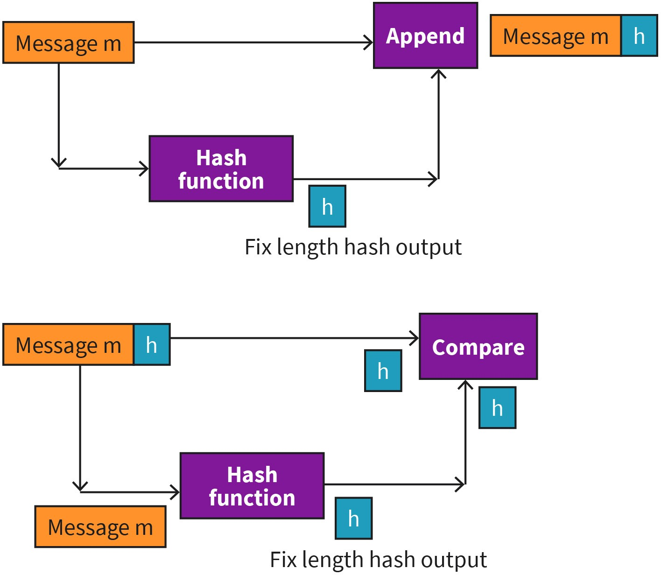

Source: Jetmir Haxhibeqiri (2023).
However, there are still possible attackers in this case. Think about if the attacker knows the hash function that the communication parties are using (which can be the case as there are certain hash function algorithms that are commonly used), then the attacker can invert the message m to n and calculate the hash of n, h_{n}, and instead of message (m,h) will send (n,h_{n}). For the sender there is no way to detect that the message is changed in the communication channel in this case.

To overcome this vulnerability, both parties will share the secret code, s, that is known as authentication key. The authentication key is a bit stream that is appended to the message before calculating the hash function. Thus, the sender will calculate the hash function of extended message h⁺=H(m+s), and send the extended message (m,h⁺). Then the receiver who knows the authentication key of the transmitter can calculate back the hash

function of the extended message and check if it is the same as the appended hash value. In this case even if the attacker knows the used hash function, it cannot produce a valid appended message as it does not know the secret key.

Digital Signature

In the physical world we use signature to agree with the content of a document or to acknowledge that a document is written by us. Like the physical world, there should be similar mechanisms in the digital world. As such, the digital key should be unique to the persons, non-forgeable and reverse verifiable.

In cryptography, encryption and decryption or just inverse mathematical functions that can retrieve the message from the encrypted message and vice versa. In case of digital sig- nature, the main point is not to change the content of the message but rather to append the message with another content that can prove that the message is original and not inverted. In cryptography the message is encrypted with the public key by the sender, while decrypted using the private key by the receiver. Since the digital signature should be unique and not known by others, one way to achieve this is to sign the message with a private key. As such, the transmitter will use its own private key to digitally sign the message, K_{pr}(m), and append it to the main message. Then, for the receivers and others that want to prove that the message is unchanged they can use the public key to check if the message is original and unforgeable by K_{pub} (K_{pr}(m)). The process of adding and confirming the digital signature is shown below.

Figure 32: Digital Signature Process
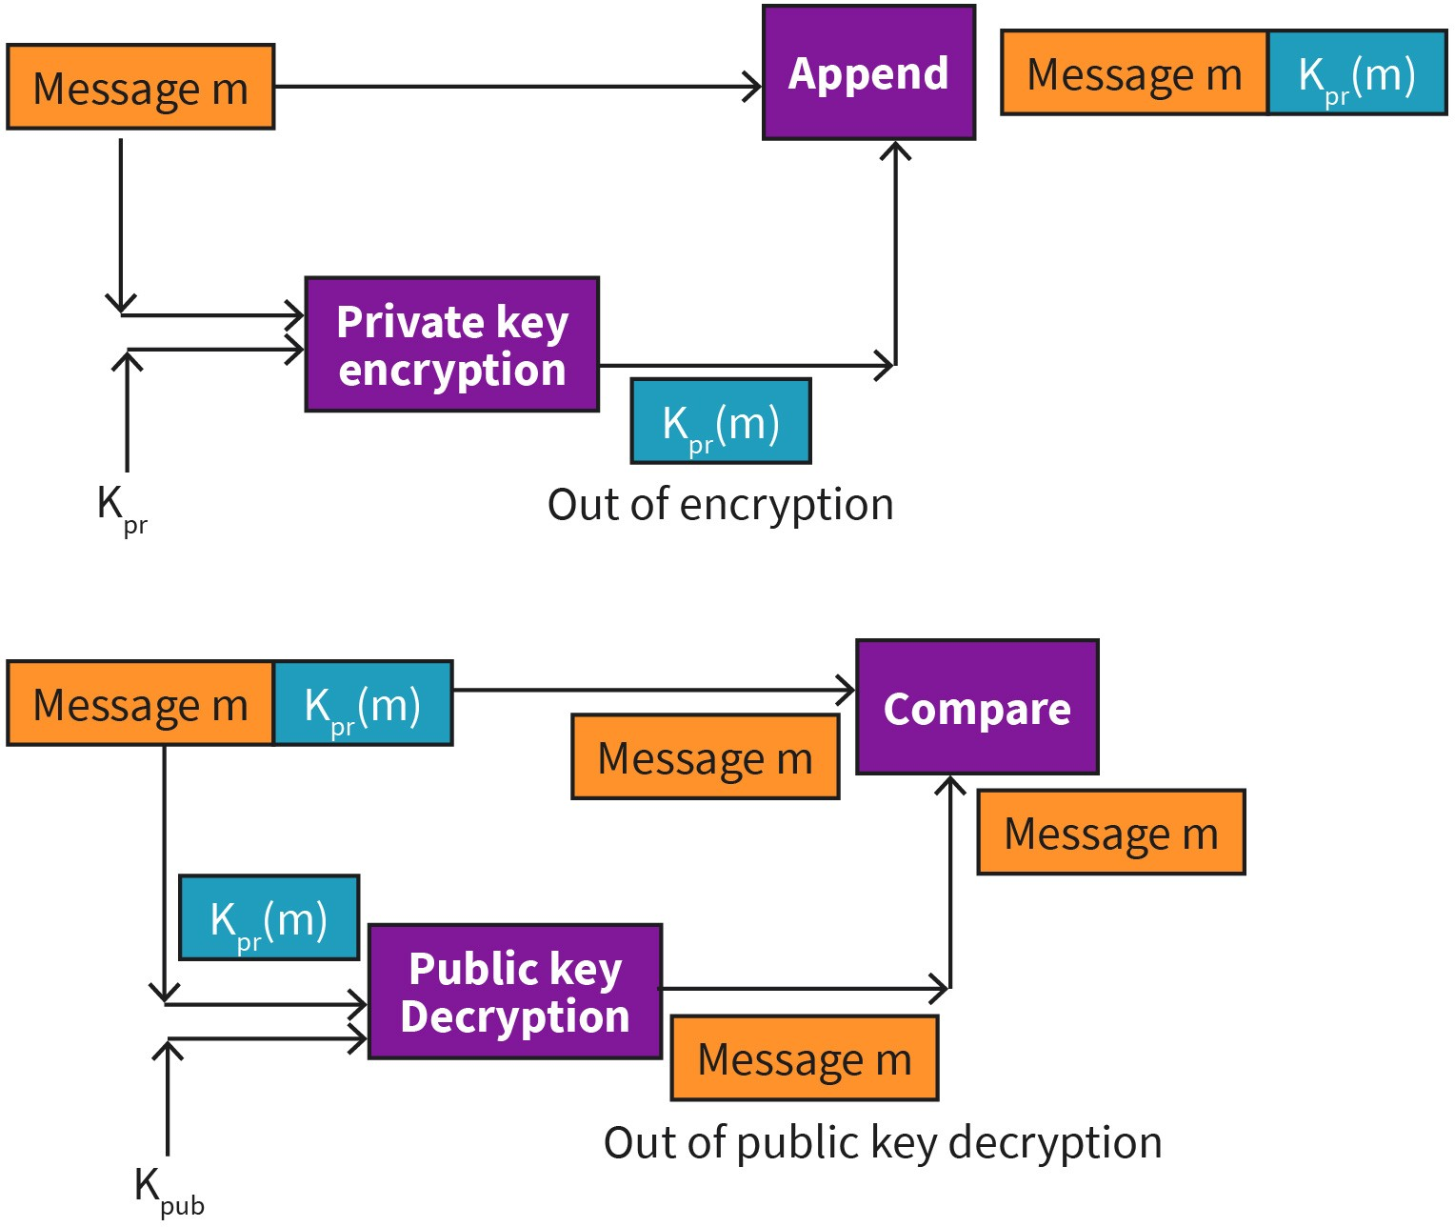

Source: Jetmir Haxhibeqiri (2023).
Let’s assume that the original document is modified from m to n, but the signature has remained the same. Then the receiver will check to decode the digital signature by doing K_{pub} (K_{pr}(m)) = m, which is not the same as modified message n. Thus, the receiver proves that the message is altered and not valid anymore.

In order to decrease the computational efforts in encrypting the whole message with the private key, a better approach would be first to calculate the hash function of the message and then to digitally sign the ash function output of the message. In that case the encryption will always be applied to a fixed length message, K_{pr}(H(m)).

For the digital signature to work, there is a need for public key verification. So, the receiver should be assured that the public key that he/she uses is the public key related to the sender. As such public key certification plays a key role in digital signature process. To achieve this verification certification authorities (CA) exist that bind between the public key and their entities by validating identities and issuing certificates [RFC1424].

Network Layer Security: IPsec

Network layer security refers to security mechanisms applied at layer 3 of the OSI model to provide communication confidentiality between two hosts in the network. This is the case for most of the companies whose communication traffic leaves the premises of the local company network and must travel via the public internet. As such, using IPsec companies can interconnect separated local networks by providing Virtual Private Networks over public Internet (Kurose, 2013).

The IPsec provides secure communication between two separated local networks or a company or between a host that is connected to public internet and its local network of the company. In case of interconnection between two separated local networks, the IPsec is implemented in the routers that connect both sites to the public internet. The IPsec takes the original IP packet and encrypts it. The encrypted original IP packet becomes a payload of another packet that is exchanged between the routers. The new packet will have a new IP header containing the source and destination IP of the routers, as well as IPsec header between the payload and the new IP header. The IPsec packet is shown below.

Figure 33: IPsec Packet
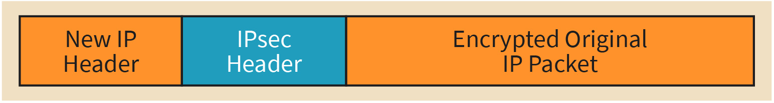

Source: Jetmir Haxhibeqiri (2023).
IPsec (Internet Protocol Security) defines three protocols to enable secure IP connections. Each protocol covers an areas of security operations (Kurose, 2013)

- key exchanged by the Internet Key Exchange (IKE) protocol
- authentication implemented by the Authentication Header (AH) protocol

Encryption by the Encapsulating Security Payload (ESP) protocol Transport Layer Security (TLS) Protocol

The transport layer security (TLS) protocol is standardized by IETF under RFC-4346 [RFC4346] for its first version and the latest version TLS 1.3 is standardized with RFC-8446 [RFC8446]. TLS is a sublayer located in between the application and transport layer. It is used to provide security and privacy for several application like HTTP, FTP, and SMTP. The TLS protocol is based on the three sub-handshaking procedure which is exchanged between the device and the server. This procedure is as follows:

- exchanging of supported security parameters
- authenticating peer devices
- negotiating and instantiating security key parameters

As shown in the next figure, TLS Handshake Procedure, the protocol exchange starts by establishing the TCP connection by TCP three-way handshake procedure. Then the TLS handshake is initiated by the client with a Hello message that includes the supported security parameters: session identifier, compression method and cipher specification. The server will reply with the supported security parameters from its side and if it agrees with the negotiated parameters. Next the server will share the authentication certificate as well with the client. Since the server certificate is issued by a certification authority, the authentication procedure of the server with the client is finished as well. On the next step, client will generate the master-secret key and send that key to the server encrypted with its public key. Then each side will use the master-secret key to generate keys needed for data encryption and message integrity check.

Figure 34: TLS Handshake Procedure
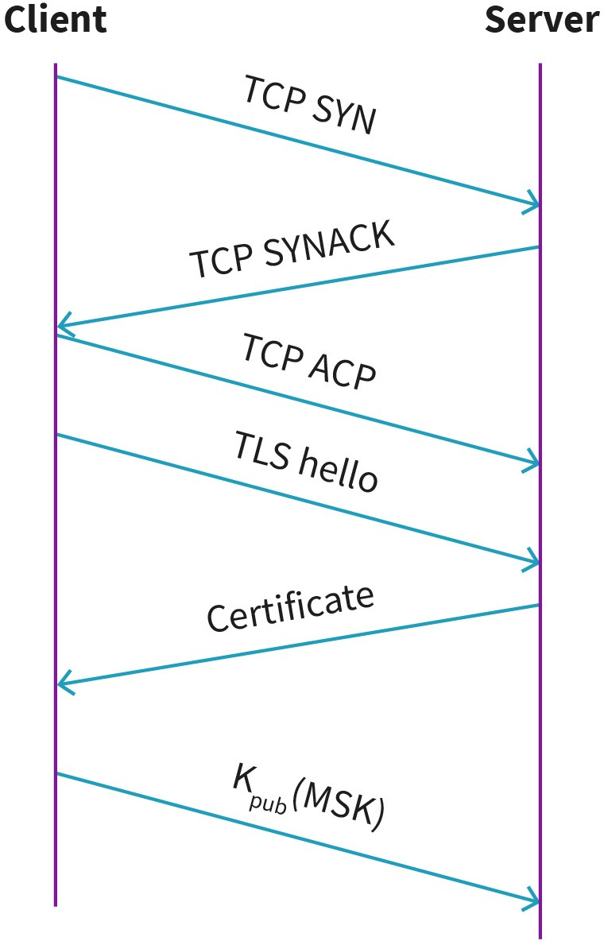

Source: Jetmir Haxhibeqiri, 2023.
The newest version of TLS is TSL 1.3 that is standardized in 2018 by RFC- 8446 [RFC8446]. The main differences with the previous versions include the faster connection setup and better security providing encryption at an early state [RFC8446].

TLS 1.3 has reduced the amount of round-trip communication to only one and a half round trip communication. Some encryption mechanisms are proved to be vulnerable, such as: RSA, RC4. MD5, and DES. As such, they are deprecated in TLS 1.3 and thus they are removed from the list of possible encryption mechanisms. Since the encryption mechanism list is shorter in TLS 1.3, client can put all the information needed in Client Hello Message and there is no need for client key exchange mechanism.

At the moment the server receives the client hello message it has all the required parameters to generate all the keys: client key share, server key share, client and server random. Based on these keys the server can generate the master secret key and encrypt the server hello message already.

Once the client receives the server hello message it generates the same master key and sends the change ciphers message to server and the authentication is finished. From now on the secure data communication can proceed.

SUMMARY
In this unit we got familiar with telecom network architecture and their building blocks. The focus was given to the network architecture of the LTE and 5G cellular networks as two currently operational cellular net- work generations. Main building parts of the cellular network, namely the core network and the radio access network, were described. While radio access network (RAN) part implements the wireless communication between the end devices and the network part via base stations, the core network part integrates the cellular network with other packet data network as well as provide network control, maintenance and monitoring functions.

With the advancement of network technologies, the network functions are getting implemented as software blocks in general purpose hard- ware. As such, in this unit software defined networking (SDN) was dis- cussed and analyzed in its main building blocks. We saw that the main SDN planes were composed of the data plane and the control plane that runs centrally in the network.

To target better service for dedicated use cases, 5G cellular networks can be deployed independently of mobile network operator in industrial campus premises. Such network deployments are analyzed in this unit, by giving different possibilities of 5G campus network deployments.

Last but not the least, in this unit different application layer security mechanisms were discussed. We analyzed the hash functions and how they are used for message integrity check of the application packets in the network. Further digital signatures were discussed together with transport layer security (TLS) protocol and its usage.

UNIT 5

HANDSET AND DEVICE SECURITY

STUDY GOALS

On completion of this unit, you will be able to ...

- understand the main device security requirements.
- outline the typical hardware design flow.
- differentiate between different steps in the hardware design flow and their impact on security.
- analyze the IoT device operation and differentiation between the sensors and actua- tors as main IoT devices.

5. HANDSET AND DEVICE SECURITY

Introduction
End device security is an essential part of networked systems, in order to ensure the security of the whole system. If one end device of the system is compromised in a way, the system security is at risk as well as the security of all the other devices connected in the network. The device security is divided in the software security that includes information security in the sense of confidentiality, integrity, and availability (known as CIA) and the hardware security that includes designs to protect hardware assets in a device (such as integrated circuits (ICs) of all types, printed circuit boards (PCBs) and passive components (inductors, capacitors and resistors). Hardware security involves also protecting hardware configuration data, firmware and programable hardware parts.

In this unit we will focus on a typical hardware design for a device and the main components. We will analyze all the phases of the hardware design and their impact on security issues. Furthermore, security requirements needed to be fulfilled by each end device are revisited and explained. Last but not least, the internet of things (IoT) device classes will be analyzed. We will cover the IoT device security requirements, their vulnerability and their main mechanisms to provide secure communication.

Requirements
System security is a paramount concern for telecommunication networks with the current trends of technological development, increased networks attacks and critical information leakage. As such, system protection targets forms and methods to defend systems from being attacked and to prevent corruption or leakage of data information from the system. As part of the system, handsets and end devices are one of the possible “doors” for the attackers to attack and harm the communication systems, thus they need to be protected with security mechanisms in software as well as in hardware part. In the past years the software security primarily based on cryptography was analyzed, while the hardware was regarded as trusted and secure. However, with the latest trends of hardware production where the chip design and production are not coupled and are done by different entities, the possibility of available “opened back doors” in handset and end device hardware is increased.

Meltdown (Lipp, 2020) and Spectre (Kocher, 2020) two possible attacks that exploit vulnerabilities of processor to outbreak the isolation between the applications and operating system and between applications themselves, respectively. These attacks allow a program to access memory locations that are reserved for operating systems as well as other pro- grams, by leaking sensitive data.

Hardware security is become a concern in the recent years due to the shift in the hardware production, where the intellectual property (IP) of system on chip (SoC) design is done by different entity from the chip manufacturer, and the supply chain of the SoC is distributed, leaving low to no control to manufacturers from the chip designer. Such a way of production gives rise to many security concerns that include: any form of modifications of the integrated circuits by the manufacturer that can make the hardware prone to hardware Trojan attacks.

A hardware trojan can be classified physically as functional or parametric. While a functional hardware trojan will change the design itself by placing new or removing certain hardware components, such as gates or transistors, the parametric hardware trojan can change the size of the chip itself, e.g., by thinning the connection lines between components. A hardware Trojan can change functionality of the hardware, reduce the availability of the hardware and leak unnecessary information (Bhunia, 2018).

As such, to overcome these issues, the two main requirements for hardware security
are as follows (Bhunaia, 2018):

- A trusted execution environment (TEE)
- The protection of security-critical assets in SoC

TEE is the one part of the main processor of the device where the code is guaranteed by means of CIA measures. The code saved in TEE cannot be changed or altered even by the own user of the device. The TEE can be used as an anchor of trust for securely booting of the device. An example of TEE is the ARM TrustZone that is a set of hardware secure extension features to ARM SoC in processor, memory and peripherals that can be used for secure bootup of the device (Zhao, 2014). The protection of security-critical assets in SoC is done by implementing security policies regarding the information flow and access control between components.

While hardware security is related to existence of hardware vulnerability that can be exploited by attackers, the hardware trust relates to the use of untrusted hardware pieces in the device or involvement of untrusted partners during the design and production phase. As stated, due to distributed way of hardware production, untrusted design and production entities can change the intended functionality, decrease the achieved performance and usability of the produced hardware in order to decrease the usage security. The trust issue can raise vulnerability issues also in safety usage of the devices and decreased performance. Think about an industrial use case where a radio frequency frontend produced by an untrusted entity is used. Untrusted entity can make the RF frontend radiate in another channel (in addition to the operational channel), which can increase the interference for other applications resulting even in safety issues.

Since in the following subsections we will use a few terminologies related to hardware security, we will define them here. A threat is a set of hardware circumstances that gives a high potential of information loss or information leakage, performance drop or decrease in usability. A hardware vulnerability is a weakness in hardware security system, e.g., a
Main requirements for hardware security These include trusted executed environment (TEE) and protection of security-critical assets in SoC.

side channel attack vulnerability (Tehranipoor, 2011). A hardware security attack is an act of exploiting hardware vulnerabilities to cause loss or retrieve of information or decrease in hardware performance.

Typical Hardware Design
Every device is composed of a set of hardware components. The main components of a device include (Bhunia, 2018)

    - device memory, used to store information,
    - device processor, used for processing the information and running the protocol stack, and
    - peripherals, used for input/output interaction with the user.

The end device is capable of capturing the physical world information and interacting with it using its input/output peripherals. In a smart phone a touch screen can act either as an input peripheral (receives the physical touch signal from the user) or as an output peripheral (shows different images in the screen). This incoming information from the physical world is transformed into digital signals in order to be processed and stored as digital signals. A similar approach happens in the communication frontend. The physical signals of the transmitted waves are transformed into digital signal by sampling the transmitted analog radio wave into I and Q samples, that will further be processed by the digital signal processing (DSP) modules.

The devices can be classified in two main groups: the general-purpose devices and embedded devices (Bhunia, 2018). The first ones include computers, switches, routers and servers and all the other network nodes, while the later ones include the mobile devices, cameras, IoT devices, home automation devices, and others. General-purpose devices have complex and highly optimized hardware architecture. On the other hand, the embedded devices are highly customized for specific use cases and have high integration between the hardware and software. However, with advancement in processors and memory footprint technology, the embedded devices have become more powerful in terms of processing power and handling of general-purpose applications (Bhunia, 2018). Nowa- days, you can buy cheap and small devices that have the same processing power as computers 10 years ago, such as Raspberry Pi, and APU boards, which in addition to increased processing power have decreased the size of the device in some cm3.

Device Hardware Layering

The software stack in each network device is organized in layers, with each layer having specific functionalities in end-to-end communication between devices. The most commonly used software stacking is the OSI layer stacking, which is composed of 7 layers. Similarly, from the perspective of hardware design, every hardware device consists of three main layers. The following are the main layers, going from top to bottom (Bhunia, 2018):

- System-level hardware
- Printed circuit board (PCB)
- Integrated circuit (IC)

The system-level hardware offers the integration of all the hardware components in a system grade, producing a usable device, such as a smartphone, an IoT device or a sensor. It encloses PCB(s) and input/output peripheral devices. Going deeper into the hardware design, we find the PCB that gives the interconnection of the electronic components, such as gates, transistors and integrated circuits. Interconnections are printed using conductive material in a multilayer insulating substrate to prevent undesirable signal leakage. At the bottom of this layering stand the electronic components including the integrated circuits. The integrated circuits can be a microcontroller, a system-on-chip (SoC) or a microprocessor.

Hardware Production Life Cycle

The device design, its development, production, and maintenance process (known as the device life cycle) might be vulnerable, causing the malfunctioning of the device. As such, we will discuss the vulnerabilities and trust issues in the hardware production life cycle.

The biggest trust issues in hardware comes from the distributed way of hardware design and production. In order to understand the rise of trust issues, we will revisit the hardware production life cycle steps. The hardware life cycle phases include

- Functional specification phase
- Design and validation phase
- Component fabrication phase
- Package assembly phase
- Package assembly test phase
- PCB and system integration phase

Out of all these phases, only the first two phases can be trusted, since they are performed by the design owner entity. Trust in the first two phases comes from the fact that after the first two phases more entities are included, increasing the introduction of vulnerabilities in the hardware itself. However, even during the first two phases vulnerabilities might be introduced if the designer is not trusted, and not carefully followed the security measures. In all the other phases, involvement of new entities in each phase can break the trust and increase hardware vulnerabilities.

User Equipment (UE) in the Cellular Network

A user equipment device is composed of the telephony subsystem, the general-purpose mobile operating system (OS), cellular network radio and other communication modules (Bluetooth, Wi-Fi, near-field communication (NFC), and others) and the hardware token. The general-purpose mobile OS can be Android, Windows Phone, or others, and depending on the phone producer, and provide interaction between the users and applications installed in the phone. The telephony subsystem usually is developed as software on chip (SoC) in the baseband processor by cellular manufacturers and provides interaction

between the user equipment (UE) and the cellular network itself. Usually the telephony subsystem runs a real-time operating system (RTOS). The cellular radio operates on specific channels to connect the UE with the cellular network being it 3G, long-term evolution (LTE) or 5G network. The removable hardware token is commonly known as Subscriber Identity Module (SIM) card that is a smart card that contains the secret cryptographic key and runs the application that enables network access.

The UE lies under the embedded device category that is highly customized for mobile communication. The main challenges in UE hardware design are the battery design constraints, SoC design constraints as well as antenna design and distribution (Huo, 2017). UE is equipped with different wireless technologies and antenna system need to support not only different bands and wide range of frequencies (700 MHz to 6 GHz), but also should support antenna diversity for MIMO in 5G networks.

Trustworthiness during the life cycle of the UE depends fully on the designer and producer. Due to such matters, there are certain bans for certain products from specific producers in different countries. An example of this is the United States' ban of telecommunication products from Huawei producers due to security aspects and their trustworthiness (Reuters, 2022).

IoT Devices
The Internet of Things relates to the connection of physical objects, sensors, auctors and other non-standard devices different from desktops, PCs and laptops to the Internet. The embedded devices are getting more efficient, increasing the processing and memory power and decreasing the initial costs, with more communication capabilities, such as Wi- Fi, Bluetooth and cellular. With such a development, integrating such devices to network is possible as well. As such, IoT extends internet connection to “dump” devices and everyday objects. The IoT has grown in the last decade with IoT nodes connected to the internet reaching ~13 billion by 2022 surpassing the human population (Stats, 2022).

IoT devices are low-end devices composed of a communication module, a processing unit and a storage unit. Usually, IoT devices are battery powered, and the main concern during the design of IoT devices is reducing the energy consumption while maintaining the functionality for what they are designed (e.g., communicating sensing information, action to the received commands). Due to limitation in energy consumption, communication capabilities, computation and storage capabilities, IoT device security is a challenging task.

The embedded devices are a subset of IoT devices, which do not have any communication capabilities to be connected to the Internet. Depending on the use case used the IoT devices can have different processing and communication capabilities. For agriculture monitoring use case an IoT device does not need to have a high processing power but should include long-distance communication. On the other hand, for a safety-critical scenario an IoT device needs to have sufficient processing power in order to support certain security mechanisms.

IoT Security Requirements

IoT device security requirements can be grouped into three main levels (Meneghello, 2019), namely, the information level, the access level, and the functional level. At the information level security mechanisms should ensure integrity, anonymity, confidentiality and privacy of information passing through or started in the IoT device. This is the general security aspect even for every internet device.

At the access level, security mechanisms should specify certain features to control access of the IoT device to the network. These features include the following (Meneghello, 2019):

- Access control mechanisms guarantee access only for legitimate users to the IoT device and network administration functions.
- IoT device authentication mechanisms check if the IoT device is allowed to access the network. This is the first step before establishing communication between the device and the network.
- The authorization mechanism ensures that IoT device access only the authorized serv- ices in the network.

At the functional level, security mechanisms should ensure IoT device functionality throughout the operational time. These mechanisms should include the following (Mene- ghello, 2019):

- resilience: ensures that IoT devices should stay operational even under security attacks as well as fast restore in case of breakdown. This is the hardest function to reach in the IoT network.
- self-organization mechanism: ensures the IoT network remains operational based on automatic readjustment after a security attack in the network

IoT Security Vulnerabilities

An IoT system can be separated into edge, access/middleware and application part (Pielli, 2015). While the edge part implements the physical and medium access control (MAC) layer to provide local communication between IoT devices and gateways, the middleware layer does the intermediary between the IoT world and Internet. An example of middle- ware layer is 6LoWPAN, that provides mapping between the IPv6 layer on the Internet side with low level layers of LoWPAN devices. Similarly, in case of Bluetooth Low Energy (BLE) we have IPv6-over-BLE [RFC7668], that makes use of 6LoWPAN over BLE by considering the BLE frame formats and features. An application layer implements the IoT device functionality and offers service-level communication with the network as well as other IoT devices.

Due to IoT device constraints, several security vulnerabilities exist that here we will separate based on the layer at which they occur.

At the physical and MAC layer the main threats for IoT devices are side channel attacks and hardware trojans. Side channel attacks utilize analysis of side information, such as communication timing, electromagnetic radiation and power consumption to leak informa-

tion from encrypted packets. As such power consumption of the IoT device can be exploited to recover and guess encryption keys based on statistical analysis of a large amount of traces.

IoT devices are vulnerable to hardware trojan attacks as well. Such attacks can make the IoT device unavailable for the user, achieving Denial of Service attack by e.g., battery power drain, jamming of communication channels for other devices without hardware trojan.

At the middleware layer, there are several vulnerabilities that can be exploited by attackers such as Address Resolution Protocol (ARP) spoofing (making nodes think that the next hop is some other node rather than the legitimate one), DHCP server spoofing (a rouge DHCP server that replies to the IoT device requests and reroutes the traffic), packet drop- ping, fraudulent packet injection, etc.

Application layer vulnerabilities relate to the software stack running in the IoT device and directly expose the risk toward functionality of the IoT device. Application layer threats can be divided into four main categories (Ronen, 2016) (i) ignoring of IoT device functionalities, (ii) reducing IoT device functionality, (iii) misusing IoT device functionalities and (iv) extending IoT device functionalities for malicious purposes.

IoT Security Mechanisms

Encryption is one of the main security mechanisms to provide information security in IoT devices. Encryption is a process of changing the main information into a different one using a function that can be inverted using a known shared secret. In IoT systems the communication usually is broadcasted or multicasted in downlink. Recall massive machine type communication when single gateway or access point will serve multiple end devices. In this scenario, symmetric key encryption is not possible, as such, public key encryption is preferred. Due to limitations and power constraints the decryption takes time and resources of the end node. As such, some approaches allow for the message to be sent in the plaintext attached by an encrypted tag that saves the authentication of the sender. Then each device can get immediately the plaintext while only one selected device per group of devices will authenticate with the tag attached to the message (Stallings, 2017). If not correct it will inform the other devices. To improve further the encryption process for low-end IoT devices, other lightweight encryption mechanisms are specified, such as PRESENT, CLEIFA, PRINCE (Fremantle, 2017).

Next to encryption, being able to generate random numbers is an important feature for security protocols in order to e.g., generate nonces, avoid reply attacks or generate asymmetric keys (Meneghello, 2019). Random number generators exploit physical characteristics of the device. Two main random number generators are: true random number genera- tor (TRNG) that exploit the randomness of the white noise from the communication channel or other noise sources in the device, and pseudo random number generator (PRNG) that creates a long random sequence of bits from a short key using a deterministic algorithm. Again, due to power limitations TRNG is not feasible to be implemented in IoT devices, but rather lightweight PRNG algorithms are used.

IoT devices are deployed in remote areas where they can get physically in contact with possible attackers that can do side channel attacks. One way to prevent this is by adopting physically unclonable functions (PUFs) to improve hardware security (Meneghello, 2019). PUFs exploit the little differences in chip manufacturing process to generate unique signa- ture for each device. However, this approach increases power usage of the IoT device and is feasible only for devices where power consumption is not a problem. The table below summarizes some of the vulnerabilities and their countermeasures in IoT network.

Table 6: IoT Security Vulnerabilities and Countermeasures

Vulnerabilities Countermeasures

Side channel attacks Hardware trojans Physical attacks | Physical unclonable functions (PUFs)
Eavesdropping attacks Application layer attacks Packet injection | Full message encryption  Attach of encrypted tag to message
Source: Jetmir Haxhibeqiri (2023).

SUMMARY
During this unit we analyzed the end device and handset security approach mechanisms, as one of the most challenging nodes of the net- work from the security perspective. The focus was given to the hardware design of the end devices and what are the main requirements for hard- ware security. We analyzed further the main hardware component parts of the end device: device memory, device processor, communication part and device peripherals.

Next to this we zoomed in the device lifecycle and all the steps during the device hardware production. Due to the distributed way of hardware production, we analyzed trust and security aspects of each phase. Last but not the least, the IoT devices were discussed including IoT device security requirements, IoT security vulnerabilities and security mechanisms to overcome such vulnerabilities.

UNIT 6

THREATS

STUDY GOALS

On completion of this unit, you will be able to ...

- understand and analyze the threats and common attack vectors on the end devices.
- analyze the mitigation possibilities on the attack vectors against end devices.
- explain the threats and common attack vectors against core network.
- outline the mitigation possibilities on the attack vectors against core network.
- describe and analyze threats against 5G campus networks.

6. THREATS

Introduction
With the development of communication technology and the increase of its usage by the general public, the number of cyberattacks in communication networks has increased as well. Attackers try to exploit different network security vulnerabilities by taking different paths in order to get access to networks or data communicated or saved via/in those net- works. Such attacking paths are commonly known as attack vectors.

A network attack can be active or passive. In passive network attacks, attackers get access to the communication network but do not change the data passing through/saved in the network but just steal sensitive data that can be used by them for malicious purposes. In passive attacks the attacker does not interact with the users. In active attacks, attackers get access to the network and change the data passing through/saved in the network by deleting, encrypting or changing them.

In order to mitigate the network vulnerabilities and possible attacks, a network engineer should understand the common attack vectors used by the attackers, so mitigation would be possible. In this unit we will discuss the common attack vectors on end devices, on the core network and campus networks.

Common Attack Vectors Against Devices and Handsets
The mobile device technology stack is composed of hardware, firmware, operating system and applications. While the telephony subsystem uses dedicated hardware and firmware implemented in System on Chip (SoC), mobile devices are composed also by different communication technologies and front ends, such as cellular radio, Wi-Fi, Bluetooth, near- filed communication (near-field communication (NFC).

Attack vectors are grouped into mobile application attack vec- tors, communication part attack vectors, authenti- cation attack vectors, net- work stack attack vectors, and physical attack vec-
tors.
Depending on what part of the mobile device technology stack is attacked, we will classify the attack vectors in the following categories, as specified in (NIST, 2016):

- mobile application attack vectors: These vectors are related to threats and vulnerabilities coming from software of mobile applications running in the general-purpose operating system of the mobile device.
- communication part attack vectors: These vectors are related to vulnerabilities and threats coming from using communication technologies like cellular, Wi-Fi or GPS.
- authentication attack vectors: These vectors are related to vulnerabilities and threats coming from authentication mechanisms between the user and mobile device, mobile device and service in the network and mobile device and network itself.

  - network stack attack vector: These vectors are related to vulnerabilities and threads to different mobile technology stack (operating system (OS), firmware, SIM card, device drivers or trusted execution environment (TEE))
  - physical attack vectors: These vectors are related to vulnerabilities and threats from physical attacks and changes to the mobile device.

According to MobThreats (n.d.) out of all the reported threats for mobile devices, the highest percentage is the cellular and network stack attack with 18.6% each, then comes application attack vectors with 18.2%, then authentication attack vectors with 5.9% and physical attack vectors with 3.4%. In the following subsections, we will describe each of the categories mentioned.

Mobile Application Attack Vector

When an app communicates with a server in the network, all unencrypted traffic at the application layer can be eavesdropped on by an attacker by accessing the physical wire- less media (MOBILE, 2018). Even though the data might not be sensitive, attackers can use such data for other attacks on servers. To mitigate such attacks a mobile user can use always secure connection (HTTPS) to connect to the web server if possible. As an application developer you can use other forms of encryption employing transport layer security protocol, while as enterprise network manager you can employ VPN connection to increase security.

Another form of attack on applications is man-in-the-middle attacks. If mobile app has a weak authentication mechanism (e.g., dose not validate the server certificate), then a man-in-the-middle attack can occur, where the attacker impersonates the back-end server and receives all unencrypted traffic from the end device to it and can modify the data in transit. Mitigation of MiTM is to use public key encryption in communication server, or to implement a fail-safe logic where the communication is stopped when the server certificate validation fails.

While cryptographic mechanisms are used by mobile applications, choosing the cyphering that is easily brute force broken can be exploited by the attackers. Saving the crypto- graphic key to the source code should be always avoided. Also in order to avoid the unauthorized disclosure, variables that save the encryption keys should be overwritten after every time they are used.

Other mobile application attack vectors include usage of third-party libraries that are vulnerable to attacks, or exposure of functions and data untrusted apps that can be exploited by the attackers to get access to sensitive data. To mitigate such attack vectors, app vet- ting tools exist that identify apps that use vulnerable third-party libraries.

A malicious app is a software program that is designed to harm or exploit a device or its user. This can include stealing personal information, spreading malware, or performing unauthorized actions on the device. Users should exercise caution when downloading and installing apps, and only download from reputable sources, such as, official app stores like GooglePlay and the Apple App Store. It is also a good idea to regularly check for and remove any suspicious or unwanted apps from your device.
malicious app
a software program that is designed to harm or exploit a device or its user

On mobile devices, malicious apps can be introduced in several ways (Sharma, 2021):

- The re-packing of a legitimate app includes the creation of a genuine app that can have malicious codes and distribute those codes to users via third parties app stores.
- Bug exploitation refers to a genuine app that is used by an attacker to compromise the user’s data.
- Fake applications are used by attackers to make users think that they are installing the correct app. For example, a fake application of a bank app can be used by attackers to get the access codes of the users to their accounts. Two-factor authentication is often used in these cases.
- Remote installation is used to install other malicious apps to a mobile device remotely by an attacker.

Communications part attack vectors

A mobile device is composed of multiple communications technologies, thus there exists several attack vectors for each of them. Jamming of the air interface is one of the commonly wireless attack vectors that is common for all wireless technologies. It is an attack vector the cause the service interruption and decreases the network availability for the mobile node. Radio jamming is the easiest attack vector in wireless mobile devices as it can be achieved by decreasing the signal to noise ratio for the mobile devices in certain channels by transmitting dummy signal in the frequency band. Radio jamming can be done on specific channels at specific time to avoid detection and is referred to as smart jamming, while continuous jamming of all the frequency band is easily detected and is referred to as dump jamming (NIST, 2018). While for Wi-Fi networks radio jamming can be easily achieved by a cheap software defined radio (SDR), for cellular communication more advanced equipment is needed.

Another common attack vector for all wireless communication technologies is eavesdrop- ping on air interface of unencrypted traffic or purely encrypted traffic (recall WEP in Wi-Fi networks). While in 5G networks the data traffic is both encrypted and integrity check, in long-term evolution (LTE) the integrity of data plane traffic in the air interface is not checked. Even if the data traffic is not encrypted at all, the eavesdropping attacks in cellular radio interface (LTE or 5G) are complex. The attacker needs to know the exact channel that the user is using and the time slots that are used for the data traffic in order to be able to demodulate the captured traffic into data IP packets (NIST, 2018).

A downgrade attacks are related to making a connection or protocol to use an older version that is less secure, and which can be further utilized to initiate other attacks on the victim device. A downgrade attack in the communication part of cellular network can be achieved by a so-called rouge base, where a node connected to compromised base station is instructed to downgrade its communication to older cellular generations (e.g., 3G) (Enisa, 2020). Then in case when the downgrade has already happened, different security aspects can be exploited for further attacks like IMSI catching attacks in 3G network where IMSI is transmitted unencrypted (Palma, 2021).

Another attack vector is via compromised femtocells. Femtocells are used in both LTE and 5G standard for improving the indoor cellular connectivity, while using the owner’s inter- net connection to connect to the network. As such the standard requires use of the IP security [REF] protocol between the femtocell and the femtocell gateway to protect the data traffic on the internet outside the mobile operator network (NIST, 2018). However, if the femtocell is in physical possession of an attacker it can be compromised, by giving access not only to the data traffic but also to the encryption keys used by the end device (DePerry, 2013). Similarly, small cells can be less updated to patch security and configuration, exposing this to possible vector attacks to eavesdrop calls and data going through the small cell (NIST, 2018).

Other Denial of Service (DoS) attacks can be achieved by different attack vectors in cellular networks such as: message injection, SMS-induced DoS and silent message DoS (NIST, 2018). In all cases the attacker will send a stream of messages (or SMS) to the mobile device in order to make the mobile device incapable of serving the user. As such the serv- ice availability is limited.

Authentication Attack Vectors

Mobile devices use personal identification number (PIN) or user biometrics to give access to the mobile device. Biometrics, such as fingerprinting, and face recognition are part of the latest releases of mobile OSs in Android as well as iOS.

Certain attack vectors try to gain access to the mobile devices by brute-forcing the PIN/ password of the mobile device. Other attack vectors on PIN/password used to access mobile device include interfering PIN/password information from sensors of the device or by screen smudges (NIST, 2018). Each mobile device has sensor data that can collect information on which part of the screen user presses. If allowed, certain malicious applications can collect such information inferring PIN and passwords of the mobile device. Such attack vectors can be prevented or the required time to brute force the PIN/password can be extended by choosing longer and more complex PIN/passwords. To determine the number of all possible combinations with a subset of n elements out of a set with k element, the following formula can be used:

Ckn =
k!
n! k − n !

So, the number of combinations with 4 ciphers out of 10, is only 210, that is not that high for the current processing times of modern processors. Further, if you want to find all the permutations with a subset of n elements out of a set with k elements, the following formula can be used:

Pkn =
k!
k − n !

Other vector attacks authentication between the mobile devices with the services in the network. One such form of stealing authentication credentials is by sending phishing emails or man in the middle attacks (MOBILE, 2018). Phishing emails are personalized emails sourced from attackers, that look pretty much the same as coming from a trustful

source, that asks the user to access certain website. Then by providing the authentication credentials, the attacker can get access to the main user profile of that site. Similarly, MiTM attacks can redirect the user to malicious websites to steal the authentication credentials of the user. Such attacks can be prevented by being more attentive to the phishing emails and websites we browse.

The last vector attacks deal with the possibility to steal authentication credentials of the mobile device with the network itself. A common attack vector in this regard is insecure credential storage of authentication data by different apps in the device (MOBILE, 2018).

In cellular networks the International Mobile Subscriber Identity (IMSI) (for 3G and 4G net- works) is used only at the beginning when the user registers with the network and the temporary identifiers are not yet available. In any other case the user will use the tempo- rary identifiers in order to protect the IMSI. However, there are cases where the attackers might force the user to re-connect to the network and share the IMSI where IMSI is steeled from the signaling messages between base stations transmitted as plain text broadcast messages. Such attacks are known as IMSI Catcher attacks (Palma, 2021). In 5G the IMSI is encrypted using public-key encryption.Physical Attack Vectors

Physical attack vectors include all attacks done in person by attackers. Here it includes device loss and theft, where the attacker will gain full access to the mobile device. SIM card swapping with a compromised SIM that gives the attacker the possibility to run malicious java applet in the new SIM (MOBILE, 2018). A new way to mitigate these forms of attacks is integrated SIM cards or eSIM, that cannot be physically swapped. Another physically attack vector is malicious charging stations that can cause battery overheating and battery damage. To prevent this attack, allow an overheated battery to be cooled down, use certified charging stations or charge the mobile device from a USB port.

Common Attack Vector Against the Core Network
Mobile core network architecture provides control, administration, and maintenance functions for radio access network (RAN) as well as bridges the data traffic from the mobile network toward the Internet in the data plane. With the advancement in network virtualization function (NFV), software defined networking (SDN) and edge computing technologies the core network in case of 5G network can be deployed in distributed fashion in general-purpose hardware devices. Moreover, such technologies offer the possibility to support ever increasing number of services and use cases that 5G supports.

Core network in 4G and 5G, has evolved to fully packet-switching networking. As such, certain attack vectors that are valid for IP-based networks can be used against core networks as well, such as: domain name system (DNS) server hijacking, and routing manipulation. In this subsection we will focus on the attack vectors that can be used toward core net-

work by exploiting potential security vulnerabilities of technologies introduced to 5G (edge computing, NFV and SDN) as well as attack vectors inherited from the IP based net- works.

Security Challenges in Core Network

The main security challenges in mobile core network relate to the introduction of new technologies of the core network (edge computing, NFV/SDN) and other challenges inherited from the IP based networks. Some of the main challenges of the core network include (Ahmad, 2018)

- user plane communication integrity,
- roaming security,
- denial-of-service attack in the network infrastructure, and
- signaling storms.

Current user plane communication in 5G does not include integrity checks. As such, data traffic can be altered by the attackers and go undetected, incurring malicious behavior of the applications. Roaming security can be compromised as user security parameters are not updated after roaming from one network operator to the other. Control information shared in unencrypted channels can be used by attackers to perform denial-of-service attacks in the infrastructure of the network control plane. Consequently, a network data plane can be attacked as well. Similarly, signaling storms in distributed control systems can cause part of the system to be unresponsive on due time.

It must be stated that at the moment internal protocols used in the core network, such as Packet Forwarding Control Protocol (PFCP), GPRS Tunnel Protocol (GTP) are not the focus of security considerations. However, there have been studies regarding the security aspects of the GTP, and there is possible to perform man-in-the-middle and denial-of-serv- ice attacks against GTP (Kim, 2020).

Attack Vectors on SDN

SDN offers logically centralized control plane for the packet forwarding logic in the net- work. It simplifies network management and increases network programmability; how- ever, it imposes new challenges for network security as well.

An attacker can attack the SDN logic in three different ways: by performing attacks on con- trol plane, by performing protocol attacks or by attacking programable interface (APIs) between the controller and the agents and vice versa.

An attack on SDN control plane refers to attacks where the forwarding policy is deduced by analyzing the forwarding performance metrics (Enisa, 2020). Next to this, fully centralized network controllers pose a security risk of DoS attack on control planes by compromised agents, while distributed controllers can be vulnerable by compromised distributed controller entity performing signaling storm attacks.

A protocol attack refers to attacks targeting data plane by exploiting vulnerabilities of packet forwarding devices, being those software or hardware vulnerabilities (Enisa, 2020). Packet forwarding devices in SDN case are “dummy” devices without any embedded intelligence, they can only be programmed by the SDN controller. As such, an intruder can exploit firmware bugs on devices or hardware issues (memory leakage) to get access and to change the forwarding rules in the device. Compromising one packet forwarding device in the network might cause other issues in other network devices, e.g., increased in load, decrease in network node performance.

Programmable interface (API) attack can be done on the southbound and northbound interface of the SDN controller. The southbound interface can be made unavailable using TCP-attacks achieving DoS for the SDN agents. In this case the southbound interface is flooded with TCP-SYN packets. Other attacks can eavesdrop on the packets between the SDN controller and agent, to understand forwarding policy in the network to perform further DoS attacks on data plane. Once the forwarding policy is understood by the attacker, the DoS in the data plane is achieved by sending packets that match certain rules. Finally, interaction attacks are performed to invert the forwarding plane logic, by malicious packet interaction insertion. Similar attacks can be performed on the northbound interface of the SDN controller. However, attacks on northbound interface can have higher impact on the network as the attacker most probably has higher penetration in the application side and can impact the whole network performance.

Attacks on Multi-Access Edge Computing (MEC)

Multi-access edge computing (MEC) provides edge computing capabilities in the 5G net- work closer to the end user to achieve low-latency and high-throughput communication. MEC provides services that in previous generations used the run-time of the end-users or were not possible to be offered. To support orchestration between MEC applications, an MEC orchestrator maintains the overall view of the MEC system, selects MEC host(s) to run applications, triggers application initiation (Enisa, 2020), etc. MEC leverages multiple virtualized systems to optimize hardware processing resources for different applications.

MEC exposes several possible attack vectors in the network. Since MEC uses open APIs for the developers, providers and content creators for the end device, this introduces a new attack vector like malicious software execution on containers. Since MEC utilizes virtual resources in shared hardware resources, this can result in cross-contamination of the system from the malicious containers. Containers requiring root privileges can increase the risk to host as well as to other containers (Enisa, 2020). Further, DoS attacks can be performed on MEC orchestrator to put the whole MEC system out of service. Other attack vectors on MEC infrastructure include orchestrator hijacking, resource theft, configuration attacks, etc. (Ahmad, 2018). Back-end attacks can be performed in MEC systems that tar- gets the edge servers, protocols, storage systems and virtual machines. In this category we can classify the XML DoS attacks and data-replication attacks to decrease the performance of the MEC (Salahdine, 2022).

Attack on VNF and NFV

The core network of the 5G systems is based fully in micro-service architecture where net- work functions run as software in distributed hardware nodes. The virtualized network functions (VNF) relate to the software form of the core network nodes that are deployed as virtual machines in off-the shelf devices. All the VNFs are controlled, managed and orchestrated by the network function virtualization (NFV) framework.

One vulnerability of the NFV is VNF dynamic nature that might cause configuration errors leading to security breaches. In addition to this, VNFs are vulnerable to common vector attacks, such as IP/MAC address spoofing, sniffing or DoS attacks (Ahmad, 2018). Spoofing is done either to invoke distributed DoS attacks or to impersonate a legitimate user/node/ device. Since VNFs run as virtual machines or virtualized containers, they are vulnerable to virtualization attack vectors such as: side-channel attacks, flooding and hijacking orchestrator attacks, and malware and spyware injection. In orchestrator hijacking attacks an attacker takes control of the main controller/orchestrator and via it misconfigures other devices, in this case the VNFs (Ahmad, 2018).

Potential Attacks Against 5G Campus Networks
5G campus networks are dedicated 5G system deployments for serving specific campus area (e.g., an industrial plant) in order to support specific use cases in terms of communication latency, throughput and the number of devices. 5G campus networks can be deployed as private stand-alone 5G campus networks, virtualized networks in the 5G pub- lic mobile network operator network or as hybrid integration between the 5G campus net- work and MNO network. Each of the network deployment approaches has its pros and cons in terms of applications supported, security measures needed and operational and maintenance costs.

The 5G campus network integrate cellular networks, IT networks and the operational net- work of the campus (e.g., industrial plant) into one. Security attacks in any of the network parts will cause security issues on the others. As it is known, the campus networks are deployed with the aim to fulfil certain key performance indicators (KPIs) over certain time and specific area for specific use cases. As such even the attack vectors used against cam- pus networks depend highly on network usage. For example, a denial-of-service attack is the most common attack vector in a campus network designed for highly reliable and low latency communication in an industrial scenario. On the other hand, man-in-the-middle attack can be the most common one for campus networks designed to handle security critical data. As such, in this section we will focus on the potential attack vectors against these parts of the network.

Attack Entry Points

To compromise a 5G campus network an attacker must exploit entry points that are weakly secured. Such entry point can be one of the servers that hosts any of the 5G cam- pus network core services, containers or virtual machines that run such services, managed routers or switches that interconnect core network hardware servers or the management ports of the core network (Lin, 2021).

Server nodes that host the 5G campus core network services usually are commercial off- the-shelf (COTS) devices running Linux operating system distribution. An attacker can use vulnerabilities of the operating system itself, zero-day vulnerability, an unpatched vulnerability or even usage of weak passwords to protect access to the node. The zero-day vulnerability relates to vulnerabilities that are exploited by the attackers that are not yet known by the producer or maintainer of the software/hardware part.

Services usually run on virtual machines (VM) or docker containers that are usually highly secured and separated. However, attackers can still use the unpatched doors, misconfigurations (exposure of the security information in log files in the host device) or usage of weak password.

Similarly to an IT network, the network infrastructure that interconnect hardware devices w5G core network services are running can be under attack due to old unpatched doors. Thus, 5G campus core network can end up under the same attacks as in an IT network like IP/MAC address spoofing, impersonating the server, session hijacking, and others. As the availability of the communication network is a crucial point in the campus networks, frequent patching can cause certain services to be down for certain times. In absence of complementary service in the network, patches might be done less frequently compared to a MNO network (Lin, 2021).

Attack Vectors

In the following subsection we will discuss some of the attack vectors that can prove to be detrimental in the way how 5G campus network operates (Lin, 2021).

DNS Hijacking

When a user equipment (UE) registers with the Session Management Function (SMF) in the 5G campus network, it will get assigned to one or more DNS servers. The DNS hijacking can happen either by compromising the DNS cash server in the 5G campus network or by hijacking a legitimate DNS response, achieving redirecting the DNS traffic toward an illegitimate DNS server. In both cases the DNS record must be updated as well. Then the attacker can control the user equipment by downloading malicious firmware, updating applications, and changing any other parameters in the UE.

SIM Swapping

SIM swapping can either be done physically by replacing the SIM card on the UE, or by taking over the ISDN of the SIM and assigning it to another SIM card (Lin, 2021). By doing so, an attacker can have access to the data network of the campus.

An attacker can come to contact with the original SIM either by picking up a crashed device drone in the campus, or by having physical access to the campus network devices.

Access Point Name (APN) Security in Campus Network

The Access Point Name (APN) is configured by the mobile network operator in the UEs and gives the identity of the gateway that connects the user equipment (UE) with the internet. Usually, to offer possibility for campus networks separation and to support certain QoS, in case of virtualized campus networks, MNO can ask for custom configuration of APN in the campus network UEs.

Once the authentication between the UE and the core network has taken place, the APN identifier is exchanged between the UE and the core network. This message is already encrypted in the air interface, to be decrypted in the gNB and forward further in the core network. If the attacker has access to the N2 interface, then the APN name is noticeable in clear text (Lin, 2021). Differently, if the attacker has access physical to the UE, it might change the SIM to make UE communicates with attacker gNB. Then the device will be rejected due to an unknown APN from the network, and APN is retrieved by the attacker (Ciancaglini, 2021).

The custom APN from the MNO does not mean higher security. To overcome the APN retrieval by attackers, VPN/IPsec between the base station and the core network is a must, when using public internet (Lin, 2021).

SMS Brute Force Attacks

In campus networks many devices that are connected to cellular campus network support remote SMS configuration in case the link toward them is blocked or broken. Via SMS commands the device can be rebooted, check the connection status or even change certain configuration parameters, such as APN.

Even though SMS-based remote-configuration is password-protected, the default pass- words are usually the last 4 digits of the SIM card identifier (Lin, 2021). An attacker can get the last digit of the SIM card identifiers as they are the same as the IMSI identifier. As such, an IMSI catcher attack can reveal the default password.

On the other hand, even if the password is changed to not a default one, it is prone to brute-force attacks. Thus, it is recommended to have a strong password for the SMS-based configuration link.

Other possible attack in this case is to send SMS to the device and make the device respond with wrong password message to increase the costs of messaging for the com- pany owning the campus network. In the same time, a denial-of-service attack are possi- ble in such a case.

SUMMARY
With development of new network technologies, attackers are finding new ways to break the network security and to retrieve users' data and take control of networks. In order to understand how network security can be improved and mitigate the harmful actions of attackers, a communication engineer should be able to understand and analyse different attack vectors against the network.

In this unit we discussed the common attack vectors against devices and handsets. We showed several attack vectors that were defined in different groups, such as: mobile application attack vectors, communication part attack vectors, communication stack attack vectors, authentication attack vectors and physical attack vectors. We showed how malicious application can retrieve user information, some examples of downgrade attacks in cellular networks, IMSI catcher in cellular network and some physical attacks, such as SIM card swapping.

Next to security of end devices, we have dived into the possible attack vectors against the core network of cellular communication systems. We showed and analysed attack vectors against software-defined networking in 5G networks (DoS attacks being one of the most common for centralized architectures), attacks on multi-access edge computing (MEC) and attack vectors against network function virtualization (NFVs).

Campus networks are quite similar to networks deployed by mobile net- work operators. They will inherit the same attack vectors as other cellular networks, however, the impact of any attack against campus network will have higher impact for companies or campus owners. Depending on the reason of the deployment of campus network (deployed to support low-latency high-reliable communication or for highly sensitive data communication) different attack vectors can be more common in one case than in the other. We extended the attack vector list against cam- pus network with DNS hijacking, SMS brute-force attacks, SIM card swapping and APN name retrieving attacks.

UNIT 7

OTHER WIRELESS APPLICATIONS

STUDY GOALS

On completion of this unit, you will be able to ...

- understand and analyze other wireless applications and protocols that are in use for different use cases.
- analyze usage of aviation and nautical wireless protocols.
- explain different proprietary wireless protocols such as: Z-Wave and Zigbee.
- evaluate different low power wide area protocols (LoRaWAN and SigFox) and analyze their usage.
- outline evaluate different satellite communication protocols and digital voice and data technologies.

7. OTHER WIRELESS APPLICATIONS

Introduction
Communication technologies are not limited only to Institute of Electrical and Electronics Engineers (IEEE) 802.11 regarding wireless fidelity (or as it is known commercially Wi-Fi) and cellular networks. Even though these two technologies are the most widely used by the general public, they share only part of the market. When it comes to digital communications there are specific communications technologies that are used in specific use cases and sectors. For example, in aviation or the nautical sector cellular networks cannot be used, raising the need for dedicated communication systems that are based on satellite communication. In this unit we will analyze and understand the usage and topology of technologies used in aviation and nautical sector.

Other proprietary communication technologies are used in home automation and building management that are more appropriate for low data rate communication with low power. Here we will discuss the Z-Wave and ZigBee technologies. Next to this, still for low data rate and low power communication in wider and distant areas Low-Power Wide Area Network (LPWAN) technologies are used with the most prominent technologies, such as LoRaWAN and SigFox. We will analyze their differences and their applications.

Next to this, other digital data and voice technologies, such as DECT/GAP and TETRA will be described in the way they operate and analyzed for their application. Finally, satellite communication technologies will be analyzed and discussed in more detail in the last sec- tion of the unit.

Aviation and Nautical Wireless Protocols
Aviation and nautical communication systems play a critical role in the safety and efficiency of these industries. In order to facilitate communication between aircraft, ships, and ground-based control centers, a variety of wireless protocols are used. Some of the technologies used include the following:

- Automatic Dependent Surveillance-Broadcast (ADS-B): ADS-B is a technology that allows aircraft to determine their position using GPS and other sensors, and then broad- cast this information to ground stations and other aircraft. This information can be used to improve air traffic control, increase situational awareness, and reduce the risk of mid- air collisions.
- Aircraft Communication Addressing and Reporting System (ACARS): ACARS is a digital data communication system that is used to exchange short messages between aircraft and ground stations. It is primarily used for messaging related to maintenance, scheduling, and flight operations. ACARS utilizes very high frequency (VHF) and high frequency (HF) radio frequencies to transmit data.
- Automatic Identification System (AIS): AIS is a system that uses VHF radio frequencies to exchange information between ships, such as position, course, and speed. AIS is used to improve navigation safety and avoid collisions between ships.

Automatic Dependent Surveillance-Broadcast

The ADS-B communication technology uses a network topology known as a “star” topology. In this type of network, each aircraft equipped with an ADS-B transmitter broadcasts its position, altitude, and other information to a network of ground stations with a periodicity of twice per second (Strohmeier, 2013). These ground stations then relay this information to other ground stations and to air traffic control centers, where it is used to track the aircraft and ensure safe and efficient air traffic management. ADS-B messages can integrate fields, such as aircraft ID, intent, urgency code, and uncertainty level of localization.

The ground stations in an ADS-B network are typically located at airports and other strategic locations around the globe. They are connected to each other and to the air traffic control centers through a network of land-based communication systems, such as satellite and terrestrial data links.

Each aircraft equipped with ADS-B technology has a unique identifier that is used to track and identify the aircraft in the network. The ADS-B network relies on a combination of GPS (Global Positioning System) and other navigation technologies to determine the position of each aircraft with high accuracy.

ADS-B protocol runs over 978 to 1090 MHz Extended Squitter (1090ES) data link layer. It uses 1090 MHz band to transmit data from aircraft and the 1030 MHz band to interrogate the aircraft (FAA, 2009).

There are some potential security issues with ADS-B technology that have been identified by researchers and aviation authorities. Some of the main concerns include the following (Strohmeier, 2013):

  - spoofing attacks: It is theoretically possible for an attacker to spoof the ADS-B signals transmitted by an aircraft, by transmitting false information about the aircraft's position and other data. This could potentially cause confusion and disruptions in air traffic management. To counter this threat, some aviation authorities have implemented measures, such as encryption and authentication of ADS-B signals.
  - eavesdropping: The ADS-B signals transmitted by aircraft are broadcast at open frequencies and can be received by anyone with the appropriate equipment. This means that it is possible for an attacker to intercept and listen to these signals, potentially learning sensitive information about the aircraft and its flight path. To mitigate this risk, some aviation authorities have implemented measures, such as encryption and frequency hopping to make it more difficult for unauthorized parties to intercept ADS-B signals.
  - jamming: It is possible for an attacker to interfere with ADS-B signals by jamming the frequencies on which they are transmitted. This could potentially disrupt air traffic management and create safety hazards. To counter this threat, some aviation authorities have implemented measures, such as frequency hopping and redundant communication systems to ensure that ADS-B signals can still be received even if one frequency is jammed.

Aircraft Communication Addressing and Reporting System

Aircraft Communication Addressing and Reporting System (ACARS) is a digital data communication system that is used to exchange short messages between aircraft and ground stations. It is primarily used for messaging related to maintenance, scheduling, and flight operations.

Technologically, ACARS consists of a number of components that work together to transmit and receive data. These components include:

  - onboard ACARS equipment: This equipment is installed on the aircraft and consists of a transmitter, a receiver, and a control unit. The transmitter and receiver use very high frequency (VHF) or high frequency (HF) radio frequencies to transmit and receive data, respectively. The control unit processes the data and sends it to the appropriate destination.
  - ground-based ACARS equipment: This equipment is installed at ground stations and consists of a transmitter, a receiver, and a control unit. The ground-based equipment functions in a similar manner to the onboard equipment, transmitting and receiving data using VHF or HF frequencies.
  - ACARS network: The ACARS network connects the onboard and ground-based ACARS equipment and consists of a series of VHF or HF radio stations that are spaced out around the globe. These stations act as repeaters, forwarding data between the aircraft and the ground stations.

In operation, the onboard ACARS equipment transmits data to the nearest VHF or HF radio station, which then forwards the data to the appropriate ground station. The ACARS net- work and their communication links are shown in the figure ACARS Network. Depending on the coverage, the ACARS transceiver on the plane can communicate with an HF, VHF transceiver on the ground or with the geostationary satellite.

Figure 35: ACARS Network
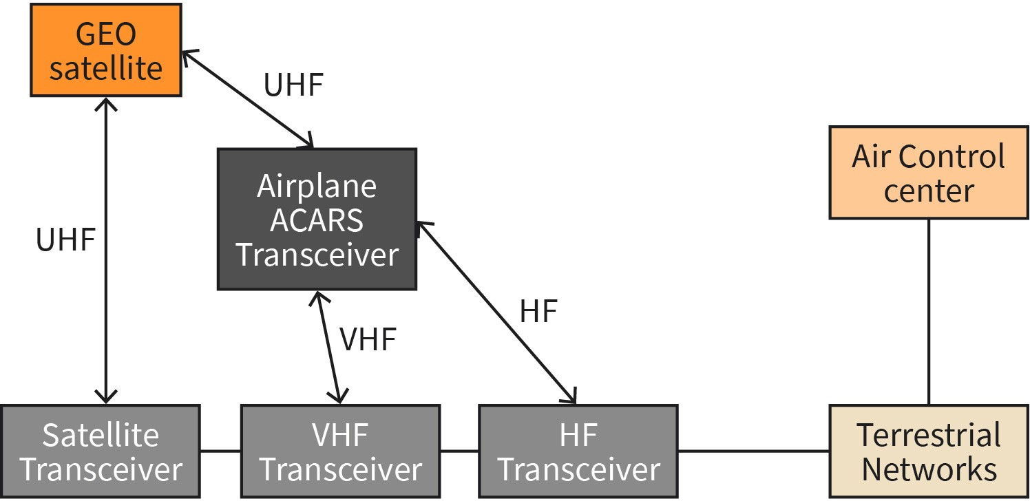

Source: Jetmir Haxhibeqiri (2023).
The ground station processes the data and sends a response back to the aircraft via the same route. ACARS has a maximum data rate of 1200 bits per second. ACARS messages are composed only of characters and can be up to 210 characters long (Smith, 2018). They exchanged messages using ACARS include route clearance assignment, information serv- ices, flight planes, diagnostic feeds for maintenance and in some cases positional reports (in absence of ABS-D system) (Smith, 2018).

To improve reliability of communication ACARS might choose to communicate via multiple radio links. This will boost reliability if one of the links is either under noisy conditions or under jamming conditions.

An ACARS attacker can try to collect data for achieving different gains either for competitive advantage or breaching the safety of the operations. By default, ACARS does not use security mechanisms, however, there are standards that have standardized the security mechanisms as ads on to ACARS. This adds on security mechanism is standardized by specification ARINC 823 that includes two parts: Part 1 standardizing ACARS Message Security (AMS) and Part 2 standardizing AMS Key management [ARINC823]. With this standard the confidentiality, integrity and authentication of ACARS messages is ensured. Encryption of ACARS message is done using AES128 algorithm, while the integrity of messages is achieved using a message authentication code (MAC) of 32 bits long that is produced using SH256 algorithm (Olive, 2009).

Automatic Identification System (AIS)

The Automatic Identification System (AIS) is a maritime communication system that is used to improve the safety and efficiency of shipping operations. AIS uses a combination of VHF radio communication and GPS to transmit and receive information. Each ship equipped with AIS has a transceiver that sends and receives AIS messages on specific VHF frequencies to other messages and to shore-based facilities. These messages contain information about the ship's position, heading, speed, and other data.

AIS messages can be received by other ships and by shore-based facilities, such as ports, coast guards, and Vessel Traffic Services (VTS). These messages can be used to track the movement of ships and to monitor their activity in real time.

AIS is used for a variety of purposes, including collision avoidance, maritime safety, search and rescue, and traffic management. It is an important tool for improving the safety and efficiency of shipping operations and is widely used by ships of all types and sizes.

AIS does not include any authentication or encryption mechanism as it is intentionally designed to be used in broadcast environments. Due to this absence of security mechanisms, there are a set of attacks that AIS suffers from including spoofing, hijacking and availability disruption (Balduzzi, 2014). Spoofing attacks might lead to generating AIS messages from a non-existent ship, ship course change due to collision spoofing or announcing false weather conditions. AIS hijacking includes eavesdropping on AIS original messages and changing the information contained in the message and rebroadcasting it (Balduzzi, 2014). This will cause the receiver to receive false information about an existent ship.

Proprietary device
protocols are used to enhanced per- formance, to increase customization and decrease costs.

Proprietary Device Protocols
Proprietary device protocols are standards or protocols that are used in devices and are owned and controlled by a particular company or organization. These protocols may be used for communication between devices, such as for data transfer or control, and may not be publicly available or standardized. Proprietary device protocols are often used in closed systems, where all of the devices are made by the same manufacturer and are designed to work together using a specific protocol. These types of protocols may not be compatible with other devices or systems that use different protocols. Advantages of proprietary protocols include enhanced performance (they are designed for specific use cases improving performance), are highly customized (for specific needs of use cases for which they are designed) and usually target lower cost production. Disadvantages of proprietary protocols include the vendor locked-in issue (usually you are obliged to deploy nodes from single producer), leak of interoperability with other devices and lack of standardization.

Examples of proprietary device protocols include the protocols used in some types of home automation devices, wireless printers, and remote controls. Some of such technologies are: Z-Wave, X10, Insteon, and ZigBee.

Z-Wave

Z-Wave is a proprietary wireless communication protocol that is used in home automation systems. Z-Wave is used to control a variety of devices, including lighting, thermostats, security systems, and appliances. Z-Wave is used in use cases where low power consumption is needed with shorter range communication.

Z-Wave operates in the sub-gigahertz frequency band of 800–900 MHz, respectively it operates at 868.42 MHz in Europe and at 908.42 MHz at United States. It has a range of approximately 30 meters. At physical layer it uses frequency shift keying (FSK) modulation and with Manchester and non-return to zero (NRZ) encoding (Fouladi, 2013). The achieved data rates are low being 9.6 and 40 kbps.

The Z-Wave network topology is a mesh network where each device on the range of each other can communicate directly with the other device. In case when devices are not within reach of each other, they can still communicate provided there are sufficient nodes in between to form a mesh network. All the non-battery powered Z-wave nodes behave like a signal repeater to increase network connectivity. Each Z-Wave network is identified with a 32-bit network ID, while each device connected to the network is identified with an 8-bits node ID (Fouladi, 2013).

Differently to mesh networking, Z-Wave Long Range (LR) supports star network topologies, where a central control device, such as a smart hub or a smart home controller, is used to coordinate communication between the other devices in the network. The control device sends commands to the other devices, which can be configured to perform certain actions in response to those commands. For example, a smart thermostat might be con- figured to turn the heating or cooling system on or off in response to a command from the control device.

Z-Wave includes two security frameworks S0 and S2. S0 framework ensures the encryption network key (Kn) exchange, key generation for frame encryption (Kc) and data origin authentication key (Km) using AES encryption algorithm from Kn (Fouladi, 2013). As such, Z-Wave frames are both encrypted and authenticated using these keys. S0 frame- work supports usage of Elliptic Curve Diffie Hellmann (ECDH) encryption algorithm, usage of multiple network keys decreasing the possibility that compromising single device you compromise the whole network, and fewer message exchanges during network key negotiation (Buron, 2018).

Insteon

Insteon is a proprietary technology for home automation that supports power line and RF communication. On the wireless part it uses 915 MHz sub-band, while for power line communication it operates at 31.65 KHz band (Insteon, 2013). It uses frequency shift keying (FSK) modulation and binary phase shift keying (BPSK) modulation for wireless and power line communication, respectively. The achieved data rate is 13.165 kbps.

Insteon supports peer-to-peer networking where each network device can act as a control- ler, as a repeater or as a responder. Since it operates wireless as well as power line, Insteon network is referred to as dual-mesh network, where both links are used to repeat the messages in case of interference in any of the links.

Insteon messages are short, being 10 bytes for standard messages, and 24 bytes long for extended messages that in addition to commands also contain 14 bytes of user data. Each message contains the source and destination address that are 3-bytes long each, 1-byte of message flags, 2 bytes of command data and 1 byte of cyclic redundancy check (CRC).

Network security in Insteon is composed of two main mechanisms: the link control mechanism and message encryption (Insteon, 2013).

The link control mechanism ensures the connections only between devices that are physically under possession of one entity. The linking process between the device and the con- troller is done manually by pressing a button on both or by knowing the 3-byte address of the device usually stamped at it. This will ensure that unlinked devices will not be able to control other devices, even if they are in reach of each other. A responder device will not respond to an unlinked device to the network, even if the packet is overheard.

Message payload encryption may be used only for extended messages. The common encryption methods include public-key encryption, managed-key encryption and rolling code encryption (Insteon, 2013). However, to keep the communication simple and to avoid an increase in processing costs of packets, the encryption is used only for more critical communications, such as garage doors or car keys.

X10

X10 is a communicating protocol that is used in home automation for communication over power lines and communication using radio frequency. In power line systems the digital signal is encoded in 120 KHz carrier using Manchester encoding, as a binary “1” is defined as presence of the pulse followed by the absence of the pulse, while binary “0” is defined as the opposite [X10].

The X10 protocol is simple, providing a low number of bits exchange between the controller and X10 devices. Each frame starts with a 4 bits tart code representing 1110 in Manchester encoding. Then the frame is composed of 4 bits house code and 4 bits unit code, that are expressed in 16 different letters (A to P) and 16 different values (1 to 16), respectively. The mapping of the letters and values to binary codes is not done sequentially, e.g., A is 0110, B is 1110 and so on, while 3 is 0010, 4 is 1010 and so on [X10]. In addition to house code and unit code, there is a 4-bit command code as well. Different commands are possible, such as “all units off,” “all units on,” “dim,” “on,” “off.”

A frame is composed of a 4-bit start code, a 4-bit house code and a 5-bit functional code. The functional code can be a unit code, or a command code followed by a functional bit, 0 or 1, respectively. An example of a command in X10 is “select house B, unit 15, turn off.” Then this command will be written in binary format of a frame with 18 bits in total. First 4 bits are the start code of the frame, the second four bits represent the house code, then we have 4 bits of unit code followed by one 0 bit, then we have 4 bits of command code and then the last bit of 1, showing that the last 4 proceeding bits were the command code and not the unit code. One simple frame of X10 is shown in the X10 Frame image below. One frame can contain several unit codes before applying the command code to all of them at once. The biggest challenge of X10 protocol is the lack of encryption.

Figure 36: X10 Frame
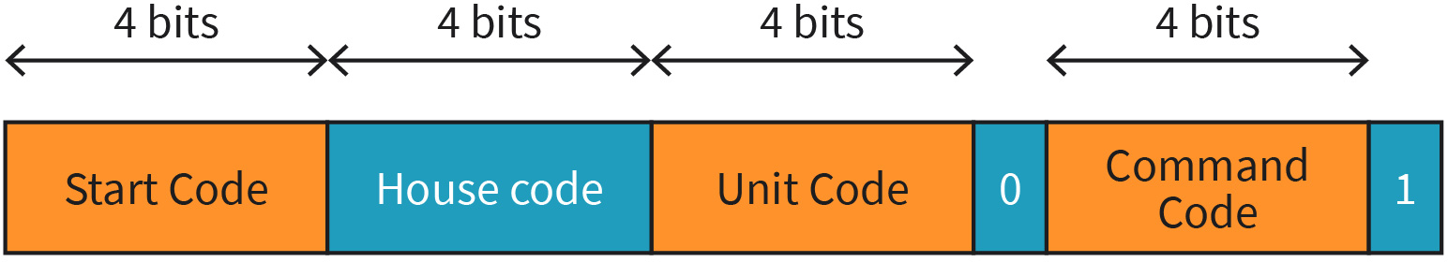

Source: Jetmir Haxhibeqiri (2023).

Wide Area Sensor Networks (LoRa, Sigfox, ...)
Wide area sensor networks (WASNs) are a type of wireless sensor networks that span a large geographic area, such as a city or a rural area. These networks consist of many sensor nodes that are distributed over a wide area and are connected to a central control system. WASNs are used for a variety of applications, including environmental monitoring, traffic management, and disaster response. They provide real-time data collection, processing, and dissemination capabilities. WASNs are also a very important technology for the Internet of Things (IoT) as it allows one to connect and monitor sensors in a large area and to make decisions based on the data.

One main characteristic of all the use cases where WASNs are used is that end devices need to be battery powered and communication needs to happen in long ranges. As such, the most used technologies are low-power wide area networks (LPWAN) that preserve the energy of end devices by providing low-complexity communication protocols with low communication overhead. In this section we will focus on LoRaWAN and Sigfox as two main technologies of LPWANs.

LoRa and LoraWAN

LoRa (Long Range) is a wireless technology developed by Semtech (Seller, 2016) in 2014 that uses a proprietary modulation scheme to provide long-range, low-power communications for Internet of Things (IoT) devices. Its modulation produces a signal composed of chirps of the same duration. The instantons frequency of a chirp changes from f0 to f1 over an interval time. LoRa defines two chirp types. The base chirp starts with minimum

LPWAN
Low-power wide area net- works (LPWAN) are used when long range commu- nication with low power is required.

frequency at the lower bound of the bandwidth fmin = −BW
2
and ends at the upper

bound of the bandwidth fmax = BW . All the other modulated chirps are time shifted versions of the base chirp. Any chirp can start with high frequency (upper bound of the band- width) and ends with low frequency (lower bound) that is referred to as down chirp (Haxhibeqiri, 2018). In the figure below, we can see the base chirps as well as time shifted chirps that are modulation of base chirps with down chirps.
2

Figure 37: LoRa Spectrum Composed of Base Chirps and Modulated Chirps
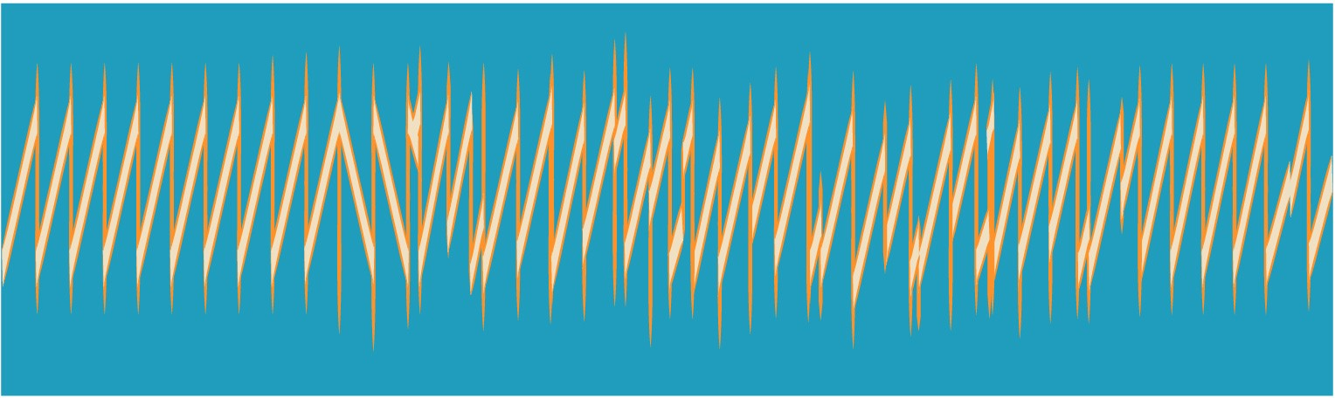

Source: Jetmir Haxhibeqiri (2018).
The spreading factor (SF) in LoRa determines the ratio between the chirp rate and symbol rate. The signal is spread to larger bandwidth that improves the resistance against interference and improves receiver sensitivity. The higher the spreading factor means lower data rate, higher sensitivity and larger communication range. SF range is from 7 to 12. As such, the symbol rate depends on SF, and can be calculated by formula:

R = SF BW
s
2SF

where BW is the bandwidth used. To further improve robustness against interference the diagonal interleaving and forward error correction codes (FEC) of 4/5 to 4/8 are used.

To make use of LoRa technology in network context, LoRaWAN medium access control (MAC) standard is specified by LoRa Alliance (LoRa, 2015), enabling communication between the IoT devices and the network server. It has a star of stars network topology with network sever in the center connected to multiple LoRa gateways that communicate with multiple end devices. LoRaWAN gateways just forward communication between the network server and end devices, as shown in the LoRaWAN Network Topology image.

Figure 38: LoRaWAN Network Topology

Source: Jetmir Haxhibeqiri (2018).
Three classes of end devices, Classes A–C are defined. Class A devices have a basic set of features. Bidirectional communication in Class A devices is enabled by opening two short downlink receive windows after the uplink communication during which the end device will listen for possible downlink traffic. As such DL communication is always triggered by

UL communication. The first and second downlink receive windows start 1 and 2 s, respectively, after the end of the uplink transmission. When DL transmission happens during the first receive windows, it uses the same physical layer characteristics as UL transmission. In the case of the second receive window, it will use lowest SF, and channel with higher duty cycle of 10% (at frequency of 869.525 MHz). All other channels used by LoRaWAN should comply with a duty cycle of 1%. Class A end devices consume the least power since most of the time they are asleep. Different from Class A, Class B will open more receive windows at certain periodicity, while Class C has a continuous receive window unless it is transmit- ting (Haxhibeqiri, 2018).

For secure communication between the end device and the network, several security keys need to be known or derived by the end node. The key derivation process happens at the time end device joins the End devices can join the network either by over-the-air activation procedure or by personalization. The over-the-air activation procedure is as followes (LoRaWAN 1.1):

    - The end node sends a join request including device extended unique identifier (DevEUI) of 8-bytes, JoinEUI of 8-bytes and a random device nonce of 2-bytes (that is counter-based). The join request is not encrypted, but the message integrity is checked using the network key (NtwKey) by the server.
    - The network server will reply with a join-accept message that includes the device address (DevAddr) and 3 bytes join nonce (incremental-based counter) if the device is allowed to join the network.
    - The join reply message is encrypted using NwkKey, while its integrity is validated using the join session encryption key (JSEncKey).
    - The end node will generate all the needed keys (FNwkSIntKey, SNwkSIntKey, and NwkSEncKey) from the NtwKey, and AppKey and join once using the AES128 algo- rithm, while AppSKey is derived from AppKey.
    - The end node will reply with a MAC command to the network server to switch to the new security context (usage of new session keys) for communication.

AppSKey is used to encrypt the payload of the LoRaWAN messages, while the NwkSKey is used to validate the message integrity check of the messages exchanged with the net- work. As such, communication in LoRaWAN can be both confidential and authentic.

Figure 39: Over-the-Air Activation in LoRaWAN
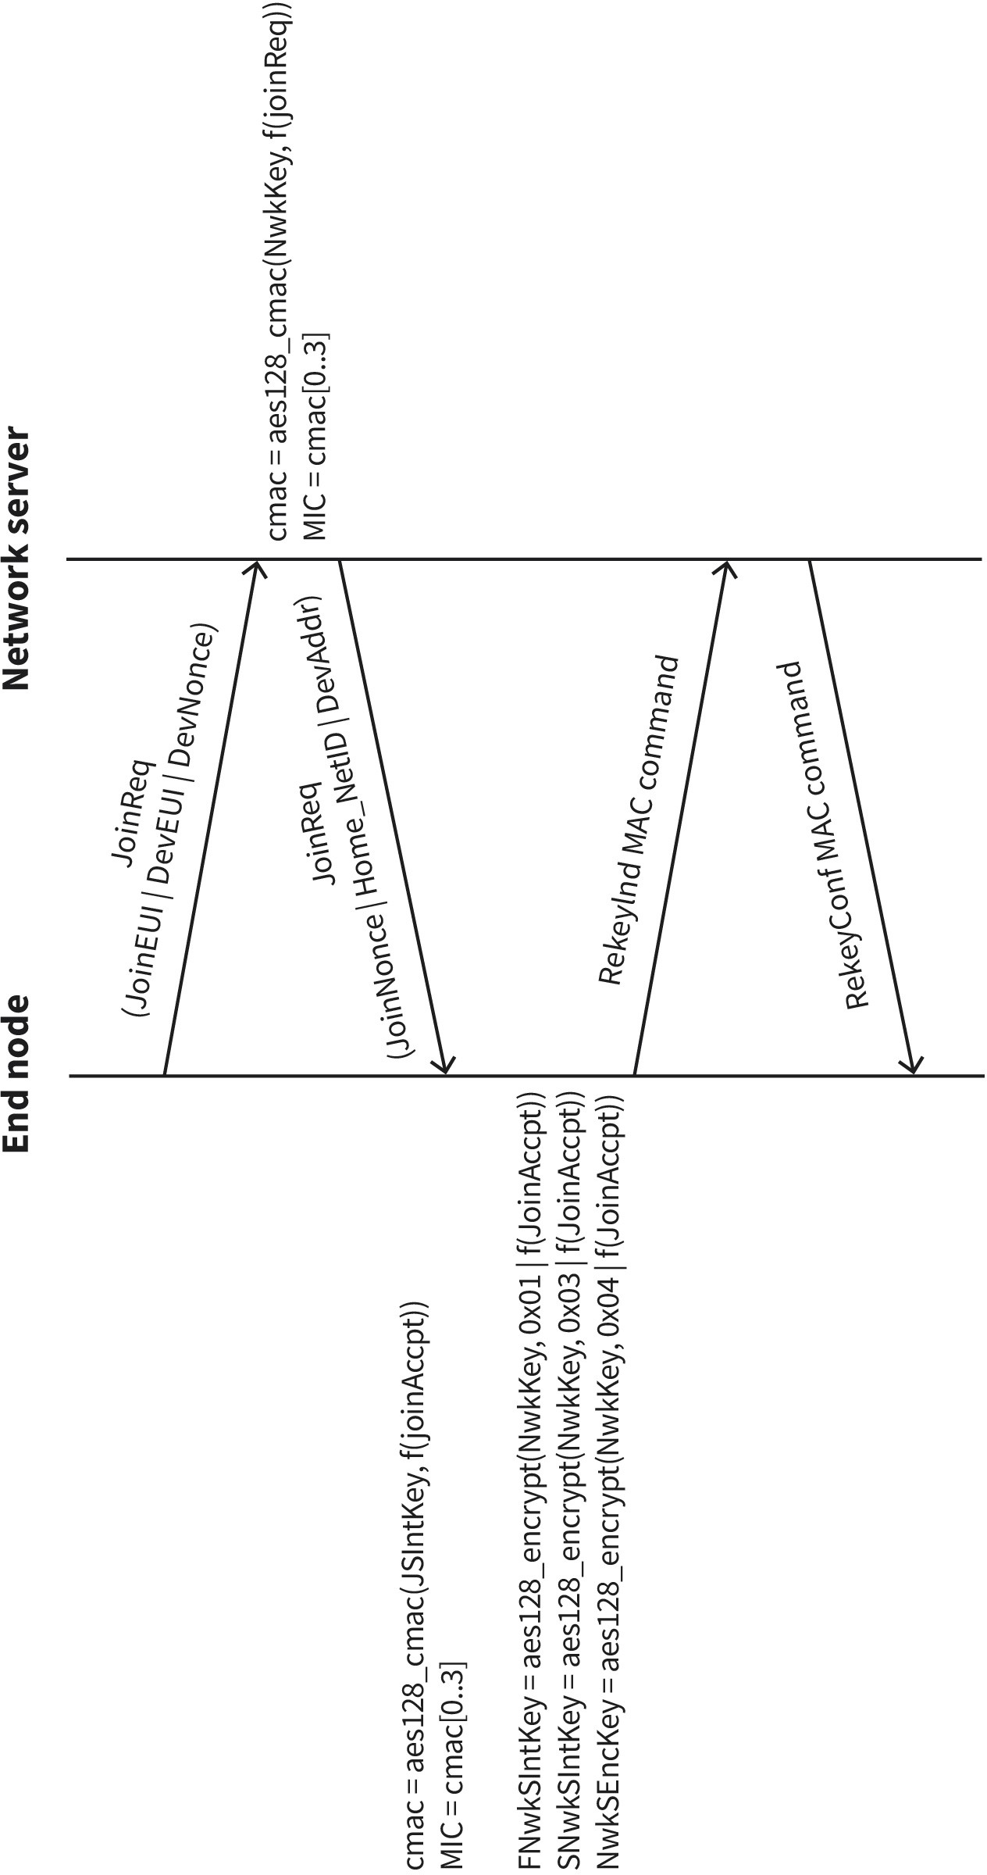

Source: Jetmir Haxhibeqiri (2018).

Sigfox

Sigfox is a proprietary wireless communication technology that uses ultra-narrowband (UNB) modulation scheme to provide low-power, long-range communication for Internet of Things (IoT) devices. It is designed to provide a simple and cost-effective solution for connecting devices that require infrequent data transmissions and have low data rate requirements.

In Europe, Sigfox uses a frequency band of 868 MHz. For uplink it uses Differential Phase Shift Keying (DPSK) modulation, using 100 Hz channels in 200 Khz bands. The uplink com- munication should comply with the 1% duty cycle rule in the band, with a maximum of 140 messages of 12 bytes per day at a data rate of 100 bps. In downlink it uses Gaussian Frequency Shift Keying (GFSK) modulation scheme, achieving data rate of 600 bps. Base station needs to apply 10% duty cycle rule on the band, limiting the traffic to 4 messages per day per device of 8 bytes long.

The network topology of Sigfox is like LoRawan, with network server and backend in the center connected to base stations, which in return connects to end device. The base sta- tion just provides forwarding of the messages in uplink toward backend and transmitting the downlink packets toward end devices.

To improve the reliability in uplink each message is transmitted 3 times in different pseud- random frequencies. Due to low data rate used, this transmission and retransmission can take up to several seconds. In addition, to spatial diversity of the base station this message might end up received multiple times by the back end. Like in LoRaWAN Class A devices, the downlink communication is triggered by an uplink communication. In Sigfox case the device will enable a flag in uplink communication if it is ready to receive a downlink communication. Also, it will specify at which frequency will listen for incoming packet. As such, downlink communication needs to wait in the backend, till a downlink-enabled uplink packet is received. The downlink communication, if indicated by end device, will happen 20 seconds after the end of the first transmission in uplink. The following table shows some advantages and disadvantages of Sigfox usage.

Table 7: Pros and Cons of Sigfox

Pros Cons

Easy to use | Low data rate
Single operator across multiple countries | Limitation in number of messages send
Extreme low energy consumption | Limitation on bi-directional traffic
Source: Jetmir Haxhibeqiri (2023).

To enable secure communication in Sigfox some security mechanisms are in place. First, all the messages in Sigfox have a counter that takes a value of 2i-1, where i is from the interval [7,12] (Ferreira, 2020). This counter can be used to detect replay attacks. Counters are used also to accept or discard packets at the backend. If a new packet is received in the

backend with a counter that is bigger than the previous one for cnt_interval then the backend can decide to discard the packet. Sigfox also supports packet encryption for messages. However, this one cannot be done on packet bases but should be enabled for all the communications or none (Ferreira, 2020). The key derivation for packet encryption is done using AES algorithm from network key K and two 16-byte values. In addition to encryption, Sigfox messages include a message authentication code tag based on AES algorithm using static network key K (Ferreira, 2020).

Since the message integrity check is based on static network key, reply attacks are possible once the counter is reset. Replay attacks can be used also to achieve denial of service for legitimate users. This attack can be achieved by replaying a packet that has a counter well higher than the last counter of a packet from legitimate user and which is inside the cnt_interval. The back end will accept the replayed message and then all the other messages of the legitimate user that will have smaller counter than the last (illegitimate) message received will be discarded.

Digital Voice/Data Technologies (DECT/GAP, TETRA, …)
Digital voice and data technologies are a group of wireless communication systems that are used to transmit voice and data over a short distance. Some common examples include Digital Enhanced Cordless Telecommunications (DECT) and Generic Access Profile (GAP), which are used for short-range wireless communication in for broad range of appli- cations and environments. Terrestrial Trunked Radio (TETRA) is another digital voice and data technology that is used for professional mobile radio communication, such as for public safety and government agencies. These technologies can be integrated with the internet to allow for enhanced communication capabilities, such as the ability to make internet-based calls or access data from remote locations. Other possibilities for digital voice and data technologies include 5G, long-term evolution (LTE), and Wi-Fi, which are all used for wireless communication in various settings.

Digital Enhanced Cordless Telecommunications (DECT)

Digital Enhanced Cordless Telecommunications (DECT) is a standard for wireless communication that is primarily used for high traffic density, short-range communications in different environments (residential, business or industrial). From a network topology perspective, DECT consists of a series of base stations, or “fixed part” that terminates the radio communication, and the “portable parts” that communicates wirelessly with the base station. DECT is composed of the following functional elements (going from wired to wireless parts), which make up the DECT network (Rappaport, 2002):

- cordless controller (CC): Provides the medium access control and data link control for several DECT base stations or radio fixed parts.
- radio fixed parts or DECT base station: Provides physical layer by serving several portable DECT handsets in one cell of the DECT system. The communication between radio fixed parts and the portable handsets is done using TDMA/FDMA with TDD for full duplex.
- portable handset: Amobile terminal that can roam around the cell and connect wirelessly to the DECT base station. It can further provide wired connection for other terminals, such as wired phone or fax.

It must be mentioned that single DECT CC can be connected to single phone line jack, pro- viding the gateway functions toward fixed line telephony system. The DECT network top- ology is shown in the figure DECT Network Topology

Figure 40: DECT Network Topology
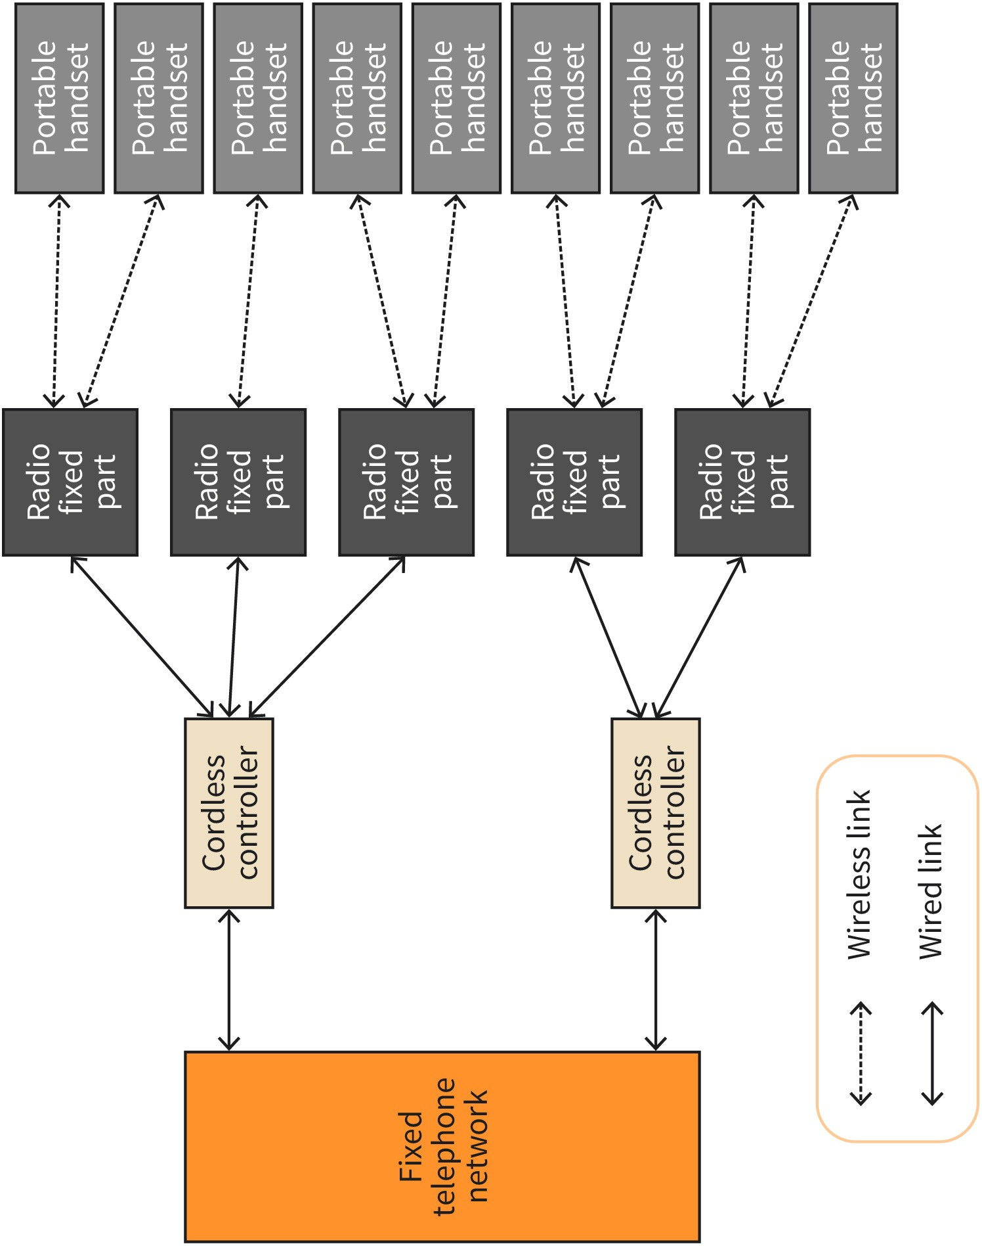

Source: Jetmir Haxhibeqiri (2023).
DECT operates in the frequency band of 1.88–1.9 GHz with 10 channels defined with spacing of 1728 KHz. It uses a Gaussian Frequency-Shift Keying (GFSK) as modulation technique, supporting a data rate of 1152 kbps. Communication is organized in multi-carrier TDMA where multiplexing is supported using TDD. As such, DECT physical layer is organized in 24 time slots that form a communication frame, the first 12 of which are used for downlink communication and the other 12 for uplink communication. One frame lasts for 10 ms. In total 480 bits can be transmitted in single time slot, out of which 32 first bits are used for synchronization between devices as part of preamble, 388 bits are used for data

transmission and the last 60 bits are used as guard time interval not to interfere with the upcoming time slot (Rappaport, 2002). The frame organization is shown in the figure DECT Frame Organization.

Figure 41: DECT Frame Organization
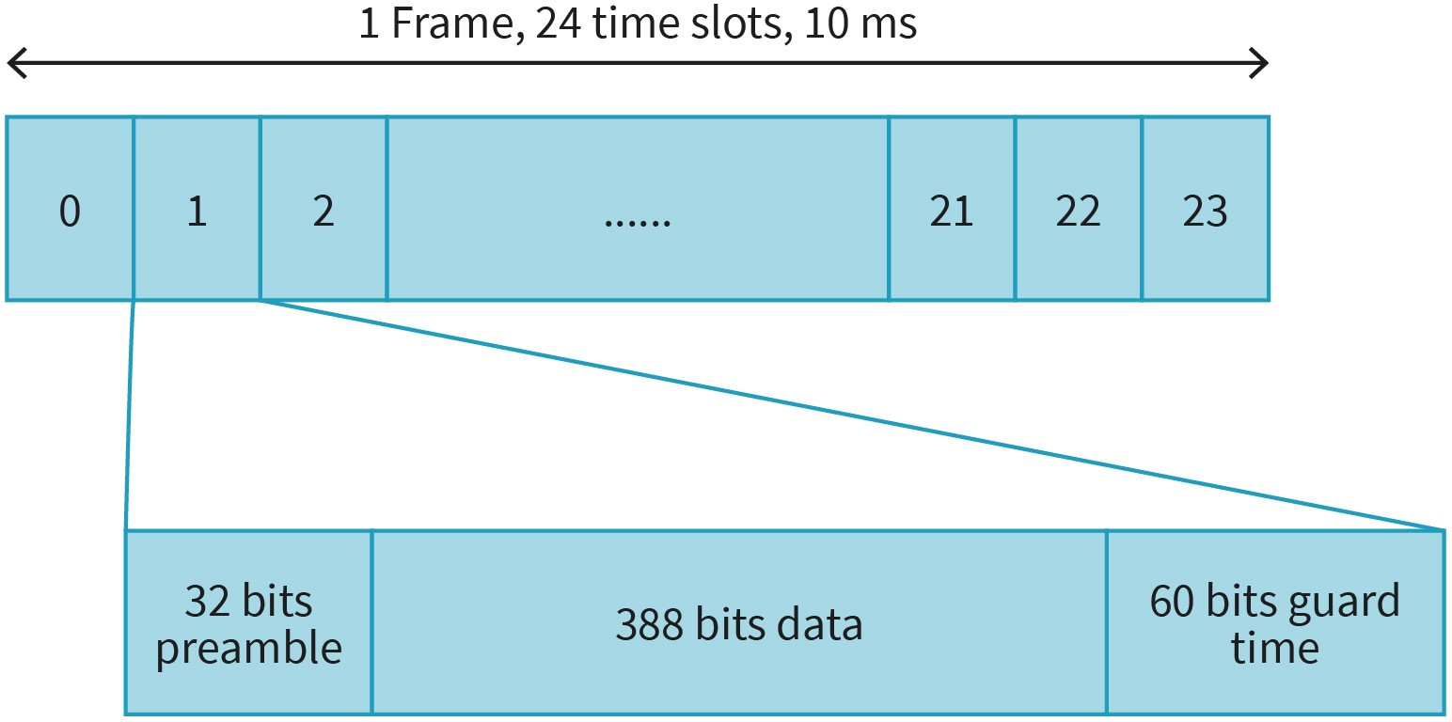

Source: Jetmir Haxhibeqiri (2023).
MAC layer supports a paging and control channel for device signaling as well as a data channel for user plane communication. Usually, single user is served with 32 kbps for data channel. However, other multiples of 32 kbps can be supported. MAC layer also supports handover function for portable handsets from one radio fixed part to the other, as well as broadcast of beacon services to all portable handsets.

DECT provides a variety of security mechanisms to protect against unauthorized access. These include encryption of the voice and data transmissions, as well as the authentication process for devices to join the network, which ensures that only authorized devices are able to access the network. As such, DECT supports encryption based on DECT Standard Cipher, using 64-bit stream cipher-based encryption. Encryption is weak using only 35- bits as initialization vector (Nohl, 2010). DECT includes authentication as well, that is done using a 128-bit pre-shared key.

DECT is endangered by several security attack possibilities. This includes eavesdropping on unencrypted channels or due to late encryption. Some DECT devices encrypt only the call but not the message exchange during establishment of calls. Also, other attacks on radio fixed part hijacking and jamming are possible and reported (Tews 2012).

Terrestrial Trunked Radio (TETRA)

Terrestrial Trunked Radio (TETRA) is a professional wireless communication system that supports two-way communication. It is defined by ETSI and it is mainly used for communications of government agencies and emergency services: such as: police, ambulance, and fire brigades.

TETRA operates in the 400 MHz and 800 MHz ISM bands with a bandwidth of 25 KHz wide. From a network topology perspective, TETRA has a centralized network architecture with the TETRA enabled base station at the center serving several TETRA handheld devices. TETRA handheld devices communicate with TETRA base station using Trunked Mode Operation (TMO) [TETRA R2]. In the absence of the TETRA network (in case of emergencies) an ad-hoc mode communication is possible. TETRA handheld devices can communicate in Direct Mode Operation with each other, if the communication range permits it [TETRA R2]. Moreover, certain TETRA handheld devices can help in extending communication range for others, by forwarding the traffic between other TETRA handheld devices.

TETRA uses time-division multiple access (TDMA) structure where 4 timeslots per carrier are assigned [TETRA R2]. To support full duplex communication, it uses frequency division duplex (FDD), where duplex spacing is separated by 10 MHz and 45 MHz, respectively, in 400 MHz and 800 MHz bands. It uses pi/4-DQPSK modulation scheme, supporting a physical layer data rate of 36 Kbps. The TETRA Communication Frame Structure image below shows the organization of TDMA structure in TETRA. One time slot lasts for 14.167 ms, 4 of these timeslots making one TDMA frame lasting for 56.67 ms. 18 TDMA frames are organ- ized in 1 multiframe, while 60 multiframes are organized in 1 hyperframe lasting for 61.2 s [TETRA R2]. Each time slot can be either full uplink or downlink slot, or half uplink slot. It has to be stated that when FDD cannot be used by the handheld device, duplex communication is not done using TDD.

Figure 42: TETRA Communication Frame Structure
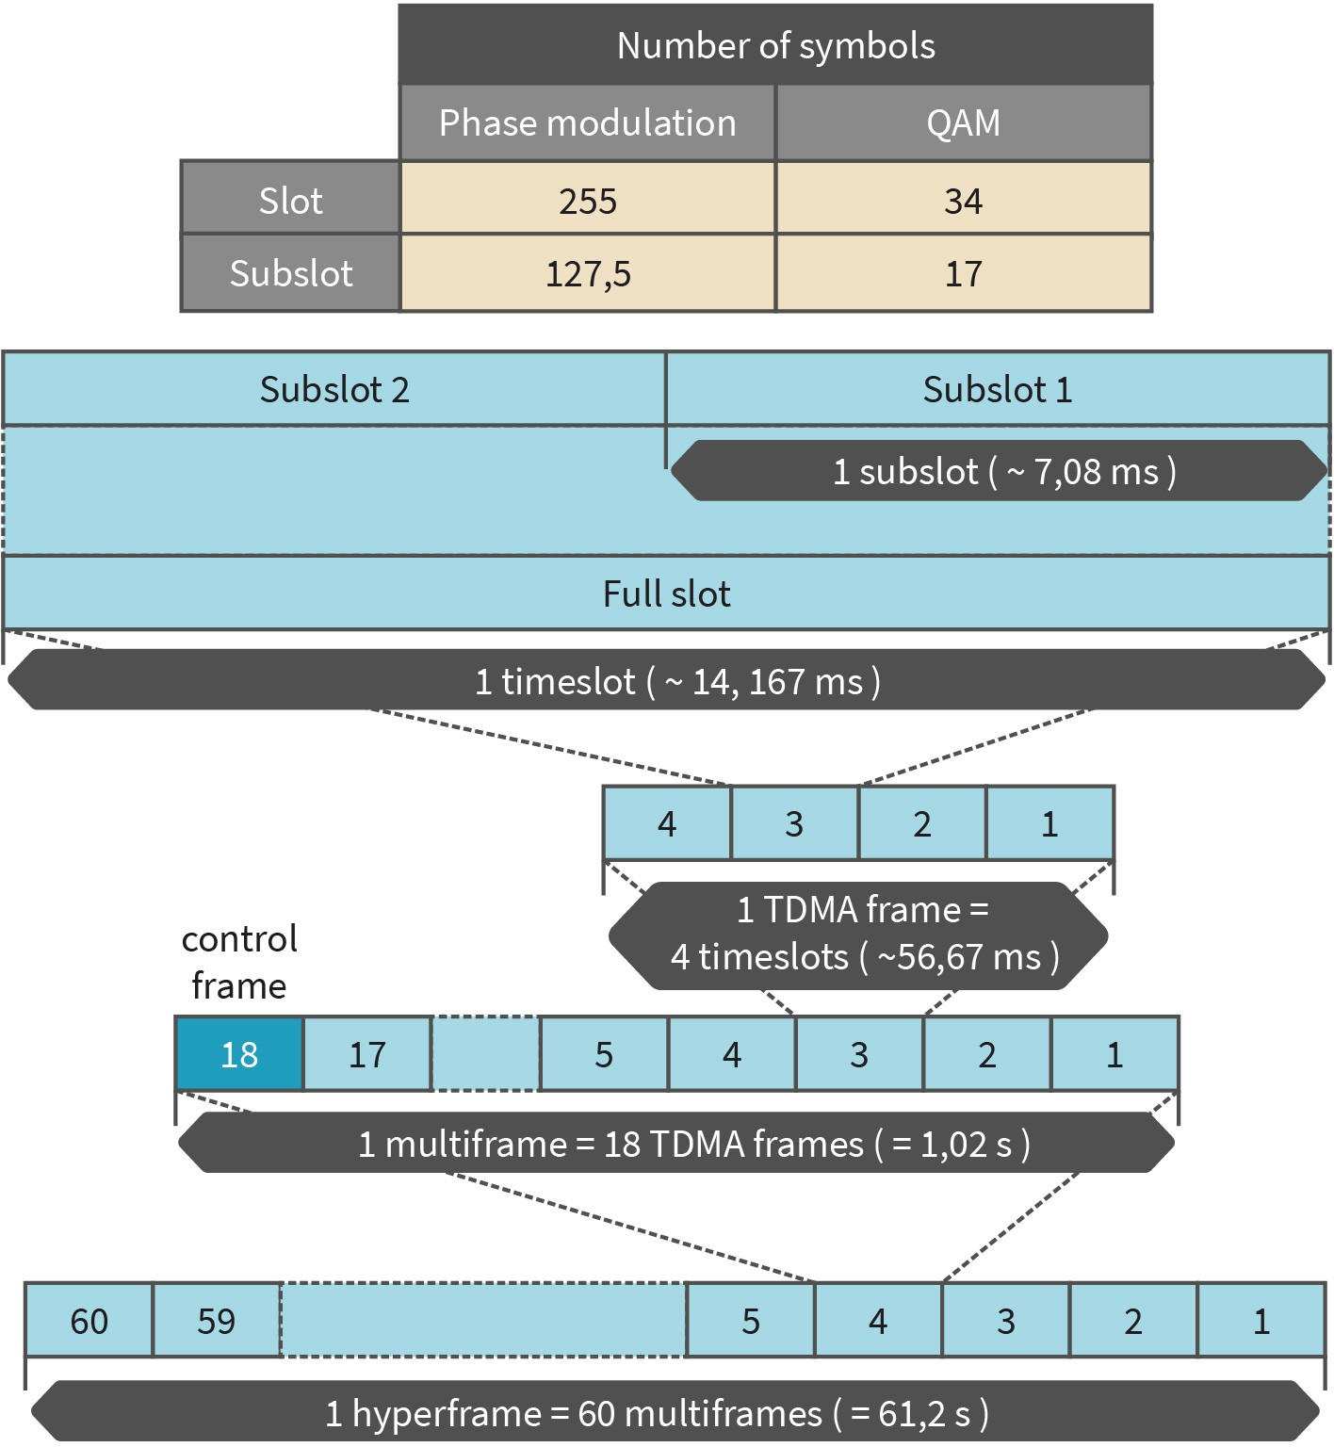

Source: TETRA R2 (2007).
Compared to initial TETRA specification, TETRA release 2 [TETRA R2] specification has introduced new modulation schemes to support higher data rates (4-QAM,16-QAM,64- QAM) and new channel bandwidths (50 Khz, 100 KHz, 150 KHz). However, even for 64-QAM and 150 KHz channel bandwidth the achieved maximal data rate is only 691.2 Kbps.

From aspects of security, TETRA specifies two types of security mechanisms. One is the air interface encryption that is done independently on each air interface, and the other is end-to-end encryption between two TETRA devices [TETRA R2]. End-to-end encryption provides users with an additional security layer, no matter if the air interface is secure or not. TETRA specifies the following three different classes of security [TETRA R2]:

- Class 1 security: Where air interface signaling is not encrypted, however, authentication may be used.
- Class 2 security: Where air interface encryption is applied by using static cipher key (SCK) that is the same for all handheld devices. Still authentication maybe be used but is not mandatory.
- Class 3 security: Where air interface is encrypted using individual derived cipher keys (DCK). For group communication a common cipher key (CCK) is combined with group cipher key (GCK) to create a modified group cipher key (MGCK) that is used in encryption. Authentication in this class is mandatory.

Satellite Communications
Satellite communications are part of telecommunications systems that make use of artificial satellites to relay signals between different points on Earth. They make a vital part of telecommunication systems in the world for communication in distant areas and areas that are not covered with signal of other technologies, such as cellular networks. While the main advantage of satellite communications systems includes large coverage range, they are costly to deploy and maintain, the communication latency is large, and they suffer from multipath fading and/or shadowing.

Satellite Segments

A satellite communication segment is composed of the space segment and ground (or earth) segment. Space segment is composed of satellites in orbit and the tracking, telemetry, command and monitoring (TTC&M) station on ground. The TTC&M station supports all the satellite management and control functions that are needed to keep the satellite orbiting around the earth. Usually, due to its criticality, the control communication of satellites happens in different link compared to the normal satellite communication (Louis, 2008). The control link can operate at the same frequency band, or another frequency band compared to normal communication link. As the name already states, the TTC&M station supports the following main functions (Louis, 2008):

- tracking function that relates to determination current position and future movement of satellite in the orbit. This is done by tracking the satellite beacons in the TTC&M station point or from multiple satellite communication ground terminals.
- telemetry functions that includes reception of several sensor data from the on-bord satellite in the TTC&M ground station. These sensors monitor current conditions of different satellite subsystem and transmit periodically to ground stations.
- command function that includes transmission of management and control commands from TTC&M station toward satellite regarding the change and correction of altitude and orbital control, transponder operation mode, antenna pointing system, etc.

The ground segment of satellite communications system is located anywhere in the Earth (including ground, sea and air) and make use of satellite communication for the needs of the user. The ground station can be a fixed ground station, a portable grand station or a mobile ground station. The TCC&M ground station is not part of the ground segment.

Satellite Orbits

Based on the orbit parameters, such as: distance from the surface of earth, the eccentricity of the orbit (measuring how much circular is an orbit), inclination angle (angle between orbital plane and earth equatorial plane), revolution time, etc., different orbits for a satellite can be defined. However, in general usage three main orbital systems are used.

An ideal geostationary orbit (GEO) has an inclination angle of 0° revolute for 1 day around the globe (actually 23h and 56 m) and the satellite is positioned 35 786 km above the earth surface (Louis, 2008). It is possible to cover the whole earth (except the poles) spaced between each other 120° in the equatorial plane. While they can support communication between two ground points that are part of the same coverage zone, the GEO satellites suffer from long communication delays where the propagation time is the main contributor to the latency.

Low earth orbit (LEO) satellites are placed at a distance between 120 km to 2500 km above the earth surface. While the lower distance has an impact on the communication design system (lower path losses, lower transmit power, etc.), LEO does not stay fixed above the Earth surface point for more than 10 minutes. As such, for full earth coverage multiple satellites are required in order to track the ground station terminals.

Medium earth orbit (MEO) satellites are placed at a distance between 2500 km and 36000 km above the earth surface. One satellite can support one fixed point in the earth surface for 1 to 2 hours, with many revolutions per day. There are also other classes of satellite systems like highly elliptical orbit (HEO) satellites, geosynchronous orbit (GSO) satellites, etc. However, since these satellite classes are not commonly used, we skip the further explanation for those at this point.

Satellite Communication Networking

Satellite communications use Extremely High Frequency (EHF) band for communication between the ground segment and the satellite. The typically frequency bands used are between 1 to 50 GHz and are separated in lower frequencies (L (1–2 GHz), S (2–4 GHz), C (4–8 GHz) and X (8–12 GHz) bands) and higher frequencies (Ku (12–18 GHz), K (18–26 GHz), Ka (26–40 GHz) and Q/V (above 48 GHz) bands) (Kodheli, 2020). From lower bands most of the bandwidth is already in use: e.g., GPS operates in L-band, S-band is mainly used for weather radar monitoring, ship-satellite communication as well as for TTC&M communication. TV broadcasting satellites usually use C and Ku band. Due to highly congested spectrum in C and Ku band, satellite communication is moving from single beam to multi- beam with smaller spots to enable frequency reuse (Kodheli, 2020).

From modulation techniques perspective the most used techniques are the constant envelope techniques, such as frequency-shift keying (FSK) and phase shift keying (PSK). Other non-constant envelope modulation schemes, such as quadrature amplitude modulation (QAM) and their higher order versions are not used due to the I/Q distortion from non-linear amplifiers (Hsu, 2020). As such, for higher order modulation techniques amplitude phase shift keying (AMPS) and their higher order versions modulation techniques are used.

Medium access control for satellite communication tries to prevent the interference between them by organizing the channel access either in time or frequency. In addition to basic medium access techniques like TDMA, FDMA and CDMA, satellite communications use also other techniques like: multi-frequency TDMA (cfr, DVB satellite), orthogonally frequency division multiple access (OFDMA) (cfr. satellite NBIoT), random-access based (cfr LoRaSat) (Kodheli, 2020).

Due to their large coverage zone, satellite communication systems are prone to eaves- dropping and jamming attacks. The later one can achieve to make satellite communication service inexistent in certain regions of the world. For example, GPS jamming attacks were reported to be effective to change the accuracy of the GPS system (Hunkeler, 2012). Other vulnerabilities of satellite systems include spoofing and relay/replay attacks. It is reported that even with off-the-shelf hardware relaying signals over large distances to achieve GNSS spoofing is possible (Lenhart, 2021). Satellite systems in some cases inherit the single point of failure issues. If one satellite is misfunctioning or missed a large region is affected. Here we include physical attacks (e.g., missile strikes) and space debris (physical damaged caused to satellite systems by other defunct satellites, rocket parts, and other debris orbiting the earth) (Lewis, 2017).

SUMMARY
In this unit we have dived into other wireless technologies that are not limited to cellular networks and IEEE 802.11 (or Wi-Fi) networks. We analyzed main wireless communication technologies used in avionics and nautical communication such as: Automatic Dependent Surveillance- Broadcast (ADS-B), Aircraft Communication Addressing and Reporting System (ACARS) and Automatic Identification System (AIS). Next to this we discussed differences between the proprietary device protocols and standardized technologies. We had a look at Z-Wave, Insteaon and X10 communication technologies that are primarily used in home automation and sensor networks.

Next to home automation networks, one bog set of sensor applications requires distribution of sensors in wide ranges where all the sensor nodes need to be battery power. Some of the most common applications using this requirement include agriculture monitoring and city monitoring. To this end we described and analyzed differences between LoRa-based networks (LoRaWAN) and Sigfox. In the next subunit we analyzed digital voice and data protocols, such as TETRA and DECT, that are commonly used by emergency services. Last but not the least, we gave a description of common functional blocks of satellite communication systems with their separation based on the orbit distance.

UNIT 8

PROTECTIONS

STUDY GOALS

On completion of this unit, you will be able to ...

- understand methods to integrate mobile technology securely explain firewall types and their advantages and disadvantages.
- outline intrusion detection and prevention systems.
- describe a mobile device management system.
- analyze the monitoring techniques for mobile devices.

8. PROTECTIONS

Introduction
As a communication engineer it is not sufficient to understand possible attack vectors against telecommunication and wireless technologies and their inherited vulnerabilities, but also to understand how such technologies can be protected from such attacks. Inte- grating different telecommunication technologies securely with the Internet should be the aim of any communication network engineer.

From the perspective of networks and their security management, the communication network is divided into legitimate network users that are allowed to use network resources and the rest of the Internet which might have a lot of intruders trying to illegitimately access your network and making harm to it and to data passing/stored in it or to services provided by the network. As such, a communication network should be protected from intruders trying to attack the network using protective measures, such as firewalls or intrusion detection/protection systems. In this unit we will analyze how firewalls work and how they are implemented in the network. We will further analyze different possibilities of intrusion detection systems and how they are applied in the network. Next to this the zero-trust integration of communication networks will be analyzed, where even the legitimate users are classified as untrustful, and security measures are taken to protect the net- work in any possible case. Finally, we will analyze the monitoring points and monitoring techniques of the network focused on in-band network telemetry as one of the latest development in network monitoring for software defined networking (SDN).

Secure integration protects a network by placing a firewall or intru- sion detection/protection systems at the entry points where the network connects to the Internet.

Integrating Mobile Technology Securely
Multiple mobile networks can be integrated with each other using the Internet to interconnect them. To support secure integration between networks and the Internet one must prevent possible malicious attacks from the Internet toward the mobile network. Core net- work of cellular network systems, such as 5G can suffer from denial-of-service (DoS) attacks or distributed denial-of-service (DDoS) attacks coming from the Internet. Such attacks can detrimentally change the core network behavior endangering the usage of such networks by mobile users. Also, a weaponized mobile device might use vulnerabilities of GTP and SCTP to initiate signaling storms attack and DDoS attacks in core network. As such, one way to protect any network that is connected toward the Internet is to place firewalls at the entry point of the network from the Internet. In addition to network secure integration, one should consider secure integration of mobile devices as well. This is achieved by supporting virtual private network (VPN) tunneling or Mobile Device Management system in the enterprise network.

Firewalls

Firewalls are a combination of software rules and hardware devices that can isolate certain networks services from the rest of the Internet. They can control the access of the net- work for incoming traffic as well as outgoing traffic based on certain security policies that are applied by the network management. The main goals of a firewall are (Kurose, 2013)

    - to investigate all the traffic going in both directions between the network and the Inter- net,
    - to allow only authorized traffic based on security policies to traverse the firewall router, and
    - to be protected from penetration attacks via the control network.

Firewall types can be categorized into three main groups: packet filters (that check each packet separately), stateful filters (that track the connections in addition to checking packets separately), and application gateways (based on application layer data).

A firewall based on packet filters will inspect each packet that traverses the firewall router based on firewall security policies. Each packet will be filtered based on one or more of the following parameters: source/destination IP address, source/destination transport protocol port, protocol type field of the IP header, transport protocol flag bits and other security policy rules. Filtering policy may consider preventing users of network certain services outside toward the Internet, e.g., some companies block access to Spotify or You- Tube services to limit the bandwidth used, other companies block access to certain sites that think are inappropriate and can harm users with malwares. As a rule of thumb to pro- tect the network from any attack is to close all the incoming/outgoing services that are not used by the user of the network. The firewall router will maintain an access control list (ACL) for each interface depending on the chosen policy.

Differently from packet filtering based firewalls, the stateful based firewall filters track the TCP connections to decide if a connection needs to be filtered out or not. By doing so, the network is protected even by attacks that might utilize short TCP control packets like ACKs to load the network and crash any service provided by the network. Since the TCP connection is a connection-oriented protocol, a firewall can track all the TCP connections that are initiated from the network toward the internet, as well as incoming TCP packets. If a certain TCP packet is shown to be coming into the network without any previously established TCP connection (e.g., flooding ACKs attack) the firewall will prevent such communication.

While the first two firewall approaches inspect packets only on the network and transport layer (more concretely on source/destination IP addresses/ports), they cannot distinguish between different users of the network to give different access to certain services running outside the main network. Moreover, they do not inspect any of the parameters from the application layer. In order to support a firewall that inspects parameters from application layer and gives differentiated access for users of the main network toward Internet, the so- called application gateway firewalls are used. An application gateway is a type of server that makes authentication of the users and does the bridging toward the requested serv- ice on the Internet. For example, if a user wants to access a certain service on the Internet,

first it must identify and create a session with the application gateway. If the application gateway policies allow that user to access the service on the Internet, it will create the session with the outside service and bridge the communication for that user. In a network multiple application gateways can run simultaneously. In combination with packet filtering firewall, the network is protected to allow only communication between the application gateways and outside services, while preventing this for the normal users. Advantages and disadvantages of all three firewall types are given in the following table:

Table 8: Advantages and Disadvantages of Firewall Types

 | Advantage | Disadvantage
Packet filtering firewall | Can handle high volume of traf- fic | Limited control over traffic Inspects only the network layer
Stateful filter firewall | Can track state of network con- nection | Requires higher network resources  Does not provide application- level control
Application gateway | Provides application-level con- trol | Can impact network performance  Requires knowledge of application protocols
Source: Jetmir Haxhibeqiri (2023).

Intrusion Detection

Firewall routers are based on packet header inspections to decide when a packet is allowed to pass through. In order to detect intrusions in the network packet header inspection is not sufficient but the system needs to perform a deep packet inspection (Kur- ose, 2013) when packets are cross-checked with the previous packets and packets after. When the system detects suspicious packets or series of packets, it will either raise an alert or filter out those packets. The system that only raises alerts is known as Intrusion Detection System (IDS), while the system that prevents such packets is known as Intrusion Pre- vention System (IPS). Both can be combined in a single system that detects and prevents intrusions. Detection methods of intrusions are divided into two categories (Douligeris, 2007)

- Signature-based detections where packets or series of packets are compared against signatures of well-known attacks (e.g., port scan, network map, DoS flooding attacks). The well-known attack signatures are maintained in a database. One example of sig- nature-based IDS is Snort (Snort, 2023) which is widely used in today's networks. A drawback of signature-based detection is that it only can detect known attacks and sometimes it can generate false alarms if normal traffic patterns match any signature in the database.
- Anomaly-based detections are based on statistical measurements that deviate from the normal traffic profile. The traffic profile includes e.g., common destination to which network nodes are communication, frequency of the packets between each other, services that are required from outside of the network toward network. There is

no need for previously known attack signatures, however, during the baseline record- ing of traffic profile false negative detection can happen. A drawback of anomaly- based detection is that they need some time to generate the baseline and this time can be long for complex systems.

Zero-Trust Architecture Integration

Intrusion detection and prevention systems and firewalls are known as perimeter-based security as they are deployed at the boundary of the internal network and the Internet. Such ways of network protection separate the network into the trusted part (that is the internal network) and the potentially dangerous part of the network (that is the Internet). As such, the internal network components and devices are considered trustfworthy, and any other external device first needs to authenticate with the network before it can get served.

The issue with perimeter-based protection is that with the new advancement of network technologies, there is no possibility to determine the boundary of the network. Moreover, authenticated devices can still be harmful to the network, if it gets compromised.

Recently, zero trust network architectures are being used for where the trustfulness of the device is independent of its physical position in the network and every device in the net- work is considered untrustful (He, 2022). For a device to be trusted in the network authentication procedure, access control as well as trust evaluation should be performed. The differences between perimeter-based security and zero-trust architecture are shown in the image below.

Figure 43: Perimeter-Based Security Vs Zero-Trust Network Architecture
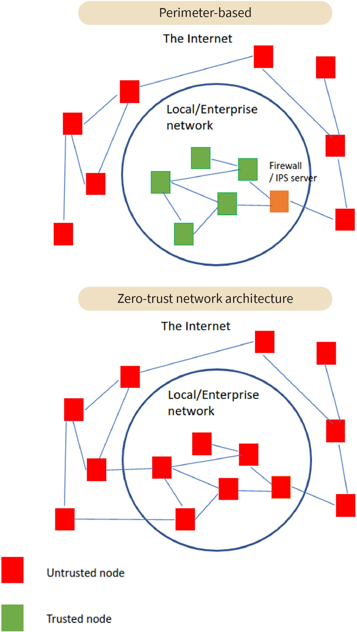

Source: Jetmir Haxhibeqiri (2023).

The basic principles of zero trust architecture are based on the following assumptions (Hu, 2022):

- The network is constantly in a non-friendly environment.
- In addition to external threats, there are also internal threats to the network.
- Device location is not sufficient to determine its trustworthiness and credibility.
- Everything needs to be authenticated and authorized, including devices, users, and traffic flows
- Security policies should not be static, instead they should be based on statistical calculations of many data sources.

Zero trust architecture controls the trustworthiness of each device, user and traffic flow. As such it follows certain steps to fulfill networks security. Users are always authenticated based on their device usage, location and behavior. Access control policies are implemented for each device no matter its type, and only trusted endpoints are allowed to access certain resources. Each device will access a minimal restricted set of resources to reduce the impact of any possible malfunction action. And finally, based on machine learning security policies are updated based on new contexts in the network.

Mobile Device Management System

An organization or an enterprise, in addition to protecting its network, should protect its workers mobile devices (smart phones, laptops, tablets). Mobile Device Management (MDM) system is a software solution that is being utilized by organizations to control functionalities of mobile devices, in order to prevent any sensitive data leakage by a misused or a lost device (Rhee, 2012).

The MDM is composed of two main components: the MDM mobile application or MDM agent and MDM server (Batool, 2020). The MDM application is installed in the mobile device while the MDM server is typically hosted on the cloud or on-premises of the organization, as shown in the MDM Components image. IT administrator of the organizations interacts with MDM server via MDM console unit to enforce policies and restrictions. Further on, based on the security level of the device, certain policies and restrictions are applied from MDM server to MDM agent. MDM can be used to manage devices that are company-owned or employee-owned, which is known as bring your own device (BYOD). From the functional perspective, MDM includes the following (Rhee, 2012):

- device enrolment: This involves registering the mobile device with the MDM server and installing the client application.
- policy management: This involves defining policies and restrictions for the mobile device, such as passcode requirements, app blacklisting, and wireless fidelity (Wi-Fi) settings.
- device monitoring: This involves monitoring the status of the mobile device, such as battery life, storage capacity, and network connectivity.
- app management: This involves managing the installation and removal of apps on the mobile device, as well as enforcing app-specific policies.
- data protection: This involves encrypting sensitive data on the mobile device, as well as providing remote wipe capabilities in case the device is lost or stolen.

Compared to other management methods, such as manual configuration or using consumer-grade tools, MDM offers centralized management for all the mobile devices of an organization supporting consistency in applied rules and policies as well as high scalability. Further MDM can remotely monitor and manage mobile devices with the possibility to erase sensitive data in case of device theft.

Figure 44: MDM Components
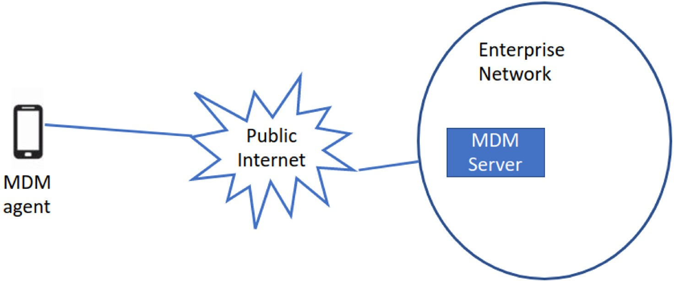

Source: Jetmir Haxhibeqiri (2023).

Virtual Private Network (VPN) Connection of Mobile Devices

Enterprises often restrict their services to only authenticated, authorized devices connected to their local network to avoid security issues, such as data leakage and DoS attacks. However, when mobile devices are connected to the internet via public Wi-Fi networks, they are vulnerable to security risks. To securely connect mobile devices to an enterprise network from a remote location, a virtual private network (VPN) is a reliable solution. By creating an encrypted tunnel between the mobile device and the VPN server, VPNs can prevent unauthorized access to sensitive information transmitted over the internet.

A VPN can be defined as a private network that is constructed within the public network infrastructure, where access is controlled only to permitted peer connections (Ferguson, 1998). It uses a packet encapsulation to wrap the data in an additional layer of encryption. The most common types of packet encapsulation used by VPN are Layer 2 Tunneling Protocol (L2TP) [RFC 3931] and Internet Protocol Security (IPsec).

L2TP connects two end points the L2TP access concentrator (LAC) and L2TP network server (LNS). L2TP is a combination of two main procedures the control connection management (including control connection establishment and teardown) and the session management (session establishment for incoming and outgoing call) [RFC 393]. The procedure of establishing a control connection in L2TP goes as follows [RFC 393]:

- The L2TP connection begins with LAC initiating a connection request by sending a start-control-connection-request (SCCRQ) to the LNS.
- The LNS responds by opening an L2TP tunnel and sending the start-control-connection-reply (SCCRP) to the LAC including the tunnel ID.

- LAC then sends a start-control-connection-connected (SCCCN) to the LNS and con- firms the tunnel ID.
- Once the control connection is established, the session establishment follows [RFC 393]:
- Once LAC detects a call it sends an incoming-call-request (ICRQ) packet to LNS to establish an incoming call.
- Then LNS responds with an incoming-call-reply (ICRP).
- LAC accepts the call and responds with incoming-call-connected (ICCN).

The same procedure happens with outgoing an call establishment as well, by exchanging the outgoing-call-request, reply and connected messages. The next figure shows the exchange of packets.

Figure 45: L2TP Protocol
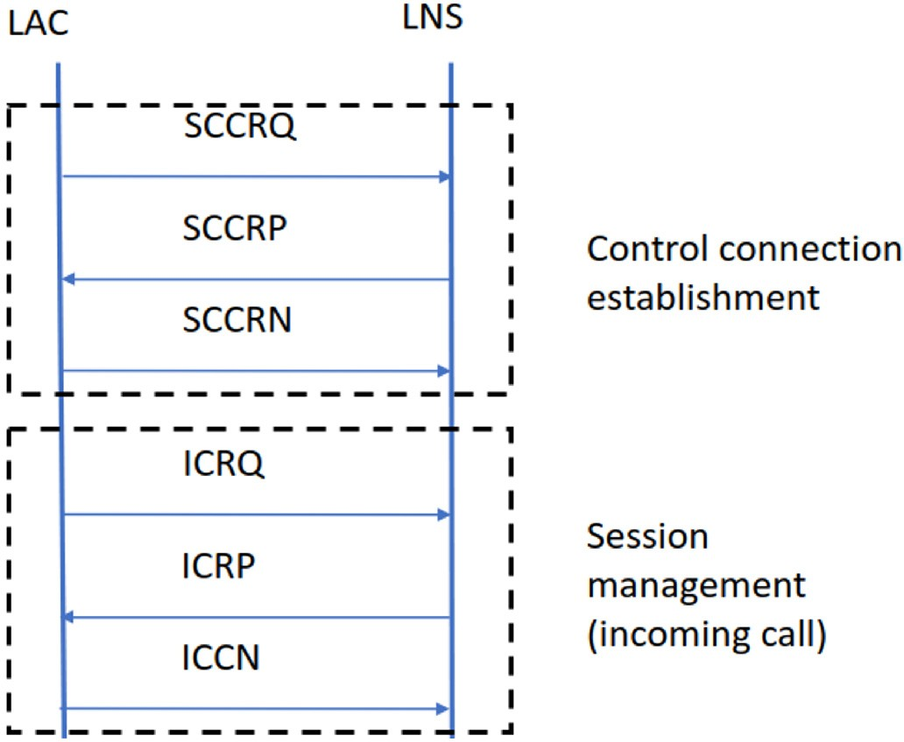

Source: Jetmir Haxhibeqiri (2023).
L2TP provides a tunnelling mechanism to transmit data between two endpoints (e.g., between the mobile end device and the local enterprise network). However, it cannot pro- vide full security because it does not provide any encryption or authentication for the data transmitted over the tunnel. L2TP can be vulnerable to various types of attacks, including eavesdropping, packet sniffing, and data tampering. As such, always it is used together with IPSec protocol that provides network-level security by encrypting and authenticating IP packets. Overall, a VPN connection based on L2TP and IPsec is an effective way to secure communication between the mobile device and the local enterprise network over the Internet, by providing confidentiality, integrity and authenticity.

Monitoring Mobile Devices
Accurate network control and management and timely network reconfiguration need accurate, low-overhead and real-time network monitoring. This accurate real-time monitoring is needed to take on-time decision for network reconfiguration by a network con- troller. Such real-time network monitoring can be based on temporal, historical and frequent network data. A full cognitive-based network management mechanism can decide to adapt the network resources leveraging such monitoring data as well as application network performance demands. In this unit we will discuss such monitoring techniques that are based on in-band monitoring to achieve application demands.

Current monitoring techniques can be passive or active monitoring techniques (Mohyud- din, 2007). Active monitoring techniques inject additional traffic (such as probe packets) between endpoints in the network for measurement purposes. On the contrary, in the case of passive monitoring a central entity periodically polls network devices for performance statistics. Polling traffic can use off-the-band links, not impacting data flows, or in absence of control links, it will share the bandwidth with data traffic. Consequently, such traffic injection into the network will be bandwidth consuming, impacting traffic data flows. Passive based monitoring is limited only to network devices statistics, with no information from the end devices. Moreover, both techniques lack the flow specific monitoring information and in the case of scheduled network, they do not show the real performance experienced by the data traffic.

In-band network
telemetry INT provides real-time network monitoring on per flow, per-hop, and an
end-to-end basis.
In-band network telemetry (INT) is a monitoring technique where the monitoring data is encapsulated within the data packet, being it at network layer or at data link layer, and where each node in the path will add its own monitored information (Haxhibeqiri, 2020). To provide end-to-end monitoring capabilities INT monitors end-devices as well, giving information on per-hop, per-flow and end-to-end. Such monitoring technique is beneficial also for Software-Defined Networking (SDN) where a real-time network monitoring is nee- ded in order to take timely and accurate decisions for network reconfiguration.

In-Band Network Telemetry (INT)

In-band network telemetry (INT) is a monitoring technique where the monitoring data is encapsulated within the data packet, being at the network layer or the data link layer, and where each node in the path will add its own monitored information.

Monitoring can be distinguished by three main functions: the INT source node, the INT intermediate node, and the INT destination node. The following description details each function (Isolani, 2022), (Haxhibeqiri, 2020):

- INT source node function includes initialization of the monitoring data header inside the data packet. This includes determining the types of communication parameters to be monitored in the end-to-end path, the types of communication parameters to be monitored on each network hop, and the number of nodes that are allowed to add monitored information before the maximum data length is reached. In addition, it

includes the initialization of the end-to-end monitored information. The INT source node function is implemented in the network nodes that implement the full OSI layer stack, i.e., the end devices.
  - INT intermediate node function includes the collection of monitored information specified by the INT source function and encapsulating such information in the data packet itself. INT intermediate function will process only the INT hop-by-hop header. The INT intermediate node function is implemented in the network nodes that do not implement the full OSI layer stack, i.e., routers and switches.
  - INT sink node function includes processing of the INT information before they are passed to the centralized network controller or feedback to the network for distributed control and management purposes. The INT sink node function is implemented in the network nodes that implement the full OSI layer stack, i.e., end devices.

Monitoring Information Data Encapsulation

Encapsulation of INT monitoring data is done as IPv6 extension header in field-based. The formatting of INT monitoring information in IPv6 extension header is shown in the Monitoring Information Encapsulation in IPv6 Header image below. The extension header is composed of layer 3 extension header, option type and option data. The Layer 3 extension header includes the next header after the extensions and the header length expressed in multiple of 8-octets without including the first 8 octets of the extension.

INT monitoring data are composed of two option types: the end-to-end type and the hob- by-hop type. The end-to-end INT type is initialized at the INT source node and is processed only by the destination node. They include the source timestamp and INT packet counter. The source timestamp is used to calculate the E2E latency, while the counter can be used to determine the E2E reliability and per-hop reliability.

Figure 46: Monitoring Information Encapsulation in Ipv6 Header
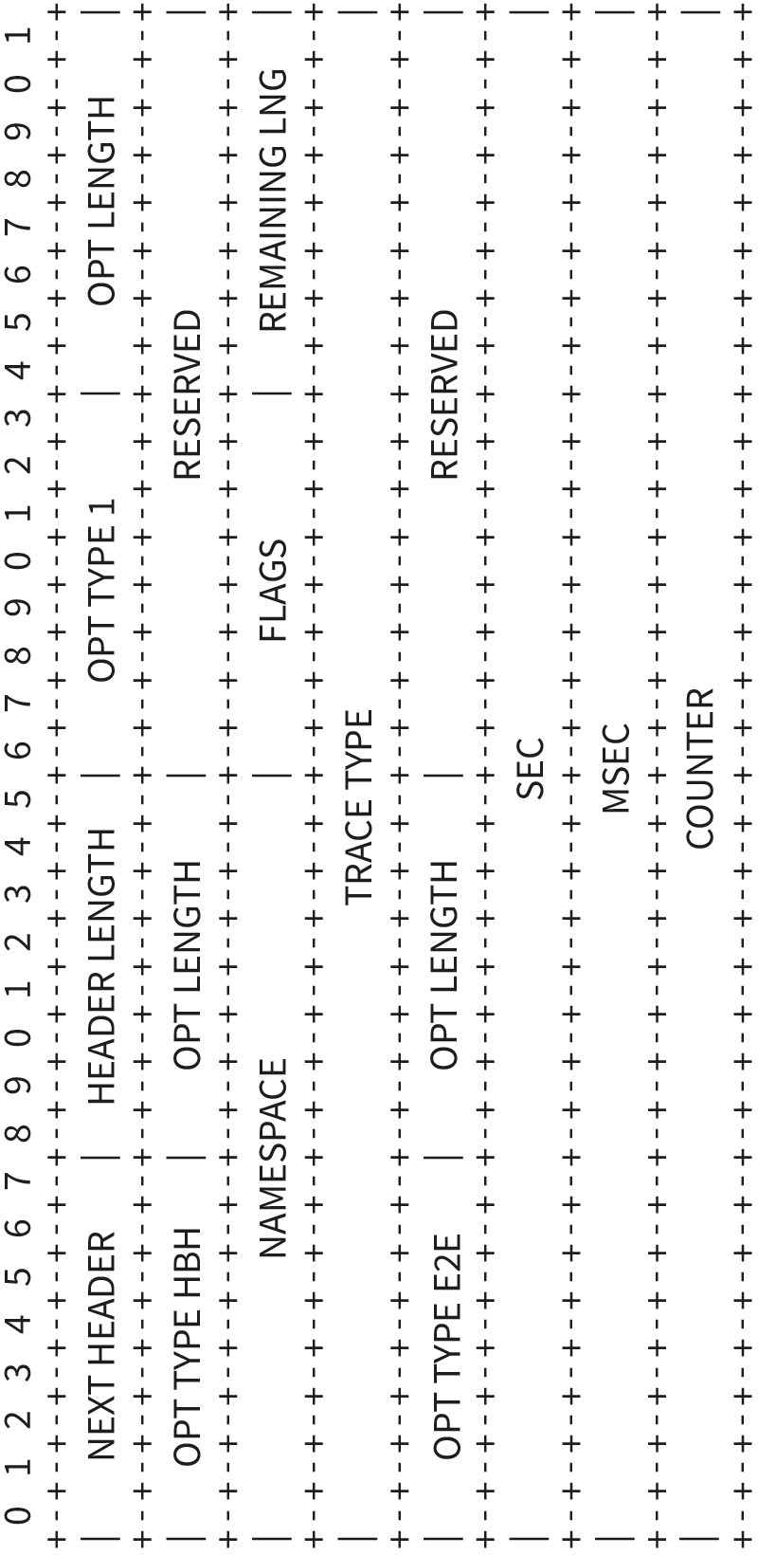

Source: Jetmir Haxhibeqiri (2023).
The hob-by-hop INT type is initialized at the INT source node and is processed by each INT intermediate node in the path toward destinations. Different parameters can be collected by the intermediate node based on the trace type that the INT source node specifies. The namespace value in hop-by-hop option type is a unique ID that relates to the flow that is being monitored in the network. The flags field shows if the INT data are overflown or if the destination needs to process the report immediately and reply. The remaining length shows the remaining length before the packets get overflown, or how many more nodes can add their monitored data.

Monitoring Parameters and Monitoring Points

INT can monitor different parameters on per-hop, per-flow and end-to-end basis. The next table shows parameters that can be monitored and their definition.

Table 9: INT Parameters

INT parameter Definition

Node ID | The last three bytes of the MAC address or predefined by the user
Timestamp [μs] | Timestamp when the packet enters the network stack at TX/RX side
RSSI [dBm] | Received signal strength indicator at the receiver
SNR [dB] | Signal to noise ration at the receiver
Channel used [Mhz] | Channel at which the communication happened
Data rate [Mbps] | Physical data rate used in the link
MCS | Modulation and coding scheme index used at the link
INT packet counter | Incremental packet counter
Processing delay [μs] | Time difference between the timestamp at the arrival and the time- stamp at the network layer in the receiver nodes
End-to-end latency [μs] | Time difference between the timestamp entering the network layer of the sender until leaving the network layer of the receiver
Packet loss | INT counter difference detection
Source: Jetmir Haxhibeqiri (2023).

From the network stack perspective, INT can monitor parameters at different points of the network stack. It can monitor data at the transport layer (e.g., TCP congestion window size), at MAC layer (timestamping when the packet leaves the communication stack, time slot used, communication cycle used) or at physical layer (physical data rate used, channel used to transmit, MCS index, etc.).

In order to decrease the monitoring overhead even further different monitoring possibilities exist. INT supports probabilistic monitoring when the source node will initialize the INT header probabilistically in a traffic flow. Further INT supports temporal monitoring where INT source node initializes the INT header on temporal basis or periodic basis. Finally, monitoring can be done based on Age of Information (AoI) of the monitored data.

SUMMARY
In this unit we covered the protection techniques of a communication network and how they can be integrated securely to the Internet. The perimeter-based security approach was analyzed, where the security functions are implemented at the boundary of the network at the con- nection point to the Internet. The firewall and intrusion detection and protection systems were discussed and analyzed in detail. We distin- guish between three different types of firewalls that are based on packet

filtering, stateful based firewall filters and application gateway. Then the IDS and IP systems were analyzed and comparison between their detection methods were shown. Finally, the zero-trust security architecture for integrating mobile networks with the Internet was analyzed as well. Next to this we analyzed how a mobile device can be connected securely to the network. We analyzed the mobile device management system that gives the possibility to network administrators to remotely monitor and manage mobile devices of the company/enterprise workers. Next to MDM, we analyzed the virtual private networks (VPNs) as a way of secure communication between mobile devices and enterprise network.

In the second part of the unit, we discussed the network monitoring techniques based on the lates developments in in-band network telemetry. The INT is a new network monitoring technique that gives the possibility to monitor on per hop, per flow and down to the end device bases. We analyzed different node roles in INT and parameters that can be monitored using INT.

