Historical-Geography of the Bene Israel in Bombay and Konkan:

Their Synagogues and Prayer Halls

Historical-Geography of the Bene Israel in Bombay and Konkan:

Their Synagogues and Prayer Halls

Prof. Shaul Sapir

Hebrew University, Jerusalem

Copyright  Shaul Sapir, 2023

All rights reserved. No part of this book may be translated, reproduced, stored in any retrieval system or translated in any form or by any means, electronic, mechanical, photocopying, recording or otherwise, without the prior permission in writing from the author.

Shaul Sapir has asserted his rights under the Copyright,
Design and Patents Act, 2023, to be identified as the Author of this Book.

Book Design: Shaul Sapir

Cover Design:

Cover and photographs: Shaul Sapir

ISBN:

The present book is dedicated to

My dear and beloved wife Ann,

our cherished children Vered, Michal, Alon and Orly

and to our wonderful and precious grandchildren
Yair, Michael, Maayan, Lee, Ben, Leah, Kelly, Lior,
Carmel, Yuval, and Tamar,
who bring us joy and enrich our life.

This book was made through funding from
Marian Scheuer Sofaer and Judge Abraham Sofaer
I am deeply grateful for their confidence and support.

Contents

Note to the Reader 8

Preface 9

Acknowledgments 11

Historical-Geography of Bombay 14
From Seven Islands to one Peninsula 14

Bombay’s Natural Features 15
Under Portuguese Reign 16

Great Britain and the East India Company 17
From Surat to Bombay, under Governor Gerald Aungier 18

Governor Charles Boone and Bombay Fort and Walls 18

The First Causeway, Hornby Vellard 19
The Great Fire of 1803 19

Governor Mountstuart Elphinstone, the Forerunner of Education 20
1830’s- New Beginnings: The Town Hall and the Mint 22
Roads to New Horizons 23
The First Train in Bombay 25
The Textile Revolution 26
First War of Independence - the Sepoy Mutiny 29

The British Raj Era, 1858-1947 30
Governor Sir (Henry) Bartle (Edward) Frere (1815-1884) - 32
Father of Modern Bombay
The American Civil War and the Effects of the Share Mania Era on Bombay 35
More on land Reclamation 36
Gas Lighting in Bombay 37
The Aftermath of the Share Mania Era and Modern Bombay- 38
“Frere Town”

The Early Synagogues in Bombay 43

The First Bene Israel Synagogues 46
Masjid Bunder Railway Station 48
Samuel Street 50

Sha’ar Harahamim (Gate of Mercy) Synagogue 51

Sha’are Ratzon (Gates of Desire) Synagogue 59

Other Bene Israel Synagogues in Bombay 62
Tiphaeret/Tipheret Israel (Pride of Israel), Synagogue, Jacob Cicrle 62

Magen Hassidim (Shield/Defender of the Pious) Synagogue, Agripada 65

Etz Haeem (Tree of Life) Prayer Hall/Synagogue, Umerkhadi 72

Rodef Shalom (Pursuer of Peace, Pursuing Peace) Synagogue, Byculla 77

Kurla Bene Israel Prayer Hall, Jewish Colony, Kurla West 81

Parel Bene Israel Prayer Hall, Parel 85

Bandra Temporary Prayer Hall, Bandra 87
Thana/Thane 88

Sha’ar Ha’Shamaim (Gate of Heaven) Synagogue, Thane 91

The Konkan Division- Maharashtra 96

The Raigad District 110
The Bene Israel Heritage in Raigad 113

The Coastal Route 131

Mandve/Mandva/Mandwa 131

Navgaon 133
Bene Israel Monument, Site of the First Landing at the Konkan Shores, Navgaon 134

Alibag/Alibaug 138
Magen Aboth (Defender or Shield of Ancestors) Synagogue, Alibag 144

Prophet Elijah's Chariots' Site, Talvali (also known as Khandala) 148

Revdanda 151
Beth-El (House of G-d) Synagogue, Revdanda 158

Therwada, Oil Press and Coconut Plantation 164

Nandgaon 165 Or Le'Israel/Orle Israel (Light to Israel) Synagogue, Nandgaon 169

Panvel 172

Beth El (House of G-d) Synagogue, Panvel 175

The Inland Route 172

Pen 179 Beth-Ha-Elohim (House of God) Synagogue, Pen 186

Poynad 191

Hessed El (G-d's Mercy) Synagogue, Poynad 192

Ambepur, Alibag Taluka, Raigad District, Konkan 195

Ner Israel (Light of Israel) Synagogue, Ambepur 195

Borlai /Borli/Borle 198
Shaarai Shaloam/Sha’are Shalom (Gates of Peace) Synagogue, Borlai 199

Pali 201

Unhere Hot Springs, Pali 205

Samson Soda Factory 208
Ashtami/Ashtumi/Astami (Roha Taley/Tehsil) 211
Beth-El (House of G-D) Synagogue, Ashtami 213

Tala/Talla/Murad Teshil 218
Kenesseth Israel (Assembly of Israel), Prayer Hall/Synagogue, Tala 220

Mhasla 225
Sha'ar Ha'Tephilla (The Gate of Prayer) Synagogue, Mhasla 226

Shrivardhan/Shriwardhan 230
Shrivardhan Prayer Hall, Raigad. 233

Index 235

Names of people and Organizations 235

Names of Places

Note to the Reader
In this work, we shall acquaint the reader with the historical geographical aspects of the Bene Israel communities in Bombay and Konkan and their prominent sites. Accordingly, we shall focus on getting acquainted with the communities in their villages and towns, by tracing as many as possible of their Prayer Halls and their Synagogues.
In the intention of clarifying the geographical space within the Raigad District, we classified the villages and towns where the Bene Israel settled into two routes:
The ‘Western Route’, which includes places by, or next to the Arabian Sea, and the ‘Eastern Route’, which are places located more inland.

We also have realized in our work, that many general studies dealing with Bombay and Konkan have neglected, probably unintentionally, their geo-historical features and we hope this volume will fill the gap and rekindle the focus upon the geographic and historic side of Bombay and Konkan’s Bene Israel communities, the villages and towns where they have lived in the past and where they continue living today. We hope it will provide a profound and an in-depth exploration of these communities. By doing so, a modest yet crucial phase shall be initiated to help the preservation of their splendid heritage.

In fact, and with much effort, our research looking into historical information relating to the Prayer Halls and Synagogues in Bombay and Konkan, faced some fundamental dilemmas concerning the authenticity of the sources. There is not enough in the existing literature that could supply us with the information for which we were searching. The dilemma stems, in some of the books published in recent years, from the lack of footnotes that are so necessary in trying to trace the authenticity of their sources.

Another dilemma includes the need to clarify the duplication of names of the settlements appearing on maps which is ostensibly a trivial issue. In this matter, besides using the archival sources, we were in contact with well-known experts (historians and qualified guides) on Konkan villages and towns, who would be able to supply us, from their own personal and worthwhile knowledge on the Raigad District and whom are known for their experience, knowledge and contact with the Bene Israel and the Konkan region. But, to our great dismay, without much success!
So therefore, in order to fully accomplish this task, I would like to invite those members whom I did not reach before the printing of this volume, to contact me at: mssapir@mail.huji.ac.il and to furnish me with any information they deem important.

The reader may also find an interest in the two well researched books by the author:
Bombay: Exploring the Urban Heritage (2013), and Bombay/Mumbai- 14 City Heritage Walks (2019).

June, 2023 Shaul Sapir
Preface

The historiography of India’s Jewish population consists of three independent and clearly defined communities, each with their own distinctive lifestyle and religious, cultural and communal characteristics. The last of the three to arrive in India is the Baghdadi community. The earlier two are the Cochin Jews (also known as Malabar Jews) and the Bene-Israel (Children of Israel) Jews. In addition, there are the Bene Menashe (Children of Menashe) living in the north-eastern border States of Manipur and Mizoram, who claim belonging to the Jewish faith, as well as the Bene Ephraim (Children of Ephraim), dwelling near the delta of the river Krishna, Guntar District, in the State of Andhra Pradesh.

Many are the questions concerning the time frame of the arrival of the Bene Israel on the Konkan coast. Although speculations exist in various studies, there is neither historical proof, nor any serious academic research dealing thoroughly with this subject: what was their native country; who were their ancestors; do they belong to one of the Ten Lost Tribes of the ancient Kingdom of Israel; if so, then to which one of the Tribes did they belong; what were the circumstances that led to their journey from their homeland to the Indian sub-continent?

We should notice that the Bene Israel settlements in the Konkan Division were, to a great extent, concentrated within the Raigad District. Raigad’s original name was Kolaba. The name Kolaba is attributed to the Sea Fort Kolaba/Kulaba, built in 1680 by Chhatrapati Shivaji Bhosale, the Great Maratha leader (1630-1680), founder of the Maratha kingdom of India.

From the geographical point, the Konkan forms the coastal area between the Arabian Sea in the west and the Western Ghats (ghat means “pass” in Marathi) - the Sahyadri Mountain Range, in the east. In 1961 the Konkan region became part of the newly formed State of Maharashtra and occupies the entire west coast of the new State.

Raigad District borders in the north by the Thane District, the Pune District to the east, the Satara District to the south-east, the Ratnagiri District to the south, and the Arabian Sea to the west. It includes the natural harbor of Pen-Mandwa, which is immediately south of Mumbai harbour. The northern part of the District is included in the planned metropolis of Navi Mumbai. It also includes the Isle of Gharapuri Elphanta.

It is said that the arrival of the Bene Israel to the Indian shore, approximately 2,000 years ago, was due to their ship wreck at the Konkan coast. The survivors swam and found shelter in Navgaon village. Legend tells of fourteen survivors of whom seven were women and seven men. The victims were buried by the coast. As their numbers grew, they began migrating to other parts of Konkan and later, during the second half of the 18th century, to Bombay and other parts of the country as well.
The Bene Israel lived in friendship and co-operation with the local population as well as adapting to their way of life. They took to agriculture and oil pressing, spoke Marathi and became part and parcel of the country.

In all, there are approximately a few hundred surnames based upon the names of villages in which the Bene Israel had settled in Konkan. In the course of time, they adopted the local dialect and surnames akin to other Maharashtrians. For their livelihood, they became farmers. Their main occupation was agriculture, oil pressing and also carpentry, which were the traditional skills they had been accustomed to in their native land. In Konkan they were referred to as Shaniwar Teli (Saturday Oilpressers). They were so called because they worked at their presses throughout six days of the week, but abstained from working on Saturdays.

Culturally, Raigad has been an ever-vibrant community, its population made up of different religions, dialects, ethnicity etc. Currently, there are only a few places in the Raigad District which are the historic hinterland of the Bene Israel Jews. The Bombay Gazetteer, relating to the Bene Israel in 1883 mentions:
“Beni Isra’els are returned as numbering 2,139 and as found over the whole district…The men are fairer than the middle-class Hindus of Kolaba and are generally above middle height and strongly made…The women are generally good-looking and fair. Like Hindu women they wear the hair tied behind the head in a knot, ‘ambada. Though somewhat quarrelsome and revengeful, the Beni-Israels are one of the best-behaved classes in the district, hardworking, fairly sober, and well-to-do…Like middle Hindus their houses are generally of one storey with brick or wattle and daup walls, and thatch or tile roofs…Beni Israels worship one God and use no images. In their Synagogues they have manuscript copies of the Old Testement and consider it to be of divine authority. They preach their religion only to people of their own tribe. They have Synagogues in the Kolaba district at Alibag, Ambepur, Barlai, Pen and Revdanda…”

Beginning in the mid-twentieth century, as a result of political and social changes, specifically both India’s and Israel’s Independence, the Bene Israel began to emigrate. At that point, the Bene Israel population in India dropped from an estimated twenty thousand to a few thousands, and today, the number of Jews currently living in the Raigad District is quite small. Of the Synagogue buildings and Prayer Halls built in the towns and villages in this region, from the mid-nineteenth to early twentieth centuries, only a few survive today. Some of these Synagogues remain active houses of prayers, others endure marginally, and the rest have been converted to serve other purposes. These vernacular structures, appropriately scaled and decorated for their function, served their congregations well for many years. They are a testament to the region’s diversity and to India’s tradition of tolerance of that diversity.

Acknowledgements
The volume before us provides an extensive study of the Prayers Houses and Synagogues in the Raigad District, previously known as Kolaba, during the time frame of the late 18th century until the present.
The major part of this study was carried out in archives and in libraries, mainly in London and India. During my journeys for this research, my dear wife Ann consistently and patiently encouraged, as well as assisted me, for which she deserves my deepest gratitude and appreciation.
In London, work was conducted in the archives of the Indian Office Record (I.O.R.) located in The British Library and in the archives of the Newspaper Library at Colindale. Extensive work was also carried out in the archives and library of The Royal Institute of British Architects- RIBA and information collected by studying the maps in The Drawing and Archives Collection at The Victoria and Albert Museum.
In India, much effort was invested at The Maharashtra State Archives in Bombay-Mumbai, formerly known as The State Record Office (S.R.O.), located in the Elphinstone College Building, Mumbai.
I would like to express my thanks to Dr. Dilip P. Balsekar, Executive Editor and Secretary, Gazetteers Department, Government of Maharashtra, Sassoon David Building, Fort, Mumbai.
Many hours were spent in the archives of The Times of India in Bombay as well.
I would like also to extend my special thanks to the staffs at the David Sassoon Library and Reading Room and at the Library and Archives of the University of Mumbai.
In order to supplement the existing information in written literature, an inclusive survey and extensive fieldwork was conducted of the sites still in existence, focused on locating and exposing “hidden” sites, of which a few have already been long forgotten during the course of time.
I heartfully thank my friend Ralphy Jhirad, for taking me on a few extensive trips to the various Synagogues and Prayer Halls of the Bene-Israel community in the villages and towns of Raigad District, Konkan.
I would like to extend my appreciation to my friend Menash Hannock Chordekar, who assisted me during our interesting walks and visits to the unique Synagogues and Prayer Halls of the Bene Israel in Mumbai.
I would also like to express my very special gratitude to my friend Nissim Moses, the Bene Israel historian.
Finally, my heartfelt thanks to my companion and my dear wife Ann, who consistently and patiently encouraged and assisted me in reviewing the manuscript and making the necessary changes. She deserves my utmost gratitude and deep appreciation. As always, she has my warmest and deepest love.
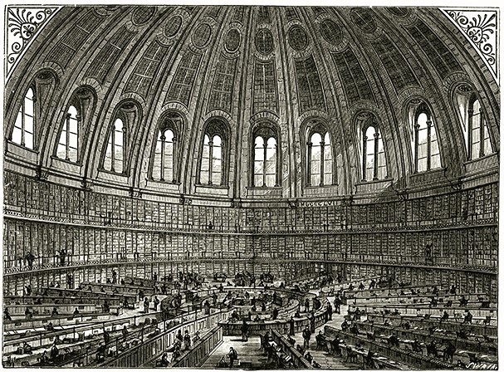 The British Library Reading Room, London

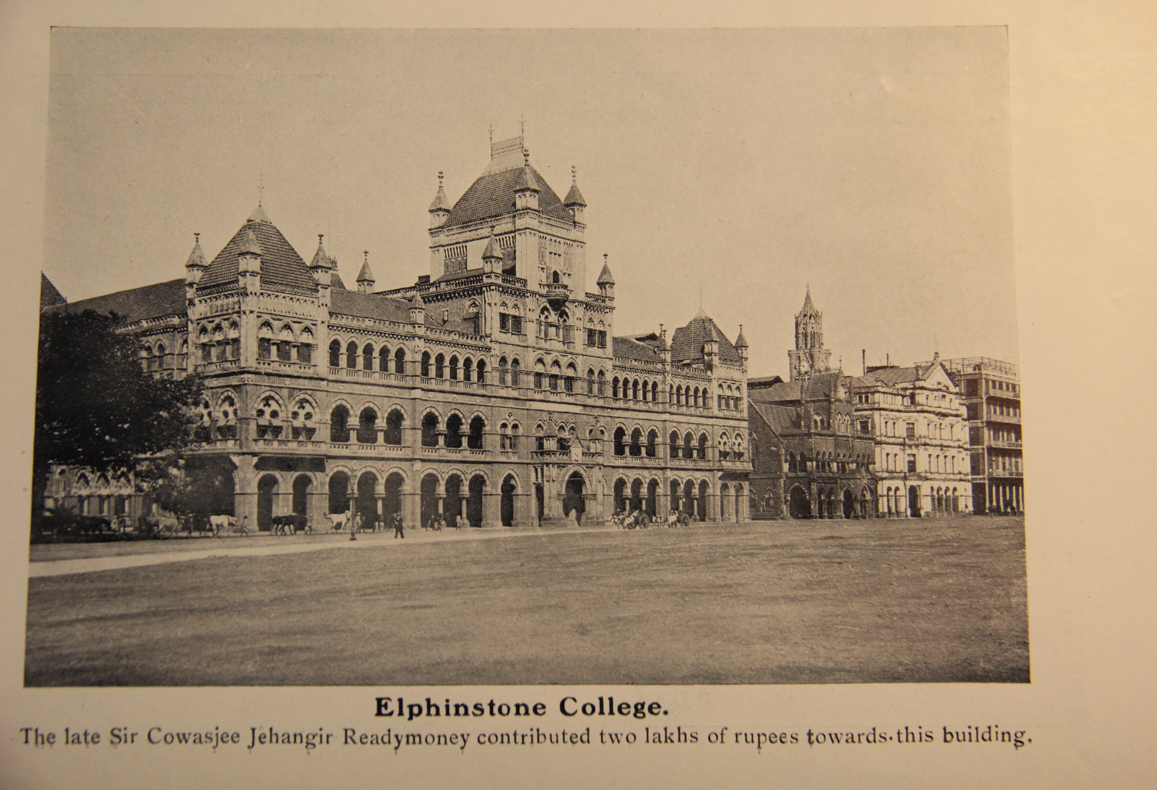
Elphinstone College, Bombay, c. 1900
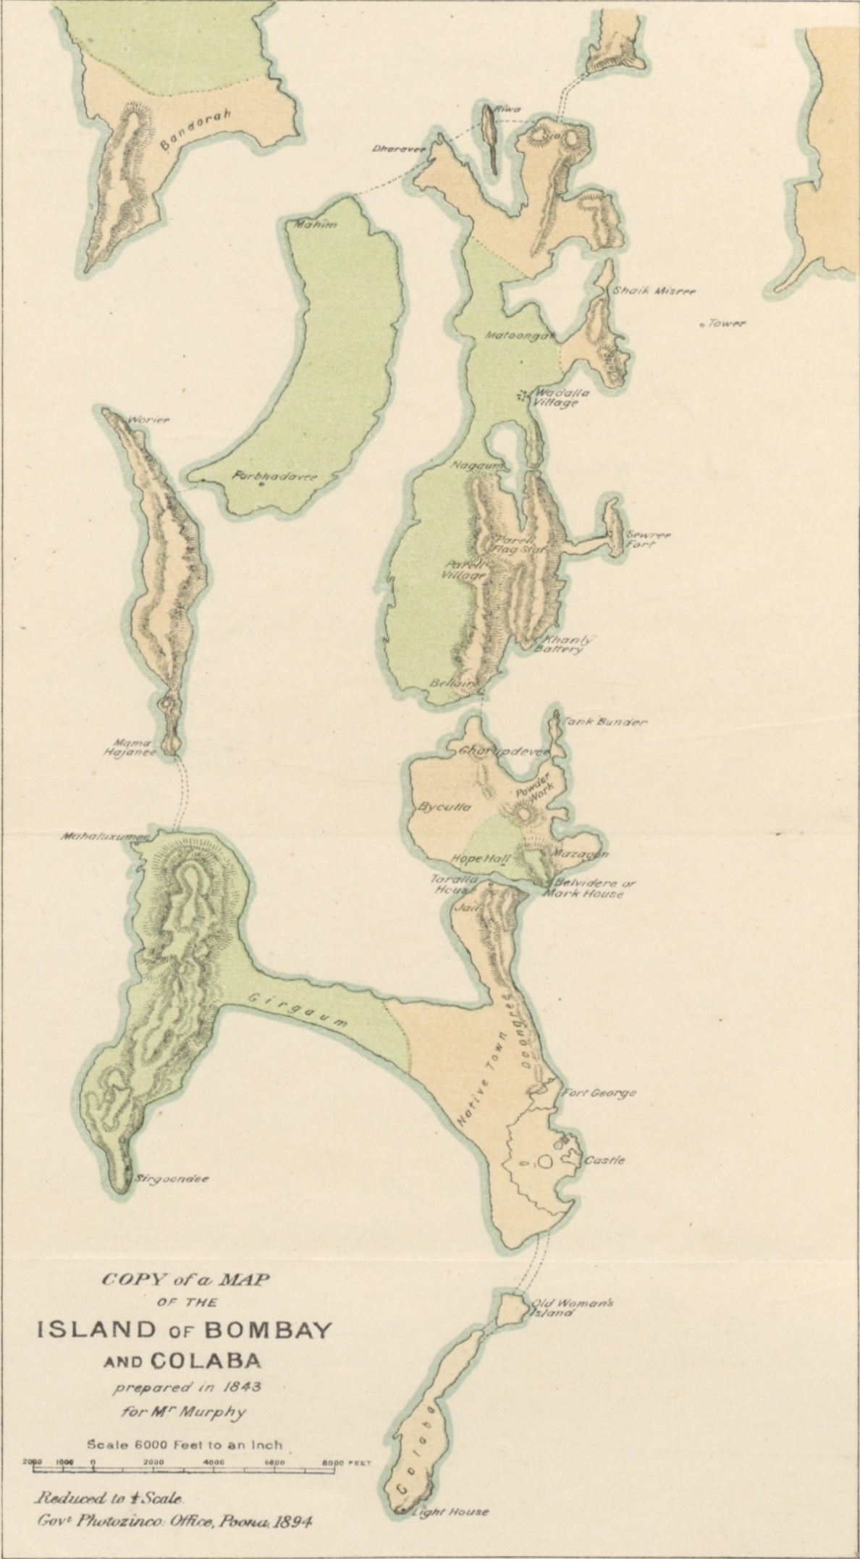Historical-Geography of Bombay

From Seven Islands to one Peninsula
The Island of Bombay (Mumbai, today) takes its name from the Koli (a native tribe of husbandman and fisher folk) goddess Mumba (a form of Parvati), whose Temple
formerly stood near the site now occupied by the Victoria Station.

The city of Bombay, which is the capital of the state of Maharashtra, is situated on the Indian subcontinent’s Western shore brushing the Arabian Sea. The urban expanse, which nowadays constitutes the city of Bombay, is comprised of seven islands. Research shows that the formation of these islands resulted from breaks caused by tectonic disturbance. Through the breaks and fissures in these ridges, the ocean at high tide swept with unbridled force and covered with its waters a considerable tract of low-lying ground between the islands.
The islands, from south to north are:
1.Colaba-Kola Bhat, 2. Old Women's Island, 3. Island of Bombay,
4. Mazagoan/Mazgaon or Mazagon, 5. Matunga or Parel, 6.Worli, 7. Mahim.
These islands, which were once separated from each other during high tides, were connected, mainly by land reclamation. The extensive activity of reclaiming the land from the sea during the course of the 19th and the 20th centuries led to the creation of the land peninsula continuum of greater Bombay.

Bombay’s Natural Features
Bombay’s growth was mainly peaceable and undisturbed by attacks from native potentates or foreign competitors. The natural and well-protected water inlet of Bombay, has granted the city its strategic and economic advantages, from which it went on benefiting for generations. The harbour was, as described in 1831: “Considered to be one of the finest in the world; it is accessible at all seasons, and from its land-locked situation and excellent anchorage affords protection to any number of vessels, during the most tempestuous seasons.” This is also one of the reasons why the governors of the East India Company preferred transferring the firm’s commercial and economic activities to Bombay and establishing the governmental and administrative institutions of Western India there.

In addition, the natural depth of the harbour’s waters offered better facilities for ship-building and Bombay was preferable in this instance, to Surat, where until 1735, the East India Company’s ships were built.
Following the intercontinental trade to and from India, Europe began to show heightened interest in the subcontinent. The following quote appeared in The Imperial Gazetteer of India and explicitly summarises the geographical features of Bombay:
“The island consists of a low-lying plain about 11½ (eleven and a half) miles long by 3 to 4 broads, flanked by two parallel bridges of low hills. Colaba Point, the headland formed by the longer of these ridges, protects the harbour lying on its eastern side from the force of the open sea; The other ridge terminates in Malabar Hill.” Sheppard, supplies a few possibilities on this name, one of them: The Hill- the native a name of which is Shri Gundi, which seems to mean 'Lucky Stone'- is also said to derive its name from the fact that the neighbourhood of the Walkeshwar Temple on it was a favourite haunt of the Malabar pirates. Shri-Gundi is called Malabar Point after the pirates of Dharmapatan, Kotta, and Parka on the Malabar Coast, who at the beginning of British rule in Bombay, used to lie in wait for the northern fleet in the still water in the sea of the north end of Back Bay.
In 1668 so exposed was the trade of Bombay to Malabar pirates and to Shivaji that three small armed ships had to be built as convoys and between the two lies the shallow expanse of Back Bay.
The island is in (the) shape (of) a trapezoid. It is popularly likened to a hand laid upwards, with the fingers stretching southwards into the sea, and the thumb representing Malabar Hill, with Back Bay between the thumb and forefingers…on a slightly raised strip of land between the head of Back Bay and the harbour is situated the Fort, the original nucleus around which the city grew up…”

Under Portuguese Reign
In 1532, the Portuguese conquered the islands of Bombay and Mahim from the control of Sultan Bahadur Shah, the ruler of the Kingdom of Gujarat. Two years later (1534), Bahadur Shah was forced, under a special peace accord, to also surrender the sovereignty over the remaining islands around Bombay as well as other, more remote territories, to the King of Portugal. A treaty of peace and commerce between Bahadur Shah and Nuno da Cunha, the Viceroy of Goa, confirmed the surrender of Bombay, on the 25th of October 1535.

However, the new Portuguese rulers were not wise enough to exploit the advantages that Bombay offered. The city remained stagnant under their reign and many years later, in the year 1661, it was handed over to Charles II, King of England (1630-1685), as part of the dowry, which he had received on his marriage to the Infanta Catherine of Braganza, the younger sister of Alfonso the Second, King of Portugal. The official change of ownership was delayed until 1665.
The transfer into English hands was delayed due to difficulties imposed by the representatives of the local Portuguese regime who were not pleased with the new arrangement.

In fact, the Portuguese authorities in Goa decisively objected to the transfer and caused many difficulties in its application.
At this time, the population of Bombay was about ten thousand.

Great Britain and the East India Company
Experience proved that the outlay on the maintenance and development of the new possession would make too heavy a demand upon the Royal purse, thus on March 1668, King Charles II leased Bombay to the London East India Company for the symbolic sum of ten English pounds in gold per annum.
The East India Company’s trade soon increased immeasurably and it was only a matter of time before the Company’s headquarters on the western coast of India were to be transferred from Surat to Bombay.
The East India Company was established in the year 1600 as a commercial company by a union of traders with shares in the company, who wished to receive a cut of the spice trade with East India.
The victory of Britain over the Spanish Armada in 1588 provided a convenient background for its establishment because after this Britain was searching for new markets to trade in. As time went by, the company evolved into a political power
in India.

The Royal Charter, which was signed on March 27th, 1668, gave the company a monopoly in all that concerned trade with India, along with the right to rule over Bombay.
A few months later, on September 23rd, the actual handing over of Bombay to the East India Company came about, which placed it under the authority of Surat.

From Surat to Bombay with Governor Gerald Aungier
The founder of Bombay and the person who was responsible for the initial growth of the city, was Gerald Aungier (born-unknown date-1677), who was Governor of Bombay and President of Surat (June 1672-June 1677). Surat is located about 130 kilometers north of Bombay. Surat was then the base and the headquarters of English commerce and seat of the regime’s Presidency on India’s western coast. In June of the same year (1672), Aungier took a monumental step in the history of Bombay by shifting the Government centre from Surat to Bombay. Hand in hand with this basic transition, Aungier began laying the cornerstone for the infrastructure of the city’s plan as a barricaded Government centre.
He made it the main task of his administration to raise the new settlement to a satisfactory level, and laid the basis of the administrative, commercial and social expansion of Bombay. He took measures for the settlement of the land to receive revenue on equitable terms; to strengthen the defenses; to introduce a suitable currency; to extend inducements to merchants and to artisans to settle on the island; and to secure freedom of trade and worship for all comers.

Aungier’s business incentives attracted Parsis, Jews and Armenians, along with Gujarati Banias from Surat, Dawoodi Bohras and Brahmins from Salsette. Upon the death of Aungier on June of 1677, Bombay was well on the road to prosperity, embracing a population of about 60,000 inhabitants.

Governor Charles Boone and Bombay Fort and Walls
A few years later, in 1680, instructions arrived from England stating that the status of the British regime in Bombay must be reinforced. It was also the clear intention of England to make known to those around them that they were there to stay for the long run. This policy could make them appear as a stabilizing factor, rather than represent them as a passing fleet of merchants, meddling in matters, which are of no concern to it. After approximately a period of fifty years, following the arrival of Charles Boone as Governor (1715-1722), the British rebarricaded Bombay. Trade picked up and settlers flocked into town, especially from remote Gujarat.

Boone fortified the city against attacks and protected the island town from seaborne assailants, by enclosing it within a massive wall. The barricaded city was constructed in the form of a great fortress and named the Fort, with the governing castle in its centre Bombay castle served as the official residence of the Governor until the 1770’s, when it was transferred to Parel and later, in 1883, it was moved to Malabar Hill.
In the course of time, the Fort gave its name to the entire area within the city walls. Boone also extended the dockyard and urged the construction of new buildings. Three major roads forked out of the three main gates of the fortress wall: the Apollo Gate in the south, Church Gate in the west and Bazaar Gate in the north.

The First Causeway, Hornby Vellard
Towards the closing of the 18th century, another important event took place in the history of Bombay in the shape of the construction of a causeway between Bombay Island and the Island of Worli. The project, which was the first of its kind, came to be known as the Hornby Vellard. It was initiated and executed by William Hornby (1723-1803), Governor of Bombay (1771-1774). The work commenced in 1782 and was completed in 1784.
The purpose of constructing this Vellard (meaning fence or embankment, which is a local corruption of the Portuguese word Vallado), was to prevent the low-lying areas from becoming flooded at high tide, by constructing a blockade upon the Worli Creek. With the completion of the Hornby Vellard, Worli was linked to the main Island of Bombay.

The Great Fire of 1803
The commencement of the 19th century marked two notable events, which had an immense impact on the future development of Bombay. Both events happened in1803: the great famine, which drove a vast number of people from the Konkan and the Deccan to seek employment in Bombay; and the great fire, which broke out in the Fort on the 17th of February 1803.
At the time, the southern part of the Fort was allocated to the English settlers, while the locals resided in the northern part, which was built by using a dense and cramped method of construction. The fire, which was of great magnitude, annihilated nearly a third of the constructed area of the Fort, mainly on the northern side of the town.
Though most of the damage was done to private residences, the conflagration enabled the Government to plan wider thoroughfares in the most congested parts of the Fort. The effect of the fire, however, lay not so much in the improvement of the town within the Fort walls, as in the inducement, which it offered to the construction of a new town outside the city walls. It acted as a great incentive to the native community to build their houses, shops and godowns outside the Fort walls.

The devastating fire of 1803 was, actually, a blessing in disguise, for it accelerated the foundation of that settlement, which grew into the city of Bombay. Yet, this development had to wait another half a century.

Governor Mountstuart Elphinstone, the Forerunner of Education
The 1820’s, presents developments in the sphere of education during the term of Mountstuart Elphinstone (1779-1859), as the Governor of Bombay (1819-1827). The school was erected in 1820, as a branch of The Bombay Education Society. During his Governship, Elphinstone initiated and promoted various projects in the expanse of his territory, such as commercial bonds, paving new roads, erecting vital public buildings and mainly promoting the subject of education amongst the local population.
In 1822 the school was separated from The Bombay Education Society, under the title of The Bombay Native School Book and School Society. In 1827, the society became The Bombay Native Education Society and Mountstuart Elphinstone was its first President.
In 1835, the School was formally constituted and was named The Elphinstone Institute. A few years later, in 1840, the school was incorporated with The Elphinstone College classes and all former designations were merged in that of The Elphinstone Native Education Institute. In 1856, the professorial element, constituting the College, was separated from The Elphinstone Institute, which thenceforth was known as The Elphinstone School. The school, including the institution's various branches, was situated on Cruickshank Road, known today as Mahapalika Marg.
Regarding the High School, Sir Albert Sassoon donated in 1872, a significant sum for establishing a new building for the Elphinstone Technical High School, to be named after his father – The David Sassoon Building.

The Times of India (1885), relating to Sir Albert’s contribution to the school stated that the reason for the contribution was vested in his high regard of the excellent education, which he had received in Bombay, after arriving there at the age of 14. It was also mentioned that this was: "…probably the largest sum ever given by a single person for one educational purpose.

The Elphinstone High School was designed in 1878, by architect Molecey (1839-1894), in the Neo Gothic Style, who tried to break the building’s elongated façade with a massive staircase (40 feet wide) leading directly from the sidewalk right into the first floor of the building.

The inauguration of the Elphinstone High-School Building took place on the 23rd of February 1881 and was conducted by Sir James Fergusson (1832-1907), the Governor of Bombay Presidency (1880-1885). The ceremony was most glamorous and was attended by the community members and by many distinguished guests.
The building’s architecture was most impressive and was described in the Jewish Chronicle (1896), as one of Bombay’s delightful treasures: “…which is one of the chief architectural ornaments of Bombay.”
Following the transition of 1856, the School continued to remain on Cruickshank Road and the College was shifted to Parel, which in 1860 was formally affiliated with the University of Bombay. In 1888, the College was moved to its present palatial premises on Esplanade Road, located off the Kala Ghoda Square and adjacent to the David Sassoon Library.
The magnificent building was constructed owing to a generous donation by the Parsi businessman and benefactor Sir Cowasjee Jehanghier. Today, in addition to serving as a well-respected College, the building also houses the Maharashtra State Archives. The Elphinstone College building embellished with its Gothic Style architecture is classified as a Grade 1 Heritage structure.

1830’s - New Beginnings: The Town Hall and the Mint
In the following years, the face of the land was undergoing important changes within the Fort and beyond its walls as well. The year 1832 marks the arrival of David Sassoon in Bombay who, with his descendants, was to play a vital role among the Jewish community and the general population of urban Bombay as well. In time, Sassoon became a major magnate in Bombay’s commerce and finance. With no doubt we may say that the arrival of David Sassoon in Bombay marked a new era in the history of the city.

However, at the time of his arrival, Bombay was but a minor force in these spheres. An authentic description of this state of affairs is illustrated in the Bombay Times from 1838: “Before the year 1830, there existed scarcely any intercourse between the part of Bombay and Central India. We received nothing whatever from those vast and fertile provinces; and supplied them with but a single commodity, namely salt, which was conveyed upon bullocks from our coast to Oumrawutty in Behar, a distance of 600 miles. As the bullocks returned unlade, it occurred to an enterprising native (one whose humble history has scorned to write, though his genius has already influenced the fortunes of people) to load a few of those returning bullocks with the cotton of the country…The experiment was completely successful and the very next year [1831] 10,000 loads were brought by the same means to our city! In 1836 (six short years from the first experiment of the Hindoo) 90,000 bullocks’ loads of 240 lb. each were received in Bombay from that single District.”

The 1830’s’, also witnessed the erection of a new Town Hall completed in 1833.
The year of the establishment of the Town Hall in 1833, appears on the tablet, which is located on the right wall of the landing above the stairs and it says: “The Town Hall, after the design of Colonel Thomas Cowper. Commenced A.D. 1821. Completed A.D. 1833. Architects: Colonel Thomas Cowper. Captain Charles Waddington. Bombay Engineers.”
Hildreth (1917) mentions that the building was completed according to the plans of Colonel Cowper, R.E. (Royal Engineer) and adds: “…the main hall contains a fine organ presented by Sir A.D. [Albert David] Sassoon.”

A new Mint, where coining was commenced, was erected as well, at about the same time. Like the Town Hall, the Mint was designed in the Neo-Classical Style, known also as the Greek Revival Style. The Gazetteer of Bombay noted that Governor Aungier established the first Mint in 1670. The erection of the present one was sanctioned by The East India Company in 1823. An inscription on the building shows that the building was designed and constructed by Major John Hawkins of the Bombay Engineers. The work was commenced in 1824 and was completed in 1829.
At the same time, Bombay was elevated to the status of a Bishopric in 1835.

Roads to New Horizons
Gradually, Bombay’s identity changed from an archipelago to a peninsula through a network of roads that continued to link the seven islands.
One noteworthy improvement in this period, which must have greatly assisted in the communication between the inhabitants of the Deccan with Bombay, was the construction of a good carriage road up the Bhor Ghat to Poona which was formerly known as the key to the Deccan and which was said to “break down the walls” of the Konkan and the Deccan. The Konkan is the coastal area between the Arabian Sea in the west and the Western Ghats (the Sahyadri Mountain Range) in the east. The Mayura River marks the northern boundary and the Gangavali River forms its southern boundary.
The Deccan is derived from the Sanskrit- Daksina, meaning South. Deccan is a large Plateau, which includes part of Central and most of Southern India. The Plateau is located between three mountain ranges: Separating it in the north from the Indo-Gangetic Plain are the Satpura and Vindhya Ranges; in the west lies the Western Gaths; and in the east, the Eastern Ghats. Both, the Western and Eastern Ghats nearly meet at the southern tip of the sub-continent, forming a downward triangle of the Indian Coastline. The Plateau rises about a hundred meters high in the south, creating a moderate gradient upwards (from north to south).
Geographers have attempted to define the region using indices such as rainfall, vegetation, soil type or physical features. Besides rice and sugarcane, the chief product of the Deccan was cotton.

The road was opened on the 10th of November 1830 by Sir John Malcolm (1769-1833), Governor of Bombay (1827-1830).
Soon after the opening of the Bhor Ghat road from Bombay to Poona, Poona started to become a popular resort.
A few years later, two main thoroughfares within the city limits of Bombay were completed (1838). The first one was Grant Road, after Sir Robert Grant (1779-1838), Governor of Bombay (1834-1838), which linked the palm groves of Chowpaty and southern Bombay to the upcoming new northern neighbourhoods. These new neighbourhoods included Byculla, where David Sassoon chose to build his mansion and which in time would emerge as one of the two main Baghdadi Jewish neighbourhoods in Bombay. This major event was noticed by Edwardes in his work: The Rise of Bombay (1901):
“Not only in the Fort was the face of the land undergoing change. The town was creeping gradually over the reclaimed high grounds, westward along Back bay, and northward to Byculla, so that by 1835 it became imperative to construct new communications. One of the first and almost noteworthy was the great main road, named after Governor Grant…"

The second main thoroughfare was the Colaba Causeway, linking the islands of Colaba and Old Woman’s, which were located in the southern part of the city, to the other five islands in the north. Regarding this progress, Edwardes mentioned:
“The spirit of progress, by which this period is characterised, led to alterations and improvements with the limits of our island, of which the most remarkable
was the construction of the Colaba Causeway in 1838. Colaba and Old Woman’s Island formed… the only remaining vestiges of Ptolemy’s Heptanesia, and were the last of the seven to be absorbed into the Island of Bombay…the Causeway was built and the welding together of the seven pristine islands was an accomplished fact.”

Sheppard informs on the Colaba Causeway: “The Island of Colaba was, in 1838, linked with Bombay, by this Causeway, which had been projected in 1820 but not started until 1835. It was widened and rebuilt, 1861-63.”

Colaba Causeway is famous today for its shopping opportunities and is dotted with numerous restaurants, cafes and roadside eateries.
The population of Bombay at this period was estimated at 236,000, which was comprised of various ethnic groups and castes.

The First Train in Bombay and in India
In addition to these developments from the second half of the 19th century, a network of railways, the Empire’s greatest capitalist expression, linked Bombay with the rest of the sub-continent. Thus, in the early 1850’s, the first sod of the Great Indian Peninsula Railway was turned and on 16th April 1853, the first 21 miles (33.6 kms.) leading north-east to Thana (also spelled as Tannah, and today, Thane) were opened for traffic. The distance was covered in 57 minutes. The day was marked as a public holiday.

Ten years later, in 1863, the Bhor Ghat incline was inaugurated and in 1864, the Bombay Baroda and Central India Railway was completed.
The infrastructure of the new railway system had a great impact on the access to and from Bombay, which was one of the main factors to influence the growth of the city in the years to come.

Along with the development activities in the sphere of the road and railway infrastructure during the early second half of the nineteenth century, it seems, that there was, naturally, a demand for an expansion in the sphere of high education. A few educational establishments came into existence, including the Bombay University which was founded in 1857.

The Textile Revolution
Another important feature in the history of Bombay during the 1850’s was the opening of the first spinning and weaving mill in Tardeo, a southern suburb of Bombay, which marked the entrance of Bombay into the Industrial Age. The year 1854 provides an important milestone in the history of Bombay’s textile factory industry: the first cotton mill was erected in India. 1854 may therefore be regarded as the natal year of the Indian mill industry.
In July of 1854, a stock-holding company was founded in order to erect the mill where production began in February 1856.

As for Bombay’s textile mills and factories, there was good reason why most of them were located in new areas of the developing northern part of town, while the offices and the businesses were located at the Fort’s business District, in its southern part. Between these two centres, yet closer to the textile factories, the new neighbourhoods were beginning to advance northward, following the footsteps of the cotton textile industry. The textile industry during this period started to take its place as Bombay’s most prominent industry and had become more and more dominant in the city’s economy and development which continued to gather momentum, as the years went by.
Due to the multitude of textile mills in town, there was a growing concern on the part of their owners, which led to the establishment of The Millowners’ Association, founded in Bombay in 1875. Along with its establishment, it amalgamated 28 factories, which employed 13,550 workers.
The same year (1875), featured the silk cloth which was a variant product in the textile industry. The pioneers of this industry were members of the Sassoon family, who established the first silk production factory in 1875 and was known as the Sassoon Silk Mill. In 1883, it was amalgamated with the Alliance Silk Mill and has been called since then The Sassoon and Alliance Silk Mill.

During the following decades, the textile industry gathered momentum and became Bombay’s most prominent manufacturing enterprise, boasting 136 mills at the close of the 19th century.
The Sassoons were on the road to making a lasting impact on the cotton-textile industry in Bombay and in India as well! In January 1877, an item was published in The Times of London, relating to the opening of a new textile mill in Bombay, belonging to the David Sassoon branch, a mill that was considered to be one of the largest of its kind in the sub-continent. The short news item stressed the high quality of the modern machinery in the mill, which boasted the latest improvements: "The engines of the new Sassoon Spinning and Weaving Mills started on Tuesday last. This mill is one of the largest in Bombay, and is fitted with the latest improvements in the machinery.”
The E.D. Sassoon & Co. branch also was active and productive in the booming mill industry, being the owners of a few mills. Jacob Sassoon was obliged to employ Hindu workers in his new mills, yet he did his best to appoint Jews as managers and inspectors, in order to continue providing work and income for his fellow religionist. During that time, the 1880’s and 1890’s, a big wave of Jewish immigrants began arriving from Baghdad and they were offered many tempting benefits. This was proved by full employment for adults at the cotton-textile mills, good schools for their children, as well as Synagogues and proper health services.

At this point, in the early 1890`s, another turning point came into progress in the textile mill industry, led by the E.D. Sassoon & Co. Among the textile mills erected in Bombay, the one that deserves special notice is the Jacob Sassoon Mill, established in 1893 in Parel’s bustling centre of textile mills. The new mill built by Jacob Sassoon, was considered to be one of the larger, if not the largest, textile mill ever built on the Indian subcontinent. The daily production was estimated at about 40,000 pounds of yarn and 16,000 pounds of cloth, through the labor of 3,000 manufacturing line and operational workers. The new mill’s inauguration ceremony took place on the 5th of September 1893.
On the 10th of February 2008, the author visited the Jacob Sassoon Mill and toured within and around its deserted and neglected buildings. The whole complex appeared to be totally abandoned. In an interview with the director of the mill, Vasant B. Naik, he clarified the situation and explained vigorously that the mill closed just the day before our arrival (the 9th of February) and production ceased which also resulted the firing of seven hundred employees as well.
Within the mill grounds and facing the sea, Jacob Sassoon built a magnificent Colonial Style Villa for his comfort and for the guests visiting him in Bombay. Today, unfortunately, this once splendid villa stands in disrepair. The Jacob Sassoon Textile Mill was located on Sopari Baugh Road.
Another Jewish textile tycoon was Sir Sassoon Joseph David (1949-1926), who was married (1876) to Hannah, daughter of Elias David Sassoon and sister to Jacob Sassoon.
Sir Sassoon David received a British Knighthood by the British Crown on the 14th of November 1905, and was knighted by the Prince of Wales in Bombay, who happened to be on a visit to India on that occasion.
In the same year (1905), Sir Sassoon J. David was appointed to the Shrievalty of Bombay.
By this year (1905), Sir Sassoon J. David held the seat of Chairman of the Bombay Millowners' Association, had three cotton mills in the possession of his firm, the Sassoon Joseph David & Company. Among them were the David Mills Co., Ltd. and the Standard Mills, Ltd.

Within a year, in 1906, Sir Sassoon J. David with Sir Cowasjee Jehangir established the Bank of India, known to be one of the largest banks in India. He was the living spirit behind the establishment and the success of the bank and served as its chairman for twenty years, since its foundation in 1906, until his death in 1926.

The First World War (1914-1918) led to tremendous development in the textile field, as a result of the increasing demand for textiles and its products. This trend was also apparent during the following years and the growth of the new textile mills increased from year to year.
At the end of the war, India's textile mills harvested great profits, and the E.D. Sassoon & Co. owned more than a dozen of textile mills and dying clothing factories, some of Bombay's largest ones.

It seems, as if during decades and in fact, throughout the entire first half of the 20th century and onwards, Bombay had become one of the most important textile centres in the world. Essentially, the textile industry was quite successful in facing the enduring and threatening competition from other big industrialists elsewhere, which competed over the same market share in the world market of textile exportation.
The Sassoon’s, who had a leading role and an important impact in this process, became the largest mill owners in pre-independence India. The textile mills at the end of the regime of the British Raj had an important part in the development of the city of Bombay. In recent years, there is reasonable concern that a great part of these mills and their tall chimneys will disappear from the urban skyline of the city's landscape. In a publication that appeared recently, this issue received special attention by its author Shyam Chainani: "…the heritage value of the mill structures had played a crucial role in the development of Bombay. Foreign experts have described these as 'gold mines of industrial archeology'."
In his work, Shyam mentions the existence of 170 sites of the NTC (National Textile Corporation) Mills and while focusing on this important topic, he quotes the London architect and town planner Abe Hayeem (who returned to Bombay, following an absence of 47 years): "Driving into Mumbai from the airport, I passed the amazing cotton textile mills, which though derelict, would also classify as an important part of the Victorian heritage of Mumbai. It would be tragedy if these amazing sites and buildings were to be demolished."

Obviously, the preservation of at least a fraction of the textile mills in the city should be part of a comprehensive scheme, involving all parties concerned, led by the Municipality of Bombay.

First War of Independence - the Sepoy Mutiny
As great an impact as the development of new transport methods in the country and the industrialization in the sub-continent in the 1850’s, another vital turning point in the history of the British regime in India took place, which was later to be labeled; the First War of Independence.
In May of 1857, the Sepoy (native infantrymen serving in the British Army) Mutiny erupted against the British, a stormburst that threatened the very existence of the English in India, and one that would shake the regime’s foundations to the ground. Charles Forjett, Commissioner of Police (1855-1863), fortunately rescued the city from the horrors of it. The Sepoy mutiny was suppressed with great brutality towards the end of the year 1858. The Sepoy Mutiny had several titles: Indian Mutiny, Sepoy Rebellion, Indian Rebellion, Great Indian Revolt, and First War of Indian Independence.

The results of the rebellion ended the everlasting and almighty reign of the East India Company in India, which had lasted about two hundred years. Lord Palmerston (1784-1865), the British Prime Minister (in his first term in post), presented in February of 1858 his motion before Parliament (even before the suppression of the mutiny) to transfer control from the hands of the East India Company to the hands of the British Crown. His act was named “The Act of 1858” and is better known as “An Act for the Better Government of India”. The significant decision received by the Parliament, with regard to this matter brought forth a fundamental structural change on all levels of the British regime in India. The transition of control over India in 1858 lead to important changes in the administration of Bombay's municipality, which went on in their new pattern until 1865.

The British Raj Era, 1858-1947
The actual transition of government to the hands of the British Crown took place on the 1st of November, 1858.
A special document prepared by the Crown was issued upon this striking historical event, which was titled: Proclamation of the Queen, by which the Queen’s direct supremacy over India was finally substituted for the long-lasting rule of the East India Company on the Indian sub-continent. The Proclamation, also dealing with the solemn declaration of Indian rights and duties, was publicly read on the 1st of November, on the steps of the Town-hall. The Times correspondent in Bombay in his communication from the 9th of December 1858 reported:
“…this Proclamation is one of the greatest documents, the weightiest instruments that has ever appeared in this country; that it has simplicity and a force well calculated to inspire respect and to rivet public attention. It conveys, with a solemnity worth the greatness of the occasion, the principles on which the future policy of England in India is based. It affixes the stamp of a Royal guarantee on a course of policy founded on the experience of the past. It declares, once for all, that England is sovereign mistress throughout the length and breadth of these lands. It confirms treaties, assures toleration, and promises such reforms as are consistent with the peculiar form of the institutions under which this country has been governed.”

Four months after the official day of the transition of control from the East India Company to the British Crown, David Sassoon held a festive ball on 28th February 1859, which was celebrated at Sans Souci, with the utmost splendor and majesty. Among the invited guests, there were Government members, Senior Officers, Consuls and the representatives of various countries, along with their wives. During the ceremony, Lord Elphinstone (the Governor of Bombay Presidency) praised the Jews for their loyalty towards England and stated that the Jewish community (headed by David Sassoon) was the first in line to offer a helping hand to the government as the mutiny broke out. He also blessed David Sassoon for his exceptional initiative.

The Jewish community in Bombay also celebrated this significant event. By late afternoon they started decorating their homes, yards and gardens and towards the evening convened at the Synagogue (probably the one at David Sassoon’s mansion) in order to pray, in exaltation and express their feelings of thanksgiving for the ending of the mutiny.

The transfer of Government from the East India Company to the British Crown actually put an end to all intentions and attempts made by the Portuguese, the Dutch and the French to establish some kind of territorial stronghold in India and to their commercial aspirations with regard to the subcontinent.
Because of this new political situation, Britain emerged victorious as the only authority in the subcontinent, until India’s independence on 15th August 1947.

Governor Sir (Henry) Bartle (Edward) Frere (1815-1884) -
Father of Modern Bombay
A short time following these events, during the decade of the sixties of the 19th century, the process of leaving the walls of the old Fort began. These years provide us with one of the most important and fascinating chapters in the history of Bombay.

During this period, extensive changes occurred to the city’s fabric. The expression of these changes can be seen in the city’s monumental-grandiose construction as well as in the expansion of its urban space into new frontiers. The emergence of the new city began close to the old historical core of the Fort area, spreading out in an extensive process of aggressive and accelerated development.

Various factors were involved in accelerating the process of moving out of the city walls, headed by Sir (Henry) Bartle (Edward) Frere (1815-1884), the Governor in tenure at the time, ruling over Bombay Presidency. Many personas endlessly praised the effort made by Frere during the first and vital steps that he took in order to glorify the town during his term as the Governor of Bombay. In this body of work, we shall use but a mere fraction of the material published concerning one of the most dynamic personages in Bombay’s history, the one who laid down the infrastructure that made it a leading modern city on the sub-continent.

Frere reached Bombay’s shore on the 22nd of April 1862 and his inauguration as Governor of Bombay Presidency took place two days later, in a modest ceremony at the city hall.

His term as governor ended in 1867. Upon his arrival in Bombay, Frere was the man behind the demolition of the Fort’s walls, which enabled the massive and intensive construction that began taking place outside the walls. It should be noted that the maintenance of the Fort of Bombay was already, by the early 1840’s, not only useless, but had also become a most serious nuisance to the inhabitants of Bombay at large. Thus, the idea of demolishing the Fort walls was mooted as early as 1841, as a result of land reclamation activities beyond the walls, as well as the influx of population into the town.

Along with the acceleration of trade and commerce under Frere’s governorship, Bombay was transformed into a thriving trading port and commercial centre and into a colonial town of high architectural accomplishment.
In order to promote his goals, Frere acknowledged the need to involve a talented, respected and experienced architect in his plans to stand at the head of this unique project.
Architect James Trubshawe (the consulting architect to the Government of Bombay), was chosen for this purpose to head The Ramparts Removal Committee.

The Fort had walls about forty feet high and from twenty-five to fifty feet wide at the top. These carried guns and were surrounded by trenches, which were full of water during the rainy seasons.
The removal of the walls took place during the years 1862-1863 and their debris was used to fill up the wide and long moat.
The main streets: Rampart Row (today K. Dubash Marg), Esplanade Road (today Mahatma Gandhi Road) and its northern continuation – Hornby Road (today Dr Dadabhai Naoroji Road) were planned along the course of the wall and the moat.
Along the Esplanade, the Ramparts Removal Committee planned an impressive line of public and government buildings (mostly in a Neo-Gothic Style), on a scale that was unheard of in Bombay’s past.

During Frere’s governorship, the Gothic Revival Style, innovatively adapted to local conditions, was introduced to 19th century Bombay. Some of these remarkable changes were pointed out in The Times of December 1863: “The population is 800,000…The beauty and appropriate of its situation have already been alluded to, its quays are being enlarged by many hundred acres, its ramparts are being placed, like those of Vienna, by a splendid boulevard (which was to be named, when completed, Rampart Row and Esplanade Road) and a series of public and private buildings of magnificent scale and architectural pretension.”

Other important roads were also planned during the 1860’s, which can be noted as another turning point of the city’s improvement. Referring to it as stated by The Gazetteer of Bombay City and Island: “The decade 1860-1870 marks the point at which the broad modern thoroughfares of the island were planned and commenced…In all 35 big roads were either newly constructed or converted from old narrow tracks during the ten years above-mentioned, and many of these were 80 feet in width and were provided with broad footpaths bordered with trees.”

In the following paragraphs, we shall present several of the many examples, which showered upon Frere with praise, pinpointing the importance of his contribution and the expression of appreciation by various personages in all that concerns the moving out of the walls of the old town, on the eve of modern Bombay.

Architect Claude Batley, in his essay referring to the tearing down of the city walls and the development of building in Bombay, praised the work of Frere and stated with respect: “For this act, alone, it is only fitting that Sir Bartle Frere’s name be presented among the City’s road-names for all time.”

Great appreciation to Frere’s extensive and diversified activity was noted by Philip Davies, the author of a monograph on British Architecture during the time of the Raj, as stated in his scholarly essay:
"Sir Henry Bartle Edward Frere was one of the most dynamic Imperial figures of his day… under his enlightened tutelage the city was transformed into the Gateway of India.”

Chaudhari offered similar appreciation with regard to Bombay’s development during Frere’s time, in his essay on the history of Bombay: “If any one individual were to be credited for making the greatest contribution to the physical development of Bombay, it must surely be Sir Bartle Frere, under whose Governorship from 1862 to 1867, the dawn of Modern Bombay may be said to have really begun.”

The American Civil War and the Effects of the Share Mania Era on Bombay
The age in which Frere operated is documented throughout Bombay’s historiography as the “Share Mania” era. A great deal of wealth was flowing into the municipal funds because of the Civil War that was sweeping the United States (1861-1865).
The great crisis affected the cotton trade, which in the absence of American cotton, resulted in marketing Indian cotton to Britain.

In consequence, Bombay became, in those critical years, the major supplier of cotton for Britain’s textile factories, especially those in Manchester. Cotton grower farmers as well benefited from the new circumstances, as described by Arthur Crawford the city’s first Municipal Commissioner who took a leading part in improving Bombay: “Yellapa, like all cotton growers in that part of the Western Presidency profited enormously by the high price of the staple during the American war. Silver was poured into the country (literally) in crores or millions sterling, and cultivators who previously had as much as they could do to live, suddenly found themselves possessed of sums their imagination had never dreamt of. What to do with their wealth, how to spend their cash, was their problem.”
With regard to the request to provide cotton from India to the textile mills in Manchester at the beginning of the civil war in the U.S, we note for instance, the letter of G. R. Haywood, the secretary of Manchester’s Cotton Supply Association from 15th of May 1861, to India’s Governor-General in Calcutta.
In his letter, Haywood noted that the American Civil War was no longer hypothetical, but an existent fact whose results could not be foreseen and therefore the greatest urgency was attributed to this matter.
Several weeks later, on the 9th of August 1861, India’s government published a decision signed by the Secretary of State, W. Grey, with five clauses and seven sub-clauses, guaranteeing support and generous incentives to India’s cotton growers.
This circumstance was another important factor, which influenced the city’s course of development, because Bombay was the biggest beneficiary from this crisis. Another important factor, concerns the development of innovative and modern means of transport and transport routes for efficient, fast and cheap mass transportation such as a new system of good roads and a branched network of iron railways all over the subcontinent, bringing distant areas closer to Bombay’s vibrant economic centre.
Many merchants and businessmen, through speculations, became rich in a relatively easy way, thus launching the intensive construction of infrastructures and the monumental construction of public buildings, on a large scale, some of them on land reclaimed from the sea, which intended to reflect the new economic situation.

More on land Reclamation
The newspapers furnished announcements of new Financial Associations and Land Reclamation Companies, of which the Back Bay Association was the most noteworthy. This company was designed to provide land on the shore of Back Bay (which runs along the shoreline of the Arabian sea, from Nariman Point to the leafy slopes of Malabar Hill), along which the B.B.& C.I. (Bombay, Baroda & Central India, and today called, Western railway) Railway runs and for the purpose of providing land for marine residences.

Concerning Back Bay, one should notice that this reclaimed area on the south-west coast of Bombay, was and remains an attractive site for Bombayites and for visitors as well. The shore of Back Bay includes the well-known Chaupati Beach (also Chowpatty, and other forms) and additional landmarks. Its extensive dramatic curved-line along the water front, inspired people to bestow nicknames upon the Bay, especially in the late evening when the glittering streetlights round the graceful curve of Back Bay, make a fairy scene. Alice (McDonald) Kipling, a citizen of Bombay and mother of the well-known author Rudyard Kipling, called it “Bombay’s Golden Necklace”.

Others named it “The Queen’s Necklace”, as to quote one of the many examples: “…the whole curve of land being jewelled with an unbroken chain of lights, which have earned the appropriate title of ‘The Queen’s Necklace’.”
Back Bay is also famously known as Marine Drive.

Concerning the positive effect of Land Reclamation in Bombay, it was aptly described in The Bombay Builder (1868): “It is always a pleasant task to trace the history, and watch the effects of any great works, and this pleasure is not confined to the professional man only, but can be shared by every thinking person. Who is there amongst our readers who, when enjoying his evening drive along the Hornby Vellard [or also other similar Land Reclamation projects such as: The Queen’s Necklace, or The Colaba Causeway], cannot see and appreciate the effect which the construction of causeway has produced upon Bombay”.

Gas Lighting in Bombay
Another important milestone during Frere’s Governorship was the commencing in gas lighting, which marked a further step of the modernisation of Bombay City. Kerosene oil lamps for lighting the principal streets, as a measure of tending to the comfort and security of the inhabitants, were already in use by 1853.
The Bombay Gas Company made the lamps for the city to be lighted by gas, as early as the mid-1862, collected a special capital.

Relating to this topic, it is mentioned by Edwardes: “In July 1859, the Bench recorded their opinion that it was desirable tolight the Town with Gas…but nothing was done until 1865, when on the 7th October of that year Gas, was first lighted in Bombay. At the end of that year there were 220 lamps, but which number gradually increased year by year. The introduction of gas in Bombay was much appreciated and during 1866, several native gentlemen presented the Municipality with large ornamental lamps for central positions on the public roads…Mr. A.D. [Albert David] Sassoon gave one of the three lights.”

Interesting enough to note that the first gas lamps lighted in 1865, caused some kind of a sensation as the lamp lighters were followed by a large crowd of wondering natives.

The Aftermath of the Share Mania Era and Modern Bombay-
“Frere Town”
It seems that many varied fields during the 1860’s, particularly in the construction domain, were living on borrowed time. With the end of the American Civil War, the Indian cotton market experienced an inevitable downfall. In the spring of 1865, the long-protracted resistance of the Southern States collapsed, General Lee’s army surrendered, the blockade ended and in consequence, a mass of American cotton entered English markets. Millions of English Pounds declined within a few weeks, to less than half their value and when the crash came, they were worth no more than the paper they were printed upon. Many citizens, who had enjoyed the fast road to wealth, lost their fortune as quickly and easily as they had made it and various urban projects were halted and made stagnant, until the hard times blew over.

Despite the great crisis, the damage seemed to have been only temporary. A significant share of the projects commenced upon during the time that Frere acted as Governor of Bombay, were renewed and completed, according to his original plans, during the 70’s and the 80’s of that century.

A report of The Bombay Builder, dated 6th January 1868, focusing on the Improvements in Bombay, which appeared just after Frere’s term as Governor of Bombay, sums up the state of development at that time period:
“In Frere Town [that is how Bombay was referred to at the time] the only new buildings as yet begun are the new Secretariat designed by Col. Wilkins, R.E…” Sir Henry St. Clair Wilkins (1828-1896), besides planning the Secretariat building (1867-1874), being the first major building to be erected immediately following the American Civil War boom, he also designed in Bombay some other significant edifices such as: the Public Works Offices (1869-1872); the Post and Telegraph Offices (1871-1874, designed in the inspiration of the Medieval Italian Gothic Style; the Law Courts (1871-1878), in a severe Early English Style;
The Sassoon Building (in Kala Ghoda Square) and the Albert Sassoon's Garden Reach Mansion in Poona. Garden Reach was commenced by Wilkins in 1862, for the Parsee Rustamjee Jamsetjee Jeejeebhoy, but he lost a fortune in the cotton boom and it was completed for Sir Albert Sassoon.

The Mechanics Institution (1867-1870), changed its name in 1867 to The Sassoon Mechanics Institution and known today as The David Sassoon Library and Reading Room, was planned in a Venetian Gothic Style, designed by Messrs. Scott, McClellan Walter Simpson & Co. McClelland (1833-1904), was a native of Glasgow. This distinct edifice is a Grade 1 Heritage Structure and is located on the Esplanade Road/Mahatma Gandhi Road, west of the Kala Ghoda Square. Between 1857-1863, McClelland served as Assistant Resident Engineer in the Great Indian Peninsula Railways. Commenced practice in 1863 in the firm of Scott and McClelland, Civil Engineers and Architects. They carried on several important works in Bombay, notably the beautiful Elphinstone Garden (Horniman Circle today), erected on the east-west axis of the Old Fort, near the New Town Hall building. In 1869, McClelland returned home. Some monetary losses obliged him to go back to India in 1877, where he worked until 1896.

Messrs. Treacher & Co.’s (Chemists) Shop, designed by William Emerson. Sir William Emerson (1843-1924, knighted in 1902), served as President of The Royal Institute of British Architects during 1899-1902.

Emerson went to India in 1864, when he was 21 years old. He designed in Bombay the well-known Crawford Markets and the Fountain within it (1865-1871), decorated with a series of sculptured panels by John Lockood Kipling, the father of his famous son Rudyard.
Emerson also designed the Girgaum Church (1872-1873) and several other English churches in Western India, the most conspicuous being the Gothic Cathedral of the Diocese of Luknow at Allahabad. In Calcutta, he desighned the Queen Victoria Memorial Hall (1905-1921).
For the Governor of India, Emerson designed the Allahabad University and a large palace for the Maharaja of Bhownuggur.

Another noted building was “… Messrs. Watson & Co.’s (tailors) shop, a cast iron structure the upper stories of which will form a hotel…”. The building is identified with the Watson Hotel, designed by engineer and architect R.M.Ordish. The building "…is practically an iron framing filled with brickwork, and seems well contrived to building materials, and appropriate to the requirements of the climate." Ironically, the building today is in terrible disrepair while time and climate were not kind to this structure as was prophesied above.

Sir Edwin Arnold, an English poet, educator and journalist who spent a few years in India, stated that the new buildings in Bombay were most impressive and that they integrate characteristics of architecture drawn from the Indian, as well as the Gothic school altogether, and gave an admirable report, referring to the new structures of this period. Arnold has actually composed a document that praises, to the greatest extent, Bombay’s residents, its buildings and its sites.
Roger Smith, a British architect practicing in Bombay, also expressed a similar opinion, which deals with integrating in the new buildings, the imported Gothic European Style with the local Indian Style.

One must therefore assume that the successful integration of the “Share Mania” era on one hand and the innovativeness, skillfulness and the daring spirit of Frere, on the other hand, merged together, thus becoming a vital central component in the network of factors shaping Bombay’s renewed urban fabric and coined their unique and impressive imprint for generations to come.
“Such is, in outline, the history of the great Share Mania.”, as this unique saga was pointed out by Edwardes, in his work: The Rise of Bombay (1901), who also added: “Posterity, while regretting that chastisement of so terrible a nature should have been meted out to individuals is yet forced to admit that modern Bombay was really established in those troublous years
After presenting a list of interesting structures and works which embellished Bombay by the labor of Government, the Municipality, private firms and by individual citizens, including David Sassoon’s Mechanics’ Institute, Edwardes gives praise to Frere, as a token of his gratitude, for laying the foundations of the new Bombay: “…may well be reminded that it is to Sir Bartle Frere that Bombay owes the origination and inception of this comprehensive project. It would be a mistake to attribute too much to individual governors…But in justice it must be said, that Frere deserves the lion’s share in the credit of this undertaking, and that without him the work would never have reached that magnitude which now be held by all English spectators with a feeling of national pride.” Further, Edwardes adds: “The city, though huge, is not, on the whole, unhealthy; its water supply is assured…Architecture, as an art, has made its appearance; streets and dwellings are being illuminated with gas. Finally, the character of the island has changed…and Bombay is now one of the strongest outposts of a wide empire, the devoted adherent of a ‘Queen of Isles’ who stretches forth…”

Relating to the water supply of Bombay, the construction of the Vihar Water Works was started in 1856 and completed in March 1860. Lord John Elphinstone (1807-1860), was responsible for this vital initiative, during his Governorship of Bombay (1853-1860).
Throughout the ages, Bombay City continued to develop and expand in various ways and directions, with an interesting blend of local characteristics and a strong western influence, and it seems, that altogether, the west had visibly asserted its supremacy in Bombay. Regarding this matter it was stated at the turn of the 19th century:
“Fortunately, though one cannot ignore altogether the darker side of the picture presented by the contact of the West with the East in Bombay, there is also a brighter side which affords ample encouragement for the future. It is reflected in many of the great buildings with which this great city abounds, in its schools and colleges, in its libraries and public institutes, in its hospitals and model dwelling-houses—in a word, in all those varied manifestations of private munificence as well as of intelligent government by both State and municipality which are the hall-mark of Western civilization.”

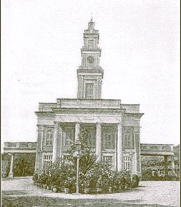

Magen David Synagogue, Byculla

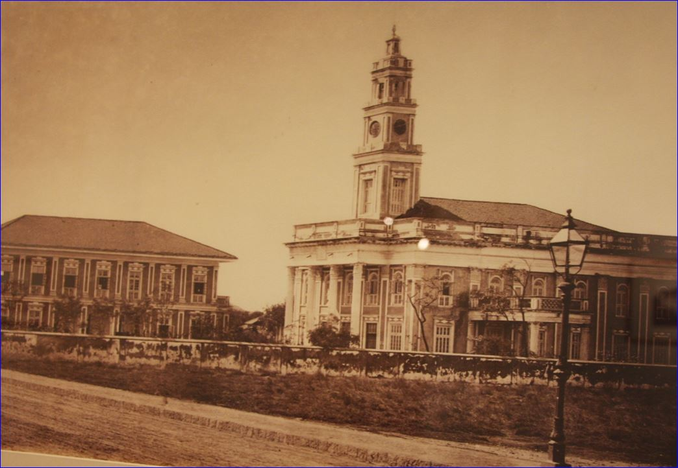

Magen David Synagogue (right) and School

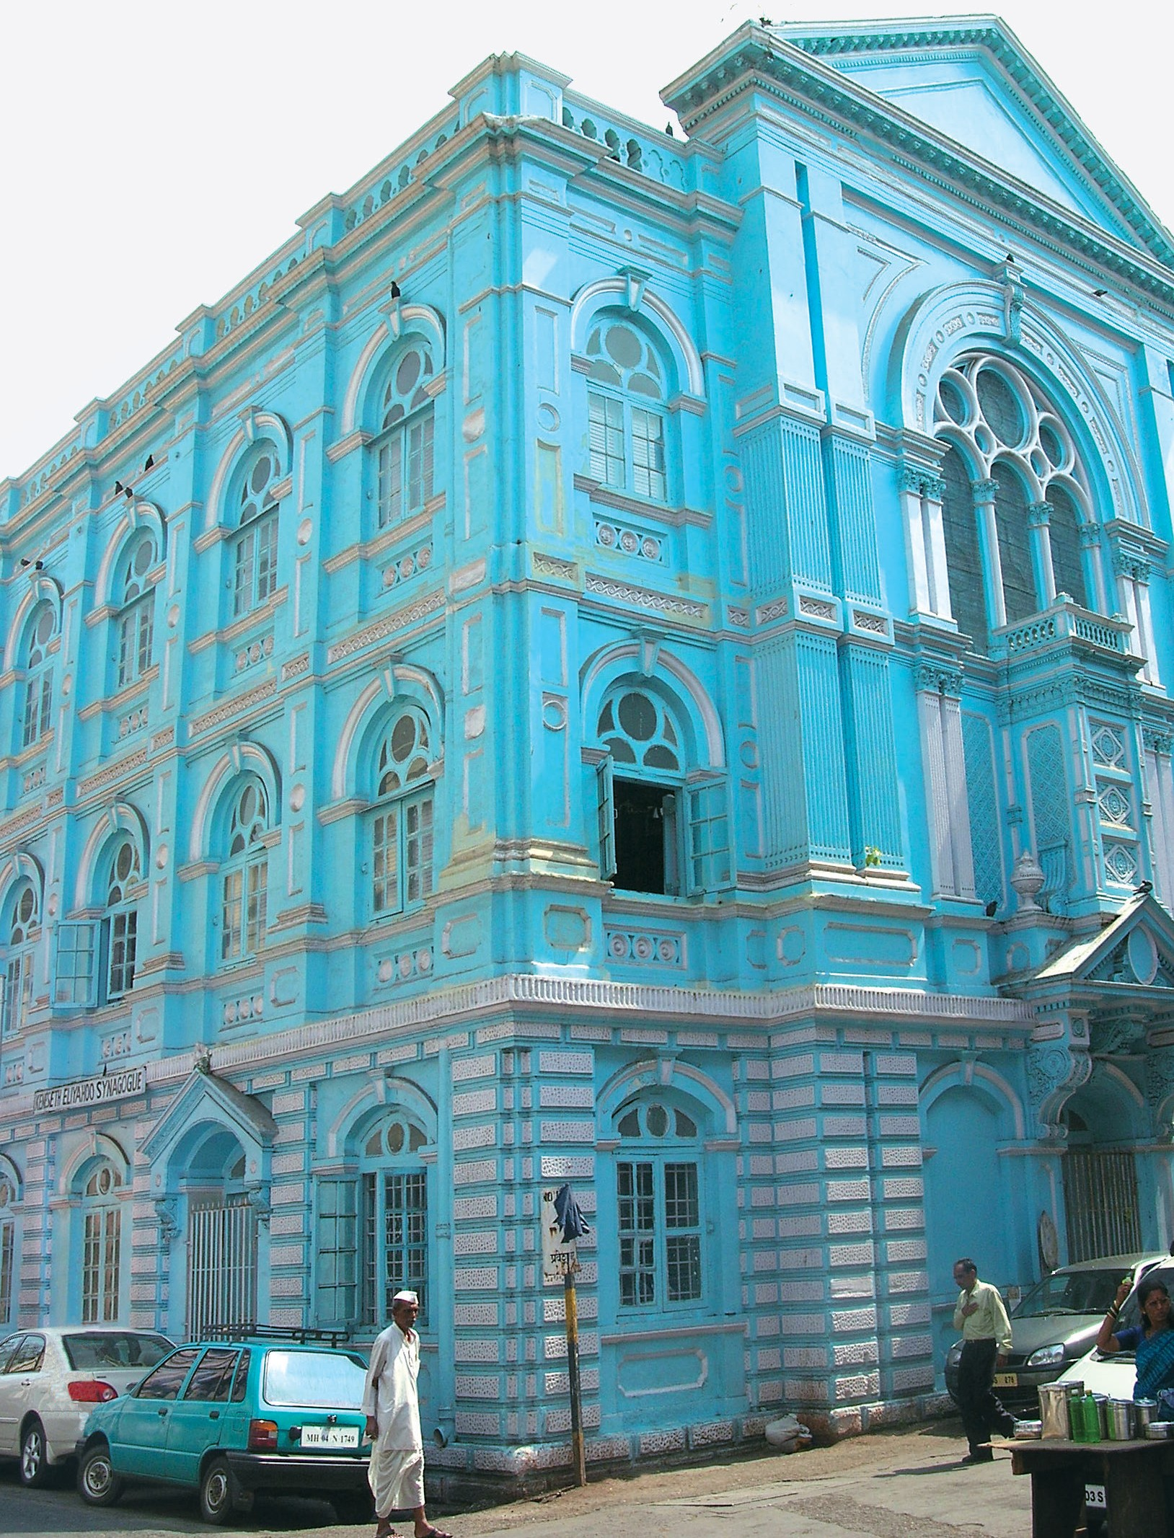
The Early Synagogues in Bombay
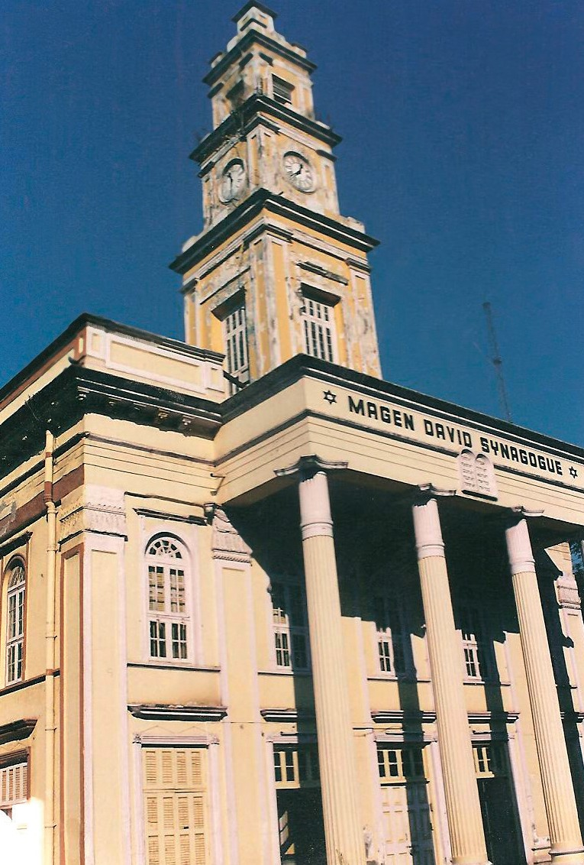

Keneseth Eliyahoo Synagogue, Magen David Synagogue,

in its Original Colours, 2006 in its Original Colours, 1997

The majority of Indian Jewry was concentrated in the area of Bombay and especially in Bombay city itself, which was a vivacious centre of religious and community life for the members of the Bene-Israel community as well as for the Baghdadi community. Their rituals were conducted in some of the impressive synagogues that were constructed for their congregations.
M

Synagogues are actually a prominent trademark of the Jewish community and provide their identity, to a great extent, wherever they may be. The Synagogues catered to the spiritual needs of the congregation as well as playing an important role in the field of education for the younger generation and social affairs for all community members.
Most of India’s Jewry was concentrated in the Bombay area and especially in Bombay city itself, which was a vivacious centre of religious and community life for the members of the Bene-Israel congregation as well as for the Baghdadi congregation.

As we do not have an exact date for the appearance of the Bene Israel on the safe shores of the Navgaon/Nagaon Beach, Konkan, we may note, as we will see in the following pages, that the first Synagogue erected by this community in Bombay was about two millenniums, after their arrival.

Many decades later, the Baghdadi community erected their first Synagogue in Bombay, the “Magen David” Synagogue in Byculla, built by David Sassoon in 1861. We did not manage to locate the place of prayer of the first Baghdadi settlers in Bombay.

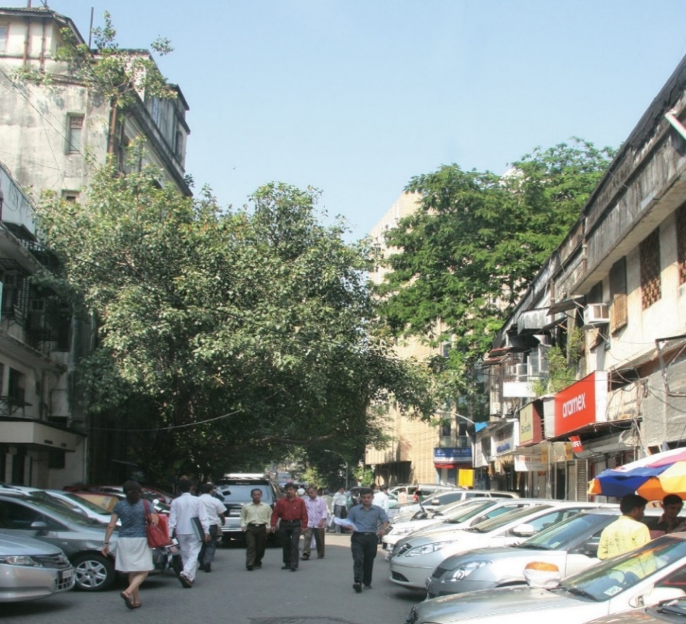
One may assume that prayer quorums were held in the homes of the new immigrants and possibly even at David Sassoon’s family home at 9 Tamarind Lane, located in Fort.

Jackson stated that the building’s ground level was used for offices and warehouses to store the merchandise and the above floor for residence.

Tamarind Lane, Bombay

On the 13th of February 2008, Bombay historian Deepak Rao and the author, tried to locate the building on 9 Tamarind Lane, but found that nothing survived of the original structure.

During the course of time, prior to the establishment of a permanent Synagogue building for this community, prayers were held, mainly on Saturdays and holidays at Sans Souci, (from the French: Without Worries), David Sassoon’s impressive mansion in Byculla.
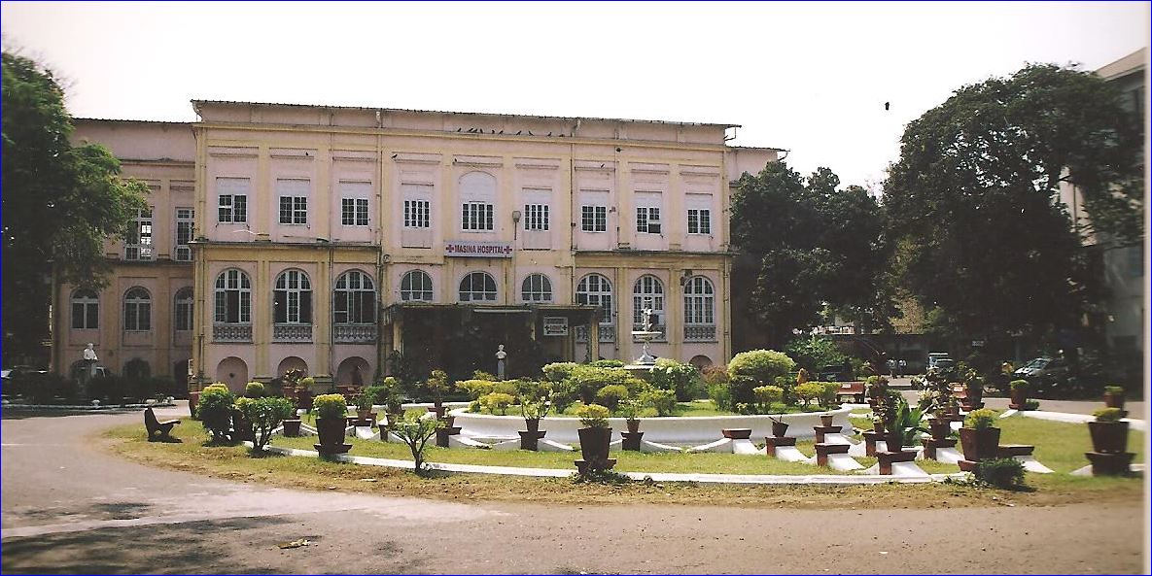

Sans Souci, David Sassoon’s impressive mansion in Byculla, 2006

In addition, it was suggested that a building was rented from the Parsi community or that the prayers were held at the Synagogues of the Bene-Israel in town.

Today, it is quite challenging to estimate the number of Synagogues that are in Mumbai and Konkan, due to the fact that quite a few ceased to exist while others are in various stages of functioning

.

The First Bene Israel Synagogues and their Location

The Bene-Israel community, who pioneered the Jewish settlement in Bombay, established their first Synagogue in the city in 1796. We do not have any historical documentation mentioning a Prayer House for conducting communal services before this date, in spite of the community’s existence on Indian sub-continent soil for many centuries. Most of their Houses of Prayer and Synagogues were built during the middle of the nineteenth century onwards and were situated near what was known as the Israel Alley, or the Israil Mohalla.

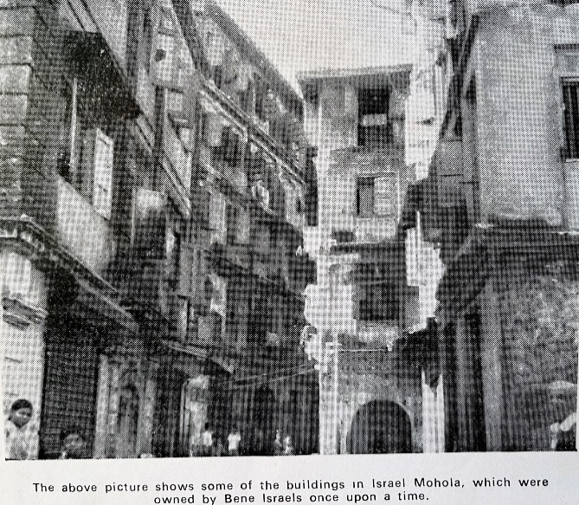
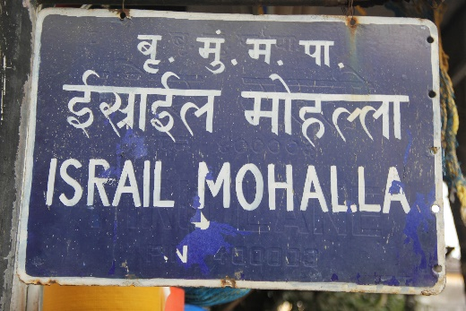

Israil Mohalla Neighbourhood

While comparing them with the large scale of the Baghdadi edifices, these were relatively small structures, with spacious comfort within their walls sufficient enough to house a small congregation. The small number of congregation members, along with difficulties in raising building funds which usually were collected by local donors or by a general contribution made by congregation members, would be good enough reasons for erecting their modest structures which were simple in their architectural design as well.

In Konkan, almost all the Prayer Halls and Synagogues were endowed with some land from which their income supplies the funds to maintain the religious functions, as well as the maintaining of the buildings.

In some of them, congregants, worshipers and visitors were asked to remove their footwear when entering the main hall where prayers were conducted, thus adopting an ancient custom apparently followed by the Cochin Jews and introduced by them to the Bene Israel congregations. This practice finds support in the epic of Moses and the Burning Bush, as quoted in the Book of Exodus, chapter 3, verse 5: “Put off thy shoes from off thy feet, for the place whereon thou standest is holy ground.”

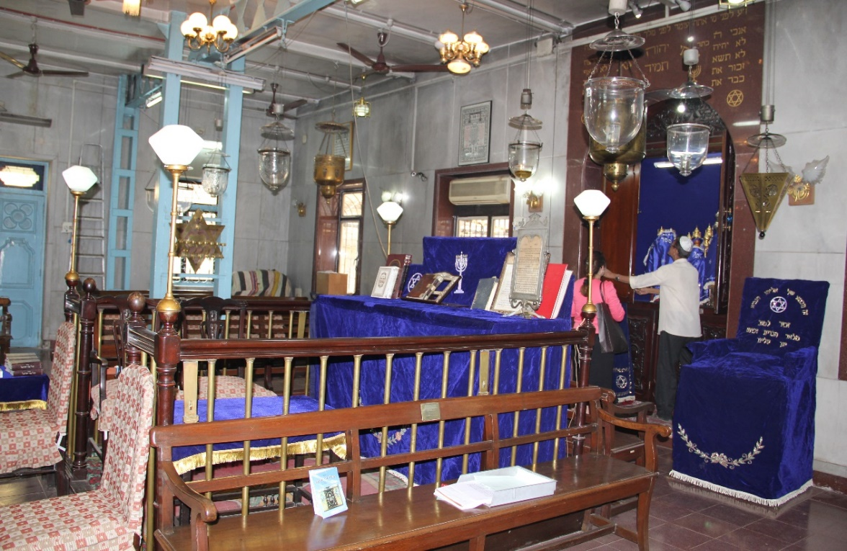

The Shamash/Beadle by the Hechal) at the Tiphaeret Israel Synagogue, 2015

The Jewish Synagogue is characterized by some of the following essential features: there are no images in the Synagogues and Prayer Halls; a separate gallery or accommodation is arranged for the ladies; the continuous burning of an oil lamp in a decorative metal vessel (Ner Tamid) hangs in front of the Hechal (Holy Ark) where the Torah (Pentateuch, the Mosaic Law) are kept placed to face Jerusalem; picturesque religious symbols are depicted over the entrance or on the side of the Hechal including the Tablets of the Ten Commandments, the seven branched golden Menorah (Candelabrum) and the Magen David (Shield of David); the Tebah or Bimah, a raised platform for reading the prayers is located in the centre of the main hall where the men pray; rows of benches are installed on three sides of the Hall, facing the Hechal; a special Chair, and sometimes two, dedicated in honour of the Prophet Eliyahoo/Elijah, are situated at each side of the Hechal.

All Prayer Halls and Synagogues employed a Hazzan (Cantor or Reader) and a Sama (Shamash/Beadle) in order to conduct the prayers and the other religious affairs and ceremonies. Their services were paid for from congregation funds. Some of them were also provided with living quarters, located at or near the Prayer Halls.
The Synagogues and Prayer Halls also conducted Hebrew classes for children of congregation members and for those living in the nearby villages as well.

In Bombay, we may notice the existence of the two first Bene Israel Synagogues: the 1796, Sha’ar Harahamim (Gate of Mercy) Synagogue; and the 1843, Sha’are Ratzon (Gates of Desire) Synagogue.
Masjid Bunder Railway Station

Masjid Bunder is a railway station in South Mumbai on the Central and Harbour Lines of the Mumbai Suburban Railway. It is the penultimate stop for all trains on those lines traveling north. Contrary to popular belief, the station is not named after a Masjid (Mosque) but a Synagogue, the 220-year old Gate of Mercy Synagogue, near a once thriving Jewish neighbourhood, popularly known by the locals as the Juni Masjid. It is of interest to note that the locals called the Synagogue, Masjid (or Musjid, which both mean Mosque in Arabic).

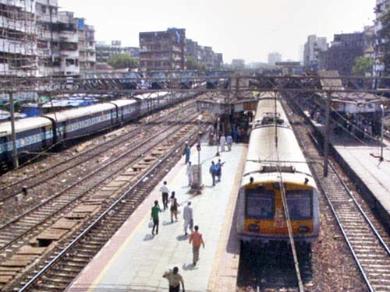
Masjid Bunder Railway Station, 2012

When in 1853 the government inaugurated the first railway tracks from Bombay to the faraway suburb of Thana (or Thane), this first station on the line was named Masjid Bunder, meaning, the Synagogue Station.

The volume of passengers at Masjid station is very large due to different wholesale markets and bazaars adjacent to the station such as the busy areas of Yousuf Mehar Ali Road, Jama Masjid, Kalbadevi, Crawford Market, Mandvi and its surroundings. Thanks to the nearby docks, Masjid is a prominent area recognized as the hub of the larger shipping and maritime companies of India.
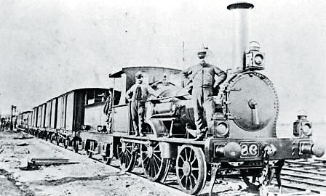

First Passenger Train on the Bombay-Thana tracks, 1853

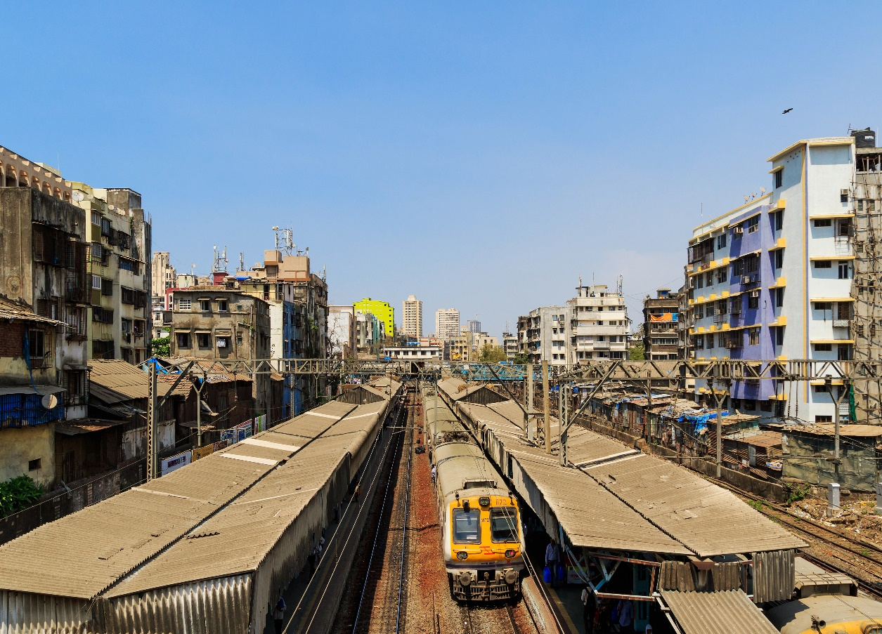
Masjid Bunder Railway Station
Samuel Street
Samuel Street, which at times is referred to as Samuel Road, leads to the Synagogue building and was named after the Synagogue’s founder, Samuel Ezekiel. Samuel Street was formerly known as Samaji Hassaji Street, on the name of the Bene Israel commander, who served in the native army of the British East India Company.
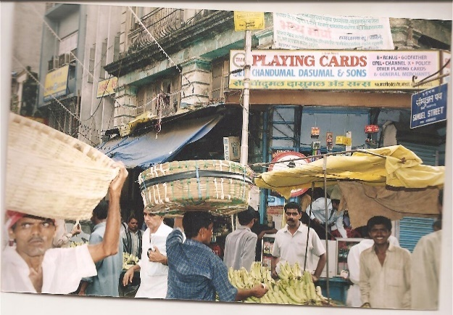
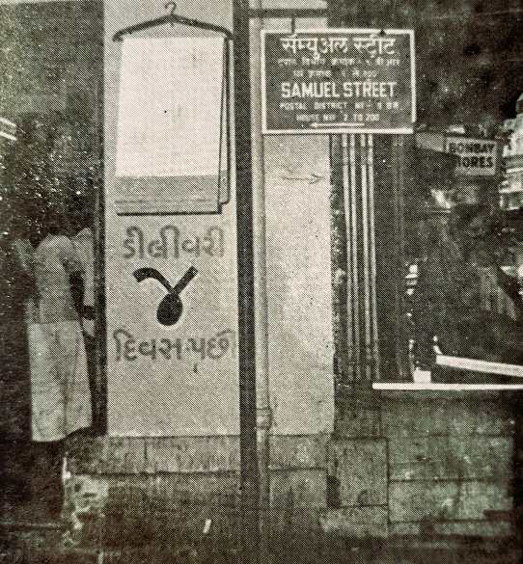
Samuel Street, 1960s
In the past, the street was also called by its Indian name Samaji Hassaji Street. The street is located in Mandvi, which means Customs House in Marathi. It is near Masjid Bunder train station and Pydhone. The area was also called Israel Mohalla, meaning, the locality, or dwelling place of the Jews.

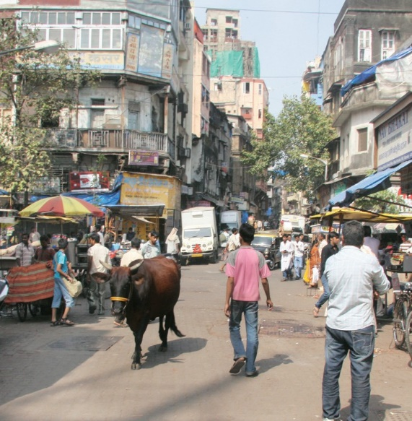
The Gazetteer of Bombay (1901), mentions that the Bene Israel also settled in the Umarkhadi and Dongri neighbourhoods, nearby Mandvi. In another place it states the area of the Bene-Israel settlement as follows: "… Israel Mohalla and Khadak in Mandvi represent the places to which they (the Bene- Israel community in Bombay) moved before finally settling in Umarkhadi."
Samuel Street remains the name of the street until today.
Samuel Street, 2003

Sha’ar Harahamim (Gate of Mercy) Synagogue

The first Synagogue in Bombay, as well as the first in Western, Central and Northern India, was constructed in the Mandvi neighbourhood, where the Bene Israel lived during the 18th – 20th centuries and which, in the course of time, had approximately 2,000 inhabitants.
The Synagogue was built on Samuel Street in 1796, through the initiative of Samaji (Samuel), Hassaji (Ezekiel) Divekar (1730-1797). The Synagogue and the street are named after him.
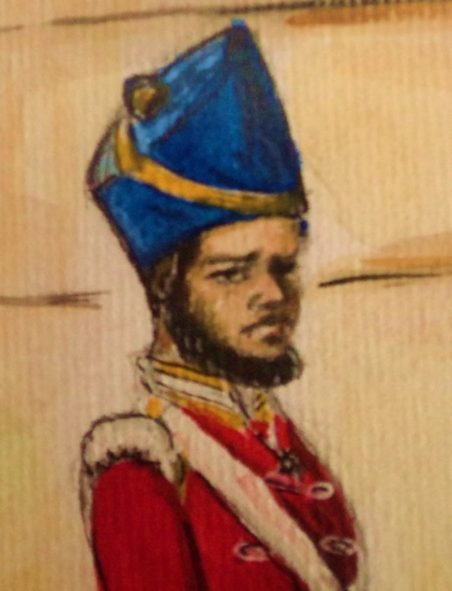
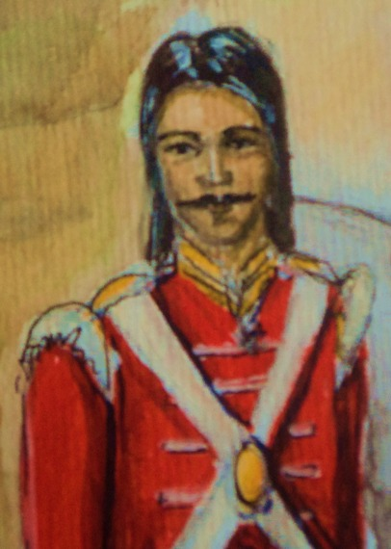
Samaji Hassaji (Samuel Ezekiel) Divekar Issaji Hassaji (Isaac Ezekiel) Divekar
Divekar was an officer and the Commandant of The Sixth Regiment of Bombay Native Infantry in the Armed Forces of the East India Company.
The narrative of building the Synagogue takes place at the time when Samaji Hassaji Divekar was held prisoner during The Second Mysore War (July 1780 - March 1784) in south India.

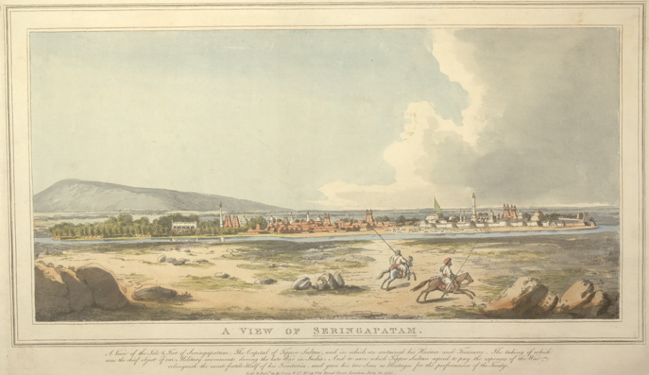
Seringapatam Island Town, Mysore, early 19th century

Spanning the last three decades of the 18th century, there took place a series of four Anglo-Mysore Wars between the Sultanate of Mysore and the British East India Company: The First Mysore War (1766-1769);
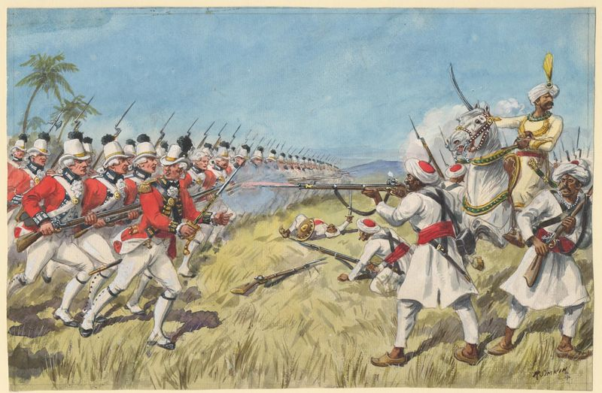

Second Anglo-Mysore War- Siege of Cuddalore, 7 June – 25 July 1783
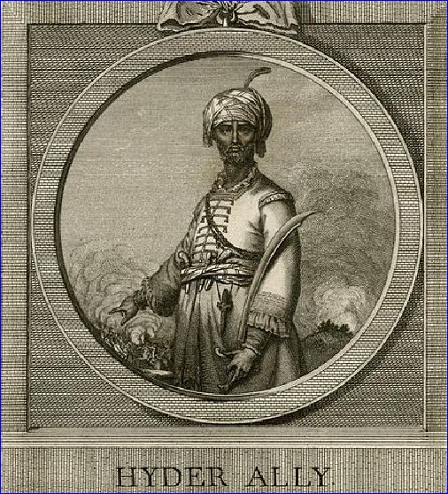
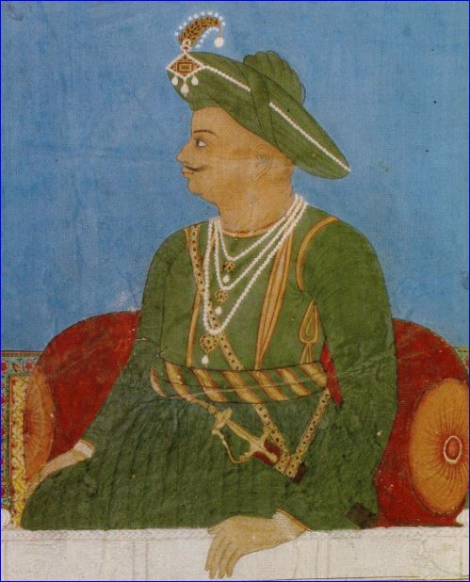
The Second Mysore War (1780-1784); The Third Mysore War (1789-1792); The Fourth Mysore War (1798-1799), which was the last in the series, resulted in the overthrow of the House of Hyder Ali (1720-1782). Hyder Ali was a military officer in service to the Kingdom of Mysore who had become the de facto ruler of Mysore in 1761.
Tipu Sultan, 1790 (1750-1799) Hayder Ali, 1720-1782

The Kingdom of Mysore became a Princely State of British India. Tipu, Hyder Ali’s son, followed his father in becoming the ruler in the state of Mysore in South India and his final battle against the British in 1799 took place on the Isle of Seringapatam/Srirangapatna, his capital.
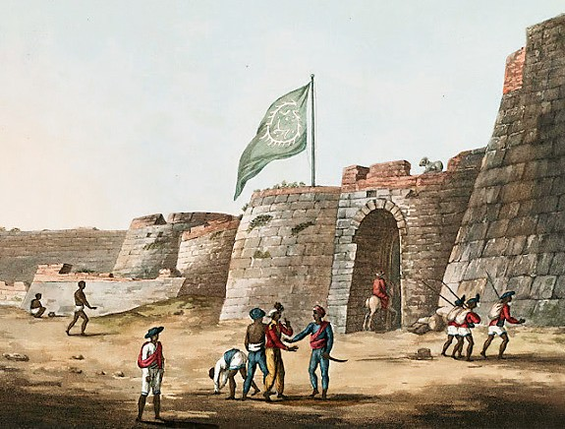

The north entrance into Tipu’s Fort at Bangalore (with Tipu’s flag)
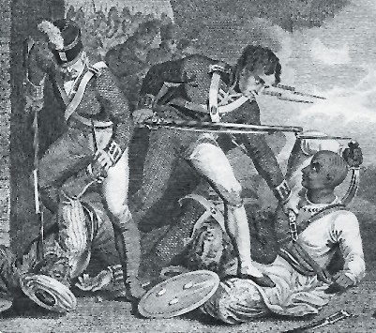
Death of Tipu Sultan at Srirangapatna, Karnataka, 1799

Divekar was captured (1783) by Tipu Sultan, who reigned as Sultan between 1782 and 1799. It appears that Divekar was taken prisoner with his brother Issaji Hassaji (Isaac Ezekiel) Divekar (1735-after 1810), and a number of other officers and kinsmen, when the whole Bombay contingent surrendered to Tipu Sultan at Bednur/Bednore (modern day Nagara) in 1783.
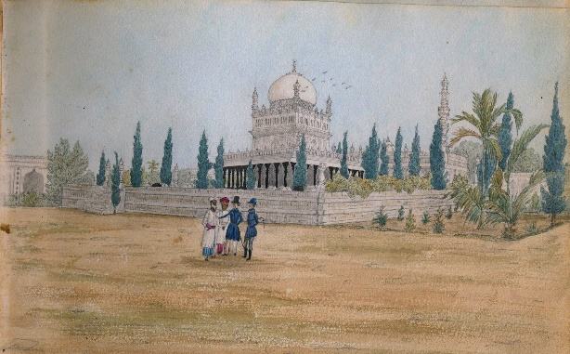
Mausoleum, Laul Baug, Seringapatam, with tombs of Hyder Ali, his wife, and son, Tipu Sultan. By Henry Jervis, 1832

Issaji/Issajee Hassaji, was an officer in the native army at the same time as his brother Samaji. The street, called today Bardan Street, was formerly known as Issajee Street.
During the time of his captivity, Divekar vowed that upon his and his men’s safe release he would erect a Synagogue in gratitude to the Lord of Israel

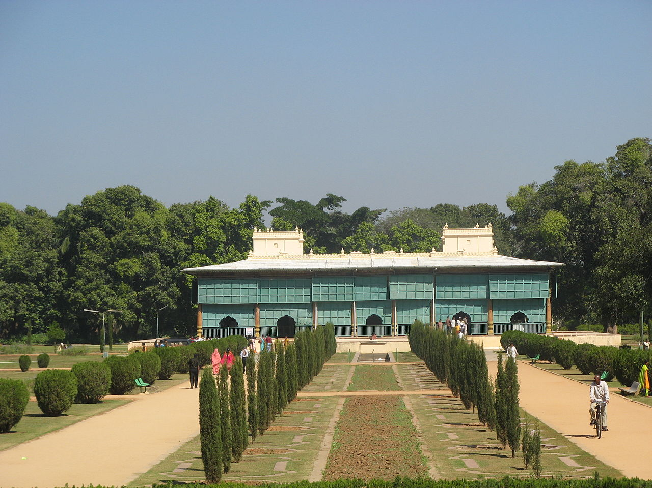
Palace of Tipu Sultan, built by him in 1784

Later, Tipu released Divekar at the request of his mother, Fatima Fakhrun Nissa (or Fakhr-un-Nisa), on the grounds that the Banu Israel had been praised in the Koran as God’s chosen people and that she was glad to see them face to face.
Indeed, the prisoners were released upon termination of the war in 1784. A Peace Treaty was signed in the same year. Divekar continued to serve in the Armed Forces of the East India Company and retired in 1792, with the rank of Native Commandant.
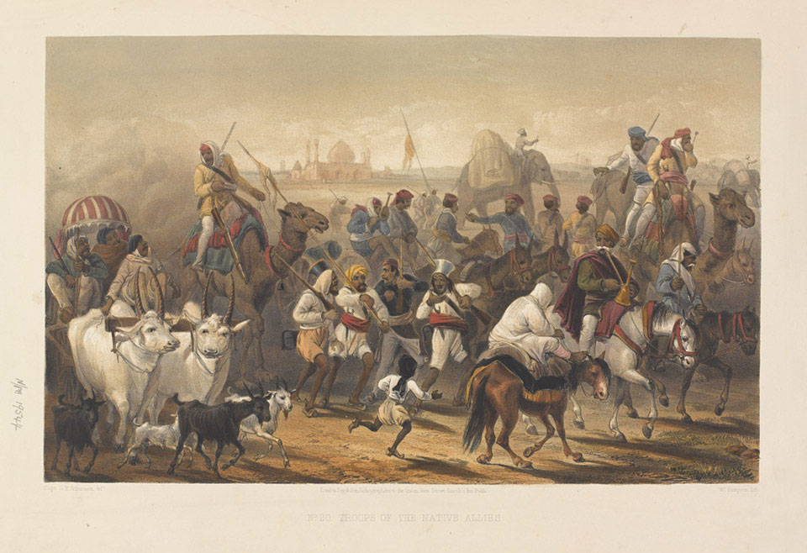
Troops of the Native Allies', within the East India Company, 1857-1858

In that same year Divekar settled in Bombay. A few years later he realized his dream, and in 1796 built his Synagogue on Samuel Street which was named for him. His next move was to obtain Torah Scrolls for his new built Synagogue, realizing he might be able to secure one at the Jewish community in Cochin. In fact, Divekar knew about the existence of the Pardeshi Synagogue (built in Cochin in 1568), in the course of his visits there in his official capacity as a Commandant of the Army.

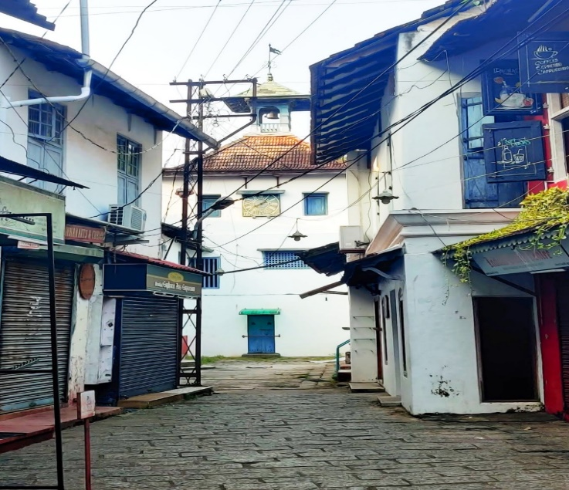
Thus, a year later, Divekar proceeded in 1897 to Cochin’s Pardeshi Synagogue to procure the Torah Scrolls for his own Synagogue. Eventually, the visit proved strenuous for him. Two days before his departure to Bombay he returned his life to The Almighty, at the age of 67.

Pardeshi Synagogue,
built in Cochin, 1568
Over the course of time, the small structure which was not large enough to hold all of the members of the growing community was demolished in the 1850’s and a larger edifice was constructed upon its ruins.
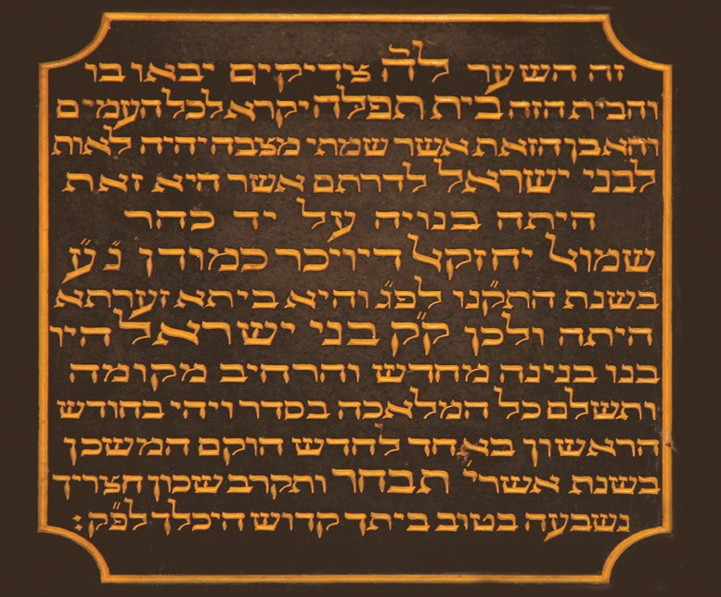
The building was commenced in January 1859, and completed on the 4th of March 1860.According to the commemorating plaque fixed at the entrance of the edifice, the Synagogue was dedicated on the 24th of March 1860.

The Dedication Plaque, 1860
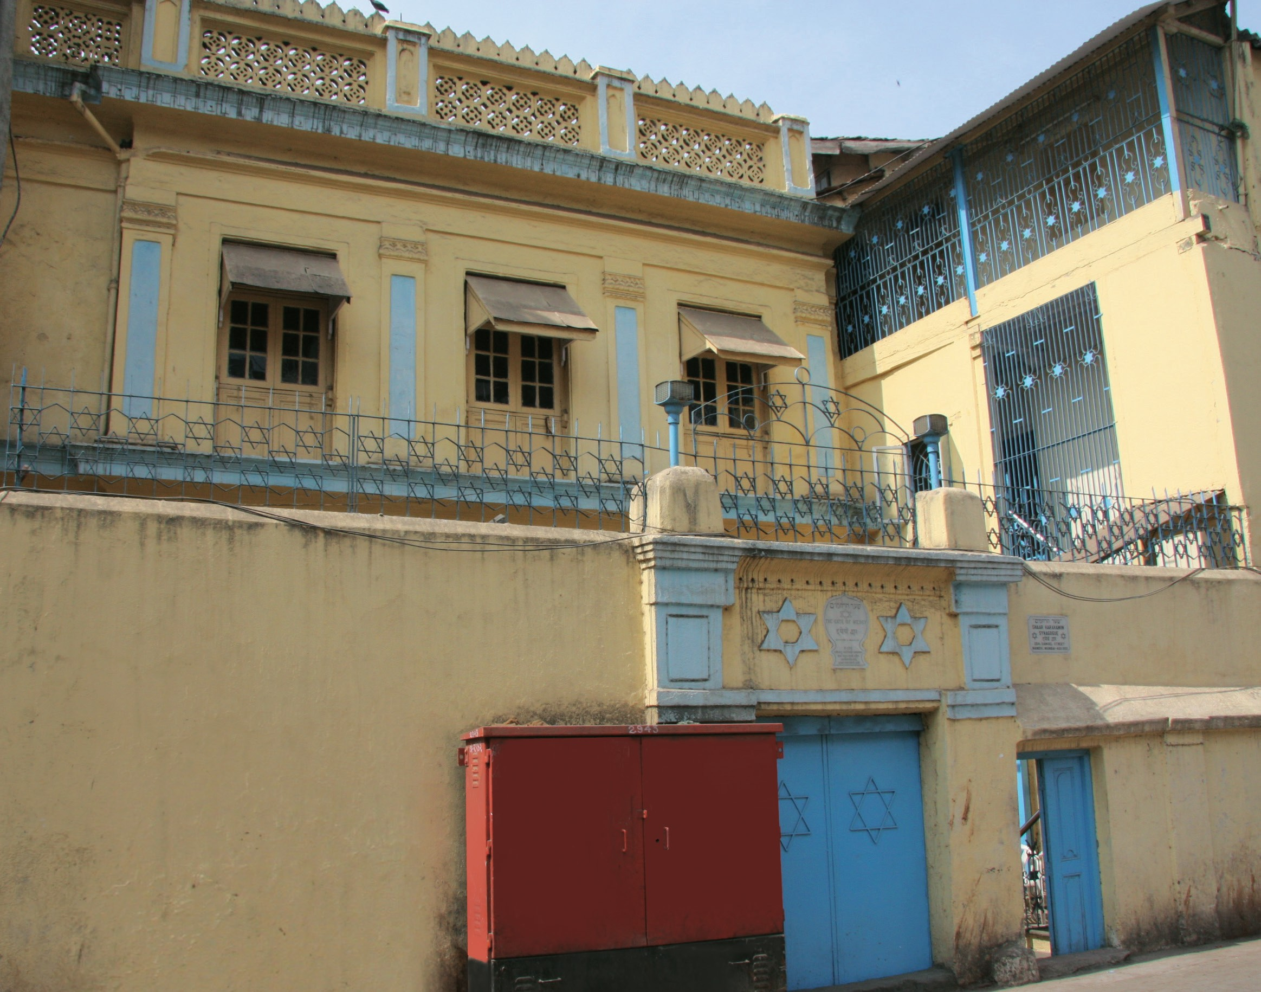
Sha’ar Harahamim Synagogue, 2008

A few decades later, on the 13th of May 1896, the community celebrated, with great grace and elegance the centennial Jubilee commemorating the establishment of the Synagogue. On that occasion the name of the Synagogue was changed to ‘Sha’ar Harahamim’ (The Gate of Mercy).
At a special General Meeting held by the Synagogue’s officials on the 23rd of February 1919, the following unanimous resolution was passed as a tribute to the memory of its founder: “This meeting of the General Body of the SHAAR-HA-RAHAMIM Synagogue places its deep sense of gratitude to the late Mr. Samuel Ezekiel Divekar, Commandant in the Armed Forces of the East India Company and Muccadam (President) of the Synagogue for building the Synagogue at his own expense in order to cater to the spiritual needs of the community, and as a mark of respect to the departed soul, resolves that on every “Yom-Kippur” day, after Shaharit prayers are over, ‘HASHKABA’ be recited loudly in the Synagogue for him.”
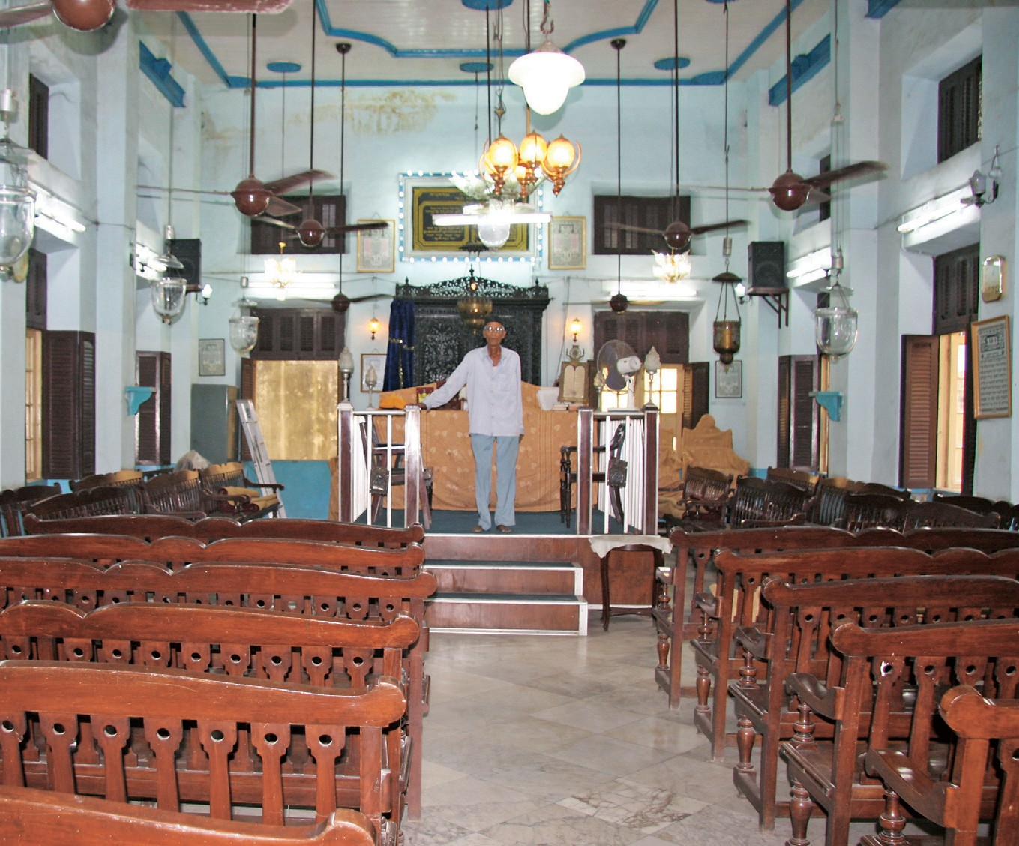
Sha’ar Harahamim Synagogue, 2008

The Synagogue is located at 254, Samuel Street in the neighbourhood of Mandvi and remains open with a small, yet active, congregation. A caretaker is sometimes there to immediately receive guests, but a visit can be arranged through Samuel Waskar’s mail address: samuelwasker@hotmail.com.

Sha’are Ratzon (Gates of Desire) Synagogue

Approximately fifty years after the building of their first Synagogue, the Bene Israel community inaugurated another Synagogue in 1843, the second Jewish Synagogue in Bombay, which was named Sha’are Ratzon (The Gates of Desire).
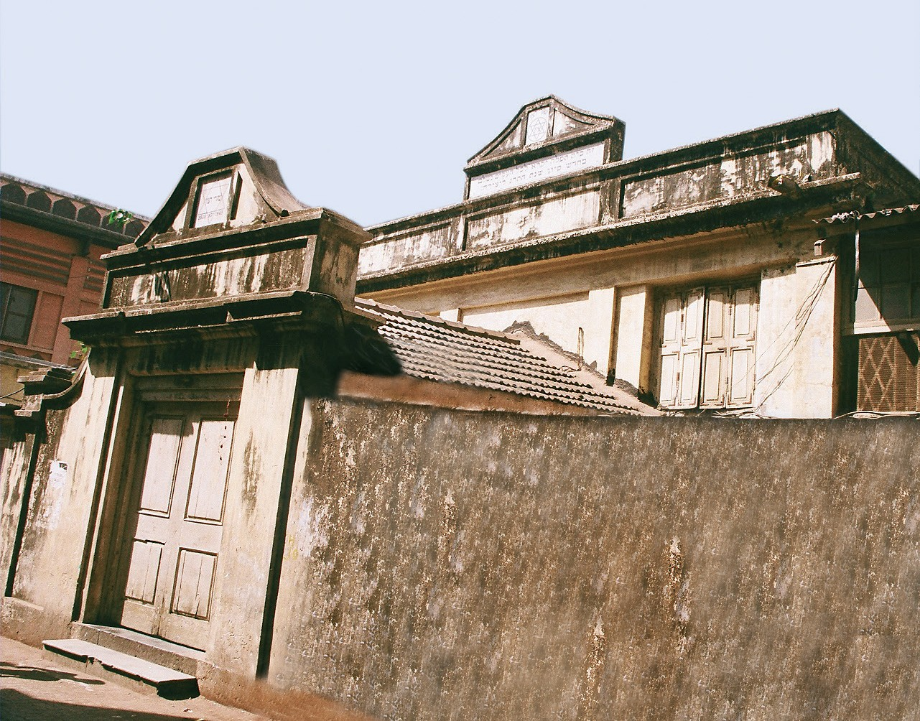
Sha’are Ratzon Synagogue, 2008

The Synagogue which was also built in the Israel Mohalla (in the neighbourhood of Mandvi) was often called The New Synagogue, compared to Sha’ar Harahamim, which was The Old Synagogue. The entrepreneurs behind the new project, Samuel Jacob Divekar and Hyam Isaji/Essaji (Isaac) Garsulkar, were not satisfied with the way things were being handled at the existing Synagogue and, therefore, decided to build a new one. Together with other community members, they establish the new Sha’are Ratzon Synagogue.
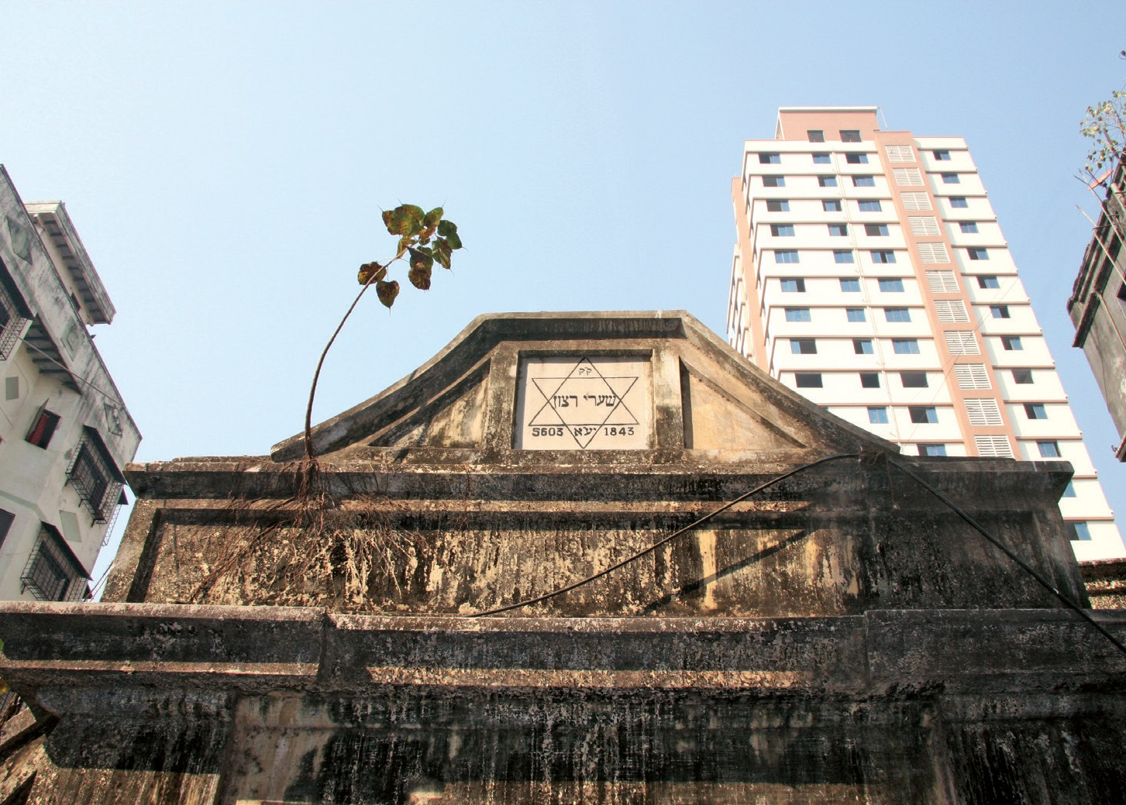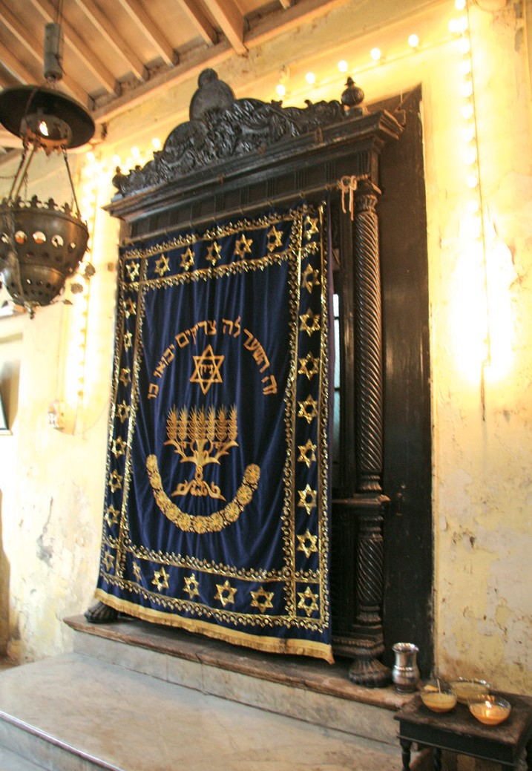
Sha’are Ratzon Synagogue, 2012 The Hechal (Hekhal), 2012

The funds towards the building were collected in 1839, the land was bought on the 22nd of December 1840, the foundation stone was laid on the 2nd of August 1841 and the inauguration took place on the 4th of June 1843.

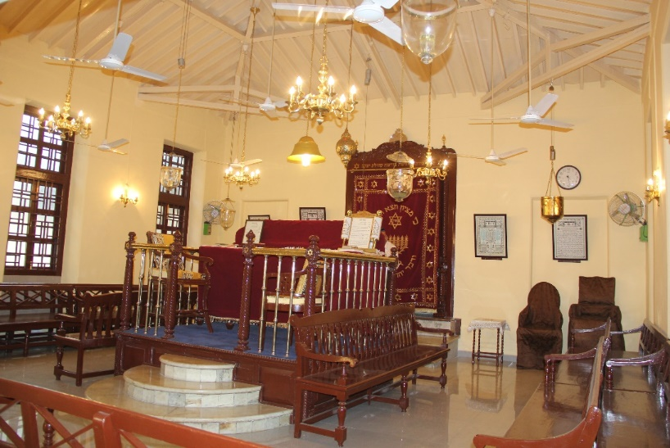
Sha'are Ratzon Synagogue- the Tebah (Bima) and the Hechal (Hekhal), 2015
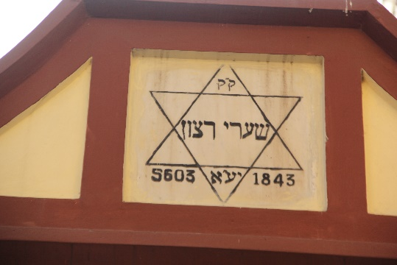
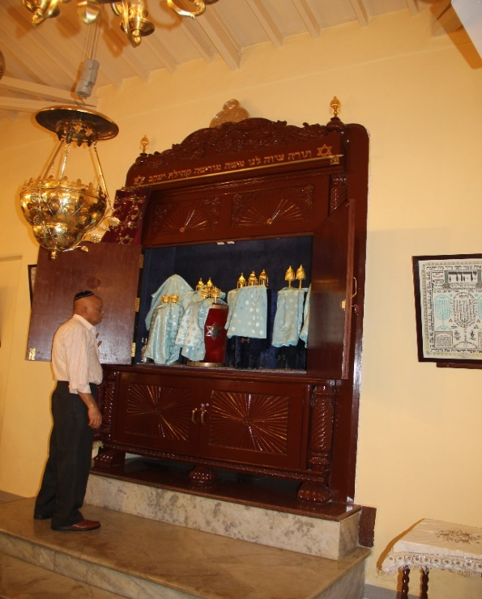
Sha'are Ratzon Synagogue- Torah Scrolls in the Hechal (Hekhel), 2015

The ladies’ galleries in both Synagogues, as well as in the Synagogues in Thana/Thane and some other Synagogues in Konkan (Alibag, Panvell), consist of a mezzanine floor in the space above the entrance to which access is gained by a detached stairway from the exterior.
Location: 90, Tantanpura Street, in the neighbourhood of Mandvi.

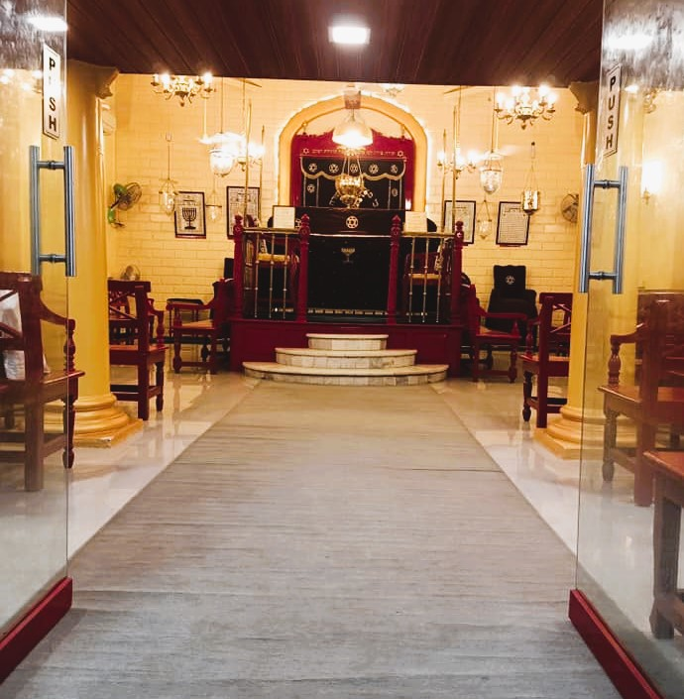 Sha'are Ratzon Synagogue- the entrance to the Main Hall, facing towards Jerusalem

Other Bene Israel Synagogues in Bombay

Tiphaereth/Tipheret Israel (Pride of Israel) Synagogue, Jacob Circle

Tiphaeret Israel Synagogue was erected at Jacob Circle, due to the increase of the Bene Israel population in this area during the 1870’s and 1880’s. The main cause of this movement was the industrial expansion of Bombay towards the north. The new cotton mills and other factories built there prompted many Bene Israel families to search for dwellings closer to their place of work. This tendency accelerated following the bubonic plague which struck the city in 1896, when many Bene Israel families moved to the Jacob Circle area from their previous localities.

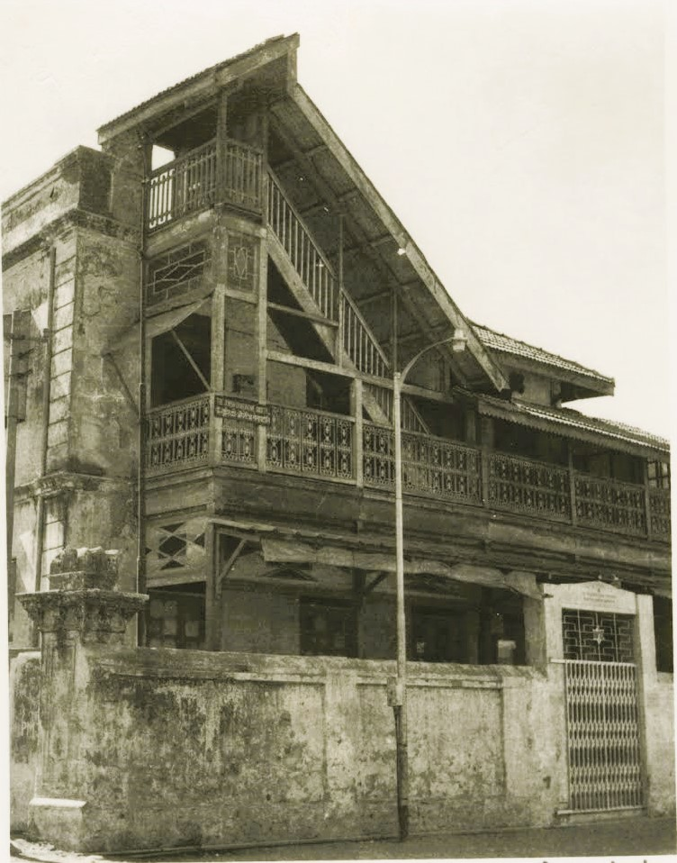
At first, a Prayer Hall was started in 1886 in rented premises named Talegoakar or Talegaonkar Building. The initiators of the Prayer Hall were Benjamin Samson Ashtamkar (a Hebrew scholar who at the time, was the Hon. Secretary of the Gate of Mercy Synagogue), Solomon Benjamin Ghosalkar, Elijah Joseph Bashtekar, among others.

Tiphaereth Israel Synagogue Jacob Circle, early 1960’s
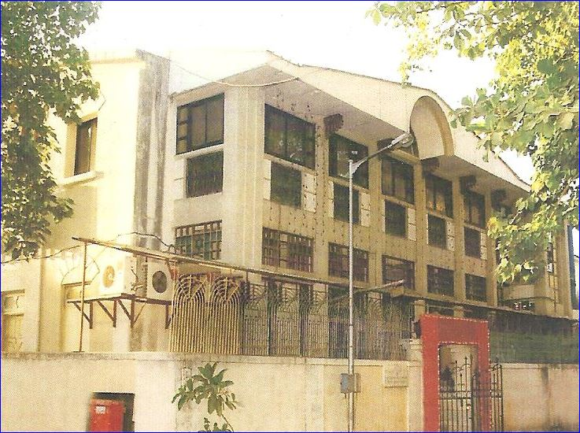
Tiphaereth Israel Synagogue, Jacob Circle

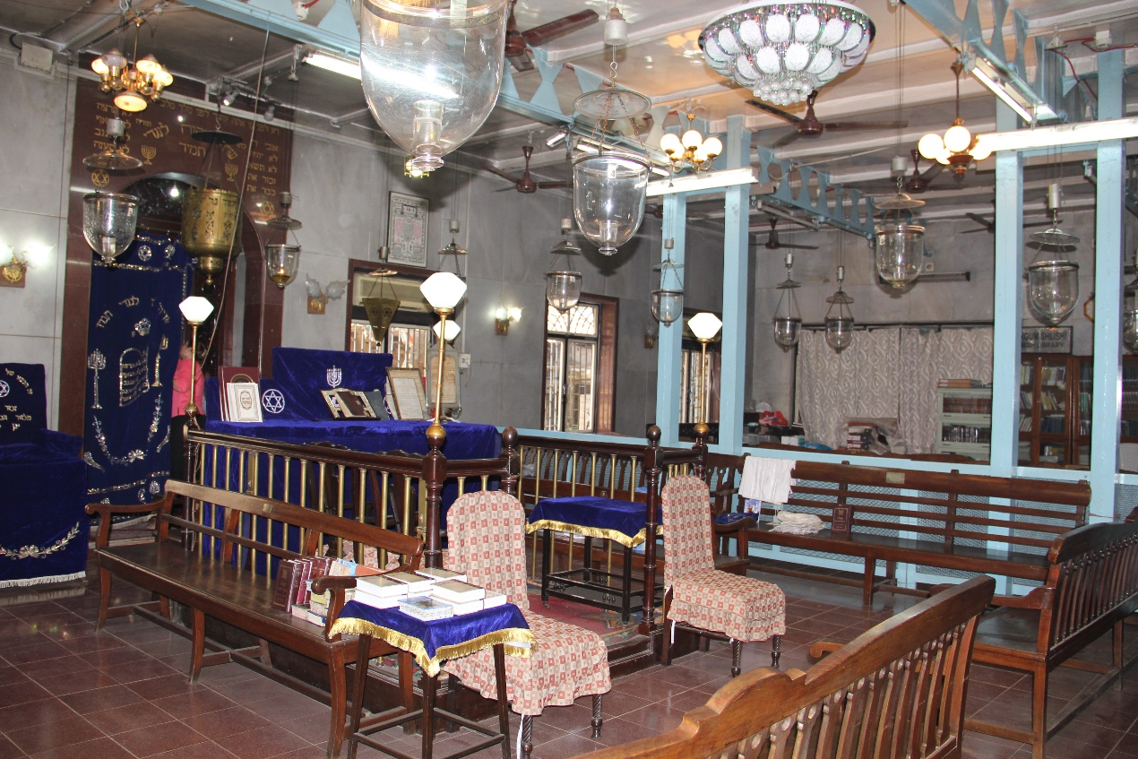
Tiphaereth Israel Synagogue Interior. Showing the Holy Ark (Hechel/Hekhal) and Tebah (Bimah), 2015

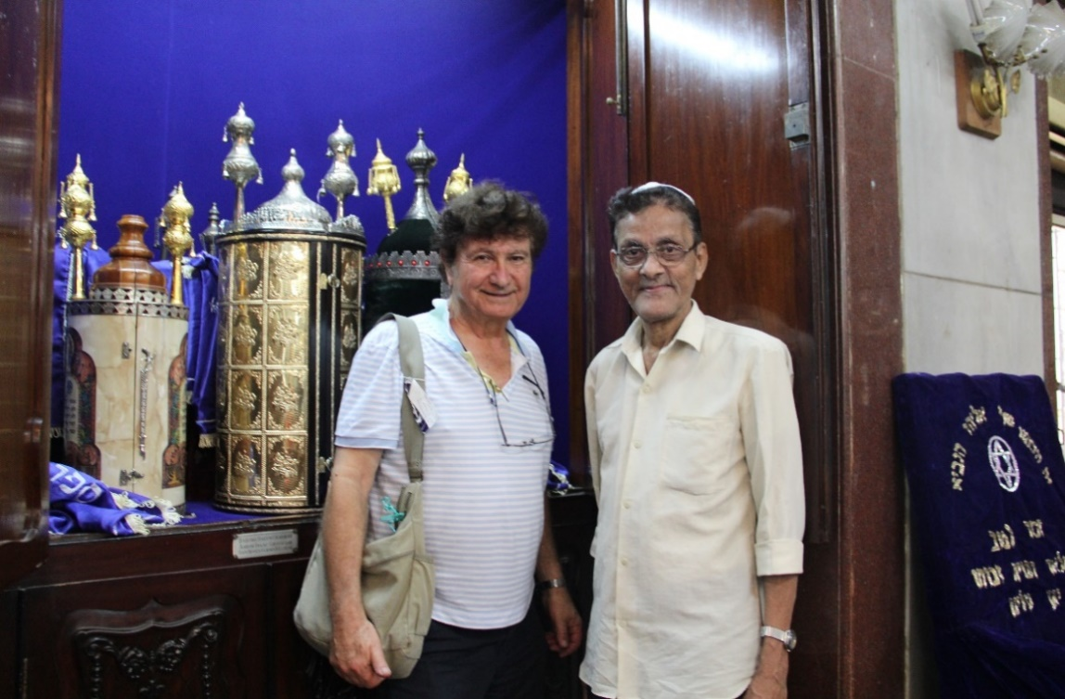

Tiphaereth Israel Synagogue Interior. Showing the Holy Ark, 2015

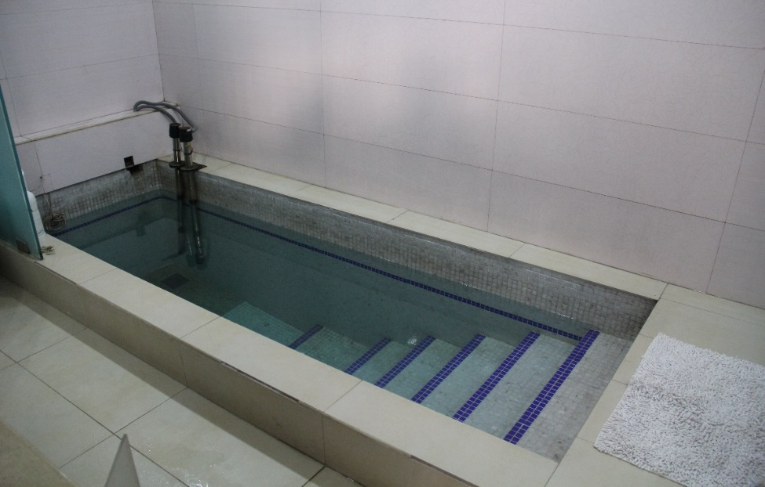
A Mikveh (Ritual Bath) in Tiphaereth Israel Synagogue, 2015

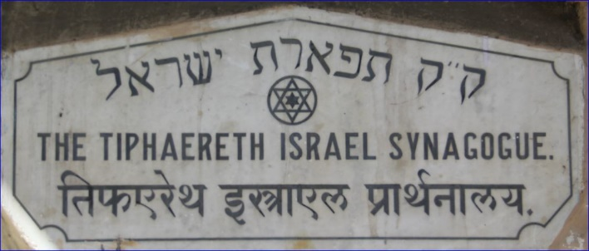
Plaque on the Tiphaereth Israel Synagogue

Magen Hassidim (Shield/Defender of the Pious) Synagogue, Agripada

Differences of opinion among Tipheret Israel community members, as well as the need for a larger hall for the growing congregation, led to the establishment of another Bene Israel Prayer Hall nearby. Daniel Elijah Benjamin Gadkar marked the event by adding: “Seventeen years after the establishment of the first Prayer Hall, another Prayer Hall was provided in the same area, not because of its needs but because of differences of opinion amongst the members of the first Prayer Hall. It was known as the ‘Jacob Circle New Prayer Hall’. Then popularly known as Dandoolkar’s Prayer Hall, since Benjamin Samson Dandoolkar had played a leading role in the formation of the New Prayer Hall…which was consecrated on March 29, 1931.”

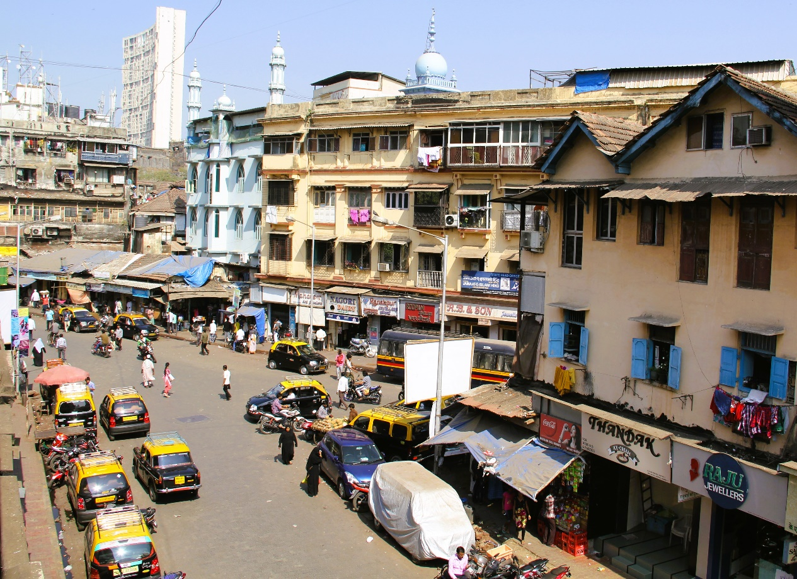
Building of the first Prayer Hall (right), Agripada.
View to the north from Solomon and Sarah Hall, Magen Hasidim Synagogue, 2015

Roughly, almost thirty years later, a plot of land was acquired at 8 Moreland Road, Agripada, a site nearby and south of the Tipheret Israel Synagogue for the purpose of building a new edifice for the Magen Hasidim Synagogue.

Designs of the building were prepared by a local firm named S. V. Pradeau, Architects, the corner stone was laid on the 17th of November 1929 and the Synagogue was consecrated on the 29th of March 1931.
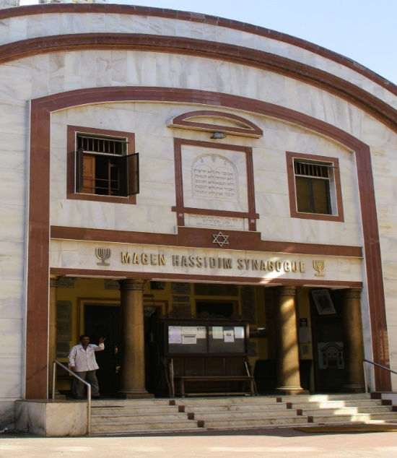

Magen Hassidim Synagogue Façade, 2015

The columns are mounted with a cumbersome architrave, with the Synagogue’s name inscribed in its front panel: ‘Magen Hassidim Synagogue’, in addition to the Menorah (Candelabrum) ornament on both sides of the name. The frieze above the inscription is decorated with a single Magen David (Star of David, literally, Shield of David), upon which are installed two marble panels, both bearing inscriptions in Hebrew. The top line of the lower panel indicates the year when the Synagogue was erected; above, its Hebrew name; and on the top, a verse from the Hebrew prayer book. Within the larger panel are inscribed the Ten Commandments, adorned with a vaulted top.

Ben Eliahu mentions that the plan was drawn by architect Samson A. Elijah, and exclusively Bene Israel carpenters were employed for preparing all the wood work for the Synagogue.
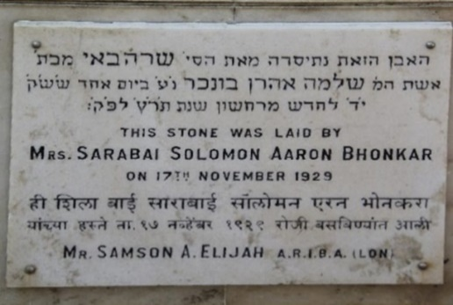
A plaque commemorating the laying of the corner stone of the structure says: “This stone was laid by Mrs. Sarabai Solomon Aaron Bhonkar on 17th November 1929.”

Corner Stone Dedication Plaque of Magen Hassidim Synagogue, 1929
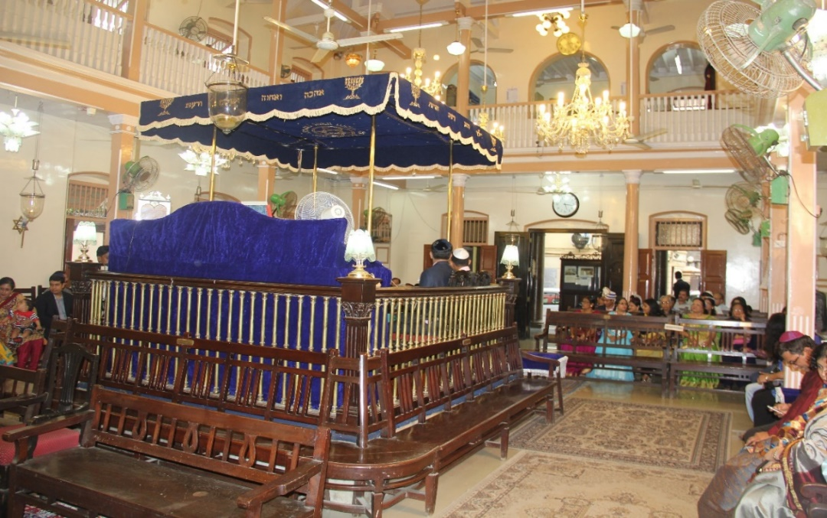
Synagogue Interior, facing the Tebah and Women’s Gallery, 2015

The interior of the Synagogue has a high ceiling, thereby permitting an upper level gallery for the women on three sides of the hall, while a center elevated prayer area in the hall houses the Tebah (the Sephardic term for the Bimah), where the Torah (Pentateuch, the Mosaic Law) is read and where the prayers are conducted by a Chazzan (Cantor).
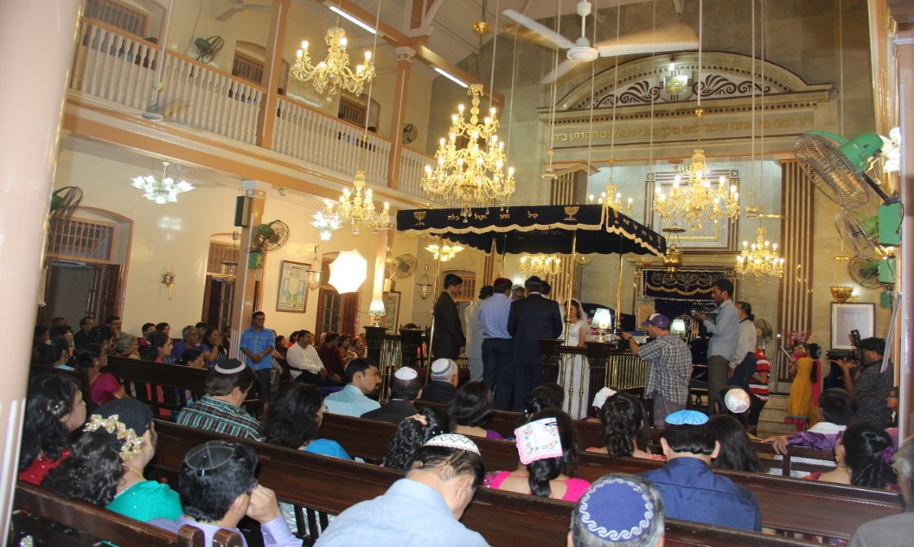

Magen Hassidim Synagogue during a Wedding Ceremony, 2015
As customary in most Sephardic Synagogues worldwide, the men’s benches are affixed along the three walls of the building, facing the Tevah. In a similar manner, the upper three women galleries, based upon high columns, address the centre of the hall as well. Dangling from the ceiling are stylish chandeliers and fans, hanging from the edges of long metal poles.

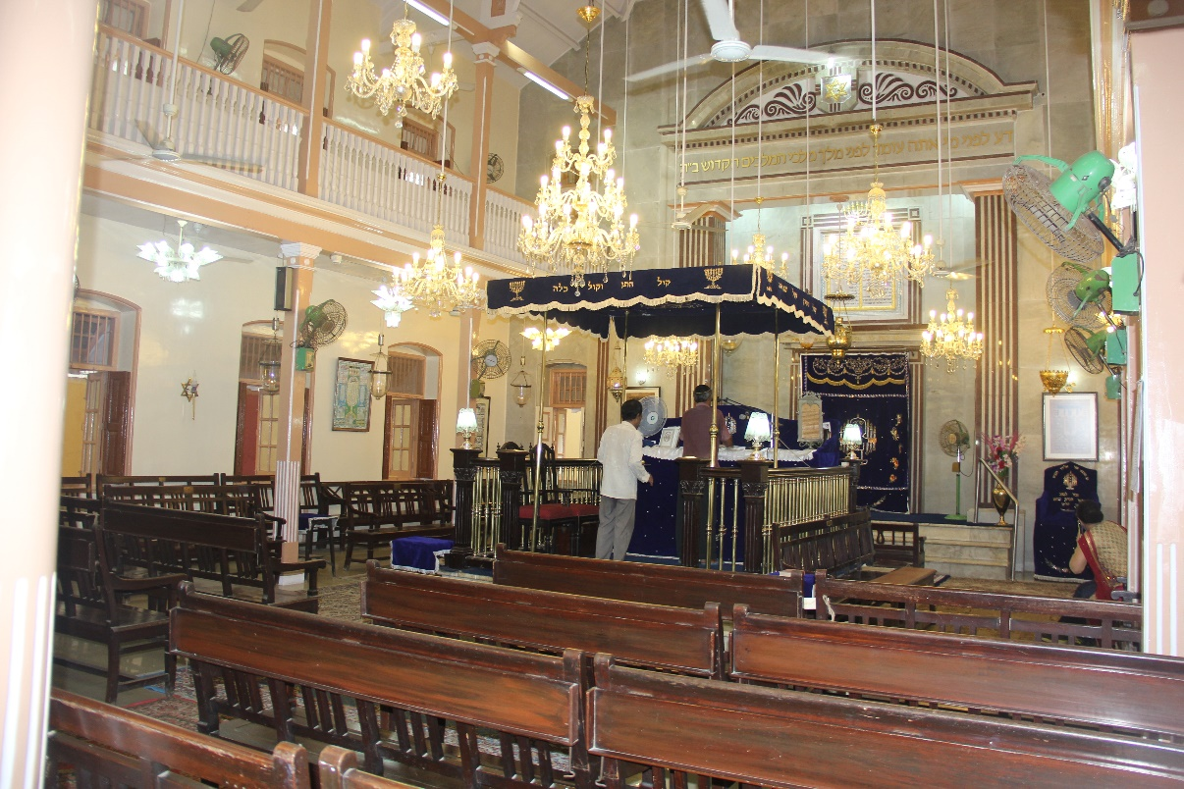
Magen Hassidim Synagogue Interior. The Main Hall, 2015

Following a straight east-west axis from the main doorway, through the Tevah and westward, facing Jerusalem, is where the Hechal is located. The Hechal derives its name from the Holy place where the Tablets of the Law were kept during the time when the two Jewish Temples existed in Jerusalem, and were destroyed in 586 BCE by the Babylonians, and in 70 CE, by the Romans. At present, the Torah Scrolls are installed in a built-in cabinet within the Hechal which was entirely renovated in 1993 by Miriambai Uziel Borgavkar in memory of her husband Uziel Samson.

When comparing the Bene Israel Magen Hassidim Synagogue edifice to the Baghdadi Magen David Synagogue in Byculla, it is interesting to note the similarity, on a smaller scale, in the design of the first to the second structure: its façade with the four columns, the entablature and the frieze on top with the layout of the Synagogue’s name and its side ornaments (which differs only by using the Menorah instead of the Shield of David in the Magen David Synagogue); as well as the general plan of the interior, and also the use of the very same name, ‘Magen’, for the Magen Hassidim Synagogue.

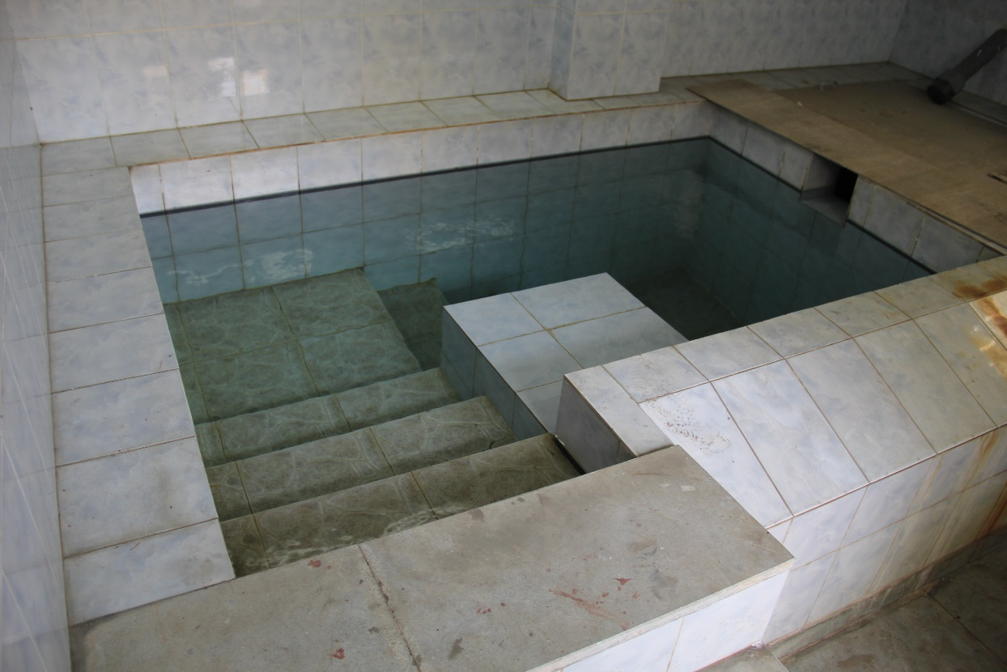
Magen Hassidim Synagogue, the Community Mikvah (Ritual Bath), 2015

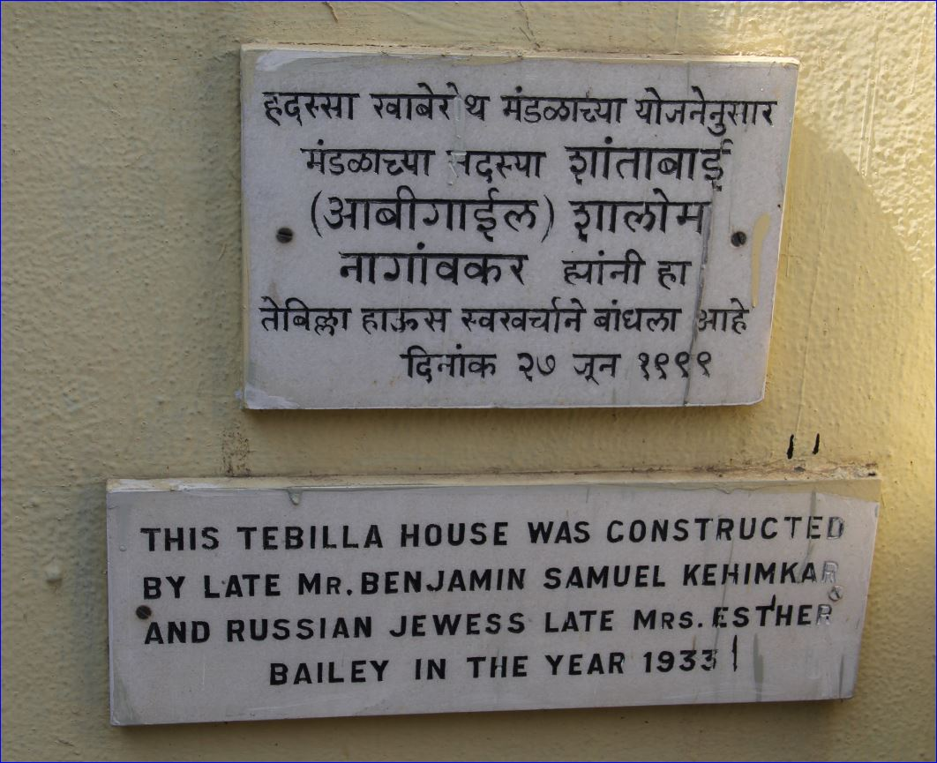
Plaque commemorating the donors of the Mikveh (Ritual Bath), 1933

In 1933, a Mikvah (Ritual Bath) for the use of the community was constructed by Benjamin Samuel Kehimkar and Esther Bailey. A plaque affixed to the structure says: “This Tebilla house was concentrated by late Mr. Benjamin Samuel Kehimkar and Russian Jewess, late Mrs. Esther Bailey I the year 1933.”

Location: 8, Mohomad Shahid Marg (Morland Road), Agr

The Rebecca Samuel Pavilion
About fifty years later, a separate pavilion was built by Rebecca Samuel in the Synagogue compound area, which was inaugurated in 1983. A plaque commemorating the event says: “Rebecca Samuel Pavilion inaugurated by Miss Sifra Nissim Samuel, 20th October 1983.”

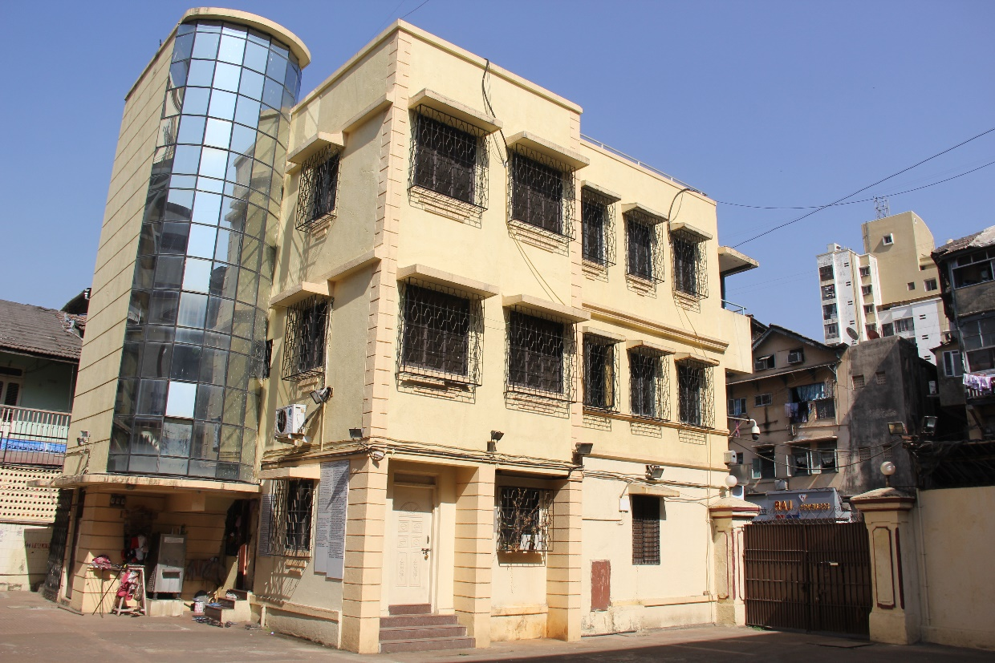
Magen Hassidim Synagogue-Rebecca Samuel Pavilion, 2015

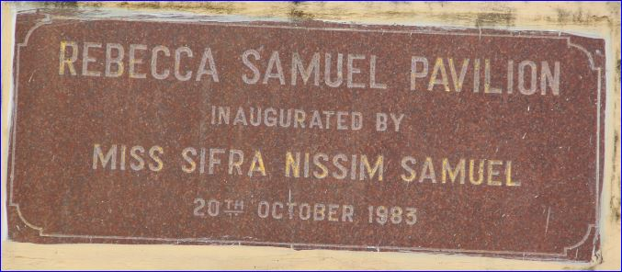
Rebecca Samuel Pavilion dedication plaque, 2015

The new addition to the compound, the Rebecca Samuel Pavilion was dedicated for the use of the community for functions such as receptions, weddings, cultural events and other social activities and ceremonies, as it still functions today.

The Solomon and Sarah Hall

The top floor of the Pavilion, the Solomon and Sarah Hall was opened on the 16th of May 1934. The donors were Mrs. and Mr. Solomon Nagawker.

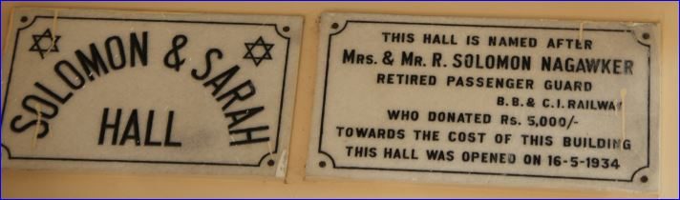
Solomon and Sarah Hall and Sassoon

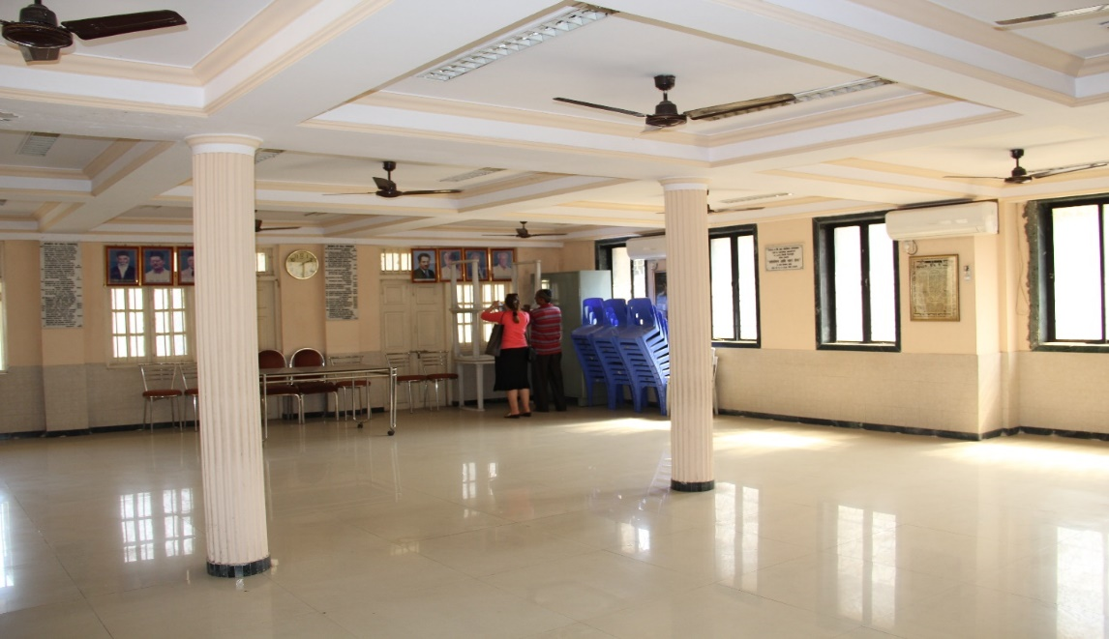

Benjamin Asshtamkar Hall, 2015

The Sassoon Hall

Thirty years later, the Hall was enlarged and renovated through a donation of Sassoon Benjamin Asshtamkar and was opened on June 2005, adding the name Sassoon Hall to the previous name.

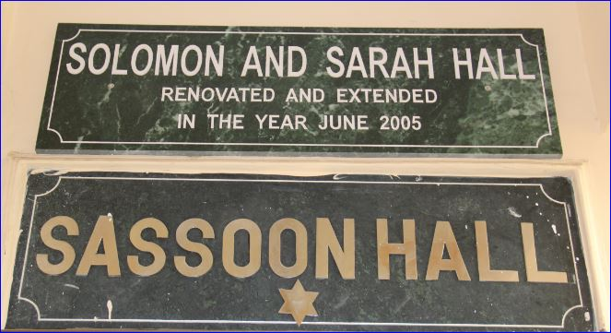

Etz Haeem (Tree of Life) Prayer Hall/Synagogue, Umerkhadi

The Etz Haeem Prayer Hall was erected and consecrated by Bene Israel educator, Haeem Samuel Kehimkar (1830-1908), on the Jewish New Year of 5469 (in the Jewish Calender), the 5th of September 1888. Kehimkar, historian of the Bene Israel, born in Alibag, was the first to write an authentic history of the Bene Israel. Like many of his community he became a civil servant in Bombay. In 1853, he founded the ‘Bombay Bene Israel Benevolent Society’. In 1875, he and his two brothers opened a school in Bombay which taught both Marathi and Hebrew. His untiring efforts, against all odds and criticism, to raise the standard of his co-religionists, especially the underprivileged, is a saga in itself.

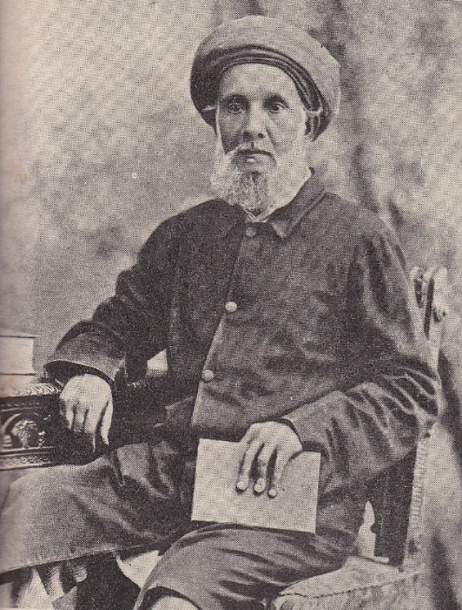
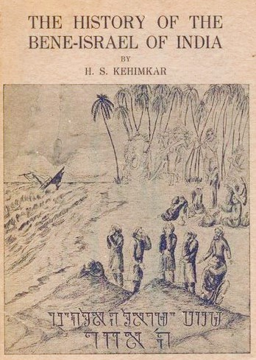
Haeem Samuel Kehimkar’s Book Haeem Samuel Kehimkar, 1897
The Prayer Hall was within the premises of The Israelite School (started in 1875) in Khadak, later known (1932) as the Sir Elly Kadoorie School in Mazgaon. According to Judah Shalome and D.S. Erulkar, based on information from 1918 (The Iaraelite, issues of February, May, June), it is mentioned that: “The Prayer Hall, known as Etz Haeem was started in 1888 by Haeem Samuel Kehimkar with the object of helping the school financially, and continued to pay Rs. 300/- annually towards the School Fund. In addition, the Prayer Hall was assisting the poor children of the school with clothes every year before the commencement of the Jewish New Year.”

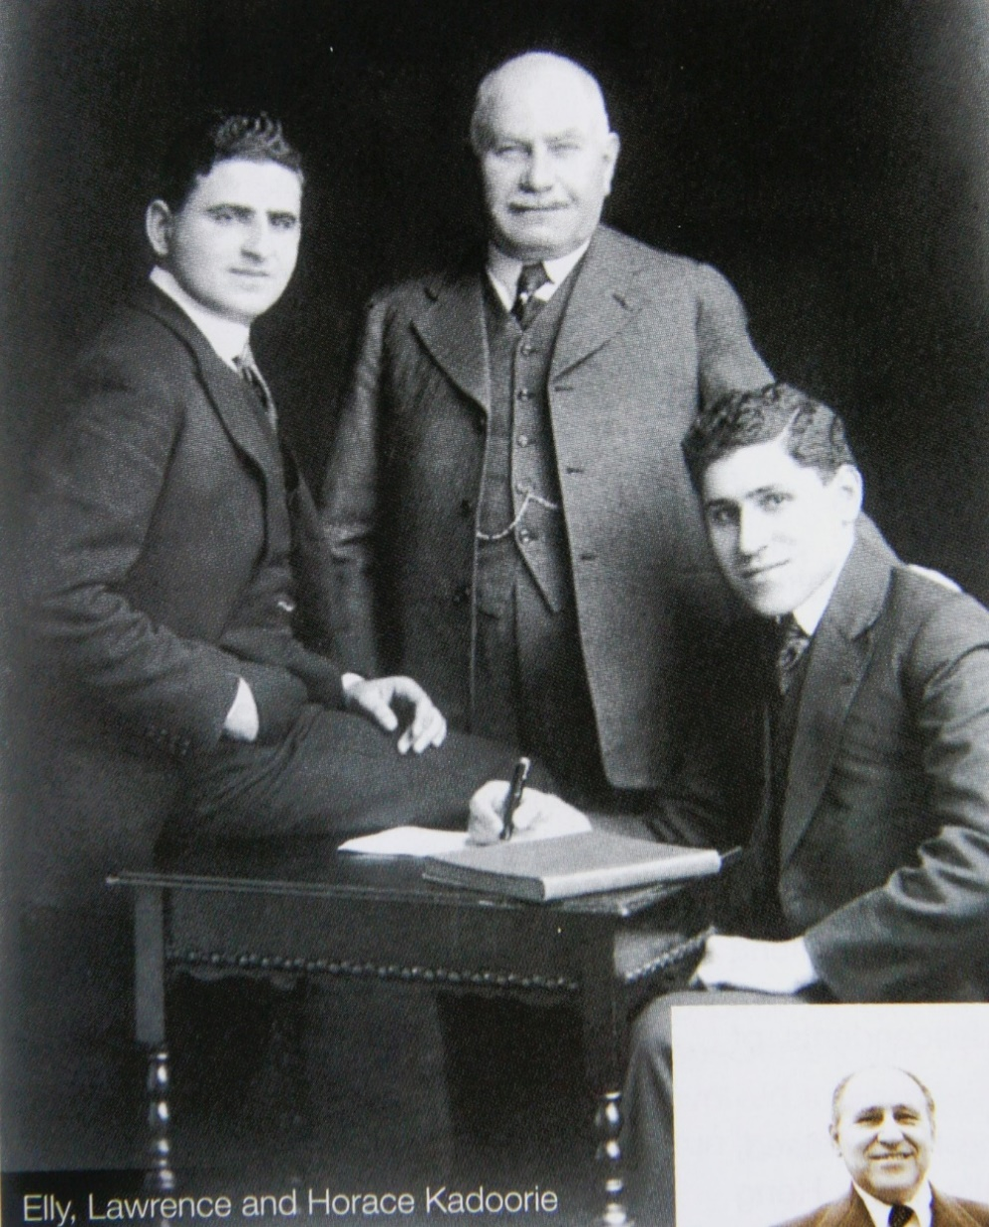
Elly, Lawrence and Horace Kadoorie
Kehimkar, who served at the time as President, Secretary and Treasurer of the school (from 1893, until he passed away in 1909), believed that a Prayer Hall/Synagogue is not only a House of Prayer, but also a House of various social functions such as, a House of Assembly and a House of Study. Accordingly, to his views, Kehimkar launched a number of religious and educational institutions, along with various charities for the Bene Israel community. Consequently, he devoted his life to the community and particularly to the advancement of Jewish education among the Bene Israel children. He named the Synagogue Etz Haeem.

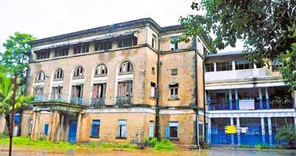

Sir Elly Kadoorie High School in Mazgaon, Bombay

By this act, Kehimkar had taken a philosophical and practical view. In keeping with the teachings of the Bible which imports significance to trees, the name Etz Haeem - Tree of Life was selected. Etz means Tree and Haeem means Life. The Holy Book forbids the destruction of trees, even during warfare or siege of enemy towns and also instructed the Israelites to plant trees as soon as they reached the Promised Land. With this point of view, Kehimkar very much desired that the young, when they became adults, should be imbibed with the rare qualities of trees. In other words, they should protect the needy and the weak and assist in caring for institutions, particularly Synagogues and Schools. Haeem was also a pioneer in the field of Women’s education.

After Kehimkar’s death, the new Management of the School refused to uphold the idea of continuing the Prayer Hall on School premises.

Fortunately, his two sons, Joseph and David and son in law, Daniel Moses Talkar, along with other relatives and friends, came to the rescue by shifting the Prayer Hall to a location beyond the School compound. According to E.M. Jacob (1988), the new location is unknown and he adds: “I have attended prayers at the present Prayer Hall in or about 1915, when it was on the first floor, in a building at Umerkhadi Road, off Babula Tank Road, I do not know when the Prayer Hall was shifted to the present site. I think it was in early twenties.”
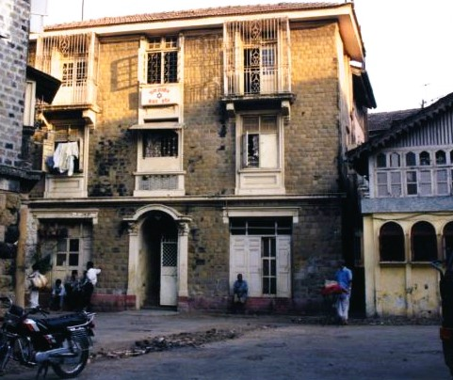
Etz Hayim Synagogue, Umerkhadi, Bombay. Photo, Eliyahu Ornah, 1995

The Prayer Hall is located on the top floor of a symmetrical 3 story residential apartment building. The name is affixed below the centre window of the top floor of the building’s façade. The interior is described by architect Jay E. Waronker:
“The intimate sanctuary, although a modest space, is nicely furnished and fitted out. Etz Haeem contains a raised centrally-positioned tebah that is surrounded by long wood benches…Since this is a single-story, small-scaled room, the women’s section is to the east side of the room, and it is demarcated by a mechitzah separating men and women according to Orthodox synagogue convention…Position next to the wakk closest to Kerusalem, as per synagogue cuetom, us the hekhal. Special chairs, all wood and draped in fabric, dedicated to the prophet Elijah and used in the brit mila ceremony flanked the hekhal…Above the hekhal is a hand painted panel dating from
1930 with Hebrew verses, and atop it is the Jewish Ten Commandments…
The walls are decorated with religious art and various Jewish objects, including a menorah and Hanukkiah… Hanging from the prayer hall ceilings structure, and common to most Indian synagogues, are glass domes, chandeliers, , metal lighting fixtures, and fans. Among these is the brass ner tamid positioned near the hekhal.”

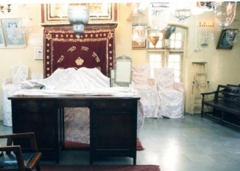
Etz Hayim Synagogue. Facing the Bimah and the Hechal. Photo, Eliyahu Ornah, 1995

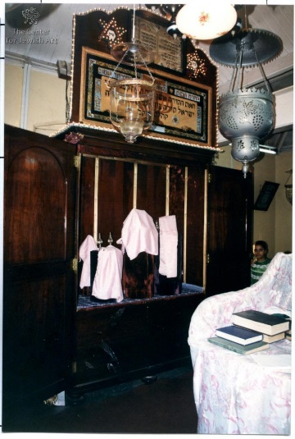
In the course of time, the Etz Haeem Prayer Hall has undergone numerous changes and has experienced ups and downs. Finally, the Prayer Hall reached its Centenary celebrations in 1988, with a great deal of achievements. Its financial situation was satisfactory and it had a vibrant youth wing which was full of activities. It recaptured, in the minds of its successors, the role of being an important function in religious and communal spheres, which serve as a tribute to its founder, Haeem Samuel Kehimkar.

The Hechal

Location: 19, Umerkhadi, 2nd Cross Lane

Rodef Shalom (Pursuer of Peace, Pursuing Peace), Synagogue, Byculla

Founded in 1925, a small band of keen and dedicated young men and women, through the initiative of Dr. (Miss) Jerusha Jacob Jhirad, formed a branch of a progressive movement in Bombay known as the Jewish Religious Union (JRU), in order to encourage religious enlightenment, progressive thinking and meaningful Jewish worship. The erecting of the JRU in Bombay was influenced by the teaching of Claude Montefiore (1858 – 1938), from London. Montefiore, a great nephew of Sir Moses Montefiore, was a significant figure in the context of modern Jewish religious thought and a founder of British Liberal Judaism. He was a member of numerous educational, social and religious bodies and President of some of them, such as: The Anglo Jewish Association; the Jewish Historical Society of England; the Jewish Religious Union (JRU). The JRU in Bombay held regular services in Hebrew and English which they conducted in rented premises until 1958.
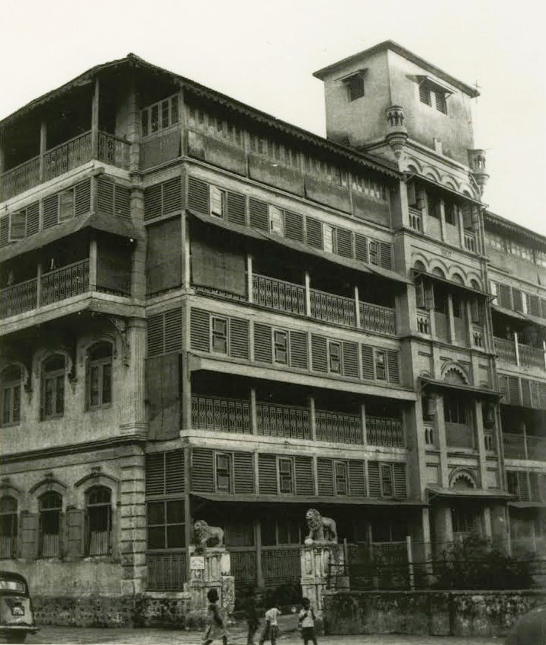

Rodef Shalom Synagogue, Dadoji Konddeo Marg (Sussex Road), Byculla
In August 1958, Rabbi Hugo Gryn (1930-1996), a British Reform Rabbi and his wife Jacqueline Selby, arrived in Bombay and gave the JRU movement and the Synagogue a new impetus. Gryn was born in Berehove (a city located in Zakarpattia Oblast (province) in western Ukraine, once in Hungary and Czechoslovakia. After studying to be a Rabbi in the US, he lived for a few years in Bombay and then moved to London in 1965. The building which was purchased with the aim of serving as a synagogue, was a four storey structure built in 1907, formerly owned by a Jewish woman and was known as Matilda House. Its location in a pre-dominantly Jewish area, aided in its functioning as a vibrant Synagogue for the Reform followers in Bombay.

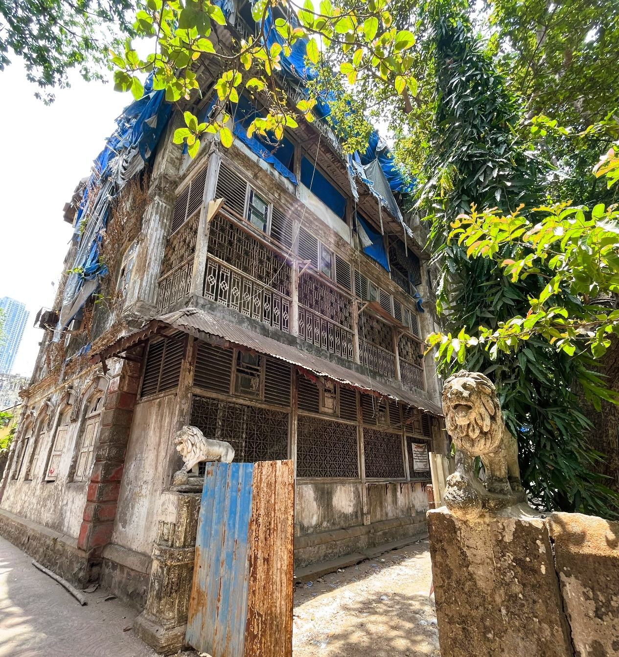
Rodef Shalom Synagogue, Dadoji Konddeo Marg (Sussex Road), Byculla, 2023

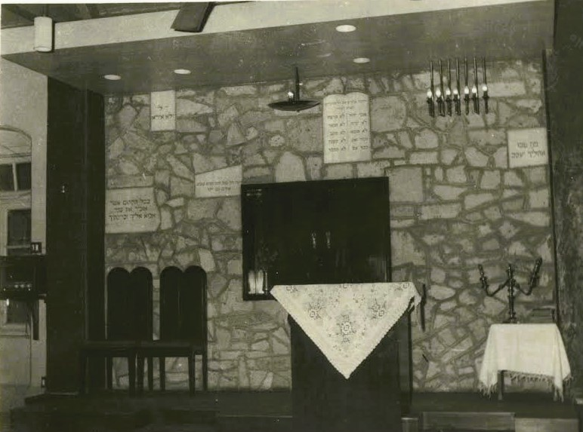
Rodef Shalom Synagogue, facing the Holy Ark, Early 1960s.

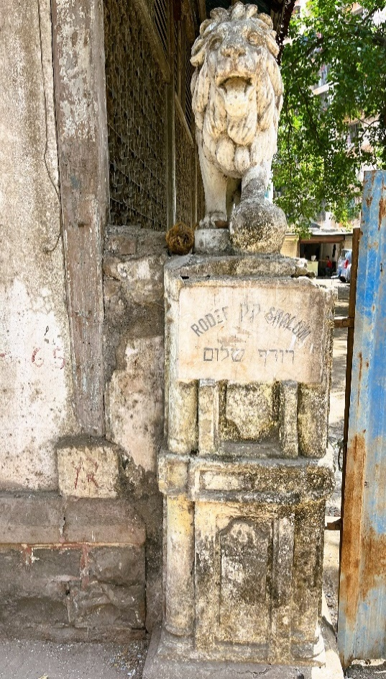
The JRU converted the right wing of the third floor into a Synagogue. The task of architect Solly Reuben, who was involved with the renovation of the Synagogue which was named Rodef Shalom, was to convert the open space of the empty hall into an aesthetic and calm place of worship. Within the building is a Rabbi’s flat, as well as a Jewish Old Age Day Centre which is under the auspices of the American Joint.

The Rodef Shalom Synagogue has been closed for some decades even before the space was burned down during local riots in January 1993. Distribution Committee in India.

Synagogue’s Name and Statue
at the Entrance Gate, 2023
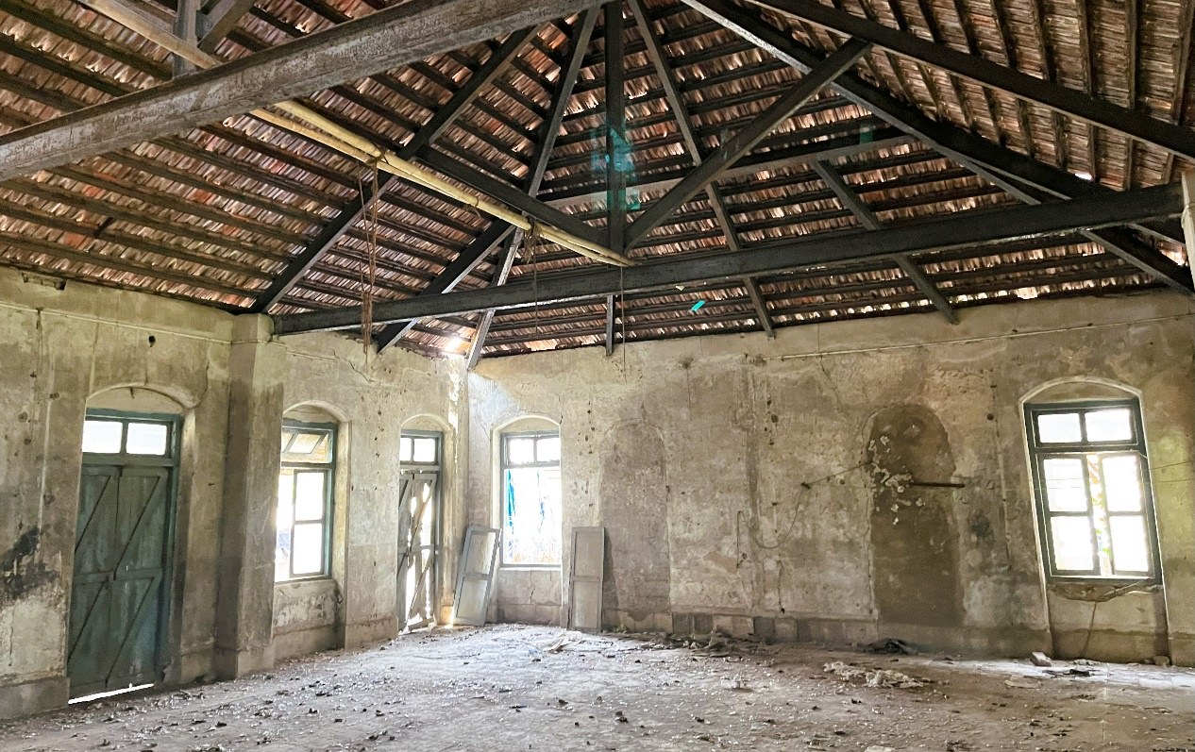
Interior of the Rodef Shalom Synagogue, facing the Holy Ark, 2023

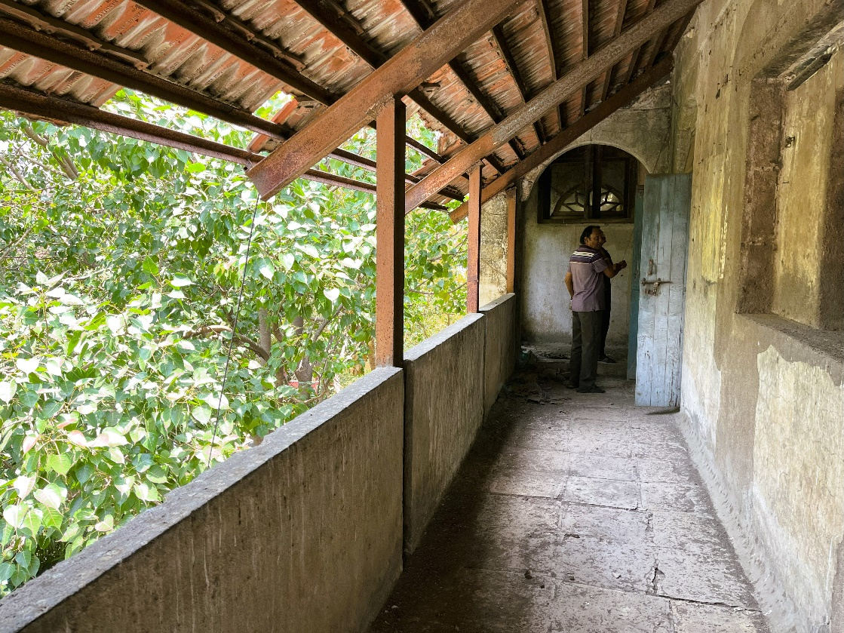
Synagogue Corridor, 2023

Originally, Congregation Rodef Shalom was a Reform Synagogue in Manhattan in New York City, founded by immigrants from German lands in 1842. It is known as one of the oldest Synagogues in the United States. Synagogues by the same name were built in other states in the U.S. as well.

Location: Dadoji Konddeo Marg (Sussex Road), Byculla
Kurla Bene Israel Prayer Hall, Jewish Colony, Kurla West

The founder of the Kurla Bene Israel Prayer Hall in Kurla West, was Isaac Moses Jiradkar, who from 1915 to 1922, conducted prayer services in his residence in Chunabhatti, near Kasaiwada in Kurla East. After Jiradkar’s death, the prayer services were arranged from 1922 until 1933, in the house of Benjamin Shalom Sagaonkar (Sagaonson/Sogavkar-Sogavson).

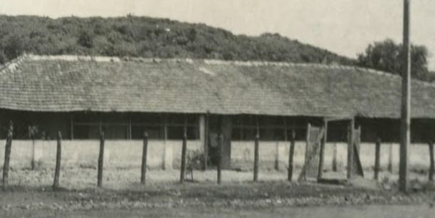
Between the years 1933-1946, Sagaonkar organized prayers from a leased property known as the Old Court Building located in Kurla West, which was retained from the Government of Maharashtra in 1946. In this period, the size of the Bene Israel community reached about two hundred families, in what was known as the Jewish Colony.
Kurla Synagogue, Jewish Colony, 275, S.G. Barve Marg, Kurla West

Following Sagaonkar’s death in 1953, the control of the Prayer Hall was transformed in June 1954, to the Kurla Bene Israel Committee, which at the request of Mordekhai Aaron Mazgaonkar held prayer services on Fridays and Saturdays. In 1958, the lease of the Old Court Building was transferred to the Kurla Bene Israel Prayer Hall.

The location of the Prayer Hall was excessively accessible to the expanding Jewish Communities of the nearby suburbs of Ghatkopar, Anderi, Chembur and Santacruz and functioned as their religious, cultural and social centre.
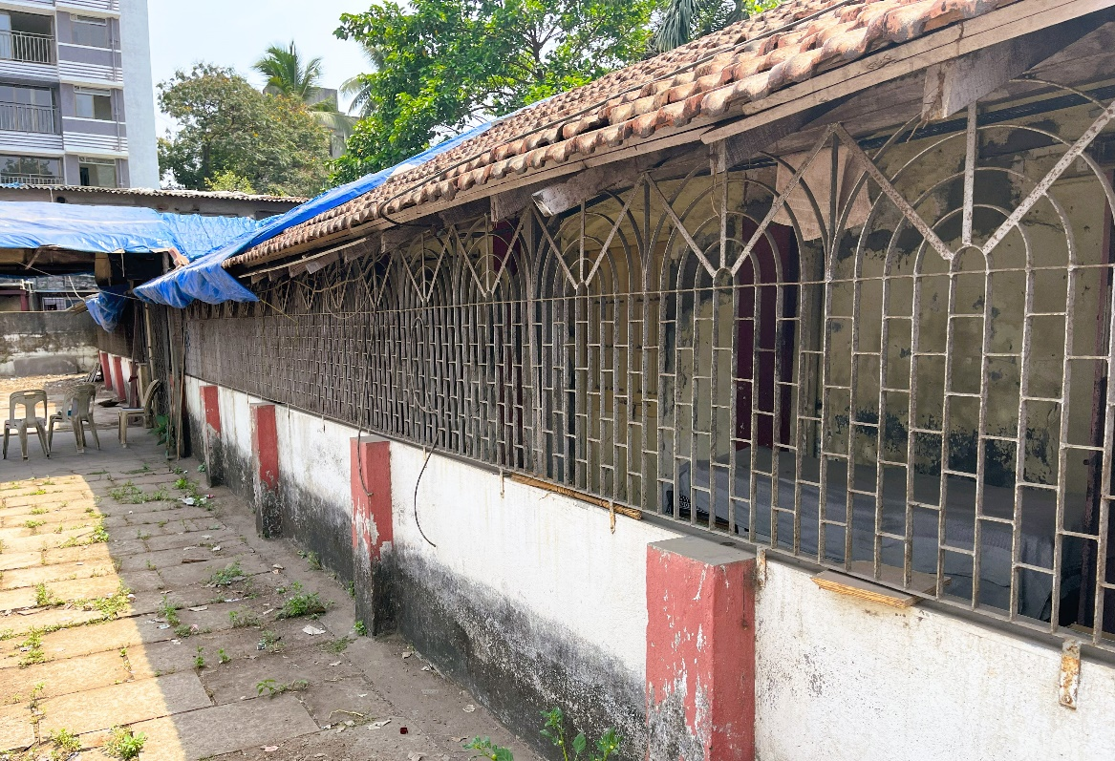
Kurla Synagogue, Jewish Colony, 275, S.G. Barve Marg, Kurla West, 2023

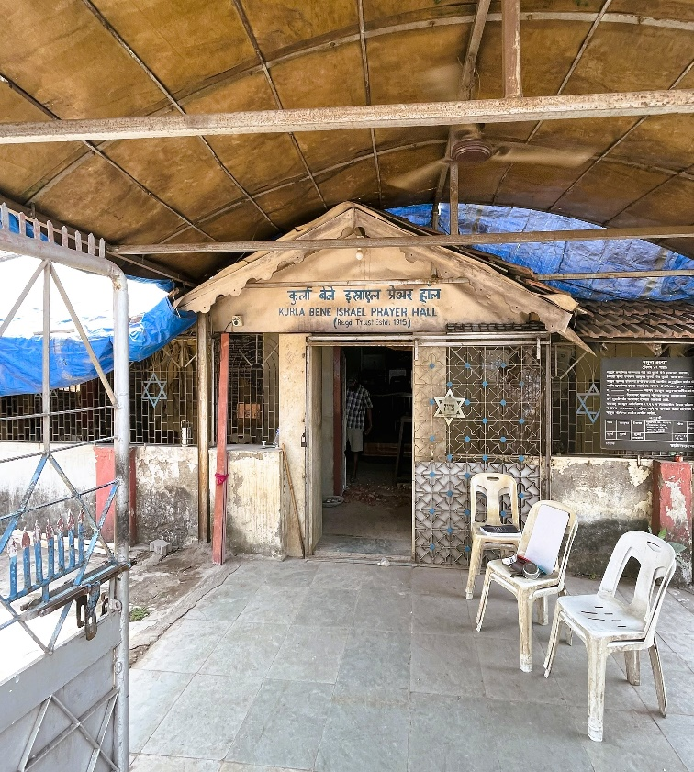
The Kurla Pray Hall, according to architect Waronker: “…is housed in an understated, single-storied, low-lying strip building…A narrow covered porch contained by a low wall and metal grill (a later addition to the façade) decorated with Stars of David painted blue runs along the entire front (east) side of the building…the building’s long volume…has a gable roof covered in flat clay tiles. Atop this roof is a small perpendicular gable, which features the prayer hall’s name in Marathi and English. It marks the entrance to the prayer hall.”

Entrance to the Kurla Synagogue, 2023
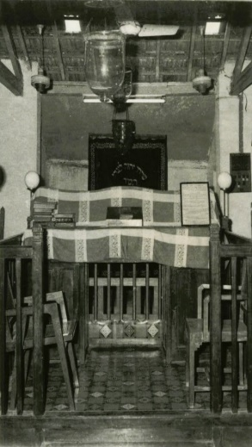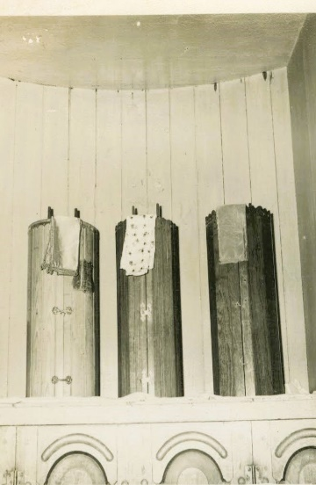
Kurla Synagogue, the Tebah,and the Hekhal, early 1960s

Relating to the interior of the building Waronker states: “Kurla Bene Israel Prayer Hall is an intimately rectangular room with entry doors flanked with windows at the east elevation and a rosewood hekhal with another pair of shuttered windows to each side at the west elevation.
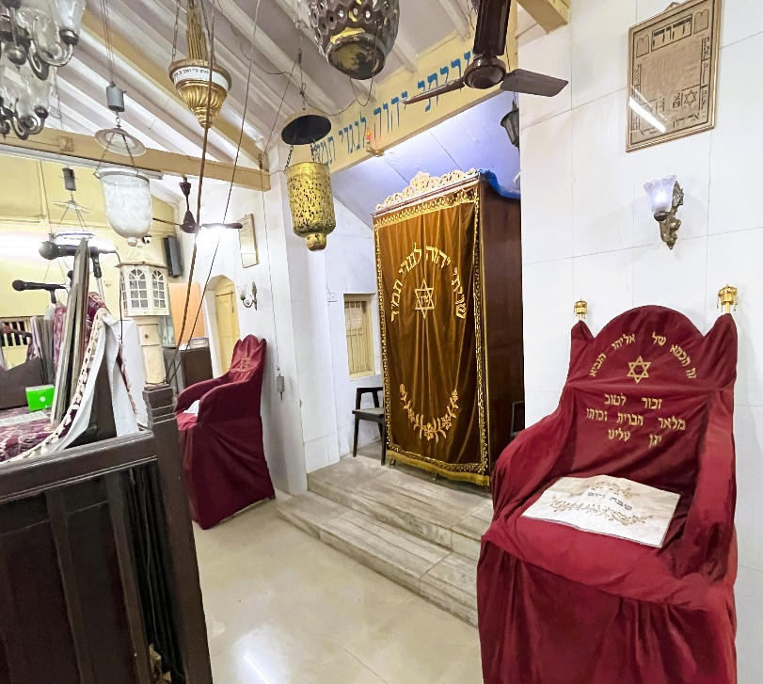
The cabinet-like freestanding hekhal is set in a niche along this wall closet to Jerusalem per synagogue convention. Flanking the hekhal are two large wood chairs used in a brit mila; one is dedicated to the prophet Elijah. The partitioned north area of the sanctuary has a dedicated space for women’s seating according to Orthodox synagogue custom. The tebah is centrally placed as in other Indian synagogues… Front: The Hekhel. & Prophet Elijah’s Chairs
on the sides, 2023

Hanging from the ceiling, in usual Indian synagogue fashion, are vintage glass metal lighting fixtures and fans. Among these is the brass ner tamid positioned directly in front of the hekhal. Another special light, also of brass, is for the prophet Elijah. These lighting fixtures and ceiling fans gives the room a sence of place and character…Long wood benches and chairs provide seating for congregants and guests, and wood bookcases line the walls of the sanctuary space.”

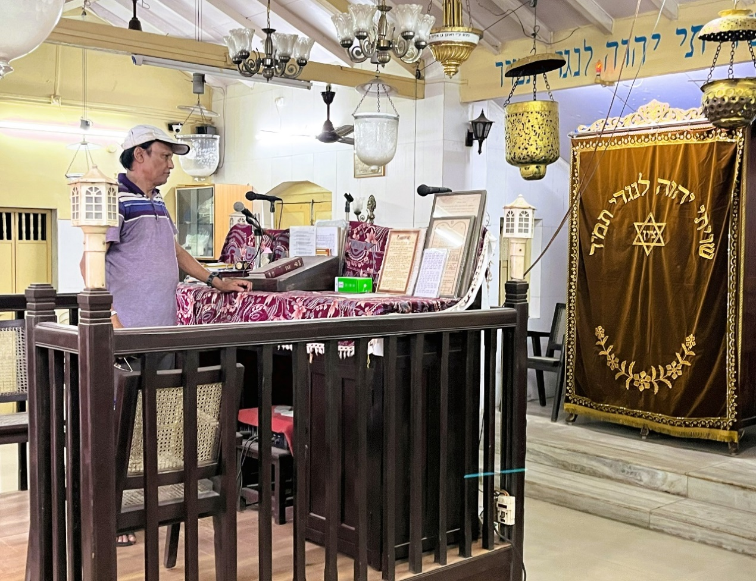
Chazzan Menash Hannock Chordekar, reading at the Tebah, facing the Hekhal, 2023

After the emigration of the Bene Israel in vast numbers to the State of Israel during the 1950’s and the 1960’s, the Synagogue was closed in 1978. As of 2015, there were ten families who lived in the area and conducted prayer services at the Prayer Hall on special events. The person in charge of the Kurla Prayer Hall is Moshe Yoseph Rajpurkar who earned a Bachelor of Commerce degree from the University of Bombay and who dwells a few buildings away from the Prayer Hall.

Location: Jewish Colony, 275, S. C. Barve Marg, Kurla West

Parel Bene Israel Prayer Hall, Parel

Very little is written on the historiography of the Parel Prayer Hall, therefore most of the information is based on Ben Eliahu who mentions in The Synagogues in India (1978): “The expansion of Bombay towards the East and further North consequent on the removal of the ‘cotton Green’ from to Sewri, the building of the Port Trust Railway with a large marshalling and interchange yard at Vadala and staff quarters for Railway Employees, the opening in 1925 of the electric suburban service of the Railway from Kurla to Victoria Terminus and Bandra to Vadala and so to Victoria Terminus, via the Harbour Branch, brought about a large concentration of the Bene Israel in the Parel and Dardar localities.

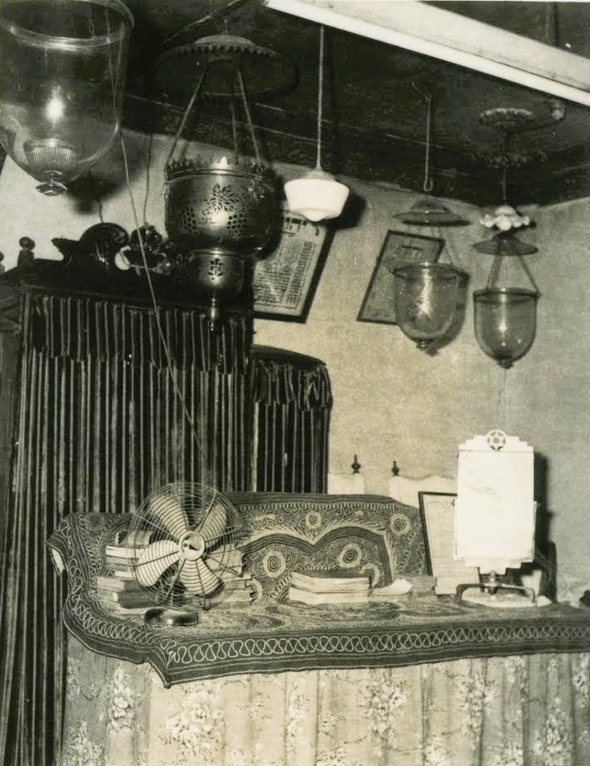
Parel Jewish Prayer Hall, Bombay, established in 1930. Photo, early 1960s
The improvement Trust Schemes of the Municipal Corporation provided better housing accommodation, schools, colleges and other civil amenities. A prayer hall has been founded in rented premises at Parel near the Carrol Road overbridge opposite the Parel Market. This has now been established on a permanent basis with the active assistant of Mr. Shalome Abraham (Cheulkar) B.A.J.P. and Hon. Presidency Magistrate and former Head Master of the [Sir] Jacob Sassoon Free [High] School. Due to keen interest of Mr. Shalome Abraham and his family members prayers are rdgularly held and religious instructions imparted. Mr. is also a Counsellor to the members of the Congregation who come to him with their difficulties.”

As of 2015, the building served as a local hospital.

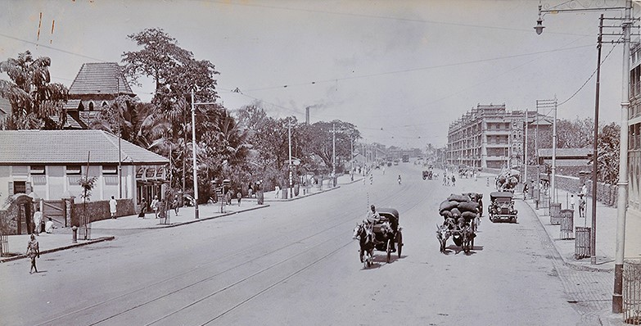
Parel Road

Location: 5/28 Haji Abdulla Noor Mohamad Building, Elphinstone Road, Parel

Bandra Temporary Prayer Hall, Bandra

Bandra, located in north-west Bombay with a long seafront, developed into a fashionable suburb by the middle of the 20th century. Today it is included in Greater Mumbai.
In 1926, Dr. Elijah Moses (first Bene Israel in post as Mayor of Bombay, 1937-38) and other prominent members of the Bene Israels residing in Bandra (Chapel Road Colony Scheme) and later from other close by neighbourhoods such as Pali Hill, Khar, Santa Cruz and Vile Parele, held prayers during the High Holidays in the hall of Dr. E. Moses’ bungalow at Chapel Road, Bandra. The High Holiday prayers were regularly held there for a few decades. In 1946, a Jewish cemetery was established in Bandra.

Location: Chapel Road Colony Scheme, Bandra

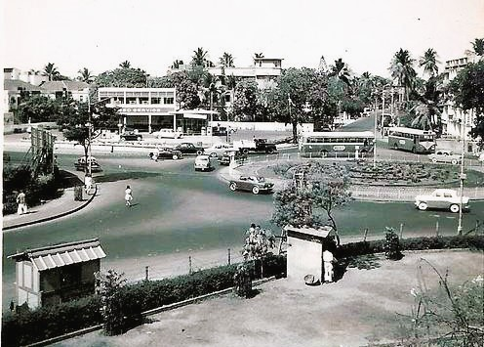 Bandra, junction of SV Road, Linking Road and Turner Road
Thana/Thane
The Marathas, who conquered Bassein and Thane in the late 30s of the 18th century, held sway over the region for less than fifty years, when the British captured the Fort in 1784 and made it the Headquarters of the District Administration with a District Collector stationed in Thane.

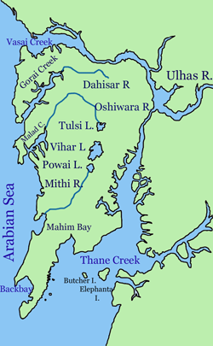
Map of Mumbai and Surroundings- North-Ulhas River- which splits at the northeast corner of Salsette Island into its two main distributaries, Vasai Creek and Thane Creek.

The District was later divided by transferring part of its land (from Mulund to Sion), to Mumbai for its future development. The Thane Municipal Council was formed in 1863 when the city had a population of 9,000. In the early 1800’s, the Bene Israel military pensioners started settling in Thane.

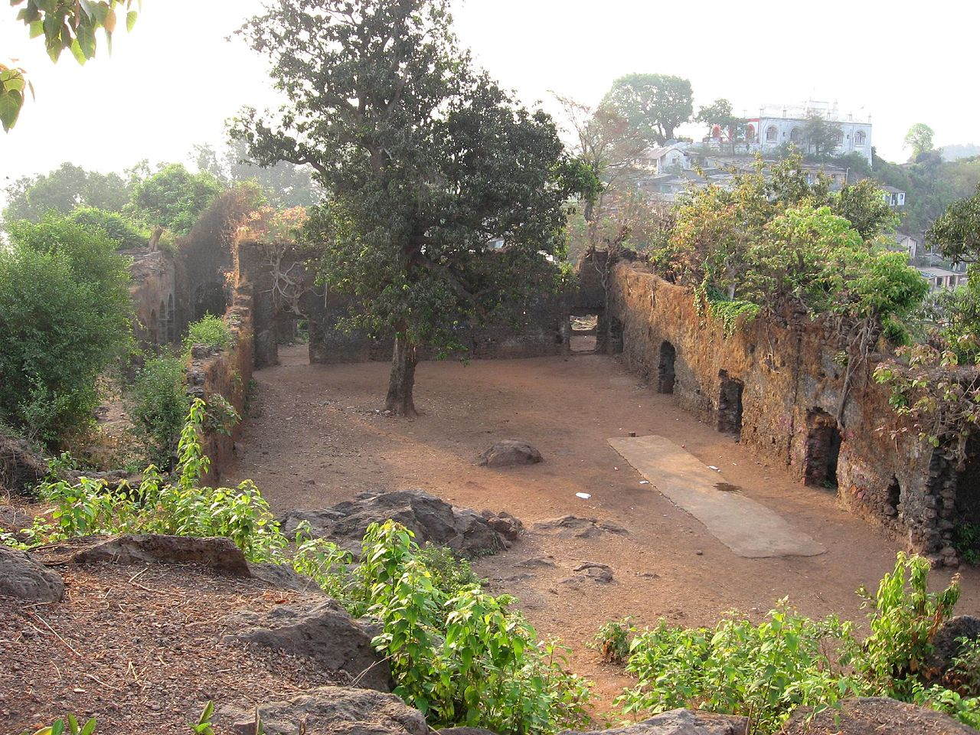Ghodbunder Fort Courtyard

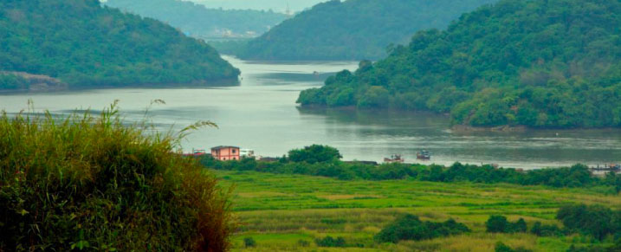Ulhas River, as seen from Ghodbunder Fort

There are about 30 lakes located within and around the city, earning Thane the distinction of being known as the City of Lakes. Apart from being a source of water for Thane District and its larger neighbour Mumbai, some of the lakes emerged to become tourist attractions, turning Thane into a great and popular getaway for Mumbaians.

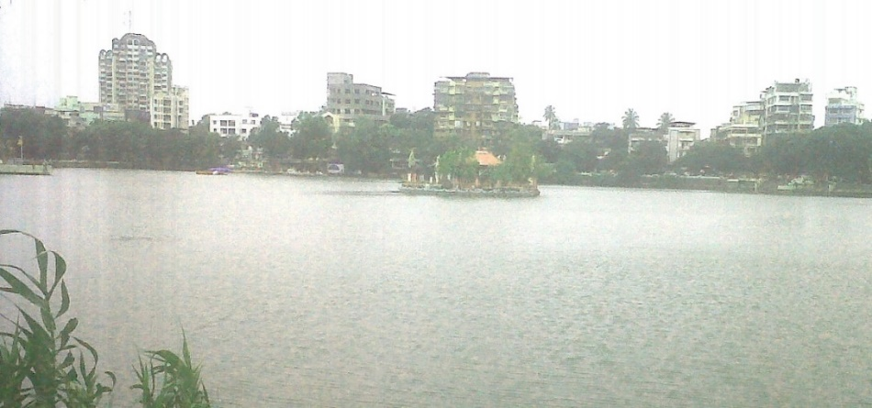
Masunda Lake in Thane, also known as Talavpali Lake is considered to be among the most picturesque lakes in the State of Maharashtra. The lake is home to a small island with a Shiva temple on it. Masunda Lake, Thane
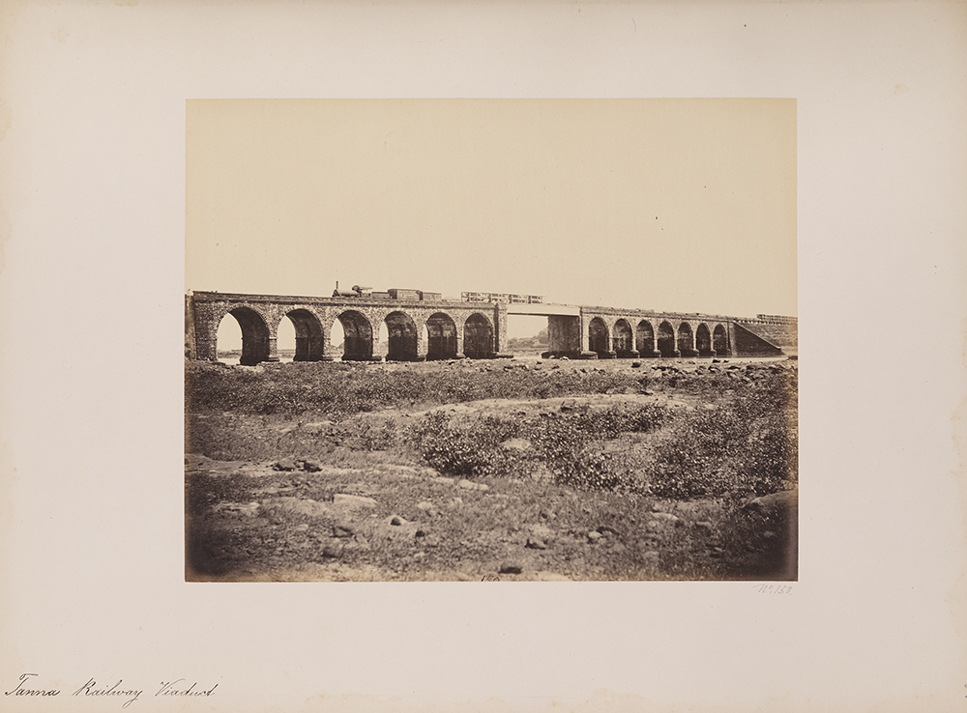
Train from Bombay to Thane. Circa 1855
Its greater claim to fame lies in the more recent history of the city; the first railway line laid in India was from Boribandar/Boree Bunder (later: Victoria Terminus and today: Chhatrapati Shivaji Terminus) to Thane in 1853. This unique event marked the dawn of the railway age on the Indian Peninsula, as well as in the history of public transportation in India. Thus, in the earlier 1850’s, the first sod of the Great Indian Peninsula Railway was turned and on 16th April 1853, the first 21 miles (33.6 kms.) was covered in 57 minutes. The day was marked as a public holiday.

Sha’ar Ha’Shamaim (Gate of Heaven) Synagogue, Thane

Sha'ar Ha’Shamaim Synagogue in Thane was built by voluntary subscription and donations collected from the local members of the community. Some members demonstrated great zeal and generosity in contributing towards the construction of the building which was dedicated on the 30th of December 1879.
A few plaques adorn the outer walls of the Synagogue from which one can follow a portion of its history. The commemorative plaque, located on the front wall of the Synagogue, are divided into two sections and supply us with the following details: "This Stone is a Monument in honor of Samson David Mhedekar Esq. & of other Israel Brethren who have contributed Rs. 1,000 & Rs. 7,540 to the erection of this House of Prayer called שער השמים )Gate of Heaven)." "The Foundation of this Synagogue was laid on the 26th March 1878. It was completed on the 29th December 1879 under the able & careful management of Subedar Samuel Moses Nagavkar & Consecrated on the following day."
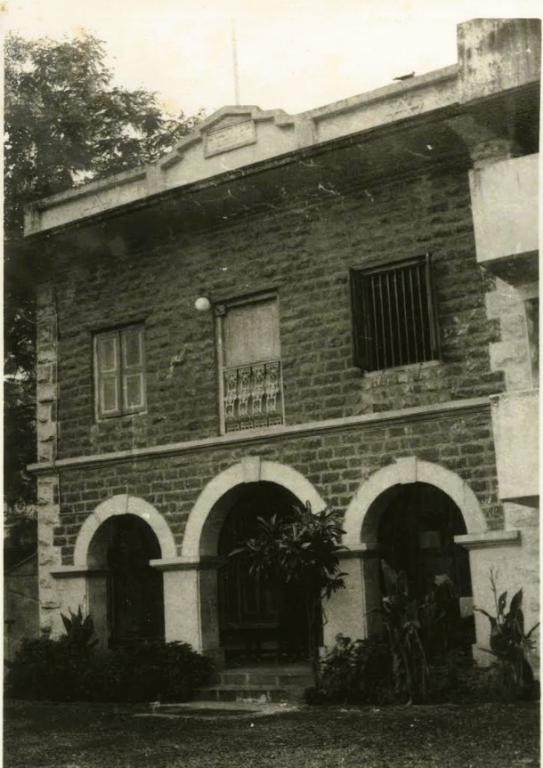
Another plaque mentions the erecting of a new Mikveh attached to the Synagogue: "Shaar Hashamaim's Mikveh was built by Isaac Ezekiel Haeem on 1st November 1926. It was further rebuilt renovated - beautified reopened & dedicated on 16th September 2001, 28th Elul-Rahamim 5,761, under the religious supervision of Rabbi Abraham Benjamin & Rabbi Meir Posen of Israel, with the able guidance of Ezra Moses."

Thane Sha’ar Ha’shamaim Synagogue, Early 1960’s
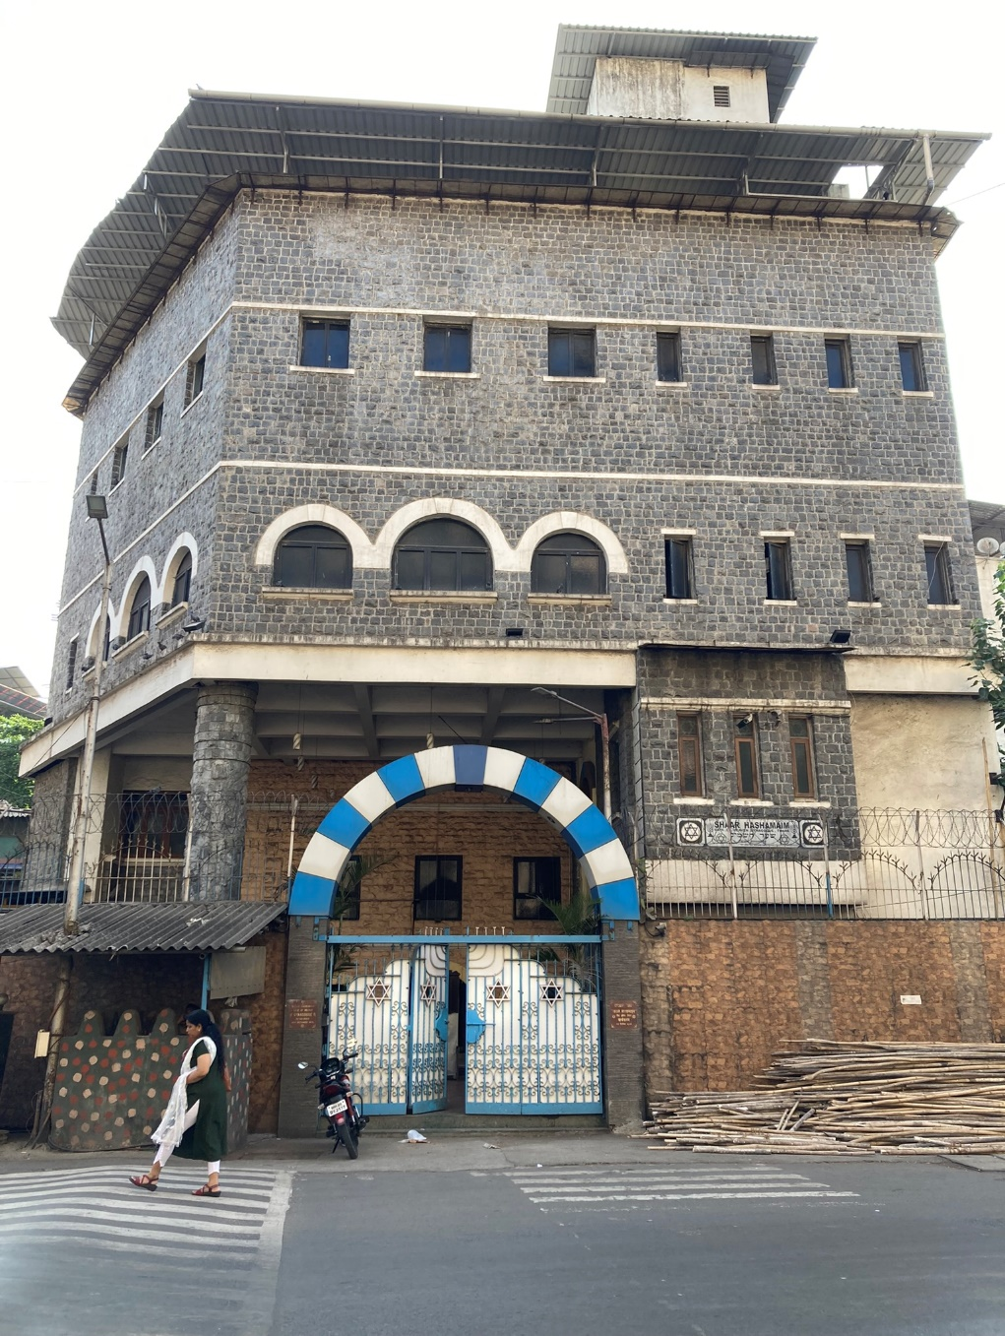
Sha'ar Ha’Shamaim Synagogue, 2022

Regarding the Synagogue’s expansion, architect Waronker mentions: “Thane grew in popularity and size, and it attracted more of the Bene Israel. As Shaar Ha-Shamaim’s membership greatly expanded, the need for more synagogue and community activity space became apparent. To meet this demand, Shaar Ha-Shamaim was enlarged and altered a number of times. An annex in a crisp white modern aesthetic was added in 1970 to the north side of the original traditional structure built of stone, and significant changes to the synagogue complex also occurred in 1994, 1998, and 2008.”

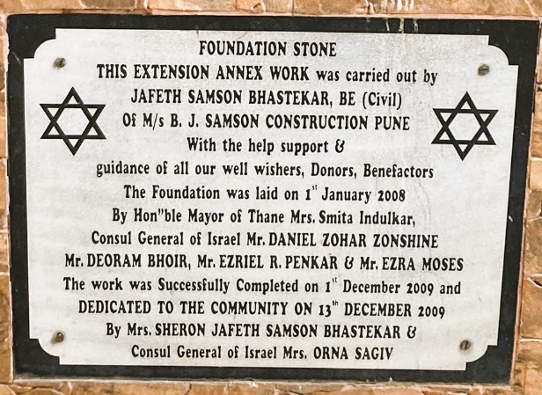
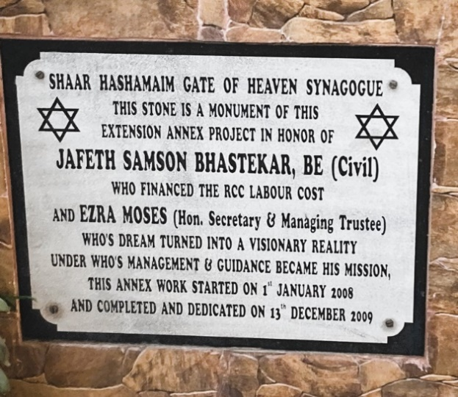
Plaques Commemorating the Synagogue’s expansion in 2008-2009

Relating to the Synagogue’s exterior, Waronker continues: “Separated from the street by a high wall and rounded portal with iron gates decorated with Stars of David, Shaar Ha-Shamaim is today made up of a compound of buildings, covered spaces, and outdoor areas. The two-story façade of the original 1879 synagogue building is currently finished in dressed stone that has been painted. The exterior features quoins at the corners, a band of trim dividing the two levels, and windows with paneled shutters. The result is a symmetrical, aesthetically-eclectic building typical of its period in this part of India. In front of this original building, towering over it and mostly concealing it from street view, is a large and proportionally- dominant four-story gray stone addition dating to 2008. This addition contains a covered yet outdoor ground-floor gathering area with social, support, and guest accommodation above. A mikvah, office and meeting spaces are also included today. A recessed porch at the original building that is fronted by rounded archways contains doors opening into the sanctuary.”
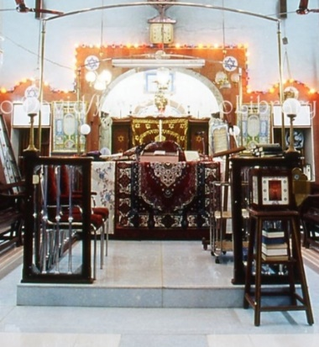
As to the interior, Waronker mentions: “The rectangular sanctuary, greatly modified over the years, includes a centrally-positioned raised tebah contained by wood posts and metal balusters. The tebah, set on a marble base, features lights at the four corners and metal rods for a wedding chuppah.

Interior of Sha'ar Ha’Shamaim Synagogue. the Tebah, 2022
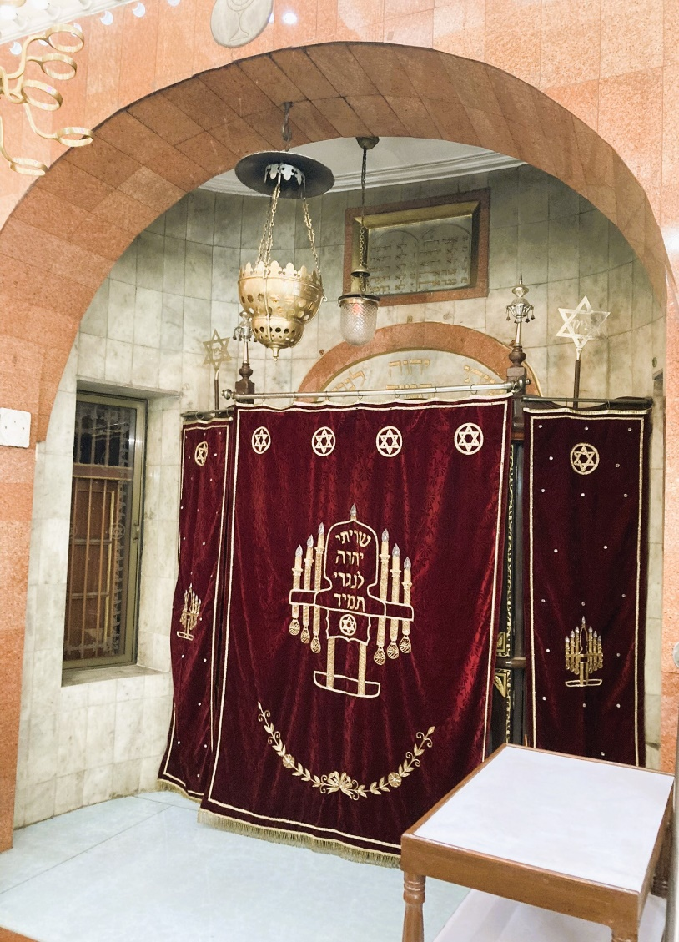
There is also the carved-wood hekhal set within a shallow niche positioned on the wall nearest to Jerusalem as per synagogue convention. The hekhal is draped with a parochet, and it is flanked by windows. Completing the sanctuary ceiling and wall fans, glass lanterns, metal hanging fixtures, wall sconces, Stars of David, a menorah, and Hebrew ‘Tree of Life’ framings… Positioned along the walls of the sanctuary are large windows. Stained wood benches which as is customary in Indian synagogues are not fixed to the floor, fill the space.

Interior of Sha'ar Ha’Shamaim Synagogue, the Hekhal, 2022

On the ground floor are the benches for the men, and the stepped gallery level, not original to the room, has fixed theater-like chairs – an anomaly for Indian synagogues – for women…In the center above the tebah is a skylight decorated with a large Star of David and blue tiles.”

Thane had, and still has, a relatively large Bene Israel community. Describing community and congregation activities throughout the year, Waronker summarizes: “Shaar Ha-Shamaim Congregation holds regular prayer services and social events, and its religious school operates on a weekly basis in the annex spaces…The synagogue also includes a Jewish Men’s Club and Eve’s Association for the women. Life-cycle events are held here, including B’nei Mitzah, weddings, and other religious and social ceremonies…Immediately behind Shaar Ha-Shamaim is property owned and rented out by the synagogue, and nearby is a kosher butcher shop.

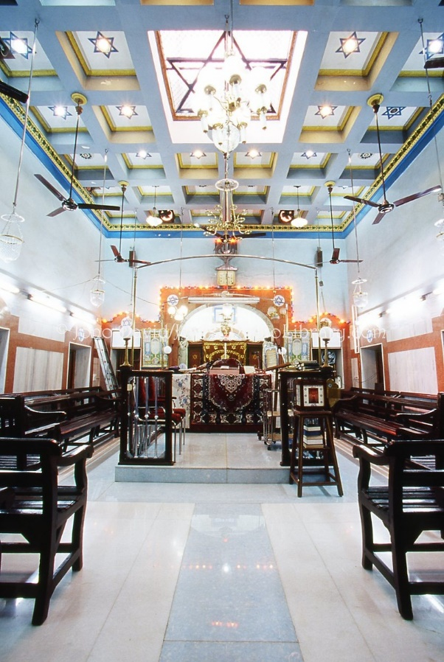
Interior of Sha'ar Ha’Shamaim Synagogue, the Centre Hall

Shaar Ha-Shamaim today is a thriving Jewish center, and on a regular basis a host of religious and social activities and events are held throughout the synagogue spaces for its congregation of over fifteen hundred members.”

Location: Situated near Civil Hospital, Synagogue Chowk.

The Konkan Division- Maharashtra

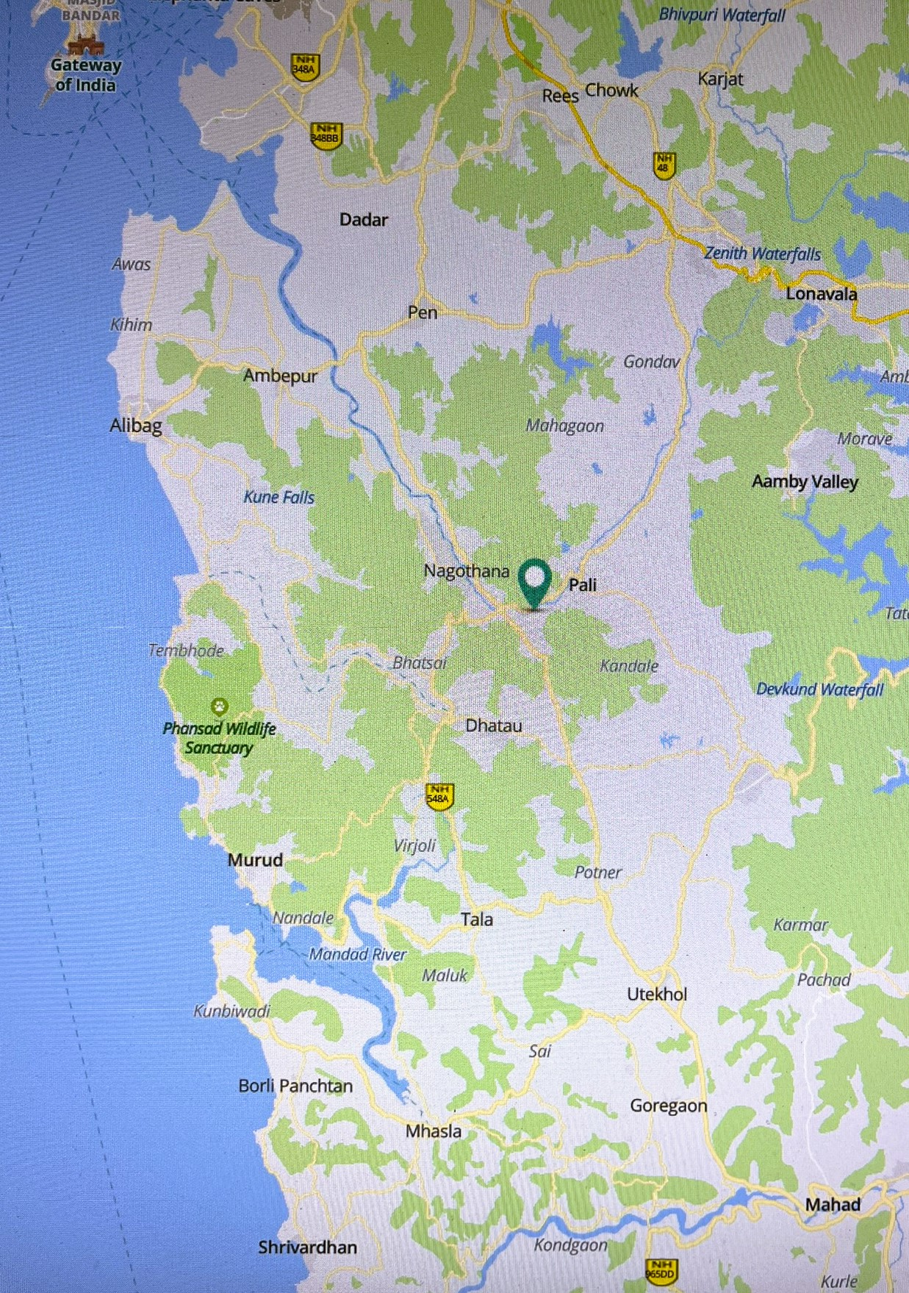 Map of Raigad District, Konkan
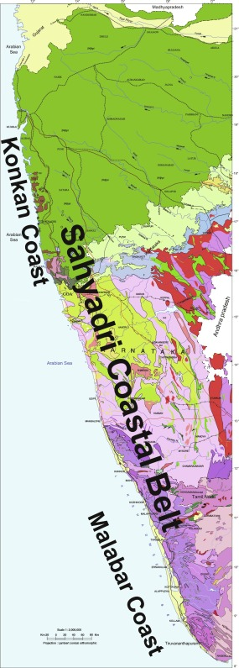
The Konkan Division is an administrative sub-division of the Maharashtra State which comprises all the Coastal Districts of the State. The western sea-board of the Indian sub-continent, from the coastal town of Dhanu/Dahanu in the north (a municipal council in Palghar district of Maharashtra state in Konkan division, located 110 km from Mumbai), to Cape Comorin, known also as Kanyakumari, the southernmost extremity of the peninsula. The western sea-board is known as the Western Ghats, or the Sahyadri Mountains Range. The Western Ghats is one of the eight hotspots of biological diversity in the world and is spread across six states - Gujarat, Maharashtra, Goa, Karnataka, Tamil Nadu and Kerala.

The Sahyadri Mountains Range (Western Coastal Belt)

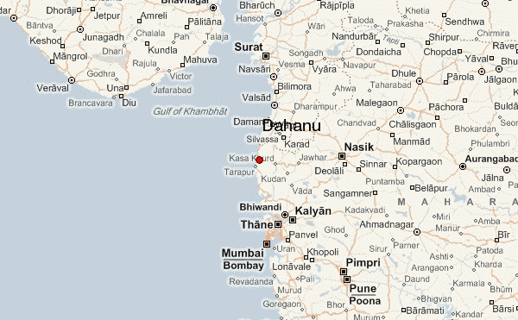 Arial Map: Dahanu-Mumbai
According to UNESCO The Western Ghats are older than the Himalayas and they influence Indian monsoon weather patterns by intercepting the rain-laden monsoon winds that sweep in from the south-west during late summer.
The Western Ghats has three sections: The Northern Western Ghats, The Middle Sahyadri (Central Western Ghats), and the Southern Western Ghats.
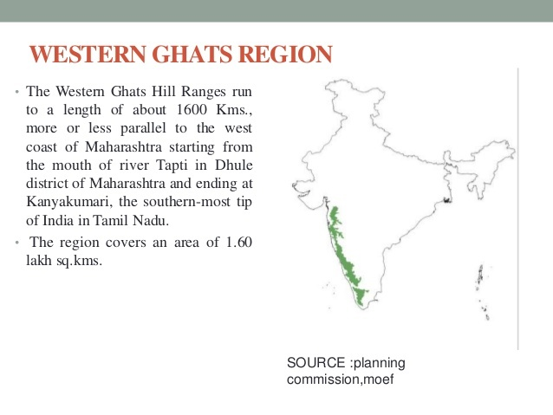

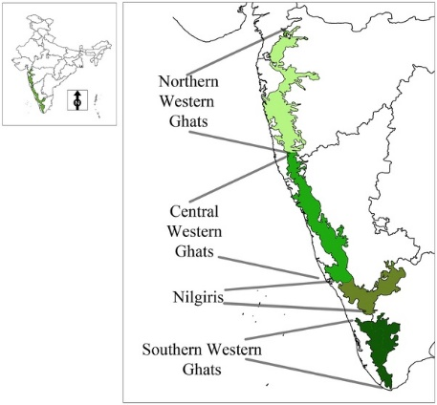
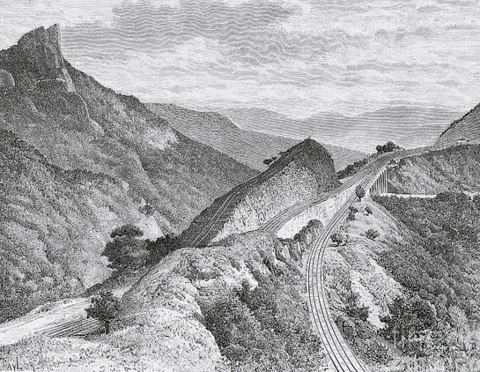 The Bhor Ghat Near Khandala
The northern section of the Ghats, from Tapi river valley to a little north of Goa, is made of horizontal sheets of Deccan lava (Deccan Traps). The average height of this section of the Ghats is 1,200 m above sea level, and some peaks attain more height. Thal Ghat and Bhor Ghat are important passes that provide passage by road and rail between the Konkan Plains in the west and the Deccan Plateau in the east.
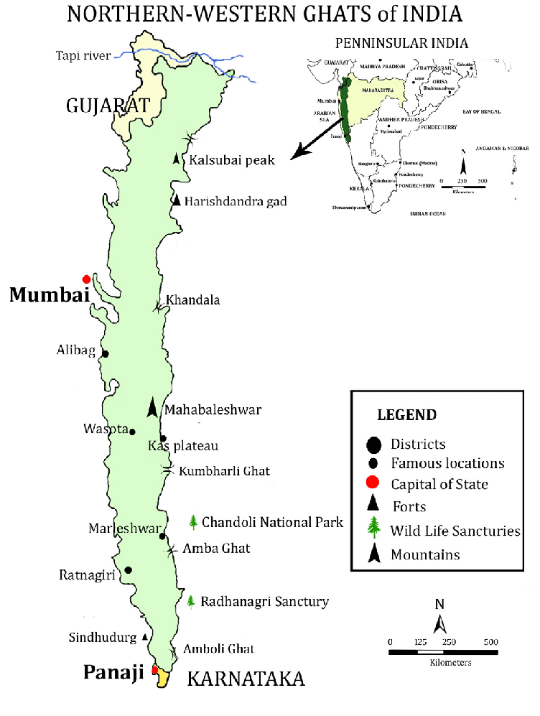
The Northern Western Ghats. Source: Sayajirao Gaikwad, Ramchandra Gore, Krushnadeoray Garad, Sampatrao Gaikwad, Ramjan Mulani (13 January, 2015), “Geophytes of Northern Western Ghats (Sahyadri Ranges) of India: A Checklist”, The Journal of Biodiversity Dada, Vol. 11, No. 1, Walchand College of Arts and Science, Shivaji College, S.R.T. Marathwada University, 2015. p. 2

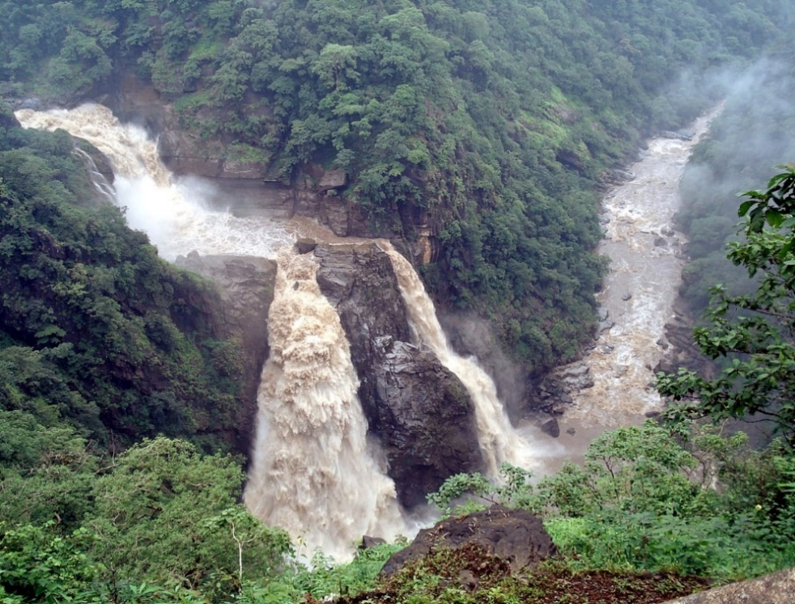
Roughly, the geographical boundaries of the Konkan are: The Arabian Sea at the West; The Mayura River at the north; the Sahyadri/Sayahari Mountain Range (Western Ghats) at the east and the Gangavali River at the south.

Ganagvali River, Magod Falls, Karnataka

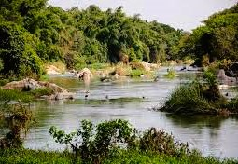
The Mayura River, Marks the Northern Boundary of the Western Ghats
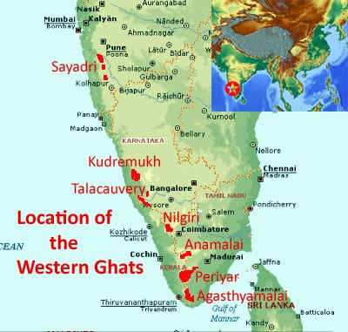
From the geographical point, the Konkan forms the coastal area between the Arabian Sea in the west and the Western Ghats (ghat means “pass” in Marathi) - the Sahyadri Mountain Range, in the east.

The Mayura River marks the northern boundary of the Western Ghats, and the Gangavali River forms its southern boundary, while the Tapti River marks the northern boundary of the Konkan in the north and the Chandragiri River (also known as the Perumpuzha River) in the south.

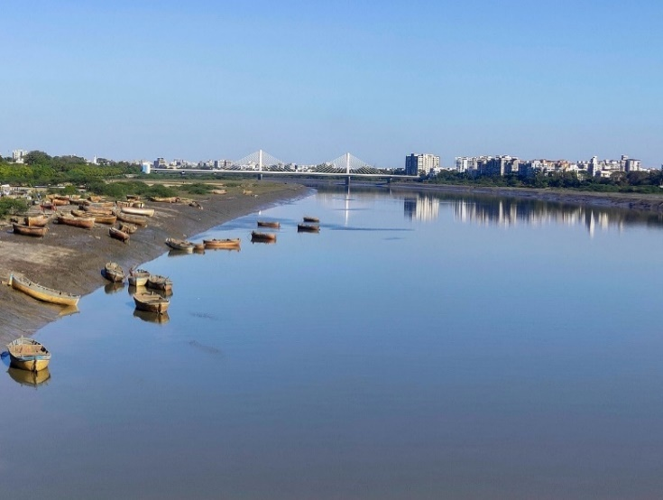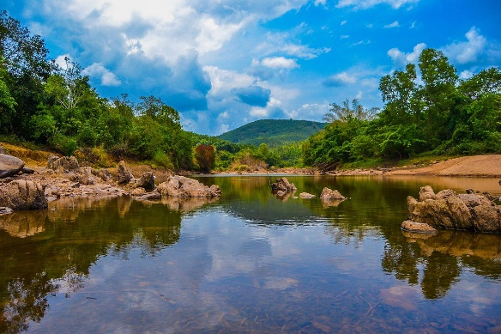
Tapti River- Cable Bridge - Surat Chandragiri River - Kerala

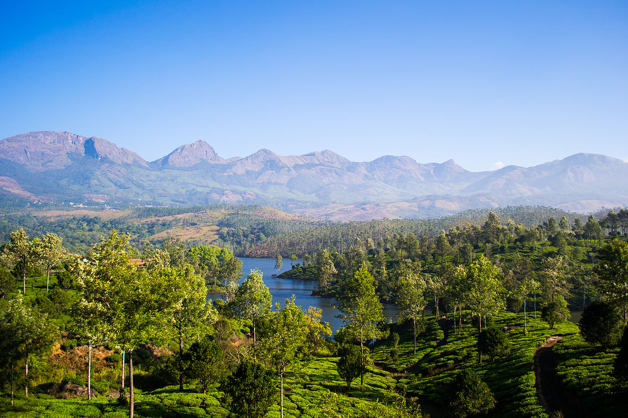
Ooti, located in the Western Ghats, known also as Udhagamandalam, is the Queen of Hill Stations in the south of Tamil Nadu. 2014. By Rignam Wangkhang

In 1961 the Konkan region became part of the newly formed State of Maharashtra which occupies the entire west coast of the new State.
The coastal region of Maharashtra is very different from the Western Ghat highlands near Pune or the hinterland of the Deccan Plateau in Vidharba region.

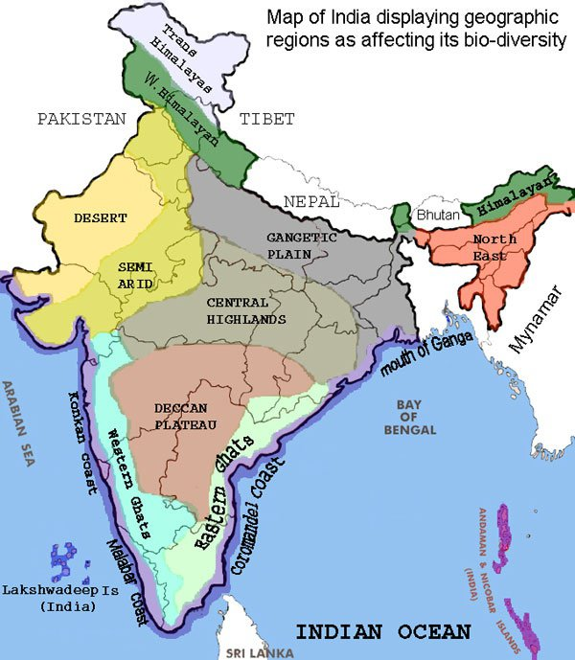
The Deccan Plateau is a large plateau in India, making up most of the southern part of the country. It rises a hundred metres high in the north, and more than a kilometre high in the south, forming a raised triangle within the familiar downward-pointing triangle of the Indian subcontinent's coastline.

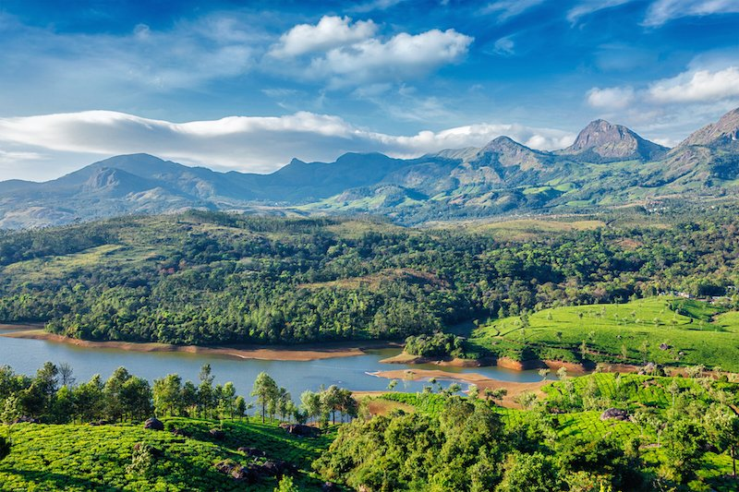
The Western Ghats - Countryside near Munnar. Picturesque sites and home to beautiful natural parks, wetlands and peaks, with an average elevation of 915m, around 27% of the country’s flowering plants and an incredible array of wildlife

There are numerous beaches stretching from Alibag in the north up to Sindhudurg near Goa in the south, with some admirable sea fortresses dotted along its coast line. The Konkan area is endowed with lush green mountains, waterfalls and amazing fishy rivers and is covered with a mosaic coat of coconut, mangoes and banana trees, among others in the region.

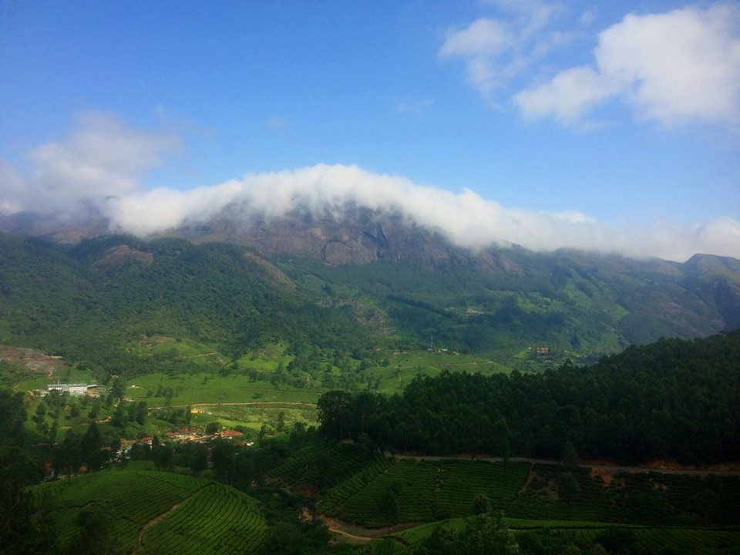
The Western Ghats- Anamudi peak, Munnar- The peak of Anamudi in Kerala is the highest peak in the Western Ghats, as well as the highest peak in India outside the Himalayas. Photo by Shveata Mishra
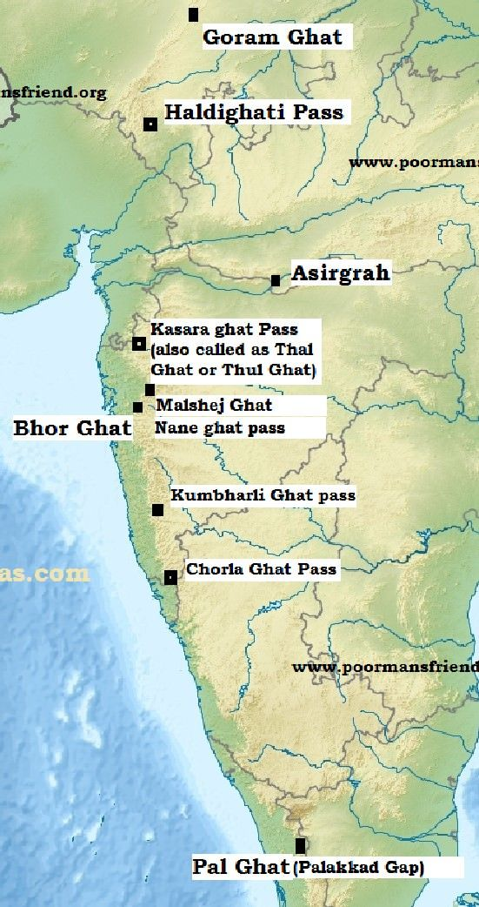
Maharashtra presents a complex range of physical diversity. To the west is the narrow Konkan coastal lowland, which reaches its widest expanse near Mumbai. Numerous minor hills dominate the relief. There are many small, swift, west-flowing streams, most of them less than 50 miles (80 km) long. The biggest, the Ulhas, rising in the Bhor Ghat, joins the sea after an 80-mile (130-km) course.

.

Map exposing the Ghats
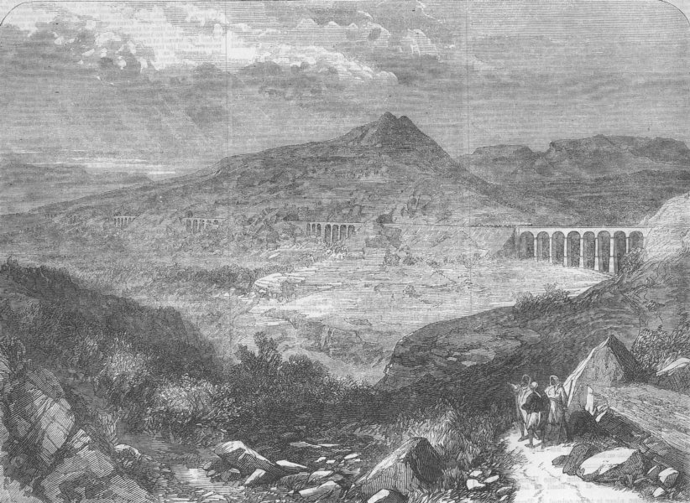
Fall of a Viaduct on the Great Indian Peninsular Railway, the Bhore Ghat incline. Illustration for The Illustrated London News, 21 September 1867

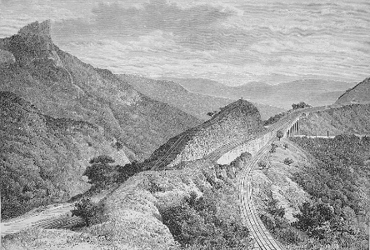
The Bhore Ghat, Gradient of the Railway near Khandala. Wood engraving from 1884

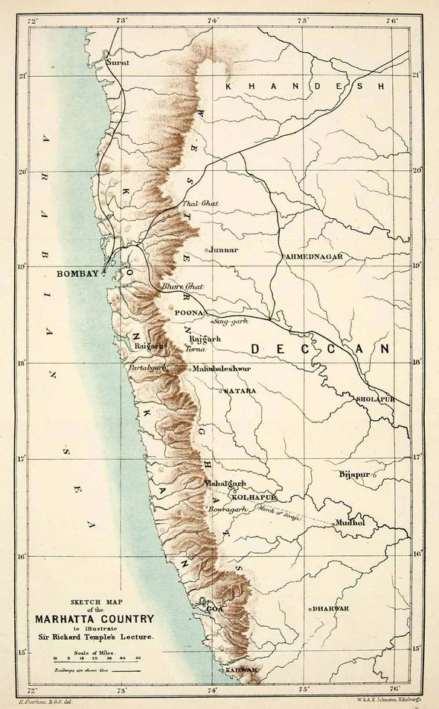
Map of the Konkan- Including from left to right:
the Arabian Sea, the Konkan, the Deccan.
The Konkan is also divided in to six Administrative Districts, as follows (from north to south): Thane, Mumbai Suburban, Mumbai City, Raigad, Ratnagiri and Sindhudurg. We should note that the Bene Israel settlements in the Konkan Division were, to a great extent, concentrated within the Raigad District.

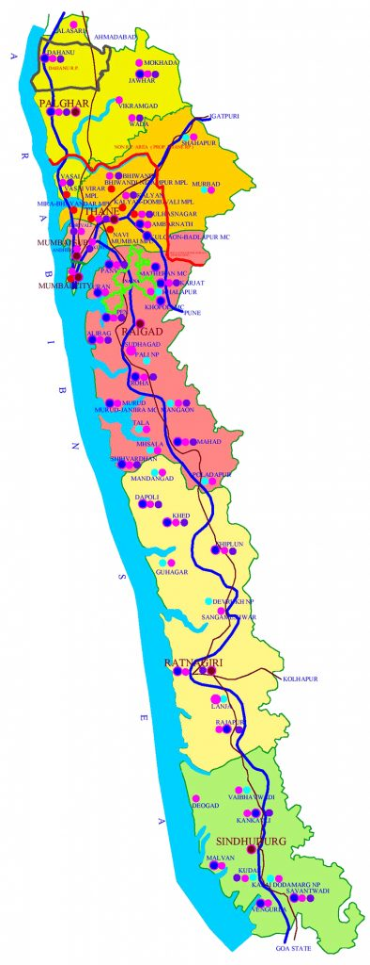
Beginning in the mid-twentieth century, as a result of political and social changes, India’s and Israel’s Independence from England the Bene Israel Jews began to emigrate. At that point, the Bene Israel population dropped from an estimated twenty thousand to a few thousands, and today the number of Jews currently living in the Raigad District is quite small. Of the synagogue buildings and Prayer Houses built in the towns and villages in this region, from the mid-nineteenth to early twentieth centuries, a few survive today. Of those, some remain active houses of prayers, others endure marginally, and the rest have been converted to other functions. These vernacular structures, appropriately scaled and decorated for their function, served their congregations well for many years. They are a testament to the region diversity and to India’s tradition of tolerance.

Konkan Districts.
Raigad District marked in Red.

Raigad District

Raigad's was first called Kolaba and today's Ramnath was the main village at that time. The name Kolaba is attributed to the Sea Fort Kolaba/Kulaba built in 1680, by Chhatrapati Shivaji Bhosale the Great Maratha leader (1630-1680), founder of the Maratha kingdom of India.

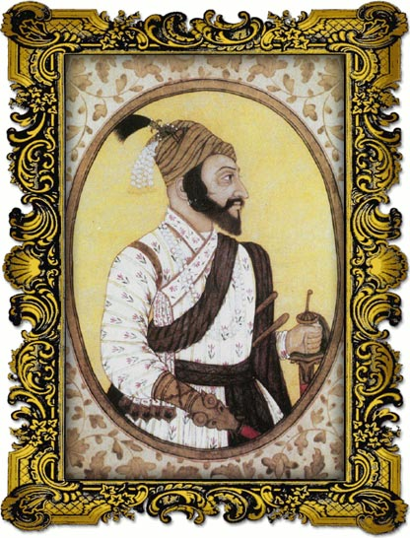
The District was named after Raigad, the Fort that was the former Capital of Shivaji Maharaj, located in the interior regions of the District, on a western facing spur of the Western Ghats of the Sahyadri Range.

Raigad is one of the districts in the Konkan Division of Maharashtra. The Arabian Sea’s coast forms the western boundary of the district. Most hilly places of the District are in the Sahyadri mountain range. Raigad is known for its scintillating historical places, like Kolaba Fort.

Chhatrapati Shivaji Bhosale

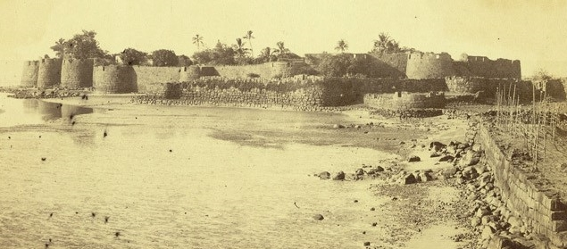 Kolaba Fort, 1855. It is nine hundred feet long and three hundred and fifty feet wide, built by Shivaji Maharaj in 1652
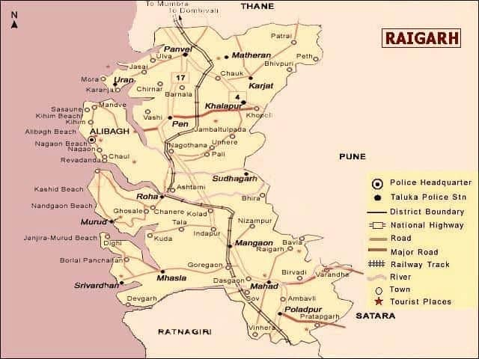 Raigad/Raigarh and the surrounding districts map

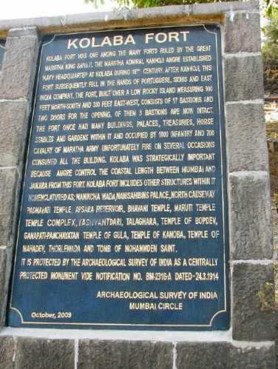
Kolaba Fort is a sea Fort built by Chhatrapati Shivaji Maharaj in 1652, on the Alibag Beach of the Arabian Sea, after south Konkan attained freedom and was chosen by him to be one of his chief naval stations. Its reinforcement was completed by Shivaji Maharaj's prodigal son, Sambhaji Maharaja, upon his untimely death in June 1681.

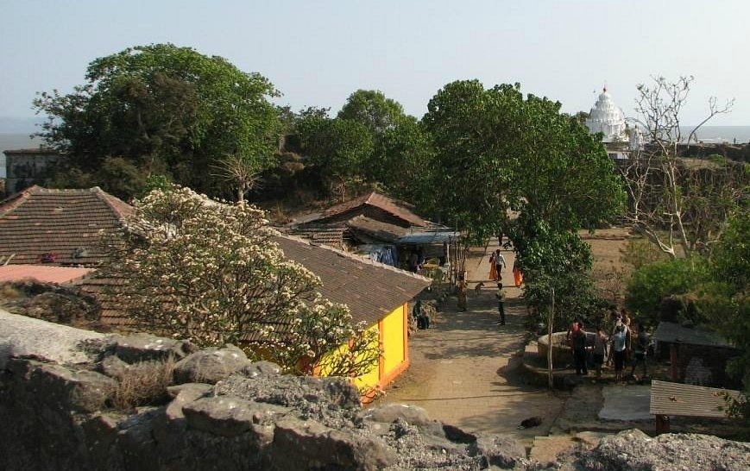
Inside Kolaba Fort

Other features are the pristine beaches, picturesque landscapes and diverse flora and fauna of the Western Ghats. Religious places in the district as well (such as Ashtavinayak Temples, Elephanta caves etc.), are extraordinary testimonies to its rich cultural past.
The Bene Israel Heritage in Raigad District

As they increased in numbers the early Bene Israels spread, in the centuries after they landed on Indian soil, to the east towards Pen and to Roha-Ashtami to the south-east, where the migrations towards the south, reached as far as the Savitri River. They also settled in some parts of the Hubshi’s territories, usually known as the Janjira State or Habsan.

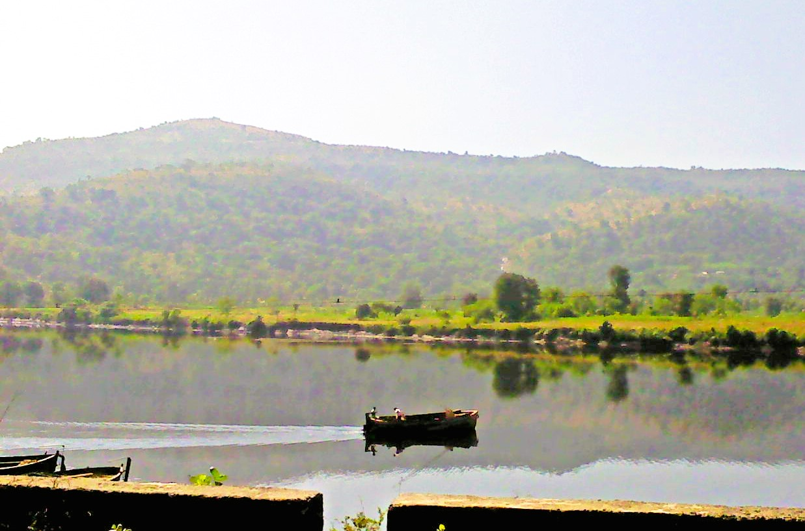
Savitri River, which originates at Savitri point near Mahabaleshwar

Ever since the early 19th century, Christian missionaries and Jews (non-Bene Israel as well as Bene Israel) have offered diverse suggestions to explain the community’s origins. The Christian missionaries in India persisted in their efforts of conversion of the Bene Israel, but without success. The stubborn Bene Israel stuck to their Fathers, Abraham, Isaac and Jacob and followed the Commandments given by their Prophet Moses openly and without fear through the periods of great upheavals from the ever-changing rulers of the land. They lived mainly in the Konkan Strip in Maharashtra, until the East India Company took over as rulers in the 1660s.
The history of the Bene Israel in the Konkan most likely goes back to the time after the death of King Solomon (d.928 BCE) when his realm was divided into the Kingdom of Israel and the Kingdom of Judea. The territory of the Kingdom of Israel covered most of the central and northern Land of Israel and was inhabited by descendants of ten of the original twelve tribes (the twelve Tribes excluding Judah and Benjamin), that conquered the land of Canaan under the leadership of Joshua.

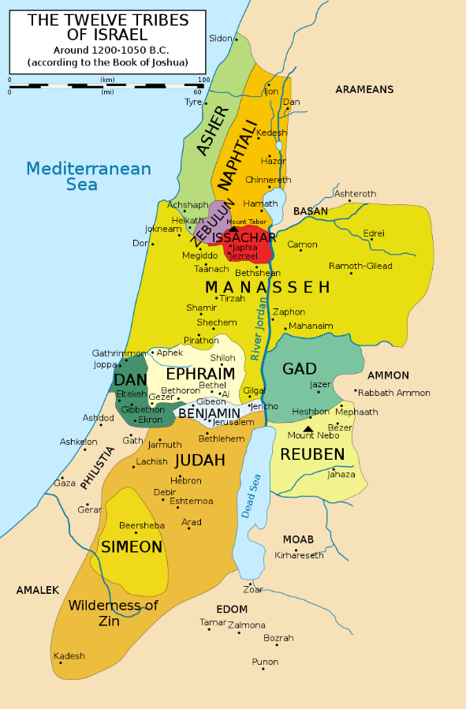
The Territory covering the Original Twelve Tribes of Israel
In 721 BCE, the time the Ten Tribes were exiled from the Land of Israel by Tiglath Pileser 111 (770-727 BCE), the Assyrian King (Reign- 745-727 BCE), and his sons, Shalmaneser V (Reign- 727-722) and Sargon II (Reign- 721-705.

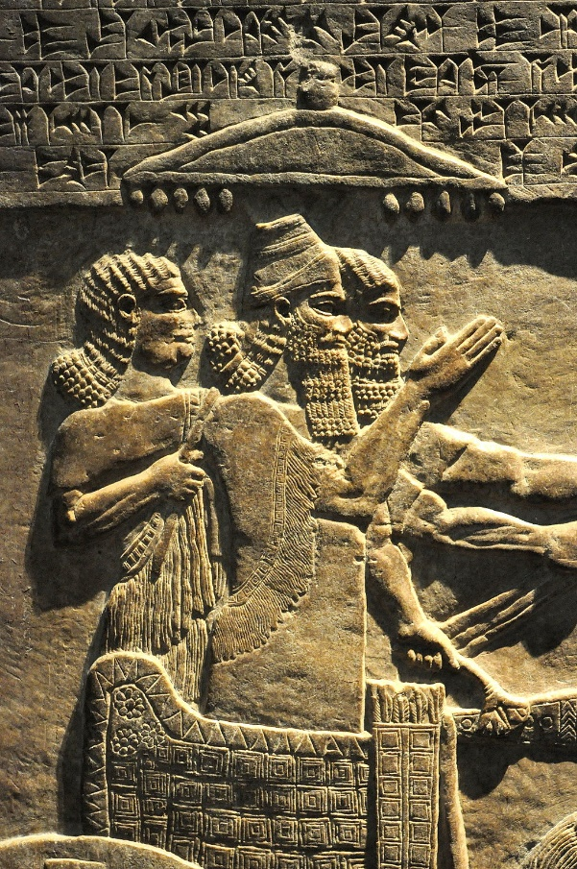
Tiglath-Pileser III, Depicted in a Royal Chariot,
in one of the Reliefs from the Royal Palace in Nimrud
Or perhaps they migrated to Konkan in 586 BCE, the time that indicated the exile of the Jews from Judea by the Babylonians and following the destruction of the First Temple in Jerusalem by king Nebuchadnezzar, also known as Nebuchadrezzar II (642-562. Reign- 605-562).

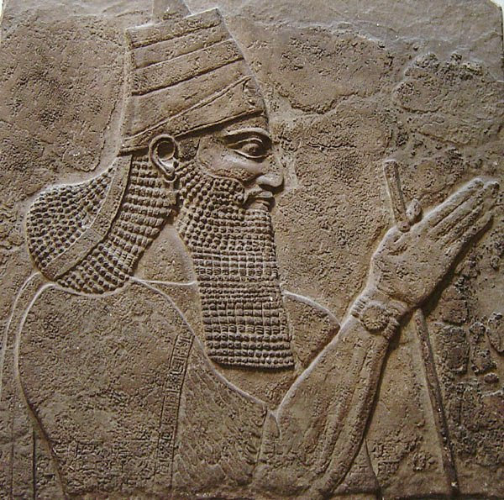
Nebuchadrezzar II
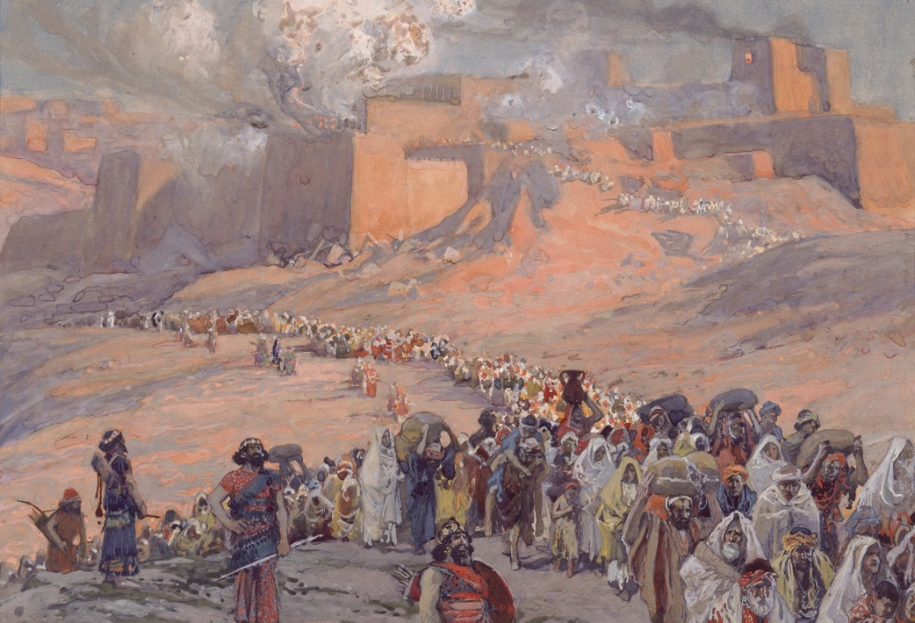
The exile of the Jews from Canaan to Babylon, James Tissot, 1806
Other suggested periods of the arrival of the Bene Israel on the Konkan Coast, is the year 167 BCE, which marks the beginning of the Hasmonean Revolt against the Seleucid Greeks in the Land of Israel, known also as the Revolt of the Maccabees and also as the Maccabean Revolt (167-160 BCE), and the narrative that Jewish rebel Judas Maccabeus vanquished the evil Greek emperor Antiochus and rededicated the Temple, at which the miracle of the oil occurred, followed by Hanukkah, the Jewish festival of lights..
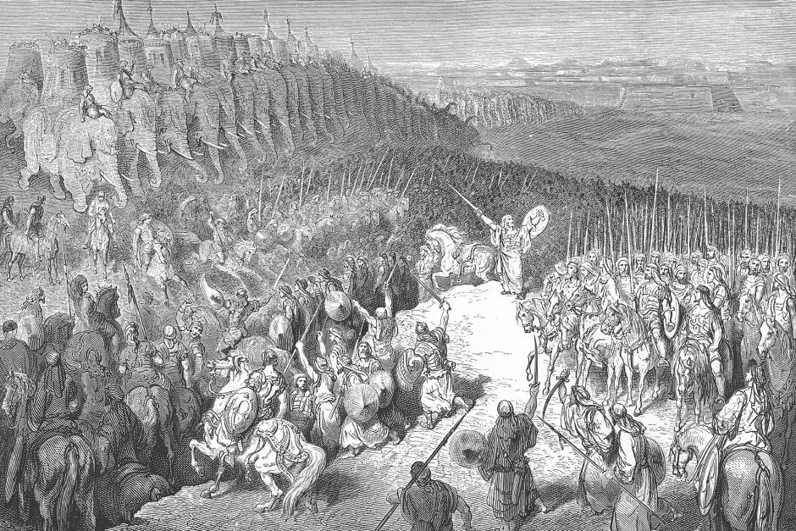 Judah Maccabee, Center. During the Maccabean Revolt, in front the Army of Nicanor. Image by Gustave Doré
Another opinion marks the year 70 CE, indicating the exile of the Jews from Judea by the Romans following the Jewish Revolt against the Romans and the destruction of the Second Temple in Jerusalem. Therefore, it seems that dating of the arrival of the Bene Israel on the Konkan shore, ranges anywhere from the 8th century BCE to the 2nd century CE.

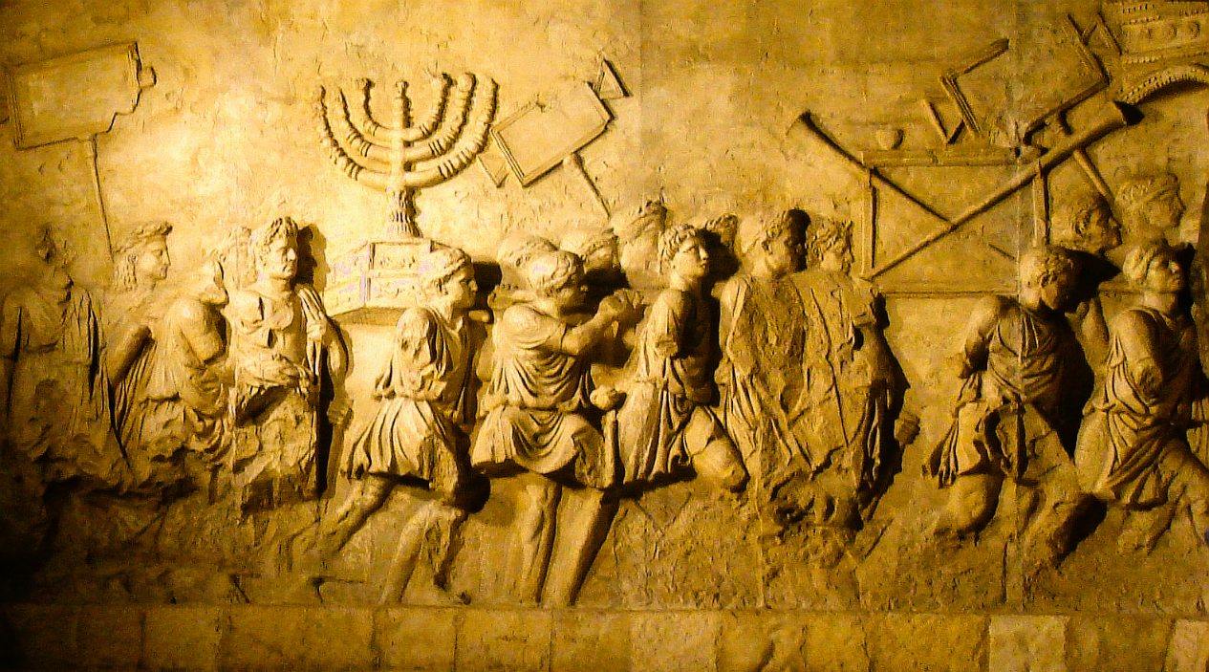
Depiction of the Roman triumph celebrating the destruction of Jerusalem on the Arch of Titus in Rome. The procession features the Menorah and other vessels taken from the Second Temple.

All of the above-mentioned periods are conjectures and hypotheses and/or traditions depending upon which of the many works one reads dealing with this matter. There is neither any historical base, nor any serious academic study dealing with this subject. Many are the questions concerning the time period of the arrival of the Bene Israel in India; what was their native country; who were their ancestors; do they belong to one of the Ten Lost Tribes of Israel; to which one of the Tribes did they belong to; what were the circumstances that led to their emigration from their homeland to the Indian sub-continent?
It is said that the arrival of the Bene Israels on Indian shore was due to their ship wreck on the Konkan coast. The survivors swam and found shelter at Navgaon (or Navgav/Navgaw, Naugav/Naugaw, Nagaon, Naugoan, Navgoan, Novgoan, about two miles south of Kihim village). Fourteen people survived, of whom seven were women and seven were men. The deceased were buried on the coast. As their numbers grew, they began migrating to other parts of Konkan and later, during the second half of the 18th century, to Bombay and other parts of the country.

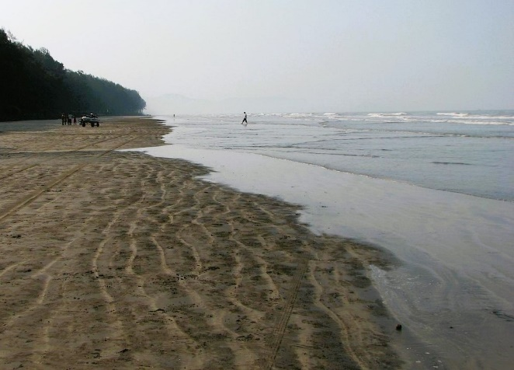
In all, there are approximately a few hundred of surnames based upon the names of villages in which the Bene Israel had settled in Konkan. In the course of time, they adopted the local dialect and surnames akin to other Maharashtrians. For their livelihood, they became farmers and farm workers.
Navgaon-Nagaon Beach, Raigad, Konkan

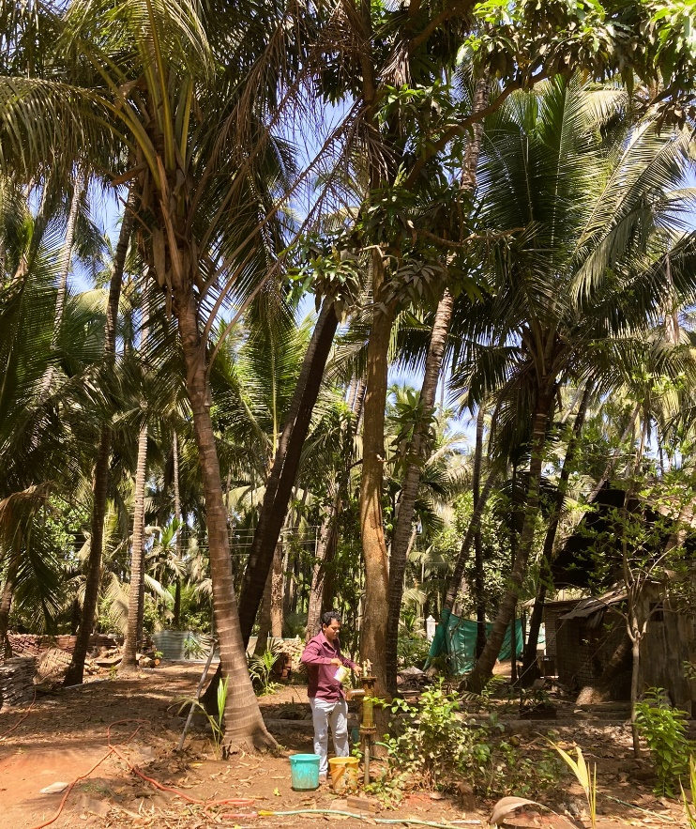
Their main occupation was agriculture, oil pressing and also carpentry, which were the traditional skills they had been accustomed to in their native land.

In Konkan area, they were referred to as Shaniwar Teli (Saturday Oilpressers). They were so called because they worked at their Coconut farms and their Oil Presses throughout the six days of the week, but abstained from working on Saturdays.

Therwanda Village, Wadi (Coconut Plantation)
Shoshanna and Benjamin Waskar, Owners and Oil Press operators, May, 2022

According to E.M. Jacob Gadkar, the Bene Israel in Konkan went through a series of renaissances when, throughout history, they were recognised as being Jews, on the basis of their following certain Jewish rituals and traditions: they observed the Sabbath, as well as Rosh Hashana (the Jewish New Year), Yom Kippur (the Day of Atonement) and Passover; their male born was circumcised on the eight day of his birth; they knew to recite the Shema prayer before going to bed at night and upon rising at dawn, as well as on all religious occasions; they scrupulously observed the dietary laws and some other customs regarding the Jewish faith. In the course of history, the Bene Israel were 'discovered' by Jews (mainly from Cochin) and Christian missionaries, who assisted them in resuming their religious rituals and customs, in order to strengthen their Jewish identity in the Jewish faith. It was David Ezekiel Rahabi, (1694-1771), a Jew from Cochin, who met the Bene Israel and identified them as belonging to one of the Ten Lost Tribes.

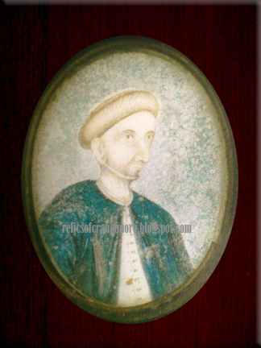
It is said that the camming of Rahabi to Konkan effected the religious revival amongst the Bene Israel. Rahabi, was the chief Jewish merchant of the Dutch East India Company in Cochin for almost 50 years, taught them to recite their prayers in Hebrew, their ancestral language, and trained them in other religious rituals which they had ceased observing generations before.

David Baruch Rahabi,

In the early 1820’s, another distinguished Jew from Cochin with a similar name, together with a few other eminent personages, also from Cochin, were involved with much about the same experience among the Bene Israel community, as did their predecessor, roughly eight hundred years earlier. The Christian missionaries, on their behalf, filled in the missing spheres with their unique contribution.
The Books of Genesis (1819) and Exodus (1833) were translated by American missionaries into Marathi.
The spoken language of the Bene Israel was Marathi and so Medium Schools were open to their children where they studied in the Marathi language. They began to learn, read and write in Marathi, in English and in Hebrew.
Jews, as well as Christians, were involved in this awakening of the Bene Israel from their long-lasting illiteracy into a modern new world. At the beginning of the nineteenth century, the Bene Israel community was a Konkan Jati with limited knowledge of Judaism. However, by the end of the century, the community had become an Indian-Jewish community roughly analogous to other Jewish communities. This transformation occurred, detailing the content, motivation, and means by which British and American missionaries and, to a lesser extent, Cochin Jews instructed the Bene Israel in Jewish knowledge.
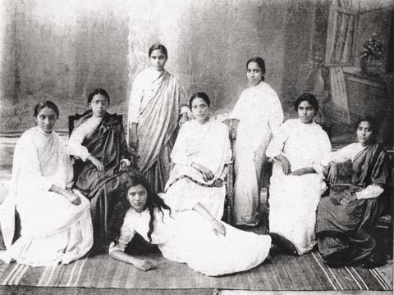
Bene-Israel- Hebrew class at the boarding school, Huzurpaga High School
for Indian Girls, Narayan Peth, Laxmi Road. Their teacher, Rebecca Reuben,
seated in the middle (circa 1913)

Their attitude towards the Christian missionaries who laboured amongst them, demonstrates that the Bene Israel were active participants and selective consumers in their interaction with the missionaries, taking what they wanted most from the encounter: knowledge of the Old Testament and the Hebrew language. Christian missioners in India opened schools and health clinics for rural and urban people. They are credited with setting up the first printing presses and first modern colleges in South Asia, boosting literacy and education for females.
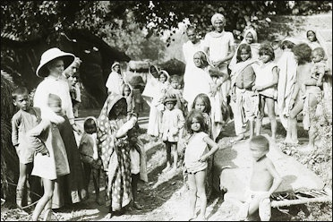
Christian Missionary activities, Sunday School

Ultimately, the instruction that Bene Israel received from Protestant missionaries, did not convert them to Christianity but strengthened and transformed their Judaism.

The use of the name Bene Israel deserves special attention. The Israelites of the Bombay Presidency, being unable to show their lineage from the tribe of Judah, consequently adopted the name Bene Israel (the Sons of Israel): Traditionally, they believed that they were decedents of one of the Ten Tribes that formed the Kingdom of Israel which was located in the northern part of Eretz Israel (the Land of Israel while the southern part of the Land was occupied by the Kingdom of Judah called Judea). Also, they were led to believe, from traditional accounts and from corroborating facts, that this name was embraced by them and by their ancestors during the time when the Mohamedans/Muslims ruled India.

The Mohamedans had respect for the Bene Israel, who are mentioned in the Koran, but were antagonistic towards the Judahs or Yehudim (Jews). Essentially, during the Second Mysore War (1780-1784), when a number of Bene Israel, while serving in the East India Company's army were taken captive by the soldiers of Tipu Sultan (1750-1799, ruler of the Kingdom of Mysore in south India,) would have lost their lives had they identified themselves as Judahs.

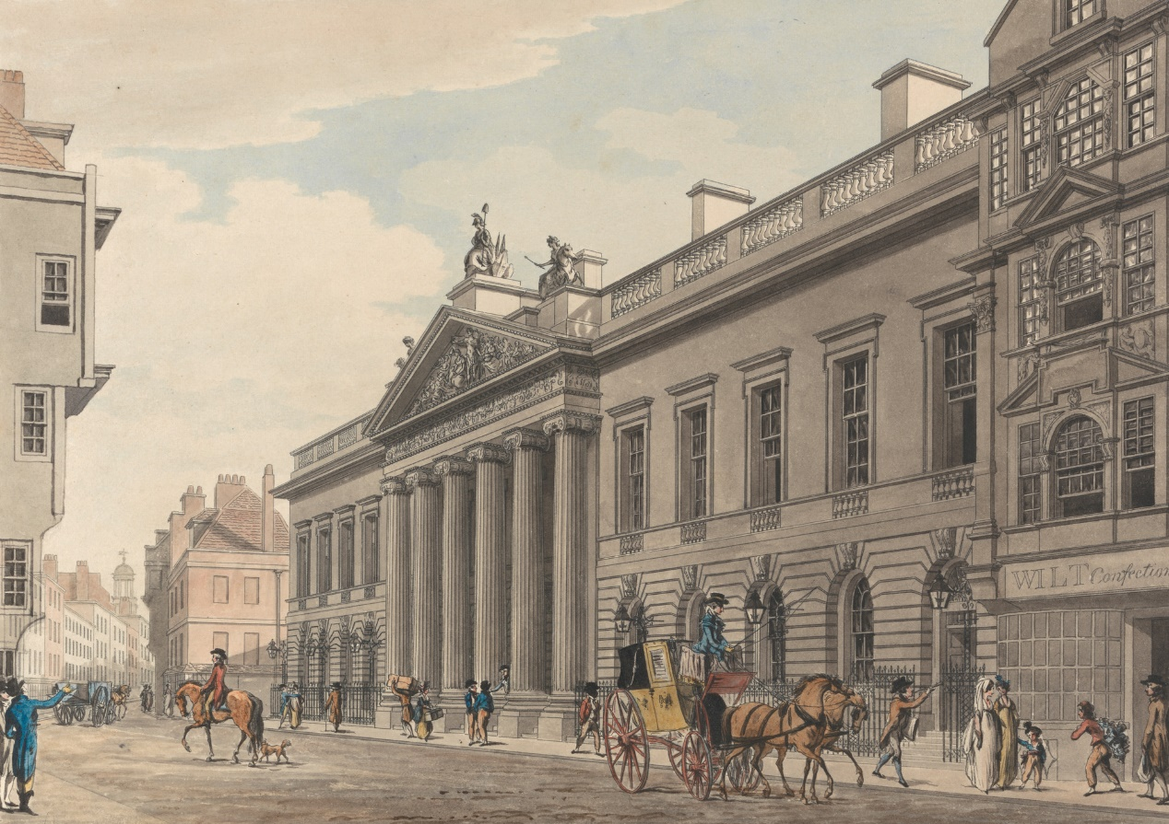
East India House by Thomas Malton the Younger

Eventually, their lives were saved at the request of Tipu's mother, on the grounds that the Bene Israel had been mentioned in the Koran and whom she had never seen before in India. One of these survivors was to build the first Synagogue in Bombay (1796), and in the Indian sub-continent as well.
As a matter fact, and according to relevant sources, the Bene Israel made good soldiers in the East India Company’s army and were found in considerable numbers in the ranks of the native army.

Strange as it may sound, for a long period after the Island of Bombay was under British rule, the Bene Israel refrained from dwelling within its massive walls.

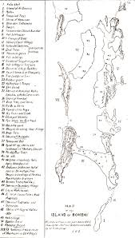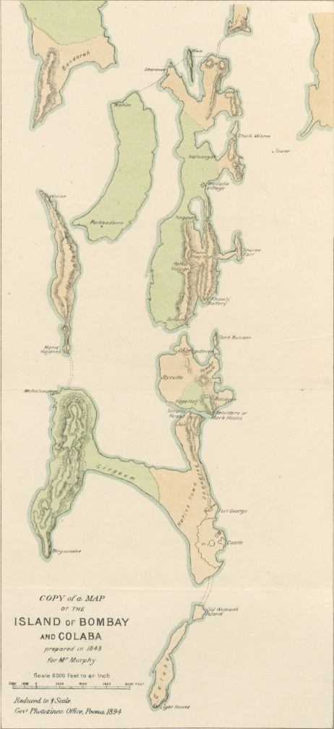
Island of Bombay, 1843 Island of Bombay, 1843

This can be explained due to reasons such as: the unstable security of Bombay Island in its various historical stages and the fear from hostile attacks by foreign armies; its poor location, as was perceived by the population, considering that epidemics were not uncommon. It was only towards the second half of the eighteenth century, that the Bene Israel began arriving on the Island. The Awaskar and the Divekar families are noted to be among the first of the Bene Israel to arrive in Bombay. They resided near the Bazaar Gate, located at the northern side of the historical Bombay Fort. Gradually, they left the Fort walls and settled down in Mandvi and Khadak, known at the time as Israel Mohala which means, Dwelling Place of the Jews, situated on the west side of Samuel Street.

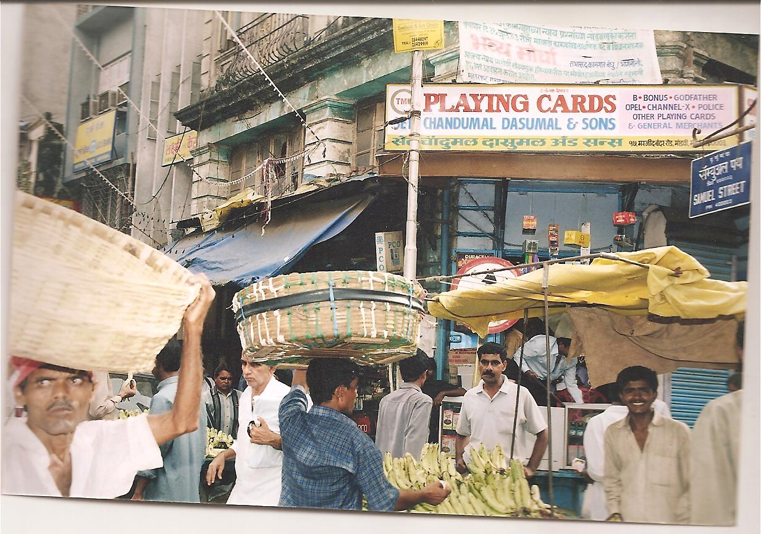
Samuel Street- 2003
Beginning in the mid-twentieth century, as a result of political and social changes in India, the Bene Israel Jews began to emigrate. At that point, the Bene Israel population dropped from an estimated twenty thousand to a few thousand, and the number of Jews currently living in the Raigad District is quite small. Of the Synagogue buildings and Prayer Houses built in the towns and villages in this region between the mid-nineteenth to early twentieth century, a few survives today. Of those, some remain active houses of prayers, others endure marginally, and the rest have been converted to other functions. These vernacular structures, appropriately scaled and decorated for their function, served their congregations well for many years. They are a testament to the region’s diversity and to India’s tradition of tolerance.
In conclusion, the Jews in India have distinguished themselves in various progressive capacities, as for example, in the Defense Forces, the Railways, Post and Telegraph, Customs, as Educationist, Doctors and Nurses as well as in the Film Industry and as Office Workers, where their quiet devotion to duty made them much-wanted members of the organizations where they were employed.

Culturally, Raigad has been an ever-vibrant community with a population of different religions, dialects, ethnicity etc. Few places in the Raigad District are historic hinterland of the Bene-Israel Jews. The Bombay Gazetteer, relating to the Bene Israel in 1883 mentions: “Beni Isra’els are returned as numbering 2,139 and as found over the whole district…The men are fairer than the middle-class Hindus of Kolaba and are generally above middle height and strongly made…The women are generally good-looking and fair. Like Hindu women they wear the hair tied behind the head in a knot, ‘ambada. Though somewhat quarrelsome and revengeful, the Beni-Israels are one of the best-behaved classes in the district, hardworking, fairly sober, and well-to-do…Like middle Hindus their houses are generally of one storey with brick or wattle and daup walls, and thatch or tile roofs…Beni Israels worship one God and use no images. In their synagogues they have manuscript copies of the Old Testement and consider it to be of divine authority. They preach their religion only to people of their own tribe. They have synagogues in the Kolaba district at Alibag, ambepur, Barlai, Pen and Revdanda…’”

Raigad District is bordered on the north by Thane District, Pune District to the east, Satara District to the south-east, Ratnagiri District to the south, and the Arabian Sea to the west. It includes the natural harbor of Pen-Mandwa, which is immediately south of Mumbai harbour. The northern part of the District is included in the planned metropolis of Navi Mumbai. It also includes the Isle of Gharapuri Elphanta.

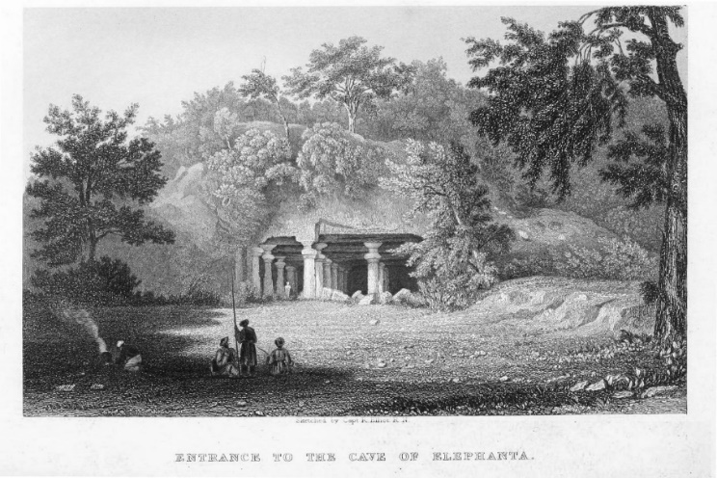
Elephanta Caves- Sketched by Capt. R. Elliot. R.N. 1858

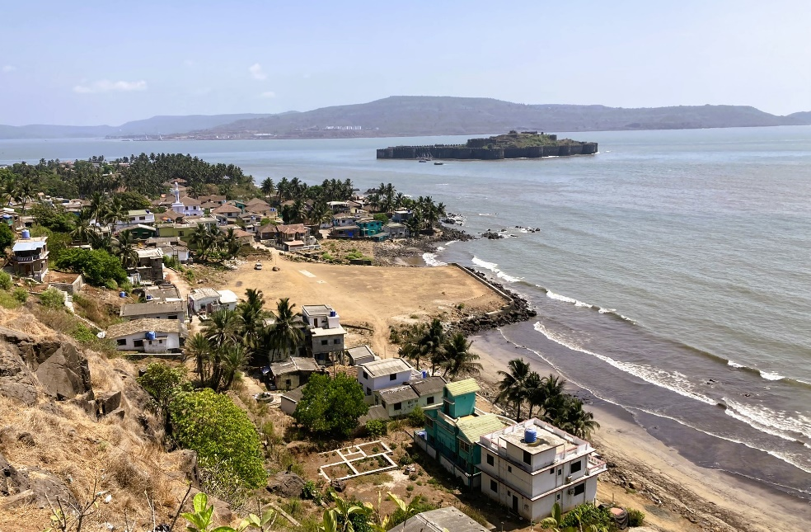
Raigad District includes the towns/cities of Panvel, Alibag/Alibaug, Pen, Mangaon, Roha, Khopoli, Kharghar, Taloja, Khalapur, Uran, Patalganga, Rasayani, Nagothana, Poladpur, Karjat and Mahad.
Mahad and Mahad Fortress, 2022

The largest city, both, in area and population is Panvel. The District also includes the Isle of Gharapuri, more famously known as Elephanta, located in Uran which possesses a few ancient Hindu and Buddhist caves.
Pen was from historic times, known as the centre of education and culture in the District and in the Konkan Region as well. During the 19th century, due to Christian Missionary activities, English schools were opened in the District.

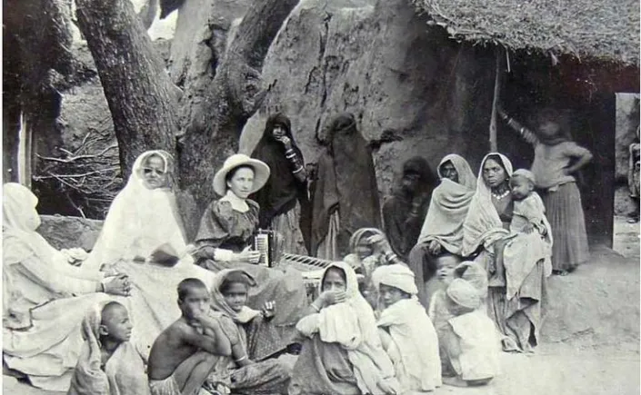
Christian female missionaries played a prominent role in the spread and
development of female education in Colonial India
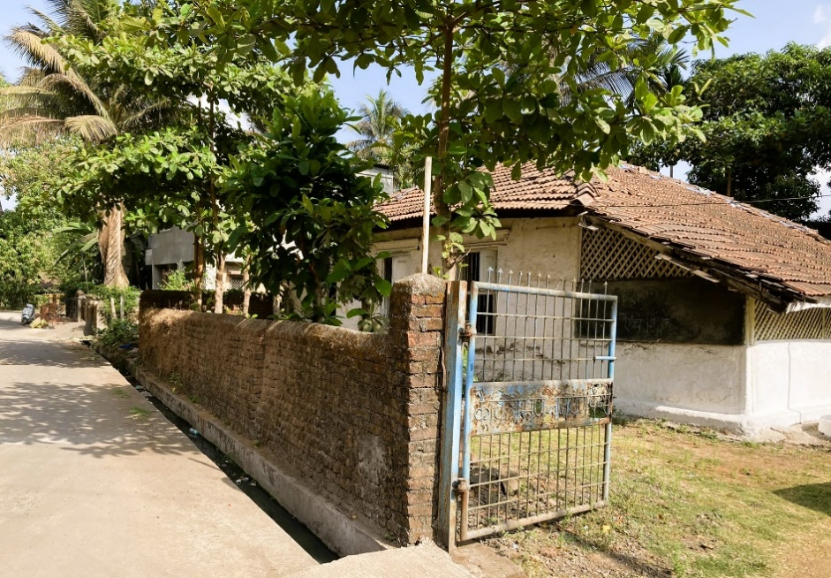
Synagogue in Konkan, Beth El Synagogue in the Village of Ashtami, 2022

According to earlier texts, at one time the Bene Israel Synagogues and Prayer Halls all over the Konkan, were approximately 250. However, today they are practically inexistent especially in smaller towns and villages: As mentioned by Pune-based Dr Irene Judah:
“This is because of the mass migration to Israel and elsewhere, which was much more from Konkan initially, followed by exodus from bigger cities in the late 1960s to the first half of 1970s.” Says, who has written the book Evolution of the Bene Israels and their Synagogues in the Konkan.
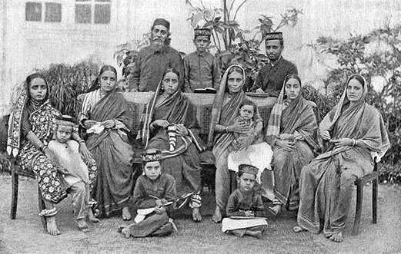
Bene Israel Family, Bombay, formerly known as Shanvar Telis 'Saturday Oil Pressers'. End of the 19th century, or beginning of the 20th century

Regarding the state of the remaining Synagogues and Prayer Halls – only a few are functional. Citing the reasons behind the dilapidated Synagogues in Konkan, Judah says that the rural Bene Israel congregations are too small to maintain their local Synagogues, even though there is still sufficient income coming in from the
Synagogue land holdings which are rented out to tenant farmers. The few functional Synagogues include Magen Aboth Synagogue in Alibaug taluka; Beth El Synagogue in Revdanda (Alibaug taluka); Sha’are Shalom Synagogue in Borlai; Beth Ha Elohim Synagogue in Pen; and Hesed El Synagogue in Poynad. “But not all the functional structures witness regular prayers being said,” said Judah.
The majority of the Bene Israel population in the Raigad District was located in towns and villages nearby two main routes, heading from north to south:

The Coastal Route, following from north to south, approximately alongside the Arabian Sea Coast, including: Navgaon, Alibag, Revdanda, Borlai, Ambepur, Nandgaon, Shrivardhan.
The Inland Route, eastward from the Coastal Road Route is the Inland Route, including: Panvel, Pen, Poynad, Pali, Ashtami, Roha, Tala, Mhasla.

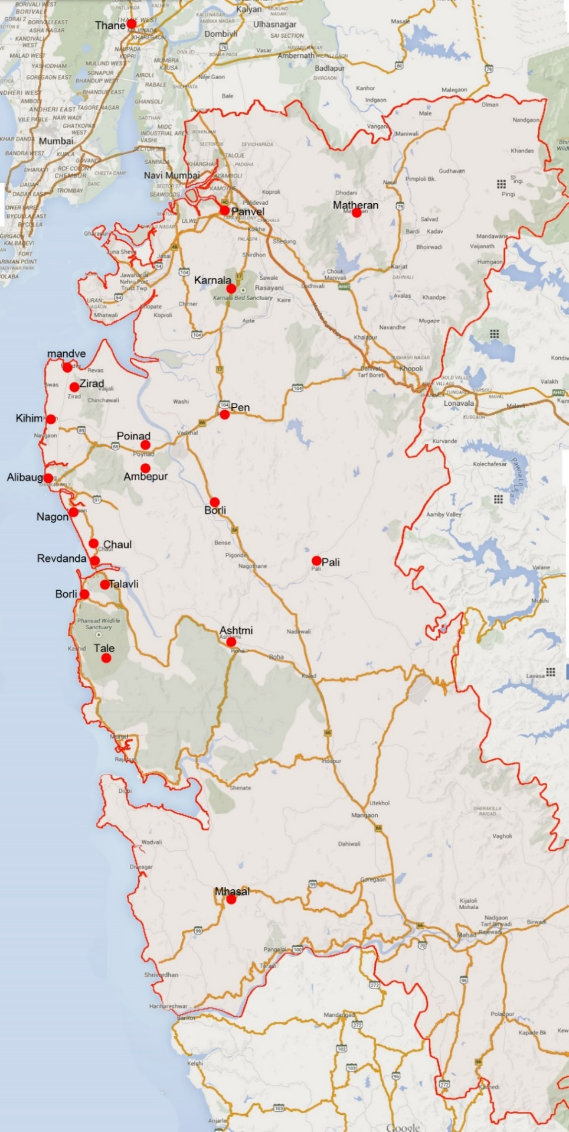
Raigad roadmap

The Coastal Route

Mandve/Mandva/Mandwa

Mandve is a village in Alibag Taluka, about 20 kms north of Alibag, 9 kms to Nagaon and 16 kms south-east of Mumbai by sea (about 120 kms by road). Right across from Mumbai, Mandve has a dock of some importance in connecting Mumbai to Konkan towns and villages. The first glimpse of the coastal settlement is a sight of beautiful groves of coconut palms and old houses with clean and narrow roads winding through the length and breadth of the village, located at the head of a short broad bay with a shallow sandy beach.
There is a regular ferry service between the Gateway of India and Mandve Jetty and on a clear sunny day the Gateway of India is visible from Mandwa Jetty.
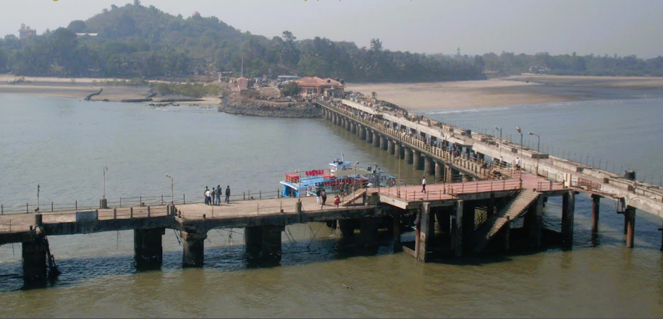
Mandve Jetty,

Here travellers would have to arrange for private transportation to this and other regional synagogues, which will be challenging since finding someone near the ferry jetty who knows where they are all located is difficult.

The alternative is to begin in Mumbai and travel by road with a car and knowledgeable driver. This is the longer option but will insure that all the synagogues can be reached.

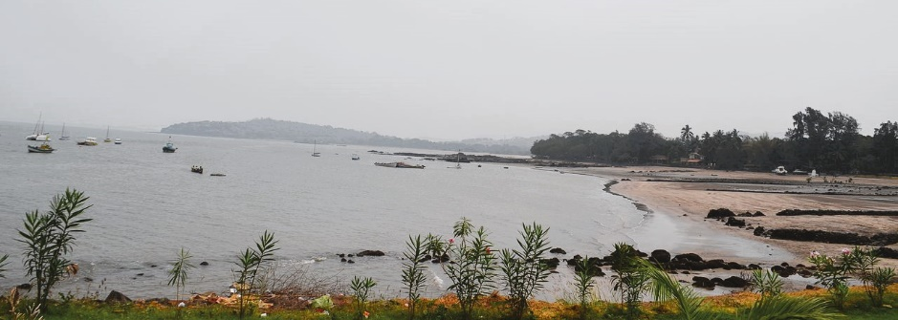
Mandve Beach, 2015

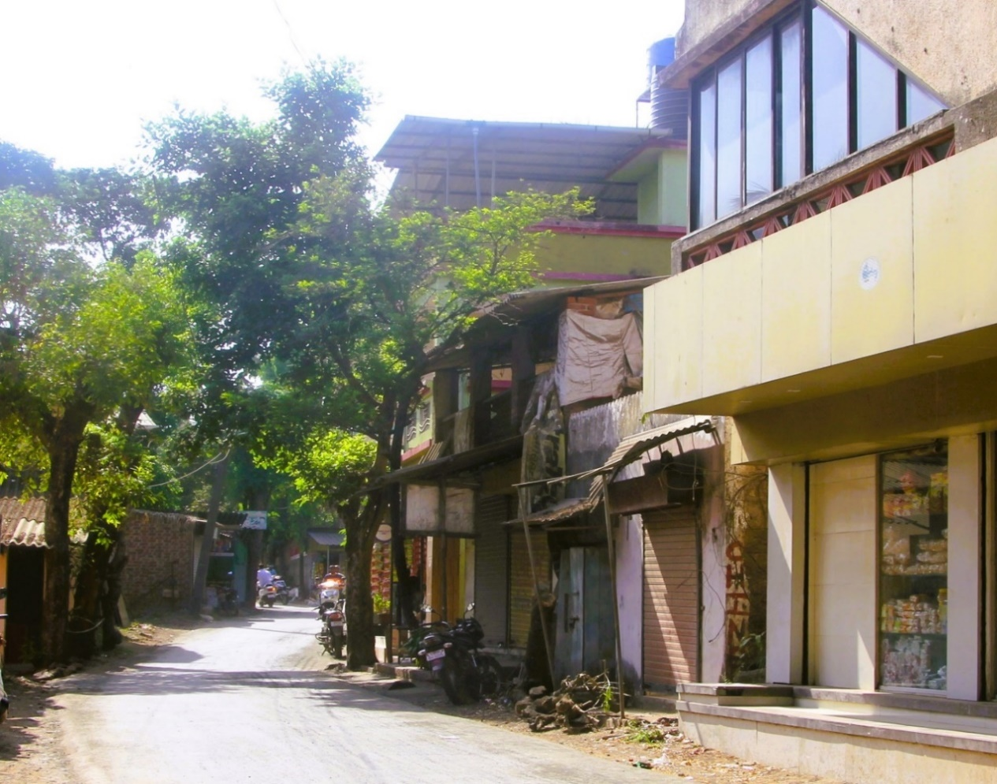
A Street in Mandve Village
Navgaon

Navgaon is situated about 7 kms south-east from Alibag, on the Alibag-Revdanda route, in Raigad District. It occupies the middle of the thickly inhabited strip of palm plantations and orchards, which stretches eight miles between the Alibag and the Revdanda creeks, the former of which runs on the north-east side of the village. Documented in 1883, it is mentioned: “The houses of the village are generally some distance apart in palm plantations. Here and there by the roadside is a temple with a masonry pond, some large trees surrounded by masonry plinths, one or two grain and miscellaneous shops, and some large well kept Brahman and goldsmiths’ houses. At these places the villagers meet on market days and holidays.”

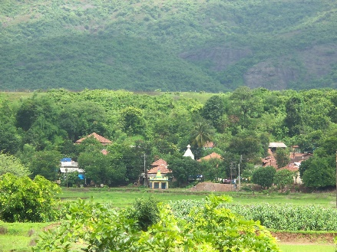
Navgaon, Gabriel Project, Mumbai -GPM, 2012

The enormity of the history of Bene Israel can be seen in a rather subtle way in the Jewish cemetery in Navgaon which is considered to be the oldest Bene Israel cemetery In India. This small coastal village can be looked upon as the original historical location to the Bene Israel in Konkan and as a landmark of Indian Jewish historiography as well. This is where the long period old story of Indian Jewry comes alive. The Jewish community has been using this cemetery for centuries. The recent graves have tombstones, while the ones that look ancient just have stones around them and the more ancient ones are left unmarked in an open field.
There has simply been too much history to maintain all of it. Tradition says that the bodies of the people from the ship wreck were buried on this site which is a large piece of guarded land with the noise of waters breaking on the shore in the background.
Bene Israel Monument
Site of the First Landing on the Konkan Shore, Navgaon

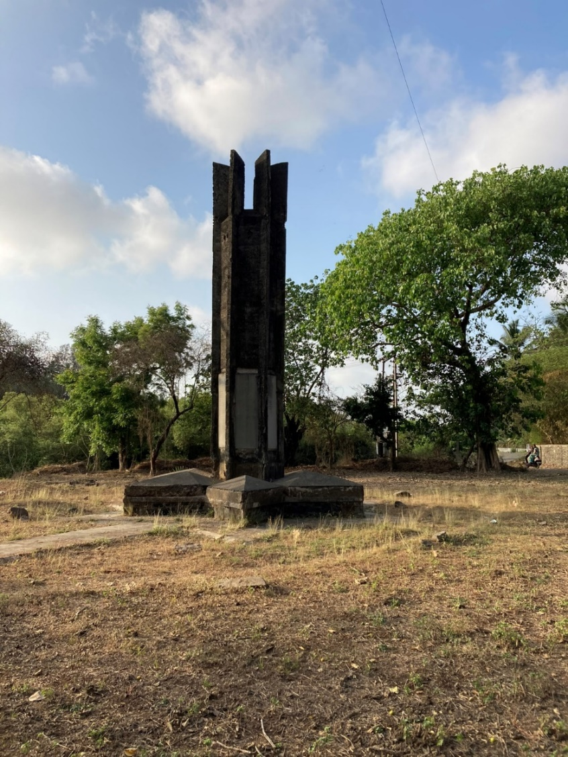
According to tradition, it is said that this is the site where the Jews first landed on the Konkan coast. It is a small village and a memorial structure has been erected here. The burial place of those Jews who perished at this location is also found here.

The monument was designed by Bene Israel architect Joshua Moses Benjamin Bhonkar, commemorating the landing point and the burial place on this part of the coast.

Navgaon- Bene Israel Monument, 2022
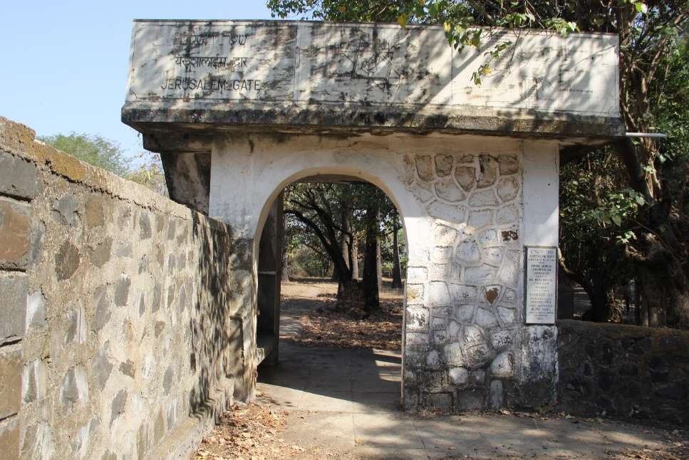
Navgaon- Jewish Cemetery, Jerusalem Gate, built in 1997. Photo, 2022.

Regarding the reaction of the monument, the first meeting of the committee, which was formed under the sponsorship of the Tiphereth Israel Synagogue in Mumbai, was held on the 9th of August 1973. The meeting was well attended by representatives from all Bene Israel Synagogues and Prayer Halls in Mumbai and in Konkan, as well as from outside of India who supported the project and sent donations.

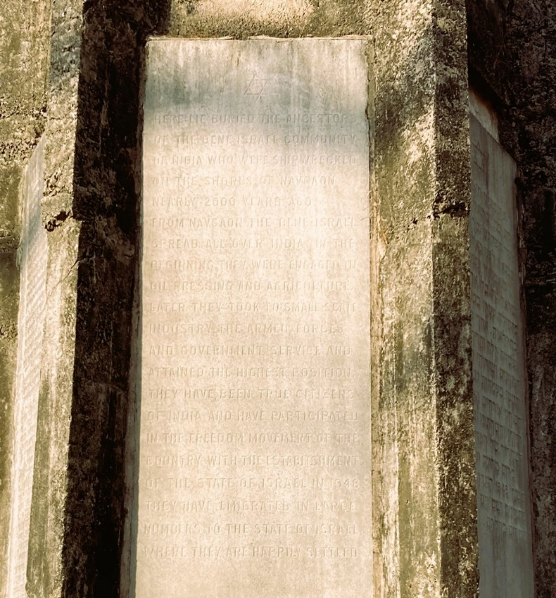
The monument was built during the years 1973-1985. Architect Benjamin’s design for the monument is based upon the traditional Jewish symbol, the Magen David (Shield of David, the six-pointed star), which was the base of the six-sided pillar. At the bottom of the approximately 5.2-metre-high pillar, inscriptions were affixed in Hebrew, English and Marathi commemorating the landing of the Bene Israel at the shores of Navgaon village.

Part of one of the Pillar Panels mentioning the landing of the Bene Israel at Navgaon

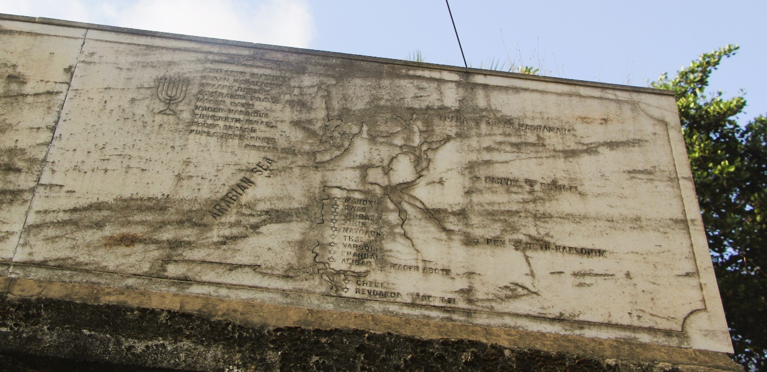 Top right of the Jerusalem Gate, indicating names of the Bene Israel Synagogues

The location of the historical site is mentioned 1n 1883 by the British scholar James Campbell, in his words: “At Navgaon village, two miles south of Kihim, are two large graves the one to the north said to be of male and to the south of female Beni-Israels who are said to have been shipwrecked when they first arrived on the Alibag coast. About 150 paces from the two mounds are about 500 separate graves said belong to the Black and White Beni-Israels of the neighbourhood.”

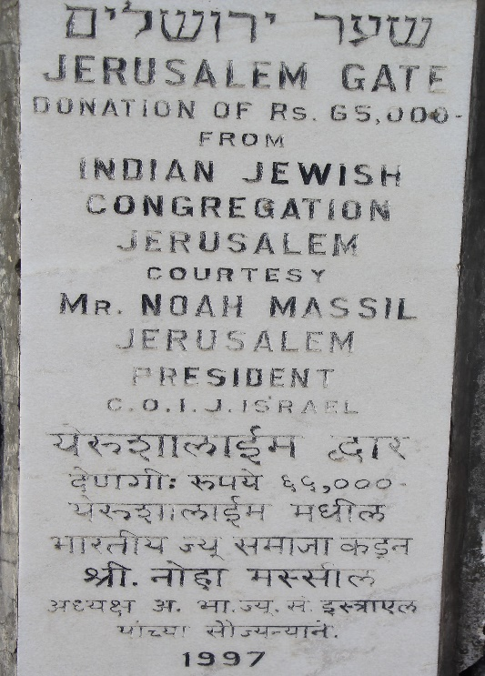
According to the local legend, a boat left the land of Israel either at the time of the destruction of the First Temple or during the Hasmonaean period, headed for the Indian coast, perhaps for trade or to flee the turmoil in Jerusalem.

At the Konkan coast, just outside Navgaon, This ship is said to have crashed on the Konkan coast, just outside Navgaon, leaving seven women and seven men to survive and who made their home in Navgaon. The Bene Israel are believed to be the descendants of these seven couples. In this case, the number seven is not to be taken literally; as is the nature of traditions, a small number stands for a few.

Navgaon, Dedication Plaque, Jerusalem Gate, 1997

These Jews, strangers to India, brought with them Jewish traditions and religious practices and kept a diligent oral tradition over the generations. They were steadfast about circumcision, Shabbat, saying the Shema and eating only kosher fish (ones with fins and scales). Interestingly, they worked primarily in oil-making and they were known as “Shenwar Teli” the “Saturday oil-pressers”, because of being their day of rest. The Bene Israel have also developed fascinatingly and meaningful Jewish customs of their own, for example, the Malida, a thanksgiving ceremony held in the Synagogue or at home, where guests partake in plates full of cooked dishes, fruits, sweetmeats and flowers. In this ceremony they sing songs praising the Lord. In the main song they also praise Prophet Elijah as the precursor of the Messiah.

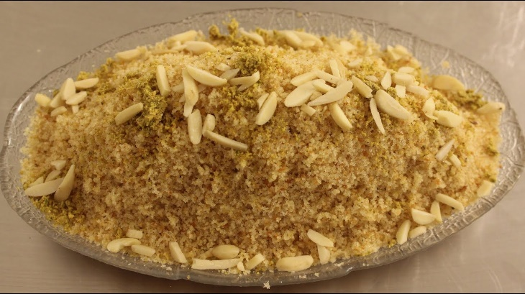
Malida Plate, one kind from many varieties

The Bene Israel community has been performing the 'Malida' ceremony on most of their festive occasions, and especially on the Jewish festival of Tu B’Shvat. Tu B’Shvat is an ancient Jewish festival, also known as the New Year of the Trees. It marks the beginning of spring in Israel. On this day, the Jewish community in India performs a special ritual – Malida. The Malida ceremony consists of special prayers and a dish of sweetened poha, coconuts, dates and fruits.
Those who partake in a Tu B'Shavt Seder will eat at least 15 different types of fruits and vegetables. It is also customary to include the seven species mentioned in the Torah (the Bible): wheat, barley, grapes, figs, pomegranates, olives, and dates.
Tu B’shvat has developed into an ecological holiday that reminds Jews of our connection to the earth and to our role as caretakers of the environment. Some modern practices include donating money to plant trees in Israel or planting trees locally.
libag/Alibaug

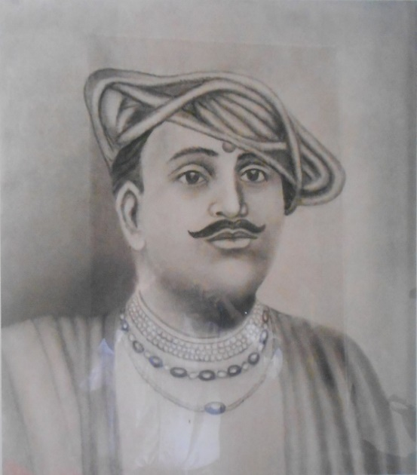
Alibag is an old coastal town relating to the Marathas which was developed at the turn of the 18th century by Sarkhel Angre/Kanhoji Angre (or Conajee Angria/Kanoji Angrai, 1669-1729), the Admiral of a fleet, whom is often said to be the Father of the Indian Navy, the naval chief of Shivaji's Kingdom. Alibag, also called Shribag, flourished under the regime of the Angria and thus, also known as Angria's Kolaba.
It said that during the reign of Angre, that in the Durbar, he changed the name “Shanivar Teli” to “Bene Israel”. He used to attend a number of Bene Israel functions. Admiral Sarkhel Angre/Kanhoji Angre

Alibag was the first town in Konkan where the Bene Israel erected a Synagogue. The name Alibag, also Alibaug (Ali's Gardens), is derived from a rich Bene Israeli (or also called Musselman) who lived there in the latter part of the 17th century and owned gardens of mango, Coconut and Supari palm groves in that vicinity, so local people called the place Alichi Bag.
Alibag is the north-west sub-division of the Distrect, bounded on the north and west by the sea, on the south, by the Habsan or Janjira, the Kundalika River and Roha.
On the east by the Amba River and Nagothna. Alibag’s landscape is broken by an irregular range of hills which runs roughly north and south five or six miles inland.
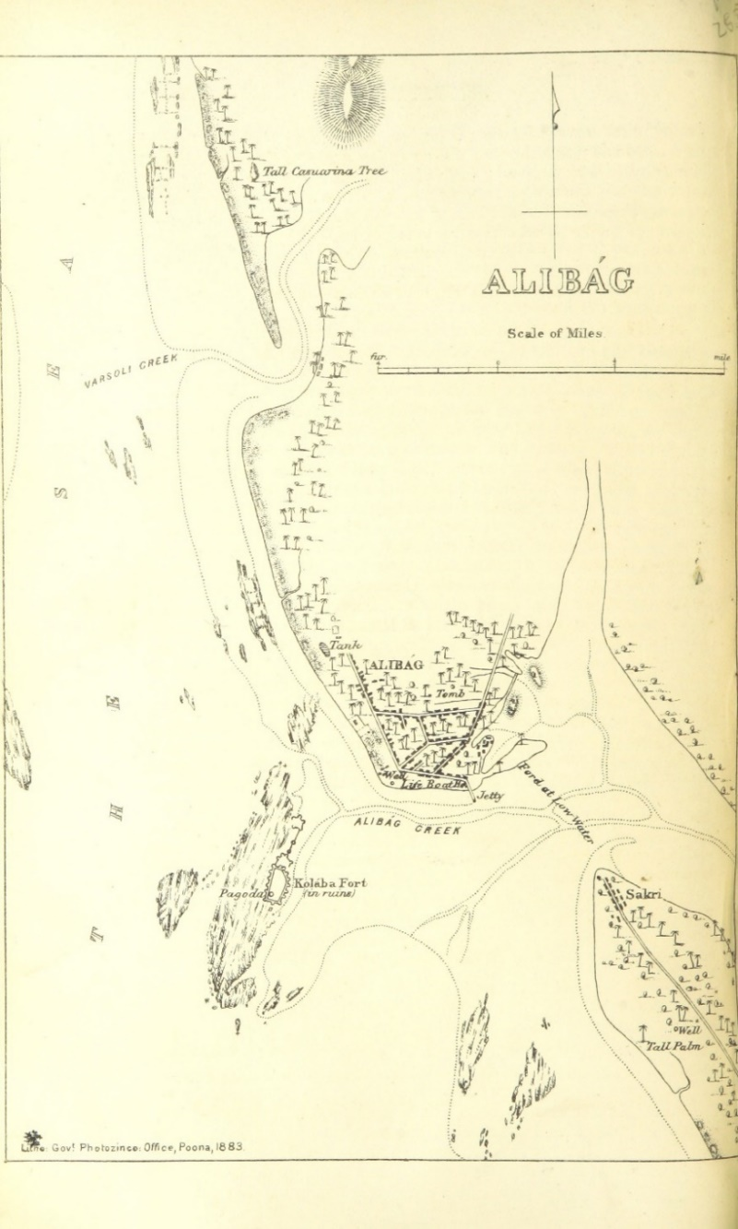
Alibag, in 1883

The west coast is fringed by palm gardens and orchards, and along most of the east, low bare rice fields border the Amber River. In the west, behind the palms, is a stretch of rice land and on both, west and east, beyond the rich land, the ground breaks in knolls and mounds which rise to the outlying spurs of the central range of hills.

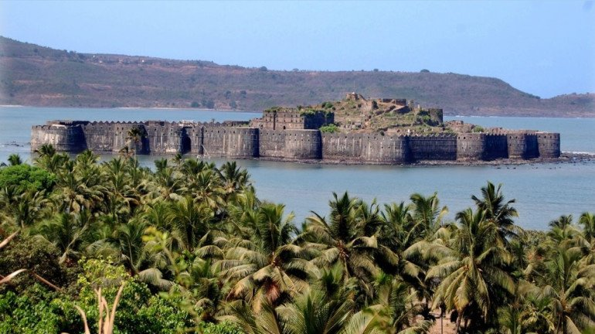
Alibag, Kolaba Fort, 2022
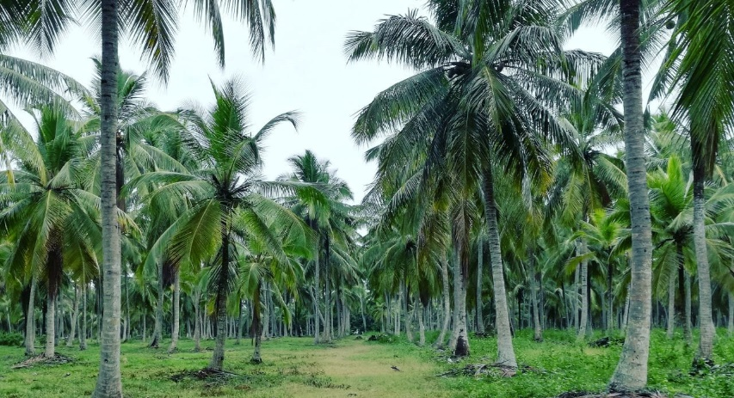
A Coconut Farm
The area of Alibag is covered with coconut, mango, cypresareca trees, and lush greenery.
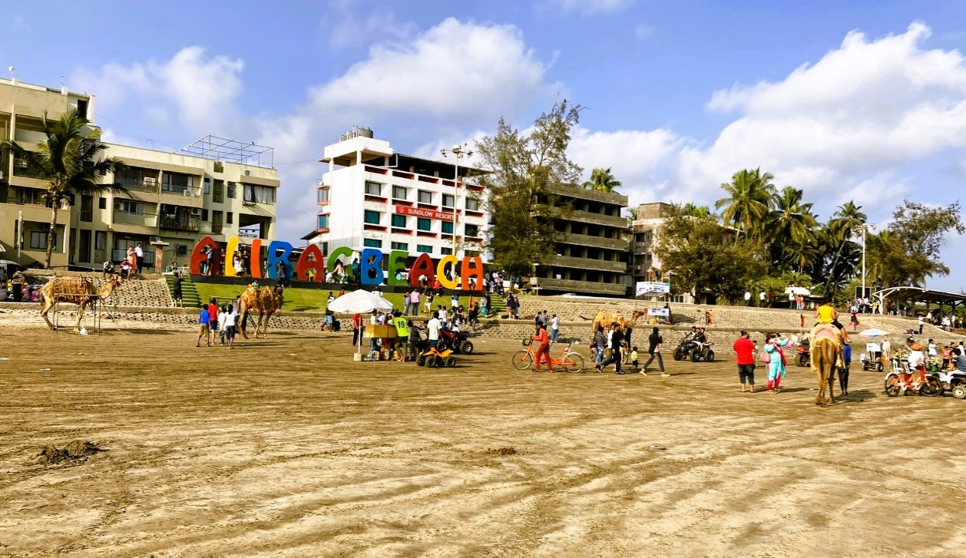
Alibag Beach, 2022

Alibag is also well-known for its charming sandy beach which is reasonably clean and unspoiled and free from noise and air pollution.

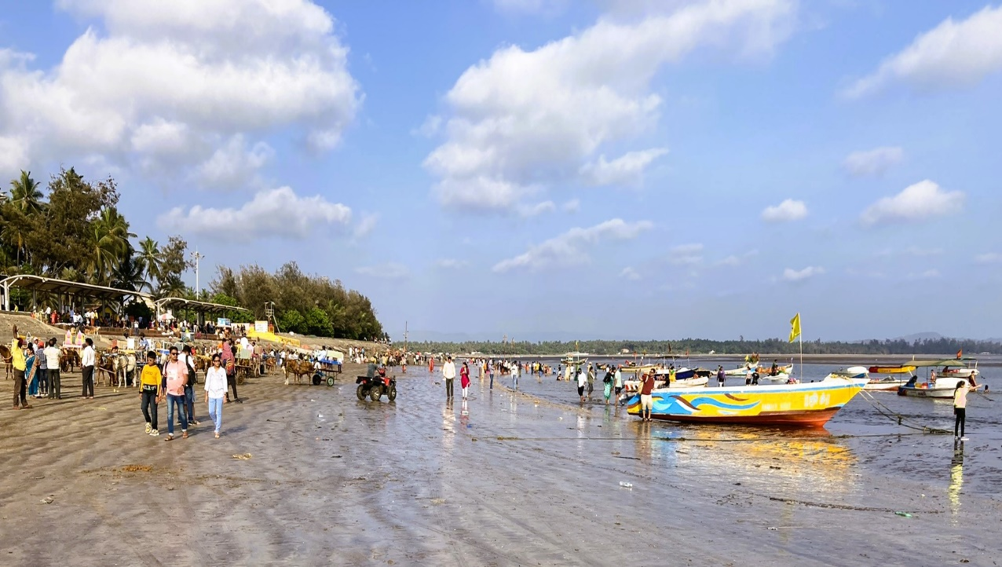
Alibag Beach, 2022

In addition, there is the sight of the ruins of the famous Kolaba Fort, just off the beach. The Fort can be only accessed during low tide through a narrow strip of land which goes underwater during high tide.
The hill range of the Western Ghats,line the other side of the city, giving it a unique character of greenery, which is a neat contrast to the blue shade of the sea.

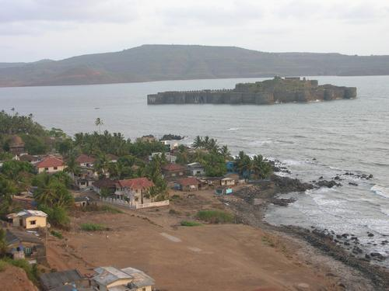
Alibag facing Kolaba Fort, 2022

One can plan a visit to Alibag almost any time of the year, keeping in mind the hot weather of the summer and the monsoon months, as getting around may be seriously compromised because of heavy rain falls.
In 1827, a Hebrew School was established in Alibag by the American Christian Mission, followed by a Synagogue, which was erected by the community in 1840.

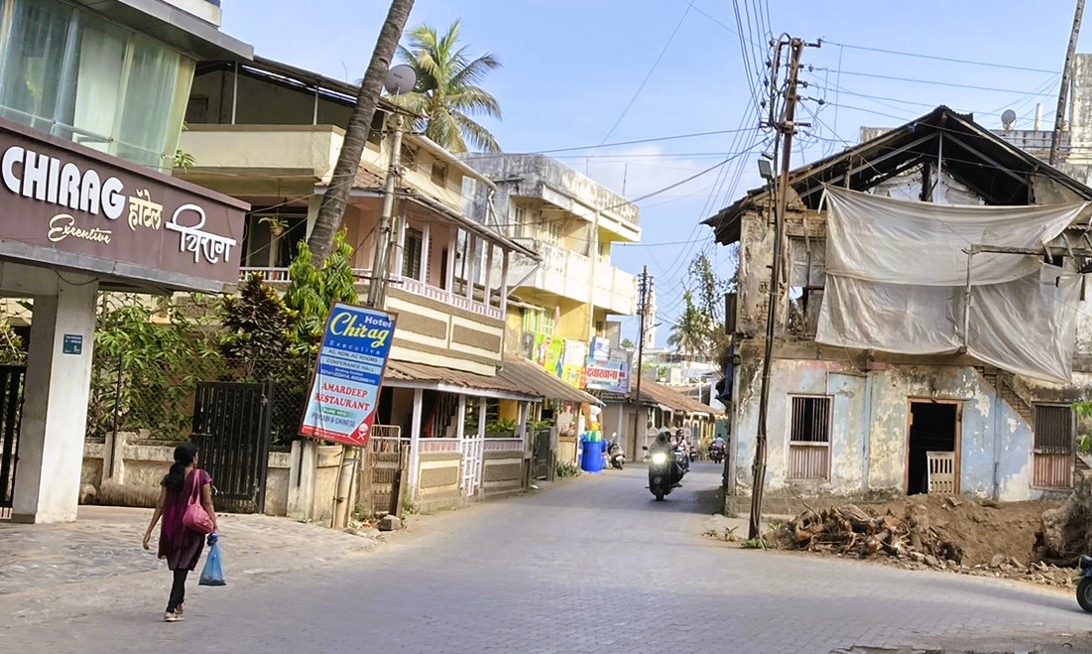
Street in Alibag Town, 2022

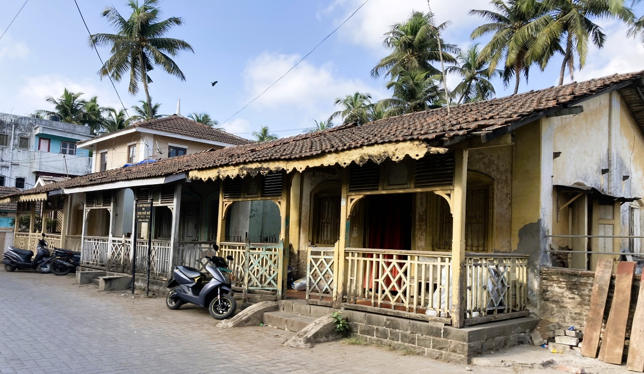
Alibag Town, the Israel (Ali) Lane, leading to Magen Aboth Synagogue, 2022

Magen Aboth (Defender or Shield of the Fathers) Synagogue, Alibag

The Alibag Synagogue Magen Aboth, is located in what was known as the Israel Lane (Israel Aali), at the south-east part of the town, the locality where the Bene Israel built their houses.

The Synagogue was built in 1840, by means of voluntary contributions and upon the initiative of Hacham Shelomo Salem Shurrabi, Cochini of Yemenite descent, who succeeded involving retired personnel from the Indian army. They warmly supported the proposal and sufficient funds were raised for the erection of the sacred edifice.
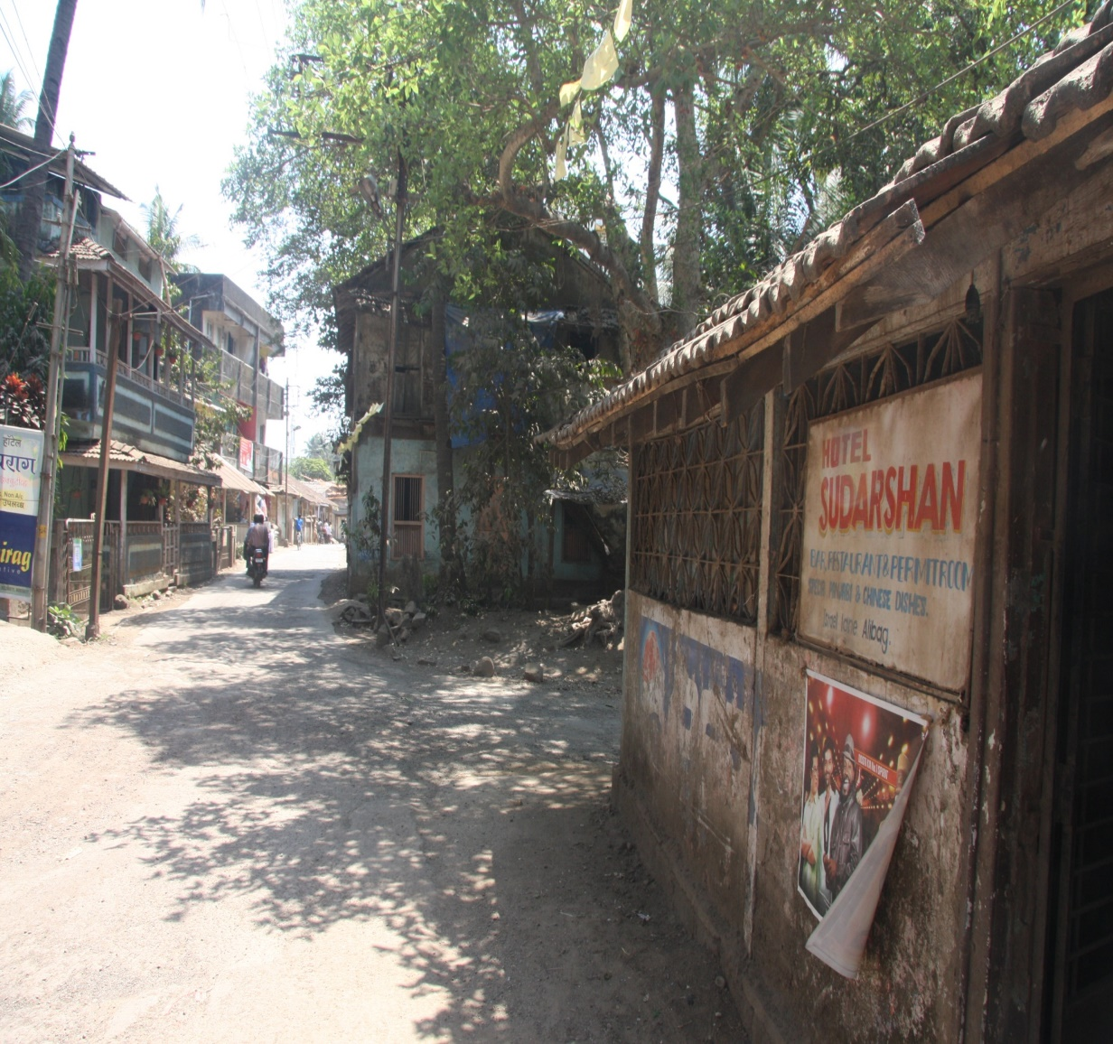
At the time, there were about 150 Bene Israel residing in the town and by 1881, their number increased to 172.
Alibag Town, the Israel (Ali) Lane, leading to Magen Aboth Synagogue, 2015

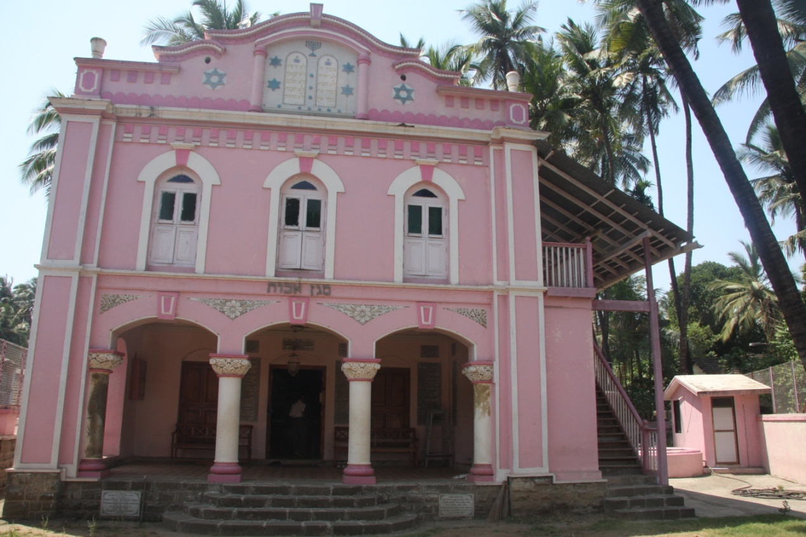
Magen Aboth (Defender or Shield of Ancestors) Synagogue, 2019

We should notice that Hacham Shelomo Salem Shurrabi, was involved in the erecting of the first three Synagogues in Raigad District. Besides the Magen Aboth Synagogue in Alibag, he was associated, as we should see ahead, with the Beth-El Synagogue in Panvel and the Beth-El Synagogue in Revdanda. Shurrabi, was earnest in teaching the Bene Israels the true spirit of Judaism until he passed away on April 17, 1856.
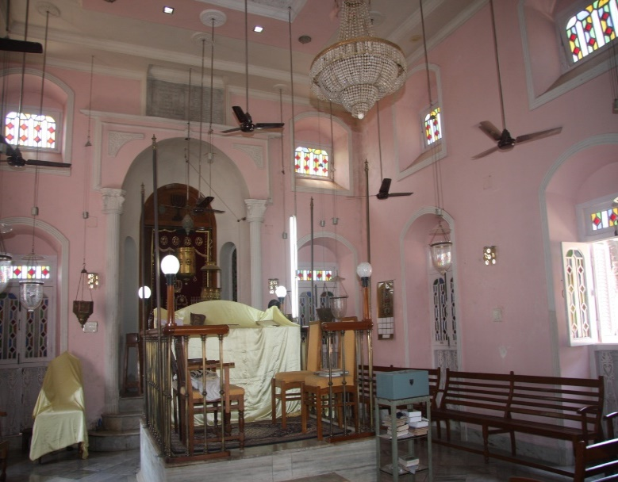
Towards the end of the 19th century, it was stated by Kehimkar that it was "...a matter of regret that there is dis-union among the Alibag congregation."
A few years later, donations which were collected again led to the construction of the
present Synagogue in 1910, according to the design of Samuel Solomon Mazgavkar.

Synagogue Interior, facing towards Jerusalem. At the rear- the Holy Ark. In front- The Tebah/Bimah, 2022

Names of the donors are commemorated on marble slabs that decorate the Synagogue. The construction of the building was supervised by Moses Samuel Wakrulkar and Solomon Aaron Charikar. The new building was neat and compact, nicely furnished and was enclosed by a compound wall. The ornamented wrought iron gates fixed in the wall was added in 1936 at the full expense of Mrs. Hannabai Jacob Shapurkar, in memory of her late husband. The inauguration ceremony was held on 25th December 1910 and was attended by almost a thousand guests. At this event the Synagogue received its present name, Magen Aboth. On December 1949, Dr. Emmanuel Olsvanger contributed to the Synagogue a Sefer Tora (Tora Scroll), saved from the Nazi holocaust. The Hazzan (Cantor or Reader) and the Shamash (Shamash/Beadle) were provided with quarters in a building across the lane, owned by the Synagogue.
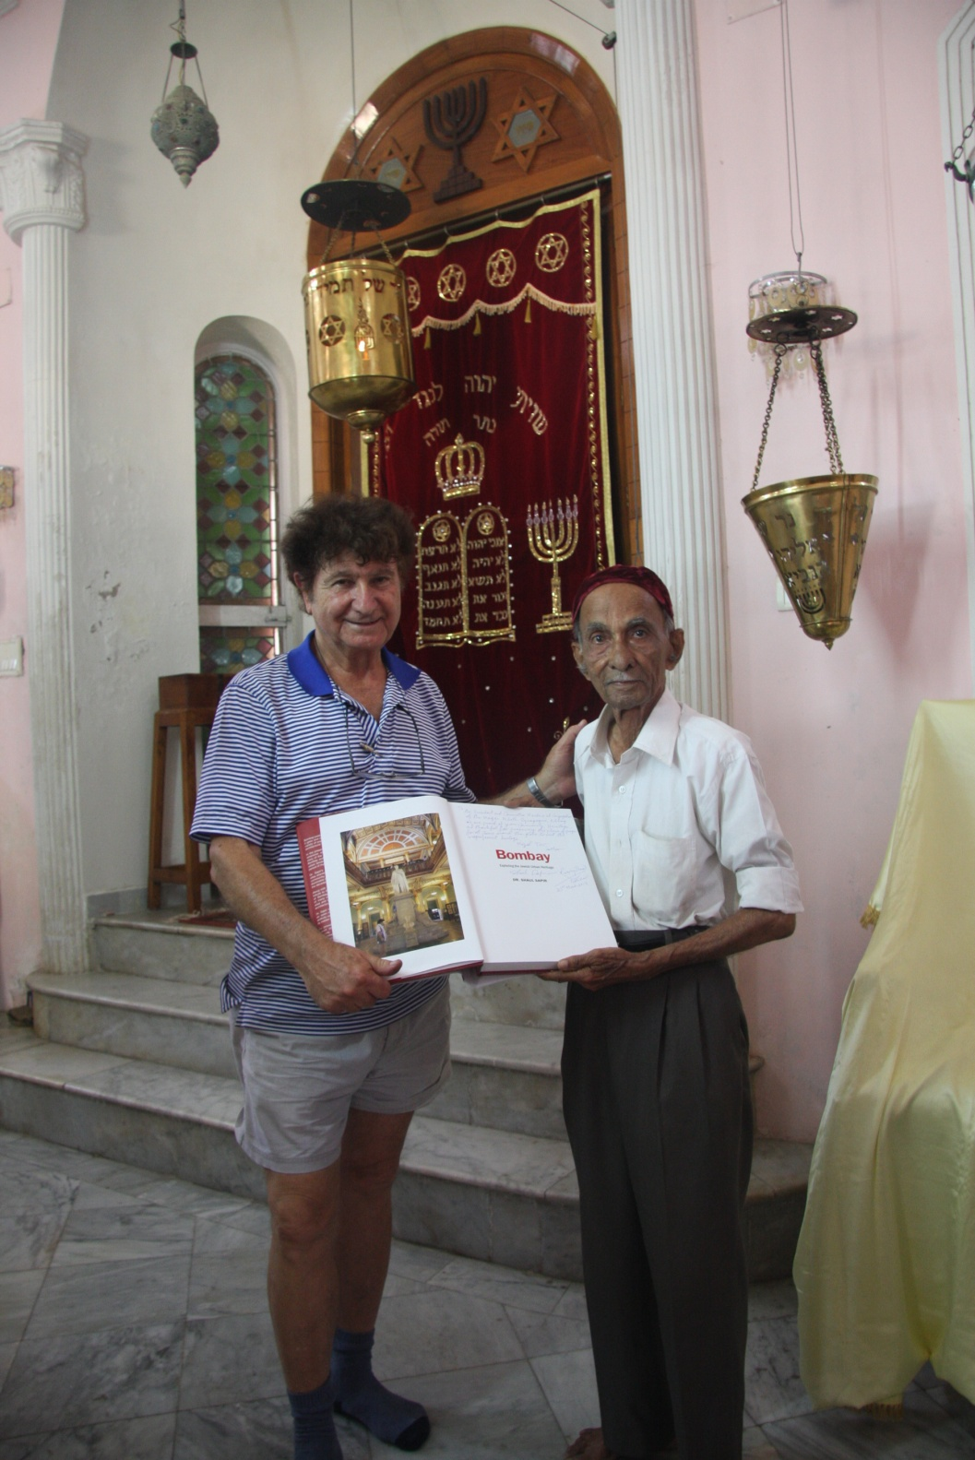
Facing the Holy Ark, the Arthur Presenting His Book to Binyamin,
2019
The front edifice of the Synagogue has an eclectic appearance in its architectural Style, with a strong Pseudo-Baroque Style design, dominated by three arches on the ground floor. The middle arch, through a narrow porch, leads to the main door and to the hall of the Synagogue. The upper floor has three windows; each window is centered on top of an arch. The dividing line between the two floors is adorned with the name Magen Aboth, in its centre. A decorative gable crowns the top of the facade, ornamented with traditional Jewish images. At the centre, the two tablets of the Ten Commandments are situated, accompanied with a pair of Magen David (Shield of David) figures on each of its sides. Above the tablets, the Menorah (Candelabrum) is displayed. Further, on opposite sides, a larger figure of the Magen David is displayed in a circle. The whole building is plastered and covered with a dominating light pink colour.

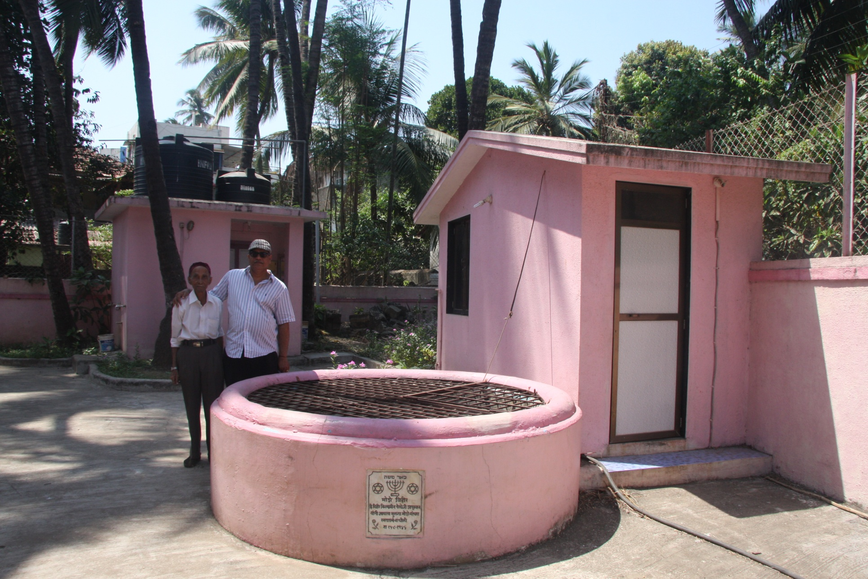 With Ralphy Jhirad and Binyamin in the Courtyard- the Cistern and Facilities, 2019

The inner hall resembles other Bene Israel Synagogues in the Konkan and some other in Mumbai. At the far end of the interior, lay a set of few steps leading to a raised platform, boarded with railings on either side. This is the place of the Holy Ark (Pulpit or Altar) in which the Tora scrolls are placed vertically in a closed cabinet, at the rear end of the wall. In front of the cabinet, a burning brass lamp shielded with a perforated cover hangs from the ceiling. This lamp is kept burning 24 hours a day throughout the year, using coconut oil. Several wooden benches are spread within the rest of the hall.

Prophet Elijah's Chariot’s Site, Talvali (also known as Khandala)

Located at an approximately short distance from Alibag, at Talvali (also known as Kandala), is one of the most important sites for the Bene Israel in India, known as the Prophet Elijah's Chariots' Site.

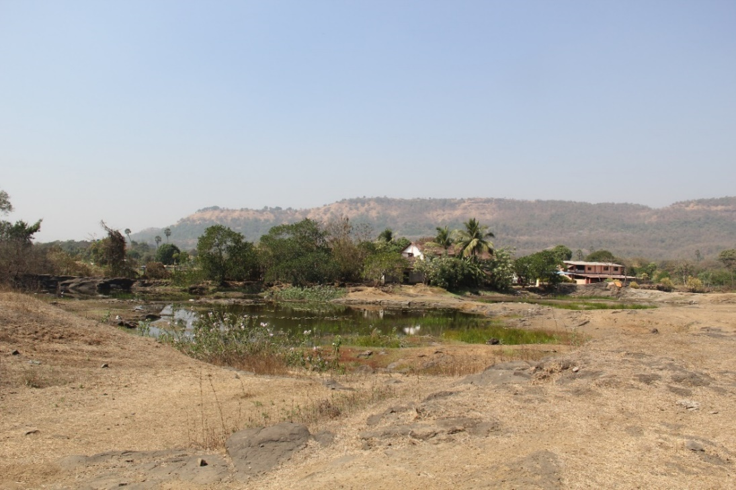
Prophet Elijah's Chariot’s Site, Talvali (also known as Khandala), 2015

Prophet Elijah stands exalted almost to the status of a patron saint of Bene Israels and the deep veneration for him is unflinching and unwavering. No auspicious ceremony is performed unless appropriate blessings are recited first, inviting him to bless the occasion. Each and every vow made, is redeemed in his name.
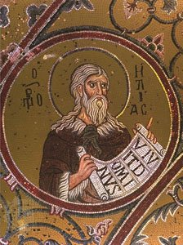
According to Bene Israel legend, the first account of Prophet Elijah's visit to India, recounts his stop in Talvali, about a few miles from Alibag.

Prophet Elijah, 12th–13th century; in the Cathedral of Monreale, Sicily.

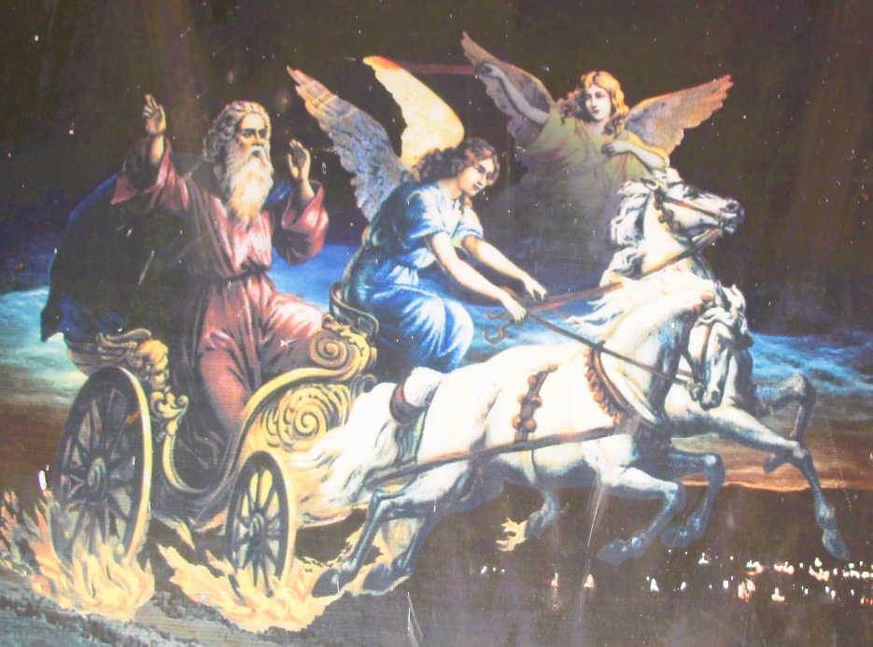
The second event of the Prophets' visit took place immediately after the arrival of the Bene Israel boat to the Konkan coast, about 2,000 years ago. On this occasion, Prophet Elijah revived the unconscious Bene Israel who washed up on the beach from the sea.

Prophet Elijah’s Ascent to Heaven on a Fiery Chariot (Kings II, 1-18).

The Bene Israel legend narrates two occasions when Eliyahu Hanabi (Prophet Elijah) visited India and ascended to heaven. It is said that Prophet Elijah took off from here into the sky on a chariot of fire. It is also believed, that the chariots' wheels and horses' footprints which are visible today at this site, are imprinted on a large rock, where the Prophet took off to heaven.

Dr. Irene Judah contributes her own personal experience about Prophet Elijahs' site in Khandala by adding: “Legend has it that it is a place of Biblical significance. The Jews or let say mainly the Bene Israels believe that prophet Elijah ascended to heaven on his chariot from this spot. Marks of the chariot wheels and of the hooves of the horses, about 4 or 5, can be seen on the rock of KhandalaThe first time I saw it was in 1985. At that time, there nothing there. There was a small stream flowing and on the rocks by the side of the stream these marks are visible, though not clearly. After the 1990’s the place has been commercialized. Houses have come up next to it and the owners made rooms where Bene Israels could stay…On the side of the rock there is a small alcove carved into the rock, where the Bene Israels light candles. I have been there several times and observed the changes. Over the years, besides the Jews, I noticed symbols of Hinduism…So now it is not only the Jews, but also the Hindus who visit the site in large numbers. All I have seen in happen in a span of about 30 years. What is the real truth, I do not know….”
.

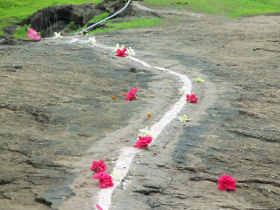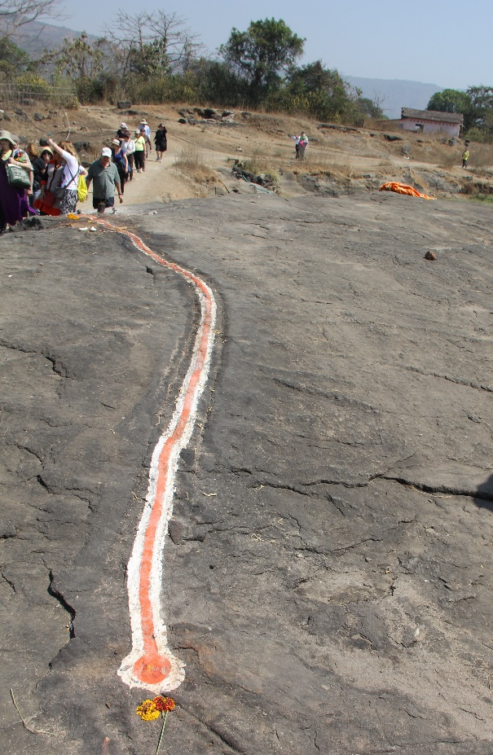
Prophet Elijah's Chariot's Site - Print mark of the Chariot. Left- 2012. Right- 2015

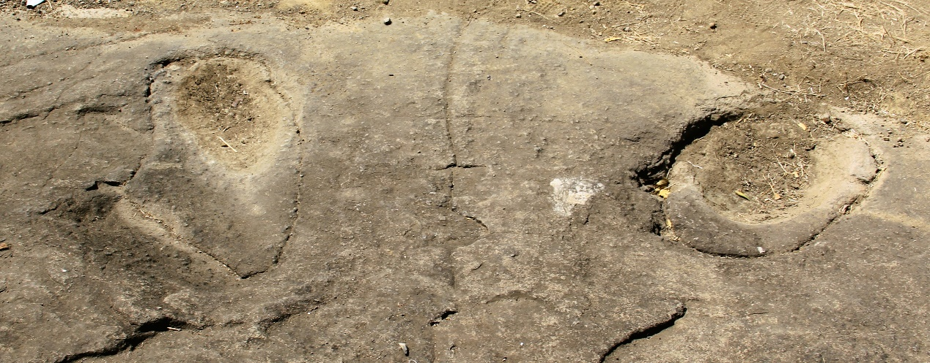
Prophet Elijah's Chariot’s Site - Print mark of the Hooves, 2015

The Hindu person who lives by this site was told by his grandfather, who was told by his grandfather, etc., the story of a holy man who took off to heaven in a chariot of fire. The man added that their family has been there for generations and won't leave because they feel the area is blessed. Jews, Hindus, Muslims and Christians consider the place holy. Hindu visitors to this site leave flowers and incense on the bare rock, while the Bene Israel go there to have the Malida, a thanksgiving ceremony when people have babies or celebrate anniversaries or other Simchas (happy events) and welcome Prophet Elijah to attend. In this ceremony they sing songs praising the Lord and Prophet Elijah as the precursor of the Messiah.
Revdanda

Revdanda is a small village, about 17 kms away from Alibag, and 125 kms from Mumbai. Part of the town is situated within the premises of an old Portuguese Fort, right on the beach, located at the mouth of the Kundalika River, better known as the Revdanda Fort.

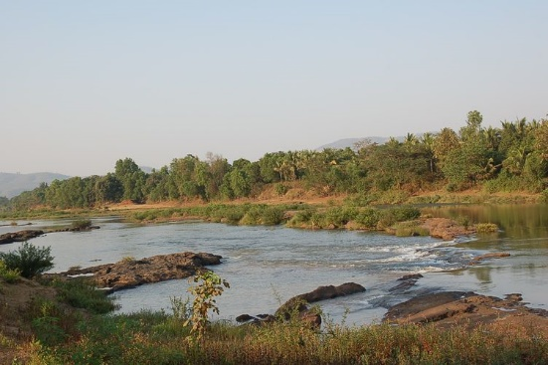 Kundalika River, leading to Revdanda beach

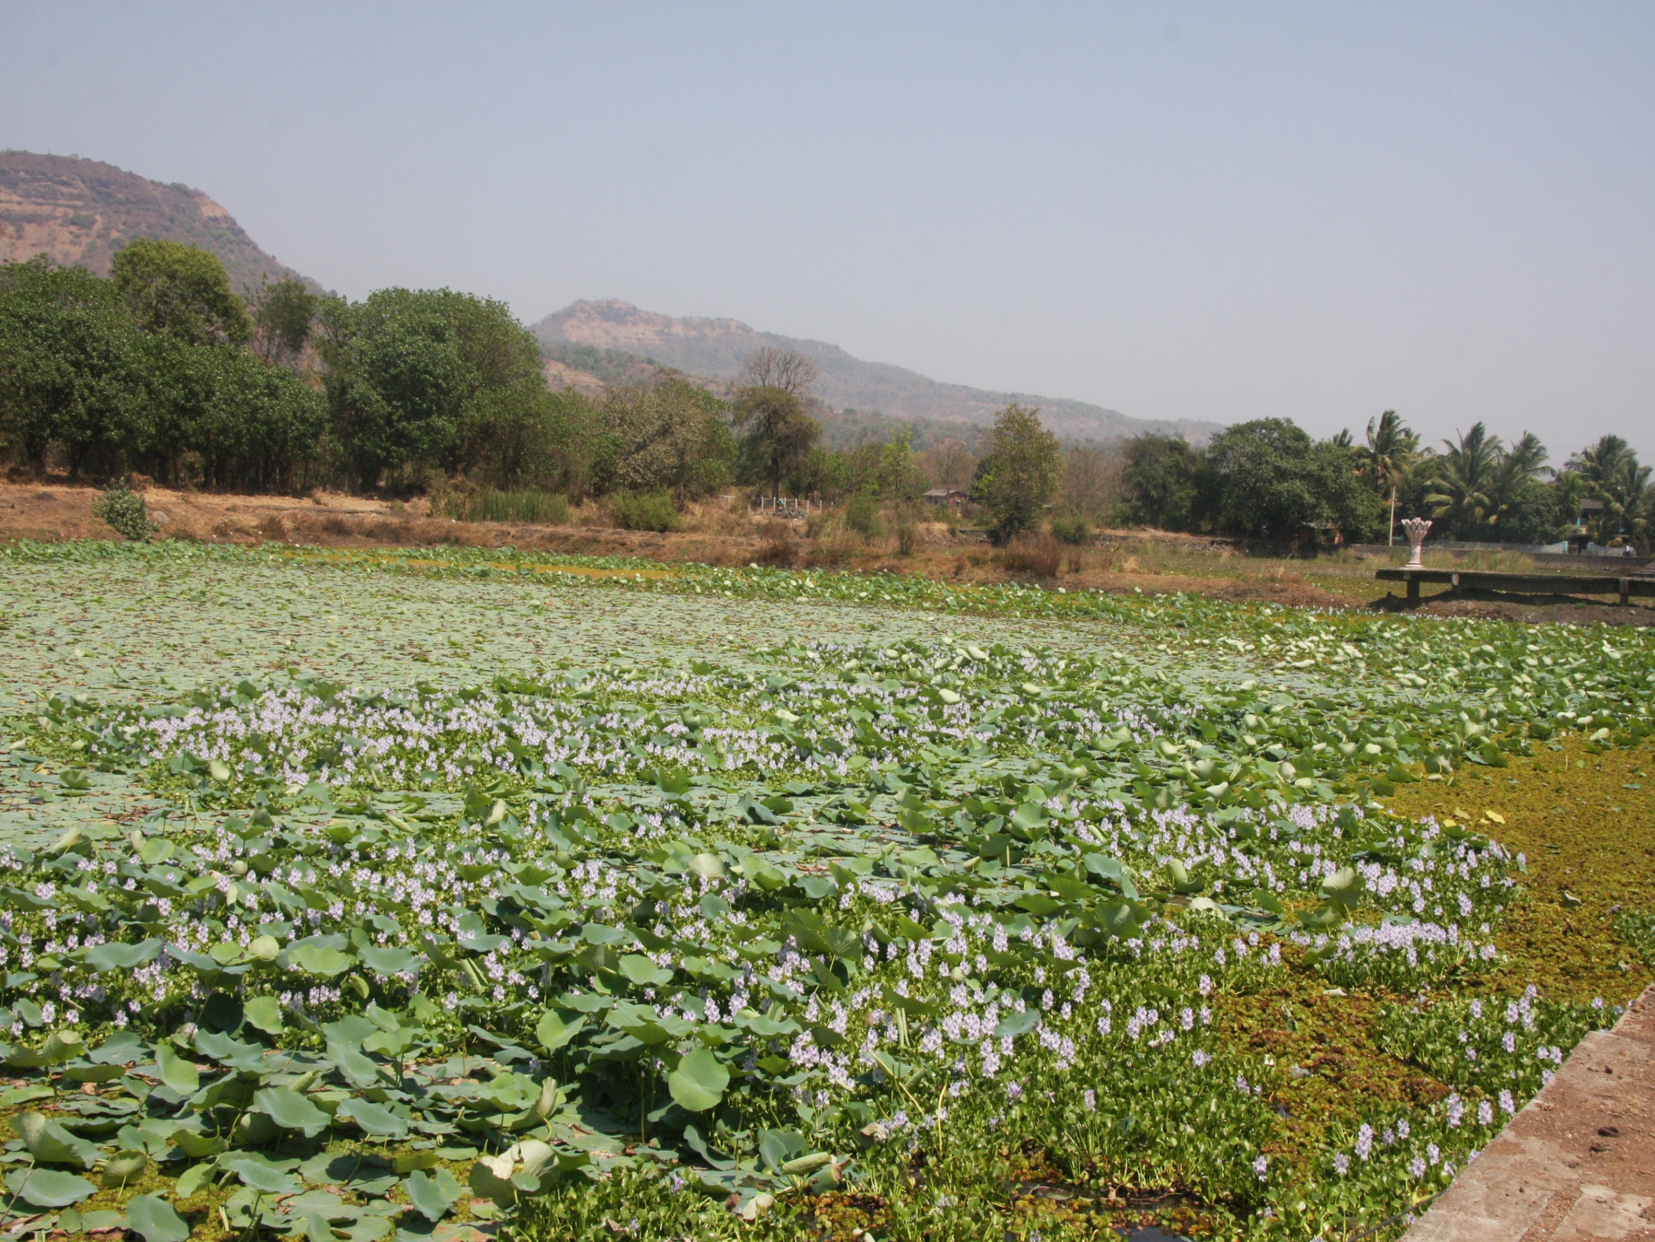
On the way to Revdanda

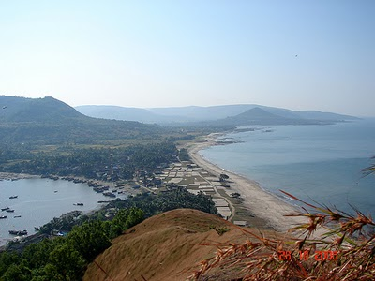 Revdanda Village
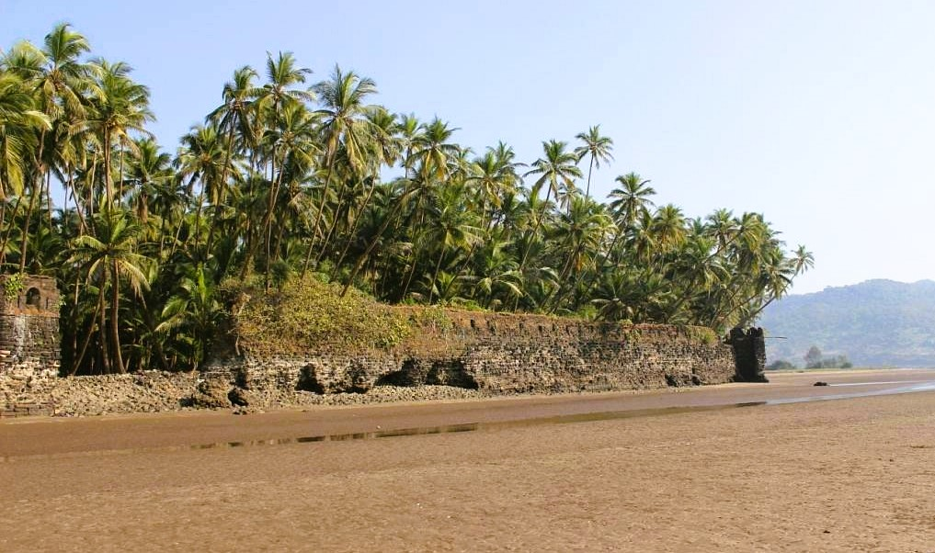
Revdanda_Fort- Dating back to the 15th-century, this is one of the few beach-facing Forts in Raigad district which was built by the Portuguese to protect their sea shipments. Initially known as Santa Maria de Castelo, it was captured by the Marathas and finally ceded to the British. 2022

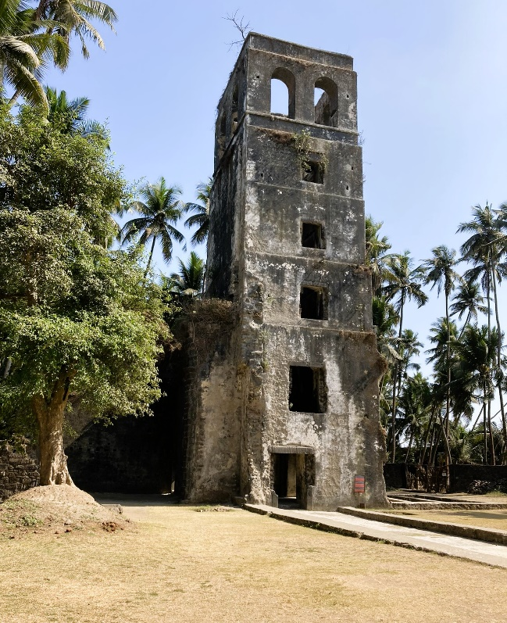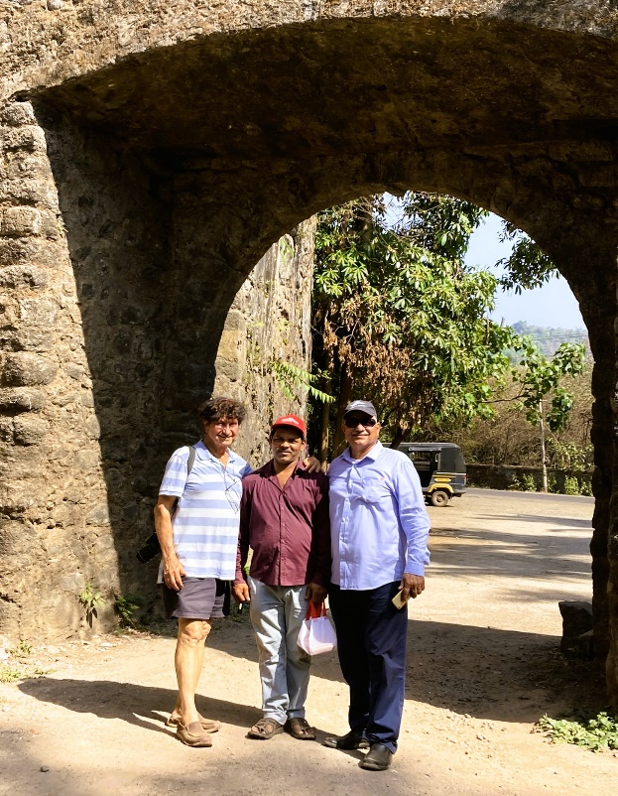
Revdanda Fort at the Fort Entrance with Ralphy Jhirad (right) and the Author (left), 2022

Revdanda is a historical place and relates closely to the era of Shivaji, though it's not one the famous places in Konkan history related to him. In order to get to the Fort,
drive through the town; the road enters through an old archway and then exits from another. Turn right between the two archways and make a detour to the western part of the Fort which reaches out into the sea. During high tide the waves crash onto the palm-fringed ramparts of the Fort and one gets a magnificent view of the creek to the south and the beach to the north. There is an entrance from the beach to the Fort.
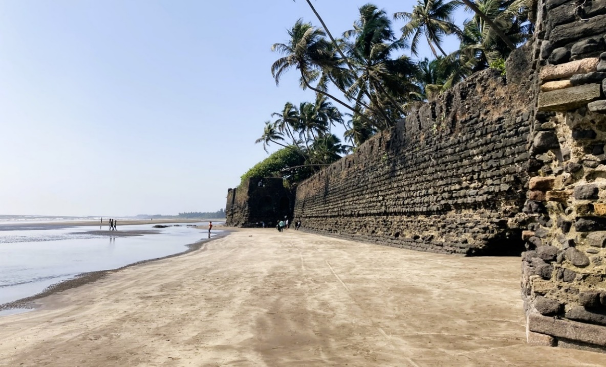 Revdanda_Fort Walls and Revdanda’s Beach, 2022
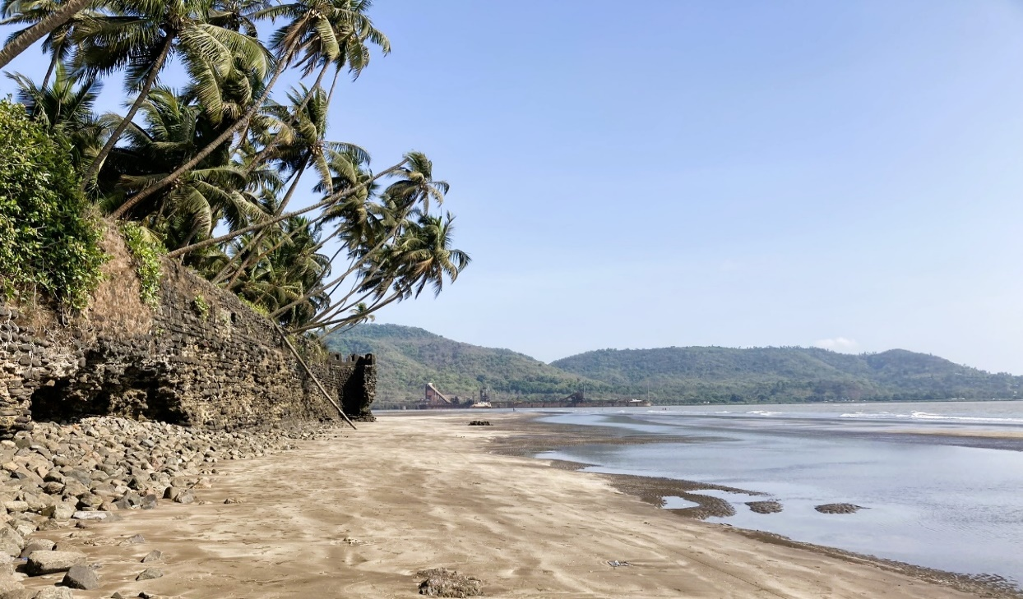Revdanda_Fort Walls and Revdanda’s Beach, 2022
Revdanda is also noted as the place where St. Francis Xavier delivered one of his early sermons in India. The chapel, within the south side of the walled Fort, is in rundown condition. Revdanda came into public notice, when Russian historians found out that the first Russian traveler to India, Afanasy Nikitin, landed in Revdanda in the 15th century. A monument was raised in his memory on 23rd November 2000. The function was attended by a high-level delegation from Russia.
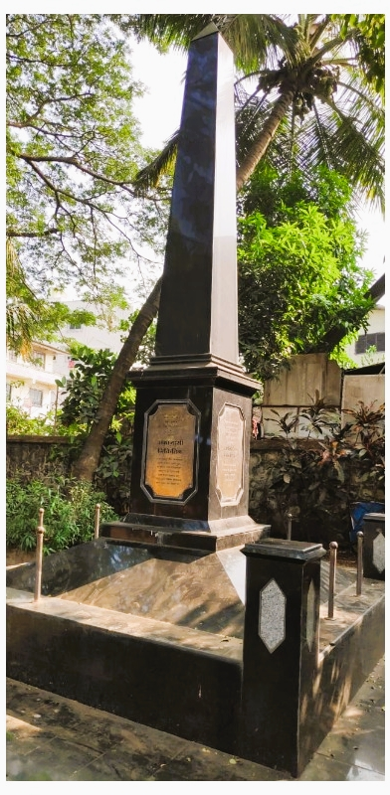
Nikitin (d. 1472), was a Russian merchant and one of the first European to travel to and document his visit to India (1466-1472). He described his trip in a narrative known as “The Journey Beyond Three Seas” (translated from Russian). The abundance and trustworthiness of Nikitin's factual material provide a valuable source of information about India at that time.

Monument to Afanasy Nikitin in Revdanda, 2022
The idea to introduce to India a monument to the Tver merchant belongs to the President of the Russian Federation Vladimir Putin, who announced it while in India in October 2002. Funds for the construction of the monument was allocated by the administration of the Tver region, and the educational society of the Konkan region donated a plot of land on the territory of the School K. E. S. Sardar Ravbahadur Tendulkar High School, Revdanda.
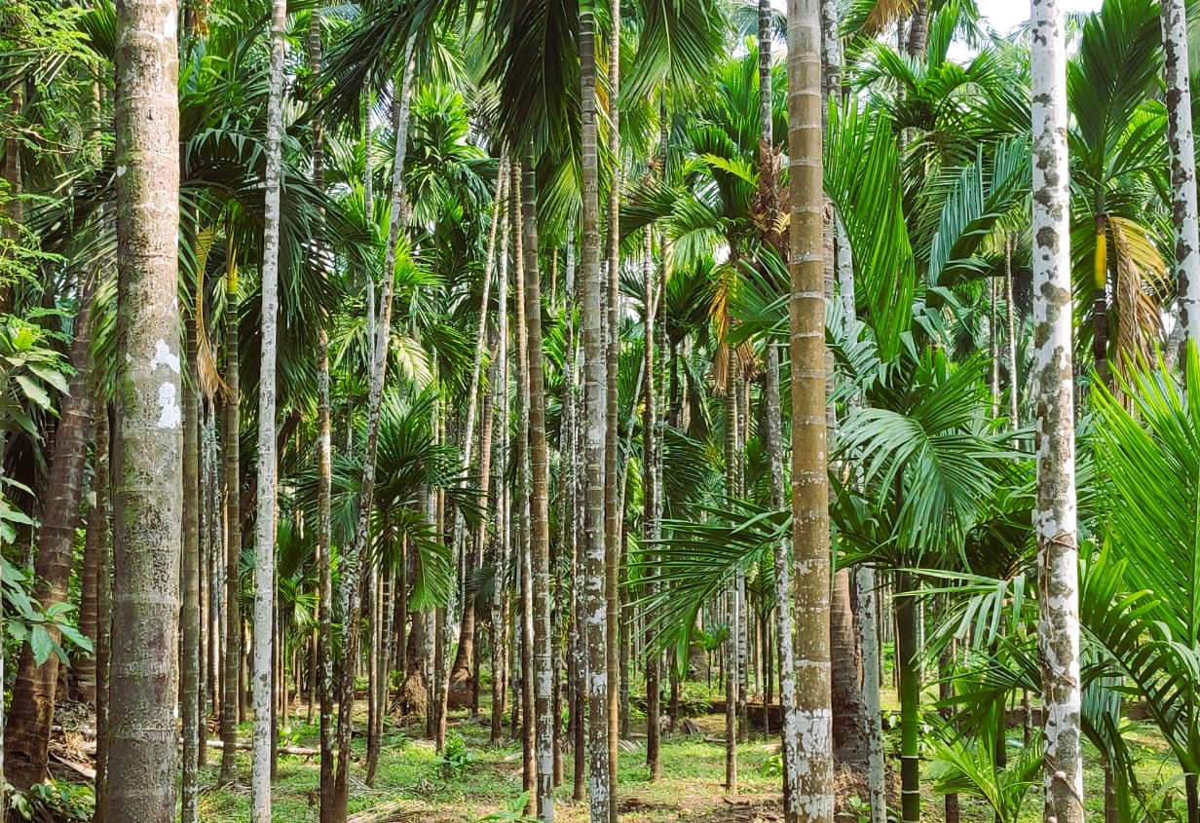 The Plantation of Betel Nut (Areca Catechu) in Revdanda
The beauty of Revdanda region lies in the coconut plantations (called naralachi baag or wadi in Marathi) and the betel nut plantations. Apart from these plantations the livelihood of the people in this region comes from the production of rice and tourism, in a low scale.
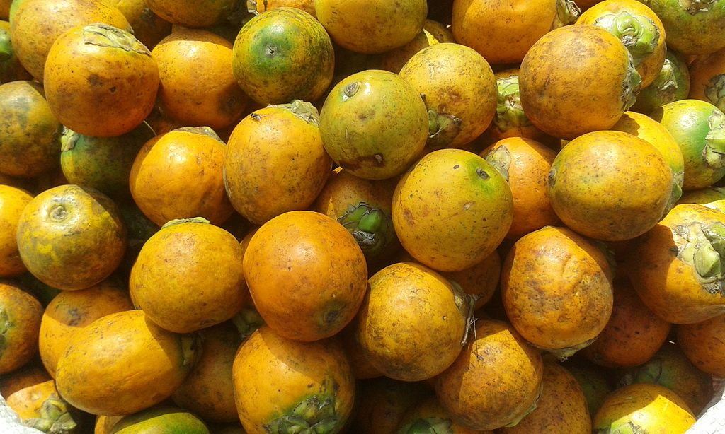
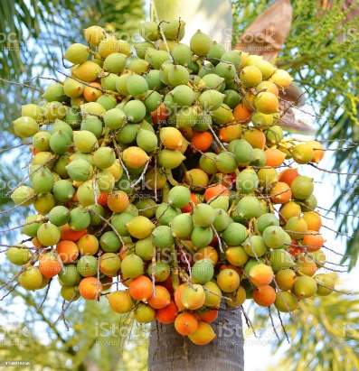Betel Nuts
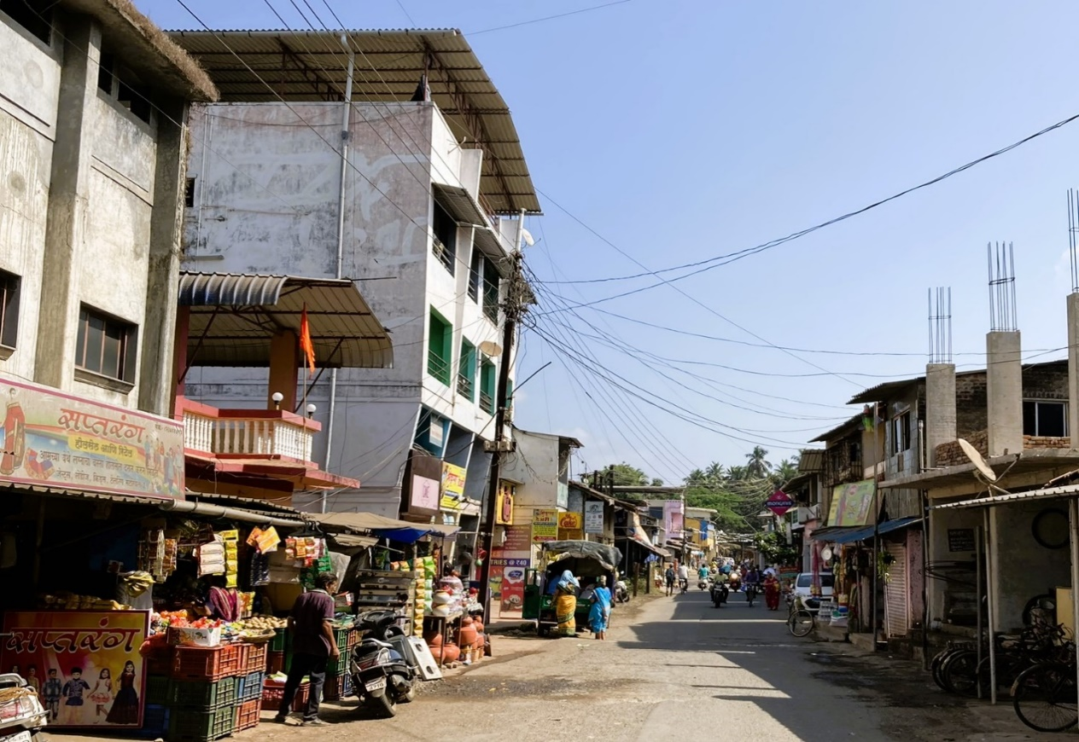Village Road to Revdanada, 2022
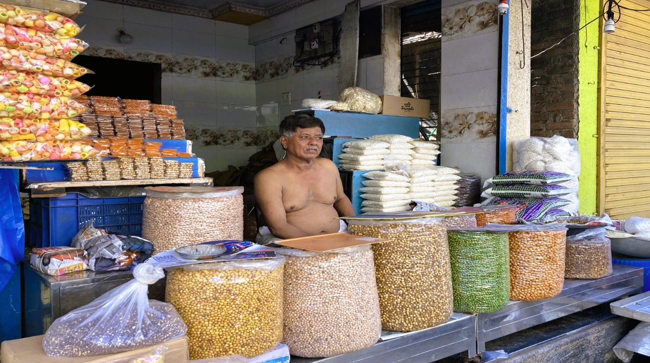
Dr. Irene Judah mentions: “Many Bene Israels worked in rhe Revdanda and Corley fort and palaces. In the fort and palaces, several plaques are still there which give evidence of the presence of the Bene Israels. They worked in administration, keeping accounts etc, as well as in the army as fighters. The highest rank they could earn was Subedar Major.
Local Store at Revdanda, 2022
Beth-El Synagogue, Revdanda
Revdanda had a small Jewish community who erected a Synagogue named Beth-El (The House G-d). The Synagogue was built by the initiative and contributions from the local Bene Israel community in 1842. According to Kehimkar, its establishment was mainly due to the exertions of Hacham Shelomo Salem Shurrabi.
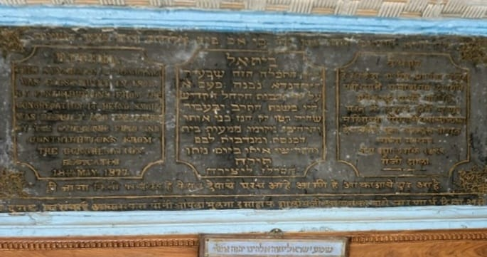
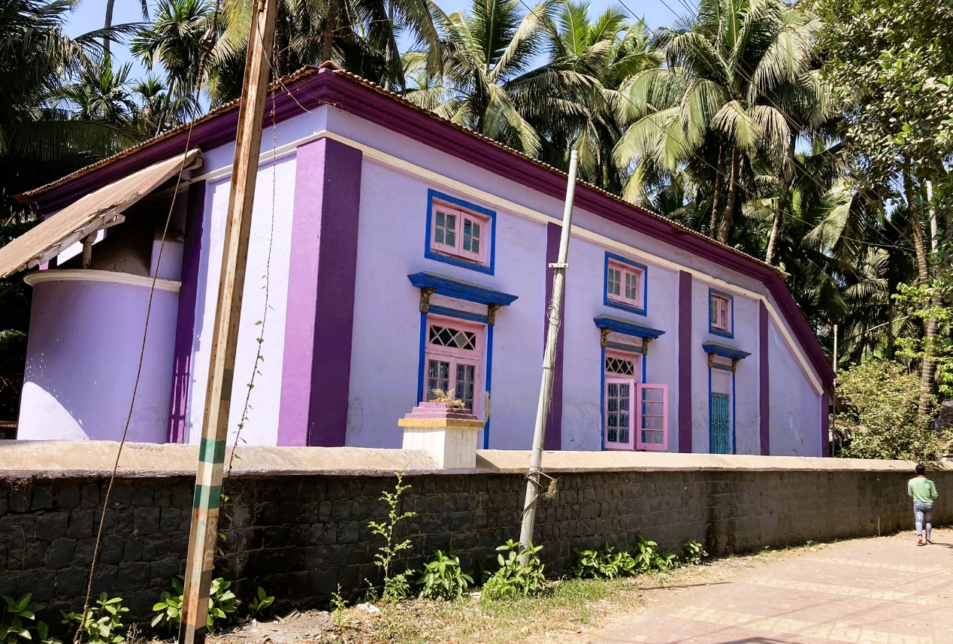 Revdanda, Beth El Synagogue, 2022
Beth El Synagogue, Dedication Plaque, 1877
The commemorative plaque located above the entrance door to the Synagogue gives us the following details: "BETHEL. This Synagogue at Revdanda was first built in 1842, by contributions from the congregation. It being small was rebuilt and enlarged by the Synagogue fund and contributions from the congregation. Dedicated 18th May, 1877".
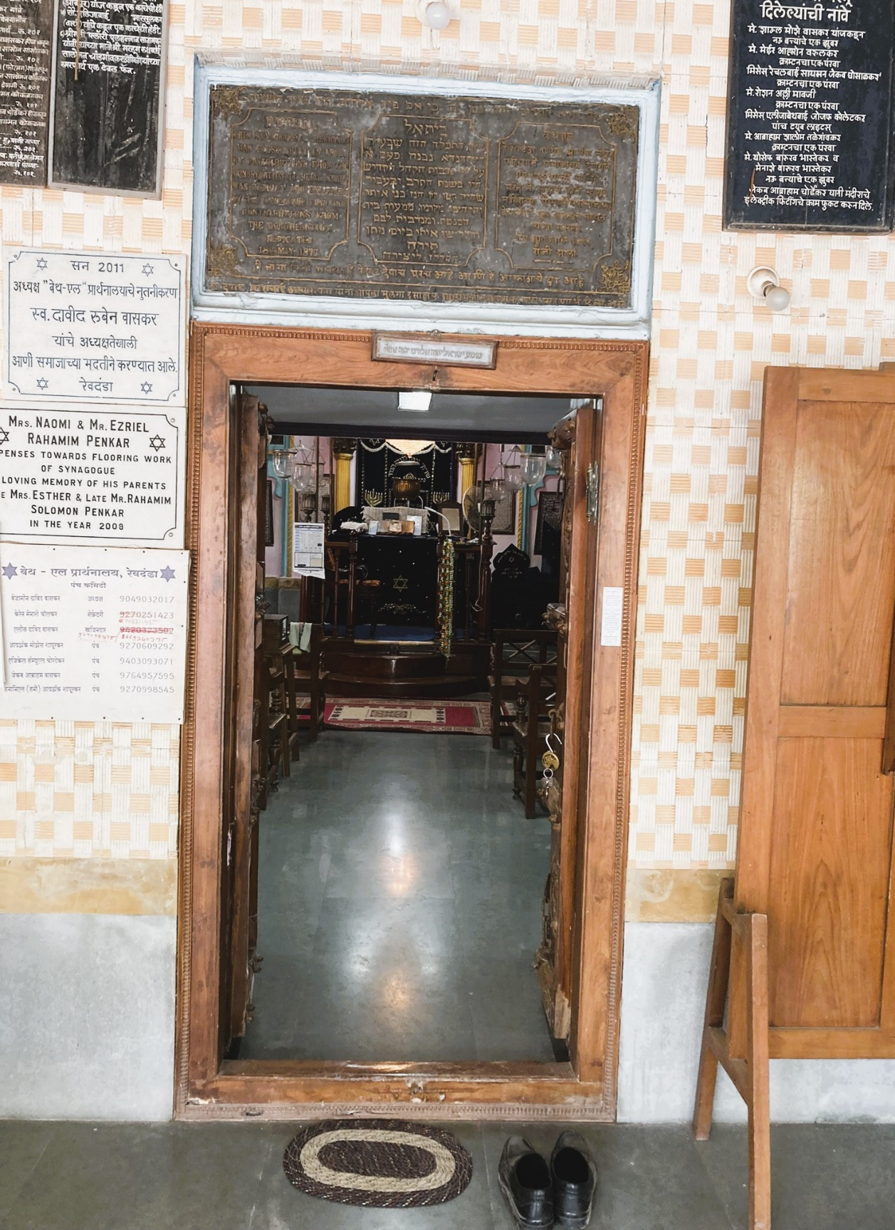Revdanda, Beth El Synagogue Main Entrance of Beth El Synagogue, 2022

In the course of time, when the congregation grew, the building was extended and rebuilt and dedicated in 1877, from the donations of the offerings made by the people of the Synagogue.
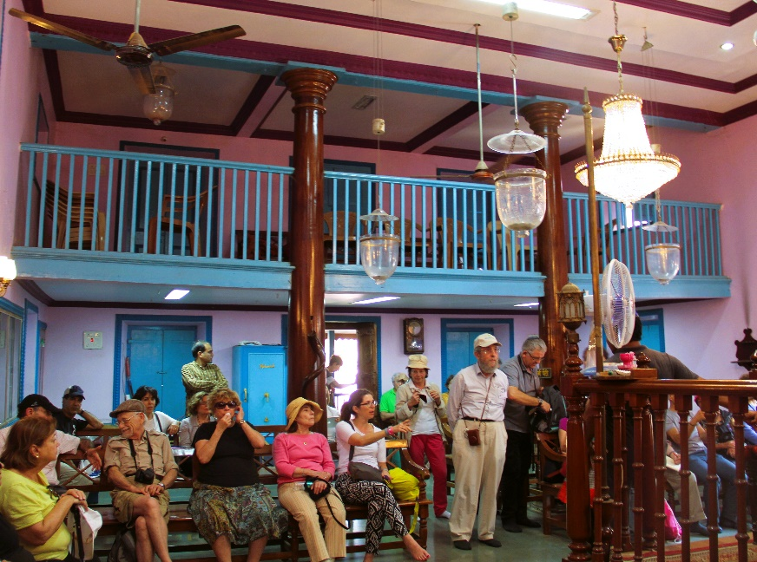 Synagogue Interior, Facing the Entrance and Women’s Gallery, 2015
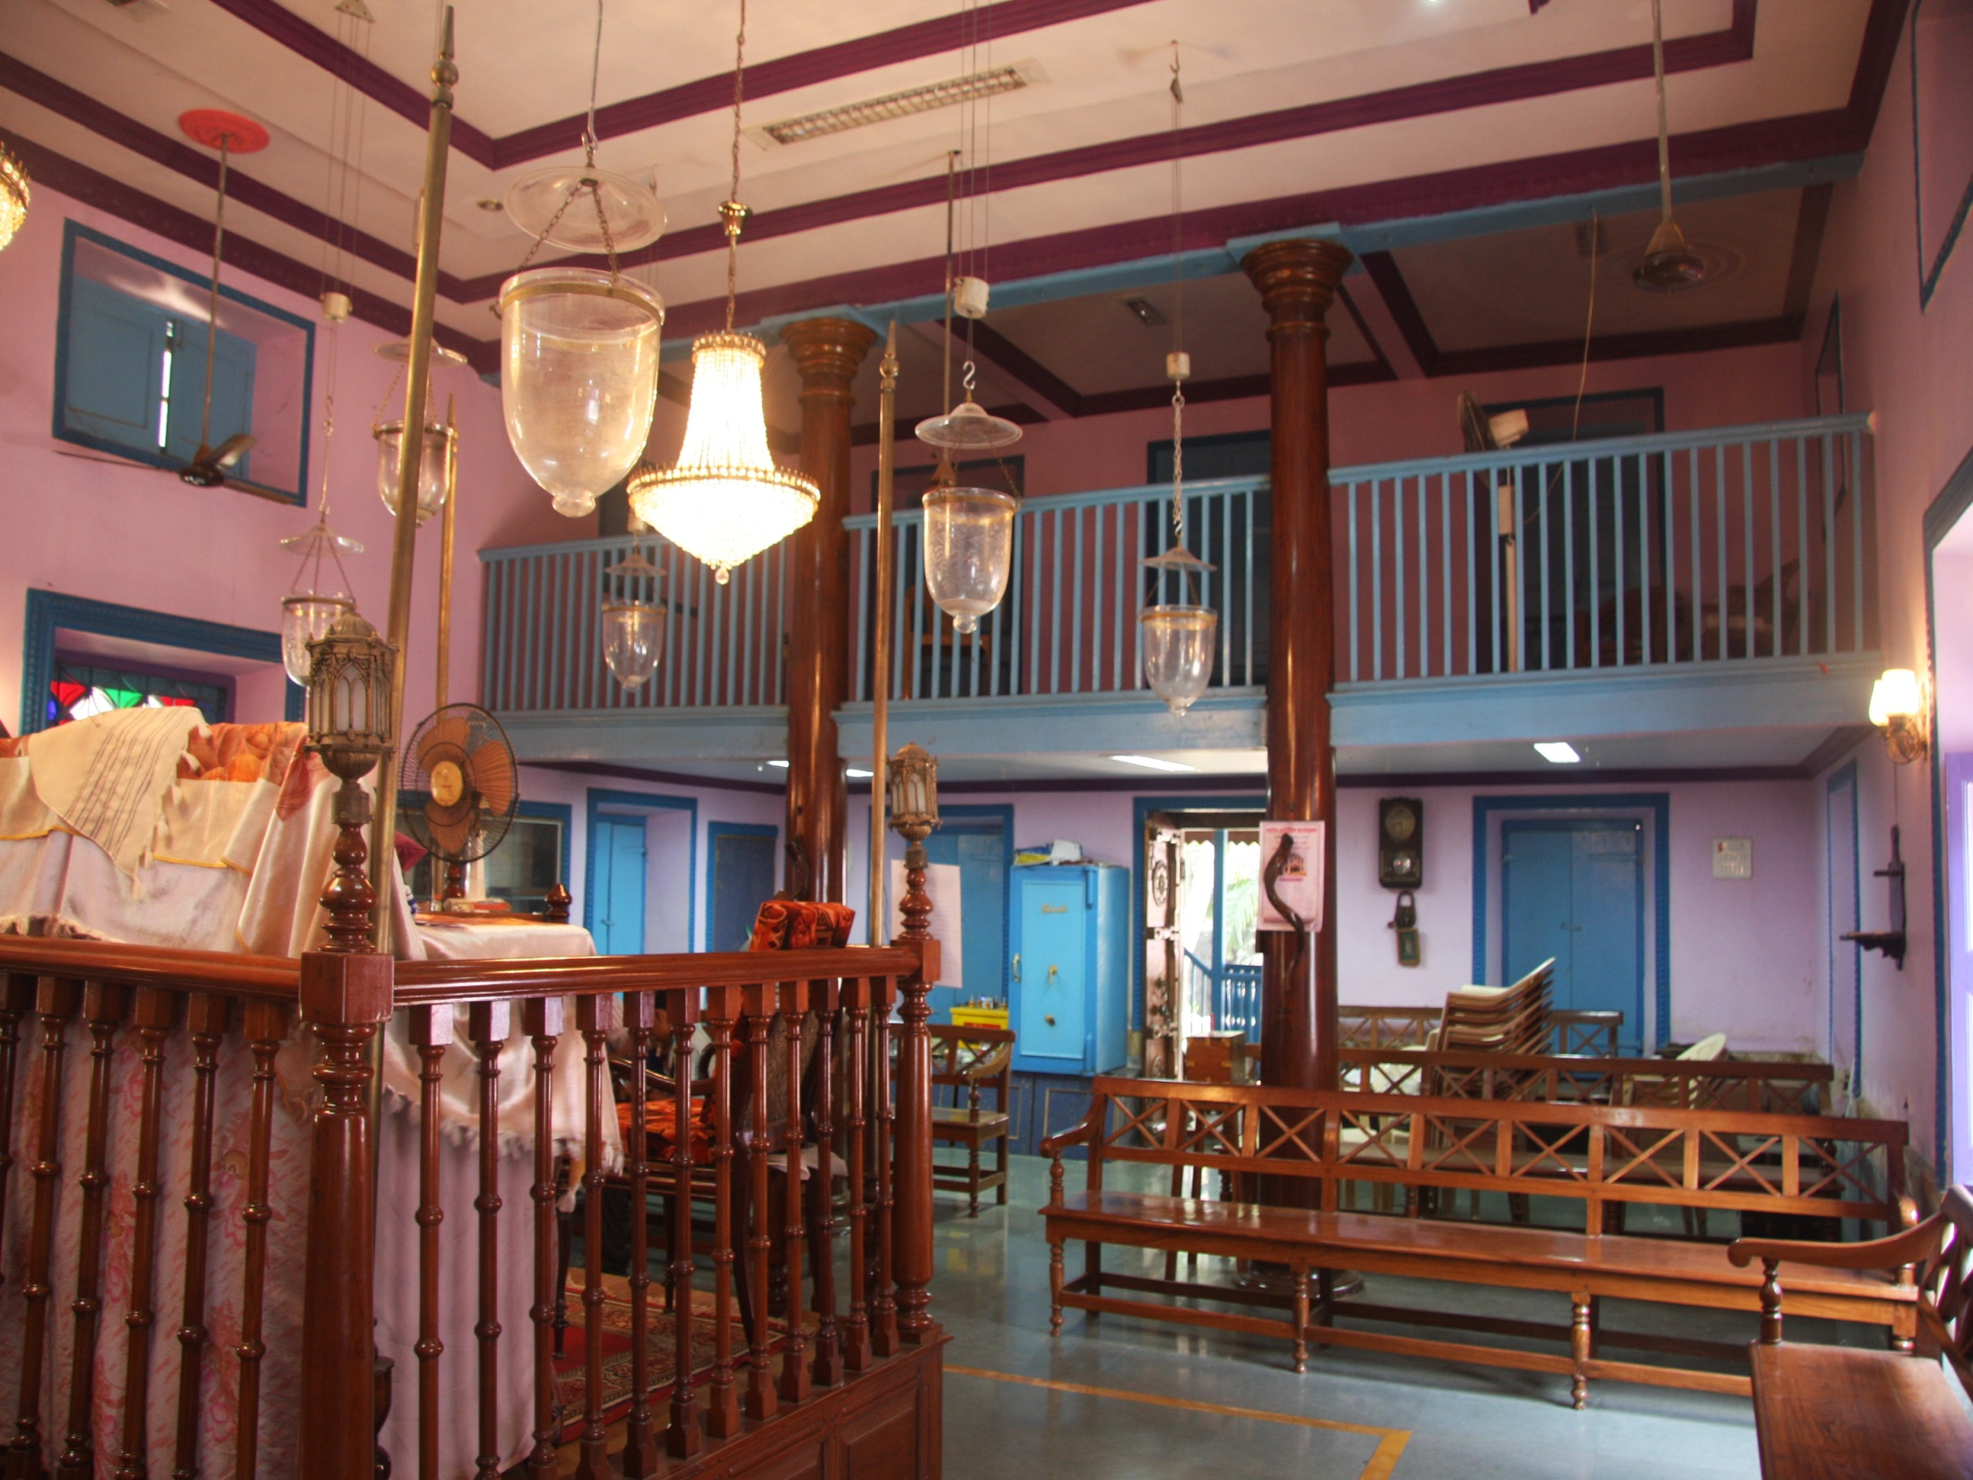 Synagogue Interior, Facing the Entrance, and-the Women’s Gallery on top, 2015 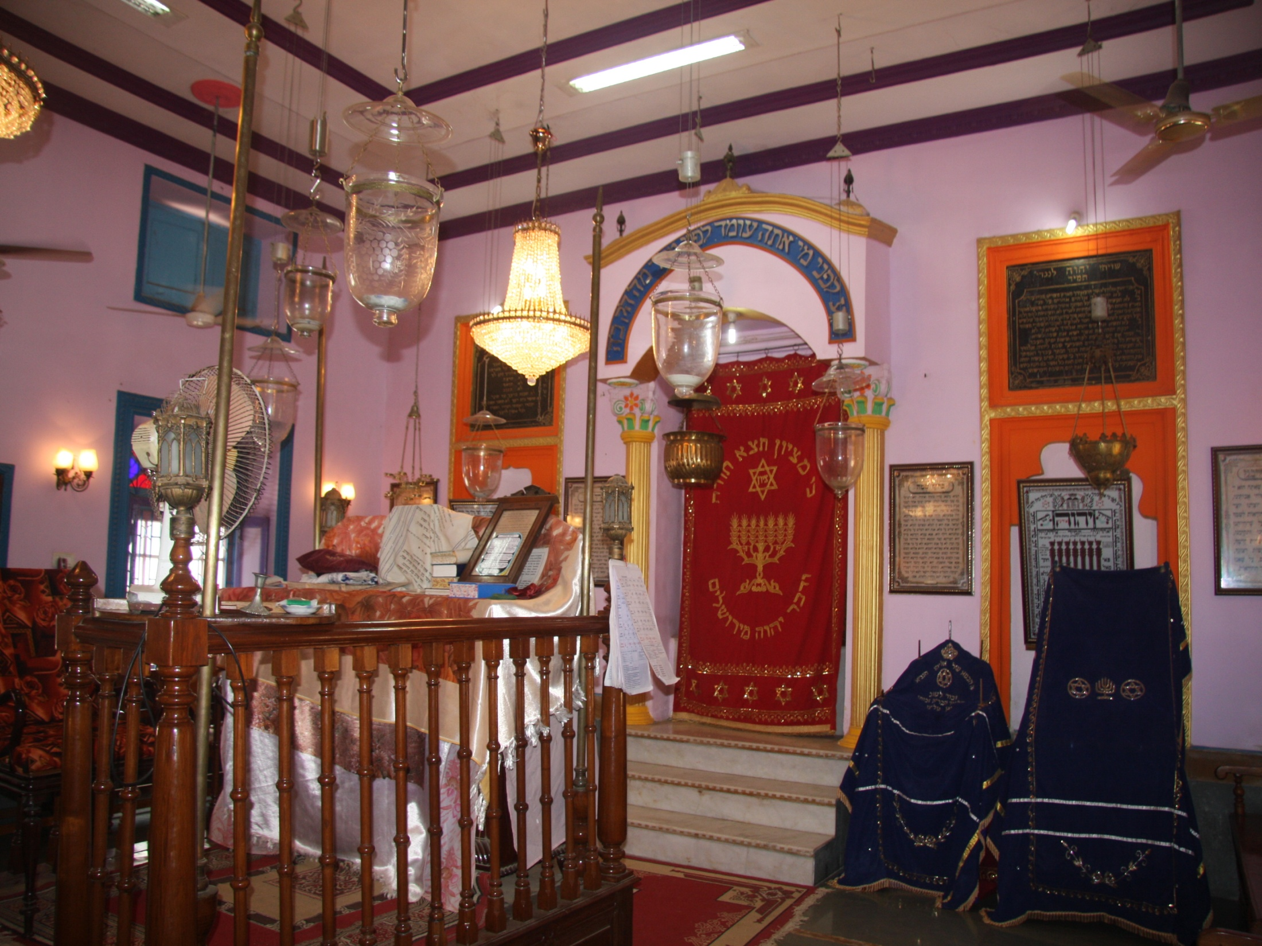 Revdanda Synagogue Interior. Left- the Bima, right- the Hechal, 2015
Kehimkar gives a positive report on the Synagogue in Revdanda and its congregation by mentioning that the Synagogue was well managed and credit was due to the congregation and especially to Samuel Jacob Dandakar, for the good management exercised by him. The Centenary celebrations were held on 28th May 1941 and the 150 Years celebration was marked on 27th February 20renovation of the building.
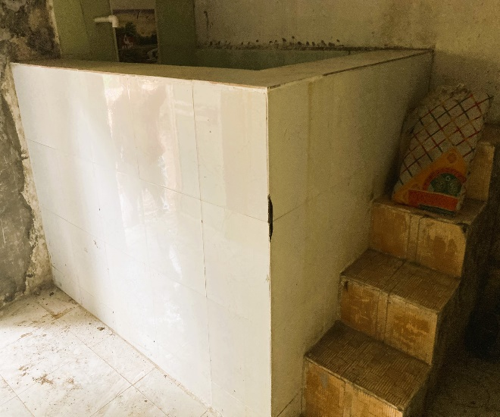 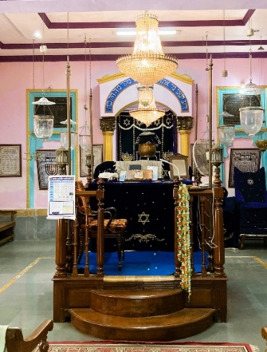 The Mikvah/Ritual Bath, 2022 The Tebah, 2022 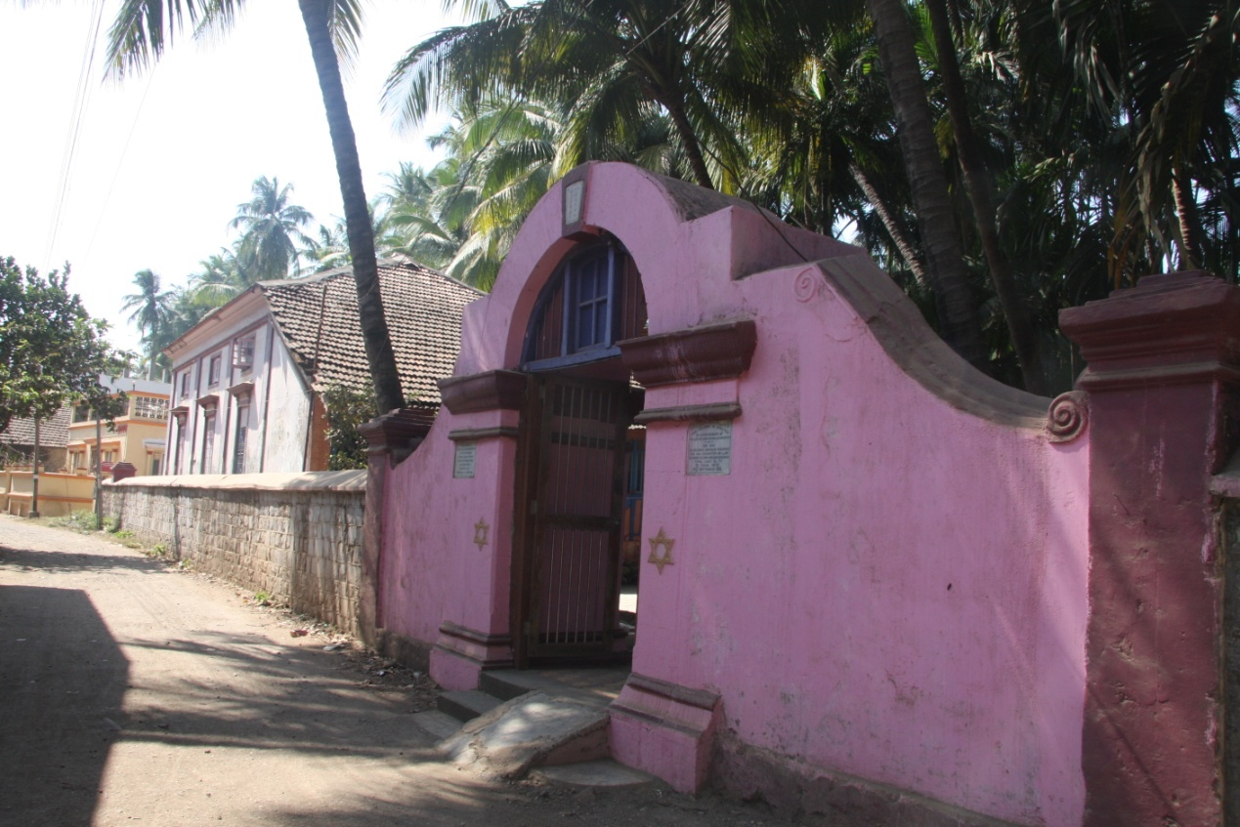 Revdanda Synagogue Stone Wall, 2015
A stone wall is massively built around the Synagogue compound with a decorative gate affixed to it, leading from the main street into the compound courtyard (painted today in pink). From an architectural point of view, it seems that the gate structure appears to resemble a Gable edifice depicting the Pseudo-Baroque Style. Both sides of the gate are decorated with figures of The Star of David and above them, are two commemorative plaques. The one on the left is written in the Marathi language and on the right one, in English, and it says:
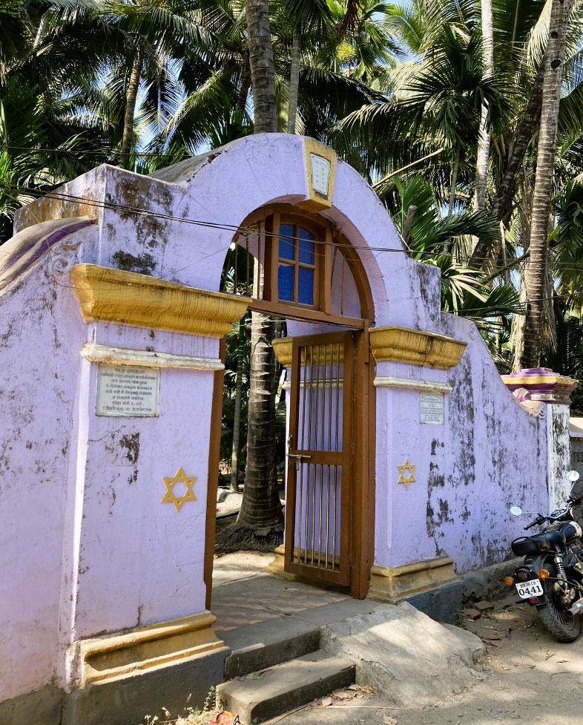
"This Archway is erected in loving memory of the late Mr. Abraham Balaji Sogavker by his son Mr. Solomon Abraham Sogavker jerusha jhirand his daughter-in-law Mrs. Simha Solomon Abraham Sogavker. Total cost Rs. 711. 1st Tishri 5673 [Tishri is the first of the twelve months in the Jewish calendar, and the 1st Tishri is the first day of the Jewish New Year, which has two days] 12th September 1912.". The headstone of the arch is decorated with two rows of the first ten letters in Hebrew, depicting the Ten Commandments. Synagogue Stone Wall, 2015
Today, Chazzan Binyamin (Benjamin) David Waskar is involved with the maintenance of the Synagogue. Waskar lives with his family in Therwanda, a nearby village next to Revdanda. Binyamin owns a coconut plantation and a traditional oil press, left to him by his ancestors.
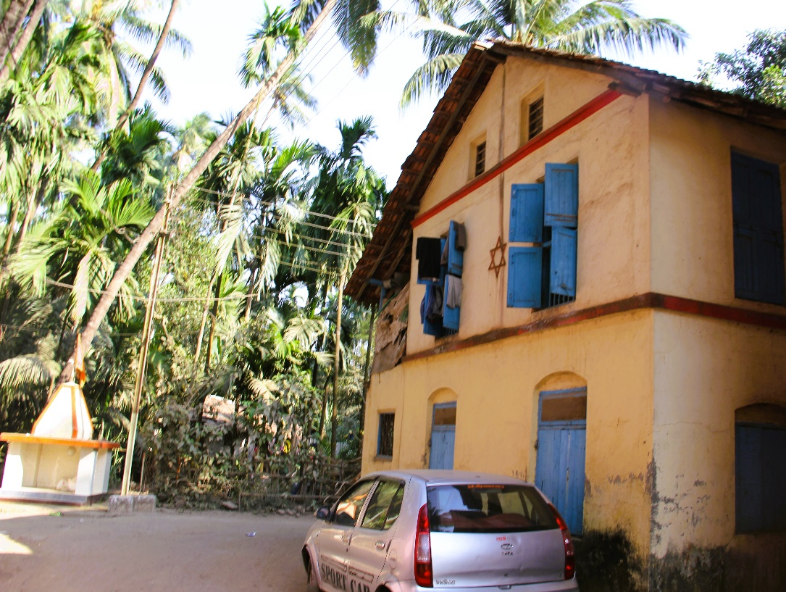 Opposite the Synagogue, a house under the care of the Synagogue, 2015
Opposite the Synagogue, are dwellings which are part of the Synagogue property. A Star of David decorates the wall on the second floor, facing the street. Originally, the dwellings were constructed for the use for community members who were involved in Synagogue matters, such as the Chazzan and the Shamash. Today, the building is rented out and the income is used for maintaining the Synagogue.

Therwanda, Oil Press and Coconut Plantation
A short distance of a few miles from Revdanda, is the village of Therwanda, where the Bene Israel Waskar family owns an Oil Press and a Coconut Plantation, having been in their possession for generations. Visiting the Waskar family is a most riveting experience which can highlight the wonder of the historical Jewish narrative in Konkan.
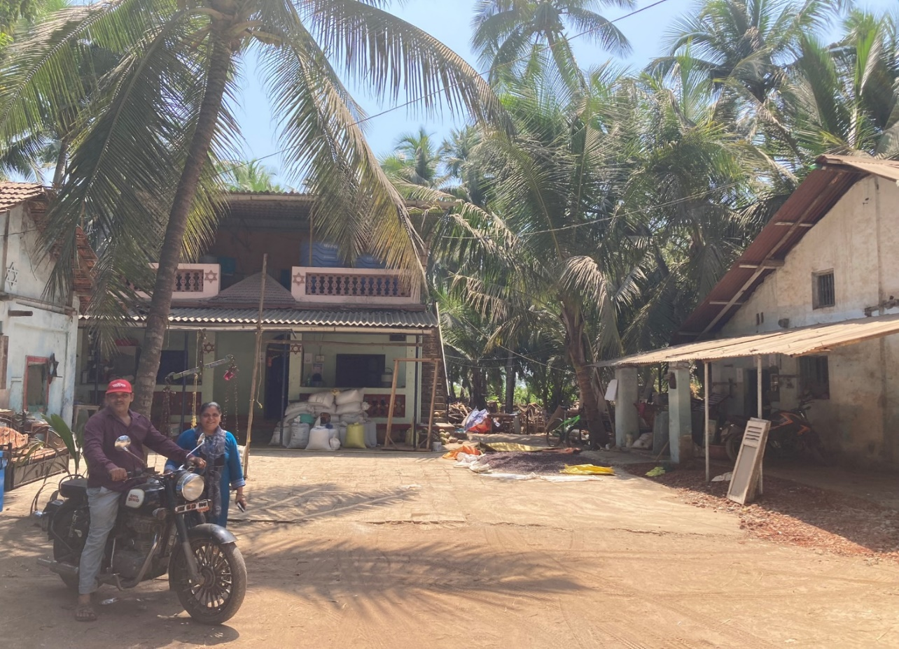 The Shoshanna and Benjamin Waskar Family Home, Therwanda Village, 2022
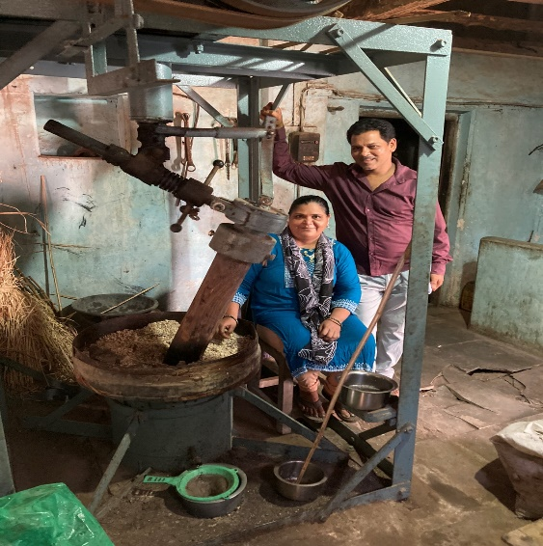
Binyamin (Benjamin) David Waskar, lives with his wife Shoshanna and their three children (Aliza, Eyal and Israel) on a small farm with a coconut plantation, operates an old oil press which has been in his family for generations. Next door is his parents’ house. Binyamin cannot tell for how long the oil press existed in the family but his grandfather vouched for the fact that his great-grandfather had already operated the oil press in his time.

The Waskar Family’s Old Oil Press, 2022

Nandgaon
Nandgaon is a village in Panvel Taluka, Raigad District. It is located at the Murud-Alibag Road with the Nandadevi Sidhi Vinayak Temple Temple of Nandadevi, from where the village drives its name Nandgaon. It’s about 4 kms from Panvel, 14 kms from Murad, 33 kms from State Capital Mumbai and 50 kms towards north from District Head Quarters Alibag.
The main street of Nandgaon, flanked by beautiful two-storied houses, leads to betel nut plantations next to the beach.
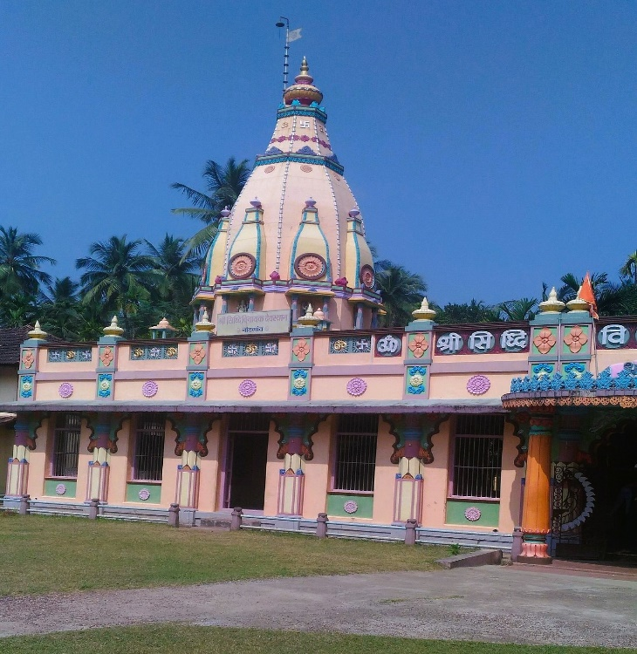
The Nandadevi Sidhi Vinayak Temple, Nandgaon

The 2 km long beach, protected by hillocks on its two ends, offers a serene atmosphere. Nandgaon is surrounded by Navi Mumbai Taluka, Uran Taluka towards west, Karjat Taluka and Khalapur Taluka towards east.
Nearby Cities to Nandgaon are: Panvel, Pen, Navi Mumbai, and Uran. Some nearby Villages to Nandgaon are: Palaspe (1 kms), Phata (1 kms), Kalundre (1 kms).

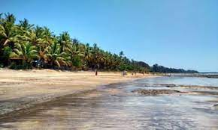
Nandgaon Beach

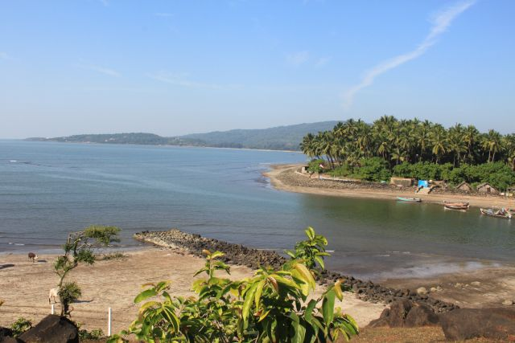 Nandgaon Beach

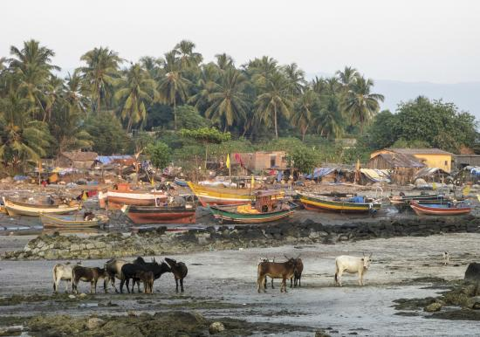

Nandgaon Fising Village

Once an agricultural village, it is now more engaged in business and private sector employment, while farming is done on household basis only. Paddy is a main crop grown here in the monsoon season. Most of the houses in the village are two or three storyed with plastic or metal roofs to rid the rainwater.

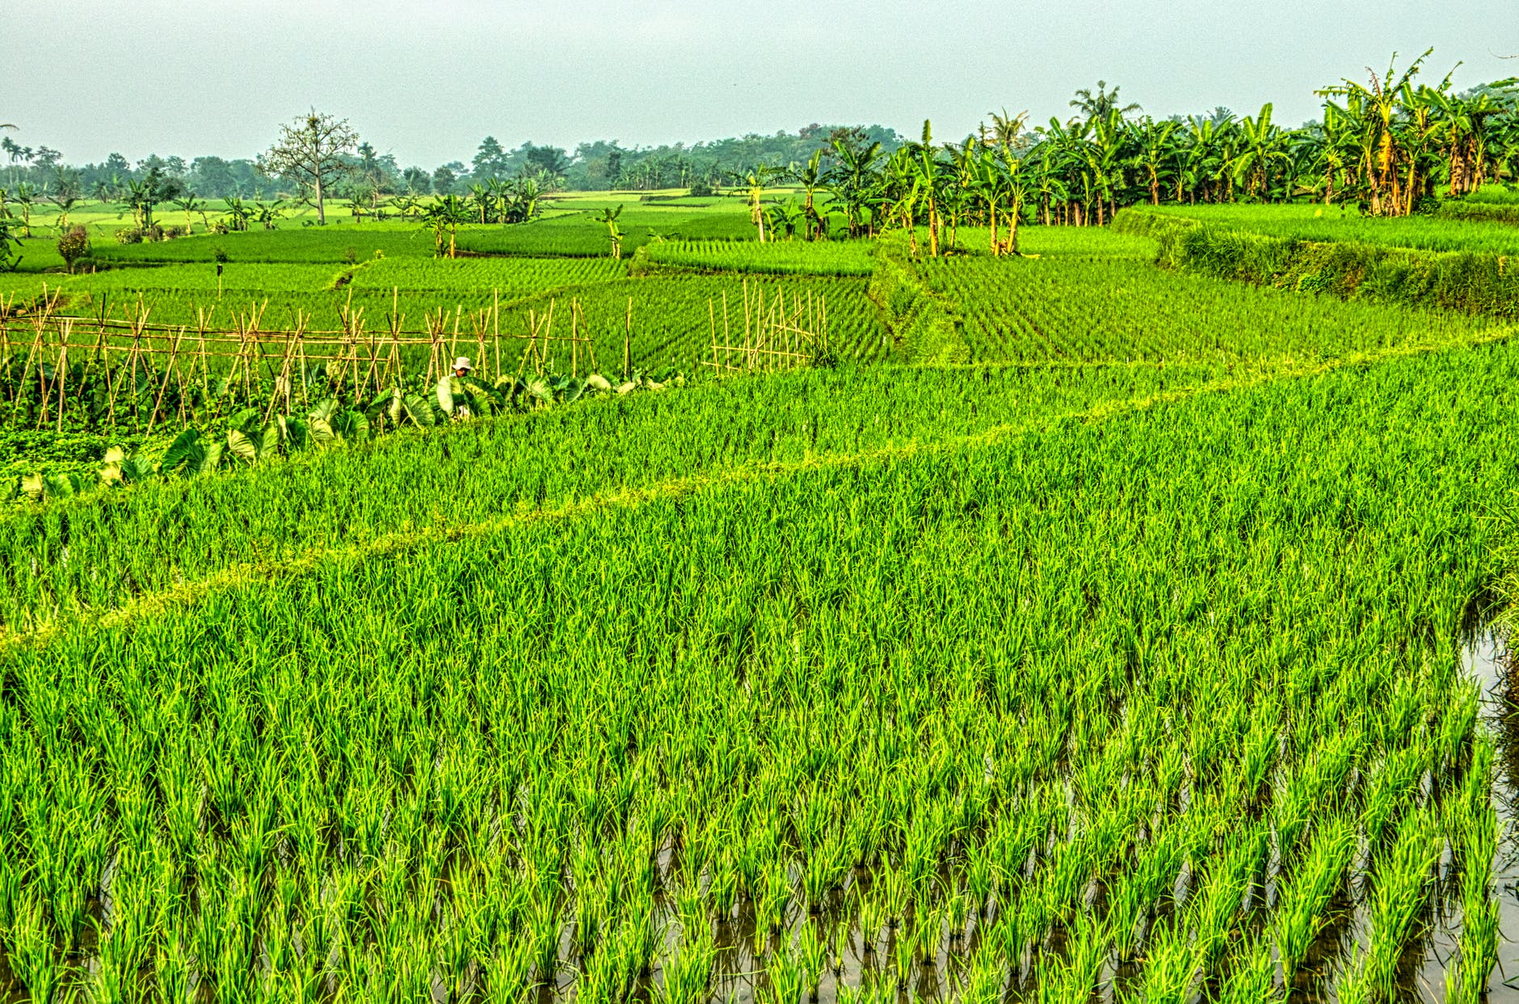 Rice Paddy Field

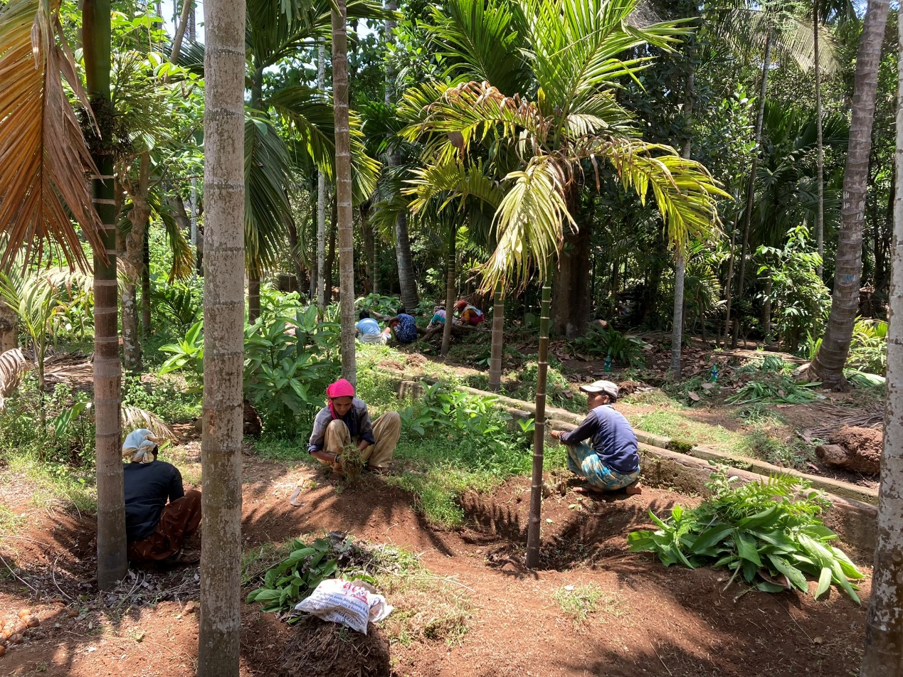
Nandgaon, Bene Israel Wadi (Farm) of Betel Nut and Coconut Plantations, 2022

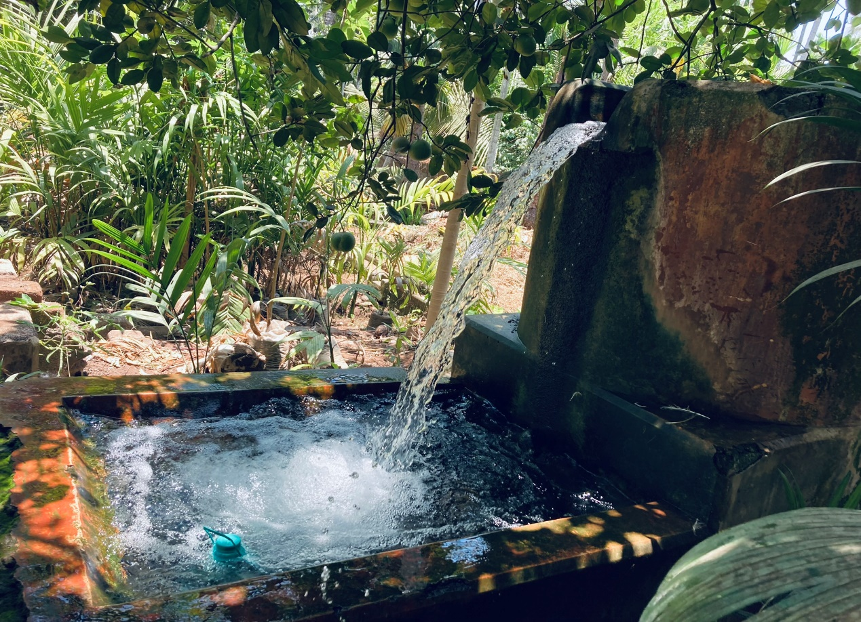
Farm Water System, Nandgaon, 2022

Or Le'Israel/Orle Israel (Light to Israel) Synagogue, Nandgaon

The Synagogue Or Le'Israel, situated on Zurul Peth (Lane), down the street from a large Hindu temple and across the street from what were once Jewish homes, is located in the Tehsil (Municipality) of Nandgoan Murad and represents one of almost twenty Bene Israel congregations that were organized in the Raigad District of the Konkan Region of coastal Maharashtra during the mid-to-late nineteenth century.

The Synagogue in Nandgaon was built in 1866 and rebuilt in 1945.
Another source mentions the establishment of the Synagogue in 1866 and adds that the nearby cemetery has about 50 old graves of which the names are not decipherable. Architect Waronkar mentions that Or Le’Israel was founded as a congregation in the 1870’s and was formally established as a Synagogue in the 1880’s. A few years later, in 1895, the congregation began the construction a new edifice for the Synagogue. Much of the cost was paid for by a community member, Havaldar Moses Malyankar.

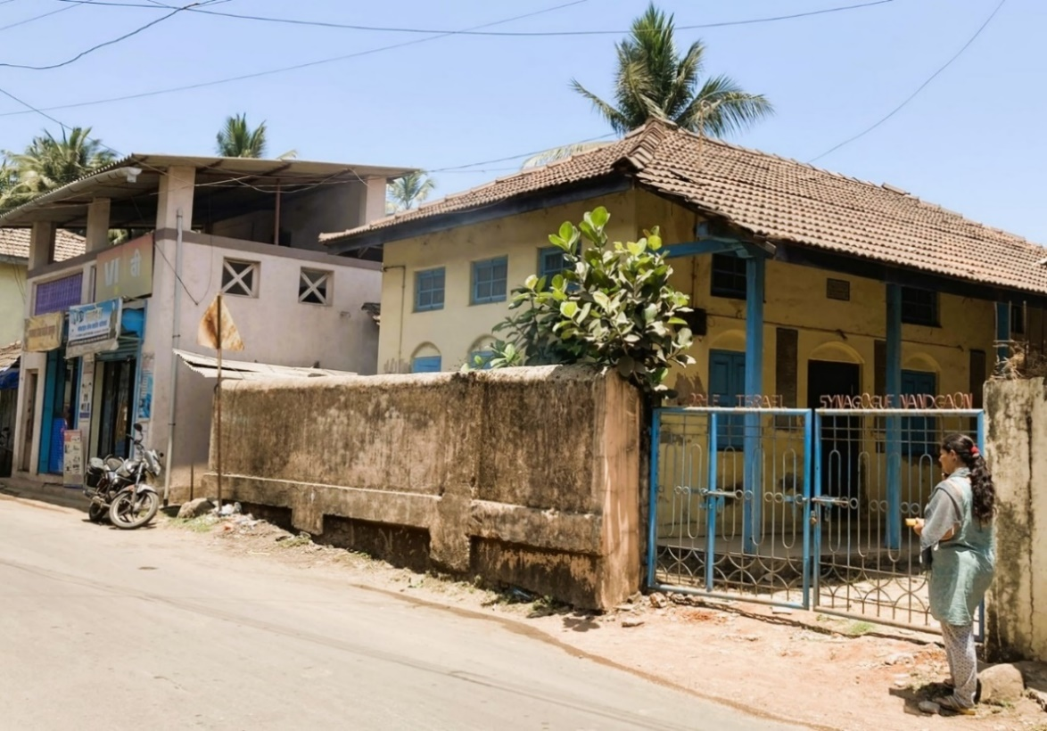
Or Le'Israel Synagogue on Zurul Peth (Lane), 2022
In 1945, the structure was replaced by a new and a larger one, covered by chunam-(polished lime) over a brick wall running along the village road. This solid fence encloses the Synagogue structure and has a wide painted iron gate that in recent decades replaced an earlier one. Decorating the top of the gate are the words: “ORLE ISRAEL SYNAGOGUE NANDGAON.”
The Synagogue is a small low structure constructed of simple structural brick veneered in painted chunam, which supports a hip gable roof framed in wood that is covered in clay roof tiles. A two-story covered porch, contained by a wooden balustrade, runs along the short (east) end of the edifice.
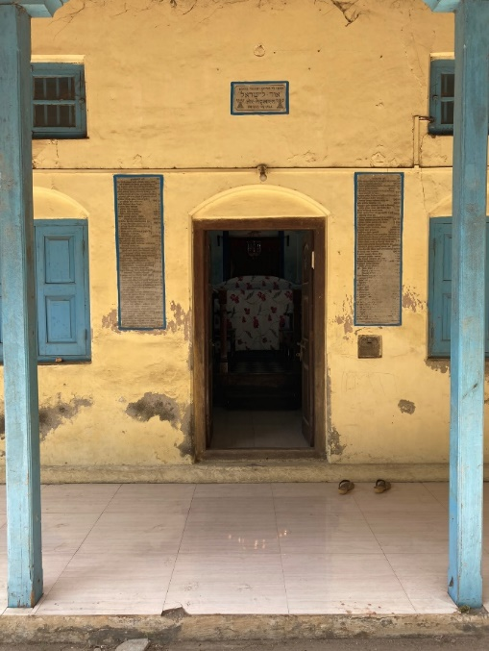
.

Or Le'Israel Synagogue’s Main Entrance, 2022
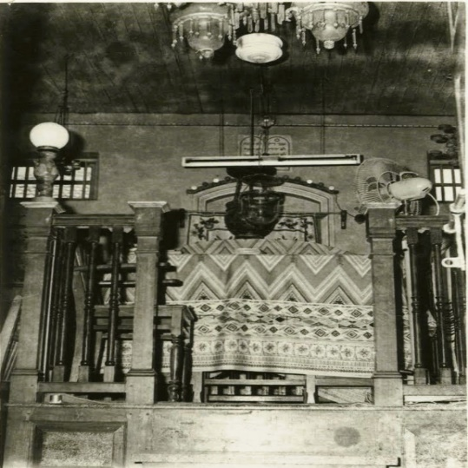
The doors of the porch open onto the sanctuary. Adjacent to the porch is a staircase leading up to the women’s gallery.
Or Le’ Israel’s other short elevation (at the west side of the building) contains an apse of the Heckal/Holy Ark.

Or Le'Israel Synagogue’s Tebah/Bimah, earl
\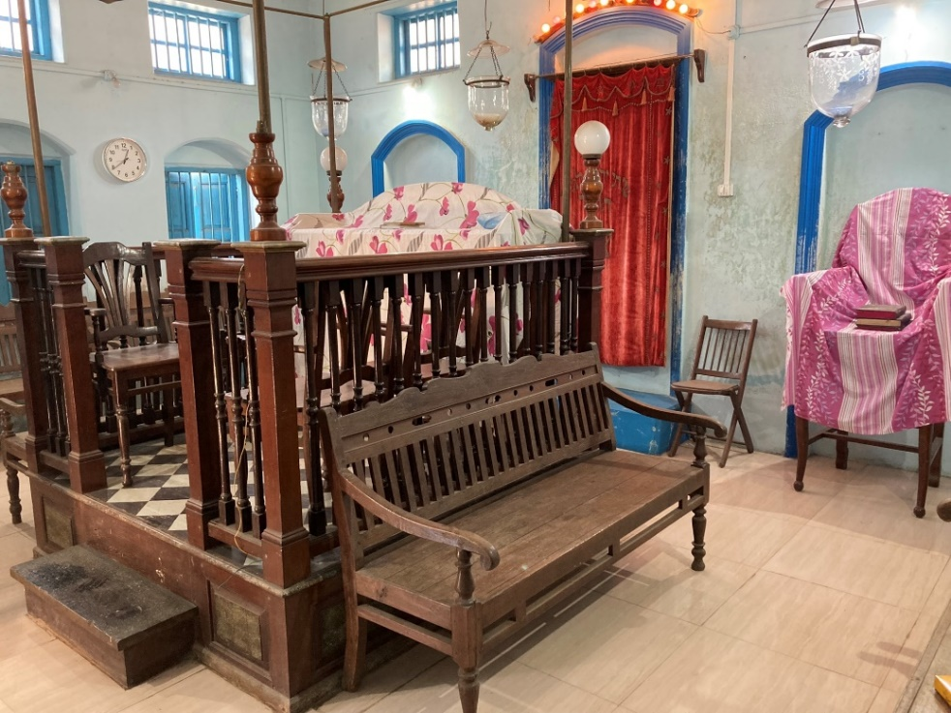 Or Le'Israel, Synagogue: The Heckal (at the rear), the Tebah (in front), 2022
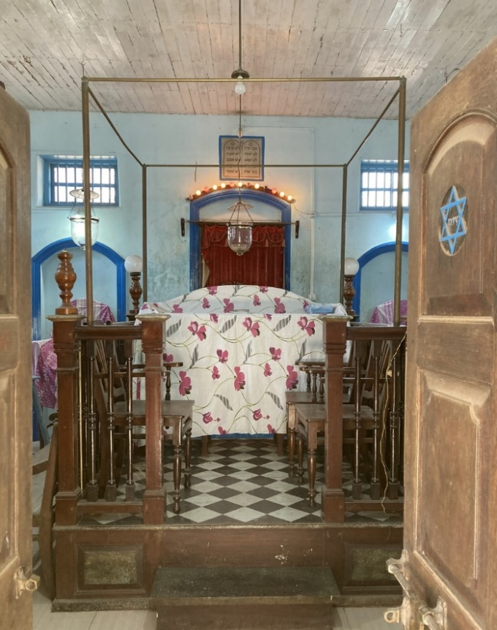 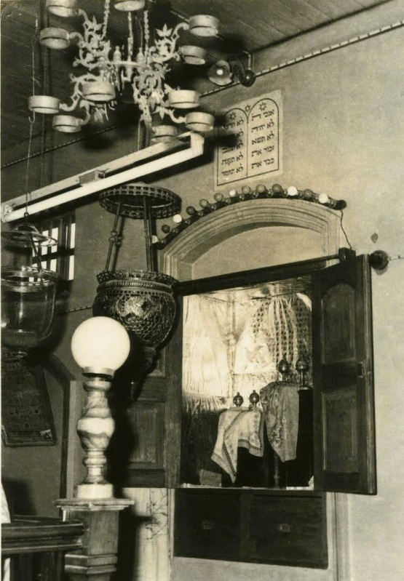Tebah at Or Le'Israel, Synagogue, 2022 The Heckal. Early 1960’s
Placed in the center of the western elevation that is closest to Jerusalem, as is traditional, the Heckal, as in many Synagogues, is raised off the floor by a few steps, is a wooden cabinet that is draped in the traditional curtain called the Parochet.

The Inland Route

Panvel

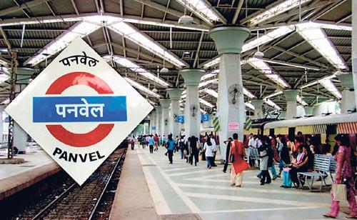
Panvel located on the Western Ghats, also known as Panwell by the British, is the chief town in the Panvel Taluka. It is just adjacent to Navi Mumbai and lies on a creek adjoining the Mumbai-Pune highway, about 28 kms east of Mumbai and 34 kms south-east of Thane by road. It is also said that old name of this city was Paneli (Panelim in Konkani). Panvel Railway Station

It probably rose to importance along with Bombay, as the direct route from Bombay to the Deccan lies through this town. Panvel is the largest and most populated city in Raigad District and is also known as the gateway of Konkan Region when entering in Raigad from east. The city is the headquarters of the Panvel Sub-Division of Raigad District, which is the largest in the District as per number of villages (564) and also Panvel Taluka which has 177 villages under it. Panvel is a fast-developing city of Raigad District which falls under Navi Mumbai Area.

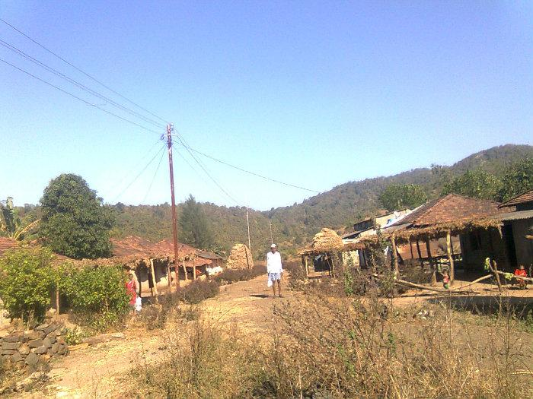
Rural area next to Panvel
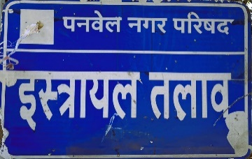
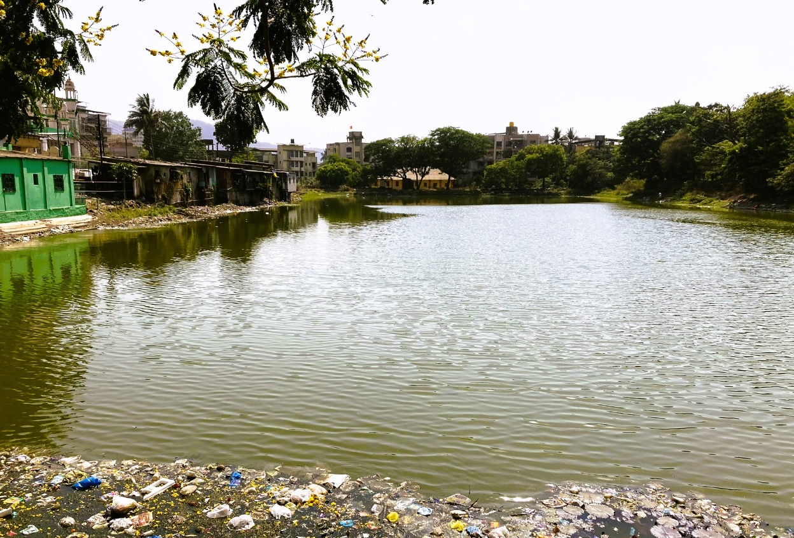 Israel Lake, Panvel, 2011
Historically, Panvel is approximately more than 300 years old and developed around trade routes (both land and sea) during the Mughal rule and hence after by the Portuguese, Marathas and the British. In 1570, Panvel is mentioned as a European trading port paying revenue to Gujarat. Panvel in its earlier days, was a small port handling Salt, Ganja etc. and once famous for its rice market. At the beginning of the 19th Panvel was described as a populous wooded village, prettily situated on the banks of the river, in a plain surrounded by high hills and distinguished by the handsome dome of a mosque. In 1862, Panvel was described as a populous town, for whose improvement provision had been made.
Panvel Municipal Council (PMC) was established in the early 1850's and is the oldest municipal council of Maharashtra. Panvel Municipal Council's elections started in 1910.
The recent development of Panvel are in New Panvel, which was initiated in the 1970's to meet the housing requirements of employees working in the nearby industrial MIDC (Maharashtra Industrial Development Corporation) areas.
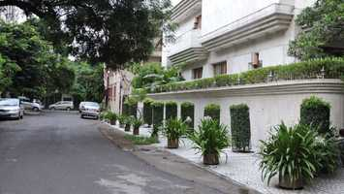 A Street in New Panvel, north of Old Panvel
New Panvel is strategically located on the eastern side of the Mumbai-Bangalore National Highway and the Mumbai-Pune Expressway. It is well connected to rest of India by road and railway and is divided in two parts: New Panvel East and New Panvel West (commonly known as Khanda Colony).

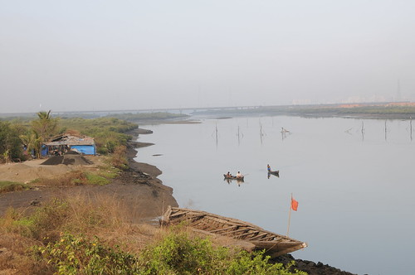Kalundre River, West and south of Old Panvel

Beth El (House of G-d) Synagogue, Panvel

Beth El is one of the oldest Bene Israel congregations in the Raigad District. The building is a modest structure located at the main square of the town. Prior to the erection of the Synagogue, congregation prayers were held in the house of Aaron Elijah Navgavkar. Later, David Sankar gave his house for the same purpose. Upon the arrival of Hacham Shellomo Salem Shurabi, it was decided to erect an edifice for a Synagogue, by raising subscriptions from its members. The land and grounds for the purpose were granted by Joseph David and the inauguration ceremony and dedication of the Synagogue was held on the 17th of May 1849, on which day the Jewish holiday of Shavuot (Pentecost)was also celebrated. a time when 250 families were living in and around the area of Panvel.
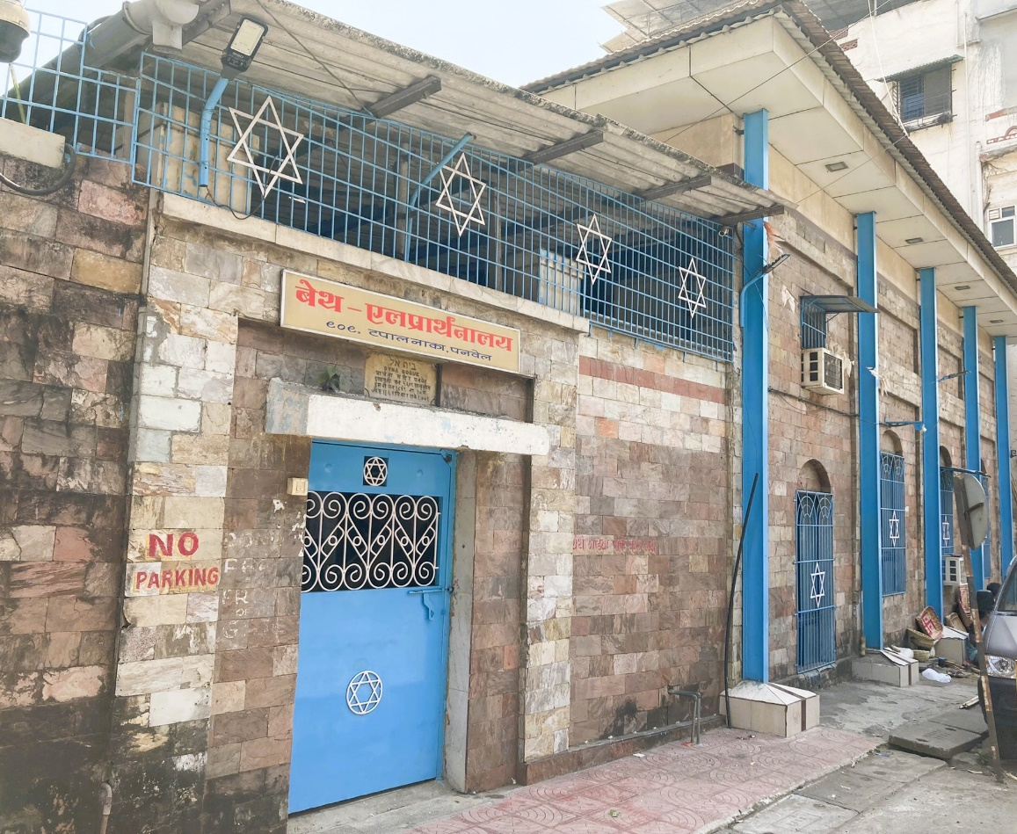 Panvel, Beth El (House of G-d) Synagogue, 2022
According to architect Waronker, a wall surrounds the Synagogue premises with bright blue metal doors and a ‘Star of David’ at the centre, allowing entry to an enclosed hall. Inside the gateway is a covered porch with fixed benches, running along the east end of the building. Adjacent to the property gate and in front of the building’s porch is an exterior staircase that leads up to a pair of doors providing access to the upper level. These doors open into a women’s gallery along the east elevation of the Synagogue.
Outside the Synagogue there are a number of rooms that help fulfill its needs and those of the community members: an office, a caretaker’s lodging, mikvah, kitchen, storerooms, meeting rooms and toilets.

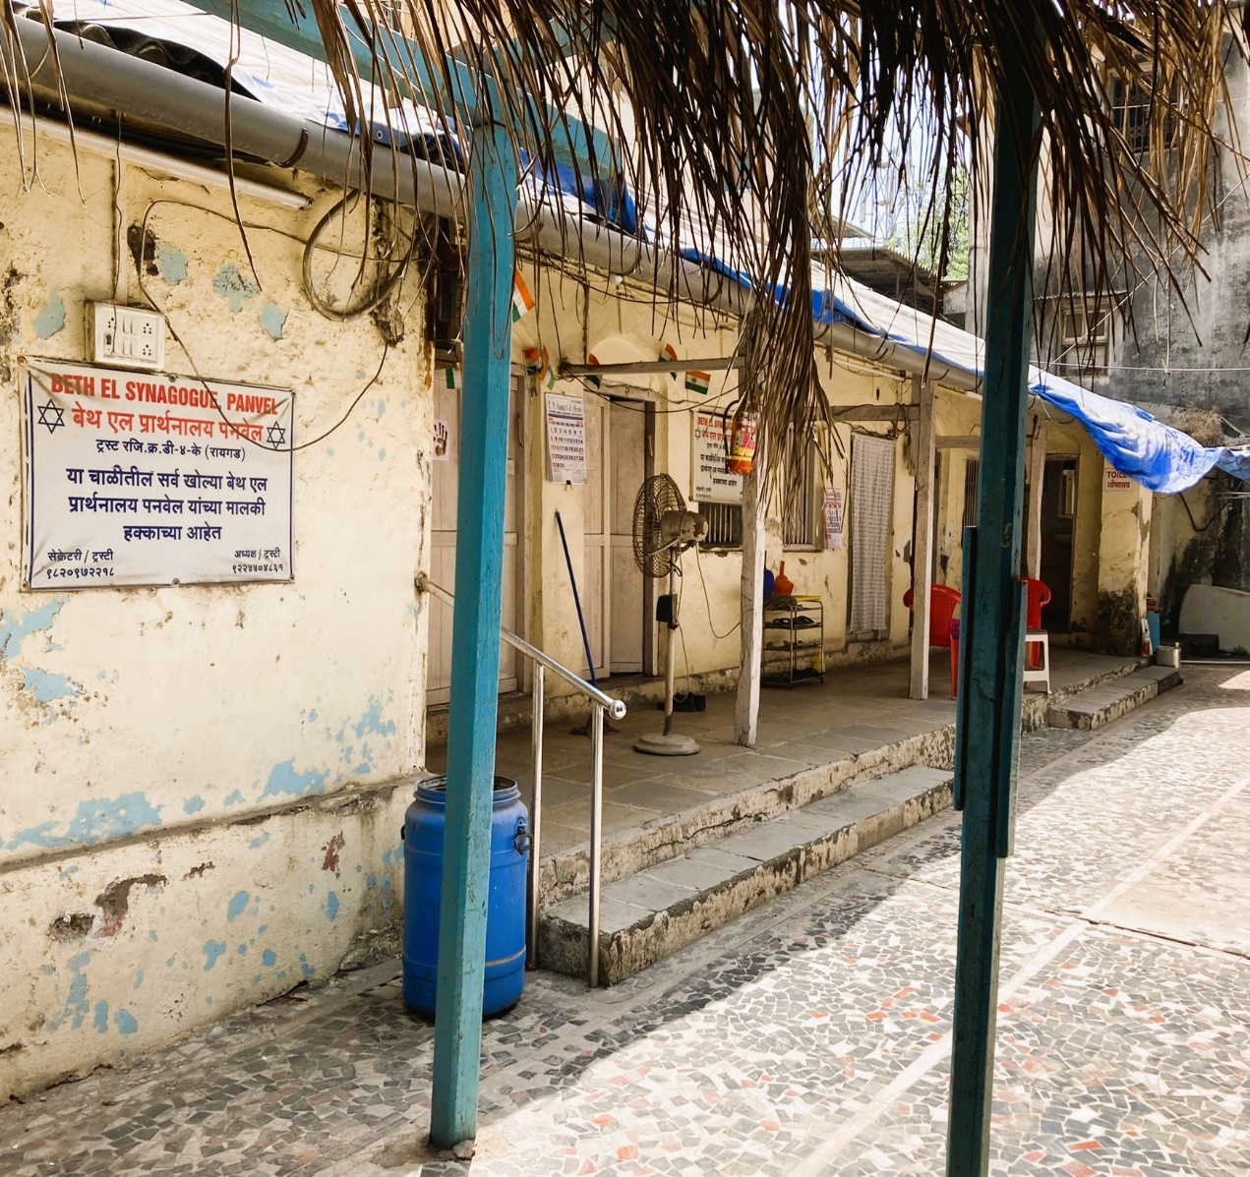
Beth El (House of G-d) Synagogue, rooms that help fulfill the needs of community members, 2022

Describing its architectural features, Waronker’s mentions: “In recent decades, the original architecture of Beth El, an archetypal nineteenth-century period building difficult to label stylistically, has been altered and compromised. It was originally constructed of brick veneered in painted chunam walls and now the walls are completely veneered in textured stone tiles…The hip roof is covered by flat clay tiles that replace similar ones. Along all sides of the building were once pilasters, a plain entablature, and bands of trim surrounding the windows and clerestories.”

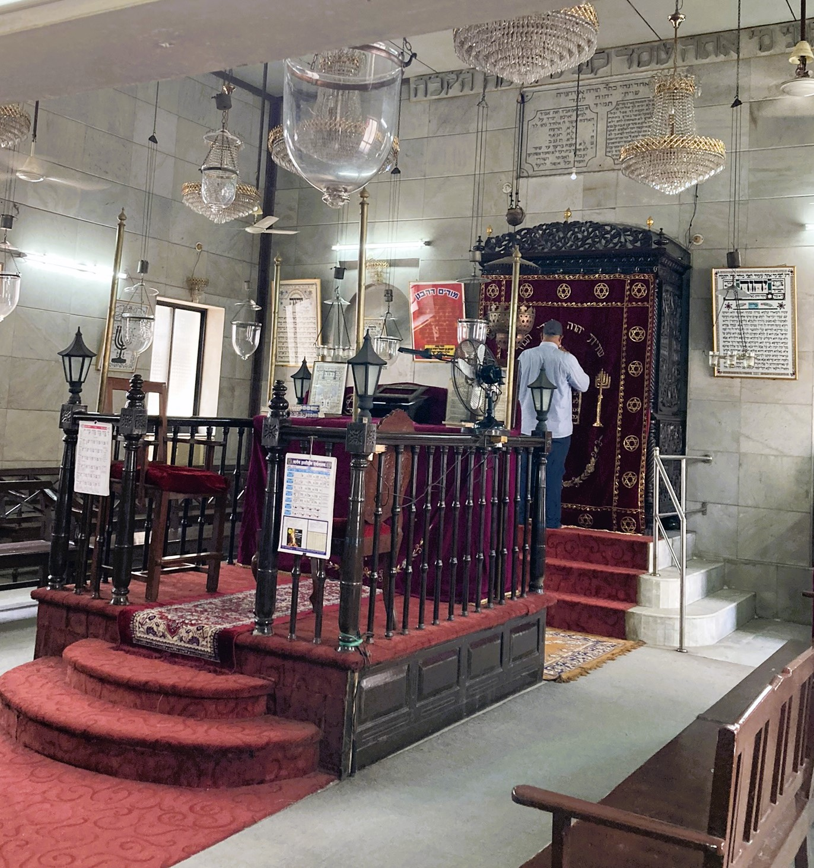 Beth El Synagogue Main Hall, facing the Tebah and the Hekhal, 2022

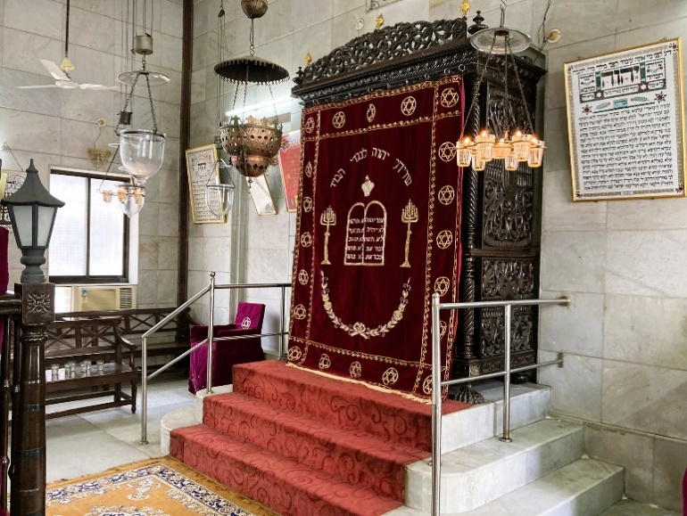
Relating to the interior of the Synagogue, Waronker points out that the sanctuary is rectangular and its original Tevah is located in the middle. The Hekhal is located on the west wall, both are carved from beautiful local rosewood. The Hekhal, which houses the Torah scrolls, stands upon a 3-step staircase due to its deep religious significance. Beth El Synagogue, the Hekhal, 2022

In the architect’s words: “Beth El’s sanctuary features include light-gray floor pavers that once also ran along the walls as a wainscot. This wainscot and the white chunam walls were altered in recent years, and today the walls are veneered in gray marble tiles. Along the walls of the sanctuary are sconces, large casement aluminum windows, transoms of stained glass, and clerestory casement units…The flat painted wood ceiling with applied trim and a Star of David was likewise replaced in recent years by white Masonite panels, constituting another significant alteration the synagogue’s nineteenth-century architecture. Still hanging from the ceiling, however, are fans, glass lanterns, and brass and other metal lighting fixtures.

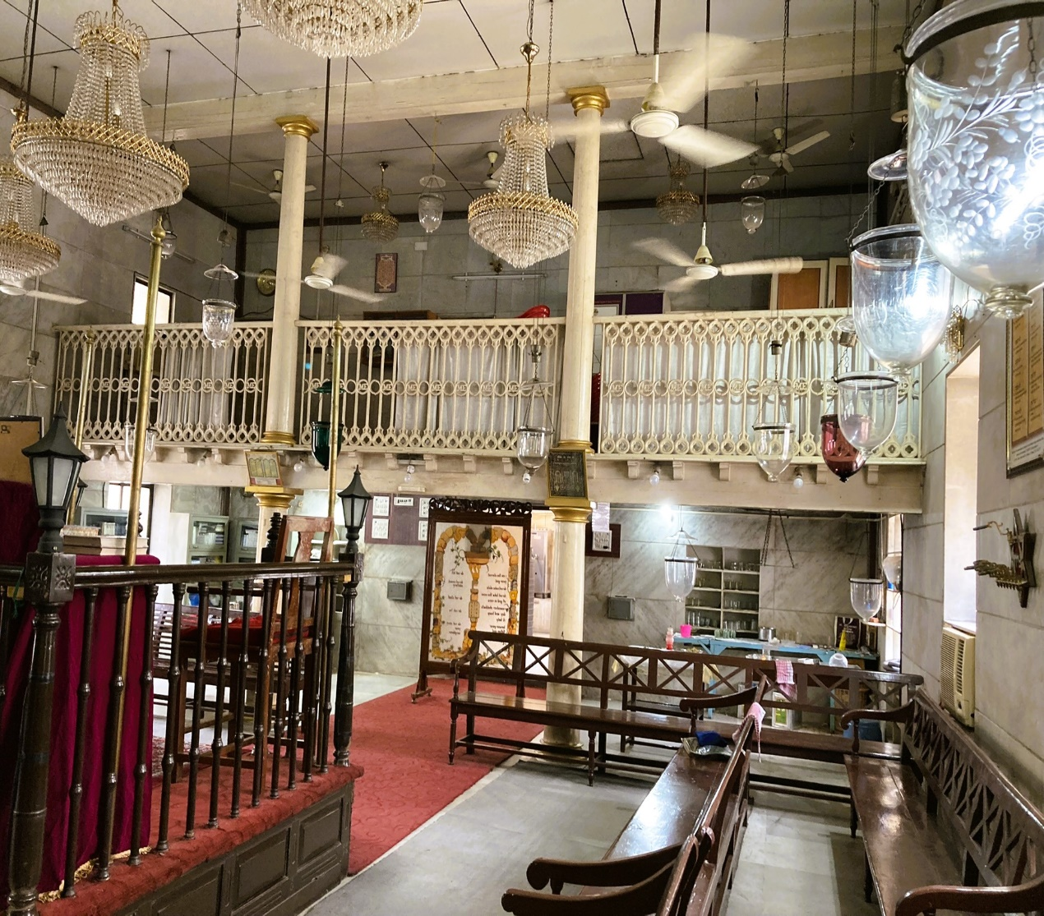 Beth El Synagogue’s Main Hall, facing the entrance and the Women’s Gallery

Other architectural and liturgical design features include the old freestanding wood benches positioned around the sanctuary, some red carpeting, and a pair of draped chairs adjacent to the hekhal, used for the circumcision ceremony, one of them dedicated to Elijah. Today the synagogue is airconditioned, which is unusual for a synagogue in India.”

Pen
Pen is a town and Taluka in the Raigad District and it is the geographical and the cultural centre of the District. Pen is bound on the north of the District by Panvel and Karjat in Thane, on the north-east corner it includes the minor division of Nagothna, on the east by Pone and the Pant Sachiv’s territory, on the south by Roha, and on the west by Poynad and Alibag. In the north-west, near the mouth of the Amba River, Pen rises slowly from slimy mangrove swamps into lands about high-tide level bare and flat, and salt pans, partly, reclaimed as rice fields.
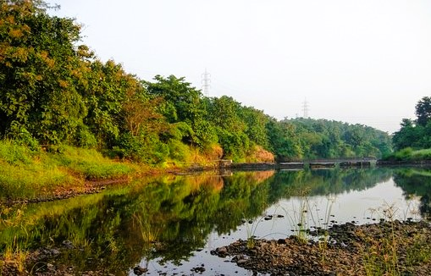Pen, located south-east from the mouth of the Amba River
In the north-east, there are many bare rocky spurs, and in the south, the country is rough with flat-topped hills well-wooded in places, but much of them given to cattle grazing and to the growth of hill grains. The chief river is the Amba. Besides, there are the Nigdi and the Vasi, and three nameless streams, all flowing into the Amba creek.
The name Pen is derived from the term Pene which means: A place to rest. Despite the fact that no one is certain about the origin of Pen, historians think it probably dates back to the times of Buddha (Circa 4th-5th century B.C.E). During the rule of the Marathas, Pen was known as ‘Sankchi’. The present name was given in 1866, after the advent of the British.
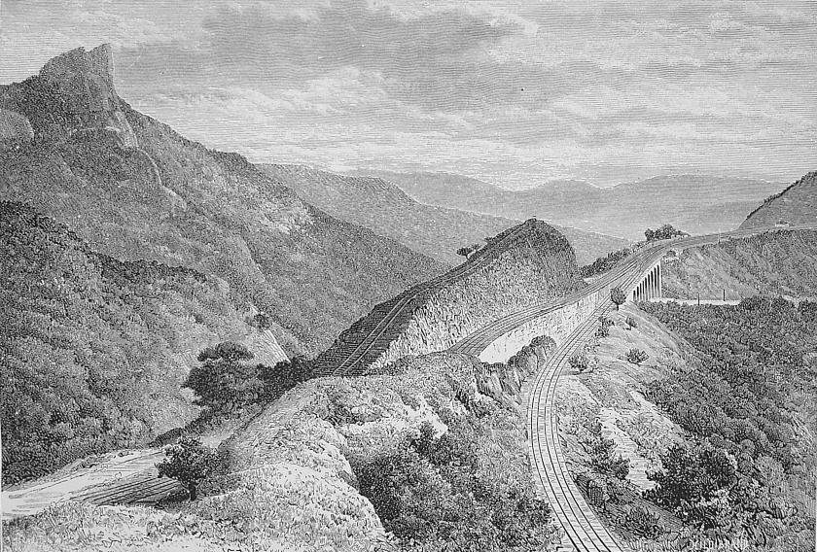
Bhor Ghat, Gradient of the Railway Near Khandala, 1884

In 1819 the easy communication with Bombay and the Deccan by the Bhor Ghat/Pass, turned Pen into an important centre of trade. Bhor Ghat is a mountain passage located between Palasdari and Khandala for railway, and between Khopoli and Khandala on the road route in Maharashtra, situated on the crest of the Western Ghats. The passage has been an important trade route since ancient times. The Ghat opened Mumbai to the Deccan plains of Peninsular India.
The Bhor Ghat is a mountain passage situated on the crest of the Western Ghats which connects Mumbai to Pune.

The passage has been an important trade route since ancient times. The discovery of a route to make a motorable pass in Bhor Ghat came after information was provided by local Dhangar tribesman called Shigroba. Later, the Great Indian Peninsula Railway laid a railway line from Mumbai to Pune. The section through Bhor Ghat with 28 tunnels, and old bridges was opened in 1863.

Pen is the geographical and cultural center of Raigad district. Geographically, Pen town is located on the outskirts of the Mumbai Metropolitan Region and lies on the bank of the Bhogavati Creek, about 15 kms from its mouth. Pen can be divided into two separate areas: Pen East, which is hilly and covered by the most part of it by a pristine jungle.


Pen West, which is mostly flat and a densely populated area, surrounded by small creeks. Much of it is known as Kharland (hub of Salt production), acclaimed from sea by centuries old seawalls. Pen is known for Salt cultivation by the Aagri and Koli community. Salt is manufactured from sea brine, due to unique geological features of Western Pen County (Vashi Subdivision), which has been the hub of salt making industry for centuries.

Salt Pans in the area of Pen, 2022

The chief prosperity of Pen lay in its salt beds, besides a considerable export of rice which was shipped to Bombay. Pen is also famous for its world class Ganesh idol industry and its wooden toys as well.
Later, in the second half of the 19th century, its Municipality was established in 1865.
Formerly, Pen had a serious problem with its supply of water. Almost all the wells and ponds ran dry during the hot season, a situation that demanded to be solved.

A short while later, the Sanitary Commissioner's Report for 1876 mentions that Pen was formerly badly supplied with water; almost all the wells and ponds ran dry during the hot season. About three-quarters of a mile to the east of the town a small stream runs through a valley which is sufficiently high to deliver water in the town under pressure. The area of this valley is about 100 acres, and it is calculated that, with an average yearly rainfall of 110 inches, 120,000,000 gallons could be stored for the use of the town in one season. The works consist of an earthen dam built across the mouth of the valley about 500 feet long, and forty feet at its greatest height.

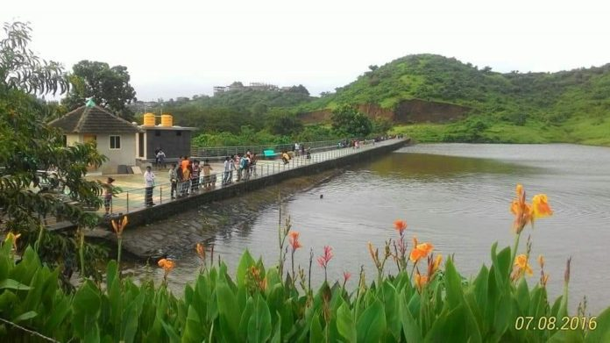Motiram Lake- Pen. Photos, Loveleen Kaur

Two reservoirs were constructed at the entrance to the town on the main road; The Sir Cawasji Jahangir and the Kesvaram Motiram Lake, on the name of a rich grain merchant of Pen. Over the outlet there is a tablet with the inscription:
“The Kesav Motiram Reservoir is named after a Marvari merchant of Pen who bequeathed Rs. 12,000 for the Pen water-supply. This dam was commenced 2nd January 1876, and finished 1st June 1876 by Arthur Crawford, Collector; W. Gray, C. E., Engineer; and Nagu Purbhaji Contractor.
The reservoir is also known as the Crawford Tank. No major repairs were carried out to the Pen Water Works in recent years. Wells supplement the tap water and during summer the supply falls short.

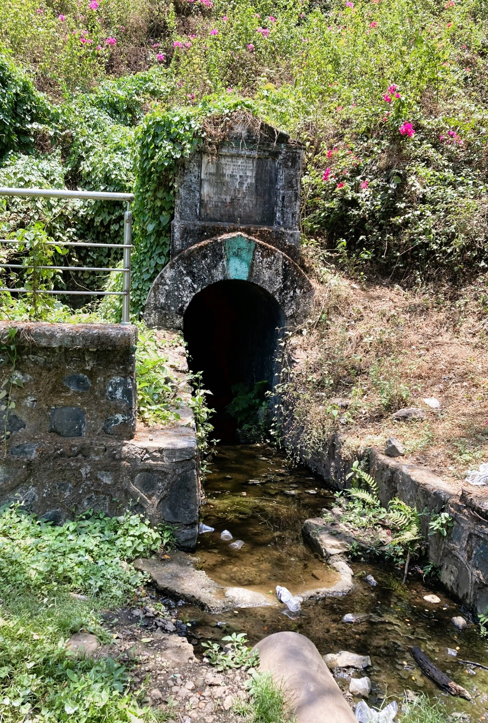 The Commemorating Plaque at the Motiram Lake, Pen, District, Raigad, 2022
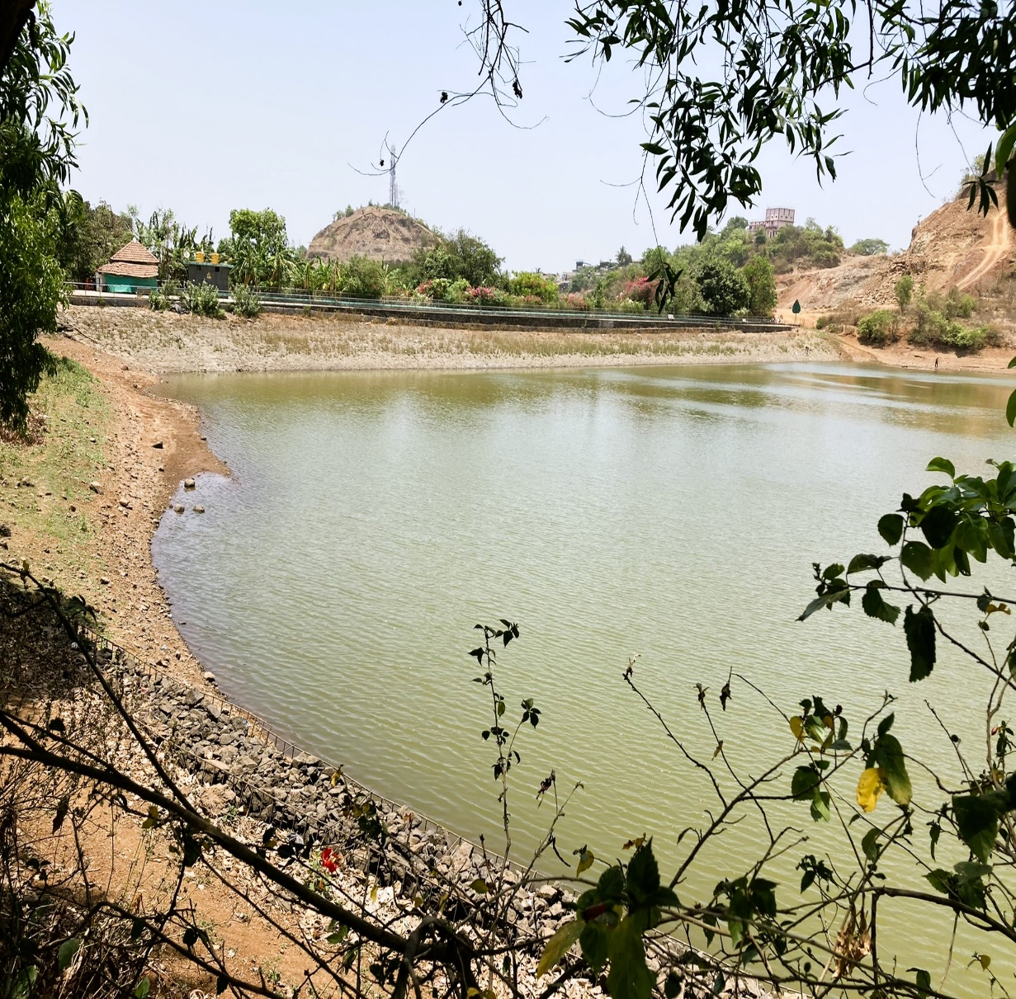Motiram Lake, Pen, District, Raigad, 2022

Traditionally, Pen was populated by Brahmins and a merchant's community, as it was a centre of culture, education and trade.
Today, Pen has become a pleasant amalgam of diverse castes and religions, co-existing peacefully, side by side. Pen has a small Bene Israel community with a Synagogue named Beth-Ha-Elohim.
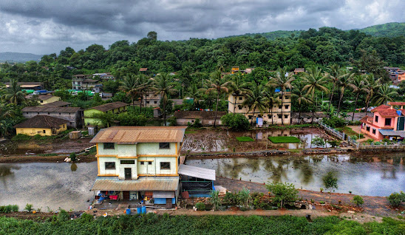
Dwellings in Pen Town, Raigad

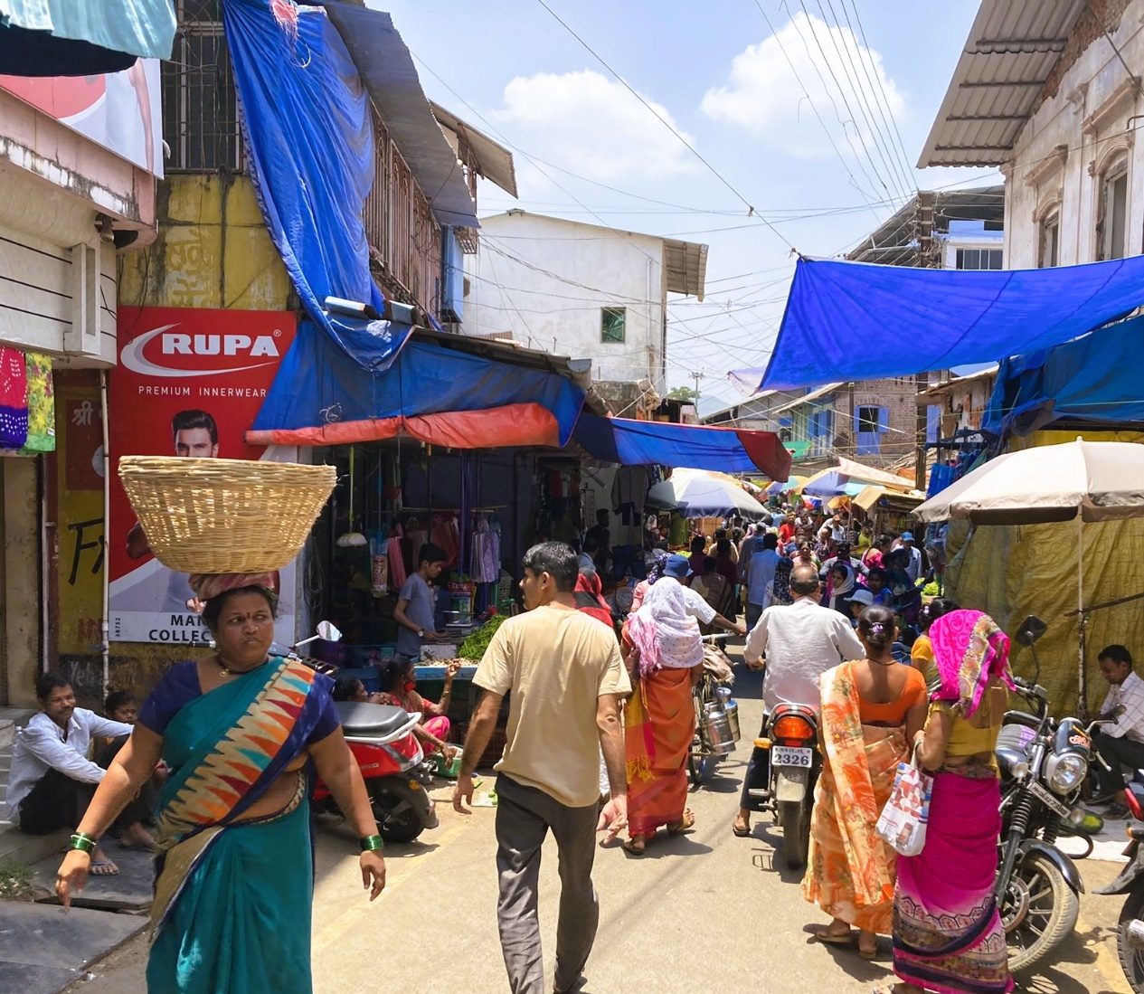
Pen Market, Raigad, 2022

Beth-Ha-Elohim (House of God) Synagogue, Pen

Prior to the building of the Synagogue, a Prayer Hall was opened in a private residence. A piece of land, located on Israel Lane, (opposite Saifee Stores, Bazar Peth
today), was presented to the community by Sutkiel/Santkel Benjamin Kandelkar, for the erection of an edifice for a Synagogue, which was erected at the sole expense of Mrs. Hannahbai Hyam David Diverkar.

Galsurkar mentions that the edifice was built by using funds donated by Mrs. Divekar, with other members of the community contributing construction materials; the brothers Hashkel Aaron Penkar and Solomon Aaron Penkar supplied cement, whilst Aaron Reuben Pezarkar donated 21 wooden benches.

Finally, the Synagogue was built and dedicated on the 1st of the Hebrew month of Elul, 5623- 1863. In the course of time, the needs of a growing community were met by building a more accommodating edifice for a new Synagogue which was built from funding raised by the Pen community. The dedication of the new Synagogue took place on the 9th of March 1893.
Approximately 50-60 families lived in Pen at the time, dwindling to 3 in 2011.

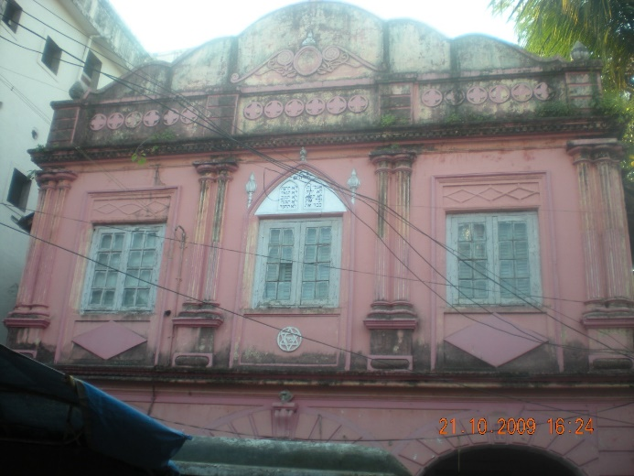
Beth-Ha-Elohim (House of God) Synagogue, Pen
Concerning the exterior of the building, architect Waronker reports:
“A stone with a metal gate decorated with Stars of David, not original to the Synagogue, fronts the synagogue property, and it provides access to an intimate space directly in front of the building…The transition from the crowded and noisy street life to the calm and less cluttered space within the gate is dramatic and memorable. This apace has for years served as a gathering area just before and after prayer services. It has also been used for holiday celebrations. The façade of Beth Ha-Elohim, fancier than most regional Bene Israel synagogues, is an eclectic composition constructed of simple brick veneered in chunam that has been painted various color schemes over the years.

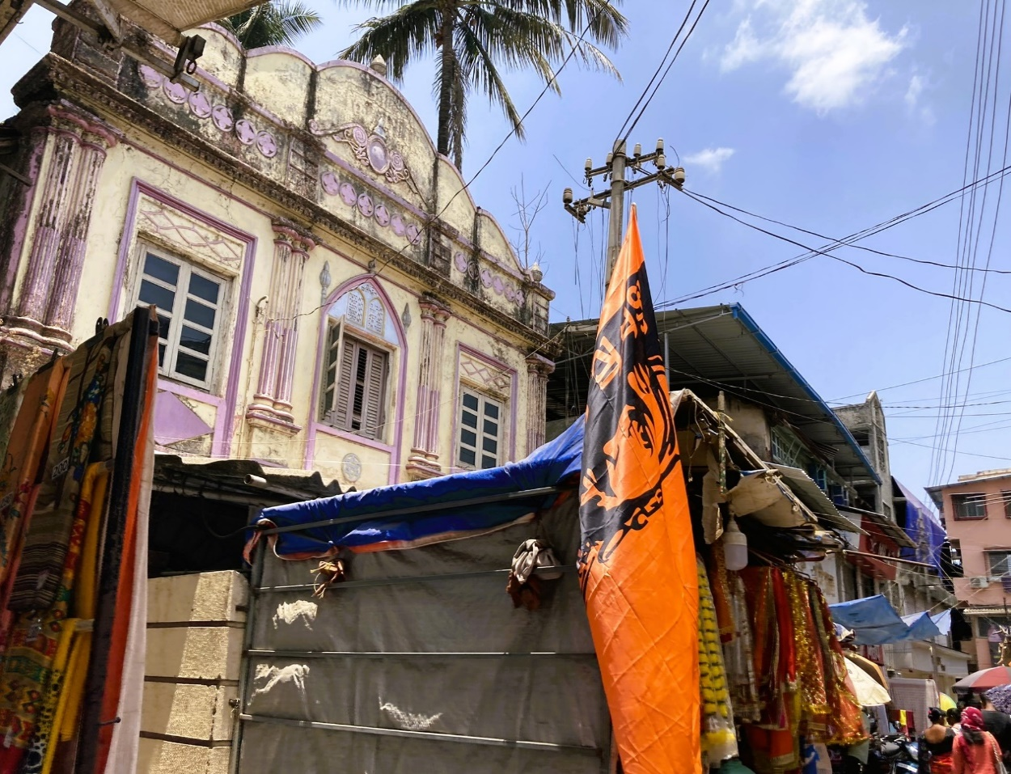
The façade of Beth-Ha-Elohim Synagogue from the Market Street, 2022

The façade includes stylized European elements paired groupings of pilasters set on plinths, windows encased in heavy trim and a roof parapet with a repetitive quatrefoil pattern crowned by a curvilinear, broadly Baroque-Revival flourished capped by acorns…Alongside these European-influenced features is an Indian one:’guldastra’ (stem-like) elements flanking the facade’s central window. The rusticated base of the façade of Beth Ha-Elohim, with three arched openings flanked by pilasters, serves as a porch, and from here a stair[case] leads up to the women’s gallery and doors open to the sanctuary.

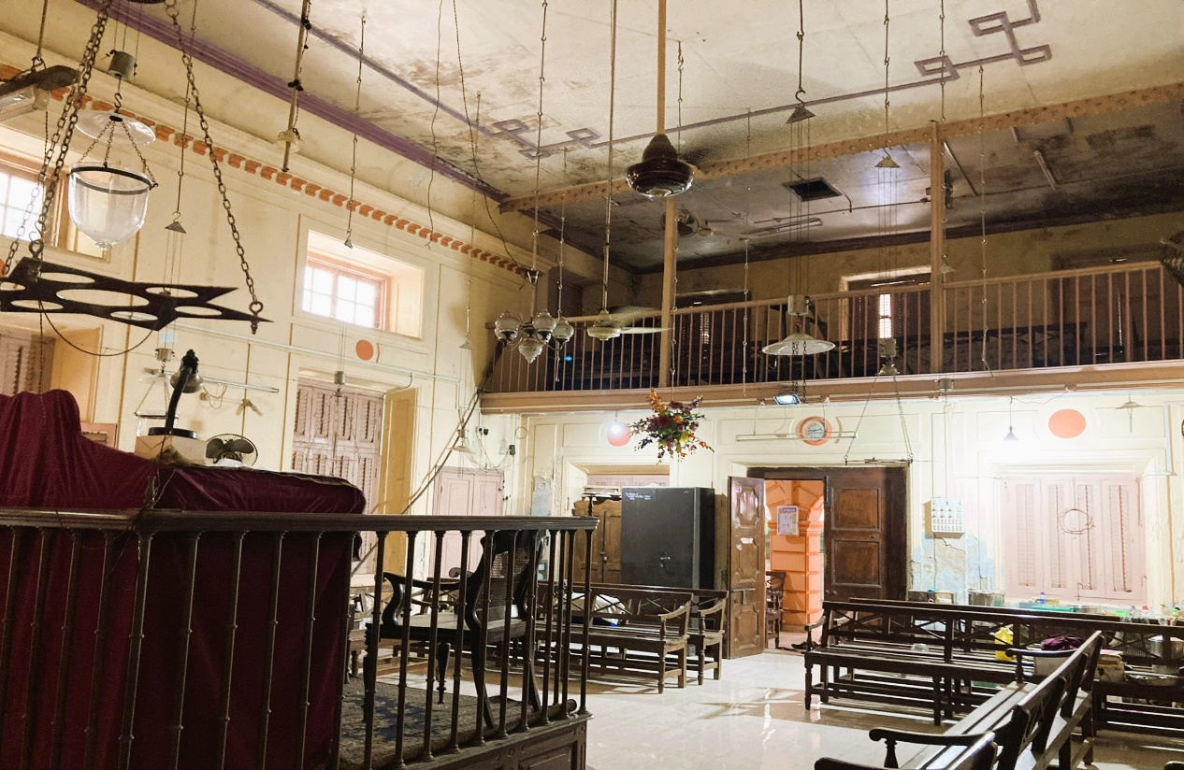
Beth-Ha-Elohim Synagogue Main Hall,
facing the Entrance and the Women’s Gallery, 2022

Regarding the interior of the Synagogue, Waronker describes: “The sanctuary followers the spatial plan of other Bene Israel synagogues. Each is a rectangular space with a centrally-positioned elevated ‘tebah’ and on the far wall...the ‘hekhal’.

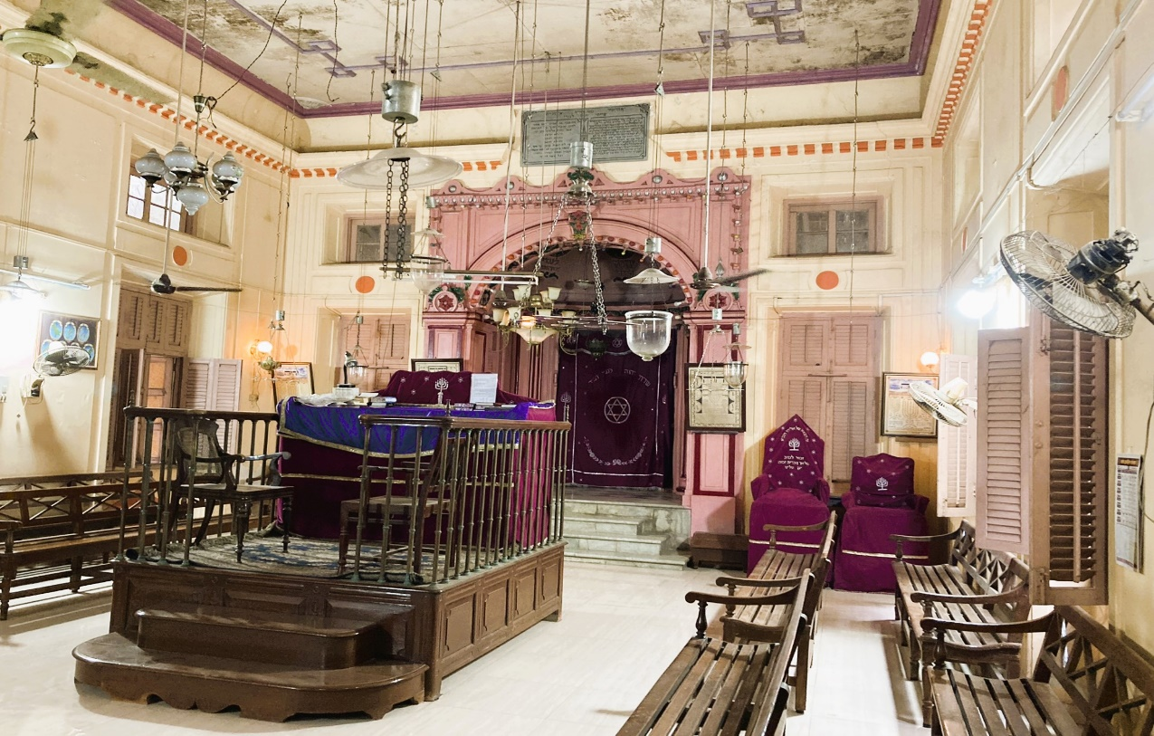
Beth-Ha-Elohim Synagogue Main Hall, facing the Tebah and on the Hekhal, 2022

The ‘tebah’ is constructed out of wood…Its design includes raised panels at its base, brass balusters, and a shaped handrail. Placed, as is traditional, in the center of the elevation closest to Jerusalem, which is the wall to the west, the wood ‘hekhal’ is painted and draped by a ‘parochet’…
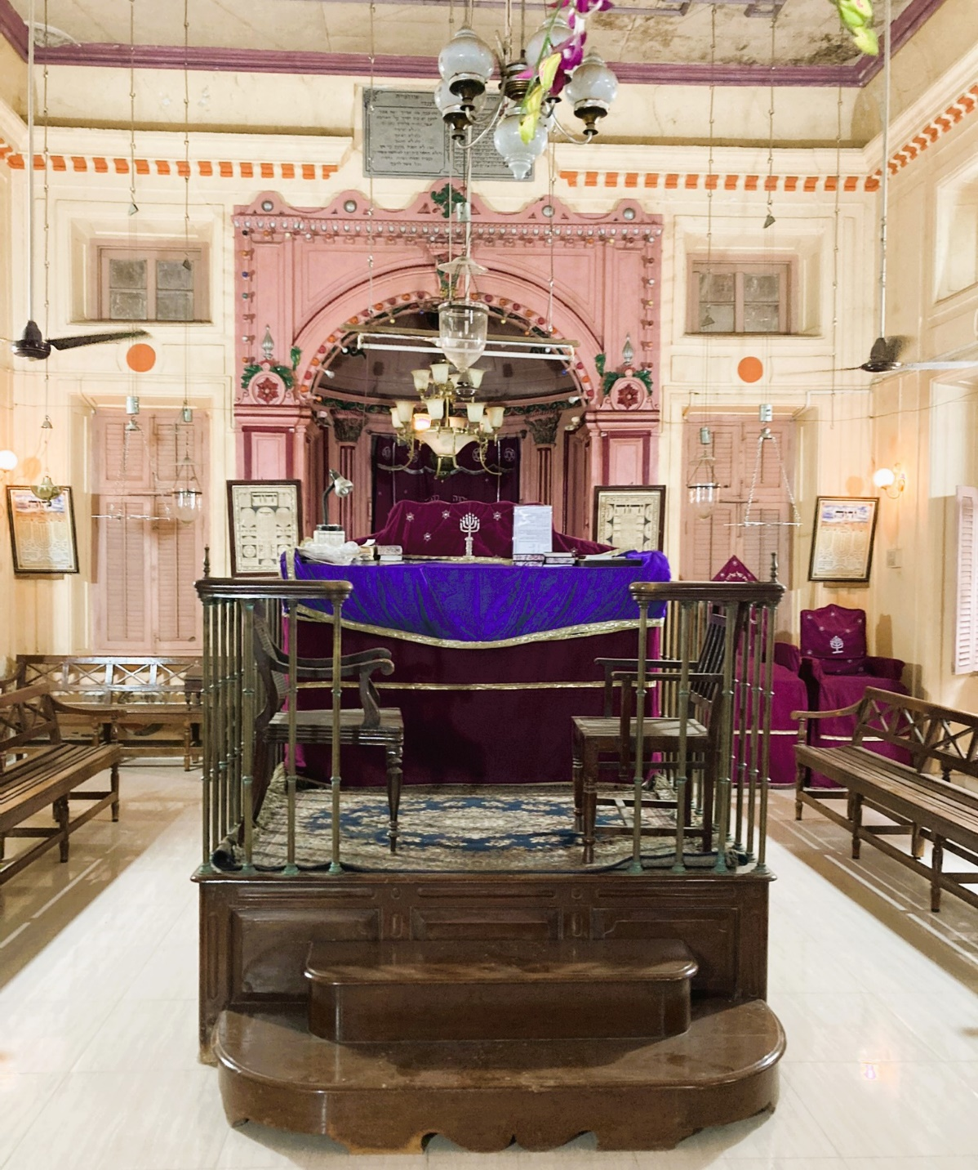
Beth-Ha-Elohim Synagogue Main Hall, facing the Tebah, 2022

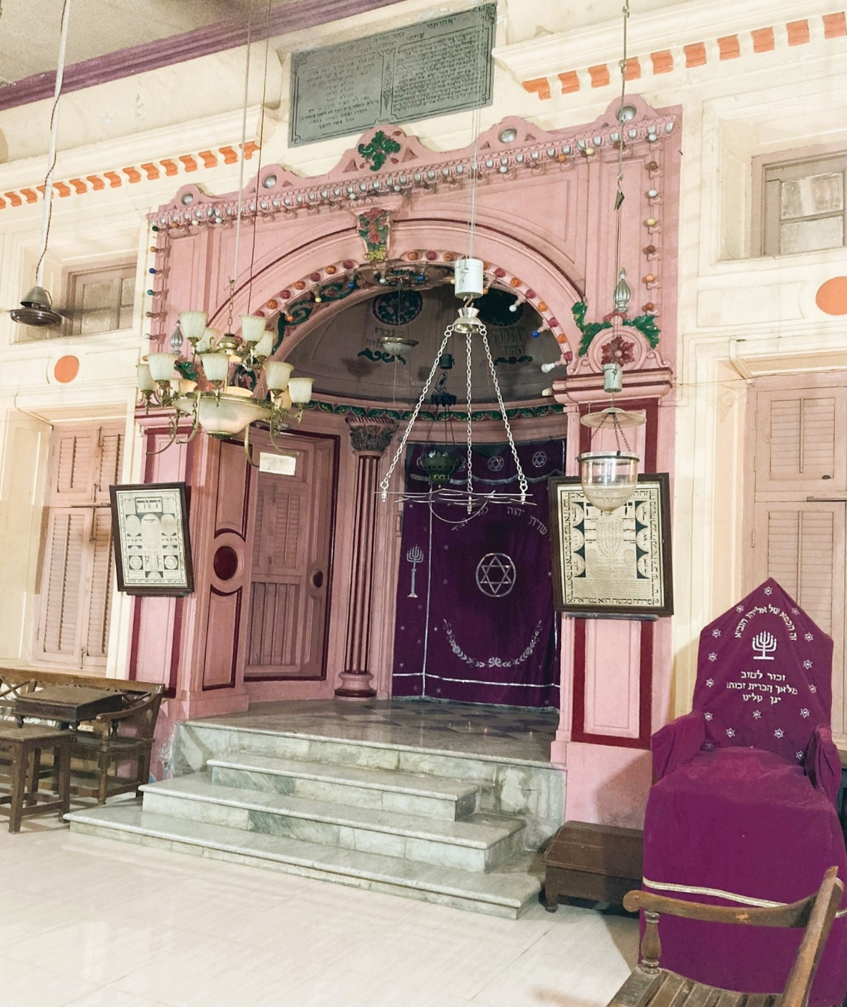
Beth-Ha-Elohim Synagogue Main Hall, Facing the Hekhal, 2022

The apse, containing two windows, is embellished with paneled wall surfaces, half-round fluted pilasters with foliated capitals…The pink half-domed ceiling of the niche is highlighted with floral medallions, Hebrew text in relief, and panels that frame the curved surfaces. The face of the ‘hekhal’ wall is decorated by an arched surround constructed of wood…and it features pilasters at the ends, Stars of David floral embellishments, a strip of small lights around its perimeter, and a crowning feature with an undulating pattern and a marble dedication panel above it.”

Dr. Irene Judah noticed (2012), a well on side of the Synagogue, near the entrance which she mentions was slightly different as compared to the other
Poynad

Poynad is a village Panchayat, located in the Raigad District and Mumbai is the State Capital for the village. It is located about 82 kms away from Mumbai. The surrounding nearby villages and Talukas from Poynad are: Tadwagale (5 kms), Varsoli (13 kms), Pen (14 km), Narangi (15 kms), Alibag (16.4 kms), Varande (27 kms), Revdanda (30).

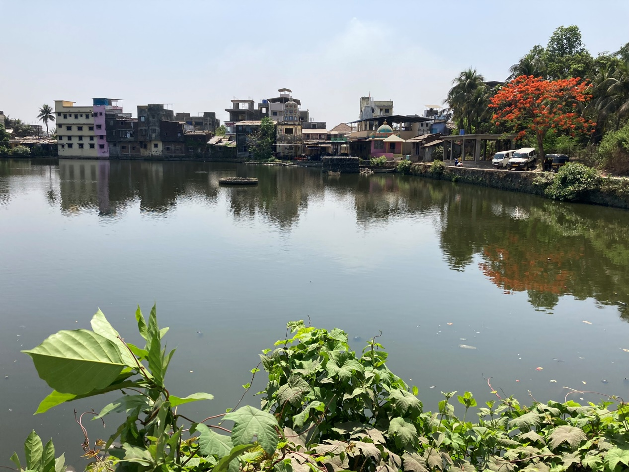
Poynad Village, 2022

Poynad's nearest town/city/ is Pen located at the distance of 12 kms. Alibag is about 16 kms, Uran, about 25 kms, Thane 71 kms. In 1883, it is mentioned that (…a market is held every Monday to which people come from the country around, some with merchandise and grain, and others to make purchases. The average attendance is about 200 sellers and 1,500 buyers. Water is scarce and on market days the few wells about the village are thronged night and day…It is a busy well-to-do village, with a population of 781, of whom, according to the1881 census, 710 were Hindus, 31 Beni-Israels, 15 Musalmans, and 25 others".

Poynad has a Synagogue called Hessed El (G-d's Mercy), located east from the Amber river.

Hessed El (G-d's Mercy) Synagogue, Poynad

Poynad Synagogue is mentioned by architect Waronker as “…the smallest and most intimately-scaled Bene Israel synagogue in all of India. According to Bene Israel community records, a first synagogue was built in the town in 1866, and the building was rebuilt some decades later [in 1893] through membership subscriptions. In 1933, the synagogue was given the name Hessed El.

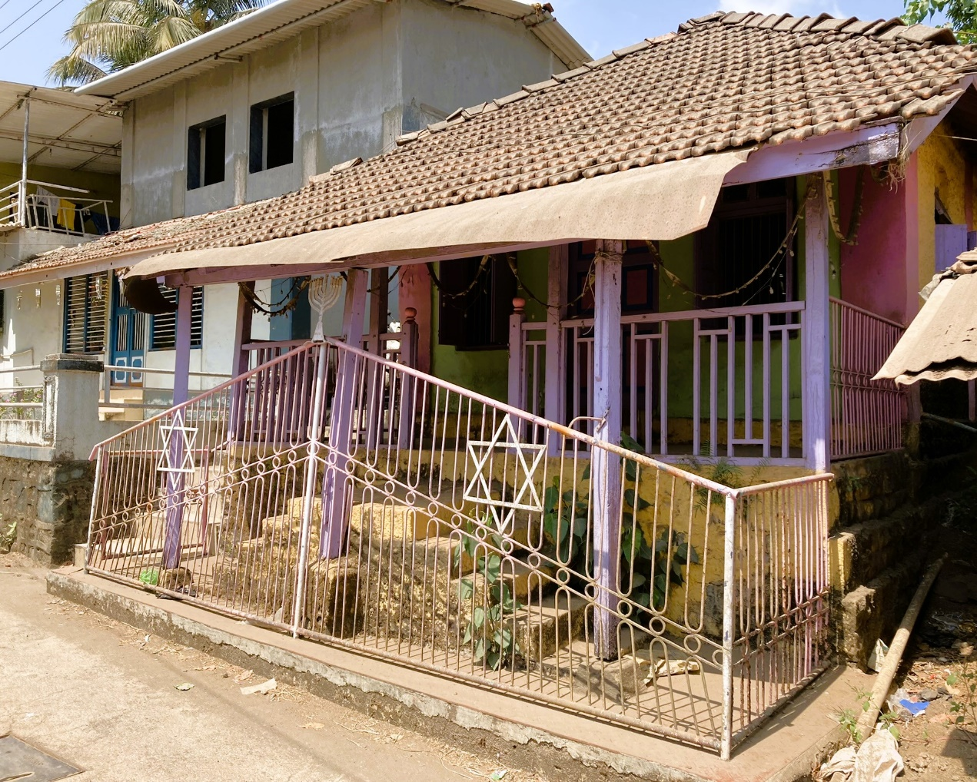
Hessed El Synagogue Exterior, Poynad, 2022

The major donation was contributed by Haeem Ezekiel Penkar from Bandra, Mumbai.
As to the exterior of this Synagogue Waroker mentions: “Hessed El is a particularly modest and low-slung single-story structure at the front. At the rear of the building, because of the sloped side, the synagogue appears even smaller in scale since its positioned a half level below the finished grade. Hessed El is constructed of simple brick veneered in rough-textured painted chunam walls that support a pitched roof framed in wood and covered in flat clay roof tiles…
the building’s modest architecture is in keeping with neighboring village and regional structures in scale, construction and materials. Most of them date to the late nineteenth and early centuries…
The porch and steps up to it are fronted by a painted metal fence, a more recent addition, that is decorated with two Stars of David. The symbol reveals that the building has a Jewish function.”

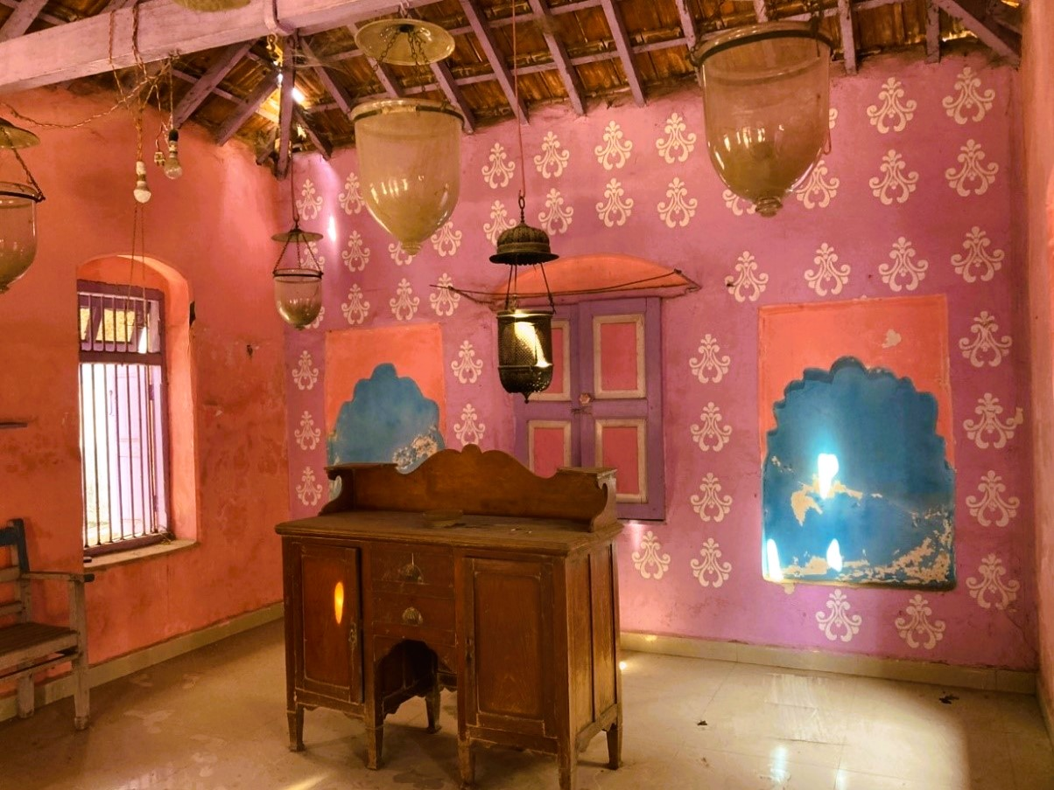Hessed El Synagogue Interior, Poynad, 2022

As to the interior of the Synagogue, Waronker adds: “The small rectangular sanctuary, measuring only 4.5m X 5.5m/ 14’ x17’, follows the plan other Bene Israel synagogues with a centrally-positioned tebah and at the far wall, the hekhal. The tebah is not a defined raised platform typical of most Bene Israel synagogues in India but a very small freestanding wood desk. Placed in the center of the west elevation that is closet to Jerusalem as per synagogue convention, the hekhalis a raised, wood-paneled cabinet, painted vibrant purple and blue. Hessed El’s interior features smooth composition floor pavers, which are replacements of the original textured stones tiles that were there for decades…Celling fans, glass lenterns, and lighting fixtures hang from Hessed El’s open ceiling, which provides volume to the small room through its exposed wood rafters and purlins.
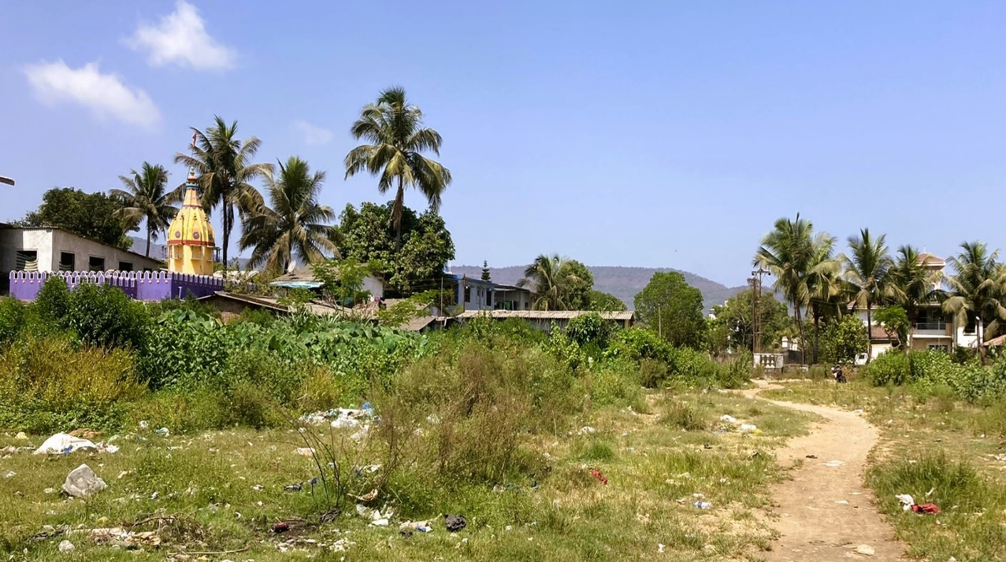
Poynad Village, Raigad District, 2022

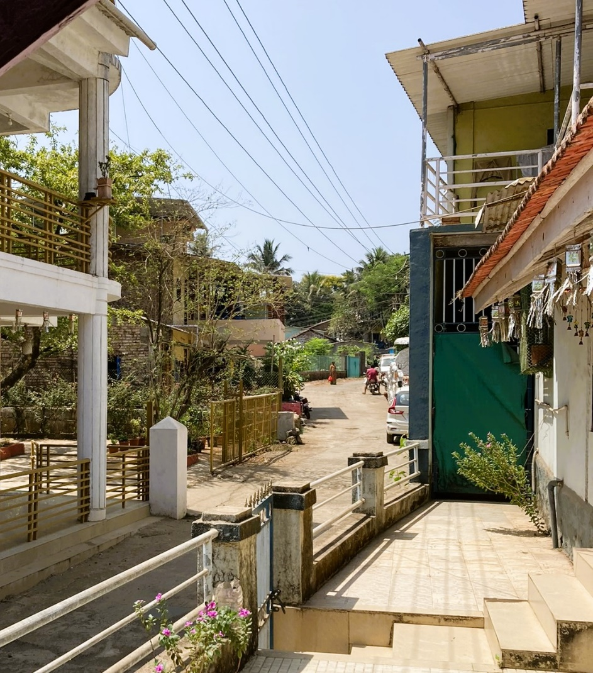

Poynad Village, Raigad District, houses adjacent to the Synagogue, 2022

Ambepur, Alibag Taluka, Raigad District, Konkan

Ambepur is a Village Panchayat in Alibag Taluka, Raigad District. It is located 15 kms towards East from District Head Quarters Alibag and 40 kms south, south-east from State capital Mumbai.
Some nearby Villages are: Poynad (2kms), Shrigaon (2.6 kms), Shahapur (6 kms) and Kusumbale (6 kms).
Ambepur is surrounded by Alibag Taluka towards west, Uran Taluka towards north, Pen Taluka and Sudhagad Taluka towards east.
Nearby Cities to Ambepur are: Mumbai, Pen, Nandgaon and Uran.

Ner Israel (Light of Israel) Synagogue, Ambepur

The Synagogue was built in 1874 at the partial expense of Joseph Solomon Sankar and partly by public subscription. It was rebuilt in 1884, but for lack of a congregation has remained closed for a few decades, the scrolls of The Law being kept in the Synagogue at Revdanda.

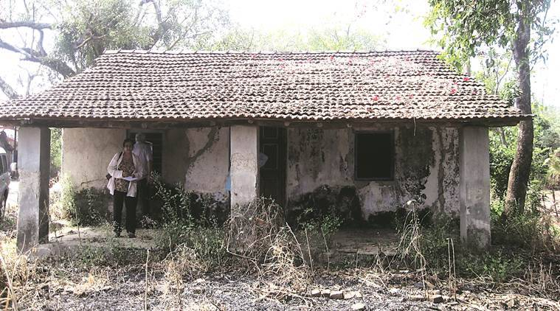
Ambepur Synagogue, photo by Garima Mishra

The exterior of Synagogue is classified and described by architect Waronker as: “The modest one-room, single story building, one of the smallest and simplest Indian synagogues…has the scale and appearance of a single-family residence.
It is a rectangular structure [measuring 25’m x 23’/7.5m x 7m] that is composed of structural brick veneered in buff-colored chunam. Atop the walls is a gable roof finished in flat clay tiles.
The roof has deep overhangs in response to the hot monsoon climate, and it covers a porch that runs along the long (east) end of the building…Wood-shuttered windows and a pair of wood doors allowed access, natural light, and ventilation into the former sanctuary from the porch.”

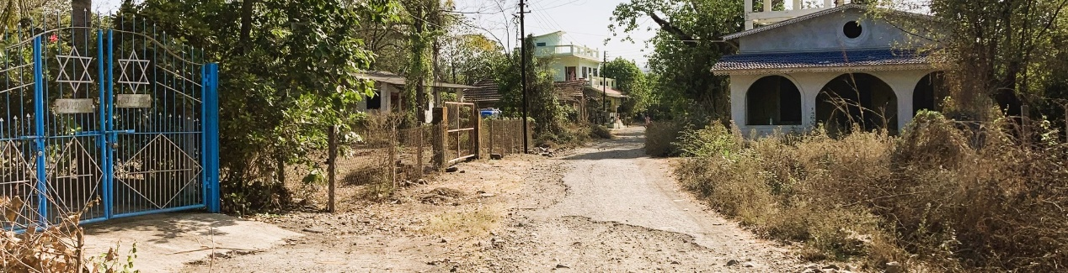
Ner Israel Synagogue, Ambepur, May, 2022

Relating to its past interior, Waronker mentions: “Hanging from the open ceiling were lighting fixtures, including glass dome, metal, and modern fluorescent tube lights…the space was similar to other Bene Israel synagogues, featuring a centrally-positioned tebah that was constructed out of local wood and painted. The hekhal was the focal point of the rectangular synagogue. Placed in the center of the otherwise blank west wall oriented to Jerusalem as per synagogue convention, the hekhal’s wood cabinet was draped in a traditional parochet.
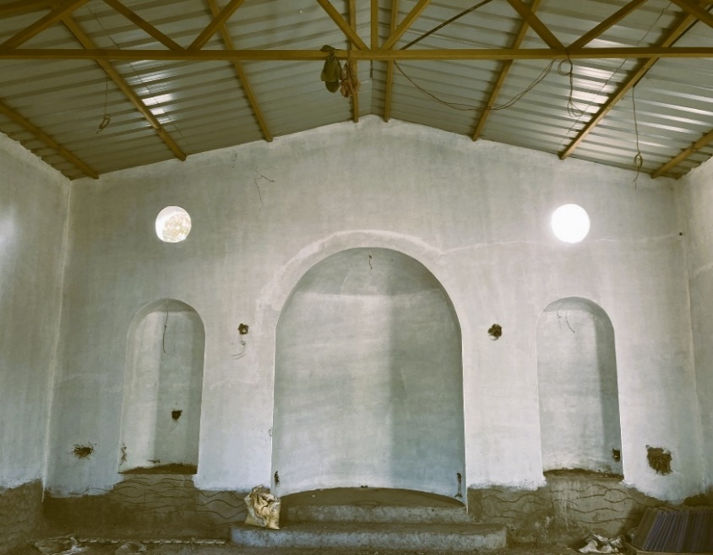
Flanking the hekhal were two special chairs both covered in cloths. One chair was dedicated to Elijah, and they were used for the brit mila…The synagogue remains as a relic of a bygone era when a Bene Israel congregation and their synagogue were an integral part of the make-up and community of Amber.”

Interior of the Ner Israel Synagogue, Ambepur, May, 2022
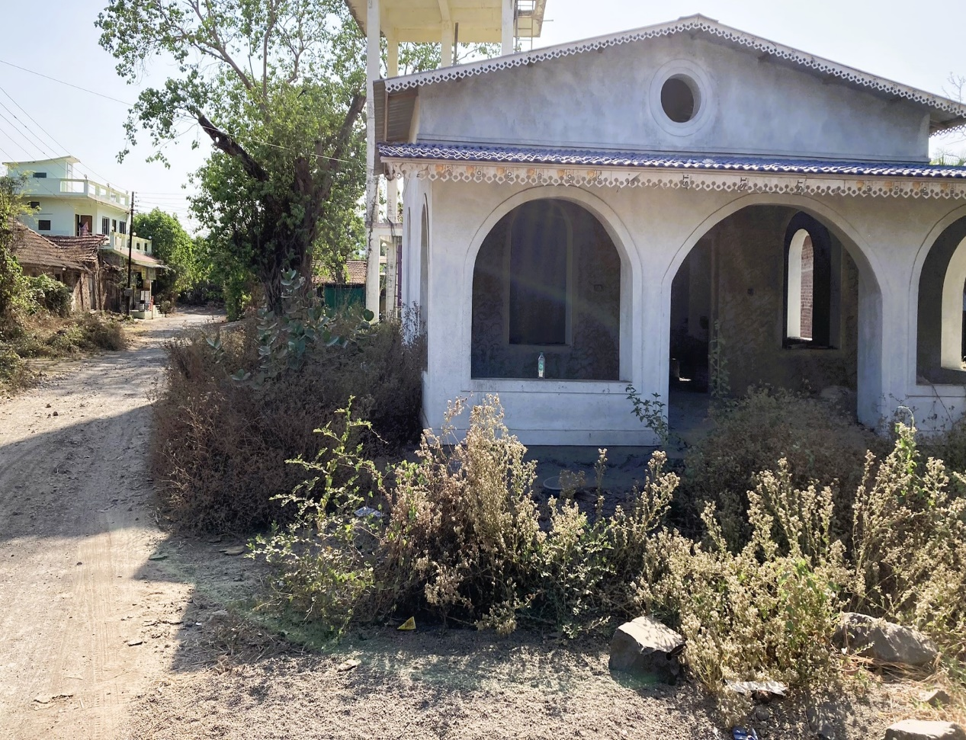
Exterior of the Ner Israel Synagogue, Ambepur, May, 2022

Recently, I received a note from my friend and colleague Nissim Moses, an Historian of the Indian Jewish Heritage and Bene Israel Genealogy, who visited the site of the Ner Israel Synagogue, Ambepur, a few years ago, mentioned in his post:
“Several Years ago, when the author [Nissim Moses] had visited the site, there were still to the Best of his recollection, hanging in the Synagogue several Lamp Bowls (called Handi), a few old benches, and a niche for the Heichal. But the Synagogue being abandoned due to population migration; at first to Bombay and then later to Israel; there remained a very sparse population of Bene Israel in the Konkan Region. Finally, even the secretary moved to Bombay. Though the keys to the synagogue were available at that time with a neighboring Bene Israel Family. There were not enough Bene Israel in the locality to maintain financially or operate the synagogue functions as per religious traditions and customs.”

Dr. Irene Judah says in her book that in 2010, a tree fell on the roof and completely destroyed it and Benjamin Waskar repaired it at his own expense.
Borlai /Borli/Borle
Borlai is a small village in Mangaon Taluka in the Raigad District. It comes under the Borlai Panchayath and belongs to the Konkan region and to the Konkan Division. It is situated 10 km away from the sub-district of Mangaon Headquarters, 80 km away south towards the District Headquarters of Alibag and 114 km from the state capital Mumbai.
Borlai is surrounded by Roha Taluka towards the North, Tala Taluka and Mhasala Taluka towards the west and Mahad Taluka towards the South. Nearby towns are Mahad, Roha, Ashtami and Mhasla and Nandgaon.
The total geographical area of Borlai village is 159 hectares, which had a total population of 288 peoples in 2019, out of which the male population is 129, while the female population is 159. Literacy in Borle is 70.83% out of which 80.62% males and 62.89% females are literate. There are about 85 houses in Borlai.
The village is administrated by a sarpanch who elect a representative to the district headquarters. As per 2019 stats, Borlai village comes under Shrivardhan assembly constituency & Raigad parliamentary constituency. Tourist places nearby Borlai include Koland, Lavasa, Murad Janjira, Shrivardhan. and a Bene Israel Synagogue, located in the centre of the village.
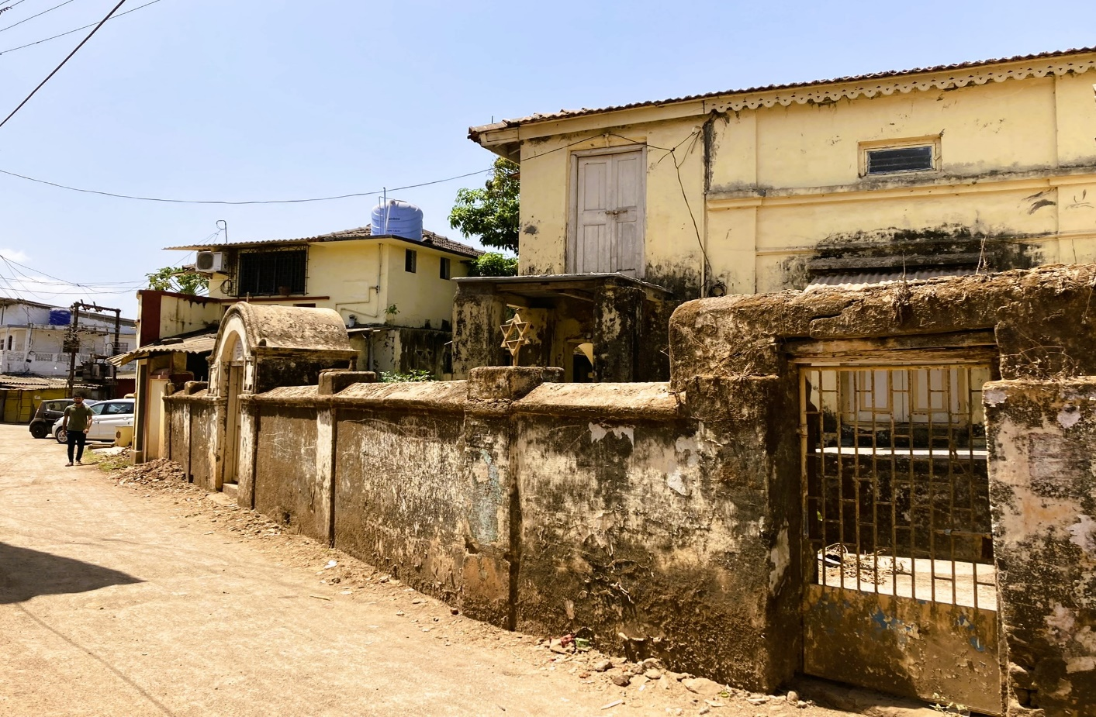
Shaarai Shaloam Synagogue, located in the Village, Centre, 2022
Shaarai Shaloam/Sha’are Shalom (Gates of Peace) Synagogue, Borlai

The street from the main road up to the Synagogue is called Israel Alley. Shaarai Shaloam, Synagogue, as the name appears on top of the gate entrance, was built in 1865 and was dedicated in May 1869. Like some of the Bene Israel communities in the Raigad District, in the second half of the 1800s, the Borlai congregation members also gathered for their religious and other social functions, within a Prayer Hall which was built a few years earlier. Community members, led by Shalom Isaac Sagoankar payed for constructing the Synagogue’s edifice. He also donated some land so that the income from its yields could be utilized for the expenditure of the Synagogue and its upkeep.

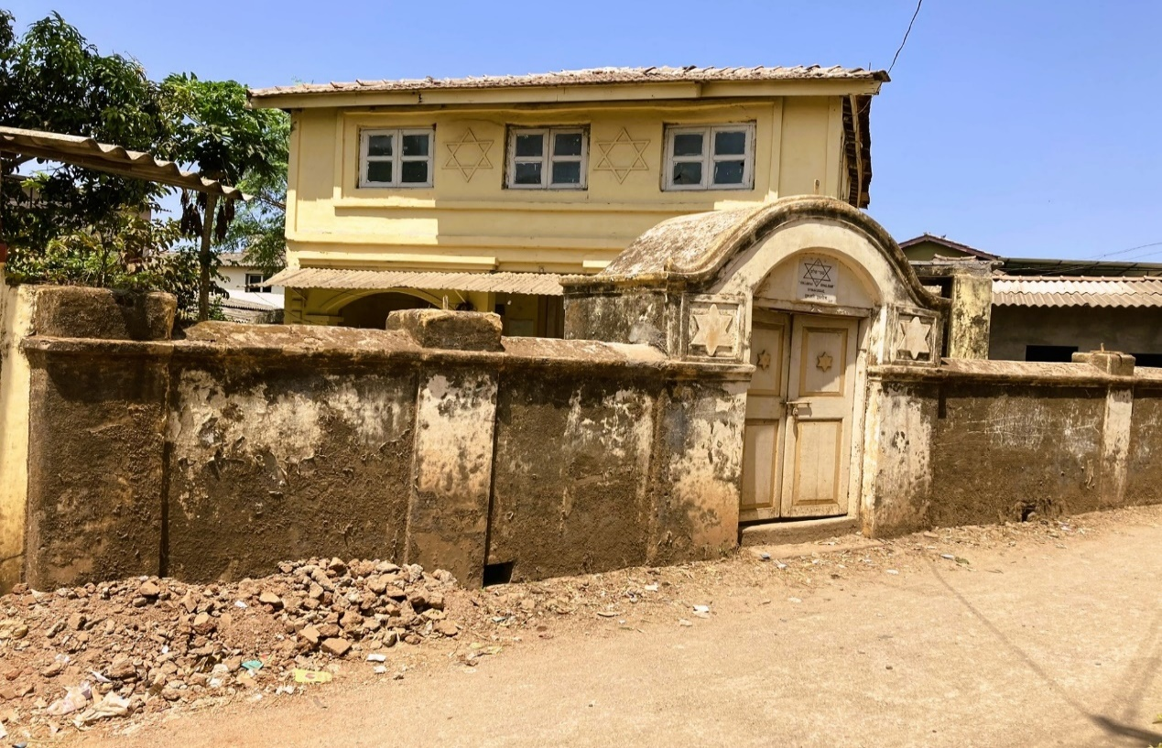
Entrance to the Shaarai Shaloam Synagogue, 2022

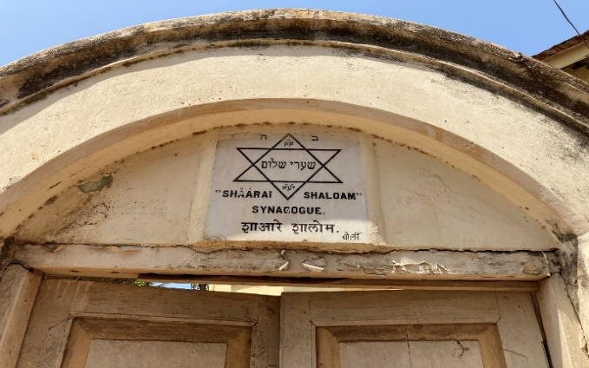
Facing the wall and the main gate, one notices the Magen David (Star/Shield of David) decoration, which demonstrates a Jewish or a religious identity to the building. The symbol is depicted in several places; at the wall, the door gates, the arch above the door gates and at the walls of the Synagogue building.
The Synagogue Emblem
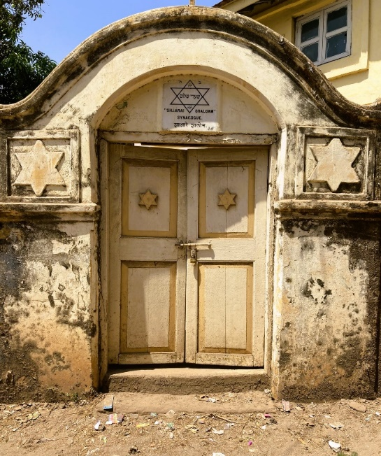
Relating to the interior of the building, architect Jay Waronker gives an account of its “…small square sanctuary…in size and a departure from most other Bene Israel synagogues that are rectangular, otherwise follows the layout of other community synagogues with a centrally-positioned raised tebah …constructed out of local wood. Its design includes raised panels at its base, turned newel posts and balusters, and a shaped handrail.
Projecting from the corners of the tebah and attached to the projecting corner lights with glass shades are four metal rods. The various purposes for these aluminum rods include supporting a chuppah, or ceremonial wedding canopy. The tebah reading table is teak, stained, and beautifully carved.” Shaarai Shaloam’s Main Gate, 2022
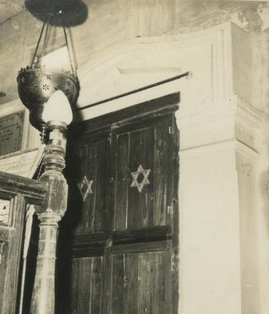
Describing the hekhal, Waronker adds: “Placed in the center of the west elevation that is closest to Jerusalem…the hekhal is a cabinet produced from local wood. It is draped in the traditional parochet that is most recently a bright blue fabric decorated with Stars of David. The hekhal is raised off the floor by a few steps since it is the synagogues most important liturgical and architectural feature.
The hekhal wall is accentuated by applied trim that forms a decorative surround at the hekhal proper. This surround, with its camel back profile and pointed-arch lintwl atop matching pilasters, gives the hekhal a sence of visual prominence.”
The Hekhal, early 1960’s
Pali

Pali is a village in Sudhagad Taluka, Raigad District. The village, by Amba River, is located 99 km south-east from State capital Mumbai, 54 kms towards east from District Head Quarters Alibag. Villages in close proximity to Pali are: Kumbharshet (3 km), Rasal (5km), Chikhalgaon (6 km), Patansai (11 km), Uddhar (12 kms), Nagothana (14 km). Pali is surrounded by Pen Taluka and Khalapur Taluka towards north, Roha Taluka, Alibag Taluka towards west and Tala Taluka towards South. The nearby towns are: Pen, Nandgaon and Uran (Raigad District) and Lonavla (Pune District).

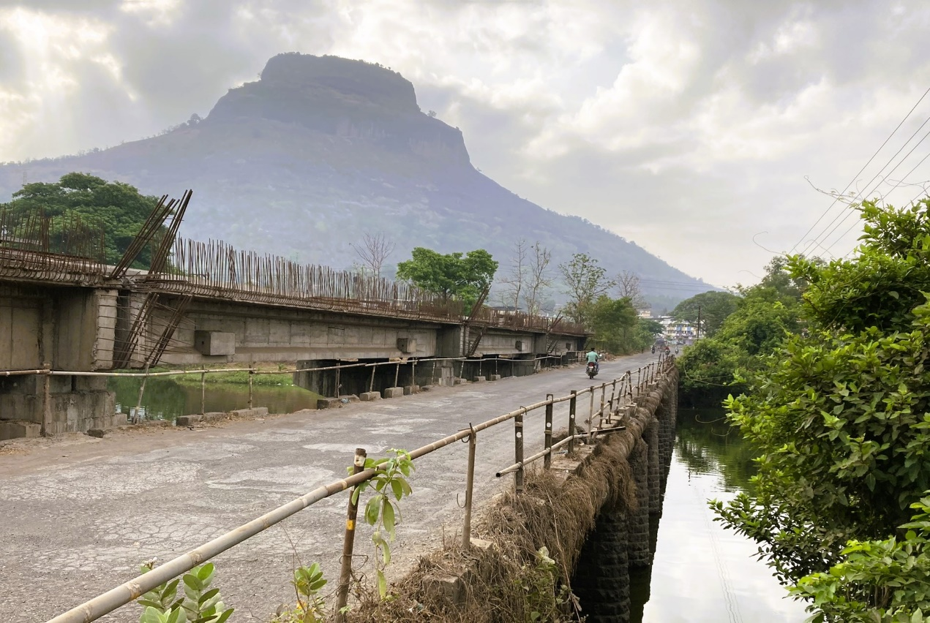
Approaching Pali Village, facing Sudhagad Fort, 2022
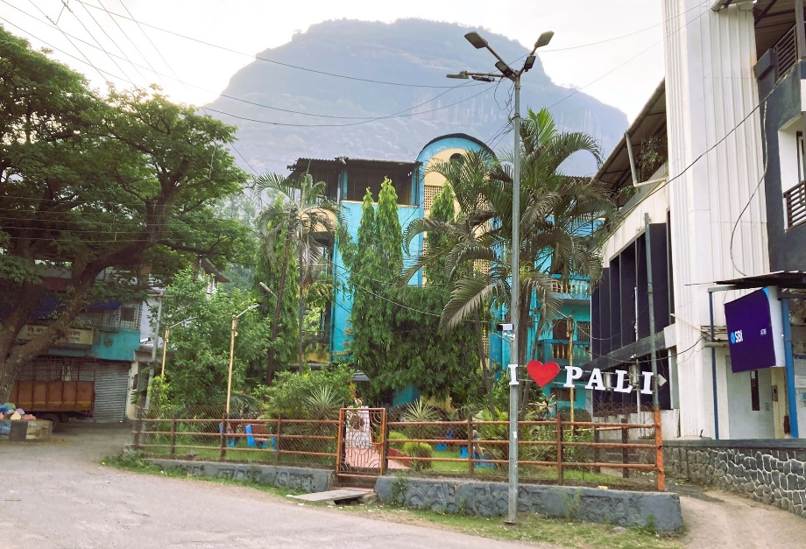
Pali is one of the eight Ashtavinayaks (a term refers to eight Temples of Ganesha) in Maharashtra. In the village of Pali, is one of the eight Temples of Ganesha, the famous Ballaleshwar Temple (lit.: "Ballal's Lord").

Entrance to Pali Village, 2022
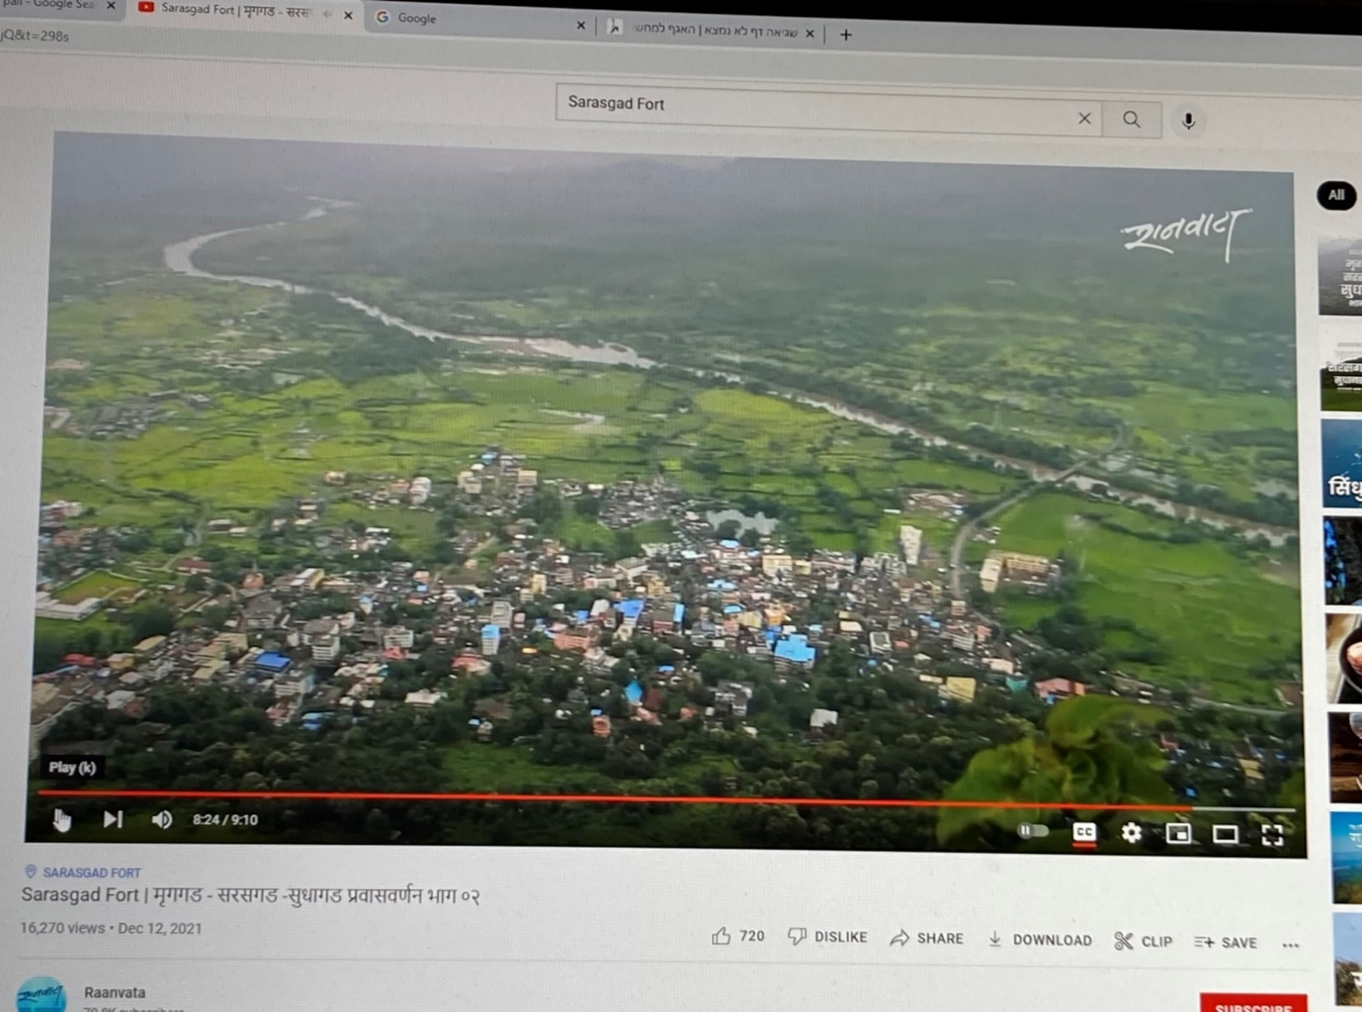
Pali Village from the top of Sarasgad Fort. At the rear, the Banks of the Amba River

Among Ganesha Temples, Ballaleshwar is the only incarnation of Ganesha that is known by his devotee's name. The idol is dressed up as a Brahmin. This is the only idol of Ganesha to be outfitted up in such a way in the world.
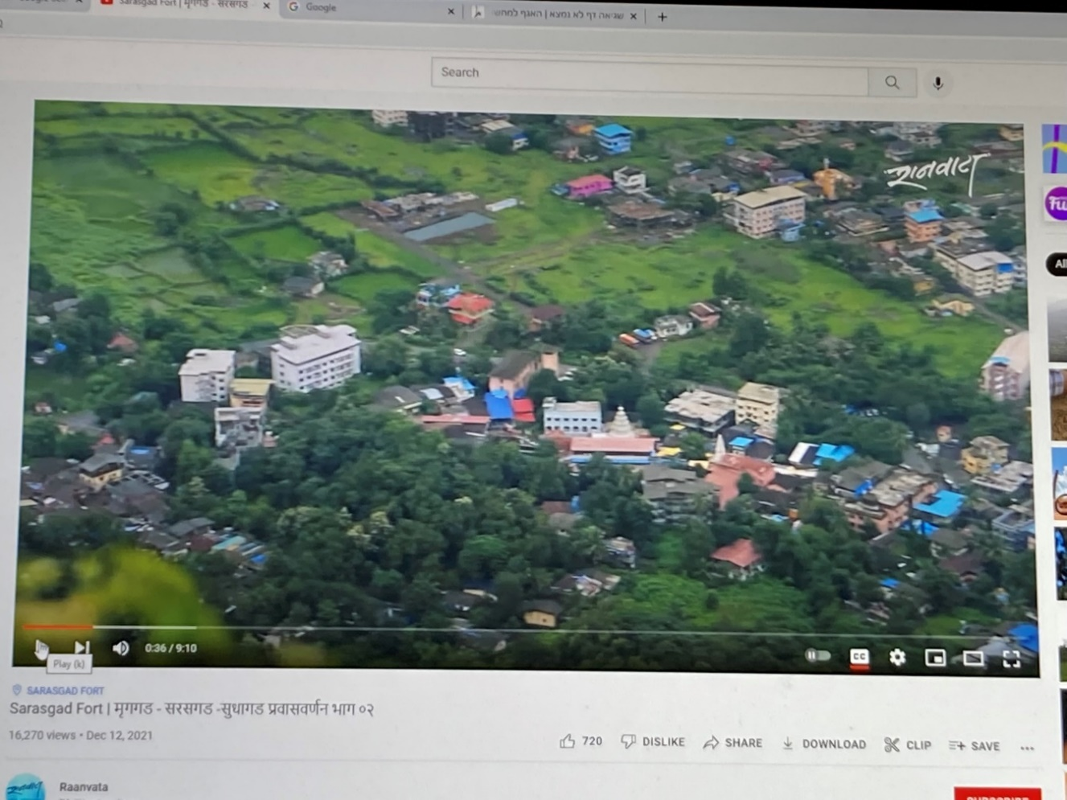
Part view of Pali Village from Sarasgad Fort. Ballaleshwar Temple in the centre.
Photographed by Sandip Bedeka

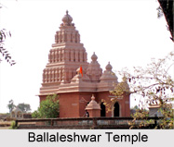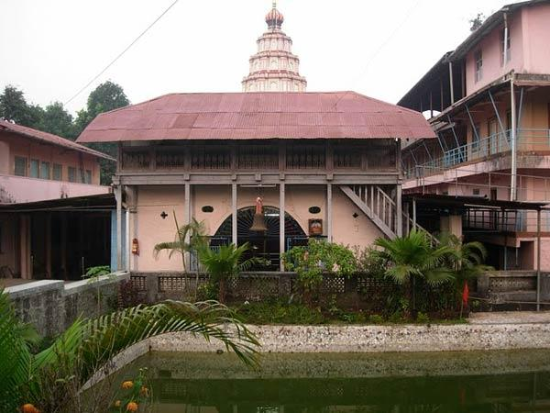
Ballaleshwar Ganesha Temple Ballaleshwar Ganesha Temple

The Temple, as well as the town, is situated by the side of the Sarasgad Fort. Sarasgad Fort is a hill fort which can be identified by its four pinnacles and thus, was mainly used as an observation station to check the surrounding region.

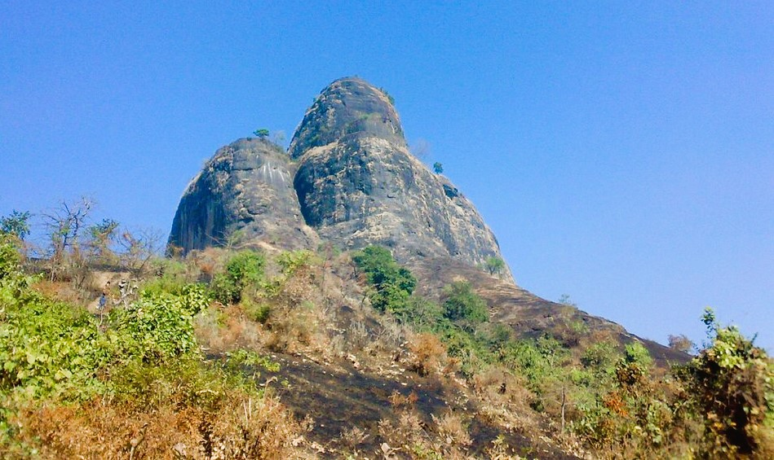
Sarasgad Fort.
The Sudhagad Fort rises about 490 metres (1,607 feet) from sea level, providing an excellent panoramic view of all the mountain ranges surrounding this area, including its twin Fort, the Sudhagad Fort. Captured from the Bahamani Sultan in 1657 by the Maharahas, it was considered by Chhatrapati Shivaji Maharaj as the capital of his kingdom. He surveyed it, but instead chose Raigad because of its central location.
Sudhagad/Bhorapgad is a hill Fort. The origin of this Fort is said to date back to the 2nd century B.C.E. the same age as the Thanale Caves and Khadsamble caves nearby. It was then called Bhrorapgad (after its presiding deity, Bhoraidevi). In 1436, it was captured by the Bahamani Sultan. In 1657, the Marathas took over and renamed it "Sudhagad" (the sweet one).

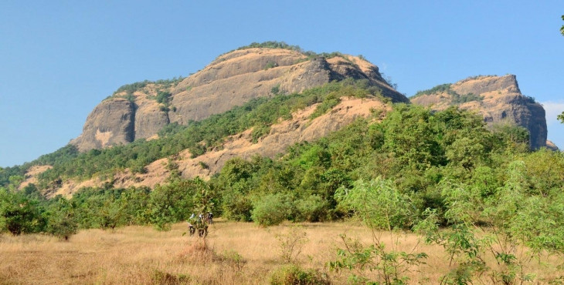
Sudhagad Fort

Unhere Hot Springs, Pali

The Unhere Hot Water Springs, just by the a Ballaleshwar Ganesha Temple are sulphur springs, known for being a scientific and a natural attraction. The Gazetteer of the Bombay Presidency for 1883 states: The spring at Unheri Budruck, about six miles north-east of Nagothna, is in a plain close to the fort and old town of Pali… The spring has a cistern of cut stone twenty-five cubits square and floored with wood. The water is three feet deep… The cisterns were formerly much frequented by persons suffering from skin diseases, dyspepsia, and rheumatism. People of all castes still bathe in the springs, but none stay for a prolonged period of time.
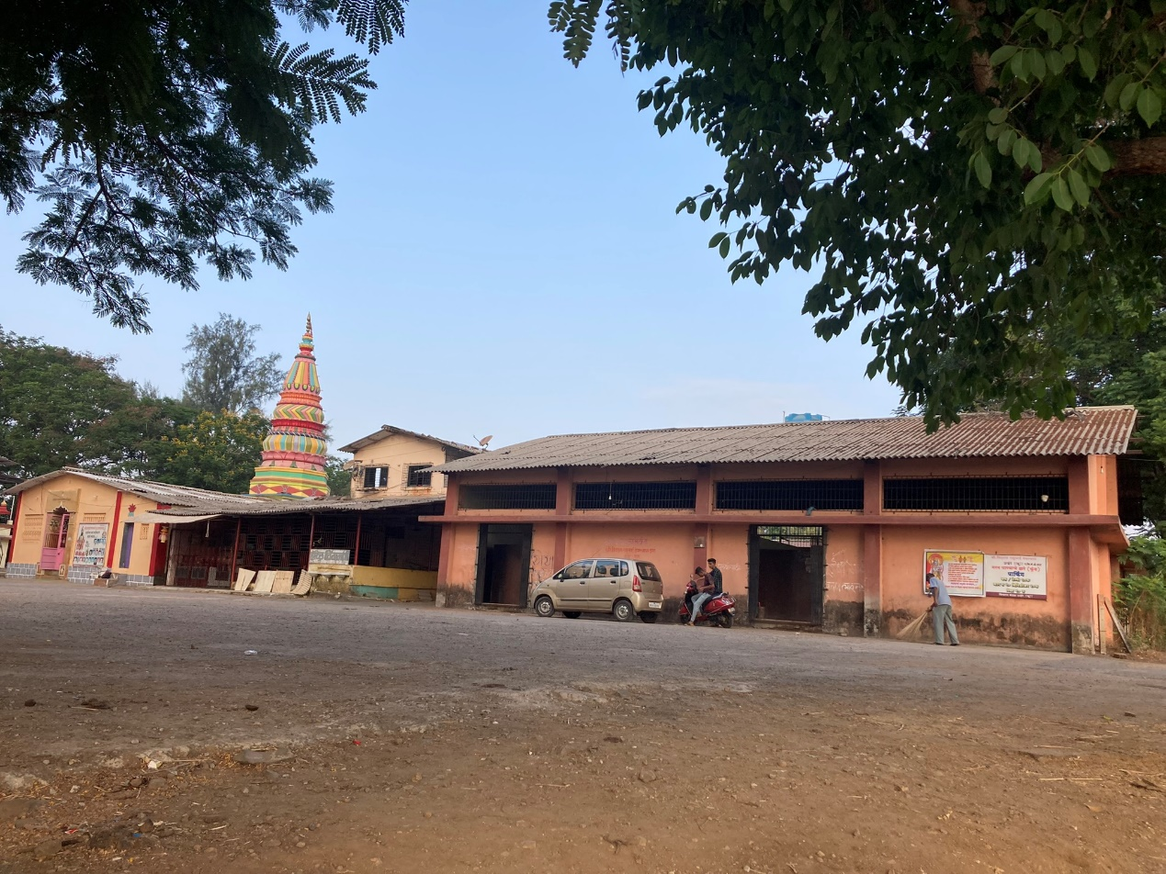 Entrance to the Indoor Unhere Hot Water Springs, Pali, 2022
The specialty of the springs is that the water is noticeably relatively very hot. The temperature maneuvers between 40 to 60 degree Celsius, due to the high Sulphur content in the water and its reaction with other minerals. When reaching nearby the springs, one can smell a strong odor of Sulphur.
There are two stone water bath structures over the water springs, the covered one is reserved for women.
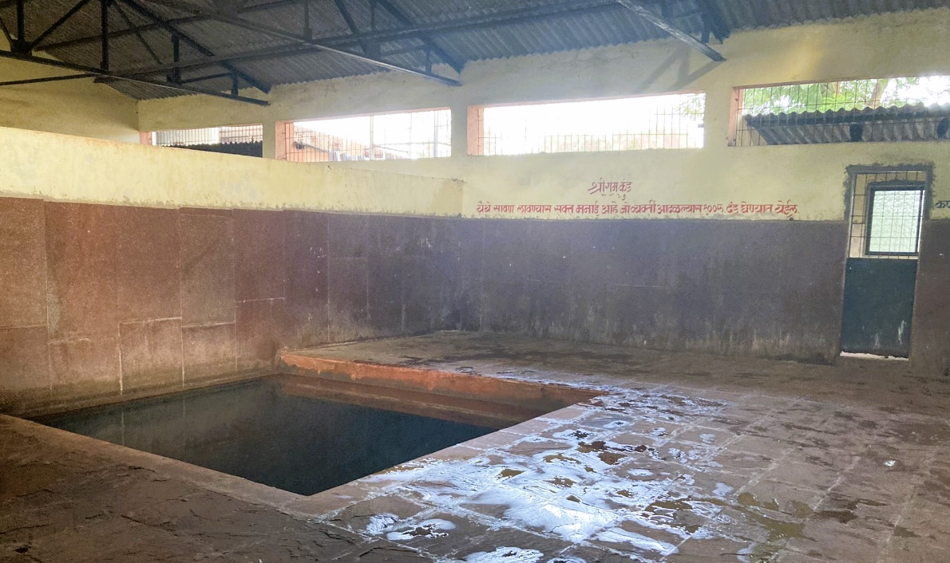 Unhere Indoor Hot Water Spring, Pali, 2022
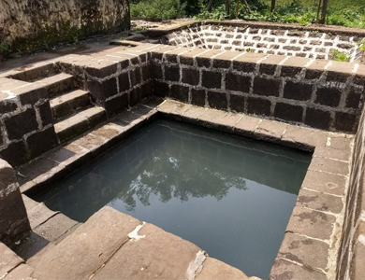 Unhere Outdoor Hot Water Springs, Pali, 2022
It is said that this water possesses medicinal value for curing skin diseases and allergies. The only problem is that the water is stagnant and not a flowing water. Thus, anybody entering inside the small common baths, should actually be prevented doing so under all circumstances.
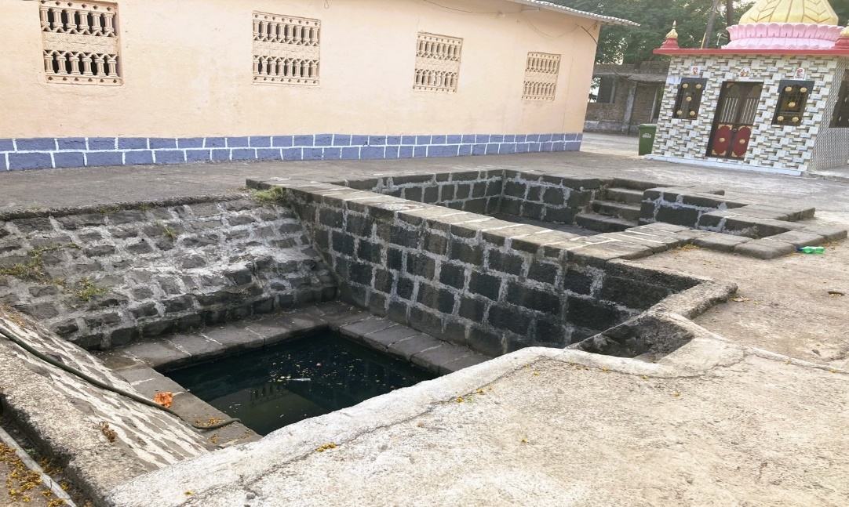 Unhere Outdoor Hot Water Springs, Pali, 2022

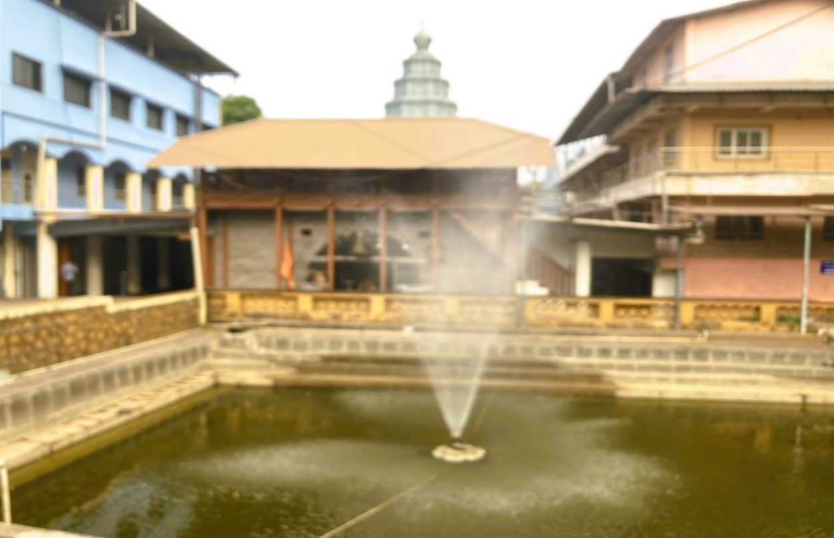 Outdoor Pool at the Ballaleshwar Ganesha Temple, 2002

Samson Soda Factory – Pali
There is an amazing soda stop along the road from Pen to Alibag; a one-of-its-kind soda factory experience! The soda factory sits comfortably in a quiet Konkan village, Pali, which is 11 km from Alibag. What is most impressive about the place is that it has managed to retain the old-world charm and brings back memories of by-gone times. The factory which located on 20 gunthas of land in Pali village churns out its popular ice cream and masala sodas off a carved in, tile-roofed home, with picturesque paddy fields forming its backyard.

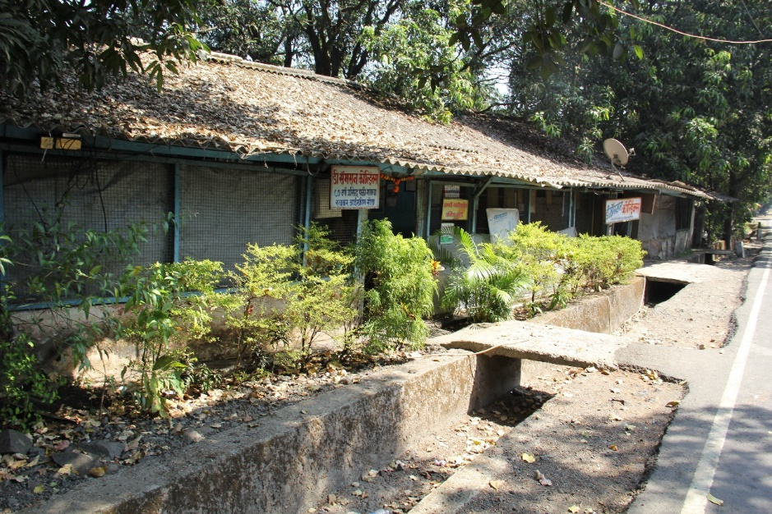
Samson Soda Factory, 2015

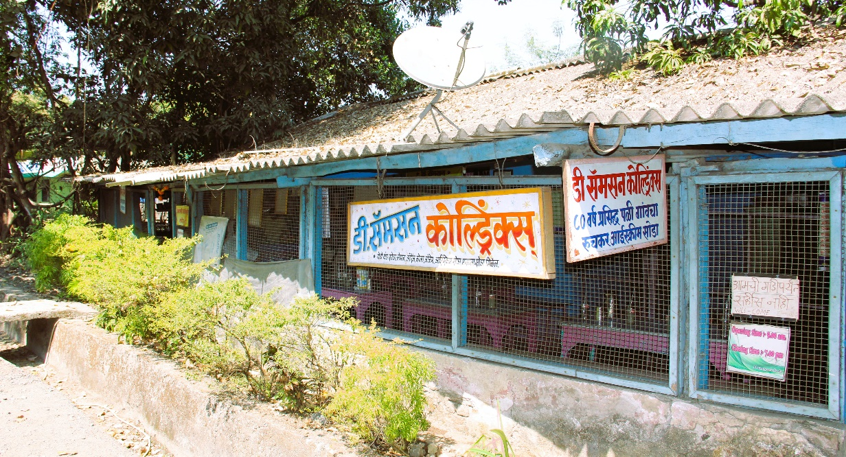
Samson Soda Factory, 2022
Daniel Samson Dighodkar, a Jewish man whose family settled down in Dighod village in Konkan, had established this well-known and iconic soda shop in Pali in the year 1938. Daniel Samson Dighodkar’s, first and middle names signify his Jewish connection, while his last name Dighodkar is acquired from his village Dighod near Mandwa. His aim was to serve the British who were very fond of the soda, so much so, that when being back home in England, they missed Samson’s soda.

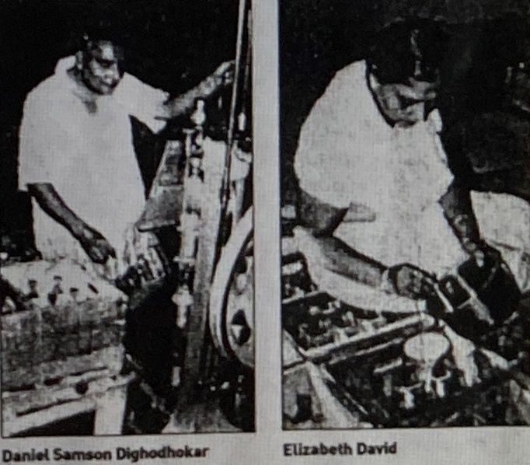
Daniel Samson and Sister Elizabeth David

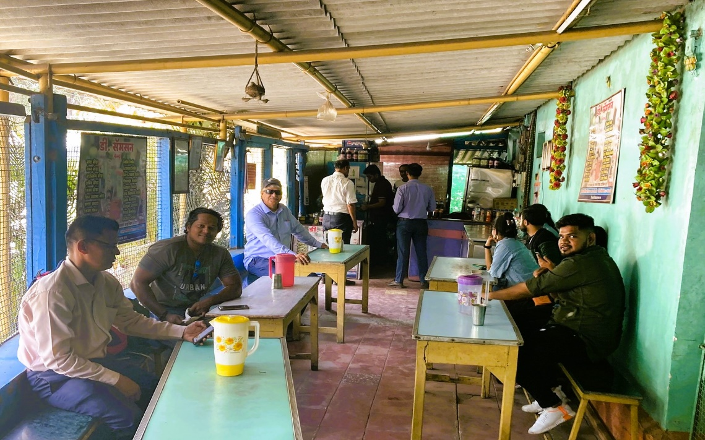
Interior of Samson Soda Factory. Ralphy Jhirad third from left, 2022

These fizzy drinks were a favourite amongst the British, and Daniel Samson began by offering unique sodas such as Ginger Lemon Soda, Kala Khatta Soda, Masala Soda and their most loved, the Ice Cream Soda.

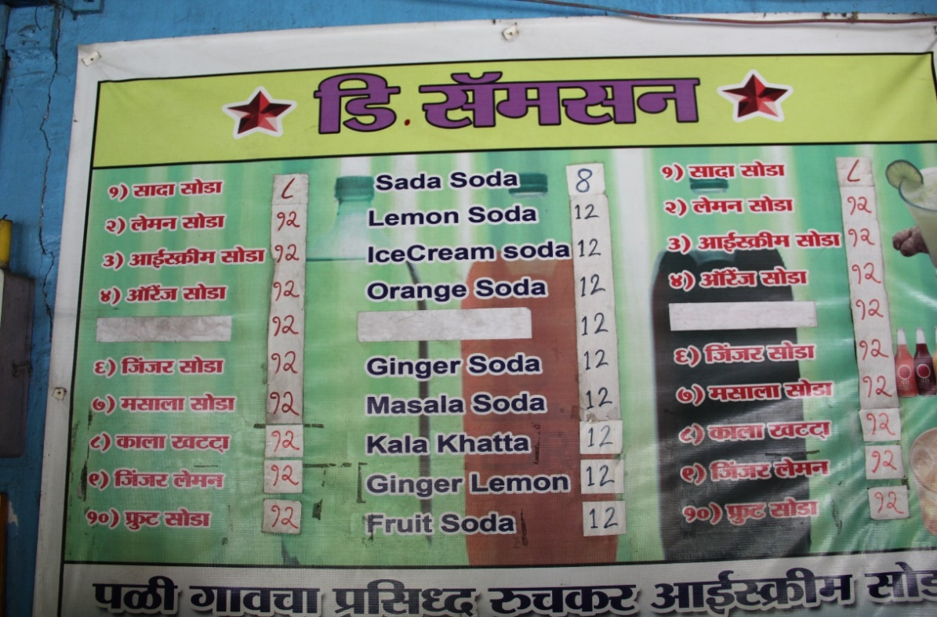
Samson’s Soda for sale, a few examples chosen from 32 flavors. Prices for 2015

Daniel Samson’s Soda Factory holds a strange enigma of time, colours and multiculturalism. It has a Konkani architecture with a Marathi signboard, a blue wall with a pink star of David, and a sepia-tinted picture of Moses. D. Samson serves as a monument to the Bene Israel Community who set up the villages in the area which was their home for centuries, without letting go off their roots.
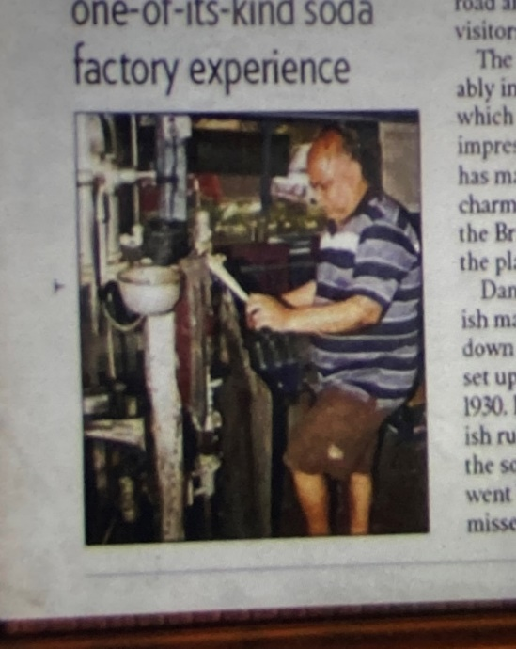
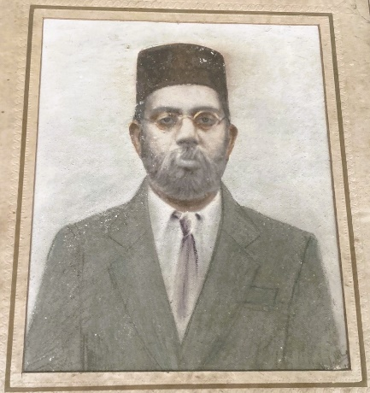
Daniel Samson Dighodkar,
After D. Samson’s death, his sister Sydney Moses started overseeing the operations. As of now (2018), it is run by her son, Daniel Sydney, who had always been very fond of his uncle’s sodas and decided as a young child that he wanted to continue this business after him.
Ashtami/Ashtumi/Astami (Roha Taley/Tehsil)
Ashtami is a village/hamlet across the creek from Roha, included within Roha municipal limits, Roha Taluka, Raigad. It comes under Ashtami Panchayath and belongs to Konkan region and to Konkan Division. It is located 53 km towards north-west from District headquarters Alibag, 79 km from State capital Mumbai, and a short distance from from Roha.

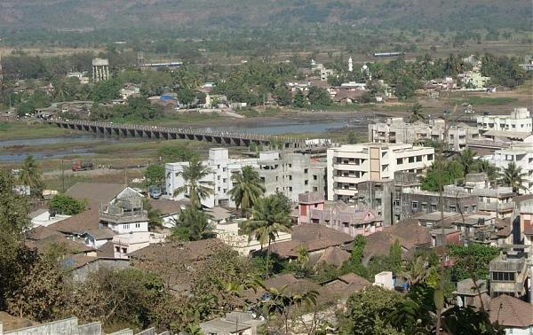
Roha- Bridge Connecting to Ashtami

Ashtami is surrounded by Murud Taluka towards west, Tala Taluka towards south, Sudhagad Taluka towards east, and Alibag Taluka towards north.
The Cities near Ashtami are; Nandgaon, Pen, Lonavla, and Uran.
In 1883, it was documented that “Several well-to-do Bene Israel families live in Astami.”

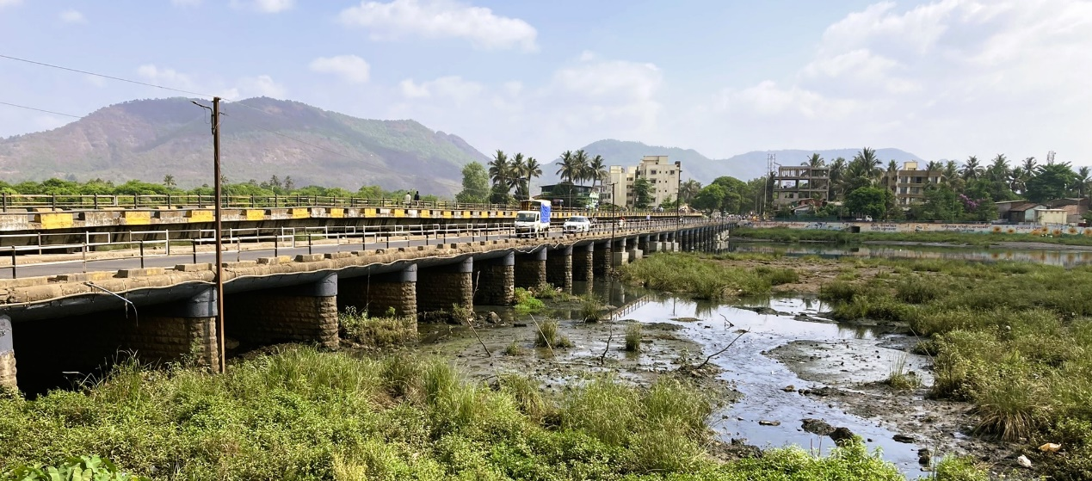 Bridge over Kundalika River Connecting the Villages of Roha and Ashtami, 2022
Today's Kundalika River on the banks of which Roha is situated, was once part of the sea. Small ships used to sail from here, which carried rice, brass & copper utensils to all parts of the world. The bridge upon the Kundalika River was built in 1960, joining Roha with the small village of Ashtami which has a long history behind it. The history of 1000-1200 years relates that Ashtami was the original place where people started residing. At that time, people from Ashtami village used to cultivate rice crops on the other side of the Kundalika River. It is assumed that when Roha was established on that part of land, people derived the name Roha from Rohe (which means seedling of rice). During Shivaji Maharaj reign, the Kundalika River was the boundary of the two separate kingdoms, Ashtami which was under the Marathas and Roha which was ruled by the Siddhis.

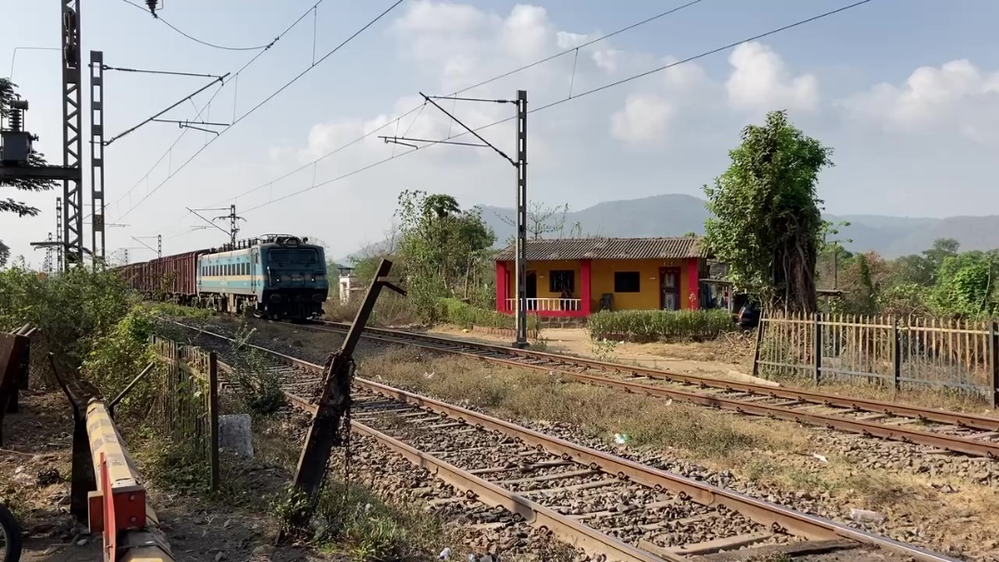 The drive on the way from Pali to Ashtami, 2022

Beth-El (House of G-D) Synagogue, Ashtami

Following the Independence of the State of Israel in 1948, the Bene Israel emigrated to Israel, their homeland, while their Synagogue structure in Ashtami still exists.
The Synagogue is described by architect Waronker as one of the smallest and most intimate Bene Israel Synagogues in the Raiged district. Relating to the exterior features of its edifice he states: “Beth El featured a modest design typical to this region of India and its late nineteenth century date of construction. It was a low-slung, single-story building erected towards the center of town and adjacent to other small-scaled residencies, shops, and businesses. The synagogue was constructed of simple brick veneered in chunam with a painted finish. The walls supported a gable roof framed in locally-harvested wood covered in flat clay roof tiles. The deep roof overhangs were a response to the region’s annual monsoons and hot climate. Window openings were set within the thick walls, and a covered porch ran along the entire width of the east elevation, enclosed by a low solid wall with a painted lattice screen above it. Beth El’s rectangular sanctuary was accessed from the covered porch, and it followed the plan of other Bene Israel synagogues.”

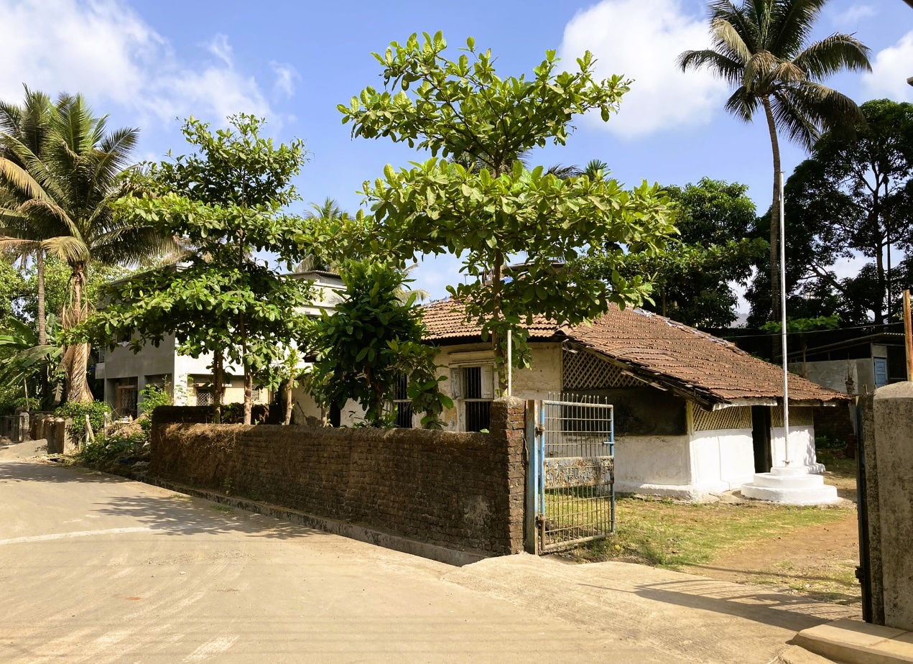

Beth-El (House of G-D) Synagogue, Ashtami, 2022

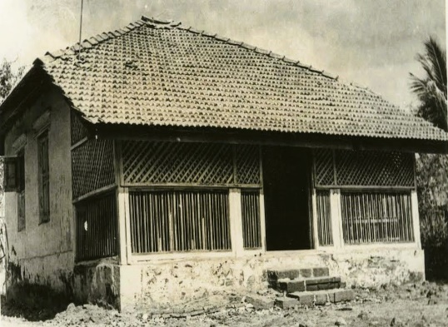
Beth-El (House of G-D) Synagogue, Ashtami, early 1960s

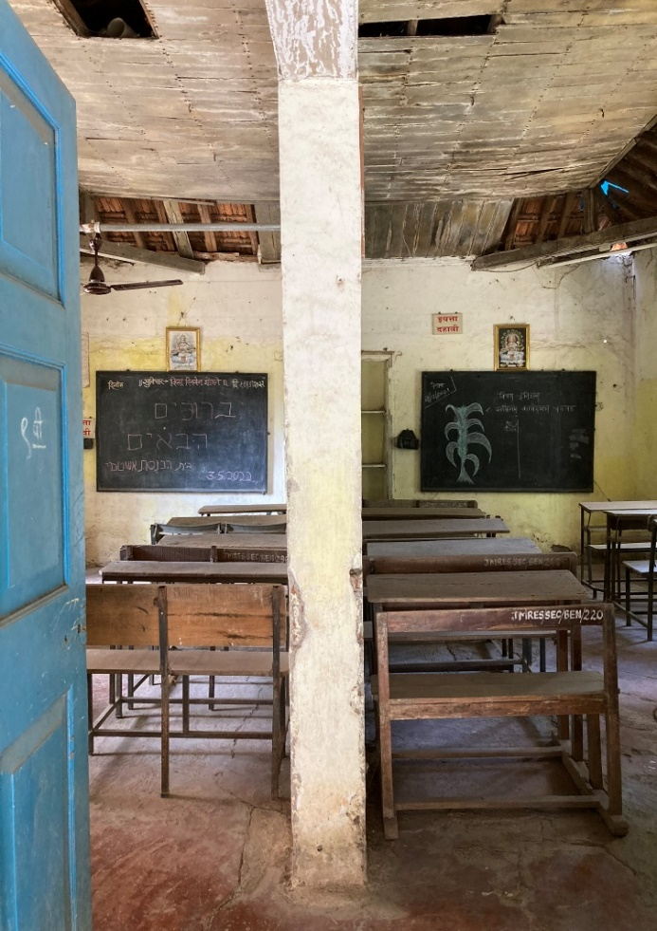
Regarding the Synagogue’s past interior, Waroker mentions that the original building had a: “…centrally-positioned raised tebah and, on the far wall, the painted-wood cabinet of the hekhal. Placed on the wall to the west, geographically closet to Jerusalem as is traditional, it was designed with raised panels at its base, newel posts, balusters, and a shaped handrail. The hekhal was draped in the traditional parochet…Beth El”s sanctuary contained a stone floor, painted chunam walls, framed Jewish art, and a painted-wood shuttered windows. Hanging from the exposed rafters were glass lanterns and other lighting fixtures…

The interior Hall of the Synagogue is divided into two Classrooms, Ashtami, 2022

Other architectural and liturgical design features included the freestanding wood benches around the perimeter of the sanctuary and the matching pair of draped chairs adjacent to the hekhal. The chairs were used in the circumcision ceremony, with one dedicated to Elijah.”

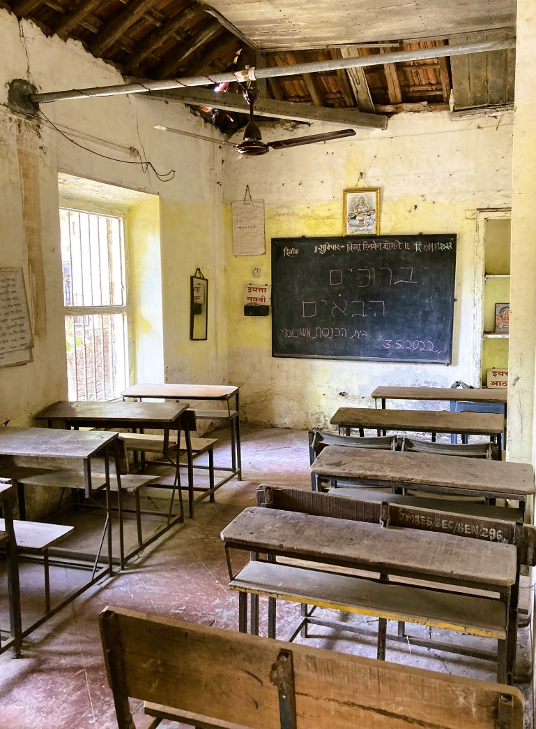

One of the two Classrooms in the Beth-El Synagogue, Ashtami, 2022

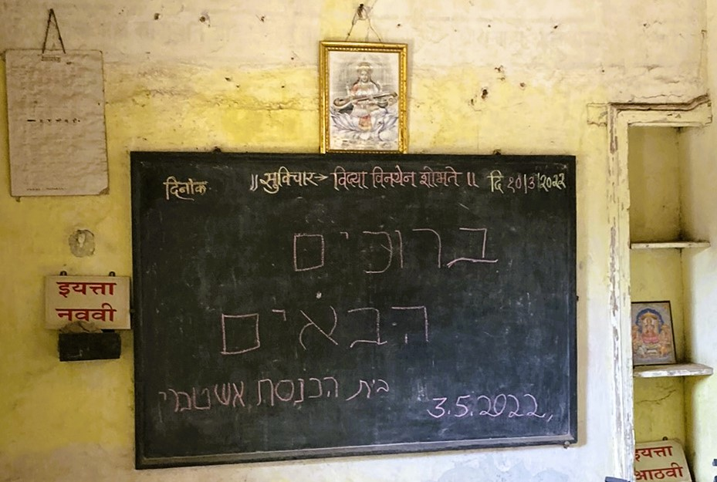
Facing the Front Wall of the Classroom, 2022

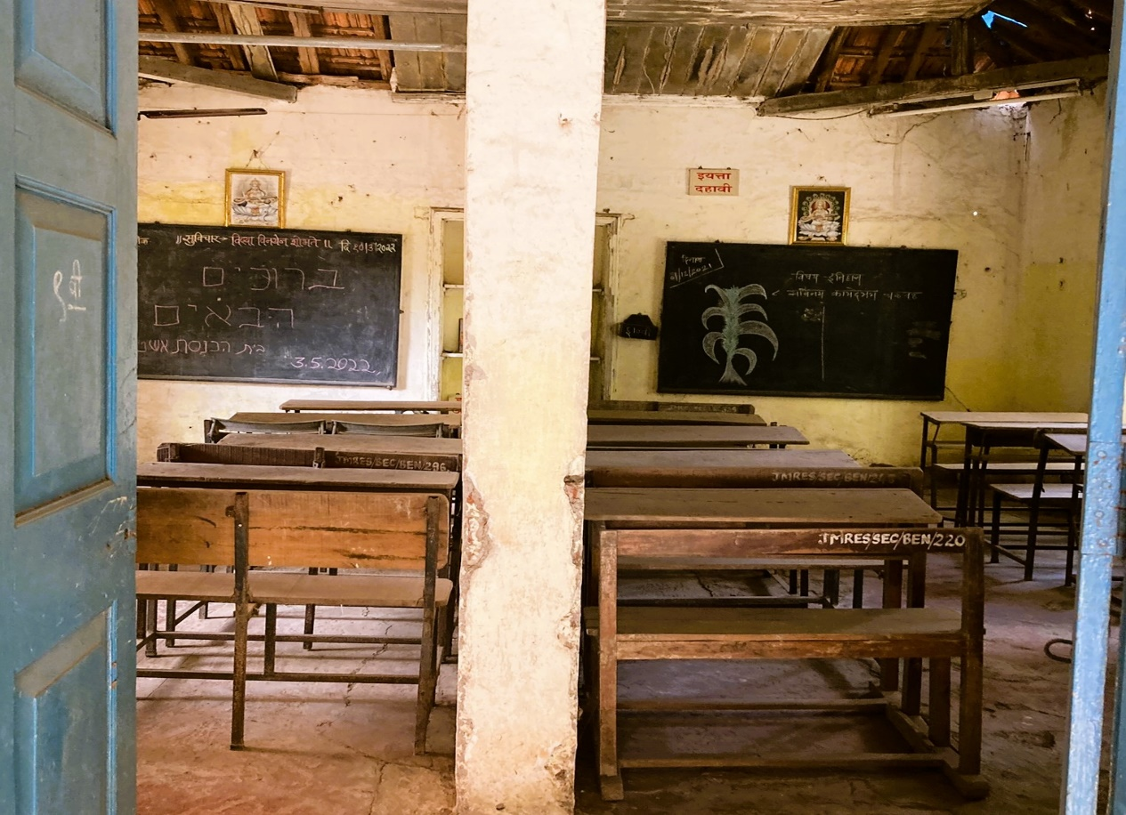
The two Classrooms, 2022

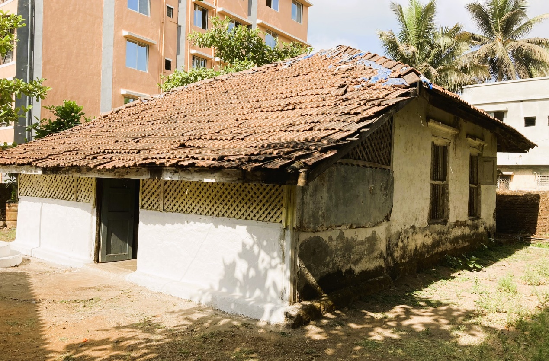
The Rear side of the Beth-El Synagogue, Ashtami, 2022

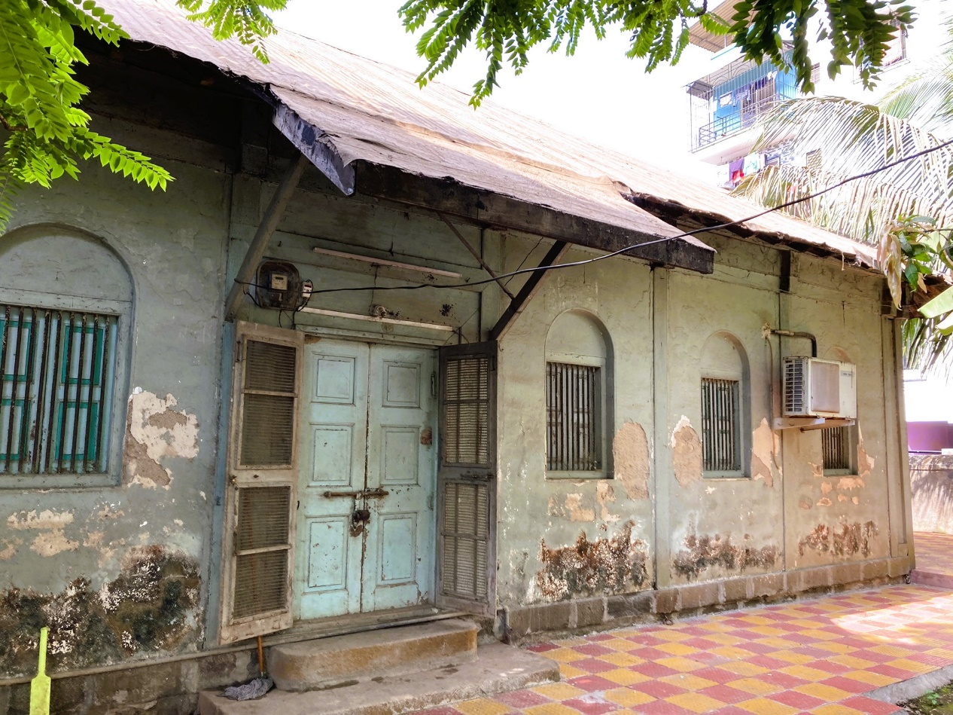
A Jewish Home in Ashtami, 2022

Tala/Talla/Murad Teshil

Tala is a small town and taluka in Mangaon subdivision of Raigad district. Tala is located is located 18 km south of Roha town, 57 kms south-east from District Head Quarters Alibag, and is a Taluka Headquarter. Tala is translated to Lake in Marathi, there are many lakes located in the area of Tala village, which is the reason behind the name Tala. Chandrika Mata Temple is located at Marketplace of Tala village.

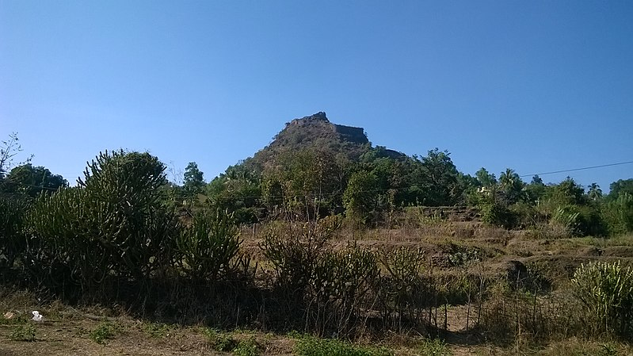Talagad Fort

West of Tala village, the Talagad/Talgad (Tala Fort) is located, being the main attraction of Tala. The Fort is one of the important Forts in Raigad District, situated on a narrow spur (about 20 meters wide), guarded by fortifications, which served to keep watch on the enemy and the trade route from Maval to the sea ports around.

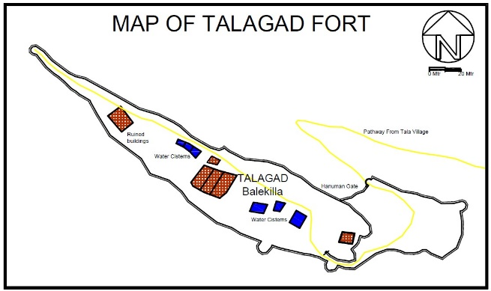
Talagad Fort, is a fortified hill, about 122 meters over Tala village and about 305 meters above sea level. The hillsides are treeless and bare, but along the north, east and south, close to the bottom of the Fort, is a richly wooded belt on which stands the village of Tala.

Sketch Map: In Yellow- Pathway from Tala village to the Fort

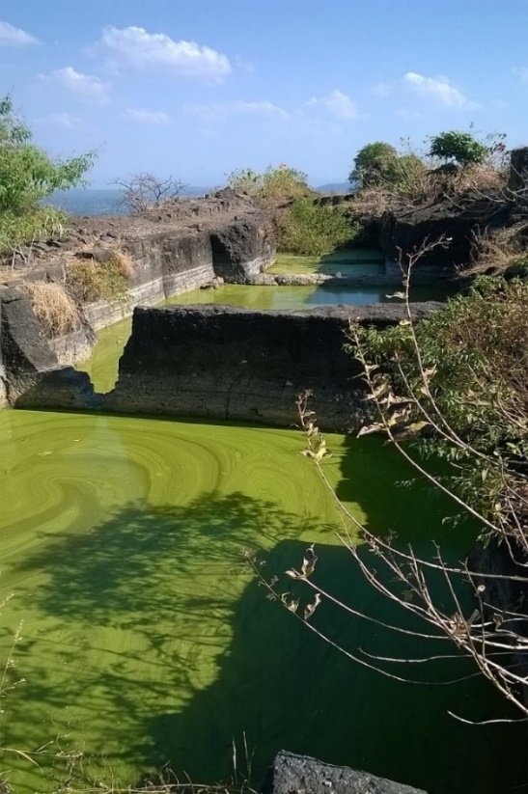
Near the main gate of the Fort, known as Hanuman Gate, is an image of Veer Maruti. The fortifications include two parapet walls which run along the northern and southern sides of the top eastern highest half of the rocky ridge that forms the upper course of the mountain. There are many rock cut water cisterns and four water storage on the top of the Fort.
The Fort was also used to keep check on the activity of Siddhis of Janjira. It is not known who built Talagad Fort. In the 16th century, the Fort was under the control of Adil Shah dynasty of Bijapur. In 1648, Shivaji won the battle on this Fort and in 1659, the Fort was encircled by troops of Siddhis of Janjira.

Talagad Fort- Rock-cut Cisterns

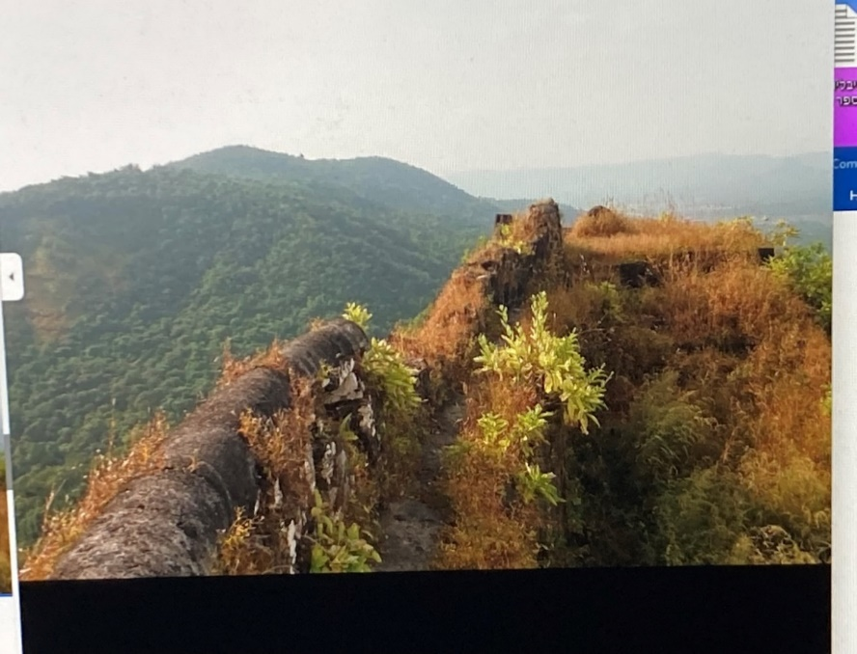
Talagad Fort
Kenesseth Israel (Assembly of Israel), Prayer Hall/Synagogue, Tala

Tala Kenesseth Israel Synagogue, was first built in 1849 as a simple wooden structure which unfortunately burnt down three years later in 1852. The new Synagogue was rebuilt in 1876 with stone walls.
The formerly Kenesseth Israel Synagogue in the village of Tala, Mangaon Taluka, currently is a Kindergaton.

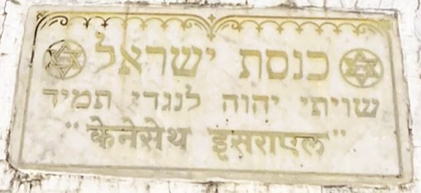
At the entrance on the right side is the door beyond which is the staircase leading to the ‘ladies gallery’, a significant part of all synagogues. Facing east is a small curtained portion on the wall like an alcove, a closed window covered by a curtain.
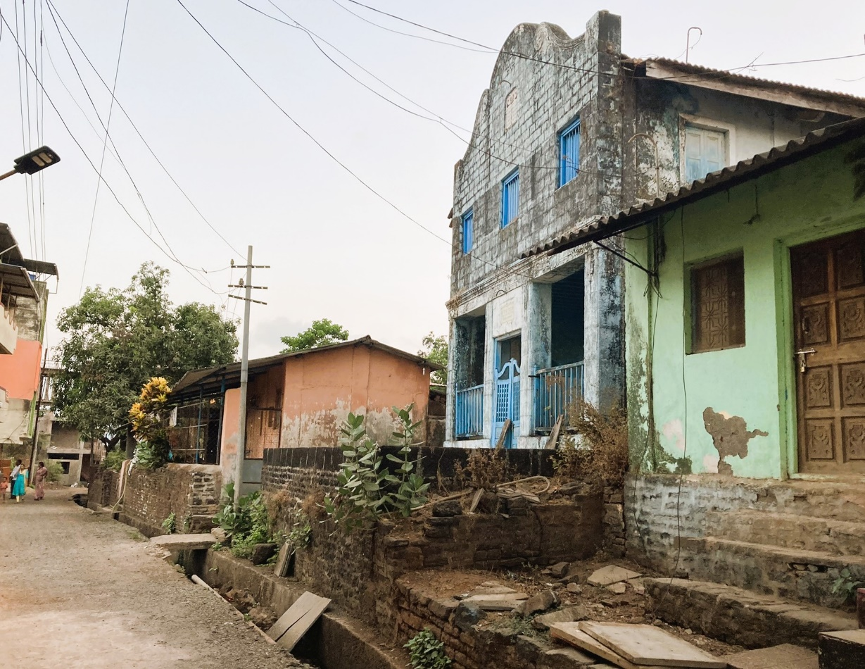
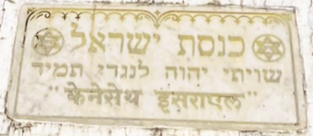

Kenesseth Israel Synagogue (adorned with a plaque at the top left),
Tala Village, facing north-east, 2022

Architect Waronka adds: “This second synagogue was used by the community until 1876, when a third and larger building was constructed…this building is a full two stories high and slightly larger than the most…Set on a raised stone base that extends out from in front of the synagogue, Kenesseth Israel has a block-cut stone façade, while its other elevations are finished in chunam…

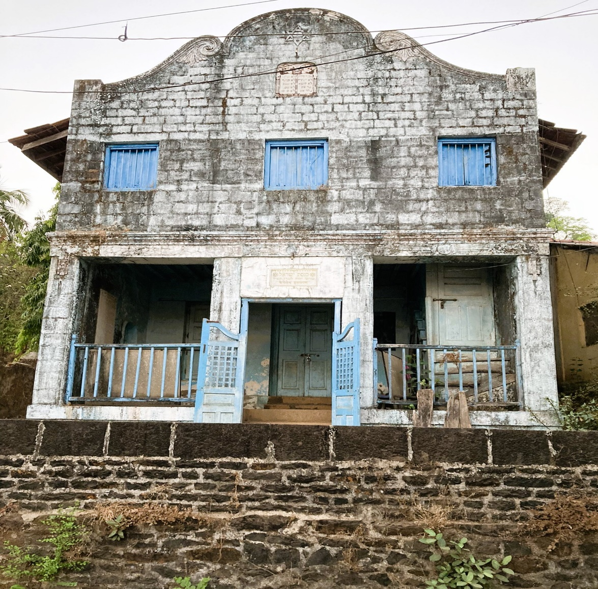
The block-cut stone Façade, Kenesseth Israel Synagogue, Tala, 2022

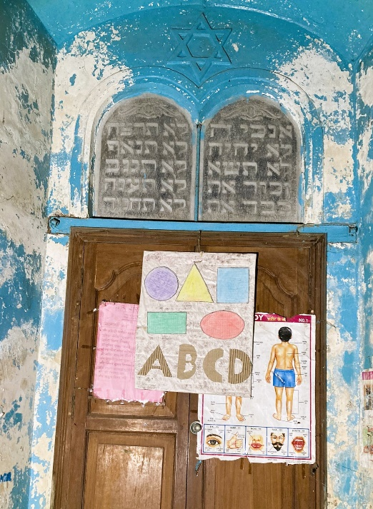
Behind the façade, with its [Baroque style] gable end, is an abutting sloped gable roof, covered in flat clay tiles. The porch serves as an anteroom to the building and it is where congregants would gather before and after prayer services and at times of religious holidays and communal events.”

Decorating the center of the pediment is a Ten Commandments panel…Centered in the porch is an entry gate made up of painted wood panels and a wood grid…

Facing the Hechal. Above- The Ten Commandments and the Star of David at the top
Behind the façade, with its [Baroque style] gable end, is an abutting sloped gable roof, covered in flat clay tiles. The porch serves as an anteroom to the building and it is where congregants would gather before and after prayer services and at times of religious holidays and communal events.”

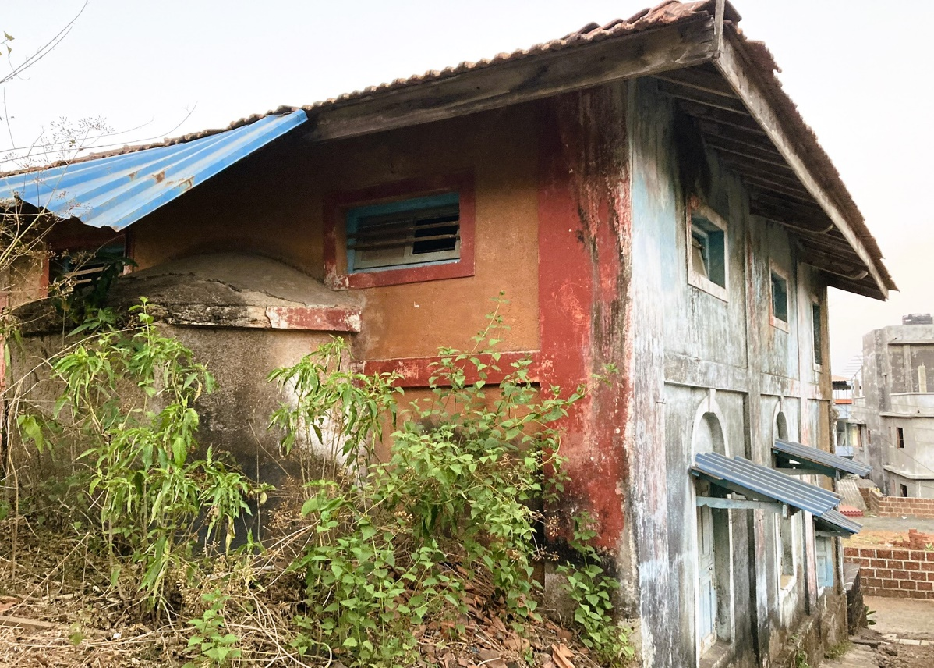
The rear side of the Kenesseth Israel Synagogue, 2022

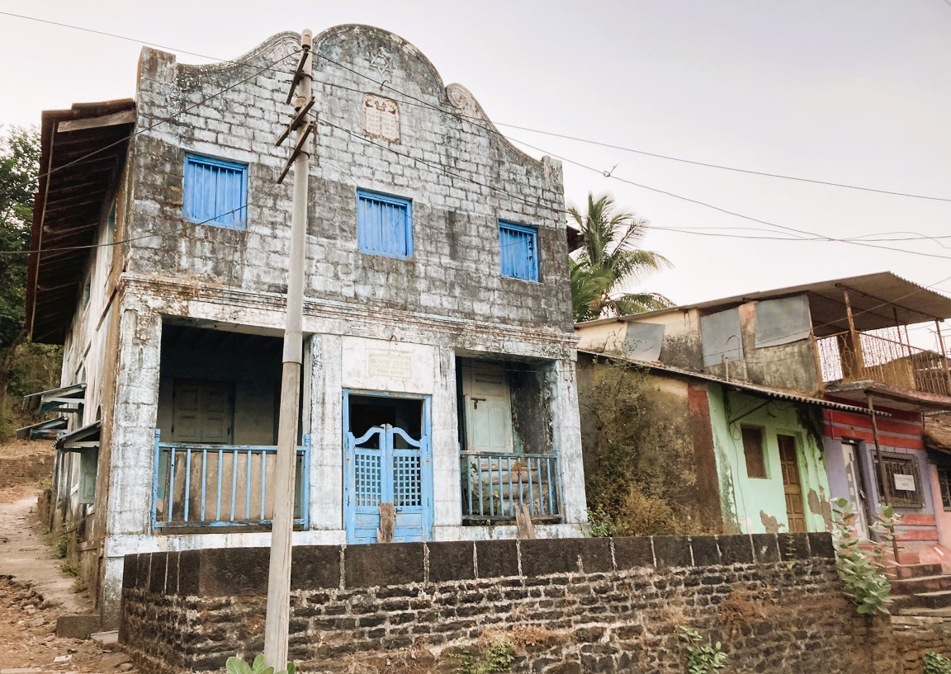
Kenesseth Israel Synagogue façade, Tala village 2022,
The Synagogue, designed by the carpenter Benjamin Ezekiel Mashilkar, was completely renovated and included many improvements, such as the lady’s gallery.

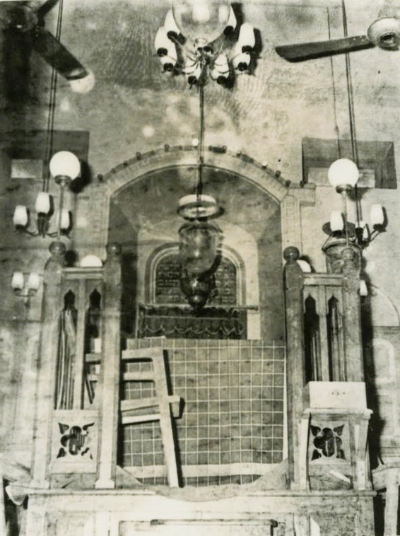
Relating to the interior of the building, Waronker mentions: “At the porch are doors opening into the building’s main space, which for many years was a sanctuary, as well as a stair up to the former women’s gallery. The rectangular sanctuary lined with windows, followed the spatial arrangements of other Bene Israel synagogues with its centrally-placed tebah and the hekhel positioned at the center of the wall closet to Jerusalem, in this case to the west. Freestanding wood benches at both the ground floor and women’s gallery filled the space, providing seating for the congregants and their guests.”
The Hekhel positioned at the centre of the wall facing Jerusalem, early 1960’s

By the 1960s, only 10 Jewish families lived Tala who slowly immigrated to Israel and in 1974, the last Jewish family left the area. Thereafter, the premises were handed over to the local Gram Panchayat for use as a library.
Currently (2022), the former Kenesseth Israel Synagogue is a Kindergarten.
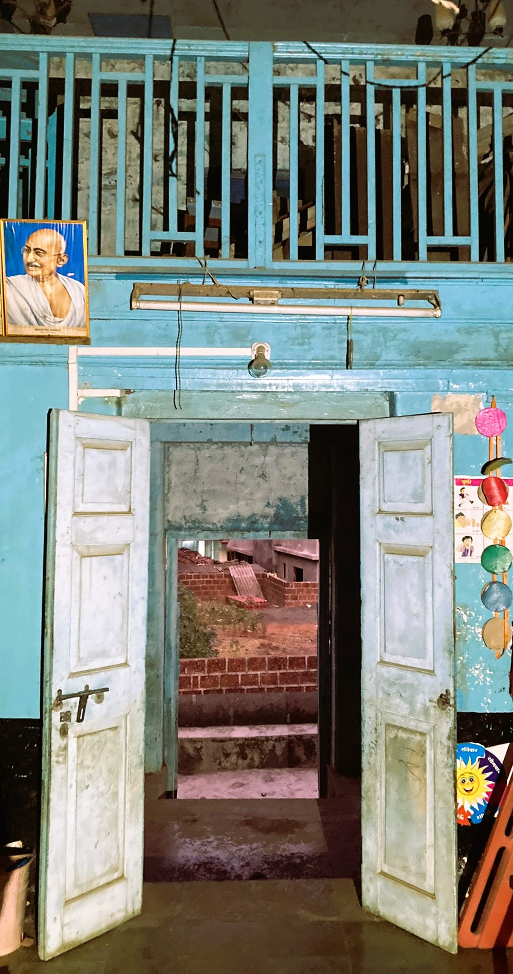
Kenesseth Israel Synagogue, the entrance, facing the doors, Women’s Gallery
and the Village houses seen beyond, 2022

Mhasla

Mhasla, is a Taluka in Raigad District, located at the head of the south branch of the Rajpuri Creek, about 25 kms from the sea, 44 km south of Tala, 92 kms south from District Head Quarters Alibag, and 165 kms from Mumbai. It was informed in the early 1880’s: “Mhasla, at the head of the south branch of the Rajpuri creek about sixteen miles from the sea, has a population of 1830 souls, chiefly Musalmans. The position of Mhasla, at the head of this great gulf, marks it as one of the early centres of trade, and suggests that it may be Ptolemy's (A.D. 150) Musopalli, the metropolis of the Pirate Coast…The trade of the town is poor, but an impetus may be given to it by constructing a cart-road so as to enable the Govale produce to reach its market.”

Mhasla is known for growing Alphonso mangoes, cashew nuts, coconuts and supari. The population is mostly Kokani Muslims. The major occupation of the people is in farming, but most of the males working in the Gulf. Mhasla is a growing town in recent years, old buildings have been renovated and given new looks, many attractive buildings are being constructed, including fancy buildings, commercial complexes and modern shopping malls, besides many new projects which are being planned for this town.

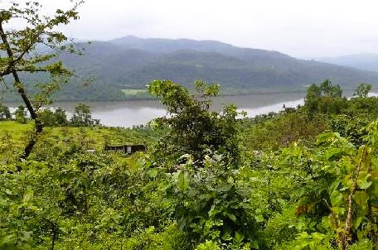
Mhasla Area
Sha'ar Ha'Tephilla (The Gate of Prayer) Synagogue, Mhasla

Mhasla’s Synagogue is the most southern of the Bene Israel Synagogues in the Raiged district. Before erecting its own structure for a Synagogue, the Jewish community of Mhasla made use of a rented house for prayer services around the early 1860’s. As the community grew in size, it became clear that a separate and a larger Prayer Hall was greatly needed. Once the land was granted, a more solid structure was built in 1886 and was named Sha'ar Ha'Tephilla.

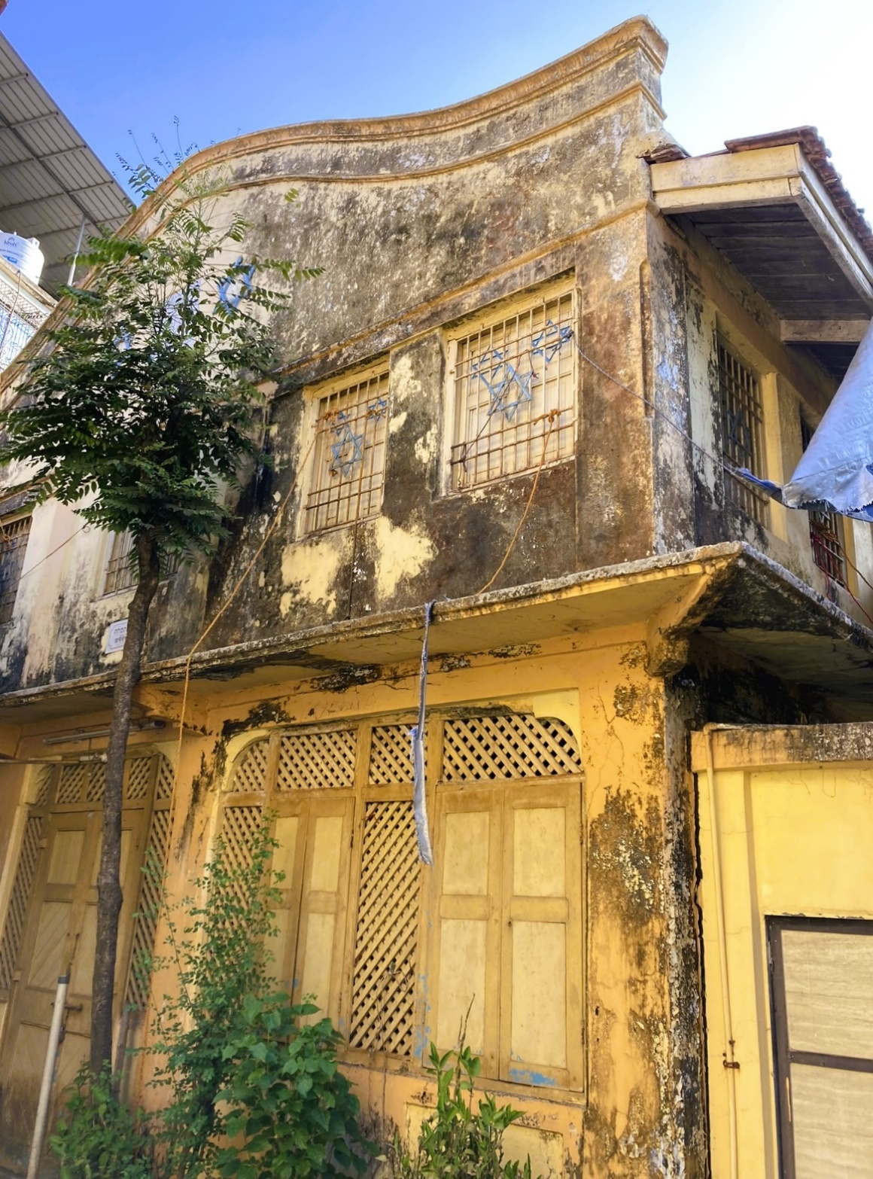 Shaar Ha’Thephillah -Exterior, Mhasla, 2022
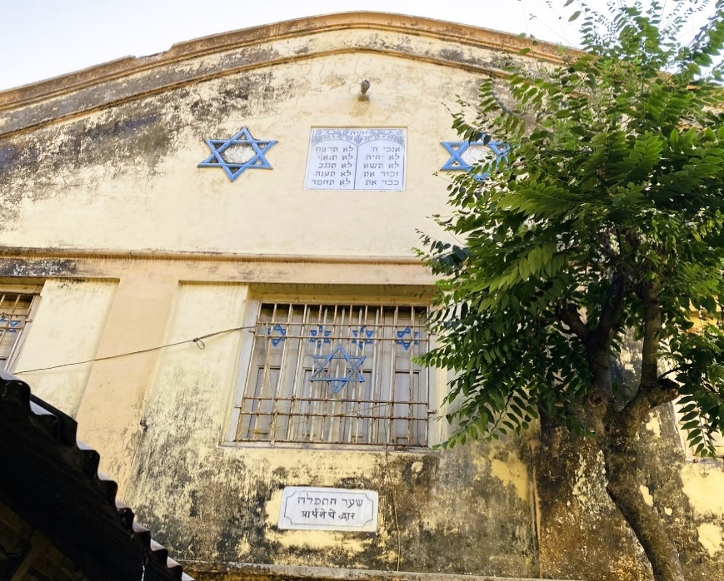
Architect Waronker mentions that the Synagogue is located in the centre of the town, adjacent to a busy narrow road lined with small buildings and dozens of marketplace outdoor vendors, and fronted by a small open space: “From the road, the synagogue is reached by passing through a sizable gatehouse that is marked with Stars of David… the synagogue’s two- Shaar Ha’Thephillah, upper level of the façade, 2022
story faced, finished in chunam painted pale yellow and orange, includes a camel back top with a centered inscription panel that is flanked by Stars of David. This applied decoration helps identify the building as having a Jewish and civic function…In the center of the ground floor is a pair of doors that provide access to a recessed porch. This anteroom has always functioned as the synagogue’s arrival space and sitting area.

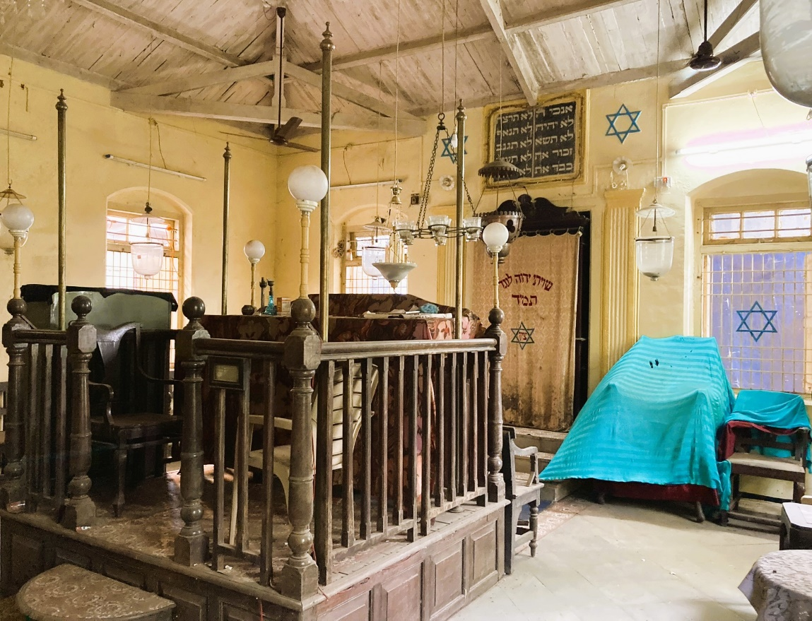
Shaar Ha’Thephillah Interier- the Bimah (left) and the Hechal, 2022

Over the years, congregants have informally used this porch for chatting with fellow members before and after prayer services, for other synagogue events, including the Sabbat Kiddush, and as a place for synagogue meetings…At the front of the synagogue to the left is a covered narrow stair that leads up to the synagogue’s women’s gallery.”

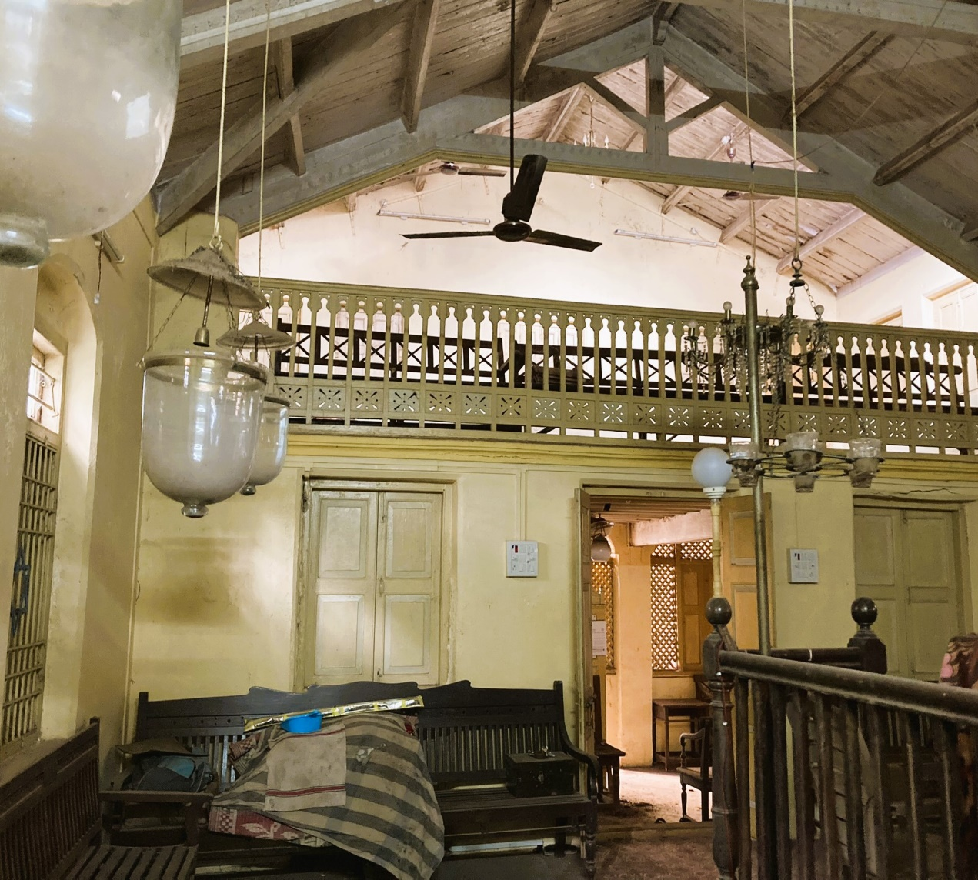
Shaar Ha’Thephillah Interier- facing the Doors and the Women’s Gallery, 2022

Waronker, relating to the interior of the Synagogue writes: “The rectangular sanctuary, measuring 7.62m x 7.22m (25’ x23’-7’’), follows the plan of other Bene Israel synagogue with a centrally-positioned raised tebah and to the far wall, the hekhal. The tebah is constructed out of a local wood. Its design includes raised panels at its base, turned balusters and newel posts, and a shaped handrail…Placed in the center of the west elevation that is closet to Jerusalem as per synagogue convention, the hekhal, a wood cabinet that features a shapely broken pediment and other details, is draped in the traditional parochet. The important hekhal is raised off the floor by a few steps and is accentuated by fluted pilasters, lights, Stars of David, and a panel in Hebrew. As traditional in Orthodox synagogues, seating for men and women is separate, and Shaar Ha-Tephilah follows this convention with a gallery where the ladies sat.

One of the most attractive features of Shaar Ha-Thephilah’s sanctuary is the gallery ‘s profiled painted wood balustrade…From the open ceiling, hang ceiling fans and a variety of lighting fixtures, including the ner tamid.”

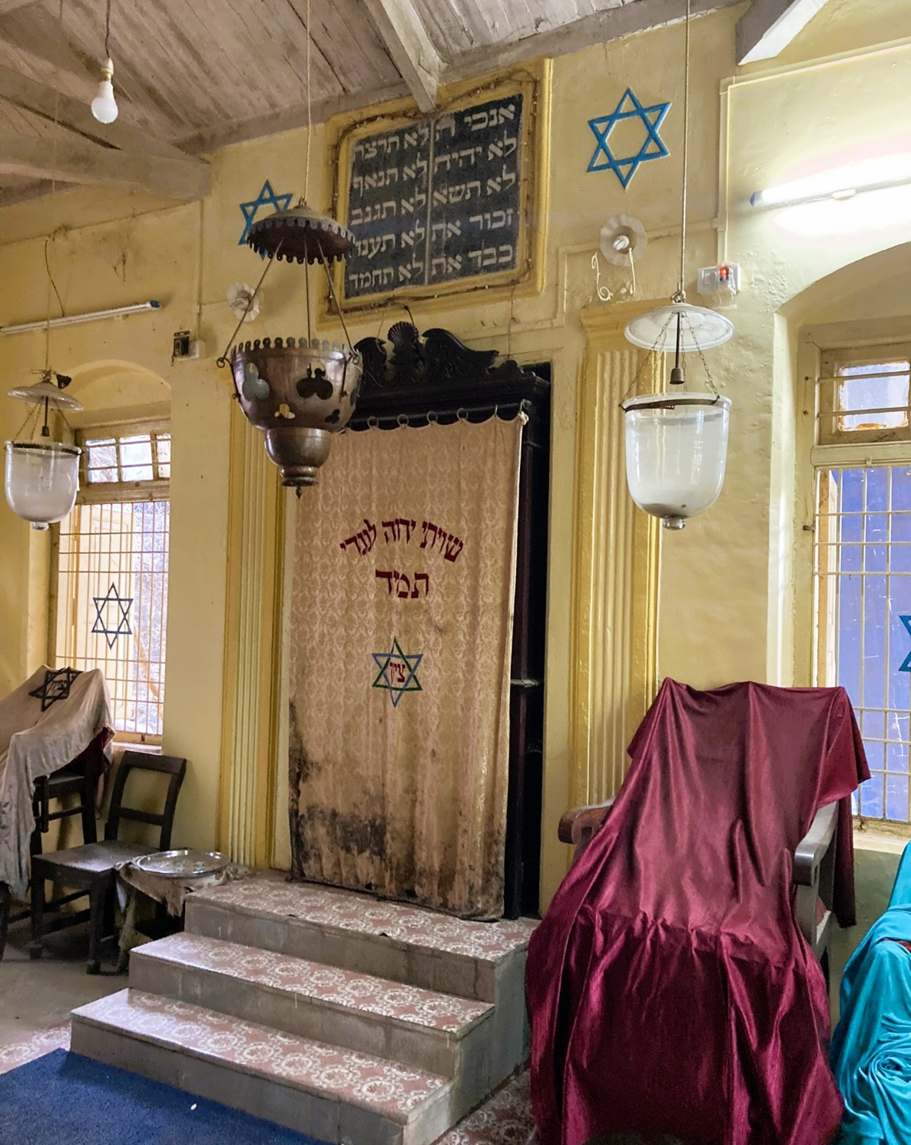
Shaar Ha’Thephillah Interier- facing the Hechal, 2022
Shrivardhan/Shriwardhan
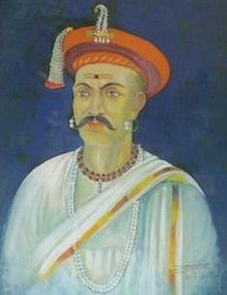
Srivardhan (taluka) is a town and a municipal council, located in the south-west of Raigad District. Many of the ancient names of the villages and towns have been changed by the time in Raigad, but Shrivardhan must be one of the few that refused to change its ancient name till present day.
Srivardhan is an ancient place of historical importance, known as the birth place of Balaji Vishwanath (1662–1720), better known as Peshwa Balaji, the First Peshwa.

Peshwa Balaji (1662–1720)

Balaji assisted a young Maratha king Shahu to consolidate his grip on a kingdom that had been racked by civil war and persistently intruded on by the Mughals under Aurangzeb. He was called the Second Founder of the Maratha State.
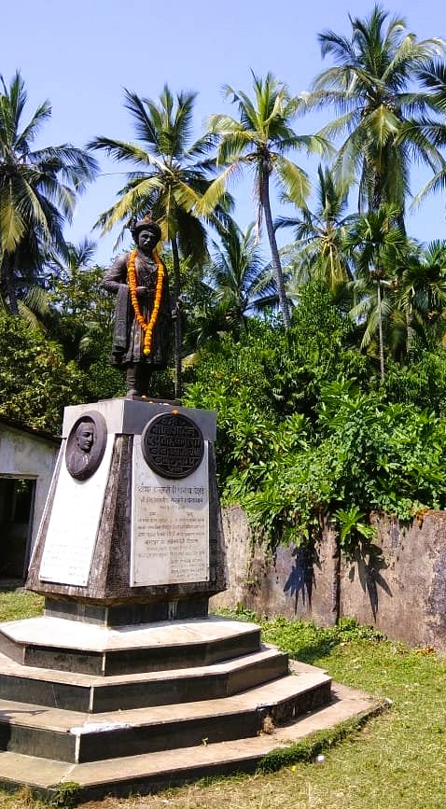
Shrivardhan is the town of Peshwas. The Bhats of Shrivardhan, later popularly known as Peshwas, witnessed the rise and fall of Marathas after Shivaji's period. Though the capital of Peshwas was Pune, the actual Peshwa (prime-minister ship under a symbolic king) started here in 1713. Balaji Vishwanath took the control of Peshwai in this year which was continued until 1818. The Peshwas (legendary warriors of Maratha empire), administered the Maratha kingdom for more than 100 years. The bronze statue of Balaji Vishwanath was built by the authorities in Shrivardhan in 1988. It has been established as a mark of respect and is a symbol of the Peshwa’s valor and patriotism.
Statue of the First Peshwa,Balaji
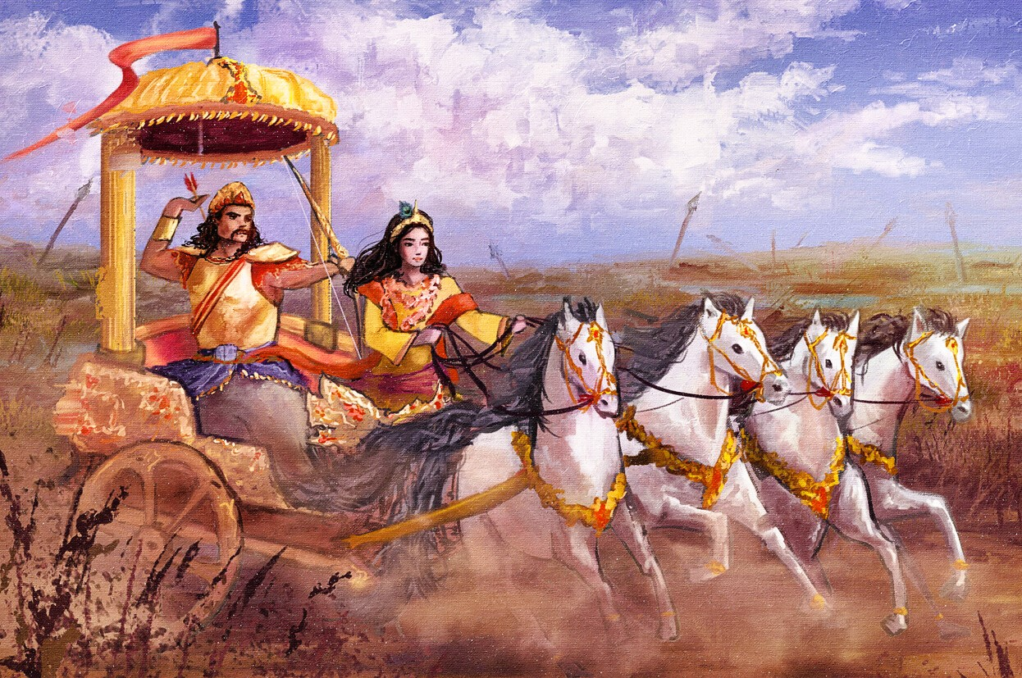
Krishna and Arjuna on the Chariot

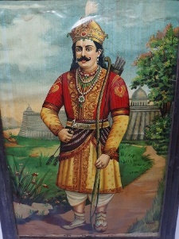
It is also said that the great Prince-Warrior, Arjuna Pandav has visited the village of Srivardhan.
Arjuna, the magnanimous figure, acclaimed for his sincerity and archery skill, is a legendary Hindu hero whose adventures are recounted in several ancient texts. His tale is mostly recounted in the Mahabharata, the ancient Indian epic, as the immortal tale of one of India’s greatest heroes, the Pandava Warrior-Prince, who has captured the imagination of millions across centuries.
Arjuna’s chronicle appeals equally to the average, discerning reader and the scholar. It spans the epic journey from before his birth, when omens foretold his greatness, across the fabled, wondrous landscape that was his life.
Arjuna
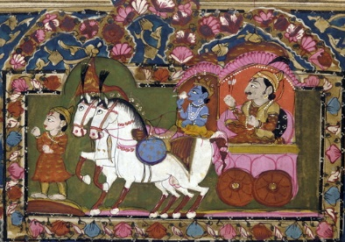
Krishna and Arjuna on the Chariot, Mahabharata, c. 18th -19th century

Shrivardhan has developed into a seaside resort, along with the nearby town of Harihareshwar, which also has a Shiva temple. Shrivardhan town itself does not have many beaches, but there are other beautiful beach destinations nearby – such as Kondivali Beach and Diveagar Beach.

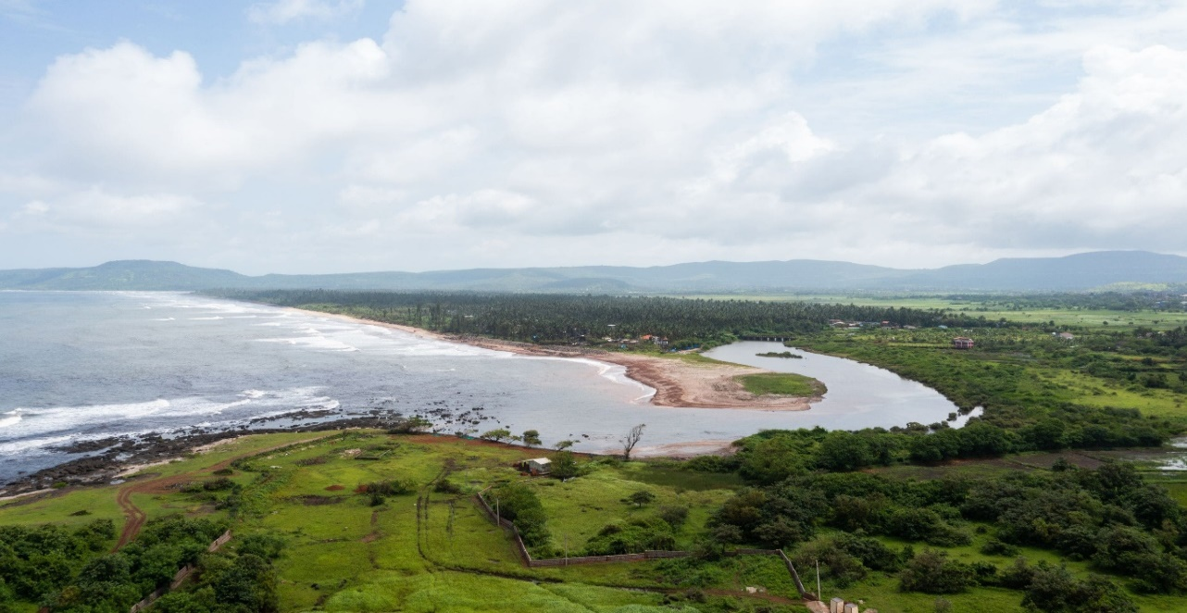Diveagar Beach

Currently, Shrivardhan has a foundation of old residences of Peshwas and the bronze Statue of Balaji Vishwanath Peshwa.
Shrivardhan Prayer Hall, Raigad

With much effort, we tried to search for historical information on the Shrivardhan Prayer Hall. We were faced with a dilemma concerning the clarification of the duplication of the names of settlements appearing on the maps. Unfortunately, there is almost nothing in the existing literature that supplies the information in need. We were also in contact with experts on the Konkan villages and towns, who are thought to be experts on the Raigad District, and whom are quite known for their experience, knowledge and contact with the Bene Israel and the Konkan. But, to our great dismay, without any success!

In a conversation I had with Dr. Irene Judah from Pune, India, on 23 March, 2023, she noted that she visited the village of Shrivardhan, about 15 years ago and all her efforts in her contact with the authorities regarding the history of the Jewish community in this village were fruitless.
From what Dr. Judah gave in the same conversation, she noted that there used to be a small community in Shrivardhan that included about 15 families, who used to gather in the Prayer Hall on Saturdays, Holidays and at social events that took place in the community. She also noted that the structure of the Prayer Hall no longer exists and that another public building was erected in its place.

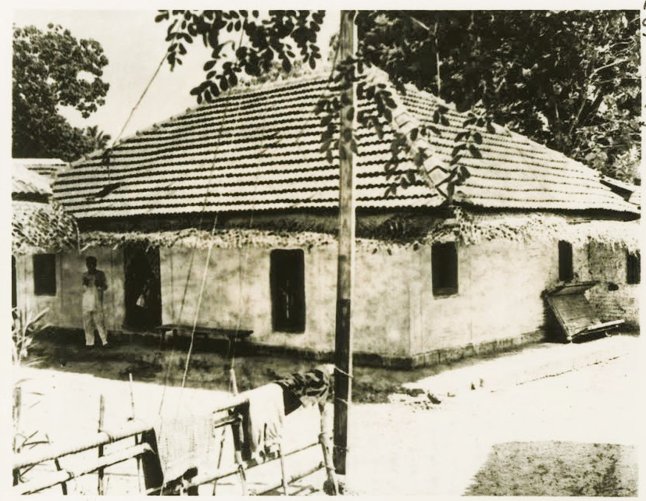
Shrivardhan Prayer Hall, Raigad, early 1960s

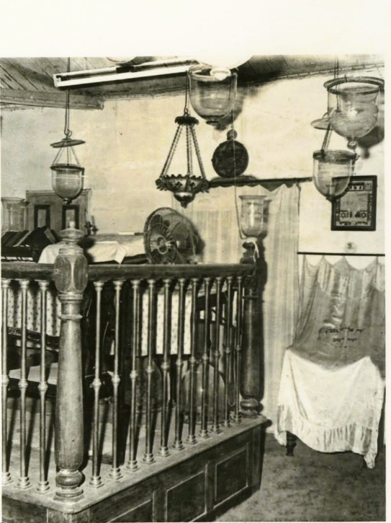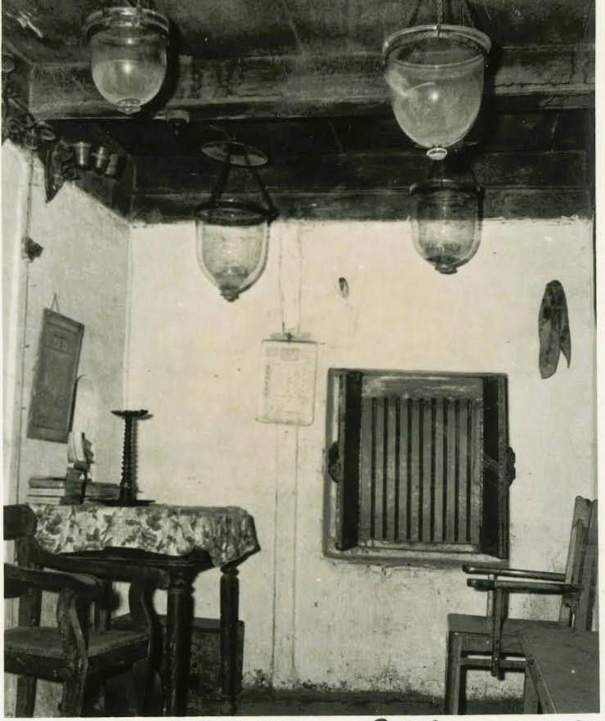
Shrivardhan, the Bimah and Hechal (left) and part of the Prayer Hall, early 1960s

According to Ben Eliahu, other Prayer Halls in the Konkan were also been founded at Ghosale, Virjoli (south of Roha and north of Tala, Roha Taluka), Murad (Hasban, north-northwest of Tala), and Shriwardhan (south-west from Mhasla).

It is customary, that Synagogue edifices are unpretentious buildings and are usually located at or near the Israel Alley.
All premises are endowed with lands, the income which augments the Synagogue’s funds obtained from various other sources.

Almost all Synagogues and Prayer Halls conduct a Hebrew class for children living in the locality and for those in nearby villages. A ‘hazan (cantor) and a ‘shamash’ (beadle), both paid from Synagogue funds, are engaged as well.

Imperial Gazetteer of India, Vol. 8. pp. 402-403.
I.O.R./ V2812 Edwardes, S.M., The Rise of Bombay, a Retrospect, The Times of India, Bombay 1902 (infra: Edwardes, The Rise of Bombay). p.3.
The Bombay Gazetteer (1894), suggests: "The proble origin of the village name is the tree 'Paral' or 'Padel', Heterophragma Chelonoides or Bignonia Suaveolens, the Tree Trumpet Flower." More on this topic, see: I.O.R./ OIH 915.479 Bombay Gazetteer, Materials towards a Statistical Account of the Town and Island of Bombay, Vol. xxvi, Part 3, Government Central Press, Bombay 1894 (infra: Bombay Gazetteer). p. 595.
Sheppard states: "Mahim is undoubtedly the Portuguese equivalent of Mahikavati, the pompous Sanskritised form of Mahi meaning either the earth or the Great (Goddess) which was the name given to the island by Bhimdeo's colonists." for this and more detailed information relating to the name Mahim see: I.O.R./ T37389 Sheppard, T.S., Bombay Place- Names and Street Names, Bombay 1917. (infra: Sheppard, Bombay). p. 95.
See a map on this subject within I.O.R/ OIH 915.479 Chaudhari, K.K., Gazetteer of India, Maharashtra State, History of Bombay- Modern Period, Government of Maharashtra, Bombay 1987. (infra: Chaudhari, Gazetteer). See there also an appended map (there is no page number). As for primary ideas, with regard to the land reclamation, as early as during the time of the Portuguese regime in Bombay (the middle of the 16th century) and during the continued reclamation activities of the following centuries, including specific information, with regard to the companies that dealt with the land reclamation, the placement of the plots, their size, the financial costs, the year the lands were reclaimed and maps of the reclaimed areas, see the subject in-depth at: Gazetteer of Bombay, Vol. 1, 1909. pp. 64-70.
O.I.R./ T30223 Burford, R., Description of a View of the Island and Harbour of Bombay, London 1831. (infra: Burford, Description). p. 7.
I.O.R/ T31215 The Port of Bombay, a Brief History, Issued by the Trustees of the Port of Bombay- to Mark the First Centenary of the Bombay Port Trust (1873-1973), Bombay (n.d.), (1974?) (infra: Times of India, Port of Bombay). p. 6.
Burford, Description. p. 20
Sheppard, Bombay. p. 96. On this issue, also see: Bombay Gazetteer, 1894. p. 667.
The Imperial Gazetteer of India (26 Vols.), Vol. 8 (new edition), Berhampore to Bombay, published under the Authority of His Majesty's Secretary of State for India in Council, Clarendon Press, Oxford 1908 (infra: Imperial Gazetteer of India, indicating the no. of volume). p. 404. We should note that the first edition of the Imperial Gazetteer of India was published in 9 volumes in 1881. The second edition augmented to 14 volumes and was issued in 1885-87. William Wilson Hunter who died in 1900 edited all these. Later volumes were edited by Sir Herbert Risley; W.S. Meyer; R. Burn; J.S. Cotton. Officials have likewise rewritten the articles that make up the body of the Gazetteer. Altogether 26 volumes were issued. On the subject on Malabar Hill, also see: I.O.R./ OIH 954, Dodwell, H.H. (ed), in: The Cambridge History of India, vol. 5, Cambridge 1929 (infra: Dodwell, History). p. 100.
Times of India, Port of Bombay. p. 10.
Gazetteer of Bombay, Vol. 1, 1909. P. 166.
I.O.R/ J10058 (n.n.) Bombay Illustrated: Her Resources, Industries and Commerce, Bombay 1904 (infra: Bombay Illustrated). p. 1. On this matter, see also: I.O.R./ T15062 Karkaria, R. P. (ed.), in: The Charm of Bombay, Bombay 1915. (infra: Karkaria, 1915), pp. X-X1; Bombay Illustrated. p. 1. For a portrait of Queen Catherine of Braganza, see within: The Burlington Magazine for Connoisseurs, vol. 9, April-September 1906. p. 396. For an illustrated portrait of King Charles II see: Ibid. ibid. p. 375.
Dodwell, History. p. 87.
O.I.R./ 954.92 Burns, L.C., Municipality of Bombay… Catalogue of the Collection of Maps, Prints and Photographs illustrating the history of the Island and City of Bombay, The Times Press, Bombay 1918 (infra: Burns, Municipality of Bombay). p. 2.
Burford, Description. p. 4.
Dodwell, History. p. 87.
For further details, see: Bhargava, National Archives. pp. 9-10.
Gazetteer of Bombay, vol. 2, 1909. pp. 57-58.
Dodwell, History. p. 87.
Gazetteer of Bombay, vol. 2, 1909. pp. 59-65.
Imperial Gazetteer of India, Vol. 8. p. 399.
This figure is supplied by Dodwell who wished to note Bombay's accelerated development during such a relatively short time frame. On this matter, see: Dodwell, History, p. 101. In our opinion, this estimate seems to be very much exaggerated.
See a summary of the table of contents in the introduction to the book - Sharma, J. S., India since the Advent of the British, New Delhi 1970. p. XVII. (infra: Sharma, India).
Imperial Gazetteer of India, Vol. 8. p. 405.
Pinder, D.A., Visitors' Illustrated Guide Book to Bombay, Bombay 1906. (infra: Pinder, Illustrated Guide). p. 32.
Sheppard, Bombay. p. 76.
Imperial Gazetteer of India, Vol. 8. p. 407.
Gazetteer of Bombay, vol. 2, 1909. pp. 130-132.
Imperial Gazetteer of India, Vol. 8. p. 407.
Edwardes, The Rise of Bombay. pp. 229-230.
On this matter and other contributions made by Elphinstone, see: Bombay Gazetteer, volume 2, 1909. pp. 140-141.
Bombay Gazetteer, volume 3, 1910. pp. 130, 278. Tables displaying the number of schools and pupils in Bombay City at successive decades, since 1820 and in 1909, see: ibid. p. 125. On the Society's further development and activity in the educational field, see: ibid. pp. 101-109. Referring to other important and famous educational institutions in Bombay City, see: ibid: pp. 133-137.
Bombay Gazetteer, volume 3, 1910. pp. 130, 278.
On this matter, see: Jewish Chronicle, 21st November 1873. p. 558.
The Times of India, 22nd January 1885. p. 6.
For further details on the building's uniqueness from an architectural point of view, see: Gupta, S., Architecture and the Raj, Western Deccan, 1700-1900, Bombay 1985. (Infra: Gupta, Architecture). p. 96.
The Times, 24th February 1881. p. 5.
Jewish Chronicle, 30th October 1896. p. 8.
Hildreth, H.R., Picturesque Bombay, London 1917 (infra: Hildreth, Picturesque Bombay). p. 27. In the commemorating plaque at the entrance to the College, it is mentioned that the building was formally opened on February 1889.
Obviously, before David Sassoon’s arrival in Bombay there was no other significant Jewish persona in the city, while the majority was the Parsis. An appeal granted by the British Parliament “…to Indians holding commissions of the Peace by the Charter Act of 1833, and of the 14 Indians appointed under this Act, nine belonged to the Parsi community, two were Hindus, two mahomedans, and one belonged to what now [1916] is called the East Indian community.” Sheppard, T.S., The Byculla Club: 1833-1916, Bombay 1916. p. 13.
Quoted in: The Times of India-Illustrated Weekly, 28th May 1913. p. 12. Also see: Ashburner, G., “Memorandum Respecting the Internal Trade of the Presidency of Bombay”, in: The Journal of the Royal Asiatic Society of Great Britain and Ireland, Vol. 4, no. 2, 1837. p. 13.
Edwardes, The Rise of Bombay. p. 251.
Hildreth, Picturesque Bombay. p. 28. A slightly different version is given in the Gazetteer of Bombay, vol. 3, 1910. pp. 373-374, where it is mentioned that the Town Hall was completed in 1833 and the architect was Colonel Cowper, R.E. It was also added here: "The large hall contains a fine organ given by Sir Albert Sassoon to commemorate the visit of H.R.H. the Duke of Edinburgh in 1872".
Gazetteer of Bombay, vol. 3, 1910. p.p. 305-308.
Edwardes, The Rise of Bombay. pp. 245-246.
Bhor Hills, also spelled as Bhore and as Bore. Bhor city is in the Poona District, State of Maharashtra, 150 kms. from Bombay and 50 kms. south of Poona.
Eaton, Richard M. (2005), A Social History of the Deccan, 1300–1761. Cambridge University Press. P. 2.
Imperial Gazetteer of India. Vol. 8. p.407.
Claridge, Bombay. p. 27.
Relating to various sources, Sheppard offers different dates, concerning the construction of Grant Road, and see: Sheppard, Bombay. p. 70. On this subject also see: Gazetteer of Bombay, Vol. 1, 1909. p. 363.
Edwardes, The Rise of Bombay. p. 252.
Ibid, pp. 248-249.
Sheppard, Bombay. p. 49.
Ibid. pp. 253, 258, 261.
Gazetteer of Bombay, Vol. 1. 1909. pp. 343-344. Also see: Pinder, Illustrated Guide. p. 6; Mclean, James Mackenzie, Guide to Bombay, Historical, Statistical, and Descriptive (1889), Compiled and Printed at the “Bombay Gezette” Steam Press, Esplanade Road, Bombay, Publisher, G. Street & Co., London 1889. pp. 101-102.
Imperial Gazetteer of India. Vol. 8. p. 407. Relating to the same issue also see: Michael, History. p. 161.
Claridge, Bombay. p. 32.
The Times of India, 29th November 1905. p. 11.
Kulkarni, V.B., History of the Indian Cotton Textile Industry, Bombay 1979 (Infra: Kulkarni, History). p. 10.
With no name of the author, I.O.R./ P.T. 3299 Industries in the City of Bombay, Pub., the All-India Manufacturers' Organization, Bombay 1942. (Infra: Industry in Bombay). pp. 2-4.
Vijayanagar, R.L.N. (ed.), Millowners' Association Bombay- Hundred Years of Dedicated Service: 1875-1975- Centenary Souvenir, Bombay 1975. (Infra: Vijayanagar, Association). p. 3.
Bombay Gazetteer, volume 1, 1909. p. 494.
Michael, History. p. 372.
The Times, 16th January 1877. p. 9. We should note that the news did not specify to whom of the Sassoon family the new factory belongs to, but in our opinion, David Sassoon & Co. established the factory. For references on this, see: Jewish Chronicle, 19th April 1907. p. 21. In this source, the factory appears under the name, which belonged to the company listed here.
For more on this subject see: Jackson, The Sassoons. p. 63.
Gazetteer of Bombay, Vol. 1, 1909. p. 488.
I would like to thank my friend and colleague Rashid Wadia who accompanied me on this special and interesting “mill hunting” day trip to the various textile mills of the Sassoons.
My special gratitude to Yael Jhirad, a family friend who accompanied me to this site in 2003.
The Times, 15th November 1905. p. 5. For further details about the trip, including matters such as: The arrival of the Prince and Princes at Bombay; The City's welcome; The Prince's speech and more, see: The Times, 10th November 1905. p. 5a; Ibid, 13th November 1905. p. 5.
The Times of India, 23rd December 1905. p. 7. Also see: Jewish Chronicle 21st September 1906. p. 13.
The Times of India, 7th October 1905. p. 8.
The Times of India, 19th August 1905. p. 16.
The Bank of India Limited- Golden Jubilee- 50 Years of Service: 1906- 1956, Bombay 1956. (Infra: Bank of India). pp. 3, 5. My special thanks to Mathuradas J. Bhatia (Vice General Manager of the Bank of India's head office in Bombay) for informing me of the existence of this book, the last remaining copy at the bank's disposal and for preparing a special copy for me!
Industry in Bombay. p. 5. On this matter, also see: Jackson, The Sassoons. p. 155.
Ibid. p. 201.
Industry in Bombay. pp. 4-5.
Shyam Chainani, Heritage & Environment, an Indian Diary, Mumbai 2007. p. 119.
Ibid, ibid.
On this matter, see the words of Martin Moir, the deputy of the chief archivist and the editor of the essay: Seton, R., The Indian 'Mutiny' 1857-58 (a guide to source material in the India Office Library and Records), the British Library, London 1986. (infra: Seton, The Indian Mutiny) Ibid. p. V (within the introduction).
Lord Palmerstone was a British statesman who served twice as Prime Minister. He is best remembered for his direction of British foreign policy. Some of his actions were greatly controversial at the time.
On this matter, see: I.O.R/ V2812 Edwardes, S.M., The Rise of Bombay, a Retrospect, The Times of India, Bombay 1902 (infra: Edwardes, The Rise of Bombay). p. 267. For further reading into the same matter, see Bhargava, National Archives. pp. 17-20.
Seton, The Indian Mutiny. P. XVI.
For the whole report and for the full text of the Proclamation, see: The Times, 6th December 1858. p. 7; The Times, 2nd November 1908. p.10; and also, as a newspaper Supplement: The Times of India-Illustrated Weekly (Supplement), 4th November 1908. p I. The emphasizes in the text are by the author.
Jewish Chronicle, 3rd July 1908. p. 27.
About this interesting event see: Jewish Chronicle. Ibid, ibid. This item was originally published in a newsletter that was published in Bombay, under the name: Doresh Tov Le'Amo (In Hebrew: Wishing well to His People), on 4th March 1859, and the Jewish Chronicle used a summary of the article.
Sharma, India. p. XIX.
On the man, Frere and his extensive efforts for Bombay's development, see the words of Sir Richard Temple, who served as Bombay's Governor between the years 1877-1880, within: Temple, R., Men and Events of My Time in India, London 1882. (infra: Temple, Men and Events). pp. 254-268. For details concerning the personality of Frere, see: O.I.R/ 12354. I16- Temple, R., Cosmopolitan Essays, London 1886. pp. 171-178. We shall deviate here from the main discussion and add an interesting fact for our Israeli readers. In 1883 Sir Richard Temple went on a unique visit to the Land of Israel and left his impressions from this visit in a thick book with many of his very own illustrations. For his book, see: Temple, R., Palestine Illustrated, London 1888.
The Times of India, 22nd April 1862. p. 3; Ibid, 23rd April 1862. pp. 2, 4.
Edwardes, The Rise of Bombay. p. 265.
(n.n.), Director of British Architects, 1834-1914, Vol. 2, London & New York 2001. p. 839. On this topic, also see: Davies, Architecture. p.155. Other projects that Trubshawe was involved with includes: the preparing of a Strategic Plan for Bombay, Plans for Bombay Cathedral, Plans for the Post Office building (with Walter Paris, 1842-1906. Lived in Bombay: 1865-1880) and the Elphinstone College in Byculla. In Poona Trubshawe designed the Government House. On this subject, see: ibid. p.257. An illustration of the New Post Office, see: The Builder, 6th March 1875. p. 211. On Walter Paris, see: British Architecture, Vol. 2. p. 314.
Pinder, Illustrated Guide. p. 32.
An intensive correspondence on removing the Western Ramparts of the Fort, during December 1861 and September 1863, see: Bombay's Municipal Archives,General Department (G.D.), Vol. 15, 1862-64/ Comp. no. 261. pp. 125-157.
For further reading on this subject see: Samita, G., Architecture and The Rag, Western Deccan, 1700-1900. Bombay 1984. pp.45-49. See in this work, a special chapter on Bombay's fortifications during the different eras. Ibid. pp. 68-75.
This information was reported in a letter to the editor, by a correspondent signed Young Bombay, in: The Times, 12th December 1863. p. 12.
A few examples of these roads are given in this work, which relies on different sources, and see: Gazetteer of Bombay, Vol. 1, 1909. p. 363. On the process of constructing a new road and maintaining public roads in Bombay see: ibid. pp. 364—367.
O.I.R./ PT4005, Batley, C., Bombay's Houses and Homes, Bombay 1949. p.13. In addition, Batley stated that the urban area has grown due to the demolition of the walls, from 18 square miles to 27 square miles. Ibid, ibid.
On this matter and for further clarifications on the subject, see: Davies, P., Splendours of the Raj, British Architecture in India, 1660 1947, London 1985. (infra: Davies, architecture). p. 155.
Chaudhari, Gazetteer. p. 312.
Crawford, A.T., Reminiscences of an Indian Police Official, London 1894. pp. 52-53.
For further reading and specification on this issue, see: The Times of India, 18th July 1861. p. 3.
On this issue, see: Ibid, 27th August 1861. p. 3. It is important to state in this context that the correspondences on the matter of exporting cotton from India to England and to Manchester in particular fed the crowded columns on this newspaper for many weeks.
For more on this topic, see: Gazetteer of Bombay, volume 2, 1909. pp. 161-162.
For information about the building and the structures, which have been erected during this period and about Frere’s part in their establishment, see: Edwardes, The Rise of Bombay. pp. 273-284. Another list of projects constructed during this time by Bartle Frere and by various individuals and companies, see: Gazetteer of Bombay, volume 2, 1909. pp. 171-172. As for the companies that reclaimed the land from the sea and the development of the road and street system in Bombay during this period, see: Gazetteer of Bombay, volume 1, 1909. pp. 66-67.
Edwardes, The Rise of Bombay. p.275. Further reasons for adopting the Back Bay Scheme in the 1920's, see: The Times of India-Illustrated Weekly, 17th August 1921. p. 19.
Karkaria, 1915. p. 32.
Imperial Gazetteer of India. Vol. 8. p. 401.
Explaining the term Vellard, Sheppard mentions: "Vellard, from Portuguese Vallado, a fence or embankment, is said to be peculiar to the island of Bombay, and now is used only in this connextion." For this and other information regarding the construction of this road see: Sheppard, Bombay. p. 76.
The Bombay Builder, an Illustrated Journal of Engineering, Architecture' Science and Art, Vol. 3, July 1867-June1868. p. 86. For the entire and interesting article on Land Reclamation projects in Bombay: past and present, with suggestions for the future, see: ibid. pp. 86-88.
Gazetteer of Bombay, volume 3, 1910. pp. 51-52.
The Times of India, 12th July, 1862. p. 3.
Edwardes, The Rise of Bombay. p.275.
Gazetteer of Bombay, volume 3, 1910. pp. 51-52.
Sullivan, J.F.R., One Hundred Years of Bombay, History of the Bombay Chambers of Commerce, 1836-1936, Bombay 1936. (infra: Sullivan, one hundred years). pp. 64-77. Also, see: Edwardes, The Rise of Bombay. p. 276.
Temple, Men and Events. p. 268 and: Gazetteer of Bombay, volume 2, 1909. p. 173.
See details on this building in: The Builder, 20th November 1875. p. 1039 and illustrations on pp. 1040-1041.
On this matter, see: Metcalf, T.R., An Imperial Vision: Indian Architecture and Britain's Raj, University of California Press, L.A. 1989 (Infra: Metcalf, Indian Architecture); Davies, Architecture. p. 257.
More on this issue and on a detailed description of the Mansion, see: ibid, p. 184. Referrence on the Public Works Offices, see: The Builder, 23rd May 1874. pp. 437, with illustrations on pp. 438-439.
On these matters see: British Architects, Vol. 2. p. 95.
Illustrations of Market and Fountain, see: The Building News, Vol. 27, 27th November 1874. pp. 642-643.
For more extensive details on Emerson and his works, see: the archives and library of The Royal Institute of British Architects, William Emerson File. Doc. RIBA/B10.613; Journal of the Royal Institute of British Architects, Vol. 32, 24th January 1925. p. 191.
The Builder, 2nd January 1925. p. 5.
The Builder, 20th November 1875.
The Architecture, Vol. 2. 11th December 1869. p. 286. A good illustration of the building appears between pp. 286-287.
For further information on this issue see: The Bombay Builder, an Illustrated Journal of Engineering, Architecture, Science and Art, Vol. 3, July 1867-June1868. p. 236.
For these details and others, see: Arnold. E., India Revisited, London 1886.pp. 54-58
For his words, see: Davies, Architecture. pp. 153-154. On this matter, see also: Gazetteer of Bombay, volume 2, 1909. pp. 167-168.
Edwardes, The Rise of Bombay. p. 279.
Ibid. p.p. 280-284.
Ibid. p. 303.
For further details on this subject see: Rao, D., Mumbai’s Water Supply, Mumbai 2005.
The Times, 10th November 1905. p. 5.
Background material on the Bene Israel congregation during the early 20th century, including the historical aspect, their religion, culture, lifestyle customs and more, see: Gazetteer of Bombay, vol. 1909. pp. 247-254.
Jackson, The Sassoons. pp. 12-13.
Ibid. p. 12.
Lentin, S.S., "The Jewish Presence in Bombay", in: Weil, S. (ed.), India's Jewish Heritage, Mumbai 2002. pp. 23-36. (Infra: Lentin, Jewish Presence). p. 27.
Roland, G.J., Jews in British India, Identity in a Colonial Era, Hanover 1989 (infra: Roland, Jews). p. 16
Israel, The Jews of India. 1982. p. 16.
For further details on this topic see: Gadkar, 1984. p. 11.
Ben Eliahu, Synagogues. pp. 49-52.
On this matter, see the letter of John Perry from English Town, New Jersey, which was published in The Times of India on 10th August 1995. p.13. As for India’s first railway track (which was the first railway track east of the Suez Canal), many essays have been published, see mainly: The Archives of the Indian Office in the British Library: Cases and correspondences mentioned on page 211 within: (with no name mentioned of the author), Indian Railways-Parliamentary Returns on Indian Railways, 1845-1861.
Sheppard, Bombay. p. 127. For more details on the subject, see: Sapir, Bombay. pp. 64-65.
Gazetteer of Bombay, vol. 1, 1909. p. 26.
Ibid. p. 249.
Gazetteer of Bombay, vol. 1, 1909. Comment number 2, on pp. 249-250.
(n.n), Jewish Landmarks in Bombay & Thane, Bombay (circa: 1990). (Infra: Jewish Landmarks). p. 7. As well as Gazetteer of Bombay, vol. 2, 1909. p. 189. See also: Gazetteer of Bombay, vol. 3, 1910. p. 350.
The Divekar Brothers are: Divekar, Samaji (Samuel), Hassaji (Ezekiel). Born 1730-1797. Appointed Jemedar in the 6th Battalion on 2nd July, 1775 and later elevated to Subedar and Subedar Major. He fought in the 2nd Mysore war under Gen. Mathews and was then taken prisoner. After his release the records show that on 4th July, 1791. Major General Abercrombie, Commander-in-Chief of the East India Company, appointed him President of a General Court Martial. Divekar, Issaji (Isaac) Hassaji (Ezekiel), enlisted in 1760, appointed Jemedar on 13th December, 1791, promoted to Subedar on 11th December, 1775, and to Subedar Major. He fought in the 2nd Mysore war. Divekar, Silliman (Solomon), Hassaji (Ezekiel), enlisted in 1760, was promoted to Subedar of the 6th Battalion and subsequently Subedar Major. He fought in the 2nd Mysore war. Divekar, Eloji (Elijah), Hassaji (Ezekiel), enlisted in 1760, appointed Jemedar in the 5th Battalion on 12 October, 1775. He fought in the 2nd Mysore war. Divekar, David Hassaji (Ezekiel), enlisted in 1760, promoted to Subedar in the 7th Battalion on 1st September, 1781. He fought in the 2nd Mysore war. I express my special thanks to my college and friend, Nissim Moses for this information.
See: Sheppard, Bombay. p. 127.
More in detail on Samaji Hassaji Divekar see: Kehimkar, History. pp. 190-191.
In the second war, Hyder Ali joined forces with the Marathas in 1780 and again devastated Karnataka. The tide was turned by the dispatch of British help from Calcutta and by the death of Hyder Ali in 1782. Peace was made with Hyder Ali’s son Tippu Sultan by the Treaty of Mangalore (1784).
Hyder Ally was Born in 1721 and started his career as a soldier in the Mysore army. He became the Sultan of Mysore 1n 1761, after the death of Nanjaraj, who had usurped power reducing its king Chikka Krishna Raj of Wodeyar dynasty. Hydar took steps to train his army on European lines, by preferring infantry to horseman troops and by setting up modern artillery.
About the final hours of his life see: The Times of India-Illustrated Weekly, 5th September 1906. pp. 2-3.
Sheppard, Bombay. p. 124.
For further details on this matter see: Ben Eliahu, Synagogues in India, Kiryat Motzkin (Hebrew date 5,739 – 1978/79). (Infra: Ben Eliahu, Synagogues). pp. 8-12. On the same matter, see: Gazetteer of Bombay, vol. 3, 1910. p. 350.
Kahimkar, History. 1939. pp. 75-76.
Kolet, List. Site 2.
Gadkar, Religious. p. 29. The content is based on a booklet written by Abraham Samson Shapurkar which was published by the Synagogue in 1927. Also see: Gadkar, Bombay. pp. 85-86; Ben Eliahu, The Synagogues in India, Kiryat Motzkin 1978 (infra: Ben Eliahu, Synagogues). pp. 12-22.
Gazetteer of Bombay, vol. 3, 1910. p. 350. In this source a slightly different version is given on the erecting of the Synagogue.
Gadkar, Religious. p. 87.
Jewish Chronicle, 5th June 1896. p. 18. Also see: Ben Eliahu, Synagogues. p.p. 19-21.
The Times of India,10th August 1995. pp. 14-16; Jewish Landmarks. p. 8; Gazetteer of Bombay, vol. 1, 1909. Comment 2, on p. 250; Hyam Joseph Halegoa, with the assistance of Hyam Isaji/Essaji (Isaac) Garsulkar, translated in 1845 the Hebrew Passover service (the Haggada), into Marathi, for the use of the Bene Israel. See Kehimkar, History. pp. 67-68.
Haeem Samuel Kehimkar, in his book: The History of the Bene Israel in India, Tel Aviv 1937, pp. 181-182, mentions, mistakenly, that the dedication of the New Synagogue Don Tad (Two Palmyra Trees), 3rd Row, was held in 5th June 1844, but he was correct in mentioning the Hebrew year of its dedication in the year of 5603, which is 1843. (Kehimkar completed his book in 1897, 40 years before it saw light, but he was unable to secure the funds to publish it, so it was finally published by Dr. Immanuel Olsvanger in 1937). Also see: Gadkar , Religious. pp. 2, 86-87; Ben Eliahu, Synagogues. pp. 22-25.
Ben Eliahu, Synagogues. pp. 24-25.
Ben Eliahu. pp. 25-26.
Gadkar, 1984. p. 12.
The name Agripada is derived from the Dravidian origin, means a hamlet which in the past was occupied by Agris or cultivators. For further details see: Sheppard, Bombay. pp. 17-18.
Gadkar, Synopsis. p. 12.
Ben Eliahu, Eliya, The Synagogues in India, Kiryat Motzkin, Israel 1978 (Infra: Ben Eliahu, Synagogues). p. 30.
Haeem Samuel Kehimkar (1830-1909), historian of the Bene Israel community in Bombay. Born in Alibag, on the Konkan Coast, like many other in the community, he became a civil servant in Bombay. Kehimkar, was the editor of the periodical ‘Israel’, which appeared until 1885. His work ‘Sketch of the History of the Beni-Israel and an Appeal for Their Education’, was published in 1892. On his death in1909, he left his manuscript ‘History of the Bene-Israel of India’, which has been a source of considerable inspiration and assistance. His treatment of the subject, both lucid and learned, has proved a work of reference, valuable and dependable, focused on the history and customs of the Bene Israel community. The book was published in Tel Aviv in 1937, on the initiative of Immanuel Olsvanger. Alsos see: Gadkar, Ezekiel Moses Jacob (1984, The Religious and Cultural Heritage of the Bene-Israels of India, book 2, published by, Gadkar E.M. Jacob, Printed at, Appan Printers, Sayani Road, Bombay (Infra: Gadkar, 1984). pp. 34-35, and almost the same article on pp. 36-37.
See: Hyams, Haim David “Bene Israels of India”, Shofar: The Voice of the Federation of Indians Jews, Issue 4th of May, Jerusalem 1973. pp. 35-43 (Infra: Hyams, 1973). p. 37.
Judah Shalome and D.S. Erulkar (Compiled by), “Some Important institutions: The Bene - Israel Benevolent Society (1853”), in: Gadkar E.M. Jacob (publisher), The Religious and Cultural Heritage of the Bene Israels of India, Vol. 2, Bombay 1984. pp. 111- 128. p. 113.
Kehimkar, Norah and Benjamin (eds., 2010), Poems and Memoirs of Judah Benjamin Kolatkar- Architect, Poet, Singer and Philosopher, Ahmedabad 2010. pp. 44-45.
E.M. Jacob, Etz Haeem Prayer Hall, in: Etz Haeem Prayer Hall Centenary Year, Bombay 1988. pp. 18-21. (Infra: Etz Haeem, 1988). p. 20.
Jay E. Waronker, The Synagogues of India, A Friends of Indian Synagogues Publication, printed by Sprint, Johannesburg, South Africa 2019. (Infra: Waronker, 2019). p. 26.
Israel, The Jews of India. p. 27.
Gadkar, 1994. p. 46.
Gadkar, Synopsis. pp. 11-12; Galsurkar, 2011. p. 11. Also see: Ben Eliahu, Synagogues. pp. 36-37.
(n.n.), Jewish Landmarks in Bombay and Thane, Mumbai (circa 1994). p. 11. It is mentioned here that the Prayer Hall was erected by a “…Mr. Jiradkar who earlier conducted the High Holiday prayers at his residence in Chunabhatti near Kasaiwada in kurla (East). After Mr. Jiradkar expired Mr. Benjamin Shalom Sagaonkar (Sagaoson)assumed the prayer responsibilities and arranged for a rented room upto 1938-39. Then, in 1942, a Rabbi on his trip to India visited the Kurla Bene Israel Prayer Hall and donated a Sefer Torah to be installed in it. This building was known as Old Court Building and it was leased to Mr. Sagaonson who shifted his residence to it in 1943. He allocated a hall for the community for prayer and he did so without charging any rent.” Regarding the history of the Kurla Prayer Hall, also see: Galsurkar, Shalom, “Konkan”, Jewish Landmarks of India, Mumbai 2011 (Infra: Galsurkar, 2011). p. 11.
Waronker, 2019. p. 36.
Ibid, ibid.
I would like to thank Bensiyon Ghosalkar for joining me on the trip to Kurla. Bensiyon is a native of Kurla whose parent’s bungalow was just opposite the Prayer Hall building. I also give my thanks to Moshe Yoseph Rajpurkar, who is charge of the Prayer Hall today, and who welcomed us very warmly to his home, and supplied me with some of the information regarding the Prayer Hall.
Ben Eliahu, Synagogues. pp. 31-33. I would like to express my special thanks to Bensiyon Ghosalkar for joining me on the trip to Parel and assisting me in locating the Parel Prayer Hall.
Ben Eliahu, Synagogues. p. 35. Also see: Gadkar, Synopsis. pp. 11-12; Galsurkar, 2011. p. 12. My special thanks to Bensiyon Ghosalkar for joining me on the trip to the Prayer Hall in Bandra
Israel, The Jews of India. p. 26.
Gazetteer of Bombay Vol. 1. 1909. pp. 343-344. Also see: Sapir, 2019. p. 35; Pinder, D.A., Visitors’ illustrated Guide Book to Bombay, Publisher, G. Claridge, Bombay 1906. p. 6.
Kahimkar, History. p. 184.
Subedar is a historical rank in the Indian Army, ranking below British commissioned officers and above non-commissioned officers. The rank was otherwise equivalent to a British lieutenant.
Waronker, 2019. p. 38.
Ibid, ibid.
Ibid, ibid.
Dekkan- The Etymology of the word ‘Dekkan’ and its denotation originates from the word ‘Dekkhan’, meaning ‘southern’ which once designated the position of the Indian Peninsula lying to the south of the Narmada River (also called the Reva and previously also known as Narbada or anglicised as Nerbudda). The Narmada is the 5th longest river and overall longest west-flowing river in India, and largest flowing river of the state of Madhya Pradesh. This river flows through Madhya Pradesh and Gujarat States of India. Further details on the subject see: Bhandarkar, Ramkrishna Gopal, Early History of the Dekkan, Susil Gupta Private Limited, Calcutta 1884. (Infra: Bhandarkar, 1884). pp. 10-11; Chisholm, Hugh (ed.) "Nerbudda", Encyclopedia Britannica, 19 (11th ed.), Cambridge University Press, Cambridge 1911. p. 388.
Gangavalli River is one of the many small rivers that originates and flows entirely within the western part of state of Karnataka. Gangavalli River (also called Bedthi River) originates from the Western Ghats the south of Dharwad (Near Someshwara temple) as Shalmala and flows in the west direction to meet the Arabian sea just after the Ganga temple. Here the River embraces the name Gangavalli from Ganga; the village in this area carries the same name Gangavalli. On its course towards the Arabian Sea, the river falls from a height of 180 metre at a point called Magod, where the river bed falls rapidly with a clear over fall of 183 m (600 ft) at Magod and is popularly known as The Magod Falls.
About the Ghats and Scenery of the Ghats see: Karkaria, 1915. pp. 459-462.
The Chandragiri River also known as Perumpuzha River, is the longest river in Kasaragod district, Kerala, India. It was named after the great Mauryan king Chandragupta Maurya. The 17th century Chandragiri Fort is located on the river. See: Jayashanker, S. (2001), Temples of Kasaragod District, Controller of Publications, Delhi 2001. p. 4.
About the occurrence of the names Maharashtra and Maharathi see: Bhandarkar, 1884. pp. 21-22.
Deccan, the entire southern peninsula of India, south of the Narmada River, marked centrally by a high triangular tableland. The name derives from the Sanskrit daksina (“south”). The Deccan Plateau is a large plateau in southern India between the Western Ghats and the Eastern Ghats, and loosely defined as the peninsular region between these ranges that is south of the Narmada river. To the north, it is bounded by the Satpura and Vindhya Ranges. Further details on this topic see: Goldberg, Maren (2014), “Deccan Plateau”, Encyclopaedia Britannica, 2014. The Deccan produced some of the most significant dynasties in Indian history, for details see: Rao B.V. (2004), History of Asia, From Early Times to the Present, Publisher,‎ New Dawn Press, Inc, Elgin, IL, United States 2004. p.288
The Bhor and Thul Ghats were constructed between 1863 and 1872, by over 40,000 labourers, and helped Bombay access goods from the hinterland. Bhor Ghat connects Mumbai with Pune, while Thul connects the city with Nashik.
Chhatrapati Shivaji was the famous Maratha king who had the utmost courage to stand against the vast ocean of Mughal rule, single-handedly. Although his original name was Shivaji Bhosle, his subjects lovingly gave him the title of ‘Chhatrapati’ or the ‘Chief of the Kshatriyas’ for his undaunted ability to protect them all under the safe shelter of his leadership. See the epic text of Ranjit Desai, Shivagi- The Great Maretha, (translated from the Marathi by Vikrand Pande, Publisher- Harper Perennial, India 2017) an immersive narrative of the foundations of the Maratha empire and the saga of its charismatic founder. On Shivaji the Great, also see: Bhave, Y.G., From the Death of Shivaji to the Death of Aurangzeb (The Critical Years), Northern Book Centre, New Delhi 2000. pp. 34-42, and other various pages.
The Fort has a height of 25 feet and is at a distance of only 2 km from the Alibag Beach shore. The most interesting feature of the Fort is that despite being a part of a saltwater body, the Fort has a fresh-water well. In 1713, with the treaty being created with Peshwa Balaji Vishwanath, the Kolaba Fort and many other forts were handed over to Sarkhel Kanhoji Angre, who used it as his main base from which to launch raids on British ships (see ahead). A temple dedicated to Ganesha, built by Raghoji Angre in the year 1759, is also present in the Fort premises and is still worshipped by the fishermen from the area. An extensive report on the Kolaba Fort see: Campbell, 1883. pp. 260-265.
Elephanta or Gharapuri- Uran is “…an Island on Bombay Harbour about 7 miles east of the Apollo Bunder…The Hindu name, Gharapuri is the name of a small village in the south of the island; it is perhaps Giripuri or the hill hamlet. Elephanta, the European name, was given to the island by the Portuguese in honour of a huge rock-cut elephant that stood on a knoll a little to the east of Gharapuri village.” See: Maharashtra State Gazetteer, 1964. p. 759. For further detailed information on the Elephanta Caves see: pp. 714-797. Also see: Karkaria, 1915. pp. 434-438.
Samuel, Shelim, (1963), A Treatise on the origin and Early History of the Beni-Israel of Maharashtra State, Iyer and Iyer Private LTD., Bombay 1963 (Infra: Samuel, 1963), p. 11. Savitri River is one of the five rivers which originate from Mahabaleshwar in the Maharashtra State. It originates at Savitri point near Mahabaleshwar and flows through the bankot village and directly goes to Arabian sea Raigad district and eventually meets the Arabian Sea at Harehareshwar. It passes through rocky and hilly terrain of western the ghats till Poladpur and further through the towns of Mahad, Mangaon and Shrivardhan Tehsil (taluka). The other four rivers originating from Mahabaleshwar (Panchganga) are: Gayatri River, Koyna River, Krishna
Hyams, 1973. p. 35.
However, the passage in I Chronicles, 5:26 to the effect that the ten Tribes “unto this day” and the prophecies of Isaiah, 11:11, Jeremiah, 31:8 and above all, of Ezekiel 37:19-24, kept alive the belief that they had maintained a separate existence and that the time would come when they would be rejoined with their brethren, the descendants of the Exile of Judah to Babylon.
Tiglath Pileser 111, meaning "my trust is in the son of the Ešarra", was a prominent king of Assyria in the eighth century BCE (ruled 745–727 BCE) who Savitri River introduced advanced civil, military, and political systems into the Neo-Assyrian Empire. See, Schwartzwald, Jack (2014), The Ancient Near East, Greece and Rome: A Brief History, McFarland & Company, Jefferson, NC. p. 24
Further information on the subject of the ten tribes also see: Samuel, 1963), p.1-4.
Nebuchadnezzar II, also spelled Nebuchadrezzar II, was the second king of the Neo-Babylonian Empire, ruling from the death of his father Nabopolassar in 605 BC to his own death in 562 BC. Historically known as Nebuchadnezzar the Great, he is typically regarded as the empire's greatest king. Nebuchadnezzar remains famous for his military campaigns in the Levant, for his construction projects in his capital, Babylon, and for the important part he played in Jewish history. Ruling for 43 years, Nebuchadnezzar was the longest-reigning king of the Chaldean dynasty. At the time of his death, Nebuchadnezzar was among the most powerful rulers in the world. In 586 BC, Nebuchadnezzar destroyed the Kingdom of Judah, and its capital, Jerusalem. The destruction of Jerusalem led to the Babylonian captivity as the city's population, and people from the surrounding lands, were deported to Babylonia. The Jews thereafter referred to Nebuchadnezzar, the greatest enemy they had faced until that point, as a 'destroyer of nations'. See, George, Andrew R. (2011), "A Stele of Nebuchadnezzar II", CUSAS, 17, pp. 153–169. p. 153-154; Wallis Budge, George, Andrew R. Ernest Alfred (1884), Babylonian Life and History, Religious Tract Society, London. p 116; Sack, Ronald H. (2004), Images of Nebuchadnezzar: The Emergence of a Legend, (2nd Revised and Expanded ed.), Selinsgrove: Susquehanna University Press, Pennsylvania. pp. 129; Redditt, Paul L. (2008), Introduction to the Prophets, William B. Eerdmans Publishing, Grand Rapids Michigan. p. 180.
Concerning this interesting subject in detail see: D.J. Samson (Killekar), "The Bene-Israel, Why? Where? and Whence?", in: (n. n.), The Religious...etc. pp. 51-54.
Kehimkar, History. p. 15.
During his period, Rehabi made a major contribution to the community, not only in the economic and diplomatic areas but also in the socio-culture and religious spheres as well: the Paradesi Synagogue was completed by him in 1730, after its destruction in 1662. For futher information, see: Fischel, W. J. (1962) Cochin in Jewish History: Prolegomena to a History of the Jews in India, Proceedings of the American Academy for Jewish Research, Vol. 30 (1962), pp. 37-59.
Kehimkar, History. p. 40.
Ibid, ibid; Gadkar, History. pp. 98-99.
Numark, Mitch (November 2012), “Hebrew School in Nineteenth-Century Bombay: Protestant Missionaries, Cochin Jews, and the Hebraization of India’s Bene Israel Community”, Modern Asian Studies, Vol., No. 6, Cambridge University Press, United Kingdom. pp. 1,764-1,808.
Kehimkar, History. pp. 74-75. In this matter also see: Divekar and the First Jewish Synagogue in Bombay in the neighbourhood of Mandvi.
I.O.R. V/2812. Edwardes, S.M., The Rise of Bombay, a Retrospect, Bombay 1902 (Infra: Edwardes, The Rise of Bombay). p. 259.
Kehimkar, History. pp. 78-79.
Israel, The Jews of India, 1982. p. 64.
For the full report on the Bene Israel see: Campbell, 1883. pp. 85-86.
Isenberg, Shirley Berry, India's Bene Israel: A Comprehensive Inquiry and Sourcebook, Judah Magnes Museum, Berkley University, CA 1988. pp. 257-262, which gives an overview of the State of Jewish education, the community has valued Jewish education for both boys and girls.
Judah Irene (2015), Evolution of The Bene Israels and their Synagogues, Vishwakarma Publications, Pune. (Infra: Judah, 2015)
Garima Mishra, The Indian Express, |Pune, |May 22, 2017 (Infra: Mishra, 2017). The information was presented by Mishra, who interviewed Pune-based Dr. Irene Judah, see the note above.
Taluka, also pronunciation tahsil or Tahasil means an administrative subdivision in India. Typically Taluka or Tehsils are parts of a District, comprising a municipality, and have administrative, fiscal and simple policing powers. The Talukar or Tehsildar is the administrative manager of a Taluka or Tehsil. For more details see: Balakrishnan, Ragive, Participatory Pathways: People's Participation in Development Initiatives, Pearson Education, India 2007. p. 65.
For further details on Mandva, see: Campbell, 1883. p. 350.
Campbell, 1883. P. 351.
For details see: News Letter: n.n. “Jewish Indian Heritage Comes Alive on the Konkan Coast”, Gabriel Project, Mumbai, Monday, July 2, 2012. (Infra: GPM, 2012). The Gabriel Progect Mumbai (GPM), was established in 2012, is a community-led development organization that works with communities residing in the underserved informal urban settlements of Mumbai, and the historically marginalized rural tribal villages of Maharashtra, India. Together with communities, we create innovative and comprehensive development solutions, enabling communities to thrive; Architect Joshua M. Benjamin, retired As Chief Architect to the Government of India, designed the Impressive and beautiful Parliament annex in addition to various State Bhawans and buildings in some Government colonies in the capital. See: Israel, The Jews of India. p. 64.
Judah, 2015. p. 65.
Campbell, 1883. pp. 327-328.
Israel, The Jews of India, 1982.p. 16.
GPM, 2012.
Angre was born on the fort Suvarnadurg, near Ratnagari in the year 1667. His surname "Angre" is derived from Angarwadi; the family's original name was Sankpal, and the family members before Kanhoji were known as Sankpals. Kanhoji Angre, was an Indian admiral of the Maratha Navy. Angre became noted for attacking and capturing European merchant ships and ransoming their crews. British, Ducth, and Portuguese ships were often victims of these raids. Angre continued to capture and ransom European merchant ships until his death in 1729. Kanhoji's naval prowess in capturing dozens of European trading ships and avoiding capture has led to many historians to appraise Kanhoji as the most skilled Indian admiral in the maritime history of India. More in detail see: Manohar, Malgonkar, Kanhoji Angrey, Maratha Admiral: An Account of His Life and His Battles with the English, Asia Publishing House, India 1959. p. 11; Sen, Surendra Nath, The Military System of the Marathas, Orient Longmans Private Ltd., Bombay 1928. pp. 170-171.
Judah, 2017. p. 94.
Ben Eliahu, Synagogues. p. 44, also see, Campbell, 1883 pp. 258-259.
Campbell, James (1883), Gazetteer of the Bombay Presidency – Kolaba and Janjira, Vol. 11, Government Central Press, Bombay 1883 (Infra: Cambell, 1883). p. 240. Physical features of the Kundalika River see: Rao, Setu Madhava (ed., 1883- 1st published, 1964- 2nd revised edition), Maharashtra State Gazetteers: Kolaba District, Bombay, Government Press, Bombay 1964. pp. 6-8.
The Western Ghats, is a mountain range that covers an area of 160.000 km² (62,000 sq. mi), in a stretch of 1,600 kms (990 mi) parallel to the western coast of the Indian peninsula, traversing the States of Karnataka, Goa, Maharashtra, Gujarat, Kerala, and Tamil Nadu. It is a UNESCO World Heritage Site and is one of the eight hotspots of biological diversity in the world. It is sometimes called the Great Escarpment of India. It contains a very large proportion of the country’s flora and fauna, many of which are only found in India and nowhere else in the world. According to UNESCO, the Western Ghats are older than the Himalayas. The range runs north to south along the western edge of the Deccan Plateau, and separates the plateau from a narrow coastal plain, called Konkan, along the Arabian Sea. A total of thirty-nine areas in the Western Ghats, including national parks, wildlife sanctuaries and reserve forests, were designated as world heritage sites in 2012 – twenty in Kerala, ten in Karnataka, six in Tamil Nadu and four in Maharashtra. For further details, see: Myers, Norman; Mittermeier, Russell A.; Mittermeier, Cristina G.; Da Fonseca, Gustavo A. B.; Kent, Jennifer (2000), “Biodiversity hotspots for conservation priorities”, Nature, 403 (6772). pp. 853–858.
Gadkar, E.M. Jacob, “Bombay and Bene-Israels during the 17th, 18th and 19th Century”, in: Gadkar, Religious (infra: Gadkar, Bombay). p. 84; Adding the long Western Ghats mountain chain to UN’s list of World Heritage Sites by the United Nations, See: The Times of India, July 2, 2012; Lewis, Clara, "39 sites in Western Ghats get world heritage status", The Times of India, 7 July 2012.
Ben Eliahu, Synagogues. p. 46.
Gadkar, Religious, 1948. p. 95.
Kehimkar, History. p.182.
Galsurkar, 2011. p. 25. Also see: Ben Eliahu, Synagogues. pp. 46-47.
Judah, 2017. pp. 68-70.
GPM, 2012
Revdanda Fort, in Portuguese ‘Fortaleza de Chaul’, is located at the mouth of the Kundalika River, where the Alibag-Murud road passes through the Fort. On the importance of the Revedanda Fort to the Portuguese see: Nairne, Alexander Kyd, History of the Konkan, Printed at the Government Central Press, Bombay 1894 (Infra: Nairne, 1894). pp.48-49.
Francis Xavier, born Francisco de Jasso Y. Azpilicueta (7th April 1506-3rd December 1552), was a Spanish Roman Catholic missionary, born in Xavier, Kingdom of Navarre (now part of Spain). He led an extensive mission into Asia, mainly in the Portuguese Domain of the time and was influential in evangelization work, most notably in India.
Gail Lenhoffand, Janet Martin, “The Commercial and Cultural Context of Afanasij Nikitin's Journey Beyond Three Seas”, in: Jahrbücher für Geschichte Osteuropas 37, No. 3 (1989). p.p. 321 - 344; Also see: Janet Martin, “Muscovite Travelling Merchants: The Trade with the Muslim East (Fifteenth and Sixteenth Centuries)” in: Central Asian Studies, 4, no. 3 (1985). p.p. 21 - 38.
Judah, 2017. p. 86.
Kehimkar, History. p. 182.
Ben Eliahu. 1978. p. 49; Kehimkar, History. p. 182.
Kehimkar, ibid. p. 182.
Galsurkar, 2011. p. 26. Also see: Ben Eliahu, Synagogues. p. 49.
Ben Eliahu, 1978-. p. 40.
Galsurkar, 2011. p. 25.
Ben Eliahu, Synagogues. p. 41.
Thornton's Gazetteer, 752.
Ben Eliahu, 1978. p. 43; Jewish Landmarks in India, 2011. p. 26.
Waronker, 2012. p. 44.
Ibid, ibid.
Campbell, 1883. p. 242-245
Ben Eliahu, Synagogues. p. 52.
Rao, M.A. (1988), Indian Railways, National Book Trust, New Delhi 1988. p.15.
In Medieval period the Ghat was used by traders from Gujarat and Rajastan to reach Bombay. In the 18th century, it was used by Maratha armies to march towards South India.The Ghat was constructed in 1818, by Colonel Brother, a political agent of Satara and it was opened to the public in 1819. The Ghat was named after Lord Bhor, the then Governor of the Bombay Presidency. In 1862, as many as 42,000 labourers were employed on the Bhor Ghat incline railway track, which was completed by April 1863. For its Grand opening on 21st Apirl,163, a gala event was organised at Khandala, located at the crest of the incline. It was attended by a large number of visitors and the Governor of Bombay, Sir Bartle Frere, announced that India had entered the ‘railway age’.
Dhangar is a herding caste of people found in the Indian states of Maharashtra, Karnataka, Goa, Madhya Pradesh and Uttar Pradesh. They are referred as Gavli in southern Maharashtra, Goa and northern Karnataka, Some Gavlis live in forested hill tracts of India's Western Ghats. For further information on this issue see: Malhotra, K. C. (March 1982), "Ecology of a pastoral caste: Gavli Dhangars of peninsular India", Human Ecology. 10 (1). pp. 107–143.
See: Hunter, William Wilson (2005), The Indian Empire: Its People, History, and Products, (First published in London, 1886), Published by J. Jetty, New Delhi 2005. p. 36.
Sethu Madhava Rao Pagdi, (July 1946), “Pen”, Kolaba District Gazetteer, The Gazetteers Department, Kolaba, 1946. pp. 10-28.
On solving the matter by various water projects, see, Campbell, 1883. pp. 354-357.
Patak, S. Arunchandra (1984), Maharashtra State Gazetteers, Kolaba District, Marashtra State, Bombay !984. See: Pen, Professional Papers on Indian Engineering, The Gazetteer Department, X. 121-123; Sanitary Commissioner's Report for 1876. pp. 259-260.
Israel, Benjamin J. (1984), The Bene Israel of India: Some Studies. p. 107.
Kolat, Ezra and Hyam Judah eds. (1984), List of Synagogues and Prayer Halls in India, Burma and Pakistan, Published by the Jewish Welfare Association, New Delhi 1984. (Infra: Kolat, 1948). p.13; Ben Eliahu, 1978. p. 52.
Galsurkar, 2011. p. 26.
Kolat, 1984. p. 13: Ben Eliahu, 1978. p. 52.
Waronker, 2019. p. 49.
Ibid, ibid.
Judah, 2017. p. 106.
Campbell, 1883. p. 357.
Ben Eliahu, 1978. p. 49.
Waronker, 2019. p. 51;
Jewish Landmarks of India, 2011. p. 25.; Releting to the same also see: Judah, 2017. p. 107.
Waronker, 2019. p. 51.
Like the other Synagogues in Rigad, the sanctuary includes freestanding wood benches around its perimeter, and a pair of draped chairs adjacent to the Hekhal, which were used for the Brit Mila ceremony and one designated for the prophet Elijah. Ibid, ibid.
Ben Eliyahu, Synagogues. p. 52. Architect Waronker, predates the founding of this Synagogue to 1768, through donations from community members. A new building was erected in its place in 1856, which was restored in 1910.
Waronker, 2019. p. 41.
Ibid, ibid.
Nissim Moses, 24th January, 2021.
Judah, 2017. p. 120.
Judah, 2017. p. 114.
Waronker, 2019. p. 60.
Ibid, ibid.
Census of India 2011, Maharashtra, New Delhi 2011. (Infra: Census of India, 2011). p. 12.
On the way from the south, there are 111 steps carved in stone. The door from this side is known as 'Dindi Darvaja’. On the top is a small Shiva temple providing an excellent panoramic view of all the mountain ranges surrounding this area, including Sudhagad Fort, Sankshi Fort, and TailBaila. There are many caves that were used for soldiers and other purposes because the Fort has very little area available on its top. There are around ten tanks carved in rocks. They provide cool water supply throughout the year, which can be considered as a very important feature for any Fort.
The Fort lies about 53 kms (33 mi) west of Pune, 26 kms (16 mi) south of Lonavla and 11 kms (6.8 mi) east of Pali in Raigad District.. The summit is 620 metres (2,030 ft) above sea level. The entire area around the Fort is declared a Sudhagad wildlife sanctuary. It was a large fort and Sudhagad was considered by Chhatrapati Shivaji Maharaj as the capital of his kingdom. He surveyed it, but instead chose Raigad because of its central location. The first Fort has several ruins of two temples dedicated to Lord Shiva. However, the temple of Bhoraidevi (its patron goddess) is well maintained temple. On the large plateau at the summit, scattered around the Fort area there are a big granary, some tombs, a shrine (Vrindavan) and numerous other ruins. The Fort has three main gates, the largest of which is called the Maha Darwaja. From the top, other Forts like Sarasgad, Korigad, Ghangad, Taila-Baila are clearly visible. See: Gunaji, Milind (2005), Offbeat Tracks in Maharashtra, Popular Prakashan Pvt., Mumbai 2005. pp. 40–41; Kohli, M.S (2004), Mountains of India (Illustrated ed.), Indus Publishing New Delhi 2004. p. 254.
Chaudhari, K.K., 1883 (Facsimile Reproduction, 1989), Gazetteer of the Bombay Prsedency, Kolaba District, Government Photozincographic Press, Pune 1989. (infra: Chaudhari, Gazetteer, 1989). p. 13.
A review as an attempt to place the information on Indian hot water springs at a glance to the wide range of readers see: Satpal, Singh Bisht, Nagendra, Nath Das & N. K. Tripathy (2011), Indian Hot- Water Springs: A Bird’s Eye View, Journal of Energy, Environment & Carbon Credits, Volume 1, Issue 1, Sep, 2011, Dept. of Biotechnology, Roland Institute of Pharmaceutical Sciences, Berhampur, Orissa, India, and Department of Zoology, Berhampur University, Orissa. pp. 1-15.
Sen, Mamta (2010), “Old Jewish Masala Soda Thrives in the Time of Cola”, The Sunday Guardian, 25.07.2010.
Patil, Mohan (July 8, 2012), “Where The Fizz Still is”, Sunday Sakal Times, Pune 2012.
Nighoskar, Devyani, “The Jewish Legacy of Alibaug’s 80-Year-Old Ice Cream Soda Shop”, Homegrown, 26 Febuary, 2018. (Infra: Nighoskar, 2018).
Rashi, Arora (n.d.), The 80 years old Jewish Soda Shop in Alibaug, Documentary Photographer, Pali, Pezari, Alibag road.
See, Nighoskar, 2018.
The Kundalika is a small river flowing from the hills of Sahyadri to the Arabian Sea. This river originates at a small town called Bhira in the state of Maharashtra, 150 km south east of Bombay. The important towns and villages located on the banks of Kundalika are Kolad, Korlai, Chaul, Roha and Salav. This river was a means of trade in ancient times, and there are many forts on the hills along the river, including Surgad, Avchiygad, Birwadi fort, Korlai fort and Revdanda. Relating to some of these Forts see: Nairne, 1894. pp. 48-51.
Roha is a town and taluka in the Raigad district, about 120 km southeast of Mumbai, located between the banks of the Kundalika River and the hills of Kalasgiri. Roha is bounded on the north by Alibag and Pen, on the east, by the pant Sachiv’s territory, on the south, by Mangaon, and the west, by the Habsan or Janjira. Roha is for the most partly hilly, the hills in the north, near the Kundalika River, being wooded and and fringed by salt marsh and rich rice lands.To the north and west of the Mandad river, in the south and south-west, the slopes and tops of the ranges that border Janjira, are specially well watered and densely wooded. The rich valley of the Kundalika passes east from Roha about eight miles to Kolad, where the rice lands are broken by picturesque spurs of rocky hills. Campbell, 1883. pp. 245-247.
Ben Eliahu, 1978. p. 49.
Waronker, 2019. p. 42.
Relating to the present state of the Synagogue building, Waronker mentions that the former sanctuary was literally bisected in its center into two equal-sized classrooms and the enclosed porch was adapted into a foyer, office and support spaces. Ibid, ibid.
For a deeper knowledge concerning the Talagad Fort, see, Campbell, 1883.
Afzal Khan (a general who served the Adil Shahi dynasty of Bijapur Sultanate), had tried to kill Shivaji at Pratapgad. However, Shivaji killed Afzal Khan whose army was defeated at the Battle of Pratapgad. See: Sarkar, Jadunath, Shivaji and His Times, Longmans, Green and Company. 1920. pp. 66-78. On the history of Janjira see: Campbell, 1883. pp. 432-452.
Jewish Landmarks in India, 2011. p. 27; Ben Eliahu, 1978. p. 49.
Mishra, 2017.
Waronker, 2019. p. 52.
Ibid, ibid.
Jewish Landmarks in India, 2011. p. 27.
In its converted function, Waronker states that the former Synagogue remains an integral part of the small town’s fabric and a remnant of its past Jewish presence. See: Waronker, 2019. p. 52.
Jewish Landmarks in India, 2011. p. 27.
Arunchandra s. Pathak (ed.), Gazetteers of the Bombay Presidency – Kolaba District 1883 (Reprinted in 1989), Gazetteer Department, Govt. of Maharashtra, Bombay 1989.
Ben Eliahu, 1978. p. 49; Jewish Landmarks in India, 2011. p. 27.
Waronker, 2019. p. 58.
The Synagogue was restored during the years 2013-2014, by Samson Abraham and his wife who made an upmost effort to maintain its original architectural features of the building. Most of the work was done by skilled Bene Israel carpenters. A few years later, the Synagogue celebrated its 120 years Anniversary, with a well-attended audience of members. The congregation of Shaar Ha’Thephilah doesn’t exist, but as mentioned by Waronker, the building “continues to stand and be lovingly maintained to honor its congregation from the past and as a testament to the town’s long tradition of acceptance and inclusiveness.” Ibid, ibid.
It is assumed that Shrivardhan is a combination of the two words “Shri” and “Vardhan”. This village has got a favourable name as it has abundant orchards of coconut trees. It’s also been said, if we look below from the north sided hills, the shape of the village looks like ‘Shri’, therefore the village might have got its name.
Sen, Sailendra (2013), A Textbook of Medieval Indian History, Primus Books. pp. 202–204.
The Mahabharata is an ancient Indian epic which was written about two-thousand years ago. Over the course of 200,000 verses, the poem recounts the dynastic struggle between the Kaurava and Pandava families for the throne of Hastinapura, the Capital city of the Pāṇḍavas.
Ben Eliahu. 1978. pp. 49-50.

