The CIA Triad
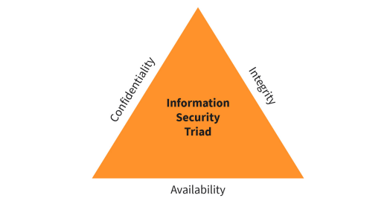
Confidentiality
Integrity
Availability
Information Security Triad

Common Security Standards and Frameworks
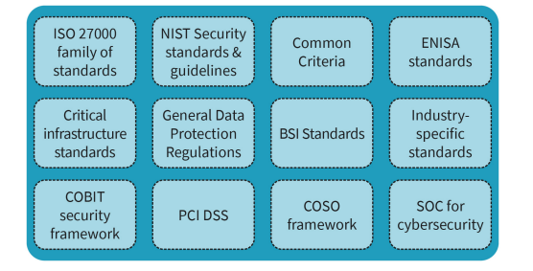
ISO27000 family of standards
NIST Security standards & guidelines
Common Criteria
ENISA standards
Critical infrastructure standards
General Data Protection Regulations
BSI Standards
Industry-specific standards
COBIT infrastructure framework
PCI DSS
COSO framework
SOC for cybersecurity

Components of an ISMS
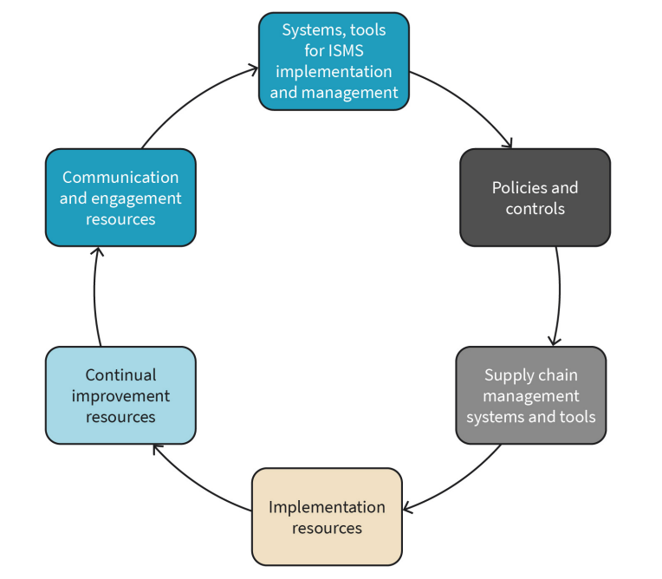
Systems, tools for ISMS implementation and management
Policies and controls
Supply chain management systems and tools
Implementation resources
Continual improvement resources
Communication and engagement resources

ISMS Scope Scenarios
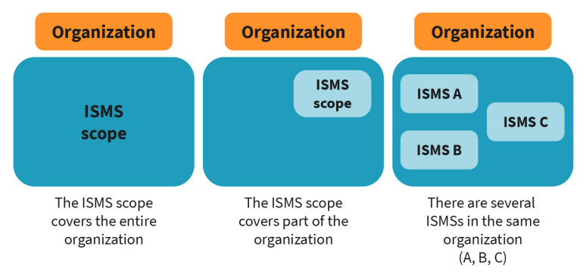
Organization
ISMS scope
ISMS A
ISMS B
ISMS C
The ISMS scope covers the entire organization
The ISMS scope covers part of the organization
There are several ISMSs in the same organization (A, B, C)

Example Organization Structure Reflecting ISMS Scope
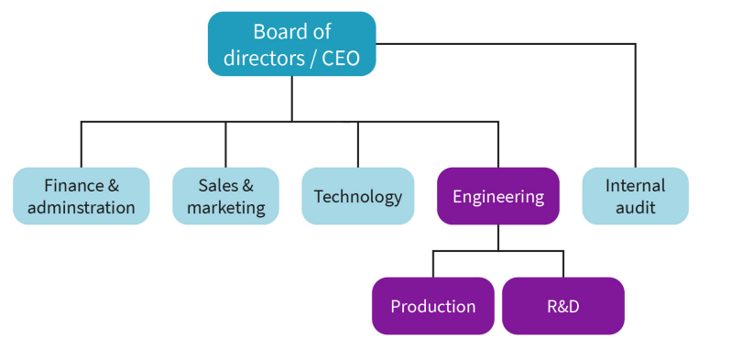
Board of directors/CEO
Finance & administration
Sales & marketing
Technology
Engineering
Internal audit
Production
R&D

PDCA Model and ISMS
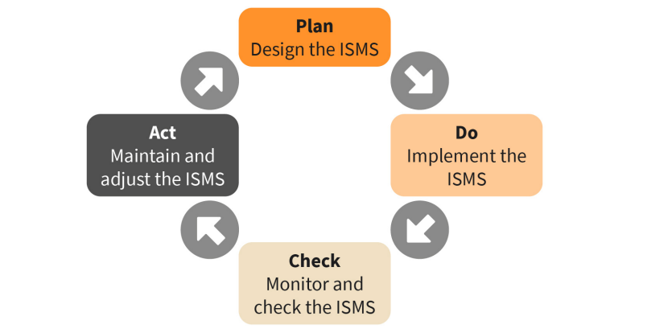X
Plan
Design the ISMS
Do
Implement the ISMS
Act
Maintain and adjust the ISMS
Check
Monitor and check the ISMS

Risk Management Process
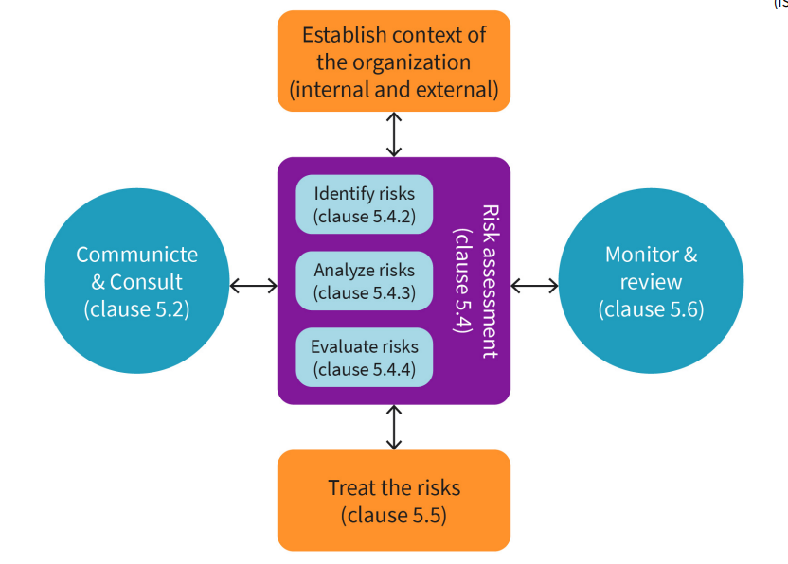
Establish context of the organization (internal and external)
Monitor & review (clause 5.6)
Treat the risks (clause 5.5)
Communicate & Consult (clause 5.2)
Identify risks (clause 5.4.2)
Analyze risks (clause 5.4.3)
Evaluate risks (clause 5.4.4)
Risk assessment (clause 5.4)

Risk Matrix Example in MS Excel
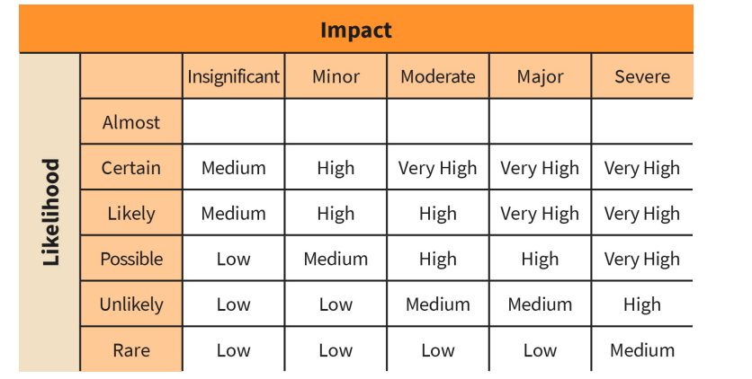
Impact
Likelihood
Insignificant
Minor
Moderate
Major
Severe
Almost
Certain
Likely
Possible
Unlikely
Rare
Medium
High
Very High
Low

Developing a Communication Plan
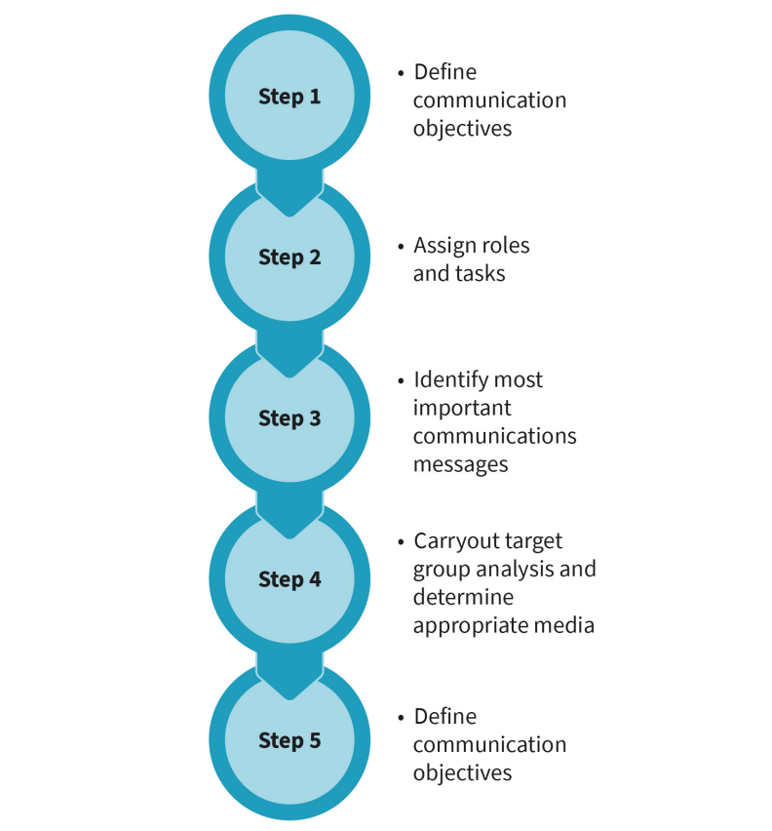
Step
Define communication objectives
Assign roles and tasks
Identify most important commnications messages
Carryout target group analysis and determine appropriate media
Define communication objectives

Continual Improvement of the ISMS Using PDCA
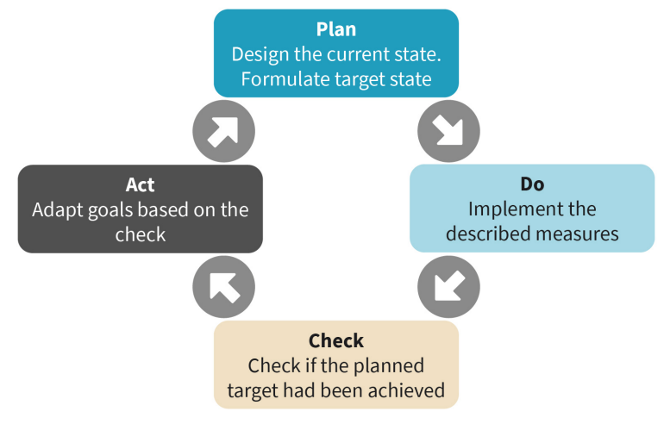
Plan
Design the current state. Formulate target state
Do
Implement the described measures
Check
Check if the planned target had been achieved
Act
Adapt goals based on the check

Continual Improvement Plan Tracker Template
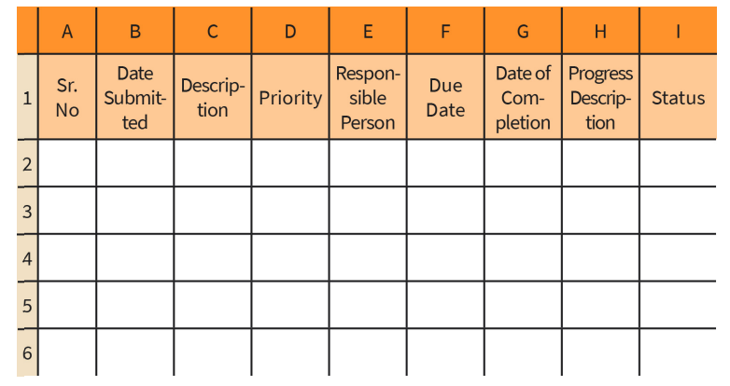
Sr. No
Date Submitted
Description
Priority
Responsible Person
Due Date
Date of Completion
Progress Description
Status

ISO/IEC 27001 Control Domains
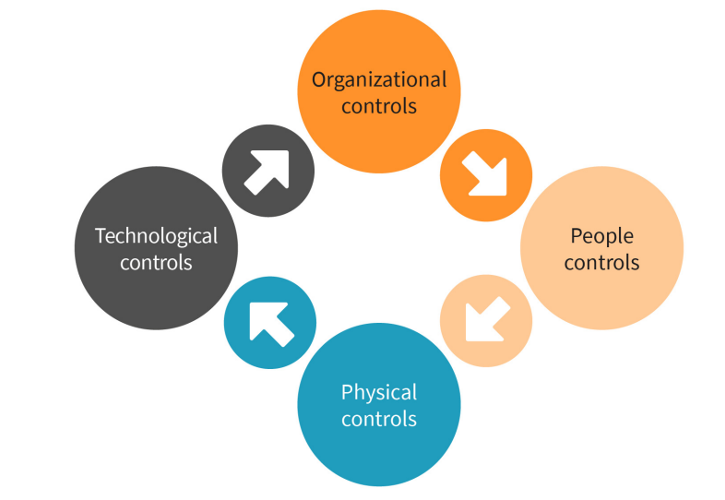
Organizational controls
People controls
Physical controls
Technological controls

