Nature Methods- Brief communication
Comparative Bioinformatic Analysis Reveals Conserved Regions in SARS-CoV-2 Genome for Rapid Pandemic Response

Abstract
SARS-CoV-2, an mRNA virus with high mutation rates, poses challenges for the timely development of targeted drugs and tests. Leveraging bioinformatic analysis, we identified conserved regions within the virus genome. This discovery enabled the creation of a reliable, fast, cost-effective, reproducible, and highly specific test applicable to current and future variants. Our findings emphasize the importance of designing tailored tests and drugs that target conserved regions, thus enhancing preparedness against emerging pathogens. This study provides valuable insights for combating future pandemics efficiently.
Main
The availability of a reliable, accessible, and cost-effective standardized assay is crucial for preventing and containing the spread of pathogens, particularly in the absence of ancestral data for newly identified viruses¹. This study focused on addressing this challenge using the current COVID-19 pandemic as a case study. Molecular testing was chosen as the optimal method due to its impact on public health outcomes and viral transmission reduction. The gold-standard one-step qPCR test, targeting three genes encoding for N, S, and E proteins, is currently used for SARS-CoV-2 detection². The N protein represents the nucleocapsid of the virus, the S protein is part of the spike glycoprotein, and the E denotes the viral envelope³. The joint global effort to eradicate the recent SARS-COV-2 pandemic provided vast information regarding the evolution of its variants^{4,5}. Aggregated information revealed that the regions used in the gold-standard test are frequently mutated, and therefore, for some variants, these qPCR tests may lead to false negative results. Moreover, it was recently demonstrated that these regions have a high similarity to other related species such as the SARS-COV, MERS--COV, HCoV-HKU1, and H-COV-OC43 proteins with SARS-COV-2 proteins⁶. This might lead to the wrong diagnosis and inaccurate treatment. For these reasons, currently available genomic tests require three different sets of primers, which are updated occasionally, due to the high frequency of mutations that are often identified⁷. Furthermore, it is important to note that these tests rely on a minute portion of the worldwide existing variants, as they are likely to represent sequences in countries that are economically- and technologically more advanced⁵. We thus predict that many more sub-variants already exist, and others will naturally evolve in the future.
We hypothesized that the key to the development of a generic, yet specific test, which can detect current and future unknown variants, is to identify conserved regions within emerging pathogens. To this aim, using a bioinformatic-driven strategy, we identified three independent short primer sets within the conserved region, which are highly specific to the SARS-COV-2 genome. In this study, we focused on a single primer set (comprised of three independent primers) to develop a specific, saliva-based qPCR test which further concentrates the sample and has additional benefits that will be further discussed. Our proposed single primer set demonstrated similar results compared to the gold-standard test, which uses three independent primer sets from non-conserved regions. Preliminary data indicate that in combination with a concentrating step of the total nucleic acids from a saliva sample could be even better than the gold-standard test. In the future, an increase in sensitivity can be achieved by including additional sets of primers from the conserved regions that we identified. The proposed saliva test also enables self-sampling and a built-in deactivating mechanism, which eliminates the need to arrive at the medical facility, as the inactivated sample can be sent directly to the collection center. This also eliminates the need for expensive destined laboratories, which further simplifies the overall process. We have also addressed the issue of test time and cost by reducing the duration of the molecular test, as well as using fewer consumables to reduce the pressure on the global chain supply,⁸ thus serving both issues of availability and sustainability while increasing the sensitivity and specificity of the current gold-standard methods.
METHODS
Comparative analysis of whole-genome data using bioinformatic tools revealed conserved regions of SARS-COV2
To develop diagnostic and therapeutic tools that can address the instability of RNA pathogens and the survival mechanism of drug-resistant pathogens^{9–13}, it is crucial to identify and target conserved regions within emerging pathogens. This approach enables the detection and development of drugs against both current and future unknown variants. To achieve this goal, we have established a five-step strategy, outlined in Figure 1
The first step involved dividing the entire COVID-19 genome MN988713.1 into K-mers (20-mers). From these K-mers, certain sequences were excluded. Firstly, K-mers that appeared more than once in the COVID-19 genome were removed. Additionally, sequences that were present in the human genome and those found in related species were excluded. The selection of related species was determined through blast analysis, considering species with an identity higher than 99% and a bit score greater than 54998 were considered as identical. This filtering process resulted in the identification of K-mers specific to human COVID19.
Subsequently, optimal qPCR rules were applied to these K-mers to identify primer sets that would generate the most favorable amplicons. The following rules were implemented: the CG content should range between 40% and 60%, the last five primers should include at least two G/C bases, and the last nucleotide in the 3' prime should be a G/C base. Repetitive sequences such as ATATAT or ACCCC were excluded, as well as complementary K-mers and those that could potentially form hairpins. The melting temperature (Tm) of the two primers should not exceed a difference of 3°C. Additionally, the distance between the forward and reverse primers should range from 150 to 300 base pairs.
3. Calculate “primer properties” of the k-mers:
1) if it can be 5’ primer (left-end G or C, the next 4 letters at least 50% C/G).
2) if it can be 3’ primer (wright-end G or C, the previous 4 letters at least 50% C/G).
3) Calculate the Tm (C/G weighted as 4, A/T weighted as 2)
4. Compose primers pairs according to the rule:
Select all pairs of primers that started from the 5’ primer and finished by the 3’ primer, and the distance between them 150-300 bp and the difference of Tm not larger than 3.
5. Select primer pairs, containing the third primer in the middle region according to the rule:
1) Starts from G or C
2) Finished by A or T
3) Tm between the interval: [58, 68]
4) The Tm of the central primer is larger than Tm of the 3’ and 5’ more than 10.
5) The optimal third middle primer (as required for TaqMan) was selected by the homology criterion
6. Homology criterion of k-mer X:
1) For each similar genome (as described above) calculate the identity ( Heming distance) of every k-mer with X, find the case with the minimal number of mismatches.
2) Calculate the sum of these minimal numbers for all similar genomes. A lower value for the sum signifies a better Homology criterion.
7. An identical path was chosen in order to select the final set of primers comprised by the three primers (the pair with the additional third primer in the middle) with the minimal sum of the homology criteria of each primer.
8. THe final sets ttha were chosen were the sents of primers that were selected by the ABI primer one application.
9. As new variants of COVID 19 were sequences all three primers were checked for their similarity within these genomes.

2) Calculate the sum of these minimal numbers for all similar genomes. The less value of this sum is better the Homology criterion.

The first step involved the identification of conserved regions within the Wuhan MN908947.3 severe acute respiratory syndrome coronavirus 2 isolate (SARS-COV2) using BLAST. In the second step, several sets of primers were identified in three different conserved regions of the human SARS-COV2. In the third step, three final sets of primers within the conserved regions were identified through sequence analysis, following a predefined set of specific and general rules outlined in the material and methods section. The selected regions, all of which are well-conserved, are located in either the coding region (SET1, SET2) or the non-coding region (SET3) (Supplementary Figure 2). The exact sequences and positions of all three primer sets within the SARS-COV-2 genome are depicted in Supplementary Figure 1.
SET1 and SET2 are suitable for the TaqMan assay, while SET3 is more suitable for the SYBR Green analysis. This step resulted in two theoretically possible primer sets (SET1 and SET2). Synthetic DNA and RNA strands, each consisting of a 90-mer sequence that partially overlaps with the SARS-COV2 genome and flanks the selected primer sets, were used to test the ability to generate full-length amplicons in the future. The amplicon sizes were expected to be 300 bp and 66 bp, respectively. These synthetic strands were designed to include all three primer sequences that make up each set. Initially, a DNA polymerase-based qPCR was performed to test the primer sets, followed by a one-step qPCR assay on the synthetic RNA template to evaluate the entire process.
Primer SET1 resulted in a single amplicon with the expected size of 300 bp, as indicated by a distinct peak in the melting curve analysis (Figure 1, Step 5). Interestingly, primer SET1 did not yield a successful qPCR amplicon (data not shown) when tested, possibly due to the short, expected amplicon length (66 bp). However, it is worth noting that this primer set met all the quality control requirements of the entire in silico pipeline (Figure 1).

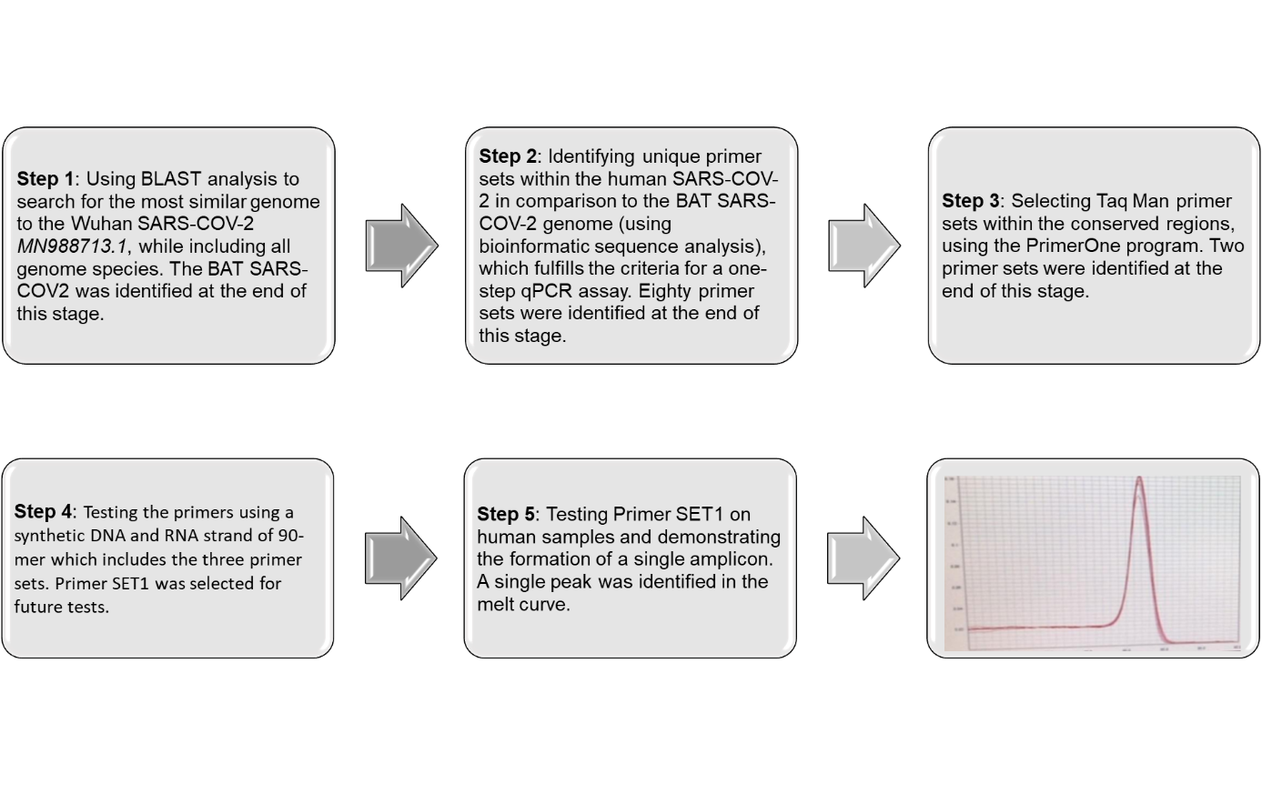
Figure 1. The five-step strategy aims to identify conserved regions within SARS-COV2 and develop a single Taq-Man primer set that generates a single amplicon in infected individuals. The strategy consists of three consecutive steps involving sequence analysis and verification, ultimately leading to the selection of a final primer set that produces the desired single amplicon.
Using BLAST analysis, we validated the presence of the final three primers of SET1, in all known globally distributed SARS-COV-2 variants (Figure 2).
Original Wuhan-NC_045512.2
LNNLGVDIAANTVIWDYKRDVPAHISTIGVCSMTDIAKKPTETICAPLTVFFDGRVDGQVDLFRNARNGVLITEGSVKGLQPSVGPKQASLNGVTLIGEAVKTQF

INDIA- MT416725
LNNLGVDIAANTVIWDYRDAPAHISTIGVCSMTDIAKKPTETICAPLTVFFDGRVDGQVDLFRNARNGVLITEGSVKGLQPSVGPKQASLNGVTLIGEAVKTQF

INDIA- MZ208926
LNNLGVDIAANTVIWDYKRDAPAHISTIGVCSMTDIAKKPTETICAPLTVFFDGRVDGQVDLFRNARNGVLITEGSVKGLQPSVGPKQASLNGVTLIGEAVKTQF

B.1.617 (Delta variant): First identified in India, the Delta variant has multiple mutations in the spike protein. It is associated with increased transmissibility and potential resistance to certain treatments.

SOUTH AFRICA- MT324062
LNNLGVDIAANTVIWDYKRDAPAHISTIGVCSMTDIAKKPTETICAPLTVFFDGRVDGQVDLFRNARNGVLITEGSVKGLQPSVGPKQASLNGVTLIGEAVKTQF

B.1.351 (Beta variant): First identified in South Africa, this variant has several mutations in the spike protein. It may have an impact on vaccine effectiveness and is associated with increased transmissibility.

UK- MW531680
LNNLGVDIAANTVIWDYKRDAPAHISTIGVCSMTDIAKKPTETICAPLTVFFDGRVDGQVDLFRNARNGVLITEGSVKGLQPSVGPKQASLNGVTLIGEAVKTQF

B.1.1.7 (Alpha variant): This variant was first identified in the UK and has multiple mutations in the spike protein. It is associated with increased transmissibility.

Italy- MT622321
LNNLGVDIAANTVIWDYKRDAPAHISTIGVCSMTDIAKKPTETICAPLTVFFDGRVDGQVDLFRNARNGVLITEGSVKGLQPSVGPKQASLNGVTLIGEAVKTQF

D614G-This mutation affects the spike protein of the virus and has become the most prevalent strain globally. It was first identified in early 2020 and is associated with increased infectivity.

USA- MT246470
LNNLGVDIAANTVIWDYKRDAPAHISTIGVCSMTDIAKKPTETICAPLTVFFDGRVDGQVDLFRNARNGVLITEGSVKGLQPSVGPKQASLNGVTLIGEAVKTQF

Morocco- MT513758
LNNLGVDIAANTVIWDYKRDAPAHISTIGVCSMTDIAKKPTETICAPLTVFFDGRVDGQVDLFRNARNGVLITEGSVKGLQPSVGPKQASLNGVTLIGEAVKTQF

B.1.427/B.1.429 (Epsilon variant): Initially detected in California, these variants have mutations in the spike protein. They are associated with increased transmissibility.

Brazil- NC_045512.2
LNNLGVDIAANTVIWDYKRDAPAHISTIGVCSMTDIAKKPTETICAPLTVFFDGRVDGQVDLFRNARNGVLITEGSVKGLQPSVGPKQASLNGVTLIGEAVKTQF

P.1 (Gamma variant): Originally found in Brazil. Carries multiple mutations, including some in the spike protein. It may have an impact on vaccine effectiveness and is associated with increased transmissibility.

Omicron- OM570263
LNNLGVDIAANTVIWDYKRDAPAHISTIGVCSMTDIAKKPTETICAPLTVFFDGRVDGQVDLFRNARNGVLITEGSVKGLQPSVGPKQASLNGVTLIGEAVKTQF

Figure 2. The locations of currently known mutations in SARS-COV-2 genome variants are adjacent to the unique and conserved region of primer SET1. In-silico verifications were conducted to confirm the presence and location of the SET1 primers (highlighted in yellow) at the protein level within selected SARS-COV-2 variants from around the world. Regions that differ from the original SARS-COV2 are highlighted in red.

Based on published sequences and using blast analysis, none of the following pathogens - Hepatitis C ^{14,15}, HIV1 ^{16,17}, Influenza A ^{18,19},Influenza B ^{20,21},SARS ²², MERS ^{23,24}, Polio ^{25,26} - contain the specific regions targeted by primer SET1. While the reverse primer of SET1 was found to be present in Influenza B and partially present in MERS and SARS, it is important to note that a PCR product can only be formed if both the forward and reverse primers anneal to the same template. Therefore, primer SET1 remains specific and unique to SARS-COV2.

A quick, reproducible, and inexpensive single-step method to preserve and extract viral RNA from saliva.
To validate the sensitivity of primer SET1, we conducted a one-step RT-qPCR assay. Initially, we tested the primers on a synthetic DNA fragment, followed by establishing a one-step qPCR assay using a synthetic RNA fragment (Promega cat# ). The previous in silico process (Figure 1, steps 1-3) combined with optimization on synthetic nucleic acids (Figure 1, steps 3-4) facilitated calibration and optimization in a BSL2 laboratory, reducing the need for BSL3 or BSL4 facilities and lowering associated costs. By selecting a primer set closer to the 3'-prime end, we further reduced the duration of the one-step RT-qPCR process (Figure 3). This enabled a shorter incubation time in the cDNA synthesis step, reduced from 35 to 7 minutes. Additionally, we shortened the amplification cycles from 26 to 18 minutes (Figure 3).
In collaboration with Soroka Medical Center, we tested our qPCR assay on SARS-COV-2 samples extracted using the Seegene method. When comparing the results to the RNA isolated from these patients, the cycle threshold (CT) values of our assay were identical to those of Seegene. The sensitivity of our primer SET1 was similar to the RdR set used in the Seegene RT-qPCR assay (Supplementary Figure 3). Notably, both primers target the ORF1b region; however, our primer, unlike Seegene's, targets a conserved region within the SARS-COV-2 gene (Supplementary Figure 1). This reduces the occurrence of false negative results in the case of new variants. All samples that tested negative with Seegene were also negative in our assay. It is important to note that the negative SARS-COV2 results in patients admitted to the hospital with flu-like symptoms demonstrate the high specificity of both Seegene and our newly established assay. Samples that tested positive with Seegene also yielded positive results with either identical or shorter cycles (Supplementary Figure 3), indicating that our primer SET1 performs similarly to Seegene's three primers but with a faster turnaround time.
To further enhance the assay's sensitivity, we explored the possibility of collecting saliva in a lysis buffer that exposes the viral genome while preserving its integrity. This step is crucial for accurate testing and avoiding false negative results in the case of an RNA virus. The additional benefits of this method include creating an affordable, non-invasive test and preserving the collected sample for at least two days at room temperature, as well as concentrating larger amounts of viral particles. We collected 2 ml of viral RNA from saliva, which was further concentrated to a final volume of 20 microliters. We utilized glass wool, an adsorbent material with a net positive charge and hydrophobicity (Cat# ), capable of concentrating waterborne viruses. Small fragments of glass wool were compacted into a 0.5 ml Eppendorf tube (Figure 3). This technique allowed for the processing of large water volumes without requiring pre-conditioning^{27,28}.
The entire process, including RNA extraction and the one-step RT-qPCR test, was significantly shortened in both cases, reducing the overall processing time from 2.5 hours to 20 minutes, thus decreasing the total duration from 5 hours to 40 minutes. Moreover, our process utilized significantly lower volumes of reagents and fewer disposables, in addition to the non-invasive method that reduces resistance among the population being tested. Saliva was self-collected into a 15 ml tube, and in a 2 ml tube, 500 microliters of saliva was mixed with 500 microliters of lysis buffer and vortexed briefly. Subsequently, 1 ml of 100% EtOH was added and vortexed briefly. This mixture was loaded onto the collection tube and vortexed for 1 minute at 10,000g. The column was washed twice with 500 microliters of 70% EtOH in the same manner, followed by elution of the RNA with 18 microliters of preheated DDW at 65°C. As we did not need to amplify the full cDNA of the pathogen, the reverse transcriptase (RT) step was significantly shortened from the original protocols (X min to X min at 45°C), followed by the activation of the DNA polymerase (X min to X min at 95°C). We opted for the short version of the qPCR amplification, shortening the denaturation step at 95°C from X seconds to 15 seconds. The annealing process was conjugated with the extension step at 60°C, and the overall process duration was shortened from X seconds to 30 seconds. The entire process was completed in 22 minutes, compared to the gold standard qPCR assay.

supplementary figure 1. The exact sequences and the position of all three primer sets within the SARS-COV-2 genome. Forward primer (F1), Internal fluorescent primer (IP), Reverse primer (RP), Open reading frame (ORF).
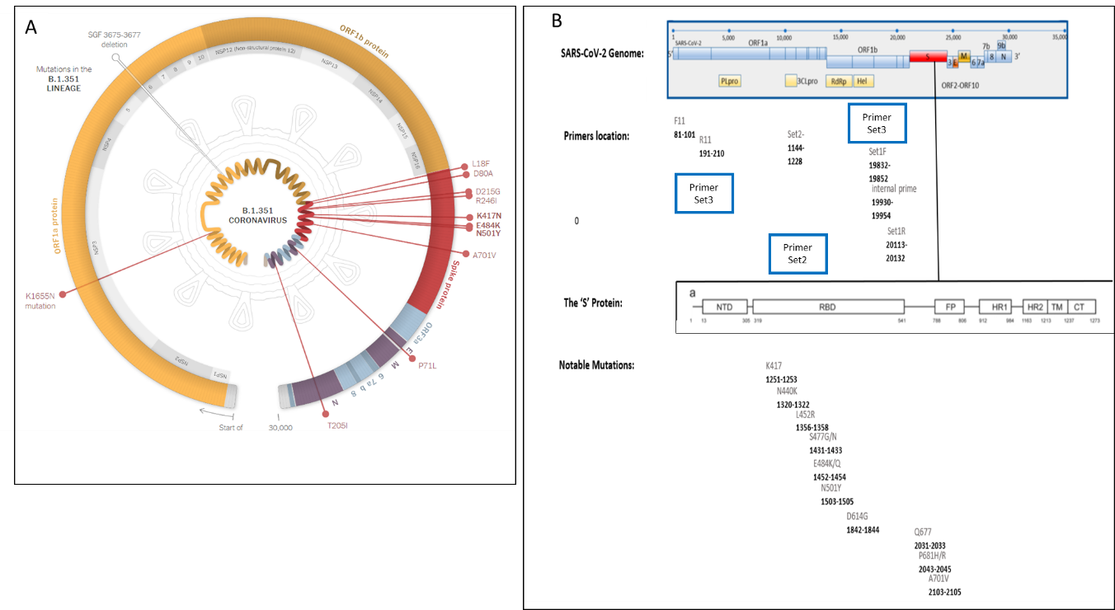

Supplementary figure 2. The three primer sets identified in this work are conserved while the primers used in the current gold standard COVID19 tests are within regions prone to mutations. Illustration of the position of the various identified mutations within the S, E and N regions selected for the current gold standard test (A) versus the three primer sets (blue rectangles) identified and used in this work (B). Primer set 1 is present in world-wide SARS-COV-2 variants (C).

Primer set | Primer name | Primer Sequence | Primer position within the genome | The position of the gene within the entire genome
Set 1 | F1 | TACTCAATAATTTGGGTGTGG | 19830-20132 | The endo RNAse within the ORF1ab  19601-20638
 | IP | ATGACTGACATAGCCAAGAAACCAA
 | R1 | GTCACATTAATTGGAGAAGC
Set 2 | F1 | TGATGGCTTTATGGGTAGAATT | 1144-1228 | The non-Structural protein nsP2 within the ORF1ab  795-2708 ²⁸
 | IP | CCAGTTGCGTCACCAAATGAATG
 | R1 | TGTGCCTTTCAACTCTCATG
Set 3 | F11 | AATCTGTGTGGCTGTCACTCG | 81-210 | The primers are located prior to the ORF
 | R11 | TGCTTACGGTTTCGTCCGTG

Supplementary Figure 3.
AIRPORT: Sensitivity, specificity compared to gold standard - AIRPORT
שם הערכה | The proposed test | TaqPath™ COVID-19 CE-IVD RT-PCR Kit  (ThermoFisher scientific) | Allplex 2019-nCoV Real-time PCR (Seegene, Seoul, Korea) | PowerChek 2019-nCoV (KogeneBiotech, Seoul) | Real-Q 2019-nCoV Real-Time Detection (BioSewoom, Seoul) | StandardM nCoV Detection (SD BIOSENSOR, Osong, Korea) | GeneFinder™ COVID-19 Plus RealAmp Kit
גן מטרה | EndoRNAse | S,ORF1,N | E,RdRp,N | E,RdRp | E,RdRp | E,RdRp | ORF1ab, E, N
מספר מבחנות דרושות | 1 | 1 | 1 | 2 | 1 | 1 | 1
ביקורת פנימית | COVID-19 EndoRNAse positive control | MS2 Phage,TaqPath COVID-19 | Bacteriophage MS2, spiked into sample | Recombinant DNA plasmide spiked into PCR mixture | Human RNase P, intrinsic | Pseudovirus particle | RdRp, E, N, RNAse P
נפח מיצוי RNA הדרוש לביצוע הבדיקה l)µ( | 10 | 6.25 | 8 | 5 | 5 | 10 | 10
מספר מחזורי בדיקה ב- PCR | 40 | 40 | 45 | 40 | 40 | 45 | 45
זמן הרצה של ה- PCR | 30 min | 36 min | 110 min | 120 min | 110 min | 90 min | 81.25 min
Cutoff Ct | Target gene: =<37  positive control: =<10 | Target gene: =<37  Internal control: =<32 | 40> | 35>= | Target gene: <38  Internal control: =<35 | Target gene: <36  Internal control: =<32 | Target gene: =<37  Internal control: =<21
LOD | NA | 10 GCE/reaction | 153.94 Copies/reaction | 84.12 Copies/reaction | 80.60 Copies/reaction | 153.94 Copies/reaction | 100 copies/mL
sensitivity (%) | 90/0 | 100.0 | 90.0 | 82.3 | 75.0 | 100.0 | 95.0
Specificity (%) | 100.0 | 100.0 | 100.0 | 100.0 | 100.0 | 100.0 | 100.0

CONCLUSIONS:
Recently, the implementation of improved population testing was raised¹. An entire road map was constructed to consolidate multiple SARS-COV-2 tests that were developed worldwide. The variety of tests included a variety of molecular and antigen tests though it is obvious that the molecular diagnosis of any pathogen is the most accurate and sensitive. This should be taken into account especially when dealing with a deadly infection to a certain or the entire population². The SARS-CoV-2 testing is the largest program in history, however it is important to note that the sequences available in the database are only a minute portion of the existing variants and are likely to represent sequences in countries that are economically and technologically more advanced. We thus predict that many more sub variants exist and will naturally evolve. Our strategy which identifies conserved regions within the genome of any given pathogen, even at the non-coding region, which is a non-conventional approach compared to the current molecular diagnostic tests, overcomes these important issues and many more.

REFERENCES:
1. Mercer, T. et al. The Coronavirus Standards Working Group’s roadmap for improved population testing. Nat. Biotechnol. 40, 1563–1568 (2022).
2. Chu, V. T. et al. Comparison of Home Antigen Testing With RT-PCR and Viral Culture During the Course of SARS-CoV-2 Infection. JAMA Intern. Med. 182, 701–709 (2022).
3. Domnich, A. et al. Evaluation of extraction-free RT-qPCR methods for SARS-CoV-2 diagnostics. Arch. Virol. 166, 2825–2828 (2021).
4. Tracking SARS-CoV-2 variants. https://www.who.int/activities/tracking-SARS-CoV-2-variants.
5. Schmidt, C. New Coronavirus Variants Are Urgently Being Tracked around the World. Scientific American https://www.scientificamerican.com/article/new-coronavirus-variants-are-urgently-being-tracked-around-the-world/.
6. Cosar, B. et al. SARS-CoV-2 Mutations and their Viral Variants. Cytokine Growth Factor Rev. 63, 10–22 (2022).
7. SelectScience. Seegene introduces new SARS-CoV-2 variants detection test. http://www.selectscience.net/product-news/seegene-introduces-new-sars-cov-2-variants-detection-test/?artID=55308.
8. Global supply chains at work: A tale of three products to fight COVID-19. OECD https://www.oecd.org/coronavirus/policy-responses/global-supply-chains-at-work-a-tale-of-three-products-to-fight-covid-19-07647bc5/.
9. Belizário, J. E. Immunity, virus evolution, and effectiveness of SARS-CoV-2 vaccines. Braz. J. Med. Biol. Res. 54, (2021).
10. Chedid, M. et al. Antibiotics in treatment of COVID-19 complications: a review of frequency, indications, and efficacy. J. Infect. Public Health 14, 570–576 (2021).
11. Gagliotti, C. et al. Community use of antibiotics during the COVID-19 lockdown. Infect. Dis. 53, 142–144 (2021).
12. Qi, X. et al. Clinical course and risk factors for mortality of COVID-19 patients with pre-existing cirrhosis: a multicentre cohort study. Gut 70, 433–436 (2021).
13. Taylor, L. Covid-19: Antimicrobial misuse in Americas sees drug resistant infections surge, says WHO. BMJ 375, n2845 (2021).
14. Lu, L. et al. Full-length genome sequences of five hepatitis C virus isolates representing subtypes 3g, 3h, 3i and 3k, and a unique genotype 3 variant. J. Gen. Virol. 94, 543–548 (2013).
15. Hepatitis C virus subtype 1a polyprotein gene, complete cds. (2009).
16. Gall, A., Morris, C., Kellam, P. & Berry, N. Complete Genome Sequence of the WHO International Standard for HIV-1 RNA Determined by Deep Sequencing. Genome Announc. 2, e01254-13 (2014).
17. HIV-1 isolate NIBSC-1 from United Kingdom gag protein (gag), pol protein (pol), vif protein (vif), vpr protein (vpr), tat protein (tat), rev protein (rev), vpu protein (vpu), envelope glycoprotein (env), and nef protein (nef) genes, complete cds. (2014).
18. Influenza A virus (A/Kerala/RGCB140815/2014(H1N1)) segment 1 polymerase PB2 (PB2) gene, complete cds. (2016).
19. Jones, S. et al. Whole-Genome Sequences of Influenza A(H1N1)pdm09 Virus Isolates from Kerala, India. Genome Announc. 5, e00598-17 (2017).
20. Oong, X. Y. et al. Whole-Genome Phylogenetic Analysis of Influenza B/Phuket/3073/2013-Like Viruses and Unique Reassortants Detected in Malaysia between 2012 and 2014. PLoS ONE 12, e0170610 (2017).
21. Influenza B virus (B/Malaysia/9012150273/2009) segment 4 hemagglutinin (HA) gene, complete cds. (2017).
22. SARS coronavirus Sin2500, complete genome - Nucleotide - NCBI. https://www.ncbi.nlm.nih.gov/nuccore/30468042.
23. Lu, R. et al. Complete Genome Sequence of Middle East Respiratory Syndrome Coronavirus (MERS-CoV) from the First Imported MERS-CoV Case in China. Genome Announc. 3, e00818-15 (2015).
24. Middle East respiratory syndrome coronavirus strain ChinaGD01, complete genome. (2015).
25. Human poliovirus 1 isolate 558/BRA-PE/88, complete genome. (2013).
26. Tavares, F. N., da Costa, E. V., Kew, O. M. & da Silva, E. E. Complete Genome Sequence of the Last Representative Genotype of Wild Indigenous Poliovirus Type 1, Which Circulated in Brazil. Genome Announc. 1, e00811-13 (2013).
27. Albinana-Gimenez, N. et al. Comparison of methods for concentrating human adenoviruses, polyomavirus JC and noroviruses in source waters and drinking water using quantitative PCR. J. Virol. Methods 158, 104–109 (2009).
28. Frolova, E. I. et al. Roles of Nonstructural Protein nsP2 and Alpha/Beta Interferons in Determining the Outcome of Sindbis Virus Infection. J. Virol. 76, 11254–11264 (2002).

Supplementary figure: The presence of the different primer within other symptom related viruses.
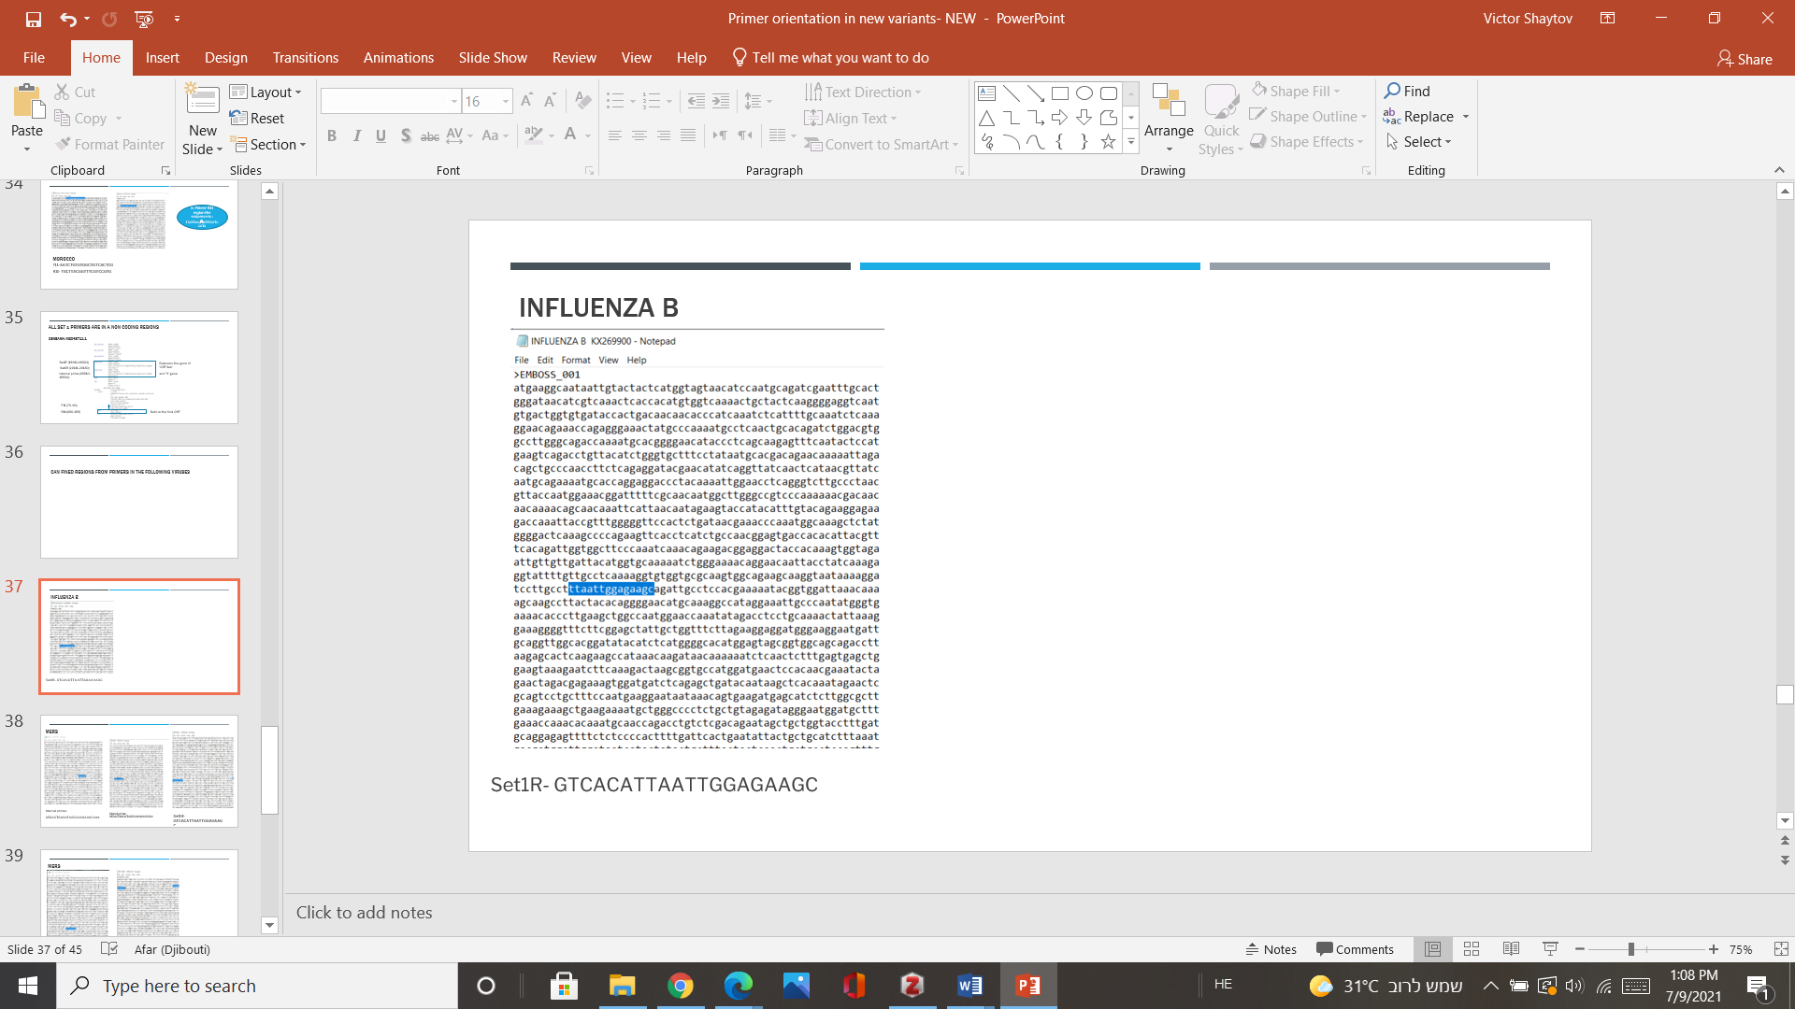
Set1R-GTCACATTAATTGGAGAAGC

תמונ

-

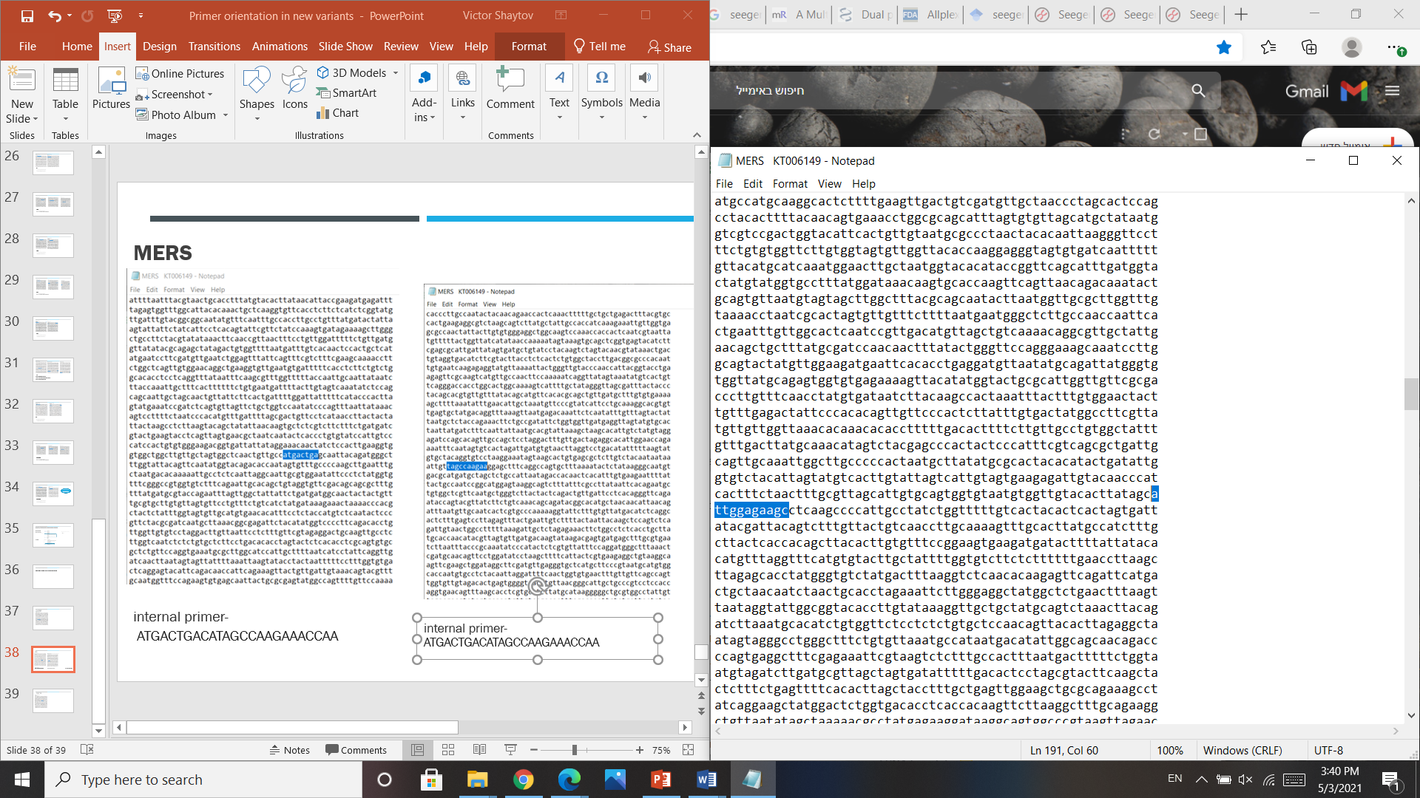
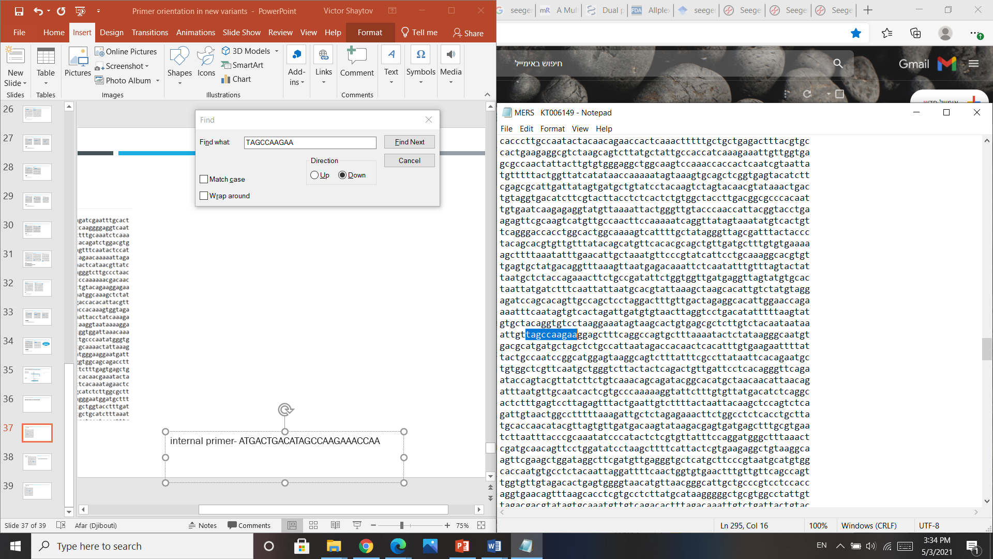
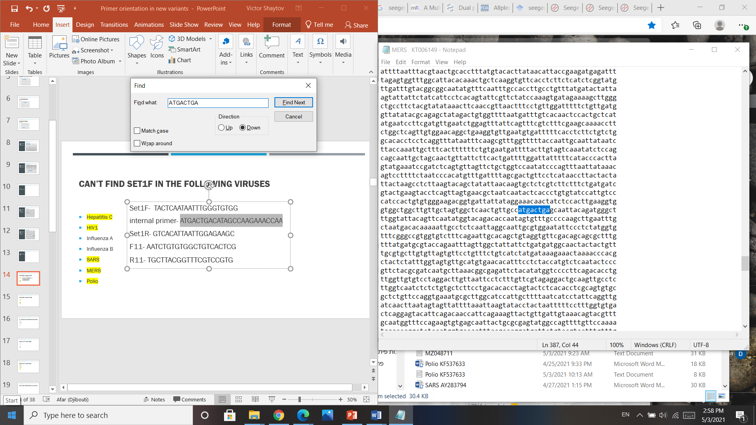

Set1R-GTCACATTAATTGGAGAAGC

internal primer-
ATGACTGACATAGCCAAGAAACCAA

internal primer-
ATGACTGACATAGCCAAGAAACCAA

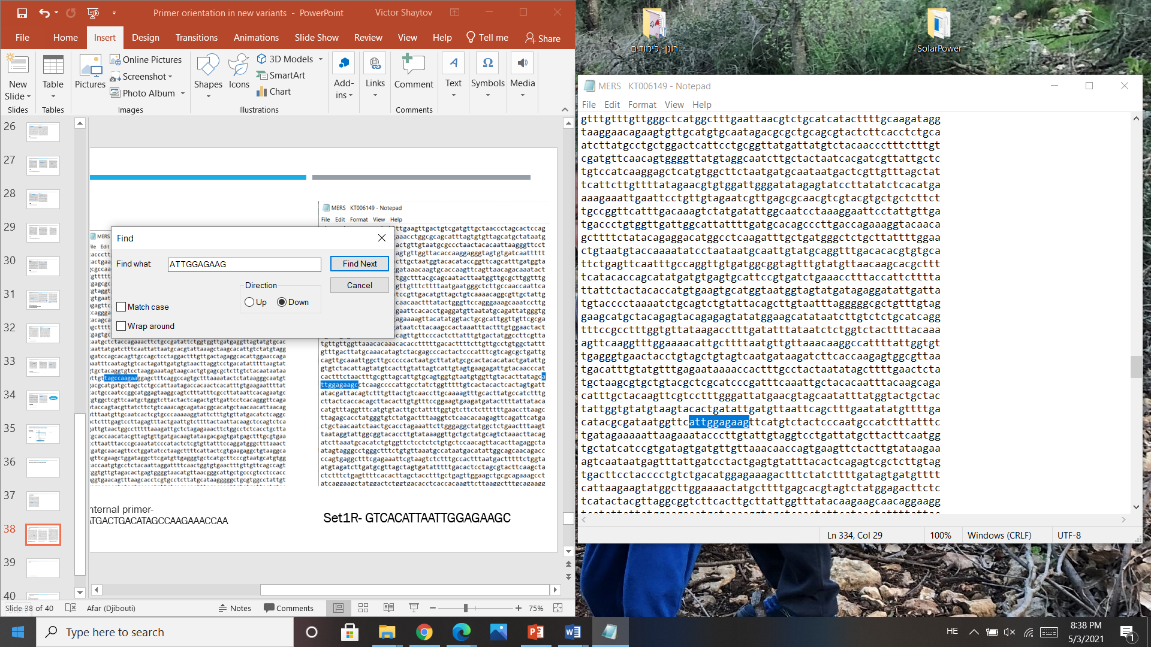
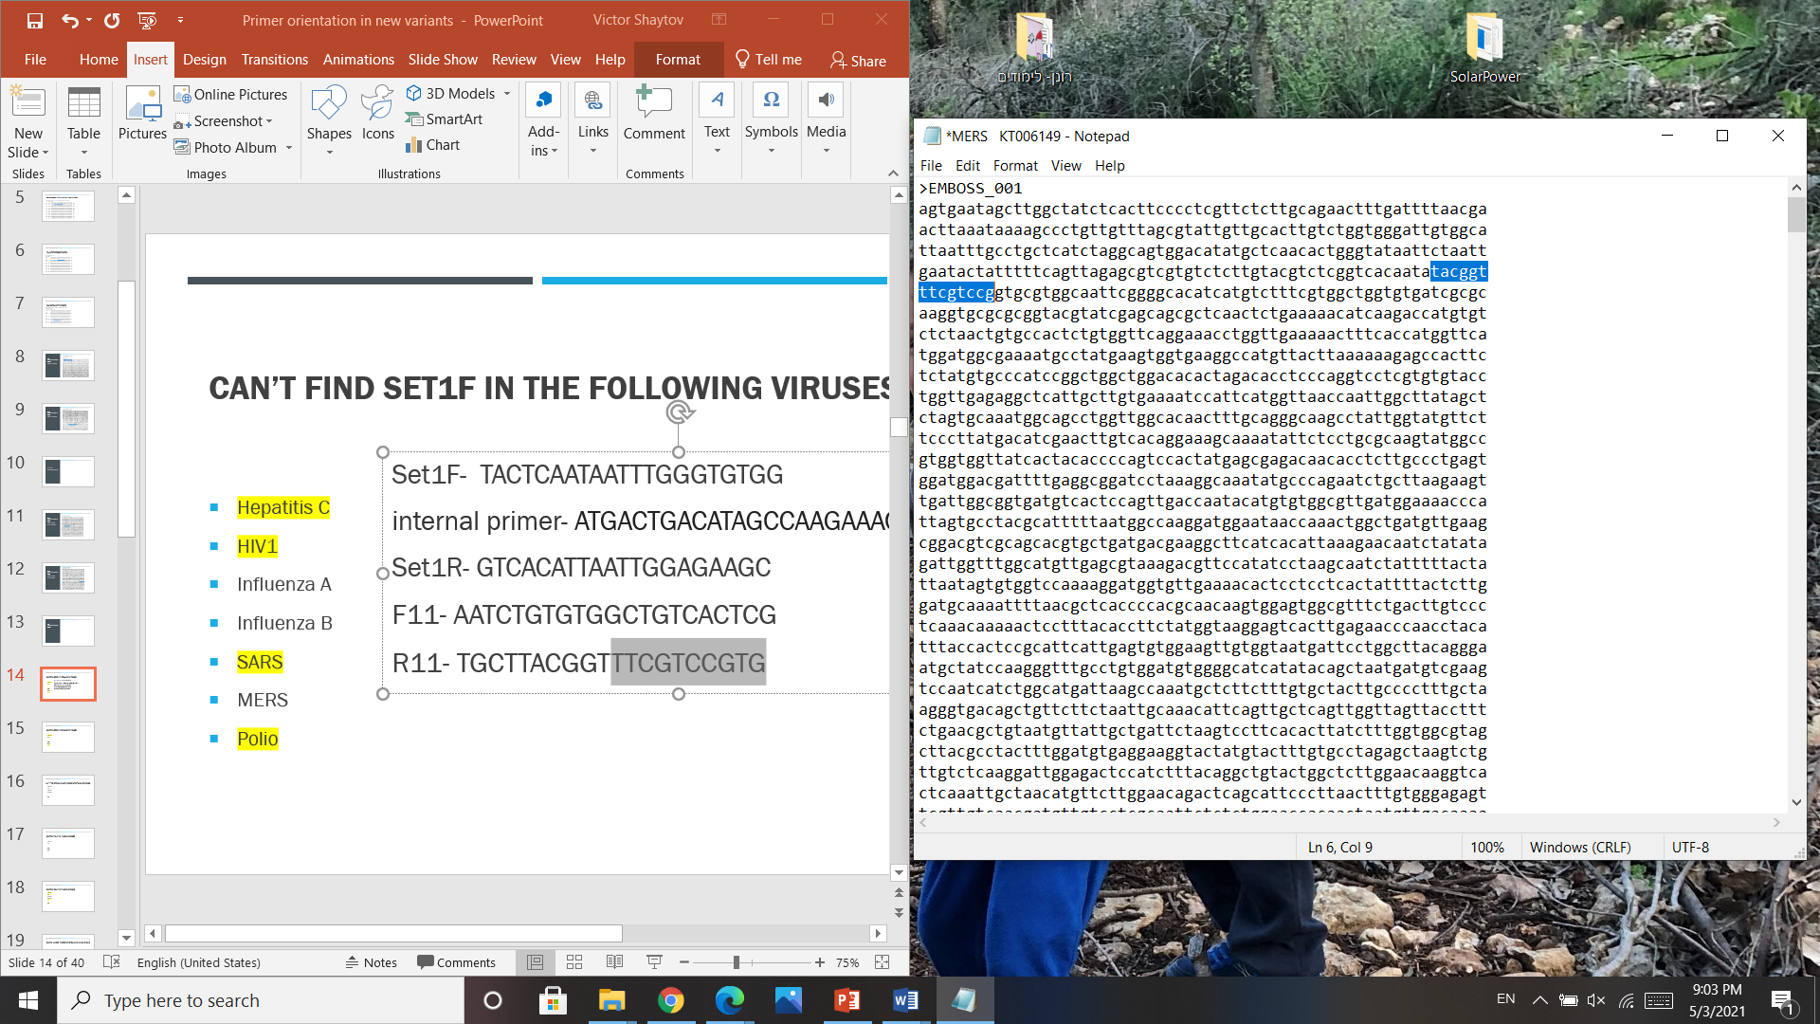
R11- TGCTTACGGTTTCGTCCGTG

Set1R-GTCACATTAATTGGAGAAGC

^{23,24}-

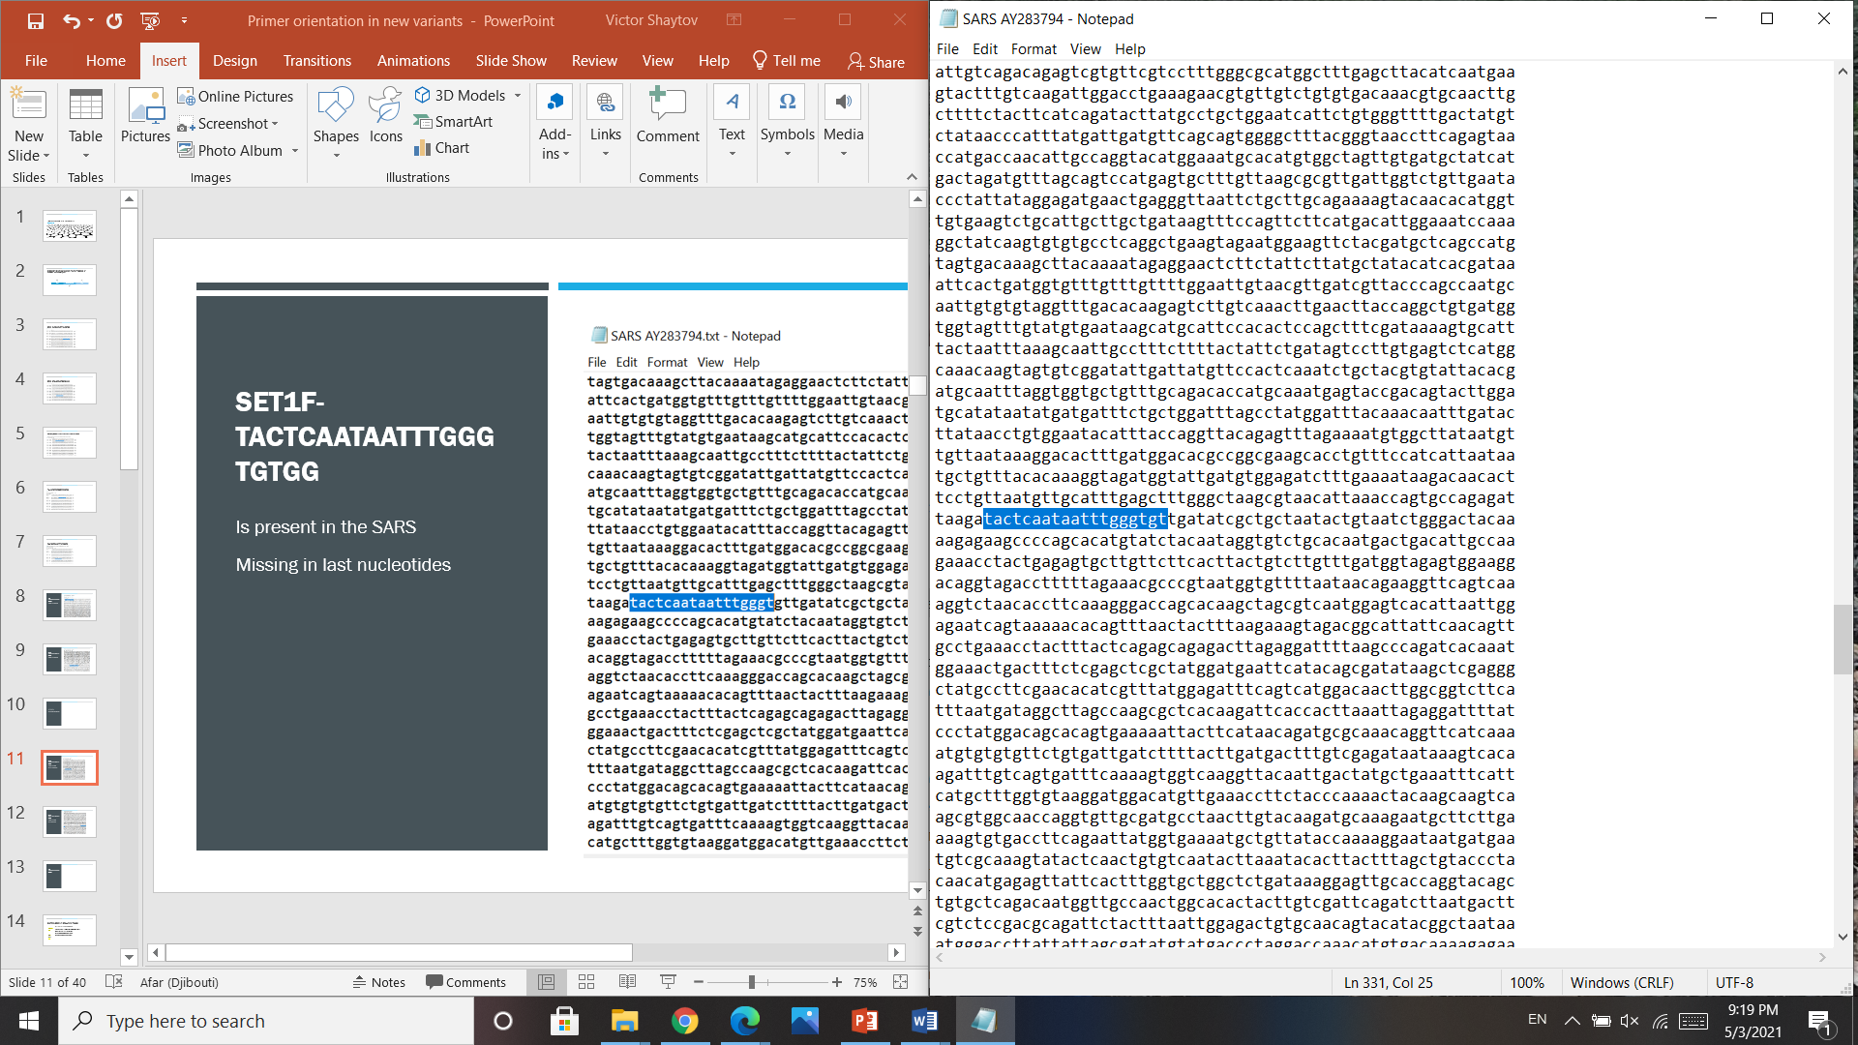
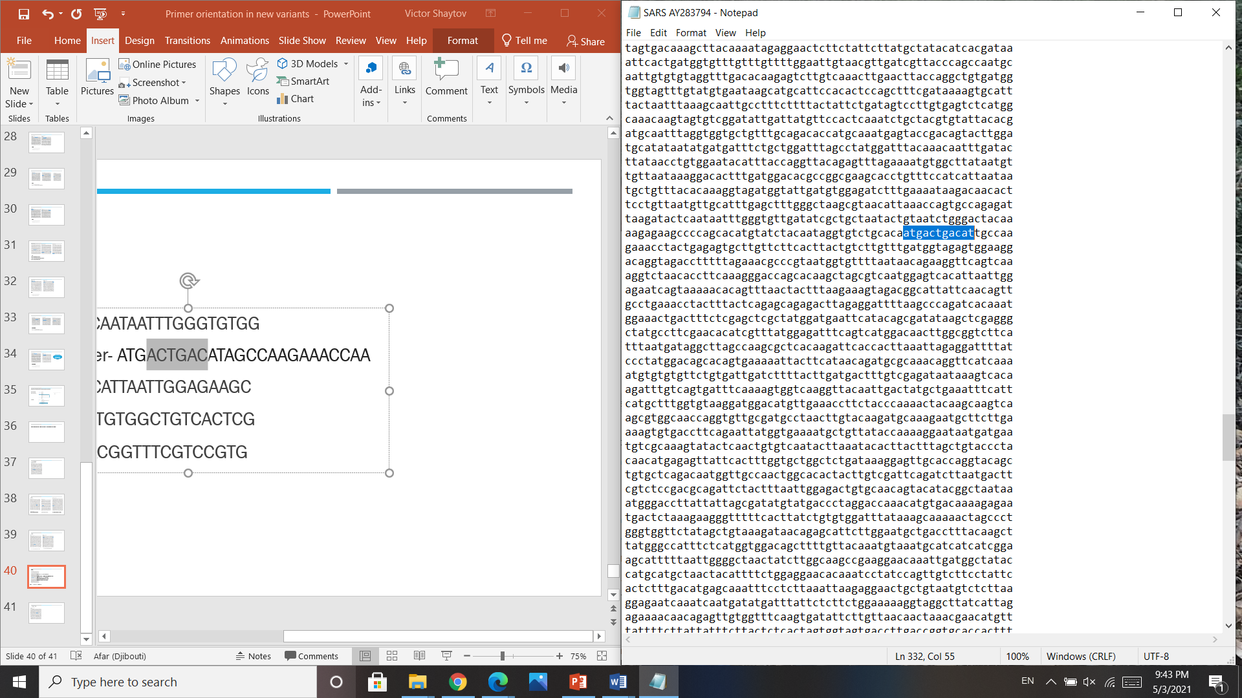
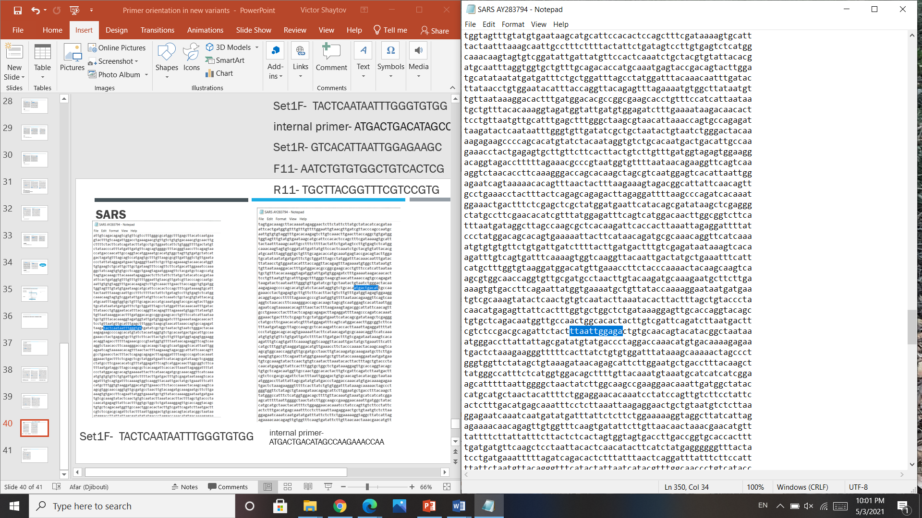
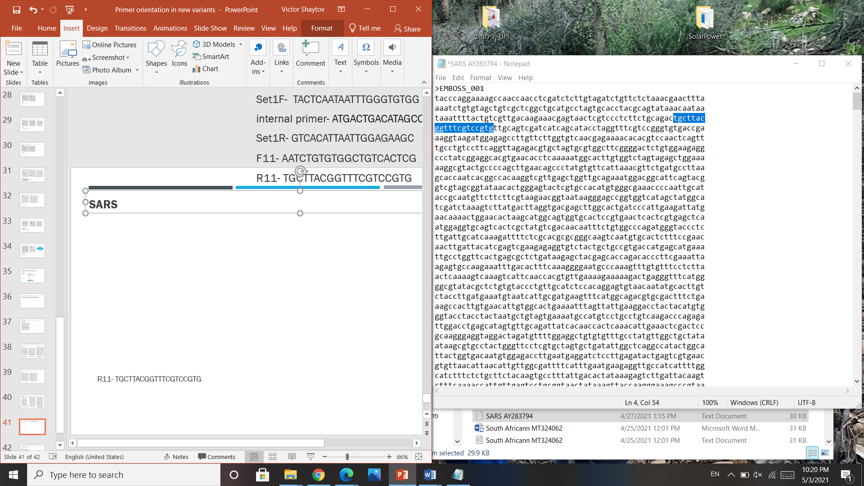
Set1F- TACTCAATAATTTGGGTGTGG

R11- TGCTTACGGTTTCGTCCGTG

Set1R-GTCACATTAATTGGAGAAGC

internal primer- ATGACTGACATAGCCAAGAAACCAA

תמונה מס

Supplementary figure: The location of each primer set within each SARS-COV2 representative variant at the genome level.
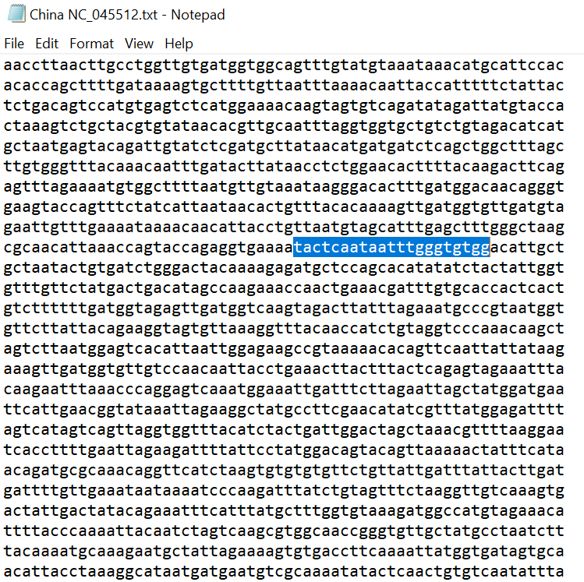
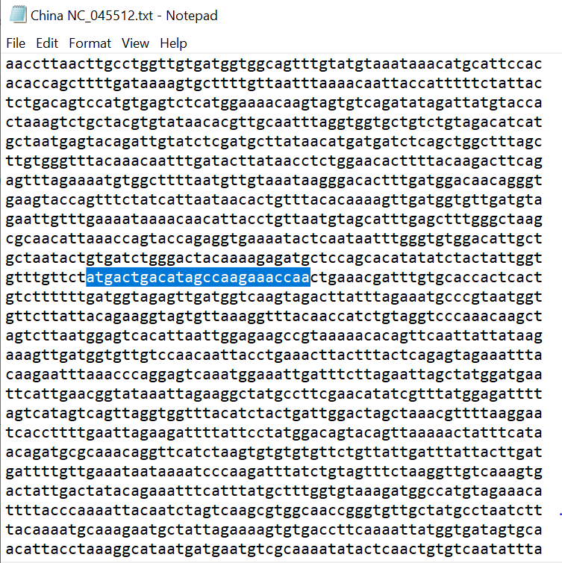
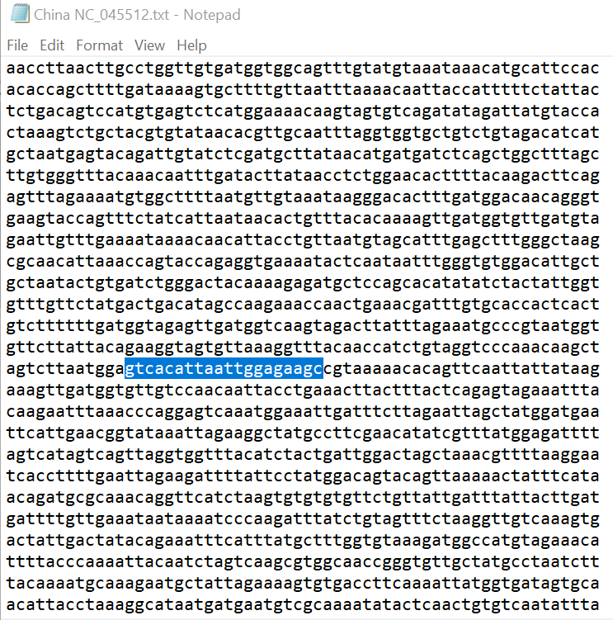
Set1F- TACTCAATAATTTGGGTGTGG
internal primer-ATGACTGACATAGCCAAGAAACCAA

Set1R-GTCACATTAATTGGAGAAGC

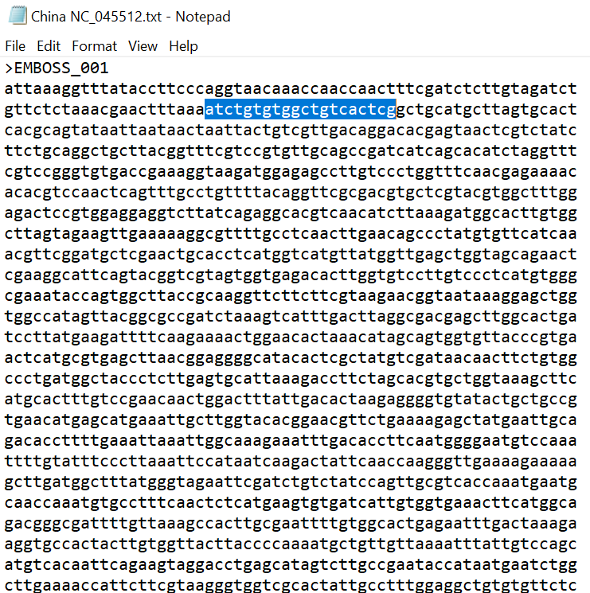
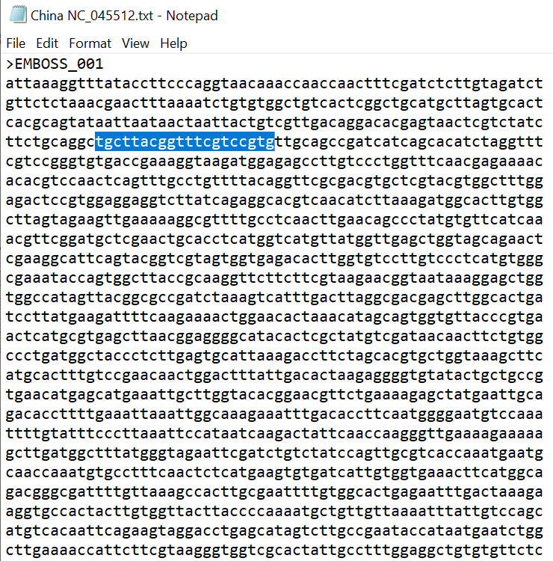

F11-AATCTGTGTGGCTGTCACTCG

R11-TGCTTACGGTTTCGTCCGTG

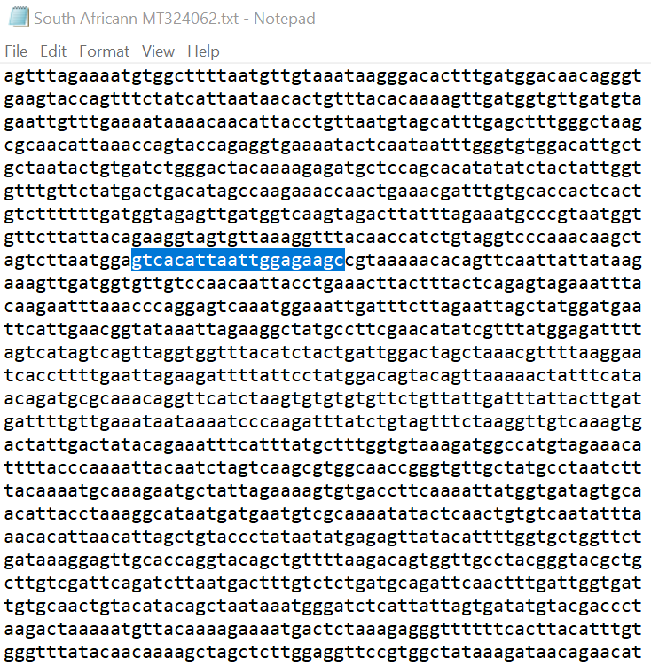
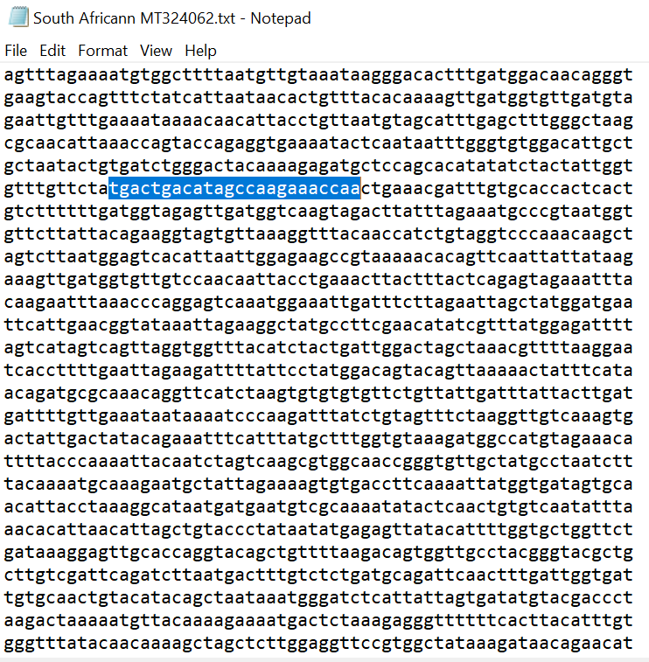
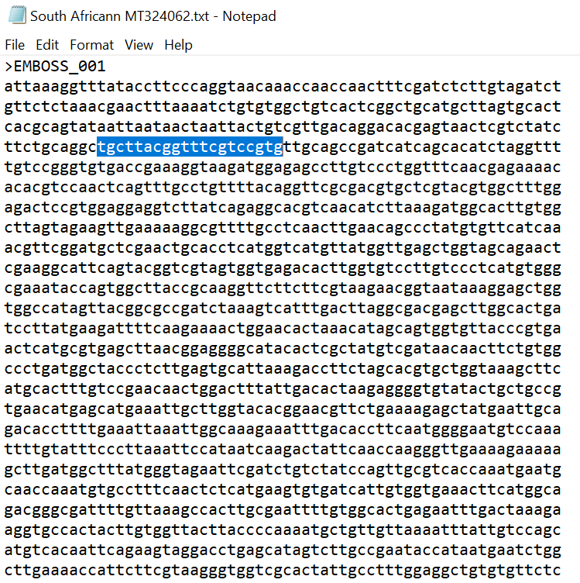
Set1F- TACTCAATAATTTGGGTGTGG
internal primer-ATGACTGACATAGCCAAGAAACCAA

Set1R-GTCACATTAATTGGAGAAGC

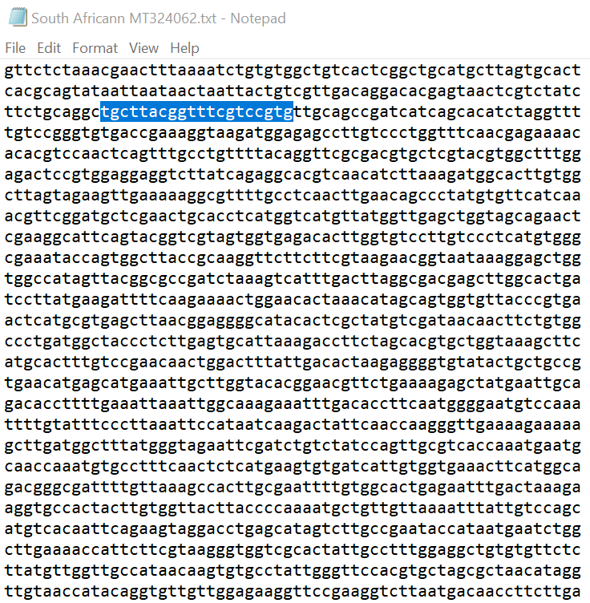
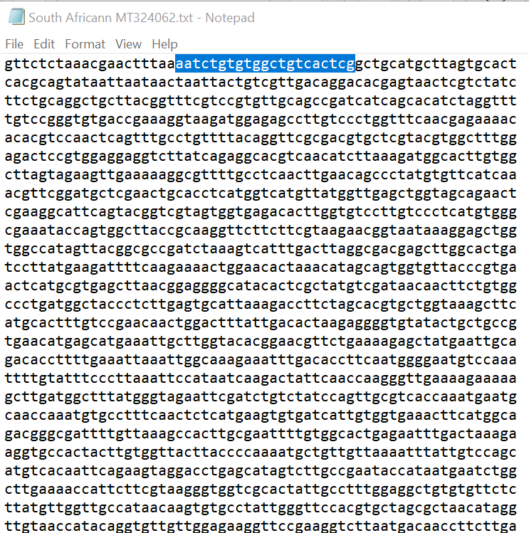
F11-AATCTGTGTGGCTGTCACTCG

R11-TGCTTACGGTTTCGTCCGTG

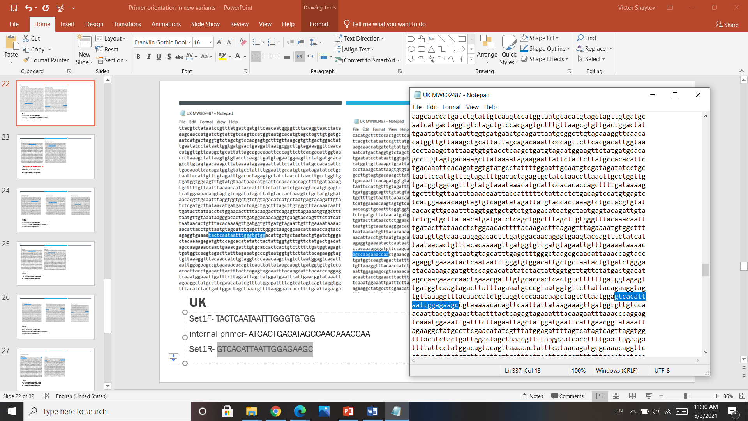
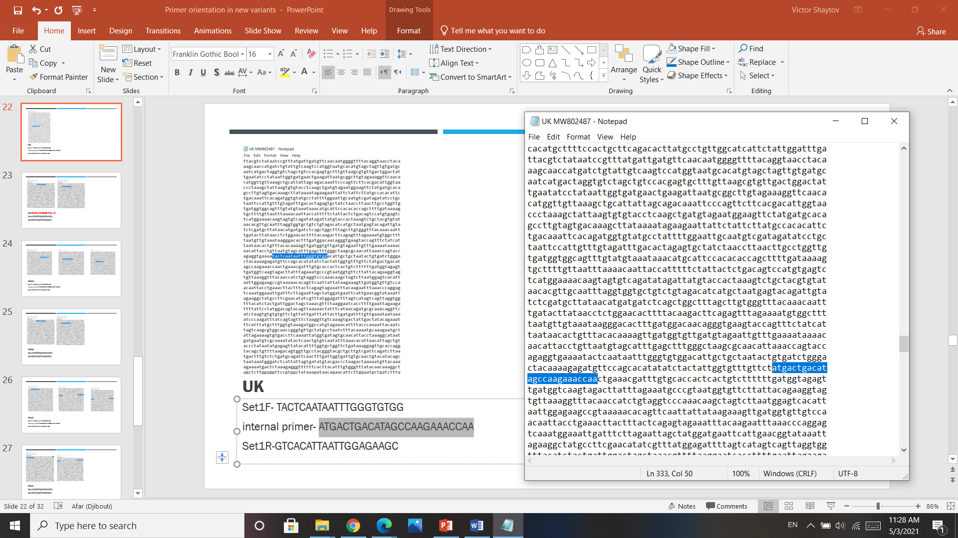
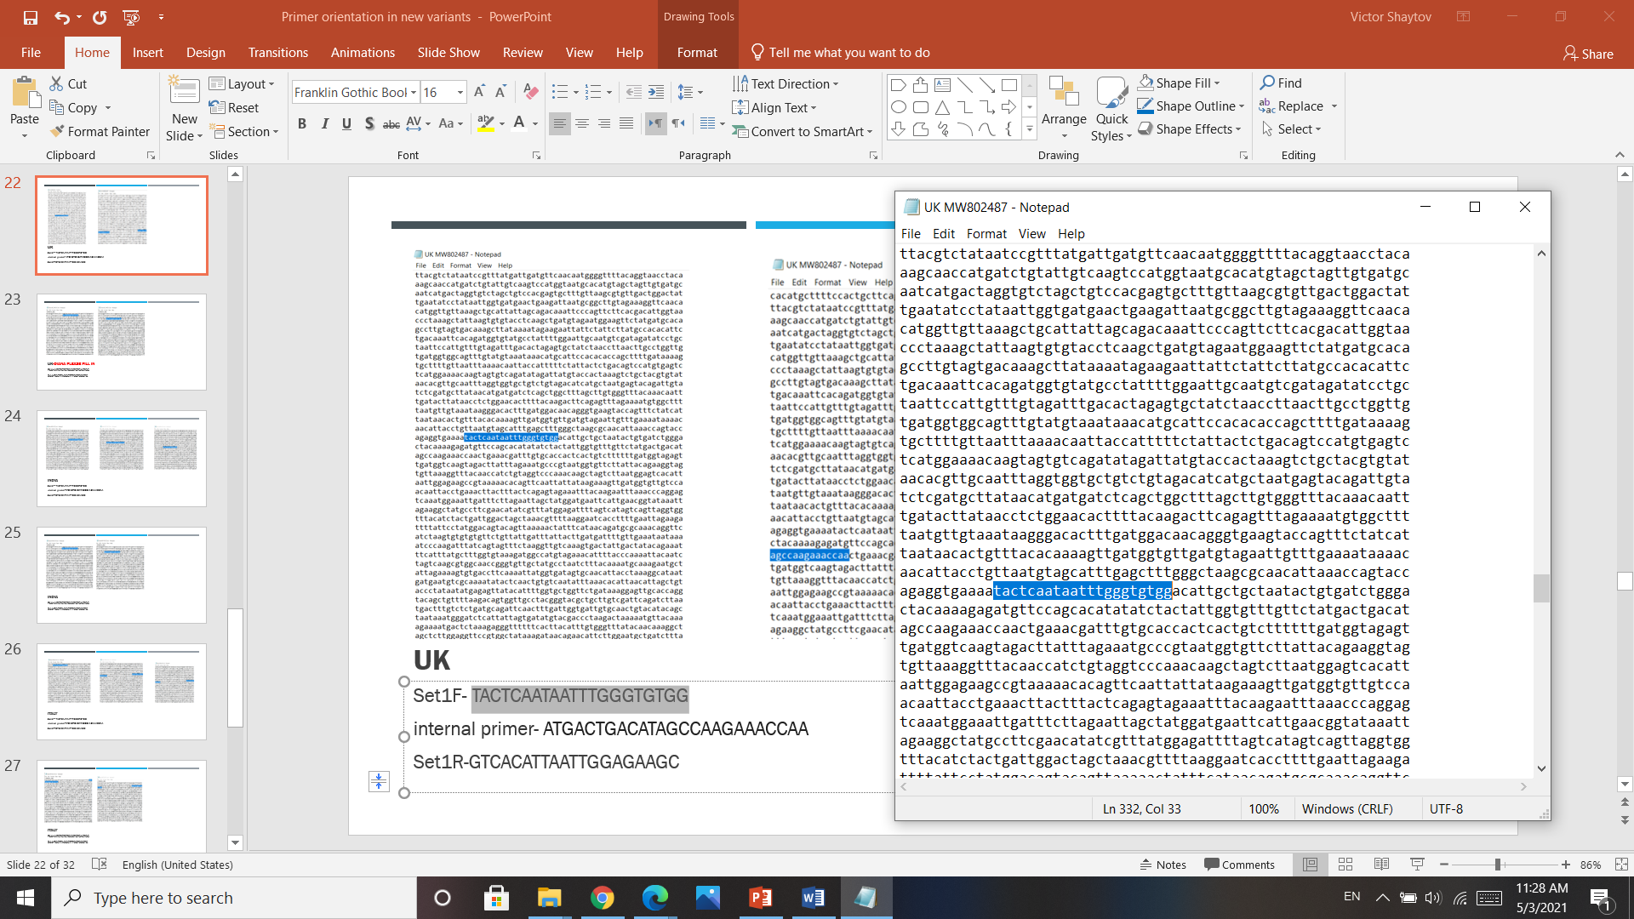

Set1F- TACTCAATAATTTGGGTGTGG
Set1R-GTCACATTAATTGGAGAAGC

internal primer-ATGACTGACATAGCCAAGAAACCAA

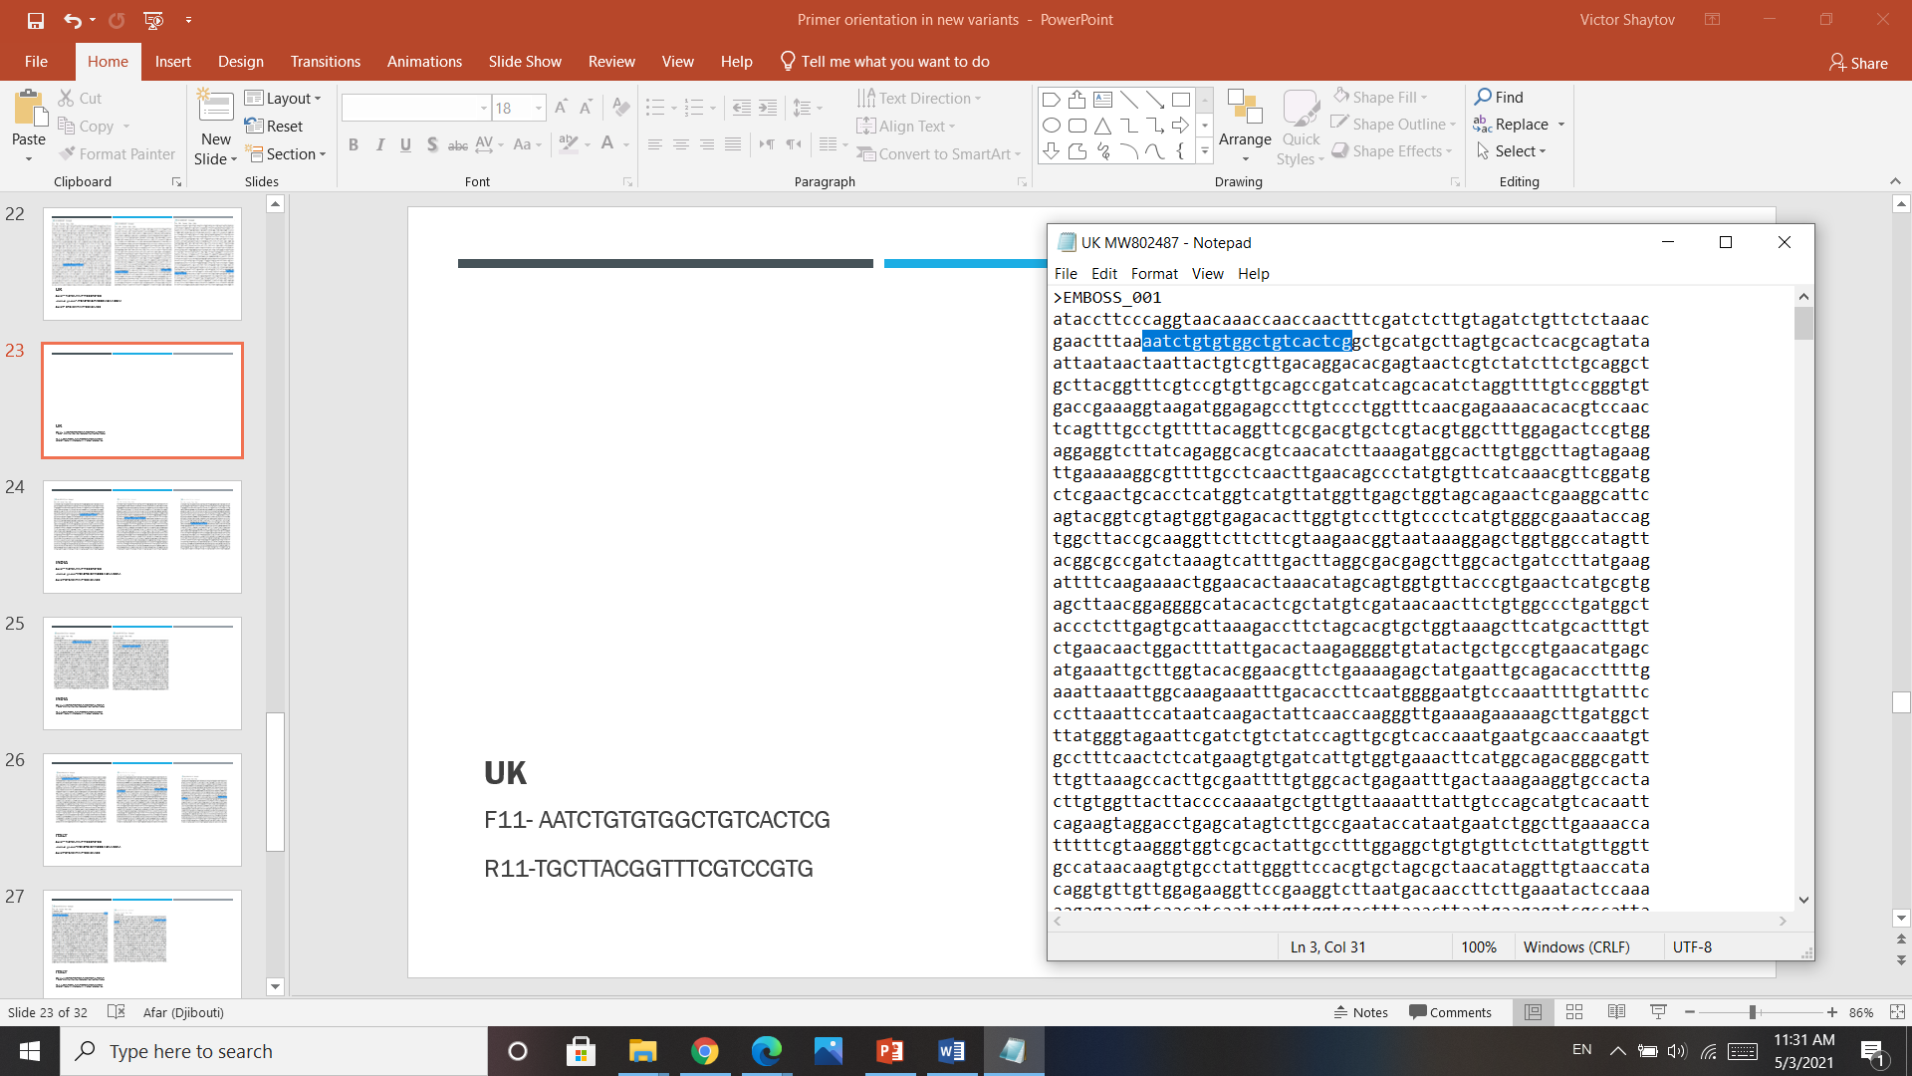
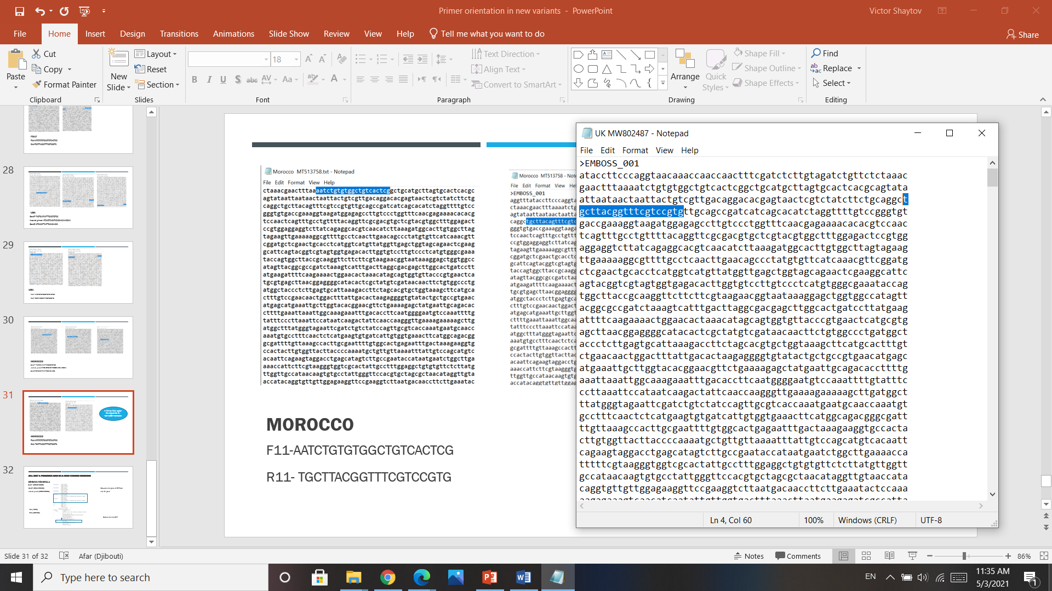

F11-AATCTGTGTGGCTGTCACTCG

R11-TGCTTACGGTTTCGTCCGTG

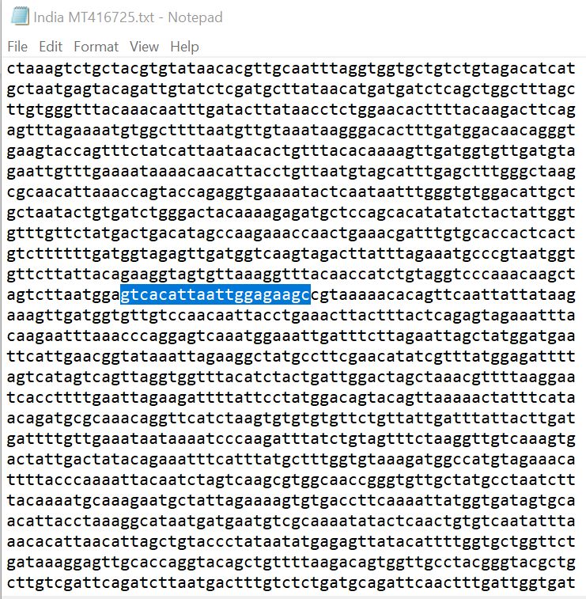
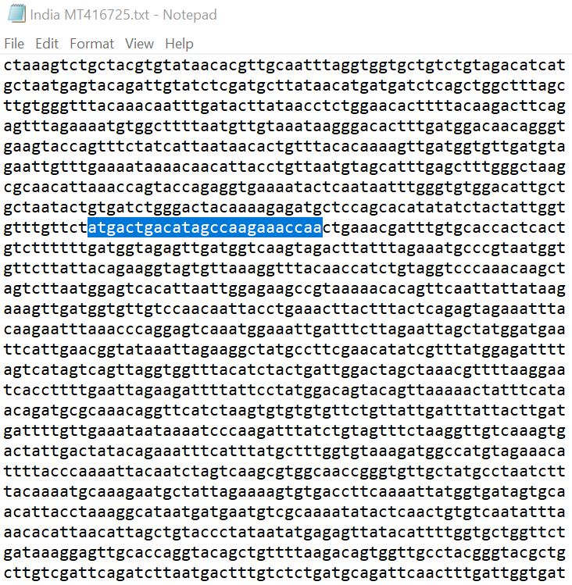
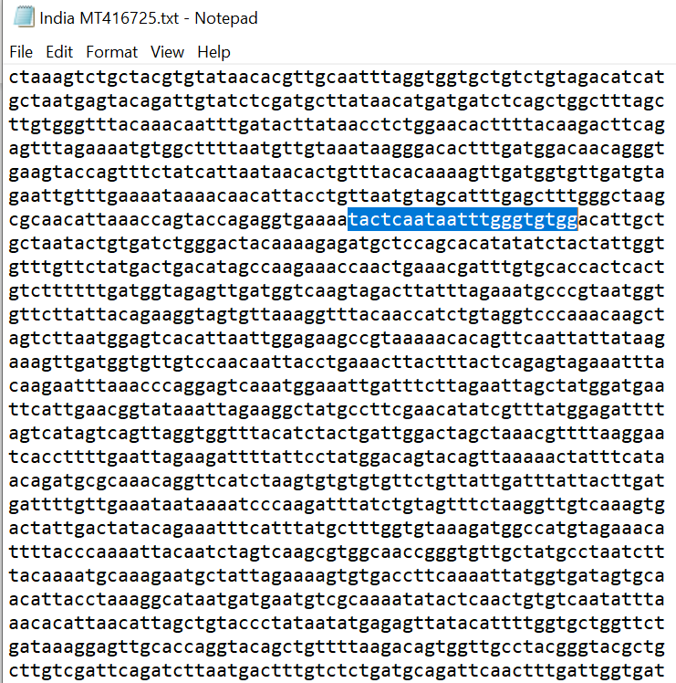
Set1F- TACTCAATAATTTGGGTGTGG
internal primer-ATGACTGACATAGCCAAGAAACCAA

Set1R-GTCACATTAATTGGAGAAGC

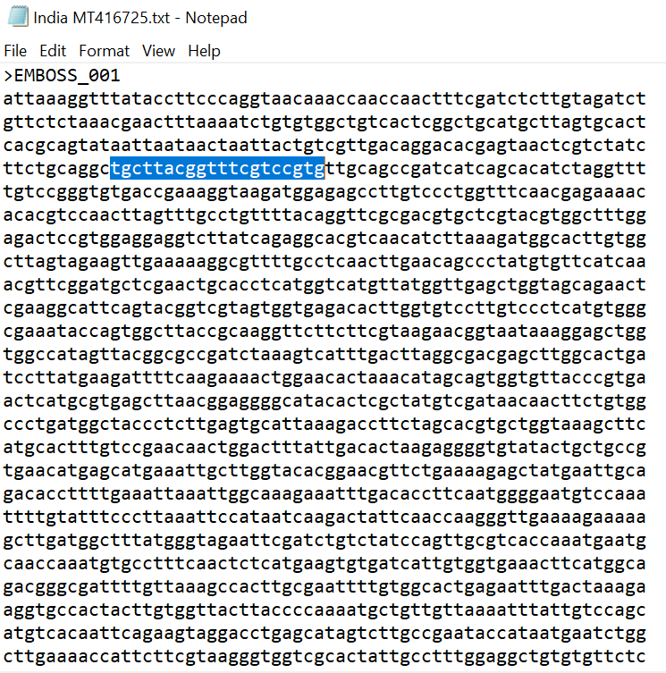
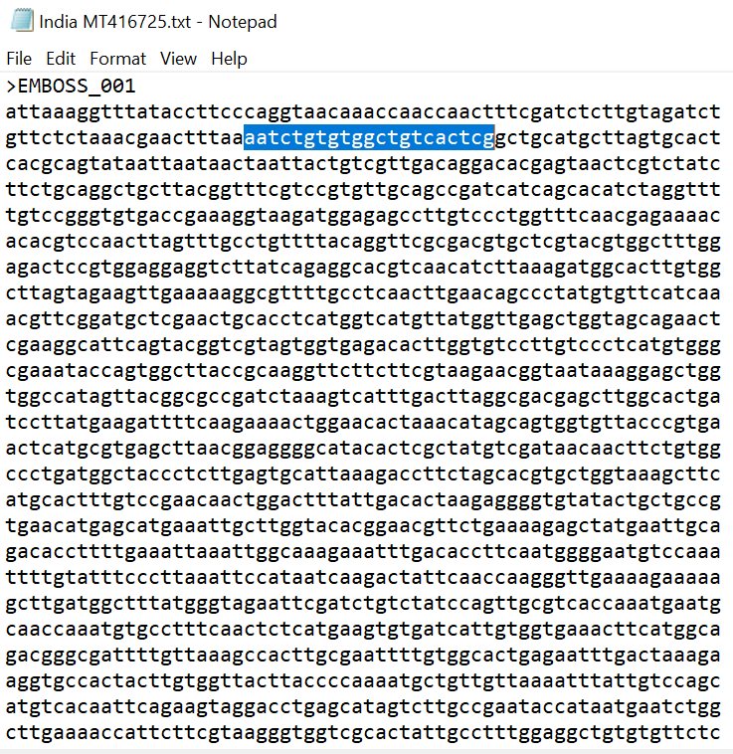

F11-AATCTGTGTGGCTGTCACTCG

R11-TGCTTACGGTTTCGTCCGTG

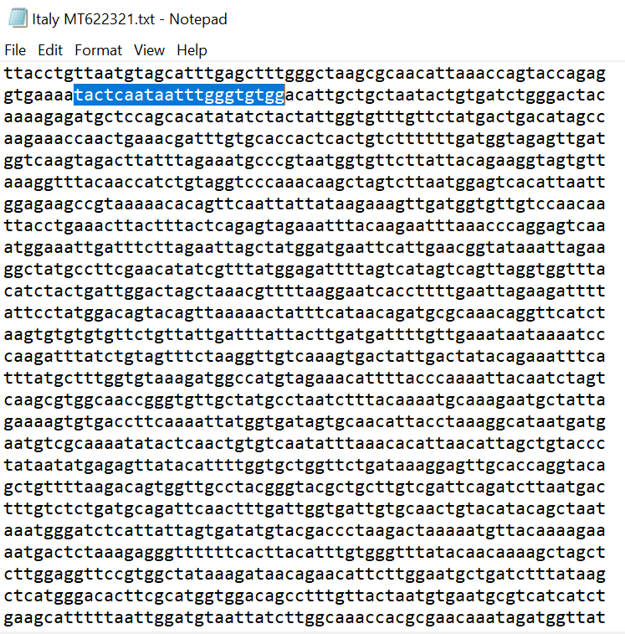
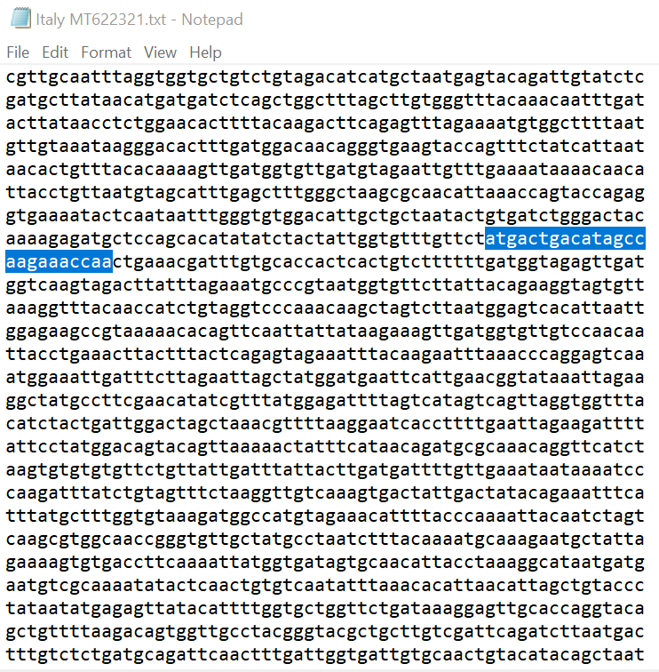
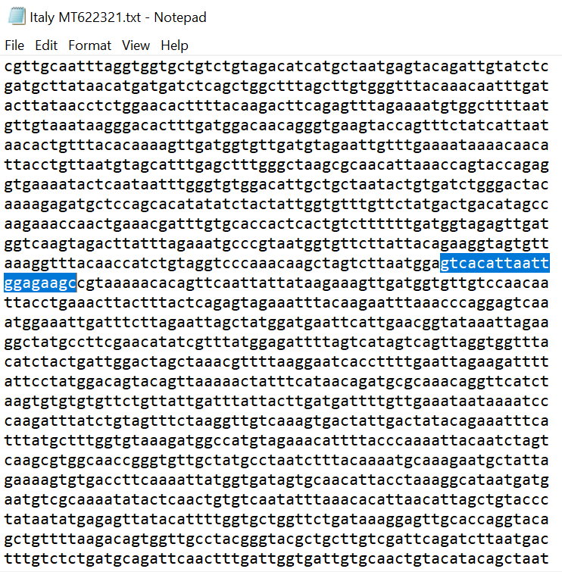
Set1F- TACTCAATAATTTGGGTGTGG
internal primer-ATGACTGACATAGCCAAGAAACCAA

Set1R-GTCACATTAATTGGAGAAGC

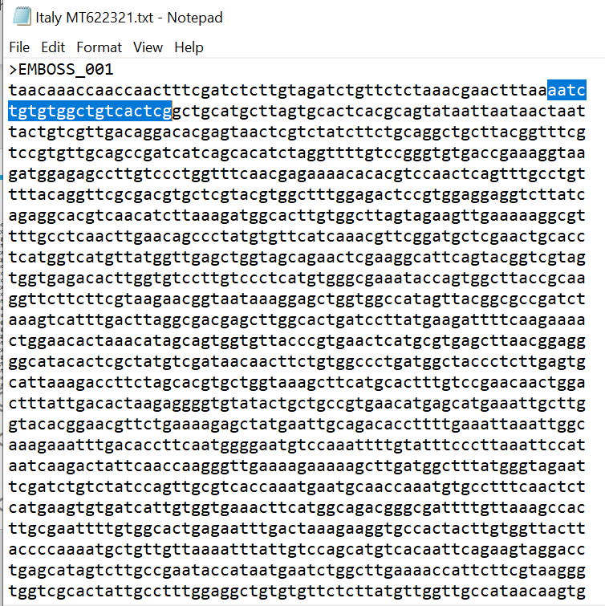
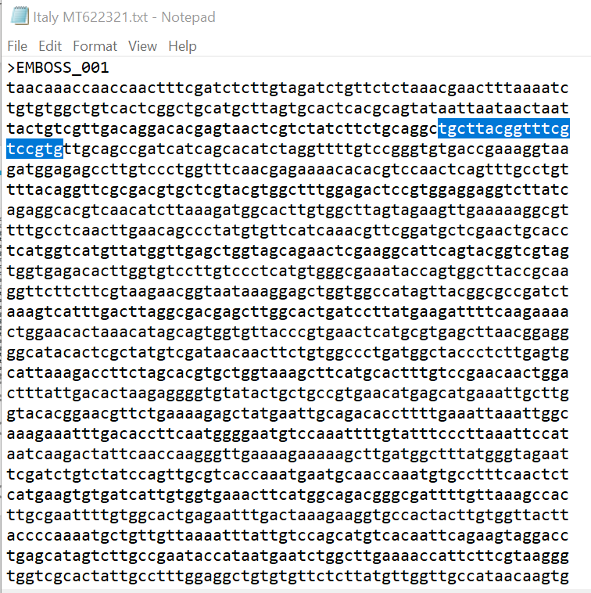
F11-AATCTGTGTGGCTGTCACTCG

R11-TGCTTACGGTTTCGTCCGTG

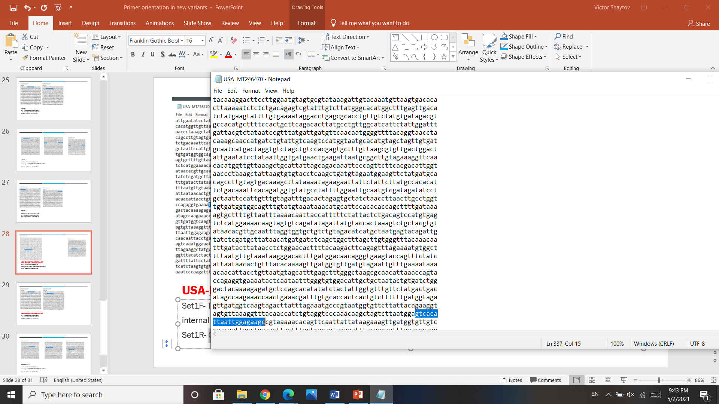
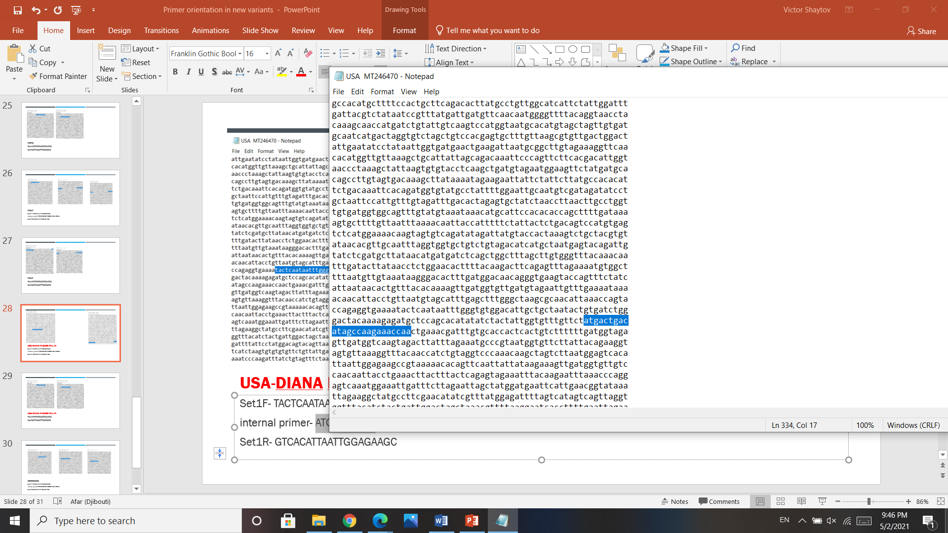
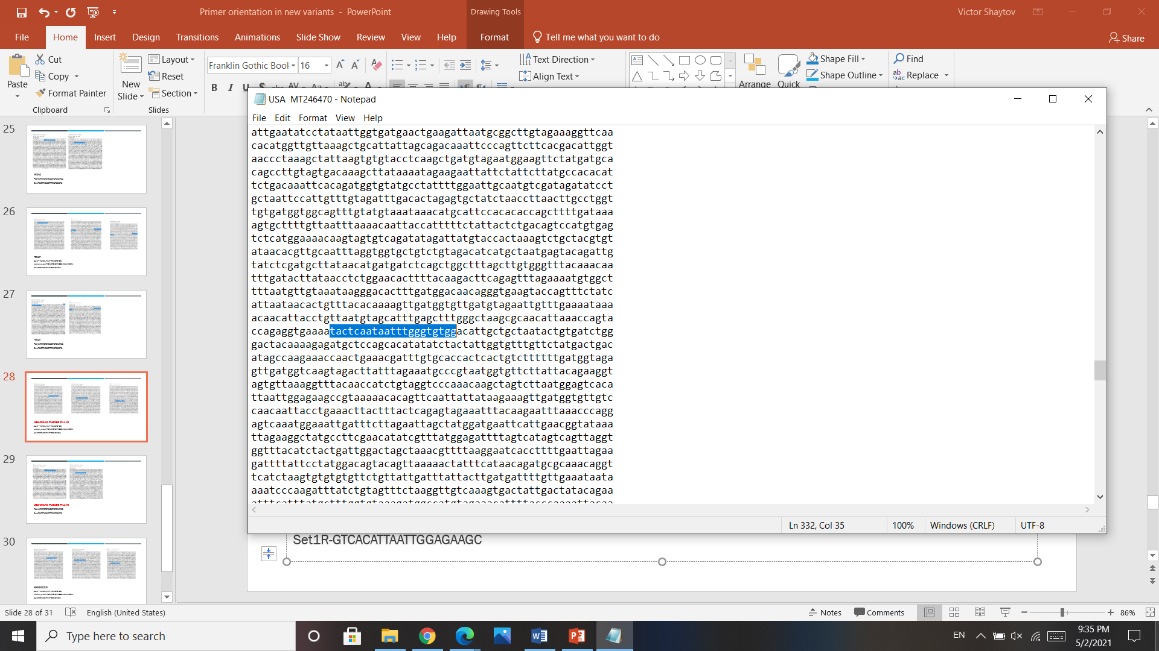

Set1F- TACTCAATAATTTGGGTGTGG
internal primer-ATGACTGACATAGCCAAGAAACCAA

Set1R-GTCACATTAATTGGAGAAGC

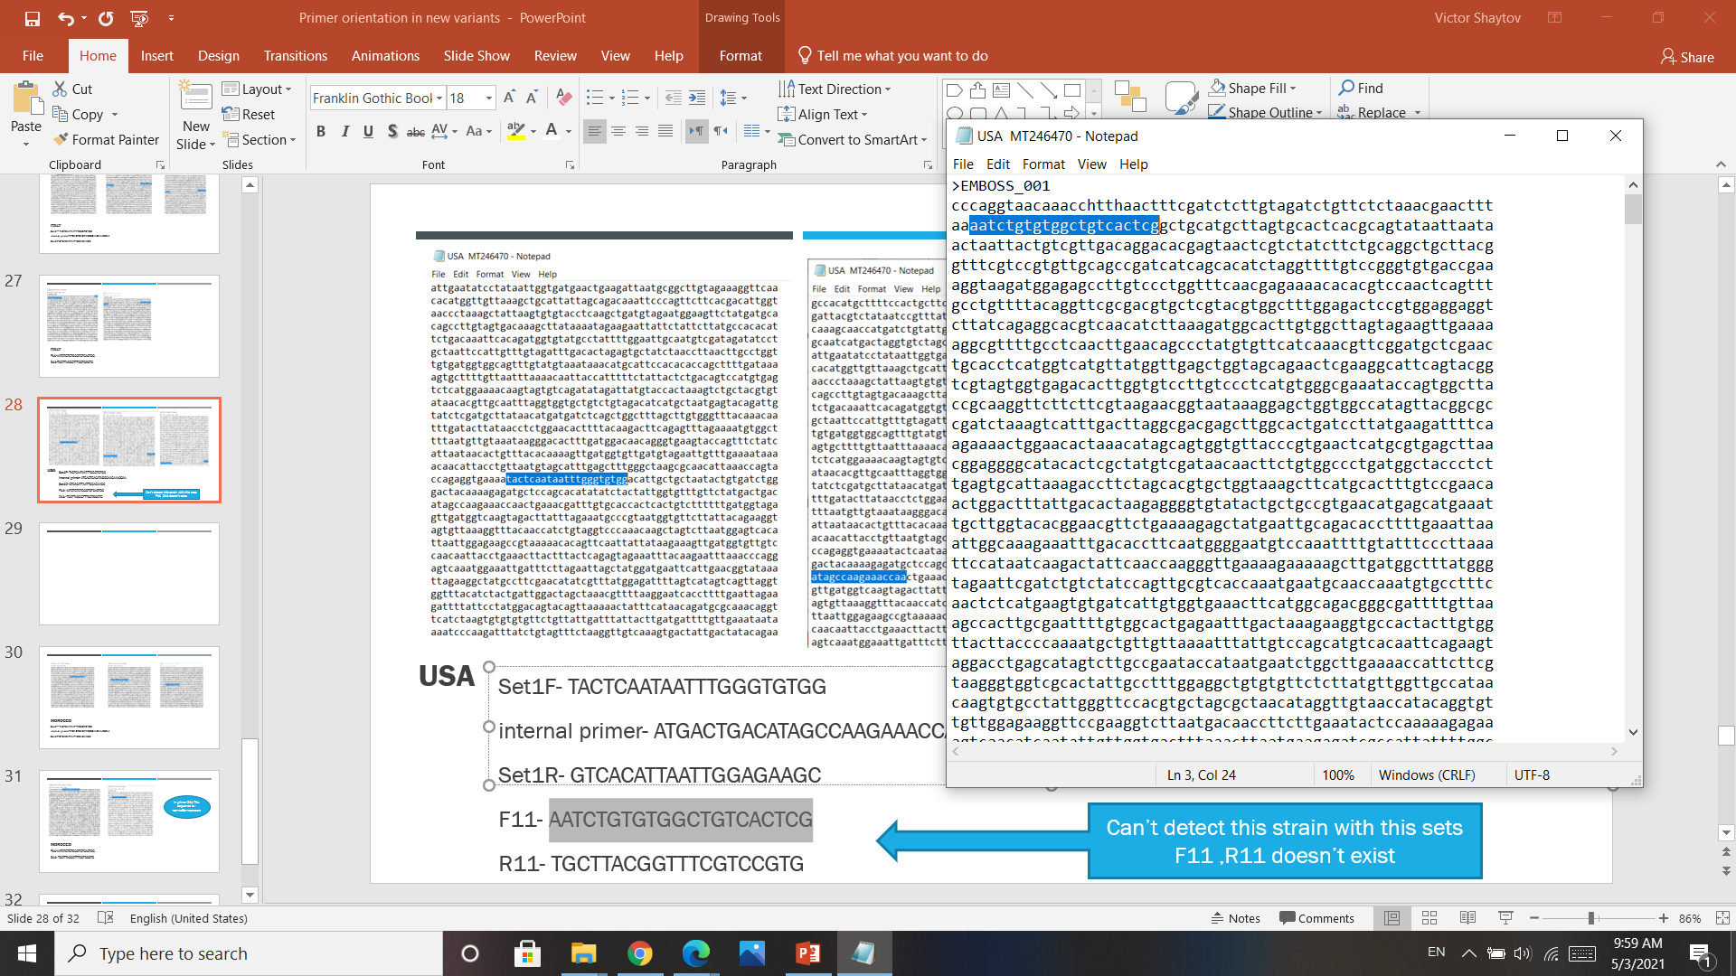
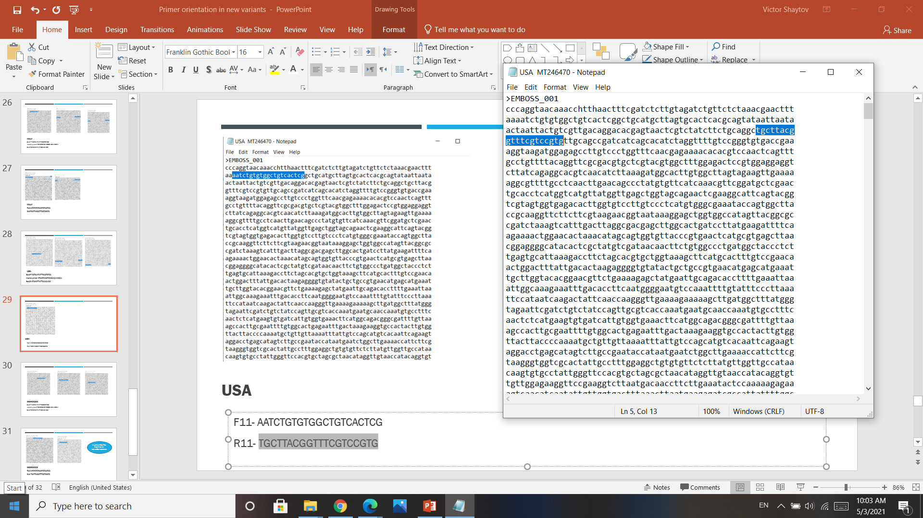

F11-AATCTGTGTGGCTGTCACTCG

R11-TGCTTACGGTTTCGTCCGTG

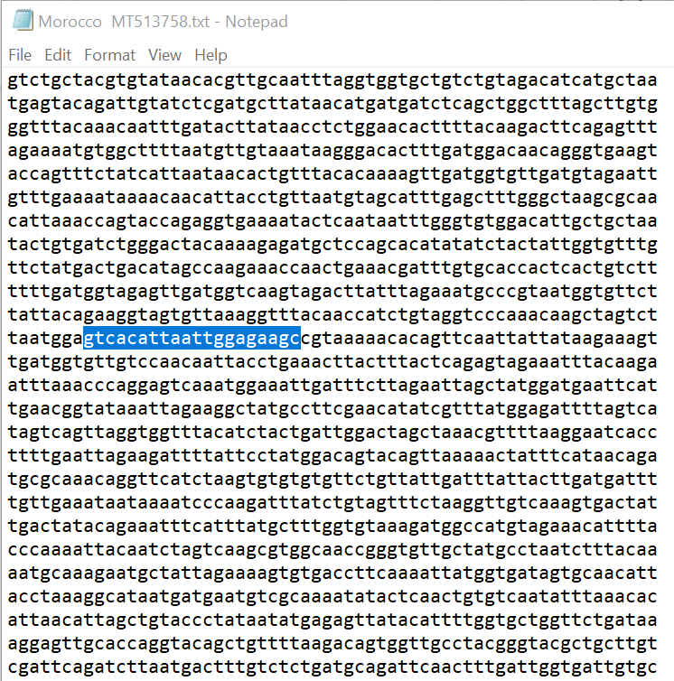
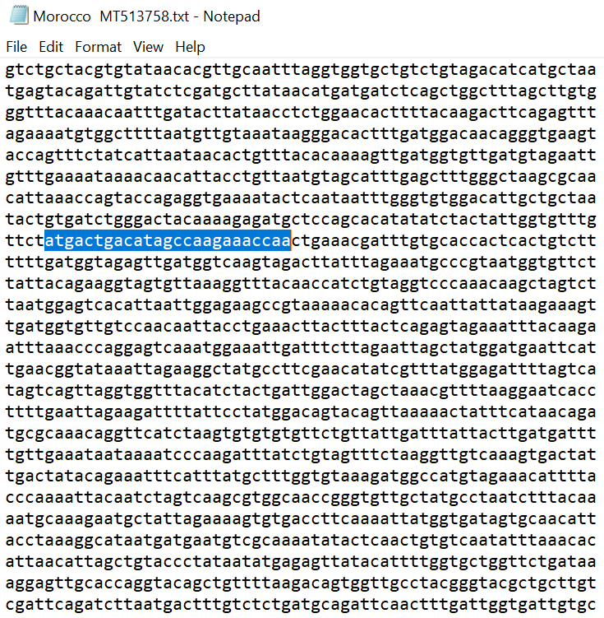
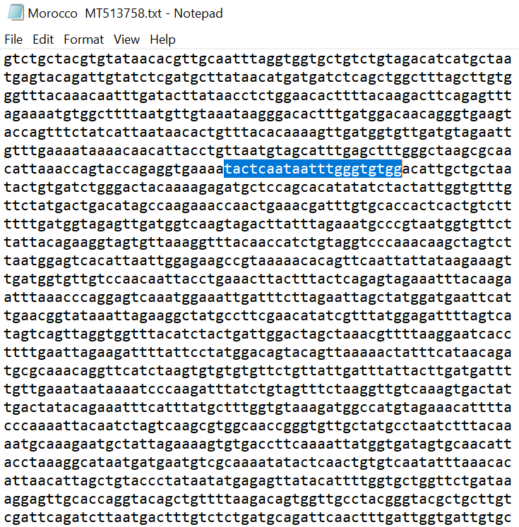

Set1F- TACTCAATAATTTGGGTGTGG
internal primer-ATGACTGACATAGCCAAGAAACCAA

Set1R-GTCACATTAATTGGAGAAGC

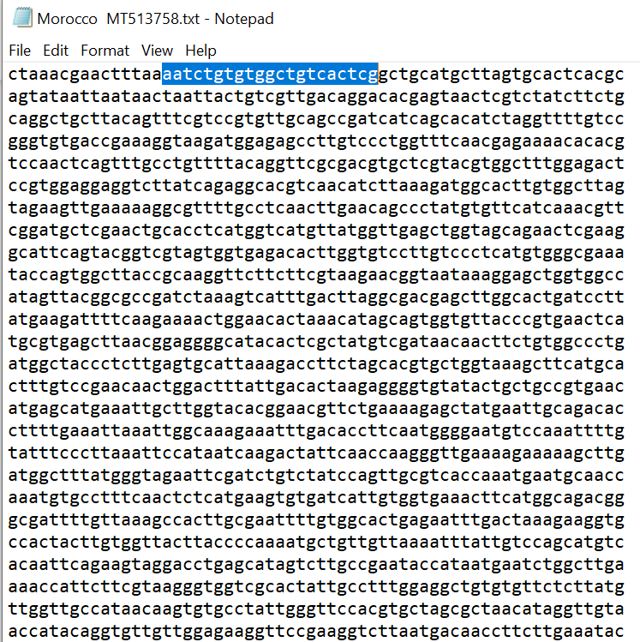
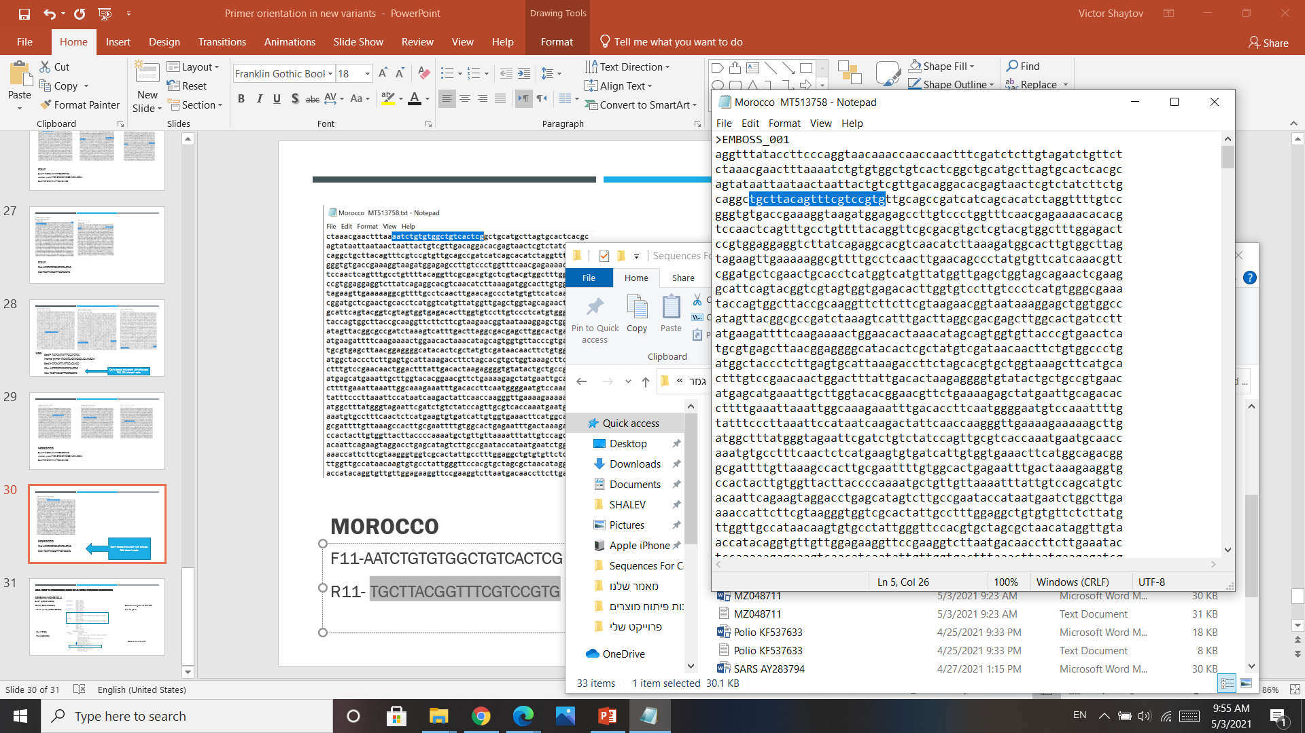

F11-AATCTGTGTGGCTGTCACTCG

R11-TGCTTACGGTTTCGTCCGTG*

supplementary figure 1. The exact sequences and the position of all three primer sets within the SARS-COV-2 genome. Forward primer (F1), Internal fluorescent primer (IP), Reverse primer (RP), Open reading frame (ORF).

Supplementary figure 2. The three primer sets identified in this work are conserved while the primers used in the current gold standard COVID19 tests are within regions prone to mutations. Illustration of the position of the various identified mutations within the S, E and N regions selected for the current gold standard test (A) versus the three primer sets (blue rectangles) identified and used in this work (B). Primer set 1 is present in world-wide SARS-COV-2 variants (C).

Primer set | Primer name | Primer Sequence | Primer position within the genome | The position of the gene within the entire genome
Set 1 | F1 | TACTCAATAATTTGGGTGTGG | 19830-20132 | The endo RNAse within the ORF1ab  19601-20638
 | IP | ATGACTGACATAGCCAAGAAACCAA
 | R1 | GTCACATTAATTGGAGAAGC
Set 2 | F1 | TGATGGCTTTATGGGTAGAATT | 1144-1228 | The non-Structural protein nsP2 within the ORF1ab  795-2708 ²⁸
 | IP | CCAGTTGCGTCACCAAATGAATG
 | R1 | TGTGCCTTTCAACTCTCATG
Set 3 | F11 | AATCTGTGTGGCTGTCACTCG | 81-210 | The primers are located prior to the ORF
 | R11 | TGCTTACGGTTTCGTCCGTG

Supplementary Figure 3.
AIRPORT: Sensitivity, specificity compared to gold standard - AIRPORT
שם הערכה | The proposed test | TaqPath™ COVID-19 CE-IVD RT-PCR Kit  (ThermoFisher scientific) | Allplex 2019-nCoV Real-time PCR (Seegene, Seoul, Korea) | PowerChek 2019-nCoV (KogeneBiotech, Seoul) | Real-Q 2019-nCoV Real-Time Detection (BioSewoom, Seoul) | StandardM nCoV Detection (SD BIOSENSOR, Osong, Korea) | GeneFinder™ COVID-19 Plus RealAmp Kit
גן מטרה | EndoRNAse | S,ORF1,N | E,RdRp,N | E,RdRp | E,RdRp | E,RdRp | ORF1ab, E, N
מספר מבחנות דרושות | 1 | 1 | 1 | 2 | 1 | 1 | 1
ביקורת פנימית | COVID-19 EndoRNAse positive control | MS2 Phage,TaqPath COVID-19 | Bacteriophage MS2, spiked into sample | Recombinant DNA plasmide spiked into PCR mixture | Human RNase P, intrinsic | Pseudovirus particle | RdRp, E, N, RNAse P
נפח מיצוי RNA הדרוש לביצוע הבדיקה l)µ( | 10 | 6.25 | 8 | 5 | 5 | 10 | 10
מספר מחזורי בדיקה ב- PCR | 40 | 40 | 45 | 40 | 40 | 45 | 45
זמן הרצה של ה- PCR | 30 min | 36 min | 110 min | 120 min | 110 min | 90 min | 81.25 min
Cutoff Ct | Target gene: =<37  positive control: =<10 | Target gene: =<37  Internal control: =<32 | 40> | 35>= | Target gene: <38  Internal control: =<35 | Target gene: <36  Internal control: =<32 | Target gene: =<37  Internal control: =<21
LOD | NA | 10 GCE/reaction | 153.94 Copies/reaction | 84.12 Copies/reaction | 80.60 Copies/reaction | 153.94 Copies/reaction | 100 copies/mL
sensitivity (%) | 90/0 | 100.0 | 90.0 | 82.3 | 75.0 | 100.0 | 95.0
Specificity (%) | 100.0 | 100.0 | 100.0 | 100.0 | 100.0 | 100.0 | 100.0

