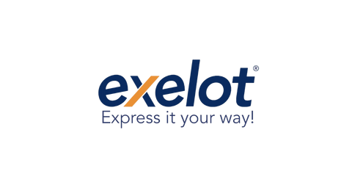

2023

Exelot - ESG Progress Report

# Exelot's Social Responsibility Policy 2023

**Ethics and Compliance**



**Safety**

**Data Security**

**Social**

**Environment**

**Valuable Logistic Chain**

Exelot consistently tries to eradicate corruption risks from all its operations and activities.

Exelot works to reduce risks associated with security and accidents, as well as improve the standards of the working environment.

Exelot ensures that the personal information of our staff, clients, suppliers, and other business partners is protected.

Exelot supports the regional communities where we do business and encourages diversity among our teams.

Exelot strives to continuously lessen the negative environmental impact of all of its operations and activities.

Exelot collaborates with carefully chosen and skilled partners to advance quality along the whole supply chain of services.

# The UN Sustainability Development Goals

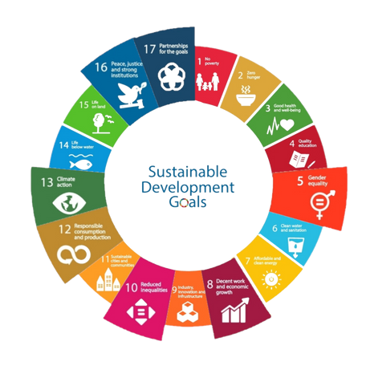

The Sustainable Development Goals (SDGs) are a set of 17 worldwide objectives for sustainable development. They express the most important global issues that the international community has identified as future priorities in order to motivate governments, corporations, and non-profit organizations to unite with the aim of finding solutions for them and achieving global prosperity by 2030. Exelot therefore identified and evaluated the crucial targets where we have the most immediate and significant impact that might considerably boost global efforts

SDGs: 5, 7, 8, 10, 12, 13 ,16, 17

SDG Implemented by Exelot 2023-2024

## Gender equality goal- Exelot implementation 2023-2024

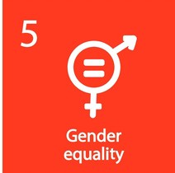

In 2022 appx. 40% of Exelot employees and about 31% of our managers are women.

Respect and protect our employees’ fundamental rights and freedom, in line with our Code of Ethics and human rights.

Committed to preventing all forms of discrimination throughout our organization.

Running mandatory tutorials for sexual harassment prevention and a respectful work environment, as well as the appointment of a company sexual harassment commissioners (of both genders woman and man).

## Decent work & economic growth goal- Exelot implementation 2023-2024

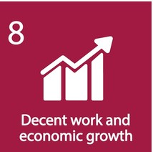

Implementing cautionary regulations to promote safe performance.

Promoting the company’s approach to work-life balance.

Employee training and education with ongoing programs, annual tutorials, professional training, and enrichment courses

Continuing to conduct engagement survey evaluation processes for employees and managers.

Implementing innovative technological solutions and tools in operations, customer service, and business conduct.

Internal HR audit procedures are in place to regularly check recruitment processes and employment procedures.

## Reduced inequalities goal- Exelot implementation 2023-

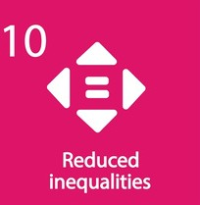

2024

Promoting employment equality, diversity, and inclusion by hiring from diverse populations and adopting KPIs for diversity and inclusion.

* Minorities to focus on for 2023 - 2024:
  + Ultra-orthodox (R&D)
  + Ethiopians' immigrants (WH)
  + Special needs & mentally challenged (Operation & Logistics)
  + LGTBQ (2024)

## Responsible consumption & production goal- Exelot implementation 2023-2024

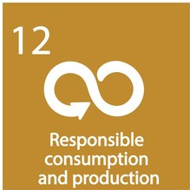

Measuring scope 2 emissions in all owned offices in favor of improving and setting targets for better use of energy.

Reducing paper consumption - digital invoices project, WAVE platform for reducing paper waste and promoting paperless operations.

## Climate action goal- Exelot implementation 2023-2024



Exelot Eco - calculating the carbon footprint of each parcel.

ESG index - analysis and rating of vendors and sellers.

Emphasis shall be given to:

1. Delivery companies and the usage of fossil-based vehicles compared with electric solutions
2. Usage of photo-voltaic automatic lockers as pick up points.

Encourage package recycling with customized stickers.

## Peace, justice & strong institutions goal- Exelot implementation 2023-2024



Conducting on-going business relations and operation with the Palestinian authority – including both public and private sectors: Exelot is an official vendor for the Palestinian Authority Post and 2 additional private delivery vendors.

Following the Abraham Cords initiative Exloe is under an on-going process with the Dubai state authorities for cooperation and registration in Dubai.

Conducting business ethically and honestly in accordance with our Code of Ethics and our vision and values.

Conducting anti-bribery and corruption tutorials for employees regularly.

Communication with suppliers on ethics topics, as well as launching a Supplier Code of Conduct.

Implementing a compromise mechanism and mediation process first for trials

## Partnerships for the goals- Exelot Implementation 2023-

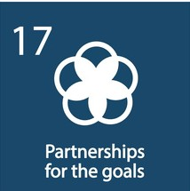

2024

**Exelot Plan for 2024:**

Promoting local initiatives with agencies, operating sites around the world with surrounding communities and local organizations.

Cooperation with stakeholders to advance sustainability-related issues.

Creating partnerships and alliances with peers to support development and improvement in sectorial issues.

Cooperation with organizations and NGOs for protecting biodiversity and rejuvenation.

**Thank You!**

**UNITED KINGDOM ISRAEL CHINA GERMANY**

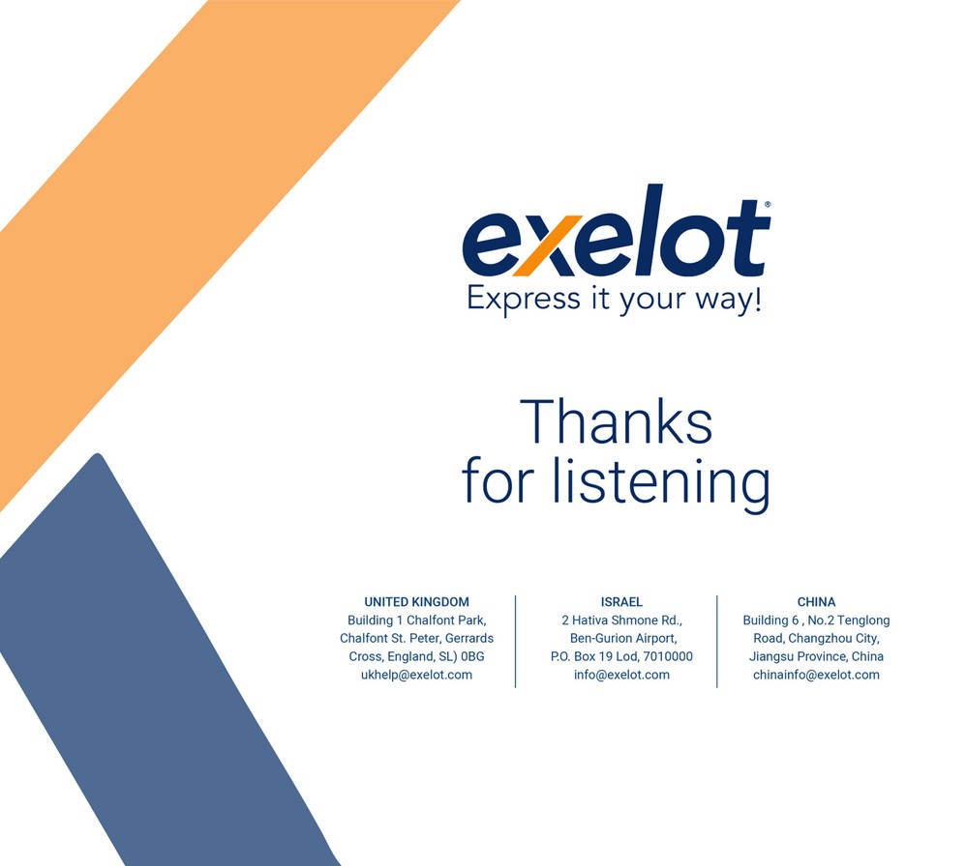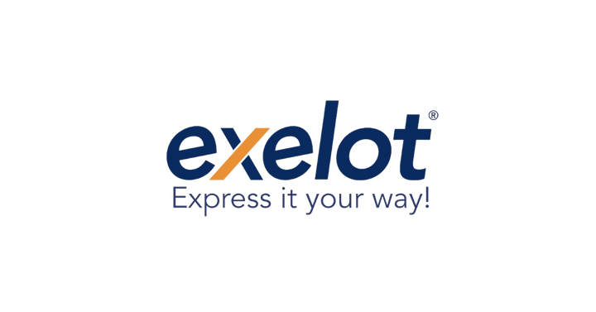

Building 1 Chalfont Park, Chalfont St. Peter, Gerrards Cross, England, SL OBG [ukhelp@exelot.com](mailto:ukhelp@exelot.com)

2 Hativa Shmone Rd.

Ben-Gurion Airport,

P.O Box 19 Lod, 7010000 [info@exelot.com](mailto:info@exelot.com)

Building 6, No/2 Tengglong Road Changzhou City, Jiangsu Province, China [chinainfo@exelot.com](mailto:chinainfo@exelot.com)

Friesenplaz 4,

50672 Koln NRW/Deutschland [Aysel@exelot.com](mailto:Aysel@exelot.com)