**Advances in Civil Engineering**

**Comparative Study on the Encased Stone Column and the Reinforced Sand-bed in Improving the Clay Deposit Supporting Isolated Footing**

Premalatha Krishnamurthy,1 Priyadharshini M. Rajan2

1 Professor,

2 Research Scholar

1,2 Division of Soil Mechanics & Foundation Engineering, Department of Civil Engineering, College of Engineering Guindy, Anna University, Chennai, Tamil Nadu, India, P.C- 600025

Correspondence should be addressed to Priyadharshini M. Rajan; priyadharshini.civil@gmail.com

**Abstract**

The working mechanism of a geotechnical structure can be understood from the deformations and the vertical stresses in the soil media. This article attempts to study the deformation, vertical stress development, and distribution of improved clay deposits carrying a single isolated footing. Through PLAXIS 3D software, numerical analyses were conducted for the ground improvement methods, such as the Geogrid reinforced sand-bed (GRGB) and ordinary and encased stone column installation (OSC & ESC). In GRGB, the results show that the stresses were maximum at the sand-clay interface at a depth of 0.67B. It is proposed to place an additional layer of geogrid at the interface, provided it is within the critical depth, i.e. width of the footing. Furthermore, the stiffness of the geogrid in the sand layer greater than 500 kN/m was insignificant in soil improvement, whereas the optimum stiffness of the stone column encasement was 1000 kN/m. The stone column installation improved the clay layer even below the depth of 0.67B, improving the capacity of clay to carry higher vertical stresses on par with the stone columns. The sand bed + geogrid layer carried higher vertical stresses than the unimproved ground. However, the ground reinforced with the stone column could carry vertical stresses higher than the composite layer. This knowledge can provide the practitioners to decide the depth of placement of the reinforcement and also to choose an alternate if one method is not feasible for the site.

**Introduction**

Improving the weak soil deposits is the most necessary in the present-day scenario due to the lack of suitable areas for construction. Ground-improvement techniques strengthen weak soil deposits with different working mechanisms. The techniques such as placement of reinforced sand-bed and installation of stone columns are given due importance in this paper. There are several studies related to these two techniques. In most of them, the focus on geosynthetics applications was on bearing capacity improvement [1,2,3] and settlement reduction [3,4].

The study of vertical stress development and distribution in the Geogrid-Reinforced Granular Bed (GRGB) layer below the footing was insignificant in previous research. The initial study on vertical stress distribution theory proposed by Boussinesq (1885) [5] is still widely used to analyse the stresses and displacements in a homogeneous, isotropic, elastic, semi-infinite medium when subjected to a vertical point load. Soil reinforcement using geosynthetics leads to a variation in the vertical stress development and distribution, which was not widely researched. Recently, studies have attempted to explore such changes in the vertical stress influenced by geosynthetic reinforcement within homogeneous [6] and layered soil systems [7].

El Sawwaf (2006) [8] reported from numerical studies that reinforcing the sandy layer with geogrid improved the footing performance and reduced the settlement compared to the unreinforced sand layer. A similar study portraying the beneficial effects of geogrid reinforcement by Lakshmikant & Yadu (2013) [9] reported the best adoptable geogrid length as 4 times the width of the strip footing. Demir (2014) [10], in continuation with the large-scale field tests [11], also conducted numerical investigations exploring the influence of the thickness of the granular fill, the number of geogrid reinforcements and the depth of the reinforcement. Subinay & Deb (2017) [12] conducted model tests on footings with different aspect ratios and reported findings that reinforcing the granular bed with two geogrid layers would be more beneficial. The depth of the first reinforcement was 0.25 and 0.375 times the footing width for the square and rectangular footing, respectively.

In studying the functioning of geosynthetic reinforcement, the axial stiffness of the reinforcement is an essential parameter. Deb et al. (2007) [13] numerically studied the multi-layered reinforced granular bed. It was reported that the increase in reinforcement layers influenced the stress distribution in the soil. Also, the settlement of the soil is reduced considerably when the axial stiffness of the reinforcement is within 4000 to 5000 kN/m. A contrary finding by Latha & Somwanshi (2009) [14] reported that the reinforcement's tensile strength did not significantly improve the bearing capacity of the reinforced soil than the reinforcement's layout and configuration. Niculescu-Enache (2013) [15], from detailed numerical analyses, noted that the inclusion of geosynthetic reinforcement resulted in stress concentration in a smaller area below the footing. Thus, the reinforcement inclusion led to a smaller pressure bulb than the unreinforced soil, contrary to the results reported in the present study. A new study on bearing capacity improvement by the wrap-around reinforcement technique and its use in limited land areas was also reported [17-20].

There are several studies on the geogrid-encased stone columns (GESC). Unlike sand bed-geogrid reinforcement, the stresses developed in the stone columns and clay is expressed in terms of the Stress Concentration Factor (SCF) [21]. SCF indicates the intensity of the vertical stress transferred from the footing to the stone column and the surrounding soil. Fattah & Majeed (2012) [22] studied the effect of different parameters like length-to-diameter ratio (L/d), area replacement ratio, and thickness of the stone cap (granular layer) on the settlement reduction and the bearing capacity improvement of the stone columns. Encased stone columns performed better when compared to ordinary stone columns for all the (L/d) ratios. Also, Fattah & Majeed (2012a) [23] performed similar analyses on stone columns to study the effect of the parameters mentioned above on the cohesive strength (cu) of the soil. The author observed the bearing capacity improvement when the area replacement ratio (ar) increased beyond the value of 25% for encased stone columns. Also, the lateral displacement of the stone column decreased to a large extent due to the provision of the encasement material. The maximum (L/d) ratio was 7-8 and 10-11 for cu 20-40 kPa and 10 kPa for ordinary stone columns. For encased stone columns, the maximum (L/d) was observed as 7-8 for all values of cu.

A new study on the effect of soil arching in embankments over stone column-reinforced soil was reported by Fattah et al. (2015, 2016) [24,25]. It was found that the effect of the soil arching in embankments was a function of the ratio of the embankment height (h) to the clear spacing between the columns (s), i.e. (h/s). The soil arching effect was prominent for the ratio (h/s) >2.2 for both ordinary stone columns (OSC) and encased stone columns (ESC), and no soil arching occurred for (h/s) < 1.2 and 1.4 in OSC and ESC, respectively. The increase in the SCF values also indicates the soil arching effect with the increase in the h/s ratio. The study emphasises the significance of soil arching in the working mechanism of stone columns supporting embankments. Similarly, the additional stress the stone column carries due to geogrid encasement also plays an important role. The provision of encasement around the stone columns improves the bearing capacity and reduces the settlement of the composite ground [26].

The literature review shows that the bearing capacity can be improved by providing the GRGB layer below the footing and as geogrid-encased stone columns (GESC). However, the development of stresses within the soil medium needs to be assessed to understand the capability of one type of improvement over the other. This study explores the vertical stress development in the composite clay–geogrid layers and the stress concentration in the composite clay–encased stone column ground by observing the soil media. Vertical stresses and their development are discussed in this paper, and the ground improvement method, which performs better based on vertical stress, is also proposed.

**Validation of the Numerical Modelling**

**Numerical Simulation of Improved Clay Deposit**

Numerical Modelling was performed using the PLAXIS 3D finite element software. The model dimensions were chosen based on the field test details. Soil layers were simulated using the 'borehole' option on the 'soil' tab. The properties of the material were given as input parameters. The material models were selected as Mohr-Coulomb (M-C) for the soil layers, linear elastic for footing and built-in geogrid model for geogrids. The Mohr-Coulomb material model can adequately simulate the behaviour of soil layers in numerical modelling [27-29]. The geogrid is chosen to behave elastically with isotropic behaviour. The geogrid property input is the axial stiffness in the longitudinal direction. The axial stiffness of the geogrid can be obtained as the ratio of the maximum tensile strength of the geogrid to a percentage of strain, which can be determined experimentally. The increase in the stiffness value directly indicates the increase in the tensile strength of the geogrid. Therefore, in this study, the strength of the geogrid is identified in terms of axial stiffness.

Soil layers and stone columns were meshed using 10-noded tetrahedral elements, whereas the footing and the geogrid were meshed using the 6-noded plate and geogrid elements, respectively [30]. After completing the modelling part, the model meshed using the medium-size element distribution. In continuation with meshing, the actual working method is simulated from the initial phase in the staged construction. The initial phase consists of the undisturbed soil deposit without any foundation element. The field construction sequence for the GRGB and GESC and footing were simulated in the subsequent phases for the validation and the present study. The GRGB and GESC composite foundation system was analysed, and the results are discussed in the following sections.

**Validation 1: GRGB improved Clay Deposit**

**Model, Input Parameters & Numerical Simulation**

A large-scale field test data for GRGB improved clay deposit performed by Demir (2012) [11] was chosen for validating the modelling scheme. The field test was performed on a test pit area of 2.8 m × 2.8 m with a 2 m depth. This depth is taken as the existing ground level, and the levels were fixed. Like the field, the model dimension was 2.8 m × 2.8 m × 16 m. The 16 m forms the thickness of the soil deposit. The footing was modelled as a plate element of 0.9 m diameter and 0.03 m thickness made of mild steel. A schematic representation of the GRGB-installed clay deposits is shown in Figure 1.

The field test data regarding the SPT N values and the Menard modulus were available. The soil correlations from the standard publications [28,31-37] were utilised to obtain the missing soil properties. The Young's modulus of the soil was obtained from the Menard modulus using the correlation Em/E = α. The relationship between the moduli was studied by Fawaz et al. (2014)[37] and was reported to be between 0.55 to 1. For the present study, the value of α was taken as 1, and Young's modulus was calculated.

The unit weight and Poisson's ratio of the soil were obtained from the references [33,38] & [34], respectively. The SPT N value for limestone was correlated with the study of Cole & Stroud [36], and the shear strength values were obtained from it. The nature of limestone in the field was not provided explicitly. But with the SPT N values, it can be understood that limestone was not strong as a rock but may be in weathered condition in the form of soil. With that as the assumption, the properties of limestone were taken from the correlations for hard clay [34].

The properties thus obtained are shown in Table [1]. The geogrid was placed at a depth of 0.67 times the footing diameter in the granular bed. The geogrid used for the field test had a tensile strength of 60 kN/m. The axial stiffness of the geogrid was determined as 3000 kN/m by assuming a small % strain value of 2%. The same has been used as the input value in the numerical modelling.

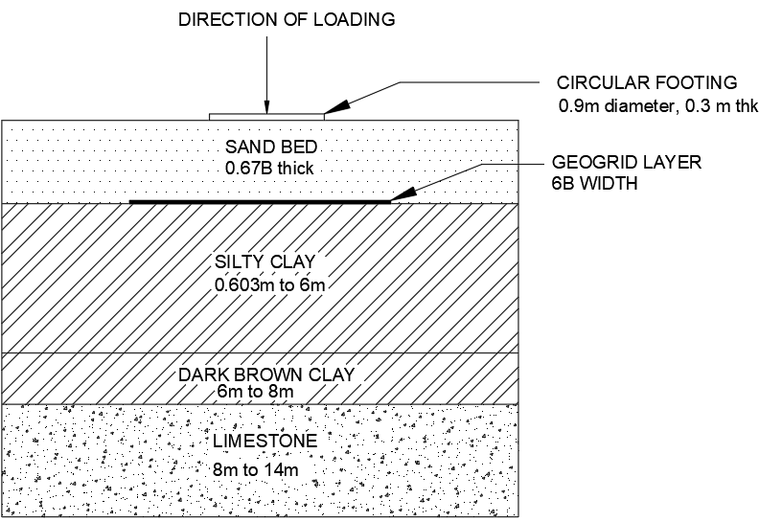

Figure 1. Schematic view of validation - 1.

Table 1. Soil Properties for the Validation – 1.

|  |  |  |  |  |
| --- | --- | --- | --- | --- |
| **Soil** | **Dense Sand** | **Silty clay** | **Dark brown clay** | **Limestone** |
| Layer thickness (m) | 0 to 0.603 | 0.603 to 6 | 6 to 8 | 8 to 14 |
| Material model | M-C | M-C | M-C | M-C |
| Unit weight, γ (kN/m3) | 21.7 | 18 | 20 | 21 |
| Young's modulus, E (kPa) | 30000 | 3400 | 4250 | 50000 |
| Poisson's ratio, ʋ | 0.3 | 0.4 | 0.4 | 0.2 |
| Cohesion, cu (kPa) | 15 | 75 | 38 | 198 |
| Friction angle, φ (°) | 43 | - | - | - |

**Validation – 1 - Discussion**

The field test pressure of 440 kN/m2 was applied on the footing, and the problem was analysed. The bearing capacity–settlement behaviour of the GRGB improved clay was observed from the output results. The same has been plotted along with the field result. The result of the validation is shown in Figure 2. Only a few points from the cited paper [11] were chosen, reflecting the curve's trend. It can be observed that the field and the PLAXIS 3D results follow the same pattern of bearing capacity-settlement curve. The soil properties chosen must be more or less equal to the field values, because of which the settlement values are equal. The behaviour changes slightly only during the loading process but not at the end. The numerical material models evidently reflected the non-linearity in the trend. This observation proves that the material models and the meshing scheme can visibly recreate the field problem numerically. The slight difference in the settlement values may be attributed to the material properties, model, meshing and iterations in the numerical modelling.

Figure 2. Validation -1- graph comparing Field test [11] and PLAXIS 3D results.

**Validation 2: Stone Column Installed Clay Deposit**

**Model, Input Parameters & Numerical Simulation**

A field test was conducted on a square footing supported on a 4 - stone column group arranged in a square pattern at a spacing of 1.07 m [39]. The stone column of diameter 0.76 m was installed 5.1 m into the alluvial clay layer. A schematic representation of the stone column installed clay deposit is shown in Figure 3.

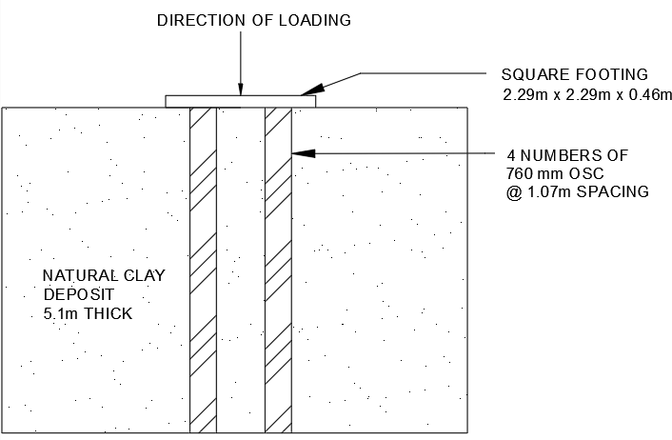

Figure 3. Schematic view of validation - 2.

A numerical model was developed using the PLAXIS 3D software simulating the field test. The model dimension of 10 m × 10 m × 14 m was chosen after several trials to avoid any interference effect of the boundaries on the deformation pattern of the stone column. Similar to the field, the footing was modelled as a concrete volume with the linear elastic model. The footing properties and the soil and stone column parameters used for the numerical analysis are listed in Tables 2 & 3, respectively. The material model assigned was Mohr-Coulomb for clay and stone columns because of the adequacy of the model in simulating the load-settlement response. The Mohr-Coulomb was commonly used in the numerical study of stone column problems [12,17].

**Validation – 2 - Discussion**

The footing was loaded to the maximum field testing load of 1700 kN. The field curve from the load-settlement curve was re-plotted from the literature [Fig.6(b) of [39]] and is shown in Fig.4. The load-settlement curve obtained from the numerical analysis was in good agreement with the field curve. There is more difference in the settlement in the middle region of the load-settlement curve, which may be attributed to the material properties, model dimensions, meshing and the iterations in the calculation part. However, the material models chosen have accurately predicted the final settlement value. Also, as observed in the previous validation case, the Mohr-Coulomb model reflects the non-linear behaviour of the soil. The comparison shows that the numerical model can simulate the field conditions with appropriate material properties.

Table 2 Properties of footing installed in the field for validation-2 [39]

|  |  |
| --- | --- |
| Shape of the footing | Square |
| Size of the footing | 2.29 m × 2.29 m (0.46 m thick) |
| Material model type | Linear elastic |
| Unit weight, γ (kN/m3) | 25 |
| Young's modulus, E (MPa) | 27000 |
| Poisson's ratio (ν) | 0.15 |

Table 3 Soil and stone column properties for the validation – 2 [39].

|  |  |  |  |
| --- | --- | --- | --- |
| **Parameters** | **Desiccated clay layer** | **Alluvial clay layer** | **Stone column** |
| Layer thickness (m) | 0 – 1 | 1 – 13 | - |
| Material model | M-C | M-C | M-C |
| Unit weight, γ (kN/m3) | 18.9 | 18.9 | 20.6 |
| Undrained shear strength, cu (kPa) | 150 | 30 | - |
| Angle of internal friction, φ (⸰) | 35 | 24 | 47 |
| Young's modulus, E (MPa) | 8 | 3.5 | 85 |
| Poisson's ratio (ν) | 0.45 | 0.3 | 0.25 |

Fig. 4 Validation -2- graph comparing Field test [39] and PLAXIS 3D results

**Numerical Modelling of the field problem**

**Input Parameters for the field-scale model**

The field-size clay soil deposit of dimensions 30 m × 30 m × 12 m was considered for the study —the square footing of 3 m × 3 m with a thickness of 0.5 m. The numerical Modelling procedure was similar to that of the validation section. The modelling dimension was chosen after several trials to obtain a complete picture of the deformation pattern of the soil in both case studies. The properties of the clay deposit are the following: cohesive strength, cu = 6 kN/m2, Young's modulus, Eu = 1000 kN/m2, Poisson's ratio, ν = 0.45, permeability, k = 8.64x10-4 m/day [12]. The clay deposit was strengthened by planar geogrid placement below the footing along with a sand layer (GRGB); stone column installation with radial geogrid encasement (GESC).

For the first case, a 0.67B thick sand layer was placed over the clay deposit, as adopted from Demir et al. (2013) [11], where B is the width of the footing. The geogrid is placed at a depth of 0.17B from the bottom of the footing. As per the studies by Khing 2013 [40], the bearing capacity of the clay deposit with geogrid placed at the sand bed-clay interface was similar to the unreinforced sand bed. The geogrid at the sand bed-clay interface was not provided for the same reason. Also, as per Demir et al. (2013) [11], the geogrid depth at 0.67B below the footing showed no significant improvement. Therefore, it was chosen to place the geogrid closer to the footing.

The width of the geogrid was assumed to be equal to 4B as the bearing capacity increment was assessed to reach up to 95% at this width [1]. Many authors have used a wider dimension of geogrid in past studies [14,41,42-44]. The properties of the sand layer are as follows: angle of internal friction, φ = 43°, unit weight = 21 kN/m3 [11], Young's modulus, E = 40000 kN/m2 [14].

Four 600 mm diameter end-bearing stone columns were installed in the square pattern below the footing for the second case. The analyses were conducted for ordinary and encased stone columns (OSC and ESC). 500 kN/m, 1000 kN/m, 2000 kN/m, 3000 kN/m, 4000 kN/m and 5000 kN/m were chosen as the encasement stiffness. The range of geogrids was chosen based on practical applications [26]. The properties of the stone column are as follows: angle of internal friction, φ = 48°, unit weight, γ = 18.4 kN/m3, Young's modulus, E = 10000 kN/m2, permeability, k = 1 m/day [27].

**Modelling of the field-scale model**

The schematic diagrams of the field problem for numerical study are shown in Figures 5(a) & (b). The generalised 3D modelling of the natural clay deposit, GRGB and GESC are shown in Figures 6(a) to 6(c). The remaining modelling part was similar to that explained in the validation part of this paper.

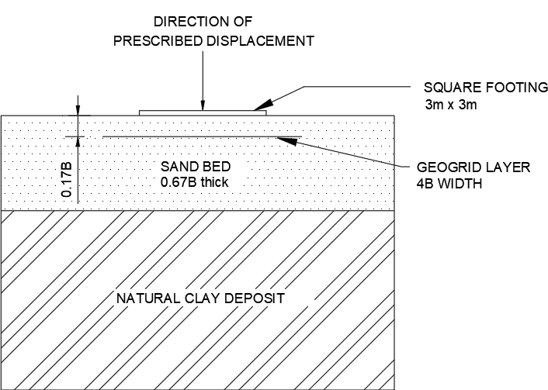

Fig. 5(a) GRGB-installed clay deposit

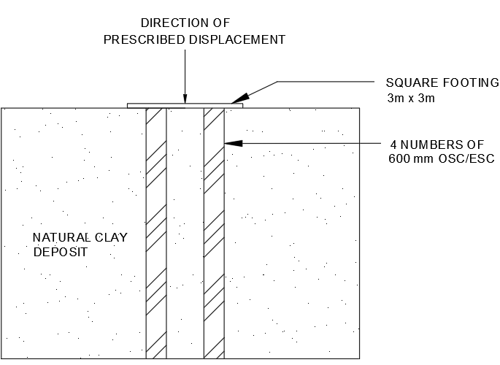

Fig. 5(b) Stone column installed clay deposit

Length

Width

Height

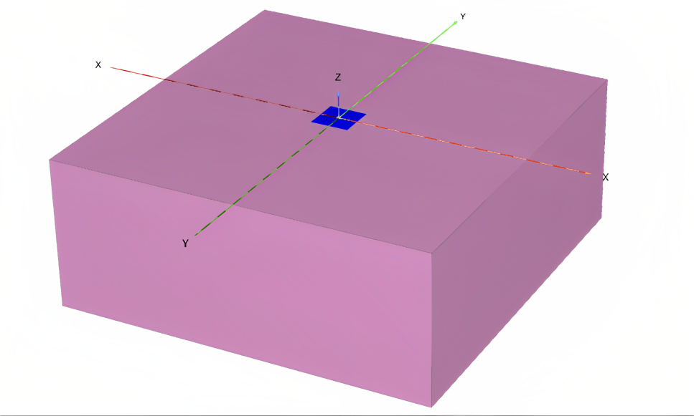

Figure 6(a): Generalised 3D model - natural clay deposit.

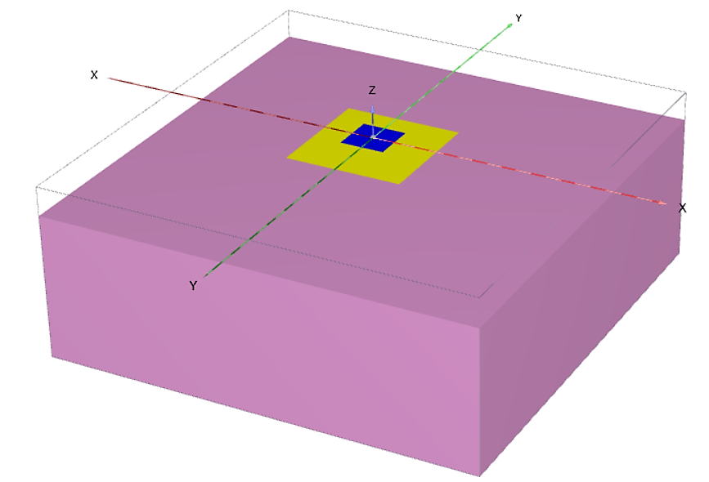

Figure 6(b): Generalised 3D model - footing with single layer geogrid.

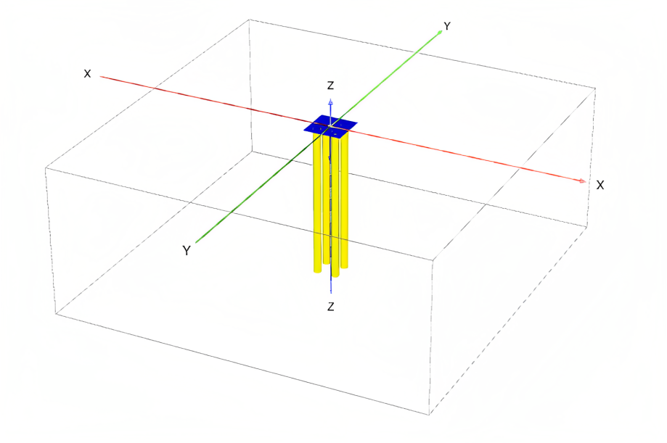Figure 6(c) 3D model – Footing with ESC.

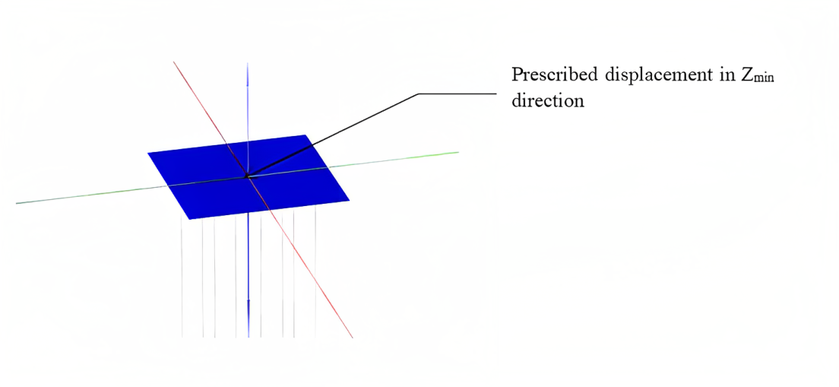

Figure 6(d): Footing model showing prescribed displacement.

**Parametric Analyses of the field problem**

The different cases which were numerically analysed were: (i) footing on the natural clay deposit alone (fig.6(a)), (ii) footing on the sand layer with a planar geogrid layer (fig.6(b)) and (iii) footing on the OSC/ ESC-reinforced clay deposit (fig.6(c)). The clay, sand, and stone column properties were kept constant. The axial stiffness of the encasement varied from 500 kN/m to 5000 kN/m. The effect of encasement stiffness on vertical stress development and concentration was analysed.

The system needs to develop a higher level of vertical stress to address the stress distribution. So, to develop higher stresses, the system has to undergo a larger settlement. Analysing by applying load on the system can sometimes lead to failure, which does not entirely create a stress field in the finite element modelling software. So, the settlement is controlled instead of applying load to obtain developed stress in the system. For this reason, the numerical analyses were performed for a prescribed displacement of 0.3 m in the Zmin direction, equal to 10% of the footing dimension [4], as shown in Fig. 6(d).

**Results and discussion**

The numerical simulation results of the footing with a geogrid layer and OSC / ESC are discussed in this section. The vertical stress development and distribution are expressed at the layers instead of an overall pressure bulb. The footing settlement (S) was presented as a function of the footing dimension (B) [7,14]. The force developed for the prescribed displacement was used for plotting the load vs S/B graph, as shown in Figures 7 & 8. The following discussions are presented from the vertical stresses developed in the composite ground (Table 4) and the deformation profile (Figures 9(a) to (c)).

**Footing on the sand layer with single-layer geogrid**

The vertical stresses observed from the clay deposit, reinforced sand layer, and natural clay deposit are tabulated in Table 4. Vertical stresses are observed at the footing depth, geogrid layer, sand-clay interface, and clay deposit. The depths are 0.5 m, 1 m, 2 m and 2.2 m, respectively.

It should be noted that the transfer of stresses to depths is a function of the thickness of the granular bed, the depth of the first reinforcement, length and number of reinforcements [45]. The discussion here is given for a single reinforcement at a depth of 0.17B from the base of the footing in a granular bed of 0.67B thickness. From Table 4 values, it can be observed that there was a gradual increase in the vertical stresses with depth for natural clay with no ground improvement. The vertical stress developed at the bottom of the footing resting on the sand layer and natural clay is significantly less for all the cases. The stress development has changed with depth for the reinforced sand layer conditions for 500 kN/m. At the geogrid depth, the vertical stress increased many folds and reached the maximum at the sand-clay interface. As the geogrid carries the load, the tensile strength mobilises, and vertical stress is developed on this layer. The geogrid's additional length than the footing's width provides anchorage against pull-out resistance [45]. Because of these two reasons, there is an increase in vertical stress at this level by many folds.

The past study by Khing (2013) [40] revealed the non-effectiveness of the influence of geogrid at the sand-clay interface on the bearing capacity. However, the vertical stresses were observed to be the maximum at this depth. From this observation, it can be proposed that an additional geogrid at the sand-clay interface could carry higher vertical stresses. The proposed additional layer influences the stress-carrying capacity of the composite foundation if the geogrid layer is placed within the critical depth below the footing. The critical depth of the footing is equal to the width of the footing [41]. The sand layer is 0.67B, lesser than the critical depth. At 2.2 m depth, i.e., in clay, the stresses were reduced by about 95%. A significantly lesser stress developed in the clay deposit ensures that only a lesser load is transferred to it, thereby reducing the settlement of the soft clay deposit.

Table 4. Vertical stresses in the soil at different depths for footing + sand + geogrid reinforcement.

|  |  |  |  |  |
| --- | --- | --- | --- | --- |
| Geogrid stiffness (kN/m) | Vertical stress (kN/m2) | | | |
| Footing depth | Geogrid depth | Sand-clay interface | Below sand layer |
| At 0.5 m | At 1 m | At 2 m | At 2.2 m |
| Natural clay | 8.9 | 14.6 | 15.0 | 18.4 |
| 500 | 5.9 | 269.2 | 698.6 | 33.4 |
| 1000 | 6.1 | 267.9 | 694.5 | 33.3 |
| 2000 | 6.4 | 265.3 | 685.9 | 33.3 |
| 3000 | 6.7 | 262.8 | 678.1 | 33.2 |
| 4000 | 6.9 | 260.4 | 670.9 | 33.2 |
| 5000 | 7.0 | 257.9 | 663.9 | 33.1 |

The increase in the geogrid stiffness from 1000 kN/m to 5000 kN/m has shown a minor increase in the vertical stresses at the depths under consideration and is much similar to the 500 kN/m. The mobilisation of the stiffness of the geogrid may occur under higher loading conditions, which did not happen here. Moreover, from past studies, it is evident that the geogrid use may become redundant when the axial stiffness of the geogrid is greater than 5000 kN/m [13]. Also, the use of geogrid at the sand-clay interface may not be of use if the thickness of the sand bed is greater than the shear zone formed below the footing, which may not be applicable in this case under consideration.

Figures 7 & 8 show that the curve is slightly linear, indicating that the composite foundation can carry more load from the footing. The vertical stresses not transferred to the deeper layers may be due to the geogrid stiffness and length [46]. The reinforcements with a length greater than the width of the footing can bear the additional development of stresses, thereby preventing the stresses at deeper layers. As mentioned before, the length of the reinforcement has to get the tensile strength mobilised; a part of it must act as the anchorage for providing a pull-out resistance [45]. Therefore, if improving the deeper layers, it can be proposed that reinforcements of optimum width must be placed in several layers within the critical depth of the footing or the depth of the shear zone below the footing [46]. So the reinforcement's length and depth play a major role in the composite foundation. The stiffness of the geogrid would be more significant if the loading intensity is of a higher range.

The extent of the vertical stresses in the horizontal direction was measured along the geogrid and the sand-clay layer. The stresses were maximum and minimum at 1B and 2.3B from the centre of the footing, respectively. These maximum and minimum values were read as 690 kN/m2 and 20 kN/m2, respectively. The vertical stresses beyond 2.3B were lesser than that in the clay deposit. In the vertical direction, the stresses were maximum at the sand-clay interface, as mentioned earlier, which was 0.67B. The geogrid-reinforced sand layer intercepted the vertical stress distribution with depth and formed a different pattern of the vertical stress distribution.

Figure 7. Load vs. S/B - footing + sand + geogrid

Figure 8. Load vs S/B - footing + OSC/ESC.

**Footing on the Stone Columns OSC / ESC**

The stone column installed ground improvement can be expressed through the Stress Concentration Factor (SCF). SCF is the stress ratio the stone column carries when compared with the surrounding soil below the footing. Generally, the SCF is maximum at the head of the stone column and decreases with increasing length. Moreover, SCF is maximum for rigid footing compared to flexible foundations. With the unit cell concept, the SCF values would be between 2.5 and 5 [21].

In these numerical analyses, the vertical stresses were measured at the stone columns and the centre of the four columns. As the stone column's critical length is twice that of the width of the footing [47], the vertical stresses were measured up to 6 m from the column head. But the vertical stresses were prominent only up to 2 m, i.e. 0.67B, so only those values are presented. SCF values were calculated from the vertical stresses. The vertical stresses were read from the numerical output tables, as shown in Table 5.

As in the stone column, the vertical stress in clay is almost 85%. So, the SCF values range from 1 to 1.1 in all cases. However, the vertical stresses measured in the unimproved clay were 8 to 20 kN/m2. The increase in stress in OSC / ESC reinforced deposits may be due to the stone column installation, which improved the soil between the stone columns due to the effect of column confinement. The maximum vertical stress in the horizontal direction was maximum till the edge of the footing. Beyond the footing edge, the stresses become negligible.

Table 5. Vertical stresses in the soil and stone columns with SCF at different depths for footing + stone column.

|  |  |  |  |  |  |  |  |  |  |
| --- | --- | --- | --- | --- | --- | --- | --- | --- | --- |
| encasement stiffness (kN/m) | ground level | | | 1 m below GL | | | 2 m below GL | | |
| vertical stress (kN/m2) | | SCF | vertical stress (kN/m2) | | SCF | vertical stress (kN/m2) | | SCF |
| stone column | clay | stone column | clay | stone column | clay |
| 0 | 922.35 | 808.11 | 1.14 | 780.47 | 734.09 | 1.06 | 574.73 | 589.84 | 0.97 |
| 500 | 923.26 | 811.53 | 1.14 | 797.6 | 736.22 | 1.08 | 578.14 | 590.06 | 0.98 |
| 1000 | 924.14 | 814.28 | 1.13 | 799.53 | 737.99 | 1.08 | 580.52 | 590.13 | 0.98 |
| 2000 | 925.29 | 818.39 | 1.13 | 802.43 | 740.52 | 1.08 | 584.34 | 590.06 | 0.99 |
| 3000 | 926.39 | 821.54 | 1.13 | 804.69 | 742.37 | 1.08 | 589.87 | 587.43 | 1.00 |
| 4000 | 927.06 | 823.87 | 1.13 | 806.35 | 743.68 | 1.08 | 589.96 | 589.62 | 1.00 |
| 5000 | 929.54 | 826.88 | 1.12 | 808.74 | 748.58 | 1.08 | 592.45 | 589.72 | 1.00 |

The effect of the encasement stiffness is prominent up to 1000 kN/m. For stiffness greater than 1000 kN/m, the SCF remains the same. Thus, the optimum encasement stiffness for improving the soft clay can be considered 1000 kN/m. The deformation pattern of the soil below the footing in natural clay, sand, and geogrid layer and stone columns OSC / ESC are shown in figures 9(a), (b) & (c). The pattern variation interprets the composite ground's different mechanisms against the footing on natural clay.

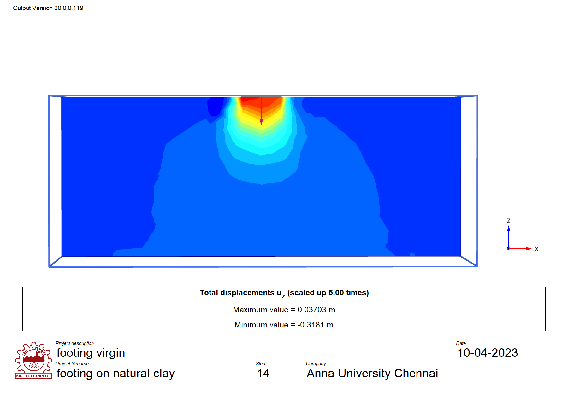 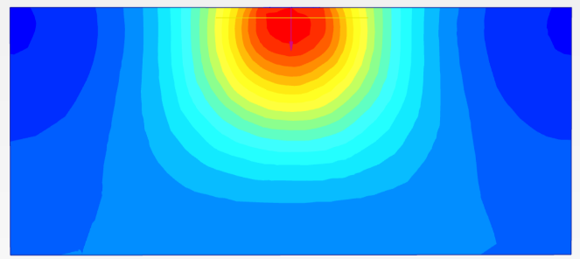

(a) (b)

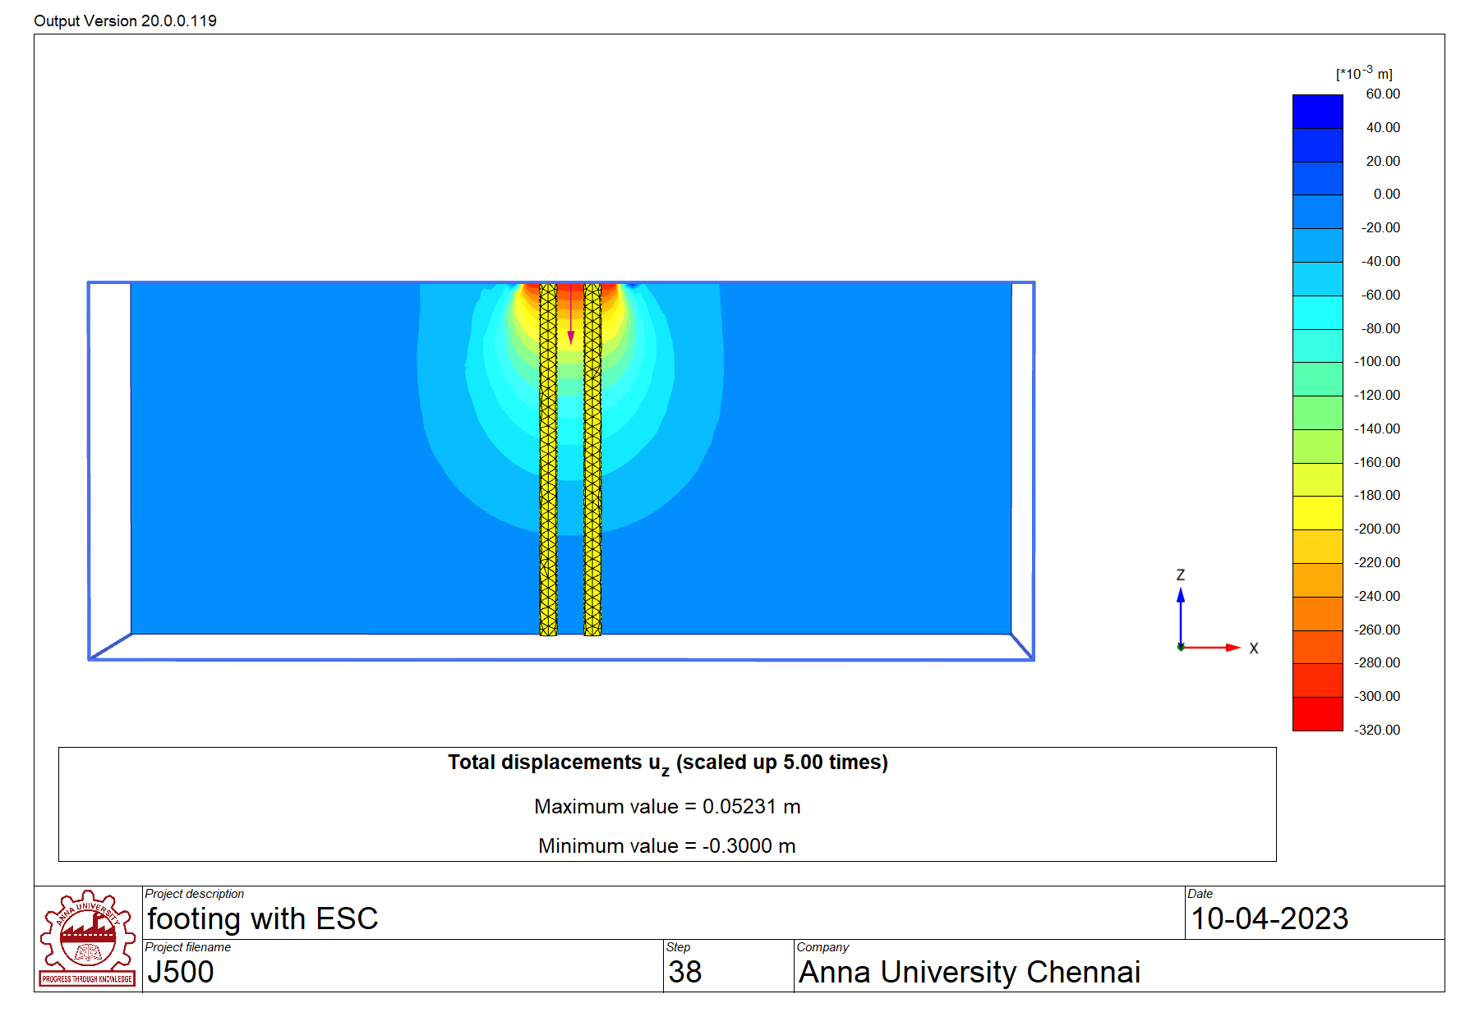

(c)

Figure 9. Deformation pattern of soil below footing in (a) natural clay, (b) GRGB, (c) GESC.

**Conclusions**

In this paper, a numerical investigation of the footing supported on (i) a layer of the sand bed with a single layer geogrid – GRGB and (ii) four numbers of stone columns – GESC was carried out and discussed. The conclusions and comparisons for the same are presented below:

*GRGB:*

1. The sand bed + geogrid layer improved the bearing capacity of the weak soil deposit by 95%.
2. The soil deformation was in the broader direction extending beyond the footing edge for the sand and geogrid layer. In the sand bed + geogrid layer, the strain in the clay deposit was prevented by the developed stress within the composite layer.
3. The vertical stresses were maximum and minimum at 1B and 2.3B, respectively, from the central axis of the footing in the horizontal direction at the location of the sand-clay interface. In the vertical direction, the stresses were maximum at the sand-clay interface depth of 0.67B.
4. It is mandatory to provide a layer of geogrid below the footing within the critical depth, which is equal to the width of the footing.
5. It is proposed to provide an additional geogrid layer at the sand-clay interface depth to carry the higher vertical stresses at this depth, provided the depth of placement is within the critical depth.
6. Below the footing in the sand bed + geogrid layer, the 500 kN/m geogrid stiffness alone had a significant performance. Geogrids with a stiffness greater than 500 kN/m did not significantly affect or perform. So, providing a 500 kN/m geogrid layer is sufficient and considered optimum for footing placement for the conditions under consideration.

*GESC:*

1. The provision of the OSC/ESC improved the bearing capacity of the weak soil deposit by 99%. The ground reinforced with the stone columns carried higher vertical stresses when compared to the unimproved clay.
2. The deformation pattern was concentrated within the stone column's shallower depth and the footing's dimension.
3. Along the depth, the stress concentration factor becomes 1 at 0.67B from the ground level for both OSC/ESC. Beyond this depth of 0.67B, the stone columns and clay shared the vertical stresses equally, indicating the clay's improvement by installing stone columns.
4. The optimum geogrid encasement stiffness was found as 1000 kN/m.

*GRGB vs GESC:*

1. The variation in the development of vertical stresses and the two ground improvement techniques' ability to transfer the vertical stresses can be understood from the results.
2. The vertical stresses at different depths explain the stress transfer mechanism. This knowledge can provide the practitioners to decide the depth of placement of the reinforcement and also to choose an alternate if one method is not feasible for the site.
3. The sand bed + geogrid layer carried higher vertical stresses than the unimproved ground. However, the ground reinforced with the stone column could carry vertical stresses higher than the composite layer.
4. The stone column installation improved the clay layer even below the depth of 0.67B, improving the capacity of clay to carry higher vertical stresses on par with the stone columns.
5. Thus, a better view of the effect of the reinforcement installation changed the vertical stress development below the footings. Furthermore, stone columns carried and confined higher stresses within the footing dimension better than the sand bed + geogrid layer. The confinement of vertical stresses within the footing width by the stone columns indicates no interference of the stresses with the adjacent footings, if any. So in places of limited land width, stone columns would be a better option.
6. The conclusions are for a set of geotechnical conditions deviating from which a new study has to be performed.

**Conflicts of interest**

The authors declare that there is no conflict of interest regarding the publication of the paper.

**Acknowledgement & funding statement**

The Union Grants Commission of India funds the research through the UGC-NFOBC fellowship [NFO-2018-19-OBC-TAM-73673]. The authors greatly acknowledge the financial support provided by the Union Grants Commission of India.

**Data availability**

Previously reported experimental data was used for the validation purpose of this study and are available at <https://doi.org/10.1007/s40891-015-0023-5> and https://doi.org/10.1061/(ASCE)1090-0241(2007)133:12(1503). This prior study is cited at relevant places within the text as a reference [7, 39].

**References**

1. Michalowski, Radoslaw L. "Limit loads on reinforced foundation soils." *Journal of geotechnical and geoenvironmental engineering* 130, no. 4 (2004): 381-390.
2. Krishna, A. Murali, and Arghadeep Biswas. "Performance of geosynthetic reinforced shallow foundations." *Indian Geotechnical Journal* 51, no. 3 (2021): 583-597.
3. Hasan, Noor Ibrahim, Aizat Mohd Taib, Nur Shazwani Muhammad, Muhamad Razuhanafi Mat Yazid, Azrul A. Mutalib, and Dayang Zulaika Abang Hasbollah. "Effectiveness of strip footing with geogrid reinforcement for different types of soils in Mosul, Iraq." *Plos one* 15, no. 12 (2020): e0243293.
4. Biswas, Arghadeep, A. Murali Krishna, and Sujit Kumar Dash. "Behavior of geosynthetic reinforced soil foundation systems supported on stiff clay subgrade." *International Journal of Geomechanics* 16, no. 5 (2016): 04016007.
5. Boussinesq, J. "Application of potentials to the study of the balance and motion of elastic solids." *Mathematics and analysis*, 4. *Paris: Gautiher-Villars* (1885).
6. Abu-Farsakh, Murad, Qiming Chen, and Radhey Sharma. "An experimental evaluation of the behavior of footings on geosynthetic-reinforced sand." *Soils and Foundations* 53, no. 2 (2013): 335-348.
7. Biswas, Arghadeep, Md Asfaque Ansari, Sujit Kumar Dash, and A. Murali Krishna. "Behavior of geogrid reinforced foundation systems supported on clay subgrades of different strengths." *International Journal of Geosynthetics and Ground Engineering* 1 (2015): 1-10.
8. El Sawwaf, Mostafa A. "Behavior of strip footing on geogrid-reinforced sand over a soft clay slope." Geotextiles and Geomembranes 25, no. 1 (2007): 50-60.
9. Yadu, Laxmikant, and R. K. Tripathi. "Effect of the length of geogrid layers in the bearing capacity ratio of geogrid reinforced granular fill-soft subgrade soil system." Procedia-Social and Behavioral Sciences 104 (2013): 225-234.
10. Demir, Ahmet, Abdulazim Yildiz, Mustafa Laman, and Murat Ornek. "Experimental and numerical analyses of circular footing on geogrid-reinforced granular fill underlain by soft clay." Acta Geotechnica 9 (2014): 711-723.
11. Demir, Ahmet, Mustafa Laman, Abdulazim Yildiz, and Murat Ornek. "Large scale field tests on geogrid-reinforced granular fill underlain by clay soil." Geotextiles and Geomembranes 38 (2013): 1-15.
12. Saha Roy, Subinay, and Kousik Deb. "Bearing capacity of rectangular footings on multilayer geosynthetic-reinforced granular fill over soft soil." International Journal of Geomechanics 17, no. 9 (2017): 04017069.
13. Deb, Kousik, N. Sivakugan, Sarvesh Chandra, and P. K. Basudhar. "Numerical analysis of multi layer geosynthetic-reinforced granular bed over soft fill." Geotechnical and Geological engineering 25 (2007): 639-646.
14. Latha, G. Madhavi, and Amit Somwanshi. "Bearing capacity of square footings on geosynthetic reinforced sand." Geotextiles and Geomembranes 27, no. 4 (2009): 281-294.
15. Niculescu-Enache, Felicia. "The behavior of foundation soil with and without geosyntethic reinforcement." Constructii 14, no. 1 (2013): 61.
16. Aria, Shadi, Sanjay Kumar Shukla, and Alireza Mohyeddin. "Numerical investigation of wraparound geotextile reinforcement technique for strengthening foundation soil." International Journal of Geomechanics 19, no. 4 (2019): 04019003.
17. Aria, Shadi, Sanjay Kumar Shukla, and Alireza Mohyeddin. "Behaviour of sandy soil reinforced with geotextile having partially and fully wrapped ends." Proceedings of the Institution of Civil Engineers-Ground Improvement 174, no. 1 (2021): 29-41.
18. Jaiswal, Sagar, and Vinay Bhushan Chauhan. "Response of strip footing resting on earth bed reinforced with geotextile with wraparound ends using finite element analysis." Innovative Infrastructure Solutions 6, no. 2 (2021): 121.
19. Jaiswal, Sagar, Ananya Srivastava, and Vinay Bhushan Chauhan. "Improvement of bearing capacity of shallow foundation resting on wraparound geotextile reinforced soil." In IFCEE 2021, pp. 65-74. 2021.
20. Jaiswal, Sagar, and Vinay Bhushan Chauhan. "Evaluation of optimal design parameters of the geogrid reinforced foundation with wraparound ends using adaptive FEM." International Journal of Geosynthetics and Ground Engineering 7, no. 4 (2021): 77.
21. IS: 15284 (part 1). "Indian standard code of practice for design and construction for ground improvement-guidelines." In New Delhi (2003).
22. Fattah, Mohammed Y., and Qutaiba G. Majeed. "A study on the behaviour of geogrid encased capped stone columns by the finite element method." GEOMATE Journal 3, no. 5 (2012): 343-350.
23. Fattah, Mohammed Y., and Quitaba G. Majeed. "Finite element analysis of Geogrid encased stone columns." Geotechnical and Geological Engineering 30 (2012): 713-726.
24. Fattah, Mohammed Y., Bushra S. Zabar, and Hanan A. Hassan. "Soil arching analysis in embankments on soft clays reinforced by stone columns." Structural Engineering and Mechanics 56, no. 4 (2015): 507-534.
25. Fattah, Mohammed Y., Bushra S. Zabar, and Hanan A. Hassan. "Experimental analysis of embankment on ordinary and encased stone columns." International Journal of Geomechanics 16, no. 4 (2016): 04015102.
26. Murugesan, S., and K. Rajagopal. "Geosynthetic-encased stone columns: numerical evaluation." *Geotextiles and Geomembranes* 24, no. 6 (2006): 349-358.
27. Priyadharshini, Maniam Rajan, and Krishnamurthy Premalatha. "Deformation of Stone Column Subjected to Earthquake Loading by Numerical Analysis." In *Ground Improvement Techniques: Select Proceedings of 7th ICRAGEE 2020*, pp. 187-200. Singapore: Springer Singapore, 2021.
28. Maniam Rajan, Priyadharshini, and Premalatha Krishnamurthy. "Termination criteria of bored pile subjected to axial loading." Indian Geotechnical Journal 49 (2019): 566-579.
29. Kwa, Sally Fahmi, E. S. Kolosov, and Mohammed Yousif Fattah. "Ground improvement using stone column construction encased with geogrid." Stroitel'stvo Unikal'nyh Zdanij i Sooruzenij 3 (2018): 49-59.
30. R.B.J. Brinkgreve, L. M. Zampich, N. Ragi Manoj, "PLAXIS CONNECT Edition V20 Manual," *PLAXIS BV*, Bentley Systems, Netherlands, 2019.
31. Das, Braja M. Principles of geotechnical engineering. Cengage Learning, 2021.
32. Terzaghi, Karl, Ralph B. Peck, and Gholamreza Mesri. Soil mechanics in engineering practice. John Wiley & Sons, 1996.
33. <https://dot.ca.gov/programs/engineering-services/manuals/geotechnical-manual>, visited on 5th July, 2023.
34. Bowles, Joseph E. Foundation analysis and design. 1988.
35. Goodman, Richard E. Introduction to rock mechanics. John Wiley & Sons, 1991.
36. Cole, K.W., and M.A.Stroud. "Rock socket piles at Coventry point, market way, Coventry" Geotechnique 26, no. 1 (1976): 47-62.
37. Fawaz, A., F. Hagechehade, and E. Farah. "A study of the pressuremeter modulus and its comparison to the elastic modulus of soil." Study of civil engineering and architecture (SCEA) 3 (2014): 7-15.
38. Lindeburg, Michael R. "Civil engineering reference manual for the PE exam." Professional Publications Inc. (1999).
39. D. J. White, H. T. V. Pham and K. K. Hoevelkamp, "Support mechanisms of rammed aggregate piers I: Experimental results", Geotech. Geoenviron. Eng., 133(12), 1503-1511 (2007).
40. Khing, K. H., B. M. Das, V. K. Puri, S. C. Yen, and E. E. Cook. "Strip foundation on sand underlain by soft clay with geogrid reinforcement." In The Third International Offshore and Polar Engineering Conference. OnePetro, 1993.
41. DeMerchant, M. R., A. J. Valsangkar, and A. B. Schriver. "Plate load tests on geogrid-reinforced expanded shale lightweight aggregate." Geotextiles and Geomembranes 20, no. 3 (2002): 173-190.
42. Omar, M. T., B. M. Das, V. K. Puri, and S. C. Yen. "Ultimate bearing capacity of shallow foundations on the sand with geogrid reinforcement." Canadian geotechnical journal 30, no. 3 (1993): 545-549.
43. Akbar, Asif, Javed Ahmad Bhat, and Bashir Ahmed Mir. "Plate load tests for investigation of the load–settlement behaviour of shallow foundation on bitumen-coated geogrid reinforced soil bed." Innovative Infrastructure Solutions 6, no. 2 (2021): 80.
44. Alawaji, H. A. "Settlement and bearing capacity of geogrid-reinforced sand over collapsible soil." Geotextiles and geomembranes 19, no. 2 (2001): 75-88.
45. Rethaliya, R. P., and A. K. Verma. "Strip footing on sand overlying soft clay with geotextile interface." Indian Geotech J 39, no. 3 (2009): 271-287.
46. Cicek, Elif, Erol Guler, and Temel Yetimoglu. "Stress distribution below a continuous footing on geotextile-reinforced soil." International Journal of Geomechanics 18, no. 3 (2018): 06018005.
47. M. Miranda, J. Fernández-Ruiz and J. Castro, "Critical length of encased stone columns," *Geotextiles and Geomembranes*, vol.49(5), pp. 1312-1323, 2021.