1. Highlights
2. From Soil to Printed Structures: A Systematic Approach to Designing Clay-Based Materials
3. for 3D Printing in Construction and Architecture
4. Ofer Asaf, Arnon Bentur, Pavel Larianovsky, Aaron Sprecher

s • Flow-table and rigidity test evaluate mixture performance at green state.

6 • Clay particle grading and composition impact rheological properties and printing perfor-

? mance.

a • Analytical model predicts stability and failure of 3D printed soil elements.

9 • Identified disparity between green and hardened states of clay mixes in 3D printing.

From Soil to Printed Structures: A Systematic Approach to  
Designing Clay-Based Materials for 3D Printing in Construction  
and Architecture

Ofer Asafr, Arnon Benturb, Pavel Larianovskyb, Aaron Sprecher[1] [2] [3]

*a Faculty of Architecture and Town Planning, Technion - Israel Institute of Technology, Haifa, 3200003, Israel  
bFaculty of Civil and Environmental Engineering, Technion - Israel Institute of Technology, Haifa, 3200003, Israel*

Abstract

3D printing of clayey soils has gained traction in construction and architecture due to its eco-  
friendly and design advantages. However, comprehensive method for transforming these soils into  
a mix that exhibits flow and stability is limited. To this end, a series of tests were conducted on 12  
mixes of sand and clay. These mixes were tested for their rheological properties and performance in  
rigidity and pumping tests. Linear relationships between the various results were compared. This  
was followed by an in-situ printing test. An analytical model for predicting the plastic collapse of  
the bottom layer was employed. To better elucidate the failure mechanism, digital image correlation  
was used. Finally, the mechanical properties of the mixes were assessed at 14 and 28 days. The  
results indicate that using values obtained from flow-table test and custom rigidity test, effectively  
optimizes a mix for 3D printing. Rheological findings show that increased kaolinite enhances the  
thixotropic effect of the mix. Coarser particle size distribution improves static yield due to elevated  
interparticle friction. In-situ printing tests suggest that a rotational rheometer test can predict  
element failure from plastic collapse according to the printing parameters. Finally, mechanical  
properties reveal a disparity between fresh and hardened properties of the clay-soil mixes.

*Keywords:* 3D printing, Soil-based materials, Buildability, Robotic fabrication, Earth  
construction

drive this growing interest. Firstly, 3D printing technologies, lauded for their advanced design  
capabilities, empower architects and engineers to actualize optimized, innovative structures [5, 6].  
Secondly, escalating environmental concerns related to the building sector have catalyzed a search  
for sustainable materials [7]. In this context, soils emerge as an alternative to traditional construc-  
tion materials, owing to their reduced environmental footprint [8, 9], and their adaptability within  
a circular economy framework [10, 11],

The synergy between 3D printing and using soils as construction materials presents extensive  
application opportunities, ranging from small-scale elements to large-scale structures. Examples of  
these structures include integrated wall components [12], elements designed for green infrastructure  
[13], structures aimed at providing low-impact affordable housing [14], and architectural edifices  
[15]. Moreover, 3D printing of soils also captures interest for extraterrestrial construction [16,17].  
In these scenarios, local regolith, rich in amorphous inorganic compounds, promises potential  
transformation by alkalis into geopolymer binders [18]. All these applications underscore the need  
for clear guidelines to convert local soils into 3D printable mixtures [19].

For designing such materials, understanding their rheological properties is essential [20, 21].  
These properties govern the material’s transportation through the pumping system and determine  
the stability of the layer post-deposition [22]. A 3D printable material should demonstrate two  
contrasting characteristics that necessitate a balance: the ability to flow through the pumping  
system and rigidity upon deposition. In order to initiate flow of the material, a critical shear stress  
is delineated as the static yield stress (ro5). must be surpassed before the material starts to flow.  
Following that stage, the mixture enters a dynamic state where a linear relationship is exhibited  
between the shear strain and shear stress. This association is described according to Bingham  
model[23]. The magnitude of this relation can be expressed by the material’s apparent viscosity p.  
The intersection of this linear relation is expressed as the dynamic yield stress *(rod)* of the material  
[24].

In terms of material processing, when the material is conveyed to the printhead, a phenomenon  
known as ’’plug flow” is observed due to the material’s heightened viscosity [25]. This flow  
state results in pressure loss, primarily due to particle friction against the delivery hose. Such  
friction subsequently slows down the flow rate and necessitates more energy from the pump. Formaterials that align with the Bingham model, their pressure loss when flowing inside a conduit is  
determined by two factors: yield stress and viscosity. This relationship can be described using the  
Buckingham-Reiner model [26]. Ideally, to ensure a smooth and efficient flow, a mixture should  
have both a low dynamic yield stress and low viscosity. Yet, after being extruded from the nozzle,  
it is crucial for the material to quickly elevate its static yield stress to retain stability. The difference  
in behavior between these static and dynamic properties is referred to as the material’s thixotropy.  
Consequently, an optimal 3D printing material should demonstrate a rapid increase in thixotropic  
behavior without a corresponding rise in its dynamic properties. While cement-based systems  
often exhibit this thixotropic nature [27, 28], such behavior is less commonly seen in clay-based  
mixtures during printing [29].

For cementitious systems, the rheological properties required for the 3D printing process have  
been considerably discussed. Roussel introduced a theoretical model for printable concrete that  
is rooted in rheology[30]. This model aims to prevent critical strain, which could result in the  
collapse of the printed bottom layer. Kruger et al. put forth an analytical model to ascertain  
layer stability during the printing process, grounded in rheological testing [31, 32]. Their model  
leverages static yield stress and a correction factor tied to the layer’s cross-section. It can predict,  
with a commendable level of accuracy, the potential failure of a printed artifact when its self-  
weight surpasses the static yield. Furthermore, Kruger applied this model to pinpoint optimal  
printing parameters [33]. In the context of earth-based materials, Perrot et al. employed a similar  
methodology to evaluate the buildability of a soil-based mixture, though they did not conduct  
in-situ 3D printing tests [29].

In the realm of 3D printing of soils, literature sought to design optimal soil-based mixtures.  
Several methods have been proposed to imbue these mixtures with the rheological properties  
essential for 3D printing. Perrot et al. highlighted the use of alginate bio-polymer to induce a  
thixotropic effect in earth-based mixtures and analyzed the mix based on a penetrometer test [29].  
Biggerstaff et al. employed a rotational rheometer to estimate the yield stress of bio-polymer bound  
soil mixtures [34, 35]. Bajpayee et al. charted a holistic approach for 3D printing soil, comprising  
particle distribution analysis, mineralogical composition analysis and rotational rheometer for using  
geopolymerization reaction [36]. Silva et al. turned to a shear-vane test and a custom stabilitytest to evaluate the fresh state properties of the mix [37]. Alqenaee et al., using a deformation  
test introduced by [38], explored the various aspects of mixture design [39]. In a different vein,  
Ferreti et al. utilized rice husk and hydraulic lime to enhance the material’s hardened properties  
[40]. Faleschini showcased the incorporation of lime, cement, and vegetable fiber to optimize both  
the mechanical and economic properties of the mix [41]. Nevertheless, a comprehensive method  
that unifies basic tests with in-situ printing evaluations tailored for designing 3D printable clayey  
soils remains absent. The short-term rheological characteristics of clay-based materials, crucial  
for predicting construction speeds [30], are yet to be thoroughly examined. Furthermore, despite  
their heterogeneous nature, the impact of mineralogical and physical variations in local soils on  
3D printing largely remains understudied [42, 43, 44].

Consequently, there is a need for fundamental guidelines for designing and evaluating soil-  
based mixtures for 3D printing reflecting their shared characteristics. These guidelines could be a  
foundational reference for designing and developing such materials. The primary contribution of  
this study is to identify a shared framework for developing soil-based mixtures and setting the right  
printing parameters for 3D printing applications in construction. In doing so, this research strives  
to lay the groundwork for refining 3D printing of soils, considering both material progression and  
the printing parameters. Multiple mixtures were developed with different particle grading and  
water content. These were assessed using simple testing methods, rotational rheological tests, and  
performance values. Linear correlations emerged between the different testing methods and perfor-  
mance values, providing guidelines to find the best performance window for any specified printing  
equipment. Three different clay types were then tested to gauge the influence of mineralogical  
and particle grading on the printing behavior. In-situ cylinder printing was utilized to predict the  
collapse of the layers buildup based on rheological properties. Lastly, the study delves into the  
effect of clay type on the mechanical properties of the different clays, suggesting a tension between  
optimizing the green and hardened properties of the mixture.

1. Materials and methods

Figure 1 describes the step-by-step experimental method followed in this study.

* 1. *Materials*

The tested mixtures comprised of quartz dune sand and three distinct types of powdered clays.  
Quartz dune sand (Sand) was sourced from Kfar Giladi Minerals and sieved through a 1.18 mm  
sieve. White kaolinite clay (White) was procured from Alco Chemicals. Brown-red kaolinite clay  
(Chocolate) and yellow marl clay (Mamshit) were obtained from Yehu Clays Ltd.

* 1. *XRD analysis*

A McCrone micronizing device with 16 agate was used to wet-grind the clays. During each  
preparation, 6 g of each sample and 15 ml of isopropanol were added as griding media. The  
samples were ground at 1500 rpm for 15 minutes. After the milling, the clays were filtered in a  
Whatman grade 3 filter paper (6 pm pore size) using a vacuum pump, rinsed with diethyl ether,  
and dried for 15 min at 40 °C in a vacuum oven at a constant pressure of 300 mbar. X-ray  
powder diffraction (XRPD) using a PANalytical EMPYREAN X-ray diffractometer equipped with  
a Cu-Kal,2 radiation tube (A = 1.5408 X). The XRD optical configuration for the incident beam  
consisted of a 10 mm mask, 0.04 rad Soller slit along with 1/16° divergence and 1/8° anti-scatter  
fixed slits. The diffracted beam optics comprised a 7.5 mm anti-scatter fixed slit and 0.04 rad  
Soller slit. The XRD data were collected at 45 kV accelerating voltage and 40 mA current in  
a conventional Bragg-Brentano 9-29 geometry. The samples were scanned with a PIXcel 3D  
detector for data acquisition. All scans were measured using a continuous scan mode over an  
angular range of 5° to 70° (29) with 0.017°29 step size for approximately 20 min per scan for  
Kaoline (18-2023) the range was of with 3-75 (29) with the same step, 0.017°29. Quantitative  
phase analysis was performed by the Rietveld refinement method as implemented in the HighScore

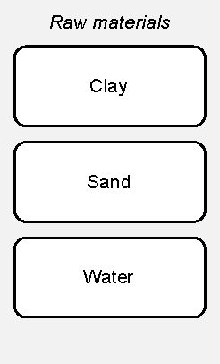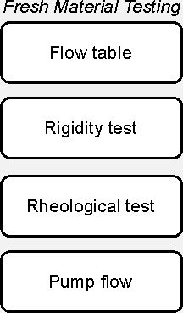

*Raw material analysis*

composition

Particle sir

Mineralogical

distribution

*in-situ Testing*

*Mixture preparation*

Cylinder collapse

High-shear pan  
mixing

DIC analysis

*Mechanical  
characterization*

Compressive strength

Flexural strength

*Results analysis and  
mix optimization*

Suitable soil-based  
mixture for 3D  
printing

Figure 1: Flow chart illustrating the step-by-step experimental method used in the study.

Plus software (Malvern Panalytical).

Table 1: Mineralogical composition of raw powdered clay mixtures.

|  |  |  |  |  |  |  |  |  |
| --- | --- | --- | --- | --- | --- | --- | --- | --- |
| **Phase** | **Kaolinite** | **Quartz** | **Calcite** | **Illite** | **Muscovite** | **Ivsite** | **Picromerite** | **Orthoclase** |
| Sand | 0 | 99.9 | 0.1 | 0 | 0 | 0 | 0 | 0 |
| White | 99.4 | 0.4 | 0 | 0 | 0.2 | 0 | 0 | 0 |
| Chocolate | 76.8 | 12.7 | 1.4 | 0 | 0 | 3.9 | 3.1 | 2.1 |
| Mamshit | 41.5 | 17.0 | 22.9 | 7.0 | 5.0 | 0 | 0 | 6.2 |

* 1. *Particle size distribution*

A Laser diffractometer Mastersizer 3000 Particle Size Analyzer (Malvern Panalytical) was used  
to analyze the particle size distribution. 0.1 grams of sample were mixed with 10 ml of isopropanol,  
followed by 30 seconds of sonication to avoid aggregate formation. The mixture was slowly added  
to the Hydro LV device.

* 1. *Mixture preparation*

The mixtures were prepared with a high-shear pan mixer. The mixer tank was first filled with  
all dry ingredients, after which the water was added. The clay/sand and clay/water ratios of the  
mixture are described in Table 2. Following the addition of water the materials were intensively  
mixed for 3 minutes. The mixer was inspected to ensure that no dry ingredients were left unmixed  
before continuing with another 6 minutes of high-shear mixing.

* 1. *Test methods of green material*

The test methods of the fresh green material included ones that can provide basic physical and  
mechanical parameters of the material for 3D printing, as well as standard tests which can be used  
for comparison and characterization of properties.

Flow test was conducted using the ASTM C230 flow table test for hydraulic cement [45], as  
shown in Figure 3a. A brass conical mold was placed at the center of the table and filled with  
the mixture. The mold was then removed and the table was jolted 25 times and the spread of the  
material was recorded.

Table 2: Composition of tested white clay-sand mixtures.

|  |  |  |  |
| --- | --- | --- | --- |
| **Mix** | **Clay (wt.%)** | **Sand (wt%)** | **Water (wt.%)** |
| Ml | 19.41 | 65.50 | 15.09 |
| M2 | 21.62 | 62.45 | 15.93 |
| M3 | 24.03 | 60.07 | 15.91 |
| M4 | 23.44 | 58.60 | 17.96 |
| M5 | 23.89 | 59.72 | 16.39 |
| M6 | 24.18 | 60.44 | 15.38 |
| M7 | 24.03 | 60.07 | 15.91 |
| M8 | 28.26 | 54.17 | 17.57 |
| M9 | 28.60 | 54.61 | 16.79 |
| M10 | 30.37 | 51.40 | 18.22 |
| Mil | 32.97 | 49.46 | 17.57 |
| M12 | 32.74 | 49.11 | 18.15 |

The rigidity of the fresh green mix was characterized using the loading apparatus shown in  
Figure 3b, following Kazemian et al. [46]. During the test, a cylindrical mold with a diameter  
of 185 mm and a height of 100 mm was used. The mold was first filled with fresh material in  
two stages to ensure proper packing, followed by removal of the mold. A transparent board was  
placed on top of the material, which was loaded with an incremental increase of 500 gr weights  
equivalent to 0.18 kPa. The deformation at four comers of the board was measured and the average  
deformation was recorded. The test continued up to a load of 2.9 kPa. Load-deformation curves  
were obtained, and the rigidity coefficient, defined as the slope of the curve, was calculated.

Rheological test was carried out using a commercialized rotational rheometer, ICAR Plus  
(Germann Instruments Inc.), as shown in Figure 3c. The geometry of the rheometer consists of  
a 4-bladed vane located at the center of a cylindrical container. The test was performed in two  
modes, stress growth test to determine the static yield strength, and flow curve test to determine  
the dynamic yield strength and apparent viscosity.

In the stress growth test, the vane rotation was set to a constant value of 0.16 rad/s, and the  
static yield stress is computed according to Eq. 1.

‘US / \

(1)

*JIM f*

Where *tqs* is the static yield stress, T is the maximum torque value recorded, D is the vane’s  
diameter and H is the vane’s height.

In the flow curve test, varying rotation rates, 0.31 to 3.14 rad/s, subject the mixture to different  
shear strain rates. This led to a stress shear-strain rate, or rotation rate curve, that exhibited a  
linear pattern which could be described by the Bingham model as described in Equation 2. For all  
mixtures analyzed, a *R2* value of no less than 0.95 was observed, pointing to a pronounced linear  
association between shear stresses and shear strain rates. As such, the flow curve test characterized  
the two dynamic rheological parameters: dynamic yield stress and apparent coefficient of viscosity.

*T = TOd + UY* (2)

Where *Tod* is the dynamic yield stress, *ft* is the Plastic viscosity and *y* is the shear strain rate.

The abovementioned rheological measurements were conducted at specific time intervals (0,  
0.5, 1, 2, 5, 10, 15, 30, 45 min), with the material remaining stationary in the rheometer during the  
intervals. This resting period allowed for the development of physical bonds between particles and  
simulated the time elapsed following material deposition from the nozzle in a 3D printing process.

To evaluate the ability to transport the material through the delivery system, the flow rate of  
the pump (Figure 4) was recorded at a set voltage value (5 V) supplied to the pump control unit.

* 1. *Statistical Analysis for Linear Correlation*

A statistical analysis was conducted using the NumPy and Matplotlib libraries for Python to  
evaluate linear correlations between the composition, rheological characteristics, and performance  
parameters of the mixtures. The strength and direction of these linear relationships were quantified  
by calculating Pearson’s *r* correlation coefficient, as described in Equation 3. This coefficient  
ranges between-1 and 1, indicating the extent of linear association between two datasets [47]. The  
aim of the analysis was to identify potential patterns and dependencies, shedding light on how the  
mix’s composition and rheological characteristics influence its performance parameters.

100

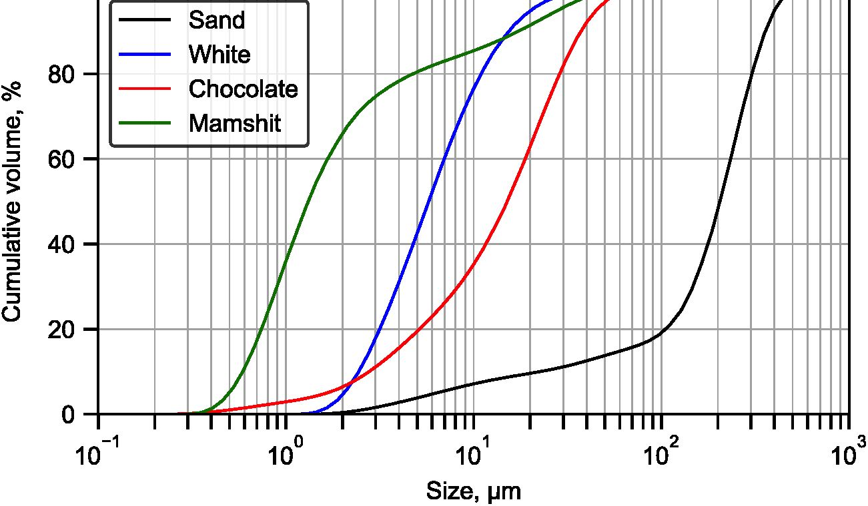

Figure 2: Particle size distribution of raw materials.

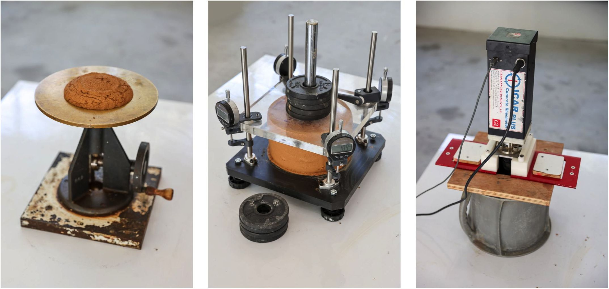

c)

Figure 3: Green material test methods: a) Flow table test, assessing flow properties through the mix spread after  
jolting; b) Fresh green material loading rig, measuring rigidity via deformation under incremental load increases; c)  
ICAR rheometer, evaluating static and dynamic rheological properties of the mix.

EOz *-x)(yt -y)* zqx

*r = . -* (3)

*y/Ztxi* -%)2E(yz *-y)2*

Where x, and yz- are individual data points and *x* is the mean of the x-values and *y* is the mean  
of the y-values.

* 1. *In-situ testing*

In-situ testing involved printing cylindrical samples with a diameter of 180 mm. To continuously  
monitor the layer heights during the printing process, 30 frame per second video recording was  
employed. A Canon 6D camera, equipped with a Canon EF 70-200/2.8L IS II lens, was positioned  
to capture detailed footage of each layer as it was printed. This allowed us to closely inspect of  
the print layers throughout the procedure. The experiment continued until the cylinder collapsed,  
at which point the time to failure and the number of layers at failure was recorded. A digital  
analysis of the printing process was conducted with digital image correlation software, Tema PRO  
by ImageSystems, to evaluate the deformation of the lower layers during printing.

* 1. *Mechanical characterization*

For mechanical characterization, specimens from each mixture were prepared in accordance  
with standards EN 12350-1 for compressive strength and EN 12390-5 for flexural strength. The  
dimensions of the test specimens were 50 x 50 x 50 mm for the compressive strength test and 40 x  
40 x 160 mm for the flexural strength test. It should be noted that these dimensions, while effective  
for our experimental objectives, do not strictly conform to standard sizes for earthen materials.  
After 24 hours post-casting, the samples were demolded and subsequently subjected to drying for  
14 days in a controlled laboratory environment, maintaining a temperature of 21 °C and a relative  
humidity of 50

A 500 kN MULTIPURPOSE 500 (CONTROLS Group) compression-flexure cement testing  
frame was used to evaluate the compressive and flexural strength of the specimens. Two steel  
plates, each measuring 40 x 40 mm with a height of 10 mm, were employed during testing. Each  
specimen was centrally positioned on these plates, and the load was progressively increased at a

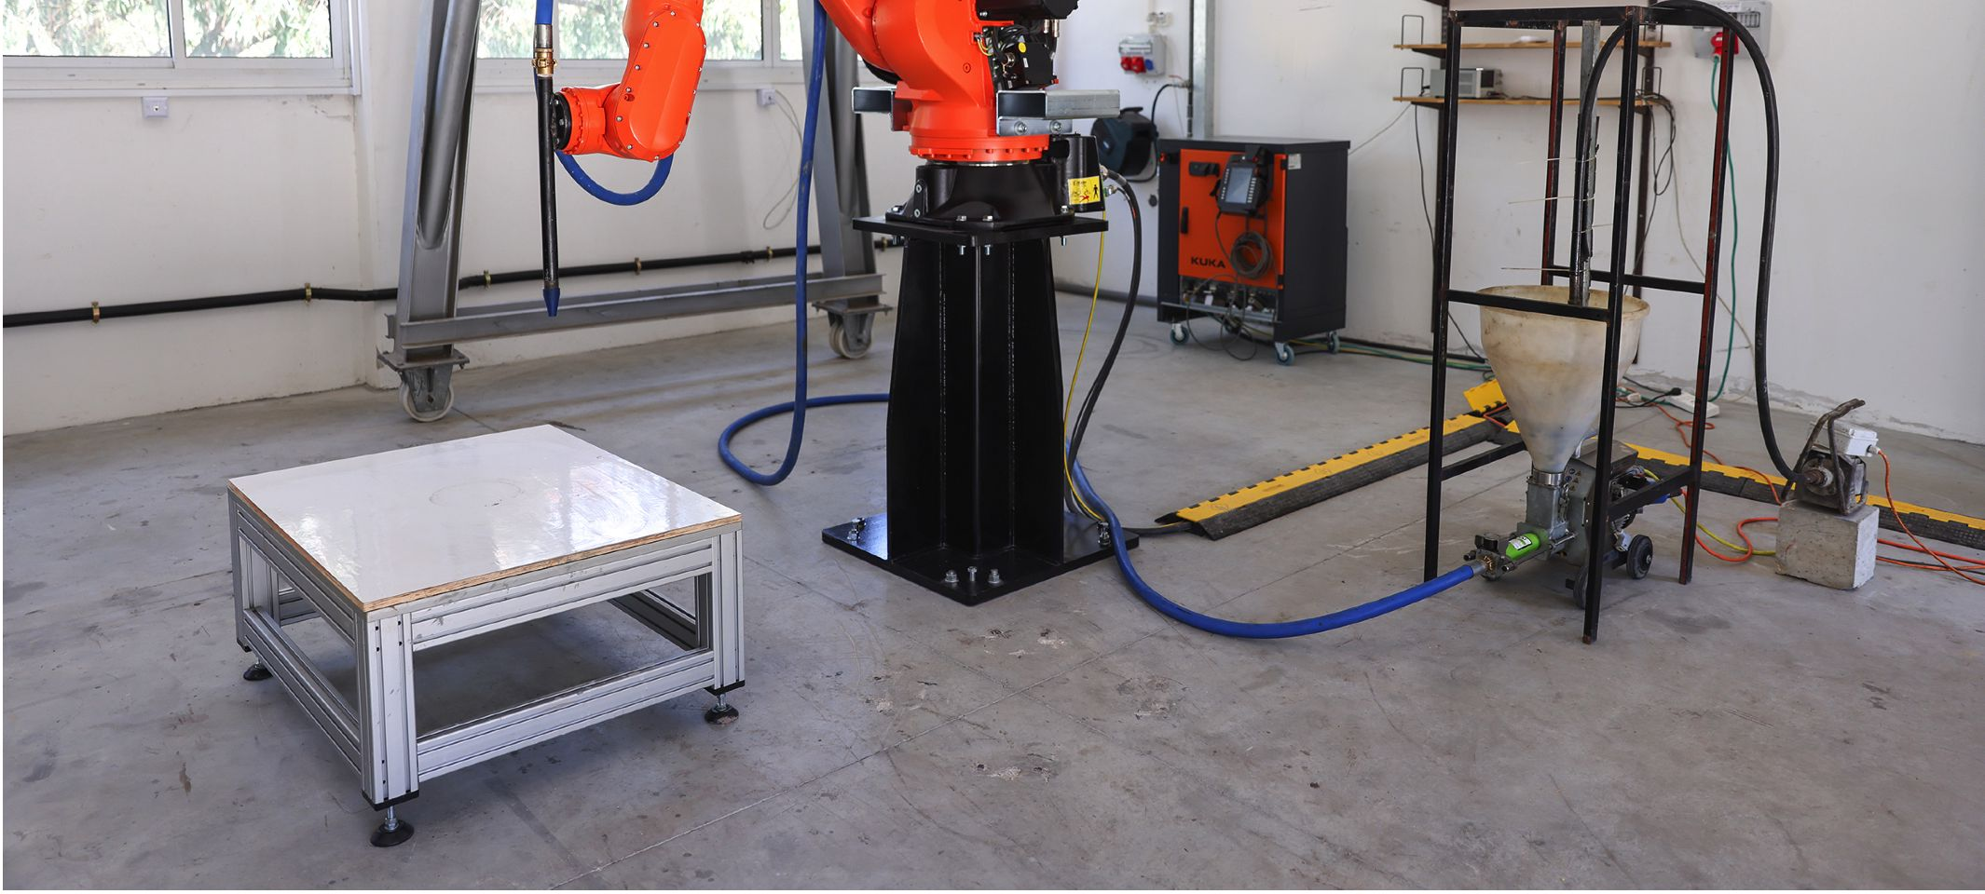

Figure 4: Robotic cell setup for 3D printing of clayey soils, featuring an industrial robotic arm, mortar pump, and  
concrete vibrator.

rate of 0.5 MPa per second. The uniaxial compressive strength of the specimens was determined  
by the peak force recorded by the machine at the moment of specimen failure.

* 1. *3D printing setup*

The robotic setup used for this research is shown in Figure 3. The setup includes a KUKA  
KR50R2100 industrial robotic arm, featuring a payload of 50 kg and a radial range of 2100  
mm. The printhead used for printing comprised a 450mm long metal rod, which was mounted  
perpendicularly to the robot flange. The nozzle used in the printhead was 3D printed from PET-G  
and featured a diameter of 12.5 mm. The mortar pump used for the printing process was MAI  
2PUMP-PICTOR, with a 24L worm pump, featuring a flow rate of 1.5-8.5 L/min. A concrete  
vibrator was used to promote the mixture flow from the hopper to the worm pump. A GW Instek  
DC power supply was connected to the pump to control the flow rate by altering the supplied  
voltage. A 10-meter high-pressure hose was used for delivering the mixture from the pump to the  
printhead mounted on top of the robotic arm.

1. Results and discussion
   1. *Rheological properties and mix performance at green-state*
      1. *Rheological behavior*

Typical results of the rheological parameters as a function of resting time are shown in Figure  
5. The time scale represents the resting time between consecutive measurements, up to 45 minutes.  
The cumulative time since the end of mixing was longer, totaling 110 minutes.

In the studied clay-based systems, the static shear yield stress can be analyzed in terms of its  
development over two stages: re-flocculation and structuration. During the re-flocculation stage,  
which occurs within the first few minutes, the increase in static shear yield stress is attributed to  
microstructural recovery of the platy clay particles, flocculation of the soil’s particles and a change  
in the adsorbed water structure [48,49]. Following re-flocculation, the structuration stage involves  
further increases in static shear yield stress, due to material dehydration and compaction over time.  
The structuration of non-stabilized clay system is not significant within the test period in this study  
[29].

The dynamic state of the mixture occurs as sufficient shear stress is applied to the mixture and  
the bonds between the particles break. The dynamic yield value and apparent viscosity characterize  
the mixture at this stage. In the studied systems, the dynamic parameters stay stable throughout the  
test, as seen in Figure 5. The difference between static and dynamic shear yield stresses reflects  
the thixotropic nature of the system, which is crucial for the manufacturing process.

* + 1. *Relations between the rheological parameters and performance values*

The rheological characteristics of the mixtures were compared with actual performance param-  
eters. For that purpose, a series of tests were carried out with 12 clay mix compositions, changing  
the ratio between the white-kaolinite clay and sand, as well as the content of water over a wide range  
(Table 2). The effect of the mix composition was characterized by a variety of tests: rheological  
tests, which provide fundamental physical parameters, performance tests which include flow table  
test, flow rate measurement through the printing nozzle, and the rigidity of the material using the  
test presented in Figure 3. The correlations between the composition, rheological characteristics  
and performance parameters are described in Figure 6.

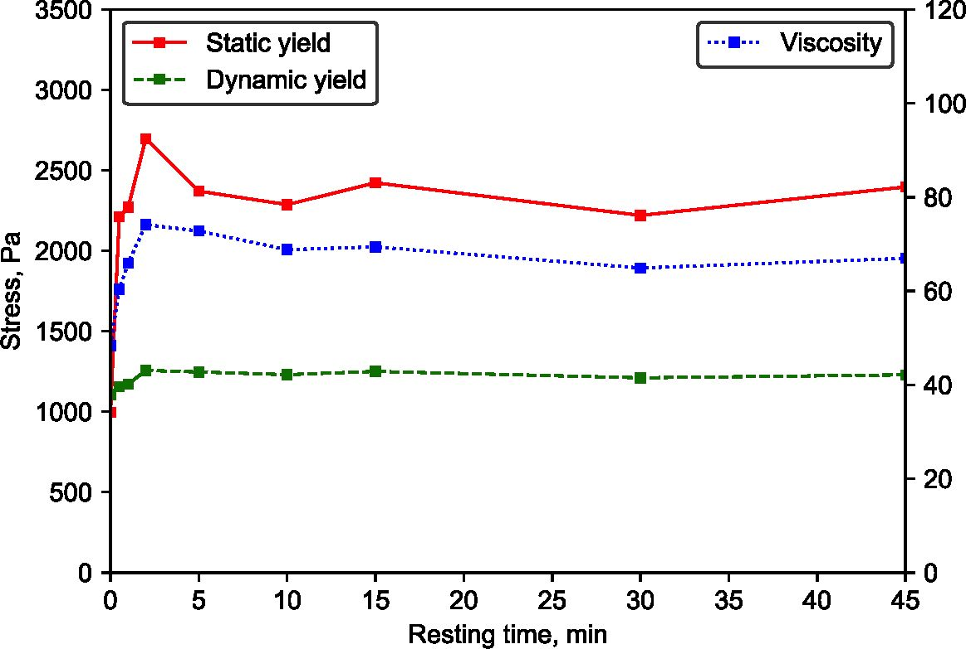

Figure 5: Evolution of rheological parameters in clayey soils over resting time, showcasing the results for white  
kaolinite clay and sand mixtures.

Significant linear relations were found between the flow rate and apparent viscosity (-0.9), and  
the flow rate and static yield (-0.87) as shown in Figure 7. The strong negative relation between  
the viscosity, static yield and the flow rate is typical for materials following the Bingham model  
[25, 22], This relationship emphasizes the critical role that viscosity plays in determining the  
effectiveness of material delivery during 3D printing.

The rigidity of the fresh mix was determined by loading the green material with increasing  
load as described in Figure 3. The loading test was done manually, with the test lasting about 10  
minutes. Under such regime of loading of a viscoelastic material, the rigidity coefficient can be  
considered as an apparent modulus of the mixture, since the deformations registered include both  
elastic and plastic deformations. The values measured in this test ranged between 10-120 kPa,  
which is agreeable with findings reported in literature for 3D printing of clayey soils [29]. The  
strongest relation was found between the rigidity coefficient and the static yield value (0.97), as  
shown in Figure 7. This relation can be attributed to the nature of the test, which was incremental  
and load dependent, therefore influenced highly by the static yield of the material. A controlled  
deformation test can also be employed for a more precise analysis of the viscoelastic properties of  
such mixture [50, 51].

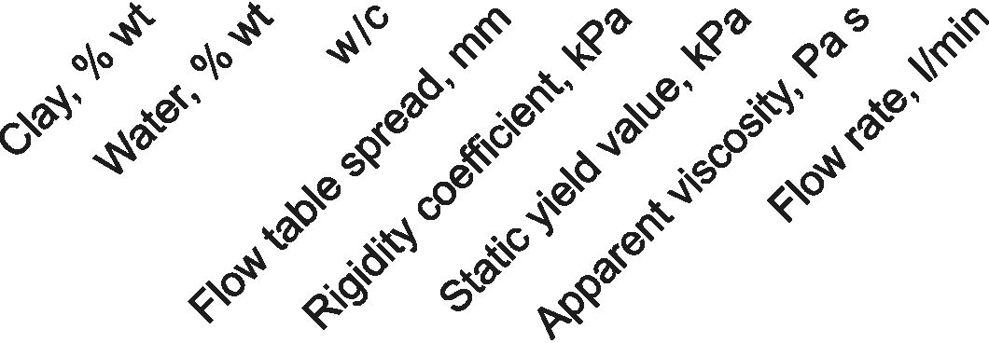

1.00

| Clay, % wt -1 | 1.0 | 0.77 | -0.93 | -0.68 | 0.71 | 0.8 | 0.43 | -0.65 |
| --- | --- | --- | --- | --- | --- | --- | --- | --- |
| Water, % wt -1 | 0.77 | 1.0 | -0.5 | -0.17 | 0.24 | 0.33 | -0.14 |  |
| w/c *4* | -0.93 | -0.5 | 1.0 | 0.81 | -0.81 | -0.88 | -0.67 | 0.83 |
| Flow table spread, mm *4* | -0.68 | -0.17 | 0.81 | 1.0 | -0.88 | -0.94 | -0.84 | 0.93 |
| Rigidity coefficient, kPa *4* | 0.71 | 0.24 | -0.81 | -0.88 | 1.0 | 0.97 | 0.84 | -0.84 |
| Static yield value, kPa *4* | 0.8 | 0.33 | -0.88 | -0.94 | 0.97 | 1.0 | 0.79 | -0.87 |
| Apparent viscosity, Pa s *4* | 0.43 | -0.14 | -0.67 | -0.84 | 0.84 | 0.79 | 1.0 | -0.9 |
| Flow rate, l/min *4* | -0.65 | -0.09 | 0.83 | 0.93 | -0.84 | -0.87 | -0.9 | 1.0 |

Figure 6: Statistical analysis results for performance parameters in clay mix systems with varying composition,  
encompassing a range of water/clay and sand/clay ratios as well as clay content in the mix.

0.75

0.50

0.25

0.00

-0.25

-0.50

-0.75

-1.00

* + 1. *Relations between performance values and testing methods*

The use of clayey soils in 3D printing mixtures often calls for quick, cost-effective on-site  
assessments. The statistical analysis, depicted in Figure 8, reveals a strong linear correlation  
between the spread value from the flow table test, material rigidity coefficient (-0.88), and the  
flow rate in the pump (0.93). This evidence suggests that a flow table test could be a reliable and  
practical method for assessing both material flow rate through the nozzle and material rigidity on  
sit.

As previously discussed, the flow rate, driven by dynamic rheological parameters, is a crucial  
factor in 3D printing processes. On the other hand, material rigidity is essential to ensure the  
printed layers retain their intended shape. Therefore, the ability to quickly and efficiently evaluate  
these characteristics on-site can significantly improve the efficacy and quality of the 3D printing  
process.

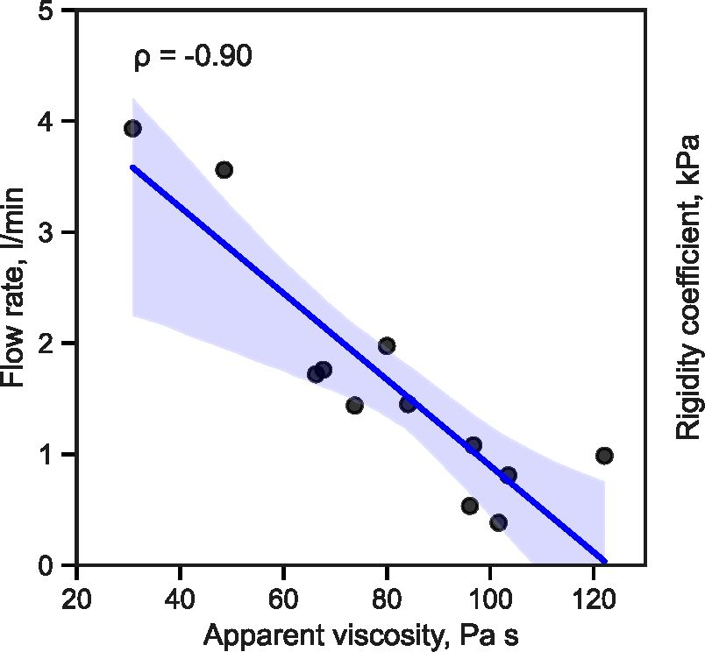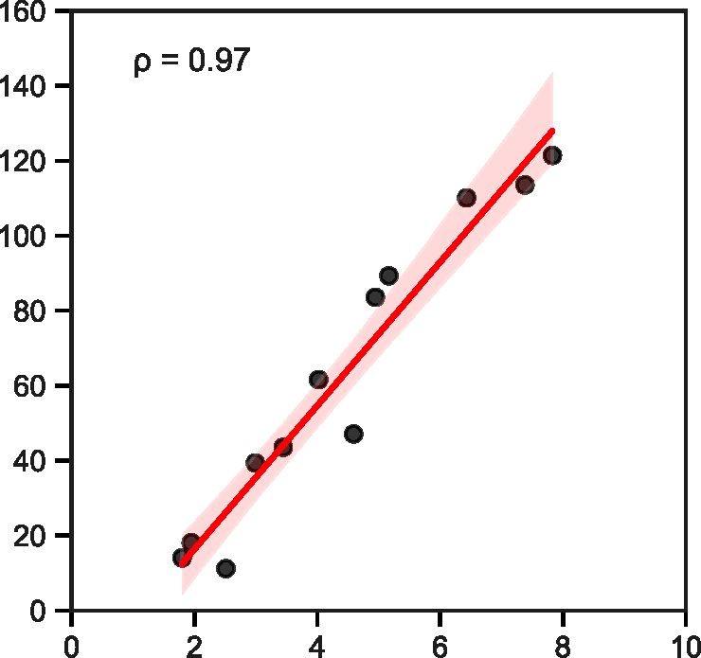

a)

Figure 7: Relations between basic rheological and engineering parameters which are statistically significant: (a)  
Relation between flow rate through the printing nozzle head and the apparent coefficient of viscosity for clay systems,  
and (b) Relation between the rigidity of the green material and the static shear yield strength. The highlighted area  
represents a 95% confidence interval for that relation.

Static yield value, kPa  
b)

* + 1. *Relations between performance values and of mix composition*

The impact of mix composition on material performance is described in Figure 9. The findings  
reveal a moderate positive correlation between the clay/water ratio and the pump flow rate (0.83).  
As expected, increasing water content reduces friction between particles, which improves flow.  
The relationship between the clay weight percentage and the flow rate was less pronounced (-0.65),  
suggesting that water content is the more influential factor in this process.

Unlike traditional earth construction methods, where optimal moisture content is typically  
determined based on maximum dry density [43, 52, 53], the moisture content in 3D printing  
should be evaluated with respect to process performance, to balance the flow properties and  
material rigidity. Furthermore, the rigidity of the mixture showed a moderate negative correlation  
with the clay/water ratio (-0.81). In this instance, increasing water content decreases particle  
friction, thus reducing material rigidity. Conversely, a mild positive relationship was observed  
between the clay weight percentage and rigidity (0.71).

These results underscore the intricate dynamics between the mix components. Therefore, the  
optimal balance for 3D printing mixtures will likely depend on carefully tuning these ratios to

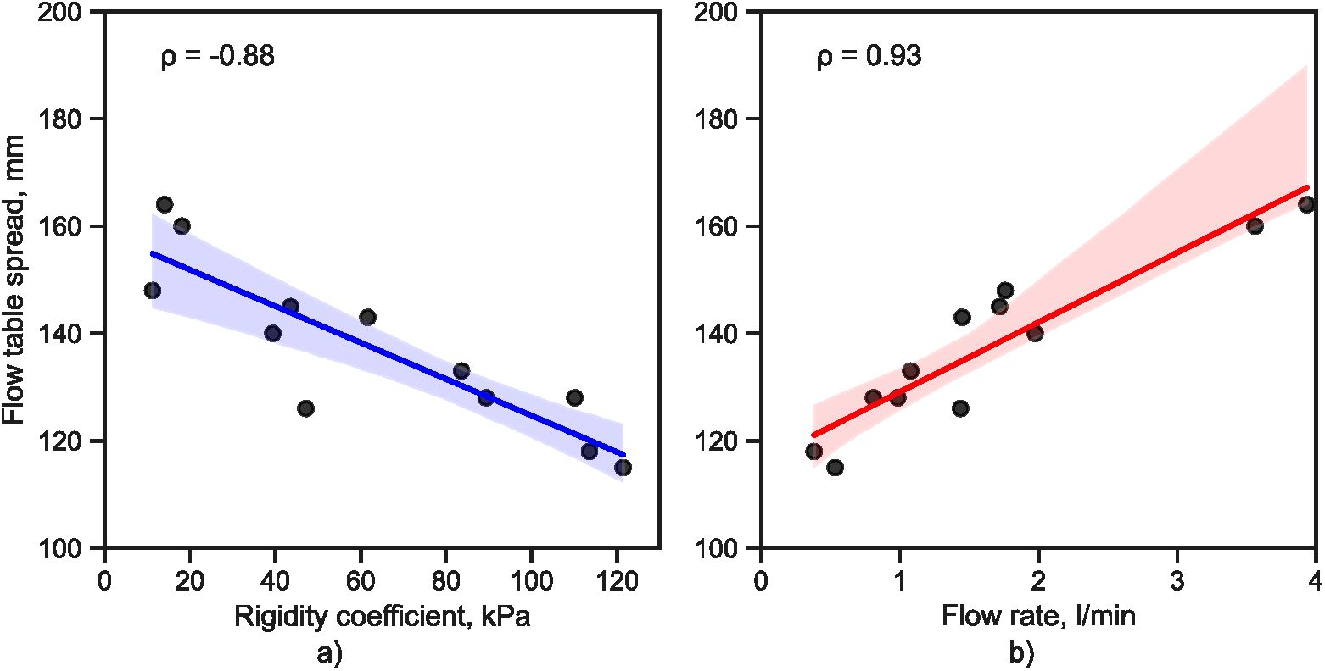

Figure 8: Relations between performance values and testing methods which are statistically significant: (a) Relation  
between the rigidity coefficient and the spread in flow table test, and (b) Relation between the flow rate through the  
nozzle and the and the spread in flow table test. The highlighted area represents a 95% confidence interval for that  
relation.

accommodate both process requirements and desired material properties.

* 1. *Design principles*

*3.2.1. Design principles of the clayey soil mix*

The statistical analysis of relationships between rheological and performance parameters, as  
presented in Section 3.1, can serve as a foundation for insights that can be utilized for optimal mix  
design of clayey soils for 3D printing applications. The analysis above implies that the overall  
performance of the mix can be assessed by simultaneously considering two performance tests: the  
flow table test, which provides an indication of flow through the pumping system, and the rigidity  
test, which offers insight into the stability of printed layers in the green state.

The relationships between these two parameters for the clay systems studied here are illustrated  
in Figure 10, highlighting the systems that demonstrated adequate performance for 3D printing.  
The figure also indicates an optimal performance window, that is, values of a mix that provides  
a suitable combination of flow and rigidity to facilitate optimal early-age behavior, enabling both  
pumping and stability in the buildup of printed layers. The various tested mixes were characterized

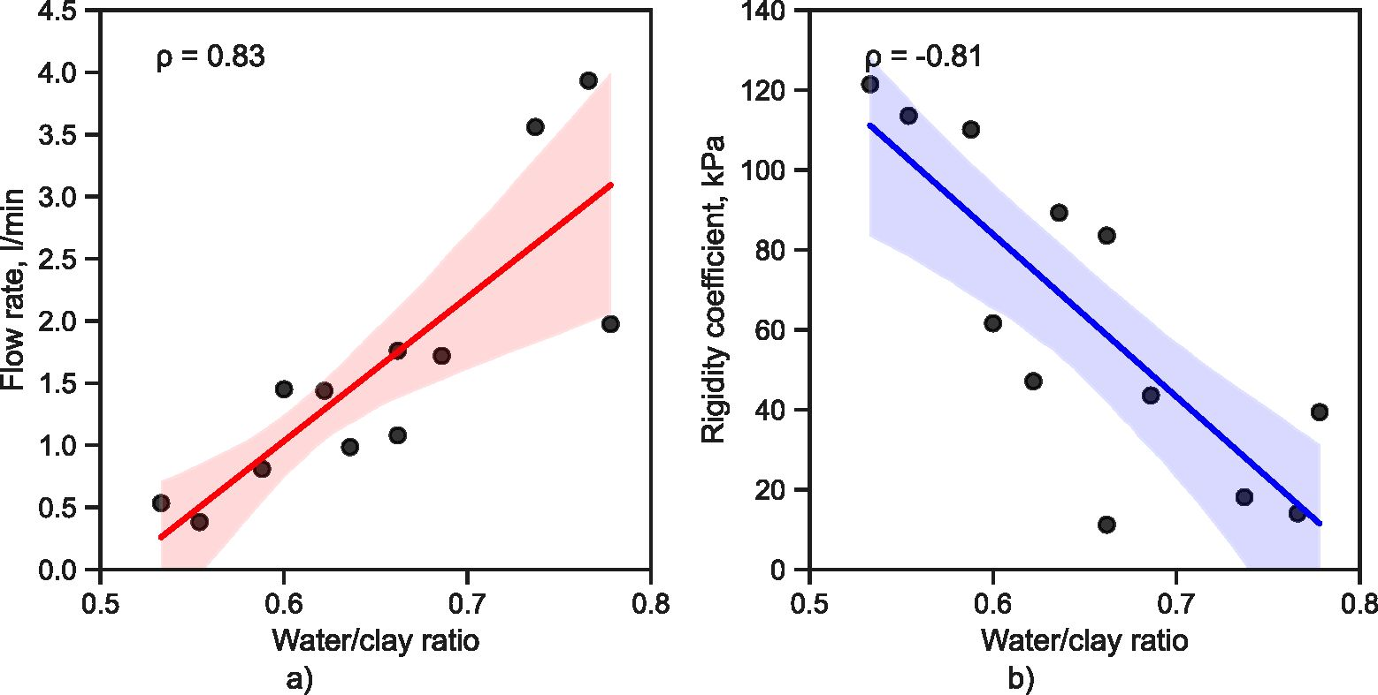

Figure 9: Relations between performance values and mix composition which are statistically significant: (a) Relation  
between the flow rate through the nozzle and the water/clay ratio, and (b) Relation between the apparent modulus and  
the water/clay ratio. The highlighted area represents a 95% confidence interval for that relation.

based on their visual appearance, performance in the green method tests, and their ability to be  
pumped through the delivery system and characterized as either ‘good’, ‘dry’, or ‘unstable’. This  
approach of identifying a performance window based on relatively simple laboratory performance  
tests can be highly practical as a guideline for developing optimal mixes. However, it is important  
to note that such a window serves as a ’’fingerprint” specific to a particular printing technology.  
Factors like different printing systems (e.g., pumping system, printing head, and nozzle) and  
element size and quality can affect the described window. Consequently, for different printing  
technologies and elements, a specific ’’window” needs to be developed

1. *Effect of particle grading*

The mix with a clay content of 28.6%, which resides within the defined ’’optimal window”  
in Figure 10, appears to demonstrate optimal grading. This blend, possessing a water/clay ratio  
of 0.66, produced the most favorable outcomes regarding pump flow, while simultaneously en-  
suring satisfactory stability. The particle grading of this mixture is presented in Figure 11. This  
observation underscores the role that grading plays in influencing a mix’s performance within 3D  
printing applications. Clay particles enhance the flow within the pumping system by forming a

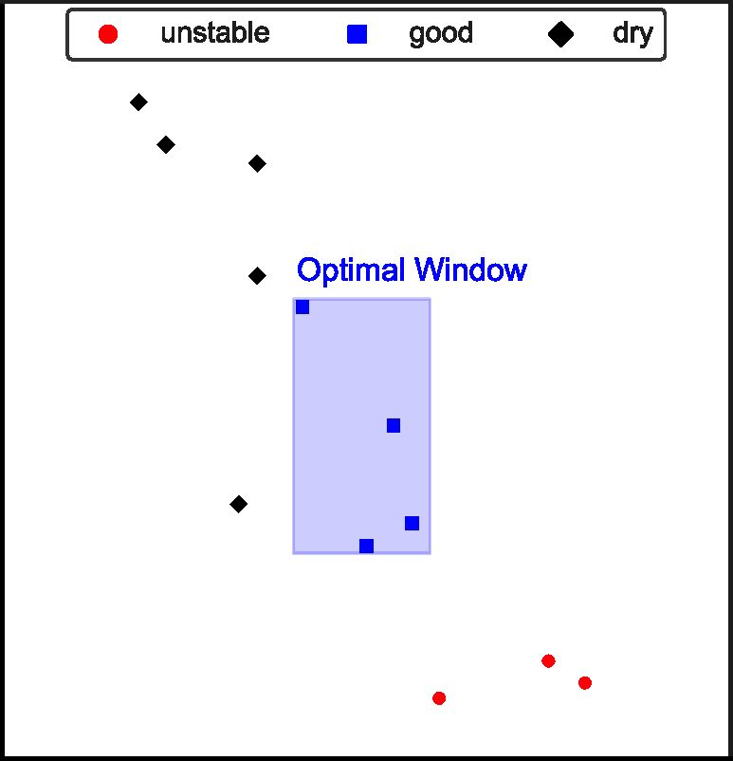

140

100 110 120 130 140 150 160 170 180

Flow table spread, mm

Figure 10: Plot of performance parameters, rigidity and flow, representing different compositions of the clay mix  
system (white clay/kaolinite-sand-water) and identifying a “window” of adequate overall performance for 3D printing.

lubricating layer. This layer formation results from the clay-water paste migration in response to  
inhomogeneous shear stresses present in the pipe, leading to a reduction in pressure loss during  
the delivery stage [54], Yet, an overabundance of clay particles can inadvertently increase the  
viscosity of the mix, thereby negatively impacting the flow rate of the pump [55]. On the other  
hand, the presence of coarse granules in the mix is crucial to enhance the mixture’s rigidity by  
increasing interparticle friction [56]. Therefore, designing an optimal mix for 3D printing of soils  
necessitates a well-considered balance of these components. The best mix should harmoniously  
integrate the benefits of both clay and coarse particles, achieving a balance that optimizes both  
flow and stability for successful 3D printing.

1. *in-situ stability in the green state*

While the stability of deposited layers is commonly associated with their rigidity, there is a  
need to introduce a more comprehensive design methodology to ensure layer stability in-situ. With  
this goal in mind, an analytical model, proposed by Kruger et al. for cement-based materials, was  
applied in this study [31]. The utilization of this model facilitates a more intricate understanding of  
layer stability, anchored on the analysis of the rheometer test, which can consequently improve the  
18

336

337

338

339

340

341

Figure 11: Grading curve representing the optimal composition of the white clay-sand mixture, yielding the best  
balance between flow and rigidity.

design strategy. The shear stress at the bottom layer, at which yielding occurred, can be calculated

as follows [31]:

*Pgh*

*ZFar*

(4)

Where *t* is the shear stress (Pa), g is the gravitational acceleration (*m/s*2), h is the element height

(m), and *Far* is a strength correction factor that accounts for confinement due to the layer aspect

Figure 12: Chocolate clay mix cylindrical column printing until collapse for a 180 mm diameter. Left to right: 10  
layers, 20 layers and 30 layers high cylinder and during collapse.

Controlled experiments were conducted, where a cylinder was printed until collapse to deter-

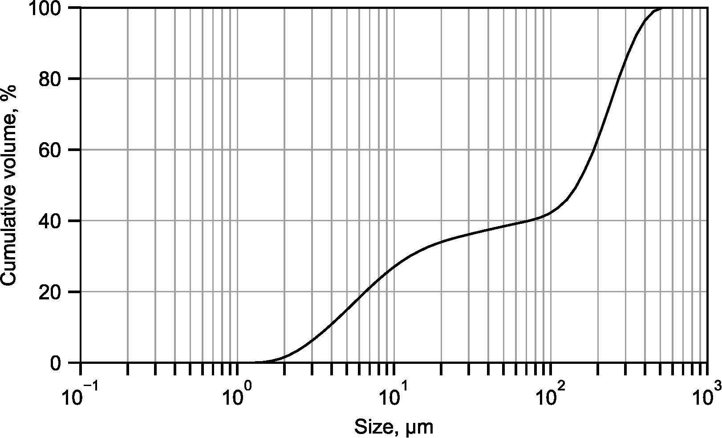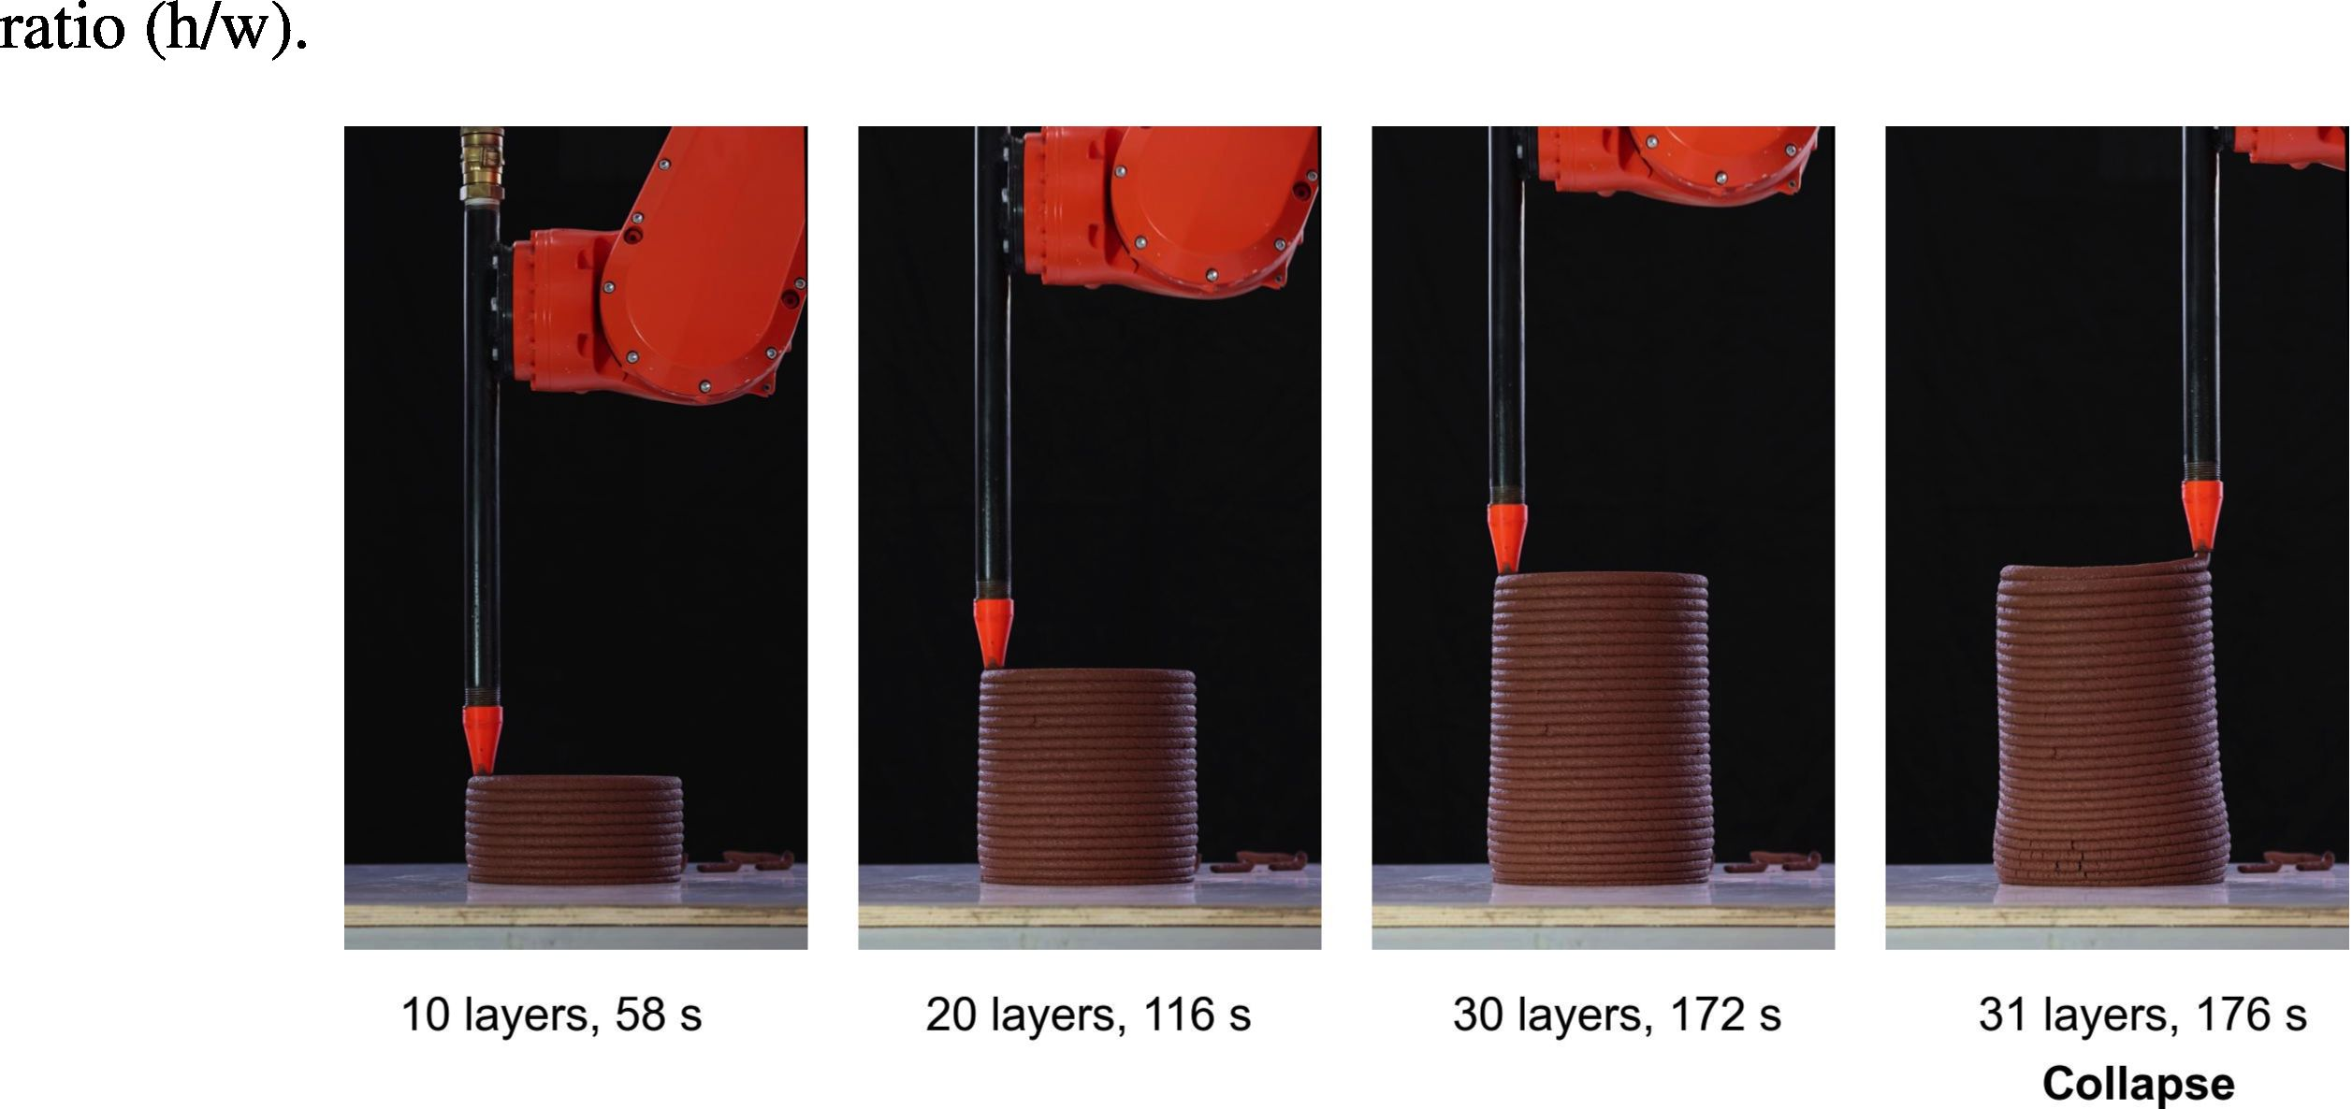

1. mine the point at which the bottom layer yields to the weight of the overlying layers (Figure 12).
2. Three mixtures were examined at this stage, with White, Chocolate, and Mamshit clays. The three
3. mixtures were prepared based on the optimal mixture outlined in Section 3.2. Each mix contained
4. 2:5 clay/sand wt.% ratio. The clay/water ratio differed for each mix and was adjusted to achieve
5. a spread of 140-145 mm in the flow table test after 25 jolts, as detailed in Table 3. A rheometer  
   34? test (as described in Section 2) was conducted on each mixture after preparation, and the results
6. are depicted in Figure 13. The printing test was repeated three times for each mix. The cylinder
7. printing process parameters are described in Table 4.

Table 3: Composition of tested White, Chocolate, and Mamshit clay-sand mixtures.

|  |  |  |  |
| --- | --- | --- | --- |
| **Mix** | **Clay (wt.%)** | **Sand (wt%)** | **Water (wt.%)** |
| White | 24.80159 | 62.00396825 | 13.19444444 |
| Chocolate | 25.15723 | 62.89308176 | 11.94968553 |
| Mamshit | 23.87205 | 59.68011459 | 16.44783958 |

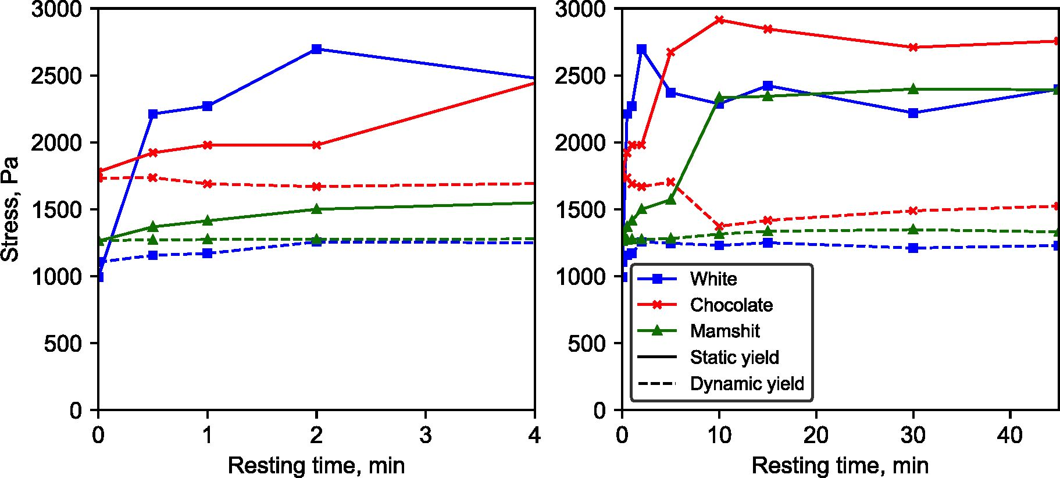

a) b)

Figure 13: Influence of clay type on the rheological behavior of clay-sand mixtures (28.6% clay content), a) 0 to 4  
minutes resting time, b) 0 to 45 minutes resting time.

Table 4: Cylinder printing process parameters

|  |  |  |  |  |  |  |
| --- | --- | --- | --- | --- | --- | --- |
| **Diameter** | **Nozzle** | **Layer** | **Layer** | **Aspect** | **Strength** | **Shear** |
| **(mm)** | **velocity** | **height** | **width** | **ratio** | **correction** | **stress** |
|  | **(mm/s)** | **(mm)** | **(mm)** |  | **factor** | **buildup** |
|  |  |  |  |  |  | **(Pa/min)** |
| 180 | 100 | 10 | 20 | 0.5 | 1.4 | 730 |

Consequently, based on equation 4 and under the specified conditions, the buildup rate of shear  
stress on the lower layer of the printed cylinder is 730 Pa/min. The intersection point of the plots  
obtained by plotting the shear stress buildup rate against the static yield of the tested material, as  
recorded by the rheometer test, can be used to predict cylinder collapse. For example, a cylinder  
printed with the Chocolate clay mix at the described conditions is calculated to collapse at 3.04  
minutes, i.e., 184 seconds.

For the Chocolate clay mix an average failure time of 2.92 minutes was recorded, with a  
6.8% coefficient of variation. The average number of layers at failure was found to be 32. The  
deviation between the predicted and measured values were 4.11% suggesting a good fit with the  
analytical model 14. This is agreeable with failure prediction of cement-based materials [31].  
Across all experiments, it was observed that failure was consistently due to the plastic collapse of  
the lower layer [57]. Interestingly, an elastic buckling deformation was noted during the printing  
of the cylinder, which could potentially lead to distortions in the overall shape of the element (as  
illustrated in Figure 12).

To delve deeper into the failure mechanism and ascertain the critical strain values of the four  
lowermost layers, a digital image correlation analysis was performed as shown in Figure 15. This  
analysis results between 100 to 180 second window of the printing process are depicted in Figure  
16. The data reveals a direct correlation between the increasing dead weight on a layer and its  
deformation, with the greatest deformations seen in the lowest layer. This supports the assertion  
that the cylinder's failure is triggered by the yield of the lower layer when a critical strain threshold  
is surpassed.

3500

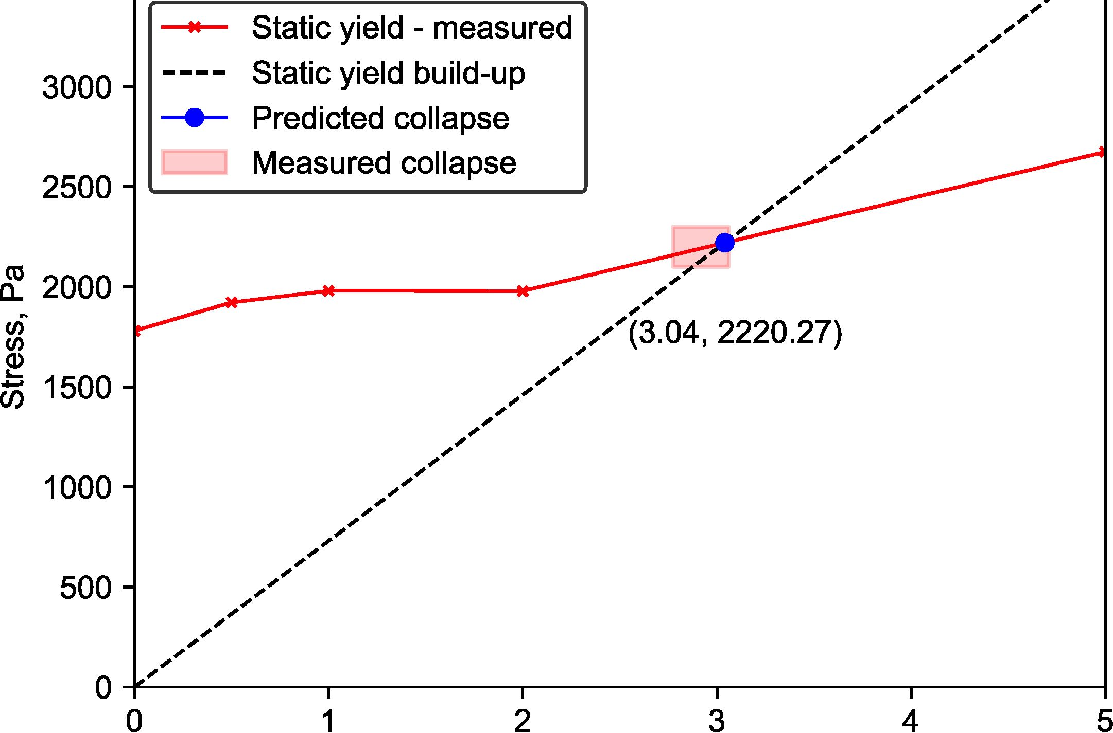

Resting time, min

Figure 14: Intersection of calculated shear stress build-up at the bottom layer and characteristic shear yield strength  
for Chocolate clay mix, depicted for a 180 mm diameter cylindrical column.

1. Furthermore, the analysis discerns two distinct regimes during the printing process. The first
2. regime exhibits elastic behavior, demonstrated by the relatively linear slope of the strain, persisting
3. until the strain reaches a value of approximately 0.15 for the lowermost layer, or 140 seconds. The
4. second regime is characterized by plastic deformation, evidenced by the exponential rise in strain
5. leading up to the point of total collapse.
6. The outcomes of this test demonstrate that the presented approach provides a sound estimation
7. of the mechanical dynamics occurring during the printing process. As such, it lays the foundation

X Layer 4 . '

X Layer 3 - >

X Layer 2

X Layer 1

_ X Base

Figure 15: Digital Image Correlation (DIC) analysis illustrating based on layers strain during the 3D printing process.

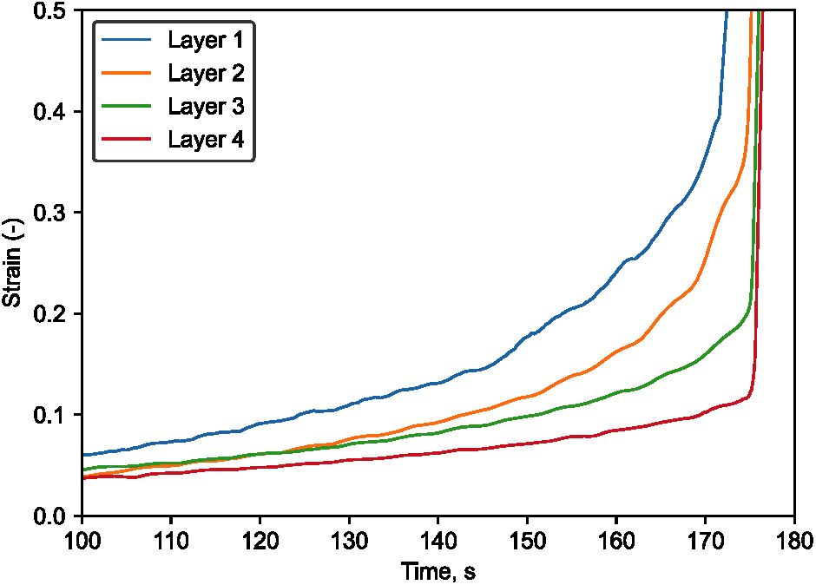

Figure 16: Lower layer strain during 180 mm cylinder printing until collapse for Chocolate clay mixture.

for developing a comprehensive design methodology for the entire printing operation. For example,  
considering a specific material and design, adjusting the nozzle speed could enhance the element’s  
stability by granting more time for the consolidation of the mixture [6]. Alternatively, the mixture  
could be modified to better suit the element static yield build-up. This could be achieved by  
treating the soil with various stabilizers [29, 41, 35], thereby tailoring the mixture’s properties to  
the demands of the process.

*3.2.4. Effect of clay composition on stability in the green state*

The three clays examined in this study vary in their mineralogical composition, particularly  
in terms of kaolinite content: 99.3%, 76.8%, and 41.5% for the White, Chocolate, and Mamshit  
clays, respectively, as detailed in Table 1.

The static yield achieved is similar for all three clay types as demonstrated in Figure 13, with  
Chocolate clay mix exhibiting slightly higher values. This may be attributed to its coarser and wider  
particle size distribution (Figure 17), which may facilitate a more efficient and denser packing.  
Additionally, the Chocolate clay mix has a greater proportion of silt-sized particles, which may  
increase the interparticle friction and consequently, the static yield of the mix.

There is, however, a considerable difference in the build-up of the static yield which is quickest  
in the White clay and slowest in the Mamshit clay (Figure 13a.), 2, 5 and 10 minutes for the White,  
Chocolate and Mamshit clay respectively. This could be correlated with the kaolinite content in eachof them. The charged plate-shaped particles of kaolinite form a card-house structure increasing the  
thixotropic effect of the mix [58]. The individual kaolinite particles, with their layered structure and  
net negative charge, are capable of establishing strong, electrostatic interactions with surrounding  
particles and water molecules. This contributes to the formation of a stable, gel-like network in  
the mixture, thereby augmenting its thixotropic behavior [59]. Furthermore, the size and shape of  
kaolinite particles also play a vital role in promoting thixotropy. The thin, platy morphology of  
kaolinite particles leads to high specific surface area and facilitates the formation of a closely-knit,  
coherent microstructure in the mixture [60]. This structure enhances resistance against deformation,  
contributing to the rapid build-up of static yield stress.

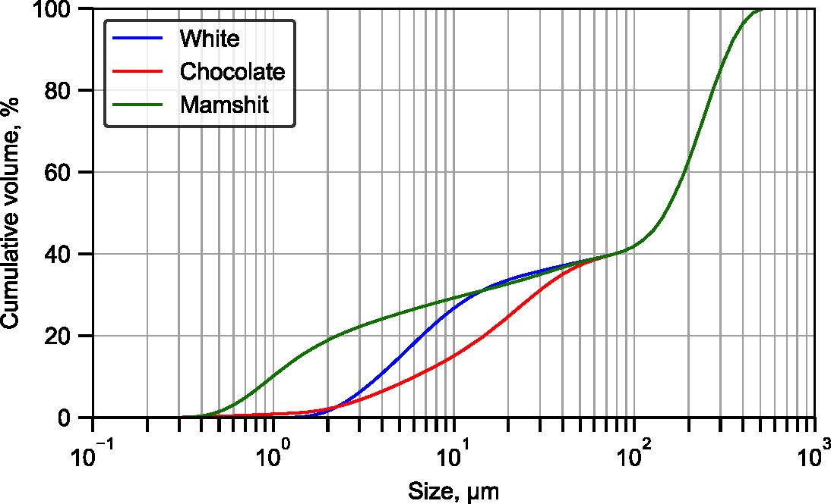

Figure 17: Particle size distribution of the tested clay-sand mixes.

To assess the influence of various clay compositions and gradings on the 3D printing per-  
formance of the artifact, in-situ stability tests were conducted on each mix using the cylindrical  
column printing method. The evolution of static yield and the intersection with shear stress buildup  
at the lowest layer are displayed in Figure 18. Images taken during the photographic monitoring of  
the printing process until column collapse are provided in Figure 19.

Differences in static yield evolution among the mixes became evident in the initial minutes  
of the test. The Mamshit clay mix, which contained the largest volume of clay sized particles,  
collapsed the quickest, on average, after 2.5 minutes (4.2% variation, 21% deviation from the  
analytical model). The chocolate clay mix collapsed within 2.92 minutes (5.1% variation, 4.11%deviation), while the collapse of the white clay mix took place after 3.2 minutes (6.8% variation,  
7.7% deviation).

The results demonstrate that the analytical model aligns with the trends observed in the rheo-  
logical test, and effectively predicts the point of collapse for the cylinder across several tested soils.  
The pronounced deviation witnessed in the Mamshit clay mix from the analytical model could be  
attributed to sensitivities tied to the rheological test procedure. This divergence can be addressed  
by refining the procedure of the rheological test and by allowing the mix to homogenize over several  
days prior to conducting the various tests. This approach should ensure a more consistent mixture,  
potentially leading to more accurate predictions.

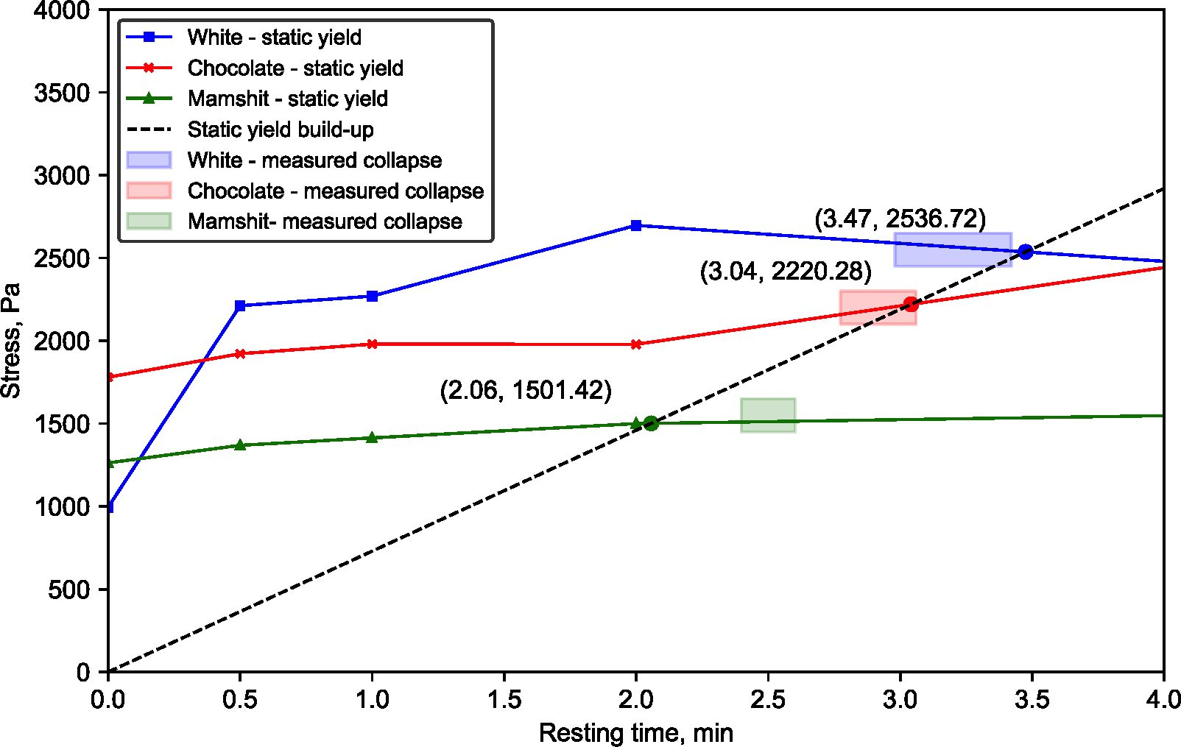

Figure 18: Comparison of calculated shear stress build-up and characteristic shear yield strength for three different  
clay mixes in a 180 mm diameter cylindrical column. The values calculated based on the intersection point of the two  
curves are shown. The highlighted boxes indicate the range of measured values for collapse time.

3.2.5. *Effect of clay composition on mechanical properties*

Figure 20 shows the mechanical characterization results for the various soils tested. In contrast  
to stability in the green state, the highest compressive strength values were observed in the Mamshit

RflHFini IR

min

HMM

0.0 0.5 1.0 1.5 2.0 2.5 3.0 3.5 4.0

Figure 19: In-situ stability test via cylindrical column printing of the three tested clay-sand mixes. The printing process  
is described in 30-second intervals until collapse.

clay mix, followed by the Chocolate clay mix, with the White mix demonstrating the lowest values.  
Similarities were found in the flexural test results for both Mamshit and Chocolate clay mixes, but  
these were notably lower for the White mix.

The outcomes of the compressive strength tests suggest an absence of direct correlation between  
the kaolinite content and the strength of the mixture, unlike its relation with the static yield buildup  
rate. However, the particle grading appears to hold a significant influence over the strength of the  
mixture, which is consistent with the results described by Cuccurullo et al. [61]. The Mamshit clay  
mixture, which contains a larger fraction of clay-sized particles, rather than clay-mineral particles,  
is likely to have prompted a denser microstructural arrangement of its constituent granules, thereby  
resulting in a more structurally robust mixture. The Chocolate clay mixture, characterized by a  
coarser particle grading, could potentially enhance the frictional resistance between particles, thus  
yielding positive outcomes.

The results from the mechanical characterization imply a potential contradiction between  
the green and hardened state properties when optimizing clay-based mixtures for 3D printingapplications. While some mixtures may exhibit enhanced properties in the green state, such as an  
increased rate of static yield buildup, these may not necessarily correspond with an augmentation of  
improved mechanical properties. Notwithstanding, strategies for soil stabilization, might provoke  
a synergistic effect capable of improving both the green and hardened state properties.

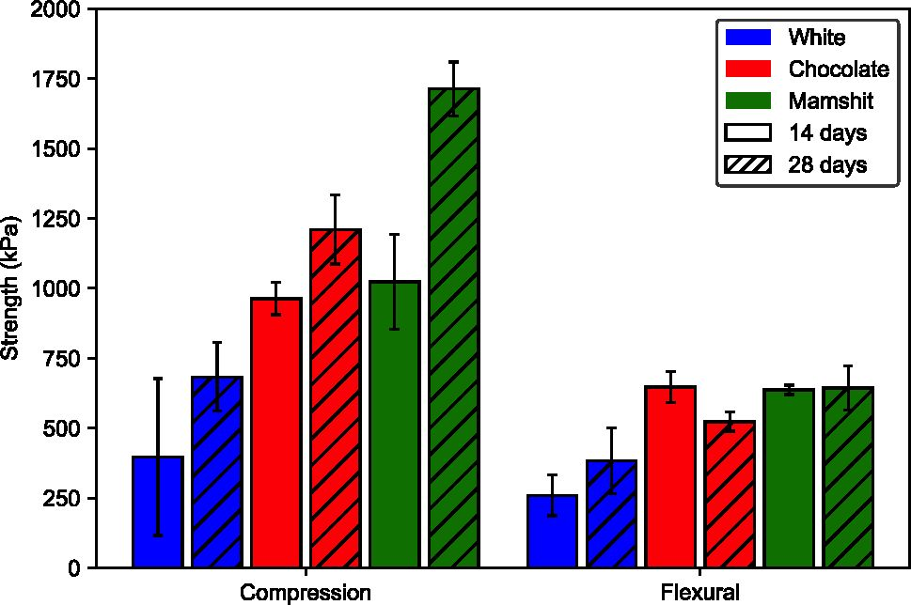

Test Type

Figure 20: Compressive and flexural strengths of the tested mixes at 14- and 28-days.

1. Conclusions

The presented study offers valuable guidelines for designing mixtures for 3D printing of clay-  
based soils in construction and architecture.

Performance and rheological tests were conducted on various ratios of clay/sand and clay/water.  
The results of these tests revealed significant linear correlations, highlighting essential performance  
metrics for evaluating the mix. The analysis identified a robust linear relationship between a custom  
rigidity test and static yield stress, as well as between the flow table test and flow rate through the  
pump. These findings suggest that a simple flow table test, combined with a custom-built rigidity  
test, offers a sufficient and cost-effective method for the evaluation of soil-based material properties  
for 3D printing.

Basic rheological parameters were verified using an analytical model to predict the green state’s  
stability during 3D printing. This was achieved by 3D printing a cylinder model at constant velocity  
until collapse. Plastic collapse was observed for all mixtures due to bottom layer yield. The in-situstability test provides a practical framework for fine-tuning printing parameters and layer geometry  
to avoid plastic collapse. The results of this test suggest the printing parameters should be adapted  
according to the material rheological properties and printed artifact scale. Additionally, the in-situ  
test was completed by a digital image correlation analysis, revealing critical strain in the bottom  
layer as the driving force for the printed cylinder plastic collapse.

Finally, the results of the study highlight the influence of particle size distribution and clay  
mineralogy on material performance in 3D printing. It was observed that an increased presence of  
the kaolinite mineral could trigger a more pronounced thixotropic effect at the re-flocculation stage,  
facilitating quicker static yield evolution and therefore delaying the structure collapse. Furthermore,  
a coarser particle size distribution enhanced static yield value of the tested mix.

Future work in this area should focus on better understanding and improving the thixotropy of  
the mixtures, in order to optimize the design of soil-based materials for 3D printing. Such studies  
could refine the material’s short-term thixotropy using stabilizing agents, which would otherwise  
be limited, enabling faster construction rates. These modifications, however, should maintain low  
dynamic rheological values, specifically the dynamic yield value and viscosity, to ensure a smooth  
pumping stage. Furthermore, a micro-structural investigation into the effects of soil mineralogy  
and particle grading on both short and long-term rheological properties of the mixture could  
provide insights into the design strategies of soil-based materials for 3D printing. Additionally, it  
is imperative that methods for optimizing these short-term rheological properties go hand in hand  
with enhancing the material’s long-term attributes, such as compressive and flexural strength, as  
well as durability. As these efforts progress, it is crucial to consider the environmental impact  
of any mineral or bio-based additives, ensuring that the soil remains a low-impact and recyclable  
material

1. Data Availability Statement

Some or all data that support the findings of this study are available from the corresponding  
author upon reasonable request.

1. Acknowledgments

The authors gratefully acknowledge the generous funding provided by the Israel Ministry of  
Housing and Construction under grant no. 2031203. This financial support has been instrumental  
in enabling this research.

Additionally, this research benefited immensely from the support of the National Building  
Research Institute (Israel) staff. Their dedication and cooperation are greatly acknowledged.  
Finally, We would like to extend our sincere gratitude to Research Assistant Tair Shekel for her  
assistance in preparing some of the illustrations presented in this paper.

References

1. K. L. Bar-Sinai, T. Shaked, A. Sprecher, Robotic tools, native matter: workflow and methods for geomaterial  
   reconstitution using additive manufacturing, Architectural Science Review 64 (6) (2021) 490-503.
2. A. Veliz Reyes, W. Jabi, M. Gomaa, A. Chatzivasileiadi, L. Ahmad, N. M. Wardhana, Negotiated matter: a  
   robotic exploration of craft-driven innovation, Architectural Science Review 62 (5) (2019) 398-408.
3. J.-B. Izard, A. Dubor, P.-E. Herve, E. Cabay, D. Culla, M. Rodriguez, M. Barrado, Large-scale 3d printing with  
   cable-driven parallel robots, Construction Robotics 1 (2017) 69-76.
4. M. Gomaa, W. Jabi, A. V. Reyes, V. Soebarto, 3d printing system for earth-based construction: Case study of  
   cob, Automation in Construction 124 (2021) 103577. doi: 10.1016/J.AUTCGN.2021.103577.
5. G. Vantyghem, W. De Corte, E. Shakour, O. Amir, 3d printing of a post-tensioned concrete girder designed by  
   topology optimization, Automation in Construction 112 (2020) 103084.
6. M. Mogra, O. Asaf, A. Sprecher, O. Amir, Design optimization of 3d printed concrete elements considering  
   buildability, Engineering Structures 294 (2023) 116735.
7. I. Agustf-Juan, G. Habert, Environmental design guidelines for digital fabrication, Journal of cleaner production  
   142 (2017) 2780-2791.
8. J.-C. Morel, A. Mesbah, M. Oggero, P. Walker, Building houses with local materials: means to drastically reduce  
   the environmental impact of construction, Building and environment 36 (10) (2001) 1119-1126.
9. A. Shukla, G. Tiwari, M. Sodha, Embodied energy analysis of adobe house, Renewable Energy 34 (3) (2009)  
   755-761.
10. J.-C. Morel, R. Charef, E. Hamard, A. Fabbri, C. Beckett, Q.-B. Bui, Earth as construction material in the  
    circular economy context: practitioner perspectives on barriers to overcome, Philosophical Transactions of the  
    Royal Society B 376 (1834) (2021) 20200182.
11. D. Ardant, C. Brumaud, A. Perrot, G. Habert, Robust clay binder for earth-based concrete, Cement and Concrete  
    Research 172 (2023) 107207.
12. O. Kontovourkis, G. Tryfonos, Robotic 3d clay printing of prefabricated non-conventional wall components  
    based on a parametric-integrated design, Automation in Construction 110 (2020) 103005.
13. S. Barnes, L. Kirssin, E. Needham, E. Baharlou, D. E. Carr, J. Ma, 3d printing of ecologically active soil  
    structures, Additive Manufacturing 52 (2022) 102670. doi:10.1016/J.ADDMA.2022.102670.
14. H. Alhumayani, M. Gomaa, V. Soebarto, W. Jabi, Environmental assessment of large-scale 3d printing in  
    construction: A comparative study between cob and concrete, Journal of Cleaner Production 270 (2020) 122463.  
    doi: 10.1016/J. JCLEPRG.2020.122463.
15. A. Chiusoli, 3D printed house TECLA - Eco-housing — 3D Printers — WASP — 3dwasp.com,  
    <https://www.3dwasp.com/en/3d-printed-house-tecla/>, [Accessed 17-08-2023] (2021).
16. A. Ellery, Sustainable in-situ resource utilization on the moon, Planetary and Space Science 184 (5 2020).  
    doi:10.1016/j.pss.2020.104870.
17. S. Pilehvar, M. Amhof, R. Pamies, L. Valentini, A. L. Kjpniksen, Utilization of urea as an accessible su-  
    perplasticizer on the moon for lunar geopolymer mixtures, Journal of Cleaner Production 247 (2 2020).  
    doi:10.1016/j.jclepro.2019.119177.
18. S. Qaidi, A. Yahia, B. Tayeh, H. Unis, R. Faraj, A. Mohammed, 3d printed geopolymer composites: A review,  
    Materials Today Sustainability 20 (2022) 100240. doi:<https://doi.org/10.1016/j.mtsust.2022.100240>.

URL <https://www.sciencedirect.com/science/article/pii/S2589234722001324>

1. M. Gomaa, W. Jabi, V. Soebarto, Y. M. Xie, Digital manufacturing for earth construction: A critical review,  
   Journal of Cleaner Production 338 (2022) 130630. doi: 10.1016/J.JCLEPRG.2022.130630.
2. N. Labonnote, A. Rpnnquist, B. Manum, P. Riither, Additive construction: State-of-the-art, challenges and  
   opportunities, Automation in construction 72 (2016) 347-366.
3. M. T. Souza, I. M. Ferreira, E. G. de Moraes, L. Senff, A. P. N. de Oliveira, 3d printed concrete for large-scale  
   buildings: An overview of rheology, printing parameters, chemical admixtures, reinforcements, and economic  
   and environmental prospects, Journal of Building Engineering 32 (2020) 101833.
4. V. Mechtcherine, F. P. Bos, A. Perrot, W. R. da Silva, V. N. Nerella, S. Fataei, R. J. Wolfs, M. Sonebi,  
   N. Roussel, Extrusion-based additive manufacturing with cement-based materials - production steps, pro-  
   cesses, and their underlying physics: A review, Cement and Concrete Research 132 (2020) 106037.  
   doi: 10.1016/J.CEMCGNRES.2020.106037.
5. K. Kovler, N. Roussel, Properties of fresh and hardened concrete, Cement and Concrete Research 41 (7) (2011)  
   775-792.
6. Y. Qian, S. Kawashima, Distinguishing dynamic and static yield stress of fresh cement mortars through thixotropy,  
   Cement and Concrete Composites 86 (2018) 288-296.
7. G. D. Schutter, D. Feys, Pumping of fresh concrete: Insights and challenges, RILEM Technical Letters 1 (2016)  
   76-80. doi: 10.21809/rilemtechlett.2016.15.
8. E. Buckingham, On plastic flow through capillary tubes, in: Proc. Am. Soc. Testing Materials, 1921, pp.  
   1154-1156.
9. F. Bos, R. Wolfs, Z. Ahmed, T. Salet, Additive manufacturing of concrete in construction: poten-  
   tials and challenges of 3d concrete printing, Virtual and Physical Prototyping 11 (2016) 209-225.  
   doi:10.1080/17452759.2016.1209867.
10. R. A. Buswell, W. R. L. de Silva, S. Z. Jones, J. Dirrenberger, 3d printing using concrete extrusion: A roadmap  
    for research, Cement and Concrete Research 112 (2018) 37-49. doi:10.1016/J.CEMCONRES.2018.05.006.
11. A. Perrot, D. Rangeard, E. Courteille, 3d printing of earth-based materials: Processing aspects, Construction  
    and Building Materials 172 (2018) 670-676. doi:10.1016/j.conbuildmat.2018.04.017.
12. N. Roussel, Rheological requirements for printable concretes, Cement and Concrete Research 112 (2018) 76-85.  
    doi: 10.1016/J.CEMCONRES.2018.04.005.
13. J. Kruger, S. Zeranka, G. van Zijl, 3d concrete printing: A lower bound analytical model for buildability  
    performance quantification, Automation in Construction 106 (10 2019). doi: 10.1016/j.autcon.2019.102904.
14. J. Kruger, M. Van den Heever, S. Cho, S. Zeranka, G. Van Zijl, High-performance 3d printable concrete  
    enhanced with nanomaterials, in: Proceedings of the international conference on sustainable materials, systems  
    and structures (SMSS 2019), Vol. 533,2019, pp. 533-540.
15. J. Kruger, S. Cho, S. Zeranka, C. Viljoen, G. van Zijl, 3d concrete printer parameter optimisation for high rate  
    digital construction avoiding plastic collapse, Composites Part B: Engineering 183 (2020) 107660.
16. A. Biggerstaff, M. Lepech, G. Fuller, D. Loftus, A shape stability model for 3d print-  
    able biopolymer-bound soil composite, Construction and Building Materials 321 (2022) 126337.  
    doi: 10.1016/J.CGNBUILDMAT.2022.126337.
17. A. Biggerstaff, G. Fuller, M. Lepech, D. Loftus, Determining the yield stress of a biopolymer-bound soil  
    composite for extrusion-based 3d printing applications, Construction and Building Materials 305 (2021) 124730.  
    doi: 10.1016/J.CGNBUILDMAT.202L 124730.
18. A. Bajpayee, M. Farahbakhsh, U. Zakira, A. Pandey, L. A. Ennab, Z. Rybkowski, M. K. Dixit, P. A.  
    Schwab, N. Kalantar, B. Birgisson, S. Banerjee, In situ resource utilization and reconfiguration of soils  
    into construction materials for the additive manufacturing of buildings, Frontiers in Materials 7 (3 2020).  
    doi: 10.3389/fmats.2020.00052.
19. G. Silva, R. Nanez, D. Zavaleta, V. Burgos, S. Kim, G. Ruiz, M. A. Pando, R. Aguilar, J. Nakamatsu, Eco-friendly  
    additive construction: Analysis of the printability of earthen-based matrices stabilized with potato starch gel and  
    sisal fibers, Construction and Building Materials 347 (2022) 128556.
20. G. Bai, L. Wang, G. Ma, J. Sanjayan, M. Bai, 3d printing eco-friendly concrete containing under-utilised and

waste solids as aggregates, Cement and Concrete Composites 120 (2021) 104037.

1. A. Alqenaee, A. Memari, Experimental study of 3d printable cob mixtures, Construction and Building Materials  
   324 (2022) 126574.
2. E. Ferretti, M. Moretti, A. Chiusoli, L. Naldoni, F. De Fabritiis, M. Visona, Rice-husk shredding as a means of  
   increasing the long-term mechanical properties of earthen mixtures for 3d printing, Materials 15 (3) (2022) 743.
3. F. Faleschini, D. Trento, M. Masoomi, C. Pellegrino, M. A. Zanini, Sustainable mixes for 3d printing of  
   earth-based constructions, Construction and Building Materials 398 (2023) 132496.
4. P. Narloch, P. Woyciechowski, J. Kotowski, I. Gawriuczenkow, E. Wojcik, The effect of soil mineral composition  
   on the compressive strength of cement stabilized rammed earth, materials 13 (2020). doi:10.3390/mal3020324.  
   URL [www.mdpi.com/journal/materials](http://www.mdpi.com/journal/materials)
5. G. Minke, Building with Earth: Design and Technology of a Sustainable Architecture, 3rd Edition, Birkhauser,  
   2012. doi:doi:10.1515/9783034608725.

URL <https://doi.org/10.1515/9783034608725>

1. A. Ammari, K. Bouassria, M. Cherraj, H. Bouabid, S. Charif D’ouazzane, Combined effect of mineralogy and  
   granular texture on the technico-economic optimum of the adobe and compressed earth blocks, Case Studies in  
   Construction Materials 7 (2017) 240-248. doi:<https://doi.org/10.1016/j.cscm.2017.08.004>.

URL <https://www.sciencedirect.com/science/article/pii/S2214509517300827>

1. ASTM International, ASTM C230/C230M - 20: Standard Specification for Flow Table for Use in Tests of  
   Hydraulic Cement, Standard C230/C230M - 20, ASTM International, accessed: 2023-05-08 (2020).

URL <https://www.astm.org/Standards/C2> 30.htm

1. A. Kazemian, X. Yuan, E. Cochran, B. Khoshnevis, Cementitious materials for construction-scale 3d print-  
   ing: Laboratory testing of fresh printing mixture, Construction and Building Materials 145 (2017) 639-647.  
   doi:10.1016/J.CGNBUILDMAT.2017.04.015.
2. J. Lee Rodgers, W. A. Nicewander, Thirteen ways to look at the correlation coefficient, The American Statistician  
   42 (1) (1988) 59-66.
3. Y. Ren, S. Yang, K. H. Andersen, Q. Yang, Y. Wang, Thixotropy of soft clay: A review, Engineering Geology  
   287 (6 2021). doi:10.1016/j.enggeo.2021.106097.
4. X. W. Zhang, L. W. Kong, A. W. Yang, H. M. Sayem, Thixotropic mechanism of clay: A microstructural  
   investigation, Soils and Foundations 57 (2017) 23-35. doi:10.1016/j.sandf.2017.01.002.
5. A. Perrot, D. Rangeard, A. Pierre, Structural built-up of cement-based materials used for 3d-printing extrusion  
   techniques, Materials and Structures (2016) 1213-1220doi:10.1617/sl 1527-015-0571-0.
6. R. Wolfs, F. Bos, T. Salet, Early age mechanical behaviour of 3d printed concrete: Numerical modelling and  
   experimental testing, Cement and Concrete Research 106 (2018) 103-116.
7. S. Cytryn, SOIL CONSTRUCTION, its principles and application for Housing, Vol. 5, The Weizman Science

Press of Israel, 1958.

1. M. C. J. Delgado, I. C. Guerrero, The selection of soils for unstabilised earth building: A normative review,  
   Construction and Building Materials 21 (2007) 237-251. doi:10.1016/J.CONBUILDMAT.2005.08.006.
2. S. D. Jo, C. K. Park, J. H. Jeong, S. H. Lee, S. H. Kwon, A computational approach to estimating a lubricating  
   layer in concrete pumping, CMC 27 (2012) 189-210.
3. M. Westerholm, B. Lagerblad, J. Silfwerbrand, E. Forssberg, Influence of fine aggregate characteristics on the  
   rheological properties of mortars, Cement and Concrete Composites 30 (4) (2008) 274-282.
4. J. Gong, X. Wang, L. Li, Z. Nie, Dem study of the effect of fines content on the small-strain stiffness of gap-graded  
   soils, Computers and Geotechnics 112 (2019) 35-40.
5. A. S. Suiker, R. J. Wolfs, S. M. Lucas, T. A. Salet, Elastic buckling and plastic collapse during 3d concrete  
   printing, Cement and Concrete Research 135 (2020) 106016.
6. V. Gupta, M. A. Hampton, J. R. Stokes, A. V. Nguyen, J. D. Miller, Particle interactions in kaolinite suspensions  
   and corresponding aggregate structures, Journal of Colloid and Interface Science 359 (1) (2011) 95-103.  
   doi:<https://doi.org/10.1016/j.jcis.2011.03.043>.

URL <https://www.sciencedirect.com/science/article/pii/SQQ21979711003195>

1. R. Ran, S. Pradeep, S. K. Acharige, B. C. Blackwell, C. Kammer, D. J. Jerolmack, P. E. Arratia, Understanding  
   the rheology of kaolinite clay suspensions using bayesian inference, Journal of Rheology 67 (2023) 241-252.  
   doi:10.1122/8.0000556.
2. E.-J. Teh, Y.-K. Leong, Y. Liu, A. Fourie, M. Fahey, Differences in the rheology and surface chemistry of kaolin  
   clay slurries: The source of the variations, Chemical Engineering Science 64 (17) (2009) 3817-3825.
3. A. Cuccurullo, D. Gallipoli, A. W. Bruno, C. Augarde, P. Hughes, C. L. Borderie, A comparative  
   study of the effects of particle grading and compaction effort on the strength and stiffness of earth  
   building materials at different humidity levels, Construction and Building Materials 306 (2021) 124770.  
   doi: 10.1016/J.CGNBUILDMAT.2021.124770.

1. **Introduction**
2. Additive manufacturing, often referred to as 3D printing, using clayey soils, has gained in-
3. creased interest in the architectural and construction sector [1, 2, 3, 4], Several prominent factors  
   *Preprint submitted to Elsevier August 23, 2023*