Middle Bronze II period village at El'ad.
Alla Nagorsky

The town of El'ad is situated at the junction of the western fringes of the Samarian Mountains and the Sharon coastal plain. The town is surrounded by low hills that are separated by broad shallow ravines with fertile soil accumulating at their bottom. The region, rich in perennial water sources and heavy rains, has a high-water table, facilitating water drawing from wells. In the past, as well as today, Nahal Yarqon and its springs supplied drinking water and water for agriculture. The upper bedrock layer is cracked and broken in many places, which promotes the easy extraction of building materials. All these, obviously, were the reasons that attracted people to live here in ancient times.
Two ancient sites, which are located immediately to the north of the entrance to the town of El'ad were damaged in 2001 during construction of a new patrol road around the northern residential quarter of the town. The wide pathway, laid by tractors during the works, crossed and cut a low hill, on which the remains of a small MB II village (about 6 dunams, Site 226) are located. The second damaged site occupies the hill covered by cactuses about 500 meters to the south-east from the MB II village, where the remains of large Hellenistic structure were revealed (Site 230).
The Mazor-El‘ad region was surveyed in the past. The site discussed here (survey number 226) was scrupulously examined by M. Kochavi and I. Beit-Arieh in the 70s and 80s in the framework of survey project "Map of Rosh ha-Ain" (1994:95). Numerous archaeological excavations were conducted nearby and architectural remains that ranged in date from the Chalcolithic to the Ottoman periods were exposed (Fig. 1).
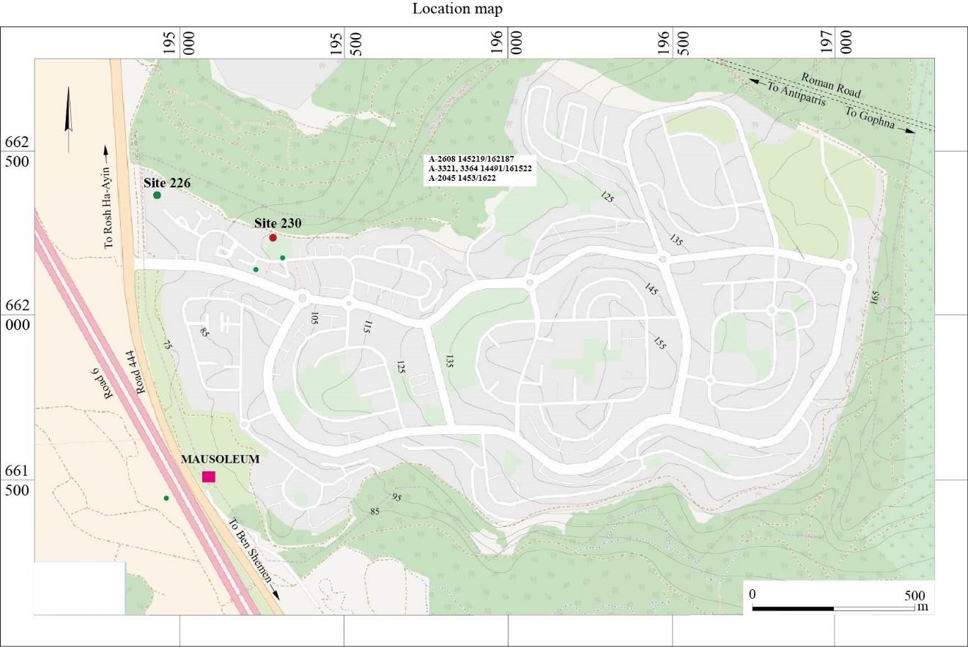
Fig. 1. Location Map.
Few excavations, carried out within the municipal boundaries of the city of Elad and its immediate vicinity, revealed traces of habitation dating to the Middle Bronze Age II period (Fig.1). In 1997 and 1999 a tomb and the compendium of potsherds dated to the MB II period were excavated by I. Milevski some 300 meters to the west of Site 226 (1999:87-89, 2001:73-74). Another tomb (Cave B4) situated on the western margins of the Cross Israel Highway, about one kilometer to the south of the entrance to the town, was explored during the excavations carried out during 2000 – 2001 (Milevski 2007; Gershuny, Nagar, Horowitz and Milevski forthcoming).
The current report will deal with two seasons of excavations, which were carried out at site 226. The first five adjacent squares were excavated in 2001, soon after the patrol road construction works were stopped. The remains of a large building were discovered immediately beneath the topsoil (Area A). The second season of excavations (2007) was caused by the plan of the town development; ten squares (4.0x4.0 m) and thirteen half squares (2.5x4.0 m), arranged in a grid, were spread over an area of 70x115 m. Squares, which were excavated during the previous season were included in a new grid and got new notations (Plan 1). The tasks of the second season excavation were: 1) To verify the boundaries of the ancient settlement; 2) To attest the preservation of its structures and 3) To examine the occupation span of the site.
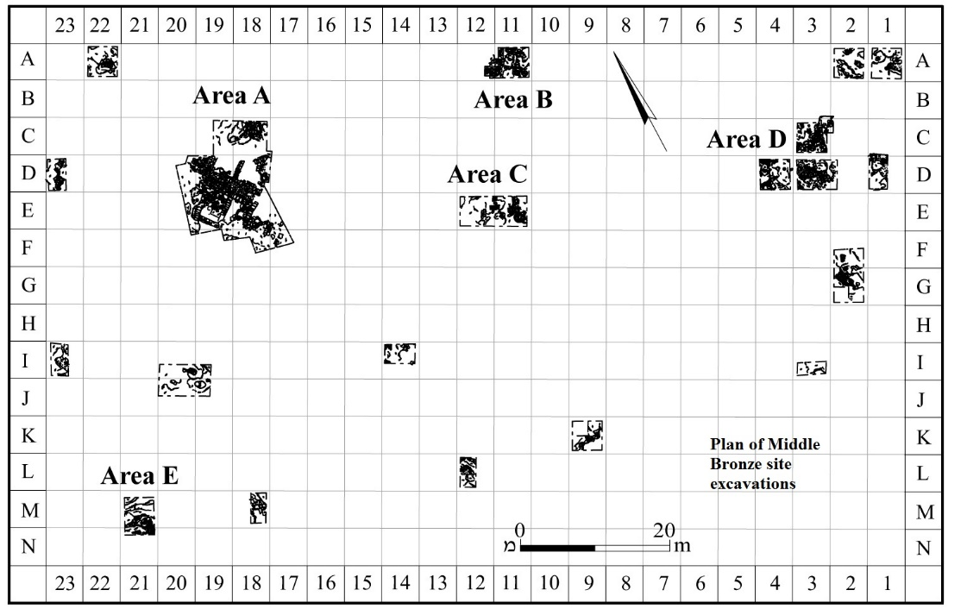
Plan 1. Joint plan of two seasons excavations
Constant use of the area in a variety of activities by local inhabitants and by the city's municipality exposed the remains of the ancient settlement in most of the squares almost at surface level. Rough topography contributed to the preservation of architectural remains only where the rock surface was somewhat lower, creating shallow gaps, while in those places where the bedrock rises and is visible, architecture was not preserved. Since excavation squares were isolated and scattered over a large area, only fragments of buildings were discovered, that do not compose buildings’ complete plans or the plan of the entire settlement. However, in those places where it was possible to open several adjacent squares: Area A (squares: C–F 18-20), Area B (squares A 11-12), Area C (squares E 11-12), Area D (squares C 3, D 3-4), the architectural remains revealed the method of buildings construction and even the character of the settlement (Plans 2-5).
The soil fill mixed with mud-brick debris and various sized stones in the other squares and half squares covering the bedrock and natural gaps included among MB IIB potsherds significant quantity of red painted pottery fragments dated to the MB IIA period. Small sections of well-packed earth floors (living surfaces) and bits of walls were discerned within a few of these squares (See Table I, Plans 6-12). An installation cut in bedrock was revealed in square J-19 (Plan 9). The lack of architecture in other squares may be explained by their small yardage and isolated location relatively far away from one another as well as poor preservation. In these squares, however, as well as in all the others, traces of the leveling of the bedrock were visible, and gaps and hollows were filled with soil mixed with pottery fragments and small field stones. (See Table 2, Plan 1). In spite of the lack of architectural remains in most of the single separately located squares, pottery and other finds from them will all be presented and discussed.
It should also be noted that those rooms/units which during excavations were intersected by a bulk received double numbers, such as 39/56 or 41/51.
Area A (Plan 2, Fig. 2)
It seems that all architectural remains revealed here belong to one large building, which consisted of at least nine rooms arranged on both sides of a narrow corridor. Walls between the rooms, as well as walls separating the rooms from the corridor, were built in two different techniques. In the first case (the south-western part of W28, W22, W32 and W50), they were built from large oblong fieldstones set in the width of the walls, while in the second case walls were constructed from two rows of medium to large fieldstones with a fill of small stones between. In a few rooms (Loci 39, 49, 57, 60) there were stone floors built of medium size flat stones, laid on a foundation of tightly rammed earth mixed with small stones. In other rooms (23, 41), the floors were earthen, sometimes with a few flat stones incorporated within.
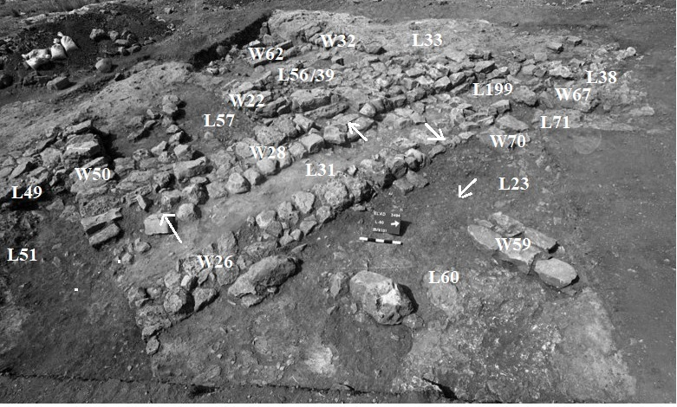
Fig. 2 Area A, General view to the south-west
The corridor (L31) is 1.30 m wide in the south-east, tapering towards the north-west. Its original floor (L199, height 80.63) was comprised of compacted mud - brick debris, mixed with animal bones, potsherds (Usiel: Fig. 5 - this volume), fragments of stone tools (Vered: Figs. 1: 1, 12; 2: 4 - this volume), flint (Yaroshevich: Fig. 3:6) and small pieces of charcoal. Later the corridor underwent structural changes (having no stratigraphic significance); two benches (W65, W66) were built along its eastern side close to W28. New floor (L31, height 80.73) built of large flat stones immediately above the earlier floor, tightly abutted the benches. Different in width, benches protruded above the floor at the same height of 10-12 centimeters.
Western row of rooms
Although only one of five rooms (Loci 33, 41/51, 49, 57 and 39/56) located to the west of the corridor was preserved with all four walls, it seems that all rooms were of the uniform size.
The western part of these rooms preserved badly, one of the reasons being the bedrock rising to the south and to the south-west (Loci 12, 24, 25). The southern room (L41/51) were partly destroyed by modern construction works.
Access into the rooms was from the corridor, as can be seen in the example of rooms L39/56 and L57. The wide entrance (0.90 m) framed by two jambs lead into room L56/39. The threshold abutting to the door socket on the south-western end only slightly protrudes above the corridor floor level. A large stone, carefully inserted into the stone floor immediately behind the threshold, forms a high ledge, probably preventing penetration of water into the room (Fig. 3).
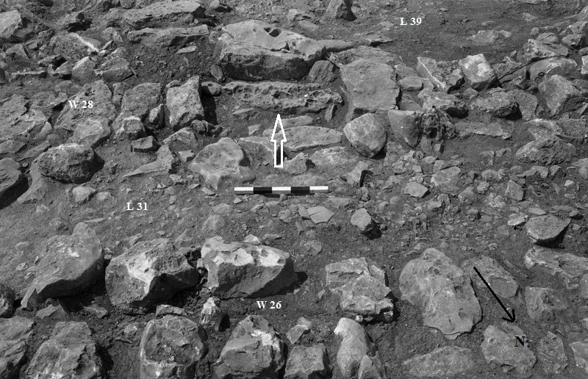
Fig. 3 Entrance to room L 39. View to the south-west
Only the eastern half of the room (L39) was paved with stones, while the rest of the floor in the other half of the room (L56) was made of beaten earth. This part of the room was about 30 centimeters lower than the stone paved part. Four crushed jars and a jug were found lying on the earth beaten floor L56 (Fig. 4; Uziel: Fig. 7).
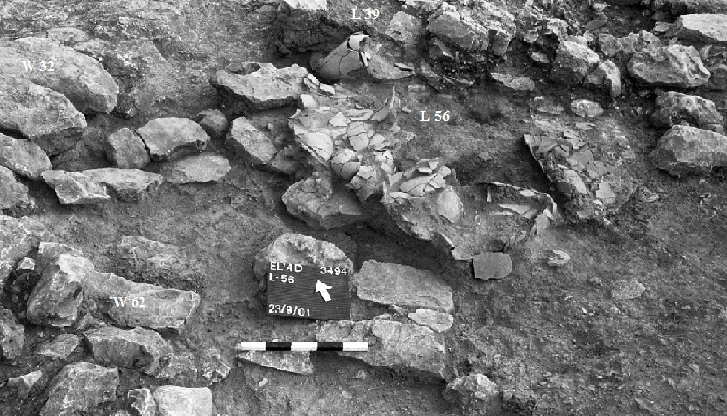
Fig. 4 Crushed jars in room 56. View to the north-east
Two grinding slabs (Vered: Fig. 2: 2), a few hammers (Vered: Fig. 1:2, 4-5) rubbing stones (Vered: Fig. 3: 6) and one perforated item (Vered: Fig. 4: 5) were collected from the thin layer of crushed bricks that covered the floor. Few flint tools were found within soil fill (Yaroshevich: Fig. 3:3, 5, 7). An upper half of a plaque figurine mold depicting a nude figure was found among the sherds of one of the crushed jars (Ras: Fig. 1:2).
No trace of the door was found at the entrance (0.90 m wide) to room L57. The stone floor of the room was laid at the same height as the stone pavement of corridor L31. Flat fieldstones of various sizes in room L57 as well as in room L49 were partly laid on soil fill mixed with small stones and partly on bedrock (Fig. 5). Few stone tools (Vered: Fig. 1: 3) and two perforated items (Vered: Fig. 4: 6-7) were collected from these floors.

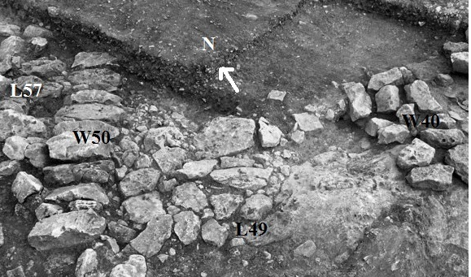
Fig. 5 Stone pavement in room L49
Few flat stones, which were found in the southern room (L41) indicate that this room was also paved. The floor here was covered with crashed pottery ware (Fig. 6; Uziel: Figs. 8: 5, 10-12; 9: 3, 16, 19).
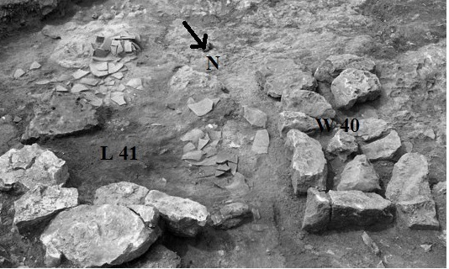
Fig. 6 Crushed jars in room L41
A thin soil fill above bedrock contained a fragment of a basalt mortar (Vered: Fig. 3: 7), animal bones and charcoal (Table 3).
The floor of the fifth room (L33), closing from the north a number of rooms located on the east side of the corridor is a leveled, almost smoothed bedrock. A square installation L64 (0.50 x 0.50 m) built of two long stones was discovered in the south-eastern corner of the room, rising over the floor to the height of 0.20 m. A rectangular stone, adjacent to the installation from the north, probably served as a jamb of a door that did not survive. Two rounded cone-shaped cup marks were hewn, one close to W32, the other not far from the first to the north. Fragments of a large jar were found in an ash deposit (L33) that filled the gap in bedrock in the corner between W32 and installation L64. (Uziel: Fig. 1: 12). Considerable number of potsherds (Uziel: Fig.1), flint tools (Yaroshevich: Fig. 3:1-2) and two grinding slabs (not illustrated) were found on the bedrock floor near the installation (Fig. 7).
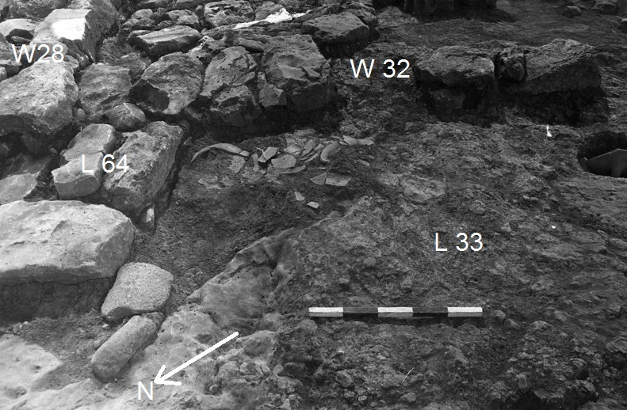
Fig. 7 Courtyard L 33. View to the south
Eastern row of rooms
Corridor L71 which diverges from corridor L31 in its northern part has almost a similar width and leads to the eastern row of rooms. Only few stones of this part of the corridor pavement survived, while its continuation to the west is represented by flattened bedrock. At least four rooms were revealed along the eastern side of corridor L31, one room was located to the north of corridor L51 while three others to the south.
Due to the limited area of the excavation only the southern corner of the northern room L38, enclosed by W27 and W67 was exposed. The massive collapse of stones filled the room up to the tops of the walls. A few pottery fragments were derived from the earth fill and stone collapse (Uziel: Figs. 8: 18; 9: 7).
The passage from room L23 to room L60 and beyond was arranged along W26 (Fig. 8). Considerable amount of crushed vessels, especially cooking ware, was collected from the earth-beaten floors in these rooms. A horn handle, probably of some small tool, was discovered on the floor of room L60 (Fig. 18: 6).
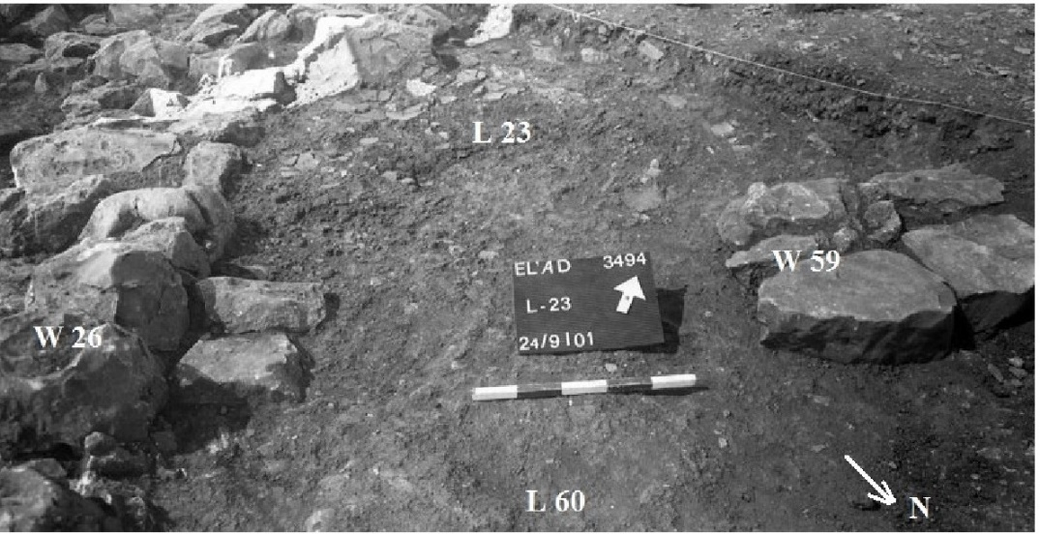
Fig. 8 The passageway between rooms L23 and L60
The north-western part of all rooms was not preserved, though traces of preparatory construction works are well represented. Bedrock was leveled, while hollows and gaps were filled with flat stones (L128, L186, Fig. 9). Two grinding stones were found within stone fill of L128 (Vered: Fig. 1: 11).
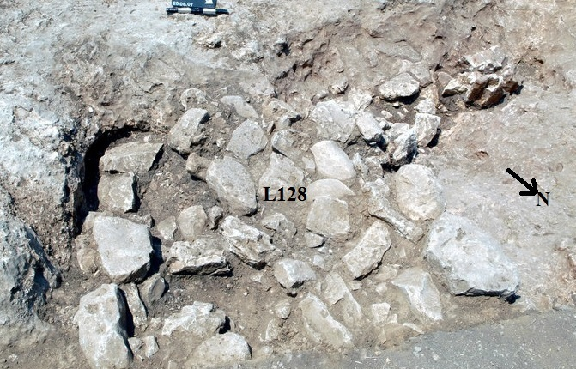
Fig. 9 Cavity in bedrock filled with stones L128, view to south-east
Summary
It seems that outer and inner walls of the building were built of mud bricks on stone foundations. This is indicated by the width of walls (0.65 - 0.75 m), built of roughly flattened stones and the debris fill covering the floors composed of mud-brick material.
The limited area of the excavation and the poor state of the architectural elements do not permit to restore the full layout of the building. Nevertheless, a careful interior plan should be noted. It includes two rows of similar size rooms, located on both sides of a long corridor, wide and convenient entrances to the rooms and passages between them as well as a rich and diverse repertoire of finds, which were collected from these rooms.
The domestic character of pottery finds, with the dominant presence of bowls, cooking pots and storage jars, as well as the wide repertoire of ground-stone tools, most of the them belonging to a plant-food processing, fit well the residential nature of the building.

Area B (squares A 11, 12, Plan 3, Fig. 10)
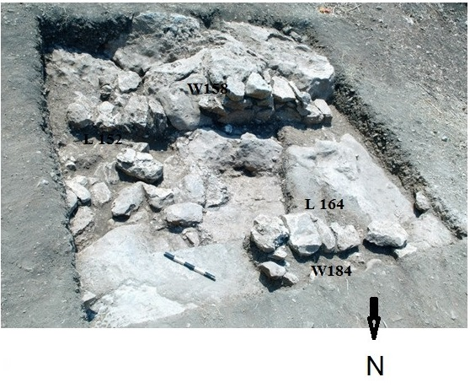
Fig. 10 Area B. View to the south
Architectural remains related to two construction phases were discovered at this small area. Wall 158, built straight on the bedrock with relatively big stones, placed across the wall and an earth-beaten floor (L152) abutted to it, are associated with the lower phase. Small portion of an earth-beaten floor (L203), which was discovered in the western corner of the area has the same height as floor (L152) and probably is its continuation. A grinding slab (Vered: Fig. 2:1), a flint tool (Yaroshevich: Fig. 6:6) were found within a massive layer of small potsherds (Uziel: Figs. 8: 1, 14; 9: 8, 11 – 12) and animal bones that covered the floor. Wall 158 continued to be used in the upper phase, while W184 was built on the earth fill, accumulated above floor L152. The earth-beaten floor (L126) adjacent to both walls was found covered by a thick layer of ash. Bronze awl (Fig. 18: 4), a scarab (Ben-Tor: Fig. 1: 1), two fragments of grinding stones (not illustrated), flint tools (Yaroshevich: Fig. 5:2; 6:2) and an upper part of a plaque figurine mold depicting a nude figure (Ras: Fig. 1:1) were collected from the floor. The floor continues to the north, into a passageway built in W184; originally it was narrower.
Summary
Fragmentary remains discovered in this area belong to two construction phases. The lower phase is represented by a part of one large room limited from the south-west by W158. Construction of a new wall (W184) was followed by lifting the floor and division of the space into smaller rooms.

Area C (squares E 11, 12, Plan 4, Fig. 11 View to the north)
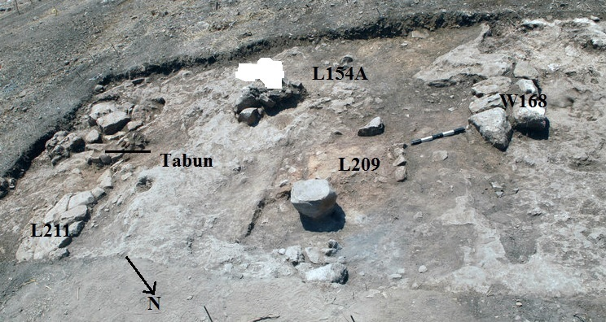
Fig. 11 Area C, view to south-east
Occupation layer that overlaid bedrock in Area C was only 0.25-0.35 m thick. However, modest architectural remains pointed to the existence of at least two construction phases. Only one architectural element can be attributed to the earlier phase. A small section of a well-packed earth floor L209 (height 82.25) laid straight on bedrock (L 196, height 82.20) was found limited from the north and east by a row of large pebbles. It seems that this floor belonged to an installation. Pottery sherds (Uziel: Fig. 2), two fragments of grinding slabs (Vered: Fig. 2: 3), flint tools (Yaroshevich: Fig. 4:2) and olive seeds (Table 3) were revealed incorporated in this floor.
A gray plaster floor (L154A), related to the upper phase, covered the earlier installation and a large portion of both squares. The floor is adjacent to W168 from both sides. The wall was built of two rows of roughly hewn stones and preserved to a height of one course. The remains of a tabun (L180) were preserved to the height of 10 centimeters, incorporated into this floor (Fig. 12).
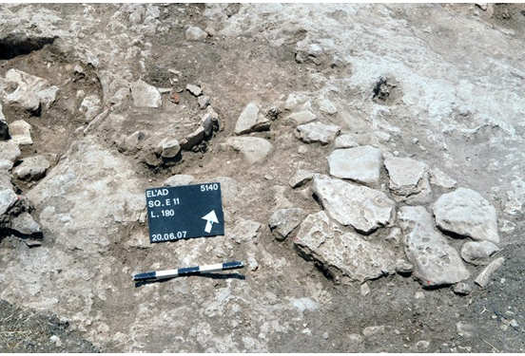
Fig. 12 Tabun L180 incorporated in floor L154A
A stone built rectangular installation (L170) has its floor built of small pebbles and is sunken into floor L154A near cupmark L147, whose inner sides were covered by gray plaster. A few animal bones were collected inside the installation as well as inside the cupmark. Large, almost flat on the upper surface, stone which was found protruding a couple of centimeters above the floor level in the northern part of the room, was probably used as a pillar base (W213). Ash debris layers (Loci 148, 153, 159) covered the floor and the entire area included many potsherds, mainly of large jars (Uziel: Figs. 4: 1-4; 4: 5-14; 9: 2, 13, 15), a hammer stone (Vered: Fig. 1: 8), a bronze dagger (Fig. 18: 1), flint tool (Yaroshevich: Fig. 6:5) and one perforated item (Vered: Fig. 4: 8).
A small segment of stone floor L211 was uncovered close to the eastern corner of square E11 laid on the debris layer and it has no relation to other elements. It is possible that this floor was related to the same stratum as floor L154A.
Summary
Two construction phases revealed in this area are represented by different installations. It gives the strong indication to a household work area, i.e. a courtyard. The lifting of the floor in the courtyard, caused probably by the reconstruction of the building to which the courtyard belonged, did not introduce major changes in the building plan, leaving the courtyard at the same place. Carefully built installations, some with paved floors and tabuns are often found in the courtyards of MB II dwellings (Edelstein, Milevski and Auarant 1998: 35, 36).
Area D (Squares C, D – 3, D 4, Plan 5, Fig. 13)
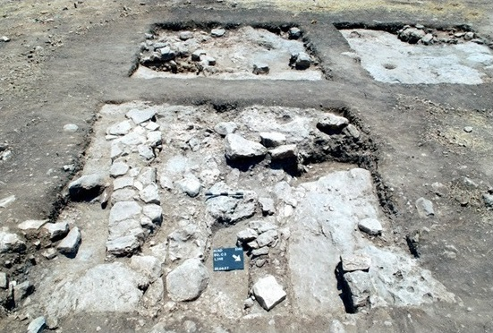
Fig. 13 Area D, view to the south-west
Excavations of three squares in this area revealed architectural remains related, as it seems, to three different units. A wide entrance, paved with flat large stones, indicated by a jamb, was exposed on the southern edge of W124 in square C3 (Fig. 14).
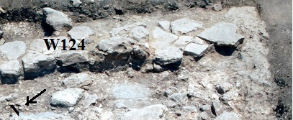
Fig. 14. Threshold in wall 124
The northern edge of the wall abutted to a protruded bedrock. The wall was built of two rows of unhewn stones flat on the top with a core of small stones straight on the debris deposit. A short segment of west - east W212, built in the same technique and abutted to the same bedrock, could potentially create a corner with W124. A hardly-packed yellowish - gray layer adjoined to W124 from both sides at the same height (L119, L147). A few flat stones, which were incorporated in this layer, gave the strong indication of the absolute level of the floors. The floor abutted on the west to a protruding bedrock with a conical shaped cupmark (0.34 m in diameter) hewn in its center. The debris fill covering this floor was composed of mud-brick material and it gave the floor a yellowish tint. Pottery fragments, a ceramic stopper (Vered: Fig. 4:9) and flint tools (Yaroshevich: Fig. 4:3) were collected from this fill.
Another unit (Sq. D3) consists of at least three rooms. Wall 125 was built of two rows of roughly hewn stones arranged with flat side up. The threshold built of two large stones indicates that the door opened to the east. The entrance leads from a large room (L109) on the west to smaller room (L102) on the east. The floor of this room did not survive. The stone pavement of the second eastern room (L121) abutted accurately to both exposed walls, W125 and W138. Yellowish - gray layer covered by mud - brick material, same as in Sq. C3, adjoined to W125 from the west along its length. In both squares (C3, D3) the yellowish-gray floors were laid over a thin layer of dark - brown earth, which covered a thick, gray plaster layer (L120, L140, Fig. 15).
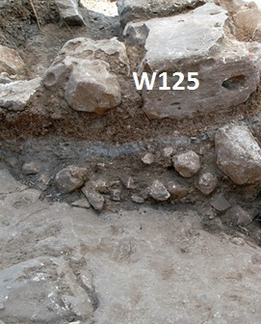
Fig. 15 Gray layer, sq. D3
Large amounts of red-painted pottery fragments, derived from within this layer and below it, few stone tools (Vered: Figs. 1:10; 2: 5; 3: 3), two perforated items (Vered: Fig. 4:1, 3) and flint tools (Yaroshevich: Fig. 4:5) were collected.
The eastern corner of the third building created by W143a and W143b was unearthed in Sq. D 4. Wall 143a was built of one row of large fieldstones while only small stones of foundation arranged in two rows survived from W143b.
An open space around the building corner was covered with a thick (up to 15 cm) layer of very densely compacted yellow material (crushed mud-bricks) mixed with many fragments of pottery, pieces of charcoal, animal bones and other debris (Loci 106, 136, Fig. 16).
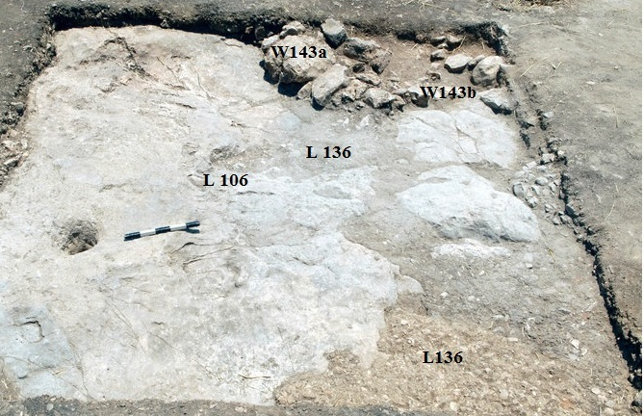
Fig. 16 Yellowish compacted layer, sq. D4
The layer abutted on the west W143b and on the south the protruding bedrock, the surface of which was slightly rectified and smoothed. Two conical cupmarks were found hewn in the bedrock, one in the eastern side of the square (0.35 m in diameter), the other (0.14 m in diameter) near the south-eastern corner of the square.
Summary
The poor preservation of architecture in this area was due not only to modern construction activity, but to the lowering of the bedrock to the south and south-west.
Two occupation strata were clearly discerned in this area. The earlier stratum consists of a gray plaster layer with a lot of red-painted potsherds, typical of MB IIA assemblages, within and below it. The late stratum is represented by bits of walls and floors related to at least three separate units. Two wide entrances, one in W124 and the other in W125, lead inside the buildings which probably had contiguous walls of two separate residential units. A large open space separates the two eastern units from the third; in its bedrock surface several hewn cupmarks were found. A thick, densely compacted layer of debris might indicate the usage of the place as a working area by the inhabitants of the residential quarter.
Squares with scanty architectural remains (Table I, Plans 6-12)
Scanty architectural traces preserved within six squares and semi-squares relates to two stratigraphic levels. The characteristic feature of the earlier level is many red slipped pottery sherds typical of MB IIA assemblages found mixed with potsherds of MB IIB within the soil that filled natural gaps in the bedrock. The upper stratum is represented by short sections of walls, small portions of floors, and one small oil press
A few small sections of an earth-beaten floor were discovered in squares A22 (L116, Plan 6), D23 (L156A, Plan 8), A12 (L113, Plan 11), M/N21 (L117, Plan 12). Floors partially laid above a flattened bedrock, and partly on a foundation built of flat stones, carefully filling natural hollows in bedrock were revealed.
Square D1 (Plan 7)
Large portion of an earth-beaten floor (L165) preserve covering a flattened bedrock and a light-brown sandy soil fills above it (L183). The floor was covered with gray spots and numerous burnt bones of small animals. Few flint tools were collected from the floor (Yaroshevich: Fig. 4:6). Perhaps, close to this place there was a tabun that did not preserve. In the north-west the floor abuts wall 214, which was built of large and medium-sized field stones, arranged in two rows or laid in the width of the wall.
Squares I/J 19/20 (Plan 9, Sq. IJ – 19 – 20; Fig. 17)
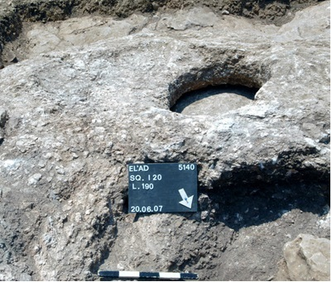
Fig. 17 Oil Press, sq. IJ-19-20
A small oil press (L190) was discovered hewn in the bedrock in the northern corner of square J 19. The installation included an oval treading floor, which was connected by a short channel to a round vat. The floor surface sloped toward the vat. Additional hewn lines were visible on the bedrock around the installation. An oblong gap in the rock was found filled with soil, pottery sherds (Uziel: Figs. 8: 4, 9, 17; 9: 14) and stones of various sizes (L195).
Bronze and bone artefacts (Fig. 18)
- Nagorsky
A few metal artefacts, all of them of bronze, were found. Three samples (Nos. 1-3) were analyzed by Ed XRF method using instrument EX-CALIBUR, although the data could be problematic because of possible influence of surface segregations.
No.1. An almost intact dagger with a broken tang, a rounded point and square shoulders was uncovered within the thin layer of soil that covered the gray plaster floor (L154A; Area C, Plan 4). It is 12.4 cm long, the maximum width is 4.2 cm. The long tanged daggers appear to be a local Canaanite phenomenon and were dated by Philip to the MB IIB (Philip 1989, I:113-114, II:414). Ed XRF method shows the following chemical composition: Cu + 0.3÷0.6%As + traces of Pb,Sn,Sb.
Two awls were found in the soil fills covering bedrock in squares M21 (L117, Plan 12) and A11 (L126; Plan 3). No. 2 is a complete tool with a handle made of horn. The bronze shaft (5.5 cm in length) square in section tapers toward the end, the slightly concave handle is 6.4 cm long. Its chemical composition is Cu + 12÷21%Sn + 0.6÷1%As + 0.1÷0.2%Pb. The awl was discovered on the well-packed earth floor (L117; Sq. M21) together with a fragment of a bronze blade (No. 4) and a cut bronze item of unknown function (No. 5).
The rounded shaft of awl No. 3 is 8.5 cm long and has remained sharpened at the tip. The opposite end, which is inserted in the handle, is square in section. Its chemical composition is different from the previous awl and consists of Cu + 0.3÷0.6%As + traces of Pb,Sn,Sb.
It is possible that the horn handle No. 6 found on the floor of room L60 in Area A (Plan 2) was also an awl handle. Tools of such type were found at several sites dating from the Early Bronze until Iron Age (Edelstein, Milevski and Aurant S. 1998:89).
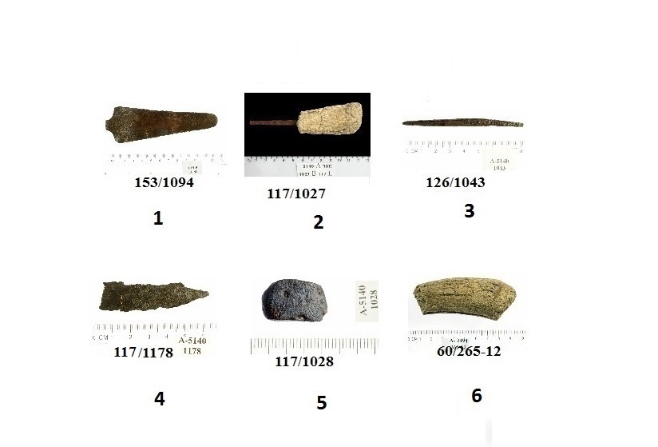
Fig. 18 Bronze and bone artifacts

Discussion and Summary
Although the excavation of the site in El’ad was limited and the excavated areas were small and spread far from one another, it provided some new data about the small MB II settlement.
A careful examination of the suburbs around the excavated area showed that most likely the area of the settlement did not exceed six dunams, i.e. the territory of the low mound occupied by the site today. On the gentle slope to the north of the site there are numerous caves, some of which apparently served as dwellings, others for burials in different periods (Kochavi and Beit-Arieh 1994:95). It is possible that two burial caves, one 300 meters to the west of village (Milevski 1999:87-89, 2001:73-74) and the other (Cave B4, Milevski 2007; Gershuny, Nagar, Horowitz and Milevski forthcoming) situated about one kilometer to the south of the entrance to the town, belonged to the inhabitants of the settlement.
No architectural remains were reported during modern construction works to the south, east and west of the mound, although potsherds dated to the MB II period were detected in the vicinity. Detailed survey as well as excavations of semi-squares, which were located around the perimeter of the site, revealed no remains of fortifications, gate or ramp, which confirms the rural character of the settlement.
Site construction is typical of hilly regions with protruding bedrock. The bedrock is used as walls foundation and its flattened surface often serves as floors. The walls lower courses were built in two rows of fieldstones or stretchers that form the width of the wall, with brick construction above them. Open spaces, perhaps used as working areas, were part of residential buildings.
The construction methods reflect a tradition that was observed in other small MB II settlements excavated along Nahal Mazor – Kh' Shai'ra (Peilstocker 2004), Fejja (Kaplan 1993), Kefar Avraham (IAA Archives, Kochavi and Beit-Arieh 1994: Site 94) as well as in many other similar sites in different parts of Israel, where such advanced architecture appeared together with the arrival of organized settlers (Kempinski 1992:97; Faust 2005:112; Cohen 2009:127).
The archaeological remains reveal two occupational periods: MB IIA and MB IIB. The first represented by bedrock hewn to level its surface and natural bedrock gaps, hollows and depressions being filled with soil and stones. The finds recovered from the fills revealed significant presence of red slipped pottery, typical of MBIIA assemblages. The most important indication of this phase comes from Area A (L33) and Area D (Loci 120, 140). Such massive straightening /flattening of the area suggests that the final aim was preparation of the area for construction works already in the MB IIA period, i.e. the time when the coastal plain south of the Yarkon river were occupied by a plurality of settlements (Kempinski 1992a: 166; Cohen 2002: 109).
Two construction phases were discerned in architectural remains belonging to the MB IIB settlement. The bulk of the architecture remains refers to the first, initial period of the construction while the second period is characterized only by renovation of buildings, proved by division of large rooms into small ones.
Although it is impossible to discuss the type of the dwellings as well as the plan of the entire village, the relatively small size of the settlement and the character of finds indicate a rural character. The pottery assemblage in which bowls, cooking pots and storage jars prevailed, and almost absolute lack of imported pottery reinforces this assertion. The repertoire of small finds, especially the rich variety of stone tools clearly shows that the main occupation of the villagers was plant-food processing, i.e. grinding and pounding. Careful analysis of the flint assemblage indicates an extensive production of flint tools on site, including the production of ad-hoc tools (Yaroshevich, this volume). Numerous spindle whorls, rubbing and hammer stones as well as bronze and flint tools display the multifarious household activities of the village inhabitants. Particularly noteworthy are the two figurine mold fragments made of the local sandy soil, whose discovery in definite archaeological context improves our understanding of religious cults and fine arts in the Middle Bronze Ages.
Wide and varied ensemble of findings as well as the results of the 14C analysis dated the beginning of the settlement to sometime in the mid-MB IIA and the abandonment during the MBIIB (Table 3; See in Table file).
Two scarabs, one of which was not discovered insitu (the scarab was found at the excavation of Hellenistic farmhouse, Site 230) offer a more accurate dating of the settlement existence at least until the middle of the sixteenth century BCE.
A modest repertoire of pottery vessels, in which many forms characteristic of settlements of MBII period are absent, chronologically parallel the Palace or post Palace phase at Aphek (Uziel this volume), which was the dominant city of the central coastal plain in the Middle Bronze period. The sphere of geopolitical influence of Aphek, limited in the south by the Yarkon River and the surrounding fertile plains and in the north reaching the Nahal Poleg basin (Gophna and Beck 1981:77) included numerous large and small settlements. Such extensive network of settlements is well known in the Jerusalem region (De Groot and Bernick-Greenberg 2012:148), Tel Aviv (Peilstocker 2004:78), the coastal plain (Broshi and Gophna 1986: Tables 8 - 9; Pp. 83-85), Samarian hills (Broshi and Gophna 1986: Table 6; Pp.79–81), Kabri and its environment (Yasur – Landau, Cline and Pierce. 2008:72), Beth-Shean area (Gal and Zori 2005:30) and other places.
The absence of any indication of destruction at the site suggests that it was probably abandoned, and this was not a unique phenomenon. Elad settlement as well as other different small settlements in the Costal Plain region was part of the overall process of the movement of rural population to large urban centers, which were quickly developing during the MB IIB period (Kletter 2006:115; Uziel 2008:234–235).
Tables

Table 1. Squares with scanty architectural remains
Square | Loci | Description | Finds
A 22  Plan 6 | 115, 116, 134, 202 | Earth-beaten floor | Pottery, animal bones, mill stones
D 1  Plan 7 | 151, 165, 183, W214 | Earth beaten floor, fragment of wall | Pottery, flint, animal bones
D 23  Plan 8 | 156, 156A, 161, 162 | Earth-beaten floor | Pottery, animal bones, mill stones
I-J/ 19 - 20  Plan 9 | 157, 175, 181, 189, 190, 195 | Oil Press (L 190) | Pottery, flint, animal bones
K 9  Plan 10 | 129, 135, 144 | Earth-beaten floor | Pottery, flint
L 12  Plan 11 | 111, 113, 123 | Earth-beaten floor, cupmark | Pottery, flint, animal bones
M – N 21  Plan 12 | 108, 117 | Earth-beaten floor | Pottery, flint, animal bones, bronze awl with a handle made of horn, arrowhead

Table 2. Squares without architectural remains.

Square | Loci | Description | Finds
A 1-2 | 100, 101, 107, 118, 132 | Fill | Pottery, flint, animal bones
FG 2 | 137, 166 | Fill | Pottery, flint
I 3 | 110 | Fill | Pottery
I 14 | 176, 201 | Fill | Pottery
I 23 | 182, 188, 200 | Fill | Pottery, animal bones
M 18 | 130 | Fill | Pottery, charcoal

Table 3. Radiocarbon Dating

Lab# | Field  ID | Type | 14C age ±1σ year BP | Locus | Basket | Calibrated range  ±1σ | Calibrated range  ±2σ
RTD6912 | L51, B190 | Charcoal | 3400±45 | 41 | 190 | 1745BC (68.2%) 1640BC | 1880BC ( 5.7%) 1840BC  1825BC (88.8%) 1610BC  1575BC ( 0.9%) 1565BC
RTD6913 | L196, B1168 | Olive pit | 3300±45 | 196 | 1168 | 1625BC (68.2%) 1520BC | 1690BC (93.7%) 1496BC  1475BC ( 1.7%) 1460BC
RTD6914 | L196, B1180 | Olive pit | 3340±45 | 196 | 1180 | 1690BC (51.7%) 1610BC  1580BC (16.5%) 1545BC | 1740BC ( 6.9%) 1710BC  1700BC (88.5%) 1510BC

References:
Ben-Tor D. This volume. El’ad Scarabs.
Broshi M. and Gophna R. 1986. Middle Bronze Age II Palestine: Its Settlements and Population. BASOR 261:73-90.
Cohen H. 2009. Middle Bronze Age II B Rural Settlements in the Eastern Valleys and
the Desert Frontier of Samaria Hill Country. Ostracon.
Cohen S.L. 2002. Canaanites, Chronologies, and Connections. The relationship of
Middle Bronze IIA Canaan to Middle Kindom Egypt. Eisenbrauns, Winona Lake, Indiana.
De Groot A. and Bernick-Greenberg H. 2012. Excavations at the City of David 1978-
1985 directed by Igal Shiloh. VIIA. Area E: Stratigraphy and Architecture. Text. (Qedem 53). Jerusalem
Edelstein G., Milevski Y. and Aurant S. 1998. Villages, Terraces, and Stone Mounds.
Excavatioms at Manahat, Jerusalem, 1987-1989. (IAA Reports No. 3). Jerusalem.
Faust A. 2005. The Canaanite Village: Social Structure of Middle Bronze Age Rural
Communities. Levant 37:105-125
Gal Z. and Zori N. 2005. A MB IIB-LB I Burial Cave at 'En Nasab. 'Atiqot 49:17-31
Gershuny L, Nagar Y, Horowitz L.K. and Milevski I. forthcoming . A Middle Bronze Age II Cave at Mazor (West). ‘Atiqot
Gophna R. and Beck P. 1981. The Rural Aspect of the Settlement Pattern of the
Coastal Plain in the Middle Bronze Age II. Tel Aviv 8:45-80
Kaplan Y. 1993. Fejja. In Stern E. ed. NEAEHL II. Jerusalem and Washington: Pp. 444-445.
Kempinski A. 1992. The Middle and Bronze Ages: Introduction. In Kempinski A.
and Reich R. eds. The Architecture of Ancient Israel from the Prehistoric to the Persian Periods. Jerusalem. Pp.97 - 98
Kempinski A. 1992a. The Middle Bronze Age. In A. Ben-Tor ed. The Archaeology of
Ancient Israel. New Haven–London. Pp. 159–210.
Kletter R. 2006. A Middle bronze Age II Site West of Tell Qasile. ‘Atiqot 53:66-128
Kochavi M. and Beit-Arieh I. 1994. Map of Rosh Ha – 'Ain (78) (Archaeological
Survey of Israel). Jerusalem.
Milevski I. 1999. Mazor (El'ad), Area S8. HA-ESI 109:87-89 (Hebrew).
Milevski I. 2001. Mazor (El‘ad), Area S8. HA-ESI 113:73-74 (Hebrew)
Milevski I. 2007 Mazor (West). HA-ESI 119 http://www.hadashot-esi.org.il/Report_Detail_Eng.aspx?id=571&mag_id=112 (Last visit 13.03.2019)
Peilstocker M. 2004. Khirbet Sha'ire: Excavations of a Rural Settlement from the
Middle Bronze Age II in the Vicinity of Tel Afeq (Aphek). ‘Atiqot 48:63-81.
Philip G. 1989. Metal Weapons of the Early and Middle Bronze Ages in Syria-
Palestine. (BAR Int. S. 526). Oxford.
Ras K. This volume. Two Middle Bronze Age II Female Plaque Figurine molds.
Uziel, J. 2008. The Southern Coastal Plain of Canaan during the Middle Bronze Age, Unpublished Ph.D. Thesis, Bar Ilan University, Ramat Gan.
Usiel J. This volume. The Middle Bronze Age Ceramic Assemblage from Elad.
Yaroshevich A. This volume. Flint Assemblage recovered from the Middle Bronze Age II site of El’ad.
Yasur – Landau A., Cline E.H. and Pierce G. A. 2008. Middle Bronze Age Settlement
Patterns in the Western Gallilee, Israel. Journal of Field Archaeology 33, 1:59-83
Vered A. This volume. The Ground -stone Tools from El’ad MBII Settlement.

Notes The rescue excavation was carried out in September 2001as a consequence of damage to the ancient sites during the construction of a new patrol road around the northern quarter of the town of El'ad (map. ref. NIG. 1949/6624; OIG. 1449/6624). The excavation (Permit No. 3494) was conducted by Alla Nagorsky on behalf of the Israel Antiquities Authority. Extension of the construction program in the city has caused the need for additional excavation at the area of the Middle Bronze II village and in May - June 2007 10 archaeological squares and 13 half squares were opened spreading on the area 70x120 m (Permit No 5140). I wish to thank Elena Kogan-Zehavi (area supervision), Yair Rehamim and Raid Abu-Khalaf (administration), Tania Kornfeld, Avi Hajian and Lilia Bolshov (surveying and drafting), Tsila Sagiv and Clara Amit (photography), Irena Lidsky and Avshalom Karasik (pottery drawing), Elena Kupershmidt (metal conservation). The report of the excavations of the Hellenistic farmhouse will be published separately.
As far as the pottery fragment derived from L179 (Sq.F-G2) is presented in Fig. 4:15 and discussed, the excavation plan in this square is also presented separately (Plan 13).
The red-slipped potsherds were almost 80 percent in the derived here ceramic finds, but lack of indicative fragments resulted in a decision not to represent them.
I want to thank Professor Sariel Shalev (Zinman Institute, University of Haifa) for the assistance in conducting the metallurgical analysis.
I wish to thank Dr. Elisabetta Boaretto for conducting the Co14 analyses and want to note that such imprecision and scatter in the dating may be explained by too shallow cultural layer and the proximity of the findings to the surface of the site. Plans Plan 2. Area A Plan 3. Area B Plan 4. Area C Plan 5. Area D Plan 6. Sq. A22 Plan 7. Sq. D1 Plan 8. Sq. D23 Plan 9. Sq. I-J 19-20 Plan 10 Sq. K9 Plan 11 Sq. L12 Plan 12. Sq. M-N 21 The Middle Bronze Age Ceramic Assemblage from El’ad Joe Uziel The excavations at El’ad (Nagorsky, this volume) yielded a ceramic assemblage from several achitectural units as well as an alleyway. Beneath the architectural units, intentional fills were used in order to fill gaps in the bedrock (Nagorski, this volume). These fills provide a dating for the initial settlement and construction at the site, while the accumulations on the floors can attest to the final use of the settlement and its abandonment. The proximity of the site to the major urban center of Aphek (Kochavi, Beck and Yadin 2000; Gadot and Yadin 2009) most likely indicates that the village was within the cultural and political sphere of the primary Middle Bronze Age city along the Yarkon River. Other similar villages have been excavated in the region, such as Fejja (Kaplan 1964; 1993), Nahshonim, Hirbet Mullabis (Gophna and Beck 1981) and Khirbet Sha’ira (Peilstocker 2000; 2004). In the following paper, the assemblage from the construction and accumulations from the buildings is presented typologically, followed by a discussion of the different contexts and their chronological attribution. The Ceramic Assemblage Bowls Open (BL1), rounded (BL2) and Carinated bowls are all represented in the ceramic assemblage from El’ad, with one example of a globular bowl. The open bowls, with relatively straight walls and a large diameter in relation to the vessels height, are quite common throughout the Middle Bronze Age, although slight changes in rim forms are chronologically indicative. Rim forms include plain (BL1.1, e.g., Fig. 1.1), everted (BL1.2, e.g., Fig. 2.4), thickened (BL1.3, e.g., Fig. 4.1), and inverted (BL1.4, e.g., Fig. 8.8–10). Two open bowls have loop handles extending from the rim to the body (BL1.5, e.g., Fig. 1.4). All such open bowls, well–represented in the El’ad assemblage, are also known from nearby MB sites, such as Aphek (Beck 2000: Fig. 10.20:8), Lachish (Singer–Avitz 2004: Fig. 16.4:2–6), Gezer (Dever et al. 1974), Shechem (Cole 1984: Plate 2:i–j). Seemingly absent are open bowls with outfolded rims and bowls with red–cross decorations, typical of the MBIIA (e.g., Beck 2000: Fig. 10.18:3; Baker 2006:11). Also absent are the very large open bowls which develop in the later part of the period. Rounded bowls include vessels with curved walls, deeper than the open bowl. The chronological value of these vessels is minimal, as they mostly continue throughout the period. Rim morphology varies very slightly, with no chronological or functional significance. The vessels were divided according to rounded bowls with simple rims (BL2.1, e.g., Fig. 8.11–12) and everted rims (BL2.2, e.g., Fig. 6.6). Rounded bowls can be found at many sites in the region (e.g. Lachish, Singer–Avitz 2004: Fig. 16.9:5–6; Aphek, Beck 2000: Fig. 10.4:8–9; Yavne–Yam, Uziel 2008: Figure 18; Tel Nagila, Uziel 2008: Fig. 53:7–9; Tel Batash, Panitz–Cohen and Mazar 2006: Pl. 38:3). Carinated bowls are the most chronologically significant in the Middle Bronze Age, as they are quite common in most assemblages, with their classic forms limited to the period, almost completely disappearing in the subsequent period. Within the period, they also help in the differentiation of MBIIA and MBIIB contexts, with certain types only known from later contexts. Open carinted bowls (BL3.1, e.g., Fig. 2.7), a hallmark of the MBIIB, were present, although rare in the El’ad assemblage. Parallels are known from many sites, including Lachish (Singer–Avitz 2004: Fig. 16.11:6), Gezer (Panitz–Cohen and Maeir 2004: Plate 3:1), Shechem – Cole 1984: Plate 18:f) and Tel Nagila (Uziel 2008: Fig. 54:1). Closed carinated bowls (BL3.2, e.g., Fig. 5.9–10) are more common in the assemblage. While these vessels are known throughout the period, the particular form and the fact that many of the vessels are red–slipped seems to indicate that they date to the MBIIA (Tel Batash, Panitz–Cohen and Mazar 2006: Pl. 6:20; Aphek, Beck 2000: Fig. 10.12:4; Gezer, Dever et al. 1974: Plate 14:12; Tell el–Dab’a, Aston 2004: Pl. 93: 284–286). Other carinated bowls include a straight wall above the carination, with an everted rim (BL3.3, e.g., Fig. 4.2–3). These bowls are typical of the later stages of the MB and the very early stages of the LB (e.g. Gezer, Panitz–Cohen and Maeir 2004: Pl. 3:5; Lachish, Singer–Avitz 2004c: Fig. 18.6:3). A similar form, although with a more rounded carination, is the S–Shaped Rim (BL3.4, e.g., Fig. 6:8–9). Whereas the carination of the former types were located at the lower part of the bowl, here it is located below the rim. Furthermore, the carination on s–shaped bowls is less sharp and more rounded in nature. Examples are known from Lachish (Singer–Avitz 2004: Fig. 16.33:2) and Ashkelon, Phase I (Baker 2006: Fig. 6–7). Kraters Kraters were defined as such according to their size, being lagrer than the bowls discussed above. Most of the kraters are deeper than the bowls, with rounded walls, similar in form to the rounded bowls, with varying rim forms, ranging from plain rims (KR1, e.g., Fig. 5.11), everted rims (KR2, e.g., Fig. 8.14–16) and outturned rims (KR3, e.g., Fig. 2.11). One example has a simple rim, with two loop handles extending from the rim to the body (KR4, e.g., Fig. 6.10). Kraters are a common form in most MB assemblages, such as Lachish – Singer–Avitz 2004: Fig. 16.9:11) and Tel Nagila (Uziel 2008: fig. 57). Cooking Pots Cooking pots were categorized according to globular (CP1) and carinated (CP2), and then further divided according to rim morphology. It is interesting to note the absence of straight–sided handmade cooking pots. While once thought to be MB I, their appearance in MB II contexts has been substantiated (e.g. Ilan and Marcus forthcoming; Bonfil forthcoming). Globular cooking pots (CP1) are the most dominant form at El’ad, with only a few examples of the later, carinated form (CP2). Rim form include plain rims (CP1.1, e.g., Fig. 1.6), gutter rims (CP1.2, e.g., Fig. 1.7–8) and Thickened out–turned rims (CP1.3, e.g., Fig. 5.13). Similar cooking pots were found at Aphek (Beck 2000: Fig. 8.10:6, 8), Lachish (Singer–Avitz 2004: Fig. 16.31:1) and Tel Batash (Panitz–Cohen and Mazar 2006: Pl. 5:16). The few examples of carinated cooking pots (CP2, e.g., Fig. 6.15) found at El’ad have a triangular section rim. While this is dominant rim form of Late Bronze Age cooking pots (e.g. Lachish, Yannai 2004: 19.9:9; Tel Batash, Panitz–Cohen and Mazar 2006: Plate 22:1–3 its appearance in the Middle Bronze Age is also well–known, although more indicative of the later part of the period (e.g. Lachish, Singer–Avitz 2004: Fig. 16.16:1; Ashdod, Dothan and Porath 1993: Fig. 2:15). Despite the lack of straight sided cooking pots, the dominance of the globular form, with only few examples of the cartinated form seem to indicate that both phases of the MB village at the site date prior to the final stages of the Middle Bronze Age. Baking Trays Baking trays were also found in the assemblage in small quantities (e.g., Fig. 6.11). The baking tray is common in the Middle Bronze Age (e.g. Aphek, Beck 2000: fig. 10.13:17; Shechem, Cole 1984: Plate 45:l; Gezer, Dever et al. 1974: Plate 17:7; Plate 16:16; Yavne–Yam, Uziel 2008: fig. 22). The examples here are missing the rope decorations, commonly found on the vessels. Storage Jars Storage jars were divided according to rim typology, as for the most part not enough of the body was restorable in order to determine the full shape of the vessel. Six rim types were defined, all typical of Middle Bronze Age assemblages. The first is an everted rim, with a ridge on the neck of the jar (SJ1, e.g., Fig. 9.1; see, e.g. Lachish, Singer–Avitz 2004: Fig. 16.14: 6; Tel Batash, Panitz–Cohen and Mazar 2006: Pl. 5:7). Profiled rims are the most common rim form (SJ2, e.g., Fig. 1.11), a very common rim form in the MB (e.g. Aphek, Beck 2000: Fig. 10.23: 4; Lachish, Singer–Avitz 2004: Fig. 16.26: 7; Tel Batash, Panitz–Cohen and Mazar 2006: Pl. 5:6, 8; Tell ed–Dab’a, Aston 2004: Pl. 174: 639). Plain everted rims (SJ3, e.g., Fig. 2.15–16) are also common in the El’ad assemblage, and well–known at nearby sites (Tel Batash, Panitz–Cohen and Mazar 2006: Pl. 5:21; Aphek, Beck 2000: Fig. 10.20: 10; Lachish, Singer–Avitz 2004: Fig. 16.17: 4). Other, less common forms include straight neck jars (SJ4) with a gutter rim (4.1, e.g., Fig. 2.4), plain rim (4.2, e.g., Fig. 2.17), and outfolded rim (SJ4.3, e.g., Fig. 2.18) as well as an everted neck jars with an outfolded rim (SJ5, e.g., Fig. 9:13–14) and with an out–turned rim (SJ6, e.g., Fig. 9:16). Jugs and Juglets Jugs and juglets are not very common in the El’ad assemblage. The most common type defined is the dipper jug (JG1, e.g., Fig. 7.10) and juglet (JL1, e.g., Fig. 9:17–18). Such vessels are common in the Middle Bronze Age, with a piriform shaped–body, a pointed base a long neck and a strap handle from the shoulder to the rim of the vessel. The differentiation between the jugs and juglets was made according to size, with the shape remaining the same. While the dipper juglet continues to appear in the LBA, the larger jugs are exclusively known from the MBA, particularly the MBIIB. The earlier versions of juglets are often red slipped and burnished. The juglet form is more common (for a detailed discussion of dipper juglets’ formation, see Kopetsky 2002). Similar vessels are found at Tell el–Dab’a Strata E/2–E/3 (Kopetzky 2002:231–234), Lachish (Singer–Avitz 2004: Fig. 16.32:5), Ashdod (Dothan and Porath 1993: Fig. 1:21), Shechem (Cole 1984: Plate 27:c), Gezer (Dever et al. 1974: Plate 14:31; Panitz–Cohen and Maeir 2004: Plates 5:3; 12:5), Yavne–Yam (Uziel 2008: Fig. 24:1) and Tel Nagila (Uziel 2008: Fig. 61:1). A few examples of other common MB types of juglets were found. Several button base of juglets likely belong to typical piriform juglets (JL2, e.g., Fig. 7.11–12), another type almost exclusive to the Middle Bronze Age (e.g. Lachish, Singer–Avitz 2004b: Fig. 17.8:10; Shechem, Cole 1984: Plate 28:h–k; Tel Nagila, Uziel 2008: Fig. 61:3–4). It is likely that the rim types defined also belong to this type of juglet, although this is not certain and therefore were defined individually. The rim types vary greatly, with the stepped rim (JL3, e.g., Fig. 9.19), candlestick rim (JL4, e.g., Fig. 3.13), rolled rim (JL5, e.g., Fig. 3.14), out–folded (JL6, e.g., Fig. 4:15), out–turned (JL7, e.g., Fig. 5.22), flaring (JL8, e.g., Fig. 7.13) and gutter rim (JL9, e.g., Fig. 1:16) represented. Several of these types – particularly, the gutter, stepped, and candlestick rims are hallmarks of the MB IIA (e.g. Beck 2000:209–210). It has been suggested that the stepped–rim juglet is the successor of the collarette juglet (e.g. Epstein 1974:2*). The juglets were found in the post–palace phase at Aphek (Beck 2000: Fig. 10.21:10) and Tell el–Dab’a (Aston 2004: Pl. 114:374). This type of rim is very indicative of the later stages of the MB IIA and early stages of the MB IIB (Ilan 1991; Maeir 1997b; Beck 2000:215). One bottle rim and neck was also found (JG2, e.g., Fig. 3:10). These vessels have a globular body, long neck and no handles. The latter feature (or lack thereof) has led some scholars to exclude them from the category of jugs, as jugs must have a handle. That said, functionally and size wise, bottles are similar to jugs, and used for pouring liquids too. The form is typical of MBIIA assemblages, continuing IBA forms and possibly being of Syrian stylistic influence (Ilan and Marcus forthcoming). Bottles were found at Efrata (Gonen 2001: Fig. 24:13) Decorated Sherds and Surface Treatment The assemblage at El’ad yielded significant amounts of red slipped pottery. As noted in the MBIIA Aphek assemblage, this is a very common feature in the palace and post–palace assemblages, which almost completely disappears in the MBIIB (for a possible reason for this disappearance, see Franken and London 1995). The presence of red slip is mostly limited to the earlier phase at El’ad, providing a likely date sometime in the MBIIA, probably parallel to the palace and post–palace phases at Aphek (Beck 2000). In addition to the red slipped pottery, one sherd of RWB ware was found (Fig. 7:14). This type of decoration appears in the early stages of the MB I (Stager 2002: 355), and continues into the MB II, until it is replaced by the Chocolate–on–White ware in the terminal phases of the MB. The blue paint is perhaps an indication of ties with Egypt during the period, where cobalt was used for blue designs (Maeir 2002). Finally several sherds of seemingly Cypriot origin were found in the excavations. The first belongs to the Cross–Line and Pendant Line Style, with red lines crossing, painted on the body sherd of a jug (Fig. 7:15). This family of imported pottery is widespread in the Middle Bronze Age IIB (see, e.g., Johnson 1982; Maguire 2009). The three remaining Cypriot sherds belong to the typical Late Bronze Age imported pottery families of the white–slipped milk bowl and Base Ring jugs, and are seemingly intrusive, although may indicate a Late Bronze Age presence at the site, which is yet to be discovered. Discussion The ceramic assemblage from the village of El’ad is comprised of typical Middle Bronze Age forms, with representation of earlier types (such as the closed carinated bowls and the stepped–rim and candlestick juglets) and later forms (such as the open carinated bowl and the carinated cooking pots). In addition, notable is the significant presence of red slipped pottery, typical of MBIIA assemblages, and lacking in the MBIIB. With this in mind, it seems that the building was first established in the MBIIA, as noted in the MBIIA pottery found in the fills within the bedrock (e.g., L33). The building was used from this point and into the MBIIB period, as noted in some of the later forms found within the building. The assemblage is composed primarily of bowls (including open, rounded and carinated bowls), cooking pots and storage jars. The dominance of these types, along with the lack of imported pottery, save for one sherd, and unique vessel types (e.g., goblets) and families (e.g., Tel el–Yehudiah Ware, Levantine Painted Ware), fit well with the rural nature of the settlement, where mostly locally made, utilitarian vessels were found. The relative paucity of juglets fits well with this definition for the site. It appears that the settlement was abandoned sometime in the MBIIB, as there is little evidence for later occupation, save for stray imported Cypriot sherds. It is possible that these reached the excavation area from a different part of the site, settled in this period, which has yet to be exposed. In fact, it would seem that the abandonment of the village occurred prior to the end of the period, with some typical late wares lacking, such as the eggshell and bichrome ware families. While it is possible that the lack of these wares is due to the nature of the site (and thus linked to the other wares not present mentioned above), the general paucity of classic MB IIB forms, such as only one example of a high ring base, one example of an open carinated bowl, and the presence of certain early forms in the buildings floor accumulations, seem to suggest that in fact the settlement was a short-lived settlement, established at some time in the mid-MBIIA, chronologically parallel to the Palace or post Palace phase at Aphek. This is indicated by the fragmentary, eroded slipped pottery commonly found in these fills, which is typical of the Palace and Post-Palace phases at Aphek. The site was then abandoned during the MBIIB. While certain types (BL3.1, CP2, Cypriot White Painted, high ring bases) ensure that the settlement continued during the MBIIB, these are rare in the assemblage and suggest that perhaps the abandonment of the settlement may have been linked to the geo-political changes occurring between the MBIIA and the MBIIB. The abandonment of rural settlements in the MBIIB has already been suggested (Dever 1997: 291) as a result of the Hyksos expulsion and the change in settlement patterns. While some have argued against the extent of influence of the Hyksos expulsion on MB Canaan (see, e.g., Hoffmeier 1989), there are shifts in the location of rural sites during the course of the MB IIB, possibly also linked with the changes in intra-site dynamics and dominance of one major urban center over another. While in the MBIIA, Aphek is clearly one of the most dominant sites in the region (with only Ashkelon on its level – see, e.g., Stager 2001; 2002; Burke 2004: 214-228), during the MBIIB, the urban sites grow extensively, creating a shift in the location of rural ssites, which are place more strategically in relation to their controlling urban center as well as available land resources (Uziel 2008:234–235). It is likely that the abandonment of El’ad is in some way related to shifting settlement patterns, whether due to the Hyksos expulsion or not (for further discussion on the effects of the Hyksos expulsion on MB Canaan, see, e.g., Weinstein 1981, 1991; Hoffmeier 1989; Dever 1990). Fig. 1 Pottery from Locus 25 and 33, Fill above Bedrock # Loci Reg. # Class Type Comments 25 126/6 BL 1.1 25 126/1 BL 1.4 33 223/4 BL 1.4 25 264 BL 1.5 25 225/5 BL -- High Ring Base 25 126/5 CP 1.1 25 126/4 CP 1.2 33 222/8 CP 1.2 25 243/3 CP 2 33 209/2 CP 2 33 152/1 SJ 2 33 152/3 SJ Lower portion of Ovoid SJ 33 152/2 SJ 3 33 222/10 JG 1 33 152/9 JL 1 Pointed base 33 152/12 JL 9 Gutter rim Fig. 2 Pottery from Loci 196 and 209 # Loci Reg. # Class Type Comments 196 1180/11 BL 1.1 196 1180/6 BL 1.1 196 1180/9 BL 1.1 196 1180/10 BL 1.2 209 1184/2 BL 2.1 209 1184/3 BL 2.1 196 1180/12 BL 3.1 209 1184/4 BL 3.2 209 1184/5 BL 3.2 196 1180/1 BL 3.3 196 1159/3 KR 3 196 1180/2 SJ 2 196 1180/3 SJ 2 196 1180/7 SJ 2 196 1159/6 SJ 3 196 1180/4 SJ 3 196 1180/8 SJ 4.2 209 1184/1 SJ 4.3 Fig. 3 Pottery from Surface Loci 153 and 12 # Loci Reg. # Class Type Comments 153 1094/3 BL 1.1 153 1094/2 BL 1.4 153 1096/1 SJ 2 153 1096/2 SJ 2 153 1096/3 SJ 2 153 1096/5 SJ 2 153 1094/4 SJ 3 153 1094/6 SJ 4.1 153 1094/5 JG 1 153 1096/4 JG 2 12 102/26 BL 1.1 12 102/8 BL 2.1 12 102/54 JL 4 12 102/53 JL 5 Fig. 4 Pottery from Surfaces of Structures (L 148, 153, 179, 202) # Locus Reg. # Class Type Comments 148 1082/3 BL 1.3 148 1082/4 BL 3.3 148 1082/5 BL 3.3 148 1082/2 SJ 3 153 1094/3 BL 1.1 153 1094/2 BL 1.4 153 1096/1 SJ 2 153 1096/2 SJ 2 153 1096/3 SJ 2 153 1096/5 SJ 2 153 1094/4 SJ 3 153 1094/6 SJ 4.1 Straight neck, gutter rim 153 1094/5 JG 1 153 1096/4 JG 2 Bottle 179 1190/1 JL 6 Out-folded rim 202 1171/5 SJ 2 202 1171/2 JG 1 Tri-strand handle Fig. 5 Pottery from Loci 31/199 (Corridor) # Loci Reg. # Class Type Comments 199 1165/6 BL 1.4 199 1165/8 BL 1.4 31 221/18 BL 1.4 31 260/11 BL 1.4 31 260/8 BL 1.4 31 260/9 BL 1.4 31 221/25 BL 2.2 31 221/19 BL 2.2 199 1165/3 BL 3.2 31 221/21 BL 3.2 31 221/4 KR 1 31 200/1 CP 1.1 31 221/22 CP 1.3 199 1175/1 SJ 2 31 221/23 SJ 2 31 335/1 SJ 2 31 185/4 SJ 3 31 260/12 SJ 3 31 228/26 SJ 4.1 31 260/4 JL 1 Pointed base 31 221/10 JL 2 Button base 199 1165/1 JL 7 Fig. 6 Pottery from Loci 39 and 56, Brick Collapse above floor # Loci Reg. # Class Type Comments 39 170/4 BL 1.1 39 170/6 BL 1.1 56 288/8 BL 1.2 56 1275/3 BL 1.2 56 288/10 BL 1.4 39 124/4 BL 2.2 56 289/1 BL 3.2 56 275/18 BL 3.4 56 275/6 BL 3.4 56 288/1 KR 4 56 288/5 BT 56 289/2 CP 1.1 56 249/6 CP 1.2 39 169 CP 1.2 56 253/2 CP 2 Fig. 7 Pottery from Loci 39/56, Brick Collapse above floor # Loci Reg. # Class Type Comments 56 275/8 SJ 2 56 273/20 SJ 2 56 267/2 SJ 2 56 275/17 SJ 3 39 224/1 SJ 3 56 2617 SJ 3 56 288/12 SJ 4.1 39 224/5 SJ 4.3 56 253/4 SJ 6 39 224/7 JG 1 56 266/1 JL 2 Button base 56 275/2 JL 2 Button base 56 266/2 JL 8 56 240/2 SJ RWB Ware 56 240/1 JG Cypriot White Painted Cross-band Fig: 8 Pottery from various MB Fills, Loci 23, 24, 38, 41, 51, 60, 152, 162, 195, 204 # Locus Reg. # Class Type Comments 152 1088/1 BL 1.1 51 211/5 BL 1.1 51 211/51 BL 1.1 195 1135/2 BL 1.2 41 174/10 BL 1.2 24 125/1 BL 1.3 60 254/4 BL 1.3 204 1173/11 BL 1.4 195 1135/3 BL 1.4 41 226/8 BL 1.4 41 174/2 BL 2.1 Burnish on exterior and base 41 174/21 BL 2.1 Burnish on exterior 60 265/10 BL 3.2 152 1088/3 KR 2 204 1173/4 KR 2 162 1109/7 KR 2 195 1135/1 CP 1.1 38 185/3 CP 1.2 23 139/8 CP 1.2 162 1109/2 CP 1.2 23 139/11 CP 1.3 Fig. 9 Pottery from various MB Fills, Loci 23, 38, 41, 60, 152, 159, 162, 195, 204 # Locus Reg. # Class Type Comments 60 291/2 SJ 1 159 1120/9 SJ 2 41 242/1 SJ 2 204 1173/7 SJ 2 204 1173/2 SJ 2 204 1173 SJ 2 38 168/1 SJ 3 152 1100/1 SJ 3 162 1109/5 SJ 3 204 1173/3 SJ 3 152 1088/2 SJ 4.2 152 1100/2 SJ 4.2 159 1120/7 SJ 5 195 1155/1 SJ 5 159 1120/8 SJ 6 41 212/1 JG Flat Base 23 139/5 JL 1 Pointed base 204 1173/6 JL 1 41 226/4 JL 3 References Aston D.A. 2004. Tell el–Dab’a XII: A Corpus of Late Middle Kingdom and Second Intermediate Period Pottery. Vienna: Osterreichischen Akademie der Wissenschaften. Baker J.L. 2006. The Funeral Kit: A Newly Defined Canaanite Mortuary Practice Based on the Middle and Late Bronze Age Tomb Complex at Ashkelon. Levant 38:1–31. Beck P. 2000. Area A: Middle Bronze Age IIA Pottery. Pp. 173–238 in M. Kochavi, P. Beck and E. Yadin (eds.) Aphek–Antipatris I: Excavations of Areas A and B – The 1972–1976 Seasons. Tel Aviv: Tel Aviv University. Bonfil R. Forthcoming. Pottery of the Middle Bronze Age IIB–C. In S. Gitin (ed.) The Ancient Pottery of Israel and its Neighbours from the Neolithic through the Hellenistic Period. Jerusalem: Israel Exploration Society. Burke, A.A. 2004. The Architecture of Defense: Fortified Settlements of the Levant during the Middle Bronze Age. Unpublished PhD Dissertation, University of Chicago. Cole D. P. 1984. Shechem I: The Middle Bronze IIB Pottery. Winona Lake: Eisenbrauns. Dever W. G., Lance H. D., Bullard R.G., Cole D. P. and Seger J. D. 1974. Gezer II: Report of the 1967–1970 Seasons in Fields I and II. Jerusalem: Hebrew Union College. Dever W. G., 1990. Hyksos, Egyptian Destructions, and the End of the Palestinian Middle Bronze Age. Levant 22:75-81. Dever W. G., 1997 Settlement Patterns and Chronology of Palestine in the Middle Bronze Age. Pp. 285-302 in E. Oren (ed.) The Hyksos: New Historical and Archaelogical Perspectives, University Museum Monograph 96. Philadelphia: University Museum. Dothan M. and Porath Y. 1993. Ashdod V: Excavations of Area G. `Atiqot 23. Jerusalem: Israel Antiquities Authority. Epstein C. 1974. Middle Bronze Age Tombs at Kefar Szold and Ginosar. ‘Atiqot 7: 13–39. Franken, H.J. and London, G. 1995. Why Painted Pottery Disappeared at the End of the Second Millennium BCE. Biblical Archaeologist 58(4): 214–222. Gadot, Y. and Yadin, E. 2009. Aphek–Antipatris II: The Remains on the Acropolis, the Moshe Kochavi and Pirhiya Beck Excavations. Tel Aviv University Sonia and Marco Nadler Institute of Archaeology Monograph Series 27. Tel Aviv: Tel Aviv University. Gonen, R. 2001. Excavations at Efrata: A Burial Ground from the Intermediate and Middle Bronze Ages. IAA Reports 12. Jerusalem: Israel Antiquities Authority. Gophna R. and Beck P. 1981. The Rural Aspect of the Settlement Pattern of the Coastal Plain in the Middle Bronze Age II. Tel Aviv 8: 45–80. Hoffmeier J.K. 1989. Reconsidering Egypt’s Part in the Termination of the Middle Bronze Age in Palestine. Levant 21: 181-193. Ilan D. 1991. “Stepped–rim” Juglets from Tel Dan and the MB I–II (MB IIA–B) Transitional Period. Israel Exploration Journal 41/4: 229–238. Ilan D. and Marcus E. Forthcoming. Pottery of the Middle Bronze Age IIA. In S. Gitin (ed.) The Ancient Pottery of Israel and its Neighbours from the Neolithic through the Hellenistic Period. Jerusalem: Israel Exploration Society. Johnson P. 1982. The Middle Cypriot Pottery Found in Palestine. Opuscula Atheniensia 14: 49–72. Kaplan J. 1964. Fejjah. Hadashot Arkheologiyot 9:11–12 (Hebrew). Kaplan, J. 1993. Fejjah. P. 1304 in E. Stern (ed.) New Encyclopedia of Archaeological Excavations in the Holy Land. Jerusalem: Israel Exploration Society and Carta. Kochavi M., Beck P. and Yadin E. 2000. Aphek–Antipatris I. Excavations of Areas A and B. The 1972–1976 Seasons. Tel Aviv University Monograph Series 19. Tel Aviv: Institute of Archaeology. Kopetsky K. 2002. The Dipper Juglets of Tell el–Dab`a. A Typological and Chronological Approach. Pp. 227–44 in M. Bietak (ed.) The Middle Bronze Age in the Levant: Proceedings of an International Conference on MB IIA Ceramic Material, Vienna, 24th–26th of January 2001. Vienna: Osterreichischen Akademie der Wissenschaften. Maeir A.M. 1997. The Material Culture of the Central Jordan Valley during the Middle Bronze II Period: Pottery and Settlement Pattern. PhD Thesis, the Hebrew University, Jerusalem. Maeir A.M. 2002. Red White and Blue Ware: A Little–Known Group of Painted Potteyr of the Middle Bronze II Period. Pp. 29–55 in E. Oren and S. Ahituv (eds.) Aharon Kempinski Memorial Volume: Studies in Archaeology and Related Disciplines. Beer–Sheva XV. Beer–Sheva: Ben Gurion University. Maguire, L.C. 2009. Tell el–Dab’a XXI: The Cypriot Pottery and Its Circulation in the Levant. Untersuchungen der Zweigstelle Kairo des Österreichischen Archäologischen Instituts 33, Vienna. Panitz–Cohen N. and Maeir A. M. 2004. The Pottery Assemblage. Pp. 9–41 in A.M. Maeir (ed.) Bronze and Iron Age Tombs at Tel Gezer, Israel: Finds from the Raymond–Charles Weill’s Excavations in 1914 and 1921. BAR International Series 1206. Oxford: Archaeopress. Panitz–Cohen N. and Mazar A. 2006. Timnah (Tel Batash) III: The Finds from the Second Millenium BCE. Qedem 45. Jerusalem. Peikstocker M. 2000. Khirbet Sha’ira. Hadashot Arkheologiyot 111: 99* (Hebrew). Peikstocker M. 2004. Khirbet Sha’ira: Excavations of a Rural Settlement from the Middle Bronze Age II in the Vicinity of Tel Afeq (Aphek). ’Atiqot 48: 63–81. Singer–Avitz L. 2004. The Middle Bronze Age Pottery from Areas D and P. Pp. 900–965 in D. Ussishkin (ed.) The Renewed Archaeological Excavations at Lachich (1973–1994). Tel Aviv: Tel Aviv University. Stager, L.E. 2001. Port Power in the Early and the Middle Bronze Age: The Organization of Maritime Trade and Hinterland Production. Pp. 625-38 in S. Wolff (ed.) Studies in the Archaeology of Israel and Neighboring Lands in Memory of Douglas L. Esse, Studies in Ancient Oriental Civilization 59. American Schools of Oriental Research Books 20. Chicago: University of Chicago. Stager, L.E. 2002. The MBIIA Ceramic Sequence at Tel Ashkelon and its Implications for the Port Pwer Model of Trade. Pp. 353–362 in M. Bietak (ed.) The Middle Bronze Age in the Levant: Proceedings of an International Conference on MB IIA Ceramic Material, Vienna, 24th–26th of January 2001. Contributions to the Chronology of the Eastern Mediterranean III. Vienna: Osterreichischen Akademie der Wissenschaften. Uziel, J. 2008. The Southern Coastal Plain of Canaan during the Middle Bronze Age, Unpublished Ph.D. Thesis, Bar Ilan University, Ramat Gan. Weinstein J. 1981. The Egyptian Empire in Palestine: A Reassessment. Bulletin of American Schools of Oriental Research 241: 1-28. Weinstein J. 1981. Egypt and the Middle Bronze IIC/Late Bronze IA Transition in Palestine. Levant 23: 105-115. Yannai E. 2004. The Late Bronze Age Pottery from Area S. Pp. 1032–1146 in D. Ussishkin (ed.) The Renewed Archaeological Excavations at Lachich (1973–1994). Tel Aviv University Sonia and Marco Nadler Institute of Archaeology Monograph Series 22. Tel Aviv: Tel Aviv University. The ground-stone tools from El'ad MBII Settlement Ariel Vered Introduction The excavations at El'ad (IAA Permits Nos. A-3494 and A-5140) yielded a relatively large assemblage (N=67) of ground-stone tools. Following their examination, all stone items were classified into tool types and were then accordingly measured and weighted (using a 0.5 gram accurate digital weight). Terminology and typological classifications followed Wright (1992), unless specified otherwise in the text. Use and manufacturing signs on several objects were observed through a magnifying glass (×10), but raw material identification was based solely on observations in the naked eye. The assemblage originated in contexts dated to the Middle Bronze IIa–IIb. However, no items were recovered from contexts that were defined as clearly dating to the MB IIa. In addition, the number of tools that could have been attributed clearly to either MB IIa or b (N=20) or MB IIb (N=19) was rather small. As no obvious quantitative or typological differences between these two sub-assemblages were noted, it was decided to study the assemblage is examined here as a whole. Description The assemblage comprises tools that were made of a variety of raw materials. The most common ones were limestone (both hard and soft), basalt (both compact and vesicular) and flint; other materials, i.e., beach-rock, scoria and metamorphic rocks, occur to a far lesser extent. A few items that are made of recycled pottery shards are included here as well. The large majority of the rocks are of local origin: soft limestone must have originated in the immediate vicinity, while flint and hard limestone pebbles are available in the nearby wadis. Other raw materials are to be found within a day walk from the site: a few basalt outcrops are known in the mountains of Samaria, the closest of them being only ca. 15 km north-east to the site, above Wadi Yaʻqub, one of the tributaries of Nahal Qanah; and beach-rock is to be found in the coastal plain, within a similar distance from the site. The breakdown of the assemblage into types is shown in Table 1, which is followed by a short description of each tool type. Table 1. Typological breakdown of the ground-stone assemblage, according to major stratigraphic units. Table 1. Type / Period MB IIa/b MB IIa/b? MB IIb Other Total % of tools Fragments 1 2 1 4 6.0 Grinding slabs 1 4 5 10 14.9 Hammer-stones 6 4 3 8 21 31.3 Handstones 2 1 1 4 6.0 Mortars 1 1 2 3.0 Perforated items 5 2 2 9 13.4 Pestles 1 3 2 6 9.0 Rubbing stones 3 1 1 1 6 9.0 Stoppers 2 2 4 6.0 Whetstone 1 1 1.5 Total tools 20 5 19 23 67 100.1 Pebbles 10 8 16 11 45 Total 30 13 35 34 112 Fig. 1 Hammers and grinding stones Nn Locus/Basket Kind of artefact 1 31/221 Hammer stone 2 56/268-1 Hammer stone 3 57/254 Hammer stone 4 56/268-2 Hammer stone 5 39/177 Hammer stone 6 49/189 Hammer stone 7 33/221 Hammer stone 8 154A/1148 Hammer stone 9 56/252 Hammer stone 10 109/1012 Hammer stone 11 128/1044 Grinding stone 12 31/238 Grinding stone Hammer-stones (Fig. 1:1–10). Hammer-stones are the most common tool-type in the assemblage, accounting for nearly a third of all tools. Two major groups of hammer-stones may be defined: rounded, egg-shaped or elongated items, with no clear flat facets (N=14; Fig. 1:1–3, 5, 6); and cuboid or semi-cuboid items, with three and up to six facets (N=7; Fig. 1: 4, 7–10). However, even among the hammer-stones of the first group, battering marks often tend to be more concentrated on the ends of the items (e.g., Fig. 1:3), suggesting that a continual use would have had them turned into facets. No clear differences in size were observed between the two groups, with most of the complete items from both groups averaging ca. 60 mm in length and ca. 230 grams in weight. The elongated items (whole length is more-or-less twice their width) are exceptional, being 54 – 127 mm in length; one such item (Fig. 1:5) has a natural "waist" that encircles its middle, as well as knapping scars on one of its ends. The majority of the hammer-stones were made of flint (N=12), with the remainder being made of hard limestone (N=5), basalt (N=2), and limestone (N=2). The basalt and hard limestone hammer-stones include both round and multi-faceted, nearly cuboid items, while the limestone ones are both rounded. Grinding stones (Fig. 1:11, 12). All four grinding stones were found broken. Still, some variability in their dimensions is attested by their maximal width (103–160 mm) and thickness (46–66 mm). The complete items must have been loaf-shaped, and their plan was either oval or semi-rectangular. Cross-sections are plano-convex or semi-triangular, with the lower, active surfaces being slightly convex; the use of the latter in grinding left clear indications in the form of polish and striations. Occasionally, these extend to the worn dorsal faces of the items as well (e.g., Fig. 1:12). Raw material selection echoes that of grinding slabs: two grinding stones were made of vesicular basalt, one of compact basalt, and one of limestone. Grinding slabs (Fig. 2) Fig. 2 Grinding slabs Nn Locus/Basket Kind of artefact 1 152/1113 Grinding slab 2 39/170 Grinding slab 3 209/1186 Grinding slab 4 31/200 Grinding slab 5 120/1063 Grinding slab These massive objects were made mostly of compact (N=4) and dense basalt (N=4); only one was made of beach-rock (Fig. 2:1), and another of limestone (Fig. 2:2). Their upper, slightly concave surface is smoothed and occasionally polished, and its ends, when preserved, are tapering. The maximal thickness of the fragments (44–82 mm) depends to a large extent on their position within the complete slabs, so this metric variability does not necessarily bear on the size of the complete items. Pestles (Fig. 3:1 – 3) Fig. 3 Pestles and rubbing stones Nn Locus/Basket Kind of artefact 1 157/1099 Pestle 2 165/1129 Pestle 3 121/1031-9 Pestle 4 58/281 Rubbing stone 5 130/1070 Rubbing stone 6 39/177-1 Rubbing stone 7 41/174 Mortar fragment These conoid or dome-shaped objects were previously referred to as 'pestles', 'pounders', 'hammer-rubbers' (Brandl 1993:245 and references therein) and lately as 'crushers' (Rosenberg 2013); Wright (1992:57) refers to similar earlier tools as 'mullers'. Brandl (1993:245) suggests that in Shiloh (Kh. Seilun) they may in fact have served as weights, based, among other reasons, on their spatial distribution and lack of association with mortars at that site. However, the term 'pestles' was preferred here because of the general proportions of the objects; their having each a single, down-facing work surface; and them commonly forming a part of a set of tools, complemented by objects that are referred to as 'mortars'. By choosing this term we do not exclude the possibility that the use of MB II pestles differed to some extent from that of pestles in other periods. The pestles are carefully made from pebbles that were battered, ground and polished to their final shape. All were made of compact basalt, except for a single pestle that was made of hard limestone. The oval or rounded working surfaces of the pestles are either flat or concave, and are extremely polished, indicating an intensive grinding activity. On three pestles, the working surfaces of are set in an angle to the height of the tool, rather than perpendicular to it. Assuming that these pestles could originally stand alone on their bases, they seem to support the notion that the operation of the tools involved repeated motions that grounded the working surface and altered its position in relation to the pestles' axis. One basalt pestle differs from the others: it has a wide base, and in the middle of its broken top there is a rounded man-made cavity (Fig. 3:1). This seems to be a reused solid base of a vessel, perhaps a chalice; such bases are known both in basalt (e.g., Yahalom-Mack 2007, Fig. 11.1:5) and alabaster (e.g., Brandl 1993, Figs. 9.15:4, 9.18:2). Rubbing stones (Fig. 3:4 - 6). These items (sometimes referred to as "burnishers") have each a single polished face. All were made of flat limestone pebbles and seem to retain their original shapes. Of note is one item, tear-drop in plan, that had stains of yellow-orange powder on its flat face (Fig. 3:5); perhaps it was used in grinding minerals. Mortars (Fig. 3:7). Basalt footed mortars/bowls are represented by two characteristic foot fragments. Fig. 4 Perforated items and stoppers Table for Fig. 4 Nn Locus/Basket Kind of artefact 1 127/1042 Perforated item 2 139/1069 Perforated item 3 127/1042 Perforated item 4 151/1090 Perforated item 5 56/275 Perforated item 6 12/108 – 1 Perforated item 7 12/108 Perforated item 8 159/1158 Perforated item 9 119/1023 Stopper 10 117/1035 Stopper 11 198/1163 Wet stone Perforated items (Fig. 4:1–8) Most of the items in this group were perforated in their center. The largest one (diameter 154 mm; Fig. 30:1) was made of a limestone pebble that was pecked from both sides, which resulted in a wide bi-conical perforation (diameter 27 mm). A similar two items (diameter of both 76 mm) were made of limestone (Fig. 4:2) and of basalt (Fig. 4:3) had scars along its circumference and a polished bi-conical perforation. Two small items (e.g., Fig. 4:4) had drilled perforations (diameter 5 mm). Also included in this group was a spindle whorl (diameter 49 mm, thick 13 mm; Fig. 4:5) which was made of a recycled base of a pottery bowl. The hole (diameter 10 mm) in its center was drilled and then smoothed, perhaps as a result of the friction caused by the wooden spindle. Two crudely shaped pottery shards that were drilled approximately in their center (Fig. 4: 6 - 7) probably served a similar function. The only items with off-center holes were two irregularly-shaped stones with natural perforations that could have served as suspended weights. Another item that was counted among the perforated items is a broken button (29 × 22 × 5 mm; Fig. 4:8) that was made of a pottery shard and had a pair of bi-conically drilled holes. Stoppers Fig.4:9-10 Of the four stoppers, one is a round polished disc (diameter 18 mm, thickness 4 mm) that was made of limestone. The other three were made of broken pottery shards and had broken or ground edges; two were similar in size to the limestone stopper (diameters 23, 25 mm and thickness 6 mm; Fig. 4:9), while the third was somewhat larger (diameter 42 mm, thickness 9 mm; Fig. 4:10). Whetstone Fig.4:11 The whetstone (109 × 36 × 10 mm; Fig. 4:11) is trapezoid in shape and rectangular in cross-section. It was made of a metamorphic greenish-gray rock. One of its ends is broken near where a small hole (diameter 5 mm) was drilled bi-conically. Unidentifiable fragments. A few stone items showed evidence for working or use, or were made of non-local raw materials, but their preservation was too fragmentary to allow clear-cut identification to type. These included a plano-convex basalt item that must have been detached from either grinding slabs or hand-stones; a somewhat rounded polished basalt fragment, perhaps part of a pestle; a squarish piece of limestone; and a piece of scoria. Pebbles (Figs. 5). Table for Fig. 5 Nn Locus/Basket Kind of artefact 1 54/109 - 7 Pebble 2 38/161 Pebble 3 31/200-3 Pebble 4 33/221 - 4 Pebble 5 33/221 - 6 Pebble 6 33/221 - 7 Pebble 7 56/256 - 16 Pebble In addition to the stone tools, many pebbles were noted during the excavation, and a large sample (N=45) was collected. About half of the pebbles were of flint (N=23), the remainder being of limestone (N=16) and hard limestone (N=6). They vary in size but are mostly small (length 23–97 mm, average=55.2 mm). Many are egg-shaped, while the others are round, slightly flat, or rounded with a flat side. Several egg-shaped and round pebbles, mainly of hard limestone, exhibit battering marks on their circumference, and may have been used as hammer-stones; this suggestion is supported by the size of these particular pebbles (length 54–81 mm; average 66.4 mm), which is similar to that of hammer-stones. The surface of most pebbles, however, is smooth allover, not exhibiting any clearly polished areas that could have resulted from use; it seems more probable that the smoothness of the pebbles' surface results from them being carried by a water stream. The aesthetic qualities of the pebbles, such as symmetric shape and lively colors, catches one's attention immediately. They may have been brought to the site from the nearby Nahal El'ad, either unintentionally or for some unknown purposes. Discussion The repertoire of ground-stone tools from El'ad is typical for MB II sites. A large portion of the assemblage revolves around plant-food processing, i.e. grinding (grinding- slabs and stones) and pounding (mortars and pestles). Other tools may be related to various other household activities, such as spinning (the spindle whorl), the maintenance of metal tools (the whetstone), and knapping (the hammer-stones). Crushing and grinding of ochre-like minerals also took place, as attested by the remains on a rubbing stone, but it cannot be stated whether this done as part of household activities or in a more specialized context. Only a minor portion of the assemblage relates to other, more elaborate aspects of life. The scarcity of bijouterie items and stone vessels, let alone a single button and a possible vessel-fragment (reused as a pestle), is of special interest. In contemporary urban contexts, such categories are much richer and more varied. Perhaps it indicates that the population of the site was of a low socio-economic level, with no access to such luxury items. Of the various ground-stone tool types represented at El'ad, the hammer-stones deserve special attention. Their large number, to which at least several of the pebbles should be added, attests to their importance in everyday life. A high frequency of hammer-stones is not unusual in post-Chalcolithic ground-stone assemblages. The reason(s) for the rise in the frequency of this type of tool, however, and its exact function(s), are not yet clear. Even though their name suggests a use in flint-knapping, it is questionable whether all hammer-stones, or even most of them, were employed in this task. The gradual decline of flint-knapping, from the Late Neolithic onwards, is both quantitative and typological (Rosen 1997). While a non-specialized industry of ad-hoc tools that made use of hard hammer-stones persisted throughout the Bronze Age, the variety and number of its products declined significantly during that period. Thus, it does not seem to correlate with the rise in the relative frequency of hammer-stones. One alternative use of such tools may have been the renewal of the surfaces of grinding tools. Another interesting aspect of the assemblage are the many pebbles that are present at the site and may have been brought to it from the nearby wadis. Their exact meaning and use remain obscure, but must relate somehow to their shiny and colorful appearance. It is yet to be seen whether this behavior is unique to El'ad, or present at other MB II sites as well. To conclude, the ground-stone assemblage from El'ad attests to the various household activities that were carried out at the site. The composition of the assemblage, which is poor in elaborate stone vessels and items, highlights the rural character of the site in comparison to contemporary urban sites. Much of our current knowledge of ground-stone tools in MB II derives from large tell sites of urban character (e.g., Yahalom-Mack 2007; Rosenberg 2013), while rural settlements were mostly excavated on a smaller scale, and hence produced much smaller assemblages (but see Milevski 1998). The ground-stone assemblage from El'ad is therefore a welcomed addition and helps in reconstructing MB II village life via stone tool use, as opposed to that of contemporary larger urban centers. Bibliography Brandl B. 1993. Clay, Bone, Metal and Stone Objects. In I. Finkelstein (ed.), Shiloh: The Archaeology of a Biblical Site. Tel Aviv: Tel Aviv University; Pp. 223 – 262. Milevski I. 1998. The Groundstone Tools. In G. Edelstein, I. Milevski and S. Aurant (eds.), Villages, Terraces and Stone Mounds – Excavations at Manahat, 1987- 1989 (IAA Reports 3). Jerusalem: Israel Antiquities Authority; Pp. 61–77. Rosen S.A. 1997. Lithics After the Stone Age. Walnut Creek: Altamira Press. Rosenberg D. 2013. The Groundstone Assemblage. In I. Finkelstein, D. Ussishkin and E.C. Cline (eds.), Megiddo V. The 2004–2008 Seasons. Vol. III. Winona Lake, IN: Eisenbrauns; Pp. 930–976. Yahalom-Mack N. 2007. Groundstone Tools and Objects. In A. Mazar and R. Mullins (eds.), Excavations at Tel Beth-Shean 1989–1996. Vol. II: The Middle and Late Bronze Age Strata in Area R. Jerusalem: Israel Exploration Society and The Hebrew University of Jerusalem; Pp. 639–660. Wright K.I. 1992. A Classification System for Ground Stone Tools from the Prehistoric Levant. Paléorient 18/2:53–81. The flint assemblage of the Middle Bronze Age II site of El'ad Alla Yaroshevich Introduction Two seasons of excavation at the Middle Bronze Age II (MB II) site of El'ad yielded 251 flint artefacts. These include 82 sickle blades – the most prominent tools group which exhibits variability in blanks and modification modes. The report presents the technological make-up and typological composition of this assemblage and also offers a detailed analysis of the sickle blades. The MB II site at El'ad is situated on top of bedrock and does not have overlaying archaeological deposits, implying that the flint assemblage is virtually avoid of any intrusive components. This rare case of a “clean” MB II flint assemblage can contribute significantly to our knowledge regarding technological adaptations applied during the period. In particular, the variable assemblage of the sickle blades exposed in El’ad allows a closer examination of the recently suggested chrono-technological framework (Shimelmitz, 2012) which places Middle Bronze Age technology in an intermediate position between Canaanean blade production characteristic of the preceding Early Bronze Age, and geometric sickle blades typical of the subsequent Late Bronze and Iron Ages. Raw material While some items are patinated, the overall appearance of the artefacts is rather fresh. Several flint kinds could be distinguished (Figs.1, 2): 1) a homogeneous beige medium-grain flint, observed in particular among Canaanaen-like sickle blades; 2) a beige-greyish flint with very smooth surface, sometimes with inclusions or a banded pattern close to the cortex. This kind was observed among sickle inserts as well as among ad hoc tools; 3) a non-homogeneous flint with common impurities, from the Mashash formation. This kind, as well, was observed among sickle inserts and ad hoc tools; 4) a homogeneous grey to whitish flint with a matt surface, again, observed among sickle blades and ad hoc tools; 5) a dark brown medium-grain flint, observed on several blade-based sickle inserts. Techno-typological analysis Table 1 shows the general composition of the assemblage. Debitage and tools appear in roughly similar frequencies, 44.3% and 43.9%, respectively. The remaining 11.9% of the assemblage constitute debris, mostly chunks. The group of debitage is dominated by flakes, comprising 61.6% of the group. The numerically second-most prominent group is constituted by core trimming elements (13.4%). Primary elements, cores and blades appear in roughly similar frequencies 8.0%, 7.1% and 6.3%. Finally, three bladelets and one naturally backed knife make up for the remaining 2.7% and 0.9% of debitage, respectively. The cores predominantly exhibit flake removals, most can be defined as amorphic, medium to small in size (Fig. 3: 5, 6, 7). Typological composition Sickle blades are predominant, comprising more than 73.9% of the tools (Figs. 1, 2, 4-6). Retouched flakes constitute 9.9%, notch/denticulates another 7.2% of the tools (Fig. 3: 1-4). One of the latter was modified on a rather massive CTE, the other on a sickle blade. Four retouched blades comprise 3.7% of the tools. The rest of the tools are represented by three scrapers and two awls. Sickle blades Blanks and metric characteristics Flakes (N=38) and blades (N=42) were used in virtually equal numbers for the production of sickle inserts (Figs. 4-6); three sickle blades are made on CTE. The majority of blades are plain blades (N=31). In addition, one typical Canaanean blade and seven more items defined as Canaanean-like blades were found, as well as one NBK and one fragment of blade with cortex along the sharp edge (Fig. 4). The Canaanean blade is represented by a medial fragment; it is a delicate piece, with two perfectly parallel ridges providing the item with a trapezoidal cross-section. One edge exhibits a prominent gloss alongside remains of serration and nibbling; the second edge, apparently less extensively used, exhibits gloss and nibbling. The Canaanean-like sickle blades are somewhat robust, all modified with truncations, or with truncation and back (see below). All but one bear gloss on one edge. This edge is invariably serrated. These characteristics, namely the serration and predominantly a single working edge, suggest that these items are part of an MB industry. Table 3 and Figs. 7-11 show metric features of the inserts according to blank. It is apparent that blade-based inserts are longer on average compared to flakes (53mm for plain blades and 56.5mm for Canaanean-like blades as opposite to 39mm for flakes on average). Flakes, on the other hand, are considerably wider (33mm as opposite to 23mm and 19.8mm for plain blades and Canaanean=like blades respectively) and thicker compared to blades (8.6mm as opposite to 7.1mm and 5.8mm for the two blade groups, respectively). It is important to stress, however, that there is an overlap between blade and flake-based inserts in all the metric characteristics, including width and thickness (Figs. 7-11). This overlap suggests that both kinds could have been fitted together in one and the same haft (e.g., Figs 1, 2 ). Modification The modification of the items involved backing and/or truncation (Table 4). Following Rosen and Vardi, 2014 the modification of different blank types enabled division of the assemblage into three main types: backed blade sickles, plain blade sickles and large geometrics. A fourth group constitutes items which could not be affiliated with any of the three main categories. - Blade backed sickles (Fig. 4). The morphology of the back varies from straight to slightly curved; in some cases the back is partially modified. One distinctive group is constituted by items modified by a truncation and a slightly curved or oblique back creating a sub-triangular elongated form. This kind of modification characterizes in particular Canaanean-like blades. The morphology of these implements suggests that their position within the haft was at the end of the row (Figures 1, 2). - Plain blade sickles (Figs. 4:1; 6:5). Most of the items are modified by truncations which may be straight or oblique, providing the item with roughly a rectangular or asymmetric trapezoid form. In some cases one of the extremes constitutes the natural end of the blade blank. Several truncated items are broken on one edge. - Large geometrics (Fig. 4-6, also Figs. 1, 2). These are predominantly flake-based items modified through truncations and back into rectangles, trapezes or parallelograms. The retouch is usually dorsal, but ventral modification is present as well. In some cases the back or one of the truncation constitutes the butt of the flake blank. A considerable group exhibits a particular pattern where one of the truncations is fully modified and the second one is modified only to mid-length. In these cases the back of the item is partially retouched or remains unmodified. In such a way, the inserted part of the sickle is much less modified compared to the exposed part. It should be stressed that all items within this group show gloss, i.e., have been used and thus cannot be considered to have been unfinished products. Moreover, some appear to have been intensively used, to the extent that the glossed edge is blunted, i.e., requires re-sharpening. This “partial modification” may reflect the intention to re-modify the item later on, following re-sharpening of the working edge of the item. Such “partial modification” of the insert allows changing the angle of the truncations and re-configuration of the back, i.e., allows changing the position of the item within the shaft and adjustment to other inserts after re-sharpening. - Varia. This group contains the singular Canaanean blade, one Canaanean-like blade modified with truncations, and one flake- based fragment. Hafting facilitation. Thinning of the item in order to facilitate hafting (Figs. 1, 2, 4-6) is common. While blade-based items exhibit thinning only in six cases - large geometrics, i.e., flake-based items were thinned in 50% of the cases. The thinning may appear at the area of truncation, back, or both, in accordance to the position of the bulb. In some cases thinning was related to the thickness of the back or the truncation itself, possibly indicating re-hafting of the insert. None of the Canaanean-like blades exhibits thinning. The absolute majority of the items has gloss on a single edge. Gloss on both cutting edges - an indication that such items had been reversed in the haft - was observed on three blade-based items, one of them the typical Canaanean blade and on one flake-based insert. Four items, clearly designed as sickle blades, do not exhibit gloss. They were either never used or used insufficiently to develop gloss. Modification of the cutting edge by serration is common (ca 75% of the sickle blades) and equally present on flake- and blade-based items. Discussion and conclusions The composition of the MB II assemblage from El'ad indicates two industries. The first one, namely the production of ad-hoc tools, took place on-site starting from the beginning of the core reduction sequence. The second one, related to the production of blanks for sickle inserts, apparently took place off-site; This conclusion is based firstly on the low number of cores and primary elements present in the assemblage, and secondly, on the small size of the cores and debitage – features which do not correlate numerically with the sickle inserts found at the site nor with their size/dimensions. It should be stressed, however, that the overlap in raw material used for the production of ad hoc tools and sickle blades suggests that some of the blanks brought to the site could have been used for the production of ad-hoc tools. Another possibility is that some of the cores’ “leftovers” processed off-site were brought to El'ad and subsequently used for production of ad-hoc tools. Of special interest is a small group delineated as Canaanean-like blades. Whether this phenomenon indicates small-scale production of Canaanean-like blades during the MB – a possibility suggested by Shimelmitz (2012) - or these items were collected from somewhere and brought to the site as blanks for subsequent re-modification (i.e., Rosen and Vardi, 2014) remains a question. As mentioned above, in case of El'ad the possibility of intrusion can be safely excluded. The variability in blanks, sizes and modifications that characterizes the sickle blade assemblage indicates flexibility alongside a careful planning strategy. The planning is noticed not only in the production of differently shaped inserts in accordance with their position in the haft (shaft), but also in considering future need in re-modification of the items. This behavior could be observed in particular in the “partially modified” large geometrics. This feature corresponds with the observation that large geometrics show significantly greater or more intense retouch compared to other types of sickle blades (i.e., plain blade or backed blade inserts) and thus are more valuable as items which could have been used over a longer period of time (Rosen and Vardi 2014, p. 997, also Manclossi et al., 2019). The striking similarity between the large geometrics of El’ad and the inserts comprising the reconstructed sickle blades found in Late Bronze Age contexts is of interest. In particular, large geometrics, including the “partially modified large geometrics” described here look similar to some of the inserts (N2 and N4) in the reconstructed sickle from Lachish which contains six items (Mozel, 1993). Other forms, in particular, large geometrics with curved back look virtually identical to the inserts from the Hazor sickle composed of three items (Lavi, 2017, Fig. 19.3). Recent studies (Shimelmitz, 2012; Rosen and Vardi, 2014; Manclossi et al., 2019) provide techno-morphological frameworks for the description of the flint industry during the Bronze and Iron Ages. These frameworks in most part are based on assemblages of sickle blades – the prominent tools group during these periods. The substantial assemblage from El’ad allows a meaningful comparison with other roughly contemporary assemblages. Thus, the comparison to Qiryat Shemona – yielding an assemblage which contains tools from both MBI and MBII contexts (Shimelmitz, 2012) – El'ad shows similarities as well as profound differences. Similarity can be found in the general composition of blanks, in particular in the presence of Canaanean-like blades shows affinity with the preceding Early Bronze Age. Another similar feature of interest concerns the absence of geometric, i.e., flake based triangles and the presence of the blade-based sub-triangular items which could have been positioned at the end of the row in the sickle haft. This particular feature, i.e., the rarity or absence of triangular geometrics alongside the presence of the blade-based sub-triangular forms was suggested as one of the technological characteristics of the MB (Shimelmitz, 2012, p. 177 and references therein). A prominent difference between these two assemblages is noticeable in the frequency of flakes which is considerably higher at El'ad. The metric characteristics of El'ad sickle inserts moreover show somewhat lower values, in particular in length– a phenomenon which apparently reflects the reduced proportion of blades in the assemblage. Notably, the average metrics of sickle inserts from El’ad are virtually identical to those of geometric sickle blades from Lachish (Rosen, 2004, p. 2205) and Tell Jammeh (Rosen and Vardi, 2014, p.997). Another prominent difference between the two assemblages is the frequency of sickle blades, which constitute almost 74% of the tools in El'ad as opposed to 41.6% in Qiryat Shemona. The notable increase in frequency of flake-based blanks at El’ad, the associated reduction in their length, as well as the increase in the proportion of sickle blades in its tool assemblage all correspond with the general trend recorded towards the subsequent Late Bronze and Iron Ages that are associated with a proliferation of geometric sickles. To summarize, the assemblage of El'ad is typical for the MB II flint industry by encompassing both non-specialized and specialized components, in which the production of blanks for sickle inserts represents a medium level of craft specialization. While some of the features, i.e., Canaanean-like sickle blades, show affinity with the preceding Early Bronze Age - many of the technological and morphological characteristics, as well as the composition of the assemblage correspond to the trend that characterizes the succeeding Late Bronze and Iron Ages. Figures Figures 1, 2. Possible arrangement of sickle inserts exemplifying variability of raw material and techno-morphological characteristics of the tools. Fig. 1 Composed sickle 1 Fig. 2 Composed sickle 2 Fig. 3 Ad hoc tools and cores Locus Basket 1 Scraper 33 152 2 Notch/denticulate 33 152 3 Notch/denticulate 56 275 4 Notch denticulate on sickle blade 159 1106 5 Core fragment 56 241 6 Core 31 238 7 Core on flake 56 252 Fig. 4 Blade based sickle blades, including Canaanean-like blades (N3, 4) Locus Basket 1 Plain blade sickle 109 1012 2 Backed blade sickle 209 1184 3 Backed blade sickle 119 1053 4 Backed blade sickle 119 1053 5 Backed blade sickle 120 1063 6 Backed blade sickle 183 1150 Fig. 5 Large geometric sickle segments, including the "Partially modified" (N3, 4) Locus Basket 1 Large geometric sickle segment 148 1082 2 Large geometric sickle segment 126 1060 3 Large geometric sickle segment 106 1011 4 Large geometric sickle segment 128 1068 5 Large geometric sickle segment 101 1036 Fig. 6 Large geometric sickle segments (1-3, 6), and plain blade sickle blades (4, 5). Locus Basket 1 Large geometric sickle segment 130 1047 2 Large geometric sickle segment 126 1060 3 Large geometric sickle segment 137 1091 4 Plain blade sickle with truncations 154 1095 5 Plain blade sickle, truncated fragment 153 1091 6 Large geometric sickle segment, no gloss 152 5140 Fig. 7 Length histogram Fig. 8 Width histogram Fig. 9 Thickness histogram Fig.10 Length Width scattergram Fig. 11 Width Thickness scattergram Table 1. General composition of flint assemblage N % primary element 9 8.0% flake 69 61.6% blade 7 6.3% nbk 1 0.9% bladelet 3 2.7% cte 15 13.4% core 8 7.1% Total debitage 112 100.0% (44.3% out of total) Tools 111 43.9% Debris 30 11.9% Total assemblage 253 100.0% Table 2. Composition of tools assemblage N % retouched flake 11 9.9 truncation 1 0.9 retouched blade 4 3.6 sidescraper 1 0.9 endscraper 2 1.8 notch/denticulate 8 7.2 awl 2 1.8 sickle blade 82 73.9 Total 111 100.0% Table 3. Metric characteristics of sickle blades according to blank blank length width thickness blade Mean 53.041 23.819 7.158 N 29 31 31 Std. Deviation 13.9066 4.6141 .9273 Minimum 27.4 17.0 5.1 Maximum 83.9 33.9 9.3 Canaanean blade Mean 56.525 19.800 5.838 N 8 8 8 Std. Deviation 15.0378 2.1003 1.2917 Minimum 28.0 17.5 4.5 Maximum 76.7 23.1 7.6 flake Mean 39.414 35.265 8.642 N 36 37 38 Std. Deviation 9.3667 6.4607 2.2164 Minimum 20.4 20.9 4.5 Maximum 56.7 49.8 15.3 CTE Mean 46.000 26.167 8.000 N 3 3 3 Std. Deviation 5.8813 4.8336 .6245 Minimum 40.5 20.6 7.5 Maximum 52.2 29.3 8.7 NBK or cortical blade Mean 48.500 20.700 6.450 N 2 2 2 Std. Deviation 11.3137 1.8385 .0707 Minimum 40.5 19.4 6.4 Maximum 56.5 22.0 6.5 Total Mean 46.722 28.660 7.730 N 78 81 82 Std. Deviation 13.5433 8.1672 1.9049 Minimum 20.4 17.0 4.5 Maximum 83.9 49.8 15.3 Table 4. Modification characteristics of sickle blades according to blanks Truncated (no back) Backed Medial fragment, non-backed blade 19 12 - Canaanean blade 1 5 2 Flake 13 24 1 CTE 2 1 - NBK or cortical blade 1 1 - Total 36 53 3 Two Middle Bronze Age II Female Plaque Figurine Molds From EL'ad Keren Ras Two plaque figurine mold fragments were found during salvage excavations near the entrance to the city of El`ad. Both fragments were found on earth beaten floors, the first in Area A, and the second in Area B. The molds are of the open mold type, known to have been used for the manufacturing of plaque figurines. DESCRIPTION AND ARCHAEOLOGICAL CONTEXT Plaque figurine mold 1 (L126, Fig.1:1) The upper part of a clay mold depicting a nude female figure in frontal position was found in Area B, on an earth beaten floor (L126), dated to the Middle Bronze Age II. It is made of slightly pinkish-brown clay with very small white grits. The fragment's measurements are: height – 4.8 cm, width – 3.8 cm, thickness 2.0 cm. The mold portrays a nude woman in frontal position holding/supporting her breasts. The mold that was probably oval shaped is broken at the thighs, so legs and feet are missing. The figure's hair style is divided in the middle and ends with two defined outward locks at shoulder length. The facial features are somewhat blurred due to erosion but most of them can still be defined. The ears are naturalistically depicted, emphasized and seem relatively large. The left ear seems blurred, while the right ear is more clearly defined. The nose is elongated and straight, with the eyes flanking the upper part of it. The forehead is small and concludes a narrow strip between the eyes, nose and hair. The mouth is not depicted or too blurred. The elbows of the bent arms are not pressed against the body, but are raised in an angle away from it. The hands that support the breasts are shown in profile, and the fingers are not depicted in detail. The woman's pubic area seems to be emphasized only by the curving of the thighs, which create a triangle, but no further indication of genital is visible. The depiction portrays no jewelry or other adornments of any kind, nor does the depiction portray any additional elements or attributes. Plaque figurine mold 2 (L56, Fig.1:2) The upper part of a clay mold depicting a female figure in frontal position was found in Area A, room L56/39. The mold was found within the shards of the crushed jars, dated to the Middle Bronze Age II, situated on the earth-beaten floor. It is made of slightly pinkish-brown clay with very small white grits. It seems to have been of oval shape. The fragment's measurements are: height – 7.5 cm, width – 4.4 cm, thickness 2.0 cm. This mold is almost identical to the previous one. It also portrays a nude woman in frontal position, left hand raised and holding/supporting the breast. The mold is broken at the upper torso, so most of the body is missing. The right hand and breast are broken, but the depiction seems to have been symmetrical, and thus identical on both sides. The figure's hair style is divided in the middle and ends with two large outward locks at shoulder length. The ears are emphasized and naturalistically portrayed. The left ear is a bit blurry, while the right ear is more clearly depicted. The nose is elongated and straight, with the eyes flanking the upper part of it. The forehead is small and concludes a narrow strip between the eyes and nose and the hair. The mouth is not depicted or blurred. The figure in this mold also portrays no jewelry or other adornments of any kind, nor does the depiction portray any additional elements or attributes. The two clay molds found at El'ad, are open clay molds intended for molding pottery plaques (terracotta), and thus the depiction is in intaglio and negative. Despite the different coloration, both were made of local clay, are similar in their petrographic affinities and both portray a very similar depiction. DISCUSSION Clay plaque figurines (terracotta) have, for the most part, been divided into groups defined by the position of the woman's arms. Pilz was the first who attempted to catalog figurines and create a complete typology (Pilz 1924:129-168). Although Pilz defines additional criteria, the position of the arms is at the base of his typology. This emphasis on the position of the arms was followed by other scholars including Pritchard (1943), Holland (1975:215-229), Winter (1983) and Keel and Uehlinger (1998). Contrary to this, Tadmor put an emphasis on the position of the legs and feet (Tadmor 1981; 1982a; 1982b). Recently, Cornelius (2004: 21-39) emphasized the female figure's position as well as the gesture. Generally, plaque figurines have been divided into two main groups: 'Qudshu' type plaques and 'Astarte' type plaques. Pritchard, who emphasized the position of the arms, defined the first group and characterized it by the unique V position of the female's raised arms, which in most cases holds something, usually papyrus or lotus flowers (Pritchard 1943:32-42). In addition, the depicted female has shoulder length locks and her feet point sideways. This type is also characterized by the appearance of various divine attributes, strong indicators that the presentation is indeed divine (Pritchard 1943:32-42; Keel and Uehlinger 1998:66-68). The depiction is very similar to depictions found in Egypt in which the goddess, identified by the same position of the arms, is standing on a lion (Winter 1983:110-114; Keel and Uehlinger 1998:66-68; Cornelius 2004:28). The 'Astrate' type plaques is more varied in terms of the female's position. It usually lacks the defined divine attributes (Keel and Uehlinger 1998:97-108). This characteristic, among others, has yielded a lively discussion regarding the character of these depictions and the function of the plaques. Parallels The two molds found at Ela'd exhibit a relatively rare mixture of characteristics. These include namely the "Hathor"-like hair style, clearly parted in the middle, ending in an emphasized outward lock on each side above the shoulder, the emphasized ears and the holding/supporting of the breasts, with the hand in profile, while portraying no adornments, attributes or additional elements of any kind. An almost identical depiction can be seen on a plaque figurine found in the high place at Gezer during Macalister's excavations (Macalister 1912:415, Fig. 500) . In Macalister's report not much data is provided regarding this figurine that is presented only by a drawing. Macalister dated it to the late third – early fourth Semitic (Late Bronze to Iron Age) and stated that several more fragments of this figurine type were also found in the high place. The High Place at Gezer, discovered by Macalister in 1902 is one of the most well-known cultic sites excavated in Israel/Palestine. Located inside the city walls, on the northern part of the tell, it consists mainly of ten monolithic stones, erected and aligned in a north to south axis and a large rectangular stone installation (Macalister 1912:381-406; Dever 1993:501; 1998:85-91). Macalister dated the establishment of the high Place to his Second Semitic period (Middle Bronze – Late Bronze Ages). Renewed investigations in the High Place area were conducted by Dever in 1968 and demonstrated that the construction and main use of the High Place should indeed be dated to the later part of the Middle Bronze Age II, with perhaps a phase of reuse during the Late Bronze Age Period (Dever 1973:68-70). Aspects of Typology and Chronology The El'ad clay molds belong to the type of a nude woman holding her breasts (Pritchard 1943:10-12, 42-43, group II (A); Winter 1983:103-110; Keel and Uehlinger 1998:53, type I; Cornelius 2004:23-26, type 2a), usually defined as 'Astarte'. However, due to the assumed position of the feet sideways, demonstrated by the parallel from Gezer, it could also be considered a 'Qudshu' type plaque, as was stated by Keel and Uhelinger 1998:99). According to the data we currently hold, there is no way to securely date the above mentioned figurine from Gezer. However, the renewed investigations conducted by Dever seem to narrow the time frame to the later part of the Middle Bronze Age II or the Late Bronze Age Periods. Despite their abundance during the Late Bronze Age, plaque figurines (terracotta) began to appear in Israel/Palestine in the Middle Bronze Age II (Albright 1939:112-114; Givon 2002:*30). Moreover, there is evidence to suggest that the motif of female figures holding their breasts with both hands, though abundant during the Late Bronze Age, predates as well as postdates the Late Bronze Age Period (Pritchard 1943: Nos. 38-97, 42-43; Winter1983:103-110; Holland 1975:217; Keel and Uehlinger 1998:54). Terracotta figurines depicting nude women holding their breasts are known as early as the third millennium BCE in Mesopotamia (Albright 1939:108; Pritchard 1943:44-49), and as early as the second millennium BCE in Syria (Winter 1983:109). In Israel/Palestine this motif seems to have been very popular from the later part of the Middle Bronze Age (Winter 1983:103-104; Keel and Uehlimger 1998:54). This posture is also seen in metal figurines dated to the Middle Bronze Age II. Examples can be found at Megiddo (Loud 1948: Pl. 234:18) and Tell el-Ajjul (Petrie 1931: Pl. XXI:112, 1933:Pl. XV:37). Furthermore, despite the fact that this posture is not characteristic of female depictions on scarabs it does appear on a few scarabs of the Middle Bronze Age II Period (Keel and Uehlinger 1998:26; Ben-Tor 2007:181, Pl. 105:9, 10, 17, design class 10D1). SUMMARY AND CONCLUSION The two clay molds found in a salvage excavation near Ela'd are as unique in their depiction as in the archaeological context in which they were found. Unearthed on Middle Bronze Age II floors, they exhibit a rare mixture of characteristics that can now be interpreted as part of the Middle Bronze Age II archaeological horizon in Israel/Palestine. The secure archaeological context opens the door for a reexamination of our conventional thinking regarding the assumed Late Bronze Age date of appearance of terracotta figurines in Israel/Palestine, and demonstrates that plaque figurines were part of the artistic repertoire since the Middle Bronze Age II. As mentioned above, the depiction of the woman can be categorized as 'Astarte' or as 'Qudshu', depending on which characteristics are emphasized. The position of the arms and the lack of clear divine attributes are usually attributed to the 'Astarte' type, while the Hathor hair style, emphasized ears and side pointing feet (as indicated by the parallel from Gezer) all allude to the 'Qudshu' type. The Ela'd molds seem to portray a prototype of the Late Bronze Age clay plaque figurines that exhibits a unique mixture of characteristics. References Albright, W. F. 1939. Astarte Plaques and Figurines from Tell Beit Mirsim. Mélanges syriens offerts à monsieur René Dussaud 1:107-120. Ben-Tor, D. 2007. Scarabs, Chronology, and Interconnections: Egypt and Palestine in the Second Intermediate Period. Fribourg. Cornelius, S. 2004. A Preliminary Typology for the Female Plaque Figurines and their Value for the Religion of Ancient Palestine and Jordan. Journal of Northwest Semitic Languages 30, 1:21-39. Dever, W. G. 1973. The Gezer Fortifications and the 'High Place': An Illustration of Stratigraphic Methods and Problems. PEQ 105:61-70. Dever, W. G. 1993. Gezer. In: E. Stern ed. The New Encyclopedia of Archaeological Excavations in the Holy Land. Jerusalem: Pp.496-506. Dever, W. G. 1998. Gezer: A Crossroad in Ancient Israel. Tel Aviv (Hebrew). Givon, S. 2002. Six Female Figurines from the Late Bronze from Tel Ḥarasim. Beer-Sheva 15: *24-*37 (Hebrew). Guzowska, M. and Yasur-Landau, A. 2009. Anthropomorphic Figurines. In: Y. Gadot and E. Yadin eds. Aphek-Antipatris II. The Remains on the Acropolis. The Moshe Kochavi and Pirhiya Beck Excavations. Tel Aviv: Pp.387-395. Holland, T. A. 1975. A Typological and Archaeological Study of Human and Animal Representations in the Plastic Art of Palestine during the Iron Age. PhD Diss. Oxford. Keel, O. and Uehlinger, C. 1998. Gods, Goddesses and the Images of God in Ancient Israel. Minneapolis. Loud G. 1948. Megiddo II: Seasons of 1935–39 (OIP LXII) (2 vols.). Chicago. Macalister, R. A. S. 1912. The Excavations of Gezer: 1902-1905 and 1907-1909. London. Negbi, O. 1976. Canaanite Gods in Metal. Tel Aviv. Paz, S. 2014. A Female Plaque Figurine. In: Y. Gadot ed. The Bronze Age Cemetery at 'Ara. Salvage Excavations Reports No. 8: 237-241. Petrie, F. 1931. Ancient Gaza I: Tell el-Ajjul. London. Petrie, F. 1933. Ancient Gaza III: Tel el-Ajjul. London. Pilz, E. 1924. Die weiblichen Gottheiten Kanaans. ZDPV 47:129-168. Pritchard, J. B. 1943. Palestinian Figurines in Relation to Certain Goddesses Known Through Literature. New Haven. Ohata K. 1965. Tel Zeror. Vol II. Tokio Schroer, S. 2008. Die Ikonographie Palästinas/Israels und der Alte Orient: Eine Religionsgeschichte in Bildern. Die Mittelbronzezeit. Fribourg. Tadmor, M. 1981. Women Relief Figurines in Late Bronze Age Canaan. Eretz-Israel 15:79-84. (Hebrew). Tadmor, M. 1982a. Female Cult Figurines in Late Canaan and Early Israel: Archaeological Evidence. In: T. Ishida ed. Studies in the Period of David and Solomon and other Essays: Papers read at the International Symposium for Biblical Studies, Tokyo, 5-7 December 1979. Tokyo: Pp.139-173. Tadmor, M. 1982b. Female Figurines in Canaan in the Late Bronze Age. Qadmoniot 15:2-10. (Hebrew). Tazawa, K. 2009. Syro-Palestinian Deities in New Kingdom Egypt: The Hermeneutics of their Existence. (BAR Int. S. 1965). Oxford. Winter, U. 1983. Frau und Göttin. Exegische und ikonographische Studien zum weiblichen Gottesbild im Alten Israel und in dessen Umwelt. Göttingen. El’ad scarabs Daphna Ben-Tor Two scarabs displaying distinctive characteristics of Middle Bronze Age Canaanite scarabs were found during salvage excavations near the entrance to the city of El`ad. One (3494-53/230) was found in secondary context beneath a Hellenistic fortress on a late Iron Age floor, and one (A-5140) was found on the floor of a MBIIB house, which is possibly its original context. Fig.1 El’ad Scarabs Scarab (Fig. 1:1) Material: Glazed steatite, no remains of glaze Measurements: L: 1.6 cm W: 1.1 cm H: 0.7 cm Features: Back: Plain stylistic; Head: D6; Side: e9 Base design: 9F – Heraldic beasts (Tufnell 1984:134, Pl. XLI; Ben-Tor 2007:178, Pls. 101-102). First published: Keel 2010:554-55, Elad-Masor 1. The base design of this scarab displays a striding human-headed sphinx, its back decorated with a cross-hatched pattern. There is a branch in front of the sphinx and a uraeus above its back. This particular style of sphinx is found exclusively on scarabs of the late Palestinian series produced in the southern Levant during the MBIIB between. 1650-1500 BCE (Ben-Tor 2007:178, Pls. 101-102). Scarabs of the late Palestinian series display a more or less equal distribution of human-headed and falcon-headed sphinxes, most examples showing the sphinx with one or more uraei (Ben-Tor 2007:Pl. 101:12-38). Examples displaying the sphinx with a branch and a uraeus are occasionally found with human-headed sphinxes (Ben-Tor 2007: Pl. 101:23, 26, 37, 38). The inspiration for sphinxes on Canaanite scarabs probably came directly from Egypt, though from media other than scarabs as sphinxes are not attested on Egyptian scarabs of the first half of the second millennium BCE. The human-headed sphinxes depicted on Middle Bronze Age Syrian cylinder seals display a completely different stylistic profile (Teissieer 1996:144-49), and do not seem to be the source of inspiration for the sphinxes on Canaanite scarabs. Scarab (Fig. 1:2) Material: Glazed steatite, no remains of glaze Measurements: L. 2.1 cm W: 1.3 cm H: 0.7 cm Features: Back: Lined stylistic, decorated with a branch; Head: D5; Side: e9(?) Base design: combination of designs 3C – Formulae (Tufnell 1984:121, Pl. XVI; Ben-Tor 2007:133-34, 165-66, Pls.55-56, 82-84), and 3E1 – panels: three or more signs in margins (Tufnell 1984: 122-23, Pl. XIX; Ben-Tor 2007:135, 167-68, Pls. 57, 86). The right side of base surface is damaged and the right panel is almost completely lost. The base design of this scarab depicts a variation of the so-called ënrë formula named after the hieroglyphs ë n r, which occur in most variations including this scarab. The ënrë formula is completely absent on Egyptian scarabs of the Middle Kingdom, but forms one of the most distinctive traits of Canaanite scarabs throughout the Middle Bronze Age, and its Canaanite origin is now generally accepted (Richards 2001; Keel 2004:97-98; Goldwasser 2006:130-31; Ben-Tor 2007:133-34, 165-66). This scarab displays the formula in a central column bordered by panels and flanked by three symmetrically displayed hieroglyphs: a central ënã = life flanked by a symmetrically opposed stylized sign possible representing sæ = protection (Keel 1995:168, Figs. 283-84; Ben-Tor 2007:126). The combination of designs 3C and 3E1 is found on Canaanite scarabs of both the early and the late Palestinian series (Ben-Tor 2007; Pl.56:8, 20, 34-35, 39, 43, 46-47, Pl. 57; 24-33, Pl. 82; 16, 39, Pl. 84; 5). Yet, the features of this scarab argue for assigning it to the D-head group, one of the three main groups of Canaanite scarabs of the early Palestinian series, which are dated between ca. 1700-1600 BCE (Keel 2004:93-98, Fig. 74-86; Ben-Tor 2007:151-52, Pls. 67-70). For close parallels see Ben-Tor 2007:Pl. 57:27-30, 32-33; Ben-Tor and Keel 2014:10-11, scarab AR 314. References Ben-Tor D. 2007.Scarabs, Chronology, and Interconnections: Egypt and Palestine in the Second Intermediate Period. (Orbis Biblicus et Orientalis, Series Archaeologica 27). Fribourg, Switzerland. Ben-Tor D. and Keel O. 2014. Middle and Late Bronze Scarabs, chapter 8 in Y. Gadot ed., The Bronze Age Cemetery at `Ara. (Salvage Excavations Report 8), Tel Aviv. Pp. 187-210. Gardiner A. 1957. Egyptian Grammar. 3rd ed. revised. Oxford. Goldwasser O. 2006. Canaanites Reading Hieroglyphs; Horus is Hathor? – The Invention of the Alphabet in Sinai. Ägypten und Levante XVI:121-60. Keel O. 1995. Corpus der Stempelsiegel-Amulette aus Palästina/Israel. (Orbis Biblicus et Orientalis, Series Archaeologica 10). Fribourg, Switzerland. Keel O. 2004. Some of the Earliest Groups of Locally Produced Scarabs from Palestine. in Scarabs of the Second Millennium BC from Egypt, Nubia, Crete and the Levant: Chronological and Historical Implications, eds. M. Bietak and E. Czerny. Vienna. Pp. 73-101. Keel O. 2010. Corpus der Stempelsiegel-Amulette aus Palästina/Israel, Katalog Band II, (Orbis Biblicus et Orientatlis, Series Archaeologica 29), Fribourg, Switzerland. Richards F. 2001. The Anra Scarabs: An Archaeological and Historical Approach. (BAR International Series 919). Oxford. Teissier B. 1996. Egyptian Iconography on Syro-Palestinian Cylinder Seals of the Middle Bronze Age. (Orbis Biblicus et Orientalis, Series Archaeologica 11), Fribourg, Switzerland. Tufnell O. 1984. Scarabs and Their Contribution to History of the Early Second Millennium B.C. 2 vols. (Studies on Scarab Seals 2). Warminster. Ward W.A. and Dever W.G. 1994. Scarab Typology and Archaeological Context: An Essay on Middle Bronze Age Chronology. (Studies on Scarab Seals 3). San Antonio.

