**Preventive and remedial effects of Cannabidiol (CBD) in Alzheimer’s disease-related cognitive and emotional dysfunction in male and female rats**

**Research Program**

**Scientific background**

Progressive impairment of memory and cognition is a key clinical feature of Alzheimer’s disease (AD), which is characterized by extracellular amyloid β-protein (Aβ) deposits in the brain (plaques), intraneuronal tau pathology, neuronal cell death, and inflammation that ultimately manifest in the form of neuropsychiatric symptoms including depression and anxiety (Galts et al., 2019; Mendez, 2021). Around 95% of hospitalized patients with AD have the sporadic form of the disease known as late-onset AD (Diniz et al., 2017). Pathological changes in AD brains (Aβ deposition, tau proteins hyperphosphorylation, neuroinflammation through glial activation) begin decades before the onset of clinical symptoms )6, 7(. Therefore, the long preclinical phases before the onset of dementia present a challenge for early diagnosis of AD patients. No effective cure for AD has been established, highlighting the need to identify novel compounds that can counteract the AD course.Given the urgent need to develop new disease-modifying medications that can mitigate AD progression, we propose the present study with the **aim of improving the early diagnosis and treatment** of this devastating disease.

**Cannabidiol (CBD)** is the primary non-psychomimetic compound found in cannabis (Cannabis sativa) that shows anti-inflammatory properties (Burstein, 2015) and therapeutic potential for several neuropsychiatric and neurodegenerative disorders [Bhunia et al., 2022; Elsaid et al., 2019; Pisanti et al., 2017; Fogaca et al., 2014). CBD exerts its molecular and behavioral effects through various molecular targets; it displays a low affinity for cannabinoid 1 and 2 (CB1, CB2) receptors [[2](https://www.ncbi.nlm.nih.gov/pmc/articles/PMC7917759/" \l "B2-ijms-22-01863)]. It inhibits fatty acid amide hydrolase (FAAH), preventing the catabolism of the endogenous cannabinoid anandamide (AEA) [[4](https://www.ncbi.nlm.nih.gov/pmc/articles/PMC7917759/" \l "B4-ijms-22-01863),[5](https://www.ncbi.nlm.nih.gov/pmc/articles/PMC7917759/#B5-ijms-22-01863)]. CBD also acts as an allosteric modulator of the serotonin type 1A (5-HT1A) receptor, promoting the agonist-related stimulation of GTPgammaS binding [[6](https://www.ncbi.nlm.nih.gov/pmc/articles/PMC7917759/" \l "B6-ijms-22-01863)] and activating and desensitizing the transient receptor potential cation channel subfamily V members 1-2 (TRPV1-2) [[7](https://www.ncbi.nlm.nih.gov/pmc/articles/PMC7917759/#B7-ijms-22-01863)]. CBD can promote PI3K/Akt signaling, which in turn inhibits GSK-3β, thus increasing **Wnt/β-catenin pathway** activity and exerting neuroprotective activity against Aβ-induced neurotoxicity in AD (Cassano et al., 2020). Consistently, in an in vitro model of AD, CBD treatment suppressed β-catenin and GSK-3β mediated hyperphosphorylation of tau protein, in Aβ-stimulated PC12 neuronal cells (Esposito et al., 2006). We have recently shown that β-catenin in the nucleus accumbens (NAc) and prefrontal cortex (PFC) modulates the impact of FAAH inhibition on anxiety- and depressive-like phenotype in a rat model for post-traumatic stress disorder (PTSD) (Mizrachi Zer-Aviv et al., 2022; and **Figure 1** in preliminary); specifically, when NAc and PFC β-catenin levels were downregulated by viral-mediated gene transfer, the therapeutic-like effects of the FAAH inhibitor URB597 were blocked, suggesting a novel mechanism for the therapeutic-like effects of FAAH inhibition that is dependent on β-catenin activation in the NAc and PFC in a PTSD rat model (Figure 1 and Mizrach Zer-Aviv et al., 2022).

Dysregulated Wnt/β-catenin signaling plays an important role in the pathogenesis of AD via multiple mechanisms (Jia et al., 2019). Loss of Wnt/β-catenin signaling renders neurons more susceptible to Aβ-induced apoptosis [13], and activation of Wnt/β-catenin signaling rescues Aβ-induced neuronal death and behavioral deficits [14,15,16,17]. Increased activity of GSK3β, one of two major kinases responsible for β-catenin phosphorylation and degradation, has been found in the brain of AD patients [111, 112]; also, a significant decrease in β-catenin protein levels is inversely associated with increased activation of GSK3β in the PFC of AD patients [113], further strengthening the notion that GSK3β activity is associated with Wnt/β-catenin signaling in AD brain. Notably, overactivation of GSK3β is closely linked to tau hyperphosphorylation, Aβ deposition, plaque-associated microglial-mediated inflammatory responses and memory impairment [111, 112, 114]

CBD reportedly exhibits immunomodulatory activity in neurodegenerative disease, and may ameliorate the symptoms of AD and slow cognitive decline (Li et al., 2020). In vitro data indicate CBD can reduce AD-relevant pathology [reviews: (Karl et al., 2017; Watt and Karl, 2017)]. Preclinical in vivo data suggest that remedial CBD treatment via i. p. administration reverses cognitive impairment in pharmacological and genetic mouse models for AD [reviews: (Karl et al., 2017; Watt and Karl, 2017)]. Chronic CBD prevents learning and memory impairments in mice injected with Aβ intraventricularly (Martin-Moreno et al., 2011). Chesworth et al. (2022) showed a beneficial effect of long-term CBD (20 mg/kg CBD via gel pellets daily for 8 months) on learning and anxiety in female APPxPS1 mice, a model of familial AD. CBD (5–50 mg/kg) was found therapeutic in APPxPS1 mice, which showed increased Aβ accumulation and spatial learning and memory deficits (Cheng et al., 2014a; Coles et al., 2020; Watt et al., 2020)]. Finally, CBD (administered orally for 8 months from 2.5 months of age) prevented impairment in social recognition in male APPxPS1 mice (Cheng et al., 2014c). We have preliminary data demonstrating that CBD (10 mg/kg, i.p.) administered following intracerebroventricular (ICV) injection with streptozotocin (STZ), a rat model of sporadic AD that is a widely used method for modeling neuroinflammation and neurodegenerative processes, prevented the development of cognitive and affective deficits (see **figure 2**). Taken together these studies suggest that CBD preventive treatment (i.e., when administered before behavioral deficits are observed) or remedial treatment (i.e., after the development of cognitive deficits), could have a significant impact by limiting symptom onset and disease progression. However, the mechanisms involved in the effects of CBD in AD are not entirely clear.

A fundamental challenge to the treatment of AD is that its accurate diagnosis relies on clinical criteria and the presence of symptoms such as memory loss and cognitive difficulties (Sabbagh et al., 2017). Still, cognitive deficits are observed only in the advanced stage of the disease, and irreversible damage has already occurred in the brain of the patient (3). In the search for better biomarkers, epigenetic modifications have emerged as important players in the development of AD, with potential implications for its treatment (Perkovic et al., 2021). **MicroRNAs (miRNAs(** are short noncoding RNAs that modulate gene expression and are closely linked to AD pathogenesis (Kou et al., 2020). Importantly, miRNA expression profiles in AD patients are distinct from those of healthy controls (Perkovic et al., 2021 41, 42). A growing body of literature suggests that miRNAs are causally linked to AD by directly affecting the underlying pathogenic pathways, e.g., by targeting APP [5] or BACE1 expression [6, 7], thereby altering the risk and/or progression of the disease [4, 5]. Due to their crucial role in “fine-tuning” gene expression, miRNAs play a key role in the pathogenesis of AD by regulating the expression of various genes and pathways, especially through **neuroinflammatory (NI)** mechanisms (Brites and Fernandes, 2015). Inflammatory markers [e.g., interleukin (IL)-1, IL-6, tumour necrosis factor (TNF)-α, and NF-kB] are also commonly found in AD postmortem brain tissue (McGeer et al., 2016) and are hypothesized to precede the development of Aβ and tau pathology (Holmes, 2013, Zotova et al., 2013).

There is support that specific miRNAs may be used as diagnosis markers and for innovative treatment (Liu et al., 2022). Several miRNAs that are highly implicated in the regulation of dementia-related proteins and pathways include miR-9-5p, mir-16, mir-29, miR-34a, miR-107, miR-125b, miR-146-5p and miR-155-5p (for a recent review see Perkovic et al., 2021). Decreased blood levels of miR-9-5p were associated with an increased risk of AD and miR-9 upregulation was sufficient to restore Aβ42-induced dendritic spine loss, suggesting miR-9-5p as a neuroprotective regulator in AD development (68). MiR-16 is upregulated by Aβ deposition in in vivo and in vitro AD models (Kim et al., 2020; Zhigang et al., 2018). miR-29a/b/c is downregulated in AD patients in blood, CSF and brain, and was suggested a cause of increased apoptosis rate seen in AD (Van den Berg et al., 2020). miR-34 in AD is usually upregulated in brain and blood of AD patients (Perkovic et al., 2021; Sarkar et al., 2016). MiR-107 was downregulated in blood samples and CNS of AD subjects, especially during the early stages of the disease (Wang et al. 2008) and negatively correlated with BACE1 protein levels, suggesting BACE1 mRNA as a target of miR-107. MiRNAs affected by CBD were found to be linked to inflammatory pathways, cell cycle arrest and Nrf2-mediated cellular stress (65). miR-125b-5p was downregulated in the serum (61),‏ CSF (62, 63) and plasma (64, 65) of AD patients and was negatively correlated with performance in cognitive functioning tests in AD patients (67). It was hypothesized to affect tau kinase expression and induce tau phosphorylation (67). AD patients show increased expression levels of the inflammation-associated miR-146a-5p in the peripheral circulation and brain (69-71), that was inversely correlated with tau and Aβ, suggesting that it may inhibit tau production (70). Moreover, miR-146a-5p was upregulated in the hippocampus and CSF of AD patients in Braak stages III/IV but downregulated in Braak stage VI compared to controls suggesting that miR146a-5 has a crucial role in initiating AD (71). MiR-155-5p was upregulated in peripheral blood mononuclear cells (PBMCs) and different brain regions of patients diagnosed with AD and was associated with AD through its influence of T lymphocyte function (Song et al., 2015). Taken together, this suggests that the unbalanced expression of these miRNAs plays an important role in the progression of AD.

Due to the long prodromal period of AD, early diagnosis of AD is crucial to utilize disease-modifying drugs effectively (11). In fact, the potential for accessible and effective therapeutic methods has generated a need for early detection of this neurodegenerative disorder, because such remedies are more profound when implemented during the initial stages of pathogenesis and are ineffective in advanced stages of the disease (11). Recognizing individuals at risk can prevent or slow down the disease, and timely diagnosis can significantly delay its progression (9).

**To address the current lack of effective tools for the early detection and disease-modifying treatment of AD, the overarching aim of this study is to explore whether AD-related pathology can be prevented or reversed by CBD and to identify non-invasive biomarkers with the potential to aid in AD diagnosis and to guide disease-modifying treatment efforts**. To that end, we will examine AD-associated patterns of miRNA, β-catenin and inflammatory dysregulation in male and female AD model rats and related regulatory mechanisms in the hippocampal-prefrontal cortex (HPC-PFC) pathway and in peripheral circulation. We will further examine promising novel therapies for AD including (i) the phytocannabinoid CBD, and whether it could slow neurodegenerative processes through a bi-directional dialogue with miRNAs and β-catenin, and (ii) silencing or mimicking specific miRNAs to impact the development of AD and to test whether the effects of CBD in AD are associated with miRNA. Our planned experiments will offer insight into the potential therapeutic utility of the targeted activation or silencing of specific miRNAs as an approach to restoring memory and alleviating emotional deficits, while also better defining the role that miRNAs play in the context of AD in both males and females, highlighting a mechanistic basis for the slowing of neurodegenerative processes. Ultimately, the establishment of a validated noninvasive biomarker of AD or associated targets will guide the future development of early diagnostic tools, preventive strategies, and effective pharmacological treatments for dementia.

**b. Research objectives & expected significance**

**The main objective** is to examine whether CBD has preventive and remedial effects on AD-related pathology in males and females and to identify non-invasive biomarkers with the potential to aid in AD diagnosis and to guide disease-modifying treatment efforts. To that end, we will characterize miRNA dysfunction in the HPC-PFC pathway in AD model rats, to determine whether modulating the expression of specific miRNAs can attenuate or inhibit AD-related neurodegenerative processes by miRNAs silencing or activation, and to assess whether CBD can attenuate associated cognitive and emotional symptoms through β—catenin.

We propose three specific aims:

**Aim 1: To identify AD-related patterns of miRNA, mRNA, and protein dysregulation in male and female rats that may be prevented or reversed by CBD treatment, and to explore the utility of peripheral miRNAs as biomarkers of AD progression and treatment responses.** To that end, male and female adult rats will receive ICV injection with streptozotocin (**STZ**), a rat model of sporadic AD that is a widely used method for modeling neuroinflammation and neurodegenerative processes. They will be treated with CBD, before the onset of cognitive deficits and AD pathology to **prevent** the development of AD-associated pathology, or after the onset of cognitive deficits and AD pathology, to **reverse** AD-associated pathology. Cognitive and emotional function will be assessed in a battery of behavioral tests that will be correlated with alterations in the expression of miRNAs and β-catenin in the HPC-PFC pathway and several interacting systems and targets, including NI markers, primary targets of CBD )CB1 and CB2 receptors, FAAH(, protein markers associated with AD pathology )Aβ protein, phosphorylated Tau (p-Tau Ser396) protein], and mRNA markers of AD (APOE4, TREM2). We will also investigate peripheral miRNAs as potential biomarkers of AD and treatment responses in the blood and correlate these alterations with the ones observed in the brain.

**Aim 2: To determine whether CBD can protect against AD phenotypes through β-catenin-mediated mechanisms.** To that end, male and female adult rats will receive ICV injection with STZ and will be infused with a viral vector to downregulate β-catenin in the PFC or dorsal hippocampus. They will be treated with CBD, before the onset of cognitive deficits and AD pathology. If downregulating β-catenin in the PFC/hippocampus will block the preventive impact of CBD on AD-related pathology, this would suggest that β-catenin is a key mediator of CBD’s therapeutic-like effects.

**Aim 3: To explore whether inhibiting or activating specific candidate miRNAs in the HPC-PFC can reverse AD-related cognitive and emotional dysfunction.** To that end, we will explore whether different miRNAs are critically involved in AD-related cognitive and emotional dysfunction by using antimiRs and miRNA mimics. Many miRNAs appear to play beneficial rather than pathologic roles in settings of disease (Mendell and Olson, 2012). As such, the activation or silencing of particular miRNAs may be ideally suited to restore AD-induced alterations in cognitive and emotional function. Our planned experiments will offer insight into the potential therapeutic utility of the targeted activation or silencing of specific miRNAs as an approach to restoring memory and alleviating emotional deficits, while also better defining the role that miRNAs play in the context of AD in both males and females. We expect that these experiments will clarify the therapeutic potential of specific miRNA activation/silencing as a means of improving memory and emotional deficits in AD, and clarify the role that miRNAs play in mediating the beneficial effects of CBD in male and female AD model rats, thus revealing the mechanisms by which CBD slows neurodegeneration.

**Significance**: The early diagnosis of AD will enhance our understanding of the pathological mechanisms underlying this disease, and will support the development of innovative preventive strategies. As there is no effective cure for AD, and the treatments available can only reduce the symptoms in the initial phase of the disease, it is of paramount importance to identify novel compounds that can treat this disease and prevent its progression. Our work has the potential to significantly impact the early diagnosis of AD, clarify its pathophysiological mechanisms, and support the development of interventional strategies in the short- and long-term. CBD treatment can be immediately translated to humans to relieve symptoms while further studies of the clinical manipulation of miRNA activity progress.

CBD holds promise as a potential clinically safe and efficacious disease-modifying therapy that may attenuate neurocognitive decline and emotional dysfunction symptoms or slow AD progression through a range of neurogenic, antioxidative, and anti-inflammatory activities. Findings from this study will offer insight into whether CBD can exert these neuroprotective benefits through a bi-directional dialogue with miRNAs and β-catenin signaling. A drug that acts on a single pathway is unlikely to diminish the complex pathological cascade that ultimately leads to AD (Watt and Karl, 2017). CBD has a wide range of targets, suggesting it may have potential as a multimodal treatment for AD. Our findings will be well-suited to rapid clinical translation given that CBD is readily available, appears to only have limited side effects (Bergamaschi et al., 2011) and is safe for human use (Leweke et al., 2012). Our study will provide proof of principle for the validity of CBD as a candidate treatment for this devastating disease.

miRNAs regulate a diverse array of AD-related processes and may thus offer wider-ranging benefits than the available treatments. miRNAs are interesting therapeutic targets given their ability to regulate endogenous gene expression such that one miRNA can potentially regulate entire biological pathways. As such, miRNA-based therapeutic strategies may be ideally suited to AD given its complex etiology. These therapeutic effects may be achieved by completely or partially ablating the functions of miRNAs of interest in order to downregulate the expression of targeted genes and proteins involved in disease pathogenesis. By identifying miRNA biomarkers associated with AD, our study will define non-invasive biomarkers that may aid in the early diagnosis of this disease such that appropriate treatments can be administered prior to the onset of irreversible dementia. Moreover, identifying specific markers in males and females can guide the development of personalized, sex-specific medicine. Dementia is more than twice as common in women than in men, even in middle age (Chêne et al., 2015; Koran et al., 2017). Estrogen regulates key processes implicated in AD pathogenesis, in particular β-amyloid protein accumulation (Scheyer et al., 2018).

While the miRNA therapeutic strategies employed in our animal models are too invasive for human implementation, this work will provide an invaluable and unprecedented framework for AD treatment by identifying specific miRNAs that can be delivered through a safer route.

**c. Detailed description of the proposed research:**

**c1. Working hypothesis**

We hypothesize that (i) AD is associated with impaired cognitive and emotional behaviors and the abnormal expression of miRNAs and AD-associated genes and proteins in the HPC-PFC, (ii) the early stages of AD development are associated with abnormal miRNA expression patterns in the peripheral blood, (iii) CBD can ameliorate AD-induced cognitive and emotional symptoms and AD-related changes in gene and protein expression, (iv) the neuroprotective benefits of CBD are mediated by β-catenin, and (v) the activation or inhibition of specific miRNAs can protect against AD-related disease phenotypes.

**c2. Research design and Methods:**

**Aim 1:** **To identify AD-related patterns of miRNA, mRNA and protein dysregulation that may be prevented/reversed by CBD treatment, and to explore the utility of peripheral miRNAs as biomarkers of AD progression and treatment responses.**

To address this, male and female adult rats will receive ICV injection with streptozotocin (**STZ**), a rat model of sporadic AD that is a widely used method for modeling neuroinflammation and neurodegenerative processes; after which cognitive and emotional function correlations with alterations in the expression of miRNAs and mRNA in the HPC-PFC pathway, including β-catenin and targets related to neuroinflammation (NI), CBD signaling and AD pathology. We have successfully established this model in our laboratory and have generated preliminary data (see **Figure 2**) demonstrating impaired performance of **STZ adult male rats** in hippocampal-dependent object location and PFC-dependent recognition tasks, decreased sociability in the social interaction task and increased anxiety-like behavior in an open field. STZ rats also showed increased expression of NI markers, mRNA TNFα and mRNA NFkB1, and increased mRNA expression of AD-associated markers, APOE4 and TREM2, in the CA1 area of the hippocampus. Importantly, chronic (2 weeks) treatment with **CBD prevented STZ-induced impairment** in cognitive and emotional function, and prevented STZ-induced increase in NI expression and AD-related pathology (**Figure 2**).

In the suggested study, two experiments will be conducted to elucidate the preventative and the reversal potential of CBD treatment in AD ICV-STZ model.

Experimental Design 1.1 - Prevention: Adult (2-month-old) male and female Sprague-Dawley rats are group housed at 22 ± 2°C under 12-hour light/dark cycles with ad libitum food and water access. Appropriate measures are taken to minimize the number of animals used and their suffering. The animal study protocol was approved by the University of Haifa Ethics and Animal Care Committee (approval number: UoH - IL - 2207 - 164 - 4). Rats receive an ICV injection of STZ (10 μl, 3 mg STZ), or artificial CSF (aCSF; Day 0) injected to the left ventricle (anterior posterior: −0.8 mm, medial lateral: +1.5 mm, ventral: −3.6 mm from dura). One day after the stereotaxic procedure, before the onset of cognitive deficits and AD pathology, rats are treated daily with CBD or vehicle (i.p. injections) for two weeks. Rats are randomly divided into 4 groups: aCSF+Vehicle, aCSF+CBD, STZ+Vehicle, and STZ+CBD. CBD dose was selected based on previous work (Bright and Akirav, 2023; Gall et al., 2020) and our preliminary results (Figure 2). Tail blood will be collected on days 1 and 14 and trunk blood on day 30 to measure peripheral miRNAs. In females, the estrous cycle will be examined one day before commencing behavioral testing by collecting vaginal cytology samples as previously described (Zer-Aviv and Akirav, 2016); blood estrogen levels are analyzed using ELISA, as previous studies suggest that estrogen regulates key processes implicated in AD pathogenesis, in particular β-amyloid protein accumulation (Scheyer et al., 2018).

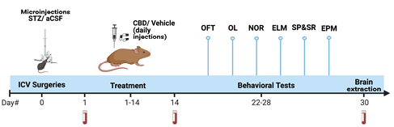

Experimental Design 1.2 – Reversal: To assess the reversal effects of CBD, 1 month after the stereotaxic procedure, after the onset of cognitive deficits and AD pathology, rats are treated 3 times a week with CBD or vehicle (i.p. injections) for two months. This treatment schedule is based on previous studies that evaluated the therapeutic potential of chronic CBD treatment which also used a chronic treatment regimen of 3 times a week and found CBD to be effective and safe (Iffland and Grotenhermen, 2017). Furthermore, mice treated with 60 mg/kg CBD i.p. for 12 weeks (three times a week) did not show ataxia, kyphosis, generalized tremor, swaying gait, tail stiffness, changes in vocalization behavior or open-field physiological activity (Bergamaschi et al., 2011). Tail blood will be collected on days 1, 14, 30, 60, 90 and trunk blood on day 100 to measure peripheral miRNAs. In females, the estrous cycle will be examined one day before commencing behavioral testing.

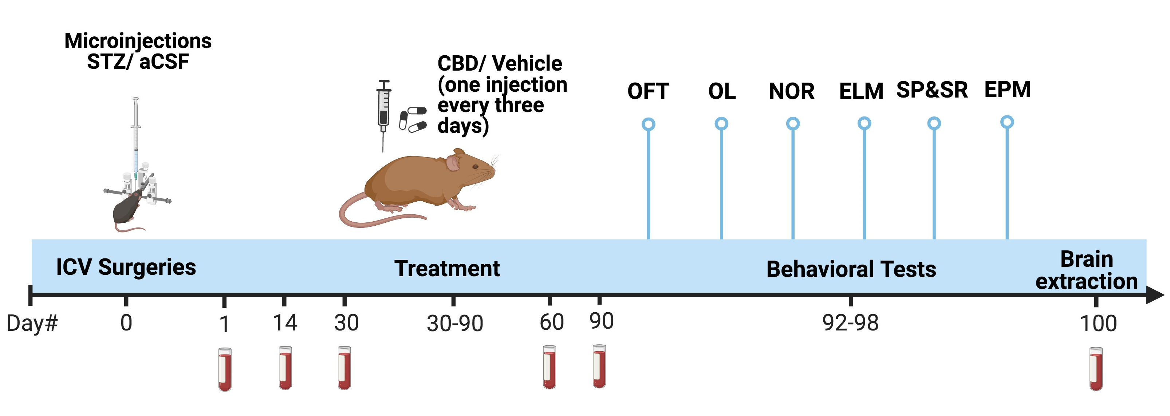

For both the preventing and reversal protocols, rats are exposed to a battery of behavioral tests assessing cognitive and emotional function in STZ males and females. This could provide new insights concerning both early and late brain alterations following STZ.

The behavioral battery of tests is based on our previous studies (Abush and Akirav, 2012; Bauminger et al., 2022;Burstein et al., 2018) and will be performed in the following order: open field (**OF**; day 22 or day 92) to assess general locomotor function and novelty-induced anxiogenic behavior; object location )**OL**; day 24 or day 94( and novel object recognition (**NOR**; day 25 or day 95); episodic-like memory (**ELM**, day 26 or day 96), in which animals spontaneously explore an environment and attempt to associate an object (What), its location (Where), and the temporal context (first or second occurrence – When) (based on Chao et al., 2014); social preference (**SP**) and social recognition (**SR**) (day 27 or day 97); elevated plus maze (**EPM**, day 28 or day 98), is used to assess anxiety-related behavior.

Cognitive and emotional function will be correlated with alterations in the expression of **miRNAs in the HPC-PFC pathway** and several interacting systems and targets using **RT-PCR,** **Western Blotting** (Alteba et al., 2021; Bauminger et al., 2021; Korem et al., 2017) and **ELISA**. These include **β-catenin and GSK-3-β, NI markers** (IL-6, IL-1, TNF-α, NF-kB1), **primary targets of CBD** [CB1 and CB2 receptors, FAAH, 5HT1a, TRVP1-2], protein **markers associated with AD pathology** (Aβ protein, p-Tau Ser396 protein), and mRNA markers of AD (APOE4, TREM2)]. We will also investigate **peripheral miRNAs** (miR-9, miR-9-5p miR-29abc, miR-34a , miR-107, miR-125b, miR-132 and miR-146-5p) **as potential biomarkers** of AD and treatment responses in whole blood samples and correlate these alterations with miRNA levels in the PFC-HPA pathway.

**ELISA**: Levels of pro-inflammatory cytokines including IL-1β, IL-6 and TNF-α in whole blood as well as estrogen levels in females will be evaluated via sandwich ELISA according to the manufacturer’s instructions (Abcam and R&D systems).

**Western Blotting** (based on Mizrachi Zer-Aviv et al., 2022): Protein levels are determined by the bicinchoninic acid (BCA) Protein Assay Kit (Thermo Fisher Scientific, Waltham, MA, USA) according to the manufacturer's protocol [Anti-tau pS396 (1:500 dilution; ab109390; Abcam, Cambridge, UK); Anti Aβ (1:200; rabbit monoclonal, Cat. No. ab201060; Abcam, Cambridge, UK)].

**Real-time (RT) PCR** (based on Bright and Akirav, 2022; Portugalov et al., 2023): For mRNA, 1000 ng of total RNA is converted into cDNA using qScript cDNA Synthesis Kit (Quanta Biosciences, Gaithersburg, USA). For miRNA, 500 ng of total RNA is polyadenylated and converted into cDNA using qScript microRNA cDNA Synthesis Kit (Quanta Biosciences, Gaithersburg, USA). This is followed by Real-Time SYBR Green qRT-PCR amplification using specific primers (Quanta Biosciences, Gaithersburg, USA) according to manufacturer’s instructions. RT reactions are carried out by a Step One real-time PCR system (Applied Biosystems). Fold-change values are calculated using the ddCt method relative to the housekeeping gene hypoxanthine phosphoribosyl transferase (HPRT; mRNA) or RNU6 (miRNA). Primers for both miRNAs and mRNAs are designed and synthesized by Agentek (Tel Aviv, Israel). Primer suitability was determined using standard curve analysis, melting curve analysis and linearity and threshold. (Portugalov et al., 2022; Zaidan et al., 2018).

**Aim 2: To explore whether downregulating β-catenin in the PFC-HPC pathway can block the impact of CBD on AD-related cognitive and emotional dysfunction.**

Studies have shown that dysregulated Wnt/β-catenin signaling plays an important role in the pathogenesis of AD via multiple mechanisms (Jia et al., 2019; Liu et al., 2021).

CBD, among other effects, inhibits FAAH, preventing the catabolism of the endogenous cannabinoid anandamide, hence, CBD can protect against AD phenotypes through β-catenin-mediated mechanisms in the HPC-PFC. We have recently found that when NAc and PFC β-catenin levels were downregulated by viral-mediated gene transfer, the therapeutic-like effects of the FAAH inhibitor URB597 were blocked in a rat model for PTSD (Mizrachi Zer-Aviv et al., 2022; Figure 2). Moreover, we have preliminary findings demonstrating that compared to STZ rats treated with vehicle, STZ rats treated with CBD demonstrate increased mRNA expression of β-catenin and decreased expression of GSK-3β (Figure 3).

In our second Aim, we will explore whether β-catenin downregulation in the PFC-HPC pathway will block the therapeutic-like effects of CBD on AD-related cognitive and emotional dysfunction.

Experimental Design 2 – β-catenin downregulation: The experimental design is similar to 1.1, except for the viral infusion. Adult male and female rats receive ICV injection of STZ or aCSF to the left ventricle and a total of 1μL of the HSV viral vector or green fluorescent protein (GFP) bilaterally into the PFC or dorsal hippocampus (Day 0) (Stoelting, Wood Dale, IL, USA) at a rate of 0.1 μL/min (coordinates relative to Bregma: PFC: AP: +2.9 mm; ML: ± 0.6 mm; DV: -5 mm; dorsal hippocampus: AP: -4.2 mm; ML: ± 2.5 mm; DV: -2 mm). The vector was used to downregulate (DR) the expression of β-catenin compared to a GFP control; the vector is expressed in vivo within 2–3 h, with maximal expression from 3–5 days post-injection that lasts only 8 days in vivo (see Mizrachi Zer-Aviv et al., 2022 for more details), after which the study will be completed as in Aim 1.

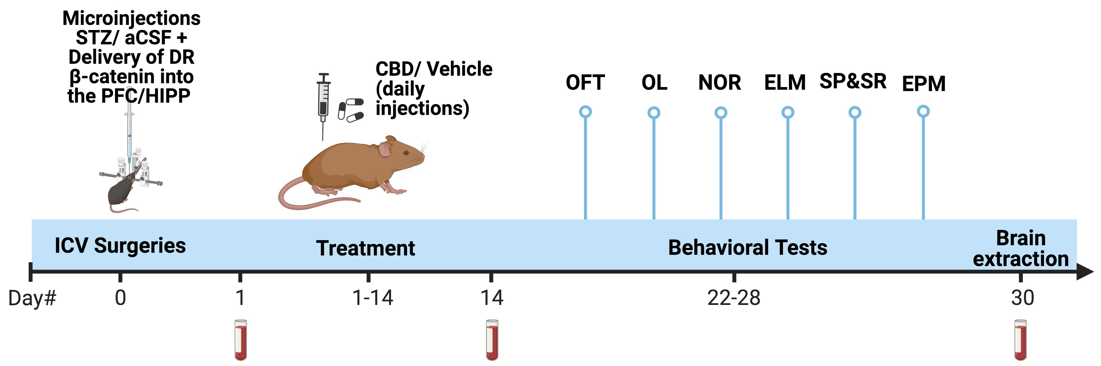

**Viral Mediated Gen Transfer**: Rats are anesthetized with a mixture of ketamine/xylazine solution and placed in a stereotaxic frame (Stoelting). Holes are drilled into the skull, and viruses are delivered bilaterally using a 10-μl syringe and metal needle (Hamilton, Reno, NV). The injection volume and flow rate are controlled by a micromanipulator at a volume of 1 μl for HSV viral vector (provided by Prof. E. Nestler), a high titer range of 3 to 5 × 10ʌ8 transduction unit, TU/ml) and a rate of 0.1 μl/ min. Injection needles are left in place for 10 min following all injections to ensure adequate viral delivery.

**Aim 3: To explore whether inhibiting or activating specific candidate miRNAs can reverse AD-related cognitive and emotional dysfunction, and to determine whether CBD can protect against AD phenotypes through miRNA-mediated mechanisms.**

In our third Aim, we will explore whether different miRNAs are critically involved in AD-related cognitive and emotional dysfunction and the therapeutic effects of CBD by using antimiRs and miRNA mimics. Many miRNAs appear to play beneficial rather than pathologic roles in settings of disease (Mendell and Olson, 2012). As such, the activation or silencing of particular miRNAs may be ideally suited to restore STZ-induced alterations in cognitive and emotional function. Our planned experiments will offer insight into the potential therapeutic utility of the targeted activation or silencing of specific miRNAs as an approach to restoring memory and alleviating emotional deficits, while also better defining the role that miRNAs play in the context of STZ in both males and females. To determine whether specific miRNAs mediate STZ-induced alterations in behavior CBD are mediated by specific miRNAs, we will use antimiRs/agomirs to inhibit/activate specific miRNAs.

We have preliminary findings that microinjecting antagomir-16 (anti-mir) into the right ventricle significantly decreases the expression of miR-16 in the PFC week after microinjection (**Figure 4a**), but has no effect on miR-16 in the NAc (**Figure 4b**). This decrease in the mPFC lasted 7 weeks after microinjection of anti-mir 16 (**Figure 4c**), but had no effect on the expression of a different mir (miR-135a) (**Figure 4d**). Importantly, we have preliminary results from a rat model for depression (early life stress, ELS) suggesting that the antagomir has a potential sustained effect on behavioral performance weeks later. Rats were exposed to ELS on postnatal day (PND) 7-14, microinjected with anti-mir 16 into the right ventricle on PND 36. On PND 45-60 rats were treated with the FAAH inhibitor URB597, that increases physiological levels of anandamide, and tested for depression-like behavior on PND 70. We found that URB597 restored an ELS-induced increase in immobility in the forced swim test and that anti-mir 16 blocked the restoring effect of URB597 (**Figure 5**)

Findings from Aim 1 are expected to put forward specific miRNAs that are altered following STZ and CBD (e.g., miR-9, miR-9-5p miR-29abc, miR-34a, miR-107, miR-125b, miR-132 and miR-146-5p), and according to these findings, specific miRNAs will be activated or inhibited in an attempt to prevent STZ-induced alterations in cognitive and emotional function.

Experimental Design 3 - antimiRs and miRNA mimics: The experimental design is similar to the one on Aim 1, except for the antagomir/agomir injections. Adult male and female rats receive ICV injection of STZ or aCSF to the left ventricle and an agomir or antagomir to the right ventricle (Day 0), after which the study will be completed as in Aim 1.

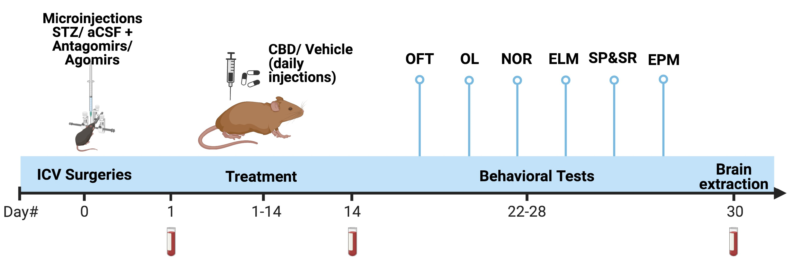

**Agomir/antagomir** **surgical procedure**: The surgical procedure will be performed as described by Moreira-Silva et al. (2019). Briefly, rats are first anesthetized with ketamine/domitor (75/0.5 mg/kg SC) and then restrained onto a stereotaxic apparatus. STZ is ICV microinjected into the left ventricle as described above and the agomir/antagomir (20nmol in 1 µl; 0.1 μl/min) is injected to the right ventricle (AP: +1.92 mm; ML: ˗0.9 mm; DV: -4.7 mm) using a 10 μl Hamilton syringe (Hamilton Co., USA). The syringe will be held in place for 10 min after injection to prevent reflux. Previous studies have also injected antagomirs to STZ animals (Chen et al., 2022) suggesting that the rats can complete the experiment.

Mimicking or inhibiting the relevant miRNAs (e.g., miR-9-5p, miR-16, miR-22-3p, miR-29ab, miR-34a, miR-101, miR-107, miR-125b, miR-129, miR-132, miR-146-5p, miR-155, miR-195, 214-3p, miR-340) are determined based on the results from the first aim and from the literature described above. Hence, for example, if we find that STZ up-regulates the expression levels of miR-34a, that is associated with depression and anxiety, in aim 3 we will use an antagomir to inhibit its expression following STZ and examine their effects on the behavioral phenotype. We hypothesize that the antagomir will prevent at least some of the long-term effects of STZ on depression- or anxiety-like behaviors.

**c3. Preliminary results: See figures below**

**c4. Available resources**

The Akirav lab is located in the Brain and Psychopathology laboratory space at the University of Haifa, and has access to rat vivarium and to several core equipment facilities. We have the equipment, space, and expertise to perform the proposed experiments. The lab is equipped with all necessary behavioral equipment (open field, mazes, social preference chambers, etc.) and behavioral tracking software (Ethovision 9.0, Noldus; FreezeFrame, Actimetrics). Data analysis is performed using Ethovision software or DeepLabCut. All equipment necessary for stereotaxic injections (i.e., 2 stereotaxic instruments, motorized and manual injection systems) and molecular experiments (i.e., for western blots, ELISA kits and rtPCR) is also available in-lab. Shared rooms are designated to transduce viral vectors and use cryostat, confocal microscope etc.

**c5. Expected results and pitfalls:**

In case CBD does not prevent STZ-induced alterations in miRNAs, ???preliminary from Shira?.

In case we do not find that the agomir/antagomir affects STZ-induced alterations in miRNAs or behavior, we will block inflammatory markers e.g., anti-TNF-α and IL-6 therapies [181]. TNFα and IL-6 play crucial roles in cytokine storm pathogenesis and are likely responsible for the escalation of many Inflammation-induced diseases (Coomes et al., 2020; Liu et al., 2016; Radner et al., 2015). Hence, drugs with demonstrated anti-inflammatory effects may well show improvement in mental conditions when used as add-on treatments to conventional psychiatric medications [Fitton et al., 2022; Fond et al., 2014; Uzzan et al., 2021].

**Figures**

**Figure 1: Downregulating β-catenin in the PFC of rats exposed to the shock and reminders model of PTSD blocks the preventive effects of the FAAH inhibitor URB597 on anxiety-like phenotype and the increase in CRF.**

1. the Shock-GFP-Veh group demonstrated increased acoustic startle response (ASR) compared to the No Shock-GFP-Veh and Shock-GFP-URB groups; (b)compared to Shock-GFP-Veh and Shock-DRβ-URB groups, the Shock-GFP-URB group demonstrated decreased freezing during extinction day 5; (c) the Shock-GFP-Veh group demonstrated significant upregulation in CRF expression compared to NoShock- GFP-Veh and Shock-GFP-URB groups in the mPFC and Shock-GFP-URB group demonstrated significant downregulation of CRF expression compared to the Shock-DRβ-URB group. (n=8-9 in all groups) *, p<.05; **, p<.01; ***, p<.001 indicate statistically significant effects followed by post-hoc comparisons; p<.05; p<.01; p<0.001 indicate statistical significance in shocked vs non-shocked groups. Taken from Sbarski, Portugalov, Parise, Nestler, Mizrachi Zer-Aviv and Akirav, submitted.

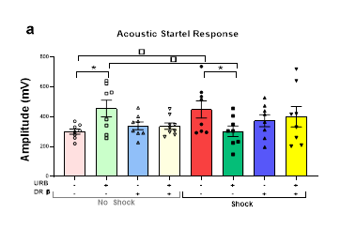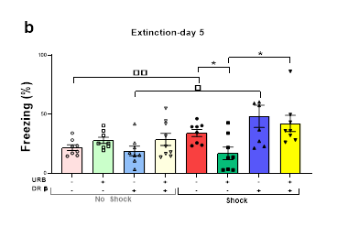

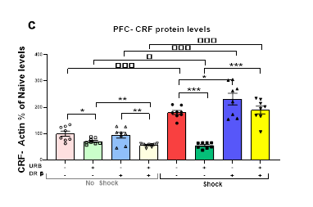

**Figure 2: CBD prevents STZ-induced deficits in cognitive and emotional function, as well as STZ-induced increases in hippocampal neuroinflammation and AD-pathology.**

(a) Compared to all groups, the STZ-Veh group exhibited impaired performance in hippocampal dependent object location; (b) and PFC-dependent novel object recognition tasks; (c) decreased sociability in the social interaction task; (d) increased anxiety-like behavior in an open field; (e) increased mRNA expression of TNFα; (f) the STZ-Veh group demonstrated increased mRNA levels of NFkB1; (g) and of APOE4 compared to ACSF-Veh; (h) and increased mRNA expression of TREM2 compared to the ACSF-Veh and STZ-CBD groups, in the CA1 of the hippocampus. (n=8-10), \**p*<0.05, \*\**p*<0.01, *\*\*\*p<0.001*

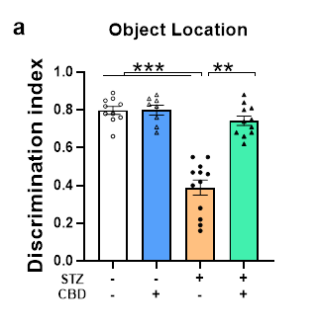 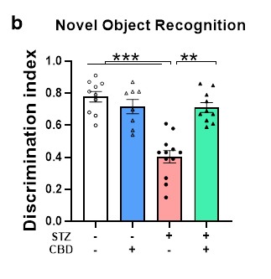 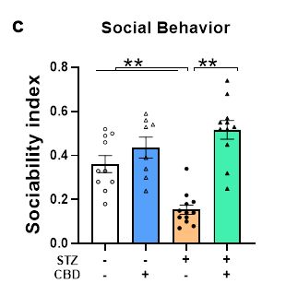 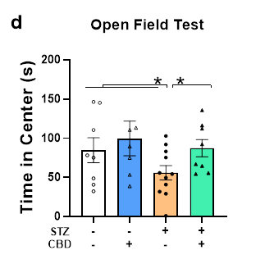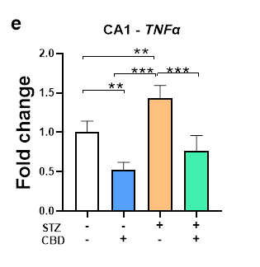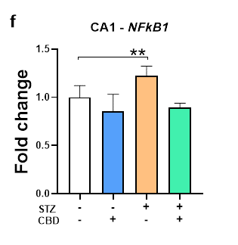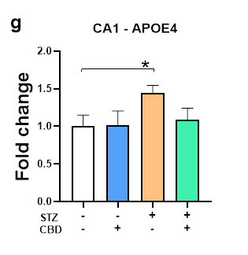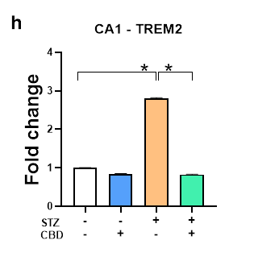

**Figure 3:** **CBD effects on β-catenin and GSK-3β in the CA1 of STZ rats.** (a) Ccompared to STZ rats treated with vehicle, STZ rats treated with CBD demonstrate increased mRNA expression of β-catenin; (b) decreased expression of GSK-3β. (n=5 in all groups) *, p<0.05.

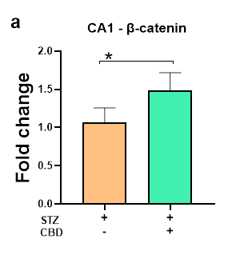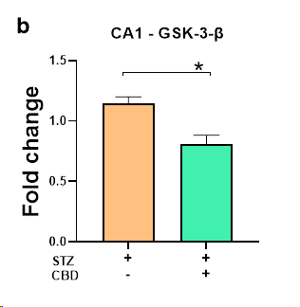

**Figure 4:** **The effects of silencing miR-16 in the PFC and Nac**. (a) antagomir-16 into the right ventricle decreased the expression of mir-16 in the PFC; (b), but not in the Nac; (c) this decrease in the mPFC lasts 7 weeks; (d) but has no effect on the expression of miR-135a. (n=5 in all groups) *, p<0.05.



**Figure 5: The effects of silencing miR-16 on behavior.** Anti-mir-16 blocks the effects of URB597 on ELS-induced increase in immobility in the FST (n=8-10) *, p<0.05

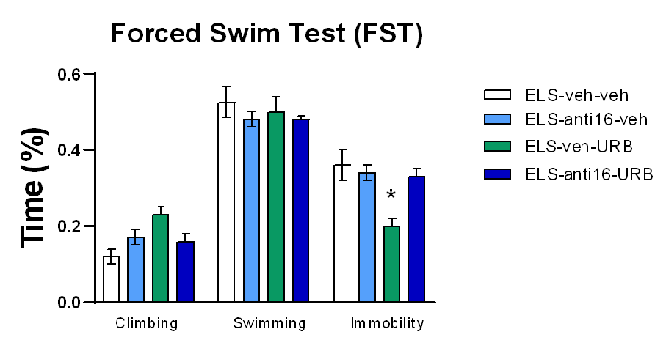

**References**

1. Abush, H., & Akirav, I. Short- and long-term cognitive effects of chronic cannabinoids administration in late-adolescence rats. PloS one, **7**(2), e31731 (2012).
2. Alteba, S., Portugalov, A., Hillard, C. J., & Akirav, I. Inhibition of fatty acid amide hydrolase (FAAH) during adolescence and exposure to early life stress may exacerbate depression-like behaviors in male and female rats. Neuroscience, **455**, 89-106 (2021).
3. Bahlakeh, G., Gorji, A., Soltani, H., & Ghadiri, T. MicroRNA alterations in neuropathologic cognitive disorders with an emphasis on dementia: Lessons from animal models. Journal of cellular physiology, **236**(2), 806–823 (2021).
4. Bauminger, H., Zaidan, H., Akirav, I., & Gaisler-Salomon, I. Anandamide Hydrolysis Inhibition Reverses the Long-Term Behavioral and Gene Expression Alterations Induced by MK-801 in Male Rats: Differential CB1 and CB2 Receptor-Mediated Effects. Schizophrenia bulletin, **48**(4), 795–803 (2022).
5. Burstein, O., Shoshan, N., Doron, R., & Akirav, I. Cannabinoids prevent depressive-like symptoms and alterations in BDNF expression in a rat model of PTSD. Progress in neuro-psychopharmacology & biological psychiatry, **84**(Pt A), 129–139 (2018).
6. Cassano, T., Villani, R., Pace, L., Carbone, A., Bukke, V. N., Orkisz, S., ... & Serviddio, G. From Cannabis sativa to cannabidiol: Promising therapeutic candidate for the treatment of neurodegenerative diseases. Frontiers in pharmacology, **11**, 124 (2020).
7. Chao, O. Y., Nikolaus, S., Huston, J. P., & de Souza Silva, M. A. The neurokinin-3 receptor agonist senktide facilitates the integration of memories for object, place, and temporal order into episodic memory. Neurobiology of learning and memory, **114**, 178–185 (2014).
8. Chêne, G., Beiser, A., Au, R., Preis, S. R., Wolf, P. A., Dufouil, C., & Seshadri, S. Gender and incidence of dementia in the Framingham Heart Study from mid‐adult life. Alzheimer’s & Dementia, **11**(3), 310–320 (2015).
9. Cheng, D., Low, J. K., Logge, W., Garner, B., & Karl, T. Chronic cannabidiol treatment improves social and object recognition in double transgenic APPswe/PS1∆E9 mice. Psychopharmacology, **231**(15), 3009–3017 (2014). *
10. Chopra, N., Wang, R., Maloney, B., Nho, K., Beck, J. S., Pourshafie, N., Niculescu, A., Saykin, A. J., Rinaldi, C., Counts, S. E., & Lahiri, D. K. MicroRNA-298 reduces levels of human amyloid-β precursor protein (APP), β-site APP-converting enzyme 1 (BACE1) and specific tau protein moieties. Molecular Psychiatry, **26**(10), 5636–5657 (2021).
11. Diniz, L. P., Tortelli, V., Matias, I., Morgado, J., Araujo, A. P. B., Melo, H. M., ... & Gomes, F. C. A. Astrocyte transforming growth factor beta 1 protects synapses against Aβ oligomers in Alzheimer's disease model. Journal of Neuroscience, **37**(28), 6797-6809 (2017).
12. Esposito, G., de Filippis, D., Carnuccio, R., Izzo, A. A., & Iuvone, T. The marijuana component cannabidiol inhibits β-amyloid-induced tau protein hyperphosphorylation through Wnt/β-catenin pathway rescue in PC12 cells. Journal of Molecular Medicine, **84**(3), 253–258 (2006).
13. Gáll, Z., Farkas, S., Albert, Á., Ferencz, E., Vancea, S., Urkon, M., & Kolcsár, M. Effects of chronic cannabidiol treatment in the rat chronic unpredictable mild stress model of depression. Biomolecules, **10**(5), 801 (2020).
14. Galts, C. P., Bettio, L. E., Jewett, D. C., Yang, C. C., Brocardo, P. S., Rodrigues, A. L. S., ... & Gil-Mohapel, J. Depression in neurodegenerative diseases: Common mechanisms and current treatment options. Neuroscience & Biobehavioral Reviews, **102**, 56-84 (2019).*-?
15. Khodadadi, H., Salles, É. L., Jarrahi, A., Costigliola, V., Khan, M. B., Yu, J. C., ... & Baban, B. Cannabidiol ameliorates cognitive function via regulation of IL-33 and TREM2 upregulation in a murine model of Alzheimer’s disease. Journal of Alzheimer's Disease, **80**(3), 973-977 (2021).
16. Koran, M. E. I., Wagener, M., & Hohman, T. J. Sex differences in the association between AD biomarkers and cognitive decline. Brain Imaging and Behavior, **11**(1), 205–213 (2017).
17. Korem, N., Lange, R., Hillard, C. J., & Akirav, I. Role of beta-catenin and endocannabinoids in the nucleus accumbens in extinction in rats exposed to shock and reminders. Neuroscience, **357**, 285–294 (2017).
18. Kou, X., Chen, D., & Chen, N. The regulation of microRNAs in Alzheimer's disease. Frontiers in Neurology, **11**, 288 (2020).*
19. Kovner, R., Oler, J. A., & Kalin, N. H. Cortico-limbic interactions mediate adaptive and maladaptive responses relevant to psychopathology. American Journal of Psychiatry, **176**(12), 987-999 (2019).‏
20. Leweke, F. M., Piomelli, D., Pahlisch, F., Muhl, D., Gerth, C. W., Hoyer, C., Klosterkötter, J., Hellmich, M., & Koethe, D. Cannabidiol enhances anandamide signaling and alleviates psychotic symptoms of schizophrenia. Translational Psychiatry, **2**(3), e94–e94 (2012).
21. Li, H., Liu, Y., Tian, D., Tian, L., Ju, X., Qi, L., Wang, Y., & Liang, C. Overview of cannabidiol (CBD) and its analogues: Structures, biological activities, and neuroprotective mechanisms in epilepsy and Alzheimer's disease. European journal of medicinal chemistry, **192**, 112163 (2020). *
22. Li, R., & Singh, M. Sex differences in cognitive impairment and Alzheimer’s disease. Frontiers in Neuroendocrinology, **35**(3), 385–403 (2014).
23. Machado Bergamaschi, M., Helena Costa Queiroz, R., Waldo Zuardi, A., & Alexandre S. Crippa, J. Safety and Side Effects of Cannabidiol, a Cannabis sativa Constituent. Current Drug Safety, **6**(4), 237–249 (2011).
24. Manoli, D. S., & Tollkuhn, J. Gene regulatory mechanisms underlying sex differences in brain development and psychiatric disease. Annals of the New York Academy of Sciences, **1420**(1), 26–45 (2018).
25. Mendez, M. F. The relationship between anxiety and Alzheimer’s disease. Journal of Alzheimer's disease reports, **5**(1), 171-177 (2021). *-?
26. Mizrachi Zer-Aviv T., & Akirav, I. Sex differences in hippocampal response to endocannabinoids after exposure to severe stress. Hippocampus, **26**(7), 947–957 (2016).
27. Mizrachi Zer-Aviv T, Islami L, Hamilton PJ, Parise EM, Nestler EJ, Sbarski B, Akirav**I**. Enhancing endocannabinoid signalling attenuates PTSD- and depression-like behaviour via β-catenin in the nucleus accumbens of rats. Biomedicines, accepted for publication.
28. Müller, M., Kuiperij, H. B., Claassen, J. A., Küsters, B., & Verbeek, M. M. MicroRNAs in Alzheimer’s disease: differential expression in hippocampus and cell-free cerebrospinal fluid. Neurobiology of Aging, **35**(1), 152–158 (2014). *
29. Nikolac Perkovic, M., Videtic Paska, A., Konjevod, M., Kouter, K., Svob Strac, D., Nedic Erjavec, G., & Pivac, N. Epigenetics of Alzheimer’s Disease. Biomolecules, **11**(2), 195 (2021).
30. Ruggiero, R. N., Rossignoli, M. T., Marques, D. B., de Sousa, B. M., Romcy-Pereira, R. N., Lopes-Aguiar, C., & Leite, J. P. Neuromodulation of Hippocampal-Prefrontal Cortical Synaptic Plasticity and Functional Connectivity: Implications for Neuropsychiatric Disorders. Frontiers in Cellular Neuroscience, **15** (2021).
31. Sabbagh, M. N., Lue, L. F., Fayard, D., & Shi, J. Increasing Precision of Clinical Diagnosis of Alzheimer's Disease Using a Combined Algorithm Incorporating Clinical and Novel Biomarker Data. Neurology and therapy, **6**(Suppl 1), 83–95 (2017).
32. Salomone, S., Caraci, F., Leggio, G. M., Fedotova, J., & Drago, F. New pharmacological strategies for treatment of Alzheimer’s disease: focus on disease modifying drugs. British Journal of Clinical Pharmacology, **73**(4), 504–517 (2012).
33. Scheyer, O., Rahman, A., Hristov, H., Berkowitz, C., Isaacson, R. S., Diaz Brinton, R., & Mosconi, L. Female sex and Alzheimer’s risk: the menopause connection. The journal of prevention of Alzheimer's disease, **5**(4), 225-230 (2018).‏*
34. Scuderi, C., Steardo, L., & Esposito, G. Cannabidiol Promotes Amyloid Precursor Protein Ubiquitination and Reduction of Beta Amyloid Expression in SHSY5Y APP+ Cells Through PPARγ Involvement. Phytotherapy Research, **28**(7), 1007–1013 (2014).
35. Teo, C. H., Soga, T., & Parhar, I. S. Brain Beta-Catenin Signalling During Stress and Depression. Neuro-Signals, **26**(1), 31–42 (2018).
36. Walgrave, H., Balusu, S., Snoeck, S., Eynden, E. V., Craessaerts, K., Thrupp, N., ... & Salta, E. Restoring miR-132 expression rescues adult hippocampal neurogenesis and memory deficits in Alzheimer’s disease. Cell Stem Cell, **28**(10), 1805-1821 (2021).‏
37. Watt, G., & Karl, T. In vivo Evidence for Therapeutic Properties of Cannabidiol (CBD) for Alzheimer’s Disease. Frontiers in Pharmacology, **8** (2017).*
38. Woldemichael, B. T., & Mansuy, I. M. Micro-RNAs in cognition and cognitive disorders: Potential for novel biomarkers and therapeutics. Biochemical pharmacology, **104**, 1–7 (2016).