**Determinants of elephant crop-raiding and counteractive defense strategies farmers use in Laikipia County, Kenya**

Patrick Mwangi Gichohi1, Benson M. Mwangi2 & Kiplagat Kotut3

**Abstract**

Conflicts between humans and elephants are common in farmlands bordering elephant conservation areas. In Laikipia County, Kenya, elephants have frequently raided farms for many years resulting in a persistent human-elephant conflict. To resolve this problem, it is imperative to understand the determinants of elephant crop-raiding and the efficacy of counteractive farm-based defense strategies used by farmers against it. The distances of crop farms to forest edges, homesteads, major roads and river valleys were determined as well as trees cover percentage in relation to farm sizes. The study revealed that crop raid incidences varied significantly with the distance of crop farms to forest edges at (P <0.05) in two sampling sites Mutara (P-value 0.032) and Kinamba (P-value 0.029) with exception of Marmanet (P-value 0.203). The crop farms located more than 2Km from the forest edges encountered less crop raid incidences. Elephant crop raid incidences were more prevalent in small-sized farms (<2.0 ha) with <5% trees cover, constituting over 95% of the crop incidences recorded. A variety of defence strategies used by local farmers were ineffective in deterring elephants from crop farms. We recommend to local farmers near forest edges to practice livestock keeping other than food crop cultivation which is highly prone to elephant crop-raiding. Local farmers should intensify trees-planting activities to increase tree cover in their farms thus forming a buffer zone that shields crops from elephants.

**Keywords**: Determinants, elephant crop-raiding, crop-farms, tree-cover, defense strategies.

1University of Embu, Biological Sciences Department, P.O. Bo x 6-60100 Embu;

Email: [pmgichohi2000@gmail.com](mailto:pmgichohi2000@gmail.com)

2Murang’a University of Technology, Biological Sciences Department, P.O. Box 75-10200, Murang’a;

Email: [bmmwangi@mut.ac.ke](mailto:bmmwangi@mut.ac.ke)

3University of Embu, Biological Sciences Department, P.O Box 6-60100, Embu;

Email: [kotut.kiplagat@embuni.ac.ke](mailto:kotut.kiplagat@embuni.ac.ke)

**Introduction**

Elephants crop-raiding remains a major cause of human-elephant conflict (HEC) in farming areas bordering elephant conservation areas. The effects of persistent HEC are the disruption of the livelihood of local farmers (Sitati et al., 2005; Thouless et al., 2016) and a decline in elephant populations following the counter-attack measures executed by local communities (Graham, 2010). Elephants raid farms; destroy crops leading to a decline in crop yields and heavy financial losses for local farmers’ (Nyhus, 2016; Tiller, 2017). Persistent crop raids by elephants have exacerbated food insecurity in rural areas when elephants target local farmers’ food reserves (Nyirenda *et al*., 2012). When elephants raid farms, they cause crop damage resulting to food shortage within farming communities. Hence, this fuels local farmers’ hostility toward elephants and it erodes their support for biodiversity conservation (Gadd, 2005).

Crop raiding has become a persistent cause of human-elephant conflict commonly witnessed in farms that border protected areas with elephant populations, in a number of African and Asian countries (Chen et al., 2016; Danquah, 2016). In 2010, there were recorded 2,429 crop-raiding incidences by African elephant (*Loxodonta Africana* L.) in Laikipia County, Kenya (Graham *et al.,* 2010). Elephant crop-raiding triggers retaliation attacks by farmers and in the process, both humans and elephants are either injured or killed (Graham, 2010). In Kenya alone, problem animal control under wildlife authorities shoots between 50-120 elephants each year. In addition, about 200 people are reported to have died in human-elephant conflict (Mariki et al., 2015).

The current efforts by conservation biologists in Africa and Asia are geared towards reducing HEC to stem further losses to communities and the elephant population (Chen et al., 2016). Previous studies on human-elephant conflict have revealed that crop raiding depends on of a number of determinant factors localized in farming areas such as trees cover and the proximity of crop farms to forest edges (Sitati et al., 2005). However, very few studies have been carried out to establish whether, the determinant factors that influence elephant crop raiding are similar or different in the perspective of agro-ecological zones. Most of these studies are silent they did not put into consideration whether determinants influencing elephant crop raiding have any significant variation in different agro-ecological zones. Sitati’s study on human-elephant conflict in Maasai Mara Reserve in Kenya showed that elephants raided small farms near forest edges more than larger ones and avoided the crop farms near homesteads and major roads (Sitati & Wapole*,* 2006). River valleys act as ‘refugia’ (a hiding places for elephants during the day) as night falls, they raid farms (Li et al, 2019; Naha et al., 2019). Elephants depended on forest patches for resting and forage (Goswami & Vasudev, 2017; Naha et al., 2019). Past studies in Africa and Asia reported that the loss of tree cover was a major driver of HEC (Naha et al., 2019). Most studies have focused on effects of loss of trees cover in natural habitats with elephant populations. But hardly has there been work carried out to establish whether tree cover in farming areas has any significant influence on elephant crop-raiding. Hence, it was paramount to determine whether proximity of crop farms rivers valleys, homesteads and major roads to forest edges do have any significant role in influencing elephant crop raiding in different agroecological zones. To resolve elephant crop raiding conflict it would be necessary to establish its determinants in the context of different agro-ecological zones.

Local farmers have heavily relied on traditional methods to defend their crop-farms from elephant raids (Bal et al., 2011,). Since, majority of the local farmers cannot afford conventional mitigation methods e.g., electric fence or translocation of elephants (Graham et al., 2010; Gichohi,2013; King et al., 2017). Hence, there was dire need to establish the efficacy of the traditional farm-based defense strategies used against elephant crop-raiding in Laikipia County.

Even though many studies have been conducted in an attempt to seek along lasting solution to resolve elephant crop raiding conflict, it has remained elusive. Therefore, an understanding of the dynamics of the determinants influencing elephant crop raiding in the context of specific agroecological zones was considered critical in this study. An Agroecological zone is a land resource mapping unit, defined in terms of climate, landform and soils, and/or land cover, and having a specific range of potentials and constraints for land use (Balasubramanian, 2017; FAO, 1996). The study aimed to compare the determinants influencing elephant crop raiding in the three distinct agro-ecological zones of Laikipia County and to establish the efficacy of farm-based defense strategies farmers use. This study was conceived to give insights that would be useful when designing long lasting solutions to elephant crop raiding conflict within the agro-ecological zones in Laikipia County, Kenya.

**Materials and methods**

**Study area**

The study area is located in Laikipia County, Kenya (latitudes 36°10’–37°3’ East & 0°17 South, 0°45° North). The county is located within northwest of Mt. Kenya (5199 m) and northeast of the Aberdare ranges (3999 m) at 1700–2000 m above sea level, Figure: 1. The area experiences a bimodal rainfall pattern; with long rains in April-June, short rains from October- December, and a dry season in January-March. Temperatures in Laikipia County range from 25°-30o C.

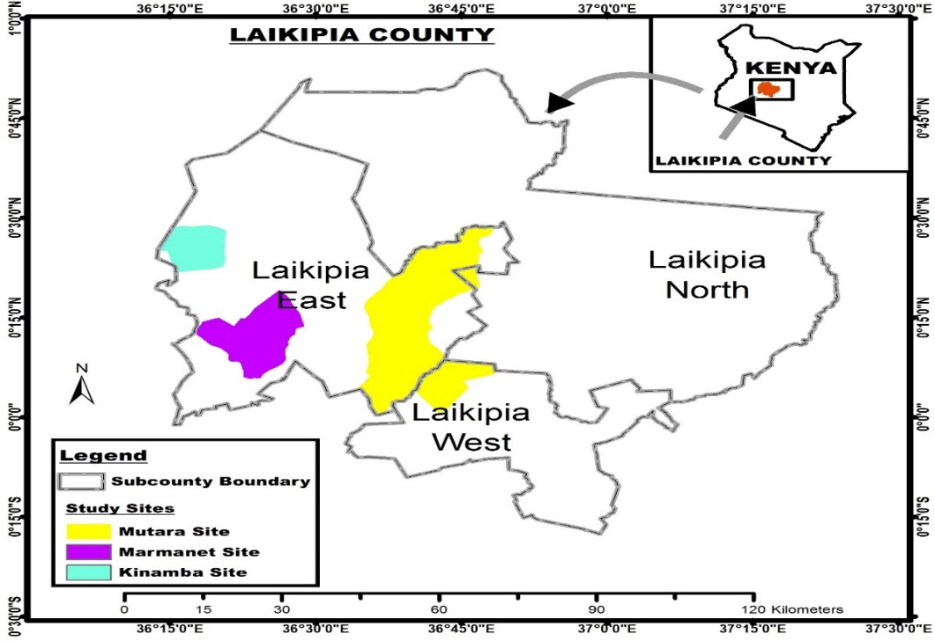

**Fig. 1: Map of the three study sites in Laikipia County: Marmanet (Purple), Kinamba (Blue) & Mutara (Yellow)**

Laikipia County in Kenya has three main agro-ecological zones namely; Kinamba a high agricultural potential area with an annual rainfall of 1000-1400 mm. Marmanet a moderately agricultural potential area with an annual rainfall of 600-750 mm. Mutara a low agricultural potential area with an annual rainfall of 300-500 mm (Kenya Meteorological Department, 2017).

Soil types are mainly well-drained black cotton soils. The vegetation comprises a mosaic of savannah grassland, forests mixed with deciduous trees, and scrub vegetation (Graham et al., 2010). Laikipia County has an estimated population of 7000 elephants (Ngene et al., 2012). The main socio-economic activities are livestock keeping in ranches and wildlife conservancies with wild animals. The small-scale farmers practice subsistence farming, they grow food crops; maize, beans, potatoes, and vegetables, and keep a few livestock.

**Study approach**

Determinants are the key factors that directly or indirectly influence elephant crop-raiding in farm lands bordering protective areas or forests with elephant populations. In this study the determinants considered critical were investigated. These included; the distance of crop farms to forest edges, homestead, main roads, river valleys, tree cover in farms and farm-sizes. The distance from crop-farms to forest edges, homesteads, main roads, and river valleys were measured using a tropofile (surveyors’ tape) (Sitati et al. 2003). The other crucial determinants were the sizes of the farms frequently raided by elephants, and tree cover percentages in those farms. Information of the farms frequently raided by elephants was obtained from group focus discussions held with farmers in various villages within the study sites before the study commenced. During the study period, the occurrence of crop raiding incidences was recorded through-out the year from village to village. Whenever, elephants raided farms the incidence(s) and crop damage caused were immediately recorded. This recording took place mainly in the farms which were raided by elephants. This was carried out within the sampling sites comprising three agroecological zones of Laikipia County. The three Agroecological zones of Laikipia County are: Marmanet, Mutara, and Kinamba study sites. The researcher was assisted in data collection by research assistants who were evenly distributed per each study site.

A field survey was conducted in Marmanet, Mutara, and Kinamba study sites to establish the efficacy of the farm-based defense strategies used by farmers against crop-raiding elephants. Local farmers whose farms were raided by elephants were purposively selected for this study’s survey (Nyhus *et al*., 2005). The crop farms that elephants raided were identified during group focus discussions held with local farmers and government authorities before commencement of this study. The distribution of local farmers to be interviewed from the three study sites was based on the human population of the area (Kenya’s People Census ,2009). Hence, local farmers were selected as follows: Marmanet being populous n=211, Kinamba n=115 and Mutara n=58. During the study period questionnaires and interview schedules were administered at random to a sample of 384 local farmers.

**Results**

During the study period from 2016- 2018, elephants raided 605 farms owned by 400 local farmers within 20 villages of Marmanet, Kinamba and Mutara study sites. In the span of three years n=2184 crop raid incidences were recorded, with n=448 hectares of crop land damaged. There were higher crop-raid incidences recorded on farms closer to forest edges than on those located over a distance of 2 km away from the forest edges; Table, 1.

**Table 1: Determinants influencing elephant crop raiding incidences**

|  |  |  |  |  |  |  |  |  |  |
| --- | --- | --- | --- | --- | --- | --- | --- | --- | --- |
| Study site | Villages | Average Farm sizes (ha) | Distance in kilometers (KM) | | | | % Tree cover | Crop raid incidences | Crop damage levels (ha) |
| Farms - forest edges | Farms – homesteads | Farms - roads | Farms – rivers |
| Mutara | Suguroi | 5 | 1.6 | 0.1 | 4.6 | 6.0 | 3% | 102 | 57 |
|  | Wamura | 9 | 0.9 | 0.2 | 5.5 | 5.0 | 5% | 97 | 48 |
|  | Kiangoru | 14 | 1.9 | 0.4 | 6.0 | 8.0 | 10% | 63 | 39 |
|  | Habahaba | 16 | 2.3 | 0.5 | 9.0 | 7.7 | 25% | 51 | 25 |
| Kinamba | Mbogo-ini | 5 | 0.2 | 0.4 | 8 | 4 | 2% | 111 | 37 |
|  | Ndururu | 8 | 0.4 | 0.5 | 9 | 7 | 5% | 102 | 30 |
|  | Makutano | 45 | 3.9 | 0.9 | 11 | 6 | 7% | 84 | 29 |
|  | Kiwanja | 40 | 0.6 | 0.8 | 10 | 4.7 | 10% | 75 | 19 |
| Marmanet | Gatundia | 5 | 0.4 | 0.2 | 10 | 8 | 1% | 56 | 25 |
|  | Gathwara | 8 | 0.3 | 0.1 | 12 | 7 | 2% | 55 | 18 |
|  | Kandurubu | 8 | 1.6 | 0.5 | 14 | 10 | 5% | 33 | 31 |
|  | Gataracha | 7 | 2.0 | 0.5 | 13 | 11 | 5% | 29 | 18 |
|  | Ruturu | 8 | 0.4 | 0.4 | 16 | 8 | 5% | 29 | 25 |
|  | Gituamba | 8 | 1.6 | 0.6 | 11 | 12 | 5% | 18 | 14 |
|  | Munanda | 10 | 0.4 | 0.2 | 18 | 9 | 10% | 76 | 58 |
|  | Muguongo | 10 | 0.3 | 0.1 | 12 | 7 | 10% | 75 | 47 |
|  | Njogu-ini | 5 | 0.8 | 0.3 | 20 | 10 | 5% | 57 | 36 |
|  | Dagara | 15 | 1.2 | 0.5 | 17 | 14 | 10% | 26 | 27 |
|  | Kiriti | 15 | 0.4 | 0.4 | 29 | 12 | 10% | 20 | 5 |
|  | Murichu | 15 | 3.2 | 0.5 | 26 | 13 | 10% | 21 | 8 |
|  |  |  |  |  |  |  |  | 2184 | 448 |

In Table 1 above, the crop farms ranging from 0.2 - 0.4 Km to forest edges recorded the highest annual crop raid incidences n= 102 & 111 respectively in Mbogoini and Ndururu villages of Kinamba. Likewise, in Marmanet, the crop farms at range of 0.3 - 0.4 Km from forest edges encountered n= 47 & 58 annual crop raid incidences. But, in Mutara site the crop farm distances to forest edges were 1.6 - 0.9 Km at Surugoi and Wamura villages and they witnessed annual crop raid incidences at n=97& 102. In the three study sites the crop farms located at a distance of more than 2 Km from the forest edges encountered less crop raid incidences.

**Table 2: Distance of crop farms to forest-edges/homesteads/roads/river valleys**

The determinants influencing elephant crop raid incidences in Marmanet, Kinamba and Mutara study sites were recorded during the study period. Hence, results revealed that the distance of crop farms to forest edges when regressed with crop raid incidences was significant in Mutara, P-values = 0.032 and Kinamba P-values = 0.029 respectively at P-value < 0.05, except Marmanet at P-value = 0.203 was > 0.05. However, the distance of crop farms to homesteads in Marmanet was significant at P-value 0.002 < 0.05.

|  |  |  |  |  |
| --- | --- | --- | --- | --- |
| **Regression results of determinant factor: Distance with Crop raid incidences** | | | | |
| Study site | Distance from crop farms to forest edges (km) | Distance from crop farms to homesteads (km) | Distance from crop farms to roads (km) | Distance from crop farms to rivers (km) |
| Marmanet | DF = 2, F-value = 1.858  P-value = 0.203 | DF = 2, F=17.224  P-value = 0.002 | DF = 2, F=0.744  P-value =0.400 | DF = 2, F = 1.268  P-value = 0.286 |
| Mutara | DF = 2, F-value = 29.543  P-value = 0.032 | DF = 2, F = 4.306  P-value =0.174 | DF = 2 F=89.896  P-value = 0.011 | DF= 2, F = 6.003  P-value = 0.134 |
| Kinamba | DF = 2, F-value = 33.242  P-value = 0.029 | DF = 2, F=11.077  P-value = 0.080 | DF = 2, F = 5.143  P-value = 0.151 | DF= 2, F = 0.006  P-value = 0.945 |

**Comparison of farm sizes and percent tree cover in crop farms**

During the study period the percentages of tree cover in farms raided by elephants and their sizes in the study sites were regressed (Table, 3). The results showed that the farm sizes significantly influenced crop raiding incidences as follows Mutara- P-value= 0.032 and Marmanet P-value = 0.038, Kinamba P-value = 0.046 all at <0.05. But, the percentage of tree cover in the same farms was only significant in Kinamba study site, P-value =0.024, <0.05.

**Table 3: Relationship between farm size and percent tree cover in raided farms**

|  |  |  |
| --- | --- | --- |
|  | Farm sizes (Ha) | Farm Trees cover (%) |
| Marmanet | DF=2, F-value = 5.704; P-value = 0.038 | DF= 2, F=0.028; P-value=0.870 |
| Mutara | DF = 2, F-value = 29.543; P-value = 0.032 | DF= 2, F=7.850; P-value =0.107 |
| Kinamba | DF=2, F-value = 13.622; P-value = 0.046 | DF= 2, F=40.500; P-value =0.024 |

**Farm-based defense strategies used by farmers against elephant crop raiding**

In Table, 4 below farmers used kerosene or diesel fuel to burn rags together with a mixture cattle of dung, and elephant piles. In some villages they also used ‘(muchui)’, a 60 cm hand-held stick with a cloth soaked in kerosene or diesel which when lit produces a smoky flame. When thrown to elephants, a burning muchui scares them away from farms. Farmers were beating drums and tanks, blowing whistles, shouting, and driving tractors and motorcycles to scare off elephants. Scarecrows and poisoned arrows were rarely used. A majority of the local farmers, 98%, consistently used noise producing objects to scare of elephants from their farms, 90% used fire by burning old rugs, tires, cow dung and plastics. While “muchui” was mainly used by 83% percent of the local farmers. Despite fire, noise and “muchui” being the most commonly used traditional farm-based strategies against crop raiding elephants they were not effective at all, since elephants continued to raid farms undeterred every year during the cropping season. A minority of the farmers at 1% & 2% used scarecrows or poisoned arrows to defend their farms against elephant crop raiding.

**Table 4: Traditional Farm-based strategies used against elephant crop raiding and perceived effectiveness rating by local farmers**

|  |  |  |  |  |  |  |
| --- | --- | --- | --- | --- | --- | --- |
| Type of farm-based defence strategy | Rating of Tradition farm-based defence strategies effectiveness | | | | |  |
| Very High | High | Moderate | Low | Total |  |
| Fire & Muchui | 0 | 12 | 20 | 133 | 165 |  |
| Noise | 0 | 14 | 31 | 74 | 119 |  |
| Flashing Torches | 3 | 11 | 15 | 19 | 48 |  |
| Improvised Homemade Device | 2 | 9 | 28 | 10 | 49 |  |
| Scarecrows | 0 | 0 | 0 | 2 | 2 |  |
| Poisoned arrows | 0 | 0 | 0 | 1 | 1 |  |
|  | 5 | 46 | 94 | 239 384 | |  |

Majority of the local farmers perceived fire, noise, and flashing torches as affordable traditional farm-based defence strategies even though ranked lowly in terms of their efficacy (Table, 4).

**Innovative farm-based strategies used to scare off elephants from farms**

Flashing torches were used to scare elephants from farms, (Fig. 2). A flashing torch is put in a clear polythene bag to protect it from rain. It is then hung on a wooden stick. As it swings at night elephants gets scared. At least 49% of the farmers reported that the strategy was effective. An improvised home-made petrol explosive device (IHPED) is made from a petrol-filled bottle with a wink inserted, Fig.3. When lit it explodes with a deafening sound that scares off the elephants 48% of the farmers indicated that it was effective.

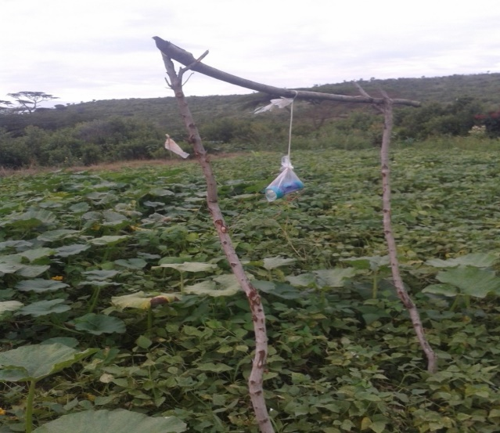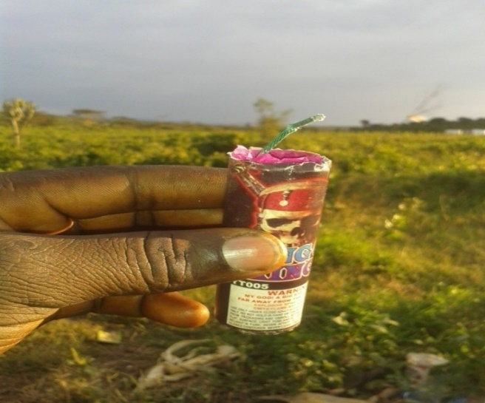

Fig. 2: Flashing Torch Fig. 3: Homemade Petrol Explosive Device (IHPED)

**Common Plant Fences**

A majority of local farmers (94%) used plant fences for instance; sisal (*Agave sisalana* L.), and milk brush (*Euphorbia tirucalli* L.). Plant fences were ineffective in keeping elephants away from farms and they even destroyed the fences instead (Fig. 4 & 5). Elephants avoided thorny plant fences, e.g., Kei apple (*Dovyalis caffra* L.) and Mauritius thorn (*Caesalpinia decapetala* L.).

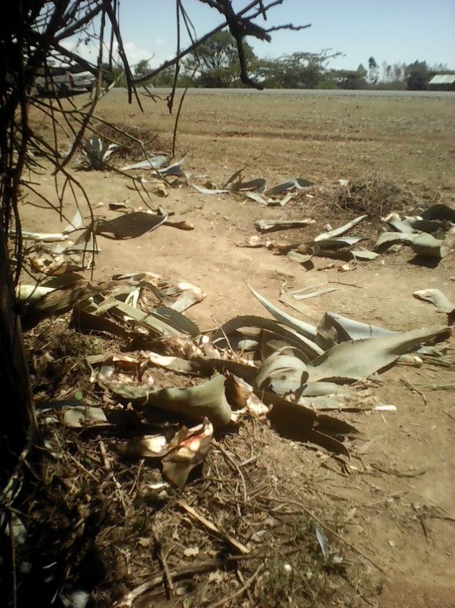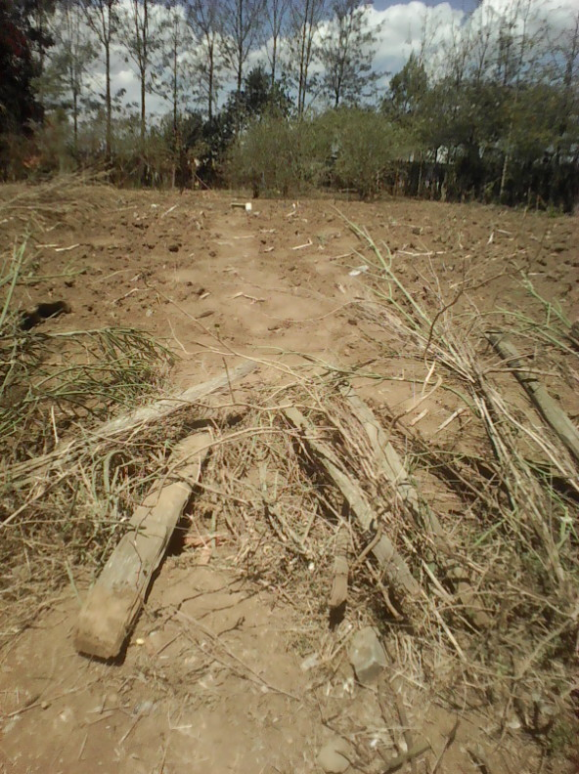

Fig. 4 A sisal plant fence: Fig. 5 Milk brush plant fence

**Discussion**

During the study period the proximity of crop farms to forest edges emerged as one of the major key determinant factors that significantly influenced elephant crop-raiding incidences in the study area. This was evident within the three study sites of Marmanet, Mutara, and Kinamba in Laikipia County, Kenya. The crop farms that elephants frequently raided in the villages were those at close proximity to the forest edges. But, those crop farms furthest away from forest edges encountered fewer cases of elephant crop raid incidences. Meaning, as the distance of crop farms away from forest edges increased the crop raids proportionally decreased. Hence, in this study, it can be postulated that elephants will only risk raiding crop farms within a certain minimum proximity range referred to as the risk range beyond which they will avoid such farms. The behavior of elephants avoiding the crop farms far away from forest edges can be attributed to high-risk factors involved, such as possible detection by aggrieved farmers and their consequential retaliatory attacks. Therefore, elephants preferred to cover shorter distances to access the target crop farms. In addition, the shorter the distance (risk range) to cover to get to the crop farms the less time elephants took to raid them. This is an advantage since crop raiding is a high-risk venture for elephants. Consequently, crop raiding by elephants must be executed the within shortest time possible to avoid detection by farmers. Those crop farms located beyond the high-risk range did not encounter frequent crop raid incidences. A related study by Nath et al. (2013) confirmed that crop raiding incidents were primarily concentrated on farms adjacent to the park's edges. However, in contrast, results revealed that the proximity of crop farms to river valleys, homesteads and major roads had no significant effect in influencing crop raiding by elephants in the three study sites of Marmanet, Mutara and Kinamba. The terrain of Laikipia County is generally an undulating flat plain with very few river valleys. Hence, the influence of river valleys on crop raiding by elephants in this case was minimal. The spatial distribution of homesteads in relation to crop farms made it easier for crop raiding elephants to raid only those crop farms away from homesteads. This can be explained by the fact that local farmers could easily detect elephants raiding crop farms within the vicinity of their homesteads.

In this current study the small sized farms were found to be more prone to elephant crop raiding farm than large farms. The small sized farms were easily targeted by elephants because much of their land space was devoted to crop cultivation and have little or no tree cover at all. Due to absence of tree cover in the small sized farms they become exposed and more vulnerable to elephant attacks. The tendency of elephants to raid the small farms can also be attributed to their proximity to forest edges where the cultivated crops easily allure elephants to the farms. Sitati et al. (2005) study in Maasai Mara Game reserve of Kenya established that small sized farms were an easy target for elephant crop raiding and they experienced more raids than large farms. Similarly, Nyirenda et al., (2012) study found that elephants raided small farms more than large farms.

This study has revealed that most crop farms in the three study sites that had little or no tree cover were targeted for elephant crop raiding. Large farms with high tree cover experienced fewer crop raids than small scale farms. This is arguably because trees cover acted as a shield and buffer zone that deterred elephants from the farms. In the large farms where crop cultivation is rarely done near forest edges and they had more swathe of land left to natural forests, unlike in small scale farms where much of the land is often devoted to crop cultivation. This finding is consistent with a Narok study, which found that large farms with more tree cover were less likely to be raided by elephants (Sitati et al. 2005).

The crop-raiding elephants were often observed to avoid crop farms near homesteads and roads due to fear of human interactions. This occurred in Surugoi and Wamura villages in Mutara study site, and seemed to apply in Gatundia and Gathwara villages in Marmanet study site, and Mbogoini, and was also replicated in Ndururu village of Kinamba study site. Elephant crop raid incidences were observed in isolated crop farms near forested river valleys but located away from human settlements. The avoidance of elephants from raiding crop farms near human settlements and roads, was an advantage because they were not easily detected, thus evading human retaliation. In a few instances they did break into maize granaries looking for dry maize.

This current study has established that common fences used locally did not deter elephants from farms. In most instances elephants trampled on some of these common farm fences when raiding farms. But they avoided the farms with thorny plant fences like Kei apples and Mauritania thorns. Other types of fences observed were open ditches (moats) that had no significant effect in reducing crop raiding. For instance, in the Kinamba area, a moat dug along the border of the Laikipia Ranching Company and farming areas failed to keep elephants off from farms. This was confirmed by past studies carried out in Africa; that classified ditches and farm hedges as passive deterrents against elephants (Hoare, 2015).

Majority of local farmers relied on farm-based defense strategies which failed to keep off elephants from the crop farms. These farmers were persistently using noise-producing objects like drums and whistles, shouting, throwing stones, lighting fires, and burning objects. The lighting of fires and burning of objects had drawbacks because it was difficult to keep the fire glowing for long durations, and rain could put it out. Other studies on usage of traditional defense strategies by farmers to deter elephants from farms confirm that they were less effective than other counter-measures (Sitati et al., 2005; Nyirenda et al., 2012). Local farmers were using an innovative and ingenious flashing of torches covered in polythene paper and raised to a height of one meter that proved to be effective to some extent in deterring elephants from farms. These flashing torches scared elephants away, but their batteries had a short life-span. However, the study recommended that the issue of short-life batteries can be resolved by using solar charged batteries. The IHPED used by farmers in Mutara scared off elephants and kept them away for about two weeks. This is despite the fact that IHPED have drawbacks of a possibility of causing human injury or death, fire outbreak, and being illegal. If local farmers are trained to use it effectively and its legality regularized by the Kenyan government. IHPED would be a more feasible farm-based strategy among the tradition strategies. It would allow farmers to harvest their crop yields during the short interlude when elephants are kept away due to its use.

**Conclusion**

The vulnerability of the crop farms to elephant crop raiding is determined by their proximity to the forest edges. Therefore, local farmers should avoid cultivation of crops near forests edges which attracts elephants to their farms. Small farms are more prone to elephant crop raids than large farms; because they have less tree cover, which did not shield crops. Small farms have a higher percentage of land dedicated to crop cultivation than large farms, which had large swathe of land occupied by trees which shields crops from elephant crop raiders. The small-scale farmers should endeavor to increase tree cover through intensive planting of trees on their farms. Trees will shield crop farms while acting as a buffer zone that deters elephants. Elephant crop-raiding was greatly influenced by the location of homesteads and the distance of roads from forest edges and crop farms. Local farmers should strive to use live fences or hedges preferably the thorny plant species that acts as a passive deterrent against elephants. They should also try practice other alternative farming methods apart from crop cultivation such as livestock keeping amongst which is compatible to wildlife.

**Acknowledgments**

We wish to thank the NRF (National Research Fund) of Kenya for financing this study. We acknowledge the NACOSTI a government organization, for granting us a research permit. Lastly, we appreciate all local farmers, community leaders from Laikipia County for their cooperation during this study.

**References**

Balasubramanian, A. 2017. Agroecological zones of India: Centre for Advanced Studies in Earth Science, University of Mysore, Mysore.

Bal, P., Nath, C. D., Nanaya, K. M., Kushalappa, C. G. & Garcia, C. (2011). Elephants Also Like Coffee: Trends and Drivers of Human–Elephant Conflicts in Coffee Agroforestry Landscapes of Kodagu, Western Ghats, India. *Environmental Management* 47:789–801

Chen, Y., Marino, J., Chen, Y., Tao, Q., Sullivan, C.D. & Shi, K. 2016. Predicting Hotspots of Human-Elephant Conflict to Inform Mitigation Strategies in Xishuangbanna Southwest China. *PLoS ONE:* 11

Danquah, E. 2016.Spatial Distribution of Elephants versus Human and Ecological variables in Western Ghana. *Advances in Ecology* Volume 2016, Article ID 8038524

FAO (1996). Agro-ecological Zoning Guidelines. FAO Soils Bulletin 73. Rom. [www.fao.org](http://www.fao.org/docrep/W2962E/w2962e00.htm#P-2)

Gadd, M. E. (2005). Conservation outside of parks: attitudes of local people in Laikipia, Kenya. *Environmental Conservation 32 (1): 50–63*

Gichohi, P. M. 2013. Effectiveness of Electric Fence in Mitigating Human –elephant conflict in Aberdare National Park, Kenya. (Msc. in Animal Ecology), Kenyatta University, Nairobi, Kenya.

Graham, M.D., Notter, B., Adams, W.M., Lee, P.C. & Ochieng, T.N. 2010. Patterns of crop-raiding by elephants, *Loxodonta africana L.*, in Laikipia, Kenya, and the management of human-elephant conflict. *Systematics and Biodiversity 8: 435–445*.

Goswami, V. R., & Vasudev, D. 2017. Triage of Conservation needs the juxtaposition of conflict mitigation and connectivity considerations in heterogeneous, human-dominated landscapes. Ecol. & Evol. 4:144

Haturusinghe, H. S. & Weerakoon, D. K. 2012. Crop Raiding Behavior of Elephants in the Northwestern Region of Sri Lanka, Gajah 36 (2012) 26-31

Hoare, R. 2015. Lessons from 20 years of Human–Elephant Conflict mitigation in Africa. *Hum. Dimensions Wildlife* 20, 289–295

Katharina, E. M. 2011. Elephant Movements and Human-Elephant Conflict in a Trans-frontier Conservation Area. Msc. (Thesis) in Conservation Ecology at the University of Stellenbosch.

Kenya Meteorological Department. 2017. Rainfall data of Laikipia County. Nairobi: Kenya Meteorological Department.

King, L.E., Lala, F., Nzumu, H., Mwambingu, E. & Douglas Hamilton, I. 2017. Beehive fences as a multi-dimensional conflict mitigation tool for farmers coexisting with elephants. *Conservation Biology*, 31 (4): 743-752.

Mariki, S. B., Svarstad, H. & Benjaminsen, T. A. 2015. Elephants over the cliff: explaining wildlife killings in Tanzania. *Land Use Policy* 44, 19–30.

Naha, D., Sathyakumar, S., Dash, S., Chettri, A. & Rawat, G.S. 2019. Assessment and prediction of spatial patterns of human-elephant conflicts in changing land cover scenarios of a human-dominated landscape in North Bengal. *PLoS ONE* 14(2).

Ngene, S.M., Okello, M. M., Mukeka, J.A., Muya, S., Njumbi.S. & Isiche, J. 2012. Home range sizes and space use of African elephants (*Loxodonta africana*) in the Southern Kenya and Northern Tanzania borderland landscape. *International Journal of Biodiversity & Conservation*. 9(1), 9-26

Ogunjobi, J.A., Halidu, S.K., Odebiyi, B.R. & Fxentirimam, I. J. 2018. Crop raiding pattern of the African elephant (*Loxodonta africana*) in farms around Kamuku National Park, Nigeria. *African Journal of Agriculture Technology and Environment* Vol. 7(2): 174-187

Shaffer, L.J., Khadka, K.K., Van Den Hoek, J. & Naithani, K.J. 2019. Human-Elephant Conflict: A Review of Current Management Strategies and Future Directions. *Front Ecology and Evolution.* 6:235.

Sitati, N. W. & Walpole, M. J. 2006. Assessing farm-based measures for mitigating human-elephant conflicts in Transmara District, Kenya. *Oryx,* 40:279-286.

Sitienei, A. J., Ge, J. & Ngene, S.M. 2014. "Assessing the Cost of Living with Elephants (*Loxodonta africana*) in Areas Adjacent to Meru National Park, Kenya. *European Journal of Wildlife Research*, 60:323-30.

Tiller, L. N. 2017. Understanding how the land-use change in the Trans Mara District, Kenya is driving human-elephant conflict and elephant movement. Doctor of Philosophy (Ph.D.) thesis, University of Kent.

Thouless, C., Dublin, H. T., Blanc, J., Skinner, D., Daniel, T., Taylor, R. & Bouche, P. 2016. African Elephant Status Report 2016. *Occasional Paper Series of the IUCN Species Survival Commission*, 60

Webber, C. E., Tuy, S., Maltby, M. P. & Lee, P. C. 2011. Elephant crop-raiding and human-elephant conﬂict in Cambodia: crop selection and seasonal timings of raids. *Oryx*, 45(2):243–251