**The Scientific World Journal**

**Evaluation of Surface Roughness and Color Stability of Rhodium Coated Orthodontic Archwire.**

Maryam S. Al-Ameri1, and Sami K. Al-Joubori2

1 Department of Orthodontic, ministry of health /00000, Iraq

2Department of Orthodontic, College of Dentistry / Baghdad University, 00000, Iraq

[mariam.salman1203a@codental.uobaghdad.edu.iq](mailto:mariam.salman1203a@codental.uobaghdad.edu.iq)

drsami_orthodontist@codental.uobaghdad.edu.iq

**Abstract**

*Objectives.* This research aims to compare the impact of fluoridated and non-fluoridated mouthwashes on the surface roughness and color stability of rhodium-coated stainless steel archwires at different time intervals. *Methods.* Specimens were distributed into two groups: non-coated stainless steel (NC-SS) archwires and rhodium-coated stainless steel (RC-SS) archwires from the same company (DB Orthodontics/UK); each group contained 45 archwires that were divided into halves, eighteen strips were made, each comprising the tenth halves of the esthetic archwires. The deionized water, fluoridated mouthwash, and non-fluoridated mouthwash were the immersion media; the strips were immersed for thirty seconds twice a day, and the measurement was done after one, three, and six weeks; the specimens were incubated at 37°C during the testing period. The surface roughness was assessed using atomic force microscopy, and a spectrometer was used to analyze the color change using the Commission Internationale de l'Eclairage L*a*b* color space standard. The independent sample T-test, ANOVA, and HSD tests were used to examine the data statistically. *Result.* Both uncoated and rhodium-coated SS archwire showed the highest roughness in fluoridated mouthwash at 1-week intervals (4.12± 0.57) and (5.54± 0.85), respectively. According to the spectrometer assessments, the ΔE* values of NC-SS and RC-SS were 0.62−1.37 and 0.52−2.92, respectively. According to NBS units, both archwires showed “slight” color changes except for RC-SS, which showed a noticeable color change in the fluoridated solution after 6 weeks. In conclusion, SS archwires' color stability and surface roughness can be affected by the daily usage of mouthwashes. However, fluoridated mouthwash showed more effect than non-fluoridated mouthwash; when immersed in different immersion media, rhodium-plated stainless steel archwires are less affected than uncoated ones. Increasing the immersion time will increase the surface roughness and color change.

**Keywords**: Orthodontics, Color stability, Surface roughness, Rhodium archwire, Mouthwashes.

1. **Introduction**

One of the main issues during orthodontic treatment is aesthetics, thus making the manufacturers create appliances offering good clinical work and patient-acceptable appearance **[1, 2].** The advent of methods of coating archwires gives the patient a more aesthetically pleasing image; the surface of the bracket, stainless steel, and nickel-titanium (NiTi) wires can be served as a base where they are applied **[3]**; rhodium plating is sometimes used to cover these archwires **[2]**.

Rhodium, a precious metal with a white reflecting surface and outstanding anticorrosion capability, is reported to have such an attractive feature in commercially available wires that it can tolerate the environment of the oral cavity since it can withstand corrosion and deterioration **[4]**.

Rhodium plating is used on basic archwires nowadays and has several benefits, including improved aesthetics, less nickel interaction with saliva and mouth tissue, and reduced friction. Since rhodium provides the wire with a high sheen and reduces its visibility, it aligns with the current trend toward using more stable, nontoxic materials from the precious metals category **[5].** The coating layer of the rhodium aesthetic archwire is between (0.3 μm to 0.5 μm) in thickness; it is approximately 370 nm (0.37 μm) **[6].**

The plasma-immersion ion implantation method is used to apply rhodium coating **[7]**. Ion implantation is the technique by which energized atoms refine a substrate by attaching to the coating material's highly energetic, positively charged radicals through negative loading. After piercing the substrate's surface, the radicals bond to it. The surface composition is permanently modified by introducing energized atoms (it is not a coating) **[8].**

Orthodontic archwires with an aesthetic coating tend to discolor with internal elements, such as UV irradiation and heat energy, **[9, 10]** andexternal factors, like food dyes and colored mouthwash. Oral health, moisture content, and inadequate polymerization [11].

The surface quality of the material is a property that significantly affects the archwires; It is a crucial part of assessing the hygiene and, consequently, the efficacy of orthodontic treatment **[12]**. Regarding the safety of orthodontic treatments, the surface texture can impact biocompatibility, plaque retention, and aesthetic results **[13-15]**. In addition, the greater surface roughness of the wire can provide more sliding contact between the bracket and the wire, which increases the sliding friction, which results in improper stress distribution in the orthodontic device and, as a result, a reduction in the effectiveness of guided tooth movement along the archwire **[16]**.

Mouth rinses are one of the many elements that come into contact with orthodontic materials and significantly impact their responsive condition and surface quality **[17]**. However, despite their advantageous effects, mouth rinses have the potential to alter the archwires and brackets' mechanical and surface properties as well as raise friction and microhardness levels. **[18]**.

Previous research has assessed orthodontic archwires' mechanical and physical characteristics using various methods; for example, Alsanea and Shehri **[2]** assessed the surface degree of roughness, nanomechanical characteristics, and the color durability of three products of coated nickel‑titanium (NiTi) esthetic archwires (rhodium, epoxy, and Teflon) after staining them in two different solutions that included coffee and black tea. Likewise, Inami et al. **[19]** examined the color durability of glass-fiber-reinforced plastic archwires after being subjected to coffee. Although Da Silva et al. evaluated the color stability and fluorescence of six different orthodontic esthetic archwires **[20]**, there needs to be more information on the surface topography and color durability of stainless steel esthetic archwires with a rhodium coating. Therefore, this research aimed to compare rhodium-coated aesthetic stainless steel orthodontic archwires with those not coated in terms of surface roughness and color stability. The null hypothesis is that the mouthwash did not affect the rhodium-coated aesthetic archwires' surface roughness and color stability.

**2. Materials and methods:**

2.1 The sample

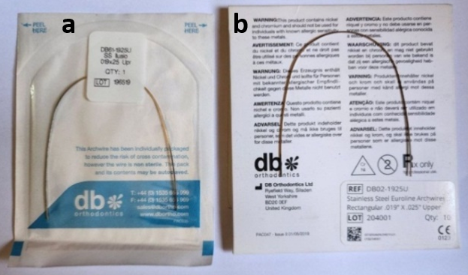 In *vitro* experimental research was performed on two types of stainless steel archwires: non-coated stainless steel archwire (NC-SS) and rhodium-coated stainless steel archwire (RC-SS) from the same company (DB Orthodontics/UK). The cross-section of each archwire was the same size (upper rectangular), measuring 0.019 by 0.025 inches (Figure 1). For the independent sample T-test and one-way ANOVA testing, this study calculated the sample size using post hoc power analysis with GPower (version 3.1.9.4, Win), considering α = 0.05 and a power of 0.80. A sensitivity analysis was conducted using the anticipated sample size (N = 180, control = 10, N1 = N2 = N3 = 20) following this supposition, and the results showed that the minimal detectable sample size was of Cohen's d = 0.379. **[2, 11, 21, and 22].**

Figure 1: The archwires. (a)rhodium-coated SS archwire.(b)non-coated SS archwire.

Ninety archwires were prepared for measurement (45 of NC-SS archwire and 45 of RC-SS archwire). The samples were rinsed in distilled water and dried with tissue paper to eliminate the contaminated layer that developed during storage. The specimen was produced by dividing the preformed archwires into two halves with an orthodontic cutter, the sample became 180, then joining the ten halves of the archwire segments' free ends with a thread of regular dental floss so that the specimen resembled a strip **[2, 11, and 21]**. Eighteen strips are made, nine for each type of SS archwire. (Figure 2).

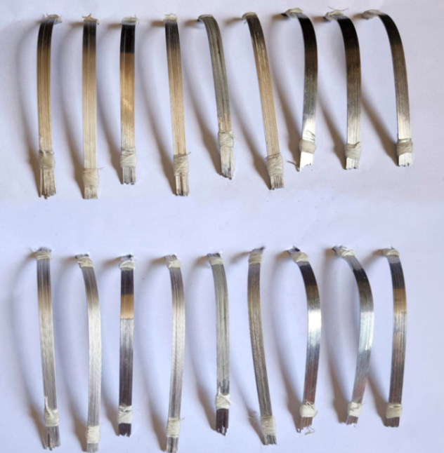

Figure 2: Eighteen strips are made by joining ten halves of an orthodontic archwire

Each sample was tied by a piece of retraction cord that catted several millimeters away from the sample end and placed in one glass container and held at one of its ends by a dental floss in a particular manner to avoid contacting the wall of the container; the free end of the dental floss is squeezed agenized the container cover that capped perfectly and labeled by the group name by marking pen**,** After that, the samples were maintained at *37*ºC (the most relevant mouth temperature) in the incubator (figure 3). Following 24 hours of average temperature storage in deionized water, the initial color measurement (T0) was carried out **[2, 11, 19-22]**. Then two strips from each wire type are included in the following immersion media for one, three, and six weeks. (Figure 4).

* Sidra Zac mouth rinse (chlorhexidine digluconate 0.12%, fluoride0.05, pH=6, Alpha Pharma, Turkey)
* Biofresh mouth rinse (chlorhexidine digluconate 0.12, pH=5.3, Scitra Co, United arab emirates).
* The control medium utilized is deionized water.

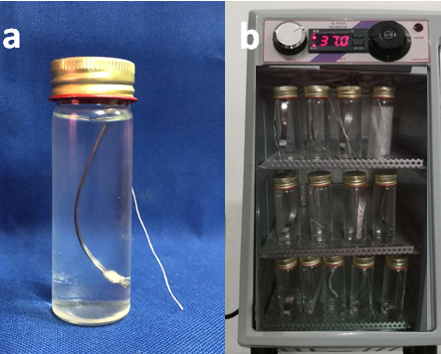

Figure 3: Preparation of the Samples. (a) Sample in immersion media. (b) The samples were inside the incubator.

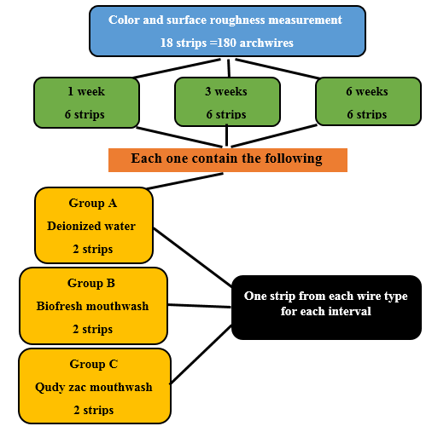

Figure 4: Schematic view of the sample grouping**.**

2.2 Measurement of surface roughness and color stability

Atomic force microscopy -AFM- (model TT2, AFM Workshop Company, USA) was used to assess the surface topography of all archwire samples. Surface topography is examined by tapping mode**,** and a silicon sensor placed on a cantilever is part of the AFM. It was set up to scan in a pressing mode for 540 seconds (9 minutes) (figure 5). The NOVA SPM software was used to manage the scan settings, and the image processing P9 program was used to process the images, ten spots on the strip, spaced 4 mm apart, were investigated for every specimen. Using a vernier, the distance was determined; the points were identified using a marker pen at the back surface of the sample. Following one week (T1), three weeks (T2), and six weeks (T3) of submersion in the staining solution, the surface roughness measurement was carried out once again**[23]**.

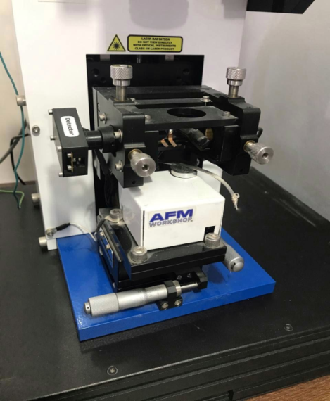Figure 5: The specimen were measured with atomic force microscopy

The color was measured using the Commission Internationale de l'Eclairege L*a*b* (CIELAB) color space with a spectrometer (Model Lambda 365, Perkin Elmer/USA) from 12 isolated spots**]** spaced 3mm apart. The specimen was positioned in the middle of a spectrophotometer tube in front of a xenon lamp (the light source). **[2, 11, 21]**

The CIE L*a*b* color system uses rectangular dimensions and is a quantifiable system that enables an accurate color assessment by measuring the sample's value and chroma in L*a*b* coordinates: L* measures the intensity of the color from black (L* = 0) to white (L* = 100); a* refer to the hue in red (a* > 0) and green (a* 0) dimensions; and b* measures the color in yellow (b* > 0) and blue (b*< 0) dimensions. The following equation (1) was used to obtain the total variation before and after immersion: **[2, 11, 19, 20]**

∆E lab* = ([∆L*] 2 + [∆a*] 2 + [∆b*] 2)1/2. (1)

To relate the colored changes to a clinical environment, the ΔE values are covered in National Bureau of Standards (NBS) units by equation (2) : **[19-24]**

NBS units = ΔE × 0.92 (2)

In the description, NBS units 0.0 to 0.5 were included: trace: very slight change, 0.5-1.5: slight to moderate change, 3.0-6.0: noticeable change by a skillful operator, 6.0-12.0: much extremely substantial change, 12.0 or more: very much-shift to another color. After the initial measurement (T0). Following one week (T1), three weeks (T2), and six weeks (T3) of submersion in the staining solution, color analysis was carried out once more. The specimen was removed from the container, rinsed with distilled water for 5 minutes, and dried with tissue paper for each color measurement. **[2, 11, 19, 20, 24]**

1. Results

The research data were evaluated using the Statistical Package for the Social Sciences (SPSS) software (version 18.0, SPSS Inc., Chicago, Illinois, USA); the data are generally distributed according to Shapiro–Wilk's test for both Surface roughness(**Ra)** and color change **(ΔE*)**values, descriptive statistics were obtained (maximum, minimum, mean and standard deviations (SD)) were calculated. Independent sample T-test was used to test for differences between the groups. In contrast, Tukey's post hoc test and analyses of variance (ANOVA) were used to compare differences in the average surface roughness (Ra) among the immersion media and time intervals.

Figures 7 and 8 show representative AFM topographical images of the studied wires, which exhibit pores, dimples, striations, or sharp grooves parallel to the archwire's long axis. Each type of wire had unique surface micro-morphologic characteristics. There are variations in the elevations and depressions on the surfaces of the two types of archwire. In addition, some samples had scratches that weren't parallel to the archwire's long axis. Pitting was the third kind of pattern identified. Regarding the fluoridated and non-fluoridated mouthwash immersion and time effect, both wires first displayed noticeable surface defects with high peak-to-valley height, significantly increasing after one week of immersion with significantly increased roughness height. They then decreased gradually over time to become considerably less rough.

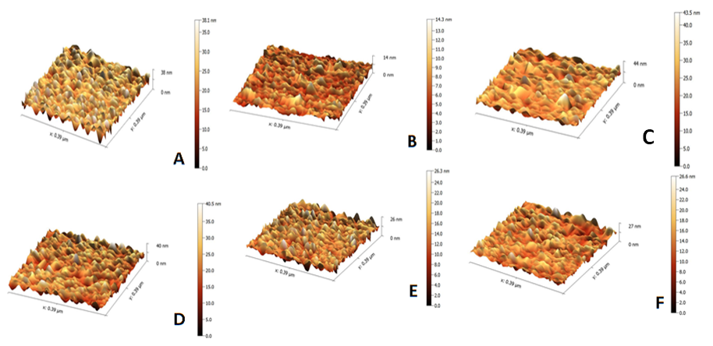

Figure 6: three-dimensional AFM topography images (25 * 25 µm) after immersion in sidrazac of non-coated SS archwires for A)1 week, B) 3 weeks, and C) 6 weeks and of rhodium-coated SS archwires for D) 1 week E)3 weeks and F ) 6weeks.

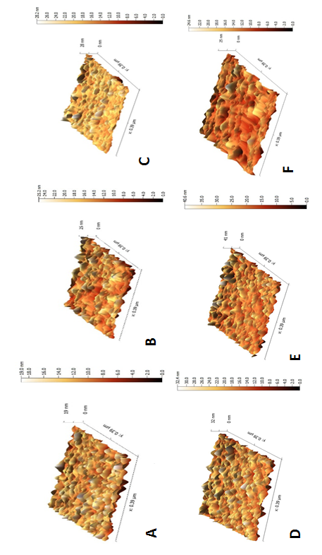

Figure 7: three-dimensional AFM topography images (25 * 25 µm)after immersion in biofresh of non-coated SS archwires for A)1 week, B) 3 weeks, and C) 6 weeks and of rhodium-coated SS archwires for D) 1 week E)3 weeks and F ) 6weeks

By noticing the mean of surface roughness (±SD) in (Table 1),the uncoated stainless steel archwire shows the highest Ra (4.12± 0.57) and lowest Ra (0.81± 0.08)values found in fluoridated mouthwash (sidrazac) at 1 and 6 weeks interval respectively. On the other hand, in Rhodium-coated stainless steel archwires, the highest **Ra**(5.54 ± 0.85) were found in fluoridated mouthwash (sidrazac) at a 1-week interval, and the lowest **Ra**(0.51±0.63) values were found in non-fluoridated mouthwash (biofresh) at 6 weeks interval. In addition, independent sample T-tests were done to examine the differences in **Ra** values between non-coated SS archwires and rhodium-coated SS aesthetic archwires in various immersed mediums over time intervals (Table 2). The T-test shows a significant difference between NC-SS archwire and RC-SS aesthetic archwires of fluoridated mouthwash (sidrazac) effect in one and three weeks and of the effect of non-fluoridated mouthwash (biofresh) deionized water in all weeks intervals.

**(ANOVA)** test was used to examine the influence of various immersion media and immersion time on **Ra** values of non-coated and Rhodium-coated SS archwires at different intervals; **when** **(ANOVA)** showed a difference, Tukey **(HSD)** test was performed to show the difference between each group. (Table 3) demonstrated that there were significant differences in **Ra** values in the uncoated SS group in 1 week (biofresh vs. sidrazac), 3 weeks (biofresh vs. sidrazac), and 6 weeks (control vs. sdrazac and biofresh vs. sidrazac). There were significant differences in **Ra** values in Rhodium coated SS archwire group in 1 week (control VS sidrazac), 3 weeks among all immersion media at different time intervals, and 6 weeks intervals (control VS biofresh and control VS sidrazac)**.** (Table 4) demonstrated that there was a significant difference inuncoated SS archwires in the control group (1 week vs 3 weeks and 1 week vs 6 weeks) and sidrazac group among all weeks intervals; there was also a significant difference in rhodium-coated SS archwires in the control group (1 week vs. 6 weeks), sidrazac in all weeks interval and biofresh (1 week vs. 3 weeks and 1 week vs. 6 weeks).

Table 1: Arch wires' Ra (in nm) values for various immersion mediums at various time intervals are described in descriptive statistics.

|  |  |  |  |  |  |  |  |  |  |  |
| --- | --- | --- | --- | --- | --- | --- | --- | --- | --- | --- |
|  |  |  | surface roughness | | | | color change | | | |
| wire type | media | Duration | Min. | Max. | Mean | Std. Deviation | Min. | Max. | Mean | Std. Deviation |
| uncoated stainless steel archwire | control | 1 week | 1.84 | 3.59 | 2.48 | 0.57 | 0.53 | 0.86 | 0.7 | 0.11 |
| 3 weeks | 1.43 | 2.52 | 2.03 | 0.39 | 0.23 | 2.19 | 1.08 | 0.68 |
| 6 weeks | 1.54 | 1.98 | 1.81 | 0.16 | 3.45 | 7.56 | 5.02 | 1.07 |
| sidrazac | 1 week | 1.98 | 4.12 | 3 | 0.57 | 0.53 | 0.85 | 0.73 | 0.09 |
| 3 weeks | 1.12 | 1.91 | 1.48 | 0.25 | 0.82 | 1 | 0.93 | 0.05 |
| 6 week | 0.81 | 1.12 | 0.98 | 0.08 | 0.91 | 1.89 | 1.21 | 0.3 |
| biofresh | 1 week | 1.05 | 3.54 | 2.1 | 0.87 | 0.34 | 0.75 | 0.62 | 0.12 |
| 3 weeks | 1.12 | 3.43 | 2.15 | 0.75 | 0.48 | 0.95 | 0.71 | 0.18 |
| 6 weeks | 0.91 | 3.59 | 1.98 | 0.71 | 0.22 | 2.76 | 1.37 | 0.9 |
| Rhodium-coated stainless steel archwire | control | 1 week | 2.44 | 4.22 | 3.25 | 0.62 | 0.82 | 1 | 0.9 | 0.06 |
| 3 weeks | 2.22 | 5.02 | 3.73 | 0.97 | 0.49 | 1.42 | 1.04 | 0.31 |
| 6 weeks | 3.02 | 4.54 | 3.834 | 0.49 | 0.51 | 3.48 | 1.85 | 0.89 |
| sidrazac | 1week | 3.12 | 5.54 | 4.23 | 0.85 | 0.22 | 0.89 | 0.52 | 0.26 |
| 3 week | 2.22 | 3.54 | 2.85 | 0.51 | 0.32 | 1.83 | 0.94 | 0.48 |
| 6 weeks | 0.51 | 2.34 | 1.24 | 0.63 | 1.23 | 4.45 | 2.92 | 0.96 |
| biofresh | 1 week | 2.02 | 4.62 | 3.49 | 0.92 | 0.29 | 1.35 | 0.89 | 0.27 |
| 3 weeks | 0.11 | 2.11 | 1.18 | 0.71 | 0.42 | 1.21 | 0.9 | 0.22 |
| 6 weeks | 0.81 | 1.12 | 0.96 | 0.09 | 0.49 | 1.42 | 1 | 0.29 |

Table 2: Independent sample T-test results of the influence of Archwires on the average roughness Values (Ra)

|  |  |  |  |  |
| --- | --- | --- | --- | --- |
| media | duration | mean difference | T-test | P value |
|
|
| sidrazac | 1 week | -1.237 | -3.822 | 0.001 |
| 3 weeks | -1.367 | -7.598 | 0.000 |
| 6 weeks | -0.259 | -1.285 | 0.230 |
| biofresh | 1 week | -1.392 | -3.469 | 0.003 |
| 3 weeks | 0.973 | 2.981 | 0.008 |
| 6 weeks | 1.019 | 4.518 | 0.001 |

Table 3: The Impact of Immersion Media on Surface Roughness Average Values (Ra).

|  |  |  |  |  |  |  |
| --- | --- | --- | --- | --- | --- | --- |
| ANOVA (Ra) | | | | Tukey HSD test | | |
| wire type | duration | F-test | P value | control vs. biofresh | control vs. sidrazac | biofresh vs. sidrazac |
|
| uncoated stainless steel archwire | 1 week | 4.364 | 0.023 | 0.434 | 0.227 | 0.018 |
| 3 weeks | 4.931 | 0.015 | 0.854 | 0.058 | 0.017 |
| 6 weeks | 16.111 | 0.000 | 0.643 | 0.000 | 0.000 |
| Rhodium-coated stainless steel archwire | 1 week | 4.039 | 0.029 | 0.786 | 0.029 | 0.117 |
| 3 weeks | 29.566 | 0.000 | 0.000 | 0.036 | 0.000 |
| 6 weeks | 143.907 | 0.000 | 0.000 | 0.000 | 0.383 |

Table 4: Results of the (ANOVA) test and (HSD) test for both varieties of archwires, as well as the impact of immersion time

|  |  |  |  |  |  |  |
| --- | --- | --- | --- | --- | --- | --- |
| ANOVA | | | | Tukey HSD test | | |
| wire type | duration | F-test | P value | 1 week vs. 3 weeks | 1 week vs 6 weeks | 3 weeks vs. 6 weeks |
| uncoated stainless steel archwire | control | 7.065 | 0.003 | 0.050 | 0.003 | 0.459 |
| sidrazac | 84.364 | 0.000 | 0.000 | 0.000 | 0.012 |
| biofresh | 0.131 | 0.878 |  |  |  |
| Rhodium-coated stainless steel archwire | control | 3.771 | 0.036 | 0.306 | 0.028 | 0.441 |
| sidrazac | 48.841 | 0.000 | 0.000 | 0.000 | 0.000 |
| biofresh | 43.080 | 0.000 | 0.000 | 0.000 | 0.751 |

NBS units were created by converting ∆E* values (table 5) for each type of SS archwire. The ΔE* values at 1, 3, and 6 weeks after immersion in sidrazac for NC-SS and RC-SS ranged from 0.73-1.21 and 0.52−2.92, respectively. The NBS units at 1, 3, and 6 weeks after immersion in biofresh for NC-SS and RC-SS ranged from 0.62-1.37 and 0.89-1, respectively; according to the NBS values, all samples exhibited discoloration, both archwires showed “slight” color changes in all times interval except for RC-SS that showed trace change after 1 week and noticeable discoloration after 6 weeks in fluoridated solution.

Table 5: Color change values (ΔE*) according to National Bureau of Standards (NBS) units.

|  |  |  |  |  |  |
| --- | --- | --- | --- | --- | --- |
| Group | media | duration | ΔE | NBS unit | color change |
| uncoated stainless steel archwire | control | 1 week | 0.70 | 0.65 | slight |
| 3 weeks | 1.08 | 0.99 | slight |
| 6 weeks | 5.02 | 4.62 | Appreciable |
| sidrazac | 1 week | 0.73 | 0.67 | Slight |
| 3 weeks | 0.93 | 0.85 | Slight |
| 6 week | 1.21 | 1.11 | Slight |
| biofresh | 1 week | 0.62 | 0.57 | Slight |
| 3 weeks | 0.71 | 0.65 | Slight |
| 6 weeks | 1.37 | 1.26 | Slight |
| rhodium-coated stainless steel archwire | control | 1 week | 0.90 | 0.83 | Slight |
| 3 weeks | 1.04 | 0.95 | Slight |
| 6 weeks | 1.85 | 1.70 | Noticeable |
| sidrazac | 1week | 0.52 | 0.48 | Trace |
| 3 week | 0.94 | 0.86 | Slight |
| 6 weeks | 2.92 | 2.69 | Noticeable |
| biofresh | 1 week | 0.89 | 0.82 | Slight |
| 3 weeks | 0.90 | 0.83 | Slight |
| 6 weeks | 1.00 | 0.92 | Slight |

After one week, three weeks, and six weeks of immersion, there is a statistically significant difference in the color and roughness of coated and uncoated stainless steel archwires between Sidrazac and Bio-fresh. According to this, the null hypothesis was invalid; the mouth rinse impacted the surface topography and color durability of rhodium-coated archwires.

1. **Discussion**
   1. **The need for the study**

Many Adult patients seek orthodontic treatment for cosmetic reasons; the bracket and archwires have developed to produce many aesthetically pleasing materials **[1]**. After a fixed orthodontic device is fitted, oral hygiene is severely affected. Mouthwash can be used to maintain proper dental hygiene. **[25].** Commercial mouth rinses, toothpaste, and preventive gels that include fluoride are frequently used to lessen gingival swelling and enamel decalcification while promoting enamel remineralization next to orthodontic brackets. **[6].** The surface topography and color durability of aesthetic archwires are clinically essential and worth estimating **[19, 26]**. Although the topic of color durability and surface roughness of orthodontic wires has been previously studied, this study uses different materials; without taking into account other outside and intraoral influences, it can help make relative comparisons and estimate how different mouthwashes will affect the roughness of the surface and color durability of aesthetic archwires.

* 1. **The study design**

Due to the ability to control material criteria and the challenge of controlling the external elements in a clinical trial, especially the impact of additional staining agents other than mouthwashes, such as cigarettes, wine, coffee, and tea, an in vitro study approach was adopted. Additionally, since changing the patient's archwire might occur more often at the orthodontic clinic, an analysis of the surface roughness and color stability across three cycles was done to determine how long the archwire could withstand before altering its color. Archwire with a rectangular cross-section (0.0190*0.025 inch) was used because it is simpler to create a strip and to get the sample's diameter as nearly identical to one inch, which is the diameter of the sample sensor in the spectrophotometer (figure 8) due to the difficulty in detecting the color change of thin archwires. After all, to measure colors accurately, the wires must be at least 7 mm wide **[2, 11, 19-22].**

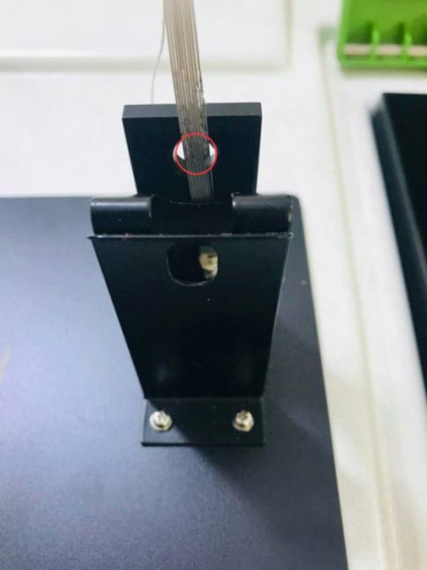 Figure 8: The diameter of the strip is nearly close to the diameter of the sample detector of the spectrophotometer (red circle)

**4.3 The equipment selection**

AFM is known as the most suitable device for studying surface topography. Its non-invasive and non-destructive optical method over stylus profilometry has helped study the surface characteristics of orthodontic materials at the microscopic level without deterioration of samples, It promotes accurate comprehension (by providing quantitative and qualitative height measurements). The samples don't need additional processing, like metallization; the AFM can also offer numerical figures for the parameters under investigation. **[27]**

In several earlier research using the CIE Lab methodology, the color change was measured using a spectrophotometer by comparing the values of L*, a*, and b* before and after treatment. However, the value of ΔE denotes the relative discoloration that a viewer might notice. Therefore, ΔE has more significance than the individual values of L*, a*, and b*. **[2, 11, 19-24]**.

**4.4 The Impact of Different Materials of Arch Wires on the Surface Roughness (Ra) in various Immersion Media at Diverse Timelines (table 2).**

The findings of this investigation indicated that the surface of NC-SS archwires was affected by fluoridated mouthwash more than the non-fluoridated one; this can be explained by the protecting chromium oxide (CrO2) coatings on the SS wires' outermost surface that are particularly vulnerable to attack by F-ions **[28].** According to Alwafe et al. findings **[29],** samples dipped in sodium fluoride mouth rinse had the highest contact resistance and surface roughness value, followed by herbal mouthwash, while artificial saliva had the least. Hosseinzadehet al.[**30]**; assessed the impact of chlorhexidine on orthodontic wires and brackets' surface characteristics and friction; the findings demonstrated that a 1.5-hour immersion in a mouth rinse containing 0.2% chlorhexidine without fluoride had no appreciable impact on the surface roughness of SS archwire. On the other hand, the 0.12% chlorhexidine mouthwash revealed a higher pitting view on a stainless steel wire, according to another investigation on the surface features of orthodontic archwires **[31]**.

RC-SS archwires' surface roughness was generally less affected than NC-SS archwires because Rhodium metal is well known for its unusual quality, physical attractiveness, and durability in corrosive situations. **[32]**. A rhodium-coated archwire comprises rhodium ions over the senta alloy wire; this increases the shimmering and surface finish of the metals **[33]**. According to Yakima et al., the rhodium-coated archwires were rougher than the sent alloy non-coated wires **[34].** Orthodontic wires with stainless-steel (SS) alloys were examined under a microscope without and with an aesthetic coating by D'Anto et al. **[14],** who discovered that the rhodium ions' implantation increased aesthetic wires' roughness.

This study concludes that rhodium coating provides a protective layer against the effect of corrosive agents such as fluoride.

**4.5 The Influence of the Immersion Medium on the surface roughness Values (Ra) (table 3).**

Chromium, a highly reacting base metal, imparts corrosion resistance to NC-SS by passively developing and regenerating a passive chromium oxide coating on its surface in the air and under most tissue fluid conditions. **[30]** Since there was no significant difference between the control group and the biofresh group in all time intervals and between the control group and the sidrazac group after one and three weeks, the passive film protecting both wires may preserve after 30 days in pH = 5.0 **[28, 35]**. Because after six weeks of exposure to sidrazac, fluoride may play a significant role in the failure of the insulating oxide layer of alloys; this thin oxide layer, which fluoride removes, inhibits oxygen passage and gives SS wires corrosion resistance **[36]**. While the F- ion may permeate into the metal/oxide film interface in acidic conditions, the acidity of the fluoride solution utilized in this experiment does not influence the roughness of the wire since the CrO2 layer can remain intact in pH = 3**[28,37]**.

Without fluoride, the time is not considered enough for chlorhexidine to cause considerable roughness change in the RC-SS archwire, so there is no difference between the control and biofresh groups after 1 week. However, the findings of this study showed that the rhodium layer had significantly worsened and high roughness in biofresh (3 and 6 weeks) and sidrazac (all time intervals). The high corrosion propensity of rhodium-covered wires may be explained by the development of an electrochemical reaction between both the noble covering and the base metal of the archwire due to the coating's porosity, where the coating becomes a negative charge, and the base wire becomes a positive charge **[38].**

With a 3-electrode cell coupled to a potentiostat, Katic and colleagues **[23]** discovered that rhodium-coated nickel-titanium wires corroded more frequently and intensely upon SEM examination; according to Katic's hypothesis, this might be caused by the galvanic interaction between the noble rhodium covering and the wire's base metal. Rhodium-coating, according to the identical conclusion reached by Rincic et al. **[39]**, enhances the propensity towards general and localized corrosion.

So regarding the influence of the Immersion Media on the surface roughness values, the fluoride agent has more effect on the roughness of the rhodium wire, with a significant difference between NC-SS and RC-SS noticed after 3 weeks.

**4.6 The Influence of the Immersion Time on the surface roughness Values (Ra) (table 4)**.

As shown in Table 4, the time of immersion affects the surface roughness of both SS archwires except for the NC-SS archwire immersed in biofresh because, as mentioned earlier in Section 4.4, chlorhexidine does not affect the surface roughness of the NC-SS archwire.

Increased time of immersion of both wires in sidrazac will cause a change in the surface characteristics of the wire, and the analysis shows no difference between specific time intervals, which may be attributed to the existence of flaws in the rhodium-gold coating, suggesting that sidrazac and biofresh somehow contributed to the coating's pores being filled; according to the findings of Rincic et al. **[39]** in the study of oral antiseptics' implications on the resistance to the deterioration of nickel-titanium orthodontic materials, it is feasible that the metal's vesicles are loaded with corrosive substances or that organic matter of the antiseptic agent adheres to the metal's surface and gradually decreases corrosion

**4.7 The Impact of Fluoride on Color Change Values of Different Arch Wire in Different Immersion Mediums at Different Time Intervals. (Table 5)**

The color change of NC-SS and RC-SS archwires is assessed in NBS units; both archwires showed “slight” color changes in all time intervals in fluoridated and non-fluoridated mouthwashes except for RC-SS archwire samples immersed in sidrazac that show a gradual increase in Color Change Values from trace change after 1 week (ΔE=0.48) to slight color change after 3 weeks (ΔE=0.86) to noticeable color change after 6 weeks (ΔE=2.69).

According to studies, aesthetic archwires often start to discolor after 21 days of being submerged in the staining media, and the amount of color change increased over time **[2,11, 20, 40],** which is consistent with the results of the current investigation; this may be explained by the colorant particles of the mouthwashes absorbing or adhering to the coating material, causing it to degrade over time as mouthwash solutions contain various components, such as disinfectants, dispersants, organic acids, and colorants, which could impact the substance's color**[41].** The discoloration could be caused by water absorption that acts as a polymer softener, including continuous adsorption or absorption, superficial washing penetration, and surface coating degradation. **[42]**.

According to Noori and Ghaib **[43]**, it was discovered that the longer the wires were immersed in staining solution, the more color changes occurred. Moreover, Al-Attar **[44]** and Albo Hassan and Ghaib **[45]** reported that the degree of aesthetic bracket discoloration increased with the duration of immersion in mouthwash and staining media. Fluoride ions could cause the material's surface to become rougher, ultimately leading to discoloration **[46]**.

Although the examined aesthetic arch wires displayed discoloration across all immersion environments at various intervals, not all were clinically significant.

1. **conclusion**

There were differences in the surface roughness between NC-SS and RC-SS archwires, but generally, RC-SS archwires were less affected than NC-SS archwires.' So rhodium coating provides a protective layer against the effect of corrosive agents such as fluoride. Regarding the influence of the immersion media on the surface roughness Values, The fluoride agent has more effect on the roughness of the rhodium wire, with a significant difference noticed after 3 weeks. Increased time of immersion of both wires in sidrazac will cause a change in the surface characteristics of the wire.

The color differences are indicated by the ΔE* values of both NC-SS archwires and RC-SS archwires. Following NBS units, NC-SS archwires showed “slight” color changes in all time intervals in both types of mouthwash. Although the ΔE* values increase within time in both solutions, the values are approximately the same. This indicates that the color changes in the NC-SS archwires were minimal during the 6 weeks of both immersions. The RC-SS archwires showed “slight” color changes in all time intervals in biofresh, but the color change in sidrazac rang from “trace” within 1 week to “noticeable” after 6 weeks. This indicates that the fluoridated mouthwash has more effect on the RC-SS archwire, and increasing the immersion time will cause more color change.

The orthodontist can consider using non-fluoridated mouthwash instead of fluoridated mouthwash to help individuals receiving orthodontic treatment maintain good dental hygiene.

**Clinical consideration**

Aesthetic arch wires' discoloration is crucial for getting good results; however, the discoloration can occasionally cause patient disappointment. Moreevwe, maintaining good dental hygiene is crucial for the success of orthodontic therapy.

The findings of this study suggest that clinicians should exercise caution when recommending fluoridated mouthrins because these products will cause more roughness and color changes in aesthetic archwires. However, these wires can be changed before one month to maintain their color and aesthetic value throughout an orthodontic treatment regimen.

**Limitations of the study**

Like other in vitro research, this one could not replicate the oral environment or account for what occurred in a clinical setting. The aesthetic value and color of orthodontic archwires can be affected by a variety of factors, including oral commensal bacteria and its deposits on the archwires, plaque buildup, salivary quality, quantity, proteins, and enzymes, pH variation, the physical and chemical constituents of ingested food and liquids, surface roughness and patient habits. However, this research can provide helpful guidance for a series of interrelated correlations and the impact of individual mouth rinses on the discoloration and surface quality of aesthetic arch wires without the impact of other outside and intraoral variables.

**Data Availability**

The research's original, unprocessed data, which served as the basis for the statistical analysis, was fully kept and is always available upon request.

**Ethical approval**

The Baghdad University/College of Dentistry's research institute verified this study and granted ethical approval. The research's registration number is 595422.

**Funding statement**

This work is self-funded.

**Conflict of interests**

Regarding publishing this paper, the authors confirm no conflicting interests.

#### Acknowledgments

The writers appreciate the research center of Baghdad University/College of Dentistry.

**References**

1. Rafeeq RA, Saleem AI, Saloom HF. Effects of Fluoride Varnish and Chlorhexidine Gel on Shear Bond Strength of Monocrystalline Sapphire Orthodontic Brackets. Int Med J. 25(2):669-76. 2020.

2. Alsanea JA, Al Shehri H. Evaluation of nanomechanical properties, surface roughness, and color stability of esthetic nickel-titanium orthodontic archwires. Journal of International Society of Preventive & Community Dentistry. Jan; 9(1):33-39,2019.

3. Aldabagh DJ, Alzubaydi TL, Alhuwaizi AF. Surface Characterization of Stainless Steel 316L Coated with Various Nanoparticle Types. International Journal of Biomaterials. 2023 Jan 25; 2023.

4. KATIC V, CURKOVIC L, BOSNJAK MUJEVIC, PEROS K, MANDIC D, and SPALJ S. Effect of pH, fluoride and hydrofluoric acid concentration on ion release from Niti wires with various coatings. Dental Materials Journal.; 36(2):149–56,2017.

5. Katić V, Mandić V, Ježek D, Baršić G, Špalj S. Influence of various fluoride agents on working properties and surface characteristics of uncoated, rhodium coated and nitrified nickel-titanium orthodontic wires. Acta Odontologica Scandinavica. 73(4):241–9,2015.

6. Iijima M, Muguruma T, Brantley WA, Mizoguchi I. Comparisons of nanoindentation, 3-point bending and tension tests for orthodontic wires. Am J Orthod Dentofacial Orthop. 140(1): 65-71,2011.

7. T. Gerard Bradley, David W. Berzins, Nicholas Valeri, Jessica Pruszynski, Theodore Eliades, Christos Katsaros, An investigation into the mechanical and aesthetic properties of new generation coated nickel-titanium wires in the as-received state and after clinical use, European Journal of Orthodontics, Volume 36, Issue 3, June, Pages 290–296,2014.

8. Husmann P, Bourauel C, Wessinger M, Jäger A. The frictional behavior of coated guiding archwires. J Orofac Orthop. May; 63(3):199-211,2002.

9. Firas Elayyan, Nick Silikas, David Bearn, Ex vivo surface and mechanical properties of coated orthodontic archwires, European Journal of Orthodontics, Volume 30, Issue 6, Pages 661–667, December 2008.

10. Faltermeier A, Rosentritt M, Reicheneder C, Behr M. Discoloration of orthodontic adhesives caused by food dyes and ultraviolet light. Eur J Orthod. 30: 89-93,2008.

11. Al-Joubori SK, Al-Mashhadany SM, Albo Hassan AF. Color Stability of Rhodium-Coated Archwire after Immersion in Mouthwashes. International Journal of Dentistry. 2023 Mar 2; 2023.

12. Inami T, Tanimoto Y, Yamaguchi M, Shibata Y, Nishiyama N, Kasai K. Surface topography, hardness, and frictional properties of GFRP for esthetic orthodontic wires. J Biomed Mater Res B Appl Biomater. 104(1):88-95,2016 Jan.

13. Amini F, Rakhshan V, Pousti M, Rahimi H, Shariati M, Aghamohamadi B. Variations in surface roughness of seven orthodontic archwires: An SEM-profilometry study. Korean J Orthod. 42(3): 129-137,2012.

14. D'Antò V, Rongo R, Ametrano G, Spagnuolo G, Manzo P, Martina R, Paduano S, Valletta R. Evaluation of surface roughness of orthodontic wires using atomic force microscopy. Angle Orthod. 82(5):922-928,2012 Sep.

15. Elayyan F, Silikas N, Bearn D. Mechanical properties of coated superelastic archwires in conventional and self-ligating orthodontic brackets. Am J Orthod Dentofacial Orthop. 137(2): 213-217,2010.

16. Al‐Bitar ZB. Anchorage. Preadjusted Edgewise Fixed Orthodontic Appliances: Principles and Practice. 28:57-78,2023 Feb.

17. Eliades T, Eliades G, Watts DC. Intraoral aging of the inner headgear component: A potential biocompatibility concern? Am J Orthod Dentofacial Orthop. 119(3):300-306,2001 Mar.

18. Tufekci E, Casagrande ZA, Lindauer SJ, Fowler CE, Williams KT. Effectiveness of an essential oil mouthrinse in improving oral health in orthodontic patients. The Angle Orthodontist. 78(2):294–8,2008.

19. Inami T, Tanimoto Y, Minami N, Yamaguchi M, Kasai K. Color stability of laboratory glass-fiber-reinforced plastics for esthetic orthodontic wires. Korean J Orthod 45:130-5,2015.

20. Da Silva DL, Mattos CT, De Araújo MV, de Oliveira Ruellas AC. Color stability and fluorescence of different orthodontic esthetic archwires. The Angle Orthodontist. 2013 Jan;83(1):127-32

21. L. M. Hussein and N. H. Ghaib, “Color stability of different aesthetic arch-wires after immersion into different types of mouthwashes : in vitro study,” *Journal of Baghdad College of Dentistry*, vol. 29, no. 3, pp. 100–105, 2017.

22. Copello FM, Nojima LI, Souza MM, Pithon MM, Ruellas AC, Castro AC, Nojima MC. The influence of cigarette smoke on colour stability and friction property of aesthetic orthodontic wires—In vitro study. International Orthodontics. 1;18(3):555-60,2020 Sep.

23. Katic V, Ivankovic Buljan Z, Spalj S, et al. Corrosion behaviour of coated and uncoated nickel-titanium orthodontic wires in artificial saliva with shortterm prophylactic fluoride treatment. Int. J Electrochem Sci. 13:4160-4170,2018.

24. Filho HL, Maia LH, Araújo MV, Eliast CN, Ruellas AC. Colour stability of aesthetic brackets: ceramic and plastic. Aust Orthod J.29:13-20,2013.

25. Latuta N, Corbella S, Taschieri S, Diachkova E, Tarasenko S, Oksentyuk A, Trifonova D, Admakin O. Use of an antiseptic rinse (N an A rgol) for the oral hygiene maintenance of subjects with fixed appliances: A randomized clinical trial. International Journal of Dental Hygiene.21(1):219-26,2023 Feb.

26. Mohammed MS, Sami AJ. The Influence of, Surface Roughness and Different Types of Coating and Implantation Materials on the Frictional Forces of Aesthetic NiTi Arch Wires. Indian Journal of Forensic Medicine & Toxicology. 2021 May 17;15(3):1565-71.

27. D'Antò V, Rongo R, Ametrano G, Spagnuolo G, Manzo P, Martina R, Paduano S, Valletta R. Evaluation of surface roughness of orthodontic wires by means of atomic force microscopy. Angle Orthod.;82(5):922-928,2012 Sep.

28. Arianne Madureira Barcelosa, Aderval Severino Lunaa, Nancy de Assis Ferreirab, Antônio Vitor Castro Bragaa, Dalva Cristina Baptista do Lagoa, Lilian Ferreira de Senna Corrosion Evaluation of Orthodontic Wires in Artificial Saliva Solutions by Using Response Surface Methodology Materials Research. 16(1): 50-64,2013.

29. Alwafe NA, Hammad SM, El-Wassefy NA, Hafez AM. Evaluation of the effect of an experimental herbal versus fluoridated mouthwash on frictional resistance and surface roughness between orthodontic brackets and two types of archwire: In vitro study. J Dent Mater Technique8:205–14,2019.

30. Hosseinzadeh Nik T, Hooshmand T, Farazdaghi H, Mehrabi A, Razavi ES. Effect of chlorhexidine-containing prophylactic agent on the surface characterization and frictional resistance between orthodontic brackets and archwires: An in vitro study. Prog Orthod. 14:48,2013.

31. Omidkhoda M, Poosti M, Sahebnasagh Z, Zebarjad SM, Sahebnasagh Z. Effects of three different mouthwashes on the surface characteristics of nickel-titanium and stainless steel archwires in orthodontics. J Dent Mater Technique. 6:19–266, 2017.

32. Kalal hossein sid, Ali Reza Khanchi, Hassan Hoveidi, Mohmmad Taghiof, Maryam Noroozi JOURNAL OF ENVIRONMENTAL STUDIES. 40 (371); 51-53,2014.

33. Madasamy R, Prabhakar R, Ramanadhan T, Ramachandran S, Natrajan R, Vasudevan S. Assessment of Roughness of Fiber-reinforced Polymer Composite Wires and Other Coated Esthetic Archwires. World. 2021 Mar;12(2):157.

34. Iijima M, Muguruma T, Brantley W, et al. Effect of coating on properties of esthetic orthodontic nickel-titanium wires. Angle Orthod;82(2):319–325. DOI: 10.2319/021511-112.1,2012.

35. Lee TH, Huang TK, Lin SY, Chen LK, Chou MYR and Huang HH. Corrosion resistance of different nickel-titanium archwires in acidic fluoride-containing artificial saliva. Angle Orthodontist. 80(3):547-553, 2010.

36. Walker MP, Ries D, Kula K, Ellis M, Fricke B. Mechanical properties and surface characterization of beta titanium and stainless steel orthodontic wire following topical fluoride treatment. Angle Orthod. 77(2):342-8, 2007 Mar.

37. Kao C-TR and Huang T-H. Variations in surface characteristics and corrosion behaviour of metal brackets and wires in different electrolyte solutions. *European Journal of Orthodontics*. 32(5):555-560, 2010.

38. Zohdi H, Emami M, Shahverdi HR. Galvanic corrosion behavior of dental alloys. Environmental and Industrial Corrosion: Practical and Theoretical Aspects. 157-168, 2012.

39. Rincic Mlinaric M, Kanizaj L, Zuljevic D, et al. Effect of oral antiseptics on the corrosion stability of nickel-titanium orthodontic alloys. Mater. Corros; 69:510-518 ,2018.

40. T. Mujawar, M. Agrawal, J. Agrawal, L. Nanjannawar, S. Fulari, and V. Kagi, “Evaluation and comparison of colorstability of recent esthetic archwires: an in vitro study under spectrophotometer,” International Journal of Scienti7c Study, vol. 4, pp. 151–154, 2017.

41. Razavi Sh, AhmadiZenouz G, Gholinia H, Jafari M. Evaluation of the effects of different mouth rinses on the color stability of one type of glass ionomer, compomer and giomer. J Dent Mater Tech. 5(1): 36-42, 2016.

42. Lepri CP, Ribeiro M, Dibb A, Palma-Dibb RG. Influence of mouth rinsesolutions on the color stability and microhardness of a composite resin. Int J Esthet Dent. 9: 236-244, 2014.

43. Noori ZTH, Ghaib NH.Color stability of different aesthetic arch wires: An in vitro study. J Bagh Coll Dentistry. 28(1): 164-168,2016.

44. Al-Attar A. Discoloration of aesthetic bracket by mouth washes. J Bagh Coll Dentistry. 26(2): 125-130, 2014.

45. Albo Hassan A, Ghaib NH. Effect of different staining materials on colorstability of sapphire brackets bonded with different types of light cure orthodontic adhesives: An in vitro study. J Bagh Coll Dentistry. 27(2):136-141, 2015.

46.Butler CJ, Masri R, Driscoll CF, Thompson GA, Runyan DA, Anthonyvon Fraunhofer J. Effect of fluoride and 10% carbamide peroxide on thesurface roughness of low-fusing and ultra low-fusing porcelain. J ProsthetDent. 92(2): 179-183, 2004.