|  |
| --- |
| IU |
| Software Architectures of Mobile Devices |
| DLBCSEEMT02_E  Panji Harawa  If you do not wish to be credited, please indicate it below:  __________________________________________________________________ |

# Learning Objectives

The course **Software Architectures of Mobile Devices** offers a deep dive into the intricacies of mobile device technology, focusing on the various aspects that make up the handset technology stack. As mobile devices become an essential part of everyday life, understanding the underlying software architectures, and ensuring their efficient operation and security has grown increasingly important. In this course, you will examine the fundamental components of the handset technology stack, including hardware, firmware, operating systems, applications, and ecosystem. You will develop an understanding of the software architectures that underpin Android and iPhone Operating System (iOS) operating systems, focusing on their unique features, security, and performance capabilities. Additionally, you will delve into the variety of mobile device types and their associated operating systems, such as the Internet of Things, Linux, Real-time Operating System (RTOS), and embedded systems.

Throughout the course, you will study the common threats and vulnerabilities that impact mobile devices and learn the principles of mobile device management for prevention and mitigation. Furthermore, you will assess the role and impact of software ecosystems and cloud services on mobile device security and usability. By the end of the course, you will be able to investigate the main components and functions of the handset technology stack, including hardware, firmware, operating systems, applications, and ecosystem. You will also be able to compare the software architectures of Android and iOS operating systems, evaluating their features, security, and performance capabilities.

In the second part of the course, you will build on your understanding of mobile device software architectures and delve deeper into advanced topics related to mobile device management, security, and usability. You will explore the ever-evolving landscape of mobile device technology and the challenges it presents. By the end of the course, you will be able to differentiate between distinct types of mobile devices and their operating systems, such as the Internet of Things, Linux, RTOS, and embedded systems. You will also be able to identify and analyze common threats and vulnerabilities in mobile devices and apply mobile device management techniques for prevention and mitigation. Lastly, you will evaluate the role and impact of software ecosystems and cloud services on mobile device security and usability and develop strategies for optimizing device performance and user experience

## Basic Reading

Tanenbaum, A. S., & van Steen, M. (2015). Modern operating systems (4th ed.). Pearson Education

Silberschatz, A., Galvin, P. B., & Gagne, G. (2020). Operating system concepts (10th ed.). John Wiley & Sons

## Further Reading

# Unit 1 – Handset Technology Stack?

Study Goals

On completion of this unit, you will be able to …

…. Describe the main components of hardware in mobile computing.

...Understand how mobile operating systems deal with mobile threats.

…. Describe how a mobile device ecosystem is structured.

…. Discuss in detail how firmware works in a mobile device.

## Introduction

The technology space in the past decades has witnessed unparalleled change in modular design, high-level architecture engineering and use of mobile devices. In today’s world mobile technology stack comes rich with an ecosystem of mobile applications, which was not possible without the advancement of software and hardware architecture in the past two decades. Furthermore, modern mobile handset technology stack provides multipurpose computing platforms that have ability to executive tasks that are beyond convectional voice and text as most legacy devices used to do. To this end, mobile devices nowadays are extended with a number of sensors that provide information for the mobile devices as well as the cloud to which mobile devices are connected to. Mobile devices are equipped with several communication technologies ranging from cellular network technologies (4G/5G), wireless fidelity (WiFi), Bluetooth, near field communication (NFC), and global positioning system (GPS), as well as several sensor technologies: face recognition, fingerprint recognition, cameras, and accelerator sensors. The computing power of mobile devices nowadays is million times higher than that of the personal computer (PC) that was used for Apollo 11 mission, which can be further extended with computing resources present in the cloud. In this section we will discuss the hardware architecture of mobile devices, integration of their firmware and operating system as well as application ecosystem on top. All of this makes it possible for a mobile device to fulfill its mission of being a personal computer in your pocket.

## 1.1 Hardware

System on a chip

refers to the hardware stack on a mobile device.

Smartphones in the realm of mobile computing are often regarded as minicomputers due to their extensive array of features that rival those of conventional computers. Like computers, mobile devices hardware is composed of the following main parts (Bhunia, 2018):

* device processor
* device memory
* the peripherals

The end device is capable of capturing the physical world information and interacting with it using its input/output peripherals. In a smartphone, a touch screen can act either as an input peripheral (it receives the physical touch signal from the user) or as an output peripheral (it displays different images on the screen). This incoming information from the physical world is transformed into digital signals so that they can be processed and stored as digital signals. A similar approach happens in the communication front end. The physical signals of the transmitted waves are transformed into digital signals by sampling the transmitted analog radio wave into I and Q samples, which will be processed further by the digital signal processing (DSP) modules.

The hardware stack in a mobile device is consolidated within a system on a chip (SOC), which serves as an integrated circuit binding together all functional components of a computer. Unlike the typical single processing chip used in personal computer assembly, a SOC encompasses a package that integrates various processing parts, including modems, memory, and other components, into a single chip embedded within the phone's circuitry.

The process of integrating these components is essential as it makes it easy for phones to save on cost, power and space using this single chip. SOC can also be referred to as the brain of any smartphone that is used to manage and handle all processes from the phone's operating system to getting and detecting all physical inputs on a phone such as power/off/on buttons. SOC is also the component that connects other parts of the phone such as cameras, memory, display, and flash memory and many more.

#### 1.1.1 SoC components

Most Common SoC Components

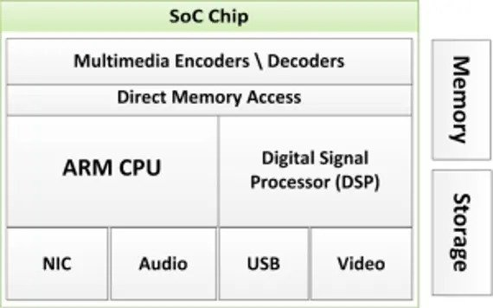

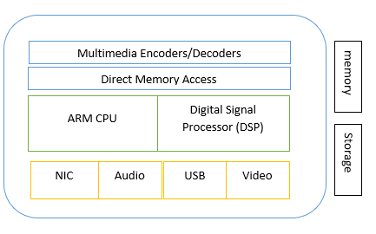

Source: Panji Harawa (2023) based on Katakkar, T. (2022, August 9). What is a SoC? Engineers Garage. <https://www.engineersgarage.com/what-is-an-soc> .

According to Harvard computer architecture [Pawson, 2022], the computer architecture is composed of the control unit, data memory, instruction memory, the I/O devices, and the arithmetic-logic unit. Unlike computer architecture where there is a clear separation between components, in mobile devices all the components are integrated in Software on Chip (SoC) for better performance and lower power consumption. In the figure Most Common SoC Components the most common components are shown and can be explained as follows [Singh 2014]:

* **Central Processing Unit (CPU)**: This is considered the brain of the phone as it runs most of the phone’s OS and mobile apps I.e.., ARM CPU. CPU performs the instruction executions from the instruction memory, it performs arithmetical and logic operations (AND, OR, NOT), clock management for all the other components in SoC as well as handles interrupts from the peripheral devices.
* **Graphics Processing Unit (GPU)**: Responsible for handling graphics-related to visualization tasks, app’s user interfaces and 2D/3D gaming. It performs graphics and video processing; it drives the output of the display and is able to perform parallel computing. As such it is usually used in parallel computing tasks such as machine learning algorithms and crypto mining.
* **Image/Multimedia Processing Unit (ISP)**: Used mostly to convert camera data and process it into image and video files.
* **Digital Signal Processor (DSP)**: This is used to manage all mathematical and intensive functions than a CPU such as decompressing and compressing music files and analyzing gyroscope sensor data. It performs all sorts of processing of signals coming from peripherals. It helps in the processing of audio signals, video signals, sensor data as well as signals coming from wireless interfaces e.g., WiFi, BT, and NFC.
* **Multimedia encoder/decoder**: Convert and managed power during conversion of video files and formats.
* **Memory processor:** used to manage device memory blocks used for computation. The device has two types of memories volatile which is used to store information on temporal basis and non-volatile used for long term storage of information and data. Another categorization of memories is the random-access memory used to store data on a temporary basis and the read-only memory (ROM) that can store data even under power-off condition of the device.
* **External Storage Interfaces:** SoCs include interfaces for connecting external storage devices. Common interfaces to external storage units found in SoCs include Secure Digital (SD) card interfaces, Universal Flash Storage (UFS) interfaces, Serial ATA (SATA) interfaces, and Universal Serial Bus (USB) interfaces
* **Modems/NIC** — Handles all wireless signals and converts them into data the phone understands, this module is responsible for converting and communicating to wireless signals generated from 4G LTE, 5G, Wi-Fi, and Bluetooth, infrared and other modems.

With advancement in ML and AI, more AI algorithms are running on mobile devices for different tasks e.g., for video analytics. To speed up AI algorithms based on neural networks in one hand neural networks are being composed to speed up processing time in mobile devices while on the other hand more powerful processing units such as Neural PUs are being included in the mobile devices [Tan 2022].

As we understand that mobile hardware core functionalities are determined by using integrated circuits (IC), as part of SOC, the integration of processors made is easy for smartphones to be smaller and have many functionalities than before when they were huge and bulky. The use of IC’s made it easy for mobile devices to execute millions of instructions per second. The size of the system-on-chip (SOC) in mobile devices is an important factor in the competitiveness between hardware manufacturers. SOCs, which are measured in nanometers (nm), are designed to be small and efficient, with the goal of making mobile devices faster and more efficient. As technology continues to evolve, these chips are becoming increasingly smaller, which is a trend that is likely to continue in the future. (Delgado et al 2020).

#### 1.1.1 ARM CPU

As said previously, one of the most widely used CPU architectures for mobile devices is ARM CPU. Form mobile devices ARM 32-bit architecture is used. It is calculated that around 60% of today’s mobile phone run on ARM CPU architecture. The reason why the ARM got so popular in the market are:

* It provides highly customized SoC that achieves high passage efficiency. The customization is based on wat usage per operation making it suitable to be used in battery powered devices like smartphones and other IoT devices.
* It is highly scalable allowing for vendors to adapt the usage of the SoC for different use cases and applications
* It has a high industry support

ARM CPU architecture has defined three main profiles (as of AMRv7) [Singh 2014]:

* Application profile or A-profile supported by Cortex-A series
* Real time profile or R-profile supported by Cortex-R series
* Microcontroller profile or M-Profile supported by Cortex-M series.

### Self-Check Questions

* List some of the main hardware components of a mobile device, and how do they work together to enable the device to function?
* *-Processor (CPU): The central processing unit (CPU) is the "brain" of the device, responsible for executing instructions and performing tasks*
* *- Display: The display is used to show information to the user and is usually a touchscreen that allows the user to interact with the device. Asks.*
* What is the main function of the CPU in a mobile device?
* *The CPU, or central processing unit, is the main processing unit in a mobile device and is responsible for executing instructions and performing tasks.*
* What is the main difference between RAM and ROM in a mobile device?
* *RAM, or random-access memory, is used to store data temporarily and is volatile, meaning it is lost when the device is powered off. ROM, or read-only memory, is used to store data that is not intended to be changed and is non-volatile, meaning it is not lost when the device is powered off.*
* What are some examples of input/output (I/O) devices in a mobile device?
* *Some examples of I/O devices in a mobile device include buttons, keyboard, touchpad, and speakers. These devices allow the user to input data and receive output from the device.*

## 1.2 Firmware

Mobile devices have several core functional components that work together on a high architecture level. One of the key functional components is the firmware which is a hardcoded software that is stored in mobile devices static random-access memory where content is retained on a hardware device even after interruption of external source of power. As there are different hardware devices, for each hardware device there will be different firmware. In Figure Mobile Device Components and place of firmware in architecture we have shown layers of mobile device, where firmware is located (logically) in-between the hardware and operating system.

**Firmware**

is a read only memory type of software that is used for low level management of any small but critical programs in a mobile device. It

In mobile devices the firmware that is used to access the cellular network and the firmware used for operating the general-purpose operating system of the device are fully separated [Franklin 2020]. The first one, together with the hardware makes up the telephony subsystem that in combination with real-time operating system (RTOS) gives access of the mobile device to the cellular network. The later one together with the general-purpose operating system make up the application process and can be accessed by the user as well as administrator of the device. In addition to hardware and firmware separation, telephony subsystem utilizes a completely separate SoC that is called baseband processor [Franklin 2020]. The telephony subsystem collaborates with the Subscriber Identity Module (SIM) card that stores the international mobile subscriber identity (IMSI) while international mobile equipment identifier is stored together with the device firmware.

#### 1.2.1 What is firmware?

Firmware ***is a read only memory type of software that is used for low level management of any small but critical programs in a mobile devic***e. It is used for specific hardware related components such as BIOS, that mostly provides high level abstraction on a mobile device. By design the firmware is usually part of a hardware stack that is not easily accessible by regular end users of a smartphone.

Mobile Device Components and Place of Firmware in Architecture

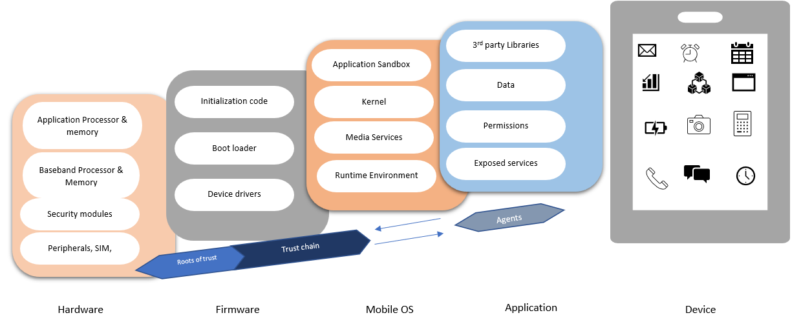

Source: Panji Harawa (2023) based on Source: <https://nvlpubs.nist.gov/nistpubs/SpecialPublications/NIST.SP.800-124r2-draft.pdf> .

Firmware is a critical part of a mobile device and is very key to the high-level abstraction which also varies depending on the type of mobile operating system being used in the mobile device.

The key roles of the firmware are [Franklin 2020]:

* Device booting: firmware boots up the device once it is powered on and takes care of hardware initialization. Before the operating system starts firmware performs self-tests of each hardware component.
* Loading device drivers: firmware loads the device drivers that enable communication between the hardware components and operating system. Based on the device drivers operating system can access the hardware devices (e.g., WiFi interface card) and interact with it (e.g., send/receive packets)
* Hardware control: it provides the necessary instructions to control the hardware devices (e.g., in the case of BT interface it provides the necessary instructions to communicate with it from higher layers (from operating system).
* Root of Trust: it provides the root of trust for all the other logical layers on top [Zhao 2014]

Firmware provides different levels of abstractions. Based on the abstraction levels firmware can be divided into high-level firmware and low-level firmware. The high level-firmware relates to abstraction level toward operating system. In a mobile device (e.g., Samsung or Apple phones), it provides abstraction level towards Android and iOS operating systems, respectively. On the other hand, the low-level firmware provides direct control over hardware devices such as CPU, memory, peripherals, and interface cards.

As part of a mobile device all peripherals and application processors formulate a root of trust. These hardware components interface with firmware to power or boot the device also known as **boot loader**. The boot loader after loading will first initialize and then allow additional code that is responsible for loading device drivers for all the hardware parts of the mobile device and other peripherals.

**Boot loader**

Refers to a component on a mobile device software program that is responsible for booting a mobile device

#### 1.2.2 Threats towards firmware and telephony subsystem

A mobile device would not boot and function properly, if there is any tampering done to the bootloader part of the firmware. To protect the firmware from such code tampering, part of the firmware for secure boatload can be executed in the trusted execution environment (TEE). The code saved in the TEE cannot be changed or altered, even by the owner or user of the device. The TEE can be used as an anchor of trust for securely booting the device. An example of a TEE is the ARM TrustZone, which is a set of hardware secure extension features to ARM SoC in processor, memory, and peripherals that can be used for secure bootup of the device (Zhao et al., 2014). This then creates a high-level abstraction that is useful for storing and executing sensitive cryptographic and secure computations that prevent mobile threats that can come through the applications. All these operations are done by the device in a trusted execution environment that is provided by the hardware of the processor itself. (Mahendra et al., 2014).

Another threat to telephony subsystem of a mobile devices is SIM card swapping or SIM card code tempering [Lin 2018]. To mitigate such threats and possible attacks integrated SIM with telephone subsystem (as described in section 1.2.1) known as eSIM are used nowadays.

### Self-Check Questions

* What is firmware in a mobile device?

*Firmware is a type of software that is stored in a mobile device's hardware and is used to control the device's functions.*

* List three functions of firmware in mobile devices?
* *Firmware controls the hardware and software of a mobile device, ensuring that the device functions as intended.*
* *Firmware is responsible for booting up the device and preparing it for use.*
* *Firmware can be used to configure the device's settings, such as the display, network, and power options.*
* *Firmware can include security measures to protect the device from malware and unauthorized access.*

## 1.3 Operating System

**Mobile operating system**

is part of core software that acts as an intermediary between the mobile user and the device peripheral components, to execute various instructions and input from the user to the mobile device.

**Mobile operating system** is part of core software that acts as an intermediary between the mobile user and the device peripheral components, to execute various instructions and input from the user to the mobile device. The Mobile OS on low level helps a user to run applications and make computing easy with little constraints by also making the mobile hardware run efficiently [Stallings 2012].

The mobile device market has diverse mobile operating systems available, as technology advances the core functionality of secure devices has also been growing. Operating systems have not yet fully reached their full parity when it comes to the availability of management technology as compared to the traditional desktop and legacy computers. The engineering of mobile technologies is designed different from convectional desktop computers, this is because devices such as smartphones, laptops and tablets were designed to run on very constrained resources. It is from this background that the underlying software known as operating system is designed to be different from the software used in desktop computers (Chauhan Naresh. 2014). Each mobile device has a distinct OS’s depending on the different hardware stacks/capabilities each mobile device has. This section discusses the various characteristics of smartphones that make them different from desktop computers with a leaning of the mobile operating system.

The main differences between a mobile operating system and desktop (or laptop) operating system relies on the following [Srikanth 2020]:

* It is highly optimized to run in less powerful devices (smartphones, tablets etc.) in terms of processing power and power efficiency
* Optimized for touch-screen user interface compared to traditionally graphical user interface in desktops
* Mobile OS have dedicated application stores where application developed for that particular OS are maintained, while desktop OS have more diverse software application

As another operating system, the mobile operating system is composed of the kernel space and user space. While the applications run in user space, the kernel is the central part of the operating system and is the first part to be loaded in the device. It helps in interaction between the user space and the device drivers and underlying hardware. In addition to this, as we showed in Figure Mobile Device Components in section 1.2, the mobile operating system is composed of application sandbox that can protect unwanted interactions between applications [Franklin 2020].

#### 1.3.1 System calls

In mobile computing a system call is a process of how a device's application interacts with the phone programmatically hence providing an interface between the user input/instruction and the operating system***.*** This therefore allows the users and software engineers to develop mobile applications without worrying about the high-level **machine**/assembly language. They can easily develop the apps on top of the OS without needing to employ low-level architectural controls, which require a lot of expertise to configure and run. This makes the mobile OS have easy to use interfaces that allows it access a wide range of mobile devices. However, since mobile devices are designed with portability in the mind of the users, their architectural design requires different types of OS. This then caters for the vast capabilities mobile devices must achieve. Due to this difference in architectural design, smartphones, tablets, Personal Digital Assistants will normally run different types of mobile OS. Since by design a mobile device executes multiple instructions, they are designed to run multiple tasks in real time and these instructions are required to be completed within a short period. This is achieved through the SOC and embedded software executed in tandem with the mobile OS to then issue instructions to peripheral devices, network software through device drivers. To achieve this the mobile device, have application that are run on top of the smartphone OS. The OS by design considers the hardware restrictions that these gadgets have. To resolve such challenge mobile device manufactures keep upgrading their devices with new features, as well as the OS (Chauhan N 2014).

System call

a process of how a device's application interacts with the phone programmatically hence providing an interface between the user input/instruction and the operating system

At hardware level the mobile operating system uses a predesign set of Application Programming Interface (API’s) known as system calls. In mobile computing a system call is a process of how a device's application interacts with the phone programmatically hence providing an interface between the user input/instruction and the operating system***.***

Introduction to a System Call

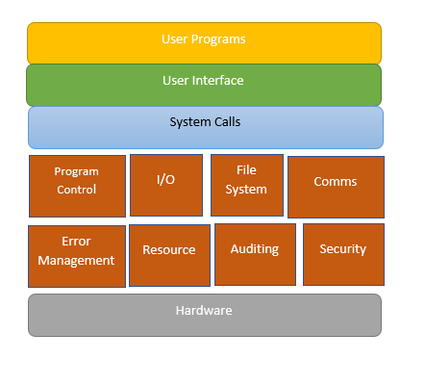

Source: Panji Harawa (2023) based on Source: Shah, P. (2022, January 28).

From the figure in mobile devices, system calls facilitate the interaction between applications running in user space and the underlying operating system part running in kernel space, enabling access to privileged operations and system resources. When an application needs to perform such operations, it initiates a system call, causing a transition from user mode to kernel mode. The operating system's kernel validates the request, executes the operation on behalf of the application, and returns the results. System calls provide a secure and controlled mechanism for applications to access system resources while maintaining the overall integrity and security of the mobile device's operating system.

There are different types of system calls in an operating system. Each of the system call type and their function is shown in Table Types of System Calls and Their function.

Types of System Calls and Their Functions

|  |  |
| --- | --- |
| Types of System Calls | Function |
| File Management | Used to manage files by creating, deleting, opening, closing, read, and writing to files |
| Device Management | Used to manage device calls such as device writing, reading, and getting device attributes |
| Information Maintenance | Used for information calls such as read, set, and get system data, |
| Communication | Used for communication calls such as sending, receiving messages |

How does a system call actually work? When a user application is running a process in the user space and needs to access a hardware device or some OS resources to perform some computing it makes a system call. The system call is pushed by the process to the system call handler that runs in the kernel space. The kernel space executes the system call sequentially as they appear and gives the result back to the user space process. This is shown in Figure System Call Operation.

System Call Operation

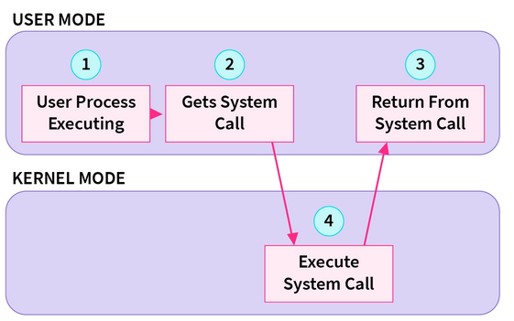

Source: <https://www.scaler.com/topics/operating-system/system-calls-in-operating-system/>

#### 1.3.4 Types of Mobile OS

There has been three-phased evolution to the mobile operating system designs, the first phase was PC based operating systems, there after an embedded OS took over the second era, and the third era has seen smartphones taking over the overusing integrated systems on a Chip. This evolution has been backed by rapid architectural changes in the designs of the OS. (Li et al 2012). As highlighted, modern-day smartphones have been advanced to handle better basic and essential capabilities of a mobile device such as memory, processes, and security. These functions have been inherited from legacy operating systems but have only been improved over time. The advancement of mobile operating systems has seen optimization to enhance user friendlies, responsiveness, and an easy-to-use graphical user interface. This has also emanated in making modern day computers to manage power efficiently, multitask and support multiple sensors. This section highlights some of the common and popular mobile operating systems and their features.

The possibility for users to be able to have access to low level hardware has been possible with the help of Operating system, (Silberschatz et al 2012). Just like conventional computers OSs there are diverse types of mobile operating systems. These types of mobile OS have been getting frequent updates, upgrades, and modifications to keep up with the needs of the users. These updates are also especially important due to the modern advancements in hardware. In recent years we have seen modern mobile devices be defined more by the type of software they are running. The more recent operating system has vast features and functionalities on a phone. As such a vast range of companies have developed mobile operating systems to cater for high-end needs of consumers/users. As such by design these mobile tech companies make phones that have features which vary from each model of the device which also reflects on how they operate.

The most widely used mobile OS nowadays are Android, iOS, Chrome OS, Windows phone, Tizen and KaiOS. Previously there has not been much research on Tizen and KaiOS as most of the discussions have been on the two popular and most used operating systems, Android, and iOS. However, these operating systems differ in their core architectural designs, their security and many robust features that exist between the traditional OS and the emerging ones. (T. Omelchenko et al 2018).

Android OS is a mobile operating system that was developed by Google and is based on Linux kernel. Its base implementation is offered open source under Apache License 2.0 [Android], however apps and drivers that provide functionality are bounded with the platform where they run and are proprietary solutions. Currently according to Gartner market share, it has the highest mobile OS market share in the world with 70.79% [Marketshare 2023]. The first version to work with touchscreen mobile devices was released in 2011 as Android 2.3, while the latest version is Android 13 released in August 2022.

The second largest market share in mobile OS is held by iOS, known as iPhone Operating System. IOS is developed by Apple and, differently from Android, is a closed source and proprietary solution. The first version was released in 2008 as iOS 1 with the latest release planned in the late 2023 as iOS 18.

1.3.5 Example Case: Android Software Stack Architecture

Android software stack architecture is an open-source code that is provided by Google. It consists in a number of layers that are shown in Figure Android Software Stack Architecture and can be summarized as follows [Arch 2023]:

* Applications are developed to interact with end users and depending on APIs they use the are categorized on: Android apps that are developed by third parties and have access only to Android APIs publicly available, privileged apps the come pre-installed in the device and use Android APIs as well as system APIs and device manufacturer apps that are developed by the device manufacturer and have access directly to APIs provided by the Android framework.
* Android framework is a set of libraries, interfaces and APIs that are made available to the device manufacturer under licensing agreement, while part of it is available publicly for third party developers.
* System services provide communication between the Android framework APIs and underlying hardware, while application runtime environment (ART) compiles the app’s bytecode into processor instructions.
* Hardware abstraction layer (HAL) is a hardware agnostic abstraction API on top of hardware platforms. This makes sure that all the hardware functions are exposed similarly towards higher layers no matter what hardware is being used.
* Native daemons and libraries interact directly with the kernel, and they do not depend on HAL itself.
* Kernel of Android operating system is based on open-source Linux Kernel.

Android Software Stack Architecture

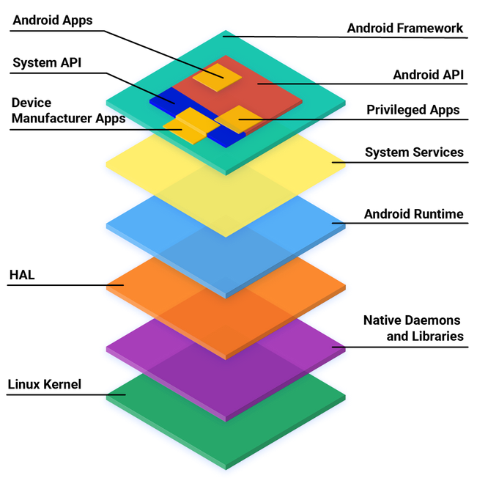

Source: [Arch 2023].

### Self-Check Questions

* Name some system call types:
  + *File management system calls, device management system calls, information maintenance system calls and communication system calls.*
* List four ways in which multithreading in mobile OS is important
* *By allowing multiple threads to execute concurrently, multithreading can improve the overall performance of a mobile device*
* *Multithreading can improve the responsiveness of a mobile device by allowing it to perform multiple tasks concurrently,*
* *Multithreading allows different threads to share resources, such as memory and I/O devices, which can improve the efficiency of the device.*
* *Multithreading allows certain tasks, such as network communication and data synchronization, to be performed in the background without disrupting the user's experience.*

## 1.4 Applications

**Mobile applications** or “apps” are designed to be used on a variety of mobile devices, including smartphones and tablets, and developers need to consider the context in which the app will be used. This includes the screen size of the device, its resolution, and its connectivity and power limitations. To create a successful mobile app, developers need to consider the needs and preferences of their target audience, as well as the constraints of the devices on which the app will be used.

**Mobile applications**

are a type of software applications that are developed to be used on smartphones, tablets, and other mobile devices.

Developing a mobile app requires careful planning and design, as well as a thorough understanding of the platforms and technologies involved. It is important for developers to consider the user experience, performance, security, and other key factors when designing and developing a mobile app.

Overall, the portability and mobility of a mobile app can be crucial to its success, as it enables users to access and use the app anytime and anywhere. (Harrison D 2013**).**

As technology advances, mobile apps are also rising, as they are used daily for personal and professional purposes (Weichbrod 2020). These applications have commonly used functionality that enables them to share some similarity and their use in education, entertainment, business, social networking, and transportation. Since most of these functionalities makes mobile applications to have many used cases for service delivery to users as they are often having improved access to online services at a reduced cost while also ensuring that there is data security and increased safety. As such, mobile applications use calls for quality usability assessments designed to check how usable and accessible an application can be compared to other applications accessed using basic computers. The use of mobile application is increasing as such the number of developers is also increasing, even though some applications have seen their use diminish overtime as user begin to experience various issues such as unsubstantiated service claim, changes in app behaviors and unfriendly human interaction with the mobile app features (Evans, S et al 2021). According to the International Standards Organization, there are some standards that mobile applications are supposed to follow during design phase. Mobile apps are expected to be usable, accessible, portable, reliable, and easy to maintain and secure. It is however noted that usability models are still not fully established as often these are isolated and not proven even though we see mobile apps have prevalence in health, education, e-commerce, and provision of financial solutions. (B. I. Attah et al 2021).

Mobile applications can be used to perform various tasks for home, social or office uses. This has made mobile applications contribute to a fast-developing sector in this information technology era. Most apps are quite easy to use and available for free and some preinstalled in the mobile as they have vast functionals such as accessing the internet, making calls, games, and social media. If an application is not available on a mobile device, it can be downloaded from a wide range of software markets available with common ones being Google Play store for Android OS and Apple Store for iOS. Technically all of these applications are managed by the operating system of the mobile device. The mobile application runs through the following managed platforms: Android, Symbian, Blackberry, iOS, and Windows. On abstraction level these mobile apps are run on java/j2me, flashlight, brew, and Silverlight virtual machines.

#### 1.4.1 Mobile application types and development process

Mobile applications can be categorized in three different types based on the way they are developed and how they interact with the network:

* Native apps are developed solely for specific a mobile device and an operating system. As such a native mobile app that is developed for a device running iOS cannot be used in an Android based mobile device. Usually, developers of native apps should use development tools of provided by each platform (e.g., Java/Kotlin for Android [Kotlin 2023])
* Web-based mobile apps are developed to give the same experience as mobile apps when they are accessed via a mobile browser from a mobile device. This does not require a specific development of the app for the mobile device; however, the web server should support the optimization for the mobile web-browser access.
* Hybrid mobile apps where native apps are combined with web technologies to provide the required service. In this case for the mobile web client app the developer should use the specific development tools for the given platform (e.g., Kotlin for Android [Kotlin 2023]) .

Depending on how mobile apps interact with the underlying software platform and device hardware they can be categorized in the following:

* Platform specific APPs are apps that use only the publicly available platform specific API to interact with the underlying software stack and device hardware. In the case of Android, the Android apps have access only to Android API [A-API 2023] that give access to underlying system services.
* Privileged apps are usually pre-installed apps that come together with the mobile device and operating system that is running in it. They make use of system specific APIs that are publicly available as well as system specific APIs that are made available by the device producers on an agreement basis.
* Device manufacturer apps that use both platform specific APIs that are publicly available, system APIs as well as direct APIs to the framework. These apps come pre-installed with the device. In the case of Android mobile devices such apps make use of Android APIs, system APIs as well as having direct access to underlying hardware and software functionalities [Arch 2023].

Based on the reason for what apps are used they can be categorized as:

• Communications: Internet Access, Social Networking, emails

• Multimedia: Graphics, Video, and audio players

• Productivity: Word processors, Spreadsheets

• Navigation: GPS/Maps, Schedules, Weather

• Utilities: Task manager, File manager

#### 1.4.2. Application run time

Runtime environment is used by mobile operating system to execute mobile applications. It is responsible for running the mobile app's bytecode (compiled code) and managing its execution within the mobile operating system. Different platforms use different runtime environments and execution mechanisms. Each platform has its own runtime designed to optimize performance and resource usage based on its specific architecture and requirements.

For example, iOS uses the Objective-C runtime for apps written in Objective-C and Swift [Objective-c 2023]. It employs Just-In-Time (JIT) compilation for Swift, while Objective-C uses a mix of ahead-of-time and JIT compilation. On the other hand, Android uses Android Runtime (ART) environment and Dalvik (in older releases of the OS) [ART 2023]. In general, we can say that any runtime environment for mobile apps should support at least the following features:

* **Ahead-of-Time (AOT) Compilation:** Runtime environment uses an AOT compilation approach, which means that the app's bytecode is converted into native machine code during installation. This results in faster app startup times since the native code can be directly executed by the device's processor without further interpretation.
* **Improved Garbage Collection:** Runtime environment should introduce a more efficient garbage collection mechanism that helps manage memory more effectively, reducing pauses during app execution and improving overall system performance.
* **Support for Native Code:** Runtime environment should support executing native code written in C/C++ using the Native Development Kit (NDK) for specific platform. This will allow developers to use native code for performance-critical parts of the app.

### Self-Check Questions

* Name three main features of Android Runtime (ART) environment?
  + *Ahead-of-time compilation, improved garbage collection and support for native code.*
* What are some of the standards of mobile applications?
* *The user experience (UX) is the overall feel of the app and how it is perceived by the user.*
* *The performance of a mobile app is critical, as users expect apps to be responsive and perform well. This includes fast loading times and smooth transitions*
* *Mobile apps should be compatible with a wide range of devices, including different screen sizes, resolutions, and hardware configurations.*
* *Mobile apps should be secure and protect sensitive data, such as user credentials and personal information.*

## 1.5 Ecosystem

The mobile application ecosystem is composed of different components, stakeholders and factors that based on their close collaboration contribute to development, distribution and use of mobile applications. It consists of the entire lifecycle of a mobile application from its creation to distribution and its usage by the end users. Though mobile application ecosystem is dynamic, the main stakeholders and components of the mobile application ecosystem are shown in Figure Mobile App Ecosystem and include [Xu 2016]:

* **App Developers:** are individuals or companies that create mobile apps ensuring app functionality and user-friendly interface.
* **Mobile Operating Systems:** The core software platforms that power mobile devices, such as Android, iOS, and Windows Phone (now Windows 10 Mobile). Each operating system has its unique app distribution channels, guidelines, and development tools.
* **App Stores:** Digital platforms where users can discover, download, and install mobile apps. Examples include the Apple App Store (iOS) and Google Play Store (Android).
* **App Distribution Channels:** The process of submitting mobile apps to app stores for approval and making them available for download by users.
* **App Users:** The end-users who download, install, and use the mobile apps on their devices.
* **App Security and Privacy:** Ensuring that mobile apps are secure and protect users' data and privacy. This involves implementing secure coding practices and adhering to platform-specific security guidelines.

Once the application is submitted to the mobile app store the other processes followed by the app developer include app monetization (the way how developers will generate revenues out of their work (advertisements, subscriptions etc.), app maintenance and bug fixture and app analytics to track app usage and user behavior.

Mobile App Ecosystem

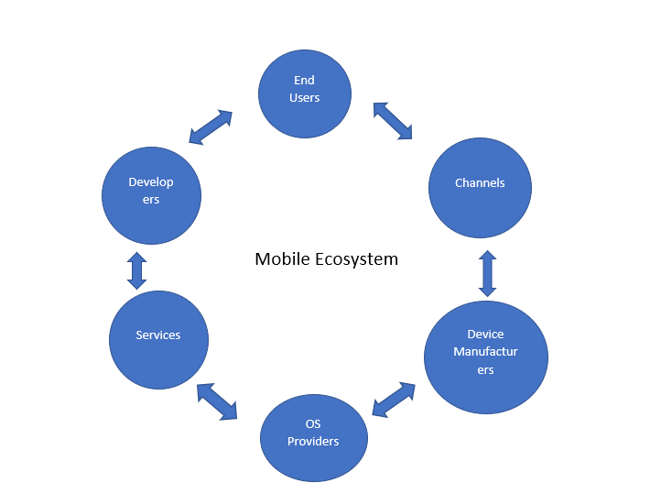

Source: Panji Harawa (2023).

#### 1.5.1 Android Ecosystem

Android apps ecosystem consist of interaction between the main developer of open-source Android operating system, Google, equipment manufacturers, app developers and users. Google in addition to operating system, which is based in Linux kernel, has provided with the framework for app development [Kotlin 2023]. The core stakeholders in the android ecosystem are users, developers, app stores, and the Open Handset Alliance that is composed of Google itself, original equipment manufacturers (OEM) and carriers [Xu 2016]. The Android ecosystem stakeholders are shown in Figure Main Android Ecosystem Stakeholders

Main Android Ecosystem Stakeholders

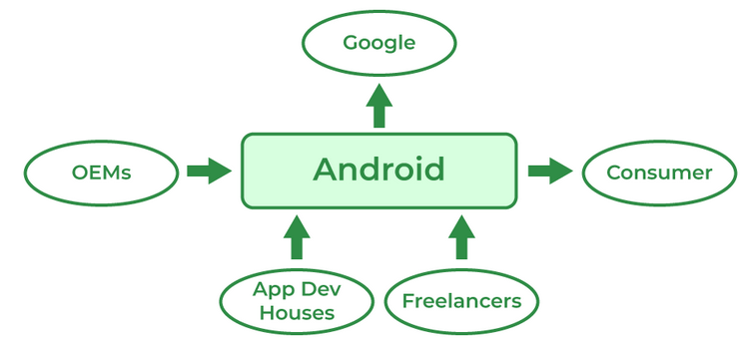

Source (<https://www.geeksforgeeks.org/android-ecosystem/>).

The android ecosystem is more decentralized as Google will provide only the operating system to device manufacturers through a license, while device manufacturers can tailor it to their devices [Xu 2016, DC 2023]. Devices come with some apps preloaded from the manufacturer. Google also provides an Android app store named “Google Play” through which applications for android can be distributed. However, Android users can download and install apps from third parties as well, like Amazone app store and Xiaomi App store.

In addition to stakeholder's Android ecosystem is composed of a number of components including hardware devices, software applications and services as well as security measures. While hardware devices that run Android range from mobile smartphones to smartwatches and TVs, software applications have reached to 2.7 million apps in the Goole Play Store [STA 2023]. Google offers a number of services for Android users that come preloaded in the device, such as: Google Play Services (apps for Google maps, Google Drive and Google Analytics), Google Assistant that is and digital assistant to device users and Google Pay that is payment assistant for the users.

#### 1.5.2 iOS Ecosystem

Differently from Android Ecosystem that is more decentralized, iOS ecosystem is fully centralized by Apple. Apple provides the iOS operating system, it provides with the devices (iPhones or iPads), as well as the app store. The only decentralized part is development of iOS apps, which are done from different third parties, rather than Apple itself. However, such apps coming from third parties cannot access private and proprietary application programing interface (API) that is provided only for the preloaded Apple apps [DC 2023]. While in Android ecosystem other app stores are allowed, in iOS devices only The App Store the official distribution app store is allowed, limiting user choices, and increasing the centrality of the ecosystem.

Given the centralized fashion of the iOS ecosystem, the security of apps distributed via The App Store is high due to vetting process that each app should pass before it becomes available in Apple store. Currently, there are more than 2 million apps available for users in The App Store [APP 2023].

#### 1.5.3 Connected device ecosystem

As more connected devices are progressively growing in numbers, mobile devices have also drastically changed how users perceive, interact as well as engage with mobile applications, their products, and services they offer. As the mobile ecosystem is growing, we have seen a collection of multiple devices such as mobile device, tablets using various software’s and operating systems that are designed and developed by companies such as hardware manufacturers, software developers using and processing data and communicating between users from one gadget to another. Apps software designers often consider the cohesion that connected devices create coupled with user experience to provide accessibility and usability for such apps to create a flexible environment that works and enhances dynamicity.

The device prioritizes enhancing the user experience with connected mobile gadgets, making it seamless for users to meet their needs across various daily applications. This is possible since most of these devices can connect to each other whilst sharing data, either in voice or text or video format across different operating systems. This has been possible because the collections of such devices created by an ecosystem. This then enable various components to talk to each other through a secure cloud from which through mobile network carriers or channels, one can install all required software applications from which users then can subscribe to, for various online or cloud services. The manufactures of mobile devices such as Sony, Nokia, XIOAMi, Apple therefore contribute to this by a way of allowing mobile apps to be managed by OS. (Lauren C et al 2015).

Connected Device Ecosystem

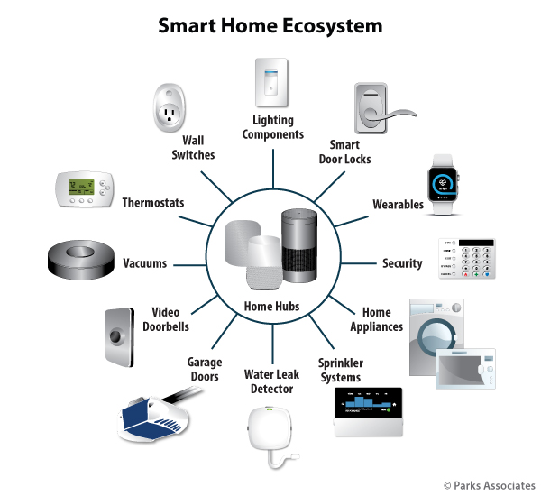

Source: <https://www.parksassociates.com/report/race-control-ecosystem>

Source: Panji Harawa (2023) based on <https://www.parksassociates.com/report/race-control-ecosystem> .

The figure Connected Device Ecosystem shows a detailed mobile application ecosystem of connected devices In the diagram smart gadgets are talking to each other through a centralized hub that the modern technology stack has established and interconnection of devices such as mobile phones, laptops, smart watches enable. Through this interconnection devices can interface and share data to make some informed decisions or carry out some tasks. For example, in case of a water leakage you will get informed in your smart phone or smartwatch via the application that is receiving data from the home cloud. On the other hand, in case of increased temperature in the room, the connected thermometer can interact directly with the window opening system to cool down the room based on the outside temperature retrieved from Internet services. These are just some examples of how an inter-connected mobile ecosystem can help in everyday life.

### Self-Check Questions

* Identify key stakeholders of Android ecosystem.

*Google, OEM, Users and App developers.*

Summary

The mobile technology stack is built on advanced software and hardware architecture that enables rich ecosystems of applications and enhanced mobile security. The unit establishes that key hardware components in mobile computing are integrated into a System on a Chip (SoC), includes the Central Processing Unit (CPU), Graphics Processing Unit (GPU), Image/Multimedia Processing Unit (ISP), Digital Signal Processor (DSP), video encoder/decoder, memory processor, and modems/NIC. These components work together to enable various functionalities and maintain device security. As technology evolves, SoCs are becoming increasingly smaller, driving competitiveness in hardware manufacturing. One cannot talk about hardware with reference to mobile firmware, a type of read-only memory software, which plays a crucial role in managing low-level programs in mobile devices. It is part of the hardware stack and handles initializing and loading device drivers. The unit further highlights how firmware also provides high-level abstraction for secure storage and execution of sensitive cryptographic computations, ensuring protection against mobile threats. Overall, understanding the mobile technology stack, including hardware components and firmware, is essential for software engineers and designers to develop and enhance smartphone user experiences. For hardware and firmware to easily interface this however cannot be possible without Mobile OS which serves as an intermediary between users and mobile devices, enabling efficient hardware operation and user-friendly application execution. With multiple mobile operating systems in the market, there is a growing emphasis on security and management technology. Mobile devices like smartphones, laptops, and tablets were designed to run with limited resources, so their OSs differ from those in desktop computers. Over the years it has been evident that operating systems, such as Android and iOS, have evolved to offer better memory management, enhanced security, and increased user-friendliness. They also support power efficiency, multitasking, and multiple sensors as well as more mobile applications designed for smartphones, tablets, and other mobile devices. Mobile Apps are used in various domains, including education, entertainment, business, and social networking. Developers must consider user experience, performance, security, and other factors when designing and developing mobile apps. To meet international standards, which allow them to be deployed on platforms such as Google Play Store and Apple Store. As user expectations increase, there is a growing need for sophisticated mobile applications across various industries. In this unit we showed the main stakeholders in both Android and iOS ecosystem. While the Android ecosystem offered a decentralized approach, where Google offered only the operating system and app development platform, while devices are developed by OEM and apps by third parties, iOS ecosystem is highly centralized by Apple that provides both the iOS operating system as well as devices.

# Unit 2 – Hardware

**Study Goals**

On completion of this unit, you will be able to …

… distinguish how RF technology works in mobile devices.

… describe what a trusted execution Environment is.

… learn about how biometric devices enhance security and prevent mobile threats.

… understand how location technologies work/function.

## Introduction

Hardware stack of mobile devices has connectivity at the center of it, with the coming in of the internet we seen mobile devices be used more often for personal and business uses. However, just like computers mobile devices are also susceptible to attacks due to their ability to connect to various networks and each other. Hardware plays a significant role in ensuring that security is maintained, and mobile threats are minimized. However, security of most components also becomes challenging as running robust security systems depends on high computational capabilities as well as an understanding of the hardware ecosystem. For instance, all mobile components already employ proven technologies while considering various characteristics to enhance security in mobile devices. As such there is need to align the connection of all components at hardware level and how each part provides convectional security mechanisms independently in addition to the already embedded hardware based mobile security integrated circuits (IC) used to prevent or minimize vulnerabilities and attacks. These components employ proven technologies while considering various characteristics to enhance security in mobile devices. Key elements of mobile device hardware include the System on a Chip (SoC), which houses components such as the Central Processing Unit (CPU) modems/NIC, radio frequency (RF) modules, and portable digital assistant (PDA) modules. RF modules enable wireless communication between mobile devices and networks, while PDA modules provide essential functionality for personal digital assistants. These components not only contribute to the device's functionality but also collaborate to support security measures such as encryption, secure boot processes, and trusted execution environments, ensuring a comprehensive defense against potential threats.

### 2.1 RF Modules

A mobile device would not have been able to be omnipresent in our lives without its ability to have connectivity with different systems and between each other. The connectivity of the mobile devices is supported by radio frequency (RF) module that enables wireless communication in different technologies that mobile device supports. Nowadays mobile devices support multitude of wireless communication technologies ranging from satellite communication support (GPS), cellular network technologies (4G/5G), mid-range communication technologies (WiFi) and short range (Bluetooth) to near field communications (NFC). We will dig more into the concept of radio frequency, the RF module components and the basics of wireless technologies incorporated in modern mobile devices.

#### 2.1.1 Radio frequencies (RF)

A radio frequency (RF) signal is generated as an alternative current by a transmitter and propagates through the communication medium, whether it is a wire or wireless. For the wireless transmitter, this signal is emitted by the antenna in the air. In an ideal vacuum environment, the RF signal will be emitted at the speed of light at 299 792 458 m/sec (~300 000 km/s). An RF signal radiates away from the antenna with a continuous pattern and is governed by the radio properties, such as amplitude, frequency, and phase.

Thinking of the RF signal like a sinusoidal wave that travels away from the antenna, the wavelength is defined as the distance between two successive peaks or valleys of the sinusoid. Frequency is the inverse proportion of the wavelength. The following formula describes the relationship between the wavelength, λ, frequency, f, and the speed of light, c:

*𝜆=cf*

where the unit of λ is in meters, the unit of c is in m/s and the unit of “f” is in hertz [Hz].

Different wireless technologies operate at different frequency bands, e.g., the Institute of Electrical and Electronics Engineers (IEEE) 802.11 wireless fidelity (Wi-Fi) based technologies operate at 2.4 GHz, 5 GHz and 6 GHz frequency bands, cellular networks operate at 900 MHZ, 1.8 GHz, 1.9 GHz, 2.1 GHz (some of the bands), Bluetooth technology operates at 2.4 GHz [Tanenbaum 2021], while NFC and RFID operates at 433 MHz, 2.4 GHz and 5 GHz [Want 2006]. Different frequencies band are used for different reasons, e.g., the lower the frequency the higher the communication range, the lower the frequency the higher the penetration in indoor environments. For example, for a cellular network operating in the 900 MHz band the coverage zone is much longer than for cellular networks operating in the 1700 MHz band.

#### 2.1.2 RF Module Components

RF module in the mobile device is responsible for supporting communication using different technologies. Some functions of the RF module components are shared between different technologies and include the following [Egan 2004]:

**RF transceiver:** converts the digital data to analog and vice-verse depending on the direction of operation (transmit/receive).

**Antennas:** transmits and receives the radio frequency from the wireless medium. Single antenna cannot operate in the different spectrum bands, as such typical mobile devices employ several antennas for each communication technology (cellular, Wi-Fi, Bluetooth, etc.).

**Power amplifiers:** increase the signal power before transmissions to prepare it according to regulatory rules for transmitting power levels on specific channel and band. E.g., the maximum transmit power at 2.4 GHz band by a Wi-Fi module should not exceed 30 dBm.

**Filters:** Filters are used to separate the desired signal from other signals in the spectrum band. They can be done in digital domain or in analog domain. Usually filter is used to filter-out all the signals from other channels and keep only the signal detected in the operational channel

**Low Noise Amplifiers (LNA):** is used on the receiving path of the RF module to amplify the weak received signal without amplifying the noise, thus improving the signal-to-noise ratio before the signal is processed by the baseband processor.

**Baseband processor:** handles the signal according to the technology used. It performs modulation/demodulation of the signal, it handles physical layer protocol used by the technology, it performs error correction and encoding.

#### 2.2.3 Modulations

In communication engineering, the modulation process is achieved by varying certain parameters of the carrier signal based on the inputs of the modulation signal. The carrier signal is a continuous electromagnetic wave, while the modulation signal can be a continuous signal or a discreet signal. Analog modulation modulates a continuous signal to the carrier wave (like audio or video signals), while digital modulation modulates a discrete signal that is composed of 0s and 1s. Basic analog modulation techniques are: the amplitude modulation (AM), where the amplitude of the carrier is changed according to the modulation signal, the frequency modulation (FM), where the frequency of the carrier is changed according to the modulation signal and phase modulation (PM), where the phase of the carrier is varied based on the modulation signal. The last two are known as angle modulation techniques. Basic digital modulations are the amplitude shift keying (ASK), the frequency shift keying (FSK) and the phase shift keying (PSK). In the following sections we will discuss each of the digital modulation techniques. The transmitter block that performs the modulation process is called modulator, while the receiver block that performs the reverse process is called demodulator.

#### 2.2.3.1 Digital Modulations

The basic digital modulation technique is amplitude shift keying (ASK). In this modulation technique, each of the two binary values (0 and 1) are represented with a different level of amplitude of the carrier signal. In Figure Digital Modulation Techniques an example of ASK is shown where one amplitude is 0 representing the binary 0, and the other high amplitude represents binary 1. Even though that ASK is simple to implement, it is susceptible to interference and multipath. Moreover, due to channel propagation characteristics (multi-path, noise, path loss etc.), constant amplitude cannot be ensured, thus AKS is not used for wireless communication.

Most appropriate modulation technique for wireless communication is frequency shift keying (FSK), where shift in the frequency of the carrier signal represent each of the binary values (0 and 1). The simplest way to implement such a modulation technique is to switch the transmission of the carrier signal between two different oscillators with different frequencies. Then the demodulator will detect the frequency changes of the signal to detect the transmitted binary value. The FSK is more robust compared to ASK, as it is less susceptible to channel propagation characteristics. However, on the other hand it requires higher bandwidth to be transmitted compared to ASK. Figure Digital Modulation Techniques shows the FSK modulation.

Like FSK, phase shift keying (PSK) uses shifts of the angle of the carrier to modulate data. In this case it shifts the phase of the carrier signal for each modulated 0 or 1. Figure Digital Modulation Techniques shows the PSK modulation, where a phase shift of 180 degrees represents a change from 1 to 0 and a phase shift of –180 degrees represent a change from 0 to 1. Indeed, PSK that uses such phase shift is called binary PSK (BPSK). Compared to FSK, PSK is even more robust to wireless channel propagation characteristics, however it comes with complexity of modulator and demodulator as both transmitter and receiver need to be synchronized in frequency as well as in phase.

Digital Modulation Techniques

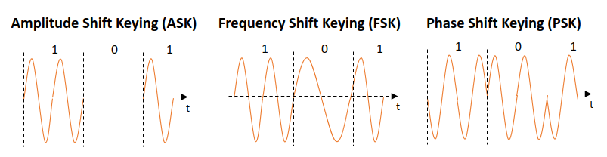

#### 2.2.3.2 Advanced shift keying

In order to improve the bit rate of the modulation techniques, multiple levels of varying parameters are used. E.g., in order to transmit 2 bits at once (4 different possible symbols) Quadrature PSK (QPSK) is used. Instead of using only two possible phase shifts (+-180 degrees), QPSK uses 4 different phase shifts (+-90 and +-180 degrees) being able to modulate two bits at once. The constellation diagram is shown in Figure QPSK constellation diagram. The constellation diagram shows all the possible positions of a signal in quadrature (Q) and in-phase (I) plane. The QPSK modulation uses lower bandwidth for the same amount of data transmitted compared to BPSK. However, it is more complex in implementation and the transmitter, and the receiver needs to be synchronized using a reference signal. In QPSK transmitter will select chunks of data and modulate them as phase shift compared to the reference signal. In order to avoid the need for reference signal, differential-QPSK (DQPSK) is used, where the phase shift of current two bits is determined based on the position of the previous two bits. Other higher order PSK schemes use mode phase angle shifts to modulate data, achieving higher bit rates.

QPSK Constellation Diagram

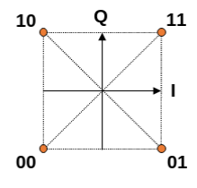

**Frequency spectrum**

refers to the range of frequencies that can be used by a signal

In order to use the assigned bandwidth more efficiently and increase the bit rate, PSK can be combined with ASK to achieve a higher number of varying parameters. In Figure 16-QAM constellation diagram, the 16-Quadrature Amplitude Modulation is shown, where for each symbol 4 bits are transmitted. It uses 12 different angle shifts and 3 different amplitudes. The number of bits per symbol on the X-QPSK can be calculated at *log2⁡X*. In current wireless communications (e.g., IEEE 802.11ax) the higher order modulation schemes up to 1024-QAM are used to improve spectrum efficiency and data rate.

16-QAM Constellation Diagram

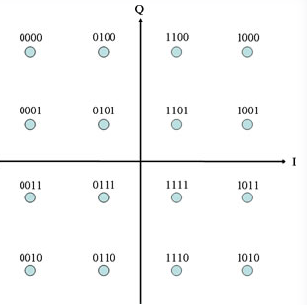

Source (<http://ecelabs.njit.edu/ece489v2/lab5.php>)

### Self-Check Questions

**dynamic spectrum management**

is a process of using intelligent cognitive software technics on concepts in network information and software define to improve communication performance in general (Salhab, A. M. 2016)

What are the components of the radio frequency?

*Amplitude, frequency, and phase.*

Name some of the RF module components?

*RF transceiver, antenna, power amplifiers, filters, LNAs and baseband processors.*

Which varying parameters are used to modulate the signal in QPSK?

*QPSK uses both the amplitude and phase variations to modulate the signal.*

How many bits per symbol are transmitted in 1024-QPSK?

* 4
* *10*
* 5
* 12

## 2.2 PDA Module

The use of mobile devices has gone to unprecedented levels and the numbers are still growing, this has indeed been the mobile computing revolution. Statista has estimated that as of 2022 the number of mobile devices has reached 6.5 billion in the entire world (Statista, 2022). There is however an expectation that this number may grow bigger, this has resulted in more devices being designed to be more sophisticated and have modern functions for use as a day-to-day gadget. However, within the scope of limitations that come with mobile devices, on hardware and software there are some challenges that have only been resolved by use of Portable Digital Assistants (PDA). This type of mobile device is designed to enhance how users interact with a mobile device by making them more productive and responsive to provision of information to the user in the context that information is required. This is because PDAs often referred to as virtual assistants have functions that are responsive to the natural language such as completing some tasks using applications and online web services.

Due to the responsiveness that PDA have they have been quite useful in some sectors such as tourism, controlling of devices and gadgets at home and at office. (Edu et al 2020). Recently there has been a lot of development of PDA in the technology space with the coming of modern and major virtual assistants such as Siri (Bellegarda 2014) that is commonly used in Apple desktop and mobile devices, the second PDA that has been developed by google is called Google Now commonly used in google products and services, then lastly Alexa an assistant developed by amazon referred to as Amazon Alexa Voice AI. The coming in these modern technologies have changed the landscape of PDA’s as they have been useful in helping users be able to get proactive and reactive assistance using natural languages and commands. (Kepuska & Bohouta 2018) adds that’s PDA are more useful in providing proactive assistance to users by using the devices agent explicitly to conduct an action or task without the user’s direct request, whereas the agents in PDA can also reactively aid by being given voice activated commands or simply by typing. As seen on (Statistica 2022), the surging number of users of smartphones are also using PDAs as the features are also highly integrated with most smartphones as well as in other gadgets such as tablets, headsets with a high-level integration also in operating systems.

The use of these PDA has also evolved quite a lot because these mobile devices can easily be customized to adapt to individual personalities as they can be programmed to determine the users’ activities online such as their profiles, locations, and normal routines that the user does. These are mostly done and activated using natural language processing that give PDA as proactive role to allow users interact with these devices using notifications, responding to commands or questions which create a real-life simulation or users speaking to a real assistant in human form. (Kepuska & Bohouta 2018). It has been noted that PDA’s relays proficiently users’ intents using the numerous services and mobile applications as it has become an intelligent feature within the mobile devices’ meta layer. This is because explicitly a user can be detected when commands actively given to the PDA to executive a particular action, or this can be inferred by the virtual assistant by detecting or suggesting results after some evaluations triggered by some pre-existing conditions. The architectural design of PDA’s applies concepts such as machine learning, text to speech, inferencing, analytics, and data mining, and voice recognition systems all integrated. Using this combination of technologies and application PDAs have become useful in assisting users to easily setup tasks such as alarm/reminders as well as getting users organized and giving them access to online structured webservices and information such as getting locations. Some of the tasks can also involve automating users’ experiences through use of collective functionalities, some of which can be automated organization of users’ information and data for instance PDA can automatically scan flight related information’s and organize all the details related to the flight such as GPS coordinates to checking flight status and weather forecasts and notifying the users accordingly. (Edu et al 2020).

Ideally PDAs are required to be personal, so that they can assist users to share their own personal interests and needs which must be unique and specific to every individual. However, challenges have still been encountered when reactively or proactively to users’ commands created for several reasons. Firstly, as PDA’s use a lot of machine learning and language processing models, there is inadequate data that is required for virtual assistants to model properly all users' experiences and interests. The limitations come in that it is expected to only be used and understand the user basic on its experience and feedback provided as such it is limited only to this. User behaviors cannot also distinctively be models due to low computing power, as machine learning requires a lot of computing power the PDA’s do not have the capacity to do so. It is easy for PDAs to distinguish users interests and those of the agent/platform hence the mobile system struggles to put users interests over its other actors. Lasty PDAs are challenged when it comes to creation of content, this is because they will only conform to specific coded user interactions and thus may not be able to perform or generate the actual content the users may want. (Sarikaya 2017). Despite the challenges however, PDA has been adapted to take them closer to personalization by ensuring the use of more sensors that are allowing more learning as well as integration of cloud computing to enhance the quantity and quality of the data users can get access to enhancing the user experiences and interests. Due to an extended connection to cloud, PDAs have fully represented users’ interest in enhancing their online user profile data such as bio data, and favorites and all interest explicitly shared by the user. It has also allowed for an increase in digital footprint as well as the creation of time and space for most of the users' interests hence allowing easy generation of more personal interest

## 2.2.1 PDA’s Agent System Architecture

The design of the PDA support structure is categorized into two, u**se of Proactive Assistance** and **Reactive Assistance**. This can be seen from the system architecture below on how the two agents work:

The PDA Agent Architecture

The PDA Agent Architecture For (A) Reactive Assistance And (B) Anticipatory Computing

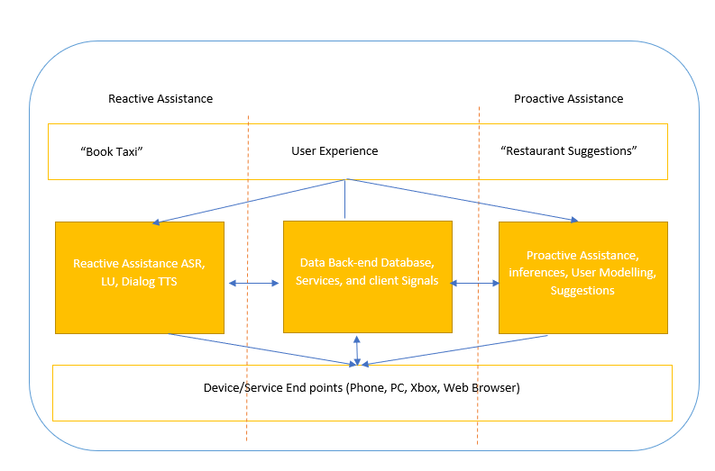

Source: Panji Harawa (2023) based on Sarikaya, R. (2017).

The figure depicts two instances of the agent's data and service points, from Figure a, a user can explicitly give a command to the agent to book a Taxi, then the reactive assistance component all work together after checking all specific natural language queries to connect to the database and serve the user. In addition, the digital agent will compute what is assumed to be an expected valuable output and then contextualizes the results. The agent will then infer and apply user models and check previous experience from the endpoints.

### Self-Check Questions

* 1. Please name two of some common features and capabilities of PDAs and how do they differ from those of smartphones.
* *Personal organization, PDA often used as digital organizers*
* *Communication PDA can send and receive emails and text messages,*

## 2.3 Trusted Execution Environment component

In the ever-evolving landscape of mobile technology, security has become a paramount concern for users and businesses alike. As mobile devices increasingly handle sensitive information, from personal data to financial transactions, safeguarding these devices against cyber threats and unauthorized access has become a critical imperative. To address these security challenges, the concept of Trusted Execution Environment (TEE) has emerged as a key solution.

A Trusted Execution Environment (TEE) is a secure and isolated area within a mobile device's central processing unit (CPU) that provides a protected environment for running sensitive applications and processing critical data. It operates independently of the device's main operating system (OS) and is characterized by its high level of security and tamper-resistant properties. TEE leverages a combination of hardware and software-based security mechanisms to ensure the confidentiality, integrity, and authenticity (CIA) of data and applications residing within it.

The TEE's primary objective is to enhance mobile device security by creating a secure enclave within the device's hardware, where sensitive operations can take place even in case of compromised OS and apps running on top. This isolation helps mitigate security threats associated with malware, unauthorized access, and attacks targeting the mobile device.

#### 2.3.1 TEE Architecture and its key features

**Trusted execution environment (TEE)**

is a mechanism that means provision of a computational environment that is isolated and safe for applications to be executed in a ***mobile phone system*.**

Trusted Execution Environment (TEE) General Architecture

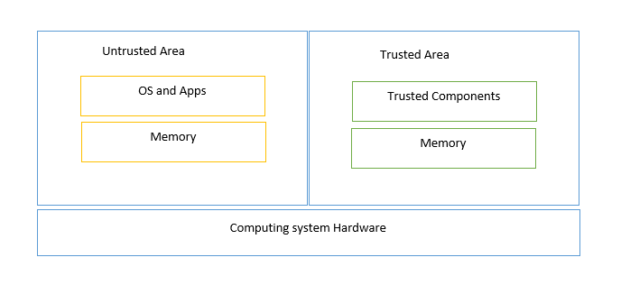

Source: Panji Harawa (2023) based on (Hosam & BinYuan 2022).

As shown in Figure TEE General Architecture the mobile computing ecosystem and the structure of a generic TEE platform is divided into two components, the trusted area and the non-trusted. These two environments are separated to have one part dealing with operating systems (OS) whereas mobile applications are executed in their own untrusted environment. This marks these platforms and makes it easier for security engineers to know the untrusted areas and the trusted software stacks. As such the trusted environments are also referred to as TEE whereas the untrusted environment is also known as Rich ExecutionalEnvironment (REE).

The key features of TEE architecture are summarized in four categories [Ekberg 2014]:

* Isolation: TEE operates in a separate, isolated environment from the main OS, ensuring that sensitive operations and data are protected from interference by malicious software or other parts of the system.
* Secure Data Storage and Access: TEE provides a secure storage space, often in the form of a trusted file system or key store, where sensitive data can be encrypted and stored.
* Secure Communication Channels: TEE enables secure communication channels between trusted applications and external entities running in REE.
* Secure Execution Environment: The TEE ensures that critical applications, such as mobile payment solutions, authentication services, and digital rights management (DRM), run in a secure execution environment.

#### 2.3.2 TEE versus REE

REE Versus TEE

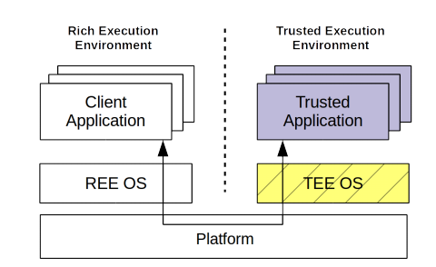

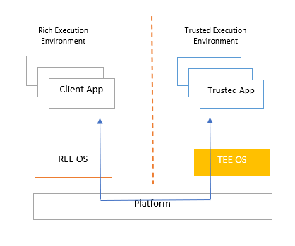

Source: Panji Harawa (2023) based on Brian et al. 2015.

The figure REE vs. TEE illustrates the application of specific industry standards for trusted components, which facilitates addressing security issues tailored to various application ecosystems. Essential to this approach is the collaboration between Trusted Execution Environments (TEEs) and Rich Execution Environments (REEs). TEEs provide confidentiality, integrity, and authenticity by isolating security-critical tasks from the main operating system or REE, which runs most applications and services but is more exposed to vulnerabilities. By working together, TEEs handle sensitive operations such as cryptographic processes, secure storage, and secure boot, while REEs manage the execution of everyday applications and services The early days saw use of processors securely as a TEE guideline for smartphones and tablets using the ARM trust zone [Zhao 2014], which among other things provided a standard for mobile processing which is still being used today. As seen from the figure there are number of critical components that market trusted pillars and security mechanism that are common to any device and their use are in creating a trusted environment (Brian et al 2015)

In it envisioned that to access standard interfaces there will still be need for more implementation of TEE overall on several platforms. This will however be easily doable by ensuring that these trusted components are accessible to everyone hence spanning and increase in use of trusted technologies in developing of mobile applications and embedded systems. This will eventually then make it easy for engineers to make more solutions available that will impact the standardization, use and deployment of TEE for mobile devices including its application in lightweight trust platforms used in mobile computing. To gain more understanding the TEE has a component built upon called the Trusted Computing Base (TCB). This is a part of mobile devices that consists of hardware and firmware that, by default, are supposed to be trusted without any limitations or restrictions on a device. It is therefore important to note the critical hardware components that form the base for TEE has core parts shown in grey and non-core parts (Ekberg, et al 2014).

**Trusted Computing Base** (TCB)

This is a part of mobile devices that consists of hardware and firmware that by default are supposed to be trusted without ***any limitation/restrictions on a device***.

#### 2.3.4 TEE security mechanisms

The security mechanism employed by TEE can be broken down into several critical components that require attention when it comes to dealing with mobile threats on the hardware level. This component includes boot integrity, secure storage, device identification, isolated execution and device authentication capabilities [Ekberg 2014].

The first component deals with the integrity of the platform. Such integrity check can be achieved by ***secure booting*** or ***authenticated booting***. Secure boot includes a verification process that runs an early detection process to check if there has been any modification to the platform. If any modifications have been detected the device booting process is halted. The devices ensure checking this by implementing code signatures, which is a process that ensures that some cryptographic code matches with previous stored values hence making the boot sequence unchangeable. The device will only achieve this if the operating system executes from memory, which checks the boot code hashes that will be signed and has its public key stored safely for verification on next boot process sequence (Chai et al 2014).

Once the signature validation of the boot loader is finalized the next component of the software stack, in this case the kernel, is launched. It is from such process that TEE ensures there is no tampering of the environment since these hashes are stored in read only memory part of the kernel. Secure booting is therefore achieved on the TCB by ensuring that the pillars of the block have an immutable booting order that is already verified together with integrity protected cryptographic algorithms. In the case of authenticated boot, the only difference is that the platform components are loaded and measured but there is no verification. This boot model works in a way that the bootloader measures the state of component launched in turns one after the other, which is then used to fix any components that may have been modified (Kirkpatrick et al 2012)

To prevent attackers from accessing sensitive information, the TCB employs secure storage as a second component, which requires one confidential and device-specific key. Usually such a key is initialized during manufacturing time in the processor memory [Ekberg 2014] and is accessed through authenticated encryption mechanism. To maintain the integrity of data even in the event of rollback attempts, nonvolatile memory that retains its state during the device's boot sequence is utilized for secure storage.

Next component is isolated execution of processes for certain REE applications. This is achieved by letting TEE expose functionalities as a predefined cryptographic algorithm to the REE applications, while ensuring the cryptographic keys will not leave the TCB (Truong et al 2021).

The last component under basic security mechanism of mobile devices is the use of device authentication, which is one of the mechanisms relied upon by service providers, this entails use of manufactures information’s as a standard for compliance through creation of unique identities. Different manufactures of hardware components of mobile devices use this mechanism to embed a unique unchangeable serial number as an identity. These are often randomly generated identifiers that follow a unique pattern as per manufacturers specifications. As such using base keys and root a verification process can be established that will bind these uniquely assigned numbers to uniquely identify a device or hardware component. This mechanism is used for generating International mobile Equipment Identifiers (IMEI) as well as hardware coded network link layer identification commonly used for accessing wireless networks (WIFI) such as MAC addresses and wireless connectivity (Bluetooth). The authentication is done in such way that digital certificates are generated for the devices by the manufacturers that binds an identity of a device or hardware component to the devices public key which provides authentication of the devices with external entities (Asokan et al 2014).

Device Hardware and Firmware with TEE Support

Source: (Asokan et al 2014).

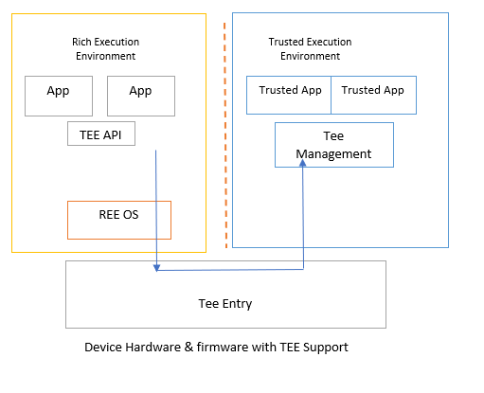

Source: Panji Harawa (2023) based on Asokan et al. (2014).

From the figure Device Hardware and Firmware with TEE support we can see that for a high-level architectural virtualization there are indeed different components that can be seen to achieve an ideal TEE. From the figure any isolated REE can be considered a TEE instance this is because ideally a TEE architecture can be purely designed to use software chips specifically designed and then use virtualization and processing to create separate executional instances for TEE which can be accessed using the entry interface of the TEE. This makes it easy for applications that are not trusted to be executed and run by connecting to an API connecting TEE services through the devices OS hence allowing such applications to be able to read and write to the TEE

#### 2.3.5 Example of TEEs

There are several examples of technologies that support TEE in the market. One of them is Trusty TEE that is used by Android devices to provide secure operating system [Trusty 2023]. The architecture layout of Trusty TEE is shown in Figure Trusty TEE. As in generic architecture Trusty TEE consists of secure and non-secure environment. The secure environment is isolated from the rest of the operating system by both software and hardware means. The Trusty TEE is composed of the Trusty kernel part that exposes its functions via Trusty driver towards Linux kernel. Trusty driver supports data transfer between the Trusty kernel and the rest of the Android OS. Next to Trusty driver, Trusty libraries are used by the trusty applications to communicate with kernel driver. Via Trusty libraries, third party developers can choose to execute certain part of the application processes in the trusty environment. An example of such use cases are proprietary algorithms for online banking. Trusty TEE is compatible with ARM processors, and it uses ARM TrustZone to create the secure trusted environment in the processor level.

Trusty TEE

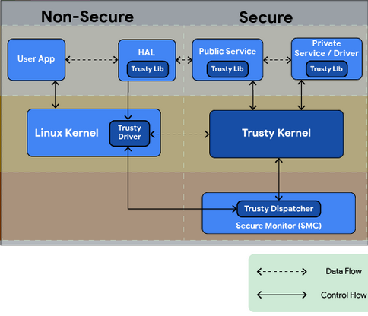

Source: [Trusty 2023].

Another example of security mechanism in mobile devices that use hardware TEE is Samsung KNOX mechanism [Kanonov 2016]. It leverages fully hardware TEE provided by Samsung mobile devices or ARM TrustZone. It provides mechanisms for boot-time defense, load-time defense, run-time defense and update-time defense [Samsung 2015]. At hardware level it provides the secure boot and trusted boot, it provides roll-back prevention as well as device root key. The later one is used to provide cryptographic operations associated with the device.

### Self-Check Questions

* What are the main roles of TEEs and REEs in mobile security?

T*EEs provide a secure environment for executing sensitive tasks and storing critical data, while REEs manage general applications and less sensitive tasks.*

***Biometrics devices***

***employ a technology that uses and measures the physiology of a human body such as fingerprints or use of hand gestures.***

## 2.4 Biometric Devices

**Biometrics devices** employ a technology that uses and measures the physiology of a human body such as fingerprints or use of hand gestures. In the modern era, it has been useful to provide high security due to its accuracy in identifying individuals. Technology is developed on the fact that human beings are different from one another, that is in both physical appearance and in our behavior. As such biometric devices harness this unique feature to provide an extra layer of security to mobile devices by distinguishing these unique traits to identify users (Ximenes et al., 2019). For many mobile applications, like the one from banking sector and mobile payments, there is a need for authentication of users and to ensuring security most devices opt for using more secure biometric identification rather than the legacy way of using password. Biometric identification simply refers to the verification or use of a person's physiological or behavioral traits to provide a secure identification and authentication to a device which can be done using facial recognition technologies, fingerprints, iris, and voice recognition (Chen Y et al, 2022). As seen clearly, smartphones have employed the used biometric devices to enhance security, this is because the use of biometric devices has proved to be more secure than the use of generic password-based authentication systems. Due to this there have been attempts to use biometric based authentication that can be accessible remotely. However, this use of biometrics is ideally realistic only in real-time and requires accurate time synchronization. The proposed mechanism of using time synchronization was deemed to have security loopholes as it had vulnerabilities to hacking. which made it easy for someone to predict an online or offline password and server manipulation.

Now since the use of biometrics has become more common, many smartphone applications have this feature enabled to enhance security as an addon to the use of traditional passwords. With this technology mobile payments have advanced so that it has been more convenient than using traditional smart cards. The innovation has made it easy for companies such as google pay, and apple pay to provide virtual currencies and virtual credit cards as payment gateway that is integrated within most mobile applications. However, this privacy and security is very hard as when one uses a virtual credit card. It means they may need to keep the credit card number in their mobile devices which possess a security risk if falls into the wrong hands. This can however be mitigated by using remote biometric based authentication where user’s biometric features such as fingerprints, iris or voice recognition can be used to verify users’ information to a biometric server through a bounding server (Yichen et al., 2020).

#### 2.4.1 Types of biometric authentication

Biometric authentication can be broken down into various types since they are designed to use physical features of a person, and such features include use of fingerprints, use of eyes (iris), voice recognition (Timothy et al 2016). It is also inherently extended to use behavioral traits like signatures, gait, and keystrokes. However, unlike the use of generic passwords biometrics have proved to have quite more advantages and use cases as described below

* Biometric keys cannot easily be lost
* Biometric keys cannot easily be duplicated, copied, or shared
* Biometric keys are inherently difficult to forge
* Biometric keys are not easy to guess
* Biometric keys cannot easily be broken/hacked

Uniquely biometrics use of human being physiological features makes them almost immutable, and every person has unique parts that have many traits that can be distinguished from person to person. As said previously, the most used biometric technology has been fingerprints, which have been used for decades because of their distinguishable features. Over the years we have also seen more technologies such as using face recognition, voice recognition, hand geometry and iris recognition technologies (Mohammad, et al 2020).

The first and most used biometric authentication technology is fingerprints. This technique uses sensors that are small and often embedded on mobile devices such as smartphones, laptops and even desktops. The device searches for patterns on someone's fingertips and checks for these patterns using the fingers ridges and valleys and matches them against an existing pattern within a database. The patterns that are generated are uniquely distinguishable and can only belong to one person. As such at a single touch of a finger identification and authentication is established within the shortest period. However, during registration of fingerprints any good fingerprint device requires multiple samples to enhance accuracy of the results and prevent authentication errors. The only challenge with this type of authentication device comes in when a user has unclear fingertip valleys and ridges that make it difficult for the device to match or read.

The other most used biometric authentication technique is the use of voice recognition technology which uses audio to distinguish individuals. The technology employs a blend of behavioral patterns associated with sound, including the formulation of accounting patterns that can discern the size and shape of a person's throat. This information is then combined with the matching of the user's voice pitch and speaking style. This type of technology has some disadvantages: it is easily affected by any changes in the tone and pitch of the users’ voices and if there are any background noises it can be difficult for the device to authenticate (Lai, X. 2021).

The next biometric used to authenticate users on mobile devices is face recognition. This technology creates a model that picks some of a user’s key features that are immutable from their face and creates an image that will have features that cannot easily change over a period. The technology learns and models some features from a human face and picks features that are not going to change, and this is done by ensuring that it skips through some of difficult features such as facial expressions which can make authentication difficult for mobile devices. To create an easily identifiable model, more than five samples are required and created by the technology to enhance authentication (Asmitha, P et al 2022).

Another user authentication that is based on behavioral biometrics is gait recognition. Gait recognition identifies different people based on characteristics of their walking by analyzing several features, such as: stride length, walking speed, and the angle of movement of different body parts. A mobile device first needs to create a gait signature of the user. This is done by collecting information from mobile device sensors (accelerometer, gyroscope, rotation vector, step counter and detection, etc.), training the data model and extraction of user’s gait features [Axente 2020]. Then once the gait signature of the user is created and stored, it can be used continuously with the collected information from mobile devices sensors to take a decision if the user is the owner of the mobile device or not.

2.4.2 Biometric system for verification and identification. All the above biometric devices follow a similar pattern when it comes to identification and verification of biometric data. As such an effective biometric system considers some important aspects such as how users will be registered and enrolled in the system that is being used. This also stipulates different use cases for such systems as to whether they may be used for identification or only for verification of data.

A biometric system used for verifying will authenticate the user's identity by checking against a database that they were enrolled in. This database usually stores biometric information and have a format that is preconfigured to make quick biometric references which them compares the data on a one-to-one basis to confirm the identification, the result can either be rejected or verified by the system.

As for a biometric system designed for identification, the devices also ensure that it searches the entire database the user was registered on to check for any matches. It therefore makes comparisons against all the records in the databases in one-to-many scenario as it must ensure that it uniquely identifies the user and authenticates them against all other identifiers. Hence making use of biometrics for identification is harder than just verifications (Lafta et al 2013).

Biometric System Enrollment

Source: (Lafta et al 2013).

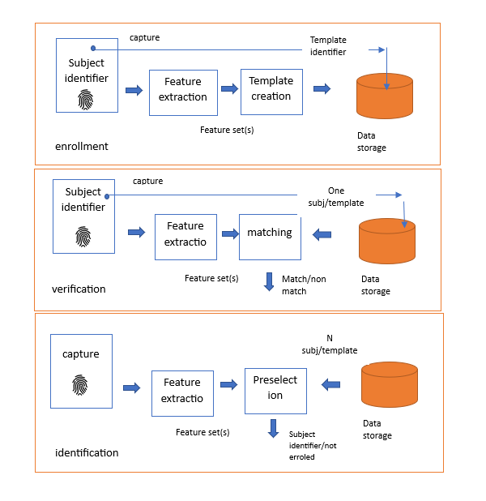

Source: Panji Harawa (2023) based on Lafta et al. (2013).

The figure Biometric System Enrollment demonstrates an biometric systems can be used for identity checks and what it takes to use it for verifying users. The first part requires all users to be enrolled into a particular database which can then be checked either for identification or verification of the users. The process of identifying or verifying takes two forms as follows capturing and extracting. These processes require that the biometric device receives a digital copy of the biometric feature in use that generally varies depending on the type of the physical feature. E.g. for a fingerprint the scanner will sense and generate and image that is then used as a sample within the fingerprint system. This sample is then used as raw digital copy and extracted by a feature extractor within the biometric devices to be used for an enhanced search for preselection and matching against the database (Kolda et al 2019).

#### 2.4.2 Attacks against biometric authentication

As with any other authentication method, even biometric based authentication is prone to cyber-attacks that can breach system security. Based on the way how cyber-attack is performed, attacks on biometric authentication can be classified as follows [Rui 2018]:

* Spoofing or faking the sensor: in this type of attacks attacker tries to spoof the sensor by presenting fake biometric features, such as: a fake photo, a fake fingerprint mold or a fake voice recording.
* Reply attacks: in this type of attack the biometric sensor is fed with a replay of a previously recorded biometric feature that was presented to the system. This mostly can be the case for systems that do not check the liveness and dynamics of biometric features. Such replay samples can be stolen by the attacker through network eavesdropping at the time the information is provided to the authentication system.
* Network server attacks and biometric data breach: in this type of attack attackers might try to gain control over server containing the biometric data or by manipulating the data in server. This relates more to network attacks such as server hijacking and database injection, rather than to the biometric sensor itself.

In order to reduce the potential attacks in biometric authentication system it is advised to use multi-factor authentication being it combination of biometric authentication, or biometric authentication and traditional authentication (passwords, pins, tokens), to always encrypt the biometric data when they are shared over the network during registration/enrollment phase and implement liveness check methods to detect if the biometric data is coming from alive person and not from static source of it.

### Self-Check Questions

* What are the two main steps involved in using biometric systems for identity checks?
* *The two main steps involved in using biometric systems for identity checks are enrolling users into a particular database and then checking the database to either identify or verify the users.*

## 2.5 Location Technology

Location technologies in mobile devices refer to the use of various systems and methods that enable devices to determine and share their geographic location. They have become an integral part of modern mobile devices and are being used by multiple mobile apps that provide location-based services ranging from localizations and navigations maps, safety and emergency services, social media apps to food-ordering apps. Based on the environment where location technology works, they can be classified as outdoor localization technologies and indoor localization technologies.

Outdoor localization technologies include Global Navigation Satellite System (GNSS) known as well as global positioning system (GPS) and cellular based localization using cellular technologies. The indoor localization includes WiFi, Bluetooth and RFID based localization systems. Though each indoor technique can be used also for outdoor localization, the accuracy might reduce depending on the conditions of the network deployed (e.g., number of WiFi APs or BT anchors). There exist also other localization techniques based on ultra-wide band (UWB) communication and low-power communication [Coppens 2022], but since those are not usually integrated with mobile devices we will not cover in this section. A summary of each of the following localization systems can be as followed [Yeh2009, Zafari 2019]:

* Global Positioning System (GPS) is a satellite-based navigation and localization system that uses satellite communication to determine position on the Earth's surface. In highly dense urban environments GPS location can be enhanced with data from cellular network to increase localization accuracy, as the GPS signals might be obstructed.
* Wi-Fi Positioning System (WPS) leverages Wi-Fi signals to estimate a device's location usually based on received signal strength (RSSI) value from multiple WiFi APs.
* Cellular Location Technologies leverages triangulation technique and other cellular-based methods to estimate a device's location based on its proximity to nearby cell towers.

Different localization technologies use different methods. Based on methods and techniques that they use location technologies can be classified as follows [Zafari 2019]:

* RSSI based localization where the distance from anchors is determined based on the received signal power given the transmit power is known.
* Time of fly (ToF) localization where the distance from anchors is determined based on the ToF of the signal. It requires accurate time synchronization between anchors as well as mobile devices
* Time difference of arrival (TDoA) localization where the location is determined based on the time difference of arrival from different anchors. It does not require accurate time synchronization between devices.
* Angle of arrival (AoA) localization where location is determined based on the angle of arrival of the signal.

#### 2.5.1 Global Positioning System (GPS)

GPS is a satellite-based navigation and localization system that is owned and managed by the US Government. GPS is a medium earth orbit (MEO) satellite system orbiting at ~20000 km above the Earth. It has 32 satellites, out of which 27 are operational covering the whole surface of the Earth [Tanenbaum 2021]. Nowadays each mobile device is equipped with GPS radio receiver that is used for real-time localization purposes.

The technique used by GPS to locate mobile devices is based on time-of-flight (TOA) and trilateration method. But how does this work in principle? To determine the locations, GPS follows the following steps [Crato 2010]:

* Message transmission: All the GPS satellites are time synchronized with nanosecond accuracy [GPS 2023] and each satellite will broadcast a message periodically where it includes its position and the time of transmission (ToT) of the message.
* Determining ToF: When a mobile device receives the messages it timestamps the time of arrival (ToA) of the message. Then based on the ToT and ToA the mobile device determines the ToF.
* Distance calculation: Since electromagnetic signal travels with the speed of light, knowing ToF can allow the mobile device to determine the distance from the satellite itself. The ToF calculation is shown in Figure GPS ToF calculation.
* Position calculation based on trilateration: Trilateration is a geometric method to determine position of a point based on distances from some other given points. In GPS trilateration involves intersecting spheres centered at each satellite position with radius as the distance calculated in previous step. To determine the single position in 3D, four such spheres are necessary. One satellite will locate the device in a sphere, adding the second satellite will locate the device in a circle (eclipse) intersection of two spheres. Third satellite will locate in just 2 points as intersection between three spheres. Thus, the fourth satellite is needed to locate accurately in single point in 3D.

To improve GPS localization accuracy, in certain parts of the world (US and Canada) differential GPS (DGPS) is employed. The DGPS consists of fixed Erath station that calculate the location based on GPS signal coming from satellites. DGPS fixed Earth station calculate the position difference based on their own fixed position and position determined based on GPS signal reception. This difference then is transmitted in their coverage areas to help other mobile GPS devices to improve their localization accuracy.

### GPS security

Regarding the security of GPS, it inherits the security threats of the satellite systems. Due to their large coverage zone, satellite communication systems are prone to eavesdropping and jamming attacks. The latter can make satellite communication services inexistent in certain regions of the world. Other vulnerabilities of satellite systems include spoofing and relay/replay attacks. For example, GPS jamming attacks were reported to be effective in changing the accuracy of the GPS system [Lenhart 2022]. It is also reported that even with off-the-shelf hardware relaying signals over large distances to achieve GNSS spoofing is possible [Lenhart 2022].

Jamming attacks are a denial-of-service type of attacks against receivers in proximity. In case of GPS signals they are weak when reaching on the Earth surface and it is quite easy to perform and jamming attack. Even with a 1 W transmit power in the GPS operation band one can attack and area of 35 Km [Papadimitratos 2008].

Spoofing attacks are the transmission of forge signals that make the receiver think the location is different than the actual one. To perform a spoofing attack the attacker will generate a GPS satellite signal that includes a ToT synchronized with the GPS system however the position of the satellite is faked in the message. In case of replay attacks, the attacker will record the GPS signals from satellites and replay them in another position to attack victim devices [Lenhart 2022].

#### 2.5.2 Localization based on cellular networks

Mobile device can use localization services offered by the cellular networks as well. The localization service offered by cellular networks has improved with the new generations of the cellular networks and in 5G standardization it supports an accuracy of several meters down to several decimeters [Dwivedi 2021]. The localization service architecture in 5G is shown in Figure Localization in 5G. The mobile device can be localized using the new radio (NR) communication with the gNB as well as via communication with the LTE eNB. Localization information is exchanged via Transmission Reception Points (TRPs) in gNB and Transmission Points (TP) in eNB. The base stations exchange the necessary information with the Location Management Function (LMF) via Access Mobility Function (AMF) module of 5G core network using the NR Positioning Protocol Annex (NRPPa) signaling protocol.

Localization in 5G

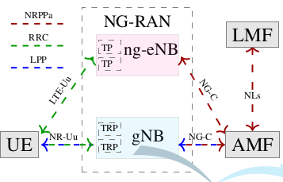

Source: [Dwivedi 2021].

Algorithms that are implemented by LMF can be divers and are left to operators to choose. Some new positioning methods that are introduced in 5G cellular networks cover [Dwivedi 2021]:

* Multi round-trip time localization technique where the localization is determined based on RTT measurements with multiple gNBs. Since RTT measurements are done in relative time, they are prone to network time synchronization errors.
* Downlink angle of departure (DL-AoD) and uplink angle of arrival (UL-AoA) are methods based on the transmitted/received signal angle to/from the mobile device.

In case of multi-RTT localization technique the LMF initiate the localization procedure by requiring the gNBs to perform multiple Tx-RX with specific mobile device by transmitting in downlink positioning reference signal (DL-PRS) and receiving in uplink the sounding reference signal (UL-SRS). Both UE as well as gNB report the measurements on their side to LMF which runs the multi-RTT algorithm.

In the case of DL AoD the mobile device will provide the beam angle of DL-PRS to the LMF while the gNB will provide the azimuth and elevation of its antenna. In the UL AoA only gNB will inform the LMF with the AoA of the UL-SRS.

GPS ToF Calculation

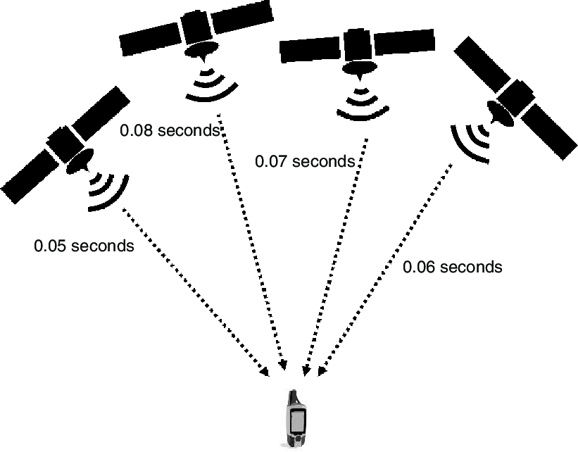

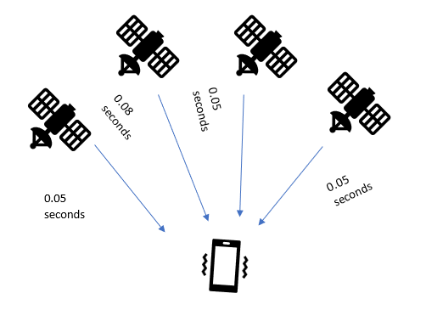

Source: Panji Harawa (2023) based on Lafta et al. (2013).

### Self-Check Questions

* How many satellites are needed for GPS mobile device to determine location in 3D?

*4 satellites*

Summary

The unit aims to provide students with the ability to understand the RF technology used in mobile devices, Trusted Execution Environment, biometric devices for secure authentication, and location technologies.

In this unit we have highlighted the need for communication between mobile devices and how this is done via radio frequencies. First of all, the radio frequency is defined and its main properties: amplitude, frequency and phase are described. In this unit we described the RF module main building components and their roles including RF transceivers, antennas, power amplifiers, LNA and baseband modems. Based on different technologies used by the mobile device (GPS, cellular, WiFi, Bluetooth) we have shown the frequency bands they operate on. Then we have dived into the basic modulation techniques and multi-order quadrature amplitude modulation (X-QAM).

Furthermore, as there is an increasing use of mobile devices it has led to the development of Portable Digital Assistants (PDAs), which are designed to enhance user interaction with mobile devices and provide responsive information through natural language processing. PDAs such as Siri, Google Now, and Alexa have become useful in sectors such as tourism, controlling devices, and automating user experiences. While challenges exist in adequately modeling and understanding user experiences and interests, PDAs have been adapted to improve personalization using sensors and cloud computing. The architecture of PDA support is categorized into proactive and reactive assistance making them more useful as PDAs have become an intelligent feature within the mobile devices meta layer, using machine learning, text to speech, analytics, data mining, and voice recognition systems to assist users in setting up tasks and accessing online services.

The Unit further goes to discuss the Trusted Execution Environment (TEE), a mechanism that provides a secure computational environment for mobile phone applications. The TEE comprises hardware components that enable applications to execute in a separate secure platform. The TEE is divided into two environments, the trusted and untrusted, and is designed to restrict access to sensitive data, such as cryptographic keys. The Unit highlights how TEE employs four critical components to prevent tampering of the environment, including secure booting, secure storage, execution of applications and services in an isolated environment, and device authentication. This unit further analyzes how we use biometric devices and how biometric authentication has become increasingly common in mobile devices, replacing traditional password-based systems. Biometric technology uses unique human physiological or behavioral traits, such as fingerprints, iris, voice recognition, and facial recognition, to provide secure identification and authentication. Biometric keys are difficult to forge, guess, duplicate, or break/hack, providing advantages over password-based systems. The unit continues to discuss the most widely used biometric technologies and their advantages and limitations. This unit in the module also explains the differences between biometric systems designed for verification and identification and the process of capturing and extracting biometric data for authentication or verification.

Finally, we discuss the location techniques used in determining the geographical position of mobile devices. We have defined the localization methods based on RSSI, AoA, ToF and TDoA. We have dived into the GPS and explained how GPS works based on ToF determining the distance of the mobile device from multiple satellites and then based on trilateration method determining the actual position in 3D. In addition, the GPS security attacks (signal jamming and spoofing) are described. In conclusion, we describe the localization based on cellular network, 5G incorporates two new methods multi-RTT localization and DL-AoD/UL-AoA.

# Unit 3 – Android Operating System

**Study Goals**

On completion of this unit, you will be able to …

… determine core components of the Android hardware architecture.

… understand how the bootloader of Androids OS functions and enhanced mobile security.

… identify key sandboxing and virtualization processes of the Androids OS for mobile applications.

… understand how mobile device kernel provides security in Android OS.

… determine how code signing of applications enhances security in mobile devices.

## Introduction

Android is a type of mobile operating system that has predominantly taken over the mobile devices landscape. Developed by GOOGLE, this mobile device software has 71.47% of the mobile operating system landscape with estimated two billion users worldwide (Statista 2022). As such there are several features that have made Android operating system (O.S) to be widely adopted, one of which is that it is developed and designed to be an open-source system. By design the OS has several key features that are similar to other common open sources operating systems which have a Linux kernel that is similar to other Linux based operating systems for both mobile devices and desktop computer systems. This section introduces the Android OS with a deeper understanding of how it is designed and developed considering the underlying frameworks and all other related software and hardware features of the OS. The Android OS ecosystem has been growing over the years due to its ability to be adaptive and enable more startups to contribute to this ecosystem by developing mobile applications. Due to this the mobile technology devices landscape has changed so much as we have witnessed a paradigm shift in mobile computing technology ranging from designs of its hardware architectures and software applications. The modernization of the mobile space has been a large contribution from emerging modern software operating systems and their companies and the companying large ecosystem of mobile applications. As such, the coming of Android operating systems has pioneered advances in mobile technology as this software has predominantly become the most used mobile platform including in use and market share (Statista 2022).

## 3.1 Hardware

The Android operating system has a Linux touch to it having been developed by an alliance known as Open Handset alliance which comprises of companies such as Samsung, Intel, Sony and led by Google. Google later developed and deployed the software freely and open for mobile use as a Mobile As a Linux kernel-based software, the architectural hardware of the OS provided a platform for software developers to be able to develop applications that can be installed on any mobile devices that is running Android OS regardless of the underlying hardware used by the device. These hardware features of Android Operating System made it possible for designers to take advantage of its cross-platform features, which is also common across Linux based operating system. (Boyer et al 2016). This is possible because the OS created an ecosystem for developers to be able to re-use some of the software components without the need of redevelopment. At software level, the Android OS source as an open source allows mobile tech companies to modify and reengineer it accordingly to suit their hardware requirements as it is hosted by Google using a public open-source license under the public license. (Prateek Singh 2020).

Since the Android OS is mostly available for free it has some features that companies take advantage of to modify as per their need, which are mostly later installed and run by various mobile companies such as Samsung, Sony, Huawei, and others. This makes it easy for companies to take advantage of its cross-platform features to develop functionalities that are unique to each of the major carriers’ flagships. The android hardware features create a platform for easy running of apps due to similarities in the hardware architecture. Security is enhanced differently in each of such architectures as application provenance, application permissions, application isolation, and encryption mechanisms (Shuangbao Paul Wang 2021). However, at hardware level Android OS provides high level encryption within the kernel to prevent and protect from mobile threats by using mechanism such as controlling mobile apps permissions and access to the device, or the use of highly level isolation depending on the environment. (Mohamed and Patel 2015)

In Android operating system the software components work better, they are mostly integrated with some key hardware components. Hence on architectural level all hardware is integrated with a software component that manages the mobile devices hardware components such as microphones, speakers and GPS for easy management and use of these tools. The Android OS also uses embedded hardware to assist technologies that enable high-level graphical user interface providing support for development of application with modern front-end technologies. Mobile devices are also embedded with Near Field Communication (NFC) technology which allows connectivity between two devices by holding them closer to each other (Chin et al 2016). Furthermore, since these features formulate part of a communication architectural design level the android OS consists of some communication modules that are designed to support the function of the mobile device communication and network connectivity. However, all these packages and modules are comprised of integration of kernel and support libraries that make software development possible. The hardware packages also enable the computation of these applications which are executed as part of runtime processes for mobile applications (Collins et al 2015)

Since Android OS has the backing of Google who manages it as an open-source project, it allows for different developers of Original Equipment Manufacturers (OEMs), mobile network operators, and chip manufacturers to contribute to this project. Android OS has a diverse ecosystem of mobile applications since most of the mobile applications are developed using Java which has several libraries making it easy to use. This makes the mobile OS to be easily compatible with most applications and their hardware driver capabilities, coupled with architectural features that allow easy memory management and general manageable services. However, this aspect of Android OS varies from the different vendors of Android as developed by the OEM’s. Hence the underlying technology stack is still dependent on using common application libraries that make it easy for creation of both native and hybrid mobile applications that are cross platform. (Prateek Singh 2020).

However, due to various mode of designs of mobile applications these apps present various security vulnerabilities that come due to the mobile companies’ customizations. They indicate that using a three-fold analysis that considered mobile application permission as a security mechanism, provenance of apps by various application stores and vulnerability analysis before apps are deployed in one of the mechanisms required to enhance security and prevent mobile threats. The hardware requires some components of the android architecture to enhance security, its key role is that through the software components the CPU, GPU, and other hardware components use encryption to secure the device. The Android OS also uses hardware features to enhance security, such as the Secure Element (SE) and the Trusted Execution Environment (TEE).

Android Architecture

Source: Panji Harawa (2023) based on Acharya et al. (2022).

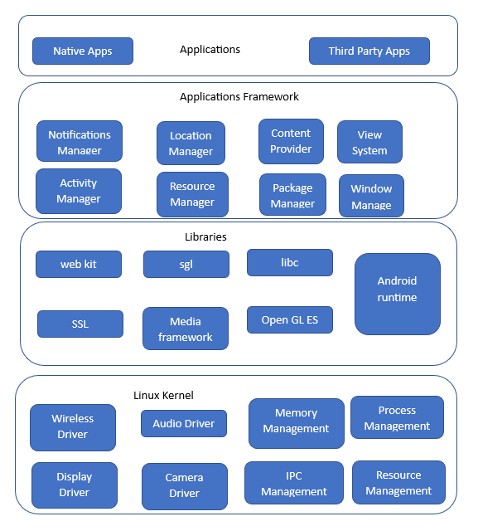

The android architecture as seen from the figure has several components broken down as managers for different services. By design each manager has a unique function used to manage resources. For example, mobile devices employ notification services to display alerts from applications on the screen. Within the device architecture, content services or providers focus on securely sharing data among different apps. This is achieved through the use of APIs and interprocess sharing, enabling seamless data exchange between various applications. In Android OS, applications create what are known as activities, these are application activities which are run to carry up a specific functionality. If an app would like to access a wireless driver for connectivity it will initiate an activity that will go through the activity manager to manage through the kernel and initiate a call for the wireless connection. As such through the same application framework the design app which requires access to a GPS/location feature will be executed and managed by the location manager service which then generates a request for the app to use location or depending on the user knowledge on mobile threats they can allow the app since by default GPS is normally deactivated for security and privacy purposes.

Every component of the Android OS serves a distinct service or function. The resource manager oversees core services, including graphic user interfaces components. Additionally, a separate high-level notification manager is responsible for handling all notifications. For users to share information to each other and the content share across multiple platforms is handled by the content provider. Each running application is an android phone runs what we call an activity, and each application has various activities running in the background. To determine location there is a separate package responsible for this and it requires setting the necessary permissions for the mobile phone so access location services (GPS) on a mobile device (Cai & Ryder 2017). Furthermore, to protect the mobile device from threats, all native and third-party mobile applications are developed to request permission to access critical services in a mobile device. As such these services are managed by controllers and through user approvals the OS handles all such requests. However, since the end users eventually approves or permits installation and access of services by apps the requests still present high security threats as it leaves the OS vulnerable to attacks as most users do not pay critical attention to most of these app’s requests (Faruki et al., 2015).

### Self-Check Questions

* How does the Android OS provide security for mobile devices?
* *One way is through application permissions, mobile apps must request*  *permission from the user before they can access certain features, such as the*  *camera or the microphone.*

## 3.2 Bootloader

The Android bootloader is an essential software component that serves as the foundation of the Android operating system. It is responsible for initializing the hardware, loading the operating system (OS) kernel, verifying the OS's integrity, and starting the OS before it fully launches. Android bootloaders come in two forms, locked, and unlocked. A locked bootloader restricts users from modifying the OS or installing custom ROMs, while an unlocked one allows for these actions but may void the phone's warranty, introduce stability issues, and make it difficult to revert to the original OS.

There are several benefits to having an Android bootloader, such as enhanced security against malware and other threats, optimized performance through boot process streamlining, and increased customization options through custom ROMs or other modifications. However, there are also drawbacks, such as voiding the device's warranty, causing stability issues, and increasing security risks when the bootloader is unlocked.

The Android bootloader operates in two stages. The first stage loads the device's boot information into the read-only memory (ROM) at the architectural level, while the second stage involves the Primary Bootloader (PBL), which is integrated into the Original Equipment Manufacturer (OEM) instances. The PBL is a hardware chipset manufactured by vendors, responsible for initializing the hardware, loading the OS kernel, verifying the OS's integrity, and starting the OS. In contrast, the fast boot layer refers to the layer where booting interfaces provide security against tampering through secure storage, focusing on PBL integrity verification, OS kernel loading, and OS startup (Borzemski et al 2019).

The bootloader processes undergo a secure boot process to prevent tampering of the system's memory. This is achieved by having partitions on the android device which are built in the kernel making it read only. As the system boots the system caches as a core process in the boot process together with memory spaces are secured to prevent unnecessary modifications. Mappers in the devices assist in dynamic partitions of the memory done through a component also found in the kernel. Dynamically, this results in metadata of the device memory partition storing blocks of information. As such the same data is used to vary all other blocks during boot initialization by comparing the block values with the virtual clocks that are created during dynamic partition. (Yadav, et al 2022).

Android OS Bootloader

**Table**

a structure that is used to define the layout of the hard drive or other storage media on a computer

Source: Panji Harawa (2023), based on Acharya et al. (2022).

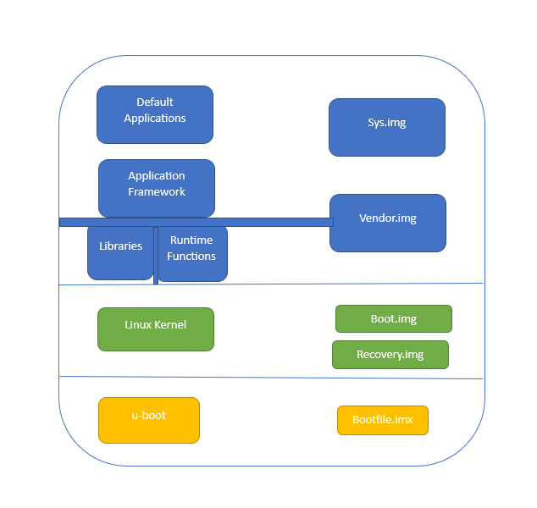

Android Bootloader Steps

|  |  |
| --- | --- |
| **Step** | **Description** |
| Start |  |
| 1 | Load System Image: Link core libraries and APIs, load default mobile OS application systems |
| 2 | Load Vendor Image: Store device-specific protected binaries, store inaccessible binary files |
| 3 | Load Boot Image (Linux kernel): Mount required partitioning tables |
| 4 | Load Recovery Image (in recovery mode): Perform tasks like Boot Image, install packages and software updates |
| 5 | Load Uboot File.imx: Execute device bootloader (Uboot) |
| 6 | Boot Android Device |
| End |  |

Based on the Android OS Bootloader figure and the Android Bootloader Steps table, the Android OS bootloader is divided into several components, as per the OS system partitioning table. During the boot process, the following build components are loaded (Acharya et al 2022):

1. System img: This image is referred to by system calls to link all the required libraries during runtime. It comprises core libraries and essential Application Interfaces (APIs) that form part of the default application system of the mobile OS.
2. Vendor img: The Android OS loads a second image known as vendor img, containing protected binaries specific to certain files. This image also stores binary files that are inaccessible to Android software development teams.
3. Boot img: Under the Linux kernel, the boot img is loaded, containing all the boot files required to mount the necessary partitioning tables.
4. Recovery img: This image is used to load tasks similar to the boot img but is executed in recovery mode. It is a requirement for U-Boot to install components such as packages and software updates.
5. Uboot file.imx: Before the OS starts, this image loads the devices' bootloader called U-Boot, which is executed when the mobile device boots.

### Self-Check Questions

* What is the use of mappers in bootloader?
* *Mappers in the devices assist in dynamic partitions of the memory done through a component also found in the kernel*

**Abstraction layer**

is a set of software components in the mobile operating system that provide a standard interface between the underlying hardware and the higher-level software that runs on top of it.

## 3.3 Kernel and Hardware Abstraction Layer

Every mobile device comprises various hardware components that require efficient management, including device drivers necessary for camera, wireless, Bluetooth connectivity, and memory storage. These hardware components are crucial during runtime. When the mobile device boots, the kernel establishes an abstraction layer to manage mobile memory and connected peripheral devices. This abstraction layer consists of software components within the mobile operating system, offering a standardized interface between the underlying hardware and the higher-level software running on top of it.

To achieve this abstraction, specific features are utilized, such as security measures implemented by the Android OS component, managing security-related matters between the OS and mobile apps. The networking hardware stack handles all communication related to networks, while the driver manager is responsible for managing hardware manufacturers' drivers, ensuring seamless integration of their applications with the inbuilt drivers (Jacobson et al., 2019).

The Linux kernel in mobile devices serves multiple functions, including resource management that involves creating an interface with the mobile device hardware and establishing a Hardware Abstraction Layer for users' applications. Additionally, it performs other functions, which can be summarized as in figure below.

**Kernel Kernel**

CPU Privileges

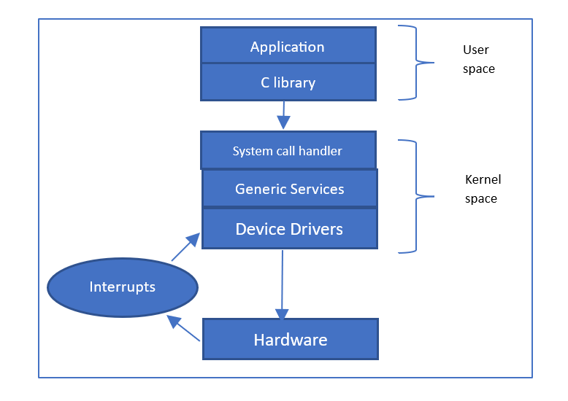

Source: Panji Harawa (2023) based on Simmonds Chris. (2015).

The figure CPU privileges highlights how applications that are running in the user spaces are given low CPU privileges unlike applications running in the kernel. This is because these applications normally make library calls to access some core app functionalities. However, since there is a primary interface between the user and kernel space, the library executes high-level user functionalities called systems calls. It is these system calls that then creates an interface for an action that requires the switch between the two modes that is from high to low level kernel mode. (Simmonds Chris 2015)

In the Android operating system, the Hardware Abstraction Layer (HAL) is designed to provide an ecosystem that enables the creation of certain system functionality without requiring any changes to the OS system code. As a result, each mobile device manufacturer may have different implementations of the HAL depending on the specific device and its hardware structure. The typical structure of the HAL is based on modules, which contain specific hardware information and data, as well as pointers stored in a shared library that includes primary metadata about the modules, such as the version and designer of the product.

This information stored in these libraries is unique to each hardware. Whereas the other structures typically rely on using system calls to identify and communicate with the core hardware components through JAVA application interfaces (Doan et al 2020). This higher-level isolation is also particularly useful as the system calls are being generated by its active processes and communication inter-processes also formulate part of the security model. The model creates a multiuser system whose objective was to ensure there is separation of resources. However, since during installation each mobile application is given a unique user id this entails all resources required by the application will only be used by that app, which can also be used to uninstall the application. Mobile operating systems, like all software-based systems, face various security vulnerabilities due to the increasing complexity of software, evolving attack techniques, and the interconnected nature of devices. These vulnerabilities can arise from programming errors, design flaws, or configuration issues. Some common security concerns include unauthorized access, data leakage, malware infections, and man-in-the-middle attacks. The widespread use of mobile devices and the sensitivity of user data stored on them make addressing these security vulnerabilities crucial. To mitigate these risks, developers and manufacturers need to implement robust security measures, such as regular updates, encryption, and access controls, while users should be mindful of their digital habits and follow best practices for securing their devices and personal information (Ayala, J. 2021).

3.3.1 Usage of HAL: A real-world example

As we described previously, the Hardware Abstraction Layer (HAL) abstracts the low-level hardware details of a hardware component (camera, communication interface, microphone etc.) by providing a standardized interface for the applications to interact with hardware components. In case of Android OS, HAL is accessed through the Android framework API [Arch 2023]. For the sake of understanding how this interaction goes we will provide the following steps how and application can access the camera in a mobile device through HAL:

* Requesting Camera Functionality: When the camera application is launched, it makes a request to the Android operating system to access camera functionality. The operating system then communicates with the HAL to initialize the camera hardware.
* Initialization of Camera Hardware: The HAL is responsible for initializing the camera hardware, such as the camera sensor, lens, and image processing components. It ensures that the camera hardware is properly initialized and ready to capture media.
* Setting Camera Parameters: The camera application may require specific settings, such as resolution, focus mode, exposure, and white balance, for capturing photos or videos. It communicates these requirements to the HAL, which then configures the camera hardware accordingly.
* Capturing Media: When the user clicks the capture button, the camera application requests the HAL to start capturing media. The HAL interacts with the camera hardware to begin capturing photos or videos based on the specified parameters.
* Closing Camera Session: Once the camera application finishes capturing media, it requests the HAL to close the camera session. The HAL ensures that the camera hardware is released, and any necessary cleanup is performed.

By utilizing HAL, the camera application can work across various Android devices with different hardware configurations seamlessly. The HAL shields the application from the complexity of interacting directly with the hardware, providing a standardized and simplified interface for accessing camera functionality. This abstraction improves the portability and compatibility of the camera application across a wide range of devices.

### Self-Check Questions

* What role does the HAL play in Android OS? Name two security vulnerabilities in mobile operating systems related to user data.
* *HAL connects hardware and software, enabling device-specific implementations.*
* Name two security vulnerabilities in mobile operating systems related to user data
* *Privacy threats and mismanaged data protection are two user data-related vulnerabilities*

## 3.4 Sandboxing and Virtualization

**Sandbox**

a mechanism that provides a controlled environment for applications as it only allows application to run without having absolute control to write or read applications information that they are not permitted to

The Android operating system employs a sandbox mechanism, providing a controlled environment for applications. This restricted environment ensures that applications run without absolute control over reading or writing data they are not authorized to access. To utilize network services and access hardware at lower levels of the hardware stack, applications must be granted specific permissions. The use of sandboxes has also been instrumental in identifying bugs in mobile applications, as it isolates unverified modules within the device and ensures that only trusted application modules are executed (Yao et al., 2020). The security mechanisms in sandboxes are similar to those found in virtual boxes.

Virtualization, on the other hand, involves a collection of techniques that create resources and divide them into separate executional environments. When designing a VirtualBox, the environment can be tailored to suit user requirements, effectively hiding hardware details. Virtualization operates through virtual machines, which are isolated software systems independent of hardware, enabling them to run applications as if on a physical computer system. Most virtual machines are configured to provide an isolation layer for hardware requirements and resources, allowing users to scale and work with flexibility. The proximity of the virtual machine's configuration to the physical hardware affects its scalability and flexibility; closer configurations to the physical hardware make it less scalable, while farther configurations enhance scalability and flexibility (Vokorokos et al 2015).

**Virtualization**

as a collection of techniques and steps with creates resources and divides them into several executional environments

Position of Sandbox Virtualization Layer Within OS

|  |  |
| --- | --- |
| Process 1 in Sandbox | Process 2 in Sandbox |
| Virtualization layer | |
| Host Os | |
| Hardware | |

Source: Panji Harawa (2023) based on Vokorokos et al 2015.

Sandboxing refers to a security mechanism that allows devices to utilize limited resources while separating all executed programs. The sandbox provides an easily accessible platform to run code that has been developed and has not yet been tested. This technique prohibits access to critical mobile devices resources therefore enhancing security. Software developers used sandboxing to roll out new releases of software that is yet to be verified and untested from all security vulnerabilities such as virus and malware while protecting the host device from being infected. Sandboxes are used to control mobile applications access to critical resource through setting up on permission, as part of the program can only be allowed to access the device after being granted permission by the device

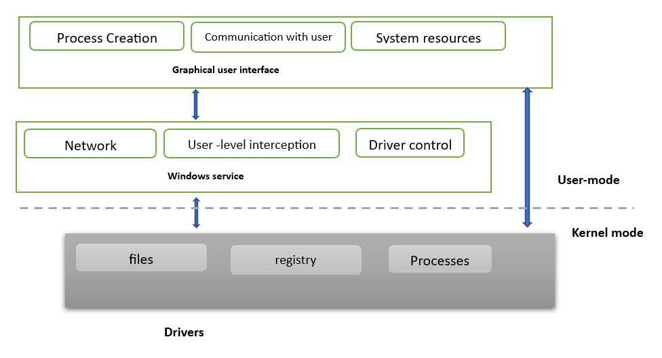Basic Sandbox Architecture

Source: Panji Harawa (2023) based on Vokorokos et al 2015.

The Basic Sandbox Architecture depicted in the figure above comprises three distinct components at the architecture level. The first component is responsible for the core execution of the Android operating system kernel, housing the main software modules and drivers. It handles process operations and filters the device registry and files from the user mode. The devices window services, once loaded, implement functions such as network and driver controls, also performed in the user mode. User interaction with the services is facilitated through a graphical user interface (GUI), which triggers the activation of drivers and service calls, providing feedback to the user via the same GUI. Interactions from the kernel create an abstraction layer when programs wish to access files and processes. The Android OS is designed to safeguard user data by ensuring that mobile applications maintain data integrity. However, the level of protection can vary among Original Equipment Manufacturer (OEM) vendors, as it depends on their adherence to security standards. These protocols subject mobile applications to rigorous malware checks and backdoor prevention embedded within the OS security protocol. As Android OS is based on Linux kernel it inherits the Discretionary Access Control (DAC) security model from it. The DAC is a security model that controls access to resources based on user identities and permissions. When a file is created the permission is defined as read, write, or execute. The owner of the files can give certain access to different users that can be the owner itself, the group where the resource belongs and all the other users.

**Discretionary Access Control (DAC**)

A model that secures each mobile application with a unique identification number that it uses to access critical features in the sandbox.

The Android OS extends the Discretionary Access Control (DAC) model, securing each mobile application with a unique identification number that grants access to critical features within the sandbox. Through sandboxing, untested applications are secured by preventing app core frameworks from interacting or interfering with other running mobile applications. This includes regulating app access to networking modules, Bluetooth, and wireless communication, which are implemented using complex network security protocols accessible only within the sandboxes (Goonasekera et al., 2015).

#### 3.4.1 Apk sandboxing

The integrity of mobile data is maintained using application signatures which also ensures security of the data. It does this by signing each application with a unique ID that is used by the app in the virtual environment. In the figure above three applications access various hardware components and are grouped depending on the component required by the app. This is done during the installation process. If there is any tampering done that identifies invalid certificates, the application installation will be aborted and terminated by the Android OS. (Tejinder S. Randhawa, 2022).

Setting up a sandbox involves configuring a secure space with specific rules and safety measures to ensure a safe environment for applications to operate within. This process requires adhering to an architectural design that dictates how applications can access and utilize mobile device resources. Key components of a sandbox can be containers or virtual machines, serving as modules that facilitate this control mechanism. Defined policies govern the data flow within the sandbox, and its operation takes place on a user level (Vokorokos et al., 2015). These modules also track unverified and untrusted applications, enabling the management of insecure system calls, ensuring that applications can safely function and execute within the same confined space.

Security Sandbox

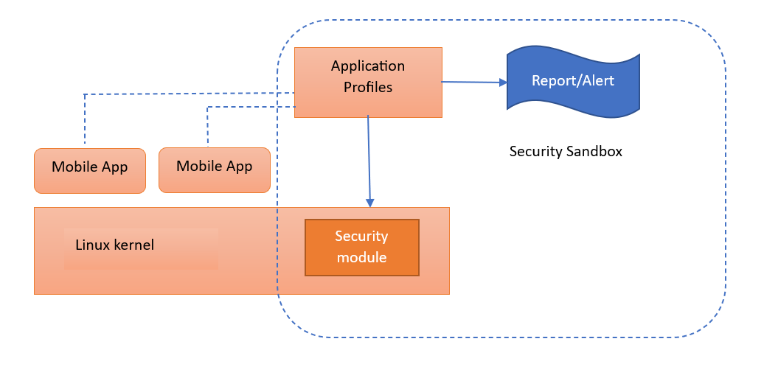

Source: Panji Harawa (2023) based on Vokorokos et al. (2015).

The implementation of sandbox modules comes with its challenges, as depicted in the figure "Security Sandbox." These modules depend on the kernel to efficiently manage, and grant permissions required by applications at an advanced level (Spreitzenbarth, 2013). Consequently, a robust standalone security sandbox is established, enabling applications to operate securely while accessing all essential system resources on the device. Prior to running an application, it generates an authenticated profile using the security module in the kernel. If any suspicion of tampering arises, an alert is promptly generated.

### Self-Check Questions

* How does the APK sandboxing function?
* *The APK sandboxing mechanism creates a cryptographic hash value of the devices UID which is then cross referenced by the hash value of a verified app certificate*

**Code signing**

the process of using a digital certificate to authenticate and verify that an application has been developed by a software designer is referred to as code signing.

## 3.5 Code Signing

The process of using a digital certificate to authenticate and verify that an application was developed by a software designer is referred to as **code signing**. The process uses a cryptographic hashing mechanism to provide proof that there are no changes made to a piece of software since its release into production. Two main cryptographic hashes are used for this, the SHA1 and SHA256. These cryptographic hashes once invoked create a combination of a private and a public key pair, which formulate a digital signature which can then be used to verify an application package through its **manifest file**. These signatures are used to compare and link them to verify for any tampering or suspected modification that could exist. This is done by confirming the pairs of the public keys and checking if they are the same with the package contents (Horn, K 2018).

As determined, the Android operating systems must digitally sign each mobile application during installation. This allows the OS to provide a mechanism to verify the authentication of a mobile application as well as checking the security features of the app. This is done to ensure only approved apps are run to which then creates trust on the usability of the app, as it is being run. Since most applications will require permission to access some of the resources, code signing helps in establishing a trusted environment between these applications. As such as part of dealing with mobile threats if an application is not digitally signed and authenticated the android OS emulators will not accept/allow its installation on the devices. The signing of each application is usually done during deploying of an application and tools such as key tool and jar signer can be used to generate unique signatures for applications Apk files. Code signing can enhance the security of mobile applications by enabling the establishment of unique permissions for each application. These permissions can be tailored to either allow or restrict access to specific resources, bolstering the overall security of the applications. The android security component by default does not grant automated permissions to applications; each application must request permissions that allow use of APIs. The user must allow an application to access application interfaces that allow accessibility for camera, GPS, as well as telephony subsystem to access calls, sms and contacts. (Boyer & Mew, 2016).

**Manifest file**

in computing, this is a file that includes metadata about a group of accompanying files that are intended to be used together as a unit.

Still, like other mobile security mechanisms, employing cryptographic hashes presents certain challenges. Cooper et al. (2018) contend that verifying the authenticity of an application using cryptographic hashes can be problematic, primarily due to their reliance on public keys. It is often difficult for mobile devices to ascertain whether a generated public key is owned by an individual or an organization, which poses a challenge in ensuring the security and integrity of the application This also creates a challenge in identifying and determining if the public key was modified or changed completely. To resolve this the android OS employs use of Public Key infrastructure (PKI). This mechanism uses third entities in the verification and authentication of applications, referred to a Certificate Authorities (CA) which is an entity responsible for issuing, managing, and revoking digital certificates in a public key infrastructure (PKI) system. The idea was first initiated through the development of security standards for web applications as a key requirement for HTTPS internet Protocol. The same model is implemented using various mobile software application distribution platforms such as Google Play store for android apps and other android vendor-based app markets such as Samsung Store. As such, when it comes to mobile application developers, they also must choose the CA they would like to use for the app. To enhance and reduce mobile threats, the developer must be registered and vetted by the CA. This, however, can create challenges if the developer of the application and the publisher are different. This is addressed by requesting g issuance of signed certificate from the developers which the CA verifies and grants allowing their application to be published by the software distributor i.e., Google Play store. (Kwon et al., 2021).

The Android Operating system resolves this by implementing two strategies that use a decentralized public key infrastructure. This model allows developers to generate the cryptographic keys themselves as seen below.

Upload Key Resolution Strategy

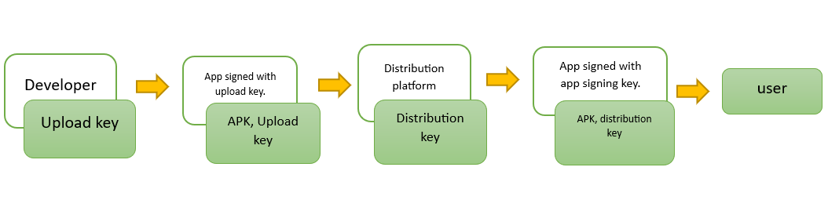

Source: Panji Harawa (2023) based on Horn, K. (2018).

In the context of the figure "Upload Key Resolution Strategy," the software distributor, such as Google for Android mobile apps, generates two pairs of keys. The first pair consists of the distribution key and the upload key. For app authentication purposes, the upload key is utilized. Afterward, Google proceeds to re-sign the APK package.

Distribution Key Resolution Strategy

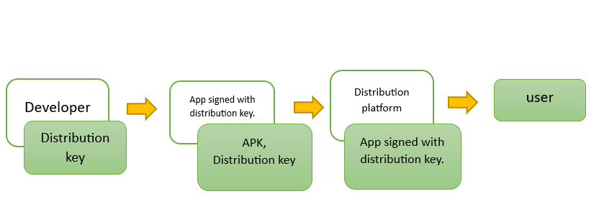

Source: Panji Harawa (2023), based on Horn, K. (2018).

From the figure Distribution Key Resolution Strategy, the responsibility for signing of the application lies with the developer, who needs to sign both for the distribution and upload key.

#### 2.5.1 Permission management in Android

To support user privacy app permissions, protect access to the restricted data and restricted functions. Restricted data relate to private data such as e.g., users contact list while restricted functions deal with e.g., connecting a device to another BLE device or giving access to read functions for your directories [PERM 2023].

Android application permissions are categories as follows [PERM 2023]:

* Install-time permissions are permissions that are granted to the app at the installation time. The application store presents this install-time permissions requirements at the time when the installation is performed by the user, who has to accept them to continue with installation.
* Run-time permissions are permissions that are asked during the runtime of the applications. Such runtime permissions can affect the system as well as the work of other applications, thus this permission is asked every time before accessing restricted data or restricted functions.
* Special permissions relate to particular apps and can be defined only by the platform and the OEMs.

Android permission management high-level architecture is shown in Figure Permission Management in Android.

Permission Management in Android

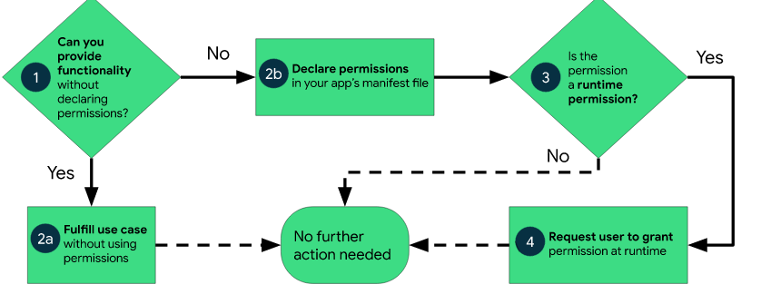

### Self-Check Questions

* What is the purpose of code signing in Android OS and how does it enhance mobile application security?

*The purpose of code signing in the Android operating system is to verify the authenticity and integrity of mobile applications*

Summary

This Unit gives a background on how Android operating system is based on Linux and was developed by the Open Handset Alliance led by Google. As such being an open source, it allows for easy software development and modification, making it easy for companies to develop unique functionalities. Android has hardware components that enable easy running of apps, provide high-level encryption, and manage mobile devices' hardware components. The unit critically discuss the diversity of mobile applications in the Android ecosystem, and the how the underlying technology stack is dependent on common application libraries, making it easy for development of both native and hybrid mobile applications that are cross-platform. The Android architecture has several components broken down as managers for different services, with each component used for a specific function. However, the requests made by native and third-party mobile applications present high security threats, as most users do not pay critical attention to them. OEMs use bootloaders to customize their own operating systems and ensure that these customizations also consider all the peripherals controlled and managed by the software on the chip. At hardware level we see that Android kernel creates an abstraction layer that manages all the connected peripheral devices and the mobile device memory. The Hardware Abstraction Layer (HAL) provides an ecosystem that enables the creation of certain system functionality without requiring any changes to the OS system code, and each mobile device manufacturer may have different implementations of the HAL depending on the specific device and its hardware structure.

The unit has digested how Android OS uses sandboxing to provide a controlled environment for applications to run in, with limited access to resources. In this aspect the unit further explains how virtualization is also used to create isolation and flexibility for users. The sandboxing mechanism allows for untested code to be rolled out while protecting the device from security vulnerabilities. The sandbox architecture consists of three components: core execution of the kernel, modules for process operations and filtering, and user interface for device interaction. The sandbox uses modules such as containers or virtual machines to gain access to device limitations and ensure secure execution. When it comes to mobile application security, it is maintained by use of the APK sandboxing mechanism which uses cryptographic hash values and verified app certificates to ensure data integrity. The implementation of modules in the kernel can create an effective standalone security sandbox but can also present challenges. The same principle is applied when code signing, as a process that uses a digital certificate to authenticate and verify that an application has been developed by a software designer. The unit details how It uses cryptographic hashes to provide proof that there are no changes made to a piece of software since its release into production. As for Android OS it uses code signing to verify the authentication and security features of an app during installation. Code signing enhances mobile application security by setting up unique permissions for each application that can allow or restrict permission to some resources. In nutshell the unit explains how Android OS employs a Public Key infrastructure (PKI) that uses Certificate Authorities (CA) to verify and authenticate applications. In addition, the Android OS implements two strategies that use a decentralized public key infrastructure to generate cryptographic keys for developers.

# Unit 4 – Apple iOS Operating System

**Study Goals**

On completion of this unit, you will be able to …

… determine the iOS hardware architecture.

… analyze how the bootloader of iOS functions.

… identify key sandboxing and virtualization processes of an iOS operating system.

… understand how mobile device kernel provides security in iOS.

… explain how code signing of applications enhances security in iOS mobile devices.

## Introduction

MAC OS has been at the core of Apple computer products since the late 1990s. It was during this era that was the birthplace of Macintosh platform, after which there was a mobile Operating System (OS) that was developed called iOS. iOS is a mobile operating system developed by Apple Inc. It is the operating system that powers many of Apple's mobile devices, including iPhone and iPad. iOS is known for its user-friendly interface and sleek design, as well as its many features and capabilities, such as access to the App Store and the ability to connect to iCloud. Most Apple mobile devices use iOS as core software that creates an ecosystem to manage and control software resources, hardware, and all peripherals. As a software it has support for mobile applications that are used to act and create an interface that users, software developers can interactively interact with hardware. Just like all other types of operating system it has also evolved over the years with an ecosystem of mobile apps being used on daily basis and implementation of standard OS services such as storage, process scheduling and management of boot processes. Due to its easy implementation of their APIs on low level single digital personal computers, it made it easy for software engineers to write and execute programs in a convenient way. In today modern technological trends Apple platforms have grown and gained more popularity through their iPhone technology, (Statistica 2022) which has been escalating with the emergence of cloud computing, use of web applications and mobile applications.

## 4.1 Hardware

As a mobile operating system, iOS is designed to run on a wide range of hardware devices, including smartphones, tablets, and other mobile devices. These devices typically have several hardware components, such as a processor, memory, storage, and various sensors, necessary for the device to function and perform the tasks it is designed for. The specific hardware components of a given Apple device will vary depending on the model and manufacturer of the device's internal components. However, at the core of the Apples iOS there is critical infrastructure hardware. For many years it has been a widespread practice for system engineers to have a standard that can be used for all common OS versions across different hardware. However, it has been noted that most of mobile devices by Apple have several components that are integrated as such for software engineers to use mac OS they also must consider recent changes to hardware that occur with typical latest version of the operating system. This is an element of Apple dealing with mobile threats hence there is no backward compatibility for most of their older versions of iOS or macOS (Drew Smith. 2020).

**Extensible firmware interface (EFI)**

a specification that defines a software interface between an operating system (OS) and platform firmware.

As part of the hardware components, every Apple device features an **extensible firmware interface** (EFI) which is a specification that defines a software interface between the operating system (OS) and the platform firmware. The EFI is one of the core hardware components of the iOS security boot that uses pre boot password features. This feature works at lower level, like the firmware, to operationalize the password utility, also called startup security utility. This iOS password utility feature’s main function is to allow system administrators to lock down the booting of the mobile devices without the need to enter a password. The setting up of a password on EFI usually does not need to show the password prompt when the system is normally used on startup. This feature is only activated when the user tries to access the device in recovery mode, recovery media booting process or network boot. These features provide security and prevent mobile threats on iOS devices by allowing locking of the devices so that it can only boot from a legitimate, trusted operating system. Afterwards, the pre-boot password feature is employed to verify the integrity of the bootloader and the operating system, preventing any unauthorized code execution or tampering.

**UEFI Secure boot IOS**

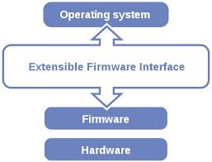

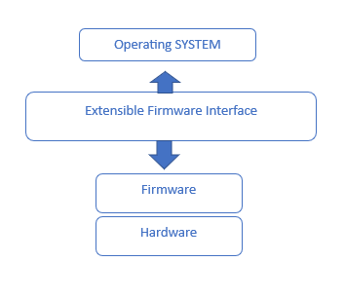

Source: Panji Harawa (2023) based on Source: <https://www.linux.com/training-tutorials/uefi-secure-boot-big-hassle-questionable-benefit/>

From the figure UEFI secure boot in iOS the EFI (Extensible Firmware Interface) encompasses two categories of services: boot-time services and runtime services. Boot services are accessible when the EFI firmware governs the system by loading the OS while making sure that runtime services remain available during firmware control and after the operating system assumes control. After that several extensions are loaded from hardware which may include closed-source drivers, support for legacy operating systems, and various other proprietary enhancements.

#### 4.1.1 iPhone architecture

The hardware components of an iOS device have large applicability to several Apples devices such as Apple TV and iPads, since we are in technological era where devices need to connect to each other. By design iOS architecture has at the bottom of software stack the main OS layer, after this layer there exists a pre occupational layer, followed by a media, cocoa-touch layer whose main function is to provide the main framework for app development. In addition, there is the core services layer of the software stack at the bottom whose function is to provide high level networking, security, and multimedia. As an operating system, iOS relies heavily on schedulers, a framework that offers a programming model used for task scheduling, state management, and the creation of asynchronous workflows and integrated file systems. These schedulers work in conjunction with the Mach kernel, a vital component responsible for interfacing memory management systems. The primary role of the Mach kernel includes providing essential low-level services, especially in process scheduling and handling drivers. It is also responsible for configuration, and control of hardware drivers for all peripheral devices. It is also responsible for the iOS telephony subsystems that control all inter process communication with the device (Gronli et al 2014).

iPhone Architecture

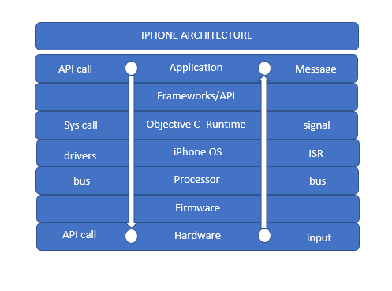

Source: Panji Harawa (2023) based on Tiwari, A. (2017).

The iPhone architecture is structured in multiple layers as shown in the figure iPhone Architecture. Starting from the bottom layer, the hardware layer refers to physical chips that are embedded within the mobile device circuitry. Processors and system on a Chip are integrated on this chip to manage all computing and scheduling of all instruction sets which are done in the memory descriptor but executed at processor level. The next layer is firmware that has unique code that has been developed to work with the device's memory and stored there as well on this chip. After storing and execution, the processor issues a specific ARM instruction set which formulates the booting of the iOS device and drivers. This is a direct linkage between the two layers processor and iOS. As the processor is executing it normally sets up interrupts descriptor table (IDT), a data structure used by the x86 architecture to implement an interrupt vector table. The IDT is used by the processor to determine the correct response to interruptions and exceptions which are managed by the iPhone OS. For the iPhone OS to fully function it needs applications that are developed by software developers, who prefer working with objective c as a programming tool for easy scaling up and support by other libraries. The iPhone mobile application technology stack also uses several frameworks/APIs which are mostly accessible through the Apple SDK, which is responsible for incorporating Apple distributed headers such as App kit, UI kit as they already provide access to Apples API’s). It is essential to emphasize that all mobile applications in Apple products are compiled at the hardware level using native code and a distributed compiler feature of Xcode. This feature enables developers to distribute the compilation of their code across multiple platforms. This has allowed apps to run within a predefine user environment (Khan et al 2022).

iOS Architecture

Source: Source: Panji Harawa (2023), Based on Atkar (2020) <https://www.fosstechnix.com/ios-architecture-and-concepts/>

Title iOS Architecture

Source: Panji Harawa (2023).

The iPhone hardware stack as introduced above seen from the structure has five components at the core of its hardware. The top layer referred to as cocoa touch layer is a layer that contains all the software frameworks and libraries that are used in mobile applications. Software engineers develop apps that reference the Cocoa APi, within the iOS framework that is used to access libraries. The second layer, media services for iOS devices, is responsible for management of audio, video, and graphic capabilities. Since all components of this layer, it also comprises of various frameworks used to develop applications that require using audio, video, and any graphics requirements. The third layer is the core services layer in iOS, which serves as a foundation for all software components to integrate and function. This layer provides essential services for the other layers to build upon, including features like the address book and core data frameworks.

Lastly the core OS is for managing the user interface and supporting touch-based interactions. All these components are fully embedded in the core iPhone hardware that also helps in management of these native applications (Pršeš, F. 2020).

### Self-Check Questions

* 1. What are the key components of Apple hardware and how do they enable the functionality of an iPhone
* *Processor: The processor, or central processing unit (CPU), is the "brain" of the device, responsible for executing instructions and performing calculations*.
* *Memory, or random-access memory (RAM), is used to store data that the device is currently using or processing*
* *Storage: Storage is where data is stored on a device*

## 4.2 Bootloader

The bootloader is a type of software that loads the operating system on a computer or mobile device. On Apple iOS devices, the bootloader is called "iOS Boot Loader" or "iBoot". This low-level program verifies the integrity of the iOS operating system and checks for proper sign-in before loading it into memory for execution. The iBoot boot loader is an important part of the iOS operating system as it ensures the security and integrity of the system by only allowing signed and trusted operating system software to run on the device.

**boot loader**

a type of software that loads the operating system on a computer or mobile device.

When an iOS device is turned on, the iBoot boot loader is the first software to run. It checks the integrity of the operating system by computing a cryptographic hash and comparing it to the expected value stored in the device's ROM. If the hashes match, iBoot verifies that the operating system has been signed by a trusted source, such as Apple. This prevents any mobile threats on the device. After the operating system has been verified, iBoot loads it into memory and transfers control to it. The operating system then initializes the device's hardware and starts the user interface. The iOS architecture as seen from the structure has five components at the core of its hardware. The top layer referred to as cocoa touch layer is a layer that contains all the software frameworks and libraries that are used in mobile applications. Software engineers develop apps that reference the Cocoa APi, within the iOS architecture used for building user interfaces. Apple provides specific frameworks to help with app development in iOS as follows:

* Core Graphics framework: provides support for 2D graphics I.e., drawing shapes, text rendering
* Core Data framework: provides support for managing structured data
* Core Location framework: provides support for accessing the device's location and heading information I.e., GPS
* Core Bluetooth framework: provides support for communicating with Bluetooth devices

Together, the iOS kernel and its frameworks provide the foundation upon which the rest of the operating system and its applications are built and are essential for the proper functioning of the device. (Garcia et al 2016).

User Mode, Kernel Mode, and Hardware

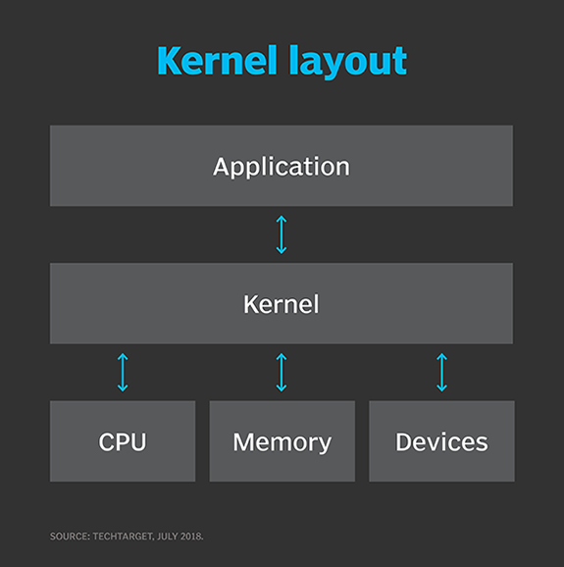

Source: <https://www.techtarget.com/searchdatacenter/definition/kernel>

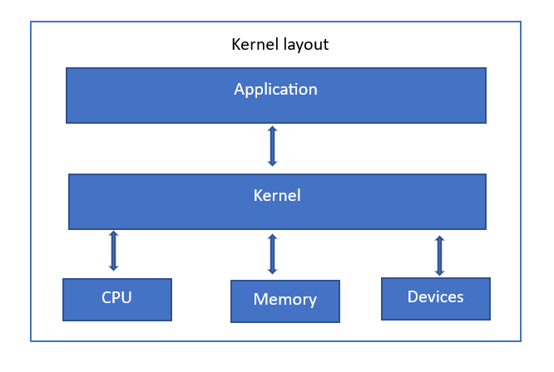

Source: Panji Harawa (2023), based on <https://www.techtarget.com/searchdatacenter/definition/kernel>

Kernel designs vary to cater to different system requirements. Monolithic kernels operate entirely within a single address space and prioritize speed, functioning in supervisor mode. In contrast, microkernels allocate most services to the user and application areas, focusing on modularity and resilience. The microkernel itself offers only fundamental functionality, while separate applications and devices assume previous kernel roles such as system drivers (Bigelow et al., 2022). Mobile devices, including smartphones and tablets, require a mobile operating system to enable various communication interfaces and services like voice calls, messaging, and internet browsing. In the context of iOS, Apple's proprietary mobile operating system, the kernel plays a crucial role in managing system resources and serving as an intermediary between applications and hardware devices. (Bigelow et al 2022)

### Self-Check Questions

Please complete the following sentence:

* Discuss the three key responsibilities of the kernel in managing system resources,

*The kernel of an operating system is responsible for managing system*  *resources, such as process and thread management, memory management,*  *device management, file system management, I/O management*

## 4.4 Sandboxing and Virtualization

iOS sandboxing is a security feature of the iOS operating system that restricts applications' access to the device's resources and data. This means that each app is isolated from other apps and is only allowed to access the resources and data that it has been specifically granted access to. Whereas when we talk about **virtualization**, we’re referring to a technology that allows multiple instances of an operating system to run on a single device. This allows iOS to run multiple instances of the operating system, each with its own set of applications and resources, on a single device. Together, these technologies help to improve the security and stability of the iOS operating system. The sandbox and virtual machine do this by limiting app access to the device's resources and data. Security in iOS is strengthened by employing techniques such as sandboxing and virtualization, which are a combination of hardware and software features. These measures enable the operating system to run multiple instances of itself on a single device, effectively isolating individual apps from each other. As a result, one app is prevented from interfering with or accessing the data of another app, enhancing overall security, and ensuring a safer user experience.

Virtualization

a technology that allows multiple instances of an operating system to run on a single device

At the software level, iOS uses a security model called "application signing" to ensure only trusted apps can run on the device which in return adds an extra layer of security during virtualization. This is also particularly useful when using containerized applications running in a sandbox and virtual machines. This requires developers to sign their apps with a unique certificate issued by Apple, which will be verified by the operating system before the app can run. Furthermore, iOS incorporates a technology known as containers, which operate as an abstraction at the app layer. These containers bundle the source code and dependencies of an application together, effectively implementing virtualization. Each app is assigned its own container, which then creates a virtualized environment that provides the app with its own private set of resources and data (Talal et al 2019).

Overall, since sandboxing and virtualization depends on software and hardware features such as isolation and resource sharing that help to improve the security and stability of the operating system, making iOS one of the secure platforms when it comes to mobile threats. iOS uses sandboxing and virtualization to improve the security and stability of the iOS operating system from attacks. Sandboxing achieves this by further preventing apps from being able to interfere with or access the data of other apps, while virtualization allows the operating system to run multiple instances of itself on a single device, which helps to prevent one instance from crashing and affecting the other instances. Below is the iOS security structure.

iOS Security Structure

Source: Android v/s iOS – The Unceasing Battle Aditya Sahan 2017

For Based on graphics:

Source [Author], (2023) based on Aditya Sahan (2017).

**Root certificates**

Also called trusted root certificates, these are used to establish a chain of trust that's used to verify other certificates signed by the trusted roots).

As seen from the figure above iOS has two key components hardware and software that formulates iOS core security features. The secure enclave as part of the iOS kernel helps provide security at low level. Since iOS also employs use of cryptographic hashes using Group keys and **root certificates**, which are stored at hardware level. The software as seen creates an abstraction through iOS App sandbox, hence ensuring that there is no tampering of apps externally. One of the main security mechanisms is that iOS does not make its source code available to the public, making iOS to be less vulnerable to being "jailbroken," or hacked to gain access to unauthorized features. iOS also includes various hardware and software features that enhance security by default, such as data encryption and the use of touch ID and face ID. These features not only improve security, but also enhance the user experience. This combination together with iOS devices use encryption to protect data stored on the device and transmitted over the network. Data is encrypted using a unique key that is generated when the device is first set up, and the key is stored in the Secure Enclave which through iOS crypto engine access the required key at hardware level.

### Self-Check Questions

* What is iOS virtualization and how does it enable the execution of multiple operating systems on a single device?
* *iOS virtualization is the process of running multiple operating systems on an iOS device through virtual machines. It enables the execution of multiple OSes by abstracting hardware resources and providing isolated environments for each OS*

## 4.5 Code Signing

OS code signing is a security measure that ensures only trusted apps can run on the device. It is managed by the operating system and involves developers signing their app with a unique certificate issued by Apple. This certificate acts as a digital signature that verifies the developer's identity and the app's integrity. When an app is installed on an iOS device, the operating system will verify the signature to ensure it is valid and has not been tampered with. If the signature is valid, the app will be allowed to run. If the signature is invalid or has been tampered with, the app will not be allowed to run, and the user will be notified. In addition, iOS periodically checks the signatures of installed apps to ensure they are still valid. To further improve security, iOS devices use hardware-enforced memory protection to prevent apps from accessing unauthorized memory and the operating system uses a security model called "application signing" to verify the authenticity and integrity of apps achieved by signing the application with a unique developer certificate issued by Apple. Overall, code signing helps to prevent malicious or tampered with apps from being installed and executed on the device which is achieved by signing the compiled code or binary of the app with the developer's certificate, hence improving the security of the operating system. To be able to achieve and execute this, the following steps in iOS devices are necessary(*Application Code Signing*, 2018):

Code Signing

(original)

Source: (Apple, *Application Code Signing*, 2018).

The signing process is as follows:

* Develop the app: The first step in the code signing process is to develop the app. This involves writing the code, testing it, and making any necessary updates or changes.
* Obtain a developer account: To sign an app for iOS, you must have a developer account with Apple. You can sign up for a developer account through the Apple Developer Program website.
* Create a signing certificate: Next, you will need to create a signing certificate to sign your app. This is done through the Apple Developer website or using the Xcode development tool.
* Sign the app: Once you have a signing certificate, you can use it to sign your app. This is typically done using the XCode development tool, which will generate a signed version of your app that is ready to be submitted to the App Store.
* Submit the app to the App Store: The last step in the code signing process is to submit your signed app to the App Store. This is done through the Apple Developer website, and it involves providing information about your app, such as its name, description, and screenshots.

Concisely, the process of iOS code signing involves developing the app, obtaining a developer account, creating a signing certificate, signing the app, and submitting it to the App Store. This helps ensure that only trusted, signed apps can run on iOS devices, improving the operating system security (Apple *Application Code Signing*, 2018).

### Self-Check Questions

* What are the two key components of the iOS code signing process?
* *Development Certificate: A development certificate is a digital certificate that*  *is issued by Apple to a developer*.
* *Signing Key: A signing key is a unique digital key that is used to sign software*

Summary

In this unit it is stipulated how Apple's mobile operating system (OS), iOS, has been the core of its products since the late 1990s, powering devices like iPhones and iPads. Known for its user-friendly interface and sleek design, and how iOS has evolved over the years, with an ecosystem of mobile apps used in various industries. The OS has gained popularity through iPhone technology, enhanced by cloud computing, web applications, and mobile applications. Furthermore, as for hardware components of iOS devices, these mostly include a processor, memory, storage, and sensors. Just like other mobile devices Apple features an extensible firmware interface (EFI) as a core hardware component for iOS boot security. Its architecture at the core consists of five main layers: Cocoa Touch, Media, Core Services, Pre-Occupational, and Main OS Layer, and has evolved over the years, applying to Apple TV and iPads. The Mach kernel interfaces with memory management systems, hardware drivers, and controls the iOS telephony subsystems. iOS also requires a bootloader which is referred to as "iBoot” which is responsible for loading the iOS operating system on a device. It verifies the integrity of the OS by computing a cryptographic hash and comparing it to the expected value stored in the device's ROM. In addition, the secure boot chain ensures the lowest levels of software on the device have not been tampered with. Apple devices have a dedicated processor called the Secure Enclave, which performs a secure boot process to verify the software's signature. Further the units highlight how the iOS kernel, a core component of the operating system, is responsible for managing resources and providing low-level services to the operating system and apps. iOS also includes frameworks that offer specialized functionality, such as Core Foundation, Core Graphics, Core Data, Core Location, and Core Bluetooth. These components form the foundation for the operating system and its applications. To achieve all these iOS employs sandboxing and virtualization to improve security and stability. Sandboxing isolates apps from each other, limiting their access to resources and data, while virtualization allows multiple instances of the operating system to run on a single device. These features are implemented through a combination of hardware and software, including application signing, containers, and the Secure Enclave, which stores cryptographic keys at the hardware level. This comprehensive approach to security makes iOS one of the most secure mobile platforms, this is also detailed in how iOS handles and manages code signing is which happens to be a security measure employed by the iOS operating system to ensure that only trusted apps run on devices. Mobile app developers sign their apps using a unique certificate issued by Apple, which verifies the developer's identity and the app's integrity. The operating system checks the app's signature upon installation and periodically afterward to maintain security. To achieve this, developers follow a process that includes developing the app, obtaining a developer account, creating a signing certificate, signing the app, and submitting it to the App Store. This process enhances the security of the iOS operating system by preventing malicious or tampered apps from being installed and executed on devices.

# Unit 5 – Mobile Devices

**Study Goals**

...learn about Linux distributions and their use for mobile devices,

... learn about the Internet of Things (IoT) and how mobile devices can be integrated into IoT systems

... understand the architectures of real-time operating systems (RTOS) and how they can be used on mobile devices

... understand how embedded systems function, including issues related to security, performance, and power management.

## Introduction

Mobile devices, specifically smartphones, have become a crucial aspect of our society due to the diverse range of functions and capabilities they possess. These handheld electronic devices are incredibly convenient and useful for both personal and professional use. With a smartphone, individuals can make phone calls, send texts and emails, access the internet, and utilize various apps to stay organized, entertained, and connected to their surroundings. Moreover, smartphones are equipped with cameras and other features that allow users to capture and share memories, record video, and much more. No matter if a smartphone is being used for work or leisure, it offers numerous possibilities for staying connected and completing tasks while on the go. However, when it comes to mobile threats mobile devices are not spared. As such, this section tackles how the use of these devices also carries with it certain risks, such as the potential for malware, hacking, and phishing attacks, which can compromise the security and privacy of the device and its users. It is therefore important for individuals and organizations to be aware of these risks and to take measures to protect against them. This may include regularly updating security patches, implementing strong password protocols, and exercising caution when downloading apps or accessing websites. By acknowledging the potential for mobile threats and taking appropriate precautions, it is possible to maintain the security and integrity of mobile devices as a platform for communication and productivity

## 5.1 The Internet of things

**The Internet of Things**

a network of electronic devices and objects that can communicate and exchange data with each other and the internet, enabling remote control and monitoring.

The **Internet of Things** (IoT) is a network of electronic devices and objects that can communicate and exchange data with each other and the internet, enabling remote control and monitoring. These devices, such as smart thermostats, security cameras, and wearable fitness trackers, use sensors, actuators, and communication capabilities to interact with their surroundings and one another. The goal of the IoT is to create a network of connected devices that can be easily accessed and controlled, automating many everyday tasks and processes. The potential uses of the IoT are vast, with the possibility to transform industries such as healthcare, transportation, agriculture, and energy management. By gathering and analyzing data from connected devices, businesses and individuals can make more informed decisions and optimize their operations. For example, a smart home system can use IoT technology to adjust the temperature, lighting, and security based on the occupants' preferences and behavior. In healthcare, IoT devices can monitor patients' vital signs and alert medical personnel of any abnormalities. The IoT has the potential to enhance our daily lives and increase the efficiency of various industries. (Anand et al 2021)

The structure of the Internet of Things (IoT) in mobile devices is typically made up of several layers, each of which serves a specific function in the system. These layers may include[Jenky 2019]:

Sensors and Actuators

Source: Panji Harawa (2023) based on Janky et al. (2019).

* Sensors and actuators layer: these components of IoT collect data from the physical world and allow the system to interact with it. In mobile devices, these may include sensors like accelerometers, gyroscopes, and GPS, and actuators like vibration motors and speakers.
* Device layer: this refers to the hardware and software components that make up the mobile device itself, such as the processor, memory, storage, and operating system.
* Networking layer: this part is responsible for enabling communication between the device and the internet, and between the device and other connected devices. This may include Wi-Fi, cellular network connection, Bluetooth, NFC and other communication technologies.
* Platform layer: refers to the software and services that enable the device to connect to and interact with the IoT. This may include cloud services, middleware, and APIs that allow the device to send and receive data from the internet and other connected devices. In addition, data can be processed and formatted based on the needs of the data sinks.
* Application layer: a layer that users interact with, consisting of apps and other user-facing features of the device. These may include apps for tracking fitness, managing smart home devices, or accessing location-based services.

Furthermore, the architecture of the IoT in mobile devices involves the integration of various hardware, software, and communication technologies to enable the device to collect and exchange data with the internet and other connected devices such as smart security home systems and smart appliances As such due to this multifaceted integration, IoT has an immense number of mobile threats that it faces such as malwares, the following is how it manages and prevents mobile threats (Rathod et al 2022) .

#### 5.1.1 IoT Security Requirements

IoT device security requirements can be grouped into three main levels [Meneghello 2019]: information level, access level and functional level. At information level security mechanisms should ensure integrity, anonymity, confidentiality, and privacy of information passing through or stared in the IoT device. This is the general security aspect even for every internet device.

At access level security mechanism should specify certain features to control access of the IoT device to the network. This includes [Meneghello 2019]:

* Access control mechanisms that guarantee access only for legitimate users to the IoT device and network administration functions.
* IoT device authentication mechanism to check if the IoT device is allowed to access the network. This is the first step before establishing the communication between the device and the network
* Authorization mechanism ensures that IoT device access only the authorized services in the network.

At functional level security mechanisms should ensure IoT device functionality throughout the operational time. This includes [Meneghello 2019]:

* Resilience ensures that IoT devices should stay operational even under security attacks. This is the hardest function to reach in the IoT network.
* Self-organization mechanism that ensures the IoT network remains operational based on automatic re-adjustment after a security attack in the network.

#### 5.1.2 IoT Security Vulnerabilities

An IoT system can be separated into edge, access/middleware, and application part [Pielli 2015]. While the edge part implements the physical and medium access control (MAC) layer to provide local communication between IoT devices and gateways, the middleware layer does the intermediary between the IoT world and Internet. An example of middleware layer is 6LoWPAN, that provides mapping between the IPv6 layer on the Internet side with low level layers of LoWPAN devices. Similarly, in case of Bluetooth Low Energy (BLE) we have IPv6-over-BLE [RFC7668], that makes use of 6LoWPAN over BLE by considering the BLE frame formats and features. An application layer implements the IoT device functionality and offers service-level communication with the network as well as other IoT devices.

Due to IoT device constraints, several security vulnerabilities exist that here we will separate based on the layer at which they occur.

At physical and MAC layer the main threats for IoT devices are side channel attacks and hardware trojans. Side channel attacks utilize analysis of side information such as communication timing, electromagnetic radiation, and power consumption to leak information from encrypted packets. As such power consumption of the IoT device can be exploited to recover and guess encryption keys based on statistically analyzes of large number of traces.

IoT devices are vulnerable to hardware trojan attacks as well. Such attacks can make the IoT device unavailable for the user, achieving Denial of Service attack by e.g., battery power drain, jamming of communication channel for other devices without hardware trojan.

At the middleware layer there are several vulnerabilities that can be exploited by attackers, such as Address Resolution Protocol (ARP) spoofing (making nodes think that the next hop is some other node rather than the legitimate one), DHCP server spoofing (a rouge DHCP server that replies to the IoT device requests and reroutes the traffic), packet dropping, and fraudulent packet injection.

Application layer vulnerabilities relate to the software stack running in the IoT device and directly expose the risk towards functionality of the IoT device. Application layer threats can be divided into four main categories [Ronen 2016] (i) ignoring of IoT device functionalities, (ii) reducing IoT device functionality, (iii) misusing IoT device functionalities and (iv) extending IoT device functionalities for malicious purposes.

#### 5.1.3 IoT Security mechanisms

Encryption is one of the main security mechanisms to provide information security in IoT devices. Encryption is a process of changing the main information into a different one using a function that can be inverted using a known shared secret. In IoT systems the communication usually is broadcasted or multicasted in downlink. Recall massive machine type communication when single gateway or access point will serve multiple end devices. In this scenario, symmetric key encryption is not possible, as such, public key encryption is preferred. Due to limitations and power constraints the decryption takes time and resources of the end node. As such, some approaches allow for the message to be sent in the plaintext attached by an encrypted tag that saves the authentication of the sender. Then each device can get immediately the plaintext while only one selected device per group of devices will authenticate with the tag attached to the message [STALLINGS2017]. If not correct it will inform the other devices. To improve further the encryption process for low-end IoT devices, other lightweight encryption mechanisms are specified such as PRESENT, CLEIFA, PRINCE etc. [Fremantle 2017].

Next to encryption, being able to generate random numbers is an important feature for security protocols in order to e.g., generate nonces, avoid reply to attacks or generate asymmetric keys [Meneghello 2019]. Random number generators exploit physical characteristics of the device. Two main random number generators are: true random number generator (TRNG) that exploit the randomness of the white noise from the communication channel or other noise sources in the device, and pseudo random number generator (PRNG) that creates a long random sequence of bits from a short key using a deterministic algorithm. Again, due to power limitations TRNG is not feasible to be implemented in IoT devices, but rather lightweight PRNG algorithms are used.

IoT devices are deployed in remote areas where they can get physically in contact with possible attackers that can do side channel attacks. One way to prevent this is by adopting physically unclonable functions (PUFs) to improve hardware security [Meneghello 2019]. PUFs exploit the little differences in chip manufacturing process to generate unique signature for each device. However, this approach increases power usage of the IoT device and is feasible only for devices where power consumption is not a problem.

### Self-Check Questions

How do mobile devices, such as smartphones and tablets, support the connectivity and communication of IoT devices?

* *Mobile devices can be used to access and control IoT devices remotely, either through dedicated apps or through web-based interfaces.*

## 5.2 Linux

"***Linux is Unix based free and open-source operating system “(***“Top 10 Best Linux l 2019). First released in 1991, it has since become a popular choice for servers and high-performance systems, known for its stability, security, and flexibility. Linux can be customized to fit the specific needs of an organization or individual and can run on various hardware, including smartphones, tablets, and supercomputers. Its open-source nature allows users to access and modify its source code, fostering collaboration and innovation within the community. Linux has strong security features, making it less vulnerable to malware and other threats compared to other operating systems.

Linux plays a significant role in the mobile market, particularly in smartphones, where it can serve as an operating system, support apps, provide terminal emulation, and function as the basis for Android. As the kernel used in most mobile device operating systems, Linux is lightweight, customizable, and secure, making it a popular choice for mobile devices handling sensitive information.

While Android is built on a modified version of the Linux kernel, iOS is based on Darwin, an open-source Unix-like operating system that shares some similarities with Linux. Both iOS and Android benefit from the robustness and security features of Unix-based systems.

In the mobile market, Linux has become an important player and is expected to continue growing in popularity in the future (Amit et al., 2019).

Mobile Device Hybrid Kernel

Source: Panji Harawa (2023) based on Krasov et al (2020).

From the figure Mobile Device Hybrid Kernel, hybrid kernel combines features of both microkernel and monolithic kernel architectures to interact with file servers, device drivers, hardware, and applications in a balanced and efficient manner. In a hybrid kernel, some essential services like device drivers and file systems run in kernel space to reduce performance overhead, while others, such as user interface components and application services, run in user space for better fault isolation and modularity. The microkernel provides essential services such as inter process communication (IPC) whereas the monolithic kernel provides high performance and efficiency for the devices.

In addition, to enhance performance a protected structure of the Linux kernel is implemented in the same hybrid kernel. This is because the protected structure of the Linux kernel ensures that mobile device operating systems maintain a high level of security and stability. Key security features like process isolation, access controls, and address space layout randomization help safeguard mobile devices against unauthorized access, malware, and other threats. Additionally, kernel hardening techniques and secure boot mechanisms further enhance the security posture of mobile operating systems built on Linux (Kerrisk, M. 2018).

The kernel provides a tool useful in preventing mobile threats, a tool that is accessible through command line interface (CLI). On a mobile device running Linux, you can access the CLI using a terminal emulator app or by connecting to the device over a network using SSH. Common tasks that can be performed using the CLI on a mobile device include managing files and directories, installing and updating software packages, and customizing the system settings.

Mobile devices running Linux can be used to develop and deploy a wide range of applications, including native apps that run on the device itself and web-based apps that run in a browser. To develop apps for a mobile device running Linux, you need to choose a programming language and development environment and may need to install additional libraries or frameworks (Leonard et al 2019). Once you have developed the app, you can deploy it to the device by installing it from a package manager or by building and installing it from source. One of the benefits of using Linux on a mobile device is the ability to customize the user interface and system settings to meet your specific needs and preferences. This can include changing the desktop environment, installing custom themes and icons, and modifying system-wide settings such as the network configuration and power management options. To customize the user interface and system settings on a mobile device running Linux, you can use the CLI and edit configuration files or a GUI-based tool like a desktop settings app (Takahiro et al 2022).

### Self-Check Questions

* Name one of the key components of Linux and how do they enable the functionality of a mobile device?
* ***One key component of Linux that enables the functionality of a mobile device is the kernel. as it interacts directly with the hardware and manages system resources.***

## 5.3 RTOS

Real-time operating systems (RTOS) are specialized operating systems designed to handle time-sensitive tasks and provide predictable and reliable performance for real-time applications. These systems are commonly used in industries such as aerospace, automotive, and industrial automation and are found in systems requiring precise, timely control such as robotics, medical devices, and control systems. RTOS prioritize and quickly execute time-critical tasks using fast interrupt handling and minimal overhead to ensure accurate, timely completion. They also offer deterministic performance, meaning they can guarantee a certain level of performance under specific conditions, enabling predictable and, reliable performance in the face of external events or disruptions. This therefore makes them ideal for use in internet of things as well as embedded system. This works best because RTOS is an essential component of many real-time systems, and their importance is expected to continue growing in the future. Some of the key security measures that can be implemented for RTOS which are like and apply to other types of Operating System include:

• Regular updates and patches: RTOS should be regularly updated and patched to fix any known vulnerabilities and ensure the latest security features are in place.

• Security policies and procedures: this means that organizations should develop and implement security policies and procedures to ensure that RTOS is used securely and in accordance with best practices.

• Access controls: all RTOS are often restricted to authorized users only, and access controls should be in place to prevent unauthorized access.

• Encryption: RTOS ensures that all data be encrypted to protect it from unauthorized access. Overall, RTOS can be secure if proper security measures are implemented, and best practices are followed (Frank J. Furrer 2022).

Due to their use cases and application, there are several types of RTOS some of which are explained below:

* Preemptive RTOS: these systems allow high-priority tasks to interrupt lower-priority tasks, ensuring that time-critical tasks are completed in a timely manner. The main advantages of this are that it guarantees that task is executed with a time limit and offer high performance whereas sometimes the major drawback is that they are utterly expensive as they require more hardware
* Non-preemptive RTOS: these systems do not allow high-priority tasks to interrupt lower-priority tasks. Instead, they use time slicing to allow each task to run for a set amount of time before allowing another task to run. These have several advantages, one of them being that it is simple to design since they do not track all tasks. However, due to this they can also be very unpredictable since it is not guaranteed that all tasks will be run.
* Hybrid RTOS: these systems combine the elements of both preemptive and non-preemptive RTOS. This makes them scale easily since they can handle more tasks.

Real Time Operating System

Source: Panji Harawa (2023) based on Source: <https://www.javatpoint.com/hard-and-soft-real-time-operating-system>.

From the figure Real Time Operating System, a RTOS just like other OS, also consists of a kernel and system services that manage resources, tasks, and memory. It also includes device drivers to interact with external hardware. RTOS connects the system operator, real-time system, and the object being controlled, processing inputs in real-time to ensure timely and predictable performance. This allows the system to meet strict deadlines and efficiently manage time-sensitive tasks.

RTOS are used in a variety of applications, including:

* Embedded systems, these are commonly used in embedded systems, which are small, specialized computer systems that are integrated into other devices.
* Industrial automations are used in industrial automation systems to control and monitor production processes.
* Aerospace and defense are commonly used in aerospace and defense systems to control and monitor aircraft and military equipment.
* Medical devices, used in medical devices such as defibrillators and ventilators to provide precise, timely control.

RTOS are also used in mobile devices, such as portable gaming consoles, smartwatch. In these devices, RTOS are used to manage and prioritize tasks, ensuring that the device can respond quickly and accurately to user input. They may also be used to manage the device's power consumption, allowing the device to run longer on a single charge.

Concisely, RTOS is an essential component of many real-time systems, and their importance is expected to continue growing in the future. (Hermann et al 2022)

### Self-Check Questions

* Name one of the key components of Linux and how do they enable the functionality of a mobile device?

***The kernel is one of the central parts of the Linux operating system that manages the system's resources and communicates with the hardw****are*

## 5.4 Android On Devices

By numbers Android is the most used mobile operating system that is based on the Linux kernel and developed by Google (Statista 2022). It is used on a wide range of devices including smartphones, tablets, and other mobile devices. Android has gained popularity due to its open-source nature, user-friendly interface, and seamless integration with Google services such as Gmail and Google Maps. It also has a rich ecosystem of applications and services and is supported by a wide range of hardware manufacturers. Taking security into consideration, Android is one of the most secure mobile operating systems. It has built-in security features like sandboxing, which isolates applications from each other and the operating system, and encryption, which protects sensitive data. Google also releases regular security updates to fix known vulnerabilities and provide the latest security features. These updates are automatically pushed to devices, and it is important to install them promptly to ensure the security of the operating system. However, there are still some security risks to consider with Android, such as the possibility of installing malicious applications from untrusted sources or not keeping devices up to date with the latest security patches. To maintain the security of Android devices, it is recommended to only install applications from trusted sources and to keep the operating system up to date with the latest security patches. In summary, Android manages security through a combination of built-in security features, regular security updates, and user-implemented security measures (Lauren Collins  
& Scott R. Ellis 2015).

Android Platform Architecture

Source: <https://developer.android.com/guide/platform> (Creative Commons Attribution license.)

Source: Panji Harawa (2023).

Figure Android Platform Architecture shows the main building of Android Platform. In the top-down approach, the Android platform is composed of system apps, Java API framework, native C/C++ libraries and android runtime environment.

System apps include the core apps for email, web-browsing, calendar, dialing, and more, which come together with the Android device. Java API framework is composed of modular systems and includes the following [GUIDE 2023]:

* Content providers that enable apps to share data between each other
* View system that enabled to build apps UI
* Different managers including activity manager (manages the lifecycle of an app), resource manager (manages resource access of the apps), notification manager (manages notifications of apps in the display).

Next to this Android provides native libraries that are built in C or C++. Some examples include the surface manager (which handles graphics), the media framework (which handles audio and video), and the SQLite database (which is used for storing data). Also, at the core we have Android runtime, this is a core service of the Android OS runtime which consists of two main components: the Dalvik virtual machine and the core libraries. The Dalvik VM is a custom virtual machine that is designed specifically for Android, and it is responsible for running Android applications. The core libraries provide the classes used by those applications during development and compilation. In additional another layer known as the Java API framework provides mobile devices with access to a set of APIs that provide access to the various features and services of the Android operating system. It includes classes for things like networking, databases, and user interface elements. These APIs are mostly used for content providers, the view system, are accessed and used by developers to create apps that run on Android devices. Notably the android OS has a large free ecosystem of mobile apps that can be downloaded for free on google play. Most of these apps run on Android devices, such as the home screen, the phone app, and the web browser, which uses many libraries and APIs. These apps are built using the APIs provided by the Java application framework, and they provide the core functionality of the device. Android on devices enjoy a market share by usage because of its open structure that has made the architecture of the Android operating system to be more modular and flexible, so that it can be used on a wide range of devices with different hardware configurations (Shaheen et al 2017).

### Self-Check Questions

* . List at least three of some common features of Android devices that make them popular among users?"
* *Customization: Android devices offer a high degree of customization*
* *Wide range of devices: Android devices come in a wide range of sizes, prices, and hardware configurations*
* *Open ecosystem: Android is an open platform, which means that developers can create and distribute apps*

## 5.5 Other Common Embedded Operating Systems

Embedded systems are specialized computer systems that are designed and integrated into other devices or systems. They often require a specialized operating system to run, called an embedded operating system. These systems are characterized by their small size and limited resources and are designed to be efficient and reliable. Embedded operating systems are used in many industries, including aerospace, automotive, industrial automation, and healthcare. They can be found in small devices such as microcontrollers, sensors, and medical devices. Embedded systems heavily rely on hardware resources, and both Android and iOS can be categorized as embedded systems with high-performing underlying hardware. However, on low hardware resource systems some common examples of embedded operating systems include the following:

• VxWorks, a real-time operating system (RTOS) that is widely used in a variety of industries, including aerospace, automotive, and industrial automation. It is known for its fast interrupt handling, minimal overhead, and deterministic performance, which makes it well-suited for real-time applications.

• ThreadX, another type of RTOS that is designed for high-performance and low-power devices. It is known for its fast interrupt handling and minimal footprint, which makes it a popular choice for embedded systems.

• MicroC/OS-II, mostly known for its simplicity and small footprint. It is often used in small embedded systems, such as microcontrollers and sensors.

• QNX, this type of RTOS is best known for its reliability and real-time capabilities. It is commonly used in mission-critical systems, such as medical devices and industrial control systems. There are several distinct types of embedded operating systems, including real-time operating systems (RTOS), lightweight operating systems, and specialized operating systems.

• Lightweight operating systems, these are designed to be small and efficient, with minimal overhead and a small footprint hence often used in small embedded systems, such as microcontrollers and sensors. All these types of systems are essential for enabling embedded systems to function properly. (Jabeen Q et al 2016)

Taxonomy of Embedded RTOS

Source: Panji Harawa (2023) based on Jabeen Q et al. (2016).

As an operating system embedded systems are specialized computing devices designed to perform dedicated tasks within larger systems. That is why they are built on the same architectural principles for OS. These systems often have limited resources, such as processing power, memory, and energy, which require a tailored architecture to efficiently manage resources and provide reliable performance. The core architecture of an embedded system typically consists of a kernel, task management system, interrupt handling system, memory management system, device drivers, and various services and libraries. The kernel is the central component responsible for managing the system's resources, such as memory, processors, and devices. It also provides scheduling and synchronization services to ensure tasks are executed quickly and predictably.

Task management is crucial in embedded systems, as it helps allocate the necessary resources and CPU time for each task within the system. Efficient task management ensures that the system can maintain its performance even with limited resources. Interrupt handling is essential in embedded systems because it enables the system to respond to external events or device interrupts promptly and efficiently, ensuring seamless operation and minimal latency. Memory management in embedded systems is designed to optimize resource allocation and deallocation, providing sufficient memory for tasks to execute in devices with limited resources. (Jabeen Q et al 2016)

Embedded systems include device drivers that grant access to the system's hardware and devices. In addition, various services and libraries support application development and execution, such as networking, file systems, and communication libraries. Lastly***,*** just like the other RTOS andembedded real time systems mostly specialize in computing devices whose focus is on efficient resource management, reliable performance, and seamless operation, even with limited resources. Their architecture is designed to address the unique requirements of performing dedicated tasks within larger systems.

### Self-Check Questions

* What are some common embedded operating systems?
* VxWorks an embedded (RTOS) developed and designed for use in embedded systems that require fast and reliable performance
* QNX a widely used OS in embedded systems used for real-time performance, small footprint, and ability to handle multiple requests

Summary

This unit primarily focuses on the vital role of mobile devices, especially smartphones, today and their significant impact on the Internet of Things (IoT). It sheds light on the various risks and challenges associated with mobile devices, including malware, hacking, and unauthorized access, while stressing the importance of implementing security measures such as regular updates, robust passwords, and exercising caution when downloading apps or visiting websites. In the context of IoT, mobile devices serve as essential components, as they form the backbone of a network of interconnected devices spanning various layers, encompassing sensors and actuators, device layer, communication layer, platform layer, and application layer. The unit highlights the necessity to address security challenges faced by IoT devices and adopt protective measures, including encryption, secure boot, access controls, and network security. At the heart of the unit, we find that most IoT devices rely on Linux, an open-source operating system known for its stability, security, and flexibility. The unit delves into the intricate process of configuring Linux on mobile devices and the crucial role played by the command line interface (CLI) in managing the system. As the development of operating systems progresses, there is a growing interest among engineers in the use and development of Real-time Operating Systems (RTOS). The unit explores RTOS in-depth, outlining their application across industries such as aerospace, automotive, and industrial automation. Moreover, it discusses distinct types of RTOS (preemptive, non-preemptive, and hybrid) and their usage in various fields, including embedded systems, industrial automation, aerospace and defense, and medical devices.

Based on data from multiple sources, Android emerges as the most popular mobile operating system, owing to its open-source nature, user-friendly interface, and seamless integration with Google services. It is highly secure, offering built-in features like sandboxing, encryption, and regular security updates. The unit provides a comprehensive explanation of Android's architecture, which comprises the Linux kernel, libraries, Android runtime, and the application framework. Mobile phone users employing Android-based devices are urged to install apps from trusted sources and keep their devices up to date for optimal security. This is because such applications tend to be more secure, reliable, and less vulnerable to mobile threats. Lastly, on the topic of operating systems, the unit investigates the usage of embedded operating systems in specialized computer systems integrated into other devices or systems. Although there are numerous embedded OS options, some common examples include VxWorks, ThreadX, MicroC/OS-II, and QNX. The unit further delineates how embedded real-time operating systems (RTOS) possess core architectures that consist of a kernel, task management system, interrupt handling system, memory management system, device drivers, and numerous services and libraries. This architecture is strikingly like the core hardware architecture found in mobile devices running either iOS or Android operating systems.

# Unit 6 –Software Ecosystems and Security

Study Goals

On completion of this unit, you will be able to …

… Understand the distinct types of software ecosystems and how they function

… Learn about the various security threats that can arise in a software ecosystem

… understand how google handles security in their ecosystem

… understand the role of the cloud in mobile security ecosystem.

## Introduction

The mobile software ecosystem refers to cooperation and interplay between the mobile users, mobile apps and their developers, mobile device manufacturers and app markets themselves. There are billions of mobile device users, millions of apps and app developers, thousands of mobile device manufacturers and several mobile app markets and platforms with two of them being the most well-known and widely used, Google Play Store and Apple Store. In this unit we will discuss each of the application distribution platforms of Google and Apple and how they interact with both app developers and users. We will show the application development phases from the perspective of ecosystem interaction and how app monetization can be achieved. Part of the revenues goes to the market store distribution platform, each company (in this case Google and Apple) have their own models of contract conditions for app distributions.

Application distribution platforms do not only distribute the apps as they are, however, they play a crucial role in app security by ensuring protection from malware, spyware, and other security threats. Each of the platforms have their security scanning policies even before the app becomes available in respective app stores. Also next to distribution and security, app stores offer different monetization policies for the app developers to benefit from their work. Of course, part of the profit will go to the maintainer of the app store (in this case Google and Apple). In this unit we will discuss all of these aspects for both main app ecosystems: Google Play and Apple store.

## 6.1 Google play

Google Play is the official app store for Android OS based devices that serves as digital distribution service that is developed and maintained by Google. It provides applications, games, books, movies, and other digital content for the users. It is the primary marketplace for Android apps. Google Play was released in 2012 by merging and centralizing the Android Market (specialized in Android App distribution), Google Music, Google Movies and Google eBook store in one distribution platform. The number of available Android applications has reached to 2.7 million in the Goole Play Store [STA 2023], making Google Play the most widely used app store in the market. Though Android devices allow for other app stores to be used, more than 90% of the apps downloaded in an Android device come from Google Play Store [DC 2023].

Android was introduced in 2007 as a mobile operating system, targeting open-source model of software where everyone was invited to contribute to the development. In the beginning this faced a range of hesitance from the device manufacturers that were used to producing devices working with closed-source operating systems such as e.g., Microsoft [Mob 2008]. In the beginning only HTC agreed to produce Android-based devices [Mob 2008]. Despite the resistance, Google remained committed to the principles of open platforms, emphasizing the benefits of collaboration, innovation, and a thriving developer community. The company continued to refine and enhance Android, making it more robust, feature-rich, and user-friendly with each iteration.

Over time Android OS as well as Google Play (its official app store) came to share more than 70% of the app store market [MARKT 2021].

#### 6.1.1 Application lifecycle in Google Play Store

An application lifecycle refers to various steps and stages that an application development process undergoes until the application is available to be used by the user. Typically, applications lifecycle involves the following steps:

* Application development and testing: include the application design and coding using the Android development platform, Android Studio, and using one of the programing languages Kotlin [Kotlin 2023], Java or C++.
* Application submission: using the Google Play console an application developer can submit its app to Google Play store once it has created an account. The process includes submitting the application details (app language, title, screenshots etc.), generation and upload of signed APK of the application file and content rating for the targeted audience.
* Application review: is done by the Google Play side and includes several processes: policy compliance check, application functionality review and security review. The whole process can take from several hours to days depending on the complexity of the app.
* Application publishment: Once the application has passed all the reviews by Google Play it will be listed in Google

#### 6.1.2 Components of Google Play Ecosystem

The Google Play ecosystem is a dynamic and multifaceted platform that encompasses several key components, each playing a crucial role in shaping the mobile app experience for Android users. These components work together to provide a comprehensive environment for app discovery, installation, security, and overall user satisfaction. The main components of the Google Play ecosystem are [Android 2023]: Google Play store, Google Play services and Google Play protect.

As said previously, Google Play Store serves as the central hub for discovering, downloading, and updating applications and other digital content for Android OS based devices. It offers an extensive catalog of apps, games, movies, books, music, and more.

The Play Store employs advanced algorithms to facilitate app discovery. Users can search for apps by keywords, categories, or trending topics, enhancing the visibility of both established and emerging applications. Apps are categorized in 32 different categories such as productivity, entertainment, education, and tools [Wang 2019]. In addition to categorization, Google Play Store features ranking systems that showcase top apps based on factors like downloads, ratings, and user engagement. Next to this, apps can be categorized as paid apps and free to use apps. In 2019 the amount of free to use apps in Google Play store amounted to 99.7% of all apps [Wang 2019]. Users can provide reviews and ratings for apps, enabling others to make informed decisions. Positive reviews and high ratings contribute to an app's credibility and visibility within the store.

Google Play Services is a set of APIs and background services that provide essential functionality to Android apps. It operates behind the scenes, offering developers access to powerful features while maintaining consistency across different Android devices. Google play services provide optimization of on-device resources, automatic updates of apps, backward compatibility with Android 5.0 APIs [GP Service 2023]. Google Play Services offers APIs for tasks such as location services, Google Maps integration, authentication, cloud messaging (Firebase Cloud Messaging), and more. These APIs simplify app development by providing pre-built solutions for common functionalities. For developers, Google Play Services streamline app development by offering a unified platform to access various services. On the other hand, for users, it ensures a consistent experience across devices and facilitates the integration of Google features into third-party apps.

Google Play Protect is a security solution designed to safeguard Android devices from potentially harmful apps and activities. It combines machine learning, app scanning, and real-time threat detection to provide a secure environment for users [GP Protect 2023]. Google Play Protect gives protection at two stages: on-device level and on-cloud level security. On-device security capabilities help to keep the device and data secure. Google Play Protect scans apps on user devices daily for malware, spyware, and other security threats. If a potentially harmful app (PHA) is found in the device, the user will be asked with a notification to remove the app. If the app is not useful or not used for a long time by the user, it can be removed automatically and blocked for future installations. The cloud-based security scans the app before it is published on the Google Play Store. Google Play Protect conducts thorough checks to ensure its safety and compliance with policies. This verification process enhances the overall security of the app ecosystem.

#### 2.1.3 Monetization

Every app developer will want to generate revenue out of their intellectual property. Google Play provides developers with means of generating revenue from their apps and content while offering end users a range of pricing models and options. In this section we will describe various monetization strategies and models available within the Google Play ecosystem. Three main monetization strategies are: paid apps, in-ap purchase, subscription, and advertising [GP monet 2023].

In-app purchases are a popular monetization model that allows developers to offer additional content, features, services, or digital or physical goods within their apps. Users can make purchases directly from the app, enhancing user engagement and revenue potential. In-app purchases are effective for apps, where the basic version is free, and users can opt to purchase more content or to remove ads. Google Play provides a robust infrastructure for handling in-app purchases securely, ensuring a seamless user experience and reliable revenue stream for developers.

Subscriptions provide a recurring revenue stream for developers and offer users access to premium content or services for a specified period [GP Sub 2023]. This model is suitable for apps that offer ongoing value, such as video streaming apps, news apps or fitness apps. Google Play supports various subscription types, including monthly, yearly, and introductory pricing. Developers can customize subscription plans, offer trial periods or discounts to attract subscribers. The subscription model encourages long-term engagement and establishes a stable income source for the developers, if the number of subscribers is maintained.

As in any other content sharing platform, advertising is another monetization strategy for apps in Google Play. Developers can aim to display ads within their apps to get revenues from the advertising companies. Google Play offers integration with Google AdMob, a platform that enables developers to earn revenue by displaying relevant ads to users. Ad-based monetization is often paired with free apps and is effective when implemented thoughtfully to balance user engagement and ad display.

All the revenues are not 100% owned by the developers. Google Play employs a revenue-sharing model, where developers typically receive 70% of the app's revenue, while Google retains the remaining 30%. However, certain circumstances, such as subscription revenue and geographical considerations, may lead to adjusted revenue shares.

### Self-Check Questions

* Name main monetization models in Google Play store?
* Paid apps, in-ap purchase, subscription, and advertising

## 6.2 Apple Store

The App Store is the official app store maintained by Apple for its iOS-based products. It serves as a digital distribution service for applications running in iOS for different Apple products: iPhones, iPads, iPod, Apple smartwatch or Apple TV. The origins of The App Store trace back to a pivotal moment in technology history—the unveiling of the iPhone in 2007. Initially Apple was planning to limit the third-party development of apps for iOS. But due to concurrency, Apple agreed to open the app development to third-parties, however centralizing the distribution of apps for iOS and providing a software development kit (SDK) for development. This laid the foundation for a groundbreaking innovation: a centralized platform where users could seamlessly discover, download, and enjoy a diverse array of applications. A year after introducing the first iPhone, on July 10, 2008, Apple officially launched The App Store, forever altering the digital landscape.

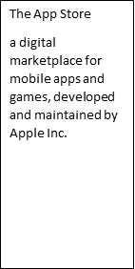The App Store's launch marked an unprecedented leap forward, as it democratized software distribution. Prior to its existence, acquiring and installing software was often cumbersome, requiring manual installation from various sources. The App Store introduced a seamless and user-friendly mechanism, enabling users to access a wealth of applications directly from their devices.

From its inception, The App Store offered a selection of just 500 apps—an impressive number at the time. However, this modest number in beginning reached around 1.6 million in 2022 [STA 2023]. Within the first year, The App Store boasted over 65,000 apps, showcasing the power of a platform that empowered developers to highlight their creativity and ingenuity to a global audience.

#### 6.2.1 Application life cycle in The App Store

For the app to be available in The App Store certain steps need to be followed before it can be downloaded, installed, and used by the user. These steps can be summarized as following:

* Application development and testing: include the application design, coding, and testing to ensure it functions as intended and is free of major bugs. Apple provides tools like Xcode and the iOS Simulator [App Sim] to assist in the development and testing process.
* Application submission: before submission of the app to The App Store, the developer should take care to test for crashes and bugs, enable back-end services if needed, check whether the app follows the Apple guidance and include detailed explanation of non-obvious features of the app [App Sub]. The submission process includes submitting the application details (app language, title, and screenshots), and the application itself using Apple's App Store Connect portal for the review.
* Application review process: Apple's App Review team evaluates your app to ensure it adheres to the App Store Review Guidelines. This process includes checking for compliance with safety, security, design, functionality, and content guidelines. The review process time can happen as soon as The App Store can, and there are no time frames for review process to finish [App Sub].
* Application publishment: Once the app is approved during the review process, the app will become available within 24h in The App Store. However, if the app release date is set in the future, this is delayed until the release date.

There are cases where the app is rejected to be available in The App Store. If the developer thinks that the rejection is unjustified, they can appeal the decision by submitting it in the Apple Store Connect platform. They might choose to include a new version of the app with changes/updates in the appealing process.

Once the app is available in The App Store, it can be downloaded and used by users. During the lifetime of an app new bugs might appear that have to be fixed, or the developer wants to update certain features of the app. The bug fixture review is faster and does not require the whole review procedure again [App Sub].

#### 6.2.2 The App Store privacy

During interaction between the users and apps that are downloaded from The App Store, users might come to a situation where they must share their data which will be managed by the app. To protect the user privacy and manage the user data usage The App Store provides two mechanisms: description of data usage and permission tracks.

Each developer is asked to make a detailed description of the data that the app tracks and processes and if such data are related to the identity of the user or the identity of the device [APP Priv]. In addition to this, developers should report if third-party code and SDKs are used in the app and if they collect any data from users for third parties. Based on this a Privacy Nutrition Label (PNL) is assigned to the app, so the user can determine what is the privacy level of their data when using the app. The Privacy Nutrition Labels can be categorized based on the data types of apps collect, as follows [App PNL]:

* Contact Information PNL: this category includes data like names, email addresses, phone numbers, and other personal contact details.
* Health and fitness PNL: data related to health and fitness, such as exercise routines, medical information, and activity tracking.
* Financial Information PNL: information related to financial transactions, payments, credit card details, and banking.
* Location PNL: Data about the user's physical location, often used for services like navigation, mapping, and location-based features.
* User content PNL: Any content that the user creates, uploads, or interacts with, such as photos, videos, messages, and other user-generated content.
* Browsing history PNL: Information about the websites, pages, and content the user interacts with while using the app.
* Identifiers PNL: Unique identifiers associated with the user or device, such as device IDs, advertising IDs, and user account information.
* Usage data PNL: Information about how the user interacts with the app, such as app usage patterns, session durations, and interaction behaviors.
* Diagnostic data PNL: Technical data that helps diagnose app performance issues and identify bugs.

The second mechanism to ensure privacy is privacy permission track. Since iOS 14.5 The App Store provides App Tracking Transparency (ATT) framework that requires the developers to get explicit permission from users if the app wants to track their data or to access their device advertisement identifier. Users will be prompted with a message to accept or not the tracking of data as shown in Figure ATT prompting message. The user can choose to allow or deny the app’s request. By denying it users can prevent apps from building a comprehensive profile of their interests and behaviors across different apps and websites, thereby enhancing their online privacy.

ATT prompting message

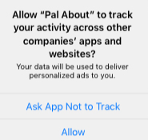

Source: <https://developer.apple.com/app-store/user-privacy-and-data-use/>

#### 6.2.3 App monetization in The App Store

Developers can generate revenues out of their apps based on several business models and monetization techniques that The App Store offers. However, they have to make it clear during the review process which is their chosen monetization technique. In the following subsections we will describe each of the payment and monetization methods that developers can use by The App Store.

#### In-App Purchase

In-app purchases can be used to allow app developers to unlock new features and functionalities within the app. Also, in-app purchases can be used to allow users to tip the app developer. Further in-app purchase can be used only to sell digital products (digital gift cards, certificates, vouchers, and coupons) and services, rather than physical products [App Sub].

#### Subscriptions

Subscription is another monetization model that is used for apps to offer e.g., new game levels, episodic content, consistent updates and access to large collections of media content, software as a service (“SAAS”), or cloud support. Subscription should be at least 7 days long and user should be able to upgrade or downgrade their subscription seamlessly [App Sub]. The Apple Store asks the developers to make clear the actual subscription information, e.g.: how many issues per month will user get, how much cloud storage will user get, what kind of access to service and how many times per month.

#### Other purchase methods

In some specific cases other purchase methods rather than in-app purchases can be used. Some of such cases include [App sub]:

* ‘Reader’ apps: where content providers (e.g., magazines, newspapers) might ask the user payment via an external link to their web-based platforms
* Person-to-person services: where apps allow purchases of real-time services
* Multiplatform services: apps that run in multiple platforms can allow users to access content and subscriptions that they have paid in other platforms
* Goods and services outside the app: can allow other payment such as credit card payment or Apple-Pay payment for purchasing goods and services.

#### Apple Pay and cryptocurrencies

Another method of monetization is to offer Apple Pay possibility withing your app. In such cases the developer and owner of the app should provide all purchase information to the user prior to sale [App Sub]. And the last payment method is cryptocurrency, where apps can support wallets, mining, and exchanges [App Sub].

The App Store uses a revenue share 70/30, where 70% of the revenues go to the developer of the app, and 30% go to Apple. In the case of subscriptions model this share will be 85/15 in case the subscriber will be subscribed for more than a year.

### Self-Check Questions

* Based on what Privacy Nutrition Labels are categorized in The App Store?
* Based on types of data that are being collected by the app.

## 6.3 Security Providers

In the continuously evolving digital market, app security and user privacy have become important factors. Two of the most used app distribution platforms, the Google Play Store and Apple's App Store, are committed to safeguarding users' data and providing a secure environment for app downloads. They provide a number of mechanisms to enhance the security of their users and their data. Such mechanisms play a pivotal role in maintaining the integrity, authenticity, and safety of the apps available on these platforms as well as security of their user's data. From pre-screening apps for potential vulnerabilities during reviewing process to actively monitoring and preventing malicious behaviors of different apps, provided security mechanisms within these platforms ensure that users can confidently engage with the apps they download.

In this section, we will look in more detail about the mobile application attack vectors and the security mechanisms that each of the platforms provides to overcome such issues.

#### 6.3.1 Security Mechanisms in Google Play Store

To prevent different attack vectors from malicious apps Google Play Store has implemented and follows several mechanisms and policies. First of all, Google Play Store has a strict review process of all the apps that will be included in the store before they appear to the general public for downloading and publishing. Google Play provides several security mechanisms to protect mobile devices from application malwares as well as to protect the integrity of data that applications interact with.

#### Jetpack security

Android Jetpack suit provides a set of libraries and tools to simplify the implementation of security best practices in Android apps. It leverages the Android KeyStore to create a hardware-backed AES 256 key that is used to protect encryption keys [Android ES 2021]. It also provides Encrypted File API to support secure storage and Encrypted Shared Preferences API that ensures encryption of data saved in shared preferences [Muhammad 2023].

#### Application Signing

To ensure the authenticity of the app, verify the source of the app and enable secure communication between the ap and services, Google Play applies application signing. Application signing is a process that involves generating a digital signature for your Android application package (APK) file [Android ES 2021]. Apps are signed with the same key can run in the same process and can expose functionality to each other. In case of the updates, to prevent the security breach with a malware application that is not genuine, the corresponding certificates of the newer version and the old version of the app are compared. The update is allowed only if the certificate is the same.

#### SafetyNet

SafetyNet is another set of service APIs offered by Google Play to protect apps against security threats. It can be used to mitigate device tempering, malicious URLs, potentially harmful applications, non-genuine API, and fake users. It provides several APIs [Android ES 2021]:

* SafetyNet Device Attestation API allows to assess the integrity of a device’s hardware and software, looking for integrity issues by comparing it with the reference data for approved Android devices.
* SafetyNet App Verification API is used to verify the integrity of installed apps by comparing their cryptographic signatures against the known values published on the Google Play Store. If the app is tampered with or repacked, it can be detected at this stage.
* SafetyNet reCAPTCHA API provides CAPTCHA challenges to detect and prevent automated bots or abusive behavior.

#### Network Security

In addition to security of data at rest, Android also provides secure communication to avoid any man-in-the-middle attack possibility. Android supports Domain Name System over Transport Layer Security (TLS). By this the administrators can configure the DNS over TLS as well as prevent users from changing such configuration [Android ES 2021]. Also, by default Android app developers are required to use TLS 1.3 to avoid clear text traffic over the network. The TLS protocol is standardized by IETF under RFC-4346 [RFC4346] for its first version and the latest version TLS 1.3 is standardized per RFC-8446 [RFC8446]. The TLS is a sublayer located between the application and transport layer. It is used to provide security and privacy for several applications, such as HTTP, FTP, and SMTP. The TLS protocol is based on the three-way handshaking procedure which is exchanged between the device and the server. This procedure is as follows:

* exchanging supported security parameters
* authenticating peer devices
* negotiating and instantiating security key parameters

Android also supports Wi-Fi Protected Access version 3 (WPA3) as well as Virtual Private Network (VPN) for protected communications between the apps and the services on the cloud.

#### 6.3.2 Security mechanism in The App Store

The App Store provides several security mechanisms to prevent any possible attack from malicious apps. Apple devices that run on iOS, by default, don't allow users to install apps that are from different websites or app stores rather than App Store. In addition to this The App Store requires from the app developers to sign their apps with a unique certificate ensuring the integrity and authenticity of the app. The security mechanisms can be classified as follows [APS]:

* Mandatory code signing: this mechanism requires developers to sign their apps with a unique certificate, helping to ensure the integrity and authenticity of the app. If code from third parties is used in the app, it is required that that code be validated with an Apple-issued certificate. This helps prevent tampering with the app's code.
* Verifying proprietary in-house apps: when an organization wants to write proprietary apps, they have to apply to become part of Apple Developer Enterprise Program (ADEP). After becoming a member of ADEP, an organization obtains a profile that allows for proprietary apps to run on the devices of the organization, but apps will not be publicly available. Such apps are installed using the mobile device management system and are implicitly trusted.
* Sandboxing: Apps on iOS are sandboxed, meaning they are isolated from each other and the system, reducing the potential impact of security breaches.
* Data protection: Data stored on iOS devices from different apps is encrypted by default, adding an extra layer of security. Data Protection is available for file and database APIs, including NSFileManager, CoreData, NSData, and SQLite.

From network security perspective iOS platform uses security mechanisms in transport layer, network layer as well as lower communication layer. At transport layer it supports TLS up to version 1.3 as well as Datagram Transport Layer Security (DTLS). At network layer it supports VPN tunneling, while at communication layer it supports WPA3 for WiFi as well as authentication, encryption, and message integrity check for Bluetooth [APS].

### Self-Check Questions

* What are the ways of introducing malware applications in a mobile device?
* Re-packing of legitimate apps, bug exploitation of genuine apps, fake applications, or remote installation of malicious apps.

## 6.4. The Role of the Cloud

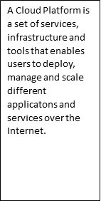A cloud platform is a set of services, infrastructure and tools that enables users to deploy, manage and scale different applications and services over the Internet. They provide virtualized environments where users can run their solutions and services without the need for the user to own infrastructure, processing power, storage, network, or database. Three main services that are offered by cloud solution include infrastructure as a service (IaaS), platform as a service (PaaS) and software as a service (SaaS) [Jawale 2016]. While IaaS provides virtualized computing resources over the internet, PaaS offers a higher-level environment that also includes development tools, middleware, and runtime environments. Next to this, SaaS delivers fully functional software applications over the internet where users do not need to install it locally but can access the application via a web interface. Major cloud platforms include Amazon Web Services (AWS), Microsoft Azure, Google Cloud Platform (GCP), IBM Cloud, and Oracle Cloud.

#### 6.4.1 Cloud for mobile app ecosystem

In the mobile app development and distribution ecosystem cloud plays a crucial role, both for Google Play as well as for The App Store. The cloud enables app distribution and management, as well as enhanced functionalities, features, and services.

#### Google Cloud Platform

Google Cloud Platform (GCP) is provided by Google as a tool for cloud computing services. It offers a wide range of infrastructure and platform services that enable businesses, developers, and organizations to build, deploy, and manage applications and services in the cloud. GCP provides scalable, flexible, and cost-effective solutions for various computing needs. GCP follows a pay-as-you-go model, where users can pay and utilize cloud resources as needed. Users can create virtual machines, store, and analyze data, build machine learning models, and develop applications without the upfront investment in hardware or infrastructure. GCP's global network of data centers ensures low-latency access and high availability.

Services that GCP provides to users are divers and can be categorize as follows [Bisong 2019]:

* Compute services: Provides scalable virtual machines (Google Compute Engine) and container orchestration (Google Kubernetes Engine) for e.g., machine learning algorithms and big data handling.
* Storage services: Offers object storage (Google Cloud Storage), file storage (Google Cloud Filestore), and databases (Google Cloud SQL, Bigtable).
* Networking service: Includes networking services like virtual private clouds (VPCs), load balancing, and content delivery (Google Cloud CDN).
* Big Data and Analytics services: Offers data storage, processing, and analysis tools such as BigQuery, Dataflow, Dataproc, and Pub/Sub.
* Machine Learning and AI services: Provides tools for building and deploying machine learning models, such as Google AI Platform, AutoML, and TensorFlow.

#### ICloud

Apple does not offer a comprehensive cloud platform as Google does; however, it provides a platform named iCloud that offers Apple device users cloud storage service and synchronization of files. iCloud is a cloud-based service that works seamlessly throughput all Apple devices: iPhones, iPads, iCloud etc. iCloud offers several services, amongst others:

* iCloud Drive service: A file storage and synchronization service that allows users to store files, documents, photos, and other content in the cloud and access them from any supported device.
* iCloud Photos service: Automatically stores photos and videos in the cloud, ensuring that users' media content is accessible across devices while saving local storage space.
* iCloud Backup service: Enables users to back up their devices to the cloud, ensuring that their data is protected and recoverable in case of device loss or damage.
* ‘Find My’ service that helps users locate lost or stolen devices, as well as share location with friends and family.

Summary

The mobile software ecosystem provides the mechanisms for how the cooperation and interplay between different stakeholders take place. The mobile users, mobile apps and their developers, mobile device manufacturers and app markets themselves all cooperate between each other to enable security communication and secure usage of mobile apps.

This unit we revisited the Google Play and The App Store ecosystems as two of the most widely used mobile application development and distribution platforms. For each of the ecosystem platforms we showed the life cycle of the app from the moment it is developed by third-party developer until it becomes publicly available in the distribution platforms. In addition to this we showed how each of the two platforms ensure user privacy and the privacy labels of the apps. Since ecosystem is not related only to technicalities of app development and distribution, we delved into monetization mechanisms in both platforms starting from in-app purchases, subscriptions as well as other methods how developers monetize their work.

In the third part of the unit, we analyzed the security providers and mechanisms for each platform. First, we looked at possible mobile application attack vectors as well as different security mechanisms that Google Play and The App Store provides to overcome such attack vectors. In the last part of the unit, we analyzed the role of the cloud in mobile app distribution as well as analyzed in detail the two cloud platforms provided by Google (Google Cloud) and Apple (iCloud).

**man-in-the-middle**

a type of cyber-attack where an attacker relays and alters the communication between two targets. By intercepting the communication between two parties, the attacker can eavesdrop on the conversation and potentially steal sensitive information, or alter the contents of the communication),

# Unit 7 – Mobile handset threats

Study Goals

On completion of this unit, you will be able to …

* Analyze and understand historic development of cyber-attacks against handsets
* Understand and analyze taxonomy of handset threats and different attack vectors against mobile device
* Analyze the mitigation possibilities on the attack vectors against end devices

## Introduction

With the development of communication technology and increase of its usage by the general public, the number of cyber-attacks in the communication networks has increased as well. Attackers try to exploit different network security vulnerabilities by taking different paths in order to get access to networks or data communicated or saved via/in those networks. Such attacking paths are commonly known as attack vectors.

A network attack can be active or passive. In passive network attacks, attackers get access to the communication network but do not change the data passing through/saved in the network but just steal sensitive data that can be used by them for malicious purposes. In active attacks, attackers get access to the network and change the data passing through/saved in the network by deleting them, encrypting them, or changing them.

Mobile handsets as one of many devices that are connected to the network are not exempt from such threats and attacks. Similar threats can also happen to mobile handsets. Attackers can get access to mobile handsets and can change data saved on them or sourced on them onto the network.

In order to mitigate the vulnerabilities and possible attacks in mobile handsets and in the network, an engineer should understand the common attack vectors used by the attackers, so mitigation would be possible. In this unit we will discuss the historic examples of handset attacks, taxonomy of handset threats and attacks as well as jailbreaking.

## 7.1 Historic Examples Of Handset Attacks

Worm

a worm is a type of malicious software (malware) that is designed to self-replicate and spread across computer networks without requiring any user action.

Viruses, malware, and worms are malicious software that can change the behavior of mobile devices and will try to get access to specific data inside the mobile devices. All these three types of malicious software have their own characteristics and can be distinguished as follows [Dunham 2008]:

* Malware includes all types of malicious software such as viruses, worms, and Trojans, and is designed to get access to mobile devices, network or data saved/communicated via them.
* Viruses are a subtype of malware that are attached to legitimate programs or files and require users' interaction to distribute them by sharing infected programs and files.
* Worm is another subtype of malware that is a standalone software that can be spread without users’ interaction via communication networks using system vulnerabilities.

While mobile devices are well protected from virus type of malwares due to usage of sandboxing (different apps are sandboxed and do not share data between them), they are target of worm type of malwares. One of the earliest examples of mobile malware was the Cabir worm, which spread in early 2004 and targeted Symbian OS based mobile handsets [Dunham 2008]. The attack vector used to spread this worm was Bluetooth communication. Even though the initial Cabir worm was not that risky, as it did not use data from mobile handset the source code of Cabir was spread by an attack group called 29A and became the base for Symbian viruses' family. Symbian viruses' family got spread by mid-2005 and was stealing the phone book addresses and distributing it via Bluetooth to the next Symbian infected device [Clooke 2017].

Another malware attack was DroidDream in 2011. It targeted Android devices by appearing as a legitimate third-party application on Google app store. DroidDream could gain root access to the device, allowing it to steal sensitive information and perform various malicious activities. Once infected, a mobile phone could download other infected apps degrading the security even further. Google responded by removing the infected apps from the Google Play Store and enhancing security measures.

Another malware was Judy in 2017 that affected Android devices similar as DroidDream through infected apps on the Google Play Store. It used a technique called "auto-clicking" to generate fraudulent ad clicks, generating revenue for the attackers. Judy was estimated to have infected between 8.5 and 36.5 million devices before being discovered and removed from the Google Play Store [Judy 2017].

Once a possible attack vector is recognized different approaches are taken to fix the issue by releasing a patch for this. One such example was the master key vulnerability in Android. Android requires that each app to be signed by the developer in order to determine its authenticity. However, due to discrepancies in how application verification procedure in Android, it was possible for APK code to be modified without breaking the cryptographic signature [AMK 2013]. This would allow attackers to add different malicious functionalities to legitimate apps that will steal different data from users. Google reacted to this and since Android 4.4 this vulnerability is already fixed.

In the fall of 2021 silver Sparrow malware was released targeting iOS devices running Apple's new M1 chip. Although its exact purpose remained unknown, it could download and execute malicious payloads. (Moses and Morris 2021).These examples demonstrate the ongoing threat posed by cyber-attacks to mobile devices and highlight the importance of staying vigilant and taking steps to protect your device and your information (Bhatt & Gupta 2017).

### Self-Check Questions

* What is the difference between a worm and a virus?

*A worm is standalone software and can get spread without the interaction of the user, while a virus is attached to legitimate application or file and can be spread only with interaction of users.*

## 7.2 Taxonomy of Handset Threats

The mobile device technology stack is composed of hardware, firmware, operating system, and applications. While the telephony subsystem uses dedicated hardware and firmware implemented in System on Chip (SoC), mobile devices are composed also by different communication technologies and front ends, such as cellular radio, WiFi, Bluetooth, and near-filed communication (NFC).

Depending on what part of the mobile device technology stack is attacked we will classify the threats in the following categories, as specified in [NIST 2016]:

* Mobile application threats: related to threats and vulnerabilities coming from software for mobile applications running in general-purpose operating system of the mobile device.
* Communication part threats: related to vulnerabilities and threats coming from using communication technologies like cellular, WiFi or GPS.
* Authentication threats: related to vulnerabilities and threats coming from authentication mechanisms between user and mobile device, mobile device and service in the network and mobile device and network itself.
* Communication stack threats: related to vulnerabilities and threads to different mobile technology stack (operating system (OS), firmware, SIM card, device drivers or trusted execution environment (TEE))
* Physical threats: related to vulnerabilities and threats from physical attack and changes to the mobile device.

According to [NIST 2016] the highest number of threats comes from communication part (mainly cellular and WiFi communication), with stack threats and application attack threats following.

#### 7.2.1 Mobile application threats

When an app communicates with a server in the network, all unencrypted traffic at the application layer can be eavesdropped on by an attacker by accessing the physical wireless media. Even though the data might not be sensitive, attackers can use such data for other attacks on servers. To mitigate such attacks a mobile user can use always secure connection (HTTPS) to connect to the webserver, if possible, as an application developer you can use other form of encryption employing transport layer security protocol, while as enterprise network manager you can employ VPN connection to increase security [MTC].

Another form of attack on applications is man-in the-middle attacks. If mobile app has a weak authentication mechanism (e.g., dose not validate the server certificate), then a man-in-the-middle attack can occur, where the attacker impersonates the back-end server and receives all unencrypted traffic form the end device to it and can modify the data in transit [MTC]. Mitigation of MiTM is to use public key encryption in communication server, or to implement a fail-safe logic where the communication is stopped when the server certificate validation fails.

While cryptographic mechanisms are used by mobile applications, choosing the cyphering that is easily brute force broken can be exploited by the attackers. Saving the cryptographic key to the source code should be always avoided. Also, in order to avoid unauthorized disclosure, variables that save the encryption keys should be overwritten after every time they are used.

Other mobile application attack threats include usage of third-party libraries that are vulnerable to attacks, or exposure of functions and data untrusted apps that can be exploited by the attackers to get access to sensitive data. To mitigate such threats, app vetting tools exist that identify apps that use vulnerable third-party libraries.

A malicious app is a software program that is designed to harm or exploit a device or its user. This can include stealing personal information, spreading malware, or performing unauthorized actions on the device. Users should exercise caution when downloading and installing apps, and only download from reputable sources, such as Google Play and the Apple App Store. It is also a good idea to regularly check for and remove any suspicious or unwanted apps from your device.

On mobile devices, malicious apps can be introduced in several ways [Sharma 2021]:

• The re-packing of a legitimate app includes the creation of a genuine app that can have malicious codes and distribute those codes to users via third-party app stores.

• Bug exploitation refers to a genuine app that is used by an attacker to compromise the user’s data.

• Fake applications are used by attackers to make users think that they are installing the correct app. For example, a fake application of a bank app can be used by attackers to get the access codes of the users to their accounts. Two-factor authentication is often used to prevent this.

• Remote installation is used to install other malicious apps to a mobile device remotely by an attacker.

#### 7.2.2 Communications part threats

A mobile device is composed of multiple communications technologies, thus there exists several threats for each of them. Jamming of the air interface is one of the common wireless threats that is common for all wireless technologies. It is an attack vector that causes service interruption and decreases the network availability for the mobile node. Radio jamming is the easiest attack vector in wireless mobile devices as it can be achieved by decreasing the signal to noise ratio for the mobile devices in certain channels by transmitting dummy signal in the frequency band. Radio jamming can be done on specific channels at specific time to avoid detection and is referred to as smart jamming, while continuous jamming of all the frequency band is easily detected and is referred to as dump jamming [NIST 2018]. While for WiFi networks radio jamming can be easily achieved by a cheap software defined radio (SDR), for cellular communication more advanced equipment is needed.

Another common threat for all wireless communication technologies is eavesdropping on air interface of unencrypted traffic or purely encrypted traffic (recall WEP in WiFi networks). While in 5G networks the data traffic is both encrypted and integrity check, in LTE the integrity of data plane traffic in the air interface is not checked. Even if the data traffic is not encrypted at all, the eavesdropping attacks in cellular radio interface (LTE or 5G) are complex. The attacker needs to know the exact channel that the user is using and the time slots that are used for the data traffic in order to be able to demodulate the captured traffic into data IP packets [NIS 2018].

Another attack vector is via compromised femtocells. Femtocells are used in both LTE and 5G standard for improving the indoor cellular connectivity, while using the owner’s internet connection to connect to the network. As such the standard requires use of the IP security [REF] protocol between the femtocell and the femtocell gateway to protect the data traffic on the internet outside the mobile operator network [NIST 2018]. However, if the femtocell is in physical possession of an attacker, it can be compromised, by giving access not only to the data traffic but also to the encryption keys used by the end device [DePerry 2013]. Similarly, small cells can be less updated to patch security and configuration, exposing this to possible vector attacks to eavesdrop calls and data going through the small cell [NIST 2018].

Other Denial of Service (DoS) attacks can be achieved by different attack vectors in cellular networks such as: message injection, SMS-induced DoS, and silent message DoS [NIST 2018]. In all cases the attacker will send a stream of messages (or SMS) to the mobile device in order to make the mobile device incapable of serving the user. As such the service availability is limited.

#### 7.2.3 Authentication Attack Threats

Mobile devices use personal identification number (PIN) or user biometrics to give access to the mobile device. Biometrics such as fingerprinting, and face recognition are part of the latest releases of mobile OSs in Android as well as iOS.

Certain attack vectors try to gain access to the mobile devices by brute-forcing the PIN/password of the mobile device. Other attack vectors on PIN/password used to access mobile device include interfering PIN/password information from sensors of the device or by screen smudges [NIST 2018]. Each mobile device has sensor data that can collect information on which part of the screen user presses. If allowed, certain malicious applications can collect such information inferring PIN and passwords of the mobile device. Such attack vectors can be prevented or the required time to brute force the PIN/password can be extended by choosing longer and more complex PIN/passwords. To determine the number of all possible combinations with a subset of *n* elements out of a set with *k* element, the following formula can be used:

$$P_{k_{n}}=\frac{k!}{n!\left(k-n\right)!}$$

So, the number of combinations with 4 ciphers out of 10, is only 210, that is not that high for the current processing times of modern processors. Further, if you want to find all the permutations with a subset of n elements out of a set with k elements, the following formula can be used:

$$P_{k_{n}}=\frac{k!}{\left(k-n\right)!}$$

Other vector attacks authentication between the mobile devices with the services in the network. One such form of stealing authentication credentials is by sending phishing emails or man in the middle attacks [MOBILE 2018]. Phishing emails are personalized emails sourced from attackers, that look pretty much the same as coming from a trustful source, that asks the user to access certain website. Then by providing the authentication credentials, the attacker can get access to the main user profile of that site. Similarly, MiTM attacks can redirect the user to malicious websites to steal the authentication credentials of the user. Such attacks can be prevented by being more attentive to the phishing emails and websites we browse.

The last vector attacks deal with the possibility to steal authentication credentials of the mobile device with the network itself. A common attack vector in this regard is insecure credential storage of authentication data by different apps in the device [MOBILE 2018]

#### 7.2.4 Physical threats

Physical threats include all attacks done in person by attackers. Here it includes device loss and theft, where the attacker will gain full access to the mobile device. SIM card swapping with a compromised SIM that gives the attacker the possibility to run malicious java applet in the new SIM [MOBILE 2018]. A new way to mitigate these forms of attacks is integrated SIM cards or eSIM, that cannot be physically swapped. Another physical threat is malicious charging stations that can cause battery overheating and battery damage. To prevent this attack, allow an overheated battery to be cooled down, use certified charging stations, or charge the mobile device from a USB port.

### Self-Check Questions

1. How many password combinations can be formed with 3 single digit natural numbers?

*120*

## 7.3 Jailbreaking

As mobile devices are being used for plethora of tasks, including personal and business purposes, compromised devices are a major security issue for the applications running on that device as well as for data being shared from that device. Compromised devices are devices that have been altered in order to remove the limitations imposed on the device by its manufacturer or the operating system. This is done with the aim of giving low-level access to applications and users that do not possess such rights. In context of Android such devices are known as rooted devices while in context of iOS such devices are known as jailbroken devices [Geist 2016].

In the iOS the jailbreak is performed by patching the /private/etc./fstab to mount the system partition as ‘read-write' mode so users can have access to the system partition [AW 2023]. In return this will allow to run arbitrary code in the kernel of iOS. Recently jailbreaks can be done by patching the kernel code to bypass the code signing and other restrictions to run custom applications or third-party applications.

Types of jailbreaks include [AW 2023]:

* Tethered where the device should be booted using a computer in a jailbreaking mode every time otherwise it will not boot up.
* Semi-tethered where the device should be booted using a computer in a jailbreaking mode every time otherwise it will boot up in normal mode.
* Untethered where the device boots every time in jailbroken mode after it is jailbroken once.
* Semi-untethered where the device needs to run an application to perform jailbreaking

Apple Jailbreaking Processes

Source: Panji Harawa (2023), based on Dana et al. (2016).

The figure Apple Jailbreaking Process shows the process of jailbreaking an iOS device through a third-party application. It involves sideloading the said app onto the mobile device using SSH. Subsequently, the third-party application loads a developer certificate within your device's settings. This certificate is then utilized to exploit vulnerabilities present in iOS. Once root access is obtained, an additional tool is introduced via the debugger, followed by a reboot of the device [Geist 2016]. This sequence of steps grants users the ability to manipulate the execution of the program. The tool provides precise control, allowing for identification and circumvention of potential obstacles. By setting breakpoints, the debugger inspects memory and alters the program's state. This process effectively facilitates the implementation of the necessary bypassing strategy essential for the jailbreaking procedure.

For mobile devices jailbreaking carries risks such as reduced security, heightened susceptibility to malware and cyberattacks, and incompatibilities with software and hardware. Once a device is jailbroken, it loses the manufacturer's security protections, making it more prone to malware and various attacks. Moreover, jailbreaking may lead to compatibility problems, hindering the installation and usage of legitimate applications and services. (Adams, A.2015)

Jailbreaking also voids the device's warranty, meaning that if the device is damaged or needs repairs, it will not be covered by the manufacturer's warranty. In addition, jailbreaking may also cause the device to become unstable, leading to crashes and other issues that can be difficult to resolve. Jailbreaking can offer users increased flexibility and customization options, but it also comes with significant risks and dangers to the device's security and stability. Before jailbreaking a device, it is important to consider the potential risks and weigh them against the benefits. (Lee & Soon 2017).

### Self-Check Questions

1. What is jailbreaking and what are some potential risks associated with it?

*Jailbreaking is the process of removing software restrictions on an Apple device, such as an iPhone, to allow the installation of unauthorized apps and modifications to the device's operating system.*

Summary

This unit covers mobile handset threats and focuses on understanding the types of threats, common attack vectors, potential consequences of security breaches, and best practices for protection. Mobile handset threats include malware, phishing, and unauthorized access to sensitive information, and have targeted mobile devices like smartphones and tablets since their widespread adoption. Notable historic examples of handset attacks include the Cabir worm, DroidDream, and Judy, are described as well as measured taken against them. When it comes to discussing mobile threats, it cannot be done in isolation without engaging in the taxonomy of handset threats and this gives a definition into the categorization of security risks affecting mobile devices. According to NIST we have categorized the handset threats to threats related to mobile applications, threats related to communication technologies used, threats related to authentication breaches, threats related to communication stack and physical threats. Further for each threat category we have discussed in detail examples of attack vectors that can be used and how they can be overcome. The unit further expounds on how jailbreaking is executed to remove limitations imposed by manufacturers or operating system providers on mobile devices. This process is detailed on how it allows users to run unauthorized third-party software. While jailbreaking offers users more flexibility and customization options, it carries several risks, including reduced security, increased susceptibility to malware and cyberattacks, and potential incompatibilities with software and hardware. Moreover, jailbreaking voids the device's warranty, which means that any damage or repairs will not be covered by the manufacturer. Additionally, jailbreaking can cause device instability, leading to crashes and other issues that may be difficult to resolve. Considering the potential risks associated with jailbreaking, users should carefully weigh the benefits against the drawbacks before proceeding.

# Unit 8 – Mobile Device Management

Study Goals

On completion of this unit, you will be able to …

…understand the benefits of mobile device management (MDM).

…learn about the features and capabilities of bring your own device (BYOD) solutions

…. identify the potential risks and challenges associated with mobile devices

…. explore best practices for implementing patching policy

## Introduction

Mobile device management (MDM) refers to the practices, policies, and technologies used to secure and manage mobile devices such as smartphones and tablets, both in the workplace and for personal use. With the increasing popularity of mobile devices, and the increasing amount of sensitive data stored on them, MDM has become a critical issue for organizations and individuals alike. MDM solutions can be used to enforce security policies, monitor device usage, and ensure the integrity of data on mobile devices. This can include remote wiping of lost or stolen devices, monitoring of device activity, and controlling access to corporate data and networks. In this unit, we explore the various components of MDM, including the different types of mobile devices, the challenges posed by mobile device security, and the various MDM solutions available. We will also look at the various approaches to MDM, including the bring-your-own-device (BYOD) model. By the end of this unit, you will have a comprehensive understanding of MDM and the various solutions and approaches that can be used to secure and manage mobile devices in the workplace and for personal use.

## 8.1 The Threats Of BYOD

The bring-your-own-device (BYOD) trend, where employees bring their own personal mobile devices to work and use them for work purposes, has created new security challenges for organizations. In a BYOD scenario, the organization has limited control over the security of the device and its contents, and may be vulnerable to data breaches, theft of sensitive information, and malware attacks. Additionally, the use of personal devices for work purposes may also raise privacy concerns for employees. To mitigate the security risks posed by BYOD, organizations can implement the following strategies (Tejinder S. Randhawa 2022). There exist different approaches of BYOD methods [Boon 2015]:

* Full BYOD where employees can use their own mobile devices (smartphone, tablet, laptop) for work without any restrictions in application used or operating system. While this provides the highest flexibility it provides the highest possible security threats.
* Choose Your Own Device (CYOD) where employees can choose between a range of company-approved mobile devices that are configured with specific security settings.
* App-based BYOD where users can access work-related resources (network and data) via specific apps. This is a highly secure approach as data resides in the network and all the interactions are done via highly secure links (e.g., VPN, IPsec).

In technology most of the things are tradeoffs. Higher flexibility for employees to use their own mobile devices comes with higher risks of security attacks. The possible threats of BYOD can be summarized as follows [Zambrano 2018]:

* Advanced Persistent threat (ATP) is an advanced targeted cyber-attack that tries to detect vulnerabilities of employee-owned device over a long period of time to access company network and/or data.
* Malware exploit BYOD vulnerabilities to steal confidential information over companies and employees. In cases where companies do not fully control the security policies of BYOD, malware can easily spread over the devices of the employees. Diversity of devices, lack of full control, phishing attacks and possible unvetted apps pose a high challenge on security of BYOD.
* Theft or loss of mobile devices is another challenge for corporate security. Since employees can take their own mobile devices anywhere, and such devices contain personal and corporate data, attackers can come to physical access of the corporate network and data via a stolen device. One approach to protect against stolen devices is the ability to erase sensitive data remotely.

#### 8.1.1 Mobile Device Management System

An organization or an enterprise, in addition to protecting its network, should protect its workers mobile devices (smart phones, laptops, tablets). Mobile Device Management (MDM) system is a software solution that is being utilized by organizations to control functionalities of mobile devices, in order to prevent any sensitive data leakage by a misused or a lost device [Rhee 2012].

The MDM is composed of two main components: the MDM mobile application or MDM agent and MDM server [Batool 2020]. The MDM application is installed in the mobile device while the MDM server is typically hosted on the cloud or on-premises of the organization. IT administrator of the organizations interacts with MDM server via MDM console unit to enforce policies and restrictions. Further on, based on the security level of the device, certain policies and restrictions are applied from MDM server to MDM agent. MDM is used to manage devices that are company-owned or employee-owned.

Form the functional perspective MDM includes [Rhee 2012]:

* Device enrollment: This involves registering the mobile device with the MDM server and installing the client application.
* Policy management: This involves defining policies and restrictions for the mobile device, such as passcode requirements, app blacklisting, and Wi-Fi settings.
* Device monitoring: This involves monitoring the status of the mobile device, such as battery life, storage capacity, and network connectivity.
* App management: This involves managing the installation and removal of apps on the mobile device, as well as enforcing app-specific policies.
* Data protection: This involves encrypting sensitive data on the mobile device, as well as providing remote wipe capabilities in case the device is lost or stolen.
* Compared to other management methods, such as manual configuration or using consumer-grade tools, MDM offers a centralized management for all the mobile devices of an organization supporting consistency in applied rules and policies as well as high scalability. Further MDM can remote monitor and manage mobile devices with the possibility to erase the sensitive data in case of device theft.

#### 8.1.2 Virtual private network (VPN) connection of mobile devices

Enterprises often restrict their services to only authenticated, authorized devices connected to their local network to avoid security issues such as data leakage and DoS attacks. However, when mobile devices are connected to the internet via public Wi-Fi networks, they are vulnerable to security risks. To securely connect mobile devices to an enterprise network from a remote location, a virtual private network (VPN) is a reliable solution. By creating an encrypted tunnel between the mobile device and the VPN server, VPNs can prevent unauthorized access to sensitive information transmitted over the internet.

A VPN can be defined as a private network that has been constructed within public network infrastructure, where access is controlled only to permitted peer connections [Ferguson 1998]. It uses a packet encapsulation to wrap the data in an additional layer of encryption. The most common types of packet encapsulation used by VPN are Layer 2 Tunneling Protocol (L2TP) [RFC 3931] and Internet Protocol Security (IPsec).

L2TP connects two end points the L2TP access concentrator (LAC) and L2TP network server (LNS). L2TP is a combination of two main procedures the control connection management (including control connection establishment and teardown) and the session management (session establishment for incoming and outgoing call) [RFC 393]. The procedure of establishing control connection in L2TP goes as follows [RFC 393]:

* The L2TP connection begins with LAC initiating a connection request by sending a start-control-connection-request (SCCRQ) to the LNS.
* The LNS responds by opening an L2TP tunnel and sending the start-control-connection-reply (SCCRP) to the LAC including tunnel ID.
* LAC then send a start-control-connection-connected (SCCCN) to the LNS and confirming the tunnel ID.
* Once the control connection is established, the session establishment follows [RFC 393]:
* Once LAC detects a call it sends an incoming-call-request (ICRQ) packet to LNS to establish an incoming call.
* Then LNS responds with an incoming-call-reply (ICRP).
* LAC accepts the call and responds with incoming-call-connected (ICCN).
* Same procedure happens with outgoing call establishment as well, by exchanging the outgoing-call-request, reply and connected messages. L2TP provides a tunnelling mechanism to transmit data between two endpoints (e.g., between the mobile end device and the local enterprise network). However, it cannot provide full security because it does not provide any encryption or authentication for the data transmitted over the tunnel. L2TP can be vulnerable to several types of attacks, including eavesdropping, packet sniffing, and data tampering. As such, always it is used together with IPSec protocol that provides network-level security by encrypting and authenticating IP packets. Overall, a VPN connection based on L2TP and IPsec is an effective way to secure communication between the mobile device and the local enterprise network over the Internet, by providing confidentiality, integrity, and authenticity.

### Self-Check Questions

What are some potential security threats associated with BYOD in mobile devices?

*Some potential security threats associated with BYOD in mobile devices include the possibility of users accessing sensitive data on insecure networks.*

## 8.2 Unique Threats To Mobile Devices

Mobile devices, such as smartphones and tablets, have become an integral part of our daily lives. While they offer numerous benefits and conveniences, they also face a myriad of unique threats that can compromise user privacy, security, and device functionality. These threats include mobile malware targeting specific platforms, malicious apps in official app stores, unsecured mobile networks, location-based threats, mobile payment fraud, sensor-based attacks, and mobile botnets, among others. To ensure the safe use of mobile devices, it is crucial for users to be aware of these threats and adopt best practices to mitigate potential risks. In the following paragraphs, we will delve into the details of each of these unique mobile threats, highlighting their potential impacts and offering insights into how users can protect themselves against such risks. In addition, we will also describe the SIM swapping attacks, access point name (APN) security threats and SMS brute-force attacks that are unique to mobile devices connected to mobile networks.

### 8.2.1 Malware

Mobile malware targeting specific platforms and malicious apps in official app stores are significant concerns for mobile users. Mobile malware is designed to exploit the unique features, vulnerabilities, or app ecosystems of specific platforms like Android or iOS. These malware types may come in the form of viruses, worms, Trojans, or ransomware, causing harm to the user's data or device. Malicious apps in official app stores pose a unique threat since users trust apps that are available on these platforms. While app stores like Google Play Store and Apple App Store have stringent security measures, some malicious apps can still bypass these checks, allowing users to inadvertently download and install them, exposing their devices to various security risks (Ezer et al 2014).

Mobile devices also face another unique threat that targets all unsecured mobile networks and location-based threats are also unique to mobile devices. Mobile users frequently connect to public Wi-Fi networks or use mobile data, exposing them to network-based threats such as man-in-the-middle (MITM) attacks or Wi-Fi eavesdropping. Attackers can intercept and manipulate network communications, gaining access to sensitive information or injecting malware into the user's device. Location-based threats arise due to mobile devices' reliance on GPS and other location services. Attackers can track a user's location, enabling stalking, or deploy location-aware malware targeting users in specific geographic areas. This can lead to privacy breaches and potential physical harm (Akhtar et al 2022).

Furthermore, mobile payment fraud, sensor-based attacks, and mobile botnets represent additional unique threats to mobile devices. As mobile payment systems gain popularity, attackers have devised new techniques to exploit these platforms and commit fraud. They may intercept payment information or manipulate transactions, causing financial losses. Sensor-based attacks exploit the various sensors found in mobile devices, such as accelerometers, gyroscopes, and microphones. Attackers can gather sensitive information or infer user activities by accessing these sensors, compromising user privacy. Mobile botnets involve malware-infected devices being remotely controlled by attackers, who can use them to launch distributed denial-of-service (DDoS) attacks or spread further malware. These threats highlight the need for users to take necessary precautions when using mobile devices and be aware of potential vulnerabilities (Joshua et al 2016).

#### 8.2.2 SIM Swapping

Subscriber Identity Module (SIM) swapping can either be done physically by replacing the SIM card on the UE, or by taking over the ISDN of the SIM and assigning it to another SIM card [Lin 2021]. By doing so, an attacker can have access to the data network of the campus.

An attacker can come into contact with the original SIM either by picking up a crashed device drone on the campus or by having physical access to the campus network devices.

#### 8.2.3 Access point name (APN) security

The Access Point Name (APN) is configured by the mobile network operator in the user equipment (UE) and gives the identity of the gateway that connects the UE with the internet.

In the case of virtualized 5G campus networks, a mobile network operator can ask for a custom configuration of APN in the campus network UEs to achieve campus network separation and a certain quality of service (QoS).

Once the authentication between the UE and the core network has taken place, the APN identifier is exchanged between the UE and the core network. This message is already encrypted in the air interface, to be decrypted in the base station, and forwarded further in the core network. If the attacker has access to the interface between base station and the core network, then the APN name is noticeable in clear text [Lin, 2021]. Alternately, if the attacker has physical access to the UE, it might change the SIM to make UE communicate with the attacker gNB. Then the device will be rejected due to an unknown APN from the network, and APN is retrieved by the attacker [Ciancaglini 2021].

The custom APN from the mobile network operator does not mean higher security. To overcome the APN retrieval by attackers, VPN/internet protocol security (IPsec) between the base station and the core network is a must when using public internet [Lin 2021].

#### 8.2.4 SMS brute force attacks

Many devices that are connected to cellular campus network support remote SMS configuration in case the link toward them is blocked or broken. Via SMS commands the device can be rebooted, the connection status can be checked, or certain configuration parameters, such as APN, can be changed.

Even though SMS-based remote configuration is password-protected, the default passwords are usually the last four digits of the SIM card identifier (Lin, 2021). An attacker can get the last digit of the SIM card identifiers, as they are the same as the international mobile subscriber identity (IMSI) identifier. As such, an IMSI catcher attack can reveal the default password.

On the other hand, even if the password is changed, it is prone to brute-force attacks. Thus, it is recommended to have a strong password for the SMS-based configuration link. Another possible attack is to send an SMS to the device and make the device respond with the wrong password message to increase the costs of messaging for the company that owns the campus network. At the same time, a denial-of-service attack is possible in such a case.

### Self-Check Questions

Give two examples of unique threats to mobile devices?

*Two examples of mobile unique threats to mobile devices include malicious apps, and phishing.*

## 8.3 Patch And Policy Management

One of the key components of MDM is patch and policy management, which involves regularly updating the device's software and enforcing security policies. Keeping mobile devices up to date with the latest security patches and software updates helps to protect against potential security vulnerabilities. Additionally, organizations can enforce security policies, such as password requirements, device encryption, and data wiping, to further secure the device and protect sensitive information (Kleiner & Disterer 2018).

Patch and policy management are crucial components of a comprehensive mobile device management (MDM) strategy. **Patch management** refers to the process of updating software on mobile devices to address security vulnerabilities and improve device performance. This can include updates to the device's operating system, updates to kernel, as well as updates to individual applications. Organizations can use mobile device management (MDM) solutions to automate the patch management process and ensure that all devices are up to date with the latest security patches (Pilarski et al 2015). As part of MDM system, patching and policy management include:

Patch management

the process of updating software on mobile devices to address security vulnerabilities and improve device performance.

* Security policy enforcement, such as encryption, password requirements, and app list usage
* App control where list of apps to be installed and updated is managed
* Patch management including automated OS, app, and kernel updates
* Remote wipe of the whole software in device including software and data in case of lost or stolen mobile device

Furthermore, mobile devices employ policy management refers to the process of creating and enforcing security policies on mobile devices to ensure that they are used in a secure manner. Many software companies such as Microsoft and Google enforce and invoke policies specific to their software platforms. This can include policies on password protection, app usage, and such as strong password requirements, this entails establishment of a policy that requires the use of strong passwords or passphrasWhies, with a minimum length of 8-12 characters, including a mix of uppercase and lowercase letters, numbers, and special characters. Another policy would be password expiration, where users passwords would have to be reset after a specific period among others. To achieve prevention and mitigation these policies are implemented to govern the use of mobile devices can help to ensure that sensitive information is protected and prevent unauthorized access to corporate data.  
Organizations have the ability to utilize MDM solutions for policy enforcement, tracking device usage including app utilization and device performance, and confirming policy compliance. According to (Batool & Masood 2020), proficiently managing software updates, a process known as effective patch management, which involves applying and installing all necessary updates for critical software applications alongside policy administration, can assist organizations in safeguarding mobile device security and safeguarding sensitive information. By implementing and enforcing security policies, it becomes possible to proactively avert security breaches and uphold the integrity of corporate data on mobile devices (Charles & Trouton 2020).

#### 8.3.1 Example: Android Device Policy

Android device policy enforces security policies of the organization that mobile device belongs to. This is to protect organization data as well as organization network. Android device policy works together with MDM solutions for remote control of policies applied in the mobile device [ADP].

Android device policy access the following device parameters [ADP]:

* Device's location used to check for available WiFi networks and roaming to new network when needed
* Camera used by administrator to scan QR codes during enrollment in security policies
* Phone number used for device registration with MDM

Administrator of the device can remotely apply security policies regarding length and strength of the device passwords, number of failed passwords attempts before the device is cleared, time before the device password expires, idle time before the device gets locked, and encryption of device.

### Self-Check Questions

How can patch and policy management be used to mitigate the risks?

*Patch and policy management can be used to mitigate the risks associated with software vulnerabilities by ensuring that all software on the organization's systems is up to date with the latest security patches.*

**What does policy and patching management include?**

*Patching and policy management include security policy enforcement, app control, patch management (automated OS and kernel updates) and remote wipe.*

Summary

The units highlight how the BYOD trend is gaining popularity, and as a result, organizations face new security challenges. Notably It is crucial for companies to establish strict security policies and train employees on best practices for using personal devices at work to reduce the risk of data breaches, sensitive information theft, and malware attacks. The module in other subsequent units clearly stipulates how mobile devices are vulnerable to various unique security threats, including platform-specific malware, malicious apps in official app stores, SIM swapping, APN security, and SMS brute force attacks.

Further it has been described how users need to be aware of these risks and adopt best practices to mitigate potential vulnerabilities. They also need to play a role in protecting and preventing mobile threats as such to safeguard against security vulnerabilities. It is crucial to keep mobile devices updated with the latest patches and software updates. The unit further explores one of the mechanisms used which is referred to as patch management, which mostly involves updating the OS and individual applications, while policy management focuses on creating and enforcing security policies, such as password requirements and app usage restrictions. The units further stipulate how organizations can use MDM solutions to automate patch management and ensure compliance with overall security policies of the organization. As a real-world example Android Device Policy is given.

# References

Agrawal, L. K., Agrawal, D., & Gopalaiyengar, S. K. (2022). Security and privacy in health data storage and its analytics. In Tanwar Sudeep (Ed.), *Blockchain for 5G Healthcare Applications - Security and Privacy Solutions*. Institution of Engineering and Technology. <https://doi.org/10.1049/PBHE035E_ch10>

Al-Qershi, F., Al-Qurishi, Rahman, S. M. M., & Al-Amri, A. (2014). Android vs. iOS: The security battle. *2014 World Congress on Computer Applications and Information Systems (WCCAIS)*, 1–8. <https://doi.org/10.1109/WCCAIS.2014.6916629>

Arp, D., Quiring, E., Wressnegger, C., & Rieck, K. (2017). Privacy threats through ultrasonic side channels on mobile devices. *2017 IEEE European Symposium on Security and Privacy (EuroS&P)*, 35–47. <https://doi.org/10.1109/EuroSP.2017.33>

Batool, H., & Masood, A. (2020). Enterprise mobile device management requirements and features. *IEEE INFOCOM 2020 - IEEE Conference on Computer Communications Workshops (INFOCOM WKSHPS), Computer Communications Workshops (INFOCOM WKSHPS)*. 109–114. <https://doi.org/10.1109/INFOCOMWKSHPS50562.2020.9162763>

Bhatt, A. J., & Gupta, C. (2017). Comparison of static and dynamic analyzer tools for iOS applications. *Wireless Personal Communications*, *96*(3), 4013–4046. <https://doi.org/10.1007/s11277-017-4366-1>

Bigelow, S. J., & Lulka, J. (2022). kernel. Data Center. <https://www.techtarget.com/searchdatacenter/definition/kernel>

Brunschwig, L., Guerra, E., & de Lara, J. (2022). Modelling on mobile devices: A systematic mapping study. *Software & Systems Modeling*, *21*(1), 179–205. <https://doi.org/10.1007/s10270-021-00897-8>

Chen, C.-M., Liu, Y.-H., Cai, Z.-X., & Lai, G.-H. (2020). A power-efficient approach to detect mobile threats on the emergent network environment. *IEEE Access*, *8*, 199840–199851. <https://doi.org/10.1109/ACCESS.2020.3035192>

Collins, L., & Ellis, S. R. (Eds.). (2015). *Mobile devices: tools and technologies*. Chapman and Hall/CRC.

Edge, C., & Trouton, R. (2020). *Apple Device Management: A unified theory of managing Macs, iPads, iPhones, and AppleTVs*. Apress.

Google Workspace Learning Center. (n.d.). *About Android Device Policy*. <https://support.google.com/a/users/answer/9453213?hl=en>

Hamzenejadi, S., Ghazvini, M., & Hosseini, S. (2022). Mobile botnet detection: a comprehensive survey. *International Journal of Information Security*, *22*, 137–175. <https://doi.org/10.1007/s10207-022-00624-4>

Harris, M. A., & Patten, K. P. (2014). Mobile device security considerations for small- and medium-sized enterprise business mobility. *Information Management & Computer Security*, *22*(1), 97–114. <https://doi-org.pxz.iubh.de:8443/10.1108/IMCS-03-2013-0019>

*UEFI secure boot: Big hassle, questionable benefit*. (2012, June 12). Linux.com. <https://www.linux.com/training-tutorials/uefi-secure-boot-big-hassle-questionable-benefit/>

Jabar, T., & Mahinderjit Singh, M. (2022). Exploration of mobile device behavior for mitigating advanced persistent threats (APT): A Systematic literature review and conceptual framework. *Sensors*, *22*(13), Article 4662. <https://doi.org/10.3390/s22134662>

Kleiner, C., & Disterer, G. (2018). *Bring your own device: Mobile Device Management in Bildungskontexten*. Springer VS. <https://doi.org/10.1007/978-3-658-19123-8_19>

Laayu, M. R., Kurniawan, A., Cahyani, N. D. W., & Satrya, G. B. (2022). Comparison of acquisition results on iPhone 7 Plus (iOS 14.8.1) between jailbreaking vs non-jailbreaking device. *2022 10th International Conference on Information and Communication Technology (ICoICT),* 402–406. <https://doi.org/10.1109/ICoICT55009.2022.9914862>

Lee, M. S., & Soon, I. (2017). Taking a bite out of Apple: Jailbreaking and the confluence of brand loyalty, consumer resistance and the co-creation of value. *Journal of Product & Brand Management*, *26*(4), 351–364. <https://doi.org/10.1108/JPBM-11-2015-1045>

Olaleye, S. A., Ukpabi, D., Karjaluoto, H., & Rizomyliotis, I. (2019). Understanding technology diffusion in emerging markets: The case of Chinese mobile devices in Nigeria. *International Journal of Emerging Markets*, *14*(5), 731–751. <https://doi.org/10.1108/IJOEM-01-2018-0055>

Pilarski, B., Freier, P., & Schumann, M. (2015). Mobile Device Management - Eine strukturierte Marktanalyse. *HMD Praxis Der Wirtschaftsinformatik*, *52*(3), 373–385. <https://doi.org/10.1365/s40702-015-0117-5>

Tanenbaum, A. S., & van Steen, M. (2015). Modern operating systems (4th ed.). Pearson Education

Sahani, A. (12 2017). Android v/s IOS – The Unceasing Battle. *International Journal of Computer Applications*, *180*, 23–26. doi:10.5120/ijca2017915990

References 7 & 8

Saman Mirza Abdullah, Bilal Ahmed, & Musa Ameen. (2018). A New Taxonomy of Mobile Banking Threats, Attacks and User Vulnerabilities. *Eurasian Journal of Science and Engineering*, *3*(3), 12–20. <https://doi.org/10.23918/eajse.v3i3p12>

Tejinder S. Randhawa. (2022). *Mobile applications: Design, development and optimization*. Springer. <https://doi.org/10.1007/978-3-030-02391-1>

Tlachac, M. L., Reisch, M., Lewis, B., Flores, R., Harrison, L., & Rundensteiner, E. (2022). Impact assessment of stereotype threat on mobile depression screening using Bayesian estimation. *Healthcare Analytics*, *2*. <https://doi.org/10.1016/j.health.2022.100088>

Ullah, I., Boreli, R., & Kanhere, S. S. (2022). Privacy in targeted advertising on mobile devices: a survey. *International Journal of Information Security*. <https://doi.org/10.1007/s10207-022-00655-x>

Vashisht, S., Gupta, S., Singh, D., & Mudgal, A. (2016). Emerging threats in mobile communication systems. *2016 International Conference on Innovation and Challenges in Cyber Security (ICICCS-INBUSH)*, 41–44. <https://doi.org/10.1109/ICICCS.2016.7542341>

Silberschatz, A., Galvin, P. B., & Gagne, G. (2020). Operating system concepts (10th ed.). John Wiley & Sons

Xu, S., Xia, Y., & Shen, H. (2022). Cyber Protection for Malware Attack Resistance in Cyber-Physical Power Systems. *IEEE Systems Journal,* *16*(4), 5337–5345. <https://doi.org/10.1109/JSYST.2022.3150576>

Yeboah-Boateng, E. O., & Amanor, P. M. (2014). Phishing, SMiShing & Vishing: An assessment of threats against mobile devices. *Journal of Emerging Trends in Computing and Information Sciences*, *5*(4), 297–307.

Zukarnain, Z. A., Muneer, A., & Ab Aziz, M. K. (2022). Authentication Securing Methods for Mobile Identity: Issues, Solutions and Challenges. *Symmetry*, *14*(4), Article 821. <https://doi.org/10.3390/sym14040821>

[Pawson 2022] Pawson, Richard. "The myth of the Harvard architecture." *IEEE Annals of the History of Computing* 44.3 (2022): 59-69.

[Tan 2022] Tan, T., & Cao, G. (2022, May). Deep learning on mobile devices through neural processing units and edge computing. In *IEEE INFOCOM 2022-IEEE Conference on Computer Communications* (pp. 1209-1218). IEEE.

[Singh 2014] Singh, M. P., & Jain, M. K. (2014). Evolution of processor architecture in mobile phones. *International Journal of Computer Applications*, *90*(4), 34-39.

[Bhunia 2018] Bhunia, S., & Tehranipoor, M. (2018). Hardware security: A hands-on learning approach (1st ed.). Morgan Kaufmann.

[Franklin 2020] Franklin, J., Howell, G., Sritapan, V., Souppaya, M., & Scarfone, K. (2020). *Guidelines for Managing the Security of Mobile Devices in the Enterprise* (No. NIST Special Publication (SP) 800-124 Rev. 2 (Draft)). National Institute of Standards and Technology.

[Zhao 2014] Zhao, S., Zhang, Q., Hu, G., Qin, Y., & Feng, D. (2014, November). Providing root of trust for ARM TrustZone using on-chip SRAM. Proceedings of the 4th International Workshop on Trustworthy Embedded Devices, 25–36. <https://doi.org/10.1145/2666141.2666145>

[Lin 2018] Lin, Ph. Z., Perine, C., Voseler, R., Lin, W. (2018). Attacks from 4G/5G core networks risks of the industrial IoT in compromised campus networks. Trend Micro Research. [https://docu](https://docu/)ments.trendmicro.com/assets/white_papers/wp-attacks-from-4G-5G-core-networks.pdf

[Stallings 2012] Stallings, W., & Paul, G. K. (2012). *Operating systems: internals and design principles* (Vol. 9). New York: Pearson.

# [Srikanth 2020] Srikanth V. (2020) Operating System(OS) Tutorial

[Android] <https://android.googlesource.com/>

[Marketshare 2023] <https://gs.statcounter.com/os-market-share/mobile/worldwide>

[Kotlin 2023] <https://developer.android.com/kotlin/first>

[A-API 2023] <https://developer.android.com/reference>

[Arch 2023] <https://source.android.com/docs/core/architecture>

[Objective-c 2023] <https://developer.apple.com/documentation/objectivec/objective-c_runtime>

[ART 2023] <https://source.android.com/docs/core/runtime>

[Xu 2016] Xu, M., Song, C., Ji, Y., Shih, M. W., Lu, K., Zheng, C., ... & Kim, T. (2016). Toward engineering a secure android ecosystem: A survey of existing techniques. *ACM Computing Surveys (CSUR)*, *49*(2), 1-47.

[DC 2023] Competition in the Mobile Application Ecosystem, Department of Commerce of the USA, 2023.

[STA 2023] Number of available applications in the Google Play Store from December 2009 to March 2022, Statista, <https://www.statista.com/statistics/266210/number-of-available-applications-in-the-google-play-store/>

[APP 2023] Apple App Store, <https://www.apple.com/app-store/>

[Egan 2004] Egan, W. F. (2004). *Practical RF system design*. John Wiley & Sons.

[Want 2006] Want, R. (2006). An introduction to RFID technology. IEEE Pervasive Computing, 5(1), 25–33. <https://doi.org/10.1109/MPRV.2006.2>

[Tanenbaum 2021] Tanenbaum, A. S. (2021). Computer networks (5 th ed.). Pearson Deutschland.

[Ekberg 2014] , J. E., Kostiainen, K., & Asokan, N. (2014). The untapped potential of trusted execution environments on mobile devices. *IEEE Security & Privacy*, *12*(4), 29-37.

[Trusty 2023] <https://source.android.com/docs/security/features/trusty>

[Kanonov 2016] Kanonov, U., & Wool, A. (2016, October). Secure containers in Android: the Samsung KNOX case study. In *Proceedings of the 6th Workshop on Security and Privacy in Smartphones and Mobile Devices* (pp. 3-12).

[Samsung 2015] "Android security maximized by Samsung KNOX", *White Paper, Samsung 2015.*

[Asmitha 2022] Asmitha, P., & Sunitha, T. (2022, July). Student Attendance using Face Recognition Technology. In *2022 International Conference on Intelligent Controller and Computing for Smart Power (ICICCSP)* (pp. 1-4). IEEE.

[Lai 2021] Lai, Xiaojun, and Pei-Luen Patrick Rau. "Has facial recognition technology been misused? A public perception model of facial recognition scenarios." *Computers in Human Behavior* 124 (2021): 106894.

[Axente 2020] Axente, M. S., Dobre, C., Ciobanu, R. I., & Purnichescu-Purtan, R. (2020). Gait recognition as an authentication method for mobile devices. *Sensors*, *20*(15), 4110.

[Rui 2018] Rui, Z., & Yan, Z. (2018). A survey on biometric authentication: Toward secure and privacy-preserving identification. *IEEE access*, *7*, 5994-6009.

[Pace 2022] Pace, P. E. (2022). *Developing digital RF memories and transceiver technologies for electromagnetic warfare*. Artech House.

[Coppens 2022] Coppens, D., De Poorter, E., Shahid, A., Lemey, S., Van Herbruggen, B., & Marshall, C. (2022). An overview of UWB standards and organizations (IEEE 802.15. 4, FiRa, Apple): Interoperability aspects and future research directions. *IEEE Access*.

[Yeh 2009] Yeh, S. C., Hsu, W. H., Su, M. Y., Chen, C. H., & Liu, K. H. (2009, March). A study on outdoor positioning technology using GPS and WiFi networks. In *2009 International Conference on Networking, Sensing and Control* (pp. 597-601). IEEE.

[Zafari 2019] Zafari, F., Gkelias, A., & Leung, K. K. (2019). A survey of indoor localization systems and technologies. *IEEE Communications Surveys & Tutorials*, *21*(3), 2568-2599.

[Crato 2010] Crato, N., & Crato, N. (2010). How gps works. *Figuring It Out: Entertaining Encounters with Everyday Math*, 49-52.

[Fakhreddine 2016] Fakhreddine, A., Giustiniano, D., & Lenders, V. (2016, May). Evaluation of self-positioning algorithms for time-of-flight based localization. In *2016 14th International Symposium on Modeling and Optimization in Mobile, Ad Hoc, and Wireless Networks (WiOpt)* (pp. 1-8). IEEE.

[GPS 2023] <http://gpsinformation.net/main/gpstime.htm>

[Lenhart 2022] Lenhart, M. (2022). Distributed Relay/Replay Attacks on GNSS Signals.

[Papadimitratos 2008] Papadimitratos, Panagiotis, and Aleksandar Jovanovic. "Protection and fundamental vulnerability of GNSS." *2008 IEEE International Workshop on Satellite and Space Communications*. IEEE, 2008.

[Dwivedi 2021] Dwivedi, S., Shreevastav, R., Munier, F., Nygren, J., Siomina, I., Lyazidi, Y., ... & Gunnarsson, F. (2021). Positioning in 5G networks. *IEEE Communications Magazine*, *59*(11), 38-44.

[PERM 2023] <https://developer.android.com/guide/topics/permissions/overview>

[Meneghello 2019] Meneghello, F., Calore, M., Zucchetto, D., Polese, M., & Zanella, A. (2019). IoT: Internet of threats? A survey of practical security vulnerabilities in real IoT devices. *IEEE Internet of Things Journal*, *6*(5), 8182-8201.

[Pielli 2015] Pielli, C., Zucchetto, D., Zanella, A., Vangelista, L., and Zorzi, M. (2015) “Platforms and protocols for the Internet of Things,” EAI Endorsed Trans. Internet Things, vol. 15, no. 1, p. e5, Oct. 2015.

[RFC7668] Nieminen, J., Savolainen, T., Isomaki, M., Patil, B., Shelby, Z., & Gomez, C. (2015). *Ipv6 over bluetooth (r) low energy* (No. rfc7668).

[Ronen 2016] Ronen, E., & Shamir, A. (2016, March). Extended functionality attacks on IoT devices: The case of smart lights. In *2016 IEEE European Symposium on Security and Privacy (EuroS&P)* (pp. 3-12). IEEE.

[STALLINGS2017] Stallings, W. (2017). *Cryptography and network security, 7/E*. Pearson.

[Fremantle 2017] Fremantle, P., & Scott, P. (2017). A survey of secure middleware for the Internet of Things. *PeerJ Computer Science*, *3*, e114.

[Mob 2008] [*https://www.zdnet.com/article/battle-for-the-mobile-platform-space-in-2008/*](https://www.zdnet.com/article/battle-for-the-mobile-platform-space-in-2008/)

[MARKT 2021] <https://blog.gitnux.com/google-play-store-statistics/>

[GUIDE 2023] <https://developer.android.com/guide/platform>

[Android 2023] <https://developers.google.com/android>

[Wang 2019] Wang, Haoyu, Hao Li, and Yao Guo. "Understanding the evolution of mobile app ecosystems: A longitudinal measurement study of google play." *The World Wide Web Conference*. 2019.

[GP Service 2023] <https://developers.google.com/android/guides/overview>

[GP Protect 2023] <https://developers.google.com/android/play-protect>

[GP monet 2023] <https://play.google.com/console/about/guides/play-commerce/>

[GP Sub 2023] <https://play.google.com/console/about/subscriptionsetup/>

[STA 2023] <https://www.statista.com/statistics/276623/number-of-apps-available-in-leading-app-stores/>

[App Sim] <https://developer.apple.com/documentation/xcode/running-your-app-in-simulator-or-on-a-device>

[App sub] <https://developer.apple.com/app-store/review/guidelines/>

[APP Priv] <https://developer.apple.com/app-store/user-privacy-and-data-use/>

[App PNL] <https://www.apple.com/privacy/labels/>

[MTC] Mobile Threat Catalog, <https://pages.nist.gov/mobile-threat-catalogue/>

[Sharma 2021] Sharma, T., & Rattan, D. (2021). Malicious application detection in android — A systematic literature review. Computer Science Review, 40, Article 100373. <https://doi.org/10.1016/j.cosrev.2021.100373>

[Android ES 2021] Android Enterprise Security Paper, April 2021

[Muhammad 2023] Muhammad, Z., Amjad, F., Iqbal, Z., Javed, A. R., & Gadekallu, T. R. (2023). Circumventing Google Play vetting policies: A stealthy cyberattack that uses incremental updates to breach privacy. *Journal of Ambient Intelligence and Humanized Computing*, 1-10.

[RFC4346] Dierks, T., & Rescorla, E. (2006). The transport layer security (TLS) protocol version 1.1. (RFC4346). Internet Engineering Task Force (IETF). <http://doi.org/10.17487/RFC4346>

[RFC8446] Rescorla, E. (2018). Rfc 8446: The transport layer security (tls) protocol version 1.3.

[APS] Apple Platform Security, May 2022, Apple Inc.

[Jawale 2016] Jawale, A. S., & Park, J. S. (2016, August). A security analysis on apple pay. In *2016 European Intelligence and Security Informatics Conference (EISIC)* (pp. 160-163). IEEE.

[Bisong 2019] Bisong, E., & Bisong, E. (2019). An overview of google cloud platform services. *Building Machine Learning and Deep Learning Models on Google Cloud Platform: A Comprehensive Guide for Beginners*, 7-10.

[Dunham 2008] Dunham, K. (2008). *Mobile malware attacks and defense*. Syngress.

[Clooke 2017] Clooke, R. (2017) A brief history of mobile malware (Available online: <https://www.retaildive.com/ex/mobilecommercedaily/a-brief-history-of-mobile-malware>)

[Judy 2017] <https://blog.checkpoint.com/securing-user-and-access/judy-malware-possibly-largest-malware-campaign-found-google-play/>

[AMK 2013] <https://securityintelligence.com/understanding-the-android-master-key-vulnerability/>

[NIST 2016] Franklin, J. M. (2016) “Assessing Threats to Mobile Devices & Infrastructure, The Mobile Threat Catalogue”, National Institute of Standards and Technology (NIST)

[NIST 2018] Cichonski, J., Franklin, J. M., Bartock, M. (2018) “Guide to LTE Security”, National Institute of Standards and Technology (NIST)

[DePerry 2013] D. DePerry, T. Ritter, and A. Rahimis, Traffic Interception & Remote Mobile Phone Cloning with a Compromised CDMA Femtocell, Defcon 2013, Las Vegas, Nevada, August 1-4, 2013.

[MOBILE 2018] “Mobile Threat Catalog Website”, <https://pages.nist.gov/mobile-threat-catalogue/> (Accessed: September 2023)

[Geist 2016] Geist, D., Nigmatullin, M., & Bierens, R. (2016). Jailbreak/root detection evasion study on iOS and Android. *MSc System and Network Engineering*.

[AW 2023] Apple Wiki, Available online: <https://theapplewiki.com/wiki/Jailbreak>

[Boon 2015] Boon, G. L., & Sulaiman, H. (2015). A review on understanding of byod issues, frameworks and policies.

[Zambrano 2018] Zambrano, F. R. R., & Rafael, G. D. R. (2018). Bring your own device: a survey of threats and security management models. *International Journal of Electronic Business*, *14*(2), 146-170.

[Rhee 2012] Rhee, K., Jeon, W., & Won, D. (2012). Security requirements of a mobile device management system. *International Journal of Security and Its Applications*, *6*(2), 353-358.

[Lin 2021] Lin, Ph. Z., Perine, C., Voseler, R., Lin, W. (2018). Attacks From 4G/5G Core Networks Risks of the Industrial IoT in Compromised Campus Networks. *Trend Micro Research*

[Ciancaglini 2021] Ciancaglini, V., Costoya, J., Lin, P., & Reyes, R. (2021) Identified and authorized: Sneaking past edge-based access control devices. Trend Micro Research. [https://documents.tren](https://documents.tren/)dmicro.com/assets/white_papers/wp-identified-and-authorized-sneaking-past-edge-based-access-control-devices.pdf

[ADP]https://support.google.com/a/users/answer/9453213?hl=en&ref_topic=9335739&sjid=13490580988519079111-EU