# Analyzing the Varied Impact of COVID-19 on Stock Markets: A Comparative Study of Low and High Infection Rate Countries

Sharon Teitler-Regev* *Department of Economics and Management, The Max Stern Yezreel Valley College, Israel 19300, ORCID 0000-0001-5288-0458***.** [sharont@yvc.ac.il](mailto:sharont@yvc.ac.il)

Tchai Tavor*Department of Economics and Management, The Max Stern Yezreel Valley College, Israel, ORCID 19300 0000-0001-9282-7352.* [ttavor0@gmail.com](mailto:ttavor0@gmail.com)

Data share: 10.6084/m9.figshare.18972923

JEL: G11, G14, I12, I18

**Declarations**:

Competing interests:

There is no conflict of interests.

Funding:

There was no funding for this research

# Abstract

The global health crisis initiated by the COVID-19 pandemic has triggered unparalleled economic upheavals. In this comprehensive study encompassing 16 nations categorized by their infection rates, we scrutinized the impact of various variables on stock market indices. Moreover, we calculated four critical ratios derived from these variables. Our regression analyses brought to light striking differences in how these variables influence stock indices in countries with low and high infection rates. Notably, in countries with low infection rates, all variables exhibited significant impacts on stock returns. An increase in infection numbers and fatalities correlated with more substantial stock market declines, underscoring the market's sensitivity to the health and economic risks posed by the pandemic. Furthermore, recoveries and testing rates displayed positive associations with stock returns, reflecting investor optimism concerning potential recovery scenarios. Conversely, nations grappling with high infection rates experienced notably weaker influences from these variables. While fatalities had a negative impact on stock indices, other factors like recoveries, infections, and testing rates did not yield significant effects. This suggests that the market in high-infection countries had likely factored pandemic conditions into its pricing, thereby reducing the immediate impact of these metrics on stock returns. Our findings underscore the intricacies of the COVID-19 pandemic's impact on stock markets, highlighting the importance of tailored strategies and policies for distinct country categories. This research furnishes valuable insights for policymakers and investors as they navigate financial markets during global health crises and prepare for future epidemics.

# Keywords: COVID-19 pandemic, Stock market indices, Infection rates, Economic impact, Tailored strategies

# Introduction

The year 2020 will be remembered as a year of public health crisis caused by the COVID-19 virus, which has led to some of the greatest economic disruptions the world has known. The health emergency and the extreme measures implemented to slow the virus's spread have generated economic crises whose extent and outcome are yet to be fully understood. This event is unique in that the virus swiftly spread around the world to nearly every country. Commencing in December 2019, the initial economic shocks affected specific sectors, such as hospitality and culture, before extending to encompass entire markets. Schools closed, employees faced layoffs, and supply chains were disrupted, leading to declines in consumption and investments. Notably, the impact of COVID-19 on the U.S. stock market more closely resembles the repercussions of major economic crises in 2008, 1987, and 1929, rather than the consequences of other infectious diseases [1].

Motivated by these extraordinary circumstances, our study investigates how COVID-19 affected capital markets in 16 countries. We classify these countries into two distinct groups based on their infection rates: one characterized as having a low infection rate and the other as having a high infection rate. Subsequently, we gather two types of data: pandemic impact metrics, which consist of numeric data, and pandemic response metrics, which encompass categorical data. Utilizing a comprehensive methodological approach with 10 variables and four calculated metrics, this research aims to offer valuable insights to capital market participants and policymakers. Our study was conducted during the initial wave of COVID-19 from January 2020 to June 30, 2020. This period, marking the onset of the pandemic, is crucial for examining the measures taken by different countries and their economic effects in preparation for future health crises [2]. Focusing on this early, uncertain phase, our research predates the development of strategies and the introduction of vaccines and treatments that subsequently reduced financial market volatility. This period offers vital insights into the economic ramifications of health crises, informing future preparedness, policy development, and investment strategies within capital markets.

This study's contributions are multi-fold. It diverges from the norm by encompassing a broad international perspective, analyzing 16 countries categorized into low and high infection rates. Furthermore, it adopts a comprehensive dataset comprising ten variables, classifying them into pandemic impact metrics and pandemic impact metrics. This study's uniqueness lies in its inclusive use of diverse data sources, including previously omitted categorical data on public behavior and government responses, facilitating a comprehensive analysis of the epidemic's impact. Notably, it investigates both positive and negative indicators of the epidemic, offering a balanced assessment. The temporal focus on the initial COVID-19 outbreak wave, marked by significant effects on capital markets, sets it apart from studies concentrating on later phases or shorter timeframes. In essence, this research enriches the existing literature by providing a nuanced and insightful understanding of the COVID-19 pandemic's relationship with capital markets.

The findings reveal that in countries with low infection rates, all variables significantly influenced stock index returns. In countries with high infection rates, the effects were weaker and observed on fewer variables. Generally, more deaths and infections correlated with larger stock market declines, while higher recoveries and testing rates had a positive impact. Government-imposed restrictions and public unresponsiveness resulted in declining market indexes, while proactive measures led to increased returns. The easing of workplace and educational restrictions also contributed to higher index returns. Notably, the variable "VIP" was associated with a decrease in returns.

# Literature review

**Analyzing the influence of health crises and disasters on stock markets**

This literature review explores the significant impact of diseases and pandemics on stock markets, unveiling the findings of various researchers. The effects of natural disasters, health crises, and even acts of terrorism on economic activities have drawn extensive attention in the academic world, particularly concerning the escalation of such events. Tavor & Teitler-Regev [3] conducted a comprehensive study exploring the impact of different event types on stock markets. Their research unveiled that among these events, natural disasters were the most damaging to the economy, while terrorism had the least detrimental effect. Moreover, they highlighted the severity of natural disasters as the highest, with artificial disasters demonstrating the lowest economic impact. Chen [4] conducted a separate study in Taiwan, revealing that extreme incidents like earthquakes, the 9/11 terrorist attacks, and the 2003 SARS outbreak significantly affected hotel sales, while their impact on the stock prices of hotel companies was comparatively milder. Chopra & Mehta [5] expanded the scope of research, examining the effects of major crises, including the Asian financial crisis, the US Supreme Court crisis, the Eurozone debt crisis, and the COVID-19 pandemic on Asian stock markets. Their investigation identified the US Supreme Court crisis as the most severe among these events.

In the context of diseases, Donadelli et al. [6] explored the role of media news and World Health Organization (WHO) alerts in shaping investor attitudes and pharmaceutical stock prices in the United States. Their findings indicated that media coverage of infectious diseases and WHO alerts had a positive influence on investor sentiment on Wall Street. Similarly, Bai et al. [7] conducted a study spanning the US, China, the UK, and Japan, examining the impact of infectious disease pandemics on stock market volatility from 2005 to 2020. Their research uncovered a substantial positive influence on the permanent volatility of these markets, with effects persisting for up to 24 months. Notably, the actions taken by individual countries in response to pandemics produced varied outcomes on their respective stock markets. Schell et al. [8] investigated the influence of World Health Organization announcements on stock markets. Their analysis of six WHO announcements from 2008 to 2020 revealed that, except for COVID-19, other diseases did not exert significant effects on stock markets within a 30-day window.

Furthermore, some researchers have concentrated on specific diseases. Pendell and Cho [9] focused on the outbreaks of foot-and-mouth disease in Korea between 2000 and 2010, uncovering a range of stock market reactions, including both anticipated and unexpected responses, with cumulative abnormal returns (CAR) extending over several days. Chen et al. [10] centered their study on the impact of the SARS outbreak in Taiwan. They employed an event-study approach to assess its effect on hotel stock prices, revealing a sharp decline in earnings and stock prices for seven publicly traded hotel companies during the outbreak, resulting in significantly negative cumulative mean abnormal returns. Additionally, Ali et al. [11] delved into the dramatic impact of the SARS outbreak on the Malaysian stock market. Moreover, Nippani & Washer [12] explored the effects of SARS on stock markets in a range of countries, concluding that only China and Vietnam exhibited significant impacts among the examined nations. Ichev & Marinč [13] investigated the effect of the Ebola outbreak on the U.S. stock market, identifying the highest impact on the stocks of companies exposed to West African countries or events in those countries.

**The global impact of COVID-19 on stock markets**

The COVID-19 pandemic has sparked an extensive body of research examining its far-reaching effects on global stock markets and economies. Researchers have explored the pandemic's impact at both the national and international levels, focusing on diverse metrics and variables. Their investigations have revealed various insights into the intricate relationship between health crises and financial markets. Several studies have adopted a single-country approach, investigating how specific nations' stock markets responded to the pandemic. For instance, Hatmanu and Cautisanu's [14] research delved into Romania, offering valuable insights into the nation's stock market dynamics amid the crisis. Similarly, Liu et al. [15] focused on China, providing a detailed analysis of the pandemic's effects on the Chinese stock market.

In addition to single-country analyses, researchers have conducted comparative studies to discern disparities in market reactions across nations. Tetteh et al. [16] undertook a comparative study of Ghana and Botswana, allowing for a nuanced understanding of the differing impacts on these two African nations. Meanwhile, Ganie et al. [17] expanded the scope of their analysis, comparing stock market reactions in the USA, Brazil, India, Russia, Mexico, and Spain, providing a broader perspective on the pandemic's financial ramifications. Global comparative studies have been instrumental in shedding light on market dynamics across nations. Ali et al. [18] conducted a comprehensive assessment of the correlation between the worldwide spread of COVID-19 and its impact on financial markets, revealing notable differences between global financial markets and the Chinese market. Singh and Shaik [19] scrutinized the effects of World Health Organization (WHO) announcements on various sectors, unearthing significant negative impacts on all markets, with distinctions between developed and emerging economies.

In the context of the United States, researchers have closely examined its unique stock market characteristics and their interactions with the pandemic. Baker et al. [1] reported an unusual number of market jumps during a specific period, offering multiple explanations, including the disease's severity and the policy responses to the pandemic. Chowdhury and Abedin [20] employed an event-study approach to scrutinize the US stock market's response to confirmed COVID-19 cases and death tolls. Similarly, Chowdhury et al. [21] conducted a comprehensive analysis from January 2020 to April 30th, 2022, highlighting the market's sensitivity to the number of deaths and the positive market response to government financial aid announcements.

Market responses worldwide have been evaluated across various timeframes, from short-term to more extended periods. These studies provided insights into the nuanced effects of COVID-19 on stock markets and the factors influencing these outcomes. They underscored the intricate relationship between the pandemic and financial markets and the importance of tailoring strategies to navigate these complex interactions [22-25]. Additionally, the media's role during the pandemic has drawn attention, with researchers investigating its impact on investment sentiment and equity market volatility. In this realm, Haroon and Rizvi [26] discerned the media's substantial contribution to investment uncertainty, while Teitler Regev and Tavor [27] conducted a comprehensive analysis of variables related to COVID-19, comparing the market situation in Israel to the global landscape, revealing differential effects of these variables.

# Hypotheses and theoretical framework

Drawing from the empirical evidence presented earlier, the subsequent hypotheses are posited.

Hypothesis 1 (H1): Pandemic impact metric variables exhibit differing effects on stock indices when applied to countries with low and high infection rates.

Hypothesis 2 (H2): Calculated metrics exhibit differing effects on stock indices when applied to countries with low and high infection rates.

*Rationale for Hypothesis:*

The hypotheses put forth in this study are founded upon a robust theoretical framework and are substantiated by empirical evidence garnered from an extensive review of the existing literature. As exemplified by Tavor and Teitler-Regev [3] and Chopra and Mehta [5], the type and severity of events have been shown to exert differential influences on financial markets. These findings underscore the significance of considering various metrics to comprehend the unique repercussions of health crises, particularly within the context of countries marked by varying infection rates. Moreover, the pivotal roles of information and media in shaping investor sentiment during pandemics, as underscored by Donadelli et al. [6] and Bai et al. [7], accentuate the influence of diverse pandemic impact metric variables as critical determinants of investor behavior and, consequently, stock market dynamics.

The diverse stock market responses to various pandemics, as elucidated by Schell et al. [8], indicate that not all pandemics manifest identical effects on financial markets, especially when accounting for the disparities in infection rates among countries. Therefore, Hypothesis 1 postulates that these Pandemic impact metric variables, including the number of Infections, Deaths, Recovered cases, and Tests conducted, will result in distinct consequences on the stock indices of countries characterized by both low and high infection rates. Hypothesis 2 posits that the calculated metrics, which comprise Deaths per Infection (DPI), Recoveries per Infection (RPI), Tests per Infection (TPI), and Tests per Death (TPD), will yield diverse effects on the stock indices of different countries, particularly when applied to countries with low and high infection rates. This hypothesis takes into account the nuanced and multi-dimensional nature of stock market responses to pandemics, recognizing that each calculated metric contributes distinctly to the overall market impact.

# Material and methods

**Data**

Our research explores into the impact of COVID-19 on capital markets in 16 countries, covering the daily data spanning from January 2 to June 30, 2020. These countries are divided into two distinct categories: those with a high incidence of infections (UK, Italy, Spain, Sweden, France, Germany, the U.S., and Brazil) and those with lower infection rates (New Zealand, Austria, Slovenia, Argentina, China, Taiwan, Singapore, and Israel). Table 1 provides a description of the variables collected for regression analysis. In Panel A, these variables are divided into two primary groups: pandemic impact metrics, which consist of numeric data, and pandemic response metrics, which encompass categorical data. The first group, pandemic impact metrics, comprises four quantitative variables, including Infections, Deaths, Recovered cases, and Tests conducted. The second group, pandemic impact metrics, encompasses six categorical variables representing governmental and public responses to the epidemic, such as Restrictions, Public behavior, VIP, Dealing, Education, and Working arrangements.

Furthermore, in Panel B, a detailed description of four calculated metrics is presented to enhance the robustness and reliability of the regression results obtained from the initial variables. These metrics, namely DPI (Deaths per infection ratio), RPI (Recoveries per infection ratio), TPI (Tests per infection ratio), and TPD (Tests per death ratio), contribute to a more comprehensive data evaluation. Detailed data sources for the generation of these variables are available in Appendix A.

Table 1: Overview of the explanatory variables

|  |  |  |
| --- | --- | --- |
| Panel A: Collected variables | | |
| Variable | Details | Values |
| Pandemic impact metrics variables | | |
| Infections | Numbers of people infected by COVID-19 | Exact value collected |
| Death | Numbers of COVID-19 fatalities | Exact value collected |
| Recovered | Numbers of people who recovered from COVID- 19 | Exact value collected |
| Tests | Numbers of tests for COVID-19 performed in the country | Exact value collected |
| Pandemic impact metrics variables | | |
| Restrictions | The level of restrictions in the country including closures and travel bans, restrictions on citizens’ movements, limitations on tourists coming into the country, lockdowns, and isolation measures | -1= New restriction applies |
| 0 = Unchanged |
| 1= Restrictions are removed |
| Public behavior | Public responsiveness to government instructions | -1= Disobeying the government's instructions |
| 0 = Unchanged |
| 1= Obeying the government's instructions |
| VIP | The level of infection among key figures in the country, including leaders, medical personnel, and security personnel | -1 = New infections |
| 0 = Unchanged |
|  |
| Dealing | Positive measures taken in order to deal with COVID-19 including publishing economic measures, developing vaccines, testing experimental treatments, and increasing the number of tests available to citizens | 1 = Announcement of a positive step |
| 0 = Otherwise |
| Education | Level of restrictions in the education system | -1 = New restriction applies |
| 0 = Unchanged |
| 1 = Restrictions are removed |
| Working | Restrictions in workplaces | -1= New restriction applies |
| 0 = Unchanged |
| 1= Restrictions are removed |
| Panel B: Calculated metrics | | |
| Ratios | Details | Values |
| DPI | Deaths per infection - ratio between the number of people death from COVID-19 to the number been infected | Calculated value |
| RPI | Recoveries per infection - ratio between the number of recoveries and the total number of infections | Calculated value |
| TPI | Tests per infection - ratio between the number of tests performed and the number of infections | Calculated value |
| TPD | Tests per death - the ratio of the number of tests performed to the total number of deaths from COVID-19 | Calculated value |

Note: The table provides a comprehensive description of the study's variables. In Panel A, the variables are categorized into two primary groups. The first group, pandemic impact metrics, includes four quantitative variables: Infections, Deaths, Recovered cases, and Tests conducted. The second group, pandemic response metrics, consists of six categorical variables representing governmental and public responses to the epidemic, namely Restrictions, Public behavior, VIP, Dealing, Education, and Working arrangements. In Panel B, a detailed explanation is presented for four calculated metrics: DPI (Deaths per Infection Ratio), RPI (Recoveries per Infection Ratio), TPI (Tests per Infection Ratio), and TPD (Tests per Death Ratio).

**Methods**

To evaluate the impact of COVID-19 on stock markets in the specified country categories, we conducted two distinct regression analyses. The initial regression was tailored for the primary examination. In this regression, the ten collected variables were assigned as independent variables, with stock index returns designated as the dependent variable. In the subsequent robustness analysis, we employed four calculated metrics as independent variables, while stock index returns continued to serve as the dependent variable. The standard regression equation is formulated as follows:

(1)

$$AR_{FC,t}=α_{a}+\sum_{i=1}^{I}{β_{i}X_{a,t}^{i}}+\sum_{j=1}^{J}{γ_{j}C_{a,t}^{j}}+ε$$

and

(2)

$$AR_{MC,t}=α_{a}+\sum_{i=1}^{I}{β_{i}X_{a,t}^{i}}+\sum_{j=1}^{J}{γ_{j}C_{a,t}^{j}}+ε$$

In this context, *ARFC,t* denotes the average return in nations characterized by low infection rates, while *ARMC,t* signifies the average return in nations experiencing high infection rates on a given day, denoted as day "t." The parameter αa represents a constant term within the regression model. *Xi* collectively refers to the pandemic impact metrics variables, encompassing Infections, Deaths, Recovered cases, and Tests. Similarly, *C*j collectively represents the variables associated with government actions and policies, which include Restrictions, Public behavior, VIP, Dealing, Education, and Working arrangements.

The regression analyses for assessing robustness are as follows:

(3)

$$AR_{FC,t}=α_{a}+\sum_{k=1}^{K}{δ_{i}Y_{a,t}^{k}}+ε$$

and

(4)

$$AR_{MC,t}=α_{a}+\sum_{k=1}^{K}{δ_{i}Y_{a,t}^{k}}+ε$$

In this context, Yk denotes the calculated metrics, specifically, DPI , RPI, TPI, and TPD.

# Empirical results

**Descriptive statistics**

This section provides an overview of the data through descriptive statistics. Table 2 presents a statistical analysis of the stock indices in two distinct groups of countries based on the number of infection rates, as gathered from Investing.com. These indices serve as the dependent variables in the regression analysis.

Table 2: Descriptive statistics of the research indices

|  |  |  |  |  |  |  |  |
| --- | --- | --- | --- | --- | --- | --- | --- |
| Country | Index | N | Mean (%) | Median (%) | Std. Dev. (%) | Max (%) | Min (%) |
| Panel A: Low infection | | | | | | | |
| Israel | TLV 35 | 118 | -0.173 | -0.079 | 2.158 | 7.099 | -6.699 |
| Austria | ATX | 125 | -0.235 | -0.310 | 2.952 | 10.740 | -13.650 |
| Slovenia | SBITOP | 123 | -0.054 | 0.100 | 1.758 | 6.140 | -8.960 |
| Argentina | Argentina General | 119 | -0.004 | -0.160 | 3.974 | 10.460 | -14.850 |
| China | SSEC | 117 | -0.009 | 0.110 | 1.362 | 3.150 | -7.720 |
| Taiwan | TPEX 50 | 116 | 0.059 | 0.305 | 2.194 | 7.490 | -8.290 |
| Singapore | FTSE Singapore | 129 | -0.149 | -0.090 | 1.974 | 6.940 | -7.210 |
| New Zealand | NZX 50 | 125 | -0.025 | 0.000 | 1.972 | 14.200 | -6.160 |
| Panel B: High infection | | | | | | | |
| UK | FTSE 100 | 125 | -0.133 | 0.110 | 2.345 | 9.530 | -10.820 |
| Spain | Madrid 35 | 126 | -0.185 | 0.020 | 2.605 | 7.820 | -14.060 |
| Italy | Milano 40 | 126 | -0.111 | 0.195 | 2.850 | 9.060 | -16.640 |
| Sweden | Stockholm 30 | 123 | -0.024 | 0.130 | 2.302 | 7.090 | -10.570 |
| France | CAC 40 | 126 | -0.119 | 0.085 | 2.563 | 8.390 | -12.280 |
| Germany | DAX | 125 | -0.025 | 0.070 | 2.620 | 10.980 | -12.240 |
| US | S&P 500 | 125 | 0.009 | 0.190 | 2.893 | 9.380 | -11.980 |
| Brazil | Brazil INDEX 50 | 123 | -0.084 | -0.050 | 3.824 | 14.700 | -14.990 |

Note: The table provides descriptive statistics for the primary stock indices under examination in the study, categorized into two groups. Panel A displays the findings for countries characterized by low infection, while Panel B presents the results for countries marked by high infection. The table features statistical measures, including mean, standard deviation, minimum, median, and maximum values, expressed as percentages.

The table illustrates notable trends in daily return rates across various countries in the context of infection rates. Taiwan, a country characterized by a low infection count, exhibits the highest average daily return (0.059%). Conversely, in countries with a significant infection prevalence, the United States registers the highest daily return (0.009%). Austria, another nation with a relatively low infection rate, reports the lowest daily return (-0.235%). In contrast, Spain, among countries with a high infection rate, records the lowest daily return (-0.185%). Argentina and Brazil demonstrate considerable index variation, while China displays the most stable index. On average, countries with a low infection rate exhibit a daily return of -0.074%, which surpasses the daily return of countries with a high infection rate, standing at -0.084%.

Table 3 provides a comprehensive dataset characterizing the countries in our sample with respect to several key COVID-19 indicators, namely: the number of infections, deaths, recoveries, and tests conducted. Notably, these data have been standardized per million residents to facilitate cross-country comparability. The countries featured in Table 3 have been segregated into two panels: Panel A, comprising eight countries with relatively low infection rates ("Few Infected"), and Panel B, featuring eight countries with higher infection rates ("Many Infected"). Cumulative values for each variable within these panels were computed. To ascertain the significance of disparities between the two groups, an independent t-test was employed, shedding light on the extent to which countries with varying infection rates differ in these critical COVID-19 metrics.

Table 3. Cumulative values of the stock indices and pandemic impact metric variables

|  |  |  |  |  |  |  |  |  |  |
| --- | --- | --- | --- | --- | --- | --- | --- | --- | --- |
| Panel A: Low infection | | | | | | | | | |
|  | Israel | Austria | Slovenia | Argentina | China | Taiwan | Singaporeb | New Zealand | ALL |
| Return | -20.75% | -30.43% | -8.72% | -8.36% | -3.26% | 2.45% | -12.50% | -5.64% | -9.42%** |
| Infections | 2,823.74 | 1,961.49 | 762.41 | 1,377.45 | 58.9 | 18.77 | 7,462.98 | 244.29 | 1636.53*** |
| Death | 36.86 | 78.06 | 53.39 | 28.32 | 3.22 | 0.29 | 4.44 | 4.56 | 23.27*** |
| Recovered | 2003.46 | 1829.59 | 665.73 | 487.39 | 55.33 | 18.35 | 6580.81 | 240.74 | 1,329.64*** |
| Tests | 115,648.60 | 68,035.60 | 48,933.30 | 7,797.23 | 0a | 3,228.05 | 0a | 83,363.81 | 47,176.38*** |
| Panel B: High infection | | | | | | | | | |
|  | UK | Spain | Italy | Sweden | France | Germany | US | Brazil | ALL |
| Return | -18.69% | -25.38% | -18.67% | -7.98% | -18.30% | -8.03% | -4.84% | -19.80% | -15.21% |
| Infections | 4,595.42 | 5,331.46 | 3,976.66 | 6,700.19 | 2,516.49 | 2,318.57 | 7,826.38 | 6,436.77 | 4,962.74 |
| Death | 641.89 | 606.46 | 574.64 | 525.78 | 456.74 | 107.1 | 381.09 | 274.34 | 446 |
| Recovered | 0a | 3,216.30 | 3,146.60 | 0a | 1,098.67 | 2,125.70 | 2,177.12 | 3,708.69 | 2,578.84 |
| Tests | 87,243.10 | 74,219.80 | 89,148.90 | 0a | 14,375.51 | 0a | 97,578.04 | 6,956.51 | 61,586.98 |

Note: The table illustrates the cumulative values of the stock indices and pandemic impact metric variables, categorized into two groups. Panel A presents the outcomes for countries characterized by low infection, while panel B showcases the results for countries characterized by high infection. Statistical significance is denoted by p-values, with asterisks ***, **, and * representing significance at the 1%, 5%, and 10% levels, respectively.

a. *Data omissions*: Missing data indicates instances where data points are not available.

b. *Singapore inclusion*: Singapore's inclusion in panel A can be attributed to its limited susceptibility to the COVID-19 pandemic. Nonetheless, it is noteworthy that Singapore, despite its modest size, exhibited a relatively high infection rate, measured in terms of infections per million individuals.

Within the subset of countries characterized by lower infection rates (Panel A, as detailed in Table 3), Austria and Israel notably displayed the most significant declines in their respective index returns, with reductions of 30.43% and 20.75%, respectively. In contrast, among the countries characterized by higher infection rates (Panel B, also presented in Table 3), a specific cluster of five nations experienced substantial declines in their index values: the United Kingdom (-18.69%), Spain (-25.38%), Italy (-18.67%), France (-18.30%), and Brazil (-19.8%). It's worth mentioning that out of the seven indexes exhibiting declines, five belong to European countries.

Comparing the two panels reveals a substantial divergence in the average cumulative number of infections per million individuals, with Panel A countries reporting a significantly lower average of 1,636.53, while Panel B countries exhibit a considerably higher average of 4,962.74. Specifically, Taiwan (18.77) and China (58.9) reported the lowest infection rates, while the United States (7,926.38), Brazil (6,436.77), and Sweden (6,700.19) registered the highest infection rates among the countries examined. In the realm of COVID-19-related fatalities, the numbers of deaths per million in Panel A countries (averaging 23.27) were notably lower than for countries in Panel B (averaging 446). The countries with the lowest numbers of deaths were Taiwan (0.29) and China (3.22), while the United Kingdom (641.89), Spain (606.46), and Italy (574.64) reported the highest numbers of deaths.

On the other hand, in terms of recoveries, it becomes evident that Panel A countries exhibit significantly lower numbers of recoveries per million residents (averaging 1,329.64) than Panel B countries (averaging 2,578.84). Notably, Brazil (3,708.69), Spain (3,216.3), and Italy (3,146.6) reported the highest numbers of recoveries, whereas Taiwan (18.35) and China (55.53) exhibited the lowest figures. Regarding testing efforts, the average numbers of tests conducted per million people were significantly higher in Panel B countries (averaging 61,586.98) compared to Panel A countries (averaging 47,176.38). Israel (115,648.56) and the United States (97,578.04) had the highest testing rates, while Taiwan (3,228.0) and Brazil (6,956.51) reported the lowest numbers of tests administered per million individuals.

Figures 1.1 to 1.4 elucidate the performance of the indices over the course of the examination period for two distinct cohorts. Panel A countries (depicted by a continuous line) exhibit a low incidence of infections, while Panel B countries (depicted by a dashed line) display a high prevalence of infections. Specifically, Figure 1.1 portrays the ratio between the count of COVID-19 deaths and the count of infections (DPI); Figure 1.2 conveys the ratio between the count of recoveries and the count of infections (RPI); Figure 1.3 delineates the ratio between the count of administered tests and the count of infections (TPI), and Figure 1.4 delineates the ratio between the count of administered tests and the count of deaths (TPD).

Figure 1: Characterization of calculated metrics during the period of the epidemic

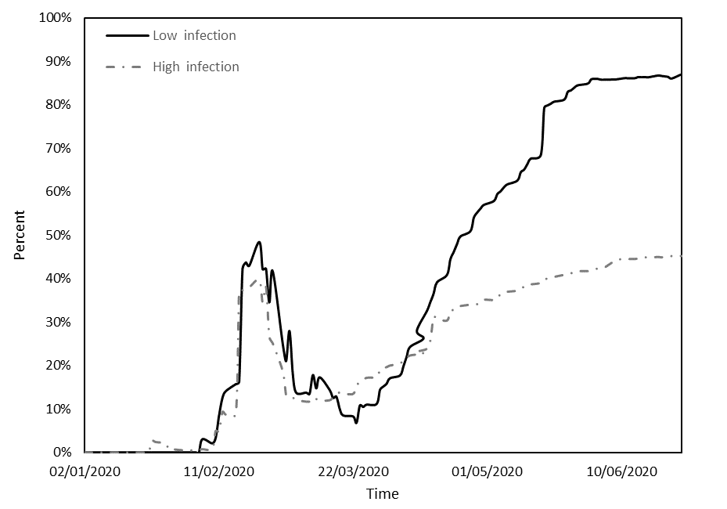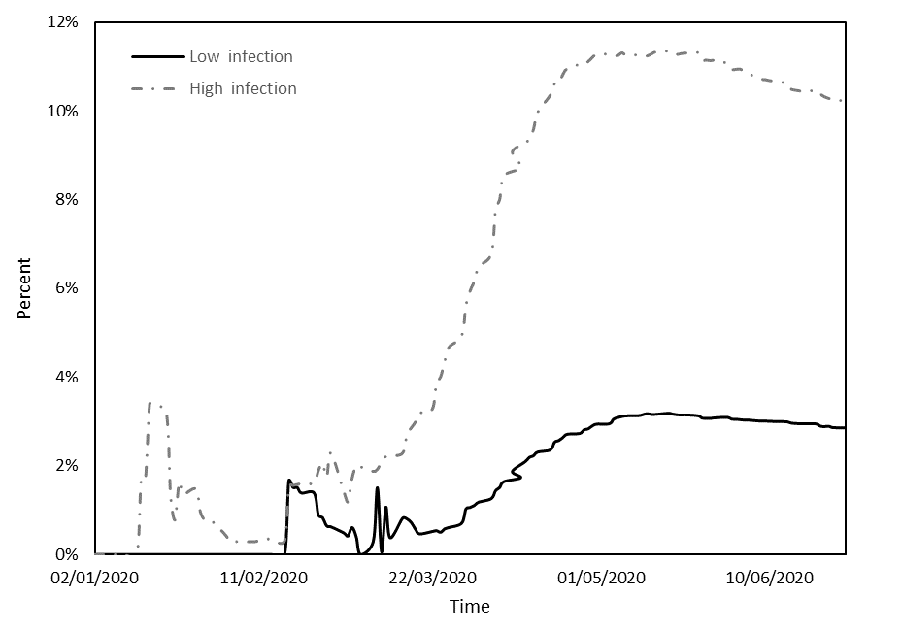

Figure 1.2. Performance of the *RPI* index.

Figure 1.1. Performance of the *DPI* index.

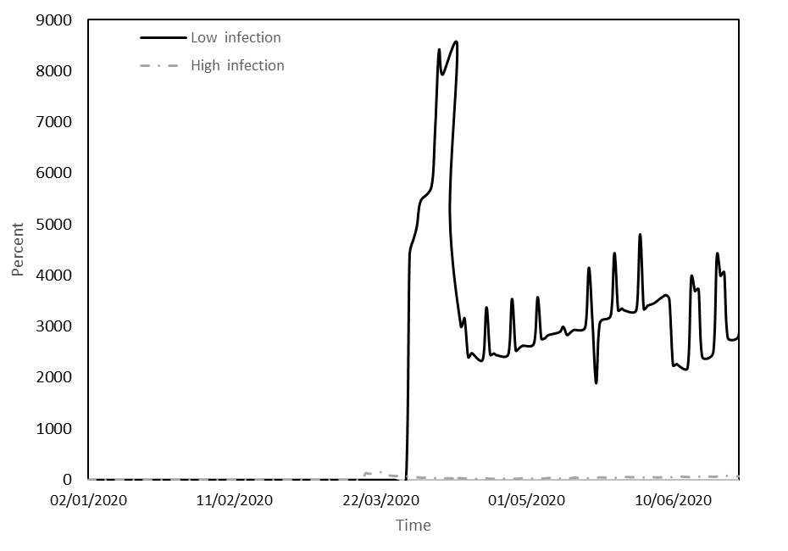

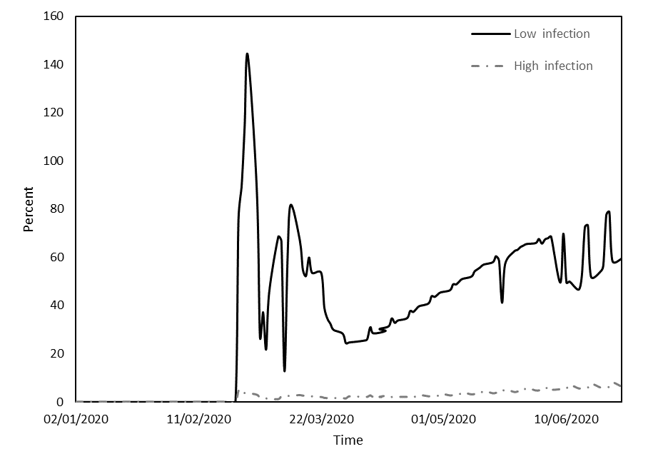

Figure 1.4. Performance of the *TPD* index.

Figure 1.3. Performance of the *TPI* index.

Note: The figures illustrate the dynamics of key calculated metrics, including DPI (Deaths per Infection Ratio), RPI (Recoveries per Infection Ratio), TPI (Tests per Infection Ratio), and TPD (Tests per Death Ratio), throughout the duration of the epidemic. The horizontal axis represents the timeline by dates. Solid black lines represent countries with low infection rates, whereas dashed lines are indicative of countries experiencing high infection rates.

Figure 1.1 reveals three distinct phases over the study period. The initial phase extended until mid-March, followed by the second phase from mid-March to the end of April, and the final phase from the beginning of May to the close of June. During the initial phase, DPI exhibited relatively low values for both groups, with Panel B countries experiencing notably higher values. Notably, this phase saw a significant surge in fatalities in Asian countries during January, coinciding with a substantial number of infections. This initial wave of fatalities gradually receded, leading to a decline in DPI until mid-March. In the second phase, a conspicuous disparity emerged between the groups concerning DPI. Panel B countries experienced an exponential escalation in DPI, whereas Panel A countries observed a more moderate increase. The third phase saw a decline in DPI for both groups, possibly due to the implementation of various restrictive measures by the respective countries.

Figure 1.2 illustrates that during the initial phase, there was no discernible difference between the groups in terms of RPI, which underwent a pronounced increase until mid-February, followed by a decline (primarily impacting Asian countries). In the subsequent phases of transmission and containment, there was a substantial surge in RPI for countries with lower infection counts (Panel A), juxtaposed with a more modest increase for those with higher infection counts (Panel B). This phenomenon may be attributed to the rapid surge in infections in the former group compared to the gradual increase in the latter.

Figure 1.3 compares the number of tests conducted against the number of infections. Notably, data on the number of tests began to be documented from February 24, and thus, the figure's data commences from that date. TPI displayed an upward trend in both cohorts, with significantly higher values in Panel A groups compared to Panel B countries. A plausible rationale may be found in Table 3, where it is evident that, although the number of tests in countries with higher infection counts increased somewhat more than in countries with lower infection counts, the sheer volume of infections in the former group led to a more substantial increase in TPI.

Figure 1.4 compares the number of tests conducted against the number of deaths. Notably, data on the number of tests began to be documented from February 24, and thus, the figure's data commences from that date. TPD displayed an upward trend in both cohorts, with significantly higher values in Panel A groups compared to Panel B countries. A plausible rationale may be found in Table 3, where it is evident that, although the number of tests in countries with higher infection counts increased somewhat more than in countries with lower infection counts, the sheer volume of deaths in the former group led to a more substantial increase in TPD.

Figure 2: Characterization of pandemic response metrics during the period of the epidemic

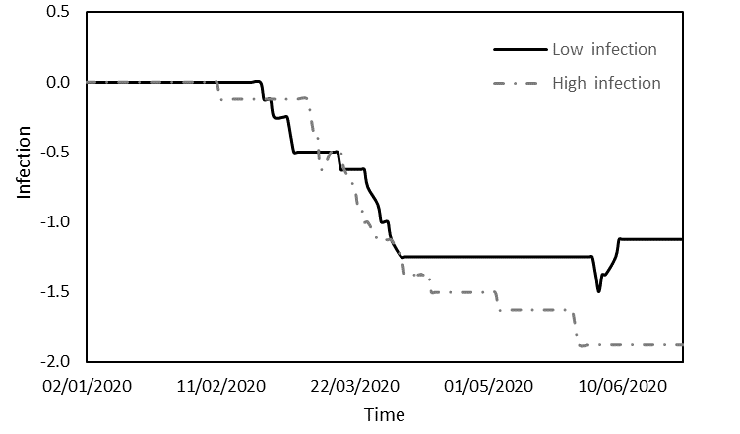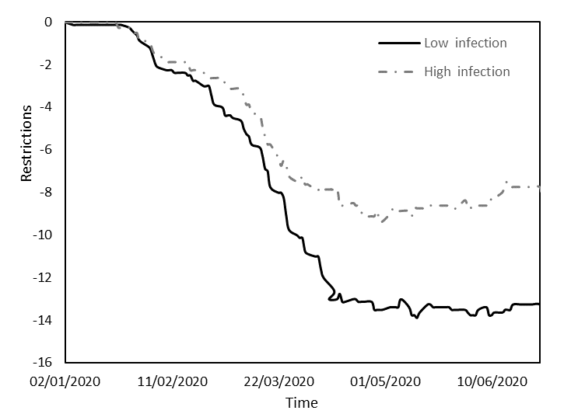

Figure 2.2. Changes in the *VIP* variable.

Figure 2.1. Changes in the *Restrictions* variable.

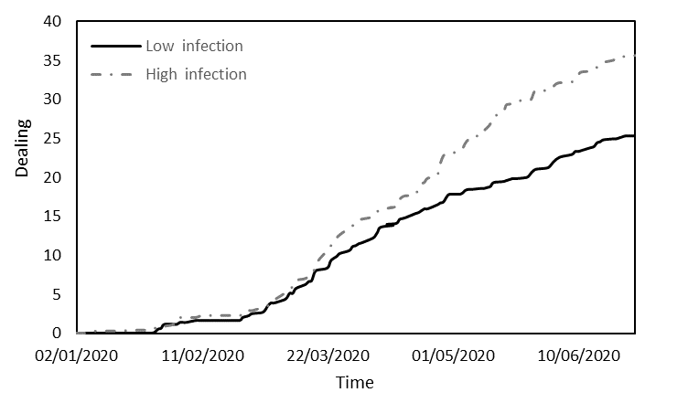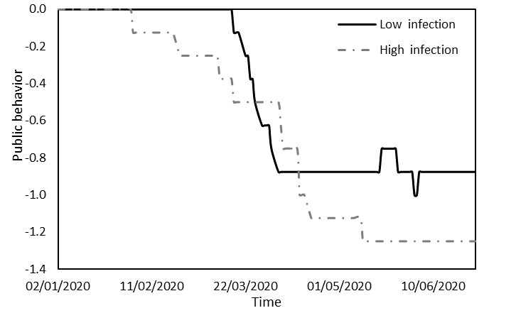

Figure 2.4. Changes in the *Dealing* variable.

Figure 2.3. Changes in the *Public behavior* variable.

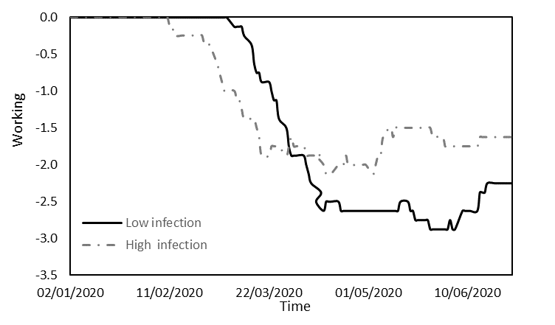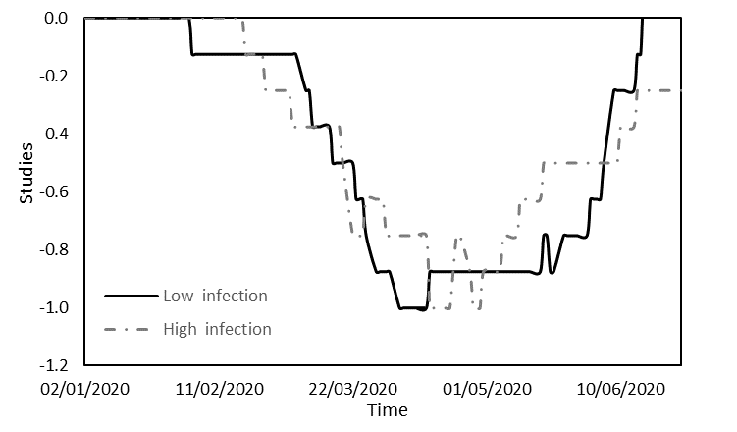

Figure 2.5. Changes in the *Education* variable.

Figure 2.6. Changes in the *Working* variable.

Note: The figures present an analysis of pandemic impact metrics, specifically focusing on Restrictions, Public behavior, VIP, Dealing, Education, and Working arrangements, over the course of the epidemic's duration. The horizontal axis represents the timeline by dates. Solid black lines represent countries with low infection rates, whereas dashed lines are indicative of countries experiencing high infection rates.

Figures 2.1 to 2.6 provide a comprehensive analysis of the distinct responses and behaviors exhibited by both Panel A and Panel B countries during the observation period. Figure 2.1 offers insight into the average values of an index reflecting a spectrum of restrictions imposed, such as limitations on movement, lockdowns, quarantine measures, and constraints on incoming international tourists. Until early February, both groups experienced minimal restrictions, resulting in negligible disparity. Subsequently, governments began implementing measures to contain the virus. Panel A countries, with lower infection rates, enforced stringent restrictions, while Panel B countries, marked by higher infection rates, imposed milder restrictions, facilitating virus transmission. By mid-April, both groups reached a state of equilibrium, as indicated by horizontal lines on the chart.

Figure 2.2 focuses on the average infection levels among VIPs, encompassing leaders, health personnel, and security forces, in each group. Until mid-February, infections were infrequent in both groups. However, from mid-February to early April, infections surged in both groups. From early April onward, countries with low infection counts reported minimal VIP infections, while Panel B countries maintained a moderated, yet persistent trend. This discrepancy may be attributed to the stringent restrictions in countries with lower infection rates, which curbed virus transmission to VIPs. Figure 2.3 examines variations in public responsiveness to government directives. Public behavior oscillated between initial compliance, a subsequent weakening of compliance, and a return to stricter adherence. Extended periods of compliance corresponded to lower infection rates. Notably, compliance eroded to a lesser extent in countries with low infection counts (from mid-March to early April) compared to their high-infection counterparts (from early February to mid-May). These findings, in conjunction with the observations in Figure 2.2, suggest that in high-infection countries, responsibility for virus transmission can be attributed to both governments and the general public.

Figure 2.4 elucidates the affirmative measures undertaken by countries to address COVID-19, including economic interventions, vaccine development, experimental treatments, and enhanced testing availability for citizens. The trajectory is analogous in both groups. Until the end of February, government involvement remained minimal in both categories. Subsequently, as the virus's impact on public health and the economy became more apparent, governments-initiated measures to assist their populations. These measures were more robust in countries with higher infection rates than in those with lower infection rates, likely due to the greater health and economic challenges faced by the former group. Figure 2.5 describes the educational landscape, marked by similar levels of restrictions in both groups and characterized by four discernible phases. Initially, restrictions were virtually absent, with countries with lower infection counts slightly leading in their implementation. Subsequently, concerns about infections in educational settings prompted the gradual imposition of further restrictions. In the third phase, both groups witnessed maximum restrictions. In the final phase, governments began to ease these restrictions. Although the trends were comparable, countries with lower infection rates experienced a more extended period of maximum restrictions (from mid-April to the end of May) compared to their counterparts (from mid-April to the end of April), which likely contributed to their lower infection rates.

Figure 2.6 outlines the work environment, characterized by similarities in both groups and divided into three phases. Initially, workplace restrictions were minimal. Subsequently, rising infection concerns in the workplace prompted governments to gradually introduce restrictions, with Panel B countries initiating these measures three weeks earlier. In the third phase, all countries reached the peak of workplace restrictions. Notably, countries with lower infection rates enforced more stringent restrictions compared to those with higher infection rates.

**The impact of model variables on index returns**

This section will investigate the influence of pandemic impact metrics and government actions and policies data, which were systematically collected, on the performance of financial indices through the application of Ordinary Least Squares (OLS) regression. Panel A in Table 4 will showcase the regression analysis for nations characterized by a low incidence of infections, whereas Panel B will present the regression results for countries marked by a high prevalence of infections.

Table 4. Regression estimates of key variables during the pandemic period

The regression models are as follows:

$AR_{FC,t}=α_{a}+\sum_{i=1}^{I}{β_{i}X_{a,t}^{i}}+\sum_{j=1}^{J}{γ_{j}C_{a,t}^{j}}+ε$ and $AR_{MC,t}=α_{a}+\sum_{i=1}^{I}{β_{i}X_{a,t}^{i}}+\sum_{j=1}^{J}{γ_{j}C_{a,t}^{j}}+ε$

In the provided model, *ARFC,t* signifies the mean return observed in countries with a minimal incidence of infections, while *ARMC,t* denotes the mean return in countries marked by a substantial prevalence of infections at a given time point, t. The parameter αa signifies a constant term. The vector Xi encompasses the variables related to pandemic impact metrics, including Infections, Deaths, Recovered cases, and Testing. Additionally, the vector Cj encompasses the variables representing government actions and policies, namely Restrictions, Public Behavior, VIP, Dealing strategies, Education measures, and Working-related policies.

|  |  |  |  |  |  |  |  |
| --- | --- | --- | --- | --- | --- | --- | --- |
|  | Panel A: Low infection | | |  | Panel B: High infection | | |
|  | R2 = 0.929, F = 168.731 | | |  | R2 = 0.896, F = 102.085 | | |
| Variable | Coefficient | Std. error | t-statistic |  | Coefficient | Std. error | t-statistic |
| C | 0.018*** | 0.006 | 2.924 |  | 0.029*** | 0.008 | 3.609 |
| Infections | -1.04E-05*** | 0.000 | -2.484 |  | 0.000 | 0.000 | -0.136 |
| Death | -2.06E-07*** | 0.000 | -3.438 |  | -1.02E-05*** | 0.000 | -3.125 |
| Recovered | 5.91E-05*** | 0.000 | 7.148 |  | 0.000 | 0.000 | 0.216 |
| Tests | 5.64E-07*** | 0.000 | 2.799 |  | 4.26E-08 | 0.000 | 1.067 |
| Restrictions | -0.023*** | 0.005 | -4.119 |  | -0.030*** | 0.012 | -2.582 |
| Public behavior | -0.434*** | 0.063 | -6.838 |  | -0.215*** | 0.076 | -2.816 |
| VIP | -0.081*** | 0.033 | -2.451 |  | -0.137*** | 0.048 | -2.878 |
| Dealing | 0.048*** | 0.004 | 10.789 |  | 0.032*** | 0.006 | 5.759 |
| Education | 0.073** | 0.038 | 1.927 |  | -0.075 | 0.055 | -1.371 |
| Working | 0.065*** | 0.025 | 2.649 |  | 0.144*** | 0.031 | 4.607 |

Note: Panels A and B delineate the regression outcomes for countries categorized by low and high infection rates, respectively. The set of independent variables comprises pandemic impact metrics and pandemic response metrics. Within each panel, the first column showcases the regression coefficients, the second column presents standard deviations, and the third column presents the associated t-statistics. Statistical significance is denoted by p-values, with asterisks ***, **, and * representing significance at the 1%, 5%, and 10% levels, respectively.

The results presented in Table 4 illuminate the discernible impact of the COVID-19 pandemic on index returns in two distinct groups of countries: those characterized by low infection rates and those experiencing high infection rates. These findings reveal that the pandemic-related variables exerted varying degrees of influence on index returns in each group, providing insight into the nuanced dynamics at play. In countries with a low incidence of infections, all examined variables exhibited statistically significant effects on stock returns. Notably, an increase in the numbers of deaths and infections correlated with more pronounced declines in stock markets, highlighting the market's sensitivity to the health and economic risks posed by the pandemic. Conversely, a positive correlation was observed between stock returns and the numbers of recoveries and testing, indicative of investor optimism regarding potential recovery scenarios.

Furthermore, the implementation of new government restrictions and a lack of responsiveness from the public were correlated with declines in stock market performance. This relationship suggests that stringent measures and public non-compliance were perceived by the market as detrimental to economic activity, leading to negative market reactions. Conversely, proactive government measures, such as the easing of restrictions in workplaces and educational institutions, contributed to gains in stock market indices. This response may signify the market's confidence in the potential economic recovery and stability associated with such policy adjustments. In contrast, the "VIP" variable, which pertains to the infection levels among key figures in the country, including leaders, medical personnel, and security personnel, was associated with decreases in stock returns. This negative correlation could be attributed to concerns over the economic implications of such infections within these critical sectors. Infections among key figures may raise uncertainty about the stability and effectiveness of leadership, public health, and security measures, potentially leading to market pessimism.

In contrast, within countries characterized by a high prevalence of infections, the impact of these variables was notably subdued. While the number of deaths did exhibit a negative effect on stock indices, the numbers of recoveries, infections, and tests did not yield statistically significant impacts. The absence of significant effects from these pandemic-related variables in high-infection countries suggests that the market had likely already integrated the prevailing pandemic conditions into its pricing, thereby reducing the immediate influence of these metrics on stock returns. The negative correlation between government restrictions and public behavior in high-infection countries and stock market performance suggests that the market perceived stringent measures as indicative of prolonged disruptions and potential economic strain. This unfavorable market response may reflect apprehension about the persistence of adverse conditions, given the high infection rates. Conversely, positive market reactions to the easing of workplace restrictions indicate that market participants considered such policy changes as potentially alleviating economic stress and fostering a path to recovery.

The disparities in the influence of pandemic-related variables and government actions between countries with low and high infection rates can be attributed to a range of factors. In countries with low infection rates, the heightened sensitivity of stock markets to pandemic metrics such as deaths and infections may reflect market reactions to perceived health and economic risks, with optimism attached to increases in recoveries and testing. In contrast, the muted market response in high-infection countries could be attributed to ongoing challenges, market adaptation to the persistent pandemic context, and investor skepticism regarding the effectiveness of stringent government measures. These differences underscore the complex interplay of pandemic-related factors and government actions, leading to divergent market responses based on the unique circumstances in each category of countries.

The results in this section validate Hypothesis 1, confirming that pandemic impact metrics exhibit diverse effects on stock indices in countries with varying infection rates. This is consistent with research by Tavor and Teitler-Regev [3], who have shown that the type and severity of events have varying impacts on financial markets, underlining the need to consider multiple metrics to understand the unique consequences of health crises. Similarly, Chopra and Mehta [5] found that different crises, including the COVID-19 pandemic, had varying degrees of impact on Asian stock markets, highlighting the non-uniform nature of market responses to such events. In countries with low infection rates, we observed heightened market sensitivity to pandemic metrics like deaths and infections, with optimism associated with recoveries and testing. In contrast, high-infection countries exhibited subdued impacts of these metrics, likely due to the market already factoring in the pandemic's effects into pricing. These findings align with our study's objectives, which aimed to investigate the impact of COVID-19 on capital markets in 16 countries categorized by infection rates. The divergent market responses underscore the importance of tailoring investment strategies and government policies to each category of countries. These results have significant implications for policymakers and investors facing the challenges of global health crises, providing guidance for navigating financial markets amid extreme uncertainty.

**Robustness check**

The robustness check section of this study examines the impact of the following metrics: DPI (Deaths per infection ratio), RPI (Recoveries per infection ratio), TPI (Tests per infection ratio), and TPD (Tests per death ratio), on the returns of indexes through the application of Ordinary Least Squares (OLS) regression analysis. Within the context of our analysis, Panel A, as displayed in Table 5, illustrates the regression outcomes for countries characterized by a low number of infections, while Panel B showcases the regression findings for countries characterized by a high number of infections.

Table 5. Regression estimates of calculated metrics variables during the pandemic period.

The regression models are as follows:

$AR_{FC,t}=α_{a}+\sum_{k=1}^{K}{δ_{i}Y_{a,t}^{k}}+ε$ and $AR_{MC,t}=α_{a}+\sum_{k=1}^{K}{δ_{i}Y_{a,t}^{k}}+ε$

Where, Yk represents the ratios: *DPI, RPI, TPI and TPD*.

|  |  |  |  |  |  |  |  |
| --- | --- | --- | --- | --- | --- | --- | --- |
|  | Panel A: Low infection | | |  | Panel B: High infection | | |
|  | R2 = 0.564, F = 47.693 | | |  | R2 = 0.553, F = 34.011 | | |
| Variable | Coefficient | Std. error | t-statistic |  | Coefficient | Std. error | t-statistic |
| C | -0.049*** | 0.013 | -3.769 |  | -0.051*** | 0.013 | -4.186 |
| DPI | -1.10E+01*** | 1.48E+00 | -7.432 |  | -1.652 | 1.307 | 1.264 |
| RPI | 0.635*** | 0.054 | 11.759 |  | 0.219*** | 0.098 | 2.237 |
| TPI | 2.08E-03*** | 0.000 | 8.501 |  | 0.005 | 0.006 | 0.768 |
| TPD | 1.39E-05*** | 0.000 | 3.371 |  | 0.002*** | 0.000 | 5.894 |

Note: Panels A and B delineate the regression outcomes for countries categorized by low and high infection rates, respectively. The independent variables consist of a specific set of calculated epidemiological metrics. Within each panel, the first column showcases the regression coefficients, the second column presents standard deviations, and the third column presents the associated t-statistics. Statistical significance is denoted by p-values, with asterisks ***, **, and * representing significance at the 1%, 5%, and 10% levels, respectively.

The results stemming from the robustness analysis lend further support to the findings obtained in the standard tests, reaffirming the substantial influence of the COVID-19 pandemic on stock returns. As detailed in Table 5, even when utilizing ratio-based variables, a statistically significant effect of COVID-19 on stock returns is evident for countries characterized by both high and low infection rates. In countries with a low incidence of infections, a compelling association between the examined ratios and stock returns is discerned. Specifically, an increase in the ratio of deaths to infections is linked to a corresponding decline in stock returns. Conversely, elevations in the ratios denoting recoveries per infections (RPI), tests per infections (TPI), and tests per deaths (TPD) are correlated with higher stock returns.

In contrast, for nations grappling with a high prevalence of infections, the impacts are less pronounced, with only two ratios demonstrating a positive and statistically significant effect on stock returns. Notably, an increase in the ratio of recoveries per infections (RPI) and the ratio of tests per deaths (TPD) is associated with increased stock returns. In summation, the robustness tests serve to reinforce the conclusions drawn from the standard tests, underscoring the greater sensitivity of stock returns to the examined variables in countries with a low incidence of infections. This phenomenon may be attributed to the proactive policy measures implemented by governments in these nations during the early stages of the epidemic, with each policy adjustment leaving a discernible imprint on stock indices. In contrast, in countries marked by a high number of infections, government interventions transpired at a later juncture, a point at which financial markets had already adapted to the ongoing circumstances, leading to a diminished responsiveness of stock indices to changes in the variables under scrutiny.

These findings confirm Hypothesis 2, which proposed varying effects of calculated metrics on stock indices in countries with low and high infection rates. They echo insights from the literature review, emphasizing how event characteristics and severity play a pivotal role in stock market responses, as noted by Tavor and Teitler-Regev [3] and Chopra and Mehta [5]. Calculated metrics such as DPI, RPI, TPI, and TPD provide nuanced insights beyond basic infection, death, or recovery counts. Moreover, they align with the findings of Donadelli et al. [6] and Bai et al. [7], emphasizing the influence of information and data on investor attitudes and stock market responses. These metrics serve as vital information for investors when making decisions. The research of Schell et al. [8] highlights the need to consider diverse metrics due to variations in stock market responses to different pandemics. In summary, these results underscore the importance of incorporating calculated metrics, like DPI, RPI, TPI, and TPD, when assessing pandemic impacts on financial markets. They carry significant implications for policymakers and investors, emphasizing the need to adapt strategies to the distinct dynamics of stock markets during health crises. These insights provide valuable guidance for navigating financial markets amidst extreme uncertainty.

# Discussion

The year 2020 will be forever remembered as a year dominated by the unprecedented COVID-19 pandemic. This global crisis has had profound and far-reaching implications, particularly on the world's economies. Our study delves into the intricate interplay between COVID-19 and capital markets in 16 countries, categorizing them based on their infection rates. This unique analysis unraveled a range of valuable insights.

In countries with low infection rates, we observed a heightened sensitivity of stock markets to pandemic metrics. Specifically, stock returns were significantly affected by the numbers of deaths and infections, highlighting the market's vulnerability to health and economic risks. This sensitivity was mirrored by the positive correlation between stock returns and the numbers of recoveries and testing, signifying investor optimism regarding potential recovery scenarios. Furthermore, our findings emphasized the critical role of government actions and policies in influencing stock market performance. Proactive government measures, such as the easing of restrictions in workplaces and educational institutions, were associated with positive stock market responses. Conversely, stringent measures and public non-compliance were linked to negative market reactions, reflecting the market's perception of these actions as detrimental to economic activity.

In countries characterized by high infection rates, the impact of pandemic-related variables was notably subdued. Here, the stock market had likely already integrated the ongoing pandemic conditions into its pricing, reducing the immediate influence of these metrics on stock returns. However, the negative correlation between government restrictions and public behavior in high-infection countries and stock market performance suggested that the market perceived stringent measures as indicative of prolonged disruptions and potential economic strain. In contrast, positive market reactions to the easing of workplace restrictions indicated that market participants viewed such policy changes as potentially alleviating economic stress and fostering a path to recovery.

However, it is important to acknowledge certain limitations of our study. Many countries affected by COVID-19 have not been included in this analysis. Furthermore, this study is based on data reported by different countries, and it should be noted that not every country reports complete data, and different measures are used, which may influence any comparisons. The observed differences in the influence of pandemic-related variables and government actions between countries with low and high infection rates underscore the need for tailored and adaptable strategies in response to health crises. The unique circumstances in each category of countries emphasize the complex interplay between pandemic-related factors and government actions, leading to divergent market responses.

However, it is important to acknowledge certain limitations of our study. Many countries affected by COVID-19 have not been included in this analysis. Furthermore, this study is based on data reported by different countries, and it should be noted that not every country reports complete data, and different measures are used, which may influence any comparisons. The observed differences in the influence of pandemic-related variables and government actions between countries with low and high infection rates underscore the need for tailored and adaptable strategies in response to health crises. The unique circumstances in each category of countries emphasize the complex interplay between pandemic-related factors and government actions, leading to divergent market responses.

**Conclusion and policy implications**

**Conclusion**

The research has illuminated the notable and divergent effects of COVID-19 on financial markets. The pandemic has significantly disrupted worldwide economies, and our investigation has provided insights into how differing infection rates and governmental reactions exert unique influences on stock markets. The heightened responsiveness identified in nations with lower infection rates emphasizes the necessity for timely and efficient health and economic interventions to mitigate disturbances and uphold market trust. Importantly, these findings offer a nuanced perspective on how governments and policymakers can better respond to similar crises in the future. While the immediate actions and policies in high-infection countries may not have the same pronounced impact on stock markets, the importance of clear and effective communication remains paramount. The ability to maintain public confidence and foster public cooperation is essential in mitigating the economic impact of pandemics. The need for well-calibrated interventions that balance health measures and economic considerations is a critical takeaway for policymakers worldwide.

# Policy implications

The policy implications of our study are both practical and actionable. Policymakers should consider the following:

1. *Effective Communication:* Effective and transparent communication is crucial. Policymakers should convey the rationale behind their measures, fostering public understanding and cooperation. Public behavior plays a significant role in shaping market reactions, and clarity in communication can help maintain public confidence during health crises.
2. *Adaptive Policy Approaches:* Policymakers should adopt adaptive policy approaches. Recognize that the impact of government actions and policies can vary based on the unique circumstances of each country. This flexibility is essential in responding to the evolving nature of health crises.
3. *Proactive Government Measures:* Proactive government measures, particularly those that support economic recovery, can have a positive impact on stock market performance. Easing restrictions in workplaces and educational institutions, when safe to do so, can be viewed favorably by investors as potential steps toward stability and recovery.

In conclusion, our study provides a valuable framework for policymakers and market participants to better navigate the complex dynamics of health crises and their impact on capital markets, offering practical guidelines for a more effective response to similar challenges in the future.

**References**

**[1]** Baker, S., N. Bloom, S. J. Davis, K. Kost, M. Sammon, and T. Viratyosin. 2020. The Unprecedented Stock Market Reaction to COVID-19. *Review of Asset Pricing Studies* 1(3). [doi:10.1093/rapstu/raaa008](https://doi.org/10.1093/rapstu/raaa008).

**[2]** Osterholm, M. T. (2020). Preparing for the next pandemic. In *The COVID-19 Reader* (pp. 11-20). Routledge.‏

**[3]** Tavor, T., and S. Teitler-Regev. 2019. The Impact of Disasters and Terrorism on the Stock Market. *Jàmbá: Journal of Disaster Risk Studies* 11(1): 1–8.‏

**[4]** Chen, M. H. 2011. The Response of Hotel Performance to International Tourism Development and Crisis Events. *International Journal of Hospitality Management* 30(1): 200–212.

**[5]** Chopra, M., & Mehta, C. (2022). Is the COVID-19 pandemic more contagious for the Asian stock markets? A comparison with the Asian financial, the US subprime and the Eurozone debt crisis. *Journal of Asian Economics*, *79*, 101450.

**[6]** Donadelli, M., R. Kizys, and M. Riedel. 2017. Dangerous Infectious Diseases: Bad News for Main Street, Good News for Wall Street? *Journal of Financial Markets* 35:84–103.‏

**[7]** Bai, L., Y. Wei, G. Wei, X. Li, and S. Zhang, S. 2020. Infectious Disease Pandemic and Permanent Volatility of International Stock Markets: A Long-Term Perspective. *Finance Research Letters*: 101709.‏ doi:[10.1016/j.frl.2020.101709](https://doi.org/10.1016/j.frl.2020.101709).

**[8]** Schell, D., Wang, M., & Huynh, T. L. D. (2020). This time is indeed different: A study on global market reactions to public health crisis. *Journal of behavioral and experimental finance*, *27*, 100349.‏

**[9]** Pendell, D. L., and C. Cho. 2013. Stock Market Reactions to Contagious Animal Disease Outbreaks: An Event Study in Korean Foot‐and‐Mouth Disease Outbreaks. *Agribusiness* 29(4): 455–468.‏

**[10]** Chen, M. H., S. S. Jang, and W. G. Kim. 2007. The Impact of the SARS Outbreak on Taiwanese Hotel Stock Performance: An Event-Study Approach. *International Journal of Hospitality Management* 26(1): 200–212.‏

**[11]** Ali, N., A. M. Nassir, T. Hassan, and S. Z. Abidin. 2010. Short Run Stock Overreaction: Evidence from Bursa Malaysia. *International Journal of Economics and Management* 4(2): 319–333.‏

**[12]**Nippani, S., and K. M. Washer. 2004. SARS: A Non-event for Affected Countries’ Stock Markets?” *Applied Financial Economics* 14(15): 1105–1110.

**[13]** Ichev, R., and M. Marinč. 2018. Stock Prices and Geographic Proximity of Information: Evidence from the Ebola Outbreak. *International Review of Financial Analysis* 56: 153–166.

**[14]** Hatmanu, M., & Cautisanu, C. (2021). The impact of COVID-19 pandemic on stock market: Evidence from Romania. *International Journal of Environmental Research and Public Health*, *18*(17), 9315.

**[15]** Liu, Z., Huynh, T. L. D., & Dai, P. F. (2021). The impact of COVID-19 on the stock market crash risk in China. *Research in international Business and Finance*, *57*, 101419.

**[16]** Tetteh, J. E., Amoah, A., Ofori-Boateng, K., & Hughes, G. (2022). Stock market response to COVID-19 pandemic: A comparative evidence from two emerging markets. *Scientific African*, *17*, e01300.

**[17]** Ganie, I. R., Wani, T. A., & Yadav, M. P. (2022). Impact of COVID-19 outbreak on the stock market: an evidence from select economies. *Business Perspectives and Research*, 22785337211073635.

**[18]** Ali, M., N. Alam, and S. A. R. Rizvi. 2020. Coronavirus (COVID-19): An Epidemic or Pandemic for Financial Markets. *Journal of Behavioral and Experimental Finance* 2020: 100341. doi:[10.1016/j.jbef.2020.100341](https://doi.org/10.1016/j.jbef.2020.100341).

**[19]** Singh, G., & Shaik, M. (2021). The short-term impact of COVID-19 on global stock market indices. *Contemporary Economics*, 1-18.

**[20]** Chowdhury, E. K., and M. Z. Abedin. (2020). COVID-19 Effects on the US Stock Index Returns: An Event Study Approach. *SSRN*. doi:10.2139/ssrn.3611683.

**[21]** Chowdhury, E. K., Dhar, B. K., & Stasi, A. (2022). Volatility of the US stock market and business strategy during COVID‐19. *Business Strategy & Development*, *5*(4), 350-360.

**[22]** Anh, D. L. T., & Gan, C. (2021). The impact of the COVID-19 lockdown on stock market performance: evidence from Vietnam. *Journal of Economic Studies*, *48*(4), 836-851.

**[23]** Chen, L., Li, T., Jia, F., & Schoenherr, T. (2023). The impact of governmental COVID‐19 measures on manufacturers' stock market valuations: The role of labor intensity and operational slack. *Journal of Operations Management*, *69*(3), 404-425.

**[24]** Sharif, A., Aloui, C., & Yarovaya, L. (2020). COVID-19 pandemic, oil prices, stock market, geopolitical risk and policy uncertainty nexus in the US economy: Fresh evidence from the wavelet-based approach. *International review of financial analysis*, *70*, 101496.

**[25]** Tanjung, A. A., Ruslan, D., Lubis, I., & Pratama, I. (2022). Stock Market Responses to Covid-19 Pandemic and Monetary Policy in Indonesia: Pre and Post Vaccine. *Cuadernos de Economía*, *45*(127), 120-129.

**[26]** Haroon, O., and S. A. R. Rizvi. (2020). COVID-19: Media Coverage and Financial Markets Behavior – A Sectoral Inquiry. *Journal of Behavioral and Experimental Finance* 27: 100343. doi:[10.1016/j.jbef.2020.100343](https://doi.org/10.1016/j.jbef.2020.100343).

**[27]** Teitler-Regev, S. & Tavor T. (2021) Behavior of financial markets during the COVID-19 crisis: a comparison of Israel and the rest of the world, Israel Affairs, 27:4, 691-710, DOI: 10.1080/13537121.2021.1940604.

# Data sources

administracion.gob.es. 2020. Retrieved from Nueva normalidad. Crisis sanitaria COVID-19: https://administracion.gob.es/pag_Home/atencionCiudadana/Nueva-normalidad-crisis-sanitaria.html#-bb7ad21ed1cf

Argentina.gob.ar. 2020. Retrieved from nuevo coronavirus COVID-19: https://www.argentina.gob.ar/salud/coronavirus-COVID-19

Bundeskanzleramt. 2020. Retrieved from Bundeskanzleramt - Bundesregierung: https://www.bundeskanzleramt.gv.at/bundeskanzleramt/die-bundesregierung.html

Bundesministerium für Gesundheit. 2020. Retrieved from Coronavirus: https://www.bundesgesundheitsministerium.de/coronavirus/chronik-coronavirus.htmlGouvernement.fr. 2020. Retrieved from Les actions du Gouvernement: https://www.gouvernement.fr/les-actions-du-gouvernement

Congress.gov. 2020. Retrieved from Current Legislative Activities: https://congress.gov/

Gov.il. 2020. Retrieved from News: https://www.gov.il/he/departments/news?limit=10

Gouvernement.fr.2020. Retrieved from Les actions du Gouvernement: https://www.gouvernement.fr/les-actions-du-gouvernement

gov.sg. 2020. Retrieved from Latest update: https://www.gov.sg/features/covid-19

GOV.UK. 2020. Retrieved from Coronavirus (COVID-19) - News and communications: https://www.gov.uk/search/news-and-communications?level_one_taxon=5b7b9532-a775-4bd2-a3aa-6ce380184b6c

Governo do Brasil. 2020. Retrieved from Legislação COVID-19: http://www.planalto.gov.br/CCIVIL_03/Portaria/quadro_portaria.htm

Governo Italiano. 2020. Retrieved from Coronavirus, le misure adottate dal Governo: http://www.governo.it/it/approfondimento/coronavirus/13968

HDX. 2020. Retrieved from Novel Coronavirus (COVID-19) Cases Data: https://data.humdata.org/dataset/novel-coronavirus-2019-ncov-cases

Investing.com. 2020. Retrieved from Investing.com: https://il.investing.com/indices/major-indices

Israel Ministry of Health. 2020. Retrieved from: https://govextra.gov.il/ministry-of-health/corona/corona-virus/?gclid=CjwKCAjw0_T4BRBlEiwAwoEiAaeH0-sYUL95P5WMn0ThqucoCRlSMvw662XArQJRI6OkaaZGK5ZlsRoCNLYQAvD_BwE

New Zealand Legislation. 2020. Retrieved from COVID-19 legislation: http://www.pco.govt.nz/covid-19-legislation/

Regeringen styr Sverige. 2020. Retrieved from Regeringsförklaringen: https://www.regeringen.se/tal/20192/09/regeringsforklaringen-den-10-september-2019/

Republike Slovenije. 2020. Retrieved from Vlada Republike Slovenije: https://www.gov.si/drzavni-organi/vlada/novice/

World Health Organization. 2020. Retrieved from WHO Coronavirus Disease (COVID-19) Dashboard: https://covid19.who.int/

中国政府. 2020. Retrieved from 中国政府: http://www.gov.cn/

台湾政府. 2020. Retrieved from 台湾政府: https://www.president.gov.tw/

|  |  |
| --- | --- |
| Use | Source |
| Spain | Aministracion.gob.es |
| Argentina | Argentina.gob.ar |
| Germany | Bundesministerium für Gesundheit |
| France | Gouvernement.fr |
| Israel | Gov.il |
| UK | GOV.UK |
| Italy | Governo Italiano |
| Brazil | Gov.br |
| Numbers of people who recovered | HDX |
| Stock index | Investing.com |
| Israel | Israel Ministry of Health |
| New Zealand | New Zealand Legislation |
| Singapore | New Zealand Legislation |
| Austria | Österreich |
| Sweden | Regeringen styr Sverige |
| US and VIX | U.S*.*gov |
| Slovenia | Vlada Republike Slovenije |
| COVID-19 data | World Health Organization |
| China | 中国政府 |
| Taiwan | 台湾政府 |

Appendix A. List of data sources.