**Research Program**

**1. Scientific background**

**1.1 Vestibular dysfunction and rehabilitation**

Vestibular dysfunction is a common medical condition, affecting more than a third of the adult population, according to data in the United States1. Patients with vestibular dysfunction usually experience symptoms of dizziness, unsteadiness, gait problems, and gaze stability impairments2. These symptoms have a negative impact on patients’ quality of life, i.e., limited ability to work, disrupted social life, family difficulties, and travel difficulties1,3–9. Vestibular dysfunction is often referred to as vestibular hypofunction, as it occurs when one (unilateral) or both (bilateral) of the peripheral vestibular sensory organs or vestibular nerves are partially or completely dysfunctional. Common causes of vestibular dysfunction include head trauma, vestibular neuronitis, surgical transection, Meniere’s disease, ototoxic medications, or other lesions of the vestibulocochlear nerve and labyrinth10–14.

Vestibular Rehabilitation (VR), a therapeutic strategy that includes tailor-made exercises prescribed by physiotherapists, aims to alleviate the occurrence of symptoms in daily activities2. It consists primarily of an exercise program that patients should perform at home, along with weekly clinic visits to enable physiotherapists to monitor results and make exercise progression/modifications2. Typically, VR exercises include balance exercises and repetitive head movements aimed at improving gaze stability and overcoming dizziness2,15–17. Strong evidence suggests that VR is the most effective treatment method for vestibular dysfunction2.

**1.2 Compliance and adherence to therapy**

Because exercise performance by patients plays a major role in VR, patient compliance, engagement, and adherence to therapy are essential to achieving successful medical care outcomes18. Compliance and adherence are commonly used terms to describe patients’ behavior in physiotherapy treatments. Compliance can be defined as “the extent to which a person’s behavior coincides with medical advice,”19 whereas adherence describes an “active, voluntary, and collaborative involvement of the patient in a mutually acceptable course of behavior to produce a therapeutic result”20. We will use both terms, as they are closely related and serve the same purpose in this study.

The degree to which patients adhere to their home-based treatment plan is considered to account, in part, for the success of their physiotherapy programs21. Adherence to physiotherapy is generally low, with up to 65% of patients not adhering or partially adhering to home programs, and approximately 10% of patients not completing prescribed physiotherapy plans21. Notably, poor compliance and adherence rates to VR programs specifically have also been observed22.

A variety of factors are known to affect adherence to physiotherapy, including personal characteristics (i.e., sociodemographic characteristics, motivation, social support), factors related to the disease or the type of injury (i.e., chronic disorders and patients’ perceptions of their symptoms), treatment factors (i.e., timing of appointments, the clinic environment, the content of the treatment program), and the interaction between the therapist and the patient21. A number of barriers related to poor adherence have been identified, which include low baseline levels of physical activity, low self-efficacy, depression, anxiety, helplessness, poor social support/activity, a greater perceived number of barriers to exercise, and increased pain levels during exercise23.

While these factors have been studied in the context of other physiotherapy domains, only limited data are available in the context of VR. One study from Spain aimed to identify the personal characteristics that predict adherence to VR and concluded that older men with balance problems tend to resign from VR programs more than do other population groups24. Another study suggested various strategies for improving compliance and adherence to vestibular home exercises, such as documentation of the prescribed exercises, self-monitoring of symptoms and exercise performance in a logbook, and telerehabilitation25.

The factors affecting adherence to medical treatments have been described using several healthcare models predicated on the notion that patients’ health behaviors are shaped by both internal and external factors [See The Health Behavior Model, the Social Cognitive Theory, and Health Belief Model;26]. Figure 1 summarizes the integration of these models, as proposed by Chisolm et al.27.

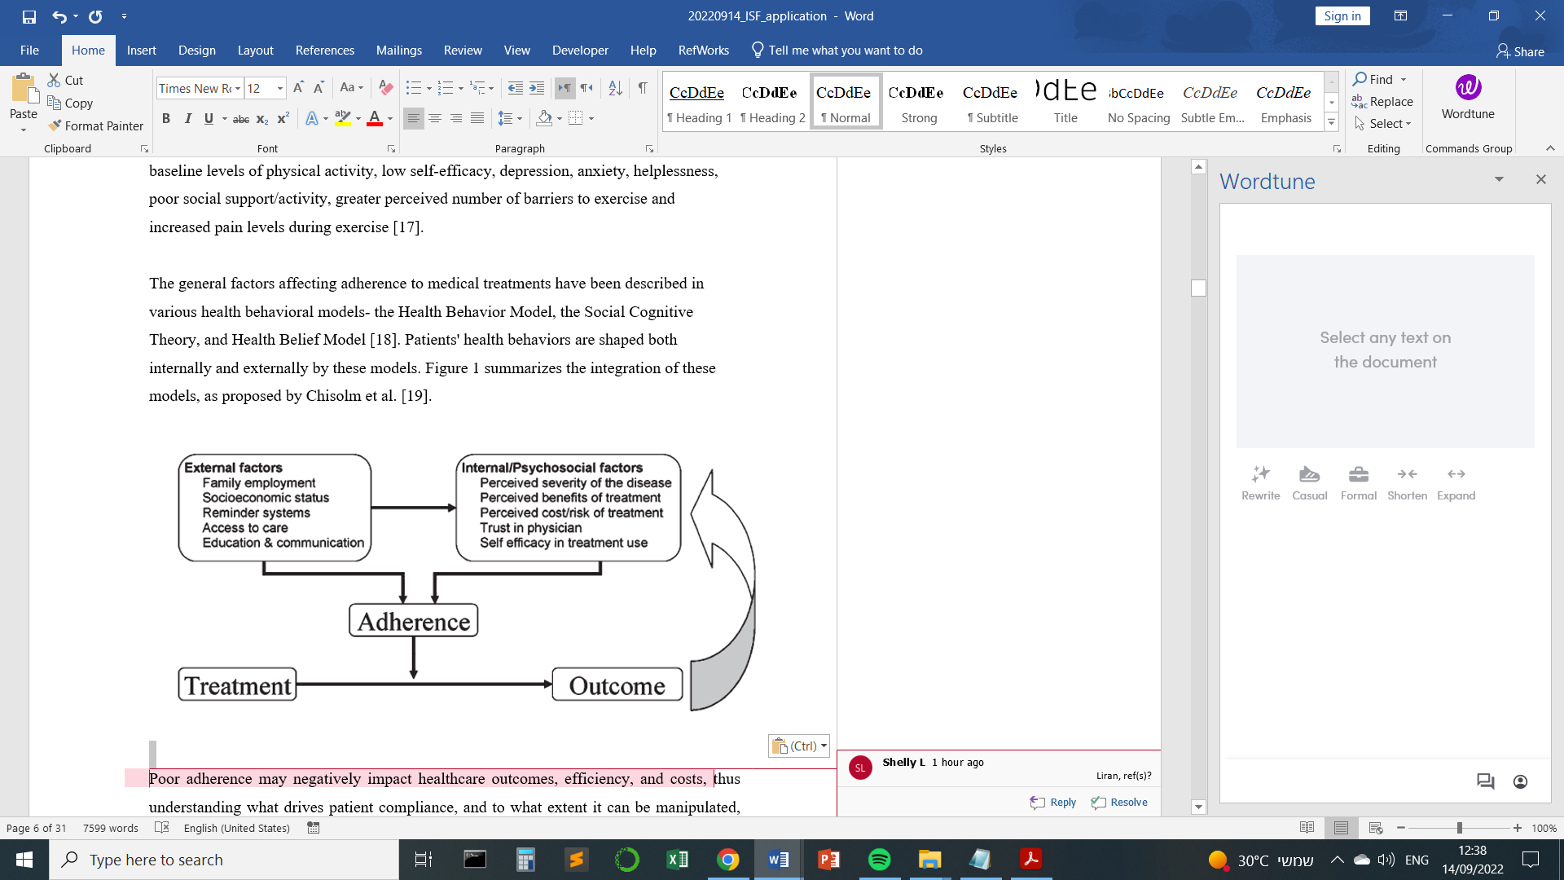

**Figure 1. The integration of adherence models in health** (Figure taken from Chisolm et al., 2010)

Poor adherence to recommended medical care negatively affects healthcare outcomes, efficiency, and costs28; thus, understanding what drives patient adherence, as well as the extent to which it can be manipulated, can provide insights into the psychological underpinnings of this aspect of human behavior, and, at the same time, serve as a basis for developing and implementing effective interventions aimed at increasing patient adherence.

Based on previous literature, we assume that adherence rates are contextual and vary based on a range of parameters21,23. Thus, a model of patient adherence should refer to the specific context of the patient and his or her treatment plan (e.g., adherence to a 4-week rehabilitation program may be different than adherence to a 12-week program). While existing models describe adherence in the context of health care in general, these models need to be updated and developed specifically in the context of VR and other domains in physiotherapy.

As a first step towards updating the existing models of patient adherence in physiotherapy, we propose to examine it in the context of VR, which is of particular interest since: (1) The rehabilitation period for most patients is usually relatively short (4–7 weeks)2; (2) vestibular disorders affect people in a wide range of ages, including children, young adults, and older adults2; (3) The exercises patients are prescribed as part of the rehabilitation scheme usually lead to great – although temporary – discomfort, including dizziness, nausea, or even vomiting2, which may further decrease adherence; (4) However, the intervention is highly effective, with strong evidence that vestibular physiotherapy provides a clear and substantial benefit to individuals with unilateral and bilateral vestibular hypofunction2. VR thus provides a useful test case for the study of patient compliance and what external factors may increase it.

**1.3 Potential significance of technological interventions**

In recent decades, there has been an increase in the development of innovative technological interventions for medical care, including the use of robots29–32. Recently, telerehabilitation platforms, including mobile phone applications, have been developed to address care gaps and increase adherence to home exercise programs in various fields of rehabilitation33–35. Phone applications have been developed for patients with neurological and orthopedic disorders to motivate and monitor exercise performance through gamification, and have been found to be beneficial36–38. Using applications developed for mobile phones thus presents an opportunity to positively impact health behaviors39.

In the context of VR, limited data are available in the literature on the effectiveness and feasibility of such technologies40. Existing evidence suggests that phone applications can serve as a useful and enjoyable platform to promote adherence to VR. However, these data were not obtained from patients with vestibular dysfunction, but from healthy participants40. Evidence also suggests that since the COVID-19 pandemic, physiotherapists’ attitude to vestibular telerehabilitation has improved41. In a study published this year, more than 75% of participating physiotherapists said they felt comfortable treating vestibular dysfunction resulting from both peripheral and central disorders and 80% said that telerehabilitation is an effective platform for vestibular rehabilitation41.

Considering the widespread use of smartphones, telerehabilitation using phone applications may be a simple, yet promising option, for promoting adherence to VR. Before that is possible to develop and deploy, a comprehensive understanding of patients’ barriers and facilitators to vestibular rehabilitation is needed in order to implement insights from the primary stakeholders in the vestibular care chain (i.e., patients and physiotherapists) in the development of such technologies.

Our goal is to create an updated model of patient adherence, using VR as a test case. Our working hypothesis is that by identifying the main facilitators and barriers – as described by the primary stakeholders (patients and physiotherapists) – and implementing those in a phone application to be used by these stakeholders, we will be able not only to improve adherence, and in so doing, improve patients’ functional recovery, but also to construct an updated model of patient adherence.

**2. Research objectives & expected significance**

**2.1 Study aims**

The first overarching goal of this study is to identify the barriers and facilitators underlying patient adherence in the context of VR. The second is to test whether manipulation of these factors using technology can improve adherence rates such that a context-specific model of patient compliance can be constructed. Third, is to evaluate the efficacy of this approach in terms of improvement in rehabilitation outcomes. To achieve these goals, our **specific aims** are:

**Aim 1:** To identify the main barriers to and facilitators of adhering to prescribed home-based VR exercises, as related by patients with vestibular disorders and by vestibular physiotherapists in focus groups (**phase 1**);

**Aim 2:** To incorporate elements based on the barriers and facilitators identified in the focus groups in phase 1 into the development and design of a novel phone application (version 1.0) to assist patients with home-based VR (**phase 2**);

**Aim 3:** To test the feasibility of the resulting phone app in a pilot feasibility study with patients with vestibular dysfunction and vestibular physiotherapists (**phase 3**), and, based on these results, to update the phone application accordingly (version 2.0; **phase 4**);

**Aim 4:** To test whether the resulting, novel vestibular-rehabilitation phone application increases patient adherence to vestibular home exercises and improves rehabilitation outcomes, by conducting a randomized controlled trial (**phase 5**).

**2.2 Novelty & expected significance** There is currently no comprehensive account of the factors affecting adherence in VR. This will be the first study, to the best of our knowledge, to directly ask the primary stakeholders in the vestibular care chain – VR patients and physiotherapists – about the specific barriers and facilitators of patient adherence to their rehabilitation process as well as about their specific needs from technology for VR rehabilitation. While performing VR exercises, patients with vestibular disorders experience symptoms that are unique to them2, such as dizziness and nausea, which is why we should **modify the technology** **to meet the specific needs of these patients**. Although there are technologies available to improve adherence in other areas of physiotherapy, this will be the first study to implement a dedicated phone application designed to address the specific barriers and facilitators in VR and to test, using a randomized controlled trial, the effectiveness and feasibility of this approach. The proposed study will have both fundamental and applicative implications. Not only will it add to our understanding of the factors underlying human adherence, it will also serve as a resource for other researchers working to understand adherence in health care, as well as for those developing technological tools to help individuals adhere to rehabilitation programs. Overall, adherence is not a standalone concept, but rather the means of **improving clinical outcomes and quality of life** for those who suffer from dizziness. Additionally, opportunities for home-based care became increasingly necessary during the recent pandemic when healthcare systems responded by making home-based care more widely available via telehealth. This trend seems likely to be permanent and may help to increase patient confidence with other home-based technologies as well42–46. It is thus essential to have **an updated, validated model of patient adherence**. While the information collected in this study will be specific to the VR patient population, we expect it will also provide insights about patient adherence and how it can be improved more generally, which can then be used by a wider range of researchers and physiotherapists. We further hope that this bottom-up approach, eliciting knowledge directly from patients and clinicians, will inspire others to increasingly initiate design processes that ask end users about their specific needs and concerns – an approach that caters to the specific needs of patients and avoids expenditure of resources on less fruitful directions.

**3. Detailed research plan**

**3.1 Research design, methods, expected outcomes & preliminary results**

**Aim 1/Phase 1 – Stakeholder input (estimated time – 3 months)**: This qualitative phase of the research will be designed to identify the main barriers and facilitators to performing VR exercises at home. It will rely on focus group discussions with 20 vestibular physiotherapists and 20 patients with vestibular dysfunction. There will be three single-session focus groups per population (for a total of six sessions overall). **(1)** **The physiotherapist focus groups** will include those who currently assess and treat patients with vestibular disorders. They will be recruited via a direct approach through colleagues and with the assistance of social media (e.g., physiotherapists’ Facebook groups). **(2) The patient focus groups** will include those diagnosed with any peripheral or central vestibular disorder that can benefit from VR. We intend to recruit men and women with a wide range of vestibular disorders in order to enhance the external validity of this study- individuals who are currently engaged in VR as well as those who have participated in VR in the past. Patients with vestibular dysfunction will be recruited from Dr. Yoav Gimmon’s “Dizziness Clinic” at the Ear, Nose and Throat (ENT) Department of Sheba Medical Center. All participants will be asked to provide their written informed consent to participate in the study. Based on related research47–50, each 90-minute focus group will be conducted at the Sheba Medical Center. Each focus group will include 5**–**10 participants and recruitment will continue until data saturation is reached51,52. The number of focus groups and the number of participants in each group was estimated based on recommendations from previous studies, with over-recruitment of 10**–**25% of participants in each focus group, considering potential non-attenders51,52. The moderator of the groups will be a PhD student (Liran Kalderon), a physical therapist, who will be assisted by an observer from the research team (Shelly Levy-Tzedek, Yoav Gimmon or Yuliya Berdichevsky). All sessions will be audio- and video-taped for further analysis, and notes will be written during the sessions by the observer from the research team.

At the beginning of each session, the moderator will present the aims of the focus groups, followed by structured questions to elicit discussion about the barriers and facilitators for home exercise, and the needs/requirements of technology in VR **(see Table 1)**. Each question will be available in multiple versions to acquire additional ideas from the participants. To ensure that everyone who wishes to contribute does indeed participate, the moderator may turn to participants who have not participated in the discussion and ask them if they are interested in providing their response to the questions.

|  |  |
| --- | --- |
| **Table 1: Structured questions for the focus groups discussions** | |
| **Q.1** | *What are the three main* ***barriers/limitations*** *that prevent you from regularly performing the rehabilitation exercises as prescribed*? |
| **Q.2** | *What are the three main* ***facilitators*** *that help/encourage/motivate you to do your rehabilitation exercises and adhere to the prescribed rehabilitation program*? |
| **Q.3** | *How can* ***technology*** *help overcome barriers/limitations of adherence to do vestibular rehabilitation exercises?* |
| *In the physiotherapists’ groups, instead of referring “you” / “your,” the questions will refer to “your patients” | |

The information from the audio and video files will be transcribed. We will perform a thematic analysis of the transcripts, using ATLAS.ti (version 22) software, to systematically categorize the data into common emerging themes across sessions and participants53,54.

**Aim 1 – Expected outcomes** include a detailed description and analysis of the factors affecting adherence, as described by VR patients and physiotherapists; and, a comparison between patients’ and clinicians’ views which will be used to inform physical therapy practice. It is our intention to incorporate these factors into the integrated adherence model in health27 (**Figure 1**) and categorize them as either external or internal factors.

**Aim 1 – Preliminary results**

|  |  |
| --- | --- |
|  | |
| **Table 2: Demographics and work background of the physiotherapists’ focus group (N=21)** | |
| **Age** (years)1 | 45 ± 9 |
| **Gender** (women%)2 | 14 (68) |
| **Years of experience as physiotherapists** 1 | 18 [7-35] |
| 1Mean ± S.D; 2count (%); 3median [min-max] | |

To date, we have conducted three focus groups with vestibular physiotherapists, and have recently obtained the approval of the Institutional Review Board of Sheba Medical Center to recruit patients with vestibular disorders for this study. **Table 2** summarizes the demographics and years of experience of the participants in this group. **Figure 2** summarizes the main barriers and **Figure 3** the primary facilitators to performing home vestibular physiotherapy exercises reported by participants.

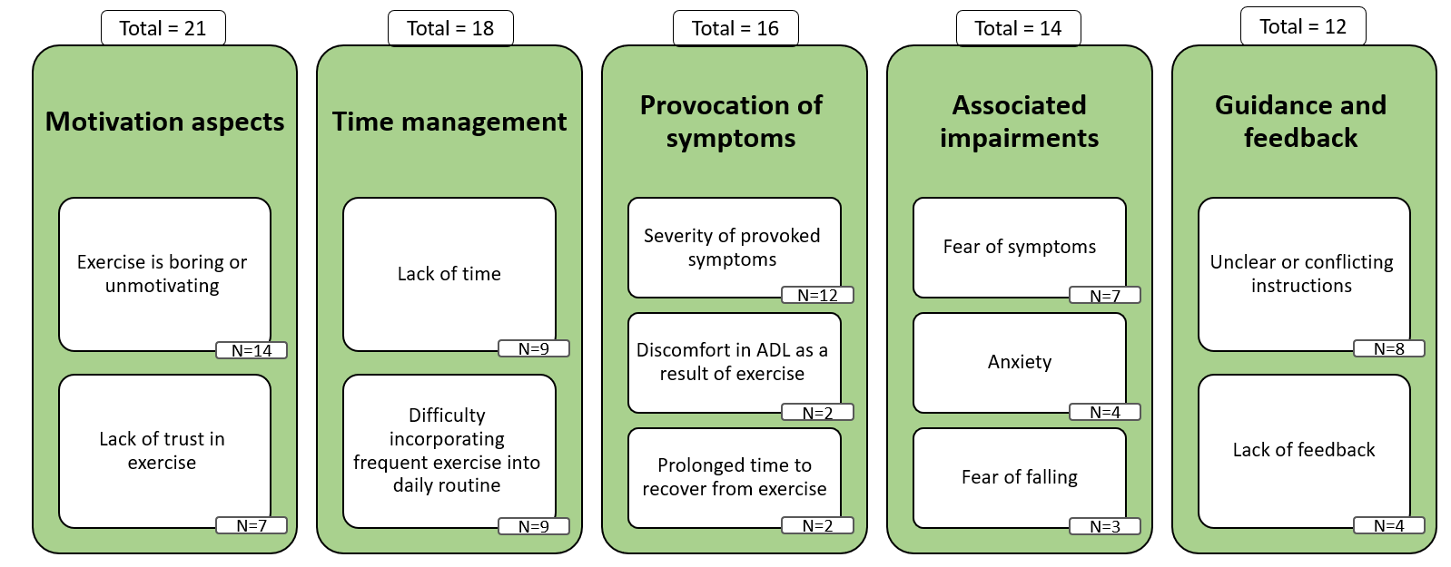

**Figure 2**. **The main *barriers* to performing home vestibular physiotherapy exercises as perceived by vestibular physiotherapists (N represents the number of utterances).**

The main **barriers** were related to motivational aspects, time management, the provocation (triggering) of symptoms experienced by patients in response to exercise, associated impairments and a need for feedback and guidance. The main **facilitators** were related to different strategies for exercise time management, motivational aspects and exercise explanations/instructions (patient education). **Figure 4** summarizes the primary needs for technology to be used for VR, as perceived by physiotherapists.

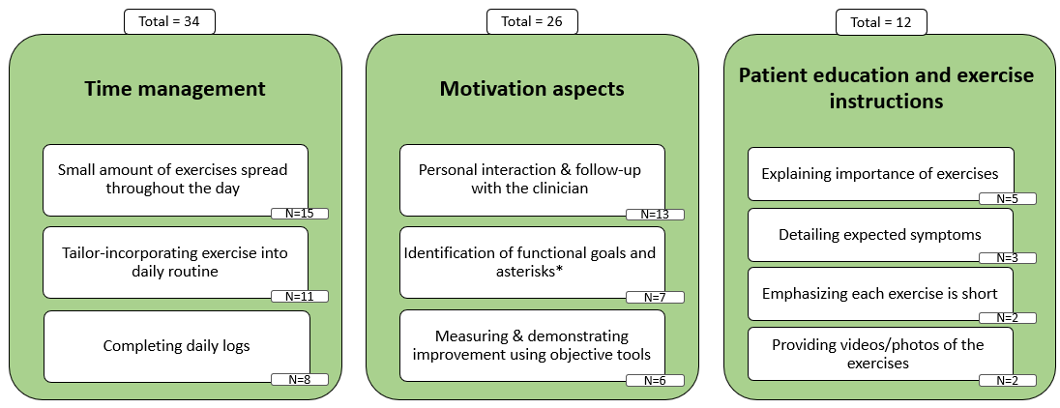**Figure 3. The main *facilitators* for performing home vestibular physiotherapy exercises as perceived by vestibular physiotherapists (N represents the number of utterances). *Asterisks are measurable, reproducible clinical indicators used for the reassessment of patient progress.**

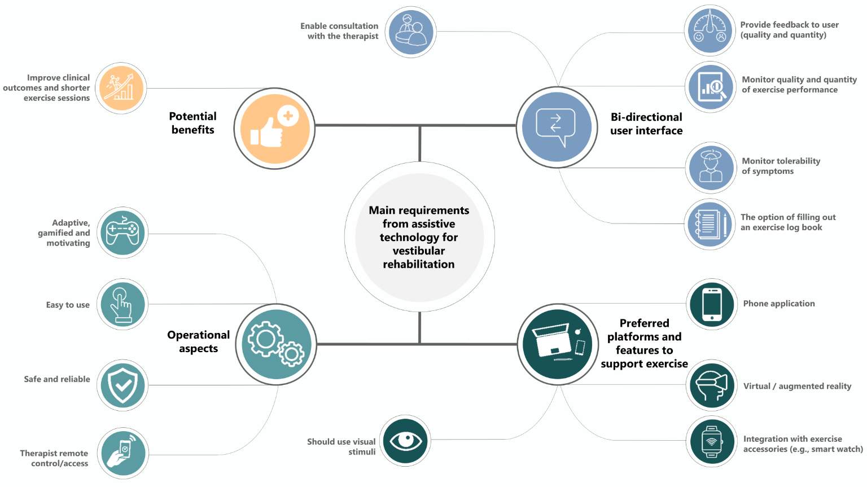

**Figure 4. the primary needs for technology to be used for VR, as perceived by physiotherapists.**

The main needs related to technology included operational aspects (mainly easiness of use), suggestions for different platforms (mainly phone apps), potential benefits (improved clinical outcomes and short exercise sessions), and user interface qualities that provide feedback and monitor exercise performance.

**Aim 2/Phase 2 – Development of phone application version 1.0 (estimated time – 8 months)**. Based on the analysis of the focus group study’s qualitative data from Phase 1, we will develop version 1.0 of a phone application for Android and iOS platforms to meet the primary needs of both physiotherapists and patients, while considering the technology acceptance models55,56 and the adherence models in health27. As a concept, the app will enable both the therapist and the patient: (1) continuous communication with each other; (2) follow-ups and monitoring of exercise performance. The app will aim to optimize the VR process by overcoming specific barriers related to compliance and adherence for self-exercise at home. Furthermore, it will allow the physiotherapists to remotely adjust the treatment program, e.g., adding or removing exercises or modifying the exercise dose and difficulty level. The app will include commonly prescribed exercise programs used in vestibular physiotherapy, a metronome for pacing the movements, as well as reminders for exercises and monitoring of exercise performance. It is also planned that the app will enable physiotherapists to monitor and follow-up on patients’ adherence to home exercise, as well as track symptom provocation as a result of exercising. We have hired the services of an application developer, and have designed a conceptual basis for the phone application based on preliminary results from Phase 1. We will conduct repetitive rounds of testing the app with our multidisciplinary lab team members, who have different backgrounds (physiotherapy, engineering, computer science, psychology, UX/UI). The app will be following the regulatory demands in Israel and all the competent authorities, and we have already begun the process with Sheba Medical Center.

**Aim 2 – Expected outcome** is a working prototype (version 1.0) of the novel phone application.

**Aim 3/Phases 3 and 4 – Pilot Feasibility study (estimated time – 10 months) and Updating phone app to version 2.0 (estimated time: 7 months).** In Phase 3, we will evaluate the feasibility of the phone application developed in Phase 2 as an assistive technology tool. We will recruit five experienced vestibular physiotherapists and ten patients with vestibular dysfunction who will be asked to use version 1.0 of the novel phone application for 2**–**6 weeks, which is the standard range for VR2,57. After this time period, we will collect and analyze qualitative and quantitative data on user experience with a structured online questionnaire and the User Satisfaction Evaluation Questionnaire (USEQ)58. Additional quantitative data on adherence to home exercise will be extracted from users’ phone application database, which include the frequency of the different exercises prescribed to patients throughout the days and weeks, and the level of difficulty of each exercise, as reported by patients. The structured online questionnaire will include the questions listed in **Table 3**.

We plan to evaluate the results in accordance with the Technology Acceptance Models55,56. Based on the analysis of the information collected from vestibular patients and physiotherapists in **Phase 3**, in **Phase 4** we will develop version 2.0 of the phone application for Android and iOS platforms.

**Aim 3 – Expected outcomes** include a detailed evaluation of the usability, benefits, and drawbacks of the phone-application prototype by patients and physiotherapists that will be used to develop version 2.0 of the application; and version 2.0 of the application.

|  |  |
| --- | --- |
| **Table 3: Questions to be included in the online questionnaire** | |
| Q.1 | What did you like most about the mobile application? |
| Q.2 | What did you like the least about the mobile application? |
| Q.3 | Which feature did you use the most? |
| Q.4 | Are there any features that you think you need but are missing in the mobile application? |
| Q.5 | How was the navigation (moving between screens) and convenience of the mobile application? |
| Q.6 | What were your goals when you used the mobile application? |
| Q.7 | With the existing features, did the mobile application help you to achieve your goals? How? |
| Q.8 | Describe a situation which the mobile application was the most useful to you. |
| Q.9 | On a scale of 1 to 5, how likely do you think you would benefit from the mobile application? |
| Q.10 | On a scale of 1 to 5, how likely do you think others would benefit from the mobile application? |
| Q.11 | On a scale of 1 to 5, rate your experience using the mobile application. |
| Q.12 | On a scale of 1 to 5, rate the interface of the mobile application. |
| Q.13 | On a scale of 1 to 5, rate the intuitiveness of using the application. |
| Q.14 | On a scale of 1 to 5, rate the loading speed of the mobile application. |
| Q.15 | How do you think the mobile application can be improved? |

**Aim 4/Phase 5 – Testing efficacy for improving adherence rates and rehabilitation outcomes (estimated time: 20 months)**.In **Phase 5**, a randomized control trial (RCT) will evaluate whether using the phone application developed in Phase 2, tested in Phase 3, and updated in Phase 4, indeed increases adherence rates and improves rehabilitation outcomes compared to standard care. We will recruit four experienced vestibular physiotherapists and 24 patients with vestibular dysfunction. There will be 12 patients in each group - intervention or control. We used the PS Power and Sample Size Calculation software (version 3.0) to calculate the sample size from the ratio variable Timed Up and Go (TUG), from both independent control and experimental groups, as well as normative data of 5.72 seconds for patients with unilateral vestibular hypofunction59. When calculating the sample size we considered potential drop-outs60, power of 80%, and type I error probability of 5%. Inclusion criteria: (1) Individuals aged 18 and over; (2) diagnosis with any vestibular disorder that requires a VR exercise program; (3) physical and cognitive ability to perform VR, without further neurological disorder (except for hearing loss). Exclusion criteria: (1) patients with a physical disability that does not allow for the performance of VR; (2) patients who are not qualified to give informed consent; (3) patients with central nervous system (CNS) disease affecting balance; (4) patients undergoing additional physiotherapy interventions during the study period. The patients will be randomly assigned to the intervention (VR with phone application) or the control group (standard VR care). The participants in the intervention group will be asked to use version 2.0 of the novel phone application for five weeks, within the standard range for VR2,57. Participants in the control group will be asked to keep a log documenting which exercises they performed, when and for how long, and any symptoms they experienced during practice over a five-week period2,57. Physiotherapists will be asked to monitor patients' exercise regimen weekly using their phone app and to interact (through the app) with patients who do not exercise enough or to modify their exercise program based on the difficulties reported by patients. We will collect and analyze data to evaluate:

(1) **Rehabilitation outcomes**: (a) symptoms severity (dizziness, postural stability, gaze stability, nausea) using Visual Analogue Scales61 and two questionnaires – The Hebrew version of the Dizziness Handicap Inventory (DHI)62,63 and the Activities-specific Balance Confidence Scale (ABC)64,65; (b) functional tests to asses gait and balance, using the Timed Up and Go (TUG) Test66,67, 10-Meters Walk Test (10MWT)68, 2-Minute Walk Test (2MWT)69 and the Dynamic Gait Index (DGI)61; (c) physiological tests to assess the function of the vestibular system, using the Computerized Dynamic Visual Acuity (DVA)70, Video Head Impulse Test (vHIT)71 and Video-Nystagmography (VNG)72. We will collect rehabilitation measures from all patients at three time points- baseline evaluation (beginning of study), after five weeks of VR (rehabilitation period), and one month after the VR period (follow-up). The examiner will be blinded for all of these tests.

(2) **Adherence measures**: In the intervention group quantitative data will be extracted from users' phone application database, and will include the frequency of the different exercises prescribed to patients throughout the days and weeks, and the level of difficulty of each exercise, as reported by patients. The control group will record similar measures in a diary. Adherence measures will be collected throughout the five-week period of VR.

In addition, we will collect feedback from physiotherapists regarding the use of the app in their daily routines for the purpose of understanding their willingness to adopt or use the app.**Statistical analysis:** we will use the Shapiro-Wilk and the Kolmagorov-Smirnoff tests to assess normality distribution of ratio variables. Between groups analysis: for nominal scale variables we will use the Chi-squared analysis of contingency table; for ratio variables that are not normally distributed and ordinal scale variables we will use the Mann-Whitney test; for ratio variables that are normally distributed we will use the independent student's t-test. Within groups analysis: for nominal scale variables we will use the Chi-squared analysis of contingency table; for ratio variables that are not normally distributed and ordinal scale variables we will use the Kruskal-Wallis statistic and the Wilcoxon signed rank test to compare differences between pairs; for ratio variables that are normally distributed we will use the Analysis of Variance (ANOVA) and the student's paired t-test to compare differences between pairs. Post-hoc analysis will be done with the Bonferroni correction. We will also asses the association between adherence measures and rehabilitation outcomes with the Spearman and Pearson correlation coefficients depending on the types of the variables. Data analyses will be performed with the SPSS software (version 29). Statistical significance will be considered for p-values<0.05.

**Aim 4 – Expected outcomes** of a quantitative analysis of the benefit of using the phone application should be increased adherence and improved rehabilitation outcomes. Should adherence rates and rehabilitation outcomes be better in the intervention group, it will be possible to draw conclusions regarding factors that affect patient adherence in VR. We will then create an updated model of patient adherence which is specifically adapted for the VR population. Taking these conclusions into account will help us understand the relationship between adherence, treatment, and rehabilitation outcome measures in the integrated adherence model in health27 (**Figure 1**), as we will examine all three in the RCT. It can then be tested in future experiments in other contexts (different medical conditions, exercise in health, etc.), adding building blocks to the model of human adherence, with a focus on patient adherence.

**3.2 Overall plan and time frame**

**Summary – schematic representation of the study plan & timelines**

**3.3 Summary of expected outcomes & significance**

**Expected outcomes**.We expect to establish which factors are perceived by patients and physiotherapists as affecting adherence, to build a model based on their input, informed by existing models of adherence, and to test this model in a randomized controlled trial. We will do this in the context of VR, which offers a useful test case for the study of adherence. We will collect and report the specific factors that are perceived as facilitators and as barriers to VR practice, as well as the similarities and differences between the stakeholder groups. When reporting the results, we will follow the *consolidated criteria for reporting qualitative research* (COREQ) reporting guidelines54,73,74.**This study will have important implications for**: (1) **Theory** on the underpinnings of compliance, by developing a model of factors that contribute to patient adherence in the context of VR; **Preliminary results (Phase 1) already revealed barriers that are not part of existing models**, and are related to the provocation of symptoms, fear, anxiety, time management, motivational aspects, and a need for feedback and guidance; facilitators related to strategies for time management, motivational and feedback factors and exercise explanations/instructions; technology needs related to operational aspects, platforms (mainly phone app) and user interface qualities that will provide input and monitor exercise performance. (2) **Patients** who need to maintain an intensive training regimen in order to be able to fully participate in activities of daily life; (3) **Physiotherapists**, who will be able to use the updated model of patient compliance to provide better care for their patients; and (4) **The healthcare system**, which struggles to provide the care needed, and would benefit from increased adherence rates. Lastly, we hope to inspire a broader use of the participatory-design approach when studying, designing, and testing technological interventions for specialized population groups.

**Significance.** Motivation and adherence likely depend on a variety of factors, including the specific context of the task. Identifying the factors that lead to higher adherence in the context of rehabilitation exercises will contribute to creating a versatile model of human compliance across contexts, building on previous data on compliance in other contexts. Moreover, as an associated benefit of the study of compliance, the successful implementation of the novel tailor-made telerehabilitation platform for VR will help achieve quicker access to rehabilitation, shorter wait periods for rehabilitative care, fewer days of lost work and a quicker rehabilitation process for vestibular patients.

**4. Available resources & expertise**

The PI Shelly Levy-Tzedek has extensive (>19 years) experience in running and analyzing results from behavioral studies in healthy and impaired individuals75,76. The Levy-Tzedek laboratory at Ben-Gurion University (BGU) of the Negev, established in 2014, has been studying the use of technology **–** such as robotics and computer-based interventions **–** in a variety of assistive contexts, including stroke and Parkinson’s disease. The team has also successfully developed technologies for medical applications. The PI was previously awarded an ISF grant and successfully completed all aims listed in the application, culminating in the publication of the results. The lab team that will work on this project has been successfully applying the participatory-design approach, using focus groups and interviews, in the context of rehabilitation and has published four journal articles using this approach to date. The lab team work is multidisciplinary as team members have different backgrounds (physiotherapy, engineering, computer science, psychology, UX/UI). The lab currently includes one PhD student, four MSc students, one 4th-year undergraduate engineering student, and a part-time laboratory technician who provides technical assistance, as well as software and administrative support. An additional PhD student in Physical Therapy and an MSc student with a clinical background will be recruited to work on this project. The laboratory possesses all the equipment necessary to complete Phase 1 of the proposed research. We have also hired an app developer to design the mobile phone app in Phases 2 and 4. The PI Dr. Yoav Gimmon is a leading research clinician of the vestibular system77–80. He established and serves as the head of the National Vestibular Center at Sheba Medical Center and established the Gimmon laboratory at the University of Haifa. At the Vestibular Center and his lab, residents and students are collaborating on several clinical trials aimed at improving vestibular treatments and diagnostic accuracy, as well achieving a better understanding of the underlying mechanism of vestibular adaptation.Prof. Levy-Tzedek and Dr. Gimmon have an ongoing two-year collaboration, which lay the foundations for this proposal. Together, they jointly supervise a PhD student, a physical therapist with eight years of experience who specializes in vestibular disorders, and an MSc student in Physical Therapy. Further support for this project will be given by Dr. Amit Wolfovitz, a board-certified otolaryngologist from the Sheba Medical Center (see letter of support). The team has access to the services of a biostatistician through the university for the analysis and interpretation of results.

**5. Possible pitfalls and contingency plan**

We estimate the risk of the proposed work to be low, thanks to the interdisciplinary background of the research team that will be dedicated to this project, the experience of Prof. Shelly Levy-Tzedek in the proposed methodology47–50,75,81,82 and the experience of Dr. Yoav Gimmon in the field of VR57,77–80,83–87, as well as his access to patients and physiotherapists as part of his work as the director of the national vestibular center at the Sheba Medical Center. However, four main issues may arise that would require amendments to the protocol. **First**, it could be a concern that the availability of physiotherapists may be limited. There are three reasons why we believe this will not hamper the progress of this proposed research: (1) Dr. Yoav Gimmon (one of the PIs) is an experienced clinician in the field of VR and heads the Dizziness clinic within the ENT department of the Sheba Medical Center. His strong network of colleagues can thus serve as a basis for recruiting physiotherapists in other medical institutions. (2) The research team already successfully recruited 21 physiotherapists in to the three focus-group discussions. **Second**, if vestibular patients are unwilling to share their experience in a group setting, we will instead conduct structured *individual* interviews, in lieu of focus groups. **Third**, patients and physiotherapists recruited into the pilot study and the RCT may be worried about privacy issues when installing the application on their phones. To reassure them, we will use a secure server with password-protected access to the data, which only the research team can access. In addition, all data will be anonymized and removed from the server upon completion of the data collection. **Fourth**, Participation in this study is voluntary. Therefore, there may be population groups within the two stakeholder groups that will not be represented in the focus groups. To address this possible pitfall, we will make every effort to recruit a diverse set of participants from diverse geographical regions across the country, from a variety of socioeconomic backgrounds, as we aim to get as full a representation of the relevant stakeholders as possible. **Finally**, the professional context in which recruited physiotherapists work (e.g., working in a central rehabilitation facility vs. a private clinic in the periphery) and their relative numbers in the groups, may affect the content of the focus group discussions. We will address this by endeavoring to recruit as balanced a sample of physiotherapists as possible.

**References**

1. Agrawal Y, Carey JP, Della Santina CC, Schubert MC, Minor LB. Disorders of balance and vestibular function in US adults: data from the National Health and Nutrition Examination Survey, 2001-2004. *Arch Intern Med*. 2009;169(10):938-944. doi:10.1001/archinternmed.2009.66

2. Hall CD, Herdman SJ, Whitney SL, et al. Vestibular Rehabilitation for Peripheral Vestibular Hypofunction: An Updated Clinical Practice Guideline From the Academy of Neurologic Physical Therapy of the American Physical Therapy Association. *J Neurol Phys Ther*. 2022;46(2):118-177. doi:10.1097/NPT.0000000000000382

3. Sun DQ, Ward BK, Semenov YR, Carey JP, Della Santina CC. Bilateral Vestibular Deficiency: Quality of Life and Economic Implications. *JAMA Otolaryngol Neck Surg*. 2014;140(6):527-534. doi:10.1001/jamaoto.2014.490

4. Lempert T, Bronstein A. Management of common central vestibular disorders. *Curr Opin Otolaryngol Head Neck Surg*. 2010;18(5):436-440. doi:10.1097/MOO.0b013e32833dbd69

5. Neuhauser HK, Radtke A, Brevern M von, et al. Migrainous vertigo: Prevalence and impact on quality of life. *Neurology*. 2006;67(6):1028-1033. doi:10.1212/01.wnl.0000237539.09942.06

6. Sekitani T, Imate Y, Noguchi T, Inokuma T. Vestibular Neuronitis: Epidemiological Survey by Questionnaire in Japan. *Acta Otolaryngol (Stockh)*. 1993;113(sup503):9-12. doi:10.3109/00016489309128061

7. Brevern M von, Radtke A, Lezius F, et al. Epidemiology of benign paroxysmal positional vertigo: a population based study. *J Neurol Neurosurg Psychiatry*. 2007;78(7):710-715. doi:10.1136/jnnp.2006.100420

8. Ward BK, Agrawal Y, Hoffman HJ, Carey JP, Della Santina CC. Prevalence and Impact of Bilateral Vestibular Hypofunction: Results From the 2008 US National Health Interview Survey. *JAMA Otolaryngol Neck Surg*. 2013;139(8):803-810. doi:10.1001/jamaoto.2013.3913

9. Shupak A, Nachum Z, Stern Y, Tal D, Gil A, Gordon CR. Vestibular Neuronitis in Pilots: Follow-up Results and Implications for Flight Safety. *The Laryngoscope*. 2003;113(2):316-321. doi:10.1097/00005537-200302000-00022

10. McDonnell MN, Hillier SL. Vestibular rehabilitation for unilateral peripheral vestibular dysfunction. *Cochrane Database Syst Rev*. 2015;(1). doi:10.1002/14651858.CD005397.pub4

11. Grill E, Heuberger M, Strobl R, et al. Prevalence, Determinants, and Consequences of Vestibular Hypofunction. Results From the KORA-FF4 Survey. *Front Neurol*. 2018;9. Accessed October 30, 2022. https://www.frontiersin.org/articles/10.3389/fneur.2018.01076

12. Lee SU, Park SH, Kim HJ, Koo JW, Kim JS. Normal Caloric Responses during Acute Phase of Vestibular Neuritis. *J Clin Neurol*. 2016;12(3):301-307. doi:10.3988/jcn.2016.12.3.301

13. Zingler VC, Weintz E, Jahn K, et al. Causative Factors, Epidemiology, and Follow-up of Bilateral Vestibulopathy. *Ann N Y Acad Sci*. 2009;1164(1):505-508. doi:10.1111/j.1749-6632.2009.03765.x

14. Herdman SJ, Clendaniel R. *Vestibular Rehabilitation*. F.A. Davis; 2014.

15. Brown KE, Whitney SL, Wrisley DM, Furman JM. Physical Therapy Outcomes for Persons With Bilateral Vestibular Loss. *The Laryngoscope*. 2001;111(10):1812-1817. doi:10.1097/00005537-200110000-00027

16. Klatt B, Carender W, Lin C, et al. A Conceptual Framework for the Progression of Balance Exercises in Persons with Balance and Vestibular Disorders. *Phys Med Rehabil Int*. 2015;2(4):1044.

17. Herdman SJ, Schubert MC, Das VE, Tusa RJ. Recovery of dynamic visual acuity in unilateral vestibular hypofunction. *Arch Otolaryngol Head Neck Surg*. 2003;129(8):819-824. doi:10.1001/archotol.129.8.819

18. Vermeire E, Hearnshaw H, Van Royen P, Denekens J. Patient adherence to treatment: three decades of research. A comprehensive review. *J Clin Pharm Ther*. 2001;26(5):331-342. doi:10.1046/j.1365-2710.2001.00363.x

19. Haynes RB, Taylor DW, Sackett DL. Compliance in health care. *Johns Hopkins Univ Press‏*. Published online 1979.

20. MEICHENBAUM D, TURK DC. Facilitating, treatment adherence: a practitioner’s guidebook. *Facil Treat Adherence Pract Guideb*. 1989;21(1):116-117.

21. Bassett SF. The assessment of patient adherence to physiotherapy rehabilitation. *N Z J Physiother*. 2003;31(2):60-67.

22. Yardley L, Barker F, Muller I, et al. Clinical and cost effectiveness of booklet based vestibular rehabilitation for chronic dizziness in primary care: single blind, parallel group, pragmatic, randomised controlled trial. *BMJ*. 2012;344:e2237. doi:10.1136/bmj.e2237

23. Jack K, McLean SM, Moffett JK, Gardiner E. Barriers to treatment adherence in physiotherapy outpatient clinics: a systematic review. *Man Ther*. 2010;15(3):220-228. doi:10.1016/j.math.2009.12.004

24. Soto-Varela A, Faraldo-García A, Del-Río-Valeiras M, et al. Adherence of older people with instability in vestibular rehabilitation programmes: prediction criteria. *J Laryngol Otol*. 2017;131(3):232-238. doi:10.1017/S0022215116009932

25. Gaikwad SB, Mukherjee T, Shah PV, Ambode OI, Johnsonb EG, Daher NS. Home exercise program adherence strategies in vestibular rehabilitation: a systematic review. *Phys Ther Rehabil Sci*. 2016;5(2):53-62. doi:10.14474/ptrs.2016.5.2.53

26. Redding CA, Rossi JS, Rossi SR, Velicer WF, Prochaska JO. Health behavior models. In: *International Electronic Journal of Health Education*. Citeseer; 2000.

27. Chisolm SS, Taylor SL, Gryzwacz JG, O’Neill JL, Balkrishnan RR, Feldman SR. Health behaviour models: a framework for studying adherence in children with atopic dermatitis. *Clin Exp Dermatol*. 2010;35(3):228-232. doi:10.1111/j.1365-2230.2009.03741.x

28. Iuga AO, McGuire MJ. Adherence and health care costs. *Risk Manag Healthc Policy*. 2014;7:35-44. doi:10.2147/RMHP.S19801

29. Gonzales MJ, Riek LD. A sociable robotic aide for medication adherence. In: *Proceedings of the 5th International Conference on PErvasive Technologies Related to Assistive Environments*. PETRA ’12. Association for Computing Machinery; 2012:1-4. doi:10.1145/2413097.2413146

30. Henschel A, Laban G, Cross ES. What Makes a Robot Social? A Review of Social Robots from Science Fiction to a Home or Hospital Near You. *Curr Robot Rep*. 2021;2(1):9-19. doi:10.1007/s43154-020-00035-0

31. Šabanović S, Bennett CC, Chang WL, Huber L. PARO robot affects diverse interaction modalities in group sensory therapy for older adults with dementia. In: *2013 IEEE 13th International Conference on Rehabilitation Robotics (ICORR)*. ; 2013:1-6. doi:10.1109/ICORR.2013.6650427

32. Alves-Oliveira P, Budhiraja T, So S, Karim R, Björling E, Cakmak M. Robot-mediated interventions for youth mental health. *Des Health*. 2022;6(2):138-162. doi:10.1080/24735132.2022.2101825

33. Laver KE, Adey‐Wakeling Z, Crotty M, Lannin NA, George S, Sherrington C. Telerehabilitation services for stroke. *Cochrane Database Syst Rev*. 2020;(1). doi:10.1002/14651858.CD010255.pub3

34. Loubani K, Schreuer N, Kizony R. Telerehabilitation for Managing Daily Participation among Breast Cancer Survivors during COVID-19: A Feasibility Study. *J Clin Med*. 2022;11(4):1022. doi:10.3390/jcm11041022

35. Givon Schaham N, Vitek H, Donda N, Elbo Golan I, Buckman Z, Rand D. The Development and Feasibility of TECH: Tablet Enhancement of Cognition and Health, a Novel Cognitive Intervention for People with Mild Cognitive Impairment. *Games Health J*. 2020;9(5):346-352. doi:10.1089/g4h.2019.0157

36. Zhou X, Du M, Zhou L. Use of mobile applications in post-stroke rehabilitation: a systematic review. *Top Stroke Rehabil*. 2018;25(7):489-499. doi:10.1080/10749357.2018.1482446

37. Nussbaum R, Kelly C, Quinby E, Mac A, Parmanto B, Dicianno BE. Systematic Review of Mobile Health Applications in Rehabilitation. *Arch Phys Med Rehabil*. 2019;100(1):115-127. doi:10.1016/j.apmr.2018.07.439

38. Hou J, Yang R, Yang Y, et al. The Effectiveness and Safety of Utilizing Mobile Phone–Based Programs for Rehabilitation After Lumbar Spinal Surgery: Multicenter, Prospective Randomized Controlled Trial. *JMIR MHealth UHealth*. 2019;7(2):e10201. doi:10.2196/10201

39. Zhao J, Freeman B, Li M. Can Mobile Phone Apps Influence People’s Health Behavior Change? An Evidence Review. *J Med Internet Res*. 2016;18(11):e5692. doi:10.2196/jmir.5692

40. DSilva LJ, Skop KM, Pickle NT, et al. Use of Stakeholder Feedback to Develop an App for Vestibular Rehabilitation–Input From Clinicians and Healthy Older Adults. *Front Neurol*. 2022;13:836571. doi:10.3389/fneur.2022.836571

41. Harrell RG, Schubert MC, Oxborough S, Whitney SL. Vestibular Rehabilitation Telehealth During the SAEA-CoV-2 (COVID-19) Pandemic. *Front Neurol*. 2022;12. Accessed October 30, 2022. https://www.frontiersin.org/articles/10.3389/fneur.2021.781482

42. Bernocchi P, Bonometti F, Serlini M, et al. Telehealth and Telecare: A Real-Life Integrated Experience in the COVID-19 Pandemic. *Telemed E-Health*. 2022;28(5):720-727. doi:10.1089/tmj.2021.0181

43. Leochico CFD, Austria EMV, Espiritu AI. Global Online Interest in Telehealth, Telemedicine, Telerehabilitation, and Related Search Terms Amid the COVID-19 Pandemic: An Infodemiological Study. *Acta Med Philipp*. 2022;56(11). doi:10.47895/amp.vi0.3037

44. Gokalp H, de Folter J, Verma V, Fursse J, Jones R, Clarke M. Integrated Telehealth and Telecare for Monitoring Frail Elderly with Chronic Disease. *Telemed E-Health*. 2018;24(12):940-957. doi:10.1089/tmj.2017.0322

45. Navaz AN, Serhani MA, El Kassabi HT, Al-Qirim N, Ismail H. Trends, Technologies, and Key Challenges in Smart and Connected Healthcare. *IEEE Access*. 2021;9:74044-74067. doi:10.1109/ACCESS.2021.3079217

46. Shah DA, Sall D, Peng W, Sharer R, Essary AC, Radhakrishnan P. Exploring the role of telehealth in providing equitable healthcare to the vulnerable patient population during COVID-19. *J Telemed Telecare*. Published online July 14, 2022:1357633X221113711. doi:10.1177/1357633X221113711

47. Fruchter D, Feingold Polak R, Berman S, Levy-Tzedek S. Hierarchy in Algorithm-Based Feedback to Patients Working With a Robotic Rehabilitation System: Toward User-Experience Optimization. *IEEE Trans Hum-Mach Syst*. 2022;52(5):907-917. doi:10.1109/THMS.2022.3170831

48. Dembovski A, Amitai Y, Levy-Tzedek S. A Socially Assistive Robot for Stroke Patients: Acceptance, Needs, and Concerns of Patients and Informal Caregivers. *Front Rehabil Sci*. 2022;2. Accessed October 30, 2022. https://www.frontiersin.org/articles/10.3389/fresc.2021.793233

49. Bar-On I, Mayo G, Levy-Tzedek S. Socially Assistive Robots for Parkinson’s Disease: Needs, Attitudes and Specific Applications as Identified by Healthcare Professionals. *Trans Hum-Robot Interact*. Published online 2022.

50. Feingold Polak R, Tzedek SL. Social Robot for Rehabilitation: Expert Clinicians and Post-Stroke Patients’ Evaluation Following a Long-Term Intervention. In: *Proceedings of the 2020 ACM/IEEE International Conference on Human-Robot Interaction*. HRI ’20. Association for Computing Machinery; 2020:151-160. doi:10.1145/3319502.3374797

51. Guest G, Namey E, McKenna K. How Many Focus Groups Are Enough? Building an Evidence Base for Nonprobability Sample Sizes. *Field Methods*. 2017;29(1):3-22. doi:10.1177/1525822X16639015

52. Hennink MM, Kaiser BN, Weber MB. What Influences Saturation? Estimating Sample Sizes in Focus Group Research. *Qual Health Res*. 2019;29(10):1483-1496. doi:10.1177/1049732318821692

53. Rabiee F. Focus-group interview and data analysis. *Proc Nutr Soc*. 2004;63(4):655-660. doi:10.1079/pns2004399

54. Braun V, Clarke V. Using thematic analysis in psychology. *Qual Res Psychol*. 2006;3(2):77-101. doi:10.1191/1478088706qp063oa

55. Davis FD. *A Technology Acceptance Model for Empirically Testing New End-User Information Systems: Theory and Results*. PhD Thesis. Massachusetts Institute of Technology; 1985.

56. Venkatesh V, Morris MG, Davis GB, Davis FD. User Acceptance of Information Technology: Toward a Unified View. *MIS Q*. 2003;27(3):425-478. doi:10.2307/30036540

57. Millar JL, Gimmon Y, Roberts D, Schubert MC. Improvement After Vestibular Rehabilitation Not Explained by Improved Passive VOR Gain. *Front Neurol*. 2020;11. Accessed October 30, 2022. https://www.frontiersin.org/articles/10.3389/fneur.2020.00079

58. Gil-Gómez JA, Manzano-Hernández P, Albiol-Pérez S, Aula-Valero C, Gil-Gómez H, Lozano-Quilis JA. USEQ: A Short Questionnaire for Satisfaction Evaluation of Virtual Rehabilitation Systems. *Sensors*. 2017;17(7):1589. doi:10.3390/s17071589

59. Gill-Body KM, Beninato M, Krebs DE. Relationship among balance impairments, functional performance, and disability in people with peripheral vestibular hypofunction. *Phys Ther*. 2000;80(8):748-758.

60. Ricci NA, Aratani MC, Caovilla HH, Ganança FF. Challenges in conducting a randomized clinical trial of older people with chronic dizziness: Before, during and after vestibular rehabilitation. *Contemp Clin Trials*. 2015;40:26-34. doi:10.1016/j.cct.2014.11.002

61. Hall CD, Herdman SJ. Reliability of Clinical Measures Used to with Peripheral Vestibular Disorders. *J Neurol Phys Ther*. 2006;30(2):74-81. doi:10.1097/01.NPT.0000282571.55673.ed

62. Kaplan DM, Friger M, Racover NK, Peleg A, Kraus M, Puterman M. The Hebrew dizziness handicap inventory. *Harefuah*. 2010;149(11):697-700, 750, 749.

63. Mutlu B, Serbetcioglu B. Discussion of the dizziness handicap inventory. *J Vestib Res*. 2013;23(6):271-277. doi:10.3233/VES-130488

64. Whitney SL, Hudak MT, Marchetti GF. The activities-specific balance confidence scale and the dizziness handicap inventory: a comparison. *J Vestib Res*. 1999;9(4):253-259. doi:10.3233/VES-1999-9402

65. Legters K, Whitney SL, Porter R, Buczek F. The relationship between the activities-specific Balance Confidence Scale and the Dynamic Gait Index in peripheral vestibular dysfunction. *Physiother Res Int*. 2005;10(1):10-22. doi:10.1002/pri.20

66. Podsiadlo D, Richardson S. The timed “Up & Go”: a test of basic functional mobility for frail elderly persons. *J Am Geriatr Soc*. 1991;39(2):142-148. doi:10.1111/j.1532-5415.1991.tb01616.x

67. Whitney SL, Marchetti GF, Schade A, Wrisley DM. The sensitivity and specificity of the Timed “Up & Go” and the Dynamic Gait Index for self-reported falls in persons with vestibular disorders. *J Vestib Res Equilib Orientat*. 2004;14(5):397-409.

68. Tyson S, Connell L. The psychometric properties and clinical utility of measures of walking and mobility in neurological conditions: a systematic review. *Clin Rehabil*. 2009;23(11):1018-1033. doi:10.1177/0269215509339004

69. Brooks D, Davis AM, Naglie G. The Feasibility of Six-Minute and Two-Minute Walk Tests in In-patient Geriatric Rehabilitation. *Can J Aging Rev Can Vieil*. 2007;26(2):159-162. doi:10.3138/cja.26.2.009

70. Dannenbaum E, Paquet N, Chilingaryan G, Fung J. Clinical Evaluation of Dynamic Visual Acuity in Subjects With Unilateral Vestibular Hypofunction. *Otol Neurotol*. 2009;30(3):368-372. doi:10.1097/MAO.0b013e31819bda35

71. Alhabib SF, Saliba I. Video head impulse test: a review of the literature. *Eur Arch Oto-Rhino-Laryngol Off J Eur Fed Oto-Rhino-Laryngol Soc EUFOS Affil Ger Soc Oto-Rhino-Laryngol - Head Neck Surg*. 2017;274(3):1215-1222. doi:10.1007/s00405-016-4157-4

72. Des Courtis A, Castrillon R, Haenggeli CA, Delaspre O, Liard P, Guyot JP. Evaluation of subjectivity in the interpretation of videonystagmography. *Acta Otolaryngol (Stockh)*. 2008;128(8):892-895. doi:10.1080/00016480701784957

73. Tong A, Sainsbury P, Craig J. Consolidated criteria for reporting qualitative research (COREQ): a 32-item checklist for interviews and focus groups. *Int J Qual Health Care*. 2007;19(6):349-357. doi:10.1093/intqhc/mzm042

74. Nowell LS, Norris JM, White DE, Moules NJ. Thematic Analysis: Striving to Meet the Trustworthiness Criteria. *Int J Qual Methods*. 2017;16(1):1609406917733847. doi:10.1177/1609406917733847

75. Feingold-Polak R, Barzel O, Levy-Tzedek S. A robot goes to rehab: a novel gamified system for long-term stroke rehabilitation using a socially assistive robot—methodology and usability testing. *J NeuroEngineering Rehabil*. 2021;18(1):122. doi:10.1186/s12984-021-00915-2

76. Yaffe JA, Zlotnik Y, Ifergane G, Levy-Tzedek S. Implicit task switching in Parkinson’s disease is preserved when on medication. *PLOS ONE*. 2020;15(1):e0227555. doi:10.1371/journal.pone.0227555

77. Gimmon Y, Migliaccio AA, Kim KJ, Schubert MC. VOR adaptation training and retention in a patient with profound bilateral vestibular hypofunction. *The Laryngoscope*. 2019;129(11):2568-2573. doi:10.1002/lary.27838

78. Chow MR*, Ayiotis AI*, Schoo DP,* Gimmon Y* et al. Posture, Gait, Quality of Life, and Hearing with a Vestibular Implant. *N Engl J Med*. 2021;384(6):521-532. doi:10.1056/NEJMoa2020457. *Equal contribution

79. Gimmon Y, Migliaccio AA, Todd CJ, Figtree WVC, Schubert MC. Simultaneous and opposing horizontal VOR adaptation in humans suggests functionally independent neural circuits. *J Neurophysiol*. 2018;120(4):1496-1504. doi:10.1152/jn.00134.2018

80. Gimmon Y, Millar J, Pak R, Liu E, Schubert MC. Central not peripheral vestibular processing impairs gait coordination. *Exp Brain Res*. 2017;235(11):3345-3355. doi:10.1007/s00221-017-5061-x

81. Koren Y, Feingold Polak R, Levy-Tzedek S. Extended Interviews with Stroke Patients Over a Long-Term Rehabilitation Using Human–Robot or Human–Computer Interactions. *Int J Soc Robot*. 2022;14(8):1893-1911. doi:10.1007/s12369-022-00909-7

82. Fruchter D, Feingold Polak R, Berman S, Levy-Tzedek S. Automating provision of feedback to stroke patients with and without information on compensatory movements: A pilot study. *Front Hum Neurosci*. 2022;16:918804. doi:10.3389/fnhum.2022.918804

83. Gimmon Y, Schubert MC. Vestibular Testing-Rotary Chair and Dynamic Visual Acuity Tests. *Vestib Disord*. 2019;82:39-46. doi:10.1159/000490270

84. Kim KJ, Gimmon Y, Millar J, Brewer K, Serrador J, Schubert MC. The Instrumented Timed “Up & Go” Test Distinguishes Turning Characteristics in Vestibular Hypofunction. *Phys Ther*. 2021;101(7):pzab103. doi:10.1093/ptj/pzab103

85. Boutros PJ, Schoo DP, Rahman M, et al. Continuous vestibular implant stimulation partially restores eye-stabilizing reflexes. *JCI Insight*. 4(22):e128397. doi:10.1172/jci.insight.128397

86. Tan MR, Serrador J, Perin J, et al. Binocular Alignment Changes Between Sitting and Supine Positions in Patients with Dizziness. *J Assoc Res Otolaryngol*. 2022;23(3):427-433. doi:10.1007/s10162-022-00845-3

87. Millar JL, Schubert MC, Gimmon Y. Inter-Rater Differences of Vor Gains Using Video Head Impulse Test: A Reliability Study. In: APTA; 2020. Accessed October 31, 2022. https://apta.confex.com/apta/csm2020/meetingapp.cgi/Paper/24148