Counter-wave jellyfish swimming

Dror Malul1,2,3, Hadar Berman2, Aviv Solodoch4, Omri Tai2,  
Noga Barak5, Gur Mizrahi2, Igal Berenshtein5, Yaron Toledo6,

Tamar Lotan5, Daniel Sher5, Uri Shavit1, Yoav Lehahn2*

1 Department of Civil and Environmental Engineering, Technion,  
Technion City, Haifa, 10587, Israel.

^Department of Marine Geosciencnes, University of Haifa, Abba  
Khoushy Ave., Haifa, 3498838, Israel.

3The Inter-university Institute for Marine Sciences, Eilat, 8810302, Israel.

4Institute of Earth Sciences , The Hebrew University, Givat Ram,  
Jerusalem, 9190401, Israel.

5 Department of Marine Biology, University of Haifa, Abba Khoushy  
Ave., Haifa, 3498838, Israel.

6 School of Mechanical Engineering, Tel Aviv University, Rarnat aviv, Tel  
Aviv, 6997801, Israel.

^Corresponding author(s). E-mail(s): [ylehahn@univ.haifa.ac.il](mailto:ylehahn@univ.haifa.ac.il);

Abstract

Having a profound influence on marine and coastal environments worldwide, jelly-  
fish hold a significant scientific, economic, and public interest. The predictability  
of outbreak and dispersion of jellyfish is limited by a fundamental gap in our  
understanding of their movement. Although there is evidence that jellyfish may  
actively affect their position, the role of active swimming in controlling jelly-  
fish movement, and the characteristics of jellyfish swimming behavior, are not  
well understood. Consequently, jellyfish are often regarded as passively-drifting  
or randomly-moving organisms, both conceptually and in process studies. Here  
we show that the movement of jellyfish is controlled by distinctly directional  
swimming patterns, which are oriented against the direction of the surface grav-  
ity waves. Taking a Lagrangian viewpoint from drone videos that allows tracking  
of multiple adjacent jellyfish, and focusing on *Rhopilema Nomadica* as a model  
organism, it is shown that the behavior of the individual jellyfish translates into  
a synchronized directional swimming of the aggregation as a whole. Numerical  
simulations show that this counter-wave swimming behavior results in biased  
correlated random walk movement patterns that reduce the risk of stranding,thus providing jellyfish with an adaptive advantage critical to their survival. Our  
results emphasize the importance of active swimming in regulating jellyfish move-  
ment, and open the way for a more accurate representation in model studies, thus  
improving the predictability of jellyfish outbreak and dispersion, and contribut-  
ing to our ability to mitigate their possible impact on coastal infrastructure and  
populations.

**Keywords:** Jellyfish movement, directional swimming, surface gravity waves,  
Lagrangian analysis, drone-based remote sensing

Main text

The outbreak of jellyfish exerts a profound influence on marine and coastal envi-  
ronments worldwide, impacting ecosystem structure and functioning, biogeochemical  
cycles, and human well being [1-5]. Despite their broad impact, our understanding  
and ability to predict the jellyfish outbreak and subsequent dispersion, are charac-  
terized by a high level of uncertainty. A major source of this uncertainty is lack of  
sufficient knowledge on the nature of jellyfish movement. Although there are evidences  
that jellyfish may actively affect their position [6-9], the role of active swimming in  
controlling jellyfish movement, and the environmental cues triggering and directing  
it, are not clear. Consequently, jellyfish are often regarded as passively-drifting or  
randomly-moving organisms, both conceptually [2, 10] and in environmental studies  
[11-13],

A natural framework to study jellyfish movement is rooted in the movement ecol-  
ogy paradigm, which attributes the temporal change in the position of an organism  
to four basic components, namely motion capacity, navigation capacity, internal state  
and external factors [14, 15]. For the case of jellyfish, the motion capacity has been  
thoroughly addressed in a large number of laboratory experiments and numerical mod-  
els, providing a mechanistic understanding of jellyfish swimming abilities, energetics,  
modes of swimming, turning mechanics, and the unique flow structures that are cre-  
ated [16-18]). Here we look to achieve a fundamental understanding on the nature of  
jellyfish movement, by unveiling the interrelationships between the three latter com-  
ponents. As a conceptual framework, we center our analysis around the eminent risk  
of stranding, whose severity is intensified by the fact that jellyfish swarms are pre-  
dominantly found in proximity to the coastline [19]. We hypothesize that due to the  
critical need of jellyfish to reduce the risk of stranding, both the internal state (i.e.  
the intrinsic factors affecting jellyfish motivation to move), and the navigation capac-  
ity are linked to external factors associated with the stranding threat, jointly acting  
to reduce it.

Evidence to the importance of directional movement in reducing jellyfish strand-  
ing was provided by [9], who attributed swimming directionality to the strong tidal  
currents characterizing their study area in the Bay of Biscay. Here we look to elu-  
cidate the nature of jellyfish movement in the context of surface currents not being  
dominated by a coastward component, such that current-oriented swimming wouldnot necessarily reduce the risk of stranding. For that we focus on the Southeastern  
Mediterranean Sea, where the circulation is characterized by relatively weak tidal cur-  
rents and strong along-shore currents [20, 21]. Our model organism is the Scyphozoan  
jellyfish *Rhopilema nomadica,* which forms massive seasonal regional blooms [22, 23].

A useful tool in the study of jellyfish is aerial imaging from airplanes and drones,  
which provide synoptic non-intrusive observations of large numbers of adjacent indi-  
viduals [24-28]. Here we expand the common utilization of aerial imaging in jellyfish  
research, and collect the required information using drone videos, which provide the  
time-varying perspective necessary for investigating organismal movement.

Drone data were collected in 8 experiments during the summertime jellyfish blooms  
of the years 2020 - 2022 (Fig. SI). In each experiment, a research vessel was directed  
to the heart of a spatially-dense jellyfish aggregation that was detected in real-time  
by an observer on a small aircraft dying simultaneously above. Upon arrival to the  
experiment site, a series of videos (mean duration *XX ± sd* ) were recorded by a drone  
hovering at a fixed height, location, and orientation, above the aggregation. The videos  
were analyzed in a Lagrangian framework, which tracks jellyfish along their trajectories  
(Fig. 1). At constant intervals along the trajectory of each jellyfish, we obtained the  
instantaneous swimming orientation (a), defined as the direction to which the head is  
pointing, based on the observed body positioning (see top insert in Fig. 1).

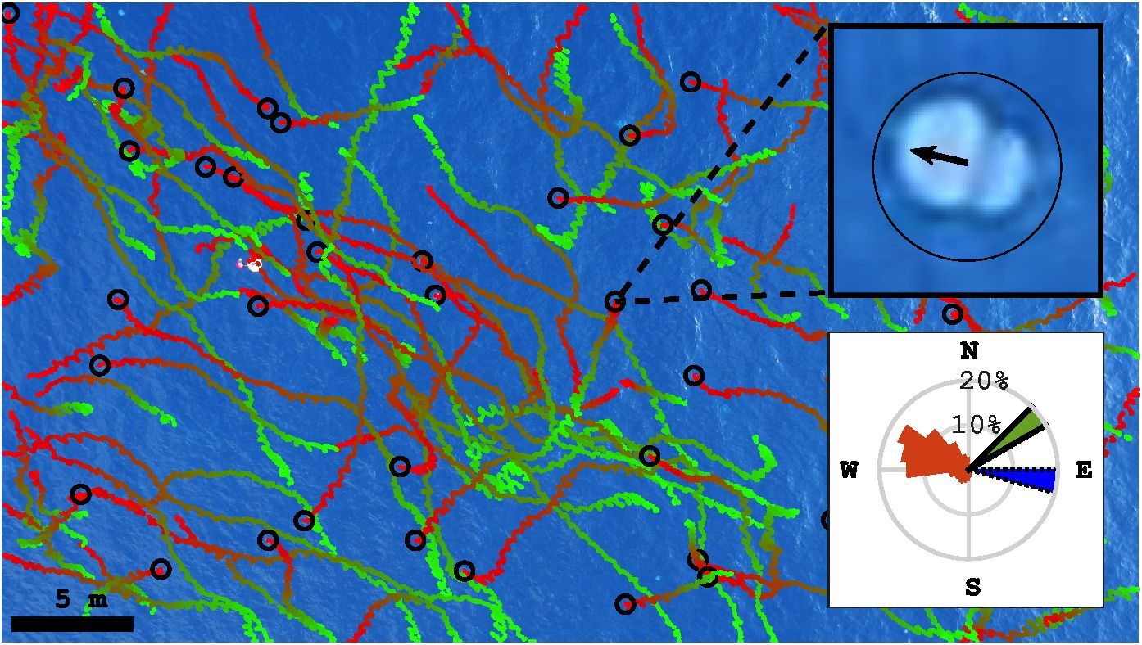

**Fig. 1 An exemplary drone-based Lagrangian view on the movement of aggregated  
jellyfish.** The dotted lines show Lagrangian jellyfish trajectories extracted from a 5 minutes video.  
The trajectories are overlaid on the last frame of the video, with the colors gradually changing from  
green to red during the trajectory. Black circles indicating locations of jellyfish in that frame. The  
upper insert shows a blow up of a single frame, focusing on an individual jellyfish, with the black arrow  
pointing to its swimming orientation, *a.* Lower insert shows the distribution of *a* for all instances  
measured in this video (2589 instances of 117 jellyfish in total, orange), and mean direction of surface  
gravity waves (blue, dotted edge) and currents (green, solid edge). The video was taken at 7:45 AM  
on July 6, 2020 (Fig. SI)

A key behavioral trait in aquatic locomotion is directional movement, defined as  
the tendency of an individual to move along a straight path [29, 30].The observed  
jellyfish maintained a constant swimming orientation, with the standard deviation  
(SD) of *a* along individual trajectories being, on average, 26.8 ± 18.5° (Fig. 2A).  
Consistently, out of the 4240 jellyfish examined, 4143 (> 97%) exhibited statistically  
significant directional swimming (Rayleigh’s test *p* < 0.05 [31]).

Expanding the analysis, we tested swimming directionality at the scale of the  
jellyfish aggregation. For each video we calculated the mean swimming orientation  
*(a)* and found that the individual instantaneous orientations deviated from it by only  
±62° (shaded area in Fig. 2B). In agreement with that, aggregated jellyfish were found  
to collectively orient their swimming in the same direction (Rayleigh’s test *p* < 0.001).  
Notably, in all cases *a* had a strong westward component, with a mean azimuth of  
262 ± 44.7°, (north defined as 0° and clockwise is the positive direction; Fig. 2C).  
In our study area, this westward orientation coincides with swimming away from the  
general direction of the coast (Fig. SI).

The directional nature of the swimming behavior indicates the use of an external  
cue [32]. Consistently with the hypothesized importance of stranding avoidance in  
modulating jellyfish movement, jellyfish swimming was distinctly oriented opposite to  
the direction of surface gravity waves, which in coastal areas provide a reliable indicator  
to the general direction of the shoreline [33], with *a* differing from the direction of  
short-waves and long-waves by 174 ± 83° and 155 ± 50°, respectively (Fig. 2C and  
Table 1). Moreover, a statistical analysis revealed that *a* was significantly negatively  
correlated with the direction of long and short surface gravity waves (p < 0.001 ;  
circular-circular correlation; Table 1).

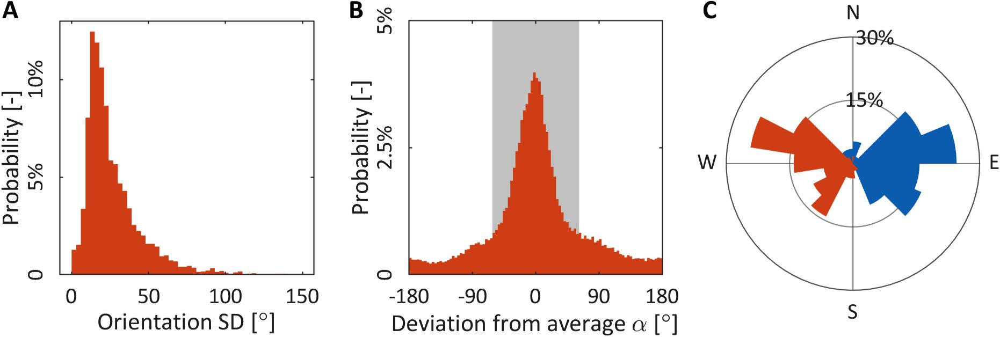

**Fig. 2 Characteristics of the jellyfish swimming behavior.** (A) The standard deviation of *a*along the trajectories of 4,240 jellyfish. The median standard deviation of *a* is 21°, which indicates  
that jellyfish maintained relatively straight paths; (B) The deviation of *a* from *a* in all 90,429 instances  
of measurement (4,240 jellyfish), with the shaded area showing the standard deviation. The narrow  
distribution indicated that aggregated jellyfish tend to swim in the same direction; (C) Mean direction  
of short surface gravity waves (blue) and *a* (orange) in each of the 57 movies examined.

Further investigation of the linkage between the different components of jellyfish  
movement was done through numerical modeling of the jellyfish swimming behav-  
ior. We first reconstructed the observed jellyfish movement trajectories (e.g. Fig. 1).  
Jellyfish swimming speeds *(vjs)* were taken from previous analysis of the drone

**Table 1** Circular statistics between *a* and possible environmental cues

|  |  |  |  |  |  |  |
| --- | --- | --- | --- | --- | --- | --- |
|  | *P* | *P — value* | | Difference in direction1 | *N* | Source |
| Short surface waves | -0.658 | *P‘* | < 0.001 | 174 ± 83° | 57 | Drone video |
| Long surface waves | -0.6731 | *p<* | < 0.001 | 155 ± 50° | 53 | Reference to model - Aviv |
| Surface currents | 0.1363 | *P'* | < 0.25 | 115 ±77° | 57 | Drone video |
| Sun azimuth | 0.4146 | *p<* | < 0.01 | 61 ± 38° | 53 | Reference - Dror |
| Magnetic field delenation | 0.4755 | *p<* | < 0.025 | 103 ± 40° | 53 | Reference - Dror |

1 Absolute values

data used here, showing that *R. Nomadica* in the region swim at a mean velocity  
0.1±0.03ms-1 Tai et al.. The simulated jellyfish trajectories exhibited distinct Biased  
Correlated Random Walk (BCRW, [34]) movement patterns. To optimize the BCRW  
parameters we employed a genetic algorithm, which yielded an angular diffusivity of  
0.02s-1, a preferred angle of 287.4° and an average reorientation time to the preferred  
angle (B) of 32.2°s. When subject to constant velocity current conditions, the simu-  
lated Lagrangian particle tracking produced trajectories similar to the drone-captured  
jellyfish trajectories (Fig. 3a).

To test the importance of directional swimming in reducing stranding risk, we  
compare the latter, defined here as the percentage of jellyfish whose net propagation  
is towards coats, for varying levels of directionality (manifested by changes in *B,*going from Os for fully directional swimming away from the coast, to 200s for simple  
random walk behavior) (Fig. 3b). The comparison is performed for coastward current  
speeds that are half, similar and double the mean *Vjs,* which are representative of the  
summertime surface currents in measured in the region (Fig. S ??). For the case of *Vjs*equal to the percentage of stranded jellyfish is 40% when the swimming is fully  
directional (i.e. *B* —> 0s), and reaches 100% when *B* approaches 150s. For the case of

— 0.5, the percentage of stranded jellyfish goes from 7% when the swimming is  
fully directional to 88% when *B* increases to 200s. In the extreme case when *vcc* is very  
high compared with *Vjs (ycc* — 2vJS), the directionality becomes negligible for jellyfish  
survival, as the jellyfish swimming is too slow to counteract the flow (90% stranding  
when *B* —> 0s).

The westward (i.e. away from the coast) counter-wave swimming, and its role in  
reducing the risk of stranding, manifest a distinct relationship between the internal  
state and external forcing components of jellyfish movement. The opposite direction-  
ality and significant negative correlation between the wave and swimming directions  
suggests that interrelationship also exists with the navigation capacity component,  
such that the jellyfish orient their swimming by perception of the surface gravity waves.  
This hypothesis is supported by the fact that in coastal areas, where jellyfish aggregar  
tions are commonly found [19], the direction of surface waves is most often indicative  
to the direction of the coastline [33], making the applicability of a wave-perception  
mechanism for swimming away from the coast a universal feature. This is in contrast  
to other environmental cues that were previously found to be associated with jellyfish  
swimming directionality, such as the magnetic field [35], sun position [7], and current

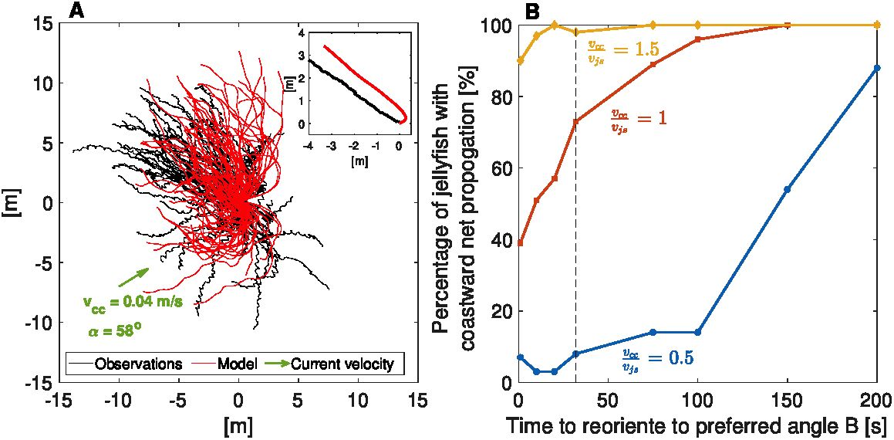

**Fig. 3 Numerical simulation of jellyfish swimming behavior and its impact on stranding.**(A) Comparison between observed (blacked) and modeled (red) jellyfish trajectories, for July 6, 2020.  
The model was run for 100s under a constant current, *vcc,* of 0.04ms-1 at an azimuth of 58° (indicated  
by the green arrow in the lower left corner). The upper right insert displays the trajectories of center-  
of-mass of the observed (black) modeled (red) aggregated jellyfish. (B) Percentage of jellyfish with net  
coastward propgation under varying model-parameters *B* and Increase in *B* manifest decrease  
*Vja*

in swimming directionality, with *B* —> 0 representing fully directional swimming away from the coast,  
and 200s represents simple random walk behavior). Vertical line marks the value of *B* found here.

direction [9], which require ar priori knowledge on the relative location of the coast-  
line. In agreement with that, in our observations *a* was found to be less correlated  
with the sun azimuth and magnetic field inclination, and not significantly correlated  
with surface currents (circular-circular correlation *p* > 0.2) (Table 1). In addition,  
as was recently shown for the case of oil pollution transport [36], the actual process  
of beaching is driven by waves that, via stokes drift, produce the only mechanism for  
substantial cross-shore flows. Therefor, efficient avoidance of stranding requires coun-  
teracting the effect of waves, rather than that of the currents, which can only bring  
the jellyfish to the vicinity of the shoreline.

Evidences for animals orienting their swimming against surface waves are limited  
to a small number of animals [33, 37-40]. A wave-induced directional perception mech-  
anism was identified in sea turtles, who were found to detect the wave direction from  
the sequence of accelerations occurring within wave orbits below the water surface

1. . In jellyfish, while such sensory mechanism has not been identified, counter-wave  
   orientation was suggested as a possible explanation to observed correlation between  
   the direction of jellyfish swimming and that of surface wind [6]. As for the observe  
   tions reported here, this explanation is supported by the fact that in the context of  
   moving fluids, it is likely that any mechanoreceptor sensitive to fluid motion would  
   not be sensitive to constant unidirectional flow, but rather to time-dependent compo-  
   nents of the flow field. These may include shear flows, local turbulence, and orbital  
   currents produced by surface waves [42, 43], as suggested here.

Providing a unique Lagrangian viewpoint on multiple adjacent jellyfish, our drone-  
based observations bring new insights on jellyfish swimming behavior, and resulted  
movement, in their natural environment. Focusing on aggregations of *R. Nomadica,*we found that individual jellyfish consistently maintained constant swimming direc-  
tion, oriented against the surface gravity waves and away the shoreline. This behavior  
translates into synchronized directional swimming of the aggregation as a whole, which  
reduces the eminent risk of stranding, and provides jellyfish with an adaptive advan-  
tage critical to their survival. In addition to shedding light on jellyfish swimming  
behavior and its importance, our results open the way for a more accurate representer  
tion of jellyfish movement in model studies, improving our ability to understand and  
predict dynamical, ecological, biogeochemical and societal aspects of jellyfish outbreak.

**Supplementary information.** Supplementary files are found at the end of the  
document

**Acknowledgments.** This work was supported by the Israeli Ministry of Science and  
Technology, grant number ***, and by the Israeli Science Foundation, grant number  
***

Declarations

* Funding
* Conflict of interest/Competing interests (check journal-specific guidelines for which  
  heading to use)
* Ethics approval
* Consent to participate
* Consent for publication
* Availability of data and materials
* Code availability
* Authors’ contributions

References

1. Purcell, J. E., Uye, S.-i. & Lo, W.-T. Anthropogenic causes of jellyfish blooms  
   and their direct consequences for humans: a review. *Marine Ecology Progress  
   Series* **350,** 153-174 (2007).
2. Richardson, A. J., Bakun, A., Hays, G. C. & Gibbons, M. J. The jellyfish joyride:  
   causes, consequences and management responses to a more gelatinous future.  
   *Trends in ecology & evolution* **24,** 312-322 (2009).
3. Condon, R. H. *et al.* Jellyfish blooms result in a major microbial respiratory sink  
   of carbon in marine systems. *Proceedings of the National Academy of Sciences***108,** 10225-10230 (2011).
4. Hays, G. C., Doyle, T. K. & Houghton, J. D. A paradigm shift in the trophic  
   importance of jellyfish? *Trends in ecology & evolution* **33,** 874-884 (2018).
5. Wright, R. M., Le Quere, C., Buitenhuis, E., Pitois, S. & Gibbons, M. J. Role of  
   jellyfish in the plankton ecosystem revealed using a global ocean biogeochemical  
   model. *Biogeosciences* **18,** 1291-1320 (2021).
6. Shanks, A. L. & Graham, W. M. Orientated swimming in the jellyfish stomolopus  
   meleagris 1. agassiz (scyphozoan: Rhizostomida). *Journal of Experimental Marine  
   Biology and Ecology* **108,** 159-169 (1987).
7. Hamner, W., Hamner, P. & Strand, S. Sun-compass migration by aurelia  
   aurita (scyphozoa): population retention and reproduction in saanich inlet, british  
   Columbia. *Marine Biology* **119,** 347-356 (1994).
8. Graham, W. M., Pages, F. & Hamner, W. M. *A physical context for gelatinous  
   zooplankton aggregations: a review,* 199-212 (Springer, 2001).
9. Fossette, S. *et al.* Current-oriented swimming by jellyfish and its role in bloom  
   maintenance. *Current Biology* **25,** 342-347 (2015).
10. Chapman, J. W. *et al.* Animal orientation strategies for movement in flows.  
    *Current Biology* **21,** R861-R870 (2011).
11. Moon, J.-H., Pang, I.-C., Yang, J.-Y. & Yoon, W. D. Behavior of the giant jellyfish  
    nemopilema nomurai in the east china sea and east/japan sea during the sum-  
    mer of 2005: A numerical model approach using a particle-tracking experiment.  
    *Journal of Marine Systems* **80,** 101-114 (2010).
12. Vodopivec, M., Peliz, A. J. & Malej, A. Offshore marine constructions as prop-  
    agators of moon jellyfish dispersal. *Environmental Research Letters* **12, 084003**(2017).
13. Edelist, D. *et al.* Tracking jellyfish swarm origins using a combined oceanographic-  
    genetic-citizen science approach. *Frontiers in Marine Science* 486 (2022).
14. Nathan, R. *et al.* A movement ecology paradigm for unifying organismal  
    movement research. *Proceedings of the National Academy of Sciences* **105,**19052-19059 (2008).
15. Allen, R. M., Metaxas, A. & Snelgrove, P. V. Applying movement ecology to  
    marine animals with complex life cycles. *Annual Review of Marine Science* **10,**19-42 (2018).
16. Costello, J. H., Colin, S. P. & Dabiri, J. O. Medusan morphospace: phylogenetic  
    constraints, biomechanical solutions, and ecological consequences. *Invertebrate  
    Biology* **127,** 265-290 (2008).
17. Gemmell, B. J. *et al.* Passive energy recapture in jellyfish contributes to propulsive  
    advantage over other metazoans. *Proceedings of the National Academy of Sciences*

**110,** 17904-17909 (2013).

1. Costello, J. H. *et al.* The hydrodynamics of jellyfish swimming. *Annual Review  
   of Marine Science* **13,** 375-396 (2021).
2. Lilley, M. *et al.* Global patterns of epipelagic gelatinous zooplankton biomass.  
   *Marine Biology* **158,** 2429-2436 (2011).
3. Ferrarin, C., Bellafiore, D., Sannino, G., Bajo, M. & Umgiesser, G. Tidal dynamics  
   in the inter-connected mediterranean, marmara, black and azov seas. *Progress in  
   Oceanography* **161,** 102-115 (2018).
4. Solodoch, A. *et al.* Basin scale to submesoscale variability of the east-  
   mediterranean sea upper circulation. *Journal of Physical Oceanography* (2023).
5. Galil, B., Spanier, E. & Ferguson, W. The scyphomedusae of the mediterranean  
   coast of Israel, including two lessepsian migrants new to the mediterranean.  
   *Zoologische mededelingen* 64, 95-105 (1990).
6. Edelist, D. *et al.* Phonological shift in swarming patterns of rhopilema nomadica  
   in the eastern mediterranean sea. *Journal of Plankton Research* **42,** 211-219  
   (2020).
7. Magome, S. *et al.* Jellyfish patch formation investigated by aerial photography  
   and drifter experiment. *Journal of Oceanography* **63,** 761-773 (2007).
8. Kim, H. *et al. Development of a uav-type jellyfish monitoring system using deep  
   learning,* 495-497 (IEEE, 2015).
9. Schaub, J. *et al.* Using unmanned aerial vehicles (uavs) to measure jellyfish  
   aggregations. *Marine Ecology Progress Series* **591,** 29-36 (2018).
10. Hamel, H., Lhoumeau, S., Wahlberg, M. & Javidpour, J. Using drones to measure  
    jellyfish density in shallow estuaries. *Journal of Marine Science and Engineering***9,** 659 (2021).
11. Raoult, V. *et al.* Operational protocols for the use of drones in marine animal  
    research. *Drones* **4,** 64 (2020).
12. Cheung, A., Zhang, S., Stricker, C. & Srinivasan, M. V. Animal navigation: the  
    difficulty of moving in a straight line. *Biological cybernetics* **97,** 47-61 (2007).
13. Berenshtein, I. *et al.* Evidence for a consistent use of external cues by marine fish  
    larvae for orientation. *Communications biology* **5,** 1307 (2022).
14. Batschelet, E. Circular statistics in biology. *ACADEMIC PRESS, 111 FIFTH  
    AVE., NEW YORK, NY 10003, 1981, 388* (1981).
15. Dusenbery, D. B. Sensory ecology: how organisms acquire and respond to  
    information. *(No Title)* (1992).
16. Lohmann, K. J., Lohmann, C. M. & Endres, C. S. The sensory ecology of ocean  
    navigation. *Journal of Experimental Biology* **211,** 1719-1728 (2008).
17. Codling, E. A., Plank, M. J. & Benhamou, S. Random walk models in biology.  
    *Journal of the Royal society interface* 5, 813-834 (2008).
18. Cresci, A. *et al.* Glass eels (anguilla anguilla) have a magnetic compass linked to  
    the tidal cycle. *Science advances* **3,** el602007 (2017).
19. Weisberg, R. H., Lianyuan, Z. & Liu, Y. On the movement of deepwater horizon  
    oil to northern gulf beaches. *Ocean Modelling* **111,** 81-97 (2017).
20. Nishimoto, R. T. & Herrnkind, W. F. Directional orientation in blue crabs, call-  
    inectes sapidusrathbun: Escape responses and influence of wave direction. *Journal  
    of Experimental Marine Biology and Ecology* **33,** 93-112 (1978).
21. Rudloe, A. E. & Herrnkind, W. F. Orientation by horseshoe crabs, limulus  
    polyphemus, in a wave tank. *Marine & Freshwater Behaviour & Phy* **7,** 199-211  
    (1980).
22. Hamilton, P. & Russell, B. Field experiments on the sense organs and directional  
    cues involved in offshore-oriented swimming by aplysia brasiliana rang (mollusca:  
    Gastropoda). *Journal of Experimental Marine Biology and Ecology* **56,** 123-143  
    (1981).
23. Wang, J. H., Jackson, J. K. & Lohmann, K. J. Perception of wave surge motion  
    by hatchling sea turtles. *Journal of Experimental Marine Biology and Ecology***229,** 177-186 (1998).
24. Lohmann, K. J., Swartz, A. W. & Lohmann, C. M. Perception of ocean wave  
    direction by sea turtles. *Journal of Experimental Biology* **198,** 1079-1085 (1995).
25. Arkett, S., Mackie, G. & Meech, R. Hair cell mechanoreception in the jellyfish  
    aglantha digitale. *Journal of experimental biology* **135,** 329-342 (1988).
26. Watson, G. M. & Hessinger, D. A. Cnidocyte mechanoreceptors are tuned to the  
    movements of swimming prey by chemoreceptors. *Science* **243,**1589-1591 (1989).