The Title “Pharaoh”

The change in usage over time and what this tells us about the biblical text.

[Dr. Shirly Ben-Dor Evian](https://www.thetorah.com/author/shirly-ben-dor-evian)

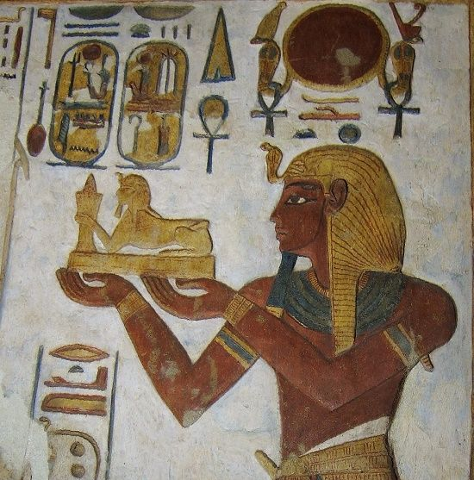

Relief from the sanctuary of the Temple of Khonsu at Karnak, depicting Ramesses III. Wikimedia

‍The Unnamed Pharaoh

One of the challenges of studying the Exodus story is identifying which Egyptian pharaoh the text is speaking of. The biblical text does not provide the name of the stubborn king of Egypt who defies the God of Israel, but only refers to him as “Pharaoh.”

“Pharaoh” is the Egyptian loan word that means the “Great House” and is the most frequently used Egyptian loan word in the biblical text. Appearing 274 times, about half of these are in the Exodus narrative and another third in the Joseph story.

But to what extent does the biblical “Pharaoh” describe the Egyptian king, and can it be taken in Exodus to refer to a *specific* Egyptian king?

Ancient Egyptian Kingship

Ancient Egyptian Kingship is all about legitimacy.[1] The king rules because he is the legitimate king. His legitimacy is manifest by his effective actions, his rights of inheritance and succession, and finally by his special relation to the gods of Egypt. Many of these royal functions resonate in the Bible.

‍*Action and efficacy* are best manifest by monumental building activities. Nothing says ACTION more that the huge temples and monuments of the Pharaohs. By carving elaborate reliefs depicting the subjugated enemies of Egypt in front of the ruling king on these buildings, the Egyptian king demonstrates his efficient domination of the earthly world of enemies.

The importance of buildings in the Egyptian royal ideology is likely reflected in Exodus 1:11:

שמות א:יא ...וַיִּ֜בֶן עָרֵ֤י מִסְכְּנוֹת֙ לְפַרְעֹ֔ה אֶת־פִּתֹ֖ם וְאֶת־ רַעַמְסֵֽס:

Exod 1:11 ...And they built for Pharaoh storage cities, Pithom and Ramses.

‍*The inheritance and succession* are tightly linked to the divine rights of the king but also to the family line of the ruling king. Addressing their continuity in the royal family line and referring to their royal forefathers was part of Egyptian rhetoric, most notably manifest in the long king lists that provide the ruling king’s inheritance line.

‍*Different dynasties* - as termed by modern research and following the Manethonian historiography[2] - were sometimes inserted within one’s family line as one continuous line. The Bible may refer to this issue in Exod 1:8 where the anonymity of Joseph is best understood as a change of dynasty:

שמות א:ח וַיָּ֥קָם מֶֽלֶךְ־חָדָ֖שׁ עַל־מִצְרָ֑יִם אֲשֶׁ֥ר לֹֽא־יָדַ֖ע אֶת־יוֹסֵֽף:

Exod 1:8 Now a new king arose over Egypt, who did not know Joseph.

*‍The king’s relationship with the gods* is the most important aspect of his kingship. Although not a god himself, the king was depicted with the same proportions and special attributes - particularly on his head - as the gods of Egypt.

The king carries a special role as the sole mediator between the Egyptians and their gods. He is entrusted with the sacred balance known as the MA’AT= the Egyptian word for truth, but also used to describe the cosmic balance that rules the ancient Egyptian world. When the king does not uphold this balance terrible things might happen to Egypt.

Perhaps the reaction of the Pharaoh to the plagues in Gen 12:17-19 is a reflection of this concept- when finding out that he accidentally slept with Abraham’s wife, he reacts by balancing the scale, returning Abrahams wife to him and sending him off with all his estate:

בראשית יב:יז וַיְנַגַּ֨ע יְ־הֹוָ֧ה׀ אֶת פַּרְעֹ֛ה נְגָעִ֥ים גְּדֹלִ֖ים וְאֶת בֵּית֑וֹ עַל דְּבַ֥ר שָׂרַ֖י אֵ֥שֶׁת אַבְרָֽם: יב:יח וַיִּקְרָ֤א פַרְעֹה֙ לְאַבְרָ֔ם וַיֹּ֕אמֶר מַה זֹּ֖את עָשִׂ֣יתָ לִּ֑י לָ֚מָּה לֹא הִגַּ֣דְתָּ לִּ֔י כִּ֥י אִשְׁתְּךָ֖ הִֽוא: יב:יט לָמָ֤ה אָמַ֙רְתָּ֙ אֲחֹ֣תִי הִ֔וא וָאֶקַּ֥ח אֹתָ֛הּ לִ֖י לְאִשָּׁ֑ה וְעַתָּ֕ה הִנֵּ֥ה אִשְׁתְּךָ֖ קַ֥ח וָלֵֽךְ:

Gen 12:17 But YHWH struck Pharaoh and his house with great plagues because of Sarai, Abram’s wife. 12:18 Then Pharaoh called Abram and said, “What is this you have done to me? Why did you not tell me that she was your wife? 12:19 Why did you say, ‘She is my sister,’ so that I took her for my wife? Now then, here is your wife, take her and go.”

The Titles of the Egyptian King

The most common expression of the king’s divine rights and legitimacy to the throne is provided in his titles. The Egyptian king was known by five different names. These include:

* The Horus name and the golden Horus name - after the falcon god who is the divine manifestation of Egyptian kingship. The Horus name is frequently written within a rectangular frame designed as an architectural feature, perhaps of the palace. The Horus falcon is found perched on top of the feature and above the king’s name.
* The *nebty* name, meaning literally the Two Ladies – referring to the patron goddesses of Upper (southern) and Lower (northern) Egypt, being the vulture and the cobra deities, respectively. This title refers to the king’s role in the unification of the two regions that were previously separate in both geography and culture.
* The king’s prenomen follows the symbol of the sedge-plant and the bee – emblems of Upper and Lower Egypt, respectively. The prenomen itself is written inside an oval frame, known as a cartouche. The cartouche is a symbolic representation of all things encircled by the sun, referring to the king’s rule of everything under the sun.
* The king’s nomen follows the title “Son of Re”- the all-powerful sun god. The nomen is also written in a cartouche.

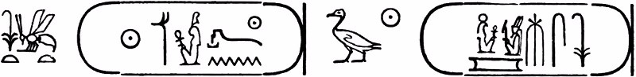

Figure 1. Prenomen and nomen of Ramesses II: King of Upper and Lower Egypt (the strong one belonging to the Ma’at of Re, chosen by Re), son of Re (Re bore him, beloved of Amun)

All these titles are a manifestation of the king’s divine legitimacy. However, none of these titles resonate in the biblical text. Instead we find that the king is called by his most mundane title - Pharaoh or simply מלך מצרים (king of Egypt).

The Title Pharaoh in Ancient Egyptian Texts

As noted above, the Egyptian word *pr-‘A* means the “Great House”. From very early times this word referred to the royal palace or to the institution of kingship and not to the actual king. (The word for king in Egyptian is *nessut*.)

The most common use of the word “*pr-‘A*” in Egyptian texts is within the titles of officials such as the Middle Kingdom “Chief physician of the Pharaoh,”[3] or New Kingdom “Overseer of the cattle of herds of the Pharaoh,”[4] and even Third Intermediate Period: “scribe of Pharaoh.”

However, during the New Kingdom and Third Intermediate Period, the term began to be used together with the King’s throne name and eventually replaced the reference to “his majesty” in descriptions of the king’s deeds. In the later phases of the Third Intermediate Period, Egyptian texts began to regard the *pr-‘A* as a cartouche worthy title, therefore treating it as a proper throne or birth name of the ruling king.

The shift in the employment of the term from palace or royal institution to the actual king was a very long process. It began during the reign of Akhenaton in the 18th dynasty (1348 B.C.E.) and continued sporadically until the early 22nd dynasty (until 833 B.C.E.), increasing from the mid 22nd dynasty (ca. Sheshonq III 833-794 B.C.E.) and peaking during the 25th dynasty (722-664 B.CE.). The term Pharaoh therefore became a frequent reference to the actual king only during the 8th-7th century B.C.E.

Pharaoh as a Name in the Bible

The Pentateuch never mentions the actual name of the Egyptian king, referring to the monarch in one of the following ways: פרעה (“Pharaoh;” Exod 1:11), פרעה מלך מצרים (“Pharaoh king of Egypt;” Exod 6:11) or מלך מצרים (“King of Egypt;” Exod 1:15). It therefore employs the term “Pharaoh” as a substitute for the actual throne name, i.e., treating it like a personal name, paralleling such biblical examples as Achish king of Gath, Og king of the Bashan.

The only biblical references to specific Egyptian rulers are found in the books of Kings, Chronicles and Jeremiah. These can be classified into two types, pending on the use of the word Pharaoh in the title. Thus, Shishak (962-941 BCE) is not called a Pharaoh but “king of Egypt” (1 Kgs 11: 40; 14: 25; 2 Chr 12: 2, 9) as is also So (an unknown Egyptian king mentioned in 2 Kgs 17: 4). On the other hand, Necho II (610-595 BCE) is referred to as “Pharaoh Necho king of Egypt” (2 Kgs 23:29, 33, 34; Jer 46: 2) as is also Khephre (King Apries 589-570 BCE, Jer 44: 30). This formula, using the title “Pharaoh” followed by the throne name, became frequent during the 25th dynasty in Egypt.

However, most of the biblical occurrences relating to the Egyptian king only use the word Pharaoh rather than an actual name. Since this reflects Egyptian practice that only started in the 8th century B.C.E., these biblical texts must date from that period or later. In other words, the frequent use of the term Pharaoh in the Exodus narrative does not reflect second millennium practices, but reflects, at the earliest, a late monarchic horizon.

[View Footnotes](https://www.thetorah.com/article/the-title-pharaoh)

1. For more on Egyptian kingship, see, Ronald J. Leprohon, *The Great Name: Ancient Egyptian Royal Titulary* (ed. Denise M. Doxey; Writings from the Ancient World Number 29; Atlanta: SBL 2013); David B. O'Connor and David P. Silverman, eds., *Ancient Egyptian Kingship* (Probleme Der Agyptologie 9; Social, Economic, and Political Studies of the Middle East 9; Leiden: Brill, 1995).
2. For more on Manetho, see Gary Rendsburg, [“Ancient Egypt: An Overview of Its History,”](https://www.thetorah.com/article/ancient-egypt-an-overview-of-its-history) *TheTorah* (2016).
3. See, Stephan Quirke, *Titles and Bureaux of Egypt 1850-1700 BC* (Egyptology 1; London: Golden House, 2004), 37.
4. Abdul R. Al-Ayedi, *Index of Egyptian Administrative, Religious and Military Titles of the New Kingdom* (Ismailia: Obelisk pub., 2006), 57.