Top of Form

Prof. Scott B. Noegel

University of Washington

Prof. Scott B. Noegel is Professor of Biblical and Ancient Near Eastern Languages and Literatures in the Department of Near Eastern Languages and Civilization at the University of Washington. He holds a Ph.D. from Cornell University andan Honorary Ph.D. in Letters from University of Wisconsin-Milwaukee. Among his many books are *Nocturnal Ciphers: The Allusive Language of Dreams in the Ancient Near East;*and (with Gary A. Rendsburg) *Solomon’s Vineyard: Literary and Linguistic Studies in the Song of Songs.*

The Egyptian “Magicians”

Is the Bible’s portrayal of the magicians (*Ḥarṭummīm*) in accord with Egyptian literature and ritual practice? How did the Israelite writers obtain this knowledge?

[Prof. Scott B. Noegel](https://www.thetorah.com/author/scott-b-noegel)

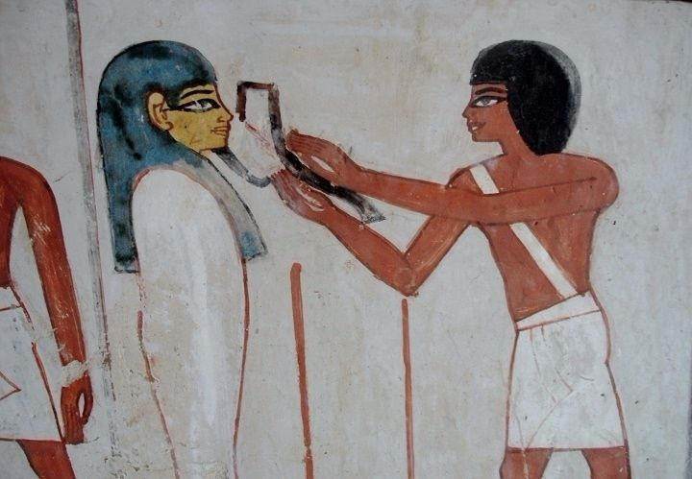

Fig. 1.Lector-priest with kilt and sash performing the Opening of the Mouth ceremony on the deceased.Tomb of Menna at Thebes (ca. 14th c. BCE). © Ted Grudowski

Whether portrayed as failing to interpret dreams (Gen 41:8, 41:24), transforming staffs into serpents (Exod 7:11-13), or as exacerbating the plagues in an effort to prove their abilities (Exod 7:22, 8:3, 8:14, 9:11), the Egyptian magicians always serve as literary foils for God’s plan. Despite their uncanny abilities, they continually demonstrate the superiority of Yahweh.

But does the Bible’s portrayal of these magicians fit what we know of them from Egyptian sources? Their roles as literary figures encourage one to ponder whether they represent bonafide Egyptian functionaries and whether their marvelous feats depict real or imagined Egyptian practices. After all, biblical narratives set in Egypt often evince a knowledge of Egyptian customs and beliefs:[1]

* The ten plagues represent attacks against specific Egyptian dieties (cf. Exod 12:12).[2]
* The method by which Joseph interprets pharaoh’s dreams finds parallels in an Egyptian dream manual.[3]
* The hardening (lit. making heavy) of pharaoh’s heart tendentiously alludes to the Egyptian belief that pharaoh’s heart must be weighed against the feather of truth, *maat*(*mꜣʿ t*) to grant him entry to the afterlife.[4]

In fact, the very term used for the magicians, *ḥarṭummīm*(חַרְטֻמִּים), is a Hebrew refraction of the Egyptian title *ẖry-ḥb*, “lector-priest.”[5]

The Problem with “Magic”

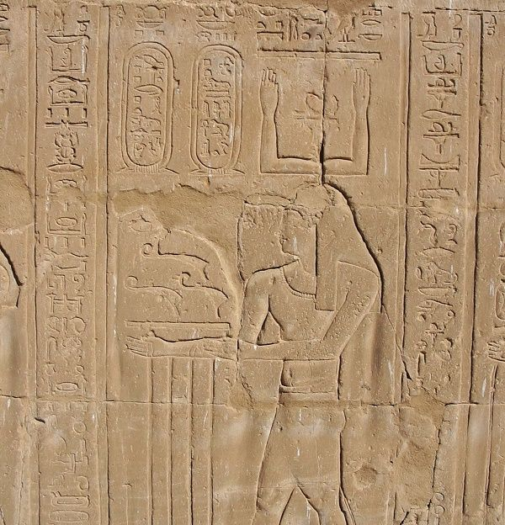

Fig. 2.The god Ḥeka.Temple of Horus at Edfu (ca. 237-57 BCE). © Scott Noegel

This last fact naturally begs the question of whether it is accurate to label the actions of these figures “magical.” The answer to this question is both yes and no. Yes, in that lector-priests performed numerous spells and rituals that evoked the illocutionary power of*ḥkꜣ* (*ḥeka*), a cosmic force perceived as efficacious, capable of manipulating reality in this world and the next.[6] Yet, no, because *Ḥeka*also was a deity in his own right, and so invoking his power also constitutes a form of prayer (Fig. 2).

Moreover, as contemporary scholarship has shown, the definition of both magic and religion is fraught, and the dichotomy “magic vs. religion” is problematic, having its roots in an outdated and pejorative understanding of “primitive” (read: non-monotheistic) religions as “superstitious.”[7] Regrettably, such views have informed early interpretations of the biblical *ḥarṭummīm*.[8] Therefore, while Egyptian priests evoked *ḥeka*to empower apotropaia (repulsion of harm), heal ailments, induce love, produce rain, harm Egypt’s national enemies, and even enliven the dead in the afterlife, it is more accurate to think of the *ḥarṭummīm*as highly learned priests, masters of their ancient literary traditions and rituals of perceived power.

It bears stressing that there is nothing inherent in the title or actions of the biblical *ḥarṭummīm*that suggests that they are merely charlatans engaged in sleight of hand. Quite the contrary, the Bible portrays them as elite professionals who possess considerable abilities, even if they pale in comparison to those of Yahweh.

Learned Egyptian Priests in Context

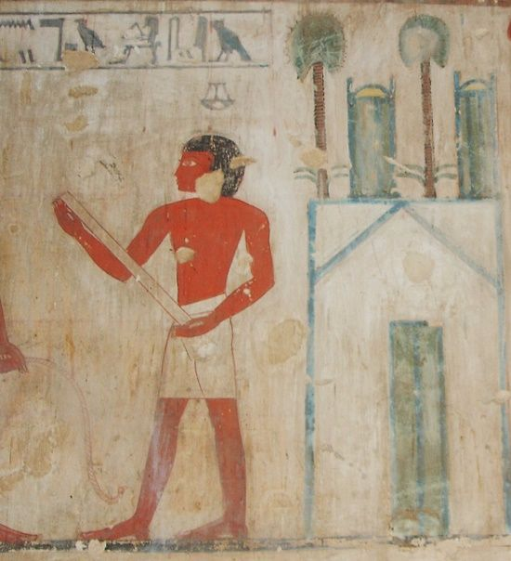

Fig. 3.Chief lector-priest in tomb of Rekhmire (ca. 1400 BCE). © Ted Grudowski.

Egyptian reliefs typically depict lector-priests as donned in a white kilt and sash (see Fig. 1 above). Elsewhere they appear without the sash and carrying a sacred scroll or other ritual implements (Fig. 3), or with a longer kilt and a shaved head (Fig. 4). They were Egypt’s elite religious professionals and the prime players in major rituals connected to the *prʿnḫ*, i.e., “House of Life,” an institution of higher learning associated with temples. They also presided over the “Opening of the Mouth” ceremony, by which the deceased entered the afterlife as a transfigured being.

Therefore, it is more useful to examine the acts of the *ḥarṭummīm*from the perspective of Egyptian priestly rituals and the portrayals of priests in Egyptian literary texts. Indeed, when approached in this way, a number of striking parallels emerge. I shall restrict myself to two primary examples, the plague of blood and the transformation of the staffs into serpents.

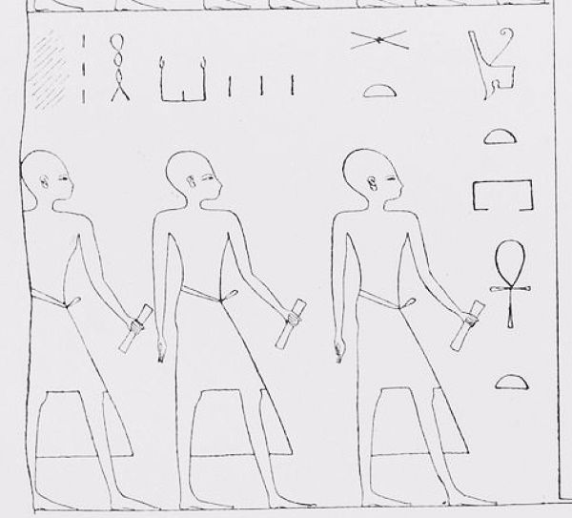

Fig. 4. Lector-priests, here called ḥekaʾu, i.e., “magicians,” carrying sacred scrolls from the House of Life. Festival Hall of Osorkon II (ca. 9th c. BCE). Found in EdouardNaville, *The Festival-Hall of Osorkon II in the Great Temple of Bubastis, 1887-1889* (London: Kegan Paul, Trench, Trübner, 1892), Plate III.

Example 1: Plague of Blood

I begin with the first plague—the turning of the Nile to blood—a wonder that the *ḥarṭummīm*easily replicate. The event has three analogues in Egyptian texts.

**Tale of Ipuwer:**The *Tale of Ipuwer*(ca. 1650-1550 B.C.E.), which laments the chaos that has engulfed Egypt, claims: “The river is blood. If one drinks of it, one rejects it and thirsts for water… Foreign tribes have come to Egypt” (2:10, 3:1). As in the biblical text, the Egyptian story describes a bloody Nile and a defeat at the hand of foreigners.

**A Demon of Bastet:** A ritual text that identifies one of seven demons of the goddess Bastet (here a manifestation of Sekhmet) as “The one who is in the Nile-flood who makes blood” (924-889 BCE). As Thomas Schneider observes: “This could be understood as a demon who creates carnage in the Nile, and thus turns the Nile into blood (Exod 7:17-20).”

**Tale of the Heavenly Cow:** The *Tale of the Heavenly Cow*(14th-12th c. BCE), describes how the goddess Sekhmet wreaks havoc upon humankind. When the Nile fills with their blood, she wades into it as far as Herakleopolis. The sun god Re, then tricks Sekhmet by filling the Nile with beer that is the color of blood. When Sekhmet drinks the beer, she becomes drunk and is unable to recognize humankind. The sun god, Re thus averts the complete annihilation of humanity.

These three accounts of the water/Nile being likened to blood in Egyptian literature certainly bear on the blood plague in Egypt, especially since that plague, like the Egyptian accounts, shares in common a theme of destruction.

The Red Water of the Bloody Nile

Informing the aforementioned Egyptian texts, and thus also the biblical story, is the color of the water when it turns to blood. In Egyptian, the word “blood” (i.e., *dšr*) also means “red.” In Egyptian ritual practice, red is the color of Apep, the serpent of chaos, and it serves as a synonym for “evil.” As such, it plays a key role in the ritual of execration, in which priests drowned, stabbed, crushed, burned, dismembered, buried, or otherwise destroyed red pots or red human figurines as proxies for Egypt’s enemies. Thus, the biblical account also evokes Egyptian execration.

From a literary perspective, the bloody Nile marks an ironic reversal in which it is the Egyptian priests who experience, rather than execute, the destruction. More practically, from the vantage of Egyptian ritual praxis, the plague put a stop to the priests’ many protection and purification rites by tainting the water they used to perform them as evil and impure.

Example 2: Staffs into Serpents

The famous account of Aaron and the *ḥarṭummīm*casting down their staffs to transform them into serpents (Exod 7:8-12) also reflects knowledge of Egyptian priestly traditions. Some have seen the account as reminiscent of the Egyptian *Tale of Pharaoh Cheop’s Court*, which details several amazing deeds performed by *ḥeka*masters, all of which involve the manipulation of the natural world, such as the parting of waters and the attachment of a severed head. In one scene, a chief lector-priest turns a wax crocodile into a real one and back again (ca. 1600 BCE). Though there are a number of differences between the two tales, many scholars see the story as evidence for a widespread belief in the transformative powers of Egyptian priests—a point to which I shall return below.

Apep the Primordial Serpent

The biblical account appears to represent a literary inversion of the Egyptian priestly ritual of casting down wax figurines of Apep, the primordial serpent of chaos. Underscoring the parallel is the repeated use of the term *tannīn*(תַּנִּין) for the snake (Exod 7:9, 9:10, 9:12) rather than the more common *naḥash* (נחש). Significanlty, *tannīn*(תַּנִּין) elsewhere refers to the Israelite’s primordial serpent (Isa 27:1, 51:9, Job 7:12). In the Egyptian context, the rite served to maintain the cosmic order by assisting the sun god on his journey through the underworld. If the Israelite author was aware of the ritual’s purpose, then depicting Aaron’s serpent as devouring those of the *ḥarṭummīm*would signal a threat to the Egyptian cosmic order, a warning realized the next morning with the first plague.

A Rod Swallowing Rods and Egyptian Serpent Staffs

Exod 7:12 states that Aaron’s “rod swallowed their rods,” a detail that has troubled exegetes for centuries. Many read the rods as metonyms for the serpents, since the passage makes no reference to them turning back into rods. However, some early commentators insist on reading the passage literally and see in it an even greater miracle (see b. *Shabbat* 97a, *Exodus Rabbah* 9:7, Rashi on Exod 7:12).

Here again a knowledge of Egyptian priestly praxis is informative. Many iconographic depictions of staffs in the form of serpents exist in Egypt:

People Carrying Serpent Staffs

* A procession of priests carrying a serpent staff in each hand also appears on the western wall in the tomb chamber of the Theban Mayor, Sennefer (Fig. 5, 15th c. BCE).
* Also attested are many depictions of a threshing festival rite, known as the “Driving of the Calves,” in which the king (or less often a priestess) carries two halves of a serpent staff in each hand (Fig. 6).[9]

|  |  |
| --- | --- |
| https://firebasestorage.googleapis.com/v0/b/bageladmin.appspot.com/o/TheTorah.com%2Frtf%2FPriests-holding-serpent-staffs..jpg?alt=media&token=4bda35e8-86bf-4931-9335-766d24280a82Fig. 5. Priests holding serpent staffs. Tomb of Sennufer. © Scott Noegel. | https://firebasestorage.googleapis.com/v0/b/bageladmin.appspot.com/o/TheTorah.com%2Frtf%2Fdriving-calves-serpent-staff.jpg?alt=media&token=bbc2b17c-f2e0-4061-af4f-69f2c0a7bd39  Fig. 6. Shepenwepet II performing the “Driving of the Calves” ritual. Shepenwepet II (adopted daughter of Amenirdas I) Tomb chapel of Amenirdas I, god’s wife (priestess) of Amun, at MedinetHabu (ca. 700 BCE). © Laurie RamacciNoegel. |

Gods Carrying Serpent Staffs

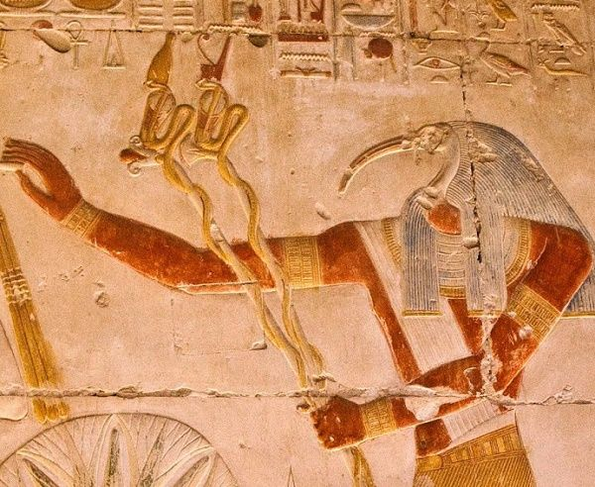

Fig. 7. Thoth with serpent-staffs. Temple of Seti I at Abydos. © Scott Noegel.

* In the temple of Seti I at Abydos, the god Thoth holds two staffs (known as *wꜣḏtỉ*) wrapped in serpents that wear the headdresses of northern and southern Egypt, respectively (Fig. 7, 13th c. BCE).
* Several registers on the Metternich stele (4th c. BCE) feature gods grasping serpent staffs.
* The god Nehy holds a serpent staff in each hand at the temple at Kom Ombo (Fig. 8, 180-47 BCE).
* Two serpent staffs precede Sekhmet at the temple of Isis at Philae (Fig. 9, ca. 370 BCE).
* Several coffins also depict the god *Ḥeka*himself wielding a serpent staff in each hand (Fig. 10).

|  |  |  |
| --- | --- | --- |
| https://firebasestorage.googleapis.com/v0/b/bageladmin.appspot.com/o/TheTorah.com%2Frtf%2Ftwo-serpent-staffs-Nehy.jpg?alt=media&token=05133a66-74e1-495b-88f1-44ee9c2dd2a4  Fig. 8. Nehy holding two serpent staffs. Temple of KomOmbo. © Scott Noegel. | https://firebasestorage.googleapis.com/v0/b/bageladmin.appspot.com/o/TheTorah.com%2Frtf%2Fserpent-wands-sekhmet-birth-house-philae.jpg?alt=media&token=0703e05b-fe20-47f4-bc02-220ca7812afe  Fig. 9. Serpent staffs before the goddess Sekhmet at the Temple of Isis at Philae. © Scott Noegel. | https://firebasestorage.googleapis.com/v0/b/bageladmin.appspot.com/o/TheTorah.com%2Frtf%2Fgod-H%CC%A3eka%CA%BE-serpents.jpg?alt=media&token=b89843e4-3c90-4d29-b331-981aea96d6b8  Fig. 10. The god Ḥeka holding two serpent staffs.* |
| *Detail from the coffin of Neb-Taui at The Metropolitan Museum of Art (ca. 1000 BCE). Found in Alexander Piankoff and N. Rambova, *Egyptian Religious Texts and Representations: Mythological Papyri*(Bollingen Series, 40/3: New York: Pantheon Books, 1957), p. 59. | | |

Depictions of Serpent Staffs

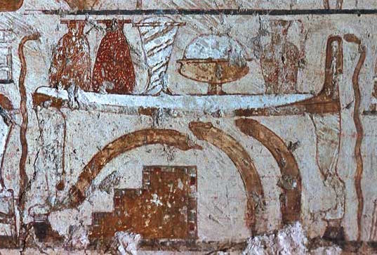

Fig. 11.Tomb of Rekhmire.Second register.Courtesy of © Bruno Sandkühler-Unidia, www.osirisnet.net.

* A vignette found in the tomb of the vizier Rekhmire (ca. 1400 BCE) shows a collection of items produced by temple artisans. The utensils include, *inter alia*, three curved ivory “magic” wands for use in birthing rituals and two copper serpent wands (Fig. 11).[10]
* At the Ramesseum at Thebes (ca. 2055-1650 BCE), excavations even unearthed an engraved copper serpent wand, now housed at the Fitzwilliam Museum in Cambridge (see [fitzmuseum.cam.ac.uk](http://webapps.fitzmuseum.cam.ac.uk/explorer/index.php?oid=49493)).

Thus, rods and serpents were intimately connected in Egyptian priestly rituals of power.

Holding Snakes as Depictions of the Power of Ḥeka**‍**

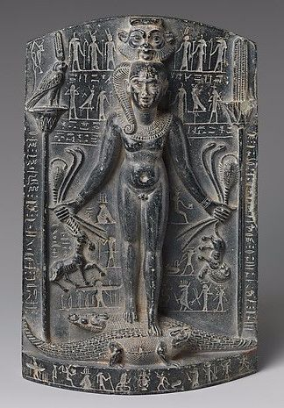

Fig. 12.Cippus of Horus on the crocodile stele (no. 20.2.23), ca. 332-280 BCE.© The Metropolitan Museum of Art.

Moreover, priests believed that *ḥeka*could protect them from poisonous snakes and other natural dangers, as the *Coffin Texts*make clear: “The serpent is in my hand and cannot bite me” (spell 885).[11] A visual depiction of this appears on a number of *cippi*that depict the so-called “Horus of the Crocodiles,” such as the aforementioned Metternich stele, in which the young god Horus stands upon crocodiles while holding a variety of noxious animals by their tails, including serpents, thus sympathetically conferring protection on the stele’s owner from snake bites and other forces of chaos (Fig. 12).

Grabbing the Serpent by the Tail

**‍**John Currid[12] opines that the depictions of Egyptians with serpent canes represent the serpent charming tricks performed by the Psylli, the so-called “snake charmers” of Egypt. This is a very old view.[13] Nevertheless, the trick involved grabbing a serpent by the head, whereas these images picture the priests holding the serpents by the tail. This fits with what Yahweh instructed Moses in Exodus 4:4, namely to “grasp its tail” (וֶאֱחֹז בִּזְנָבוֹ).

Swallowing as Performative Tool for Destruction and Absorption of Power

**‍**In addition, priests generally viewed swallowing as a performative act that functioned either to destroy the thing swallowed or to acquire its power and knowledge:

***Pyramid Texts*** (ca. 2400 BCE): “(King) Unas is one who eats men and lives on the gods… Unas eats their *ḥeka*, swallows their spirits” (spell 273).

***Coffin Texts***: “I have swallowed the seven uraei-serpents” (spell 612), and “I have eaten truth (lit. Maat), I have swallowed *ḥeka*”(spell 1017).

***Book of the Heavenly Cow***: “Moreover, guard against those handlers of *ḥeka*who know their spells, since the god *Ḥeka*is in them himself. Now as for the one who swallows/knows him, I am here.”

Thus, we may see the devouring of the *ḥarṭummīm*’s staffs by Aaron’s “staff of God” (Exod 4:20) as depicting the destruction of their authority and absorption of their power.[14]

Superpositioning and Control of the *Ḥarṭummīm*

***‍***A priestly ritual in which one item was placed atop another, a rite that Egyptologists have labeled “superpositioning”[15] elucidates another element of Exodus. Known primarily from royal iconographic materials, the image positions a human over an animal, an animal over another animal, or a human over another human. In each case, the ritual sympathetically conveyed control over the subjugated object. Of special interest are cases in which one serpent was poised atop or striking another serpent. Such depictions specifically functioned to transform one’s opponents into one’s allies.

Strikingly, this is precisely what occurs after Aaron’s contest involving the serpents. Not only do the *ḥarṭummīm*abet the Israelite cause by conjuring more bloody water and more frogs, the Egyptian people give the Israelites gifts of silver and gold, and of clothing before they depart (Exod 12:35-36). In essence, the Egyptians have become allies who assist Moses in his mission.

The Finger of God: The Finger of Thoth or Seth

In fact, when the *ḥarṭummīm*realized that their abilities were out-matched, they relented and proclaimed: “this is the finger of God” (אֶצְבַּע אֱלֹהִים הִוא; Exod 8:15). The expression stands out as peculiar, especially in the light of the more familiar “hand of God” (Exod 9:3).[16] As Abraham Yahuda long ago observed, the idiom is Egyptian.[17] It appears usually in the phrases “the finger of Thoth” and “the finger of Seth” to denote these gods’ performative powers.

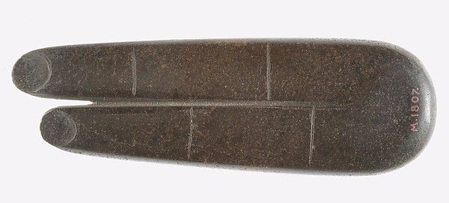

Fig. 13.Fingers of Horus amulet (no. 10.130.1807), ca. 664-343 BCE. © The Metropolitan Museum

of Art

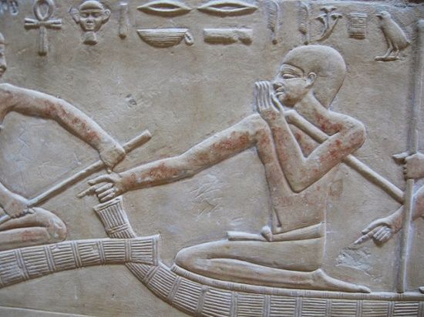

Fig. 14.Ritual pointing gesture to ford dangerous waters.Mastaba of Kagmeni at Saqqara (24th-23rd c. BCE). © Scott Noegel.

Moreover, numerous extended “Horus” forefinger amulets (Fig. 13) have been recovered from ancient Egypt, and extending the forefinger was an apotropaic ritual gesture used alongside spells, especially by shepherds, to ford dangerous waters with their herds.[18] To ensure safe passage the herdsman pointed his hand over the water, and those nearby were commanded to stop talking (Fig. 14). Such a practice calls to mind the account of the shepherd-priest Moses extending his arm over the Reed Sea (Exod 14:27) and commanding the Israelites to “be quiet” (Exod 14:14).[19]

How Could the Israelites Obtain Knowledge of the Egyptian Priestly Arts?

Such parallels, which could be multiplied, suffice to demonstrate that the biblical depictions of the *ḥarṭummīm*reflect a knowledge of Egyptian priestly arts. Yet, how did the Israelite writers obtain this knowledge? Indeed, the texts involving the *ḥarṭummīm*reflect a grasp of Egyptian priestly performative praxis that goes well beyond the sort of information that one might have obtained from Egyptian literary traditions. Recall that some parallels occur only in ritual texts. Moreover, one must ask how Israelite authors could have known any Egyptian literary traditions, since most of the literary parallels cited above predate the Israelite monarchy by many centuries.

Egyptian Learning Outside of Egypt

**‍**Some scholars have assumed that the Egyptian priestly traditions circulated widely, even beyond Egypt’s borders. However, there is little evidence for this; in fact, lector-priests safeguarded their professional knowledge from the non-initiated as divine mysteries.[20] Even the artistic depictions of lector-priests and their ritual tools would have been inaccessible to most Egyptians, and of course, all Israelites. Others have suggested that some knowledge was accessible to educated Israelite elites, though to date no one has offered a plausible scenario for how these elites would have acquired this knowledge.

An Outsider’s Imagination about Egyptian Religion

**‍**Others have posited that the biblical and Egyptian literary accounts alike represent widespread beliefs concerning the Egyptian priesthood and their perceived extraordinary powers. The problem with this view is that many of the parallels bespeak a deep knowledge of ritual texts to which few Egyptians (much less Israelites!) would have had access.[21] Moreover, the Egyptian priestly elite produced the literary texts. Therefore, the stories that highlight the miraculous feats of lector-priests tell us little about what the average person might have thought of such figures, but a great deal about the kind of self-image of ritual power that the priestly professionals sought to promote.[22]

Israelites and the Egyptian Priesthood

Therefore, it would appear that we must posit some degree of Israelite contact with the Egyptian priesthood. Such a view fits well the position held by a number of scholars that the Levites originally were Egyptians who settled among the indigenous Israelite tribes and became their cultic officials.[23] According to this view, the group introduced the ark of the covenant,[24] and perhaps even the worship of Yahweh, and it is their story, the exodus from Egypt, which entered Israel’s narrative of national origins.[25]

Such a reconstruction certainly accounts for how Israelite narratives could exhibit such a close knowledge of Egyptian ritual and literary texts. It also explains why many of the individuals connected to the early Israelite priesthood possess Egyptian names (e.g., Aaron, Assir, Hophni, Hur, Miriam, Moses, Phinehas, etc.). Yet, such a model also bears significantly on how we understand these and other so-called “Egyptianisms.”

If they are the product of a highly literate cultic group from Egypt with a deep knowledge of ritual and lore, it is difficult to view them merely as literary attempts to lend biblical narratives an Egyptian flair or even as literary tools in the service of polemic. Instead, it is best to understand them, like the integration of their story into the larger national narrative, as representing a negotiation of Egyptian religious ideas within the nascent Israelite cult. To what degree other aspects of Egyptian religion informed Israel’s developing cult is a matter worthy of further consideration.

[View Footnotes](https://www.thetorah.com/article/the-egyptian-magicians)

1. See, e.g., Abraham S. Yahuda, *The Languages of the Pentateuch in Its Relation to Egyptian*(London: Oxford University Press, 1933); T. O. Lambdin, “Egyptian Loan Words in the Old Testament,” *Journal of the American Oriental Society*73 (1953), pp. 144-155; James K. Hoffmeier, “The Arm of God Versus the Arm of Pharaoh in the Exodus Narrative,” *Biblica*67 (1986), pp. 378-387; John D. Currid, *Ancient Egypt and the Old Testament*(Grand Rapids, MI: Baker Books, 1997); Gary A. Rendsburg, “Moses the Magician,” in Thomas E. Levy, Thomas Schneider, and William H. C. Propp, eds., *Israel’s Exodus in Transdisciplinary Perspective: Text, Archaeology, Culture, and Geoscience*(Quantitative Methods in the Humanities and Social Sciences, 2; New York: Springer, 2015), pp. 243-258.
2. Ziony Zevit, “Three Ways to Look at the Ten Plagues,” *Bible Review*6 (1990), pp. 16-23. See also Gary Rendsburg, [“The Egyptian Sun-God Ra in the Pentateuch,”](http://jewishstudies.rutgers.edu/docman/rendsburg/63-the-egyptian-sun-god-ra-in-the-pentateuch/file) *Henoch*10 (1988), pp. 3-15; [“The Plagues in their Ancient Egyptian Context,”](http://thetorah.com/plagues-in-their-ancient-egyptian-context/) *TheTorah.com* (2014); and [“YHWH’s War against the Egyptian Sun God Ra,”](http://thetorah.com/yhwhs-war-against-the-egyptian-sun-god-ra/) *TheTorah.com* (2015).
3. Scott B. Noegel, *Nocturnal Ciphers: The Punning Language of Dreams in the Ancient Near East*(American Oriental Series, 89; New Haven, CT, 2007), pp. 128-140.
4. John D. Currid, “Stalking Pharaoh’s Heart: The Egyptian Background to the Hardening of Pharaoh’s Heart in the Book of Exodus,” *Bible Review*9 (1993), pp. 46-51. Emily Teeter, *The Presentation of Maat: Ritual and Legitimacy in Ancient Egypt* (Studies in Ancient Oriental Civilization, 57; Chicago, IL: Oriental Institute, 1997). Editor’s note: For more on *ma’at* and the pharaoh’s role in maintaining it, see Jan Assmann, [“Pharaoh’s Role in Maintaining Ma’at,”](http://thetorah.com/pharaohs-divine-role-in-maintaining-maat/) *TheTorah.com* (2016).
5. See Jan Quaeqebeur, “On the Egyptian Equivalent of Biblical *Ḥarṭummîm*,” in Sarah Israelit-Groll, ed., *Pharaonic Egypt: the Bible, and Christianity*(Jerusalem: Magnes Press, 1985), pp. 162-172, who also discusses the complex history of the term’s relation to the title *ḥry-tp*“chief.” It is possible that the Israelites did not consider the term *ḥarṭummīm* an Egyptian loanword any more than we today consider the word “magic” a loanword from Greek (or ultimately from Persian).
6. See Robert Kriech Ritner, *The Mechanics of Ancient Egyptian Magical Practice*(Studies in Ancient Oriental Civilization, 54; Chicago, IL: Oriental Institute of the University of Chicago, 1993); Geraldine Pinch, *Magic in Ancient Egypt*(Austin, TX: University of Texas Press, 1995).
7. See David Frankfurter, “Ritual Expertise in Roman Egypt and the Problem of the Category ‘Magician,’” in Peter Schäfer and Hans G. Kippenberg, eds., *Envisioning Magic: A Princeton Seminar and Symposium*(Leiden: E. J. Brill, 1997), pp. 115-135.
8. The Septuagint twice translates *ḥarṭummīm*with ἐξηγητής “interpreter of oracles, dreams, omens” (Gen 41:8, 41:24).
9. See A. Egberts, *In Quest for Meaning: A Study of the Ancient Egyptian Rites of Consecrating the Meret-Chests and Driving the Calves*. Vols. 1-2 (Egyptologische Uitgaven 8:1-2; Leiden: Nederlands Instituutvoor het Nabije Oosten, 1995), p. 285.
10. Since artisans, and not priests, produced these items, one might gather that they were not perceived as possessing performative powers unless handled by experts in *ḥeka*. On the other hand, as the stela of the chief artist Iritisen makes clear (ca. 2000 BCE, Louvre Museum C 14), the making of artistic items such as amulets, statues, and wall reliefs was regarded a secret knowledge that required knowledge of *ḥeka*.
11. *ḥfꜣ m ʿ=ỉ n*(*p*)*sḥ wỉ*. See Adriaan de Buck, eds., *The Egyptian Coffin Texts. VII. Texts of Spells 787-1185*(Oriental Institute Publications, 87; Chicago, IL: University of Chicago Press, 1961), p. 97. For an English translation of the texts, see Raymond O. Faulkner, *The Ancient Egyptian Coffin Texts*(Oxford: Aris & Philips, 2015).
12. Currid, *Ancient Egypt and the Old Testament*, p. 95.
13. See already E. W. Hengstenberg, *Egypt and the Book of Moses*(Edinburgh: Thomas Clark, 1845), pp. 98-99.
14. Note that the Reed Sea “swallows” the Egyptians in Exod 15:12.
15. Ritner, *The Mechanics of Ancient Egyptian Magical Practice*, p. 128, n. 583.
16. See also Hoffmeier, “The Arm of God Versus the Arm of Pharaoh in the Exodus Narrative.”
17. Yahuda, *The Languages of the Pentateuch in Its Relation to Egyptian*, pp. 66-67. The Hebrew expression appears elsewhere only in reference to Yahweh inscribing the tablets of the law (Exod 31:18, Deut 9:10). Of course, chief Egyptian lector-priests also were master scribes, and Thoth was the patron god of scribes. I thank my graduate student, Corinna Nichols, for drawing my attention also to Luke 11:20, in which Jesus uses the same expression (i.e., δακτύλῳθεοῦ) for exorcising demons.
18. Ritner, *The Mechanics of Ancient Egyptian Magical Practice*, pp. 225-231.
19. On the Song of the Sea and execration motifs, see Noegel, “Moses and Magic,” pp. 55-57.
20. The lector-priests also bore the title *ḥri sšt3*“Keeper of Secrets.” An inscription in the mastaba of the lector-priest Khentika (ca. 2300 BCE) records.
21. See Noegel, “Moses and Magic”; Schneider, “Modern Scholarship Versus the Demon of Passover,” in *Israel’s Exodus in Transdisciplinary Perspective*, p. 544.
22. The aforementioned stories in P. Westcar demonstrate this well. Written during the Middle Kingdom, they report fictitious events that took place during the reign of a pharaoh who ruled more than 500 years earlier. Thus, the text legitimizes the ritual professionals of the Middle Kingdom by lending them a distinguished and long-lived pedigree steeped in rituals of extraordinary performative power.
23. On this view, see Richard Elliott Friedman, ([“The Historical Exodus,”](http://thetorah.com/the-historical-exodus/) *TheTorah.com* (2015). Though some characterize this group as non-Israelites living in Egypt, as opposed to Egyptians, Egyptian identity was not based on ethnicity, but was attributed to anyone who could speak the language and participate in ordinary Egyptian life. A group of non-Israelites living in Egypt, who possessed the sort of close knowledge of Egyptian ritual and literary texts discussed herein, likely would have been indistinguishable from native Egyptians other than through their bilingualism and possibly their attire.
24. See Scott B. Noegel, “The Egyptian Origin of the Ark of the Covenant,” in *Israel’s Exodus in Transdisciplinary Perspective*, pp. 223-242.
25. On other reconstructions, see by Mark Leuchter, [“Who Were The Levites,”](http://thetorah.com/who-were-the-levites/) *TheTorah.com* (2017), who opines that the etymology of the name Levite, derives from the root ל–ו–ה “connect, attach,” thus bespeaking their “attachment” to local Israelite cult centers.