**Political Targeting of Psychological Intergroup Interventions Promoting Social Equality**

Despite the recent progress in the development of psychological interventions aimed at promoting intergroup relations, most interventionists overlook the potential interaction such interventions may have amongst people who differ in their political ideology. The current work puts forth a novel ~~methodological~~ framework for psychological targeting people from different ideological groups, with the most effective social equality interventions – as well as implementing them in real-life. Study 1, which consisted of a large-scale intervention tournament conducted amongst Jewish Israelis, revealed that while Conservatives' support of social equality was highest after exposure to a corrective meta-perception intervention, Centrists averaged the strongest support of social equality after exposure to a social norms intervention, and Liberals exhibited the strongest support of social equality after exposure to a Malleability intervention. Study 2 replicated and extended these findings in a field experiment, by comparing (A/B Testing) the effectiveness of different social media intervention campaigns among each political group. These findings corroborated our preregistered hypotheses, demonstrating that combining theoretical foundations from social psychology with modern day marketing tools may increase the effectiveness of socio-psychological interventions and their applicability in real-life circumstances.

**Introduction**

In February 2023, Israel's newly appointed ultra-conservative government promoted vast legislation aimed at reducing the power and independence of the Israeli court and judiciary system. The legislation sparked a wide wave of civil protest across the country, with hundreds of thousands of liberal demonstrators persistently rallying against the government's plan. The protest was accompanied by a nationwide campaign carried out by organized civil society groups, which highlighted the danger to democracy posed by the government reform. However, while this message was extremely effective in mobilizing liberals to protest, it was ineffective - and at times even counterproductive – amongst conservative audiences[1]. A series of focus groups and social discourse analyses conducted by the authors during April 2023, revealed that, while liberals think about democracy mainly as insurance for the maintenance of human rights and social equality, conservatives view democracy mainly as the majority role. For them, the "democracy" argument was often perceived as hypocritical, since this newly elected government has just won the popular vote, therefore opposing its decisions undermines the democratic majority rule. This opening example portrays the importance of pairing distinct types of messages to people who differ in their political ideology, as political affiliation is associated with underlying socio-psychological characteristics and motivations which affect information processing and interpretation of one's social reality (Van Dijk, 1998).

This current work offers an implementation driven, empirical framework for matching and targeting individuals affiliated with different ideological groups, with the most effective psychological intergroup intervention to promote social equality.

targeted psychological intergroup interventions. We begin with a short overview of the current intergroup interventionist approach and compare it to the principles of targeted communication, before addressing the potential moderating effect of political identification on intergroup interventions aimed at promoting social equality. We procced to introduce our suggested theoretical principles and hypotheses of matching distinct sociopsychological intervention to members of different political group. Finally, we report findings from two experimental studies conducted to put these hypotheses to the test.

**Psychological Intergroup Interventions vs Targeted Persuasive Communication**

In recent decades, following similar trends in other domains within psychological sciences (Walton, 2014; Walton & Wilsom, 2018), social psychologists who study intergroup relations have shown an increasing shift from a descriptive to a more interventionist science, in which they are trying to offer evidence-based interventions to promote constructive relations between social groups engaged in conflictual relations. These psychological intergroup interventions usually aim to reduce intergroup violence and hostility (Nir et al., 2023); to promote intergroup reconciliation (Hameiri et al., 2014; Paluck, 2016); or to increase support of social equality (Shuman et al., 2022).

Despite an impressive advancements in the field in recent years, the interventionist approach suffers from two major limitation. Most (though not all: Bruneau & Saxe, 2012; Hameiri et al., 2019; Tappin et al., 2023) research in this field, as well as public campaigns utilizing interventions in the actual field (Abrams, 2010), apply the same interventions to all target populations while ignoring fundamental individual differences in psychological needs, motivations, and orientations, which may interact with the effectiveness of such messages. An additional limitation concerns the applicability of psychological intergroup interventionsin real-life circumstances (Shrout, 2018). Attempts to generalize empirical findings from a controlled experimental design into public mass media campaigns, often disregarded the changing format, medium and context. Indeed, many of these public efforts have yielded mixed results, and some (as in our opening example) were even found to be counterproductive (Kemper & Kennedy 2021; Beelmann & Lutterbach, 2020; Abrahams, 2010; Paluck & Green, 2009).

In contrast, matching different types of individuals with a different types of persuasive communication messaging have become the corner stone of modern day persuasive communication, from medicine (Collins & Varmus, 2015; Hamburg & Collins, 2010) to commercial (Matz et al., 2017) and political marketing (Bannon, 2004) – with 78% of all social media campaigns conducted in the first half of 2023 consumer targeted (Gitnux Analytics, 2023). Targeted marketing is a proven, effective method of attracting new customers, generating additional revenue and improving ROI – while yielding extremely effective and optimized results (Bernritter, 2021; Matz et al., 2017).

For example, Meta (the parent company of Facebook, Instagram, Whatsapp) offers marketers a wide range of analytical tools to examine and compare the effectiveness of different appeals prior to launching a campaign, based on a criterion (*A/B Testing*), such as target audience, messaging, and more. Creative A/B testing exposes the same target audience to different messaging (or visualizations), using the same budget and duration, in the same media placements. Meta then compares the effectiveness of theses campaigns (which are identical in everything except for the ads image and text) based on the a-priori defined outcome (e.g., clicks, leads, sales), and choses the "winner" based on these criterions (Gemenis, 2023; Guess et al., 2023).

On the academic front, targeting studies in the communication field mostly relay on the self-congruity principle to posit that congruent ads (i.e., ads that contain text that coincides with someone’s self-concept) are more effective than incongruent ads because they increase personal relevance (Hong & Zinkhan, 1995; Xue & Phelps, 2013). Various studies have applied self-congruity in the context of commercial advertising, offering support for the claim that messages are more effective when the content is tailored to people’s personal characteristics (e.g., Hirsh et al., 2012; Matz et al., 2017; Moon, 2002; Wheeler et al., 2005; Zarouali et al., 2018).

However, congruent-targeting studies, as well as real-life marketing practices, rarely puts forwards a theoretical or methodological frameworks, instead intuitively relaying on congruency in choosing the moderating/targeting variable, as well as the matched intervention (Jacobs-Harukawa, 2022). Digital advertising practitioners do not address the psychological mechanisms of influence, nor do they allow the generalization of best practices and insights from one targeted campaign to another (Braun & Schwartz, 2023).

Finally, it is reasonable to suggest that, unlike selling products and services, interventions aimed at changing long-held attitudes, social beliefs, and political behavior may arguably involve different, more complex, psychological mechanisms and motivations. Indeed, there is much less evidence for the potency of personality-congruent in political advertising, as compared to commercial advertising.The absence of a systematic theoretical framework for targeted psychological intergroup interventions, is a major barrier for the optimization and implementation of such interventions in real-life circumstances.

**Political Targeting of Psychological Intergroup Interventions**

It has been long established that political identification is more than an ideological worldview: It often corresponds with underlying sets of personality traits, psychological motivations and needs – which in turn shape ideological preferences (Jost et al., 2009). Political identification influences information processing in conflict related situations, both because of the content of the ideology (Altemeyer, 1996; Schwartz, 1992) and due to its motivational properties (Jost et al., 2009).

Hence, it is reasonable to assume that the effectiveness of socio-psychological interventions related to highly political issues will interact with one's political identification - as their potency relies on distinct psychological motivations which may differ (or even contradict) between members of different political groups. In contrast to focusing on a specific personality trait or social orientation, political identification captures a wide set of socio-psychological characteristics that are especially relevant in determining intergroup attitudes (McClosky & Zaller, 1984). Beyond the relevancy of psychological political targeting, from an implementation perspective, targeting individuals who differ in their political ideology is highly applicable in the actual field, especially in comparison to other psychological characteristics (e.g., mass targeting individuals on social media based on salient psychological traits).

An especially relevant example of concurrency-based messaging in the political context, can be found in moral reframing studies, which persistently demonstrate that reframing a position that an individual would not normally support in a way that is consistent with her moral values — can be an effective means for political communication and persuasion (Feinberg & Willer, 2019). These findings suggests that a moral frame that appeals to some individuals (e.g., liberals) could even offend others (e.g., conservatives), if the two groups ascribe to different moral foundations (Ditto & Koleva, 2011; Koleva et al., 2012).

However, moral reframing interventions usually focus on persuading people to adopt an opposing attitude (i.e., promoting liberals and conservatives support of the other side's policy positions) - while often having a null effect in increasing support of a previously held position (e.g., increasing support of environmentalism amongst liberals). Moreover, the authors state that the effectiveness of moral framing will be bounded by how closely the morality underlying the argument fits with the moral convictions of the target (Feinberg & Willer, 2013, 2015) – which may be limited to certain contexts and issues.

Additional empirical investigations of political targeting (mostly conducted in the communication field) have produced inconsistent patterns of results across studies (Jacobs-Harukawa, 2022; Endres, 2020; Hersh et al., 2013). To address that ambiguity, Tappin and his colleagues (2023) recently conducted a pioneering empirical examination of political microtargeting, which is extremely relevant to the current work. The researchers collected dozens of specific messages, based on prior content used in surveys, and applied machine learning to assess which of these messages would be most effective for different types of socio-demographics (age, gender, political affiliation). They then conducted a study which compared the effectiveness of their micro-targeting to other types of messaging strategies (aimed at promoting support of the US Citizens act), finding that their microtargeting approach outperformed alternative messaging strategies.

Although this pioneering work is highly important, its findings bear some serious limitations. The authors took a purely exploratory approach which used message matching and targeting based on prior surveys data and automated algorithms, while neglecting to offer a theoretical socio-psychological framework - or raise specific hypotheses about the relations between the interventions and the moderating variables. Finally, although the authors themselves recognized the importance of context and placement in social targeting, their empirical test was not conducted in the actual field (i.e., real life social media campaigns) but via a traditional survey using experimental designs – overlooking various evidence, which undermines the generalization of findings from experimental survey designs to real-life social media campaigns (where the media is an integral part of the message).

The current work does not wish to "import" targeted marketing to the scientific field of conflict resolution, nor to apply classic socio-psychological interventions into social media campaigns – but rather to integrate the advantages of each field into a coherent framework which utilizes political targeting to optimize the effectiveness of social equality interventions in the field.

**Theoretical Framework and Guiding Principles**

To the best of our knowledge, this current work is the first attempt to offer a comprehensive theoretical framework for developing and field implementing politically targeted intergroup interventions (although it may be applicable to additional contexts). Our framework aims to optimize the fit between individual-level factors and the type of intervention selected, based on a well-defined psychological mechanism of motivational congruency and baseline appraisals. Congruency-wise, the intervention should align with the psychological needs and validate the compatible motivations of individuals from each political group. Content-wise, we suggest that intervention will be more effective the greater the discrepancy between the information they present, and the baseline perceptions and attitudes held by the individual (e.g., interventions aimed at increasing perception of outgroup heterogeneity by presenting new information, will be less effective amongst people who already perceive their outgroup as heterogenous).

The *intervention selection* is based on a pool of interventions which were previously established to positively affect the outcome variable, and/or operate on the defined psychological mechanism of each group. When comparing competing interventions, each intervention should be associated with a clear and unique psychological mechanism allowing us to match each mechanism to the needs and motivation of each profile – but as identical as possible in presentation to isolate the message and mechanism from potential confounding variables. To ensure generalization and effectiveness in the field, the intervention selection and operationalization should be as similar as possible to the medium and context it would be applied in the real world (for example, if intended to be used as an outdoor campaign, interventions should be operationalized as graphic ads). Finally, we suggest that any social equality interventions based on mass communication, should conclude with a field replication stage.

**Rational and Hypotheses**

Derived from our methodological principles, we analyzed the psychological needs and social cognitions of members of the three major political groups in Israel (Conservatives, Centrists and /Liberals), while matching each group with the most relevant social equality intervention from on a pool of previously established psychological intergroup interventions – derived from our theoretical principles.

***Conservatives: Correcting Meta-Perceptions Intervention***

Conservative individuals are characterized by strong needs for order, certainty and structure (Jost et al., 2003; Schimel et al., 1999). Wright and Baril (2013) demonstrated that conservatives are more tendentious to threat-sensitivity than liberals, and Jost and Amodio (2012) explain that the motivation to attain certainty and resolve ambiguity and threat are positively associated with conservative ideology. This heightened sensitivity to threats effects conservatives' social cognitions, leading them to attribute exaggerated hostility to their social outgroups (Rouhana et al., 1997). Hence, motivation-wise, conservatives should be especially affected by an intervention that can decrease their uncertainty and sensitivity to threat posed by their warring outgroup. Accordingly, the information presented in the intervention should lead to reevaluation of their misperceptions they attribute to the members of that outgroup. As exposing ingroup members to the real attitudes of their warring outgroup members (i.e., correcting intergroup meta-perceptions intervention) was previously established (Nir et al., 2023) to mitigate negative outcomes of intergroup relations, we suggest that for conservatives, intervention presenting correct information about the attitudes of their outgroup should be most effective at increasing their support of social equality. To that end, we generated a two-minute clip exposing Jewish Israelis to recent findings showing that the vast majority of Arab Israelis wants to integrate into Israeli society and believe in Jewish-Arab co-existence[2].

***Centrists: Social Norms Intervention***

In his book "The Psychology of Political Ideology" (2022), Robert Samuels postulates that centrists differ from conservatives and liberals in various psychological characteristics, as opposed to "averaging" the psychological traits of these political extremes. Centrists are more motivated to avoid confrontation, they are more sensitive to social cues, and experience psychological discomfort when faced with attitudes they perceive to be in violation of the mainstream view (Samuels, 2022). Similarly, Girvan & Snyder (2010) have found that social self-monitoring was the main decision criterion in functional independents' political behavior, concluding that social consensus was more important to their decisions, as compared to both liberals and conservatives.

Hence, from a motivational perspective, an effective strategy for prejudice reduction amongst centrists should appeal to their consensus sensitivity, by positioning support of social equality as a "mainstream" phenomenon. Content-wise, intervention should lead to an increase in the normative evaluation of social equality among the Israeli Jewish group view (i.e., demonstrating that support of social equality is more consensual and accepted by their ethnic ingroup). As the potency of social norms interventions in promoting positive intergroup outcomes is widely established in various contexts (Erceg et al., 2018; Perkins et al., 2011; Ata et al., 2009), we developed a "Normative" intervention which consisted of a two-minute clip exposing Jewish Israelis to recent findings, showing that more and more (trending norms) Jewish Israelis support social equality and believe in Jewish-Arab co-existence.

***~~Liberals-Malleability~~  Liberals: Human Malleability Intervention***

Various studies have found that Liberals are generally more open to change, score higher on universalism, and perceive social groups as more malleable, compared to both Conservatives and Centrists (McCrae, 1996; Caprara et al., 1999; Jost et al., 2003a, 2003b; Ozer & Benet- Martinez, 2006; Carney et al., 2008; Rentfrow et al., 2009; Gerber et al., 2010; Jost, 2017). Hence, from a motivational perspective, Liberals should respond well to interventions focusing on human and social change (Janoff-Bulman et al., 2009). However, despite Liberals' motivation to perceive social groups as malleable, the stagnated nature of a chronic intergroup conflict may undermine their ability to do so. Hence, content-wise, the intervention should include information which reaffirms the plausibility and unavoidability of human malleability - ungrounded in the specific intergroup context. As various types of malleability interventions were previously established to effective in promoting conciliatory intergroup attitudes in the context of conflict (Halperin et al., 2011), we developed a "mixed malleability intervention" which consisted of a two-minute historical review of human progress, addressing the malleable nature of humans, as individuals, as groups - and as civilizations. The intervention did not address the intergroup relations or the two social groups (Jews and Arab citizens of Israel) but rather focused on the agility of humankind as a whole.

**Hypotheses**

The effectiveness of social equality intervention will differ between Conservative, Centrist and Liberal Israeli Jews. Specifically, we postulate that Conservatives exposed to corrective meta-perception intervention will exhibit the highest significant increase in support of social equality (compared to the control group), compared to conservatives exposed to the social norms or meta-perception intervention; Centrists will exhibit the highest significant increase in support of social equality after exposure to the social norms intervention – while Liberals will exhibit the highest significant increase in support of social equality after exposure to the human malleability intervention. The detailed hypotheses are listed in the preregistration document provided in the supplementary materials (https://doi.org/10.17605/OSF.IO/9YH2K).

**Research Design**

To put these hypotheses to the test, we conducted two experimental studies: A controlled intervention tournament and a corresponding social-media field experiment. The intervention tournamentwas conducted during April-May 2023, followed by a field replication study in the social media (September 2023) - both conducted in the context of the relations between Jews and Arabs in Israel.Israel's population (2023) consists of a vast majority of Jewish citizens (about 80% of the population) as well as a minority of Arab citizens (20% of the population). Relations between these two ethnic groups are often characterized by tensions and disputes, stemming from prevalent internal issues such as discrimination, inequality, and biased resource allocation for Arab citizens. In addition, the fact that Israel has been engaged in an historical, chronic conflict with the neighboring Palestinians (with whom most Arab citizens of Israel identify) – adds additional complexity to already volatile relations between Jews and Arabs within Israel. These tensions often lead to violent frictions, and even resulted in a full outbreak of ethnic violence between Jews and Arab Israelis in May 2021.

In the current work we have chosen to focus on the advantaged group (Israeli-Jews) for three main reasons: 1) the advantaged group tend to have greater societal power and resources at their disposal to de-escalate conflicts, and thus 2) bear relatively greater responsibility for their perpetuation, and 3) interventions for the disadvantaged tend to have a different goal (i.e., are oriented more towards social change and less towards prejudice reduction. Dixon et al., 2012).

*Preliminary study.* A year prior to the intervention tournament (March 2022), we conducted a baseline study amongst the participants who will later take part in the intervention tournament. The study measured participants' political affiliation, as well as a baseline measurement of participants' support of social equality prior to exposure to the interventions. In addition, *we* exposed a dozen social researchers to each intervention (October 2022), requesting them to "identify" the psychological mechanism used in each intervention, as well as to raise methodological issues and feedback. As these preliminary steps were not included in the pre-registration of the current work (and are beyond its scope), we report their results concisely in Appendix 1 (Baseline Study) and Appendix 2 (Pilot Study).

**Study 1: Intervention Tournament**

The Intervention Tournament was conducted during 12-14 of May 2022. Due to a long delay between the baseline measurement and the experimental study, the final number of participants was smaller than that stated on the pre-registration, and consisted of 2,241 Jewish Israeli citizens (45% females; *Mage* = 46.6, *SDage* = 16.3) who were recruited via a leading Israeli panel company (iPanel), and previously completed the baseline questionnaire (collected in two waves during March 2022 and March 2023, as reported in Appendix 1). All the participants who completed the online (Qualtrics) questionnaire were included in the analyses.

***Procedure***

After consenting to take part in the research, participants were asked to rate their political affiliation. They were then allocated to one of five conditions[3] **via randomized block design** (based on their affiliation as **either Liberals/Centrists/Conservatives, to ensure sufficient number of participants from each political group in each condition).** Three of these conditions presented a two-minute clip of the experimental interventions (correcting meta-perceptions: N=497, social norms: N=472, and universalism: N=454), while the remaining condition served as control (N=818). either an empty (N=375) or a neutral control (N=405). Half of the Participants assigned to the control condition were randomly exposed to a two-minute clip portraying historical facts about relations between Jews and Arabs in Israel (neutral control, N=405), while the remaining half were not presented with any video clip prior to the outcome measurement (empty control, N=375)[4].

Aligned with our theoretical principles aimed at minimizing confounding variables, and in contrast to previous intervention tournaments, all the interventions used in the current study had a similar duration (100-120 seconds) included the same narrator, and similar background music. After exposure to the video clip (or straight away for participants in the empty control condition), participants were asked to rate their support of, or opposition to, social equality between Jews and Arabs in Israel.

***Measures***

***Political Affiliation.*** Participants were asked to answer various demographic items (the full demographic information is provided in Appendix 3), as well as a political affiliation item, asking them to position their political affiliation on a scale ranging 1–Hard Right, 2–Right, 3–Soft-Right, 4–Center, 5–Soft Left, 6–Left, 7–Hard Left (this details the most common measure of political affiliation in Israel, which corresponds with voting patterns). The scale was recoded into three categories with participants scoring 1-3 marked as Conservatives (N=1,028), participants scoring 4 marked as Centrists (N=633), and participants scoring 5-7 were marked as Liberals (N=580). Table 1 presents the number of participants assigned to each condition, by political affiliation.



***Support of Social Equality.***Participants were asked to rate their opposition/support (ranging from 1 – "Strongly Oppose/Disagree", 4 – "Unsure", to 7 – Strongly Support/Agree") to 10 statements (presented in Table 1) addressing social equality. Five of the items measured participants' general attitudes towards social equality between Jews and Arabs, while the remaining five items assessed their willingness to act to promote social equality (the 10-item social equality scale yielded excellent internal consistency, with Cronbach alpha of 0.93. MSE = 4.7, SDSE = 1.22). The complete social equality scale item list is presented in Appendix 3.b. It is important to note that there were no significant condition differences in the baseline support of social equality, as measured in the baseline study (F(3, 2238) = 1.52m ps = .21)[5].



**Results**

Our analyses strategy consisted of two main steps. To assess whether the effectiveness of our psychological intergroup interventions was indeed moderated by participants' political affiliation,we conducted a univariant analyses on support social equality, with political affiliation, condition and their interactions as explaining variables - while controlling participants' baseline support of social equality (as measured in the preliminary study). Then, to assess the relative effects of each condition on each of the political groups, we compared the means of social equality in the four conditions via a one-way ANOVA, conducted separately to each of the three political groups.

The univariant analysis revealed a significant main effects of condition (F(3, 2238) = 12.3, p < .001) and political affiliation (F(2, 2239) = 106.7, p < .001) on support of social equality, as well as a significant interaction effect between political ideology and condition on support of social equality (F(6, 2235) = 4.6, p < .001) – above and beyond the participants baseline support of social equality (see Table 1 for the full report). Figure 1 presents the estimated marginal means of social equality and their 95% confidence intervals, factored by condition and political affiliation, and controlled by the baseline support of social equality — with Conservatives' scoring highest in the meta-perception condition, Centrists scoring highest in the social norms condition, and Liberals scoring highest under the universalism condition.

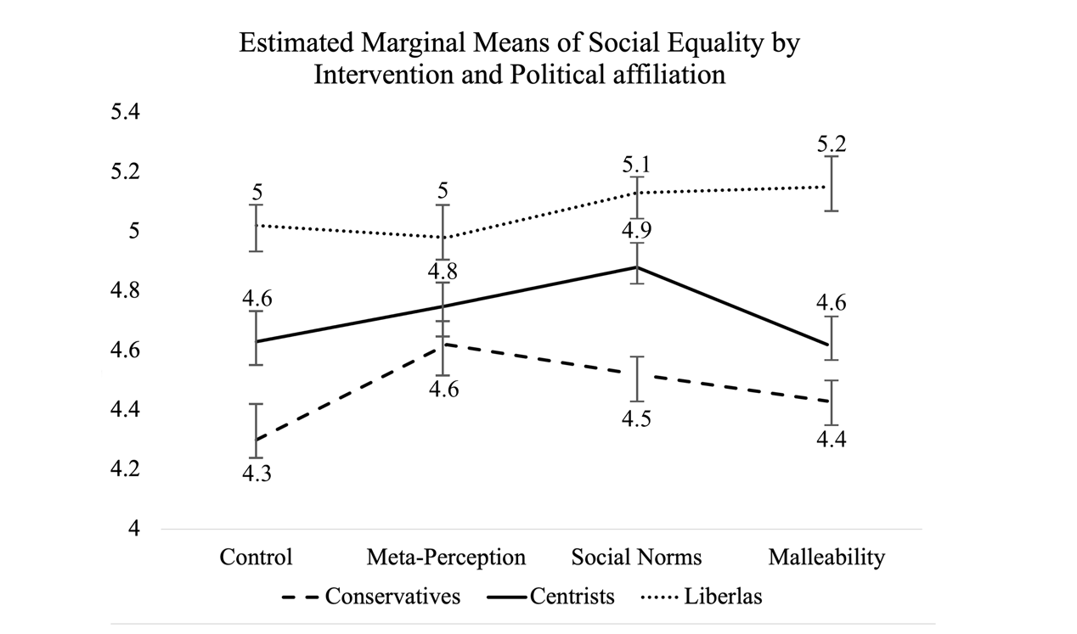 Figure 1. *Estimated marginal means of social equality factored by condition allocation and political identification. Error bars: 95% CI. Covariates appearing in the model are evaluated at the following values: Baseline Social Equality = 4.6719*. *Error bars: 95% CI.*

The univariant analysis validated that political affiliation moderates the effectiveness of social equality interventions. However, it did not account for the relative effectiveness of each intervention amongst each of the political groups. To examine which interventions led to significantly higher support of social equality (for each group), we conducted a one-way ANOVA analysis and a Post Hoc Sheffe test with condition as the factor variable and support of social equality as the dependent variable – conducted separately for each of the three political groups. The ANOVA found significant condition differences in support of social equality, for each of the three political groups (F*Conservatives* (3, 1032) = 8, p < .001; F*Centrists* (3, 633) = 5.25, p < .001; F*Liberlas* (3, 578) = 4.65, p < .001).

Post Hoc Scheffe test revealed that for most political groups, there was only one intervention that significantly differed from control. Liberals exposed to the Universalism condition exhibited significantly higher levels of social equality (Mean Difference = 0.3, Std. Error = 0.09, p < .01), compared to liberals in the control group. However, there were no significant differences between the control group and Liberals exposed to either the meta-perception condition (p = .95), or to the social norms condition (p = .36). Similarly, while Centrists exposed to the social-norms intervention exhibited significantly higher levels of social equality compared to control (Mean Difference = 0.4, Std. Error = 0.09, p < .001), there were no significant differences in support of social equality amongst Centrist participants who were exposed to the universalism (p = .98) or meta-perception (p = .2) condition (as compared to control).

Finally, Conservative participants exposed to the meta-perception condition exhibited significantly higher support of social equality (Mean Difference = 0.4, Std. Error = 0.08, p < .001), compared to Conservatives assigned to the control conditions. However, although Conservatives exposed to the universalism condition did not significantly differ in their support of social equality (p = .47), there was a marginally significant increase in support of social equality amongst Conservatives exposed to the social norms condition (Mean Difference = 0.3, Std. Error = 0.09, p = .04). While the meta-perception intervention significantly increased Conservatives' support of social equality (and their willingness to actively promote it) – it had no significant effect on Centrists and Liberals. Although Centrists exhibited the highest support of social equality (significantly higher compared to control), social norms had no significant effect on support of social equality amongst Liberals and Conservatives. While Universalism was the only intervention that was found to significantly increase Liberal support of social equality (compared to control), it had no effect over Conservative and Centrist support of social equality.

Taken together, the results validate our main hypotheses, exposing that social equality interventions have different effects on different political groups. As presented in Figure 2, 38% of Conservatives supported SE (*social equality*) after being exposed to the meta perception intervention (compared to 25% in control); Centrists exhibited the highest frequency of support of SE (76%) after exposure to the social norms condition (58% in control) – and the number of Liberal participants' supporting social equality was the highest after exposure to the malleability intervention (95%, compared to 87% in control).

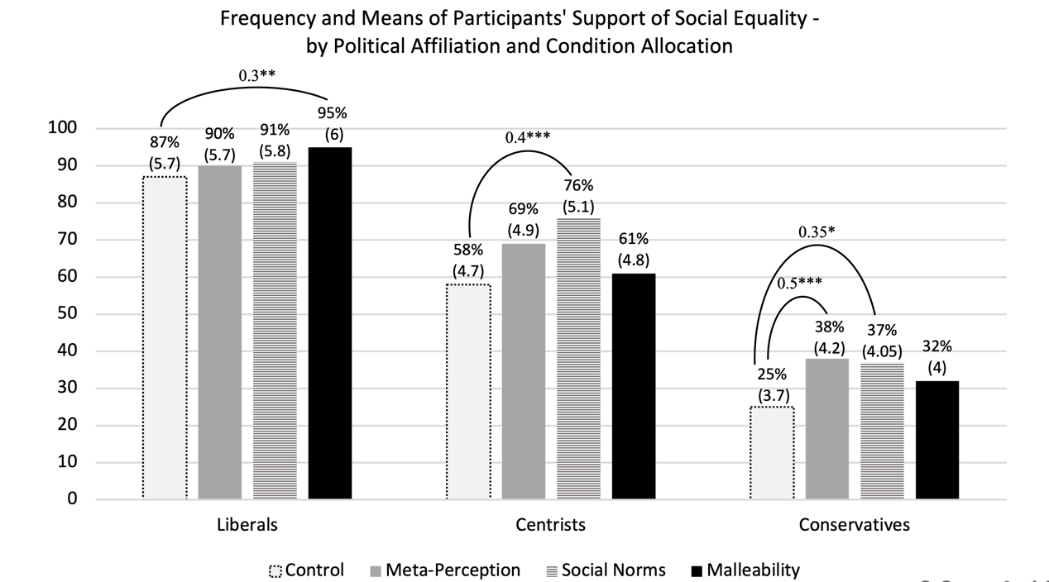

Figure 2. *Bars represent the frequency of support for social equality (means are reprted in parathesis) per each intervention, and the significant intervention differences in SE means conducted separately for each political affiliation. *p<.05, **p<.01, ***p<.001.*

However, although these findings affirm our suggested hypotheses in a controlled experimental design, they do not guarantee a successful generalization of these interventions in real-life settings.



**Study 2: Social Media Campaign Interventions**

After analyzing the results of the intervention tournament, we launched a field study using real-life social media campaigns based on the three interventions included in the tournament. We partnered with a liberal Facebook page that promotes discourse between all parts of the Israeli society ("Israelis Talk") and has the proper requirements and certification that Meta requires in order to run Facebook ads on social and political issues. We shared the intervention video clips with the page admins which in return granted us direct access to their ads manager, allowing us to examine the raw results of the intervention campaigns.

**Method**

To compare the effectiveness of each intervention amongst different political groups, the page admins created three types of target audiences, based on Facebook's targeting options. The audiences were generated based on three parameters: 1. Lookalike audiences: The Meta ads platform can generate a target audience which is similar to the followers of specific Facebook pages. In this case, we used audiences similar to those following the Facebook pages of Conservative/Centrists/Liberal politicians and parties. 2. Geographic Location: Based on the ballot results of the 2022 national election[6], each target audience was defined based on residents in one of the 50 neighborhoods and small municipalities (population under 50k) where Conservative/Centrists/Liberal parties gained the most votes. 3. Exclusion of each audience from the remaining two, so that each user could only be included in one of the target audiences, while allowing us to further distinguish between Conservatives, Centrists and Liberals.

For example, the Liberal target audience was defined based on Lookalike audiences following the page of the most Liberal party in Israel ("Meretz"), who also reside in one of the 50 neighborhoods where the liberal parties received the most votes, while excluding users which were already included in the Centrist or Conservative target audience (the full targeting protocol, as well as the materials used in the campaign, are available in Appendix C). Arabic speaking users were also excluded from all audiences (in accordance with our decision to target the high-power group, as detailed in the Intervention tournament study). Finally, we calculated the budget per each campaign based on a minimum ad reach of 5,000 unique users (i.e., the necessary budget needed to reach at least 5k unique users with each of the 9 ads). Since the size of political groups in Israel differs (with Conservatives ratio exceeding that of Centrists and Liberals), each campaign had a different budget – spreading equally between the three ads within it (see Table 6 for detailed ad budget).

***Creative A/B Testing.*** For each of our three target audiences, we launched a creative A/B testing campaign which automatically compares results from different Facebook ads (targeting the same audiences with an identical objective – while only changing the ad content). As per Meta's A/B testing requirements, all ads ran for an identical duration of time between Sep 5, 2023 – Sep 8, 2023, with all ads in each campaign having an identical budget (however, since the audience sizes were different, the total budget of each campaign differ, as detailed in Table 4), placed in identical media placements (Facebook Videos, Facebook sponsored posts, Instagram reels etc.). All ads consisted of two main elements: An identical call to action stating that "an Equal Israel is a Better Israel >> Sign and make a Difference", and one of the three intervention clips used in the intervention tournament. The Facebook video ads included an additional body text, which corresponded with the content of each clip (for the Meta-Perception clip: "What do the Arab citizens really think about the Jewish citizens?"; for the Social Norms clip: "What do the Jewish citizens really think about the Arab citizens?"; For the malleability clip: "Groups and peoples change frequently, and this change occurs everywhere, everyday"). Figure 3 presents the 3 ads which were presented to each of the target audience (translated to English).

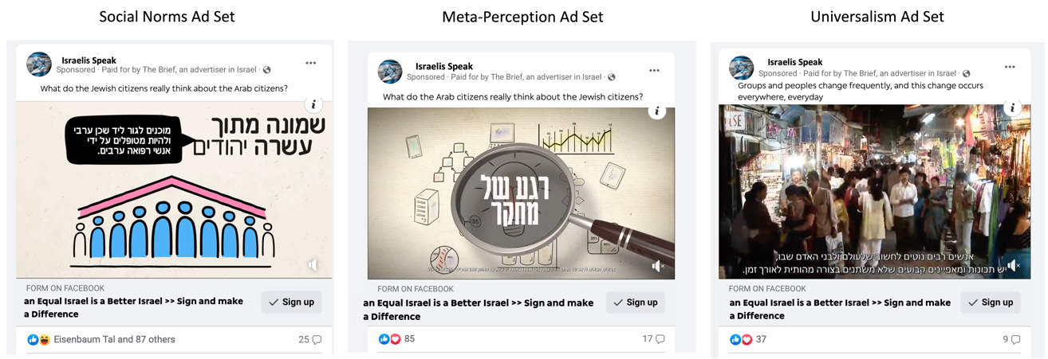

Figure 3*. Screenshots of the Facebook desktop Intervention ads, translated to English.*

Once they clicked on the ad's link, users were transferred to a website which presented them with further information regarding the importance of social equality, as well as with a short petition form. Upon the a-priori defined completion of the campaigns on September 8th 2023, Meta's ads manager generated a report which included all of the performance measures associated with each ad, for each target audience (as reported in the following section).

***Analyses Strategy****.* Upon the completion of the campaigns' duration and budget, we compared the effectiveness of each intervention (per each target audience), by analyzing two key conversion metrices (as the audience size and budget were identical for each ad, we focused on the relative effectiveness of each intervention rather than the totality of outcomes):

1. Result rate (RR): What percentage of people exposed to the ad, clicked on the petition link? clicking on the linkad reach (the number of unique people exposed to the ad).
2. Cost per link click (CPC): What is the average cost for a click on the petition signature post for each ad? Cost per click is calculated by dividing the link clicks by the amount spent per each ad.

**Results**

The three campaigns reached a total of over 69K unique Israelis, yielding over 26K engagements, and 1577 clicks on the petition signature link. Table 6 presents the performance metrices of each ad, in each campaign as generated by the Meta ads platform[7]. As the table shows, there were substantial differences in the performance of each ad, among each of the target audiences.

|  |  |  |  |  |  |  |
| --- | --- | --- | --- | --- | --- | --- |
| **Campaign / Audience** | **Ad Set Name** | **Reach** | **Ad Engagement** | **Results (Clicks on the Petition link)** | **Result rate** | **Cost Per Petition Click** |
| Conservatives | Meta-Perception | 5432 | 2148 | 139 | 2.56 | 0.68 |
| Social Norm | 8171 | 2247 | 178 | 2.18 | 0.69 |
| Malleability | 6062 | 1974 | 116 | 1.91 | 1.09 |
| Centrists | Meta-Perception | 9594 | 3589 | 178 | 1.86 | 1.01 |
| Social Norm | 15464 | 4649 | 300 | 1.94 | 0.77 |
| Malleability | 13861 | 4251 | 182 | 1.31 | 1.21 |
| Liberals | Meta-Perception | 6316 | 2495 | 129 | 2.04 | 1.01 |
| Social Norm | 11336 | 2589 | 157 | 1.38 | 0.94 |
| Malleability | 6530 | 2704 | 198 | 3.03 | 0.74 |

Table 6. *Performance Metrices of the ad sets used in each campaign.*

In accordance with our hypothesis, and extending the findings of Study 1, the meta-perception ad was most effective amongst Conservatives, with 2.6% of Conservatives exposed to the meta-perception ad clicked on the petition link, with the lowest average cost (0.68$) per petition link click. However, while the result rate difference between Conservatives exposed to the meta-perception (2.6%) condition was significantly higher than those exposed to the malleability (1.9%) condition (z = 2.33, p < .05, power= 92%, with 95% significance level), and the cost for petition click was significantly lower in the meta-perception ad (1.2$) compared to the malleability (1.5$) ad (MD=-0.41, t (11,492) = 238.71, SE=.002, p < .01, with 95% significance level); the difference in result rate between the meta-perception and social-norms ads was only marginally significant (z = 1.41, ps = .07, power= 70%, with 95% significance level), and the differences in the cost per result was not significant between Conservatives exposed to these ads (z=0.74, ps = .2).

As for the Centrist audience, the social-norms ad yielded a significantly lower cost per petition click (0.77$), compared to the malleability ad (MD = -0.44, t(29,323) = 375.29, SE=.002, p < .01, 95% CI = -0.442 to -0.437), as well as to the meta-perception ad (MD = -0.24, t(25,056) = 212.32, SE=.001, p < .01, 95% CI = -0.242 to -0.237). However, while the petition click rate was significantly higher for conservatives exposed to the social norms (1.9%) condition compared to those exposed to the malleability (1.3%) condition (z = 4.26, p < .001, power= 98%, with 95% significance level) – there were no significant differences in petition click rate between centrist exposed to the social norms ad and those exposed to the meta-perception ad (z = 0.47, ps = .31).

Finally, Liberals exposed to the malleability ad exhibited the highest petition click rate (3%) and the lowest cost per petition click (0.74$) compared to the meta-perception ad (*Petition click rate:* z = 6.8, p < .05, power = 92%, with 95% significance level. *Cost per petition click:* MD = -0.27, t(12,844) = 173.23, SE=.001, p < .01, 95% CI = -0.273 to -0.266) as well as to the social-norms ad (*Petition click rate:* z = 3.57, p < .01, power = 99%, with 95% significance level . *Cost per petition click:* MD = -0.2, t(17,864) = 17.16, SE=.001, p < .01, 95% CI = -0.229 to -0.177).



***Figures 4-5.*** Petition click rate and cost per petition click of each ad – per each audience.

**General Discussion**

The very essence of Social Psychology is to explain how psychological characteristics on the individual level, interacts with social identities, contexts, and behaviors (Allport, 1954). However, and despite the vast progress the field has experienced in recent years, most intergroup interventionists ignore the potential influence of personal characteristics on the effectiveness of such interventions, as well as the context and the medium by which such interventions occur in real life – leaving marketing and communication scientists to lead the way for psychological targeting, as well as for field implementation of intergroup interventions. This trend is contrary to the vast evidence demonstrating that targeted communication is much more effective means of persuasion, as well as to some of the basic assumptions of social psychology as a discipline.

The current works wishes to minimize this gap, by suggesting a new theoretical and methodological framework by which social practitioners may match and target the most effective types of intergroup interventions, to people differing in their political ideology – as well as to implement them in real-world contexts. We suggest that instead of asking which intervention will be most effective in promoting social equality, we add – for whom?

Appendix

Table 1

|  |  |  |  |  |  |
| --- | --- | --- | --- | --- | --- |
| **Source** | **Type III Sum of Squares** | **df** | **Mean Square** | **F** | **Sig.** |
| Corrected Model | 2496.413a | 12 | 208.03 | 496.24 | <.001 |
| Intercept | 219.8 | 1 | 219.8 | 524.31 | <.001 |
| Social Equality (Baseline) | 1188.67 | 1 | 1188.67 | 2835.44 | <.001 |
| Condition | 15.47 | 3 | 5.16 | 12.3 | <.001 |
| Political Affiliation | 89.46 | 2 | 44.73 | 106.69 | <.001 |
| Condition * Political Affiliation | 11.57 | 6 | 1.93 | 4.6 | <.001 |
| Error | 934.02 | 2228 | 0.42 |  |  |
| Total | 52577.57 | 2241 |  |  |  |
| Corrected Total | 3430.44 | 2240 |  |  |  |
| a. R Squared = .728 (Adjusted R Squared = .727) | | | | | |







1. https://www.nytimes.com/2023/04/27/world/middleeast/israel-march-judiciary-right-wing.html
2. The findings used in the clip were based on real survey data collected in the last two years amongst Arab Israelis (all materials, including translated videoclips, can be found in the supplementary material link).
3. The full questionnaire included several additional measures and conditions, unrelated to our current research focus. Hence, we only report the measures and conditions included on our pre-registration.
4. Since there were no significant differences in any of the outcome items between participants assigned to the empty control and those assigned to the neutral control, they were combined into one control condition (see supplementary materials for the full analyses of the results conducted separately for each control group).
5. The analyses of the baseline study are reported in Appendix A
6. https://votes25.bechirot.gov.il/ballotresults
7. For transparency and replication considerations, the original Facebook report which includes the ads creative, the audience targeting and the full performance metrices, is made available at https://fb.me/rfFkD6ugdo2h3E2