**Abstract**

**Elucidating the mechanisms controlling stomatal development under changing environment**

Plants can change their shape, size and cellular composition in response to environmental cues. This plasticity leans on the flexible developmental programs that enable plants to tailor their organ size and cellular composition. In eudicots leaves, the stomata and pavement cell are two essential cell types that produced from the stomatal lineage pathway to build the leaf epidermis. Plant stomata are pores on the leaf epidermis that enable gas exchange between plant and the atmosphere. To optimize gas exchanges, the stomatal abundance and pattern can vary in response to environmental cues. Based on previous studies in Arabidopsis, three cell-type specific bHLH transcription factors, SPEACHLESS (SPCH), MUTE, and FAMA were identified as central regulators of stomatal lineage flexibility. Although Arabidopsis serves as a model species to study stomatal development, **our previous study suggests that different plant species use similar molecular components, but lean on different cellular strategies, to achieve optimal stomatal distribution.** Thus, **the major goals of this proposal** is to study the mechanisms and genetic strategies using by tomato (*Solanum lycopersicum*) plants to optimize stomatal distributions under changing environments. Our preliminary results using translational reporters of SlSPCH, SlMUTE, and SlFAMA in tomato plants, show that the expression and function of these genes are conserved and can be found in the stomatal lineage cells. The characterization of stomatal development in tomato, in response to elevated temperature (34°C), revealed an increased stomatal numbers. This is in contrast to Arabidopsis, where stomatal number decreases at high temperatures. We hypothesize that the special expression of the central regulator of stomatal development, SlSPCH is controlled by temperature, light and other environmental cues, leading to changes in stomatal distribution. In addition, the effect of the environment on stomatal distribution might be mediated also by the activity of the Epidermal Patterning Factors (EPFs) peptides that act upstream to SPCH. To test these hypotheses, we aim: **1.**  **To establish a genetic and molecular “atlas” of cell types from developing tomato-leaf epidermis grown under different environmental conditions.** To this end, we will generate single-cell transcriptomic profiles of leaves exposed to different environmental conditions, and transgenic tomato plants expressing translation markers of stomatal lineage factors **2. To elucidate the cis-regulatory elements in SlSPCH promoter that mediate the effect of environmental cues on stomatal distribution.** To this end, we will use SlSPCH promoter bashing approach, generated by gene editing. **3. To explore the possible role of the signaling network upstream to SlSPCH in the environmental regulation of stomatal distribution, focusing on** **EPFs**. We will generate EPF translational reporters and mutants to study the effect of the environment on EPF transcription and stomatal distribution. This study will illuminate the intricate interplay between environmental cues and stomatal development that optimizes plant performance under changing environment.

**Background and motivation:**

An essential trait of plants is the ability to change intrinsic programs to align with external signals. Plants can sense their environment and respond by refining their development program. A good example of sensing and response is the behavior of stomata. Plant stomata optimize the assimilation of carbon dioxide (CO2) for use in photosynthesis while minimizing water loss. They do this in two ways: by physiological control of stomatal aperture (*1*) and by developmental regulation of their abundance and pattern (*2*). Both modes of control are regulated by the environment. As we face future climate change, with an increase in average global temperatures and water limitation, the understanding of how plants optimize stomatal development and patterns in response to changing environment has fundamental importance. In this research we will tackle this question using tomato plants.

Stomata originate from a pluripotent epidermal precursor cell through a series of regulated cell divisions and differentiation steps. In Arabidopsis, the process begins with an epidermal precursor undergoing an asymmetric cell division (ACD). After an initial ACD that creates a stomatal precursor (meristemoid) and a larger sister cell (SLGC), additional stem-cell like ACDs can take place, to adjust stomatal numbers and ratios. In meristemoids, these divisions are called “amplifying divisions” and in SLGCs, the divisions are named “spacing divisions”. To produce stomatal guard cells, meristemoids must undergo two additional developmental steps. First, a meristemoid transitions, without division, into a guard mother cell (GMC). Subsequently, the GMC undergoes a symmetric division, giving rise to a pair of guard cells with a stomatal aperture formed between them (*3*, *4*). Recently we found that different from Arabidopsis, in tomato, spacing divisions are extremely rare, at least under standard growth conditions. Conversely, about 30% of the ACDs in the tomato epidermis do not result in stomatal precursors, and instead become lobed pavement cells. This division type was named “meristemoid drop-out” (*5*). Because ACDs are used to adjust stomatal numbers and ratios, these finding have major implications for how different plants may adjust their development in response to systemic or environmental cues.

The ultimate targets of systemic or environmental cues that regulate stomatal development are a set of basic helix-loop-helix (bHLH) transcription factors (*6*). Three of these factors are expressed in, and required for, consecutive stages in stomatal development. SPEECHLESS (SPCH) acts first and regulates ACDs (Figure 1, 2a and c) that start the process of stomatal development and later amplify stomatal precursor cell numbers. MUTE switches the program from continued asymmetric division to commitment to making guard cells, and FAMA is critical to make functional stomata (*7*) (Figure 1, 2a and c).

Because of its role in amplifying the number of stomatal precursor cells, SPCH is thought to be the critical target for environmental inputs into development (*8*). Several environmental cues directly regulates SPCH protein stability or transcript level. For example, in Arabidopsis light promotes stomatal development. It was shown that under high light intensity, via the photoreceptors cryptochomes (CRY1 and CRY2) and phytochromes (PhyA and PhyB) promotes SPCH and MUTE activity, enhances ACDs and GMCs and increase stomatal number (*9*). In contrast to the positive affect of light on stomatal distribution in Arabidopsis, stomatal numbers decrease in response to high temperature. It was demonstrated that SPCH transcription is repressed at high temperature by PIF4, whose levels in the stomatal lineage increased under these conditions (*10*). In addition to the above environmental signals, stomatal development is regulated also by internal signals that mediated by plant hormones. The drought hormone ABA has major impact on stomatal development. ABA negatively regulates stomatal production via the degradation of AtSPCH, leading to reduced stomatal number and water loss (*11*). Although SPCH responds to many internal and environmental signals, little is known about the specific regulatory sites in its promoter that respond to the different cues.

Stomatal patterning is regulated also by developmental signal, mediated by secreted peptides called Epidermal Patterning Factors (EPFs), which promote or repress stomatal production. In Arabidopsis, EPF1 and EPF2 control stomatal patterning and regulate the ACDs by suppressing SPCH activity, while EPFL9 (STOMAGEN), promotes stomatal differentiation as a competitive inhibitor with EPF2 (*4*). EPF1 express in the stomata and EPF2 expressed in the meristemoid cells, thus they suppress different stages of the stomatal development. Their activity reduces the number of stomata, and ensure the 'one-cell-spacing rule' that makes a space between stomata by at least one epidermal cell (*12*). In contrast, EPFL9 express in mesophyll cells and positively regulates the stomatal development, and thus, the increase in stomatal number. Several studies show that EPFs are regulated also by the environment and that stomatal responses to high [CO2] involve EPF2 (*13*). Moreover, recent results show that abscisic acid (ABA) regulates *EPF1* and *EPF2* expression in Arabidopsis (*14*) and overexpression of EPF family proteins in rice, wheat and barley increases drought resistant and water use efficiency (*15*–*17*). Unlike this negative responses of stomatal development to drought related signal, light increase stomatal production by promoting *EPFL9* transcription via the bZIP transcription factor HY5 (*18*).

Nearly all land plants have stomata and use them to balance photosynthesis water loss (*2*, *19*). The sequences and function of the stomatal lineage core bHLH genes are also broadly conserved and shown to regulate stomatal production in distant plant species (*20*, *21*). This suggests that the “stomatal bHLHs” are good candidates to explore stomatal development. Although Arabidopsis is a powerful model system to study stomatal development, as discussed above, my research show that the regulation of stomatal patterning in tomato leaves is different from that in Arabidopsis. This suggests that different plant species use similar molecular components, but lean on different cellular strategies to achieve the same optimal stomatal distributions. Thus, this proposed study will use tomato as a model system to investigate how the environment affect stomatal development.

*Hypothesis:* The central hypothesis of this proposal suggested **that SPCH promoter integrates various environmental cues to regulate stomatal development for better adaptation to changing environment. We also hypnotize that environmental cues affect SPCH upstream signaling molecules, the EPF peptides.**

The **major goal** of this proposal is to **decipher the genetic and molecular mechanism that tomato plants use to optimize stomatal production and distribution to cope with changing environments**.

**Our specific Aims are:**

1. **To establish a genetic and molecular “atlas” of epidermal cell types from developing tomato leaf exposed to different environmental conditions.** We will generate single cell transcriptomic profiles of leaves exposed to different environmental conditions and use transgenic plants expressing translation markers of stomatal lineage factors
2. **To elucidate the *cis*-regulatory elements in SlSPCH promoter that mediate the effect of environmental cues on stomatal distribution** by generating SlSPCH promoter bashing, using gene editing approach.
3. **To explore the regulatory signaling network upstream SlSPCH that mediate the effect of environmental cues on stomatal distribution, focusing on** **EPFs.** We will useEPF translational reporters and mutants to study the effect of the environment on EPF transcription and stomatal distribution.

*The research rational*

**Figure 1**.  **Overview of research aims.** Shown at top are environmental cues that may impact stomata. In the center are the types of ACDs in the stomatal lineage of the tomato leaf: (**i** and **ii**) are common in tomato while (**iii)** is rare. How are these divisions regulated to generate optimal stomatal numbers and spacing? In **Aim 1**, We will characterize the ACDs in detail and how they are employed in different environments. In **Aim 2**, we'ill focus on the main transcriptional regulator of ACDs, SPCH, and in **Aim 3** we characterize SlEPF signaling peptides as components of the signaling pathway connecting environmental information to genetic and cellular responses (SlSPCH and ACDs, respectively).

**Research objectives & expected significance**

**Aim 1: Create a genetic and molecular “atlas” of cell types in the developing tomato leaf epidermis to study the stomatal lineage dynamics in response to environmental cues**

**Rationale:** Recent studies in tomato have shown that the desert-adapted wild tomato *Solanum pennellii* differs in stomatal patterning from the cultivated species *Solanum lycopersicum* (var. M82), suggesting evolutionary pressures to regulate stomatal spacing differently in tomato plants that grow in arid habitats (*22*, *23*). Base on our previous discoveries, which highlighted the similarities in development strategies between the tomato stomatal lineage and Arabidopsis also implies the existence of numerous pathways through which environmental shifts can influence alterations in stomatal density, arrangement, and behavior. To reveal the diversity of cellular and genetic mechanisms available for plants to optimize their leaves for a given environment, it is crucial to capture the live development of the young leaf by microscope and to create cell-type specific markers to enable a thorough understanding of variation in tomato stomatal development.

**Aim 1.1 Creating reporters to enable analysis of development in response to environmental change**

**Q1: What is the genetic mechanism/s of stomatal linage under changing environment?**

**Preliminary results**- Three cell-type specific bHLH transcription factors including SPCH mark the crucial cell types in the Arabidopsis stomatal lineage, and homologues of these factors are found throughout land plants (*6*, *24*). Reporters of these genes enable monitoring lineage dynamics and have been used extensively in Arabidopsis (*25*). To mark cell types and analyze the activity of the tomato stomatal lineage proteins, we created native-promoter driven reporters : *SlSPCHpro::NeonGreen-SlSPCH*, *SlMUTEpro::Scarlet-SlMUTE*, and *SlFAMApro::mTurquoise -SlFAMA* (Figure 2d). Because these reporters contain different fluorophores, they can be viewed together. The reporter lines we generated also express a reporter, *ML1p::RCI2A-mNeonGreen* that marks epidermal cell enabling to investigate specifically the leaf epidermis cells (Figure 2d). These reporters enable to capture the ACDs and other critical events in young developing leaves from germinated cotyledons to the first or second true leaf for up to 48hr (in 30-minute intervals) (*5*). These help to observe the dynamics of stomatal formation and pattern under different environments and in different mutant backgrounds. We particularly interested in how the tomato-specific ACDs are used to create larger or smaller leaves, with more or fewer stomata. An example is shown in Figure 2b-c where using live-cell imaging with the ML1p::RCI2A-mNeonGreen reporter in the leaf epidermis, we could identify ACDs and their cell fate outcomes over multiple days. This time course analysis discovered that spacing ACDs (which, in other species, increase stomatal number) in tomato are missing, whereas “symmetric differentiation” to generate non-stomatal pavement cells (Figure 1, 2a-c) is prominent. This suggests a potential “hidden” regulation for stomatal distribution in the tomato leaf epidermis, which might be promoted by specific signaling or environmental cues**.**

We also took advantage of our SlSPCH, SlMUTE and SlFAMA translational reporters (**Figure 2d**) to study how the stomatal lineage respond to changing environments. Our preliminary data show that, although both higher temperature and high light intensity increased stomatal number, probably via SPCH (as in Arabidopsis, (*8*), the mechanism, is most likely different. At the higher temperature, the high SlMUTE level provided by the transgene led to a strong stomatal overproduction and stomatal clustering phenotype, a phenotype that was not found under high light intensity (Figure 2e-h). **These results imply hidden mechanisms in the way plants cope with different environments, even when the outcome is similar as regulating stomatal development for increase stomatal number**. **Thus,** the objective of this aim is to elucidate the underline genetic mechanism that control the interplay between the environment and stomatal development by using the tomato SlSPCH, SlMUTE and SlFAMA translation markers.

**Research design and methods:** To disclose further the role of the tomato SlSPCH, SlMUTE and SlFAMA in the stomatal lineage response to changing environments, we will use the above-mentioned markers and test them in response to changes in light intensities and growth temperatures. For that, we will grow these plants in two light intensity and temperature regimes: 130 and 1300 μmol photons m-2 s-1 and 26°C and 34°C. We will then analyze the leaf stomatal patterns and distribution in the cotyledons at three stomatal developing stages: 0, 1, and 3 days post-emergence (dpe), using the state of the art Leica Stellaris 8 (Leica Microsystems, Welzar, Germany). Lines with strong stomatal overproduction and stomatal clustering phenotype as found in SlMUTE translational reporter under high temperature, will be deeply characterized in time course analysis to study the dynamics expression of SlSPCH, SlMUTE, and SlFAMA in the ACDs, GMCs, and stomata. This time-course analysis will indicate for potential role of the above factors in the response to light and temperature changes, at the stomatal lineage specific stages.

**Aim 1.2 Single cell transcriptomic strategies to study stomatal lineage under changing environment**

**Preliminary results**- We have generated scRNAseq profiles of developing M82 leaves under three growth temperature conditions (26°C, 32°C and a shift from 26°C to 32°C; Figure 3). These profiles serve as a basis for a greater transcriptome-based understanding of tomato leaf cell identity, and cell-type specific responses to temperature changes. In addition, this scRNAseq profiles will be used to investigate which genes and programs are activated in stomatal lineage cell types. We will search for genes which co-expressed with SlSPCH and other stomatal regulators and reveal correlations in expression of stomatal lineage specific genes and known environmental response genes. **From the first** analyses of the scRNAseq profiles, we identified cell clusters that have a tissue-specific identity as the leaf vascular, epidermis, and guard cells (GC) (Figure 3a). However, although we were expected to find stomatal lineage genes (as SlSPCH, SlMUTE and SlFAMA) in the leaf epidermis cell cluster, we were able to identify only SlMUTE and SlFAMA in these cells, but not SlSPCH (Figure 3b-d). Furthermore, despite the expression of SlMUTE 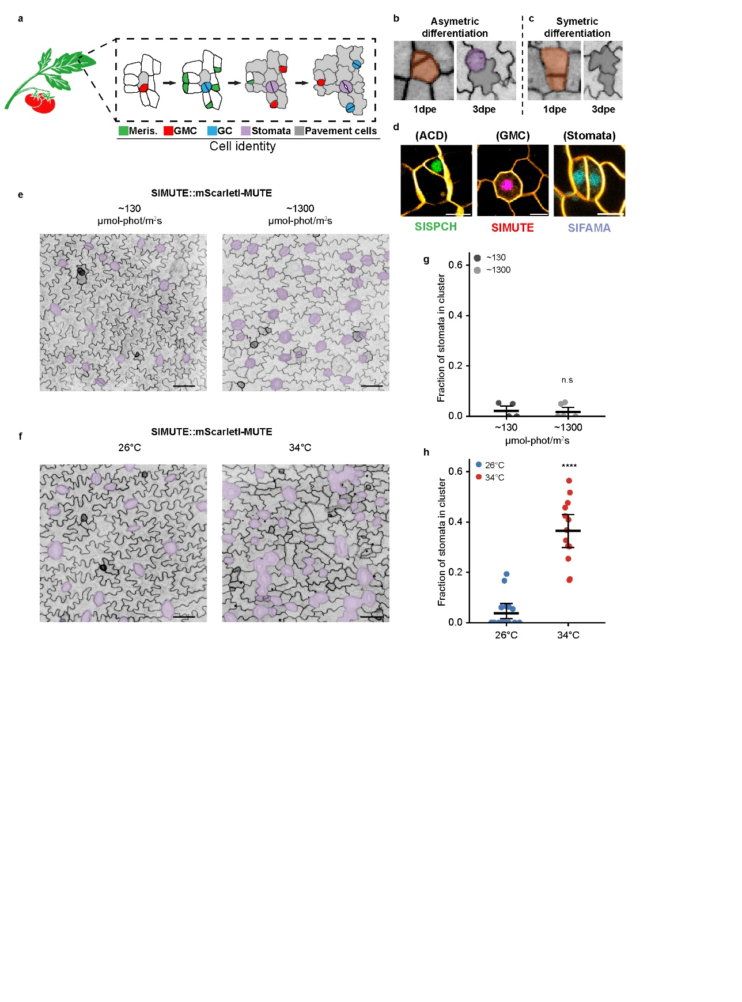and SlFAMA was in the expected tissues (epidermis and GC), only 12 cells expressed SlMUTE, and 33 cells expressed SlFAMA (Figure 3c-d). The low number of SlMUTE and SlFAMA expressed cells and the absence of SlSPCH in this scRNAseq profile, point for the option that the tissue we collected was too mature for sufficient quantity of cells representing the stomatal lineage process. Therefore, in aim 1.2, we will perform single cell analysis on younger developing leaves as described below.

**Figure 2.** (a) Schematic of stomatal development in tomato leaves based on observations of divisions and expression of reporters. (b-c) Confocal images of the same region of tomato cotyledon epidermis 2 days apart, showing two different fate outcomes of physically asymmetric cell divisions. (b) Asymmetric differentiation, ACD that create one stomata and one pavement cell; and (c) symmetric differentiation, ACD that create two pavement cells (adapted from (*5*)). (d) Fluorescent cell type reporters for *SlSPCH*, *SlMUTE* and *SlFAMA* expressed during asymmetric cell division (ACD), guard mother cell (GMC), and in young stomata, respectively. Cell outlines are visualized (orange color) by the *ML1p::RCI2A-mNeonGreen*. (e) Confocal images of 4-dpg cotyledons expressing SlMUTE at low and high light conditions. Stomata are false-colored purple. (f) Confocal images of 4-dpg cotyledons expressing SlMUTE at low and high temperature conditions. Stomata are false colored purple. (g-h) Plots of fraction of stomata found in clusters in lines bearing SlMUTE, in response to changes in (g) light and (h) temperature. Scale bars in (e) and (f) represent 50 μm. In (b-c) dpe refers to days post-emergence of the cotyledon. Statistical tests in (g-h) are represented as mean ± 95% confidence interval. Bonferroni-corrected p values from Mann-Whitney U test are ****P < 0.0001. n.s.: P > 0.05, not significant. In (a) Meris. indicated fo meristemoid, GMC indicated to guard mother cell, and GC indicated for guard cell.

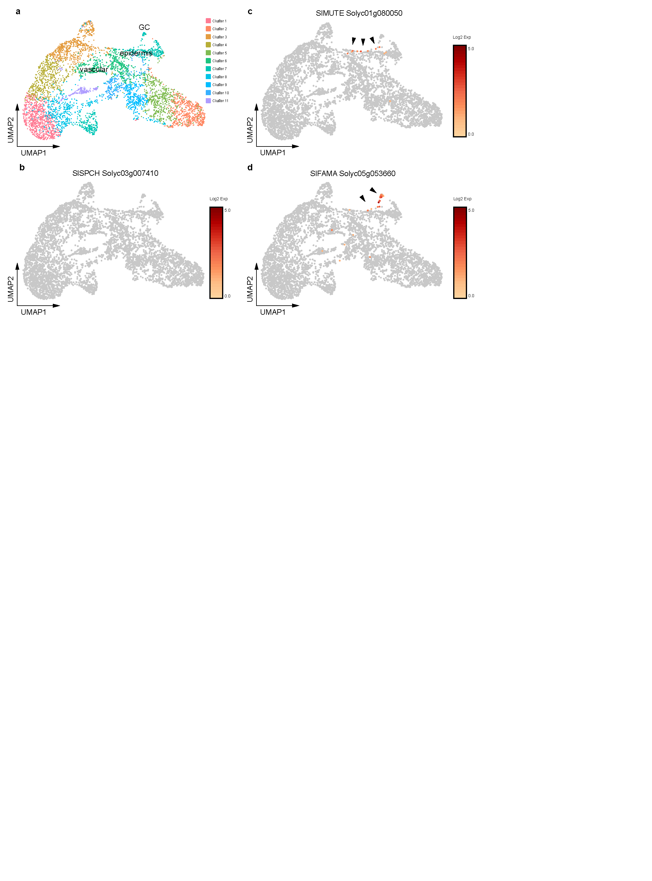**Research design and methods:** To enable sufficient quantity of cells representing the stomatal lineage process in tomato leaves, we will use the ML1p::RCI2A-mNeonGreen reporter for leaf epidermis cells. Developing leaves from this line will harvest from plants that grow under the three growth temperature conditions (26°C, 32°C and a shift from 26°C to 32°C). Cells will be isolated by fluorescence-activated cell sorting (FACS) to enrich the stomatal lineage cells for the 10x genomics scRNA-Seq. By using this approach, we could generate new scRNAseq profiles with better resolution to investigate which genes and programs are activated in stomatal lineage cell types in response to change in temperature**.**

**Figure 3.** (a) Single cell RNA sequence-based UMAP plot. The cluster of cells with the identity of leaf vascular, epidermis and guard cell (GC) are indicated. (b-d) Expression of known stomatal lineage markers in cell types, (b) SlSPCH, (c) SlMUTE, and (d) SlFAMA. The arrowhead indicates cells with gene expression in the epidermis and GC. The color scale for each gene plot represents log normalized.

Defining the cellular and physiological processes that link specific environmental conditions to stomatal density, pattern, and index (**Aim 1**) is a critical first step. It will be significantly enriched by an analysis of the genetic underpinnings of the stomatal lineage responses to changing temperature and light, which will be important as a basis for the following aims.

**Aim 2: Using genome-edited regulatory and protein coding variants of key stomatal regulators to decipher regulation of stomatal development in response to changing environments**

**Rationale:** Arabidopsis AtSPCH regulates the total number of stomata and leaf epidermal cells and may be the prime target for signals that regulate leaf growth (*26*). Responses to light, temperature, osmotic stress, and [CO2] all eventually affect AtSPCH transcription or protein stability (*8*). In tomato, SlSPCH underlies a QTL linked to stomatal distribution (*23*). For these reasons, we will devote considerable effort to study SlSPCH in tomato. We will use **genome-edited** loss of function mutants, and **targeted editing of regulatory regions** to manipulate stomatal properties and search for cis-regulatory regions on SlSPCH 5' to find potential stomatal gene network candidates involved in SlSPCH regulation in response to environmental cues.

**Aim 2.1 Establishing a comprehensive library of regulatory mutations in SlSPCH**

**Q2**: **What is the role of tomato SlSPCH in mediating response to environmental cues?**

**Preliminary results**- Complete loss of SlSPCH activity is likely to eliminate stomatal generation and be lethal (*27*). Thus we employed CRISPR/Cas9 based multiplex strategy (*28*) to make a series of small deletions in the 5’ regulatory region of SlSPCH. Preliminary results show that by using 11 gRNAs spaced along ~3000 bp upstream of the SlSPCH start site, we created SlSPCH promoter alleles, that range from small deletions of 2bp to long deletions of ~2.5Kbp and some mutations that extended into the coding region (**Figure 4a**). Under normal growth conditions, most of the mutations yielded plants whose overall morphology was not dramatically different from wildtype (*Solanum lycopersicum* cv. M82). However, mutations affecting the coding region were stomata-less, and resembled the Arabidopsis *spch* null mutant (Figure 4b) (*27*).

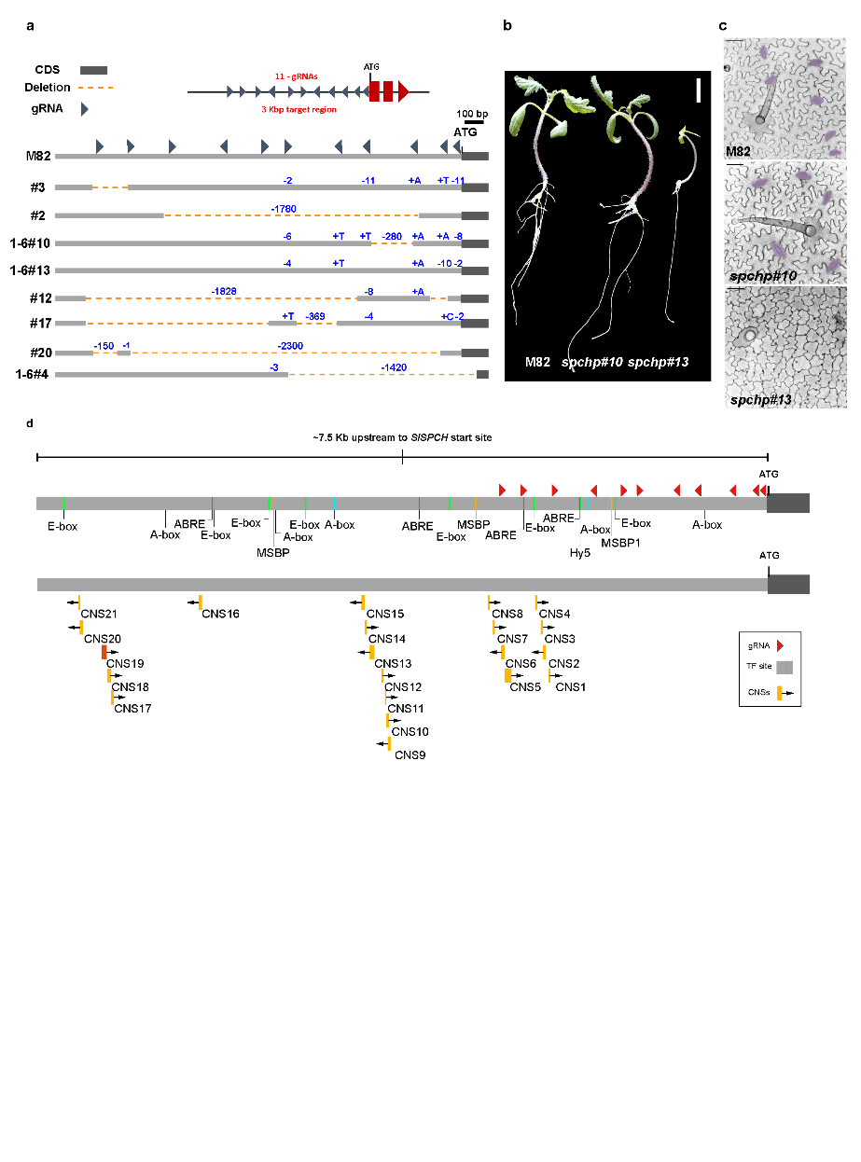**Figure 4.** (a) Diagram of SlSPCH cis-regulatory mutagenesis scheme and resultant deletions. (b) Seedling morphology and (c) cotyledon epidermis phenotypes in wild type M82, SlSPCH cis-regulatory deletion line 1-6#10 and SlSPCH coding region deletion line #13, where a one nucleotide deletion in exon 1 is predicted to cause a frameshift and premature stop codon. (d) Annotation of SlSPCH 5’ cis-regulatory region with gRNAs (red triangles), predicted transcription factor (TF) binding sites, and Conserved Non-Coding Sequences (CNS) found between *S. lycopersicum* and other plant species. Orange CNSs are conserved only within the *Solanaceae* family, and the red CNS (CNS19) is conserved among eudicots including Arabidopsis. Stomata are false-colored purple in (c). Scale bars in (b) 20 mm, and in (c) 50 μm.

For the next set of experiments, we will choose number of SlSPCH cis-regulatory mutants lines to test them in response to changes in light and temperature (**Aim 2.2**). Although the 3Kb region of our sgRNAs target contains predicted cis elements for light, temperature and ABA responses (Figure 4d), a large number of these sites can be found also upstream to our sgRNAs target. This upstream region, may have an additional role in the regulation of stomatal development by the environment. Furthermore, sequence predictions in the *SlSPCH* upstream region, and alignment with *SPCH* 5’ regions from other *Solanaceae* and from *Arabidopsis* reveal a number of Conserved Non-Coding Sequences (CNS, Figure 4d). Some of the *Solanaceae* CNS are included in our characterized deletion lines (Figure 4a and 4d) but the conserved regions between tomato and Arabidopsis (CNS19 in Figure 4d) is further upstream.

**Generation of additional cis-regulatory alleles that specifically target CNS may be a productive strategy to identify additional regulatory elements, including those that drive cell-type specific expression and those that affect *SlSPCH* transcription in response to additional environmental factors such as drought.**

**Research design and methods:** While the 11 gRNAs we already generated for the SlSPCH cis-regulatory mutagenesis is ~3Kb upstream of the start site, the nearest protein-coding region lies more than 7.5 Kb upstream of the SlSPCH start site (Figure 4d). This reveals a large region of putative SlSPCH promoter with possible CNS regulating SPCH transcription in response to changing environment. To further uncover the regulation of SlSPCH by the environment, we will generate new set of gRNAs to make an additional series of small deletions in the 5’ regulatory region of SlSPCH upstream to the former mutagenesis on SlSPCH promoter (Figure 4a).

**Aim 2.2 Elucidate the physiological mechanism of SPCH in stomatal development under changing environment**

**Rationale 1:** As the main photosynthetic tissue, leaves have finely tuned responses to changes in light quality and intensity. Along with increasing mesophyll cell and chloroplast number, plants respond to elevate light with an increase in stomatal index (SI, stomata/total epidermal cell number) and in total numbers of stomata per leaf.

**Preliminary results 1:** We established a preliminary baseline light response for tomato cv. M82 with WT SlSPCH. We grew M82 plants at 26°C and two light intensity regimes: ∼130 μmol-photons m-2 s-1 and ∼1300 μmol-photons m-2 s-1 and quantified the SI (Figure 5a). As expected, M82 plants increased their SI under high-light conditions. We then tested our SlSPCH cis-regulatory deletion mutants under the same conditions and found a variety of responses (Figure 5a).

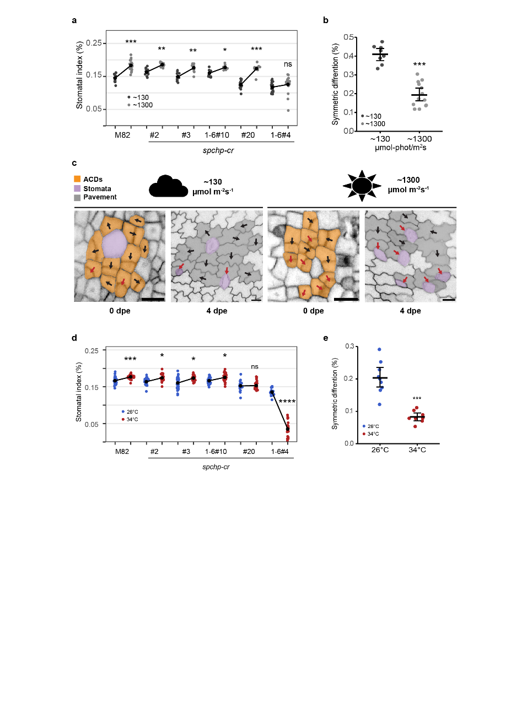Lines #2, #3 and 1-6#10 have similar SI as M82 at low light, but exhibit a dampened response to higher light intensity. Line #20 has a lower SI at low light, but is similar to M82 at high light, and therefore has an exaggerated response. Line 1-6#4 exhibits both a lower SI at low light and no response to an increase in light intensity. Taken together these phenotypes suggest that alteration of specific cis-regulatory region in SlSPCH has a specific effect on the sensitivity to to light. In Arabidopsis, a shift in the relative frequency of amplifying to spacing asymmetric divisions leads to an increase in SI (*29*). However, in tomato, spacing divisions is hardly exist (*5*), thus it is not clear what cellular mechanisms affect SI in tomato in response to changes in light intensity. We tested how tomatoes alter SlSPCH and the stomatal lineage to change SI in response to light by using the epidermal plasma membrane reporter described in Aim 1.1. We traced ACDs dividing precursor cells to their final fate outcome every two days (Figure 5c). From these time courses, we found that the major mechanism responsible for altering SI was a shift from asymmetric divisions that yield one stoma and one pavement cell to asymmetric divisions that produced two pavement cells (**Figure 1 and 2a**). Thus, tomatoes appear to use a “meristemoid drop-out” strategy (*5*) to reduce SI under low light.

**Figure 5.** (a) Plot of stomatal index (SI) response to low and high light conditions in M82 and SlSPCH cis-regulatory mutants. (b) Plot of shift in the number of ACDs that yield two pavement cells in low and high light. (c) Lineage tracing of asymmetrically dividing cells and their fate outcomes from confocal images of M82 cotyledons expressing epidermal plasma membrane reporter ML1p:RCI2A-NeonGreen. Red arrows mark ACDs that yield stomata (purple) and black arrows indicate ACDs that lead to two pavement cells (symmetric differentiation). Scale bars represent 20 μm. (d) Plot of SI response to low and high temperature in M82 and SlSPCH cis-regulatory mutants. (e) Plot of shift in the number of tomato stomatal lineage ACD that produce two pavement cells instead of one stoma and one pavement cell (symmetric differentiation) in plants grown at 26°C and 34°C. Statistical tests in (a), (b), (d) and (e) are represented as mean ± 95% confidence interval. Bonferroni-corrected p values from Mann-Whitney U test are *P < 0.05; **P < 0.01; ***P < 0.001; ****P < 0.0001. n.s.: P > 0.05, not significant.

**Rationale 2:** Plants also respond to elevated temperature by changing stomatal behavior and production (*30*, *31*). We established a baseline for temperature response in tomato cv. M82 with WT SlSPCH, and then we tested our SlSPCH cis-regulatory mutant lines to changes in temperatures.

**Preliminary results 2:** We found that stomatal number increased when tomato plants were exposed to high temperature (34°C; Figure 5d, M82). This response in tomato is opposite to that found in Arabidopsis, where stomatal numbers decrease at high temperature (*10*). During the last year we screened number of the SlSPCH promoter alleles for responses to temperature. Under different temperature regime, the SlSPCH cis-regulatory variants showed again diverse responses. SI responses in lines #2, #3 and 1-6#10 to a shift from 26°C to 34°C were slightly dampened relative to those in M82, line #20 was essentially insensitive, and line 1-6#4 showed a dramatic decrease in SI at 34°C (Figure 5d). Line 1-6#4 has a deletion that extends into the coding region and thus its response to different temperatures cannot be solely attributed to altering the cis-regulatory region. Response to changing temperature could be separated from responses to light; line #20 was hypersensitive to light, but insensitive to temperature, and line 1-6#4 only showed a strong change in response to temperature (Figure 5a vs. 5d). We used live cell imaging to track how temperature affect stomatal lineage divisions and fates, and found, similar to light responses, that the primary cellular mechanism underlying an increase SI was an increase the proportion of asymmetric precursor divisions producing a stoma and pavement cell (rather than two pavement cells) at higher temperature (Figure 5e). **Overall, these results show that the CRISPR/Cas9 editing of tomato cis-regulatory regions approach can reveal sites for environmental inputs**. To get a better resolution of cis-elements, we will expand our population of SlSPCH promoter-mutations and analyze them, in addition to changing temperature and light, under other conditions, such as drought.

As mentioned earlier, the plant hormone ABA involved the in the regulation of stomatal production by mediating the degradation of AtSPCH through SnRK2 kinases (*11*). In this work, Yang et al provided mechanistic insights into a key response to water-deficit via the regulation of SPCH protein stability. However, an open question remains: how does drought regulate SPCH expression?

**Research design and methods:** Our tomato SlSPCH cis-regulatory mutants can be served as excellent tools to study the role of SlSPCH cis-regulatory regions in the response to water-deficiency. We will use the high-throughput multi-lysimeter system (*32*) to monitor and control the water-content of the pots, whole plant transpiration and canopy conductance. Briefly, control M82 and the SlSPCH cis-regulatory mutants will be grown under controlled condition of well-watered and water-deficit of 60%, 40%, and 20% relative soil water content (RSWC), to cover large range of water-deficit conditions. Since each pot is placed on load cell with digital output to monitored the weight, we can either set specific quantity of water but also analyze the plant water loss and other physiological traits. In addition, we will examine the stomatal index of the control and SlSPCH cis-regulatory mutants, to study how the variances in water-deficit conditions affect their stomatal development. This system will enable us to study the link of SlSPCH cis-regulatory regions with drought response and stomatal development.

**Aim 3 Exploring the regulatory signaling network upstream of SlSPCH through genetic analysis.**

**Rationale:** SPCH is a central regulator of the stomatal pathway, and in Aim 2, we describe genetic approaches towards its regulation at a direct transcriptional level. AtSPCH is also regulated by hormones and developmental signals. There are many possible lines of inquiry here, but we will begin with one that unites (1) the upstream regulation of SlSPCH, (2) the novel asymmetric cell division patterns we found in tomato and (3) environmental control. This involves the stomatal lineage EPFs secreted proteins. The AtEPF1/2 ensure that Arabidopsis plants do not produce stomata in contact. We showed that in tomato, stomata are also not formed in contact, but the cellular division patterns that enforce this 'one-cell-spacing rule' are not the same as in Arabidopsis (Nir et al 2022). One hypothesis is that ACDs in tomato are actively repressed under standard growth conditions by SlEPFs. If true, then loss of EPF1 and/or EPF2 could restore these divisions. Moreover, under environmental conditions that promote stomatal production, SlEPFs might be expressed at lower levels, allowing more stomata to form. In addition, the ACDs that lead to two pavement cells (Figure 1- ii, and 2c) resemble those generated by overexpression of AtEPF in Arabidopsis which reduce stomatal number, suggesting another way this system could be responsible for altered stomatal patterns. Understanding the role of SlEPFs might be also important from an agronomic perspective because their potential to change stomatal/pavement cell ratios could generate plants that are more drought resistant.

***Aim 3.1 Elucidate the role of EPFs in tomato stomatal lineage***

**Q3: What are the regulatory signaling network upstream of SlSPCH in tomato?**

**Research design and methods:** Phylogenetic and protein structure analysis show that EPFs are conserved among vascular plants (*33*). By comparative protein sequence analysis, we found putative tomato SlEPF orthologues. Since the EPF family also includes peptides that mediate other (non-stomatal) events we will use the scRNAseq data described in Aim 1.1 to identify SlEPFs co-expressed with stomatal lineage genes like SlSPCH, SlMUTE and SlFAMA. To confirm the specific expression of these SlEPFs in leaves, we will create native promoter-driven reporters of each stomatal lineage-enriched SlEPF and track their expression during development of the stomatal lineage.

To explore function of the tomato EPFs, we will use the CRISPR/Cas9 system to generate loss of function mutations in SlEPFs. We expect that loss of SlEPFs will increase stomatal number. However, underline mechanism responsible for this alteration in tomato remain to be elucidated. We will use the reporters and time-course imaging strategies to reveal whether SlEPFs regulate different types of ACDs, including those extremely rare or prominent in tomato (examples shown in Figure 1 i,ii,iii, and 2a-c). Since EPFs have a dose-dependent effect on stomatal production, and their overexpression has been used to engineer more water-use efficient cereal crops (*15*–*17*), we will also create lines with elevated SlEPF levels in their native domains (SlEPFxp::SlEPFx-Scarlet) and lines where SlEPFs are expressed throughout the epidermis (ML1p::SlEPFx-Scarlet). In addition to defining the distance SlEPFs might secreted from their cell of origin (calculated by comparing transcriptional and translational reporter distribution), these lines may enable us to study the fine-tuning of ACD types thus changing the overall stomatal and leaf development. These lines will also help to study the role of SlEPFs and the regulation of SlSPCH and stomatal development in responses to environmental changes.

**Aim 3.2 Enhancing the Signaling Network: Investigating the impact of SlEPFs on environmental responses and exploring interactions with diverse signaling pathways**

**Rationale:** SlEPFs are signaling molecules that might regulate stomatal lineage divisions in response to environmental changes. We have already created reporters, mutants and phenotyping platforms--from detailed cellular time courses to the function and productivity of the entire plant. This together with the SlEPFs markers and mutant, will set the stage for future characterizing the functions of other genes and pathways in environmentally-responsive stomatal development.

**Research design and methods**: We will subject the tomato SlEPFs mutants and reporters to conditions that modulate stomatal production such as high or low light, high or low temperature, and ABA. These experiments will indicate whether SlEPF signaling mediates any environmental response and if it does so by changing the number or type of cells that express SlEPFs.

We will grow the SlEPFs mutants and markers under different temperatures regimes (26°C to 34°C), and light of ∼130 and ∼1300 μmol-photons m-2 s-1, as describe in Aim 2. We will characterize microscopically the SI and patterning of the mutant cotyledon at the stage of 14 days post-emergence (dpe). To examine the effect of temperature and light on SlEPFs expression and cell to cell peptide movement, we will grow the SlEPFs translation markers under the above temperature and light conditions, and characterize the epidermis of cotyledons under confocal microscope at the stages of 0, 1, 2, and 3 dpe. To test the interaction between ABA and SlEPFs, we will cross the SlEPFs mutants and markers to the ABA deficit mutants *sitiens* and *flacca*. After obtaining homozygote lines, we will characterize the SI and patterning at the stages of 0, 1, 2, 3 and 14 dpe, to study further the epistasis relationship between ABA and stomatal development. This experiment could expand our understanding if ABA affects stomatal lineage via SlEPFs, in addition to direct regulation of SPCH.

**References:**

1. J. I. Schroeder, G. J. Allen, V. Hugouvieux, J. M. Kwak, D. Waner, GUARD CELL SIGNAL TRANSDUCTION. *Annu. Rev. Plant Physiol. Plant Mol. Biol.* **52**, 627–658 (2001).

2. S. Casson, J. E. Gray, Influence of environmental factors on stomatal development. *New Phytol.* **178**, 9–23 (2008).

3. D. C. Bergmann, F. D. Sack, Stomatal Development. *Annu. Rev. Plant Biol.* **58**, 163–181 (2007).

4. S.-K. Han, K. U. Torii, Lineage-specific stem cells, signals and asymmetries during stomatal development. *Development*. **143**, 1259–1270 (2016).

5. I. Nir, G. Amador, Y. Gong, N. K. Smoot, L. Cai, H. Shohat, D. C. Bergmann, Evolution of polarity protein BASL and the capacity for stomatal lineage asymmetric divisions. *Curr. Biol.* **32**, 329-337.e5 (2022).

6. O. S. Lau, D. C. Bergmann, Stomatal development: a plant’s perspective on cell polarity, cell fate transitions and intercellular communication. *Development*. **139**, 3683–3692 (2012).

7. J. Le, J. Zou, K. Yang, M. Wang, Signaling to stomatal initiation and cell division. *Front. Plant Sci.* **5**, 297 (2014).

8. L. R. Lee, D. C. Bergmann, The plant stomatal lineage at a glance. *J. Cell Sci.* **132** (2019), doi:10.1242/jcs.228551.

9. C.-Y. Kang, H.-L. Lian, F.-F. Wang, J.-R. Huang, H.-Q. Yang, Cryptochromes, phytochromes, and COP1 regulate light-controlled stomatal development in Arabidopsis. *Plant Cell*. **21**, 2624–2641 (2009).

10. O. S. Lau, Z. Song, Z. Zhou, K. A. Davies, J. Chang, X. Yang, S. Wang, D. Lucyshyn, I. H. Z. Tay, P. A. Wigge, D. C. Bergmann, Direct Control of SPEECHLESS by PIF4 in the High-Temperature Response of Stomatal Development. *Curr. Biol.* **28**, 1273-1280.e3 (2018).

11. X. Yang, L. G. S, Z. Zhou, D. Urano, O. S. Lau, Abscisic acid regulates stomatal production by imprinting a SnRK2 kinase–mediated phosphocode on the master regulator SPEECHLESS. *Science Advances*. **8**, eadd2063 (2022).

12. L. G. L. Richardson, K. U. Torii, Take a deep breath: peptide signalling in stomatal patterning and differentiation. *J. Exp. Bot.* **64**, 5243–5251 (2013).

13. C. B. Engineer, M. Ghassemian, J. C. Anderson, S. C. Peck, H. Hu, J. I. Schroeder, Carbonic anhydrases, EPF2 and a novel protease mediate CO2 control of stomatal development. *Nature*. **513**, 246–250 (2014).

14. D. Mohamed, E. Vonapartis, D. Y. Corcega, S. Gazzarrini, ABA guides stomatal proliferation and patterning through the EPF-SPCH signaling pathway in Arabidopsis thaliana. *Development* (2023), doi:10.1242/dev.201258.

15. C. Hepworth, R. S. Caine, E. L. Harrison, J. Sloan, J. E. Gray, Stomatal development: focusing on the grasses. *Curr. Opin. Plant Biol.* **41**, 1–7 (2018).

16. J. Dunn, L. Hunt, M. Afsharinafar, M. A. Meselmani, A. Mitchell, R. Howells, E. Wallington, A. J. Fleming, J. E. Gray, Reduced stomatal density in bread wheat leads to increased water-use efficiency. *J. Exp. Bot.* **70**, 4737–4748 (2019).

17. R. S. Caine, X. Yin, J. Sloan, E. L. Harrison, U. Mohammed, T. Fulton, A. K. Biswal, J. Dionora, C. C. Chater, R. A. Coe, A. Bandyopadhyay, E. H. Murchie, R. Swarup, W. P. Quick, J. E. Gray, Rice with reduced stomatal density conserves water and has improved drought tolerance under future climate conditions. *New Phytol.* **221**, 371–384 (2019).

18. S. Wang, Z. Zhou, R. Rahiman, G. S. Y. Lee, Y. K. Yeo, X. Yang, O. S. Lau, Light regulates stomatal development by modulating paracrine signaling from inner tissues. *Nat. Commun.* **12**, 1–13 (2021).

19. G. J. Dow, D. C. Bergmann, Patterning and processes: how stomatal development defines physiological potential. *Curr. Opin. Plant Biol.* **21**, 67–74 (2014).

20. T. Liu, K. Ohashi-Ito, D. C. Bergmann, Orthologs of Arabidopsis thaliana stomatal bHLH genes and regulation of stomatal development in grasses. *Development*. **136**, 2265–2276 (2009).

21. M. T. Raissig, J. L. Matos, M. X. Anleu Gil, A. Kornfeld, A. Bettadapur, E. Abrash, H. R. Allison, G. Badgley, J. P. Vogel, J. A. Berry, D. C. Bergmann, Mobile MUTE specifies subsidiary cells to build physiologically improved grass stomata. *Science*. **355**, 1215–1218 (2017).

22. D. H. Chitwood, R. Kumar, L. R. Headland, A. Ranjan, M. F. Covington, Y. Ichihashi, D. Fulop, J. M. Jiménez-Gómez, J. Peng, J. N. Maloof, N. R. Sinha, A quantitative genetic basis for leaf morphology in a set of precisely defined tomato introgression lines. *Plant Cell*. **25**, 2465–2481 (2013).

23. C. D. Muir, J. B. Pease, L. C. Moyle, Quantitative genetic analysis indicates natural selection on leaf phenotypes across wild tomato species (Solanum sect. Lycopersicon; Solanaceae). *Genetics*. **198**, 1629–1643 (2014).

24. C. C. C. Chater, R. S. Caine, A. J. Fleming, J. E. Gray, Origins and Evolution of Stomatal Development. *Plant Physiol.* **174**, 624–638 (2017).

25. K. A. Davies, D. C. Bergmann, Functional specialization of stomatal bHLHs through modification of DNA-binding and phosphoregulation potential. *Proc. Natl. Acad. Sci. U. S. A.* **111**, 15585–15590 (2014).

26. A. R. Simmons, D. C. Bergmann, Transcriptional control of cell fate in the stomatal lineage. *Curr. Opin. Plant Biol.* **29**, 1–8 (2016).

27. C. A. MacAlister, K. Ohashi-Ito, D. C. Bergmann, Transcription factor control of asymmetric cell divisions that establish the stomatal lineage. *Nature*. **445**, 537–540 (2007).

28. D. Rodríguez-Leal, Z. H. Lemmon, J. Man, M. E. Bartlett, Z. B. Lippman, Engineering Quantitative Trait Variation for Crop Improvement by Genome Editing. *Cell*. **171**, 470-480.e8 (2017).

29. A. Vatén, C. L. Soyars, P. T. Tarr, Z. L. Nimchuk, D. C. Bergmann, Modulation of Asymmetric Division Diversity through Cytokinin and SPEECHLESS Regulatory Interactions in the Arabidopsis Stomatal Lineage. *Dev. Cell*. **47**, 53-66.e5 (2018).

30. Y. Zheng, M. Xu, R. Hou, R. Shen, S. Qiu, Z. Ouyang, Effects of experimental warming on stomatal traits in leaves of maize (Zea may L.). *Ecol. Evol.* **3**, 3095–3111 (2013).

31. J. Zhu, H. Zhu, Y. Cao, J. Li, Q. Zhu, J. Yao, C. Xu, Effect of simulated warming on leaf functional traits of urban greening plants. *BMC Plant Biol.* **20**, 139 (2020).

32. O. Halperin, A. Gebremedhin, R. Wallach, M. Moshelion, High-throughput physiological phenotyping and screening system for the characterization of plant-environment interactions. *Plant J.* **89**, 839–850 (2017).

33. N. Takata, K. Yokota, S. Ohki, M. Mori, T. Taniguchi, M. Kurita, Evolutionary relationship and structural characterization of the EPF/EPFL gene family. *PLoS One*. **8**, e65183 (2013).