Prof. Brent A. Strawn
Duke University
Prof. Brent A. Strawn is Professor of Old Testament and Professor of Law at Duke University and a Senior Fellow in the Center for the Study of Law and Religion at Emory University where he previously served as W. R. Cannon Distinguished Professor of Old Testament. He holds an M.Div and Ph.D. from Princeton University, and is an ordained elder in the North Georgia Conference of The United Methodist Church. Strawn is the author of: What Is Stronger than a Lion? Leonine Image and Metaphor in the Hebrew Bible and the Ancient Near East (2005), The Old Testament Is Dying: A Diagnosis and Recommended Treatment (2017), The Old Testament: A Concise Introduction (2020), and Lies My Preacher Told Me: An Honest Look at the Old Testament (2021). He served as both translator and member of the editorial board for The Common English Bible and has edited over twenty five volumes to date, including The Bible and the Pursuit of Happiness: What the Old and New Testaments Teach Us about the Good Life (2012), The World around the Old Testament (2014), and the award-winning The Oxford Encyclopedia of the Bible and Law (2015).

Moses’ Shining or Horned Face?
What happens to Moses’ face after his encounter with God on the mountain: Does he radiate light or grow horns? Ancient Near Eastern iconography can help us understand what Exodus 34:29–35 is trying to communicate.

Prof. Brent A. Strawn

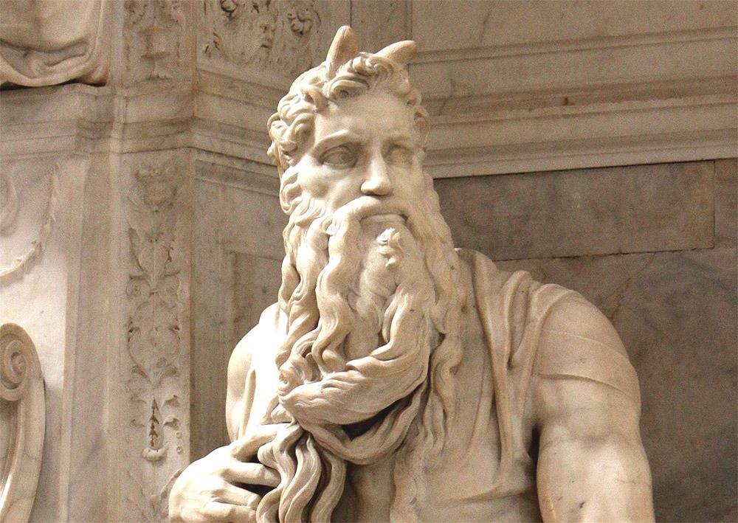
Fig. 1. Statue of Moses by Michelangelo Buonarroti, ca. 1513-1515. Wikimedia
After receiving a second set of stone tablets containing YHWH’s commandments, Moses comes down Mount Sinai with a face that has changed:
^{שמות לד:כט} ...וּמֹשֶׁה לֹא יָדַע כִּי קָרַן עוֹר פָּנָיו בְּדַבְּרוֹ אִתּוֹ. ^{לד:ל} וַיַּרְא אַהֲרֹן וְכָל בְּנֵי יִשְׂרָאֵל אֶת מֹשֶׁה וְהִנֵּה קָרַן עוֹר פָּנָיו וַיִּירְאוּ מִגֶּשֶׁת אֵלָיו.

^{Exod 34:29} …Moses did not know that the skin of his face was qāran-ed because he had been talking with him (=YHWH). ^{34:30} When Aaron and all the Israelites saw Moses, the skin of his face was qāran-ed, and they were afraid to come near him.^{[1]}

Moses’ Face in the Ancient Versions
Modern translations consistently render the word qāran (ק.ר.נ) as “shone” (NRSV) or “was radiant” (NJPS). This translation stands in a long and venerable line of tradition, which renders the Hebrew קָרַן עוֹר פָּנָיו “the skin of his face qāran-ed” as:
- LXX (Greek Septuagint)—“the appearance of the skin of his face was charged with glory”;^{[2]}
- Syriac Peshitta—אזדהי משׁכא דאפוהי “the skin of his face shone”;^{[3]}
The Aramaic Targum translations take a similar approach, but they also avoid the word skin:
- Targum Onqelos— סְגִי זִיו יְקָרָא דְּאַפּוֹהִי “the radiance of the glory of his face increased”;^{[4]}
- Targum Pseudo-Jonathan— אשׁתבהר זיו איקונין דאנפוי “the splendor of the features of his face shone”;^{[5]}
- Fragmentary Targum— שׁבחו זיווהון דאפיה “the splendor of [his] face became greater.”^{[6]}
- Targum Neofiti— נהר זיו איקרהון דאפוי “the splendor of the glory of Moses’ face shone”;^{[7]}
- Samaritan Targum—יקר זיב אפיו—“the radiance of his face became greater.”^{[8]}
These targums appear to translate the word “skin” (עור) as if it were the word “light” (אור).^{[9]} They may have misheard or misread the term—whether intentionally or otherwise—since the two are quite similar both graphically and phonologically.^{[10]}
That Moses’ face was glowing or shining is also the standard understanding of the text in most medieval Jewish commentaries. While this seems, at first glance, like a sensible translation, it seems to ignore the meaning of the verb קָרַן/qāran.

Moses Grew Horns
קָרַן/qāran is apparently a denominative verb derived from the noun קֶרֶן/qeren, “horn.” The verb occurs only four times in the Bible,^{[11]} but the noun is used dozens of times in the biblical text. If the verb does come from the noun, then qāran suggests that Moses’ face was “horned” in some fashion. In fact, the only other time that this verb occurs in the Hebrew Bible, it means to actually have horns:
^{תהלים סט:לא} אֲהַלְלָה שֵׁם אֱלֹהִים בְּשִׁיר וַאֲגַדְּלֶנּוּ בְתוֹדָה. ^{סט:לב} וְתִיטַב לַי־הוָה מִשּׁוֹר פָּר מַקְרִן מַפְרִיס.

^{Ps 69:31} I will praise the name of God with a song; I will magnify him with thanksgiving. ^{69:32} This will please YHWH more than an ox or a bull with horns and hoofs.
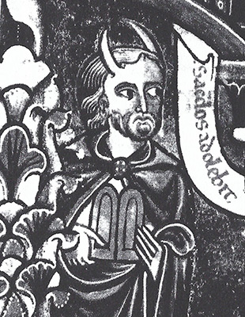
Fig. 2. A horned Moses communicating with God (detail). From the Manerius Bible: Bibliothèque Sainte-Geneviève MSS 8-10, f. 69v (late 12th c. CE). After Ruth Mellinkoff, The Horned Moses in Medieval Art and Thought (Berkeley: University of California Press, 1970), fig. 55.
Thus, Aquila—a second century C.E. Jewish Greek translation of the Bible—rendered the phrase “his face skin became horned.”^{[12]} Similarly, Jerome’s fourth century C.E. Latin Vulgate translation renders it as cornuta esset facies sua, “his face was horned.” Jerome is famous for his interest in “Hebrew Truth” (Hebraica Veritas)—returning to the Hebrew original and hewing as close to it as possible, which may explain his more wooden rendering here.^{[13]}
Under the influence of the Vulgate’s translation, the image of the horned Moses became quite common in medieval art (fig. 2). According to Ruth Mellinkoff, such depictions of Moses are first attested in eleventh-century England,^{[14]} but the image is most familiar from Michelangelo’s famous sixteenth-century sculpture of Moses in the Church of San Pietro in Vincoli in Rome, which places small horns atop Moses’ head (fig. 1, main image).
The above suggests that understanding qāran as “to shine” may be, at best, a paraphrase, and at worst, an obfuscation. Rather than “to shine,” “to be horned” or “to have horns” seems a reasonable and justifiable translation for qāran.

Polemical Response
Not all would agree. Rabbi Samuel ben Meir (Rashbam ca. 1085–1158), responds polemically to the Vulgate translation of Exod 34:29, which dominated medieval Christianity:
לשון הוד, וכמוהו: קרנים מידו לו. והמדמהו לקרני ראם קרניו אינו אלא שוטה, כי שתי מחלקות הם ברוב תיבות שבתורה.
[The word קרן is] related to the idea of הוד – grandeur. It is like the word קרנים in the phrase (Hab 3:4), “which gives off rays (קרנים) on every side.” Anyone who connects קרן, in this verse, to the meaning of “horn,” as in the phrase (Deut 33:17), “He has horns like the horns of the wild ox (קרני ראם קרניו),” is a fool. For many words in the Torah have [at least] two [separate, distinct] categories [of meaning].
Rashbam supports the traditional (Jewish) reading with a verse from Habakkuk, based on the parallelism in the verse between brightness/daylight and “horns”:
^{חבקוק ג:ד} וְנֹגַהּ כָּאוֹר תִּהְיֶה קַרְנַיִם מִיָּדוֹ לוֹ...
^{Hab 3:4} The brightness was like daylight; rays came forth from his hand…^{[15]}
We seem caught between two very different understandings: Was Moses’ face shining or was it sprouting horns? Non-textual evidence from ancient Near Eastern iconography may cast light on this question.

Moses’ Face and Ancient Near Eastern Iconography
Ancient Near Eastern divinities were often portrayed with horns.^{[16]} Sometimes the horns were part of the deities’ bodies (fig. 3); at other times they appear as stacks of horns worn as or on a headdress (figs. 4-5). In some cases, various anthropomorphic figures are identifiable as gods in ancient art only by means of the presence of horns. Without horns was artistic “code” signifying that the figure was (likely merely) human; with horns meant the figure was divine.^{[17]} A further calculus is often present: the more horns, the higher the god’s status in the pantheon.
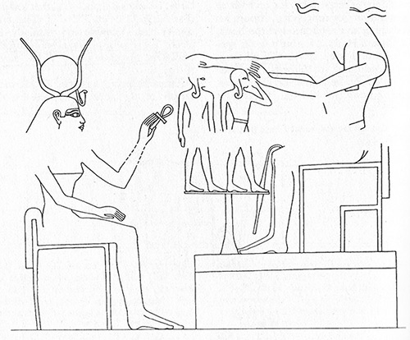
Fig. 3. The goddess Hathor, with sun disk between her cow horns, sits enthroned and extends the life-sign (ankh) to the bodies shaped by the ram-headed (and horned!) god Khnum. Relief. Luxor: Temple of Amenhotep III (ca. 1390-1352 BCE). After Othmar Keel, The Symbolism of the Biblical World: Ancient Near Eastern Iconography and the Book of Psalms (repr. ed., Winona Lake: Eisenbrauns, 1998), 250 fig. 334.

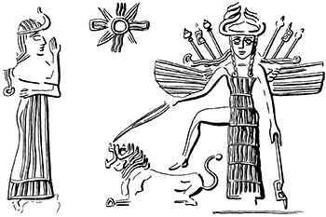  Fig. 4. The goddess Ishtar, with horned headdress. Cylinder seal (Akkadian period). After Brent A. Strawn, What Is Stronger than a Lion? Leonine Image and Metaphor in the Hebrew Bible and the Ancient Near East, OBO 212 (Fribourg: Academic Press and Göttingen: Vandenhoeck & Ruprecht, 2005), 479 fig. 4.242. | 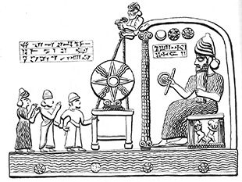  Fig. 5. The sun god, with horned headdress, enthroned before his divine symbol. Stone tablet. Sippar (King Nabu-apla-iddina of Babylon; ca. 885-850 BCE). After Keel, Symbolism, 174 fig. 239.

Naram-Sin: A Horned Human
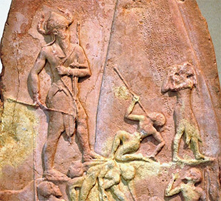
Fig. 6. Stele depicting Naram-Sin, King of Akkad, with horned headdress (detail). Sandstone. Susa (ca. 2250 BCE). Wikimedia
Horns on human individuals are quite rare, but, when present, are significant. An example from Mesopotamia is the victory stele of Naram-Sin (fig. 6). In this image, which dates to ca. 2250 B.C.E., the great king of Agade is portrayed with horns, not unlike the gods.
In Naram-Sin’s case, his horns are connected to his conical helmet. Naram-Sin himself is thus not a god—not yet at least^{[18]}—since at least one god (if not two) is represented at the very top of the stele by means of astronomical symbols.^{[19]} Even so, Naram-Sin is at the very least god-like, a point signaled not only by his horned helmet, but through his large stature and obvious military prowess.

Egyptian Rulers with Horns
In Egypt, other god-like rulers also occasionally portrayed themselves with horns. The atef (fig. 7) and hmhm (“The Roaring One”) crowns had horns as part of the headdress; the latter, notably, may have served to identify the king with the solar deity at sunrise.^{[20]}
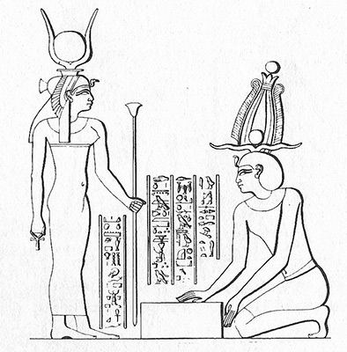
Fig. 7. Pharaoh, wearing the atef-crown, prepares the cornerstone of the temple of Hathor in the presence of the goddess (cf. fig. 3). The atef-crown was “a combination of the tall crown of Upper Egypt and the feather crown, supplemented by a pair of horns” (Keel, Symbolism, 206). Relief. Dendera: Great Temple (1st c. CE); after Keel, Symbolism, 271 fig. 369.
Moreover, the pharaohs of Dynasties 18-19 (ca. 1550-1186 BCE) are sometimes depicted with ram’s horns wrapped around their ears, with the tips of the horns curling down to rest along their cheeks or jawlines, apparently signaling thereby their divine or semi-divine status (figs. 8-9).^{[21]}
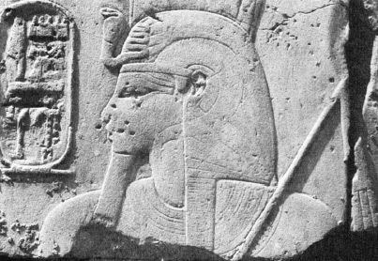Fig. 8. Amenhotep III (ca. 1390-1352 BCE) with horn (erased). Relief. Luxor temple. After Lanny Bell, “Luxor Temple and the Cult of the Royal Ka,” JNES 44 (1985): 266 fig. 4. | 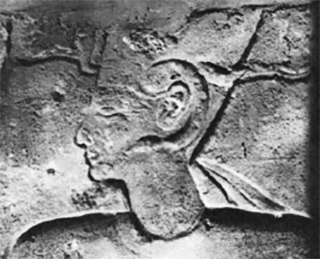Fig. 9. Ramesses II (1279-1213 BCE) with horn. Relief. Luxor temple. After Bell, “Luxor Temple,” 267 fig. 5.

Problems with the Horned Approach
The iconographic evidence lends support to the notion that Exodus 34 may conceive of Moses having horns, not simply shining. Additional details in the passage challenge such a conclusion, however.
If Exodus 34 imagined Moses having horns, why not place them on his “head” (rʾš), which is where they appear in ancient Near Eastern iconography (and also in medieval art)? Instead, the Hebrew text repeats three times that it is Moses’ face—not his head—that was qāran-ed. Moreover, the text states that it was the skin (עור) of his face that was qāran-ed.^{[22]} Such a description strikes one as dissonant with the image of sprouting horns.
And yet, the Egyptian iconographic evidence does allow for a connection between horns and the face. The horns in figs. 8-9 appear precisely on the face, running from the temples to the cheeks or jawline of the pharaoh, touching, or so it would seem, “the skin of his face.” They may even have been considered part of the pharaoh’s visage. Perhaps this is what Exodus 34 is envisioning—actual horns that sprout from the head but nevertheless also touch the skin of the face somehow.

Tough Skin?
Rejecting both the shiny and horned interpretations, William H. C. Propp, in his Anchor Bible commentary on Exodus, suggests that the textual emphasis on Moses’ skin means that his face became dry or hardened in some fashion. Moses’ face becoming disfigured in his conversations with God could be an example, he argues, “of a symbolic wound incurred during a rite of passage.”^{[23]}
Though novel, and correctly attuned to the text’s threefold emphasis on “skin,” Propp’s interpretation is not entirely convincing. Instead of Propp’s understanding of Moses’ potentially grotesque visage, the passage seems to imply something awe-inspiring and other-worldly, something that caused the Israelites fear and/or awe. Both the traditional Jewish interpretation of glowing, or the god-like interpretation of sprouting horns, seems to fit the context better.

Tying the Two Interpretations Together
In his commentary on the Torah (ad loc.), Rashi (Rabbi Solomon Yitzhaki 1040–1105) connects both options: the horned and the shining:
לשון קרנים, שהאור מבהיק ובולט כמין קרן.

[The word qāran] is related to the term “horns,” since the light was shining and projecting in the form of a horn.^{[24]}
Rashi here intuits a connection between qāran as “horned” and qāran as “shining.” This is supported with what we know from ancient Near Eastern divine imagery, according to which the gods who wore horns on their heads were often associated with supernatural light.
The Mesopotamian concept of melammu refers to a brilliant light that radiated from the gods, particularly from their heads (see, e.g., Enuma Elish IV 58). Divine weaponry, among other items belonging to the gods, could also radiate melammu. The gods were able to give melammu to others, especially monarchs, and they could also take melammu away.^{[25]}
Melammu was often combined with the term pulḫu, the “fear” or “awe” that was evoked by powerful entities like deities and rulers.^{[26]} This may stand behind the poetry in Habakkuk 3:4 referenced above, according to which light and horns (horns of light?) are associated with YHWH, though that passage remains difficult.

Why Would Moses Be Qāran-ed?
Whether shining or horned—or in a synthesizing interpretation: horned with light or shining because horned—the fact that Moses’ face was qāran-ed underscores his close encounter with the deity; an interaction so close that God’s divine qualities are, as it were, quite literally rubbing off on Moses and becoming physically manifested in him.
As Exodus makes clear, Moses’ face looks this way “because he had been talking with him (YHWH)” (34:29).^{[27]} Moses has been “exposed” to YHWH in extremely close quarters—and for extended periods of time (see 34:28)—and so is now taking on godly characteristics himself. No wonder the people are said to be afraid of him (34:30)!
The change to Moses’ face may just be what was thought to happen in prolonged divine-human encounters, or perhaps readers are to understand it to be a divine gift of some sort, like the melammu given by the gods. What is clear, regardless, is that, unlike Naram-Sin, Moses does not boast or even take pride in his new divine-like status. He is, instead, characteristically humble.^{[28]} In fact, the text clearly states that Moses had no idea that his face looked like this (v. 29).
Indeed, once he becomes aware of how his visage frightens the Israelites, Moses takes steps to remediate it. He calls the people over to him and delivers God’s message, after which he puts on a veil:
^{שמות לד:לג} וַיְכַל מֹשֶׁה מִדַּבֵּר אִתָּם וַיִּתֵּן עַל פָּנָיו מַסְוֶה.

^{Exod 34:33} When Moses had finished speaking with them, he put a veil on his face.
The veil somehow alleviates their fear, though Moses removes the veil whenever he speaks with YHWH (v. 34), and puts it back on when he relays YHWH’s message to the people (vv. 34–35). The text is not clear as to why this practice is effective, but we see from earlier texts in Exodus that to look on God—and also, or so it would seem, God’s god-like representative—is dangerous (Exod 3:6; 33:20, 23; but cf. 24:10). The use of the veil thus connects Moses’ qāran-ed face once again with the divine realm and qualities of divinity.

Behaving Like God
Despite his fear-inducing appearance, Moses must deliver God’s message to the people, which he does:
^{שמות לד:לא} וַיִּקְרָא אֲלֵהֶם מֹשֶׁה וַיָּשֻׁבוּ אֵלָיו אַהֲרֹן וְכָל הַנְּשִׂאִים בָּעֵדָה וַיְדַבֵּר מֹשֶׁה אֲלֵהֶם. ^{לד:לב} וְאַחֲרֵי כֵן נִגְּשׁוּ כָּל בְּנֵי יִשְׂרָאֵל וַיְצַוֵּם אֵת כָּל אֲשֶׁר דִּבֶּר יְ־הוָה אִתּוֹ בְּהַר סִינָי.

^{Exod 34:31} Moses called to them; and Aaron and all the leaders of the congregation returned to him, and Moses spoke with them. ^{34:32} Afterward all the Israelites came near, and he commanded them all that YHWH had spoken with him on Mount Sinai.
The way Moses relates to the people, and their response to him after he was qāran-ed is reminiscent of accounts earlier in Exodus where God interacts with Moses and the Israelites in much the same way, with the same key terms:
- ק.ר.א—God calls to Moses and the Israelites in 19:3, 20; 24:16; 31:2; 33:19; 34:5–6; 35:30;
- ש.ו.ב—The people or its leaders return to God in 19:8; 32:31;
- ד.ב.ר—God speaks to Moses and Israel in 19:8-9; 20:1, 22; 25:1; 29:42;
- נ.ג.ש—The Israelites come near to God in 19:22; 20:21; 21:6; 28:43; 30:20;
- צ.ו.ה—God commands the Israelites in 19:7; 23:15, 22; 29:35; 31:6; 34:4, 11, 18.
Such echoes are likely intentional: Moses has taken on a divine quality after all! Not surprisingly, therefore, his face, like God’s, is best left unseen (see above). Just as Moses serves as a mediator between YHWH and the people when they express their fear of hearing the divine voice (20:18–21), Moses again recognizes the need to protect Israel from the divine, this time by using the veil.^{[29]}

Is Moses Too God-Like?
That Moses’ qāran-ed face requires veiling signifies his elevated status. To quote Leon Kass, Moses, it would seem, “has become a godlike figure, towering above the people, an object of awe and reverence.”^{[30]} In fact, in one pseudepigraphic text, the second-century B.C.E. drama called Exagōgē (“Leading Out”) by Ezekiel the Tragedian, Moses assumes the very throne of God, takes God’s scepter, and wears God’s crown:
I [Moses] made approach and stood before the throne.
He [God] handed o’er the scepter and he bade
me mount the throne, and gave to me the crown;
then he himself withdrew from off the throne.
I gazed upon the whole earth round about;
things under it, and high above the skies.
Then at my feet a multitude of stars
fell down, and I their number reckoned up.
They passed by me like arméd ranks of men. (lines 73-81)^{[31]}
Yet such a presentation is surely extreme and not the best reading of what happens with (and to) Moses in the rest of Exodus (and the Torah) after chapter 34.

Redirection toward God: The Tabernacle
As Kass rightly notes, “Moses will immediately use his elevated status to build the Tabernacle, to redirect the people’s awe and reverence to the Lord”^{[32]}—not himself—a wise move in light of the people’s history in Egypt under despotic pharaohs, whose powers were god-like. It is also a wise move given what takes place at Sinai, both with the Decalogue and the punishment for the Golden Calf, where YHWH makes it clear that he will brook no rivals (20:3–6; 32:7-10).^{[33]} A further wisdom here is that the Tabernacle can function as a place of divine-human mediation even when Moses is gone.^{[34]}
And yet, given what transpires with (and to) Moses in Exodus 34, subsequent traditions that exalt Moses, even to the highest, are not entirely unrelated to this curious text that says his face shone—or was horned—like the very God(s) and like the very god-kings. In point of fact, Moses’ qāran-ed face may lay at the very root of those later interpretive traditions.

Coda
It is highly ironic, and profoundly unfortunate, that the remarkably positive notion that Moses’ face was qāran-ed was received, later, by some Christians, in anti-Semitic ways.^{[35]} In this later context and reception, Moses’ horns were seen as somehow demonic if not downright devilish.
But even the most cursory look at the ancient context—the material remains of antiquity, especially art—demonstrates that nothing could be further from the truth. In fact, the truth is precisely to the contrary. Looking at ancient Near Eastern iconography helps us to see the text afresh and “in a new light”—and we might add in this case—also to see it aright.

View Footnotes

- The verb appears a third time at the end of the story:
^{שמות לד:לה} וְרָאוּ בְנֵי יִשְׂרָאֵל אֶת פְּנֵי מֹשֶׁה כִּי קָרַן עוֹר פְּנֵי מֹשֶׁה וְהֵשִׁיב מֹשֶׁה אֶת הַמַּסְוֶה עַל פָּנָיו עַד בֹּאוֹ לְדַבֵּר אִתּוֹ.
^{Exod 34:35} The Israelites would see the face of Moses, that the skin of his face was qāran-ed; and Moses would put the veil on his face again, until he went in to speak with him.
- δεδόξασται ἡ ὄψις τοῦ χρωτὸς τοῦ προσώπου αὐτοῦ. The verb is a form of the verb doxazō (“to glorify”). The English is from Albert Pietersma and Benjamin G. Wright, eds., A New English Translation of the Septuagint (Oxford: Oxford University Press, 2007), 76.
- ܐܙܕܗܝ ܡܫܥܐ ܕܐܦܘܗܝ. The verbal root here is ז.ה.י. Mark R. Meyer, George A. Kiraz, and Joseph Bali, The Syriac Peshiṭta Bible with English Translation (Piscataway, NJ: Gorgias, 2017), 196-197.
- From ס.ג.י. Bernard Grossfeld, The Targum Onqelos to Exodus, Aramaic Bible 7 (Wilmington, DE: Michael Glazier, 1988), 98. Israel Drazin thinks that Onqelos “does not visualize Moses with beams or horns, for if so he would have used the language in Deut 33:2 (Targum Onkelos to Exodus [New York: Ktav, 1990], 319 n. 44). Onqelos employs the same construction in Deut 34:7.
- From ב.ה.ר. See Michael Maher, Targum Pseudo-Jonathan: Exodus, Aramaic Bible 2 (Collegeville, MN: Liturgical, 1994), 260.
- Michael L. Klein, The Fragment-Targums of the Pentateuch, 2 vols., AnBib 76 (Rome: Biblical Institute Press, 1980), 1:88, 181.
- The is from נ.ה.ר. Martin McNamara and Robert Hayward, Targum Neofiti 1: Exodus, Aramaic Bible 2 (Collegeville, MN: Liturgical, 1994), 141.
- From י.ק.ר, and note the variant spelling of ziv. This is the text of the Shechem Synagogue MS 3. The British Museum MS simply reads like the Hebrew, קרן עור אפיו.
- A similar situation obtains in early Jewish and Christian interpretation of Genesis 3:21. See Brent A. Strawn, “bĕ-rēʾšît, ‘With “Wisdom,”’ in Genesis 1:1 (MT),” Journal for the Study of the Old Testament (forthcoming).
- Cf. James L. Kugel, Traditions of the Bible: A Guide to the Bible As It Was at the Start of the Common Era (Cambridge, MA: Harvard University Press, 1998), 727.
- In Exodus 34:29-30, 35, the verb ק.ר.נ is in the qal form while in Psalm 69:32 (see below) it is inflected as a hiphʿil participle. Denominative verbs are found within the qal and niphal stems, but they are most common in piel and hiphʿil (see Bruce K. Waltke and M. O’Connor, An Introduction to Biblical Hebrew Syntax [Winona Lake: Eisenbrauns, 1990], 373, 391, 410-14, 443-45 (§§22.5; 23.5; 24.4, 27.4, respectively).
- As preserved in a comment from Jerome; see John William Wevers, Exodus, Septuaginta II.1 (Göttingen: Vandenhoeck & Ruprecht, 1991), 383; Propp, Exodus 19-40, 623.
- Nevertheless, unlike Aquila, his translation lacks an equivalent for “skin.” Perhaps Jerome deemed “skin” redundant in some fashion; alternatively, maybe Jerome, no less than other interpreters and translators, struggled with how the skin of Moses’ face could be horned, even if he was quite certain qāran was related to horns. The “skin problem” will be discussed in depth below.
- See Ruth Mellinkofff, The Horned Moses in Medieval Art and Thought (Berkeley: University of California Press, 1970), esp. 13–17.
- Hebrew text from Martin Lockshin, available (ad loc.) on AlHaTorah.org.
- Nevertheless, here too the Vulgate translates latter phrase as cornua in manibus eius, “horns in his hands.”
- See, e.g., Margit L. Süring, The Horn-Motif in the Hebrew Bible and Related Ancient Near Eastern Literature and Iconography, AUSDDS 4 (Berrien Springs, MI: Andrews University Press, 1980).
- This is not to suggest that gods were always horned; they were not. For horned humans, see below.
- Notably, Naram-Sin is apparently the first king to use the divine determinative for god in front of the writing of his name, signaling his divinity. See Walter Farber, “Die Vergöttlichung Naram-Sins,” Or 52 (1983): 67–72; Zainab Bahrani, Mesopotamia: Ancient Art and Architecture (London: Thames & Hudson, 2017), 118, 123.
- Bahrani, Mesopotamia, 125.
- Katja Goebs, “Crowns,” in The Oxford Encyclopedia of Ancient Egypt, ed. Donald B. Redford, 3 vols. (Oxford: Oxford University Press, 2001), 1:321–26 (324).
- See Gary A. Rendsburg, “Moses as Equal to Pharaoh,” in Beckman and Lewis, eds., Text, Artifact, and Image, 201-19, esp. 216-18.
- Recently, Leon R. Kass, Founding God’s Nation: Reading Exodus (New Haven: Yale University Press, 2021), 569–71, has reiterated the argument that the presence of the word “skin” eliminates the idea that Moses had horns atop his head.
- See Propp, Exodus 19-40, 623. Note also his earlier studies: “The Skin of Moses’ Face—Transfigured or Disfigured?” CBQ 49 (1987): 375-86, popularized in “Did Moses Have Horns?” BR 4/1 (1988): 30-37, 44.
- See also Exodus Rabbah 47:6, which speaks of קרני ההוד “glory-horns.”
- See Haran, “The Shining,” 172 n. 19; A. L. Oppenheim, “Akkadian pul(u)ḫ(t)u and melammu,” JAOS 63 (1943): 31-34; and, extensively, Aster, Unbeatable Light.
- The point is made explicit in Targum Pseudo-Jonathan which reads:
ומשה לא חכים ארום אשתבהר זיו איקונין דאנפוי דהוה ליה מן זיו איקר שכינתא מייי בזמן מללותיה עימיה.
Cf. Maher, Targum Pseudo-Jonathan: Exodus, 260; cf. Grossfeld, Targum Onqelos to Exodus, 99 n. 20.
- See Kass, Founding God’s Nation, 570.
- Propp goes so far to suggest that “the veiled, shining Moses may be regarded as a walking Tabernacle, manifesting and yet concealing Yahweh’s splendor” (Exodus 19-40, 621). Cf. ibid., 623, where Propp writes that Moses’ face, “branded by Yahweh—whether horned, beaming or hardened—becomes the Mask of God.”
- Kass, Founding God’s Nation, 571. Kass finds the notion “disquieting” and likely not “what the Lord intended” (ibid.). Cf. the marginal glosses in Neofiti, discussed above.
- R. G. Robertson, “Ezekiel the Tragedian,” in OTP 2:812.
- Kass, Founding God’s Nation, 572.
- According to scholars, these various texts likely stem from different traditions/sources.
- A somewhat similar situation is found in Deuteronomy, where what Moses leaves behind, is “this book of the Torah.”
- See Stephen Bertman, “The Antisemitic Origin of Michelangelo’s Horned Moses,” Shofar 27 (2009): 95–106; Kugel, Traditions of the Bible, 737; as well as Mellinkoff, The Horned Moses, 121–37, who notes ambiguity in the meaning of the horns: there were “horns of honor” but also “horns of dishonor.”

