# Narrative Report

## The big picture

### Overview

SPHERE aims to reduce existing diabetes disparities between the Galilee population and the general Israeli population through the unique model we have developed. The impact of SPHERE translates into three central goals:

|  |
| --- |
| **Main goals of SPHERE** |
| A 30% reduction in the conversion rate of patients from pre-diabetes to diabetes |
| A reduction in the relative number of poorly controlled diabetic patients in the Galilee |
| Reduction of obesity |

To reach our goals and reduce these disparities, SPHERE considers the well-established World Health Organization’s concept of the social determinants of health (SDoH) in which, access and quality of clinical care account only for twenty percent of people’s health outcomes. The remaining eighty percent are a direct result of peoples social or economic background, their health behaviors such as diet and exercise, or the surrounding physical environment which they live.

SPHERE works to **research & design, pilot** and **implement new evidence-based sustainable interventions** that combine the clinical and place of residence, integrating between healthcare and municipal systems, addressing 70 percent of the factors that influence health outcomes (healthcare 20% + SDoH 50%, leaving patient behaviors (30%)). This enables communities to identify and address their barriers to better health outcomes and enables SPHERE to close the gap between research and real-world practice to achieve large-scale, sustainable change.

SPHERE and its partners perform this research and design new interventions across four key pillars that form the diabetes care pathway: Prevent, Control, Care and Cure.

* **Prevent** - New and sustainable strategies to prevent high risk population groups from becoming diabetic.
* **Control** - New strategies to improve clinical management and mitigate complications.
* **Care** – New care models which align and integrate care systems and the community to proactively address and implement best practices for diabetes care.
* **Cure** - Basic and clinical science, which highly leverage specialized Galilee, community and Faculty opportunities and strengths.

To be able to research, design, pilot and implement these new interventions, we need at least two core partners: (1) the healthcare system which in Israel largely means the HMOs and the regional hospitals; and (2) a partner that can address (many of) the social determinants impacting people’s health. In the Galilee, and in many regions around the world, this partner is the municipality. The main reason being that many social determinants, such as education, housing, access to healthy food or places to exercise, are under the day-to-day responsibilities of municipalities.

Today, municipalities in Israel do not have a formal mandate from the government or are accountable for improving the health of their residents. Therefore, SPHERE first needs to establish ownership, knowledge, and capabilities. We do this through our Municipal Engine for Social Health (MESH) model, building the infrastructure and partner that can work with us to address challenges stemming from the local social determinants.

SPHERE collaborates today with both partners addressing relevant issues either through the healthcare system alone or through the municipalities alone but, most interestingly, builds the pathway to an integrated system whereby healthcare and municipalities research, design, pilot and implement interventions:

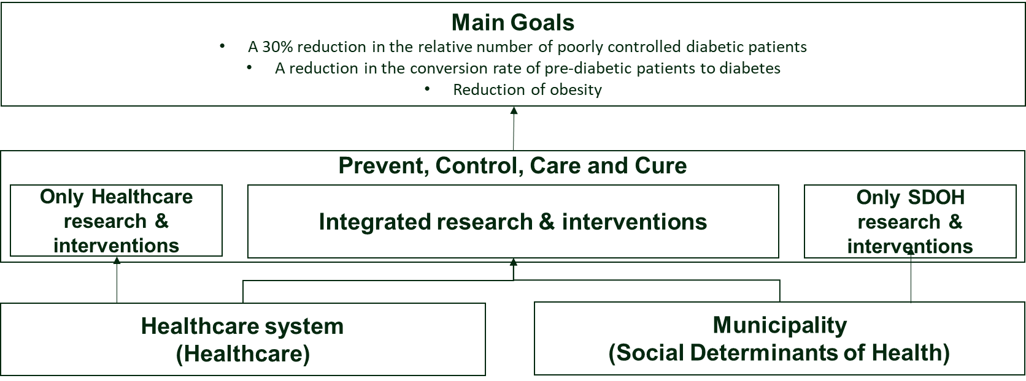

Figure SPHERE target situation

In the next paragraphs we will first provide an overview of our work with both the municipalities and the healthcare system. We then move to explain SPHERE’s work in the SPHERE pillars of PREVENT, CONTROL, CARE and CURE in more detail.

It is important to note here that, as the healthcare system is very established, our projects with the healthcare system are typically already directly attributable to one of our major pillars (e.g. Prevent, Care or Control). Our work with the municipalities to date has largely focused on building the infrastructure. Therefore, most Prevent, Control, Care or Cure projects with these municipalities are expected to begin during year 3 of SPHERE (2024).

### Status of SPHERE’s work with municipalities

#### Goals

To date, health related programs in cities, if they exist, have been sporadic or largely rhetorical (i.e. without implementation actions to back up policies). These programs have failed to translate for and integrate health into the municipal DNA. There are typically no structured teams, strategies, resources, and tools.

Therefore, to be able to combine between activities implemented by healthcare providers with that of municipalities, we first need to establish ownership, knowledge, and capabilities to lead health focused actions in municipalities. For this we have developed a new integrated Care model[1] for cities which we call MESH. After beginning implementation in five cities, in year 2 SPHERE has expanded implementation of this model to approximately 17 cities across the Galilee.

**Goal 1 - Establishing the Integrated Care model for cities – the Municipal Engine for Social Health (MESH)**

SPHERE has developed a unique model of intervention at the city level, with municipal government becoming the pivot for change. MESH begins by making an economic case for municipalities’ health promotion. By demonstrating the financial implications and value of a healthier community, we incentivize city authorities to assist healthcare providers in lowering rates of diabetes and obesity. The MESH model requires participating municipalities in the Galilee to establish a health unit/department. Once this unit is set-up we then engage in a three-step, iterative process for creating “health-managing” municipalities using SPHERE’s innovative tools: First, we identify and map the local ecosystems relevant for reducing diabetes disparities to gain a full and up-to-date picture of a community’s healthcare resources, existing policies and programs. Second, we use the resulting information to create a digital Municipal Health Dashboard, and train municipalities’ personnel to analyze its data and draw critical insights. And third, we help translate those insights into holistic strategic plans that include interventions from city planning, educating residents to changing behavior. It is important to note that the initial focus of these units is on programs addressing diabetes and obesity which includes of course healthy lifestyles.

Along with data and digital tools, MESH also features ongoing professional support: SPHERE’s urban planner, municipal-development coordinator, and educational-system coordinator assist a field team of SPHERE facilitators, who themselves help municipalities design and implement their strategic health plans. SPHERE further facilitates the ongoing exchange of data between municipalities and the healthcare system, which ensures that both can make better decisions that affect residents’ health outcomes.

**Goal 2 – Research and design, Pilot and Implement Prevent, Control, Care and Cure interventions**

Once the municipal health units are up and running, SPHERE’s focus will, as mentioned, shift to work with the units to translate insights into actions. These actions will focus on making impact in Prevent, Control, Care and Cure. This shift will happen in SPHERE Year 3 = 2024.

In some cases, as is true for the healthcare system, the municipalities can implement initiatives to improve health on their own. In other cases, the municipalities will collaborate with the healthcare system on researching and designing, piloting, and implementing integrated Interventions.

#### Starting point for the year

Before the start of Year 2, SPHERE selected 5 municipalities for piloting SPHERE’s MESH model, that serve a total of 228,600 residents: Safed, Nof Galil, Nazareth, Shfar’am and Sackhnin. In each of these 5 municipalities a leader of the new health unit was appointed, and the cities have been mapped for relevant health infrastructures, policies, actions as well as health-related internal and external actors.

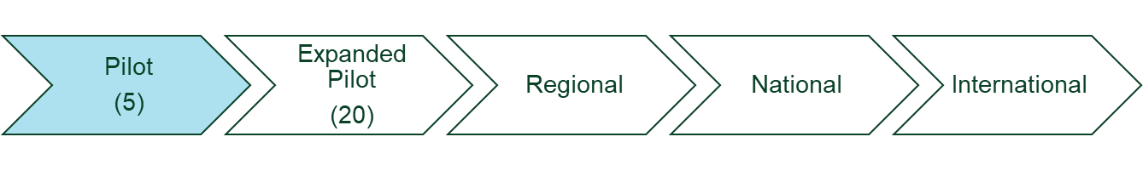

Figure Number of cities in which SPHERE is active by the start of Year 2

#### Developments during the period

During Year 2 we continued working with the pilot municipalities to further the implementation of MESH. This includes, amongst others,

* Recruiting health unit leaders for the municipalities where this was not yet done in year 1.
* Training the local municipal health leaders / teams
* Setting up and activating local advisory committees in each city to support the municipal health units
* Continued mapping of the municipalities in detail together with the local units
* Development of a municipal health data dashboard including medical data from local HMO's
* Developing the municipal business case for encouraging ownership of health as a core area of action of daily municipal work through a unique municipal cost of illness model.

In addition to the work with the existing 5 municipalities, we began a strategic partnership with the Israeli Ministry of Health (MoH) to expand SPHERE’s work to an additional 20 cities, all in the Arab community, as part of the government resolution 550 to reduce health disparities in the Arab population. In practice this partnership led to work with 12 additional cities as MoH did not close contracts with 8 of the initially targeted cities, for a variety of non-SPHERE-related reasons. SPHERE’s MESH model now reaches approximately 660,000 citizens.

We have combined the 17 cities into one group, largely synchronizing our work across all cities. Only Safed has been delayed due to a series of administrative mishaps at the municipality. The work with Safed was therefore largely put on hold but has now resumed course.

By the end of this Year 2, 16 municipalities are now in the following situation:

* All have a health unit / health unit leader
* All municipalities have been fully mapped, in collaboration with the local health units
* All have been mapped and analyzed using the municipal cost of illness model.
* The health leaders of the 16 cities have been trained in a unique training course developed by SPHERE
* All have now active Local advisory committees that support the municipal health units
* All are working on their strategic plans for the coming years to create policies and programs focused on healthy life style, diabetes and obesity

One key element has not yet been synchronized and continues only in the original 5 cities:

* The work on the development of a municipal health data dashboard that integrates municipal and medical data from the HMO's.

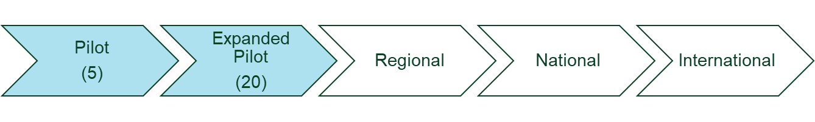

Figure Number of cities in which SPHERE is active end of Year 2

#### Expectations for next reporting period

In year 3 of SPHERE, between 1st October 2023 and 30th September 2024, we expect the following developments:

* SPHERE will further expand to
  + 4-5 additional Arab municipalities in collaboration with the Israeli Ministry of Health
  + 2-3 additional Jewish municipalities in the Galilee
* Safed will become an active SPHERE city
* All cities will finalize their strategic plans
* All cities will have active work plans including a series of Prevent, Control, Care or Cure interventions, some on their own and some integrated with the healthcare system.
* In some of the cities, the SPHERE dashboard (for details see CARE) and the SPHERE social prescription platform (CARE) will be implemented.

### Status of SPHERE work with the healthcare system

#### Goals

SPHERE’s work with the healthcare system focuses on researching and designing, piloting and then implementing diabetes focused sustainable interventions which

1. the healthcare system can implement on its own.
2. the healthcare system can implement in collaboration with municipalities.

To enable this work, the healthcare system, as well as the individual professionals, need to be able to execute (collaborative) research and design, test/pilots as well as implement projects.

Contrary to the work with municipalities, the healthcare system is a well-established group of organizations with established cultures, teams, processes, and procedures.

SPHERE goals therefore are to:

1. Execute research and design, piloting and implementation of sustainable interventions.
2. Strengthen existing or complement missing capabilities where necessary.

We identified within the healthcare system areas that require strengthening such as research focused training for professionals, funding, implementation of interventions and their evaluation.

#### Starting point for the year

In the first year of SPHERE, we established strategic collaborations with the 3 main HMOs in the Galilee: Clalit Health Services, Maccabi Health Care, and Meuhedet. In addition, we established collaborations with several leading hospitals in the region including in Galilee Medical Center Nahariya, EMMS Nazareth, and Tzafon Medical Center Poriya.

In the first year of SPHERE, we executed the following research/design and pilot interventions:

1. Mapping the clinical status of diabetic and pre-diabetic patients living in SPHERE cities
2. Pilot/ proof-of-concept phase of SPHERE’s pre-diabetes project (for details see Prevent below)
3. Preparing the data and program for appropriate treatment intervention project (for details see Control)
4. Preparing the data and program for the reduction in number of poorly controlled diabetic patients
5. Research projects lead by physician-researchers (see Cure)

In terms of strengthening the healthcare system we executed:

1. Physicians training (Education)
2. Establishment of a small grants mechanism to provide joint funding to BIU and healthcare system researchers.

#### Developments during the period

During year 2 of SPHERE, we built upon the work done in Year 1 as follows:

**Interventions**

1. Design of the proof-of-concept pre-diabetes project was finalized and implementation began with Maccabi in: Nazareth, Nof-Hagalil, Safed and Shfar’am (Prevent)
2. A pharmaco-equity program was developed (Control)
3. Obesity clinics were established, in collaboration with the HMOs, across the Galilee (Prevent)
4. Development of additional tools for physicians began. (Education)

**Strengthening activities**

1. A series of training sessions for physicians were organized (Education)
2. A school for training professional on obesity was established in collaboration with the Technion (Education)
3. SPHERE’s internal development of the intervention design and implementation infrastructure support needed for the healthcare system to design and execute interventions.

#### Expectations for next reporting period

In Year 3 of SPHERE, we expect that the pre-diabetes project will become operational in various cities across the Galilee with both Maccabi and Clalit and the second major intervention (the pharmaco-equity program) will be launched. A series of training for physicians will be organized. The obesity school begins on Dec. 5th 2023. Additional supporting tools for physicians and other healthcare professionals will become available and additional research infrastructure and support will be made available including funding for small research projects.

### Status of SPHERE’s Integrated intervention efforts

In addition to our work with the cities and the healthcare system separately, SPHERE has been developing a series of activities which combine both the healthcare system and the municipalities. As SPHERE, our aim is to lead these projects until either the healthcare system or the municipalities (or both) will take over the lead and integrate them into their operations. Examples include:

* The one-stop-shop mobile lab – See Control below.
* Kfar Tikva & Kishorit – See Prevent below.
* Education programs for the community – see Education below
* The social prescription program – See Care below

**Precision Medicine**

A special type of integrated effort, critical for SPHERE’s long-term sustainability, is what we refer to Precision Medicine. Through the new municipal MESH model, and the collaboration with the healthcare system, SPHERE works hyper locally with populations that from many points of view are still largely underrepresented in (clinical) research today.

This combination of the healthcare with the municipal system creates a unique platform for various types of (clinical) real-world research, in which the characteristics and needs of these populations are considered in the development and clinical trials of new pharma, medical devices and digital health solutions. It also enables research into new policies and a variety of other topics including for example the food industry.

### Impact

#### Three main SPHERE goals

So where are we in terms of impact? In the original proposal to RBF, we divided the expected SPHERE impacts into 4 – The Galilee patients, the Galilee Community, the healthcare system in the Galilee, and the Azrieli Faculty of Medicine.

By now, 2 years into the actual operation of SPHERE, we can synthesize these impacts slightly more accurately, with three main goals and a series of secondary impact measurements.

**Main Goal 1 – A 30% reduction in the relative number of poorly controlled diabetic patients in the Galilee**

It is well established that poor metabolic control of diabetic patients is strongly correlated with the development and severity of diabetic complications. According to Ministry of Health, the definition of diabetes poor control is HbA1c>9%. While nationally 10% of patients are poorly controlled, in the Galilee area 15% of patients are poorly controlled. SPHERE aims to reduce the number of poorly controlled diabetics in the Galilee by 10% each year. We will reach this target through implemented interventions in the healthcare system, including for example, a focus on pharmaco-equity to reduce the disparities in physician under prescribing of new medications.

**Main Goal 2 - A reduction in the conversion rate of pre-diabetic patients to diabetes**

In Israel, a million men and women are diagnosed as pre-diabetic, 280,000 of them reside in the Galilee. Every year, 6-8% of pre-diabetics will become diabetic, making the objective to reduce the proportion of patients diagnosed as pre-diabetics and prevent their progression to diabetes an imperative. While diabetes prevention programs have been implemented in Israel, they were not structured or organized in a comprehensive and systematic approach, nor did they account for the structural social determinants in real world settings. SPHERE aims to reduce the conversion rate from 6% to 3% by implementing an integrated comprehensive real-world program of health and municipal systems to address clinical and social determinants. We will reach this target by designing interventions that leverage SPHERE platforms such as collaborations with the HMOs and the social prescription platform.

**Main Goal 3 - Reduction of obesity**

In Israel, 56% of adults over the age of 21 are overweight and 18% are obese. In the Galilee, obesity rates in children are constantly on the rise with 38% of children in 7th grade being overweight and obese compared to 30% of kids in the center of country. It is important to note that in many of SPHERE’s intervention municipalities, over 40% of children in 7th grade are overweight and obese. It is widely acknowledged that among children classified as overweight or obese, 30% will experience prediabetes and 10% will develop hypertension, perpetuating a continuous cycle of diabetes-related health issues. SPHERE aims to reduce obesity rates using a three-pronged approach to reach this target: (1) working with the health system and setting up obesity clinics for adults and children (2) working with municipalities to implement interventions in the local education system, and (3) training health professionals.

Note: As you will have noticed the original goal “Reduce the relative number of diabetic patients in the Galilee” is no longer mentioned. We believe that the combination of the updated goals 1, 2 and 3 together automatically provides this reduction of the relative number of diabetic patients.

#### Additional Impacts

The additional impact measures are secondary and serve to ensure we reach our three overarching impact measurements.

| **Original Target Impact** | **Updated Target Impact** | **How do we reach this impact?** | **How do we measure?** | **Status 30.9.2023** |
| --- | --- | --- | --- | --- |
| **The Galilee Healthcare system** | | | | |
| (1) Increase the number of physicians and clinical teams across Galilean communities and hospitals that are professionally proficient in studying and providing excellent diabetes care | Increase the number of physicians, clinical teams and other professionals across Galilean communities that are professionally proficient in providing excellent diabetes care and support | Educational programs combined with execution of projects in Prevent, Control, Care and Cure. | Number of physicians and other professionals that attend trainings and participate in research. | 10s of physicians and other healthcare professionals have participated in SPHERE’s education and training and are participating in research and pilots. |
| (2) Increase the number of clinical "research capable" healthcare professionals in the Galilean healthcare system | Increase the number of “clinical, SDOH and integrated research”- capable health professionals in the Galilee | Educational programs combined with grant programs for clinical research and execution of projects in Prevent, Control, Care and Cure. | * Number of physicians and other professionals that participate in research. * Number of publications and active participation in medical conferences. | 10s of physicians and other healthcare professionals and are participating in SPHERE related research and pilots. |
| (3) Improve integration of care across the Galilean healthcare system | Improve integration of care across the Galilean health system | Design and implementation of integrated interventions with the healthcare system and municipalities | Number of Integrated interventions | The initial Integrated research projects and interventions have started. (see below) |
| **Galilee community at large** | | | | |
| Economic assessment of the indirect savings and cost effectiveness of interventions and new care delivery strategies for improving care of pre-diabetic and diabetic patients | No change | We work with Social Finance Israel to develop (new) economic models for SPHERE’s interventions and new care delivery strategies | Number of economic assessments | Two economic assessments are in progress |
| Development of regional initiatives with environmental and social benefits to lifestyle and diabetes management | Development of integrated initiatives with environmental and social benefits to lifestyle and diabetes management | Development, pilots and implementations of integrated research and interventions | Number of Integrated research and interventions in development, in testing or in the implementation phase. | The initial Integrated research projects and interventions have started. (see below) |
| **Azrieli Faculty of Medicine** | | | | |
| A substantial increase in academic faculty | - | - To be discussed with the new Dean | - | - |
| A substantial increase in clinical faculty, in both numbers and academic ranking | - | - To be discussed with the new Dean | - | - |
| Development of new paradigms, models and best practices relevant to peripheral communities worldwide | Development of new paradigms, models and best practices relevant to peripheral communities worldwide | Many of the interventions of SPHERE will be new paradigms, models and best practices. This is true for the work with the healthcare system, the municipalities and especially the design and implementation of integrated interventions. The interventions that will be proven in the Galilee can be replicated to other communities beyond the Galilee (see below) | Number of paradigms, models and best-practices published by SPHERE and/or its partners | To date SPHERE has presented its unique developed models in international conferences and we are preparing publications presenting the model and implementation lessons thus far. |
| Evaluation of interventions through implementation research | Evaluation of interventions through implementation research | Evaluation, both economic and implementation wise, is embedded in all SPHERE activities. | Number of implementation wise evaluations published by SPHERE and/or its partners | None to date as we are still in the implementation phase |
| Introduction of Social Determinants of Health constructs into diabetes related research | Introduction of Social Determinants of Health constructs into diabetes related research | The establishment of MESH and the integration of the work of the healthcare system with the SDOH is a core element of SPHERE’s work. | - | -Presentation in leading conferences and participation in Novo Nordisk Cardio Metabolic Disease Taskforce |

#### Impact beyond the Galilee

**Expanding to additional regions**

Expansion of SPHERE’s model to additional regions seems feasible. First, in Israel, we are currently working with 3 cities beyond the Galilee (as part of our agreement with the Ministry of Health). In addition, we already see interest of other, currently not affiliated municipalities, in SPHERE’s work. Expansion of SPHERE does seem possible through:

1. Direct expansion by SPHERE – for example the inclusion of cities such as Kiryat Shmona, Carmiel and Akko.
2. Consultancy – for example an agreement with an organization in southern Israel that will use SPHERE’s methodologies, concepts, and best practices to implement SPHERE in municipalities in the Negev.
3. With MoH and the Ministry of the Interior – already these ministries are exploring whether it is possible to make the municipal Health Units (MESH) a formal requirement on each Israeli municipality.

**Beyond Israel**

Like the potential expansion in Israel, SPHERE sees potential in expanding to other regions around the globe. We are scoping for and reviewing new possibilities. Also, international collaborations with researchers are slowly being established. It is too early to provide a realistic roadmap.

**Beyond the SPHERE model**

As mentioned above, SPHERE’s hyper local work and integration between the healthcare system and Municipal SDOH system provides new opportunities (Precision Medicine). In terms of impact this means that we can work in the Galilee, and later in other regions, expand our work with pharmaceutical and other industries on the research of new treatments, interventions, products and working methodologies. The results of these efforts can, in principle, be relevant for patients around the world.

## Prevent

Following our above review of how we work with the healthcare system and the municipalities, the chapters below describe SPHERE run interventions in partnership with the healthcare system, with the municipalities or in an integrated manner with both. Interventions are implemented in all four pillars of: PREVENT, CONTROL, CARE and CURE.

SPHERE ideally has 3 types of projects: (1) with the Healthcare system; (2) with the municipalities and; (3) Integrated. This obviously remains true but in practice there are projects which SPHERE executes by itself. Therefore, there are currently four types of projects which are executed by SPHERE and its partners.

|  |  |
| --- | --- |
| **Type of projects** | **Explanation** |
| Projects with only the healthcare system | Projects which   1. Directly address SPHERE’s goals but (currently) require only the healthcare system 2. Prepare the healthcare system for work with external partners such as the municipalities |
| Projects with only the municipalities | Projects which   1. Directly address SPHERE’s goals but (currently) require only the municipality. 2. Prepare the municipality for work with external partners such as the healthcare system |
| Integrated projects | Projects which combine the municipalities and the healthcare system |
| SPHERE only projects | 1. Projects or activities which have a more general character 2. Projects which are very early stage and will be transformed into other types of projects later on |

### The PREVENT Projects

Programs in SPHERE’s PREVENT pillar have a direct impact on all three of SPHERE main Impact goals:

* A reduction in the conversion rate of pre-diabetic patients to diabetes in the Galilee
* A reduction in the relative number of poorly controlled diabetic patients in the Galilee
* Reduction of obesity in youth (as precursor for diabetes) in the Galilee

There are currently several SPHERE PREVENT projects in progress:

|  |  |  |
| --- | --- | --- |
| **SPHERE Project** | **Goals for the project** | **Type of project** |
| Reducing patients’ conversion rate from pre-diabetes to diabetes | Reducing the conversion rate from pre-diabetes to diabetes by 30% in select cities | Project with the healthcare system |
| Kfar Tikva & Kishorit | Reduce percentage of poorly controlled diabetics among people living in these two special need villages | Integrated project |
| Ramadan Prevention Program | Provide healthcare professionals with the latest guidance on diabetes during the Ramadan | SPHERE only |
| Ramadan program with the Ministry of Religion training ~100 imams | Engage religious leaders with SPHERE | SPHERE only |
| Diabetes awareness days for municipal staff | Engage the employees of the SPHERE municipalities in the activities of the municipal health unit | Project with the municipality |
| Obesity clinics | Establish integrated obesity treatment and research facilities | Project with the healthcare system |
| Mindset | Initial research project into the possible stratification of pre-diabetes patients with regards to mindsets to identify possible behavioral triggers | SPHERE only |
| Beliefs and pre-diabetes | Identify the health beliefs and disease perceptions of pre-diabetic patients and design and implement an intervention to reduce the conversion rates | SPHERE only |
| School Obesity Prevention program | Create a unique model for a citywide municipal obesity prevention program | Project with the municipality |

These PREVENT projects align as follows:

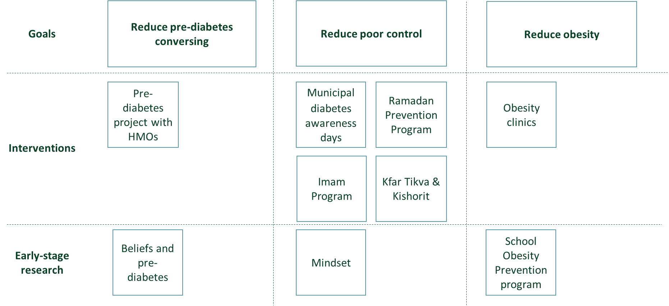

Figure Prevent Impacts and projects

Note that currently these projects are not organized yet in programs (as you will see is the case in Control). We expect a scale-up of activities in Prevent in year 3 as the municipalities will become active and will use year 3 to further structure our work in Prevent.

Reminder:

* In the original proposal to RBF, PREVENT also contained work on gestational diabetes (GDM), but we have opted to consolidate our work on GDM in the CONTROL pillar.

### Reducing patients’ conversion rate from pre-diabetes to diabetes (project with Healthcare)

#### Project overview

**Goals**

* We aim to reduce the conversion rate from pre-diabetes to diabetes by 30% which provides a substantial cost saving to the HMOs and of course has major impact on population health.

**Methods**

|  |
| --- |
| **See Appendix 1 for more detailed information on this project** |

* Identify clusters of pre-diabetic populations in SPHERE cities
* A project with the HMO in which the HMO provides:
  + Lists of patients with pre-diabetes
  + Medical and dietary consultation
  + Clinical and laboratory follow up

**Expected outcomes**

* Reduction of the conversation rate from 6% to 4%
* **Status of project** In execution

#### Progress of the project

**Starting point for the period**

At the start of year 2 we had identified clusters of pre-diabetic populations in the region, designed the program to lower the conversion rate from pre-diabetes to diabetes and began piloting the program with Maccabi. We recruited relevant family physicians and 500 at-risk patients Maccabi clinics in Nazareth and Nof Hagalil.

**Developments during the period**

We have continued working with Maccabi in Nazareth and Nof Galil to further pilot the pre-diabetes intervention. We recruited several medical students to support the family physicians leading the program.

**Initial results of the pilot program:**

* 514 pre-diabetic patients were recruited (48% men, 59% SES (Social Economic Status) 1-4)
* Only 17 patients (3%) developed diabetes (as compared to the expected 6%)
* 341 patients (66%) remained pre-diabetic
* 156 patients (31%) returned to normal glucose value

Due to the promising results, SPHERE and Maccabi have begun extending the collaboration and expand the pilot program to Safed, and Shafr-am. We have also started to work with Clalit to implement the program in Nazareth, Nof Hagalil, Safed, Sakhnin and Shafaamr.

**Expectation for next period**

* The collaboration with Maccabi will be expanded to Shafr-am and Safed
* The pre-diabetes program will be extended to include Clalit in the cities Nazareth, Nof Hagalil, Safed, Sakhnin and Shafr-am.
* The pre-diabetes program (currently a project with the healthcare system) will become an Integrated Project

### Beliefs and pre-diabetes (SPHERE only)

#### Project overview

**Goals**

* We aim to understand pre-diabetic patients’ perceptions and beliefs, the facilitators and barriers that impact their compliance to treatment and intervene to optimize it.

**Methods**

* We will first explore patients’ and health care providers’ disease perception and health control. Next, we will prepare and implement an intervention using a specially designed video according to patients’ health beliefs so that their compliance to treatment increases. Patients behavioral change following the intervention will be compared to a control group.

**Expected outcomes**

* To be able to tailor messages to pre-diabetic patients according to their believes to trigger behavioral change and reduce the conversion rate from pre-diabetes to diabetes.

**Status of project**

* In Execution

#### Progress of the project

**Starting point for the period**

We conducted preliminary research disseminating an online survey (N=169). We found that while diabetes is perceived as a dangerous disease and should be avoided, pre-diabetes was seen as less dangerous. Importantly, diagnosed people attributed their health status to external factors beyond their control and underestimated their ability to improve their health in comparison to people who were healthy.

**Developments during the period**

We designed the conceptual model, conducted the preliminary online survey, and analyzed the data. Following the survey, we designed an intervention and are currently awaiting ethics approval.

**Expectation for next period**

* Ethics approval will be granted.
* Interviews will be conducted pre-implementation to assess challenges in clinic.
* Video will be designed and piloted.

### Kfar Tikva & Kishorit

#### Project overview

**Goals**

* Improve the management of diabetes in cognitive disabled populations
* Pilot the SPHERE model in a small “municipality”

**Methods**

* Provide clinical support (through Maccabi and Clalit) to the physicians and medical team of these assisted living villages
* Develop a strategic plan with the villages to address both medical and SDOH elements

**Expected outcomes**

* Improved health outcomes for the population in the treatment villages
* Lessons learned for the SPHERE model

**Status of project**

* In Execution

#### Progress of the project

**Starting point for the period**

We have established the relationships with Kfar Tikva and Kishorit, two assisted living village for people with special needs.

**Developments during the period**

Our work in Kfar Tikva and Kishorit started with engaging the teams of both villages and ensure collaboration. This worked well with Kfar Tikva, with Kishorit it was less successful to the extent that after some initial steps we decided that it was no longer realistic to work with Kishorit. We therefore focused and will focus our attention on Kfar Tikva.

During the period we executed the following process with Kfar Tikva:

1. Mapping of the health needs
2. Data analysis
3. Establishing of a steering committee including representation of the residents
4. Development of the strategic health plan for the village

In addition, as part of our integrated approach, physicians have worked with the Kfar Tikva team to review the medical files of the residents and suggest adjustments to their medical treatment where relevant.

**Expectation for next period**

* Formal discontinuation of work with Kishorit
* Finalize the development and begin execution of the integrated strategic action plan for Kfar Tikva

### Ramadan Prevention Program

#### Project overview

**Goals**

For many residents in the Galilee, Ramadan is a highly significant period of the year. For (pre-) diabetics, the disturbed eating patterns during this holy month are not easy to navigate and thus we see an increase of urgent care requests for diabetic patients during this period as well as an increase in the number of new diabetics.

SPHERE is piloting a Prevention program, currently implementing a project with healthcare (Maccabi). It is likely that (parts of) this program will move to the municipalities and/or transform into an integrated activity with Clalit, Maccabi and Meuhedet.

**Methods**

* Awareness for the general public.
* Awareness and guidelines for physicians
* Activities in participating SPHERE municipalities

**Expected outcomes**

* Specific outcomes to be determined

**Status of project**

* In Execution

#### Progress of the project

**Starting point for the period**

* None

**Developments during the period**

The program in 2023 consisted of several workstreams.

* **Awareness for the general public.** This included publication of materials through social media, interviews on radio and television, publication of articles in leading news platforms, Maccabi’s network and more.
* **Awareness and guidelines for physicians** through publications and online updates (SPHERE and Maccabi).
* **Activities in participating SPHERE municipalities** ranging from an awareness day for the employees of Nazareth to an activity by the health leader in Shfar’am at a local school.

**Expectation for next period**

* Development of the program into something more structured.
* Execution of the program but this year as either a Project with Municipalities or an Integrated Project

### Imam program with the Ministry of Religion (SPHERE Only)

#### Project overview

**Goals**

* Establish a long-term engagement with religious leadership across the Galilee

**Methods**

* Workshops
* Content driven initiatives.

**Expected outcomes**

* Support and facilitate involvement of religious leaders (currently Imams) in the SPHERE programs

**Status of project**

* In Execution

#### Progress of the project

**Starting point for the period**

* In Year 1 of SPHERE initial conversations were held with the Ministry of Religion. This ministry is largely responsible for the Imams and thus an excellent channel to reach imams in difference municipalities.

**Developments during the period**

* SPHERE, in collaboration of the Ministry of Religion and support from Clalit, held a workshop with approximately 100 imams from the region. The imams were presented with the latest medical insights as well as a more religious discussion on how diabetes can be managed during Ramadan. Ramadan is a month of disrupted eating patterns for many, and includes many festive meals in the evening following a day of fasting. Guidance for diabetes patients is thus crucial and Imams have an important role to play as leaders in their communities.

**Expectation for next period**

* Development of the Ramadan program into a more structured and longer-term Integrated Program hopefully including leaders from other religions as well

### Diabetes awareness days for municipal staff in all 5 pilot towns (Healthcare and Municipality only)

#### Project overview

**Goals**

* Create awareness for diabetes among the professional municipal staff SPHERE directly works with

**Methods**

* Days/Events focused on diabetes

**Expected outcomes**

* Increased awareness of the municipal staff as a step of integrating health into daily municipal activities.

**Status of project**

* Continuation of the program especially in the municipalities where this has not yet taken place.

#### Progress of the project

**Starting point for the period**

* None

**Developments during the period**

* Execution of 4 days during the period in Nazareth, Shfar’am, Sakhnin, and Tsfat.
* Execution of similar days with teams of Maccabi and Clalit

**Expectation for next period**

Continuation of the project in the various SPHERE cities

### Mindset (SPHERE only)

#### Project overview

**Goals**

The overall objective of this project is to determine the mindsets of pre-diabetic patients in Israel- what motivates them to adopt a healthier lifestyle.

**Methods**

To uncover the motivations driving lifestyle changes in pre-diabetic patients, we will employ Mind Genomics via the BIMILEAP program developed by Dr. Howard Moskowitz and Prof. Martin Braun's U.S. team. The online tool consists of crafting four questions, each with four answers, forming the study's basis. Using iPads in clinic waiting times, patients will complete a quick 5–10-minute questionnaire, categorizing them into specific mindsets. Tailored educational videos corresponding to their mindset will then be provided, optimizing the potential for a positive impact on their behavior.

**Expected outcomes**

We anticipate identifying 3-4 distinct mindsets among pre-diabetic patients in Israel. Subsequently, we will use these mindsets to inform the development of tailored educational videos for this specific demographic. The effectiveness of the videos on raising awareness, increasing knowledge, and changing behavior will be evaluated.

**Status of project**

The project is in ongoing. We are in the stage of understanding the data and determining if we need to run the test again with new questions.

#### Progress of the project

**Starting point: August 2023**

**Developments during the period**

Collaborating with the U.S. team, we conducted numerous meetings to comprehend mindset research and the functionality of the BIG MIND APP. Together, we crafted four questions with corresponding answer sets to identify mindsets. These questions were translated into Hebrew and Arabic, integrated into the system, and evaluated on 200 individuals (100 Hebrew speakers, 100 Arabic speakers). Presently, we are analyzing their responses to discern mindsets and evaluate the necessity of rerunning the study with modified questions.

**Expectation for next period**

We're in the ongoing process of data analysis to pinpoint the mindsets. Anticipating that, in the coming months, we'll finalize the identification of mindsets, marking the transition to the subsequent phase: creating the tailored educational video intervention.

### School Obesity Prevention program (SPHERE only)

#### Project overview

**Full project title - Municipal-School-Community Eco-System Model to Reduce Child Obesity and Promote Health**

The overall objective of this project is to create a municipal-school-community eco-system model that develops infrastructures, policies, and capacities and assess its impact reducing child obesity rates and promoting health.

**Methods**

School, primary or secondary, will be selected in each town for the intervention based on local data on obesity rates. The intervention includes 4 components: health promoting activities, advocacy, environment/policy changes, and capacity building. A teacher-student team will be trained as “champions” to serve as health advocates. Examples of such activism includes working with school kiosks to ensure healthy food options are available, organizing active breaks to increase physical activity, community media campaigns. Teachers will incorporate health into day-to-day teaching, such as teaching nutrition and the implications of obesity in biology class. Educational activities on adverse health impacts of overweight/obesity in youth and the importance of healthy behaviors will be conducted for all students in the schools. An in-depth evaluation will be conducted to assess impact of activities. Evaluation indicators include changes in overweight/obesity rates, and associated morbidity according to age and gender (compared to control schools in same city). Surveys, observations, and semi-structured interviews with key stakeholders will be held to understand facilitators/barriers to implementation.

**Expected outcomes**

The municipal health unit leaders will have increased capacities, skills, and know-how to work directly with schools to integrate health into their core strategies. Schools will have strategic work plans that integrate health activities into their policies and programs. A network of teachers and students across the Galilee will be trained as health activists. Partnership between the municipality, schools, and community will be strengthened. We expect that this model of community engagement between schools and youth, facilitated and supported by the local municipality, can be expanded and adopted by other municipalities throughout the region. The long-term outcome is reductions in child obesity rates.

**Status of project**

The project is in ongoing. Initial training of municipal health leaders has been implemented, and mapping process is in initial stages.

#### Progress of the project

**Developments during the period:** The first year of the project was a preparatory research phase. The existing literature on school/community obesity interventions was assessed and evidence-based interventions were examined. Based on existing literature, we developed our own work model. The municipal coordinators received training on health promotion in the schools and an introduction to interventions that have been implemented worldwide. Actual activities within the school were postponed due to the war.

**Expectation for next period:** During the next months, we will implement an in-depth mapping process within each town to assess child obesity rates, health status quo, current health activities, infrastructure and resources in schools. We will pilot the intervention. Schools will be selected in coordination with the municipal health leaders. A strategic work plan for each school will be developed and initial implementation of interventions will begin.

### Obesity clinics (Healthcare only)

#### Project overview

**Goals**

* Enable the establishment of obesity clinics across the Galilee

**Methods**

* Financial support

**Expected outcomes**

* Establishment of 5 obesity clinics in the Galilee

**Status of project**

* In Execution

#### Progress of the project

**Starting point for the period**

* None

**Developments during the period**

In our work with Novo Nordisk pharmaceutical company, an opportunity presented itself to obtain targeted financial support for specialized equipment for dedicated integrated obesity clinics in northern Israel. SPHERE has provided this support to the obesity clinics resulting in additional 5 clinics now being operational in the Galilee in Nazareth (Maccabi and the French Hospital), Nof Hagalil (Clalit), Safed (Clalit) and Carmiel (Maccabi).

**Expectation for next period**

* Development of research agenda in collaboration with the clinics

## CONTROL

### The CONTROL Programs and projects

Programs and projects in SPHERE’s CONTROL pillar focus on one of the three SPHERE main Impact goals:

* A reduction in the relative number of poorly controlled diabetic patients in the Galilee

The disparities in poor glycemic control including the low rates of patients treated with appropriate medications, is perhaps the most glaring discrepancy in diabetes management between the Galilee and other regions in Israel. Data show the marked increase in morbidity and mortality from complications of diabetes, mainly T2DM, in the Galilee compared to the rest of Israel.

To address this discrepancy, SPHERE originally designed two main projects:

* “Balancing Health” - Improving glucose control, especially given proliferation of new therapies and varying guidelines, by addressing comprehensively the effects of the social determinants of health, enriching and improving knowledge and capabilities of physicians, and implementing precision molecular medicine focused clinical trials. In more detail the goals of this original program where:
  + Educate physicians on glycemic control targets
  + Provide tightest glucose control to T2DM patient with Hp 2-2- genotype
  + Provide antioxidant therapy with natural source vitamin E.
  + Patients will receive lifestyle modification programs
* Reduce morbidity associated with gestational diabetes (GDM)

As reported before, the original Balancing Health program was centered around a collaboration with the Technion on HP2-2 genotype. Various considerations have led us to change this collaboration to a smaller project. However, to compensate for these changes, we have developed Balancing Health into three programs: Provide tightest glucose control, Increase Compliance, Ensure appropriate Treatment. Together with the original Gestational Diabetes, this means that CONTROL now has 4 programs. In each of these programs we have developed and started projects and will continue to do so in the year(s) to come.

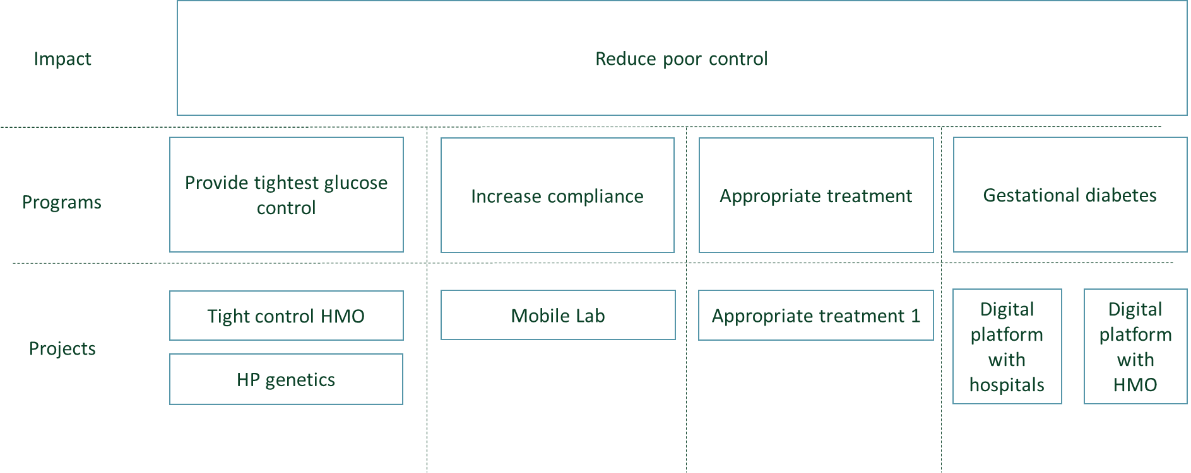

Figure The SPHERE CONTROL programs

### Tight control project (project with Healthcare system)

#### Project overview

**Program:** Provide tightest glucose control

**Goals**

* The rate of poorly controlled patients (HBA1C> 9%) in the Galilee area is 15% which is 20% higher than the national rate. To bring this down our goal is to provide tightest glucose control to poorly controlled T2DM patients (HBA1C >9%)

**Methods**

* Increased physician awareness
* Increased involvement of clinical support team including nurses and dieticians
* Regular follow-up

**Expected outcomes**

* Reduction of the percentage of poorly controlled T2DM patients in the Galilee

**Status of project**

* Planning phase

#### Progress of the project

**Starting point for the period**

* None

**Developments during the period**

* Begun project development

**Expectation for next period**

* Start of the execution of the program

### HP genotype project (project with Healthcare system)

#### Project Overview

**Program:** Provide tightest glucose control

**Goals**

* Provide tightest glucose control to T2DM patient with Hp 2-2- genotype

**Methods**

* Provide antioxidant therapy with natural source vitamin E.
* Patients will receive lifestyle modification programs

**Expected outcomes**

* New treatment method for patients with HP2-2 genotype

**Status of project**

* Planning phase

#### Progress of the project

**Starting point for the period**

* Before the start of SPHERE’s second year, we reviewed the original HP genotype project, including a calculation of the necessary size of the trial to obtain statistically significant results and development of the budget.

**Developments during the period**

During the period we have:

* Finalized our review of the large-scale HP genotype project which we proposed as part of the original SPHERE project.
* Decided, based on this review, to change this project. Recent developments in available medications seem to have significantly reduced the potential impact of the project, that even if successful, will be too limited to justify the substantial financial investments needed for the original project. Therefore, we will be executing a smaller project in collaboration with the Technion and researchers in India.
* Started contract discussions with the Technion

**Expectations for the next period**

For SPHERE Year 3 we expect the following:

* Finalization of the contract discussions with the Technion
* Start of the execution of the program

### Appropriate treatment 1.0 (with Healthcare system)

#### Project overview

**Program:** Appropriate treatment

**Goal**

* Increase the use of appropriate medication by patients with cardiovascular and renal complications in the Galilee

**Methods**

* Research to
  + Map existing disparities in medication prescriptions for T2DM patients.
  + Identify patient and provider level factors that contribute to pharmacoequity based disparities.
* Design an intervention program consisting of:
  + Comprehensively enrich and improve knowledge and capabilities of physicians
  + Build a special digital prescription decision-making application to assist family physicians
  + Train physicians to communicate better with selected patients.
  + Increase awareness of patients
* Develop and implement a novel ‘pharmacoequity’ quality of care metric that will enable performance monitoring to improve patients’ quality of care.

**Timeline**

* Research - SPHERE Year 3.
* Pilot intervention program – SPHERE Year 3 and 4.
* Develop novel ‘pharmacoequity’ quality metric - SPHERE Year 3 and 4.
* Expansion / Implementation – Beyond SPHERE Year 4.

**Expected outcomes**

* Currently the use of appropriate medications by patients in the Galilee is ~50% in comparison to central Israel which is closer to 80%. We expect to see improvements of the Galilee figures over time. It is too early to define specific targets.
* **Status of project** Launch (The plan of the intervention is ready – 01/2024 to start in 4 SHERE cities: Nazareth, Nof Hagalil, Shfar'am and Safed)

#### Project progress

**Starting point for the period**

* Before the start of Year 2 of SPHERE, we held initial discussions around “appropriate treatment” projects to reduce cardiovascular and renal complications (in collaboration with AstraZeneca, BI and Bayer).

**Developments during the period**

Research

* We completed writing of the research protocol.

Intervention

* Further development of “appropriate treatment” projects to reduce cardiovascular and renal complications in collaboration with the HMOs who will be the main partners for SPHERE in this project at this stage.
* Develop the relevant contracts with the HMOs

Novel pharmacoequity’ quality metric

* None

**Expectations for next reporting period**

Research

* Execution of the research

Intervention

* Start of the intervention with the HMOs in the cities Nazareth, Nof Hagalil, Safed, Sakhnin and Shafar-am.

Novel pharmacoequity’ quality metric

* Start of development

### One-stop-mobile lab (Integrated project)

#### Project Overview

**Program:** Increase compliance to annual checkups

**Goal**

* Increase compliance with clinical and laboratory testing for diabetic patients in the Galilee to improve diabetes management.
* Facilitate clinical trials and other relevant research in the Galilee.

**Methods**

* Provide all relevant tests in one convenient laboratory, accessible to diabetic patients in their local neighborhood

**Timeline**

* The mobile lab is expected to become operational during SPHERE Year 3.

**Expected outcomes**

* Improve compliance to annual testing
* Increase research in the Galilee

#### Project progress

**Starting point for the period**

Before the start of Year 2 of SPHERE, we developed a general understanding of the lab we want to build as well as the detailed design.

**Developments during the period**

During the period we:

* Recruited the SPHERE project lead
* Released the tender for the build of the mobile lab and completed the tender process leading to the selection of the company that will build the mobile lab
* Obtained approval for the mobile lab from the Israeli Ministry of Transportation
* Began the build
* Began developing the operational plans for the mobile lab including topics such as equipment in the lab, the business plan, team, interaction with HMOs, and interaction with the municipalities.

**Expectations for next reporting period**

In SPHERE Year 3 we expect the following:

* Launch the mobile lab operations:
  + Signing contracts with HMOs
  + Start testing diabetic patient in low compliance areas
* Start research and clinical trials e.g. around genetics

### GDM Digital platform with hospital-based clinic (healthcare system)

Notes re SPHERE and GDM.

In the original proposal to RBF, the GDM activities of SPHERE were split into 2:

1. GDM Research Agenda – originally included in PREVENT.
2. Achieving the expert international consensus guidelines for the prevention and management of GDM

We have opted not to develop a detailed GDM Research Agenda yet, and therefore our focus is on specific programs focused on “achieving the expert international consensus guidelines for the prevention and management of GDM”. We do this currently through two programs.

#### Project Overview

**Program – Gestational diabetes**

**Goal**

This first program is executed with Tzafon Medical Center (previously called Poriya Hospital). The goals of the program are to:

* Improve self-management and assist pregnant women who come from diverse backgrounds and are diagnosed with GDM in adhering to required lifestyle changes.
* improving their engagement and adherence to treatment through a digital tool used in the treatment process by addressing barriers and challenges such as cultural and linguistic differences;
* Create an improved monitoring and clinical decision-making system for health care providers

**Timeline**

* SPHERE applies an innovative approach to develop and implement a digital platform (m-health) for treating and monitoring pregnant women diagnosed with gestational diabetes (GDM) who live in Israel’s social and geographic northern periphery. Expected to test the beta version in year 3.

**Methods**

* SPHERE applies an innovative approach to develop and implement a digital platform (m-health) for treating and monitoring pregnant women diagnosed with gestational diabetes (GDM) who live in Israel’s social and geographic northern periphery.

**Expected outcomes**

* Women who have a culturally and linguistically tailored app will improve their GDM management as well as improve neonatal outcomes.

Status of the project

* In Execution

#### Project Progress

**Starting point for the period**

This project began in Year 1 of SPHERE.

**Developments during the period**

* The original project aimed to work only with Tzafon Hospital
* We implemented a study to understand women’s barriers and facilitators to GDM treatment as well as their cultural needs.
* During year 2 the opportunity arose to expand the work to include additional hospitals across the Galilee (a multi-center study). As the collaboration with Tzafon on this specific project was more difficult than expected, we have changed our mode of collaboration with Tzafon from a collaborative project to a project in which SPHERE finances part of the research.
* An important lesson learned during the period is that while the hospital in the regions have an important role to play in the treatment of women with GMD, most of the burden is on the HMOs in the community.

**Expectations for next reporting period**

* We expect the multi-center research to continue and results to become available
* We will evaluate whether a continued collaboration with Tzafon on this topic and if this is beneficial to SPHERE.

### GDM - Digital platform for support in the community (with healthcare system)

#### Project overview

**Program – Gestational diabetes**

**Goal**

The goals of this program are similar to the first GDM program with Tzfon:

* Improve self-management and assist pregnant women who come from diverse backgrounds and are diagnosed with GDM in adhering to required lifestyle changes.
* improving their engagement and adherence to treatment through a digital tool used in the treatment process by addressing barriers and challenges such as cultural and linguistic differences;
* Create an improved monitoring and clinical decision-making system for health care providers

However, taking into consideration the lessons learned during the first program, this second program will be executed in the community in collaboration with the HMOs (and in the future potentially the municipalities).

**Methods**

* x

**Timeline**

* In development

**Expected outcomes**

* In development

#### Project progress

**Starting point for the period**

* This program did not begin before Year 2

Developments during the period

* We are exploring this program with Maccabi
* Identify and secure meetings with relevant Maccabi personal for input
* Design an application.
* Assess usage as “prescribed”

**Expectations for next reporting period**

For SPHEREs Year 3 we expect:

* Exploration of this program with Maccabi

## CARE

### Introduction

The growing health disparities together with the rise in chronic disease and healthcare costs in the Galilee intensify the need for developing new organizational models and policies. In CARE, SPHERE will address several key challenges including:

* The HMOs lack of resources to address challenges that are not at the core
* Lack of “health security” and inadequate access to healthcare in the Galilee region
* Facilitated access to data

In the original proposal to RBF, we proposed to do this through the “Managing Healthcare” program, a Galilean Integrated Care Model. MESH, our municipal program explained in detailed in Chapter 2 above, is that Integrated Care Model. As this MESH program is being developed and implemented as a basis for SPHERE projects in PREVENT, CONTROL, CARE and CURE, the CARE pillar of SPHERE has been updated. This means that CARE currently includes two programs which directly support SPHEREs work with Municipalities and through this have direct impact on all three of SPHERE main Impact goals:

* A reduction in the conversion rate of pre-diabetic patients to diabetes in the Galilee
* A reduction in the relative number of poorly controlled diabetic patients in the Galilee
* Reduction of obesity in youth (as precursor for diabetes) in the Galilee

There are currently two SPHERE CARE programs in progress:

|  |  |  |
| --- | --- | --- |
| SPHERE Program | Goals for the program | Type of program |
| Municipal data dashboard | Enable municipalities to take data-driven decisions regarding health | With municipalities |
| Social prescription platform (previously included in the infrastructure pillar) | Enable municipalities to include local business in addressing health challenges | With municipalities |

### Municipal data dashboard

#### Project overview

**Goal**

Provide municipal health leaders with a broad and detailed data-driven picture of the state of diabetes morbidity and related social determinants of health across their communities, as well as data on the municipal ecosystem and available resources. The dashboard will enable them to design and implement health intervention strategies tailored both to municipal specific needs and resources.

**Methods**

To achieve this we

* Are designing and developing a digital Municipal Health Dashboard that will include data from different stakeholders on diabetes morbidity and related social determinants of health across communities as well as data on the municipal ecosystem and available resources;
* Define decision-making processes and a corresponding user interface that will allow for a data-driven day-to-day work of the municipal health leadership;
* Define a data strategy for planning, implementing and evaluating interventions in the municipality and a data-based management routine;
* Pilot the Municipal Health Dashboard in all its parts in selected municipalities, and guide their health leadership in implementing a data-driven day-to-day work through it;
* Roll-out the dashboard to additional municipalities.

**Timeline**

* Year 1 and 2 - Design and development
* Year 3 – Finalize development and start of pilot in selected municipalities
* Year 4 – Pilot
* From Year 5 – roll out beyond the pilot cities

**Expected outcomes**

Use of the Municipal Health Dashboard in its entirety by municipal health leadership in many municipalities in decision-making processes as part of their ongoing work and in the planning, implementation, and evaluation of interventions.

#### Project progress

**Starting point for the period**

During Year 1 of SPHERE we:

* Engaged in a strategic collaboration with Nova Projects, a subsidiary of Social Finance Israel. Nova Projects specializes in data-driven projects, including dashboards, and in building internal organizational capabilities to collect, process, and analyze data at public authorities such as municipalities.
* Started the development of the requirements for the SPHERE Municipal Health Dashboard.

**Developments during the period**

During Year 2 of SPHERE we:

* Continued the development of the requirements for the SPHERE Municipal Health Dashboard;
* Defined the data and applicable cross-data that will be integrated into the Municipal Health Dashboard, mapped the existing data, e.g. data from national databases and open sources, identified other data partners that hold data, and worked to obtain regulatory approval for the transfer of this data to the dashboard;
* Held a dedicated training day for the municipal health leadership to familiarize them with the dashboard;
* Developed an innovative and unique dashboard section that includes data related to the municipality's ecosystem in the health field, as well as resources available to carry out interventions, which will allow the municipal health leadership to implement the health unit operation model developed by SHPERE.

**Expectations for next reporting period**

* Finalize the development of the first version of the SPHERE Municipal Health Dashboard;
* Collect and assimilate real-world data in the Municipal Health Dashboard;
* Define a data strategy for interventions in the municipalities for the planning, implementation, and evaluation of interventions for a data-based municipal management routine;
* Train municipal health leadership in implementing data-based work routines in decision-making processes in their day-to-day work and in the planning, implementation, and evaluation of interventions;
* Start the piloting phase with the implementation in the first two SPHERE municipalities

### Social prescription platform

#### Project overview

**Goal**

The goal of this program is to promote and sustain healthy lifestyle among patients with (pre-) diabetes through connecting the healthcare system, the municipalities and local business.

**Methods**

To achieve this we

* Map relevant community service providers to create a network of ‘certified’ community health partners.
* Create an electronic Social Prescription platform that will include identification of relevant service providers in the community and allow physicians to give patients personalized resource prescriptions while also allowing to track referrals
* (potentially) Subsidize community referrals for low socio-economic status patients (exempt from social security and co-payments) to ensure equal access.
* Perform a cost-benefit analysis to understand the business case and how maintaining the system, after this project ends, is sustainable and worthwhile.

**Timeline**

* Year 1 and 2 of SPHERE – Research and development of the SP software
* Year 3 and 4 of SPHERE – Pilot in two SPHERE towns- Shfar’am and Safed to gather feedback and improve the software.
* Beyond Year 4 – introduction to other northern communities.

**Expected outcomes**

* For the initial pilot phase in Shfar’am and Safed we expect that over 200 patients and 40 local businesses will test the SP platform. User drop-off (no repeat use after 2 prescriptions) after 1 year will be limited to 20%.

#### Project progress

**Starting point for the period**

During Year 1 of SPHERE we:

* Executed comprehensive research into the existing global activities and technology platforms related to social prescribing. A scientific paper has been published.
* Developed the main business and technological requirements for the SPHERE platform.

**Developments during the period**

* Continued our research into the requirements for the platform and finalized a first design document.
* Developed a first version (MVP) of the SPHERE social prescription platform
* Conduct research with local businesses to assess implementation readiness and feasability

**Expectations for next reporting period**

For Year 3 of SPHERE we expect that the Social Prescription Program will move forward as follows:

* Start of the pilot in Shfar’am and Safed

## CURE

### Introduction

The CURE pillar in SPHERE builds upon opportunities or "pockets of strength" which we have identified to restore health and effectively deal with the different biomedical aspects of diabetes and diabetes treatment, while taking into consideration the unique environment of the Galilee, its different populations, their unique genetic background, their different traditions, and rapidly changing dietary cultures.

We focus on three areas of research:

* Program 1 – Genetics
* Program 2 - Microbiome
* Program 3 - Islet cell biology/Endocrine pancreas/Target organ injury

### Program 1 – Genetics

#### Program overview

**Goal**

The unique population structure in the different communities of the Galilee causes high rates of diabetes, as well as other genetic diseases. However, this unique population structure, together with the existence of very large nuclear families in the more traditional communities of the Galilee, are extremely beneficial for genetic studies and make the Galilee a “gold mine” for the genetic research of diabetes. Our suggested research program will identify genetic mutations that cause diabetes and are specific to each sub-population in the Galilee. Identifying such mutations will lead to improved tailored medical care for patients in this region, as well as the development of personalized medicine diagnostic and prevention tools.

**Methods**

To achieve this, we currently execute several early-stage research projects. Part of these projects we conduct on our own, part we co-finance through small grants.

SPHERE only projects

This currently consists of two sub-projects which focus on identifying the clinical and genetic basis of T1DM in population isolates of the Galilee, aiming to find methods for T1DM prediction and prevention.

|  |  |
| --- | --- |
| **Subproject** | **Project description** |
| Sub-project 1 | Identifying clinical characteristics of families with multi-generational type 1 diabetes from the galilee area |
| Sub-project 2 (With Prof. Ram Weiss at Rambam) | Research Title: Identification of the genetic contribution of Diabetes Mellitus and its complications in population isolates of the Galilee.  The aim of this study is to analyze families with multi-generational type 1 diabetes genomically and transcriptomically. The overall research hypothesis is that through such families it will be possible to identify a combination of genetic signatures and specific expressions of proteins that characterize the unique transmission pattern of the disease. |
| Sub-project 3 With Dr. Bashkin at Galilee Medical Center (Nahariya) | Identifying clinical characteristics of patients with isolated benign glycosuria due to mutation in the SGLT2 gene from the galilee area |

Grant projects

|  |  |
| --- | --- |
| **Subproject** | **Project description** |
| Project by Hussein Osamah & David Karasik | The genetic basis of metabolic syndrome in the Druze community |
| War-zone stress | Testing war-zone stress as a possible trigger for T1DM and T2DM - Pending |

**Timeline**

* Each of these projects have their own timeline typically lasting 2-5 years

**Expected outcomes**

* Better understanding of clinical and genetic characteristics of families with multi-generational type 1 diabetes from the galilee area. This new data will pave the way for improved personal and precision medicine approach.

#### Program progress

|  |  |  |  |
| --- | --- | --- | --- |
| **Project** | **Starting point for the period** | **Progress during the period** | **Expectation for next period** |
| Sub-project 1 | None | Protocol approval by the Ethics committee | Execution of the research |
| Sub-project 2 | Establish a partnership with Prof. Ram Weiss at Rambam Medical center in Haifa. | The partnership with prof. Ram Weiss has been translated into a research project. During the period we have detailed the project, worked on the contract, and secured some external funding. | Execution of the research |
| Sub-project 3 | None | Protocol approval by the Ethics committee – Galilee Medical Center | Execution of the research |

Grant projects

|  |  |  |  |
| --- | --- | --- | --- |
| **Project** | **Starting point for the period** | **Progress during the period** | **Expectation for next period** |
| Project by Hussein Osamah & David Karasik | Contract signature | In progress | Continuation of the research |
| Testing war-zone stress as a possible trigger for T1DM and T2DM | Pending | Pending | Start of the research |

#### Future projects

In the field of genetics, we expect additional projects and developments. Examples are:

* New studies to be financed by SPHERE through small grants
* New studies in collaboration with the SPHERE biobank
* Genetics studies for special populations with PSIFAS Israel’s national genetics initiative, managed by Prof. Barabash, which we expected to engage with in more detail once our mobile lab is up and running.

### Program 2 – Microbiome

**Goal**

Changes in the composition of the microbiome (dysbiosis) are associated with a growing list of diseases, one of which is diabetes. Such associations raise the question of whether dysbiosis contributes to or is a symptom of the disease. Microbiome transplant experiments have demonstrated a role of the microbiome in several diseases, as several phenotypes could be transferred via the microbiota, including enhanced fat gain and insulin resistance. Microbiome transfer from lean human subjects to human subjects with metabolic syndrome was shown to increase insulin sensitivity. Taken together, these studies suggest that the specific composition of the microbiota can be an important factor in the onset, and possibly the progression of diabetes.

**Methods**

The original research plan includes three projects:

* Project 1 - Prediction of GDM among the Galilee population
* Project 2 - Aging, T2DM and the microbiome in the Galilee
* Project 3 - Predicting the effect of the perturbation on the human microbiome for therapeutic intervention

Today, Prof. Omry Koren continues to operate his own lab. SPHERE is involved through one grants:

|  |  |  |
| --- | --- | --- |
| **Project Title** | **Project Description** | **Funding provided by SPHERE** |
| The gut microbiome as a target for prediction, prevention and treatment of gestational diabetes in the Galilee | In this study, we aim to identify stable microbial and clinical biomarkers of GDM for pregnant women in T1 of pregnancy with a specific focus on the unique, heterogeneous population in the Galilee. The expected outcome of this research is a clinical tool that can be used to predict GDM at early stages of pregnancy amongst ethnically diverse patients | NIS 150,000 |

### Program 3 - Islet cell biology/Endocrine pancreas/Target organ injury

#### Introduction

**Goal**

Regardless of the diabetes type, all are eventually characterized by β-cells loss, or by β-cells losing their capacity to produce adequate insulin. This program aims to achieve six main goals through these projects: (1) Activating β-cell regeneration (2) Reversing Latent Autoimmune Diabetes in Adults (LADA) progression (3) Protecting pancreatic β-cells from destruction in T1DM and T2DM (4) Understanding the molecular differences between the various endocrine cells of the pancreas. (5) Modulating PAR2 activation to a variety of regenerative processes, including β-cell regeneration (6) Preventing target organ injury.

**Methods**

Work by Dr. Ron Piran

The original research plan included 6 projects by dr. Ron Piran, which, to the best of our understanding, are all in progress:

* Activating β-cell regeneration
* Reversing Latent Autoimmune Diabetes in Adults (LADA) progression
* Protecting pancreatic β-cells from destruction in T1DM and T2DM
* Understanding the molecular differences between the various endocrine cells of the pancreas.
* Modulating PAR2 activation to a variety of regenerative processes, including β-cell regeneration
* Preventing target organ injury

Today, Dr. Ron Piran continues to operate his own lab. SPHERE is involved through two grants:

|  |  |  |
| --- | --- | --- |
| **Project Title** | **Project Description** | **Funding provided by SPHERE** |
| Stabilizing Neogenic β-cell Transdifferentiation by Inhibiting Somatostatin Secretion | Our mathematical model predicts that by inhibiting somatostatin (Sst) secretion, neogenic insulin-secreting, glucose-responsive β-cells could be formed. The research aims to test this hypothesis experimentally. Positive results would highlight the possibility to cure diabetes if somatostatin effect is being inhibited in diabetic patients. | NIS 100,000 |
| Combined therapy for LADA in a novel murine model: the recovery pro | Our preliminary results indicate that in a murine model for LADA a portion of the population can be completely cured. In this proposal we aim to investigate the underlying mechanisms and find discriminators to predict responsive individuals. | NIS 100,000 |

Work by others on Target Organ Injury

In addition, SPHERE is financing several smaller projects (grants) focused on target organ complications as follows:

|  |  |  |
| --- | --- | --- |
| **Project Title** | **Project Description** | **Funding provided by SPHERE** |
| Nakhoul Farid | The effect of SGLT2i on renal and  pancreatic αKlotho/Autophagy pathways  in diabetic mice model | NIS 100,000 |
| Amal Arabi-Zoabi | Diabetes control and complications in  Jews and Arabs – a data base cohort | NIS 50,000 |
| Dr. Amir Bashkin, Dr. Yelena Kirzner, Dr. Tal Shiller | Development of complications in diabetes type 1 patients of Ethiopian descent | NIS 20,000 |
| Dr Kaled Khazem | Diabetic Nephropathy | NIS 50,000 |

## Education

SPHERE has three supporting pillars: Education, Healthcare Delivery and Infrastructure.

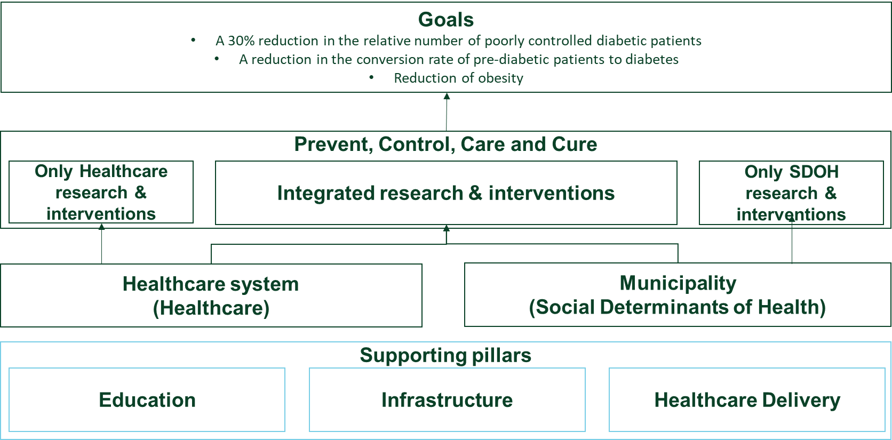

Figure Overview of SPHERE and it's supporting pillars

In this and the following two chapters we describe these supporting pillars.

### Introduction

The SPHERE Education pillar was developed to address several key challenges to our projected projects in PREVENT, CONTROL, CARE and CURE:

* **Shortage of family physicians with specialized diabetes knowledge** - High quality professional primary care forms an important basis for improving population health. However, in the Galilee there is currently a significant shortage of qualified family practitioners. Their positions are typically filled by general physicians without appropriate family practice specialization.
* **Poor research infrastructure in the regional HMOs** making it difficult to increase the number of physicians and allied healthcare professionals taking part in multi-disciplinary research.
* **The lack of continued education opportunities in the north of Israel**

Originally, we translated these challenges into four goals:

1. Healthcare professionals
   1. Increasing the number of family physicians with diabetes specialization
   2. Increasing participation of established professionals in research
   3. Increasing the standard of knowledge of established professionals
2. Students
   1. Increase the number of students with deep research skills

An additional goal of EDUCATION was to establish local branches of the Israeli Diabetes Association to enable local courses for patients.

Over the past year, we have adjusted our goals for EDUCATION and included a new group of professionals which we need to take into consideration – the relevant professionals in municipalities.

We have therefore added two new goals to our education activities:

* Develop municipal healthcare leaders
* Support the inclusion of municipal healthcare in municipal practice

We address these goals through a series of programs. As follows:

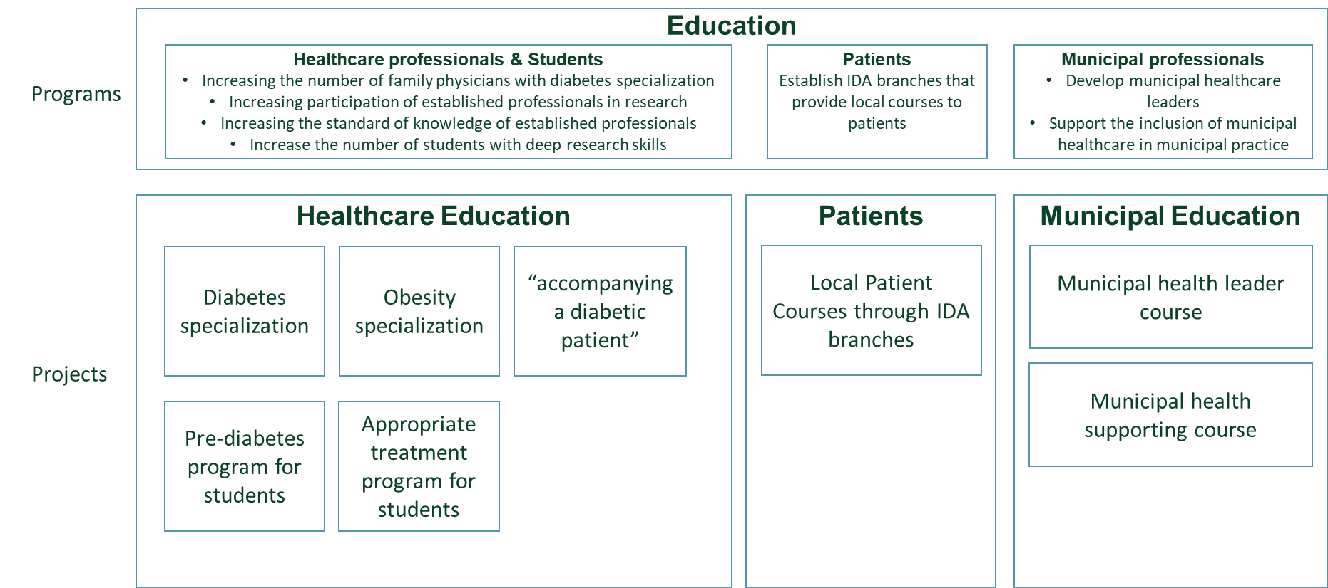

Figure SPHERE's Education Programs

The EDUCATION pillar is very dynamic and additional programs are developed and added where necessary. For example, the obesity specialization program mentioned in the picture above has been developed during SPHERE’s Year 2.

### Healthcare Professionals and Students

#### Diabetes specialization for family physicians

**Goal**

To increase the number of family physicians with diabetes specialization working in the Galilee.

**Methods**

To achieve this, we provide family physicians in the region, with preference for physicians practicing in the cities SPHERE work’s with, to attend a 2-year course for family physicians to become diabetologists at the Technion

These physicians also receive SPHERE mentoring led by Dr. Elias Srour and Prof. Naim Shehadeh.

**Timeline**

* A cohort of 10-15 family physicians is expected to begin the diabetologist’s course every 2 years.

**Expected outcomes**

Over the course of 10 years, 50 to 75 family physicians working in the Galilee will be trained to become certified diabetes experts.

**Developments over the period**

* A cohort of 10 family physicians is expected to finish the course in December 2024

**Expectation for next reporting period**

* A cohort of 10 family physicians is expected to start the course in the course of 2024

#### Obesity specialization for family physicians

**Goal**

To increase the number of family physicians with obesity specialization working in the Galilee.

**Methods**

To achieve this we provide family physicians in the region, with preference for the cities in which SPHERE work’s with, to attend a obesity training course which SPHERE co-developed with the Technion.

These physicians will also receive SPHERE mentoring led by Dr. Elias Srour and Prof. Naim Shehadeh.

**Timeline**

* A cohort of 10-15 family physicians is expected to start this course every 2 years.
* The first cohort began the course on December 5, 2023

**Expected outcomes**

Over the course of 10 years, 50 to 75 family physicians working in the Galilee will be trained to become certified obesity experts.

**Developments over the period**

* We developed the course
* Marketed the course
* Registered participants
* Prepared for execution

**Expectation for next reporting period**

* Execution of the course

#### Accompanying a diabetic patients – project in evaluation

We are exploring an additional “accompanying a diabetic patient” program for the city of Sachnin with a partner.

**Goal**

Train students to assist a diabetes patient, enabling these patients to lead healthier lives

**Methods**

* Regular meetings between students and patients

**Timeline**

* Program for 1 max 2 semesters

**Expected outcomes**

* Improved health outcomes
* Training for the students

**Developments over the period**

* We are still evaluating this option

**Expectation for next reporting period**

* Finalize evaluation and, depending on decision, execute or not

#### Pre-diabetes program for medical students

**Goal**

Train medical students to assist family physicians in preventing pre-diabetic patients from becoming diabetic

**Methods**

Medical students become physician assistant and assist family physicians in implementing SPHERE’s pre-diabetes program in the clinics

**Timeline**

* 5 months program, students are recruited for 80 hours, 4 hours per week

**Expected outcomes**

Students will gain clinical knowledge and real-world experience in pre-diabetes and diabetes

**Developments over the period**

* 11 students were recruited.
* Students were trained on pre-diabetes and diabetes risk factors and evidence-based interventions by Prof. Shehadeh
* Students are working in clinics in Nazareth and Nof Hagalil

**Expectation for next reporting period**

Expansion of the program as SPHERE expands to additional cities

#### Appropriate treatment program for students

**Goal**

Train medical students to assist family physicians in reducing diabetes medication prescription disparities

**Methods**

* To be determined

**Timeline**

In the coming year we will:

* Develop program
* Recruit students
* Implement the pharmacoequity intervention.

**Expected outcomes**

Students will gain clinical knowledge and real-world experience, by participating in the implementation of an intervention to achieve pharmacoequity across the Galilee

**Developments over the period**

* We designed the appropriate treatment program
* Defined medical students roles and responsibilities

**Expectation for next reporting period**

* Begin execution of the program

### Patient Education

#### Local patient courses through IDA branches in SPHERE cities

**Goal**

* Enable municipal health units to provide courses and other relevant activities for diabetes patients in their municipalities

**Methods**

* Provide IDA’s content, methodologies and expertise to the municipal health units which then can choose whether to engage with IDA or not

**Timeline**

* Development of concept – Year 2
* Repository set up and connection made during 2024

**Expected outcomes**

* Launch of patient courses in the various SPHERE cities

**Developments over the period**

* Development of the concept

**Expectation for next reporting period**

* Repository set up and start of courses in 2024

### Municipal Education

#### Municipal Health Unit Leader Course

**Goal**

To support the implementation of the MESH model and establish municipal health units.

A concentrated training course was provided to the various leaders of the municipal health units June to August 2023. Training is continuing during the rest of 2023 and into 2024 through monthly sessions.

**Methods**

The SPHERE team developed a course for the leaders of this unit. This course consisted of several core modules including:

* What are the key health (focusing on diabetes and obesity) issues in the region and the cities
* How do municipalities work in general?
* What does the new role of the health units contain?
* How to establish a municipal ecosystem to improve health
* Implementing interventions in the local education system following the Gefen reform (a national reform in the education system)

**Timeline**

* Development of the course – May 2023
* Execution of first course – August 2023
* Execution of further courses – 2024 as needed

**Expected outcomes**

Leaders of municipal health units are trained well to execute and succeed in their role.

**Developments over the period**

* Development of the course
* Execution of first course (June – August 2023)

**Expectation for next reporting period**

* Execution of further courses to new municipal health leaders

#### Municipal health supporting course

**Goal**

To support the implementation of the working processes of the municipal health units by enabling other municipal employees to understand and support the health unit within their own fields of responsibility

**Methods**

* Course with project in the community

**Timeline**

* Development – December 2023 – March 2024
* Execution – March – July 2024

**Expected outcomes**

* 10-15 municipal employees (from 5-7 different municipalities) will have better insights on how they can support the municipal health unit and health in general within their municipality.

**Developments over the period**

* Won a tender in the Beit Hakerem regional cluster to provide this course to a consortium of cities in the Galilee

**Expectation for next reporting period**

* Development of the course
* Execution of the course

### Discontinued Education Programs

**“Program 1 - Increase participation of community physicians and allied healthcare professionals in multi-disciplinary research” was cancelled as we have** decided to change this set up. The new set-up will be integrated into the Social-Precision medicine efforts of SPHERE and largely move to a research-supporting infrastructure at the HMOs which will better answer the needs of family physicians and our partner HMOs

### Future Education Programs

The original programs Green North and a combined MD/PHD degree track in Health Science are future priorities.

## Healthcare delivery

### Introduction

In the original proposal to RBF, the pillar Healthcare Delivery has been defined as “the translation arm of the SPHERE's research activities, integrating relevant research results into the operations of the Israeli healthcare system.”

With the development of the municipal health units, we are changing this definition slightly to “the translation arm of the SPHERE's research activities, integrating relevant research results into the operations of the Israeli healthcare and municipal systems.”

The Healthcare Delivery pillar in SPHERE focuses on:

|  |  |
| --- | --- |
| **Activity** | **Goal** |
| Economics and sustainability of the new interventions | * Provide the economic evidence for the effectiveness and cost-savings of new interventions. * Ensure that SPHERE executes research that could be implemented at scale |
| Implementation science | Use implementation science to develop appropriate implementation strategies assessing impact on fidelity and adaptability of implementing interventions in different contexts |

Note that in the original proposal there were 5 activities. One such activities, “Health Disparities” does not have specific projects related to it but is a core element of SPHERE. We continuously work through a health equity lens as the main goal of the SPHERE is reducing diabetes healthcare disparities.

Also “Training to support implementation” has been taken out of this pillar and moved to Education. Last but not least we have reorganized the work around CRO activities which is now included in Infrastructure.

Two activities are left in this pillar: Economics and sustainability of the new interventions and Implementation Science.

These activities are divided into several projects:

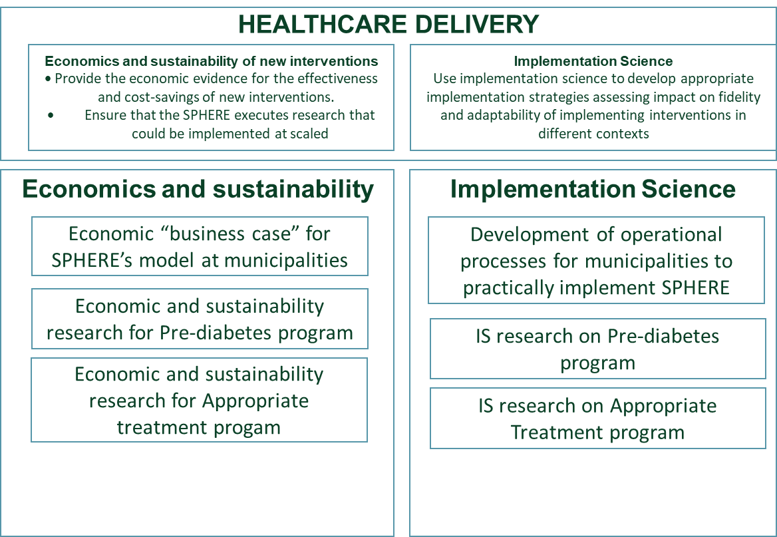

This pillar is dynamic and programs are added regularly.

Figure Healthcare Delivery overview

### Economics and sustainability

#### Economic “business case” for SPHERE’s model at municipalities

**Goal**

Development of the economic basis for SPHERE’s municipal health units

**Methods**

* Selection of a strategic partner with experience in developing complicated social economic models (Social Finance Israel)
* Analyze existing models that could serve as the basis for the SPHERE municipal model
* Collection of data from municipalities and other relevant sources
* Development of a first model
* Development of additional versions of the model
* Publication of the model both to the municipalities as well as through academic papers

**Timeline**

* Selection of partner – Until July 2022
* Analysis of existing models – December 2022
* Development of the initial model – March 2023
* Ongoing iterations and data collection – December 2023
* Publication – March 2024

**Expected outcomes**

An economic model for the SPHERE’s municipal health units which provides municipal decision-makers as well as (national) policy makers with the confidence how such units can provide financial benefits to municipalities.

**Developments over the period**

* Development of the initial model – March 2023
* Ongoing iterations and data collection – December 2023

**Expectation for next reporting period**

* Ongoing iterations and data collection – December 2023
* Publication – March 2024

#### Economic and sustainability research for Pre-diabetes program

**Goal**

Development of the economic “business case” for SPHERE’s pre-diabetes program to be executed by the HMOs and, in a later stage, with the municipalities.

**Methods**

* Assess the cost-benefit and cost-effectiveness of the pre-diabetes healthcare system focused intervention.

**Timeline**

* Submit ethics request.
* Extract relevant data from the HMOs.

**Expected outcomes**

* Understand the economic implications of the pre-diabetes program

**Developments over the period**

* We identified the relevant data
* Applied for ethical approval for extraction of the data from HMOs.

**Expectation for next reporting period**

* Analysis of the data
* Relevant lessons for HMO decision makers
* Relevant lessons as we develop the next phase of implementation with the municipalities.

#### Economic and sustainability research for Appropriate Treatment

**Goal**

To identify the cost-benefit of appropriate treatment for the health system and the patient.

**Methods**

* Develop the assessment model
* Identify the relevant clinical and social data

**Timeline**

* Submit ethics request.
* Extract relevant data from the HMOs.

**Expected outcomes**

* Understand the economic implications of appropriate treatment.

**Developments over the period**

* We have begun to design the model.

**Expectation for next reporting period**

* Apply for ethical approval for extraction of the data from HMOs.
* Analysis of the data
* Relevant lessons for HMO decision makers
* Relevant lessons for patients
* Design of interventions to reduce gaps and assess their cost-effectiveness

### Implementation science

#### Operational processes for municipalities to practically implement the SPHERE model

**Goal**

Develop and deliver operational working processes that enable municipal health units to succeed in their missions.

**Methods**

* Research potential working methods
* Develop working processes accounting for the specific municipal environments in the Galilee
* Release these working processes to the health unit leaders.
* Work with these health unit leaders to implement the processes.

**Timeline**

* Develop the operational processes needed by the health units in 2023 – October 2023
* Develop the operational processes needed by the health units in 2024 – Ongoing as per the need

**Expected outcomes**

Evidence-based practical working processes which enable the health units to deliver high quality work on time to the right stakeholders.

**Developments over the period**

During the period we have developed the following processes:

* Mapping
* Project proposals
* Strategic plans
* Work plan

**Expectation for next reporting period**

In the next period we expect to:

* Assess implementation of the tools – understanding fidelity versus adaptability.
* Develop new tools as needed.

#### Implementation research for pre-diabetes program

**Goal**

This research aims to understand the barriers and facilitators in the implementation process of a DPP program in Israel’s disadvantaged northern periphery, assessing both patient and health care provider related factors and the interaction between them.

**Methods**

The study converges between qualitative and quantitative methods and is guided by the reach, effectiveness, adoption, implementation, and maintenance (REAIM) evaluation framework. We will assess participating clinics in Nazareth and Nof Hagalil of Maccabi Health Care (Maccabi) and Clalit Health Services (Clalit). The study will include the following participants: (1) Patients, (2) Health care providers (physicians, nurses, dieticians, physical activity consultants) (HCPs), and (3) Maccabi and Clalit northern district’s leadership such as medical and nursing director. Qualitative data will include interviews with HMOs leadership, health care providers (HCPs), and patients. Participants will be interviewed at early (or pre-) implementation and late (or post-) implementation of the DPP.

**Timeline**

* Collect data and conduct interviews with patients and providers in 2024

**Expected outcomes**

* Understanding what the facilitators and barriers in program implementation were and adjusting the pre-diabetes program accordingly to achieve better outcomes.

**Developments over the period**

* We developed the research protocol
* Submitted request for ethics approval

**Expectation for next reporting period**

In the next period we expect to develop:

* Conduct interviews with patients and program team providers (physicians, nurses and dieticians)
* Extract clinical patient data
* Assess qualitative and quantitative data
* Extract and publish lessons learned

#### Implementation research for appropriate treatment program

**Goal**

To understand the implementation barriers an facilitators when implementing the appropriate treatment program

**Methods**

* Currently in development

**Timeline**

* Develop the research protocol in first quarter of 2024
* Conduct the research in the second half of 2024

**Expected outcomes**

* Currently in development

**Developments over the period**

* will begin first quarter of 2024

**Expectation for next reporting period**

In the next period we expect to:

* Begin executing the research.

## Infrastructure

### Introduction

The infrastructure of SPHERE originally aimed to solve one of the biggest potential barriers to research in the Galilee in general and SPHERE in specific: independent access to data whereby we work closely with the local (regional Galilee) branches of the HMOs, hospitals and others. To enable all actors in SPHERE's "ecosystem" to be able to collect and exchange data.

The Infrastructure pillar in SPHERE focuses on:

* Establishing the Biobank and integrating with Israel 'PSIFAS' Biobank and Data Center
* Establishing a data sharing platform
* Ongoing data analysis and artificial intelligence (AI) capabilities
* NEW: Establishing clinical trial capabilities in the Galilee

Note: the Social Prescription platform was moved from Infrastructure to the CARE pillar.

### Biobank

**Goal**

The goal of the Biobank is to enable regional hospitals, SPHERE (and potentially the HMOs), with the possibility to develop an income generating repository of biological samples which can be used in future research on topics related to CURE.

**Methods**

The biobank is being developed in collaboration with the hospitals in Nahariya and Poriya as well as with Midgam, Israel’s national Biobank. The hospitals will collect the samples, Midgam will provide the know-how regarding the operations and commercialization of the samples.

**Timeline**

The expected timeline for the biobank is as follows:

* Final ethical approvals at Nahariya – December 2023
* Set up of the biobank in Nahariya – December 2023 – June 2024
* Start of operations of the biobank in Nahariya – July 2024
* Final ethical approvals at Tsafon Hospital (Poriya) – March 2024
* Set up of the biobank at Tsafon Hospital – April 2023 – September 2024
* Start of operations at Tsafon Hospital – July 2024
* Integration with Israel 'PSIFAS' Biobank and Data Center – To be determined
* Start of commercialization – not before the end of 2025

**Expected outcomes**

A commercially viable biobank serving researchers in the Galilee, Israel and internationally.

**Developments over the period**

* Further clarified the collaboration with Midgam
* Obtained initial (almost final) ethics approval at Nahariya.
* Set up of team in Nahariya
* Continued discussions with Poriya

**Expectation for next reporting period**

* Final ethical approvals at Nahariya – December 2023
* Set up of the biobank in Nahariya – December 2023 – June 2024
* Start of operations of the biobank in Nahariya – July 2024
* Final ethical approvals at Tzafon Hospital (Poriya) – March 2024
* Set up of the biobank at Tzafon Hospital – April 2023 – September 2024
* Start of operations at Tzafon Hospital – July 2024
* Continue conversations with the national initiative PSIFAS for collaboration on genetic sample collection and research

### Data sharing platform

**Goal**

Enable SPHERE and its partners (HMOs, municipalities, hospitals, researchers, NGOs and others) to securely exchange data for SPHERE-related research, piloting and operational (implementation) purposes.

**Methods**

The high-level architecture / design of the SPHERE data sharing platform is ready. Setting up the actual platform will be executed step by step

**Timeline**

* High-level architecture design – October 2023
* Initial set-up – March 2024
* Continued expansion of the capabilities – From March 2024

**Expected outcomes**

We expect the SPHERE data platform to be instrumental in:

* Facilitation data driven research by SPHERE itself and its various partners
* Support exploratory research questions
* Support, through data collection & analysis, the development of financial and implementation basis for the new interventions
* Support implementation of new interventions in healthcare or municipal practice

**Developments over the period**

* Recruitment of SPHERE’s new CIO/CTO Mr. Ronen Segal. Mr. Segal has a rich background at various large organizations including ELAL and HMO Meuhedet.

**Expectation for next reporting period**

* Set up of the first version of the data sharing platform focusing on short-term needs
* Set up of the supporting team largely through contracts with external technology providers

### Ongoing data analysis and artificial intelligence (AI) capabilities

**Goal**

Develop a SPHERE network of data analysists and technologies that supports data analysis for SPHERE and its partners including through the use of AI.

**Methods**

* Establishment of data analysts at the HMOs Clalit and Maccabi and potentially Meuhedet
* Establish / strengthen data analysis capabilities within SPHERE

**Timeline**

* Data analysts at the HMOs Clalit and Maccabi – December 2022
* Recruitment of data lead at SPHERE – September 2023
* Ongoing strengthening of capabilities including AI – Ongoing from September 2023

**Expected outcomes**

A network of data analysts, supported by leading technology, at SPHERE and its partners to support the research and design, piloting and implementation of new evidence-based interventions.

**Developments over the period**

* Recruitment of data lead at SPHERE
* Development of the SPHERE data infrastructure including data analytics capabilities

**Expectation for next reporting period**

* Ongoing strengthening of capabilities

### Clinical trial capabilities in the Galilee

**Goal**

The goal of this program is to create a pipeline of (clinical) research projects which SPHERE and partners could over time scale up into real world interventions that address CONTROL.

**Methods**

To achieve this we

* Secure clinical trials with industry
* Support researchers through small grants (see also CURE)
* Recruit and train research assistants at the HMOs and potentially regional hospitals
* Apply for research grants
* Promote scientific publications

**Timeline**

* In development

**Developments over the period**

* Recruitment of data lead at SPHERE
* Development of the SPHERE data infrastructure including data analytics capabilities

**Expected outcomes**

* Over time we expect to execute 10s of such research projects of which we expect a select number to be scaled up to interventions in the Galilee and beyond.

# SPHERE Emergency activities following October 7

## SPHERE Emergency-related activities following October 7

### Emergency support for diabetes patients

**Executed to date**

To date we executed the following emergency related activities:

* **Clinical consultation for family physicians on diabetes treatment during periods of stress -** SPHERE's diabetes experts, Prof. Naim Shehadeh, Dr. Afif Nakhle as well as Prof. Julio Weinstein, provided and continue to provide individual and immediate clinical advice to family physicians at various HMOs operating in the Galilee to ensure optimal patient care.
* **Clinical consultation for evacuees** – A larger Galilee-wide team of specialist doctors and diabetes nurses provide a helpdesk for evacuees currently residing in hotels in northern Israel as well as a hotline that is coordinated with the supervisors of the evacuees from the Ministry of Health. Glucometers were also sent to hotels in Haifa and Hadera.
* **Emergency supplies for diabetic patients -** As part of the preparation for a prolonged stay in protected areas / safe rooms and further to the guidelines of Israel’s Home Front Command, SPHERE published recommendations in Hebrew, Arabic and English for diabetic patients and their caregivers that they ensure to have the following essential supplies at hand including for example blood glucose meters with glucose test strips - a spare glucose sensor for those who use sensors, Sufficient medication for a month as well as water and healthy food with lots of vegetables and many other topics.
* ​​**Support information for diabetes, pre-diabetes, and obesity patients in a state of war or under continuous states of stress -** SPHERE has produced, in collaboration with the Israeli Diabetes Association, a guide for managing diabetes during a state of war and continuous stress. In this guide, the mechanisms behind the harmful effect of mental stress on our bodies are presented, and practical tools are offered from experts to help prevent or reduce this negative impact on health. The guide was released in digital and printed versions, in Hebrew and Arabic, and so far over ten thousand copies were distributed among diabetics in the Galilee region and demand continues, with additional copies printed and distributed. The guide consists of a combination of text and videos from leading professionals in the fields of nutrition, sleep, physical activity, and pharmacy.
* **Webinars / Press –** During the last 2 months, several webinars and/or press interviews have taken place with SPHERE’s leadership and other leading health professionals addressing diabetes and best treatment in times of emergencies.

**Moving forward**

The emergency support for patients is continuing in 2 separate ways:

1. **Preparations for a patient hotline that can be operationalized immediately in case active fighting breaks out in the north** – This hotline and more importantly the volunteering staff and connections with the HMOs, hospitals and others relevant stakeholders have been set up. We can launch the hotline within 24 hours, probably substantially less.
2. **Continued publication of the SPHERE flyer and related online materials** – the HMOs but also other stakeholders such as religious leaders (e.g imams) and patient organizations continue to distribute the materials across the country. In addition, we continue to publish on social and other media information, including interviews by SPHERE experts on TV and radio.

### Emergency support for municipal health units

**Executed to date**

Using the same methodology SPHERE developed to help the Galilee move the needle on diabetes, the SPHERE’s Municipal Population Emergency-Management Platform connects all key partners in SPHERE’s 17 municipalities into a local ecosystem, leveraging their data, evidence, and information into an optimized emergency health response.

Comprising multi-sectoral data, tools, and ongoing professional support, the very basic platform takes as its starting point Israel’s Home Front Command’s national emergency guidelines for municipalities for maintaining the health of their residents. We then map municipalities to gain a full and up-to-date picture of available healthcare providers (including pharmacies and clinics); existing health equipment, such as generators and first-aid kits; volunteer healthcare professionals, such as physicians, nurses, and social workers; and residents’ health and social-welfare priorities. We then input this information into an online dashboard, which offers a comprehensive view of a municipal ecosystem’s population-emergency operations.

To translate data into action, SPHERE’s team of health professionals, municipal coordinators, and urban planners, along with students from the Azrieli Faculty of Medicine, work closely with municipal leaders. They help identify residents most in need of emergency health and social services; design and deliver the right intervention; and engage in constant assessments to improve efficacy.

**Moving forward**

The emergency support for municipal health units is progressing in 2 separate work streams:

1. **Moving emergency health into the day-to-day operations of the municipal health units** – We are working with the leaders of these health units, as well as the Ministry of Health, to make sure that the units regularly update their information, policies and working processes from now on.
2. **Closing gaps** – The work done by SPHERE and the municipal health units highlighted a series of gaps between the necessary state of health-related emergency preparations and the actual state. We are supporting the municipalities to close some of these gaps by connecting municipalities to resources such as emergency response training as well as acquisition of equipment such as first aid kits

1. See the original Care program