Artificial intelligence and innovations in the United States
Martin M. Bojaj^{a*} Nina Vujanovicª David Y. Aharon^{b}

Abstract: This study analyzes the connectedness of artificial intelligence (AI), innovations, output growth, labor, stock, commodity, carbon, and cryptocurrency markets in the United States. Contrary to common assumptions, innovations and AI have a very high cost and de-anchor investor expectations, disrupt markets, and overheat key macroeconomic factors. Our findings indicate that sustainable growth policies should not be based exclusively on traditional technological treatment assumptions about innovations and AI and identify the key gaps in the existing policies by prudential authorities.

Keywords: policy objective, AI, connectedness, forecast, macroeconometrics
JEL classifications: O14, C5, E17, E61

* Corresponding author.
^{*a}Martin M. Bojaj, Central Bank of Montenegro, Blvd. Sv. Petra Cetinjskog 6, 81000, Podgorica, Montenegro, martin.bojaj@cbcg.me. https://orcid.org/0000-0003-1433-4821.
ª Nina Vujanovic, Central Bank of Montenegro, Blvd. Sv. Petra Cetinjskog 6, 81000, Podgorica, Montenegro, nina.vujanovic@cbcg.me.
^{b} David Y. Aharon, Faculty of Business Administration, Ono Academic College, Tzahal St 104, Kiryat Ono, Israel, dudi.ah@ono.ac.il.

Introduction
Innovations, especially artificial intelligence (AI), are transforming our lives with implications for a range of phenomena, from economic growth and financial markets to climate changes, biotech, production, and family and social life (Acemoglu and Restrepo, 2018; Russel, 2019). It is anticipated that in the months to come, this shift will accelerate (Neopolitan et al., 2018; Xie et al., 2019).
Figure 1: AI and Bitcoin in the US (2021 - 2022)

Source: authors’ calculations.
Note: Figure 1a plots the relationship between the AI and Bitcoin in the US for 2021-2022. Figure 1b plots the Bitcoin against the AI.
Figure 1a indicates there is a significant positive relationship between AI and Bitcoin. Undoubtedly, Figure 1 is hardly evidence of causation. Both variables show parallel trends. Figure 1b examines the correlation between the increase in Bitcoin and the increase in the percentage of AI. Figure 1b shows a significant positive correlation between the two variables. The interconnectedness among other markets, such as innovations, gross domestic growth (GDP), NASDAQ stock, commodity, labor, and carbon markets is very important for individuals, businesses, institutions, and fiscal and monetary policymakers in the US since it helps clarify one-to-one connectedness (e.g., stock-to-carbon emission connectedness, aggregate macroeconomic connectedness, or total connectedness from others to output growth).

According to some recent studies (West, 2018; Susskind, 2020), AI portends a jobless future, while others believe that the impending AI revolution will increase human productivity and improve the working environment (e.g., McKinsey Global Institute, 2017). Considering limited research on the connectedness of macroeconomics and financial, cryptocurrency, commodity, and labor market innovations of AI, the ongoing existence of these differing visions is not surprising.

Earlier research has relied on incomplete relationships between AI and other markets, which has made it difficult to distinguish the specific macroeconomic connectedness of AI effects from general AI measures. This study fills the gaps in the existing research, offering connectedness measurements of AI, innovations, output growth and labor market, and stock, carbon, and cryptocurrency markets in the United States.

This study’s key novelty is four-fold. First, we add depth to the work of Diebold and Yilmaz (2014), spillover connectedness measures, forecasting and assessing how exogenous policy shocks to AI factors affect the real economy. Second, we add breadth by combining for the first time, and to the best of our knowledge, specific tailored set variables of ESG and key macroeconomic factors. Third, we identify specific risk factors that could potentially act as mechanisms that transmit destabilization. Finally, our evaluation offers novel perspectives by illustrating the dynamic effects of ESG regulations in several hypothetical situations. This study fills the gaps in the existing research, offering empirical measurements of ESG policy shocks and macroeconomic connectedness volatility measures.

The resulting research represents a marked departure from the approaches currently used, in that: (1) adds depth to the work of Diebold and Yilmaz (2014), spillover connectedness measures, forecasting and assessing how exogenous policy shocks to AI factors affect the real economy; (2) expands breadth by combining for the first time, and to the best of our knowledge, specific tailored set variables, combining multiple markets; (3) identifies specific risk factors that could potentially act as mechanisms that transmit destabilization; and (4) offers novel perspectives by illustrating the network dynamic effects of AI and innovations in several hypothetical situations. To the extent to which we have addressed the most acute issues of reversed causality and endogeneity, we believe that our results provide the first evidence that without a substantial regulation of innovations, optimizing the impact of AI is difficult.

This paper is structured according to the following framework: Section 2 outlines the methodology. Section 3 provides results and implications. Finally, a succinct summary of our findings is provided in Section 4.

Methodology
Our method for determining connectedness is based on Diebold and Yilmaz’s (2014) unified framework concept of connectedness. The forecast error variance of a variable is broken into its attributable constituent parts (Aharon and Qadan 2022). Table 1 shows the conceptual framework of the connectedness and relationship measures. We use a new Keynesian macroeconomic model, and the neoclassical production function is used to estimate GDP growth (Giordani 2004). We include AI factors, as shown in Equation (1), with a description of the variables provided in Table 2. Our sample spans the weekly data from January 2021 to December 2022.

Table 1: Spillover (connectedness) table
 | $$x_{1}$$ | $$x_{2}$$ | … | $$x_{N}$$ | From others
$$x_{1}$$ | $${ d}_{11}^{H}$$ | $${ d}_{12}^{H}$$ | … | $$d_{1N}^{H}$$ | $\sum_{j=1}^{N}{d_{1j}^{H}, }j≠1$
$$x_{2}$$ | $${ d}_{21}^{H}$$ | $${ d}_{22}^{H}$$ | … | $$d_{2N}^{H}$$ | $\sum_{j=1}^{N}{d_{1j}^{H}, }j≠1$
. | . | . | . | . | .
. | . | . | . | . | .
. | . | . | . | . | .
$$x_{N}$$ | $${ d}_{N1}^{H}$$ | $${ d}_{N2}^{H}$$ | … | $$d_{NN}^{H}$$ | $\sum_{j=1}^{N}{d_{Nj}^{H}, }j≠N$
To others | $\sum_{i=1}^{N}{d_{i1}^{H} }$ | $\sum_{i=1}^{N}{d_{i2}^{H} }$ | … | $\sum_{i=1}^{N}{d_{iN}^{H} }$ | $\frac{1}{N}\sum_{ij=1}^{N}{d_{ij}^{H} }$
 | $$i≠1$$ | $$i≠2$$ |  | $$i≠N$$ | $$i≠j$$

A target variable is represented by a row, and a source shock is represented by a column. By definition, the numbers across a row will add up to 100. The “From others” sum $\frac{1}{N}\sum_{ij=1}^{N}{d_{ij}^{H} }$denotes the value that comes from other shocks and is not attributable to endogenous shocks. The sum of the row “To others,” $\sum_{i=1}^{N}{d_{i1}^{H}}$, denotes the shocks transmitted to other target variables. The “From others” column and the “To others” row sum to the same value, denoted by $\frac{1}{N}\sum_{ij=1}^{N}{d_{ij}^{H}}$, $i≠j$. Therefore, except for pairwise directional connectedness, from $j$ to $i$, $C_{i←j}^{H}= d_{ij}^{H}$, the off-diagonal total directional connectedness labeled “from” others to $i$ is $C_{i← ∙}^{H}=\sum_{\underbrace{j=1}}^{N}{d_{ij}^{H}}$, $j≠i$; total directional connectedness “to” others from $j$ is $C_{∙ ←j}^{H}=\sum_{\underbrace{i=1}}^{N}{d_{ij}^{H}}, i≠j$; and the total connectedness is $C^{H}=\frac{1}{N}\sum_{ij=1}^{N}{d_{ij}^{H}, i≠j}$. $x_{1}, x_{2}, …,x_{N}$ denote the set of variables, and we examine their connectedness. $d_{ij}^{H}$ denotes the cross-variance decomposition of the $ij$th $H$ – forecast horizon step. This is the result of Cholesky shocks from a reduced set.

Table 2: Description of variables
Variables | Description | Source
$$y_{t}$$ | Gross domestic growth— H.P. filtered gap | https://fred.stlouisfed.org
$${lai}_{t}$$ | Natural logarithm of artificial intelligence | https://ai-index.info
$${lnasdaq}_{t}$$ | Natural logarithm of NASDAQ | https://ai-index.info
$${lcarb_p}_{t }$$ | Natural logarithm of carbon prices | https://www.investing.com
$${lbitcoin}_{t}$$ | Natural logarithm of bitcoin | https://www.
$${lcrb}_{t}$$ | Natural logarithm of commodity prices | https://stooq.com/
$${ltfp}_{t}$$ | Natural logarithm of total factor productivity | http://www.longtermproductivity.com
$${ljobs_un}_{t}$$ | Rate of job openings to unemployment | https://www.bls.gov

${A_{0}z}_{t}=A_{1}z_{t-1}+A_{2}z_{t-2}+...+A_{p}z_{t-k}+ε_{t}$ (1)
$z_{t}=(y_{t}, {lge}_{t},{le}_{t}, {lal}_{t}, {li}_{t}, {lw}_{t}, {lc}_{t}, {lrer}_{t})$.
where $z_{t}$ is a $(nx1)$ vector of endogenous variables. Matrix $A$ is invertible and has $(nxn)$coefficients of contemporaneous relations on the endogenous variables. $A_{i}^{'}s$ are matrices $(nxn)$ capturing the dynamics of variables, and $ε_{t}$ is a $\left(nx1\right)$ structural shock vector.

Results
The results suggest a gain from Bayesian methods, using the Normal-flat prior to having the lowest GDP_GAP RMSE (0.912), given the setting $μ_{1}=0$ and $λ_{1}=0.5$ (implying a relatively uncertain prior for $β$).

  - Sensitivity analysis
For policy modeling purposes, we analyze sensitivity (stress testing) by increasing total factor productivity (TFP, approximate for innovations – scenario 1) AI (scenario 2), bitcoin (scenario 3), carbon market prices (scenario 4), commodity research bureau (CRB) prices (scenario 5), NASDAQ stock prices (scenario 6), and the rate of job openings to unemployment (scenario 7), respectively, by +10%, +20%, +30%, +40%, and ±50% during the five weeks 11/01/2022 – 11/29/2022.

Figure 2: Forecasts for alternative scenarios
Source: authors’ calculations.
Note: Figure 1a plots the relationship between the AI and Bitcoin in the US for 2021-2022. Figure 1b plots the Bitcoin against the AI.

The simulation scenarios show: (a) AI and commodity prices impact GDP growth, starting after two weeks, (b) AI increases job openings immediately, (c) the NASDAQ stock market impacts positively AI, (d) NASDAQ creates oscillations in carbon prices, and CRB increases carbon prices, (e) NASDAQ forecasts to increase CRB prices, (f) AI forecasts to create oscillations in NASDAQ market, and (g) innovations are impacted positively from AI, CRB, and NASDAQ from the first week. Overall, the AI model forecasts to increase in the GDP, jobs to unemployment, innovations, and Bitcoin, from the second week, and lowers carbon and CRB prices.

  - Variance decomposition
We fully account for dynamic effects when we decompose the variation in any endogenous variable into its sources using the estimated model and the calculated impulse response functions for historical shocks.

Figure 3: The sources of variation

Source: Authors’ calculations.
Note: The figure shows a decomposition of the sources of variables, 10 periods, based on the impulse response functions. The colored segments of each bar represent the fully dynamic contribution of each exogenous shocks to variable fluctuations during that particular period.

The NASDAQ stock market prices contribute a little to the movement of AI: 2.83% in 10 periods. The AI’s contribution to the NASDAQ decomposition is significant even at the very start 68.57% and 82.18% after 10-week horizons. The AI contributions and their associated shocks to the carbon price increased from 3.94% to 32.22% in 10 weeks. Meanwhile, the Bitcoin and jobs to unemployment to carbon price movement rise to capital stock and human capital contributions and their associated shocks to tourism development rise to 8.13% and 5.46%, respectively, at 10-week horizons. In 10-week horizons, Bitcoin is moved by AI shocks up to 41.74%. At 24-week horizons, the CRB movement proportions resulting from shocks of AI, carbon prices, and NASDAQ reach 23.40%, 15.32%, and 11.38%, respectively. The AI and NASDAQ are the greatest contributors to the movement of innovations: 45.62% and 17.29% in 24-week horizons. Jobs to unemployment are mostly moved from AI, innovations, and Bitcoin: 41.81%, 9.25%, and 9.02% in 24-week horizons. Finally, carbon prices and AI contribute greatly to the movement of output growth: 16.22% and 7.8% at 24-week horizons. The message is clear: AI shocks explain a great share to the movement of all other variables. The dynamics of expectations are forward-looking, revealing a fundamental result: the market adapts quickly to new technologies. In other words, anchoring expectations with the new AI policy platform brings prosperity.

  - Network connectedness and policy analysis
Figure 4 shows the spillover connectedness of the variables. The pairwise connectivity between innovations and GDP_GAP is the strongest (${\hat{C}}_{GDP_GAP ← logtfp}^{H}= 71.40\%$). The second highest pairwise connectivity is from innovations to jobs to unemployment (${\hat{C}}_{jobs_to_un ← logtfp}^{H}= 27.00\%$). Next, pairwise connectivity is from jobs to unemployment to NASDAQ and CRB (${\hat{C}}_{lognasdaq ← jobs_to_un}^{H}= 23.80\%$) and (${\hat{C}}_{logcrb ← jobs_to_un}^{H}= 22.80\%$), respectively.

Figure 4: Macroeconomic spillover connectedness
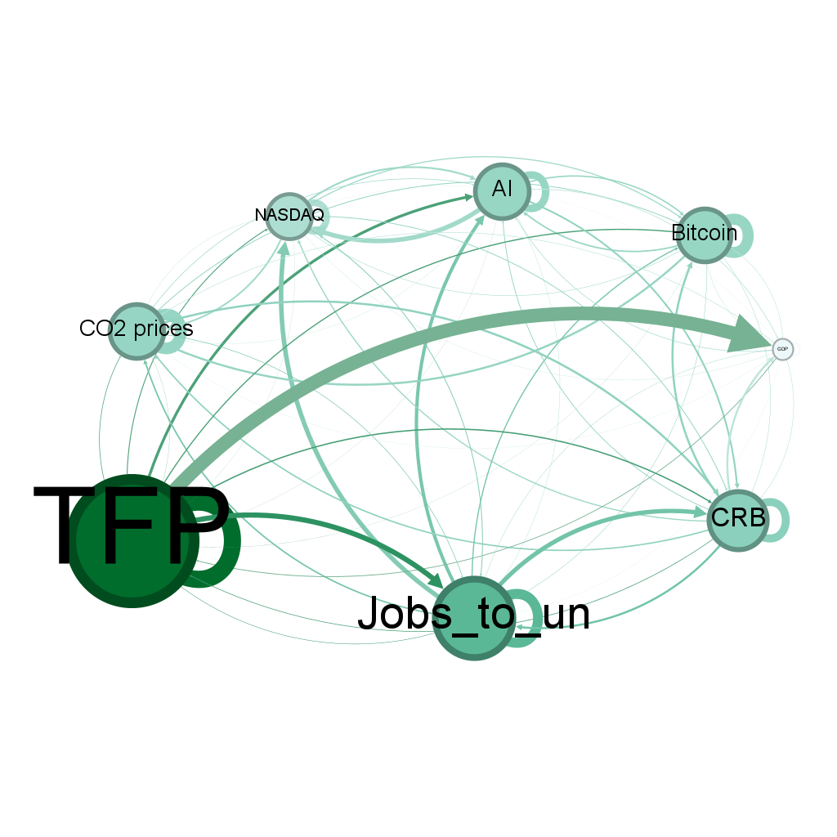

Source: Authors’ calculations.
Note: Figure 4 shows the macroeconomic spillover connectedness of all variables in the model.

The net total connectedness spillover of innovations is the highest, at 223.40% (${\hat{C}}_{i}^{H}= {\hat{C}}_{∙ ← i}^{H} -{\hat{C}}_{i ← ∙}^{H}$). Innovations have the potential to generate a lot of spillover connectedness from growth to the labor market since they are “recipients of small’’ and ‘‘transmitters of big” volatility spillover shocks. The message of Figure 4 is clear: innovations are substantial net transmitters, overheating the economy (“to others”–“from others”), potentially leading to hyperinflation. This is confirmed by Figure 5, showing that the highest net spillover connectedness results from innovations.

Figure 5: Net spillover connectedness

Source: Authors’ calculations.
Note: The figure shows the static net “from – to” spillover connectedness.
      - Dynamic policy analysis
The previous analysis is static and does not address the dynamics by design. Figure 6 shows the total dynamic directional connectedness (“net” degrees) for jobs to unemployment and carbon prices. In Figure 6, we notice that idiosyncratic shocks always affect individual institutions and their policies, and these shocks are transmitted to other institutions. These policy shocks become more frequent and each time affect more institutions and therefore are passed on to others in greater quantities than before. In times of crisis relatively more than in non-crisis times, there are a few sectors that receive very little and a few sectors that transmit very much. The job-market balance is not efficient, having more jobs than available workers for work: thus, overheating the economy. Net carbon prices generate dynamic spillovers as in the first two weeks and last week of December 2022.
Figure 6: Total “net” directional dynamic connectedness
Source: Authors’ calculations
Note: The figure shows the net dynamic spillovers for jobs to unemployment and carbon prices. The spillovers greater than 50% are in yellow-shaded areas.

    - Dynamic pairwise connectedness
Figure 7 shows that net traditional energy has the highest correlation with volatility in the pair in climactic months.

Figure 7: Network pairwise dynamic directed connectedness
Source: Authors’ calculations.
Note: The figure shows the pairwise dynamic spillover connectedness among four pairwise spillovers greater than 80%, which are in yellow-shaded areas.

If we present the most important observation in Figure 4 it is this: AI spillovers are the ones that have the highest net total connectedness and pairwise volatility in the climactic weeks. The highest pairwise volatility connectedness exists between AI and NASDAQ stock market prices, followed by GDP and innovations. We notice that AI-jobs to unemployment and AI-Bitcoin create dynamic spillover waves greater than 80%. The technological advancement pace is greater and the educational readiness in the US, accounting for the substantial rise in the overheatness of the economy, inflation, and crisis.

Policy modeling implications of all the results are that the AI sector in the US represents a big opportunity and risk, in the meantime, to increasing sustainable growth and overheating the labor market. The results reveal that the innovation policies and their implementation, through AI and other channels, should be carefully drafted since the risk of excluding the masses from flourishing in innovations is great. This implies and reflects feelings about the extent to which public authority is not calculated properly, and sometimes large-scale corporations “capture” the policies, potentially poised to wreak havoc on the system.

III.4. Policy implications and advisory steps
Considering the US's need for a well-defined AI policy plan, the results recommend that regulatory authorities take the following essential steps to narrow the AI risk gap and, consequently, stimulate sustainable economic growth: (1) formulate and enforce comprehensive innovation and AI regulations and standards, (2) develop educational programs and training initiatives aimed at cultivating a skilled workforce proficient in sustainable techniques and technologies, (3) enhance corporate governance regulations to ensure transparency, accountability, and ethical conduct within the corporate sector, and (4) establish mechanisms for monitoring and reporting the implementation of AI initiatives and their influence on macroeconomic factors.
- Conclusion
Our novel findings, which were obtained by estimating our model using Bayesian connectedness, support the inclusion of innovation and AI policy modeling in macroeconomic connectedness prediction models. Notably, the introduction of AI in the model firmly reduces the likelihood of misclassifying a clear net contagion spillover distributor as totally healthy.

The results indicate first that the US should immediately address the disparity in approaches to innovations and AI policies, in connectedness with NASDAQ, carbon, CRB, and labor markets, since the dangerous and growing AI imbalance has a very high cost, de-anchoring investor expectations, disrupting markets, destabilizing key macroeconomic factors, and historically running and leading to unhealthy shocks and even great crises in the US. The strategies for sustainable growth should not be only based on conventional technology presumptions, and they also point out key regulatory loopholes in the prudential authorities' framework.

Importantly, the outcomes of our analysis have significant policy implications. They underscore the AI sector poses a strong opportunity and threat to designing adequate policy criteria for the US to regain world leadership, indicating an insecure strategic and economic and political approach over the state apparatus in Montenegro.

Disclosure statement

Authors have no competing interests to declare.

References

Acemoglu, D., Restrepo, P., 2019. Artificial Intelligence, Automation, and Work. The Economics of Artificial Intelligence: An Agenda, edited by Ajay Agrawal, Joshua Gans and Avi Goldfarb, Chicago: University of Chicago Press, 197-236. https://doi.org/10.7208/9780226613475-010
Agbloyor, E. K., Pan, L., Dwumfour, R.A., Gyeke-Dako, A., 2023. We are back again! What can artificial intelligence and machine learning models tell us about why countries knock at the door of the IMF? Finance Res. Lett. 57(C).
https://doi.org/10.1016/j.frl.2023.104244.
Aghion, Ph., Jones, B.F., Jones, Ch.I., 2019. Artificial Intelligence and Economic Growth,” in The Economics of Artificial Intelligence: An Agenda, Ajay Agrawal, Joshua Gans, and Avi Goldfarb, eds. (Chicago: University of Chicago Press), 237–290. https://doi.org/10.7208/chicago/9780226613475.003.0009.
Beraja, M., Kao, A., Yang, D.Y., Yuchtman, N., 2023. AI-tocracy. Q. J. Econ. 138 (3), 1349–1402. https://doi.org/10.1093/qje/qjad012.
Beraja, M., Kao, A., Yang, D.Y., Yuchtman, N., 2023. Data-intensive Innovation and the State: Evidence from AI Firms in China. Rev. Econ. Stud. 90 (4), 1701-1723. https://doi.org/10.1093/restud/rdac056.
Bonaparte, Y., 2023. Artificial Intelligence in Finance: Valuations and Opportunities. Finance Res. Lett. 104851. https://doi.org/10.1016/j.frl.2023.104851.
Farboodi, M., Veldkamp, L., 2022. A Model of the Data Economy. NBER Working Paper 28427. https://doi.org/10.3386/w28427.
Gofman, M., Jin, Zh., 2023. Artificial Intelligence, Education, and Entrepreneurship. J. Finance. https://doi.org/10.1111/jofi.13302.
Goldfarb,A., Trefler, D., 2018. AI and International Trade. NBERWorking Paper 24254. https://doi.org/10.3386/w24254.
Jones, Ch.I., Tonetti, Ch., 2020. Nonrivalry and the Economics of Data. Am. Econ. Rev. 110, 2819–2858. http://dx.doi.org/10.1257/aer.20191330.
Korinek, A., Stiglitz, J.E., 2017. Artificial intelligence and its implications for income distribution and unemployment. NBER Working Papers. https://doi.org/10.3386/ w24174.
Korinek, A., Stiglitz, J.E., 2018. Artificial Intelligence and Its Implications for Income Distribution and Unemployment,” in The Economics of Artificial Intelligence: An Agenda, Ajay Agrawal, JoshuaGans, and Avi Goldfarb, eds. (Chicago: University of Chicago Press), 349–390. http://dx.doi.org/10.7208/chicago/9780226613475.003.0014.
Moretti, E., Steinwender, C., Van Reenen, J., 2023. The Intellectual Spoils of War? Defense R&D, Productivity and International Spillovers. Rev. Econ. Stat. 1-46. https://doi.org/10.1162/rest_a_01293.
Qu, J., Zhao, Y., Xie, Y., 2022. Artificial intelligence leads the reform of education models. Syst. Res. Behav. Sci. 39 (3). https://doi.org/10.1002/sres.2864.
Sandrini, L., Somogyi, R., 2023. Generative AI and deceptive news consumption. Econ. Lett. https://doi.org/10.1016/j.econlet.2023.111317.
Schwab, K., (2017). The Fourth Industrial Revolution. Currency: Redfern, Sydney.
Xie, M., Ding, L., Xia, Y., Guo, J., Pan, J., & Wang, H. 2021. Does artificial intelligence affect the pattern of skill demand? Evidence from Chinese manufacturing firms. Econ. Model. 96, 295-309. https://doi.org/10.1016/j.econmod.2021.01.009.

