**Citation Mapping:**

**A Powerful Tool for Producing and Visualizing Data-driven Reviews of Research Fields**

ABSTRACT

How can political science researchers use citation mapping tools to refine the development of research on complex theoretical concepts? Citation mapping, a powerful research tool commonly used in the natural sciences, is not yet widely used in political science. This study illustrates citation mapping’s capabilities by producing citation maps of academic research on the term “organizing” in the context of political action. We describe our multi-step methodological approach for generating citation maps and demonstrate how these maps can be analyzed to produce insights about themes, potential gaps, canonical literature, and levels of dialogue across research streams. We conclude by outlining future research possibilities based on this study’s citation mapping approach.

Visually mapping scientific fields offers a powerful tool to analyze a particular field’s academic landscape. In recent years, comprehensive reviews of scientific fields have become increasingly challenging, as the number of publications has grown beyond human cognitive capacities (Wagner, Lukyanenko, and Paré 2022, p. 209). Traditional literature reviews, which rely on the researchers’ subjective judgement, have generated problems such as in-group citation practices (Zhou, Chai, and Freeman 2024), citation bias (Esarey and Wu 2016), and reliance on conventional indicators of scholarly impact (Ramírez-Castañeda 2020). In addition, many studies no longer attempt to create comprehensive reviews of the literature (Knopf 2006).

Statistical bibliometric methods have been used to remedy some of these difficulties. These methods include systematic search and analysis techniques, as well as visualization tools (Van Eck and Waltman 2014). Visualizing a scientific field’s universe of publications enables scholars to generate clear images of networks that communicate complex information in a simple form, and provides comprehensive coverage of research fields, reducing the level of subjective judgment (Booth-Tobin et al. 2021). In addition to analyzing a list of topics or cited authors, citation mapping also analyzes the relationships between them. Units of analysis include research areas, scholars, institutions, journals, and countries where research originated. Scientific mapping is therefore ideally suited to answer critical questions such as:

1. *What areas of research exist within a scholarly field? How well connected are these areas?* Answering these questions helps researchers achieve objectives such as identifying areas where synergy is needed (Adro and Fernandes 2022), identifying understudied areas (Park et al. 2020), tracing the evolution of a field (Fils and Van Eck 2018), and identifying emerging trends (Goncalves et al. 2019).
2. *What studies form the cannon of a field?* *What are their main themes and what is the relationship between them?* Answering these questions allows scholars to identify the studies that compose a research area’s canon in a rigorous way, to situate their own research in relation to the general cannon, and to identify studies that serve a bridging role, as we have done in the current study.
3. *Which actors and institutions are creating knowledge in the field?* Scientific mapping can analyze relationships between authors, journals, institutions, and countries to draw conclusions about the actors shaping the field (Arora 2024). Such analyses have been used, for example, to guide science policy and funding decisions (Ciarli and Ràfols 2019).

Despite its many advantages, citation mapping is not yet widely employed in political science scholarship. To facilitate its implementation, this study demonstrates the capabilities of scientific mapping for studying complex concepts in political science, focusing on the illustrative example of scholarship on “organizing.” The methods used are documented in further detail in the appendices, facilitating replication and expansion of our approach.

**Organizing as a Case Study**

We demonstrate the capabilities of citation mapping using the term “organizing” in the context of political action. We focus on this term because there has been a recent surge in research on this topic (see Appendix C), yet the meanings attributed to it have been so diverse that its meaning has become opaque (Han, McKenna, and Oyakawa 2021). Recently, given fears of democratic erosion in advance democracies, scholars have found a renewed interest in organizing as a central pillar of democracy (Han, McKenna, and Oyakawa 2021; Woodly 2021).

A recent review of organizing focuses on the U.S. context and differentiates the strategic logic that underlies organizing in comparison to other types of collective action (Authors forthcoming). Using a citation map of scholarship on organizing in the United States, the review identifies central areas in the literature. The current study adds to this work in three main ways. First, we provide a methodological description of citation mapping. Second, we expand the geographical scope of the mapping to include the global scholarship on organizing beyond the U.S. context. Third, we present additional types of citation maps and analyses of organizing and democracy that provide methodological guidance to researchers seeking to implement these techniques in their research.

To this end, we define the following three research questions in our illustrative analysis of organizing and democracy that we answer through citation mapping techniques:

1. What thematic areas and sub-areas of scholarship exist globally that have studied organizing as a distinct concept? (RQ1, “Thematic areas”) This question also draws our attention to the relationship between these thematic areas in terms of their level of autonomy and interdependence.
2. Which of these areas includes substantial research on the connection between organizing and democracy? (RQ2, “Organizing and democracy”) Answering this question also clarifies which areas do not currently focus on this connection but could do so in the future.
3. What themes exist in the canonical literature on organizing, how do they relate to each other, and which key studies belong to each theme? (RQ3, “Canonical literature”) Answering this question helps position future research on organizing in relation to core theories.

Before proceeding to the case study analysis, we compare prevalent techniques to review and map a scientific field, and highlight the advantages of the citation mapping approach that we have used.

**Comparison of Prevalent Techniques**

Bibliometric methods include searching, analyzing, and mapping techniques. For searching, many studies in political science have employed a basic search string composed of a few core terms determined by the authors (e.g., Boulianne et al. 2023). However, bibliometric experts have found that basic searches may omit important related terms, especially in emerging fields (Huang et al. 2015).

A central challenge in devising more sophisticated methods is balancing between recall and precision (Huang et al. 2015). Each search term may retrieve false positives, as well as false negatives. While false positives can be eliminated manually, false negatives can only be identified by expanding the search. Bibliometric experts have devised semi-automatic techniques that balance recall and precision, using systematic transparent thresholds. These methods tolerate some level of false negatives and positives, while attempting to minimize both (Huang et al. 2015). We outline the adaptations we implemented in the Data and Methods section. While these adaptations resolve the problem of false positives, the tradeoff is that they may miss some relevant results. However, for versatile terms like “organizing,” these adaptations are necessary.

After defining the search and constructing the dataset, bibliometric analysis can be used to explore various types of relationships between publications, including citation, co-authorship, co-citation (two publications that cite the same source, see Small [1973]), and co-occurrence (the appearance of two keywords in the same source). For a comprehensive review of types of relationships that can be analyzed, see van Eck and Waltman (2014). While choosing which relationship to analyze depends on the research objectives, choosing the methods and tools for the analysis involves additional considerations. For example, to identify themes within a research field, scholars have successfully employed topic modeling techniques (Ambrosino et al. 2018). However, topic modeling does not analyze the relationship between themes, and does not support the analysis of citation relationships. It also requires full-text access and additional visualization tools.

For scholars interested in visualizing relationships between publications, citation mapping offers a useful solution (van Eck and Waltman 2014). VOSviewer, which uses a unified approach for distance-based mapping and clustering called Visualization of Similarities (VOS) (Waltman, van Eck, and Noyons 2010), has several advantages over the alternatives. Compared to general statistical software, it creates more visually comprehensible maps by overcoming problems such as label overlap (van Eck and Waltman 2010) and circular maps (Van Eck et al. 2010). Relative to other bibliometric tools, VOSviewer is well-suited for both map creation and viewing, and integrates files directly from major databases. It also enables flexible viewing settings and an accessible interface that does not require background in computer science or statistics. In addition, unlike most statistical software packages, VOSviewer is free. These features have made it the most popular software tool for bibliometric mapping purposes (Pan et al. 2018). For a comparison of VOSviewer with other bibliometric mapping tools, see van Eck and Waltman (2010; 2014), Pan et al. (2018) and McAllister, Lennertz, and Mojica (2022).

To determine the number of clusters in the map, VOS implements a resolution parameter. The larger the value of this parameter, the larger the number of clusters in the map. When this parameter is set to the default setting of 1.0, then the clustering equation reduces to the well-known modularity function (Newman and Girvan 2004). However, the modularity-based clustering may fail to identify small clusters, whereas the resolution parameter facilitates identifying clusters of varying sizes (Waltman, van Eck, and Noyons 2010, p. 631). Several studies have shown how adjusting the resolution parameter can yield useful scholarly insights (Fils and Van Eck 2018; Waltman, van Eck, and Noyons 2010).

In addition to these bibliometric tools, there has been a recent surge of artificial intelligence tools to assist scholars with literature reviews (Wagner, Lukyanenko, and Paré 2022). AI’s strengths in this domain include complex semantic meaning analysis using natural language processing (NLP) methods and deep-learning capabilities that can potentially learn to replicate researchers’ decisions. However, available tools are still in early development stage, and do not yet offer a comprehensive solutions suite for science mapping research.

**Data and Methods**

Implementing a research agenda using a citation mapping approach involves three main stages as depicted in figure 1.

Figure 1. Step-by-Step Flowchart for Implementing Citation Mapping Research

We now present the approach we took at each stage to answer our research questions on “organizing.” For a detailed guide on how to perform the steps presented in figure 1, see Appendix D.

***Search Strategy***

Choosing the database: we sourced the data on scholarly works from the Web of Science (WoS), which has been identified as a leading scientific literature database with high accuracy and smooth integration of output files with citation mapping software (Visser, Van Eck, and Waltman 2021).

Developing the search term: the literature on bibliometric searches is focused on expanding a core dataset created by using search terms that retrieve mainly relevant results (Arora et al. 2013; Chen and Song 2019; Huang et al. 2015). However, for complex terms with versatile meanings, like organizing, constructing this core dataset proves difficult. A simple search for “organizing” in the WoS “Topic” field yielded over 80,000 mainly irrelevant results.[1] To meet our main challenge of focusing the search, we developed a strategy combining existing approaches (Arora et al. 2013; Huang et al. 2015), which we call “targeted lexical search.” To narrow the search, we adapted techniques from two established bibliometric studies approaches: a core lexical search and an expanded lexical search (Huang et al. 2015).

In a core lexical search, researchers identify search terms through a literature review and subsequently vet them based on experts’ opinion (Arora et al. 2013; Huang et al. 2015), yielding a core dataset. In an expanded lexical search, researchers extract frequent keywords from the core dataset. These keywords become candidate search terms and are vetted using a “noise ratio” measurement—an estimate of the percentage of irrelevant records retrieved by the candidate term, based on a comparison with the core dataset (Arora et al. 2013; Huang et al. 2015). To further enhance these strategies’ precision, some candidate terms are formatted as contingent terms, meaning that they are included in the search only when appearing alongside another term.

In this study, rather than using “organizing” as an independent search term, we identified contingent terms that appeared next to the term “organizing” and modified its meaning (e.g., *community* organizing) through a literature review. We composed a list of 29 candidate terms that met this contingency format. We then developed a modified version of the “noise ratio” measurement. In our case, because the benchmark core dataset did not exist, we created an equivalent measurement, termed “hit ratio,” calculated for each candidate term separately. The “hit ratio” is the proportion of relevant results out of the 10 most cited records retrieved when searching for the candidate term. Following the expanded lexical search (Huang et al. 2015), we applied a 70% threshold to determine whether to include or exclude each contingent term. That is, for each candidate term, if seven or more of the ten most cited results were relevant, the term was included. We manually determined the relevancy of results based on core definitions from the literature (Appendix H). This process yielded 21 contingent terms that we used in our final search. For a full list of terms, hit ratios, and the final Boolean search term, see Appendix A. This strategy yielded a dataset of 2,334 records on the WoS.[2]

Screening the dataset: To validate the method, we manually vetted all search results in the dataset. After two independent coders determined whether a record was relevant (see Appendix B: Vetting Instructions), the vetted dataset included 2,156 records, comprising 92.4% of the original dataset. Inter-coder reliability was 95.7%. The high rate of relevant results demonstrates our search strategy’s strength, producing a low noise ratio of only 7.6%. This study’s tables and figures all use the vetted dataset. Nevertheless, our search strategy’s high hit rate suggests that this method may be used without manual vetting. See Appendix C for a detailed characterization of the resulting dataset and Appendix D for more information on search strategy development.

***Maps Creation***

Choose visualization tool: we used VOSviewer (version 1.6.18) to construct and visualize bibliometric networks (Van Eck and Waltman 2010). Appendix D includes a basic walkthrough for using the software, and references of additional guides and tutorials.

Choose types of maps: we chose to create a co-occurrence map and a co-citation map because these maps were best suited to answer the research questions we sought to address about “organizing,” as demonstrated in the Results section.

Prepare supplementary files: following best practices in the literature (McAllister, Lennertz, and Mojica 2022), we created thesaurus files for the maps, as documented in Appendix E.

Choose map preferences and create maps: map preferences can be adjusted to accommodate different research objectives. We relied on common practice in the literature and used the preferences of full counting, a threshold of 15 occurrences or citations, and the default clustering resolution parameter of 1.0 (Van Eck and Waltman 2014). More information on setting map preferences is included in Appendix D. Data and replication files are available in the Harvard Dataverse at (*doi to be added upon publication*).

***Maps Analysis***

Label clusters: We labeled the clusters in the maps manually. In the co-occurrence map (figure 2), we chose the labeling after observing the list of keywords associated with each cluster. For the co-citation map (figure 4), we chose the labeling based on a review of the titles and abstracts of all references associated with each cluster.

Leverage mapping tools to obtain relevant insights: We used VOSviewer’s features to draw insights about the literature that go beyond thematic labeling of sub-fields. Specifically, for the two maps in this study, we leveraged VOSviewer’s distance-based mapping to assess the relationship between sub-fields, identifying sub-fields that are tightly connected versus sub-fields that are disconnected. This analysis allowed us to identify potential gaps in the literature when analyzing the co-occurrence map (figure 2). Leveraging the software’s viewing options to focus on one keyword that we consider important – democracy – we visualized its links within the general map and identified disconnected sub-fields where more research on this topic could yield new insights. In the co-citation map (figure 4), we identified clusters of canonical literature and their relationships to orient scholars interested in pursuing future research on organizing.

**Results**

***Thematic Analysis***

To answer RQ1 (“Thematic areas”), we created a co-occurrence map (figure 2), which visually represents the co-occurrence of terms that appear in the Author Keywords and Keywords Plus (a list of frequent words extracted by WoS’s algorithm) fields on WoS. This map illustrates the topics and sub-fields found in the study of organizing and their relationships. Appendix F includes the list of keywords and their frequencies.

In the map, the nodes’ size represents the keywords’ frequency. The links between nodes represent the co-occurrence of terms across records. A term’s association with other terms is marked by its color and map location. Two terms appearing close to each other are therefore more strongly connected than those appearing at a greater distance.

Figure 2. Main Topics of Thematic Interest: Terms Co-occurrence Map

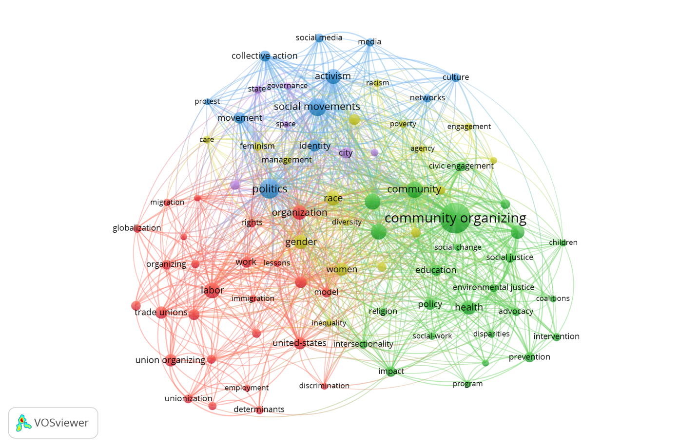

*Note:* n=85 out of N=4,893.

Figure 2 reveals that scholarship on organizing is structured around five distinct clusters of thematic interests. Observing the most frequent terms, we characterized each of these clusters’ main themes, from largest to smallest:

(1) Labor (red)

(2) Community organizing (green)

(3) Race/gender (yellow)

(4) Social movements (blue)

(5) Urban studies and community development (purple)

An analysis of the terms’ locations shows that the labor and community organizing subfields, while connected to other themes, are relatively autonomous. The absence of red or green nodes within other clusters suggests that research on these themes tends to be more independent compared to research on social movements, race/gender, and urban studies.

An examination of the terms’ location within the labor and community organizing clusters also revealed the existence of sub-areas within these themes. In the labor cluster, peripheral terms included all keywords related to unions, indicating that there is a body of literature on union organizing that is relatively disconnected from community organizing and social movements. Likewise, in the community organizing cluster, peripheral terms include keywords such as intervention and prevention, indicating the existence of a body of literature on intervention and prevention programs with a community organizing component, found in applied research fields (e.g., healthcare, psychology).

***Organizing and Democracy***

Based on the thematic analysis above, we leveraged VOSviewer’s viewing options to answer RQ2 (“Organizing and democracy”). To this end, we visualized the relationships between the keyword “democracy” and other keywords in the map, as highlighted in figure 3.

Figure 3. Democracy in the Terms Co-Occurrence Map

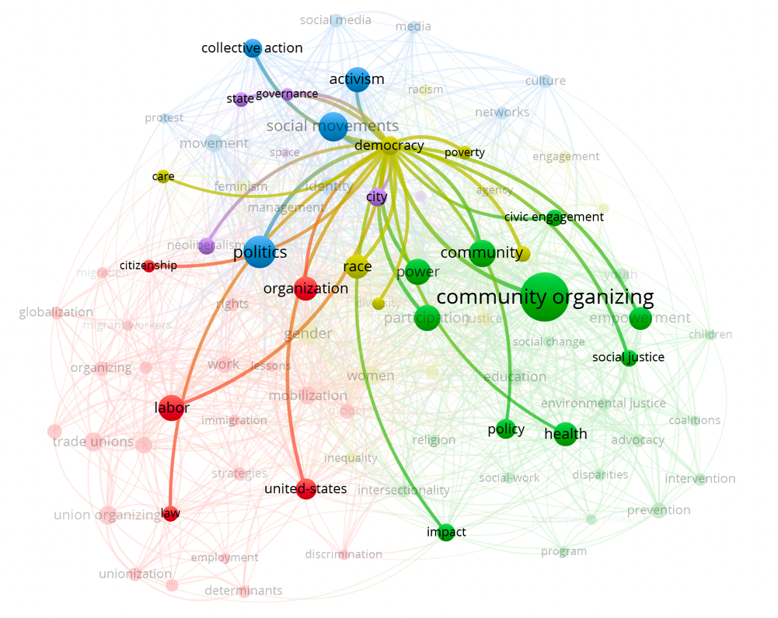

*Note*: This map, structurally identical to figure 2, visually highlights the keyword “democracy” and its relationship with other keywords.

Figure 3 shows that the relationship between organizing and democracy is studied across a wide range of fields, as evidenced in the links between democracy to keywords in all five clusters. Despite this interdisciplinary reach, some sub-areas were significantly detached from the study of democracy. Particularly noticeable peripheral areas in figure 3 are the those in the labor cluster focusing on unions, in the community organizing cluster focusing on prevention and intervention programs, and in the social movements cluster focusing on social media—none of which have a relationship to the keyword “democracy.”

We used these observations to characterize potential gaps in the literature. Manually reviewing records in the dataset related to the study of unions, we found that the few studies that explicitly explore the relationship between unions and democracy focused on unions’ internal democratic practices, without relating to unions’ contribution to democracy on the societal level. Similarly, in health-oriented research, experimental research on the impact of community organizing interventions is focused on measuring behavioral outcomes related to health, and does not focus on organizing’s impact on leadership capacity, or on organizational or political structures. Likewise, research on social media and organizing has focused primarily on the influence of social media on social movements, but it has not directly addressed the question of how organizing in the age of social media affects collective democratic outcomes or the representation of marginalized groups. We conclude that there are three sub-areas where the connection between organizing and democracy has been understudied, and where future research on this connection can yield new and interesting insights.

***Canonical Literature***

Scholars producing research on the connection between organizing and democracy need to orient their research in relation to the canonical literature of the field. We facilitate this orientation by answering RQ3 (“Canonical literature”) through our identification of the body of literature composing the field’s cannon, its structure, and its relationship to the study of democracy. We do so by analyzing the co-citation map (figure 4).

Figure 4. Canonical Literature: Co-citation Map

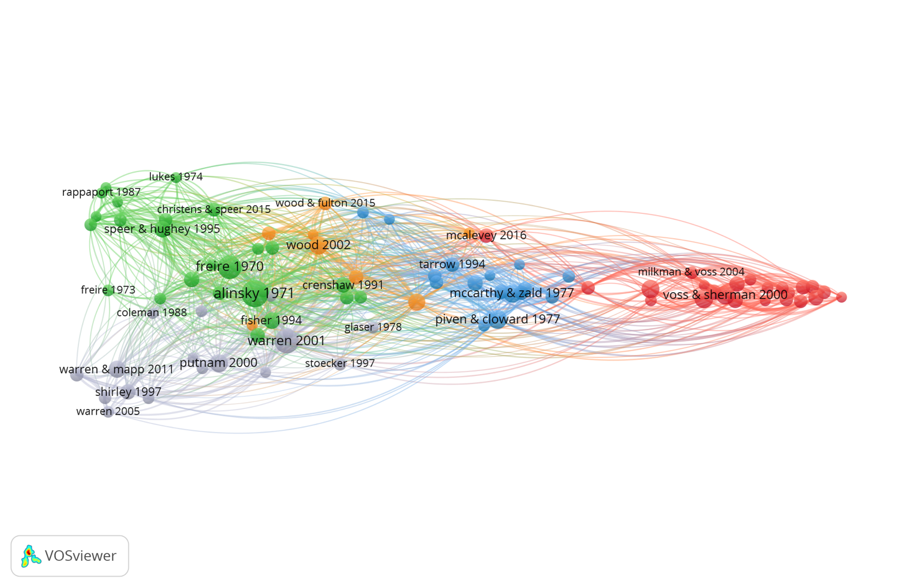

*Note*: n=89 out of N>70,000 references.

Figure 4 documents the body of literature frequently cited by scholars of organizing. The lines between nodes represent the co-citation of two references by the same record. The map contains five clusters, representing five areas of canonical literature. Observing the titles and abstracts of the references in each cluster, we characterized the thematic content of each area, beginning with the largest cluster (for a detailed thematic characterization of each cluster, see Appendix I; for the full list of references ordered by thematic clusters, see Appendix G).

1. Community organizing (green)
2. Labor (red)
3. Civic associations (gray)
4. Social movements (blue)
5. American democracy (orange)

The canonical literature clusters identified in the co-citation map (figure 4) clarify the theories and concepts that underly the research themes in the keywords analysis (figure 2). Specifically, we observe that the social movements and community organizing clusters in figure 2 draw upon more than one group of theories. By analyzing the main content of the classic studies in each cluster of the co-citation map (see Appendix I), and by looking at the location of the canonical literature clusters in the co-citation map, we conclude that the social movements area in figure 2 draws upon classic social movement studies (blue cluster in figure 4) as well as on classic American democracy studies (orange cluster in figure 4). Likewise, the community organizing area in figure 2 draws upon classical studies of community organizing (green cluster in figure 4) as well as on classic American democracy studies (orange cluster in figure 4) and classic civic associations studies (gray cluster in figure 4).

This analysis of the canon helps orient scholars pursuing research on organizing in general, and its connection to democracy in particular. For example, to pursue research on the understudied connection between unions and collective democratic structures and norms, scholars would benefit from drawing upon the set of classic studies included in the canonical labor cluster and the American democracy cluster. In bridging these two classic bodies of literature, scholars may find relevant concepts and theories in the canonical social movement cluster, which, as its location in the map shows, has traditionally served a bridging role between these two research areas.

We further observe that the research areas of gender, race, and urban development that appear in the terms co-occurrence map (figure 2) are absent in the co-citation map (figure 4). We hypothesize that this difference is due to the temporal evolution of the field, where newer areas of research, such as race and gender, have not yet consolidated a clearly demarcated canon. We offer this hypothesis as a future research direction which can be addressed using a temporal citation mapping analysis that goes beyond the scope of this study.

**Conclusion**

This study demonstrates how citation mapping can contribute new levels of analysis for political science researchers aiming to enhance their understanding of the literature on complex topics. Using a terms co-occurrence map, we identified sub-areas of research where the connection between organizing and democracy has been understudied and which potentially merit additional research. Next, using a co-citation map of highly cited references, we helped orient scholars who wish to address these gaps, by identifying the specific classic studies that their research can benefit from, as well as groups of studies that can help them synthesize research areas.

The mapping of scholarship on “organizing” presented in this study serves as an illustration of this method’s capabilities, but it is not exhaustive. Future directions for research on “organizing” that stem from this study include a temporal analysis to identify emerging themes, and a thematic analysis to identify sub-areas of research that merit a meta-analysis. For example, using the terms co-occurrence map (figure 2), we identified a significant body of literature on the effects of health-related intervention programs with a community organizing component that merits a meta-analysis. Citation mapping can also facilitate the identification of citation bias in meta-analyses, as has been done in other disciplines (e.g., Bellos 2021). Taken together, our illustrative analysis shows the multiple ways in which citation mapping can generate valuable insights for researchers who aim to produce comprehensive data-driven reviews of political science research fields.

**References**

Adro, Francisco do, and Cristina Fernandes. 2022. “Social Entrepreneurship and Social Innovation: Looking inside the Box and Moving out of It.” *Innovation-the European Journal of Social Science Research* 35 (4): 704–30. <https://doi.org/10.1080/13511610.2020.1870441>.

Ambrosino, Angela, Mario Cedrini, John B. Davis, Stefano Fiori, Marco Guerzoni, and Massimiliano Nuccio. 2018. “What Topic Modeling Could Reveal about the Evolution of Economics.” *Journal of Economic Methodology* 25(4): 329–48. <https://doi.org/10.1080/1350178X.2018.1529215>.

Arora, Sanjay K., Alan L. Porter, Jan Youtie, and Philip Shapira. 2013. “Capturing New Developments in an Emerging Technology: An Updated Search Strategy for Identifying Nanotechnology Research Outputs.” *Scientometrics* 95(1): 351-370.

Bellos, Ioannis. 2021. “A Metaresearch Study Revealed Susceptibility of Covid-19 Treatment Research to White Hat Bias: First, Do No Harm.” *Journal of Clinical Epidemiology* 136(August): 55-63.

Booth-Tobin, Jane, Kal Munis, Lynsy Smithson-Stanley, Hahrie Han. 2021. “Understanding Strategic Capacity in Constituency-Based Organizations.” *P3 Lab, Johns Hopkins University.* <https://drive.google.com/file/d/1AOkvH0yB2S66QBI2Bs4lXiIu7O57m3z7/view>. Retrieved Feb 14, 2024.

Boulianne, Shelley, Jennifer Oser, and Christian P. Hoffmann. 2023. "Powerless in the digital age? A systematic review and meta-analysis of political efficacy and digital media use." *New Media & Society* 25(9): 2512–2536. <https://doi.org/10.1177/14614448231176519>.

Chen, Chaomei, and Min Song. 2019. “Visualizing a Field of Research: A Methodology of Systematic Scientometric Reviews.” *PloS One* 14(10): e0223994.

Ciarli, Tommaso, and Ismael Ràfols. 2019. “The Relation between Research Priorities and Societal Demands: The Case of Rice.” *Research Policy*, 48 (4): 949–67. <https://doi.org/10.1016/j.respol.2018.10.027>.

Esarey, Justin, and Ahra Wu. 2016. “Measuring the Effects of Publication Bias in Political Science.” *Research & Politics* 3(3).

Fils, Ivan, and Nees Jan Van Eck. 2018. “Framing Psychology as a Discipline (1950–1999): A Large-Scale Term Co-Occurrence Analysis of Scientific Literature in Psychology.” *History of Psychology* 21 (4): 334–62.

Goncalves, Maria C. P., Theo G. Kieckbusch, Rafael F. Perna, Jaqueline T. Fujimoto, Sergio A. V. Morales, and Joao P. Romanelli. 2019. “Trends on Enzyme Immobilization Researches Based on Bibliometric Analysis.” *Process Biochemistry* 76(January): 95-110.

Authors. Forthcoming. “Organizing and Democracy: Understanding the Possibilities for Transformative Collective Action.” *Annual Review of Political Science*.

Han, Hahrie, Elizabeth McKenna, and Michelle Oyakawa. 2021. *Prisms of the People: Power and Organizing in Twenty-First-Century America*. Chicago: University of Chicago Press.

Huang, Ying, Jannik Schuehle, Alan L. Porter, and Jan Youtie. 2015. “A Systematic Method to Create Search Strategies for Emerging Technologies Based on the Web of Science: Illustrated for ‘Big Data.’” *Scientometrics* 105(3): 2005-2022.

Knopf, Jeffrey W. 2006. “Doing a Literature Review.” *PS: Political Science & Politics* 39(1): 127–32. <https://doi.org/10.1017/S1049096506060264>.

McAllister, James T., Lora Lennertz, and Zayuris A. Mojica. 2022. “Mapping a Discipline: A Guide to Using VOSviewer for Bibliometric and Visual Analysis.” *Science & Technology Libraries* 41(3): 319-348.

Newman, M. E. J., and M. Girvan. 2004. “Finding and Evaluating Community Structure in Networks.” *Physical Review E* 69(2): 026113. <https://doi.org/10.1103/PhysRevE.69.026113>.

Pan, Xuelian, Erjia Yan, Ming Cui, and Weina Hua. 2018. “Examining the Usage, Citation, and Diffusion Patterns of Bibliometric Mapping Software: A Comparative Study of Three Tools.” *Journal of Informetrics* 12(2): 481–93. <https://doi.org/10.1016/j.joi.2018.03.005>.

Park, Andrew, Matteo Montecchi, Kirk Plangger, and Leyland Pitt. 2020. “Understanding Fake News: A Bibliographic Perspective.” *Defence Strategic Communications* 8(Spring 2020): 141–72.

Pritchard, Alan. 1962. “Statistical Bibliography or Bibliometrics?” *Journal of Documentation*, 25: 348–349.

Ralph, Alisha, and Akarsh Arora. 2024. “Mapping the Literature on Decent Work: A Bibliometric Analysis of Sustainable Development Goal 8.” *Sustainable Development*. <https://doi.org/10.1002/sd.2879>.

Ramírez-Castañeda, Valeria. 2020. “Disadvantages in Preparing and Publishing Scientific Papers Caused by the Dominance of the English Language in Science: The Case of Colombian Researchers in Biological Sciences.” *PLOS ONE* 15(9): e0238372. <https://doi.org/10.1371/journal.pone.0238372>.

Small, H. (1973). Co-Citation in the Scientific Literature: A New Measure of the Relationship between Two Documents. *Journal of the American Society for Information Science*, 24: 265-269.

Van Eck, Nees Jan, and Ludo Waltman. 2010. “Software Survey: VOSviewer, a Computer Program for Bibliometric Mapping.” *Scientometrics* 84(2): 523-538.

Van Eck, Nees Jan, and Ludo Waltman. 2014. “Visualizing Bibliometric Networks.” In *Measuring Scholarly Impact: Methods and Practice*, edited by Ying Ding, Ronald Rousseau, and Dietmar Wolfram, 285-320. Cham: Springer.

Van Eck, Nees Jan, Ludo Waltman, Rommert Dekker, and Jan Van Den Berg. 2010. “A Comparison of Two Techniques for Bibliometric Mapping: Multidimensional Scaling and VOS.” *Journal of the American Society for Information Science and Technology* 61(12): 2405–2416. <https://doi.org/10.1002/asi.21421>.

Visser, Martijn, Nees Jan van Eck, and Ludo Waltman. 2021. “Large-Scale Comparison of Bibliographic Data Sources: Scopus, Web of Science, Dimensions, Crossref, and Microsoft Academic.” *Quantitative Science Studies* 2(1): 20-41.

Wagner, Gerit, Roman Lukyanenko, and Guy Paré. 2022. “Artificial Intelligence and the Conduct of Literature Reviews.” *Journal of Information Technology* 37(2): 209–226. <https://doi.org/10.1177/02683962211048201>.

Waltman, Ludo, Nees Jan van Eck, and Ed C. M. Noyons. 2010. “A Unified Approach to Mapping and Clustering of Bibliometric Networks.” *Journal of Informetrics* 4(4): 629–635. <https://doi.org/10.1016/j.joi.2010.07.002>.

Woodly, Deva R. 2021. *Reckoning: Black Lives Matter and the Democratic Necessity of Social Movements*. New York: Oxford University Press.

Zhou, Sifan, Sen Chai, and Richard B. Freeman. 2024. “Gender Homophily: In-Group Citation Preferences and the Gender Disadvantage.” *Research Policy* 53(1): 104895. <https://doi.org/10.1016/j.respol.2023.104895>.

1. Search performed on November 16, 2022.
2. Search performed on Jan 10, 2023.