The Reader’s Turn: Deconstructing the “Penguinification” of the Girls of Riyadh

Get on a plane to Riyadh, Saudi Arabia. Rent a house, find a job, settle in. Learn Arabic, make friends, spend years in the country. Still, you will never get as full a glimpse into the lives of young Urban Saudi women as you will get from reading ... Girls of Riyadh … The details of life on the Saudi Peninsula are perfectly evoked.
Religions writer.com, “Praise for Rajaa Alsanea Girls of Riyadh,” (i–iii)

Introduction

Girls of Riyadh, Once Again
Why—and how—does a work receive a hospitable reception when translated in its host context but receive a lackadaisical counterpart in its home context? Does an appreciation for a text transmogrify when translated? How? The novel بنات الرياض Bānātū ʾrrīyāḍ (2005) was written by the Saudi novelist Rajaa Alsanea and co-translated by the novelist herself and Marilyn Booth as Girls of Riyadh (GOR), which is a close literal translation of the Arabic title. The Arabic version was published by the Lebanon-based publisher Saqi Books, whereas the English translation was released by, as Roger Allen sarcastically put it, “(Penguin, no less).” Allen’s qualm about the text is justifiable because its production is surrounded by a “scandal,” to use Venuti’s eponymous term. Imagologically and culturally speaking, the published version is a massive departure from the original Arabic and the version submitted by Booth as the final draft. It was (re)reconstructed to be in harmony with what Faiq described as “master discourse”—a phrase he used to describe the fossilized image of the Orient that remains in active circulation in the Anglophone host context and to designate the system of representation that sustains it. Through the employment of various measures, this discourse homogenizes incoming images (via translations from Arabic into English) by recasting them to be congruous with the preexisting one(s). This article, therefore, instantiates those tactics by probing GOR and its politics of production.
A caveat is in order: examining how the translated text deviates from its source is by no means a gesture to adopt outdated assumptions about the relationship between the original and the translation, assuming that the so-called “original” is a fixed and stable entity that the translation should faithfully represent. Rather, the aim is to demonstrate how the translated text is shaped to achieve a function that, in the words of Toury, is determined “first and foremost by considerations originating in the culture that hosts them.” And so, those shifts shall be underscored not necessarily to exemplify deviations from the source text to invoke a discourse of unfaithfulness, but to illuminate uniformities of translated text with pre-existing representations in the host context. From this perspective, comparing the translation with the source text carries little weight. The Kingdom of Saudi Arabia has seen prodigious changes in recent years, leading the Economist in 2023, to mention but one example, to recommend five books to read to “make sense of the rapidly changing country.” Some of those books are authored by Kim Ghattas and Robert Tracey and they feature nonfictional historical research and on-the-ground reporting. Problematic though it may be, GOR makes it to the list, invigorating an already-popular text that has been in active circulation since its publication. This unyielding—or rather, snowballing—popularity of a heavily manipulated text (as shall be shortly demonstrated) could be attributed to the virtual absence of translation literacy—a notion gaining currency in contemporary translation studies) beyond the academic sphere.
I first want to start by justifying the somehow provocative subtitle—GOR, once again. First, much has indeed been written this text, so much so that scholars not associated with the Arabic tradition were compelled to comment on it. However, GOR in its English translation remains in active circulation, with almost no cognizance of its controversies beyond the academic realm, as mentioned above. Second, GOR has not yet been investigated from the vantage point of (actual) reception, a lacuna to be addressed in the present project. Comparing and contrasting the Arabic text with its English translation, the investigation considers two main parameters: packaging (how each version is packaged and introduced to readers); and reception (corpus-based analysis of reader response—in the form of online book reviews—to each text). By investigating paratextual materials (packaging) and meaning creation (reception), it is hoped that this paper will illuminate the nexus between paratexts and meaning creation. By so doing, a post-structuralist approach is adopted, conceptualizing meaning not as a predetermined knowledge that readers simply recover or discover, but as a posteriori construct that is affected by variegated factors and the multifarious “agents” along the chain of mediation.

Arabic Texts Meet the “Explosive” Demand
There is a well-established consensus among scholars that Arabic literature has become more visible on the global literary scene following two significant events, one positive and the other negative: Naguib Mahfouz’s winning of the Nobel Prize in literature in 1988 and the cataclysmic events of 9/11 in the United States. Prior to those two events, Arabic literary works had hitherto been going through a period that Edward Said described as one of enforced “embargo” (1990), whereas Hibbard described it as “ghettoization.” Shortly after the cataclysmic attacks, interest in Arabic literature has, statistically speaking, reached unprecedented levels—and sales of religious books, including the Quran, have “ascended towards the heavens.” However, there is a perspicuous concurrence among many figures within the realm of translated Arabic literature that this shift is rather an unfavorable vicissitude. “Unfortunately,” Hoyt noted, knowing the “enemy” is the primary motivation behind this shift. With master discourse acting as the furnace in which the image of the Orient—and Orientals—is forged, the role of the blacksmith merits dissection. Parallel to—and coincident with—this surge in interest in translated texts is the whole genre of writing about the abused Muslim woman, which “exploded onto the scenes in the 1990 and took off after 9/11.”
Ideologically driven representations of the Global South are neither an embryonic phenomenon nor are they confined to the realm of translation. Those representations are longstanding and have a checkered history. For example, on the American children’s TV program “Sesame Street,” children were inculcated that the word “danger” connotes “Arabs” by displaying next to the word a drawing of an Arab with a headdress. In the movie “Inside Man,” which came out in 2006, there is a scene where a police officer takes fright at the appearance of a bearded man, yelling: “oh shit a fucking Arab … are you bobby-trapped?” As Translation Studies (TS) is increasingly becoming systems-oriented, it is crucial to situate translation—and its unique capacity to generate representations of other cultures—within the broader network through which (constructed) images of the “other” are disseminated (e.g., Hollywood films, televisions programs, network news, etc.).
Writings from Saudi Arabia—the homeland Alsanea—are especially coveted by anglophone publishers: “if there is a single society that contemporary readers in the global North see as encapsulating the mystery of the ‘Islamic Orient,’ it is Saudi Arabia.” But translated literature is especially appreciated by readers, who conceive translated writers as “authentic insiders” who can speak about their own culture from a knowing position, which is an appreciation that seems to be fueled by a naïve, yet prevalent and accepted, conceptualization of translation as “a primally mechanical task,” “a simple linguistic matching game,” or as a straightforward process involving “robotic pairings” between source and target text segments. David Crystal stated, “It is sometimes said there is no task more complex than translation.” “When all the variables involved are taken into account,” Crystal continued, this “claim can be readily believed.” Because it serves the purpose of conducting an in-depth analysis of a certain phenomenon, a case study approach is adopted in this paper to encompass sundry variables pertaining to GOR to throw illuminating light on the complexities of translation.

Why reception? Why readers? Why Paratexts?
In her excellent survey of the field of reception, Ika Willis labeled the period between 1960 and 1990 as the “birth of readers.” This phase marks a fundamental shift in the conceptualization of meaning (if there is such a thing) and the understanding of reception. Meaning ceased to be conceptualized as a fixed entity—what Venuti referred to as “invariance”—planted in the text and can simply be picked out by readers, but as a far more complex phenomenon affected by a myriad of factors. Readers, to cadge Barthes’ famous declaration of the “death of the author,” are the living “authors” of the texts they read because they decide what these texts “mean” for them by shaping their interpretation in their own unique ways. “The reader,” Stuart Hall wrote, “is as important as the writer in the production of meaning [original emphasis].” To recast that relationship metaphorically, it is through the reader’s encounter with text that it comes into existence, for no text has “music without the reader’s voice.” “According to postmodern thought,” Van Wyke noted, “meaning does not reside inside texts and is not uncovered or extracted but is attributed to them via the act of interpretation.” An argument for reader integration into reception studies is advanced below.
The reception of translated texts, and in particular reader response, has become a prominent area of research within contemporary TS, as put forward by Angelelli and Baer in their edited volume Researching Translation and Interpreting. Despite that, end-readers lack proper integration into studies of the reception of translated literature. In the chapter on reception studies and reader response in the abovementioned volume, after a relatively comprehensive survey of the literature regarding reception studies in relation to translation, the contributor noted that the reception of translation has never been ignored, but the reader, he concluded, “has been relegated to a secondary, if not marginal, position.’’ Several scholars have spotlighted this gap more widely. More recently, Anthony Pym has remarked that knowledge about a text and its translation exists, but knowledge about the “actual reception” by “flesh and blood readers” remains to be so, marking this gap as one that should be a focal point of scholarly attention. But Bertens argued that the dearth of reader integration into reception studies—to place the lacuna in a larger context—is an omnipresent concern that relates to all readers of literature, as they have suffered from “decades of neglect.” Accordingly, immediate full integration of end-readers is especially overdue within TS, which is the primary impetus behind undertaking the present project. By focusing on translation, this paper can be viewed as a contribution to—or an extension of—Joseph Conte’s excellent monograph on the novel after 9/11, which does not employ translation as a critical lens or offer an overt discussion thereof, despite the critical role it played—and continues to play—in the aftermath of the tragic events.
Paratexts are inextricably linked to meaning creation—a link that led the cultural theorist Gérard Genette to describe them as “thresholds of interpretation.’’ Genette maintained that paratextual materials fulfill two functions: (a) holding the reader’s interest and (b) delineating “why and how” the text should be read. Correspondingly, Richard Watts averred that a text cannot be divorced from its frame because it is subject to shifting interpretations in response to the paratexts by which it is surrounded. He further posited that paratexts direct the text toward a particular readership and that they exist to “capture readers and influence the work’s reception.” Wolfgang Iser’s metaphor can help us fathom how interpretation is shaped and how amorphous its contours can be: “Two people gazing at the night sky may both be looking at the same collection of stars, but one will see the image of a plough, and the other will make out a dipper.” The “stars,” Iser wrote, are fixed, but the lines by which they are joined to shape up are “variable.” To expand on Iser’s metaphor, if the stars were the text and the interpretation is the final shape that emerges after connecting the dots, the packaging that surrounds the text—to unravel its reverberation on the sensorium—can be conceived of as the “hints” to connect the dots and create meaning. The paratextual element is indispensable for the publisher because it enables direct communication with readers. “Very often with foreign authors,” Pierre Bourdieu wrote to spotlight the capacity of paratexts to cue readers, “it is not what they say that matters, so much as what they can be made to say [emphasis added].” On this score, the packaging of GOR will be scrutinized to take stock of its impact (or lack thereof) on reception. And so, a post-structuralist stance on meaning is adopted, that it is construed during the act reading, and this credo entails approaching meaning creation empirically to gain insights into its formation and metamorphoses. “Translation is not a neutral practice,” Watts wrote, nor is the inclusion of paratexts into/around texts serendipitous or innocent—“every choice is motivated.”

GOR “Toeing the Line”
GOR chronicles the lives of four female characters—Lamees, Gamrah, Sadeem, and Michelle. The narrative has a unique format. The stories are told in the form of emails sent to all subscribers to the list weekly, thus replacing the conventional, numerically sequential chapter format. In these emails, the anonymous sender narrates a new, much anticipated—as assumed by the sender—chronicle about the four protagonists. It is worth mentioning that these emails were initially sent to subscribers via email before they were compiled and then published as a novel. Some readers—whose responses constitute the empirical data collected for analysis—report that they were among the subscribers, therefore avid readers of these weekly emails (GORAR35; GORAR53). When it first appeared, it was immediately banned.
Being a novel from Saudi Arabia by a female author wildly popular in the Arab world, GOR challenges many Western assumptions about how and what Arabs read and write. As a result, Marylin Booth—the first translator whose rendition was deprecated and eventually heavily manipulated—described it as a ‘‘foreignizing’’ text. Yet it is also ‘‘domesticated’’ by a prior Orientalist framework that constructs the Arab female existence as shuttered, narrow, and silent. Seeing it as a text that could challenge preconceptions about the Arab woman, Booth, citing Venuti (2004) and Spivak (1993), adopted deeply informed and consistent “foreignizing” and “literalist surrender,” respectively, strategies. She was determined not to “succumb to a homogenizing language that erases or diminishes the differences within the original text” but rather to force “the reader (rather than the text) to accommodate to ‘the other.’” This translation decision entails, as she continued to elaborate, “exposing [anglophone] readers to local pop cultures and idioms, language mixing, politics of literary writing, puns and saucy asides.” Booth further elaborated on her “project,” to use Berman’s term: “It means expecting the reader to be respectful enough of the text—and interested enough—to seek out cultural knowledge on her own.” Having translated the text per her clearly articulated objectives, Booth said the translation was not well-received by the publisher, nor by the novelist:
Through the publisher’s editorial staff, the author objected and requested that she be permitted to revise my translation without consulting me. The publisher concurred. Informed that the translation was unacceptable, I was never told the specifics of the author’s and/or publisher’s dissatisfaction, despite repeated requests for that information on the basis that I had a right to know the grounds on which my professional expertise was questioned and ultimately ignored. In the end, I was given only the opportunity to read the final text and decide whether I wanted my name to appear on the title page.
Booth then went on to offer many examples accompanied by detailed explanations of how the publisher, and the novelist/co-translator, made remarkably consistent changes to the text Booth had submitted as the final version. Examples are provided below to give an overview of those editorial interventions to explicate how hugely the published version departs from both Booth’s manuscript Arabic source. Because Booth’s ownership of her translation was terminated, she had to ask Penguin for permission to cite in her articles examples from the version she submitted.
Having worked in cahoots with Alsanea to “manipulate” the text submitted by Booth, Penguin added Booth’s name not as the translator, but as the co-translator (along with Alsanea, the novelist). The more serious ethical problem here, I believe, is not manipulating Booth’s translation against her will and without her knowledge, but the fact that the publisher assigned her name to decisions she had not made in the published translation. This treatment of the translator (and her translation) cast a bitter shadow over the relationship between Penguin and Booth, setting off a chain reaction, as the latter began publishing a series of articles about the affair. In them, she criticizes various aspects of the intervention and lashes out at the publisher and novelist, to whom Booth refers as “editor (of my text).” Below I discuss some of the shifts that transpired in the translated text.
One of the key features in the Arabic text is the politics of language, which attests to the heterogeneity of the modes of communication within the text, such as the “Arabization” of English. Booth averred that this feature would enrich the Saudi women’s portraits, showing them to be “conversant across cultures.” In other words, it would represent them as cosmopolitans; the Saudi girls (of this particular socio-economic background) are well-traveled and open to the world and are not “shut away linguistically, just as they are not uniformly shut away in their social lives.” To render this linguistic feature, Booth resorted to italicizing the novel’s “Arabenglish” expressions throughout the translation, spelling them phonetically according to the Arabic script. “If Western readers could become aware of the permeation of English in this particular Arabic,” Booth argued, “it might break down or complicate stereotypes, suggesting that a prevailing North American public discourse of binary opposition between ‘Arab’ and ‘American’ or ‘West’ and ‘Islam’ was oblivious to ways in which everyday practices of cultural belonging are deeply, mutually shaped by encounter rather than difference.” However, this feature disappeared in the published version, as Booth explained.
Another key shift is the wholesale removal of Saudi cultural references that abound in the Arabic text. These cultural elements were, of course, retained in the version submitted by Booth, in close alignment with her project. In the published version, cultural references—such as proper names of Arab singers known region-wide, poets and other cultural figures, in addition to place names and local customs—are consistently omitted, whereas proper names of, for example, European designers are kept. Such a shift is likely to give anglophone readers the impression that Arabic culture is bereft of any cultural significance, on the one hand, while suggesting the cultural superiority of European culture, on the other. This shift seems commonplace; Huda Sha’arawi’s translated memoir has undergone analogous treatment. In the light of examples, it is perhaps fitting to recall Sumner’s notion of ethnocentrism and how it influences the process of identity construction: debasing the other operates in tandem with boosting oneself. Elsewhere Booth wrote, “Penguin’s decision to give full control of the translation to Alsanea after I had submitted my very different translation yielded, in my opinion, a text stripped of its political valence, muted in its gender politics, and denied its quite distinct voice.” Although the above examples of the textual interventions I cited from Booth’s articles may seem relatively exhaustive, they constitute only a fraction of the examples she provided, taken from only the first chapter of the published text.
Booth, however, is not alone in expostulating with those interventions. Faiq grew suspicious of the English translation of GOR when he noticed a certain addition in the translation. Faiq questioned the addition of “abaya-clad,” stating that the only logical explanation for this shift is to “consolidate the view of how these ‘little Arab girls dress!’” And although the Arabic segment contains no mention of how the characters dressed, the translation does. Faiq’s misgiving about this shift and the explanation he provided for it seems reasonable, as they dovetail with the consistent shifts observed by Booth—and the packaging of a large swath of Arabic literary works in English translation.“[if the] Arab woman [is] not wrapped in ten layers of fabric [emphasis added], forced to marry her cross-eyed cousin, and pushed to the back seat of a car, then, ‘the reviewer says, ‘What an unrealistic depiction of Arab women!’,” stated Adam Talib. Talib’s note, albeit made not with reference to GOR, is still relevant: reviewers at Penguin seem to have found the absence of a veil, and its concomitant image of woman, “peculiar,” flagging it as an aberration, and therefore made that addition to align the representation of the “other” with the way it has always been represented. “Many of our limited notions about Arab women,” Hartman wrote, in harmony with Said and Talib, are propagated by “a sameness of representation.”

Collecting and Analyzing the Data
All data were collected over a period of four months, between September 2019–January 2020. The total number of the Arabic reviews culled from Goodreads.com is 172, amounting to 12,333 words; whereas that of the English, culled from the U.S. Amazon.com, is 86, amounting to 13,036 words. Before I delineate how the data were collected, it is crucial to establish criteria for what constitutes a review to be included in the corpus for analysis. This project investigates the anglophone, particularly the U.S., and Arabophone reception of the text. Therefore, a working definition (operationalization) of what constitutes a review is in order. For the present paper, a review is a report written by the reader in which there is clear articulation of an interpretation or position toward the text. Hence, a purposive sampling strategy, the pre-defined criteria, was adopted for data collection, and this necessitated the perusal of all the reader responses to ensure their compliance. Excluding irrelevant reviews (those failing to match my working, guiding definition) was of paramount importance, as failing to do so would have led to the inclusion of unrelated data that would have jeopardized the contingent findings. The reasons for excluding some reviews vary, and below some examples are proffered.
Some reviews offer information only about how the reviewer knew about the work or obtained a copy thereof (e.g., I received this for my birthday), abstaining from articulating a position following reading. Another review dealt with an irrelevant version of the text (i.e., the German translation), which has been excluded as it lies outside the scope of the current project. Reviews about the seller through which the reader has purchased the text have also been sifted out. Some anglophone reviews were written by readers currently living in an Arab country (as they state) and then veered off to narrate experiences and personal encounters with the locals, not the “meaning” constructed from reading the text in question. Data analysis is explained next.
First, two subsequent procedures were conducted: a quantitative analysis (quantification of the most frequent twenty keywords in context (KWICs) appearing in the reviews) and a qualitative counterpart (analysis of the KWICs in their respective contexts). So, I did not subjectively decide what KWICs to analyze; they were objectively selected as dictated by the statistical data (frequency lists) that emerged after uploading the corpora to the tool. The exact steps, adapted from John Sinclair’s Reading Concordances: An Introduction, followed for analysis are as follows:
- initiate; looking at the segments in which the keywords occur to spot any recurring themes;
- interpret; looking at the repeated themes and patterns to try to form a hypothesis;
- consolidate; assuming the previous steps have been a success (a hypothesis has been developed following the observation of an emerging pattern), look for further evidence, with openness to noting new patterns;
- report; assigning a label (or “code,” to maintain consistency with the terminology of the tool used for the analysis) to the emerging patterns and a number that indicates how many times each pattern occurred;
- recycle; following the same steps, looking at the next most repeated pattern;
- result; reporting all emerging patterns assigned to the given keyword, along with the number of occurrences of each theme;
- repeat; moving on to the next keyword and reapplying the steps above.
I used ATLAS.ti software to analyze the data. This analysis procedure involves a great deal of decision-making, but I abstain from expounding the decisions for reasons of space; however, footnotes are provided in the discussion section for occasional clarifications.

Packaging

Visual Paratexts
A cursory glance at the figure below reveals how different the images of the two texts are. The Arabic displays some cartoonish/caricature images of male and female Saudis, next to which appears a computer mouse cursor, hinting at the text’s genre and format. The novelist’s name appears at the top, the publisher’s at the bottom, with minimal cover design and a total absence of promotional blurbs. Moving to the back cover, one observes a continuation of the design pattern, with a lengthy blurb occupying the entire page, written by Ghazi Algosaibi, a Saudi Diplomat and renowned man of letters. As for the English front cover, it features a palm tree, together with a mosque and minaret. The cover’s color is a vibrant red, with a cell phone screen displaying a heart to indicate the romantic theme within the text, all within a nocturnal setting, as evidenced by the crescent moon and stars. The contours of the front cover are enveloped by a frame of Middle Eastern (exotic) embellishments. The cover’s imagery seems to set the scene for a romantic reading experience, perhaps an intertextual reference to The Nights. To sum up, the Arabic text’s paratextual materials tend to be more in sync with its narrative; however, the English counterpart is more in harmony with the master discourse and its idiosyncrasies that run rampant in the host context.
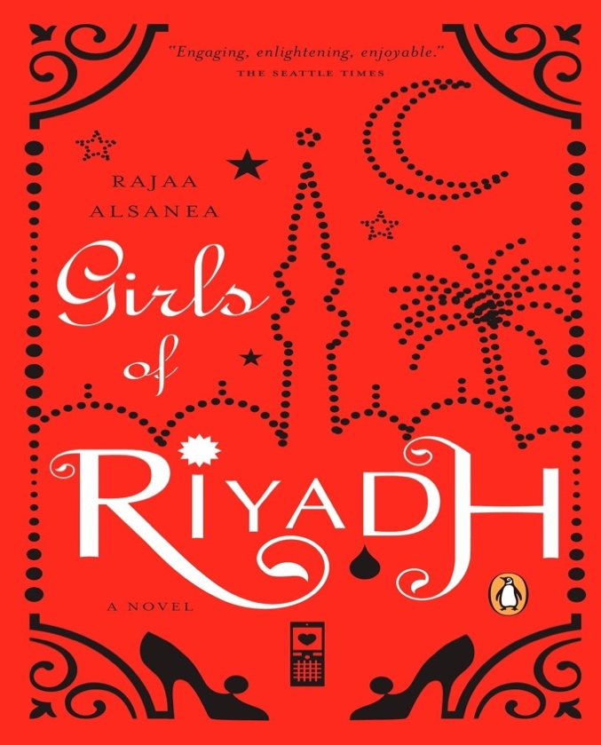 | 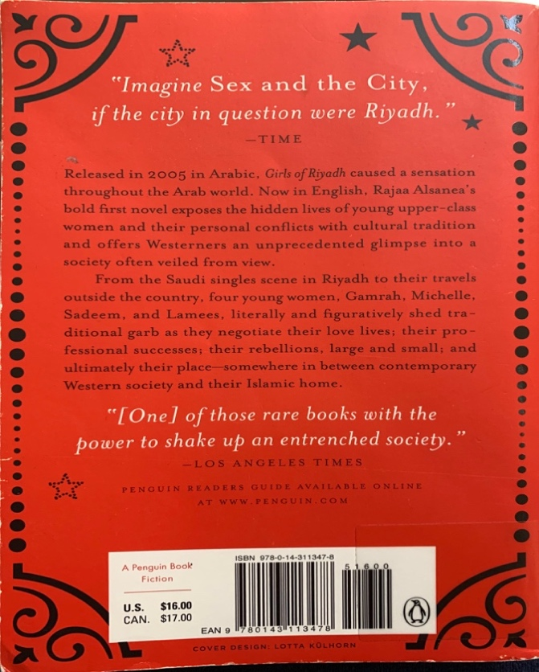
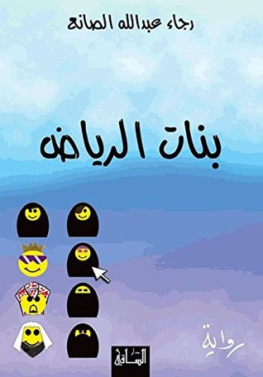 | 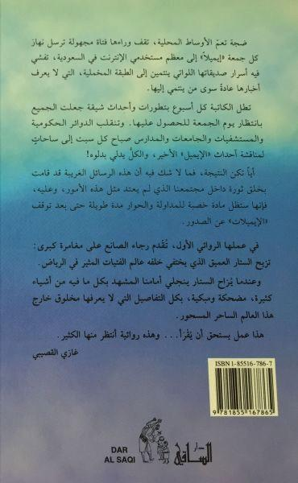
Figure 1 Front and Back Covers of English and Arabic GOR

Textual Paratexts
In this lengthy blurb, Alghosaibi speaks highly of Alsanea, with words of encouragement for her to continue along a literary path, GOR being the first literary attempt. Although the blurb is self-explanatory, it is still worth analyzing its representational component. Alghosaibi stated that this novel lets the reader in on the mysterious world of a specific group of girls in Riyadh: “those belonging to the velvet [wealthy] class.” So, the text is hailed, inter alia, as a partial representation of Saudi girls: those belonging to the upper class. The blurb, in its initial part, touches on the text’s aesthetic aspects, as the narrative’s format is described and the suspenseful endings of those emails are foregrounded, giving the blurb a function akin to that of a teaser. I now proceed to the English text, where critical gestures are more numerous and striking.
Although the Arabic version features a sole blurb, the translated version offers its readers twenty-seven: one on the front cover, three on the back, and twenty-three inside the book. Numerous to be displayed or discussed individually, below I quantify the blurbs and then offer a representative example for their discerned categories. The three categories are: ethnography (15), praise (11), and intertextuality (1). Below are the three examples, one for each, respectively:
“This is a distinctive and rare peek into a rarely revealed culture” (II)
The Morning News
“Be warned: this book will rearrange your priorities for the rest of the day so you can finish it” (I)
Pensacola Independent News
“Imagine Sex and the City, if the city in question were Riyadh” (back cover)
Time
What is conspicuous here is the total absence of paratextual elements from the source text, now replaced with new ones that bear no resemblance to what surrounded the Arabic version. One can observe three packaging trends by scrutinizing the textual materials surrounding the English translation. First, there is ample attestation of what Dima Ayoub referred to as “ethnographicization of Arabic fiction”, a phenomenon that bleeds into the second trend—essentialization. By framing the text as the absolute guide to Saudi culture, the image projected by the text becomes essentially true of those belonging to it. Coupling essentialization with ethnographicization effectuates metonymization—a notion Maria Tymoczko has deployed within TS—whereby a part represents the whole; in other words, one text (GOR) becomes representative of the whole culture, which is what the text, through its paratexts, purports to achieve. This tripartite amalgam—ethnographicization, metonymization, and essentialization—culminates in textualizing the other, a process of representation predicated on written materials. Furthermore, although the novelist did not have a paratextual presence in the Arabic version, she comes to have a highly visible and imposing one in the translation.
Alsanea initiated her note by stating: “It never occurred to me, when I wrote my novel (Banat Al-Riyadh), that I would be releasing it in any language other than Arabic. I did not think the Western world would actually be interested”. She then proceeded to precisely articulate the image the West has about Saudi Arabia and its people. This image, as she argued, was the driving force behind making her text available to the English reader: “It seemed to me, and to many other Saudis, that the Western world still perceives us either romantically, as the land of the Arabian Nights and the land where the bearded sheikhs sit in their tents surrounded by their beautiful harem women, or politically, as the land that gave birth to Bin Laden and other terrorists, the land where women are dressed in black from head to toe and where every house has its own oil well in the backyard!” After enunciating the reductive image, she then divulged her intention: “Therefore, I knew it would be very hard, maybe impossible, to change this cliché.” By so stating, her project is laid bare: she is dismayed by that unflattering, clichéd image, hence her determination to deconstruct it. “Furthermore,” she continued, “coming from a family that values other cultures and nations, and being the proud Saudi I am, I felt it was my duty to reveal another side of Saudi life to the Western world.” By aiming to “reveal another side,” Alsanea’s note shouts all familiar keywords of ethnographicization, concerned exclusively with the prevailing (master) discourse in the target context and displaying unequivocal keenness to problematize it. Below is an empirically grounded analysis of reception.

Reception

English Text
What is striking in the English corpus is the rise of the lemma “woman,” with 151 occurrences—"women” (107), “girls” (24), “females” (24), and “woman” (18). The second most frequent word is “book” (115 occurrences), followed by some other words that seem to hint at the text’s ethnographic features: “life” (56 occurrences), “culture” (43), and “society” (37). Below is the table of all codes/labels, along with their degree of iteration as indicated by the number of the coded segments in the readers’ posted responses, with a representative example for each category. To facilitate reading the examples below, I resorted to bolding the KWICs and underlining the proposition that indicates a reaction to each KWIC, upon which label assignment—“coding,” to use the terminology of ATLAS.ti—is based.
Table 20 English Reception of GOR
Code | example
ethnography (61) | It is an eye-opening book to a westerner like me who previously knew nothing of customs and culture in Saudi Arabia. I loved it.
woman image (negative) (34) | It gives a fascinating yet troubling inside view of the lives of young women in the incredibly oppressive, misogynistic society of Saudi Arabia. But these young women find ways of living their lives within the restrictive rules, or ofttimes in spite of them. This is a real eye-opener for anyone living in the luxury of a free society
woman image (neutral) (16) | What an incredible glimpse into a whole different ethnic lifestyle! I loved this book, incredible writing, storytelling, whatever, it was incredible.... I wish the best of everything for Rajaa Alsnea....this is a wonderful introduction for Western women/girls into the lives of women/girls in the Eastern part of our world
woman image (positive) (2) | Thank you, Rajaa, for your ability to transform women whom we often perceive as merely burka-bound beings into real human, feeling women!
aesthetic (18) | Over time, the constant intrusion of the author (i.e. the anonymous email writer) wears thin. Perhaps this is because in the last half of the novel, she just taunts the reader with the fact that she is unknown to them, and will keep her identity a secret. This refrain is repeated at the start of each chapter in the second half of the novel, and quickly becomes repetitive.
universal (15) | The fact that this book is titled "Girls of Riyadh" is a bit misleading, as I think it really can represent a group of girls anywhere, as the heroines face heartbreak and tough decisions like anyone from any country.
clichéd image (9) | I was surprised by the amount of cliches used in the book, hence, the four star rating. I don't think this took away from the content of the stories, but the cliches were distracting at some serious points
superiority (5) | A good insight into the Saudi culture and it will make you feel lucky you're an American.
compassion (5) | Hard to believe that this kind of life exists in the twentieth first century. I just hope that changes will happen in my life time!
resistant (2) | As at least one reviewer has noted here, sexism and chauvinism exist in and out of marriage everywhere in the world - in some places it is simply more extreme. I'm sure there are some Saudi men who do not "change" and become tyrannical or scornful toward their wives after marriage, just as there are some loving, understanding men in western culture who honor the women they love.

Having identified the emerging patterns and provided clarifying representative examples for each category, below I offer a summary of all the labels, followed by my typical discussion section, which includes some concluding remarks.
Table 21 English Reception Summary of GOR
Code | Number of Occurrences | Percentage
ethnography | 61 | 35%
woman image | 56 | 33%
aesthetic | 18 | 10%
universal | 16 | 9%
clichéd image | 9 | 5%
superiority | 5 | 3%
compassion | 5 | 3%
resistant | 2 | 1%

The tables above demonstrate that GOR was received as a sociological depiction of Saudi women, men, life/living, culture, and society (these are the KWICs individually analyzed, in addition to “book” and “novel”). The lemma “woman” is the word with the highest frequency, which suggests that the text was read as a kind of documentary portrayal of the Saudi woman, her life, and her treatment in/by society. I have decided to split the three codes associated with “woman” from the more general one (“ethnography”) because “woman” is the most frequent word and therefore necessitates greater attention. Furthermore, this separation will help us measure the success/failure of Alsanea’s project because the image of Saudi women was her preeminent concern. So, the woman image is basically part of the code “ethnography,” but I separated it for the two reasons I just mentioned.
Readers discuss the image of the Saudi woman in three distinct, yet correlated, ways: negative (34), neutral (16), and positive (2). By “neutral” I mean that the reader merely mentions that they learned about the Saudi woman, revealing insufficient clues for us to discern whether the image is positive or negative, as the semantic prosody is rather ambiguous. Looking at the representative examples of “negative,” one finds substantial evidence that Alsanea has failed to disrupt the preexisting image of the Saudi woman she found so disturbing. Out of all the segments considered for analysis in association with the KWIC “woman,” merely two readers, in two coded segments, express a positive image, providing us with two concrete pieces of evidence—or, counterexamples, to use empirical terminology—that a more flattering one indeed supplanted the negative image. Hence, these two readers remain outliers (and concurrently counterexamples); therefore, we cannot declare the success of Alsanea’s project based on these two occurrences, ignoring the thirty-four occurrences that strongly suggest otherwise.
The three labels associated with “woman” do not actually constitute the sole ground on which I base my conclusion that Alsanea’s project seems to have failed. The codes “superiority,” “clichéd image,” and “compassion” provide additional evidence. With these three codes in mind, we can perhaps see very clearly that Alsanea merely reinforced her readers’ already existing images, leading them to feel thankful and/or lucky for being American, more appreciative of the lives they have as Americans. This triggers some sense of superiority, as readers under this code start comparing their more privileged living conditions with the miserable ones under which those in Saudi Arabia are living. Furthermore, those under the code “clichéd image” stated that GOR presented nothing new, leading one reader to describe the text as “unoriginal”: “After reading this book, I felt that the whole ‘behind the veil’ story genre was overdone. This was largely due to the author being too obvious in trying to create a scandalous and provocative storyline [. . .] This made the book feel uninspiring and unoriginal” (GORENG64). A second reader dismissed it altogether for lacking genuineness, as it seems to have been tailored for the English reader: “there were awkwardly inserted passages designed to explain Saudi Arabian culture to the Western reader . . . but I really felt more like I was reading something written from a western perspective” (GORENG84). Finally, a third reader questioned the source text: “. . . clichés were distracting at some serious points, and did make me wonder about the original version” (GORENG33). These segments also serve as a testament to the prevalent master discourse in the target context, for describing the narrative as “cliché” implies it is the “same old story.” Saudi society, the state, men, and culture—in which Alsanea professes pride in her prefatory note—have all been perceived in an extremely negative light, so much so that Saudi culture, for example, was described as “medieval” (GORENG28) and Saudi Arabia as a country “stuck in 7th century” (GORENG60). So, although Alsanea mainly was concerned about the image of the Saudi woman, her readers went beyond her intention and constructed unfavorable images of the larger context in which women live, as well as the people (the oppressors) they are surrounded by. Saudi men were perceived as brutal and misogynistic, and, in some cases, as childlike and mentally underdeveloped: “It appears that the men in that society also stop their emotional maturation at around age 12” (GORENG10). This complete mismatch between Alsanea’s project and the actual reception by her readership might be surprising, but it is less so when we factor in the editorial intervention made to the text, as those changes evince remarkable consistency in fostering the reception discussed above. The inveterate hostility towards difference as manifest in the editorial interventions that seem to have led to this reception is a testimony that Edward Said’s Orientalism is still relevant—more on this below.
GOR in translation is undoubtedly a widely read text, as evidenced by the number of reviews on Amazon.com. But beyond the sheer number of reviews as an indicator of popularity and wide circulation, some readers reported how they encountered the text, providing us with additional insight into the text’s distribution and appeal. GOR has been, to borrow Casanova’s term, “consecrated” in its new environment in a variety of ways. Observe the following examples: “I mostly avoid romance and drama novels but this one was required for one of my anthropology classes” (GORENG5); “I positively loved this book. I did not expect to get into it, because it was required reading for my Middle Eastern Studies class, but I absolutely did” (GORENG8); “I read this for a book club and would not have finished it otherwise” (GORENG46); “I bought this book after hearing about it on the news. I don't know much about the Saudi culture so it was very eye opening to read as an American woman” (GORENG54); “I was initially drawn to this title due to an NPR discussion I heard about it . . . found that this was a fascinating insight to a hidden culture” (GORENG10); and “I’ve seen the author being interviewed on a French TV channel” (GORAR107). As one can glean from these responses, the text is not only widely circulated but also widely promoted through its inclusion on reading lists within academic contexts. Furthermore, by virtue of being assigned in courses on anthropology and the Middle East, the text is somehow guaranteed to be read by generations of American readers for primarily ethnographic reasons (insofar as it is assigned, of course). Moreover, the text seems to have received good coverage in the mass media, as it was featured—and praised—on radio and TV channels. Finally, following the massive success of GOR, Alsanea received a multitude of offers from film companies that she was considering back in 2009. It seems, however, that those cinematic projects did not take off the ground.
The published translation departs so significantly from the Arabic text that some readers—vigilant readers, one might feel inclined to call them— started to grow suspicious and curious, the result perhaps of the excision of a significant passage from the Arabic version in the English translation. Observe the following response (GORENG20): “One question, however: who was the e-mailer? I didn't catch that for some reason. She said she would ‘reveal all’ by the end of the book, but I didn't get it.” Indeed, the author promises in the Arabic and English versions to reveal her identity; but although she delivers on her promise in the Arabic text, she fails to do so in the English translation. Here is a translation of the passage existing in the Arabic source but omitted in the translation:
Now that I have compiled these emails in a published text, as many have recommended me to do, I reveal my identity. But I am still afraid that you might call it a novel, for it is nothing but an assembly of emails written with honesty and spontaneity. They are just a diary of manias had by one juvenile girl in her early twenties. Hence, I accept neither placing them under the constraints of literary conventions, nor under a patina that makes them appear more serious than they actually are; I just want to publish them as they are.
With that missing part in mind, the incentive behind its omission seems perfectly understandable: the novelist’s own identification of her work as just a “diary” of the “manias” of a single (one) “juvenile girl in her early twenties” undercuts the packaging of the texts as the omitted part runs counter to the function it tries to fulfill. Intriguingly, the novelist did not take the text so seriously, presenting and framing the Arabic version as a mere documentation of the capricious desires of a girl in her twenties, warning readers against attaching unwarranted significance to it. This is not to declare her narrative erroneous or a mere compilation of lies; instead, the aim is to spotlight the sharp contrast between the rather whimsical and flippant status of the text in its source context (per the author’s own admission, which was omitted from the translation) and how it came to acquire an authoritative, ethnographically instructive one in the host context.
To close this section, despite the significant shifts I have discussed, Alsanea remains a fierce defender of her version: “I did not write the book for Western readers. This is why it is very authentic and genuine even after translation.” It seems that Alsanea defends the English text as a “faithful” rendering of the Arabic text, although the numerous shifts gainsay her claims. Juxtaposing “her” project with “her” textual decision-making, one cannot help but feel perplexed, given how at odds the two are with each other. In the acknowledgment section, Alsanea vouchsafes multiple hands involved in translating GOR by giving credit to several people who helped her “edit the English counterpart” to ensure her translated novel “does not get lost in translation.” The names she mentions are Nasser (brother), Aceel (friend), Rasha (sister), and finally Liza Darnton, the editor at Penguin. This mishmash of agents lends credence to Kobus Marais’s advocation for complexity thinking in TS which, to guard against reductionism, rejects binary thinking, with “source” and “target” being one of those enduring binaries. But Penguin’s decision to add this acknowledgment section seems to be a preemptive measure—an alibi of sorts—against potential criticism. This postulation is predicated on one premise: the institutional “manipulation” of texts to reinvigorate and petrify “stereotypic representations of foreign cultures” is an already-existing phenomenon—as I shall historicize below—and attaching native and contemporary names to another iteration of a longstanding practice does not render Penguin—nor the Saudi agents, including the novelist—acquitted. A greater concern that one should pay more attention to is the translations’ representativeness of the Saudi people, a role thrust by Penguin into a handful of agents.
Penguin’s collaboration with Alsanea and the wholesale exclusion of the translator, in addition to the rejection of her translation, disrupt, as Emmerich noted, “conventional post-colonial understandings of the relationship between western translators and non-western authors,” as the so-called “first world” (Western) translator was relegated to a marginal position, whereas the so-called “third world” writer was elevated to a higher status in regard to shaping the published version. Transmutations are intrinsic to translation. A text’s position and function are not determined by “the field of origin” but by the “field of reception”. But how was the text received in the home context? I answer this question next and then segue into discussing the implications of the outcomes of the current project.

Arabic text
The first observation is that the frequency list of the Arabic text of the translation stand in sharp contrast, and by zooming in to observe in what sense they are being used by readers can we reach a better understanding of reception. The KWICs appearing in the frequency list are: الرواية (novel) (274), المجتمع (society) (104), الكاتبة (author) (77), كتاب(book) (67), السعودي (Saudi) (50), قصة (story) (57), ضجة (hype/fuss) (40), and وقت (time) (17). Following the analysis of all KWICs in their respective context of appearance, ten themes rose to the surface. Starting with the most frequent to the least, they are: “aesthetics,” “hype,” “representation,” “social analysis,” “translation,” “fame-seeking,” “girl mentality,” “fellow feeling/bond,” and, “men as demons.” Below I nuance these emerging themes by providing a table containing all the codes associated with the themes. I then conclude the analysis with a brief discussion of the codes and segue into an exploration of the English reception.
Table 18 Arabic Reception Summary
Code | Number of Occurrences | Percentage
Aesthetic/ critical | 85 | 31%
hype unworthy | 49 | 18%
partial representation | 35 | 13%
misrepresentation | 22 | 8%
social analysis | 22 | 8%
aesthetic/positive | 17 | 6%
translation/disapproval | 15 | 5.5%
universal | 8 | 3%
fame seeking | 8 | 3%
ethnography | 4 | 1.5%
insight into girl mentality | 3 | 1%
fellow feeling / bond | 3 | 1%
men as demons | 1 | .5%
translation/untranslatable | 1 | .5%

Although the codes and their examples are quite self-explanatory, I think it is necessary to make a few points. As evident in the table above and the examples provided, the readers of the Arabic version have been a loud voice of dissent. The text was received negatively on mostly aesthetic grounds, having no literary merit given the poor style of writing. Most of the coded segments under the label “aesthetic/critical” express severe criticism of the writing style on varying, yet related, grounds. These criticisms range from typos and grammatical/syntactic mistakes to the chatty language that readers deem inappropriate for a published novel. Also, many readers repulse calling GOR “a novel,” seeing it as a misnomer that would raise the text to a higher status, of which it is unworthy. By contrast, segments strung together by the code “aesthetic/positive” express, generally, an appreciation of the style because readers find it innovative, mainstream, and non-elitist—or plain and simple, thereby extremely readable and less cognitively demanding. Representation is a central theme, too, with three codes associated with it: “partial representation” (i.e., true representation of only a certain class); “misrepresentation” (untrue or deforming); and “universal” (true of all human societies). A surprising theme to emerge is “translation,” with fifteen occurrences (by fifteen readers) in which readers expressed outright objection or dismay that the text has been translated. The objection is raised because the text is either a poor literary ambassador to represent Arabic literature, as readers state or imply that there are better candidates for translation, or that it transmits a negative/deformed image of Saudi society beyond the national borders, chiding the novelist (and co-translator) for exporting a negative image. (What seems noteworthy here is that Arabophone readers seem to view translation as a consecration, a dignifying act that should not be bestowed upon any text.) Additionally, the segments under this code could have been inserted under two other relevant codes, “aesthetic/critical” or “misrepresentation,” respectively. However, because the readers under this code are concerned more about the text’s international representation (literary and imagological), I have nuanced my analysis by collecting them under a separate, more appropriate code (“translation disapproval”) to reflect that distinction. Finally, only one reader expressed astonishment that the text was translated because the dialect and slang featured in the Arabic text cannot be “carried across” without a degree of inexorable “loss” of “meaning.”

Conclusion

Preunification and translation
In the grand scheme of things, what GOR has undergone is not anomalous. Classicist Trevor J. Saunders described such normalization practices as “penguinification,” which, as Connor argued quite ferociously, remains operative today (2014, 426–27). Connor did not include Arabic literature in his discussion, and this bespeaks an ongoing, across-the-board tendency by Penguin that involves translated literature from a wide range of languages, of which Arabic is only one. Having discussed the production of the English GOR and then demonstrated that it is only a part of a holistic penguinification phenomenon, I can argue more confidently that GOR has indeed been “engineered” for an anglophone readership by editing “other people’s realities into the terms of the receiving culture,” a process that Edward Said once described as “Orientalizing the Oriental” through regulated textualization.
Marco Sonzogni maintained that book covers reveal the cultural assumptions of their designers and readers, an argument that can be vindicated by the figure below. To further instantiate the power of the master discourse to homogenize the heterogeneous by harmonizing GOR in English with the preexisting mold, indexed by domes, nocturnal settings, minarets, crescents and stars, and so on:
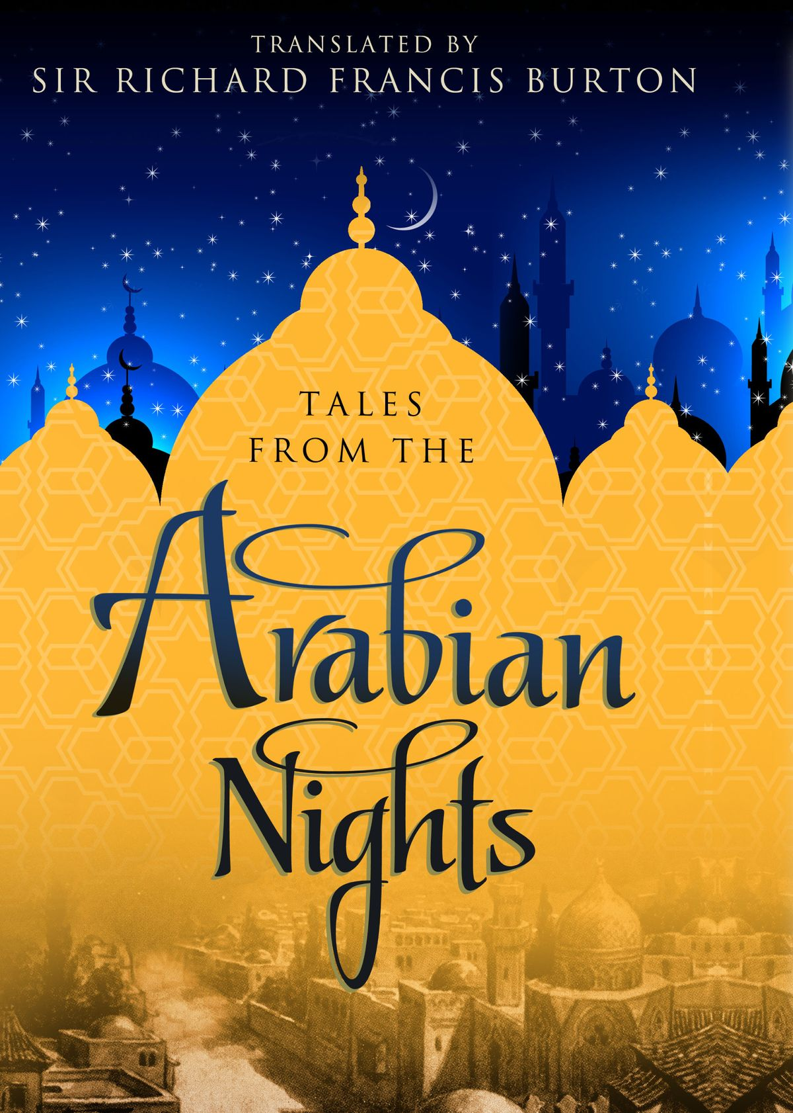
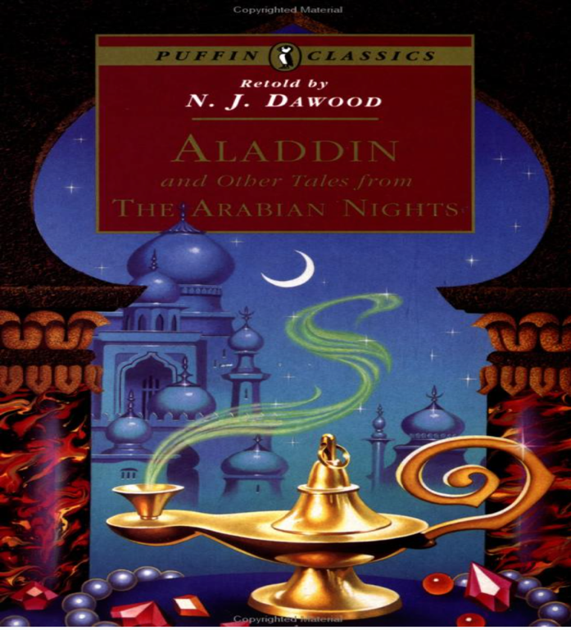
Figure 2 Homogenizing the Heterogeneous (“penguinification”)
Because GOR has been translated into innumerous languages, the figure below may lend further credence to Sonzogni’s postulation; therefore, I call for a multilingual collaboration to investigate GOR in translation (and for a similar endeavor for works from other languages that have undergone similar treatment). The figure below hints at the transformations that have transpired in translation as GOR continues to acquire an “afterlife” beyond its origins:
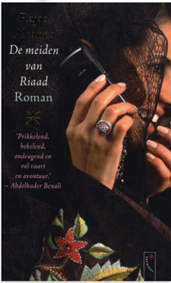 | 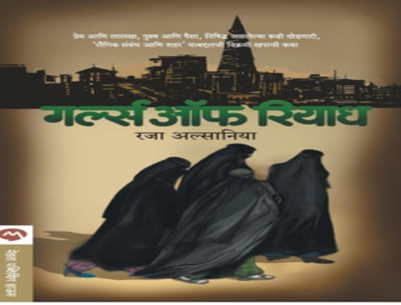 | 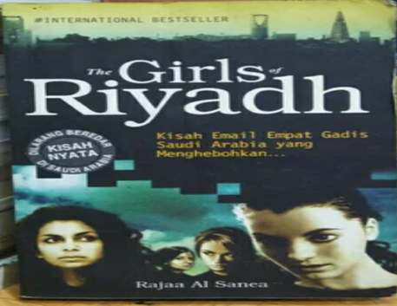
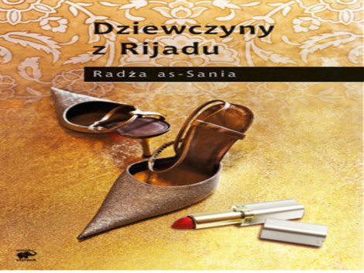 | 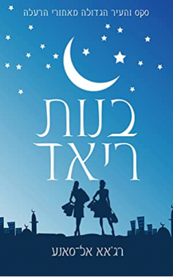 | 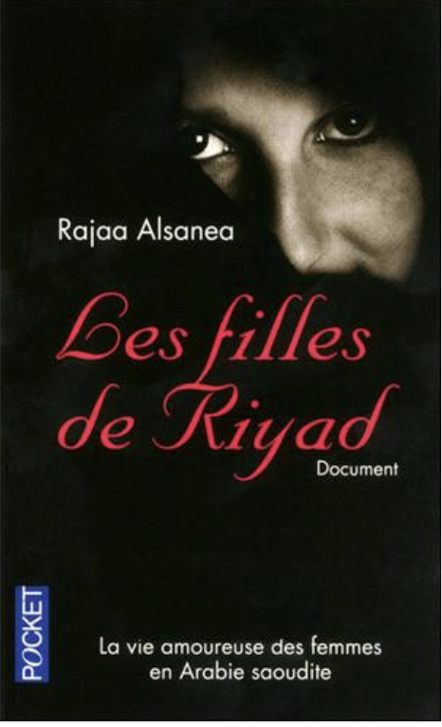
Figure 3 Packaging GOR in Global Contexts
What makes the need for a multilingual effort more pressing is the fact that Penguin’s version seems to have acquired some authoritativeness through serving as intermediary text. By virtue of being the most translated language, English enjoys the most central position in the translation system. Thus, translator Edith Grossman views translating into English positively for its potentiality to serve as a relay language, thereby instigating translations of a given text into other languages. But Grossman’s endorsement should be approached with great caution, for she seems to endow translating into English—a language on which there is an enormous body of literature documenting its exploitation as a tool for appropriating other cultures—with essential utility. GOR, to drive the point home by way of an example, has been translated into one of the Indian languages, not from the Arabic source, but from the (“penguinified”) English text. This is also not to invoke relay translation as an ominous specter—Heekyoung Cho’s work is a prime example of how productive it can be—but to invite healthy skepticism by considering the broader context that shapes translations. Akin to a boomerang, exported images can be imported back into their context of origin. English GOR is now on sale at major bookstores in Saudi Arabia—Jarir Bookstore, to mention but one example—whereas the Arabic original no longer is. But it must be stressed that the whole penguinification phenomenon is not purely reductive or essentially gloom-ridden, as it might seem at first glance; it can be channeled productively to unleash the discursive potential of translation.
Contemplating a course of action that would lift the mantle of “invisibility” that continues to shroud the production of GOR in its English translation, Booth wrote: “I’m already thinking about how one could shake up the text in translation by, for instance, using Arabic script somehow side-by-side with English for the phrases originally in English.” By having the translated text published adjacent to its source in a parallel fashion, Penguin’s cultural appropriations can be pushed into public view. But without a sufficient command of Arabic, a parallel reading is essentially out of reach. Moreover, publishing the text in a parallel edition would necessarily expose Penguin’s editorial interventions (in case Booth was advocating for that format to be published through Penguin), and this is nothing short of a self-destructive act for the publisher. An alternative is proposed below.

The Reader’s Turn: Towards the Promotion of (Virtual) Translation Literacy
Having carefully combed through the data over the multiple stages of this research project, starting with the data collection and through the actual analysis and discussion of results, I’ve observed the following features in the reader responses:
- (mostly) uncritical acceptance of the English GOR as complete and accurate depictions of the source culture;
- no sign of awareness about the controversies surrounding the production of GOR in English;
- willingness to initiate and engage in dialogue about translated literature, as confirmed by the very act of posting reviews, through which some readers of GOR pose direct questions about the source text because they view the translated text with some suspicion;
- total absence of scholarly voices in these platforms.
Based on those observed features, especially the last one, there is an ethical obligation incumbent on the scholarly community of TS. Thus, I propose that the scholarly community begin a joint promotion of translation literacy among lay readers virtually by joining these online discussions to initiate dialogues with readers. Van Wyke’s position on translation ethics rests on the following two tenets: (a) an awareness of the ubiquitous mechanistic view of translation among lay users and (b) a particular emphasis on the need for “educating” general users of translation to problematize that simplistic conceptualization. But an attempt to promote literacy is treading on thin ice, for readers may cast a bleak eye on translation. This indeed is a great challenge that the scholarly community can overcome by adopting (and adapting) a “social constructivist workshop” by discussing certain case studies (GOR, in our case). Following in-class discussions, students can be empowered by having the instructors delegate the task of approaching translation users to them. The students then report back to the group in class to discuss what their interactions with readers have yielded to think collectively about how to progress. This can be done over the semester under the guidance of the instructor—the “facilitator,” to use a constructivist term. By establishing dialogues with readers of translations on such digital platforms to educate them about how translation shapes distant cultures, we can enable “understanding of identity as a learned or constructed allegiance rather than an innate condition.” Such awareness could induce a moment of epiphany which could, on the one hand, kindle readers’ interests in exploring more literary opportunities and provide a scaffold for better-informed reading of translated texts, on the other. This literacy intersects with imagology, a field that aims to “describe the origin, process, and function of national prejudices and stereotypes, to bring them to the surface, analyze them and make people rationally aware of them.”
These images reveal more about the Anglophone context—and its biases and prejudices—than about the “reality” of the Arab world. Additionally, the arsenal of tactics that Penguin has deployed to construct the identity of the other and then present it as the ultimate and irrecoverable “truth” speaks volumes of how brittle and frangible the protected image is. Thus, readers of translation can be informed to question and cogitate their schemata of translation, viewing it as a trope for critically examining circulating images of other nations. Prioritizing interrogations of such simplistic and widespread conceptualizations is the sine qua non of bringing to light alternative views of translation—and of the East. With better and more translations being available than ever before, David Damrosch has declared a “golden age of translation.” Thus, it is crucial for translation literacy to burgeon in a manner commensurate with the golden age declared by Damrosch. By promoting translation literacy about how GOR has come to exist, the following statement becomes felicitous timely: “We are always somewhat settled by novelty, difference and otherness, which challenge our own values and hold up a mirror that forces us to examine ourselves. Translation, in the final analysis is about discovery—a journey of exploration through the fabulous realm of knowledge.”
Moving beyond GOR in its English translation to investigate its reception in its new context aligns closely with Michael Allan’s shift of emphasis from a formalist “close reading” to approach world literature as “the world in which the text accrues meaning.” Allan therefore espouses historicizing literature not by simply “finding texts deemed literary” but by enquiring about “the conditions in which these texts are understood, how they come to matter, and the ends to which they are put.” And so, this paper has traced an arc that spanned GOR through to its background(s), packaging, reception, and ultimately the forward-looking proposal for promoting a broad-based translation literacy. Therefore, pronouncing judgements on the translation of GOR, not to invoke a simplistic and outdated rhetoric of betrayal and distortion, was eschewed. By arguing for translation literacy, I by no means argue for a reading or an interpretation to replace the one investigated herein; rather, I’m arguing for an alternative reading to unleash more interpretive possibilities, ultimately enriching our understanding of the text. By doing so, we can give readers more agency and further establish the concept of translation’s greater nuance and sophistication. This will allow us to “enlarge translation” and “empower” the reader, to use Maria Tymoczko’s eponymous words. Tarek Shamma maintains that Power imbalance(s) is one unifying thread of postcolonial approaches to translation, which could be disrupted and redistributed by promoting translation literacy, allowing Booth to regain her usurped agency. “One is not born a reader of translations, but made one.” Anthony Pym has recently remarked that the “big black box in Translation studies is still reception.” It is hoped that this paper has provided original insights, however brief, into the black box, offering prospective researchers of reception a model to keep venturing into yet another known unknown of TS.

This is a prime example of how the Orient is a “textual construct,” as argued by Edward Said in his Orientalism (1979). In this blurb, the publisher dismisses personal encounters and projects the text as the ultimate guide to local cultures. (The aim here is not to advocate for one approach over the other, but rather to reject the notion that any one perspective is the definitive source of truth.)
Rajaa Alsanea, بنات الرياض Bānātū ʾrrīyāḍ ( دار الساقيDar Alsaqi, 2005).
Rajaa Alsanea, Girls of Riyadh, trans Rajaa Alsanea and Marilyn Booth (New York: Penguin Group, 2007).
Roger Allen, Selected Studies in Modern Arabic Narrative: History, Genre, Translation (Atlanta, Georgia: Lockwood Press, 2019), 193.
Lawrence Venuti, The scandals of Translation. (New York, NY: Routledge, 1998).
Said Faiq, “The Routledge Handbook of Literary Translation,” in The Routledge Handbook of Literary Translation, ed. Kelly Washbourne and Ben Van Wyke (Abingdon, Oxon; New York, NY: Routledge, 2018).
Gideon Toury, Descriptive Translation Studies (Amsterdam, The Netherlands; Philadelphia, PA: John Benjamins Publishing Company, 1995), 26.
“What to read (and watch) to understand Saudi Arabia,” The Economist, accessed, February 11, 2024, https://www.economist.com/the-economist-reads/2023/06/22/what-to-read-and-watch-to-understand-saudi-arabia.
Jeremy Munday, Introducing Translation Studies: Theories and Applications, 4th ed. (Routledge, 2016); Karen Emmerich, “Visibility (and Invisibility),” in Handbook of Translation Studies: Volume 4, eds. Yves Gambier and Luc van Doorslaer, 200–206 (John Benjamins Publishing Company, 2013).
John Milton and Paul Bandia, “Introduction: Agents of Translation and Translation Studies,” in Agents of Translation, eds. John Milton and Paul Bandia, 1–18 (John Benjamins Publishing Company, 2009).
Sherif H. Ismail, “Arabic Literature into English,” Interventions 17, no. 6 (2015): 916–31; Claudia Roth Pierpont, “Found in Translation,” The New Yorker, January 2010; Salih J. Altoma, Modern Arabic Literature in Translation: A Companion (London: Saqi, 2005); Alice Guthrie and Alexandra Buchler, Literary Translation from Arabic into English in the United Kingdom and Ireland, 1990-2010 | Anna Lindh Foundation (Aberystwyth, 2011); Heather M. Hoyt, “Teaching from Cover to Cover: Arab Women’s Novels in the Classroom,” in Edinburgh Companion to the Arab Novel in English, ed. Nouri Gana, 405–25 (Edinburgh University Press, 2015); Allen, Selected Studies; Abdel Wahab Khalifa and Ahmed Elgindy, “The Reality of Arabic Fiction Translation into English: A Sociological Approach,” International Journal of Society, Culture & Language 2, no. 2 (Special Issue on Translation, Society & Culture, 2014): 41–56.
Edward Said, “Embargoed Literature,” The Nation, September 17, 1990, 278–80.
Allen Hibbard, “Translation of Modern and Contemporary Literature in Arabic,” in Literature in Translation: Teaching Issues and Reading Practices, eds. Carol Maier and Françoise Massardier-Kenney, 218–34 (Kent, OH: Kent State University Press, 2010).
Ron Charles, “13 Sept. 11 Novels That Changed the Fiction Landscape,” The Washington Post, September 7, 2021.
Hoyt, “Teaching from Cover to Cover,” 419.
Lila Abu-Lughod, Do Muslim Women Need Saving? (Cambridge, MA: Harvard University Press, 2015), 87.
Joseph Massad, “‘Homeland,’ Obama’s Show,” Aljazeera.com, 2012. https://www.aljazeera.com/opinions/2012/10/25/homeland-obamas-show/.
Can be viewed at: https://www.youtube.com/watch?v=SV8hosb-H54
Mona Baker, “The Changing Landscape of Translation and Interpreting Studies,” in A Companion to Translation Studies, eds. Sandra Bermann and Catherine Porter, 13–27 (Oxford, UK: John Wiley & Sons, Ltd., 2014), 16; Lawrence Venuti, The Translator’s Invisibility: A History of Translation (Routledge, 1995), 19.
Marilyn Booth, “Three’s a Crowd: The Translator-Author-Publisher and the Engineering of ITALICS Girls of Riyadh for an Anglophone Readership,” in Translating Women: Different Voices and New Horizons, eds. F Farahzad and L von Flotow, 105–19 (New York, NY: Routledge, 2017), 115.
Amal Amireh and Lisa Suhair Majaj, eds., Going Global: The Transnational Reception of Third World Women Writers (New York, NY: Routledge, 2000), 9.
van Wyke, Ben, “Translation and Ethics,” in The Routledge Handbook of Translation, eds. Carman Milan and Francesca Bartrina, 548–60 (New York, NY: Routledge, 2013), 557.
Brian James Baer, “Is There a Translation in This Class? A Crash Course in Translation Literacy,” in Teaching Literature in Translation: Pedagogical Contexts and Reading Practices, eds. Brian James Baer and Michelle Woods, 3–12 (New York, NY: Routledge, 2022), 5.
Edith Grossman, Why Translation Matters (Orwigsburg, PA: Yale University Press, 2010), 69.
David Crystal, How Language Works (New York: Avery, 2005), 417.
Bernd Meyer, “Case Studies,” in Researching Translation and Interpreting, eds. Claudia Angelelli and Brian James Baer, 177–84 (New York, NY: Routledge, 2016), 178.
Ika Willis, Reception (New York: Routledge, 2018).
Lawrence Venuti, Contra Instrumentalism: A Translation Polemic (University of Nebraska Press, 2019).
Roland Barthes, “The Death of the Author,” in Image, Music, Text, ed. Stephen Heath, 142–48 (New York, NY: Hill and Wang, 1978).
Stuart Hall, Representation: Cultural Representations and Signifying Practices (London: Sage in association with the Open University, 1997), 18.
Clive Scott, Translating the Perception of Text: Literary Translation and Phenomenology (Oxford, UK: Routledge, 2012), 6.
Ben van Wyke, “Ethics and Translation,” in Handbook of Translation Studies, eds. Yves Gambier and Luc van Doorslaer, 1:111–15 (Amsterdam/Philadelphia: John Benjamins Publishing Company, 2010), 113.
Claudia Angelelli and Brian James Baer, eds., Researching Translation and Interpreting (New York, NY: Routledge, 2016).
Leo Tak-hung Chan, “Reader Response and Reception Theory,” in Researching Translation and Interpreting, eds. Brian James Baer and Claudia V. Angelelli, 146–54 (Abingdon: Routledge, 2015), 152.
Haidee Kruger and Jan‐Louis Kruger, “Cognition and Reception,” in The Handbook of Translation and Cognition, eds. John W. Schwieter and Aline Ferreira, 71–89 (Hoboken, NJ: Wiley, 2017); Gisèle Sapiro, “The Sociology of Translation: A New Research Domain,” in A Companion to Translation Studies, eds. Sandra Bermann and Catherine Porter, 82–94 (Oxford, UK: John Wiley & Sons, Ltd, 2014); Brian James Baer, “Translated Literature and the Role of the Reader,” in A Companion to Translation Studies, 333–45 (Oxford, UK: John Wiley & Sons, Ltd, 2014).
Anthony Pym, “Translations and Their Readers. What We Know and Don’t Know,” YouTube, 2021. https://www.youtube.com/watch?v=JYrXneLIjq4&t=5s.
Hans Bertens, Literary Theory: The Basics, 3rd ed (New York, NY: Routledge, 2017), 98.
Joseph Conte, Transnational Politics in the Post-9/11 Novel (New York, NY: Routledge, 2020).
Gérard Genette, Paratexts: Thresholds of Interpretation (Cambridge, England: Cambridge University Press, 1997).
Ibid., 238.
Richard Watts, Packaging Post/Coloniality: The Manufacture of Literary Identity in the Francophone World (Lanham, MD: Lexington Books, 2005), 14.
Ibid., 2.
Wolfgang Iser, The Implied Reader (Baltimore and London: The John Hopkins University Press, 1974), 282.
What is unique about Iser’s metaphor is that once it is inverted—that the lines (meaning) are fixed even if the stars (a ST and its translation, for example) are different—positivism surfaces.
Of course, this is not meant to underestimate the reader’s agency, as the reader has the final say in the matter of meaning creation, or to suggest that packaging is the sole player in meaning creation, but rather to stress the immense significance of articulated interpretations transmitted to the reader through a paratextual medium (i.e., packaging), whereby reading against the backdrop of specific presuppositions is scaffolded so that certain interpretations are buttressed during the reading act.
Şehnaz Tahir Gürçaglar, “Translated Texts / Paratexts,” in A History of Modern Translation Knowledge: Sources, Concepts, Effects, eds. D’hulst Lieven and Yves Gambier, 287–92 (Amsterdam: John Benjamins Publishing Company, 2018), 289.
Pierre Bourdieu, “The Social Conditions of the International Circulation of Ideas,” in Bourdieu: A Critical Reader, ed. Richard Shusterman, 220–28 (Oxford, UK: Wiley-Blackwell, 1999), 224.
Watts, Packaging Post/Coloniality, 5.
This is how I’ve decided to cite the reader responses collected as data: Initializing the text “GOR,” followed by “ENG” to indicate English translation and “AR” to indicate the Arabic text and then a number to designate the sequential order of the review as it appears in each corpus.
Alev Adil, “Girls of Riyadh, by Rajaa Alsanea, Trans. Marilyn Booth,” Independent, August 3, 2007, para. 1, https://www.independent.co.uk/arts-entertainment/books/reviews/girls-of-riyadh-by-rajaa-alsanea-trans-marilyn-booth-5334374.html; Philippa Kennedy, “Beyond the Book,” The National, March 17, 2009, para 9, https://www.thenational.ae/arts-culture/books/beyond-the-book-1.554538.
Marylin Booth, “Translator v. Author (2007),” Translation Studies 1, no. 2 (2008): 199.
Booth, “Translator v. Author (2007).
Booth, “Translator v. Author,” 200.
Antoine Berman, Toward a Translation Criticism: John Donee, ed. Françoise Massardier-Kenney (Kent, OH: Kent State University Press, 2009).
Booth, “Translator v. Author.”
Booth, “Translator v. Author,” 201.
I hope it is clear at this point that I am not advocating for prescriptivism, seeing this as an “unfaithful” or “wrong” translation, for I am merely providing context.
Booth, “Translator v. Author,” n. 2.
I’m cautious with this term because this word suggests there is a fixed and concrete entity preexisting in the ST subject to manipulation, as if the ST is ever intact, which is a positivist premise that this paper does not embrace.
Booth, “Translator v. Author”; Marylin Booth, “‘The Muslim Woman’ as Celebrity Author and the Politics of Translating Arabic,” Journal of Middle East Women’s Studies 6, no. 3 (2010): 149–82; Booth, “Three’s a Crowd.”
Booth, “‘The Muslim Woman,’” 174.
Booth, “‘The Muslim Woman,’” 205.
Ibid.
Ibid., 172.
Booth, “Translator v. Author,” 208; Michelle Hartman, “Prose Fiction,” in The Routledge Handbook of Literary Translation, eds. R. Kelly Washbourne and Ben Van Wyke, 206–19 (Abingdon, Oxon; New York, NY: Routledge, 2018), 213.
Mohja Kahf, “Packaging ‘Huda’: Sha’rawi’s Memoirs in the United States Reception Environment,” in Critical Readings in Translation Studies, ed. Mona Baker, 28–45 (New York: Routledge, 2010), 36–38.
William Graham Sumner, Folkways: A Study of the Sociological Importance of Usages, Manners, Customs, Mores, and Morals (Pantianos Classics, 2017), 11.
Booth, “‘The Muslim Woman,’” 170.
Booth, “Translator v. Author,” 209.
Faiq, “The Routledge Handbook of Literary Translation,” 442.
Lynx Qualey, “Translating for Bigots,” Arablit, November 4, 2013, para. 7. https://arablit.org/2013/11/04/translating-for-bigots/.
See Mohammed Alzahrani, “Reading Arabic Texts in English Translation: Lifting the ‘Veil,’” in Teaching Literature in Translation: Pedagogical Contexts and Reading Practices, eds. Brian James Baer and Michelle Woods, 111–22 (Routledge, 2022) for a more elaborate discussion of the “veil.”
Michelle Hartman, “Gender, Genre, and the (Missing) Gazelle: Arab Women Writers and the Politics of Translation,” Feminist Studies 38, no. 1 (2012): 18.
Gabriela Saldanha and Sharon O’Brien, Research Methodologies in Translation Studies (New York, NY: Routledge, 2014), 34.
Rare occurrence.
John Sinclair, Reading Concordances: An Introduction (Pearson/Longman, 2003), xvi–xvii.
Alsanea and Booth, Girls of Riyadh, i–iii.
Dima Ayoub, “Politics of Paratextuality: The Glossary between Translation and the Translational,” Journal of Arabic Literature 51, no. 1–2 (2020): 34. https://doi.org/10.1163/1570064x-12341399.
Maria Tymoczko, Translation in a Postcolonial Context: Early Irish Literature in English Translation. (New York, NY: Routledge, 2014).
Edward Said, Orientalism (Vintage Books, 1979) 52.
Alsanea, Girls of Riyadh, ix.
The last part of this review (“This is a real eye-opener for anyone living in the luxury of a free society”) had been coded “superiority” and was added to the other segments where readers express thankfulness or privilege for not leading such life.
This quotation is associated with three codes: “ethnography,” because the reader reportedly learned about Saudi men and how they treat their partners; “resistant,” because the reader refuses to buy the idea that all Saudi men are tyrannical and scornful towards their significant others, which is an image well in line with how they were depicted in the translated text; and “universal,” because this reader mentions that such abhorrent qualities exist “in and out of marriage everywhere in the world.” I decided to keep them in one quotation and not chop this segment up into three sections because, first, each coded segment in the quotation bleeds into the other and, second, these segments would sound awkward if they were decontextualized through chopping them up and inserting them into three separate categories.
This word is particularly problematic, for although cultural aspects have been dramatically watered down, if not expunged, the text is still packaged (and read) as a guide to the culture.
Edward Said, Orientalism (Vintage Books, 1979).
Pascale Casanova, “Consecration and Accumulation of Literary Capital: Translation as Unequal Exchange,” in Critical Readings in Translation Studies, ed. Mona Baker, 285–303 (London: Routledge, 2010).
Kennedy, “Beyond the Book,” para. 5.
Alsanea, بنات الرياض Bānātū ʾrrīyāḍ, 318.
Kobus Marais, Translation Theory and Development Studies: A Complexity Theory Approach (New York, NY: Routledge, 2014), 17.
Gisèle Sapiro, “Translation and the Field of Publishing,” Translation Studies 1, no. 2(2008): 163. https://doi.org/10.1080/14781700802113473.
Emmerich, “Visibility (and Invisibility),” 201.
Bourdieu, “The Social Conditions,” 223.
These words appear in contexts in which readers express regret for wasting their “time” on reading this—or that this text is not worthy of one’s “time.”
Peter Connor, “Reading Literature in Translation,” in A Companion to Translation Studies, ed. Sandra Bermann and Catherine Porter, 425–37 (Oxford, UK: John Wiley & Sons, Ltd, 2014), 426–427.
Booth, “Three’s a Crowd,” 105.
Kate Sturge, Representing Others: Translation, Ethnography and Museum (Manchester, UK: St. Jerome Publishing, 2007), 79.
Edward Said, Orientalism (Vintage Books, 1979) 49.
Marco Sonzogni, Re-Covered Rose: A Case Study in Book Cover Design as Intersemiotic Translation (Amsterdam: John Benjamins Publishing Company, 2011), 4.
Sonzogni, Re-Covered Rose.
Walter Benjamin, “The Task of the Translator,” in Theories of Translation: An Anthology of Essays from Dryden to Derrida, eds. John Biguenet and Rainer Schulte, 71–82 (Chicago: The University of Chicago Press, 1992).
Johan Heilbron, “Books Translations as a Cultural World System,” in Critical Readings in Translation Studies, ed. Mona Baker, 304–16 (New York, NY: Routledge, 2010).
Grossman, Why Translation Matters, 58.
https://www.mehtapublishinghouse.com/book-details/GIRLS-OF-RIYADH/665.aspx
Heekyoung Cho, Translation’s Forgotten History: Russian Literature, Japanese Mediation, and the Formation of Modern Korean Literature (Harvard University Asia Center, 2016).
As of February 2024: https://www.jarir.com/sa-en/arabic-books-287362.html.
Booth, “‘The Muslim Woman,’” 171.
van Wyke, “Translation and Ethics,” 557–558; van Wyke, “Ethics and Translation,” 114–115.
Donald Kiraly, A Social Constructivist Approach to Translator Education: Empowerment from Theory to Practice (Manchester, UK: St. Jerome Publishing, 2000), 63–64.
Carol Maier, “Toward a Theoretical Practice for Cross-Cultural Translation,” in Between Languages and Cultures: Translation and Cross-Cultural Texts, eds. Anuradha Dingwaney and Caro Maier, 21–38 (Pittsburgh: University of Pittsburgh Press, 1995), 31.
Manfred Beller, “Perception, Image, Imagology,” in Imagology The Cultural Construction and Literary Representation of National Characters. A Critical Survey, eds. Manfred Beller and Joep Leerssen, 1–16 (Leiden, The Netherlands: Brill, 2007), 12.
David Damrosch, Around the World in 80 Books (New York: Penguin Press, 2021), xviii.
Jean Delisle and Judith Woodsworth, “Preface,” in Translators through History, eds. Jean Delisle and Judith Woodsworth, Revised edition, xix–xxii (Amsterdam, The Netherlands: John Benjamins Publishing Company, 2012), xix.
Michael Allan, In the Shadow of World Literature: Sites of Reading in Colonial Egypt (Princeton: Princeton University Press, 2016), 133–134.
Ibid., 116.
Maria Tymoczko, Enlarging Translation, Empowering Translators, 2nd ed. (New York: Routledge, 2010).
Tarek Shamma, “Translation and Colonialism,” in The Routledge Handbook of Translation and Culture, eds, Sue-Ann Harding, Ovidi Carbonell Cortés, 279-295 (New York: Routledge, 2018) 279.
Berman, Toward a Translation Criticism, 49.
Anthony Pym, “Rebranding Translation, a Lecture by Anthony Pym,” YouTube, 2022. https://www.youtube.com/watch?v=_Zhm9FQmZ2g&t=2859s.

