**The Relationship Between Functioning and Psychological Capital of Adolescents with Cerebral Palsy and Their Mothers' Coping (Psychological Capital and Perception of Their Children's Psychological Capital):**

**Comparison** B**etween Two Theoretical Models (Exploratory Research)**

**Abstract**

One of the issues that concerns researchers in psychology, education and rehabilitation of adolescents with cerebral palsy (CP) is the relationship between the level of functioning of adolescents with CP and their psychological wellbeing.

The aim of the research was to examine the association between the motor, cognitive, socio-communicative and ADL functioning and the extent of Psychological Capital among adolescents with CP. Two theoretical models were compared applying the level of functioning of the adolescents and extent of their Psychological Capital.

The first model used the functioning of adolescents with CP in different fields as an independent variable. It examined the contribution of adolescents' functioning to explanation of their Psychological Capital.

The second model used adolescents' psychological capital as an independent variable. It examined the contribution of adolescents' psychological capital as an explanation of their functioning in ADL, motor, cognitive and socio-communicative fields.

Adolescents' functioning was assessed by applying the Pediatric Evaluation of Disability Inventory, Raven's Standard Progressive Matrices and the Peabody Picture Vocabulary Test.

The Psychological Capital was examined using the Life Orientation Test-Revised, The Hope Scale, General Self-Efficacy Scale and the Resilience Scale.

The main findings are as follows:

1. The crucial model is the one reflecting the ICF model, according to which the level of functioning of adolescents with CP explains their extent of psychological capital.

2. The functioning level of adolescents with CP negatively contributes to the explanation of their level of Psychological Capital: the higher the functioning level of adolescents with CP, the lower their extent of Psychological Capital.

**'What this paper adds?'**

For the first time, two theoretical models which examine the contribution of the variables "Psychological Capital of adolescents with CP" and "functioning of adolescents with CP" were tested against each other.

The study findings will help researchers in educational, rehabilitation and psychological fields understand the relationship and contribution of the level of motor, cognitive, communicative, social and the ADL functioning of adolescents with CP and their Psychological Capital as a part of their wellbeing.

Practitioners in the aforementioned fields will also benefit in developing intervention programs for adolescents with CP and their families based on the model which was found to be dominant in this study. This study will, ultimately, be helpful in bringing full, effective, and active integration of the adolescents with CP into society.

Understanding the connections between the level of functioning of CP adolescents in various fields, their psychological capital may serve a variety of professional factors (educational and rehabilitation personnel, paramedicine, psychology, welfare) in the construction of intervention plans and the adaptation of strategies and supports to the therapeutic and educational needs of this population. Professionals should focus on finding a balance between the adolescent's abilities in various fields, and his/her psychological state. Special attention should be paid to building programs that aim to help adolescents with CP with a medium and high levels of motor function in accepting themselves and coming to terms with their functional disability, in order to raise the level of their psychological state.

**Cerebral palsy - definition and characteristics**

Cerebral palsy (CP) is a group of permanent disorders of the development of movement and posture, causing limitation in activity and are attributed to non-progressive damage that occurred in the brain of the fetus or newborn. The motor difficulties in people with CP are often accompanied by problems in various functional areas (cognitive, communicative, sensory, behavioral-emotional etc.) (Rosenbaum, Paneth, Leviton, Goldstein, & Bax, 2007).

Adolescence is a period in human development (ages 10-21) when dramatic changes occur in various areas: physical, emotional, cognitive, social (Graber, Brooks-Gunn & Petersen, 2018). This period of puberty is a time to re-evaluate their health status and personal needs, to take advantage of learning opportunities and support in order to enter adulthood as successfully as possible with and despite the disability (Downs et al., 2017).

The level of physical functioning (including mobility and ADL functioning) of adol.CP has a significant impact on their successful transition to adulthood, especially when the adolescent needs the help of an adult (parent or caregiver) for various functions. With increasing age, the level of physical function decreases and the need for assistance increases. Thus, adol.CP report that they tend to walk independently or with assistance much less than when they were younger. At the same time, during this period the person's self-image and body image take shape (Palisano, Copeland, & Galuppi, 2007).

**Psychological Capital**

Our research focuses on one of the innovative concepts in psychology: Psychological Capital (Psych.Cap), which is a core concept defined as "a positive psychological state that is based on the level of hope, self-worth, optimism and resilience" (Luthans & Youssef-Morgan, 2017). 

Hope is conceptualized as a tendency that includes an individual’s ability to set a goal, pave the way to it and mobilize the motivation to persist on the path until the goal is achieved (Snyder, 2002). The higher a person's level of hope, the more he/she will treat difficulties as challenges and less as obstacles, see them as part of life and focus on choosing the right way for him/her to deal with them (Luthans & Youssef-Morgan, 2017).

According to Bandura (2001) Self-efficacy is the individual's self-perception of his ability to mobilize motivation, cognitive resources, psychological strengths and active behavior necessary to perform a specific task. This concept doesn’t reflect a person's abilities, but rather his assessment regarding the use of these abilities.

Optimism is "people's characteristic of expecting good things to happen to them" (Carver, Scheier, & Segerstrom, 2010) or "a general expectation of positive outcomes" (Seligman, 1991). An optimist is one who attributes internal, stable and global causes to positive events, and external, unstable and specific causes to negative ones. Similar to hope, optimism is not a fixed state, but rather a changing and evolving trait (Seligman, 1991).

Resilience is dynamic process demonstrated by an ability to adapt to situations of distress and stress (Masten & Obradovic, 2006) and reflected in a return to the previous normal function or in the use of the distress experience for the purpose of "forging" the personality (Heiman, 2002).

**Psych.Cap in adolescents with CP (adol.CP)**

Our research deals, among other things, with the relationship between the Psych.Cap of adol.CP and their Activity of Daily Living (ADL), motor, cognitive and communicative-emotional functioning. In a search of the APA PsycNet, ERIC and Proquest databases, no studies were found that investigated the Psych.Cap in all its components among adol.CP. Some literature deals with individual components of Psych.Cap and with concepts belonging to the field of positive psychology among adol.CP.

The level of motor functioning of adol.CP contributes positively to their participation in social activities and their level of self-efficacy (Palisano et al., 2007). The higher the level of motor function of adolescents with motor disabilities, the higher and more positive their self-image and self-esteem (Varsamis, & Agaliotis, 2015).

The level of cognitive and communicative functioning of adol.CP contributes to their quality of life, level of participation, self-efficacy and self-concept (Russo et al., 2008). Also, personality factors of the children with CP such as motivation have a connection to their motor function. (Majnemer, 2011).

**The significant others in the life of the adol.CP**

A successful transition from childhood to adulthood, through the period of adolescence, is always accompanied by the support, encouragement and provision of a positive model by significant others (Levitt & Addison, 2019). The significant person in the adolescent's life has a decisive role in decision-making and shaping the adolescent's identity (Walsh et al., 2010). There is a positive relationship between the behavior and attitudes of significant adults toward adolescents and the adolescents’ social-emotional development (Guan, Qi, Zhang, & Yang, 2014).

The belief of significant others, first and foremost the parents, in adol.CP is a key factor in the feeling of success and happiness in their lives, strengthening the adolescents' belief in themselves. At the same time, adol.CP report that low expectations and a lack of faith in them by significant others negatively affect their belief in themselves and their self-concept and limit their functioning in various areas. The positive perception of the significant others of the adolescent is a pillar in building a positive attitude of the adolescent towards himself and towards society (King et al., 2000).

**Parenting of adolescents with CP**

Raising a child with a disability is a complex experience, which includes dealing with the child's developmental and functional difficulties, with its effects on the family structure and environment (Kriti, Pradhan, & Tufel, 2019). A high level of physical and emotional burnout characterizes many parents of children with disabilities (Majnemer et al., 2012).

There is research evidence for a link between the level of functioning of the adol.CP in the emotional, communicative and social domains and family functioning, the quality of the marriage, burnout and parental stress of the parents of these adolescents (Fritz & Sewell-Roberts, 2018). There is a negative relationship between the (ADL) of children with CP and their parents' burnout level (Ketelaar, Volman, Gorter, & Vermeer, 2008), between the motor, cognitive, communicative and social functioning of children and adol.CP and their parents' stress level (Park et al., 2012). Communication and speech problems in children with CP are associated with depression in their parents (Parkes et al., 2011).

**Theoretical Models**

As mentioned, Two models were compared ……

Model A of our study is based on the ICF model in accordance with the study population. In this model, the domain "Body function & structure" refers to the motor and cognitive functioning of adol. CP, the domain "Activities" refers to their ADL functioning, and the domain "Participation" refers to their social-communication function. "Environmental Factors" refers to the "Psych.Cap Level of adol.CP' Mothers" (MotherPsych.Cap) and the level of Mothers' Perception of their Children with CP' Psych.Cap (Mother-Child.Psych.Cap). "Personal Factors" refers to the "Psych.Cap of adol.CP". This model examined to what extent the level of functioning of the adol.CP in the aforementioned areas explains the measures of their mothers' coping and the Psych.Cap. of the adol.CP. Theoretical model A is presented in Figure 1.

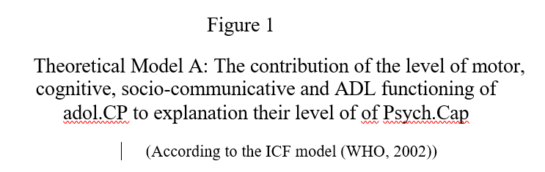

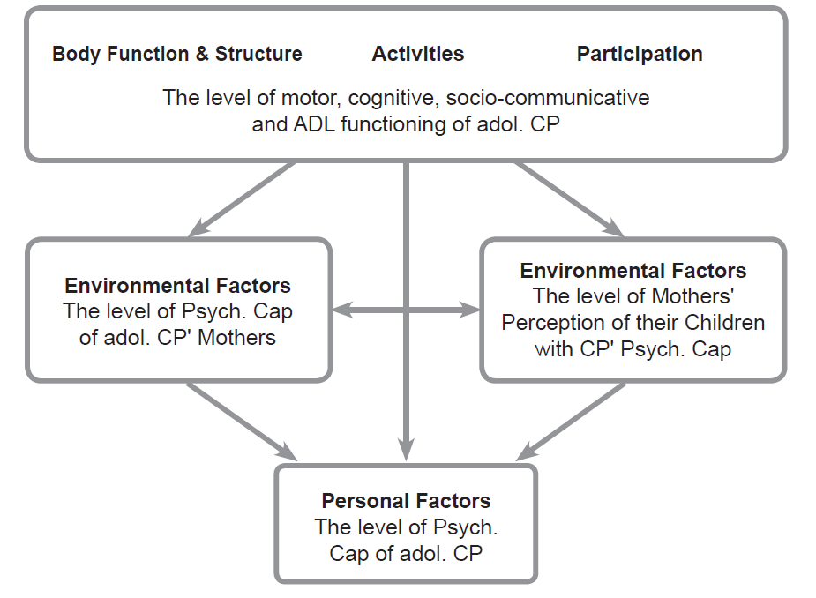

**Conductive Education  Model**: Model B is based on the Conductive Education (CE) approach which asserts that the source of the limitation in the motor activity of the person with CP is not from the motor disability itself, but from psychological marital factors including helplessness, lack of motivation, lack of self-belief acquired by the person from early childhood following the disability and lack of experiences of success in achieving developmental milestones ( Tuersley‐Dixon & Frederickson, 2010). According to the CE approach, the personal psychological resources (motivation, perseverance, optimism, self-belief, etc.) of an adol.CP and the psychological resources of people around him contribute to his level of functioning in various fields (O’Shea, Jones, & Lightfoot, 2020).

In this model (hereinafter - model B) the variable "Psych.Cap of adol.CP" represents their personal psychological resources, similar to the field of "Personal Factors" in model A, the variables "MotherPsych.Cap" and the "Mother-Child.Psych.Cap" represent the psychological resources of the society in which the person with CP lives, similar to the field of "Environmental Factors", while the function of the adol.CP in the motor, cognitive field, the social-communicative and ADL represents the functional result that the person with CP achieves in his life, similar to the fields of "Body function & structure", "Activities" and the field of "Participation" in Model A.

This model tested to what extent the level of Psych.Cap of adol.CP explains the level of functioning of the adolescents in the motor, cognitive, social-communication and ADL functioning areas, as well as the coping of the mothers of these adolescents on its various measures. Theoretical model B is shown in figure 2.

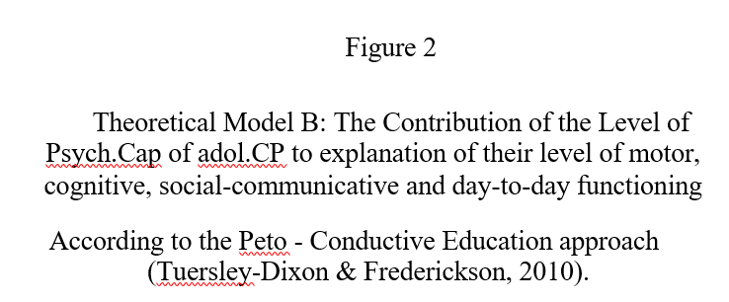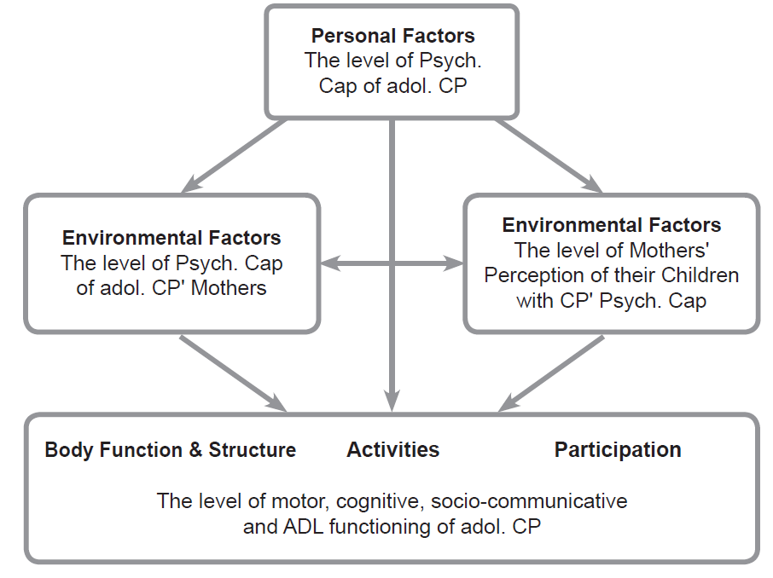

**The aims of the research:**

The current study is an exploratory study. It poses questions that have not yet been investigated in the population of adol.CP. The study posits two possible models to examine the contribution? המשקל שיש לתפקוד ל.... of the relationship between the functioning of adol.CP in the field of motor, cognitive, social-communication and ADL functioning and their psychological resources and strengths, including Psych.Cap.

**Method**

53 adolescents with CP (as a primary diagnosis) participated in the current study.

Adolescents with CP:

Chronological age: 12-21 years (M = 15.83, SD = 2.44).

Gender: 28 boys (52.8%) and 25 girls (47.2%).

All adolescents attend special education schools. In these schools, students study from 7:30 a.m. to 3:30 p.m. Additionally, all students participate in various activities such as classes, the youth movement, activities of annual associations (fun days, trips, classes, etc.).

35 of the participants use a motorized or manual wheelchair for mobility (66% of all participants), 12 use a walker or crutches (23%), 6 move independently without the need for a mobility aid (11%).

The mothers:

Chronological age: 31-60 years (M = 44.50, SD = 6.907)

Education range: from high school graduate to Ph.D.

In our study, analyses were conducted on the demographic indicators in relation to the gender of the adolescents, the age of the mothers, their education and marital status, no differences were found between boys and girls, between mothers of different ages, different marital status or having a different level of education in any of the indicators. Therefore, we will not refer to these factors as variables during the study.

**Research tools**

The current study combined two types of tools:

**1. Assessment of adolescent functioning in the fields of cognitive, motor, social-communication and ADL functioning.**

The adolescents answered the questions with the following tools: Raven's Standard Progressive Matrices and Peabody's PPVT - Peabody Picture Vocabulary Test.

   The mothers filled out the Pediatric Evaluation of Disability Inventory (PEDI).

1.Raven's Standard Progressive Matrices (Raven, Raven & Court, 1998) tests general non-verbal cognitive level and is commonly, used among a population with special needs (including cerebral palsy). The α coefficient of the test among the 53 subjects was high α=.82.

2.Peabody Test - PPVT - Peabody Picture Vocabulary Test (Dunn & Dunn, 1981) - for the purpose of testing the mental age of the subjects, the 1997 test 3-PPVT was used. This test tests vocabulary and is similar to a verbal intelligence test. The test contains 204 items of increasing difficulty. Each item has 4 black and white drawings. The subject is requested to choose the drawing corresponding to the word read to him.

The α coefficient of the test in the current study among the 53 subjects was found to be 85.

3. Pediatric Evaluation of Disability Inventory (PEDI) (Haley et al., 2011) tests the functional ability of children with special needs (including children and adol.CP up to the age of 21) in the areas of ADL, motor and social-communication functioning.

The α coefficient of this tool is 98.

**2.Tools for testing the level of Psych.Cap of adol.CP and MotherPsych.Cap**

To test the level of Psych.Cap of the adol.CP, MotherPsych.Cap and the Mother-Child.Psych.Cap, the following tools were used: The Hope Scale, the General Self-Efficacy Scale, the Life Orientation Optimism Questionnaire (LOT- R), Resilience Scale.

1. The Hope Scale (Snyder et al., 1991) (Hebrew version) measures the level of hope of the individual. The α coefficient of the "goal" component is .71-.77 and of the "path" component is 80. (Snyder et al., 1991).

2. The General Self-Efficacy Scale (Schwarzer & Jerusalem, 1995) measures the individual's level of self-efficacy. The α coefficient of this questionnaire is 94 (Cramm, Strating, Roebroeck, & Nieboer, 2012).

3. The Life Orientation Test-Revised (LOT-R) optimism questionnaire (Scheier et al., 1994) measures the individual's tendency toward optimism. The α coefficient of this questionnaire is α=.78 (Scheier et al., 1994).

4. The Resilience Scale questionnaire (Wagnild & Young, 1993) measures the individual's level of resilience. The α coefficient of this questionnaire is 88. (Cardoso & Sacomori, 2014).

In addition, weighted general indices were built:

A general function index is the sum of the subjects' achievements in the function tests - the Peabody test (level of verbal cognitive function), the Raven test (level of non-verbal cognitive function) and the three PEDI test indices - (level of motor, social-communication and ADL functioning).

A general measure of the Psych.Cap of adol.CP is the sum of all the indices that make up their Psych.Cap.

A general index of the MotherPsych.Cap is the sum of all the indices that make up their Psych.Cap.

A general measure of the Mother-Child.Psych.Cap is the sum of all the indices that make up their perception of their Psych.Cap.

**Research Process**

The research was conducted in the participants' homes, in individual meetings in a quiet room free of auditory and visual distractions. In the same meeting, in another room, the mothers filled out questionnaires intended for them.

The mothers signed an informed consent form and received an explanation of the purpose of the study and the manner of its execution.

The study guaranteed anonymity and did not allow the identity of the subjects or officials to be revealed. The subjects' scores in the various tests and questionnaires were coded and analyzed in SPSS software (Version 23).

**Results**

In this section we present the descriptive statistics data obtained in our study -- the averages, standard deviations, medians and ranges of the background data of the functioning of adol.CP in the areas examined in our study, also their Psych.Cap, the indices of MotherPsych.Cap and the indices of Mother-Child.Psych.Cap .

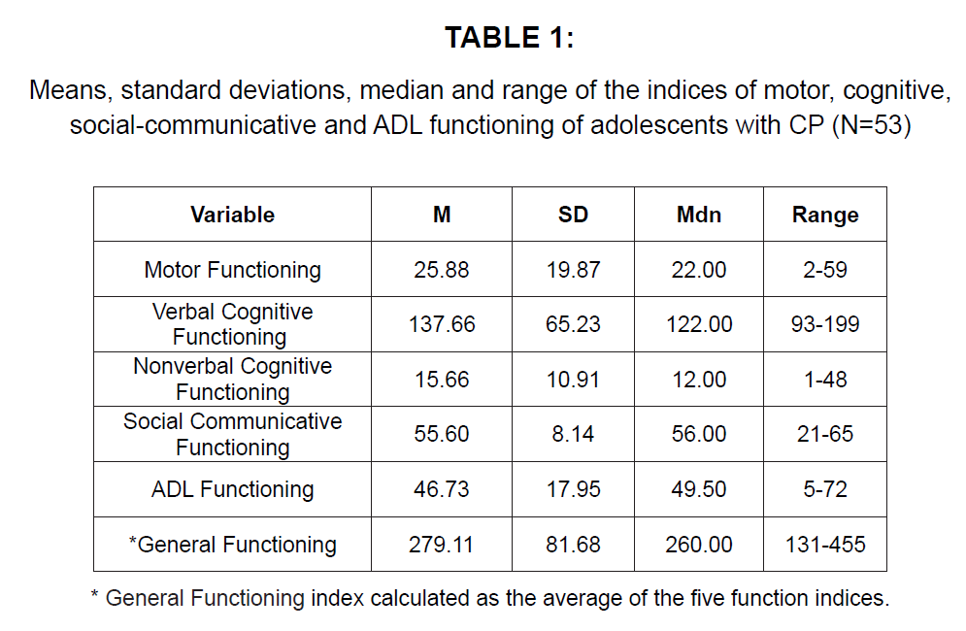

The general functioning of adol.CP is moderate. The highest level of functioning of the adol.CP is in the social-communication field (M=55.60, with range between 21 and 65 points). The level of functioning in the cognitive field is low. The non-verbal cognitive function level scores are M=15.66 with range between 1 and 48 points, and the verbal cognitive function level scores are M=137.66 with range is between 93 and 199 points. Deciphering the verbal cognitive function index scores of the adolescents and presenting it as mental age indicates a low mental age of the participants: M = 8.8, Mdn = 7.6 ranging from 5.9 to 19.7 years, (the chronological age ranging from 12 to 21). In the other areas, the level of adolescents' functioning is medium-high. The building blocks of structural equation analysis (through which we tested the research models) are the two types of variables: observational (manifest) variables and latent variables. Observational variables are variables measured empirically using the research tools. The latent variables are theoretical concepts which are represented by observational variables. The latent variable is not empirically measured but is inferred from its observational variables.

In the current study, the adolescent's level of functioning was examined using five different indices: the motor, verbal cognitive, nonverbal cognitive, social-communicative and ADL domains. All of these are observational variables of our study. In order to simplify the theoretical model which was examined through structural equation analysis (SEM), we examined the possibility of dividing the indicators of the child's functioning level into central factors which will constitute latent variables. In order to examine this, an exploratory factor analysis was conducted. The factor analysis was performed with Varimax type rotation and a minimum Eigenvalue greater than 1 was defined as well as a loading level not less than 30. In the factors analysis, it was found that the five performance indicators can be divided into two main factors: 1. An index containing components of cognitive abilities including the adol.CP’s scores in the area of basic verbal cognition (Peabody test), the scores in the area of basic non-verbal cognition (Raven's test) and the level of social-communication functioning. This factor explained 40.38% of the variance in the adolescents' level of functioning. 2. An index containing components based on motor abilities including the level of motor function of the adol.CP and the level of their ADL functioning. This factor explained 34.65% of the variance in the adolescents' level of functioning. Table 2 shows the loadings of each of the five performance indicators on the two different factors.

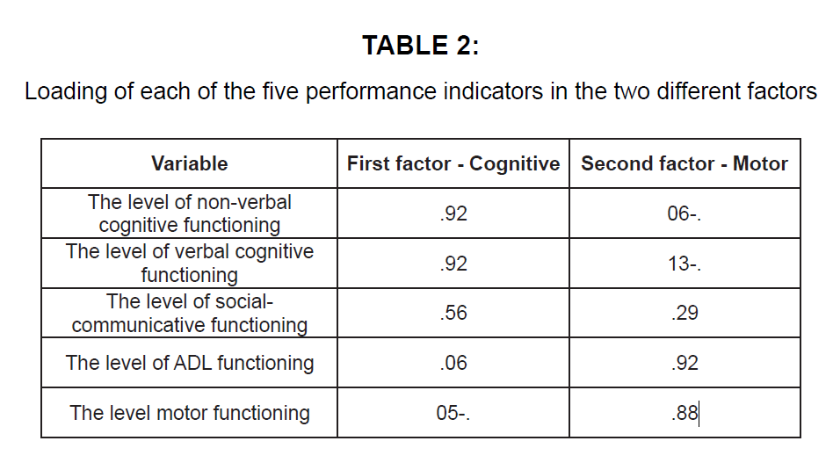

Table 2 indicates that the loading level of the items in the various factors is very high and the ability to distinguish between the two different factors that make up the functioning of the adol. CP is clear. Below we will use these two factors (the cognitive and the motor function) as the research variables.

In order to examine whether there are differences between the Psych.Cap indices of adol.CP, the MotherPsych.Cap indices and the indices of Mother-Child.Psych.Cap, one-way analysis of variance tests of the ANOVA type were conducted with repeated measurements regarding the three of the indices. The independent variable is the object of the measures (within subjects) and the dependent variables are the degree of Psych.Cap - a general measure and each of the four measures of Psych.Cap: the level of hope, self-efficacy, optimism and resilience. First, the findings of the analysis of variance of the Psych.Cap general index is presented and then, the findings of the analysis of variance for each of the four indices of Psych.Cap.

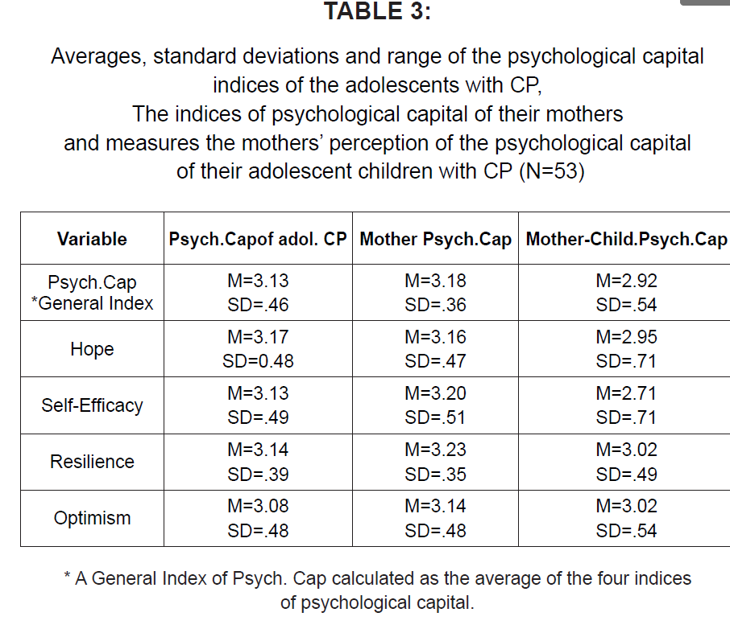**Psych.Cap - general index**: no significant differences were found between the general index of adolescent Psych.Cap and the general index of MotherPsych.Cap (p < .01). In a follow-up Bonferroni test, it was found that both the general index of the mother's Psych.Cap (M = 3.18, SD = 0.36, p < .001) and the general index of the adolescent's capital (M = 3.13, SD = 0.36, p < .05) are significantly higher than the general index of Mother-Child.Psych.Cap (M = 2.92, SD = 0.54). That is, the Mother-Child.Psych.Cap is significantly lower than the adolescent's perception of his own Psych.Cap. In other words, an adol.CP sees himself as having a higher level of Psych.Cap relative to Mother-Child.Psych.Cap.

**Hope:** No significant differences were found between the mother's hope index and the adolescent's one (p < .05). In a follow-up Bonferroni test, it was found that both the adolescent's degree of hope (M = 3.17, SD = 0.48, p < .05) and the mother's degree of hope (M = 3.16, SD = 0.47, p < .05) are significantly higher than the mother's perception of the degree of hope of her adol.CP (M = 2.95, SD = 0.71). That is, the mother's perception of the level of hope of her adol.CP is significantly lower than the adolescent's own perception of his Psych.Cap. In other words, an adol.CP sees himself as having a higher level of hope relative to his mother's perception.

**Self- efficacy**: No significant differences were found between the mother's self-efficacy index and the adolescent's self- efficacy index (p < .001). In a follow-up Bonferroni test, it was found that both the adolescent's degree of self-efficacy (M = 3.13, SD = 0.49, p < .01) and the mother's self-efficacy (M = 3.20, SD = 0.51, p < .001) are significantly higher than the degree of self-efficacy of an adol.CP daughter as perceived by her mother. (M = 2.71, SD = 0.71). That is, the mother's perception of the level of self-efficacy of the adol.CP is significantly lower than the adolescent's own perception of his own self-efficacy. In other words, an adol.CP sees himself as having a higher level of self-efficacy in relation to mother's perception of his self-efficacy level.

**Resilience:** No significant differences were found between the mother's resilience index and the adolescent's resilience index (p < .01). In a follow-up Bonferroni test, it was found that the mother’s perception of the degree of mental resilience of her adol.CP (M = 3.02, SD = 0.49) is significantly lower than the mother's resilience degree (M = 3.23, SD = 0.35, p < .01), but is not significantly different from the degree of adolescent resilience (M = 3.14, SD = 0.39, p = .41). That is, the mother's perception of adol.CP' resilience level is similar to the adolescent's own perception of his own resilience level. In other words, an adol.CP sees himself as having a similar level of self-resilience as his mother perceives him to be.

**Optimism:** It was found that there are no significant differences between the objects of the indices (p = .40). In a follow-up Bonferroni test, it was found that the optimism degree of the adol.CP (M = 3.07, SD = 0.48) is not significantly different from both the mother's optimism degree (M = 3.14, SD = 0.48) and the degree of optimism of the mother's perception of the level of optimism of her adol.CP (M = 3.02, SD = 0.54) is similar to the adolescent's own perception of his own level of optimism (M = 3.07, SD = 0.48). In other words, an adolescent with CP sees himself as having an optimism level similar to that of his mother.

In conclusion: the results of the study show that the mothers of adol.CP perceive the optimism level and the resilience level of their children similar to the adol.CP’s own perception of themselves. However, the Mother-Child.Psych.Cap level is lower both in the general index and in the various Psych.Cap indices (except for the optimism and resilience indices) than the adol.CP's self-perception. Likewise, no differences were found in the degree of Psych.Cap, both in the general index and in the four different factors between the mothers' self-esteem and the adol.CP's self-esteem.

Examination of the two theoretical models to test the direction of the relationship between the adol.CP's functioning level in the areas of motor, cognitive, social communication and ADL functioning and the Psych.Cap level of these adolescents show opposite directions of relationships between the various research indicators.

Model A: The level of motor, cognitive, social-communication and ADL functioning of the adol.CP will contribute to explaining the level of Psych.Cap of their mothers and of the Mother-Child.Psych.Cap.

Model B: The Psych.Cap level of the adol.CP, the level of the Psych.Cap of their mothers and the level of Mother-Child.Psych.Cap will contribute to explaining the level of their motor, cognitive, communicative-social functioning and the ADL functioning of the adol.CP.

In order to test the relationships between the various research indicators at the same time, a SEM (Structural Equation Model) analysis was employed, and based on the assumption that there is a relationship between the research variables. The analysis of the paths in the comparative structural model aims to test the contribution of the independent (exogenous) variables to the prediction of the dependent (endogenous) variable, while testing the contribution of mediating variables (indicators). The general model of a structural equation includes two sub-models: a structural model, which presents path analysis, and a measurement model, which presents confirmatory factor analysis. When the structural component and the measurement component are combined in one step, a comprehensive statistical model is obtained. The theoretical model was tested by AMOS 20 software and is based on the two types of models. In order to examine the suitability of the two proposed models, one must examine the indices of the suitability of the theoretical models with the empirical data obtained from the adol.CP. The first goodness-of-fit index (GFI) that is examined in the two current models is the Chi-square index (also called CMIN). When the CMIN index is not significant, it can be concluded that the proposed models (which are not necessarily the only ones) correspond to the empirical data. If the CMIN indices are significant, the conclusion is that the theoretical models do not match the empirical data and therefore the proposed models are incorrect.

Beyond the examination of the CMIN GFI, additional GFI indices will be examined in the current study of the theoretical model with the empirical data:

A. GFI - an alternative to χ2 is a measure of the percentage of explained variance. Values higher than 0.90 indicate a good fit of the models to the data.

B. CFI (Comparative Fit Index) - this fit index reflects the degree of general explained variance of each of the models. A CFI value close to 1 indicates a good fit of the models to the data. A CFI value higher than the value 0.9 indicates a good fit of the theoretical model with the empirical data.

C. RMSEA (Root Mean Square of Error Approximation) – measurement reflects the degree of GFI of the model while taking into account the simplicity of the model. This index gives weight to the degrees of freedom of the model and values lower than 0.08 indicate a good fit of the models to the empirical data.

In order to test, as mentioned, the relationships between the various research indicators at the same time, a comparative SEM (Structural Equation Model) analysis was used. As mentioned, the use of SEM in this study is based on the assumption that there is a predictive relationship between the research variables.

Findings:

Figure 4

Model A: The contribution of the level of motor and cognitive function of adol.CP to the explanation of their Psych.Cap level

(According to the ICF model (WHO, 2002)).

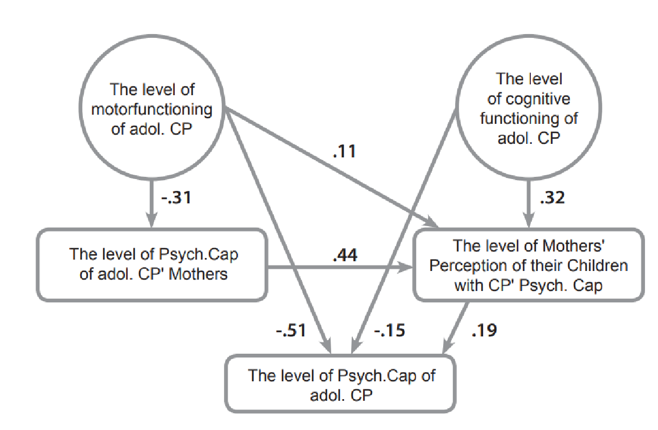

This model showed a good fit of the variables: χ2 = 99.11; df = 85, p = .14, CFI = .97, GFI = .82, RMSEA = .05

According to this model, it is the level of functioning of the adol.CP in the motor and cognitive fields that explains the level of their Psych.Cap. The results show that the level of motor function of the adol.CP explains 51% (in the negative direction) of variation in the level of their Psych.Cap (β = - .51**), i.e. the higher the motor function level of the adol.CP, the lower their Psych.Cap level. The cognitive functioning level of the adol.CP also explains 15% of the variance, also in the negative direction, of their Psych.Cap level (β = - .15*), i.e., the higher the cognitive level of the adol.CP, the lower their level of Psych.Cap.

The motor function level of the adol.CP explains 31% of the variance (in the negative direction) in the level of Psych.Cap of their mothers (β = - .31*). The higher the level of motor function of the adol. CP, the lower their mothers' Psych.Cap. It should be noted that the Psych.Cap level of the mothers of adol.CP is only explained by the adol.CP' motor function level.

The Mother-Child.Psych.Cap is explained by 3 variables: the adol.CP' motor functioning level, their cognitive functioning level and the mothers' Psych.Cap level. Thus, the the adol.CP' motor function level explains 11% of the variance in Mother-Child.Psych.Cap (β = .11*), i.e. the higher the adol.CP' level of motor function, the more their mothers perceive them as having a higher Psych.Cap. The level of cognitive functioning of the adol.CP explains 32% of the variance in Mother-Child.Psych.Cap (β = .32*), i.e. the higher the level of cognitive functioning of the adol.CP, the more their mothers perceive them as having a higher Psych.Cap. Furthermore, the level of Psych.Cap of these mothers explains 44% of the variance in Mother-Child.Psych.Cap (β = .44**), i.e. the higher the mother's Psych.Cap, the more she perceives the level of Psych.Cap of her adol.CP as higher.

In addition to the contribution of the level of motor and cognitive functions to the explanation of the level of Psych.Cap of adol.CP, the Mother-Child.Psych.Cap also contributes to the explanation of 19% of the variance in the level of Psych.Cap of these adolescents (β = .19*). As much as the mother perceives her adol.CP as having a higher Psych.Cap, so too does he see himself as having a higher Psych.Cap.

In conclusion, model A indicates two prominent trends:

1. The level of their motor and cognitive functioning contribute to the Psych.Cap of adol.CP in such a way that the higher the level of both motor and cognitive functioning of adol.CP, the lower their level of Psych.Cap. As such, adol.CP whose functioning is lower are people with a more positive outlook on their lives and vice versa: adol.CP whose functioning is higher are people with a less positive outlook on their lives.
2. The level of motor and cognitive functioning of the adol. CP positively explains the Mother-Child.Psych.Cap: the higher the functioning of the adol.CP, especially their functioning in the motor field, the higher Mother-Child.Psych.Cap. At the same time, the higher Mother-Child.Psych.Cap, the more the adolescents perceive themselves as having higher Psych.Cap. That is to say, the higher the motor and cognitive functioning of adol.CP, the more their mothers see them as people with a more positive outlook on their lives and the more the adolescents themselves see themselves as such.

**Theoretical model B - the contribution of the level of Psych.Cap of adol.CP to explaination of the level of their motor and cognitive function.**

Figure 5

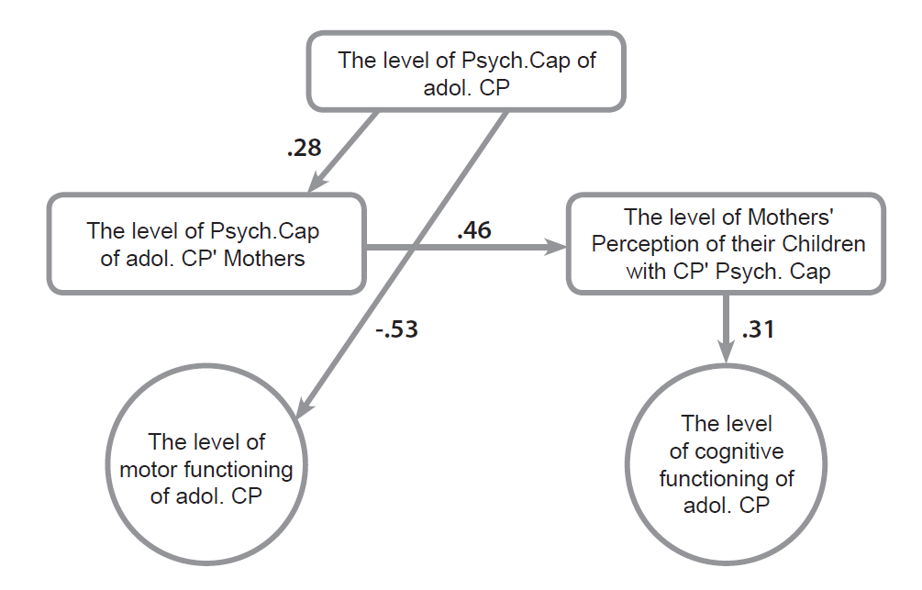

This model showed a good fit of the variables: χ2 = 15.41; df=19, p = .70; GFI = .94; CFI = 1.00; RMSEA = .00

From a comparison of the level of adjustment of the variables of the two models presented above, it appears that the model in with the better adjustment is model A. Also, model A produces higher significance than model B.

According to model B, the level of Psych.Cap of adol.CP contributes to explaining 53% (in the negative direction) of variation in the level of their motor function (β =- .53**). That is, the higher the level of Psych.Cap of the adol.CP, the lower their motor level. At the same time, the level of Psych.Cap of adol.CP does not contribute at all toward explaning the level of their cognitive function.

In addition, this model shows that the level of Psych.Cap of the adol.CP contributes to the explanation of 28% of the variance in the level of Psych.Cap of their mothers (β = .28*). That is, the higher the Psych.Cap of adol.CP, the higher the level of Psych.Cap of their mothers. Yet, at the same time, the level of Psych.Cap of the adol.CP does not contribute at all toward explaining Mother-Child.Psych.Cap.

Also, the level of Psych.Cap of the mothers of adol.CP contributes to 46% of the variance in their perception of the level of Psych.Cap of their adol.CP (β = .46*). Another finding is that the level of Mother-Child.Psych.Cap contributes to the explanation 31% of variation in the level of cognitive functioning of their adol.CP (β = .31*). That is, the more the mothers of adol.CP see themselves as having higher Psych.Cap, the more they see their adol.CP as having higher Psych.Cap, and thus the cognitive functioning of these adolescents is higher.

In conclusion, Model B indicates that the level of Psych.Cap of adol.CP directly explains the level of functioning of the adolescents in the motor field in the negative direction and indirectly explains their functioning in the cognitive field. These two areas of functioning are explained by the Psych.Cap of adol.CP in such a way that the higher the level of Psych.Cap of adol.CP, the lower their level of both motor and cognitive functioning. That is, adol.CP who have a more positive outlook on their lives are those whose level of functioning in various areas is lower.

The conclusions from the model are:

The level of Psych.Cap of adol.CP directly explains the level of their motor function only, 53% in the negative direction. The level of Psych.Cap of adol.CP does not directly explain the level of their cognitive functioning, but only indirectly, through an explanation of the level of Psych.Cap of their mothers and the Mother-Child.Psych.Cap.

From a comparison of the level of adjustment of the variables of the two models presented above, it appears that the better model is model A (according to which the level of motor and cognitive functioning of adol.CP explains the level of their Psych.Cap). This model has a higher significance than model B. In addition, model A fully confirms the implications of the study, unlike model B. Therefore, model A was chosen as the decisive model in the question of the direction of the contribution of the research variables as an explanation of each other.

**Discussion**

One of the issues that preoccupies researchers and field personnel in the fields of psychology, education and rehabilitation of adol.CP is the relationship between the level of functioning of adol.CP in the motor, cognitive, social-communication and ADL functioning and their psychological state.

The main goal of our study was to examine the direction of the relationship between the level of motor, cognitive, social-communication and ADL functioning of adol.CP and their Psych.Cap. The results of the study indicated that the ICF model according to which the level of functioning of adol.CP in the motor, cognitive, social-communication and ADL functioning explains their level of Psych.Cap is the model with the most significant statistical fit. The results also show that the level of functioning of adol.CP in the motor, cognitive, social-communication and ADL functioning areas does contribute to explaining their level of Psych.Cap in such a way that a lower level of functioning of the adolescents, especially their functioning in the motor field, contributes to a higher level of their Psych.Cap.

A theoretical model that best explains the results of our research is the Disability Centrality model (Bishop, Stenhoff, & Shepard, 2007). It holds that an adolescent who has not come to terms with his disability retains his high expectations of himself which do not match his abilities, and thus is not satisfied with himself. This model is a possible explanation for the findings of our research, according to which an adolescent with a high level of motor functioning reports a low level of Psych.Cap. Such an adolescent who tries to achieve higher motor function results than he is capable of achieving, becomes more and more disappointed with himself and therefore his level of Psych.Cap decreases.

It also means, the low level of motor of an adol.CP contributes to his high level of Psych.Cap. This is a result of the adol.CP coming to terms with and accepting his disability. With a realistic view of his abilities comes the re-organization of his priorities and expectations of himself and the redirection of resources to other areas of life. In other words, a lower level of motor function leads the adolescent to come to terms with his condition and to a better quality of life, as reflected in the Psych.Cap of adol. CP.

How can we explain the finding of our research according to which a low level of motor function (that is, a lower level of independence) contributes to a higher Psych.Cap and vice versa? A possible explanation for this fact lies in the fact that people with CP whose motor function in adolescence is low, grew up as children whose level of motor function was already low in early childhood. A low level of motor function, even if the person's mobility skills have improved somewhat over the years of practice, leads to the fact that throughout the years and into adolescence a person with CP gets around using a wheelchair or a walker. An adolescent who spends most of his years moving around using a wheelchair or a walker, is used to this way of mobility. It is possible that he/she has never known otherwise, and that makes him accept!?להתנהל ביעילות בתוך הנכות his disability and reconcile with his situation. Acceptance of adolescents with various disabilities, among them adol.CP, helps them develop realistic expectations of themselves and thus contributes to improving their psychological condition (Madi, Mandy, & Pountney, 2012).

In addition, the level of cognitive functioning of participants in our study is moderately low, which adds to the explanation of the high level of their Psych.Cap. These adolescents do not sufficiently understand their low level of motor functioning, and do not see their difficulties realistically.

There are other possible explanations for this phenomenon.

Social desirability: The Psych.Cap questionnaires we used in the present study are self-report questionnaires delivered by the interviewer. It may be assumed that the high scores in the various dimensions of the Psych.Cap of adol.CP reflect "social desirability" typical of people with disabilities (Stoeber, 2001). Social desirability is a concept that explains a possible bias resulting from the tendency of the interviewee to please the questioner according to what he thinks is expected of him.

Adol. CP present themselves as having a much more positive body image than the people in their environment see in them (Adamson, 2003). This finding explains the participants' desire to present themselves as "normative" in the eyes of the interviewer.

Failure to meet the expectations of the environment and self-expectations: The higher the level of motor function of the adol. CP, the more expectations there are of him (both of the environment and of himself) for higher achievements. When this adolescent doesn't achieve these expectations, there is often disappointment which affects one’s self-esteem, self-image and self-depravity. In contrast, the expectations for achievements from an adol.CP with a low functional level are realistic, and this contributes to a high level of Psych.Cap of adol.CP (Ribeiro et al., 2014).

Realism and awareness of the limitation:

We found that adol.CP whose cognitive level is low, don't understand their disability in a realistic way, therefore they perceive their abilities to be much higher than they are in reality. They see themselves as having a high level of Psych.Cap. Conversely, adol.CP whose cognitive function is high, understand their true situation, are aware of their disability, and therefore report a low level of their Psych.Cap (Varsamis, & Agaliotis, 2015).

In conclusion, we found that the decisive model is the model according to which the level of functioning of the adolescents in the various fields, especially in the motor field, explains the level of their Psych.Cap, specifically that the higher the functional level of the adolescents, the lower the level of their Psych.Cap. At the same time, a high level of the motor function of adol.CP explains the low level of Psych.Cap of the mothers of these adolescents. Aditionally, the higher the functional level of the adol.CP in all the areas examined and the higher the level of Psych.Cap of their mothers, the more the mothers see their adol.CP as having higher Psych.Cap, which explains the high level of Psych.Cap of these adolescents.

**Bibliography:**

Adamson, L.(2003). Self-image, adolescence, and disability*, American Journal of Occupational Therapy,* 57(5),578*-*581*.*

[Bandura, A.](http://en.wikipedia.org/wiki/Albert_Bandura) (2001). [Social cognitive theory: An agentic perspective](http://www.des.emory.edu/mfp/Bandura2001ARPr.pdf). *Annual Review of Psychology*, *52*(1), 1-26.

Bishop, M., Degeneffe, C.E., & Mast, M. (2007). Family needs after traumatic brain injury: Implications for rehabilitation counseling. *Australian Journal of Rehabilitation Counselling, 12* (2), 73-87 .

Cardoso, F. L., & Sacomori, C. (2014). Resilience of athletes with physical disabilities: A cross-sectional study. *Revista de Psicologia del Deporte*, *23*(1), 15-22.

Carver, C. S., Scheier, M. F., & Segerstrom, S. C. (2010). Optimism. *Clinical Psychology Review, 30*, 879-889.

Cramm, J. M., Strating, M. M. H., Roebroeck, M. E., & Nieboer, A. P. (2012). The importance of general self-efficacy for the quality of life of adolescents with chronic conditions. *Social Indicators Research, 113*(1), 551-561.

Downs, J., Blackmore, A., Epstein, A., Skoss, R., Langdon, K., & Jacoby, P. et al. (2017). The prevalence of mental health disorders and symptoms in children and adolescents with cerebral palsy: a systematic review and meta-analysis. *Developmental Medicine & Child Neurology, 60*(1), 30-38.

Dunn, L., & Dunn, L. (1981). *The Peabody Picture Vocabulary Test- Revised.* Circle Pines, MN: American Guidance Service.

Fritz, H., & Sewell-Roberts, C. (2018). Family Stress Associated with Cerebral Palsy. *Cerebral Palsy,* 1–31.

Graber, J., Brooks-Gunn, J., & Petersen, A. (2018). *Transitions Through Adolescence.* London: Taylor & Francis Group.

Guan, L., Qi, M., Zhang, Q., & Yang, J. (2014). The neural basis of self-face recognition after self-concept threat and comparison with important others. *Social Neuroscience, 9*(4), 424–435.

Haley, S. M., Coster, W. J., Dumas, H. M., Fragala-Pinkham, M. A., Kramer, J., NI, Ludlow, L. H. (2011). Accuracy and precision of the Pediatric Evaluation of Disability Inventory Computer-Adaptive Tests (pedi-CAT). *Developmental Medicine &amp; Child Neurology*, *53*(12), 1100–1106.

Heiman, T. (2002). Parents of children with disabilities: Resilience, coping, and future expectations. *Journal of Developmental and Physical Disabilities*, *14*(2), 159-171.

Ketelaar, M., Volman, M. J. M., Gorter, J. W., & Vermeer, A. (2008). Stress in parents of children with cerebral palsy: What sources of stress are we talking about? *Child: Care, Health and Development, 34*(6), 825-829.

King, G., Cathers, T., Polgar, J. M., MacKinnon, E., & Havens, L. (2000). Success in life for older adolescents with cerebral palsy. *Qualitative health research, 10*(6), 734-749.

Kriti, K., Pradhan, A., & Tufel, S. (2019). Severity of cerebral palsy and its impact on level of stress in the caregivers: A correlational study. *The Indian Journal of Occupational Therapy, 51*(1), 21.

Lackaye, T., Margalit, M., Ziv, O., & Ziman, T. (2006). Comparisons of Self-Efficacy, Mood, Effort, and Hope Between Students with Learning Disabilities and Their Non-LD-Matched Peers. *Learning Disabilities Research & Practice, 21*(2), 111–121.

Levitt, S., & Addison, A. (2019). *Treatment of cerebral palsy and motor delay.* Hoboken, NJ: Wiley Blackwell.

Luthans, F., & Youssef-Morgan, C. M. (2017). Psychological capital: An evidence-based positive approach. *Annual Review of Organizational Psychology and Organizational Behavior, 4,* 339–366.

Madi, S., Mandy, A., & Pountney, T. (2012). The Perception of the Term Cerebral Palsy (CP) in Saudi Arabia. *Archives Of Disease In Childhood*, *97*(Suppl 2), 495-496.

Majnemer, A. (2011). Importance of motivation to children's participation: A motivation to change. *Physical and Occupational Therapy in Pediatrics, 31*, 1-3.

Masten, A. S. & Obradovic, J. (2006). Competence and Resilience in Development, Annals: *New York Academy of Sciences, 1094 (1),* 13-27.

O’Shea, R., Jones, M., & Lightfoot, K. (2020). Examining conductive education: Linking science, theory, and intervention. *Archives of Rehabilitation Research and Clinical Translation, 2(4)*, 100077.

Palisano, R. J., Copeland, W. P., & Galuppi, B. E. (2007). Performance of physical activities by adolescents with cerebral palsy. *Physical Therapy*, *87*(1), 77-87.

Park, M. S., Chung, C. Y., Lee, K. M., Sung, K. H., Choi, I. H., & Kim, T. W. (2012). Parenting stress in parents of children with cerebral palsy and its association with physical function. *Journal of Pediatric Orthopedics: Part B*, *21*(5), 452-6.

Parkes, J., McCullough, N., Madden, A., & McCahey, E. (2009). The health of children with cerebral palsy and stress in their parents. *Journal of Advanced Nursing, 65*(11), 2311-2323.

Raven, J., Raven, J. C., & Court, J. H. 1998. Manual for Raven's Progressive Matrices and Vocabulary Scales, Section 1: General Overview. *San Antonio, TX*: Harcourt Assessment.

Ribeiro, M. F. M., Sousa, A. L. L., Vandenberghe, L., & Porto, C. C. (2014). Parental stress in mothers of children and adolescents with cerebral palsy. *Revista Latino-Americana De Enfermagem, 22*(3), 440–447.

Rosenbaum, P., Paneth, N., Leviton, A., Goldstein, M., & Bax, M. (2007). A report: The definition and classification of cerebral palsy, April 2006. *Developmental Medicine and Child Neurology*, *49*(2), 8-14.

Russo, R. N., Goodwin, E. J., Miller, M. D., Haan, E. A., Connell, T. M., & Crotty, M. (2008). Self-Esteem, Self-Concept, and Quality of Life in Children with Hemiplegic Cerebral Palsy. *The Journal of Pediatrics,* *153*(4), 473-477.

Scheier, M. F., Carver, C. S., & Bridges, M. W. (1994). Distinguishing optimism from neuroticism (and trait anxiety, self-mastery, and self-esteem): A re-evaluation of the Life Orientation test. *Journal of Personality and Social Psychology*, *67*, 1063-1078.

Schwarzer, R., & Jerusalem, M. (1995). Generalized self-efficacy scale. In J. Weinman, S. Wright, & M. Johnston (Eds.), *Measures in health psychology: A user’s portfolio. Causal and control beliefs* (pp. 35-37). Windsor, UK: NFER-NELSON.

Seligman, M. (1991). *Learned optimism: How to change your mind and your life*. New York: Knopf.

Snyder, C. R. (2002). Hope theory: Rainbows in the mind. *Psychological Inquiry, 13*, 249-275.

Snyder, C. R., Harris, C., Anderson, J. R., Holleran, S. A., Irving, L. M., Sigmon, S. T., Yoshinobu, L., Gibb, J., Langelle, C., & Harney, P. (1991). The will and the ways: Development and validation of an individual-differences measure of hope. *Journal of Personality and Social Psychology, 60*(4), 570–585.

Stoeber, J. (2001). The social desirability scale-17 (SD-17). *European Journal of Psychological Assessment, 17*, 222-232.

Tuersley‐Dixon, L., & Frederickson, N. (2010). Conductive education: appraising the evidence. *Educational Psychology in Practice, 26*(4), 353–373.

 Tuersley‐Dixon, l., &  Frederickson, N. (2010). Conductive education: appraising the evidence. *Educational Psychology in Practice, 26(4),* 353-373.

Varsamis, P., & Agaliotis, I. (2015). Relationships between Gross- and Fine Motor Functions, Cognitive Abilities, and Self-Regulatory Aspects of Students with Physical Disabilities. *Research in Developmental Disabilities, 47*, 430-440.

Wagnild, G. M., & Young, H. M. (1993). Development and psychometric evaluation of the Resilience Scale. *Journal of Nursing Measurement, 1*(2), 165-178.

WHO (2002).[International Classification of Functioning, Disability and Health (ICF). who.int](https://www.who.int/standards/classifications/international-classification-of-functioning-disability-and-health)