1. Introduction – HIV as a model for studying metazoan transcription regulation
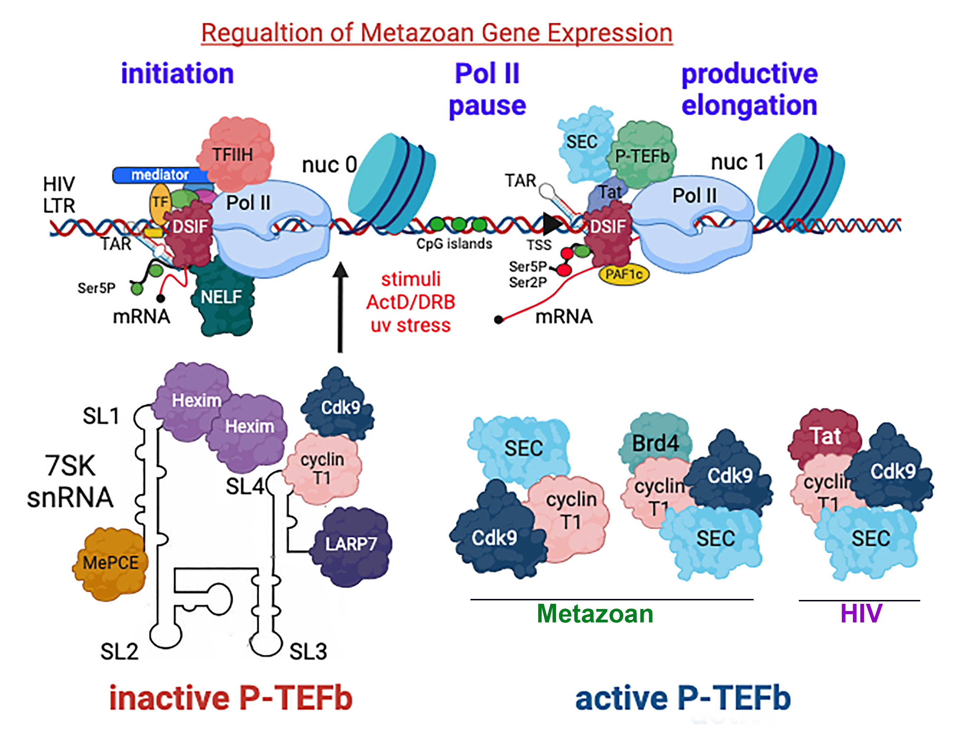
Metazoan gene transcription control by RNA polymerase II (Pol II) is a multi-step process which is highly coordinated by numerous transcription factors that execute an accurate gene expression program in a highly dynamic environment. Early transcription events include the recruitment of DNA-binding transcription factors (TF) to their specific motifs within promoters. With the help of additional pioneering factors, chromatin-modifying enzymes are brought into the complex to remodel the condensed nucleosome environment and expose core promoter elements near transcription starting sites (TSS). General transcription factors and mediators are then assembled and Pol II is recruited to the promoter to form the pre-initiation complex (PIC), which facilitates the initiation of nascent RNA synthesis [1-6]. As a part of the PIC, TFIIH has roles in both transcription and DNA excision repair. Its core module accelerates promoter DNA unwinding that is mediated by the XBP subunit and is linked via Mat1 to a second kinase module. Here, cdk7 joins cyclin H and acts as a CDK-activating kinase (CAK) to phosphorylate cellular kinases cdk1-6
, and regulate the cell cycle [7-9]. Cdk7 also phosphorylates serine residues 5 and 7 (Ser5/7) of the Pol II C-terminal domain (CTD) [2, 10]. While Ser5P modification attracts capping enzymes which act on the nascent RNA and also disrupt interactions of Pol II with mediator, thereby enhancing TFIIH-mediated promoter clearance and Pol II pausing, Ser7P primes the CTD for subsequent Ser2 phosphorylation [11-13]. At this stage of the transcription program, the DRB sensitivity-inducing factor (DSIF, which already associates with Pol II) and negative elongation factor (NELF) jointly assemble onto PIC to induce pausing of Pol II at +20-60 nucleotides from TSS [14-16]. Only upon recruitment of the positive transcription elongation factor b (P-TEFb; cdk9; cyclin T) and the super elongation complex (SEC) is the paused Pol II released from its pausing, triggering elongation of the nascent RNA. This step is mediated through phosphorylation of Spt5, NELF, and the CTD (at Ser2) by cdk9 [17, 18]. Other kinases, including cdk12 and cdk13, can also mediate Ser2 phosphorylation [19-25]. As a pivoted transcription complex, the activity of P-TEFb is tightly regulated in cells. Active P-TEFb is assembled together with SEC or bromodomain-containing protein 4 (Brd4), while the inactive complex resides within the 7SK snRNP and serves as a P-TEFb reservoir [26-29]. In the unique case of HIV, the Tat protein binds to the TAR stem-loop RNA and hijacks P-TEFb from 7SK to the viral promoter via interactions with cyclin T1 to promote productive elongation [22].
Figure 1: HIV as a model for metazoan gene transcription regulation
The general steps of the transcription program include promoter initiation and clearance, Pol II pause-release, and productive elongation. TFIIH is part of PIC and facilitates promoter initiation and clearance through phosphorylation of serine 5/7 on the CTD of Pol II. P-TEFb phosphorylates NELF, DSIF (Spt4/5), and Ser2 to promote pause-release of Pol II and elongation. In cells, P-TEFb is tightly regulated in an inactive complex that is assembled within a 7SK snRNAP, and a free active complex. Active P-TEFb is associated with Brd4, SEC, and other cellular transcription factors. For the unique case of HIV, Tat binds cyclin T1 and hijacks P-TEFb from 7SKsnRNP to the viral promoter. Adapted from Scruggs and Adelman (2015). The figure was generated by Biorender.
Over the years, research on the regulation of HIV gene expression has served as a model for understanding the mechanisms that dictate metazoan gene expression [30, 31]. Both the integrated provirus and its host genes are tightly synchronized and progress through the cycle of gene expression. Importantly, HIV was one of the first systems in which the control of gene expression at steps of Pol II pause and release for productive elongation was documented [32-34]. Understanding HIV gene transcription regulation has significant clinical implications, as transcription repression of the proviral genome early in the course of infection promotes the establishment of infected cell reservoirs. These reservoirs comprise mainly memory-resting CD4⁺ T cells and myeloid lineage cells, and carry transcriptionally silent yet replication-competent intact proviruses that persist despite administration of antiretroviral therapy (ART) and the effects of the host immune response [35]. The infected cells within the reservoirs go through a selection process to express surface marker signatures that confer their increased resistance to immune-mediated killing and are paired with elevated levels of immune checkpoint markers which limit proviral gene transcription [36-41]. Extensive research has been conducted to understand the molecular mechanisms that elicit HIV latency [42]. Cellular transcription regulation and epigenetic constraints that are imposed on the integrated provirus play pivotal roles in suppressing HIV transcription [43]. Within infected resting T cells, minimal levels of basal and elongating transcription factors combined with the absence of the viral trans-activator of transcription (Tat) further ensure that proviral transcription remains beneath detectable levels [34, 44, 45]. To translate these observations into clinical therapeutic benefits, one proposed approach to eliminate the viral reservoirs is the “shock and hill” strategy. Here, latency reversing agents (LRAs) are used to activate doormat HIV-infected T cells and then facilitate cell death through viral cytopathic effects or immune-mediated killing. Such treatment is carried out in the presence of ART to inhibit rebound HIV replication [46-48]. Conversely, the “block and lock” methodology aims to free infected individuals from ART by suppressing HIV transcription and inducing a deep state of latency [49]. However, despite promising outcomes, ongoing strategies to eliminate HIV reservoirs have unfortunately fallen short of achieving clinical effectiveness, underscoring the necessity for a comprehensive understanding of the molecular events that control HIV gene expression and govern the establishment and maintenance of HIV latency [50-55].
2. Preliminary Work
2.1 Identification of differentially expressed cellular factors that regulate HIV gene expression and viral latency following stimulation of primary CD4 T cells. In an effort to identify critical cellular transcription regulators of HIV gene expression and viral latency, we monitored changes in the transcriptome of CD4-positive primary T lymphocytes isolated from healthy donors upon T cell stimulation and HIV infection (n=4). CD4+ primary T cells were stimulated with anti-CD3/CD28 beads and were then transduced with HIV_{GKO}. This reporter lentivirus encodes a codon-optimized GFP reporter that is controlled by the HIV-1 LTR promoter, along with an mKO2 reporter cassette driven by the constitutive promoter EF1α (provided by E. Verdin; Fig 2A) [56]. Transduction with this virus allows simultaneous measurements of the two reporters by FACS, which monitors both HIV gene expression and latency based on HIV-GFP expression and transduction efficiency levels by the expression of EF1α-mKO2. Following the transduction of primary CD4+ T cells, two distinct cell populations were obtained and sorted based on their GFP and mKO2 expression profiles: HIV-transduced cells that express transcriptionally active virus (GFP+; mKO2+; P2) and transduced cells that carry a transcriptionally repressed HIV provirus (GFP-; mKO2+; P1) (Fig. 2A). RNA was extracted from each of the two cell groups and subjected to library construction and RNA-sequencing (RNA-Seq). Our analysis revealed that T-cell stimulation induced a broad change in cellular gene expression (Fig. 2B). Differential expression analysis of genes in active versus latent HIV-infected cells identified 684 annotated genes that were differentially expressed; of these, 636 were upregulated and 48 were downregulated (adjusted p-value ≥0.05; log2 FC>2). KEGG enrichment analysis revealed significant enrichment of genes involved in transcription regulation, cell differentiation, inflammatory, immune responses, and more. We next validated the RNA-Seq data by direct RT-qPCR on representative differential genes in primary CD4+ T cells. By comparing resting and stimulated conditions, a notable shift in expression levels was confirmed for most tested genes (Fig. 2C). Intriguingly, several mRNA transcripts that are known to impact HIV were identified, including HSP90 [57], ESR-1 [58], ELL [59], and IFI16 [60]. Also identified were cyclin T1, an established partner of HIV Tat [32, 61], and ZNF304, which was previously identified by our group as a silencer of HIV gene expression [62]. Given that host transcription factors are required for the regulation of HIV gene expression, the overall goal of this work will be to elucidate their role in HIV-specific and cellular transcription regulation.
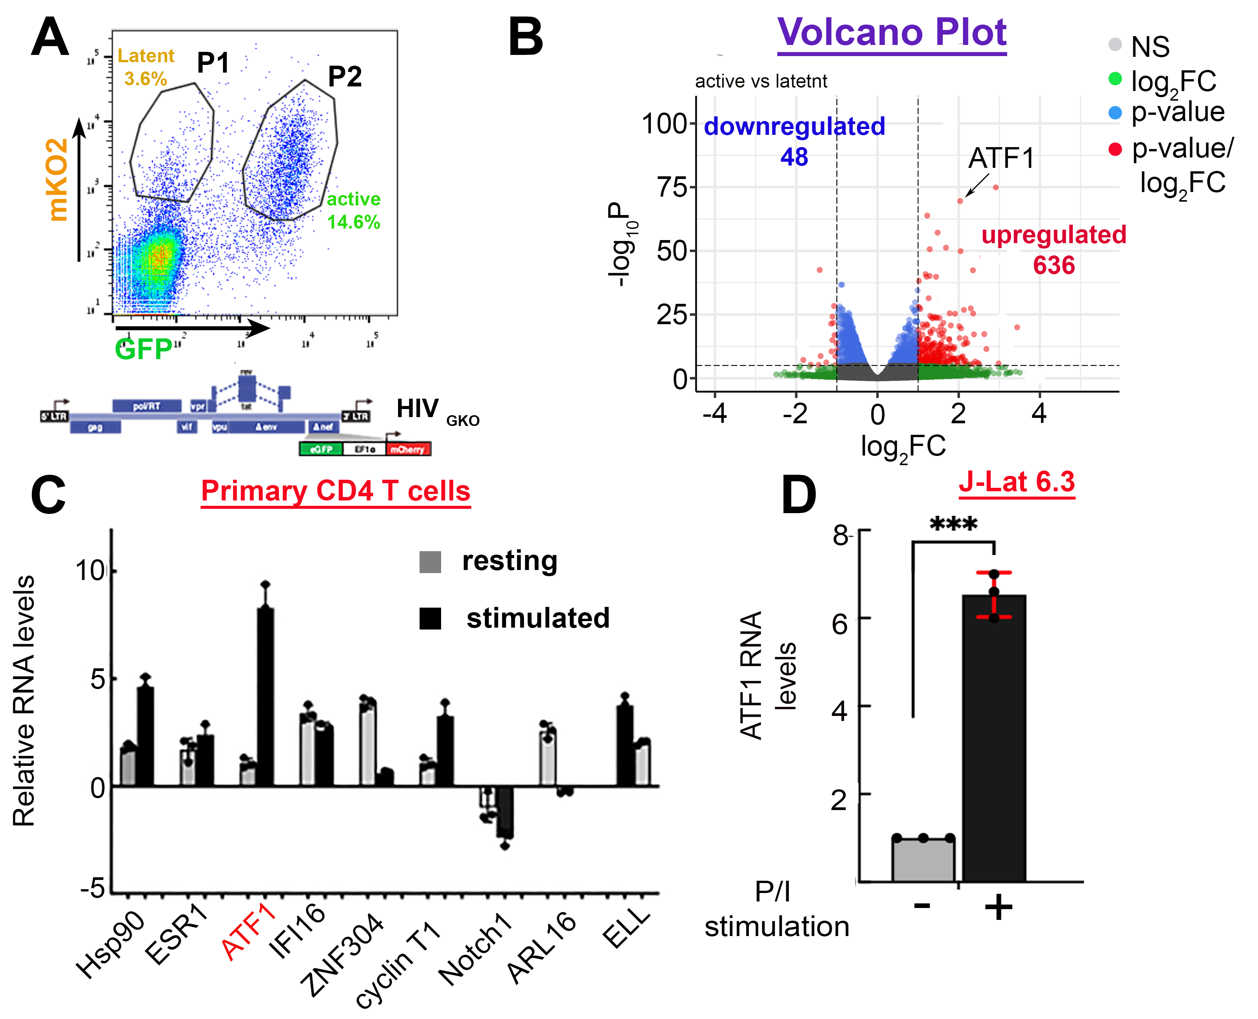
Figure 2: RNA-Seq reveals differential expression of multiple transcripts during latent and active HIV infection
)A( Isolation of stimulated primary CD4+ T cells carrying active or latent HIV. FACS plot of stimulated CD4+ T cells transduced with HIV_{GKO}. The gated P2 exhibits transduced cells that carry active HIV (GFP+/mKO2+). Conversely, the P1 gate shows HIV-transduced cells expressing only mKO2, therefore carrying latent HIV (GFP-; mKO2+).
)B (Volcano plot of RNA-Seq of primary CD4+ T cells carrying active or latent HIV, illustrating the expression changes (log₂FC) between cells carrying active HIV versus latent HIV with an adjusted p-value of ≤0.05 (n=4).
(C) Expression of top candidates in primary CD4+ T cells under resting or stimulated conditions. RNA levels of the most prominent transcription factors that display differential expression in stimulated versus resting primary CD4+ T cells. RNA levels were monitored by RT-qPCR and normalized to GAPDH, and are presented as mean±SD.
(D) ATF1 RNA levels in J-Lat 6.3 are elevated upon T cell stimulation. RNA was extracted from cells under resting conditions or P/I stimulation and was monitored by RT-qPCR. Data are normalized to GAPDH and presented as mean±SD. n=3; *** p≤0.05.

2.2 Activating transcription factor 1 (ATF1) regulates HIV gene expression and latency.
Among the transcription factors that exhibited robust induction of expression upon T cell stimulation of HIV-infected CD4+ primary T cells, our attention was drawn to activating factor 1 (ATF1) as a promising regulator of HIV gene expression. Initially, elevated RNA levels of ATF1 upon T cell stimulation were confirmed in Jurkat 6.3 T cells (Fig. 2D). ATF1, a member of the ATF/CREB family (ATF1-7), features a basic leucine zipper (bZIP) motif in its C-terminus region that binds to a 5'-GTGACGT^{A}_{c}^{A}_{G}-3 consensus sequence in both viral and eukaryotic promoters and activates transcription. ATF1 is a cAMP-induced transcription initiation factor and exerts its effects over numerous cellular pathways by modulating the expression of target genes that are associated with growth, differentiation, apoptosis, and inflammation-related processes. Two of the best-characterized classes of genes that contain ATF binding sites are the E1A-inducible adenoviral and cAMP-inducible genes [63, 64]. Activation of ATF1 occurs through phosphorylation of a serine residue at position 63 by several possible kinases, including PKA, calmodulin-dependent protein kinase I/II, and cdk3. Notably, ATF1 expression also promotes human malignancy, as it fuses with FUS or EWSR1 proteins and forms chimeric oncogenes that are highly expressed in various cancers [45]. In the context of HIV, CREB/ATF proteins have been reported to be activators of transcription. ATF1 binds to AP-1 binding sites on the HIV promoter and mediates cellular activation through PKA pathways [65-68]. However, the molecular mechanisms by which ATF1 functions in regulating HIV-specific or cellular gene expression are not thoroughly studied, and its effects on viral latency have not been documented.
2.3 Manipulation ATF1 expression levels and effects on HIV gene expression.
Given the identification of ATF1 as a transcription factor that is differentially expressed following T cell stimulation of HIV-infected CD4+ primary lymphocytes and the fact that its expression is correlated with HIV gene activation, we initiated gain- and loss-of-function studies to unravel its role in the regulation of HIV gene expression. To manipulate ATF1 expression in CD4+ T cells, we first transitioned our efforts into T cell lines that are infected with HIV, which are an excellent model for studying the control of HIV gene expression and viral latency. These Jurkat-based T cells are easily grown in culture and are readily subjected to gene manipulation. Our cells carry transcriptionally silenced (latent) integrated proviral HIV, in which a GFP reporter gene is inserted under the control of a viral promoter, allowing measurement of HIV gene expression by FACS. As different cell models of HIV latency behave differentially in response to T cell stimulation and latency reversal due to the clonal integration sites of the provirus, two distinct latency models for the effects of ATF1 were tested: 1) Jurkat 6.3 (J-Lat 6.3) cells that are infected with a full-length HIV provirus, which is transcriptionally repressed unless activated by T cell activators, leading to increased GFP expression [69]; and 2) 2D10 Jurkat cells that carry a mini-lentiviral cassette expressing Tat, Rev, and a short-lived green fluorescent protein (d2EGFP) under the control of the viral promoter [70]. We achieved knockout (KO) of ATF1 in both cell lines by transducing cells with a lentivirus that drives the expression of CRISPR-Cas9 and a specific sgRNA that targets ATF1. As a control, cells were also transduced with a lentivirus that expresses both Cas9 and a scramble sgRNA, and does not target any gene in cells. Following transduction, cells were selected for antibiotic resistance and analyzed for ATF1 RNA levels by RT-qPCR. Our analysis confirmed that in both J-Lat 6.3 and 2D10 cells, efficient ATF1 KO was obtained, and ATF1 RNA levels were low when compared to control cells that expressed scramble sgRNA (Fig. 3A and 3B; compare gray to red bars). A similar protocol was employed to obtain ATF1 overexpression using a lentivirus that expresses ATF1. ATF1-overexpressed cells (OE) exhibited a significant increase in ATF1 RNA levels (Fig. 3A and 3B; compare gray to green bars).
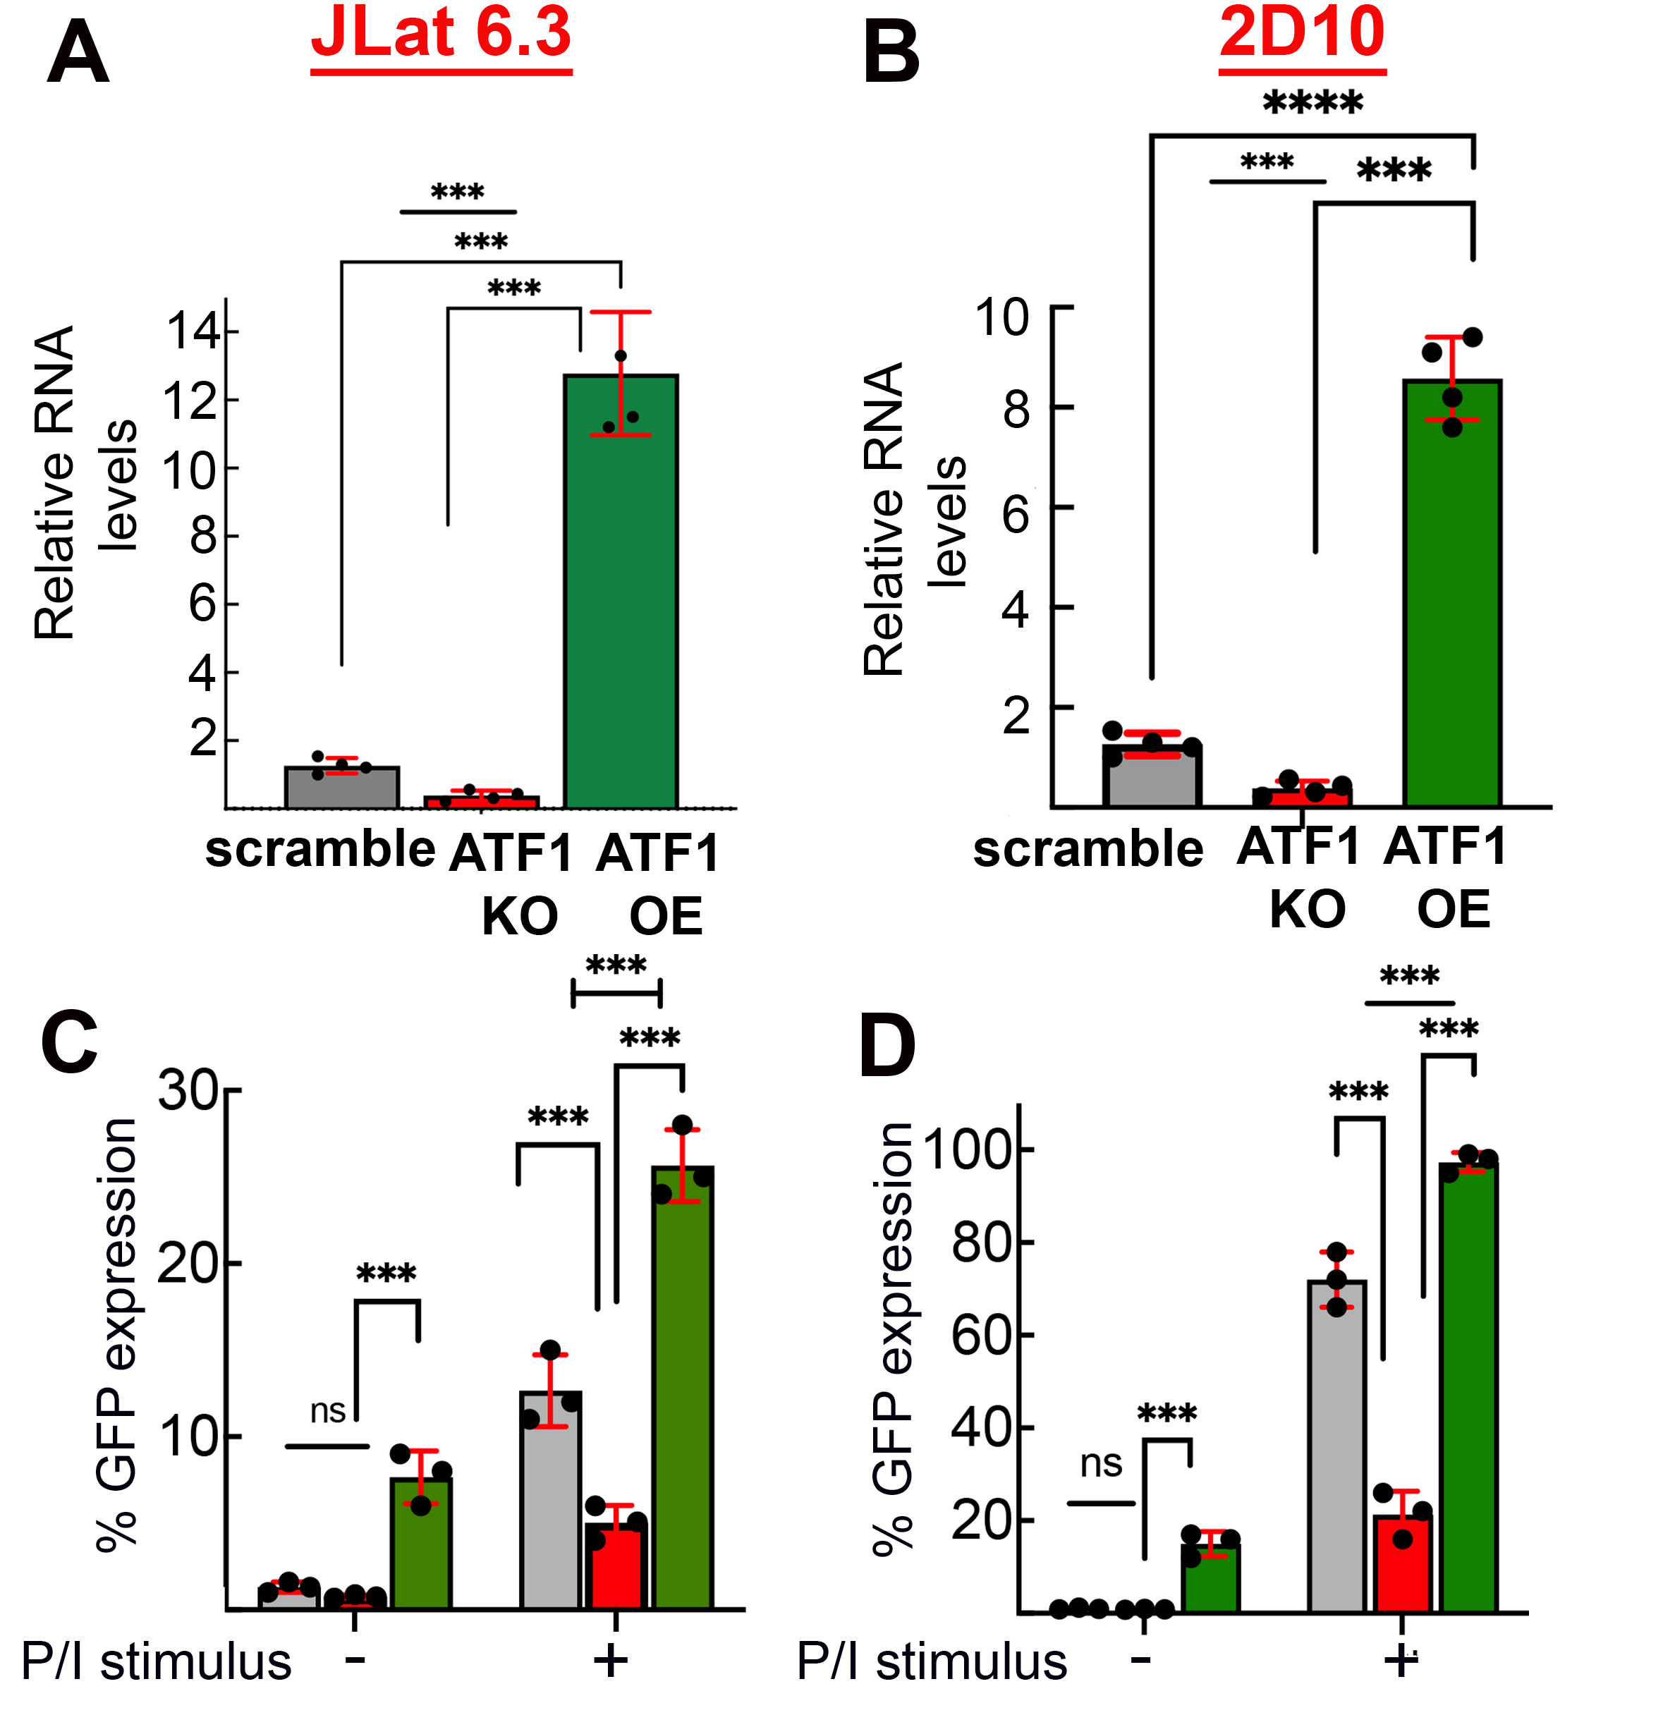
Conducting parallel FACS-based analyses of HIV-GFP expression in J-Lat 6.3 or 2D10 cells in which ATF1 expression was manipulated provided insight into the role of ATF1 in regulating HIV gene transcription. In the absence of T cell stimulation, a modest effect on HIV gene expression was observed only in cells that overexpressed ATF1. In ATF1 KO cells, we could not document an effect on HIV gene expression relative to control cells. Yet, recognizing the multi-factorial nature of HIV latency in different cell models with blocks in several transcription steps, our efforts shifted to assessing the role of ATF1 in HIV gene expression following T cell stimulation. Our two cell models were stimulated with commonly used activators, phorbol 12-myristate 13-acetate (PMA), which is a potent activator of protein kinase C (PKC), combined with ionomycin, a calcium ionophore that facilitates calcium transport into cells, to achieve optimal T cell stimulation (P/I). HIV-GFP expression was monitored by FACS in the context of ATF1 gene manipulation. Our observations indicated that for both cell lines tested, T cell stimulation of control cells with P/I increased the levels of HIV-GFP, while ATF1 KO reduced these effects of T cell stimulation by P/I relative to control cells. On the other hand, ATF1 overexpression (OE) elevated HIV-GFP expression relative to control in both cell models (Fig. 3 C+D).
Figure 3: Role of ATF1 in HIV gene expression
A+B RT-qPCR analysis showing ATF1 RNA levels in J-Lat 6.3 (A) and 2D10 (B) Jurkat T cells following CRISPR-mediated knockout (KO) of ATF1 (red bar), or ATF1 overexpression (OE; green bar). RNA levels were normalized to GAPDH and are presented relative to control cells expressing scrambled sgRNA (gray bar) - set to 1. Statistical analysis was performed by two-way ANOVA. Data are mean±SD; ***p≤0.05. n=3.
C+D FACS analysis of HIV-GFP expression in J-lat 6.3 (C) and 2D10 (D), where ATF1 expression is KO (red) or overexpressed. Cells were analyzed under conditions of no stimulus, or 24 h after stimulation with PMA-100 nM and ionomycin 500 ng/ml (P/I). Data are presented relative to cells expressing scramble sgRNA set to 1.

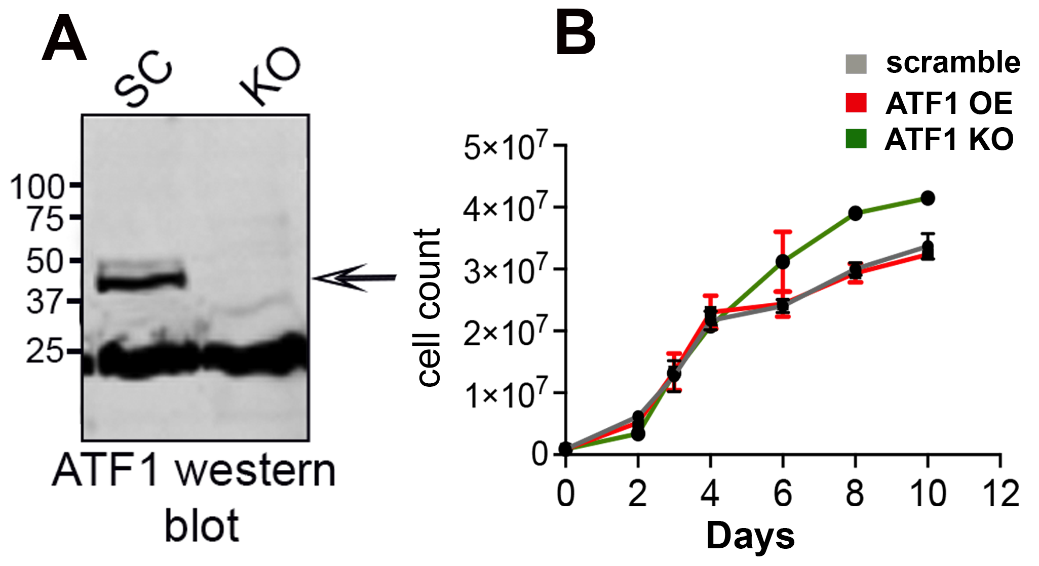
Finally, we also verified ATF1 KO by western blot (WB) (Fig. 4A) and analyzed the effects of ATF1 depletion or overexpression on cell viability. Depletion of ATF1 had no effect on cell viability or proliferation over time. Conversely, overexpression of ATF1 elicited minor proliferative effects on cell growth (Fig. 4B).
Figure 4: ATF depletion has no effect on cell viability
(A) Western blot confirming ATF1 KO in J-Lat 6.3 cells.
(B) ATF1 manipulation has no effect on cell proliferation. Counts of J-Lat 6.3 cells, where ATF1 expression is KO (red), over-xpressed (OE; green) or control cells expressing scramble sgRNA (gray). Data are mean±SD. n=3.

II. Working hypothesis, research objectives, hypothesis, and expected significance
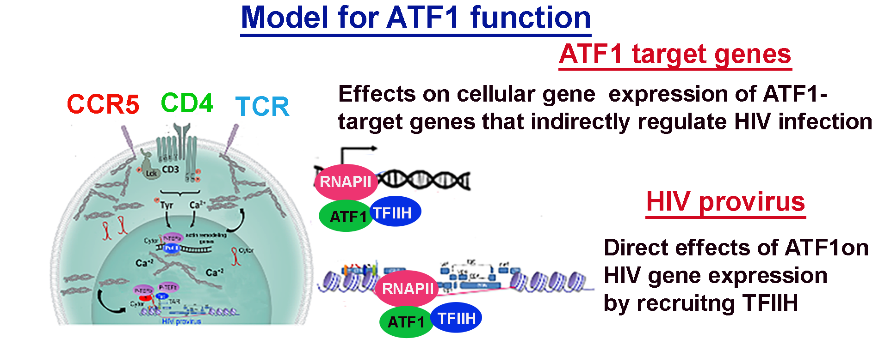
HIV is heavily regulated at early steps of Pol II pause-release and productive elongation by the action of the cellular transcription machinery. We will exploit its gene expression program as a model to identify and investigate the role of cellular transcription factors in the control of early events of gene transcription. Building on our preliminary findings, we propose a working model for ATF1 mode of function and hypothesize that it activates early events of gene transcription by directly binding to the gene promoters and recruiting TFIIH.
Figure 5: Working hypothesis for ATF1 role in gene expression regulation. Levels of ATF1 are elevated upon T cell stimulation or HIV infection. ATF1 binds to the HIV promoter (or cellular promoters) and recruits TFIIH to enhance HIV-specific cellular gene activation. ATF1 also regulates downstream target genes, thereby indirectly promoting HIV-specific gene expression. Preliminary data (shown below) suggest that CCR5 coreceptor is an ATF1-target gene.

Specific Aim 1. To decipher the molecular mechanisms underlying ATF1-mediated gene activation.
We will dive into the mechanisms by which ATF1 activates HIV gene expression, extending our preliminary results (presented below) which suggest that ATF1 binds to the HIV promoter and alters the phosphorylation state of Pol II. Additional preliminary analysis has revealed that ATF1 associates with TFIIH, a cellular transcription initiation factor. We will employ cellular and biochemical approaches to confirm the interplay between ATF1 and TFIIH and peruse the hypothesis that TFIIH-ATF1 interactions are mediated via cyclin H. These experiments will help to elucidate the interplay between ATF1 and TFIIH, defining the mechanisms that enable ATF1 to regulate cellular and HIV-specific gene activation.
Specific Aim 2. To unravel the global role of ATF1 in regulating cellular gene transcription.
Our preliminary RNA-Seq analysis in CD4+ primary T cells has revealed that depletion of ATF1 expression results in broad changes in the host transcriptome, signifying its effects on cellular gene expression. We will employ genome-wide tools to define the binding loci of ATF1 in the genome and identify its downstream-regulated gene targets. The role of these genes in controlling HIV-specific and global gene expression will be investigated by conducting gain- and-loss-of-function studies. We will further determine the global co-occupancy of ATF1 and TFIIH and define the role of ATF1 in the regulation of early steps of transcription and promoter clearance. These analyses will provide insight into the contribution of ATF1 to the control of HIV and cellular gene expression, yielding new information about the global role of ATF1 in controlling HIV-specific and cellular transcription.
Specific Aim 3. To determine the relevance of ATF1 to HIV latency in primary resting CD4+ T cells.
As HIV persists in infected resting T cells that constitute the latent reservoirs, we will place our study in a clinically relevant context and extend our preliminary findings regarding the functions of ATF1 in regulating HIV gene expression and latency reversal (Fig. 3 and Fig. 9; see below). However, these observations relied on experiments that were performed in immortalized HIV-infected T cell lines and stimulated primary CD4+ T cells that do not reflect the actual cells of the HIV reservoirs. Therefore, we will investigate the role of ATF1 in HIV gene expression and latency in primary resting CD4+ T cells, which are the original target cells that comprise the HIV reservoirs. Using innovative CRISPR editing tools, ATF1 expression will be depleted in primary CD4+ resting T cells, and the role of ATF1 in HIV transcription regulation and latency reversal will be explored. We expect that completion of this aim will allow us to obtain a comprehensive understanding of the functional relevance of ATF1 in resting CD4+ primary cells.
Significance and Innovation
Our proposal is aimed at providing a better understanding of the pathways that control HIV-specific and cellular gene expression. We will use HIV as a model for studying cellular gene expression control and provide evidence for the role of ATF1 as an activator of HIV transcription. We further elucidate the mode of ATF1 function, and by doing so, we hope to extend our knowledge of the ways by which ATF1 regulates gene activation through association with TFIIH. Key aspects of this proposal include the following:
      - Regulation of HIV gene transcription and latency. Cellular transcription factors that play a role in the establishment and maintenance of viral reservoirs need to be identified. This will deepen our understanding and potentially pave the way to developing innovative tools to eliminate these HIV reservoirs. We will elucidate the direct and indirect functional effects of ATF1 on viral gene transcription in primary resting CD4+ T cells, which comprise the HIV reservoirs. New transcription factors that play a role in the regulation of HIV gene expression and latency will also be identified.
      - Role of ATF1 in regulating early events of cellular gene transcription activation. We expect that our findings will broadly impact the field of general cellular transcription regulation, advancing our understanding of the global function of ATF1 in early steps of transcription activation through binding to gene promoters and recruiting TFIIH and the basal transcription machinery. We will provide evidence for the role of ATF1 in promoting cellular gene expression by recruiting TFIIH and Pol II for transcription initiation.
      - Clinical implications for treating latent HIV reservoirs by manipulating ATF1 levels. The identification of ATF1 and its gene partners as regulators of HIV gene expression and latency reversal will open ways to develop new therapeutic strategies in regulating the HIV reservoirs. We envision that manipulation of ATF1 expression may be incorporated into, or even substitute for current approaches, and improve the clinical outcome by suppressing HIV infection and eliminating the viral reservoirs.
      - Cancer therapy. As ATF1 expression is also elevated in several human malignancies, primarily when fused to Fus or ESWR proteins, and acts as an oncogene, it is essential to understand the mechanism of function that enhances ATF1 transcription activation in human malignancies. Elucidating the mode of action of ATF1 and identifying its downstream target genes will define the pathways that potentially promote cell malignancy and, importantly, pave the way to the development of novel therapeutic tools that may aid in combatting human cancer. As cdk7 is an established target for cancer therapy and is being examined in several ongoing clinical trials, ATF1 targeting may be combined with cdk7 inhibitors to improve treatment for cancer.

III. Work program including detailed research description
Specific Aim 1. To decipher the molecular mechanisms underlying ATF1-mediated gene activation.
Our preliminary data indicate that ATF1 activates HIV gene expression (Fig. 3). Additional new preliminary analyses presented below reveal that ATF1 binds to the HIV promoter (Fig 6A), and its occupancy is elevated upon T cell stimulation. In these ChIP-qPCR experiments, HA-ATF1 was precipitated from HA-ATF1-expressing stable cells with an anti-HA antibody, as we could not obtain a appropriate commercial ATF1 antibody for ChIP analysis. ATF1 does not bind to downstream HIV loci, suggesting that it specifically occupies the HIV promoter (not shown). To further expand our understanding of the mechanisms by which ATF1 enhances HIV gene expression, we followed the phosphorylation state of the CTD of Pol II in the context of ATF1 gene manipulation by employing ChIP-qPCR with commercially available antibodies that target the phosphorylated-modified C-terminal domain (CTD) of Pol II. Our analysis confirmed that depletion of ATF1 decreased levels of phosphorylated serine 5 (Ser5P) of the Pol II-CTD, compared to phosphorylated serine 2 (Ser2P) levels, which were not changed as a result of ATF1 depletion (Fig. 6B). Ser2P is catalyzed on the CTD of Pol II by cdk9/P-TEFb and is a marker for Pol II pause-release and elongation of transcription. Ser5P and Ser7P, on the other hand, mark the initiation of transcription and promoter clearance, and are primarily catalyzed by cdk7/TFIIH (Fig. 6B) [71, 72]. To further peruse this line of evidence, we conducted ChIP-qPCR with commercially available antibodies that target the regulatory subunits of TFIIH. Our preliminary observations show that ATF1 depletion decreased levels of cdk7 and cyclin H, with little effect on levels of cdk9, the kinase subunit of P-TEFb (Fig. 6C). Finally, additional new immunoprecipitation (IP) and western blot (IP; WB) analysis revealed that in cells, ATF1 specifically associates with the cyclin H subunit of TFIIH (Fig. 6D). These results suggest that ATF1 activates steps of HIV gene transcription through binding to the viral promoter and affect the phosphorylation state of Pol II by recruiting TFIIH.
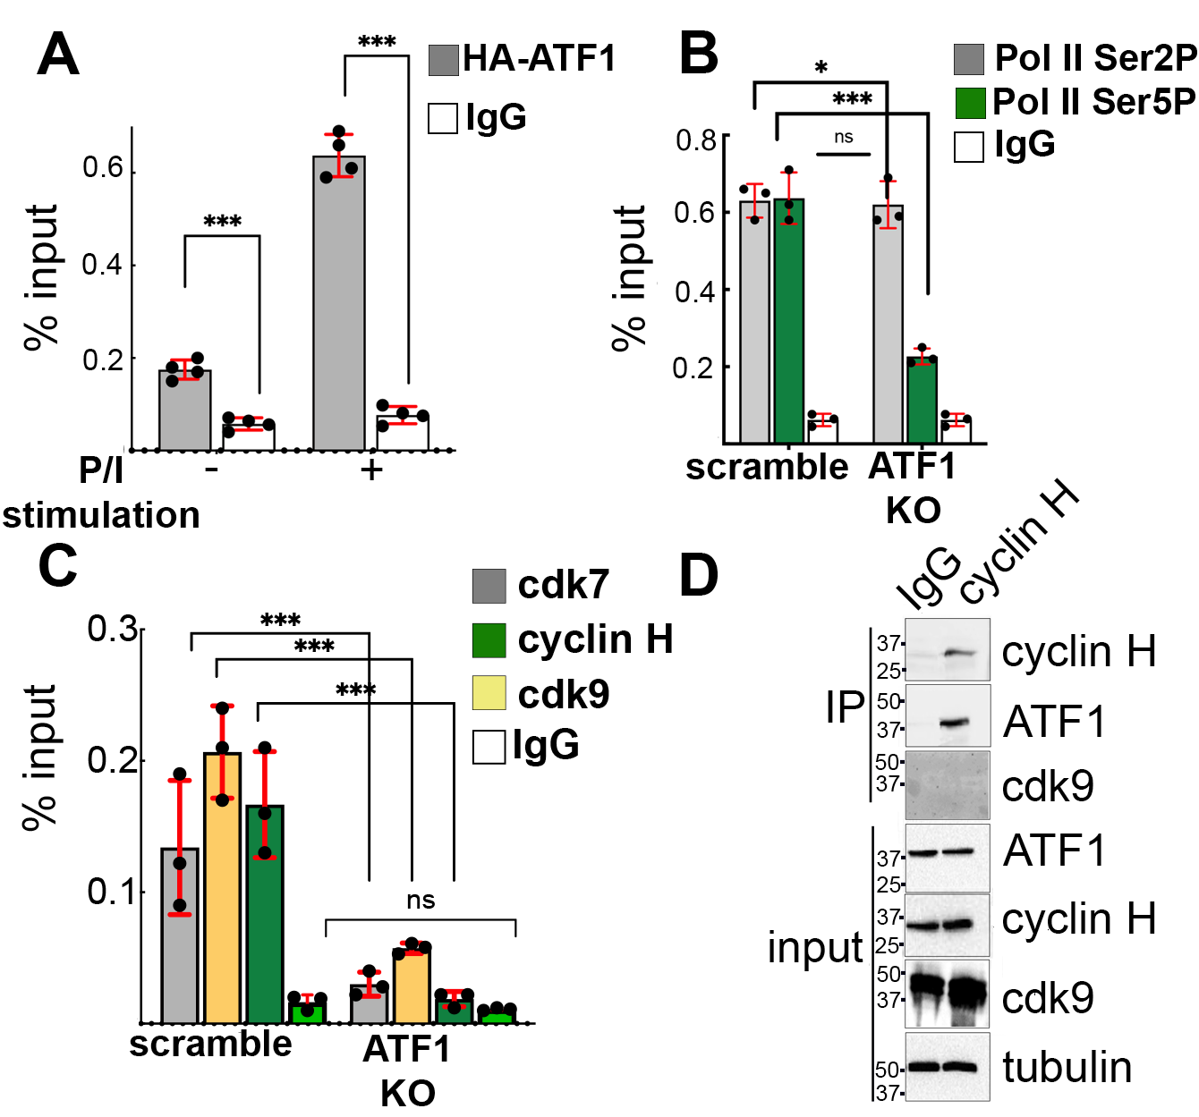
Figure 6: ATF1 binds to the HIV promoter, affects the Pol II CTD phosphorylation state, and associates with TFIIH.
(A) ATF1 binds to the HIV promoter upon T cell stimulation. ChiP-qPCR in resting or P/I stimulated J-Lat 6.3 cells that express HA-ATF1. ChIP material was IP with anti-HA or control antibodies and, following washing, associated DNA was eluted and analyzed by qPCR with primers specific for the HIV promoter (mean±SD; ***p≤0.05). n=4. Downstream HIV loci served as a control (not shown).
(B) ATF1 alters Pol II CTD phosphorylation. ChIP qPCR from control or ATF1 KO J-Lat 6.3 cells. ChIP material was IP with antibodies against Ser2P or Ser5P of the CTD and subjected to qPCR with primers that are positioned on the HIV promoter. Non-specific IgG served as a control. Percentage of input are mean±SD; ***p≤0.05 calculated between scrambled and KO cells. n=3.
(C) ATF1 associates with TFIIH on the HIV promoter. ChIP qPCR from control or ATF1 KO J-Lat 6.3 cells. ChIP material was IP with antibodies against TFIIH subunits cdk7 and cyclin H or against P-TEFb/cdk9. IP material was subjected to qPCR with specific primers on the HIV promoter. Non-specific IgG served as a control. Percentage of input values are mean±SD; ***p≤0.05 calculated between scrambled and KO cells for each antibody. n=3.
(D) ATF1 associates with cyclin H of TFIIH. ATF1 was IP from nuclear-isolated samples from J-Lat 6.3 cells using an antibody for endogenous ATF1, followed by western blot with the indicated antibodies. IP and input protein levels are also shown. Control antibodies include non-relevant IgG and anti-cdk9 as negative controls.
1a. Define binding between ATF1 and TFIIH in cells. Our above observations suggest that ATF1 activates HIV gene expression via association with TFIIH/cyclin H (Fig. 6D). We will initially confirm these preliminary results and monitor the interactions of ATF1 with other TFIIH subunits including cdk7, Mat1, or ERCC3, the largest subunit of TFIIH, by immunoprecipitation (IP) followed by western blot analysis [73]. Commercially available antibodies are available for these experiments. As a control for the specificity of ATF1-cyclin H interactions, we will document ATF1 association with P-TEFb (cdk9/cyclin T) using antibodies that target the endogenous subunits of P-TEFb, cdk9 and cyclin T1. Binding assays will be complemented by ChIP-qPCR to confirm ATF1 association with TFIIH/cyclin H on the HIV promoter (Fig. 6C). We will also follow occupancy of TFIIH subunits, Pol II, CTD phosphorylation state, and histone activation markers on the HIV promoter upon depletion or overexpression of ATF1. These experiments will be complemented by additional protein binding assays that will map the domains within ATF1 that are responsible for association with cyclin H/TFIIH in cells. For this, we will express HA-ATF1 mutants that are either deleted from the C-terminal basic leucine zipper DNA-binding motif or lack the N-terminal region, which exhibits low homology between ATF1 proteins and binds to its specific protein partners. HA-ATF1 mutants will be IP from cells with an HA antibody and monitored for association with cyclin H or other TFIIH subunits by western blot using commercially available antibodies. Similarly, we will generate cyclin H mutants that lack the N-terminal cyclin box (binds to cdk7) or have a deletion in its C-terminal region that binds protein partners. Cyclin H mutants will be expressed in cells as Flag fusion proteins and will be IP with a Flag antibody followed by western blot for ATF1. These experiments will establish the association between ATF1 and TFIIH in cells.
1b. Characterize interactions between ATF1 and cyclin H in vitro. We will confirm ATF1-cyclin H binding in vitro with protein binding experiments using purified recombinant proteins. ATF1 will be transcribed and translated (IVT) in vitro, labeled with ³⁵S (Promega) [74], and incubated with cyclin H as a GST fusion protein purified from bacteria using GST columns. ATF1-cyclin H binding complexes will be IP with an anti-cyclin H antibody , followed by protein A-Sepharose bead precipitation and extensive washing under stringent conditions. IP beads will be run electrophoretically on an SDS gel, followed by autoradiography to visualize labeled ATF1. GST alone or GST-cyclin T1 will serve as controls for this assay. Alternatively, in vitro binding assays will be conducted with purified recombinant ATF1-His and GST-cyclin H proteins. ATF1-cyclin H complexes will be IP with a specific cyclin H antibody followed by western blot with anti-His antibody to detect ATF1. GST tag will be cleaved by thrombin. Appropriate controls for non-specific binding through GST or His tags will be employed (in collaboration with Prof. Koh Fujinaga; UCSF).
1c. Determine the role of cdk7 kinase activity in association with ATF1. ATF1 is reported to be phosphorylated in response to cellular stress at serine 63 (Ser63) and threonine 184 (Thr184) by either MAP kinases or cdk3 [75, 76]. These events are correlated with ATF1 transcription activity, enhancing recruitment of the coactivator CREB-binding protein (CBP)/p300) to the transcription complex [77]. We will examine the possibility that cdk7 also phosphorylates ATF1 on Ser or Thr residues using kinase assays [74]. TFIIH/cdk7 will be IP from cells with a specific cdk7 antibody (or expressed in cells as HA-cdk7 and specifically IP the entire TFIIH with an HA antibody) and subjected to kinase assays using recombinantly expressed ATF1. Alternatively, peptides designed to correspond to ATF1 Ser63 and Thr184 phosphoresidues will be used as substrates for the kinase assay. These experiments will confirm that cdk7 kinase phosphorylates ATF1. To determine if the kinase activity of cdk7 is required for association of TFIIH/cyclin H with ATF1, we will conduct IP/western blot binding experiments with HA-ATF1 or ATF1 mutant in their phosphorylation sites (serine to alanine mutations at Ser63 and Thr184). ATF1 proteins will be expressed in cells as HA fusions and will be IP with an HA antibody. IP fractions will then be tested for endogenous cyclin H and cdk7 interactions by western blot. Similar experiments will be carried out on overexpressing cdk7 kinase-deficient mutants in cells, monitoring their effects on ATF1-TFIIH binding. Residues within the T loop motif of cdk7 (S170; T176; Ser164) will be mutated to alanine and tested for association with ATF1 by western blot. These residues within cdk7 are also important for stable cdk7-cyclin H binding and may affect the association of ATF1 with cyclin H. An additional cdk7 kinase-dead mutant, D155N, will also be tested for binding to ATF1 in cells. Finally, to confirm the specificity of cdk7 as an ATF1 kinase, the above kinase and binding assays will be conducted in the presence of specific cdk7 inhibitors such as triptolide TZH1 and YKL-5-124 that prevent transcription initiation [78-80].
Expected outcomes, potential pitfalls, and alternative strategies
We will establish how ATF1 activates HIV-specific gene expression via association with TFIIH. To determine the binding between ATF1 and cyclin H, we will perform alternative in vitro ELISA-based binding analysis between recombinantly expressed and purified ATF1 and cyclin H. Kinase assays will be carried out on recombinantly expressed and purified TFIIH and ATF1 (or purchased TFIIH from Millipore - 14-476M). In case the ATF1 antibody will not work in our binding or kinase assays, we will express HA-ATF1 and use an HA antibody to pull down ATF1. If we fail to demonstrate direct binding between cyclin H and ATF1, we will test direct binding with different subunits of the TFIIH.

Specific Aim 2: To unravel the global role of ATF1 in regulating cellular gene transcription.
Identifying new ATF1 downstream target genes
To extend our studies on the global role of ATF1, we performed RNA-Seq analysis in CD4+ stimulated primary T cells, in which ATF1 expression was depleted. A detailed KEGG differential expression analysis revealed broad changes in the transcriptome of cells due to ATF1 KO. We identified 105 genes that were upregulated and 437 genes that were downregulated in ATF1 KO versus control cells (adjusted p-value ≤0.05; log FC≥2) (Fig. 7A). This analysis documented significant enrichment of genes involved in processes of transcription regulation, T cell activation, chromatin activation, immune response, and more (Fig. 7B).
Figure 7. ATF1 regulates cellular transcription.
(A) Gene expression levels in primary CD4+ T cells depleted of ATF1 using lentivirus expressing CRISPR-Cas9. Heat map of the expression pattern from RNA-seq of control (n=3) and ATF1 KO (n=3). Color gradient represents upregulated (orange) or downregulated (blue) genes.
(B) KEGG enrichment analysis of selected pathways in ATF1 KO cells.

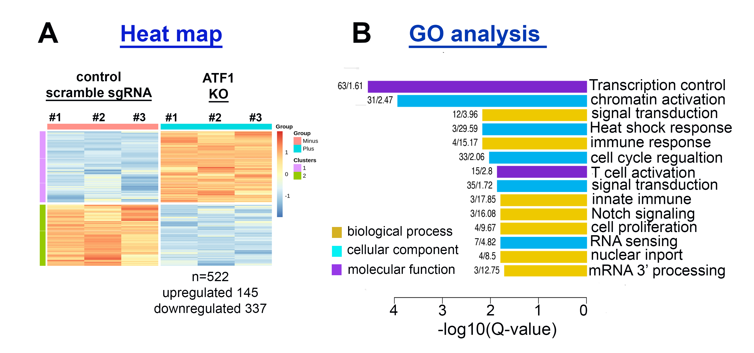
2a. To identify ATF1 target genes that regulate gene transcription and to characterize their role in HIV-specific and global gene transcription. Based on the above RNA-Seq analysis, we identified genes that were differentially expressed following ATF1 depletion. We will initially confirm our RNA-Seq data in primary CD4+ T cells by qPCR on representative target genes and in the context of ATF1 depletion. We will also employ ATF1 ChIP-Seq to narrow the list of ATF1 gene targets. These analyses will help us to identify the binding loci of ATF1 on its gene targets. These gene candidates, in which ATF1 is enriched, will be further subjected to gain- and-loss-of-function assays to determine the role of new ATF1 target genes in indirectly regulating HIV gene transcription. For this, we will use our T cell lines and follow experiments described in Fig. 3. The role of these genes in mediating early events of cellular transcription will also be analyzed (see below).
2b. ATF1 regulates the expression of the CCR5 co-receptor and plays a role in HIV infection.
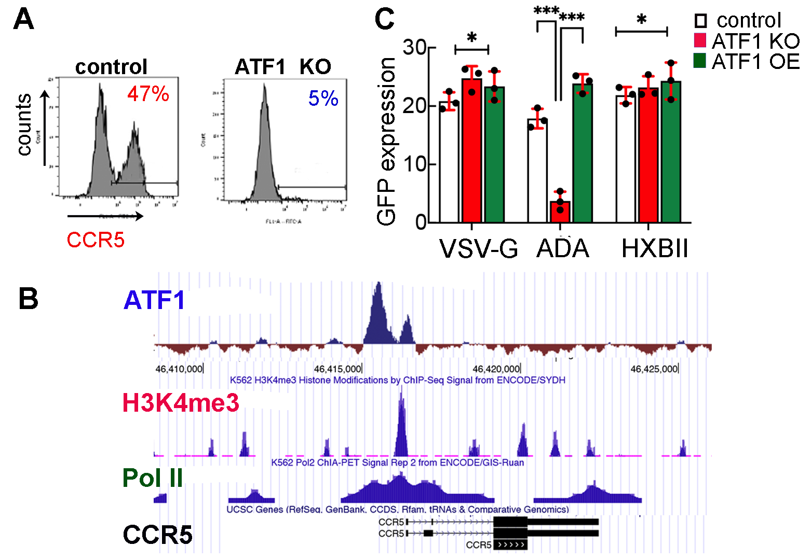
One of our top identified gene candidates that was differentially expressed upon ATF1 depletion is CCR5, a chemokine receptor that acts as a co-receptor for HIV infection in T cells. To confirm that CCR5 is a downstream target of ATF1, we monitored CCR5 expression levels in control or ATF1 KO J-Lat 6.3 T cells by FACS, using an antibody that targets surface CCR5. Our findings suggest that upon ATF1 depletion, CCR5 levels are reduced relative to control cells that express scramble sgRNA (Fig. 8A). A similar analysis will be applied to other genes that were differentially expressed in the RNA-Seq experiment. To further extend our results, we took advantage of a publicly available ATF1 ChIP-Seq ENCODE dataset and aligned it with ChIP-Seq data of Pol II and the H3K4me3 histone activation marker. Our analysis revealed significant enrichment of ATF1 on the promoter region of CCR5, in conjunction with Pol II and H3K4me3 enrichment (Fig. 8B). To assign functional significance to these results, we assessed the effects of ATF1 on HIV infection, using viruses that carry envelopes with specific tropism to either CCR5 or CXCR4 chemokine receptors. Specifically, ADA-pseudotyped HIV, which exclusively targets the CCR5 co-receptor for cell entry, or HXBII pseudoviruses with a CCR4-specific tropism were used. Lentivirus that was pseudotyped with a VSV-G envelope and is not dependent on chemokine co-receptors for viral infection served as a control. Our analysis revealed that ADA-pseudotyped HIV (CCR5-dependent) could not enter target cells depleted of ATF1 (Fig. 8C), but successfully transduced control. Interestingly, ATF1 expression (OE) rescued the transduction of ADA-pseudotyped viral particles. In contrast, ATF1 modulation of expression had no impact on the HXBII-pseudoviruses (CXCR4). Transduction levels of HIV-VSV-G were also unaffected by ATF1 KO or OE (Fig. 8C). These findings confirm that CCR5 is a downstream target of ATF1, consequently affecting HIV infection. We plan to validate these results in primary resting CD4 T cells and investigate the effects of ATF1 on latency reversal upon treatment with LRAs (see Fig. 9 below). Similarly, we will analyze the indirect effects of other ATF1-targeted genes on HIV gene expression and infection.
Figure 8. ATF1 regulates the expression of the CCR5 HIV co-receptor, thereby affecting viral infection.
- FACS histograms show decreased CCR5 expression in ATF1 KO in J-Lat 6.3 T cells relative to control cells expressing scramble sgRNA.
- Capture of UCSC genome browser showing ChIP-Seq co-occupancy of ATF1, Pol II, and H3K4me3 enrichment on the CCR5 promoter in K562 cells (ENCODE).
- Infection of J-Lat 6.3 T cells with pseudoviruses carrying envelopes with different tropism for the chemokine co-receptors. ADA (CCR5 tropism), HXBII (CXCR4 tropism), and VSV-G (all cells). Cells in which AFT1 was KO or overexpressed were transduced at equal MOIs. Cells were harvested 48 h post-transduction, and monitored for HIV GFP expression by FACS. Results are means ±SD; ***p≤0.05. n=3.

2c. To define the genome-wide role of ATF1 in early steps of cellular gene expression. Following our preliminary data on the function of ATF1 in the control of HIV expression via association with TFIIH, we will monitor the genome-wide association of TFIIH and ATF1 on ATF1 gene targets using ChIP-Seq analysis with commercially available antibodies for ATF1 and TFIIH subunits, cyclin H, and cdk7 antibodies. We expect to confirm the global co-occupancy of ATF1 and TFIIH. In addition, to address the effects of ATF1 depletion on global recruitment of TFIIH to gene promoters and effects on promoter initiation, we will perform TFIIH-ChIP-Seq in control or ATF1 KO cells using ChIP-grade TFIIH antibodies. We will also define the role of ATF1 in transcription initiation and promoter clearance by following genome-wide Pol II occupancy in control and ATF1 KO cells by ChIP-Seq. Similarly, we will profile CTD phosphorylation and the global histone landscape (H3K4me3 and H3K27Ac activation markers) around promoters of ATF1 gene targets, comparing control and ATF1-depleted cells. By employing these tools, we hope to establish a correlation between ATF1 and TFIIH-mediated gene transcription initiation. To further validate gene activation of ATF1 being regulated at early steps of transcription initiation and promoter clearance, we will employ qPCR analysis in ATF1 KO or overexpressed cells on loci adjacent or downstream to the TSS of the HIV promoter and other ATF1 target genes. Finally, we will compare nascent RNA synthesis in the context of ATF1 modulation of expression to investigate the role of ATF1 in early synthesis of mRNA and pause-release of Pol II. We will employ PRO-Seq (precision run-on sequencing) and map actively engaged Pol II at single-nucleotide resolution. PRO-Seq will provide a view of nascent RNA transcription, thereby allowing us to study the genome-wide dynamics of transcription initiation at gene loci and Pol II promoter-proximal pausing in the context of ATF1 manipulation (in collaboration with Karen Adelman; Harvard) [81].
Expected outcomes, potential pitfalls, and alternative strategies
ChIP-Seq protocols are well established in our lab. However, we are aware that this analysis may suffer from high noise-to-signal ratios mainly when analyzing transcription factors. The Adelman lab will support these experiments and bioinformatic analysis. We will also use CUT and RUN analysis, which uses low numbers of cells and provides a more specific signal when analyzing the occupancy of transcription factors [82]. In addition, we will complement our study on ATF1 global effects on transcription initiation and Pol II pausing by conducting GRO-Seq (global run-on sequencing), which will provide a broad genome-wide view of transcription initiation, capturing nascent RNA of coding and non-coding genes and documenting actively or paused Pol II (in collaboration with the Adelman lab). To comprehensively complement our investigation on the role of ATF1 in gene regulation, we will also employ ATAC-Seq, which will provide insight into the structural and functional organization of chromatin, enabling us to identify chromatin accessibility DNA regions to which ATF1 binds. ATAC analysis will be performed in control or KO ATF1 cells. Finally, we will identify new ATF1-regulated genes that indirectly regulate HIV gene expression and viral latency (see Aim #3 below). The roles of ATF1 target genes in controlling global gene expression will be explored. We will follow the experimental scheme for HIV described in our preliminary results in other gene targets that are potentially regulated by ATF1, thereby determining whether similar mechanisms of ATF1 that were attributed to HIV are also relevant to newly identified genes.
Specific Aim 3. To determine the relevance of ATF1 to HIV latency in primary resting CD4+ T cells.
Modulation of ATF1 in stimulated CD4+ primary cells and effects on latency. Since our preliminary results, presented above, were obtained in Jurkat-based T cell lines, we were interested in extending them and confirming our findings in stimulated CD4+ primary T cells which are the target cells of HIV and are more clinically relevant for HIV infection (Fig. 9). Primary CD4 T cells were obtained from healthy donors according to the Soroka Medical Center ethics protocols (n=3) and stimulated with anti-CD3/CD28 beads. To explore the role of ATF1 on HIV gene expression and latency reversal, ATF1 expression was depleted from cells by transducing stimulated primary CD4+ T cells with lentivirus encoding Cas9 and a specific sgRNA that targets ATF1. We achieved a significant decrease in ATF1 expression relative to control cells expressing scrambled sgRNA (Fig. 9A+B). Control or ATF1 KO-stimulated primary cells were then transduced with HIV_{GKO}, which simultaneously measures active HIV infection (LTR-GFP+) and transduction efficiencies (EF1α-mKO2+) by FACS [56]. Our observations revealed that in control cells which expressed scramble sgRNA, 20% of HIV-transduced cells carried active HIV (P2-GFP+; mKO2+; green bar), while 11% of transduced cells carried latent HIV (P1-GFP-; mKO2+; pink bar). In contrast, upon depletion of ATF1, a decrease in HIV-transduced cells that carry active HIV and an increase in the percentage of cells that carried active HIV_{GKO} was documented. Only 4% of cells contained active HIV (P2- GFP+; mKO2+; green bar), while 14% of cells carried latent HIV (P1-GFP-; mKO2+; pink bar) (Fig. 9C+D). We conclude that upon stimulation of primary CD4+ T cells, depletion of ATF1 inhibits HIV gene expression and latency reversal, with no effects on viral transduction efficiencies.
Figure 9. Depletion of ATF1 in stimulated CD4+ primary T cells inhibits HIV infection.
- Workflow of ATF1 depletion using CRISPR-Cas9 in stimulated primary CD4+ T cells.
- Depletion of ATF1. RT-qPCR for ATF1 RNA levels. RNA levels were normalized to GAPDH and shown relative to scrambled cells expressing scramble sgRNA set to 1. Data are mean ±SD;*** p≤0.05; n=3.
- ATF1 KO inhibits HIV gene expression. FACS analysis of control or ATF1 KO cells transduced with HIV_{GKO}
- Quantification of FACS analysis showing the percentage of cells carrying active HIV (GFP+; mKO2+) or latent HIV (GFP-; mKO2+). Data are mean ±SD;*** p≤0.05. n=3
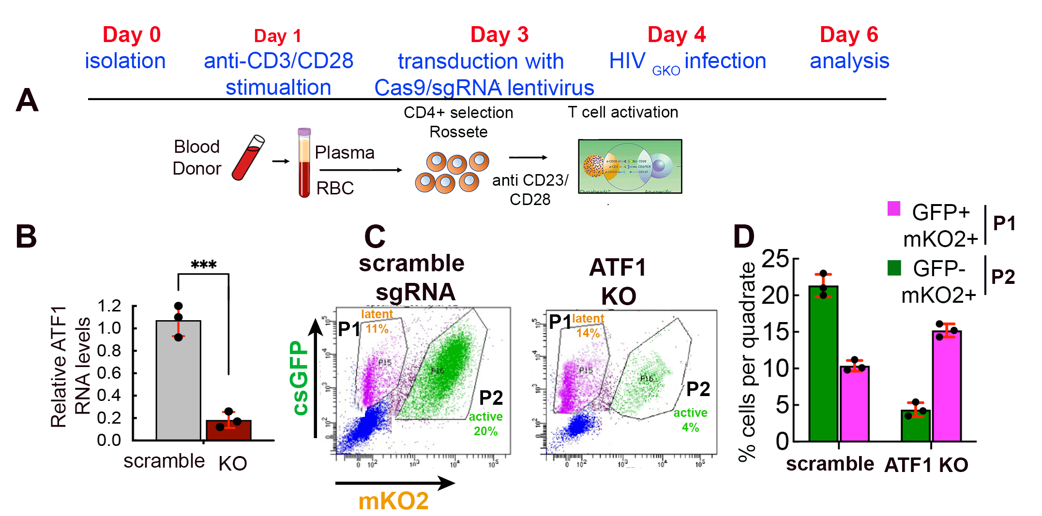
Figure 9. Depletion of ATF1 in stimulated CD4+ primary T cells inhibits HIV gene expression and latency reversal.
- Workflow of ATF1 depletion using CRISPR-Cas9 in stimulated primary CD4+ T cells.
- Depletion of ATF1. RT-qPCR for ATF1 RNA levels. RNA levels were normalized to GAPDH and are shown relative to scrambled cells expressing scramble sgRNA set to 1. Data are mean±SD; *** p≤0.05. n=3.
- ATF1 KO inhibits HIV gene expression. FACS analysis of control or ATF1 KO cells transduced with HIV_{GKO}
- Quantification of FACS analysis showing the percentage of cells carrying active HIV (GFP+; mKO2+) or latent HIV (GFP-; mKO2+). Data are mean±SD; *** p≤0.05. n=3.

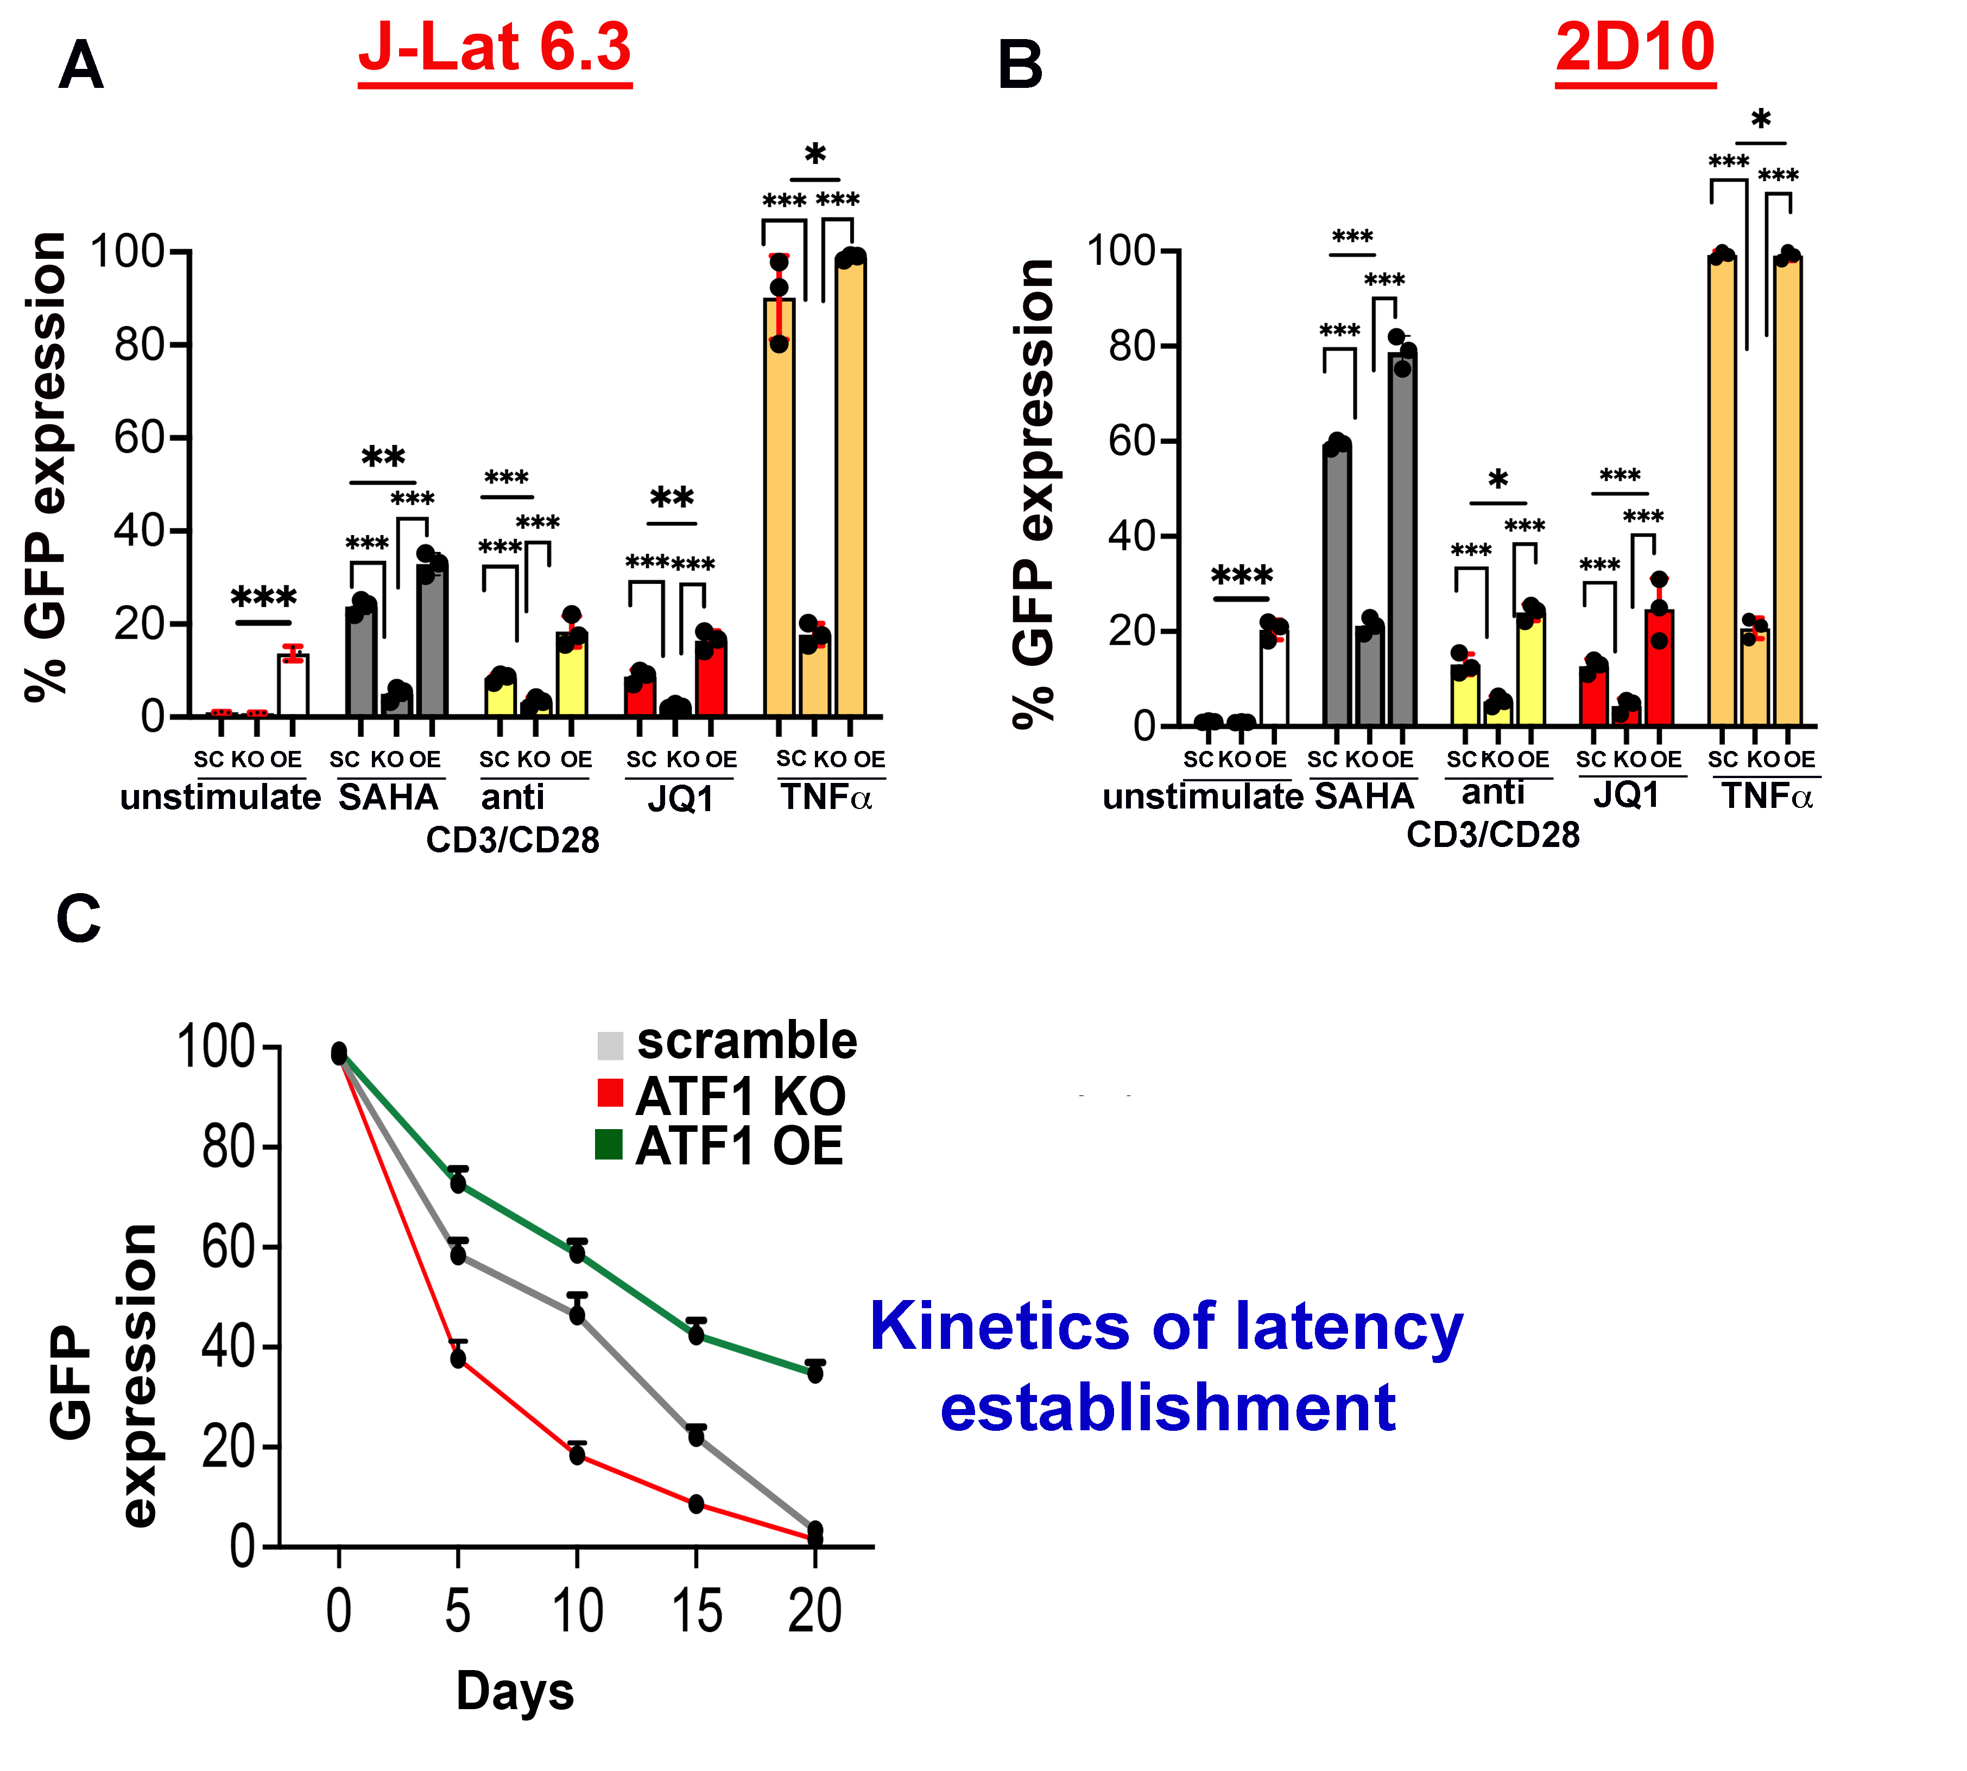
ATF1 plays a role in latency reversal and establishment. Our initial data provide a potential role for ATF1 in activating HIV gene expression (Fig. 3-5). As HIV latency is primarily established through the regulation of the integrated HIV gene expression by the cellular transcription machinery, we were interested in assessing the involvement of ATF1 in the control of HIV latency. To this end, our T cell models, J-Lat 6.3 and 2D10, in which ATF1 expression was modulated (Fig. 3), were subjected to treatment with different latency reversing agents (LRAs) that are known to activate HIV gene expression and reverse latency (Fig. 10) [83]. These LRAs included suberoylanilide hydroxamic acid, which is a histone deacetylase inhibitor that reactivates HIV-1 expression )SAHA) [84]; anti-CD3/CD28 beads that stimulate T cells via their T cell receptor; JQI, a P-TEFb releasing agent [85, 86]; and TNFα, an activator of NFκB. Levels of T cell activation were simultaneously confirmed by immunofluorescence for CD69, CD25, and HLA-DR (not shown). All tested LRAs induced latency reversal in control cells to different extents, as measured by HIV-GFP expression. Interestingly, ATF1 KO inhibited the effects of LRA-mediated latency reversal. Moreover, ATF1 overexpression successfully rescued the inhibitory effects of ATF1 depletion on latency reversal to the activation levels that were detected in control cells. These results confirm that ATF1 is as an activator of HIV gene expression that supports latency reversal in response to LRA stimulation (Fig. 10A and B). To further address whether ATF1 plays a role in HIV latency establishment, we monitored HIV-GFP gene expression in J-Lat 6.3 cells following T cell stimulation with P/I in the context of ATF1 depletion or overexpression (Fig. 10C). Cells were stimulated with P/I and sorted based on their HIV-GFP expression to obtain a pure cell population that expresses GFP. Establishment of latency was monitored over time by measuring HIV-GFP expression by FACS. While control cells gradually re-entered latency, as seen by the decrease in GFP expression, ATF1-depleted cells rapidly entered latency. In contrast, ATF1-overexpressing cells sustained their GFP expression for a prolonged period (Fig. 10C). These results underscore the role of ATF1 in regulating HIV gene expression and its impact on latency reversal and establishment.
Figure 10: ATF1 effects on HIV latency.
Effects of LRA stimulation on latency reversal of HIV in J-Lat-6.3 (A), or 2D10 T cells (B) in the context of ATF1 KO or overexpression (OE). LRA concentrations: SAHA 10 μM; JQ1 1 μM; TNFα 12.5 ng/ml. CD3/CD28 beads were added at a 1:1 ratio with cells. Cells were analyzed by FACS 24 h post-LRA treatment for HIV-GFP. Data are shown as fold change in GFP expression relative to control cells that expressed scrambled sgRNA. Data are mean±SD; *** p≤0.05. n=3.
C. Kinetics of latency establishment. Control J-Lat 6.3 cells expressing scramble sgRNA (gray), cells in which ATF1 expression is KO (red) or ATF1 OE (green) were stimulated with P/I and sorted by FACS to achieve 100% purity of GFP+ cells. HIV GFP levels were monitored by FACS.
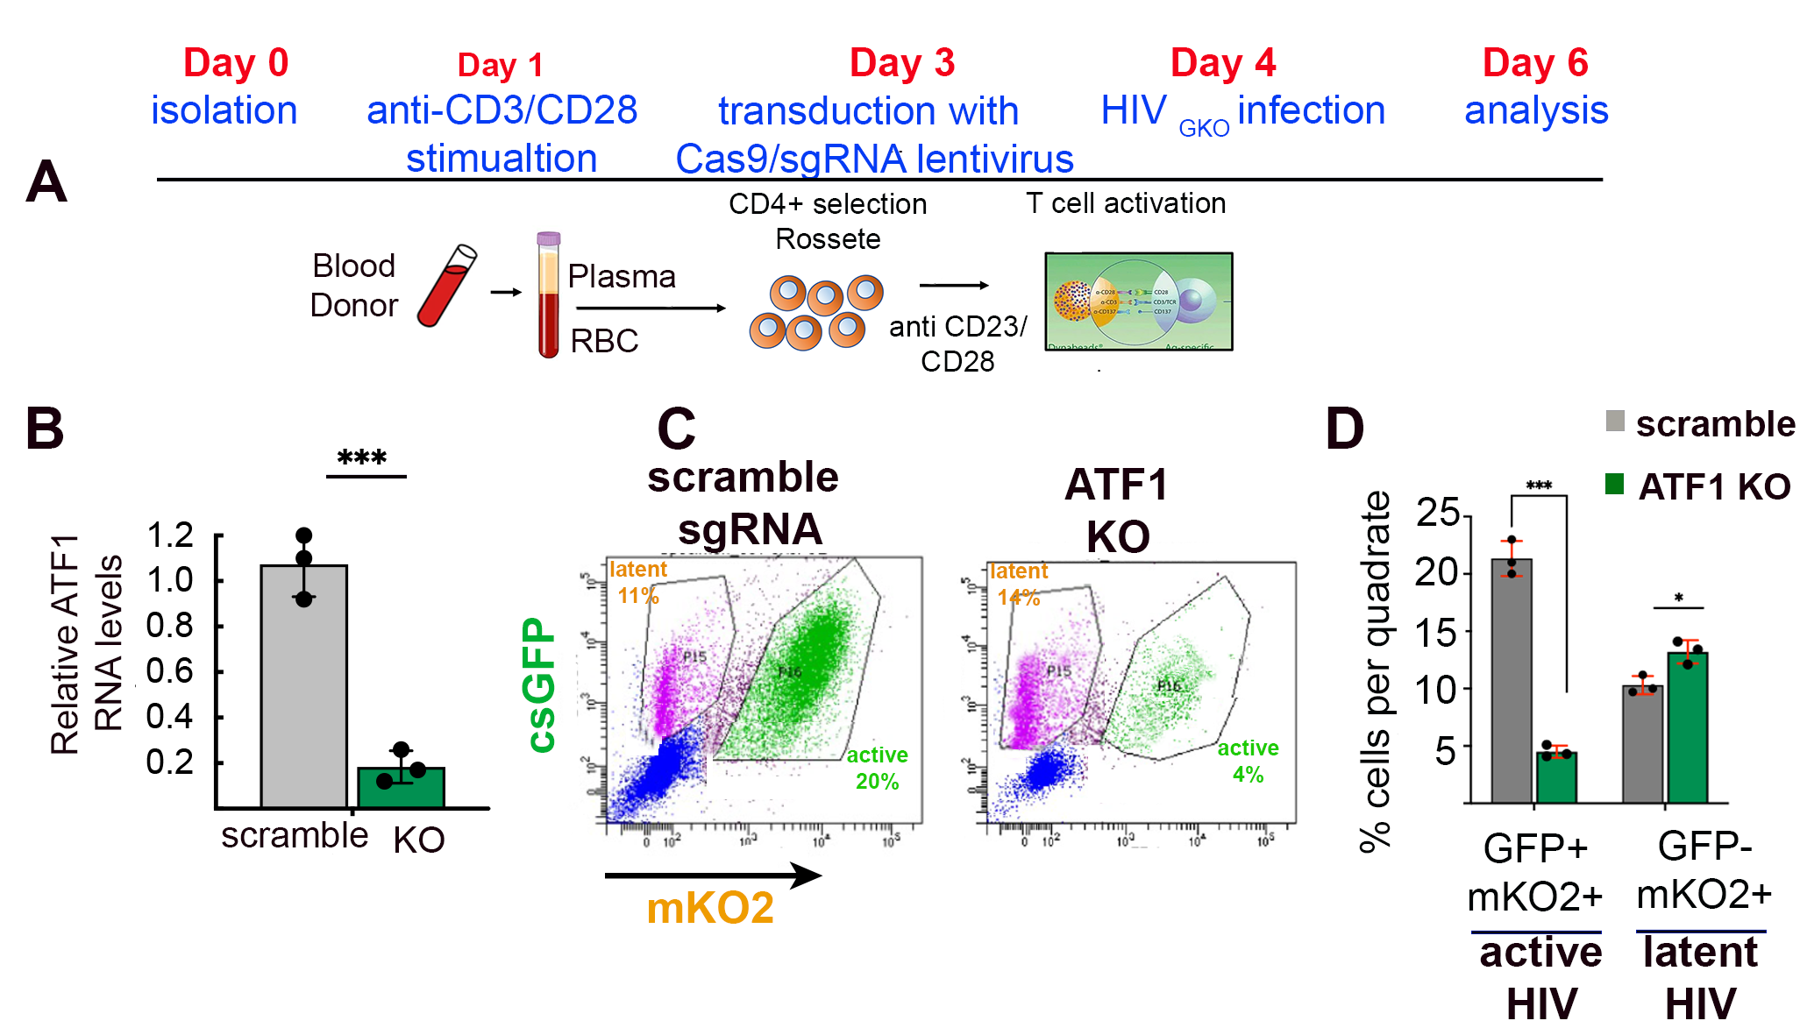
3a. Manipulate ATF1 expression in primary resting CD4+ T cells and monitor effects of ATF1.
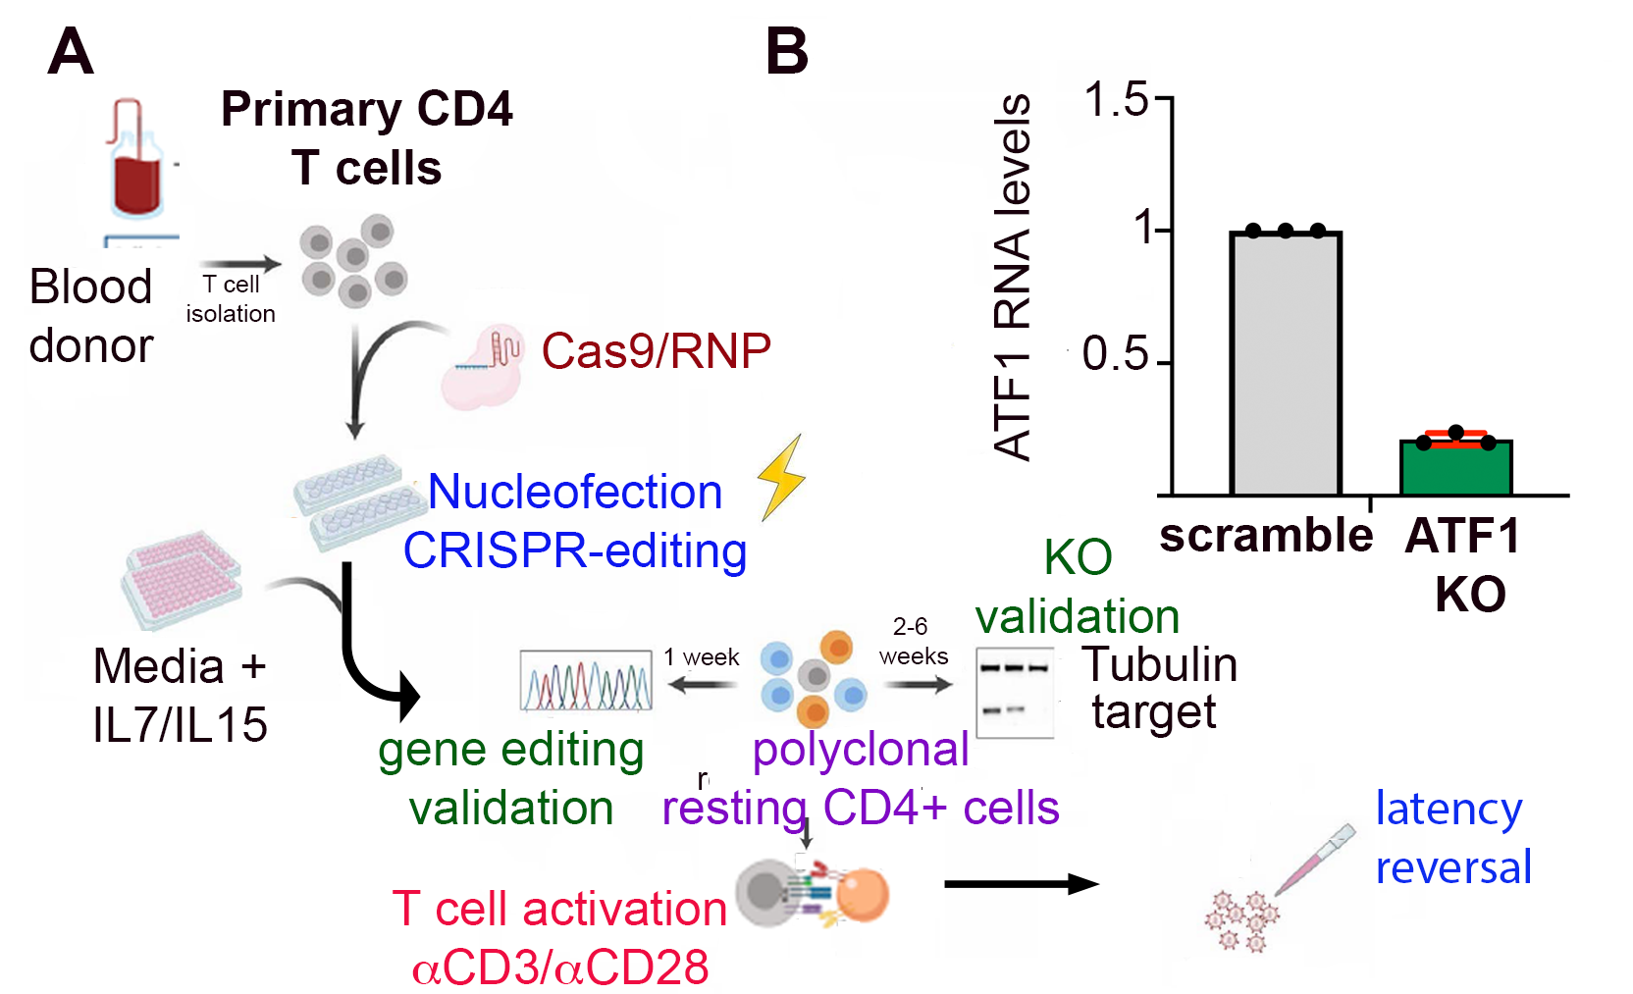
A bottleneck for mechanistic studies of the role of host factors in HIV gene expression and latency is the ability to manipulate their expression in appropriate cellular models of latency without simultaneously affecting the activation state of these cells. In cell lines such as HIV-infected J-Lat 6.3 cells, we have already established the efficient overexpression and knockdown of ATF1 (Fig. 3). While these approaches will continue to be helpful, particularly for proof-of-concept and functional analyses, the activation state of these immortalized and thus dividing cell lines does not mirror that of physiologically-relevant primary resting CD4 T cells which constitute the latent HIV reservoir. However, resting CD4 T cells are refractory to genetic manipulation and to HIV infection due to their low expression of the CCR5 co-receptor and reduced amounts of the dNTPs required for DNA synthesis during reverse transcription [87]. This barrier has thus far been overcome only by manipulating gene expression in activated primary CD4 T cells and waiting until they return to a resting state following removal of stimulus. Such post-activated CD4 T primary cells are not true resting cells, and this procedure likely impacts HIV gene expression and latency reversal. Therefore, we collaborated with the Fackler laboratory in Heidelberg (see attached letter) to employ a nucleofection-based CRISPR approach in resting CD4 T primary cells to generate ATF1-KO without altering the activation state of the T cells (preliminary ATF1 KO is presented in Fig. 11) [88]. Following nucleofection and validation of ATF1 KO, cells will be stimulated and transduced with HIV_{GKO} to investigate the role of ATF1 in the control of HIV transcription and its effects on the establishment or reversal of latency in resting CD4 primary cells [88]. Once efficient KO of ATF1 has been achieved, we will conduct a detailed quantitative analysis of reporter expression (viral gene expression) and integration (via Alu PCR) in ATF1-modulated cells.
Figure 11: Depletion of ATF1 in primary CD4+ resting T cells using CRISPR.
- Schematic overview of the workflow to achieve gene KO in primary resting CD4 T cells by employing nucleofection-based CRISPR-gene editing [88].
- Proof-of-concept for depleting ATF1 expression in primary resting CD4 T cells. Cells were purified from three healthy donors and subjected to nucleofection with Csa9-sgRNA riboprotein complex.

3b. Role of ATF1 in HIV latency establishment and reversal. To quantitatively assess the role of ATF1 in HIV latency reversal, latently infected resting CD4+ T cells, in which ATF1 expression is manipulated, will be reactivated by different latency reversal agents. Reactivating latently infected cells will be preceded by FACS sorting to remove cells expressing GFP prior to reactivation. The re-emergence of GFP expression in response to LRA treatment will be studied in the context of ATF1 gene manipulation. Based on our preliminary findings, we anticipate obtaining experimental conditions that will allow us to modify HIV gene expression in primary human CD4 T cells via the modulation of ATF1 expression levels. Nevertheless, this approach will only provide information regarding the reversal of latency in cells which were highly activated only a few days prior and thus may not have fully reached a resting state. To place our study in a clinically relevant context, we will test whether ATF1 gene manipulation levels can enhance or even replace current reactivation protocols for therapeutic latency reversal. To this end, the two most effective LRA-activation approaches will be applied to primary CD4 T cells isolated from HIV patients undergoing therapy, and the amount of spontaneous or LRA-induced reactivation will be assessed. We will monitor viral transcripts, protein synthesis, and the release of virus particles [48, 89, 90]. These experiments will be conducted in the context of ATF1 gene manipulation, and the levels of ATF1 will be confirmed by RT-qPCR and compared to those in cells from healthy donors or patients not receiving HAART. To minimize the bias that may arise due to the heterogeneity of patients, the geometric means of two reference genes, β-actin and GAPDH, will be used to normalize ATF1 levels [91]. Patient blood samples and Helsinki ethics approval are available from the Soroka Medical Center. We will also perform latency establishment in isolated CD4+ primary cells, as described in our experiments with J-Lat 6.3 cells (Fig. 9C). In this case, primary cells will be reactivated and infected with HIV_{GKO} as described, and we will follow the entry of cells into latency by monitoring GFP expression.
Expected outcomes, potential pitfalls, and alternative strategies.
We will establish the functional relevance of ATF1 as an HIV gene activator in resting CD4 T primary cells. Such cells are viable only for several weeks and will be isolated regularly. The frequency of patient-derived peripheral CD4 T cells that carry HIV proviral DNA is below 1%. Thus, although challenging, we expect that the high efficiency of our CRISPR approach to manipulating ATF1 levels in resting CD4 T cells will allow us to test the effects of ATF1 KO on HIV gene expression in HIV patient cells. ATF1 expression will be manipulated, and KO levels between individuals will be verified by sequencing. Changes in ATF1 levels can affect other steps in the HIV life cycle. Thus, viral gene expression may be low even if transcription is unaffected. Therefore, proviral DNA will be normalized, and GFP mRNA levels will be monitored.
IV. Resources
The research will be conducted in the Department of Microbiology, Ben-Gurion University, Israel. Our lab is 66 m², and is outfitted with the equipment required for this study, including PCR cyclers, quantitative PCR, gel electrophoresis devices, centrifuges, and freezers (-20°C and -80°C). The tissue culture room includes a biological hood, CO₂ incubators, light and fluorescence microscopes, centrifuges, and freezers. Our team comprises a research associate lab manager at the Ph.D. level, one Ph.D. student, and two M.Sc. students. BGU core facilities include genomics, proteomics, sequencing, and bioinformatics units, all headed by skilled researchers.

Bibliography:

1. Muse, G.W., D.A. Gilchrist, S. Nechaev, R. Shah, J.S. Parker, S.F. Grissom, J. Zeitlinger, and K. Adelman, RNA polymerase is poised for activation across the genome. Nat Genet, 2007. 39(12): p. 1507-11.
2. Schier, A.C. and D.J. Taatjes, Structure and mechanism of the RNA polymerase II transcription machinery. Genes Dev, 2020. 34(7-8): p. 465-488.
3. Scruggs, B.S. and K. Adelman, The Importance of Controlling Transcription Elongation at Coding and Noncoding RNA Loci. Cold Spring Harb Symp Quant Biol, 2015. 80: p. 33-44.
4. Chen, F.X., E.R. Smith, and A. Shilatifard, Born to run: control of transcription elongation by RNA polymerase II. Nat Rev Mol Cell Biol, 2018. 19(7): p. 464-478.
5. Core, L. and K. Adelman, Promoter-proximal pausing of RNA polymerase II: a nexus of gene regulation. Genes Dev, 2019. 33(15-16): p. 960-982.
6. Allen, B.L. and D.J. Taatjes, The Mediator complex: a central integrator of transcription. Nat Rev Mol Cell Biol, 2015. 16(3): p. 155-66.
7. Harper, J.W. and S.J. Elledge, The role of Cdk7 in CAK function, a retro-retrospective. Genes Dev, 1998. 12(3): p. 285-9.
8. Larochelle, S., J. Pandur, R.P. Fisher, H.K. Salz, and B. Suter, Cdk7 is essential for mitosis and for in vivo Cdk-activating kinase activity. Genes & Development, 1998. 12(3): p. 370-381.
9. Larochelle, S., R. Amat, K. Glover-Cutter, M. Sanso, C. Zhang, J.J. Allen, K.M. Shokat, D.L. Bentley, and R.P. Fisher, Cyclin-dependent kinase control of the initiation-to-elongation switch of RNA polymerase II. Nat Struct Mol Biol, 2012. 19(11): p. 1108-15.
10. Eick, D. and M. Geyer, The RNA polymerase II carboxy-terminal domain (CTD) code. Chem Rev, 2013. 113(11): p. 8456-90.
11. Wong, K.H., Y. Jin, and K. Struhl, TFIIH phosphorylation of the Pol II CTD stimulates mediator dissociation from the preinitiation complex and promoter escape. Mol Cell, 2014. 54(4): p. 601-12.
12. Glover-Cutter, K., S. Larochelle, B. Erickson, C. Zhang, K. Shokat, R.P. Fisher, and D.L. Bentley, TFIIH-associated Cdk7 kinase functions in phosphorylation of C-terminal domain Ser7 residues, promoter-proximal pausing, and termination by RNA polymerase II. Mol Cell Biol, 2009. 29(20): p. 5455-64.
13. Czudnochowski, N., C.A. Bosken, and M. Geyer, Serine-7 but not serine-5 phosphorylation primes RNA polymerase II CTD for P-TEFb recognition. Nat Commun, 2012. 3: p. 842.
14. Luse, D.S., M. Parida, B.M. Spector, K.A. Nilson, and D.H. Price, A unified view of the sequence and functional organization of the human RNA polymerase II promoter. Nucleic Acids Res, 2020. 48(14): p. 7767-7785.
15. Adelman, K. and J.T. Lis, Promoter-proximal pausing of RNA polymerase II: emerging roles in metazoans. Nat Rev Genet, 2012. 13(10): p. 720-31.
16. Vos, S.M., L. Farnung, H. Urlaub, and P. Cramer, Structure of paused transcription complex Pol II-DSIF-NELF. Nature, 2018. 560(7720): p. 601-606.
17. Luo, Z., C. Lin, and A. Shilatifard, The super elongation complex (SEC) family in transcriptional control. Nat Rev Mol Cell Biol, 2012. 13(9): p. 543-7.
18. Yamaguchi, Y., H. Shibata, and H. Handa, Transcription elongation factors DSIF and NELF: promoter-proximal pausing and beyond. Biochim Biophys Acta, 2013. 1829(1): p. 98-104.
19. Barboric, M. and K. Fujinaga, The two sides of Tat. Elife, 2016. 5: p. e12686.
20. Zhou, Q., T. Li, and D.H. Price, RNA polymerase II elongation control. Annu Rev Biochem, 2012. 81: p. 119-43.
21. Price, D.H., P-TEFb, a cyclin-dependent kinase controlling elongation by RNA polymerase II. Mol Cell Biol, 2000. 20(8): p. 2629-34.
22. Wei, P., M.E. Garber, S.M. Fang, W.H. Fischer, and K.A. Jones, A novel CDK9-associated C-type cyclin interacts directly with HIV-1 Tat and mediates its high-affinity, loop-specific binding to TAR RNA. Cell, 1998. 92(4): p. 451-62.
23. Blazek, D., J. Kohoutek, K. Bartholomeeusen, E. Johansen, P. Hulinkova, Z. Luo, P. Cimermancic, J. Ule, and B.M. Peterlin, The Cyclin K/Cdk12 complex maintains genomic stability via regulation of expression of DNA damage response genes. Genes Dev, 2011. 25(20): p. 2158-72.
24. Bartkowiak, B., P.D. Liu, H.P. Phatnani, N.J. Fuda, J.J. Cooper, D.H. Price, K. Adelman, J.T. Lis, and A.L. Greenleaf, CDK12 is a transcription elongation-associated CTD kinase, the metazoan ortholog of yeast Ctk1. Genes & Development, 2010. 24(20): p. 2303-2316.
25. Greenleaf, A.L., Human CDK12 and CDK13, multi-tasking CTD kinases for the new millenium. Transcription, 2019. 10(2): p. 91-110.
26. Nguyen, V.T., T. Kiss, A.A. Michels, and O. Bensaude, 7SK small nuclear RNA binds to and inhibits the activity of CDK9/cyclin T complexes. Nature, 2001. 414(6861): p. 322-5.
27. AJ, C.Q., A. Bugai, and M. Barboric, Cracking the control of RNA polymerase II elongation by 7SK snRNP and P-TEFb. Nucleic Acids Res, 2016. 44(16): p. 7527-39.
28. Yang, Z., J.H. Yik, R. Chen, N. He, M.K. Jang, K. Ozato, and Q. Zhou, Recruitment of P-TEFb for stimulation of transcriptional elongation by the bromodomain protein Brd4. Mol Cell, 2005. 19(4): p. 535-45.
29. Yang, Z., Q. Zhu, K. Luo, and Q. Zhou, The 7SK small nuclear RNA inhibits the CDK9/cyclin T1 kinase to control transcription. Nature, 2001. 414(6861): p. 317-22.
30. Mbonye, U., F. Kizito, and J. Karn, New insights into transcription elongation control of HIV-1 latency and rebound. Trends Immunol, 2023. 44(1): p. 60-71.
31. Fujinaga, K., F. Huang, and B.M. Peterlin, P-TEFb: The master regulator of transcription elongation. Mol Cell, 2023. 83(3): p. 393-403.
32. Garber, M.E., P. Wei, and K.A. Jones, HIV-1 Tat interacts with cyclin T1 to direct the P-TEFb CTD kinase complex to TAR RNA. Cold Spring Harb Symp Quant Biol, 1998. 63: p. 371-80.
33. Ott, M., M. Geyer, and Q. Zhou, The control of HIV transcription: keeping RNA polymerase II on track. Cell Host Microbe, 2011. 10(5): p. 426-35.
34. Verdikt, R., O. Hernalsteens, and C. Van Lint, Epigenetic Mechanisms of HIV-1 Persistence. Vaccines (Basel), 2021. 9(5).
35. Deeks, S.G., N. Archin, P. Cannon, S. Collins, R.B. Jones, M. de Jong, O. Lambotte, R. Lamplough, T. Ndung'u, J. Sugarman, C.T. Tiemessen, L. Vandekerckhove, S.R. Lewin, and A.S.G.S.S.w.g. International, Research priorities for an HIV cure: International AIDS Society Global Scientific Strategy 2021. Nat Med, 2021. 27(12): p. 2085-2098.
36. Finzi, D., M. Hermankova, T. Pierson, L.M. Carruth, C. Buck, R.E. Chaisson, T.C. Quinn, K. Chadwick, J. Margolick, R. Brookmeyer, J. Gallant, M. Markowitz, D.D. Ho, D.D. Richman, and R.F. Siliciano, Identification of a reservoir for HIV-1 in patients on highly active antiretroviral therapy. Science, 1997. 278(5341): p. 1295-300.
37. Perelson, A.S., A.U. Neumann, M. Markowitz, J.M. Leonard, and D.D. Ho, HIV-1 dynamics in vivo: virion clearance rate, infected cell life-span, and viral generation time. Science, 1996. 271(5255): p. 1582-6.
38. Siliciano, J.D., J. Kajdas, D. Finzi, T.C. Quinn, K. Chadwick, J.B. Margolick, C. Kovacs, S.J. Gange, and R.F. Siliciano, Long-term follow-up studies confirm the stability of the latent reservoir for HIV-1 in resting CD4+ T cells. Nat Med, 2003. 9(6): p. 727-8.
39. Ho, Y.C., L. Shan, N.N. Hosmane, J. Wang, S.B. Laskey, D.I. Rosenbloom, J. Lai, J.N. Blankson, J.D. Siliciano, and R.F. Siliciano, Replication-competent noninduced proviruses in the latent reservoir increase barrier to HIV-1 cure. Cell, 2013. 155(3): p. 540-51.
40. Chun, T.W., L. Carruth, D. Finzi, X. Shen, J.A. DiGiuseppe, H. Taylor, M. Hermankova, K. Chadwick, J. Margolick, T.C. Quinn, Y.H. Kuo, R. Brookmeyer, M.A. Zeiger, P. Barditch-Crovo, and R.F. Siliciano, Quantification of latent tissue reservoirs and total body viral load in HIV-1 infection. Nature, 1997. 387(6629): p. 183-8.
41. Sun, W., C. Gao, C.A. Hartana, M.R. Osborn, K.B. Einkauf, X. Lian, B. Bone, N. Bonheur, T.W. Chun, E.S. Rosenberg, B.D. Walker, X.G. Yu, and M. Lichterfeld, Phenotypic signatures of immune selection in HIV-1 reservoir cells. Nature, 2023. 614(7947): p. 309-317.
42. Pasternak, A.O. and B. Berkhout, HIV persistence: silence or resistance? Curr Opin Virol, 2023. 59: p. 101301.
43. Dutilleul, A., A. Rodari, and C. Van Lint, Depicting HIV-1 Transcriptional Mechanisms: A Summary of What We Know. Viruses, 2020. 12(12).
44. Blazkova, J., K. Trejbalova, F. Gondois-Rey, P. Halfon, P. Philibert, A. Guiguen, E. Verdin, D. Olive, C. Van Lint, J. Hejnar, and I. Hirsch, CpG methylation controls reactivation of HIV from latency. PLoS Pathog, 2009. 5(8): p. e1000554.
45. Chen, M., Y. Liu, Y. Yang, Y. Qiu, Z. Wang, X. Li, and W. Zhang, Emerging roles of activating transcription factor (ATF) family members in tumourigenesis and immunity: Implications in cancer immunotherapy. Genes Dis, 2022. 9(4): p. 981-999.
46. Siliciano, R.F. and W.C. Greene, HIV latency. Cold Spring Harb Perspect Med, 2011. 1(1): p. a007096.
47. Deeks, S.G., HIV: Shock and kill. Nature, 2012. 487(7408): p. 439-40.
48. Archin, N.M., A.L. Liberty, A.D. Kashuba, S.K. Choudhary, J.D. Kuruc, A.M. Crooks, D.C. Parker, E.M. Anderson, M.F. Kearney, M.C. Strain, D.D. Richman, M.G. Hudgens, R.J. Bosch, J.M. Coffin, J.J. Eron, D.J. Hazuda, and D.M. Margolis, Administration of vorinostat disrupts HIV-1 latency in patients on antiretroviral therapy. Nature, 2012. 487(7408): p. 482-5.
49. Vansant, G., A. Bruggemans, J. Janssens, and Z. Debyser, Block-And-Lock Strategies to Cure HIV Infection. Viruses, 2020. 12(1).
50. Margolis, D.M., N.M. Archin, M.S. Cohen, J.J. Eron, G. Ferrari, J.V. Garcia, C.L. Gay, N. Goonetilleke, S.B. Joseph, R. Swanstrom, A.W. Turner, and A. Wahl, Curing HIV: Seeking to Target and Clear Persistent Infection. Cell, 2020. 181(1): p. 189-206.
51. Ndung'u, T., J.M. McCune, and S.G. Deeks, Why and where an HIV cure is needed and how it might be achieved. Nature, 2019. 576(7787): p. 397-405.
52. Chen, I.P. and M. Ott, Turning up the heat on HIV-1. Proc Natl Acad Sci U S A, 2020. 117(28): p. 16109-16111.
53. Dufour, C., P. Gantner, R. Fromentin, and N. Chomont, The multifaceted nature of HIV latency. J Clin Invest, 2021. 131(11).
54. Moranguinho, I. and S.T. Valente, Block-And-Lock: New Horizons for a Cure for HIV-1. Viruses, 2020. 12(12).
55. Sengupta, S. and R.F. Siliciano, Targeting the Latent Reservoir for HIV-1. Immunity, 2018. 48(5): p. 872-895.
56. Battivelli, E., M.S. Dahabieh, M. Abdel-Mohsen, J.P. Svensson, I. Tojal Da Silva, L.B. Cohn, A. Gramatica, S. Deeks, W.C. Greene, S.K. Pillai, and E. Verdin, Distinct chromatin functional states correlate with HIV latency reactivation in infected primary CD4(+) T cells. Elife, 2018. 7.
57. Anderson, I., J.S. Low, S. Weston, M. Weinberger, A. Zhyvoloup, A.A. Labokha, G. Corazza, R.A. Kitson, C.J. Moody, A. Marcello, and A. Fassati, Heat shock protein 90 controls HIV-1 reactivation from latency. Proc Natl Acad Sci U S A, 2014. 111(15): p. E1528-37.
58. Das, B., C. Dobrowolski, B. Luttge, S. Valadkhan, N. Chomont, R. Johnston, P. Bacchetti, R. Hoh, M. Gandhi, S.G. Deeks, E. Scully, and J. Karn, Estrogen receptor-1 is a key regulator of HIV-1 latency that imparts gender-specific restrictions on the latent reservoir. Proceedings of the National Academy of Sciences of the United States of America, 2018. 115(33): p. E7795-E7804.
59. Shilatifard, A., W.S. Lane, K.W. Jackson, R.C. Conaway, and J.W. Conaway, An RNA polymerase II elongation factor encoded by the human ELL gene. Science, 1996. 271(5257): p. 1873-6.
60. Hotter, D., M. Bosso, K.L. Jonsson, C. Krapp, C.M. Sturzel, A. Das, E. Littwitz-Salomon, B. Berkhout, A. Russ, S. Wittmann, T. Gramberg, Y. Zheng, L.J. Martins, V. Planelles, M.R. Jakobsen, B.H. Hahn, U. Dittmer, D. Sauter, and F. Kirchhoff, IFI16 Targets the Transcription Factor Sp1 to Suppress HIV-1 Transcription and Latency Reactivation. Cell Host Microbe, 2019. 25(6): p. 858-872 e13.
61. Hafer, T.L., A. Felton, Y. Delgado, H. Srinivasan, and M. Emerman, A CRISPR Screen of HIV Dependency Factors Reveals That CCNT1 Is Non-Essential in T Cells but Required for HIV-1 Reactivation from Latency. Viruses, 2023. 15(9).
62. Krasnopolsky, S., A. Kuzmina, and R. Taube, Genome-wide CRISPR knockout screen identifies ZNF304 as a silencer of HIV transcription that promotes viral latency. PLoS Pathog, 2020. 16(9): p. e1008834.
63. Lin, Y.S. and M.R. Green, Interaction of a common cellular transcription factor, ATF, with regulatory elements in both E1a- and cyclic AMP-inducible promoters. Proc Natl Acad Sci U S A, 1988. 85(10): p. 3396-400.
64. Lee, K.A.W., T.Y. Hai, L. Sivaraman, B. Thimmappaya, H.C. Hurst, N.C. Jones, and M.R. Green, A Cellular Protein, Activating Transcription Factor, Activates Transcription of Multiple E1a-Inducible Adenovirus Early Promoters. Proceedings of the National Academy of Sciences of the United States of America, 1987. 84(23): p. 8355-8359.
65. Rabbi, M.F., M. Saifuddin, D.S. Gu, M.F. Kagnoff, and K.A. Roebuck, U5 region of the human immunodeficiency virus type 1 long terminal repeat contains TRE-like cAMP-responsive elements that bind both AP-1 and CREB/ATF proteins. Virology, 1997. 233(1): p. 235-245.
66. Roebuck, K.A., D.S. Gu, and M.F. Kagnoff, Activating protein-1 cooperates with phorbol ester activation signals to increase HIV-1 expression. AIDS, 1996. 10(8): p. 819-26.
67. Hai, T.W., F. Liu, E.A. Allegretto, M. Karin, and M.R. Green, A family of immunologically related transcription factors that includes multiple forms of ATF and AP-1. Genes Dev, 1988. 2(10): p. 1216-26.
68. Hai, T.W., F. Liu, W.J. Coukos, and M.R. Green, Transcription factor ATF cDNA clones: an extensive family of leucine zipper proteins able to selectively form DNA-binding heterodimers. Genes Dev, 1989. 3(12B): p. 2083-90.
69. Jordan, A., D. Bisgrove, and E. Verdin, HIV reproducibly establishes a latent infection after acute infection of T cells in vitro. EMBO J, 2003. 22(8): p. 1868-77.
70. Pearson, R., Y.K. Kim, J. Hokello, K. Lassen, J. Friedman, M. Tyagi, and J. Karn, Epigenetic silencing of human immunodeficiency virus (HIV) transcription by formation of restrictive chromatin structures at the viral long terminal repeat drives the progressive entry of HIV into latency. J Virol, 2008. 82(24): p. 12291-303.
71. Fisher, R.P., Cdk7: a kinase at the core of transcription and in the crosshairs of cancer drug discovery. Transcription-Austin, 2019. 10(2): p. 47-56.
72. Peterlin, B.M. and D.H. Price, Controlling the elongation phase of transcription with P-TEFb. Mol Cell, 2006. 23(3): p. 297-305.
73. Drapkin, R., G. Le Roy, H. Cho, S. Akoulitchev, and D. Reinberg, Human cyclin-dependent kinase-activating kinase exists in three distinct complexes. Proc Natl Acad Sci U S A, 1996. 93(13): p. 6488-93.
74. Cujec, T.P., H. Okamoto, K. Fujinaga, J. Meyer, H. Chamberlin, D.O. Morgan, and B.M. Peterlin, The HIV transactivator TAT binds to the CDK-activating kinase and activates the phosphorylation of the carboxy-terminal domain of RNA polymerase II. Genes Dev, 1997. 11(20): p. 2645-57.
75. Zheng, D., Y.Y. Cho, A.T. Lau, J. Zhang, W.Y. Ma, A.M. Bode, and Z. Dong, Cyclin-dependent kinase 3-mediated activating transcription factor 1 phosphorylation enhances cell transformation. Cancer Res, 2008. 68(18): p. 7650-60.
76. Huang, G.L., D. Liao, H. Chen, Y. Lu, L.Y. Chen, H.H. Li, B.B. Li, W.L. Liu, C.G. Ye, T. Li, Z. Zhu, J. Wang, T. Uchida, Y. Zou, Z.G. Dong, and Z.W. He, The protein level and transcription activity of activating transcription factor 1 is regulated by prolyl isomerase Pin1 in nasopharyngeal carcinoma progression. Cell Death & Disease, 2016. 7.
77. Chrivia, J.C., R.P. Kwok, N. Lamb, M. Hagiwara, M.R. Montminy, and R.H. Goodman, Phosphorylated CREB binds specifically to the nuclear protein CBP. Nature, 1993. 365(6449): p. 855-9.
78. Kwiatkowski, N., T. Zhang, P.B. Rahl, B.J. Abraham, J. Reddy, S.B. Ficarro, A. Dastur, A. Amzallag, S. Ramaswamy, B. Tesar, C.E. Jenkins, N.M. Hannett, D. McMillin, T. Sanda, T. Sim, N.D. Kim, T. Look, C.S. Mitsiades, A.P. Weng, J.R. Brown, C.H. Benes, J.A. Marto, R.A. Young, and N.S. Gray, Targeting transcription regulation in cancer with a covalent CDK7 inhibitor. Nature, 2014. 511(7511): p. 616-20.
79. Olson, C.M., Y. Liang, A. Leggett, W.D. Park, L. Li, C.E. Mills, S.Z. Elsarrag, S.B. Ficarro, T. Zhang, R. Duster, M. Geyer, T. Sim, J.A. Marto, P.K. Sorger, K.D. Westover, C.Y. Lin, N. Kwiatkowski, and N.S. Gray, Development of a Selective CDK7 Covalent Inhibitor Reveals Predominant Cell-Cycle Phenotype. Cell Chem Biol, 2019. 26(6): p. 792-803 e10.
80. Vispe, S., L. DeVries, L. Creancier, J. Besse, S. Breand, D.J. Hobson, J.Q. Svejstrup, J.P. Annereau, D. Cussac, C. Dumontet, N. Guilbaud, J.M. Barret, and C. Bailly, Triptolide is an inhibitor of RNA polymerase I and II-dependent transcription leading predominantly to down-regulation of short-lived mRNA. Mol Cancer Ther, 2009. 8(10): p. 2780-90.
81. Kwak, H., N.J. Fuda, L.J. Core, and J.T. Lis, Precise maps of RNA polymerase reveal how promoters direct initiation and pausing. Science, 2013. 339(6122): p. 950-3.
82. Skene, P.J. and S. Henikoff, An efficient targeted nuclease strategy for high-resolution mapping of DNA binding sites. Elife, 2017. 6.
83. Rodari, A., G. Darcis, and C.M. Van Lint, The Current Status of Latency Reversing Agents for HIV-1 Remission. Annu Rev Virol, 2021. 8(1): p. 491-514.
84. Contreras, X., M. Schweneker, C.S. Chen, J.M. McCune, S.G. Deeks, J. Martin, and B.M. Peterlin, Suberoylanilide hydroxamic acid reactivates HIV from latently infected cells. J Biol Chem, 2009. 284(11): p. 6782-9.
85. Darcis, G., A. Kula, S. Bouchat, K. Fujinaga, F. Corazza, A. Ait-Ammar, N. Delacourt, A. Melard, K. Kabeya, C. Vanhulle, B. Van Driessche, J.S. Gatot, T. Cherrier, L.F. Pianowski, L. Gama, C. Schwartz, J. Vila, A. Burny, N. Clumeck, M. Moutschen, S. De Wit, B.M. Peterlin, C. Rouzioux, O. Rohr, and C. Van Lint, An In-Depth Comparison of Latency-Reversing Agent Combinations in Various In Vitro and Ex Vivo HIV-1 Latency Models Identified Bryostatin-1+JQ1 and Ingenol-B+JQ1 to Potently Reactivate Viral Gene Expression. PLoS Pathog, 2015. 11(7): p. e1005063.
86. Li, Z.C., J. Guo, Y.T. Wu, and Q. Zhou, The BET bromodomain inhibitor JQ1 activates HIV latency through antagonizing Brd4 inhibition of Tat-transactivation. Nucleic Acids Research, 2013. 41(1): p. 277-287.
87. Pan, X., H.M. Baldauf, O.T. Keppler, and O.T. Fackler, Restrictions to HIV-1 replication in resting CD4+ T lymphocytes. Cell Res, 2013. 23(7): p. 876-85.
88. Albanese, M., A. Ruhle, J. Mittermaier, E. Mejias-Perez, M. Gapp, A. Linder, N.A. Schmacke, K. Hofmann, A.A. Hennrich, D.N. Levy, A. Humpe, K.K. Conzelmann, V. Hornung, O.T. Fackler, and O.T. Keppler, Rapid, efficient and activation-neutral gene editing of polyclonal primary human resting CD4(+) T cells allows complex functional analyses. Nat Methods, 2022. 19(1): p. 81-89.
89. Laird, G.M., C.K. Bullen, D.I. Rosenbloom, A.R. Martin, A.L. Hill, C.M. Durand, J.D. Siliciano, and R.F. Siliciano, Ex vivo analysis identifies effective HIV-1 latency-reversing drug combinations. J Clin Invest, 2015. 125(5): p. 1901-12.
90. McKernan, L.N., D. Momjian, and J. Kulkosky, Protein Kinase C: One Pathway towards the Eradication of Latent HIV-1 Reservoirs. Adv Virol, 2012. 2012: p. 805347.
91. Tyagi, M., R.J. Pearson, and J. Karn, Establishment of HIV latency in primary CD4+ cells is due to epigenetic transcriptional silencing and P-TEFb restriction. J Virol, 2010. 84(13): p. 6425-37.

