# Topic 5 Retail banking

## Learning objectives

In this topic we shall cover:

* the characteristics of the main retail banking products and services;
* why retail customers may have different needs and how banks segment their products and services to meet them;
* the importance of client risk appetite when considering the suitability of mortgage and savings products for individual customers.

## 5.1 Products and services overview

The primary products and services offered by retail banks include:

* **current accounts** – essential for most people to make payments and receive income on a day-to-day basis;
* **lending products** – help customers to manage short-term cash flow shortages as well as to make significant purchases without the need to save for an extended time;
* **savings and investment products** – savings are necessary to cope with short‑term emergencies (rainy‑day funds) or to build capital, while investments are used to set aside lump sums to fund future needs such as education fees, healthcare or retirement. Most retail customers can access investment services through their bank, whether digitally or otherwise. You will learn more about investment services in Topic 6.

There is a vast range of products that banks provide in each of these three groups for retail banking clients; in this topic we will provide a broad overview of the main types available. Additional products and services offered to private banking clients will be discussed in Topic 6.

**A note on terminology**

Banks use a range of terms to describe the segmentation of the overall retail banking market.

Segmentation is typically achieved by grouping customers into different categories based on what is known about their income levels.

While the distinction between retail and corporate banking is readily understood, things become less

clear when trying to distinguish between retail banking segments, which may use terms such as ‘personal’, ‘premier’, ‘mass affluent’, ‘high net worth’, ‘private client’, ‘select’, ‘elite’ and ‘priority’.

Each bank has its own range of segment names and applies these depending upon what its marketing team has assessed might appeal to prospective customers. This means, for example, that a ‘private’ client in one bank may be a ‘premier’ client in another. There is no single definition of each of the terms mentioned above, so students should not be too concerned about trying to distinguish precisely between these.

For study purposes, the terms ‘retail banking’ and ‘personal banking’ can be considered

interchangeable. Further guidance is provided where a deeper level of understanding is considered important.

## 5.2 The hierarchy of financial needs

Retail banking customers generally require similar services from their banks. These can be categorised broadly as services that help facilitate life on a day-to-day basis and those that focus on future needs. Figure 5.1 demonstrates the building blocks of retail banking services. Each of these building blocks is discussed in more detail in the sections that follow and in Topic 6.

**Figure 5.1 The hierarchy of financial needs**

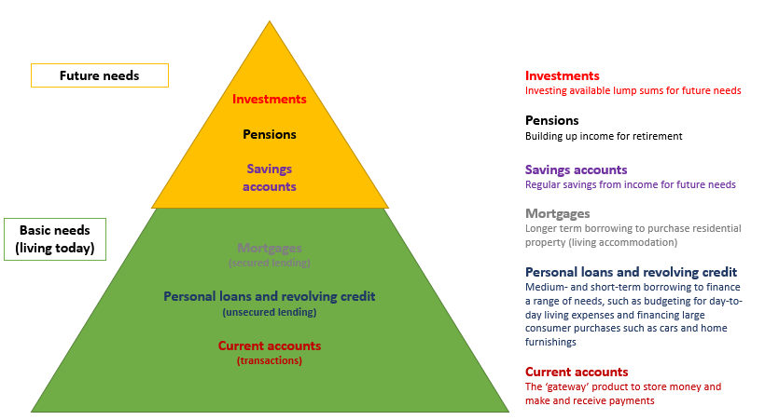

**Reflect**

How do you use your own current account? If you did not have a current account, how easy would it be for you to replace the services it provides? Do you borrow money from your own bank, save money with it, or do both?

## 5.3 Current accounts

Current accounts are designed to meet individuals’ basic, everyday banking needs. People open current accounts to provide a safe place to store their money and to facilitate the receipt of funds, such as salary or pension payments, and to make payments such as rent, utility or mortgage instalments. Banks often offer low‑cost or no‑cost basic account services as these attract low-cost deposits from consumers. Current accounts are considered to be demand accounts as customers can withdraw their money on demand.

|  |
| --- |
| **Common features of current accounts**  Current accounts typically offer:   * the ability to make and receive different types of payments, including standing orders and direct debits; * statements showing transactions posted to the account; * debit cards to access cash or make payments; * account access via online banking or a mobile app; * in some cases, a small amount of credit interest paid on balances held; * overdraft facilities to creditworthy customers up to an agreed limit (see section 5.4.2). |

Some types of customers expect their current accounts to provide levels of service that go beyond these ‘basic’ features. Some banks will offer customers other services to attract more business from them, such as additional deposits or the cross-selling of other products (eg credit cards and foreign exchange). This allows banks to capture more revenue from each customer.

As you learned in Topic 1, banks target customers at most income levels up to mass affluent or even high-net-worth individuals (HNWI). These customers are the top-end segment of the mass retail banking market and are highly sought after by banks. They often bring more in liquid assets, such as deposits, and are likely to use more of a bank’s services, which can add significantly to the income generated.

**IN BRIEF: mass affluent or HNWI – what’s the difference?**

The terms ‘mass affluent’ and ‘HNWI’ were discussed in Topic 1. There is no precise global definition for these terms, which can vary significantly from country to country and even between banks operating within the same borders.

For example, the mass affluent market segment in the UK has been said to consist of around six million households who have between £100,000 and £1m of investable assets (Furber, 2020). Individuals with investable assets over this threshold could then be considered to be HNWIs. The UK’s HM Revenue & Customs (HMRC), however, has a different definition for HNWI. Since 2016, HMRC has defined anyone with assets valued in excess of £10m as an HNWI (National Audit Office, 2016).

In the USA, HNWIs are often said to have over US$1m in liquid financial assets. In 2019, the USA had the most HNWIs in the world (Capgemini Research Institute, 2020).

**Reflect**

What benchmark is used to identify HNWIs in your country?

|  |
| --- |
| **Example: current account segmentation**  Banks can package their ‘basic’ current accounts in various ways to appeal to further customer groups. By offering different packages, banks aim to encourage the top-end segment of retail customers to increase the level of current account deposits they maintain. Below is an example of how a bank might differentiate its packages.  **Silver Account**:US$12.95 per month; fee waived if daily balances exceed US$2,500. Fee-free debit card.  **Gold Account**: US$15 per month; fee waived if daily balances exceed US$5,000. No fee on unarranged overdrafts up to US$500; standard borrowing rates apply. Fee-free debit card. Credit card with cardholder protection benefits and no annual fee.  **Premier Account**: no monthly fee as eligibility criteria needs to be met; account holders need to earn US$100,000 per year or have US$50,000 to save or invest. The account offers a range of benefits, including:   * + dedicated financial planning manager and mortgage adviser;   + interest and fee-free overdrafts up to US$500 with preferential interest rate on overdrafts over US$500;   + travel insurance and access to airport lounges;   + premier debit and credit cards. |

## 5.4 Unsecured lending

The majority of bank lending to individuals for medium- and short-term needs (ie personal loans for purchases such as cars and home furnishings) is granted on an unsecured basis. The same applies to finance provided to assist with budgeting and day-to-day living expenses.

Key terms

**Unsecured lending**

Unsecured lending relies on the personal promise (covenant) of the borrower to repay. Unsecured lending therefore typically carries more risk than secured lending, which generally makes it subject to higher rates of interest and shorter-term availability.

Credit scoring is commonly used to assess unsecured lending propositions to make sound decisions and remove the subjective, human element from the decision‑making process.

### 5.4.1 Personal loans

Personal loans (sometimes referred to as consumer loans) are typically defined as loans to retail customers for the purchase of both goods and services. This type of retail lending includes:

* car or auto loans, both for new and used cars;
* home improvement loans;
* student or education loans;
* debt consolidation loans;
* consumer durable loans (eg furniture and electrical appliances).

Personal loans have a repayment structure, which makes them ideal for when funds are required for a specific purpose. Banks provide personal loans through their branches, call centres and online.

**Common features of personal loans**

Personal loans are typically:

* + - for a fixed amount and have a fixed interest rate;
    - provided for a fixed period of time, generally between one and five years (although in some cases loans can be for up to ten years);
    - arranged with fixed monthly payments that cover interest and capital;
    - assessed centrally through credit scoring, credit reference and fraud agency searches.

**Personal loan costs**

In many jurisdictions, regulation requires banks to disclose the true cost of personal loans and credit. The consumer must be given a means of direct comparison between different loan products, either offered by the same bank or by different banks.

Banks are therefore required to state, on advertising and on the loan documents, the cost of the loan as an annual percentage rate (APR).

Key terms

**Annual percentage rate (APR)**

A figure expressing the ‘true cost’ of a loan, including the interest rate and any fees charged. This allows borrowers to compare different loans and lenders.

**Example: APR**

**APR on a one-year loan**

A customer is offered a one-year, single-payment loan of US$2,000 at an interest rate of 10%. Other charges incurred are:

* + US$20 loan processing fee
  + US$20 credit check fee
  + US$60 credit insurance fee (to cover repayment if the borrower defaults)

The calculation for determining the APR is (annual interest + fees) / loan amount.

The customer’s interest cost is calculated as principal x interest rate x time.

The APR for the one-year loan is:

* + Interest is 2,000 * 10 * 1 year = 200
  + Fees are 20 + 20 + 60 = 100
  + The customer’s APR is therefore (200 + 100) / 2,000 = **15%**

**APR on a two-year loan**

What would this customer’s APR be if this was a two-year loan with principal and interest paid only at maturity and assuming a simple interest calculation?

* + Interest is 2,000 * 10 * 2 years = 400
  + Fees are 20 + 20 + 60 = 100
  + The customer’s APR is therefore [(400 + 100)/2] / 2,000 = **12.5%**

The point here is that the personal loan, while offered with an annual interest rate of 10%, has an effective cost to the borrower of either 15% or 12.5%, depending on the maturity of the loan. In both cases, this is significantly above the pure interest rate quoted.

**Note**: this is a simplified version of the calculation as, in reality, the amount of the loan over a period of time may (for example) decrease due to monthly repayments, which would be factored into the calculation. Banks use calculation tools (which are often online) to allow staff and customers to calculate their potential monthly payments and APR cost.

APR requirements also apply to overdraft and credit card borrowing. The calculations involved are complex, given the revolving and changing nature of the balances involved, and are beyond the scope of this qualification.

### 5.4.2 Overdrafts

An overdraft is a revolving line of credit on a current account that enables the customer to continue to use the account as normal, even though their funds have been used up. They can be useful to customers in periods in which expenditure exceeds income (eg when an unexpectedly high utility bill is received or to fund the purchase of seasonal gifts). The bank sets a limit on the amount by which the account can be overdrawn.

Key terms

**Revolving credit**

Revolving credit refers to arrangements where a customer can continue to borrow further amounts while still repaying existing debt. There is usually a maximum limit on the amount that can be outstanding at any one time. The most common types of revolving credit are credit cards and overdrafts.

Overdrafts are intended to cover borrowing of a temporary nature, with the money repaid on the receipt of expected funds (eg salary). The amount lent is usually equivalent to no more than one month’s salary; any requests for much more than this should be taken as a personal loan (discussed in section 5.4.1).

Overdrafts are on demand arrangements. This means that although the limit is granted for an agreed period before the next review, technically the lender can demand repayment of the amount outstanding at any time. This is in contrast to a personal loan, where the term is agreed over a number of years, the benefit to the customer being certainty that repayment can be spread over a longer period.

Overdrafts that have been authorised in advance by the bank are a relatively inexpensive form of borrowing, as interest is calculated on a daily basis, although there may be an arrangement fee to pay.

**FACTFIND**

Are overdrafts offered by your bank? If so, is there a difference between unauthorised and preauthorised overdraft borrowing rates of interest? Does a preauthorised overdraft cost more than a personal loan?

### 5.4.3 Credit and charge cards

Cards are a popular method of paying for goods and services. There are a number of different types of cards available, each with its own unique attributes. Debit, credit and charge cards are all distributed by card issuers and can be presented by the cardholder to a retailer as immediate payment for goods and services, also known as ‘point of sale’ (PoS) transactions.

Payment to the retailer is processed in a similar manner for all cards. Debit cards are a typical offering provided with a bank current account. While credit and charge cards offer a revolving credit limit, debit cards do not; funds are debited immediately from a consumer’s current account when a debit card is used.

**Credit cards**

Credit cards enable customers to shop without cash or cheques in any establishment that is a member of the credit card company’s scheme. Most cards are issued under the umbrella of Mastercard or Visa and are generally branded to the bank that issued the card.

As well as providing cash‑free purchasing convenience, the customer has a credit limit and can use the card for purchases or other transactions up to that amount, provided that at least a specified minimum amount (usually 3% of the outstanding balance and interest charge) is repaid each month. The customer receives a monthly statement, detailing recent transactions and showing the outstanding balance. If the balance is repaid in full within a certain period (usually 25 days or so), no interest is charged; this can give the customer a period of up to 56 days’ interest‑free credit. If a smaller amount is paid, the remainder is carried forward and interest is charged at the company’s current rate.

Some individuals struggle to repay their credit card borrowing if they do not pay off their monthly balance in full. Credit card borrowing is very remunerative for banks, with APR interest rates of over 20% not uncommon.

**Example: the high cost of credit card borrowing**

A credit card debt of US$2,000 charged at an APR of 22% where the borrower makes a payment of US$60 per month would take over four years to repay. Interest charges would be in excess of US$1,000 (US$1,119 – 56% of the initial amount borrowed).

**FACTFIND**

Explore the costs of credit card borrowing further [here](https://www.bankrate.com/calculators/managing-debt/minimum-payment-calculator.aspx).

Some credit cards offer a cash advance feature, allowing the cardholder to borrow cash against the credit line. Usually, interest starts to accrue as soon as the cash advance is taken; there is no grace period as there would be when making a purchase. There is also often a fee associated with this type of borrowing.

Cards can often be used internationally; however, fees may apply, and the transaction may be subject to an unfavourable foreign exchange rate when converting the charge into the currency of the card issued.

The credit card limit will be determined initially from a credit score of the customer information on application. Then, as a pattern of card usage by the customer develops, behavioural scoring might automatically increase the limit.

In general, credit cards are an expensive way to borrow unless the balance is paid in full, with rates of interest considerably higher than most other lending products.

**Charge cards**

Although a charge card is used in the same way as a credit card to make purchases, the outstanding balance must be paid in full each month, usually by direct debit to a bank account. The best-known example is the American Express charge card. Charge cards may be subject to a subscription fee.

## 5.5 Secured lending

With a secured loan, borrowers offer something of value so that, in the event of default, the lender can take the asset, sell it (realise the security), and obtain repayment out of the proceeds. The asset must be something that is readily realisable, such as a life policy or property. The most common type of secured loan is a mortgage, which we will discuss in section 5.5.1.

Security provides a safety net to the lender should the borrower default. In addition, where the asset over which the lender has taken security represents something of value to the borrower, the prospect of its potential loss may increase their financial self‑discipline and therefore the likelihood of their keeping up repayments.

Where security is available, it plays a role in reducing the lender’s risk, making secured loans generally less risky than unsecured loans. This is reflected in the pricing differential between secured and unsecured loans; the interest rate charged on secured loans is usually lower.

### 5.5.1 Mortgage loans

House purchase loans are usually known as mortgage loans, with the borrower creating a legal charge over the title deeds to the lender as security for the loan. Mortgage loans are the most common method of purchasing residential property.

Key terms

**Mortgage**

A long-term loan to finance the purchase of real estate (property) for a set period, usually 25 or 30 years (though mortgages can also have maturities of 10, 15 or 20 years).

**Mortgagor**

The person who owns the property.

M**ortgagee**

The financial organisation that lends the money to allow the mortgagor to purchase the property.

Although the mortgagee does not own the buildings or land, a lender with a legal charge is entitled to take possession of the property and sell it to recover money owed, although that step would be taken only as a last resort. Before resorting to possession, lenders explore all avenues by which an arrangement could be reached, considering the borrower’s circumstances. Retail banks typically have a significant lending appetite for residential mortgage lending as the long-term, secured nature of the loans generally make them remunerative and low risk.

**Mortgage commitments**

For many individuals, purchasing a property with the help of a mortgage is the biggest financial commitment they will ever make. It is therefore important that they receive appropriate advice on the suitability of mortgage products as they are ultimately at risk of losing their home if they run into repayment difficulties.

In some jurisdictions, consumer protection is a focus of regulation. In the UK, for example, the Financial Conduct Authority (FCA) places a mandatory requirement upon lenders to assess affordability for all mortgage applications to encourage responsible lending.

It is the responsibility of the lender to demonstrate that the mortgage is affordable. Income needs to be verified for every mortgage application, along with an assessment of the borrower’s:

* committed expenditure (credit commitments, child maintenance, alimony, etc);
* essential expenditure (housekeeping, fuel, water, telephone, council tax, essential travel, etc);
* quality of living costs (clothing, furniture, appliances, repairs, toiletries, childcare, basic recreational facilities such as television, non-essential transport, etc).

The amount of a mortgage loan could be anything up to 95% of the property value, although it is usually prudent for the lender to advance a lower percentage. The percentage of the property value advanced is generally known as the loan‑to‑value (LTV) ratio. If the value of a property falls, a lender could find that the amount outstanding on the mortgage loan is greater than the value of the asset on which that loan is secured. This is known as negative equity and can cause problems for both the lender and the borrower. If the borrower defaults on the payments and the property is taken into possession, the lender may be unable to sell the property for an amount sufficient to repay the loan.

**Mortgage repayment types**

There are two ways to arrange for a mortgage to be repaid: capital and interest (repayment) or interest-only.

**Capital and interest (repayment) mortgage**

With a capital and interest mortgage, the borrower makes regular payments (usually monthly) covering repayment of both capital (ie the initial amount borrowed) and interest. In the early years of the mortgage the bulk of each payment generally consists of interest, while in the later years more capital is repaid each time. The mortgage is structured so that the monthly repayment is constant throughout the term.

This type of mortgage provides two benefits for the borrower:

* The outstanding capital reduces each time a payment is made, albeit slowly to start with. This means the borrower can see the debt gradually reducing.
* The mortgage will be repaid by the end of the term, as long as the borrower makes all payments on time and at the required level.

The borrower may arrange life assurance to repay the mortgage in the event of death during the term and may decide to buy income protection to ensure the payments can be met in the event of illness or unemployment.

**Interest‑only mortgage**

The borrower pays interest each month on the outstanding capital but makes no capital repayment. The capital does not reduce and will remain outstanding at the end of the agreed term. The borrower may arrange a savings or investment product to build up a fund to repay the capital in one lump sum at the end of the term. Savings and investment products, such as those discussed in section 5.6.1 and Topic 6, could be used for this purpose.

Interest‑only loans are only suitable for those who are prepared to take a degree of risk with their mortgage repayment. Those who are risk averse should not contemplate an interest‑only mortgage.

### 5.5.2 Mortgage interest rate structures

In this section we will look briefly at the traditional mortgage products available.

**Variable (adjustable) rate mortgage**

Variable rate mortgages are referenced to a country’s local floating rate benchmark. These will fluctuate over time as they are affected by the economic conditions within the local market.

A variable rate is usually described as a standard variable rate (SVR), which is set at the lender’s discretion. Most lenders change their SVR in line with general market rates.

A variable rate can be both an advantage and a disadvantage. A fall in the mortgage rate will result in the borrower having a lower monthly cost for their mortgage, whereas a borrower who experiences a rising rate will have added pressure on their monthly budget.

**Figure 5.2 The variable rate mortgage**

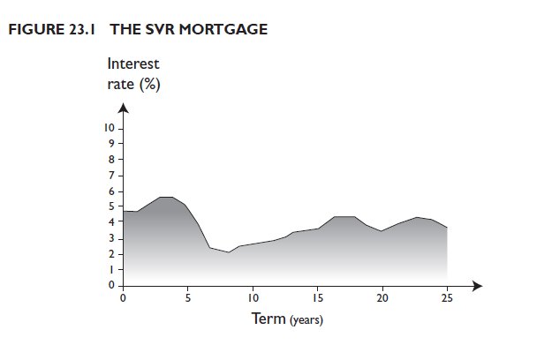

**Fixed-rate mortgage**

Mortgage loans range in structure from country to country. In the USA and parts of Europe it is common to find fixed-rate mortgages available for 25 or 30 years. However, in some markets banks only offer shorter fixed-rate terms, eg two, three, five, seven or ten years, and then the rate becomes variable at the prevailing market rate.

Fixed rates enable a borrower to know exactly how much monthly income will be spent on housing. A borrower on a strict budget is protected from the impact of rising interest rates and does not have to worry that their mortgage payments will increase over the life of the mortgage.

Conversely, locking in a fixed rate at a time when interest rates are high could mean significant risk to the borrower if rates subsequently fall.

**Figure 5.3 The fixed-rate mortgage**

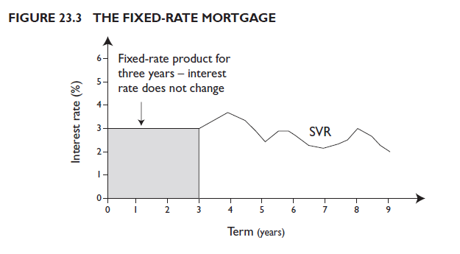

**Capped rate mortgage**

This arrangement offers the certainty of fixed‑rate loans but with a degree of flexibility. The lender sets an upper limit, or cap, to the interest that can be charged for an agreed term. If the SVR is below the cap, the borrower will pay the SVR; if the SVR is above the cap, the borrower will pay the cap rate. This enables the borrower to benefit from rate decreases while at the same time being able to budget for a given period.

**Figure 5.4 The capped rate mortgage**

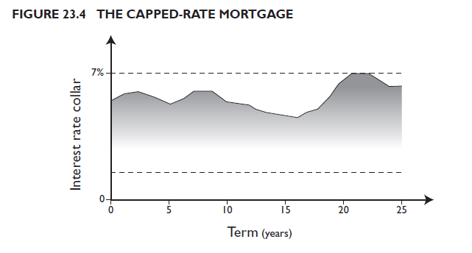

**Discounted rate mortgage**

A discounted rate on the lender’s SVR is provided for a stated period. The discount is a genuine reduction, so lenders usually impose a penalty if the loan is repaid within a specified timeframe; the penalty could be as much as the discount gained.

There is likely to be a set‑up fee, although this is usually lower than for a fixed‑rate mortgage. Early repayment charges will usually apply.

**Tracker mortgage**

This is a variable rate arrangement. The rate paid by the borrower ‘tracks’ the movement in a specific benchmark rate. The rate is usually set at a fixed percentage above the benchmark rate and will increase or decrease as it changes.

### 5.5.3 Other types of secured lending

**Second charges**

When the value of a property increases significantly, the homeowner may wish to borrow further funds secured against the equity. This may be done by way of a further advance from their existing mortgage lender, or a second mortgage from a different lender.

The advantage to a borrower of a further advance is that generally they will be able to obtain a rate that is similar to the mortgage rate. This will usually be significantly lower than unsecured personal loan lending rates.

**Bridging loans**

A bridging loan may be used when a property owner needs to finance a new purchase before they have sold their existing property; for example, if they have exchanged contracts on both their new and existing homes, but the completion date for their existing home is after the completion date for their new home. They can ‘bridge’ the financing gap by arranging a short‑term mortgage secured on their existing home, repayable when they receive the money from the sale.

|  |  |  |
| --- | --- | --- |
|  | **Unsecured** | **Secured** |
| Bridging loans |  |  |
| Overdrafts |  |  |
| Second charges |  |  |
| Mortgages |  |  |
| Charge cards |  |  |
| Credit cards |  |  |
| Personal loans |  |  |

**Activity: unsecured and secured lending**

Drag and drop the different types of retail borrowing into the correct category.

## 5.6 Products and services meeting the future needs of retail customers

We introduced the concept of the hierarchy of financial needs in Figure 5.1. Banks provide a very wide range of products and services to meet both basic, day-to-day needs (as discussed in sections 5.3–5.5) and future needs.

In this section we will outline the provision of savings accounts and pensions. Investment products and services will be discussed in greater detail in Topic 6.

### 5.6.1 Savings

Many individuals have some form of savings account to meet future needs, from building a contingency fund to cover unexpected expenses to funding longer-term future expenditure. Savings accounts are generally considered demand accounts as, in their most basic form, they allow customers to withdraw their savings on demand. These accounts are common and may be the first type of account that customers initially have opened for them as children by family members.

Savings accounts offer customers a return in the form of interest. Interest is normally variable and linked to the bank’s benchmark lending rate. It is calculated daily and added to the account periodically (normally quarterly, half‑yearly or yearly). Some accounts offer higher interest rates, provided a certain minimum sum is paid in.

The low interest rates offered by banks reflect the low level of risk savers take compared to other types of investment. Savers know that their capital is secure, subject only to the security and solvency of the bank holding their savings. In some jurisdictions, savings are protected by government-backed compensation schemes in the event of bank insolvency, which would otherwise put customer deposits at risk.

Savings accounts are therefore suitable for risk-averse individuals requiring no more than a safe home for their money. Those seeking higher returns will have to consider a greater element of risk within the investments they make. Risk and reward will be discussed in Topic 6.

**Other types of account**

**Notice (term) accounts**

Deposits can be subject to notice of withdrawal, with typical notice periods being from 7 to 90 days. Often the requirement for notice will be waived subject to a penalty, which is normally equal to the amount of interest that could be earned over the notice period. Notice accounts typically attract a higher interest rate than savings accounts that let you access cash on demand.

**Money market accounts**

Available to depositors of large amounts. Money market accounts typically attract a higher rate of interest than basic savings accounts and reflect current money market interest rates.

**FACTFIND**

Research the demand, notice and money market deposit accounts offered by your bank and compare the interest rates offered to savers for each type.

### 5.6.2 Pensions

Some employers offer company schemes, typically managed by occupational pension providers, to which they contribute funds as part of a remuneration package. However, many others do not, which means individuals are increasingly having to make their own personal pension plan arrangements.

The state pension provided by some governments give only a basic income in retirement, so those who can afford to pay into a scheme should consider doing so as early as possible.

Governments are keen to encourage pension saving to reduce dependency on any state retirement pension offered. Pension savings are long-term in nature and usually cannot be withdrawn until the pension owner reaches a certain age.

## Key terms

**Occupational pension providers**

Commercial organisations that provide pension arrangements and services to pension schemes. Occupational pension schemes are generally set up under trust by employers and run by trustees, specialist pension consultants and life assurance companies. They are specialists in pooled investments and invest in a range of asset classes.

**Personal pension plans**

Individual pension savings arrangements for people who have relevant earnings from pensionable income, such as self‑employed sole traders and employees who choose not to contribute to an employer’s scheme.

Savers can invest in a range of asset classes, notably commercial property (some prefer to invest in this type of asset rather than stock markets). Asset classes will be discussed in Topic 6.

Banks and life assurance companies offer personal pensions through dedicated financial advisers who are regulated on the advice they can give.

## 5.7 Digitalisation in retail banking

The digitalisation of financial services has had a large impact on the accessibility of retail banking products and services for customers.

Retail banks have adopted technological innovations continuously, with decades-old innovations such as automated payments and ATMs joined more recently by advances in digital web applications, which have increased in popularity as challenger banks gained market share (see section 5.7.2).

**Increasing customer expectations in a digital age**

Tech-savvy, time-poor customers see digital solutions as a way to save time and money. They expect that their banking provider will offer, as a minimum:

* 24/7 personalised banking, available in the palm of their hand;
* rewards for their custom;
* an omnichannel ‘anytime, anyplace’ service;
* a consolidated view of all their accounts;
* immediate payment solutions.

### 5.7.1 The impact of digitalisation

Digitalisation has forced the financial services industry to conduct a fundamental review of how products and services are delivered to retail banking customers.

Fintech now allows customers to open a bank account over the internet without physically visiting a bank. Customers can link their bank account to their smartphone, effectively converting it into a ‘digital wallet’. This empowerment means that customers have become the new drivers in financial services.

Key terms

**Fintech**

Fintech (a contraction of ‘financial technology’) is any new technology or electronic system used within the financial services industry to automate and/or improve the delivery of financial services. The term is also often used to refer to firms that utilise financial technology.

Fintech challenges banks to:

* innovate;
* be more flexible;
* provide a faster and better service.

### 5.7.2 Challenger banks

Breaking the traditional dependency between the provision of banking services and physical bank branches has also meant that new competitors, known as challenger banks, have emerged.

The digital challenger bank is built on the premise of doing one or a few things really well (eg current accounts) with a lean infrastructure, leading with technology and with services accessible on a smartphone.

Challenger banks have disrupted banking and finance in a similar way to how Spotify disrupted the music industry or digital photography disrupted Kodak.

**FACTFIND**

**How incumbent banks are combatting challenger banks**

A typical approach for incumbent banks is to replicate their retail banking services by launching their own digital banking apps. Below are three strategies adopted by banks to combat digital disruption.

1. Banks may create a ‘white label’ product with a fintech to capture new markets (ie the bank lends its brand to a fintech partner, who creates the digital service).

**Example**: in the UK, M&S Bank operates as a joint venture arrangement between HSBC and the retailer Marks & Spencer. M&S Bank has its own banking licence and its own Board. Access the M&S Bank website [here](https://bank.marksandspencer.com/).

1. Fighting fintech with fintech by building new businesses.

**Example**: Goldman Sachs launched online-only bank, Marcus, in 2018. Access Marcus’s website [here](https://www.marcus.co.uk/uk/en?prd=os&chl=ps&schl=psg&cid=Brand_Core_Brand_Marcus_X_Exact&agp=Brand_Core_Brand_Marcus_Bank_X_Exact&kid=marcus_bank&mtype=e&gclid=Cj0KCQjwsZKJBhC0ARIsAJ96n3Xmm24KH_Ufaa9H0D_rohmU7Z2mOoNeVtImbhD8Ub4rA43J1CFyOmEaArPiEALw_wcB&gclsrc=aw.ds).

1. Collaborative approaches to increase channel availability and payment functionality for customers.

**Examples**: Zelle in the USA and PayNow in Singapore. Access Zelle’s website [here](https://www.zellepay.com/how-it-works) and PayNow’s website [here](https://www.abs.org.sg/consumer-banking/pay-now).

Effective strategies are a matter of survival for incumbent banks. They must prevent challenger banks from eroding their market share of retail current accounts and savings deposits, which, as we have seen in this topic, form the foundations of other services such as personal lending and mortgages.

## Test your knowledge

1. Retail banking services can be categorised broadly as serving either day-to-day or future needs. True or false.
2. Why are top-end segment individuals considered desirable as current account customers by banks?
   1. They can afford to pay the high account fees.
   2. They often bring more in liquid assets and are likely to use more of a bank’s services.
   3. They are more likely to leave the bulk of their money untouched in the account.
   4. They are more likely to make use of an overdraft.
3. Secured lending typically carries more risk than unsecured lending, which makes it subject to higher rates of interest and shorter-term availability. True or false.
4. When offering personal loans, banks are required to state the cost of the loan in terms of its:
5. Point of sale (PoS).
6. standard variable rate (SVR).
7. annual percentage rate (APR).
8. loan-to-value (LTV).
9. Which of the following products is primarily designed to help individuals with their long-term future needs?
   1. A car loan.
   2. A credit card.
   3. A personal pension.
   4. An authorised overdraft.

## References

The Association of Banks in Singapore (no date) *PayNow* [online]. Available at: <https://www.abs.org.sg/consumer-banking/pay-now>

Bankrate (no date) *Credit card calculator* [online]. Available at: <https://www.bankrate.com/calculators/managing-debt/minimum-payment-calculator.aspx>

Capgemini Research Institute (2020) *World wealth report 2020* [pdf]. Available at: <https://www.capgemini.com/nl-nl/wp-content/uploads/sites/7/2020/07/World-Wealth-Report-WWR-2020.pdf>

Furber, S. (2020) *2 new UK digital banks take aim at profitable 'mass affluent' market* [online]. Available at: <https://www.spglobal.com/marketintelligence/en/news-insights/latest-news-headlines/2-new-uk-digital-banks-take-aim-at-profitable-mass-affluent-market-60871507>

M&S Bank (no date) *M&S Bank* [online]. Available at: <https://bank.marksandspencer.com/>

Marcus (no date) *Online savings account* [online]. Available at: <https://www.marcus.co.uk/uk/en?prd=os&chl=ps&schl=psg&cid=Brand_Core_Brand_Marcus_X_Exact&agp=Brand_Core_Brand_Marcus_Bank_X_Exact&kid=marcus_bank&mtype=e&gclid=Cj0KCQjwsZKJBhC0ARIsAJ96n3Xmm24KH_Ufaa9H0D_rohmU7Z2mOoNeVtImbhD8Ub4rA43J1CFyOmEaArPiEALw_wcB&gclsrc=aw.ds>

National Audit Office (2016) *HMRC’s approach to collecting tax from high net worth individuals* [pdf]. Available at: <https://www.nao.org.uk/wp-content/uploads/2016/11/HMRCs-approach-to-collecting-tax-from-high-net-worth-individuals-Summary.pdf>

Zelle (no date) *Zelle* [online]. Available at: <https://www.zellepay.com/how-it-works>