# Topic 9 Credit assessment – corporate

## Learning objectives

In this topic we shall cover:

* how a credit proposal is put together for corporate borrowing;
* different models for assessing a credit proposal;
* what these models analyse and how this helps banks in the lending decision.

## 9.1 Corporate borrowing needs

You learned in Topic 7 that corporate banking covers the provision of financial products and services to small- and medium-sized businesses as well as larger companies. Corporate banks typically recognise three main types of clients:

* Small- and medium-sized corporates with fewer than 250 employees and an annual turnover up to US$50m.
* Mid-to-large corporates with a turnover between US$50m and US$500m.
* Large corporates with an annual turnover in excess of US$500m.

Larger corporates tend to have more complex borrowing needs. To meet the specific needs of a prospective borrower, the bank will need to establish what it thinks the most suitable product is to present to the corporate customer. This is an important stage for the customer as the wrong advice may lead to missed business opportunities or, at worst, business failure. It is also important for the bank to understand the risk the customer and the loan pose and to be able to provide loans that are sustainable. Following this, the credit officer will write the credit proposal (also known as a credit assessment) for the bank to be able to assess the risk the credit poses to it, and to decide whether it wants to proceed.

## Key term

**Turnover**

The total amount of money a company receives from its goods or services over a certain period of time. Turnover is recorded net of (ie including) elements such as VAT or discounts, so it represents ‘gross revenue’ or ‘income’.

## 9.2 Putting together the credit proposal

Before agreeing to lend to a corporate customer, a bank will put together a credit proposal that will be used to assess the risk of the credit to the bank. This will then be submitted for internal approval.

**Obtaining information from the customer**

Most corporate customers will come to a bank with a clear idea of the amount of funding they need as well as the term required (ie the length of the loan), including financial information and a business plan. More sophisticated customers may already know how they want to structure the loan, including a detailed repayment plan and cash flow forecasts to support that plan. Based on the information provided, the relationship manager (discussed in section 7.1) will recommend the best way to finance the requirements. The bank will consider the type of transaction that best suits the requirement and will take into consideration any existing loans and credit facilities the customer already has.

**Calculating the bank’s total exposure**

Corporate customers will usually already have existing credit, either with the bank they are applying with or another institution. For customers with pre-existing credit facilities with the bank, a table of exposures (see Table 9.1) will be part of the decision-making process. A table of exposures shows the customer’s total loans before and after the new request is approved. If known, any loans from other banks will be included.

|  |  |
| --- | --- |
| **Table 9.1 Table of exposure for ABC Ltd** | |
|  | US$ |
| Overdraft | 200,000 |
| Term loan (three years remaining) | 300,000 |
| **Existing facilities** | **500,000** |
| **New request** | |
| Five-year revolving credit | 500,000 |
| **Total facilities** | **1,000,000** |

**Assessing the risk posed by the loan**

The proposal, which is put together by the relationship manager, will then be reviewed by a credit officer to assess the risk of the loan, including whether there is any reduction in risk through the use of a security (eg collateral or guarantees). The credit officer is part of the risk department, which is independent from the relationship managers.

|  |
| --- |
| Key terms **Security**  A security is considered to be a secondary form of repayment that can be used in case the customer fails to repay its loan. Securities come in two main forms: collateral and guarantees.  **Collateral**  An item of value (eg a physical asset such as land, buildings or machinery, or a financial asset such as invoice receivables) used to secure a loan in order to reduce the risk for the lender.  **Guarantee**  An agreement in which a third party promises to pay the loan if the borrower defaults. |

The credit officer typically uses a rating model to assess the risk the corporate customer poses to the bank, as well as the additional risk due to the new transaction. Inputs to such a model consist of:

* credit rating from a rating agency (if applicable);
* financial statement history;
* projected cash flow;
* securities;
* payment history.

The credit officer will also take into consideration industry information (eg growth forecast for the industry or main market participants) and the company’s place within the industry. For existing corporate customers, their repayment behaviour will be used to assess willingness to pay.

Rating models can vary from highly sophisticated statistical models to relatively simple score cards.

**Approving the loan**

As part of the bank’s approval process, it will consider the loan itself, but also take into consideration other issues such as:

* what the existing facility limit set for that corporate customer is;
* how valuable the customer is to the bank in terms of present profitability (eg revenue) and potential future business across different departments;
* how the additional credit meets the bank’s present guidelines on exposure to that business sector and/or geography.

Depending on the size of the loan, the approval process may involve multiple layers of approval. A small loan may only require the approval of a credit officer if it is within their approval limits. A larger loan will require the approval of a more senior manager or a credit committee. The larger the loan, the higher the level of approval required.

## 9.3 Evaluating the credit proposal from a risk perspective

There are many different models for evaluating a credit proposal. Some banks create their own models, others use existing models for their analysis and evaluation. These models are usually known by a mnemonic (a tool that is designed to help make remembering information easier). Mnemonics in common use in this area include:

* RIOTARS;
* STREET CRED;
* CAMPARI;
* CCC PARTS.

In each of these examples, the letters stand for the parts that make up the model. Although each of the models differs, the components are very similar and consist of:

* the amount and type of the loan;
* the industry and the company’s position within the industry;
* company structure and ownership;
* repayment history;
* ability and willingness to pay;
* security.

We will cover RIOTARS and STREET CRED in sections 9.3.1 and 9.3.2 and cover the components of CAMPARI and CCC PARTS briefly in section 9.3.3.

### 9.3.1 RIOTARS

The mnemonic RIOTARS (Walker, 2010) stands for the following:

* **R**equest
* **I**ndustry
* **O**wnership
* **T**rading
* **A**bility to repay
* **R**isk and return
* **S**ecurity

Each of these words represents an element to be taken into account when considering an application for financing using this model. We will look at each of these elements here.

**Request**

The credit proposal contains the details of what the prospective borrower has requested from the bank, as well as whether there are likely to be any further borrowing requirements that could impact on the total potential exposure to the company. It is important to consider this, in addition to the requested financing.

|  |
| --- |
| **Example: additional financing requirements**  Company XYZ is planning to increase its production and requests a loan for the purchase of a new machine. The bank should consider if the increased output may also lead to additional financing requirements. An increase in output may, for example, mean that the company has more work in progress, greater need for raw materials and higher amounts to be paid to creditors. To cover these additional expenses, Company XYZ may need additional working capital. |

As part of the request, the bank needs to consider if the loan-to-value (LTV) is within the limits of the bank’s guidelines (we discussed LTV in section 5.5.1).

|  |
| --- |
| **Example: LTV**  The total cost of the new machinery Company XYZ is planning to invest in is US$500,000.  The company has US$200,000 in own capital and is applying for financing for the remaining US$300,000.  LTV = (300,000 / 500,000) * 100 = 60% |

**Industry**

Larger banks will have a special unit set up to analyse sector and industry trends. This information will be used as part of the loan application to assess how well the corporate customer performs compared with other companies in the same industry. If industry information is not available, other non-financial tools can be used for the analysis, which would include an assessment of the customer to evaluate its competitive position. An example of such an approach is what is known as a SWOT analysis (SWOT stands for strengths, weaknesses, opportunities, threats). A SWOT analysis uses internal and external factors as well as current and future potential to obtain an indication of performance, competitive position, risk and company potential.

**Figure 9.1 SWOT analysis**

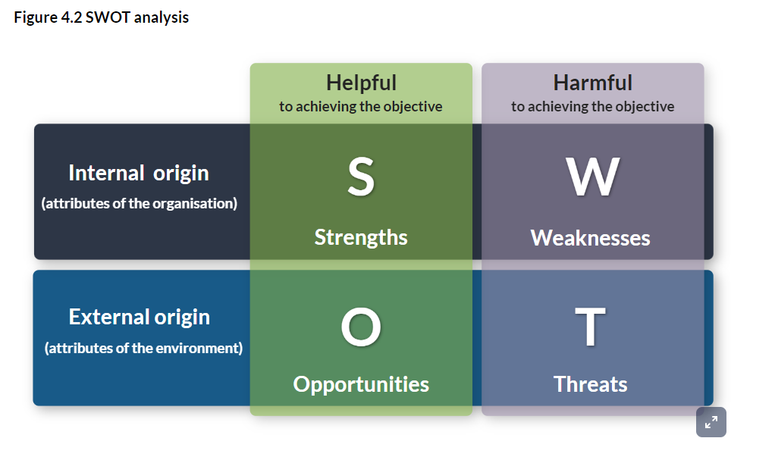

**FACTFIND**

The reading below demonstrates how a SWOT analysis might be used on a bank by its upper management; however, as discussed above, this tool can also be used for corporate customer assessment.

Sapling: [SWOT analysis for a bank](https://www.sapling.com/6680601/swot-analysis-bank)

The bank will also consider if the industry the company is in is attractive to the bank. For example, as discussed in section 1.6, a bank may have a strategy around climate change that involves avoiding investment in fossil fuels or any industry with high pollution levels.

**Ownership**

The ownership structure of the corporate needs to be assessed, in addition to its strategic and financial plans. This is usually done as part of ‘know your customer’ (KYC), which was discussed in section 1.3.1.

One of the key issues to consider is how long the company has been a customer of the bank. Corporate customers with a long history of banking with the bank will have established a track record that the bank can use to assess them and their loan application.

For any new corporate customer, the first question to be asked is why the company is not applying for a loan with its existing bank. There could be a good reason for this, such as wanting to diversify banking relations or a requirement for a type of financing not offered by the existing bank. However, the reason could also be that the existing bank refused the application.

In addition to the ownership structure and business strategy, the bank will also want to assess the management team and their capabilities, including:

* the spread and range of the management team, whose financial, marketing and operational skills, as well as their experience and qualifications, can influence the future success of the company;
* succession planning, especially what the second-tier management is like in terms of their experience, skills, etc, and if there are any succession issues.

**Trading**

The historical and future trading results of the company will provide the bank with a view on whether its cash flows will be sufficient to cover the repayment of the loan. Trading analysis/forecast is not only focused on the results of the previous year but also has to consider the trends in performance over multiple years, preferably at least three years.

Any future forecasted trading volumes and amounts provided by the company must be assessed to see if they are credible against the historical information provided and all other information the bank has available. Usually, the bank will consider three scenarios:

* worst case;
* neutral;
* best case.

**Ability to repay**

One of the most important assessments is whether or not the corporate customer will be able to repay the loan. Ability to repay can be calculated from information contained in the statement of financial position or by assessing the cash flow the company will have available to repay its loan.

Banks use financial ratios (see section 9.4), some of which, such as the level of credit in relation to the total assets of a company, always apply. Others will be different depending on the industry and type of loan. Similar to trading analysis, the financial analysis should not be undertaken just for one year, but preferably over a period of at least three years to analyse any trends over that period.

An essential part of the loan approval process is to show that the corporate customer is highly likely to be able to repay the loan. If the credit officer decides to propose a loan for acceptance where the likelihood of repayment is lower than average, then they will have to provide strong reasons for doing this.

**Risk and return**

If the risk on the loan application is considered to be too high, the bank is unlikely to approve the loan. This does not mean that banks will not approve any loan where the applicant has a less than 100% likelihood to repay. As outlined in Topic 3, banks take risk within the limits of their risk appetite. This means that the bank will consider applications with different risk levels, provided it receives an appropriate return. This means that the higher the risk of the loan, the higher the interest rate it will charge or the greater the collateral needed. To manage the bank’s exposure to risk, it may include covenants such as requesting the company:

* provides annual accounts by a certain date;
* provides monthly management accounts by a set date in the following month;
* notifies the bank if the company is in breach of any of its covenants;
* provides the bank with a schedule of insurance;
* maintains the assets of the company in good condition;
* maintains a minimum level of liquid assets.

## Key term

**Covenant**

A financial or non-financial condition that is a legally binding promise in a debt agreement that specific activities will or will not be carried out or that specific thresholds will be met.

The conditions that are assigned to a loan are not always the same but will depend on the size of the loan, the type of loan and the risk the loan poses to the bank. The type of loan impacts the risk that is assigned to it. For example, a capital investment (equity) will require a more in-depth review and understanding of the management, their skills and expertise, and the strategy, whereas a lease finance will require a more in-depth review and understanding of the underlying asset.

**Security**

The final component of RIOTARS reflects the level of security offered by the corporate customer. If a loan application is considered to be high risk, one of the ways to reduce the risk for the bank is through the securities the customer makes available.

As we learned in section 9.2, a security is considered to be a secondary form of repayment that can be used in case the customer fails to repay its loan.

|  |
| --- |
| **Example: providing security**  Company XYZ has applied for a loan of US$300,000 for a new machine, which has a price of US$500,000.  The bank has assessed the risk of the loan as medium-high and has asked the company for the machine as security on the loan. However, to cover the remaining risk, the company has been asked to provide additional security. The company has the following collateral available:   * A factory valued at US$1,000,000 with a mortgage of US$500,000. * A plot of land valued at US$250,000.   The plot of land does not cover the full loan. The factory has a mortgage-free component of US$500,000, which covers the loan, but the value of real estate goes up and down. If the customer is considered to be high risk, the bank may require both the land and the factory as collateral. If the customer is of medium risk, the bank may only request one of the securities and leave the remaining risk open. |

The credit proposal has to include a full summary of the proposed collateral, its value, any measures that need to be taken to ensure that the security is protected against potential risks, such as insurance, and whether the security is sufficient or acceptable.

The question that needs to be answered as part of the credit proposal is whether the collateral is sufficient to cover the lending requested. The level of collateral available will have an impact on the risk and therefore the potential interest the bank needs to charge to accept the loan. In the event the collateral is deemed to be insufficient, other securities such as director’s guarantees or a guarantee by another party such as a parent company might be required.

|  |
| --- |
| **Reflect**  Monad Property Development was established in 1995 to redevelop buildings into combined hotel and retail spaces. Over the last few years, Monad has noticed that the materials needed for the interiors of its retail shops have significantly increased in price, although raw material prices have stayed the same. As a result, Monad wants to take a 50% stake in a retail shop interior manufacturer. The investment is US$500,000.  Monad owns the building it operates from, which is valued at US$1,500,000 with a mortgage of US$1,100,000.  It is currently working on three projects with projected net income of US$750,000, which will be received over the next few years. Monad has had some recent issues with costs of jobs overrunning and is set to make a loss on one of its projects. Although it has paid all its suppliers, it has been a few days late with its payments.  Monad’s parent company is a global construction company with a strong credit rating.  **Question**  Monad is applying for a loan of US$400,000 to finance the investment. It will finance US$100,000 of the project out of its own funds. What sort of security, if any, should the bank consider if it wants to approve the loan? |

**Activity: RIOTARS**

Can you remember what RIOTARS stands for? Type the correct words into the mnemonic below.

**R**

**I**

**O**

**T**

**A**

**R**

**S**

### 9.3.2 STREET CRED

Similar to RIOTARS, the STREET CRED mnemonic refers to the components required for the assessment of a credit proposal:

* **S**trategy
* **T**rading forecast
* **R**esearch
* **E**arnings
* **E**ffect of borrowing
* **T**rack record
* **C**haracter of the business
* **R**epayment plan
* **E**ase of mind
* **D**efined risks

**Strategy**

The strategy behind the borrowing needs to be clear and show not only what the goal is but also how it will be achieved.

|  |
| --- |
| **Example: strategy**  Company XYZ has set a goal to increase turnover by 30%.  The strategy behind the investment is to:   * increase efficiency; * reduce production cost; * stay ahead of the competition.   The goal will be achieved by investing in a new machine. |

The borrower will provide the strategy, which will include an assessment of the market and how main competitors are likely to respond. The credit officer will assess the strategy to determine whether it is achievable, contains sufficient information and is well-considered.

**Trading forecast**

Trading forecasts, such as expected sales, cost of production and capital outlay, have to be realistic and include a cash flow forecast. Questions that need to be considered are whether other options to improve cash flow or to release funds have been considered. For example, delaying paying creditors by a few days, following up overdue receivables or invoice discounting.

**Research**

If the financing is for research and development (R&D) purposes, it is important to ensure that the product or service will work and be acceptable to the market for which it is intended. R&D projects are typically multi-year projects with a large number of decision points where the project may be cancelled. Questions that need to be considered include the size of the market, corporate customer demand expectations, and go/no-go decision points. When a decision is made not to continue with the project, there will be no resulting future income. Therefore, in such an instance the risk of the financing will need to be reviewed and, if necessary, adjusted.

**Earnings**

When assessing profit forecasts and ease of repaying the debt, the quality of business earnings is a key consideration. Ideally, turnover and gross profit should be analysed between different products and/or markets, taking into account new orders compared with repeat orders, as well as any seasonality to demand. Earnings is roughly equivalent to ‘ability to repay’ in the RIOTARS mnemonic.

**Effect of borrowing**

In the event a loan is approved, the corporate customer will have to make interest payments as well as capital repayments. The effect of borrowing is, therefore, a reduction in expected future cash flow due to the amount of interest and repayments.

**Track record**

Part of the assessment includes whether the corporate customer has repaid its obligations on time and whether it is expected to continue to do so. The customer’s track record will help to confirm the capability of management to adapt successfully to changes in trading circumstances.

**Character of the business**

The borrowing request may not be ‘in character’ for the company. For a company that has published religious books for many years, for example, a request to borrow funds to sell automotive magazines would appear to be out of character and would raise questions such as, “why this form of diversification?”, “what will happen to the present business?”, “is there previous experience of this type of new venture?”, “will the existing wholesaler contacts accept the new publishing line?”, “on what grounds have management taken this decision?”.

**Repayment plan**

The bank needs to assess what the repayment plan is going to be and whether it is sustainable. The form of borrowing proposed by the corporate customer may not be the bank’s preferred option: for example, a customer may propose to repay all debt at the end of the loan, but the bank would prefer monthly repayments.

**Ease of mind**

It will be natural for the lender's ease of mind to think of some form of shared risk and security for the loan. Shared risk means the corporate customer invests a significant amount of its own funds or provides capital assets such as land or buildings. A way for the bank to mitigate risk is to accept security. However, reduction of risk will also result in lower returns.

**Defined risks**

The risks taken by the bank are for the bank to manage (we discussed risk in banking in Topic 3). In addition, there are risks associated with the company’s business. These risks are out of the control of the bank and are managed by the company.

|  |
| --- |
| **Example: risk to the bank**  Banks are exposed to concentration risk if their corporate customers are mainly in the same industry. This is for the bank to manage.  Corporate customers may be exposed to single customer risk when one customer counts for a large component of their business. This is for corporate customers to manage but it may still impact their loan application. |

**Activity: STREET CRED**

Can you remember what STREET CRED stands for? Type the correct words into the mnemonic below.

**S**

**T**

**R**

**E**

**E**

**T**

**C**

**R**

**E**

**D**

### 9.3.3 Other methods of evaluating the credit proposal

Some other common mnemonics to evaluate a lending request from a borrower include CAMPARI and CCC PARTS. Figures 9.2 and 9.3 illustrate the components of these methods.

**Figure 9.2 Components of CAMPARI**

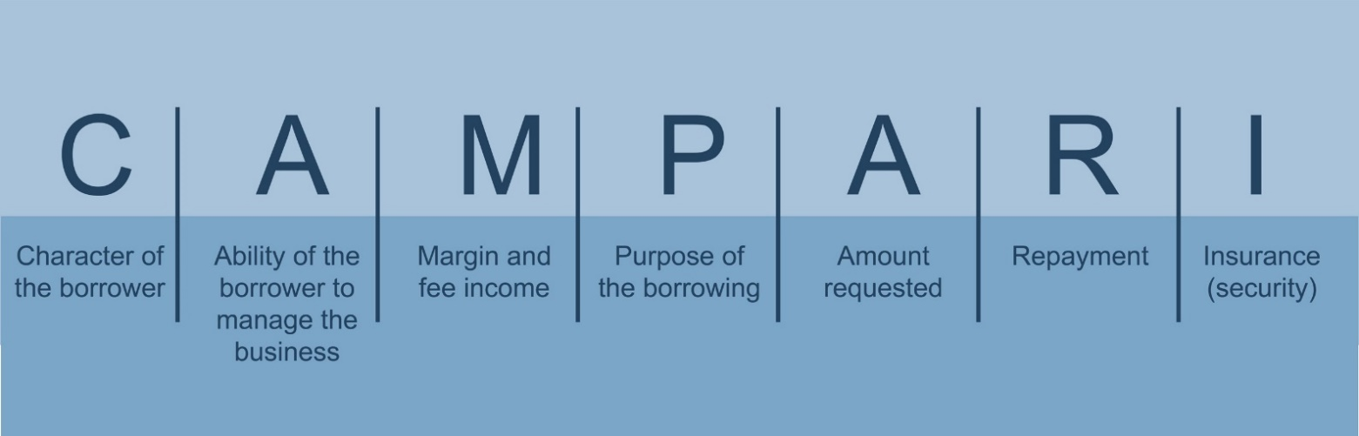

**Figure 9.3 Components of CCC PARTS**



### 9.3.4 Summary

Regardless of which mnemonic is used, there are a number of common components that are assessed as part of a loan application, which can be summarised as follows:

* ability and willingness to pay – does the company have sufficient capital, expected future income, and the intention to repay;
* purpose of the loan;
* amount of financing requested;
* terms and conditions;
* security.

## 9.4 Financial analysis

Regardless of the mnemonic used, credit officers will often engage in detailed financial analysis to determine:

* how profitable the company’s business is;
* how well it is managing its working capital and cash flows;
* its ability to service and repay its debts.

## Key term

**Financial analysis**

The process of using financial data to evaluate the performance of a company. The results of the analysis are used to determine whether the company is stable or profitable enough to invest funds or provide a loan.

Like banks (as discussed in Topic 2), corporates prepare a balance sheet and profit and loss account. They also prepare a cash flow statement, which summarises the cash and cash equivalents flowing into and out of a company. Together, these are a company’s financial statements.

By reviewing a company’s financial statements and comparing several years of data, a credit officer can gain significant insight into a company’s current financial position. The bank uses these documents to see how well the business is performing from one year to the next. It can also use them to make comparisons with similar businesses operating in the same industry or market sector.

It is important to remember, however, that financial statements provide information on what has happened in the past period and are not forward looking.

### 9.4.1 Ratio analysis

Credit officers employ ratio analysis to understand a company’s financial position when assessing credit. There are a wide variety of financial ratios for lenders to use when undertaking the analysis. Here, we shall consider three commonly used categories of ratio:

* profitability;
* liquidity; and
* solvency.

**Profitability ratios**

Profitability ratios identify trends in both gross and net profitability, including the structure and level of control over costs. Ideally, a credit officer wants to see a consistent, if not improving, trend in profitability.

**Table 9.2 Profitability ratios**

|  |  |  |
| --- | --- | --- |
| **Profitability ratios** | **Calculation** | **Definition and impact** |
| Turnover growth | (Year 2 turnover - year 1 turnover) / year 1 turnover | Indicates how much turnover has increased over the previous period: *the higher the ratio, the greater the growth* |
| Gross profit margin % | Gross profit / sales x 100 | Measures the profitability of the company’s manufacturing and selling operations: *the higher the ratio, the more profitable it suggests the operation is* |
| Net profit margin % | Net profit before tax / sales x 100 | Overall profitability of the company’s operations before tax: *a higher ratio suggests it would be able to absorb cost increases or falls in sales* |

**Liquidity ratios**

Liquidity ratios cover the management of current assets and are used to measure a company’s ability to pay its short-term financial obligations. These ratios are critical in understanding the cash dynamics of the business.

**Table 9.3 Liquidity ratios**

|  |  |  |
| --- | --- | --- |
| **Liquidity ratios** | **Calculation** | **Definition and impact** |
| Working capital ratio (current ratio) | Current assets / current liabilities | Indicates the company’s ability to service its short‑term obligations: *the higher the ratio, the greater the cushion* |
| Acid test ratio (quick ratio) | (Current assets - stock) / current liabilities | Excludes stock as these take longer to convert into cash: *the higher the ratio, the better the liquidity and the lower the risk* |
| Days sales outstanding (DSO) | (Trade debtors / sales) x 365 | How quickly (in days) debtors turn into cash: *the higher the ratio, the longer it is taking to collect cash from debtors* |
| Days payables outstanding (DPO) | (Trade creditors / purchases) x 365 | The average length of time (in days) creditors are outstanding: *the higher the ratio, the more credit is being allowed (or is being taken)* |
| Days inventory outstanding (DIO) | Stock / purchases x 365 | Average length of time (in days) that stock is held: *the higher the ratio, the longer it takes stock to turn into cash* |

## Key terms

**Purchases**

Items the company has purchased such as raw materials or goods for sale. Also known as inventory.

**Trade debtors**

Money owed to the company by parties the company has sold goods or services to. Also known as accounts receivable.

**Trade creditors**

Money owed by the customer to parties from whom the company has bought goods or services. Also known as accounts payable.

In section 7.8, you learned how DIO + DSO - DPO = the cash conversion cycle. The cash conversion cycle is a key metric that expresses the time it takes for a company to convert its resources into cash and pay its bills.

**Solvency ratios**

Solvency refers to the ability of a company to repay its long-term financial obligations on time and in full. There are a number of different solvency ratios that can be applied, including **leverage** and **coverage** ratios.

**Leverage ratios** are concerned with the level and composition of debt a business has in relation to its equity/capital resources. These ratios highlight how dependent the business is on debt.

**Table 9.4 Leverage ratios**

|  |  |  |
| --- | --- | --- |
| **Leverage ratios** | **Calculation** | **Definition and impact** |
| Gearing (also known as debt to equity ratio) | Total debt / shareholders’ funds | Measures the proportion of debt the business has: *the higher the ratio, the greater the risk being assumed by lenders rather than shareholders* |
| Net gearing (also known as net debt to equity ratio) | (Total debt - cash - investments) / shareholders’ funds | Compares the net borrowings to shareholders’ capital: *the higher the ratio, the greater the risk being assumed by lenders rather than shareholders* |

**Coverage ratios** measure a company’s ability to service its debt. A company with a higher coverage ratio is more likely to meet its debt payments more easily than a company with a lower ratio.

**Table 9.5 Coverage ratios**

|  |  |  |
| --- | --- | --- |
| **Coverage ratios** | **Calculation** | **Definition and impact** |
| Interest coverage ratio | Profit before interest and tax paid / interest paid | Measures the ability to meet interest from pre‑tax profits: *a higher ratio indicates a cushion in the event of rises in interest rates or a decline in profitability* |
| EBITDA debt service coverage ratio | (Earnings before tax + depreciation + amortisation + interest paid) / (interest + principal) | Measures the ability to fund debt repayment from cash: *the higher the ratio, the greater the ability to service and repay debt* |

## 9.5 Drawing conclusions and making recommendations

Some banks use the mnemonics outlined in section 9.3 while others will have developed their own. In addition, different areas within a bank may apply slightly different methods due to the difference in products offered. As part of the credit proposal, the bank will use qualitative (non-financial) as well as quantitative (financial) assessments.

Regardless of which method the bank chooses to use, the important thing is that it is applied in such a way that the bank is able to differentiate between a good lending application and a weaker one so that it can ensure it accepts the right applications that fit within the bank’s risk appetite and strategy.

The role of the credit officer is to provide additional insight by assessing all available information and to put forward a recommendation that clearly sets out whether they support the application and whether there are any limitations or conditions to be applied.

## Test your knowledge

1. A bank will not take a corporate’s borrowing from other banks into account when calculating its total exposure. True or false.
2. The credit proposal, which is put together by the relationship manager, will be reviewed by a credit officer to assess:
   1. the size of the loan required.
   2. which mnemonic to use to evaluate the loan.
   3. the risk of the loan to the bank.
   4. the level of interest to charge on the loan.
3. A SWOT analysis is an example of a non-financial tool that can be used as part of the loan application to assess how well the company performs compared with others in the same industry. True or false.
4. The S in RIOTARS stands for:
5. services.
6. selection.
7. strategy.
8. security.
9. If its corporate customers are mainly in the same industry then a bank will be exposed to:
10. concentration risk.
11. shared risk.
12. spread risk.
13. defined risk.

## Reference

Walker, R. (2010) *Business lending after the crunch*. Lead tutor article, *ifs School of Finance* [pdf]. Available through KnowledgeBank website at: <http://kb.libf.ac.uk/docs/default-source/lead-tutor-articles/walker-(2010)-business-lending-after-the-crunch-(corp).pdf?sfvrsn=10>