ROBOT CONTROL

ANONYMOUS AUTHOR(S)

As robots become common in our everyday lives, they are predicted to perform tasks alongside humans. Social psychology studies  
indicate that performing tasks next to others leads to a social comparison. The tendency to overestimate robots’ capabilities is predicted  
to lead to an upward comparison that can result in negative outcomes. We evaluated whether performing a task alongside a robot  
would impact participants’ sense of control and their overall performance. Participants performed a simple search task either before or  
alongside a robotic dog that was presented as performing search training. Our findings indicated that performing the task alongside  
the robot led to a negative impact on sense of control, search efficiency, and performance accuracy. We conclude that robot designers  
should carefully consider the impact of robots who perform tasks alongside humans, even when the interaction does not involve  
collaboration and despite the independence between the human and the robot’s performance.

CCS Concepts: - **Human-centered computing —> Empirical studies in HCI.**

Additional Key Words and Phrases: Opening encounters, Greeting, Help request, Human-Robot Interaction, Robot, Interaction quality

**ACM Reference Format:**

Anonymous Author(s). 2024. ROBOT CONTROL. In . ACM, New York, NY, USA, 10 pages. <https://doi.org/XXXXXXX.XXXXXXX>

1. INTRODUCTION

Robots are predicted to become an integral part of our everyday lives, share our environment, and perform tasks  
commonly performed by humans [33, 38, 50], In this context, it is believed that one of the near future challenges  
concerns the development of a cohesive workforce that involves humans and robots working alongside each other  
[33, 50], Performing tasks alongside robots presents several challenges related to the nature of the interaction, the  
robot’s behavior, the workers’ attitudes, and the task features [4, 26, 33, 50], Various studies have explored factors  
that enhance collaboration with robots (e.g., the level of the robot’s autonomy [8], trust [4], and sense of safety [50]).  
However, working alongside a robot may also involve simply sharing the same space while performing a task without  
direct collaboration (e.g., [28], [44]). Such interactions are likely to become common as robots are perceived as means  
for sharing workload [24] and for performing less desirable aspects of tasks performed by humans [33]. It is, therefore,  
surprising that the impact of performing a task alongside a robot (without direct collaboration) is hardly studied.

Studies from the social psychology domain consistently indicated that performance in the presence of others is not  
similar to individual performance [5,14, 49, 53]. Specifically, it is suggested that there are drastic effects to performing a  
task alongside others who perform similar tasks [14,40,49]. In these cases, people typically engage in social comparison  
due to an inherent tendency to observe others’ performance and judge their own performance accordingly [14]. When  
people compare themselves to those who outperform them (upward comparison), they commonly report a negative  
experience. A downward comparison (comparison to those who under-perform) commonly leads to a positive experience  
[14, 49]. Such social comparisons have been shown to impact several factors, including one’s sense of control [5, 43]  
and performance quality [27]. In particular, it is indicated that upward comparison leads people to reconsider their

Permission to make digital or hard copies of all or part of this work for personal or classroom use is granted without fee provided that copies are not  
made or distributed for profit or commercial advantage and that copies bear this notice and the full citation on the first page. Copyrights for components  
of this work owned by others than ACM must be honored. Abstracting with credit is permitted. To copy otherwise, or republish, to post on servers or to  
redistribute to lists, requires prior specific permission and/or a fee. Request permissions from [permissions@acm.org](mailto:permissions@acm.org).

© 2024 Association for Computing Machinery.

Manuscript submitted to ACM

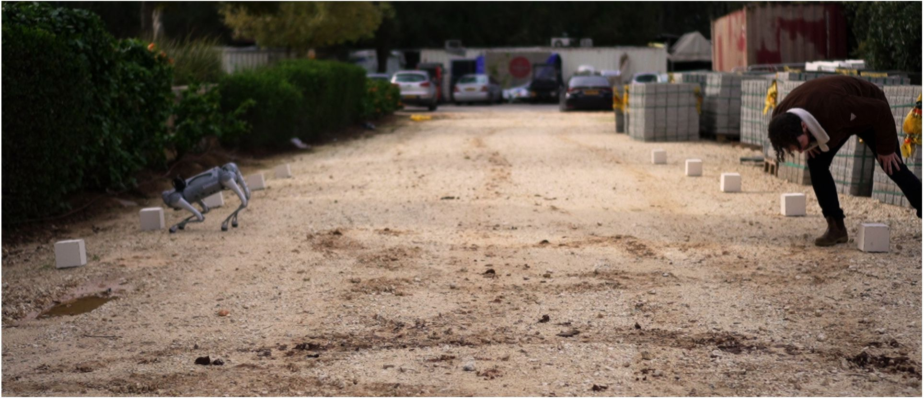

Fig. 1. Robotic dog and participant.

own abilities. This, in turn, negatively impacts their performance due to attentional resources captured by ruminative  
thoughts about their under-performance [27]. Questioning the capability to perform the task and the accompanying  
decrease in performance have additional negative effects, including a decrease in sense of control [14, 40, 49].

Maintaining a sense of control in human-robot interaction was indicated as a key factor for robot acceptance [1,8],  
positive perception of the robot [54], and the general quality of the interaction [1], It is known to impact various  
important factors that shape the interactions, including people’s level of trust in the robot [3], sense of safety [1],  
perception of teamwork with the robot [54], and sense of authority [18]. The indication that maintaining a sense of  
control can be compromised by performing tasks alongside others suggests that performing a task next to a robot could  
have negative results. This possibility is especially alarming when considering people’s tendency to perceive robots as  
having superior abilities and skills [11, 37, 41]. Such overestimation of a robot’s capabilities may lead to an upward  
comparison that would result in a decrease in people’s sense of control and overall performance.

In this work, we explored this possibility and tested if performing a task alongside a robot would impact participants’  
sense of control and the quality of their task performance. We evaluated if simply performing a task next to the robot,  
without direct collaboration, would have a negative impact despite the complete independence between the participant’s  
performance and the robot’s performance. To evaluate the extent of such impact, we intentionally designed a very simple  
task (i.e., that does not involve a-priori control challenges) and informed participants that the robot was being trained to  
perform the task (i.e., giving them no reason to believe that the robot has superior capabilities). Participants performed  
a search task where they were asked to find "X" symbols on cubes (see Figure 1). We compared their performance and  
sense of control in two conditions: (1) performing the task alongside a robotic dog; (2) performing the task alone.

1. RELATED WORK

Relevant previous work includes studies that evaluated robots’ impact on participants’ sense of control, Overestimation  
of robots’ capabilities, and social comparison in human-robot interaction.

* 1. Sense of Control

Several studies evaluated participants’ sense of control in human-robot interactions [25, 52]. Most of these studies  
explored whether control over the robot’s actions would impact participants’ general sense of control and robot  
acceptance [8, 9, 52, 54, 55]. For example, Chateau et al. (2016) manipulated the control over a robot during a cleaning  
task. They used two robots and manipulated the participants’ control over the "manager" robot, who either asked them  
to activate the "cleaning" robot, asked for their permission to activate the "cleaning" robot, or activated the "cleaning"robot without permission. Their findings showed that the participants’ level of control decreased as the autonomy of  
the "manager" robot increased [8], Negative interactions with robots were also shown to impact participants’ sense of  
control [12, 47, 51]. Erel et al. (2021) found that experiencing exclusion during an interaction with robots can threaten  
participants’ sense of control. Participants who played a ball-tossing game with two robots and hardly received the  
ball reported lower levels of control [12]. The sense of control was also altered by performing a joint task with a robot.  
Ciardo et al. (2018) asked participants to inflate a balloon without exploding it. They showed that that when a robot  
joined the task and could stop the balloon inflation, participants reported a lower sense of agency and control [10].

These studies indicate that interactions with robots can impact participants’ sense of control. We extend this line of  
work by evaluating whether simply performing a task next to a robot would decrease participants’ sense of control.

* 1. Overestimation of robots’ capabilities

Several studies have explored the overestimation of robots’ capabilities. These studies indicate that people tend to  
over-trust robots and mindlessly rely on robots’ judgment [2, 21, 36, 37]. For example, Robinette et al. (2016), showed  
that people would follow a robot’s directions during an emergency evacuation scenario even when it led them in a  
direction opposite to a safe exit (which was clearly marked by large emergency signs) and despite its poor performance  
in a prior interaction [37]. Similarly, Karli et al. (2023) demonstrated that participants would follow a robot’s guidance  
when cooking even when its instructions deviated from the written recipe they were asked to follow [19]. Another  
example was presented by Salem et al. (2015), who showed that participants would comply with a robot’s nontraditional  
requests (e.g., pouring orange juice on a plant) even after watching it perform errors earlier in the interaction [39].

These studies indicate the tendency to overestimate robots’ capabilities and judgment. Such overestimation leads  
participants to question their own abilities [16]. In this context, performing a task alongside a robot is predicted to  
trigger an upward comparison, leading to negative outcomes.

* 1. Social comparison in human-robot interactions

A few studies explored the effects of social comparison in HRI [17, 23, 46]. Most of these studies focused on the impact  
of social comparison on the perception of job insecurity. For example, Wang et al. (2023) showed participants pictures  
of a human working with a robot. They found that higher levels of a robot’s anthropomorphism led to engagement in  
social comparison that contributed to the fear of being replaced by a robot (i.e., job insecurity) [46]. Similarly, Granulo  
et al. (2019) indicated that people perceive robotic replacement as a great threat to their future economic prospects.  
They attributed this effect to the perception of robots as highly capable and an upward social comparison [17].

These studies indicated that considering robots as replacements may trigger social comparison and impact the robot’s  
perception. We further explore the impact of an upward comparison due to performing a task alongside a robot.

1. METHOD

We evaluated the impact of performing a task alongside a robot on participants’ sense of control by assessing their  
performance and experience in a simple search task that involved identifying symbols on cubes (see Figure 1). Participants  
performed the task either next to a robotic dog that also searched for symbols or before the robotic dog began to search.

* 1. The search task and the robot
     1. *The search task.* In the search task, participants were asked to review 10 cubes with different symbols on them  
        and count the number of cubes with an "X" symbol. Each of the 10 cubes had 5 symbols. On four of the cubes, one of

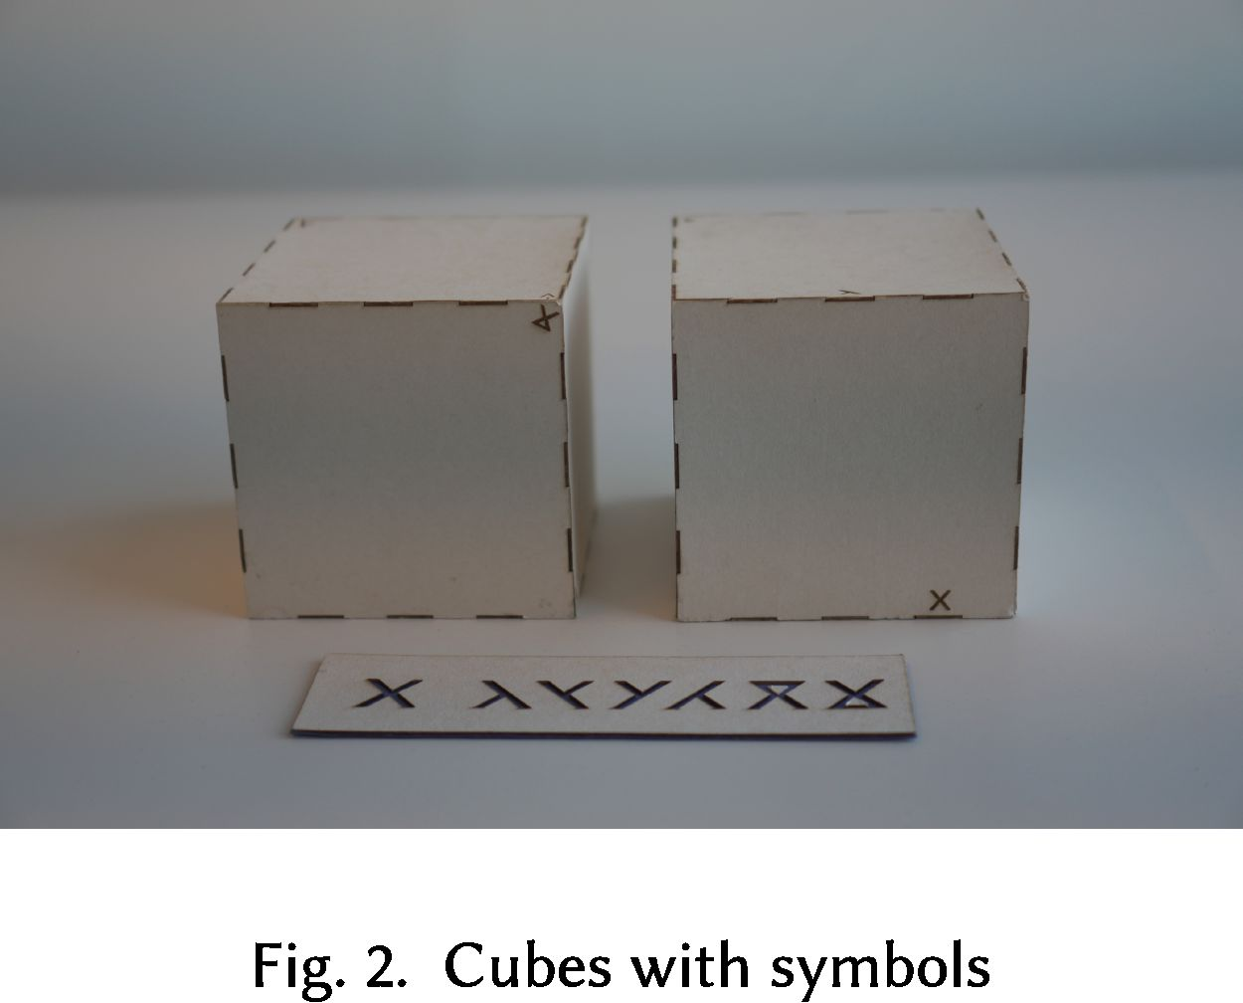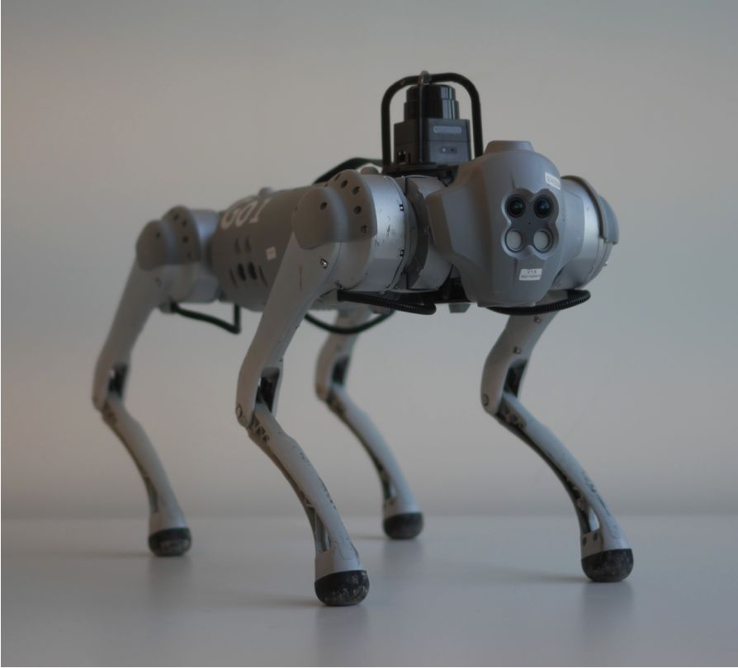

Fig. 3. Unitree Go1 robot.

the symbols was an "X" (see Figure 2). We intentionally designed a simple task where participants would experience a  
high sense of control due to their high competence and feeling that they can easily perform it accurately [34]. The  
10 cubes were placed in a quiet outdoor environment on campus (in an area that would be relevant for a robotic dog  
to search). To establish a clear and efficient search pattern, we organized the cubes based on the Gestalt principle of  
Proximity [45, 48]. According to the Proximity principle, relative distance between objects affects our perception in a  
way that would define an organization of the objects into subgroups. We, therefore organized the cubes in two parallel  
columns, with 5 cubes each. The distance between the columns (4 meters) was greater than the distance between the  
rows (2.5 meters), making each column a subgroup according to the Proximity principle (see Figure 4, Right). This  
way, we verified that the most efficient search path (beginning with one column and then moving to the other) was  
understandable. We validated the consistency of the search pattern and the simplicity of the task in a pilot study with  
10 participants. All participants first searched the cubes in one column and then switched to searching the cubes in the  
other (see Figure 4, Left). All participants easily and accurately reported finding four "X" symbols.

1. *The robot and gestures design.* We used a Unitree Gol robot (see Figure 3). The Gol is a small-scale 15 kg robot  
   with 12 degrees of freedom. The specific choice of a robotic dog allowed us to design a task (searching) that would be  
   perceived as relevant for both the participant and the robot. In addition, we could design a robotic behavior that would  
   be compatible with participants’ existing experiences (with real dogs) and reduce the need for learning processes related  
   to the novel context of human-robot interaction. The robot was controlled wirelessly from within the building using a  
   Wizard-of-Oz technique (i.e., the research assistant who controlled the robot was not visible to the participant; [29, 35]).

We designed three types of gestures: *Hello* for establishing a positive opening encounter [13]; *Scanning* for indicating  
that the robot is searching for the "X"; *Excited* for indicating that the robot found an "X". The gestures were designed via  
several iterations with an animator focusing on real dog gestures and indicating that the robot is performing the task.  
The understanding of these gestures was validated in a pilot study with eight participants who were asked to explain  
the meaning of the gestures (presented in a counterbalanced order). All participants easily understood the gestures.

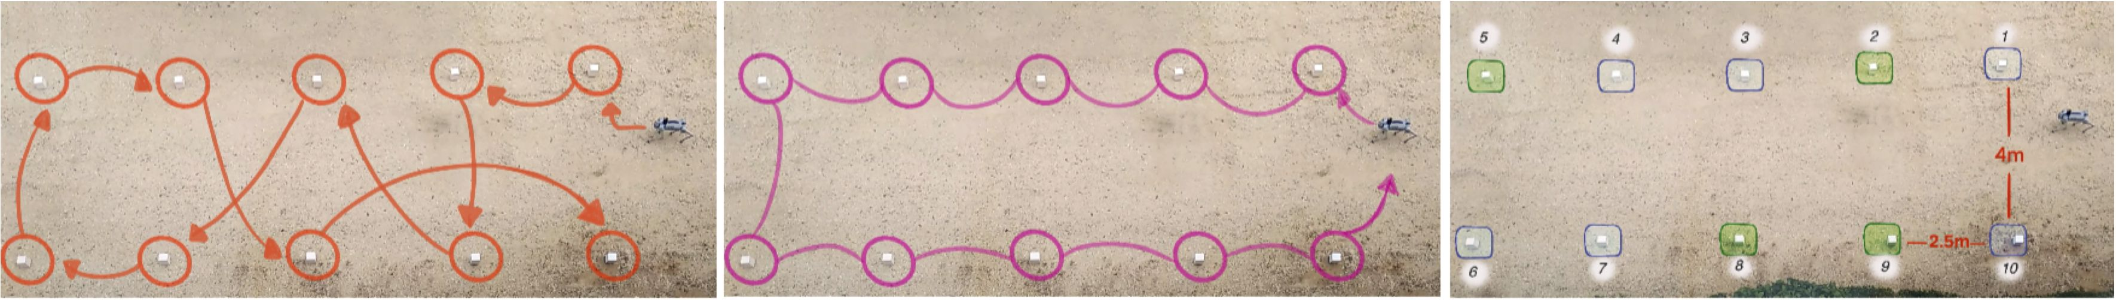

Fig. 4. Cubes and search pattern

1. *Hello:* When the robot reached a distance of 65 cm from the participant, it turned its front part up towards the  
   participant three times (simulating nodding). The robot then stood next to the participant.
2. *Scanning:* The robot went towards each box and leaned towards it (front part lowered towards the box); it then  
   performed right-left rotations of its head, simulating scanning the symbols on the box.
3. *Excited:* Next to the four cubes that had an "X" symbol, the robot first performed the *Scanning* gestures and  
   then performed quick right-left rotations of its body (a radian angle of 90 degrees, three times in a row).
   1. Participants

30 undergraduate students from the university participated in the study (20 women and 10 men; mean age - 22.9, SD -  
2.2). All participants signed a consent form and received extra course credit points or a 15 USD gift card.

* 1. Experimental Design

Our between-participant experimental design included two conditions. (1) *Alongside the robot:* participants performed  
the search task in parallel to the robot. The robot began to search a few seconds before the participant to verify that  
the participant noticed it. It searched the cubes in a fixed inefficient path that was not compatible with the Gestalt  
principle of Proximity (see Figure 4, Center). The robot’s search behavior included moving from one box to the other,  
performing the *Scanning* gesture next to each box, and the *Excited* gesture next to cubes with an "X" symbol. The  
robot’s search lasted 80 seconds. (2) *Baseline:* participants were informed that the robot would perform the search task  
after them. Once participants were done searching, the robot performed the exact same searching behavior as in the  
experimental condition but without the participant who was waiting at the starting point. The inclusion of the robot in  
the *Baseline* condition allowed us to control for novelty effects related to interacting with a robot. Participants were  
*randomly* assigned to one of the conditions using a matching technique that balanced gender, negative attitudes toward  
robots (NARS) [31], and *Sense of Control (trait)* [22] (to avoid a-priori differences between groups).

* 1. Dependent Measures

We assessed the impact of performing a task next to a robot using objective and subjective measures.

1. *Situational Sense of Control questionnaire:* The questionnaire is designed to evaluate participants’ sense of control  
   in a specific context. It is a 5-item Likert scale (l“Totally disagree” to 5 “Totally agree”) [42]
2. *Performance measures:* We used two measures: (1) accuracy - reporting four cubes with "X" symbols; and (2)  
   participants’ search path - whether it was (or wasn’t) efficient based on the distances between the cubes.
3. *Robotic Social Attributes Scale (RoSAS):* The questionnaire is an 18-item Likert scale assessing warmth, compe-  
   tence, or discomfort (l“Definitely Not Associated” to 9 “Definitely Associated”) [7],
4. *Semi-structured interview.* To understand participants’ experience, we conducted a post-experience semi-  
   structured interview [15, 20]. The interview included questions such as “Describe your experience,” “Describe  
   how you decided on your searching path,” “Describe your thoughts about the robot,”.
   1. Procedure

A few days before the experiment, participants received pre-test questionnaires by email: Negative Attitudes Towards  
Robots questionnaire [31], Sense of Control (trait) questionnaire [22], and a demographic questionnaire. When par-  
ticipants arrived at the experiment, they were informed that everything was recorded and that they could quit theexperiment without consequences. Participants were then invited to the outdoor space. The robotic dog was positioned  
in a hidden place next to box number 9. The researcher explained that their task is to look for "X" symbol on the cubes  
in the most accurate and efficient way. It was also mentioned that there is a robotic dog who is performing search  
training in the same area and that it may perform the same search task. As participants reached the starting point,  
the robotic dog approached them and performed the *Hello* gesture. Participants were then asked to plan their search  
pattern and to begin when instructed to. They then performed the task based on the experimental condition (before or  
alongside the robotic dog). After completing the search, participants were asked to report the number of "X" symbols  
they found on the cubes and to take a seat on one of two chairs placed at the far end of the outdoor space. Participants  
completed the situational sense of control and RoSAS questionnaires and participated in a semi-structured interview.  
At the end of the experiment, the researcher verified that the participants believed that the robot was autonomous,  
debriefed the participants, and verified that they left with an overall positive experience.

1. FINDINGS

To further verify the lack of early differences between groups, we first conducted Bayesian analyses for the pre-tests.  
The analysis indicated no early differences between groups (NARS: *BF\q =* 0.30; Sense of control (trait): *BF\q =* 0.29).  
The quantitative and qualitative main analyses indicated an impact of performing the task alongside the robot on  
participants’ sense of control and performance.

* 1. Situational sense of control

A one-way ANOVA revealed that performing the task next to the robot had a significant influence on the ratings of  
the situational sense of control. In the *Alongside the robot* condition, participants reported a lower sense of control  
compared to the *Baseline* condition -F(i528) - 14.64, p < 0.001, *rj? =* 0.36. (see Figure 5).

* 1. Performance

The chi-square analyses of both the accuracy and search path measures revealed that the robot had a significant  
influence on the participants’ performance. The accuracy analysis revealed that while in the (Baseline) condition,  
almost all participants reported the accurate number of "X" symbols, in the *Alongside the robot* condition, about half of  
the participants, could not provide the accurate answer /2(2) = 3.9, p < 0.04 (see Table 1). Similarly, the search path  
analysis indicated that in the *Baseline* condition, almost all participants chose the efficient search path. However, in the

5 4.38

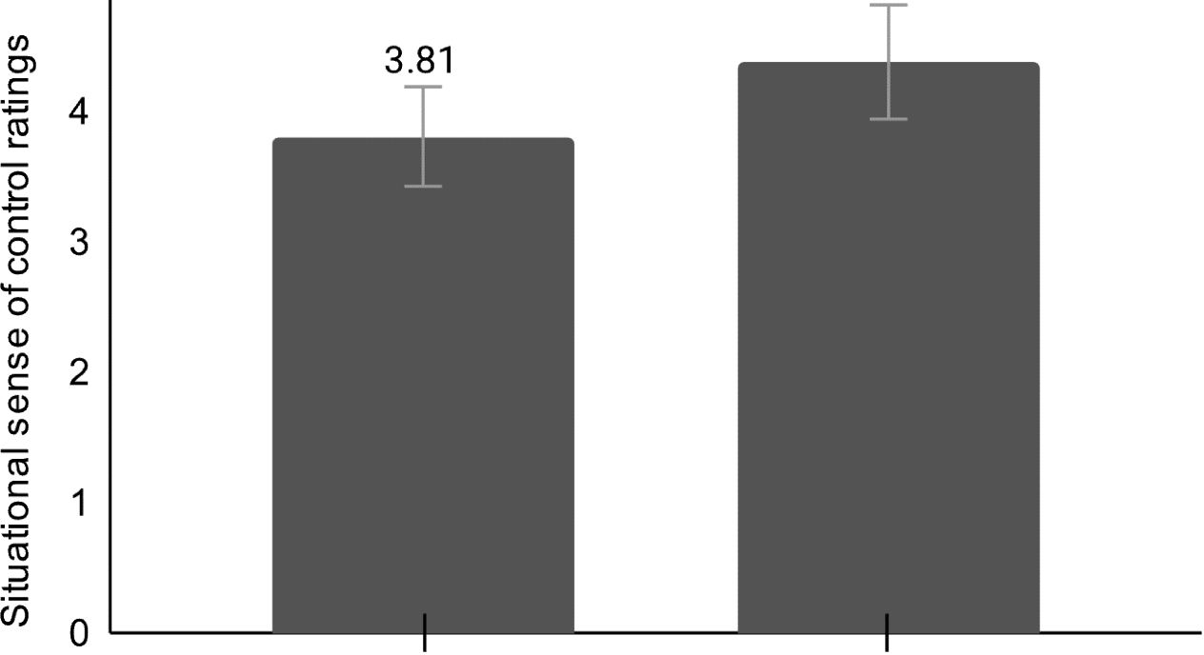

Alongside the robot Baseline

Fig. 5. Analysis of the situational sense of control.

*Alongside the robot* condition, about a third of the participants chose an inefficient path where they moved both within  
and between columns inconsistently *x\z)* = 4.6, *p* < 0.03 (see Table 2).

| **Robot Condition** | **Performance Accuracy** | | **Total** |
| --- | --- | --- | --- |
| **Accuracy** | **Inaccuracy** |
| **Alongside the Robot** | 8 | 7 | 15 |
| **Baseline** | 13 | 2 | 15 |
| **Total** | 21 | 9 | 30 |

Table!. Performance Accuracy

| **Robot Condition** | **Search Pattern** | | **Total** |
| --- | --- | --- | --- |
| **Efficient** | **Inefficient** |
| **Alongside the Robot** | 9 | 6 | 15 |
| **Baseline** | 14 | 1 | 15 |
| **Total** | 23 | 7 | 30 |

Table 2. Search Pattern

* 1. Robot Perception

A one-way ANOVA analysis was performed for each of the three sub-scales of the RoSAS questionnaire. The analysis  
indicated no significant differences between the different conditions for any of the scales: Warmth: F(228) = Old, *p -*0.66; Competence: f(2,28) = 2.4, *p* - 0.13); Discomfort: f(2,28) = 1-6, *P* - 0.26).

* 1. Thematic Analysis of the Semi-Structured Interviews

The interviews were analyzed using a thematic coding methodology [6]: Interview transcriptions were read several times;  
Initial themes were extracted by two coders and discussed in depth with a third researcher to resolve inconsistencies;  
The coders used the themes to independently analyze part of the data, verifying inter-rater reliability (kappa=83%);  
The coders analyzed the rest of the data. The thematic analysis revealed three main themes: (1) Sense of control and  
performance, (2) validation of social comparison, and (3) validation of overestimation of the robot’s capabilities.

4.4.7 *Theme* 7 - *Sense of control and performance.*

1. *Theme 2 - validation of social comparison.*
2. *Theme 3 - validation of overestimation of the robot’s capabilities.*
3. DISCUSSION
4. LIMITATIONS

This study has several limitations. First, we used a robotic dog with a particular morphology and specific behavior. It is  
important to test further the effect of performing tasks in a robot’s presence with different robots showing different  
capabilities. It is also important to test the impact of the task complexity. We chose a very simple task. It is possible that  
increasing task complexity would increase or decrease the impact of the robot’s presence. The number of participants  
in each group is another limitation, and future work should replicate our study with a larger sample. Lastly, interviews  
may be biased by the ‘good subject effect” [30, 32], We minimized this risk by following a strict protocol that defined  
the general questions, used neutral language, and emphasized that all answers were helpful.

1. CONCLUSION

We demonstrate that performing a task alongside a robot can lead to a negative impact on people’s performance and a  
sense of control. The tendency to engage in social comparison was replicated in the HRI context, which involved an  
upward comparison due to the overestimation of the robot’s capabilities. Our findings suggest that the impact of social  
comparison should be carefully accounted for in any environment where robots and humans work alongside each other.

REFERENCES

1. Neziha Akalin, Annica Kristoffersson, and Amy Loutfi. 2022. Do you feel safe with your robot? Factors influencing perceived safety in human-robot  
   interaction based on subjective and objective measures. *International journal of human-computer studies* 158 (2022), 102744.
2. Alexander M Aroyo, Jan De Bruyne, Orian Dheu, Eduard Fosch-Villaronga, Aleksei Gudkov, Holly Hoch, Steve Jones, Christoph Lutz, Henrik  
   Saetra, Mads Solberg, et al. 2021. Overtrusting robots: Setting a research agenda to mitigate overtrust in automation. *Paladyn, Journal of Behavioral  
   Robotics* 12,1 (2021), 423-436.
3. David J Atkinson, William J Clancey, and Micah H Clark. 2014. Shared awareness, autonomy and trust in human-robot teamwork. In *2014 AAAI fall  
   symposium series.*
4. SJ Baltrusch, F Krause, AW de Vries, W van Dijk, and MP de Looze. 2022. What about the Human in Human Robot Collaboration? A literature  
   review on HRC’s effects on aspects of job quality. *Ergonomics* 65, 5 (2022), 719-740.
5. Frederike Beyer, Nura Sidarus, Sofia Bonicalzi, and Patrick Haggard. 2017. Beyond self-serving bias: diffusion of responsibility reduces sense of  
   agency and outcome monitoring. *Social cognitive and affective neuroscience* 12,1 (2017), 138-145.
6. Richard E Boyatzis. 1998. *Transforming qualitative information•• Thematic analysis and code development,* sage.
7. Colleen M Carpinella, Alisa B Wyman, Michael A Perez, and Steven J Stroessner. 2017. The robotic social attributes scale (RoSAS) development and  
   validation. In *Proceedings of the 2017 ACM/IEEE International Conference on human-robot interaction.* 254-262.
8. Adeline Chanseau, Kerstin Dautenhahn, Kheng Lee Koay, and Maha Salem. 2016. Who is in charge? Sense of control and robot anxiety in  
   human-robot interaction. In *2016 25th IEEE international symposium on robot and human interactive communication (RO-MAN).* IEEE, 743-748.
9. Adeline Chanseau, Kerstin Dautenhahn, Kheng Lee Koay, Michael L Walters, Gabriella Lakatos, and Maha Salem. 2019. How does peoples’ perception  
   of control depend on the criticality of a task performed by a robot. *Paladyn, Journal of Behavioral Robotics* 10,1 (2019), 380-400.
10. Francesca Ciardo, Davide De Tommaso, Frederike Beyer, and Agnieszka Wykowska. 2018. Reduced sense of agency in human-robot interaction. In  
    *Social Robotics•• 10th International Conference, ICSR 2018, Qingdao, China, November 28-30, 2018, Proceedings 10.* Springer, 441-450.
11. Joseph DelPreto, Jeffrey I Lipton, Lindsay Sanneman, Aidan J Fay, Christopher Fourie, Changhyun Choi, and Daniela Rus. 2020. Helping robots  
    learn: a human-robot master-apprentice model using demonstrations via virtual reality teleoperation. In *2020 IEEE International Conference on  
    Robotics and Automation (ICRA).* IEEE, 10226-10233.
12. Hadas Erel, Yoav Cohen, Klil Shafrir, Sara Daniela Levy, Idan Dov Vidra, Tzachi Shem Tov, and Oren Zuckerman. 2021. Excluded by Robots: Can  
    Robot-Robot-Human Interaction Lead to Ostracism?. In *Proceedings of the 2021 ACM/IEEE International Conference on Human-Robot Interaction.*312-321.
13. Hadas Erel, Agam Oberlender, Juna Khatib, Noam Freund, Omer Sadeh, Julian Waksberg, and Elior Carsenti. 2024. The Power of Opening Encounters  
    in HRI: How Initial Robotic Behavior Shapes the Interaction that Follows. *Proceedings of the 19th ACM/IEEE international conference on Human robot  
    interaction - HRI ’24* (2024), 1-8.
14. Leon Festinger. 1954. A theory of social comparison processes. *Human relations* 7, 2 (1954), 117-140.
15. Anne Galletta. 2013. *Mastering the semi-structured interview and beyond.* New York University Press.
16. Baria GaudieBo, Elisabetta Zibetti, Sebastien Lefort, Mohamed Chetouani, and Serena Ivaldi. 2016. Trust as indicator of robot functional and social  
    acceptance. An experimental study on user conformation to iCub answers. *Computers in Human Behavior* 61 (2016), 633-655.
17. Armin Granulo, Christoph Fuchs, and Stefano Puntoni. 2019. Psychological reactions to human versus robotic job replacement. *Nature human  
    behaviour* 3, 10 (2019), 1062-1069.
18. Vahid Izadi, Aijun Yeravdekar, and Amirhossein Ghasemi. 2019. Determination of roles and interaction modes in a haptic shared control framework.  
    In *Dynamic Systems and Control Conference,* Vol. 59148. American Society of Mechanical Engineers, V001T05A005.
19. Ulas Berk Karli, Shiye Cao, and Chien-Ming Huang. 2023. " What If It Is Wrong": Effects of Power Dynamics and Trust Repair Strategy on Trust and  
    Compliance in HRL In *Proceedings of the 2023 ACM/IEEE International Conference on Human-Robot Interaction.* 271-280.
20. Eleanor Knott, Aliya Hamid Rao, Kate Summers, and Chana Teeger. 2022. Interviews in the social sciences. *Nature Reviews Methods Primers* 2,1  
    (2022), 73.
21. Bing Cai Kok and Harold Soh. 2020. Trust in robots: Challenges and opportunities. *Current Robotics Reports* 1 (2020), 297-309.
22. Margie E Lachman and Suzanne L Weaver. 1998. The sense of control as a moderator of social class differences in health and well-being. *Journal of  
    personality and social psychology* 74, 3 (1998), 763.
23. Min Kyung Lee, Sara Kiesler, Jodi Forlizzi, and Paul Rybski. 2012. Ripple effects of an embedded social agent: a field study of a social robot in the  
    workplace. In *Proceedings of the SIGCHI Conference on Human Factors in Computing Systems.* 695-704.
24. Ali Ahmad Malik and Arne Bilberg. 2019. Complexity-based task allocation in human-robot collaborative assembly. *Industrial Robot; the international  
    journal of robotics research and application* 46, 4 (2019), 471-480.
25. Bemt Meerbeek, Jettie Hoonhout, Peter Bingley, and Jacques MB Terken. 2008. The influence of robot personality on perceived and preferred level  
    of user control. *Interaction Studies* 9, 2 (2008), 204-229.
26. Antonia Meissner, Angelika Trubswetter, Antonia S Conti-Kufher, and Jonas Schmidtler. 2020. Friend or foe? understanding assembly workers’  
    acceptance of human-robot collaboration. *ACM Transactions on Human-Robot Interaction (THRI)* 10,1 (2020), 1-30.
27. Dominique Muller and Marie-Pierre Fayant. 2010. On being exposed to superior others: Consequences of self-threatening upward social comparisons.  
    *Social and Personality Psychology Compass* 4, 8 (2010), 621-634.
28. Vladimir Murashov, Frank Heart, and John Howard. 2016. Working safely with robot workers: Recommendations for the new workplace. *Journal of  
    occupational and environmental hygiene* 13, 3 (2016), D61-D71.
29. Bilge Mutlu, Takayuki Kanda, Jodi Forlizzi, Jessica Hodgins, and Hiroshi Ishiguro. 2012. Conversational gaze mechanisms for humanlike robots.  
    *ACM Transactions on Interactive Intelligent Systems (TiiS)* 1, 2 (2012), 1-33.
30. Austin Lee Nichols and Jon K Maner. 2008. The good-subject effect: Investigating participant demand characteristics. *The Journal of general  
    psychology* 135, 2 (2008), 151-166.
31. Tatsuya Nomura, Takayuki Kanda, and Tomohiro Suzuki. 2006. Experimental investigation into influence of negative attitudes toward robots on  
    human-robot interaction. Ar *& Society* 20 (2006), 138-150.
32. Raymond Opdenakker et al. 2006. Advantages and disadvantages of four interview techniques in qualitative research. In *Forum qualitative  
    sozialforschung/forum: Qualitative social research,* Vol. 7.
33. Stefanie Paluch, Sven Tuzovic, Heiko F Holz, Alexander Kies, and Moritz Jorling. 2022. “My colleague is a robot”-exploring frontline employees’  
    willingness to work with collaborative service robots. *Journal of Service Management* 33, 2 (2022), 363-388.
34. Reinhard Pekrun and Raymond P Perry. 2014. Control-value theory of achievement emotions. In *International handbook of emotions in education.*Routledge, 120-141.
35. Laurel D Riek. 2012. Wizard of oz studies in hri: a systematic review and new reporting guidelines. *Journal of Human-Robot Interaction* 1,1 (2012),  
    119-136.
36. Paul Robinette, Ayanna Howard, and Alan R Wagner. 2017. Conceptualizing overtrust in robots: why do people trust a robot that previously failed?  
    *Autonomy and Artificial Intelligence: A Threat or Savior?* (2017), 129-155.
37. Paul Robinette, Wenchen Li, Robert Allen, Ayanna M Howard, and Alan R Wagner. 2016. Overtrust of robots in emergency evacuation scenarios. In  
    *2016 11th ACM/IEEE International Conference on Human-Robot Interaction (HRI).* IEEE, 101-108.
38. Laura Romeo, Antonio Petitti, Roberto Marani, and Annalisa Milella. 2020. Internet of robotic things in smart domains: Applications and challenges.  
    *Sensors* 20,12 (2020), 3355.
39. Maha Salem, Gabriella Lakatos, Farshid Amirabdollahian, and Kerstin Dautenhahn. 2015. Would you trust a (faulty) robot? Effects of error, task  
    type and personality on human-robot cooperation and trust. In *Proceedings of the tenth annual ACM/IEEE international conference on human-robot  
    interaction.* 141-148.
40. Barry Schwartz and Andrew Ward. 2004. Doing better but feeling worse: The paradox of choice. *Positive psychology in practice* (2004), 86-104.
41. Amanda Sharkey and Noel Sharkey. 2021. We need to talk about deception in social robotics! *Ethics and Information Technology* 23 (2021), 309-316.
42. Jan-Philipp Stein, Benny Liebold, and Peter Ohler. 2019. Stay back, clever thing! Linking situational control and human uniqueness concerns to the  
    aversion against autonomous technology. *Computers in Human Behavior* 95 (2019), 73-82.
43. Nico W Van Yperen, Veerle Brenninkmeijer, and Abraham P Buunk. 2006. People’s responses to upward and downward social comparisons: The  
    role of the individual’s effort-performance expectancy. *British Journal of Social Psychology* 45, 3 (2006), 519-533.
44. Ashesh Vasalya, Gowrishankar Ganesh, and Abderrahmane Kheddar. 2018. More than just co-workers: Presence of humanoid robot co-worker  
    influences human performance. *PloS one* 13, 11 (2018), e0206698.
45. Johan Wagemans, James H Elder, Michael Kubovy, Stephen E Palmer, Mary A Peterson, Manish Singh, and Rudiger Von der Heydt. 2012. A century  
    of Gestalt psychology in visual perception: L Perceptual grouping and figure-ground organization. *Psychological bulletin* 138, 6 (2012), 1172.
46. Phyllis Xue Wang, Sara Kim, and Minki Kim. 2023. Robot anthropomorphism and job insecurity: The role of social comparison. *Journal of Business  
    Research* 164 (2023), 114003.
47. Alexandra Weidemann and Nele Rufiwinkel. 2021. The Role of Frustration in Human-Robot Interaction-What Is Needed for a Successful  
    Collaboration? *Frontiers in psychology* 12 (2021), 707.
48. Max Wertheimer. 2012. *Investigations on Gestalt principles.* MIT Press: London, UK.
49. Ladd Wheeler and Jerry Suls. 2020. A history of social comparison theory. *Social comparison, judgment, and behavior* (2020), 5-31.
50. Sangseok You and Lionel P Robert Jr. 2018. Human-robot similarity and willingness to work with a robotic co-worker. In *Proceedings of the 2018  
    ACM/IEEE International Conference on Human-Robot Interaction.* 251-260.
51. Lisa Zadro, Kipling D Williams, and Rick Richardson. 2004. How low can you go? Ostracism by a computer is sufficient to lower self-reported levels  
    of belonging, control, self-esteem, and meaningful existence. *Journal of Experimental Social Psychology* 40, 4 (2004), 560-567.
52. Setareh Zafari and Sabine T Koeszegi. 2021. Attitudes toward attributed agency: Role of perceived control. *International Journal of Social Robotics*13, 8 (2021), 2071-2080.
53. Robert B Zajonc. 1965. Social Facilitation: A solution is suggested for an old unresolved social psychological problem. *Science* 149, 3681 (1965),  
    269-274.
54. Oren Zuckerman, Viva Sarah Press, Ehud Barda, Benny Megidish, and Hadas EreL 2022. Tangible Collaboration: A Human-Centered Approach for  
    Sharing Control With an Actuated-Interface. In *Proceedings of the 2022 CHI Conference on Human Factors in Computing Systems.* 1-13.
55. Oren Zuckerman, Ofir Sadka, Ron Gissin, and Hadas Erel. 2021. TUI as Social Entity: a Study of Joint-actuation and Tum-taking-actuation in  
    Actuate d-interfaces. In *Proceedings of the 2021 CHI Conference on Human Factors in Computing Systems.* 1-12.