**Supporting Information for:**

**The interplay between crystallinity and the levels of Zn and carbonate in synthetic microcalcifications directs thyroid cell malignancy**

Lotem Gotnayer1, Yarden Nahmias1, Gabriel Yazbek Grobman1, Lonia Friedlander2, Dina Aranovich1, Uri Yoel3,4, Netta Vidavsky1,2\*

1Department of Chemical Engineering, Ben-Gurion University of the Negev, Beer Sheva, Israel

2Ilse Katz Institute for Nanoscale Science & Technology, Ben-Gurion University of the Negev, Beer Sheva, Israel

3Faculty of Health Sciences, Ben-Gurion University of the Negev, Beer Sheva, Israel

4Endocrinology, Soroka University Medical Center, Beer Sheva, Israel

\* Corresponding author

C:\Users\gotnayer\Desktop\Lotem\My 2nd Article\Figures\figure 1\Figure 1 EDS only for SI.tif

**Figure S1**. The elemental composition of an FNA-derived MC extracted from a cancerous thyroid nodule, as depicted in Figure 1 b, was assessed using EDS analysis.

|  |  |  |  |
| --- | --- | --- | --- |
| **The Zn fraction in the MC analog** **(wt%)** | $CO_{3}$**area** | $PO_{4}$**area** | $CO_{3}$**/ $PO_{4}$** |
| **0** | 0.128 | 10.7 | 0.012 |
| **0.74** | 0.0489 | 12.3 | 0.0040 |
| **1.2** | 0.0737 | 9.28 | 0.0079 |
| **2.6** | 0.0609 | 11.4 | 0.0054 |
| **5.2** | 0.0308 | 5.95 | 0.0052 |

**Table S1.** The area and ratios of carbonate and phosphate peaks in MC analogs determined through FTIR measurements.

The integration range was calculated between 850-890 cm−1 for the carbonate peak and 900-1200 cm-1 for the phosphate peak.

C:\Users\gotnayer\Downloads\XRD_SI (3).tif

**Figure S2**. X-ray diffractograms of the MC analogs. Peak broadening is associated with Zn increase.

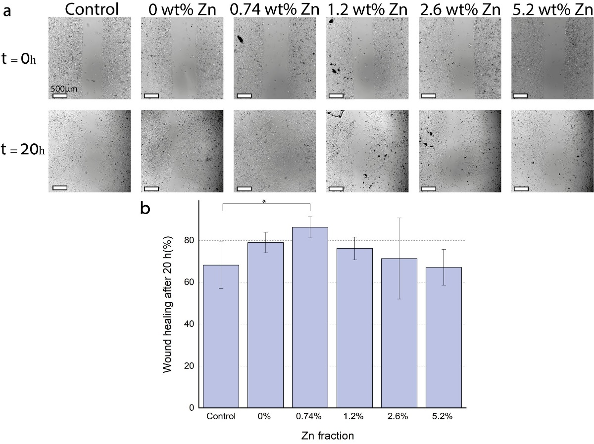

**Figure S3.** Cell migration assay according to Zn content in the MC analogs. **a**. Light microscopy imaging of the wound healing assay. **b**. The extent of cell migration quantified as wound coverage, is evaluated after 20 hours of culture with MC analogs. Wound healing is the gap area covered by cells after 20 h divided by the gap area at time 0. Error bars represent the standard deviation. P<0.05 (\*).

Add figure here

**Figure S4.** Western blot with anti-ERK, anti-p-ERK, anti-AKT, anti-EGFR, and anti-β-Actin antibodies. The samples were loaded in two duplicates on the same gel. After the transfer, the membrane was cut into two halves. One half was incubated with anti-ERK, anti-p-ERK, anti-AKT, anti-EGFR diluted at 1:50, and the second half was incubated with anti – β-Actin diluted (1:400).