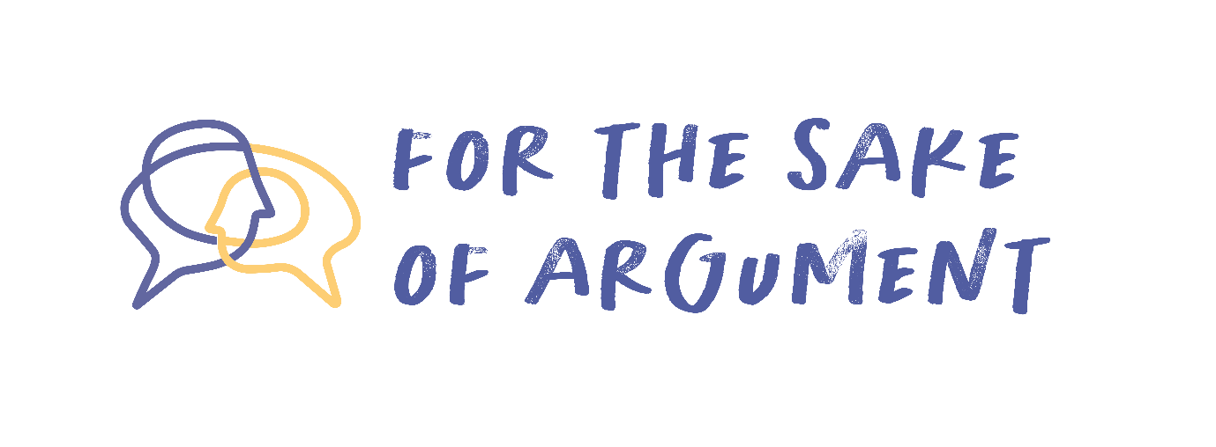
Enemy of the People
It was the most significant year of my life. Some ten months in Israel, learning about Israel, working in Israel, and connecting deeply with Israelis. My friends and I, we had gotten really close to a group of young Israelis around our age. We had all spent the previous summer together on camp while they were the Israeli shlichim (emissaries), and now we had joined them in Israel while they were doing their pre-army year of voluntary service (Shnat Sherut) working in the same impoverished neighborhood we were working in. Together the twenty of us worked at kids’ camps and cleaning up neighborhoods - bettering areas of Israel that needed help.
Our two groups became one. We would hang out together, watch sports together, play video games together, and even occasionally hook up together. And because they were Israelis, we would argue all the time. I’m a democrat and Yochai for example was crazy about Trump, but I’d say the two of us ended up being the closest friends out of everyone. There wasn’t anything romantic in it, but Yochai and I really loved each other.
Since we all went back to the States, we’ve kept up a fairly active whatsapp group. Sure, it’s not a daily connection, and not everyone writes in the group all the time, but overall we still keep up with each other, even after four, five years. Some of us have graduated, most of the Israelis have finished their army service, and the selfies keep flying across the sea.
Then came the message from Yochai on January 20th:
I’m sorry to be mean, but I’m telling you what I feel. All of you Americans who posted support for an immediate ceasefire with Hamas – you clearly don’t give a damn about the Jewish People. I even see some of you post your stupid “Stop killing children” without even mention for our children hostages in Gaza. Screw you all.
The moment I read it I felt like I’d been kicked in the stomach. I was on the verge of tears. Straight away there were additional messages from the Israelis, who went even further:
I thought we were Jews together. Now I realize you don’t care about us at all.
And many posted really horrible things in Hebrew (kind of against the law in our shared group of non-Hebrew readers) that I stopped putting into google translate after the first one or two.
I was devastated. How could they attack us in such a cruel way? And how intolerant! Disagreements are one thing, but to suddenly decide we’re almost enemies?
I tried to put together a reply for Yochai. I went backwards and forwards, editing, deleting, re-writing. And in the end I sent:
Dear Yochai and everyone in this group, in particular all the Israelis. We love you all. We worry for you and support you. We totally get that Hamas is a terrible organization and that the attack on 10.7 was an atrocity. Really. But at the same time, since when was our connection based on total agreement? Remember the fights we used to have over Trump? I used to go crazy when you put on that MAGA hat just to annoy me! But we never let that get in the way of our friendship. So, you’re right that we have a different view of what should happen now in Gaza, but I still believe you are my friend. We’re still the same people. I know it’s on a totally different level, but we Jews in America are also getting attacked for what the IDF is doing now. Now is the time for us to stick together, even if we disagree.
A couple of people messaged me privately, supporting me and saying thank you for saying what they’d wanted to say. But Yochai shot back almost immediately:
Trump and Hamas its not the same. NOT THE SAME! My friends were at the rave where Hamas massacred. Some of us were in reserve duty, fighting in the streets of Gaza. Is that the same as feeling a little uncomfortable with your woke “allies”? You American Jews you don’t understand anything. I don’t really think you are Jews at all.
And then he added another short message, as an after-thought:
And for us its 7.10. Even our dates you have to make about you.
I am stunned. Does he really think that being Jewish is all about agreeing with everything Israel does?
I really do believe that however evil Hamas is, Israel can’t just keep attacking Gaza. All those starving children. What good does it do? I know he’s grieving terribly, and doesn’t want to think beyond survival. But why should his raw emotions dictate what all Jews must do? Just because I’m more able to think about consequences doesn’t make me an enemy of the Jewish People.
Do you understand me?

Guiding Questions

- Does commitment to the Jewish People mean one must refrain from calling for an immediate ceasefire?

- If this schism were to come to your attention, and you were on the board of the camp these young people had attended, or the program in which they had participated in Israel - how would you respond? (The real life event this story is based on did most certainly come to the attention of the directors…)

Questions for further exploration

- What does supporting Israel mean - who decides?

- In what ways is it beneficial or damaging that there are Jews outside of Israel who see themselves as more able to look at this situation in a detached “objective” way?

