**Social Media and Social Movements: Visualizing the Canonical Literature of the Field and the Evolution of Scholarly Interests over Two Decades**

**Abstract**

Research focused on the intersection of social media and social movements has grown rapidly over the last two decades. Initially making bold claims about the implications of social media for social change, this literature quickly drew scholarly attention to meaningful gaps in the research. Scholars previously observed the field’s reliance on overly techno-deterministic perspectives, abrupt breaks away from established research traditions, insufficient empirical coverage, and lack of comparative research. But we know very little about the extent to which the field has evolved and overcome these gaps since they were identified. We especially lack knowledge about the evolution of the field since 2015, when a surge of new studies led to the diversification of research topics, methods, and case studies. This study amends this gap by providing a comprehensive overview of the field using systematic bibliometric analysis and literature mapping visualization methods. We show that the field has grounded itself in four long-standing canonical research traditions with substantial interdisciplinary dialogue between them. We further demonstrate that from 2015 onwards, scholarship developed more complex and multi-layered accounts of social media and social movements, whereas the empirical coverage and comparative research gaps have been properly addressed only since 2020. We conclude by pointing to meaningful gaps that still exist in the field regarding methodological approaches in the big data environment and types of questions that offer opportunities for future research, including the identification of movements’ political outcomes on the macro levels.

In the first decade of the 2000s, the digital communication landscape transformed with the introduction of Facebook and Twitter, ushering in the age of social media. A few years later, protests of mass proportions erupted in Tunisia and Egypt, followed by a wave of occupy protests across many countries – all using social media to coordinate and mobilize. These events enshrined a formidable link between social media and social movements (SMSM) in research and in public discourse. Social media were perceived as empowering movements, enhancing political engagement, and advancing democracy (Castells, 2012; Gainous & Wagner, 2014; Shirky, 2011). Moreover, scholars investigated the new affordances of social media, considering technological innovations as historical breakthroughs capable of altering social power relations (Neumayer & Rossi, 2016).

While fueling interest in the field, these tendencies also limited scholarship to technologically-focused accounts, often making abrupt breaks away from broader research questions and approaches that had preoccupied scholars before the explosion of social media. Moreover, in its initial stages, research on these topics had limited empirical coverage. Early studies focused on a few case studies and platforms, and tended to study platforms in isolation from one another, making it hard to draw generalizable conclusions. As research evolved, scholars have increasingly moved beyond these initial tendencies, producing multi-layered analyses of the link between social media and social movements. Yet the extent to which research has succeeded in this task remains unknown.

This study analyzes the transition of research on SMSM beyond its initial tendencies. Leveraging the strengths of advanced literature mapping methods, we show that research in the field has consolidated four canonical research traditions that have informed subsequent studies, with high levels of interdisciplinary dialogue between them. We further show the intellectual and thematic evolution of scholarship in the field from dichotomous positive and negative views of social media to multi-layered and complex analyses. As part of our analysis of this thematic evolution, we trace the expansion of research’s empirical coverage and methodological development. Informed by the empirical contribution of our literature mapping findings, we conclude by pointing to the need for more methodological focus in the big data era, and to promising future research directions related to studying movement political outcomes in the social media age.

**Delineating the Field: Social Media and Social Movements**

This study explores scholarship on the intersection of two fields: social media and social movements. Research linking the rise of digital communication technologies with new forms of political participation, activism, and movements, dates to the invention of the internet (DiMaggio et al., 2001; Juris, 2008). However, the introduction of social media platforms in the early 2000s, followed by the emergence of revolutions and mass protests in multiple countries in 2010-2012, solidified a connection in scholarship and in the public imagination between the spread of social media and of social movements. We therefore focus this study on the era of social media that began in 2005, aiming to capture the intellectual development of the field that has evolved since these dramatic events.

Social media was not always distinguished from other types of technologies based in user generated content, like blogs and chat rooms. In fact, Twitter was initially referred to as a microblogging service. Nevertheless, in the second decade of the 2000s, as platforms like Facebook and Twitter reached unprecedented user numbers, and as other network platforms multiplied, the distinct category of social media emerged as the dominant term referring to a specific set of features and affordances of digital communication tools (Burgess et al., 2018). The recognition of social media as a distinct field of study received an official acknowledgement with the establishment of the specialized journal *Social Media + Society* in 2015 and the publication of a dedicated handbook in 2018 (Burgess et al., 2018).

Although many scholars have used the term social media with a loose and fluid meaning, specific definitions that distinguished these platforms from other types of communication technologies referred to the abilities to create a personal profile, connect the profile to other profiles in the network, view and navigate across these connections, and share and search for content across these connections (Leong et al., 2019; Xenos et al., 2014). This study draws upon these specific definitions in order to clearly distinguish between social media platforms and other technologies.

While the focus on social media delineates a specific time frame, the study of social movements goes back many decades. Definitions of social movements are also diverse, ranging from a narrow focus on institutionalized social movement organizations (Zald & McCarthy, 1980) to a broad definition that includes individual activism, temporary protest cycles, fluid mobilization networks, and ad-hoc movement coalitions (Della Porta & Diani, 2015). Because social movements in the social media era are structurally diverse, we draw in this study on the broader understanding of social movements. We therefore consider all individual and collective efforts to achieve political, cultural, and social change relevant for this study.

**Gaps Identified in Earlier Stages of the Field**

Reviews of research on SMSM have focused on information technologies and media in general (Caren et al., 2020; Neumayer & Rossi, 2016), as well as reviews that specifically focus on social media (Foust & Hoyt, 2018; Kidd & McIntosh, 2016). Taken together, these studies have ­­identified three main issues with the overall orientation of the field in its early stages: a fascination with new technology at the expense of developing broader questions and theories, a dichotomous division between positive and negative views of social media, and a limited empirical coverage with the tendency to study platforms in isolation.

While scholars’ focus on the newness of technological phenomena led to the immense growth of the field, it also tied research to a constant effort to construct this “newness,” sometimes limiting scholars’ ability to connect their research to broader questions about the connection between media and movements (Neumayer & Rossi, 2016). These difficulties have led to claims about insufficient links to established research traditions (Kidd & McIntosh, 2016; Mattoni & Treré, 2014) and a lack of interdisciplinary dialogue between SMSM scholars (Caren et al., 2020; Foust & Hoyt, 2018).

In the early years of social media, scholars tended to subscribe to either a techno-optimistic or a techno-pessimistic perspective (Caren et al., 2020; Foust & Hoyt, 2018; Kidd & McIntosh, 2016). Techno-optimistic accounts viewed social media as a game changer for social movements, bestowing movements with unprecedented capabilities that were set to tilt the social power dynamics in favor of movements and lead to the dismantling of authoritarian regimes. Techno-pessimistic accounts, on the other hand, argued that social media would not achieve these outcomes, and would in fact reinforce existing power structures, including forms of authoritarianism, repression, and marginalization. Both perspectives were criticized for being overly deterministic (Foust & Hoyt, 2018), overplaying the role of technology in social dynamics (Kidd & McIntosh, 2016), and insufficiently contextualizing social phenomena (Caren et al., 2020). Critics therefore called for more complex, ambivalent, and contextualized explanations of the evolving dynamics between movements, social media, and social change.

A final observation of these reviews of SMSM is that scholarship on these topics initially focused on a few major case studies and platforms, lacking the global empirical coverage needed to draw broader conclusions about the implications of the social media era for political action and social change. The focus on some platforms privileged the social groups that use these platforms more often while ignoring other groups (Caren et al., 2020). Moreover, scholars tended to study platforms in isolation from one another, overlooking the fact that people and movements combine activities on different platforms (Caren et al., 2020; Foust & Hoyt, 2018).

*Research Questions and Analytic Approach*

Informed by these prior assessments of the literature, this study sets out to systematically analyze the extent to which scholarship on SMSM has addressed these issues, and to identify potential gaps that remain to be investigated in future research. We do this positing two research questions. The first research question asks: *What research traditions form the canonical literature of scholarship on SMSM?* (RQ1: Canonical literature). The second research question builds on this investigation of canonical literature throughout the entire observation period by investigating changes over time in key features of the research literature. Specifically, the second research question is: *How have research themes in scholarship on SMSM changed meaningfully over the last two decades?* (RQ2: Thematic evolution).

The first research question’s focus on identifying the canonical research traditions that have informed studies of SMSM (RQ1: Canonical literature) investigates the extent to which research on these topics draws upon established theoretical foundations. Answering this question also enables us to assess the level of interdisciplinary synergy among these traditions. The second research question’s focus on identifying the thematic changes in SMSM research over time (RQ2: Thematic evolution) allows us to assess the degree to which previously identified gaps in the literature have been addressed as this line of scholarship has evolved. In addition to our main focus in answering RQ2 on the distinctive research themes of each time period in our study, our investigation of thematic evolution also identifies evolution in *empirical scope* to cover more geographic territories, case studies, and social media platforms; in *normative stance* to produce complex accounts of social media and movements; and in *methodological approach* to trace changing analytic techniques over time.

We answer these research questions using literature mapping, an advanced bibliometric analysis visualization method that includes systematic techniques to develop literature inclusion criteria, analyze citation patterns, identify themes and research areas, assess relationships between research areas, and visualize the evolution of the scholarly landscape. In doing so, we build on an important early study by Neumayer and Rossi (2016) that investigated topics related to these research questions by visualizing trends in scholarship on protest and media technologies between 2000-2014.

While most previous reviews relied on authors’ familiarity with the literature and subjective judgement about which studies to include, our analytic approach allows for a systematic bibliometric assessment of our research questions, as well as replication of the analysis to enable robust identification of subsequent changes in the scholarly landscape (Shoshan & Oser, 2024; Van Eck & Waltman, 2014). As detailed in Data and Methods, our analytic approach creates a comprehensive dataset of over six thousand records, and produces visualizations that present the levels of interaction and congruence between various research themes. Our investigation also contributes to prior research on these topics by focusing specifically on the intersection of social media and social movements, and presenting a systematic empirical analysis of the canonical literature and of the evolution of thematic topics.

**Data and Methods**

To answer our research questions, we applied advanced bibliometric search and visualization methods which are commonly used in the natural sciences, but have only recently been applied in social science research. Social science studies have used these methods to make original contributions on topics such as identifying understudied research areas (Shoshan & Oser, 2024), tracing the evolution of a field (Fils and van Eck 2018), and drawing conclusions about the actors shaping the field (Ralph and Arora 2024).

We follow best practices in this field of research by sourcing the data on scholarly works from the Web of Science (WoS) core collection, a bibliographic data source recognized for its coverage and high accuracy (Visser et al., 2021). We then used an established bibliometric search model (Huang et al., 2015) to create the Boolean term, which is the search expression that determines which records will be retrieved based on a specification of fields, search terms, and logical operators. We analyzed the data using VOSviewer (version 1.6.20) (van Eck & Waltman, 2010), a commonly-used software tool for constructing and visualizing bibliometric networks with a wide range of mapping capabilities and high-quality visual outputs (Pan et al., 2018).

We created the Boolean term search term in three stages that we detail below: core lexical search, expanded lexical search, and specialized journals search (Huang et al., 2015). We then made adjustments to this model to adapt it to research that lies at the intersection of two fields. In a core lexical search, experts select a group of search terms based on their familiarity with the field. For this stage, we selected keywords from prominent handbooks on social media (Burgess et al., 2018) and social movements (Della Porta & Diani, 2015). Our core terms for social media included social media, Facebook, and Twitter, and our core terms for social movements included social movements, collective action, protest, and contentious politics. We applied adjustments for spelling and singular/plural variations. This search produced a core dataset.

In an expanded lexical search, researchers retrieve frequent keywords from the core dataset, and screen these keywords using a hit ratio and a noise ratio. The hit ratio is a semi-automated estimate of the share of relevant studies retrieved by a candidate search term. It calculates the share of the results retrieved by a candidate term that are already included in the core dataset. The idea is to cast a net that is wider than the core search. The noise ratio is an estimate of the number of irrelevant results retrieved by a candidate search term based on a manual check of a random selection of records retrieved by the candidate search term (Huang et al., 2015).

Based on this method, we retrieved the 100 most frequent keywords in the Author Keywords and Keywords Plus fields of the core dataset and created a candidate search term for each of these keywords. We removed generic terms, and then calculated the hit ratio for each candidate term. Based on established thresholds (Huang et al., 2015), we included all candidate terms with a hit ratio of 70% or above. For candidate terms with a hit ratio between 30% and 70%, we calculated the noise ratio, and included terms with a noise ratio below 50%. Overall, the expanded lexical search added 13 search terms to our Boolean term.

Finally, the specialized journals search involves including entire journals dedicated specifically to the field of interest (Huang et al. 2015). We sourced the titles of specialized journals for each of our two fields from the handbooks (Burgess et al., 2018; Della Porta & Diani, 2015), and we only included journals that are classified in WoS’s Journal Citation Reports. We thus identified one journal that specializes in social media (*Social Media + Society*) and two journals that specialize in social movements (*Social Movement Studies* and *Mobilization*).

When applying this process, we adapted the search model to retrieve research that lies at the intersection of two fields. We did this by dividing all core, candidate, and final search terms into three categories: category A - social media (e.g., Facebook); category B – social movements (e.g., protest); category C – combined search terms (e.g., hashtag activism). We then adjusted the hit ratio formula to calculate how many of the results obtained by a category A candidate search term *combined* with one or more of the category B core search terms were already included in the core search (“hits”). We did the same for category B candidate terms. For candidate terms in category C, there was no need to include core search terms from other categories. Finally, we structured the final Boolean term in such a way that it combined at least one search term from categories A and B, or had at least one search term from category C, thus ensuring that only research that lies at the intersection of social media and social movements is retrieved.

The dataset produced by this method has the same limitations as other studies using this analytical technique due to the type and structure of the data available on the WoS, even though it is the one of the most commonly used data sources for this type of analysis (AlRyalat et al., 2019; Visser et al., 2021). Like other leading bibliographic data sources, WoS is dominated by English language publications, and does not support full-text search. Hence, content-related search terms are searched only in the title, abstract, keywords and keywords plus fields. In addition, WoS has good coverage of academic journals, but limited coverage of books. For additional details on the search method, see the Supplemental Materials, Section A.

This method produced a dataset consisting of 6,710 records[1]. The dataset characteristics, including types of documents and disciplinary breakdown, are included in Section B of the Supplemental Materials. We then analyzed the data to produce multiple data visualization figures using VOSviewer. To answer RQ1 (Canonical literature), we used a co-citation map (Figure 1), which features references that were frequently cited by records in the dataset. To answer RQ2 (Thematic evolution), we used co-occurrence maps (Figures 3, 4, and 5), which feature keywords that appeared frequently in the Author Keywords (keywords chosen by the author) and Keywords Plus (keywords identified automatically by an algorithm on WoS). Because RQ2 focuses on temporal evolution, we followed the method of dividing the dataset into periods and producing a separate co-occurrence map for each period (Fils & Van Eck, 2018). Section C of the Supplemental Materials includes additional methodological information on the process of creating the maps. Replication files are available on Harvard Dataverse [doi to be added].

**Findings**

***RQ1: Canonical Literature in the Dataset (2005-2023)***

We use a co-citation map (Figure 1) to answer RQ1 (Canonical literature) by visualizing the main research traditions that have informed scholarship on the intersection of social media and social movements. We draw on common practice in the literature to limit our analysis to the 100 most frequently cited references (Ohba et al., 2007; Uthman et al., 2013). Using the most proximate threshold of 80 citations by records in our full dataset, our co-citation map shows 101 references. References that are frequently cited by the same records appear closer to each other. In addition, the visualization algorithm marks groups of references that are strongly connected using colored clusters. For more information on VOSviewer’s clustering and mapping techniques, see Waltman et al. (2010). The list of references by cluster is available in Section D of the Supplemental Materials.

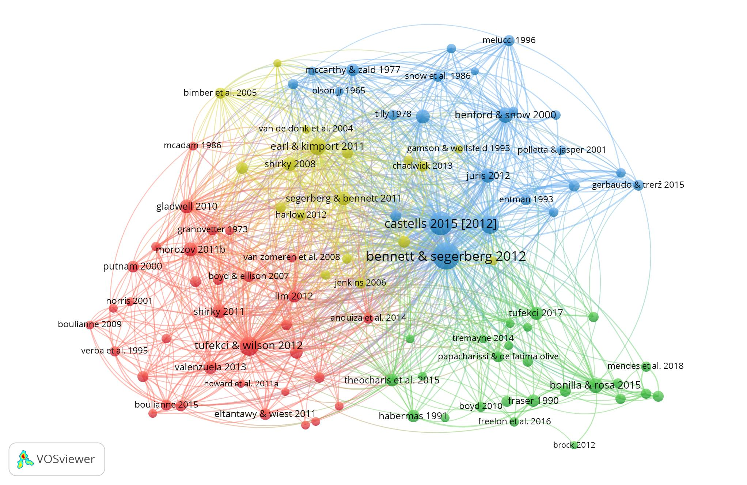

Figure 1: Canonical literature, co-citation analysis, n=101 out of N=229,296, threshold 80.

Based on Figure 1, we identify four research traditions that have informed research on SMSM over the last two decades. After reviewing the titles and abstracts of all references by cluster, we labeled each of these research traditions in the canonical literature as follows:

1. Political Participation (red)
2. Collective Action (blue)
3. Communication and Media (yellow)
4. Public Sphere (green)

The political participation canon (red) includes foundational theories focused on connecting individual-level political behavior, such as membership in voluntary organizations, protesting, and voting, with macro-level democratic structures and outcomes. It includes the study of social capital as a determinant of democratic institutions’ strength (Putnam, 2000), the debate around strong and weak social ties as facilitators of activism (Granovetter, 1973; McAdam, 1986), and seminal works about the connection between participation and representation (Verba et al., 1995). More recent studies in this canon debated whether social media penetration enhances democratization processes (Howard & Hussain, 2013; Shirky, 2011) or reinforces repressive regimes (King et al., 2013; Morozov, 2011), and investigated how social media use affects other forms of online and offline political participation (Boulianne 2015; Tufekci & Wilson, 2012; Valenzuela, 2013). Research has also addressed questions about how social media use interacts with levels of trust, efficacy, and social capital, to influence individuals’ political engagement (Gil de Zúñiga et al., 2012).

The collective action canon (blue) focuses on collective processes that enable individuals to act in concert. It is part of the social movements research tradition that has evolved to understand movements’ emergence, resource management, mobilizing capabilities, strategies, organizational dynamics, and diffusion. This canon includes foundational theories such as resource mobilization (McCarthy & Zald, 1977; Olson, 1965), political opportunity structure (Tilly, 1978), framing processes (Goffman, 1974, Snow et al., 1986), and collective identity (Melucci, 1996; Polletta & Jasper, 2001). This cluster also includes more recent studies that develop collective action theories in the age of social media. These include Bennet and Segerberg’s (2012) seminal work on connective action, which is the most cited study across the whole map. This and other works defined the differences between traditional and digitally enabled collective action logics, as well as documented how these logics played out in hybrid ways during the 2011 protest cycles (Castells, 2012; Gerbaudo, 2012). Other contemporary studies focused on collective identity work on social media (Gerbaudo & Treré, 2015; Kavada, 2015).

The communication and media research area (yellow) includes theories about the social and political effects of the internet and the transition from top-down to networked communication systems. While most theorists argued that this transition empowers movements and stirs democratization processes (Castells, 2009; Cropf, 2008; Shirky, 2008), a notable minority argued that the internet does little to liberate people and to democratize societies (Morozov, 2011). Another group of studies in this cluster analyzed the uneasy relationship between social movements and traditional media outlets (Gamson & Wolfsfeld, 1993; Gitlin, 2003). Newer studies in this vein focused on hybrid media environments where social actors must integrate traditional and internet-based repertoires (Chadwick, 2013; Earl & Kimport, 2011). This group of studies stresses the continuity of traditional media logics alongside the emergence of new ones.

Finally, the public sphere cluster (green) includes foundational theories in political theory that develop the concept of the public sphere as a deliberative discursive space that is vital for democracy, and where social conflicts are negotiated and resolved (Fraser, 1990; Habermas, 1991). More recent studies in this cluster build upon these concepts to theorize networked forms of political action, like hashtag activism, as a public space where dominant narratives are contested (Bonilla & Rosa, 2015) and where new publics are constructed (Papacharissi, 2016; Tufekci, 2017).

This analysis shows that research on SMSM over the last two decades has drawn upon four major research traditions, which are associated with at least four disciplines: empirical political science (political participation and collective action), sociology (political participation and collective action), political theory (public sphere), and media studies (communication and media). While the public sphere cluster is slightly farther away from the rest of the clusters in the map, all the clusters have numerous connections to one another. Overall, the map of the canonical literature represents meaningful interdisciplinary dialogue between major theories from these four disciplines.

***RQ2: Thematic Evolution over Time Periods***

In our investigation of RQ1, we analyzed the full dataset over the entire observation period from 2005-2023. In contrast, to answer RQ2 (Thematic evolution), our focus is on identifying change over time, with a main focus on the thematic evolution of the field. To conduct this analysis, we follow common practice in the literature to first divide the dataset into relevant time periods (Fils & Van Eck, 2018). The four periods we identified are: 2005-2009 (inception); 2010-2014 (emergence); 2015-2019 (consolidation); 2020-2023 (maturation). We use these periodic labels to represent the tremendous growth and evolution of the field over a relatively short period of time. Yet, consistent with similar research in the field, we acknowledge that these descriptors are temporary heuristics, and we expect that research in this field of study will clearly continue to mature and evolve in the coming years. Based on this periodization, Figure 2 shows the dramatic increase in publications on SMSM over these specific time periods.

Figure 2: Average annual publication rate by period, N=6,710.

For each period, we created an independent co-occurrence map that shows the prominent themes in the research during that period. The maps for each period use the common threshold of terms that appeared more than fifteen times in the keywords fields on WoS (Van Eck & Waltman, 2017). The lines between nodes represent the co-occurrence of keywords in the same records. VOSviewer groups keywords into colored clusters according to their co-occurrence relationships, facilitating the observation of dominant themes in the literature. Additionally, keywords that co-occur frequently are positioned closer to one another.

We then extracted the keywords from all maps and analyzed each cluster in each map based on the most frequent keywords. An important feature of these maps is that they show terms only after they have become prominent in the field. This means that terms tend to appear in the maps a few years after their initial appearance, and that the maps represent established rather than emerging trends. For a list of the 100 most common keywords by cluster and their occurrences in each period, see Section D of the Supplemental Materials. The full list is available in the Harvard Dataverse [doi to be added].

Period 1, Inception: 2005-2009

The first five years of research on the intersection of social media and social movements yielded a total of eleven records. Because of this scarcity of research, there are not enough keywords to create a co-occurrence map. Records in the inception period came predominantly from the fields of communication and knowledge management. The distinctive research themes of these studies focused on how the features of social network platforms shape communication practices and information flows (Langlois et al., 2009; McNely, 2009), individual-level contribution and participation (Cheshire & Antin, 2008; Faraj et al., 2008), and the dynamics of online networks as compared with traditional networks (Gaines & Mondak, 2009). Often, political action served as merely one example among others in these studies. Overall, research focused on SMSM was scarce in this period, with highly limited empirical scope, no distinctive normative stance, and lack of distinctive methodological approaches

Period 2, Emergence: 2010-2014

In the emergence period, the field grew rapidly, but did not yet establish a clear thematic structure.

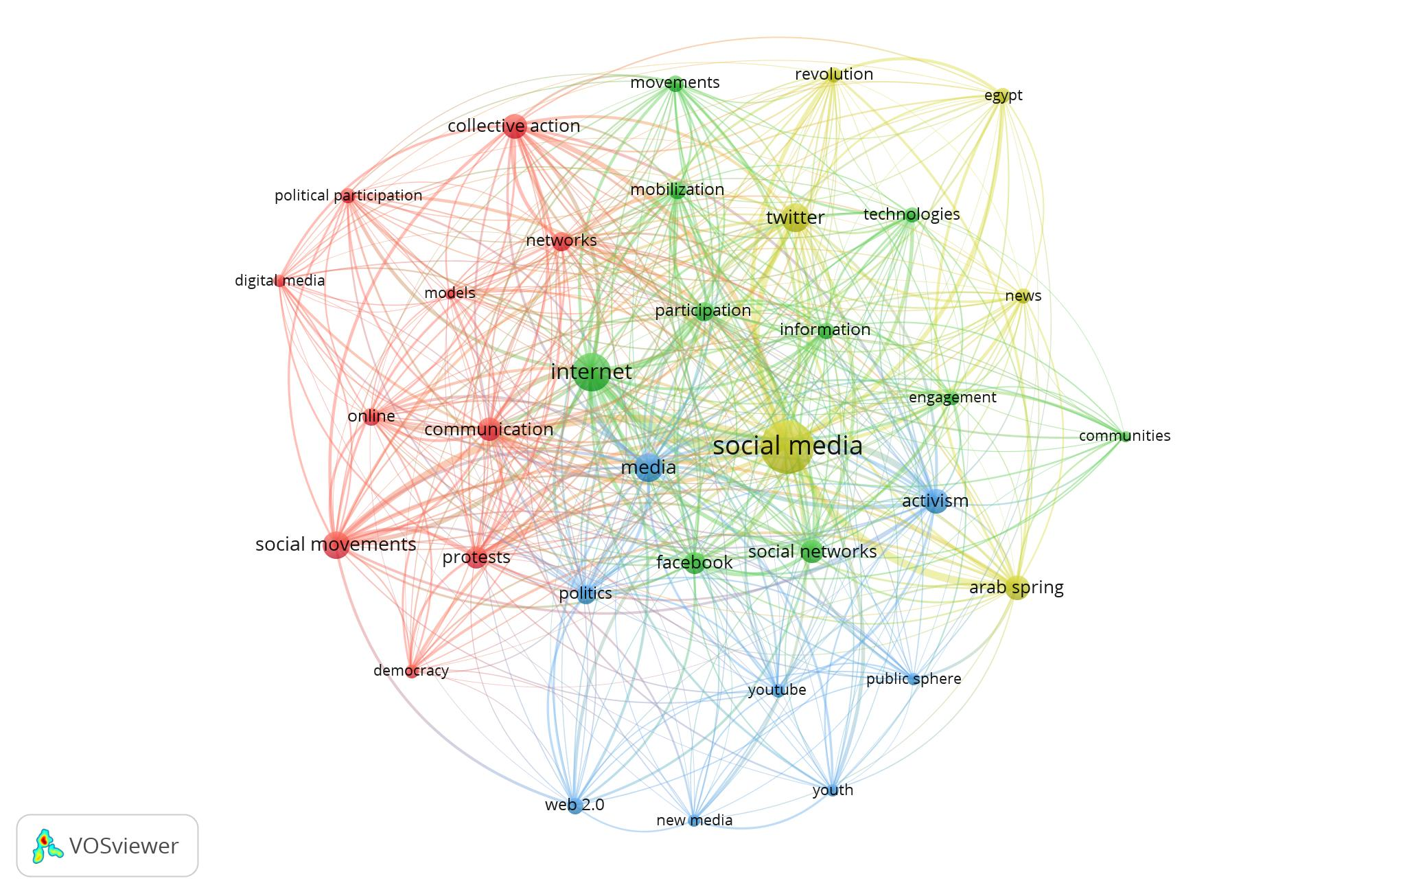

Figure 3: Main research themes for Period 2: Emergence (2010-2014), keywords co-occurrence analysis, n=32 out of N=2,011.

As Figure 3 shows, common keywords used to describe social media and movements in this period were almost all generic terms predating the social media era, such as social movements, participation, internet, and online.. We observe that these keywords are spread out in relatively similar distances from each other, with no conspicuous clusters of keywords that are closely knitted together, indicating that there is not yet a clear thematic structure for research in the field.

In terms of the empirical scope, the only case study in the map is the Arab Spring, and the only location is Egypt. This finding demonstrates the scarcity of empirical case studies in this period. Nevertheless, there is a research focus on three platforms: Facebook, Twitter, and Youtube. This finding shows that while research on social media was already substantial in this period, scholarship tended to focus on a few popular platforms. We also observe, in line with previous studies, that researchers tended to study these platforms in isolation. For example, of the 51 studies that contained Facebook in their keywords, only 7 also contained Twitter, and 2 contained Youtube.

In terms of the normative stance, all common terms related to the social phenomena of interest carry positive normative connotations, including democracy, communities, and public sphere. This finding reinforces the claims that scholarship in this early period had a positive stance towards social media. Finally, there are no specific methodological approaches mentioned in Figure 3. This finding shows that in this period, most authors did not mention methodological terms in their keywords, and the keywords algorithm did not identify methodological terms as key terms in publications. We conclude that there was scarce thematic focus in this period on methodological development.

Period 3, Consolidation: 2015-2019

In the consolidation period, the field experienced a sizable increase in the number of publications, which more than tripled as compared with the emergence period. This quantitative increase manifested in the establishment of an independent thematic structure consisting of six distinct research themes. It also experienced an expansion of the empirical scope, more complex normative stances, and a noticeable yet limited diversification of methodological approaches.

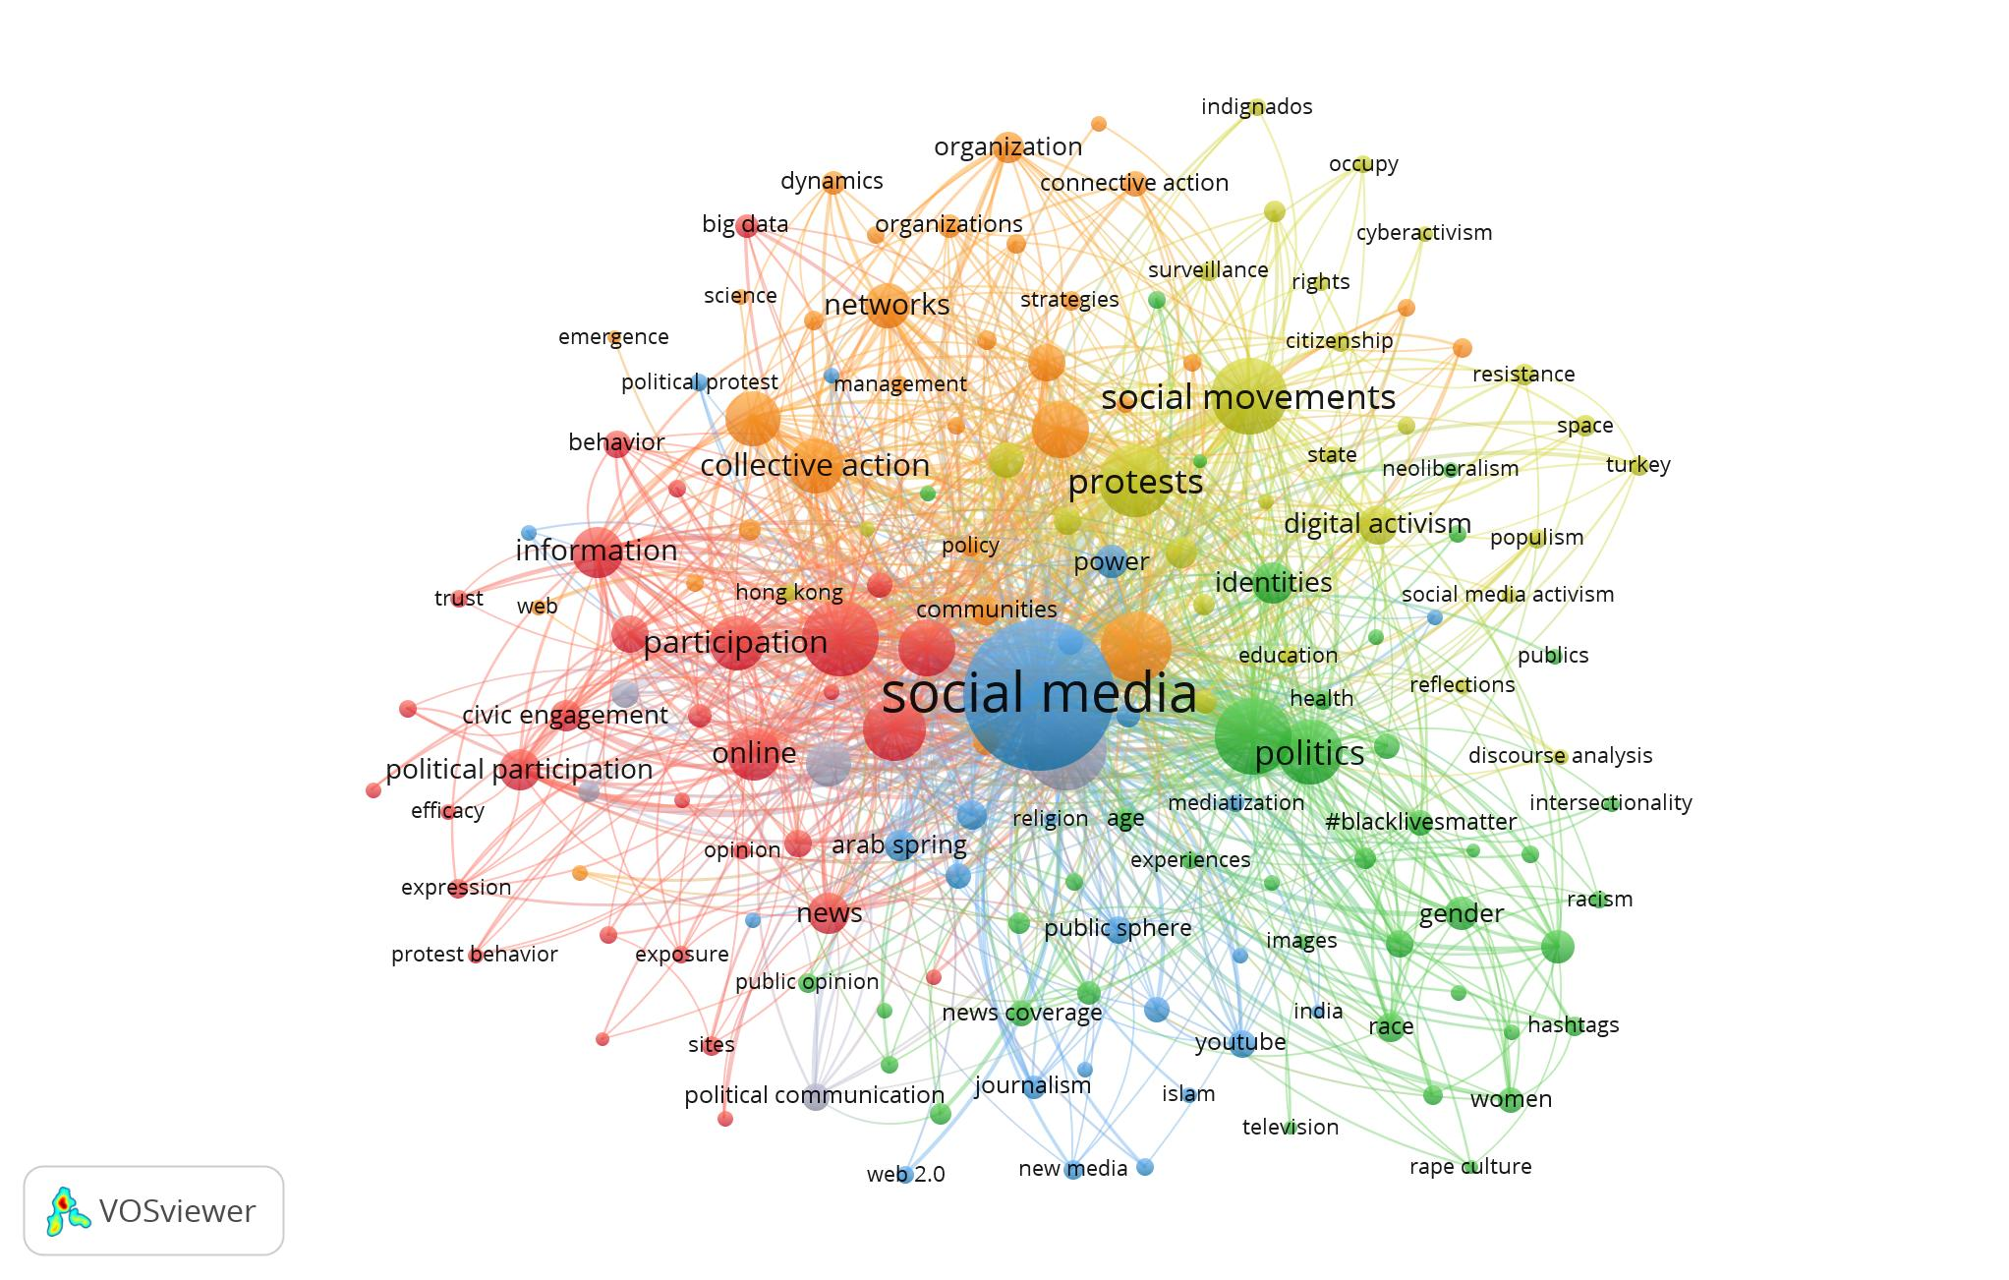

Figure 4: Main research themes for Period 3: Consolidation (2015-2019), keywords co-occurrence analysis, n=161 out of N=6,852.

The map of the consolidation period shows six main research themes that dominated research in this period (colored clusters in Figure 4). Based on the analysis of keywords in each cluster, we identify the six themes as political participation, collective action, protests, hashtag activism, revolutions, and electoral campaigns.

The political participation theme (red) includes research that extends the tradition of political participation into the field of social media. These studies focus on individual-level perceptions and behavior, as well as aggregating large-N measures and studying their impact on macro-level institutions and processes (Bode, 2017; Margetts, 2015; Oser, 2017). Using predominantly quantitative methods, this theme lends itself to meta-analyses (Boulianne, 2015, 2018; Skoric et al., 2016). These meta-analyses showed a complex picture: while finding an overall positive correlation between social media use and other forms of political and civic engagement, this effect varied considerably across different forms of engagement.

The collective action theme (orange) represents studies that extended the tradition of collective action into the social media field. These studies focus on analyzing the intermediate (organizational) level. Prominent studies in this theme explained how social media play a novel role in the construction of collective identities (Kavada, 2015; Khazraee & Novak, 2018), present opportunities and challenges for movements’ structuration processes (Dolata & Schrape, 2016; Murthy, 2018); and support frame alignment processes (Goh & Pang, 2016). One prominent development in this sub-field is the research stream that evolved around the concept of connective action, which distinguished between the traditional organizational logic of collective action, and the new networked logic of movements in the social media age (Della Porta, 2014; Theocharis, 2015; Vromen et al., 2015).

The protests theme (yellow) is delineated by an empirical focus on the early 2010s pro-democratic protest cycles that included occupations and mass protests in public spaces, and that relied on social media for their mobilization. These cycles include the Spanish Indignados, U.S.’s Occupy Wall Street, the Umbrella Movement in Hong Kong, and Occupy protests in various countries. The shared features of these protest cycles included a combination of online and offline activity, a commitment to horizontalism and participatory democracy, and an emphasis on issues related to democracy and representation. Research on these movements explored questions of space (Cheng & Chan, 2017; Suh et al., 2017), the dynamics of offline and online activities (Bastos et al., 2015; Scherman et al., 2015), and leadership and horizontalism (Gerbaudo, 2017). The focus on democracy that characterizes this cluster also involves a different sub-group of studies that relate to darker political implications of social media, including censorship and surveillance (Harwit, 2017; Hogan, 2015).

The hashtag activism theme (green) represents research on a new form of political activity that was born in the social media age – namely, the use of hashtags on social media platforms as a fluid and ad hoc tool for decentralized communication and coordination. The paradigmatic case studies for hashtag activism are #blacklivesmatter (which emerged in 2014) and #metoo (which rose to prominence in 2017). Given the characteristics of hashtag activism, research on this theme drew significantly on the public sphere theoretical tradition identified in the map of the canonical literature (Figure 1). This research theorized hashtags as discursive tools constituting a public space (Bonilla & Rosa, 2015) where groups construct counter-narratives and counter-publics through affective instruments (Papacharissi, 2016; Yang, 2016). Because of the focus on #blacklivesmatter and #metoo, this cluster also integrates questions related to gender and race into social media activism research, including intersectionality (Brown et al., 2017) and embodiment (Bonilla & Rosa, 2015).

The revolutions theme (blue) represents research focused on cases in which social media activism was used to mobilize against an authoritarian regime. The paradigmatic case studies in this cluster include the revolutions in Arab countries, often labeled “the Arab Spring,” and especially the 2011 Egyptian revolution. Research on this theme focused on how social media enabled citizens in repressive contexts to take power into their own hands and to overcome internet shutdowns and state-controlled news media. These studies explored issues such as disseminating information under restrictive conditions (Oh et al., 2015) and the interplay between social media activity and protest in physical space (Steinert-Threlkeld et al., 2015).

Finally, the electoral campaigns theme (gray) represents research about how candidates and parties use social media (Boulianne, 2016; Filimonov et al., 2016), the impact of electoral campaigns on voters’ behavior (Murthy, 2015; Vaccari, 2017), and electoral-related phenomena like polarization (Grover et al., 2019).

Taken together, the co-occurrence analysis of these six themes in the consolidation period shows that while the empirical coverage grew, clear gaps remained. The number of popular case studies increased, but it remained limited to a relatively small group of movements. A notable development in this regard is the emergence of a research interest in feminism and populism in conjunction with social media. Geographical coverage extended to Asia and more countries in the Middle East, but research disproportionately focused on China and the United States, which were mentioned far more frequently than other countries. In addition, regions like South America and Africa remained heavily understudied. Even less progress was made in the coverage of platforms. The only platforms that appear in the map remain the same as the ones in the emergence period: Facebook, Twitter, and Youtube. While more scholars studied platforms in a comparative perspective (e.g., Valenzuela et al., 2018), the vast majority still studied each platform in isolation. For example, of the 398 studies that mentioned Twitter in their keywords, only 45 also mentioned Facebook, and 10 mentioned Youtube.

In terms of the normative stance, our analysis shows that in this period, scholars produced more nuanced accounts of the effects of social media on political participation. It therefore became increasingly clear that, in contrast to techno-deterministic perspectives, the impact of social media use differs depending on forms of engagement and context. We also observe a meaningful focus on phenomena like censorship and surveillance, which reflects a growing awareness of the ways in which social media is used to repress rather than empower citizens. These findings represent the growing complexity and ambivalence of scholars’ normative stances towards social media.

Studies in this period also are also characterized by a relative increased discussion of methodologies, although this focus remained rather limited. Only six terms out of the 161 in Figure 4 denote specific methodologies. These terms occurred 134 times in total out of close to ten thousand occurrences represented in the map. These terms included both quantitative and qualitative methods. The most frequent terms mentioned older methodologies that were adapted to study social media, including content analysis and social network analysis. A newer and less frequent method was sentiment analysis, which was developed specifically for digital data.

Period 4, Maturation: 2020-2023

The maturation period, represented in Figure 5, is characterized by the sustained growth of the field, the stabilization of two major research themes, and the emergence of two new themes. This period is also characterized by a continued expansion of empirical coverage, more complex and ambivalent accounts of social media, and increased diversification of research methods.

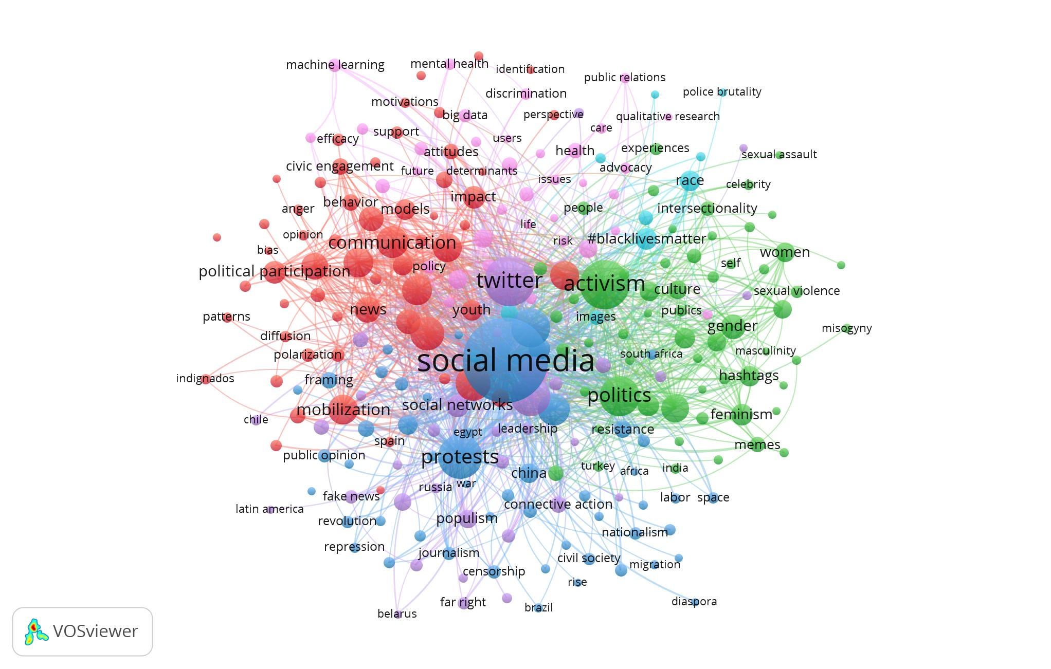

Figure 5: Main research themes for Period 4: Maturation (2020-2023), keywords co-occurrence analysis, n=248 out of N=9,805.

The thematic stabilization in the transition from the prior period of consolidation (2015-2019) depicted in Figure 4 to the period of maturation (2020-2023) mapped in Figure 5 is visible in the persistence of the two largest clusters – the political participation (red) and hashtag activism (green). Comparing the co-occurrence maps of the two time periods shows that in the maturation period, the political participation cluster merged with several clusters identified in the preceding period – namely, the collective action, protests, and electoral campaigns clusters – resulting in a large red cluster that is consequently labeled political participation-collective action.

The political participation-collective action cluster represents research centered around individual-level participation, such as the relationships between social media engagement and offline political participation or voting (Boulianne et al., 2020; Oser et al., 2022), as well as research centered on the intermediate level, studying collective processes such as how social media affordances enable and constrain movement organizing (Etter & Albu, 2021; Li et al., 2021). Important concepts explored under this theme include efficacy (Chon & Park, 2020) and repertoires (Leong et al., 2020).

In contrast to the single hashtag activism cluster identified in the consolidation period, terms that relate to this theme in the maturation period split into a main cluster focused on gender movements and issues (green) and a separate, smaller cluster focused on race-related movements and issues (turquoise). Research focused on gender-related movements studied the paradigmatic #metoo movement, as well as feminist movements throughout the world, with developing countries such as India, Turkey, and Iran attracting much scholarly attention. Research focused on race-related movements studied the paradigmatic case study of #blacklivesmatter and introduced new topics like police brutality (Lake et al., 2021; Wang & Liu, 2021).

The political participation-collective action cluster is located on the opposite side of the map in Figure 5 from the hashtag activism cluster, and between them lie three other clusters. The first is a new cluster focused on global policy issues (pink), primarily Covid-19 and climate change. The global pandemic that began in 2020 gave rise to new streams of research on topics like medical epistemic authority (Callard & Perego, 2021; Roth & Gadebusch-Bondio, 2022), identity and community making (Abidin & Zeng, 2020; Outley et al., 2021) and resistance to government mandates (Norstrom & Sarna, 2021; de Saint Laurent et al., 2021). Alongside these portrayals of citizen empowerment, research also dealt with phenomena that pose challenges for democratic stability, such as polarization and conspiracy theories (Freelon et al., 2020; Valenzuela et al., 2021).

The two remaining clusters in the bottom part of the map in Figure 5 are highly interconnected. One is the descendant of the revolutions cluster from the consolidation period (blue). However, its focus shifted, as research on the Arab Spring and other revolutions declined, while research on nationalism and repression rose, with the United States, China and Brazil serving as central empirical locations. Hence, in the maturation period, the blue cluster is labeled democratic instability. This cluster represents the increasing complexity of SMSM research: alongside studies that highlight the democratizing effects of social media, this cluster involves research on the repressive aftermath of some of the Arab uprisings (Lee, 2021; Ozduzen & McGarry, 2020) and the techniques that governments use to thwart collective action (Pan & Siegel, 2020; Earl et al., 2022).

The democratic instability cluster is closely interlinked with a new cluster that emerged in the maturation period: right-wing movements (purple). This cluster involves research on the ways in which far right groups mobilize social media for their causes, including by spreading misinformation and disinformation (Curley et al., 2022), co-opting progressive tactics (Knuepfer et al., 2022), leveraging popular issues to spread far-right messaging (Zehring & Domahidi, 2023) and building collective identity using specific platform’s algorithms (Gaudette et al., 2021). Other studies found evidence that general access to online communication tools like social media contribute to the electoral success of populist parties (Schaub & Morisi, 2020).

In terms of empirical coverage, these five themes in the maturation period point to several new developments. The range of case studies expanded considerably in this period, covering a spectrum of movements from diverse ideological backgrounds. A major development is the meaningful focus on newly emerged right-wing movements. Geographically, research expanded across the globe, including an increased interest in Russia and countries in Africa and Latin America. Similar progress was made in the coverage of new platforms. While Twitter remained the most studied platform, substantial research was carried out on newer platforms such as Instagram, Tik Tok, Weibo, and Telegram. In fact, researchers began to discern between older and newer platforms, using terms like “legacy platforms” and “emerging platforms” to differentiate between them (Boulianne & Lee, 2022). In addition, cross-platform research expanded, with 72 out of 540 studies on Twitter also studying Facebook.

In addition to expanded empirical coverage, research on SMSM in the maturation period continued to develop more complex and multi-layered accounts of social media. Expanding prior nuanced studies of political participation and investigations of censorship and surveillance, scholarship in this period contributed a new research focus on phenomena like hate speech, conspiracy theories, and fake news. This focus adds a unique perspective on how social media is leveraged for anti-democratic purposes by ordinary citizens and not only by states. Overall, the normative stance reflected in the research on SMSM in this period is broad, multi-faceted, and more contextualized.

Methodologically, research in the maturation period paid greater attention to methodological developments, even though the prevalence of methodology-related keywords remains relatively infrequent. Ten terms out of the 248 in Figure 5 designate specific methods. These terms appeared a total of 290 times, out of more than 14.5 thousand occurrences represented in this map. Social network analysis and sentiment analysis were most commonly mentioned, but this period also gave rise to the wider implementation of new methodologies such as topic modeling (Curley et al., 2022) and digital ethnography (Ahmad & Thorpe, 2020).

Synthesizing Thematic Evolutions and Identifying Gaps (2005-2023)

Table 1. Summary of Findings on Four Periods in SMSM Research.

|  |  |  |  |  |
| --- | --- | --- | --- | --- |
|  | **Inception**  **2005-2009** | **Emergence**  **2010-2014** | **Consolidation**  **2015-2019** | **Maturation**  **2020-2023** |
| **Number of records** | 11 | 717 | 2488 | 3494 |
| **Thematic structure** | Not enough research | No conspicuous structure | Political participation  Collective action  Protests  Election campaigns | Political participation-collective action |
|  |
|  | Hashtag activism | Gender-related hashtag movements |
|  | Race-related hashtag movements |
|  | Revolutions | Democratic instability |
|  |  | Global policy |
|  | Right-wing movements |
| **Empirical scope** | Not enough research | One case study (Arab Spring),  three main platforms (Facebook, Twitter, Youtube),  studied in isolation | Several case studies,  partial geographical coverage,  three main platforms (Facebook, Twitter, Youtube),  studied mostly in isolation | Many case studies,  global coverage,  multiple platforms,  greater cross-platform research |
| **Normative stance** | Not enough research | Positive normative stance, particularly toward political participation | Nuanced accounts of political participation,  attention to state-enacted negative phenomena like censorship | Nuanced accounts of political participation, attention to state- and citizen-enacted negative phenomena like censorship, disinformation,  conspiracy theories, interest in right-wing movements, increased contextualization |
| **Methodological approaches** | Not enough research | Scarce focus on methodology | Growing focus, six terms out of 161, adaptations (discourse analysis, social network analysis) and innovations (sentiment analysis) | Growing focus, ten terms out of 248, adaptations (content analysis) and innovations (topic modeling, digital ethnography) |

To synthesize our findings regarding our second research question (RQ2: Thematic evolution), the findings described above on the four periods are summarized in Table 1. The overall evolution of the field in the four periods shows that the surge in research on SMSM in the past two decades has manifested in an increasing complexity with which scholars have addressed the study of SMSM. Starting from a positive normative stance towards social media as an instigator of democratization and social change, scholars have since developed more nuanced and multi-layered accounts, showing that social media’s effects are diverse and depend on context (Boulianne et al., 2023; Elliott & Earl, 2018). Moreover, scholars have demonstrated that social media provide new possibilities for shaping narratives and public opinion (Milan, 2015; Mundt et al., 2018), but that they may also undermine organizational sustainability and knowledge preservation (Etter & Albu, 2021; Richardson, 2020). In addition, scholars have increasingly turned their gaze towards darker political implications of social media, including how they enable the spread of misinformation and disinformation, the rise of extreme right discourse, and state-censored control and repression. Our findings also indicate that the empirical coverage of the field has expanded to cover all regions of the world and multiple social media platforms, with scholars increasingly engaging in cross-platform research.

An important area where more focus may produce meaningful results is in methodological development. While most authors do not consider methodological terms as key to describing their research, quantitative and qualitative methodologies are more commonly noted as keywords since 2015. As noted in reviews of field, the methodological opportunities that face scientists in the era of social media and big data are enormous, and so are the challenges (Boyd & Crawford, 2012; Ledford, 2020). A key debate among social scientists relates to the types of questions that can be answered based on big data analysis. There is an ongoing debate on whether social media data can provide answers to long-standing big-picture questions in the social science that require causal analysis (Ledford, 2020). Big data has enabled scholars to implement innovative experimental research designs to study causal relationships in the real-world political behavior of millions of people (Bond et al., 2012; Guess et al., 2023), but the systematic interpretation and generalization of available data is not straightforward (Boyd & Crawford, 2012; Caren et al., 2020). For example, using large data sets may dismiss minority and lower status groups as outliers and ignore their distinctive contributions to contemporary social movements in the social media age (Kreiss & McGregor, 2023; Welles, 2014).

Moreover, new types of data present methodological perplexities. For example, our findings show that the analysis of visual content such as memes, images, and videos has attracted a growing interest among SMSM scholars (de Saint Laurent et al., 2021; Lee & Abidin, 2023), but the methodological toolset and vocabulary for this data is still nascent in comparison to those designed for textual data. Data access has also become a major concern, with platforms limiting permissions, closing APIs, and charging substantial sums for access (Davidson et al., 2023; de Vreese & Tromble, 2023; Freelon, 2018). These developments, generated not least by privacy concerns, have exacerbated the data divide between small groups of researchers with privileged access and the greater academic community (Lazer et al., 2020; Ledford, 2020; Wagner. 2023).

In the context of SMSM, a key area in which big questions have eluded scholars for decades is movements’ macro-level societal outcomes (Amenta & Polletta, 2019; Amenta et al., 2010). Recent research has made substantial headway in measuring such impact for traditional offline participation, for example by showing that levels of violence in protests can have dramatic effects on electoral results (Wasow, 2020). However, recent reviews of the literature indicated that macro-level movement outcomes continue to be understudied in the social media age (Caren et al., 2020; Zhuravskaya et al., 2020). To identify ongoing progress in this line of investigation, we reviewed studies in the dataset that included relevant keywords such as impact, consequences, and outcomes. We found several studies that used innovative big data methods to demonstrate how movements’ social media activity changes public discourse (Dunivin et al., 2022), public attention to issues (Freelon et al., 2018), and public opinion (Szekeres et al., 2020). Another noteworthy study succeeded in showing changes in macro-level behavior, demonstrating how the #MeToo movement led to higher reporting and arrests related to sexual crimes (Levy & Mattsson, 2023). However, studies of the political outcomes of movements in the age of social media, including electoral results and policy change, remain scarce. More research in needed to understand how movements’ spheres of influence extend to political institutions.

**Conclusion**

The mapping of two decades of scholarship on the intersection of social media and social movements has clarified that, despite scholars' tendency to focus on the “new,” the field has grounded itself in four main theoretical traditions that form its canon. In response to our first research question (RQ1: Canonical literature), the map of citation patterns (Figure 1) demonstrates that these theoretical traditions come from multiple disciplines – namely, empirical political science, sociology, political theory, and media studies – and scholars have put these traditions into meaningful dialogue with one another.

In addition, the investigation of our second research question on the evolution of scholarly themes (RQ2: Thematic evolution) based on mapping the co-occurrence of keywords (Figures 3, 4, 5), shows that the surge in publications on these topics has manifested in the increased complexity and sophistication with which scholars have approached this field. Moving beyond dichotomous perceptions of social media as “good” or “bad” for movements and democracy, scholars have advanced the understanding that social media affordances both empower and constrain social movements and that social media use enhances some forms of participation but not others. Scholarship has further expanded to cover greater regions of the world, more case studies from diverse ideological backgrounds, and more social media platforms. This empirical expansion has exposed how social media function differently in diverse political contexts, and that they are used for censorship and surveillance as well as for resistance and contestation. Scholars have also shown that social media can be used to spread vital information but also disinformation, and that they serve to amplify both progressive and far-right voices. These findings indicate that by 2023, scholars of SMSM have addressed several major gaps identified by previous reviews of the literature.

Nevertheless, meaningful gaps remain. With new opportunities brought about by big data, not all research areas have emphasized methodological development equally. A limited set of methods gained sufficient popularity to be included in our analysis. Many areas, such as the analysis of visual content, are in the early stages of methodological development. In addition, we found limited progress on studying movements’ political outcomes in the social media age. Yet our findings also point to promising advancements in the study of big questions on SMSM, with scholars leveraging multiple data sources and methodological approaches to show movements’ impact on public discourse, opinion, and behavior. Taken together, our systematic analysis and mapping of the literature shows the rapid emergence of a coherent and vibrant field of literature in a relatively short period of time, with the promise of additional meaningful breakthroughs in the years ahead.

1. Downloaded on January 1, 2024.