Who A(m)I? Quantile Frequency Connectedness between AI and IoT Tokens

Drawing on the quantile connectedness approach (QVAR) proposed by Ando et al. (2022), the key concern of this study is to examine spillover connectedness between AI and IoT tokens. Our study aims to explore static and dynamic connectedness between our variables of interest at the lower, middle, and upper quantities of return distribution. Our results indicate moderate levels of connectedness, which also remain asymmetric and subject to varies across different tails of the return distribution. We also observe that the connectedness between AI and IoT surges during periods of higher uncertainty, which signifies the need for proactive risk management strategies. Furthermore, our research confirms that AI and IoT connectedness system is more sensitive to the lower and upper quantiles than the median quantile. Likewise, the majority of IoT remain transmitters and AI tokens emerge as net recipients of return spillover from the system. Finally, our results of portfolio analysis indicate that AI and IoT offer both diversification and hedging benefits. Our findings suggest that the advantages of diversification might be more beneficial over the long run than over the medium and short durations. Our study makes significant contributions to academic literature, providing valuable insights regarding AI and IoT connectedness, dynamics of their exposure over time and portfolio performance. The findings may remain valuable for potential investors, portfolio managers and hedge funds managers to make informed investment decisions.
Keywords: Connectedness, AI, IoT, QVAR, Portfolio diversification.
JEL classifications:

Highlights

- We employ a time frequency QVAR approach for AI and IOT tokens.
- Our aim is to identify the interlinkage between AI and IOT tokens.
- Static and Dynamic analysis shows that considerable changes in connectedness.
- Connectedness is considerably strong in the short term, and weaker at the medium and long terms.
- Diversification benefits may be more useful in the long rather than medium and short terms.
- Under turbulent times of high fluctuations, such diversification benefits diminish.
- The hedge ratios and portfolio weights are also impacted, contingent on both frequency and quantile under investigation.

- Introduction
The contemporary digital revolution, also known as Industry 4.0 represents a transformative paradigm subject to the fusion of automation, digital technologies, and data-driven processes (Hassoun et al., 2023). Over the past decade, there has been a propagation of technological advancements, leading to the emergence of (Fintech)financial technology (Dhiaf et al., 2024). This field relies on a range of digital tools and technological applications, including blockchain, big data, machine learning, artificial intelligence, and the Internet of Things (IoT). The fintech disruption remains possible due to the evolving convergence of artificial intelligence (AI) and the Internet of Things (IoT). AI and IoT are arguably transformative and pervasive economic phenomena that foster effectiveness and efficiency (Khan et al., 2024). The realm of IoT is based on physical objects such as devices, sensors, operating systems, and networks that are interconnected to collect and process data (Dhar et al., 2024). However, processing the data into valuable information for informed decision-making adds value, not the data itself. Here's where AI comes into the equation (Li et al., 2023). Metaphorically, AI functions as the brain while IoT is the body of the system. The convergence of AI and IoT fosters synergy to experience the realm of proactive decision-making and even the innovation of self-learning financial systems (Greco et al., 2023; Whig et al., 2024).
IoT collects and transmits the data, while AI enables these devices to learn from data and unlock the power of data in a much more efficient way than human beings. The disruption created by AI and IoT provides extremely impactful results that can transform every aspect of businesses, industries, and economies (Greco et al., 2023). The convergence of AI and IoT is attributed to higher operational efficiency in data processing, smart data analytics abilities, and improved forecasting for better risk management strategies. The transformative impact of AI and IoT remains so invasive that industries are allocating a high volume of capital toward AI and IoT to capitalize higher levels of efficiency, reliability and creativity (Li et al., 2023). The AI market is projected to cross over US$184.00 billion in 2024, with a phenomenal growth rate of 28% from 2025–2023, which is projected to bring the AI market size up to US$826.70 billion by 2030. Likewise, the global IoT market is projected to capitalize US$1,387.00bn in 2024 with a staggering growth rate of 13% to hit a market volume of US$2,227 billion by 2028. Due to such a huge volume of investment in AI and IoT various sectors have witnessed notable shifts. The financial sector is no exception in this regard, foster to integrate AI and IoT advancements to remain competitive in an ever-evolving market (Sami et al., 2020). The rising adoption of AI and IoT from financial institutions and banking sector is witnessed by rising volume of Fintech market capitalization which will hit a staggering amount of US$340 billion by 2024 and projected to have an accumulated value of US$1152 billion by 20230.
There are several ways in which the fusion of AI and IoT is reshaping the conventional finance paradigm. One of the key applications of AI and IoT is machine learning algorithms, which are employed on a huge amount of financial data to observe key trends and enable investors to make informed investment decisions (Firouzi et al., 2022). Likewise, the synergy created through AI and IoT remains integral to provide personalized financial advice to improve returns and mitigate risk (Lee & Lee, 2015). Finally, AI and IoT are widely being used to develop algorithms that analyze blockchain data and detect emerging patterns which remain robust for devising proactive investment strategies (Nair & Tyagi, 2023). The combination of AI and IoT, along with blockchain technology, has led to the development of decentralized finance (Corbet et al., 2023). These technological disruptions empower stakeholders in financial markets to participate in a decentralized, transparent, and borderless financial ecosystem (Chen & Bellavitis, 2020).
The financial ecosystem has witnessed staggering growth and unprecedented volatility in the proliferation of cryptocurrencies and tokens (Zimmer, 2017). Since the invention of Bitcoin as a peer-to-peer digital instrument, numerous other tokens have emerged, including tokens, Defi and NFTs. The crypto market has expanded phenomenally with abnormal growth which offers expanded level of investment opportunities (Swartz, 2018). The global cryptocurrency market capitalization stands at $2.44 trillion, with exceptional future growth prospects. The rising surge of cryptocurrencies and tokens has captured the interest of financial market participants to foster greater efficiency, inclusivity, and trust in financial transactions (Phiri & Anyikwa, 2024).
The emergence of cryptocurrencies captivated heightened attention in academic literature, leading scholars to explore their complex aspects and effects. From inspecting its impact on the traditional financial system to mapping their role in shaping regulatory frameworks, paving the way forward for informed discourse and strategic decision-making in the evolving landscape of finance and technology (Osman et al., 2023). Past studies have offered valuable insights into various aspects of the global cryptocurrency market, which covered a wide range of domains, such as price determination, investment feasibility, role for mitigating volatility, and the portfolio implications of these digital assets (Ahamad et al., 2022; Osman et al., 2023; Youssef et al., 2023). For example, the study by Mercik et al. (2024) examines the firm's integration of crypto assets into its balance sheets and reveals that it amplifies their risk profiles. Their findings confirm the higher risk propensity of crypto assets, which should be considered while evaluating investment decisions. Accordingly, a growing stream of literature has devoted its effort to examining the connectedness of cryptocurrencies with other financial markets and assets (Assaf et al., 2024; Hanif et al., 2023; Ugolini et al., 2023). In this regard, the study of Ali, Umar, et al. (2024), examines the connectedness between NFTs and equity sectors of US markets and reveals that the connectedness between US sectoral markets is subject to asymmetry in extreme market conditions. This stream of literature focused on the return and volatility transmission of cryptocurrencies, offering valuable insights for the participants of the financial markets to make informed investment decisions (Bouri & Jalkh, 2023; Bouteska et al., 2023; Phiri & Anyikwa, 2024; Yadav et al., 2023). For example, Aydoğan et al. (2024), examine the return spillover between cryptocurrencies and equity markets and found that connectedness is unidirectional in most G7 countries, but bidirectional relationship was observed in certain G7 countries. Likewise, Ali, Naveed, et al. (2024), extend the crypto based literature by examining the return and volatility spillover between green cryptos and equity markets of G7 countries. Their findings hold that during heartened market uncertainty, return and volatility transmission spike at its highest level. Accordingly, they have provided the portfolio implications of green cryptos which contain robust insights for investors, hedge fund managers, and portfolio managers.
During the COVID-19 crisis and amid other economic turmoils, cryptos has attained significant attention from academics, practitioners, and policymakers alike (Ali, Naveed, et al., 2024; Ali, Umar, et al., 2024; Phiri & Anyikwa, 2024). This burgeoning body of literature remains devoted toward examining the safe haven properties of cryptos as compared to traditional assets (Rubbaniy et al., 2021; Syuhada et al., 2022; Xie et al., 2021). Likewise, scholars have examined the hedging and portfolio diversification features of cryptos during COVID-19 and other crisis, such as Russia-Ukraine conflict (Lei et al., 2023; Phiri & Anyikwa, 2024; Said & Ouerfelli, 2024). The literature regarding cryptos and their different types remain well established and provide ample evidence regarding their return and volatility connectedness with other assets/markets (Ali, Naveed, et al., 2024; Assaf et al., 2024; Hanif et al., 2023). Likewise, the role of cryptos during COVID-19 and other economic turmoil is well established in various contexts which remain detailed to get insight about the risk and return transmission of these assets as compared to their traditional counterparts. However, literature relevant to the emerging field of tokens and their connectedness with other assets/markets remain limited except certain exceptions (Corbet et al., 2023; Vidal-Tomás, 2022). Past studies have examined the role of NFTs, DeFi, asset backed tokens, derivative tokens, real estate tokens and AI tokens (Ali, Umar, et al., 2024; Corbet et al., 2023; Vidal-Tomás, 2022; Yousaf, Pham, & Goodell, 2024). However, the token market is novel and evolving swiftly as compared to Defi, NFTs and other types of crypto asset. This rising evolution of tokens and its widespread types warrant additional evidence to determine their risk and return transmission with other assets/market.
The risk and return transmission of tokens as compared to their digital and conventional counterpart remain divergent (Yousaf & Gubareva, 2024). Risk and return transmission are also terms as return and volatility spillover. Return and volatility spillover refers to the connectedness between return and volatility spillover of other assets/markets (Bouri & Jalkh, 2023). This stream of literature remains concerned with exploring how changes in the risk and return level of one asset/market influence the risk and return level of another asset/market (Bouteska et al., 2023; Lei et al., 2023; Yadav et al., 2023; Yousaf & Gubareva, 2024). This concept remains integral to comprehending the mechanism of financial markets and making informed investment decisions (Assaf et al., 2024). Additionally, stakeholders of financial markets by evaluating the connectedness between assets/markets can spot diversification and hedging benefits to mitigate their investment risk (Ali, Naveed, et al., 2024). Accordingly, to determine the return and volatility spillover between assets/markets different techniques have been employed by past studies (Assaf et al., 2024; Hanif et al., 2023; Ugolini et al., 2023; Yousaf & Gubareva, 2024). The most prominent technique remains the TVP-VAR. The TVP-VAR (Time-Varying Parameter Vector Autoregression) is robust to examine return and volatility spillover, it is employed to estimate the dynamic connectedness, which allows to capture the time-varying coefficients and volatility (Assaf et al., 2024; Aydoğan et al., 2024; Bouri & Jalkh, 2023; Bouteska et al., 2023). Likewise, past studies also compute return and volatility spillover by using QVAR technique. Quantile VAR models can provide a more complete picture of the behavior of a time series data and can be useful for identifying and characterizing the impact of structural changes, shocks, and outliers. Therefore, to respond to these questions, large number of studies have use the QVAR model proposed by Ando et al. (2022), to examine the total connectedness, and more especially the return connectedness, between our variables of interest (Abdullah et al., 2023; Balcilar et al., 2021; Korsah & Mensah, 2023). Comparatively, the TVP-VAR model captures dynamic changes among variables via its use of time-varying coefficients, which enables it to spot the ebb and flow of return and volatility spillover between assets and markets. In contrast, the QVAR model remains robust to examine the lower and extreme quantiles of return and volatility transmission. This QVAR attribute enables the detection of asymmetric transmission across assets and markets, which further allows market participants to engage in proactive risk management and crisis preparedness. Therefore, drawing on these attributes of QVAR model, our study aims to determine the return spillover between AI and IoT tokens. Additionally, we also provide the portfolio implications of AI and IoT by analyzing their static and dynamic optimal weights, hedge ratios, and hedging effectiveness.
The literature regarding the return and volatility spillover of tokens particularly in the context of AI and IoT remains limited. We have found only three studies explicitly in the context of AI tokens conducted by (Jareño & Yousaf, 2023; Yousaf & Goodell, 2024; Yousaf, Ijaz, et al., 2024). The study of Yousaf and Goodell (2024), employed quantile VAR technique to determine the static and dynamic connectedness between AI and ETFs and other asset classes. Their findings infer that AI tokens offer the feature of hedging and investors can optimize their portfolio through AI tokens. However, representative studies remain devoted toward examining the risk and return transmission of AI tokens in relation to AI-based stocks, fossil fuel markets and other traditional asset markets. However, till date there are no such empirical evidence which have examine the connectedness between AI and IoT tokens. Extending this stream of literature our study aims to determine the return transmission between AI and IoT tokens.
The rationale for AI and IoT fusion is due to the fact that both remain the two sides of the same coin. The IoT transmits the data while AI converts it into predictive information essential to make informed investment decisions. Therefore, extending this notion our study contributes to this growing stream of this literature in several ways. First, our study remains seminal to explore the return connectedness between AI and IoT tokens. By examining this uncharted avenue of research, our study offers unique insights into the AI and IoT dynamics that govern their connectedness. The literature based on crypto asset, DeFi, NFTs remain well established (Bouteska et al., 2023; Corbet et al., 2023; Osman et al., 2023; Vidal-Tomás, 2022). Accordingly, our study contributes to providing fresh insights and enriching the discourse relevant to the integration of AI and IoT tokens. Second, our study contributes to the discourse about AI and IoT token return transmission. Return transmission signifies the extent to which market shocks in one market affect returns in another. Our study provides return transmission at lower, middle and upper quantiles which broaden understanding regarding the dynamics of AI and IoT return transmission. Past studies examine the return transmission of crypto assets have provide ample evidence to understand the dynamics of their return transmission (Abdullah et al., 2023; Ali, Naveed, et al., 2024; Korsah & Mensah, 2023; Phiri & Anyikwa, 2024). For example the study of Yousaf and Goodell (2024), examine the tail connectedness between artificial intelligence tokens, artificial intelligence ETFs, and conventional assets and reveal that AI tokens offer batter returns as compared to their traditional counterpart. However, the convergence between AI and IoT has never been examined till date. Therefore, we enrich return discourse about AI and IoT tokens which not only broaden scholarly insights but also offer valuable implications for the diverse group of financial market participants and policymakers alike. Third, besides static and dynamic return connectedness at different quantiles we also provide portfolio implications of AI and IoT tokens to reveal their hedging and diversification benefits. More briefly, we provide short-, medium- and long-term optimal weights and hedging effectiveness of AI and IoT tokens which remain robust for investors and portfolio managers to device predictive investment strategies. The literature based on crypto asset’s diversification benefits remain well established (Abdullah et al., 2023; Lei et al., 2023; Osman et al., 2023; Said & Ouerfelli, 2024; Youssef et al., 2023). For example, Abdullah et al. (2023), examine the connectedness between real estate tokens, (REITs) and conventional asset by inferring the real estate token’s hedging and diversification benefits as compared to their traditional counterparts. Our study contributes to this stream of literature and provides insights into the hedging and diversification benefits of AI and IoT tokens.
To accomplish our study's objectives, we utilized the QVAR model. By conducting thorough static and dynamic analyses of AI and IoT tokens, we have discovered notable variations in the intensity of their relationship. Our analysis shows a moderate level of connectedness between AI and IoT tokens. Our analysis shows that connectedness is significantly strong in the short term, and weaker in the medium and long term. This asymmetric nature of connectedness implies valuable implications for market participants to understand the dynamic nature of these assets. Additionally, the position of the AI and IoT as return transmitters /recipient changes at lower, middle, and upper quantiles which indicate about their uneven nature of connectedness. For example, at lower, middle, and upper quantile the majority of IoT remain transmitters and AI as net recipient in the system. These findings again signal, that the relationship between AI and IoT tokens deserve a careful examination, and it seems that the mutual innovations as well as the magnitude of their impact, depends on the state of the market conditions and may be calling for a dynamic examination across time. Finally, our results of portfolio analysis indicate that AI and IoT offer both diversification and hedging benefits. Our results suggest that the advantages of diversification might be more beneficial over the long run than over the medium and short durations. Such diversification benefits therefore decrease during turbulence and significant volatility, and depending on the frequency and quantile under study, the hedging ratios and portfolio weights are similarly affected. These insights have value for both scholars and stakeholders in the AI and IoT token markets, providing practical implications for navigating this complex landscape.
Overall, our findings contribute significantly to helping the various key stakeholders in the financial markets, such as investors, portfolio managers, hedge fund managers, and policymakers, to make inform investment and policy decisions. Specifically, incorporating AI and IoT tokens into portfolio construction not only lowers portfolio risk but also promotes long-term efficiency in financial markets. Furthermore, our findings suggest that the spillovers of AI or IoT tokens are heavily influenced by market conditions and investment horizons. Policymakers should not mainly focus on the fluctuations in the short-term frequency domain. They should adopt a flexible regulatory approach that accounts for the fluctuating levels of connectedness observed across different time frames and market conditions. During extreme market movements, especially in the short run, investors should use hedging instruments to compensate for a higher level of market uncertainty.
Wrapping up, the rest of the paper is organized as follows. Section 2 contains details about data and methodology while Section 3 outlines the result and discussion. Finally, Section 4 concludes the study and provides implications along with future directions.

- Data
To investigate the spillover between AI and IOT tokens, this paper uses the daily data of five AI (NEAR Protocol – NEAR, Render – RNDR, The Graph – GRAPH, Injective – INJ, Theta Network – THETA), and IoT tokens (VeChain – VET, Fetch.ai – FET, Helium – HNT, JasmyCoin – JASMY, IoTeX – IOTX). For the selection of tokens, we have taken the data of top ten tokens based on capitalization; however, data for the majority of the tokens begins after 2021, thus we choose top five tokens based on time frame. The selected AI and IOT tokens represent approximately 51% and 76% of their respective category. Based on the data availability, our sample period runs from February 11, 2021 to March 15,2024. Whereas JASMY determine the beginning of the sample period. The data for this study is sourced from yahoo finance.
- Methodology
3.1. Quantile frequency connectedness model
To examine the interlinkage between AI and IOT tokens, we have used the quantile time-frequency connectedness model. This model is based on the quantile connectedness model proposed by Ando et al. (2022) , and the frequency connectedness model of Baruník and Křehlík (2018). The quantile time-frequency connectedness model permits us to investigate the connectedness among assets not only at normal and extreme market conditions but also at different time frequencies. To begin with, we use quantile connectedness framework of Ando et al. (2022) with basic quantile VAR (QVAR) model with $n$ variables estimated at the $α$ conditional quantile:
$Y_{t}=μ_{(α)}+\sum_{l=1}^{p}{ }A_{l(α)}Y_{t-j}+ε_{t(α)},ε_{t(α)}∼N\left(0,Σ_{(α)}\right),$ (1)
where $Y_{t}$ is a $n×1$ vector of variables, $α∈(0,1)$ is a given conditional quantile, $p$ is the lag order, $μ_{(α)}$ is a $n×1$ vector of intercepts, $A_{l(α)}$ is the lth autoregressive parameter matrix, $ε_{t(α)}$ is the error vectors and $Σ$ is the variance-covariance matrix of the error term. Then, the quantile forecast error variance decomposition is start by re-writing the QVAR model as a moving average representation:
$Q_{α}\left(Y_{t}∣Ω_{t-1}\right)=\sum_{i=0}^{∞}{ }B_{i(α)}ε_{t-i(α)},ε_{t(α)}∼N\left(0,Σ_{(α)}\right),$ (2)
where $Ω_{t-1}$ represents the information set available at time $t-1,B_{i(α)}=∑_{l=1}^{p} A_{l(α)}B_{i-l(α)}$ with $B_{0(α)}$ being an $n×n$ identity matrix and $B_{i}$ $(α)=0$ for $i<0$. Then, we do the generalized forecast error variance decomposition (GFEVD) procedure to find the contribution of one variable to another variable. To measure the GFEVD, the conditional quantile is assumed to be fix throughout the forecast horizon following the research of Ando et al. (2018). Based on this assumption, the $H$-step-ahead GFEVD can be obtained mathematically by:
$GFEVD⁡\left(y_{j},ε_{k(α)},H\right)=\frac{Σ_{kk}^{-1}\sum_{h=0}^{H-1}{ } {\left({\left(B_{h(α)}Σ\right)}_{jk}\right)}^{2}}{\sum_{h=0}^{H-1}{ } {\left(B_{h(α)}ΣB_{h(α)}^{'}\right)}_{jj}},$ (3)
where $GFEVD⁡\left(y_{j},ε_{k(α)},H\right)$ quantifies the contribution of the $k$ th idiosyncratic innovation, $ε_{k(α)}$, to the $H$-step-ahead forecast error variance of the $j$ th variable. In the following illustration, we define $Θ_{jk,(α)}(H)=GFEVD\left(y_{j},ε_{k(α)},H\right)$ for simplify. Then, Eq. (3) is standardized as:
${\tilde{Θ}}_{jk,(α)}(H)=\frac{Θ_{jk,(α)}(H)}{\sum_{j,k=1}^{n}{ } Θ_{jk,(α)}(H)}.$ (4)
By construction, $∑_{k=1}^{n} {\tilde{Θ}}_{jk,(α)}(H)=1$ and $∑_{j=1,k=1}^{n} {\tilde{Θ}}_{jk,(α)}(H)=n$. Based on Eq. (4), we can define the following connectedness indices:
$TCI_{(α)}(H)=\frac{\sum_{j=1,k=1,j≠k}^{n}{ } {\tilde{Θ}}_{jk,(α)}(H)}{\sum_{j=1,k=1}^{n}{ } {\tilde{Θ}}_{jk,(α)}(H)}*100,$ (5)
$TO_{j→,,(α)}(H)=\frac{\sum_{k=1,k≠j}^{n}{ } {\tilde{Θ}}_{kj,(α)}(H)}{\sum_{j=1,k=1}^{n}{ } {\tilde{Θ}}_{jk,(α)}(H)}*100,$ (6)
$FROM_{j←*,(α)}(H)=\frac{\sum_{k=1,j≠k}^{n}{ } {\tilde{Θ}}_{jk,(α)}(H)}{\sum_{j=1,k=1}^{n}{ } {\tilde{Θ}}_{jk,(α)}(H)}*100,$ (7)
$NET_{j,(α)}(H)=TO_{j→*,(α)}(H)-FROM_{j←*,(α)}(H),$ (8)
$NPDC_{jk,(α)}(H)=\left(\frac{{\tilde{Θ}}_{jk,(α)}(H)}{\sum_{j=1,k=1}^{n}{ } {\tilde{Θ}}_{jk,(α)}(H)}-\frac{{\tilde{Θ}}_{kj,(α)}(H)}{\sum_{j=1,k=1}^{n}{ } {\tilde{Θ}}_{jk,(α)}(H)}\right)*100,$ (9)
where ${TCI}_{(α)}⁡(H)$ represents the total connectedness index at $α$ quantile, capturing the overall connectedness among all the assets. $TO_{j}→$ $_{*,}(α)(H)$ is the TO connectedness index at $α$ quantile, measuring the shock intensity transmit from asset $j$ to all other assets $k$ at $α$ quantile. $FROM_{j} ^{*},(α)(H)$ in Eq. (7) is the FROM connectedness index at the $α$ quantile, revealing the shock intensity received by asset $j$ from all other assets $k$ at $α$ quantile. NET in Eq. (8) is the net directional connectedness quantifying the net contribution of asset $j$ to the whole asset system. An asset with positive (negative) NET can be regarded as a net information transmitter (receiver) of exogenous shocks. Finally, $NPDC_{jk,(α)}(H)$ in Eq. (9) represents the net pairwise directional connectedness.
The above quantile connectedness can be used to quantify the normal and extreme (tail) connectedness effects across multiple assets only in time domain. As noted previously, the connectedness among assets are idiosyncratic in different frequency domains for the heterogeneous frequency responses of assets to shocks (Baruník & Křehlík, 2018). Thus, to further quantify the connectedness effects at different quantiles as well as various frequencies, we construct a new quantile-frequency connectedness measurement based on the works of Ando et al. (2022) and Baruník and Křehlík (2018) as follows:
First, to capture the frequency-domain component of the connectedness at $α$ quantile, we define a frequency response function as:
$B_{(α)}\left(e^{-iω}\right)=\sum_{h=0}^{H-1}{ }e^{-iωh}B_{h(α)},i=\sqrt{-1}.$ (10)
Then, to define a generalized causation spectrum over the frequencies $ω∈(-π,π)$ as:
${\left(f_{(α)}(ω)\right)}_{jk}=\frac{Σ_{kk}^{-1}{\left|{\left(B_{(α)}\left(e^{-iω}\right)Σ\right)}_{jk}\right|}^{2}}{{\left(B_{(α)}\left(e^{-iω}\right)ΣB_{(α)}^{'}\left(e^{+iω}\right)\right)}_{jj}},$ (11)
where ${\left(f_{(α)}(ω)\right)}_{jk}$ measures the portion of the spectrum of variable $j$ at the frequency $ω$ due to the shock of variable $k$ at the $α$ quantile. The GFEVD now is measured by a weighting method as:
$Θ_{jk,(α)}(d)=\frac{1}{2π}\int_{d}{ }W_{j,(α)}(ω){\left(f_{(α)}(ω)\right)}_{jk}dω,$ (12)
where $d=(s,l)$ is a given frequency band where $s<l$ and $s,l∈(-π,π)$, and
$W_{j,(α)}(ω)=\frac{{\left(B_{(α)}\left(e^{-iω}\right)ΣB_{(α)}^{'}\left(e^{+iω}\right)\right)}_{jj}}{1/2π\int_{-π}^{π}{ } {\left(B_{(α)}\left(e^{-ir}\right)ΣB_{(α)}^{'}\left(e^{+ir}\right)\right)}_{jj}dr},$ (13)
is the weighting function. The contribution of the $k$ th idiosyncratic innovation, $ε_{k(α)}$, to the $H$-step-ahead forecast error variance of the variable $j$ can then be standardized by:
${\tilde{Θ}}_{jk,(α)}(d)=\frac{Θ_{jk,(α)}(d)}{\sum_{j,k=1}^{n}{ } Θ_{jk,(α)}(∞)},$ (14)
where
$Θ_{jk,(α)}(∞)=\frac{1}{2π}\int_{-π}^{π}{ }W_{j,(α)}(ω){\left(f_{(α)}(ω)\right)}_{jk}dω.$ (15)
This time, the above five connectedness in Eqs. (5) to (9) are updated as
${TCI}_{(α)}⁡(d)=\left(\frac{\sum_{j=1,k=1}^{n}{ } {\tilde{Θ}}_{jk,(α)}(d)}{\sum_{j=1,k=1}^{n}{ } {\tilde{Θ}}_{jk,(α)}(∞)}-\frac{Tr⁡\left\{{\tilde{Θ}}_{jk,(α)}(d)\right\}}{\sum_{j=1,k=1}^{n}{ } {\tilde{Θ}}_{jk,(α)}(∞)}\right)*100,$ (16)
${TO}_{j→*,(α)}⁡(d)=\left(\left(\sum_{k=1,j≠k}^{n}{ } {\tilde{Θ}}_{kj,(α)}(d)\right)\frac{\sum_{j=1,k=1}^{n}{ } {\tilde{Θ}}_{jk,(α)}(d)}{\sum_{j=1,k=1}^{n}{ } {\tilde{Θ}}_{jk,(α)}(∞)}\right)*100,$ (17)
$FROM_{j←*,(α)}(d)=\left(\left(\sum_{k=1,j≠k}^{n}{ } {\tilde{Θ}}_{jk,(α)}(d)\right)\frac{\sum_{j=1,k=1}^{n}{ } {\tilde{Θ}}_{jk,(α)}(d)}{\sum_{j=1,k=1}^{n}{ } {\tilde{Θ}}_{jk,(α)}(∞)}\right)*100,$ (18)
$NET_{(α)}(d)={TO}_{j→*,(α)}⁡(d)-FROM_{j←*,(α)}(d),$ (19)
$NPDC_{jk,(α)}=\left(\left({\tilde{Θ}}_{jk,(α)}(d)-{\tilde{Θ}}_{kj,(α)}(d)\right)\frac{\sum_{j=1,k=1}^{n}{ } {\tilde{Θ}}_{jk,(α)}(d)}{\sum_{j=1,k=1}^{n}{ } {\tilde{Θ}}_{jk,(α)}(∞)}\right)*100,$ (20)
respectively, where $Tr⁡(⋅)$ in Eq. (16) is the trace operator.
3.2. Minimum connectedness portfolios method
After estimating the spillover between AI and IOT tokens, this study further extends the analysis by computing multivariate portfolio weights, following (Broadstock et al., 2022). This method minimizes the pairwise connectedness of clean energy with technology, substitutes, and raw materials by adopting the pairwise connectedness index (PCI) matrix. Thus, assets with lower/weak pairwise spillover will have higher portfolio weight, which is computed as:
$W_{Rt}=\frac{{PCI}_{t}^{-1}I}{{IPCI}_{t}^{-1}I}$ (21)
Here, $W_{Rt}$ is the weight of asset in portfolio, $I$ is the identity matrix.
Finally, the portfolio performance is evaluated using the hedging effectiveness of Ederington (1979). Which is as follows:
$HE=1-\frac{V_{(y_{p})}}{V_{(y_{u})}}$ (22)
where $V_{(y_{p})}$ stands for the variance of the portfolio returns, and $V_{(y_{u})}$denotes the variance of the unhedged asset. The higher the hedge effectiveness is, the larger is the risk reduction, and vice versa.

- Results
  - Descriptive Statistics
Table 1 presents the full descriptive analysis conducted for the key variables of our study. As can be seen from Table 1, there is a considerable variation in the daily return series, with RNDR (+0.378) and FET (+0.218) having the highest mean return, whereas GRAPH (-0.142) and JASMY (-0.373) are associated with negative and the lowest average returns across time. Moreover, examination of the dispersion statistics shows that all tokens are hold a substantial degree of volatility. Specifically, the AI RNDR token (8.500) and IOT JASMY token (11.190) are associated with the most volatile behavior. On the other hand, THETA (5.857) and VET (5.5852) are the least volatile tokens. Observing the third and fourth moments of the return distribution, namely, the skewness and kurtosis of the sample distributions, imply that all series depart from normality with excess kurtosis (leptokurtic) and skewness. For some of AI tokens examined, the shape of the distribution is left-tailed (GRAH, INJ, THETA) while for remaining others (NEAR, RNDR) it is right-tailed. However, all AI tokens are characterized by fat-tails as indicated by the kurtosis values, meaning that the probability for extreme cases is higher than if once uses the assumption of normal distribution. On the other hand, for the IOT tokens, most of the tokens examined are right tailed, with the single exception of VET having asymmetry to the left. Similarly to the AI tokens, IOT tokens are also leptokurtic. The Jarque-Berra test confirm that the samples distribution departs from the assumption of normal distribution, which aligns with the former indication of asymmetry and leptokurtic shape, as we reject the null hypothesis in all tokens series.
We also used the ARCH-LM test, also known as the Lagrange Multiplier test for Autoregressive Conditional Heteroscedasticity (ARCH), to assess whether there is evidence of conditional heteroscedasticity. We test up to 10 lagged squared residuals. As can be seen, apart from HNT IOT token, we reject the null hypothesis, indicating that the variance of the error term is not constant over time, and the presence of heteroscedasticity, or volatility clustering. In addition, we used two forms of the Ljung-Box (L-B and L-B^2) test to examine the existence of autocorrelation in the tokens time series. Most of the results hint on rejecting the null hypothesis. Therefore, quantile connectedness approach could be valuable in the presence of autocorrelation, and heteroscedasticity, especially in situations where the distribution of the data or the relationship between tokens may vary across different quantiles. To summarize, these initial indications further convince us that that there could be interesting and important insights in the tails, representing different periods or market conditions, thus calling for examination of extreme behavior.
Finally, we conduct the ADF test to confirm stationarity. As can be verified, the ADF we utilized on the log return series hint on a stationary process, and the absence of a unit root.
Figure 1 tracks the trend of the raw series and returns across time. As can be seen, there are several phases in which tokens have experienced a sharp rise, and conversely some points in time are associated with rapid decline in prices. Another insight which can be derived from Figure is a well stylized fact of volatility clustering. These indicators and the possible structural breaks which are far from being uncommon in the cryptocurrency markets are again convincing prerequisites for exploring the connectedness between the AI and IOT tokens using quantile connectedness approach. Recently, Aharon et al. (2023) has shown the significance of taking into consideration the possibility of structural breaks in major crypto currencies, and that ignoring them may lead to an underestimation of the unexpected news on price volatility in cryptocurrency markets. They also highlight that ignoring structural breaks may adversely affect hedging strategies including derivatives valuations, and risk exposure measurement of investors in cryptocurrency markets. Thus, using quantile connectedness approach could identify shifts in the behavior of the tokens under extreme conditions and for different quantiles and time horizons, which were possibly induces by structural breaks.
Moreover, Figure 2 reports the unconditional correlation matrix between AI and IOT tokens, with some correlations exceeding the value of +0.5 and in some cases, relatively weak correlations are observed. JASMY, for example is associated consistently with weak correlations in the range of 0.170-0.30, with either IOT or AI tokens. In such cases it may hint on potential diversification benefits. All correlations, however, are found to be positive, which are also significant at the 1% level.
Following the Akaike Information Criteria (AIC) criterion we use a QVAR (1) model, and three quantiles representing typical or ordinary market condition (τ = 0.5), bull market condition (τ = 0.95), and bear market condition (τ = 0.95), with a rolling window of 100 days and 20 days as forecasting horizon. Additionally, we define three frequency domains: 1 to 5 days (short-term), 5 to 22 days (Medium-term) and 22 onwards (long-term), corresponding to different investment timeframes, respectively.

  - Static Short-term connectedness
Table 2 summarizes and reports the results of the Static Short-term connectedness at the middle, upper and lower quantiles. As can be seen, the total connectedness index (TCI) is quite high, regardless of the quantile examined. Specifically, the TCI equals 61.43%, 64.16% and 69.58%, for the middle, upper and lower quantiles, respectively. It seems that the dependence of the tokens is naturally high in each market state. Indeed, the diagonal values in each market condition, are quite low, which means that only a small portion of the tokens variation is determined by their own innovations, and the majority of it, is determined by the movements of the rest of the tokens in the system. However, the diagonal values are much lower under bull or bear market conditions, represented by the upper and lower quantiles, than the corresponding values under the ordinary market condition defined by the median quantile. As for the roles of each token, we can observe that for the AI tokens, NEAR, GRPAH and THETA are consistent transmitters of shocks regardless of the quantile under investigation, whereas RNDR is a consistent net recipient of return shocks. On the other hand, the IoT tokens results show that VET and FET are consistent transmitters of shocks regardless of the market condition (i.e., normal, bull or bear market condition), and HNT, JASMY and IOTX are consistent net recipients of shocks.
Figure 3 provides a graphical illustration of the connectedness reported in Table 2. The arrow thickness reflects the overall magnitude of transmission/reception for each network variable. As can be seen from the figure, and in line with the results summarized in Table 2, HNT is the main absorber of return shocks from the either AI or IoT tokens in the system, and HNT's role is consistent whether under normal, bear or bull market conditions. Moreover, JASMY and IOTX exhibit similar role to HNT, and receive much of the return shocks from the entire system. It seems that the magnitude of this impact strengths as we deviate from the center towards the ends of the return distributions, which hint that a careful attention should be dedicated to extreme market conditions rather than relying only on the normal market conditions. Also, it is worth mentioning that VET exhibit a different behavior, as in normal and bear market condition, under the median and lower quantiles examination, it is the most prominent transmitter of shocks, but under bull market conditions, it seems that its influence/transmission of shocks is negligible. These findings again signal, that the relationship between AI and IoI tokens deserve a careful examination, and it seems that the mutual innovations as well as the magnitude of their impact, depends on the state of the market conditions and may be calling for a dynamic examination across time.
Figure 4 depicts the evolution of the total connectedness index between AI and IoI tokens across time. All graphs' accounts for the short-term impacts. The top graph tracks the degree of the connectedness for the middle quantile, whereas the center and bottom figure reports the total connectivity index for the upper and lower quantiles, respectively. As can be seen, while it is apparent that the dependence of AI and IoI tokens is quite strong, such as the final phase of the COVID-19 pandemic and the early 2021 crypto market flourishing, and the 2022 Russia-Ukraine conflict, there are also short episodes of weaker connectedness. Thus, the dynamic examination verifies our initial findings that the relationship is far from being constant, and deserves a close monitoring, especially by investors and regulators, who operate in the field of AI and IoT. A support for this view, can be seen through Figure 5, showing a continuous view of the net directional role of each token at different quantiles across time. Warmer (brighter) color hints on net transmission (absorption) of shocks TO (FROM) the system. The vertical axis refers to the quantiles under investigation whereas the horizontal axis represents the time. Notably, the role of most of the tokens, either AI or IoT swaps across time. For the AI tokens, NEAR is mainly a net transmitter but around 2022 it functions as a net recipient. RNDR, on the other hand, is mainly a net recipient of shocks, but in some periods, it is becoming a net transmitter. GRPAH and INJ switch roles between transmitter and recipient, but also one can observe switches in their role under bull or market conditions represented by the end quantiles of its return distribution. Finally, THETA is the only exception which exhibit a quite consistent role across time and across different quantiles.
For the IoT tokens, VET exhibit a quite consistent role across time and across different quantiles similarly to THETA, but there are also some cases where it functions as a net recipient, especially under bull market conditions, represented by the upper quantiles. FET is a quite black box in the sense that its role switches from time to time. HNT is mainly a recipient of shocks, but it will be hard to assume that this role is consistent, as evidently it tended to transmit shocks to the system until mid-2022, even though these shocks are quite weak in their magnitude. JASMY is mainly a recipient of return shocks, but towards 2024, is becoming a net transmitter. IOTX is a net recipient of return shocks until the early stages of 2022, and in this time frame, it turns to a net transmitter in the upper quantiles representing phases of bull market. Then, from his point onwards until 2024 its switches to a transmitter of shocks, and then turns back to a recipient of shocks in 2024. From this analysis it can be concluded that at least for the short run, the relationship in the network is dynamic and complex, demanding a closer monitoring.

  - Static medium-term connectedness
The results of AI and IoT tokens static connectedness for the medium term are summarized in Table 3. As can be seen, the results of the tokens role conform to the general findings of the short term, but there are still several main differences. The most prominent one is that while in the short term the total connectedness or dependence between the tokens is quite strong, in the medium term the values of the TCI are quite low, hinting on a low dependence. For example, in the median quantile the total connectedness index equals to 5.32%, whereas in extreme market conditions it is nearly doubled to 10.98% and 9.43%, for the upper and lower quantiles, respectively. Even when doubled, these values are still considerably lower than the corresponding values in the short term. Only about 10% of the return behavior is determined by the mutual innovations of the variables in the system, whereas in normal market conditions only about 5% is determined by the fluctuations in prices of other tokens. In fact, the diagonal values shows that even the tokens own variation holds only a minor part in determining their own behavior. For example, for the NEAR AI token, only 2.46%, 1.77%, and 1.74% is the percentage of the idiosyncratic variation of NEAR token, for the middle, upper and lower quantiles, respectively. It is therefore calling that the remaining percentage is determined by other factors in the system and outside it. In addition, the results of the middle term compared with the short term also suggest that a major part of the response of AI and IoT tokens to news is grasped in the short run.
As for the roles of each group in general and for each token in part, Table 3 results show that among the AI tokens, NEAR and RNDR are recipients of return shocks, regardless of market conditions. On the other hand, GRAPH and THETA hold a consistent transmission role in the middle, upper and lower quantiles. The INJ AI token flip roles, depending on the state of the market. Under normal and bear market, it functions as a recipient of return shocks, but in the upper quantile, representing bull market, it tends to transmit shocks to the system.
For the IoT tokens, only FET has a consistent transmission role regardless of market conditions. The remaining other tokens switch roles, depending on the quantile investigated. VET is a net transmitter in the middle and lower quantiles, but not in the upper quantiles. HNT is a net recipient in the middle and upper quantiles, but not in the lower quantile. JASMY is a net recipient in the middle quantile, and a net transmitter in the upper lower quantiles. Finally, IOTX is a net transmitter in the middle quantile, and a net recipient in the upper lower quantiles.
To conclude, it seems that the results highlight that in the medium term, recognizing the role of AI tokens, and particularly IoT tokens, is a real challenge, and they therefore must be closely monitored under different market conditions. Figure 6 gives a graphical illustration for the interaction of AI and IoT tokens in the system described in Table 3. As can be seen, RNDR and HNT are the main absorbers of return shocks from the tokens system, and their role is consistent whether normal, bear or bull market conditions exist. Interestingly, JASMY and IOTX exhibit similar role, and receive much of the return shocks from the entire system, but for IOTX the degree of absorption of shocks strength dramatically as we move from the middle quantile to the upper or lower quantiles. Another interesting illustration pertaining to INJ, which seems to be a receiver of shocks, but in bull market conditions, it turns to be a main transmitter of shocks in the system.
However, it is worth mentioning that while it seems that it seems that the magnitude of this impact strengths as we deviate from the center towards the ends of the return distributions, the overall degree of connectedness in the system is quite weak. As a reminder, the entire connectedness equals 10.98% at the maximum. To illustrate that, we also depict the total connectedness index at the medium term between the AI and IoT tokens in a dynamic analysis across the years, as illustrated in Figure 7. The results are estimated using a rolling window of 100 days and 20 days as forecasting horizon and lag length of 1 based on AIC criteria The top graph refers to the middle quantile while the middle and bottom graphs depict the upper and lower quantiles, respectively. In all three cases, representing different market states, it can be noted that the connectedness is relatively low, with the exception of several short episodes of peaks in the TCI, which mainly occur in the upper quantile, i.e., bull market. Figure 8 delves further into each token role across time and under different quantiles, to gain a wider mapping and understanding of each token's role. To be reminded, in the short run, the identification of their role was characterized by swaps in the role of each token, but in the medium term, this identification is even more challenging. As can be seen, there is no obvious difference between AI and IoT tokens in the sense that their behavior is followed by many switches in role from transmitter to receiver, and vice versa. For example, observing the graphs of NEAR, THETA or JASMY tokens, in an attempt to identify their net role of, we conclude that there is no absolute answer to their specific role. The same applies to other remaining AI or IoT tokens. This phenomenon underscore again the necessity of monitoring closely their behavior and use a dynamic rather than a static connectedness approach as it is far from being constant. It is also supporting our choice of the QVAR method, and combining it with frequency analysis, as evidently the behavior is dynamic in the two dimensions, time, and quantiles.

  - Static Long-term connectedness
To complete the analysis of AI and IoT tokens relationship, we turn now to the investigation of their behavior in the longer run, defined here as an investment horizon of 22 onwards (long-term). Panel A, B and C in Table 4 report the main results of the static connectedness results for the middle ($τ$ =0.50), upper ($τ$ =0.95), and lower ($τ$ =0.05) quantiles, respectively. Similarly to the results of the medium-term connectedness, we can observe that the dependence of the AI and IoT tokens is quite weak, even weaker than the corresponding values in the medium term. For example, in the normal market condition the TCI quals to 2.64%, whereas in the medium term it was 5.32%. For the upper quantile representing bullish market, the TCI equals in the longer term to 10.52%, compared with 10/98% in the medium term. Finally, in the bearish market condition, represented by the lower quantile, the TCI value equals to 5.16%, compared with 9.43% in the medium term. This result again supports the notion that the majority of the joint behavior and the dependence between AI and IoT tokens is expressed in a very short time period, a phenomenon which investors as well other market participants and decision makers should be aware of.
The results in Table 4 show that among the AI tokens, NEAR and RNDR are still recipients of return shocks, regardless of market conditions, which is in line with former results of the medium investment term. Also, in the long investment term and in line with the results of both short and medium terms described in table 2 and table 3, GRAPH and THETA are consistent transmitters regardless of market condition. Lastly, the INJ AI token results conform to the previous results in the short and medium terms. It seems that INJ flip roles, depending on the state of the market. Under normal and bear market, it functions as a recipient of return shocks, but in the upper quantile, representing bull market, it tends to transmit shocks to the system.
For the IoT tokens, FET has a consistent transmission role regardless of market conditions, a result which conforms to previous findings in the short and medium terms. The remaining other tokens switch roles, depending on the quantile investigated. VET is a net transmitter in the middle and lower quantiles, but not in the upper quantiles, a similar behavior like the medium term, but not as revealed in the short term, at which VET is a transmitter in all market conditions. Similarly to the results of the medium term, HNT is a net recipient in the middle and upper quantiles, but not in the lower quantile. However, it is wort mentioning that this result is different from the behavior revealed in the short term, at which HNT is a recipient in all market conditions. JASMY is a net recipient in the middle and lower quantiles, and a net transmitter in the upper quantile. To be reminded, in the medium term, JASMY is a net recipient in the middle quantile, and a net transmitter in the upper and lower quantiles, whereas in the short term it is a transmitter in all market conditions. Meaning, even in the static analysis, the results of JASMY are very sensitive to both the horizon and the market condition. Finally, IOTX is a net transmitter in the middle quantile, and a net recipient in the upper lower quantiles, a result which has been also captured in the short and medium terms.
Table 5 presents a summary of the static analysis roles of each token by both the investment horizon and the state of the market. A plus sign indicates a transmitter role, whereas a minus sign indicates a net recipient role. As can be seen, a comparison of the entire static analysis shows that for the AI tokens, GRAPH and THETA hold a consistent role of transmitting shocks to the system, whereas RNDR consistently receives shocks. For the IoT tokens, only FET has a consistent role of transmitting shocks; the remaining tokens have different roles, depending on the state of the market as well as the investment horizon. This means that the examination of AI and IoT requires a special attention as differently from the tokens described above, the roles of the remaining other tokens roles are sensitive to changes in the investment horizon or in market condition, and it is natural calls for a dynamic analysis.
Figure 10 presents the dynamic analysis across time of the TCI in the long term. As previously, the upper graph pertains to the middle quantile, whereas the middle and bottom graphs illustrate the upper and lower quantiles, respectively. In line with the former results of the medium term, across all three scenarios representing various market states, it is evident that the level of interconnectedness remains relatively low. However, there are sporadic instances of heightened connectivity observed in the TCI, predominantly within the upper quantile, indicative of bullish market conditions. Finally, Figure 11 further validates he necessity of using QVAR method, coupled with frequency analysis, as it is apparent that the behavior of both AI and IoT tokens dynamically fluctuates across both time and quantiles. In fact, when coupling the entire results we conclude that the spillovers of AI or IoT tokens depend heavily on the market conditions and the investment horizons involved. It seems that information ad breaking news are spread mostly in the short run and less prominently in the middle or long term.
Policy makers should mainly focus on the fluctuations in the short-term frequency domain. They should adopt a flexible regulatory approach that accounts for the fluctuating levels of connectedness observed across different time frames and market conditions. During extreme market movements, and especially in the short run, investors should use hedging instruments to compensate for the increased dependence and risk.
- Conclusions
In this paper, we present a first attempt to identify AI and IoT tokens that function as receivers or transmitters of return shocks with IoT tokens. As technology advances, the integration of both AI and IoT is becoming more frequent, resulting in sophisticated and state-of-the-art systems. This trend is expected to continue as technology evolves further. Given this rapidly growing interest in combining AI technologies with IoT, in parallel to the blockchain and cryptocurrency markets, it is necessary to examine AI and IoT tokens mutual behavior, to better understand their roles. Therefore, based on quantile connectedness approach (QVAR) proposed by Ando et al. (2022), this study was aimed to examine the spillover connectedness between AI and IoT tokens. We have examined both static and dynamic connectedness between our variables of interest. Based on the findings of the study, there is a moderate level of connectedness observed between AI and IoT tokens, which also evident that the strength of connectedness diminishes over time, being particularly strong in the short term and gradually weakening in the medium and long term. The dynamic nature of these assets has valuable implications for market participants to consider. In addition, the AI and IoT have varying levels of connectedness at different quantiles (lower, middle and upper). This asymmetric nature of connectedness between AI and IoT tokens confers valuable insights for financial market participants to consider this heterogeneity and rebalance their portfolios more actively to capitalize the benefits of these digital assets. Additionally, our results infer that most IoT tokens act as transmitters while AI tokens emerge as the net recipients in the system. After conducting a thorough portfolio analysis, we have found that AI and IoT provide significant diversification and hedging benefits. Our results indicate that diversification can offer greater benefits in the long term compared to shorter periods. During periods of turbulence and significant volatility, the benefits of diversification tend to decrease. The hedging ratios and portfolio weights are also impacted, depending on the frequency and quantile being studied. Our findings may hold important insights into the aspects of investments, future regulations, and financial decisions for different parties in the AI and IoT domains. Our study contributes to the literature based on the newly emerging field of tokens particularly in the domains of AI and IoT. As compared to traditional assets the newly evolved AI and IoT tokens have different dynamics of return spillover. Therefore, our study offers new insights which enrich the discourse around AI and IoT tokens. Accordingly, our findings offer practical insights to investors and portfolio managers to devise predictive investment strategies. Our findings confer that adjusting portfolio according to the evolution of the dynamic spillover detected in the system may carry positive outcomes.
Based on the inferences of our study, there are several avenues for future research to enrich our understanding regarding the burgeoning discourse of AI and IoT. Future studies may explore the connectedness of these tokens with other traditional assets, such as their traditional counterparts or other traditional assets/markets. Specifically, the role of regulatory frameworks and policy interventions of each region remain divergent regarding crypto assets. By evaluating this domain how these interventions moderate the connectedness would carry robust guidance for policy makers and investors alike to make informed decisions. Additionally, future research may explore how fintech tokens interact with the fusion of AI and IoT tokens to foster hedging and portfolio diversification for investors prospecting to invest in these emerging digital assets.

References
Aharon, D. Y., Butt, H. A., Jaffri, A., & Nichols, B. (2023). Asymmetric volatility in the cryptocurrency market: New evidence from models with structural breaks. International Review of Financial Analysis, 87, 102651.
Abdullah, M., Adeabah, D., Abakah, E. J. A., & Lee, C.-C. (2023). Extreme return and volatility connectedness among real estate tokens, REITs, and other assets: The role of global factors and portfolio implications. Finance Research Letters, 56, 104062.
Ahamad, S., Gupta, P., Acharjee, P. B., Kiran, K. P., Khan, Z., & Hasan, M. F. (2022). The role of block chain technology and Internet of Things (IoT) to protect financial transactions in crypto currency market. Materials Today: Proceedings, 56, 2070-2074.
Ali, S., Naveed, M., Yousaf, I., & Khattak, M. S. (2024). From cryptos to consciousness: Dynamics of return and volatility spillover between green cryptocurrencies and G7 markets. Finance Research Letters, 60, 104899.
Ali, S., Umar, M., Gubareva, M., & Vo, X. V. (2024). Extreme connectedness between NFTs and US equity market: A sectoral analysis. International Review of Economics & Finance, 91, 299-315.
Ando, T., Greenwood-Nimmo, M., & Shin, Y. (2022). Quantile Connectedness: Modeling Tail Behavior in the Topology of Financial Networks. Management Science, 68(4), 2401-2431.
Assaf, A., Demir, E., & Mokni, K. (2024). Exploring connectedness among cryptocurrency, technology communication, and FinTech through dynamic and fractal analysis. Finance Research Letters, 63, 105260.
Aydoğan, B., Vardar, G., & Taçoğlu, C. (2024). Volatility spillovers among G7, E7 stock markets and cryptocurrencies. Journal of Economic and Administrative Sciences, 40(2), 364-387.
Balcilar, M., Ozdemir, Z. A., & Ozdemir, H. (2021). Dynamic return and volatility spillovers among S&P 500, crude oil, and gold. International Journal of Finance & Economics, 26(1), 153-170.
Baruník, J., & Křehlík, T. (2018). Measuring the frequency dynamics of financial connectedness and systemic risk. Journal of Financial Econometrics, 16(2), 271-296.
Bouri, E., & Jalkh, N. (2023). Spillovers of joint volatility-skewness-kurtosis of major cryptocurrencies and their determinants. International Review of Financial Analysis, 90, 102915.
Bouteska, A., Sharif, T., & Abedin, M. Z. (2023). Volatility spillovers and other dynamics between cryptocurrencies and the energy and bond markets. The Quarterly Review of Economics and Finance, 92, 1-13.
Broadstock, D. C., Chatziantoniou, I., & Gabauer, D. (2022). Minimum connectedness portfolios and the market for green bonds: Advocating socially responsible investment (SRI) activity. In Applications in Energy Finance: The Energy Sector, Economic Activity, Financial Markets and the Environment (pp. 217-253). Springer.
Chen, Y., & Bellavitis, C. (2020). Blockchain disruption and decentralized finance: The rise of decentralized business models. Journal of Business Venturing Insights, 13, e00151.
Corbet, S., Goodell, J. W., Gunay, S., & Kaskaloglu, K. (2023). Are DeFi tokens a separate asset class from conventional cryptocurrencies? Annals of Operations Research, 322(2), 609-630.
Dhar, S., Khare, A., Dwivedi, A. D., & Singh, R. (2024). Securing IoT devices: A novel approach using blockchain and quantum cryptography. Internet of Things, 25, 101019.
Dhiaf, M. M., Khakan, N., Atayah, O. F., Marashdeh, H., & El Khoury, R. (2024). The role of FinTech for manufacturing efficiency and financial performance: In the era of industry 4.0. Journal of Decision Systems, 33(2), 220-241.
Ederington, L. H. (1979). The hedging performance of the new futures markets. The journal of finance, 34(1), 157-170.
Greco, C., Fortino, G., Crispo, B., & Choo, K.-K. R. (2023). AI-enabled IoT penetration testing: state-of-the-art and research challenges. Enterprise Information Systems, 17(9), 2130014.
Hanif, W., Ko, H.-U., Pham, L., & Kang, S. H. (2023). Dynamic connectedness and network in the high moments of cryptocurrency, stock, and commodity markets. Financial Innovation, 9(1), 84.
Hassoun, A., Aït-Kaddour, A., Abu-Mahfouz, A. M., Rathod, N. B., Bader, F., Barba, F. J., Biancolillo, A., Cropotova, J., Galanakis, C. M., & Jambrak, A. R. (2023). The fourth industrial revolution in the food industry—Part I: Industry 4.0 technologies. Critical Reviews in Food Science and Nutrition, 63(23), 6547-6563.
Jareño, F., & Yousaf, I. (2023). Artificial intelligence-based tokens: Fresh evidence of connectedness with artificial intelligence-based equities. International Review of Financial Analysis, 89, 102826.
Khan, I., Khan, I., Ikram, R. M. A., & Ali, M. A. (2024). Integrating FinTech with Industry 4.0 for sustainable mineral resource management: Exploring the interplay of technology, regulation, and economic dynamics. Resources Policy, 92, 104971.
Korsah, D., & Mensah, L. (2023). Geopolitical risk, economic policy uncertainty, financial stress and stock returns nexus: evidence from African stock markets. Journal of Capital Markets Studies.
Lei, L., Aziz, G., Sarwar, S., Waheed, R., & Tiwari, A. K. (2023). Spillover and portfolio analysis for oil and stock market: A new insight across financial crisis, COVID-19 and Russian-Ukraine war. Resources Policy, 85, 103645.
Li, J., Herdem, M. S., Nathwani, J., & Wen, J. Z. (2023). Methods and applications for Artificial Intelligence, Big Data, Internet of Things, and Blockchain in smart energy management. Energy and AI, 11, 100208.
Osman, M. B., Galariotis, E., Guesmi, K., Hamdi, H., & Naoui, K. (2023). Diversification in financial and crypto markets. International Review of Financial Analysis, 89, 102785.
Phiri, A., & Anyikwa, I. (2024). A multiscale analysis of returns and volatility spillovers in cryptocurrency markets: A post-COVID perspective. Investment Analysts Journal, 1-21.
Rubbaniy, G., Khalid, A. A., & Samitas, A. (2021). Are cryptos safe-haven assets during Covid-19? Evidence from wavelet coherence analysis. Emerging Markets Finance and Trade, 57(6), 1741-1756.
Said, A., & Ouerfelli, C. (2024). Downside risk in Dow Jones equity markets: hedging and portfolio management during COVID-19 pandemic and the Russia–Ukraine war. The Journal of Risk Finance.
Sami, N., Mufti, T., Sohail, S. S., Siddiqui, J., Kumar, D., & Neha. (2020). Future Internet of Things (IOT) from Cloud perspective: Aspects, applications and challenges. Internet of Things (IoT) Concepts and Applications, 515-532.
Swartz, L. (2018). What was Bitcoin, what will it be? The techno-economic imaginaries of a new money technology. Cultural studies, 32(4), 623-650.
Syuhada, K., Hakim, A., Suprijanto, D., Muchtadi-Alamsyah, I., & Arbi, L. (2022). Is Tether a safe haven of safe haven amid COVID-19? An assessment against Bitcoin and oil using improved measures of risk. Resources Policy, 79, 103111.

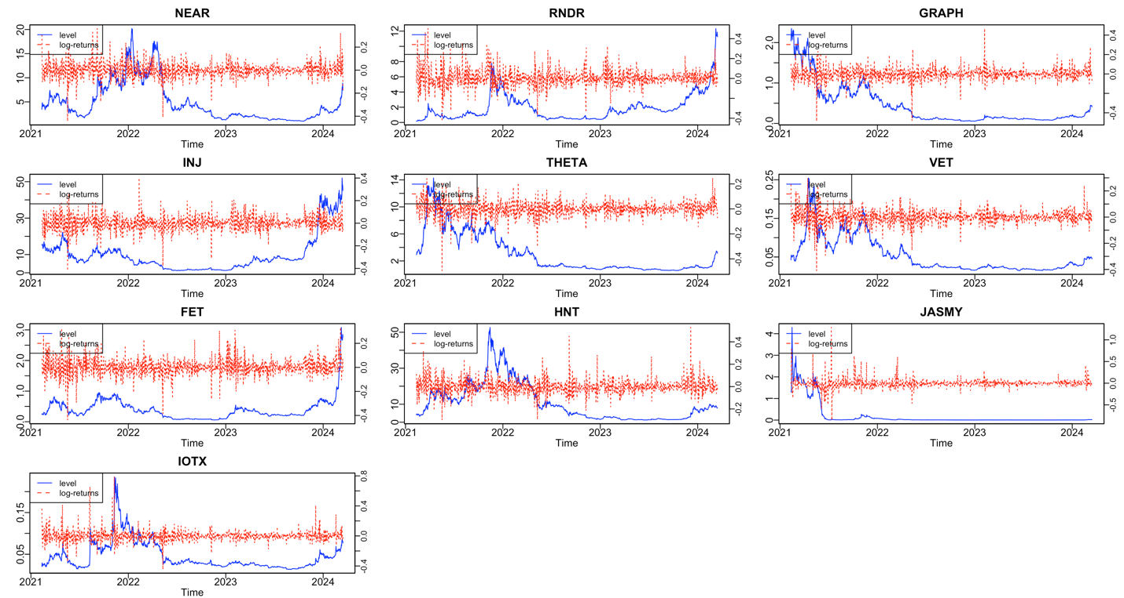
Figure 1: price and returns of AI and IOT tokens
Notes: This figure shows the trends in the prices and returns of the AI and IOT tokens. NEAR Protocol – NEAR, Render – RNDR, The Graph – GRAPH, Injective – INJ, Theta Network – THETA, VeChain – VET, Fetch.ai – FET, Helium – HNT, JasmyCoin – JASMY, IoTeX – IOTX

Table 1: Descriptive Statistics
 | Token | Mean | Median | Max | Min | SD | Skewness | Kurtosis | Jarque-Bera | L-B | L-B^2 | ARCH-LM(10) | ADF
AI | NEAR | 0.067 | -0.025 | 36.103 | -44.362 | 6.698 | 0.025 | 8.396 * | 1368.8 * | 9.565 | 42.5 * | 32.6 * | -9.747 *
 | RNDR | 0.378 | -0.074 | 50.183 | -43.017 | 8.500 | 0.595 * | 7.760 * | 1131.6 * | 12.82 | 190.7 * | 108.9 * | -9.214 *
 | GRAPH | -0.142 | -0.072 | 46.75 | -48.700 | 6.428 | -0.261 * | 12.157 * | 3954.0 * | 20.50 | 62.0 * | 42.6 * | -9.433 *
 | INJ | 0.097 | -0.081 | 40.069 | -41.960 | 6.804 | -0.130 | 7.215 * | 838.4 * | 10.94 | 116.3 * | 82.5 * | -9.736 *
 | THETA | 0.006 | 0.083 | 24.776 | -49.429 | 5.857 | -0.716 * | 9.887 * | 2325.3 * | 36.2 * | 70.3 * | 52.4 * | -8.765 *
IOT | VET | 0.005 | 0.147 | 29.892 | -40.902 | 5.582 | -0.298 * | 8.914 * | 1660.4 * | 42.0 * | 265.7 * | 142.6 * | -9.219 *
 | FET | 0.218 | 0.055 | 33.263 | -43.798 | 7.196 | 0.126 | 7.229 * | 843.5 * | 33.4 * | 115.1 * | 79.1 * | -8.999 *
 | HNT | 0.058 | -0.138 | 52.929 | -29.875 | 6.841 | 0.886 * | 9.445 * | 2100.2 * | 18.55 | 27.2 * | 20.50 | -8.819 *
 | JASMY | -0.373 | -0.713 | 128.811 | -84.978 | 11.190 | 2.129 * | 30.670 * | 36835.6 * | 35.0 * | 170.2 * | 151.8 * | -8.085 *
 | IOTX | 0.118 | 0.001 | 78.832 | -44.619 | 7.731 | 2.270 * | 24.365 * | 22422.6 * | 13.83 | 105.3 * | 107.4 * | -9.546 *

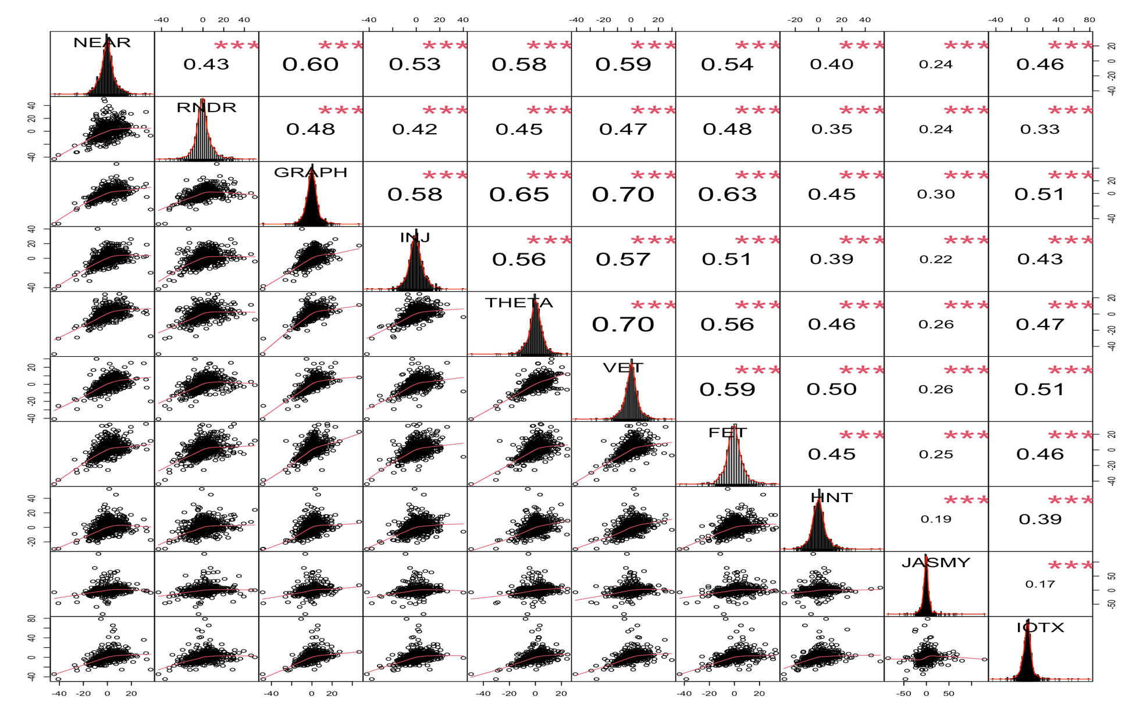
Figure 2: Correlation matrix
NEAR Protocol – NEAR, Render – RNDR, The Graph – GRAPH, Injective – INJ, Theta Network – THETA, VeChain – VET, Fetch.ai – FET, Helium – HNT, JasmyCoin – JASMY, IoTeX – IOTX

Table 2: Static Short-term connectedness at middle, upper and lower quantile
 | NEAR | RNDR | GRAPH | INJ | THETA | VET | FET | HNT | JASMY | IOTX | FROM
Panel A: Middle quantile ($τ$ =0.50)
NEAR | 25.11 | 5.47 | 7.91 | 6.87 | 9.1 | 9.28 | 7.21 | 4 | 5.3 | 7.12 | 62.27
RNDR | 6.8 | 29.3 | 7.57 | 6.07 | 7.25 | 7.68 | 7.36 | 4.78 | 5.01 | 5.92 | 58.44
GRAPH | 7.61 | 6.43 | 21.75 | 6.36 | 9.58 | 10.67 | 8.32 | 4.69 | 5.66 | 6.79 | 66.1
INJ | 8.28 | 5.96 | 7.93 | 26.06 | 8.45 | 9.27 | 7.61 | 4.12 | 4.54 | 6.63 | 62.79
THETA | 8.67 | 5.53 | 9.27 | 6.82 | 21.56 | 11.46 | 7.26 | 5.03 | 5.54 | 7.13 | 66.71
VET | 8.48 | 5.72 | 10.03 | 7.12 | 11.22 | 20.59 | 7.34 | 5.43 | 5.01 | 7.33 | 67.69
FET | 7.39 | 6.82 | 9.04 | 6.75 | 8.07 | 8.48 | 25.12 | 5.19 | 5.36 | 6.27 | 63.37
HNT | 5.54 | 5.47 | 6.57 | 4.85 | 7.34 | 8.26 | 6.55 | 34.33 | 4.39 | 5.6 | 54.57
JASMY | 6.38 | 5.63 | 7.07 | 4.62 | 6.94 | 6.7 | 5.89 | 3.44 | 35.69 | 5.63 | 52.29
IOTX | 7.85 | 5.37 | 7.62 | 5.87 | 8.24 | 8.81 | 6.25 | 5.16 | 4.9 | 28.84 | 60.07
TO | 67.01 | 52.41 | 73 | 55.33 | 76.2 | 80.61 | 63.79 | 41.83 | 45.72 | 58.41 | 614.31
Inc.Own | 92.12 | 81.71 | 94.74 | 81.4 | 97.76 | 101.2 | 88.91 | 76.16 | 81.41 | 87.24 | TCI
Net | 4.74 | -6.03 | 6.89 | -7.46 | 9.49 | 12.92 | 0.42 | -12.74 | -6.57 | -1.67 | 61.43
Panel B: Upper quantile ($τ$ =0.95)
NEAR | 10.19 | 6.82 | 7.36 | 7.91 | 7.9 | 7.41 | 7.82 | 5.68 | 6.05 | 6.24 | 63.19
RNDR | 7.17 | 11.14 | 7.24 | 8.03 | 7.71 | 7.26 | 8.04 | 5.98 | 6.28 | 6.3 | 64
GRAPH | 7.52 | 7.29 | 10.53 | 7.99 | 8.31 | 7.94 | 8 | 5.93 | 6.37 | 6.4 | 65.74
INJ | 7.64 | 7.29 | 7.62 | 11.86 | 7.76 | 7.77 | 8.34 | 6 | 6.11 | 6.59 | 65.13
THETA | 7.44 | 6.87 | 7.67 | 7.9 | 10.79 | 7.8 | 7.54 | 6 | 6.34 | 6.52 | 64.08
VET | 7.61 | 7.16 | 7.93 | 8.2 | 8.47 | 10.06 | 7.89 | 6.2 | 6.14 | 6.55 | 66.14
FET | 7.56 | 7.41 | 7.69 | 8.18 | 7.86 | 7.49 | 11.38 | 6.17 | 6.22 | 6.36 | 64.94
HNT | 6.9 | 7 | 7.19 | 7.76 | 7.73 | 7.19 | 7.95 | 11.13 | 6.12 | 6.18 | 64.01
JASMY | 7.03 | 6.65 | 7.06 | 7.28 | 7.4 | 6.65 | 7.41 | 5.71 | 11.09 | 6.05 | 61.23
IOTX | 7.26 | 6.71 | 7.18 | 7.46 | 7.84 | 7.26 | 7.42 | 5.93 | 6.07 | 10.75 | 63.14
TO | 66.13 | 63.2 | 66.95 | 70.7 | 70.96 | 66.78 | 70.41 | 53.6 | 55.71 | 57.19 | 641.62
Inc.Own | 76.33 | 74.34 | 77.48 | 82.56 | 81.75 | 76.83 | 81.79 | 64.74 | 66.8 | 67.94 | TCI
Net | 2.94 | -0.8 | 1.2 | 5.57 | 6.88 | 0.63 | 5.47 | -10.41 | -5.53 | -5.95 | 64.16
Panel C: Lower quantile ($τ$ =0.05)
NEAR | 12.65 | 7.09 | 8.24 | 7.76 | 8.76 | 8.73 | 7.78 | 6.86 | 6.73 | 7.42 | 69.37
RNDR | 7.9 | 13.74 | 7.95 | 7.54 | 8.21 | 8.21 | 7.89 | 7.22 | 6.61 | 6.94 | 68.47
GRAPH | 8.23 | 7.3 | 12.13 | 7.68 | 8.93 | 8.95 | 8.24 | 7.13 | 6.87 | 7.42 | 70.74
INJ | 8.42 | 7.34 | 8.09 | 12.76 | 8.63 | 8.68 | 7.83 | 6.85 | 6.57 | 7.43 | 69.84
THETA | 8.61 | 7.12 | 8.6 | 7.78 | 12.26 | 9.33 | 7.86 | 7.2 | 6.95 | 7.55 | 70.99
VET | 8.19 | 7.14 | 8.59 | 7.67 | 9.28 | 11.81 | 7.75 | 7.2 | 6.56 | 7.55 | 69.93
FET | 8.28 | 7.51 | 8.46 | 7.52 | 8.55 | 8.49 | 12.76 | 7.12 | 6.75 | 7.32 | 70.01
HNT | 7.73 | 7.5 | 8.07 | 7.49 | 8.58 | 8.87 | 7.89 | 14.76 | 6.78 | 7.45 | 70.36
JASMY | 8.04 | 7.12 | 8.08 | 7.18 | 8.34 | 8.18 | 7.48 | 6.83 | 15.23 | 6.99 | 68.23
IOTX | 8.03 | 6.8 | 8.04 | 7.34 | 8.3 | 8.42 | 7.47 | 7.18 | 6.31 | 13.26 | 67.89
TO | 73.43 | 64.91 | 74.12 | 67.96 | 77.59 | 77.84 | 70.19 | 63.59 | 60.1 | 66.08 | 695.82
Inc.Own | 86.08 | 78.65 | 86.26 | 80.72 | 89.85 | 89.65 | 82.96 | 78.35 | 75.33 | 79.33 | TCI
Net | 4.06 | -3.55 | 3.38 | -1.88 | 6.6 | 7.91 | 0.19 | -6.76 | -8.13 | -1.82 | 69.58
Notes: This table reports the static short-term connectedness between AI and IOT tokens estimated using QVAR model with a rolling window of 100 days and 20 days as forecasting horizon and lag length of 1 based on AIC criteria. NEAR Protocol – NEAR, Render – RNDR, The Graph – GRAPH, Injective – INJ, Theta Network – THETA, VeChain – VET, Fetch.ai – FET, Helium – HNT, JasmyCoin – JASMY, IoTeX – IOTX

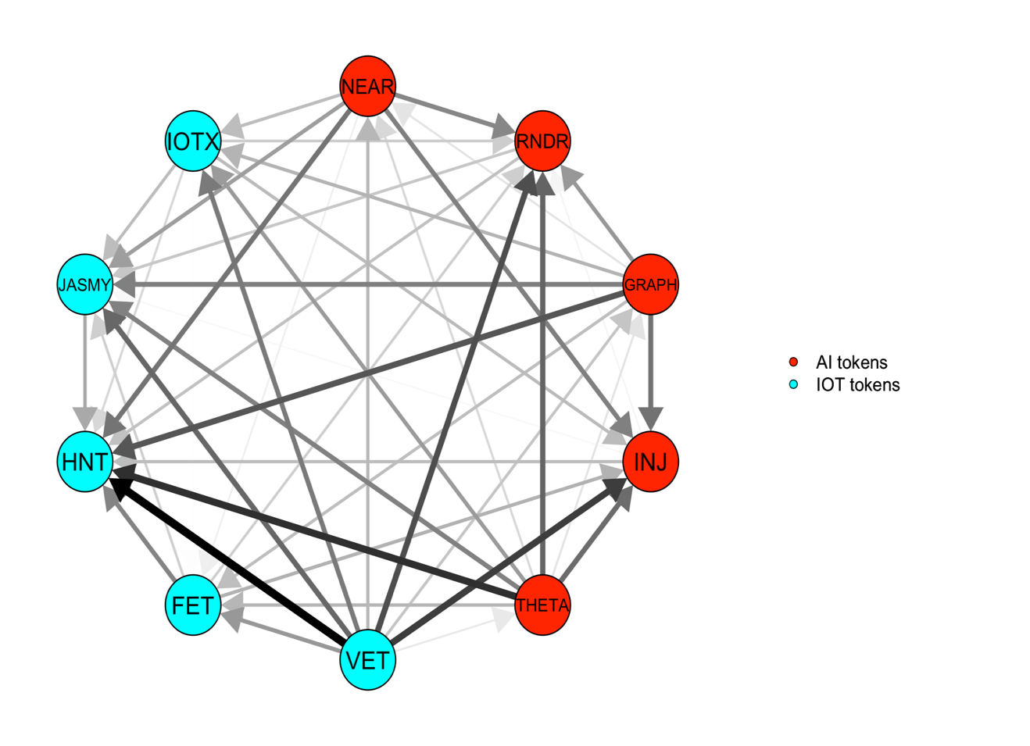 | 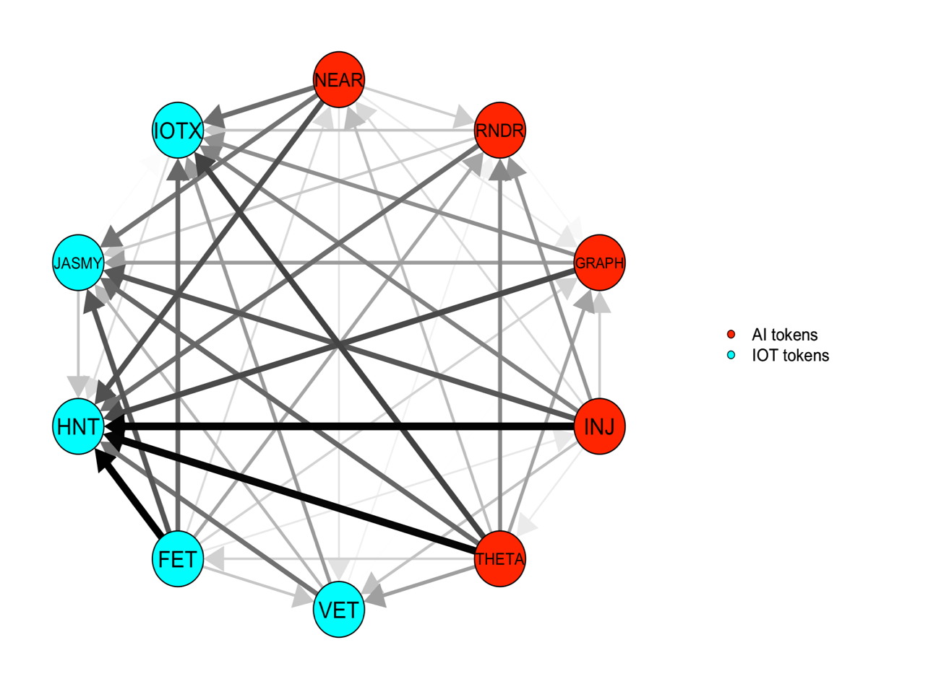 | 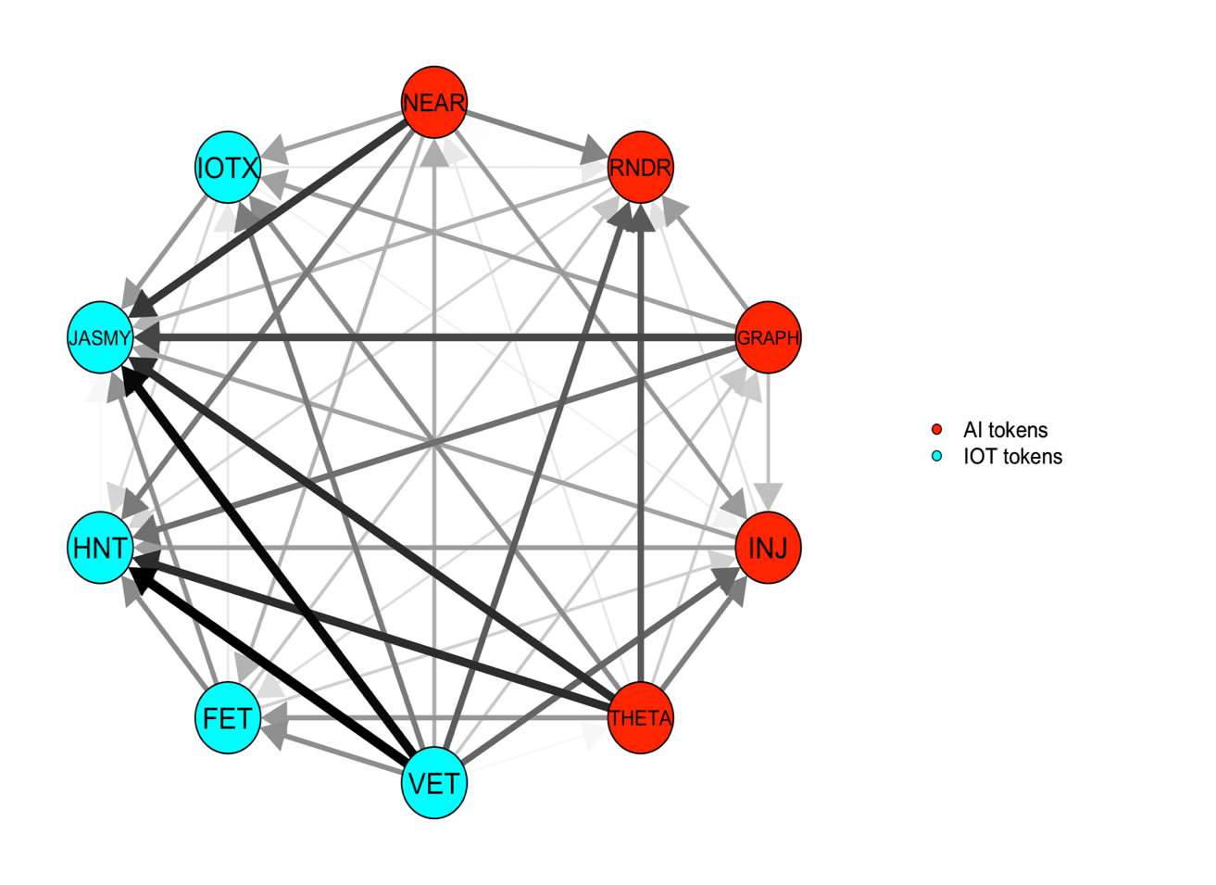
- Middle quantile (τ =0.50) | - Upper quantile (τ =0.95) | - Lower quantile (τ =0.05)
Figure 3: Short-term net pairwise directional spillover at middle, upper and lower quantile.
Notes: NEAR Protocol – NEAR, Render – RNDR, The Graph – GRAPH, Injective – INJ, Theta Network – THETA, VeChain – VET, Fetch.ai – FET, Helium – HNT, JasmyCoin – JASMY, IoTeX – IOTX

Figure 4: Dynamic total short-term connectedness at middle, upper and lower quantile.
Notes: Results are estimated using QVAR model with a rolling window of 100 days and 20 days as forecasting horizon and lag length of 1 based on AIC criteria. PLEASE CHANGE THE t IN THE HEADING IT SHOULD BE TAU FOR QUANTILE

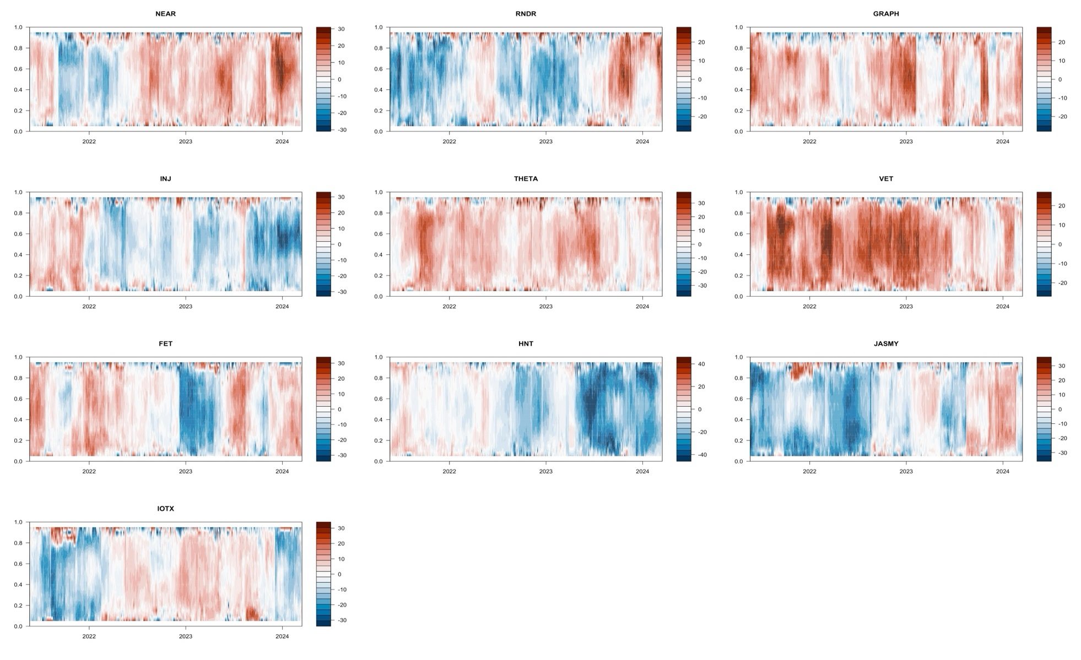
Figure 5: Short term net directional spillover at conditional quantiles
Notes: Results are estimated using QVAR model with a rolling window of 100 days and 20 days as forecasting horizon and lag length of 1 based on AIC criteria. NEAR Protocol – NEAR, Render – RNDR, The Graph – GRAPH, Injective – INJ, Theta Network – THETA, VeChain – VET, Fetch.ai – FET, Helium – HNT, JasmyCoin – JASMY, IoTeX – IOTX

Table 3: Static medium-term connectedness at middle, upper and lower quantile
 | NEAR | RNDR | GRAPH | INJ | THETA | VET | FET | HNT | JASMY | IOTX | FROM
Panel A: Middle quantile ($τ$ =0.50)
NEAR | 2.46 | 0.54 | 0.82 | 0.65 | 0.77 | 0.91 | 0.73 | 0.37 | 0.56 | 0.62 | 5.97
RNDR | 0.63 | 2.8 | 0.7 | 0.55 | 0.58 | 0.65 | 0.69 | 0.51 | 0.55 | 0.51 | 5.37
GRAPH | 0.82 | 0.43 | 2.01 | 0.64 | 0.8 | 1.01 | 0.78 | 0.44 | 0.55 | 0.66 | 6.12
INJ | 0.67 | 0.45 | 0.62 | 2.34 | 0.7 | 0.77 | 0.57 | 0.42 | 0.39 | 0.54 | 5.12
THETA | 0.74 | 0.44 | 0.86 | 0.59 | 1.94 | 1.07 | 0.61 | 0.49 | 0.47 | 0.62 | 5.9
VET | 0.73 | 0.45 | 0.95 | 0.69 | 0.88 | 1.88 | 0.67 | 0.54 | 0.42 | 0.61 | 5.96
FET | 0.72 | 0.45 | 0.84 | 0.63 | 0.67 | 0.79 | 2.15 | 0.42 | 0.48 | 0.53 | 5.54
HNT | 0.45 | 0.36 | 0.55 | 0.35 | 0.54 | 0.63 | 0.46 | 3.33 | 0.31 | 0.42 | 4.09
JASMY | 0.53 | 0.39 | 0.6 | 0.41 | 0.58 | 0.51 | 0.52 | 0.31 | 3.69 | 0.49 | 4.33
IOTX | 0.58 | 0.37 | 0.61 | 0.45 | 0.67 | 0.7 | 0.56 | 0.39 | 0.5 | 2.59 | 4.84
TO | 5.88 | 3.89 | 6.55 | 4.97 | 6.19 | 7.05 | 5.59 | 3.89 | 4.24 | 4.99 | 53.23
Inc.Own | 8.34 | 6.69 | 8.56 | 7.31 | 8.13 | 8.92 | 7.74 | 7.22 | 7.92 | 7.59 | TCI
Net | -0.09 | -1.48 | 0.43 | -0.15 | 0.29 | 1.09 | 0.05 | -0.19 | -0.1 | 0.16 | 5.32
Panel B: Upper quantile ($τ$ =0.95)
NEAR | 1.77 | 1.12 | 1.39 | 1.49 | 1.46 | 1.18 | 1.43 | 1.12 | 1.38 | 1.18 | 11.75
RNDR | 1.18 | 1.71 | 1.3 | 1.32 | 1.29 | 1.04 | 1.3 | 1.08 | 1.3 | 1.11 | 10.91
GRAPH | 1.22 | 1.02 | 1.75 | 1.35 | 1.34 | 1.08 | 1.33 | 1 | 1.23 | 1.07 | 10.64
INJ | 1.19 | 1.02 | 1.15 | 1.8 | 1.23 | 1.06 | 1.26 | 0.99 | 1.16 | 0.99 | 10.05
THETA | 1.29 | 1.08 | 1.34 | 1.43 | 1.86 | 1.25 | 1.35 | 1.16 | 1.38 | 1.15 | 11.42
VET | 1.24 | 1.01 | 1.29 | 1.43 | 1.37 | 1.46 | 1.31 | 1.06 | 1.25 | 1.1 | 11.05
FET | 1.29 | 1.02 | 1.32 | 1.39 | 1.32 | 1.08 | 1.81 | 1.07 | 1.25 | 1.11 | 10.84
HNT | 1.24 | 1.11 | 1.19 | 1.31 | 1.33 | 1.15 | 1.19 | 1.87 | 1.23 | 1.12 | 10.88
JASMY | 1.2 | 1.11 | 1.33 | 1.34 | 1.36 | 1.04 | 1.35 | 1.1 | 2.37 | 1.12 | 10.95
IOTX | 1.23 | 1.05 | 1.27 | 1.36 | 1.37 | 1.17 | 1.33 | 1.14 | 1.35 | 1.87 | 11.27
TO | 11.07 | 9.56 | 11.57 | 12.42 | 12.07 | 10.05 | 11.84 | 9.7 | 11.53 | 9.95 | 109.77
Inc.Own | 12.84 | 11.26 | 13.33 | 14.22 | 13.93 | 11.51 | 13.65 | 11.58 | 13.91 | 11.82 | TCI
Net | -0.68 | -1.36 | 0.93 | 2.37 | 0.65 | -1 | 1 | -1.18 | 0.58 | -1.32 | 10.98
Panel C: Lower quantile ($τ$ =0.05)
NEAR | 1.74 | 1.02 | 1.21 | 1.13 | 1.17 | 1.24 | 1.17 | 0.89 | 1.05 | 1.13 | 10.01
RNDR | 1.08 | 1.8 | 1.11 | 1.04 | 1.01 | 1.12 | 1.17 | 0.93 | 0.99 | 1.01 | 9.46
GRAPH | 1.07 | 0.98 | 1.58 | 0.98 | 1.08 | 1.21 | 1.12 | 0.88 | 1.04 | 1.06 | 9.42
INJ | 1.12 | 0.99 | 1.09 | 1.73 | 1.05 | 1.19 | 1.17 | 0.98 | 0.86 | 1.05 | 9.51
THETA | 1.07 | 0.93 | 1.13 | 1.01 | 1.51 | 1.26 | 1.01 | 0.92 | 0.92 | 1.06 | 9.32
VET | 1.2 | 1.02 | 1.27 | 1.15 | 1.23 | 1.69 | 1.14 | 1.04 | 1.02 | 1.15 | 10.21
FET | 1.07 | 0.99 | 1.18 | 1.01 | 1.09 | 1.24 | 1.72 | 0.92 | 0.91 | 0.99 | 9.4
HNT | 0.89 | 0.85 | 0.94 | 0.87 | 0.86 | 0.98 | 0.9 | 1.73 | 0.8 | 0.9 | 7.99
JASMY | 0.95 | 0.9 | 1.06 | 0.93 | 1.05 | 1 | 1 | 0.85 | 2.01 | 0.92 | 8.66
IOTX | 1.18 | 1.01 | 1.25 | 1.11 | 1.19 | 1.32 | 1.13 | 0.99 | 1.12 | 1.93 | 10.3
TO | 9.63 | 8.71 | 10.23 | 9.23 | 9.73 | 10.58 | 9.79 | 8.41 | 8.71 | 9.27 | 94.27
Inc.Own | 11.37 | 10.51 | 11.81 | 10.95 | 11.24 | 12.27 | 11.51 | 10.14 | 10.71 | 11.2 | TCI
Net | -0.38 | -0.76 | 0.82 | -0.28 | 0.41 | 0.37 | 0.38 | 0.42 | 0.05 | -1.03 | 9.43
Notes: This table reports the static medium-term connectedness between AI and IOT tokens estimated using QVAR model with a rolling window of 100 days and 20 days as forecasting horizon and lag length of 1 based on AIC criteria.
NEAR Protocol – NEAR, Render – RNDR, The Graph – GRAPH, Injective – INJ, Theta Network – THETA, VeChain – VET, Fetch.ai – FET, Helium – HNT, JasmyCoin – JASMY, IoTeX – IOTX

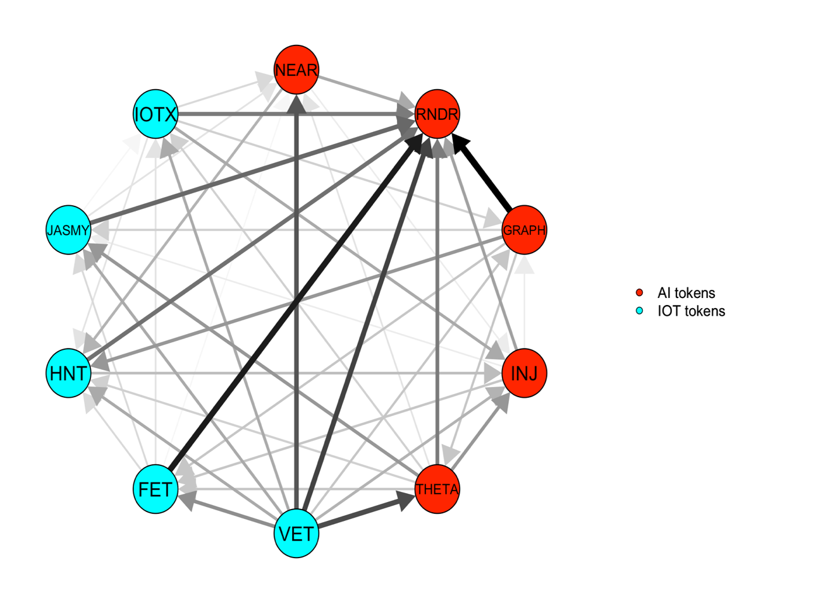 | 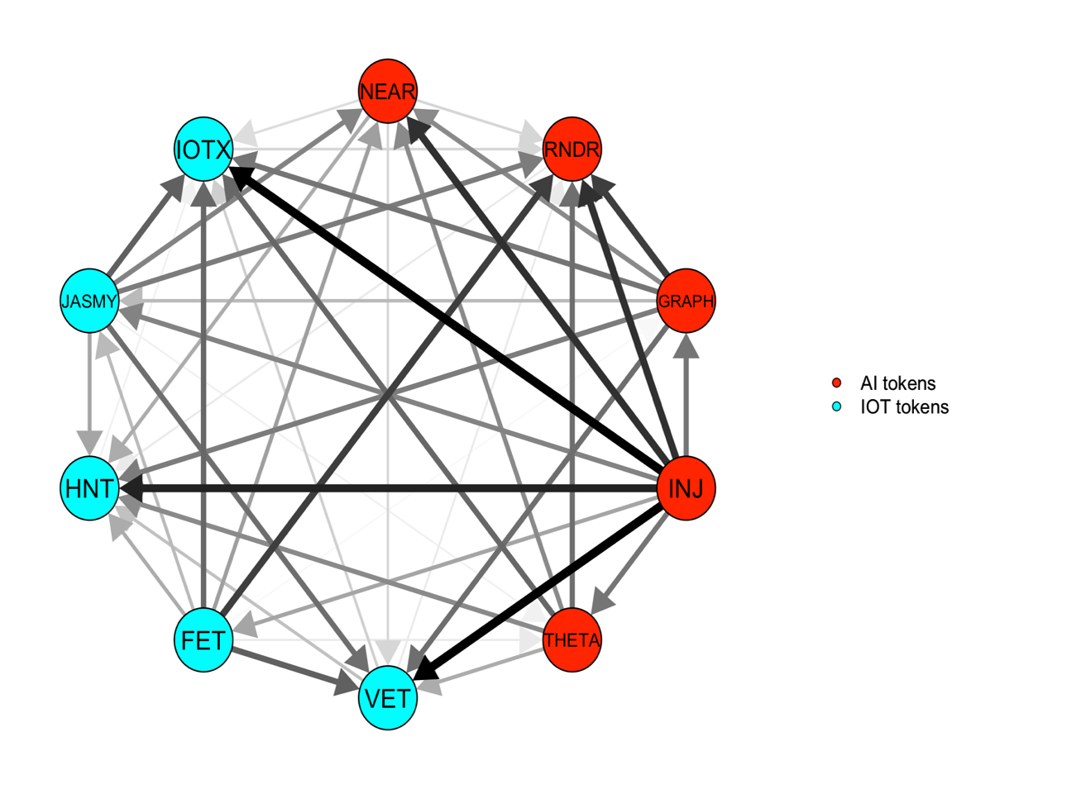 | 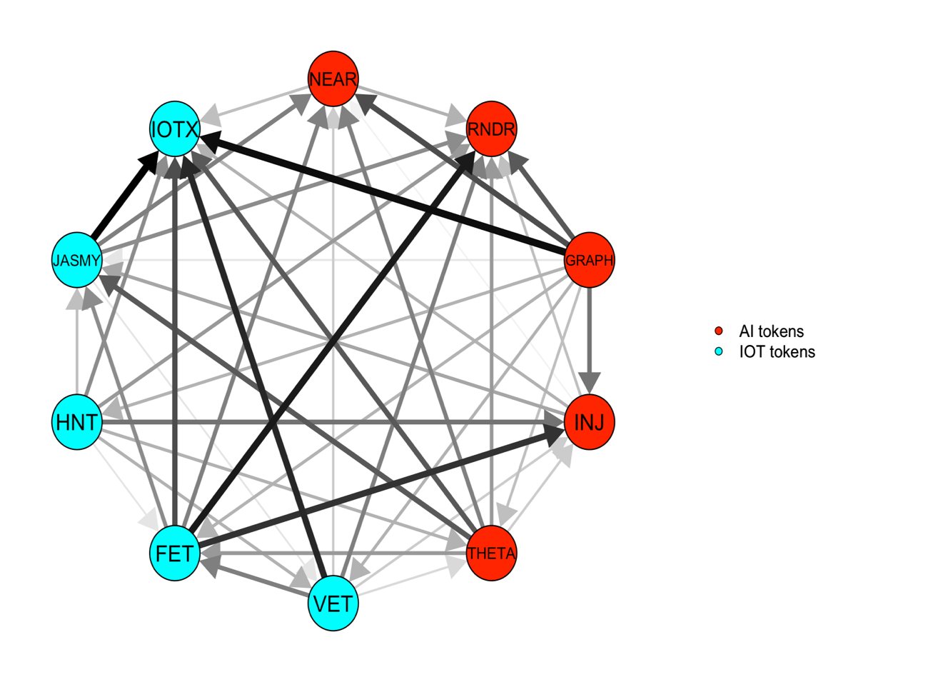
- Middle quantile (τ =0.50) | - Upper quantile (τ =0.95) | - Lower quantile (τ =0.05)
Figure 6: Medium-term net pairwise directional spillover at middle, upper and lower quantile.
NEAR Protocol – NEAR, Render – RNDR, The Graph – GRAPH, Injective – INJ, Theta Network – THETA, VeChain – VET, Fetch.ai – FET, Helium – HNT, JasmyCoin – JASMY, IoTeX – IOTX

Figure 7: Dynamic total medium-term connectedness at middle, upper and lower quantile.
Notes: Results are estimated using QVAR model with a rolling window of 100 days and 20 days as forecasting horizon and lag length of 1 based on AIC criteria.

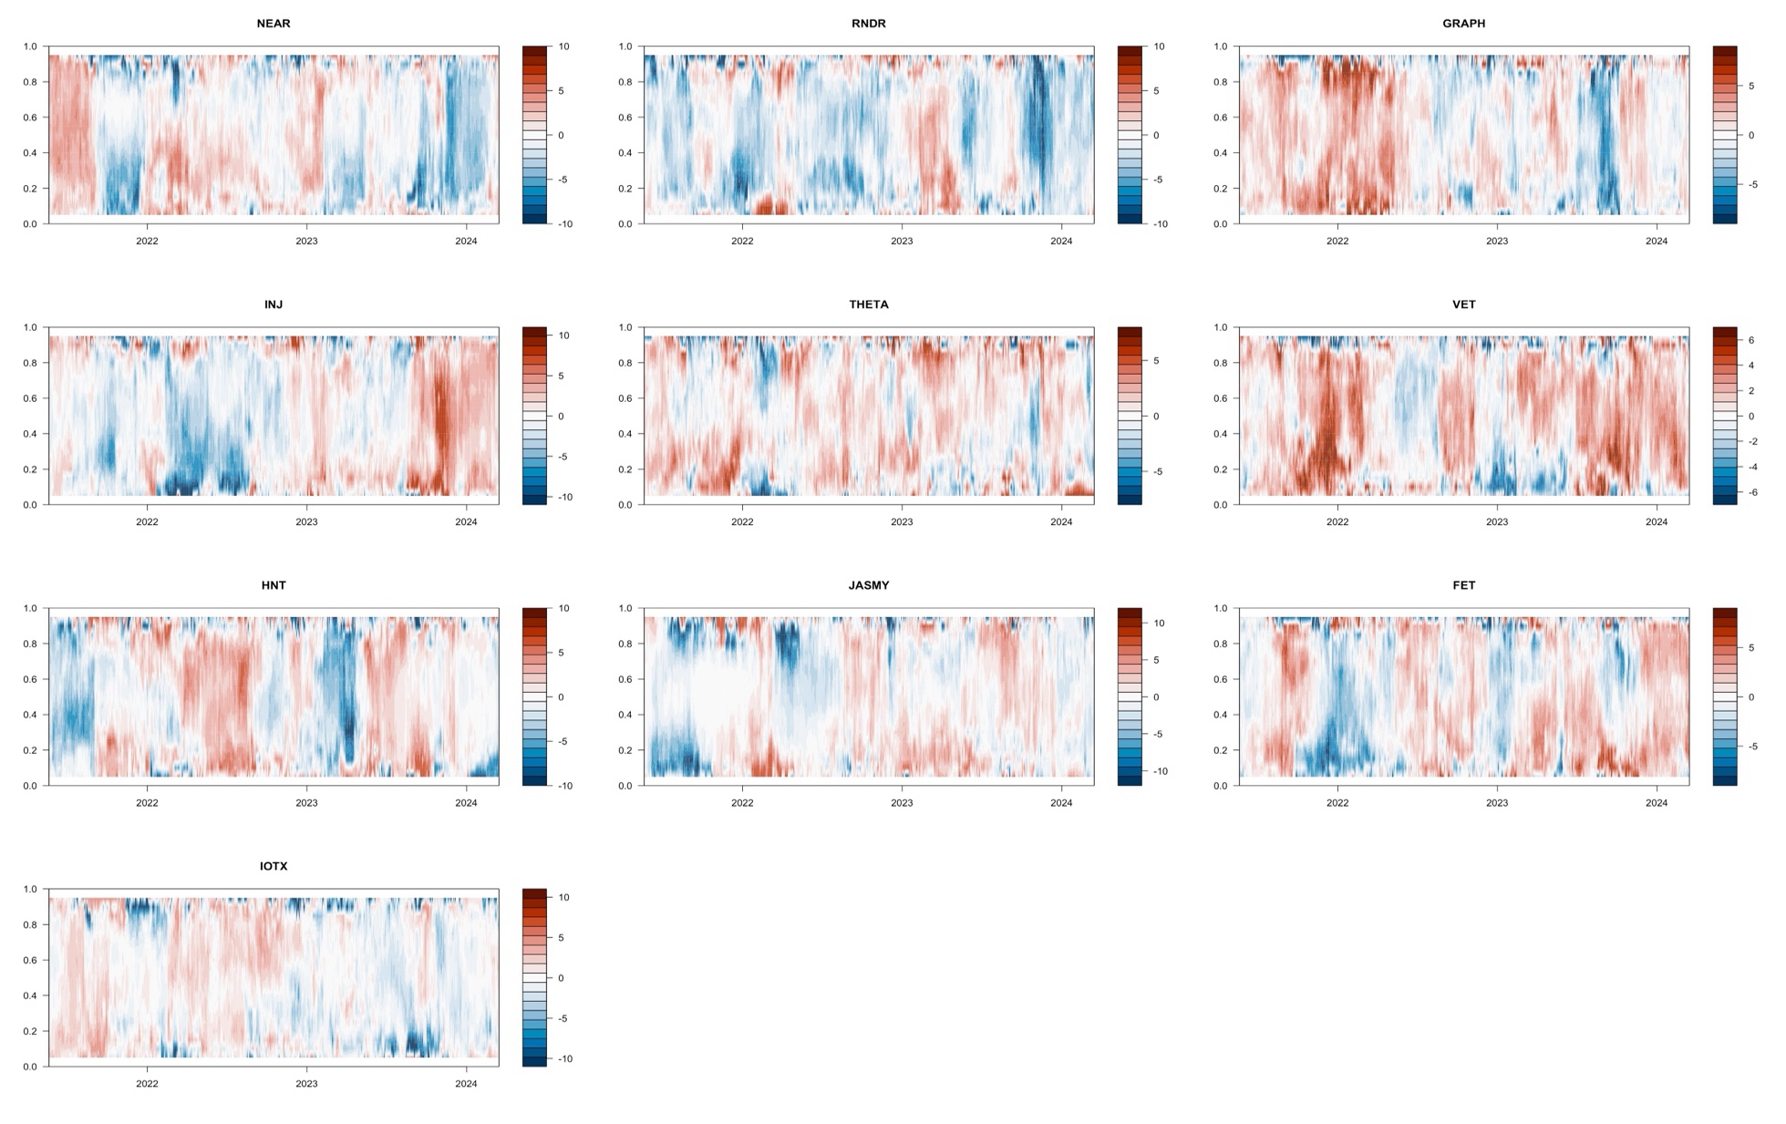
Figure 8: Medium term net directional spillover at conditional quantiles
Notes: Results are estimated using QVAR model with a rolling window of 100 days and 20 days as forecasting horizon and lag length of 1 based on AIC criteria. NEAR Protocol – NEAR, Render – RNDR, The Graph – GRAPH, Injective – INJ, Theta Network – THETA, VeChain – VET, Fetch.ai – FET, Helium – HNT, JasmyCoin – JASMY, IoTeX – IOTX

Table 4 Static long-term connectedness at middle, upper and lower quantile
 | NEAR | RNDR | GRAPH | INJ | THETA | VET | FET | HNT | JASMY | IOTX | FROM
Panel A: Middle quantile ($τ$ =0.50)
NEAR | 1.23 | 0.27 | 0.41 | 0.32 | 0.38 | 0.45 | 0.36 | 0.19 | 0.28 | 0.3 | 2.97
RNDR | 0.32 | 1.4 | 0.35 | 0.28 | 0.29 | 0.33 | 0.34 | 0.25 | 0.28 | 0.25 | 2.68
GRAPH | 0.41 | 0.21 | 0.99 | 0.32 | 0.39 | 0.5 | 0.38 | 0.22 | 0.27 | 0.33 | 3.03
INJ | 0.33 | 0.22 | 0.3 | 1.16 | 0.34 | 0.38 | 0.28 | 0.21 | 0.19 | 0.26 | 2.52
THETA | 0.37 | 0.22 | 0.43 | 0.3 | 0.96 | 0.53 | 0.3 | 0.24 | 0.23 | 0.31 | 2.93
VET | 0.36 | 0.23 | 0.47 | 0.35 | 0.43 | 0.94 | 0.33 | 0.27 | 0.21 | 0.3 | 2.95
FET | 0.36 | 0.22 | 0.42 | 0.32 | 0.33 | 0.39 | 1.07 | 0.21 | 0.24 | 0.26 | 2.75
HNT | 0.22 | 0.18 | 0.27 | 0.17 | 0.27 | 0.31 | 0.23 | 1.67 | 0.15 | 0.21 | 2.02
JASMY | 0.26 | 0.19 | 0.29 | 0.2 | 0.29 | 0.25 | 0.26 | 0.16 | 1.85 | 0.24 | 2.14
IOTX | 0.28 | 0.18 | 0.3 | 0.22 | 0.33 | 0.34 | 0.28 | 0.19 | 0.25 | 1.29 | 2.38
TO | 2.92 | 1.92 | 3.24 | 2.48 | 3.05 | 3.49 | 2.77 | 1.94 | 2.1 | 2.46 | 26.37
Inc.Own | 4.14 | 3.32 | 4.24 | 3.64 | 4.01 | 4.43 | 3.84 | 3.61 | 3.95 | 3.75 | TCI
Net | -0.05 | -0.76 | 0.21 | -0.04 | 0.11 | 0.54 | 0.02 | -0.08 | -0.05 | 0.08 | 2.64
Panel B: Upper quantile ($τ$ =0.95)
NEAR | 1.52 | 1.07 | 1.31 | 1.33 | 1.29 | 0.99 | 1.65 | 1.14 | 1.69 | 1.09 | 11.57
RNDR | 1.09 | 1.38 | 1.21 | 1.29 | 1.18 | 0.91 | 1.46 | 1.06 | 1.57 | 1.08 | 10.87
GRAPH | 1.05 | 0.92 | 1.44 | 1.24 | 1.14 | 0.88 | 1.42 | 0.99 | 1.36 | 0.89 | 9.89
INJ | 1.08 | 0.92 | 1.04 | 1.47 | 1.06 | 0.86 | 1.45 | 1.02 | 1.36 | 0.91 | 9.69
THETA | 1.12 | 0.97 | 1.14 | 1.23 | 1.4 | 0.92 | 1.45 | 1.08 | 1.51 | 1.03 | 10.46
VET | 1.05 | 0.91 | 1.1 | 1.22 | 1.09 | 1.06 | 1.44 | 1.01 | 1.43 | 0.97 | 10.23
FET | 1.1 | 0.89 | 1.07 | 1.12 | 1.09 | 0.79 | 1.69 | 1.04 | 1.29 | 0.94 | 9.34
HNT | 1.08 | 1.01 | 1.1 | 1.26 | 1.25 | 0.96 | 1.44 | 1.54 | 1.49 | 0.97 | 10.55
JASMY | 1.23 | 1.18 | 1.33 | 1.48 | 1.37 | 1.05 | 1.67 | 1.22 | 2.55 | 1.26 | 11.81
IOTX | 1.09 | 1.03 | 1.12 | 1.2 | 1.2 | 0.98 | 1.44 | 1.17 | 1.57 | 2.16 | 10.8
TO | 9.91 | 8.91 | 10.43 | 11.37 | 10.67 | 8.34 | 13.41 | 9.73 | 13.29 | 9.15 | 105.2
Inc.Own | 11.43 | 10.29 | 11.86 | 12.85 | 12.07 | 9.4 | 15.1 | 11.26 | 15.83 | 11.3 | TCI
Net | -1.66 | -1.95 | 0.54 | 1.69 | 0.21 | -1.89 | 4.08 | -0.83 | 1.48 | -1.66 | 10.52
Panel C: Lower quantile ($τ$ =0.05)
NEAR | 0.9 | 0.57 | 0.65 | 0.6 | 0.61 | 0.65 | 0.63 | 0.47 | 0.56 | 0.59 | 5.33
RNDR | 0.6 | 1.1 | 0.67 | 0.62 | 0.56 | 0.63 | 0.66 | 0.54 | 0.58 | 0.57 | 5.44
GRAPH | 0.57 | 0.62 | 0.88 | 0.55 | 0.58 | 0.66 | 0.62 | 0.48 | 0.59 | 0.58 | 5.25
INJ | 0.6 | 0.58 | 0.61 | 0.94 | 0.55 | 0.65 | 0.66 | 0.55 | 0.47 | 0.56 | 5.23
THETA | 0.57 | 0.56 | 0.62 | 0.56 | 0.8 | 0.68 | 0.55 | 0.5 | 0.51 | 0.58 | 5.11
VET | 0.63 | 0.57 | 0.68 | 0.62 | 0.64 | 0.9 | 0.63 | 0.55 | 0.53 | 0.61 | 5.46
FET | 0.57 | 0.58 | 0.66 | 0.56 | 0.58 | 0.68 | 0.95 | 0.5 | 0.49 | 0.53 | 5.15
HNT | 0.46 | 0.51 | 0.51 | 0.47 | 0.45 | 0.5 | 0.47 | 0.9 | 0.43 | 0.47 | 4.26
JASMY | 0.5 | 0.56 | 0.6 | 0.52 | 0.56 | 0.54 | 0.54 | 0.46 | 1.07 | 0.51 | 4.8
IOTX | 0.62 | 0.61 | 0.69 | 0.61 | 0.63 | 0.7 | 0.6 | 0.53 | 0.61 | 1.02 | 5.6
TO | 5.11 | 5.16 | 5.69 | 5.11 | 5.17 | 5.7 | 5.35 | 4.58 | 4.76 | 5.01 | 51.63
Inc.Own | 6.01 | 6.26 | 6.57 | 6.05 | 5.97 | 6.6 | 6.3 | 5.48 | 5.83 | 6.02 | TCI
Net | -0.22 | -0.28 | 0.44 | -0.12 | 0.06 | 0.24 | 0.2 | 0.32 | -0.04 | -0.6 | 5.16
Notes: This table reports the static long-term connectedness between AI and IOT tokens estimated using QVAR model with a rolling window of 100 days and 20 days as forecasting horizon and lag length of 1 based on AIC criteria. NEAR Protocol – NEAR, Render – RNDR, The Graph – GRAPH, Injective – INJ, Theta Network – THETA, VeChain – VET, Fetch.ai – FET, Helium – HNT, JasmyCoin – JASMY, IoTeX – IOTX

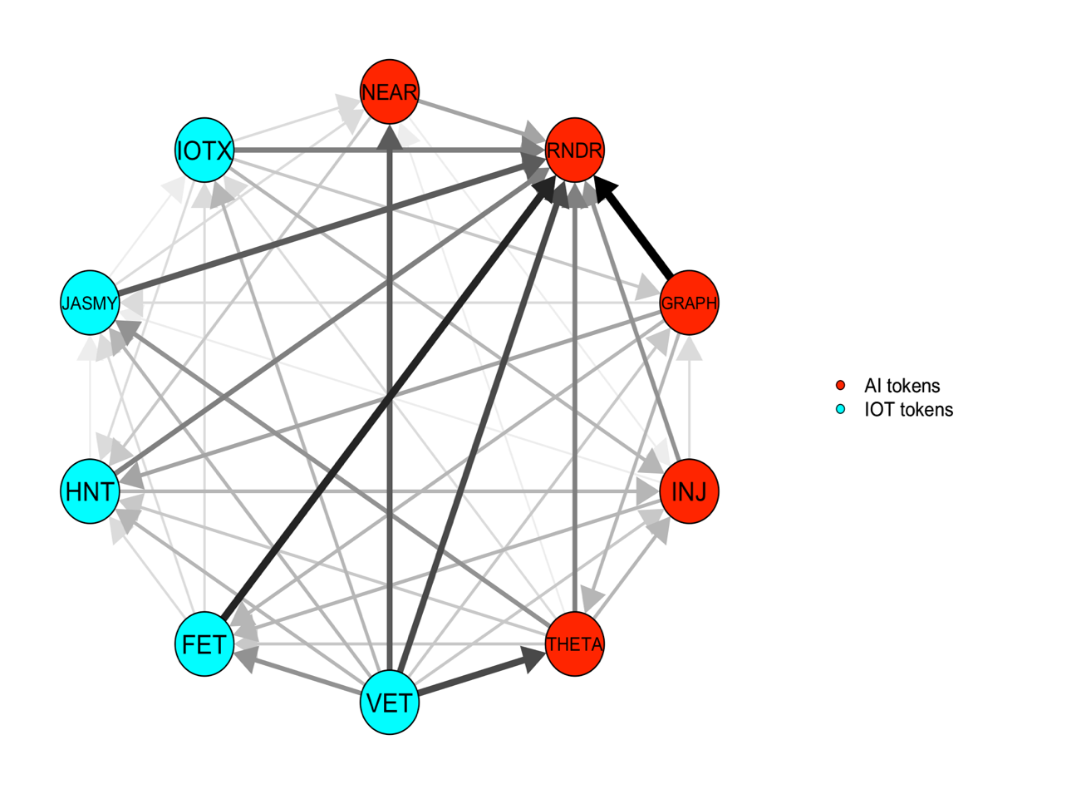 | 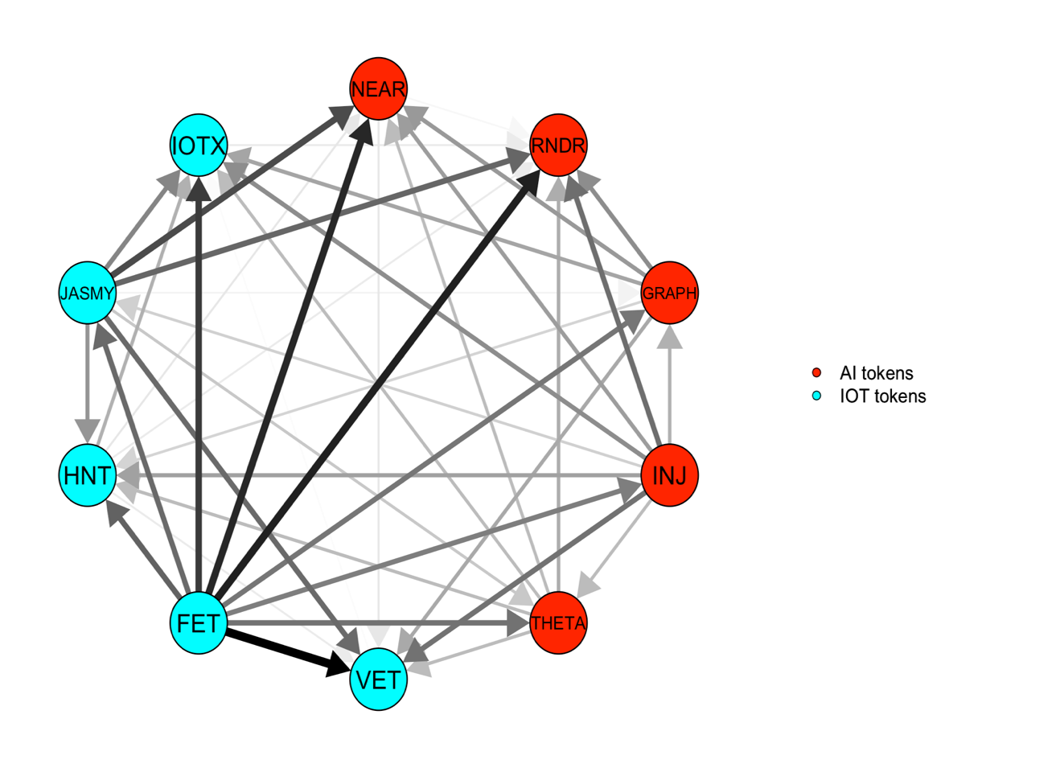 | 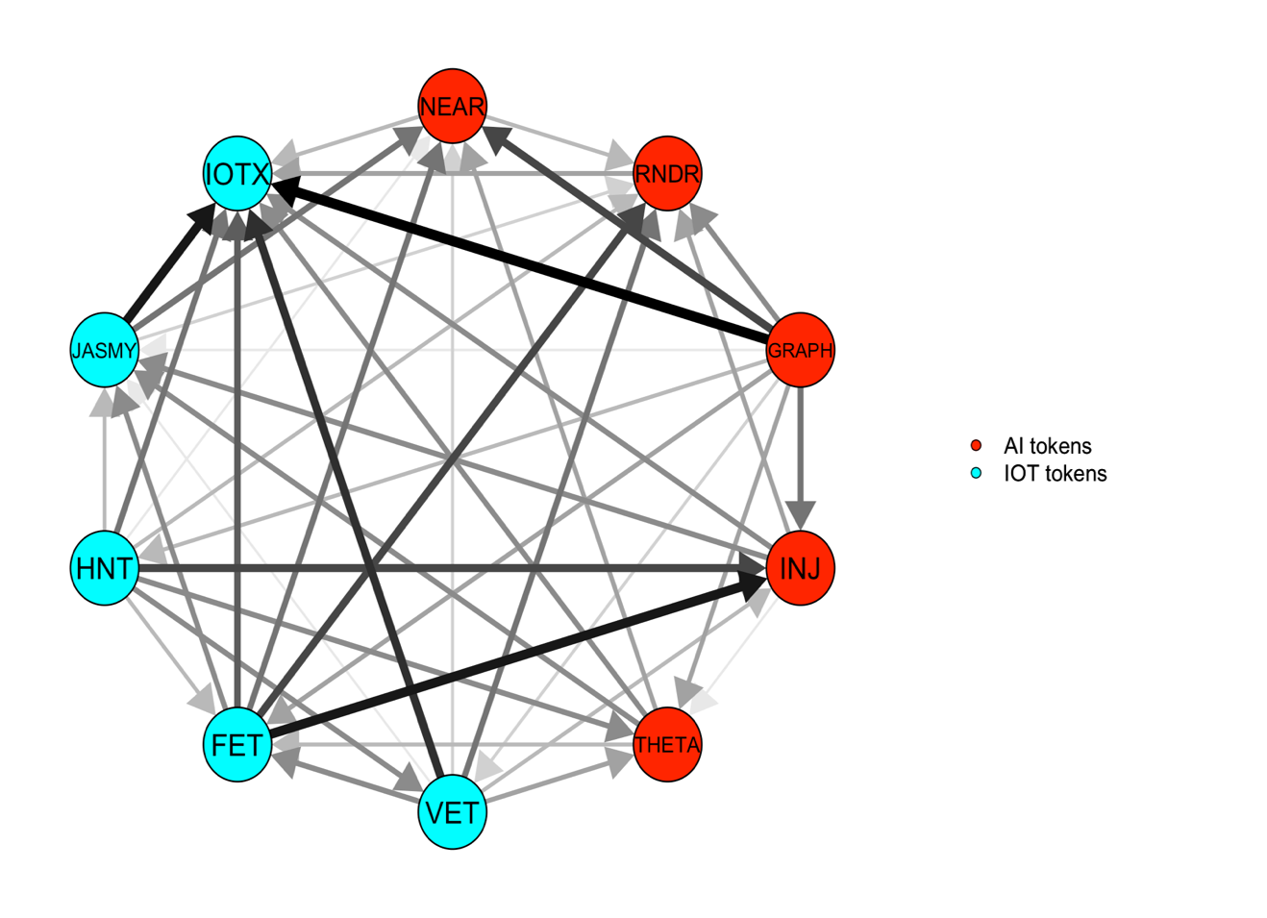
- Middle quantile (τ =0.50) | - Upper quantile (τ =0.95) | - Lower quantile (τ =0.05)
Figure 9: Long-term net pairwise directional spillover at middle, upper and lower quantile
Notes: NEAR Protocol – NEAR, Render – RNDR, The Graph – GRAPH, Injective – INJ, Theta Network – THETA, VeChain – VET, Fetch.ai – FET, Helium – HNT, JasmyCoin – JASMY, IoTeX – IOTX

Figure 10: Dynamic total long-term connectedness at middle, upper and lower quantile.
Notes: Results are estimated using QVAR model with a rolling window of 100 days and 20 days as forecasting horizon and lag length of 1 based on AIC criteria.

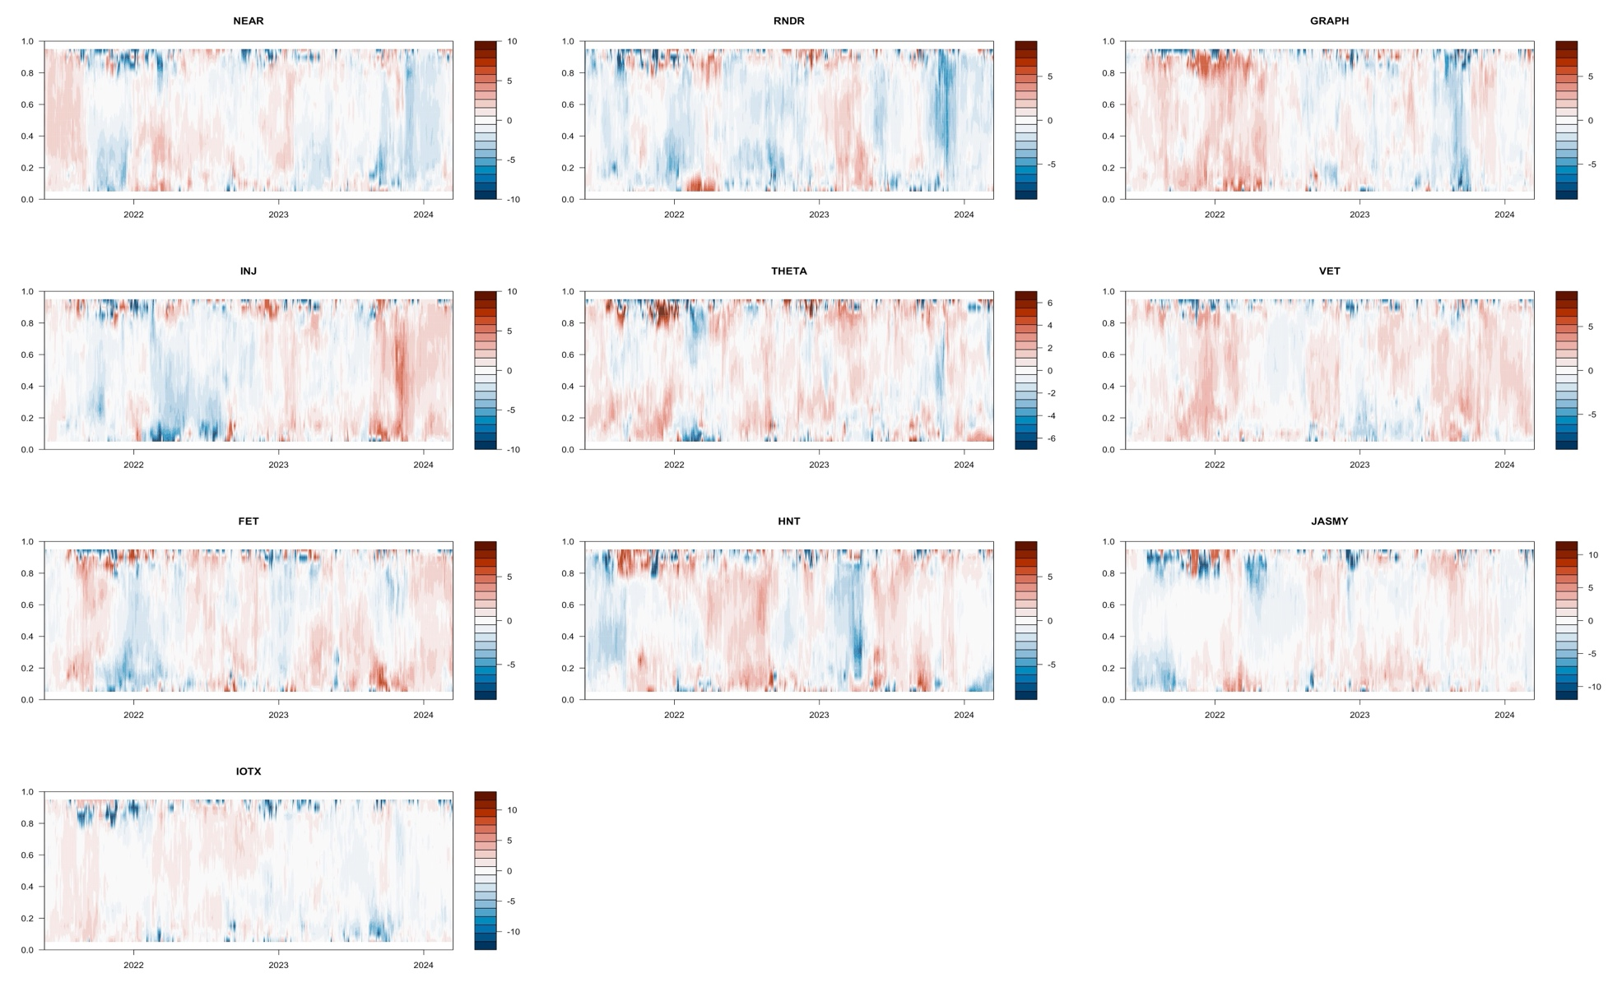
Figure 11: Long term net directional spillover at conditional quantiles Notes: Results are estimated using QVAR model with a rolling window of 100 days and 20 days as forecasting horizon and lag length of 1 based on AIC criteria.
NEAR Protocol – NEAR, Render – RNDR, The Graph – GRAPH, Injective – INJ, Theta Network – THETA, VeChain – VET, Fetch.ai – FET, Helium – HNT, JasmyCoin – JASMY, IoTeX – IOTX
Table 5: Summary of static analysis - net roles of Ai and IoT tokens
 | SHORT |  |  | MEDIUM |  |  | LONG
 | Middle | Upper | Lower | Middle | Upper | Lower | Middle | Upper | Lower
NEAR | + | + | + | - | - | - | - | - | -
RNDR | - | - | - | - | - | - | - | - | -
GRAPH | + | + | + | + | + | + | + | + | +
INJ | - | + | - | - | + | - | - | + | -
THETA | + | + | + | + | + | + | + | + | +
VET | + | + | + | + | - | + | + | - | +
FET | + | + | + | + | + | + | + | + | +
HNT | - | - | - | - | - | + | - | - | +
JASMY | - | - | - | - | + | + | - | + | -
IOTX | - | - | - | + | - | - | + | - | -

Notes: This table reports the net role of each token by both the investment horizon and the quantile under investigation.

Table 6: Multivariate short-term optimal weights and hedging effectiveness
 | Middle quantile ($τ$ =0.50) |  |  |  | Upper quantile ($τ$ =0.95) |  |  |  | Lower quantile ($τ$ =0.05)
 | Mean | HE | p-value |  | Mean | HE | p-value |  | Mean | HE | p-value
NEAR | 0.082 | 0.291 | 0.000 |  | 0.095 | 0.28 | 0.000 |  | 0.079 | 0.28 | 0.000
RNDR | 0.136 | 0.506 | 0.000 |  | 0.098 | 0.498 | 0.000 |  | 0.134 | 0.498 | 0.000
GRAPH | 0.059 | 0.221 | 0.000 |  | 0.106 | 0.209 | 0.000 |  | 0.071 | 0.209 | 0.000
INJ | 0.133 | 0.319 | 0.000 |  | 0.103 | 0.308 | 0.000 |  | 0.109 | 0.308 | 0.000
THETA | 0.055 | -0.01 | 0.868 |  | 0.090 | -0.027 | 0.671 |  | 0.059 | -0.026 | 0.677
VET | 0.026 | -0.205 | 0.003 |  | 0.079 | -0.224 | 0.001 |  | 0.064 | -0.224 | 0.001
FET | 0.062 | 0.346 | 0.000 |  | 0.089 | 0.336 | 0.000 |  | 0.090 | 0.336 | 0.000
HNT | 0.178 | 0.303 | 0.000 |  | 0.109 | 0.292 | 0.000 |  | 0.110 | 0.292 | 0.000
JASMY | 0.154 | 0.751 | 0.000 |  | 0.124 | 0.747 | 0.000 |  | 0.135 | 0.747 | 0.000
IOTX | 0.116 | 0.448 | 0.000 |  | 0.106 | 0.439 | 0.000 |  | 0.149 | 0.439 | 0.000
Notes: This table reports the optimal weights for the portfolio comprising both the AI and IOT token. The results are estimated using QVAR model with a 100 days rolling-window size, lag length of order 1 (AIC) and a 20-step-ahead generalized forecast error variance decomposition.
NEAR Protocol – NEAR, Render – RNDR, The Graph – GRAPH, Injective – INJ, Theta Network – THETA, VeChain – VET, Fetch.ai – FET, Helium – HNT, JasmyCoin – JASMY, IoTeX – IOTX

Table 7: Multivariate medium term optimal weights and hedging effectiveness
 | Middle quantile ($τ$ =0.50) |  |  |  | Upper quantile ($τ$ =0.95) |  |  |  | Lower quantile ($τ$ =0.05)
 | Mean | HE | p-value |  | Mean | HE | p-value |  | Mean | HE | p-value
NEAR | 0.071 | 0.396 | 0.000 |  | 0.093 | 0.299 | 0.000 |  | 0.096 | 0.38 | 0.000
RNDR | 0.109 | 0.579 | 0.000 |  | 0.093 | 0.512 | 0.000 |  | 0.082 | 0.568 | 0.000
GRAPH | 0.052 | 0.337 | 0.000 |  | 0.093 | 0.231 | 0.000 |  | 0.106 | 0.32 | 0.000
INJ | 0.122 | 0.42 | 0.000 |  | 0.104 | 0.327 | 0.000 |  | 0.097 | 0.405 | 0.000
THETA | 0.093 | 0.139 | 0.000 |  | 0.103 | 0.002 | 0.981 |  | 0.142 | 0.117 | 0.046
VET | 0.068 | -0.026 | 0.677 |  | 0.107 | -0.191 | 0.005 |  | 0.087 | -0.053 | 0.407
FET | 0.100 | 0.443 | 0.000 |  | 0.109 | 0.354 | 0.000 |  | 0.099 | 0.429 | 0.000
HNT | 0.152 | 0.407 | 0.000 |  | 0.097 | 0.312 | 0.000 |  | 0.101 | 0.391 | 0.000
JASMY | 0.125 | 0.788 | 0.000 |  | 0.097 | 0.754 | 0.000 |  | 0.090 | 0.782 | 0.000
IOTX | 0.108 | 0.53 | 0.000 |  | 0.104 | 0.455 | 0.000 |  | 0.099 | 0.518 | 0.000
Notes: This table reports the optimal weights for the portfolio comprising both the AI and IOT token. The results are estimated using QVAR model with a 100 days rolling-window size, lag length of order 1 (AIC) and a 20-step-ahead generalized forecast error variance decomposition.
NEAR Protocol – NEAR, Render – RNDR, The Graph – GRAPH, Injective – INJ, Theta Network – THETA, VeChain – VET, Fetch.ai – FET, Helium – HNT, JasmyCoin – JASMY, IoTeX – IOTX

Table 8: Multivariate long term optimal weights and hedging effectiveness
 | Middle quantile ($τ$ =0.50) |  |  |  | Upper quantile ($τ$ =0.95) |  |  |  | Lower quantile ($τ$ =0.05)
 | Mean | HE | p-value |  | Mean | HE | p-value |  | Mean | HE | p-value
NEAR | 0.071 | 0.397 | 0.000 |  | 0.094 | 0.288 | 0.000 |  | 0.102 | 0.387 | 0.000
RNDR | 0.108 | 0.579 | 0.000 |  | 0.094 | 0.504 | 0.000 |  | 0.081 | 0.573 | 0.000
GRAPH | 0.054 | 0.338 | 0.000 |  | 0.100 | 0.218 | 0.000 |  | 0.099 | 0.327 | 0.000
INJ | 0.120 | 0.42 | 0.000 |  | 0.113 | 0.316 | 0.000 |  | 0.101 | 0.411 | 0.000
THETA | 0.094 | 0.14 | 0.015 |  | 0.097 | -0.014 | 0.819 |  | 0.138 | 0.126 | 0.031
VET | 0.070 | -0.025 | 0.689 |  | 0.104 | -0.21 | 0.002 |  | 0.089 | -0.042 | 0.510
FET | 0.101 | 0.444 | 0.000 |  | 0.107 | 0.344 | 0.000 |  | 0.100 | 0.435 | 0.000
HNT | 0.150 | 0.407 | 0.000 |  | 0.096 | 0.301 | 0.000 |  | 0.104 | 0.398 | 0.000
JASMY | 0.125 | 0.788 | 0.000 |  | 0.093 | 0.75 | 0.000 |  | 0.088 | 0.785 | 0.000
IOTX | 0.108 | 0.53 | 0.000 |  | 0.102 | 0.446 | 0.000 |  | 0.099 | 0.523 | 0.000
Notes: This table reports the optimal weights for the portfolio comprising both the AI and IOT token. The results are estimated using QVAR model with a 100 days rolling-window size, lag length of order 1 (AIC) and a 20-step-ahead generalized forecast error variance decomposition.
NEAR Protocol – NEAR, Render – RNDR, The Graph – GRAPH, Injective – INJ, Theta Network – THETA, VeChain – VET, Fetch.ai – FET, Helium – HNT, JasmyCoin – JASMY, IoTeX – IOTX

AI Market Capitalization, 2024. For details, please see: https://www.statista.com/outlook/tmo/artificial-intelligence/worldwide.
IoT Market Capitalization, 2024. For details, please see: https://www.statista.com/outlook/tmo/internet-of-things/worldwide.
Fintech Trends 2024. For details, please see: https://dashdevs.com/blog/fintech-trends-2024/.
Global Crypto Market Capitalization, May 2024. For details, please see: https://coinmarketcap.com/

