**Pathway and Sinking of Plastic Bags in the Southeastern Mediterranean Sea**

Xingyu Li1, Revital Bookman1, and Yael Segal2

1. The Dr. Moses Strauss Department of Marine Geosciences, Leon H. Charney School of

Marine Sciences (CSMS), University of Haifa, Haifa, Israel

2. Israel Oceanographic and Limnological Research, Haifa, Israel

**Submitted to ES&t** [](https://pubs.acs.org/journal/esthag)

**Highlights from the study**

1. **The deep-sea of the Southeastern Mediterranean is one of the most polluted seafloors among the world.**
2. **Bottom litter is composed almost entirely of plastic bags, with PE as the primary type.**
3. **There are differences between the plastic bags in the continental shelf and in the deep-sea basin.**
4. **Low biofilm attachment was observed.**
5. **Various sources and pathways of the bottom litter were studied.**

**Key words**

**Plastic bags, seafloor, adhesion, tar, sinking, resuspension, source.**

**Graphical abstract**

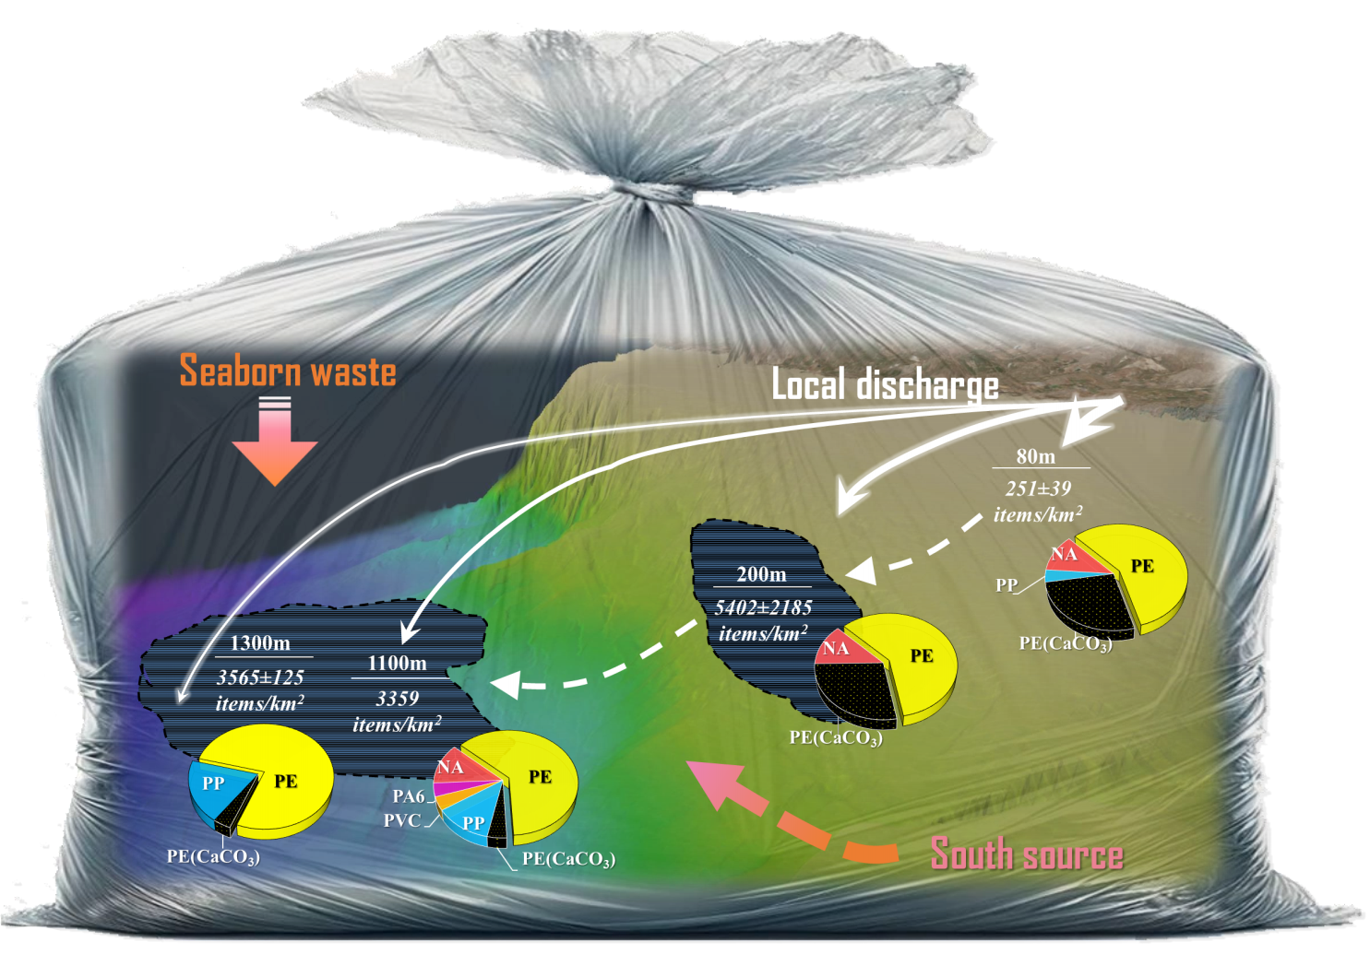

**Abstract:**

Plastic litter has been ubiquitously found on the seafloor, while their transport trajectories in the marine system are still an open question. During 2022, we collected bottom debris (>2.5 cm) in the Southeastern Mediterranean Sea at 80-1300 m ocean depth. The plastic concentration found in the deep sea is one of the highest in the world (3264.1±86.2 items/km2), mainly consisted of plastic bags & wrappings (91.3±2.2% of the total litter found). A significant difference was found in the distribution of the bags’ shape in the continental shelf and the deep sea, pointing out the shape effect on the plastic transport in the ocean. Calcium carbonate additive, which was found in almost half of the PE bags on the continental shelf, was another factor affecting the bags’ trajectories. Although 86.5% of the samples had a relatively low level of surface attachment (3 µg/mm2), adhesion on the bags, both organic and inorganic (biofouling, tar, sediments, and shells), could play a pivotal role in triggering plastic settlement and distribution. Based on our results, possible sources and trajectories of the bottom plastic bags were offered.

**Introduction**

In the Plastic Age (since the 1950s), plastic has become indispensable in a very wide range of products in human society 1, then along comes severe marine pollution due to inappropriate waste disposal, ubiquitous distribution, and ultra-slow natural degradation rates 2. Particularly, the ever-increasing quantity of various plastic debris entering the seas has raised marine litter as one of the greatest environmental threats to marine ecosystems worldwide with critical implications for the economy and food security 3-5. The most recent model 6 has suggested that a large fraction of marine plastic mass is located either on the ocean surface: 59–62% or in the deeper ocean: 36–39%, with a small remainder on beaches (1.5–1.9%). These estimates indicate that the journey of marine litter will end on the seafloor 7. However, their transportation trajectory and sinking rate are still intensively debated 8-11. For example, Koelmans’ group assumed that if the new plastic litter introduction into the ocean suddenly stopped, >95% of the plastic mass would have been removed from the sea surface in two years due to fragmentation and sinking 12. However, the newest model with similar assumptions suggests a dramatically lower removal of plastics from the marine environment of only 10% in two years 6. Indeed, the fate of marine plastics is elusive, and the mechanisms that drive the spatial distribution and long-term settlement of marine plastics are still under investigation 7, 13.

Biofouling, currently the prevailing theory explaining the vertical migration of plastics, is defined as the growth and accumulation of organisms on a submerged surface, triggering the hydrophobicity and buoyancy of plastic 14-16. When the density of the plastic combined with biofouling exceeds the density of seawater, it begins to sink 17. This mechanism has been widely studied both in lab 15, 16, 18, 19 and field 20-23. However, the accumulation of biofilm is influenced by physical forces such as wind, currents, waves 20, 24-26, and nutrient level 22, 27. Since planktonic organisms attributed to biofouling are mostly abundant at the photic zone (~upper 200 m), once the plastic sinks below their main habitat, it is expected to either remain suspended at the depth where its density equals that of seawater or float upward when biofilm is detached or decomposed 19. It is suggested that plastics would oscillate up and down in the upper water column until they collected enough adhesion to sink to the bottom of the sea, which could persist for a long term, in particular in the ultraoligotrophic Southeastern Mediterranean Sea (SE-Med) 28.

In addition to biofouling, other factors such as sediment attachment 20, and plastic’s characteristics: size, density, and shape 29-31 could significantly influence their sinking speed. Regrettably, the majority of current research is limited to top-down studies, where the sinking of “new plastics” due to biofilms is observed in a limited experimental space 18-20, 22, 32. On the contrary, there is a paucity of research on the “endpoints” – the plastics accumulated on the seafloor.

Relatively high richness of plastic litter on the bottom of the Mediterranean Sea have been recorded in the past two decades, with the prevailing of relatively large-scale plastic bags 33-38. Bags with high surface-volume ratio could potentially inhibit gas exchange from seafloor, possibly interfering with CO2 sequestration, and further change the composition or smother the benthic inhabitants in the sediments 39-41. As compared to widely researched microplastics 16, 17, 42-44, these primary plastics have not been systematically studied yet. Moreover, they seemingly evaded several transport pathways of microplastic, such as the ingestion-defecation by marine organisms 17, 45. Thus, it is still a challenge to elucidate sinking processes and transport trajectories of seafloor plastics, particularly plastic bags, which is crucial for understanding their sustained hazard on the marine system and the biosphere.

Based on seafloor samples collected during 2022 in the SE-Med, offshore Israel, we aim to provide a more systematic and precise theory of the sinking mechanism and sources of plastic bags by analyzing diverse categories, such as size, shape, integrity, and chemical composition. We also examined the surface adhesion and static buoyancy indexes to provide insight into the re-transport capability. The research primarily aims to macro-scale plastic bags: tracing their past source and trajectory, depicting their current distribution and surface condition, and predicting their future fate in the marine environment.

# Materials and Methods

## Samples collection

The samples of this study were collected offshore Israel in the shelf (S1:80m) using a commercial trawl 50 mm mesh size and 12 m opening width, and in the slope (D1:200m and D2:500m) and bathyal plains (D3:1100m and D4:1300m) using 8m width single cable shrimp trawl, 42 mm mesh size (**Figure 1**). The details of the trawling time and area were shown in **Table S1**.

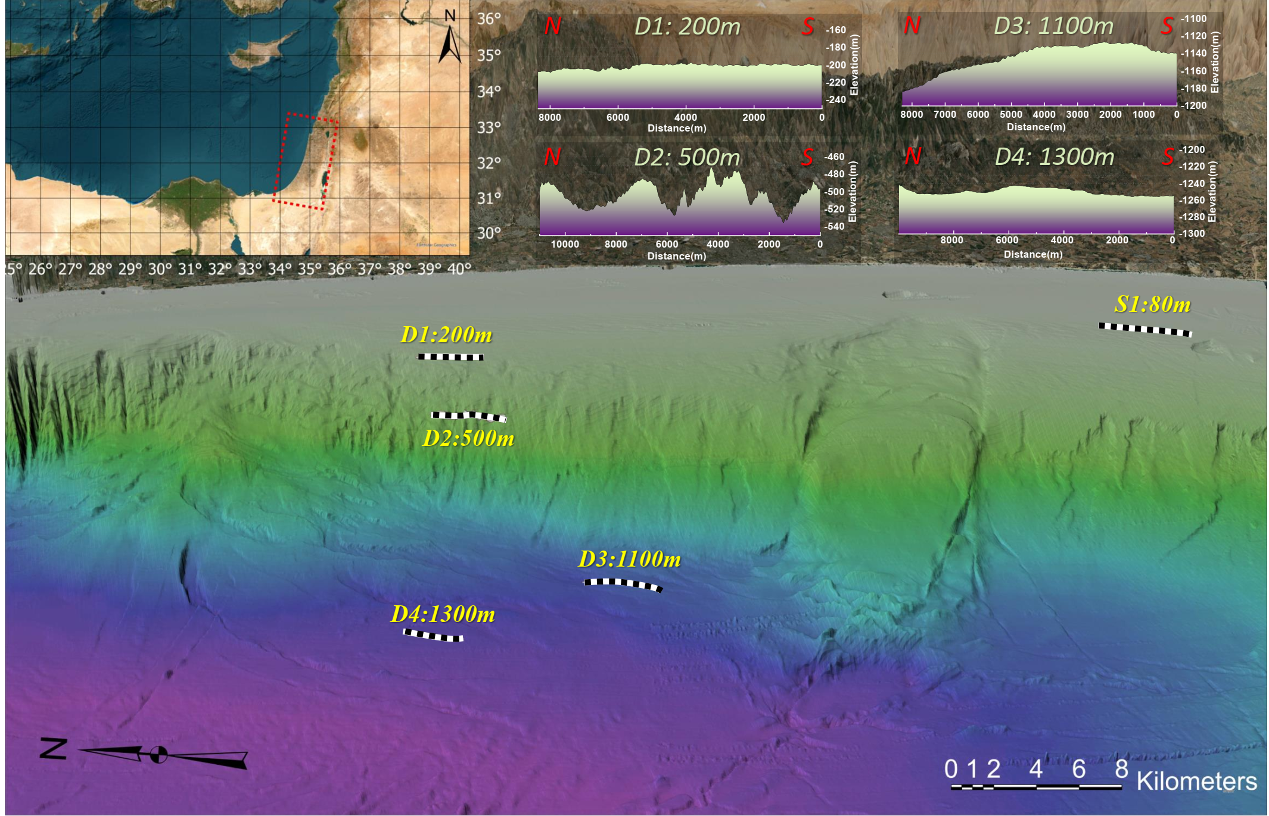

***Figure 1****. 3D mapping of the trawl surveys for bottom macro-litter. The bathymetric profiles of transects D1-D4 are listed at the top right of the figure.*

## In-situ Buoyancy test

Plastic bags with lengths over 10 cm were selected for the in-situ buoyancy test on the ship during the deep-sea survey (D1-D4). Briefly, samples were gently washed with the seawater to wipe off the sediment, which was collected during trawling, and then placed into a 100 litters plastic container filled with seawater. It was released from the middle of the container (~25cm water depth). The final position of the sample was noted after 30 seconds as positive buoyancy (Floating), at which the sample floated onto the water surface; neutral buoyancy (Suspending), in which the main part of the bag stayed in the water column (at least 10% area of the bag neither touch the water surface nor reach the bottom); negative buoyancy (Bottom sinking), in which the plastic bag deposited on the bottom the container. The density of seawater utilized in this buoyancy test was of ~1029.3 kg/m3 at the temperature of 15.6 ℃ 46

## Plastic bags classification

The plastic bags, separated from the bottom litter, were further characterized by size (2.5-10 cm, 10-30 cm, 30 cm <), shape (T-shirt – original pocket shape, open polygon- irregular polygon without a pocket structure, and strip-length-to-width ratio larger than 4:1, **Figure S1**), color, completeness (intact bags, torn bags, and pieces of a bags), attached biofilm (biofilm that extensively covered and darkened the bag, **Figure S2**), macro biota, etc. Additionally, the source of the food packaging was defined by the barcode.

## Procedure of sample processing in the lab

Samples that had passed the buoyancy test were kept individually and stored at 4℃ for further analysis (**Table 1**). Since only 8 samples fit the size standard from the 500 m transect, these were not included. Purchased new shopping bags were set as blank samples for each group and went through the whole procedure described in **Table S2**.

Selected plastic bags were washed with deionized water, dried in the oven at 40 ℃ for 48h, cut into 3 replicates (3*5, 4*8, or 5*10 cm2), and weighted using a balance with 5 digits. Then after, each sample was characterized for composition by Fourier Transform Infrared (FT-IR) Spectroscopy and rinsed in a petri dish covered by black tarps with diluted EOSIN staining agent (1% EOSIN aqueous solution in 50 ml 99% Ethanol). After 30 min, stained samples were gently washed three times using 99% Ethanol and dried in the oven at 40 ℃. After capturing the images of the stained samples (LEICA M205 C), each one of them was placed in a glass jar filled with 60 ml 35% peroxide solution (Chen Shmuel Chemicals. Ltd). The jars were kept in a 40 ℃ oven for 48 hours to peel off the adhesions from the plastic films 47. Following this digestion procedure, samples were washed with deionized water and dried. The hard tissue and mineral material in the resident solution were instructed by vacuum-filtration system using a cellulose filter with a pore size of 0.22 µm (Shanghai xin ya purification equipment Co.Ltd). Subsequently, the bleached plastic bags were weighed, measured with FT-IR, and concluded with a second buoyancy-test (similar to the 1st buoyancy test with seawater density of 1028.20 kg/m3 at the temperature of 19.3 ℃).

The mass of the removed adhesion (*Ma*) was calculated by the difference between the sample weight before and after H2O2 digestion. Considering the mass loss from trawling the sample from the seabed, each measured *Ma* is multiplied by a coefficient of 1.1. The mass of the hard matter (*Mh*, shell and sediment) refers to the matter peeled off from the plastic bag and collected by the microfilter **(Figure S14-18)**. Finally, the dry weight of the soft tissue (*Ms*) was given by the different between the two (equation 1.1). The adhesion concentration (AWPA, equation 1.2) and the soft tissue concentration (SWPA, equation 1.3) were calculated as the weight per surface area (Sp) in µg/mm2 units.







## Composition analysis using FT-IR spectroscopy.

The chemical composition of the samples, adhesion, and degradation were analyzed using Nicolet™ iS™ 5N FT-IR Spectrometer (Thermo-Fisher Scientific) in the transmission mode. The absorbance was taken in the region of 400 – 4000 cm-1 wavenumbers. Adaptive iteratively reweighted Penalized Least Squares (airPLS) has been used to correct baseline drift 48, to overcome baseline drifting problems that blurs or even swamps signals and distorting the profile intensities. Considering the complexity of marine litter composition, the FT-IR spectra were identified by three libraries (*Aldrich Condensed Phase Sample Library, Hummel Polymer Sample Library and HR Nicolet Sampler Library*). The matches with > 70% search score were accepted, while those with <70% were rejected and marked as unknown-polymer (NA).

## Statistics analysis

Chi-square was used for testing the differences in completeness and shape composition of plastic bags, as well as bags with CaCO3 addition among stations. The Kruskal-Wallis test was utilized to examine differences AWPA and SWPA of plastic bags distribution among the depths. Linear regression models with T-test were used to find out the relationships between the AWPA and SWPA of samples from each transect. Normality and homogeneity of variance were checked and the level of statistical significance was set to *p < 0.05*.

# Results and discussion

## The distribution of the bottom plastics

In total, 1399 bottom litter items were recorded across all 5 transects depths, but their composition and abundance were differently distributed from dive to dive. A “hot belt” of 5402±2185 items/km2 was detected at 200 m water depth, on the edge of the continental shelf (**Table 1**), which correlates with previous results in the area (**Figure S3**)37. On the other hand, the 500m concentration dropped significantly to 733±353 items/km2, which could be linked to the rough seabed at this depth (**Figure 1**), where bottom litter could be carried into and trapped in the submarine canyons 49-51. Considering its abnormally low abundance of bottom litters and unique bathymetry profile, data from 500 m water depth was not further discussed. In the deep-sea basin, the litter concentration of both the 1100 m (3359 items/km2) and the 1300 m transects (3566±125 items/km2) have surpassed the apex value of the past ten years, indicating the deep-sea basin is becoming another reservoir gathering the marine litter. However, as compared to the deeper transects, ultra-low bottom litter concentration at near-shore (80 m) shows that debris were continuously transported and accumulated in the deeper ocean.For

Our study site presents a high quantity of average bottom litter (2239±2141 items/km2) in the Mediterranean (**Table 1**), and the highest quantity in the deep sea (3462±146 items/km2). Moreover, the plastic litter fraction is extremely high (94.5±3.8% of bottom litter), surpassing any other bottom survey in the Mediterranean Sea, in which plastic bags (88.2±6.2% of bottom litter) were found prevailing (**Figure 2a**). In both 80 m and 200 m transects, the proportion of plastic bags in bottom litter has decreased, compared to the last ten years 37. However, for 1100 m and 1300 m, this ratio has increased from about 85% to 93%, and from about 75% to 90%, respectively, pointing that plastic bags are contributing to the major bottom litter increase in the deep-sea basin, and are the promptest litter to transfer further to the deeper sea.

***Table 1.*** *Comparison with other bottom trawl surveys conducted in the Mediterranean Sea.*

|  |  |  |  |  |  |  |
| --- | --- | --- | --- | --- | --- | --- |
| Location | Habitat | Year | Depth range (m) | Abundance of bottom litter | Plastic (%) | References |
| NW-Med (Murcian coast) | shelf | 2009 | 40-80 | (Medium) 43.05±65.07 pd/ha | ~79.32 | 52 |
| NW-Med (Catalan coast) | shelf | 2009 | 40-80 | (Medium) 97.61±  151.63 pd/ha | ~65.28 | 52 |
| NW-Med (Northern and Central Adriatic Sea) | shelf | 2014 | 0-100 | 913 ± 80 items/km2 | 80 | 53 |
| NW-Med (Gulf of Patti) | slope/bathyal | 2021 | 525–576 | 128.1 items/km2 | 64 | 36 |
| NW-Med (Gulf of Sant Jordi) | shelf | 2018 | 50-500 | 130 items/km2 | 77.8 | 54 |
| NW-Med (Gulf of Naples) | slope/bathyal | 2019-2020 | 400-600 | 1140 items/km2 | 82 | 55 |
| CW-Med (Sardinia) | shelf/bathyal | 2013-2019 | 0-800 | 29.8 items/km2 | 67 | 56 |
| NW-Med (Gulf of Lion) | shelf | 1994-2017 | 10-200 | 49.63 – 289.01 items/km2 | 40-62 | 57 |
| NW-Med (Corsica caost) | slope | 1994-2017 | 100-800 | 34.12 – 395.29 items/km2 | ~72 | 57 |
| NW-Med (Catalan coast) | Shelf/slope | 2019-2021 | 20-700 | 5.35 -13.75 kg/km2 | ~64.2 | 58 |
| SW-Med (Bay of Bejaia) | shelf | 2017-2020 | 40-200 | 125-594 item/km2 | 88 | 59 |
| SW-Med (Al Hoceima coast) | shelf | 2022 | 24-200 | 297-957 item/km2 | 57.15 | 60 |
| NE-Med (Iskenderun Bay) | shelf | 2009 | 10-100 | 450.94 item/km2 | 87 | 61 |
| NE-Med (Mersin Bay) | shelf | 2017 | ~20 | 2670 item/km2 |  | 62 |
| NE-Med (Antalya Bay) | shelf/slope | 2018 | 10-200 | 13.3 – 651.1 items/km2 | 71.2 | 63 |
| SE-Med (Offshore Israel) | Shelf/bathyal | 2012-2021 | 20-1700 | 85-5797 items/km2 | 86.0 shelf 89.9 deep stations | 37 |
| SE-Med (Offshore Israel) | **Shelf** | **2022** | ***80*** | ***250±39 items/km2*** | ***88.4±3.0*** | **This study** |
| **Slop** | ***200*** | ***5402±2185 items/km2*** | ***97.5±0.6*** |
| **Slop** | ***500*** | ***733±353 items/km2*** | ***98.2±2.5*** |
| **Bathyal** | ***1100*** | ***3359 items/km2*** | ***95.3*** |
| **Bathyal** | ***1300*** | ***3566±125 items/km2*** | ***93.2±0.3*** |

At 80 m transects, bags and wrappings were densely covered with macro-biota. Some of the shopping bags were entangled with ropes and vegetation stalks and probably from riverine source inputs, particularly in the winter when runoff discharge is high. Plunging of dense sediment-laden water (named ‘hyperpycnal flow’) initiates turbidity currents offshore the southeastern Mediterranean coast 64, 65 and probably can carry litter from river outlets into the deeper sea 66, 67. Macro-organism has been scarcely found on the bags collected in the deep station (≥200 m). A considerable number of bags from the 200 m were polluted with tar, while very few bags from the 1100 m, and none at the remaining stations. The bags from 1300 m had fine sediments attached (**Figure S9**). Besides plastic bags, polymer fibers were also distributed through almost all depths (**Figure S10-12**), particularly at 1300 m, where fishing nets and large bundles of plastic thread appeared (**Figure S12**). Beverage packaging and furniture patent leather were also found in this depth, suggesting the dense regional shipping lines may also be the source of bottom plastic bags which could be partially seaborne waste.

The production source of food/product packages was defined by the barcode embedded on them for only a very limited number of the litter found (2% of the bags found). The 200 m transect hotspot accumulated food packages from diverse sources (with number of bags): Israel (3), Egypt (4), Gaza strip (1) and Turkey (3); At 500m and 1100m, a bag from Egypt and Lebanon was found respectively; And at 1300m water depth, bags were found from Israel (1), Egypt (1) and Saudi Arabia (1) (**Figure S19**). The Egyptian manufacturer representation suggest that this southern source might play a role in plastic pollution in the study area 68.

## The characteristics of the plastic bags from the seabed

The plastic bags from the deep stations (200m, 500m, 1100m and 1300m water depth) were characterized for completeness, visible biofilm and shape, in addition to color and length, which was studied for the 80m depth as well. White or colorless was the predominant color of bags collected from the seabed, followed by black and blue, and they are all common colors for shopping and rubbish bags (**Figure 2b**). Most of the debris were in 2.5-10 cm length. However, ultra-large bags (>30) made up more than 10% of bags from each depth, and even 20% of that in the deep sea. In addition, the plastic debris previously collected from the Levantine sea-surface was in micro-scale (1.18±0.1mm) 68, suggesting that the large debris (>2.5 cm) could have a short resident time on the sea-surface. Therefore, there is likely a vertical size-gradient stratification in the water column.

The plastic bags were further defined by their completeness (**Figure 2d**), which presented a significant difference between depths (Chi-square, χ2: 176.720, *p<0.0001*), as well as when removing the 500 m (Chi-square, χ2: 137.656, *p<0.0001*). Torn bags (which were deformed but not broken into small pieces) almost uniformly distributed in a low percentage of around 4% at each depth. Indeed, as compared with other plastic products, bags & wrapping are more likely to be deformed and fragmented by the mixing of winds or currents. Whilst, the concentration of intact bags gradually decreases with depth from 200 m (10.9±1.5%) to 1100 m (8.5%), and further 1300 m (4.2±1.9%) (500m was excluded due to its different topography). The terrestrial source is considered as the major source (80%) of plastics released into the sea (Geyer et al., 2017). Therefore, this decrease trend in the intact bags could represent the weathering and fragmentation of the litter with distancing from the shore into the deep environment.

More than 50% of the plastic bags do not present an obvious biofilm (**Figure 2e)**. The “tipping point” of biofilm for sinking plastics was studied in the previous works 20, 21, 27, which proposed that sinking would not happen to the floating plastic until its surface was covered with intensive algae-fouling. However, the observed biofilm density on our bottom litter seems much lower than any of the previously proposed “tipping point” (**Figure S6-S9**). This could be generally linked to the ultra-low chlorophyll-a in the water surface of the study area 28, which results in the low biofouling accumulation rate.

A significant association has found between four depths and the composition of plastic bags according to shape (Chi-square, χ2: 280.022*, p<0.0001*), as well as between three depths (excluded 500m) (Chi-square, χ2: 277.093*, p<0.0001*). The most common shape of the plastic bags was an open polygon, as followed by the strip shape (**Figure 2f)**. was obtained. From 200 m to 1100 m water depth the concentration of the T-shirt decreased from 336±263 items/km2 (6.6±1.6%) to 172 items/km2 (5.5%), and further dropped to 31±25 items/km2 (1.0±0.6%) at 1300 m. This reveals that as similar as the distribution of intact bags, T-shirt bags had a decreasing trend with increasing distance from the shore. The pocket shape endows bags the priority in sinking by gathering the suspended sediments, resulting in its decrease with distancing from the shore. It is possible that T-shirt bags found in the deep-sea of 1100 m and 1300 m are partially seaborn waste.

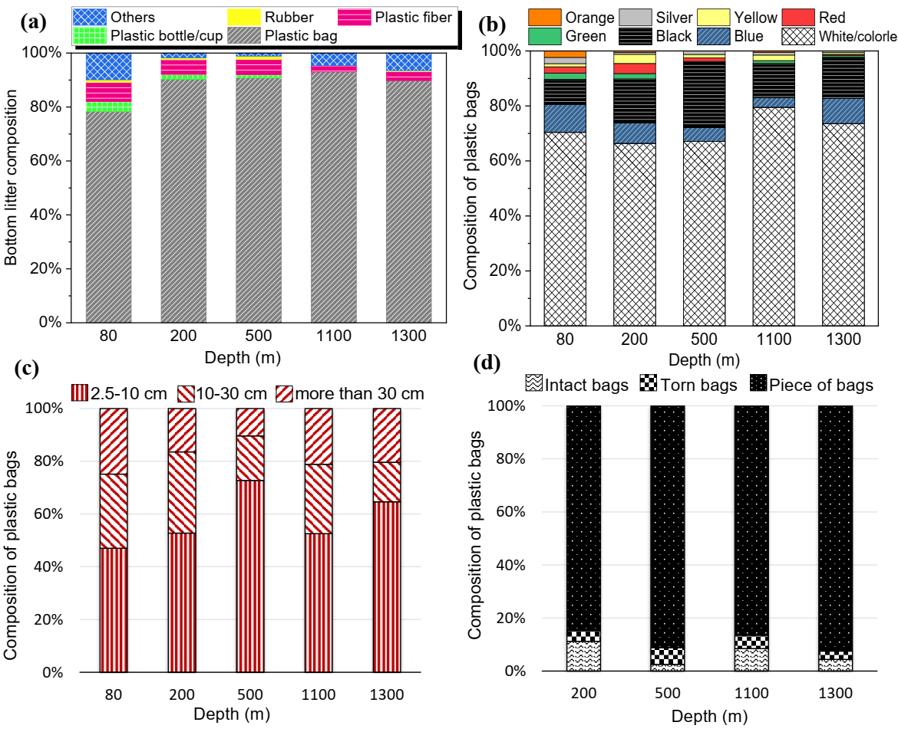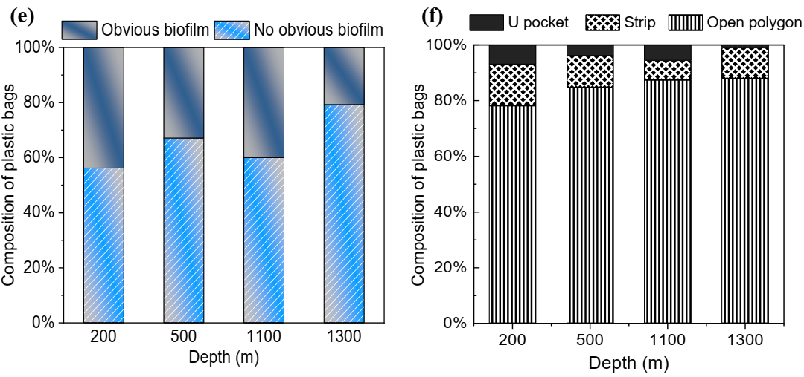

***Figure 2****. The relative contribution of bottom litter for each study depth by composition (a); and the bottom plastic bags separated by categories of color (b), length (c), completeness (d), attached visible biofilm © and shape (f).*

## Chemical composition of the plastic bags by FT-IR analysis

Polyethylene (PE) was the most common polymer type found in the studied samples (n=122), accounting for 81.1% of the plastic bags (**Figure 3a**), then followed by unrecognized plastics (NA) (9.8%) and PP (7.3%). Only one PVC and one PA6 bags were found at 1100 m, which could be seaborn waste owing to their high density 69. It has been reported that 44.8% of the produced plastic used for packaging is primarily composed of PE, PP and Polyethylene terephthalate (PET) 1. However, PET bags were not found in our bottom survey. This ‘missing PET’ in our study area could be linked to its ester bonds, which could be easily chemical depolymerized or hydrolyzed in nature 70, 71. The absence of PET debris was not only discerned in our research, but also in the Mediterranean Sea surface 72 in the Eastern Mediterranean beaches 73, 74. Some of the polymers like PET could be hydrolyzed at the easter bonds 75. While, polyolefins (especially for PE) are extremely hard be degraded on the sea-bottom 76 and will remain with macro-scale on the deep-sea basin for even centuries 77, 78.

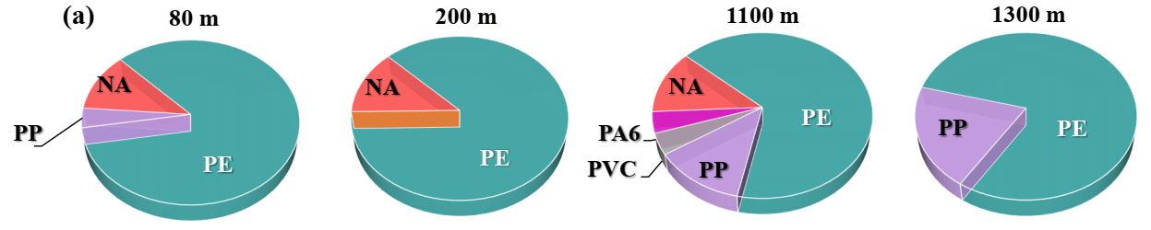

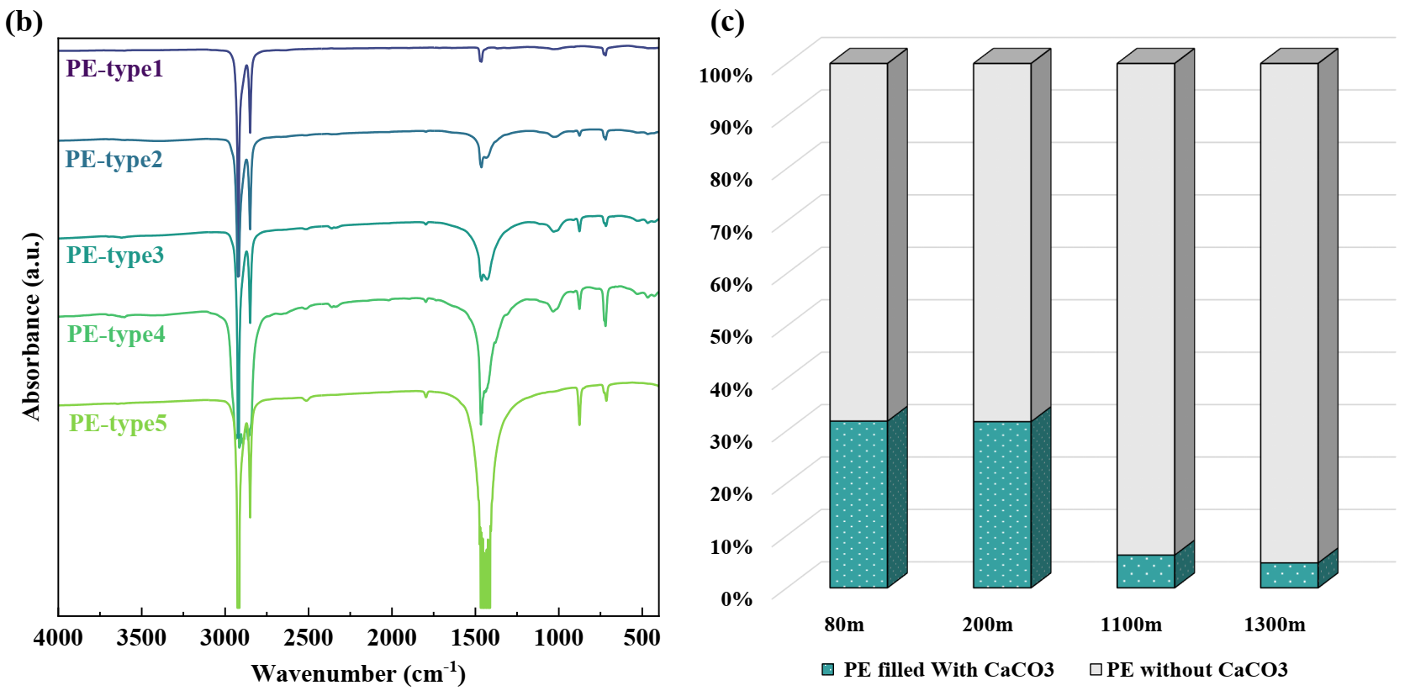

***Figure 3.*** *Polymer composition of the bags (>10 cm) from different depths :80m (n=26), 200m (n=47), 1100m (n=24), 1300m (n=25) (a). FT-IR spectra of different types of PE samples (b) and Composition of the PE bags with and without CaCO3 (according to the FT-IR analysis) (n=122) (c).*

PP and PE are less dense than water, making them potentially suitable for long-distance transportation in the ocean’s surface 79. 80 found that the relative abundance of low-density polymer is highest in the open sea surfaces and lowest in the subsurface water. However, the proportions of light-weight benthic plastics (PP and PE) obtained in this study (88.5%) are somehow consistent with their distribution at the sea surface (85-95%) as indicated by previous studies 44. Apparently, polyolefins dominate the bags from near-shore to the deep-sea seafloor, implying that there are several gaps in our knowledge on factors, other than density, that determine the spatial distribution of these plastic bags.

Four peaks were marked as the characteristic peaks of PE: 2915 cm-1 (C-H2 asymmetrical stretching), 2851 cm-1(C-H2 symmetrical stretching), 1465 cm-1 (C-H2 bending), and 718 cm-1(C-H2 rocking) (**Figure 3b)**81, 82. The major difference between different types of PE appears the intensity of the peak locates in 1470-1400 cm-1, which indicates the various concentration of calcium carbonate (CaCO3). Besides, CaCO3 could also be validated by the appearance of several other characteristic peaks at 876, 1796 and 2515 cm-1 83. Since the most distinguishable peak encompasses the intrinsic characteristics peaks of PE, rendering the exact addition of CaCO3 inauthentic as determined by FT-IR spectra. However, there is a significant decrease in the percentage of PE bags with CaCO3 from the continental shelf to the deep sea (**Figure 3c**), which was statistically significant (Chi-square, χ2: 82.208, *p<0.0001*). As a much denser filler 84 extensively used in the PE shopping bags 85, 86, CaCO3 could deteriorate the buoyancy of the plastic bags and restrict their transport pathway and final location in the ocean. Actually, the inherent density (polymer together with fillers) is not the exclusive factor determining the buoyancy of the plastic bags, encountering organic and inorganic matter could bring them to sink.

## Adhesion of organic and inorganic matter on the plastic bags.

Quantitative analysis of adhesion features has been carried out by assessing the weight of the attached matter for soft tissue, that consisted of tar and biofilm, and for hard matter, which included sediment and shell. Notably, a large number of tar-adhered samples were characterized at the 200 m transect (**Figure S6**). These tar-adhered samples were removed from the samples for biofilm analysis. The distribution of biofouling weight per unit area (SWPA) was similar to the distribution of total adhesion weight per unit area (AWPA) (**Figure S20, Figure 4a**). In general, SWPA and AWPA was relatively low in the SE-Med. 91.3% samples possessing biofilm less than 3 µm/mm2, and 86.5% samples with adhesion lower than 3 µm/mm2 (n=327). Significant difference has been found both for SWPA (Kruskal-Wallis test, *p<0.0001*) and AWPA (Kruskal-Wallis test, *p<0.0001*) between the depths. The largest interquartile range appeared at near shore coastal water at 80 m depth (n=78), and its mean and median values surpassed those at deeper depths, which could be the result from being closest to the shoreline and in the photic zone 87-89. Following was the 200m transect (n=83) with the highest mean and median value among the deep transects. Moreover, a few macro-scale organisms were attached to the samples at this depth (**Table S3**). There was a very narrow spread in 1100m and 1300m, and their median and average value of SWPA are similar. Several studies have revealed that northward currents dominate the flow along the Levant margin in the Se-Med 88, 90, 91, where the seawater is highly stratified. The high temperature and saline Levant Surface Water (LSW) and Atlantic Water (AW) alternatively occupy the 80m depth continental -shelf, and the chlorophyll fluorescence concentration is much higher than other deeper stations in this study in most of the year. Below, the 200m transect is dominated by Levantine Intermediate Water (LIW), which originated southeast of Crete 92. The Chl-a concentration decreases at this depth, but still much higher than the deeper zone. The transects in the Bathypelagic zone (1100 m and 1300 m) are located within the Eastern Mediterranean Deep Water (EMDW), which has the lowest dissolved oxygen and Chl-a concentration in the Levantine Basin 87, 93. Thus, it is suggested that there is a positive correlation between the average adhesion surface density of seafloor plastic bags and the Chl-a concentration. Nevertheless, this can only be characterized as an overall trend along the continental slope, since these stratified inhabitant zones may be vertically mixed by periodic gravity-driven flows 94. Whereas if the various rate of benthic decomposition and remineralization processes 95, 96 were taken in the consideration, the scenario of adhesion development would be more complicated.

Linear correlations were found between biofilm (SWPA) and overall attachment volume (AWPA) for each depth, as shown in **Figure 4b.** The slope of the linear fit decreased with water depths. Nevertheless, in the case that AWPA was less than 1.5 µm/mm2, the slope was close to 1 for both 200 m and 1100 m depths *(for 200m, y = 1.0414x + 0.169, R² = 0.6321; for 1100m, y = 1.0653x + 0.248, R² = 0.6723)*. It is assumed that, at each depth, there is a minimum biofilm concentration for additional adhesion of inorganic and hard matter (1 µm/mm2 for 200m, and 1.2 µm/mm2 for 1100 m, and >2 µm/mm2 for 1300 m). Actually, it has been reported that biofouling on plastic is a gradual buildup of organic matter and organisms 32. Stimulated by hydrophobicity of plastic surface, organic substances are rapidly adsorbed, creating a “conditioning film” 30, following by bacterial colonization and microalgal growth, and eventually sharing space with colonizing invertebrates 32, 97. The organic matter plays an important role on altering the surface tension, charge density and roughness of the plastic surface 98-101, providing a more favorable surface for the settlement of other organic and inorganic matter. In our case, the sufficient organic matter is prerequisite for the settlement of shells and minerals 20, 102, 103, and it seems that more biofouling is needed in water environment with lower biomass abundance. This is also proved by that no such biofilm threshold was identified at the depth of 80 m.

The Levant Basin was found to be a “hotspot” for oil pollution risk, due to the potential combination of factors, such as regional political instability hindering marine environmental surveillance, extensive coastal oil facilities attracting large numbers of tankers, and the lack of regional cooperation between countries 104, 105. Plastic waste is inevitably contacted with spilled oil when it floats on the sea surface or settles on the tar-contaminated coast. The high concentration of plastic bags contaminated with tar (**Figure 4d**) at the 200 m seabed might be associated with the serious 2021 Mediterranean oil spill 106, 107. The extensively adhered tar makes samples from 200m present a more complex adhesion condition. In **Figure 4c**, two groups can be divided by samples with and without the adherence of tar. The sediment absorbed by tar is significantly greater than that of only biofilm for a given quantity of SWPA, especially beyond the SWPA of 2 µm/mm2. Attributing to the hydrophobicity, organic pollutants, like Polychlorinated biphenyls (PCBs), polycyclic aromatic hydrocarbons, polybrominated diphenyl ethers 108, and tar, could be easily absorbed on the plastic surface 109. Tar will increase the roughness and decrease surface tension of the plastic bags, resulting in higher rates of biofilm adhesion and community succession 27, 29, 110. Instead of the gradually colonized biofilm, the interaction with tar might play an essential role in the fast-sinking mechanism of plastic bags at the 200 m transect.

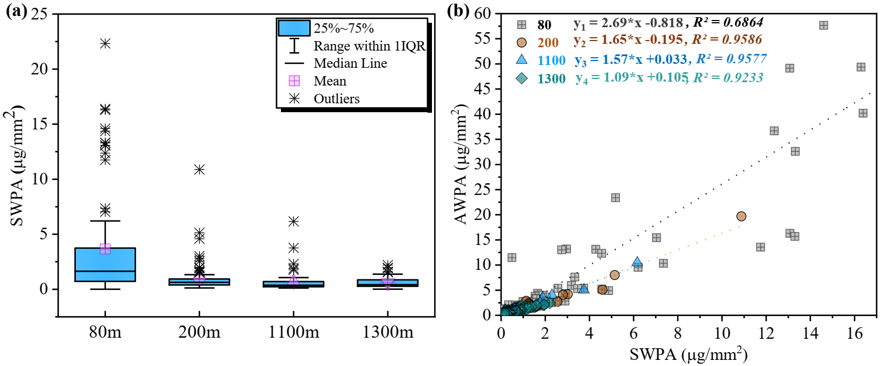

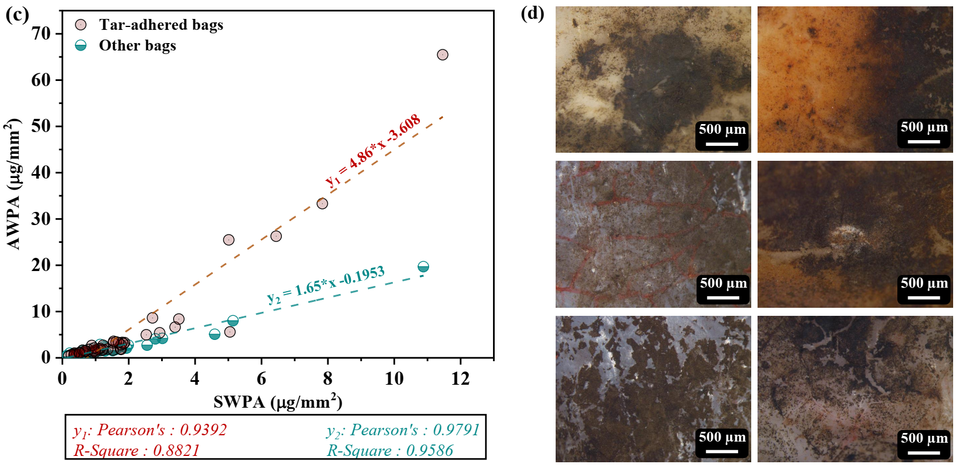

***Figure 4.***Box-plots representing the distribution of soft tissue weight per unit area (SWPA) in each transect (n=286) (a); *Relationships between SWPA* *and total adhesion weight per unit area (AWPA) on the plastic bags from 80m (n=78, p<0.0001), 200m (without tar-adhered samples) (n=83, p<0.0001)**, 1100m (n=60, p<0.0001), 1300m (n=65, p<0.0001) (samples with AWPA lower than control sample were removed) (b);adhesion distribution of 200m separated by tar-adhered samples (n=51, y1: p<0.0001) and other samples (n=83, y2: p<0.0001)(c);Images of tar-adhered plastic surface (d).*

## Re-transport capacity of the bottom plastics from deep-sea survey

Plenty of previous studies focus on the effect of incubating biofilm on changing plastic buoyancy, but few on testing the buoyancy of plastic directly collected from the seafloor 15, 17, 18, 20, 22, 27, 32, 101. Here, we investigated how plastic’s buoyancy is influenced by its chemical composition and surface adhesion. A significant proportion of the samples across all depths regain positive buoyancy as they were collected from the seabed and after mildly washed by DI water (**Figure 5**). Around 52% of the samples were marked as floating or suspending from the pelagic area (1100 and 1300 m) and 61.7% from the continental shelf (200 m). The primary cause of the sinking of plastics remains uncertain, due to the knowledge gap on the time frame during which the plastics remain on the seafloor, which makes it challenging to accurately estimate the extent of biofilm degradation on the surface of the plastics. However, it can be reasonably concluded that these plastics remained on the seafloor due to the continuous buildup of overlying sediments. At the same time, when facing strong bottom currents that resuspend the covered sediments, primarily during the Israeli winter 111, these debris, mostly in the shape of open polygon and had been fragmented into pieces, could be re-distributed. Additionally, special intermediate nepheloid layers with high interpolated turbidity at the edge of continental shelf could also be initiated by the winter storms 112. This seasonal sediment transport can annually redisperse plastic debris towards the continental slope and deep basin 113, 114. Therefore, the continental shelf area is subjected to periodic re-transportation, which can serve as a downslope transportation vector. On the contrary, the mean annual current speed in the deep basin (1300 m) was 3.5 cm s-1 with a maximum-recorded velocity of 12.6 cm s-1 112, which is generally considered insufficient to trigger resuspension of seafloor silts and clays if the current is unidirectional 115. Thus, bottom plastic debris that reached the deep basin would stay and accumulate there. The “hot belt” of bottom litter recognized in this study at the 200m transect may be considered as a “transfer stop” instead of terminus for these highly accumulated plastic debris, while 1100m transect could be one of the receiving stations. The deep-sea basin is supposed to be the “final sink”, where the plastic debris gradually accumulate (**Figure S3**).

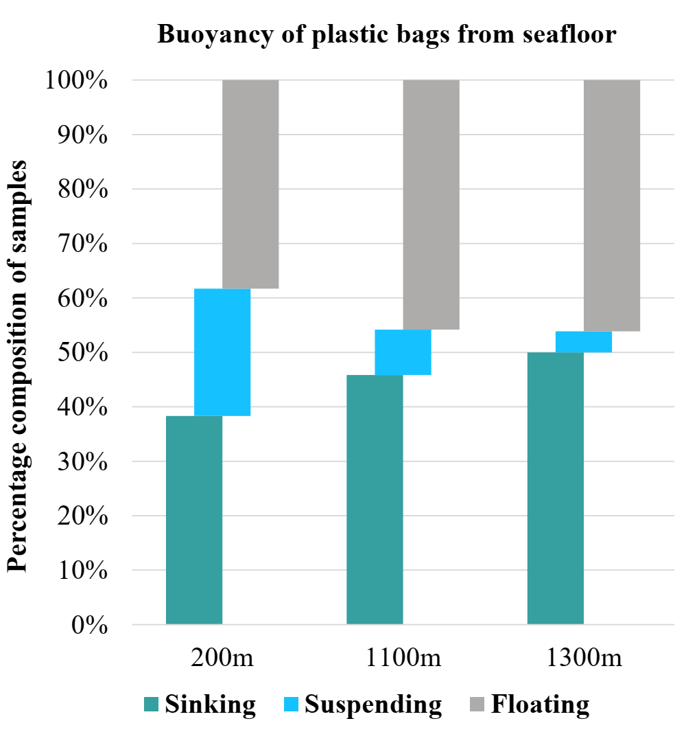

***Figure 5****. Buoyancy state of the plastic bags from deep cruise (n = 104).*

In order to study the factors affecting the sinking of the plastic bags, the buoyancy state of each sample was recorded both before and after the digestion process. The results showed that the lightweight plastic bags (80%) increased their buoyancy after digestion, meaning that the surface attachments were the decisive factor in their sinking (**Figure 6**). PE samples is distributed in such a broad range, which were separated into two groups: PE and PE (with CaCO3 filler) according to the FT-IR analysis. In **Figure 6c**, 41.2% of PE and 75% for PE (with CaCO3) sank in the in-situ buoyancy test on the ship. The average AWPA of NA (after moving the outlier of 41.6 µm/mm2, Ave: 2.86±2.26 µm/mm2) is generally higher than that of PP (Ave: 0.42±0.22 µm/mm2), but there is still 60% of NA floated in the first test. The buoyancy of all types of plastics demonstrated a recovery following the digestion process, with the exception of PA6 and PVC (**Figure 6f**), which were inherently denser than seawater. In addition, while all of the PE left from the sinking state, about 69% PE (with CaCO3) did not recover to the positive buoyancy, showing the CaCO3 indeed deteriorates the buoyancy of PE. All NA were recovered into the positive buoyancy, indicating that NA is inherently lightweight plastic. It appears that the settlement of these lightweight samples was significantly influenced by the adhesions. However, the impact of adhesions on the buoyancy of plastic bags may vary depending on their density, shape and size 25, 116, 117, which is a more intricate discussion.

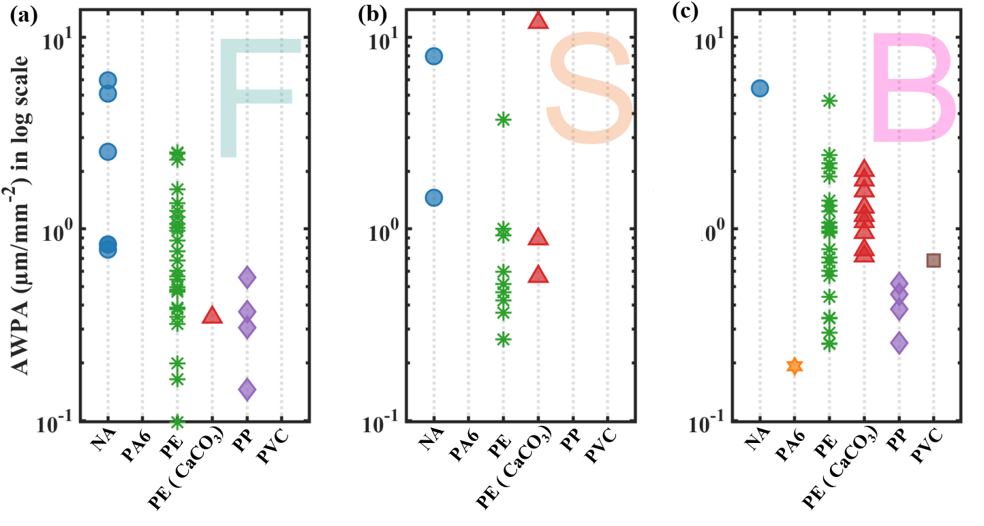

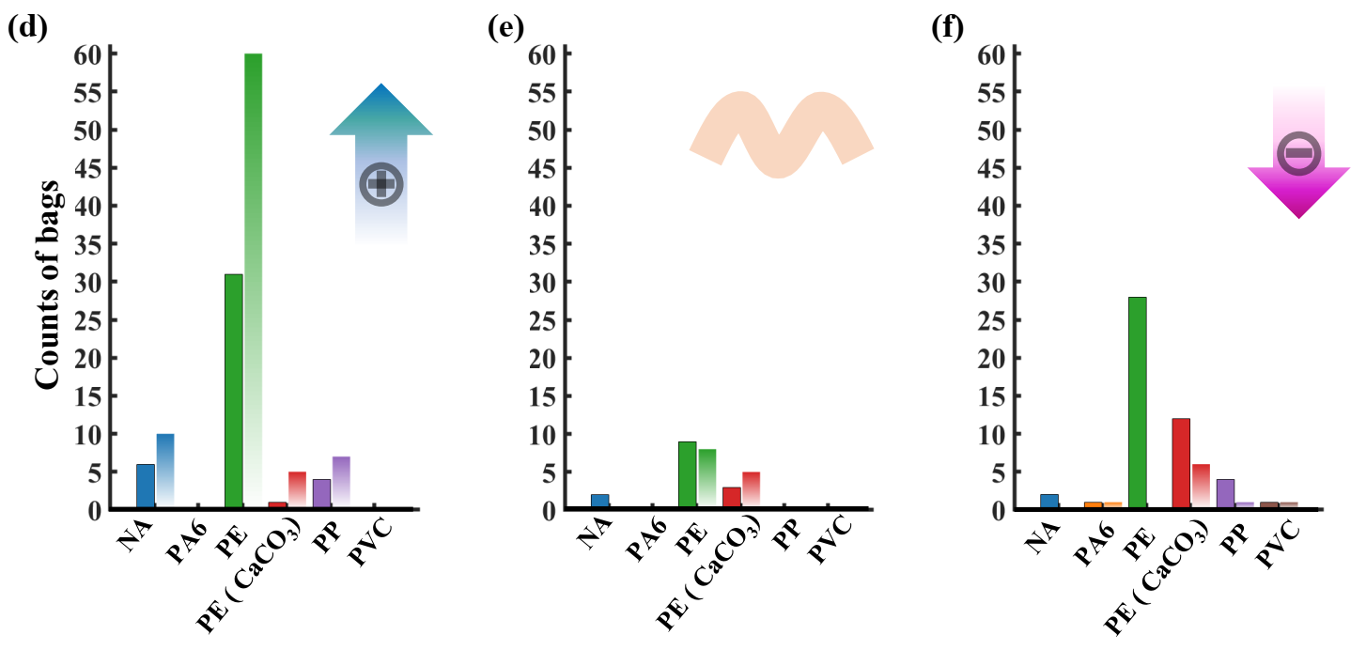

***Figure 6.*** *AWPA distribution in each composition category of plastic bags before digestion, separated by buoyancy state of (a) Floating, (b) Suspending and (c) Bottom sinking; counts of the bags of each composition category separated by buoyancy states of (d) Floating, (e) Suspending and (f) Bottom sinking before (single filled bar) and after digestion (gradient filled bar) (red arrow marks the trend of the counts of each composition after digestion).*

## Possible sources and trajectories of the plastic litter in the SE-Med

According to a recent simulation, the Mediterranean Sea, which has been predicted to accumulate the highest concentration of floating plastics, accounts for 21% - 54% of global plastic particles and 5% - 10% of the global plastic mass 118. This outcome is mainly due to the outflow of runoff water, densely populated coastline, intensive fishing, shipping, and industrial activities that contributes substantial amounts of marine litter to the Mediterranean basin. PE predominantly contains 52% of the total plastics captured from western Mediterranean surface water, followed by PP (16%) 119. The residence time of plastics on the ocean surface is estimated to be relatively short (about 7-60 days) in the Mediterranean Sea 79, 120, and which further reduced in litter item or film with a high surface-to-volume ratio 29, 31. Compared to other shapes like fiber and sphere, film, which has the highest surface-to-volume ratio, was estimated to have the shortest time for fouling up by biota to the water density 121. This could lead plastic bags to rapidly sink to the seabed probably in less than a few days. The sinking velocity can be accelerated in the bags with special shape like T-shirt due to gathering of the suspended sediments. The existence of relatively large size and even some intact bags provided evidence to this assumption.

On the contrary, the ultra-oligotrophic condition 122 and relatively low concentration of planktons in the surface SE-Med, could generate the stratification of plastic litter based on shape and size. Except to bags & wrappings, other products which have more spherical-like morphology or higher thickness, like cups, bottles and sheets, seem not to accumulate sufficient biofouling to their tipping-point of sinking. This could explain the ultra-high portion of plastic bags & wrappings in all plastic litter from our studied seabed. Two ways of the plastic transportation have been thus conceived. The 1st is that discard plastic cups, bottles and sheets around SE-Med will keep drifting on the sea-surface for a relatively long period until they reach and strand on the coast, where they would be quickly fragmented into microplastic debris owing to UV-B radiation 76, 97(which is considered to be the primary factor for degradation of most plastics in marine environment 123). These microplastics either stay on the beach and further degrading into nano-size, or will be washed back into the water. The 2nd idea is that the discarded bags will be carried in the water column and easily sink to the seafloor though encountering biofouling or sediments. After passing several re-transport events, they will accumulate on the deep-sea seafloor in macro-scale for a century long78.

Since the resident time of bottom litter on the seafloor remains unknown, the signal of biofouling grown on the plastics is blurred. It is hard to deduce the main factor responsible for their primary sinking. The complexity of dynamics and trajectories of these debris could be ascribed as the conjugating results interfered by multiple physical and biochemical processes. However, the variable distribution pattern from the continent shelf to the deep sea enable us to propose different vertical transport scenarios based on the distance from coastline. Sediment fluxes could be one of the mechanisms responsible for settling bags on the continental shelf. At the outer continental shelf, plastic bags could be intensively mixed with sediments carried by river discharge in the winter 37, 112, 124 and be transported down slope in gravity and bottom currents. For instance, we collected torn bags tied with stem washed out from the river. Owing to their high surface-to-volume ratio and original T-shirt structure, these plastic bags are highly susceptible to sedimentation, which alters their buoyancy from positive to negative. At 200m, this similar process is dominated by an intermediate nepheloid layer that is also active in the winter 112.

Marine vessels are expected to contribute a significant proportion of the waste to the 1100m and 1300m depths, which can be supported by the collection of PA6 and PVC bags, as well as glasses and building materials from these depths (**Figure S12**). The other possible pathways from land sources to the deep sea included direct settling of floating plastics from the surface waters to the deep seafloor and plastic litter which briefly stayed on the continental shelf and slope and then was re-transported by gravity and bottom currents into the deep basin. The presence of bags with macrofauna and high degree of AWPA (>2 µm/mm2) at the 1100m depth suggest that they originated from the “transfer station” on the continental shelf.

Moreover, the sinking of plastics in deep sea could be probably linked to the complex large cyclonic circulation in the SE-Med. The continuous strong Libyan-Egyptian current flows from the Egyptian coast into the Levant Basin and keeps spreading along the coast until it arrives the Turkish coast. Plastic wastes can be transported by this current and suppressed by an intense, shore-directed, Stokes drift when they enter into the Levant basin 68, 79. Indeed, a significant proportion of food packaging from Gaza and Egypt was discovered in the deep-sea seafloor in conjunction with the plastic bags. Floating plastics are likely to be trapped in the coupling system constituted with Cyprus anticyclonic Eddy and Shikmona Eddies (divided to the North Shikmona Eddy and South Shikmona Eddy) 125, 126, generating an isolated plastic sink from other sub-basins in the Mediterranean Sea 44, 127. This uniqueness further reflects at our study area in an extremely low PP/PE ratio of 0.091 (n=122). This value is not only far below that of debris (0.31) from the Mediterranean Sea surface water 68, but lower than value determined in a series of studies on bottom litter 80, suggesting the SE-Med could be an isolated plastic sink.

# Conclusion

Large amounts of plastic debris, especially bags &wrappings, have been discovered on the seabed of the SE-Med in the recent years. This study found a rising trend of bottom litter at a variety of water depths, meaning that the bags are continuing to accumulate in the SE-MED bottom.  Plastic bags were mainly lightweight (PE and PP), macro-scale pieces (2.5-10 cm), and white/colorless. Intact bags and T-shirt bags portion decreased from the continental shelf to the deep sea, representing a process where the shape of the bag increase its potential to be subjected to sediments and macro biota trap, which will keep it on the bottom. The PE bags filled with calcium carbonate fillers represents a local source, due to its high density, which decreased from the continental shelf to the deep sea.

A noticeable decline in the number of attached macro-organisms on the plastic bags with depth has been observed. The similar trend appeared in biofilm distribution, in which the mean and median SWPA decrease from the continental shelf to the deep sea. Affected by the biomass concentration, shells and sediments were prone to be absorbed on the bags settled on the coastal area, and kept decreasing through the slope. A large number of tar-attached plastic bags were found only on the edge of continental shelf (200 m), which might be related to an oil spill that occurred in 2021. Tar facilities the attachment of minerals and colonization of macrofauna, which could rapidly remove plastic bags from the sea surface. More than 50% of the plastic bags did not sink in the in-situ buoyancy test and more than 80 % had adhesion lower than 3 µm/mm2which points out that turbidity currents plays an important role in keeping the bags on the seabed and transferring them to the deeper stations, until they reach their terminal accumulation site.

The buoyancy of plastic bags can be more easily regulated through biofilms, which has led to their dominance in the bottom litter. The sources of plastics found on the deep seafloor could be more diverse than those found on the continental shelf. They may result from direct sinking of land-based plastics after drifting, re-transport of land-based plastics which primarily deposited on the continental shelf, and seaborn plastic.

Our study demonstrated the meaning of acquiring and analyzing several series of parameters such as shape, size, completeness, adhesion degree, composition, etc. These results assist in formulating reliable assumptions regarding plastic dynamics and in predicting the subsequent transport of bottom plastic. Advanced analyses are required to enhance our understanding of the ambient aquatic environment in which they settled and their resident time on the seafloor.

**Acknowledgement:**

We thank for Dr. Mor Kanari for offering the GIS data

**Funding Source:**

This work was funded by Israel’s National monitoring Program of the ocean and a fellowship from the Strauss Department of Marine Geosciences at the Charney School of Marine Sciences, the University of Haifa.

# References

(1) Geyer, R.; Jambeck, J. R.; Law, K. L. Production, use, and fate of all plastics ever made. *Science Advances* **2017**, *3* (7), e1700782. DOI: doi:10.1126/sciadv.1700782.

(2) Jambeck, J. R.; Geyer, R.; Wilcox, C.; Siegler, T. R.; Perryman, M.; Andrady, A.; Narayan, R.; Law, K. L. Plastic waste inputs from land into the ocean. *Science* **2015**, *347* (6223), 768-771. DOI: doi:10.1126/science.1260352.

(3) Ivar do Sul, J. A.; Costa, M. F. The present and future of microplastic pollution in the marine environment. *Environ Pollut* **2014**, *185*, 352-364. DOI: 10.1016/j.envpol.2013.10.036 From NLM Medline.

(4) Haarr, M. L.; Falk-Andersson, J.; Fabres, J. Global marine litter research 2015-2020: Geographical and methodological trends. *Sci Total Environ* **2022**, *820*, 153162. DOI: 10.1016/j.scitotenv.2022.153162 From NLM Medline.

(5) Deudero, S.; Alomar, C. Mediterranean marine biodiversity under threat: Reviewing influence of marine litter on species. *Mar Pollut Bull* **2015**, *98* (1-2), 58-68. DOI: 10.1016/j.marpolbul.2015.07.012 From NLM Medline.

(6) Kaandorp, M. L. A.; Lobelle, D.; Kehl, C.; Dijkstra, H. A.; van Sebille, E. Global mass of buoyant marine plastics dominated by large long-lived debris. *Nature Geoscience* **2023**, *16* (8), 689-694. DOI: 10.1038/s41561-023-01216-0.

(7) Bonanno, G.; Orlando-Bonaca, M. Ten inconvenient questions about plastics in the sea. *Environmental Science & Policy* **2018**, *85*, 146-154. DOI: 10.1016/j.envsci.2018.04.005.

(8) Woodall, L. C.; Sanchez-Vidal, A.; Canals, M.; Paterson, G. L.; Coppock, R.; Sleight, V.; Calafat, A.; Rogers, A. D.; Narayanaswamy, B. E.; Thompson, R. C. The deep sea is a major sink for microplastic debris. *R Soc Open Sci* **2014**, *1* (4), 140317. DOI: 10.1098/rsos.140317 From NLM PubMed-not-MEDLINE.

(9) Van Cauwenberghe, L.; Vanreusel, A.; Mees, J.; Janssen, C. R. Microplastic pollution in deep-sea sediments. *Environ Pollut* **2013**, *182*, 495-499. DOI: 10.1016/j.envpol.2013.08.013 From NLM Medline.

(10) Vegter, A. C.; Barletta, M.; Beck, C.; Borrero, J.; Burton, H.; Campbell, M. L.; Costa, M. F.; Eriksen, M.; Eriksson, C.; Estrades, A.; et al. Global research priorities to mitigate plastic pollution impacts on marine wildlife. *Endangered Species Research* **2014**, *25* (3), 225-247. DOI: 10.3354/esr00623.

(11) Onink, V.; Jongedijk, C. E.; Hoffman, M. J.; van Sebille, E.; Laufkötter, C. Global simulations of marine plastic transport show plastic trapping in coastal zones. *Environmental Research Letters* **2021**, *16* (6). DOI: 10.1088/1748-9326/abecbd.

(12) Koelmans, A. A.; Kooi, M.; Law, K. L.; van Sebille, E. All is not lost: deriving a top-down mass budget of plastic at sea. *Environmental Research Letters* **2017**, *12* (11). DOI: 10.1088/1748-9326/aa9500.

(13) Clark, J. R.; Cole, M.; Lindeque, P. K.; Fileman, E.; Blackford, J.; Lewis, C.; Lenton, T. M.; Galloway, T. S. Marine microplastic debris: a targeted plan for understanding and quantifying interactions with marine life. *Frontiers in Ecology and the Environment* **2016**, *14* (6), 317-324. DOI: 10.1002/fee.1297.

(14) Andrady, S. Y. a. A. L. Fouling of Floating Plastic Debris Under Biscayne Bay Exposure Conditions. *Marine Pollution Bulletin* **1991**, *22* (12), 608-613.

(15) Lobelle, D.; Cunliffe, M. Early microbial biofilm formation on marine plastic debris. *Mar Pollut Bull* **2011**, *62* (1), 197-200. DOI: 10.1016/j.marpolbul.2010.10.013 From NLM Medline.

(16) Kowalski, N.; Reichardt, A. M.; Waniek, J. J. Sinking rates of microplastics and potential implications of their alteration by physical, biological, and chemical factors. *Mar Pollut Bull* **2016**, *109* (1), 310-319. DOI: 10.1016/j.marpolbul.2016.05.064 From NLM Medline.

(17) Long, M.; Moriceau, B.; Gallinari, M.; Lambert, C.; Huvet, A.; Raffray, J.; Soudant, P. Interactions between microplastics and phytoplankton aggregates: Impact on their respective fates. *Marine Chemistry* **2015**, *175*, 39-46. DOI: 10.1016/j.marchem.2015.04.003.

(18) Jalon-Rojas, I.; Romero-Ramirez, A.; Fauquembergue, K.; Rossignol, L.; Cachot, J.; Sous, D.; Morin, B. Effects of Biofilms and Particle Physical Properties on the Rising and Settling Velocities of Microplastic Fibers and Sheets. *Environ Sci Technol* **2022**, *56* (12), 8114-8123. DOI: 10.1021/acs.est.2c01302 From NLM Medline.

(19) Kooi, M.; Nes, E. H. V.; Scheffer, M.; Koelmans, A. A. Ups and Downs in the Ocean: Effects of Biofouling on Vertical Transport of Microplastics. *Environ Sci Technol* **2017**, *51* (14), 7963-7971. DOI: 10.1021/acs.est.6b04702.

(20) Chen, X.; Xiong, X.; Jiang, X.; Shi, H.; Wu, C. Sinking of floating plastic debris caused by biofilm development in a freshwater lake. *Chemosphere* **2019**, *222*, 856-864. DOI: 10.1016/j.chemosphere.2019.02.015.

(21) Liu, S.; Huang, Y.; Luo, D.; Wang, X.; Wang, Z.; Ji, X.; Chen, Z.; Dahlgren, R. A.; Zhang, M.; Shang, X. Integrated effects of polymer type, size and shape on the sinking dynamics of biofouled microplastics. *Water Res* **2022**, *220*, 118656. DOI: 10.1016/j.watres.2022.118656 From NLM Medline.

(22) Miao, L.; Gao, Y.; Adyel, T. M.; Huo, Z.; Liu, Z.; Wu, J.; Hou, J. Effects of biofilm colonization on the sinking of microplastics in three freshwater environments. *J Hazard Mater* **2021**, *413*, 125370. DOI: 10.1016/j.jhazmat.2021.125370.

(23) Ashar, M.; Fraser, M. A.; Li, J.; Wang, C.; Huang, W.; Zhang, D.; Zhang, C. Interaction between microbial communities and various plastic types under different aquatic systems. *Mar Environ Res* **2020**, *162*, 105151. DOI: 10.1016/j.marenvres.2020.105151 From NLM Medline.

(24) He, S.; Jia, M.; Xiang, Y.; Song, B.; Xiong, W.; Cao, J.; Peng, H.; Yang, Y.; Wang, W.; Yang, Z.; Zeng, G. Biofilm on microplastics in aqueous environment: Physicochemical properties and environmental implications. *J Hazard Mater* **2022**, *424* (Pt B), 127286. DOI: 10.1016/j.jhazmat.2021.127286 From NLM Medline.

(25) Khatmullina, L.; Chubarenko, I. Transport of marine microplastic particles: why is it so difficult to predict? *Anthropocene Coasts* **2019**, *2* (1), 293-305. DOI: 10.1139/anc-2018-0024.

(26) Wang, Z.; Dou, M.; Ren, P.; Sun, B.; Jia, R.; Zhou, Y. Settling velocity of irregularly shaped microplastics under steady and dynamic flow conditions. *Environ Sci Pollut Res Int* **2021**, *28* (44), 62116-62132. DOI: 10.1007/s11356-021-14654-3 From NLM Medline.

(27) Fazey, F. M.; Ryan, P. G. Biofouling on buoyant marine plastics: An experimental study into the effect of size on surface longevity. *Environ Pollut* **2016**, *210*, 354-360. DOI: 10.1016/j.envpol.2016.01.026.

(28) Kress, N.; Gertman, I.; Herut, B. Temporal evolution of physical and chemical characteristics of the water column in the Easternmost Levantine basin (Eastern Mediterranean Sea) from 2002 to 2010. *Journal of Marine Systems* **2014**, *135*, 6-13. DOI: 10.1016/j.jmarsys.2013.11.016.

(29) Bravo, M.; Astudillo, J. C.; Lancellotti, D.; Luna-Jorquera, G.; Valdivia, N.; Thiel, M. Rafting on abiotic substrata: properties of floating items and their influence on community succession. *Marine Ecology Progress Series* **2011**, *439*, 1-17. DOI: 10.3354/meps09344.

(30) Artham, T.; Sudhakar, M.; Venkatesan, R.; Madhavan Nair, C.; Murty, K. V. G. K.; Doble, M. Biofouling and stability of synthetic polymers in sea water. *International Biodeterioration & Biodegradation* **2009**, *63* (7), 884-890. DOI: 10.1016/j.ibiod.2009.03.003.

(31) Ryan, P. G. Does size and buoyancy affect the long-distance transport of floating debris? *Environmental Research Letters* **2015**, *10* (8). DOI: 10.1088/1748-9326/10/8/084019.

(32) Kaiser, D.; Kowalski, N.; Waniek, J. J. Effects of biofouling on the sinking behavior of microplastics. *Environmental Research Letters* **2017**, *12* (12). DOI: 10.1088/1748-9326/aa8e8b.

(33) Pasanisi, E.; Galasso, G.; Panti, C.; Baini, M.; Galli, M.; Giani, D.; Limonta, G.; Tepsich, P.; Delaney, E.; Fossi, M. C.; Pojana, G. Monitoring the composition, sources and spatial distribution of seafloor litter in the Adriatic Sea (Mediterranean Sea) through Fishing for Litter initiatives. *Environ Sci Pollut Res Int* **2023**, *30* (39), 90858-90874. DOI: 10.1007/s11356-023-28557-y From NLM Medline.

(34) Angiolillo, M.; Fortibuoni, T.; Di Lorenzo, B.; Tunesi, L. First baseline assessment of seafloor litter on Italian coralligenous assemblages (Mediterranean Sea) in accordance with the European Marine Strategy Framework Directive. *Mar Pollut Bull* **2023**, *187*, 114597. DOI: 10.1016/j.marpolbul.2023.114597 From NLM Medline.

(35) Angiolillo, M.; Gerigny, O.; Valente, T.; Fabri, M. C.; Tambute, E.; Rouanet, E.; Claro, F.; Tunesi, L.; Vissio, A.; Daniel, B.; Galgani, F. Distribution of seafloor litter and its interaction with benthic organisms in deep waters of the Ligurian Sea (Northwestern Mediterranean). *Sci Total Environ* **2021**, *788*, 147745. DOI: 10.1016/j.scitotenv.2021.147745 From NLM Medline.

(36) Sciutteri, V.; Peda, C.; Longo, F.; Calogero, R.; Cangemi, G.; Pagano, L.; Battaglia, P.; Nannini, M.; Romeo, T.; Consoli, P. Integrated approach for marine litter pollution assessment in the southern Tyrrhenian Sea: Information from bottom-trawl fishing and plastic ingestion in deep-sea fish. *Mar Pollut Bull* **2023**, *188*, 114661. DOI: 10.1016/j.marpolbul.2023.114661 From NLM Medline.

(37) Segal, Y.; Lubinevsky, H. Spatiotemporal distribution of seabed litter in the SE Levantine Basin during 2012-2021. *Mar Pollut Bull* **2023**, *188*, 114714. DOI: 10.1016/j.marpolbul.2023.114714 From NLM Medline.

(38) Canals, M.; Pham, C. K.; Bergmann, M.; Gutow, L.; Hanke, G.; van Sebille, E.; Angiolillo, M.; Buhl-Mortensen, L.; Cau, A.; Ioakeimidis, C.; et al. The quest for seafloor macrolitter: a critical review of background knowledge, current methods and future prospects. *Environmental Research Letters* **2020**. DOI: 10.1088/1748-9326/abc6d4.

(39) Goldberg, E. D. Plasticizing the Seafloor: An Overview. *Environmental Technology* **1997**, *18* (2), 195-201. DOI: 10.1080/09593331808616527.

(40) Katsanevakis, S.; Verriopoulos, G.; Nicolaidou, A.; Thessalou-Legaki, M. Effect of marine litter on the benthic megafauna of coastal soft bottoms: a manipulative field experiment. *Mar Pollut Bull* **2007**, *54* (6), 771-778. DOI: 10.1016/j.marpolbul.2006.12.016 From NLM Medline.

(41) Uneputty, P.; Evans, S. M. The impact of plastic debris on the biota of tidal flats in Ambon Bay (eastern Indonesia). *Marine Environmental Research* **1997**, *44* (3), 233-242. DOI: <https://doi.org/10.1016/S0141-1136(97)00002-0>.

(42) Lagarde, F.; Olivier, O.; Zanella, M.; Daniel, P.; Hiard, S.; Caruso, A. Microplastic interactions with freshwater microalgae: Hetero-aggregation and changes in plastic density appear strongly dependent on polymer type. *Environ Pollut* **2016**, *215*, 331-339. DOI: 10.1016/j.envpol.2016.05.006 From NLM Medline.

(43) Cole, M.; Lindeque, P. K.; Fileman, E.; Clark, J.; Lewis, C.; Halsband, C.; Galloway, T. S. Microplastics Alter the Properties and Sinking Rates of Zooplankton Faecal Pellets. *Environ Sci Technol* **2016**, *50* (6), 3239-3246. DOI: 10.1021/acs.est.5b05905.

(44) Kedzierski, M.; Palazot, M.; Soccalingame, L.; Falcou-Prefol, M.; Gorsky, G.; Galgani, F.; Bruzaud, S.; Pedrotti, M. L. Chemical composition of microplastics floating on the surface of the Mediterranean Sea. *Mar Pollut Bull* **2022**, *174*, 113284. DOI: 10.1016/j.marpolbul.2021.113284 From NLM Medline.

(45) Choy, C. A.; Drazen, J. C. Plastic for dinner? Observations of frequent debris ingestion by pelagic predatory fishes from the central North Pacific. *Marine Ecology Progress Series* **2013**, *485*, 155-163. DOI: 10.3354/meps10342.

(46) Zodiatis, G.; Brenner, S.; Gertman, I.; Ozer, T.; Simoncelli, S.; Ioannou, M.; Savva, S. Twenty years of in-situ monitoring in the south-eastern Mediterranean Levantine basin: Basic elements of the thermohaline structure and of the mesoscale circulation during 1995-2015. *Frontiers in Marine Science* **2023**, *9*. DOI: 10.3389/fmars.2022.1074504.

(47) Pfeiffer, F.; Fischer, E. K. Various Digestion Protocols Within Microplastic Sample Processing—Evaluating the Resistance of Different Synthetic Polymers and the Efficiency of Biogenic Organic Matter Destruction. *Frontiers in Environmental Science* **2020**, *8*. DOI: 10.3389/fenvs.2020.572424.

(48) Zhang, Z. M.; Chen, S.; Liang, Y. Z. Baseline correction using adaptive iteratively reweighted penalized least squares. *Analyst* **2010**, *135* (5), 1138-1146. DOI: 10.1039/b922045c From NLM.

(49) Pierdomenico, M.; Bernhardt, A.; Eggenhuisen, J. T.; Clare, M. A.; Lo Iacono, C.; Casalbore, D.; Davies, J. S.; Kane, I.; Huvenne, V. A. I.; Harris, P. T. Transport and accumulation of litter in submarine canyons: a geoscience perspective. *Frontiers in Marine Science* **2023**, *10*. DOI: 10.3389/fmars.2023.1224859.

(50) Hernandez, I.; Davies, J. S.; Huvenne, V. A. I.; Dissanayake, A. Marine litter in submarine canyons: A systematic review and critical synthesis. *Frontiers in Marine Science* **2022**, *9*. DOI: 10.3389/fmars.2022.965612.

(51) Cau, A.; Alvito, A.; Moccia, D.; Canese, S.; Pusceddu, A.; Rita, C.; Angiolillo, M.; Follesa, M. C. Submarine canyons along the upper Sardinian slope (Central Western Mediterranean) as repositories for derelict fishing gears. *Mar Pollut Bull* **2017**, *123* (1-2), 357-364. DOI: 10.1016/j.marpolbul.2017.09.010 From NLM Medline.

(52) Sánchez, P.; Masó, M.; Sáez, R.; De Juan, S.; Muntadas, A.; Demestre, M. Baseline study of the distribution of marine debris on soft-bottom habitats associated with trawling grounds in the northern Mediterranean. *Scientia Marina* **2013**, *77* (2), 247-255. DOI: 10.3989/scimar03702.10A.

(53) Pasquini, G.; Ronchi, F.; Strafella, P.; Scarcella, G.; Fortibuoni, T. Seabed litter composition, distribution and sources in the Northern and Central Adriatic Sea (Mediterranean). *Waste Manag* **2016**, *58*, 41-51. DOI: 10.1016/j.wasman.2016.08.038 From NLM Medline.

(54) Saladié, Ò.; Bustamante, E. Abundance and Composition of Marine Litter on the Seafloor of the Gulf of Sant Jordi (Western Mediterranean Sea). *Environments* **2021**, *8* (10). DOI: 10.3390/environments8100106.

(55) Rizzo, L.; Minichino, R.; Virgili, R.; Tanduo, V.; Osca, D.; Manfredonia, A.; Consoli, P.; Colloca, F.; Crocetta, F. Benthic litter in the continental slope of the Gulf of Naples (central-western Mediterranean Sea) hosts limited fouling communities but facilitates molluscan spawning. *Mar Pollut Bull* **2022**, *181*, 113915. DOI: 10.1016/j.marpolbul.2022.113915 From NLM Medline.

(56) Cau, A.; Franceschini, S.; Moccia, D.; Gorule, P. A.; Agus, B.; Bellodi, A.; Cannas, R.; Carugati, L.; Cuccu, D.; Dessi, C.; et al. Scattered accumulation hotspots of macro-litter on the seafloor: Insights for mitigation actions. *Environ Pollut* **2022**, *292* (Pt A), 118338. DOI: 10.1016/j.envpol.2021.118338 From NLM Medline.

(57) Gerigny, O.; Brun, M.; Fabri, M. C.; Tomasino, C.; Le Moigne, M.; Jadaud, A.; Galgani, F. Seafloor litter from the continental shelf and canyons in French Mediterranean Water: Distribution, typologies and trends. *Mar Pollut Bull* **2019**, *146*, 653-666. DOI: 10.1016/j.marpolbul.2019.07.030 From NLM Medline.

(58) Balcells, M.; Blanco, M.; Colmenero, A. I.; Barria, C.; Santos-Bethencourt, R.; Nos, D.; Lopez-Perez, C.; Ribera-Altimir, J.; Sala-Coromina, J.; Garriga-Panisello, M.; et al. Fishing for litter, accidental catch in bottom trawl nets along the Catalan coast, Northwestern Mediterranean. *Waste Manag* **2023**, *166*, 360-367. DOI: 10.1016/j.wasman.2023.05.021 From NLM Medline.

(59) Mankou-Haddadi, N.; Bachir-Bey, M.; Galgani, F.; Mokrane, K.; Sidi, H. Benthic marine litter in the coastal zone of Bejaia (Algeria) as indicators of anthropogenic pollution. *Mar Pollut Bull* **2021**, *170*, 112634. DOI: 10.1016/j.marpolbul.2021.112634 From NLM Medline.

(60) Mghili, B.; Keznine, M.; Hasni, S.; Aksissou, M. Abundance, composition and sources of benthic marine litter trawled-up in the fishing grounds on the Moroccan Mediterranean coast. *Regional Studies in Marine Science* **2023**, *63*. DOI: 10.1016/j.rsma.2023.103002.

(61) Buyukdeveci, F.; Gundogdu, S. Composition and abundance of benthic marine litter in the fishing grounds of Iskenderun Bay, northeastern Levantine coast of Turkey. *Mar Pollut Bull* **2021**, *172*, 112840. DOI: 10.1016/j.marpolbul.2021.112840 From NLM Medline.

(62) Gundogdu, S.; Cevik, C.; Karaca, S. Fouling assemblage of benthic plastic debris collected from Mersin Bay, NE Levantine coast of Turkey. *Mar Pollut Bull* **2017**, *124* (1), 147-154. DOI: 10.1016/j.marpolbul.2017.07.023.

(63) Olguner, M. T.; Olguner, C.; Mutlu, E.; Deval, M. C. Distribution and composition of benthic marine litter on the shelf of Antalya in the eastern Mediterranean. *Mar Pollut Bull* **2018**, *136*, 171-176. DOI: 10.1016/j.marpolbul.2018.09.020 From NLM Medline.

(64) Mulder, T.; Syvitski, J. P. M.; Migeon, S.; Faugères, J.-C.; Savoye, B. Marine hyperpycnal flows: initiation, behavior and related deposits. A review. *Marine and Petroleum Geology* **2003**, *20* (6-8), 861-882. DOI: 10.1016/j.marpetgeo.2003.01.003.

(65) Jaijel, R.; Biton, E.; Weinstein, Y.; Ozer, T.; Katz, T. Observations of turbidity currents in a small, slope-confined submarine canyon in the Eastern Mediterranean Sea. *Earth and Planetary Science Letters* **2023**, *604*. DOI: 10.1016/j.epsl.2023.118008.

(66) Atwood, E. C.; Falcieri, F. M.; Piehl, S.; Bochow, M.; Matthies, M.; Franke, J.; Carniel, S.; Sclavo, M.; Laforsch, C.; Siegert, F. Coastal accumulation of microplastic particles emitted from the Po River, Northern Italy: Comparing remote sensing and hydrodynamic modelling with in situ sample collections. *Mar Pollut Bull* **2019**, *138*, 561-574. DOI: 10.1016/j.marpolbul.2018.11.045 From NLM Medline.

(67) van Sebille, E.; Aliani, S.; Law, K. L.; Maximenko, N.; Alsina, J. M.; Bagaev, A.; Bergmann, M.; Chapron, B.; Chubarenko, I.; Cózar, A.; et al. The physical oceanography of the transport of floating marine debris. *Environmental Research Letters* **2020**, *15* (2). DOI: 10.1088/1748-9326/ab6d7d.

(68) Pedrotti, M. L.; Lombard, F.; Baudena, A.; Galgani, F.; Elineau, A.; Petit, S.; Henry, M.; Trouble, R.; Reverdin, G.; Ser-Giacomi, E.; et al. An integrative assessment of the plastic debris load in the Mediterranean Sea. *Sci Total Environ* **2022**, *838* (Pt 1), 155958. DOI: 10.1016/j.scitotenv.2022.155958 From NLM Medline.

(69) Moroni, M.; Mei, A.; Leonardi, A.; Lupo, E.; Marca, F. L. PET and PVC separation with hyperspectral imagery. *Sensors (Basel)* **2015**, *15* (1), 2205-2227. DOI: 10.3390/s150102205 From NLM Medline.

(70) Taniguchi, I.; Yoshida, S.; Hiraga, K.; Miyamoto, K.; Kimura, Y.; Oda, K. Biodegradation of PET: Current Status and Application Aspects. *ACS Catalysis* **2019**, *9* (5), 4089-4105. DOI: 10.1021/acscatal.8b05171.

(71) Papadopoulou, A.; Hecht, K.; Buller, R. Enzymatic PET Degradation. *Chimia (Aarau)* **2019**, *73* (9), 743-749. DOI: 10.2533/chimia.2019.743 From NLM Medline.

(72) Suaria, G.; Avio, C. G.; Mineo, A.; Lattin, G. L.; Magaldi, M. G.; Belmonte, G.; Moore, C. J.; Regoli, F.; Aliani, S. The Mediterranean Plastic Soup: synthetic polymers in Mediterranean surface waters. *Sci Rep* **2016**, *6*, 37551-37561. DOI: 10.1038/srep37551.

(73) Munari, C.; Scoponi, M.; Mistri, M. Plastic debris in the Mediterranean Sea: Types, occurrence and distribution along Adriatic shorelines. *Waste Manag* **2017**, *67*, 385-391. DOI: 10.1016/j.wasman.2017.05.020 From NLM Medline.

(74) Rubin, A. E.; Omeysi, L.; Zucker, I. Mediterranean microplastic contamination: Israel's coastline contributions. *Mar Pollut Bull* **2022**, *183*, 114080. DOI: 10.1016/j.marpolbul.2022.114080 From NLM Medline.

(75) Nisticò, R. Polyethylene terephthalate (PET) in the packaging industry. *Polymer Testing* **2020**, *90*. DOI: 10.1016/j.polymertesting.2020.106707.

(76) Ryan, P. G.; Moore, C. J.; van Franeker, J. A.; Moloney, C. L. Monitoring the abundance of plastic debris in the marine environment. *Philos Trans R Soc Lond B Biol Sci* **2009**, *364* (1526), 1999-2012. DOI: 10.1098/rstb.2008.0207 From NLM Medline.

(77) Tokiwa, Y.; Calabia, B. P.; Ugwu, C. U.; Aiba, S. Biodegradability of plastics. *Int J Mol Sci* **2009**, *10* (9), 3722-3742. DOI: 10.3390/ijms10093722 From NLM Medline.

(78) Rangel-Buitrago, N.; Neal, W. J. A geological perspective of plastic pollution. *Sci Total Environ* **2023**, *893*, 164867. DOI: 10.1016/j.scitotenv.2023.164867 From NLM PubMed-not-MEDLINE.

(79) Liubartseva, S.; Coppini, G.; Lecci, R.; Clementi, E. Tracking plastics in the Mediterranean: 2D Lagrangian model. *Mar Pollut Bull* **2018**, *129* (1), 151-162. DOI: 10.1016/j.marpolbul.2018.02.019 From NLM.

(80) Erni-Cassola, G.; Zadjelovic, V.; Gibson, M. I.; Christie-Oleza, J. A. Distribution of plastic polymer types in the marine environment; A meta-analysis. *J Hazard Mater* **2019**, *369*, 691-698. DOI: 10.1016/j.jhazmat.2019.02.067 From NLM PubMed-not-MEDLINE.

(81) Fotopoulou, K. N.; Karapanagioti, H. K. Surface properties of beached plastics. *Environ Sci Pollut Res Int* **2015**, *22* (14), 11022-11032. DOI: 10.1007/s11356-015-4332-y From NLM Medline.

(82) Tziourrou, P.; Kordella, S.; Ardali, Y.; Papatheodorou, G.; Karapanagioti, H. K. Microplastics formation based on degradation characteristics of beached plastic bags. *Mar Pollut Bull* **2021**, *169*, 112470. DOI: 10.1016/j.marpolbul.2021.112470 From NLM Medline.

(83) Ramasamy, V.; Anand, P.; Suresh, G. Synthesis and characterization of polymer-mediated CaCO3 nanoparticles using limestone: A novel approach. *Advanced Powder Technology* **2018**, *29* (3), 818-834. DOI: 10.1016/j.apt.2017.12.023.

(84) Yuan, Q.; Shah, J. S.; Bertrand, K. J.; Misra, R. D. K. On Processing and Impact Deformation Behavior of High Density Polyethylene (HDPE)-Calcium Carbonate Nanocomposites. *Macromolecular Materials and Engineering* **2009**, *294* (2), 141-151. DOI: 10.1002/mame.200800300.

(85) Leong, Y. W.; Abu Bakar, M. B.; Mohd Ishak, Z. A.; Ariffin, A. Characterization of talc/calcium carbonate filled polypropylene hybrid composites weathered in a natural environment. *Polymer Degradation and Stability* **2004**, *83* (3), 411-422. DOI: 10.1016/j.polymdegradstab.2003.08.004.

(86) Radini, F. A.; Wulandari, R.; Nasiri, S. J. A.; Winarto, D. A. Performance comparison of plastic shopping bags in modern and traditional retail. *IOP Conference Series: Materials Science and Engineering* **2017**, *223* (1), 012058. DOI: 10.1088/1757-899X/223/1/012058.

(87) Schattner, U.; Gurevich, M.; Kanari, M.; Lazar, M. Levant jet system—effect of post LGM seafloor currents on Nile sediment transport in the eastern Mediterranean. *Sedimentary Geology* **2015**, *329*, 28-39. DOI: 10.1016/j.sedgeo.2015.09.007.

(88) Hecht, A., Pinardi, N., Robinson, A.R.,. Currents, water masses, eddies and jets in the

Mediterranean Levantine Basin. *Journal of Physical Oceanography* **1988**, *18* (10), 1320-1353.

(89) Barak Herut, A. A.-L., Natasja Jannink, Isaac Gertman The seasonal dynamics of nutrient and chlorophyll a concentrations on the SE Mediterranean shelf-slope. *OCEANOLOGICA ACTA* **2000**, *23* (7), 771-782.

(90) Malanotte-Rizzoli, P.; Artale, V.; Borzelli-Eusebi, G. L.; Brenner, S.; Crise, A.; Gacic, M.; Kress, N.; Marullo, S.; Ribera d'Alcalà, M.; Sofianos, S.; et al. Physical forcing and physical/biochemical variability of the Mediterranean Sea: a review of unresolved issues and directions for future research. *Ocean Science* **2014**, *10* (3), 281-322. DOI: 10.5194/os-10-281-2014.

(91) Rosentraub, Z.; Brenner, S. Circulation over the southeastern continental shelf and slope of the Mediterranean Sea: Direct current measurements, winds, and numerical model simulations. *Journal of Geophysical Research* **2007**, *112* (C11). DOI: 10.1029/2006jc003775.

(92) Millot, C. Another description of the Mediterranean Sea outflow. *Progress in Oceanography* **2009**, *82* (2), 101-124. DOI: 10.1016/j.pocean.2009.04.016.

(93) Kress, N., Herut, B.,. Spatial and seasonal evolution of dissolved oxygen and nutrients

in the Southern Levantine Basin (Eastern Mediterranean Sea): chemical characterization of the water masses and inferences on the N:P ratios. . *Deep Sea Research Part I: Oceanographic Research Papers* **2001**, *48* (11), 2347-2372.

(94) Leshno, Y.; Edelman-Furstenberg, Y.; Mienis, H.; Benjamini, C. Molluscan live and dead assemblages in an anthropogenically stressed shallow-shelf: Levantine margin of Israel. *Palaeogeography, Palaeoclimatology, Palaeoecology* **2015**, *433*, 49-59. DOI: 10.1016/j.palaeo.2015.05.008.

(95) Cavan, E. L.; Trimmer, M.; Shelley, F.; Sanders, R. Remineralization of particulate organic carbon in an ocean oxygen minimum zone. *Nature Communications* **2017**, *8* (1), 14847. DOI: 10.1038/ncomms14847.

(96) Eppley, R. W.; Peterson, B. J. Particulate organic matter flux and planktonic new production in the deep ocean. *Nature* **1979**, *282* (5740), 677-680. DOI: 10.1038/282677a0.

(97) Andrady, A. L. Microplastics in the marine environment. *Mar Pollut Bull* **2011**, *62* (8), 1596-1605. DOI: 10.1016/j.marpolbul.2011.05.030 From NLM Medline.

(98) Barth, E., Myrvik, Q. M., Wagner, W., and Gristina, A. G. In vitro and in vivo comparative colonization of Staphylococcus aureus and Staphylococcus epidermidis on orthopaedic implant materials. *Biomaterials 10*, 325-328. DOI: doi:

10.1016/0142-9612(89)90073-2.

(99) Xu, L. C., and Logan, B. E. Interaction forces between colloids and proteincoated surfaces measured using an atomic force microscope. *Environ. Sci.*

*Technol 9*, 3592–3600. DOI: doi: 10.1021/es048377i.

(100) Hwang, G.; Liang, J.; Kang, S.; Tong, M.; Liu, Y. The role of conditioning film formation in Pseudomonas aeruginosa PAO1 adhesion to inert surfaces in aquatic environments. *Biochemical Engineering Journal* **2013**, *76*, 90-98. DOI: 10.1016/j.bej.2013.03.024.

(101) Francius, G.; El Zein, R.; Mathieu, L.; Gosselin, F.; Maul, A.; Block, J. C. Nano-exploration of organic conditioning film formed on polymeric surfaces exposed to drinking water. *Water Res* **2017**, *109*, 155-163. DOI: 10.1016/j.watres.2016.11.038 From NLM Medline.

(102) Cooksey, K. E., and Wigglesworth-Cooksey, B. Adhesion of bacteria and diatoms to surfaces in the sea: a review. *Aquat. Microb. Ecol. 9*, 87-96. DOI: doi:10.3354/ame009087.

(103) Lynch, I.; Cedervall, T.; Lundqvist, M.; Cabaleiro-Lago, C.; Linse, S.; Dawson, K. A. The nanoparticle-protein complex as a biological entity; a complex fluids and surface science challenge for the 21st century. *Adv Colloid Interface Sci* **2007**, *134-135*, 167-174. DOI: 10.1016/j.cis.2007.04.021 From NLM Medline.

(104) Polinov, S.; Bookman, R.; Levin, N. Spatial and temporal assessment of oil spills in the Mediterranean Sea. *Mar Pollut Bull* **2021**, *167*, 112338. DOI: 10.1016/j.marpolbul.2021.112338 From NLM Medline.

(105) Levin, N.; Tulloch, A. I. T.; Gordon, A.; Mazor, T.; Bunnefeld, N.; Kark, S. Incorporating Socioeconomic and Political Drivers of International Collaboration into Marine Conservation Planning. *BioScience* **2013**, *63* (7), 547-563. DOI: 10.1525/bio.2013.63.7.8.

(106) Garcia-Sanchez, G.; Mancho, A. M.; Ramos, A. G.; Coca, J.; Wiggins, S. Structured pathways in the turbulence organizing recent oil spill events in the Eastern Mediterranean. *Sci Rep* **2022**, *12* (1), 3662. DOI: 10.1038/s41598-022-07350-w From NLM PubMed-not-MEDLINE.

(107) Herut, B.; Goldman, R.; Ozer, T.; Lazar, A.; Biton, E.; Gertman, I.; Silverman, J.; Segal, Y.; Sisma-Ventura, G.; Gertner, Y.; et al. Tar pollution event (2021) at the Southeastern Levantine oligotrophic basin, short-term impacts and operational oceanography perspectives. *Mar Pollut Bull* **2024**, *198*, 115892. DOI: 10.1016/j.marpolbul.2023.115892 From NLM Medline.

(108) Mai, L.; Bao, L.-J.; Shi, L.; Liu, L.-Y.; Zeng, E. Y. Polycyclic aromatic hydrocarbons affiliated with microplastics in surface waters of Bohai and Huanghai Seas, China. *Environmental Pollution* **2018**, *241*, 834-840. DOI: <https://doi.org/10.1016/j.envpol.2018.06.012>.

(109) Feng, Q.; An, C.; Chen, Z.; Yin, J.; Zhang, B.; Lee, K.; Wang, Z. Investigation into the impact of aged microplastics on oil behavior in shoreline environments. *J Hazard Mater* **2022**, *421*, 126711. DOI: 10.1016/j.jhazmat.2021.126711 From NLM Medline.

(110) Kerr, A.; Cowling, M. J. The effects of surface topography on the accumulation of biofouling. *Philosophical Magazine* **2003**, *83* (24), 2779-2795. DOI: 10.1080/1478643031000148451.

(111) Katz, T.; Crouvi, O. Sediment flux dynamics over the shallow (25 m depth) shelf of the Mediterranean Sea along the Israeli coast. *Marine Geology* **2018**, *406*, 1-11. DOI: 10.1016/j.margeo.2018.09.004.

(112) Katz, T.; Weinstein, Y.; Alkalay, R.; Biton, E.; Toledo, Y.; Lazar, A.; Zlatkin, O.; Soffer, R.; Rahav, E.; Sisma-Ventura, G.; et al. The first deep-sea mooring station in the eastern Levantine basin (DeepLev), outline and insights into regional sedimentological processes. *Deep Sea Research Part II: Topical Studies in Oceanography* **2020**, *171*, 104663. DOI: 10.1016/j.dsr2.2019.104663.

(113) Pham, C. K.; Ramirez-Llodra, E.; Alt, C. H.; Amaro, T.; Bergmann, M.; Canals, M.; Company, J. B.; Davies, J.; Duineveld, G.; Galgani, F.; et al. Marine litter distribution and density in European seas, from the shelves to deep basins. *PLoS One* **2014**, *9* (4), e95839. DOI: 10.1371/journal.pone.0095839 From NLM Medline.

(114) Tubau, X.; Canals, M.; Lastras, G.; Rayo, X.; Rivera, J.; Amblas, D. Marine litter on the floor of deep submarine canyons of the Northwestern Mediterranean Sea: The role of hydrodynamic processes. *Progress in Oceanography* **2015**, *134*, 379-403. DOI: 10.1016/j.pocean.2015.03.013.

(115) Miller, M. C.; McCave, I. N.; Komar, P. D. Threshold of sediment motion under unidirectional currents. *Sedimentology* **1977**, *24* (4), 507-527. DOI: 10.1111/j.1365-3091.1977.tb00136.x.

(116) Zhang, H. Transport of microplastics in coastal seas. *Estuarine, Coastal and Shelf Science* **2017**, *199*, 74-86. DOI: 10.1016/j.ecss.2017.09.032.

(117) Filella, M. Questions of size and numbers in environmental research on microplastics: methodological and conceptual aspects. *Environmental Chemistry* **2015**, *12* (5). DOI: 10.1071/en15012.

(118) van Sebille, E.; Wilcox, C.; Lebreton, L.; Maximenko, N.; Hardesty, B. D.; van Franeker, J. A.; Eriksen, M.; Siegel, D.; Galgani, F.; Law, K. L. A global inventory of small floating plastic debris. *Environmental Research Letters* **2015**, *10* (12), 124006-112417. DOI: 10.1088/1748-9326/10/12/124006.

(119) Suaria, G.; Avio, C. G.; Mineo, A.; Lattin, G. L.; Magaldi, M. G.; Belmonte, G.; Moore, C. J.; Regoli, F.; Aliani, S. The Mediterranean Plastic Soup: synthetic polymers in Mediterranean surface waters. *Scientific Reports* **2016**, *6* (1), 37551. DOI: 10.1038/srep37551.

(120) Baudena, A.; Ser-Giacomi, E.; Jalon-Rojas, I.; Galgani, F.; Pedrotti, M. L. The streaming of plastic in the Mediterranean Sea. *Nat Commun* **2022**, *13* (1), 2981. DOI: 10.1038/s41467-022-30572-5 From NLM Medline.

(121) Chubarenko, I.; Bagaev, A.; Zobkov, M.; Esiukova, E. On some physical and dynamical properties of microplastic particles in marine environment. *Mar Pollut Bull* **2016**, *108* (1-2), 105-112. DOI: 10.1016/j.marpolbul.2016.04.048 From NLM Medline.

(122) Sisma-Ventura, G.; Bialik, O. M.; Makovsky, Y.; Rahav, E.; Ozer, T.; Kanari, M.; Marmen, S.; Belkin, N.; Guy-Haim, T.; Antler, G.; et al. Cold seeps alter the near-bottom biogeochemistry in the ultraoligotrophic Southeastern Mediterranean Sea. *Deep Sea Research Part I: Oceanographic Research Papers* **2022**, *183*. DOI: 10.1016/j.dsr.2022.103744.

(123) Wang, J.; Tan, Z.; Peng, J.; Qiu, Q.; Li, M. The behaviors of microplastics in the marine environment. *Mar Environ Res* **2016**, *113*, 7-17. DOI: 10.1016/j.marenvres.2015.10.014 From NLM Medline.

(124) Lebreton, L. C. M.; van der Zwet, J.; Damsteeg, J. W.; Slat, B.; Andrady, A.; Reisser, J. River plastic emissions to the world's oceans. *Nat Commun* **2017**, *8*, 15611. DOI: 10.1038/ncomms15611 From NLM PubMed-not-MEDLINE.

(125) Barboni, A.; Lazar, A.; Stegner, A.; Moschos, E. Lagrangian eddy tracking reveals the Eratosthenes anticyclonic attractor in the eastern Levantine Basin. *Ocean Science* **2021**, *17* (5), 1231-1250. DOI: 10.5194/os-17-1231-2021.

(126) Mauri; Sitz; Gerin; Poulain; Hayes; Gildor. On the Variability of the Circulation and Water Mass Properties in the Eastern Levantine Sea between September 2016–August 2017. *Water* **2019**, *11* (9). DOI: 10.3390/w11091741.

(127) Estournel, C.; Marsaleix, P.; Ulses, C. A new assessment of the circulation of Atlantic and Intermediate Waters in the Eastern Mediterranean. *Progress in Oceanography* **2021**, *198*. DOI: 10.1016/j.pocean.2021.102673.