Table 1:
The distribution of the research variables among Jewish women and among Muslim Arab women.
 |  | Jewish  (N=743,090) | Muslim Arab  (N=74,355) | p
Age |  | 39.08(5.66) | 37.99(5.90) | <0.001
Number of children |  | 4.87(3.54) | 2.45 (1.95) | <0.001
Country of Origin | Asia/Africa | 33.4% | 4.0% | <0.001
 | Europe/America | 44.0% | 1.4%
 | Israel | 22.6% | 94.6%
Settlement Size | Small | 84.6% | 55.3% | <0.001
 | Large
Socio-economic status | Low | 23.7% | 84.7% | <0.001
 | Medium | 43.2% | 11.8%
 | High | 33.1% | 3.6%

Table 2:
Breast cancer mortality rate by research variables among study population (N = 817,455).
 |  | Breast cancer mortality per 10,000 women | AHR (Age-adjusted Hazard Ratio), 99%CI | p
Ethnicity | Jewish | 105.40 | 1.00
 | Muslim Arab | 84.33 | 0.866  (0.778-0.964 | <0.001
Number of children | 0-3 | 106.54 | 1.00
 | >3 | 95.19 | 0.902  (0.845-0.962) | <0.001
Country of Origin | Asia/Africa | 96.47 | 1.00
 | Israel | 105.06 | 1.068  (0.997-1.143) | 0.013
 | Europe/America | 107.59 | 1.109  (1.031-1.192) | <0.001
Settlement Size | Small | 84.30 | 1.00
 | Large | 107.70 | 1.229  )1.136-1.330( | <0.001
Socio-economic status | Low | 99.96 | 1.00
 | Medium | 111.94 | 1.179  )1.101-1.262( | <0.001
 | High | 97.27 | 1.019  (0.945-1.098) | 0.526`

Graph 1 - Mortality rates from all causes and breast cancer among the entire study population of 817,455 women.
Jewish women (blue line) and Muslim Arab women (Red line).
Mortality rates from all causes
Kaplan Meier  Survivor curve | Age adjusted HR  (99% CI)
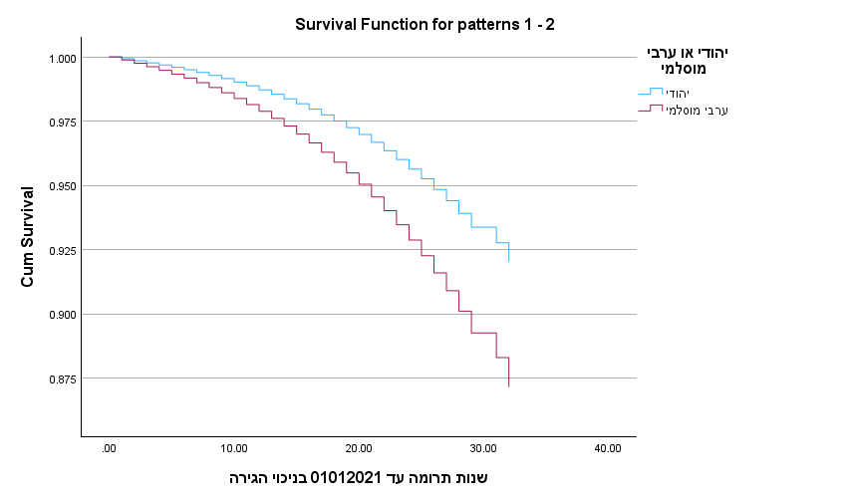 | 1.658  (1.612-1.704)
Breast cancer mortality
Kaplan Meier  Survivor curve | Age adjusted HR  (99% CI)
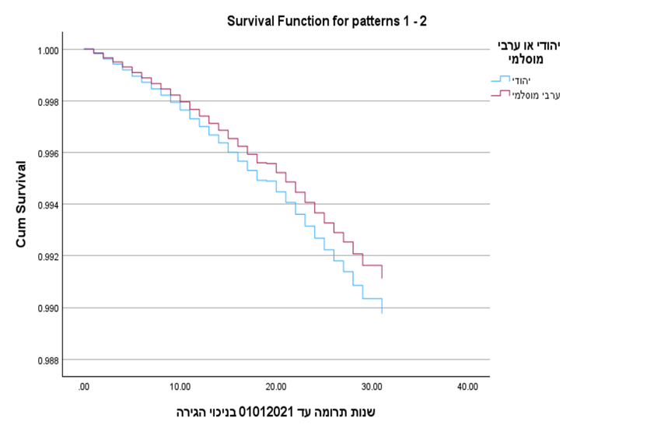 | 0.866  (0.778-0.964)

Table 3:
Multivariate Cox models for breast cancer mortality prediction among study population
(N = 817,455).
 |  | Model 1 | Model 2 | Model 3
 |  | HR CI99% | HR CI99% | HR CI99%
Ethnicity | Jewish | 1.00 | 1.00 | 1.00
 | Muslim Arab | .815(0.722-.920) | 0.849(0.752-.960) | 0.904 (0.793-1.031)
Number of children | 0-3 | 1.00 | 1.00 | 1.00
 | >3 | 0.925(0.963-0.992) | 0.938(0.875-1.007) | 0.924(0.861-0.992)
Country of Origin | Asia/Africa | 1.00 | 1.00 | 1.00
 | Israel | 1.044(0.972-1.120) | 1.046(0.974-1.123) | 1.060(0.985-1.140)
 | Europe/America | 1.166(1.078-1.260) | 1.181(1.092-1.277) | 1.173(1.083-1.270)
Settlement Size | Small |  | 1.00 | 1.00
 | Large |  | 1.219 (1.124-1.322) | 1.189 (1.095-1.291)
Socio-economic status | Low |  |  | 1.00
 | Medium |  |  | 1.140 (1.060-1.227)
 | High |  |  | 0.970 (0.893-1.364)

Table 4:
Breast cancer mortality rate by research variables among Jewish women (N = 743,090) and among Muslim Arab women (N = 74,355).
 |  | Model A : Jewish  (N = 743,090) | Model B: Muslim Arab  (N = 74,355)
 |  | Age adjusted HR  CI99ֵֵ% | Age adjusted HR  CI99ֵֵ%
Number of children | 0-3 | 1.00 | 1.00
 | >3 | 0.960(0.896-1.028) | 0.751 (0.609-0.927)
 | Asia/Africa | 1.00 | 1.00
 | Israel | 1.08 (1.001-1.146) | 0.651 (0.159-4.466)
 | Europe/America | 1.185(1.096-1.282) | 0.703(0.373-1.326)
Settlement Size | Small | 1.00 | 1.00
 | Large | 1.217  )1.115-1.329( | 1.177 (0.954-1.451)
Socio-economic status | Low | 1.00 | 1.00
 | Medium | 1.146  (1.064-1.235) | 1.309(1.015-1.796)
 | High | 0.988(0.912-1.071) | 1.591(1.052 -2.613)

Graph 2 - Breast cancer mortality by number of children among Jewish and Muslim Arab women as separate groups:
0-3 children (blue line) and >3 children (Red line).
- Breast cancer mortality by number of children among Jewish women (N = 743,090)
Kaplan Meier  Survivor curve | Age adjusted HR  (99% CI)
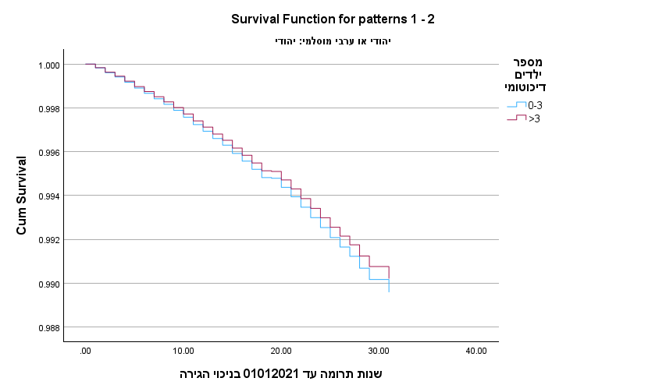 | 0.960  (0.896-1.028)
Breast cancer mortality by number of children among Muslim Arab women (N = 74,355).

Kaplan Meier  Survivor curve | Age adjusted HR  (99% CI)
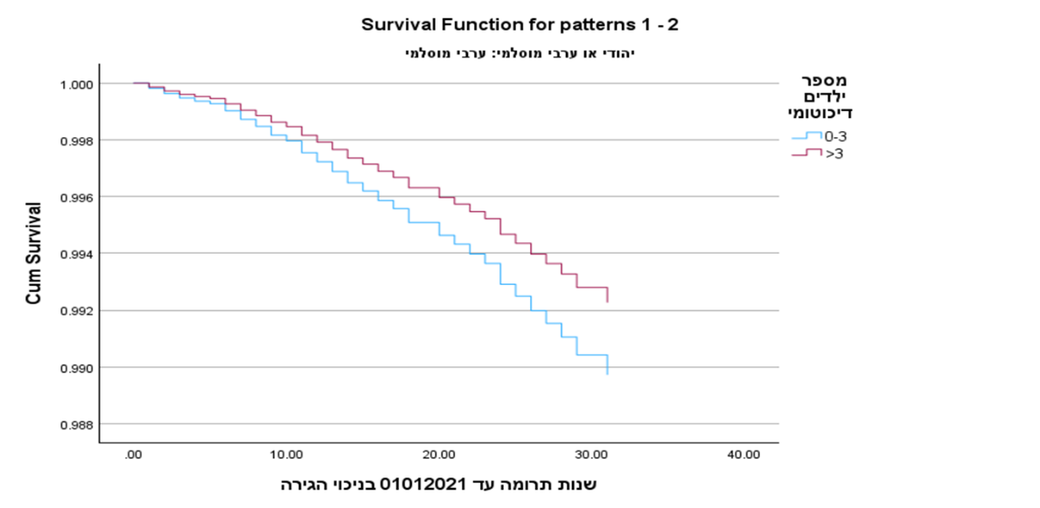 | 0.751  (0.609-0.927)

.
Graph 3 - Breast cancer by socio-economic status among Jewish and Muslim Arab women as separate groups:
Low Socioeconomic status (blue line) , Medium Socioeconomic status (Red line) and High Socioeconomic status (green line)
- Breast cancer mortality by socioeconomic status among Jewish women (N = 743,090)

Kaplan Meier  Survivor curve | Age adjusted HR  (99% CI)
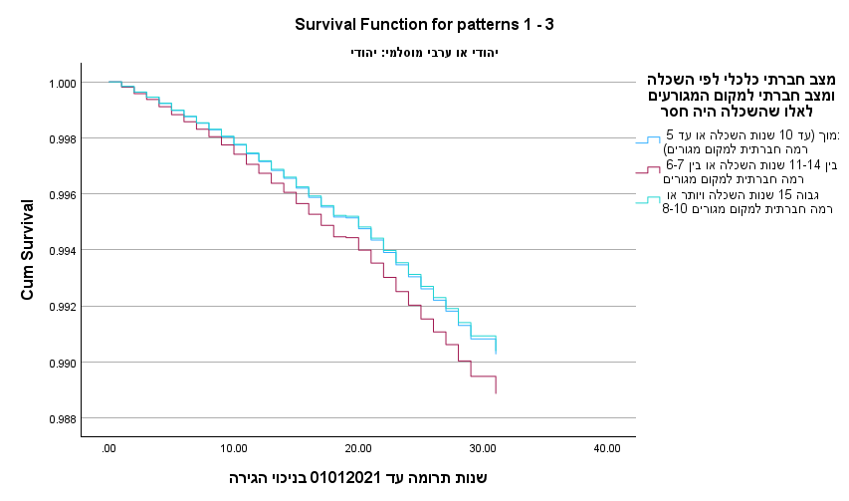 | Low -1.00  Medium- 1.146 (1.064-1.235)  High -0.988 (0.912-1.071)
Breast cancer mortality by socioeconomic status among Muslim Arab women (N = 74,355).
Kaplan Meier  Survivor curve | Age adjusted HR  (99% CI)
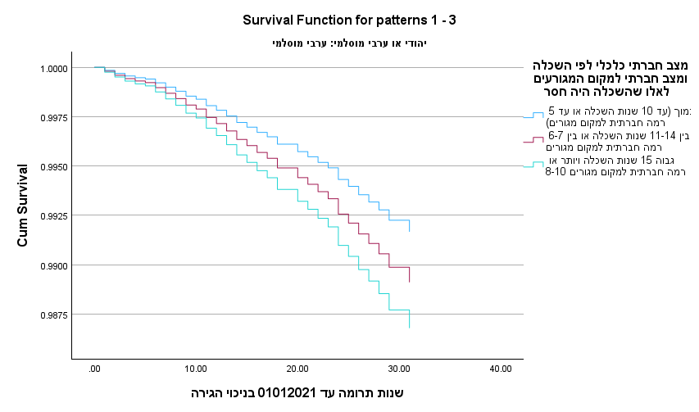 | Low- 1.00  Medium- 1.309 (1.015-1.796)  High -1.591 (1.052 -2.613)

