**A. Scientific background:**

**Angelman syndrome (AS)** is a genetic neurodevelopmental disorder, manifested by severe cognitive and motor impairments 1–5. Its prevalence is estimated as ~1:15,000 6 2,7. The cause for AS is the loss of function of the Ube3a protein in the brain, usually due to the deletion of small portions of the maternal chromosome 15(q11-13) that contains the UBE3A gene 8–11. Knockout of this gene in mice recapitulates many features of AS (e.g. motor dysfunction, aberrant behavior, absence of speech, and cognitive deficits) making this model an efficient tool for investigating this disease, and for identifying appropriate therapeutic strategies 12–21. Nonetheless, despite multiple investigations, the downstream mechanisms leading to AS development is still unclear. Studies that have investigated the critical period for rescuing AS deficits through conditional Ube3a gene reinstatement concluded that the reinstatement rescues more phenotypes if implemented at an earlier stage, but only reinstatement before the embryonic age of E12.5 induces a complete phenotypical rescue 22–25. Based on the above, we posit that to fully understand the abnormal development of AS, it is crucial to examine the cellular events that take place during the embryonic development of AS, when UBE3A levels are reduced by 50%. Moreover, given that UBE3A affects steroid sex-hormone receptor activity 26–31, and that previous studies by us and others found sex-dependent differences in AS phenotypes 32,33, it is essential to consider sex-dependent differences in AS brain development.

**Mitochondrial dysfunction and oxidative stress in early brain development of AS**. We and others showed that UBE3A deficiency induced mitochondrial dysfunction and enhanced oxidative stress in adult AS brain tissue 34–38, and that mitigating excessive mitochondrial ROS using CoQ10 analogs rescued some of the behavioral phenotypes observed in AS 36,37. We further showed that embryonic fibroblasts with complete UBE3A knockout also exhibited mitochondrial dysfunction, enhanced oxidative stress and altered proliferation-apoptosis balance 39,40. In a follow-up study we showed that primary cell cultures of neural precursor cells (NPCs) from embryonic brains of AS model mice exhibited increased mitochondrial membrane potential, elevated mitochondrial ROS levels, and enhanced apoptosis, and reducing the excess ROS levels with antioxidant administration rescued the enhanced apoptosis phenotype of AS NPCs 41. Additional preliminary results using whole-brain tissue at E16.5 indicate increased oxidative stress in embryonic brain tissue of AS mice (Figure 1) and elevated levels of apoptosis (Figure 2). These data align with studies of various models for other neurodevelopmental disorders and autism spectrum disorders (ASD) that correlate with enhanced oxidative stress, proposing the mitigation of oxidative stress as a therapeutic strategy 42–44. And indeed, some studies showed that prenatal treatment with antioxidants alleviated ASD-related behaviors in rodent models 45–49.



**Figure 1.** E16.5 embryonic brains of AS mice exhibit increased expression of Nrf2-regulated genes compared to WT littermates, indicating a defensive cellular response to oxidative stress. The graph shows the relative expression of genes calculated as the ΔΔCt fold change following real-time PCR. The reference gene b-Actin (Actb). Bars represent mean±SEM. N=4 embryos per genotype. *p<0.05, **p<0.01. Nqo1 [NAD(P)H Quinone Oxidoreductase 1], Sod1 (Superoxide Dismutase 1), Sod2 (Superoxide Dismutase 2), Cat (Catalase), Gclc (Glutamate-Cysteine Ligase Catalytic Subunit), Hmox1 (Heme Oxygenase 1).

**Mitigation of oxidative stress** can be achieved by various pharmacotherapeutic approaches that employ different mechanisms. The most common pharmacotherapy for mitigating oxidative stress is the use of antioxidants that lead to the scavenging of excessive ROS. However, another option for reducing oxidative stress is using mitochondrial uncouplers, which preempts excessive ROS production from inception 50–53. Moreover, the use of mitochondrial uncoupler in treating AS is particularly supported by our discovery that AS NPCs exhibit enhanced mitochondrial membrane potential 41, which uncouplers are known to reduce 50–53. This may be linked to studies showing that in some cases, ASD was correlated with increased electron transport chain (ETC) complex activity 54. Amongst mitochondrial uncouplers 2,4-dinitrophenol (DNP) was shown as an effective uncoupler with relatively low toxicity at low doses 50–52. Another advantage of DNP is that it induces BDNF expression 55, although this BDNF induction is in a hormetic pattern 56. This is especially beneficial for AS, knowing that BDNF signaling is impaired in AS mice brains and peripheral neurons 57–59.

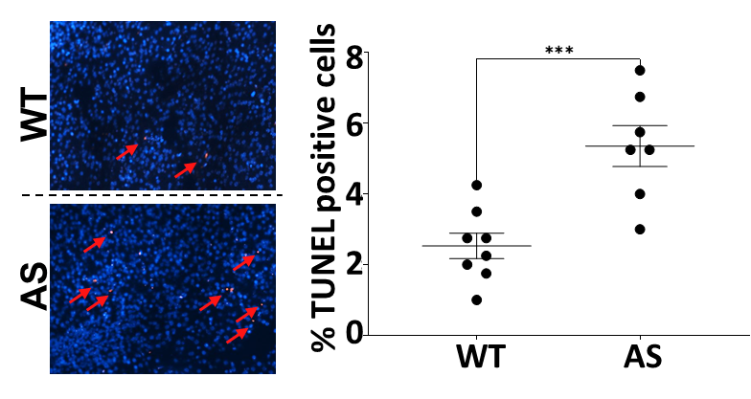

**Figure 2.** Paraffin-embedded E16.5 embryonic brains of AS mice exhibit more TUNEL-positive (apoptotic) cells compared to WT littermates. TUNEL staining used the In-situ BrdU-Red DNA Fragmentation (TUNEL) Assay Kit. The calculation of %TUNEL-positive cells was in relation to the total number of DAPI-stained nuclei. n=8 images of slices from pre-defined positions of the cerebral cortex.

N=4 embryos per genotype. ***P < 0.001.

Arrows point to TUNEL-positive cells.

Since we and others showed sex-dependent phenotypes in AS mice 32,33, and because DNP itself differentially affects males and females 60, we will address sex-dependent effects for all aims.

**B. Research aims and expected significance:**

The synthesis of the aforementioned studies collectively suggests a **central hypothesis:** *mitochondrial uncoupler administration will normalize the mitochondrial membrane potential and mitigate the enhanced oxidative stress in NPCs of AS mice embryos, reducing their increased apoptosis levels (Figure 3A).* We further posit that *in vivo treatment with mitochondrial uncoupler during embryonic development will prevent the induction of enduring alterations in neuronal functioning and morphology, and alleviate the behavioral deficits of AS (Figure 3B).*

Hence, the **specific aims** of this proposal are to:

1. Determine whether DNP reduces the mitochondrial membrane potential and oxidative stress of AS NPCs, and rescues the enhanced apoptosis phenotype.
2. Determine whether in vivo gestational DNP administration mitigates the enhanced oxidative stress in brain cells of AS embryos and reduces the elevated apoptosis levels.
3. Determine whether in vivo treatment with mitochondrial uncoupler during embryonic development rescues behavioral deficits in the brains of AS mice in adulthood.
4. Determine whether in vivo treatment with mitochondrial uncoupler during embryonic development rescues the cellular properties of pyramidal cells.
5. Determine whether in vivo treatment with mitochondrial uncoupler during embryonic development rescues the morphological properties of pyramidal cells.

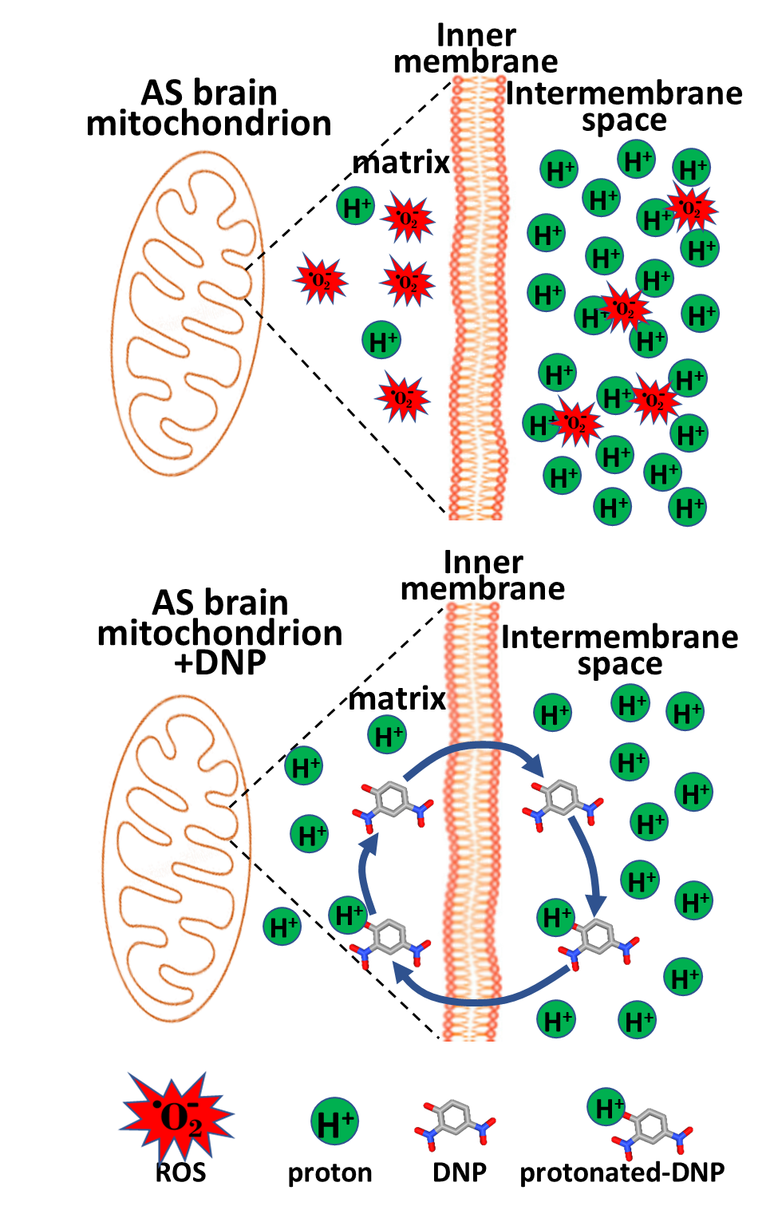

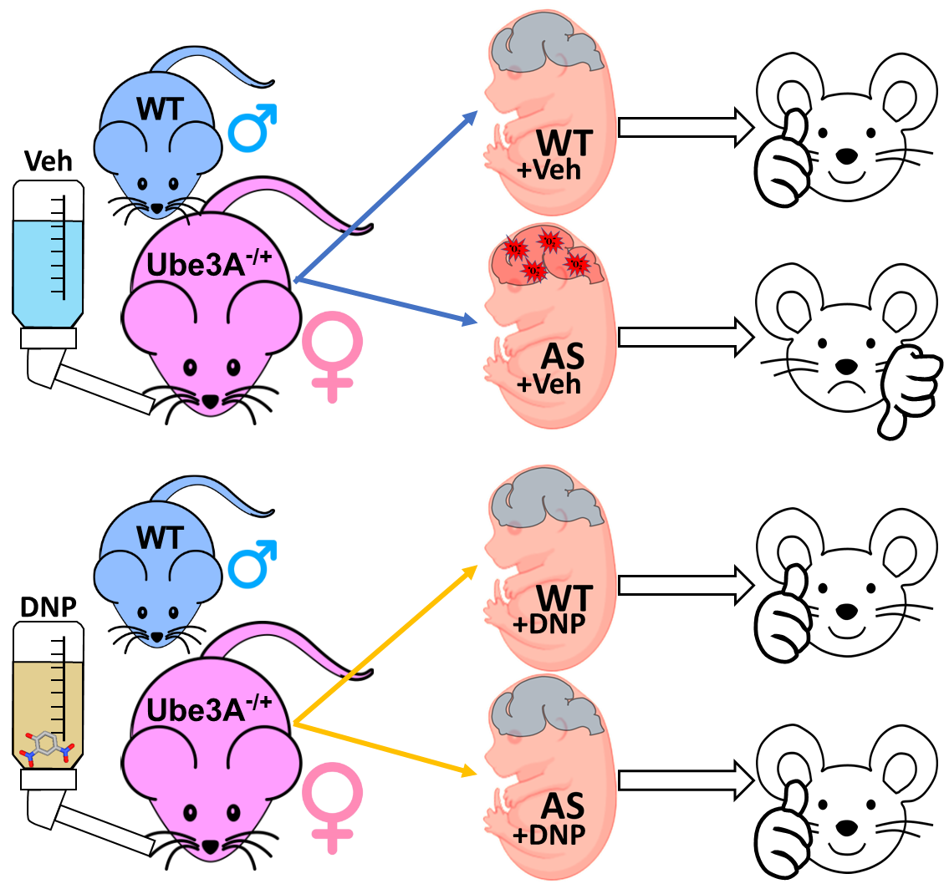

**Figure 3. A. Working hypothesis**. DNP reduces the proton gradient and prevents the generation of enhanced oxidative stress observed in AS embryonic brain cells to enable normal brain development.

**B. Experimental setup**. WT males and UBE3Am+/p- females will be paired to yield WT and AS offspring. Pregnant females will drink water with either 2,4-dinitrophenol (DNP) or vehicle (Veh) to produce four experimental groups of offspring. DNP treatment of AS embryos will mitigate the oxidative stress and their deficits will be alleviated. Sex-dependent differences will be examined.

**A**

**B**

**The expected significance** of the proposed study is threefold: 1. It will deepen our understanding of the role of mitochondrial dysfunction and oxidative stress in the pathophysiology of AS neurodevelopment. 2. It will determine whether administering mitochondrial uncoupler for mitigating oxidative stress during embryonic AS brain development is beneficial and rescues behavioral, physiological, or cellular structural phenotypes. 3. It will expand our experience and knowledge concerning the administration of mitochondrial uncouplers during pregnancy in general, and enable to optimize this treatment strategy. Oxidative stress in embryonic brain development is considered the cause of multiple neurodevelopmental disorders, and studies in models of neurodevelopmental disorders showed benefits for gestational administration of anti-oxidants that scavenge ROS 45–49. However, uncouplers were never tested. Hence, the knowledge and experience gained in this study will serve us in studying other models for neurodevelopmental disorders, such as maternal immune activation (MIA), in which we observed enhanced oxidative stress in embryonic brain (Figure 4).

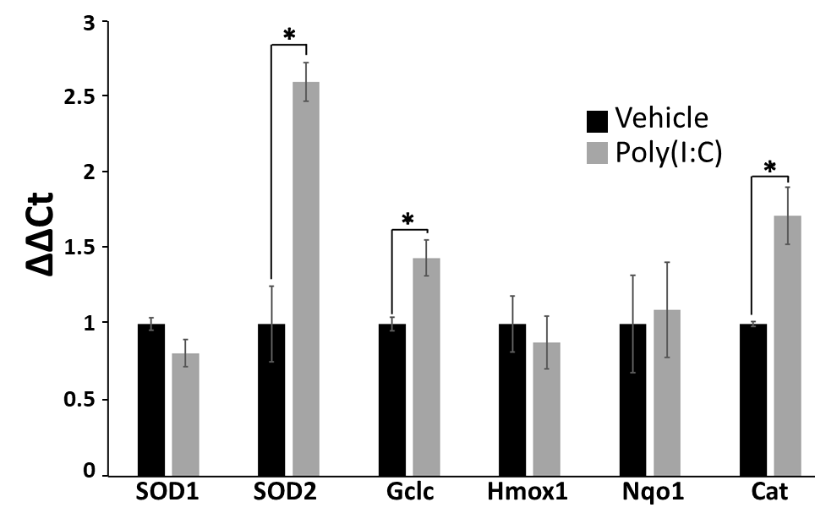

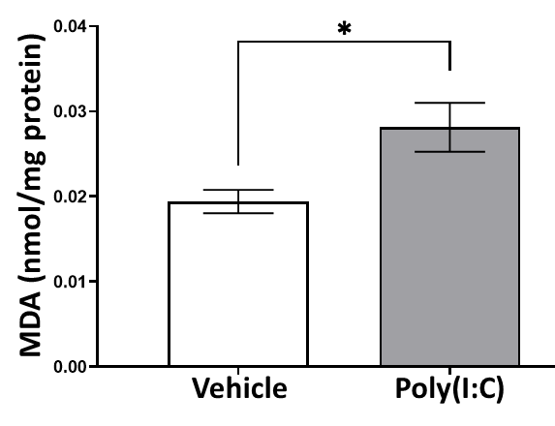

**Figure 4.** MIA model using polyinosinic-polycytidylic acid [Poly(I:C)] 20mg/kg at E12.5 indicate enhanced oxidative stress.

**A.** increase in the relative expression of Nrf2-regulated genes.

**B.** increase in lipid peroxidation as observed by MDA-TBARS assay.

**A**

**B**

**C. Experimental design and methodology**

**Aim-1: Determine whether DNP reduces the mitochondrial membrane potential and oxidative stress of AS NPCs, and rescues the enhanced apoptosis phenotype.**

***Rationale:*** We and others showed mitochondrial dysfunction and enhanced oxidative stress in AS brain cells 34–38. We also showed that mitochondria of AS embryonic neural precursor cells (NPCs) at E16.5 express enhanced oxidative stress alongside increased mitochondrial membrane potential, and also exhibited elevated levels of apoptosis. Moreover, we showed that antioxidant treatment with GSH-EE that mitigated the oxidative stress rescued the enhanced apoptosis phenotype of AS NPCs, but did not normalize their increased mitochondrial membrane potential 41. Hence, it is probable that an approach that will mitigate oxidative stress while reducing the mitochondrial membrane potential would be an even more suitable therapeutic approach for AS.DNP is a mitochondrial uncoupler that does exactly that. As a protonophore, DNP shuttles protons across the inner mitochondrial membrane, reducing its membrane potential as well as reducing oxidative stress 50. *In vitro* studies in isolated hepatocytes and cultured HepG2 cells showed that DNP 50M is sufficient to induce uncoupling activity 52,61. However, *in vitro* studies using lower doses of DNP (20M) in primary neuronal cultures and cultured cell lines showed that at this low dose, DNP 20M does not have significant uncoupling activity, although it induced significant effects of differentiation and neuritogenesis 62,63. Given these studies, we will start our experiments with DNP 50M.

|  |  |  |  |  |
| --- | --- | --- | --- | --- |
| Table-1 | WT | | AS | |
| Male groups | vehicle | DNP | vehicle | DNP |
| Female groups | vehicle | DNP | vehicle | DNP |

***Experimental design:*** As we previously described, we will extract and culture E16.5 NPCs from AS and WT littermate embryos and treat them with DNP 50M for 48 hours, in a similar method to what we previously described for incubation with GSH-EE 41. This design will generate 8 groups, 4 groups per sex (Table-1). All methods for **aim-1** were described by us in details 41.

Generation of NPCs: In brief, we will pair a heterozygous female mouse with paternally derived Ube3a deletion (Ube3ap−/m+) and a wild-type (WT) (Ube3ap+/m+) male, both on a C57BL/6 background, to generate WT (Ube3ap+/m+) and AS (Ube3ap+/m−) littermates. On gestational day E16.5, we will extract the brains of the AS and WT littermates’ embryos and dissociate them into a single-cell suspension using Neural Tissue Dissociation Kit (Miltenyi Biotec #130-093-231), collect cells with centrifugation (300×*g*, 5 min) and re-suspend in a complete embryonic NeuroCult™ proliferation medium (STEMCELL #05702) with added EGF (10 µg/ml; STEMCELL *#*78006.1). Cells will be plated in flasks coated with poly-D-lysine and laminin. For DNP treatment NPCs will be incubated for 48 hours with DNP 50M. When necessary (for FACS measurements), cells will be detached, dissociated and collected with ACCUTASE kit (STEMCELL #07922). Sex of NPCs will be determined by PCR for two Y-chromosome-linked genes (KDm5D and DDX3Y), as we previously described 39.

***Aim 1.1****:* ***DNP effects on mitochondrial membrane potential (ΔΨm) of NPCs.***

Following incubation of NPCs with DNP 50M for 48 hours, NPCs will be dissociated, washed with 0.2% BSA, collected by centrifugation, and then triple-stained by incubation for 20min at 37°C with tetramethylrhodamine ethyl ester (TMRE) 142.8 nM (to measure mitochondrial membrane potential), calcein violet-AM 0.9M (to asses cell viability), and Mitochondrial Tracker Green 75.3 nM (to label and assess relative mitochondrial mass), then washed with 5% fetal calf serum and resuspended in Opti-Klear™ Live Cell Imaging Buffer. Fluorescence labeling will be immediately measured by fluorescent antibody cell sorter (FACS) and analyzed with FlowJO software. The fluorescence intensity of TMRE will be calculated from live (calcein-positive) cells, relative to the mitochondrial mass indicator. Apart from measuring mean intensities, we will also assess relative cell population expression of high ΔΨm (TMREhigh/MitoTracker greenhigh) and low ΔΨm (TMRElow/MitoTracker greenhigh).

***Aim 1.2****:*  ***DNP effects on mitochondrial oxidative stress of NPCs.***

Similarly to aim-1.1, following incubation of NPCs with DNP 50M for 48 hours, dissociated NPCs will be triple-stained with MitoSOXTM red 3M, calcein violet-AM 0.9M, and Mitochondrial Tracker Green 75.3 nM. Using FACS followed by analysis with FlowJO software, mROS levels will be assessed by measuring the red fluorescence of MiroSOX from live (calcein+) NPCs, relative to the mitochondrial mass (MitoTracker), as we previously described 41.

We are aware that the use of TMRE and MitoSOX in themselves affects the measured mitochondrial properties, however, in our previous study we have calibrated the lowest concentrations to minimize the effects while enabling reliable readings, and all measurements are always relative to those in the control groups.

***Aim 1.3****:*  ***DNP effects on apoptosis levels******of NPCs.***

In brief, apoptosis in NPCs will be measured in two methods: TUNEL assay and Annexin-V/Propidium Iodide (PI) assay. Similar to aims 1.1 and 1.2, following incubation of NPCs with DNP 50M for 48 hours, NPCs will be dissociated and collected. For TUNEL assay, we will use TUNEL assay kit- BrdU-Red (abcam ab66110). Detached and collected NPCs will be fixed with ice-cold 4% paraformaldehyde (PFA) for 15 min on ice, followed by washing in ice-cold PBS. Next, NPCs will be incubated in 70% ethanol at -20°C overnight and the next day, NPCs will be incubated in DNA labeling solution for 60 min at 37°C, followed by sequential 30 min incubations of BrdU antibody solution and 7-AAD at room temperature (RT). Before each incubation, NPCs will be washed according to the kit manufacturer’s protocol. The ratio of TUNEL-positive cells will be assessed by FACS and analyzed with FlowJO software. For Annexin-V/PI assay, we will utilize MEBCYTO Apoptosis Kit (MBL *#*4700). NPCs will be detached and collected with ACCUTASE, and washed once with PBS. Following NPCs will be centrifuged and NPCs pellet will be resuspended with binding buffer and incubated with Annexin-V and PI antibodies according to the kit’s protocol. Next, NPCs will be measured with FACS for fluorescence of Annexin-V/PI labeled NPCs, to discriminate between viable cells (Annexin-V-/PI-), early apoptotic cells (Annexin-V+/PI-), and late apoptotic cells (Annexin-V+/PI+). The ratio of each population will be analyzed using FlowJO software.

As aforementioned, we described all of these methods in detail in a previous publication 41.

**Pitfalls and alternative approach**: We are experienced and proficient in the aforementioned methods, which we previously published 41. However, in addition, we can also directly stain cultured NPCs, and perform fluorescent measurements using fluorescent microscopy in our institutional bioimaging facility. As we previously described, we can seed 1x104 per well of NPCs in poly-D-lysine (PDL) and laminin-coated 96-well plates and culture in a complete embryonic NeuroCult™ proliferation medium for 48 h at 37°C with 5% CO2 41. This can be performed, with and without DNP 50M in the medium. Mitochondrial membrane potential, oxidative stress, apoptosis rate, and many other parameters can be performed in our Incucyte SX5 live-cell imaging system (Sartorius) with the appropriate commercial kits. It is also possible that the required DNP concentration will need to be adjusted for various reasons. We can also examine the effect of other anti-oxidant compounds if needed. As aforementioned, we have experience with anti-oxidant treatment of NPCs cultures with GSH-EE, and these results were already published by us 41.

**Aim-2: Determine whether in vivo gestational DNP administration mitigates the enhanced oxidative stress in brain cells of AS embryos and reduces the elevated apoptosis levels.**

***Rationale:*** For *in vivo* use, DNP was shown as a potent and amongst the least toxic uncouplers 52. DNP is not teratogenic in rats even at high doses 64, and was shown to be relatively safe and nontoxic in rats or in mice at a dose of ≤10mg/kg 50,56,64–69. Moreover, DNP was shown to effectively impact the brain at doses of 1 and 5 mg/kg, 50,56,70–72, and lower oxidative stress in the brain even at very low levels 56,72. Another important aspect is that DNP effectively impacts the brain when administered in drinking water even at low doses (1mg/L) 56,72–74. Average mouse C57Bl/6 drinks ~3-6ml/day 25-30g mouse 72,75,76. Various publications claimed that the clinical dose for humans, 1.2–4.3 mg/kg/day, scales to ~15–54 mg/kg/day in mice 65,73. Previous studies estimated that 1mg/L drinking water for adult mice is equal to ~100 μg/kg/day 56,65,72,77 and that 800mg/L for adult C57Bl/6J mice is equal to ~89mg/kg/day in mice 65,73. Differences between labs concerning daily consumption were due to different amounts of water drank by the mice. DNP can be delivered also via oral gavage 52,64,68,78, or via intraperitoneal injections 56,70. Hence, we aim to determine whether DNP administration in drinking water mitigates the oxidative stress in the brains of AS embryos. The study that utilized the high doses of DNP administration in drinking water (0-2000mg/L) found that 800mg/L did not reduce the amount of drinking or eating but slightly reduced weight, while 400mg/L did not affect the amount of drinking and eating, and did not affect weight 72. These results will also be investigated and sex-dependent differences will also be addressed. Overall, we will have 4 experimental groups per sex, as depicted in Table-1.

Preliminary results of whole embryonic brain tissue at E16.5 showed evidence for increased oxidative stress and enhanced apoptosis levels (Figures 1-2).

***Experimental design:*** Healthy heterozygous Ube3A females, i.e. females that accepted their deletion from their male parent (Ube3Am+/p-) on a C57Bl/6J background will be paired with a same background wild-type (WT) male. Such pairing is expected to yield offspring that 50% of them are WT (Ube3Am+/p+) and 50% are AS (Ube3Am-/p+). We will examine the female every morning for a vaginal plug to determine the date of gestation. Once a vaginal plug is observed, males will be separated, and females will water and food *ad libitum*. Drinking water will contain either DNP (400mg/L) or vehicle. At E16.5, embryonic brains will be extracted on ice and either immediately evaluated or snap-frozen in liquid nitrogen to be collected and stored at -80°C until further processing, according to the protocol specified by the kit manufacturers. Oxidative stress levels and apoptosis levels will be evaluated using several methods. On brain tissue extraction, the embryonic tail will be cut and processed for genotyping (WT or AS) and sex determination by PCR for KDm5D and DDX3Y, as we previously described 39.

***Aim 2.1****:*  ***DNP effects on mitochondrial oxidative stress in embryonic brain tissue.***

To assess oxidative stress in brain embryonic tissue of WT and AS embryos treated with DNP or vehicle, we will utilize several methods.

Western Blot Analysis: To assess the expression levels of different oxidative stress markers proteins. Total protein will be extracted from the different samples and subjected to standard western blot analysis using Anti-Keap1 antibody (Abcam, # ab227828), Anti-Nrf2 antibody (R&D Systems, #AF3925), Superoxide Dismutase 1 (SOD1) (Abcam, #ab51254), Catalase (Abcam, ab209211) and Anti-4 Hydroxynonenal (4-HNE) antibody (Abcam, #ab46545 or #ab48506) to stain protein adducts of 4-HNE. Protein readings using chemiluminescence will be normalized to Ponceau S staining and chemiluminescence of house-keeping proteins on the same blot (if in a different molecular weight) such as Anti-beta Actin antibody (Abcam, #ab6276), and Anti-beta Tubulin antibody (Abcam, #ab6046).

Real-time PCR: RNA isolation from the frozen samples will be conducted using the RNA Mini Kit (Qiagen, #74534), followed by cDNA synthesis using ReadyScript® cDNA Synthesis Mix (Merck, #RDRT-500RXN). Real-time PCR with SYBR Green will be performed using KiCqStart® SYBR® Green qPCR ReadyMix™ (Merck, #KCQS01-1250RXN) and pre-designed KiCqStart SYBR® Green primers (Merck, #KSPQ12012) for oxidative stress-related target genes, including Superoxide Dismutase 1 (SOD1), Superoxide Dismutase 2 (SOD2), Catalase (CAT), Glutathione Peroxidase (GPx), heme oxygenase-1 (Hmox-1), Glutamate-cysteine ligase catalytic subunit (Gclc), Catalase (Cat), NAD(P)H: quinone oxidoreductase 1 (Nqo1) and Glutathione S-transferase (GST). The relative expression of genes will be calculated as the ΔΔCt fold change, and the reference gene used will be b-Actin (Actb) (Figures 1 and 4).

Lipid Peroxidation Assessment:The extent of lipid peroxidation will be quantified by measuring the levels of malondialdehyde (MDA) using the Lipid Peroxidation (MDA) Assay Kit (Colorimetric/Fluorometric) (Abcam, #ab118970) and 8-isoprostane using the 8-isoprostane ELISA Kit (Abcam, #ab175819).

Quantification of total reactive oxygen species (ROS) and reactive nitrogen species (RNS): the total free radical presence in all the different samples will be assessed by utilizing the DCF ROS/RNS Assay Kit (Abcam, #ab238535). Generally, the brain samples will be immediately sonicated on ice, centrifuged at 10,000 g for 5 min, stored at -80ºC, and processed according to the manufacturer's instructions.

***Aim 2.2****:*  ***DNP effects on apoptosis levels******in embryonic brain tissue.***

To assess apoptosis levels in brain embryonic tissue of WT and AS embryos treated with DNP or vehicle, we will utilize two methods.

Apoptosis Assessment (FACS): The apoptotic capacity of harvested brains will be examined using Annexin-V/PI. Immediately after the extraction of the embryonic brain at E16.5, we will process the tissue into a single-cell suspension, as we previously described 41. Annexin-V/PI analysis will be conducted by staining 0.5x10^6 cells with Fluorescein Isothiocyanate (FITC)-conjugated annexin-V/PI, utilizing the MEBCYTO Apoptosis Kit (MBL #4700, Nagoya, Japan). The analysis will be performed via FACS following the manufacturer's guidelines. Evaluating apoptosis by FACS reading of Annexin-V/PI is similar in principle to the method described in aim 1.3 for NPCs, and like we previously described 41.

Apoptosis Assessment (TUNEL Assay): Brain tissues harvested at E16.5 will be immediately fixed using 4% paraformaldehyde. Following fixation, the tissue will be dehydrated and embedded in paraffin. According to the manufacturer's guidelines, the paraffin embedding section will be processed and analyzed using the TUNEL Assay Kit—BrdU-Red (Abcam #ab66110). This method was used in Figure-2 showing enhanced apoptosis in E16.5 embryonic brains of AS.

Caspase Activity Measurement: Brain tissues collected at embryonic day 16.5 (E16.5) will undergo assessment for Caspase 3/7 and Caspase 8 activities using the Caspase-Glo® 3/7 and Caspase-Glo® 8 Assay kits (Promega, Catalog # G8091 and # G8200, Madison, WI, USA).

**Possible pitfalls and alternatives:** The correlation between the administered dose to the pregnant dam and the corresponding effects of DNP on embryonic brain development was never established. DNP was shown to entail hormetic effects, meaning a higher dose might induce smaller effects. Hence, it is possible that the proposed amount of DNP in the drinking water (400mg/L), which is estimated to be ~40mg/kg/day to the pregnant dam, will be too high and have no effects on the embryonic brains. Moreover, studies have shown that also lower doses of DNP are effective 50,56,70–72, but none of the studies examined the dose of DNP during gestation and its effects on embryos. Hence, we will also examine the effects of lower concentrations of DNP.

**Aim-3:** **Determine whether in vivo treatment with mitochondrial uncoupler during embryonic development rescues behavioral deficits in the brains of AS mice in adulthood.**

***Rationale:*** Many research teams, as well as ours, have demonstrated that AS mice exhibit multiple behavioral deficits 12,15,32,79,80. Apart from various behavioral deficits in AS mice 32, we have also shown that AS male mice exhibit elevated levels of aggression 79. As aforementioned, only very early reinstatement of Ube3a, before E12.5 was able to rescue all AS phenotypes, and especially core autistic/emotional-related phenotypes such as marble burying and forced swim tests, were not rescued when reinstatement was performed in later ages 22–25. Interestingly, oxidative stress was found in multiple neurogenetic syndromes81–87, and in autism spectrum disorders (ASD) 44,88–90, and studies suggested the use of antioxidants in the treatment of autism 42,43. And indeed, studies in models of neurodevelopmental disorders (NDD), such as maternal exposure to valproic acid (VPA) or maternal immune activation (MIA) model, showed not only that NDD entail enhanced oxidative stress during embryonic brain development, but that mitigating that enhanced oxidative stress alleviated the NDD-related deficits 45–49,91–94. These results align with our studies, where we showed evidence for enhanced oxidative stress during the embryonic brain development of AS mice. We demonstrated that embryonic NPCs of AS mice exhibit enhanced oxidative stress, and mitigating the oxidative stress rescued their enhanced apoptosis down to normal WT levels 41, and as aforementioned, we have also shown evidence for increased oxidative stress and enhanced levels of apoptosis in embryonic brain tissue of AS mice (Figures 1-2). Furthermore, we and others showed that antioxidant treatment in adult AS mice rescued a few of the AS behavioral deficits 36,37. Taken together, DNP administration is expected to decrease the elevated mitochondrial membrane potential in AS, reduce the enhanced oxidative stress by preventing ROS production, and induce BDNF expression and signaling 50,56,59,78. Hence, we posit that the administration of DNP to a pregnant dam as an anti-oxidant during embryonic development is expected to alleviate brain maldevelopment in AS mice embryos and ameliorate their behavioral deficits later in life.

***Experimental design:***

We will breed AS mice and WT littermates in the same breeding scheme used in aim-2. From the day of inception, pregnant dams that carry the AS and WT littermates will be treated with DNP dissolved in the drinking water using the optimal dose as derived from aim-2. This experimental paradigm will generate 4 groups (WT-vehicle, WT-DNP, AS-vehicle, and AS-DNP) as depicted in Table-1, per each sex. Considering males and females we will have 8 experimental groups like in aim-2. However, here (aim-3) we will continue the pregnancy and breed the offspring into young adulthood. DNP will be provided via drinking water during the entire pregnancy and the pre-weaning lactating period until pups are 3 weeks old, although we do not know whether and how much of the DNP is delivered via the milk. Once a week we will track the weight of the pregnant dams all along the pregnancy and lactation period until the offspring are weaned.

Offspring will be weaned and genotyped at the age of 3 weeks, and raised on a regular diet until the age of 10 weeks, and then a battery of behavioral profiling will be performed. The weight of the offspring will be tracked once a week until the end of the behavioral profiling (~3 months). The behavioral profiling will include, motor and core autistic-like phenotypes using open field arena, rotarod, elevated plus maze, marble burying, forced swim test, three chambers social interaction test, aggression (in males), novel object recognition, Morris water maze, nesting behavior, and amphetamine-induced hyperlocomotion test, as we and others previously described 32,48,49,79. The behavior will be tracked and analyzed as we previously described, using Noldus EthoVision XT 12 software or ANY-maze 7.34 software 32,37,79,95. Scoring will be performed by students who are blind to the group assignment of the offspring (WT±DNP or AS±DNP), and we will consider sex in our analyses. Once behavioral scoring is completed, each mouse will be assigned to its group and statistical analyses will be performed.

**Possible pitfalls and alternatives:** The dosage will be decided considering the results in aim-2. Nonetheless, it is possible that gestational DNP administration will induce adverse effects or no effects on the behavior of offspring. In this case, we will try adjusting the dosages accordingly. Based on the literature, DNP has hormetic effects 50,56, and it is plausible that even much lower doses will induce significant beneficial changes 50,56,70–72, but the effects of developing embryos was never studied. In addition, it is possible that DNP at any dose will not induce the beneficial expected effect. In this case, we will try treating with another type of mitochondrial uncoupler or another type of antioxidant that was shown to be effective in preventing some of the behavioral deficits in offspring of maternal immune activation model like NAC or resveratrol 48,49,91–94, or antioxidants that we and others have shown to be effective in alleviating behavioral deficits of the adult AS mouse 36,37, or to try other uncoupling agents available.

**Aim-4: Determine whether in vivo treatment with mitochondrial uncoupler during embryonic development rescues the cellular properties of pyramidal cells.**

***Rationale:*** Using AS model mice, we and others showed that brain regions implicated in AS deficits correlate with aberrant intrinsic and extrinsic excitability 96–105, and although not always 97, the recovery of the excitability aberrations correlates with the rescue of some of the behavioral deficits 96,99,101,103. Modulation of mitochondrial functioning can modify neural excitability 106–108. Moreover, mitochondrial functioning and its related signaling are key players in the homeostatic regulation of average firing rates set points of neurons 109. Hence, an early intervention that regulates mitochondrial functioning and oxidative stress may affect the development of neurons and induce long-lasting effects on extrinsic and intrinsic excitability. Furthermore, it is critical to understand these aspects of neuronal excitability in a developmental perspective over time, beginning from early phases when mature neurons have just been formed (at the age of 2 weeks) and up to adulthood (at the age of 3 months). Our preliminary findings show that hippocampal CA1 pyramidal cells at the age of P14 already exhibit altered intrinsic properties (Figure 5). However, some of the aberrant intrinsic properties we reported in adult AS mice (action potential amplitude and its rate of rise) were shown only later in adulthood, which coincides with the delayed change in the expression of the axon initial segment-related proteins 102,103. The general question, of whether early modulation of mitochondrial functioning alters neuronal excitability along development is interesting in itself (even for WT alone), beyond its significance for AS.

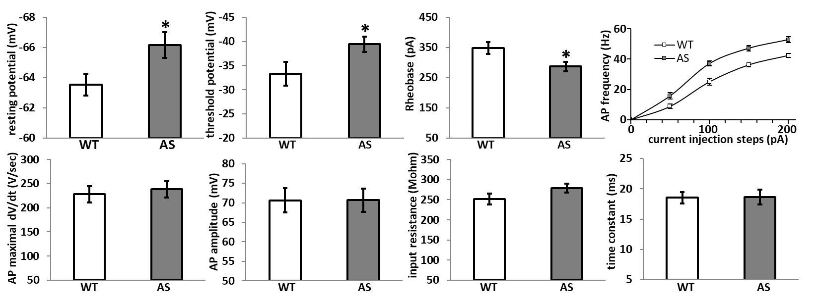

**Figure 5.** Intrinsic properties of CA1 pyramidal neurons in AS and WT littermates at P14 indicate increased excitability. Recorded in current-clamp with K-gluconate-based internal solution at 23°C. WT N=7 mice, 22 cells; AS N=8 mice, 25 cells. AP=action potential. * denotes p<0.05 in student’s t-test.

***Experimental design:***

We will utilize the same breeding scheme and DNP/vehicle treatment detailed for aim-3, to generate 4 adult mice experimental groups (WT-vehicle, WT-DNP, AS-vehicle, and AS-DNP) per each sex (Table-1). At the age of 10-11 weeks, mice will be sacrificed to achieve the following sub-aims.

***Aim 4.1****:*  ***Determine DNP treatment effects on the intrinsic properties of pyramidal neurons at the hippocampal CA1 and the prelimbic region of the prefrontal cortex***.

Mice from the aforementioned experimental groups (Table-1) at the age of 10-11 weeks will be sacrificed with immediate cervical dislocation followed by an immediate extraction of the brain under a sucrose-based ice-cold cutting solution. Following the harvesting of the brain we will produce 250m coronal slices that will be moved for incubation in carboxygenated artificial cerebrospinal fluid (aCSF) at 35˚C for 45 minutes followed by further incubation in room temperature (RT) until the transfer to the recording chamber. We will produce slices that contain the prelimbic prefrontal cortex (PFC) and slices that will contain the dorsal hippocampus (in different slices). Slices will be put in the recording chamber for at least half an hour of acclimation before recordings. Whole-cell patch recordings of pyramidal neurons from prelimbic PFC and hippocampal CA1 will be performed at 35°C with a flow (~3ml/min) of carboxygenated aCSF. Using various recording protocols of current-clamp mode we will measure the passive and active intrinsic properties, in two conditions, without any baseline current injection (I0) and with a holding current to set the resting membrane potential at -65mV. The internal solution will be potassium-gluconate-based. Passive and active properties will include also resting membrane potential, time constant, input resistance, and active membrane properties such as threshold potential, action potential (AP) amplitude, AP mid-width, maximal AP rate of rise, rheobase, medium and slow afterhyperpolarization (mAHP and sAHP), FI-curve and additional parameters. As aforementioned, all of these experiments were previously described in detail by us 110–119.

***Aim 4.2****:*  ***Determine DNP treatment effects on the synaptic properties of incoming inputs to the pyramidal neurons at the hippocampal CA1 and the prelimbic region of the prefrontal cortex***.

Similar to aim 4.1, we will produce slices for whole-cell patch clamp recordings from all experimental groups (Table-1). For evaluating the spontaneous network activity and the synaptic properties of inputs to pyramidal neurons from prelimbic PFC and hippocampal CA1 we will perform voltage-clamp recordings of spontaneous events using four experimental setups: 1. cesium-methanesulfonate (CsMeS) based internal solution clamped on -70 mV with aCSF containing bicuculline 50μM to record spontaneous excitatory postsynaptic currents (sEPSCs). 2. cesium-chloride (CsCl) based internal solution clamped on -70 mV with aCSF containing DNQX 20μM + APV 50μM for recording spontaneous inhibitory postsynaptic currents (sIPSCs). 3. to measure sEPSCs and sIPSCs from the same neurons, we will utilize internal solution containing CsMeS 135mM and CsCl 6mM and an external solution of aCSF with no inhibitors in the bath, and voltage-clamp the neurons at the reversal potential of GABAA (~-70 mV) for recording sEPSCs followed by voltage clamp at the reversal potential of glutamate receptors (~0 mV) for recording sIPSCs. 4. To measure evoked excitatory and inhibitory potentials we will use a similar approach like in the 3rd setup, but evoke external synaptic stimulation using a thin bipolar stimulating electrode positioned over the incoming axons. For hippocampal CA1 the stimulating electrode will be positioned on the Schaffer collaterals, and for layer-5 pyramidal neurons, the bipolar electrode will be placed in the adjacent layer 2-3. For evaluating the isolated synaptic properties, we will record miniature excitatory postsynaptic currents (mEPSCs) and miniature inhibitory postsynaptic currents (mIPSCs) similar to the way we record sEPSCs and sIPSCs, only with the addition of tetrodotoxin 1M to the aCSF composition. As aforementioned, all of these experiments were previously described in detail by us 110–112,114,117–121.

***Aim 4.3: Determine DNP treatment effects on the synaptic plasticity of the hippocampal CA1 in AS mice***.

Impaired hippocampal synaptic plasticity, such as the one observed by long-term plasticity (LTP) deficits was shown by us and others 12,14,37,95,101. We further showed that antioxidant administration to adult AS mice rescued their LTP deficits 37. Hence, it is imperative to investigate whether antioxidant therapy with DNP during early development would rescue the LTP deficits in AS mice. For that, we will examine in hippocampal slices whether prenatal treatment with DNP rescues the LTP deficit of AS mice, as we previously described 95,122. In brief, we will produce 300 m thick hippocampal brain slices. Slices will be placed for acclimation in the recording chamber for at least 2 hours before the start of stimulation and recording. Stimuli will be delivered via a bipolar stimulating electrode placed on the Schaffer collaterals proximal to the CA3, and a recording aCSF-filled glass electrode (3-5MΩ) will be placed in the stratum radiatum region of the CA1 at a distance of ~500m from the stimulation electrode to obtain a stable and clear field excitatory postsynaptic potential (fEPSP) signal with minimal spatial bias. Stimulus will be delivered using LSIU-01 (Cygnus Technology) stimulus isolator and recorded signals will be amplified using EXT-02B amplifier (NPI Electronic) and digitized by a Digidata 1440 apparatus (Molecular Devices) using pCLAMP 10 software (Molecular Devices). At first, we will test the input-output relation between stimulus intensity and utilize the stimulus intensity that produces ~40% maximal synaptic response, as measured by the initial fEPSP slope. Paired pulse facilitation (PPF) will be measured before tetanic stimulation and at the end of the experiment. Stable baseline (0.05 Hz) will be measured for at least 30 minutes, followed by two trains of 100Hz for 1second each, with an inter-train interval of 20 seconds, and followed by measuring the post-tetanic potentiation for 90 minutes, finalized with PPF recording. Analyses will be performed using clampfit 10. As aforementioned, we are experienced in our lab with this technique 95,122.

**Aim-5: Determine whether in vivo treatment with mitochondrial uncoupler during embryonic development rescues the cytomorphological properties of pyramidal cells.**

***Rationale:*** We and others showed that pyramidal neurons in adult AS mice exhibit distinct cellular morphological changes, such as reduced spine density 123,124 and elongated axon initial segment (AIS) in hippocampal CA1 pyramidal cells and medial nucleus of the trapezoid body (MNTB) neurons that correlate with pyramidal neurons' altered intrinsic and synaptic physiological properties 102,103,105,125. These changes might relate to enhanced oxidative stress, as previous studies showed that oxidative stress is associated with reduced spine density and immature spine morphology 126–130, and also with disruption of the axon initial segment (AIS) 131.

The first study that reported a decreased spine density in AS mice cerebellum, hippocampal CA1 and cortical neurons (layers 3-5), also observed a decrease in spine length in the hippocampus 123. Since then, despite few conflicting results (mainly in cultures), most studies replicated the decreased spine density in AS mice, and three studies that further investigated spine morphology showed that AS dendritic spines are less mature 124.

Our preliminary results replicate these findings and show decreased spine density in hippocampal CA1 pyramidal cells of AS mice even at the age of P14 (Figure 6), as well as in adult AS mice (Figure 7). Further morphological classification of the hippocampal CA1 dendritic spines in adult AS mice also shows a reduction in mature (mushroom-shaped) spines and an increase in immature (filopodia-shaped) spines (Figure 7). Concerning the AIS, as we previously showed, the AIS in hippocampal CA1 pyramidal cells of adult AS mice is elongated coinciding with enhanced expression of AIS-related proteins NaV1.6 and ankyrin-G 102,103,125. Unlike the decrease in dendritic spine density, we did not observe changes in AIS-related proteins at the age of P14 102, which correlates with the absence of increased AP amplitude and rate of rise (Figure 5), which were observed only later in adult mice. Hence, AIS morphology will be examined only at the age of P70.



**Figure 7.** Dendritic spine density in secondary apical dendrites of CA1 pyramidal cells at 10 weeks old mice from AS and WT littermates. Bar graph shows mean±SEM. Microscopy images are morphological reconstructions from Golgi staining. Spine analysis was performed with IMARIS filament tracer module. WT and AS: mice n=3 segments n=16 per genotype. **\***p<0.05 **p<0.01 in student’s t-test.



**Figure 6.** Dendritic spines density in secondary apical dendrites of CA1 pyramidal cells at P14 from AS and WT littermates. Bar graph shows mean±SEM. Microscopy images are morphological reconstructions from Golgi staining. WT and AS: mice n=3 segments n=6 per genotype. **\***p<0.05 in student’s t-test.

***Aim 5.1****:*  ***Determine DNP treatment effects on the spine density and morphology of pyramidal neurons at the hippocampal CA1 and the prelimbic region of the prefrontal cortex*** ***at P14 and P70 AS mice***.

For determining spine density and morphological classification in hippocampal CA1 and prelimbic PFC of AS mice following prenatal DNP treatment, mice from the four experimental groups per each sex will be sacrificed at the age of P14 and ~P70. Brains will be extracted and Golgi stained using the "FD RAPID" kit (FD Neurotechnology, Inc., USA). In brief, brains will be immersed in a mix of solutions A and B, kept in the dark for two weeks, then transferred into solution C for 72 hours, followed by slicing into 150 µm coronal slices using an SMZ7000 vibratome (Campden Instruments, UK). We will focus on coronal slices that contain the dorsal hippocampal CA1 and prelimbic PFC regions, but other brain regions might also be investigated. After slicing, the slices will be dried and undergo a staining procedure using a mix of solutions D and E and double-distilled water. The sections will be hydrated in three sequential ethanol dilutions (50%, 75%, and 95%), 4 minutes each, and then put in absolute ethanol four times, 4 minutes each. Afterward, the slices will be cleared using xylene, mounted on slides, and sealed with coverslips for z-stack imaging with brightfield microscopy using 100X (NA=1.40) oil immersion objective. We will utilize IMARIS 10.1.1 (Oxford Instruments) with the module ‘filament tracer’ for automated analyses of spine density and morphological classification of spines on secondary dendrites from the apical dendrites of hippocampal CA1 and prelimbic PFC pyramidal neurons, as we previously performed (Figures 7). The analysis will be performed by a ‘blind’ experimenter who will not be aware of the experimental group assignment of the slices. Statistical analyses will be performed after receiving the results from the ‘blind’ experimenter per each slice and assigning the results to the correct experimental group. We are well acquainted with these staining and imaging procedures and the requested analyses.

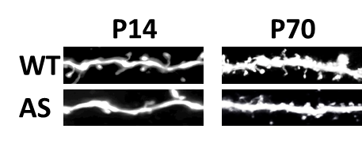

**Figure 8.** Images of dendritic spines from distal secondary apical dendrites of hippocampal CA1 neurons from infant (P14) and adult (P70) WTand AS model mice. Images are a collapsed 3D reconstruction of alexa-594fluorescence with two-photon microscope.

Alternatively, as we previously did, we will fill the recorded cells from aims 4.1 ad 4.2 with fluorescent dye (Alexa-488 or Alexa-594) 95,113 and image them using two-photon microscopy like we and others previously described 95,132. For dendritic spine imaging, we will acquire high-resolution stacks (x=0.13 µm, y=0.13 µm, z=0.2 µm per voxel) of the dendritic segments throughout the entire cell (Figure 8). Automated analysis of spines will be performed using IMARIS 10.1.1 (Oxford Instruments) with filament tracer module.

***Aim 5.2****:*  ***Determine DNP treatment effects on the axon initial segment (AIS) length of hippocampal CA1 pyramidal neurons in P70 AS mice***.

For determining AIS length in hippocampal CA1 of AS mice following prenatal DNP treatment, mice from the four experimental groups per each sex (Table-1) at the age of ~P70 will be sacrificed. As we previously described 125, mice will be deeply anesthetized using ketamine xylazine and perfused with ice-cold pre-fixative (12-15 mL normal saline), followed by ice-cold fixative [10-12 mL 1% PFA and 1% sucrose in 0.1 M phosphate buffer (PB)] for light fixation to enable the immunostaining of the AIS. Following perfusion, brains will be extracted and stored in a similar fixative for 2-3 hours at 4°C and then immersed in 30% sucrose in 0.1M PB until brains sink. Brains will be sliced in -20°C using cryostat in 30m coronal sections to include the dorsal hippocampal CA1 region in a relatively laminar structural pattern of the hippocampus. Slices will be transferred to 0.01 M PBS and washed three times in 0.01M PBS, and then blocked in for 2 hours in room temperature (RT) with 5% normal goat serum and 0.3% Triton X-100 in 0.01 M PBS (0.3% TPBSgs). Next, slices will be washed (3x10min) in 0.01M PBS and incubated overnight at 4°C 1:300 mouse anti-ankyrin-G (ank-G) primary antibody (clone N106/36, NeuroMab, Davis, CA) diluted in 0.1% TPBSgs. Next, slices will be washed again (3x10min) in 0.01M PBS and incubated in 1:1000 goat anti-mouse Alexa Fluor® 488 secondary antibody (ab150113, Abcam, Cambridge, UK) diluted in 0.1% TPBSgs for 2 hours at RT. Following, slices will be finally washed (3x10min) in 0.01M PBS, mounted on slides, airdried, covered with anti-fading agent (FluoroshieldTM with DAPI, Sigma Aldrich, St. Louis, MO), and sealed with coverslips for imaging. Z-stack imaging will be performed with a confocal microscope using a 60X (1.40 NA) oil objective with laser excitation at 406.8 nm for DAPI and 492.4 nm for the Alexa-488. Z-stacks will be imaged with an optical thickness of 0.05m in the z-axis to obtain z-stacks containing 150–200 images per ROI. The settings of laser intensity, pinhole, and exposure time will be kept identical for all experimental groups. Analysis of AIS length will be performed by a ‘blind’ experimenter in our institutional imaging facility using IMARIS 10.1.1 using filament tracer module. Statistical analyses will be performed after receiving the results from the ‘blind’ experimenter per each slice and assigning the results to the correct experimental group. My lab is experienced with AIS staining, imaging, and analyses 125.

**Available resources**

***Animals and SPF transgenic animal facility:*** WT and AS model mice are bred in our animal facility, under constant veterinary supervision. Animals are kept in 12 hours light-dark cycle. Food and water are available *ad-libitum*. Veterinary technicians are highly experienced in taking care of the mice and performing stereotactic surgeries, and all are supervised by our chief veterinarian Dr. Barak Carmi.

***Animal behavior:*** Our lab is fully equipped for all of the abovementioned behavioral experiments, where we have two dedicated behavioral rooms with EthoVision XT 12.0 (Noldus) and with ANY-maze 7.43 (Stoelting) video tracking systems.

***Electrophysiology:*** Our lab has 3 complete whole-cell rigs all with IR-DIC and epifluorescence for whole-cell electrophysiology, and additional two rigs for ex-vivo extracellular field recordings with two channels in each rig, enabling to record from two slices in parallel per each rig.

***Two-photon imaging:*** Our lab has two 2-photon microscopes, Olympus FV1200MPE and Sutter DF-scope.

***Confocal imaging:*** Our interdepartmental facility has one confocal microscope Nikon Eclipse

References

1. Angelman. ‘Puppet’ Children A Report on Three Cases. *Dev. Med. Child Neurol.* **7**, 681–688 (2008).

2. Williams *et al.* Angelman syndrome 2005: updated consensus for diagnostic criteria. *Am J Med Genet A* **140**, 413–418 (2006).

3. Peters *et al.* Autism in Angelman syndrome: implications for autism research. *Clin Genet* **66**, 530–536 (2004).

4. Williams. Neurological aspects of the Angelman syndrome. *Brain Dev* **27**, 88–94 (2005).

5. Summers *et al.* Behaviour problems in Angelman syndrome. *J. Intellect. Disabil. Res.* **39**, 97–106 (1995).

6. Buiting *et al.* Clinical utility gene card for: Angelman Syndrome. *Eur. J. Hum. Genet.* **23**, (2015).

7. Dan. Angelman syndrome: current understanding and research prospects. *Epilepsia* **50**, 2331–2339 (2009).

8. Kishino *et al.* UBE3A/E6-AP mutations cause Angelman syndrome. *Nat Genet* **15**, 70–73 (1997).

9. Matsuura *et al.* De novo truncating mutations in E6-AP ubiquitin-protein ligase gene (UBE3A) in Angelman syndrome. *Nat Genet* **15**, 74–77 (1997).

10. Knoll *et al.* Angelman and Prader-Willi syndromes share a common chromosome 15 deletion but differ in parental origin of the deletion. *Am J Med Genet* **32**, 285–290 (1989).

11. Gustin *et al.* Tissue-specific variation of Ube3a protein expression in rodents and in a mouse model of Angelman syndrome. *Neurobiol Dis* **39**, 283–291 (2010).

12. Jiang *et al.* Mutation of the Angelman ubiquitin ligase in mice causes increased cytoplasmic p53 and deficits of contextual learning and long-term potentiation. *Neuron* **21**, 799–811 (1998).

13. Miura *et al.* Neurobehavioral and electroencephalographic abnormalities in Ube3a maternal-deficient mice. *Neurobiol. Dis.* **9**, 149–159 (2002).

14. van Woerden *et al.* Rescue of neurological deficits in a mouse model for Angelman syndrome by reduction of αCaMKII inhibitory phosphorylation. *Nat Neurosci* **10**, 280–282 (2007).

15. Sonzogni *et al.* A behavioral test battery for mouse models of Angelman syndrome: a powerful tool for testing drugs and novel Ube3a mutants. *Mol. Autism* **9**, 47 (2018).

16. Schmid *et al.* CRISPR/Cas9 directed to the Ube3a antisense transcript improves Angelman syndrome phenotype in mice. *J. Clin. Invest.* **131**, (2021).

17. O’Geen *et al.* Transcriptional reprogramming restores UBE3A brain-wide and rescues behavioral phenotypes in an Angelman syndrome mouse model. *Mol. Ther.* **31**, 1088–1105 (2023).

18. Lee *et al.* Antisense oligonucleotide therapy rescues disturbed brain rhythms and sleep in juvenile and adult mouse models of Angelman syndrome. *Elife* **12**, (2023).

19. Li *et al.* A high-fidelity RNA-targeting Cas13 restores paternal Ube3a expression and improves motor functions in Angelman syndrome mice. *Mol. Ther.* **31**, 2286–2295 (2023).

20. Camões Dos Santos *et al.* Stem cell models of Angelman syndrome. *Front. cell Dev. Biol.* **11**, 1274040 (2023).

21. Clarke *et al.* Prenatal delivery of a therapeutic antisense oligonucleotide achieves broad biodistribution in the brain and ameliorates Angelman Syndrome phenotype in mice. *Mol. Ther.* (2024). doi:10.1016/j.ymthe.2024.02.004

22. Elgersma *et al.* UBE3A reinstatement as a disease-modifying therapy for Angelman syndrome. *Developmental Medicine and Child Neurology* (2021). doi:10.1111/dmcn.14831

23. Silva-Santos *et al.* Ube3a reinstatement identifies distinct developmental windows in a murine Angelman syndrome model. *J. Clin. Invest.* **125**, 2069–2076 (2015).

24. Sonzogni *et al.* Assessing the requirements of prenatal UBE3A expression for rescue of behavioral phenotypes in a mouse model for Angelman syndrome. *Mol. Autism* **11**, 70 (2020).

25. Sonzogni *et al.* Delayed loss of UBE3A reduces the expression of Angelman syndrome-associated phenotypes. *Mol. Autism* **10**, 23 (2019).

26. Khan *et al.* Multifunction Steroid Receptor Coactivator, E6-Associated Protein, Is Involved in Development of the Prostate Gland. *Mol. Endocrinol.* **20**, 544–559 (2006).

27. Catoe *et al.* E6-AP facilitates efficient transcription at estrogen responsive promoters through recruitment of chromatin modifiers. *Steroids* **76**, 897–902 (2011).

28. El Hokayem *et al.* Loss of Angelman Syndrome Protein E6AP Disrupts a Novel Antagonistic Estrogen-Retinoic Acid Transcriptional Crosstalk in Neurons. *Mol. Neurobiol.* (2018). doi:10.1007/s12035-018-0871-9

29. Nawaz *et al.* The Angelman syndrome-associated protein, E6-AP, is a coactivator for the nuclear hormone receptor superfamily. *Mol. Cell. Biol.* **19**, 1182–1189 (1999).

30. Srinivasan *et al.* E3 ubiquitin protein ligase, E6-associated protein (E6-AP) regulates PI3K-Akt signaling and prostate cell growth. *Biochim. Biophys. Acta - Gene Regul. Mech.* **1809**, 119–127 (2011).

31. Ramamoorthy *et al.* E6-associated protein (E6-AP) is a dual function coactivator of steroid hormone receptors. *Nucl. Recept. Signal.* **6**, (2008).

32. Koyavski *et al.* Sex-Dependent Sensory Phenotypes and Related Transcriptomic Expression Profiles Are Differentially Affected by Angelman Syndrome. *Mol. Neurobiol.* (2019). doi:10.1007/s12035-019-1503-8

33. Cosgrove *et al.* Sex-dependent influence of postweaning environmental enrichment in Angelman syndrome model mice. *Brain Behav.* **12**, e2468 (2022).

34. Su *et al.* Mitochondrial dysfunction in CA1 hippocampal neurons of the UBE3A deficient mouse model for Angelman syndrome. *Neurosci Lett* **487**, 129–133 (2011).

35. Wolyniec *et al.* The E6AP E3 ubiquitin ligase regulates the cellular response to oxidative stress. *Oncogene* (2013). doi:10.1038/onc.2012.365

36. Llewellyn *et al.* Administration of CoQ10 analogue ameliorates dysfunction of the mitochondrial respiratory chain in a mouse model of Angelman syndrome. *Neurobiol. Dis.* **76**, 77–86 (2015).

37. Santini *et al.* Mitochondrial Superoxide Contributes to Hippocampal Synaptic Dysfunction and Memory Deficits in Angelman Syndrome Model Mice. *J. Neurosci.* **35**, 16213–20 (2015).

38. Berkowitz *et al.* In vivo imaging of prodromal hippocampus CA1 subfield oxidative stress in models of Alzheimer disease and Angelman syndrome. *FASEB J.* **31**, 4179–4186 (2017).

39. Simchi *et al.* Novel Insights into the Role of UBE3A in Regulating Apoptosis and Proliferation. *J. Clin. Med.* **9**, (2020).

40. Panov *et al.* Bioinformatics Analyses of the Transcriptome Reveal Ube3a-Dependent Effects on Mitochondrial-Related Pathways. *Int. J. Mol. Sci.* **21**, (2020).

41. Simchi *et al.* Elevated ROS levels during the early development of Angelman syndrome alter the apoptotic capacity of the developing neural precursor cells. *Mol. Psychiatry* (2023). doi:10.1038/s41380-023-02038-7

42. Manivasagam *et al.* Role of Oxidative Stress and Antioxidants in Autism. *Adv. Neurobiol.* **24**, 193–206 (2020).

43. Bjørklund *et al.* Oxidative Stress in Autism Spectrum Disorder. *Mol. Neurobiol.* **57**, 2314–2332 (2020).

44. Membrino *et al.* The Role of Oxidative Stress in Autism Spectrum Disorder: A Narrative Literature Review. *Oxygen* **3**, 34–44 (2023).

45. Margedari *et al.* The protective role of prenatal administration of ascorbic acid on autistic-like behavior in a rat model of autism. *IBRO Neurosci. reports* **16**, 78–85 (2024).

46. Schwingel *et al.* Preventive effects of resveratrol against early-life impairments in the animal model of autism induced by valproic acid. *IBRO Neurosci. reports* **15**, 242–251 (2023).

47. Zhang *et al.* N-acetylcysteine improves autism-like behavior by recovering autophagic deficiency and decreasing Notch-1/Hes-1 pathway activity. *Exp. Biol. Med. (Maywood).* **248**, 966–978 (2023).

48. Ferreira *et al.* Resveratrol ameliorates the effect of maternal immune activation associated with schizophrenia in adulthood offspring. *Neurosci. Lett.* **734**, 135100 (2020).

49. Swanepoel *et al.* N-acetyl cysteine reverses bio-behavioural changes induced by prenatal inflammation, adolescent methamphetamine exposure and combined challenges. *Psychopharmacology (Berl).* **235**, 351–368 (2018).

50. Geisler. 2,4 Dinitrophenol as Medicine. *Cells* **8**, (2019).

51. Rai *et al.* Mild mitochondrial uncoupling protects from ionizing radiation induced cell death by attenuating oxidative stress and mitochondrial damage. *Biochim. Biophys. acta. Bioenerg.* **1862**, 148325 (2021).

52. Inoue *et al.* Carbonyl cyanide-4-(trifluoromethoxy)phenylhydrazone-induced toxicities in rats: comparative study with other mitochondrial uncouplers (2,4-dinitrophenol, OPC-163493 and tolcapone). *Toxicol. Res.* **39**, 611–623 (2023).

53. Xiong *et al.* BAM15 as a mitochondrial uncoupler: a promising therapeutic agent for diverse diseases. *Front. Endocrinol. (Lausanne).* **14**, 1252141 (2023).

54. Frye *et al.* Mitochondrial morphology is associated with respiratory chain uncoupling in autism spectrum disorder. *Transl. Psychiatry* **11**, 527 (2021).

55. Liu *et al.* The mitochondrial uncoupler DNP triggers brain cell mTOR signaling network reprogramming and CREB pathway up-regulation. *J. Neurochem.* **134**, 677–692 (2015).

56. Geisler *et al.* DNP, mitochondrial uncoupling, and neuroprotection: A little dab’ll do ya. *Alzheimers. Dement.* **13**, 582–591 (2017).

57. Cao *et al.* Impairment of TrkB-PSD-95 signaling in Angelman syndrome. *PLoS Biol.* **11**, e1001478 (2013).

58. Lau *et al.* A PSD-95 peptidomimetic mitigates neurological deficits in a mouse model of Angelman syndrome. *Prog. Neurobiol.* **230**, 102513 (2023).

59. Kohle *et al.* 2,4-Dinitrophenol does not exert neuro-regenerative potential in experimental autoimmune neuritis. *Neurosci. Lett.* **814**, 137456 (2023).

60. Aribal *et al.* The relationship between experimental 2,4-Dinitrophenol administration and neurological oxidative stress: in terms of dose, time and gender differences. *Mol. Cell. Biochem.* **478**, 1161–1168 (2023).

61. Sibille *et al.* 2,4 Dinitrophenol-uncoupling effect on delta psi in living hepatocytes depends on reducing-equivalent supply. *Cytometry* **32**, 102–108 (1998).

62. Wasilewska-Sampaio *et al.* Neuritogenesis and neuronal differentiation promoted by 2,4-dinitrophenol, a novel anti-amyloidogenic compound. *FASEB J. Off. Publ. Fed. Am. Soc. Exp. Biol.* **19**, 1627–1636 (2005).

63. Freitas-Correa *et al.* 2,4-dinitrophenol induces neural differentiation of murine embryonic stem cells. *Stem Cell Res.* **11**, 1407–1416 (2013).

64. Takahashi *et al.* Reproductive and developmental toxicity screening study of 2,4-dinitrophenol in rats. *Environ. Toxicol.* **24**, 74–81 (2009).

65. Goedeke *et al.* Therapeutic potential of mitochondrial uncouplers for the treatment of metabolic associated fatty liver disease and NASH. *Mol. Metab.* **46**, 101178 (2021).

66. Haasio *et al.* Different toxicological profile of two COMT inhibitors in vivo: the role of uncoupling effects. *J. Neural Transm.* **109**, 1391–1401 (2002).

67. Shrestha *et al.* Exploring the therapeutic potential of mitochondrial uncouplers in cancer. *Mol. Metab.* **51**, 101222 (2021).

68. Khan *et al.* Mitochondrial Uncoupler Prodrug of 2,4-Dinitrophenol, MP201, Prevents Neuronal Damage and Preserves Vision in Experimental Optic Neuritis. *Oxid. Med. Cell. Longev.* **2017**, 7180632 (2017).

69. Samuel *et al.* Mechanism of Hepatic Insulin Resistance in Non-alcoholic Fatty Liver Disease*. *J. Biol. Chem.* **279**, 32345–32353 (2004).

70. Samaiya *et al.* 2,4 Dinitrophenol Attenuates Mitochondrial Dysfunction and Improves Neurobehavioral Outcomes Postanoxia in Neonatal Rats. *Neurotox. Res.* **34**, 121–136 (2018).

71. Ennis *et al.* Effects of 2,4-dinitrophenol on ischemia-induced blood-brain barrier disruption BT - Brain Edema XIII. in (eds. Hoff, J. T., Keep, R. F., Xi, G. & Hua, Y.) 295–298 (Springer Vienna, 2006).

72. Caldeira da Silva *et al.* Mild mitochondrial uncoupling in mice affects energy metabolism, redox balance and longevity. *Aging Cell* **7**, 552–560 (2008).

73. Goldgof *et al.* The Chemical Uncoupler 2,4-Dinitrophenol (DNP) Protects against Diet-induced Obesity and Improves Energy Homeostasis in Mice at Thermoneutrality*. *J. Biol. Chem.* **289**, 19341–19350 (2014).

74. Cutting *et al.* Actions and uses of dinitrophenol: promising metabolic applications. *J. Am. Med. Assoc.* **101**, 193–195 (1933).

75. Bachmanov *et al.* Food intake, water intake, and drinking spout side preference of 28 mouse strains. *Behav. Genet.* **32**, 435–443 (2002).

76. El-Darzi *et al.* N,N-Dimethyl-3β-hydroxycholenamide Reduces Retinal Cholesterol via Partial Inhibition of Retinal Cholesterol Biosynthesis Rather Than its Liver X Receptor Transcriptional Activity. *Front. Pharmacol.* **9**, 827 (2018).

77. Dorighello *et al.* Mild Mitochondrial Uncoupling Decreases Experimental Atherosclerosis, A Proof of Concept. *J. Atheroscler. Thromb.* **29**, 825–838 (2022).

78. Wu *et al.* 2,4 DNP improves motor function, preserves medium spiny neuronal identity, and reduces oxidative stress in a mouse model of Huntington’s disease. *Exp. Neurol.* **293**, 83–90 (2017).

79. Simchi *et al.* Aberrant aggressive behavior in a mouse model of Angelman syndrome. *Sci. Rep.* **11**, (2021).

80. Tanas *et al.* Multidimensional analysis of behavior predicts genotype with high accuracy in a mouse model of Angelman syndrome. *Transl. Psychiatry* **12**, 426 (2022).

81. Sierra *et al.* Oxidative stress in Rett syndrome. *Brain Dev.* **23 Suppl 1**, S236-9 (2001).

82. Leoncini *et al.* Oxidative stress in Rett syndrome: natural history, genotype, and variants. *Redox Rep.* **16**, 145–153 (2011).

83. Ferrari *et al.* Oxidative Stress in Down and Williams-Beuren Syndromes: An Overview. *Molecules* **26**, (2021).

84. Muchová *et al.* Oxidative stress and Down syndrome. Do antioxidants play a role in therapy? *Physiol. Res.* **63**, 535–542 (2014).

85. Perluigi *et al.* Oxidative Stress and Down Syndrome: A Route toward Alzheimer-Like Dementia. *Curr. Gerontol. Geriatr. Res.* **2012**, 724904 (2012).

86. el Bekay *et al.* Enhanced markers of oxidative stress, altered antioxidants and NADPH-oxidase activation in brains from Fragile X mental retardation 1-deficient mice, a pathological model for Fragile X syndrome. *Eur. J. Neurosci.* **26**, 3169–3180 (2007).

87. Romero-Zerbo *et al.* Protective effects of melatonin against oxidative stress in Fmr1 knockout mice: a therapeutic research model for the fragile X syndrome. *J. Pineal Res.* **46**, 224–234 (2009).

88. Semple *et al.* Brain development in rodents and humans: Identifying benchmarks of maturation and vulnerability to injury across species. *Prog. Neurobiol.* **106**–**107**, 1–16 (2013).

89. Popa-Wagner *et al.* ROS and Brain Diseases: The Good, the Bad, and the Ugly. *Oxid. Med. Cell. Longev.* **2013**, 963520 (2013).

90. Chen *et al.* Oxidative stress marker aberrations in children with autism spectrum disorder: a systematic review and meta-analysis of 87 studies (N = 9109). *Transl. Psychiatry* **11**, 15 (2021).

91. Zhang *et al.* Resveratrol ameliorates maternal immune activation-associated cognitive impairment in adult male offspring by relieving inflammation and improving synaptic dysfunction. *Front. Behav. Neurosci.* **17**, 1271653 (2023).

92. Lopes-Rocha *et al.* The Antioxidant N-Acetyl-L-Cysteine Restores the Behavioral Deficits in a Neurodevelopmental Model of Schizophrenia Through a Mechanism That Involves Nitric Oxide. *Front. Pharmacol.* **13**, 924955 (2022).

93. Romero-Miguel *et al.* Maternal Supplementation with N-Acetylcysteine Modulates the Microbiota-Gut-Brain Axis in Offspring of the Poly I:C Rat Model of Schizophrenia. *Antioxidants (Basel, Switzerland)* **12**, (2023).

94. Romero-Miguel *et al.* N-acetylcysteine during critical neurodevelopmental periods prevents behavioral and neurochemical deficits in the Poly I:C rat model of schizophrenia. *Transl. Psychiatry* **14**, 14 (2024).

95. Rayi *et al.* α1-Na/K-ATPase inhibition rescues aberrant dendritic calcium dynamics and memory deficits in the hippocampus of an Angelman syndrome mouse model. *Prog. Neurobiol.* **182**, 101676 (2019).

96. Sidorov *et al.* Enhanced Operant Extinction and Prefrontal Excitability in a Mouse Model of Angelman Syndrome. *J. Neurosci.* **38**, 2671–2682 (2018).

97. Rotaru *et al.* Adult Ube3a Gene Reinstatement Restores the Electrophysiological Deficits of Prefrontal Cortex Layer 5 Neurons in a Mouse Model of Angelman Syndrome. *J. Neurosci.* **38**, 8011–8030 (2018).

98. Wallace *et al.* Maternal loss of Ube3a produces an excitatory/inhibitory imbalance through neuron type-specific synaptic defects. *Neuron* **74**, 793–800 (2012).

99. Gu *et al.* Ube3a reinstatement mitigates epileptogenesis in Angelman syndrome model mice. *J. Clin. Invest.* **129**, 163–168 (2019).

100. Judson *et al.* GABAergic Neuron-Specific Loss of Ube3a Causes Angelman Syndrome-Like EEG Abnormalities and Enhances Seizure Susceptibility. *Neuron* **90**, 56–69 (2016).

101. Kaphzan *et al.* Reversal of impaired hippocampal long-term potentiation and contextual fear memory deficits in angelman syndrome model mice by ErbB inhibitors. *Biol. Psychiatry* **72**, 182–190 (2012).

102. Kaphzan *et al.* Alterations in Intrinsic Membrane Properties and the Axon Initial Segment in a Mouse Model of Angelman Syndrome. *J. Neurosci.* **31**, 17637–17648 (2011).

103. Kaphzan *et al.* Genetic reduction of the α1 Subunit of Na/K-ATPase corrects multiple hippocampal phenotypes in angelman syndrome. *Cell Rep.* **4**, 405–412 (2013).

104. Egawa *et al.* Decreased Tonic Inhibition in Cerebellar Granule Cells Causes Motor Dysfunction in a Mouse Model of Angelman Syndrome. *Sci. Transl. Med.* **4**, 163ra157 (2012).

105. Wang *et al.* Enhanced Transmission at the Calyx of Held Synapse in a Mouse Model for Angelman Syndrome. *Front. Cell. Neurosci.* **11**, 1–19 (2018).

106. De La Rossa *et al.* Paradoxical neuronal hyperexcitability in a mouse model of mitochondrial pyruvate import deficiency. **11**, 72595 (2022).

107. Groten *et al.* Mitochondrial Ca(2+) uptake by the MCU facilitates pyramidal neuron excitability and metabolism during action potential firing. *Commun. Biol.* **5**, 900 (2022).

108. Katoshevski *et al.* CKII Control of Axonal Plasticity Is Mediated by Mitochondrial Ca(2+) via Mitochondrial NCLX. *Cells* **11**, (2022).

109. Ruggiero *et al.* Mitochondria: new players in homeostatic regulation of firing rate set points. *Trends Neurosci.* **44**, 605–618 (2021).

110. Saha *et al.* GABAergic Synapses at the Axon Initial Segment of Basolateral Amygdala Projection Neurons Modulate Fear Extinction. *Neuropsychopharmacology* **42**, (2017).

111. Chakraborty *et al.* Selective ligands for Na+/K+ ATPase α isoforms differentially and cooperatively regulate excitability of pyramidal neurons in distinct brain regions. *Neuropharmacology* **117**, 338–351 (2017).

112. Sharma *et al.* Local inhibition of PERK enhances memory and reverses age-related deterioration of cognitive and neuronal properties. *J. Neurosci.* **38**, (2018).

113. Chakraborty *et al.* Neuromodulation of Axon Terminals. *Cereb. cortex* **28**, 2786–2794 (2018).

114. Lander *et al.* Glutamate dehydrogenase-deficient mice display schizophrenia-like behavioral abnormalities and CA1-specific hippocampal dysfunction. *Schizophr. Bull.* **45**, 127–137 (2019).

115. Rayi *et al.* Electrophysiological Characterization of Regular and Burst Firing Pyramidal Neurons of the Dorsal Subiculum in an Angelman Syndrome Mouse Model. *Front. Cell. Neurosci.* **15**, (2021).

116. Vasu *et al.* The role of sodium channels in direct current stimulation-axonal perspective. *Cell Rep.* **37**, (2021).

117. Vasu *et al.* Calcium channels control tDCS-induced spontaneous vesicle release from axon terminals. *Brain Stimul.* **15**, 270–282 (2022).

118. Vasu *et al.* The role of axonal voltage-gated potassium channels in tDCS. *Brain Stimul.* **15**, 861–869 (2022).

119. Vasu *et al.* Direct Current Stimulation Modulates Synaptic Facilitation via Distinct Presynaptic Calcium Channels. *Int. J. Mol. Sci.* **24**, (2023).

120. Gaisler-Salomon *et al.* NEURONAL-ASTROCYTIC REGULATION OF GLUTAMATE HOMEOSTASIS: RELEVANCE TO COGNITIVE DYSFUNCTION IN SCHIZOPHRENIA. in *SCHIZOPHRENIA BULLETIN* **45**, S124–S124 (OXFORD UNIV PRESS GREAT CLARENDON ST, OXFORD OX2 6DP, ENGLAND, 2019).

121. Vasu *et al.* The role of sodium channels in direct current stimulation—axonal perspective. *Cell Rep.* **37**, 109832 (2021).

122. Sams *et al.* Neuronal CTCF Is Necessary for Basal and Experience-Dependent Gene Regulation, Memory Formation, and Genomic Structure of BDNF and Arc. *Cell Rep.* **17**, (2016).

123. Dindot *et al.* The Angelman syndrome ubiquitin ligase localizes to the synapse and nucleus, and maternal deficiency results in abnormal dendritic spine morphology. *Hum. Mol. Genet.* **17**, 111–118 (2008).

124. Yang. Characterizing spine issues: If offers novel therapeutics to Angelman syndrome. *Dev. Neurobiol.* **80**, 200–209 (2020).

125. Rayi *et al.* Chronic α1-Na/K-ATPase inhibition reverses the elongation of the axon initial segment of the hippocampal CA1 pyramidal neurons in Angelman syndrome model mice. *Neuropsychopharmacology* **46**, 654–664 (2021).

126. Avila-Costa *et al.* Memory deterioration in an oxidative stress model and its correlation with cytological changes on rat hippocampus CA1. *Neurosci. Lett.* **270**, 107–109 (1999).

127. Huang *et al.* Oxidative stress and redox regulation on hippocampal-dependent cognitive functions. *Arch. Biochem. Biophys.* **576**, 2–7 (2015).

128. Avila-Costa *et al.* Motor impairments in an oxidative stress model and its correlation with cytological changes on rat striatum and prefrontal cortex. *Int. J. Neurosci.* **108**, 193–200 (2001).

129. Hood *et al.* Mefloquine induces oxidative stress and neurodegeneration in primary rat cortical neurons. *Neurotoxicology* **31**, 518–523 (2010).

130. Bello-Medina *et al.* Effect of Ozone Exposure on Dendritic Spines of CA1 Pyramidal Neurons of the Dorsal Hippocampus and on Object–place Recognition Memory in Rats. *Neuroscience* **402**, 1–10 (2019).

131. Clark *et al.* Oxidative Stress Induces Disruption of the Axon Initial Segment. *ASN Neuro* **9**, 1759091417745426 (2017).

132. Santini *et al.* Exaggerated translation causes synaptic and behavioural aberrations associated with autism. *Nature* **493**, 411–5 (2013).

133. Villarreal-Martínez *et al.* Stem Cell Therapy in the Treatment of Patients With Autism Spectrum Disorder: a Systematic Review and Meta-analysis. *Stem Cell Rev. Reports* **18**, 155–164 (2022).

134. Qu *et al.* Efficacy and Safety of Stem Cell Therapy in Children With Autism Spectrum Disorders: A Systematic Review and Meta-Analysis. *Frontiers in pediatrics* **10**, 897398 (2022).

135. Adhikari *et al.* Functional rescue in an Angelman syndrome model following treatment with lentivector transduced hematopoietic stem cells. *Hum. Mol. Genet.* **30**, 1067–1083 (2021).

136. Burke *et al.* How Robust is the Evidence for a Role of Oxidative Stress in Autism Spectrum Disorders and Intellectual Disabilities? *J. Autism Dev. Disord.* **51**, 1428–1445 (2021).

137. Egawa *et al.* Decreased tonic inhibition in cerebellar granule cells causes motor dysfunction in a mouse model of Angelman syndrome. *Sci Transl Med* **4**, 163ra157 (2012).

138. Xing *et al.* Autism-linked UBE3A gain-of-function mutation causes interneuron and behavioral phenotypes when inherited maternally or paternally in mice. *Cell Rep.* **42**, 112706 (2023).

139. Elamin *et al.* The role of UBE3A in the autism and epilepsy-related Dup15q syndrome using patient-derived, CRISPR-corrected neurons. *Stem cell reports* **18**, 884–898 (2023).

140. Roy *et al.* UBE3A: The Role in Autism Spectrum Disorders (ASDs) and a Potential Candidate for Biomarker Studies and Designing Therapeutic Strategies. *Dis. (Basel, Switzerland)* **12**, (2023).

141. Markram *et al.* Regulation of Synaptic Efficacy by Coincidence of Postsynaptic APs and EPSPs. *Science (80-. ).* **275**, 213–215 (1997).

142. Kanjhan *et al.* Semi-loose seal Neurobiotin electroporation for combined structural and functional analysis of neurons. *Pflügers Arch. - Eur. J. Physiol.* **457**, 561 (2008).

143. Kanjhan *et al.* Emerging Roles of Filopodia and Dendritic Spines in Motoneuron Plasticity during Development and Disease. *Neural Plast.* **2016**, 3423267 (2016).

144. Lee *et al.* NMDA receptor activity downregulates KCC2 resulting in depolarizing GABAA receptor-mediated currents. *Nat. Neurosci.* **14**, 736–43 (2011).

145. Bosch *et al.* Postnatal maturation of GABAergic modulation of sensory inputs onto lateral amygdala principal neurons. *J. Physiol.* **593**, 4387–409 (2015).

146. Avagliano Trezza *et al.* Loss of nuclear UBE3A causes electrophysiological and behavioral deficits in mice and is associated with Angelman syndrome. *Nat. Neurosci.* **22**, 1235–1247 (2019).

147. Bikson *et al.* Effects of uniform extracellular DC electric fields on excitability in rat hippocampal slices in vitro. *J. Physiol.* **557**, 175–190 (2004).

148. Bender *et al.* Dopaminergic modulation of axon initial segment calcium channels regulates action potential initiation. *Neuron* **68**, 500–511 (2010).

149. Chalifoux *et al.* GABAB receptor modulation of voltage-sensitive calcium channels in spines and dendrites. *J Neurosci* **31**, 4221–4232 (2011).

150. Yasuda *et al.* Imaging calcium concentration dynamics in small neuronal compartments. *Sci. STKE* **2004**, pl5 (2004).

151. Laubach *et al.* What, If Anything, Is Rodent Prefrontal Cortex? *eNeuro* **5**, ENEURO.0315-18.2018 (2018).

List of figures:

1. Working hypothesis
2. Bax/Bcl
3. Julia E16 MinION results
4. LDHA results
5. HK1 fractionation
6. Metabolomics
7. Pooja’s results