Remarrying Your Ex-Wife

Why can’t a man remarry his wife once she has been married to someone else?

[Dr.](https://www.thetorah.com/author/eve-levavi-feinstein)

[Eve Levavi Feinstein](https://www.thetorah.com/author/eve-levavi-feinstein)

[Ki Teitzei](https://www.thetorah.com/parashah/ki-teitzei)

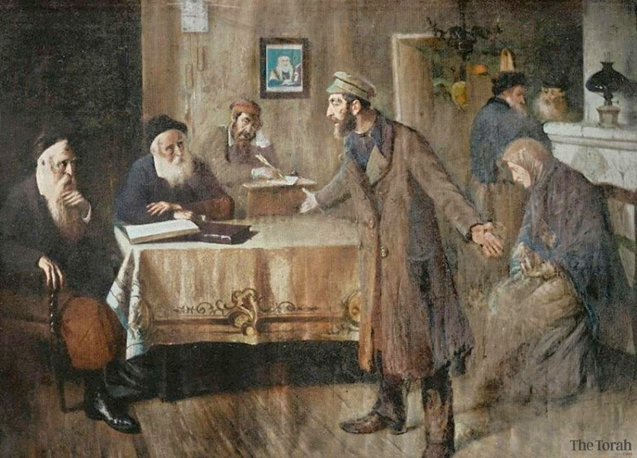

Illustration from Brockhaus and Efron Jewish Encyclopedia, 1906—1913 (colorized)

The Torah does not legislate how to marry or get divorced. It takes it as given that the reader knows how these processes work. However, Deuteronomy 24:1-4 deals with one very specific scenario related to divorce, namely a man’s remarriage to his divorcée after an intervening marriage.

Breaking Down the Law

This law falls into the category of “casuistic law,” meaning that it takes the form of an “if – then” statement. The “if” part, called the “protasis,” lays out the circumstances under which the law takes effect. The “then” part, called the “apodosis,” dictates what happens under those circumstances. Many casuistic laws end with a “motive clause,” which gives the reason or motivation for the law.

The Protasis

The circumstances under which the law applies are very specific:

1. A man marries a woman

דברים כד:א כִּי יִקַּח אִישׁ אִשָּׁה וּבְעָלָהּ

Deut. 24:1A man takes a wife and possesses her.

2. He divorces her

וְהָיָה אִם לֹא תִמְצָא חֵן בְּעֵינָיו כִּי מָצָא בָהּ עֶרְוַת דָּבָר וְכָתַב לָהּ סֵפֶר כְּרִיתֻת וְנָתַן בְּיָדָהּ וְשִׁלְּחָהּ מִבֵּיתוֹ׃

She fails to please him because he finds something obnoxious about her, and he writes her a bill of divorcement, hands it to her, and sends her away from his house;

3. The woman remarries

‎כד:ב‏ וְיָצְאָה מִבֵּיתוֹ וְהָלְכָה וְהָיְתָה לְאִישׁ־אַחֵר׃

24:2 she leaves his household and becomes the wife of another man;

4. The second man divorces her or dies

כד:ג‏ וּשְׂנֵאָהּ הָאִישׁ הָאַחֲרוֹן וְכָתַב לָהּ סֵפֶר כְּרִיתֻת וְנָתַן בְּיָדָהּ וְשִׁלְּחָהּ מִבֵּיתוֹ אוֹ כִי יָמוּת הָאִישׁ הָאַחֲרוֹן אֲשֶׁר־לְקָחָהּ לוֹ לְאִשָּׁה׃ ‎

24:3 then this latter man rejects her, writes her a bill of divorcement, hands it to her, and sends her away from his house; or the man who married her last dies.

The Apodosis

The law stipulates that the woman’s first husband, who divorced her, may not take her back.

דברים כד:דלֹא יוּכַל בַּעְלָהּ הָרִאשׁוֹן אֲשֶׁר שִׁלְּחָהּ לָשׁוּב לְקַחְתָּהּ לִהְיוֹת לוֹ לְאִשָּׁה ‏אַחֲרֵי אֲשֶׁר הֻטַּמָּאָה…

Deut. 24:4 Then the first husband who divorced her shall not take her to wife again after she has been defiled[2]…

The Motive Clause

The explanation offered by the text is that remarriage after a second marriage is abhorrent to YHWH and brings sin on the land.

כִּי תוֹעֵבָה הִוא לִפְנֵי יְ-הוָה וְלֹא תַחֲטִיא אֶת הָאָרֶץ אֲשֶׁר יְ-הוָה אֱלֹהֶיךָ נֹתֵן לְךָ נַחֲלָה׃

For that would be abhorrent to YHWH. You must not bring sin upon the land that YHWH your God is giving you as a heritage.

But Why?

The motive clause underscores how problematic this prohibited act is: it is abhorrent to YHWH and brings sin upon the land. But the reason for the severe judgment against this practice remains unclear. Why does the second marriage contaminate the woman, such that she should be prohibited to her first husband?

Philo: The Wife Was Wrong to Leave Her First Husband

The earliest known explanation of this law appears in the writings of Philo, a Jewish philosopher living in Roman Alexandria, in Egypt, from ca. 25 B.C.E-60 C.E. ([Special Laws](http://www.earlychristianwritings.com/yonge/book29.html) 3.30–31, Yonge trans.):

If … a woman having been divorced from her husband under any pretense whatever, and having married another, has again become a widow, whether her second husband is alive or dead, still she must not return to her former husband, but may be united to any man in the world rather than to him, having violated her former ties **which she forgot**, and **having chosen new allurements** in the place of the old ones.[3]

Philo’s description of this case attributes iniquity to the woman, who “chose” to forget her marriage bonds and leave her first husband for another man. But this interpretation does not reflect what is written in the biblical text. In the Torah, the woman is depicted as completely passive in the divorce (her husband “writes her a bill of divorcement, hands it to her, and sends her away from his house”), and the second marriage seems unproblematic. The prohibition lies solely on the first husband, who may not take his former wife back.

Ramban and Sforno: The Law Prohibits Wife-Swapping

Ramban (Rabbi Moses Nahmanides, 1194-1270) suggests that the prohibition is designed to prevent a sort of legalized wife-swapping:

וטעם הלאו הזה כדי שלא יחליפו נשותיהן זה לזה יכתוב לה גט בערב ובבוקר היא שבה אליו וזה טעם ולא תחטיא את הארץ כי זה סבה לחטאים גדולים

The reason for this prohibition is so that [men] do not exchange their wives between them, such that [a man] writes [his wife] a bill of divorce (*get*) in the evening, and she returns to him in the morning. That is the meaning of “you must not bring sin upon the land”: for this is a cause of great sins.

R. Ovadiah Sforno (ca. 1475-1550) makes the same suggestion:

**כי תועבה היא** כי זה דרך מבוא לנאוף שיגרש איש את אשתו לבקשת הנואף שיקחנה לאיזה זמן וישוב בעלה הראשון לקחתה:

**For that would be abhorrent:**[4] For it is a gateway to adultery, in which one man divorces his wife at the request of the adulterer so that [the latter] can take her for some amount of time, after which her first husband takes her back.

This interpretation fails to account for several details of the text. First, the Torah states that the first man divorces his wife because he “finds something obnoxious (עֶרְוַת דָּבָר) about her” and that the second divorces her because he “rejects” or dislikes her (שְׂנֵאָהּ). These descriptions of the men’s motivations do not accord with the idea that they prearranged the whole affair. Second, the text explicitly states that the law applies not only if the second man divorces the woman but also if he dies. Again, this does not suggest a deliberate arrangement.

Driver: The Law is Meant to Limit Divorce

The great British biblical scholar Samuel Rolles Driver (1846-1914) suggests that the law is meant to discourage “rash” divorce.[5] A man might hesitate to divorce his wife if he knew that he could not take her back. However, this does not explain why the prohibition goes into effect only after a second marriage.

Driver also offers another explanation, which does account for the second marriage. He suggests that the law is designed to encourage the couple to remarry if a divorce has already taken place, knowing that their remarriage would be prohibited if she married again. But this explanation falls short as well, since if the purpose of the law is to encourage reconciliation, it should not impose an impediment to reconciliation by prohibiting it after a second marriage. Moreover, if this is simply an attempt to prevent rash divorces and encourage reconciliation, why is the divorce itself not abhorrent to YHWH?

Driver was ordained as an Anglican priest, and his interpretation may have been influenced by Anglican doctrine. Although the Church of England has always permitted divorce, until 2002, divorced people were not permitted to remarry in the church unless their ex-spouses were deceased.[6]

Reuven Yaron: The Law Protects the Second Marriage

Reuven Yaron (1924-2014), an Israeli scholar of law, pushed back against the Christian bias against divorce that he believed lay behind these interpretations.[7] While rejecting Driver’s argument that the law discourages divorce, he argued in favor of yet another interpretation of Driver’s, which suggested that the law might be designed to prevent conflict within the second marriage. Driver argued that if the woman, once remarried, wished to return to her first husband, she might “intrigue” against her new spouse, disrupting their marriage.

Elaborating on this idea, Yaron argued that Deuteronomy’s law fully accepted divorce and remarriage and was designed to protect the second union. A second marriage might be beset by any number of difficulties: the first husband might regret the divorce and attempt to disrupt the second marriage, the wife might judge the second husband unfavorably relative to the first, or the second husband might suspect his wife of still being interested in her ex-husband. This law would protect the finality of the divorce and encourage harmony within the second marriage.[8]

Yaron’s interpretation, however, fails to account for the provision that the law applies if the second husband dies.[9] In addition, the text’s description of the second divorce as a result of the second husband’s rejecting or disliking the woman (וּשְׂנֵאָהּ הָאִישׁ הָאַחֲרוֹן) does not accord with all the possibilities that Yaron suggests.[10] Finally, the strong language about bringing sin on the land and acting abhorrently before YHWH does not seem appropriate to this pragmatic interpretation.

Raymond Westbrook: The Law Prevents Unjust Enrichment

Raymond Westbrook (1946-2009), a scholar of Near Eastern Law, suggested that this passage could be understood in light of a broader ancient Near Eastern legal tradition about dowries.[11] Westbrook focuses on the different descriptions of the two divorces:

1. The first man finds “something obnoxious” (עֶרְוַת דָּבָר) about her;
2. The second “rejects” or dislikes her (שְׂנֵאָהּ).

Westbrook understands עֶרְוַת דָּבָר, “something obnoxious,” as describing some improper behavior on the woman’s part. Because this is a divorce with grounds, under Near Eastern law the man would be allowed to keep his wife’s dowry. In contrast, the second man divorces the woman for subjective reasons—he “rejects” or dislikes her (שְׂנֵאָהּ), so the dowry would revert to the woman.

If the first man were to take the woman back, he would then have both dowries, the one he received upon their first marriage, and the dowry she received for her second marriage and was allowed to keep. Moreover, he would have gained the second dowry through “estoppel,”[12] by reversing on his original declaration that his wife was unfit—otherwise, how could he remarry her?

While this interpretation deserves mention for its ingenuity, nothing in the text implies that it is concerned with dowries or inheritance, and Westbrook’s reconstruction of Near Eastern “common law” is somewhat shaky.[13] More significantly, Westbrook’s interpretation does not accord with the metaphorical application of this law in Jeremiah 3:1, discussed in the following section, which assumes that the law applies in cases of adultery, where there would be no second dowry.

A Clue from Jeremiah 3:1’s Metaphorical Application of the Law

Jeremiah evokes this law as part of an extended metaphorical description of Israel as God’s adulterous wife.[14] Rather than remain faithful to her husband, Israel “fornicates” repeatedly with other deities. In response, God declares:

ירמיהו ג:א הֵן יְשַׁלַּח אִישׁ אֶת אִשְׁתּוֹ וְהָלְכָה מֵאִתּוֹ וְהָיְתָה לְאִישׁ אַחֵר הֲיָשׁוּב אֵלֶיהָ עוֹד הֲלוֹא חָנוֹף תֶּחֱנַף הָאָרֶץ הַהִיא

Jeremiah 3:1 If a man divorces his wife, and she leaves him and marries another man, can he ever go back to her? Would not such a land be corrupted?[15]

וְאַתְּ זָנִית רֵעִים רַבִּים וְשׁוֹב אֵלַי נְאֻם יְ-הוָֹה׃

Now you have whored with many lovers: can you return to Me? — says YHWH.

Jeremiah here assumes that the audience for this prophecy is familiar with the law in Deuteronomy: If a man divorces his wife and she remarries, he may not take her back, at the risk of corrupting the land. The prophet then applies this to his metaphor in a *kal va-chomer*(a fortiori) argument: surely God cannot take Israel back now that she has “fornicated” with so many other “men”! As noted above, Jeremiah takes it for granted that the principle behind this law would apply in a case of adultery as well as in cases of divorce.

Following Jeremiah’s understanding, Deuteronomy’s law is not about divorce per se, but about sex. The clause אַחֲרֵי אֲשֶׁר הֻטַּמָּאָה, “after she has been defiled,” indicates that the law is dealing with sexual purity. A woman cannot return to her former (or current) husband after being with another man because the latter sexual relationship defiles her for him. This reflects a notion, also found elsewhere in the Bible, that sex leaves something of a man’s “essence” in a woman, and that this residue can in some cases be contaminating.[16]

Purity Law as Codified Disgust

The ideas of purity (טֹהַר) and contamination (טֻמְאָה) are concretizations of disgust.[17] The language of contamination is used in legal contexts to describe things that are understood as “naturally” disgusting and to prescribe rules about them. This text views the situation from the perspective of the first husband and presumes that he ought to feel repulsed at returning to his wife after she has slept with another man. If he is not repulsed, God will be repulsed on his behalf: “for that would be abhorrent to YHWH” (כִּי־תוֹעֵבָה הִוא לִפְנֵי יְ-הוָה). Engaging in behavior that is repugnant to God—and thus “objectively” repugnant—fills the land with sin.

Rights and Justice vs. Purity and Taboo

Laws regulating sexual behavior may be based on ideas about rights, obligations, and justice, or they may be based on purity and taboo. The Torah contains both types of laws.[18] Those based on purity rely on shared feelings and notions about what is disgusting and what is acceptable, and they often resist fully logical explanation.

From a purely logical perspective, this law (or my interpretation of it) poses problems. If sex with another man contaminates a woman for her husband, why is it permissible for a divorced woman—or, for that matter, a widow or any non-virgin—to (re)marry at all? And why does this law prohibit the woman only from remarrying her first husband, and not from marrying any other man?

Yet the law makes some intuitive sense when viewed in terms of the feelings this situation might generate. If the first husband were to remarry his former spouse, the second marriage could be seen as having interrupted an ongoing relationship, introducing something foreign. As Carolyn Pressler puts it, it is “structurally similar to adultery,” in which a woman, once bound to one man, has sex with another and then potentially returns to the first.[19] This strengthens Jeremiah’s *kal va-chomer*argument: if a woman is contaminated for her first husband even in a case of divorce, how much more so in a case of serial adultery!

1. Alternatively, it has no specific ritual or legal process in mind.
2. NJPS has “since she has been defiled,” and many commentators read this as a motive clause explaining why the woman may not be taken back (see, e.g., Carolyn Pressler, *The View of Women Found in the Deuteronomic Family Laws* (BZAW 216; Berlin: de Gruyter, 1993), p. 61). However, most motive clauses in the Bible begin with כִּי, “because,” so it makes the most sense to read כִּי־תוֹעֵבָה הִוא לִפְנֵי יְ-הוָה as the beginning of the motive clause here. The first husband is prohibited from taking his former wife back *after*she has been defiled, i.e., after the first marriage has been consummated. This interpretation is found in *Sifre*270, where it is attributed to R. Yose b. Kipper, who states that the law applies only after consummated marriage (נישואים), but not after inchoate (not-yet-consummated) marriage (ארוסים).
3. Philo continues in a very harsh tone, though it is unclear whether he is cursing the second husband (the most likely possibility) or the first husband upon reconciliation, or even some third husband:

But **if any man** should choose to form an alliance with such a woman, he must be content to bear the reputation of effeminacy and a complete want of manly courage and vigor, as if he had been castrated and deprived of the most useful portion of the soul, namely, that disposition which hates iniquity, by which the affairs both of houses and cities are placed on a good footing, and as having stamped deeply on his character two of the greatest of all iniquities, adultery and the employment of a pander; for the reconciliations which take place subsequently are indications of the death of each. Let him, therefore, suffer the punishment appointed, together with his wife.

Philo appears to see the woman’s abandonment of her husband as adulterous (arguably foreshadowing Jesus’s equation of divorce with adultery) and thus sees the second husband as partaking in this sin by marrying her.

1. The connection that Sforno draws between adultery and the term תועבה, “abhorrence,” may be based on Ezekiel 22:11: ‏וְאִישׁ אֶת־אֵשֶׁת רֵעֵהוּ עָשָׂה תּוֹעֵבָה, “They have committed abhorrent acts with other men’s wives.”
2. Samuel Rolles Driver, *Deuteronomy* (Edinburgh, T&T Clark, 1909), p. 272.
3. Marc Zvi Brettler, personal communication.
4. In Matthew 5:31–32, Jesus links divorce and adultery, citing this law in the process: “It was also said, ‘Whoever divorces his wife, let him give her a certificate of divorce.’ But I say to you that anyone who divorces his wife, except on the ground of unchastity, causes her to commit adultery; and whoever marries a divorced woman commits adultery.” (NRSV translation)
5. Reuven Yaron, “The Restoration of Marriage,” *Journal of Jewish Studies*17 (1966): 1–6.
6. Although it is theoretically possible that this provision is designed to prevent the wife from murdering her second husband (Zev Farber, personal communication).
7. David Steinberg, personal communication.
8. Raymond Westbrook, “The Prohibition of the Restoration of Marriage in Deuteronomy 24:1–4,” in *Studies in Bible,*1986, ed. Sara Japhet (Jerusalem: Magnes, 1986), pp. 387–405.
9. The legal concept that someone who has profited by asserting a particular set of facts cannot profit again by making an assertion to the contrary.
10. The Bible provides no information on divorce law outside this passage, so Westbrook’s description of Near Eastern common law is based on laws a great deal earlier and a great deal later, and these laws are not consistent. Although the Laws of Hammurabi (¶141) and the Mishnah (*m. Ketub.*7:6) do require a man to compensate his divorcée, the other ancient Near Eastern laws that Westbrook cites do not support his position. The Middle Assyrian Laws, in fact, grant a husband total discretion over whether to compensate his divorcée and do not mention any misconduct on her part.
11. The book of Jeremiah has many affinities with Deuteronomy, in both language and content. This has led scholars to the consensus that the authors of Jeremiah had access to some version of Deuteronomy.
12. NJPS translates the Hebrew root חנף as “defiled,” in keeping with the Septuagint, which may have been influenced in part by the connection between this verse and Deuteronomy 24:4. However, etymology and biblical usage suggest that חנף refers to sin or corruption, not defilement. Biblical verses supporting this interpretation include Jeremiah 23:11, Isaiah 33:14, and Job 20:5.
13. Another example of this can be found in Lev 21:1–4, which prohibits priests from marrying divorcées and the high priest from marrying even a widow. As I discuss in my essay [“Purity of Priests: Contamination Through Marriage”](http://thetorah.com/purity-of-priests-contamination-through-marriage/) (*TheTorah.com*
14. ), this law aims to safeguard priests’ holiness by preventing contamination by the “essence” of another man. Note also the use of purity and pollution language to describe the effect of adultery on a woman in Num 5:11–31 (the law of the *sotah*).
15. See my discussion in [“The Animal Laws Before Kashrut: A System of Purity,”](http://thetorah.com/animal-laws-before-kashrut-a-system-of-purity/) *TheTorah.com* (2015).
16. In fact, both can be found within this *parashah.*The laws in Deuteronomy 22:14–29 are mostly justice based.
17. Pressler, *View of Women*, p. 61.  Pressler notes that, as it deals with purity, this law may not be possible to understand fully.