**FIGURES**

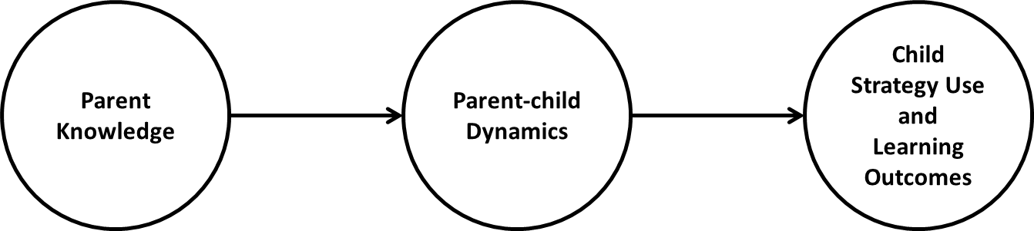

**Figure 1**. A theoretical model of the research questions and constructs. *Parent knowledge* includes metaprocesses; *parent-child dynamics* refers to coregulation and other-regulation; and *child strategy use* refers to self-regulated learning strategies.

**Figure 2.** Regulation Internalization Model (RIM)

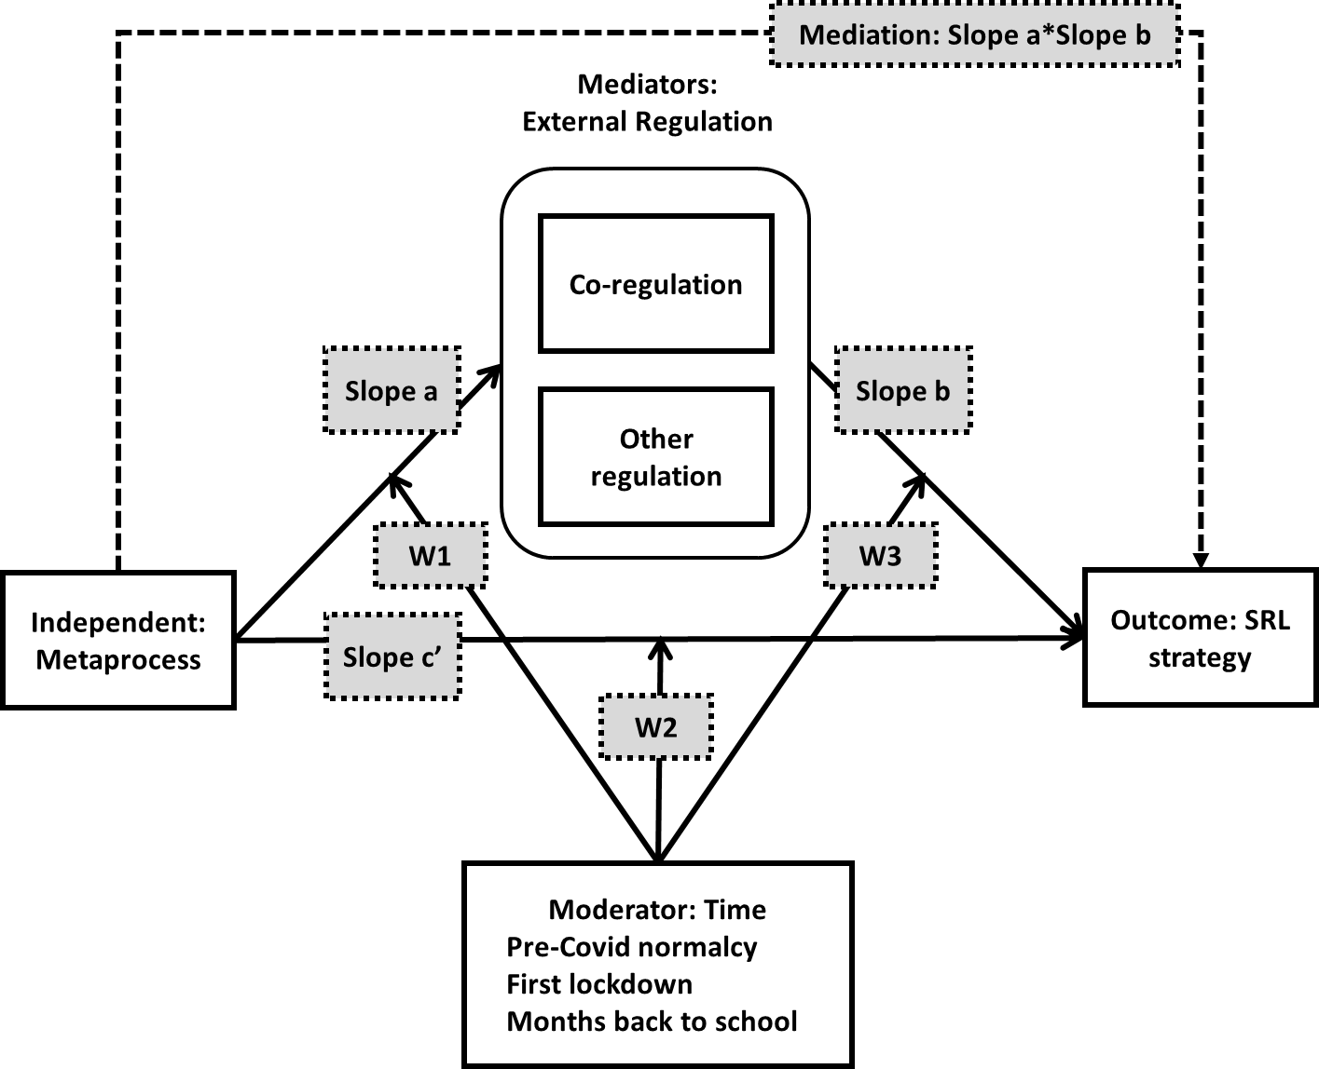

**Figure 3**. Illustration of moderated mediation modeling (Hayes PROCESS, 2013; Model 59) from metaprocesses to child SRL examined in Study 1.

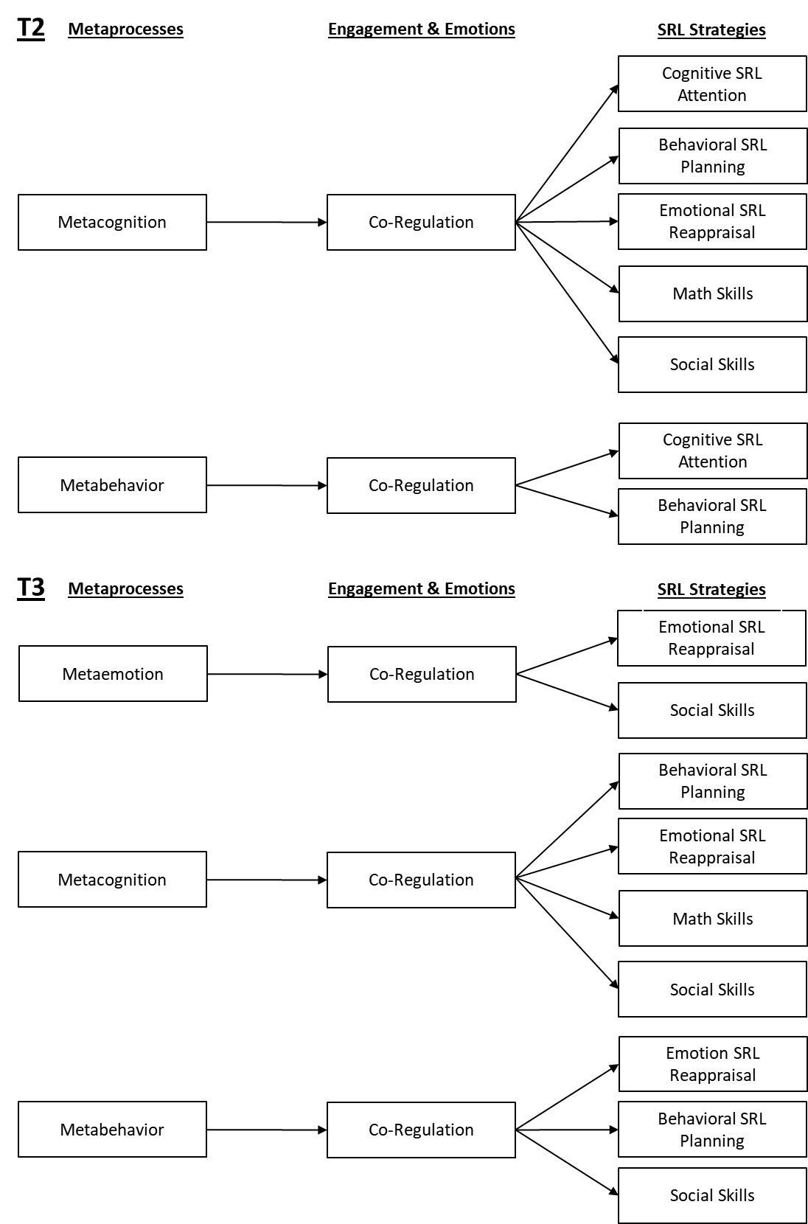

**Figure 4**. Summary of significant mediation paths in Study 1. At T1 (pre-COVID), there were no significant paths. T2 = Time 2 lockdown; T3 = Time 3 return to school at the end of the school year.

**Figure 5**. Illustration of the cross-lagged mediation model (Study 2).

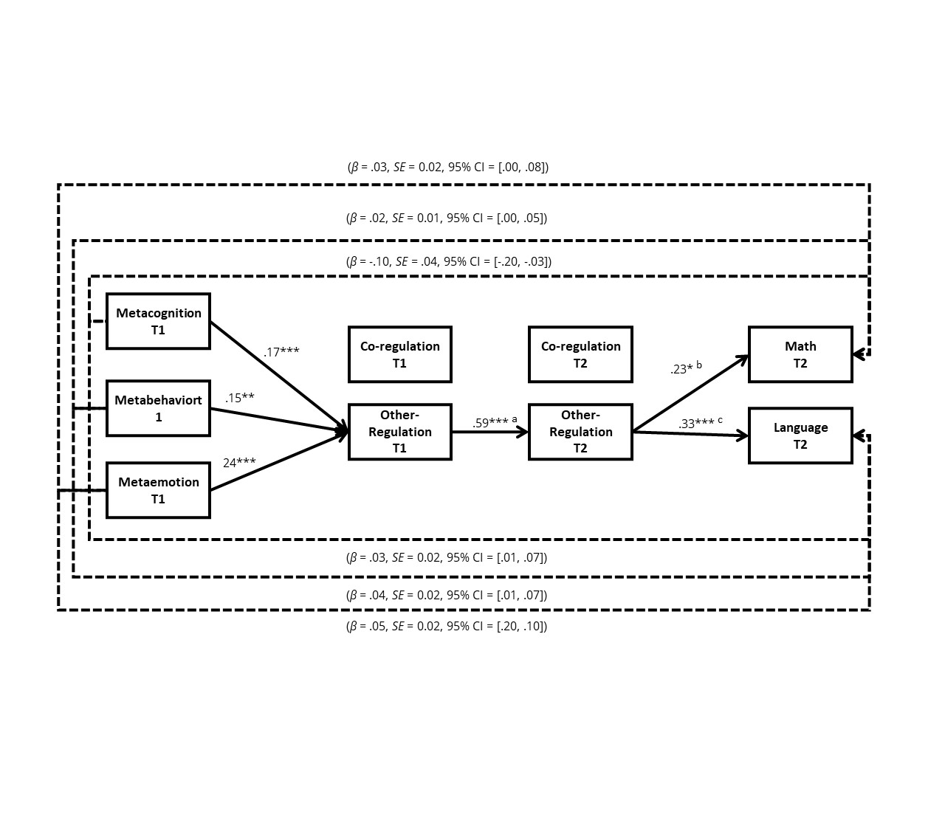

**Figure 6.** An illustration of the cross-lagged mediation model (Study 2).

*Note.* \**p* < .05, \*\**p* < .01, \*\*\**p* < .001;

a. the association between other regulation and T1 and T2 somewhat very for the different models ranging from .58 to .60 (metacognition=.59; metabehavior=.58; metaemotion=.60)

b. the association between other regulation T2 and math were not significant for all models; metacognition=.20 and metabehavior=.19

c. he association between other regulation T2 and language somewhat very for the different models ranging from .33 to .35 (metacognition=.33; metabehavior=.33; metaemotion=.35)